http://www.USScouts.Org • http://www.MeritBadge.Org
Please submit errors, omissions, comments or suggestions about this workbook to: Workbooks@USScouts.Org
Comments or suggestions for changes to the requirements for the Belt Loop or Pin should be sent to: Advancement.Team@Scouting.Orgub
Cub Scout’s Name: Pack No. :
Webelos Scouts that earn the Astronomy Belt Loop while a Webelos Scout
also satisfy requirement 14 for the Scientist Activity Badge.

Cub Scout Astronomy Belt Loop (See the Pin Requirements below.)
Complete these three requirements:
1. Set up and demonstrate how to focus a simple telescope or binoculars.
(A local astronomy club may be a resource for this activity.)
2. Draw a diagram of our solar system--identify the planets and other objects.
3. Explain the following terms: planet, star, solar system, galaxy, the Milky Way, black hole, red giant, white dwarf, comet, meteor, moon, asteroid, star map, and universe.
Planet
Star
Solar System
Galaxy
The Milky Way
Black Hole
Red Giant
White Dwarf
Comet
Meteor
Moon
Asteroid
Star Map
Universe

Cub Scout Astronomy Pin
Earn the Cub Scout Astronomy belt loop, and complete five of the following requirements:
. 1. Draw a diagram of a telescope and explain how it works.
How does it work?
2. Explain how to use a star map.
3. Draw and label five constellations. See if you can locate any of them in the sky using a star map.
4. Find the North Star.
Explain its importance.
5. With your parent's or adult partner's permission, interview an astronomer. This person may be a professional or an amateur astronomer from a local astronomy club. Report on what you learned to your den or family.
6. Learn about careers that relate to Astronomy. Make a list of those careers.
Tell your den or an adult family member what school subjects will help you get a position in those careers.
7. Visit a planetarium or a local astronomy club.
Give a report on what you learned to your den.
8. Make a poster illustrating the different kinds of stars. Include a diagram showing the life cycle of a star.
9. Learn about some of the early space missions. Tell your den or family about one of them.
10. Find a news story about a recent happening related to space. Tell your den or family about this event.
11. Write a report on two famous astronomers.
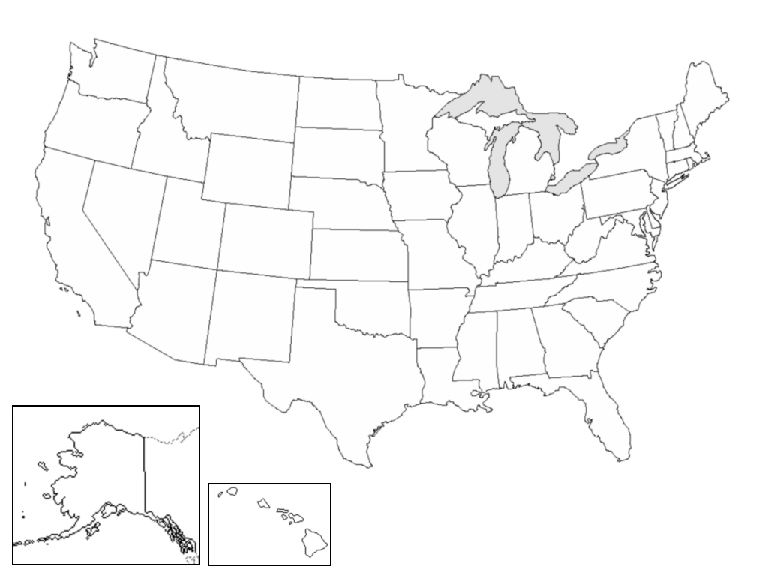
12. Locate three major observatories on a map.
Explain why these locations are good for astronomy.
Requirement resources can be found here:
http://www.meritbadge.org/wiki/index.php/Cub_Scout_Astronomy#Requirement resources

Important excerpts from the ‘Guide To Advancement’, No. 33088:
Effective January 1, 2012, the ‘Guide to Advancement’ (which replaced the publication ‘Advancement Committee Policies and Procedures’) is now the official Boy Scouts of America source on advancement policies and procedures.
- [ Inside front cover, and 5.0.1.4 ] — Unauthorized Changes to Advancement Program
No council, committee, district, unit, or individual has the authority to add to, or subtract from, advancement requirements. (There are limited exceptions relating only to youth members with disabilities. For details see section 10, “Advancement for Members With Special Needs”.)
- [ Inside front cover, and 7.0.1.1 ] — The ‘Guide to Safe Scouting’ Applies
Policies and procedures outlined in the ‘Guide to Safe Scouting’, No. 34416, apply to all BSA activities, including those related to advancement and Eagle Scout service projects. [Note: Always reference the online version, which is updated quarterly.]
- [ 4.1.0.3 ] ] — Who Approves Cub Scout Advancement?
A key responsibility for den leaders is to implement the core den meeting plans as outlined in the Den & Pack Meeting Resource Guide, No. 34409. For Wolf, Bear, and Webelos advancement, den leaders take the lead in approving requirements, though their assistants, and also parents who help at meetings, may be asked to play the role of “Akela” and assist. Parents sign for requirements that, according to meeting plans and instructions in the handbooks, take place at home. For the Bobcat trail and Tiger Cub achievements, parents (or adult partners) should sign in the boy’s handbook; the den leader then approves as progress is recorded in the den’s advancement record.
- [ 4.1.0.4 ] — “Do Your Best”
Advancement performance in Cub Scouting is centered on its motto: “Do Your Best.” When a boy has done this—his very best—then regardless of the requirements for any rank or award, it is enough; accomplishment is noted. This is why den leaders, assistants, and parents or guardians are involved in approvals. Generally they know if effort put forth is really the Cub Scout’s best.
- [ 4.1.2.2 ] — Cub Scout Academics and Sports Program
More than just a recognition opportunity, this program develops new skills, improves those existing, and otherwise enriches Cub Scouting. Details can be found in the Cub Scout Academics and Sports Program Guide, No. 34299. Activities include subjects like science, video games, collecting, and chess; and sports such as baseball, skateboarding, and table tennis. Each has two levels—a belt loop and a pin. Belt loops, which can be earned more than once, are awarded when each of three requirements is met. Cub Scouts may then continue with additional requirements and earn the pin. Archery and BB gun shooting are included, but can only be conducted at a council presented activity with certified supervisors.
Additional notes of interest:
- Tiger Cubs, Cub Scouts, and Webelos Scouts may complete requirements for all Academics and Sports Belt Loops and Pins (except shooting sports) in a family, den, pack, school, or community environment. Tiger Cubs must work with their parents or adult partners. Parents and partners do not earn loops or pins.
- “Akela” (Pronounced “Ah-KAY-la”) — Title of respect used in Cub Scouting—any good leader is Akela. Akela is also the leader and guide for Cub Scouts on the advancement trail. The name comes from Rudyard Kipling's Jungle Book. (See "Law of the Pack.")
- “Law of the Pack” — The Cub Scout follows Akela.
The Cub Scout helps the pack go.
The pack helps the Cub Scout grow.
The Cub Scout gives goodwill.

