http://www.USScouts.Org • http://www.MeritBadge.Org
Please submit errors, omissions, comments or suggestions about this checklist to: Workbooks@USScouts.Org
Comments or suggestions for changes to the requirements should be sent to: Advancement.Team@Scouting.Org
Cub Scout’s Name: Pack No. :
Source for requirements: Cub Scout Wolf Handbook (#34752 - SKU 646428)
This adventure is an elective adventure which can be used to earn the Wolf Badge.
Complete Requirements 1-4. Requirements 5-7 are optional.
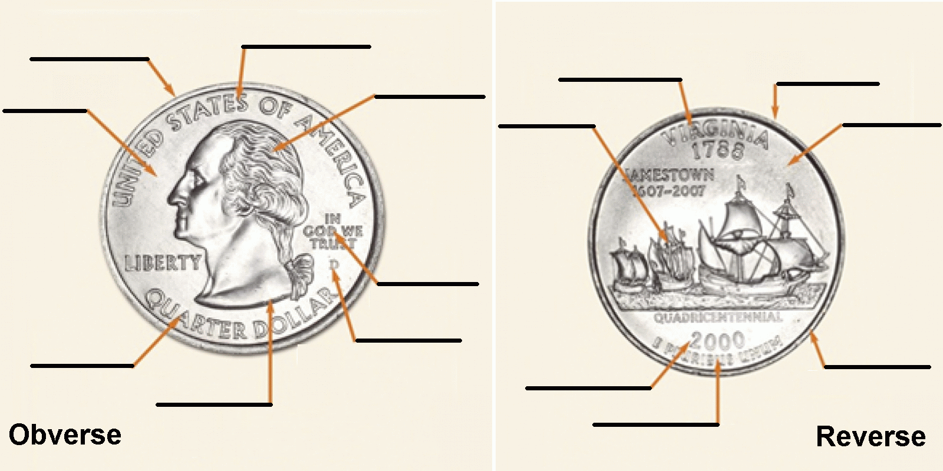
1. Identify different parts of a coin.
2. Find the mint mark on a coin.
Identify the mint where the coin was made,
and the year it was made.
Note: The image on this page is a modified version of images of a 2000-D Virginia Statehood Quarter, found on the American Numismatic Association website at https://www.money.org/parts-of-a-coin with the legend erased.
3. Choose a coin that interests you, and make a coin rubbing. List information next to the coin detailing the pictures on it, the year it was made, and the mint where it was made.
Obverse |  | Reverse
Picture: |  | Picture:
Year: |  | Mint:
4. Play a game or create a game board with your den or family where you can practice adding and subtracting coins.
Describe the game:
When was this done?

5. Play a coin game.
Describe the game:
When was this done?
6. Create a balance scale.
When was this done?
7. Do a coin-weight investigation.
What was done?
When was this done?
When working on Cub Scout Advancements and awards, Cub Scouts, their parents, and Scouters should be aware of some vital information in the current edition of the Guide to Advancement (BSA publication 33088).Important excerpts from that publication can be downloaded from http://usscouts.org/advance/docs/GTA-Excerpts-Cub.pdf.
You can download a complete copy of the Guide to Advancement .from http://www.scouting.org/filestore/pdf/33088.pdf.

