http://www.USScouts.Org • http://www.MeritBadge.Org
Please submit errors, omissions, comments or suggestions about this workbook to: Workbooks@USScouts.Org
Comments or suggestions for changes to the requirements for the Belt Loop or Pin should be sent to: Advancement.Team@Scouting.Org
Cub Scout’s Name: Pack No. :
Webelos Scouts that earn the Science Belt Loop while a Webelos Scout
also satisfy requirement 4 for the Scientist Activity Badge.

Cub Scout Science Belt Loop (See the Pin Requirements below.)
Complete these three requirements:
1. Explain the scientific method to your adult partner.
2. Use the scientific method in a simple science project Explain the results to an adult.
3. Visit a museum, a laboratory, an observatory, a zoo, an aquarium, or other facility that employs scientists. Talk to a scientist about his or her work.
Cub Scout Science Pin
Earn the Cub Scout Science belt loop, and complete five of the following requirements:
1. Make a simple electric motor that works.
2. Find a stream or other area that shows signs of erosion. Try to discover the cause of the erosion.
3. Plant seeds. Grow a flower, garden vegetable, or other plant.
4. Use these simple machines to accomplish tasks: lever, pulley, wheel-and-axle, wedge, inclined plane, and screw.
Lever Wedge
Pulley Inclined Plane
Wheel-and-Axle Screw
5. Learn about solids, liquids, and gases using just water. Freeze water until it turns into ice. Then, with an adult, heat the ice until it turns back into a liquid and eventually boils and becomes a gas.
6. Build models of two atoms and two molecules, using plastic foam balls or other objects.
7. Make a collection of igneous, metamorphic, and sedimentary rocks and label them.
8 Learn about a creature that lives in the ocean. Share what you have learned with your den or family.
9. Label a drawing or diagram of the bones of the human skeleton.
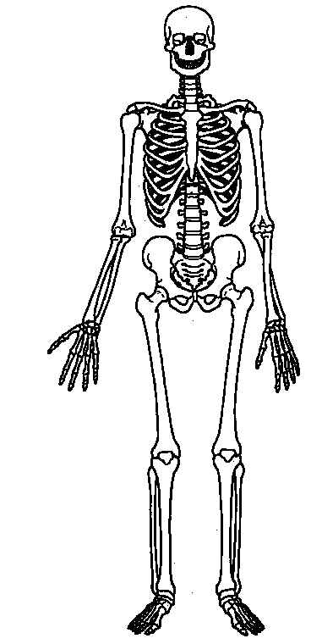
10. Make a model or poster of the solar system. Label the planets and the sun.
11. Do a scientific experiment in front of an audience. Explain your results.
12. Read a book about a science subject that interests you. Tell your den or an adult family member about what you learned.
Requirement resources can be found here:
http://www.meritbadge.org/wiki/index.php/Cub_Scout_Science#Requirement resources

Important excerpts from the ‘Guide To Advancement’, No. 33088:
Effective January 1, 2012, the ‘Guide to Advancement’ (which replaced the publication ‘Advancement Committee Policies and Procedures’) is now the official Boy Scouts of America source on advancement policies and procedures.
- [ Inside front cover, and 5.0.1.4 ] — Unauthorized Changes to Advancement Program
No council, committee, district, unit, or individual has the authority to add to, or subtract from, advancement requirements. (There are limited exceptions relating only to youth members with disabilities. For details see section 10, “Advancement for Members With Special Needs”.)
- [ Inside front cover, and 7.0.1.1 ] — The ‘Guide to Safe Scouting’ Applies
Policies and procedures outlined in the ‘Guide to Safe Scouting’, No. 34416, apply to all BSA activities, including those related to advancement and Eagle Scout service projects. [Note: Always reference the online version, which is updated quarterly.]
- [ 4.1.0.3 ] ] — Who Approves Cub Scout Advancement?
A key responsibility for den leaders is to implement the core den meeting plans as outlined in the Den & Pack Meeting Resource Guide, No. 34409. For Wolf, Bear, and Webelos advancement, den leaders take the lead in approving requirements, though their assistants, and also parents who help at meetings, may be asked to play the role of “Akela” and assist. Parents sign for requirements that, according to meeting plans and instructions in the handbooks, take place at home. For the Bobcat trail and Tiger Cub achievements, parents (or adult partners) should sign in the boy’s handbook; the den leader then approves as progress is recorded in the den’s advancement record.
- [ 4.1.0.4 ] — “Do Your Best”
Advancement performance in Cub Scouting is centered on its motto: “Do Your Best.” When a boy has done this—his very best—then regardless of the requirements for any rank or award, it is enough; accomplishment is noted. This is why den leaders, assistants, and parents or guardians are involved in approvals. Generally they know if effort put forth is really the Cub Scout’s best.
- [ 4.1.2.2 ] — Cub Scout Academics and Sports Program
More than just a recognition opportunity, this program develops new skills, improves those existing, and otherwise enriches Cub Scouting. Details can be found in the Cub Scout Academics and Sports Program Guide, No. 34299. Activities include subjects like science, video games, collecting, and chess; and sports such as baseball, skateboarding, and table tennis. Each has two levels—a belt loop and a pin. Belt loops, which can be earned more than once, are awarded when each of three requirements is met. Cub Scouts may then continue with additional requirements and earn the pin. Archery and BB gun shooting are included, but can only be conducted at a council presented activity with certified supervisors.
Additional notes of interest:
- Tiger Cubs, Cub Scouts, and Webelos Scouts may complete requirements for all Academics and Sports Belt Loops and Pins (except shooting sports) in a family, den, pack, school, or community environment. Tiger Cubs must work with their parents or adult partners. Parents and partners do not earn loops or pins.
- “Akela” (Pronounced “Ah-KAY-la”) — Title of respect used in Cub Scouting—any good leader is Akela. Akela is also the leader and guide for Cub Scouts on the advancement trail. The name comes from Rudyard Kipling's Jungle Book. (See "Law of the Pack.")
- “Law of the Pack” — The Cub Scout follows Akela.
The Cub Scout helps the pack go.
The pack helps the Cub Scout grow.
The Cub Scout gives goodwill.

