CORE VALUES
Cub Scout Roundtable Leaders’ Guide
The core value highlighted this month is:
- Faith: Having inner strength or confidence based on our trust in a higher power. Cub Scouts will learn that it is important to look for the good in all situations. With their family guiding them, Cub Scouts will grow stronger in their faith.
Why My Family Tree for the Core Value Faith?
- Faith means having inner strength and confidence based on trust in a higher power. Understanding one’s family tree, ancestors, and heritage brings stories to life of the strength and confidence of our family members. It also tells of their belief and trust in a higher power to help bring them safely to the United States. In years past, many immigrants traveled by boat. What faith they had in that boat that would change their lives!.
Scout Law equivalent to Faith is:
- A Scout is reverent toward God. He is faithful in his religious duties. He respects the beliefs of others.

The Scout Law equivalents are being presented as part of the preparation for One Oath/One Law when all scouts will be using the Scout Oath and Law be they Cub Scouts, Boy Scouts, Venturers or ...

Be a player on God's team.
Lord Robert Baden-Powell, Rovering to Success, 1922

TABLE OF CONTENTS
In many of the sections you will find subdivisions for the various topics covered in the den meetings
CORE VALUES 1
TABLE OF CONTENTS 1
THOUGHTFUL ITEMS FOR SCOUTERS 3
Prayer 3
Looking Back to See Ahead 3
Quotations 4
Reverend John Lathrop 5
Quoting Baden-Powell on Faith 7
From Aids to Scoutmastership, 1919: 7
From Rovering to Success, 1922 7
DEN MEETING TOPICS 7
PACK MEETING THEMES 8
UPCOMING MONTHS 9
Faith-Based Groups with Boy Scout Web links: 10
Connecting FAITH with Outdoor Activities 10
FAITH Character Connection 11
March Crazy Holidays 12
THE BUZZ 14
OnBoarding and E-Learning Curiculum 14
Resources 15
BSA SOCIAL NETWORKS 15
CUBCAST 15
Listen Hear 15
Training Topics 15
Self Esteem 15
An Introduction to the Scouts Own 16
Some Ideas on Scouts' Owns 17
Roundtable Note 18
Faith Bingo 19
Emblems of Faith Puzzles 19
Search for Faith 19
SONGS 19
Cub Scout Garden 19
WEB SITES 20
And Other Resources 20
Trees 20
Religious Emblem Program 21
DEN MEETINGS 21
TIGERS 21
Den Meeting #15: 21
Den Meeting #16: 22
Board Game Ideas 22
Board Game Templates: 22
Edible Maze 22
Edible Tic Tac Toe: 22
Edible Scrabble/Crossword Puzzles: 22
Litter Ideas 22
TRASH 23
DO YOUR PART 23
WOLF 23
Den Meeting #15: 23
Den Meeting #16: 23
Marble Ideas 23
Fishing Ideas 23
Fish in the Sea Game: 23
Fish Cupcakes: 24
Faith Chant 24
BEAR 24
Bear Ideas by Felicia 24
Lesson Plan Q - Family Outdoor Adventure – Ach 12. 24
Hiking Belt Loop 25
Hiking Safety Rules: 25
Sneaky Snake 26
Meeting S - Tale Tales - Achievement 4 26
John Henry 27
Make Johnny Appleseed Smiles for a snack. 27
Apple Dolls 28
Supplemental Meeting #A – Maps - 28
Elective 23, a-e and Map & Compass Belt Loop 28
Map and Compass Belt Loop 29
WEBELOS DENS 30
Book Corner 31
Meeting Planner 32
The meaning of the Pledge of Allegiance Flag Ceremony 32
Planning a Den Outdoor Activity 33
Den Meeting Helpers 34
SCHOLAR 34
SEVEN WAYS TO IMPROVE YOUR GRADE 35
WORD PUZZLES 35
SECRET SCHOLAR MESSAGE 35
CAREERS IN EDUCATION 36
A SHORT HISTORY OF AMERICAN EDUCATION 36
BRAIN TEASERS 37
LANGUAGE SKILLS 37
ARTIST 37
Rainbow Crayons 38
Colored Line Art 38
Five Dots 38
Eyes-shut Drawing 39
Outline or Wiggles 39
THE COLOR WHEEL 39
Arrow of Light 40
SPORTMAN 40
Sportsman Ideas 40
MARBLES 41
HOW TO PLAY RINGER 41
My Family Tree Ideas 43
My American Family Tree 43
Go and See It-1G 43
Family Tree Hidden Picture Puzzle 43
Family Tree Puzzle 43
Family Tree Opening: 44
GENEALOGICAL LIBRARY FIELD TRIP 44
Climbing Your Family Tree, A Beginners Guide to Genealogy 44
Family Trees 45
Family Mobile 45
Family Advancement 45
Faith Ideas 46
Native American Prayer 46
The Founder's Prayer 46
Two Prayers 46
Religious Emblems Gathering Activity 46
Emblems of Faith Puzzles 46
Faith Word Search 46
Gathering Ideas from Alice 47
Faith Bingo 47
Faith Opening 47
Where Faith is Found Opening 47
Faith Based Stories 48
A True Story about a Scout and his Faith 48
A True Story of Faith for LDS Scouts 48
Faith Audience Participation Story 49
Faith Advancement Ceremony 49
North Star Advancement Ceremony 49
Recognition Religious Emblem Square Knots 50
Faith Is.... Song 50
Kumbaya Song 50
He's Got The Whole World In His Hands Song 50
For The Beauty Of The Earth Hymn 50
Faith Is Applause: 51
Praying RUN-ON 51
A Gardener’s Faith Skit 51
Cookies of Faith Skit 51
Faith Based Four Corners Game 51
True Blue A game about Faith and Trust. 52
True Blue Skit Idea: 53
Unravel the Knot Game 53
Baden-Powell Closing 53
Beatitudes for Cubs 53
Great Master We Give Thanks Ceremony 53
North Star Cubmaster’s Minute 53
Baden-Powell on Faith Cubmaster’s Minute 53
Gold Medal Faith Cubmaster’s Minute 54
The Rabbi & The Soap Maker Cubmaster’s Minute 54
Believing Without Seeing Cubmaster’s Minute 54
Declaration of Religious Principle. 54
Connecting FAITH with Outdoor Activities 54
FAITH Character Connection 55
God and Me Shield Slide 56
Make a Pretzel of Faith Tie Slide 56
Symbol of Faith Bookmark 57
Faith Visits 57
Religious Activities: 57
Faith in Family & Friends: 58
Faith in Self: 58
T-Shirt Testimony 58
Scripture Cookies 58
Visits 59

THOUGHTFUL ITEMS FOR SCOUTERS
Thanks to Scouter Jim from Bountiful, Utah, who prepares this section of Baloo for us each month. You can reach him at bobwhitejonz@juno.com or through the link to write Baloo on www.usscouts.org.

Prayer
Father in Heaven; thankfully we come to Thee in gratitude for the valiant lives of those who have come before and established this free land been willing to give all for the cause of liberty. We are thankful for the heritage each of us has been given and the courage of our forefathers. Let us be a light and example to others of the greatness that has come before and let their lives live in us. Grant us this day, Thy great care, we pray, Amen.
Let Us Be Grateful. Today we give our thanks most of all, for the ideals of honor and faith we inherit from our forefathers – for the decency of purpose, steadfastness of resolve and strength of will, for the courage and the humility, which they possessed and which we must seek every day to emulate. As we express our gratitude, we must never forget the highest appreciation is not to utter words but to live by them. President John F. Kennedy

Looking Back to See Ahead
Scouter Jim, Great Salt Lake Council

Standing in the wedding reception line in the rotunda of Utah State Capital Building, there on the table next to the World War I uniform was the small purple metal. It was the Purple Heart, awarded to my grandfather after being wounded in France in World War I. I had never seen it before, but there it was, on the table.

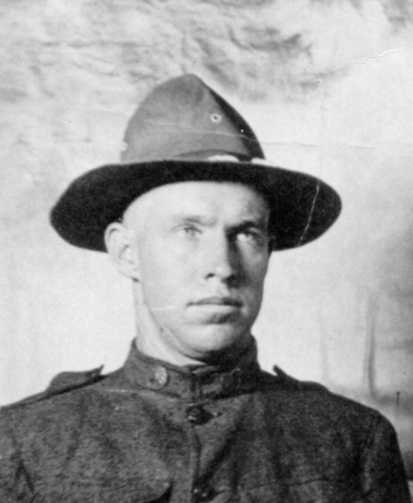

(I) went in the service 6 April 1918. Went to Camp Lewis, Washington, was in 29 Co., 166 Depot Brigade, was in Co. L364 Inf. until I got measles. My company went overseas leaving me in the hospital. I was put in Casual Co. and sent to Camp Merritt, New York where I was a replacement to Co. B56 Inf. (7 Div.) and was sent to France. We went on the U.S. Ship Leviathan, which was the largest ship afloat at the time.
We landed at Brest, France. The ship was too big to get into the dock. SO it was unloaded on lighters and barges and taken ashore. My Battalion was kept on board to unload the cargo after other troops were put ashore.
We were marched up the hill and out to some small farms surrounded by hedge fences, to what they call a rest area, but there was no rest, we were loaded in little French box cars and transported across France to a small town in what they called the Dijon Area where part of our men were taken for replacement to other outfits, and the rest of us were trained for action until in October when we went to the front lines relieving the 90th Div. I went into action October 10, 1918 on my birthday. It was supposed to be a quiet sector but it soon developed into a very active one.
When the German's found there was a new Division in front of them, they sent over an artillery borage with gas and high explosives. I was burned with mustard gas and was in a hospital about five months. When I got out of the hospital, I transferred to 7th Division Train Head Quarters where I served until I was discharged 8 July 1919, at Ft. D.A. Russell at Cheyenne, Wyoming, [Francis E. Warren Air Force Base.] Private Karl A. McMullin

When he passed away on December 28, 1976 at the age of 83 after a humble life of farming he did not leave a vast inheritance of wealth. What he did leave was a bright legacy of honor and service.
When he would go hunting, he took a small wooden box he fastened with scraps of wood. The hinges are made of strips of leather. It doubled as my mother’s dresser, but when grandpa went hunting, it was the camp grub box. It has been passed down to me and is now full of my Dutch oven cooking tools including gloves, lid lifters and a small folding shovel.
I use it when I go camping with the Scouts and it is a part of my grandfather that is still with me. Not everything we inherit from our ancestors has great value, but that does not mean they do not have great worth. With the tools in my grandfather’s grub box, I am able to feed the bodies of boys as I feed their minds and souls.

Quotations
When our forefathers put down roots in desolate places, the thing that allowed them to survive was that they had a faith to see them through the tough times. Lee Greenwood

Quotations contain the wisdom of the ages, and are a great source of inspiration for Cubmaster’s minutes, material for an advancement ceremony or an insightful addition to a Pack Meeting program cover

In all of us there is a hunger, marrow deep, to know our heritage - to know who we are and where we came from. Without this enriching knowledge, there is a hollow yearning. No matter what our attainments in life, there is still a vacuum, an emptiness, and the most disquieting loneliness. Alex Haley, Roots
If you would not be forgotten, as soon as you are dead and rotten; Either write things worthy of reading, or do things worthy of writing. Benjamin Franklin, May 1738
There are only two lasting bequests we can give our children - one is roots, and the other, wings. Hodding S. Carter
When a society or a civilization perishes, one condition can always be found. They forgot where they came from. Carle Sandburg
I don't know who my grandfather was, I am much more concerned to know what his grandson will be. Abraham Lincoln
You live as long as you are remembered. Russian proverb
We are the children of many sires, and every drop of blood in us in its turn ... betrays its ancestor. Ralph Waldo Emerson
People will not look forward to posterity who never look backward to their ancestors. Edmund Burke
Everyone has ancestors and it is only a question of going back far enough to find a good one. Howard Kenneth Nixon
He who has no fools, knaves, or beggars in his family was begot by a flash of lightning. Old English proverb
There is no king who has not had a slave among his ancestors, and no slave who has not had a king among his. Helen Keller
Family faces are magic mirrors. Looking at people who belong to us, we see the past, present and future. Gail Lumet Buckley
Genealogy: “Tracing yourself back to people better than you are.” John Garland Pollard
I don't have to look up my family tree because I know that I'm the sap. Fred Allen
We've uncovered some embarrassing ancestors in the not-too-distant past. Some horse thieves, and some people killed on Saturday nights. One of my relatives, unfortunately, was even in the newspaper business. President Jimmy Carter
When an elder dies, it is as if an entire library has burned to the ground. African saying
There's a world of wisdom in our personal stories. Your life is a legacy, a gift that only you can give. Why waste something so precious? Dolly Berthelot
Keep some souvenirs of your past, or how will you ever prove it wasn't all a dream? Ashleigh Brilliant
Family faces are magic mirrors. Looking at people who belong to us, we see the past, present and future. We make discoveries about ourselves. Gail Lumet Buckley
You are our living link to the past. Tell your grandchildren the story of the struggles waged, at home and abroad. Of sacrifices made for freedom's sake. And tell them your own story as well — because [everybody] has a story to tell.
George H. W. Bush, State of the Union Address, 1990
Remember me in the family tree
My name, my days, my strife;
Then I'll ride upon the wings of time
And live an endless life
Linda Goetsch
I promise that if you will keep your journals and records, they will indeed be a source of great inspiration to your families, to your children, your grandchildren, and others, on through the generations. Each of us is important to those who are near and dear to us and as our posterity reads of our life's experiences, they, too, will come to know and love us. And in that glorious day when our families are together in the eternities, we will already be acquainted. President Spencer W. Kimball
If you don't recount your family history, it will be lost. Honor your own stories and tell them too. The tales may not seem very important, but they are what binds families and makes each of us who we are. Madeleine L'Engle
Remember‍the days of old, consider the years of many generations: bask‍thy father, and he will shew thee; thy elders, and they will tell thee. Deuteronomy 32:
Be faithful in small things because it is in theme that your strength lies. Mother Teresa
Faith is taking the first step even when you don’t see the whole staircase. Martin Luther King Jr.
All who call on God in true faith, earnestly from the heart, will certainly be heard, and will receive what they have asked and desired. Martin Luther
When you focus on being a blessing, God makes sure you are always blessed in abundance. Joel Osteen
God always take the simplest way. Albert Einstein
If patience is worth anything, it must endure to the end of time. And a living faith will last in the midst of the blackest storm. Mahatma Gandhi
That deep emotional conviction of the presence of a superior reasoning power, which is revealed in the incomprehensible universe, forms my idea of God. Albert Einstein
Faith is knowledge within the heart beyond the reach of proof. Khalil Gibran
God didn’t make a mistake when He made you. You need to see yourself as God sees you. Joel Osteen
Faith is to believe what you do not see; the reward of this faith is to see what you believe. Saint Augustine
We are never defeated unless we give up on God. Ronald Reagan
Faith consists in believing when it is beyond the power of reason to believe. Voltaire
I gave in, and admitted that God was God. C. S. Lewis
As your faith is strengthened you will find that there is no longer the need to have a sense of control, that things will flow as they will, and that you will flow with them, to your great delight and benefit. Emmanuel Teney
God, our Creator, has stored within our minds and personalities, great potential strength and ability. Prayer helps us tap and develop these powers. Abdul Kalam
A man of courage is also full of faith. Marcus Tullius Cicero
All I have seen teaches me to trust the Creator for all I have not seen. Ralph Waldo Emerson

Reverend John Lathrop
John Lathrop was born in Etton, East Riding, Yorkshire, England and baptized on 20 December 1584, the son of Rev. Thomas Lathrop and Mary Salte. His father was an Anglican Minister and son, John made the choice to follow his father’s profession. He first entered Christ Church College, Oxford at the age of 17 and was admitted as a plebe for Christ Church on 15 October 1602. He received his Bachelor of Arts degree in 1606 and Master of Arts in 1609.
He was ordained in the Church of England and appointed curate of a local parish in Egerton, Kent, England, 48 miles southeast of London. Church records place him there from 1614 to 1619. He broke with the Church of England and joined himself with others including Puritans of the time separating themselves from the Church of England, a brave and dangerous decision. In 1623, John Lathrop became pastor for the First Independent Church in London. From a lecture by Dan Mcconnell, stored in the Sturgis Library in Barnstable, Massachusetts:
The Reverend John Lothrop was the spiritual leader of one of the first Congregational Churches in England. Since the only lawful church in England in that time was the Church of England, of which the King was the head, all other forms of worship were outlawed, and forced to meet in secret. In May 1632, Reverend Lothrop and 42 of his congregants were arrested and thrown into prison for meeting in a private home to hear him preach. As head of the Church of England, the King ordered such cases to be tried by the Royal Court of High Commission, which brutally suppressed such churches, and tried both ministers and followers in this inquisitional court. Defendants were denied the ordinary rights of English citizens, held without charges for long periods, were denied counsel, were required to sign an oath to incriminate themselves, and were subjected to cruel and unusual punishments. Ministers had to recant, leave the Realm or be executed. Many were tortured, and disfigured or died in prison.
On May 5, 1632 the prisoners were brought before the judges of the Court of High Commission, bishops all. As the court record reads, “This day were brought to the court out of prison diverse persons which were taken on Sunday last at a conventicle, met at the house of Barnet, a brewers clerk, dwelling in the precinct of Black Friars: By name, John Lothrop, their minister, Humphrey Barnard, Henry Dod, Samuel Eaton, William Granger, Sara Jones, Sara Jacob, Peninah Howes, Sara Barbon, Susan Wilson and diverse others.”
Note: Under the Royal Law, a conventicle was defined as a “meeting to hear unlicensed preaching” and was therefore illegal.
The court record goes on with an opening address by The Archbishop of Canterbury, “You show yourselves to be unthankful to God, to the King and to the Church of England, that when, God be praised, through his Majesties care and ours that you have preaching in every church, and men have liberty to join in prayer and participation in the sacraments and have catechizing to enlighten you, you in an unthankful manner cast off all this yoke, and in private unlawfully assemble yourselves together making rents and divisions in the church‐‐‐.You are desperately heretical.”
The entire congregation refused to sign the oath and refused to testify against themselves. They were returned to prison where some died. Eventually, many were released, but Reverend Lothrop languished for two more years until he was released to care for his dying wife and his children. In June 1634 he and some 30 of his congregation left England formerica, first settling in Scituate, then, in 1639, gaining a grant to settle at Barnstable. . . .
While in prison, Rev. Lathrop’s wife Hannah became ill and died. His six surviving children were left orphans to fend for themselves, begging in the streets of London. The children were brought by family friends to the Bishop who had chard for Rev. Lathrop. The Bishop finally released him on bond in May 1634 with the agreement that he would remove himself from England to the New World.
Among the vast number of descendent of the Rev. John Lathrop include:
President George H. W. Bush
President George W. Bush
President Millard Fillmore
President James A. Garfield
President Ulysses S. Grant
President Franklin D. Roosevelt
Benedict Arnold
Joseph Smith Jr., Mormon Leader
Wilford Woodruff, Mormon Leader
Oliver Cowdery, Mormon Leader
Parley P. Pratt, Mormon Leader
Orson Pratt, Mormon Leader
Governor Jeb Bush
Governor Thomas E. Dewey
Governor Jon Huntsman Jr.
Governor William W. Kitchin
Governor Sarah Palin
Governor George W. Romney
Governor Mitt Romney
Senator Adlia Stevenson III
Secretary of State John Foster Dulles
CIA Director Allen Welsh Dulles
Cardinal Avery Dulles
Wild Bill Hickcok
Henry Wadsworth Longfellow, Writer
Kingman Brewster
Harvard University President Catherine Drew Gilpin Faust
Artist Lewis Comfort Tiffany
Artist Georgia O’Keeffe
Dr. Benjamin Spock
Dr. Oliver Wendell Holmes Sr.
US Supreme Court Justice, Oliver Wendell Homes Jr.
Novelist Michael McConnell
C. W. Post, founder of Post Cereal Company
Marjorie Merriweather Post, founder of General Foods
Alfred Carl Fuller, founder of Fuller Brush Company
Financier John Pierpont Morgan
Actress Dina Merrill
Actress and Ambassador Shirley Temple Black
Actress Broke Shields
Actress Maggie Gyllenhaal
Actor Jake Gyllenhaal
Actor Clint Eastwood
Actor Kevin Bacon
Scouter Jim, Bountiful, Utah

Quoting Baden-Powell on Faith
Alice, Golden Empire Council
"No man can be really good, if he doesn't believe in God and he doesn't follow His laws. This is why all Scouts must have a religion". (Scouting for Boys, 1908)
"Scouting has been described as "a new religion". It's not, of course, a new religion: it's just the application to religious formation of the principle now accepted in non-religious formation, i.e. to point out a precise aim to the boy and give him the way to learn and practice by himself" [Quoted in Taccuino, a collection of B-P's writings and essays published in Italy. Dated January 1912]

From Aids to Scoutmastership, 1919:
"Love of God, love of your neighbour and respect of oneself as God's servant are the basis for any form of religion"
"Many difficulties may arise while defining religious formation in a Movement such as ours, where many religions coexist; so, the details of the various forms of expressing the duty to God must be left to those responsible of each single association. We insist however on observance and practice of that form of religion the boys profess"
"Nowadays the actions of a large part of youths are guided just in a small part by religious convictions. That can be attributed for the most to the fact that in the boy's religious formation the worry was on teaching instead of educating".
"If you really wish to find the way towards success, i.e. your happiness, you must give a religious base to your life. It's not simply attending church or knowing history or comprehend theology. Many men are sincerely religious almost without knowing it or having studied these things. Religion, briefly explained, means: First: know who God is; Second: use to the best the life He gave us, and do what He expects from us. This means mostly doing something for the others."

From Rovering to Success, 1922
The method of expression of reverence to God varies with every sect and denomination. What sect or denomination a boy belongs to depends, as a rule, on his parents' wishes. It is they who decide. It is our business to respect their wishes and to second their efforts to inculcate reverence, whatever form of religion the boy professes.

DEN MEETING TOPICS
When a Den Meeting occurs depends on when you start your year and how often you meet. A Den that starts in August will be doing meetings 1 & 2 then, and 3& 4 in September. A den that meets three times a month will do 1, 2, and 3 in September. The pace is up to you!!

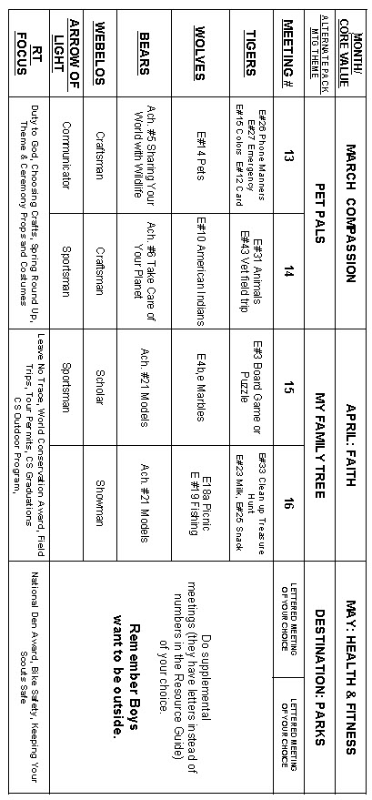

PACK MEETING THEMES
Commissioner Dave (with help from Kim)

See Item, "A Word on Monthly Themes"
at the front of Baloo's Bugle.
All 36 Supplemental Pack Meeting plans are posted at: http://www.scouting.org/scoutsource/CubScouts/Leaders/DenLeaderResources/DenandPackMeetingResourceGuide/PackMeetingPlans.aspx
Here are the remaining themes presented in the current Cub Scout Roundtable Planning Guide to be featured during 2013-2014 Roundtables -
Month Core Value Supplemental Theme
- April Faith My Family Tree
- May Health and Fitness Destination Parks
- June Perseverance Over the Horizon
- July Courage Space - the New Frontier
- August Honesty Heroes in History
Kim, the chair of the task force, says "I do want to stress that the focus is still the Core Value and the theme is just there as an enhancement. The theme pack meeting plans are specifically crafted to bring out the important points of the Core Value in a fun way."
Here is the complete list of all 36 Supplemental Themes. Any Pack/Cubmaster can use any theme any month. The year designation is to show you which themes will be featured at Roundtables each year. So, the 2012 - 2013 RT year kicked off in August with Cooperation and Hometown Heroes. Then Responsibility and Jungle of Fun.

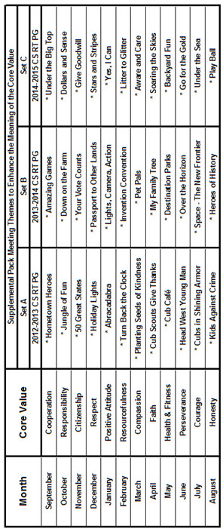

UPCOMING MONTHS
2013
-
2014
- April's Core Value, Faith, will use "My Family Tree."
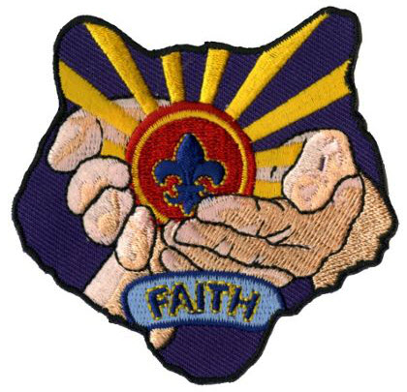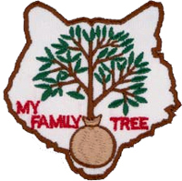
Month's that have themes that might help you with , Faith and "My Family Tree " are:
Month | Year | Theme
My Family Tree
Month | Year | Theme
November | 1997 | Family Circle
November | 1999 | Discover Our Family Heritage
November | 2005 | My Family Tree
Other Faith Ideas
November | 1952 | Faith of his Fathers
December | 1960 | Guiding Stars
December | 1997 | The Golden Rule
November | 2003 | Pilgrims of Plymouth Rock
December | 2005 | Faith, Hope & Charity
December | 2007 | Celebrations Around the World
Faith
April | 2011 | Faith
April | 2012 | Faith
April | 2013 | Faith (Cub Scouts Give Thanks)

- Core Value Patches are available at www.scoutstuff.org
- For Theme patches go to http://www.cubmasterbobkatt.com/Cubmaster-Bob-Katt-Cub-Scout-Monthly-Themes.htm
- May's Core Value, Health and Fitness, will use "Destination: Parks."
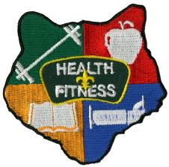
Month's that have themes that might help you with , Health & Fitness and "Destination: Parks " are:
Month | Year | Theme
Health & Fitness
Month | Year | Theme
October | 1939 | Health and Safety
August | 1944 | Strength
May | 1946 | Keeping Fit
November | 1949 | Keeping Strong
May | 1952 | Strength and Skills
July | 1962 | Strength and Skill
June | 1967 | Feats of Skill
January | 1969 | Fit For America
September | 1974 | Muscle Builders
January | 1976 | Tournament
June | 1977 | Muscle Builders
June | 1978 | Physical Fitness
August | 1981 | Physical Fitness
January | 1982 | Adventure in Good Health
March | 1985 | Step into Shape
July | 1986 | Strength and Skill
August | 1988 | Physical Fitness
April | 1994 | Shape Up
August | 2000 | Toughen Up
November | 2000 | Turn On the Power
Destination: Parks
July | 1977 | Trails, Treks, Trips
May | 1986 | Cub Scout Bird Watchers
August | 1987 | Back to Nature
April | 1988 | Cub Scout Bird Watchers
July | 1989 | Trails, Treks, Trips
April | 1990 | Mountain Trails of America
June | 1993 | Cub Scout Bird Watchers
June | 1999 | Trails, Treks and Tracks
May | 2001 | Happy Trails
June | 2005 | Destination Parks
May | 2007 | Cubs and Bugs Galore

Faith-Based Groups with
Boy Scout Web links:
http://www.ldsbsa.org/
Church of Jesus Christ of Latter-day Saints BSA Relations Office
http://www.presbyterianscouters.org/
Presbyterian Church
http://www.nlas.org/
National Lutheran Association on Scouting
http://www.jewishboyscouts.com/
Jewish Boy Scouts
http://nycatholicscouts.com/
New York Catholic Scouts
http://www.naums.org/
National Association of United Methodist Scouters

Connecting FAITH
with Outdoor Activities
Adapted from B.A.L.O.O. Appendix E
- Hikes - Conduct an Interfaith hike. Hike to a place of worship. Participate in a "Ten Commandments Hike" (Google "Ten Commandments Hike" to get ideas for this.
- Nature Activities - Identify divinity in the big (mountains, rivers, horses) and small things (insects, birds, tree leaves, snowflakes) in nature
- Service Projects - Help clean up a local place of worship or help with one of their activities (e.g. feeding the homeless or conducting a blanket drive).
- Games & Sports - Remind boys that their physical abilities are a gift from God and reinforce that they should be thankful that they are so wondrously created.
- Ceremonies - Hold a trail devotion. Hold recognition ceremonies and pack celebrations outdoors in the beauty of nature.
- Campfires - Include an item related to Duty to God. Sing a song for the closing ceremony that incorporates faith, applicable to all members' faiths. Tell a story that incorporates the concept of faith.
- Den Trips - Take a field trip to a place of worship. Visit a nearby church or mission and learn about the history and faith of people who lived in your area earlier in history.
- Pack Overnighter - Conduct an interfaith service (even if the overnighter does not take place on a traditional day of worship) An after dark or sunrise service could also be planned.
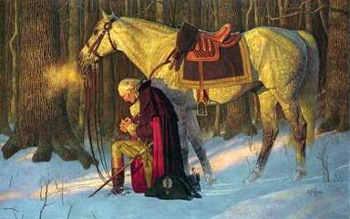

FAITH Character Connection
Carol at www.cubroundtable.com
Tiger Book
Character Connection - Faith
Achievement 5, “Let’s Go Outdoors” (Page 65)
- Practice - Do requirement 5F
- Know - Discuss things about the weather that you know to be true, but you cannot see at the moment, such as it's the sun still there although you only see clouds? Is the moon there, even though it is day? Can you see wind? Do you know that the rain will eventually stop? Do you have faith in other things you can't see?
- Commit - What makes it difficult to believe in things that you cannot see? What helps you to develop faith?
Wolf Book
Character Connection - Faith
Achievement 11, “Duty to God” (Page 94)
- Know- What is “Faith”? With your family, discuss some people who have shown their faith who have shown an inner strength based on their thrust in a higher power of cause. Discuss the good qualities of these people.
- Commit- What is “Faith”? With your family, discuss some people who have shown their faith who have shown an inner strength based on their thrust in a higher power of cause. Discuss the good qualities of these people.
- Practice - Practice your faith while doing the requirements for “Duty to God.”
Bear Book
Character Connection - Faith
Achievement 1, “Ways we Worship” (Page 26)
- Know- Name some people in history who have shown great faith. Discuss with an adult how faith has been important at a particular point in his or her life.
- Commit - Discuss with an adult how having faith and hope will help you in your life, and also discuss some ways that you can strengthen your faith.
- Practice - Practice your faith as you are taught in your home, church, synagogue, mosque, or religious fellowship.
Webelos Book
Character Connection - Faith
Requirement 8, “Faith” (Page 50-51)
After completing the rest of requirement 8,
do these (a, b, and c):
- Know. - Tell what you have learned about faith.
- Commit - Tell how these faith experiences help you live you duty to God. Name one faith practice that you will continue to do in the future.
- Practice After doing these requirements, tell what you have learned about your beliefs.
Cub Scout Roundtable Helps
- Do you think there are ways you can help during your church service? List the ideas and talk to your parents about what you would like to do. If you haven’t started the God and Me, God and Family, God and Country, God and Life series you might want to check on these to learn more about your faith.
- Many who have been in danger or lost rely on their Faith to keep the strong and overcome the hardships. Talk to your parents to learn how you can prepare yourself for an emergency. Memorizing Bible verses and songs can strengthen you even when you are sad or lonely.
- You learn that a neighbor is very sick and goes to a different church. Can you still care about them or help them? What would you learn from serving their needs? We are told to be servants, do you think you could be a servant to your family, friends, teachers, and others in your community?
Cub Scout Program Helps 2005-2006, page 6 Dec
Holidays provide an opportunity to explore our faith. What does faith mean? How does a person’s religion help him or her? How does your faith make you feel comfortable? What things will you do this month to support your religious beliefs?
2004 Pow Wow Book Cub Scouting Forever
by Great Salt Lake Council
- Faith - Having inner strength or confidence based on our trust in a higher power.
- Activity- A Blindfold Meal. At a planned outing, such as a den picnic, get everyone to eat a simple meal or undertake a simple activity blindfolded. Care needs to be taken that no one gets burnt or hurts him or herself. Afterwards encourage the Cubs to consider how wonderful their gift of sight is. This could develop into a discussion on the idea that there are different types of blindness. Blindness to the needs of others, blindness to the world that we live in, blindness to the obvious existence of God.
- Project- Keep a diary for a week. Make an eight-page diary covering one week for each Cub. (Two sheets of paper folded with the days and perhaps the dates). Get them to keep as accurately as they can an hour by hour time table of what they have done for the week: time they went to bed, got up, started breakfast, finished breakfast, left for school, got to school, etc.. Then at your next meeting (it might be helpful to have calculators) analyze how much time has been spent on each of a number of activities during the week. You might make a list like sleeping, eating, at school, doing homework, watching TV, Cub Scout activities, etc.. Produce a chart. Finally consider what this shows about priorities, inner discipline, etc…
2005 Pow Wow Book Cub Scouting Forever
by Great Salt Lake Council
Faith, Hope, & Charity
What Would Webster Say?
- Have each boy write down definitions of what they think Faith, Hope, and Charity mean. Compare boys' definitions with the definitions in the dictionary.
- Name a person or persons who demonstrates each of these qualities.
- Why should we want to develop these traits? What are some steps you can take to develop these qualities?
- What can you do each day to practice faith, hope, and charity?
Cub Scout Program Helps 2006-2007, page 8 July
Wolf Achievement 11A, “Duty to God”: Inspired by the beauty of the summer (Spring) months, Cub Scouts can complete the Character Connection for Faith.
Cub Scout Program Helps 2007-2008, page 10 Dec
Celebrations around the work involve many different faiths, as well as different versions of them. (Think Easter, Passover, and other Spring Festivals of the various Faith Traditions versus our traditional use of Christmas and Hanukkah for this activity.)
- What do you think faith is? (Not the denomination (e.g. Lutheran) but for what it stands and what your denomination believes.)
- How do you show your beliefs?
- Is one faith or belief better than another?
For the year ahead, many people rededicate themselves to their faith. This might be a good time to do Bear Achievement 2 and earn the religious emblem of your faith.
For other FAITH
Character Connection Activities go to ·
http://www.cubroundtable.com/assets/pdf-documents/2002-2010%20Character-Connections-Packet.pdf

March Crazy Holidays
Jodi, SNJC Webelos Resident Camp Director Emeritus,
2006-2011. Adapted from http://holidayinsights.com/moreholidays/index.htm
http://www.brownielocks.com/april.html
April 2014 is:
- Amateur Radio Month
- Arab American Heritage Month
- ASPCA Month
- Celebrate Diversity Month
- Child Abuse Prevention Month
- Confederate History Month
- Couple Appreciation Month
- Global Child Nutrition Month
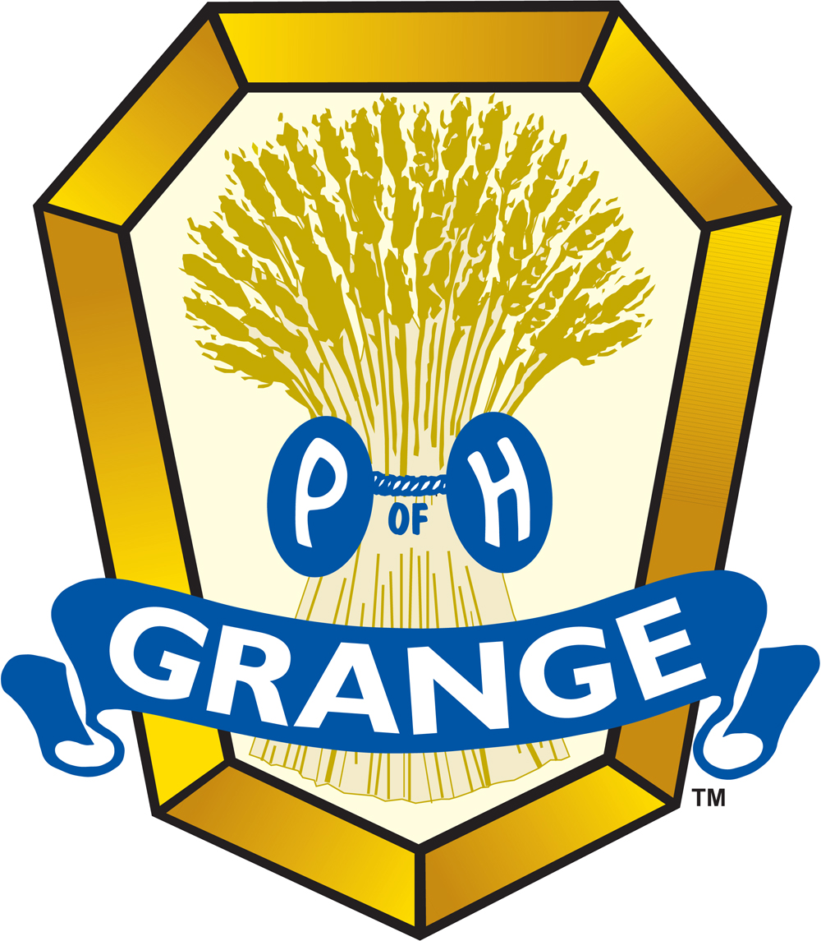
- Grange Month
- Home Improvement Time
- International Guitar Month
- Jazz Appreciation Month
- Keep America Beautiful Month
- Lawn and Garden Month
- Math Awareness Month
- National Card and Letter Writing Month
- National Decorating Month
- National Garden Month
- National Humor Month

- National Kite Month
- National Knuckles Down Month
- National Landscape Architecture Month
- National Poetry Month
- National Safe Digging Month
- National Welding Month
- School Library Media Month
- Straw Hat Month
- World Habitat Awareness Month
Food in April
- Tomatillo and Asian Pear Month
- Soy Foods Month
- National Pecan Month
- National Grilled Cheese Sandwich Month
- Cranberries and Gooseberries Month
- Brussels Sprouts and Cabbage Month
Pets in April
- ASPCA Month
- Frog Month
- National Pet Month
- Pet First Aid Awareness Month
- Adopt A Greyhound Month
Health & Fitness in April
- Autism Awareness Month
- Defeat Diabetes Month
- African American Women's Fitness Month
- National Donate Life Month
- National Occupational Therapy Month
- National Parkinson's Awareness Month
- National Youth Sports Safety Month
- Physical Wellness Month
- Women's Eye Health & Safety Month
Weekly Celebrations:

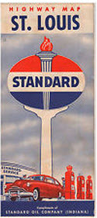
- Read a Road Map Week: 1-7
- The APAWS Pooper Scooper Week: 1-7
- Explore Your Career Options: 1-7
- Golden Rule Week: 1-7
- Laugh at Work Week: 1-7
- Medication Safety Week: 1-7
- Bat Appreciation Week: 6-12
- National Animal Control Appreciation Week: 6-12
- National Volunteer Week: 6-13
- Week of The Young Child: 6-12
- Explore Your Career Options Week: 7-11
- American Indian Awareness Week: 8-12
- The Masters Tournament: 10-13
- Global Youth Service Days: 11-13
- International Wildlife Film Week: 12-19
- Animal Control Officer Appreciation Week: 13-19
- National Environmental Education Week: 13-19
- National Robotics Week: 13-19
- National Library Week: 13-19
- National Public Safety Telecommunicators
(911 Operators) Week: 13-19
- Pan American Week: 13-19
- Cleaning For A Reason Week: 18-24
- Consumer Awareness Week: 18-23
- National Occupational Health Nursing Week: 18-25
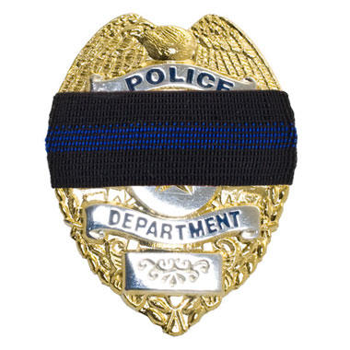
- Police Officers Who Gave Their Lives In The Line of Duty Week: 18-23
- National Park Week: 19-27
- Administrative Professionals Week: 20-26 (Last Full Week)
- International Whistlers Week: 20-26 (3rd full week)
- National Karaoke Week: 20-26
- National Princess Week:20-26 (Always Last Full Week)
- National Pet ID Week: 20-26 (Always 3rd Week)
- National Toddler Immunization Week: 20-26
- Sky Awareness Week: 20-26 (Last Full Week)
- National Playground Safety Week: 21-25
- National Work Zone Safety Awareness Week: 21-27
- Safe Kids Week: 21-26
- Gathering of the Nations Powwow: 24-26
- National Dream Hotline: 25-27 (Last Weekend)
- National Pie Championships: 26-28
- Air Quality Awareness Week: 28-5/2 (Last Week)
- National Tattoo Week: 29-5/3
April, 2014 Daily Holidays, Special and Wacky Days:
1 April Fool's Day
1 International Fun at Work Day
1 International Tatting Day
2 Children's Book Day

2 National Peanut Butter and Jelly Day
2 Reconciliation Day
3 Don't Go to Work Unless it's Fun Day - we know your decision
3 Tweed Day
4 Hug a Newsman Day
4 Walk Around Things Day
4 School Librarian Day
4 Tell a Lie Day
5 Go for Broke Day
6 Sorry Charlie Day
7 No Housework Day
7 World Health Day
8 All is Ours Day
8 Draw a Picture of a Bird Day
9 Name Yourself Day
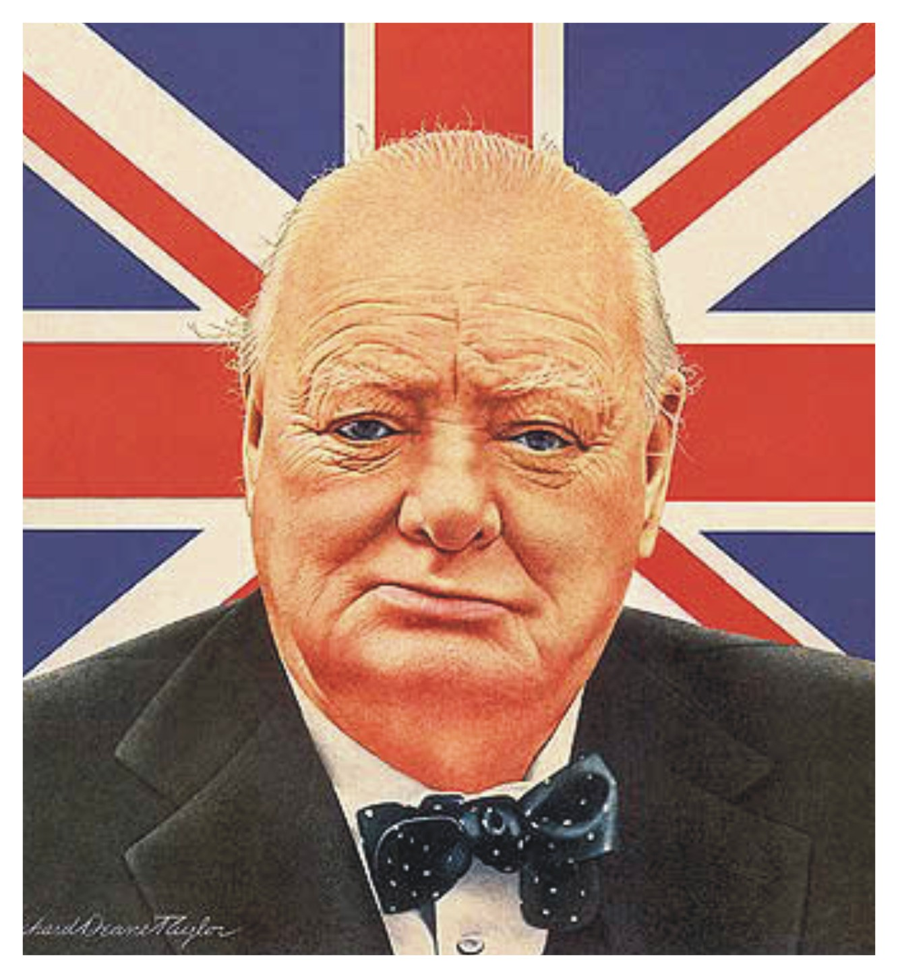
9 Winston Churchill Day
10 Golfer's Day
10 National Siblings Day
11 Eight Track Tape Day - do you remember those?
11 Barbershop Quartet Day
11 National Submarine Day
12 Big Wind Day - this day blows me away!
12 Russian Cosmonaut Day
13 Scrabble Day
14 International Moment of Laughter Day
14 Look up at the Sky Day - don't you have anything better to do?
14 National Pecan Day
14 Reach as High as You Can Day
15 Patriot's Day - third Monday of the month
15 Rubber Eraser Day
15 Titanic Remembrance Day
16 National Eggs Benedict Day
16 National Librarian Day
16 National Stress Awareness Day
17 Blah, Blah, Blah Day
17 National Cheeseball Day
17 National High Five Day third Thursday
18 International Juggler's Day - also applies to multi tasking office workers
18 Newspaper Columnists Day
19 National Garlic Day

20 EASTER
20 Look Alike Day
20 Volunteer Recognition Day
21 Kindergarten Day
21 Patriot's Day
22 National Jelly Bean Day
23 Lover's Day
23 National Zucchini Bread Day - they hold this at a time when you are not sick of all that zucchini.
23 Take a Chance Day
23 World Laboratory Day
24 Executive Admin's Day (Secretary's Day) - date varies, Also called Administrative Professional's Day
24 Pig in a Blanket Day
25 East meets West Day
25 World Penguin Day
26 Hug an Australian Day
26 National Pretzel Day
26 Richter Scale Day
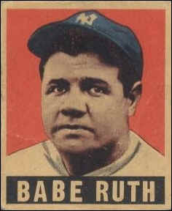
27 Babe Ruth Day
27 National Prime Rib Day
27 Tell a Story Day
28 International Astronomy Day
28 Great Poetry Reading Day
28 Kiss Your Mate Day - guys, do not forget this one. Kiss her, then read her some poetry.
29 Greenery Day
29 National Shrimp Scampi Day
30 Hairstyle Appreciation Day
30 National Honesty Day

THE BUZZ

Note - The Buzz is a biweekly video detailing recent changes and such in Boy Scouting.

OnBoarding and
E-Learning Curiculum
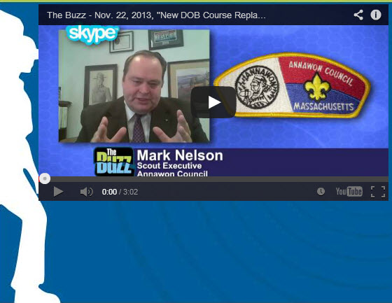
In this episode of The Buzz, learn more about the BSA's new OnBoarding and E-Learning Curriculum, which became available December 1. As part of this new curriculum, BSA has replaced the old PDL-1 course for pre-professional employees with this program, District Operations Basic.

Resources
For more information on District Operations Basic, log on to MyBSA: Resources > Center for Professional Development (Links to BSA Info box) > Training Courses.
View more episodes of The Buzz on BSA's
YouTube channel.
Click on the picture above or go to:
http://www.scouting.org/sitecore/content/InternalCommunications/The%20Buzz.aspx
View the production schedule for The Buzz.

BSA SOCIAL NETWORKS
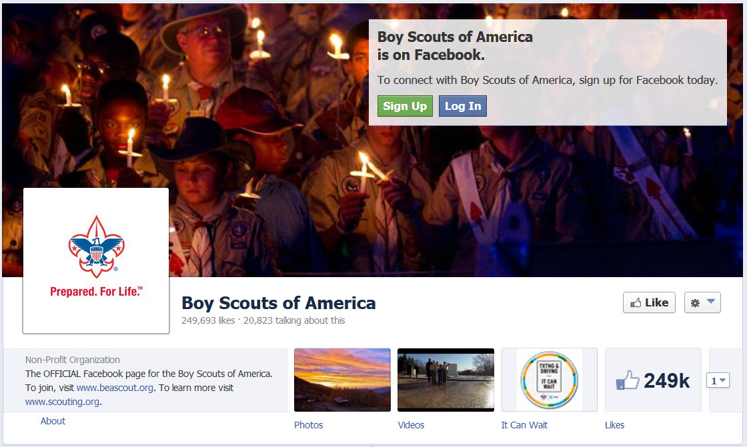
BSA Facebook page
https://www.facebook.com/pages/Boy-Scouts-of-America/113441755297


Scouting magazine You Tube Channel
http://www.youtube.com/user/scoutingmag

CUBCAST
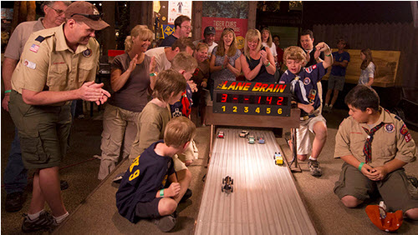
February 2014 -
Pinewood Derbies and
Other Big Events
February 8th is the BSA's birthday and there are usually lots of ways to celebrate: pinewood derbies, rain gutter regattas and other events that, well, let's be honest, take a whole lot of time and energy to make happen. Joining us this month to share his secrets on how to make it a whole lot easier to plan a big event is Rodney Beckwith, Cubmaster for Pack 315 in Pinckney, Michigan. How does he do it? Click any of the buttons below to learn more.

Listen Hear
http://www.scouting.org/filestore/scoutcast/cubcast/201402_1/Feb_CC_Big_Events.mp3

It is possible that by the time you get Baloo's Bugle and click the link, there may be a new Cubcast posted. Do not worry, all previous Cubcasts are available from the home page.

Training Topics

Self Esteem
Bill Smith, the Roundtable Guy
"The greatest gift you can give your child is
good self esteem!"
This theme comes up again and again in books about raising children. It caught my eye in the opening chapter of the Cub Scout Leader Book some years ago and has been an important part of my Scouting life ever since.
Just how do we give this gift? How do we make it or get it? How do we gift-wrap it?
Self esteem is a boy’s attitude or belief about himself. If he has good self esteem, he respects himself. He has confidence and expects success from life. He is less likely to misbehave or – as he matures – less likely to rely on alcohol or drugs. It starts with being accepted, feeling welcome and becoming part of a group. Cub Scouting should do this, not only with ritual and ceremony, but also with our genuine and heartfelt love and respect.
It grows with wearing the uniform, the wearing the badges of rank and achievement. We affect a boy’s image about himself at every stage in our advancement process. When a parent takes the time to work with him on a requirement or elective, when it is signed off in his book, when the book is checked off at the den meeting and another icon is filled in on the advancement chart or another bauble strung on the den doodle. In each of these acts, we are telling him that he is a super neat person and we are all glad that he is here with us.
The biggest boost however, is when he and his personal Akela are called up at the pack extravaganza and are presented the badge in a typical Sean Scott ceremony replete with all the flashing lights, explosions, cheers, pomp and panoply that such an event deserves.
What? You aren’t familiar with a Sean Scott Ceremony? You must go to: http://scouting.argentive.com/index.shtml
And check out his presentations and handouts.
Scouting, at every level, works strictly on positive feedback. Positive feedback builds self esteem. Be generous with recognition and praise for any accomplishment. In his book How To Behave So Your Children Will, Too, psychologist Sal Severe makes the point that children believe what adults tell them about themselves. If you tell them they are competent, that they can do things and are helpful, then they become motivated to live up to your expectations. If you continually criticize and berate a child, you give him the excuse to fail and misbehave.
Involving the parents is essential for Cub Scouting to work. As a Cubmaster, my contact with each Cub Scout lasted only seconds each month. A den leader or den chief can devote more time to each boy but it still is measures only a few minutes a week. Parents, on the other hand, spend a lot of time with him and have the opportunity to either build a boy’s self confidence or to totally undermine everything we are trying to do with continual criticism, put downs and faultfinding. Unless the parents are on your side, it will be up hill all the way for you and your fellow leaders. And that’s a drag.
The Cub Scout Advancement program follows the school grade levels ….. to build self-esteem, self-awareness and a sense of citizenship and good sportsmanship. Parental involvement is crucial to achieve the advancement of the Scouts and responsibility for advancement in rank rests with the parents; verification and assistance of the Den Leader is secondary.
Atlanta Area Council website
There is a wonderful little reminder about that in Parent's Little Book of Wisdom by Buck Tilton and Melissa Gray:
There are lots of other ways we can build a boy’s sense of how competent and valuable he his. Just recognizing him and greeting him by name helps. His name on the den chart, den doodle and the pack advancement ladder shows that we love him and respect him. Participating in pack meeting presentations, skits and ceremonies all help build confidence and self worth. Getting Boy’s Life mailed to him is a big deal.
Nothing tells your child you care more than choosing to be with him.
It takes a bit of concentration and discipline on our part to remember this in the midst of putting on good pack and den meetings. I know that most of you are much better leaders than I was, but I would guess that even the best Cubmaster or den leader will sometimes be distracted in heat of battle. I particularly like the rule of balancing each negative remark like: DON’T; THAT’S WRONG; NOW-WHAT DID YOU DO? with at least four positive statements like: I KNEW YOU COULD DO IT; THAT’S REALLY GOOD; YOU ARE THE BEST!
Competition
Boys seem to be naturally competitive. They like to test themselves and others in a variety of ways. Whether it’s a game of tag, a race like last-one-in-the-pool , a game of chess or the latest Nintendo, boys I have observed enjoy the challenge of a good contest. Letting boys compete is a natural way for them to try to do their best. When left to their own devices, a group of boys will spontaneously start into some game that often tests some physical or mental ability. Their rules are often ritualized and are applied surprisingly fairly.
We adults often mess things up by making a big fuss about who wins. Generally the boys don’t make a big thing about who wins or who loses. Once the contest is over, it’s over. A new game is started, a different skill or knowledge tested, a new chance to do his best. On the other hand, we adults like to recognize the winners with some prize or hullabaloo. Each time we exalt a winner, we also stigmatize the losers. This does nothing to raise the self esteem of those boys. The only thing worse than losing is having your nose rubbed in it.
It is best we Cub Scout leaders remember that in our games, contests and especially our derbies that we build self esteem by recognizing individual achievement and not who did it better than someone else. Probably the best reference on how to handle such activities is in Bernie DeKoven’s book The Well-Played Game, or on his website: http://deepfun.com/

An Introduction to the Scouts Own
With Pack Family Camping strongly encouraged and promoted, Packs should be holding a Scout’s Own Service every camping trip, whether it on a traditional day of worship or not. I am sure some are doing very well, some are not, and some are simply ignoring a Scout’s Duty to God and getting home earlier. Here is a brief presentation by Kyna Hendra, “Mrs. MacScouter,” clearing up what is and is not a Scout’s Own Service. Her book that you can see on www.macscouter.com is over a 100 pages of excellent tip s and ideas for building your own Scout’s Own. CD
From the MacScouter’s “A Scout is Reverent” Book
http://www.macscouter.com/ScoutsOwn/index.html
The founder of Scouting, Robert Baden-Powell, believed that Reverence and Duty to God should be an important part of the Scout Movement and of every Scout and Scouter. He originated the notion of Scout's Own ..."a gathering the Scouts for the worship of God and to promote fuller realization of the Scout Law and Promise, but supplementary to, and not in substitution for, regular religious observances." (Aids to Scoutmastership, p.38)
Let us first consider what Scouts' Owns are not.
- They are not Church Services, nor are they meant to be a substitute for them.
- They are not a structured liturgy like the Book of Common Order, etc.
- They are not a good opportunity for the Leader to bang home some truths with a little bit of God added for effect.
- They are not necessarily the Chaplains or Leaders' department or duty.
Given those guidelines, let's define what Scouts' Owns are. This is not what they ought to be - this is what they are; and if they do not fulfill one or more of these categories, they are not Scouts' Owns.
- They are an acknowledgment of God and his creation and ourselves as part of it, expressed in a way that all the faiths that Scouting embraces can share together.
- They are a pause in our activity to discover something deeper and more permanent in the things we are trying to achieve or learn or enjoy.
- They are a response to the Creator for the gift of life.
Which means, of course, they can be almost everything from a time of silence through a single sentence right up to a kind of service of worship that might include music and singing and stories and readings and prayers. In other words, although the next few paragraphs and pages suggest some material that could be useful for a Scouts' Own and end with a couple of outlines that might be useful for a colony/pack/troop/unit evening or in camp, there really is no "proper form."
For example, a group of Venture Scouts [older Scouts or high adventure group] may get to the summit of a mountain after a difficult or challenging rock climb and as they stand or sit down to recover and enjoy the view, one of them says, with feeling, "Thank God we made it!" and the others respond "Too right" (in context, another word for "Amen"), conscious or not, they have experienced a Scouts' Own, because they have recognized both their achievement and their growing because of it. The glory of a sunset and the breaking of the dawn; the sky at night, the hills by day and the flickering friendship round a camp-fire are absolutely natural settings for thinking -- sometimes silently, sometimes aloud -- about the power that is the beginning and end of everything and our human place in the complex order of the universe. And that's a Scouts' Own, without the need, even, for a mention of God by name -- only by implication. You see the point? A Scout's Own is really a spiritual experience that happens.
But sometimes, especially at the younger ages, it has to be underlined. So a game or an activity that has demanded effort in body or mind or in tolerance and team-work can, on the spot, be turned into a Scouts' Own with a thought and a "thank-you" for God -- no necessity for hymns or uniforms or readings. Of course, there is a place for a Scouts' Own with songs and readings -- when a time is set aside for God. Then it can be good to tell a story of adventure or challenge, where the people have relied on their faith -- whatever their faith -- in the Creator God to achieve their goal; and sing a campfire song or two about sharing and caring and serving. The song "Allelu, alleluia, praise ye the Lord" can be fun, because, divided into two groups, one does the 'Alleluias' and the other the 'Praise ye the Lord' and whenever they are singing they stand and when not they sit. This is praise that is ordered chaos and fun. Maybe that's a good description of a true Scouts' Own.
And prayers. A lot of young folk today find prayer difficult, yet the best prayers come from them. The young Cub Scout who prays "Thank you God for making me" has hit the nail on the head that's a Scouts' Own in a sentence. So it is far better to let the young people make up their own prayers - maybe creating a Group book of prayers and use it, updating it year by year. As a Leader you will never quite match, for them, the depth of their own thinking.
Finally, having, hopefully, done away with the mystique surrounding and the necessity of formality or a formal structure for Scouts' Owns, we suggest you go and get on with them - and enjoy them!

Some Ideas on Scouts' Owns
By Baden Powell
Printed in "The Scouter", November 1928
For an open Troop, or for Troops in camp, I think the Scouts' Own should be open to all denominations, and carried on in such manner as to offend none. There should not be any special form, but it should abound in the right spirit, and should be conducted not from any ecclesiastical point of view, but from that of the boy. Everything likely to make an artificial atmosphere should be avoided. We do not want a kind of imposed Church Parade, but a voluntary uplifting of their hearts by the boys in thanksgiving for the joys of life, and a desire on their part to seek inspiration and strength for greater love and service for others.
A Scouts' Own should have as big an effect on the boys as any service in Church, if in conducting the Scouts' Own we remember that boys are not grown men, and if we go by the pace of the youngest and most uneducated of those present. Boredom is not reverence, nor will it breed religion.
To interest the boys, the Scouts' Own must be a cheery and varied function. Short hymns (three verses are as a rule quite enough-never more than four); understandable prayers; a good address from a man who really understands boys (a homely "talk" rather than an address), which grips the boys, and in which they may laugh or applaud as the spirit moves them, so that they take a real interest in what is said. If a man cannot make his point to keen boys in ten minutes he ought to be shot! If he has not got them keen, it would be better not to hold a Scouts' Own at all.

Roundtable Note

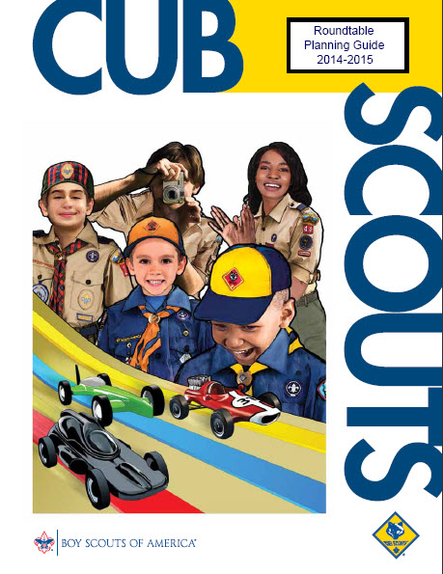

The RT Planning Guide Task Force has been formed and the work on the 2014-2015 Planning Guides is wrapping up. The new Planning Guides will be available at the National Meeting in May in Tennessee. I think we are getting a new cover picture, too!!! Look for it.

We are strengthening the Big Rock Topics, Cub Scout Interest Topics, adding discussion guides for Monthly Pack Activities, and improving many other features. This year there are six dedicated volunteers working on bringing you great Roundtables. We are assisted by the many others on Dan Maxfield's Roundtable Task Force.
Big Rock Topics (for everyone)
- Community Service
- Read the d@md'd manual
- Parent engagement
- Role of the District Committee in Unit Support
- Adult recognition
- CyberChip Programs
- Transitions in leadership
- Wood Badge
- Advancement
- Burnout
- Outdoor Ethics Program
- ADD/Autism
- Role of the commissioner
- Training
- Plus all of this year's topics will be available if there is one you did not use or one you think needs to be done again!!!
2014-2015
Cub Scout Core Values & Themes
Month | Core Value | 2014-2015  Supplemental Themes
Sep | Cooperation | Under the Big Top
Oct | Responsibility | Dollars and Sense
Nov | Citizenship | Give Goodwill
Dec | Respect | Stars and Stripes
Jan | Positive Attitude | Yes, I Can
Feb | Resourcefulness | Litter to Glitter
Mar | Compassion | Aware and Care
Apr | Faith | Soaring the Skies
May | Health & Fitness | Backyard Fun
Jun | Perseverance | Go for the Gold
Jul | Courage | Under the Sea
Aug | Honesty | Play Ball

2014-2015 Cub Scout Special Interest Topics
- Join Scouting Night
- Bobcat Badge
- Blue & Gold Banquet
- Flag Etiquette
- Age appropriate activities
- Den Chief Program
- Cub Scout Leader Recognition Plan
- Outdoor Award
- Summertime meetings – year round program
- Getting Ready for 2015-2016
- Youth Development
- World Brotherhood of Scouting
Boy Scout Special int. Topics
- Order of the Arrow (OA)
- Badges beyond Ranks
- Eagle Projects
- Troop elections
- Adult Leader Knots
- Ideals
- Sustainability
- Trailer Safety
- Annual Plans & Budgets
- Uniform

Suggestions and comments can be sent to Dan Maxfield. Dan is the RT member of Tico's National Support Staff. His E-mail is dmaxfil@yahoo.com

Commissioner Dave is the lead for the Cub Scout RT Planning Guide with 6 excellent volunteers helping. His E-mail is davethecommish@gmail.com

Faith Bingo
Commissioner Dave
Give each person a Board. They are to go around and meet people. After meeting someone and learning their name, they are to ask them to sign a box. Each person can only sign one box!!! This is not a speed contest; there should be discussion and introduction before signing!! Here is a sample board- boxes may be changed to suit your group
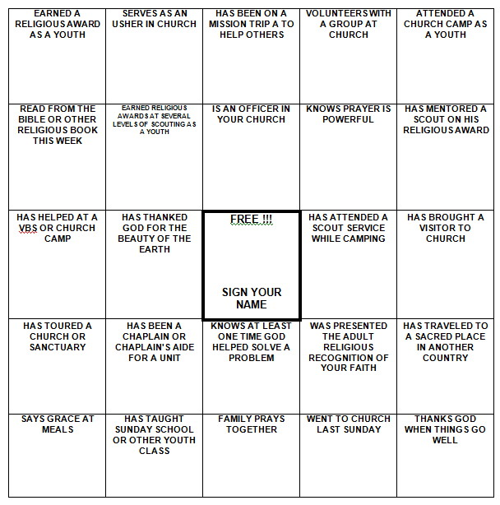
Be sure to enlarge the BINGO Board to fill a sheet of paper and put some directions on the sheet, too.

Emblems of Faith Puzzles
Commissioner Dave
Materials: Pictures of Religious Awards printed on card stock or pasted to thin cardboard..
- Cut the pictures into puzzle pieces - 4 or 6 per card.
- Give each participant a piece of a puzzle.
- Have them try and complete the puzzle by talking with others and finding the others pieces.
- During Icebreaker have them show the completed puzzle and read the back. (Have tape available)

Search for Faith
Alice, Golden Empire Council
Words in this search all pertain to Faith – words may be in any direction.
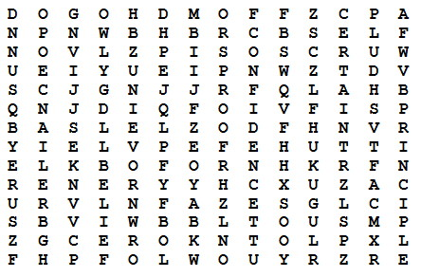
Here are the words:
Belief Principle Certain
Proof Confidence Reliance
Friends Religion God
Self Hope Sure
Loyalty Trust

SONGS

Cub Scout Garden
Commissioner Dave
Tune: She'll Be Coming Round the Mountain.
It is Spring time and planting gardens is appropriate. This ties in faith with the season. I wrote this one a few years ago. It has many more verses. (Too many for Cub Scout attention spans!!)
Be sure to create some really good motions for the verses!
We will plant our Cub Scout Garden in the spring
We will plant our Cub Scout Garden in the spring
We will plant our Cub Scout Garden
We will plant our Cub Scout Garden
We will plant our Cub Scout Garden in the spring
We will pray to God to watch our crop each day
We will pray to God to watch our crop each day
We will pray to God to watch
We will pray to God to watch
We will pray to God to watch our crop each day
We will reap our harvest early in the fall
We will reap our harvest early in the fall
We will reap our harvest early
We will reap our harvest early
We will reap our harvest early in the fall
Then we’ll Thank God for his help with our garden
Then we’ll Thank God for his help with our garden
Then we’ll Thank God for his help
Then we’ll Thank God for his help
Then we’ll Thank God for his help with our garden

WEB SITES

And Other Resources
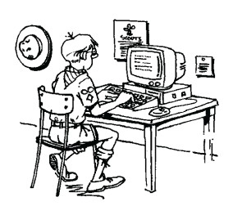
Faith Activity Badge
for British Scouts
Commissioner Dave
Beaver Magazine is published by the Scouting in England for Leaders of their youngest boys. This edition has an article on how to earn their Faith Award. It has lots of good ideas.
http://scouts.org.uk/documents/Magazine/decjan_09/beavdecjan09.pdf

Trees
by: Joyce Kilmer (1886-1918)
THINK that I shall never see
A poem lovely as a tree.
A tree whose hungry mouth is prest
Against the earth's sweet flowing breast;
A tree that looks at God all day,
And lifts her leafy arms to pray;
A tree that may in Summer wear
A nest of robins in her hair;
Upon whose bosom snow has lain;
Who intimately lives with rain.
Poems are made by fools like me,
But only God can make a tree.

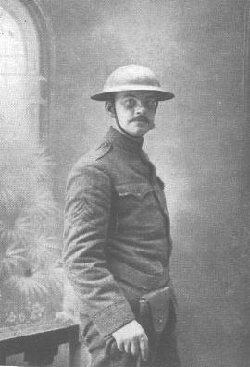

Alfred Joyce Kilmer (1886-1918), the noted American poet killed in action during World War I, was born in New Brunswick, New Jersey, on 6 December 1886.
Educated first at Rutgers College in 1904 and then at Columbia University, Kilmer worked from 1909-12 - after a brief stint as a salesman - for Funk and Wagnall, helping to edit their Standard Dictionary.
Although Kilmer exhibited early signs of radicalism and was indeed something of a socialist, he nevertheless retained a deep religious sense throughout his life. A one-time Literary Editor of The Churchman newspaper, an Anglican journal, Kilmer himself converted to Catholicism in 1913.
In June 1908 Kilmer married Aline; they had five children. In 1911 Kilmer's first volume of poetry, entitled A Summer of Love, was published to acclaim. In 1913 he joined The New York Times, also writing for The Nation and The New York Times Sunday Magazine. The fame his writings brought him earned him an entry in Who's Who.
Although married and with children Kilmer volunteered for service in 1917 following America's entry into World War I. Enlisting as a private with the 7th Regiment, National Guard in New York, he sought and received a transfer shortly afterwards to 165th Infantry (part of the famed Rainbow Division).
While in training at Camp Mills Kilmer was appointed Senior Regimental Statistician and, once on the Western Front in France, he earned promotion to Sergeant and was posted to the Regimental Intelligence Staff as an observer. In this post he would spend many dangerous nights out in No Man's Land gathering tactical information.
It was while out scouting for enemy machine guns near Ourcq that Kilmer was shot through the brain on 30 July 1918. He was aged 31. He was posthumously awarded the French Croix de Guerre.
Kilmer's best-known poem today is Trees (reproduced below), written in 1913. In it he demonstrated his deeply-held affinity for nature and for God. Although he intended to write a book based on his experiences on the Western Front his early death denied him the opportunity; he nevertheless wrote numerous war poems, one of which is Prayer of a Soldier in France
And my favorite Trivia Question while transporting Scouts on the NJ Turnpike and we get to the Joyce Kilmer Rest Stop is, "Who was Joyce Kilmer?" I invariably get, "I don't know who she was." To which I reply, "You are wrong already!!" CD

Religious Emblem Program


Faith: Having inner strength and confidence based on our trust in God.
“Faith is taking the first step even when you don't see the whole staircase.” - Martin Luther King, Jr.
The core value of Faith dovetails nicely with the Boy Scout Law, "A Scout is reverent." All Scouts show this by being faithful in their duty to God.
Of course, one way to work Faith into your program is to have your scouts work on the religious emblem for his faith. The US Scouting Service Project has a wonderful website with information on all emblems.
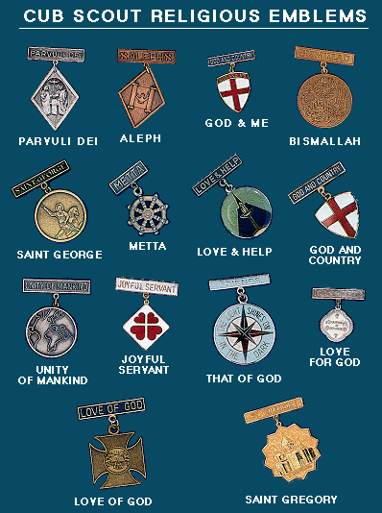
from: http://usscouts.org/advance/cubscout/religious.asp
NOTE:
The Religious awards are awards of the various denominations, they are NOT Scouting awards. A boy should be able to find a counselor for his faith at his church. If his particular local church does not have anyone who is knowledgeable about the awards, then either someone from your pack could help someone in the boy's church learn about the award or your local Council can help find a counselor or someone to help the local church.
Webelos Badge, requirement #8 is on Faith.
Pack 3371 in Lafayette, IN has a very good worksheet on its website on this requirement. http://www.pack3371.com/Dens/Webelos/dm8_webelos_8.pdf
Teachable Moments
- Consider taking a field trip to an historic place of worship. Visit an early church or mission and learn about the history and faith of people who lived in your area earlier.
- As you work on Sportsman or other badges, belt loops or pins, Remind boys that their physical abilities are a gift and reinforce that they should be thankful for these gifts.

DEN MEETINGS
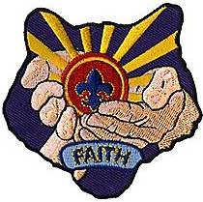
I have received questions about theme patches I use in Baloo - Want to see a great collection and copy the .jpg's for your use?? Go to - http://www.pack042.com/themes.htm#2011


TIGERS
Wendy, Chief Seattle Council

Den Meeting #15:
DO: E #3, Play a card or board game, or put together a puzzle.
HA: E #25, Make a snack to share with family or den.
E #23, Find out what kind of milk their family drinks, and why.

Den Meeting #16:
DO: E #33, Clean-up treasure hunt.
E #25, Snack
E #23, Milk.

Board Game Ideas
Leave No Trace Board Game (use with Trivial Pursuit style game): http://usscouts.org/usscouts/bbugle/bb0905.pdf ’09 Baloo’s Bugle “Camping” p. 30-32.
Bingo Board Maker: http://www.toolsforeducators.com/bingo/
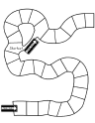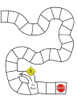
Board Game Templates: http://donnayoung.org/homeschooling/games/game-boards.htm
You could color in the plain race track boards and use them with the Leave No Trace game above. The boys could collect colored candies, pony beads, foam pieces, etc. instead of wedges.
Game Ideas referenced below are at:
Baloo’s Bugle (essentially an online Round Table for leaders): http://usscouts.org/usscouts/bbugle2010-2011.asp
’08 Santa Clara Pow Wow Book “Amazing Games”
http://www.macscouter.com/CubScouts/PowWow08/Themes.asp
More Games:
’08 Baloo’s Bugle “Amazing Games:”
p. 8-10; 20-21; 26; 28-35.
’08 Santa Clara Pow Wow Book “Amazing Games”
p. 2-6
Songs (Tiger E6): ’08 Baloo’s Bugle “Amazing Games:”
p. 15-16.
’08 Santa Clara Pow Wow Book “Amazing Games”
p. 19-22.
Snacks: ’08 Baloo’s Bugle “Amazing Games:”
p. 35-6.

Edible Maze
Alice, Golden Empire Council
Ingredients:
Graham cracker for each boy,
Frosting, Knives,
Toothpicks,
Various candies.
Directions:
- Each boy frosts (ices) his graham cracker,
- Then he “lays out” a maze by drawing with a toothpick on the frosting.
- Candies such as M&M’s can be used to show the pathway thru the maze.
- And then of course, they can eat the whole thing –
maze and all!

Edible Tic Tac Toe:
Make the board with licorice. Use life savers for Os, and another candy (different shape) for the Xs. (Wendy, Chief Seattle Council)

Edible Scrabble/Crossword Puzzles:
Use Alpha-bits cereal letters to make words. (Wendy, Chief Seattle Council)
(Note: Cheeze-It® Crackers are currently offering special edition Scrabble® crackers. –Pat)
Sometimes you can find edible games in the gummy fruit snacks isle of the grocery store.

Litter Ideas
Litter Treasure Hunt Variation: Assign point values to litter. More common items such as candy wrappers, pop cans, and water bottles get 1 point. Moderately common items such as plastic grocery bags and newspapers get 3 points. Award 5-10 points for unusual litter that is collected. Divide the boys into teams to pick up litter. The team that collects the most litter points wins. To score, look in the boys’ collection bags (usually a plastic grocery bag) and guesstimate the amount and kind of litter collected, and assign a point value for the sack. – Wendy, Chief Seattle Council
Trash grabbers: http://pbskids.org/zoom/printables/activities/pdfs/mechanicalgrabber.pdf
Ideas referenced below are at:
Baloo’s Bugle (essentially an online Round Table for leaders): http://usscouts.org/usscouts/bbugle2010-2011.asp
’08 Santa Clara Pow Wow Book, “Litter to Glitter”
http://www.macscouter.com/CubScouts/PowWow08/Themes.asp
Songs (Tiger E6): ’08 Baloo’s Bugle “Litter to Glitter”
p. 12-14.
’08 Santa Clara Pow Wow Book, “Litter to Glitter”
p. 7-10.
Snacks: ’08 Baloo’s Bugle “Litter to Glitter”
p. 33-34.
Games: ’08 Baloo’s Bugle “Litter to Glitter”
p. 8-9; 31-33; 43.
’08 Santa Clara Pow Wow Book, “Litter to Glitter”
p. 5-6
Crafts: ’08 Baloo’s Bugle “Litter to Glitter”
p. 23-31.
’08 Santa Clara Pow Wow Book, “Litter to Glitter”
p. 2-5.
http://www.makingfriends.com/recycle.htm
TRASH
(Julie R., Chief Seattle Council)
tune: Row, Row, Row Your Boat
Trash, trash, all around,
lying on the ground.
Pick it up, throw it out.
It's good for Puget Sound.
DO YOUR PART
(Julie R., Chief Seattle Council)
tune: Frere Jaques
Plastic bottles and food wrappers,
Styrofoam, shouldn't roam.
On the ground it's litter.
Pick them up, they glitter.
We are smart,
and do our part.


WOLF
Wendy, Chief Seattle Council

Den Meeting #15:
Do: E #4e, Marble Belt Loop;
http://usscouts.org/advance/cubscout/sports/marbles.asp
Verify E #10a, American Indian Book,
E #21, Computers

Den Meeting #16:
Do: E18a, b, Family Picnic
E19 a-f, Fishing

Marble Ideas
Marble games:
How to play marbles:
http://www.landofmarbles.com/marbles-play.html
Sometimes shooting marbles can be hard for the boys. To make it easier, have the boys aim a short piece of PVC pipe at the target, and roll a marble down the pipe. Experiment with different angels to increase the marble’s speed.

Box Targets:
http://familyfun.go.com/playtime/box-scores-863585/
http://familyfun.go.com/playtime/marble-target-fun-house-708598/

Marble Cliff Hanger: http://familyfun.go.com/playtime/marble-cliff-hanger-708301/

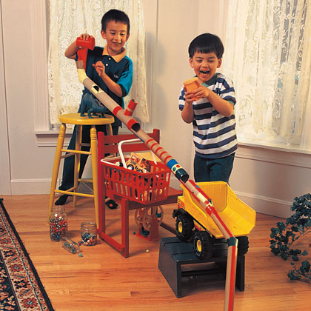
Marble Maze: http://familyfun.go.com/crafts/marble-maze-665946/

Marble Roulette: http://familyfun.go.com/playtime/marble-roulette-708304/
Marble Golf: (from “01 Baloo “Save it for Us” p. 3.)
This 9 hole golf course is laid out around the yard. Small tin cans are sunk into the ground. One to four players start
off and shoot marbles. They count the shots taken to get the marbles into the cans. Hazards may be small brushes, lengths of drain spouts, tubes through which the golfer must shoot, an upright 2 foot long board with a 4 inch hole. For a water hazard, sink a tin pie plate or other suitable container and fill with water. Use flags made from paper triangles glued to popsicle sticks. Golf rules should be observed in playing this game.
Giant Marbles: http://familyfun.go.com/playtime/giant-marbles-919494/
Devil’s Marbles: http://familyfun.go.com/playtime/devils-marbles-707483/
Treats: decorate cupcakes or cookies with gumballs (which look like marbles)
See, also, Joe's Webelos Section for more
Marbles Ideas and how to plat Ringer!!

Fishing Ideas

- '04 Baloo’s Bugle “Fin Fun” p. 9-10.
- '10 Baloo’s Bugle “Waves of Fun” p.54-55.
Ideas referenced below are at:
Baloo’s Bugle (essentially an online Round Table for leaders): http://usscouts.org/usscouts/bbugle2010-2011.asp
Fish in the Sea Game:
All players but one stand behind a line. "IT" stands midway between the line and a goal line thirty feet away. He shouts "Fish in the ocean, fish in the sea; don't get the notion you'll get by me." The fish leave their line and try to cross the goal line without being tagged. Players who are tagged join "IT" and help catch others.
-- from the ’03 “Fun in the Sun” Desert District Round Table Handout
Crafts:’09 Baloo’s Bugle “Fun in the Sun” p. 27-28.
Snacks: ‘04 Baloo’s Bugle “Fin Fun” p. 22.
Swedish Fish and Goldfish crackers are obvious choices for snacks.

Fish Cupcakes:
http://familyfun.go.com/recipes/school-o-fish-cupcakes-984981/
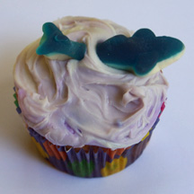
http://www.easycupcakes.com/category/ocean-and-sealife-cupcakes/

Faith Chant
(Wendy, Chief Seattle Council)
Hopefully it's not too sacrilegious to compose a chant about faith, set to a military cadence.
Just because I cannot see,
Doesn’t mean it cannot be.
Evidence is all around,
In the sky and on the ground.
Ev’ry time I hit the trail,
I see God in hill and vale.
Trees and flowers speak to me,
Of the Presence I can’t see.
God’s here!
He’s near!
God’s here, He’s near.
Praise Him! (or Amen!)

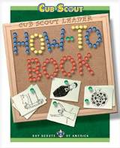
From the Cub Scout Leader How-To Book –
- Family Picnic: How To Book p. 6 – 22-23.
- Fishing Derby: How To Book: p. 6 – 37-38.



BEAR

Bear Ideas by Felicia

Bear April 2012 Faith
Den Plan Subject Activity
Q Family Outdoor Adventure
Achievement 12b &
hiking belt loop
S. Tall Tales Achievement 4
A. Maps Elective 23a-e

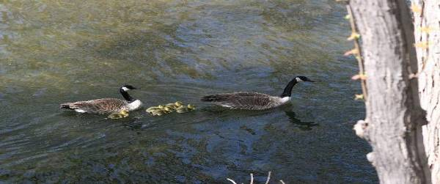

Lesson Plan Q - Family Outdoor Adventure – Ach 12.
As the weather starts to get nice it is a good time to plan an outdoor activity, hike, or camp out.
If you would like to visit a Boy Scout Camp, here is a site that will tell you what is near you & what resources they have: http://usscouts.org/databases/camp/ocd.cgi
Order of the Arrow Where-To-Go-Camping Guides can be found here: http://scoutcamp.org/oa_guides.asp.


View of the Mississippi River from Fire Point
at Effigy Mounds National Park, Iowa.
If you would like to locate & visit a National Park in your area: Here is the National Parks Web site http://www.nps.gov/index.htm
Here are some links to help you find state parks: http://www.stateparks.com/usa.html; http://en.wikipedia.org/wiki/List_of_U.S._state_parks; *this one has links to each State’s official park web site http://www.americasstateparks.org/;
The National Wildlife Foundation offers a “Nature find” which may help you find more local areas to explore.
http://www.nwf.org/Get-Outside/NatureFind.aspx The Nature Conservancy http://my.nature.org/preserves/
Local Hikes.com http://www.localhikes.com/Default.asp?MSA=ALL

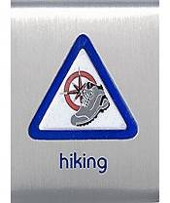

Hiking Belt Loop
Complete these requirements:
- Explain the hiking safety rules to your den leader or adult partner. Practice these rules while on a hike.
- Demonstrate proper hiking attire and equipment.
- Hike at least 30 minutes with your adult partner, family, or den.

Hiking Safety Rules:
- Always tell someone where you are going and when you will return.
- Never hike alone or at night; always use the buddy system.
- Dress properly for the weather and environment.
- Wear sun and insect protection.
- Take an extra pair of socks in case you need to change.
- Obey traffic signs and signals.
- Avoid hiking along roadways.
- Stay on the trail.
- Be alert to your surroundings.
- Don't litter as you hike.
- Be alert to dangerous animals, insects, and plants. Never touch a wild animal.
- Take 1 pint of water for each hour you will be hiking. Never drink untreated water
Remind your Bear Scouts
Do not feed or play with real bears.
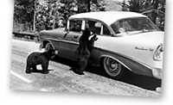
Car is a 1956 Chevy!
National Park Service Historic Photograph Collection:
Jack E. Boucher took this photo at Yellowstone National Park in approximately 1958.

Links for Hiking Pin requirements & work sheets:
- http://www.scouting.org/scoutsource/CubScouts/Cub%20Scouts/UniformsAndAwards/sanda/hiking.aspx;
- http://usscouts.org/advance/cubscout/sports/hiking.asp;
- http://www.boyscouttrail.com/content/content/cub_scouts_hiking_sports_pin_and_belt_loop-2036.asp;



The Sweet Sixteen of BSA Safety Procedures for Physical Activity is an aid to protect participants in Scout activities. These 16 points, which embody good judgment & common sense, are applicable to all activities & are set out in full detail at: http://www.scouting.org/scoutsource/HealthandSafety/Resources/sweet16.aspx.

1. QUALIFIED SUPERVISION
2. PHYSICAL FITNESS
3. BUDDY SYSTEM
4. SAFE AREA OR COURSE
5. EQUIPMENT SELECTION AND MAINTENANCE
6. PERSONAL SAFETY EQUIPMENT
7. SAFETY PROCEDURES AND POLICIES
8. SKILL LEVEL LIMITS
9. WEATHER CHECK
10. PLANNING
11. COMMUNICATIONS
12. PLANS AND NOTICES
13. FIRST-AID RESOURCES
14. APPLICABLE LAWS
15. CPR RESOURCE
16. DISCIPLINE


It’s always a good time to learn a new campfire song and teach it to your den. Below is a fun song. To hear & learn more entertaining songs check out these links. Even with songs you know are for kids: always preview the song before you let the kids watch (some people have less than family friendly versions). www.youtube.com/user/greenghoulie#g/search www.youtube.com/user/hcycamp#p/u www.youtube.com/user/ultimatecampresource#p/u


Tom T. Hall wrote

Sneaky Snake
The following version is my favorite but it’s a little different from the original:

Now Boys and girls take warning, when you go by the lake
Keep your eyes wide open and look for sneaky snake"
Now maybe you won't see him and maybe you won't hear
But he'll sneak up behind you and drink all your root beer

And then sneaky snake goes dancin', wigglin' and a-hissin'
Sneaky snake goes dancin', a-gigglin' and a-kissin'
I don't like old sneaky snake, he laughs too much you see
And When he’s wigglin' through the grass, he tickles me under my knee

Here are some sites with the original version in its entirety:
- http://www.youtube.com/watch?v=CMxv7onpdCY&feature=related;
- http://www.youtube.com/watch?v=5W1QLA-pp34&feature=related;
- http://www.youtube.com/watch?v=MchhtofbgJI;

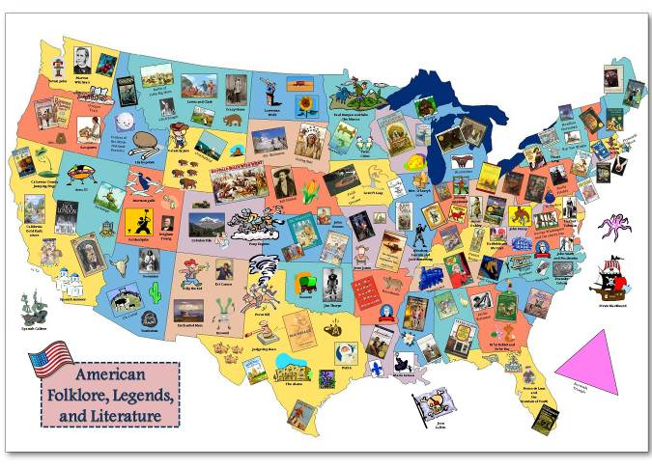

Meeting S - Tale Tales - Achievement 4

4b. This map of American Folklore, Legends, & Literature was recommended by Pack 25 in Louisiana. http://cardinalscholar.bsu.edu/handle/123456789/193992 for full-sized image
This map is part of the GRMC "Resources for
Teachers" collection of lesson plan ideas using maps
for the K-12 educator. Teachers can print copies
of the map to be used in the classroom. This is a
sample of a culminating project where students create
a map showing famous folklore and works of literature
in the United States. This lesson is part of an
instructional session provided to social studies class by
the GRMC. Ball State University. (Unpublished)

These sites talk about American folk lore.
- http://en.wikipedia.org/wiki/Folklore_of_the_United_States
- http://www.americanfolklore.net/

A fun way to introduce tale tales to your den may be to
- Watch one of the shorts on Disney's 2002 DVD American Legends. This has cartoons on Johnny Appleseed, Casey Jones, Paul Bunyan, & John Henry.
- Read a story of (Paul Bunyan's) Babe the Blue Ox. http://americanfolklore.net/folklore/2010/07/babe_the_blue_ox.html
- Listen to or sing a song about John Henry. http://toneway.com/songs/john-henry
http://www.npr.org/programs/morning/features/patc/johnhenry/index.html#audio



John Henry
When John Henry was a little baby
A sitting on his papa's knee
He picked up a hammer and a little piece of steel
Said, "Hammer's gonna be the death of me," Lord, Lord
"Hammer's gonna be the death of me."
Well, the captain said to John Henry
Gonna bring me a steam drill 'round
Gonna bring me a steel drill out on the job
Gonna whup that steel on down,...
John Henry said to his captain
"A man ain't nothin' but a man
And before I let that steel drill beat me down
I'll die with a hammer in my hand,...
John Henry was driving on the mountain
And his hammer was flashing fire
And the last words I heard that poor boy say
"Gimme cool drink of water 'fore I die,...
John Henry said to his shaker
"Shaker, why don't you sing?"
"I'm a throwin' nine pounds from my hips on down
Just listen to that cold steel ring,...
John Henry said to his shaker
"Shaker, why don't you pray?"
"'Cause if I miss this little piece of steel
Tomorrow be your burying day,...
John Henry, he drove fifteen feet
The steam drill only made nine
But he hammered so hard that he broke his po' heart
And he laid down his hammer and he died,...
They took John Henry to the graveyard
And they buried him in the sand
And every locomotive comes a roaring by, says
"There lies a steel driving man",...
- Read a poem. One like Paul Revere's Ride, by Henry Wadsworth Longfellow: which can be found at http://poetry.eserver.org/paul-revere.html Historians will tell you that this poem has inaccuracies in it & is more for fun than learning History.

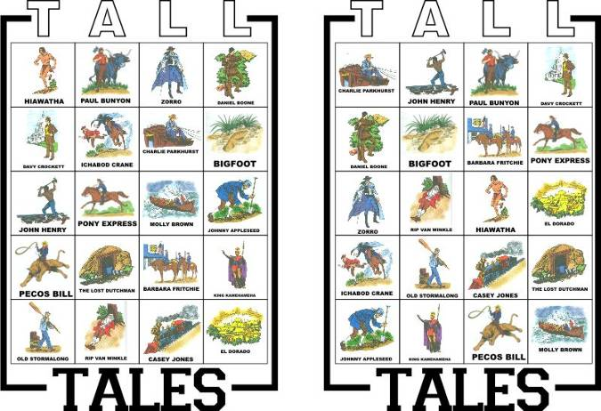

- Play a game like bingo above or a matching game.

The picture above is a Tall Tales Bingo Game that Tomi of the Pony Express district developed. More information can be found at: http://ponyexpresscubs.blogspot.com/2011/04/game-for-bear-achievement-4-tall-tales.html

This website has a pattern for cards to play a tall tale matching game. http://strongarmor.blogspot.com/2009/05/cub-scouts-tall-tales-matching-game.html



Make Johnny Appleseed Smiles for a snack.
- Make a large apple wedge, then cut a smaller wedge out from the middle of the peel-side (see photo). Take slivered almonds and push them into the apple so they look like teeth and the peel looks like lips.
- Take two apple wedges -smear them with peanut butter – add mini marshmallows for teeth. Food.com adds a dried apricot for a tongue.
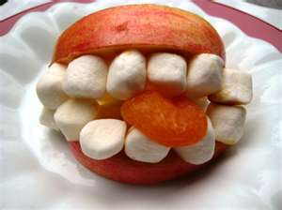

Apple Dolls
are folk dolls originating from early rural America when settlers made dolls from whatever was at hand.” http://appledolls.org/



For a Craft why not carve a Johnny Appleseed doll head. Peel & core a large apple. Carve a face in it. Set it aside for several days until it is shrunken & all dried & wrinkly. When it is fully dehydrated, you can paint facial features on it. These sites have more info on making one of these dolls - including soaking them in salt water &/or lemon juice. http://www.mtnlaurel.com/Crafts/apple.htm http://www.suite101.com/content/how-to-make-an-apple-head-doll-a48226
http://www.elder-one-stop.com/apple-doll.html & http://familyfun.go.com/crafts/apple-dolls-666871/

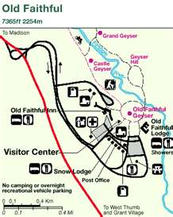

Supplemental Meeting #A – Maps -

Elective 23, a-e and Map & Compass Belt Loop

Park maps can be fun tools for studying maps & planning a hike. Many parks have their maps on their web sites.

Here are some web sites where you can access maps.
http://maps.randmcnally.com/
http://www.mapquest.com/
http://maps.google.com/
http://maps.nationalgeographic.com/maps this map is on actual photos of the earth.

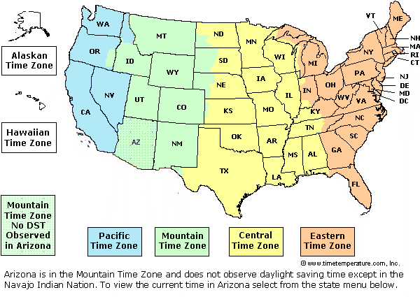

Time Zone Maps
http://www.timetemperature.com/tzus/time_zone.shtml
http://nationalatlas.gov/printable/timezones.html#one
http://www.worldtimezone.com/
http://www.time.gov/
http://www.worldatlas.com/webimage/countrys/namerica/usstates/timezone.htm

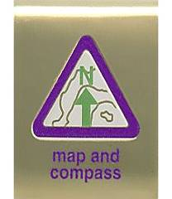

Map and Compass Belt Loop
- Show how to orient a map. Find three landmarks on the map
- Explain how a compass works.
- Draw a map of your neighborhood. Label the streets and plot the route you take to get to a place that you often visit.

Links for Map and Compass Pin requirements & work sheets:
- http://www.scouting.org/scoutsource/CubScouts/Cub%20Scouts/UniformsAndAwards/sanda/map_compass.aspx
- http://usscouts.org/advance/cubscout/academics/map-compass.asp
- http://www.boyscouttrail.com/cub-scouts/acadsports/map.asp

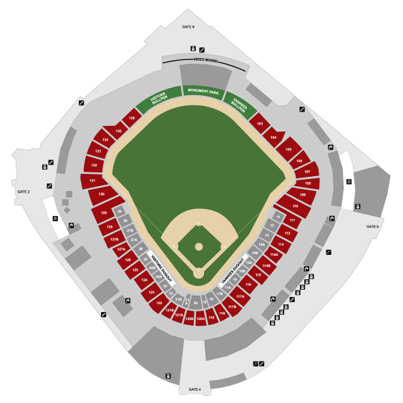
Alice, Golden Empire Council
Some Map Resources to Try
1. Visit a AAA Office (or ask a parent who is a AAA member) to obtain maps to use with this activity.
2. Show the boys how to find information such as time zones, site maps of local stadiums and auditoriums and other useful facts in special pages of the phone book.
3. Check with your local Chamber of Commerce or Better Business Bureau – they often have great maps of the local community

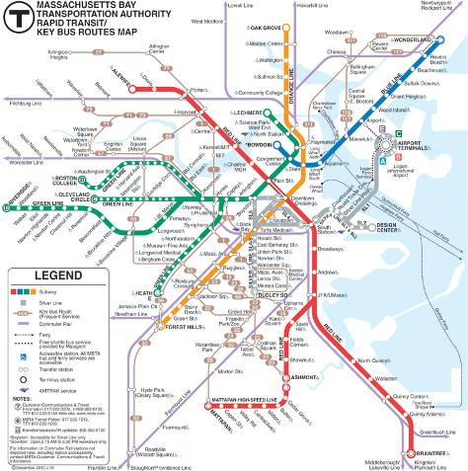
4. Check with local public transit agencies – many boys don’t realize how buses, light rail and subway systems can take them from place to place – learning how to read the system maps is a very useful skill!
5. Want a fun challenge? Check with a library, used book store, thrift store or a National Geographic fan – this publication has wonderful inserts that sometimes feature maps of states, regions, countries or special areas – and you can also see unusual maps such as maps of the seafloor, lunar surface, etc.
6. City or County Recreation Departments, or National Parks – Sometimes the best way to see the details and relationship between areas of a park or nature area are the maps made for a nature center or park.
7. USGS – If you are lucky enough to be near a regional office, you can go and purchase all kinds of great maps – especially topo maps; you can also order them online.


8. Internet – This is a resource you can use if you can’t find the map you want somewhere else. Just search the name of the area you are interested in!


I had great fun with boys and maps one time – I got a variety of maps, everything from road maps to topographical maps, “maps” of stadiums or auditoriums – had them posted on the wall and assigned a team of boys to spend some time looking at “their” map to see what they could learn. After a few minutes, we went around the room and talked about the different maps – the boys learned about using the map key or legend, how to pick out different features, how to estimate size and spaces covered – and they were better prepared to follow a map on a hike or family trip! Alice

Character Connection: Faith
2011-2012 CS RT Planning Guide
* What does faith in God or a higher power mean?
* How does a person’s religion guide him or her?
* How does your faith make you feel comfortable?
* What can you and your family do together in
the next four weeks to show greater faith?
See Fun for the Family, No. 33012, for family activities related to this month’s core value, faith.

WEBELOS DENS


Joe Trovato,
WEBELOS RT Break Out Coordinator
Westchester-Putnam Council
Have a question or comment for Joe??
Write him at
webelos_willie@yahoo.com

There is an underscore between Webelos and Willie

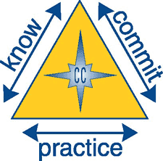

Core Value for April
Faith

Faith: Having inner strength and confidence based on our trust in God.

“Faith is taking the first step even when you don't see the whole staircase.” - Martin Luther King, Jr.

The core value of Faith dovetails nicely with the Boy Scout Law, "A Scout is reverent." All Scouts show this by being faithful in their duty to God.

Of course, one way to work Faith into your program is to have your scouts work on the religious emblem for his faith. The US Scouting Service Project has a wonderful website with information on all emblems.

http://usscouts.org/advance/cubscout/religious.asp

Your local Council can help find counselors for various faiths for the diverse Webelos dens.

Of course, Webelos requirement #8 is on Faith.
Pack 3371 in Lafayette, IN has a very good worksheet on its website on this requirement. http://www.pack3371.com/Dens/Webelos/dm8_webelos_8.pdf

Consider taking a field trip to an historic place of worship. Visit an early church or mission and learn about the history and faith of people who lived in your area earlier.

As you work on Sportsman or other badges, belt loops or pins, Remind boys that their physical abilities are a gift and reinforce that they should be thankful for these gifts.

Book Corner

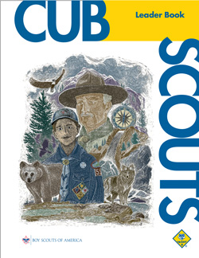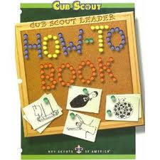

From the Cub Scout Leader Book:

Cub Scouting Teaches Duty to
God and Country

The BSA believes that no member can grow into the best kind of citizen without recognizing an obligation to God, and encourages both youth and adult leaders to be faithful in their religious duties.

The Scouting movement has long been known for service to others. Scouting believes that patriotism plays a significant role in preparing our nation’s youth to become useful and participating citizens. A Cub Scout learns his duty to God, country, others, and self.

Check out pages 4-3, 4-4 and 8-3 of the Cub Scout Leader Book for more on FAITH. In addition, this core value is an excellent way to get your scout’s parent involved by having the parent assist the scout in obtaining the religious award for his faith. More on this on page 29-2.

http://www.scouting.org/filestore/hispanic/english/33221_WEB.pdf

The How-To Book is a great resource for this month’s Webelos meeting on Artist and Showman. Chapter 2 on Crafts and see Chapter 5 (page 5-12) for all you need to know to help the boys meet the requirements for Showman 2, 3 and 7.

http://www.scouting.org/filestore/hispanic/english/33832_WEB.pdf

Meeting Planner


This month’s meeting plans for First year Webelos work on the Scholar, Artist and Showman badges.

Meeting 15: Scholar Do: Scholar 1, 5, 11, 12.
Artist 2, 8, 10
http://www.scouting.org/filestore/CubScoutMeetingGuide/webelos/WebelosMeeting15.pdf

Meeting 16 Showman (Puppetry) Do: Showman 2–5, 7, 11, 17, 20
http://www.scouting.org/filestore/CubScoutMeetingGuide/webelos/WebelosMeeting16.pdf

In March, Second year Webelos (Arrow of Light) work on Sportsman.

Meeting 15 Sportsman Do: Sportsman (Marbles belt loop))
http://www.scouting.org/filestore/CubScoutMeetingGuide/ArrowofLight/ArrowofLightMeeting15.pdf



The meaning of the Pledge of Allegiance Flag Ceremony
A couple of years ago, while working on putting together a ceremony, we came across a recording from the old red Skelton Show, where Red gave us a short story about a teacher he knew when he was a boy, who, when he saw the boys and girls saying the Pledge of Allegiance as memorized, explained the meaning of the Pledge of Allegiance to his class. We’ve since adapted it for Webelos to use at Pack Meetings. With a bit of practice at your den meeting, this will work fine. Feel free to simply it further if need be, or have the boys use their own definitions. If you want to see Red in action, you can find the video on You Tube.
Begin your opening ceremony in the usual way with the American and Pack Flags facing the Pack. Have the Webelos Scouts as a color guard on the left and right of the flags. After the Cubmaster begins the ceremony, each Webelos scout reads one (or two) of the entries from an index card. Microphones are good, if you have them!

CM: We often recite the Pledge of Allegiance without really listening to or understanding the meaning of the words we are saying. As we stand, with the Cub Scout salute, let’s listen, before we recite the Pledge.

Webelos Scout #1: “I - Me, an individual”
WS2: “Pledge - Dedicate myself”
WS3: “Allegiance - My love and devotion”
WS4: “To the Flag - Our standard - Old Glory - a symbol of freedom. Freedom is everybody's job!”
WS5: “Of the United - United - that means we have all come together”
WS6: “States of America - States - individual communities that have united into fifty great states - fifty individual communities with pride and dignity and purpose; all divided with imaginary boundaries, yet united in a common purpose - love for country.”
WS7: “And to the Republic - Republic, a state in which power in given to representatives chosen by the people to govern; and the government is the people; and it's from the people to the leaders, not from the leaders to the people.”
WS8: “For Which it Stands - This is what our Flag stands for - Our United States”
WS9: “One Nation Under God - meaning so blessed by God”
WS10: “Indivisible - Incapable of being divided”
WS11: “With Liberty – The right to live one's own life without threats or fear.”
WS12: “And Justice - Dealing fairly with others.”
WS 13: “For All - For all - which means, it's as much your country as it is mine.”

CM: Now Scouts, ladies and gentlemen, boys and girls, let us recite the Pledge of Allegiance in a way that shows we understand its meaning.

Webelos Den Leader
RT Breakout


Planning a Den Outdoor Activity

With April come warmer weather and its time to plan den outdoor activities. Webelos dens should consider day hikes, overnight camping, camping with a Boy Scout troop as well as field trips that relate to activity badges. At your local round table, share ideas for outdoor activities with other Webelos leaders. Has your Webelos den had a particularly successful activity? Share the particulars with other leaders. You’ll find that most successful outdoor activities are:

- Parent/youth or family oriented.
- Conducted with adult supervision.
- The Cub scouts are asked to do their best.
- The activity is discovery based.
- Advancement occurs as a natural part of the activity, but is not the focus of the activity.

What else do you need to know? Here are some important considerations from the Cub Scout Leader Book and the Guide to Safe Scouting:

- Two-Deep Leadership Required: It is the policy of the Boy Scouts of America that trips and outings may never be led by only one adult. Two registered adult leaders, or one registered adult leader and a parent of a participant, one of whom must be 21 years of age or older, are required for all trips and outings.

- Obtain written permission forms from a parent or guardian for all activities held away from the regular den and pack meeting places.

- File a local tour permit if necessary. Check with your local council.

- Plan ahead for adult supervision and in case of an emergency.

- Check out the site before hand.

- Use the buddy system. Coach the boys in advance on what to do if they get lost.

- Carry a first aid kit and make sure that adults know how to use it.

- Arrange for adequate insured and safe transportation.

- Insure that the activity is “age appropriate” as set out in the Guide to Safe Scouting. www.scouting.org/HealthandSafety/GSS.aspx.

Also, don’t forget to have an alternative indoor activity in case of bad weather!

Basic Adult Leader Outdoor Orientation (BALOO) training is for any Cub Scout leader with a desire to plan and carry out any outdoor experience for the pack. When you complete this training you will have an increased level of confidence and the required knowledge of the resources available from the BSA to plan an age-appropriate den or pack overnighter.
Remember, a BALOO trained person needs to sign the Tour Permit that your Pack submits to the Council and attend the camping event that your Pack has planned.

BSA Policies: Standards for Privacy on Trips or Outings

To support the BSA policy of two-deep leadership on all trips and outings, the sleeping arrangements of male and female leaders must be addressed.
All leaders are expected to reflect high moral standards established by customs, traditional values, and religious teachings. Male and female leaders require separate sleeping facilities. Married couples may share the same quarters if appropriate facilities are available.
Male and female youth participants must not share the same sleeping facility. When tents are used, no youth will stay in the tent of an adult other than his/her parent or guardian. When housing other than tents is used, separate housing must be provided for male and female participants. Adult male leaders must be responsible for the male participants; adult female leaders must be responsible for the female participants. Adult leaders need to respect the privacy of the youth members in situations where the youth are changing clothes or taking showers, and intrude only to the extent that health and safety require. Adults need to protect their own privacy in similar situations.

And, since we’re planning outdoor activities and summer is almost here. . . . . .

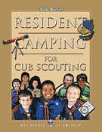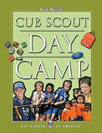

Make sure to offer your Scouts the option to attend Webelos Scout resident camping. It is a council-organized, theme oriented, overnight camping program. It operates for at least two nights (and often a week) and is conducted under trained leadership at a camp approved by the your council.
If resident camp is not possible, Day Camp should be an option. Day camp is an organized, multiple-day, theme-oriented program for Tiger Cubs and their adult partners, Cub Scouts, and Webelos Scouts. Day camp is conducted by the council/district under trained leadership at an approved site during daylight or early evening hours. Day camps do not include any overnight activities. The day camp program is age-appropriate and theme-based.
And still more on outdoor activities ……..

You may want to work into your den meetings and outings earning on the Cub Scouting’s Leave No Trace Awareness Award which is available to both Webelos Scouts and Leaders.
Information on the Award and the Cub Scout Leave No Trace Pledge may be found at
http://www.scouting.org/scoutsource/CubScouts/resources/LeavenoTrace.aspx

Den Meeting Helpers
These activities can be used for the gathering or to reinforce/satisfy badge requirements.

Webelos


SCHOLAR



The Scholar Activity Badge is an easy one for boys to earn if they are doing acceptable work in school. This is because more than half the requirements concern attendance, behavior, grades and service in school

RELATED BOY SCOUT MERIT BADGES

There are requirements for the following Boy Scout Merit Badges that can be adapted for Webelos. You can borrow the books from a local Troop’s library.

- Citizenship in the Community
- Personal Management
- Public Speaking
- Reading
- Scholarship

SEVEN WAYS TO IMPROVE YOUR GRADE

- Learn to listen--Concentrate on the speaker. You may miss important facts if you’re not paying attention.
- Develop good study habits--Have a study place away from distractions. Have supplies handy. Do your homework at the same time every day so it becomes a habit.
- Use the right reading technique--Slow careful reading is necessary when you must understand and remember.
- Improve your vocabulary--Look up a word you don’t know. Write it down. Note spelling, pronunciation and meaning.
- Sharpen your writing skills--Organize your thoughts. Make sure your handwriting is neat. Double check spelling and punctuation.
- Learn how to take tests--Study for a test ahead of time. DO NOT CRAM. Read all the directions and make sure you understand them. If there is an answer you don’t know, skip it and come back to it later. Double check your work for careless errors before you hand it in.
- Develop a positive attitude--This is most important. You are what you think you are.

Think you are going to pass and you probably will.
When you really want something at school and you are willing to work for it, your teacher is the best person to help you.

WORD PUZZLES

SECRET SCHOLAR MESSAGE
-Barb Stephens

- If you ever saw a cow jump over the moon, write "Q" in spaces 1, 4, 15, 18. If not, write "R" in these spaces.
- If "X" comes before "H" in the alphabet, write "Z" in space 3. If "X" comes after "H," write "F" in space 3.
- If 13,467 is more than 10 dozen, write the letter "E" in spaces 2, 5, 9, 16, 19. If it is less than 10 dozen, write "K" in these spaces.
- If you like candy better than mosquitoes, indicate this with an "S" in 6 and 12. If not, leave these spaces empty.
- Close one eye and without counting on your fingers, write the 8th letter of the alphabet in space 7.
- If Shakespeare wrote "Twinkle, Twinkle, Little Star," put a "C" in space 22. If he didn't, write a "Y" in that space.
- If white is the same color as black, write nothing in space 8. If they are different colors, write an "M" in space 8.
- If 10 quarts equals one cup, draw an elephant in space 10. Otherwise, write an "N" in space 10.
- If summer is warmer than winter in the Northern hemisphere, put the letter "D" in space 21 and the letter "T" in space 11.
- If you think this is silly, write the first letter of the alphabet in spaces 14 and 20. Otherwise, write an "A" in those spaces.
1 | 2 | 3 | 4 | 5 | 6 | 7 | 8 | 9 | 10 | 11 | 12
13 | 14 | 15 | 16 | 17 | 18 | 19 | 20 | 21 | 22 | 23 | 24

CAREERS IN EDUCATION


Materials needed:
Lots of old magazines, glue, construction paper, scissors
Have each boy choose one of the following careers in education and think of what may be involved in that career. Then, using old magazines, have each boy make a collage of pictures that relate his ideas about the career. You may be surprised at a Webelos perception of these jobs. When the collages are complete, discuss them and clarify any misconceptions. Display the collages at the pack meeting.
Guidance Counselor
Health Services
Librarian
Principal
Social Worker
Sports Coach
Kindergarten Teacher
Elementary Teacher
High School Teacher
College Professor

A SHORT HISTORY OF AMERICAN EDUCATION
-R. Gary Hendra

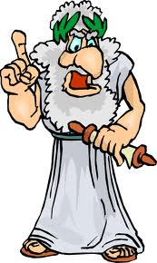

Schooling in Colonial America (1600-1775)
Resources were limited and physical demands left little room for education. Education was initially established for religious motives (Puritans in New England.) Most education of this period was either in the home and apprentice training. Nine colleges were formed during this time period.
Three practices of education were established during this time:
1. Compulsory education.
2. Public support of schooling.
3. Three levels of education (elementary, secondary, and higher) were set up.
Early Nineteenth Century (1775-1865)
Education reflected and participated in the development of "The American Way." American history was instituted in schools during this time period. Education became more secular in nature and state enacted laws requiring compulsory school attendance.
This was also the beginning of a movement toward state school systems. Establishment of the elementary level was completed. Secondary education was taken care of through academy training.
Numerous new colleges were started in the early nineteenth century.
Late Nineteenth Century (1865-1915)
As the population became more concerned with technology and material progress, education progressed in turn. Education was influenced by European immigrants and travel to Europe. Secondary education replaced the academy and public high school became a reality. Colleges increased their courses and programs. Teaching grew more toward a profession and teachers became concerned with a methodology of education.
The Twentieth Century and Beyond (1915- Present)
School efforts have been structured towards quality education; while the size of the education system increased in size greatly. In schools the vocational education program diversified its offerings, while general education was considered a preparation for earning a living. Schools began to look more toward the students’ vocational pursuits. Enrollments in elementary and secondary schools were above 90% of the eligible students. Wide inequities developed between states and local school districts. Development has increased in the areas to measurements learning and other components of education system.
America's schools have developed as the nation has advanced.

BRAIN TEASERS



Toes and Feet
Write down the number of toes on both feet.
Multiply this by the number of pints in a quart.
Add the number of months in half of a year.
Subtract the number of thumbs on two hands.
Divide by the number of oranges in a dozen.
(Answer = 2)
Money Number
Write down the number of pennies in a dollar.
Multiply this by the number of thirds in a circle.
Divide by the number of inches in a foot of string.
Subtract the number of nickels in a quarter.
(Answer = 20)
Professor Mumbles
Professor Mumbles held up a vial of bubbling liquid and said "Class, I have a substance in this bottle that will dissolve any solid it touches. I intend to ..." A student from the back of the room interrupted the Professor and said, "You have the wrong bottle!" How did the student know?
(Answer - the bottle would have dissolved)

My Three Sons
Here in my hand I have a penny, a nickel and a dime. Johnny's mom has three sons. One is named Pen for penny; one is named Nick for nickel. What is the other son's name?
(Answer - Johnny. 3 sons: Johnny, Pen, Nick)

LANGUAGE SKILLS
Teach the boys how to count to ten in several languages:
# | German | Spanish | Japanese | Swahili | Chinese | Greek
1 | eins | uno | ichi | moja | yi | ena
2 | zwei | dos | ni | mbili | er | dio
3 | drei | tres | san | tatu | san | tria
4 | fier | quatro | shi | nne | si | tessera
5 | fünf | cinco | go | tano | wu | pente
6 | sechs | seis | roku | sita | liu | exi
7 | sieben | siete | nana | saba | qi | epta
8 | acht | ocho | hachi | nane | ba | okto
9 | neun | nueve | kyuu | tisa | jiu | ennea
10 | zehn | diez | jyuu | kumi | shi | deka

ARTIST



Cub scouts allows boys to learn and experiment. Boys love to draw, paint or otherwise create. Artist allows the boys to do so and try something that they haven’t tried. For many people, art is the way they make their living. For others, it is a recreational activity which develops into a lifelong hobby. The Artist Activity
Badge won’t make an artist out of every Webelos
Scout, but it should help each boy better understand how the artist works and what he’s trying to express.

RELATED SCOUT MERIT BADGES
- Architecture
- Drafting
- Pottery
- Model Design and Building

ARTIST IDEAS

- Use acrylic paints, oil paints and water colors so the boys can experiment with each and see the difference.
- Collect things of various textures and create a collage
- Make soap carvings
- Visit a graphic design class
- Visit a print shop where graphics are created and printed
- Ask a computer design specialist to demonstrate the techniques used in computer drawing
- Let the boys study a color wheel and practice-combining paints making shades and tints with tempera or watercolor.
- Ask the boys to make a profile of a family member and an original picture at home.
- Design is basic in all art. Have the boys make two designs each, one with a straight line and a curved line, and a composite of both types of lines.
- Have each boy make a pencil sketch of a bottle, dish or other still object.
- Have modeling clay and material on hand for making models.
- Invite an art teacher to your den meeting.
- Do sand castings, sand paintings or sand sculptures.
- Display silhouettes of each Webelos Scout that they have done at the den meeting at a Pack Meeting.


In a brightly lit room with an open white or light tan wall, try this experiment.
Cut large circles from colored construction paper (red, green, blue, yellow, orange, and violet). Tape a colored circle on the wall and have everyone look at the very center of it for at least 30 seconds. Then, have everyone move their gaze to a blank area on the wall and describe what they see. For each color, keep track of what color after-image people see. If you compare these colors to the color wheel, everyone should notice that the after-image is on the opposite side of the wheel from the original color.
Ask scouts to draw a picture using colors that will make an interesting after-image. For example, to make a red, white, and blue US Flag, what colors should be used to draw it? How about an apple tree in a grassy field?
Then, let them try out their pictures on the wall.

Rainbow Crayons

Gather a bunch of broken crayons or ask scouts to bring in any broken pieces.
In a muffin pan, have scouts put muffin cups and add broken crayon bits. Put the pan in the oven to melt all the bits together.
Take it out, let it cool, and then each scout has a rainbow crayon for leaf rubbing or other wild art work.

Colored Line Art
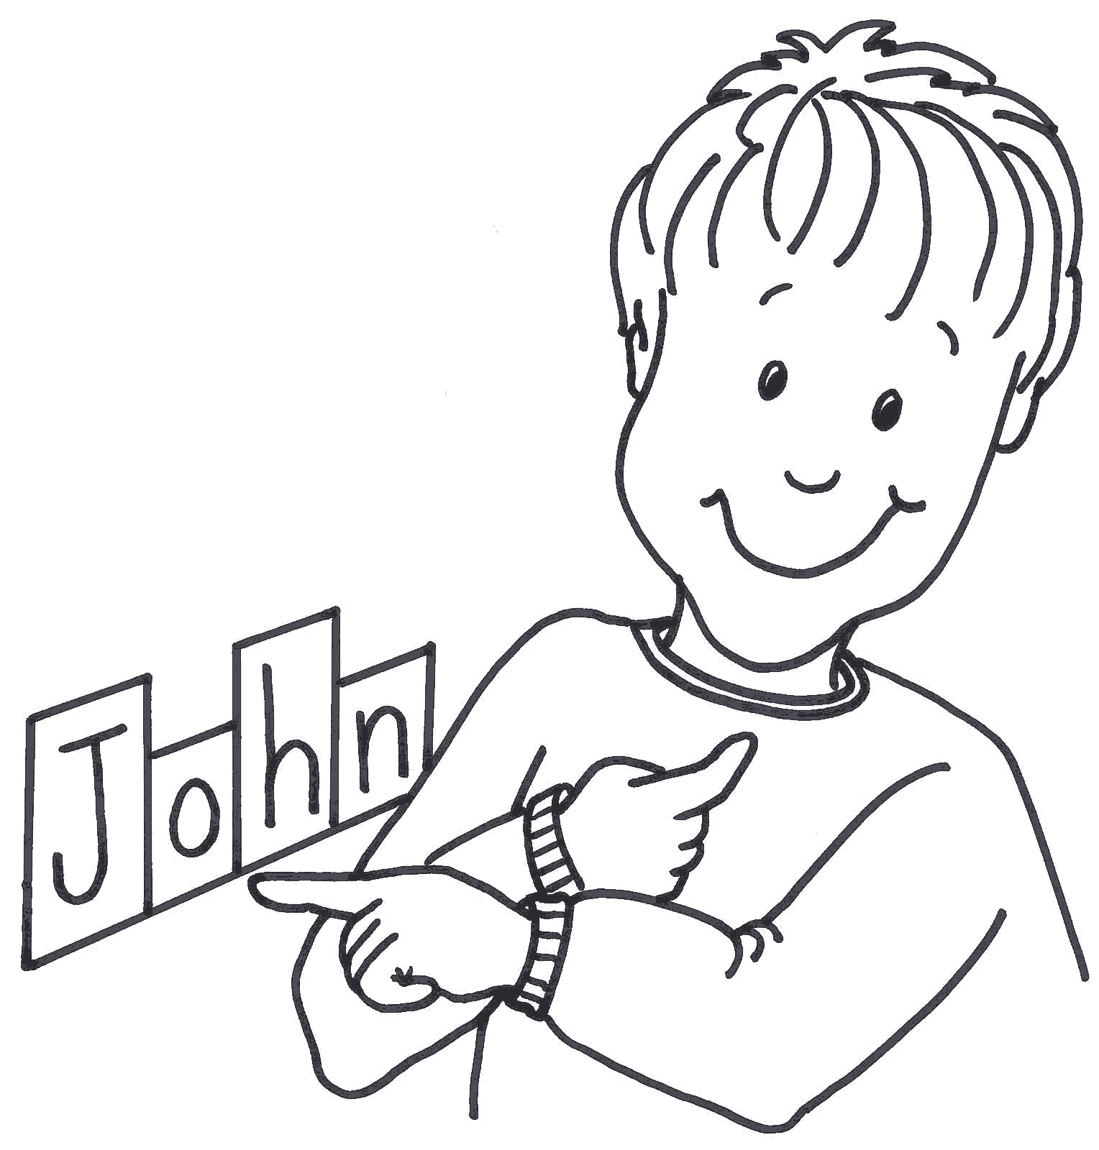
Give each scout a piece of paper. Have each write their name or some other word they like in large letters in the center of the page.
Outline each letter of the word with a line.
Repeat with different colors, making the word outline larger and larger as the individual letter outlines merge.
Fill the entire page with a rainbow of colors.



Five Dots

Give each Webelos Scout a piece of paper and have him place five dots on it wherever he pleases. He then gives the paper to another boy who tries to fit on it a drawing of a person with the head at one dot, the hands at two other dots, and the feet at the two remaining dots. The drawing may not be a simple stick figure.

Eyes-shut Drawing

Have the Scouts draw a picture of a clown, a car or some other object while blindfolded. Agree on the picture ahead of time and then blindfold the Scouts. Take up the pictures and see if the Scouts can identify their own rawing. You may have winners or no winners.

Outline or Wiggles

Have each Scout draw a wavy or zigzag line on paper. Have the boys exchange papers and make their line into a picture. The one with the best or funniest picture is the winner.

THE COLOR WHEEL
http://www.colorfaq.com


1. Primary colors - Add your 6 primary colors, warm and cool as above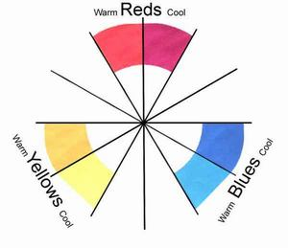

2. Adding Secondary colors
In the 2 slots in between each group
- Add a mix of Reds and Yellows, warm with warm, cool with cool
- Add a mix of Reds and Blues, warm with warm, cool with cool
- Add a mix of Blues and Yellows, warm with warm, cool with cool


3. Adding Tint - Add White to each color to give its Tint


4. Adding Shades
To make a shade of a color (darker), rather than adding Black paint you can add a little bit of it's opposite color on the color wheel.
This creates lots of other colors. Yellows become Yellow Ochre; Greens become Raw Umbers and Burnt Sienna.
- Add a tiny bit of the opposite color to your main color


Arrow of Light

Most second year Webelos would have completed Arrow of Light requirements and bridged to Boy Scouts in February or March. Those Packs that may have delayed the event should continue the program with their second year Webelos.

SPORTMAN



Sportsman Ideas

- Explain and discuss football signals.
- Invite a referee or umpire to talk with the den about signals and/or sportsmanship
- Parents and boys attend a high school or college football game.
- Go bowling as a den or at a district tournament if possible (belt loop)
- Have each boy list the sports in which he participated during the past year
- Attend a high school football/baseball game.
- Go fishing (belt loop)
- Decide on a demonstration for the pack meeting
- Learn a new sport.
- Learn what two individual and two team sports the boys will want to do.

HIDDEN SPORTS EQUIPMENT

Find the 18 hidden pieces of sports equipment in the picture below.

soccer ball - bowling ball - bowling pin - hockey stick and puck - croquet mallet - tennis racket - ice skates - roller blades – basketball – marbles – football – badminton – birdie - catcher’s mitt - golf club and ball – baseball - table tennis paddle

MARBLES

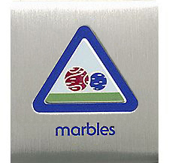

Belt Loop requirements:
- Explain the rules of Ringer or another marble game to your leader or adult partner
- Spend at least 30 minutes practicing skills to play the game of Ringer or another marble game.
- Participate in a game of marbles

Pin

Earn the Marbles belt loop, and complete five of the following requirements:
- Compete in a den, pack, or community marbles tournament
- Explain to an adult what lagging is. Demonstrate how to do it.
- Demonstrate the following shooting techniques: knuckling down, bowling, and lofting (also called plunking).
- Explain the correct way of scoring for a game of marbles.
- Play five complete matches of marbles using standard rules.
- Start a collection of marbles and show it at a den or pack meeting.
- Write a short report on the history of marbles and share it with your den or family.
- Explain the rules about shooters.

HOW TO PLAY RINGER

http://www.landofmarbles.com

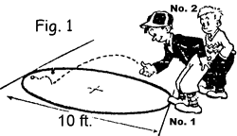
FIG. 1: To start a game of Ringer the children lag from a line, drawn tangent to the ring, to a parallel line across the ring, which would be 10 feet away. The child whose shooter comes nearest the line has the first shot. Players must lag before each game. Practice lagging, as the first shot may mean the winning of the game before your opponent gets a shot. In lagging, a child may toss his or her shooter to the other line, or he or she may knuckle down and shoot it.
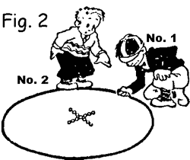
FIG. 2: This shows child No.1 who won the lag, preparing to knuckle down. His knuckle has not quite reached the ground, which is necessary before shooting. he can take any position about the ring he chooses. Notice how the 13 marbles in the ring are arranged at the start of the game.
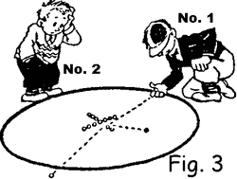
FIG. 3: child No.1 knocks a marble from the ring on his first shot and his shooter stays in the ring. He picks up the marble. As he has knocked one from the ring, he is entitled to another try. Players are not permitted to walk inside the ring unless their shooter comes to a stop inside the ring. Penalty is a fine of one marble.
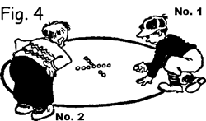
FIG. 4: Here we see child No. 1 continuing play. He "knuckles down" inside the ring where his shooter stopped on the last shot. This gives him the advantage of being nearer to the big group of marbles in the center of the ring for his next shot. Expert marble shots try to hit a marble, knock it out of ring and make their shooter "stick" in the spot.
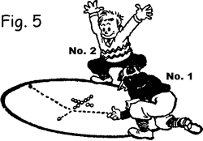
FIG 5: On this play, No.1 hit a marble, but did not knock it from the ring. At the same time his shooter, too, stays inside the ring. He can not pick up the marble, neither is he allowed to pick up his shooter. He must leave the shooter there until the other child has played.
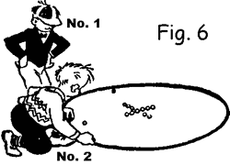
FIG. 6: child No. 2 may start by "knuckling down" anywhere at the ring edge. In this case he may shoot at the 11 marbles in the center or if he wishes, he may go to the other side and try for No.1's shooter or the marble that No.1 almost knocked from the ring.
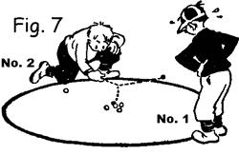
FIG. 7: child No.2 chooses to try for No. 1 child's shooter and knocks it out of ring, winning all the marbles No.1 has taken and putting No.1 out of that game. Or he could shoot as shown in Fig. 8.
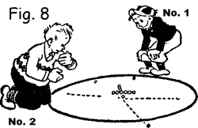
FIG. 8: child No.2 hits a marble but does not knock it out of the ring yet his shooter goes thru the ring and stops outside. The marble remains where it stopped in the ring, and as No.2 did not score, it is now the turn of No.1 to shoot again.
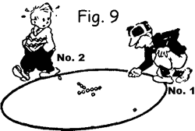
FIG. 9: No. 1 "knuckles down" inside the ring where his shooter stopped (Fig. 5). He is going to shoot at the marble nearest his shooter. By hitting it at the proper angle and knocking it from the ring he can get his shooter near the center of the ring for his next shot.

My Family Tree Ideas

My American Family Tree
Scouter Jim, Bountiful UT
We are all just branches of a family tree. Who we are, is in part, due to the roots of our family tree. I am a descendant of a humble soldier that spent the winter of 1777-1778 at Valley Forge, Pennsylvania with George Washington. The rest of his life he struggled from the effects of that winter on his body.
I am grandson of a farm boy, called by his country to travel half way around the world to fight the Huns in France. For several months he was missing in action after stepping on a Mustard gas bomb. His family did not know if he was dead or alive. During this time his mother, my great grandmother, died; never knowing her youngest son was still alive in a French hospital.
I am the nephew of seven veterans of World War II. One set of grandparents had three stars in their window, the other had four. These men served their country with honor, some in both theatres of the war, and returned home safely. Many others of their comrades did not.
I am the son of a Korean War Veteran who survived the horror of the Battle of Pork Chop Hill in July 1953. So many of his company were killed or wounded that an elite Ethiopian Unit fed him for a while. When his church, decades later, asked him to fast and give the money he would have used for food to donate to starving people in Ethiopia. By his donation in an attempt to repay his debt you would have thought he had planned to eat like a king that day.
These great men are the roots and branches of my family tree. I am not any more special that any other American. I just am lucky enough to know about my family tree. This month is a month to celebrate our heritage, and acknowledge those who have come before. Let us all take time to climb our Family Tree.

Go and See It-1G
Go to a library, historical society, museum, old farm, historical building or visit an older person in your community. Discover how life was the same, and how it was different for a boy your age many years ago.
The following ideas come from the York Adams Council PowWow book.
1. Share the family photo album. Identify special family members.
2. Share family histories and traditions.
3. Have a ‘families’ picnic. Get to know one another.
4. Have a group party. Use a holiday for theme. How about a Valentines Party in October?
5. Design and make a family tree. Share it with others in your den.
6. Design a family coat of arms. Have the Tiger include special areas of the family’s past.
7. Conduct your own ‘Family’ activity.

Family Tree Hidden Picture Puzzle
Santa Clara County Council
We found at least 10 faces in the picture below, how many can you find?

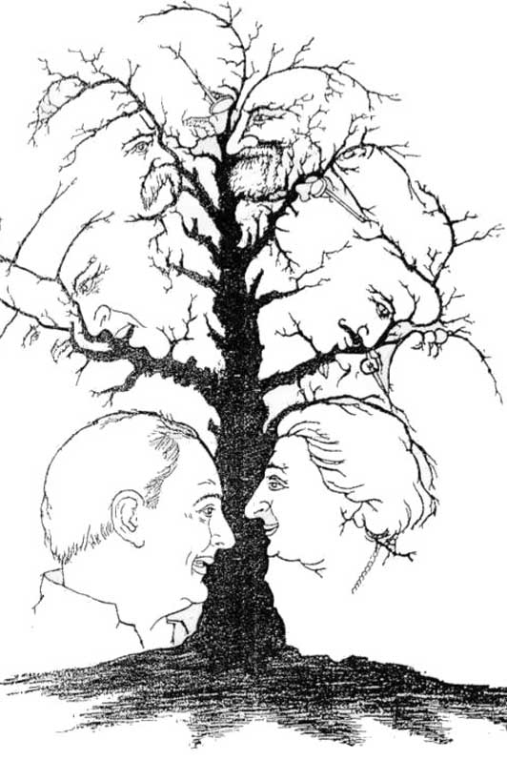

Family Tree Puzzle
Heart of America Council
AFFECTION ARGUMENTS CLOSENESS
COMFORT COMMUNE CONCERN
COZINESS DEVOTION DREAMS
ENJOY FOLKS FUN
HARMONY HELP HEREDITY
HOME HOPE JOYFUL
KIDS KIN LAUGHTER
LINE LOVE LOYALTY
MOM PAPA PEACEFUL
PLEASE PRIDE RELATE
RESPECT SHARE TEAM
TRAITS TRUST UNITY
WARMTH YOU

Family Tree Opening:
Santa Clara County Council
A family is like a strong and beautiful tree. The family’s faith in God are in its roots. The parents make up the trunk of our family tree, and the children are the branches. A poet named Helen Crawford made that comparison in a poem I would like to read to you. It’s called “The Family Tree” and it goes like this:
There’s one thing in God’s nature world that means a lot to me.
It symbolizes much of life; it is a lovely tree.
With roots so deep in God’s rich earth, it’s not disturbed by weather,
Like families with faith in God who live in peace together.
It’s trunk, the body strong and firm like parents everywhere,
To guide, control, direct, sustain the offspring which they bear.
The branches which like children spread in every known direction.
Until the fruits of their growth has reached it full perfection.
And so a tree appears to me the gem of God’s creation,
As it portrays our families which constitutes a nation.
Each of us can do our part to make our family tree stronger and more beautiful. How? By loving all the family members. Children can do it by obeying their parents, and parents showing love and fair play to their children. Let’s all resolve to strengthen out family ties.
.

GENEALOGICAL LIBRARY FIELD TRIP
Schedule a visit to your nearest genealogical library. If you cannot find one locally, check the yellow pages for The Church of Jesus Christ of Latter Day Saints. The LDS church owns the largest genealogical and family history center in the world and they open their centers to people of any denomination.
Files are archived in many different ways including computers and microfiche. Information is gathered from all over the world from other churches baptismal and christening records, census files, vital statistic records, immigration, and military resources too. Information is quite accurate and has record of over 200 million people dating back earlier than the 1500's.
Call ahead of time and arrange a tour. Given basic family information, the guide can assist you in finding information about your specific family branch. If available, take along your family tree so you can fill in any missing blanks on birth dates, birth place or marriage information, etc.

Climbing Your Family Tree,
A Beginners Guide to Genealogy
Scouter Jim, Bountiful UT
Start at the beginning. Start with you. Gather all the original records you can find on yourself, birth certificates, school records, photograph, and church records, whatever you have. Put a box in the middle of the front room. Whenever you come across any records that should be part of you personal or family history put that in the box. Leave it there for a few weeks while you gather information.
Work from the inside out. Each generation doubles in size. Genealogy is like a bull’s eye. Each generation is a circle, twice a large as the next. Work from the inside out means to progress from you to your parents, then grandparents and so on. Interview you Parents next. Gather all the information they have and copies of the original document they have.
At this point it may be wise to discuss different type of documents. There are primary documents and secondary document. Original documents are documents created at the time of the event. These are primary documents. Birth, marriage, and death certificates are examples of original or primary documents. These are the best and normally the most accurate. Secondary documents are documents created after the event. Family and local histories, newspapers articles, and other collected histories are examples of secondary documents. These documents are not always as accurate as primary documents.
As you build you family your family tree, don’t forget the bark. There is more to a family tree that names, dates, and places. There are also the lives of the people that are part of it. Interview older family members and record their life stories. Things they remember as children, memories of relatives long gone. These are the stories that give life and color to the family tree.
Don’t judge you ancestors. Every family tree has skeletons hanging from it. Owning slaves might be one of those family skeletons. These are also things that give the history color. Don’t leave out the dark portions of your family history; it is still part of what makes you who you are.
And finally don’t believe everything you read. As we grow older, sometimes we embellish the past. We claim credit, or are given credit for things we did not do. Histories are created from word of mouth sources as well as primary sources, and no one has a perfect memory
Happy Hunting!!

Family Trees
Santa Clara County Council
And Baltimore Area Council

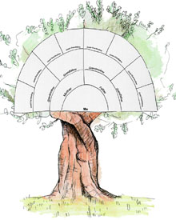
Give your Cubs a picture like either of the ones above and have them fill in the blanks. Tell them they should talk with relatives (Grandparents, Great-grandparents, Aunts, Uncles and such to get info like birth, baptism, wedding and death years

Family Mobile
Timucua District, North Florida Council
Instead of building a standard Family Tree, have your Cubs make mobiles. Illustrate a picture of each member of the family. Include the pet if the child has one. Cut out each family member. Glue each picture on strong paper or cardboard. Hang your pictures on a hanger with yarn or string to make a mobile. Print the last name on a piece of paper and fasten it to the hanger. Hang your mobile in the classroom.

Family Advancement
Baltimore Area Council
Personnel: Cubmaster
Now we’re ready to honor the boys who have achieved a new rank. Have you ever wondered why we call you and your parents up together when you get your awards? After all, it’s your award, right? Your Mom can’t wear a Wolf badge on her blouse and your Dad can’t wear Arrow Points on his suit coat. Well, stop and think about what you did to earn these awards. Who was there to help you, to cheer you, and to sign your book when you were working on your Bobcat, Wolf and Bear badges? I betcha’ it was Mom and Dad.
Because you work together as a family in Cub Scouts, we like to present your awards to your whole family. And because your parents are so proud of your work on your achievements, we give them the honor of awarding you your badges.
Would the following boys and their parents please come forward? (Call the names of the boys who have earned their Bobcat badge) With the help of your parents you have learned the Cub Scout promise, Motto, and the Law of the Pack, plus all the signs of Cub Scouting. In thanks, I’d like all you new Bobcats to give your parents the Cub Scout salute. (Give the parents the badges to present to their sons.) Congratulations.
Boys working on their Wolf badges work with their families to learn more about how they worship God, how to play games and have fun together, and how to work together around the house. Would the following boys and their parents please come forward? (Call the names of the boys who receive their Wolf badges.) I’d like for each of you
to thank your parents for their help by giving them a Cub Scout handshake. (Give the badges to the parents to present to their sons.) Good work, guys.
Boys working on their Bear badges have a opportunity to explore with their families the great outdoors, household repairs, family finances, the family tree and making the family some of their favorite treats. Would the following boys and their parents please come forward? (Call the names of the boys who have earned the Bear badge.) Your parents have been a lot of help so far in your Cub Scouting career. I think they deserve a great big Cub Scout salute in thanks, don’t you? (Give the badges to the parents to present to their sons.) Bravo, Bears.
Webelos Scouts start depending more and more on their leaders and themselves to complete the requirements for their activity pins, but can still use some help at home. By the time a boy reaches Webelos Scout age, his parents have spent a lot of quality time helping them in their Scouting activities and families have had many opportunities to work together and play together. We’d like to recognize now the boys who have earned activity pins this month. (Call the names of the boys and the awards they have earned. Have the boys line up in front of the audience as you pass out the activity pins.) For all the time and help your parents have given these past years, I think it would be nice if you gave your parents a round of applause. (Lead the boys in giving “round of applause”.)
The following boys have earned their Webelos badges of rank. Would they and their parents please come forward? (Read the names of the boys who are to be presented their Webelos badges.) To earn these badges, these boys have explored the meaning of what it is to be a Boy Scout. To be a good sport, a good friend, a good citizen is what your parents want for you. That is why they let you join Cub Scouting and that is why they have stood by you and helped you in your advancement and other activities. Would you please thank your parents now by giving them a Boy Scout handshake? And now it’s your parents’ turn to honor you. (Give badges to parents so that they may present them to their sons.) Congratulations, Webelos!
The Arrow of Light is the highest honor we can bestow on Webelos Scouts. To earn it takes real dedication on the part of the boys to continue to participate in the Scouting program and to make decisions in their lives that will help them grow into men their families, friends, and country can depend on. It is with real pride that we present these awards tonight. Would the following boys and their parents please come forward? (Call the names of the Arrow of Light recipients.) We know your parents are behind you 100% and we would like to give you an opportunity to thank them for their support. I think they deserve a big hug and I know that they are bursting with pride for you and would appreciate being able to tell you so in this way. ( Let the boys hug their parents and then give the parents the Arrow of Light badges to present to their sons.) Good work, Webelos.

Faith Ideas

Native American Prayer
For that solemn moment towards the end of Den or Pack meeting, try this Native American Prayer:
Morning Star wake us, filled with joy.
To new days of growing to man from boy.
Sun, with your power, give us light.
That we can tell wrong and do what is right.
South Wind, we ask, in your gentle way.
Blow us the willingness of obey.
North Wind, we ask, live up to thy name.
Send us the strength to always be game.
East Wind, we ask, with your breath so snappy.
Fill us with knowledge of how to be happy.
West Wind, we ask, blow all that is fair.
To us, that we may always be square.
Moon, that fills the night with red light.
Guard us well while we sleep in the night.
Akela, please guide us in every way.
We'll follow your trail in work or play.

The Founder's Prayer
"Father of us all, we meet before Thee here today, numerous in the lands we come from and in the races we represent, but one in our Brotherhood under Thy Divine Fatherhood.
We come before Thee with hearts grateful and gladdened by the many blessings Thou hast granted us and thankful that our Movement has prospered as acceptable in Thy sight. In return we would lay on Thine Altar, as our humble thank-offering, such sacrifice as we can make of self in service to others. We ask that during our communion here together we may, under Thy Divine Inspiration, gain a widened outlook, a clearer vision of all that lies open before us and of our opportunity. Thus we may then go forth with strengthened faith to carry on our mission of heightening the ideals and powers of manhood, and of helping through closer understanding to bring about Thy happier Rule of Peace and Goodwill upon Earth."
Written by Robert Stephenson Baden-Powell
for use in international events.

Two Prayers
Pamela, North Florida Council
Last night my son confessed to me
Some childish wrong
And kneeling at my knee
He prayed with tears:
“Dear God, make me a man
Like Daddy - wise and strong,
I know you can.”
Then while he slept
I knelt beside his bed,
And prayed with low-bowed head:
“O, God, make me a child
Like my child here,
Pure, Guileless
Trusting Thee with faith sincere.”
Andrew Gillies, 1870-1942

Religious Emblems Gathering Activity
2011-2012 CS RT Planning Guide
Preparations: Enlarged copies of the religious emblems for Cub Scouts. The emblems are available in the Insignia Guide, Duty to God brochure, or the boys’ handbooks. Cut apart the emblems and post them in various parts of the room. Make sure to keep together the picture of the medal, name of the program, and faith. On sheets of paper, copy only the religious emblems (without the name of the program or faith).
As people arrive, give each person a sheet with the emblems printed on it. Instruct them to go around the room and find the symbol and read the name of the program and faith. Encourage people to help each other find all the emblems. Instruct them to go around the room and find the symbol and read the name of the program and faith. Encourage people to help each other find all the emblems.

Emblems of Faith Puzzles
Commissioner Dave
Materials: Pictures of Religious Awards printed on card stock or pasted to thin cardboard..
- Cut the pictures into puzzle pieces - 4 or 6 per card.
- Give the boys puzzle pieces as they arrive.
- Have them try and complete the puzzle by talking with others and finding the others pieces.
- During Icebreaker have them show the completed puzzle and read the back. (Have tape available)

Faith Word Search
Alice, Golden Empire Council
Words in this search all pertain to Faith –
words may be in any direction.
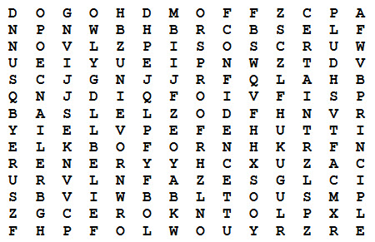
Belief Principle Certain
Proof Confidence Reliance
Friends Religion God
Self Hope Sure
Loyalty Trust

Gathering Ideas from Alice
Alice, Golden Empire Council
Gather a collection of Religious Award workbooks from different faiths – your District Executive or local scout shop might be able to help with this. Encourage parents to use the workbook published for their faith to help the boys complete the BSA Religious Award.
Invite local Boy Scouts who have earned their BSA Religious award to visit - ask them to share what they did to earn the award, what affect it had on their life, what cub scouts can do to prepare to honor their faith.
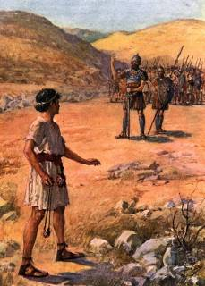
Choose a painting of a story that demonstrates faith and share it with the boys. You might choose a well-known one such as David and Goliath from the Bible, or even a picture of a news event that shows faith in action. Let the boys tell the story if they are familiar with it, and talk about how it shows faith. What would they do in the same situation? Is it always easy to have faith? To do the right thing? What if you have to stand up to your friends?

Faith Bingo
Commissioner Dave
Give each person a Board. They are to go around and meet people. After meeting someone and learning their name, they are to ask them to sign a box. Each person can only sign one box!!! This is not a speed contest; there should be discussion and introduction before signing!! Here is a sample board- boxes may be changed to suit your group
Be sure to enlarge the BINGO Board to fill a sheet of paper and put some directions on the sheet, too.

Faith Opening
2011-2012 CS RT Planning Guide
Materials: Five large cards with letters to spell out “faith” on one side and script on the other
- F is to follow. We follow the beliefs of our faith and practice them with our family.
- A is to act. We act in ways that show our love and faith.
- I is to involve. We involve ourselves in helping others with service projects and learning about our faith.
- T is to thank. We thank our God for our families, our friends, and all that he has given us.
- H is to hope. We hope for a better world as we practice our faith.

Where Faith is Found Opening
Alice, Golden Empire Council
Materials: Have each boy make a sign to hold with the letter he has been assigned. Alternately, you can simply download images or make letter signs. Write each boy’s part on the back of the sign in large letters.
Narrator: This month we have been learning all about Faith – see if you recognize these examples of where Faith is Found.
 | Cub #1: (holding up letter or posting on the wall) Follow the example of your religious leaders, your grandparents, or others who have great faith – it will help you find your own Faith.
 | Cub #2: (holding up letter x` or posting on the wall) Always look for examples of faith as you enjoy the outdoors – like the breeze, faith cannot be seen – but you can feel its presence.
 | Cub #3: (holding up letter or posting on the wall) If you want to have faith, learn to serve others – without complaining.
 | Cub #4: (holding up letter or posting on the wall) Trust in your God, your Country and Yourself – And always be a person that can BE trusted if you want to find Faith.
 | Cub #5: (holding up letter or posting on the wall) How you ACT will show what you really believe.  (All boys return and hold up their letters)  All: SHOW YOUR FAITH!
Narrator: As you can see, the boys have learned some important ways to really SHOW their faith. And we’d like you to join us in Showing how we feel about our Country – where every person can follow their own faith, and worship as they please…..
(Lead into the Flag Ceremony)

Faith Based Stories
http://scouts.org.uk/documents/Magazine/decjan_09/beavdecjan09.pdf
There are many stories that relate to the Beaver Scout (US - Cub Scout) Promise, and which come from the many faiths that make up our nation’s identity. Here is a snapshot:
    - The Good Samaritan (Christianity). The classic tale of the man from Samaria who, unlike the others who passed by, helped a man in desperate need. www.tinyurl.com/l9rdd8
    - The snake in the wall (Judaism). A tale about a girl who was especially kind and helpful and who was rewarded with her life. www.tinyurl.com/l3oqju
    - A brother like that (Islam). A modern parable about thinking of others and being kind. www.tinyurl.com/lofm36
    - Six blind men and the elephant (Hinduism) A great poem about how you shouldn’t make decisions based on one piece of evidence. www.tinyurl.com/ly89f5
Read some of these stories to the Beaver Scouts (US - Cub Scouts) and they can then act them out in small groups or draw the story for themselves in cartoon form.

A True Story about a Scout and his Faith
www.donnfendler.com
In 1939, twelve year old Donn Fendler was hiking to the summit of Maine’s highest mountain when he became separated from his family. A dark storm enveloped the peak of mile high Mt. Katahdin, and he quickly lost his way.
He spent nine long days and nights in that rugged wilderness, all alone except for the wildlife he encountered as he tried to find his way out. Meanwhile, the entire state prayed for him – while hundreds of brave citizens and blood hounds searched the mountain. It was those prayers, Donn’s courage and faith, his Scout training, and his will to live that got him through the ordeal.
After a quick recovery from malnutrition and hundreds of scrapes, cuts and insect bites, Donn was honored with a huge parade in Millinocket, Maine. He also met the President of the United States and was the subject of a story in Life Magazine. But the greatest tribute to his faith and courage was the publication of “Lost on a Mountain in Maine” – the story of Donn Fendler as told by Joseph Egan – and enjoyed for almost 70 years.
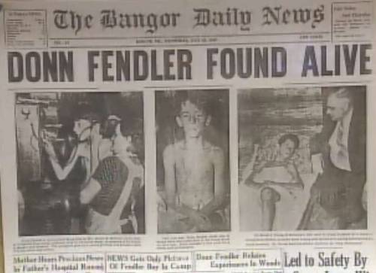
Donn Fendler is now living in Tennessee. He still summers in Maine, but remains for a few weeks in the Fall so he can visit schools across the state to share his story and answer kid’s questions about his incredible experience. His memories are vivid, and he always has a positive message for children about faith, courage, being prepared, and having the will to live.
Since his brush with death in Baxter State Park more than seventy years ago, Donn Fendler has received thousands of letters, mostly from Maine school children, which he always answers. He still visits many schools every year. He attended the University of Main and is retired from the U.S. Army.
Donn says his book was not dedicated to anybody, but if he was to dedicate the book today, it would be to the Boy Scouts of America. His appreciation of scouting is shown in his active involvement in scouting and in his giving credit to his scout training in helping him survive. He attained the rank of Life Scout.
Don’t forget to check in your pack and local area – it’s very possible you have a local example of faith that could be shared!

A True Story of Faith for LDS Scouts
Alice, Golden Empire Council
The story of how the Arnold Friberg paintings came to be used in the missionary copies of the Book of Mormon is an example of Faith:
First, the faith of Adele Cannon Howells, General Primary President in 1950. She felt strongly that Friberg’s paintings could be used to give a concrete picture of faith for the Primary children. But church leaders were unwilling to fund the project, so with great faith she sold her own household possessions to pay the commission – and died before even one was actually completed.
Secondly, each painting is a visual story of Faith – you might let each boy choose one picture to study.
And since each boy is to have at least two opportunities to show his Faith in God work each year, you might have the boys share their favorite art work and story in Primary or at the Pack meeting during the month
Note: I like to gather all twelve of the paintings (they are in the GAK picture kit, and often hang on the walls of LDS buildings) Then I challenge each boy to choose his favorite story, read more about it and share what he thinks. I also like to share Arnold Friberg’s own words about why he painted the scenes the way he did. This will fulfill the requirement to “share a story of faith” on page 6 of the Faith in God Book for LDS boys. Alice
And there’s even MORE to the story of one painting – “Abinadi Before King Noah” – the model for old man Abinadi was the elderly man who suddenly appeared at Friberg’s door when he was searching for a model for Abinadi – the same man who years before had converted the Friberg family as a young elder.
If you would like more details on how I use this lesson, feel free to contact Alice at aretzinger@hotmail.com

Faith Audience Participation Story
Wendy (of Chief Seattle)’s version of an old joke
Divide the audience in half. Assign a word and a response to each side of the group. Have them practice as you make assignments.
Water:
say “glug, glug, glug” while slowly standing up
Man:
say “help, help!” and wave arms above head
It had been raining for days and days, and a terrible flood had come over the land. The waters rose so high that one man was forced to climb onto the roof of his house.
As the waters rose higher and higher, a sailor in a rowboat appeared, and told him to get in. "No," replied the man on the roof. "I have faith in the Lord; the Lord will save me." So the sailor in the rowboat went away. The man on the roof prayed for God to save him.
The waters rose higher and higher, and suddenly a speedboat appeared. "Climb in!" shouted a woman in the boat. "No," replied the man on the roof. "I have faith in the Lord; the Lord will save me." So the woman in the speedboat went away. The man on the roof prayed for God to save him.
The waters continued to rise. A helicopter appeared and over the loudspeaker, the pilot announced he would lower a rope. "No," replied the man on the roof. "I have faith in the Lord; the Lord will save me." So the helicopter went away. And the man on the roof prayed for God to save him.
The waters rose higher and higher, and eventually they rose so high that the man on the roof was washed away into the water, where alas, he drowned.
Upon arriving in heaven, the man marched straight over to God. "Heavenly Father," he said, "I had faith in you, I prayed to you to save me, and yet you did nothing. Why?" God gave him a puzzled look, and replied "I sent you two boats and a helicopter, what more did you expect?"
Moral #1: Looking through the eyes of faith we can see God’s miracles, which may be disguised as coincidences and ordinary, everyday occurrences, and be grateful for the many small miracles around us.
Moral #2: We need to see with the eyes of faith, so we can recognize when God is trying to help us, and do our part.

Faith Advancement Ceremony
Alice, Golden Empire Council
This ceremony can be done using either fire building, cooking or gardening materials. Gather gardening, fire building, or cooking materials to use as props. You could either use just one type of material, or you could use gardening materials for the Tigers and Wolf den boys, Cooking materials for Bears and Fire Building materials for Webelos/Arrow of Light boys.
Each boy’s advancement items should be placed under (or in) an item, then brought out as the boys and their parents are called up. For example:
Cubmaster: (pointing to gardening equipment) The boys in the Tiger den have been learning all about Faith this month - They planted some seeds – and watched them grow. I’d like to call up____and his parents. (holds up seed packet and removes advancements – gives parent pin to boy to present, and advancement to parents to present to boy) ….
Continue calling up and presenting awards –
You could also make comparisons to the planting directions (scriptures), trowel (to prepare the soil), watering can (need to nourish faith), etc.
If using cooking materials, use Recipe as Scriptures, Baking Powder or yeast as the way to raise the dough, mixing or kneading as the way to practice faith, etc.
With Fire building materials, Shovel to prepare the area, tinder as first stirrings of faith, then kindling and fuel; you could also include a match as the “spark” that activates, and the need for air to keep fire going.

North Star Advancement Ceremony
2011-2012 CS RT Planning Guide
CUBMASTER: For thousands of years, men have known that the North Star is fixed. Shepherds knew it before the time of Christ, and seamen have used the North Star and other heavenly bodies to guide their ships to port ever since they first dared leave the sight of land. Even today, the North Star guides many travelers to help find their way.
Cub Scouts don’t need stars to find their way. But we do have our own guiding stars to help us through life. They are your church and your school, for instance. In Cub Scouting, our navigational aids are the Promise and the Law of the Pack. They tell us how we should act and what we should do for ourselves and for others. The Cub Scout Promise and the Law of the Pack are just like the stars by which the seaman steered his ship.
Tonight we honor the Cub Scouts who are navigating straight and true on the Cub Scouting trail. With their parents’ help, they have completed requirements for many awards and have shown that they live by the Promise and the Law. (For each award, give a brief explanation of the award and call forward the recipients and parents. Present the awards to parents so they can present them to their sons.) Lead Cheer!!

Recognition Religious Emblem Square Knots
2011-2012 CS RT Planning Guide
Materials: Religious emblem square knots
Cubmaster: When a Cub Scout recites the Cub Scout Promise, he promises to do his duty to God. Tonight the following Cub Scouts have kept their promise by completing the requirements for the religious emblem of their respective religious institutions. (Call the boys and families forward.)
Assistant CM: As you can see, these boys have already received a medal from their religious institution in recognition of their achievement. These are not Scouting awards. The religious bodies in the United States have programs to recognize members of youth organizations such as the Boy Scouts of America and the Girl Scouts of the U.S.A., who demonstrate faith, observe their creeds or principles, and give service. Scouting recognizes this achievement by presenting them with this square knot to place above the left pocket of the uniform shirt. This knot is so special that a boy can wear it on his Boy Scout uniform and adult uniform as he grows older.
Cubmaster: Because parents play an important role in guiding their children in their religious growth, I’ll ask the parents to present the religious emblem knots to their sons. (Parents present the knots to their sons.)
Congratulations! Lead Cheer!

Faith Is.... Song
Alice, Golden Empire Council
(Tune: Row, Row, Row Your Boat)
Each day the Sun will Rise,
Each night will bring the Moon,
The seasons too will come and go,
As Midnight follows Noon
Each seed can also grow,
When planted in the soil,
With water, sun and fertile earth,
And a gardener to toil
Winds blow upon the earth,
Unseen by human eyes
But on my cheek I feel the breeze
And that’s a solid prize
Just like the tiny seed
Your faith can also grow,
By every kind and trusting deed
With actions you can show.....
Faith, too cannot be held,
Its color does not show,
But when you walk in humble faith,
There is no doubt, you KNOW

Kumbaya Song
Baloo's Archives
Kumbaya, Lord, kumbaya
Kumbaya, Lord, kumbaya
Kumbaya, Lord, kumbaya
Oh, Lord, kumbaya
Someone's prayin', Lord, kumbaya
Someone's prayin', Lord, kumbaya
Someone's prayin', Lord, kumbaya
Oh, Lord, kumbaya
Someone's singin', Lord, kumbaya
Someone's singin', Lord, kumbaya
Someone's singin', Lord, kumbaya
Oh, Lord, kumbaya
Kumbaya, Lord, kumbaya
Kumbaya, Lord, kumbaya
Kumbaya, Lord, kumbaya
Oh, Lord, kumbaya
Oh, Lord, kumbaya
Oh, Lord, kumbaya

He's Got The Whole World In His Hands Song
Traditional
He's got the whole world in His hands,
He's got the whole world in His hands,
He's got the whole world in His hands,
He's got the whole world in His hands.
He's got my brothers and my sisters in His hands,
He's got my brothers and my sisters in His hands,
He's got my brothers and my sisters in His hands,
He's got the whole world in His hands.
He's got the sun and the rain in His hands,
He's got the moon and the stars in His hands,
He's got the wind and the clouds in His hands,
He's got the whole world in His hands.
He's got the rivers and the mountains in His hands,
He's got the oceans and the seas in His hands,
He's got you and he's got me in His hands,
He's got the whole world in His hands.
He's got everybody here in His hands,
He's got everybody there in His hands,
He's got everybody everywhere in His hands,
He's got the whole world in His hands.

For The Beauty Of The Earth Hymn
Alice, Golden Empire Council
For the beauty of the earth,
For the glory of the skies,
For the love which from our birth
Over and around us lies:
Lord of all, to Thee we raise
This our hymn of grateful praise.
For the beauty of each hour
Of the day and of the night,
Hill and vale, and tree and flower,
Sun and moon and stars of light:
Lord of all, to Thee we raise
This our hymn of grateful praise.

Faith Is Applause:
Alice, Golden Empire Council
(This is a repeat after me applause)
The Sun will rise (Audience repeats)
The Seed will grow (Audience Repeats)
The Wind will blow (Audience Repeats)
I KNOW! (Audience Repeats Three Times)

Praying RUN-ON
Alice, Golden Empire Council
Have a boy walking across the stage, praying as he goes - "Dear God, I didn't think orange went very well with purple until I saw the sunset you made on Tuesday. That was really extra cool. Eugene."

A Gardener’s Faith Skit
Alice, Golden Empire Council
I numbered the boys, and I made them Tigers – but just adapt to the rank and number of boys you have. If you have real props, that would be great – and some farmer hats or costumes would be great, too. But a good imagination and some real “acting out” – making big motions – can also tell the story – you could even add sound effects! Alice
Narrator: Any farmer can tell you that it takes a lot of Faith to grow things – faith that in spite of sudden storms, wind, hail, drought, and everything else that can come along – you plant those seeds and have FAITH they will turn into bumper crops! So these young Tiger scouts are no different:
Tiger #1: I’ve got the packet of seeds to plant.
Tiger #2: I’ve got the shovel to turn over the earth.
Tiger #3: I’ve got the string to mark the rows.
Tiger #4: I’ve got the watering can to water our seeds.
Parent or Leader: OK, boys, first we need to turn over the dirt – great job!
(Boys make a show of digging, wiping their foreheads)
All: Boy this is hard work – I sure am thirsty!
Parent or Leader: OK, we’ll take a break to get a drink……(Boys get a drink)…..Well, time to get back to work – we have to mark the rows!
Tiger #5: How do we do this?
Tiger #6: Find some sticks – we have to have one at each end of the rows.
Tiger #7: Be sure it’s straight. Make a hole for each seed.
(Everyone makes a show of poking a finger in the ground, then dropping a seed in and covering it with dirt)
Tiger #4: OK – time to water our seeds. (He makes a show of walking along and watering.
Parent or Leader: Great job, boys – now all we need is sun, and regular watering, and weeding – and we’ll soon have all kinds of great food!
Tiger #1: Hey talking about food – all this work made me hungry – let’s get a snack.
(Everyone begins to walk off, but one Tiger says to another)
Tiger #3: Just think - by next week, we can have some carrots to munch on!
Parent or Leader: (Rolling eyes and looking toward audience) Now, that’s FAITH for you!
You could use the same kind of idea, but make the skit about catching a fish, or making a cake. Alice

Cookies of Faith Skit
Alice, Golden Empire Council
Use the scriptures in Cub Grub, and take turns “adding” ingredients after finding out what they are by finding the scripture. Start out by reading from a REALLY large recipe book (great place to hide the script). Follow every step, including turning on the oven. You could really ham it up, with paper chef hats an extra large bowl and spoon to stir with. Pretend to put your cookies on a large cookie sheet, then into an “oven” (cardboard box). Set the timer, then have someone make the sound of it ringing. Then make a great show of taking the cookies out of the oven, using the spatula to take them off the cookie sheet, waiting for them to cool, then taking a big bite and saying – YUMMMM!
If you want some real applause, finish up by giving everyone in the audience a cookie that you made earlier!

Faith Based Four Corners Game
A Baloo Original
- Label each of the four corners of the hall with an icon from a different faith (e.g. Christianity - cross, Judaism - Star of David, Hinduism- Om and Islam-Crescent.)
- Have a stack of cards, each with a word or saying related to one of the four faiths you posted in the corners.
- Take the top card and call out the fact written on it.
- Tell the Scouts to go to the corner with the emblem of the faith to which the fact relates.
- The Scouts then run to the corner of the room they think is correct.
After writing your cards, you may wish to review some things before beginning the game to make sure everyone has a fair chance at the game
Alternate #1 -
Play like regular Four Corners. Just using the four symbols.
Other Alternate Ideas for cards - Such as:
- Religious Leaders - Brahmins (Hindu), Imams (Islam), Rabbis (Jewish), Pastors, Priests, vicars (Christianity)
- Clothing - Kacch, white shorts (Sikhs), Yarmulkes, a little cap that covers the crown of the head, as a mark of respect for God (Jewish).
- Festivals - Pesach or Passover, a festival held in March or April (Jewish), Pentecost (Christian), Ramadan (Islam), Eid Al-Adha (Muslim)
- Places of Worship - Mosques (Muslims), Temples (Jewish), Churches (Christian)
- Important Cities - Jerusalem (Jewish, Christian, Islam, Muslim). Mecca (Islam), Rome (Catholic)

True Blue A game about Faith and Trust.
Alice, Golden Empire Council
Materials: Cards with various situations on them; Red and Blue Poker-type chips, or a piece of paper and pencil to keep score.
Optional: Cut out some blue circles, or use colored adhesive dots and give each person a piece of paper to put their dots on and keep their own score.
Directions: Explain the game. Each person is trying to get as many points as possible. Points are earned according to what it says on the cards. Each card has a different situation where a choice would have to be made about the right thing to do.
If the card says you made the right choice, you earn blue dots (or chips). If you are using red and blue chips, you also give red chips for wrong choices and blue ones for right choices, as indicated on the card.
If you have only adhesive dots, give them out when a right choice is made – if a wrong choice is made, either take back the dots or cross them out with a marker.
The cards can be drawn from a stack, or taped to the wall and chosen by each boy in turn. The consequence, good or bad, is listed on the card.
Before you begin, give each boy a “free” blue dot, or chip or point – explain that when you meet someone for the first time, they will GIVE you trust – but then you have to EARN their trust from then on. And you can lose that trust if you don’t tell the truth or do something that makes it hard for them to trust you.
True Blue is like that too – you will GIVE a little trust, and they must EARN the rest.
Below are some sample cards:
Your Dad says he will give you a dollar to get some candy.  But he gives you $2 by mistake, and you spend it all!  Lose 2 points or get 2 red dots. | Your Dad says he will give you a dollar to get some candy.  But he gives you $2 by mistake, and you spend it all!  Earn 2 blue chips, dots Or points
The referee doesn’t see a foul you made.  You admit it and take the consequence.  Earn 3 blue chips, dots or points | You have to finish your homework before play – You say you’re done so you can play – you’ll finish later.  Lose 2 points or get 3 red dots
Your friend asks you to tell him the right answer on a test. You write it down and pass it to him.  Lose 3 points | Everyone is making fun of a new boy who wears a headpiece. You choose him for your team.  Earn 3 points
The Den Leader asks if you did the assigned homework. You admit you only did part of it.  Earn 2 points | The Den Leader asks if you were there the day they did an arrow  point activity – you lie and say yes.  Lose 3 points
Your Mom gives you credit for raking the leaves –but your brother did the job.  You take the cookies she offers as reward.  Lose 2 points | Your Mom gives you credit for raking the leaves –but your brother actually did it.  You take the cookies she offers as reward.  Earn 3 points
You already had your treat; your leader gives you another and you take it – no one saw you eat it.  Lose 2 points. | There’s a bowl of M&M’s on the table for a den game – you grab some when no one is looking.  Lose 2 points
A new boy joins the den – he stutters, so you don’t want to be his buddy.  Lose 3 points | A new boy who is really shy joins the den – you volunteer to be his buddy and help him earn Bobcat.  Earn 4 points
For this game to be most effective, talk about the ideas and responses after you play the game. Ask how boys would feel if they were in that situation. What would they do? Say?
In the game, each boy drew a card to earn or lost trust – what happens in real life?
What happens when people learn they can trust you? What if they can’t always trust you or count on you?
Which card situation would be hardest? Why? How does this relate to real life? What is one thing you are going to do today to help other people trust you?

True Blue Skit Idea:
You could use any of the scenarios above and have the boys act them out. You could ask the audience to vote on what the boy should do and toss out confetti or even small candies when they make the right choice.

Unravel the Knot Game
Alice, Golden Empire Council
In a circle, people put their arms in and hold someone else's hand, then try to unravel the knot without letting go of hands. Remind the boys that when you have Faith in Something or Someone, you don’t want to let go!

Baden-Powell Closing
Alice, Golden Empire Council
Cubmaster: As we prepare to close this meeting, I’d like to quote something Baden-Powell had to say about religion and faith.
“Religion, briefly explained, means: First: know who God is; Second: use to the best the life He gave us, and do what He expects from us. This means mostly doing something for the others."
- In our families we should spend time learning to know who God is.
- And in Scouting, we need to “Do Our Best” with what God gave each of us.
- We need to spend more of our time doing something for others.
- Our flag is a symbol of men and women who have sacrificed for others – and some who have given their lives.
- There’s a special way to say “Thank you” whenever we see someone from the military – just put your hand by your heart and then bring it down in front of you, like this – (Cub demonstrates)
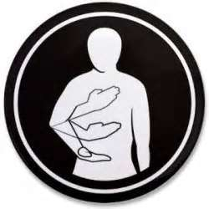
- Will the audience please rise….(Go into the flag retrieval ceremony)
Note: This could also be used as an Opening Ceremony with just a change of wording at the beginning, and changing to the flag posting ceremony. Alice

Beatitudes for Cubs
Commissioner Dave
Materials: Make sure everyone has a copy of the Closing. Explain the leader will say the first part and the audience will respond.
Leader: Blessed are the Scouts, who are taught to see beauty in all things around them,
Scouts: For their world will be a place of grace and wonder.
Leader: Blessed are the Scouts, who are led with patience understanding,
Scouts: For they will learn the strength of endurance and the gift of tolerance.
Leader: Blessed are the Scouts, who are provided a home where family members dwell in harmony and close communication,
Scouts: For they shall became the peacemakers of the world.
Leader: Blessed are the Scouts, who are taught the value and power of truth,
Scouts: For they search for knowledge and use it with wisdom and discernment.
Leader: Blessed are the Scouts, who are loved and know that they are loved,
Scouts: For they shall sow seeds of love in the world and reap joy for themselves and others.
All Amen

Great Master We Give Thanks Ceremony
Boys in an inner circle, hands across chest. Adults in an outer circle behind the boys, hands across chest.
1st Den: For all the food that the Great Master provides for us we give thanks.
2nd Den: For all the beauty that the Great Master surrounds us, we give thanks.
3rd Den: For all of our parents and leaders who guide us, Great Master, we give thanks.
Cubmaster and Adults Together: (extend arms)
And now Great Master guide us in love and friendship until we meet again.

North Star Cubmaster’s Minute
2011-2012 CS RT Planning Guide
We all enjoy gazing at the stars in the sky. Stars are especially beautiful when you are away from the city lights. Among all those stars, there is a special one. That’s the North Star. It is special because while the positions of other stars change throughout the night, the North Star remains constant. Since ancient times, the star has been used for navigation and has guided people on their journeys on land and sea. Just like your faith. Your faith guides you on your journey throughout your life.

Baden-Powell on Faith Cubmaster’s Minute
Alice, Golden Empire Council
Baden-Powell was totally unembarrassed about the role of faith in character-building. At the heart of the Scouting and Guiding promises was their ‘duty to God’. When dealing with conflicts in the Scouting movement, B.P. recommended that people "...ask themselves the simple question, ‘What would Christ have done under the circumstances?’ and be guided accordingly." Baden-Powell saw a danger in Scouting that the recreational might overwhelm the spiritual side. So he wrote them… "Don’t let the technical outweigh the moral. Field efficiency, backwoodsmanship, camping, hiking, good turns, Jamboree comradeships are all means, not the end. The end is CHARACTER --character with a purpose...the active service of Love and Duty to God and neighbour."

Gold Medal Faith Cubmaster’s Minute
Wendy, Chief Seattle Council
For months, Eric Liddell trained with his heart set on winning the 100 meter race at the Olympics of 1924. Many sportswriters predicted he would win. At the games, however, Liddell learned that the 100 meter race was scheduled to be run on a Sunday. This posed a major problem for him, because Liddell did not believe he could honor God by running on the Lord’s Day. He bowed out of the race and his fans were stunned. Some who had praised him in the past now called him a fool. He came under intense pressure to change his mind, but Liddell stood firm.
Then a runner dropped out of the 400 meter race, which was scheduled on a week day, and Liddell offered to fill the slot. This was not really “his race” – the distance was four times as long as the race for which he had trained diligently. Even so, Liddell crossed the tape as victor and set a record of 47.6 seconds in the process. He had earned an Olympic gold medal…and made an uncompromising stand for his faith.
Liddell went on to become a missionary in China, where he died in a war camp in 1945. He lives in history as a man known more for his inner mettle that for his gold medal.-- From “God’s Little Devotional Book for Men,” p. 159.

The Rabbi & The Soap Maker Cubmaster’s Minute
San Gabriel, Long Beach Area, Verdugo Hills Councils
A Rabbi and a soap maker were walking along and the soap maker questioned the Rabbi by asking, "What good is religion? There's been religion for a long time, but people are still bad to each other." The Rabbi was silent until they saw a boy who was dirty from playing in the street. The Rabbi asked the soap maker, “What good is soap? We've had soap for many, many years and people still get dirty.” The soap maker protested the comparison and insisted that the soap had to be used in order to keep people clean. "Exactly my point," said the Rabbi. "Religion," he said, "has to be applied in order to do anybody any good."

Believing Without Seeing Cubmaster’s Minute
2011-2012 CS RT Planning Guide
We all have heard the expression ‘Seeing is believing.’ Faith is believing in your God without seeing, without having to have the proof. The same things can be said about boys. We should not have to require proof that the boys are capable of things. We just need to believe in them. We just love them and guide them. As in faith, sometimes this is not easy, but just as in faith, we should strive. We can also say about faith that some things need to be believed in order to be seen. Again we can say the same thing about boys. We can be awfully blind to what is obvious. We have to believe in the abilities and qualities of the boys in order to see them. Believing without seeing—that is what a Cub Scout leader should do.”

Declaration of Religious Principle.
The Boy Scouts of America maintains that no person can grow into the best kind of citizen without recognizing an obligation to God and, therefore, acknowledges the religious element in the development of youth members. However, the BSA is absolutely nonsectarian in its attitude toward that religious development. Its policy is that the organization or institution with which youth members are connected shall give definite attention to their religious life. Only adults willing to subscribe to this declaration of principle and the Bylaws of the Boy Scouts of America shall be entitled to certificates of leadership.

Connecting FAITH
with Outdoor Activities
Adapted from B.A.L.O.O. Appendix E
- Hikes - Conduct an Interfaith hike. Hike to a place of worship. Participate in a "Ten Commandments Hike" (Google "Ten Commandments Hike" to get ideas for this.
- Nature Activities - Identify divinity in the big (mountains, rivers, horses) and small things (insects, birds, tree leaves, snowflakes) in nature
- Service Projects - Help clean up a local place of worship or help with one of their activities (e.g. feeding the homeless or conducting a blanket drive).
- Games & Sports - Remind boys that their physical abilities are a gift from God and reinforce that they should be thankful that they are so wondrously created.
- Ceremonies - Hold a trail devotion. Hold recognition ceremonies and pack celebrations outdoors in the beauty of nature.
- Campfires - Include an item related to Duty to God. Sing a song for the closing ceremony that incorporates faith, applicable to all members' faiths. Tell a story that incorporates the concept of faith.
- Den Trips - Take a field trip to a place of worship. Visit a nearby church or mission and learn about the history and faith of people who lived in your area earlier in history.
- Pack Overnighter - Conduct an interfaith service (even if the overnighter does not take place on a traditional day of worship) An after dark or sunrise service could also be planned.

FAITH Character Connection
Carol at www.cubroundtable.com
Tiger Book
Character Connection - Faith
Achievement 5, “Let’s Go Outdoors” (Page 65)
- Practice - Do requirement 5F
- Know - Discuss things about the weather that you know to be true, but you cannot see at the moment, such as it's the sun still there although you only see clouds? Is the moon there, even though it is day? Can you see wind? Do you know that the rain will eventually stop? Do you have faith in other things you can't see?
- Commit - What makes it difficult to believe in things that you cannot see? What helps you to develop faith?
Wolf Book
Character Connection - Faith
Achievement 11, “Duty to God” (Page 94)
- Know- What is “Faith”? With your family, discuss some people who have shown their faith who have shown an inner strength based on their thrust in a higher power of cause. Discuss the good qualities of these people.
- Commit- What is “Faith”? With your family, discuss some people who have shown their faith who have shown an inner strength based on their thrust in a higher power of cause. Discuss the good qualities of these people.
- Practice - Practice your faith while doing the requirements for “Duty to God.”
Bear Book
Character Connection - Faith
Achievement 1, “Ways we Worship” (Page 26)
- Know- Name some people in history who have shown great faith. Discuss with an adult how faith has been important at a particular point in his or her life.
- Commit - Discuss with an adult how having faith and hope will help you in your life, and also discuss some ways that you can strengthen your faith.
- Practice - Practice your faith as you are taught in your home, church, synagogue, mosque, or religious fellowship.
Webelos Book
Character Connection - Faith
Requirement 8, “Faith” (Page 50-51)
After completing the rest of requirement 8,
do these (a, b, and c):
- Know. - Tell what you have learned about faith.
- Commit - Tell how these faith experiences help you live you duty to God. Name one faith practice that you will continue to do in the future.
- Practice After doing these requirements, tell what you have learned about your beliefs.
Cub Scout Roundtable Helps
- Do you think there are ways you can help during your church service? List the ideas and talk to your parents about what you would like to do. If you haven’t started the God and Me, God and Family, God and Country, God and Life series you might want to check on these to learn more about your faith.
- Many who have been in danger or lost rely on their Faith to keep the strong and overcome the hardships. Talk to your parents to learn how you can prepare yourself for an emergency. Memorizing Bible verses and songs can strengthen you even when you are sad or lonely.
- You learn that a neighbor is very sick and goes to a different church. Can you still care about them or help them? What would you learn from serving their needs? We are told to be servants, do you think you could be a servant to your family, friends, teachers, and others in your community?
Cub Scout Program Helps 2005-2006, page 6 Dec
Holidays provide an opportunity to explore our faith. What does faith mean? How does a person’s religion help him or her? How does your faith make you feel comfortable? What things will you do this month to support your religious beliefs?
2004 Pow Wow Book Cub Scouting Forever
by Great Salt Lake Council
- Faith - Having inner strength or confidence based on our trust in a higher power.
- Activity- A Blindfold Meal. At a planned outing, such as a den picnic, get everyone to eat a simple meal or undertake a simple activity blindfolded. Care needs to be taken that no one gets burnt or hurts him or herself. Afterwards encourage the Cubs to consider how wonderful their gift of sight is. This could develop into a discussion on the idea that there are different types of blindness. Blindness to the needs of others, blindness to the world that we live in, blindness to the obvious existence of God.
- Project- Keep a diary for a week. Make an eight-page diary covering one week for each Cub. (Two sheets of paper folded with the days and perhaps the dates). Get them to keep as accurately as they can an hour by hour time table of what they have done for the week: time they went to bed, got up, started breakfast, finished breakfast, left for school, got to school, etc.. Then at your next meeting (it might be helpful to have calculators) analyze how much time has been spent on each of a number of activities during the week. You might make a list like sleeping, eating, at school, doing homework, watching TV, Cub Scout activities, etc.. Produce a chart. Finally consider what this shows about priorities, inner discipline, etc…
2005 Pow Wow Book Cub Scouting Forever
by Great Salt Lake Council
Faith, Hope, & Charity
What Would Webster Say?
- Have each boy write down definitions of what they think Faith, Hope, and Charity mean. Compare boys' definitions with the definitions in the dictionary.
- Name a person or persons who demonstrates each of these qualities.
- Why should we want to develop these traits? What are some steps you can take to develop these qualities?
- What can you do each day to practice faith, hope, and charity?
Cub Scout Program Helps 2006-2007, page 8 July
Wolf Achievement 11A, “Duty to God”: Inspired by the beauty of the summer (Spring) months, Cub Scouts can complete the Character Connection for Faith.
Cub Scout Program Helps 2007-2008, page 10 Dec
Celebrations around the work involve many different faiths, as well as different versions of them. (Think Easter, Passover, and other Spring Festivals of the various Faith Traditions versus our traditional use of Christmas and Hanukkah for this activity.)
- What do you think faith is? (Not the denomination (e.g. Lutheran) but for what it stands and what your denomination believes.)
- How do you show your beliefs?
- Is one faith or belief better than another?
For the year ahead, many people rededicate themselves to their faith. This might be a good time to do Bear Achievement 2 and earn the religious emblem of your faith.
For other FAITH
Character Connection Activities go to ·
http://www.cubroundtable.com/assets/pdf-documents/2002-2010%20Character-Connections-Packet.pdf

God and Me Shield Slide
Betsy O, Northwest Texas Council
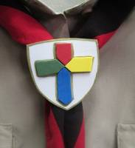
These three slides were all made of fun foam. It is so easy to work with that I use it a lot. You can use cardboard from cereal boxes and markers as an inexpensive alternative. There is a great Tree slide in January’s Baloo’s Bugle for Arbor Day! B
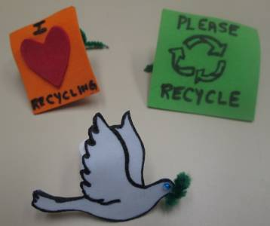
Materials-
Fun foam, 2 ½ x/2 ½ inches
Scraps of fun foam for embellishments
½ inch slice of ¾ inch PVC pipe
Clip art of what you are making or some other thing (the God and Me medal) to look at
Tiny blue seed bead and a bit of green pipe cleaner for the dove
Tools-
Tacky glue
Black and Gold Sharpie Markers
Scissors with a fine point
Pencil
Loaded glue gun
Instructions-
- Trace clip art shape onto fun foam, cut out.
- Using clip art or medal as an example cut out scraps of fun foam to match the model.
- Decorate as necessary.
- Glue PVC ring to back of the shield. Don’t forget to add your name & date on back!

Make a Pretzel of Faith Tie Slide
Alice, Golden Empire Council
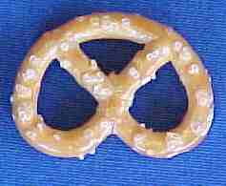
- Giving Thanks through Prayer is an important part of faith – and here’s an interesting way to “wear” your faith on your neckerchief – make a pretzel tie slide!
- Really simple – just mount a “perfect” pretzel on a piece of fun foam, or cardboard, or heavy duty paper. Background can be any color. Add a backing. But be prepared to explain what the pretzel really means. Here’s the story:
- A few weeks before Christmas in 610 AD, Brother Bachman was kneading bread dough while he watched the village children play in the snow. “Too bad they aren’t as interested in their prayers,” he thought to himself.
- "If only there was some way to get them back to saying their prayers and coming to church," he said to himself. As he was finishing up the last loaves of bread, Brother Bachman was suddenly struck with a most original idea. He thoughtfully gathered up the leftover dough and began to form pencil-like strips, which he then twisted into a shape that looked like a child's arms folded in prayer. "Ah! A Pretiola!" he declared, which in Latin meant little reward.
- He opened the bakery window and called out to the children. "Come in, come in say your prayers, and I will give you a Pretiola!" It didn't take much convincing. Soon each child had learned a prayer and proudly received a "little reward." Rushing home, the children excitedly told their parents. Word of Brother Bachman's idea soon spread through the village, and children and parents alike visited the chapel to receive a Pretiola.
- The Christmas Prayer Service that year was especially festive and bright. The church was filled with families once again. And as the cheerful voices rose in prayer and song together, Brother Bachman smiled joyfully and thanked the Lord for little rewards.
- The Pretiola soon found its way into Germany and Austria. It became a symbol of excellence used to reward worthy accomplishments as the church and youth programs flourished.
- Through the centuries, Pretiola became known as "Pretzel" as we know it today. If you make a Pretzel Tie Slide, you can tell the story, too!

Symbol of Faith Bookmark
2011-2012 CS RT Planning Guide
Materials:
Craft Foam,
Markers,
Scrap Paper in Multiple Colors,
Hole Punch,
Scissors,
Glue,
Ribbon
Directions:
- Cut craft foam approximately 1½ inches by 5 inches.
- Younger children are advised to make their pieces larger.
- Punch a hole at one end of the rectangular craft foam piece.
- Decorate the bookmark strips with various symbols and sayings of any chosen faith using cutout pieces of paper and markers.
- Examples of symbols are
The nine-pointed star of the Baha’i faith,
Christianity’s cross,
Judaism’s Star of David,
The crescent moon and star of Islam,
or any other of the symbols of the world’s faiths.
- When the bookmark is done, attach a piece of ribbon through the hole

Faith Visits
All faiths have at their heart the desire to be good citizens and to help others in the community. This spirituality lies at the heart of Scouting and is what sets us apart from youth clubs and many other organizations. Demonstrate this by visiting senior citizens and planting bulbs in their gardens. Alternatively, decorate flowerpots at a meeting, plant bulbs in these and then take them to the Senior Citizens.
Visit two places from different religions such as a church and a mosque. Make a poster to show the differences and similarities of the places visited, using drawings, words, photos (Get permission to take photos before you go) and pictures cut from magazines. Perhaps you could pair up elements of each faith you look at. For example:
 | Christianity | Judaism | Islam
Book | Bible | Tenakh | Qu'ran
Leader | Pastor, Vicar | Rabbi | Imam
Place of Worship | Church | Temple | Mosque
Before you visit with your Den, have someone go to the places of worship and, if permitted, take some photographs of details in and around each building. Print these off and create a visual treasure hunt for the boys to do during the visit. Have each Cub (or pair (Buddy System)) find each item pictured and then answer a simple question. For example, a photograph of the font asking what date is carved into it.

Religious Activities:
Alice, Golden Empire Council
BSA recognizes many different faiths – Cub Scouts and the Pack families should be encouraged to honor and practice their faith – For information on the many BSA religious awards, go to:
http://www.scouting.org/scoutsource/Awards/ReligiousAwards.aspx
Invite local religious leaders to come and share something about their faith. One of my favorite times as a Den Leader was the year I had Cubs from a variety of religious backgrounds – over a few den meetings, we learned about the Catholic faith; then we learned about the LDS, Baptist, Methodist, Jewish and Muslim faiths. We discovered some differences but also some surprising similarities!
Gather a collection of Religious Award workbooks from different faiths – your DE or local scout shop might be able to help with this. Encourage parents to use the workbook published for their faith to help the boys complete the BSA Religious Award.
Invite local Boy Scouts who have earned their BSA Religious award to visit - ask them to share what they did to earn the award, what affect it had on their life, what cub scouts can do to prepare to honor their faith.
Attend special religious or Easter events as a Pack Family – or make sure that pack families know about local performances and activities such as: Easter Egg Hunts, performances of Handel’s Messiah.
Encourage pack families to work on the BSA Family Award – it includes suggestions for regular family meetings and activities, using principles of faith. The BSA Family Activity Book is available at Scout shops and online.

Faith in Family & Friends:
Alice, Golden Empire Council
Loyalty and Trust are principles that scouts have always practiced – and Cub Scout/Webelos activities help boys develop strong family and peer loyalties, trust and trustworthiness.
Play one of the Trust Games – talk about loyalty and friendship.

Faith in Self:
Alice, Golden Empire Council
Scouting helps develop confidence and skill through age-appropriate activities and working towards goals and achievement.
Have a Wall of Fame display at the Pack Meeting – Ask parents and leaders to furnish information about positive activities and scouting achievements of each boy.
Ask each boy what scouting activity or achievement he is proudest of, enjoyed, or was challenged by – share their comments with the Pack in a display.
Make sure to talk about specific activities a boy has done to earn an award or rank – As awards are presented at the Pack Meeting, the Cubmaster could relate personal experiences furnished by parents and den leaders.
Do the T-Shirt activity under games – help each boy to recognize what he is good at, and how he helps other people and demonstrates his faith.
Don’t reward every effort – boys know if they did their best, and being rewarded when they didn’t give good effort just makes them feel less able and confident in their own abilities.

T-Shirt Testimony
Materials: T-shirt or T-shirt Shape for each boy; Markers, Stampers & Ink, various craft supplies.
Directions: This activity can be done with real T-shirts or just a T-shirt shape cut out of paper for each boy. (either have each boy bring a white T-shirt, or get them for about $2 at a craft store) You will need to discuss the project with the boys before you bring out the supplies. Shirts will be used to describe and validate each boy’s abilities and interests.
The shirt above used a different word describing that person or an interest they have – one for each letter of the person’s name.
Another technique is to think of the shirt as having four “quarters” – then ask each boy to think of something to put in each space. Some ideas would be: a favorite family activity, a favorite color or sport, a special interest, a scouting event or activity. With either idea, I would have the boys plan out a draft sample before they begin on their final “shirt” – especially if they are doing a real T-shirt. If you use permanent markers or stampers and acrylic paint, you can “set” the design with an iron as soon as the paint or ink is dry.
Some boys might need help in defining their interests or abilities – as a Den Leader, you could ask parents for some ideas ahead of time.



Scripture Cookies
To find each ingredient, look up scripture reference and fill in blank. Some clues are subtle, so check list of ingredients on bottom of page before making cookies.
Ingredients:
3/4 cup “The words of his mouth were smoother than ____” (Ps. 55:21)
1/3 cup “Come unto me all ye ends of the earth, buy ____ and honey” (2 Ne. 26:25)
1 1/2 cups “To what purpose cometh there to me … the ____ ____ from a far country?” (Jer. 6:20)
2 “As one gathereth ____ that are left, have I gathered all the earth” (Isa. 10:14)
2 cups “And Solomon’s provision for one day was thirty measures of fine ____” (1 Kgs. 4:22)
1 teaspoon “Take thou also unto thee principal spices, … and of sweet ____ half so much” (Ex. 30:23)
1 teaspoon “Ye are the ____ of the earth” (Matt. 5:13)
1/2 teaspoon “The kingdom of heaven is like unto ____ (Matt. 13:33)
3 cups “Nevertheless, … ____ for the horse” (D&C 89:17 or Gen. 1:13-14 –you will have to explain that oats are a grain and a plant bearing seed- the word oats doesn’t appear in the Bible)
1 cup “And they gave him … two clusters of ____” (1 Sam. 30:12)
Directions:
- Beat first four ingredients together.
- Mix in remaining ingredients.
- Drop by teaspoonfuls onto greased cookie sheet.
- Bake at 350° F (175° C) for 15 minutes.
Answers for Ingredients:
3/4 cup butter, 1/3 cup milk, 1 1/2 cups sugar (sweet cane),
2 eggs, 2 cups flour, 1 teaspoon cinnamon, 1 teaspoon salt,
1/2 teaspoon baking soda (leaven), 3 cups oats,
1 cup raisins

Visits
All faiths have at their heart the desire to be good citizens and to help others in the community. This spirituality lies at the heart of Scouting and is what sets us apart from youth clubs and many other organizations. Demonstrate this by visiting senior citizens and planting bulbs in their gardens. Alternatively, decorate flowerpots at a meeting, plant bulbs in these and then take them to the Senior Citizens.
Visit two places from different religions such as a church and a mosque. Make a poster to show the differences and similarities of the places visited, using drawings, words, photos (Get permission to take photos before you go) and pictures cut from magazines. Perhaps you could pair up elements of each faith you look at. For example:
 | Christianity | Judaism | Islam
Book | Bible | Tenakh | Qu'ran
Leader | Pastor, Vicar | Rabbi | Imam
Place of Worship | Church | Temple | Mosque
Before you visit with your Den, have someone go to the places of worship and take some photographs of details in and around each building. Print these off and create a visual treasure hunt for the boys to do during the visit. Have each Cub (or pair (Buddy System) find each item pictured and then answer a simple question. For example, a photograph of the font asking what date is carved into it.
Take part in a 10 Commandment Hike or plan one just for your group. Ten Commandment Hikes are interfaith and cross-cultural events. Hikers visit ten different houses of worship to hear a brief talk about that faith, its worship space, and an explanation of one of the Ten Commandments. Participants gain greater understanding of other religions and are introduced to the religious awards programs. If your community is interested in sponsoring a "Ten Commandment Hike", resources and indeas are available at http://www.praypub.org/10commhike.htm Another format is to set up ten stations (or maybe 5) around camp and have the boys hike to each. Someone at the station explains a commandment (or two). Then the boys play a game or do an activity that reflects on what was taught before moving on to the next station.
Faith Opening and Four Corners
- F FOLLOW. We follow the beliefs of our faith and practice them with our family.
- A ACT. We act in ways that show our love and faith
- I INVOLVED. We are involved. Helping in service projects for others and learning about our faith.
- T THANKFUL. We are Thankful for our faith, our family, and all that God has given us.
- H HOPE. We hope that your faith leads you to do these things, too.
(Or, We hope for a better world as people practice their Faith.)

Label the four corners of the hall a different faith (eg Christianity, Judaism, Hinduism and Islam.)
Have a stack of cards, each with a word or saying related to one of the four faiths you posted in the corners
Take the top card and call out the fact written on it.
Tell the Scouts to go to the corner with the emblem of the faith to which the fact relates.
The Scouts then run to the corner of the room they think is correct.

After writing your cards, you may wish to review some things before beginning the game to make sure everyone has a fair chance at the game
Ideas for cards - Such as:
- Religious Leaders - Brahmins (Hindu), Imams (Islam), Rabbis (Jewish), Pastors, Priests, vicars (Christianity)
- Clothing - Kacch, white shorts (Sikhs), Yarmulkes, a little cap that covers the crown of the head, as a mark of respect for God (Jewish).
- Festivals - Pesach or Passover, a festival held in March or April (Jewish), Pentecost (Christian), Ramadan (Islam), Eid Al-Adha (Muslim)
- Places of Worship - Mosques (Muslims), Temples (Jewish), Churches (Christian)
- Important Cities - Jerusalem (Jewish, Christian, Islam, Muslim). Mecca (Islam), Rome (Catholic)

