**COMMISSIONER'S CORNER**

**There are two kinds of men who never amount to much:   
those who cannot do what they are told, and those who can do nothing else.**Cyrus H. Curtis  
Cyrus H. Curtis was an American publisher of magazines and newspapers, including the Ladies' Home Journal and the Saturday Evening Post.

Judy and I were talking and as you have noticed the format of Baloo’s Bugle has changed a little.

We now have four parts –

1. Monthly Fun Stuff
2. Pack Admin and Training
3. Pack Meeting Helps
4. Den Meeting Helps

We often get comments about how cumbersome our one large file was to use. So we split it into four for easier use.

Also, this will allow us to post each section s it is ready! And minimize the time Judy spends merging together everyone’s input into one giant file.

As always, COMMENTS ARE WELCOME!! We are always wondering hwo is doing what with Baloo. Or what sections are the most important to others. Let us know, Please! THANKS! Judy & Dave

**RECOGNITIONS & CEREMONIES**

The Interest Topic for December in the CS Roundtable Planning Guide is Recognition. They have some excellent material to help leaders understand BSA’s emphasis on Recognition and different ways to do it from informal to elaborate ceremonies.

Because of the December Interest Topic, I have rounded up almost everything I could find on Ceremonies & Recognition and placed it throughout this issue of Baloo’s Bugle. Hope you enjoy it!!

Emphasis on Recognitions and Ceremonies is needed in many Cub Packs. Working in the Scout Shop and helping Pack Advancement people pick their awards I find many packs skimp on the recognition of the boys.

When I ask about how they present the awards I am often told variations on, “We just put them all in a baggie and give them out.”

Do you announce what they are?   
No, we have too many boys.

How about the rank badges for Tiger, Wolf, …?  
Them, too. Nothing is special.

Some packs buy the cards so there is a record of the award. Others tell me that filling in the cards takes too much time! *Too much time??????*

How about Parents’ Pins?  
Nope, don’t do them, either

**Isn’t Recognition one of the methods of Scouting???**

# TABLE OF CONTENTS

TABLE OF CONTENTS 2

CORE VALUES 2

**OBEDIENT QUOTES** 3

CITIZENSHIP QUOTATIONS 4

THOUGHTFUL ITEMS 6

OPENING PRAYER 6

CITIZENSHIP AND ITS DUTIES 6

BIOGRAPHY 7

THE ELECTION OF 1800 7

The US Constitution: Obedience to the Law 8

CUB SCOUT IDEAS 9

Why Do We Use Ceremonies? 9

The 5 W’s and an H of Cub Scout Ceremonies 9

The 10 Commandments of Ceremonies 9

Tips For Impressive Ceremonies 10

Tips for Effective Ceremonies 10

Den Ceremonies 10

Why Cubs Love Ceremonies 10

CHARACTER COMPASS 11

THEME RELATED STUFF 12

THEME RELATED ADVENTURES 12

PACK MEETING THEMES AND PLANS 12

PACK MEETING THEMES 13

UPCOMING MONTHS 14

CUBMASTER THOUGHTS 15

Cubmaster for Dummies 15

WEBELOS 17

SCOUTING ADVENTURE 17

JANUARY CRAZY HOLIDAYS 19

January – A Month for Obedience 23

SPECIAL OPPORTUNITIES 27

THE WHITTLING CHIP 27

KNOT OF THE MONTH 30

VETERANS RECOGNITION 30

Veteran Unit Award 30

TRAINING TOPICS 31

HAVE FUN!!! 31

FUN STUFF 33

CITIZENSHIP THINGS 33

PACK AND DEN ACTIVITIES 37

CUB GRUB 41

LAST THINGS 44

The Pinewood Derby Prayer 44

GILBERT'S PINEWOOD DERBY PRAYER 44

# CORE VALUES

For January, the suggested Pack Meeting theme,   
**CUB SCOUT CITY COUNCIL,** emphasizes the Scout Law point, **OBEDIENT.**

**The core value highlighted this month is:**

January's point of the Scout Law, **OBEDIENT,** will use the theme, **CUB SCOUT CITY COUNCIL.**

**A SCOUT IS OBEDIENT**A Scout follows the rules of his family, school, and pack. He obeys the laws of his community and country.

**HOW DOES “CUB SCOUT CITY COUNCIL” RELATE TO THIS POINT OF THE SCOUT LAW?**

A Cub Scout follows the rules of his family, school, and pack. He obeys the laws of his community and country. At this pack meeting we will have a mayor, council members, and lots of commendations for the great work that each Cub Scout has done this month.

**Per our Founder, Lord Baden-Powell  
the definition (or meaning) of the Scout Law point highlighted this month is:**[*https://en.wikipedia.org/wiki/Scout_Law*](https://en.wikipedia.org/wiki/Scout_Law)  
[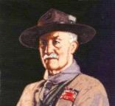](https://en.wikipedia.org/wiki/Scout_Law)

***Note –*** *The original Scout Law published in 1908 had nine points. In 1910, the BSA added Brave, Clean, and Reverent. In 1911 B-P added* ***Clean*** *to his original list.*

**A SCOUT IS OBEDIENT***Baden Powell did not use the word Obedient, he said -* **A SCOUT OBEYS ORDERS** of his patrol leader, or Scoutmaster without question. Even if he gets an order he does not like, he must do as soldiers and sailors do, he must carry it out all the same *because it is his duty;* and after he has done it he can come and state any reasons against it: but he must carry out the order at once. That is discipline.   
*(Scouting For Boys, 1908)*

Every great person has first learned how to **Obey**, whom to **Obey**, and when to **Obey**. *William A. Ward*

**[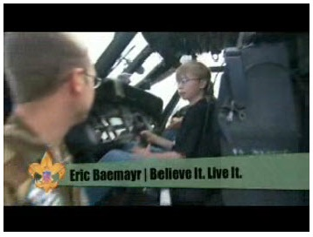](http://boyslife.org/about-scouts/scoutlaw/4274/a-scout-is-obedient/)**

 In this video, the “Believe It Live It” team interviews a U.S. Army MEDEVAC crew and shows why obedience is essential to their mission. This video on [www.Boyslife.org](http://www.Boyslife.org) relates military obedience to the Scout Law <http://boyslife.org/about-scouts/scoutlaw/4274/a-scout-is-obedient/>

**OBEDIENT QUOTES**

*Quotations contain the wisdom of the ages, and are a great source of inspiration for Cubmaster’s minutes, material for an advancement ceremony or an insightful addition to a Pack Meeting program cover.*

A boy can learn a lot from a dog: **Obedience**, loyalty, and the importance of turning around three times before lying down.   
Robert Benchley

**Obey** something, and you will have a chance to learn what is best to **Obey**. But if you begin by **Obeying** nothing, you will end by **Obeying** the devil and all his invited friends. John Ruskin

**Obedience** is better than sacrifice. I Samuel 15:22

It is much safer to **Obey**, than to govern.   
Thomas à Kempis

It is right that what is just should be **Obeyed**. It is necessary that what is strongest should be **Obeyed**. Blaise Pascal

The joy of youth is to **Disobey**; but the trouble is that there are no longer any orders. Jean Cocteau

**Obedience** of the law is demanded; not asked as a favor. Theodore Roosevelt

Those who know the least **Obey** the best.   
George Farquhar

Every good servant does not (**Obey**) all commands. William Shakespeare

Unwavering **Obedience** to the true principals we learn will assure us spiritual survival.

**Disobedience**, in the eyes of anyone who has read history, is man's original virtue. It is through **Disobedience** that progress has been made, through **Disobedience** and through rebellion. Oscar Wilde

The reason why men do not **Obey** us is because they see the mud at the bottom of our eye.   
Ralph Waldo Emerson

There can be a true grandeur in any degree of submissiveness, because it springs from loyalty to the laws and to an oath, and not from baseness of soul. Simone Weil

I have thought about it a great deal, and the more I think, the more certain I am that **Obedience** is the gateway through which knowledge, yes, and love, too, enter the mind of the child. Anne Sullivan

No principal is so noble, as there is none more holy, than that of a true **Obedience**. Henry Giles

**Obedience** is a word and concept from which the valiant look for their deliverance. Anonymous

**Obedience** without faith is possible, but not faith without **Obedience**. Anonymous

**Obey** something, and you will have a chance to learn what is best to **Obey**. But if you begin by **Obeying** nothing, you will end by **Obeying** the devil and all his invited friends. John Ruskin

Only he who believes is obedient and only he who is obedient believes. Dietrich Bonhoeffer

The doctrine of blind **Obedience** and unqualified submission to any human power, whether civil or ecclesiastical, is the doctrine of despotism, and ought to have no place among Republicans and Christians. Angelina Grimke

The ship that will not **Obey** the helm will have to **Obey** the rocks. English Proverb

There is no shame in taking orders from those who themselves have learned to **Obey**.   
William Edward Forster

**Obedience** alone gives the right to command.   
Ralph Waldo Emerson

One act of **Obedience** is better than one hundred sermons. Dietrich Bonhoeffer

A great work is made out of a combination of **Obedience** and liberty. Nadia Boulanger

The only safe ruler is he who has learned to **Obey** willingly. Thomas a Kempis

Liberty is **Obedience** to the law which one has laid down for oneself. Jean-Jacques Rousseau

**Obedience** is the mother of success and is wedded to safety. Aeschylus

When any one State in the American Union refuses **Obedience** to the Confederation by which they have bound themselves, the rest have a natural right to compel them to **Obedience**. Thomas Jefferson

Public opinion is a permeating influence, and it exacts **Obedience** to itself; it requires us to think other men's thoughts, to speak other men's words, to follow other men's habits. Walter Bagehot

Let thy child's first lesson be **Obedience**, and the second may be what thou wilt. Benjamin Franklin

True **Obedience** is true freedom. Henry ward Beecher

Strength was the virtue of paganism; **Obedience** is the virtue of Christianity. David Hare

We have come out of the time when **Obedience**, the acceptance of discipline, intelligent courage and resolution were most important, into that more difficult time when it is a person's duty to understand the world rather than simply fight for it. Ernest Hemingway

[**Obedience** keeps the rules. Love knows when to break them.](http://thinkexist.com/quotation/obedience_keeps_the_rules-love_knows_when_to/327694.html) [Anthony de Mello](http://thinkexist.com/quotes/anthony_de_mello/)

**Every great person has first learned how to Obey, whom to Obey, and when to Obey.**  
William A. Ward

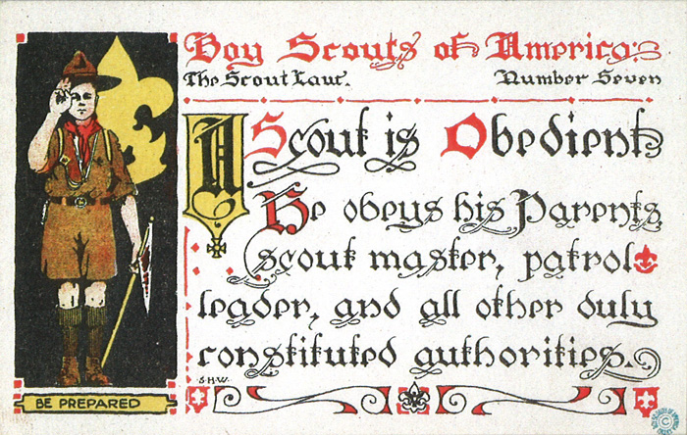

## CITIZENSHIP QUOTATIONS

***The test of good citizenship is loyalty to country. Bainbridge Colby.***

Above all, I would teach him to tell the truth Truth-telling, I have found, is the key to responsible citizenship. The thousands of criminals I have seen in 40 years of law enforcement have had one thing in common: Every single one was a liar. [J. Edgar Hoover](http://www.brainyquote.com/quotes/quotes/j/jedgarhoo117349.html)

Although an increasing proportion of the Hispanic population is foreign-born - about half of adults in this group - English proficiency is and should remain a requirement for citizenship. [Linda Chavez](http://www.brainyquote.com/quotes/quotes/l/lindachave255013.html)

As long as I live, I will never forget that day 21 years ago when I raised my hand and took the oath of citizenship. Do you know how proud I was? I was so proud that I walked around with an American flag around my shoulders all day long.   
[Arnold Schwarzenegger](http://www.brainyquote.com/quotes/quotes/a/arnoldschw168330.html)

Becoming a resident of a state may confer the right to get a driver's license, but it does not and should not confer citizenship. [Phyllis Schlafly](http://www.brainyquote.com/quotes/quotes/p/phyllissch206989.html)

Birth on U.S. territory has never been an absolute claim to citizenship. [Phyllis Schlafly](http://www.brainyquote.com/quotes/quotes/p/phyllissch206995.html)

Bohemia is nothing more than the little country in which you do not live. If you try to obtain citizenship in it, at once the court and retinue pack the royal archives and treasure and move away beyond the hills. [O. Henry](http://www.brainyquote.com/quotes/quotes/o/ohenry176164.html)

Business owners have made a strong case to me that they need guest workers. But none has suggested that these workers should be placed on a path to citizenship. [John Shadegg](http://www.brainyquote.com/quotes/quotes/j/johnshadeg351048.html)

Citizenship consists in the service of the country.   
[Jawaharlal Nehru](http://www.brainyquote.com/quotes/quotes/j/jawaharlal379274.html)

Citizenship is a tough occupation which obliges the citizen to make his own informed opinion and stand by it. [Martha Gellhorn](http://www.brainyquote.com/quotes/quotes/m/marthagell357582.html)

Experts always know everything but the fine points. When I took my citizenship exams, no one there knew how the White House came to be called the White House. [Hedy Lamarr](http://www.brainyquote.com/quotes/quotes/h/hedylamarr271444.html)

Full participation in government and society has been a basic right of the country symbolizing the full citizenship and equal protection of all. [Charles Rangel](http://www.brainyquote.com/quotes/quotes/c/charlesran285246.html)

Government health care changes the relationship between the citizen and the state, and, in fact, I think it's an assault on citizenship. [Mark Steyn](http://www.brainyquote.com/quotes/quotes/m/marksteyn411491.html)

Hospitals must provide emergency treatment to all who walk through the door, regardless of their citizenship status or ability to pay. [Gary Miller](http://www.brainyquote.com/quotes/quotes/g/garymiller348557.html)

I have dual citizenship, it just so happens I live in America.   
[Anthony Hopkins](http://www.brainyquote.com/quotes/quotes/a/anthonyhop359426.html)

In a world of inhumanity, war and terrorism, American citizenship is a very precious possession.   
[Phyllis Schlafly](http://www.brainyquote.com/quotes/quotes/p/phyllissch206994.html)

Is it unreasonable to have proof of citizenship when entering another country? [Gwen Ifill](http://www.brainyquote.com/quotes/quotes/g/gwenifill333879.html)

It's not the physical location of birth that defines citizenship, but whether your parents are citizens, and the express or implied consent to jurisdiction of the sovereign. [Phyllis Schlafly](http://www.brainyquote.com/quotes/quotes/p/phyllissch206996.html)

No other country on earth could have provided such tremendous opportunities and we should never take the privilege of our citizenship for granted. [Jane D. Hull](http://www.brainyquote.com/quotes/quotes/j/janedhull224490.html)

Nothing could be more insulting to me than the concept of civil rights. It means perpetual second-class citizenship for me and my kind. [James H. Meredith](http://www.brainyquote.com/quotes/quotes/j/jameshmer239588.html)

On the other hand, the vast majority of all westernized countries, including every single European country along with Israel and Japan, do not offer birthright citizenship. [Nathan Deal](http://www.brainyquote.com/quotes/quotes/n/nathandeal342939.html)

Our immigration system is a broken system that needs to be fixed. We need reform that provides hardworking people of good character with a real path towards citizenship. [Joe Baca](http://www.brainyquote.com/quotes/quotes/j/joebaca295474.html)

Ours is an open and accepting society, and has historically provided an avenue for lawful immigration to all those willing to accept the responsibilities of citizenship. [Spencer Bachus](http://www.brainyquote.com/quotes/quotes/s/spencerbac346185.html)

Over the years, dozens of American companies have filed papers to trade in their U.S. corporate citizenship for citizenship in tax haven countries like Bermuda.   
[Richard Neal](http://www.brainyquote.com/quotes/quotes/r/richardnea268357.html)

Perfect freedom is as necessary to the health and vigor of commerce as it is to the health and vigor of citizenship. [Patrick Henry](http://www.brainyquote.com/quotes/quotes/p/patrickhen153524.html)

Strengthening our identity is one way of reinforcing people's confidence and sense of citizenship and well-being. [David Blunkett](http://www.brainyquote.com/quotes/quotes/d/davidblunk205869.html)

Suffrage is a common right of citizenship. Women have the right of suffrage. Logically it cannot be escaped. [Victoria Woodhull](http://www.brainyquote.com/quotes/quotes/v/victoriawo312233.html)

The criteria for serving one's country should be competence, courage and willingness to serve. When we deny people the chance to serve because of their sexual orientation, we deprive them of their rights of citizenship, and we deprive our armed forces the service of willing and capable Americans.   
[Diane Feinstein](http://www.brainyquote.com/quotes/quotes/d/dianefeins411945.html)

The cry comes from the friends of the school-room, from those who would give the State a strong, great, noble citizenship, for protection from the curse of drunkenness. This cry should be heard and answered by every lover of his fellow-men, no matter where his home may be. [Thomas Jordan Jarvis](http://www.brainyquote.com/quotes/quotes/t/thomasjord375454.html)

The Holocaust illustrates the consequences of prejudice, racism and stereotyping on a society. It forces us to examine the responsibilities of citizenship and confront the powerful ramifications of indifference and inaction. [Tim Holden](http://www.brainyquote.com/quotes/quotes/t/timholden324754.html)

The real breeders of discontent and alien doctrines of government and philosophies subversive of good citizenship are such as these who take the law into their own hands. [John L. Lewis](http://www.brainyquote.com/quotes/quotes/j/johnllewi374115.html)

The social and industrial structure of America is founded upon an enlightened citizenship.   
[Bainbridge Colby](http://www.brainyquote.com/quotes/quotes/b/bainbridge250274.html)

There can be no daily democracy without daily citizenship. [Ralph Nader](http://www.brainyquote.com/quotes/quotes/r/ralphnader166136.html)

There's no such thing as second class citizenship. That's like telling me you can be a little bit pregnant. [H. Rap Brown](http://www.brainyquote.com/quotes/quotes/h/hrapbrown340546.html)

Therefore one should speak at the same time of national citizenship and wider European citizenship.   
[Jacques Delors](http://www.brainyquote.com/quotes/quotes/j/jacquesdel305361.html)

Through the years I have received my share of recognition for efforts in the fields of sports, the arts, the struggle for full citizenship for the Negro people, labor's rights and the fight for peace. [Paul Robeson](http://www.brainyquote.com/quotes/quotes/p/paulrobeso326901.html)

We also have a program in place for low income people. A family of four making $26,000 a year can receive medical coverage, irrespective of citizenship or what documents. [George Pataki](http://www.brainyquote.com/quotes/quotes/g/georgepata274185.html)

We can still find middle ground, truly secure our borders, deal with those already here and address our labor needs. But those who advocate giving current illegal aliens and future guest workers a special path to citizenship must compromise. [John Shadegg](http://www.brainyquote.com/quotes/quotes/j/johnshadeg351027.html)

We watched the U.S. citizenship immigration services web site in March. They had six million, two hundred thousand hits, and two million people downloaded applications for citizenship. So what we're doing is attempting to help people in that process.   
[Luis Gutierrez](http://www.brainyquote.com/quotes/quotes/l/luisgutier343629.html)

Well I don't know, I might have lost my citizenship, I don't think you can lose your citizenship though. [Tommy Chong](http://www.brainyquote.com/quotes/quotes/t/tommychong256342.html)

When business leaders ask me what they can do for Indiana, I always reply: 'Make money. Go make money. That's the first act of corporate citizenship. If you do that, you'll have to hire someone else, and you'll have enough profit to help one of those non-profits we're so proud of.' [Mitch Daniels](http://www.brainyquote.com/quotes/quotes/m/mitchdanie414863.html)

***We started a movement... to build character, citizenship and confidence in young people." Andrew Shue***

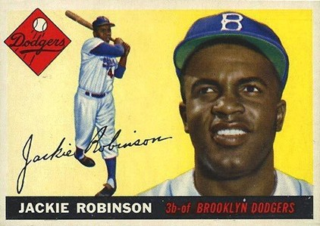

**The right of every American to first-class citizenship is the most important issue of our time.**[**Jackie Robinson**](http://www.brainyquote.com/quotes/quotes/j/jackierobi140158.html)

# THOUGHTFUL ITEMS

## OPENING PRAYER

*Scouter Jim, Bountiful UT*

Our Great and Beloved Father In Heaven, We thank Thee for those who have gone before and fought and died for the freedoms we enjoy. Bless us to server and honor that banner of One Nation under God, Indivisible. **Amen.**

## CITIZENSHIP AND ITS DUTIES

*Scouter Jim, Bountiful UT*

At a funeral recently for my mother’s brother, I was standing next to my 85 year old uncle an Air Force Veteran who had begun his career of service in World War II. He was not an officer or a pilot during his service, but served as part of the ground crew that serviced the planes. As taps was played by a member of the Disabled American Veterans’ Honor Guard, this Air Force Veteran made a crisp salute and held it until the folded flag had been carefully handed to the widow. My uncle was not in uniform, and was not properly attired to salute, but he was honoring a brother and fellow veteran. It seemed that twenty years of service made it impossible for him to hear taps or watch the folding of a flag at a grave side and not salute.

I have over twenty years of Scouting Service and I know how he feels. Whenever I watch the raising of a flag, my inclination is to bring my arm up in a Scout Salute. I don’t if I am not in uniform, but the habit of over twenty years of service almost requires it.

This experience makes me reflect on the duties of citizenship. As Citizens of the United States, we are required to obey the laws, serve on Juries when asked, and register with the Selective Service when we reach the age of eighteen. We are not required to serve as was the case with my father and uncle’s generation, and even that of my grandfather who was wounded in France during World War I. We are asked, but not required to vote. We also should show respect for those who serve our country in the Military as well as those who are serve us as Police Officers and Fire Fighters. We also should protect on honor our flag, for which so many have fought and died. It is appropriate for use when properly attired to salute the flag and honor it with that salute. That is an act that should not be taken lightly.

Cub Scouts cannot vote or serve on juries, but they can show respect for the flag with a proper and dignified salute. The flag is a great symbol of citizenship and by honoring it, young men can learn the important and benefits of being citizens of the United States. The most solemn event of my Scouting Life has been the retiring of a United States Flag that had flown over a National Park. As the large flag was tabled over the bonfire and slowly lowered, the flames consumed the flag and the smoke carried it toward the heavens and only the metal grommets dropped into the coals of the fire. This experience may be too intense for young Cub Scouts but they can taught to honor and respect the flag as they carry it into their Pack and Den meetings and watch as it is raised an d lowered.

***Citizenship consists in the service of the country.   
Jawaharlal Nehru***

# BIOGRAPHY

## THE ELECTION OF 1800

**Note –** Do not worry, there are no comments on the Election of 2016 in this article. **CD**

**We Americans are an amazingly obedient people.** Especially in following the rules of our Constitution. One great example of our obedience is our 240 year tradition of “peaceful transition of power” when a new President is elected. There was a lot of talk prior to the election about this so I thought we should take a look at the first peaceful transition of power in American History. I think you will see a lot of similarities. This election of 1800 is the topic of the song "The Election of 1800", from the hit Broadway musical [*Hamilton*](https://en.wikipedia.org/wiki/Hamilton_(musical)).

On February 17, 1801, Thomas Jefferson was elected the third president of the United States by the Presidential Electors. And his party, the Democratic-Republicans, also gained control of Congress. This election constituted the first peaceful transfer of power from one political party to another in the United States because the Democratic-Republicans won the election over the Federalists the party of the second President, John Adams.

By 1800, when he decided to run for president, Thomas Jefferson possessed impressive political credentials and was well-suited to the presidency. In addition to drafting the Declaration of Independence, Jefferson had served in two Continental Congresses, as minister to France, as secretary of state under George Washington and as John Adams’ vice president.

Vicious partisan warfare characterized the campaign of 1800 between Democratic-Republicans Jefferson and Aaron Burr and Federalists John Adams, Charles C. Pinckney and John Jay. The election highlighted the ongoing battle between Democratic-Republican supporters of the French, who were embroiled in their own bloody revolution, and the pro-British Federalists who wanted to implement English-style policies in American government. The Federalists abhorred the French revolutionaries’ overzealous use of the guillotine and as a result were less forgiving in their foreign policy toward the French. They advocated a strong centralized government, a standing military and financial support of emerging industries. In contrast, Jefferson’s Republicans preferred limited government, unadulterated states’ rights and a primarily agrarian economy. They feared that Federalists would abandon revolutionary ideals and revert to the English monarchical tradition. As secretary of state under Washington, Jefferson opposed Secretary of the Treasury Hamilton’s proposal to increase military expenditures and resigned when Washington supported the leading Federalist’s plan for a national bank.

After a bloodless but ugly campaign in which candidates and influential supporters on both sides used the press, often anonymously, as a forum to fire slanderous volleys at each other, the then-laborious and confusing process of voting began in April 1800. Individual states scheduled elections at different times and although Jefferson and Burr ran on the same ticket, as president and vice president respectively, the Constitution still demanded votes for each individual to be counted separately. As a result, by the end of January 1801, Jefferson and Burr emerged tied at 73 electoral votes apiece. Adams came in third at 65 votes.

This unintended result sent the final vote to the House of Representatives. Sticklers in the Federalist-controlled House of Representatives insisted on following the Constitution’s flawed rules and refused to elect Jefferson and Burr together on the same ticket. The highly influential Federalist Alexander Hamilton, who mistrusted Jefferson but hated Burr more, persuaded the House to vote against Burr, whom he called the most unfit man for the office of president. (This accusation and others led Burr to challenge Hamilton to a duel in 1804 that resulted in Hamilton’s death.) Two weeks before the scheduled inauguration, Jefferson emerged victorious and Burr was confirmed as his vice president.

A contingent of sword-bearing soldiers escorted the new president to his inauguration on March 4, 1801, illustrating the contentious nature of the election and the victors’ fear of reprisal. In his inaugural address, Jefferson sought to heal political differences by graciously declaring, “We are all Republicans, we are all Federalists.”

As president, Jefferson made some concessions to his opponents, including taking Hamilton’s advice to strengthen the American Navy. In 1801, Jefferson sent naval squadrons and Marines to suppress Barbary piracy against American shipping. He reduced the national debt by one-third, acquired the Louisiana Territory, and his sponsorship of the Lewis and Clark expedition opened the west to exploration and settlement. Jefferson’s first term ended in relative stability and prosperity, and in 1804 he was overwhelmingly elected to a second term.

The flawed voting system that was so problematic in the election of 1800 was later improved by the 12th Amendment, which was ratified in 1804.

## The US Constitution: Obedience to the Law

**for the Common Good**

The constitution of our country is the basis of public tranquility, the firmest support of political authority, and a security for the liberty of the citizens. We as Americans are fairly unique in our strict obedient behavior to our Constitution.

We transition our governments, Federal, State, and Local, peacefully. We change our President and Commander in Chief of our military every 4 or 8 years. We have no problems with the process that accomplishes this. We accept the process. We obey the law. No President has ever used his position as Commander in Chief of the military to order a coup and declare himself "President for Life," or a dictator. When Franklin Delano Roosevelt ran for a third term, Americans were incensed and we amended the Constitution to forbid that in the future.

The Constitution grants every one the right to choose their religion or to not believe. We have places of worship for every religion. And we have started a few ourselves. For example, the Church of Jesus Christ and Latter Day Saints was begun by Joseph Smith in New York in the 1820's. We do not tolerate bias against any religious group.

We have a unique system of Checks and Balances to keep each of the three branches of government in line. It is a giant game of rock, paper, and scissors. The Legislative Branch (Congress) enacts laws and passes bills. The Executive branch (President) can reject (veto) the bills that the Legislative Branch passed. The Judicial Branch (Supreme Court) can rule that a bill passed by Congress and signed by the President is unconstitutional and nullify it. And we all obey. When the Supreme Court said Gay Marriage was not prohibited by the Constitution, all the states obeyed. When they said segregation was unconstitutional, actions were taken (and are still in progress) to achieve integration.

Sometimes, after a check is used actions (the balance of checks and balance) can be taken to reverse it. But obedience to the ruling is maintained until during the interim. When the Supreme Court declared income tax unconstitutional, the Congress initiated action to create the 16th Amendment to the constitution that specifically states, "The Congress shall have power to lay and collect taxes on incomes, from whatever source derived, without apportionment among the several States, and without regard to any census or enumeration." After the Amendment was adopted Income Tax was part of the Constitution.

If Congress really wants their bill enacted, they can override the veto of the President with a 2/3rd majority versus a simple majority. The 1st Congressional Override of a Presidential Veto occurred when Congress overrode President Tyler's veto of an appropriations bill. Because of the Viet Nam War, Congress created the War Powers Act of 1973 to limit the President's power as Commander in Chief. Nixon vetoed this bill and it was overridden. President George W Bush vetoed the Medicare Improvements for Patients and Providers Act. It was overridden. None of Barack Obama's vetoes have been overridden. The point for this item is, we do these things peaceably, in accordance with procedure. There may be screaming and shouting and gnashing of teeth, but in the end it is all done properly.

**What else can we learn from the Constitution?**

**The Second Amendment** – to Keep and Bear Arms. We are the most well-armed nation in the world. Citizens are entitled to have guns. And many citizens are ready to jump in and defend this right for themselves and fellow citizens.

**The Fourth Amendment** - prohibits unreasonable search and seizure. We are all familiar with the police shows where they have to delay to get a search warrant. This is our obedience to the 4th Amendment. The police must prove why their search id justified. Often time you read in the newspapers (or on your computer) how a case was thrown out of court because th the evidence was gotten improperly. Similarly, we hear about "Miranda Rights" where a suspect has to be read his rights before being questioned. We are being obedient to our law.

**The First Amendment** – Freedom of Speech and Freedom of the Press. We can say what we like about our government without fear of reprisal. This has been taken quite literally, as the Supreme Court has said burning of a US Flag in protest is protected by the Freedom of Speech granted in this amendment.

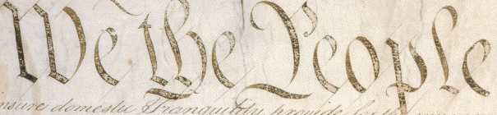

So while we are not perfect – we remain obedient to the Constitution so that we can have a more perfect Union, establish Justice, insure domestic tranquility, provide for the common defense, promote the general welfare, and secure the Blessings of Liberty to ourselves and our Posterity

# CUB SCOUT IDEAS

## Why Do We Use Ceremonies?

**Ceremonies play an important part in our lives.** We have ceremonies to celebrate birthdays, holidays, graduations, weddings, religious events, and many other special occasions. Ceremonies are also an important part of Cub Scouting.

Why do we have ceremonies in Cub Scouting?

* Everyone likes to receive recognition. A den or pack ceremony helps to recognize a boy in a positive way.
* Ceremonies provide meaningful and memorable highlights in a boy’s Cub Scouting experience.
* Ceremonies help teach the ideals and goals of Scouting. As boys participate in ceremonies, they “learn by doing.”
* Ceremonies focus attention not only on boys but also on families, leaders, and volunteers. All involved earn recognition for their accomplishments.

**Ceremonies should be a regular part of den and pack meetings.** Ceremonies define the beginning and the end of meetings, and they provide a format for presenting awards. Using ceremonies stimulates and encourages increased participation in monthly pack meetings.

**Do you remember the best ceremony you ever saw? The worst? What was the difference between the two experiences?** When you can answer these questions, you’ll be ready to put what you know into practice and make a difference in the experience a boy will have when he receives his Tiger Cub badge or crosses a bridge into Boy Scouts. Cub Scouts will remember their awards and how they were recognized for earning them, and families will value these occasions as memorable highlights on the Scouting trail.

## The 5 W’s and an H of Cub Scout Ceremonies

**Why -** Ceremonies are a vehicle for accomplishing the purposes of Cub Scouting. They give to each Cub recognition for a job well done.

**What -** Ceremonies are an important part of American life.  They can vary in length, complexity, and meaning, but they all satisfy a fundamental human need - the need to be recognized.

**Who -** Any organization with serious purpose needs to individually recognize those who help the organization reach its goals.

**When -** Anytime!  Whenever there is an opportunity, use an appropriate ceremony.

**Where -** A ceremony can be developed or adapted to fit any location, small or large rooms, indoors or out.

**How -** Ceremonies let leaders put color into the program as Cub Scouts begin their understanding of the ideals.  Plan ceremonies to fit the occasion, keeping them simple.  Remember "KIS-MIF".

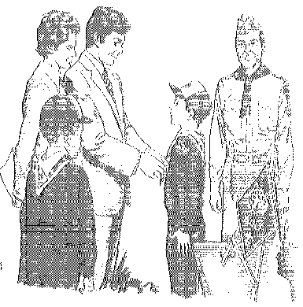

## The 10 Commandments of Ceremonies

1. Thou shalt have at least three every month – opening, advancement, and closing
2. Thou shalt keep it simple, make it fun (kis-mif)
3. Thou shalt not repeat a ceremony, no matter how many adults want to (or how good you look in an Indian headdress)
4. Thou shalt not ask Cub Scouts (or adults) to memorize or read big words
5. Thou shalt be heard and seen by all
6. Thou shalt recognize each individual and thou shalt include both the Cub and his parents. Thou shalt not do mass ceremonies.
7. Thou shalt not forget WEBELOS activity pins, to make them important also
8. Thou shalt follow the monthly theme
9. Thou shalt understand Cub Scout advancement and its importance to Cubs
10. Thou shalt use thy brain to come up with new ideas

## Tips For Impressive Ceremonies

* Present them in a dignified atmosphere
* Make sure they are well rehearsed.
* Do the ceremony like you mean it. Don't just read it.
* Use props and costumes when necessary and keep them simple.
* Make people to be recognized the center of attention. Have them face the audience. Do not do mass ceremonies. Recognize each individual.
* Make sure everyone can see and hear, since the ceremony has a message for them.
* Use symbolism, it appeals to the imagination.
* Include plenty of action.

## Tips for Effective Ceremonies

When planning your ceremonies, remember these important points:

* • Know your audience. Keep your ceremonies appropriate for boys of Cub Scout age. Simple ceremonies are more effective than long, elaborate ones. Boys this age have a short attention span.
* • Rotate responsibility among the dens for the opening, flag, and closing ceremonies at the pack meeting. When boys are involved, it is easier to hold their attention during the pack meeting.
* • Use a variety of ceremonies to hold the boys’ and adults’ interest. Keep track of which ceremonies you use and avoid repeating them month after month.
* • Adapt ceremonies to meet your needs. Packs come in many different sizes, and boys come with different skill levels. Younger boys may need to have someone read their lines while they perform an action or hold a sign. No ceremony is written in stone. Volunteers have written or adapted those presented here to meet the needs of their packs. Feel free to change them to work for you! This makes them your ceremonies.

## Den Ceremonies

* Keep them simple. A ceremony can be something as simple as having a boy stand on a chair while you praise him and present an award.
* Keep them short
* Fit them to everyday experience
* Don't get into a rut and repeat the same thing

## Why Cubs Love Ceremonies

A successful ceremony communicates with Cub Scouts primarily… *and adults secondarily*

Through a good ceremony, boys will learn:

* They are important
* They are part of a long tradition – the Brotherhood of Scouting
* They deserve recognition for what they have Accomplished
* They are examples to younger Scouts
* Through a good ceremony, parents and leaders will learn:
* They are important
* Their support of Scouting allows the program to help young boys

**Uh – Uh and Duh**

Nothing takes away from a ceremony more than a speaker that injects the words “and’, “a” and “uh” about every third word. This is just a bad habit and can be broken. Another fault is standing with your hand or hands in pockets.

**No They Didn’t Win It**

The awards are earned – boys don’t win them and they aren’t presents (even though they are presented) It’s not a prize, for a prize is something of value taken by violence from its rightful owner. It’s not a present because presents are not deserved or earned. Make this clear in your ceremonies – be careful with the imagery used in ceremonies at your December pack meeting.

DEN MEETING TOPICS

Remember – Boys want to be active!!   
See, too, that they earn their awards

***(Never say GET. You get sick, you do not get awards – You earn awards. A little CD Philosophy)***.

**Big Rock Ideas** – suggestions for Big Rocks that fit Interest Topics or seasonal activity. If years are next to an item (e.g. 13-14) that suggested Big Rock is in that Roundtable Planning guide and on-line at <http://www.scouting.org/scoutsource/Commissioners/roundtable.aspx>

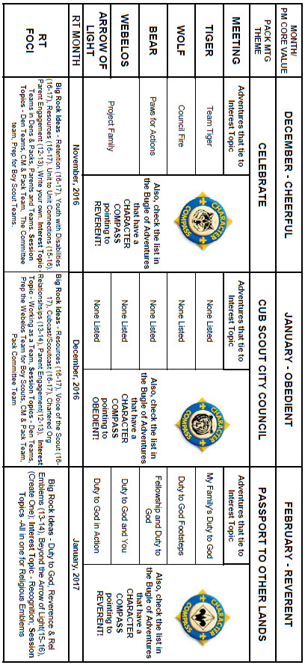

# CHARACTER COMPASS

**JANUARY -**ADVENTURES with a **CHARACTER COMPASS** pointing to **OBEDIENT:**

**TIGER –**

* Tigers in the Wild (Core)
* Floats and Boats (Elec)
* Rolling Tigers (Elec)

**WOLF –**

* Call of the Wild (Core)
* Air of the Wolf (Elec)

**BEAR –**

* Bear Claws (Core)
* Salmon Run (Elec)

**WEBELOS CORE –**

* **None** (Core)

**ARROW OF LIGHT CORE –**

* Scouting Adventure (Core)

**WEBELOS & AOL ELECTIVES –**

* Aquanaut (Elec)

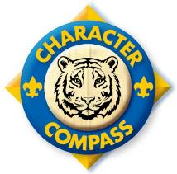

**FEBRUARY -**ADVENTURES with a **CHARACTER COMPASS** pointing to **REVERENT:**

**TIGER –**

* My Family’s Duty to God (Core)
* Sky Is the Limit (Elec)

**WOLF –**

* Duty to God Footsteps (Core)

**BEAR –**

* Fellowship & Duty to God (Core)

**WEBELOS CORE –**

* Duty to God and You (Core)

**ARROW OF LIGHT CORE –**

* Duty to God in Action (Core)

**WEBELOS & AOL ELECTIVES –**

* Into the Woods (Elec)

# THEME RELATED STUFF

## http://www.orgsites.com/in/pack3092/tsalute.jpgTHEME RELATED ADVENTURES

All Adventures are fun. –

**CUB SCOUT CITY COUNCIL RELATED**

**TIGER –**

* NONE

**WOLF –**

* Finding Your Way, Req 1a (Elec)
* Hometown Heroes Several Req (Elec)

**BEAR –**

* Paws for Action Req 1b (Core)

**WEBELOS CORE –**

* NONE

**ARROW OF LIGHT CORE –**

* Building a Better World, Req 2, 4 (Core)

**WEBELOS & AOL ELECTIVES –**

* Build My Own Hero, Req 2 (Elec)

**RECOGNITION  
RELATED ADVENTURES**

All Adventures are fun. –

**TIGER –**

* NONE

**WOLF –**

* Hometown Heroes, Req 4 (Elec)

**BEAR –**

* NONE

**WEBELOS CORE –**

* NONE

**ARROW OF LIGHT CORE –**

* NONE

**WEBELOS & AOL ELECTIVES –**

* Build My Own Hero, Req 3 (Elec)

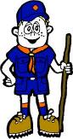

# PACK MEETING THEMES AND PLANS

[*www.scouting.org*](http://www.scouting.org)

**From National's Website for the new plans using the Core Values based on the Scout Law:**

Here are a few thoughts to consider around these new pack meeting plans. First, there is a plan for each month that corresponds with a point of the Scout Law. In addition, each plan has a theme to help make the pack meeting even more fun! The plans do not have to be used in a specific order.

**Tips for Utilizing the Plans**

* Pack meeting plans do not have to be done in any special order, but it is recommended that you include all of the points of the Scout Law each year. The pack planning meeting would be a good time to determine the order.
* There are pack meeting plans for multiple years posted on the website. It is your pack's choice of which one to select from each point of the Scout Law for each year.
* Pack meetings should not last longer than an hour. Adjust the plan to make it fit within the time. Research and experience tells us that Cub Scouts have a hard time sitting still for that long. Keep the meetings fun, active, and engaging.
* If you are comfortable with a costume to fit the theme of the meeting, go for it!
* Importantly, keep it simple and make it fun.
* The following required adventures have a requirement that suggests or requires completion at a pack meeting. Please plan accordingly as part of your annual program planning process. Work with your den leaders to plan when these activities will take place.

**Tiger**

* **Tigers in the Wild,** requirement 5. Participate in an outdoor pack meeting or pack campout campfire. Sing a song and act out a skit with your Tiger den as part of the program.
* **Games Tigers Play,** requirement 3. Make up a new game, and play it with your family or members of your den or pack.

**Wolf**

* **Council Fire,** requirement 6c. Create a den project from recyclables for a pack meeting.

**Bear**

* **Grin and Bear It**, requirement 2. Working with the members of your den, organize a Cub Scout carnival and lead it at a special event.
* **Grin and Bear It**, requirement 3. Help younger Cub Scouts take part in one of the events at the Cub Scout carnival.

**Webelos**

* **Stronger, Faster, Higher**, requirement 5. With adult guidance, lead younger Scouts in a fitness game or games as a gathering activity for a pack or den meeting.

**Arrow of Light**

* **Building a Better World (if chosen**), requirement 10b. Set up an exhibit at a pack meeting to share information about the World Friendship Fund.

**As a personal note:** *I have read most of the plans and they are excellent and just as complete as the new Den Leader Books. The games, and other stuff are right there. Including costuming ideas for that added PIZAZZ!! If you do not use themes and do not add PIZAZZ you are not doing your best for your pack.****GOOD JOB!!!*** *From CD*

Check them out at:   
<http://www.scouting.org/Home/CubScouts/Leaders/CubmasterResources/PackMeetingPlans.aspx>

Kim, the chair of the task force, says **"I do want to stress that the focus is still the Core Value and the theme is just there as an enhancement. Pack meeting theme plans are specifically crafted to bring out the important points of the Core Value in a fun way."**

## PACK MEETING THEMES

|  |  |  |
| --- | --- | --- |
| **2016–2017 Pack Meeting Plans** | | |
| December | Cheerful | ["Celebrate"](http://www.scouting.org/filestore/cubscouts/pdf/YEAR2/310-842(15)_December%20Cheerful_WEB.pdf) |
| January | Obedient | ["Cub Scout City Council"](http://www.scouting.org/filestore/cubscouts/pdf/YEAR2/310-842(15)_January%20Obedient_WEB.pdf) |
| February | Reverent | ["Passport To Other Lands"](http://www.scouting.org/filestore/cubscouts/pdf/YEAR2/310-842(15)_February%20Reverent_WEB.pdf) |
| March | Loyal | ["Our National Treasures"](http://www.scouting.org/filestore/cubscouts/pdf/YEAR2/310-842(15)_March%20Loyal_WEB.pdf) |
| April | Thrifty | ["Power Up!"](http://www.scouting.org/filestore/cubscouts/pdf/YEAR2/310-842(15)_April%20Thrifty_WEB.pdf) |
| May | Clean | ["A Picnic With Pizzazz"](http://www.scouting.org/filestore/cubscouts/pdf/YEAR2/310-842(15)_May%20Clean_WEB.pdf) |
| June | Brave | ["Roaming Reptile Alert"](http://www.scouting.org/filestore/cubscouts/pdf/YEAR2/310-842(15)_June%20Brave_WEB.pdf) |
| July | Trustworthy | ["Let The Games Begin"](http://www.scouting.org/filestore/cubscouts/pdf/YEAR2/310-842(15)_July%20Trustworthy_WEB.pdf) |
| August | Friendly | ["#CUBSCOUTS"](http://www.scouting.org/filestore/cubscouts/pdf/YEAR2/310-842(15)_August%20Friendly_WEB.pdf) |

**If you are using a paper copy the link to all the   
Pack Meeting Plans is:**

<http://www.scouting.org/Home/CubScouts/Leaders/CubmasterResources/PackMeetingPlans.aspx>



# **UPCOMING MONTHS**

For January, the suggested Pack Meeting theme,   
**CUB SCOUT CITY COUNCIL,** emphasizes the Scout Law point, **OBEDIENT.**

|  |  |  |
| --- | --- | --- |
| **Month** | **Year** | **Theme** |
| **OBEDIENT** (Themes for Respect) | | |
| May | 1962 | The World Around Us |
| November | 1967 | Around the World |
| December | 1973 | Customs of Countries |
| April | 1978 | The World Around Us |
| December | 1979 | Customs of Other Lands |
| April | 1981 | The World Around Us |
| July | 1988 | The World Around Us |
| December | 1989 | Customs of Countries |
| December | 1994 | Customs of Other Lands |
| February | 2001 | Passports to Other Lands |
| January | 2007 | Poles Apart |
| December | 2010 | Respect |
| December | 2011 | Respect |
| December | 2013 | Passport to Other Lands |

|  |  |  |
| --- | --- | --- |
| **Potential for CS CITY COUNCIL** | | |
| September | 1960 | Cub Scout Citizens |
| September | 1972 | Cub Scout Citizens |
| October | 1980 | Cub Scout Citizen |
| July | 1983 | Stars and Stripes |
| October | 1988 | Cub Scout Citizens |
| February | 2003 | Uncle Sam Depends on You |
| July | 2006 | Red, White and Baloo |
| July | 2007 | The Rockets’ Red Glare |
| July | 2010 | Celebrate Freedom |
| November | 2010 | Citizenship |
| November | 2011 | Citizenship |
| November | 2012 | 50 Great States |
| November | 2013 | Your Vote Counts |
| November | 2014 | Give Goodwill |
| December | 2014 | Stars and Stripes |
| September | 2016 | To The Rescue |

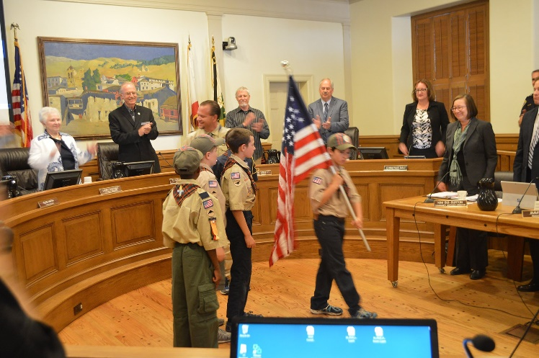

See the video of this pack’s Webelos Den at a City Council Meeting –

<https://www.youtube.com/watch?v=TH6wTJfIoFU>

For February, the suggested Pack Meeting theme, **PASSPORT TO OTHER LANDS**, emphasizes the Scout Law point, **REVERENT.**

**The core value highlighted next month is:**

February's point of the Scout Law, **REVERENT,** will use the theme, **PASSPORT TO OTHER LANDS.**

**A SCOUT IS REVERENT**A Scout is reverent toward God. He is faithful in his religious duties. He respects the beliefs of others.

**HOW DOES “PASSPORT TO OTHER LANDS” RELATE TO THIS POINT OF THE SCOUT LAW?**

Today we recognize that people of many different nationalities live in our communities. Learning about the ways of others helps lead to understanding. A Scout is reverent when he shows respect for the beliefs of others. This month we focus on experiencing the customs, religions, foods, and traditions of our friends from other countries.

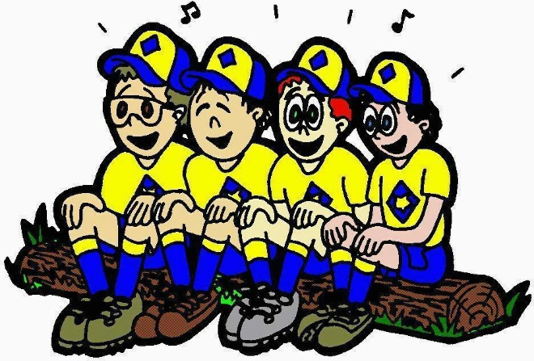

|  |  |  |
| --- | --- | --- |
| **Month** | **Year** | **Theme** |
| **REVERENT** (Themes for former CV Faith are listed here) | | |
| November | 1942 | Thanksgiving |
| November | 1952 | Faith of his Fathers |
| December | 1960 | Guiding Stars |
| November | 1974 | Pilgrims |
| November | 1980 | Thanksgiving-Living & Sharing |
| November | 1984 | Turkey Day |
| November | 2003 | Pilgrims of Plymouth Rock |
| December | 2005 | Faith, Hope & Charity |
| December | 2007 | Celebrations Around the World |
| April | 2011 | Faith |
| April | 2012 | Faith |
| April | 2013 | Cub Scouts Give Thanks |
| April | 2015 | Soaring the Skies |
| December | 2015 | Winter Wonderland |
| Potential Months - **"PASSPORT to OTHER LANDS"** | | |
| March | 1943 | United Nations Month |
| January | 1946 | Boys of the World |
| November | 1947 | In Old Mexico |
| April | 1949 | Life in the Philippines |
| March | 1959 | Canada, Land of the Mounties |
| January | 1961 | South America |
| March | 1962 | Islands of the World |
| March | 1965 | South of the Border |
| December | 1973 | Customs of Countries |
| December | 1979 | Customs of Other Lands |
| December | 1989 | Customs of Countries |
| April | 1991 | Canada, Our Neighbor |
| December | 1994 | Customs of Other Lands |
| March | 1999 | Gateway to the Orient |
| February | 2001 | Passports to Other Lands |
| April | 2003 | Land of the Pharaohs |
| December | 2013 | Passport to Other Lands |
| June | 2014 | Over the Horizon |
| February | 2016 | Friends Near and Far |
| February | 2017 | Passport To Other Lands |

CUBMASTER THOUGHTS

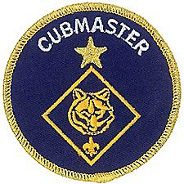

*Mark will be back next month. He had an emergency appendectomy on Saturday, November 13, 2016. That morning I texted him for help with a B.A.L.O.O. class with which I was involved. His response was “In spirit only. I am going to be appendix-less in about an hour.” His wife, Donna, says he is doing fine. Pray for him this month, please. - CD*

## Cubmaster for Dummies

*Sean Scott, Roundtable Commissioner Emeritus,   
Inland Empire Council*

The best advice I ever received on being a Cubmaster was simple and to the point:

**“POOF! You’re nine.   
Act like it. Think like it.”**

While some of the most successful Cubmasters I’ve ever met were natural nine-year-olds, there is no reason that a fully-grown adult can’t do an equally good job. It just takes a little more practice and preparation!

The monthly pack meeting is the biggest, most important job of the Cubmaster, yet many have a hard time getting it right. I've run and observed a lot of pack meetings, both good and bad, and noticed what works and what doesn’t. Interestingly, good packs, with lots of involved and motivated parents and leaders, are often the packs that have great pack meetings! They set the tone for the entire pack program!

The first thing you should do to improve your pack meeting is to stop having them altogether. Eliminate the word “meeting” from your Scouting vocabulary. “Meeting” has too many negative meanings for most of us. You go to a meeting to discuss things, learn about the latest layoffs, or have more work assigned. Meetings are dull. Nobody looks forward to meetings.

On the other hand, everybody likes to be entertained. So instead, focus on presenting a “Pack Performance” every month! That is a much better description of what your monthly gathering is—a show! Every month represents a one-night-only premiere, and as the Cubmaster, you and your cast are the producers, writers, directors and master of ceremonies!

Now that you have the right frame of mind, what should your performance contain? Make it interesting to both boys and the adults. If it isn’t, one or the other will stop paying attention and you’ll lose control. The show should appeal to the boys, but be fine-tuned for the adults. The overall program should be short and entertaining, and each act should be as brief as possible within the larger show. Keep it loud, visual and dynamic. Physiologically, boys have short attention spans, process information visually, and don't hear a good percentage of what is said to them*. (Read Michael Gurian's "Wonder of Boys" for details on this, gentleman.* ***The ladies already know men don't listen!)***

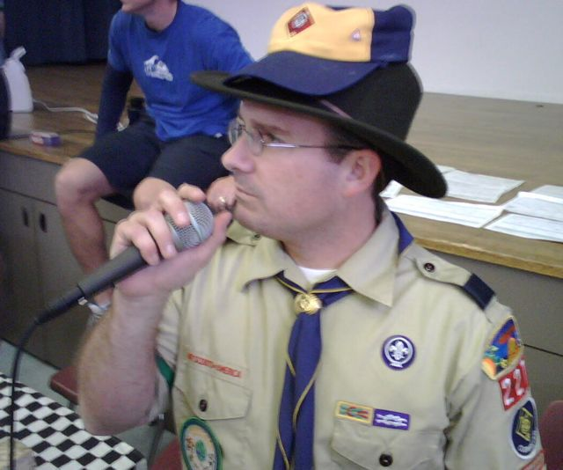  
Cubmaster DJ in Action  
<https://pack227.org/committee/about-2/>

Plan an even mixture of skits, run-ons, songs, ceremonies and games. Use costumes, props and decorations for atmosphere and visual appeal. Involve parents and leaders in the program. Sprinkle brief, informative moments throughout the show, but work on eliminating gaps, pauses, extensive preparations, long speeches, or readings.

No performance has announcements. Instead, print up a monthly newsletter with all the important information that parents and boys need to know, and make sure that everyone gets a copy. What you may find useful is to print a calendar for the coming month on one side of your newsletter, which will invariably find its way to the refrigerator doors of most families in your pack. It is better to remind parents of an event every time they reach for the milk, than to read the date out to the group during your performance. I guarantee that nobody will memorize it, and few will write it down! With the newsletter going out to all the families, you can instead concentrate on quickly pointing out how fun and exciting the coming month will be, without going into boring details.

You should also avoid having any single act deal exclusively with one boy or one den for too long, especially during recognition ceremonies. If you’re handing out awards to Den 2, nobody but Den 2 will be paying attention. Instead, try to incorporate the entire pack into your recognition segments. Boys and parents alike will soon realize that their name could come up at any moment and pay closer attention to your program, instead of gossiping or goofing off!

Finally, pull parents and leaders, boys and siblings into the program. No matter how naturally entertaining you may be, a one-man show gets old after a while! Use older siblings to help with lighting, stage setup, and ceremonies. Involve parents and boys in skits and run-ons. And get your entire audience into the act with songs and audience participation stunts. Personally, I use two assistant Cubmasters: one is my partner in crime, and one is my "announcement person" (and better half). I'll recruit one or two other leaders, one or two parents, a few older siblings, and one den each month to help out. All the adults and siblings get a script that we write on the Saturday before the meeting, based on a general plan we hash out the week before over the phone and through email. In all, it takes a couple of hours to write, and another couple to gather everything together. We'll scatter run-ons, skits and songs between the segments that take more preparation to prevent lulls while we prepare for them.

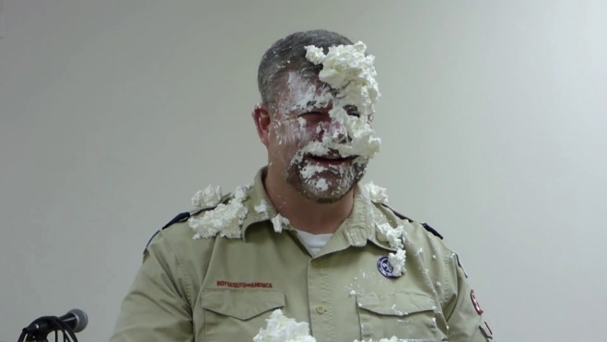  
Watch the Cubmaster get a pie in the Face  
<https://www.youtube.com/watch?v=PFkblq-g90A>

So what if it’s been a long time since you were nine, and you’ve forgotten what it was like? What is the secret to being a great Cubmaster?

As the Cubmaster you should plan on making a fool of yourself, because it has ageless appeal—kids and adults alike are inexplicably mesmerized and amused by a grown man or woman performing "Tooty-Ta", talking in a weird accent, or otherwise embarrassing themselves. It means you need to plan and practice your show, and most of all, have no pride.

Being loud enough to be heard without a microphone is helpful!

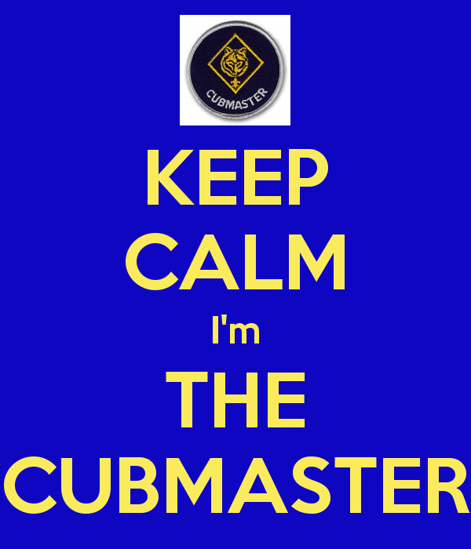

You should also think back to what it was like to pretend. Remember, as a kid, how you could turn a cardboard box into a house, racecar, space capsule, submarine or jet fighter with just a few quick crayon marks? That's the idea! “Let’s Pretend” are two mighty powerful words! Your props and costumes don’t have to be the quality of a major motion picture set, just enough to get the idea across! We use lots of props and costumes, even if it's just a bandana over the face and a sign hung around someone's neck that says "Bank Robber."

I don't claim to be the ultimate Cubmaster, or an expert by any means, but I can count on one hand how many times I’ve needed to put up the Cub Scout sign at a meeting. These methods work for me, and I’ve seen them work for others. The boys tell me they're always wondering what's going to happen next, and the parents tell me they can't believe that we did some goofy, silly thing. They pay attention (and show up on time) because they don't want to miss something, and are excited about what's coming up next.

For more help be sure to check out –



# WEBELOS

# **SCOUTING ADVENTURE**



**Always an S** Webelos always ends with an S whether talking about one Webelos Scout or a den of Webelos. It is an acronym – **WE**’ll **BE LO**yal **S**couts. As the CS RT Commissioner who mentored me says – "If you don’t have an S at the end – then there is nothing to which to be loyal."

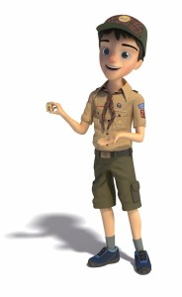

*Note: For Traditional units, Webelos Scouts / Dens means Webelos (4th grade) and Arrow of Light (5th grade) Scouts / Dens. For LDS Units where the Webelos experience is the 12 months a Scout is 10 years old, it is all inclusive.*

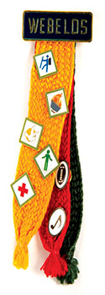



***Commissioner Dave*** *with help from -* [*http://usscouts.org/advance/cubscout/aol-core-2015.asp*](http://usscouts.org/advance/cubscout/aol-core-2015.asp)

**I love this Adventure!! -**This Adventure takes all the Boy Scout related requirements that were just a long list of extra things to do in the previous advancement program and combines them into an Adventure. This keeps them from getting overlooked and earns the Scout an award for all his hard work. I know many Webelos Leaders who assumed the Activity Awards were it and there was not much else to do who were very surprised at the extent of Boy Scout related requirements. NOW they are all together and the Webelos Scout earns another Adventure Pin!!

**Let's look at the requirements -** *(*[*http://usscouts.org/advance/cubscout/aol-core-2015.asp*](http://usscouts.org/advance/cubscout/aol-core-2015.asp) *)*

Do all of these:

1. Prepare yourself to become a Boy Scout by completing **all** of the items below:
   1. **Repeat from memory** the Scout Oath, Scout Law, Scout motto, and Scout slogan. In your own words, explain their meanings to your den leader, parent, or guardian.

***NOTE – It says "repeat from memory" not "With help as needed" like the Bobcat Award.)***

* 1. **Explain what Scout Spirit is**. Describe for your den leader, parent, or guardian some ways you have shown Scout Spirit by practicing the Scout Oath, Scout Law, Scout motto, and Scout slogan.
  2. **Give the Boy Scout sign, salute, and handshake.** Explain when they should be used.



* 1. **Describe the First Class Scout badge,** and tell what each part stands for. Explain the significance of the First Class Scout badge.

***The Webelos Den Leader Guide has a puzzle you can reproduce for this requirement. I have a wooden replica built on thin plywood that the Scouts take apart and reassemble. Hands On versus simply memorizing is the key!***

* 1. **Repeat from memory** the Outdoor Code. In your own words, explain what the Outdoor Code means to you.

1. Visit a Boy Scout troop meeting with your den members, leaders, and parent or guardian. After the meeting, do the following:
   1. Describe how the Scouts in the troop provide its leadership.
   2. Describe the four steps of Boy Scout advancement.
   3. Describe ranks in Boy Scouting and how they are earned.
   4. Describe what merit badges are and how they are earned.
2. Practice the patrol method in your den for one month by doing the following:
   1. Explain the patrol method. Describe the types of patrols that might be part of a Boy Scout troop.
   2. **Hold an election to choose the patrol leader.**
   3. **Develop a patrol name and emblem** (if your den does not already have one), as well as a patrol flag and yell. Explain how a patrol name, emblem, flag, and yell create patrol spirit.

***Not too early to begin using these Boy Scout methods. Choosing a name often immediately boosts morale and spirit. Guide them here though – make sure the name has a positive meaning and the Patrol Leader will be an asset. The Webelos Leader Book has guidance on PL elections.***

***Need ideas for patrol names & patches? Here are some samples and places to go look.–***

***From BSA's*** [***www.scoutstuff.org***](http://www.scoutstuff.org) ***-   
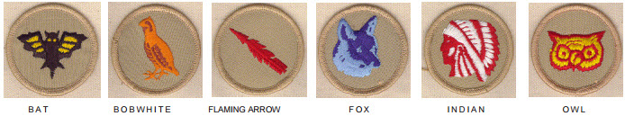***

***From*** ***www.classb.com*** ***–   
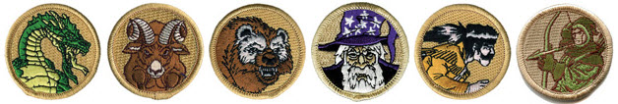***

***Just Google for "Boy Scout Patrol Patches" and you will find many more!!!***

* 1. As a patrol, make plans with a troop to participate in a Boy Scout troop's campout or other outdoor activity.

1. With your Webelos den leader, parent, or guardian, participate in a Boy Scout troop's campout or other outdoor activity. **Use the patrol method while on the outing.**

* ***Again not too early – get them started on the correct foot. The Webelos Leader Book has a Duty Roster & other stuff needed for this activity.***
* ***The Scouts will plan their meals for the campout.***
* ***If attending a troop campout at the end of this adventure, make sure the parents/guardians are aware that they are required to have an adult attend the campout with their son.***
* ***Determine a cost per boy and his parent/guardian to cover the purchase of food and any other materials for the campout. Let the boys and their parent/guardian know the***
* ***total cost of the campout in your take-home flier***

1. Do the following:
   1. **Show how to tie a square knot, two half hitches, and a taut-line hitch**. Explain how each knot is used.
   2. **Show the proper care of a rope** by learning how to whip and fuse the ends of different kinds of rope.
2. Demonstrate your knowledge of the pocketknife safety rules and the pocketknife pledge. If you have not already done so, earn your [Whittling Chip](http://usscouts.org/advance/cubscout/whittlingchip.asp)card.

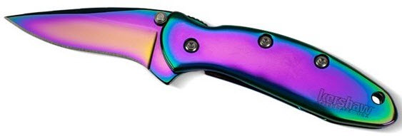

**To summarize:**This great Adventure provides an excellent intro to the Webelos Scouts to Boy Scouting. It wraps up a lot of requirements that previously were just a list into a neat package. The Webelos Den Leader guide for this Adventure has excellent information and resources.

Comments welcome. Let me know your opinion -   
[Davethecommish@gmail.com](mailto:Davethecommish@gmail.com)

# JANUARY CRAZY HOLIDAYS

*Claralyn, Golden Empire Council,   
Webelos Camp Prog Dir& Cub RT Comm Emeriti   
Adapted from*

*Adapted from* <http://holidayinsights.com>  
[http://www.brownielocks.com/month2.html](https://www.brownielocks.com)   
<http://www.gone-ta-pott.com>  
<http://www.holidays-and-observances.com>  
<http://www.nationaldaycalendar.com>  
<http://www.timeanddate.com>

**January Monthly Celebrations:**

* [National Bath Safety Month](http://homesafetyscene.com/january-is-national-bath-safety-month/)



* National Blood Donor Month



* [National Braille Literacy Month](http://meril.org/2013/01/january-is-national-braille-literacy-month/)
  + **Read** [**The Story of Louis Braille**](http://www.visionaware.org/blog/visionaware-blog/braille-literacy-awareness-month-the-story-of-louis-braille-1736/12)
* [National Hobby Month](http://www.wikihow.com/Celebrate-National-Hobby-Month)
* [Learn to Ski and Snowboard Month](http://www.skiandsnowboardmonth.org/)
* **National Get Organized Month**
* Thyroid Awareness Month



* [**National Soup Month**](http://www.gone-ta-pott.com/national_soup_month.html#.WC3NbDKZPR0)
  + **Enjoy Soup:** [**25 Recipes**](https://www.buzzfeed.com/dishofdailylife/25-amazing-soup-recipes-for-national-soup-month-18itd)
* [National Glaucoma Awareness Month](https://www.nei.nih.gov/news/briefs/glaucoma_awareness)
* [California Dried Plum Month](http://www.californiadriedplums.org/press-room/2007/6/governor-proclaims-january-as-california-dried-plum-digestive-health-month)
* [National Hot Tea Month](https://www.daysoftheyear.com/days/hot-tea-month/)
* **Be Kind to Food Servers Month**
* **National Get Organized Month**
* [Birth Defects Month](http://www.nbdpn.org/national_birth_defects_prevent.php)
* [Financial Wellness Month](http://www.weekendnotes.com/how-to-celebrate-financial-wellness-month-in-january/)
* Read:  [Teach Kids About Money](http://www.parents.com/parenting/money/family-finances/teaching-kids-about-money-an-age-by-age-guide/)



* **International Brain Teaser Month**
  + **Try** [**BrainBashers**](https://www.brainbashers.com)
* [International Creativity Month](https://www.daysoftheyear.com/days/creativity-month/)
* [Book Blitz Month](https://frombehindthepen.wordpress.com/2013/01/02/7-easy-suggestions-for-celebrating-national-book-blitz-month-in-january/)
* [National Radon Action Month](https://www.epa.gov/radon/national-radon-action-month-consumer-information)
* National Thank You Month
* National Skating Month

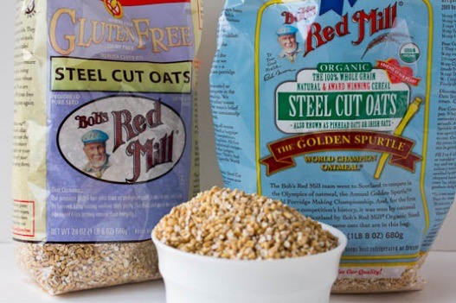

* [National Oatmeal Month](http://wholegrainscouncil.org/whole-grains-101/oats-january-grain-of-the-month)
* **National Mentor Month**
* Be On Purpose Month
* Shape Up U.S. Month
* National Polka Music Month
* [**Celebration of Life Month**](https://www.daysoftheyear.com/days/celebration-of-life-month/)
* [Walk Your Dog Month](http://www.wellnesspetfood.com/blog/index.php/tag/national-walk-your-dog-month/#.WC3idzKZPR0)

**Weekly Celebrations:**

* [New Year's Resolutions](http://www.intheblackworkshops.com/want-to-stick-to-your-new-years-resolutions-make-12-week-resolutions-instead/) Week: 1-7
* Celebration of Life Week: 1-7
* Diet Resolution Week: 1-7
* National Lose Weight/Feel Great Week: 1-8
* Someday We'll Laugh About This Week: 2-8

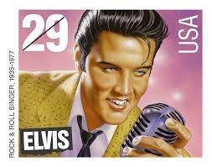

* **Elvis' Birthday Celebration Week: 4-8 (This is at Graceland. His birthday is Jan. 8.)**
* Home Office Safety and Security Week: 8-14
* Universal Letter Writing Week: 8-14
* National Pizza Week 8-14
* Hunt For Happiness Week: 15-21
* Make a [**Gratitude Journal**](http://thehappyhousewife.com/homeschool/gratitude-journals-for-kids/)

[**Gratitude Journal Prompts**](http://bouncebackparenting.com/gratitude-journal-prompts-for-the-whole-year/)

* National Soccer Coaches of America Week: 11-18
* [Sugar Awareness Week](https://www.nerdfitness.com/blog/2013/06/17/everything-you-need-to-know-about-sugar/) 16-20
* National Fresh Squeezed Juice Week: 17-23
* [National Bible Week](http://bible.org.ph/wp/pbs-announces-theme-for-nbw-2017/) (23-29)
* Week of Christian Unity: 18-25

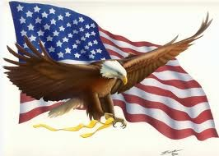

* [Bald Eagle Appreciation Days](http://greetingstonesblog.com/special-days/8299-bald-eagle-appreciation-day/): 21-22
* Clean Out Your Inbox Week: 22-29

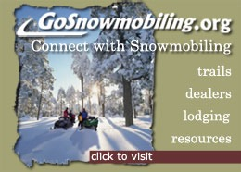

* [Snowmobile Safety and Awareness Week](http://www.snowmobile.org/): 21-29
* National Nurse Anesthetists Week: 22-28
* National Handwriting Analysis Week: 17-23
* International Printing Week: 21-26

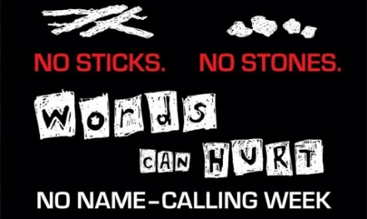

* [No Name Calling Week: 16-20](http://www.glsen.org/nonamecallingweek)

[](http://salesianum.org/)

* [Catholic Schools Week: 1/29-2/4](http://salesianum.org/)

**January Daily Holidays, Special   
and Wacky Days:**

1 [New Year's Day](http://www.holidayinsights.com/other/newyears.htm)

1 Copyright Law Day

2 [Run up the Flagpole and   
See if Anyone Salutes Day](http://holidayinsights.com/other/uptheflagpole.htm)



2 [Cream Puff Day](https://www.daysoftheyear.com/days/cream-puff-day/)

2 [Science Fiction Day](https://www.daysoftheyear.com/days/science-fiction-day/)

**Make a** [Pony Bead Alien](http://makingfriends.com/images/p_alien.gif)

3 [Festival of Sleep Day](http://holidayinsights.com/other/festivalofsleep.htm)

3 [Fruitcake Toss Day](http://holidayinsights.com/moreholidays/January/fruitcaketossday.htm)

3 [Humiliation Day](http://holidayinsights.com/other/humiliationday.htm)

4 [Trivia Day](http://holidayinsights.com/other/trivia.htm)

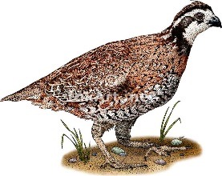

5 [National Bird Day](http://holidayinsights.com/other/birdday.htm)

6 [Bean Day](http://holidayinsights.com/other/beanday.htm)

6 [Cuddle Up Day](http://holidayinsights.com/other/cuddleupday.htm)

7 [Old Rock Day](http://holidayinsights.com/other/oldrockday.htm)

7 [Tempura Day](http://www.nationaldaycalendar.com/national-tempura-day-january-7/)

8 [Bubble Bath Day](http://holidayinsights.com/other/bubblebathday.htm)

**8** [Elvis’s Birthday](http://www.elvis.com/)



**8** [Argyle Day](https://www.daysoftheyear.com/days/argyle-day/)

**9** [Balloon Ascension Day](http://www.historynet.com/jean-pierre-blanchard-made-first-us-aerial-voyage-in-1793.htm)

**9** [National Static Electricity Day](http://www.altiusdirectory.com/Society/national-static-electricity-day.php)

**9 Apricot Day**

**9** [Balloon Ascension Day](http://www.historynet.com/jean-pierre-blanchard-made-first-us-aerial-voyage-in-1793.htm)

10 [Houseplant Appreciation Day](http://holidayinsights.com/moreholidays/January/houseplantappreciationday.htm)

10 National Poetry At Work Day



**10** [National Cut Your Energy Costs Day](https://www.daysoftheyear.com/days/cut-your-energy-costs-day/)

11 [Step in a Puddle and Splash Your Friend's Day](http://holidayinsights.com/other/puddle.htm)

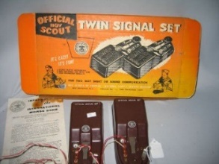

**11** [Learn Your Name in Morse Code Day](http://www.brownielocks.com/learnyournameinmcday.html)

12 [Feast of Fabulous Wild Men Day](http://holidayinsights.com/other/wildmen.htm)

12 [National Pharmacist Day](http://holidayinsights.com/other/pharmacistday.htm)

13 [International Skeptics Day](http://holidayinsights.com/moreholidays/October/internationalskepticsday.htm)

13 [Make Your Dream Come True Day](http://holidayinsights.com/other/dreamday.htm)

13 [Rubber Ducky Day](http://www.nationaldaycalendar.com/national-rubber-ducky-day-january-13/)

14 [Dress Up Your Pet Day](http://holidayinsights.com/other/dresspet.htm)

**15** [**National Hat Day**](http://holidayinsights.com/other/hatday.htm)

[Crazy Hats](https://www.pinterest.com/explore/crazy-hat-day/)  **Ideas**

16 [National Nothing Day](http://holidayinsights.com/other/nothingday.htm)



16 [Appreciate a Dragon Day](http://www.holidayinsights.com/moreholidays/January/appreciate-dragon-day.htm)

**Make a** [Fire Breathing Dragon](http://onelittleproject.com/paper-roll-dragon-craft/?crlt.pid=camp.5CbNafT5DyEd)

17[Kids Inventor Day](https://www.timeanddate.com/holidays/fun/kid-inventors-day)

Check out [Kids Invention Contests](http://www.kidinventorsday.com/contests.htm)

17 [Ditch New Year’s Resolutions Day](http://holidayinsights.com/moreholidays/January/ditchresolutionsday.htm)

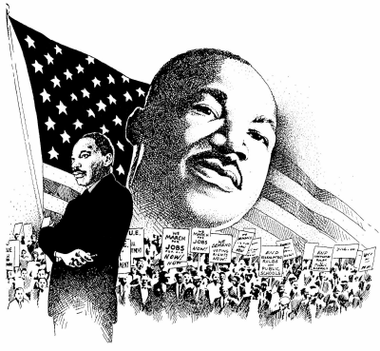

18 [Martin Luther King Jr. Birthday](http://holidayinsights.com/other/mlk.htm)  , (Actual date – January 15, celebrated on the third Monday)

18 [Thesaurus Day](http://holidayinsights.com/other/thesaurusday.htm)

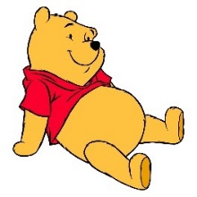

18 [Winnie the Pooh Day](http://holidayinsights.com/moreholidays/January/winniepoohday.htm) -The Birthday of Winnie's author A.A. Milne

19 [National Popcorn Day](http://www.popcorn.org/Facts-Fun/National-Popcorn-Day)

20 [National Buttercrunch Day](http://holidayinsights.com/moreholidays/January/buttercrunchday.htm)

20 Cheese Lover’s Day

**20** [**Penguin Awareness Day**](http://holidayinsights.com/other/penguinawareness.htm)

**Sing a** [**Penguin Camp Song**](https://www.youtube.com/watch?v=NIf_mVzCKiA)

21 [National Hugging Day](http://holidayinsights.com/other/huggingday.htm)

21 Granola Bar Day



21 [Squirrel Appreciation Day](http://holidayinsights.com/moreholidays/January/squirrelappreciation.htm)

Yummy [Squirrel Snack](http://www.partypinching.com/tutorials/squirrel-snack/)

22 [National Blonde Brownie Day](http://holidayinsights.com/moreholidays/January/blondebrownieday.htm)

22 Celebration of Life Day

23 [National Pie Day](http://holidayinsights.com/moreholidays/January/nationalpieday.htm)

23 [National Handwriting Day](http://holidayinsights.com/moreholidays/January/handwritingday.htm)

23 [Measure Your Feet Day](http://holidayinsights.com/moreholidays/January/measureyourfeet.htm)-   
we only ask...."Why!?!"

24 [National Peanut Butter Day](http://nationalpeanutboard.org/the-facts/fun-facts/)

24 [Compliment Day](http://holidayinsights.com/moreholidays/January/complimentday.htm)

25 [Bubble Wrap Day](http://holidayinsights.com/moreholidays/January/bubble-wrap-appreciation-day.htm)

25 [Opposite Day](http://holidayinsights.com/moreholidays/January/oppositeday.htm)

26 [Spouse's Day](http://holidayinsights.com/moreholidays/January/spousesday.htm)

27 [Chocolate Cake Day](http://holidayinsights.com/moreholidays/January/chocolatecakeday.htm)

27 [Punch the Clock Day](http://holidayinsights.com/moreholidays/January/punchclockday.htm)

28 [Fun at Work Day](http://holidayinsights.com/moreholidays/January/funatworkday.htm)

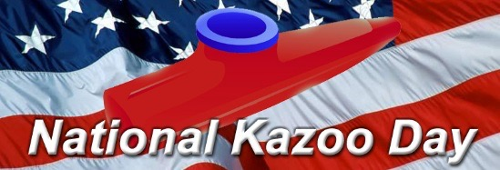

**28** [**National Kazoo Day**](http://www.nationalkazooday.com/index.html)

**Make a** [**Kazoo**](http://craftclub.com/craft/craft-stick-kazoo)

28 Data Privacy Day



**29** [**National Puzzle Day**](http://holidayinsights.com/moreholidays/January/puzzleday.htm)

**Make a** [**Make a Puzzle Piece Monster**](http://creationsbysheryl.blogspot.com/2010/04/leftover-puzzle-piece-crafts.html)

29 [National Corn Chip Day](http://holidayinsights.com/moreholidays/January/cornchipday.htm)

Recipe for [Mexican Haystacks](http://allrecipes.com/recipe/14114/haystacks/)

30 [National Inane Answering Message Day](http://holidayinsights.com/moreholidays/January/inanemessage.htm)

30 [Bubble Wrap Appreciation Day](http://www.nationaldaycalendar.com/bubble-wrap-appreciation-day-last-monday-of-january/)

30 Croissant Day



31 [Backward Day](http://holidayinsights.com/moreholidays/January/backwardday.htm)

31 [Inspire Your Heart with Art Day](http://holidayinsights.com/moreholidays/January/heartartday.htm)

# January – A Month for Obedience

*Alice, Golden Empire Council*

**January is National Hobby Month!**It’s the perfect time to try a new hobby or work on one you already enjoy. Families can work together on some hobbies – like putting together one of those really big puzzles! To succeed with the hobby, be sure to obey what your parents say to do. Take a picture and show it off at the Den or Pack Meeting.

**January 1 – New Year’s Day  
Encourage every Pack Family to choose some ways to be obedient.** Enjoy the parades and games – but you could also spend a little time deciding on some more ways you do what you should in 2017. Maybe you need to spend a little time each week practicing a skill, or learning some new words, or visiting with family.

**January 4 – National Trivia Day**In order to race your car in the Pinewood Derby, you must obey all the rules. In honor of the Pinewood Derby, let’s find out more about the Pinewood Derby – just think of the great trivia questions you could ask! If your Pack does the Pinewood Derby this month, you can have a Pinewood Trivia Game to keep everyone involved during set up or while waiting for the race results to be tabulated.

**Pinewood Derby Trivia**

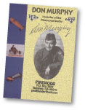

**"I wanted to devise a wholesome, constructive   
activity that would foster a closer father-son   
relationship and promote craftsmanship and good sportsmanship through competition."  
Don Murphy, 1953**

* Pinewood Derby was the brainchild of Don Murphy, Cubmaster of Pack 280C in 1953 in Manhattan Beach, California.
* He was looking for a Father-Son activity for his 10 year old son, who was too young to race in the Soap Box Derby.
* He had always made models, so he decided to design a miniature Soapbox Derby model car – and his employer, North American Aviation, agreed to fund the model cars and provide trophies for the first race.
* Leaders in his Pack were also excited, and they used their woodworking and electrical skills to make a two lane, 31 foot race track – it even had a battery powered finish gate that would light a red or white light to show which car won each heat.

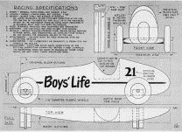

* This is the very first design – it was patterned after a Grand Prix race car, with a 7-3/8 inch block of pine with wooden struts that held the axles.
* The first “axles” were just finishing nails!
* The first kits were put in paper bags with numbers on them – but the block of wood had been carved down a little on the front third, to make a kind of cockpit.
* Don Murphy also wrote the first rules – and there were three classes of racers, based on their age.
* The first race was held on May 15, 1953 in the Scout House at Manhattan Beach.
* Pinewood Derby didn’t take long to catch on – by March of the next year, the Los Angeles City Park Department made kits available at 100 city parks! Over 300 people showed up the Los Angeles Derby Championship at Griffith Park.
* Don Murphy made a booklet called “Pinewood Derby” and sent it to the BSA National Office and gave them permission to use the program.
* The October 1954 issue of Boy’s Life had a one page article with a drawing of Don’s car plan, and two pictures from the first race.
* Those first plans for the track and the start and finish line mechanisms were available for 15 cents!

  
**First Pinewood Derby Car Kit Ad, 1955**

* The original Pinewood Derby car kits were first advertised in Boy’s Life in June 1955 for $2.75.
* Art Hasselbach’s Beta Crafts Company in **NEW JERSEY** was the exclusive supplier for Pinewood Derby car kits for 44 years (1955 – 1999)!
* In 1956, the Cub Scout Program Guide first suggested the Pinewood Derby for the Blue & Gold Banquet. But the derby soon became a separate event.
* Most of the rules are still the same ones Don Murphy wrote over 50 years ago.
* The car isn’t much different either – just a little shorter (7 inches) and without the wooden struts.



* Pinewood Derby will be 64 years young in 2017. Commissioner Dave and alice are actually older than Pinewood Derby!! Commissioner Dave built his first Pinewood Derby car for Pack 110’s Blue & Gold in 1958!!
* Over 50 million people of all ages have built the kits – including Girl Scouts, corporations and the US Military have used the kits!
* There’s a great story about “The Finder & The Founder” – how a young Cubmaster went searching for the “inventor” of the Pinewood Derby many years later – check out the rest of the story!

**A lot more detail and some great pictures can be found at the official website. Go to:** [**http://www.pinewoodpro.com**](http://www.pinewoodpro.com)

There is a large Pinewood Derby section in the Scouting Museum at the Southwestern Connecticut Scouting Heritage Museum housed within the Connecticut Yankee Council headquarters on Wellington Road, Milford, CT 06460. Among the items on display is the first Pinewood Derby car built by Joe Gargiulo, creator of [www.PinewoodPro.com](http://www.PinewoodPro.com) website.

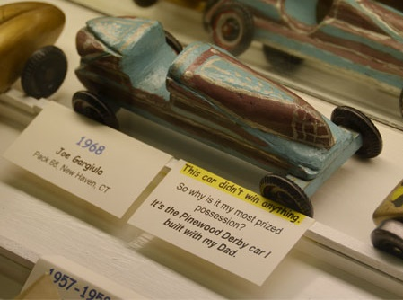

*Although this car did not win anything, it is his most prized possession because –****“It is the car I built with my dad!”***

**January 7 – Old Rock Day**Webelos can celebrate this day, as they work on the Earth Rocks Adventure this month. Be sure your Webelos obey the “Take only pictures. Leave only footprints” mantra if looking for rocks in a protected space. Here are some other ideas:

* Get in touch with a local rock collecting club or a local college Geology instructor – they are often willing to show scouts how to recognize and collect rocks and minerals
* Check out some great ideas and links at [www.trailmix.net](http://www.trailmix.net). They have a great “Rock of the Month” program – really good samples are sent each month - and there is also a mystery challenge online each month. See if you can guess the name of this mystery rock:
* Make some Rock Cookies - Here’s the recipe:

**Rock Cookies**

**Ingredients:**

1 cup butter, softened

1 t. baking soda

3 cups raisins

2 cups chopped walnuts

2 cups dates, pitted and chopped

2-1/2 cups all purpose flour

5 eggs

1-1/2 cups packed brown sugar

**Directions:**

* Cream together the butter or margarine and the brown sugar.
* Add the eggs, and beat well.
* Add the flour and baking soda.
* Chop the dates, and add them with the raisins and walnuts to the dough.
* Spoon dough onto cookie sheets. Bake at 350 degrees F (175 degrees C) for approximately 8 minutes.

**January 13 – Make Your Dream Come True Day**This is a day to think about what your dream is – what would you like to be? Where would you like to go? And what do you want to do?

Whatever YOUR dream is, if you set goals, and make a plan and work hard, it will probably come true. January is a great time to look ahead – think about what you would like to be doing in five years. How old will you be? Where will you be in school? What can you do now to start moving in the direction you want to go?

Whatever the dream, you will need to learn what os necessary to achieve it and then follow *(obey)* those guidelines to make it come true!

**January 15 – National Hat Day**National Hat Day celebrates all the different hats that you could put on your head. Hats come in all shapes, sizes, colors, materials and styles – just like people! Sometimes hats make a statement. Sometimes they identify membership and promote a cause of a product.

Hats are also practical – helmets protect and keep your brain safe. Some hats provide shade and protection from the sun’s harmful rays. At this time of year, some hats keep your head warm.

Now that may not seem important – but did you know that more body heat is lost from your head than any other part of your body? That could really be important when you are out in the snow and wintry weather – so make sure you wear a warm hat!

**Hats with Positive Attitude Game**See if you can match these hats with someone who was or is obedient. It might be a real person, or a fictional one – it might be someone famous, or just someone with a familiar hat. Do you know who would wear the hat? Can you name someone famous who might wear the hat? Can you tell how this person demonstrates Obedience? Was it to God’s Laws? To the US Constitution? To parents? To an organizations rules? To rules for safety?

Because one thing’s for sure – these hats call for Obedience!

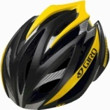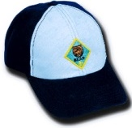

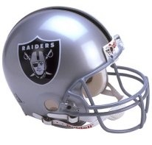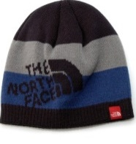

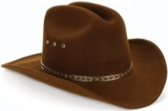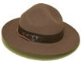

**January 16 – Martin Luther King, Jr. Birthday**Martin Luther King Jr. was a great example of obedience to God. Although he used Civil Disobedience to obtain his goals, he never used violence. He did not want to hurt others physically. He took on projects that looked impossible to many people, like organizing the 381 day Montgomery, Alabama bus boycott after Rosa Parks refused to give her seat to a white man. A lot of effort was required to challenge long-standing segregation customs.

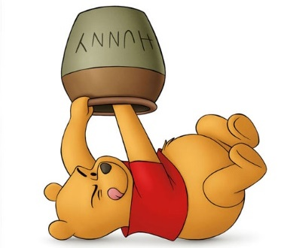**January 18 – Winnie the Pooh Day**This is the birthday of A.A. Milne, who wrote Winnie the Pooh and created one of the most loved characters in literature. And Winnie the Pooh is the very picture of Obedience – just give him a “Huny” pot and he would be good all day! So celebrate today by reading or watching one of the Winnie the Pooh stories – and make a treat with bread or biscuits – and don’t forget the honey – oh, excuse me – “Huny!”

**January 24 – Compliment Day**Practice Obedience and having a Positive Attitude by looking for ways to give a compliment to someone today – you’ll leave them smiling and share YOUR Positive Attitude!

**January 27 – Chocolate Cake Day**

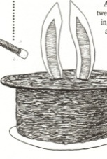

Try the Magician’s Top Hat Cake – rabbit and all! Directions under CUB GRUB. Be sure to follow **(obey)** the directions closely!

**January 29 – National Puzzle Day**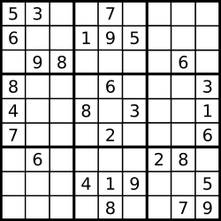 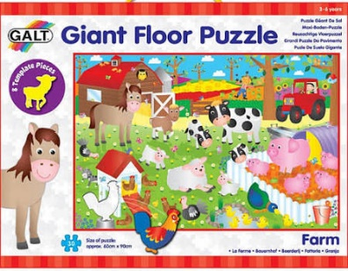  
What a perfect day to do a puzzle! And there are all kinds of puzzles – Sudoku, a number puzzle, and crossword puzzles or even those 1000 piece puzzles that families like to tackle on a cold winter night.

Doing puzzles is fun! And some people just really like the challenge of completing a puzzle and graduating to an even more difficult one. Some people start doing puzzles when they want to kill time. And some people even do puzzles to keep their mind sharp, or to learn new words.

Anyone who starts a puzzle must follow **(obey)** the rules for finishing or solving the puzzle. Doing a puzzle also demonstrates Positive Attitude – they expect to be able to find the solution or get every piece in the right place.

But scientists have also proved that someone with a Positive Attitude can actually solve puzzles or word problems 20% better than a person who’s in a bad or negative mood! Those in a bad mood can still solve problems, but they have a narrow view of possible solutions. A person with a Positive Attitude tends to have a much wider view of how to solve any problem!

So stay Positive – and get out those puzzles!

**January 31 Birthday of Jackie Robinson**Jackie Robinson was the first African American to play Major League Baseball. Before Branch Rickey signed him to play for the **BROOKLYN** Dodgers, he had him promise to keep his attitude in check by obeying rules for conduct. Because of his great play and obeying Mr. Rickey’s rules, Jackie was accepted and is now in the Baseball Hall of Fame.

**I'm not concerned with your liking or disliking me... All I ask is that you respect me as a human being.**

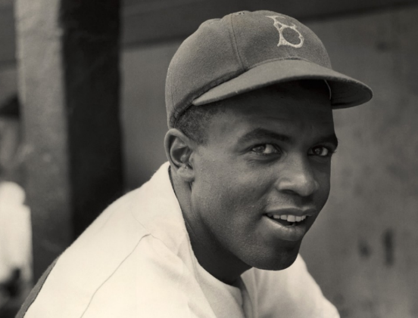

**Jack Roosevelt "Jackie" Robinson**

(January 31, 1919 – October 24, 1972) was the first [black](http://en.wikipedia.org/wiki/African_American) [Major League Baseball](http://en.wikipedia.org/wiki/Major_League_Baseball) (MLB) player of the modern era. Robinson broke the [baseball color line](http://en.wikipedia.org/wiki/Baseball_color_line) when he debuted with the [Brooklyn Dodgers](http://en.wikipedia.org/wiki/Brooklyn_Dodgers) in 1947. As the first black man to play in the major leagues since the 1880s, he was instrumental in bringing an end to [racial segregation](http://en.wikipedia.org/wiki/Racial_segregation) in professional baseball, which had relegated black players to the [Negro leagues.](http://en.wikipedia.org/wiki/Negro_leagues) His character and unquestionable talent challenged the traditional basis of segregation, which then marked many other aspects of American life, and aided to the [Civil Rights Movement.](http://en.wikipedia.org/wiki/African-American_Civil_Rights_Movement_%281955%E2%80%931968%29)

In addition to his cultural impact, Robinson had an exceptional baseball career. Over ten seasons, he played in six [World](http://en.wikipedia.org/wiki/World_Series) [Series](http://en.wikipedia.org/wiki/World_Series) and contributed to the Dodgers' [1955 World Championship.](http://en.wikipedia.org/wiki/1955_World_Series) He was selected for six consecutive [All-Star Games](http://en.wikipedia.org/wiki/Major_League_Baseball_All-Star_Game) from 1949 to 1954, was the recipient of the inaugural [MLB Rookie of the Year Award](http://en.wikipedia.org/wiki/Major_League_Baseball_Rookie_of_the_Year_Award) in 1947, and won the [National League](http://en.wikipedia.org/wiki/National_League) [Most Valuable Player Award](http://en.wikipedia.org/wiki/Major_League_Baseball_Most_Valuable_Player_Award) in 1949—the first black player so honored. Robinson was inducted into the [Baseball Hall of Fame](http://en.wikipedia.org/wiki/National_Baseball_Hall_of_Fame_and_Museum) in [1962.](http://en.wikipedia.org/wiki/Baseball_Hall_of_Fame_balloting%2C_1962)

Out of **respect** for his accomplishments, in 1997, Major League Baseball retired his uniform number, 42, across all major league teams, the only player in any major league sport ever so honored.

# SPECIAL OPPORTUNITIES

## THE WHITTLING CHIP

[*http://usscouts.org/advance/cubscout/whittlingchip.asp*](http://usscouts.org/advance/cubscout/whittlingchip.asp) *and some Friends of Baloo’s Bugle*

**What better award for a month when Obedient is the Scout Law Point to be stressed??**

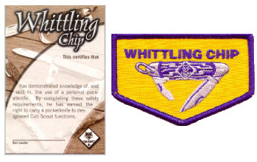

The Whittling Chip is a “license” for a Cub or Webelos Scout to use a pocket knife. In order to earn the Whittling Chip, a scout must undergo proper handling, care and safety instruction with a pocket knife.

**Requirements:**

1. Know the safety rules for handling a knife.
2. Show that you know how to take care of and use a pocketknife.
3. Make a carving with a pocketknife.* Work with your den leader or other adult when doing this.
4. Read, understand and promise to abide by the "Knives Are Not Toys" guidelines.
5. Read, understand and promise to abide by the "Pocketknife Pledge."

*One of the items carved for requirement 3  
of the "Bear Claws" adventure may be   
used to fulfill Whittling Chip requirement 3.

**The Pocketknife Pledge:**

* I understand the reason for safety rules.
* I will treat my pocketknife with the respect due a useful tool.
* I will always close my pocketknife and put it away when I am not using it.
* I will not use my pocketknife when it might injure someone near me.
* I promise never to throw my pocketknife for any reason.
* I will use my pocketknife in a safe manner at all times.

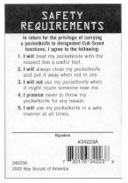

The wording on the back of the Whittling Chip card (seen above) reads:

In return for the privilege of carrying a pocketknife to designated Cub Scout functions, I agree to the following:

1. **I will** treat my pocketknife with the respect due a useful tool.
2. **I will** always close my pocketknife and put it away when not in use.
3. **I will not** use my pocketknife when it might injure someone near me.
4. **I promise** never to throw my pocketknife for any reason.
5. **I will** use my pocketknife in a safe manner at all times.

**Knife Safety Rules**

* A knife is a tool, not a toy
* Know how to sharpen a knife.   
  A sharp knife is safer than a dull knife because it is less likely to slip and cut you.
* Keep the blade clean and dry.
* Never carry an open pocketknife
* When you are not using your knife, close it using the palm of your hand and put it away.
* When you are using the cutting blade, do not try to make big shavings or chips. Cut slowly and steadily.
* Make a safety circle. Before you pick up your knife to use it, stretch your arm out and turn in a circle.  
  If you cannot touch anyone or anything else, it is safe to use your knife.   
  While using your knife, be sure to watch in case someone walks toward you and gets too close.  
  If that happens, put your knife away until it is safe to continue.
* Always cut away from you, never toward you.
* Never hand a knife to someone else blade first.   
  Learn and use the "eye contact" method of handing a knife to someone else.  
  Do not release the knife until the other person makes eye contact with you   
  and acknowledges he is receiving the knife.
* Never use a knife on something that will dull or break it.
* Never throw a knife for any reason.
* Always think before you cut.

**Knives Are Not Toys Guidelines**

* Close the blade with the palm of your hand.
* Never use a knife on something that will dull or break it.
* Be Careful that you do not cut yourself or any person nearby.
* Never use a knife to strip the bark from a tree.
* Do not carve your initials into anything that does not belong to you.

**Cutting Corners**

Tradition in many councils, districts, and units holds that when a Scout does not follow the safety precautions learned, that 1 to 4 corners of the Whittling Chip card are cut off. When all 4 corners are gone, the Scout must go through the course again to earn a “new” Whittling chip before he is allowed to carry and use a pocketknife again. How many corners are removed for each offense is determined by the severity of the offense. Not checking the area may result in the loss of one corner, whereas throwing the knife around a crowd of people may result in the loss of all four corners immediately. The card should be carried at all times if the Scout has or will be using a pocket knife.

Although these policies are not written in any official BSA publication, they bring home the point to the Scout that he may lose his privilege if he doesn’t follow the rules. **Whether corner cutting is allowed or not, an adult should never hesitate to stop a Scout who is misusing his pocket knife and instruct him again.** Also, a Whittling Chip card is only for a pocket knife. It is **NOT** for axes or saws.

In my unsuccessful search for an official BSA policy on corner cutting I did find a post in Bryan’s Blog on the Totin’ Chip Cards used by Boy Scouts addressing corner cutting. Bryan was addressing this question asked by a leader, “It was my impression before attending ITOLS that, although corner cutting was previously a popular procedure, that it is no longer allowed in the Boy Scouts of America. Is that correct?”

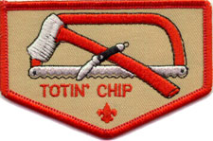  
*(Note – this is earned by Boy Scouts not Cub Scouts  
Cub Scout - Whittling Chip - Pocket Knife  
Boy Scout - Totin’ Chip - Knife, Saw, and Axe)*

**Bryan’s answer was**

I checked with Bill Evans, the BSA’s subject-matter expert on all awards and recognitions. He pointed me to the last line of the [**BSA’s Totin’ Chip guidelines**](http://www.scouting.org/scoutsource/BoyScouts/AdvancementandAwards/MeritBadges/totin.aspx): “The Scout’s ‘Totin’ Rights’ can be taken from him if he fails in his responsibility.”

“This is all we say,” Bill said. “Period.”

In other words, the BSA doesn’t tell troops they must cut corners off for Totin’ Chip violations, but it doesn’t prohibit the practice either.

This is a decision for troop leaders, and I’d recommend including your senior patrol leader in the discussion as well. Set a standard, and enforce it.

The Totin’ Chip Guidelines are found at <http://www.scouting.org/scoutsource/BoyScouts/AdvancementandAwards/MeritBadges/totin.aspx> .

I was unable to find an equivalent page for the Whittling Chip Award. But my logic says the rules are the same. Adults stop a Cub Scout who is misusing his pocketknife. The exact method is undefined.

The Official BSA Whittling Chip for Cub Scouts and Webelos Scouts is a Wallet Card (Single - No. 34398, Computer Printable sheet of 8 – 34223) and/or   
Patch (8598)

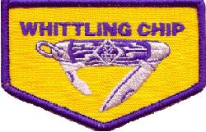

**NOTE:** The Whittling Chip patch is considered a "Temporary Patch" and, if worn, should be worn centered on the RIGHT Pocket of the Cub Scout or Webelos Scout Uniform Shirt.  **It should NOT be sewn on a pocket flap**

**Teaching hints for Whittling Chip –**

**From CD –** Whittling Chip is a great place to practice your **EDGE (Explain, Demonstrate, Guide,** and **Enable)** teaching / training skills!!! Not sure what those are – ask someone and take Wood Badge!!!

**From Mike Bowman,** [**www.USScouts.org**](http://www.USScouts.org)One idea that I really liked when I saw it at a PowWow was for the den leader to make up a large pocket knife with folding blades out of cardboard, construction paper or what-have-you. The knife was about two feet long, which made it large enough for all the boys to see when the den leader was explaining safety and how to use the knife.

**From Steve Eisenberg.**Your Cub Scout knife is an important tool. You can do many things with its blades. The cutting blade is the one you will use most of the time. With it you can make shavings and chips and carve all kinds of things.  
You must be very careful and think when you whittle or carve. Take good care of your knife. Always remember that a knife is a tool, not a toy. Use it with care so that you don't hurt yourself or spoil what you are carving.

**Good Things to Remember**

* Know the safety rules for handling a knife
* A knife is a tool, not a toy.
* Know how to sharpen a knife. A sharp knife is safer because it is less likely to slip and cut you.
* Keep the blade clean.
* Never carry an open knife in your hand.
* When you are not using a knife, close it and put it away.
* Keep your knife dry.
* When you are using the cutting blade, do not try to make big shavings or chips.
* Easy does it.
* Knives are not toys!
* Close the blade with the palm of your hand.
* A knife should never be used on something that will dull or break it
* Be careful that you do not cut yourself or any person nearby.
* A knife should never be used to strip the bark from a tree.
* Do not carve your initials into anything that does not belong to you.

**Test your knowledge**

**You should close the blade with the palm of your hand** True False

**A knife is just a toy.** True False

**It's okay to keep your knife wet.** True False

**A dull knife is more likely to slip and cut you.**  
 True False

**You should carry your open knife in your pocket.**  
 True False

**Carving your initials into a tree is okay.**  
 True False

**The Pocketknife Pledge**(fill in the blanks)

1. I understand the reason for _____________ rules.
2. I will treat my pocketknife with the ______________ due a useful tool.
3. I will always ______________________ my pocketknife and put it away when not in use.
4. I will not use my pocketknife when it might _______________________ someone near me.
5. I ______________________ never to throw my pocketknife for any reason.
6. I will use my pocketknife in a safe manner at _______________________times.

**Word bank -** Close, respect, injure,  
 promise, all, safety,

# KNOT OF THE MONTH

## VETERANS RECOGNITION

*Baloo &*[*http://www.scouting.org/scoutsource/Awards_Central/VeteranAward.aspx*](http://www.scouting.org/scoutsource/Awards_Central/VeteranAward.aspx)

***Your upcoming District or Council Annual Dinner might be an appropriate time to honor your unit, district, and/or council long term leaders. If they have 5 or more years total as a Youth in Boy Scouting (Cubs, Boy Scouts, Exploring, Venturing) and as a Leader they qualify (Or simply 5 or 10 years solely as a youth or adult). CD***

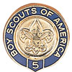 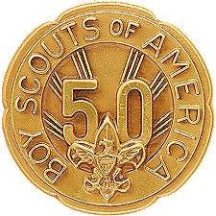 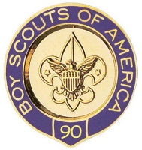

The Veteran Award is an adult recognition. However, tenure earned as a youth may be included in the total number of years registered.

After 5 years of registered service in the Boy Scouts of America, an adult may, upon application, receive the designation of “Veteran,” provided the person agrees to live up to the Scouting obligations; to keep local Scouting authorities in the community in which residing informed as to availability for service; and further, to be as active in the promotion of the cause of Scouting as circumstances and conditions permit. Service in Scouting organizations other than the Boy Scouts of America does not count toward veteran recognition.

An individual must currently be a registered member of the Boy Scouts of America in order to receive an award.

An adult designated veteran shall pay the regular registration fee if desiring to continue to retain active connection with the movement.

Scouters desiring recognition as 5, 10, 15, 20, 25, 30, 35, 40, 45, 50, 55, 60, 65, 70, 75, 80, 85, or 90 year veterans must have maintained an active registered relationship for the required number of years, paying the annual registration fee. The pin is for civilian wear only. The 90 year pin is currently the highest number of years available. *Since Cub Scouts did not exist 90 years ago, a person with 90 years of service would be (minimum) 102 years old.*

The 05, 10, 15, and 20 year awards are awarded by the local council. Awards for 25 years and more are awarded by the national office.

The records of the national office and local councils shall determine eligibility. The periods of service claimed for veteran recognition need not be continuous.

Application should be made through your local council. The application form is available on National’s Website ([www.scouting.org](http://www.scouting.org)) at <http://www.scouting.org/filestore/membership/pdf/524-701.pdf>

*This is a great way to recognize long serving members of your unit or district.*

## Veteran Unit Award

<http://www.scoutinsignia.com/>, Mike Walton, President [www.usscouts.org](http://www.usscouts.org), Baloo & <http://www.scouting.org/scoutsource/Awards_Central/VeteranUnitAward.aspx>

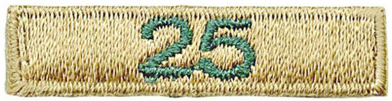

To encourage unit tenure and to recognize members of units that have been chartered 25 years or longer BSA has authorized a bar that may be worn either between the unit number and the council shoulder patch or incorporated into a unit number block –

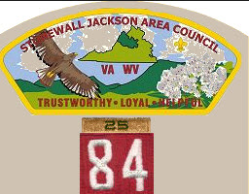 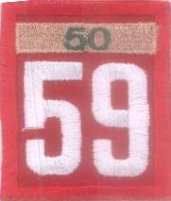

The patches are color coded with backgrounds being used to indicate different lengths of chartered life.

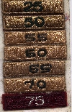

This Fall (29016) BSA authorized 105 year bar –

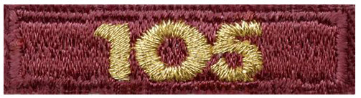

For units that have been in existence that long. Bet **Paoli 1** who traveled with me to Philmont was one of the first purchasers of that bar!!!

The veteran bar should be worn by all unit members – youth and adult. It is not just for those who were registered at the time of the unit's anniversary commemorated on the patch.

# TRAINING TOPICS

## HAVE FUN!!!

***Bill Smith****, the Roundtable Guy*

***Comment from CD –   
I believe this article was inspired by a sad event in Bill’s life that he wrote me about this month. His youngest grandson just dropped out of Cub Scouts. It took him a year to work up enough nerve to tell Grandpa Bill that the meetings were dull and boring. Apparently his youngest grandson’s Den Leader did not take Bill’s advice. We lose boys when we do small things and don’t fire their imaginations. When Scouts becomes like school. Plan BIG and have fun. Keep them moving and they will stay!!! It is not easy, but it is FUN!! Do silly stuff, lead songs with enthusiasm. Make real things.***

Ever since you were about ten years old, **looking cool** was probably one of your priorities. Certainly in high school and early adult life it was often an advantage to act the suave urbane winner. Would your spouse have been attracted to you is you were a klutz – a buffoon who wore weird clothes and who would suddenly break out singing nonsense songs? Of course not!

Now things are different. You are a parent of a Cub Scout and looking cool doesn’t always count much in the eyes of a seven year old. It’s just not in the nature of boys this age to constantly take things seriously. They crave fun, adventure and revel in the unexpected. Now that you are the parent of one of these creatures, give him and his buddies all these things.

Cub Scouting has just got to be fun. If it‘s not fun, no one will stick around long enough to get any benefit out of it.

**Be Nutty!**

Lose your inhibitions and have uproarious **FUN**. Do all the zany songs, cheers, run-ons and stunts. Wear crazy costumes and play outrageous games. Do this a lot in Cub Scouts because as the boys get close to Boy Scout age they lose much of their appreciation of madcap humor – especially by their parents.

I recall a new Pack Chairman who came to one of our training sessions. He was a corporate lawyer, very proper, but certainly open to new ideas and immediately recognized the value of pure fun. I can still, years later, vividly remember him in his three-piece business suit, leading a hilarious audience participation story in front of laughing, shouting Cub Scouts.

Cub Scout age boys have an extraordinary ability to instantly switch between the zany and the profound. They see no problem with the “Clown” who hands them an award in an inflated balloon one moment and the same person a few minutes later in a Scouter’s uniform delivering a serious Cubmaster’s minute.

Kids by age six are very clever. I have found that they can pun, they utilize sarcasm, and drama in their everyday communications. I have NO doubt that they 'get it' when I am goofing, and they 'get it' when I am serious.  
*Michael J. Seligsohn, Cubmaster Pack 117,   
Golden Empire Council,*

**Games, Ceremonies and Outings Rule!**

Everything else is boring and dull.  Gather a list of games, songs, sparklers, cheers, and all the other zany stuff that will work for you and your pack. Fill your ceremonies with cheers, drama, explosions, and such to make them exciting and memorable. **What's wrong?** Never been to a rock concert? Punctuate your calendar with lots of outings and service projects. Above all, don't hold meetings; they're boring! Put on productions.

**Sean Scott tells us in Cub-Scout-Talk:**

The point is that you get the boys expecting something exciting, and they get pulled into the story. It's more than the story of how the Indian brave climbed the mountain or whatever. There's a personal interest for the boy in the 'magic' ceremony.

For 'minor' awards I like things that have action. Scubas suits, Frisbees, cowboys, pirates, astronauts, athletes, catapults, radio controlled cars, balloon rockets, etc. are all excellent means of 'delivering' the awards to the boys. It has action and interest for the boys, and is something more than the baggie and handshake ceremony.

True, these require some advance planning. You don't just pull these off at the last minute, while the Program Helps is as easy as reading a passage, but aren't the boys worth the extra work? Don't they deserve some pizzazz and show for their efforts? Definitely!

**Run-ons**

Kriste Ryan had a wonderful description of what she calls quick, simple, easy ***Run-on Awards*** for Webelos Activity Badges on [Cub-Scout-Talks on Yahoo Groups.](http://groups.yahoo.com/group/Cub-Scout-Talk/) She relates what Jo did for some of the Webelos Activity Badges:

**Aquanaut:** I had on a swim vest, mask, and flippers and carried a big swim noodle. I had a whistle around my neck and I interrupted the meeting by coming in with the flippers on and whistling and yelling Everyone out of the pool!" and the Cubmaster, asked "What is going on here?". Then I said, "Well, there are some boys here tonight that have worked very hard on their Aquanaut badge, and I have them here in my pail. I pulled them out of a sand bucket and the Cubmaster announced their names, gave them the awards and a handshake while I told a ahort commercial of what kinds of things go into an aquanaut badge. Then I pulled a water spray bottle out of my bucket and sprayed the boy’s hair. And then the entire pack gave them a cheer.

The meeting went on and soon I interrupted again. This time I was a newspaper boy and I came in with a newspaper bag yelling "Extra! Extra! Read all about it! and I was throwing newspapers towards the various dens as I went. The Cubmaster demanded to know what I was doing again, and then we did the same sort of thing for the boys who earned their communicator badges. I had the badges inside the newspaper bag.

The meeting went on and for my final interruption; I was dressed as a tourist with a camera, a map, a visor and a roll-behind suitcase. As the Cubmaster was talking about popcorn sales, I was visiting a Wolf, Tiger or two with my map asking "Do you know how to get to Baltimore?" and things like that. By this time the kids were kind of yelling out to the Cubmaster "She's here again!". So finally, I award the Traveler badge from the suitcase.

What Kriste describes also shows preparation, A lot of the fun came when the Cubmaster, playing the straight man role, pretended to be irritated by the interruptions.

**Songs**

There is nothing that compares with a good rousing song fest. If your pack has anyone who can lead songs, you are in luck. Good Cub Scouts songs are lively, easy to learn, fun to sing and need not make much sense. The staff at a St Louis Boy Scout Camp does a great job with [“The Pizza Man” song](https://www.youtube.com/watch?v=XY3s3-Hphqk) . How about some Cubs doing [Tarzan (Bananas, Coconuts, and Grapes).](https://www.youtube.com/watch?v=6fMFiarVWEg)

**Audience Participation**

These are easy to do, plentiful, easily adapted to themes and lots of fun. Whether it’s a theme related story at a pack meeting or a ghost story at a camp fire, these are sure fire winners. A variation of the audience participation tale is the old Mad-Lib fun where Cub Scouts insert random words into a story. Sometimes, just mixing up the nouns in a normally serious story results in great comedy. I liked to print words on 3X5 index cards randomly distributed to Cub Scouts worked great.

**Cheers**

Every den needs at least one den cheer. Every pack meeting must provide dozens of reasons for dens (or parents) to cheer. And, of course, there are the yells and cheers in ***Group Meeting Sparklers*** that everyone joins in on. Beware of quiet meetings.

**Does your pack have that much fun?**

**What are YOU going to do now?**

***Go get ‘em. We need all the help we can get.***

***The best gift for a Cub Scout.......  
 ......get his parents involved!***

# FUN STUFF

## CITIZENSHIP THINGS

**20 Ways to Teach Citizenship to Cub Scouts**

*Catalina Council*

1. Hold a discussion on what citizenship means -- including rights and responsibilities of citizens. Ask the boys how they think they can be good citizens.
2. Define a good citizen and have the boys share personal stories about when they exhibited citizenship. For example:
   * I was friendly to a new child from a different country.
   * I helped clean up the park.
   * My mom and I passed out voter pamphlets.
   * I collected used toys and clothes for needy children.
   * I walked away from a fight.
   * I said "no" when a friend asked me to steal money from another child.
   * I wear my bike helmet and follow other bike safety rules.
   * I wait for the signal to cross the street and I stay in the cross walk.
3. Ask the boys to describe what would happen if there were no rules or laws at home, in school, in traffic or against stealing, attacking, etc. Involve the boys in making den rules. Discuss why rules are important and have them define the consequences if they are broken.
4. Ask the boys to interview a veteran, immigrant, or person who served overseas, lived through the Great Depression, experienced some of the September 11, 2001 events, or experienced another national event. Together make a list of questions they could ask such as:
   * How do you feel about the United States of America?
   * Tell me about your life?
   * What was a difficult time for you?
   * What does being a U.S. citizen mean to you?
5. Have the boys write about or draw what they discovered, report their findings and post the results at a Pack meeting.
6. Have the boys write a poem, story, play or song about citizenship. Have them perform their creation for others.
7. Ask the boys to search for local citizens who generously contribute to the good of the community. Thank or honor them in some way.
8. Have the boys read, analyze and debate newspaper articles on various topics concerning civic life.
9. Have the boys create a video on "American Life" or another related topic.
10. Invite guest speakers to share their knowledge of United States history or portray historical characters.
11. Read or have the boys read stories about extraordinary Americans and then act out the stories.
12. Provide an understanding of the country's founding documents for the boys:
    * Declaration of Independence
    * U. S. Constitution
    * Bill of Rights.
13. With parents assistance have the boys take photographs in their community for a book entitled "Our Freedoms," "Our Citizens" or another related topic. Have the boys work together to assemble the book.
14. Attend a city council meeting, school board meeting or court session. Visit historical museums, monuments, and/or national parks.
15. Help the boys learn patriotic songs to sing at a pack meeting, school assembly, or community event.
16. After researching the significance of American symbols and/or the Pledge of Allegiance, have the boys make a poster explaining what they learned.
17. Have the boys create a presentation to teach another den about the American Flag, its history, symbolism, care and proper display.
18. Discuss taxes and why our local, state and national governments need income for police, firemen, prisons, roads, etc.
19. Support a Pack wide Cub Scout Council composed of representatives from each den.
20. Encourage boys to participate in community service projects such as recycling, picking up litter, and volunteering for other worthwhile projects.

**Citizenship Do’s & Don’ts**

Citizenship has lots of parts – this is an old list of “To Do” and “Not to Do” things – if you want to be an example of good citizenship. Bet the boys can come up with some others from their own point of view!

**DO...**

* ...live by the Golden Rule
* ...do your share
* ...be a good neighbor
* ...be a volunteer—help your school and community be better, safer and cleaner
* ...obey laws and rules
* ...obey parents, teachers, coaches and authority figures
* ...protect the environment by conserving resources, reducing pollution, and cleaning
* up after yourself
* ...participate in voting, report wrongdoing, pay taxes, and voice your opinion

**DON’T**

* ...argue with or disobey parents, school teachers, policemen
* ...litter parks, playgrounds, school grounds, or your community
* ...complain about choices that were made even if you did not take the time to say what you thought
* ...break the rules in games or play
* ...ignore it when someone breaks the rules or does something wrong

**Kids Can Help!**

Alice, Golden Empire Council

Sometimes adults and Cub Scouts don’t realize that kids can help keep themselves and their community safe and lawful. Here’s a list of ways that kids, (and Cub Scouts and Boy Scouts) can help law enforcement and be good citizens. ***You can make any of these good choices into a game or use den time to practice the skills that kids need to know.***

**Being Prepared:**

* I know my full name, my parent's names, and our address and phone number.
* I know when and how to use 911 properly. I know I can dial 911 for free from any phone.
* I never put my name on my clothes, jewelry, caps or belongings where people can see it.
* I tell my parents, a teacher, or a trusted adult about things that happen to me that make me feel scared, uncomfortable or sad.
* I know the difference between a good secret and a bad secret. A good secret is fun to keep, like a surprise party. A bad secret feels bad to keep, and telling my parents about it doesn’t make me a “tattle tale.”
* I know what to do if I am lost.
* I know what to do if there is a fire emergency – I know two ways to get out of every room, and to follow my family escape plan. I know where to meet, and NEVER to go back inside!
* I know what to do and say in an accident or other emergency.

**Sharing Information:**

* I never tell strangers my name unless my parent says it’s OK.
* I never tell strangers where I live. I know that a stranger is anyone I don’t know well, even if I recognize them - like the mailman or ice cream truck driver.

**Buddy System:**

* I use the “buddy system” and avoid walking or playing alone outside and in public places.

**Safety on the Street:**

* I always walk against traffic, so I can see if a car stops near me.
* I never take short cuts through deserted areas like creeks or vacant lots.
* I know to stay a safe distance (approximately three arm-lengths) away from strangers and stranger’s cars, even if a stranger seems nice.
* I know to yell NO or “FIRE” and run away if someone tries to grab me or get me to enter their car. I know NOT to hide and to tell an adult as soon as I am safe.
* I know to run in the direction opposite from the direction the stranger’s car is traveling.
* I know it’s okay to yell and fight if someone grabs me or tells me I have to go with them.
* I know and follow safety rules when walking or crossing the street.
* I know the rules for riding a bike, skateboard or scooter safely.
* I ALWAYS wear a helmet and other safety equipment.

**Phony Requests:**

* If someone tells me my parents sent them, I ask them the secret password that only my parents and I have agreed on.
* I know to say NO and run to safety if someone says they need me to help them – finding a lost dog, or an address – or when they say they will give me candy or some other treat. I know not to go near them or their car.

**Home Safety:**

* I keep all the doors and windows locked when I am home alone. I know NOT to go inside if a window is broken or the door is open when I get home – I will to go to a neighbor and call 911.
* I know how to call my parents or a neighbor if I get frightened when I’m home alone.

**Doorbell Safety:**

* I answer the door by asking, “Who is it?” I never say that I am alone, and never open the door when I am alone, unless it is someone my parents told me to expect and let in.
* When I am alone, I always talk through the door and say, “My parents are busy now, I’ll tell them you stopped by.” If the person does not leave, I know to call “911.”

**Phone Safety:**

* I never say that I am alone when a stranger calls.
* I let the answering machine screen calls or say, “Mom/Dad can’t come to the phone now, can I take a message?”
* If someone is making strange noises, saying scary things, or not saying anything, I will hang up the phone.

**Internet Safety:**

* I know never to give my last name, address, or phone number to a person on the Internet, and that it is never safe to meet Internet friends in person without my parent’s supervision and consent.

**Could YOU Pass the Test?**

The questions below are just some of the questions that must be answered correctly by someone born in another country before they can become a United States citizen. Could you answer them correctly?

1. What were the first 13 original states that formed the Union?
2. How many amendments to the Constitution have been made so far?
3. What must be done before the Constitution can be amended?
4. What right is provided in the 15th Amendment?
5. When was the Constitution of the United States adopted?
6. What form of government do we have in the United States? What is

the difference between a republican type of government and a monarchy?

1. How many Presidential electors does each state have?
2. What is the most important right that the Constitution gives us as Americans?
3. What are the first 10 amendments to the Constitution called?
4. Who established the first permanent colonies in North America?
5. What is meant by referendum?
6. What are the colors of the United States flag and what do they stand for?
7. Who was the President of the United States during the Civil War and about when was this war fought?
8. What document was signed on July 4, 1776? Where was it signed? What did it declare?
9. What are the basic principles of the U.S. Constitution?
10. Who is eligible for the office of President or Vice President?
11. When and where does Congress meet?
12. Why is the government divided into three branches?
13. How many members are there in the Supreme Court? What is the term of office for these judges?

**Answers:**

1. *Connecticut, Delaware, Georgia, Massachusetts, Maryland, New Hampshire, New Jersey, New York, North Carolina, Pennsylvania, Rhode Island, South Carolina and Virginia.*
2. *Twenty-six amendments have been made so far.*
3. *Both Houses of Congress must pass the amendment, and 36 states must ratify and approve it.*
4. *The 15th amendment gave all American citizens the right to vote, regardless of race, creed, or color.*
5. *The Constitution of the United States was adopted March 4, 1789.*
6. *A republic. In a republican form of government the supreme power rests in all citizens entitled to vote and is exercised by representatives elected directly or indirectly by them and responsible to them, while in a monarchy the head of the nation is a line who inherits the throne.*
7. *Each state has as many Presidential electors as it has United States Senators and Representatives.*
8. *It gave us Equality before the laws regardless of race, color, or religion. It gives us freedom so long as we do not interfere with the rights of others.*
9. *The Bill of Rights.*
10. *The English were first with permanent colonies.*
11. *Referendum means that people may ratify or annul acts of the legislature.*
12. *Red is for courage, White stands for truth, and Blue is for justice.*
13. *Abraham Lincoln was President, 1861 -1865*
14. *The Declaration of Independence, signed at Philadelphia. Declared our independence from England.*
15. *Liberty, Equality, and Justice*
16. *A native-born American citizen who is at least 35 years old*
17. *Congress meets in Washington D.C. on January third of each year.*
18. *To provide a system of checks and balances to prevent any group from becoming too strong.*
19. *There are nine Justices in the Supreme Court. They serve for life with good behavior.*

*Alice, Golden Empire Council*

* Many people disapprove of the phrase Xmas – the original use was not disrespectful – it was based on X being the first letter of Xristos, the Greek name for Christ.
* King Richard II of England served 28 oxen and 30 hundred sheep at his 1377 Christmas feast!
* Rudolph the Red-Nosed Reindeer was written by Robert L. May as a promotion for Montgomery Ward. They distributed six million copies of the story between 1939 and 1946 alone. The [**song**](http://www.kidsdomain.com/holiday/xmas/music.html), written by Johnny Marks, came along in 1949.
* According to The Macaulay Institute in Aberdeen, Scotland, reindeer can haul up to twice their weight at speeds up to 15 miles an hour, making them great sleigh pullers.
* Over 70 million Americans give their dog or cat Christmas presents, according to an American Pet Association poll.
* “Jingle Bells,” one of the most popular holiday songs in America, was the first song ever broadcast in space, thanks to the crew of 1965’s Gemini 6 spacecraft.
* Frigg is the name of the Scandinavian love goddess who removed poison from mistletoe, bringing her son, Baldur, back to life. She was so happy, she made mistletoe a sign of love – so now people make “Kissing Balls” of mistletoe.
* The traditional Christmas ham began with the Norse custom of sacrificing and eating a pig to honor their god Freyr.
* When it's winter solstice in the Northern Hemisphere, the sun is directly overhead at noon only along the Tropic of Capricorn - Sao Paulo, Brazil, southern Madagascar, and areas north of Brisbane, Australia.

## PACK AND DEN ACTIVITIES

**Planning & Service Project Ideas**

*Wendy, Chief Seattle Council*

**Running Service Projects:**

<http://www.goodcharacter.com/SERVICE/service.html>

<http://www.scoutingmagazine.org/issues/0911/d-csc.html>

**Service Project ideas:**

* Collect food and clothing for your local food bank.
* Collect toys for children in the hospital.
* United Way Service Opportunities: <http://liveunited.org/take-action/volunteer>
* Litter Collection (Wolf Ach. #7d)
* Beautify the area where you meet (Bear El. #14c).
* Rake leaves & clean gutters for elderly people.
* Visit an assisted living facility: sing holiday songs, bring decorations and holiday cards.
* Make cookies & holiday cards for police officers & fire fighters.
* Write letters/holiday cards to service personnel:
* <http://www.redcross.org/holidaymail/>
* <http://www.flagsacrossthenation.org/>

**Citizenship Activities for Packs & Dens**

*Alice, Golden Empire Council*

**“Shoot” for Good Citizenship by taking photos of examples of duties and rights of citizenship –** Assign each boy or family to take a photo of something that shows qualities or examples of citizenship – (examples: a flag, a church, a voting booth, a Stop sign to represent laws) – encourage them to use their imagination to show examples of both duties and rights. (Digital and disposable cameras could make this easy and cheap – but you could also have the boys draw the picture). Display at the Pack Meeting with a label explaining why each photo was taken.

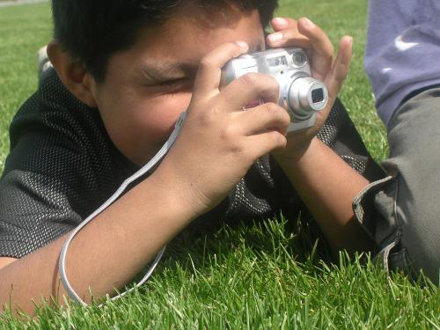

**At each den meeting, tell a story of a real example of Citizenship in action.** Check with your librarian, look for “heroes” stories in the newspaper and on TV features, or ask Den or Pack families to take a turn sharing a family story. Put up a “Wall of Honor” at the Pack meeting to share these stories.

**Challenge each boy to earn a “Certificate of Citizenship” or a patch or “medal” by doing required actions during the month:** Wearing his uniform to each meeting; Sharing a story about a good citizenship; Following Den Rules and treating every boy with respect at each den meeting; or whatever requirements you design. (You could also purchase or make a Citizenship medal, or look for a patch to award for each boy to add to his red vest).

**Invite a local political authority, local official or election official to speak to your den or pack.** Make sure they know the time and location, and what you would like them to talk about – you could give them information from the boy’s books and requirements.

**Visit the city or county department responsible for elections and learn how elections are held and votes are counted.** See how voting is made accessible to people with language or mobility issues. Be sure everyone knows that no political clothing can be worn and no campaigning comments are allowed at a polling place.

**Put a display about Citizenship in the local library –** Use a flag backdrop and display photos of scouts demonstrating good citizenship (doing a flag ceremony, retiring a worn flag properly, or giving other community service). Be sure to have contact information for your pack or den – and be sure to put up and take down your display when you agreed to!

**Take part in a Scouting for Food Activity –**In my area, a group called Senior Gleaners partners with us to collect and distribute food and other supplies to the needy.

**Raise the flag at a local school for a specific period of time.** You could also have the boys make posters, each one with a different way that students could demonstrate being a good citizen.

**Play a team sport and then discuss how the rules and different jobs on the team matter -** Talk about the different roles that team members have, why it’s important for everyone to do their job, and why we all have to play by the rules. Compare that to the rules and laws of society and how each one can be a good citizen.

**Re-enact the signing of the Declaration of Independence or some other historic event at a campfire –** or indoors at a Pack Meeting.

**Challenge each family in the pack to obtain an American Flag for their home and to fly it on National Holidays for the next year.** You might even take a photo of each family in front of their flag for the Pack or Den scrapbook.

**Attend the swearing in of some new citizens – find out what they had to learn in order to pass the test!** If you interview a new citizen and give a report to your den or family, you will have done one of the requirements for Citizenship Pin. (Check with your local government officials to see when and where)

**See who can answer the questions that immigrants must answer to become American citizens –** In the den, you can do several questions at each den meeting. At the Pack meeting, you could have a competition between dens, families, or adults and boys – at the end, do an applause to “Salute the New Citizen”

**Learn about and share the stories of some immigrants –** Each boy, family or den could choose someone, possibly even one of their own family members, who came to this country. Be sure to point out why the person came to America and what advantages there were to their becoming an American citizen. Think about education, right to vote, economic and religious freedom as reasons for immigration.

**Have a workshop to make gifts for family or to give to a local charity.** Some ideas would be: making homemade Play-Doh for young children, bath salts for women, pencil containers and/or desk sets for men. You can get lots of other ideas in the How-To Book, or check to see what suggestions the charity might have. Boys can also make Holiday cards and wrapping paper.

**Alice’s favorite Play Doh recipe**

*Alice, Golden Empire Council*

*It looks, smells, works and even tastes   
like the real thing!*

**Ingredients:**

* 1 Tablespoon vegetable oil;
* 1 Cup water;
* Food coloring of your choice   
  Paste works best and you can do any color, even black. Regular liquid food coloring will work – colors will be less intense.
* 1 Cup. flour,
* 1/2 C salt,
* 2 Tablespoons Cream of Tartar.

**Directions:**

1. Mix wet ingredients together (vegetable oil; water; Food coloring)
2. Now add in the dry ingredients (flour, salt, cream of tartar) *This is a different way to do it, but this way, you don’t have food coloring staining everything in sight*
3. Mix all ingredients in saucepan.
4. Heat, on medium, stirring constantly until ball forms. (The color will suddenly change, and the consistency will become rubbery looking) Takes only 3-5 minutes.
5. Pour out onto a board and Knead until smooth as soon as it cools a little.
6. After kneading, store in an airtight container or baggie. It will last a long time. Makes about 4x as much as you get in the little cans when you buy it!

I’ve made this Play-Doh recipe with lots of children, some as young as two, and they always have fun with it. I’ve even used it for a service project – each child made a batch, then they got to take home just a snack baggie full of the color – the rest went for stockings for other children who needed a Christmas. One time, my den watched one of those Claymation cartoons (Gromet or Gumby) then we made Play Doh in whatever colors the boys wanted. Then, either in pairs or groups, they “produced” their own Claymation films – with a parent handling a video cam. Great fun!!

**Bath Salts to Make for Christmas**

*Alice, Golden Empire Council*

**Ingredients:**

Epsom Salts or Sea Salt or both,

Essential Oils or even perfume, food coloring

(Essential Oils are available at bath shops and from some massage stores – a tiny amount is all you need for each container)

**Materials:**

* Assorted jars with glass lids or cork stoppers;
* Baggies to mix various colors and scents of bath salts,
* Wooden spoons,
* Funnels;

**For Decorations:**

* Fabric flowers,
* Small satin ribbons,
* Glue gun & glue sticks;
* Labels and
* Markers or pens,
* Stickers

**Directions:**

*This is an easy project. Jars are often available at Dollar stores, but you can also gather any kinds of jars, plastic or glass, then go to a cork supplier for cork stoppers. (Beer & Wine making retailers have lots of sizes, also)*

1. Have each boy measure out enough Epsom salts and or sea salts to fill his container.
2. Pour the contents into a baggie, then add a drop of the desired color and scent.
3. Seal the baggie and have the boy mix the contents around till the color is right. You can always add more color, but usually, women would prefer a pastel color for bath salts.
4. Decorate the container with ribbon and small fabric flowers – go with a color that matches or compliments the color of the bath salts. You can also make labels, either by hand or on the computer, so that everyone knows these are bath salts, and how to use them.
5. Pour the bath salts back into the container – if you don’t have a funnel, cut a small hole in the bottom corner of the baggie.
6. You might want to “seal” the cork or lid, if necessary – use a rubber band or even clear tape.

**Suggestions for activities to earn your pack’s Citizenship Pin:**

* **Have each boy or den create a collage about America –** Cut pictures out of old magazines, add drawings or 3-dimensional items for more texture. Display at the Pack Meeting.
* **Visit a local government building and interview someone who is involved in government.**
* **Do something patriotic for your part in a parade.** Check local websites and newspapers for information, and take the opportunity to let BSA shine!
* **Attend a community event in your area –** many communities have special Veteran’s Day events – or there might be a special activity for Thanksgiving.
* **Put up flags to honor veteran’s at a local cemetery.** Contact a local VFW or local cemeteries to get flags for putting out flags on graves of Veterans – this may only be done in older cemeteries. Newer national cemeteries instead have a Memorial Avenue of full-size flags donated by families – flags that were used to cover veteran or military caskets. They are flown on every holiday and whenever there is a funeral for active military. Your group might be able to arrange to help with this ceremony.
* **Participate in ongoing service at National Cemeteries in your area. Go to:** [**www.cem.va.gov/wn/VolunteerNCA.asp**](http://www.cem.va.gov/wn/VolunteerNCA.asp) **-** Play live "Taps" at veterans' funerals; Resurface and repaint/stain cemetery benches

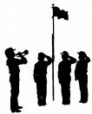

* **November is American Indian Heritage Month - Learn about the “first” citizens of the American continent – the Native American.** You might want to focus on a tribal group native to your area, and explore in what ways they were good citizens and protected the land. You could also explore how their ideas of citizenship differed from ours. Explore how Native Americans have demonstrated good citizenship – from helping scout the new land to serving as “Code Talkers” during WWII – look for the list of Native Americans honored with the Medal of Honor.

**Citizenship Crafts for Dens and Packs**

**Citizenship Tie Slide**

*Alice, Golden Empire Council*

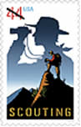

Use either the new postage stamp honoring the Centennial of BSA or any patriotic stamp to make a tie slide for this month. Using white glue that is slightly watered down, attach the stamp to either a 1” length of PVC pipe or a backing of white fun foam cut to size. Use several layers of glue, letting it dry in between. If you use fun foam, hot glue a length of pipe cleaner to the back.

**Pledge of Allegiance Poster**

*Catalina Council*

Copy the images below. Cut them out and place them in a baggie for each boy. Then have the boys glue them in order on poster board or construction paper and color them.



**Stars & Stripes Forever**

*Alice, Golden Empire Council*

**Materials:**

* 2 yards cord of choice
* 1 lanyard hook or key ring
* 37 red pony beads
* 36 white pony beads
* 8 blue pony beads

 

**Basic Instructions:**

* Fold your lanyard cord in half to find the center.
* Use a half hitch (see detail above) to secure it to lanyard hook or key ring.
* Lace beads using pattern at right as a guide.
* Finish by tying off with a double knot.
* Add beads on both ends.
* Tie off and trim.

**Saluting Cub Scout Slide**

*Catalina Council*

**

**Materials:**

* 1 Round Clothes Pin or Craft Doll Clothes Pin
* 1 Bump of Blue Bump Chenille
* 2" Yellow Chenille
* Blue Paint or Permanent Marker
* Red, Orange and Blue Fine Line Markers
* Slide Ring
* Drill with 1/8" Drill Bit
* Glue Gun

**Instructions:**

1. Drill a hole through the clothes pin at right angles to the slot.
2. Position the hole at the shoulder of the pin.
3. Glue the Slide ring to back of the clothes pin.
4. Paint the clothes pin blue from the neck down and on the very top to form the uniform and cap.
5. Add the facial features with the fine line markers.
6. Run the blue Chenille bump through the hole and bend the left arm down to the side.
7. Wrap the yellow Chenille around the neck and twist in front to form the neckerchief.
8. Bend the right arm up in a salute and glue both arms into place at the hands and the neckerchief if necessary.

**Hand and Footprint Eagle**

*Catalina Council*

The American eagle, is our country's symbol and here's an easy original pattern that makes if fun for even the youngest crafter. January 10th is Save the Bald Eagle Day. What a great project to create awareness.



**Materials:**

* Tan Construction Paper
* Brown construction Paper
* Marker
* Pencil
* Scissors
* Glue Stick

**Instructions:**

1. Fold a piece of brown construction paper in half.
2. Trace around your hand on the folded sheet with fingers spread slightly.
3. Cut out through both halves.
4. Trace around your bare foot on a tan piece of construction paper.
5. Cut out the bare foot.
6. Provide copies of the eagle head and feet on the next page.
7. Cut out the hands and feet
8. Glue pieces together using picture as a guide.
9. Use marker to draw on feathers.

 

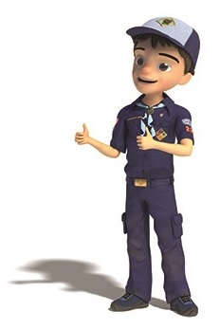

# CUB GRUB

**Star Cookies**

*Catalina Council*

**Ingredients:**

* Blue and red food coloring
* Your favorite sugar cookie dough

**Instructions:**

1. Use food coloring paste to tint one third of the dough red and another third blue, kneading the dough to evenly distribute the color.
2. Leave the last third untinted.
3. Chill the dough until it's firm, then roll out each color and cut out a bunch of larger stars.
4. With a medium-size cutter, cut a star from the center of each large star.
5. Now use the medium stars to fill in the centers of contrasting larger stars lightly pressing them in place.
6. Lightly press the medium stars into the larger stars' centers.
7. Using a third, smaller cutter, you can even create tricolored stars.

**Crunchy Cheese Stars**

*Alice, Golden Empire Council*

**–** great snack if you use the Baden-Powell “Starry Night” Recognition Ceremony from the Pack Resource Sheet for this November

[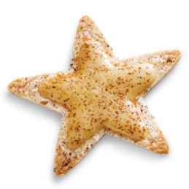](http://familyfun.go.com/assets/cms/recipes/crispy-cheese-stars-recipe-photo-420-FF0706FOURTHA11.jpg)

**Ingredients:**

* Flour tortillas cut into star shape with a cookie cutter
* Sliced cheese (cheddar, provolone, or mozzarella) cut into slightly smaller star shape
* Chili powder or paprika

**Instructions:**

1. Heat the oven to 350º.
2. Use the larger cookie cutter to cut out stars from flour tortillas (about 5 per 10-inch tortilla). It's easy for kids to do if you use a rolling pin to roll back and forth over the cutter.
3. Bake the stars on a foil-covered cookie sheet for 5 minutes.
4. Use a slightly smaller cookie cutter to cut out an equal number of cheese stars from the sliced cheese and put them on top the tortilla stars.
5. Bake the stars for 2 more minutes or so until the cheese melts.
6. Sprinkle with chili powder or paprika and let them cool before serving.

**Patriotic Rice Krispy Treats**

*Alice, Golden Empire Council*

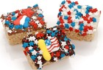

Make Rice Krispy Treats, but add in red & blue M&M’s or cookie and cake decors.

**All American Dessert**

*Catalina Council*



**Ingredients:**

* 1 large Berry blue Jell-O
* 1 large Red Jell-O, any flavor
* 4 c Water; boiling
* 2 c Water; cold
* 8 oz Cool Whip; thawed
* 4 c Angel food cake -OR-- Pound cake   
  broken into cubes
* 2 c Strawberries; sliced
* 1/2 c Blueberries; (optional)

**Directions:**

1. Dissolve each flavor of Jell-O completely in 2 cups of boiling water in separate bowls.
2. Stir 1 cup of cold water into each bowl.
3. Pour into separate 9x13" pans.
4. Refrigerate at least 3 hours until firm.
5. Cut into 1/2" cubes.
6. Place blue Jell-O cubes in bottom of clear glass trifle bowl.
7. Top with 1/3 of the Cool Whip.
8. Add cake cubes, then sliced strawberries.
9. Top with another 1/3 Cool Whip.
10. Add the red Jell-O cubes and then the remaining Cool Whip.
11. Sprinkle blueberries over top if desired.

**Follow My Tracks “Cub” Cakes**

*Alice, Golden Empire Council*

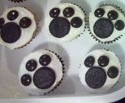

* Make cupcakes made from any mix or recipe.
* Ice with white or light color frosting so the “print” stands out.
* The centers of the paw prints are “Pattersons Mints”- like peppermint patties, but a little smaller and thinner. The “toe” prints are made from chocolate M&M’s.
* This would be a great treat after you’ve done the “Follow My Tracks” game in Baloo’s Citizenship games above..

**Patriotic Quencher**

*Science in a Glass*

*Catalina Council*



**Ingredients:**

* 3 ounces cranberry juice
* 3 ounces sports drink (blue)
* 3 ounces sugar free 7-Up (or Sprite)
* Ice cubes

**Directions:**

1. Place the ice cubes in the bottom third of a tall 12 ounce clear glass.
2. Pour the cranberry juice in to fill the bottom third of the glass.
3. Place a few more cubes in to the middle and pour in the blue sports drink to fill the glass 2/3 full.
4. Place the final 3rd of ice in the glass. Pour in the diet 7up or diet Sprite.
5. When poured carefully, this makes a red, white and blue drink.
6. It separates by using the drink with the highest sugar content on the bottom, and the least on top.

**Graham Cracker Flags**

*Catalina Council*



**Ingredients:**

* Graham crackers
* White frosting
* Popsicle sticks
* Small paper cups
* Red, white, and blue food coloring

**Directions:**

1. Give each Scout 3 paper cups with a tablespoon of frosting inside each cup.
2. Drop the food coloring in each cup – 1 red, 1 blue, 1 white.
3. Give each Scout a craft stick (popsicle stick) and instruct him to mix the food coloring in each of his cups.
4. Then ask him to draw the US flag on the cracker using the frosting.

**Apple Smiles**

*Alice, Golden Empire Council*

[](http://familyfun.go.com/assets/cms/recipes/apple-bites-halloween-recipe-photo-420-FF1007EFCA01.jpg)

Ran across this recipe looking for something else – and it brought back memories. For 9 years, I was the story-telling witch at Smith Family Farms in Brentwood, California. We had hundreds of kids, all ages, who came to go on hayrides, pick out pumpkins, and listen to my stories in the barn during the month of October – many were pre-schoolers. So although I wore a black costume and witch hat, and had a kettle with all kinds of stuff (and dry ice for bubbles and troubles), I looked for a story that would be good to use with the youngest kids.

I told the story of Horace the Ghost, who couldn’t learn to moan and groan like a proper ghost. His mother noticed that children began to moan and groan when they were hungry or tired, so the next day, she sent him down into the house – with orders to stay till dark and not to go to sleep. She expected Horace to be moaning and groaning when he came back up to the attic. But it turned out to be Halloween, and he had a wonderful time at the party and watching the kids go out in their costumes. And he ate everything – from the chocolate cake with orange frosting, to the candied apples, to the licorice candy. He even learned to smile and laugh! When it got dark and he went upstairs, his mother was very disappointed that he was NOT moaning and groaning – but later that night…..he began to moan and groan. Can you guess why? Yes, he ate too much. Well, his family was very happy he had finally learned to moan and groan. But his favorite thing is still to laugh and smile.

**And you can make Horace’s smile.** Just take an apple, cut out two slices, put peanut butter or cream cheese on each slice, then add mini-marshmallows or blanched almond slices for teeth*. (And if you have a Brownie Girl Scout, there’s a great song about the Brownie Smile.)*

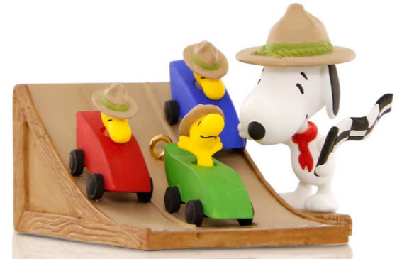

# LAST THINGS

**Pinewood Prayer**

*CS Roundtable Planning Guide*

We give thanks for the fun we have at our pinewood derby. Help us remember to do our best. Help us cope with disappointments if our cars do not go fast. Help us be thoughtful of the feelings of other if our cars should win. **Amen**

## The Pinewood Derby Prayer

*Pack 169, Egham, England*

*Pack 52, Morgantown, West Virginia*

Hey God, we ask you to draw near  
And bless the boys who gather here.  
This is the day they’ve waited for  
Their blocks of wood are blocks no more.  
Plastic wheels and dime store nails  
Become the stuff of sporting tales  
Of finishes too close to see!  
You’re here for every victory.

You bless the winners in their joy  
But there’s another kind of boy  
Whose handiwork is blessed by you  
Because his hands tried something new.  
You smile upon the crooked wheel,  
The paint job done with boyish zeal,  
The splintered car, the sloppy glue.  
You love the work that Your sons do.

But there is one here in this place  
Who shows the greatness of Your grace.  
He is the boy who hasn’t won  
But when he hears the starting gun  
He’s there to cheer his fellow scouts  
His are the loudest victory shouts.  
And when his brothers haven’t won,  
He’s just the one to say "well done,  
You’ve tried your best and you’ve had fun,  
There are more races to be run."

And so, dear God, we hear you say  
Upon this happy Derby Day,  
"Remember, whether best or worst,  
Remember, you are brothers first."

GILBERT'S PINEWOOD DERBY PRAYER

*by Peggy Porter*

[*http://usscouts.org/usscouts/pinewood/gilbert.asp*](http://usscouts.org/usscouts/pinewood/gilbert.asp)

CAR.jpg - 68559 Bytes

Gilbert was eight years old and had been in Cub Scouts only a short time. During one of his meetings he was handed a sheet of paper, a block of wood and four tires and told to return home and give all  to "dad". That was not an easy task for Gilbert to do. Dad was not receptive to doing things with his son. But Gilbert tried.

Dad read the paper and scoffed at the idea of making a pine wood derby car with his young, eager son. The block of wood remained untouched as the weeks passed.

Finally, mom stepped in to see if dad could figure this all out. The project began. Having no carpentry skills, dad decided it would be best if he simply read the directions and let Gilbert do the work. And he did. Dad read aloud the measurements, the rules of what Gilbert could do and what he couldn't do. Within days his block of wood was turning into a pinewood derby car. A little lopsided, but looking great (at least through the eyes of mom).

Gilbert had not seen any of the other kids' cars and was feeling pretty proud of his "Blue Lightning", the pride that comes with knowing you did something on your own. Then the big night came.  With his blue pinewood derby in his hand and pride in his heart he headed to the big race.

Once there this little one's pride turned to humility. Gilbert's car was obviously the only car made entirely on his own. All the other cars were a father-son partnership, with cool paint jobs and sleek body styles made for speed.

A few of the boys giggled as they looked at Gilbert's, lopsided, wobbly, unattractive vehicle. To add to the humility Gilbert was the only boy without a man at his side. A couple of the boys who were from single parent homes at least had an uncle or grandfather by their side, Gilbert had "Mom".

As the race began it was done in elimination fashion. You kept racing as long as you were the winner. One by one the cars raced down the finely sanded ramp. Finally it was between Gilbert and the sleekest, fastest looking car there.

As the last race was about to begin, this wide eyed, shy, eight-year-old asked if they could stop the race for a minute, because he wanted to pray. The race stopped, Gilbert hit his knees clutching his funny looking block of wood between his hands. With a wrinkled brow he set to converse with his Father. He prayed in earnest for a very long minute and a half. Then he stood, smile on his face and announced, 'Okay, I am ready."

As the crowd cheered, a boy named Tommy stood with his father as their car sped down the ramp. Gilbert stood with his Father within his heart and watched his block of wood wobble down the ramp with surprisingly great speed and rushed over the finish line a fraction of a second before Tommy's car. Gilbert leaped into the air with a loud "Thank you" as the crowd roared in approval.

The Scoutmaster came up to Gilbert with microphone in hand and asked the obvious question, "So you prayed to win, huh, Gilbert?"

To which this young boy answered, "Oh, no sir. That wouldn't be fair to ask God to help you beat someone else. I just asked Him to make it so I don't cry when I lose."

Children seem to have a wisdom far beyond us. Gilbert didn't ask God to win the race, he didn't ask God to fix the outcome; Gilbert asked God to give him strength in the outcome. When Gilbert first saw the other cars he didn't cry out to God, "No fair, they had a father's help". No, he went to his Father for strength.

Perhaps we spend too much of our prayer time asking God to rig the race, to make us number one, or too much time asking God to remove us from the struggle -- when we should be seeking God's strength to get through the struggle.

Gilbert's simple prayer spoke volumes to those present that night. He never doubted that God would indeed answer his request. He didn't pray to win, thus hurt someone else -- he prayed that God supply the grace to lose with dignity. Gilbert, by his stopping the race to speak to his Father also showed the crowd that he wasn't there without a "dad", but His Father was most definitely there with him. Yes, Gilbert walked away a winner that night, with his Father at his side.

*I can do all things through him who strengthens me. Philippians 4:13 (NRSV)*