**COMMISSIONER'S CORNER**

**Be a player on God's team.**

*Lord Robert Baden-Powell, Rovering to Success, 1922*

**SCOUT SUNDAY / SABBATH**

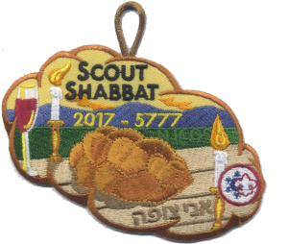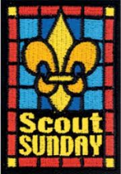Is your Pack planning a Scout Sunday or Scout Sabbath this year?? You should consider doing so. There is lots of help available to you here and via links provided in this issue.

**CUB SCOUT ADVANCEMENT MODIFICATIONS MADE**

On November 30, 2016, the BSA announced modifications to adventure requirements in response to feedback from Den Leaders who have run the new Cub Scouting program for a year. Dens may begin using the modified requirements immediately as they begin working on their next adventure. There is a PDF of the changes at: [www.scouting.org/programupdates](http://www.scouting.org/programupdates)

Judy is placing a description of the changes and their effects in **Part IV – Den Meeting Helps** of this month’s issue of Baloo’s Bugle.

THE FOUNDER'S PRAYER

*Written by Baden-Powell for international events.*

Father of us all, we meet before Thee here today, numerous in the lands we come from and in the races we represent, but one in our Brotherhood under Thy Divine Fatherhood.

We come before Thee with hearts grateful and gladdened by the many blessings Thou hast granted us and thankful that our Movement has prospered as acceptable in Thy sight. In return we would lay on Thine Altar, as our humble thank-offering, such sacrifice as we can make of self in service to others. We ask that during our communion here together we may, under Thy Divine Inspiration, gain a widened outlook, a clearer vision of all that lies open before us and of our opportunity. Thus we may then go forth with strengthened faith to carry on our mission of heightening the ideals and powers of manhood, and of helping through closer understanding to bring about Thy happier Rule of Peace and Goodwill upon Earth.

The method of expression of reverence to God varies with every sect and denomination. What sect or denomination a boy belongs to depends, as a rule, on his parents' wishes. It is they who decide. It is our business to respect their wishes and to second their efforts to inculcate reverence, whatever form of religion the boy professes.

***From Rovering to Success, 1922, B-P***

# TABLE OF CONTENTS

TABLE OF CONTENTS 2

CORE VALUES 2

REVERENT QUOTES 4

Faith Quotations 4

REVERENT / REVERENCE QUOTATIONS 5

THOUGHTFUL ITEMS 5

MONDAY EVENING PRAYER 5

FAITH AND SCOUTING 6

BIOGRAPHY 7

GEORGE WASHINGTON 7

Washington on a proposed third term and political parties, 1799 9

CUB SCOUT IDEAS 10

SCOUT SUNDAY / SABBATH 10

DEN MEETING TOPICS 11

Adventures That Involve STEM: 12

CHARACTER COMPASS 12

THEME RELATED STUFF 12

THEME RELATED ADVENTURES 12

PACK MEETING THEMES AND PLANS 13

PACK MEETING THEMES 14

UPCOMING MONTHS 14

CUBMASTER THOUGHTS 16

WOOD BADGE FOR CUB SCOUTERS? 16

WEBELOS 18

ARROW of LIGHT PRESENTATION 18

WEBELOS TO BOY SCOUTS BRIDGING CEREMONY 21

MORE A of L CEREMONIES 22

FEBRUARY CRAZY HOLIDAYS 22

February – A Month to be Reverent 26

Fun Facts about George Washington Carver 28

TRAINING TOPICS 29

A “SCOUTS OWN” INTRO 29

Point of the Scout Law for February - Reverent 31

SPECIAL OPPORTUNITIES 32

**Religious Emblems** 32

**FAQs about Religious Emblems** 33

**Adult Religious Recognitions** 35

**Religious Emblems Coordinators** 35

CUB GRUB 37

Beatitudes for Cub Scouts 39

Beatitudes for Those Who Care 40

The Five Finger Prayer 40

# CORE VALUES

For February, the suggested Pack Meeting theme, **PASSPORT TO OTHER LANDS**, emphasizes the Scout Law point, **REVERENT.**

**The core value highlighted next month is:**

February's point of the Scout Law, **REVERENT,** will use the theme, **PASSPORT TO OTHER LANDS.**

**A SCOUT IS REVERENT**A Scout is reverent toward God. He is faithful in his religious duties. He respects the beliefs of others.

**HOW DOES “PASSPORT TO OTHER LANDS” RELATE TO THIS POINT OF THE SCOUT LAW?**

Today we recognize that people of many different nationalities live in our communities. Learning about the ways of others helps lead to understanding. A Scout is reverent when he shows respect for the beliefs of others. This month we focus on experiencing the customs, religions, foods, and traditions of our friends from other countries.

**Per our Founder, Lord Baden-Powell  
the definition (or meaning) of the Scout Law point highlighted this month is:**[*https://en.wikipedia.org/wiki/Scout_Law*](https://en.wikipedia.org/wiki/Scout_Law)  
[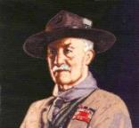](https://en.wikipedia.org/wiki/Scout_Law)

***Note –*** *Although Duty to God was part of B-P’s program, Reverent was not part of the Scout Law. The original Scout Law published in 1908 had nine points. In 1910, the BSA added Brave, Clean, and* ***Reverent****. In 1911 B-P added* ***Clean*** *to his list.*

**A SCOUT'S DUTY TO GOD**   
"No man is much good unless he believes in God and obeys His laws. So every Scout should have a religion....Religion seems a very simple thing: First: Love and Serve God. Second: Love and serve your neighbour." - (Scouting For Boys, 1908)

**[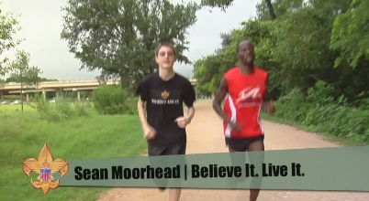](https://vimeo.com/24863948)**

 In this video, the “Believe It Live It” team interviews a Gilbert, a runner who survived a horrific attack by rebels in Burundi, Africa. This video relates his reverence to God to the Scout Law <https://vimeo.com/24863948>

**Quotes from Baden-Powell on Faith**

*Alice, Golden Empire Council*

"No man can be really good, if he doesn't believe in God and he doesn't follow His laws. This is why all Scouts must have a religion". *(Scouting for Boys, 1908)*

"Scouting has been described as "a new religion". It's not, of course, a new religion: it's just the application to religious formation of the principle now accepted in non-religious formation, i.e. to point out a precise aim to the boy and give him the way to learn and practice by himself" *[Quoted in Taccuino, a collection of B-P's writings and essays published in Italy. Dated January 1912]*

***From Aids to Scoutmastership, 1919:***

"Love of God, love of your neighbour and respect of oneself as God's servant are the basis for any form of religion"

"Many difficulties may arise while defining religious formation in a Movement such as ours, where many religions coexist; so, the details of the various forms of expressing the duty to God must be left to those responsible of each single association. We insist however on observance and practice of that form of religion the boys profess"

"Nowadays the actions of a large part of youths are guided just in a small part by religious convictions. That can be attributed for the most to the fact that in the boy's religious formation the worry was on teaching instead of educating".

"If you really wish to find the way towards success, i.e. your happiness, you must give a religious base to your life. It's not simply attending church or knowing history or comprehend theology. Many men are sincerely religious almost without knowing it or having studied these things. Religion, briefly explained, means: First: know who God is; Second: use to the best the life He gave us, and do what He expects from us. This means mostly doing something for the others."

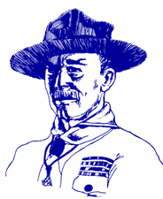**Duty to God Statements by Lord Baden-Powell**

* "The Scout, in his promise, undertakes to do his duty to his king and country only in the second place; his first duty is to God. It is with this idea before us and recognizing that God is the one Father of us all, that we Scouts count ourselves a brotherhood despite the difference among us of country, creed, or class. We realize that in addition to the interests of our particular country, there is a higher mission before us, namely the promotion of the Kingdom of God; that is, the rule of Peace and Goodwill on earth. In the Scouts each form of religion is respected and its active practice encouraged and through the spread of our brotherhood in all countries, we have the opportunity in developing the spirit of mutual good will and understanding.
* "There is no religious "side" of the movement. The whole of it is based on religion, that is, on the realization and service of God.
* "Let us, therefore, in training our Scouts, keep the higher aims in the forefront, not let ourselves get too absorbed in the steps. Don't let the technical outweigh the moral. Field efficiency, back woodsmanship, camping, hiking, Good Turns, jamboree comradeship are all means, not the end. The end is CHARACTER with a purpose.
* "The atheists....maintain that a religion that has to be learnt from books written by men cannot be a true one. But they don't seem to see that besides printed books....God has given us as one step the great Book of Nature to read; and they cannot say that there is untruth there - the facts stand before them....I do not suggest Nature Study as a form of worship or as a substitute for religion, but I advocate the understanding of Nature as a step, in certain cases, towards gaining religion." - (Rovering To Success, 1930) day.
* "Our objective in the Scouting movement is to give such help as we can in bringing about God's Kingdom on earth by including among youth the spirit and the daily practice in their lives of unselfish goodwill and cooperation."



program updates banner

# REVERENT QUOTES

*Quotations contain the wisdom of the ages, and are a great source of inspiration for Cubmaster’s minutes, material for an advancement ceremony or an insightful addition to a Pack Meeting program cover.*

PlatoLet parents then bequeath to their children not riches but the spirit of reverence. Plato

## Faith Quotations

Faith is not without worry or care, but faith is fear that has said a prayer. Author Unknown

Faith is spiritualized imagination. Henry Ward Beecher

Faith is courage; it is creative while despair is always destructive. David S. Muzzey

Faith is a passionate intuition. William Wordsworth

Faith is putting all your eggs in God's basket, then counting your blessings before they hatch.   
Ramona C. Carroll

Faith is what makes life bearable, with all its tragedies and ambiguities and sudden, startling joys.   
Madeleine L'Engle

Be like the bird that, passing on her flight awhile on boughs too slight, feels them give way beneath her, and yet sings, knowing that she hath wings. Victor Hugo

Faith is raising the sail of our little boat until it is caught up in the soft winds above and picks up speed, not from anything within itself, but from the vast resources of the universe around us. W. Ralph Ward

As your faith is strengthened you will find that there is no longer the need to have a sense of control, that things will flow as they will, and that you will flow with them, to your great delight and benefit. Emmanuel

A little faith will bring your soul to heaven, but a lot of faith will bring heaven to your soul. Author Unknown

Faith is believing that the outcome will be what it should be, no matter what it is. Colette Baron-Reid

Faith can move mountains, but don't be surprised if God hands you a shovel. Author Unknown

Faith is believing in things when common sense tells you not to. George Seaton

Faith is taking the first step even when you don't see the whole staircase. Martin Luther King, Jr.

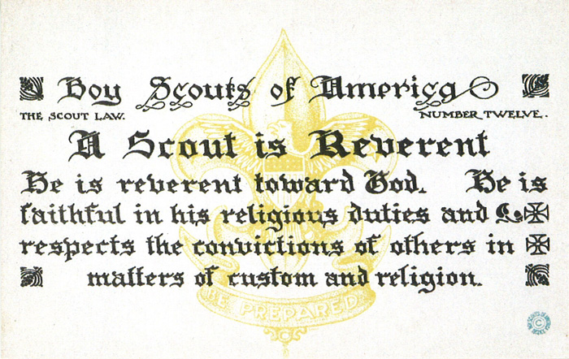

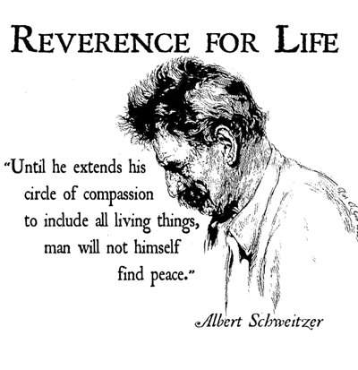

## REVERENT / REVERENCE QUOTATIONS

***Pursue some path, however narrow and crooked, in which you can walk with love and reverence.   
Henry David Thoreau***

Reverence is an emotion that we can nurture in our very young children, respect is an attitude that we instill in our children as they become school-agers, and responsibility is an act that we inspire in our children as they grow through the middle years and become adolescents.― Zoe Weil, Above All, Be Kind: Raising a Humane Child in Challenging Times

Authentic faith leads us to treat others with unconditional seriousness and to a loving reverence for the mystery of the human personality. Authentic Christianity should lead to maturity, personality, and reality. It should fashion whole men and women living lives of love and communion. False, manhandled religion produces the opposite effect. Whenever religion shows contempt or disregards the rights of persons, even under the noblest pretexts, it draws us away from reality and God.― Brennan Manning, The Ragamuffin Gospel: Good News for the Bedraggled, Beat-Up, and Burnt Out

Abba is not Hebrew, the language of liturgy, but Aramaic, the language of home and everyday life … We need to be wary of the suggestion … that the correct translation of Abba is ‘Daddy.’ Abba is the intimate word of a family circle where that obedient reverence was at the heart of the relationship, whereas Daddy is the familiar word of a family circle from which all thoughts of reverence and obedience have largely disappeared … The best English translation of Abba is simply ‘Dear Father.”― Thomas Allan Smail, The Forgotten Father

He’d never really given religion much thought himself. It was just there, one of the basic fundamentals of life and living; Heaven is generally good and one should aspire to end up there, and Hell is decidedly foul and one should generally direct their enemies there.  
― T.A. Miles, Raventide

The sympathy which is reverent with what it cannot understand is worth its weight in gold.   
― Oswald Chambers, Baffled to Fight Better

Bond is stronger than blood. The family grows stronger by bond.― Itohan Eghide, Master of Maxims

Carrying little Kunta in his strong arms, he walked to the edge of the village, lifted his baby up with his face to the heavens, and said softly, “Fend kiling dorong leh warrata ka iteh tee.” (Behold—the only thing greater than yourself.)” ― Alex Haley, Roots

Each of us experiences the perpetual revival of the self. We constantly recast our connate emotional index by perceiving each encounter in life as a marvel, impedance, problem, disaster, or nothing at all. Living in the moment allows us to escape the lonely landscape of self-interest and be part of a larger world filled with beauty, reverence, and adoration.   
― Kilroy J. Oldster, Dead Toad Scrolls

Faith in God, reverence of a Creator!  
― [Lailah Gifty Akita](http://www.goodreads.com/author/show/8297615.Lailah_Gifty_Akita), [Pearls of Wisdom](http://www.goodreads.com/work/quotes/45089802)

An enlightened person strives to live a meaningful life, defined by their personal humility joy, passion, and profound reverence for life.”   
― Kilroy J. Oldster, Dead Toad Scrolls

# THOUGHTFUL ITEMS

## MONDAY EVENING PRAYER

*George Washington*

Most Gracious Lord God, from whom proceedeth every good and perfect gift, I offer to thy divine majesty my unfeigned praise & thanksgiving for all thy mercies towards me. . . . Bless our rulers in church and state. Bless O Lord the whole race of mankind, and let the world be filled with the knowledge of Thee and thy son Jesus Christ. Pity the sick, the poor, the weak, the needy, the widows and fatherless, and all that morn or are broken in heart, and be merciful to them according to their several necessities. Bless my friends and grant me grace to forgive my enemies as heartily as I desire forgiveness of Thee my heavenly Father. I beseech thee to defend me this night from all evil, and do more for me than I can think or ask, for Jesus Christ sake, in whose most holy name & words, I continue to pray, Our Father. **Amen** *Monday Evening Prayer, George Washington 1752, Age 20*

From William J. Johnson, George Washington, The Christian (New York: The Abingdon Press, 1919).

## FAITH AND SCOUTING

*Scouter Jim, Bountiful UT*

The history of the Boy Scouts of America (BSA) begins with a legend. It is said that Chicago newspaperman William Boyce was traveling in London and had become lost in a thick fog when a boy appeared and helped Boyce find his way. Boyce attempted to give a tip, but the boy refused because he was doing his duty as a Boy Scout. Soon after, Boyce sought the Scouting for Boys handbook and, upon returning to the States, formed the Boy Scouts of America in 1910.

As Baden-Powell’s model of Scouting became more popular, groups across Europe and the United States sprang up and began using the title “Scouts.” The Church of Jesus Christ of Latter-day Saints noticed the movement as well and, using the structure of the YMMIA, Anthony W. Ivins, general superintendent, organized the MIA. Scouts in 1911. The Church organized patrols and developed lessons for boys similar to those in official Scouting.

In 1913, the Boy Scouts of America invited the Church to be an official part of their program. Bryant S. Hinckley — father of Gordon B. Hinckley — and Oscar A. Kirkham traveled to New York City and, after hearing about BSA’s focus on honor, service, and duty to God, returned with a favorable opinion. At a meeting with the YMMIA committee, Hinckley moved to officially adopt the BSA program. The First Presidency and Quorum of the Twelve approved the decision.

The Boy Scouts issued a charter on May 21, 1913, to the MIA Scouts, and The Church of Jesus Christ of Latter-day Saints became the first institution to be officially affiliated with the Boy Scouts of America program.

From that first charter, faith based groups hold a large number of the Charters for the Boy Scouts of America. Four of the top five charter holders are faith based groups. Scouting and faith based groups are closely affiliated to train young men and boys in America.

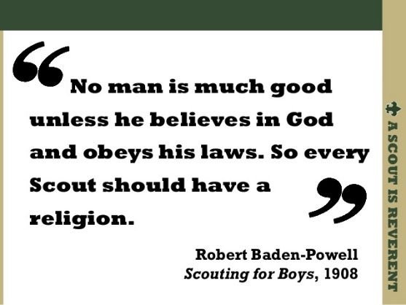

**Top BSA Chartered Organizations**

*As of 12/31/2010*

**Overview of Chartered Organizations**

* Civic, faith-based, and educational organizations operate Scouting units to deliver the programs to their youth members, as well as the community at large.
* Approximately 120,000 Scouting units are owned and operated by chartered organizations. Of these:
* 66.9 percent of all units are chartered to faith-based organizations
* 24.4 percent of all units are chartered to civic organizations
* 8.7 percent of all units are chartered to educational organizations

**Responsibilities of chartered organizations include:**

* Providing adequate meeting facilities.
* Providing quality leadership for the Scouting unit.
* Appointing a chartered organization representative to coordinate all Scouting unit operations within the organization.

**Faith based group, Boy Scout Web links:**

* <http://www.ldsbsa.org/>   
  Church of Jesus Christ of Latter-day Saints BSA Relations Office
* <http://www.presbyterianscouters.org/>  
  Presbyterian Church
* <http://www.nlas.org/>  
  National Lutheran Association on Scouting
* <http://www.jewishboyscouts.com/>  
  Jewish Boy Scouts
* <http://nycatholicscouts.com/>  
  New York Catholic Scouts
* <http://www.naums.org/>  
  National Association of United Methodist Scouters

**Top 25 Charter Organizations***(2010 Data)*



# BIOGRAPHY

## GEORGE WASHINGTON

**A Man of Faith**

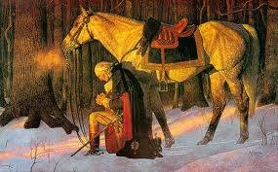

*February 22 is George Washington's real birthday (along with Lord Robert Baden Powell’s), an appropriate time to consider the faith of America's most important founding father.*

At age 13 George transcribed "110 Rules for Young Gentlemen," written by Ignatius of Loyola, founder of the Jesuits in the 1590's. George memorized them. They teach that man is God's servant who lives not for self, but for others. They became part of his character:

"Let your conversation be without malice or envy...

"When you speak of God or His attributes, be serious and speak with words of reverence.

"Let your recreations be manful, and not sinful.

At age 20, he wrote prayers to say each morning and evening. On Sunday mornings he prayed: "...pardon, I beseech Thee, my sins; remove them from Thy presence, as far as the east is from the west, and accept me for the merits of Thy son, Jesus Christ..."

At 23 Captain Washington was caught in a surprise ambush by the French and Indians near what is now Pittsburgh. Every British and American officer was shot but Washington though he rode back and forth across the battlefield. George later wrote to his brother, "By the all-powerful dispensations of Providence, I have been protected beyond all human probability or expectation, for I had four bullets through my coat, and two horses shot under me, yet escaped unhurt, although death was leveling my companions on every side of me."

On July 2, 1776 he told his troops: "The fate of unborn millions will now depend, under God, on the courage of this army. Our cruel and unrelenting enemy leaves us only the choice of brave resistance or the most abject submission. We have therefore to resolve to conquer or die."

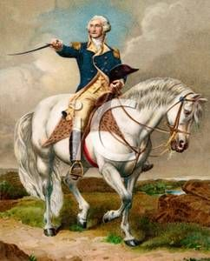

Seven weeks later British General Howe had trapped Washington and his 8,000 troops on Brooklyn Heights, ready to crush them the next morning. Washington gathered every vessel from fishing to row boats and spent all night ferrying his army across the East River. By morning many troops were still exposed to the British.

"In a most unusual change in weather, the fog did not lift from the river. It stayed thick, covering Washington's retreat until the entire army had evacuated and escaped," writes William Federer in his inspiring book, "America's God and Country." Never again did the British have such a rare chance to win the war.

During the freezing winter of 1777 at Valley Forge, a dozen soldiers died a day, with many not having blankets or shoes. "Feet and legs froze till they became black," and were amputated wrote a Committee from Congress. A Quaker named Isaac Potts came upon Washington upon his knees in the snow, praying aloud for his beloved country. He thanked God for exalting him to the head of a great nation which was fighting at fearful odds.

The Quaker told his wife of the sight: "Till now I have thought that a Christian and a solider were characters incompatible, but if George Washington not be a man of God I am mistaken, and still more I shall be disappointed in God does not through him perform some great thing for this country."

On May 5, 1778 Washington learned that the French would join America as allies. The General told his troops, "It having pleased the Almighty Ruler of the universe to defend the cause of the United American States, and finally to raise up a powerful friend among the princes of the earth, to establish our liberty, and independence upon a lasting foundation, it becomes us to set apart a day for gratefully acknowledging the divine goodness..."

In 1781 Washington's southern army defeated a detachment of British troops. Lord Cornwallis was infuriated and began pursuing the outnumbered Americans. He waited the night at the Catawba River, which the U.S. troops had crossed just two hours earlier. Miraculously, a storm arose during the night causing the river to be uncrossable for five days. Cornwallis nearly overtook Americans at the Yadkin River, but another flood arose, allowing Americans to escape.

The French navy seized control of the Chesapeake Aug. 30, 1781, driving out British ships. Washington rejoiced and besieged Cornwallis' stronghold at Yorktown. With no ships to escape upon, Cornwallis surrendered.

Washington wrote Congress, "I take a particular pleasure in acknowledging that the interposing Hand of Heaven...has been most conspicuous and remarkable."

After victory had been finalized in 1783, Washington resigned as commander-in-chief rather than seize power, proving his opposition to dictatorship and his commitment to American republicanism.[6] Washington presided over the Constitutional Convention in 1787, which devised a new form of federal government for the United States.

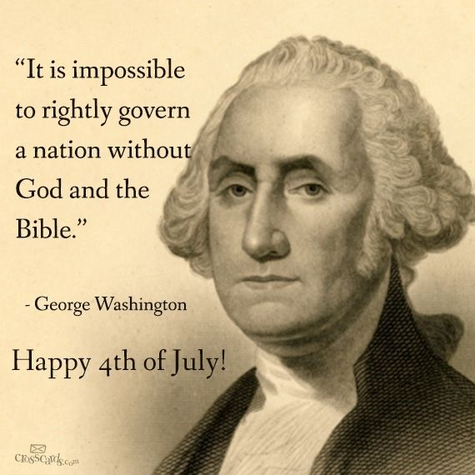

Following his election as president in 1789, he worked to unify rival factions in the fledgling nation. He supported Alexander Hamilton's programs to satisfy all debts, federal and state, established a permanent seat of government, implemented an effective tax system, and created a national bank. In avoiding war with Great Britain, he guaranteed a decade of peace and profitable trade by securing the Jay Treaty in 1795, despite intense opposition from the Jeffersonians. He remained non-partisan, never joining the Federalist Party, although he largely supported its policies. Washington's Farewell Address was an influential primer on civic virtue, warning against partisanship, sectionalism, and involvement in foreign wars. He retired from the presidency in 1797, returning to his home and plantation at Mount Vernon.

Upon his death, Washington was eulogized as "first in war, first in peace, and first in the hearts of his countrymen" by Henry Lee. He was revered in life and in death; scholarly and public polling consistently ranks him among the top three presidents in American history. He has been depicted and remembered in monuments, currency, and other dedications to the present day.

***Think about it -*** Washington had more near escapes than victories. Would God have protected him from bullets, and saved his troops with fog and floods - had he not been a praying man?

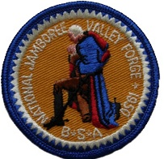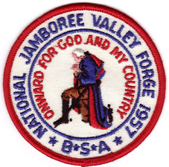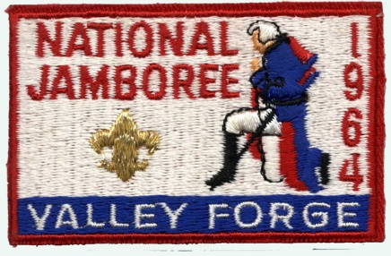

## Washington on a proposed third term and political parties, 1799

By 1798, George Washington had led America to victory in the Revolution, helped create the American government, and served two terms as the nation’s first president (1789–1797). He was called back to service, though, by President John Adams, who offered Washington a commission as chief officer of the US Army in July 1798 to help plan for possible conflict with the French. Washington reluctantly accepted.

A year later, in June 1799, Jonathan Trumbull Jr., the governor of Connecticut who had served as Washington’s military secretary during the Revolution, wrote to urge him to run for a third term as president. “Election of a President is near at hand,” Trumbull wrote, “and I have confidence in believing, that, should your Name again be brought up, you will not disappoint the hopes & Desires of the Wise & Good in every State, by refusing to come forward once more to the relief & support of your injured Country.” Trumbull continued, writing that unless Washington sought the presidency, “the next Election of President, I fear, will have a very ill-fated Issue.”

Washington had several reasons for not running again. There was his promise not to seek unfair power as a government official and his desire to avoid being, as he wrote to Trumbull, “charged with concealed ambition.” There was also his “ardent wishes to pass through the vale of life in retirement, undisturbed in the remnant of the days I have to sojourn here.” Washington’s early promise and the lure of retirement were reasons for his declining to seek a third term.

Perhaps even stronger than those factors were Washington’s feelings about the country’s heated political climate. “The line between Parties,” Washington wrote Trumbull, had become “so clearly drawn” that politicians would “regard neither truth nor decency; attacking every character, without respect to persons – Public or Private, – who happen to differ from themselves in Politics.” Washington wrote that, even if he were willing to run for president again, as a Federalist, “I am thoroughly convinced I should not draw a single vote from the Anti-federal side.” For Washington, the nation’s political parties had soured discourse and created a climate in which, as he predicted in his 1796 farewell address, “unprincipled men will be enabled to subvert the power of the people and to usurp for themselves the reins of government.” Referring to the Democratic-Republicans, Washington wrote, “Let that party set up a broomstick, and call it a true son of Liberty, a Democrat, or give it any other epithet that will suit their purpose, and it will command their votes in toto!”

George Washington was never a man to shirk responsibility. Though he might have liked nothing better than to retire to Mount Vernon after the Revolution, he was, as he wrote Trumbull, always ready to “render any essential service to my Country,” having served, after the American Revolution, in the Constitutional Convention, two terms as president, and again as commander in chief of the Army. By 1799, though, Washington was through with elected office despite the urging of those who knew him. “Prudence on my part,” he told Trumbull, “must arrest any attempt of the well-meant, but mistaken views of my friends, to introduce me again into the Chair of Government.”

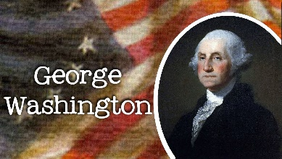

# CUB SCOUT IDEAS

## SCOUT SUNDAY / SABBATH

**Sunday, February 5, 2017**

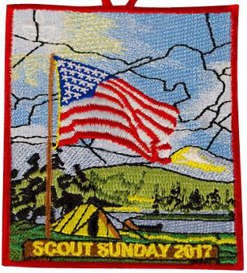  
*This patch available at Scout Shops and* [*www.scoutstuff.org*](http://www.scoutstuff.org)*. There are, also, matching neckerchiefs and pins.*

The Boy Scouts of America annually celebrates its founding on February 8, 1910, based on the program started by Lord Baden Powell in England on August 1, 1907.

Scout units and religious-based chartered organizations share a special bond that lasts all year.

But on certain days each year — namely Scout Sunday and Scout Sabbath — we set aside time to celebrate a partnership that benefits all parties involved: the religious institution, Scouts, Scouters and the communities they serve.

Scout Sunday is designated by BSA’s National Council as the Sunday preceding February 8th (Scouting’s Anniversary Date), unless the 8th is a Sunday, in which case the 8th would be Scout Sunday. The Saturday following February 8th is Scout Sabbath. Scout Sunday & Scout Sabbath celebrations began in 1940s. This is the primary date to recognize the contributions of young people and adults to Scouting. However, chartered organization and local congregations can use other options to celebrate this special day. (e.g. The United Methodist Church celebrates Scout Sunday on the second Sunday in February). A local church may celebrate on the Sunday most acceptable to the Pastor and congregation. Depending on the year, the date may be shifted to avoid conflict with Lenten and other religious observances.

The Scout units are urged to participate in the religious services. [Scout Sunday](http://www.scouting.org/scoutsource/Media/Relationships/ascoutisreverent.aspx) is an opportunity for units can attend services in uniform, conduct a flag ceremony, speak about Scouting, present [religious awards](http://www.scouting.org/scoutsource/Awards/ReligiousAwards.aspx) and/or formally thank the chartering organization for their support throughout the year.

**Elements of participation may include:**

* Reserving a section pews so the unit(s) may sit together.
* Taking an active part in the service by having youth perform such acts as leading a prayer, reading from the Bible, ushering, taking the offering,
* A notice in the church bulletin. It could simply be a mention that today is Scout Sunday or it may include information about Scouting and a Scout’s Duty to god. Perhaps The Scout Oath and Law showing “Duty to God” and Reverent.
* Hosting a Fellowship Hour and having an information (and recruiting) table in the foyer or hospitality area.

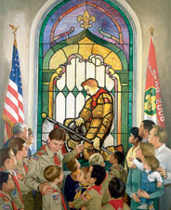  
A Scout is Reverent.

**Bryan’s Blog has an issue almost every year devoted to Scout Sunday.** Here is a link to the January 2016 article. That article has links to three of his previous Scout Sunday issues.

[**Scout Sunday 2016 and Scout Sabbath 2016: Your complete guide**](http://blog.scoutingmagazine.org/2016/01/20/scout-sunday-2016-scout-sabbath-2016-complete-guide/)

January 20, 2016

[](http://blog.scoutingmagazine.org/2016/01/20/scout-sunday-2016-scout-sabbath-2016-complete-guide/)On Scout Sunday 2016 and Scout Sabbath 2016, we set aside time to celebrate a partnership that benefits religious institutions and Scout units alike. 

**National’s website has lots of information:**

* **Scout Sunday -** <http://www.scouting.org/scoutsource/Media/Relationships/ascoutisreverent.aspx> It includes a suggested Order of Worship, recommended readings, and lots of resources.
* **Scout Sabbath -** <http://www.scouting.org/scoutsource/Media/Relationships/ScoutSabbathServices.aspx>

**US Scouts (the host for Baloo’s Bugle) has a whole section devoted to “A Scout is Reverent.” Find it at** [**http://usscouts.org/Reverent.asp**](http://usscouts.org/Reverent.asp)

There are links to:

* [*A Scout's Duty to God and Country*](http://usscouts.org/scoutduty/)
* [Big Book of Scout Worship Services](http://usscouts.org/reverent/BigBookScoutRev.doc)
* [Meditations for the Trail](http://usscouts.org/scoutduty/Meditations_for_the_Trail.rtf) (RTF)
* [Meditations for the Trail](http://usscouts.org/scoutduty/Meditations_for_the_Trail.doc) (DOC)
* [Prayers](http://usscouts.org/reverent/prayers.asp)
* [Retreat](http://usscouts.org/reverent/retreat.asp)
* [Training/Information Packet for Chaplains and Chaplain Aides by Andrew McCreight](http://usscouts.org/reverent/ChaplainBasics.doc)
* [Scouts Own Resources](http://www.macscouter.com/ScoutsOwn)

US Scouts has several versions of responsive readings based on the **Scout Law**. Some use a Bible Verse to illustrate each of the 12 points. ***I love these!! CD***

**Several churches have put out guidance for their members and churches on observing Scout Sunday:**

* The Catholic Committee on Scouting - <http://www.nccs-bsa.org/pdf/ScoutSunday.pdf>
* The United Methodist Church - <https://www.umcdiscipleship.org/resources/scouting-sunday>

**SCOUTER’S PRAYER**

Dear Lord, from your judgment seat on high,  
Look down on a Scoutmaster such as I.  
Search me through and find me whole,  
Then help me, Lord, to reach my goal.  
Help me, Lord, to work for Thee,  
Guard my homeland—keep it free.  
Help me to work with others and be kind,  
Helpful with my hands and mind.  
Keep me, Lord, both well and strong,  
To help growing boys along.  
Control my thoughts, keep them right,  
Sound, clean weapons for life's fight.  
Protect my morals, keep them high,  
Grant this to a Scouter such as I.  
*—Author Unknown*

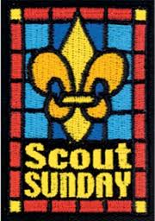

# DEN MEETING TOPICS

Remember – Boys want to be active!!   
See, too, that they earn their awards   
***(Never say GET. You get sick, you do not get awards – You earn awards. A little CD Philosophy)***.

**Big Rock Ideas** – suggestions for Big Rocks that fit Interest Topics or seasonal activity. If years are next to an item (e.g. 13-14) that suggested Big Rock is in that Roundtable Planning guide and on-line at <http://www.scouting.org/scoutsource/Commissioners/roundtable.aspx>



# Adventures That Involve STEM:

**TIGER -** Backyard Jungle, Curiosity, Intrigue, Magical Mysteries, Sky Is the Limit

**WOLF -** Adventures in Coins, Air of the Wolf, Code of the Wolf, Council Fire, Digging in the Past, Germs Alive, Grow Something, Motor Away

**BEAR -** Baloo the Builder, Forensics, Fur, Feathers, & Ferns, Make It Move, Robotics, Super Science,   
A World of Sound

**WEBELOS / A of L -** Adventures in Science, Build It, Earth Rocks!, Engineer, Into the Wild, Into the Woods

# CHARACTER COMPASS

**FEBRUARY -** ADVENTURES with a **CHARACTER COMPASS** pointing to **REVERENT:**

**TIGER –**

* My Family’s Duty to God (Core)
* Sky Is the Limit (Elec)

**WOLF –**

* Duty to God Footsteps (Core)

**BEAR –**

* Fellowship & Duty to God (Core)

**WEBELOS CORE –**

* Duty to God and You (Core)

**ARROW OF LIGHT CORE –**

* Duty to God in Action (Core)

**WEBELOS & AOL ELECTIVES –**

* Into the Woods (Elec)



**MARCH -** ADVENTURES with a **CHARACTER COMPASS** pointing to **LOYAL:**

**TIGER –**

* Team Tiger (Core)
* Earning Your Stripes

**WOLF –**

* Council Fire (Core)
* Spirit of the Water (Elec)

**BEAR –**

* Grin and Bear It (Core)
* Forensics (Elec)

**WEBELOS CORE –**

* **None** (Core)

**ARROW OF LIGHT CORE –**

* Scouting Adventure (Core)

**WEBELOS & AOL ELECTIVES –**

* Project Family (Elec)

# THEME RELATED STUFF

## http://www.orgsites.com/in/pack3092/tsalute.jpgTHEME RELATED ADVENTURES

All Adventures are fun. –

**“PASSPORT TO OTHER LANDS” RELATED**

**TIGER –**

* Family Stories, Req 1 (Elec)
* Tiger Tag, Req 3 (If you choose a game from another country) (Elec)
* Tiger Theatre, Req 1 (if your discussion includes puppets from around the world) (Elec)

**WOLF –**

* NONE

**BEAR –**

* NONE

**WEBELOS CORE –**

* NONE

**ARROW OF LIGHT CORE –**

* Building a Better World, Req 10 (Core)

**WEBELOS & AOL ELECTIVES –**

* Project Family, Req 2 (If you trace your family to other countries) (Elec)

**REVERENT RELATED ADVENTURES**

All Adventures are fun. –

**TIGER –**

* My Family’s Duty to God (Core)

**WOLF –**

* Duty to God – Footsteps (Core)

**BEAR –**

* Fellowship & Duty to God (Core)

**WEBELOS CORE –**

* Duty to God and You (Core)

**ARROW OF LIGHT CORE –**

* NONE

**WEBELOS & AOL ELECTIVES –**

* Duty to God in Action (Core)



# PACK MEETING THEMES AND PLANS

[*www.scouting.org*](http://www.scouting.org)

**From National's Website for the new plans using the Core Values based on the Scout Law:**

Here are a few thoughts to consider around these new pack meeting plans. First, there is a plan for each month that corresponds with a point of the Scout Law. In addition, each plan has a theme to help make the pack meeting even more fun! The plans do not have to be used in a specific order.

**Tips for Utilizing the Plans**

* Pack meeting plans do not have to be done in any special order, but it is recommended that you include all of the points of the Scout Law each year. The pack planning meeting would be a good time to determine the order.
* There are pack meeting plans for multiple years posted on the website. It is your pack's choice of which one to select from each point of the Scout Law for each year.
* Pack meetings should not last longer than an hour. Adjust the plan to make it fit within the time. Research and experience tells us that Cub Scouts have a hard time sitting still for that long. Keep the meetings fun, active, and engaging.
* If you are comfortable with a costume to fit the theme of the meeting, go for it!
* Importantly, keep it simple and make it fun.
* The following required adventures have a requirement that suggests or requires completion at a pack meeting. Please plan accordingly as part of your annual program planning process. Work with your den leaders to plan when these activities will take place.

**Tiger**

* **Tigers in the Wild,** requirement 5. Participate in an outdoor pack meeting or pack campout campfire. Sing a song and act out a skit with your Tiger den as part of the program.
* **Games Tigers Play,** requirement 3. Make up a new game, and play it with your family or members of your den or pack.

**Wolf**

* **Council Fire,** requirement 6c. Create a den project from recyclables for a pack meeting.

**Bear**

* **Grin and Bear It**, requirement 2. Working with the members of your den, organize a Cub Scout carnival and lead it at a special event.
* **Grin and Bear It**, requirement 3. Help younger Cub Scouts take part in one of the events at the Cub Scout carnival.

**Webelos**

* **Stronger, Faster, Higher**, requirement 5. With adult guidance, lead younger Scouts in a fitness game or games as a gathering activity for a pack or den meeting.

**Arrow of Light**

* **Building a Better World (if chosen**), requirement 10b. Set up an exhibit at a pack meeting to share information about the World Friendship Fund.

**As a personal note:** *I have read most of the plans and they are excellent and just as complete as the new Den Leader Books. The games, and other stuff are right there. Including costuming ideas for that added PIZAZZ!! If you do not use themes and do not add PIZAZZ you are not doing your best for your pack.****GOOD JOB!!!*** *From CD*

Check them out at:   
<http://www.scouting.org/Home/CubScouts/Leaders/CubmasterResources/PackMeetingPlans.aspx>

Kim, the chair of the task force, says **"I do want to stress that the focus is still the Core Value and the theme is just there as an enhancement. Pack meeting theme plans are specifically crafted to bring out the important points of the Core Value in a fun way."**

## PACK MEETING THEMES

|  |  |  |
| --- | --- | --- |
| **2016–2017 Pack Meeting Plans** | | |
| January | Obedient | ["Cub Scout City Council"](http://www.scouting.org/filestore/cubscouts/pdf/YEAR2/310-842(15)_January%20Obedient_WEB.pdf) |
| February | Reverent | ["Passport To Other Lands"](http://www.scouting.org/filestore/cubscouts/pdf/YEAR2/310-842(15)_February%20Reverent_WEB.pdf) |
| March | Loyal | ["Our National Treasures"](http://www.scouting.org/filestore/cubscouts/pdf/YEAR2/310-842(15)_March%20Loyal_WEB.pdf) |
| April | Thrifty | ["Power Up!"](http://www.scouting.org/filestore/cubscouts/pdf/YEAR2/310-842(15)_April%20Thrifty_WEB.pdf) |
| May | Clean | ["A Picnic With Pizzazz"](http://www.scouting.org/filestore/cubscouts/pdf/YEAR2/310-842(15)_May%20Clean_WEB.pdf) |
| June | Brave | ["Roaming Reptile Alert"](http://www.scouting.org/filestore/cubscouts/pdf/YEAR2/310-842(15)_June%20Brave_WEB.pdf) |
| July | Trustworthy | ["Let The Games Begin"](http://www.scouting.org/filestore/cubscouts/pdf/YEAR2/310-842(15)_July%20Trustworthy_WEB.pdf) |
| August | Friendly | ["#CUBSCOUTS"](http://www.scouting.org/filestore/cubscouts/pdf/YEAR2/310-842(15)_August%20Friendly_WEB.pdf) |

**If you are using a paper copy the link to all the   
Pack Meeting Plans is:**

<http://www.scouting.org/Home/CubScouts/Leaders/CubmasterResources/PackMeetingPlans.aspx>



# **UPCOMING MONTHS**

For February, the suggested Pack Meeting theme, **PASSPORT TO OTHER LANDS**, emphasizes the Scout Law point, **REVERENT.**

|  |  |  |
| --- | --- | --- |
| **Month** | **Year** | **Theme** |
| **REVERENT** (Themes for former CV Faith are listed here) | | |
| November | 1942 | Thanksgiving |
| November | 1952 | Faith of his Fathers |
| December | 1960 | Guiding Stars |
| November | 1974 | Pilgrims |
| December | 2005 | Faith, Hope & Charity |
| December | 2007 | Celebrations Around the World |
| April | 2011 | Faith |
| April | 2012 | Faith |
| April | 2013 | Cub Scouts Give Thanks |
| April | 2015 | Soaring the Skies |
| December | 2015 | Winter Wonderland |
| Potential Months - **"PASSPORT to OTHER LANDS"** | | |
| March | 1943 | United Nations Month |
| January | 1946 | Boys of the World |
| November | 1947 | In Old Mexico |
| April | 1949 | Life in the Philippines |
| March | 1959 | Canada, Land of the Mounties |
| January | 1961 | South America |
| March | 1962 | Islands of the World |
| March | 1965 | South of the Border |
| December | 1973 | Customs of Countries |
| December | 1979 | Customs of Other Lands |
| December | 1989 | Customs of Countries |
| April | 1991 | Canada, Our Neighbor |
| December | 1994 | Customs of Other Lands |
| March | 1999 | Gateway to the Orient |
| February | 2001 | Passports to Other Lands |
| April | 2003 | Land of the Pharaohs |
| December | 2013 | Passport to Other Lands |
| June | 2014 | Over the Horizon |
| February | 2016 | Friends Near and Far |
| February | 2017 | Passport To Other Lands |

For March, the suggested Pack Meeting theme, **OUR NATIONAL TREASURES**, emphasizes the Scout Law point, **LOYAL.**

**The core value highlighted next month is:**

March's point of the Scout Law, **LOYAL,** will use the theme, **OUR NATIONAL TREASURES.**

**A SCOUT IS LOYAL**A Scout is true to his family, friends, Scout leaders, school, and nation.

**HOW DOES “OUR NATIONAL TREASURES” RELATE TO THIS POINT OF THE SCOUT LAW?**

A Scout is loyal. A Scout is true to his nation. America is blessed with many national treasures both manmade and natural. The Washington Monument and the Grand Canyon are only two examples. Explore the importance of the treasures around you.

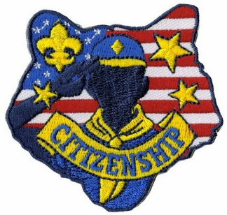

|  |  |  |
| --- | --- | --- |
| **Month** | **Year** | **Theme** |
| **LOYAL** (Selected Citizenship, Faith, and  Perseverance Theme Months) | | |
| September | 1960 | Cub Scout Citizens |
| September | 1972 | Cub Scout Citizens |
| October | 1980 | Cub Scout Citizen |
| July | 1983 | Stars and Stripes |
| October | 1988 | Cub Scout Citizens |
| November | 2001 | Hometown Heroes |
| February | 2003 | Uncle Sam Depends on You |
| November | 2009 | Scout Salute |
| November | 2010 | Citizenship |
| November | 2011 | Citizenship |
| June | 2012 | Perseverance |
| September | 2012 | Hometown Heroes |
| November | 2013 | Your Vote Counts |
| December | 2014 | Stars and Stripes |
| July | 2016 | Scout Salute |

|  |  |  |  |  |  |
| --- | --- | --- | --- | --- | --- |
| **Month** | **Year** | | **Theme** | | |
| **American History** | | | | | |
| February | | 1962 | | Parade of Presidents | |
| September | | 1966 | | Cub Scout 49'ers | |
| October | | 1972 | | Discovery of America | |
| February | | 1973 | | Famous Americans | |
| June | | 1973 | | Flags of America | |
| October | | 1976 | | Outstanding Presidents | |
| June | | 1981 | | Flags of America | |
| November | | 1985 | | Parade of the Presidents | |
| September | | 1987 | | Flags of America | |
| November | | 1989 | | Parade of the Presidents | |
| October | | 1999 | | California Gold Rush | |
| **American the Beautiful** | | | | |
| February | | 1941 | | American Highlights |
| July | | 1955 | | Discovering America |
| November | | 1956 | | Life In Puerto Rico |
| April | | 1960 | | The Great Lakes |
| March | | 1963 | | Around the U.S.A. |
| April | | 1967 | | Mountians of America |
| July | | 1971 | | Travel around U.S.A. |
| February | | 1976 | | Horizons USA |
| October | | 1977 | | Discover America |
| November | | 1978 | | High Country USA |
| November | | 1981 | | Discover America |
| July | | 1991 | | High Country, USA |
| August | | 1996 | | High Country, USA |
| July | | 2001 | | American ABC's |
| February | | 2009 | | American ABCs |

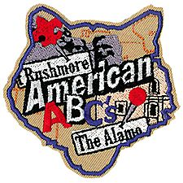



|  |  |  |  |  |
| --- | --- | --- | --- | --- |
| **Month** | **Year** | | **Theme** | |
| **American Patriotism** | | | | |
| October | | 1951 | | Strong for America |
| February | | 1955 | | Let Fredom Ring |
| July | | 1964 | | Our American Heritage |
| February | | 1966 | | Strong for America |
| February | | 1971 | | Our American Heritage |
| June | | 1976 | | Historical Flags |
| July | | 1976 | | July 4th Picnic |
| December | | 1978 | | Duty to God & Country |
| February | | 1989 | | Strong for America |
| September | | 1989 | | Our American Heritage |
| February | | 1993 | | Old Glory |
| June | | 1994 | | Strong for America |
| July | | 1999 | | Our National Treasures |
| July | | 2006 | | Red, White and Baloo |
| July | | 2007 | | The Rockets Red Glare |
| July | | 2010 | | Celebrate Freedom |
| December | | 2013 | | Passport to Other Lands |
| June | | 2014 | | Over the Horizon |
| February | | 2016 | | Friends Near and Far |
| February | | 2017 | | Passport To Other Lands |

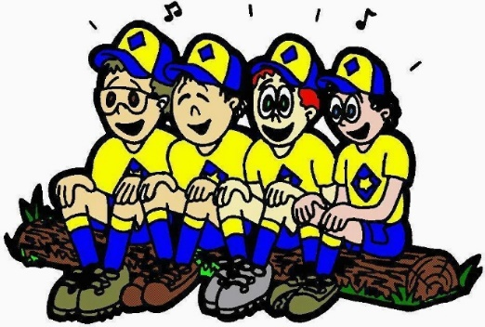

# **CUBMASTER THOUGHTS**

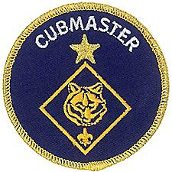

*Mark will be back next month. He had an emergency appendectomy on Saturday, November 13, 2016. That morning I texted him for help with a B.A.L.O.O. class with which I was involved. His response was “In spirit only. I am going to be appendix-less in about an hour.” His wife, Donna, says he is doing fine. Pray for him this month, please. - CD*

## WOOD BADGE FOR CUB SCOUTERS?

*Kommissioner Karl Henley  
Buckeye Council*

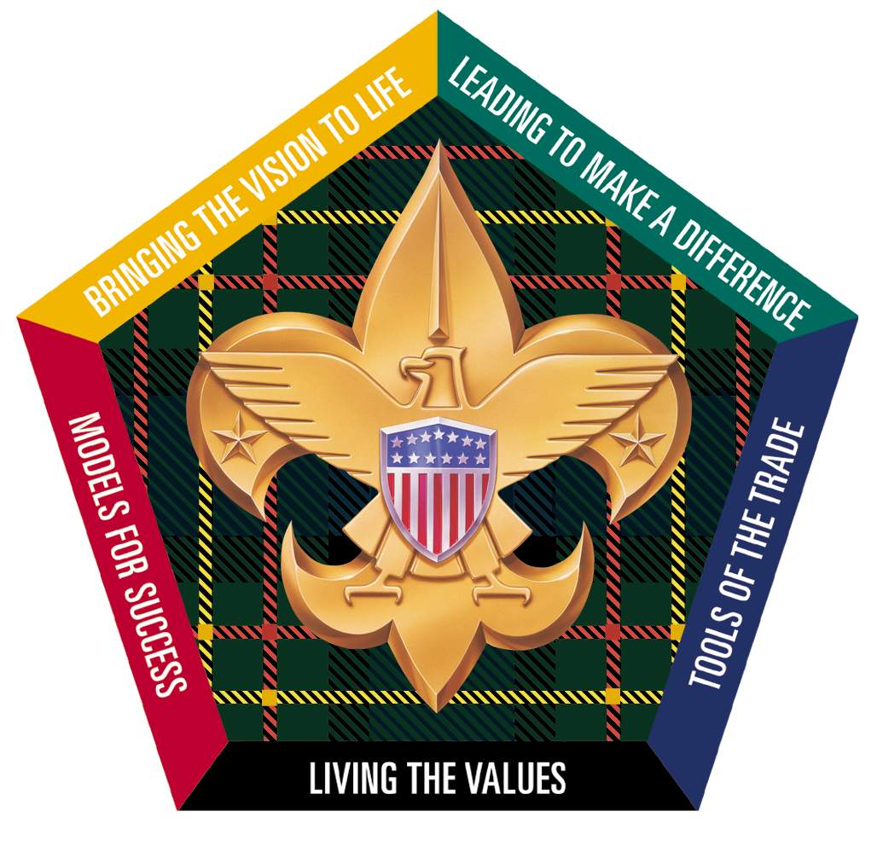

The Wood Badge course of today is not your parent’s Wood Badge. Gone are the hours of crafts and knot tying, replaced by leading edge teaching, team building, management and leadership skill building sessions. The course was re-developed by the National Council early this century and rewritten by some of the country’s best corporate trainers and authors. It remains the most advanced leader training that the Boy Scouts of America offers. To qualify to be a participant, you must have completed the Position Specific Training required for your current primary registered position. Many BSA Basic or Position Specific courses are available online at [www.scouting.org](http://www.scouting.org); You can set up your account at [www.my.scouting.org](http://www.my.scouting.org). Several types of training are available at this portal and once completed, a training card is available for you to print and the information will be passed back to your council via ScoutNet.

Wood Badge is 6 days (usually split over 2 three day weekends) of fun, learning, relationship building and skill development. The course is genius in its delivery, using the EDGE method (Explain, Demonstrate, Guide, and Enable – a session in the course) participants learn and experience each aspect of the teachings. As you look back over the experience, you will begin to realize how different sessions and team building skills are inter-related and how the course truly unfolds to not only teach the method, but take you as a participant through the same experience that your cubs and pack committees will have. The course framework starts you out as a Cub Scout and then runs through how you should see your prospective Boy Scout troops running, which can be handy when you go looking for Troops when it is time for your sons to crossover to Boy Scouts.



As a Cub Leader, what should you expect to take away from the course? A better understanding of how to follow, lead, and knowing how to recognize the best way to handle situations life can toss at you. Because the course is teaching leadership and team development, you can apply many of the lessons to your work, family and scouting life. No matter what role you are playing in the leadership of the den or pack, you will find opportunities to use the lessons learned. From coaching and mentoring the fledgling wolf scout, to getting your committee on board with developing a plan and successfully carrying it out, Wood Badge will have an impact on you, your den and your pack committee and your personal life.



You also have an opportunity to meet and spend 6 days with other top Scouters in your district and council. You may find this valuable when you need to find out information, look for a guest to come to your meeting, or just simply know who is in what role and what they do to help your unit. Since you form your own team, you will have a chance to form long lasting friendships with other like-minded Scouters.

My personal experience was very positive. Two of my best friends I would not have met were it not for Wood Badge. I was able to take what I learned and apply it to a pack that was struggling, and turn it into a successful, growing pack, with more than 20 parents on our committee and a fantastic year round program.

If you have a course coming up in your council, you should go. The best place to get more information about Wood Badge is your District Training Chair, Council Wood Badge Coordinator, or Council Training Chair. You will not be disappointed.

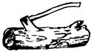

The best advice I ever received on being a Cubmaster was simple and to the point:

**Commissioner Dave** is Senior Patrol Leader and **Cubmaster Mark** is a Troop Guide for the Spring 2017 Wood Badge course being run in Garden State Council in NJ.   
Check it out at <http://www.gardenstatescouting.org/woodbadge>

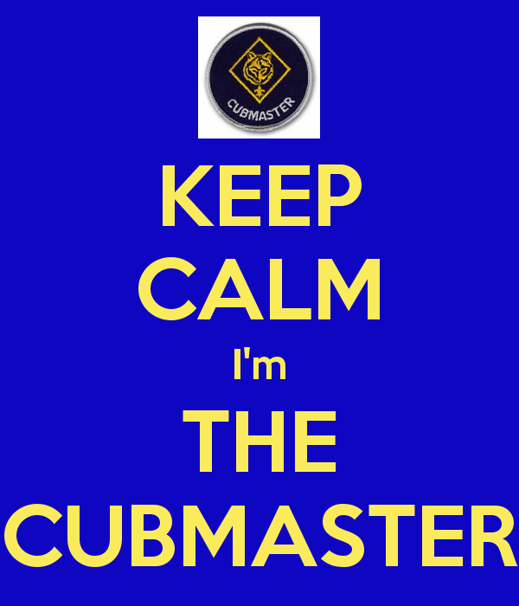

For more help be sure to check out –



# WEBELOS

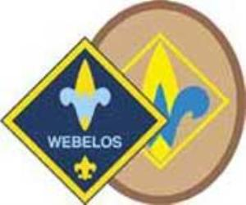

**Always an S** Webelos always ends with an S whether talking about one Webelos Scout or a den of Webelos. It is an acronym – **WE**’ll **BE LO**yal **S**couts. As the CS RT Commissioner who mentored me says – "If you don’t have an S at the end – then there is nothing to which to be loyal."

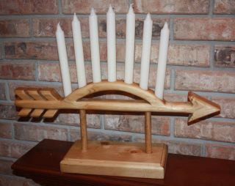

*Note: For Traditional units, Webelos Scouts / Dens means Webelos (4th grade) and Arrow of Light (5th grade) Scouts / Dens. For LDS Units where the Webelos experience is the 12 months a Scout is 10 years old, it is all inclusive.*

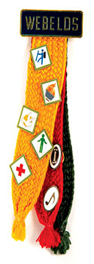

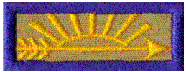

# **ARROW of LIGHT PRESENTATION**

This ceremony combines “Top of the Mountain,” based on a story by Ernest Thompson Seton and “The Seven Virtues” graduation ceremony. Either one alone also makes an impressive Arrow of Light Ceremony

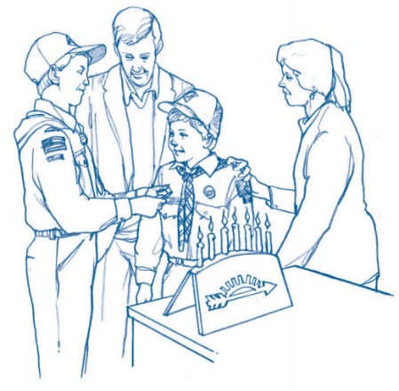

**Props:**

Pictures or actual or props for

* cactus,
* sagebrush,
* cottonwood spray,
* cedar and
* pine,

"Cub-a-labra" with 7 candles, (See picture above).   
Preferably one using the 7 rays of the Arrow of Light as candleholders. If the construction will allow this, definitions of the Seven Virtues in large type could be placed on the back side of the Cub-a-labra (out of sight) so that it looks like the boys have memorized the parts.

Candleholder with four candles – White, Green, Blue, Yellow (All about the same size and shape)

Large white candle to use to light all the others

**Personnel –**

* Cubmaster (CM)
* Assistant CM (CA)
* Webelos Leaders (WL)
* Committee Chair (CC)
* All Cub Scouts receiving the Arrow of Light
* One Cub Scout from each rank, including Bobcat.

**Set Up –** station the following Cubs outside of the ceremony area –

* Tiger with cactus
* Bobcat with Sagebrush
* Wolf with cottonwood spray
* Bear with cedar
* Webelos Scout with pine bough
* Arrow of Light Webelos Scout or one receiving it that night

**Ceremony -**

**Cubmaster -** Tonight we gather to honor (# of Scouts receiving award) WEBELOS Scouts that have earned the highest award in Cub Scouting: The Arrow of Light. But before I present these awards, let me take a moment to relate an appropriate story and tell you a little about the Arrow of Light.

Afar in our dry southwestern country was an Indian village, behind which a high mountain towered above the desert. It was considered a great feat to climb this mountain, so all the young braves of the village were eager to attempt it.

One day, the chief said, “Now, boys, you may all go today and try to climb the mountain. Start right after breakfast, and go as far as you can. Then when you are tired, come back; but each of you must bring me a twig from the place where you turned.

Away they all went; full of hope, each feeling that he surely could reach the top.

Soon the first boy returned. **(Enter Bobcat with sagebrush)** He carried a twig of sagebrush. You did not reach the mountain; you did not even cross the desert. I like to think this boy is like a newly inducted Cub Scout; he has just barely started.

An hour later the second boy came slowly back, puffing and sweating. **(Enter Tiger with cactus)** He stood before the chief, and in his hand he held a piece of cactus. The chief smiled and said, “My boy, you barely got started.” “Well” said the chief, “you reached the foot of the mountain, but you did not start the climb.” This boy is like the Cub Scout who has earned his Tiger badge; he has progressed on his journey but has not really started his climb.

After another hour, the third boy came back. **(Enter Wolf with cottonwood spray)** He held out a cottonwood spray. “Good” said the chief, “you got as far as the springs.” This might represent the Cub Scout who has reached the first level of his climb and received his Wolf badge.

A while later, another boy came back with some cedar. **(Enter Bear with cedar)** The chief smiled when he saw it, and spoke, “Well done, my boy, you went halfway up.” This is like the Cub Scout who has progressed halfway up the advancement trail and earned his Bear badge.

Later in the afternoon, the next boy returned carrying a branch of pine.  **(Enter Webelos Scout with pine bough)** To him the chief said, “Good, you went to the third level. You made three - quarters of the climb. Keep on trying. Next year you will undoubtedly reach the top.” The Cub Scout who has earned his WEBELOS badge has reached the three-quarter mark and is in sight of the top.”

The sun was low when the last boy returned. **(Enter Arrow of Light Webelos Scout)** He was a tall, splendid boy of noble character. He approached the chief and held up his hand. It was empty. But he was radiant as he spoke. “My father, there were no trees where I went. I saw no twigs, no living thing upon the peak. But far and away I saw other mountain peaks, and beyond them the shining sea.” Now the old Chief's face glowed as he said, “I knew it! I knew it when I looked upon your face. You have reached the top. It is written in your eyes and it rings in your voice. My boy, you need no twigs for token, you have seen the glory of the mountain.”

The brave who reached the top is like the Cub Scout who has reached the top - the Arrow of Light Award. But, beyond the top are the peaks of the Boy Scouting program that must be met and climbed to reach the shining sea of adulthood.

Our Scouts like the brave that reached the top of the mountain, have worked very hard to earn this prestigious award, and to demonstrate that they understand the purpose of Scouting.

Webelos Scouts of Akela, are you ready to climb the mountain?

Then climb up on the stage (using the steps) and take your positions at the large Arrow of Light

**CM** The Arrow of light is the highest Award in Cub Scouting. It is the only Cub Scout badge of rank that a Cub may transfer to his Boy Scout uniform.

Tonight we are privileged to present ___ Arrow of Light Awards.

You see the Pack ### Webelos Class of 20?? assembled at the ceremonial Arrow of Light

**CA** Webelos Scouts, you have completed all the requirements for the Arrow of Light Award. You have visited a Boy Scout Troop and obtained an application to join. You have begun to see the excitement that lies ahead for you in Boy Scouting.

**WL #1**  (Lights blue candle) This blue candle represents the sprit of Cub Scouting. That spirit of giving good will and doing your best.

**WL #2** (Lights white candle) This white candle represents the spirit of Scouting. If you promise to fulfill the Scout Oath and Law as well as the Cub Scout Motto, Do Your Best. Please say, “I do”

**WEBELOS** I DO !!!!!

**CC** (Lights yellow candle) This yellow candle represents the Arrow of Light Award. Let’s take a moment to look at the Arrow of Light before we go any further.

**CM** The seven candles before you represent the rays in the Arrow of Light. These seven rays stand for the seven great virtues of life...virtues that WEBELOS Scouts must have if they are to succeed and advance in Scouting and in life. For younger Scouts, living by and using these 7 great virtues will help you achieve much on your trail upward to the Arrow of Light.

All other Webelos scouts please join their brothers on the stage to help in explaining the seven rays on the Arrow of Light.

**Webelos #1** A Scout has WISDOM (light candle #1) Having wisdom doesn't mean that a Scout is smarter than others. It means that he uses what he knows to live a better life -- to be a good example for other people, young and old, Scouts and others, family and friends.

**Webelos #2** A Scout has COURAGE (light candle #2) Having courage doesn't mean that you're never afraid -- very courageous people are often afraid. However, facing danger despite your fear is the act of a brave, courageous Scout.

**Webelos #3** A Scout has SELF-CONTROL (light candle #3) Scouts have to know when to stop. When you can stop yourself when you have had enough or done enough of something -- enough eating, enough playing, or even enough working -- then you have self-control. Know what behavior is correct in each situation, and do it. When you have self-control, you are growing up as a Scout.

**Webelos #4** A Scout gives JUSTICE (light candle #4) Justice is part of the Pledge of Allegiance: "with liberty and justice for all." Justice is being fair with others that we go to school with, work and play with. Justice means it doesn't matter who the person is, or what color they are, or what they do...Scouts are fair to everyone.

**Webelos #5** A Scout has FAITH (light candle #5) Scouts believe in God. Faith means that we believe in God and other things we cannot see. When you know God exists in your heart, you have faith.

**Webelos #6** A Scout has HOPE (light candle #6) Hope means you look forward to good things that you believe will happen. You hope for better things tomorrow, but you work hard today to make those good things happen.

**Webelos #7** A Scout has LOVE (light candle #7) Scouts have many kinds of love. Love of family, home, your fellow Scouts, God and country are all a part of Scouting. Every kind of love is important for a full and happy life.

**CM** Thank you Webelos. You may return to your seats now.

**CA** You will find that if you live your life by these seven virtues, you will be happy and will make the people around you happy as well.

**CC** The WEBELOS Scouts before us this evening have proven that they understand their responsibilities as good sons and good Scouts. With the help of their willing parents, they will advance far along the Boy Scout Trail.

Webelos Scouts please extinguish your candles and assemble at the front of the stage.

**CA** Parents come forward and stand behind your sons

**CC** Remember that the spirit of Cub Scouting and Boy Scouting are one and the same. The spirit of the entire Scouting movement is one of service, high ideals, and fellowship.

**CM** To each family I am presenting the Arrow of Light Award and ask you pin it on your boy. This award is worn on your Webelos uniform now and your Boy Scout uniform later.

**CA** Notice that we left an unlit green candle representing the Boy Scout program. This is to remind you that there is more adventure ahead as you continue in Boy Scouting after your graduation.

**CM** Congratulations, Scouts. (Lead Cheer)



## WEBELOS TO BOY SCOUTS BRIDGING CEREMONY

*Del-Mar-Va Council*

***I picked this up at a Del-Mar-Va Council Pow Wow a few years ago and it has become my favorite bridging ceremony. The bridge I made for this ceremony generally gets used several times each year as other Packs in my district borrow it for the ceremony. CD***

**Props** –

4 - 5 to 6 foot 4 X 4's (or 2X6’s) for foundation   
notched to interlock

5 - 4 foot 2x10's - one plain, one yellow, one blue,   
one green, one red

All words are spoken by same person (Narrator, Cubmaster) but you could divide them up amongst several leaders.

**Narrative**

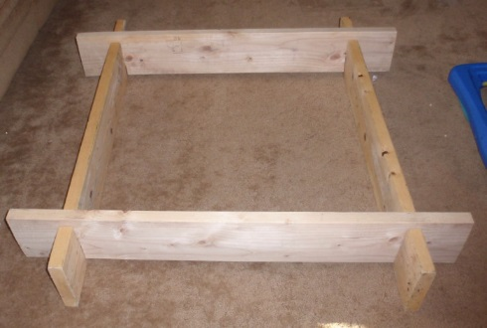

WEBELOS leader, will you please place the first post on the stage in a North/South direction. (WL places post)

WEBELOS Asst. leader, please place the second post on the stage three feet away from the first post in the North/South direction. (WA places post)

These two posts placed here are symbolic of the foundations of Scouting that these WEBELOS leaders have instilled in their WEBELOS Scouts through activities and outings as represented by the natural brown color.

Scoutmaster (name) and Assistant Scoutmaster or Senior Patrol leader), please place your posts in an East/West direction 3 feet apart over the North/South posts that are already in place. (SM and SPL place posts)

As represented by the structure assembly, Boy Scouting will build on the Scouting foundation begun in WEBELOS. These leaders have set the stage for bridging the boys from Cub Scouting into Boy Scouting.

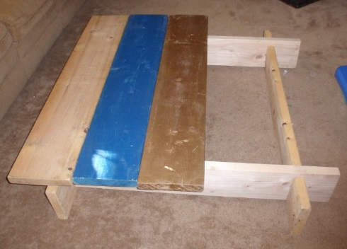

WEBELOS Scout (name), will you and your parents please bring the unfinished plank forward and place it across the east/west posts. (Scout places plank)

This unfinished plank represents the boys as they arrived in Cub Scouting, full of potential but unfinished.

WEBELOS Scout (name), will you and your parents please bring the blue plank forward and place it snuggly against the unfinished plank. (Scout places plank)

This Blue plank represents the Wolf and Bear years of Cub Scouting where with the help of their parents the Scouts became true blue and loyal friends.

WEBELOS Scout (name), will you and your parents please bring the gold plank forward and place it snuggly next to the blue planks. (Scout places plank)

This Gold plank represents their golden years in Cub Scouting as Webelos learning important skills through activity badges and culminating in the Arrow of Light.

WEBELOS Scout (name), will you and your parents please bring the green plank forward and place it next to the gold plank. (Scout places plank)

This green plank represents their new beginning as Boy Scouts, who will soon be green Tenderfoot scouts, anxious to begin the Boy Scout trial toward Eagle.

WEBELOS Scout (name), will you and your parents please place the final plank onto the bridge. (Scout places plank)

This last plank is red the predominant color in the Eagle Scout Badge and represents the fact that as they step off the bridge from Cub Scouting to Boy Scouting they are beginning of their journey to becoming Eagle Scouts.

Webelos entering Troop (number), please assemble with your parents at the unfinished board of the now completed Bridge to Scouting?

As we present you with your Pack graduation Certificate, will each parent please remove your sons Webelos neckerchief and slide.

Scoutmaster invites boys across the bridge, calling each by name and (performing whatever ceremonies are customary for your pack and troop)

After all have crossed - Pack (number) please stand and show your pride to the new Boy scouts from this Pack. (Cheer (Blast Off), Applause)...

We are very proud of you all.

***The following could be a Webelos Den’s last salute and thank you to the pack before graduation. CD***

**Graduation of a Webelos Den to Boy Scouts**

*Adapted from Alapaha Council Pow Wow Book*

*All graduating Cub Scouts stand at the front of the room.*

Props: 10 candles, 10 cards with verse

*Dim lights - candles are lit:*

1. We’ve played together and worked together.
2. Maybe had a fight or two.
3. We’ve taken trips and had some slips.
4. And seen many projects through.
5. That Tiger Badge seems so long ago
6. We earned our Wolf and extra Elective Adventures.
7. And passed the tests for Whittlin’ Chip and our Bear degree.
8. We earned Webelos Walkabout and five other Adventures for Webelos
9. And finally, Scouting Adventure and four others for the Arrow of Light
10. Now, Boy Scouts we’ll soon be.

**Leader:** We hope you remember Den (#) with delight!

**CM:** We salute you Den (#)! Good luck! Happy Scouting!

*At this time, the den does its cheer one last time and the Bridging Ceremony to Boy Scouts is begun*

Comments welcome. Let me know your opinion -   
[Davethecommish@gmail.com](mailto:Davethecommish@gmail.com)

## MORE A of L CEREMONIES

**On US Scouts -**<http://usscouts.org/usscouts/ceremony/aol.asp>

**Top 10 A of L Ceremonies   
(obviously subjective) -**<http://cubscoutideas.com/5748/top-10-arrow-of-light-ceremonies-for-cub-scouts/>

# FEBRUARY CRAZY HOLIDAYS

*Claralyn, Golden Empire Council,   
Webelos Camp Prog Dir& Cub RT Comm Emeriti   
Adapted from*

*Adapted from* <http://holidayinsights.com>  
[http://www.brownielocks.com/month2.html](https://www.brownielocks.com)

**February is:**

* **American Heart Month**[AHA Kid’s Activities](https://www.heart.org/HEARTORG/HealthyLiving/HealthyKids/ActivitiesforKids/Activities-for-Kids_UCM_304155_SubHomePage.jsp)
* Beans (Dried and Fresh) Month

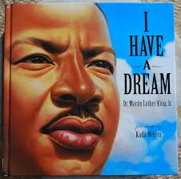

* **Black History Month  
  Make an** [African Shield, Shekere Instrument](http://www.education.com/activity/black-history-month/)
* **National Cherry Month**
* **Canned Food Month**

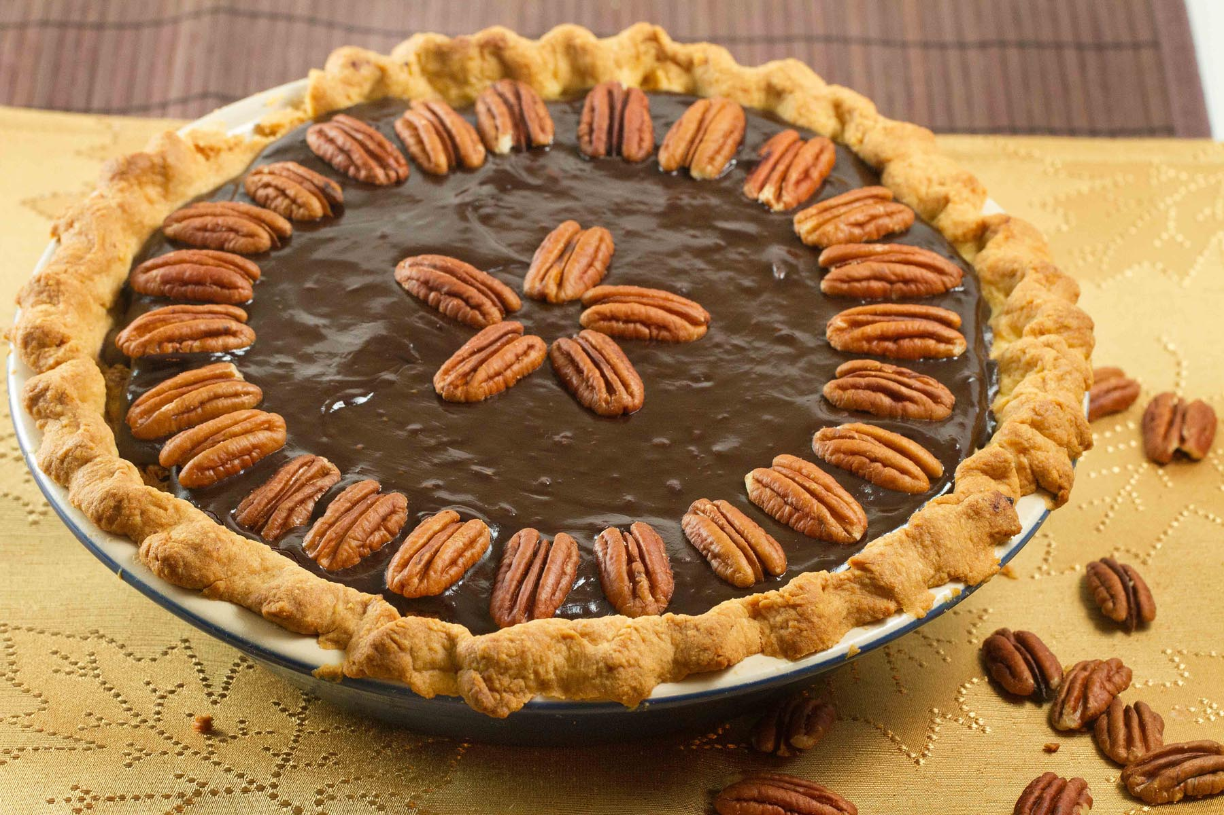

* **Great American Pie Month**



* [Library Lovers Month](https://www.daysoftheyear.com/days/library-lovers-month/)



* [**National Children’s Dental Health Month**](http://www.ada.org/en/public-programs/national-childrens-dental-health-month)
* [National Grapefruit Month](http://www.jennsblahblahblog.com/benefits-grapefruit-national-grapefruit-month/)
* [Adopt A Rescued Rabbit Month](http://www.rabbit.org/adopt-a-rabbit-month/adopt.html)

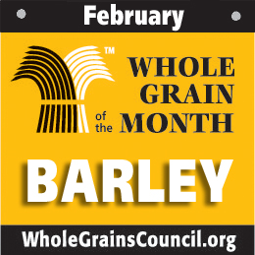

* [Barley Month](http://wholegrainscouncil.org/whole-grains-101/barley-february-grain-of-the-month)
* [Return Shopping Carts to the Market Month](http://www.wikihow.com/Observe-Return-Shopping-Carts-to-the-Supermarket-Month)

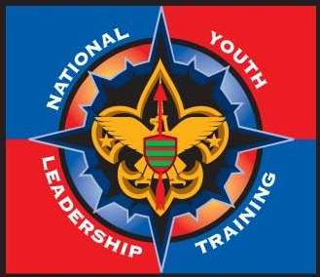

* **Youth Leadership Month**(This would be a great month to enroll your BSA-registered youth (boys and girls, 13 -21) for the upcoming National Youth Leadership Training in your council!)

**Weekly Celebrations:**

* Women's Heart Health Week: Feb 1-7

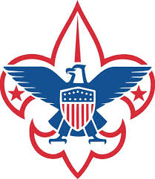

* **Boy Scout Anniversary   
  Week: Feb 5-11**
* [Burn Awareness Week](http://www.ameriburn.org/preventionBurnAwareness.php): Feb 5-11
* Children's Authors & Illustrators Wk: Feb 5-11
* Just Say No to PowerPoint Week: Feb 5-11   
  ***(We should hold Wood Badge this week)***
* [International Friendship Week: 12-17](http://www.amnesty.ie/friendshipweek)
* [Love Makes the World Go Round; But, Laughter Keeps Us From Getting Dizzy Week](https://www.humorproject.com/discussion/?mode=replys&id=17): Feb 8-14   
  *Victor Borge may have started this!!!!*



* **Jell-O Week: Feb 12-18 (Second Full Week)***A Must celebration in most Lutheran Churches!!*
* Great Backyard Bird Count: Feb 17-20

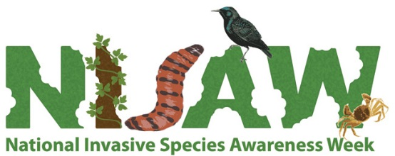

* [National Invasive Species Week](http://www.nisaw.org/): Feb 19-26
* [**Random Acts of Kindness Week**](https://www.randomactsofkindness.org/rak-week)**: February 12-18**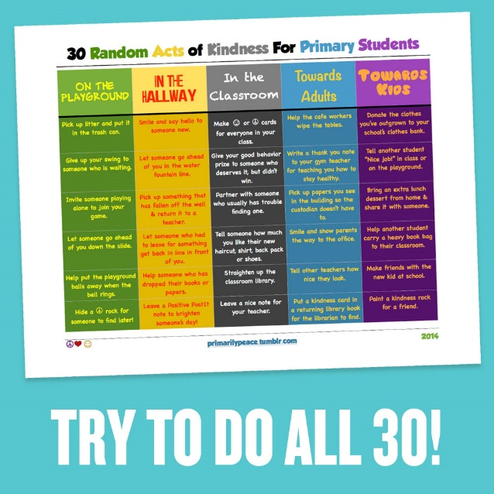

**For the full size card above -**[**https://www.randomactsofkindness.org/kindness-stories/66-10-kindness-week-ideas-for**](https://www.randomactsofkindness.org/kindness-stories/66-10-kindness-week-ideas-for)

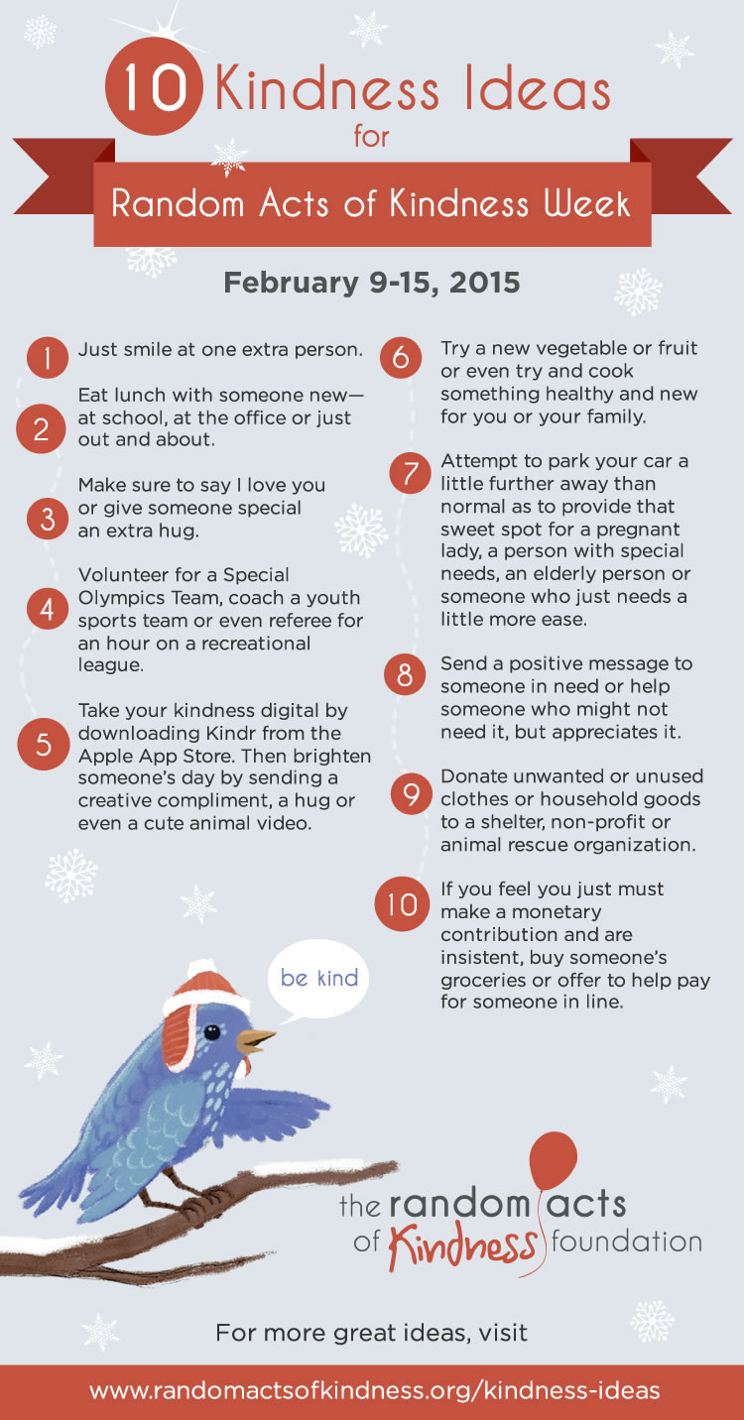

**Yes,** this picture is old but the website is still there and as lots more ideas –

[www.randomactsofkindness.org/kindness-ideas](http://www.randomactsofkindness.org/kindness-ideas)

**And in honor of George Washington –**

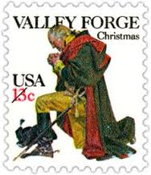

[National FFA Week](https://www.ffa.org/ffaweek): Feb 18-25   
(Week of Washington's Birthday)  
  
  
[National Engineers Week](https://www.nspe.org/resources/partners-and-state-societies/national-engineers-week): Feb 19-25   
(Week including Washington's Birthday).

**February Daily Holidays, Special   
and Wacky Days:**

1 [National Freedom Day](http://holidayinsights.com/moreholidays/February/freedomday.htm)

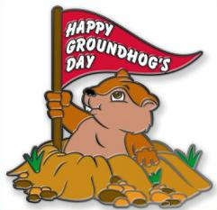

2 [Ground Hog Day](http://holidayinsights.com/other/ghog.htm)

2 [Candlemas](http://holidayinsights.com/christian/candlemas.htm)

3 [The Day the Music Died](http://holidayinsights.com/moreholidays/February/daymusicdied.htm) - Buddy Holly, Richie Valens and the Big Bopper died in a plane crash in 1959.

3 [Feed the Birds Day](http://holidayinsights.com/moreholidays/February/feed-birds-day.htm)

4 [Create a Vacuum Day](http://holidayinsights.com/moreholidays/February/vacuumday.htm)

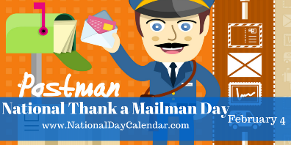

4 [Thank a Mail Carrier Day](http://holidayinsights.com/moreholidays/February/thankmailmanday.htm)

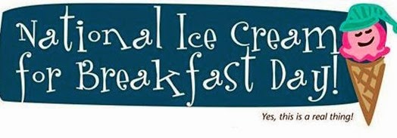

4 [Eat Ice Cream for Breakfast Day](http://holidayinsights.com/moreholidays/February/ice-cream-breakfast-day.htm)

5 [National Weatherman's Day](http://holidayinsights.com/moreholidays/February/weathermanday.htm)



5 [Super Bowl Sunday](http://holidayinsights.com/other/superbowl.htm) (I don’t know anything about this. I am a Philadelphia Eagles Fan)

6 [Lame Duck Day](http://holidayinsights.com/moreholidays/February/lameduckday.htm)

7 [Wave All you Fingers at Your Neighbor Day](http://holidayinsights.com/moreholidays/February/wavefingers.htm)

7 [Send a Card to a Friend Day](http://holidayinsights.com/moreholidays/February/sendacardday.htm) - obviously created by a card company

8 [Boy Scout Day](http://holidayinsights.com/moreholidays/February/boyscoutday.htm) - celebrates the birthday of scouting

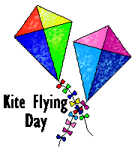

8 [Kite Flying Day](http://holidayinsights.com/moreholidays/February/kiteflyingday.htm) - in the middle of winter!?!

9 [Toothache Day](http://holidayinsights.com/moreholidays/February/toothacheday.htm)

10 [Umbrella Day](http://holidayinsights.com/moreholidays/February/umbrelladay.htm)

11 [Don't Cry over Spilled Milk Day](http://holidayinsights.com/moreholidays/February/spilledmilkday.htm)

11 [Make a Friend Day](http://holidayinsights.com/moreholidays/February/makeafriendday.htm)

11 [National Inventors Day](http://holidayinsights.com/moreholidays/February/national-inventors-day.htm)

11 [White T-Shirt Day](http://holidayinsights.com/moreholidays/February/whitetshirtday.htm)

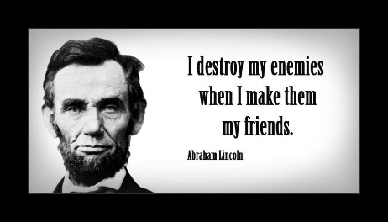

12 [Abraham Lincoln's Birthday](http://holidayinsights.com/other/lincoln.htm)

12 [Plum Pudding Day](http://holidayinsights.com/moreholidays/February/plumpuddingday.htm)

13 [Clean out Your Computer Day](http://holidayinsights.com/moreholidays/February/cleancomputerday.htm)

13 [Get a Different Name Day](http://holidayinsights.com/moreholidays/February/differentnameday.htm)

14 [Ferris Wheel Day](http://holidayinsights.com/moreholidays/February/ferriswheelday.htm)

14 [National Organ Donor Day](http://holidayinsights.com/moreholidays/February/organdonorday.htm)

14 [Valentine's Day](http://holidayinsights.com/valentine/index.htm)



15 [National Gum Drop Day](http://holidayinsights.com/moreholidays/February/gumdropday.htm)

15 [Singles Awareness Day](http://holidayinsights.com/other/singlesawareness.htm)

16 [Do a Grouch a Favor Day](http://holidayinsights.com/moreholidays/February/grouchfavorday.htm)

17 [Random Acts of Kindness Day](http://holidayinsights.com/moreholidays/February/randomactskindness.htm)

18 [National Battery Day](http://holidayinsights.com/moreholidays/February/batteryday.htm)

18 [National Drink Wine Day](http://holidayinsights.com/moreholidays/February/national-drink-wine-day.htm)

19 [National Chocolate Mint Day](http://holidayinsights.com/moreholidays/February/chocolatemintday.htm)



20 [Cherry Pie Day](http://holidayinsights.com/moreholidays/February/cherrypieday.htm)

20 [Hoodie Hoo Day](http://holidayinsights.com/other/hoo.htm)

20 [President's Day](http://holidayinsights.com/other/president.htm) - third Monday of month

20 [Love Your Pet Day](http://holidayinsights.com/moreholidays/February/loveyourpetday.htm)

21 [Card Reading Day](http://holidayinsights.com/moreholidays/February/cardreadingday.htm)

22 [George Washington's Birthday](http://holidayinsights.com/other/washington.htm)

22 [Be Humble Day](http://holidayinsights.com/moreholidays/February/behumbleday.htm)

22 [Walking the Dog Day](http://holidayinsights.com/moreholidays/February/walkdogday.htm)

22 [International World Thinking Day](http://holidayinsights.com/moreholidays/February/worldthinkingday.htm)

23 [International Dog Biscuit Appreciation Day](http://holidayinsights.com/moreholidays/February/dogbiscuitday.htm)

23 [Tennis Day](http://holidayinsights.com/moreholidays/February/tennisday.htm)

24 [National Tortilla Chip Day](http://holidayinsights.com/moreholidays/February/tortillachipday.htm)

25 [Pistol Patent Day](http://holidayinsights.com/moreholidays/February/pistolpatentday.htm)

26 [Carnival Day](http://holidayinsights.com/moreholidays/February/carnivalday.htm)

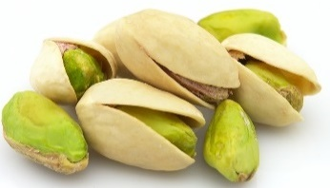

26 [National Pistachio Day](http://holidayinsights.com/moreholidays/February/pistachioday.htm) - it's a nutty day!

26 [Tell a Fairy Tale Day](http://holidayinsights.com/moreholidays/February/tellfairytaleday.htm)

27 [Polar Bear Day](http://holidayinsights.com/moreholidays/February/polarbearday.htm)

27 [No Brainer Day](http://holidayinsights.com/moreholidays/February/nobrainerday.htm) - this day is for me!

28 [Mardi Gras / Fat Tuesday](http://holidayinsights.com/christian/fat2day.htm)

28 [Floral Design Day](http://holidayinsights.com/moreholidays/February/floraldesignday.htm)

28 [Public Sleeping Day](http://holidayinsights.com/moreholidays/February/publicsleeping.htm)

28 [National Tooth Fairy Day](http://holidayinsights.com/moreholidays/February/toothfairyday.htm)

*29* [Leap Day](http://holidayinsights.com/other/leapday.htm) – *Last time for four years!!*

# February – A Month to be Reverent

*Alice, Golden Empire Council*

**February 2**



**Groundhog Day** is celebrated in the United States, especially in Punxsutawney, Pennsylvania, where “Phil” the groundhog is used to predict when Spring will arrive. The legend is that if Phil sees his shadow when emerging from his den on Feb. 2nd, (in other words, a sunny day), that there will be six more weeks or winter. If Phil doesn’t see his shadow (a cloudy day), Spring is just around the corner. For the record, Punxsutawney Phil sees his shadow about 9 out of 10 times.

**February 5**

**National Weatherman’s Day –** **If you want to double check whether Punxsutawney Phil was right, celebrate this holiday.** It honors all those who work hard to accurately predict the weather. Forecasting the weather is still tricky, even with all the technology available.

Knowing the weather is important in so many ways. It affect how we dress, where we go, and even if we go. According to the Air Force News, Weatherman's Day "commemorates the birth of John Jeffries, one of America's first weathermen". Jeffries was born on Feb 5, 1744. He kept weather records from 1774 to1816.

**February 8**

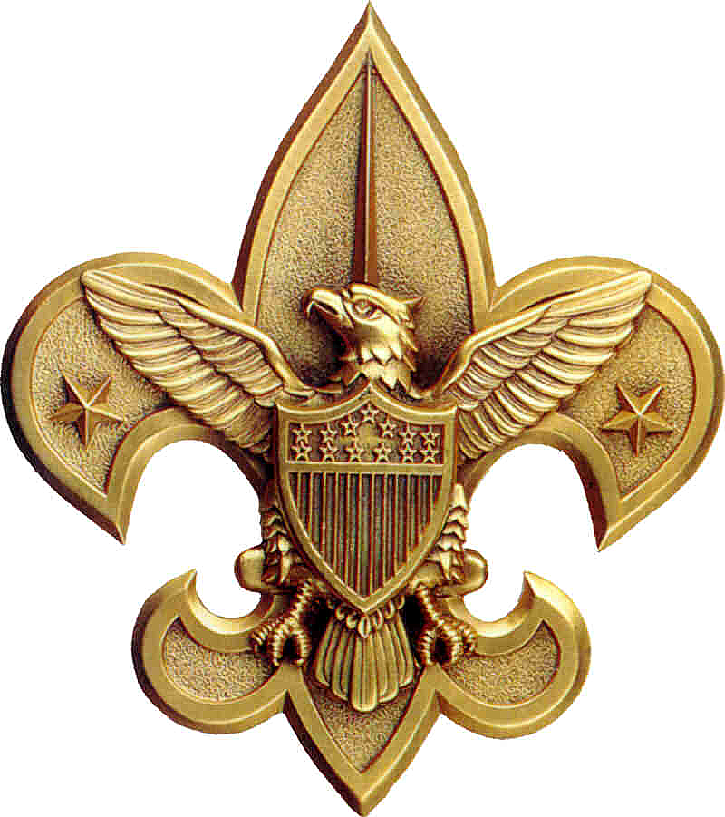

**The Birthday of Scouting,** of course. Be sure and celebrate – try some of the games that Baden Powell used, or learn more about the history of scouting. Try one of the ideas under Den & Pack Activities. Make some hand shadows, put up a display about scouting in your school, or challenge everyone to find a Baden Powell quote to share. But whatever you do, make sure you demonstrate being Resourceful!

**February 11**



**Thomas Alva Edison was born on this day in 1847** – and talk about being Resourceful! He learned telegraphy in 1862 from the father of a 3 year old boy he saved from being run over by a boxcar on the train tracks. But by the time he was 21, he had become an inventor. He developed a telegraph that could send two messages at once in both directions!

He didn’t invent the electric light bulb, but he perfected it to make it practical – which required a whole host of new inventions: the parallel circuit, a durable light bulb, and underground conductor network, devices to maintain constant voltage, safety fuses and insulating materials, and light sockets with on and off switches!

He was the most prolific American inventor, with 1,093 patents. Turn back the clock for Cub Scouts and share the phonograph player – another Edison invention. The boys may find it very old fashioned – but tell them to imagine a world where they could only hear music if there was a band available! Edison’s invention was the forerunner of the CD’s we now use every day!

**February 12**

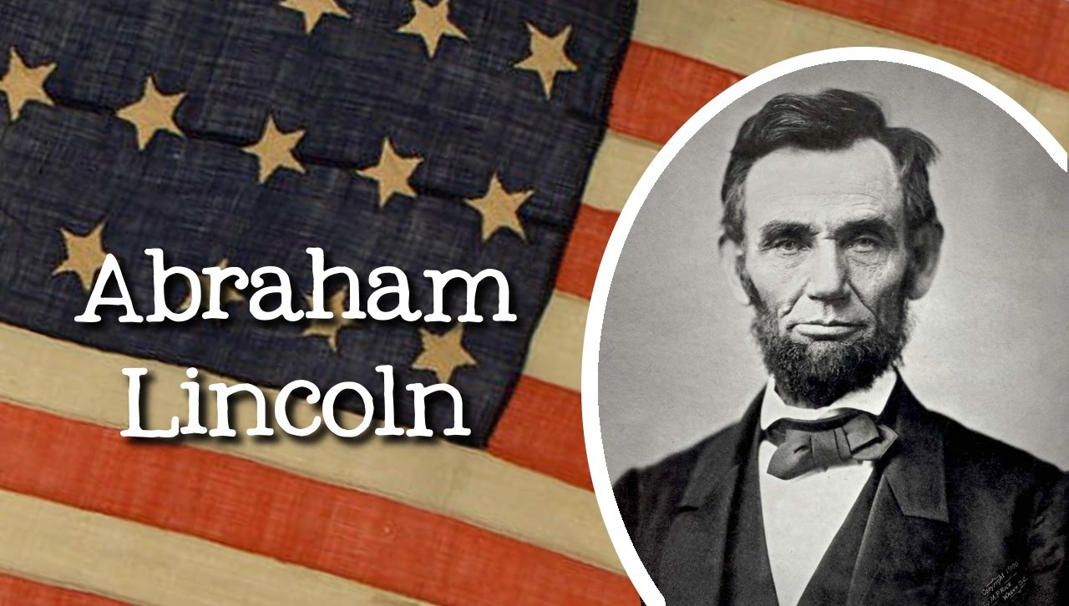

**Abraham Lincoln was born on this day in 1809.** Every American knows the story of his Emancipation Proclamation and the Gettysburg Address. But he was also another very Resourceful American. Check out the story about him under Audience Participations and Stories.

**February 16**

**Do A Grouch a Favor Day -** And you might have to be really resourceful to find something that a Grouch would appreciate. And don’t forget Oscar the Grouch – he has always been pretty Resourceful in finding uses for all that stuff he finds in his Garbage Can!

**February 18**

**National Battery Day –** Now if you want to be really resourceful, try finding things to do all day that don’t involve a Battery! Batteries are used everywhere, from the battlefield to smoke alarms to headsets. They come in all sorts of shapes, sizes, and power capacity, to fit a wide array of needs.

Just imagine where the world would be without batteries. We'd still be using a crank to start our automobiles. We'd have to cart around long extension cords to bring the boom box to the beach. And, forget about hand-held games. They'd never be popular if you always had to be tied to an electrical outlet.

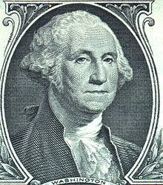**February 22**

**George Washington was born on this day in 1732.**  Now, everyone knows he is the “Father of His Country” and our first president. But the challenge is to learn about the many ways he showed his Resourcefulness. First hint: the story of crossing the Delaware. Second hint: check out his biography in this issue of Baloo. Or be REALLY resourceful and check out a website or a library book for some ideas!

**February 22**

**International World Thinking Day –** This isn’t just a day for Girl Scouts and Girl Guides to celebrate. But they do celebrate by setting aside this day to think about each other and the other Girl Scouts across the globe, and also to learn about health and education issues that affect girls. But here’s something else that you should really think about: February 22nd is the birthday of both Lord Baden-Powell founder of the Boy Scouts, and his wife Lady Olave Baden-Powell . Lady Baden-Powell who founded Girl Guides. So celebrate this day by doing something Resourceful in honor of these two great founders – their goal was always to help youth use their imagination and intelligence with experience and common sense to solve problems and find solutions!

**February 22**

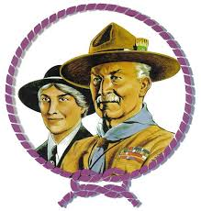

**Lady Olave and Lord Baden-Powell were born on This day** (The same date as George Washington) She was born in 1889 and he was born in 1857 *(Yes, that is a 32 year difference)* They are founders of Boy Scouts and Girl Guides.

**February 29**

**Leap Day –**SURE we celebrated this day last year - 2016 and not gain until 2020 as it only happens every four years….almost! Except for years ending with “00” that are NOT divisible by 400 – on the rare occasion when that happens, it is a Leap Year.

**Why the fancy calculation?** The earth rotates around the sun once every 365 and about 1/4 days. So, by adding an extra day every four years, we get mighty close to keeping the calendar consistent with the earth's annual trip around the sun. And to be very precise, the earth orbits the sun every 365.242190 days.  So to make up the difference, they have added in a Leap Year to cover that .242190 days difference.

If your birthday is on Leap Day, congratulations, you finally get to celebrate your birthday on your birth date. Just how many of us are celebrating our Birthday on Leap Day? Only about one in 1461 people. So, if you were born on this day, consider yourself very, very special.

**And don’t forget –**

**February 14**

## Fun Facts about George Washington Carver

*Alice, Golden Empire Council*

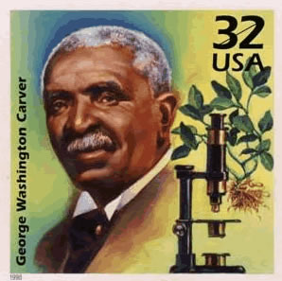

* Carver introduced the idea of crop rotation so that the soil wouldn’t lose its ability to grow crops.
* He encouraged southern farmers to rotate peanuts (which put nitrogen back in the soil) with cotton, which depleted the nitrogen from the soil.
* When farmers complained they would have no market for peanuts, Carver named three hundred different products derived from the peanut!
* Here’s a partial list of products Carver listed, many of which he developed, using the peanut or parts of the plant: margarine and salad oil, illuminating and massage oil, soap, explosives, various medicines, glycerin, cosmetics, livestock bedding, insulation, artificial wool, fertilizer.
* He also identified one hundred products that could be made from sweet potatoes and seventy five from pecans.
* He got an Honorable Mention for his paintings at the 1893 Chicago World’s Fair.
* He left his life savings of $60,000 to set up a foundation at Tuskegee Institute so that agricultural development would continue after his death.
* He was born of slave parents on July 12, 1864 in Diamond Grove, Missouri.
* He loved flowers, and always wore one in his lapel.
* As an infant, he and his mother were kidnapped – he was returned, probably because he had whooping cough – but his mother disappeared.
* He and his brother Jim were raised by their white adoptive parents, Moses and Susan Carver.
* Susan Carver taught him to read from an old spelling book, and Moses taught him to play the violin.
* As a boy, George had to empty his pockets when he came in the house, because they were always filled with plants and insects and other creatures.
* As a young boy, he became known around Diamond, Missouri as the "plant doctor.”
* He developed 115 products from the sweet potato, including flour, starch and synthetic rubber (the United States Army utilized many of his products during World War I.)
* He extracted blue, purple, and red pigments from the clay soil of Alabama. During World War II, he worked to replace the textile dyes that had previously been imported from Europe.
* He researched the manufacture of synthetic marble from green wood shavings, rope from cornstalk fibers, and veneers from the palmetto root.
* In 1927, he invented a process for producing paints and stains from soybeans and created over 500 shades.
* Although he invented many things, he only held three patents – he believed that since God gave him his talents, he should share his inventions with others.
* With the approval and support of Henry Ford, Carver helped develop a synthetic rubber made of goldenrod – a weed!
* When he was hired to teach at Tuskegee, he had to equip his lab using broken and discarded bottles, jars and other trash – he turned the items into the beakers and burners and scientific equipment he needed to teach his students.

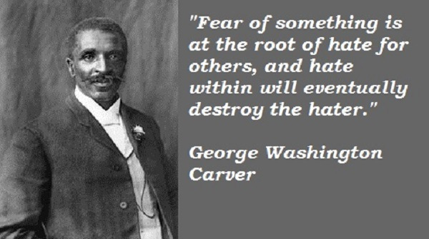

# TRAINING TOPICS

## A “SCOUTS OWN” INTRO

*With Pack Family Camping strongly encouraged and promoted, Packs should be holding a Scout’s Own Service every camping trip, whether out on a traditional day of worship or not. I am sure some are doing very well, some are not, and some are simply ignoring a Scout’s Duty to God and getting home earlier. Here is a brief presentation by Kyna Hendra, “Mrs. MacScouter,” clearing up what is and is not a Scout’s Own Service. Her book that you can see on* [*www.macscouter.com*](http://www.macscouter.com) *is over a 100 pages of excellent tips and ideas for building your own Scout’s Own. CD*

***From the MacScouter’s “A Scout is Reverent” Book***[*http://www.macscouter.com/ScoutsOwn/index.html*](http://www.macscouter.com/ScoutsOwn/index.html)

The founder of Scouting, Robert Baden-Powell, believed that Reverence and Duty to God should be an important part of the Scout Movement and of every Scout and Scouter. He originated the notion of Scout's Own ..."a gathering the Scouts for the worship of God and to promote fuller realization of the Scout Law and Oath (or Promise), but supplementary to, and not in substitution for, regular religious observances." (Aids to Scoutmastership, p.38)

**Let us first consider what Scouts' Owns are not.**

* They are not Church Services, nor are they meant to be a substitute for them.
* They are not a structured liturgy like the Book of Common Order, etc.
* They are not a good opportunity for the Leader to bang home some truths with a little bit of God added for effect.
* They are not necessarily the Chaplains or Leaders' department or duty.

Given those guidelines, let's define what Scouts' Owns are. This is not what they ought to be - this is what they are; and if they do not fulfill one or more of these categories, they are not Scouts' Owns.

**Next let’s consider what Scout’s Own are:**

* They are an acknowledgment of God and his creation and ourselves as part of it, expressed in a way that all the faiths that Scouting embraces can share together.
* They are a pause in our activity to discover something deeper and more permanent in the things we are trying to achieve or learn or enjoy.
* They are a response to the Creator for the gift of life.

Which means, of course, they can be almost everything from a time of silence through a single sentence right up to a kind of service of worship that might include music and singing and stories and readings and prayers. In other words, although the next few paragraphs suggest some material that could be useful for a Scouts' Own and end with a couple of outlines that might be useful for a colony/pack/troop/unit evening or in camp, there really is no "proper form."

For example, a group of Venture Scouts [older Scouts or high adventure group] may get to the summit of a mountain after a difficult or challenging rock climb and as they stand or sit down to recover and enjoy the view, one of them says, with feeling, "Thank God we made it!" and the others respond "Too right" (in context, another word for "Amen"), conscious or not, they have experienced a Scouts' Own, because they have recognized both their achievement and their growing because of it. The glory of a sunset and the breaking of the dawn; the sky at night, the hills by day and the flickering friendship round a camp-fire are absolutely natural settings for thinking -- sometimes silently, sometimes aloud -- about the power that is the beginning and end of everything and our human place in the complex order of the universe. And that's a Scouts' Own, without the need, even, for a mention of God by name -- only by implication. You see the point? A Scout's Own is really a spiritual experience that happens.

But sometimes, especially at the younger ages, it has to be underlined. So a game or an activity that has demanded effort in body or mind or in tolerance and team-work can, on the spot, be turned into a Scouts' Own with a thought and a "thank-you" for God -- no necessity for hymns or uniforms or readings. Of course, there is a place for a Scouts' Own with songs and readings -- when a time is set aside for God. Then it can be good to tell a story of adventure or challenge, where the people have relied on their faith -- whatever their faith -- in the Creator God to achieve their goal; and sing a campfire song or two about sharing and caring and serving. The song "Allelu, alleluia, praise ye the Lord" can be fun, because, divided into two groups, one does the 'Alleluias' and the other the 'Praise ye the Lord' and whenever they are singing they stand and when not they sit. This is praise that is ordered chaos and fun. Maybe that's a good description of a true Scouts' Own.

And prayers. A lot of young folk today find prayer difficult, yet the best prayers come from them. The young Cub Scout who prays "Thank you God for making me" has hit the nail on the head that's a Scouts' Own in a sentence. So it is far better to let the young people make up their own prayers - maybe creating a Group book of prayers and use it, updating it year by year. As a Leader you will never quite match, for them, the depth of their own thinking.

Finally, having, hopefully, done away with the mystique surrounding and the necessity of formality or a formal structure for Scouts' Owns, we suggest you go and get on with them - and enjoy them!

**Some Ideas on Scouts' Owns**By Baden Powell  
Printed in "The Scouter", November 1928

For an open Troop, or for Troops in camp, I think the Scouts' Own should be open to all denominations, and carried on in such manner as to offend none. There should not be any special form, but it should abound in the right spirit, and should be conducted not from any ecclesiastical point of view, but from that of the boy. Everything likely to make an artificial atmosphere should be avoided. We do not want a kind of imposed Church Parade, but a voluntary uplifting of their hearts by the boys in thanksgiving for the joys of life, and a desire on their part to seek inspiration and strength for greater love and service for others.

A Scouts' Own should have as big an effect on the boys as any service in Church, if in conducting the Scouts' Own we remember that boys are not grown men, and if we go by the pace of the youngest and most uneducated of those present. Boredom is not reverence, nor will it breed religion.

To interest the boys, the Scouts' Own must be a cheery and varied function. Short hymns (three verses are as a rule quite enough-never more than four); understandable prayers; a good address from a man who really understands boys (a homily "talk" rather than an address), which grips the boys, and in which they may laugh or applaud as the spirit moves them, so that they take a real interest in what is said. If a man cannot make his point to keen boys in ten minutes he ought to be shot! If he has not got them keen, it would be better not to hold a Scouts' Own at all.

**Basic Concepts for Planning a Scout's Own (Interfaith Worship) Service**

* Choose a setting that lends itself to the occasion and promotes reverence –
  + - A grove of trees,
    - A site with a view of a lake, pond, brook, etc.
    - For small groups, sitting in a circle can be a very effective arrangement.
* Everything must be in good taste.
* The service should be planned, timed, and rehearsed. (Generally 30 minutes maximum.)
* It should go without saying that those attending an interfaith worship service will be courteous, kind, and reverent. They should respect the rights and feelings of others even if their beliefs and religious practices differ from their own.
* Everyone in attendance should have opportunities to participate, if they wish, through responsive readings, silent and group prayer, singing, etc.

**Recognizing Diversity in a Scout's Own (Interfaith Worship) Service**

* Scouts practice many faiths, and many units are composed of Scouts from a variety of faiths. When this is the case during a Scout outing, ask them to suggest materials, to participate in the planning, and to assist in leading the service. If the group represents a mixture of religions, you may choose to use inspirational passages instead of particular religious materials.
* Because different faiths observe different religious practices and have a variety of holy days, it is not always possible to conduct an interfaith service in a time frame that fully recognizes individual religious obligations. This should be acknowledged and explained. Other time may need to be built into the schedule to allow individuals to meet their obligations.
* "Interfaith" means a service that all Scouts and Scouters may attend. Therefore, much attention must be paid to recognize the universality of beliefs in God and reverence.
* Encourage Scouts and Scouters to participate in religious services. Let them know ahead of time the nature of a service so that those anticipating a multi-faith experience do not find themselves surprised by a service that espouses the beliefs of a particular faith or religious tradition.

# Point of the Scout Law for February - Reverent

Universal Youth Religiuos Emblem Square Knot

**Teachable Moments**

* Consider taking a field trip to an historic place of worship. Visit an early church or mission and learn about the history and faith of people who lived in your area earlier.
* As you work on the new Cub Scout Adventures, remind boys that their abilities be they mental for the STEM type badges or physical for sports and athletic badges are all gifts from God. Reinforce in a positive way that they should be thankful for these gifts.

**Den Activities**

**Search for Faith**

*Alice, Golden Empire Council*

Words in this search all pertain to belief in God – words may be in any direction.

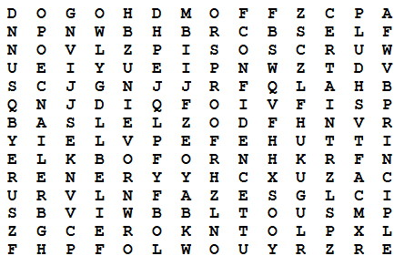

**Here are the words:**

Belief Principle Certain

Proof Confidence Reliance

Friends Religion God

Self Hope Sure

Loyalty Trust

**Song - Cub Scout Garden**

*Commissioner Dave*

*Tune*: She'll Be Coming Round the Mountain.

***It is Fall (and Winter) and harvesting our gardens is either happening or over. Gardening is a great example of reverence and faith in God. I wrote this one a few years ago. It has many more verses.*** *(Too many for Cub Scout attention spans!!)*

***Be sure to create some really good motions for the verses!***

We will plant our Cub Scout Garden in the spring

We will plant our Cub Scout Garden in the spring

We will plant our Cub Scout Garden

We will plant our Cub Scout Garden

We will plant our Cub Scout Garden in the spring

We will pray to God to watch our crop each day

We will pray to God to watch our crop each day

We will pray to God to watch

We will pray to God to watch

We will pray to God to watch our crop each day

We will reap our harvest early in the fall

We will reap our harvest early in the fall

We will reap our harvest early

We will reap our harvest early

We will reap our harvest early in the fall

Then we’ll Thank God for his help with our garden

Then we’ll Thank God for his help with our garden

Then we’ll Thank God for his help

Then we’ll Thank God for his help

Then we’ll Thank God for his help with our garden

**Web Resources**

**Activities for your Den for Reverent  
Based on the British Beaver Scout Faith Badge**

The December 2009 issue of Beaver Magazine published by the Scouting in England for Leaders of their youngest boys *(British Beavers are equivalent to our younger Cub Scouts),* has an article on their non-denominational Faith badge with many great activities your dens could do. Multi-cultural activities include Christian, Judaism, and Islam.

***[](http://scouts.org.uk/documents/Magazine/decjan_09/beavdecjan09.pdf)***

<http://scouts.org.uk/documents/Magazine/decjan_09/beavdecjan09.pdf>

***I checked the link is good - CD, December 28, 2016***



**Links to Faith-Based Scouting Groups:**

*(List is incomplete. Send me others you know about so next year I can have a longer list. Thank you CD)*

<http://www.nlas.org/>  
National Lutheran Assn on Scouting  
***(CD is a member of NLAS)***

<http://www.ldsbsa.org/>  
Church of Jesus Christ of Latter-day Saints BSA Relations Office

<http://www.presbyterianscouters.org/>  
Presbyterian Church

<http://www.jewishboyscouts.com/>  
Jewish Boy Scouts

<http://www.nccs-bsa.org/>   
National Catholic Committee on Scouting

<http://nycatholicscouts.com/>  
New York Catholic Scouts

<http://www.naums.org/>  
National Assn of United Methodist Scouters

<http://baptistscouters.org/>   
Association of Baptists for Scouting

***I checked these links, too - CD, December 28, 2016***

**Religious Awards for Cub Scouts**

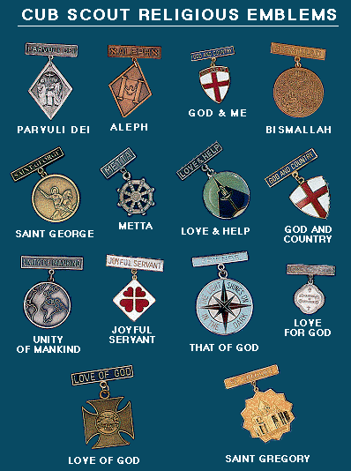  
Chart from <http://bsa-la.org/index.php?page=cub-religious-emblems>

Go to the Special Opportunities section for details on   
Cub Scout Religious Awards, Adult Religious Awards,   
and Religious Emblem coordinators in your   
Council, District, and Unit.

# **SPECIAL OPPORTUNITIES**

With the start of the Cub Scout Adventure Program, the requirements for awards that say things like, "Complete Wolf Achievement 7," need to be revised to send you to the new Adventures. We have highlighted these changes here over the last few months.

To get a complete summary of all the changes to incorporate the Adventure Program, you can go to <http://www.scouting.org/scoutsource/programupdates.aspx>.

**Or**  go to <http://usscouts.org/advancementTOC.asp#cub>   
and get the changes for a specific award.

**Religious Emblems**

[*www.USScouts.org*](http://www.USScouts.org)

 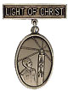 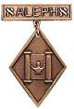

**"A Scout is Reverent."** All Scouts show this by being faithful in their duty to God. Some go further and give special service. This can qualify them for a religious emblem. Such an emblem is not a Scouting award. It is conferred on a Scout by his religious leader. Each faith has its own requirements for earning the emblem for members of its Faith. Listed at <http://usscouts.org/advance/cubscout/religious.asp#Chart> on the [www.USScouts.org](http://www.USScouts.org) website are the TIGER CUB, CUB SCOUT, AND WEBELOS SCOUT emblems and where to find out about them. Before writing or visiting your local council service center, check with your religious leader. (Unless indicated otherwise below, awards listed may be earned by both Cub Scouts and Webelos Scouts, but not by Tiger Cubs)

These groups (and others) also offer religious emblems for older youth. For information on the awards available to Boy Scouts, Varsity Scouts, Venturers, and/or Explorers, [Click here](http://usscouts.org/advance/boyscout/religious.asp).

Most of the awards consist of bar pins, ribbons, and pendants, and are worn on the uniform above the left pocket on formal occasions. In addition, the Religious Emblem Square knot, shown at the top of this page, may be worn on the uniform over the left pocket by youth or adults who earned any of the religious awards.

One or more miniature devices are affixed to the knot to indicate which level(s) of the award was earned. The youth religious emblem knot may be worn on the uniform by itself or with one or more devices to indicate the program phase(s) where the award was earned. A Scout that earns a sequence of religious emblems wears one youth religious emblem knot and up to four devices, as described below.

* The **CUB SCOUT** device for the first level (God & Me, Maccabee, etc.) earned as a Tiger Cub or Cub Scout;
* **WEBELOS** device for the second level (God & Family, Parvuli Dei, Aleph, etc.) earned as a Cub Scout or Webelos Scout;
* **BOY SCOUT** device for the first level (God & Church, Ad Altare Dei, Ner Tamid, etc.) earned as a Boy Scout;
* **VENTURING** device for the second level emblem (God & Life, Pope Pius XII, Etz Chaim, etc.) earned as an older Boy Scout, Varsity Scout, Sea Scout, or Venturer. ***Note*** *that Webelos Scout and Venturing devices are used to designate the second level emblems, even if the youth isn't a Webelos Scout or Venturer when the religious emblem was earned.*

For more information on the Youth Religious Emblem square knot patch, go to (<http://usscouts.org/awards/religyouth.asp>)

For information on the devices which are attached to the knot, go to <http://usscouts.org/awards/devices.asp>.

**FAQs about Religious Emblems**

[*www.scouting.org*](http://www.scouting.org)

**What are the religious emblems programs?**The religious emblems programs are programs created by the various religious groups to encourage youth to grow stronger in their faith. The religious groups—not the Boy Scouts of America—have created the religious emblems programs themselves. The Boy Scouts of America has approved of these programs and allows the recognition to be worn on the official uniform, but each religious organization develops and administers its own program.

**I have a unit with children of all different faiths. How can I include the religious emblems programs for my unit?**The religious emblems programs should be presented to youth members and their families as an optional program for them to complete through their religious organization. Religious instruction should always come from the religious organization, not from the unit leader. Parents need to be informed of these programs and told where to get the information for their particular faith. Interested in making a presentation on the religious awards? Find sample scripts at www.praypub.org.

**Do boys and girls participate in the same program?**It depends on the religion. Some religions have created programs that are used by both boys and girls. Other religions have created programs for members of separate youth agencies (i.e., Boy Scouts of America, Girl Scouts of the U.S.A., and Camp Fire). Please check the specific eligibility requirements for each religious emblems program.

**Do the youth have to belong to a religious institution?**It depends on the religion. Please check the eligibility requirements for your particular religious program.

**Why doesn't my religious institution know about the religious emblems programs?**Although the religious bodies at the national level created the religious emblems programs, the local religious institution may not be aware of these programs. It may be helpful to write for more information or even obtain a copy of the curriculum to give to your religious leader.

**If the religious emblems program for my faith has more than one level (for the different grade levels), may my child earn all of these recognitions?**Yes. Members can earn all levels of their religious emblems program. However, they must be in the appropriate program guidelines when they start and complete each level (they may not go backward and earn younger programs).

**How is the emblem presented?**The emblem should be presented in a meaningful ceremony, preferably in the youth member's religious institution. Some emblems come with a sample presentation ceremony.

**How long does it take to complete a program?**It depends on the program. Some programs may take three or four months, others longer.

**Where is the emblem worn on the uniform?**The universal religious square knot is worn over the left shirt pocket of the Scout uniform. The medallion is pinned over the square knot for full uniform occasions.

**How do we get started on these programs?**

1. Youth members must obtain the specific booklet for their religion. This booklet will contain information on all the lessons and service projects that they will need to complete. Each member needs to have his or her own booklet to document progress. Some religions also provide adult manuals for counselors and mentors.

Check with your local council to see if it stocks the religious award booklets in its store, or you may contact the religious organization directly

Addresses and phone numbers are provided at <http://www.scouting.org/scoutsource/Awards/ReligiousAwards/~/link.aspx?_id=9D5FA10AEB254061A248D13D459424FE&_z=z>).

1. Parents must review the specific guidelines for their particular program; age/grade requirements vary from program to program. Some programs require that the youth be an official "member" of the local religious institution, others may not. Each program determines who may serve as counselor (some require clergy, others allow parents or other family members). Be sure to look at specific eligibility guidelines!
2. Families should talk to their religious leaders and show them the booklet before beginning any program. Most of the religious emblems programs require that they be completed under the auspices of that religious organization, and many require the signature of the local religious leader. Again, check the specific eligibility requirements for your religious program.
3. The member needs to complete the requirements, obtain the proper signatures, and follow the instructions to order the emblem/award. (These emblems are not available in your local council.) The emblem can be presented at any time of the year and should be presented in a meaningful ceremony, preferably in the member's religious institution.

**Who may serve as counselor?**It depends on the program. Some programs require clergy to serve as counselor, others allow a parent or family member. Please check the specific guidelines for your religious program.

**How do I order the recognition items?**Each religious program has its own emblem. Follow the instructions in your recognition guidelines. These emblems will not be available in your local council!

**What is the adult religious recognition program?**An adult religious recognition award is presented by nomination only. The recognition is presented to worthy adults for their outstanding service to youth both through their religious institution and one of the national youth agencies. Recipients of these awards are unaware that they are being nominated. They are nominated to receive an award by submitting the required application, letters of recommendation, and resume. Please check eligibility requirements for specific awards.

**Which religious emblem square knot should I wear?**

Cloth, silver knot on purple, No. 05007, may be worn by youth or adult members who earned the knot as a youth, above left pocket.

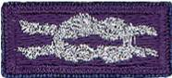 

Cloth, purple on silver, No. 05014, may be worn by adult members presented with the adult recognition of a faith, above the left pocket. Adults may wear both knots if they satisfy qualifying criteria. (See the *Insignia Guide,* No. 33066D.)

***NOTE: - Since the programs are similar or the same (as in the case of the PRAY Awards) for girls and boys in Boy Scouting, 4H, Girl Scouting, Campfire, etc., a female Venturer or Adult Leader who earned her religious award as a youth may wear the purple square knot on her uniform even though it was not earned as a member of the BSA. (My Philmont staffer daughter Dr. Darby does this!!)***

***Per Mike Walton of*** [***www.USScouts.org***](http://www.USScouts.org)***, this applies to BOTH MALES AND FEMALES, youth and adult.  If you earned a youth religious emblem as a youth member, whether or not it was earned or received as a BSA member does not matter. The youth religious emblem square knot represents ANY AWARD which youth members earned or received -- period.***

***So yes, a Girl Scout, 4Her, or Royal Ranger/Missionette who earned a youth religious emblem in one of those programs and then either becomes an adult or youth member of the BSA (to include Venturing/Sea Scouting) may wear that emblem on their BSA field uniform; and informally wear the square knot insignia without device on the uniform shirt.***

The 2015 printing of the ***"Guide to Awards and Insignia,"*** states in the Special regulations section (page 9), "The Boy Scouts of America recognizes the religious emblems programs that belong to each faith group. Anyone (youth or adult) who, as a member of another youth agency (e.g., Girl Scouts of the USA, Camp Fire USA, a Sunday school class, etc.), has earned the religious emblem of their faith is eligible to wear the approved religious emblem on their respective uniform. Individuals would also be eligible to wear the religious square knot, without any device."

**Adult Religious Recognitions**

*Baloo's Archives*

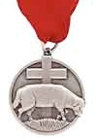 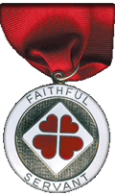



**What is the adult religious recognition program?**   
An adult religious recognition award is presented by nomination only. The recognition is presented to worthy adults for their outstanding service to youth both through their religious institution and one of the national youth agencies. Recipients of these awards are sometimes unaware that they are being nominated. They are nominated to receive an award by submitting the required application, letters of recommendation, and resume. Please check eligibility requirements for specific awards. Self and spousal nominations are usually not allowed.

Essentially every denomination that has Youth Awards has at least one Adult Award. The award on the left is **the** [**Lutheran Lamb Award**](https://www.praypub.org/pdf_docs/lamb2014.PDF). Presented to acknowledge at least 10 years of distinguished service of a Lutheran adult in fostering the spiritual growth of youth through church and civic youth serving agency programs and to increase the use and quality of the civic agency programs in Lutheran congregations as a part of their ministries with youth. (Commissioner Dave has been presented this honor). The recipient may wear the Adult Religious Emblem Square Knot. The Lutherans also have the [**Servant of Youth**](https://www.praypub.org/pdf_docs/youth2014.pdf) Award to acknowledge distinguished volunteer service by adults in ministry to young people through one or more civic youth agency programs. This award may be presented to a non-Lutheran SM of a troop chartered to a Lutheran Church. (or vice versa – a Lutheran Scoutmaster of a troop at a Baptist (or other) Church)

The award on the right is the [**Churches of Christ Faithful Servant award**.](http://goodservant.org/wp/request-curricula/faithful-servant-information/) There is a minimum ten year tenure requirement for nomination. The recipient may wear the Adult Religious Emblem Square Knot.

For complete listings of Adult Religious Recognitions for BSA Leaders go to National’s site at <http://www.scouting.org/scoutsource/Awards/ReligiousAwards.aspx>

or US Scouts site at <http://www.usscouts.org/awards/religadult.asp>

Many of these awards are coordinated by P.R.A.Y. Check their website for info, too [www.praypub.org](http://www.praypub.org/)

Only one Adult Religious Award square knot is worn regardless of how many awards have been received. It is possible, for example, to receive two or three levels of awards in some faiths or to receive awards from more than one faith.

***So, if you know someone who is deserving of receiving the Adult Award from his faith – check it out and begin the nomination process.***

**Confused??**

***Need help to figure out these awards??***

**Here is with whom you can talk –**

**Religious Emblems Coordinators**

They support the Duty to God (religious Emblems) Program, Promote Growth, & Retention in Units



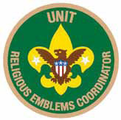

**Purpose:**There are three purposes for having Religious Emblems Coordinators at the council, district, and unit levels:

* Encourage all youth to earn the emblem of their faith
* Promote religious emblems usage the way the BSA promotes other youth advancement
* Establish goals and track the number of religious emblems earned each year

**Why?**Baden-Powell stated, "Religion seems a very simple thing: First, love and serve God. Second, love and serve your neighbor." (*Scouting for Boys*, 1908) Here are three reasons to have Religious Emblems Coordinators:

* Reinforce BSA values through religious emblems
* Improve relationships with religious chartered organizations
* Establish relationships with potential religious chartered organizations

**Responsibilities -**

**Unit Religious Emblems Coordinator**

* After appointment by the unit committee chair, serves on the unit committee
* Acquaints all youth with the religious emblems program and emblems available for their faith
* Provides Scout families and clergy with an orientation to the religious emblems program and encourages their involvement
* Urges all youth to earn the religious emblem(s) of their faith
* Disseminates information about any district or council religious emblems activities, retreats, camps, or classes
* Promotes religious emblems usage the way the BSA promotes other youth advancement
* Serves as the unit's liaison to the district religious emblems coordinator

**District Religious Emblems Coordinator**

* After appointment by the district program chair, attends district meetings and with district program chair, sets district goals for religious emblems.
* Encourages every unit to appoint a unit religious emblems coordinator
* Disseminates information to units through charter renewal packets, roundtables, and camporees
* Helps unit religious emblems coordinators recruit presenters to make presentations on religious emblems, including clergy of chartered organizations, unit leaders who promote religious emblems, chaplains, etc.

**Council Religious Emblems Coordinator**

After appointment by the council vice president of program, works with the Religious Relationships Committee. The religious emblems coordinator focuses specifically on raising awareness of religious emblems and increasing usage. The Religious Relationships Committee works directly with the faith community to recruit chaplains, coordinate the council calendar with religious holidays, sponsor religious emblems retreats, identify religious representatives from the various faith groups, and strengthen ties with local congregations and chartered organizations.

Disseminates information to district religious emblems coordinators.

Provides information for dissemination at Trainings (e.g. Colleges of Commissioner Science, Universities of Scouting, New leader trainings) and summer camp (resident and day) programs. Provides information for dissemination to Professional staff and volunteers.

Learns through the Religious Relationships Committee which faith committees are sponsoring religious emblems retreats and which congregations are offering religious emblems classes.

**To learn more:**Go to National's Web Page at <http://www.scouting.org/Home/Commissioners/newsletter/spotlight/10_2013_religious.aspx> and "read all about it."

Then, go to Roundtable and find out who your District Religious Emblems Coordinator is and call them up for help.

# CUB GRUB

**Cub Grub Cookbook**

This is a really great cookbook for Cubs -

<http://balboaoaks.bsa-la.org/download/blog/Cub%20Grub%20Cookbook.pdf>

You can save a copy on your PC by selecting   
**File, Save As...** in your web browser's menu bar.

**FRIENDSHIP TEA**

**Ingredients:**

1 cup orange-flavored instant drink powder

2/3 cup instant tea powder

1 teaspoon ground cinnamon

1/2 cup sugar

1/4 teaspoon ground cloves

Whole stick cinnamon (optional) Lemon slice (optional)

**Directions:**

**Preparation:**

* Combine drink powder, tea powder, ground cinnamon, sugar and cloves.
* You can store this up to 4 months in a Zip-Loc bag.
* Stir before using.
* Makes 2 cups, enough for 12 servings.

**For each serving:**

* Stir 1 rounded tablespoon of mix into 2/3 cup water in a microwave safe mug.
* Heat uncovered on high power for 1 to 2 minutes or until hot.
* If desired, serve with a cinnamon stick and a lemon slice.

**GERMAN EGG PANCAKES**

**Ingredients:**

For one serving:

1 teaspoon flour

2 teaspoon milk

2 eggs

1 teaspoon butter

1 teaspoon sugar or jam Lemon wedge (optional)

**Directions:**

* In a bowl, mix the flour and milk to form a smooth paste.
* Add eggs and beat until the batter is thoroughly mixed.
* Heat butter in a medium sized frying pan over medium heat.
* When the butter starts to bubble, pour in the batter. It should cover the entire pan.
* Cook for four to five minutes, until the top of the batter looks dry. Remove from heat.
* Sprinkle the sugar evenly over the entire pancake and squeeze the lemon slice over the same area.
* Lift half pancake with a spatula and fold it over the other half. Eat hot.

**Birds of Egypt Recipes**

Southern New Jersey Council

**White Chocolate Birds Nests**

**Needed –**

* 2 c. Chow Mein noodles,
* 2 c. corn flakes,
* crushed white chocolate,
* small gourmet jelly beans

**Directions:**

* In bowl, mix noodles and cereal.
* Melt white chocolate,
* Pour over cereal and noodles, coating them.
* Put by spoonfuls onto waxed paper.
* Indent to shape like nests.
* When hardened add jelly beans into indentations for eggs.

**Owl Snacks**

**Needed –**

* Creamy peanut butter 1 rice or popcorn cake
* 2 banana slices
* 2 raisins for eyeballs
* 6 fruit loops (or other ringed cereal)
* 1 cheese triangle

**Directions:**

* Spread the peanut butter on the rice or popcorn cake.
* Put the two banana slices on for the owl's eyes.
* Put the raisins, one on each banana slice for eyeballs. Push it in a little so it will stay.
* Add the six loops above the bananas to make eye brows.
* Add the cheese triangle under the banana to form the beak.
* Now you have your owl snack.

**Lebanese Cookies**

Southern New Jersey Council

**Ingredients**:

* 1/3 c Cooking oil,
* 1/2 c Butter, softened,
* 1/3 c Sugar,
* 1 TBS Orange juice,
* 1 tsp baking powder,
* 1/2 tsp baking soda,
* 2 C All-purpose flour,
* 3/4 C sugar,
* 1/3 C honey,
* 1/3 C finely chopped walnuts

**Directions:**

* In mixing bowl, beat cooking oil into butter until blended,
* Beat in sugar.
* Add orange juice, baking powder and baking soda, mix well.
* Add a little flour at a time, to make soft dough.
* Shape dough into 2-inch ovals and place onto ungreased baking sheet.
* Bake at 350 degrees for 20 to 25 minutes or until golden.
* Cool cookies on rack.
* Meanwhile, in a saucepan, combine the 3/4 cup sugar, honey and 1/2 cup water, bring to a boil, boil gently, uncovered for 5 minutes.
* Dip cooled cookies into warm syrup.
* Sprinkle immediately with nuts.
* Dry on wire rack.
* Makes 3 dozen

**Cactus Cake**

*Circle Ten Council*

Make a cake in the shape of a very large cactus with toothpicks for spines.

Use one 9 x 13 cake, cut in half lengthwise and place one piece above the other to form the center of the cactus. From a second 9 x 13 pan cut 2 arms for the cactus, or use a horseshoe shape pan and cut apart in the center placing one piece on each side of the center cactus for the arms.

**Coconut Squares**

York Adams Area Council

This sweet and tasty treat is actually Moroccan in origin.

**Ingredients:**

* 2 c. grated coconut
* 3/4 c. half and half
* 1 1/2 c. sugar
* 3 tablespoons butter
* 3 tablespoons lemon rind

**Directions:**

* Combine the coconut, the half and half and the sugar in a heavy saucepan.
* Bring to a boil, then turn the heat to low.
* Simmer until a soft ball is formed when a spoonful of the mixture is dropped into cold water.
* Add the butter and lemon rind and mix.
* Let cool to room temperature.
* Transfer to a bowl and with an electric mixer, mix the batter until thick and glossy.
* Pour into a small buttered pan and chill.
* Cut into squares and serve.

**Bunuelos (fritters)**

*Circle Ten Council*

Recipe used at Christmas in Mexico

Makes about 3dozen.

**Ingredients:**

* 2 cups sifted flour
* 2 tbsp. sugar
* 1/2 tsp. baking powder
* 1/2 tsp. salt
* 1/4 tsp. anise seeds, crushed
* 1 tsp. grated lemon rind
* 1 egg, beaten
* 2/3 cup honey
* 1/2 cup oil

Combine flour, sugar, baking powder, salt, anise, and lemon. Stir in honey, egg, and enough milk to create a dough. Roll out to thin rounds 7-8 inches in diameter. Heat oil in a shallow skillet until hot. Quarter each round and drop flat into hot oil, brown lightly about 30 seconds on each side. Remove from skillet and sprinkle to taste with topping mixture of cinnamon and sugar.

**Nachos**

*Circle Ten Council*

You will need tortilla chips, shredded cheddar or jack cheese, and your choice of optional items including: ground meat, refried beans, olives, tomatoes, jalapenos, etc.

Spread the tortilla chips evenly on a baking tray. Sprinkle the shredded cheese evenly over the chips, alternating with your other optional items.

Bake in a 350 degree oven for about 5-10 minutes (or until cheese is melted). Serve with salsa and sangria (recipe below!)

**Chili Cheese Dip**

*Santa Clara County Council*

**Ingredients:**

* 1 can chopped tomatoes
* 1 can prepared chili
* 1 lb Velveeta, cubed

Melt ingredients together in double boiler over low heat. Serve with chips when cheese is thoroughly melted. Keep warm in fondue or crock pot.

**Mexican Pizza**

*Santa Clara County Council*

**Ingredients:**

* 1/2 lb. ground burger
* 15 1/2 oz. can chili beans
* 8 oz. can corn, drained
* 2 T. chopped green chilies
* 1 12" boboli crust
* 3 green onions, chopped
* 1 cup shredded cheddar cheese
* 6 olives, sliced
* 2 tomatoes, chopped

Brown burger, drain and combine with beans, corn and chilies.

Place crust on a pizza pan. Spread mixture over crust.

Top with cheese, onions, olives and tomatoes.

Bake 10-12 minutes at 425 degrees, until cheese melts and pizza is heated through.

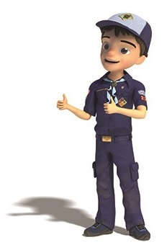

program updates bannerLAST THINGS

Beatitudes for Cub Scouts  
*Capital Area Council*

Blessed are the Cub Scouts   
who are taught to see beauty in all things   
around them.  
For their world will be a place of grace and wonder.

Blessed are the Cub Scouts   
who are led with patience and understanding  
For they will learn the strength of endurance and gift of tolerance.

Blessed are the Cub Scouts   
who are provided a home where family members dwell in harmony and close communion  
For they shall become the peacemakers of the world.

Blessed are the Cub Scouts   
who are taught the value and power of truth,  
For they shall search for knowledge and use it with wisdom and discernment.

Blessed are the Cub Scouts   
who are guided by those with faith in a loving God  
For they will find Him early and will walk with him through life.

Blessed are the Cub Scouts   
who are loved and know that they are loved  
For they shall sow seeds of love in the world and reap joy for themselves and others.

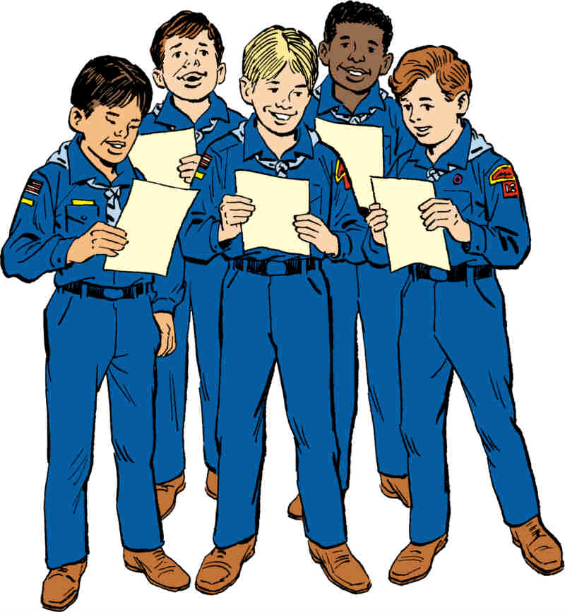

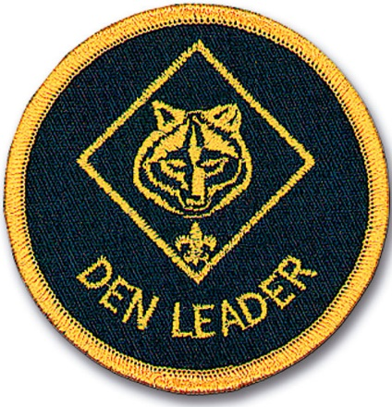

## Beatitudes for Those Who Care

*Sam Houston area Council*

* Blessed are you who take the time to listen to difficult speech for you help me know that, if I persevere, I can be understood.
* Blessed are you who never bid me to "Hurry up," or take my tasks from me and do them for me. For I often need time rather than help.
* Blessed are you who stand beside me as I enter new and untried ventures. For my failures will be outweighed by the times I surprise myself and you.
* Blessed are you who understand that it is difficult for me to put my thoughts into words
* Blessed are you who, with a smile, encourage me to try one more.
* Blessed are you who never remind me that today I asked the same question twice.
* Blessed are you who respect me and love me just as I am.

The above is why I remember my   
Den Mother. She cared and she did all that. CD

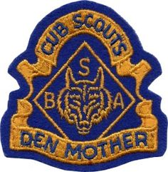

## The Five Finger Prayer



* Your thumb is nearest you. So begin your prayers by praying for those closest to you. They are the easiest to remember To pray for our loved ones is, as C. S. Lewis once said, a "sweet duty."
* The next finger is the pointing finger. Pray for those who teach, instruct and heal. This includes teachers, doctors, and ministers. They need support and wisdom in pointing others in the right direction. Keep them in your prayers.
* The next finger is the tallest finger. It reminds us of our leaders. Pray for the president, leaders in business and industry, and administrators. These people shape our nation and guide public opinion. They need God's guidance.
* The fourth finger is our ring finger. Surprising to many is the fact that this is our weakest finger, as any piano teacher will testify. It should remind us to pray for those who are weak, in trouble or in pain. They need your prayers day and night. You cannot pray too much for them.
* And lastly comes our little finger the smallest finger of all which is where we should place ourselves in relation to God and others. As the Bible says, "The least shall be the greatest among you." Your pinkie should remind you to pray for yourself. By the time you have prayed for the other four groups, your own needs will be put into proper perspective and you will be able to pray for yourself more effectively.

