# PACK MEETING THOUGHTS

I knew the theme, “Passport to Other Lands” had been used previously so I felt sure I could have a great Pack Meeting supplement. But the two previous times it was used were 2001, before Baloo started to focus heavily on themes, and 2013, while I was on hiatus from Baloo.

The description of the theme says:

**HOW DOES “PASSPORT TO OTHER LANDS” RELATE TO THIS POINT OF THE SCOUT LAW?**

Today we recognize that people of many different nationalities live in our communities. Learning about the ways of others helps lead to understanding. A Scout is reverent when he shows respect for the beliefs of others. This month we focus on experiencing the customs, religions, foods, and traditions of our friends from other countries.

|  |  |  |
| --- | --- | --- |
| **Month** | **Year** | **Theme** |
| Potential Months - **"PASSPORT to OTHER LANDS"** | | |
| March | 1943 | United Nations Month |
| January | 1946 | Boys of the World |
| November | 1947 | In Old Mexico |
| April | 1949 | Life in the Philippines |
| March | 1959 | Canada, Land of the Mounties |
| January | 1961 | South America |
| March | 1962 | Islands of the World |
| March | 1965 | South of the Border |
| December | 1973 | Customs of Countries |
| December | 1979 | Customs of Other Lands |
| December | 1989 | Customs of Countries |
| April | 1991 | Canada, Our Neighbor |
| December | 1994 | Customs of Other Lands |
| March | 1999 | Gateway to the Orient |
| February | 2001 | Passports to Other Lands |
| April | 2003 | Land of the Pharaohs |
| January | 2007 | Poles Apart |
| December | 2013 | Passport to Other Lands |
| June | 2014 | Over the Horizon |
| February | 2016 | Friends Near and Far |
| February | 2017 | Passport To Other Lands |

The World Organization of the Scouting Movement (WOSM)  
[www.scout.org](http://www.scout.org)

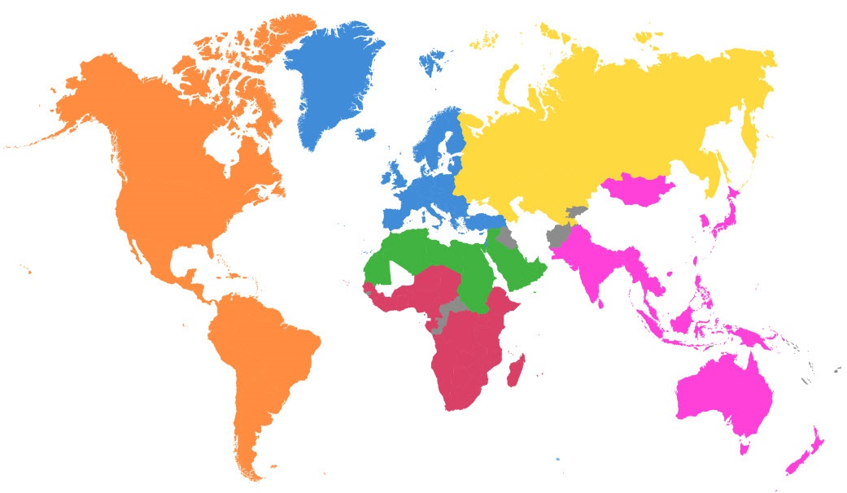

There are 164 National Scout Organizations in 224 countries & territories around the world supporting 40 Million Scouts and Scouters!!

The World Organization of the Scout Movement (WOSM) is an international, non-governmental organization composed of its recognized national Scout organizations. The United States and 150 other countries are members of the WOSM (see “Online Resources” below)

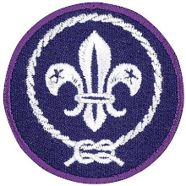The patch (shown above) that you wear above the left pocket of your Scout Uniform, the World Crest, is authorized by WOSM.

The World Crest is worn on your Scouting uniform to tell everyone that the BSA is part of WOSM and that each of us feels a part of the World Brotherhood of Scouting. It is a “passport” to identify us to other Scouts.

# TABLE OF CONTENTS

[PACK MEETING THOUGHTS 1](#_Toc471146694)

[TABLE OF CONTENTS 2](#_Toc471146695)

[GATHERING ACTIVITIES 3](#_Toc471146696)

[OPENING CEREMONIES 5](#_Toc471146697)

[OPENING PRAYERS 9](#_Toc471146698)

[AUDIENCE PARTICIPATIONS 9](#_Toc471146699)

[ADVANCEMENT CEREMONIES 10](#_Toc471146700)

[LEADER RECOGNITION 13](#_Toc471146701)

[Den Leader Passport Recognition 13](#_Toc471146702)

[Leader Appreciation Ceremony 14](#_Toc471146703)

[Quickie Thank-You's 14](#_Toc471146704)

[SONGS 15](#_Toc471146705)

[STUNTS AND APPLAUSES 17](#_Toc471146706)

[APPLAUSES & CHEERS 17](#_Toc471146707)

[RUN-ONS 17](#_Toc471146708)

[JOKES & RIDDLES 18](#_Toc471146709)

[SKITS 18](#_Toc471146710)

[CUBMASTER’S MINUTES 22](#_Toc471146711)

[CUB GRUB 25](#_Toc471146712)

[GAMES 27](#_Toc471146713)

[PACK MEETING ACTIVITIES 31](#_Toc471146714)

# GATHERING ACTIVITIES

***Note on Word Searches, Word Games, Mazes and such –*** *In order to make these items fit in the two column format of Baloo’s Bugle they are shrunk to a width of about 3 inches. Your Cubs probably need bigger pictures. You can get these by copying and pasting the picture from the Word version or clipping the picture in the Adobe (.pdf) version and then enlarging to page width.* ***CD***

**Do You Know Where?**

*Sam Houston Area Council*

**Passport Clue**

1. Boy Scouting originated in this country
2. Easiest continent to make ice cubes on
3. Last Summer Olympics were held here
4. Our neighbor to the North
5. They grow lots of coffee here
6. Shoes made of wood and lots of tulips
7. Three big pyramids and a sphinx
8. Pokémon was invented here
9. See the Great Wall
10. Taj Mahal and lots of curry

***Answers:*** *1-England; 2-Antarctica;   
3-Australia; 4-Canada; 5-Colombia;  
6-Holland; 7-Egypt; 8-Japan;   
9-China; 10-India*

**Australian Circle Game**

*San Gabriel Valley, Verdugo Hills, Long Beach Area*

Players form a circle with arm's-length spacing. "It" stands inside the circle. The players pass a basketball, play ball or football from one to the other. "It" attempts to touch it or catch it.

If "It" touches or catches the ball, the last player who touched it is "It." The ball may be passed across the circle at random or to the next player in either direction.

**Variation –**

A player stands in the center of a circle, holding a tennis ball. He tries to throw this ball to someone in the circle who will drop it. Another ball is also being passed around the circle from one boy to another.

The player in the center may throw his ball to anyone, but he usually throws it to the boy about to receive the ball being passed around the circle. If either ball is dropped, the one who dropped it changes places with the boy in the center.

**Antarctica**

*Heart of America Council*

***Be sure to enlarge this word grid before use!!***



**Word List:**

AIR ANTARCTICA BAROMETER

BLIZZARD CELSIUS CHILL

CLOUD COLD CONTINENT

DEGREE FAHRENHEIT FOG

FORECAST FREEZE FROST

METEOROLOGY PENGUIN POLAR

PRECIPITATION PRESSURE RADAR

ROBERT SCOTT ROSS ICE SHELF

SCIENTISTS SHACKLETON SLEET

SNOW STORM STRATUS

TEMPERATURE RAIN THERMOMETER

WEATHER WHALES WIND

**If You Go To The North Pole With Me...**

*San Gabriel Valley, Verdugo Hills, Long Beach Area*

***This game could be adapted to any place for which you need a passport (any country or continent) CD***

This can be used in both Den and Pack Meetings. Group can be divided into smaller groups, which compete or can be done within the den with boys taking turns. The Den Leader chants: "If you go to the North Pole with me, what are the wonders you will see?” Players call out what they might see and then must act out the Scene. More than one boy can help. In the Pack Meeting, each "picture" can be held, forming a living tableau of the North Pole.

You could make a memory game with this title by having the first person name something he would bring. Then the second person repeats the first item and adds one, and the third names the first two and adds one and so on.

**Modern** **World Wonders**Trapper Trails Council

1. The Channel Tunnel
2. The Clock Tower (Big Ben)
3. The CN Tower
4. Eiffel Tower
5. The Empire State Building
6. The Gateway Arch
7. The Golden Gate Bridge
8. The High Dam
9. Hoover Dam
10. Itaipu Dam
11. Mount Rushmore Nat’l Monument
12. The Panama Canal
13. The Petronas Towers
14. The Statue of Cristo Redentor
15. The Statue of Liberty
16. The Suez Canal
17. The Sydney Opera House

A - St. Louis, USA J – Kuala Lumpur, Malaysia

B - Arizona/Nevada, USA K – Brazil/Paraguay

C - Toronto, Canada L – San Francisco, USA

D - English Channel M - Egypt

E - Panama N – New York Harbor, USA

F - Rio de Janeiro, Brazil O - Australia

G - London, England P – Paris, France

H - New York City, USA Q – South Dakota, USA

I - Aswan, Egypt

*Answers - l-D, 2-G, 3-C, 4-P, 5-H, 6-A,   
7-L, 8-I, 9-B, 10-K, 11-Q, 12-E,   
13-J, 14-F, 15-N, 16-M, 17-O*

**Guess the Nation**

*Santa Clara County Council*

* Have small flags representing at least 12 different countries.
* Number each flag, and have participants try to guess the name of the nation it represents.
* (Optional) Provide a list of country names or hints to help them out a bit.

**How Many Countries Can You Name?**

*Santa Clara County Council*

As families arrive, give each family a sheet of paper and ask them to write as many countries as possible. Family members are encouraged to work together. During the meeting, honor those who knew the most with a cheer.

**Friends Around The World!***SCCC*

Can you find the names of eleven countries by reading vertically, horizontally, diagonally, backward or forward?

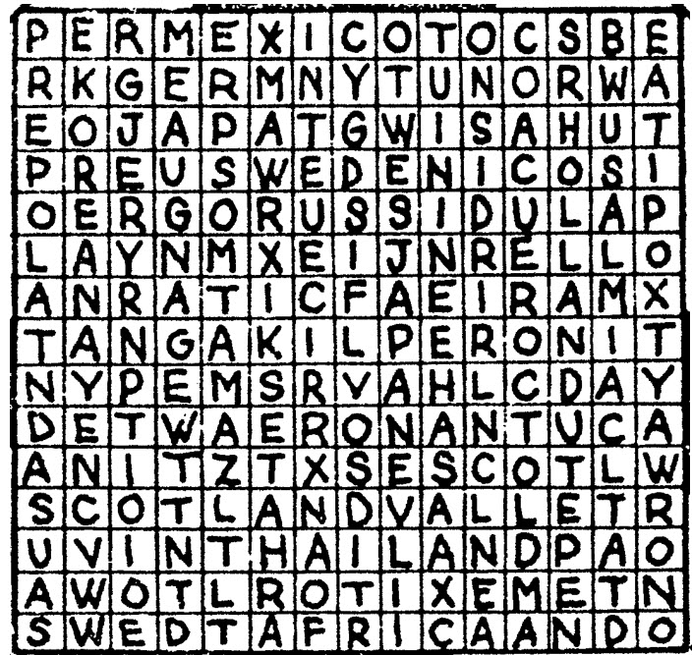

WORDS:

AFRICA GERMANY HOLLAND

JAPAN KOREA MEXICO

SCOTLAND SWEDEN SWITZERLAND

THAILAND USA

**A Scout is Reverent Puzzles**

*Commissioner Dave*

**Materials:** Pictures of Religious Awards printed on card stock or pasted to thin cardboard..

* Cut the pictures into puzzle pieces - 4 or 6 per card.
* Give the boys puzzle pieces as they arrive.
* Have them try and complete the puzzle by talking with others and finding the others pieces.

During Icebreaker have them show the completed puzzle and read the back. *(Have tape available)*

**Nation Scramble**

*Santa Clara County Council*

Unscramble the names of these countries.   
Work with your family or friends.

1. CRFNEA
2. GASDMACAAR
3. EMGARYN
4. GNAEDNL
5. SARUSI
6. NRUAHGY
7. NLODAP
8. APNJA
9. EKOAR
10. EMRKDNA
11. LIFNADN
12. RINLDAE
13. CNOLASTD
14. WRENLZISDTA
15. RUALAISAT
16. IPNELIHPISP
17. MERACIA
18. ZRLIBA
19. PISNA
20. EWN LNDZAAE

Answers: 1-France; 2-Madagascar; 3-Germany; 4-England; 5-Russia; 6-Hungary; 7-Poland; 8-Japan; 9-Korea; 10-Denmark; 11- Finland; 12-Ireland; 13-Scotland; 14-Switzerland; 15-Australia; 16-Philippines; 17-America; 18-Brazil; 19-Spain; 20-New Zealand

**Search for Reverent**

Words in this search all pertain to being Reveerent and having Faith – words may be in any direction.

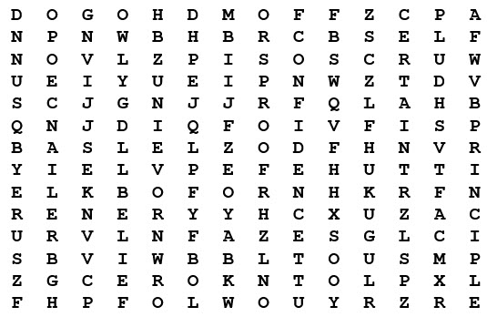

|  |  |
| --- | --- |
| Belief | Principle |
| Certain | Proof |
| Confidence | Reliance |
| Friends | Religion |
| God | Self |
| Hope | Sure |
| Loyalty | Trust |

**Faith Bingo**

*Commissioner Dave*

Give each person a Board. They go around and meet people. After meeting someone and learning their name, they are to ask them to sign a box. Each person can only sign 1 box!!! This is not a speed contest; there should be interaction!! Here is a sample board- boxes may be changed to suit your group

**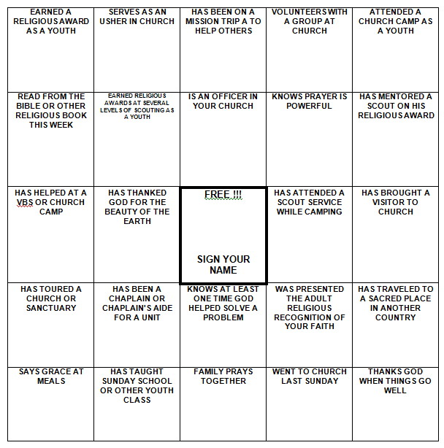**

Be sure to enlarge the BINGO Board to fill a sheet of paper and put some directions on the sheet, too.

# OPENING CEREMONIES

**Hello and Welcome:**

*Santa Clara County Council*

***Cubmaster – try this just after calling room to order before Opening. Start with a real BANG! CD***

Divide the room to North, South, East and West.

Then North faces East and says “Hello” Then East faces South and says “Hello,” South faces West and says “Hello,”, and West faces North and says “Hello.”

When this is done, everyone shouts   
**“Welcome to Pack \_\_\_\_!!”**

**Passport to Other Lands Opening***Sam Houston Area Council*

**Arrangement:** Cubmaster (CM) and a group of Cub Scouts enter. Cubmaster is holding several travel brochures. Each Cub Scout has one brochure with his lines written on it. The color guard should be just outside the door. *Any adult may play the CM role.*

**CM:** Our pack knows a lot about other countries and now we need to plan our pack trip. There are so many neat countries to visit; I just don’t know where to begin. (Looks at brochures in his hands)

1. We could go to Mexico--The motto for Cub Scouts there is “Always My Best.”
2. Or we could go to Japan--Scouts there start as Beaver Cubs and aim towards Fuji Scout, like climbing their highest mountain.
3. It says here that the Egyptian Scout and Guide Federation include four associations: Air Scouts, Sea Scouts, Boy Scouts and Girl Guides.
4. Scotland is part of the Scout Association in the United Kingdom which includes Scotland, England, Ireland, and Wales. Their program is called Scoutreach.
5. Here it says that in Canada there are two Scouting organizations--one for the English speaking Scouts and one for French speaking Scouts.
6. The program emphasis in the Scout Association of Australia is on adventure, camping, bush craft, and FUN!
7. Scouting was founded in Kenya in 1910. They do community service projects which include planting trees and campaigning for literacy. And we could see Baden-Powell’s grave!

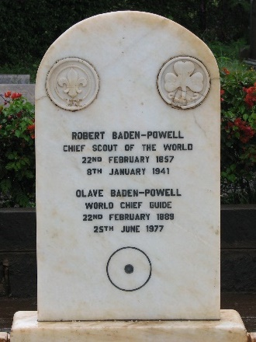

**CM:** Wow--we sure are lucky to belong to such a world-wide organization. We have over three million members in the Boy Scouts of America. Let’s stand as we post the colors of our country.

***(Proceed with the flag ceremony)***

**Where Faith is Found Opening**

*Alice, Golden Empire Council*

**Materials:** Have each boy make a sign to hold with the letter he has been assigned. Alternately, you can simply download images or make letter signs. Write each boy’s part on the back of the sign in large letters.

**Narrator:** This month we have been learning all about Faith – see if you recognize these examples of where Faith is Found.

|  |  |
| --- | --- |
| letter-f | **Cub #1:** *(holding up letter or posting on the wall)*  **F**ollow the example of your religious leaders, your grandparents, or others who have great faith – it will help you find your own Faith. |
| the+letter+a+copy | **Cub #2:** *(holding up letter or posting on the wall)*  **A**lways look for examples of faith as you enjoy the outdoors – like the breeze, faith cannot be seen – but you can feel its presence. |
| ANd9GcTTHYD9ANw_kTr3f6FQPTFWE5bSU1qSw_6ox5AKMF_6-yoRCT76&t=1 | **Cub #3:** *(holding up letter or posting on the wall)*  **I**f you want to have faith, learn to serve others – without complaining. |
| Letter-T | **Cub #4:** *(holding up letter or posting on the wall)*  **T**rust in your God, your Country and Yourself – And always be a person that can BE trusted if you want to find Faith. |
| 73369_letter-H_lg | **Cub #5:** *(holding up letter or posting on the wall)*  **H**ow you ACT will show what you really believe.  *(All boys return and hold up their letters)*  **All:** SHOW YOUR FAITH! |

**Narrator:** As you can see, the boys have learned some important ways to really SHOW their faith. And we’d like you to join us in Showing how we feel about our Country – where every person can follow their own faith, and worship as they please…..

*(Lead into the Flag Ceremony)*

**Hello Opening Ceremony**

Sam Houston Area Council

**Props:** Cue cards with the Cub Scouts' lines printed on the back in LARGE print. A picture or map of the country that speaks the language the Scout will use on the front of the card would be great. It can also be useful to display a poster or world map showing which countries have Scouting organizations.

This poster of [**World Scout National Emblems**](http://www.worldscoutshops.com/world-scout-national-emblems-poster-2014-revised-c2x14530868)displaying almost 200 National Scouting Organization logos from around the world is available from [www.worldscoutshops.com](http://www.worldscoutshops.com)

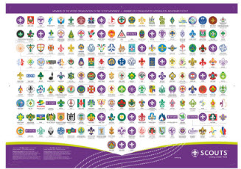

The World Scout Shop is operated by the World Organization of the Scouting Movement (WOSM).

**Set Up:** 11 Cubs (or as many as you wish to use to say Hello in foreign languages), Cubmaster (CM) or other adult as Narrator. Make a card for each Cub Scout with a picture representing the country on front and his line on the back in LARGE print.

**Props**: Cue cards with the Cubs' lines printed on the back. Poster or world map showing countries that have Scouting organizations.

Go to <https://www.scout.org/become_scout> to see the list of all countries participating in the World Brotherhood of Scouting.

**CM:** Welcome to our meeting. There are 164 National Scouting organizations in 224 countries and territories around the world that are members in the World Brotherhood of Scouting. The Maldives and the Seychelles are two of the newest. The BSA and the Bahamian Scouts have celebrated over a century of membership. There are many languages spoken in those countries but you can always hear a Scout greeting you.

1. Spanish: Hola (OH-lah)
2. French: Bonjour (bohn-ZHOOR)
3. German: Guten Tag (GOOT-en Tahg)
4. Mandarin: Ni hao (nee-HOW)
5. Russian: Zdravstvuite   
   (ZzDras t-vet- yah)
6. Mohawk: Sekoh (SEH-goh)
7. Swahili: Jambo (JAM-bo)
8. Arabic: A1 salaam a'alaykum   
   (AHL sah-LAHM-ah ah-LAY-koom)
9. Hindi: Nahmaste (nah-mah-STAY)
10. Hebrew: Shalom (Sha-LOHM)
11. Hawaiian: Aloha (ah-LOW-ha)

**CM:** No matter where you go or how you say it, you can count on being greeted by a Scout who says 'Hello'.

**Spirit of Scouting**Heart of America Council

**Personnel**: Cubmaster (CM) or Den Leader (DL)

**Cubmaster**: Did you know that millions of boys and men have been part of the Boy Scout Movement since its beginning in 1907? Many of you dads were Scouts and today your sons are Cub Scouts. What a vast force to be crusading each day, at work or play for those things America holds dear! As we light the candles on our birthday cake, over all is the Spirit of Scouting and below this, three candles representing Boy Scouting, Cub Scouting, Venturing and Exploring. Let us resolve that as someone, someplace helped us get started in Cub Scouting, so will we, together and as individuals, help more boys and institutions have Cub Scouting. Repeat with me the response to our Cub Scout motto: WE’LL DO OUR BEST! Now sing “Happy Birthday to You BSA”

**I Am I, and You Are You**Heart of America Council

**Personnel**: Narrator and Cubs

**Equipment**: American Flag, Pack Flag and poster cards representing different countries where Cub Scouting is organized such as: Denmark, Greenland, France, Great Britain, Germany, Ireland, Algeria, Belgium, Philippines, Switzerland

**Setting**: Cub Scouts enter with American Flag and Pack Flag followed by a color guard of Scouts carrying poster cards at the end of the narration

**CM:** Alike in so many ways, different in many others! But here! Now! We share a common bond - Cub Scouting. And so it is with the many nations that form the World Scout Conference; alike in many ways, different in many ways, sharing a common bond - Cub Scouting

**CA:** In 1920 Scouts from 32 countries gathered in Great Britain for the first World Scout Conference This Conference meets every two years during the intervening time the World Scout Bureau, consisting of 12 members elected at the previous World Scout Conference, meets to carry on the work of the Conference. The Bureau is headquartered in Geneva, Switzerland.

**CM:** We as Cub Scouts, are not only members of a Pack, but we are members of a National organization and then members of a World organization. It is time to pause and think about our brothers around the world, how we are alike, how we are different, but mostly think about our common bond - Cub Scouting

*(Cubs enter with Flags and Cards)*

**Gifts of Scouting**

*Santa Clara County Council*

**Arrangement:** Den Chief (DC) and 5Cub Scouts. Each Cub Scout has a candle and lights it as he speaks***. (Battery operated candles would be best!!)***

1. This is my Scouting light. It is my enthusiasm. As light brings out the sparkle in diamonds, enthusiasm brings out the sparkle in Scouting.
2. This is my Scouting light. It represents what I know I can do. And I’ll do my best to do my duty to God and my country.
3. This is my Scouting light. As we face each other tonight, let us look at the light and silently thank God for the brotherhood of Scouting we share here tonight.
4. This is my Scouting light. I shall pass this way but once so if there is any good that I can do, let me do it now for I shall not pass this way again.
5. This is my Scouting light. Let each one of us take time to look back at where we’ve been and have pride in that past. Let us look forward to where we’re going and have hope for that future.

**DC:** Would you please stand and join us in the Pledge of Allegiance? (Lead Flag Ceremony)

**Building a Better World Opening or Closing**

*Santa Clara County Council*

**Arrangement:** Den Chief (DC) or Cubmaster (CM), and 11 Cub Scouts, each holding a card with a letter on the front and his line on the back. Each speaker holds up his letter as he says his line and leaves it up for remainder of ceremony. Last line is delivered by all or by their leader.

**DC or CM:** The Scouts in Den XYZ will now tell us what it takes to “Build a Better World.”

1. Take a B for brotherhood, boosting for each other’s good.
2. Take an E for every land to share in earth’s riches everywhere.
3. Take a T for trustfulness, trusting more, and fearing less.
4. Take a T for teamwork, for joining hands to get things done.
5. Take an E for equal chance for each person to advance.
6. Take an R for real respect regardless of race, creed or sect.
7. Take a W for will to work for peace with faith and skill.
8. Take an O for opportunity to keep our speech and action free.
9. Take an R for reverence for a guiding Providence.
10. Tale an L for love to spread around when need and bitterness are found.
11. Take a D for dignity of man devoted to a bigger plan.

**ALL: There you have it--this is how to build a BETTER WORLD, right now!   
(All hold letters up high)**

**DC: If Opening – Lead CHEER for den.** Ask audience to rise for presentation of Flags and remain standing for the Pledge of Allegiance, Prayer, and Scout Oath.

*Or –*

**CM: If Closing – Lead CHEER for den.** Cubmaster’s Minute. Thank everyone for coming. Hope they had a great time. Final announcements. See you next month. Dismiss them for refreshments.

## OPENING PRAYERS

**The Scout Prayer**

*Scouting Ireland*

Dearest Father, teach me to be generous,  
Teach me to love and serve as you deserve;  
To give and not to count the cost;  
To fight and not to heed the wounds;  
To toil and not to seek for rest;  
To labor and to look for no reward  
Save that of knowing that I do Thy Holy Will. **Amen.**

**Cub Scout Prayer**

*Scouting Ireland*

Lord, in this evening hour I pray,  
For strength to do my best each day.  
Draw near to me that I may see,  
The kind of Cub Scout that I should be.  
In serving others, let me see,  
That I am only serving Thee.  
Bless me, oh Lord, in Thy great love,  
That I may be a better Cub. **Amen.**

# AUDIENCE PARTICIPATIONS

**Faith Based Stories**

[*http://scouts.org.uk/documents/Magazine/decjan\_09/beavdecjan09.pdf*](http://scouts.org.uk/documents/Magazine/decjan_09/beavdecjan09.pdf)

There are many stories that relate to the Beaver ***Scout (US - Cub Scout)*** Promise, and which come from the many faiths that make up our nation’s identity. Here is a snapshot:

* + - The Good Samaritan (Christianity). The classic tale of the man from Samaria who, unlike the others who passed by, helped a man in desperate need. [www.tinyurl.com/l9rdd8](http://www.tinyurl.com/l9rdd8)
    - The snake in the wall (Judaism). A tale about a girl who was especially kind and helpful and who was rewarded with her life. [www.tinyurl.com/l3oqju](http://www.tinyurl.com/l3oqju)
    - A brother like that (Islam). A modern parable about thinking of others and being kind. [www.tinyurl.com/lofm36](http://www.tinyurl.com/lofm36)
    - Six blind men and the elephant (Hinduism) A great poem about how you shouldn’t make decisions based on one piece of evidence. [www.tinyurl.com/ly89f5](http://www.tinyurl.com/ly89f5)

Read some of these stories to the Beaver Scouts ***(US - Cub Scouts)*** and they can then act them out in small groups or draw the story for themselves in cartoon form.

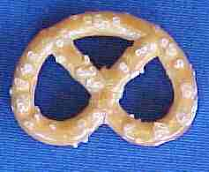**Make a Pretzel of Faith Tie Slide**

*Alice, Golden Empire Council*

Prayer is an important part of faith – and here’s an interesting way to “wear” your faith on your neckerchief – make a pretzel tie slide!

Really simple – just mount a “perfect” pretzel on a piece of fun foam, or cardboard, or heavy duty paper. Background can be any color. Add a backing.

Be prepared to explain what the pretzel really means. Here’s the story:

A few weeks before Christmas in 610 AD, Brother Bachman was kneading bread dough while he watched the village children play in the snow. “Too bad they aren’t as interested in their prayers,” he thought to himself.

"If only there was some way to get them back to saying their prayers and coming to church," he said to himself. As he was finishing up the last loaves of bread, Brother Bachman was suddenly struck with a most original idea. He thoughtfully gathered up the leftover dough and began to form pencil-like strips, which he then twisted into a shape that looked like a child's arms folded in prayer. "Ah! A Pretiola!" he declared, which in Latin meant little reward.

He opened the bakery window and called out to the children. "Come in, come in say your prayers, and I will give you a Pretiola!" It didn't take much convincing. Soon each child had learned a prayer and proudly received a "little reward." Rushing home, the children excitedly told their parents. Word of Brother Bachman's idea soon spread through the village, and children and parents alike visited the chapel to receive a Pretiola.

The Christmas Prayer Service that year was especially festive and bright. The church was filled with families once again. And as the cheerful voices rose in prayer and song together, Brother Bachman smiled joyfully and thanked the Lord for little rewards.

The Pretiola soon found its way into Germany and Austria. It became a symbol of excellence used to reward worthy accomplishments as the church and youth programs flourished.

Through the centuries, Pretiola became known as "Pretzel" as we know it today. If you make a Pretzel Tie Slide, you can tell the story, too!

# ADVANCEMENT CEREMONIES

**Passport to Adventure**

*Sam Houston Area Council*

**Personnel and Props:**

* Cubmaster (CM) and Assistant CM (CA)
* Passport folders made from folded construction paper, or printed computer form. Include a space for the Cub's vital information (name, pack number, den number, parents, birth date, etc.) Include a place for a snapshot to really dress it up. Leave a column for using the rank stickers to "stamp" his passport with the ranks he has already achieved.
* Have stickers available to place the new rank in his folder to "stamp" his arrival at this new rank destination.
* You can add to the display by building a booth marked "CUSTOMS" for the Cubs to receive their stamps.

**Ceremony:**

CM: Here at the Customs office we see many travelers on their way along the Cub Scout Trail. They come from many countries and speak many languages, but they all have an interest in the world around them. Let me see who we might have here today."

CA: Will the following Cubs and their parents please step forward?" (Calls out names of Cubs who have earned the Wolf rank)

*(Assistant Cubmaster hands each Cub his passport and tells him to go one at a time to the Customs window).*

CM: Ah! Who do we have here?" (Repeats Cub's name) "May I see your passports please?"

*(Cub hands passport to CM)*

CM: I see your Den has been very busy along the Cub Scout Trail. Your passports show you have been to Tiger and Bobcat (Reads off ranks as appropriate).

For the past few months you have been traveling on the Wolf trail. Your paperwork appears to be in order. I'll add this Wolf stamp to your passports. (Places sticker into passport)

This patch and card are for you. (Hands rank patch and card to Cubs’ parents). Parents, I have not earned the privilege of presenting the badges to your sons but you have. Please present the Wolf Rank patch to your sons.

Cub Scouts, this pin is for your parents, so perhaps you can help me by pinning it their ribbon.

***Lead a cheer for the new Wolf Cub Scouts!***

***(Repeat for each rank (Bobcat, Tiger, Bear, Webelos) that you are presenting at that Pack Meeting. Vary the talk a little to keep the audience listening. Be sure to lead a cheer for each group)***

**After all the awards have been presented:**

CM: Well this has certainly been a long line of boys traveling through my Customs office today. I am always amazed at all the sights they have seen and the places they have been. But you can't imagine all the amazing things they will encounter as they continue on the Scouting Trail. Someday I hope to see these boys get their passports stamped for Eagle. Cubs, be sure and invite me to be there when you do. Congratulations!"

**Around The World**Heart of America Council

**Personnel**: Cubmaster (CM) and Assistant CM (CA)

**Setting**: Have yellow tablecloth on awards table, displaying a globe and small flags from other countries

**CM:** Every minute of every day of every year there are thousands of boys enjoying the fun and excitement of Cub Scouting somewhere in the world. The Cub Scout uniform varies from country to country around the world because each must be suitable and practical for the climate, but they all have one thing in common: They promote Scouting and its goals. Just as Cub Scouts wear different uniforms in different countries, they also award different badges of rank. In Japan and Korea, Cubs earn the Rabbit, Deer, and Bear Badges. In Australia, the badges are Bronze, Boomerang, Silver Boomerang, and Gold Boomerang. South Africa has the Tenderpad Badge.

**CA:** As we know, the first badge of rank in the United States is Bobcat. Tonight we honor (name of boys). These cubs have earned this badge which is the start of their Cub Scout trail. Would the Bobcats and their parents please come forward? Present badges to parents to present to sons. Thank them for their help and explain that they helped their son earn his badge more than the CM did, and so they are presenting the badge.  **LEAD CHEER FOR BOBCATS.**

**CM:** The second badge on our Cub Scout trail is Tiger. Tonight we honor (name of boys). These Cub Scouts have earned this badge. Would these Tigers and their Parents please come forward? Present badges to parents to present to sons. Thank them for their help and explain that they helped their son earn his badge more than the CM did, and so they are presenting the badge.  **LEAD CHEER FOR TIGERS.**

**CA:** The next badge on our Cub Scout trail is Wolf. Tonight we honor (name of boys). These cubs have earned this badge. Would these Wolves and their Parents please come forward? Present badges to parents to present to sons. Thank them for their help and explain that they helped their son earn his badge more than the CM did, and so they are presenting the badge.  **LEAD CHEER FOR WOLVES.**

**CM:** As the Cubs learn new skills, the next badge they earn is Bear. Would these Bears and their parents please come forward. (Read names). Present badges to parents to present to sons. Thank them for their help and explain that they helped their son earn his badge more than the CM did, and so they are presenting the badge.  **LEAD CHEER FOR BEARS.**

**CA:** Our highest badge of rank is Webelos. Would the following Webelos and their parent please come forward? (Read names). Present badges to parents to present to sons. Thank them for their help and explain that they helped their son earn his badge more than the CM did, and so they are presenting the badge.  **LEAD CHEER FOR WEBELOS.**

*If you have any Scouts who have earned their   
Arrow of Light. Please close this ceremony   
and start another special ceremony just for   
Arrow of Light*

**CM:** These Cubs like Cub Scouts all around the world, have worked together and developed new interests which make them better citizens of our country and of the world. Let’s give them all one more big cheer. A Heap How seems an appropriate way to me to show how proud we are of them.

**Cub Scout Spirit**Heart of America Council

**Personnel**: Cubmaster (CM), Assistant CM (CA)

**Setting**: A world globe on the head table, candles placed around the globe (one for each rank to be presented). The room is darkened except for one candle held by the Assistant Cubmaster

**CA:** We read in the newspaper everyday about wars, nation against nation in all parts of our world. Television shows us daily pictures of bombings, buildings destroyed, people killed, a dark and not very pleasant picture and certainly not what each of us wants for ourselves or our children.

**CM:** Scouting is one thing that helps to bring people together, because its ideals and goals are the same everywhere. We tend to think of Cub Scouting as just our pack, our dens, and our friends. But, there are Cub Scouts like us in almost every country in the world — we are just a small part of this wonderful organization. Our Assistant Cubmaster, (name) holds a candle representing the Spirit of Cub Scouting. As we present our advancement awards tonight, we will light a candle next to the world globe for each rank.

**CA:** (Hands lit candle to CM) First, we have \_\_\_\_ boy(s) who have passed the requirements for the rank of Bobcat. Will Scout(s) (name(s)) and parents please come forward? (The rank patches are presented to the parents who give them to the son(s). The CM lights a candle on the table near the globe. CA leads a cheer for the Bobcat(s).

**CM:** (Hands lit candle to CA) Next, we have \_\_\_\_ boy(s) who have passed the requirements for the rank of Tiger. Will Scout(s) (name(s)) and parents please come forward? (The rank patches are presented to the parents who give them to the son(s). The CA lights a candle on the table near the globe. CM leads a cheer for the Tiger(s).

***This process, swapping roles, is repeated   
for each rank and award being presented.***

After all ranks & awards are presented -

**CM:** Notice how the darkness of the world went away as the light of the Cub Scout Spirit was spread around the globe. If we all continue to work on our Adventures and continue to advance in rank, we can keep the light bright and help our world to be a better place to live for everyone.

***Note****: You can have many variations, such as attaching rank patches on different continents with rubber cement and turn the globe as presentations are made, highlighting Scouting around the world.*

**Reverent Advancement**

*Alice, Golden Empire Council*

Gather gardening, fire building, cooking materials to use as props. You could either use just one type of material, or you could use gardening materials for the Tigers and Wolf den boys, Cooking materials for Bears and Fire Building materials for Webelos/Arrow of Light boys.

Each boy’s advancement items should be placed under (or in) an item, then brought out as the boys and their parents are called up. For example:

**Cubmaster:** *(pointing to gardening equipment)* The boys in the Tiger den have been learning all about Faith this month -They planted some seeds – and watched them grow. I’d like to call up\_\_\_\_and his parents. *(holds up seed packet and removes advancements – gives parent pin to boy to present, and advancement to parents to present to boy) ….*

*Continue calling up and presenting awards –*

*For* ***Gardening Equipment,*** *you could also use refer to the planting directions (scriptures), trowel (to prepare the soil), watering can (need to nourish faith), etc.*

*If using* ***Cooking materials****, use Recipe as Scriptures, Baking Powder or yeast as the way to raise the dough, mixing or kneading as the way to practice faith, etc.*

*With* ***Fire Building materials,*** *Shovel to prepare the area, tinder as first stirrings of faith, then kindling and fuel; you could also include a match as the “spark” that activates, and the need for air to keep fire going.*

You get the idea – and you may have much better examples than mine! Alice

**Four Corners of the Earth**

*Great Salt Lake Council*

**Personnel:** Cubmaster and 4 scouts representing four corners of the earth. East||South|| North||West.

**Preparation:** Place each scout at a different corner of the meeting place, matching east, west, north, and south.

**Materials:** Add interest with a Headband with Symbol of each Corner of the Earth for each helper. East || Chinese Laborer Cap, South || Sombrero, North || Furred hood, West || Indian head dress/Cowboy hat.

**Cubmaster:** O Great Spirit, bring forth the four winds.

**East:** I am East. From me comes the sun each day, sharing it life giving light to all living. Just as I am the first direction, cub scouting begins as the Bobcat.

**South:** I am South. From me comes heat and rain, so all living things might have warmth and water to drink. Just as I am the second direction, cub Scouting’s second step is the Wolf.

**North:** I am North. From me comes cold and snow, so all living things might experience coolness and the beauty of winter. Just as I am the third direction, cub Scouting’s third step is Bear.

**West:** I am West. To me the sun comes at the end of each day, giving the world darkness so all living things might rest. Just as I am the last direction, so Webelos is the last step of cub scouting.

**Cubmaster:** Names each Boy to receive his rank advancement and has him Join the and Stand with the boy representing the rank earned.  
Brothers East, South, North, and West - will you lead us in the Scout Law?

*(4 scouts raise the Cub Sign)*

**East:** 'The cub scout follows Akela.”

**South:** ' The cub scout helps the pack go.”

**North:** ' The pack helps the cub scout grow.”

**West:** ' The cub scout gives good will.”

**Cubmaster** The Cubmaster has each Cub receiving his advancement escort his parents in turn to stand in front of the audience with the Cubmaster. The Cubmaster presents the rank to the parent and the parent pins it on the Cub.

**Exploring Alaska**

*Heart of America Council*

***I would divide this up amongst several presenters – one for each rank or have Cubmaster and Assistant Cubmaster alternate. CD***

PERSONNEL: Cubmaster

EQUIPMENT: Awards for boys glued to gold nuggets (gold nuggets are butterscotch candies or candy covered in gold foil)

ARRANGEMENT: Cubmaster in front of audience

CUBMASTER: This month the dens have been exploring Alaska. Alaska is the most northern part of the United States. The name Alaska comes from the Aleut native word meaning "The Great Land." The nickname for Alaska is the Last Frontier and the motto is North to the Future. In 1741, a Russian, Vitus Bering led an expedition which landed in Alaska. The Russians found villages of Eskimos, Aleuts and Indians. The Alaskan territory was good to the Russians, the exporting of furs was a profitable industry until the sea otter was almost wiped out. Just as Vitus Bering explored a new frontier, we have some boys here tonight who are also in search of their new frontiers. (Call forward the boys to receive their Tiger Cub Badges and their parents. Present the badges.)

Later in 1778 James Cook mapped the coast between Sitka and the Bering Strait. Also during the 18th and 19th Centuries, the other sea captains from Spain, France and Great Britain came to explore the frontier of Alaska. As these explorers kept coming to the frontier each was in search of the wonders Alaska has to offer. We have some boys who have continued to explore the Cub Scout trail. (Call forward the boys to receive their Wolf Badges and their parents. Present the badges.)

On March 30, 1867, the Alaskan territory was sold to the United States for seven million, two hundred thousand dollars. This was less than two cents an acre. Now that Alaska had become a territory of the U.S., prospectors started to explore Alaska to see what additional treasures there were to discover. In 1896, gold was discovered in Alaska. The Alaskan Gold rush was on. Tonight we have some boys who have answered the challenges to explore the new territories along the Cub Scouting Trail. (Call forward the boys to receive their Bear Badges and their parents. Present the badges.)

The exploration of Alaska hasn't stopped with the discovery of gold. In 1959, Alaska became the 49th state. And in 1963 Congress authorized the construction of a pipeline to transport oil from the rich North Slope oil field on the Arctic Ocean. The plans called for the 800-mile long pipeline to extend to the Pacific coast port of Valdez. As the exploration continues in Alaska, so does the exploration of the Cub Scout Trail. We have some boys here who have discovered a new plateau along the Scouting Trail. (Call forward the boys to receive their Webelos Badges and their parents. Present the badges.)

As we have explored Alaska together we can also as Cub families find the treasures that are there to be discovered along the Cub Scout Trail.

# LEADER RECOGNITION

## Den Leader Passport Recognition

*Sam Houston Area Council*

*A “thank you” at the Blue and Gold time is a nice “mid-term” shot in the arm for den leaders, who at this point are starting to get tired and may be wondering if anyone realizes all the hard work they’ve been putting in. Make each den leader a passport award book, with a special thank you note inside. If you choose to give a small token of appreciation, like a Cub Scout pin or bookmark, movie rental coupon, BSA Gift Card, or a free Cub Scout car wash, clip it inside the passport (coordinate with the den parents). Gifts are not necessary, however. Just show your sincere appreciation of their work.*

**Cubmaster or Committee Chair:**

What is a passport? It’s a document that countries require you to have before you cross their borders. You might say a passport unlocks the mystery and adventure that awaits you, as you explore new lands.

In our pack every boy has a passport. I’ll bet you didn’t know that. But it’s true. Each one of you has a passport. Your passport opens the doors to the fun and adventure and excitement that we have year after year in Cub Scouting.

Your passport to fun and excitement is your Den Leaders. They are truly the lifeblood of our pack and without them; we could not experience the fun and learning of Cub Scouts. So, let’s take a moment to say thanks to our leaders. We’ve prepared these passports for you as a way of showing our appreciation for all the sacrifices you’ve made to make our Cub Scouting experience better. Den 1, please start.

**Parent from Den 1 –**

Den 1, boys and parents, please stand.

(Name of the den leader), thanks for being such a great leader, we’d like you to have this gift/certificate to say thanks for all the things you do to make this den and our pack great.

Let’s give our den cheer for (name of the den leader).

*(Repeat for each den)*

***NOTE:*** *This ceremony can easily be adopted for parent’s appreciation. Boys can make an appreciation passport for their parents for helping them on their Cub Scouting Trail.*

## Leader Appreciation Ceremony

*Baltimore Area Council*

MATERIALS: 4 Candles

Scouting is made up of many things, people, and ideas. Tonight we are going to take a few minutes to reflect on some of the more pertinent aspects of Scouting.

First - Scouting is a program. As depicted by our first candle it is a program dedicated to the development of character, citizenship, and the mental and physical fitness of our youth.

Second - Scouting is for the youth of our community. Young men who expect to learn, gain recognition by advancement, but most of all they expect to have fun with others of their own age.

Third - Scouting is the parents of our Scouts. For without parents taking an interest in the activities of their sons, taking them to meetings, and fulfilling their part of the Scouting program, we could not have Scouts.

But, as you can see, this leaves one lone candle. This candle represents the Leaders of Scouting. As I call your name would you please come forward.

Leaders, I light this candle for you, for you have been a faithful leader to us and we want you to know that your work, dedication, and tireless effort has been gratefully appreciated. For without your leadership as well as the leadership of all Cub Scout leaders. The first three candles - program - youth -and parents would be meaningless. Thank you!

## Quickie Thank-You's

*Baltimore Area Council*

1. Role of Lifesavers - You're a life saver
2. Band-Aid glued to a board - Rescue Award
3. Quarter glued to a board - Always prepared Award
4. Magic Hat - For Pulling Things out of your hat when needed.
5. Clothespin with wings and yellow stripes - Queen Bee Award (for female Cubmaster)
6. Toothpicks - You were picked for the Job Award.
7. Pick up Sticks - You Pick Up Our Spirits
8. Old Boot - Don't get off on the Wrong Foot Award
9. Blown up bag – It’s in the Bag Award
10. Picture of Dog - Hotdog of Service
11. Kite - you’re a high flyer
12. Plastic Baseball painted silver and on ,a chain, or ribbon - You’re Really on the Ball
13. Railroad Track - You are on the Right Track
14. Face with a Hole for the Mouth - Loud Mouth Award
15. Silver Star - Super Star Award
16. Painted Rock - You're our Solid Rock
17. Purple Heart - The Purple Heart Award
18. Big Sucker - You got Suckered into this Award
19. Spark Plug - You’re the Spark That Keeps us Going
20. 'Head of LX ettuce - Head of the Pack.
21. Roll of Toilet Paper - You're on a roll
22. Ice Cream Cone or Instant Coffee Creamer - You're the Cream of the Crop
23. Banana - You're the Top Banana Award
24. Telephone glued to an Ear – You Talked Our Ear Off Award
25. Fan - You're our Biggest Fan
26. Paper Plate painted Blue – Blue Plate Special
27. Package of Yeast - You Rise Above all the Rest.'
28. Puzzle - For Your Help in Putting it all Together. 4
29. Fire Log - You Helped Turn our Flame into a Raging Fire.
30. Rubber Glove stuffed with cotton, painted Silver and glued to a board - The Helping Hand Award.
31. Legg's panty hose egg, painted silver then screwed onto a block of wood - Good Egg Award
32. Plastic spoon painted Silver and glued to a board - Silver Spoon Award
33. Toy Spatula glued to board - Flapjack Award.
34. Picture of Retiring Den Leader - For Service Beyond the Call of Duty.

***There are lots more of these floating around out there. If you have a favorite, let Dave know. There’s no such thing as too many recognition ideas!***

# SONGS

**It's a Small World (With Scouting Verses)**

*San Gabriel Valley, Verdugo Hills, Long Beach Area*

It's a world of laughter, a world of tears  
It's a world of hopes and a world of fears  
There's so much that we share  
That it's time we're aware  
It's a small world after all

**Chorus:**It's a small world after all  
It's a small world after all  
It's a small world after all  
It's a small, small world

There is just one moon and one golden sun  
And a smile means friendship to everyone  
Though the mountains divide  
And the oceans are wide  
It's a small world after all

**Chorus:**

It's a world of Scouting, a world of fun  
It's a world of aims, but we work as one  
There's so much that we share  
That it's time we're aware  
It's a small world after all.

**Chorus:**

You can go to China or go to Spain  
And the Guiding Handshake will be the same  
We have friends in Japan,  
Mexico, Pakistan,  
It's a small world after all.

**Extra Verses:**

It's a world of color, a pretty sight,  
Red and yellow and brown and black and white  
And yet under our skin,  
We are all kith & kin  
It's a small world after all

Some may live in houses, in tents in shacks  
And what one man has yet another lacks  
There's so much that we share,  
That it's time we're aware  
It's a small world after all

How we live our lives we must each decide,  
Every Cub & Scout & Leader Guide  
Throughout Scouting we find,  
Both in body & mind  
It's a small world after all

**It’s A Cub World**

*Santa Clara County Council*

(Tune: It’s a Small World)

**CHORUS**

It’s a Cub’s world, after all,   
It’s a Cub’s world, after all,   
It’s a Cub’s world, after all,   
It’s a Cub’s world, after all.

There’s a world of Scouting, a world of fun,  
There’s a world of sharing for ev’ryone,  
From Tibet to Peru, Mozambique, Timbuktu,   
It’s a Cub’s world after all!

**CHORUS**

The Cub Scouts promise to help and to care,  
In our homes, our country, and ev’rywhere,  
In Brazil, Turkey, Spain, Liechtenstein, the Ukraine,   
It’s a Cub’s world after all!

**CHORUS**

Though Cubs may be diff’rent around the earth,  
By the Scout Oath and Law they prove their worth,  
Bhutan to Japan, Pakistan, Newfoundland,  
It’s a Cub’s world after all!

**CHORUS**

There are Cubs in England and Italy,  
There are Cubs in France and Germany,  
When the Cub flag’s unfurled, All around the world,  
It’s a Cub’s world, after all.

**CHORUS**

**Cub Scout Taps**

*Catalina Council*

Tune: Taps

*Can be sung or sung to the tune or*

*spoken in a solemn manner*

Sun of gold, sky of blue

Both are gone from our sight,

Day is through,

Do your best, then to rest,

Peace to you.

**Cub Scout Friendship**

*Santa Clara County Council*

(Tune: Edelweiss)

Friendships near, friendships far,   
Friendships made here in Cub Scouts.   
Find a place in your heart,  
For the memories you’ve made here.   
Think of them and you’ll laugh and smile,   
Laugh and smile forever.

Friendships near, friendships far,   
Friends and memories of Cub Scouts.

**I'd Like to Teach the World to Sing**

*Great Salt Lake Council*

I'd like to build the world a home   
and furnish it with love.  
Grow apple trees and honey bees   
and snow white turtle doves.

I'd like to teach the world to sing   
in perfect harmony.  
I'd like to hold them in my arms   
and keep them company.

I'd like to see the world, for once,   
all standing hand in hand,  
And hear them echo through the hills   
for peace throughout the land.

That's the song I hear,   
let the world sing today.  
A song of peace that echoes on   
and never goes away.

**Cub Scout Harmony**

*Santa Clara County Council*

(Tune: I’d like to Teach the World to Sing)

I’d like to teach the world to sing,   
In Cub Scout harmony.  
The Blue and Gold would be the thing,   
That everyone would see.

Each Tiger, Wolf and Bear ‘n’ Webelos,   
Is doing all he can,  
To “Do His Best” with all the rest,   
Of Cub Scouts in the land.

We’re the Cub Scouts!   
Let the whole world see.   
They’ll see you and me,   
In the Cub Scouts

**Canada**

Heart of America

(Tune: Oh Christmas Tree, words by Pat Miller)

Oh Canada, - Oh Canada,  
Our neighbor way up to the north  
Oh Canada, - Oh Canada,  
Our neighbor way up to the north

With lakes and woods and the Great Yukon,  
And Nature’s beauty on and on,

Oh Canada, - Oh Canada,

Our neighbor way up to the north

**Scouting Around The World**

*Santa Clara County Council*

(Tune: Battle Hymn of the Republic)

Around the world as far away As England or Peru,   
Wherever there are kids who Like to play a game or two,  
You’ll find some boys who do their best In everything they do,  
The best in all the world!

**CHORUS**

Scouts are having fun all over!   
Scouts are having fun all over!   
Scouts are having fun all over!   
The best in all the world!

These boys all hike and fish and camp Wherever they may be.  
They ride their bikes and sing fun songs The same as you and me.  
We’re each a tiny parcel Of the Scouting family The best in all the world

**CHORUS**

**Pharaoh, Pharaoh**

*Tune – Louie, Louie*

Hear it sung at - <https://www.youtube.com/watch?v=ZmeguN_5nJU>  
*One of over a dozen videos on Youtube for this.*

Well the burnin' bush told me just the other day

That I should go to Egypt and say

It’s time to let my people be free

Listen to God if you won’t listen to me

**Chorus**

Pharaoh, Pharaoh

Whoa baby, Let my people go!

Pharaoh, Pharaoh

Whoa baby, Let my people go!

Well, me and my people goin’ to the Red Sea

With Pharaoh's best army comin' after me

I took my staff, put it in the sand

And all of God's people walked on dry land singin’ …

**Chorus**

Well Pharaoh's Army was a comin' too

So whattaya think that God did do?

Had me take my staff, and clear my throat

And all of Pharaoh's Army did the "dead man's float

**Chorus**

Well that’s the story the stubborn goat

Pharaoh should have known that chariots don’t float

The answer is simple, it’d easy to find

When God says, “GO!” you had better mind

**My Aunt Came Back**Heart of America Council

**Set Up:** This is an action song. Explain it first and demonstrate the motions. Motions are additive. That is once you start doing one you keep doing it for the rest of the song.

My aunt came back from old Japan;  
She gave to me an old silk **Fan**  
*(Make fanning motion with right hand)*

My Aunt came back from old Tangiers;  
She gave to me a pair of **Shears**  
*(Make cutting motion with left hand)*

My Aunt came back from the New York Fair;  
She gave me a **Rocking Chair***(Rock back and forth on your heels)*

My Aunt came back from Holland, too;  
She gave to me a **Wooden Shoe***(Stomp right foot repeatedly)*

My Aunt came back from Old Hong Kong;  
She gave to me the game **Ping Pong**  
*(Move head to r ght and then left)*

My Aunt came back from Kalamazoo;  
She gave to me some **Gum to Chew**  
*(Make chewing mot on with mouth)*

My Aunt came back from Timbuktu;  
She gave to me some  
*(Leader points to audience)***Nuts like YOU!**

# STUNTS AND APPLAUSES

## APPLAUSES & CHEERS

*Heart of America Council*

**Japanese -** Place hands together about chest high and say “Ah So, Ah So” while giving little bows

**Iatlian – Gondolier -** Make a motion as if polling a boat, singing out: "O, SOLE MIO"

*Santa Clara County CouncilCub Scout*

**World Brotherhood Cheer:**Divide the room in half. One side will shouts “World” and the other shouts “Brotherhood.” All together “That’s Scouting!”

**Leaning Tower of Pisa Cheer:**Have the group stand and on the count of three, lean to the left.

**Holland Windmill Applause:** Hold both arms out straight at shoulder level. Standing on one foot, spin around while rotating arms in circle. Make a loud shoosh sound like the wind.

**Family Cheer:**We are One Big Happy Cub Scout Family! Divide the room into three groups.

Assign and practice (pointing at different group and varying the order):

Group 1--“One”;

Group 2--“Big”;

Group 3--“Happy”;

All--“Cub Scout Family”.

Then Cubmaster says “We are” and points to Groups 1, 2, 3 and All.

**Official Applause And Cheer:**Left hand raised, group claps. Right hand raised, group cheers. Raise both hand, they do both

**Spanish Flamenco Applause:** Stand with left hand on hip and right hand held above head in the manner of a flamenco dancer. Simultaneously snap fingers on our right hand and stamp your feet in a fast tempo while turning slowly. Continue until you have made a complete circle. Every quarter turn, yell “Ole!”

**Italian Applause:** Bravo! Bravo!

**BSA:** Divide group into three sections, giving each a letter to yell.

**B&G Banquet Cheer:** C’mon Gold! C’mon Blue! C’mon Cubs! C’mon through chow, chow, chow, chow!

## RUN-ONS

**Loose Thread**

Shade your eyes and look around, Aha! You spot your friend in the audience. Go to him and shake his hand, slap him on the back and hug him. Then stare at his shirt and shake your head. You find a loose thread. Take hold of it and pull and pull and pull. The thread comes and comes and comes. Wind it around your hand, dance with it, pass it around the audience and let them pull.

**The Trick:** You and your friend get ready together, thread a needle with the end of a spool of thread. Put the spool inside your friend’s shirt and run the threaded needle out through his shirt. Take off the needle and let the thread hang loose

**International Catastrophe**

**Cub 1:** If a waiter were carrying a turkey on a dish and let it fall, what 3 national calamities would occur?

**Cub 2:** I don’t have a clue.

**Cub 1:** The downfall of Turkey, the breakup of China and the overthrow of Greece.

**Love Me, Love Me Not**

*Alice, Golden Empire Council*

* Two Cubs (Or one Cub and a Leader) are walking along across the stage, one is crying (or very upset)
* First Cub asks the crying Cub, "What's wrong?"
* "God doesn't love me," he sobs.
* "Of course, God loves you," the other declares. "How did you ever come to get such an idea?"
* "No," he persists, "He doesn't love me. I know--I tried Him with a daisy." (Holds up plant stem with no more petals.

## JOKES & RIDDLES

*Santa Clara County Council*

What is it that always increases the more Cub Scouts share it? Happiness

What should a Cub Scout keep after he gives it away?   
 A promise

Why are Cub Scouts so chubby?   
 Because Scouting rounds a kid out.

Why did the mouse give up tap dancing?  
 It kept falling in the sink.

What did the postcard say to the stamp?  
 Stick with me kid, and we’ll go places.

What travels the world and stays in a corner? A stamp

Did you hear about the wooden car with the wooden wheels and the wooden engine? It wooden go!

**Things that make you go Hmm:**

*Sam Houston Area Council*

* Do Stars clean themselves with meteor showers?
* If athletes get athlete’s foot, do astronauts get mistletoe?
* If outer space is a vacuum, who changes the bags?
* Why do tourists go to the tops of tall building and then pay money to use telescopes to look at things on the ground?
* Did you know that all the planets in our solar system rotate counter-clockwise, except Venus? It is the only planet that rotates clockwise.
* Did you know that it is impossible for most people to lick their own elbow?
* Did you know that odds are that 75% of you just tried to lick your elbow? (The rest wanted to)

# SKITS

**This Is My Land**

*Santa Clara County Council*

**Arrangement:** Four Cub Scouts dressed in costumes of South America, Japan, Africa and the Netherlands. Each holds a picture or map of his land with narration written on the back. A fifth boy, dressed as Uncle Sam, carries the US flag. In turn boys come on stage and read their parts.

1. I am South America, a big continent known for its exotic foods, rain forests, and minerals. Most of my people speak Spanish or Portuguese. Some of them wear sombreros and serapes. South America! This is my land.
2. I am Japan. People come from all over the world to see my cherry blossoms and to try to use chopsticks. I am noted for making cars, cameras and video games. Japan! This is my land.
3. I am the Netherlands, but some people call me Holland. I am known for my windmills, my beautiful tulips and delicious cheese. Netherlands! This is my land.
4. I am Africa, the second largest of the six continents. I am many things--gold, diamonds, oil, exotic animals, deserts and jungles. Africa! This is my land.
5. I am the United States of America. People come to me from all over the world to find freedom. My customs are those of every land. I aim to offer equal opportunity to everyone. I am the home of the brave and the land of the free. America! This is our land.

**Limericks of the World**Heart of America Council

**Personnel**: Each boy may read one limerick or Leader may read as boys pretend to be World Scouts

1. We are a den with a skit,   
   about customs other countries do fit   
   In limerick we’ll tell you,  
   What Scouts around the world do,  
   Although we’ve stretched the truth a bit
2. There once was a Scout from Peru,  
   Who watched his mom making stew  
   Because once by mistake,  
   In an oven she did bake,  
   His birthday cake out of glue
3. There was a Cub Scout in France,  
   Who taught little ducklings to dance   
   When he said, “Tap, Tap!”  
   They only said, “Quack”,  
   What ducky dances they have in France
4. There once was a Cub Scout in Florence,  
   Who hated Christmas mutton with abhorrence  
   He found a dead buzzard,  
   And fried him in mustard,  
   Then served him for dinner in Florence
5. There was a Cub in Hong Kong,  
   Who never did anything wrong  
   He’d lay on his back,  
   With his head in a sack,  
   Singing an old Cub Scouting song
6. There once was a Cub Scout in Nice,  
   Whose friends were usually geese  
   They walked out together,  
   In all sorts of weather,  
   That’s the custom of Cub Scouts in Nice
7. In America there are Cub Scouts, too  
   With their own funny customs to do  
   Their dens yells are extreme,  
   No one’s heard such a scream,  
   Cause they yell till their faces turn blue

**Norwegian Ice Fishing**

*Heart of America Council*

**Characters:** 2 fishermen, little boy. All three have a stick with a short string on it as a fishing rod.

*(Or several fishermen in one boat and one in another. You can enlarge group so all boys in your den get a part)*

**Scene:** Two boys with "fishing rods" are standing together fishing through the ice. The rods hang without moving, as the boys are not catching anything. *If the boys wish to try accents, that would be all right, just be respectful.*

**Boy 1:**  Boy, am I cold. I don't know how I let you talk me into coming out in the middle of the night to go ice fishing. My feet are frozen to the ice, my nose is running, my ears are like ice, and I haven't even had a bite.

**Boy 2:** Knock it off! This is a great spot! Just wait till we catch a few.

*(Boys stand a few seconds with no bites.)*

**Boy 1:** It's 2:00 AM and we still haven't had a bite. I think my right ear just fell off.

**Boy 2**: Stop complaining! Soon they'll start biting; just wait.

**Boy 1:**  (after a short wait) 3:00AM and still no bites! My other ear just fell off.

**Boy 2:**  Wait! Wait!

**Boy 1:**  Talk louder, my ears fell off.

**Boy 2:**  Cut that out!!!

*(Another boy walks onto the stage at some distance from the other two. He begins to fish, and catches one after another.)*

**Boy 1**: It's 4:00 AM; my toes just fell off. I have to go to the bathroom, but I can't afford to have anything else fall off. We still haven't had a single bite. (Watches as the new boy catches more fish.) Say Charlie, that kid over there. (points) Look at all the fish he's getting!

**Boy 2:** Wow I wonder how he does it? (raises his voice) HEY-KID!

**Boy 3:**  MMMMMMMM

**Boy 2:**  You're catching fish over there, aren't you?

**Boy 3:**  UMMM HUMM. (Nods his head and catches another fish.)

**Boy 2:**  You got more than ten-don't you?

**Boy 3:** MMMMMMMMMM (Nods his head.)

**Boy 2:**  How do you do it? We've been fishing here for hours without a bite, while you get them one after the other.

**Boy 3:**  MMM MMMMMMMMM MMMMMMMM MMMMMMMMMMMM

**Boy 2:**  What?

**Boy 3:** MMMMM MMMMMM MMMMMMMMMMM

**Boy 2:** I can't hear you.

**Boy 3:**  MMMMMMMM MMMMMMMMMM MMMMMMMMM

**Boy 2:** I don't understand you! What are you trying to say?

**Boy 3:**  (Loudly spits a large something into his hand.) YOU HAVE TO KEEP THE WORMS WARM!!!  
(Puts the worms back in his mouth.)

**Canadian Ice Fishermen**

*Baloo’s Archives*

**Cast:** At least 3 scouts or 2 scouts and adult

One scout (or the adult) offstage playing God's voice.

**Set Up:** 2 scouts are going ice fishing and they walk to center stage.

**Cub #1**: This looks like a good spot to go ice fishing

**Cub #2:** Yes, let's start here, then.

*(Cub #2 starts using a manual ice drill to  
 cut through the ice.)*

**God's Voice**: There are no fish there!  
(Cubs jump and look around.)

**Cub #3:** Let's try over there.

**Cub #4:** Okay, you drill the hole this time.

*(Cub #3 takes the drill and they move to a new location   
and stars to drill through the ice.)*

**God's Voice**: There are no fish there!  
(Cubs jump and look around.)

**Cub #5**: Golly, we better try a different spot, I guess

**Cub #6:** Yes, that looks pretty good over there.

*(Cub #5 takes the drill and they move to a new location  
 and start to drill through the ice.)*

**God's Voice**: Listen, you guys, this is an ice skating rink and I'm the ice rink manager and **THERE ARE NO FISH HERE**

**Taking Penguins for a Ride**

*Baloo’s Archives*

**Cast:** "Penguin Keeper", penguins, police officer

**Set Up:** A man with a busload of penguins chugs across the stage. Or a person leading a line of boys walking (waddling) like penguins walks across stage. A police officer stops the leader.

**Police:** "Where are you taking these penguins?"

**Leader:** "I'm taking them to the beach."

**Police:** Why don’t you take them to the zoo instead?

**Leader** Good Idea!!

*The leader changes direction, and   
goes off stage with the penguins.*

*Shortly the leader returns back on stage with the penguins.*

*The police officer stops him again*

**Police:** "I thought I told you to take these penguins to the zoo!"

**Leader:** "I did!! They had a great time. Now I'm taking them to the movies."

**Limericks of the World**

*San Gabriel Valley, Verdugo Hills, Long Beach Area*

**Personnel:** Each boy may read one limerick or Leader may read as boys pretend to be World Scouts

1. We are a den with a skit,  
   about customs other countries do fit  
   In limerick we’ll tell you,  
   What Scouts around the world do,  
   Although we’ve stretched the truth a bit
2. There once was a Scout from Peru,  
   Who watched his mom making stew  
   Because once by mistake,  
   In an oven she did bake,  
   His birthday cake out of glue
3. There was a Cub Scout in France,  
   Who taught little ducklings to dance  
   When he said, “Tap, Tap!”  
   They only said, “Quack”,  
   What ducky dances they have in France
4. There once was a Cub Scout in Florence,  
   Who hated Christmas mutton with abhorrence  
   He found a dead buzzard,  
   And fried him in mustard,  
   Then served him for dinner in Florence
5. There was a Cub in Hong Kong,  
   Who never did anything wrong  
   He’d lay on his back,  
   With his head in a sack,  
   Singing an old Cub Scouting song
6. There once was a Cub Scout in Nice,  
   Whose friends were usually geese  
   They walked out together,  
   In all sorts of weather,  
   That’s the custom of Cub Scouts in Nice
7. In America there are Cub Scouts, too  
   With their own funny customs to do  
   Their dens yells are extreme,  
   No one’s heard such a scream,  
   Cause they yell till their faces turn blue

**CLOSING CEREMONIES**

**Baden-Powell and Religion**

*Alice, Golden Empire Council*

**Cubmaster:** As we prepare to close this meeting, I’d like to quote something Baden-Powell had to say about religion and faith.

“Religion, briefly explained, means: First: know who God is; Second: use to the best the life He gave us, and do what He expects from us. This means mostly doing something for the others."

1. In our families we should spend time learning to know who God is.
2. And in Scouting, we need to “Do Our Best” with what God gave each of us.
3. We need to spend most of our time doing something for others.
4. Our flag is a symbol of men and women who have sacrificed for others – and some who have given their lives.
5. Will the audience please rise….*(Go into the flag retrieval ceremony)*

**Good Bye Closing Ceremony**

*Sam Houston Area Council*

**Props:** Cue cards with the Cub Scouts' lines printed on the back in LARGE print. A picture or map of the country that speaks the language the Scout will use would be great. It can also be useful to display a poster or world map showing which countries have Scouting organizations. As this is the closing to the Hello Opening Ceremony, you may already have the picture or map on display.

**Set Up:** 11 Cubs (or as many as you to use to say Good Bye in foreign languages), Cubmaster (CM) or other adult as Narrator. Card for each Cub Scout with a picture representing the country on front and his line on the back in LARGE print.

**CM:** We close our meeting tonight as we opened it, by visiting the many places around the world which are served by the World Brotherhood of Scouting. We have seen many places, where some things are different and some things are familiar. A scout will always bid you a fond farewell after spending time with you, like this:

1. Spanish: Adios
2. French: Au revoir
3. German: Guten Nacht
4. Mandarin: Zai jian
5. Russian: Do svidanja
6. Mohawk: Onen
7. Swahili: Kwaheri
8. Arabic: Salaam
9. Hindi: Pirmelange
10. Hebrew: Shalom
11. Hawaiian: Aloha

**CM:** No matter where you go or how you say it, you can count on a fond farewell by a Scout who says "Goodbye.

**World Peace**

Heart of America Council

**Personnel**: 8 Cubs

**Setting**: The Cubs are dressed in white. Each Cub carries a card of stiff sky-blue paper tacked to a wand. On the card is pasted a dove with outspread wings cut from white paper.

**All**: Oh, may the dove of peace ascend to Earth today.

1. And may the dove of peace drive cruel war away
2. From hearts of men may love drive out all bitter strife.
3. May nations everywhere all lead a peaceful life.
4. Oh, may all battle din be stilled forevermore,
5. Oh, may the dove of peace soon banish cruel war.
6. May nations everywhere together dwell in peace.
7. Oh, quickly come the day when cruel war shall cease.
8. Oh, may the dove of peace ascend to Earth today.

**All**: And may the dove of peace drive cruel war away.

**Scouting Spirit**Heart of America Compass

**Personnel**: 6 Cubs, with strong voices; and one in charge of lights

**Equipment**: 8 small candles, 1 large candle, in holders and matches

**Setting**: Lights dim with Scouting spirit candle lit Speakers come forward one at a time, light the small candles from the Scouting spirit candle and read After all small candles are lit, turn off all house lights.

1. Cub Scouting is part of family life in more than 60 countries around the world. In all of these countries, on an evening such as this, families are sharing the spirit of Scouting.
2. Let us look at the candles’ flame and silently thank God, for the Cub Scout friendships we are privileged to enjoy.
3. Thanks to everyone, for your assistance, with the *meeting/dinner/event* tonight. We would like to share a closing poem with you.
4. Boys in uniforms shiny and bright;   
   with smiling faces to the left and right,   
   we say thanks for Cub Scouting tonight.
5. A Cubmaster who is loyal and true,   
   who works with parents and boys in blue;   
   in hopes that these boys will grow up to be,   
   Super citizens for the world to see !
6. Den leaders, too, in uniforms blue,   
   teaching Cub Scouts the need to be true,   
   working, singing, and playing with them.   
   Though at times it is total mayhem!
7. So all you Cub Scouters, in gold and in blue,   
   the door to Scouting has been opened to you!

***(Lights on)***

# CUBMASTER’S MINUTES

**Passports To Other Lands**

Scott Thayer, Sequoia Council, California

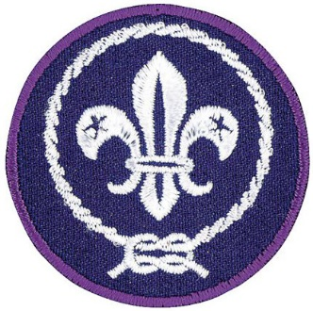

When people travel to foreign countries, they have to ask their governments to issue them what’s called a passport. A passport is a little booklet with your name and picture in it, along with several blank pages on which foreign border officials stamp the seal of their country when you enter. You can’t go into another country without your passport. But did you know that every Scout already has a passport?

It’s not a little booklet, but a small purple patch that we wear on our uniforms, called the World Crest. The World Crest is a symbol of brotherhood and good will the world over. When you wear the World Crest on your Scout uniform, you remind yourself that you are a part of an organization that includes, but also goes far beyond, your own home nation.

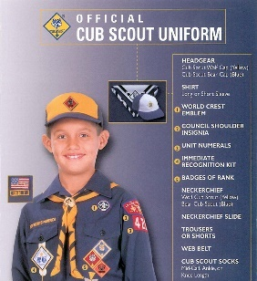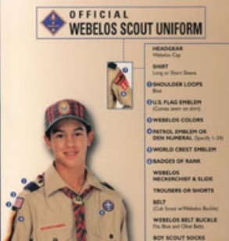  
*See the World Crest Emblems??*

The World Crest also reminds us that human beings should be respected and valued regardless of their race, color, creed, or place of origin. You’ll still need a paper passport to visit foreign lands, but the World Crest allows Scouts to think of every person as their neighbor and friend.

**A Smile**

*Santa Clara County Council*

We know much about other countries. People who live in other lands have different customs, different styles of dress and different languages than we do. But there is a universal language understood by everyone in the world. It is a smile.

A smile costs nothing but creates much. It happens in a flash but the memory sometimes lasts forever. It cannot be begged, bought, borrowed, or stolen, but it is something that is of no earthly good unless it is given away. So, if you meet someone who is too weary to give you a smile, leave one of yours. No one needs a smile quite as much as a person who has none left to give.

As you travel through this world, whether you are in a foreign land or your own neighborhood, remember to smile. Remember...”A Scout is **CHEERFUL**.”

**Do Your Best**

*Santa Clara County Council*

All over the world, Cub Scouts promise to do their best. Let’s stop for a minute and carefully consider those words. “Best” describes effort and action above our usual performance. “You” are the only person who can possibly know whether or not you have done your best. Every time you repeat the Scout Oath and the Cub Scout Motto, YOU agree to do your best to do certain things. “Your Best” is just that--the very best. Think about the meaning of the Scout Oath and decide that you will always do your very best, no matter what the job facing you might be. Now please stand, make a Cub Scout sign and repeat the Scout Oath with me.

**No One Can Pass Through Life**

*Alice, Golden Empire Council*

Robert Baden-Powell knew that “No one can pass through life, any more than he can pass through a bit of country, without leaving tracks behind, and those tracks may often be helpful to those coming after him in finding their way.” Let’s each make sure that OUR tracks lead other in the right pathway – towards being a good citizen!

**Compass Closing Thought**

*Southern NJ Council*

NA01702_

**Prop –** Compass (maybe a demonstration teaching one would be easier to see but the magnet would not affect it)

**Cubmaster -** I have here a compass. Normally because of the natural magnetic forces of the earth, the needle faithfully points north and keeps you on the right path. But when a magnet is brought near the compass, the magnet is an outside influence on the character of the compass. The integrity of the compass can no longer be trusted.

This compass represents Cub Scouting. The Scout Oath (or Promise) and the Scout Law are the natural magnetic field that directs the compass needle of our boys. Just like this magnet, outside influences are trying to affect our purposes. Our youth are continually faced with temptations – temptation to get by without working, to lie, to cheat, to give in to the negative peer pressure of friends. If our boys are going to grow up to be the good citizens we want them to be, watch out for the magnets in their lives. Help them to work hard to live up to the ideals of Scouting.

**A Scout is Reverent.**<https://scoutmastercg.com/a-scout-is-reverent-scoutmaster-minute/>

***A Scout is reverent. A Scout is reverent toward God. He is faithful in his religious duties. He respects the beliefs of others.***

Scouting’s founders recognized spirituality as an central element of the movement. As scouting expanded throughout  the world so did the way Scouting defined duty to God. Scouting would fail in its mission if it was limited to the adherents of a certain brand of religious thought. If a world brotherhood is to survive it must be based on a mutual respect for differing concepts of God.

Reverence in America has deep roots as does the concepts of political and religious freedom. A continuous, lively and often strident debate of these freedoms has been a part of our national conversation since its founding. Mutual respect for differences is one point on which almost all of us accept though we will argue as to what and who is due what degree of respect.

Tibetan Buddhist master Atisha tells us that, “All dharma (teaching, thinking, belief) agrees at one point.”. I take this to understand that there is a thread of common humanity that inspires reverence that brings forward the best and highest in us. When we take the hand of a fellow Scout we transcend the constructs culture, background, and religion to something much deeper and broader; that elemental, indefinable common point where we stand as brothers.

**A Scout is Reverent**<https://johnscout.wordpress.com/2010/10/17/sm-minute%E2%80%94a-scout-is-reverent/>

***A Scout is reverent. A Scout is reverent toward God. He is faithful in his religious duties. He respects the beliefs of others.***

Sometimes we overlook the 12th and final point of the Scout Law. How a Scout is reverent is between him, his family and his relationship with God. My relationship with God is different than yours. Some of us attend church every week. Some of us celebrate God’s grace in the great outdoors. What is important is that every Scout is reverent towards God, in his own way.

When we go camping, we have a Scout’s Own service like we did at last weekend’s Camporee. This is not meant to replace your church duties. It simply recognizes that a Scout is reverent and shares our different religious traditions.

A Scout is reverent, yet we also respect the many different ways each of us is reverent all around the world.

**All Over the World Closing***Sam Houston Area Council*

**Set Up and Props:**   
Globe of the world  
Cubmaster has all speaking parts.

**CM points at area where Pack is   
meeting on the globe**

This evening our pack has used our passport to explore other lands. Did you know that all over this world, (spin globe) Cub Scouts just like us are taking part in Scouting activities too? Well, it’s true. The Scouting movement began in England and now exists in almost every nation. Their Cub Scouts are much like us. They have the same ideals, the same Oath and Law, and the same brotherhood of service. So let’s think of our brother Cub Scouts around the world as we join in the Scout Oath and Scout Law.

***(Lead Oath and Law)***

**Thoughts for Life***National Capital Area Council*

* Do your best in everything you do on life's way
* Always be friendly to brighten another's day
* Give away your smiles for it is rewarding indeed
* Be prepared to help others, for goodness   
  - not for greed
* Be honest and sincere toward others that you meet
* Be loyal and true - a most commendable feat
* Count your blessings and be thankful for the opportunities that come to you

Good night to each and every one, may these thoughts stay with you your whole life through.

**Setting the Example**National Capital Area Council

**For Parents:**

A boy does what he knows. He is what he does, and what he is going to be, he is becoming.

**For Scouts:**

Life never stands still. If you do not advance, it will leave you behind. In Cub Scouting, you have many opportunities to learn and to advance as you work on Core and Elective Adventure. Do them well so that you will be proud of the badge you wear as a symbol of your keeping up with life, not as a symbol of an accomplishment left behind. And so that you will be setting the example for others as to how to earn your badges.

**Helpful to Others**National Capital Area Council

Lord Baden-Powell, the founder of Scouting said this to Scouts everywhere:

"I think that when the sun goes down, the world is hidden by a big blanket from the light of heaven, but the stars are little holes pierced in that blanket by those who have done good deeds in this world. The stars are not all the same size, some are big, some are little, and some men have done small deeds, but they have made their hole in the blanket by doing good before they went to heaven. Try and make your hole in the blanket by good work while you are on earth. It is something to be good, but it is far better to do good."

Think of Baden-Powell's words when you promise "to help other people". Good Night and thank you for celebrating Cub Scouting.

**Scout Uniform’s Reputation**Indian Nations Council

To end this evening, I’d like to tell you a story.

A crowded bus stopped to pick up a bent old woman. With great difficulty she struggled up the steps with a large basket of freshly washed laundry. “You’ll have to put your basket in the rear of the bus,” said the driver impatiently.

“But I can’t. They belong to me,” the woman replied. The driver was firm. “You and that basket are in the way. Either stow it or get off.” The old lady was almost in tears when a young man arose. “You sit here, Ma’am,” he offered. “I’ll take your basket to the back and watch it until your stop.” The woman was doubtful, but the driver was about to put her off. A second lady sitting nearby, said to the old woman, “That boy’s all right. Can’t you see his uniform? I'll vouch for him.”

The woman was soon seated, and the basket of clothes carried to the rear. At her stop, the boy gently set the basket down by her, then returned to the bus and continued on his way.

“Who’s the kid?” asked the driver of the second woman. “I don’t know the kid,” came the reply, “but I know the Boy Scout uniform, and you can trust it every time.”

# CUB GRUB

**Cub Grub is in PART I of Baloo’s Bugle, Fun Stuff.   
But here are a few extras -**

**Icy Blue Igloo**

*Heart of America Council*

**Ingredients:**

3 packages of Jell-O Berry Blue Gelatin Dessert (4-serving size)

2 3/4 cups boiling water

1 1/2 cups cold water

2 cups ice cubes

2 cups whipped topping

**Directions:**

1. Dissolve 2 packages of blue Jell-O in 2 cups boiling water.
2. Add cold water. Pour into 13-inch x 9-inch pan.
3. Chill until set, about 3 hours.
4. Cut gelatin into 1/2 inch cubes. Set aside.
5. Line a 6-cup bowl with plastic wrap. Set aside.
6. Dissolve remaining package of blue Jell-O in 3/4 cup boiling water.
7. Add ice cubes. Stir until slightly thickened, about 3 to 5 minutes. Remove any ice that did not melt.
8. Whisk in 1 cup whipped topping. Stir in 2/3 of the gelatin cubes
9. Pour mixture into prepared bowl.
10. Chill until set, about 3 hours.
11. Unmold onto serving plate, flat side down. The round part should be on top.
12. Remove plastic wrap and frost surface with remaining whipped topping and decorate with remaining Jell-O cubes so that it looks like blocks in the “ice” of the whipped topping.

***There you have your “igloo.”***

**Pretzel Spears**

**Ingredients:**

1 ounce Mozzarella cheese cut in 1/4 inch cubes.

1 box thin pretzel sticks

**Directions:**

* Cube cheese and spear with pretzels.
* Build a design with the cheese and pretzels.

*Boys could be divided into teams and work together to construct a tower or building. After a set amount of time the contest could be over and the boys could eat their design.*

**Snow Balls**

*Heart of America Council*

**Ingredients:**

1 stick butter

2 cups rolled oats

1/2 cup peanut butter

2 cups powdered sugar

Additional powdered sugar for rolling balls

**Directions:**

* Melt butter over medium heat;
* Add oats stirring constantly until oats are toasted, about 5 min.
* Remove from heat.
* Add peanut butter and sugar to make a stiff dough.
* Roll into balls and roll in powdered sugar.

**Danish Pancakes**

*Heart of America Council*

**Ingredients:**

2 cups flour

2 1/2 cups milk

8 eggs

1 T. sugar

1 t. salt

1 T. oil

**Directions:**

* Mix all ingredients together.
* Melt 1 T. butter in a small skillet.
* Cover bottom of pan with batter.
* Brown on one side, turn pancake and brown on other side.
* Sprinkle each pancake with granulated sugar, top with jam, and roll up.

**Option:** Fill pancake with fresh fruit and ice cream.

**Quesadillas**

**Ingredients:**

12 tortillas

1/4 lb. Jack cheese

**Directions:**

* Put slices of cheese on tortillas.
* Heat in toaster oven or broiler, or microwave until cheese is melted.
* Roll up or fold over and serve.

**Tallarina**

*Heart of America Council*

**Ingredients:**

1 lb. ground beef

1 chopped med. Onion

2 cans tomato sauce

1 can cheddar cheese soup

1 can corn

1 small jar stuffed olives

1 (8 oz.) package noodles, cooked and drained

salt and pepper to taste

**Directions:**

* Brown together: ground beef, chopped Onion, tomato sauce
* Mix everything together in a casserole dish.
* Bake at 325 for 1 hour.

**Maple Snow**

*Heart of America Council*

***I did this at a friend’s house in Vermont with Maple Syrup they made from tapping their trees. It is great!! CD***

**Ingredients:**

1 tray ice cubes, crushed or grated very fine to be like snow*.* ***(We used real snow in Vermont!!)***

Maple syrup ***(the book did not say – Measure to taste - I would guess a cup but a bottle would be good ☺ )***

**Directions:**

* Heat maple syrup over low heat until it is warm. (about 2 minutes)
* Drop 1 Tablespoon or more of the syrup on top of snow or crushed ice.
* This makes a tasty treat when there is snow outside.

**Breakfast Blanket**

*Heart of America Council*

**Ingredients:**

1 T. jam

2-6 inch whole wheat flour tortillas

1 cup fresh fruit such as peaches

**Directions:**

* Spread 1/2 tablespoon of jam on each tortilla.
* Sprinkle 1/2 cup fruit on each tortilla.
* Roll up to make bumpy blanket.

**Idea:** Creamed cheese could be used in place of jam.

**Viet Nam Spring Rolls**

*Heart of America Council*

**Ingredients:**

Quartered rice paper *(available in Asian stores already quartered)*

1 peeled cucumber

8 boiled shelled and cut into bite size shrimp

1/3 peeled daikon radish

4 green scallion strips 3” long

1/4 cup soy sauce

**Directions:**

* Cut cucumber and radish’s into 3” strips.
* Cut shrimp into bite sizes.
* Lay out on rice paper (cut in a triangle with point to the top). Spray with water in mister bottle.
* Wait 1 min. for paper to soften.
* Place 2 shrimp(chopped) on top of rice paper.
* Place 2 strips of cucumber, and 2 strips of radish, and scallion strip on top of shrimp.
* Fold sides inward and roll up from bottom.
* Serve with soy sauce.

**Pretzel Spears**

**Ingredients:**

1 ounce Mozzarella cheese cut in 1/4 inch cubes.

1 box thin pretzel sticks

**Directions:**

* Cube cheese and spear with pretzels.
* Build a design with the cheese and pretzels.

*Boys could be divided into teams and work together to construct a tower or building. After a set amount of time the contest could be over and the boys could eat their design.*

**Darbey Bread (Italian)**

**Ingredients:**

* (3 pound) package frozen bread dough, thawed,
* 1 1/2 cups shredded sharp Cheddar cheese,
* 1 onion, finely diced,
* 1/4 cup olive oil,
* 1 tablespoon Italian seasoning

**Directions:**

1. Thaw frozen bread dough loaves until they can be cut into 1 inch cubes.
2. Toss bread cubes with the grated sharp cheddar cheese, diced onion, olive oil and Italian spices. Place in a 9x9 inch square baking pan. Let sit and rise in a warm place until bread has doubled in size.
3. Bake bread in a preheated 350 degrees F (175 degrees C) oven for about 20 minutes or until golden brown and all cheese is melted.

**Apple Kugel**

"Kugel" is a noodle dish that adapts very well to apples. If making for the lunchbox, prepare the day before and refrigerate. Cut into serving-size squares. Serves 6

**Ingredients:**

* 4 cups uncooked egg noodles
* 8 ounces reduced-fat cream cheese
* 1/2 cup brown sugar
* pound low-fat cottage cheese
* egg
* egg whites
* teaspoon vanilla extract
* 1/2 teaspoon ground cinnamon
* 1/4 teaspoon ground nutmeg
* Rome Beauty apples

**Directions:**

1. Cook egg noodles according to package directions until just tender; drain. Meanwhile, in large bowl with electric mixer, beat cream cheese and brown sugar until well blended. Add cottage cheese, egg, egg whites, vanilla, cinnamon and nutmeg, beating until combined.
2. Heat oven to 350 degrees F. Lightly grease 8-or 9-inch square pan. Core, quarter and thinly slice apples; stir apple slices and cooked noodles into cheese mixture. Spread mixture in pan; bake 45 minutes or until kugel is golden and firm.

# GAMES

**Eighty-Seven Years and Counting!**

*Santa Clara County Council*

2017 marks the 87th anniversary of Cub Scouting in the United States. Let’s start counting! Have boys sit in a circle and start counting. When a player comes to “eight” or a number with an eight in it, he must instead say “blue.” When he comes to “seven” or a number with seven in it, he must say “gold.” So at 7, they say “gold.” At 18 it would be “one-blue” and 27 will be “twenty-gold.” 87 would be “blue-gold.”

**World Brotherhood Tug**

*Santa Clara County Council*

This is a teamwork game. Players should be similar in size. Start with a smaller group; gradually increase the size as the boys get used to this game. A group of boys sit in a circle holding onto a rope placed inside the circle in front of their feet. The ends of the rope are tied together to make a huge loop. The object of the game is for everyone to stand up tugging the rope. If everyone pulls at the same time, the entire group should be able to come to a standing position.

**Bivoe Ebuma (Clap Ball)**

Cameroon, Africa

Heart of America Council

Divide den into two teams. Teams line up parallel and facing each other six feet on either side of a centerline. The two teams toss a small rubber ball back and forth. No player may step across the centerline. When the ball is caught, the catcher must clap his hands and stamp his feet once. If a player forgets to clap and stamp, a point is scored against his team. Keep the ball moving fast.

**Chef Manda (The Chief Orders)**

Brazil

Heart of America Council

One Cub Scout is the Chief and stands in front. When he says, “The Chief orders you to laugh”, all other players must laugh. If he says, “He orders you to laugh”, no one should laugh because all valid commands are prefaced by

"The Chief". A player who does not obey proper orders is eliminated.

**Cherry Chop**

France

Heart of America Council

This is usually played with cherry pits at harvest time. You can use pebbles or marbles Place a shallow bowl about two feet in front of a line of Cub Scouts. Put one pebble or marble in it, and give each player five or 10 others. In turn, each uses his pebbles to try to knock the pebble out of the bowl. If he succeeds, he keeps it and the leader places another pebble into the bowl. If a player misses, he must put one of his pebbles in the bowl. The winner is the one with the most pebbles at the end of the game.

**Palito Verde (Green Stick)**

France

Heart of America Council

“It” carries a green stick (a neckerchief may be substituted). The other players form a large circle, facing inward with their hands behind their back. “It” travels around the circle, and at some point he places the stick or neckerchief in the hands of a player. That player immediately races after “It” around the circle. If ‘It” is tagged before “It” can get to the chaser’s old place in the circle, he remains “It”. If “It” reaches the space safely, the chaser becomes the new “It”

**Catch The Dragon’s Tail**

Taiwan

Heart of America Council

Two single lines are formed with each person’s hands on the shoulders of the person in front of him. Until the signal “Go” is given, the dragons must each remain in a straight line. The starter begins the countdown - “Em-Er-San-Ko!” or “1-2-3-GO!” The “fiery head” of each line then runs toward the “lashing tail” and tries to catch the last man. The whole dragon body must remain unbroken If anyone lets go, the dragon’s body is broken and the dragon dies. A new dragon must be formed with the head becoming the tail and the next in line having a turn at being the head. If, however, the head player touches the tail, he may continue to be the head.

**Exchange Race**

England

Heart of America Council

Divide the players into two, four, or six groups (for teams). Form straight lines and count off

Paired players face each other. Lines are ten, twenty, or more feet apart facing each other. On a starting signal the No 1’s of each Line run forward, meet near the center, exchange objects, run around each other, return to their lines, and give their object to No 2. Then they go to the end of their own line. The 2’s repeat, give same object to No 3, etc. Objects must work back down to the head of the line. The team wins whose No 1 man is first to receive the object and hold it up.

**Pyramids of the Nile**

Egypt

Heart of America Council

Divide the boys into teams of 4-6 boys, and line them up in straight lines that stretch from one end of the playing area to the other. (i.e. 8-10 feet between team members). The first boy on each team is given 10 flat-bottomed paper cups. On ‘GO’, he builds a pyramid in front of himself. All ten cups have to be used. When he is finished, he and the second boy on his team try to carry the pyramid from his spot to the place where the second player sat. If they drop any part of the pyramid they can rebuild it where it fell and then continue their walk. When they reach the proper spot, the second boy tumbles the pyramid and then rebuilds it so that he and the third player can advance the pyramid to the third location. The relay ends when all of the ‘Egyptians’ have built, moved, and tumbled the pyramid.

**Note**: Boys have their choice of how to move the pyramid. They may pick it up by the 4-cup base, or try to slide it across the floor.

**Popsicle Slapshot**

Canada

Heart of America

Divide the boys into two teams. Place two nets (Shoe boxes with one end cut out make a good net) at the same end of the playing area. Each team lines up about six feet in front of its net. The first member of each team puts a tongue depressor in his mouth, gets down on his hands and knees, and attempts to shoot the puck (ping pong ball) into the net, using the tongue depressor. When he has scored, he takes the ball back to the starting line and the next player shoots. The first team to complete the relay wins.

**Pick-Up Sticks**

Vietnam

*Santa Clara County Council*

You will need ten chopsticks or popsicle sticks, and small bouncy balls.

Lay the sticks on the floor in a straight line, one below the other. Throw the ball in the air and pick up one stick. Catch the ball in the same hand after you let it bounce once. Keep the stick in your hand and pick another up in the same way. Repeat until all of the sticks have been picked up. Lay them out again and as the ball is thrown up and allowed to bounce, pick up two sticks at a time. Continue with three, then four, and so on until you attempt to pick up all ten at one time. This game can be played by two or three players. One player keeps playing as long as he doesn’t drop sticks of misses catching the ball. When he makes a mistake, its the next player’s turn.

**Kabbadi**

India

*Santa Clara County Council*

Divide the group into two teams. Teams face each other behind lines drawn on the ground about six feet apart. The game begins when a boy from one team (A) crosses the line to tag a member of the other team (B). If he tags the boy before getting caught and held by the other members of team (B), the victim must join team (A). If the chaser is caught and held by team (B) before he makes the tag, he must join that team, (B). The chaser must hold his breath all the time as he runs. To prove his is holding breath, he repeats over and over, Kabbadi, kabbadi, kabbadi (pronounced “cubbidy”) without taking in breaths. The teams take turns sending out chasers. The team with the most members at the end of the allotted time is the winner.

**Kaab**

Saudi Arabia

*Santa Clara County Council*

In Saudi Arabia this game is played with the knee bones of sheep. Instead, use washers with identifying colored dots on each. Players should have at least ten washers each. Stones or marbles may also be used. To play the game, draw two lines on the ground, about 6 feet apart. Each player places one of his “bones” on one line. Standing on the other line, each player now takes turns and attempts to toss one of his remaining “bones” at the ones on the ground. If the player hits one of the bones he may pick up that bone. If he misses the “bone,” his remains as a target for the other players. He also loses his next turn. The game is played until all the bones have been hit or all the players have lost their “bone” supply.

**Number Game**

Sweden

*Santa Clara County Council*

Choose one player to be “It.” All other players scatter across the playing field and each one draws a circle around himself at about arm’s length, with a stick or chalk. Each player stands within the circle he has drawn. “It” gives a different number to each player who stands in a circle. “It” calls out two of the numbers he has given. The players with those two numbers must change circles. “It” tries to get to one of the circles first. If he fails, he must call out two other numbers. If he succeeds, the players left without a circle becomes “It” for the next game. The same procedure is followed for the new game.

**Nsikwi-**

Africa

*Santa Clara County Council*

You will need a tennis ball and an empty plastic bottle for each player (all the same size). Divide the players into two teams. Teams sit in lines, facing each other. Make sure there is about ten feet between the teams. The players place the empty bottles in front of them Each player then tries to knock down the bottle of the player opposite him with the tennis ball. A point is scored for each knockdown. After a designated time period, add up the points of the boys on each side.

**Memory Relay Race**

Great Britain

*Santa Clara County Council*

Dens in relay formation. About fifty feet in front of each den, place a judge holding a bag of small objects. On signal, the first boy of each line runs to the judge, gets an object, examines it and hands it back to the judge. Then he runs back, tells the next in line what he saw. The second player runs down, sees a second object, runs back and tells the next in line what he saw and what he was told by the first Cub. The next Cub runs down and so on. The last Cub does not go back to the den but writes, on a piece of paper, as much as he can remember of what he has been told.

**La Palma**

Bolivia

*Santa Clara County Council*

The Indians of Bolivia used the tailbones of a donkey or llama for this game. You can use a stick. Set the stick up on end in a hole in the ground. Draw a straight line away from the stick and at 3’ intervals, drive a peg into the ground; use about 6 pegs. You will need a supply of tennis balls. Boys then take turns throwing the ball to hit the stick from the first peg. Those who do, move on to the next peg. Those who don’t, stay at peg number one until they hit the stick.

Boys must throw in their correct order throughout the game. The first boy to complete the six throws from the pegs wins. This can also be done on a best time basis.

**Variations:** For younger children, make the distance between pegs shorter and allow them an option of rolling the ball. Or use a larger ball.

**Runaround**

*Commissioner Dave*

***This is a takeoff of the classic "Four Corners" game***

**Materials:**

* Four (or more) signs.
* **For Passport to Other Lands** – Each sign to represent a different country or a different continent.
* **For Reverent -** Each sign to have an emblem of a different Faith - Cross (Christian), Star of David (Jewish), ...
* Label the four corners of the hall with a different sign depending on theme you are using.
* Have a stack of cards, each with a word or saying related to one of the four pictures you posted in the corners
* Take the top card and call out the fact written on it.
* Tell the Scouts to go to the corner with the emblem to which the fact relates.
* The Scouts then run to the corner of the room they think is correct. Scouts that do not pick the correct corner are eliminated. Last person left is the winner.

**Note:**After writing your cards, you may wish to review some things before beginning the game to make sure everyone has a fair chance at the game

Ideas for cards - Such as:

* **Religious Leaders -** Brahmins (Hindu), Imams (Islam), Rabbis (Jewish), Pastors, Priests, vicars (Christianity)
* **Clothing -** Kacch, white shorts (Sikhs), Yarmulkes, a little cap that covers the crown of the head, as a mark of respect for God (Jewish).
* **Festivals -** Pesach or Passover, a festival held in March or April (Jewish), Pentecost (Christian), Ramadan (Islam), Eid Al-Adha (Muslim)
* **Places of Worship** - Mosques (Muslims), Temples (Jewish), Churches (Christian)
* **Important Cities** - Jerusalem (Jewish, Christian, Islam, Muslim). Mecca (Islam), Rome (Catholic)

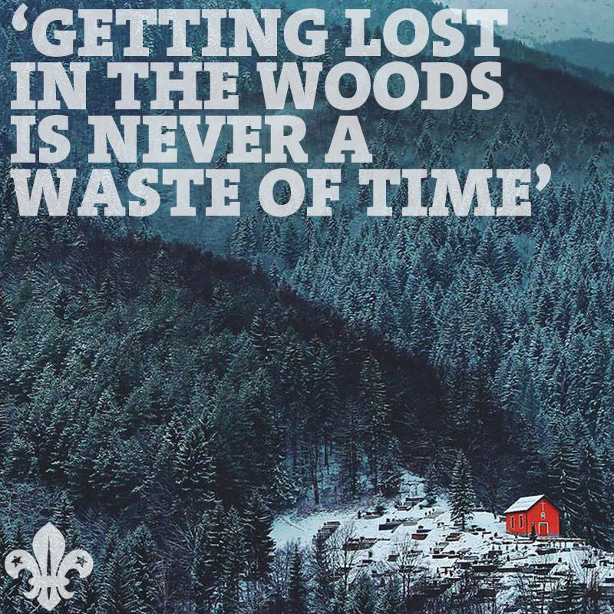

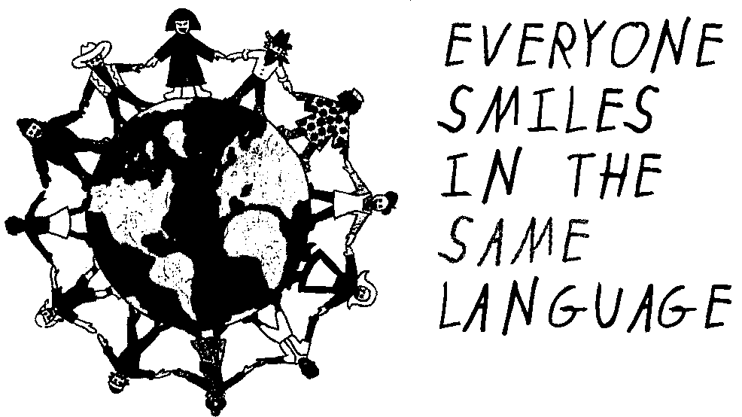

# PACK MEETING ACTIVITIES

**MAP OF THE WORLD**

Have a large world map ready at the pack meeting. As people arrive, give each person star stickers and ask them to mark places they have been or a place where they know someone is living or is from. They may want to include the place where their ancestors came from. During the meeting, comment of the map--how many countries we are connected with, etc.

**“ADOPT” A COUNTRY**

During the month each den learns about one country. What are the traditional clothes? Is it possible to make something similar to their clothes? If so, wear it at the pack meeting or in a skit. If not, draw or cut out pictures and display them at the pack meeting. Try some of the food. Learn a few phrases in the language. Read one or two traditional children’s stories from that country. Is there any video the den can watch about the country? Learn some games and songs. The library is a great resource for these activities.

* Also, is there a Scouting organization in that country? If so, learn their Cub or Boy Scout Oath or Promise. Reproduce their Scout logo.
* Prepare the Blue and Gold Banquet table decoration using the country’s colors, flags, folk crafts, and writing system. Find pictures of that country in old magazines, cut them out and use them as part of the decorations.

Have the Dens bring some of their material to the Pack Meeting to show others.

**COUNTRY FAIRE**

Have several “booths” at the pack meeting featuring Another (Not American) the country’s food, games, songs (either learn or listen), and/or crafts. If dens have adopted countries, each den can sponsor a booth. Or have a Country Faire committee to organize this. Posters and maps may be obtained through the country’s Council General, travel information center, or travel agents.

**SPECIAL GUESTS**

* Have a guest from another country. Is anyone in your den from another country?
* Ask the guest to talk about a child’s life in the country he is from. Can he bring some traditional toys from that country?
* Can he teach your den some traditional games?
* Can he teach your den some words in his native language? Can he teach the boys to write their names (phonetically) in that language?

*Children are fascinated to see their names   
written in foreign letters.*

* Have a guest who has been to another country or has hosted Scouts or students from another country.
* Ask the guest to bring some souvenirs and photos to show to the boys.
* The guest could tell the boys some of his experiences in a different culture (keep it positive).
* Make sure the boys thank the guest. Would he like to come to your Blue and Gold Banquet?

**WORLD FRIENDSHIP FUND**

Collect money or have a fundraising project such as recycling and contribute toward the World Friendship Fund. The World Friendship Fund is administered by the Boy Scouts of America to help struggling Scouting associations in other lands. For more on this go to: <http://www.scouting.org/scoutsource/International/InformationSheets/22-329.aspx> or check the Cub Scout Leader book.

**PEN PALS**

Write to people in another country as a den. Write a little about the den, pack, school, or friends. Maybe exchange a few postcards. Letters or cards may be shown at the Pack Meeting.

There is no pen pal program offered by BSA but do you know someone living in another country? Your relative? Ask teachers if they know school kids in other countries. Ask Boy Scout troops. Know anyone that attended the council’s International Rendezvous (happens every two years)? Do you know anyone who has hosted international Scouts or students? Can they give you the names of people who are willing to write