FOCUS
Cub Scout Roundtable Leaders’ Guide
Sports cars, trucks, race cars, classic cars - car have fascinated every generation since their invention in 1769. this month the boys will learn how these vehicles are built, repaired, and sold. Dens could visit a car dealership, auto repair shop or automobile museum. Boys can build car or truck models or create a model of a showroom. Or they can run their derby cars at the pack Pinewood Derby.
CORE VALUES
Cub Scout Roundtable Leaders’ Guide
Some of the purposes of Cub Scouting developed through this month’s theme are:
- Personal Achievement, Boys will gain confidence and get a sense of satisfaction by working on their Pinewood Derby cars.
- Sportsmanship, Boys will learn fair play from the Pinewood Derby and respect for others in victory and defeat..
- Fun and Adventure, Boys will enjoy learning about cars and building and racing their own cars.
The core value highlighted this month is:
- Positive Attitude, Cub Scouts will learn to take pride in their accomplishments and know that doing their best is more important than winning or losing.
Can you think of others??? Hint – look in your Cub Scout Program Helps. It lists different ones!! All the items on both lists are applicable!! You could probably list all twelve if you thought about it!!
COMMISSIONER’S CORNER
It's been a long time since I did an issue with Pinewood Derby I wasn't sure on the approach to take in Baloo and did not want anyone to think I knew how to make a car. The cars my son and I made always finished but we were never in the top 3. So I gave you some basic guidelines and suggest you google "pinewood derby" and be prepared to be overwhelmed as you search for the way to make the perfect racer. And then watch the movie, "Down and Derby,' and go have fun making and racing your cars WITH your sons.
Since this is the first time BSA has featured only cars the Pow Wow Books I reviewed tended to include other transportation, too. And so there is a little general transportation in Baloo this month.
Thanks to all my regular contributors for coming through again - Bill Smith, the roundtable Guy (who has already sent me the January Training Topic!!!), Scouter Jim in Utah (especially for the Great Salt Lake Pow Wow CD), and Alice in California.
Next month there will be a feature article by Bill Smith on the Philmont Training Center and the first ever Cub Scout Extravaganza. Do not miss it!!! (The CS Extravaganza at the Philmont Training Center that is, it's okay to miss Baloo's Bugle☺ ☺ )
Pow Wow CDs are arriving. Thank you, thank you, thank you. I always worry a little in the Fall when my books start running out. Great book from Capital Area Council, via Cubmaster Chris (Have you hear his podcasts?? Check out his website www.cubmasterchris.com and you can link to podcasts and other media presentations), Sam Houston from Rachel at Rice arrived today so it will be featured in next month's issue. I attended the Baltimore Pow Wow and finally met Pat who has been sending me their book for years and the chair, Pam and quite a cast of other characters. Their cooking instructor is fantastic!! Grand Teton from Kathy in St Anthony, ID, looks like it will regularly be featured in this year's editions.
Theme patch for January 2008,
Cub Scout Car Show not available yet
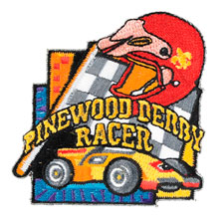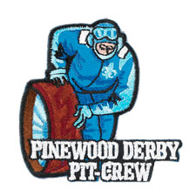
National makes a patch for every Cub Scout Monthly theme. However, they have not yet posted any of the 2008 patches so I cannot show hem to you!!! But here are two of the many Pinewood Derby patches available from www.scoutstuff.org I like the idea of special patches for your Pinewood Derby Committee - See the Pit Crew patch above.
Months with similar themes to
Cub Scout Car Show
Dave D. in Illinois
There has not been a monthly theme specifically for Cars since Cub Scouts began using themes in September 1939. There have been many themes that a den could use for cars (e.g., Things That Go, Transportation) and so I gave those here. Also, almost every year there is one theme that is the recommended month for the Pinewood Derby. I could not sort the spreadsheet that way, but if you have CS program Helps for previous years you may find the months with Pinewood Tips. CD
Month | Year | Theme
July | 1941 | Things That Go
April | 1945 | Transportation
August | 1947 | Things That Go
July | 1951 | Things That Go
January | 1953 | Transportation
June | 1963 | Things that Go
July | 1965 | Cub Scouts on Wheels
January | 1966 | Transportation
June | 1969 | Things that Go
November | 1972 | Things That Go
January | 1974 | Transportation
May | 1975 | Things that Go
July | 1980 | Things that Go
June | 1983 | Fun on Wheels
March | 1992 | Things that Go
I
THOUGHTFUL ITEMS FOR SCOUTERS
Thanks to Scouter Jim from Bountiful, Utah, who prepares this section of Baloo for us each month. You can reach him at bobwhitejonz@juno.com or through the link to write Baloo on www.usscouts.org. CD
Roundtable Prayer
CS Roundtable Planning Guide
We give thanks for the fun we have at our pinewood derby. Help us remember to do our best. Help us cope with disappointments if our cars do not go fast. Help us be thoughtful of the feelings of other if our cars should win. Amen
Iron and Wood, Steel and Rubber
Scouter Jim, Bountiful, Utah
The automobile has changed the way we work, the jobs we do, and where we do those jobs. My father was a carpenter as was his father before him and his father’s father before. Though steam powered machines were demonstrated as early as 1678, it wasn’t until the invention and development of the combustion engine in the last part of the nineteenth century that this technology was available to the common man.
My great-grandfather built homes and water powered sawmills the last quarter of the nineteenth century and the first quarter of the twentieth century. Though the automobile was in its infancy, it was not in wide spread production until much later.
In 1876, Nickolaus Otto, working with Gottlieb Daimler and Wilhelm Maybach developed a four stroke engine cycle which became known as the “Otto Cycle.” Three years later in 1879, Karl Benz working on his own, was granted a patent for a reliable two-stroke gas engine base on Otto’s design of the four stroke engine. Later Benz designed his own four-stroke engine and used it in automobiles, which he produced in beginning in 1888. Most automobiles at the time were being produced and sold in Europe and were not available to the average American. My great-grandfather traveled and worked by horse power.
My grandfather learned his trade from his father. By 1900 mass production of automobiles had begun in France and the United States. Automobiles were only available to hobbyists and enthusiasts at first, and not the average American. It wasn’t until about the end of World War I that the automobile expanded to a wider enjoyment. Cadillac and Oldsmobile were making thousands of cars, as was Henry Ford. Ford began production of the Model T in 1908. Ford was quoted as saying, “You could have it in any color you wanted, as long as it was black.” As automobiles grew in popularity, along with building homes, my grandfather also built “Auto-Courts,” or as we know them today, “Motels.” These weren’t modern multi-storied motels, but they were the old fashioned ones, where you parked your car outside of your room. The Motel was usually built in a “U” shape and sometimes had a swimming pool in the middle of the “U”.
In 1927, Ford Motor Company ended production of the Model T and started production of the Model A. More than four million model A’s were produced through 1931.
1927 was also the year my grandfather started working to help build the first lodge located on the North Rim of the Grand Canyon. He also helped build the 100 standard cabins and 20 deluxe cabins that were built there at the same time. This lodge was destroyed by fire in 1932 and the present lodge was built in 1936-37 on the stone foundation of the original. It is an interesting point that the history of the first lodge on the North Rim parallels in time the history of Henry Ford’s Model A.
My father spent most of his life building homes in the Utah suburb of Bountiful after his return from the Korean War in 1953. The technology of automobiles was expanding at a phenomenal rate with more power and speed than ever before. Cars became sleeker and more aerodynamic. The 1950’s and 60’s saw the introduction of “muscle cars” like the Corvette in 1954; the Ford Mustang and Pontiac GTO in 1964; the Dodge Charger in 1966; and the Chevy Camaro in 1969. Not only did automobile production increase, but the desire for new homes also increased with the creation of the Suburbs. This need was created as the veterans of World War II and Korea were returning home and wanted to own a place of their own outside the crowded cities. This trend continued for several decades as children of those veterans, the “Baby Boomers,” also wanted places of their own. Most of the homes in Bountiful were built between 1940 and 1980 by which time the town was nearly completely “built out,” with very little open land. As the housing market began to slow down in the 1970’s, my father found himself moving the historic “Pioneer Village”, a monument of buildings of the pioneer era of the West to Lagoon, an amusement park 17 miles north of Salt Lake City in Farmington, Utah. He spent the last twenty years of his career taking care of the village and building concession stands or whatever a destination amusement park needed built at the time.
I am not a carpenter, but I do live in the suburb my father helped to build, and I commute each day to the Salt Lake City to work. My children commute to the city to go to the University of Utah and for amusements and shopping, all by means of the internal combustion engine. Our world would be a smaller world without the widespread use of the automobile, but its use, has come with a cost. The internal combustion engine brings with it pollution and depletion of natural resources. We are on the edge of a new revolution in automotive technology, looking forward to new ideas that will be create cleaner and more efficient automobiles. Let us celebrate our automotive past as we create a vision for change in our Cub Scout charges.
The Pinewood Derby Prayer
Pack 169, Egham, England
Pack 52, Morgantown, West Virginia
Hey God, we ask you to draw near
And bless the boys who gather here.
This is the day they’ve waited for
Their blocks of wood are blocks no more.
Plastic wheels and dime store nails
Become the stuff of sporting tales
Of finishes too close to see!
You’re here for every victory.
You bless the winners in their joy
But there’s another kind of boy
Whose handiwork is blessed by you
Because his hands tried something new.
You smile upon the crooked wheel,
The paint job done with boyish zeal,
The splintered car, the sloppy glue.
You love the work that Your sons do.
But there is one here in this place
Who shows the greatness of Your grace.
He is the boy who hasn’t won
But when he hears the starting gun
He’s there to cheer his fellow scouts
His are the loudest victory shouts.
And when his brothers haven’t won,
He’s just the one to say "well done,
You’ve tried your best and you’ve had fun,
There are more races to be run."
And so, dear God, we hear you say
Upon this happy Derby Day,
"Remember, whether best or worst,
Remember, you are brothers first."
Quotations
Quotations contain the wisdom of the ages, and are a great source of inspiration for Cubmaster’s minutes, material for an advancement ceremony or an insightful addition to a Pack Meeting program cover
"To finish first, you must first finish." Rick Mears
"Nobody remembers who finished second but the guy who finished second." Bobby Unser
"You drive the car, you don't carry it." Janet Guthrie
Finishing races is important, but racing is more important. Dale Earnhardt
When he was young, I told Dale Jr. that hunting and racing are a lot alike. Holding that steering wheel and holding that rifle both mean you better be responsible. Dale Earnhardt
Natives who beat drums to drive off evil spirits are objects of scorn to smart Americans who blow horns to break up traffic jams. Mary Ellen Kelly
Patience is something you admire in the driver behind you and scorn in the one ahead. Mac McCleary
It takes 8,460 bolts to assemble an automobile, and one nut to scatter it all over the road. Author Unknown
A pedestrian is someone who thought there were a couple of gallons left in the tank. Author Unknown
Leave sooner, drive slower, live longer. Author Unknown
Your grandchildren will likely find it incredible - or even sinful - that you burned up a gallon of gasoline to fetch a pack of cigarettes! Dr. Paul MacCready, Jr.
Any man who can drive safely while kissing a pretty girl is simply not giving the kiss the attention it deserves. Albert Einstein
I drive way too fast to worry about cholesterol. Anon
Hug your kids at home, but belt them in the car. Anon
A tree never hits an automobile except in self defense. American Proverb
Never drive faster than your guardian angel can fly. Anon
When buying a used car, punch the buttons on the radio. If all the stations are rock and roll, there's a good chance the transmission is shot. Larry Lujack (I remember Larry Lujack and his crank letter of the day from WLS (World's Largest Store, founded by Sears and Roebuck as part of the Cornbelt Broadcasting System) in Chicago when I was attending Valparaiso University 1967 to 1971!! Good old Top 40 AM Rock CD)
The one thing that unites all human beings, regardless of age, gender, religion, economic status or ethnic background, is that, deep down inside, we ALL believe that we are above average drivers. Dave Barry, "Things That It Took Me 50 Years to Learn"
The shortest distance between two points is under construction. Noelie Altito
A real patriot is the fellow who gets a parking ticket and rejoices that the system works. Bill Vaughan
If all the cars in the United States were placed end to end, it would probably be Labor Day Weekend. Doug Larson
TRAINING TIP
Using a Den Chief
Bill Smith, the Roundtable Guy
What is a Den Chief?
The Den Chief is an older Boy Scout, Varsity Scout or Venturer who works with a Cub Scout or Webelos den. He is selected by the Scoutmaster and the troop Senior Patrol Leader in cooperation with the Cubmaster. He may be of any age or rank, but he can be the greatest help if he is a former Cub Scout and if he is mature enough to assume this important responsibility. As a selected leader of younger boys, he has the opportunity to help them complete their Cub Scout or Webelos Scout advancement requirements and live up to Cub Scouting's ideals in their everyday lives.
The Den Chief is a member of a leadership team which also includes the den leader, assistant den leader, and the denner. The den chief is already what every Cub Scout and Webelos Scout would like to be - a Boy Scout. As far as the younger boys are concerned, he is the person they would most like to follow, and that makes him a natural leader for them. By directing this natural leader wisely, we can influence the den of boys under his leadership
Den Chiefs are gods.
Den Chiefs don't make your job much easier, but they do make the Cub Scout experience better. They require coaching and direction to be successful but when they succeed they bring a unique spark to a Cub Scout's life that no one else can. Most children today live in an age-stratified culture where there is little interaction between older and younger kids. Just having an older Boy Scout take an interest in a seven or eight year old is a big deal. When a Webelos Scout visits a troop and one of the older Scouts recognizes him and even knows his name, it’s an even bigger deal. These relationships can play an important part in a boy’s growth and the effects may be long lasting.
But don’t expect a young teen-age lad to be a natural leader. He needs help: coaching, support and acceptance. He must feel that he is a true member of the leadership team. Include him in the planning of your program. Give him explicit responsibilities. As he gains confidence, he will surprise you with his abilities.
Who should be a Den Chief?
Any Boy Scout or Venturing Crew member may be selected to be a Den Chief. Some units and even councils add age or rank qualifications. It works best when there is a significant age difference between the Den Chief and his charges. Also it may be advantageous to graduating Webelos if his former Den Chief is still active in the troop he joins. Try to do what is best for both the den members and the Scout.

Since young women may be Venturing members, they also qualify to be Den Chiefs. I have used pronouns he and him throughout just because it was easier. So I apologize to all those wonderful female Den Chiefs for this slight.

Why would one want to be a Den Chief? In a very real sense, the service qualifies as a leadership position for advancement to certain ranks. Den Chief is an official Boy Scout office and Scouts selected for this job are recognized as troop leaders. At a personal level, the experience can be quite rewarding. Having six or ten rag-a-muffins treat you as some sort of living god once a week is good for the self-image thing. All you have to do is teach them the same games, skits and jokes that you remember doing when you were their age and WOW!!!!
When one of my own sons was a Den Chief, he formed
a close relationship with the den leader and her husband.
It seems that the husband worked for a lithograph works
that printed covers for albums (vinyl – in those days) The walls of his room, his school text books and everything else were papered with Rolling Stones album covers. Very cool, back then.
Den Chief Responsibilities
- The Den Chief helps lead the weekly den meeting. He arrives on time, in proper uniform.
- He assists with assigned den activities at the monthly pack meetings.
- He shares responsibility with the den leaders in all den activities, looking to them for adult leadership and inspiration.
- He meets with the den leader to plan his part of the program for the den meetings. These meetings are held regularly, at least once each month, or more often, if needed.
- He sees that the den program does not include Boy Scout activities, since such activities should be saved for Boy Scouting.
- He recognizes the denner (a member of the den, chosen by his peers) as his right-hand man by giving him opportunities to serve.
- He takes part in all training opportunities so he may become a better leader.
- Den Chiefs should receive training at a Den Chief's Training Conference They also receive continuous and regular training from the den leader and Cubmaster.
CBW
Helping At Den Meetings
- Gathering Period - Helps teach boys tricks, puzzles, games, while den leader is busy checking attendance and collecting dues. The activities he uses here could be related to the monthly theme.
- Opening - Helps den leader organize boys and get them ready for the more serious part of the den meeting. He could hold a uniform inspection during this time.
- Business - He will have some good ideas for theme activities, service projects, trips, etc. Give him a chance to voice his ideas.
- Activities - This is when the den chief can be the most help. He is the activities assistant, leading boys in games, songs, craft projects, etc.
- Closing - Helps restore order and quiet for closing ceremony. He can help make announcements.
- After Meeting - Be sure to include him in your planning for next week and assign him specific responsibilities.
(Note: The Webelos Den Chief helps a Webelos den similarly. In addition to the suggestions above, he helps Webelos Scouts learn Boy Scout requirements for the Webelos badge and Arrow of Light Award and helps with demonstrations and teaching of activity badges, as needed.
Helping at Pack Meetings
- The den chief should be included in the planning for monthly pack meetings. He can help with any of the following:
- Help den leader set up displays.
- Help get the boys organized and seated.
- Help den leader during stunts or skit time.
- Helps with applause stunts and audience participations.
- Helps with den yell or song - or Activity Badge demonstration.
- Helps den leader maintain good behavior from Cub Scouts.
- Helps remove displays at end of pack meeting.
- Helps return pack meeting room to order.
http://www.geocities.com/~cubbobwhite
Den Chief Training is for Scouts who wish to become Den Chiefs for Cub and Webelos Dens. Den Chief is a leadership position in the Troop. This training works best when the Boy Scout and the Cub/Webelos den leader go through the training together so that they become familiar with what he learns there. The Cubmaster of the pack should also attend, as well as any troop leadership.
Den Chief Training Conference
This one day training experience is intended for those Boys Scouts who meet National Qualifications and would like to serve in a leadership position while giving service to brother Cub Scouts. Elements of this training include:
- Your Job As Den Chief
- How To Use and Lead Games
- How To Lead Songs
- Dual Contest and Tricks
- Working With Cub Scouts and Den Leaders
- Seven Parts of A Successful Cub Scout Den Meeting
- Five Parts of A Successful Webelos Den Meeting
- Den Chief/Webelos Den Chief Responsibilities
See Den Chief Training Pamphlet #34450C.

WAYS TO KEEP YOUR DEN CHIEF HAPPY
    - Recognize him at the first pack meeting.
    - Make sure he has a Den Chief Handbook (#33211). It’s full of great ideas.
    - See that he has training.
    - Give him important jobs.
    - BE PATIENT...he’s just a boy.
    - Understand his limitations and abilities.
    - Help him feel that he is successful.
    - DO NOT leave discipline problems up to him.
    - Recognize him on his birthday or other special occasion.
    - Congratulate him before the den and pack when he receives a Boy Scout Rank Advancement.
    - Present his Den Chief cord or badge to him at a troop Court of Honor in front his peers.

LINKS
- The Den Chief Role. The Virtual Cub Leader’s Handbook
- Cub Scout Den Chief. Scouting.org
- .Den Chief Service Award. US Scouting Service Project
- You Are Boy Scouting!. Suzanne Wilson, Scouting Magazine.
- Also, be sure to visit Bill’s website
http://www.wtsmith.com/rt
to finds more ideas on everything Cub Scouting.
Have any Comments for Bill
just click right here!
PACK ADMIN HELPS
Leader Recruitment
Your Blue & Gold Banquet
Kommissioner Karl
Seneca District, Buckeye Council
NO – It is NOT too early!!! CD
The Blue & Gold banquet is the highlight of the winter months for most Cub Packs. If yours isn’t, it probably needs help. Here are some simple guidelines to help you plan a successful Blue & Gold.
2 to 3 months before the Blue & Gold Banquet.
You need to make your final decision on your date & time with the Pack Committee. Ask some of the parents to help with the arrangements (this is your Blue & Gold Committee). This will make the job much easier. You will have a lot of ideas to share with each other.
Dates - Dates for the Banquet are usually set by the Pack Committee at the beginning of the calendar year. You may use the date that corresponds with your monthly Pack meeting. Some groups like to choose a Friday night, Saturday night or a Sunday afternoon.
Locations - Use your regular Pack meeting place. Some groups are allowed to use the Charter Organization facilities to hold their Blue & Gold dinner. Check with your Charter Organization to see if this could be a possiblity for your Pack. Check with local Churches. Some local churches will allow you to use their Fellowship Hall to have your dinner. Don't be afraid to check with the church you attend or maybe that of another member of Pack Committee. Other churches will allow you to use their Fellowship Hall if you use their Youth Group to help with the dinner. Some youth group raise money by preparing and serving dinners. This will help them earn money towards their mission trips. Check with your school - some areas will allow you to use the school.
Budgeting for the Dinner - Check with your Pack Committee to see what type of money has been set aside for the Blue & Gold Dinner. You may see if the Committee will set money aside from the Popcorn sales to pay for professional entertainment. You may decide to charge each family a small fee to cover the cost of the meal or entertainment.
Planning Your Menu
Cover Dish dinners - This is a fun way for families to show off their best dishes. It is fun to share you favorite dish with a friends. The down fall to this is - most parents work. If your dinner is on a week night it is hard to get home from work and prepare something for the dinner. This is why we see a lot more hot deli in the grocery stores now.
Have a spaghetti dinner - Your committee could prepare a simple spaghetti dinner for the Pack. Ask for volunteers to help with the dinner. There is always a Mother or Grandmother that would enjoy helping with something like this. Don't be afraid to ask.
Check with a local restaurant - Local restaurants may have catering for family style meals. Often you can get a good deal on chicken or pizza if you mention you are from a Scout group.
Check with a local church youth group - Several area youth groups are always raising money for Mission trips. Contact your local churches to see if they do any dinners as fund raisers. Check with other parents from the Pack they may know of some groups looking for fund raisers. Often these are full dinners that cost under $5 per person.
Entertainment - Entertainment is the lynch pin of the Blue & Gold event. If you are skipping this, you are missing out on making the dinner something that everyone looks forward to. You may consider some or all of these options:
Skit night - Each Den Prepares a skit or song to present as part of the program. Great suggestions for skits can be found at Roundtable Meetings or at www.macscouter.com . It doesn't matter if the boys get it perfect. It is the pride they have performing for their parents and friends.
Poll your Parents - See if there are any parents with hidden talents. Again don't be afraid to ask if anyone would like to entertain at your dinner. You may find a Mariachi bank member, a juggler, magician or storyteller.
Book outside entertainment - if your pack is big enough to add a small amount to the dinner cost, or if you budget some funds from the popcorn sale, you may consider hiring a professional entertainer. There are a lot of people out there to choose from. If you local school has a program, check with them to see who they have used. Check with local Colleges - They may have students that will perform for a fee, or maybe for free.
4 - 6 Weeks before the Banquet
Send out flyers reservation flyers. You need to include the date, time, cost and location on your sign up sheet. Always include a date when you need your RSVP turned back in by. It works best to collect the money ahead of time. You will always have a few people call at the minute wanting to attend. Always include a person’s name on the flyer that the family members may contact if they have a question. Make your den leaders responsible for collecting the flyers and money to turn into you.
Select a Theme for the Blue & Gold Dinner
Your imagination does not even limit you here. There is a wealth of information of the internet for decorations, themes, and often with instructions and pictures. Simply search for “cub blue gold” and see what you like. There are also several other resources such as:
Cub Scout Program Helps - Each year the Program helps will give you a theme idea. You may want to want to use this idea or use it as a building block for something similar. I have used old ideas from the old Program helps.
Roundtable Meeting - Each month the Roundtable will focus on a theme that could be used for your dinner. The CS RT Planning Guide calls for a Blue & Gold presentation in the Pack Admin break Out this (October) month. In January the Roundtable will focus on the February theme, which you may want to consider for the banquet.
Traditional Blue & Gold - Many groups like to use the traditional Blue & Gold theme. Decorate your tables with Blue & Gold table clothes, placemats, napkins and balloons. This is great, and underscores the theme of a celebration of Scouting.
Use your imagination - Have fun with your ideas. You can use any type of theme you would like. Examples: Happy Birthday Cub Scouts, Fiesta, Celebrate Ohio Anniversary, Celebrate your Pack Founding Date (Milestone Marks), Red/White/Blue
Plan Decorations
Use decorations that go along with your theme. The decorations could be made by the committee or ask the dens to help make the centerpieces for the dinner. Demonstrate the centerpiece project at your Pack Committee meeting and have each den make their own centerpieces for the banquet theme. This can be especially helpful if you are shorthanded. Purchase placemats or allow each den to make their own placemats for their families. Be sure the Scout makes enough for his entire family so no one is left out. If you want to go with purchasing, there are special Blue & Gold placemats at most Council stores. Use Blue & Gold Balloons tied in the center of each table or on the backs of chairs. Plan for some special treats at each place setting: theme cookies, candy, nut cups.
Send Out Invitations
Make sure you include a name and phone number for them to follow-up with. Unit Commissioners, your Church Minister, Chartered Organization Rep, District Executive, District Commissioner and District Chairman can all be invited. Be sure and contact the District Family Friends of Scouting Chair to schedule your FOS presenter, and confirm the time you have allotted them.
1 to 2 Weeks before the Banquet
Finalize EVERYTHING - Get your final count together. Collect and balance your money from families ahead of time. You may have to call the den leaders and remind them that the counts are due. If your are having another group catering your banquet, call them and confirm the date and count for the dinner. Also check to see if they plan for any additional people. There is always a few people that will call the day before or the day of the dinner wanting to attend. Remind Pack Treasurer, which checks need to be issued and amounts the night of the dinner. Often your entertainment or caterer wants paid the night of the dinner. Make a sign in sheet. Check everyone in as they arrive, if any one owes money, collect it then.
Programs - The banquet is a special celebration. You should consider printing a simple program. Include all the award that the boys are receiving that night. Everyone likes to see there name in print. It is nice if the Den Leaders plan for the boys to get their rank badges during the Blue & Gold. It also a great time to print a small thank you to everyone that has helped put the dinner together. You should also include a thank you to the parents for their support during the year.
Blue & Gold’s are should be the showcase of your winter program. If your unit has special awards, you may want to give them out there. Other units plan the a father/son cake bake auction as a fund raiser to help pay for the entertainment. Be sure to recognize the Pack Committee at the banquet for a big round of applause. An “atta-boy” goes along way to getting people to help in the future.
SPECIAL OPPORTUNITY
Duty to God Promotion Patch
P.R.A.Y.
www.praypub.org
I attended the Religious Emblems conference at the Philmont Training Center in 2006. Mark Hazlewood, the Director of P.R.A.Y., led the conference. It was great being with so many Scouters who wanted to help Scouts fulfill their Duty to God and become better in their faiths. Mark and the organization at P.R.A.Y. have done a great job setting up this promotion effort. Their website and the DVD have everything – scripts, slideshows, FAQs, and other stuff. Lets get out there and make a difference. CD
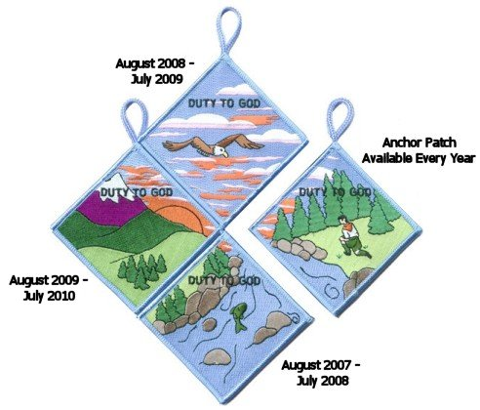
“Duty to God” is at the heart of the Scouting movement. Religious emblems reinforce this spiritual component and promote many of the values found in the Scouting program. The purpose of this “Duty to God Promotion Patch” is to encourage youth and adults to learn about and promote the religious emblems programs.
Requirements –
Youth and adults must:
- Attend or coordinate a presentation or information seminar on religious emblems (sample resources and suggestions are available at www.praypub.org ).
- Make a commitment to fulfill their “Duty to God.”
Here are some examples:
- Adults can commit to having 50% of families participate in the religious emblems programs, nominating a worthy adult to be recognized with an adult religious award, serving as counselor in their local congregation, etc.
- Youth can commit to earning the religious emblem of their faith at an appropriate time, making a presentation on religious emblems to another unit, helping younger Scouts earn their religious emblem, etc.
The Patch
- The Duty to God Promotion Patch is a four-segment puzzle patch.
- Only one segment will be offered in any given year.
- Participants are encouraged to earn all four segments over a four-year span.
- Visit www.praypub.org to find out which patch is currently available.
- Patches may be pre-ordered for distribution at the presentation/ information seminar.
The DVD
The Duty to God Promotion DVD contains the resources to make a presentation on the religious emblems programs. These resources include the video “Promoting Duty to God (Religious Emblems),” Duty to God brochure/chart listing all religious emblems (No. 05-879), scripts (for presentations to Cub Scouts, Boy Scouts, and Venturers), and Parent Handout.
Making a Presentation
- Find scripts, videos, handouts, and other resources at www.praypub.org
- Invite parents
- Provide information on emblems of ALL faiths
- Encourage Scouts to make a commitment to earn their religious emblem
- Present the Duty to God Promotion Patch to participants
Call and talk to the "Religious Emblems People" today!
1-800-933-7729 or visit them at www.praypub.org
Knot of the Month
Tiger Cub Den Leader Award
www.usscouts.org and www.scouting.org
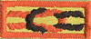
Tenure
- Complete one year as a registered Tiger Cub Den Leader.
Dates of service used to earn this award cannot be used to earn another key or award.
Training
- Complete "The New Tiger Cub Den Leader" Fast Start training.
- Complete basic training for Tiger Cub Den Leaders.
- Complete Youth Protection Training.
- During your tenure for this award, participate in a Cub Scout leader pow wow or University of Scouting, or attend at least four roundtables.
Performance
Do all of the following:
- Conduct a Tiger Cub roundup for your pack with at least five new Tiger Cub boy/adult teams recruited.
- Contact the host team each month and provide support as needed for one year.
- Coordinate Tiger Cub den participation in three Cub Scout pack activities each year.
- Graduate a Tiger Cub den into Cub Scouting with at least 60 percent of the Tiger Cubs becoming Cub Scouts.
- Report on the progress of Tiger Cub dens at 75 percent of pack leader meetings
For a scorecard to log your progress for this award, go to
http://www.scouting.org/forms/34169/50.pdf
GATHERING ACTIVITIES
Note on Word Searches, Word Games, Mazes and such – In order to make these items fit in the two column format of Baloo’s Bugle they are shrunk to a width of about 3 inches. Your Cubs probably need bigger pictures. You can get these by copying and pasting the picture from the Word version or clipping the picture in the Adobe (.pdf) version and then enlarging to page width. CD
Road Sign Game
Grand Teton Council
Road signs like these are important to drivers, Can you think of some games that can be played to help you learn the signs?? Or maybe have your Cubs create a game or three??
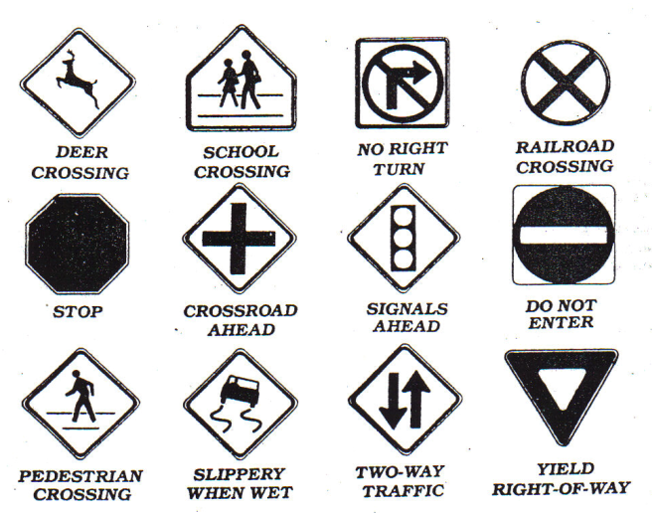
HHHMMmmmmm - this looks like the start of a BINGO board to me Just add in a few more signs and produce some cards with the signs in different orders. CD
How about Road Sign Dominoes for gathering?
Hide the signs around your meeting area and then have the boys find them and mark them off on a card.
What else can you think of creating?? Please send me a note about what you created. Thanks CD
Do You Know Cars?
Grand Teton Council
Each of the definitions below describes a car. Can you name them?
(You may need your parents' help, some of these are no longer manufactured!! CD)
1. Our 16th President?
2. River in New York?
3. First Colony in New England
4. Indian Chief
5. Theater in which Lincoln was shot
6. A spotted horse
7. A hawk
8. A motherless calf
9. A wild horse
10. One who travel and finds new things
Answers
1. Lincoln; 2. Hudson; 3. Plymouth; 4. Pontiac; 5. Ford; 6. Pinto; 7. Falcon; 8. Maverick; 9. Mustang; 10. Explorer
Transportation Quiz
Grand Teton Council
- A form a transportation that does not run on wheels is_____.
Skateboard Snow-mobile
Blade skates Tank
- The inventor of the wheel is unknown, but the first record of a wheeled vehicle goes back 5,000 years to ancient ______.
Babylonia Sumer
Egypt Greece
- The wheel is a form of a simple machine called the______.
Pulley Wedge
Screw Lever
- The earliest wheels were made of ______.
Joined wood slabs Bronze
Chiseled stone Iron
- The first important improvement in construction was the ______ wheel.
Wire Disk
Welded Spoked
- A major improvement in the wooden wheel was _______
An iron rim Harder wood
Flat area elimination Axle lubrication
- Starting with the 13th century, a person who made and repaired wheels was called a _________
Wheelwright Wheelie
Wheeler-dealer Wheelsman
- Around 1830, a new kind of wheeled vehicle began to appear, the ________.
Steamboat Stanley steamer
Shaftmobile Steam locomotive
Answers: (1) Snowmobile (2) Sumer (3) Lever (4) Joined wood slabs (5) Spoked (6) An iron rim (7) Wheelwright
(8) Steam locomotive
OPENING CEREMONIES
Car Show
Capital Area Council
Have 7 boys hold up the letters to spell, “CARSHOW.”
The fronts should have the letter and an appropriate picture.
The back (toward the cub) should have his part in LARGE letters.
One at a time, in order, have them read their part.
- C – Cub Scouts
- A – Are
- R – Ready
- S – to Show
- H – How
- O – Our Cars Go!
- W – Welcome. Please join me in the Cub Scout Promise.
Destination Cub Land
Capital Area Council
People: 6 Cubs with speaking parts and two Cubs holding the bus
Props: Large cut out cardboard bus with open windows or windows set as flaps from which a Cub can stick out his head
Set Up: Have two Cubs walk onto the stage carrying a cardboard cut out of a bus.
Have the 6 Cubs with speaking parts walking along on the side of the bus away from the audience.
As their turns occur the Cubs stick their heads out of the windows
- Ladies and gentlemen, the destination of this bus is Cub Land. It’s an attraction which offers more than Disneyland, Kings Island, and television combined.
- When you get to Cub Land, you will find fun and crafts projects to make
- You’ll find games and songs.
- Cub Land has great treats such as weekly den meetings and trips.
- Each month there is fun filled pack meetings with awards, skits, and songs.
- Webelos Scouts in Cub Land work on exciting Activity Pins and visit Boy Scout Troops.
(Proceed with a patriotic ceremony).
A History of Transportation
Capital Area Council
Materials: Narrator and 6 boys with a model or picture of the following: Foot, wheel, boat, engine, airplane and rocket.
- (foot) Man learned to get from place to place, running set a faster pace.
- (wheel) Then he invented the wheel to show how much further he could go.
- (boat) The boat helped us carry more. Now we travel from shore to shore.
- (engine) Engines helped us travel far. Almost everyone owns a car.
- (airplane) On airplanes we travel fast. The jet age has arrived at last.
- (rocket) Rockets fired into space, have taken us past the moon’s face.
Narrator: Transportation has changed our lives and so have the vehicles used. These vehicles play an important part in our lives, either taking us places or bringing us goods and services. Cub Scouting is also a vehicle. It takes us places by inspiring us to look for new adventure outside our homes. And just as cars and engines need fuel to go, so do we. We need new ideas, new incentives, and new opportunities. Trains, planes, buses and ships need crews to keep them going. We do to. We need our parents and leaders to work together to keep the dens and pack going. I’m glad you are on board. We have a wonderful ride in store for you.
Pinewood Derby Opening
Capital Area Council
Have 8 boys hold up the letters to spell, “PINEWOOD.”
The front (toward audience) should have the letter and an appropriate picture.
The back (toward the cub) should have his part in LARGE letters.
One at a time, in order, have them read their part.
- P A Pinewood Derby is fun for all,
But the whole family must answer the call.
- I I will enter the competition real soon
To win or lose or whatever my doom.
- N Neatly I painted my car with dad's expert help,
But please let me run it all by myself.
- E Excitement runs all though the night,
No matter who wins, it will be alright.
- W We would all like to come in first,
But if not, our bubble wouldn't burst.
- O On with the races, don't hesitate,
For this Pinewood Derby can't wait.
- O Open the gates, down the track; then we can rest.
For, being Cub Scouts, we've done our best.
- D Don't mind tonight, where your car places;
Cub Scouting will help you through all life's races.
Pinewood Derby Opening
Capital Area Council
With a little modification, this would be a great Cubmaster's Minute for closing. CD
If you take a moment tonight to contemplate these cars, you will realize that an awful lot of painstaking work went into each one. There is much creativity and ingenuity represented here. I don't know, but I imagine that each car was designed to be the fastest. Of course, not all cars will win. As we begin our pack meeting, keep in mind that in Cub Scouting, as in life, the victors are those who put forth earnest effort. As a great marathon runner from Kenya, a country in Africa, once said "To win is to finish. To finish is to win." Please join me in the Pledge of Allegiance.
Things That Go
Grand Teton Council
Cub Scouts line up and hold their posters up as indicated below. On the front (facing audience) is the appropriate picture. On the back in LARGE print is the Cub's part.
- (word "GO") Wheels, wings, and rudders make many things go, All invented by men I'm sure you all know.
- (Model-T Ford) Henry Ford was an important man, for he helped invent n car, He made it in mass production, and made it to go long and far.
- (Spirit of St. Louis plane}"'Lindberg was a man whom we've all read about, He helped build a plane that made the world all shout.
- (Steamship) Robert Fulton did his part in making something that would go, The steamship made him famous, about steam he sure did know.
- (Steam Engine) James Watt, too, became famous, for something that would go, His improvements on the steam engine, year after year did grow.
- (Large wheel with the word "THANKS" for spokes) So you see men such as these, make our country grow, And we're thankful to them, for inventing things that go.
- (U.S. map) So, as we're thinking about the men who have made our nation go, Let us now salute the flag, ever thankful for all that we know.
- Will the audience please rise. Those in uniform, salute. Those not in uniform, place your hand over your heart. Please join me in the Pledge of Allegiance.
Models for the Future
Grand Teton Council
The Cubmaster shows a model of a futuristic car and says: Cub Scouts, here is a great looking car. It is the builder's vision of what cars may look like in the future. We can't be sure that he's right. But we can be sure that the world is going to need good men in the future. And we can be sure that we will all be good men if we remember to follow the Cub Scout Promise. Let's remember that as we stand and repeat the Promise. (Leads audience in the Cub Scout Promise.)
This could also make a great Cubmaster's Minute for Closing. Your choice. CD
Wheels Opening
Grand Teton Council
Props: Each Cub has appropriate clothes or gear to illustrate his line.
Den Chief: There are a lot of ways to have fun with wheels. Let's see a few in action:
- I have fun riding my bicycle.
- I like to go rollerblading.
- Trains are my thing.
- A go-cart is the vehicle for me.
- Riding cross country in a truck is my type of fun.
Den Chief: As you can see there are many ways for Cub Scouts to have fun with things that have wheels. Trains and trucks are more than just fun, though. They are all important in the development of our country. Let's stand and honor their inventors as we say the Pledge of Allegiance.
SPORTSMANSHIP
Baltimore Area Council
Equipment: Cards with letters spelling S-P-O-R-T-S-M-A-N-S-H-I-P on the front and the Cubs' parts on the back in LARGE print.
CUBMASTER: Tonight we will have our Pinewood Derby. Will the boys who were asked to help, please come forward? (Boys hold up letters and explain what each letter stands for.)
- S Smile, even if you hurt inside
- P Plan to have a good time
- O Only use kind words
- R Respect the feelings of other Cub Scouts
- T Try your best
- S Speak positively of others
- M Master the art of self-control
- A Anger has no place in our meeting
- N No pouting
- S Success in “doing your best” is possible for every Cub Scout
- H Hush those words of bragging
- I Inappropriate comments and actions are not welcome
- P Participate in the derby for FUN!
CM: Let’s remember the word SPORTSMANSHIP throughout our Pinewood Derby tonight. Please stand and repeat the Pledge of Allegiance.
Cars & Wheels
Great Salt Lake Council
Welcome to our Pack Meeting. Our theme is Cub Scout Car Show and probably just about all of you arrived on some sort of wheels. Wheels have given us a great freedom to move about our neighborhood, our town, our state, and this great country of ours. However, with that freedom comes an equal responsibility. We have to use our wheels safely. Car wheels, bicycle wheels, scooter wheels, skateboard wheels: all come with different responsibilities and safety rules. Car drivers should obey the speed limit. Bike riders need to obey road regulations when riding, and pedestrian regulations when walking their bikes.
In the same manner, the Declaration of Independence and the Constitution give all citizens certain rights, but with those rights, come responsibilities. Let’s all stand and say the pledge to the flag of our great nation.
PIECE OF WOOD
Baltimore Area Council
Equipment: Piece of wood, item carved out of wood
CUBMASTER: (holding up piece of wood) This is a plain piece of wood, but with imagination we can make many things from it. This is also true of a Cub Scout. From the beginning, you learn many skills in Cub Scouting that will make you a better person.
ASSISTANT CM: (holding up item carved out of wood) This is carved out of a plain piece of wood to become something beautiful. We hope to carve a boy into an adult who is a responsible citizen. You help us to this by learning about citizenship, love of country, and love of God as you advance through each rank.
CUBMASTER: Please stand and say the Pledge of Allegiance with me.
AUDIENCE PARTICIPATIONS
Trouble with the Car
Capital Area Council
30 cards with the following words written on them are shuffled then placed face down on the head table. Cubs line up to pick a card and read it as the Narrator reads the story and pauses for an answer. Cards that are used are kept by the leader, not to be used again.
A Den Leader A Cub Scout A Neckerchief
A Roundtable An Achievement A Cubmaster
A Webelos Leader A Year Pin A Pack Meeting
An Elective An Arrow A Patch
A Uniform A Skit A Craft
A Game A Ceremony A Webelos
A Wolf A Bear A KISMIF
A Song A Den A Knot
A Promise An Akela A Banquet
A Pow Wow A Pack A Council
An alternate maybe to randomly assign numbers and have the people read their cards in numerical order.
Once upon a time, my assistant Cub Leader and I decided to drive out of town with our den for a picnic. We loaded a basket with ________, ________, and _______ and other tasty things. Then we drove off with our lunch in an old car that belonged to a friend. The cap on the radiator was decorated with _______ and holes in the roof had been patched with ______ and _____.
As we drive along, my assistant leader pointed to the side of the road. “Oh, look at that bush with _____ and_____ growing on it. Let’s stop here,” she said. We carried the basket to some shade cast by _____ and spread out _____ to sit upon. Nearby, _____ sang gaily in a tree and some low bushes had _____ and _____ growing upon them. Our den was having a wonderful time. “There’s nothing as delicious as _____ with mustard and relish,” said our cubs. “Yes,” I sighed. “However, it is getting late. Maybe we’d best start for home now.”
But our car refused to go. The motor made a noise like _____ and then stopped. “Oh dear,” said our leader, looking under the hood. “I think I see _____ and _____ caught in the gears.” “Impossible,” I said. Are you sure the tank isn’t empty? Are you sure you put in enough ______ before we left home?” “Of course I did,” said our leader. “It must be the wheels. We’ll jack them up with _____ and _____ and then replace them with _____.” Our leader covered her dress with _____ and took _____ to loosen the bolts.
Just then a former drove up and asked if he could help us. “Looks like _____ in the engine,” he said, tightening a bolt with _____. Then he stepped back and the car started. “I just connected _____ to _____, which had rattled loose.” We gave him the rest of our _____ and _____ to show our appreciation and drive happily home again.
The Big Race (Audience Participation)
Grand Teton Council
Narrator reads the following like a radio announcer with a lot of enthusiasm!
Divide audience into four groups. Assign each a word and a response they are to say when that word is read. Practice as you make assignments.
WHITE = Whiz!
RED = Zoom!
YELLOW= Zip!
BLUE = Ca-Chunk!
The cars are ready.
The flag us up.
The race is set to go.
The flag goes down,
The cars are off...
They're running toe to toe!
The WHITE car is ahead.
The RED car goes by.
Here comes the YELLOW car now.
Here comes another one - it's BLUE.
Whew, it sounds bad, wow!!
The last lap now.
The RED car is leading,
The YELLOW car and WHITE car are close behind.
I'm looking hard — I see the BLUE car.
So far back, it's hard to find!
The finish line is just ahead.
That BLUE car is coming up fast,
I can't tell why ...
The crowds on its feet...
They're yelling -
The WHITE car, the RED car,
The YELLOW car, and the BLUE car,
HAVE ALL FINISHED IN A TIE!!
The Big Wheel
Divide the audience into four groups assign each group a word and a response when that word is read. Practice the responses as you make assignments.
Big Wheel= Spin, spin
Canoe= Paddle, paddle
Airplanes= Zooooom
Cars= Rattle, rattle, bang, bang
Caution there are a lot more Big Wheel(s) in this than the other parts. Maybe you would want to make it that ALL respond when Big Wheel(s) is read. CD
Man has invented may different things which go and have provided him with transportation down through the years. The Indian made his CANOE which took him from place to place and served his purpose well. Men like Henry Ford invented CARS which today are the most popular type of transportation. There were men like the Wright Brothers who pioneered the invention of the AIRPLANE. And then there is a group of people called the BIG WHEELS who really don't go any place or do anything, but they like to feel important.
This story is about one of those BIG WHEELS who just sat and spun his wheels and felt so important while he was doing nothing at all. Everyone around him was working on new and better types of CANOES, designing new and more efficient CARS, and designing and testing new and faster AIRPLANES. But our BIG WHEEL just sat around feeling important, not doing anything to help anybody, while everyone else was doing the work.
Somehow he always seemed to get by and fool people into thinking that he was important because everyone around him was making progress. The BIG WHEELS depended on their brains and energy to make him look good. Finally, one day something happened that changed things overnight for the BIG WHEELS.
Everyone who had been working on the CANOES, the CARS, and the AIRPLANES decided it was time to teach the BIG WHEEL a lesson. They were tired of him doing nothing except acting important. So they all became very busy and didn't pay any attention to him. When something came up, the BIG WHEEL found he couldn't rely on the others to answer questions and make him look important. Finally, the BIG WHEEL realized that he could not accomplish anything without help from others. He realized he was making no contribution to the world at all. He was just sitting there spinning his wheels while the others accomplished a lot of CANOES, CARS, and AIRPLANES. BIG WHEEL felt very bad.
It was a terrible feeling when BIG WHEEL finally realized something he should have known all along. If you're going to get any place in this world, you can't expect other people to do all the work. You must learn to do your part and drive your own CAR, fly your own AIRPLANE, and paddle your own CANOE.
Go-Cart Derby
Santa Clara County Council
Divide audience into three parts. Assign each group a phrase and an action to do when they hear that phrase. Practice as you make assignments.
DOWN THE HILL “Zoo-oo-oo-mmmmmmm”
THE STRAIGHT AWAY “Swooo-oo-sshhh”
AROUND THE CORNER “Zip-zip-zip”
In a small town in the mid-west every year, there was held a big go-cart derby for all the boys in the town. This event was planned for many months in advance and was looked forward to with much anticipation by all the boys. The boys and their parents worked for months on building go-carts that would race DOWN THE HILL coast beautifully on THE STRAIGHT AWAY and go AROUND THE CORNER like winners. Each family worked hard to see if theirs could be the top winner in the derby. All over town, you could see the go-carts being tested DOWN THE HILL, THE STRAIGHT AWAY and AROUND THE CORNER.
One day, as they were making their test runs before the big race, one little boy named Johnny discovered that if he went DOWN THE HILL, AROUND THE CORNER , he would run farther THE STRAIGHT AWAY before his
cart came to a stop. He had found the ideal spot for the race. After trying it several times, he hurried to tell some of the parents about this spot, hoping that they would hold the Derby there this year.
Several parents came out and watched Johnny’s go-cart go DOWN THE HILL, AROUND THE CORNER and on THE STRAIGHT AWAY. They agreed that this would be a good spot to hold the race, except that Johnny had overlooked one thing – the go-carts were fine going DOWN THE HILL and AROUND THE CORNER, but it was when they came to a stop on THE STRAIGHT AWAY that they had problems. You see, they came to a stop right in the middle of a drive-in restaurant.
The parents got together and decided to talk to the restaurant owner. As a result, the owner agreed to close his restaurant during the Derby race and the whole town turned out to watch the go-carts race DOWN THE HILL, AROUND THE CORNER and into THE STRAIGHT AWAY. What a spectacular race it was!
After the race was over, everyone decided that, since the restaurant owner had been so generous to close his restaurant during the race, that they would all buy their dinner there that night. After all, driving those go-carts DOWN THE HILL, AROUND THE CORNER and into THE STRAIGHT AWAY had made all the boys very hungry, and the shouting and cheering done by the parents had helped them work up a good appetite, too. The restaurant owner was happy because he sold more hamburgers than he had ever sold in one day.
An agreement was made with the restaurant owner that every year they would hold their go-cart derby in that same spot, with the carts racing DOWN THE HILL, AROUND THE CORNER and into THE STRAIGHT AWAY to the drive-in restaurant. They would all celebrate afterwards and buy those delicious hamburgers. So, you see, kindness and consideration to others can make things go better for everyone.
The New Car
Santa Clara County Council
Tonight I’m going to read a little story about a couple that go shopping for a new car. But the story is really rather dull. I’d like you to help me make the story livelier by joining in when I read certain words. Whenever I say these key words, please follow these instructions; it’ll help the story a lot!
- If you have blue eyes, whenever you hear the word BLUE pat the top of your head.
- If you have brown eyes, whenever you hear the word BROWN pat the top of your head.
- If you hear the word LEFT and you’re left-handed, clap your hands.
- If you’re right-handed, clap when you hear RIGHT.
- If you’re under 20, stomp your feet when you hear the word NEW.
- If you’re over 20, stomp your feet when you hear the word OLD.
- If you’re a male, stand up when you hear MAN.
- If you’re a female, stand up when you hear WOMAN.
At this point the Narrator should practice with the audience, calling out the cue words having them respond with the appropriate action. The Narrator begins the story slowly and picks up speed Narrator pauses after each key word.
One day a MAN and a WOMAN went looking for a NEW car. Their OLD one, which was a muddy BROWN was not running well. It LEFT much to be desired in the way of speed and safety, and they wanted another one RIGHT away. They wanted a bright BLUE one.
As they walked into the dealership, the WOMAN noticed a BLUE sports car on the showroom floor. “Darling” she said, “Look at that lovely NEW car RIGHT over there. Wouldn’t it be perfect for us?’
“You may be RIGHT. It’s a lot better looking than our OLD BROWN buggy. Unfortunately there’s one problem. I’ve LEFT all my money at home,” said the MAN.
“You LEFT it at home?” asked the WOMAN.
“Yes, it’s RIGHT in the pocket of my NEW BROWN suit.” said the MAN.
“Your NEW BROWN suit? Why I took that suit to the cleaners just this morning and I didn’t notice any money in any of the pockets,” said the WOMAN.
“But I’m certain I LEFT my money in the inside RIGHT pocket of my NEW BROWN suit,” the MAN said as he scratched his head in wonder.
“Now wait a minute. Are you saying I’m not RIGHT? Are you saying I’m lying about this? MAN, oh MAN, oh MAN! You have a lot of nerve!” shrieked the WOMAN.
“Let’s not argue. We’re here to look at cars, and that BLUE one in the corner is a RIGHT nice model. And just think, if we buy the NEW BLUE car, we’ll never have to worry about our OLD BROWN one again!”
After looking at the price of the NEW BLUE-car, and figuring out what they could get as a trade on their OLD BROWN one, the MAN and the WOMAN decide buying a NEW car would be the RIGHT move for them. But before they LEFT the dealer, they started questioning their decision. Would they be better off with their OLD BROWN car if the NEW BLUE one didn’t run RIGHT? Or what about a NEW BROWN one? How long before they thought of the NEW car as and OLD car? and would they ever feel BLUE about trading in their BROWN auto? BLUE or BROWN, OLD or NEW, what was RIGHT and which car did they want to be LEFT with?
The MAN and the WOMAN were so confused that they decided to sell their car and buy themselves bicycles. And that’s just what they did. And they knew it was RIGHT...LEFT...RIGHT... LEFT (The narrator continues alternating between right and left until the audience realizes they are applauding the end of the story.)
ADVANCEMENT CEREMONIES
Traveling Advancement Ceremony
Grand Teton Council
I modified this a little for more cars and less other things and added in Webelos Rank that was not here. I am sure with some time and thought you could do better. If you do use this and modify it, drop me a line with how you changed it. Thanks CD
Props: Large pictures/posters of cars that match the descriptions
Cubmaster: The boys in our pack have not just been spinning their wheels and not going any place. We'll see tonight how many of them are reaching their destination.
Our Bobcats have really been "wheeling along" (picture of a small economical car (Volkswagen or similar) and learning the "rules of the road." Will _________ and their parents wheel on up here and receive your Bobcat license that will keep you on the Cub Scout road?
"Chugging along"(picture of a Jeep (SUV) (Not Hummer or Land Rover)) over the mountains and through the woods are our Wolfs. Some of them tonight are ready to pull up at the top of Wolf peak. (Have boys and their parents "come on up" to Wolf peak for their Wolf rank.)
We also have some Wolfs who are really loading up and have earned some Gold and Silver Arrows. (Call boys and their parents forward.)
Not to be outdone, is our Bears who are really "cruising along"(picture of a Police cruiser or luxury automobile) this month. Some have cruised right through the Big Bear Book and earned their Bear. Will ________ and their parents park their wheels and come up here to receive their license to continue cruising through their BEAR year?
The following boys have done some extra cruising and earned their Gold and Silver Arrows. (Call boys and parents forward.)
Our Webelos really "zoomed" around this month. (Picture of a sports car (Corvette)) learning to be good Citizens(first year) and Communicators (second year) Let's have them zoom up here and tell us about the exciting month they had. (Call boys forward who have earned Activity Badges this month)
And some have climbed even harder and higher (Picture of Land Rover or Hummer) reaching the height of Webelos Rank.
The big event that all of you boys are racing toward (Show picture of NASCAR Race Car) has been reached by a few of our Webelos Scouts tonight-----that of the Arrow of Light. This is the farthest and highest that anyone can go in Cub Scouting. (Call boys and their parents forward to receive their Arrow of Light.)
Pinewood Derby Advancement
Grand Teton Council
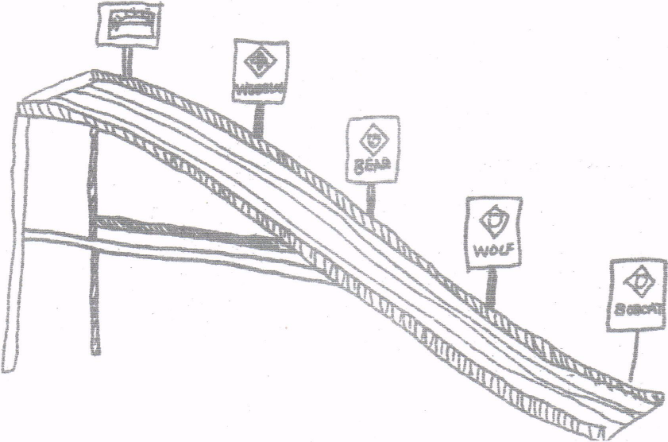
Personnel: Cubmaster, Advancing Cub Scouts and their parents
Equipment: Pinewood Derby Track, Badges of Rank or decals of them and awards to be given to the boys.
Set Up:
- Put decals or actual badges on stiff cardboard and attach to eight-inch-long sticks.
- Tape these on the track or on the side rails of the derby track in ascending order, Bobcat near the bottom, then Tiger, Wolf, Bear, Webelos, and Arrow of Light. If you have a boy graduate into a Scout Troop, have a Scout Badge at the top.
- At appropriate place on the track tape the badges and arrow points to be presented. (Fix everything ahead of time so there won’t be a boring time after the derby and before the awards.)
Cubmaster - We've all had a greet time tonight watching the pinewood derby cars race down this track. They really speed downhill don’t they? Well, you can go up hill on this track too. It is a little harder, but it is worth the climb from Bobcat to Tiger to Wolf to Bear to Webelos and to Arrow of Light. Some of our Cub Scouts who have made the climb as far as tiger please come forward with you parents
When boys and parents have assembled remove their awards from the track and have the parents pin badges on.
Do the same for the Wolf and Bear badges and the arrow points.
Have Webelos Den Leader take over for the Webelos badge and Activity badges
Cubmaster resumes if you are graduating a boy into the troop.
Advancement Ides
Grand Teton Council
Trouble - The Cubmaster and the Assistant Cubmaster dress up as a NASCAR pit crew. Announce that they see a Cub scout car in trouble. Drive over and pick him up and them carry him up front to give him his award. Announce that he is ready to reenter the Cub Scout race.
Remote Control - Have someone hide and drive the awards in with a remote control car. When it time to present an award it is driven on from off stage.
Here it comes! - If you are doing the Pinewood derby this month, attach awards to a Pinewood Derby car and send-it down the track to the recipient.
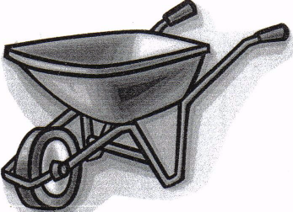
Wheely Proud - Clean out a wheelbarrow. Announce that we are "Wheely proud of our Cub Scouts that have earned awards". Go out into the audience and put them in the wheel barrow and bring them up front to award them.
Checkered Flag
Great Salt Lake Council
Prop: Checkered flag. I made one from a yard of Checkered Print bought for $2 at a material store. Attach to a pole or dowel.
Presentation:
- Cubmaster explains that it is customary and traditional for the winner of a NASCAR race to take a victory lap around the course with the flag waving then to come up to the winners’ circle with those who made it possible for the winner to win. There the winner would be awarded his trophy for the accomplishment.
- Name the first boy to receive his rank advancement.
- Give him the flag and have him run around the outside of the audience with everyone cheering and whistling.
- After he completes the lap have him bring his parents up to the winners circle to receive his award.
- Present the award.
- Lead a cheer
GRAND PRIX ADVANCEMENT CEREMONY
Baltimore Area Council
Personnel:
Cubmaster dressed as a race car driver (e.g., wearing a helmet and gloves and boots),
Four adults
Equipment:
Four black-and-white checkered racing flags,
Four 3-ft. dowels,
Toy car,
Stop sign,
Wheel from toy car
Set Up:
- Fasten checkered flags to the dowels.
- Attach awards to the items listed below.
- Create other awards as needed.
- Create a tunnel for boys to walk through to receive awards by having four adults hold flags.
Awards Sayings
- CAR: “You zoomed right into first place when you earned your _____.”
- STOP SIGN: “Way to go for earning your _____. There’s no stopping now!”
- WHEEL: “You’re on a roll now. We’ll (wheel) be proud to award you your ______.”
Car Show Arrow of Light Ceremony
Scouter Jim, Great Salt Lake Council
Jim prepared a theme related Arrow of Light Ceremony for each of the next 12 themes and was very kind to share them with me. If your Pack is like his and use age rather than grade, you may need a few of these. Thank you, Jim. CD
Props: Review “How-To-Book” on Cubanapolis 400 racing, page 6-18 for instructions on assembling a car from a box. Prepare a color or emblem (meaning) for various parts of the car, such as sides, wheels, headlights and tail lights, door, steering wheel, and key. If there is more than one boy, prepare extra cars and adjust ceremony. Have 4-6 items of information obtained about the Cub(s) ahead of time to surprise them during the ceremony.
Cubmaster - Tonight, we are going to assemble an “Arrow of Light” car. The frame for the car gives it structure and stability. Compare this structure to the requirements needed for the Arrow of Light. The color of the pack “Arrow of Light” car is very important. Give the car some color either the colors/values, emblem, etc. and explain the meaning of the Arrow of Light.
There are lots of things on the inside of a car that helps it to run at high efficiency. I wonder what our “Arrow of Light” car has that helps it run at full throttle? Pull items out of box and display items highlighting the Cub.
Every car has great wheels. Wheels help the car roll down the road. Our Webelos den leader helps our “Arrow of Light” car roll down the road. We would like our den leader to come share with us an activity/service that helps our “Arrow of Light” car. Den Leader can then put on wheels.
Headlights light the way to move forward and tail lights show us where the car is ahead of us. On our “Arrow of Light” car, we would like the parents to share some service/activity that is unique about their son. Parents then put the headlights and tail lights on the car.
We have a door here. It needs to be put on. The only person who can open this “Arrow of Light” car is _____. Will Cub share a favorite experience he did to earn the Arrow of Light award and open the door? Cub then puts on door and states the Scout Oath or Law.
This car is about done. We still need two things, a steering wheel and key. On the Steering wheel have the pin and patch. The Cub then gives the pin to his mom with the “Mother’s Salute,” after which, the Father can present the award with the Cub Scout or Scout handshake. The Cub can start the car with the key by leading everyone in his favorite cheer! The boy can then take his car home.
SONGS
Pinewood Derby Racing Song
Grand Teton Council
Tune "Take me out to the ball game"
Take me out to the pinewood,
Take me out to the crowd.
Buy me some graphite and a sanding block,
I don't care if I ever get back.
We will root root root for my racer,
If I don't win you can say.
That I cut, sanded and designed it my self
in the Cub Scout Way!
B'gosh their starting the race now,
I see my friend's in the heat
He's standing there biting his fingernails,
But I am sure that he'll never be beat!
For, We'll root root root for my den-mate,
If he doesn't win we can say.
That he cut, sanded, and designed it him self
In the Cub Scout Way!
The Scouts have declared a winner.
And I am proud to say,
My racer, it got to the end of the track.
And my den leader let me bring it back.
For a second heat in consolation.
Was my decision today.
But I cut, sanded, and designed it myself
in the Cub Scout Way!
FUN
Grand Teton Council
Tune: Auld Lang Syne
We're here for fun right from the start,
So drop your dignity,
Just laugh and sing with all your heart,
and show your loyalty.
May all your troubles be forgot.
Let this night be the best.
Join in the songs we sing tonight.
Be happy with the rest.
Pinewood Derby
Grand Teton Council
Tune: I've Been Working On The Railroad
I've been working on the Derby.
Planning my race car,
All the family has been helping.
My car should be the star!
Can't you hear the crowds a cheering.
As we win the prize?
Pinewood Derby time's exciting.
For all the Cub Scout guys,
TRANSPORTATION SONG
Grand Teton Council
Tune: Home on the Range
Oh, give me a train, or a boat, or a plane,
that will carry us Cubs far away;
To Paris or Rome- let us wander and roam.
And find new things every day.
Relax on a trail, float over the waves all day.
Or glide through the clouds far over the crowds.
But be home before five every day.
On a broomstick we'll ride,
in a rowboat we'll glide;
Take a trip to the moon in a rocket
And our trip will be fun,
but it soon will be done.
If we happen to hit an air pocket.
Up, up and away, let us orbit the far distant sun.
Or deep on the floor of the sea let's explore.
and as Cub scout we'll wheel into fun.
Pinewood Derby Song
Grand Teton Council
Tune: De Camptown Races
Cub Scouts all join in the song,
Do-da, do-da!
Pine car track is mighty long,
Oh, do-day-day!
CHORUS:
Going to run so fast,
Going to get ahead,
All my work made a blue pine car,
Somebody made a the red.
Black cars, blue cars, green and gray,
Do-da, do-da!
Are running on the track today.
Oh, do-da-day!
CHORUS
Pine cars do have lots of class.
Do-da, Do-dah!
Even though they don't use gas,
Oh, do-da-day!
CHORUS
They're the pride of all the Dens,
Do-da, do-da!
Built by Cub Scouts and their friends,
Oh, do-da-day!
CHORUS
Let’s Go For a Ride
Great Salt Lake Council
Tune: Ten Little Indians
Come everyone lets go for a ride
Start your engines we don’t need a guide.
Just hop in the car of your choice
A Mustang, school bus, or a Rolls Royce.
Gremlin, Vespa, Cadillac
Corvette, Rabbit, horse and tack.
Minivan, Cavalier, ATV
Limousine, Neon, SUV.
A Dodge with a Hemi, ain’t that super?
Or better yet, a Mini Cooper!
Motorcycle, taxi, or Ferrari
Hop into a forklift, you won’t be sorry.
Ambulance, Porsche, El Camino
Convertible, T-bird, or a Pinto.
Big rig, Charger, or a fire truck
Perhaps a crane so you don’t get stuck.
A 1998 Honda Accord
Maybe a Jeep so you don’t get bored.
Station wagon, bicycle, or a Hummer
A caboose is the end, oh what a bummer!
The Old Camp Truck
Great Salt Lake Council
Tune: John Brown’s Body
The old camp truck has a puncture in it’s tire,
The old camp truck has a puncture in it’s tire,
The old camp truck has a puncture in it’s tire,
So we patched it up with chewing gum.
Motions:
- ‘Ford’ – make a ‘brrrrmmmm’ sound as you pretend to shift into gear.
- ‘Puncture’– make a ‘ptsssss’ sound as you pretend that you are puncturing a tire with your finger
- ‘Tire’ – make a circle in front of you using both arms
- ‘Patched’ – smack your hands
- ‘Gum’ – pretend to have a wad of gum in your mouth and you reach up and pinch it between your thumb and finger and stretch it out in front of you
STUNTS AND APPLAUSES
APPLAUSES & CHEERS
Baltimore Area Council
PINEWOOD DERBY CHEER: Hold your hand over your head and bring it down as if it were a car coming down the track while saying, “Swooooooosh…..” then “Yay!”
Or from Alice, Golden Empire Council
Hold your right hand over your head and bring it down as if it were a car coming down the track, while going “Whoosh,” then “Thud” as it hits the bottom and end of the track.
Also from Alice, Golden Empire Council
Pinewood Derby Winner Cheer:
(To recognize a particular person)
Do as above, but at the end, yell out “_________ is the winner!!! (Repeat three times)
RACE CAR CHEER: Move hand forward like a race car moving down a race track and shout “V-V-R-R-o-o-o-m!”
Or shout "ZZZRRRrrrrrrOOOOOOOOOOOOMMMMMM"
Do it three times (at least!)!!
CHECKERED FLAG: Wave arm in figure 8 motions.
Great Salt Lake Council
CONSTRUCTION FLAGGER – Wave your arms and yell “Slow down!”
TRUCKER – Pretend you are driving a big rig. Reach above your head and pull the horn cord,
make a loud, deep “HONNK! HONNK!”
Trapper Trails
Pinewood Derby cheer –
Cubmaster yells, ‘Start your engines,”
Everyone places their car at the top of the ramp
(they raise their hands up in the air, fingers straight, palms down)
Then the cars go down the ramp
Everyone moves their hands in the shape of the track going “Whooooosh” all the way
It all ends as the car hits the bumper at the end
Everyone gives one big, loud clap
Harley Cheer -
Get on your motorcycle,
Kick start a couple of times saying, Vroom Vroom
Then give it the GAS and drive away.
Pop A Wheelie Cheer -
Pop wheelie leaning way back and saying, “EERRRRTTT!”
Den Yells
Grand Teton Council
Do three times, starting out softly,
and ending up really loud.
We're from Den (#)
Couldn't be prouder.
If you can't hear us,
We'll yell little louder.
Do once, LOUD!
United we stand.
Divided we fall! Den (#)
Is best of all!
Do once, LOUD!
Look out!
Here we come.
Den (#) Is on the run!
Do once, LOUD!
North, South, East or West,
Den (#) Is the best!
(LOUD, with ACTION!)
Clap your hands!
Stomp your feet!
For Den (#)
Can't be beat!
RUN-ONS
Great Salt Lake Council
- Scout 1: What words would you write on an old jalopy’s headstone?
- Scout 2: Rust in Peace!
Grand Teton Council
Joe: I saw you running along side your bike this morning.
Moe: Yes, I was late and didn’t have time to get on.
Knock, Knock.
Who’s there?
Targets.
Targets, who?
Tar gets all over my shoes when I walk down the street.
Teacher: Jimmy, your drawing of a stagecoach is very well done, but it has no wheels. What holds it up?
Jimmy: The bad guys!
A boy walks across stage carrying a car door.
He is asked why he is carrying the car door.
The boy demonstrates as he says, so that he can roll down the window when it gets hot.
- A man whose son had just passed his driving test went home on evening and found that the boy had driven slap bang into the living room.
- (Father)-How did you manage to do that?
- (son)-Quite simple, Dad. I came in through the kitchen and turned left!
- Stop! This a one way street.
- Well, I’m only going one way.
- How many elephants can you get into a small car?
- Four: Two in the front and two in the back..
- How many rhinoceroses can you get into a small car?
- None, it’s full of elephants.
- Stop! This is a one way street.
- Well, I'm only going one way.
Capital Area Council
Cub 1: Did you hear about the wooden car with the wooden wheels and the wooden engine?
Cub 2: No, I didn’t hear. What happened?
Cub 1: It wooden go!
Cub 1: I’ve come to buy a car, but I don’t remember the name. It starts with a “T”.
Cub 2: Sorry, we don’t have any cars that start with tea. All our cars run on gasoline.
Cub 1: Son, here are the keys to my magic car.
Cub 2: Is it really magic?
Cub 1: Yes, one speeding ticket and it will disappear!
Cub 1: This is a ticket for speeding.
Cub 2: Wonderful! When do I get to use it?
Cub 1: What kind of shot do you give a sick car?
Cub 2: A Fuel Injection
JOKES & RIDDLES
Tongue Twisters:
Alice, Golden Empire Council
Red Buick, blue Buick
We're real rear wheels.
Real weird rear wheels
Knife and a fork bottle and a cork
that is the way you spell New York.
Chicken in the car and the car can't go,
that is the way you spell Chicago.
The little red lorry went down Limuru road.
Limuru (Lee-moo-roo) road is a the name of a road in Kenya.
Grand Teton Council
What driver doesn’t have a license?
A screw driver.
What has a head, can’t think, but drives?
A hammer
What happened when the wheel was invented?
It caused a revolution!
What do you call a song played on car horns?
A car tune.
When is a car not a car?
When it turns into a garage.
What do you get when you cross a motorcycle and a funny story? A Yamaha ha ha ha!
Why did the Cub Scout take peanut butter bread with him in the street? He was looking for traffic jam.
Why can’t bicycles go as fast as cars?
Because they are “two” tired.
What did the jack say to the car?
“Can I give you a lift?”
What part of a car is the laziest?
The wheels. They are always tired.
What would happen if everyone bought a pink car?
We would be a pink car nation.
How do you change a duck’s tires?
With a Quacker Jack.
Alice, Golden Empire Council
What kind of car does Mickey Mouse's wife drive? A minnie van!
Why did the new racing driver make ten pit stops during the race? He was asking for directions!
Cub #1: Our car won’t start, and my mom says there’s water in the carburetor.
Cub #2: How does she know there’s water in the carburetor?
Cub #1: Because the car is in the swimming pool
SKITS
Pinewood Derby Check In
Great Salt Lake Council
Set Up: Cub Scouts are bringing in their derby cars for their Pack meeting.
Cub #1: (to Cub #2) “Hey! That’s a nifty car! Did you make it?”
Cub #2: (to Cub #1) “Nah! My dad did! Did you make yours?”
Cub #1: (to Cub #2) “No Way! My granddad did mine!
(Cub #3 enters)Wow! Look at that one! Hey! Who made yours?”
Cub #3: (to Cubs 1&2) “Oh, Hi! Like it? My mom made mine!”
Cub #2: (Cub #5 enters) “Look at that funny one coming in! I wonder who made his, his Great-Great-Grandpa?” (Cub #4 enters)
Cub #3: (to Cub #4) “Who made your car?”
Cub #4: (to all Cubs) “I did! My dad & mom said I needed to learn to follow instructions and this was a way for me to learn!”
All Cubs: “Oh! Wow! Your car is the best!”
The Human Ford
Capital Area Council
This is one of the most laughable skits imaginable. The Cub Scouts appear on the platform and take their positions. Four of them represent the car occupants, including the driver. They arrange four chairs and seat themselves, two in front and two in back. A young man then assumes a leapfrog position in front of the chairs. He is the engine and radiator. On the top of his head he has tied a baking powder or soda can. Four others group themselves around the chairs as the wheels. They stoop and hold their ankles. An extra tire is on the back. The Ford is not ready to go.
The driver gets out, and taking hold of the extended hand of the “engine” he cranks the machine. The “engine” begins to purr in an engine fashion and then sputters out just as the driver starts to get back into the Ford. He cranks it again and then they start. The riders can inch their chairs along, the rest of the Ford moves with them.
There is hissing sounds and the back tire nearest the audience flattens out. The driver gets out, makes the people in the back seat get up, pretends to get his pump, applies it to the tire and goes through the motions of pumping air into it. The tire rises slowly as if being inflated.
The next mishap is the radiator running out of water. The driver takes off the cap (which is the baking powder/soda can) and pretends to pour in the water. They get started again (after the driver cranks ups the engine again), and shortly after they start along, there is a blow-out. Someone in the car on the side away from the audience has a tightly blown paper bag and he pops this and the front tire next to the audience flattens out. The driver gets out, mops the perspiration from his brow, and after getting imaginary tools, takes the wheel off. It is well to remember here that there are four lugs on a Ford. He then rolls the tire to the rear and gets his extra tire. Then he puts on the extra tire, putting the old one in the place at the rear.
Next a police officer riding an imaginary motorcycle and making all the accompanying noises catches up with the Ford and stops it. He pretends to take the number and the necessary information, the driver pretends to sign something and the officer rides off.
The final mishap is engine trouble. The driver gets out, lifts the hood, (the radiator’s coat) on one side, then on the other. He soon has the trouble fixed, and the Ford must be restarted by cranking the “engine” again.
Remember, each time the car stops, it must be re-started again, by the driver cranking the engine.
This skit is funniest when not a word is said.
Who Am I?
Capital Area Council
Need: 8 actors – one for the narrator and one to deliver each verse. Make a placard for each verse (small for the Cub to read) and with the famous person’s name large enough for the audience to read. (Shown here in parentheses).
After the actor has delivered his verse, and allowed a short time for the audience to guess the subject, the actor turns over the card to reveal the name on the placard.
The Narrator recites the first two verses.
No costumes or scenery are required.
Narrator:
Transportation through the years
Has changed, we are aware.
Because some men had a vision,
And were not afraid to dare.
Although we see the evidence
Of all that they have done,
Let’s see if you can guess their names
Presented, one by one.
- Until I came along and helped,
Fat boats were just a dream.
For I got rid of sails and oars;
I gave the boat its steam!
Who am I? (Robert Fulton)
- I gave o life its “ups and downs”
So many men would say
The elevator makes tall buildings
Possible today!
Who am I? (Elisha Otis)
- As people peddle down the street,
From Grannies to little tykes,
They all owe me a debt of thanks,
‘Cause I invented bikes!
Who am I? (Pierre Lallement)
- As trains crisscross the continents,
My humble head is bowed.
“Father of the locomotive” is
The name of which I’m proud!
Who am I? (George Stephenson)
- As soon as you say “airplane,”
Our names quickly come to mind:
But when we started, pilots were
Quite difficult to find!
Who are we? (Orville and Wilbur Wright)
- ‘Though I did not invent it,
I played a major part
In mass-producing autos. I’d say
I gave the car its start!
Who am I? (Henry Ford)
- I’ll have a fuel-less motor
That will hit the marketplace,
And stop pollution of all kinds
And go faster into space.
Who am I? (YOU?)
Wheels That Go
Grand Teton Council
This is a question and answer skit. Two sets of answers are given and should be used according to whether you wish the skit to be serious or silly. A Cub can read each riddle and another Cub may answer or the audience may be asked to guess the answer.
- I run on boy power. I run on the streets, never on the sidewalks. I have two wheels, spokes, and pedals. What am I?
  - A bicycle.
  - Two unicycles
- I have four wheels. I usually have an air-cooled engine. You can spot me on site. What am I?
  - A dune buggy
  - A Volkswagen that ran off the road in the desert.
- I have two wheels. I have a roll bar. My pedals are as high as the seat. I have a lot of chrome. What am I?
  - A chopper or motorcycle
  - Two souped-up unicycles.
- I have a horn. I have two bright eyes. I have four wheels. I run on the street. What am I?
  - A car.
  - A unicorn on wheels on a highway.
- My horn goes toot-toot. My engine goes choo-choo. I don't always have the same number of parts. What am I?
  - A train.
  - A Cadillac with a problem.
CLOSING CEREMONIES
Pinewood Derby Conclusion
Great Salt Lake Council
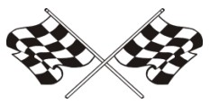
Cubmaster: At the conclusion of our Pinewood Derby, I would like to say that we were all winners here tonight.
- Dad has more respect for his son whether he was a humble winner or a graceful loser.
- Mom was proud of her son whether she gave him a hug of congratulations or comfort.
- The boys gained a better knowledge of competition; how to win, how to lose, how to be happy for a friend, who is taking home the trophy he himself wanted so badly. Cub 4: The leaders, in the pride they felt knowing that each of their boys had done their best.
- Building the car helped bring dad and son closer together.
Cubmaster: Yes, there are only winners here tonight. Thank you all for helping to make the pack go and the Cub Scouts grow. Good night and congratulations to all of us winners.
Car Fun
Grand Teton Council
Personnel: Six Cub Scouts
Equipment: Pictures of the vehicles named by the Cubs
Setting: Boys holding pictures as they recite or read lines.
- I have fun riding in my Dad's convertible on sunny days.
- It is exciting to go back country in our Jeep (or SUV).
- Riding in our street rod in a parade is my thing.
- Taking our camper out for a week in the woods is our family's favorite vacation.
- Taking the den on a field trip in the minivan lets us watch a movie on the way.
- As you can see, there are many ways to have fun in cars, just as there are many ways to enjoy Cub Scouting.
We Are All Pinewood Derby Winners
Capital Area Council
Have the winners of the various trophies stand and be recognized one more time. Ask the boys who are not yet standing to come forward and lead the Pack in the Cub Scout Promise or Law of the Pack, as they, too are winners, because they “did their best.”
RACE STEWARD’S CHEER
Baltimore Area Council
Equipment: Solid green flag and black-and-white checkered flag
CUB #1: In racing this green flag means go.
CUB #2: And this checkered flag means that the races for today are over. We’d like to lead you in a cheer for all the racers tonight.
CUB #1: Are you ready?... Get set… Cheer! (Wave the green flag for 5 seconds while everyone cheers; then CUB #2 waves the checkered flag for everyone to stop.
Do this a few times and then wave the checkered flag a final time to indicate that the meeting is over.
CM's FINAL WORDS: Good night, everyone.
Travel Closing
Grand Teton Council
Props: Draw appropriate pictures or use models or photographs of the items mentioned.
- (Train engine) When engineering a project keep on the right track. This way you never will be caught slack.
- (Covered wagon) The covered wagon served folks well in its day. But don't get in a rut, you won't get far that way.
- (Automobile) If spinning your wheels causes a terrible rumble, you may not be moving -just sitting there grumbling.
All Just like the cars in a train
We're joined together as one.
We do our best to help the Pack go
While having Cub Scout fun.
And when it's time to part
and each take a separate trail,
We'll do our best for God and country.
In that we will not fail.
Patriotic Closing
Capital Area Council
Equipment: A small American Flag for each Cub Scout, cue cards.
Set Up – Eight Cub Scouts in uniform stand in a straight line, each holding an American Flag and their cards
*Note: make sure each Cub rehearses and knows how to pronounce the words properly.
- I am the symbol of the living America, the badge of its greatness, the emblem of its destiny.
- I am faith. It is I who keep men mindful of their priceless heritage…life, liberty, and the right to pursue happiness.
- I am hope. I represent the land of promise where in, already, man’s loftiest dreams have approached closer to realization than ever before on this earth.
- I am life. Each strand and fiber of my being is a memorial, dedicated to the sacrifices of all those strong men and steadfast women who have lived and died in the nation’s service, that it might live longer.
- I am tolerance. So long as I shall wave, all people under my protection may freely worship, think, write and speak, undaunted by the shadow of fear.
- I am justice, tempered with mercy. For I am friend to he oppressed and downtrodden of every land.
- I am a sign of the future. I wave over schools throughout the nation and in them the nation’s future is molded.
- I am the flag of the United States…the last….the best hope for peace on earth.
Cubmaster’s Minutes
Our Pinewood Derby
Grand Teton Council
At the conclusion of our Pinewood Derby I would like to say that we were all winners here tonight. Dad has more respect for his son whether he was a humble winner or a graceful loser. Mom was proud of her son whether she gave him a hug of congratulations or comfort. The boys gained a better knowledge of competition; how to win, how to lose, how to be happy for a friend, who is taking home the trophy he himself wanted so badly. The leaders, in the pride they felt knowing that each of their boys had done their best. Building the car helped bring dad and son closer together. No, there are only winners here tonight. Thank you all for helping to male the pack go and the Cub Scouts grow. Good night and congratulations to all of us winners.
Henry Ford
Alice, Golden Empire Council
Henry Ford is certainly an example of positive attitude - He built his first vehicle, called the Quadricycle in 1896, and with two other investors founded the Detroit Automobile Company in 1899. But that company folded in 1900. Then in November of 1901, along with five other investors, he started the Henry Ford Motor Company. But after only four months, he left or was forced out of that company. When he left, he took with him his tools and rights to his name. In 1903, he again started the Ford Motor Company. He continued to work on new models and techniques, even visiting other countries to see their methods. In 1909, Henry Ford finally produced the “Model T” - a basic, sturdy, inexpensive car that was reliable and available to the ordinary family. But he kept on looking for even better designs and cheaper, more efficient methods. He introduced the moving assembly line in 1913, and by 1925, his basic car reached the unbelievable low price of only $260. He had set himself the goal to produce a basic, sturdy, reliable vehicle, and in spite of the failure of his first two companies and many design and production challenges, he kept a positive attitude and met his goal. Cub Scouts, too, have goals to reach – some they choose for themselves and some are requirements for advancement. And in spite of challenges, they can learn to keep a positive attitude and keep focused on their goal. Let’s make sure that we as adults also model a positive attitude when we play and work with Cub Scouts – keep focused on your goal!
Pinewood Closing
Grand Teton Council
Set Up - Form a circle around a the derby track
Cubmaster: "Coming together is a beginning. Keeping together is progress. Working together is success." This is a quote from the famous carmaker, Henry Ford. All of the dens come together to form the beginning of our pack. Keeping together at our monthly pack meeting is progress. Working together in Cub Scouting is surely a success story of which you can have a great part. Let's remember this in the coming months.
Please repeat with me the Law of the Pack. Thanks for coming out for our Pinewood Derby tonight. We've worked together and made ever boy in Pack a winner!
Tires
Capital Area Council
Hold up a tire advertisement. Cub scouts, tire manufacturers are constantly working to make a better tire; one that can withstand the pounding and abuse that high-speed driving demands. In other words, a tire that “can take it”. Like the tire, you and I are put to the test everyday. When things are going along smoothly, it’s not hard to get along. The real test is how we’ll do when the going gets rough; when things do not turn out the way we want them to. At times like these, the Cub Scout Promise can help you carry on with the right attitude and do your share without grumbling or griping. It will help you meet the test. Can you take it?
Do Your Best
Capital Area Council
When you give the Cub Scout Promise, the words “Do your Best” are often lost among all the other very important words. Let’s stop for a minute and carefully consider these words.
Best describes effort and action above our usual performances. You are the only person who can possibly know whether or not you have done your best. Every time you repeat the promise, you agree to do your best. Your best is just that: The very best that you can do. Think about the meaning of the promise that you repeated at the beginning of the Pack Meeting. Decide that you will always do your best, no matter what the job is that is facing you.
YOU HAVE A CHIOCE:
Baltimore Area Council
You have a choice.
You can be pleasant or unpleasant.
Which do you choose?
You can be grouchy and grumpy
or you can be happy and cheerful.
Which would you rather be?
It is up to you.
Tonight, we’re all winners.
We had fun and enjoyed each other’s company.
Let’s take that warm feeling of friendship home and keep it close to our hearts until our meeting next month!
Keeping Fit
Grand Teton Council
Cub Scouts, I hold in my hand a pocketknife. This is a valuable tool because it can be used for many useful things. It is a dependable tool as long as the blade is kept sharp and free from rust and the working parts are in good condition. But, if it is neglected and becomes dull and rusty, it can be a dangerous tool.
The same principle can be applied to ourselves. We have a body, which when kept in good condition, will serve us well. If we get plenty of exercise, eat the proper foods, and have good health habits, we will be able to enjoy to the fullest the things we do. But if we fail to take care of ourselves, we can become rusty and dull like the neglected knife. Do your best to keep fit!
THEME RELATED STUFF
Commissioner Dave's Roundtable Prop for
Cub Scout Car Show
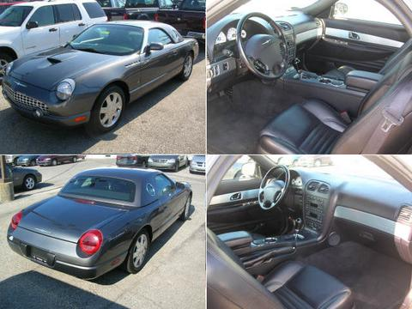
Pinewood Derby
Grand Teton Council
This poem first appeared in Baloo's Bugle in January 2000 after Margaret Holcomb, Belljoye, contacted USSSP about a Pinewood Derby poem she had written wondering if we would share it with other Sscouters. It is with pleasure and honor that I share it with the readers of Baloo's Bugle again. CD
Each year for Christmas wrapped in shape of a box
This Cub Scout receives a gift and no it's not socks.
It is some axles and wheels, a small piece of pine
You wonder what it is that makes his eyes shine
That Cub Scout, he knows, his mind all in a whirl
These small pieces, more precious than pearls
For in his hands he is holding a dream that is due
To enter a race to be held in month, maybe two
But for this one scout, this race will be his last
For he is a Webelos, his car will have to be fast
As he turns the small piece of pine in his hand
His mind is on shapes and he starts to plan
He gathers pencils, paper and a carbon or two
Traces, erases, discards, and decides on a few
It will continue like this for a few days more
Can't make up his mind, making his brain sore
Finally, picking his pattern his relief is quite great
Then we stand by our action, it is time to create
Out come the tools, a knife ,a saw and a drill
There is nothing like it. it is such a great thrill
To have watched this young grandson we adore
Year after year, build the cars, this will be four
I can now see the wheels turning in his head
Should I design this one or that one instead
Now the pattern is chosen, he traces the shape
With pencil to carbon, then he uses his tape
Making sure the length meets what is set out
In the rules that must be met by all of the scouts
He now turns to the saw, the goggles go on
Safety comes first or rule one will be blown
With his granddad or dad standing close by
He starts the cut and the sawdust does fly
When the dust settles, he fingers the cut wood
Then lifting up his goggles and nothing could
Ever be more prideful than the grin on his face
It is just the start, preparing for one last race
He runs his hands over the shaped piece of pine
I wonder what he's thinking, I'd give a whole dime
Picking up the paper to sand the wood just right
For hours he works with it late into the night
For days and days he leaves it sitting to the side
Thinking of paint and stickers, then eyes open wide
You can see the idea in his head start to form
Man or man this one will be out of the norm
Picking up his scout knife, he carves the first line
Places for the headlights, now this will take time
He has been taught the right way to handle a blade
He carefully finishes it, the groove has been laid
The knife is then closed, so carefully put away
Now on for the fun part, Hurrah! and Hooray!
This car, his last, has been built just for speed
Down deep inside him this hunger this need
For to be Grand Champion the head of the pack
Just one memory to savor, one day looking back
Tell his sons, of long ago times and to talk about
What it was like to learn and live the life of a scout
For now the time has come to just leave it alone
It is just perfect, time to let it stand on it's own
All the work that can be done has been done
He now feels it in his heart that this is the one
His dad and granddad and he all act as one
Packed in a special box, the time has come
To submit it to be judged, then the long wait
He can't touch it again, it's now all up to fate
His car is now checked for weight and design
To see if directions were followed line by line
His weight, length and height are all just right
His car has a number, impounded for the night
None will see the cars till the Derby Day Race
Now preparations for the day pick up the pace
The leaders, parents and scouts volunteers all
Join, to ready the track, they all answer the call
Derby race day is here, he is up with the sun
Trying to remember what he might have done
To build his car so it would have more speed
It is all too late, for he has now done the deed
The large building in which the race is to be run.
Is filled with families of scouts who have done
Each one their best that they could possibly do
“Do Your Best”, is the motto, and each held it true
The excitement builds as all take their places
The anticipation the fever I see in small faces
The ceremony to honor our flag is has begun
The salute to the same all now pledge as one
The first cars now race swiftly down the track
The pace will be kept there will be no slack
Yelling and screaming and cheering, we each
Encourage our own boy a crescendo we reach
The eyes of each boy is now sparkling with zeal
Hoping against hope that he wont lose a wheel
As cars plummet down the track one last time
I look at the scoreboard the moment sublime
He's done it I scream and jump up and down
He'd won the den, the pack, now the last round
Of the District Derby which has been his dream
To be grand champion, again I start to scream
With tears in my eyes and a silly grin on my face
I hug my husband, son, everyone in the place
I turn to face my grandson blow a kiss and sigh
I give him a sign, two fingers in victory held high
It's not the trophies that he has won on this day
The accolades of what others have had to say
It's in his heart and mind that someday will rest
That as a Cub Scout, he tried and did his best.
Belljoye, June 11, 1999
Cub Scout Derbies
Grand Teton Council
Derbies of one kind or another have always been a part of Cub Scouting. As early as 1939, the BSA Supply Division listed kits for model planes, boats, and airplanes. The derbies have been viewed as a way to get parents and sons to cooperate on a project.
An early Cub Leader's Round Table contained instructions for holding a Kite Derby. Competitions included the 100 yard dash, novelty kites, altitude race, artistic kites, kite battle, and the messenger race. The BSA Supply Service offered a pamphlet entitled Kites to teach kite making.
In April of 1937, Scouters were given the directions for making the Cubmobile. The original intention for the Cubmobiles was that they be any contrivance on wheels. According to the How to Book of Cubbing, "It may be drawn, pushed, or propelled by Cubs, or may be drawn by a trained animal-in fact, anything goes!" Most ended up patterned after the Soapbox Derby racers,
The first reference to the Pinewood Derby in a Scout publication was in the October, 1954 issue of Boy's Life. The June, 1955 Program Helps listed "Wheels, Wings, and Things" as a theme. The Cub Scout Program Quarterly gave instructions for running the Pack Meeting Derby. The Supply Division's catalogs had kits available for $2.75 for a package of eight. Over 15 million kits were sold during the next 20 years.
Regatta kits arrived in 1958 with kits for eight boats selling for $2.95. The rubber band driven Space Derby kits followed the start of the space race in 1961. Another derby was made available during the seventies; the Rocket Derby. The kits were later dropped from the Supply Division catalog.
Fun Facts about Fantastic Automobiles
Alice, Golden Empire Council
- Bertha Benz was the first woman driver, driving a car designed by her husband, with the first patent for a car, on the first car trip in 1888!
- Leonardo daVinci didn’t invent the first car, but he drew designs that have been built and shown to work utilizing the differential, gear shift and direction changing gears, the jack and the use of ball bearings to move gears smoothly and prevent friction from disabling a mechanical engine. He also understood the value of inter-changeable parts long before Henry Ford!
- Headlights didn’t appear on cars until 1906 – they used kerosene. But that car had no steering wheel! The driver had only a stick or shaft to steer with!
- The first self-propelled road vehicle was a tractor for the French army built in 1769 by Nicolas-Joseph Cugnot. It had three wheels and a top speed of 2.5 miles!
- Most American auto horns beep in the key of F.
- In Singapore a new car costs only $5 to license. As the vehicle gets older, the price goes up, and once the car is 8 years old, it is no longer allowed on the streets. These rules have almost wiped out pollution from cars in that country!
- Speaking of price, between 1968 and 1978, the price of the average American car doubled!
- For every 50 miles driven in an automobile, a person has a 1 in a million chance of being killed.
- In 1905 the Bosco Company of Akron, Ohio, marketed a "collapsible Rubber Automobile Driver." It was intended to scare thieves away. Modern drivers have sometimes used a dummy to access the faster lanes reserved for cars with more passengers – and paid a hefty fine if caught!
- The beloved London taxicabs with their high roofs were originally designed to keep gentlemen from knocking off their top hats as they entered and left the vehicles.
- In 1924 a Ford automobile cost $265!!
- The first automobile race in the U.S. was held in 1895, running from Chicago to Evanston. J. Frank Duryea won at an average speed of 71.5 miles per hour.
- A plumber named David Buick actually build the first General Motors car – he also invented the process where porcelain could adhere to iron, making the white or colored bathtub possible!
- Many people had arms broken by an engine backfire while hand cranking cars to start them before 1917 and the invention of the electric starter!
- On July 11, 1903, the Ford Motor Company sold the first car to Dr. E. Pfenning for $850 cash.
- In 1950 the United States had 70 percent of all the automobiles, buses, and trucks in the entire world – today, China is fast becoming a major car user!
- To manufacture a new car approximately 148,000 liters of water are needed!
- Henry Leland introduced “parts interchangeability” to the auto industry after learning the concept working in firearms factories.
- Brothers Charles and Frank Duryea set up the first American car manufacturing company in 1893.
- By 1908, 485 different companies were building “horseless carriages.”
- Electric cars are nothing new – Robert Anderson introduced an “electric carriage” in 1832 in Scotland.
- American George Selden never manufactured the internal combustion engine he designed in 1876 – but he collected royalties on his patent until 1895.
- In 1913, Henry Ford introduced the world's first moving assembly line, which allowed the same number of workers to build many more cars – and made a car that was cheap enough for the average family to afford – it was also reliable and easy to fix.
Bizarre Driving Laws
Scouter Jim from Bountiful, Utah
Alabama
- It is illegal for a driver to be blindfolded while operating a vehicle.
- It is legal to drive the wrong way down a one-way street as long as a lantern is attached to the front of your car.
- Driving barefoot is illegal.
Alaska
- It is illegal to tie a dog to the roof of your car.
Arkansas
- It is illegal for a person to blare the horn on a vehicle at any place where cold drinks or sandwiches are served after 9 p.m.
California
- Any woman dressed in a housecoat is prohibited from driving a car.
- It is illegal in San Francisco to buff or dry your car with used underwear.
- No unoccupied vehicle may exceed 60 miles per hour.
Florida
- If an elephant is tied to a parking meter, the owner or attendant must deposit money in the meter.
Georgia
- State Assembly members are immune from being ticketed for speeding while the State Assembly is in session.
- In Marietta, Georgia, it is illegal to spit from a moving car or bus, but is okay from a moving truck.
Illinois
- In Evanston, Illinois, it is unlawful to change clothes while inside a car with the curtains drawn, except during a fire.
Kansas
- In Derby, Kansas, it is considered a misdemeanor to screech your tires while driving.
Kentucky
- If you stop for ice cream while driving, be aware that it is considered unlawful to transport an ice cream cone in your back pocket.
Massachusetts
- You will be ticketed if you drive with a gorilla in the backseat of your car.
Michigan
- If you car breaks down in Detroit and you are waiting for assistance, be aware that sitting in the middle of the street to read a newspaper is illegal.
Minnesota
- It is illegal to cross state lines, regardless if you are walking or driving, with a duck on your head. And, if you're crossing into Wisconsin, the law also applies to chickens.
- In Minnetonka, Minnesota, if you drive a truck that leaves mud, dirt, or sticky substances on any road, you will be considered a public nuisance who is harming the peace, safety, and general welfare of the town.
- You cannot ride a motorcycle without a shirt.
Montana
- In Whitehall, Montana, vehicles are prohibited from driving with ice picks attached to the wheels.
Nevada
- It is illegal to drive a camel on the highway.
New Jersey
- Drivers are required to beep their car horns before passing another vehicle.
- If convicted of driving while intoxicated, you permanently lose the option of registering for a vanity license plate.
North Carolina
- In Dunn, North Carolina, it is illegal to drive on a sidewalk.
Ohio
- In Oxford, Ohio, authorities will ticket you if you consecutively drive around the town square more than 100 times.
- Keep in mind that if your car breaks down and you phone for a cab, you will be ticketed if you opt to ride on the cab's roof.
Oklahoma
- It is considered illegal to read a comic book while driving.
Oregon
- You will be ticketed if you leave your car door open longer than is deemed necessary.
- You will be slapped with a Class A traffic violation if you use your car on an Oregon highway to prove your physical endurance.
- It is illegal to pump your own gas.
Pennsylvania
- If you spy a team of approaching horses, you are required by law to pull to the side of the road and cover your car with a blanket or dust cover that has been painted or sewn to blend into the scenery. But, if the horses react skittish to your efforts, you are then required to disassemble your car and hide the parts in the nearby underbrush.
South Carolina
- In Hilton Head, South Carolina, you cannot leave trash in your vehicle out of fear of attracting rats.
Tennessee
- It is illegal to fire a gun at any wild game other than whales from a moving car.
West Virginia
- It is perfectly legal, for road maintenance purposes, to scavenge road kill.
PINEWOOD DERBY
TIPS FOR A SUCCESSFUL PINEWOOD DERBY!
Grand Teton Council
Don't Forget The Purpose Of The Pack Meeting
Make sure you are giving out the regular awards the boys have earned that month. Some Cubmasters think that there isn't enough time on pinewood derby night but the purpose of Pack Meeting still is to recognize the boys. Awards can be done, quickly but still fun. I make a Cubmaster car, which I make slow on purpose. I build it up 2 or 3 months in advance. No one will beat my car, etc. On race day the boys have to race my car to get their award. They love it!!
Give Out The Rules
Make sure everyone knows the rules before you begin. Give out a list of rules that you want them to follow. There are length and weight rules written inside the kits but they are never looked out. Make up your own rule sheet, pass it out to all the parents and then stick to the rules.
Impound The Cars
The weekend before the pinewood derby, have the boys come and impound their car at your house. Make sure each boys car is weighed properly with the same scale. After the car is inspected and weighed in then you will keep the car and bring it to pack night. I had a big box with rags in the bottom so the boy could wrap it and place it in the box. This will eliminate the before race day craziness of weighing the cars, fixing cars, taking weight in or out. It makes it A LOT better on race day to have all that over. At the church, I lay out a big blanket on a banquet table and lay all the cars out.
Awards
I truly believe there is nothing wrong with giving out a 1st, 2nd and 3rd place winners. It is a time for the boys to learn to be a good winner or a good loser. I do believe that each boy should receive the same trophy or certificate. None of this, tiny trophy for the losers and a giant one for the 1st place winner. Make sure each and every boy gets an award. Also, I think it is important to stress good sportsmanship. I give out the best sportsmanship award last of all, as the most important and best award to receive.
Here are some suggestions: Most Attractive, Most creative, Most realistic, Best Paint Job, Most Colorful, Best Workmanship, Most Imaginative, Most Artistic, Most Unusual, Best Quality, Judge's Choice, Simply Marvelous, Best Craftmanship, Most Detailed. Sportiest, Most Original, (Avoid anything that is negative: like Junkyard Special)
Open Class Races
After the official race, I always have an open class race. I encourage the dads to make a pinewood derby car of there own along side their boy. That way hopefully the boy can actually get his hands on his car, if they are building them together step by step. It is also a lot of fun to have the boys race their dads and their moms (I always make a car of my own). You can also have older brothers bring cars from other years and race. It gets the whole family involved.
Special Certificates
Make up certificates like the following for your Pinewood Derby volunteers and attach to OREO cookies, hot wheel cars, or Gold Coin candies
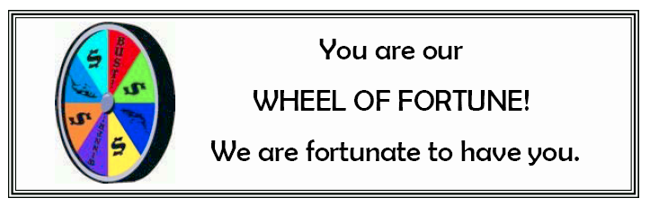
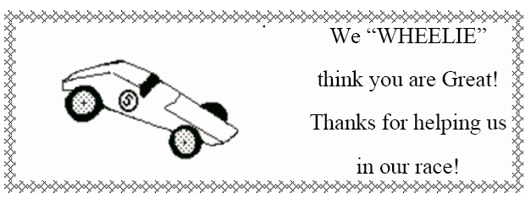
TIGERS
Baloo’s Archives
Achievement 3 Family Activity
3F Plan a family fire drill and practice it.
Be sure to plan a safe meeting place outside so that you will know when everyone in the family is safe. Go to that place as part of your practice.
Tell your Tiger Cub that if he ever feels that he is lost, he should stay where he is and hold onto something like a bench, a post, or a tree. Assure him that because you love him, as soon as you realize that he is not with you, you will quickly begin looking for him. Explain to him, that if he does not stay where he is when he is lost, it will take you a lot longer to find him. Practice a game with him where he pretends that he is lost, he holds onto something stationary, and you walk out of sight, wait a 3 to 5 min., and then come back for him.
Achievement 3 Den Activity
To keep your body healthy, it is important that you eat a well-balanced diet. The food pyramid in your book helps you by showing how many servings of certain kinds of foods you should have each day.
Be sure to visit www.5aday.org to learn about eating your fruits and vegetables by the color and www.3aday.org to learn about your dairy needs. CD
3D Make a food pyramid.
Draw a food pyramid on a big piece of paper or a poster board. Using old magazines donated by the den families cut out pictures of food and glue them in the appropriate place on the pyramid. You can also draw pictures of different foods to add to the food pyramid.
Achievement 3 Go and See It
It’s fun to play games and to take part in sports. It’s also good exercise, which helps to keep your body healthy. Some games and sports are for one person, and sometimes people play games or sports on teams. It’s also fun to watch others play games or demonstrate their abilities. Understanding the game or sport you are watching makes it a lot more fun.
3G First, learn the rules of a game or sport. Then, go to watch an amateur or professional game or sporting event.
Local High School, Community College, and other teams are great for this. We have a minor league Hockey team, The Philadelphia Phantoms, www.phantomshockey.com , which runs several Scout nights each year at reasonable cost!! You can get to all the other AHL team websites from their site. CD
More Ideas for Keeping Myself Healthy and Safe
Southern NJ Council
Den Activity
Emergency information is available from local libraries, the American Red Cross, and the local fire departments. Some free handouts can include family disaster supply kits from the local fire department and the Red Cross.
Emergency Preparedness Ideas to consider:
Does your group have emergency supplies at the meeting site? Are there food supplies, warm blankets, flashlights, and water tucked away, just in case?
At home, how do you shut off the gas, the water, and the electricity?
What neighbors can help? Have a neighborhood emergency plan ready. Who can be called when needed?
Every Tiger Cub will experience fire drills and storm drills at school. Do you have one established at your meeting site?
FITNESS
Tune: On Wisconsin
Hurry, Tigers, Build your muscles,
Get in shape for play.
When we feel our very best
We will do our best each day.
Hurry, Tigers, Build your muscles,
Get in shape for play.
Keep on running, keep on jumping,
Trying to improve.
When we’ve grown a little older,
We will still be on the move.
Keep on running, keep on jumping,
Trying to improve.

Electives
*4-Display a picture
It’s nice to have pictures of your family on display—especially when some of your family members are not close by all the time.
*Make a frame for a family picture. Glue tongue depressors or craft sticks together in a shape to fit your picture. Attach a string or ribbon to the upper corners to use as a hangar. Tape your picture to the back of the frame and display. You may want to use a photograph, or a picture that you draw of your family.
*10- Helping Hands
When people grow older, or if they become sick or have an accident, they sometimes have a hard time doing every day things. If you know an elderly person or if you know someone who is ill or recovering from an illness or accident, try to think of what things would be hard for them to do by themselves.
Along with your adult partner, help an elderly or shut in person with a chore. You might offer to do things such as help to take out trash, rake leaves, mail a package, or bring in the mail. Ask first, and do it with a big Tiger Cub smile!
*32- Feed the Birds
Pop-bottle bird feeder
Materials: one plastic 2-liter bottle, two plastic lids about 5” in diameter (from coffee cans, large margarine containers, whipped topping, etc.), 30” heavy twine, or rug yarn, scissors
Have your adult partner help you cut the bottle in half, crosswise. Poke a hole through the centers of the plastic lids with the point of the scissors or a nail. Tie a knot in the end of the twine. Refer to picture and put your feeder together by stringing together one plastic lid (curved side up), then the inverted bottle, and then the second lid (curved side down). Fill the bird feeder with seed and hang it outside.
Pinecone Bird Feeder
Materials: 1/2 cup peanut butter, 1/2 cup shortening, 1-2 cups bird seed, large pinecone, thick twine, paper bag
Twist twine around the pinecone and tie it securely. Mix the peanut butter and shortening together. Spread the mixture between the petals of the pinecone, filling in as much as you can. Put the pinecone along with the birdseed in the paper bag. Close the bag and shake, coating the pinecone with birdseed. Hang the feeder on a tree where you can watch the birds enjoy it.
PACK AND DEN ACTIVITIES
Advancement Ideas
Carol, Black Swap area Council, Ohio
Tigers –
Ach 1F, 2F, 2G,
Elect. 3, 10, 11, 17, 48
Wolf-
Ach 6, 9C, 9D
Elect. 8, 11C
Bear –
Ach 13D, 15B, 20A, 21A, 21B, 21C, 21D
Elect. 7
Alice, Golden Empire Council
Boys on all levels could work on the Positive Attitude Character Connection. Reviewing the motto, “Do Your Best” is also a good idea. Boys may need help in being good sports and feeling good about their own work if you have the Pinewood Derby this month. Have clear and simple rules for the derby cars and how they are to be built, and make sure everyone understands them before the cars are given out. If there are boys without an adult to help, or access to tools, pair them up with an adult – or sponsor a workshop for all the parents and boys to help them get started. Emphasize the value of learning new skills and using personal creativity over who wins the race. Give a “Good Sportsmanship” award. Give ribbons to every boy, with each car getting noted for something: brightest paint color, most original, etc.
Tiger Achievements:
Ach. #1D –visit a car museum or a display of cars, old or new; #2F – if you choose or draw a map of your neighborhood – you could use toy cars to “travel” from place to place
Tiger Electives:
Elect. #2 – make decorations for the Pack meeting – flags, racing cars, pennants, signs such as Pit Stop for refreshment table; Elect. #11 – begin the New Year right by collecting for local food banks or charities that will have few supplies left after the holidays; Elect. #14 – read a book or article about cars, racing or building a car; Elect. #15 – experiment with primary colors to make the colors you want to use on your Pinewood Derby car; Elect. #17 – make your pinewood car or another model; Elect. #25 – make one of the Cub Grub snacks for your den or family; Elect. #48 – take a ride on public transportation, and compare it with using a car;
Wolf Achievements:
Ach. #5 – learn about tools, especially what you would use to make your Pinewood Derby car, and make a stand to display it; Ach.#6a – work on the Positive Attitude Character Connection; Ach. 6b, c – if you have a collection of cars; Ach. #9d – review the rules of street and road safety; Ach. #10d – if you choose a book about cars or racing;
Wolf Electives:
Elect. #2 – if your den does a skit. Elect. 3 -use
these to help cut or carve your car; Elect. #5g, h, I – make a model car; Elect. #8a,b,c – learn about how wheels are used – try making the bottle racer in this packet; Elect. #12c – mix colors while choosing what to paint your derby racer; d-f – make posters, signs and scenery for the pack meeting; Elect. #16c – if your den or pack choose to make or update family first aid kits for the car
Bear Advancements:
Ach. #9b – if you make a snack for the den meeting from Cub Grub; Ach. #10a – visit a car museum or a history museum with a display of cars; Ach. #11c,d – Review what to do in case of an accident in a car or bus – make sure your car is safe and has supplies and equipment for an emergency; Ach. #13d – pretend to shop for a family car and learn about what to look for and compare; Ach. #15b,c – play some games from this packet; Ach. #17d – get some information about cars, racing or building a model; Ach. #20a – become familiar with tools, especially those you will use to make your pinewood car; Ach. #21 a, b, f – Build a model and/or a stand or display for it; Ach. #23d – if you watch a professional car race; or #23e, attend a professional car race or event;
Bear Electives:
Elect. #7 – make a scooter or Cubmobile and know the rules of safety or make an invention of your own that goes, such as the Bottle Racer; Elect. 22b, c – if you have a car collection or a library about cars or models; Elect. #23 – use maps to explore how to travel to another location, or to map out the route to take on a family trip.

Ideas For Pack Activities:
Baltimore Area Council
- Have a Boxcar Derby
- Have a Pinewood Derby Race
- Visit a Police or Fire Station
- Show and Tell – models and miniature car collections
Ideas For Den Activities:
Baltimore Area Council
- Build a snowman
- Make Pine-Cone treats for the hungry birds
- Go to a local ice skating rink
- Start a collection of model or miniature cars
- Make Race-car neckerchief slides
- Make Pinewood Derby Car Display Stand
Den & Pack Meeting Activities:
Alice, Golden Empire Council
Invite a policeman or safety expert to come talk to the Den or Pack about how to travel safely in a car.
Sponsor a safety check with your local police department – checks could be made to assure seat belts, car seats are installed and working properly.
Invite a mechanic to come and share basics of how a car works or some simple maintenance and safety checks
Update the First Aid kit used for den activities and field trips – make sure you have current information and supplies that might be needed.
Invite families to make emergency boxes for their vehicles, including items needed such as: flares, jack, battery cables, emergency air for tires, etc. Also a kit in case of accident or car
breakdowns – first aid items, some hard candy, meat sticks, water and cups, blanket, first aid supplies, list of phone numbers, extra diapers or medications, rain ponchos or sweaters, small toys, games or drawing pads to keep kids occupied while they wait. The Red Cross, local government and fire department can provide brochures and information on what to have on hand and how to use it. This would be an excellent service to your pack families as we enter the season where natural disasters can impact family safety.
Create a list of things to keep in the family car, including insurance information, flashlight and extra batteries, small tools such as screw drivers, battery cables, work gloves, etc.
Visit a “Safety City” if there is one in your area.
Visit a local museum devoted to cars old or new.
Check with local car clubs, racing associations, etc. for large photos or models of cars, racing flags, pennants, to decorate your pack meeting.
ARTFUL CARS
Great Salt Lake Council
Have a car show and race. Have each boy decorate a toy car (Hot Wheel/Matchbox size). You can supply one, or he can use his own. These can be decorated at the activity or prior to it. You may also want them to make a way of displaying it, such as a cardboard platform and backdrop. Let everyone “tour” the show with 3 or 5 anonymous judges choosing cars for different categories. If desired, you can let the boys know there will be judging and what the categories are when you announce the activity. The boys should try to be creative using tacky or hot glue to attach small objects such as beads, feathers, googly eyes, pipe cleaners, sand, sequins and buttons. Remember to keep the wheels movable if racing. There are no limits on size or weight, except original size of car. Be sure to let the glue dry completely before showing, or racing the automobiles.
After the show the cars can be raced down a simple incline. The winner is the car that goes the farthest.
CUB-anapolis 400
Commissioner Dave
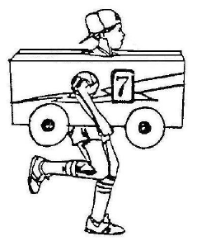
CUB-anapolis is a great fun event. We do it at my Webelos Resident camp and every year it turns out different. There is a great description of how to do it in the Cub Scout "How-To" Book on page 6-18.
The event can be run an individual basis with each Cub and his family making a car and his family being the pit crew or by Dens (how we do it in Webelos Resident Camp) with each Den making a car and the den becoming the pit crew. When done this way, be sure to rotate drivers so every boy gets a chance.
You can hold your race inside in a gym or other large room or outdoors on a field.
Some packs are requiring bicycle helmets. This is probably a good idea for safety and adds to the theme as racers wear safety helmets. And should be easy as anyone with a bicycle has to have a helmet.
A key to success is having fun pit stops.
Some ideas include -
- Clean the windshields - All drivers have goggles on and another Cub washes the goggles with a spray bottle of water (NO Soap or detergent or glass cleaner)
- Rotate tires - Cubs take off shoes and switch their socks to the other foot
- Fuel Up - Have the driver drink a specified amount of water
- Change Drivers - give every one a turn
- What can you think of doing????
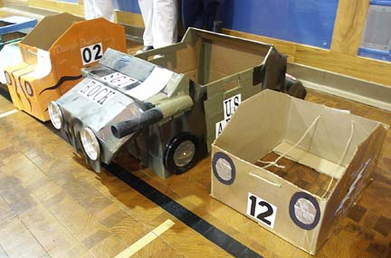
Photos from Pack 813, Dayton
CUB-anapolis 400 Hints
Pack 358, Barrington, NH
http://www.pack358.us
What does a scout need for a CUB-anapolis race?
- A Cub-anapolis Car. Cars should be made from a cardboard box. Make sure the box is not too big for the Scout. Boys need to be able to run while carrying the box.
- A pit crew (at least two people)
- A small towel or washcloth
- A pair of lace-up sneakers with socks (no Velcro or slide on)
What’s a CUB-anapolis???
- The cub carries his box and runs from start line to the finish line.
- A typical race is 3 laps.
- On each lap, the Cub will pull in for a pit stop
- On each stop, your crew will be asked to perform one of the following tasks:
Clean your windshield
Change your tires
Refuel
- After the action is complete - the cub picks up his car again and race back the finish line.
How to Build Your “Cub-anapolis” Car
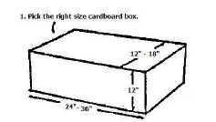
- Pick the right size cardboard box to fit the scout.
Normally a box that is 12”-18” wide, 12” high and 24”-36” long. (A copy paper box is great.)
Body of car must be constructed of cardboard.
Use a box that fits around the boy without being either too snug or too loose.
- No metal or glass materials may be used.
- No items can be hanging or dragging behind a car
- For safety reasons, cars should not have a ‘windshield’
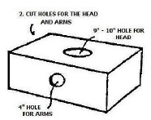
- Cut out the top and the bottom of the box so the scout can stand in the box and pick it up to his waist.
Leave about 2” of the top and bottom at each end to strengthen the box.
Cut 2 holes in the side of the car to use for carrying the car during the race.
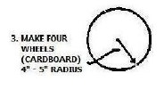
- Make 4 wheels for the car.
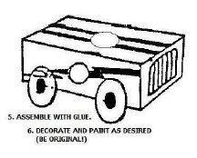
- Assemble car with glue or tape. Please assemble the car in a manner to be safe for the scout
Cut 2 holes in the side of the car to use for carrying the car during the race.
Decorate and paint the car as desired. (Be original)
Tape, tinfoil, paint, construction paper, stickers and paper plates can also be used for decoration.
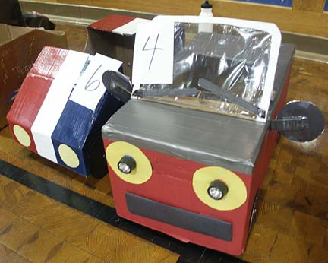
CUB-annapolis
Capital Area Council
Use a cardboard box and straps or suspenders to make a racer, as shown above. The boy provides the “wheels” to make the car go. The whole den works on the vehicle ahead of time with the fastest boy providing the “power” for the vehicle.
Of course, you don’t want to make this too easy, so you add a pit stop (See below for ideas) and GO as well as some areas of tight maneuvers, backing up and fast straight-aways. Change drivers a few times and you have an excellent race for the whole pack.
Add awards for vehicles such as Best Design, Sleekest, Most Excellent, etc.
SCENARIOS
After lap 1 – Windshield wash (wash goggles)
After lap 2 – Tire change (Remove shoes and socks, turn socks inside out, replace socks and shoes
After lap 3 – Refuel (Drink one small bottle of Root Beer)
Dens should ensure that each race car driver has the following accessories:
- Goggles for the car driver (sunglasses, safety glasses, etc) - these must be worn during the race.
- Spray bottle filled with only water (may be shared)!!
- 8 ounce Styrofoam cup and a small jug of water to fill the cup with
The RACETRACK will be laid out with orange cones in whatever pattern the leadership decides to set up...
The race format is as follows:
- START: each racer will run one lap then go to his dens pit stop area.
- 1st pit stop: the pit crew will clean the driver’s windshield (Goggles) with the water spray bottle. Once the goggles are cleaned, they must be dried too.
REMEMBER! DRIVERS ARE ONLY PERMITTED DRIVE THE CAR - They cannot do ANYTHING TO HELP THE PIT CREW!!
- Once the goggles are dried, the driver may get back into the race and complete one more lap, then pit again.
- 2nd Pit stop: The Pit crew must refuel the driver by filling the Styrofoam cup full of water and the driver must drink the ENTIRE cup (without spilling it) before entering the race again.
AGAIN, KEEP IN MIND THE DRIVER CANNOT DO ANYTHING TO HELP THE PIT CREW! THEY MUST HOLD THE CUP WHILE THE DRIVER DRINKS THE WATER!!
- Once the car is re-fueled, they may enter the race and complete another lap - then pit again.
- 3rd pit stop: The Pit crew must change the tires on the car!! To do this, the pit crew must remove the driver’s shoes - then remove his socks - flip the socks inside out – put the socks and shoes back onto the driver (shoes must be tied !!) and only then may the driver enter the race again.
- After completing the third pit stop, make one more lap then return to your pit area!!
- Once every den has completed the required pit stops, we will run the races again if there is anyone who was not afforded the chance to play - or if we just want to run again for the fun of it!!!
- Lastly, there are only winners in this race - participation awards will be given to everyone who plays.
Bottle Racer
Alice, Golden Empire Council
Boys could build and race bottle racers to explore a simple machine – and an old-time toy!
See directions under Webelos Scientist.
LE MOUSE 500 (Mousetrap Car)
Grand Teton Council
This is a mousetrap on wheels with built-in propulsion. Something so simple and inexpensive that every Cub Scout will want to make one.
The simplicity of this racer tires the imagination. The greatest momentum can be obtained from 2-4" diameter wheels, but the mousetrap needs to be mounted on a board to prevent wobble. Rubber bands or sandpaper can be glued on the rear wheels for traction. Wind the cord the opposite direction and you have front-wheel drive.

Directions
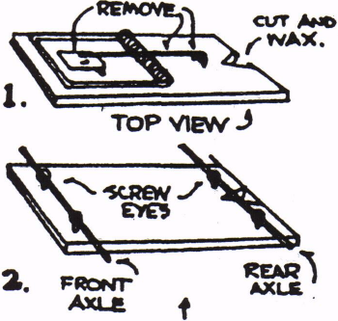
- Remove bait pan and hook arm from the mousetrap.
- Cut a 1/2" deep notch at the rear axle line for easy winding of the string. (This will be at the opposite end of the snapper, and the slot should be rounded slightly and waxed or soaped.)
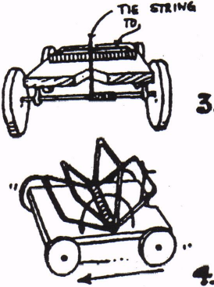
- Carefully measure 1/2" in from each end for eyelets. The wood splits easily, so drill pilot holes and screw in the eyelets carefully.
- Insert wire axles through eyelets. Coat hanger wire may be used. Sand wire if necessary for easy turning in the eyelets. Be sure to roughen the axle where the cord will be wound to give it grip.
- Make wheels from wood -1 1/4” diameter by 3/16" thick. They can be sawed from thin wood, or better, sliced from a dowel. Locate and drill center holes. The more accurate this is, the better the racer will run.
- Knot string onto snapper. Do not tie the string to the axle.
- Pull snapper back to its full extent and hold with thumb.
- Wind string onto the rear axle until tight (Best cord is nylon, as it is springy. Cut with a hot soldering iron to prevent raveling.)
- Set the racer on a rough surface (not a waxed floor) and release.
- Racer should go over 8 feet. Experiment with it and make changes until it does. Try winding the cord backwards for front wheel drive.
- You might want to mark off a board for a race track and let the boys have a race. Do not paint the track, as this will make it too slick.
Build a Clothespin Race Car
Grand Teton Council
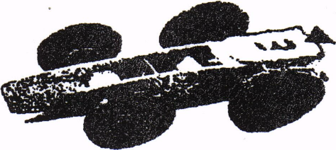
Supplies Needed:
Clothespins ( plastic or wood)
Buttons
White Glue
Twist ties
Colored Tape
Straws
Scissors
Decorations as you like
Directions:
- Thread a long twist tie through the button.
- Twist and put through a piece of straw
- Add second wheel and secure
- Trim the twist tie ends, then make another set of wheels
- Glue the front wheels in place and then the back wheels
- Wrap tape behind the rear wheels for durability
WINDRACER
Grand Teton Council
Supplies Needed:
Coat Hanger Wire, 24" long
Pliers
3 Spools
Large Cork
Thin Dowel
Thin cardboard
Hole punch
Masking Tape
Cotton thread
Directions:
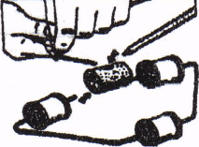
- Take the piece of thin coat hanger-type wire 24 inches long and using pliers, bend the wire as shown in the picture and put on three wood or plastic spools.
- Push the wire end into the bottom edge of a large cork, one end on each side.
- Sharpen an 8-inch thin dowel and push it into the cork so that It angles back.
- Make the sail by drawing an 8-inch-diameter circle on thin colored cardboard and cut out.
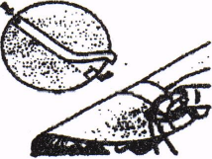
- Run masking tape across the center of the sail continuing to other side of sail. See picture above
- Make a hole 1/2" back from the edge of the card on each end with a paper punch, See picture above
- Slide the sail onto the mast and glue the mast into the hole you made in the cork.
- Secure the sail by looping cotton thread over the top of the mast and running it to the wire, tying it to the wire chassis, See picture below.
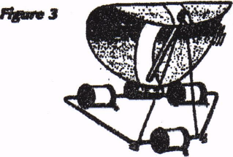
Pinewood Car Slide
Trapper Trails
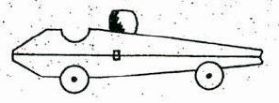
- Take apart a spring type clothespin
- Glue the flat sides together
- Cur two ¼” thick slices off a ½” diameter dowel for wheels
- Glue wheels on side toward front and back
- Glue on a colored round bead for helmeted driver’s head
- Attach ring on back – 1” length of ¾” PVC pipe works well but choice is yours
This slide can be used for several Wolf and Bear Achievements
Detergent Bottle Drag Racer
Capital Area Council
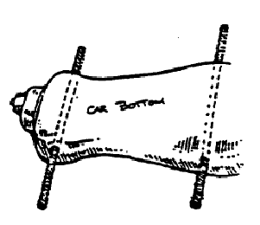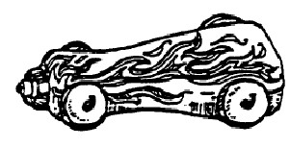
Materials:
plastic dish washing detergent bottle,
nail, hammer,
acrylic paints,
paintbrush,
4 plastic bottle tops (all the same size)
2 pipe cleaners or dowel rods.
Instructions
- First make sure your detergent bottle is washed out and dry. Put the top back on the bottle.
- Where would you like the wheels to be? It doesn’t matter which side of the bottle your use for top or bottom. Carefully punch four holes for wheels into the sides of the bottle with a nail, two on each side. Be sure to make the pairs of holes exactly across from each other.
- Now paint the racer with acrylics. You can make it any color you like and decorate it with flames, stars, racing stripes, etc. Let it dry thoroughly.
- Next use the nail to punch a hole in the center of each plastic bottle top. These will be your wheel! Push a pipe cleaner through each pair of holes, in one side and out the other. Put a bottle top “wheel” on the ends of the pipe cleaners so the wheels stay on.
Spool 4x4
Capital Area Council
You will be surprised at how much power this little “4x4” has. See how steep a hill you can make it climb. All you need to make it is an empty spool, toothpicks or matchsticks, a rubber band and a small piece of soap.
Carefully drill a hole in a small piece of the soap. Make the hole about 1/8” or a little larger, so that the rubber band will pass through it easily even when it is twisted. You must be very careful drilling the hole or you will split the soap. Push one end of the rubber band through the soap and loop it over a toothpick. Push the other end through the hole in the spool and over a small piece of a toothpick. Wind up the 4x4 by turning the long toothpick until the rubber band is tight. Place the 4x4 on the floor and watch it move along. You and your friends can have races.
Gumball Racer
Capital Area Council
Materials:
4 small gumballs
1 plastic straw
2 round toothpicks
1 spring clothespin
2 small gumballs (for chew-glue)
Instructions
- First, pop the two pieces of “chew glue” into your mouth and start chewing
- Cut two pieces of the straw, about 1” long. Using a toothpick, pike a hold all the way through the center of each gumball press slowly and carefully
- To make an axle, push a toothpick through one of the straw pieces. Poke each end through the hole in one of the gumballs and out the other side. (You might have to snip the straw pieces to make them shorter if there isn’t room for wheels)
- Clamp one axle into the front end of the clothespin Tape the other axle under the clothespin near the back
- Wet your fingers and break off a small balls of chewed gum Mold them to the ends of the axles to keep the wheels on.
Candy Race Car
Capital Area Council
Need:
Low temp hot glue gun.
Ribbons or yarn for hanging
1 large package of gum (1 ¼” x 3” x ¾”)
4 round wrapped candies (peppermint or butterscotch)
1 shiny wrapped candy about 1 ¼” long
2 mini chocolate bars (1 ½” x 1” x 3/8”)
Instructions
- Glue the shiny candy to the front of the gum pack as a bumper
- Glue the 4 round candies on as wheels
- Glue the 1 candy bar on the back half of the car, allowing it to stick off the back by a ¼” or so.
- Glue the other candy bar across the back of that candy bar having at least ½ of it extending past the edge of the lower candy bar. Look at the illustration above, and experiment
Racing Flag Slide
Trapper Trails
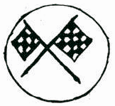
- Find some small (cupcake topper size) racing flags or make some from cardstock and attach to toothpicks
- Cut a tree cookie of appropriate diameter for your flags
- Hot glue the flags in place on the tree cookie
- Attach ring on back – 1” length of ¾” PVC pipe works well but choice is yours
Macaroni Wheel Slide
Trapper Trails
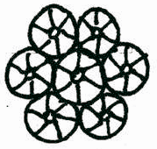
- Using wheel shaped macaroni –
- Glue wheels together to forma bigger wheel
- Spray paint
- Attach ring on back – 1” length of ¾” PVC pipe works well but choice is yours
Crazy Racing Roller
Alice, Golden Empire Council
Materials:
Colored paper
Glue
Small Marble
Scissors
Directions:
Enlarge the design below to the dimensions shown on colored paper. You can also use white paper and have the boys decorate with markers BEFORE folding up their crazy racer-Alice)
Cut out the design.
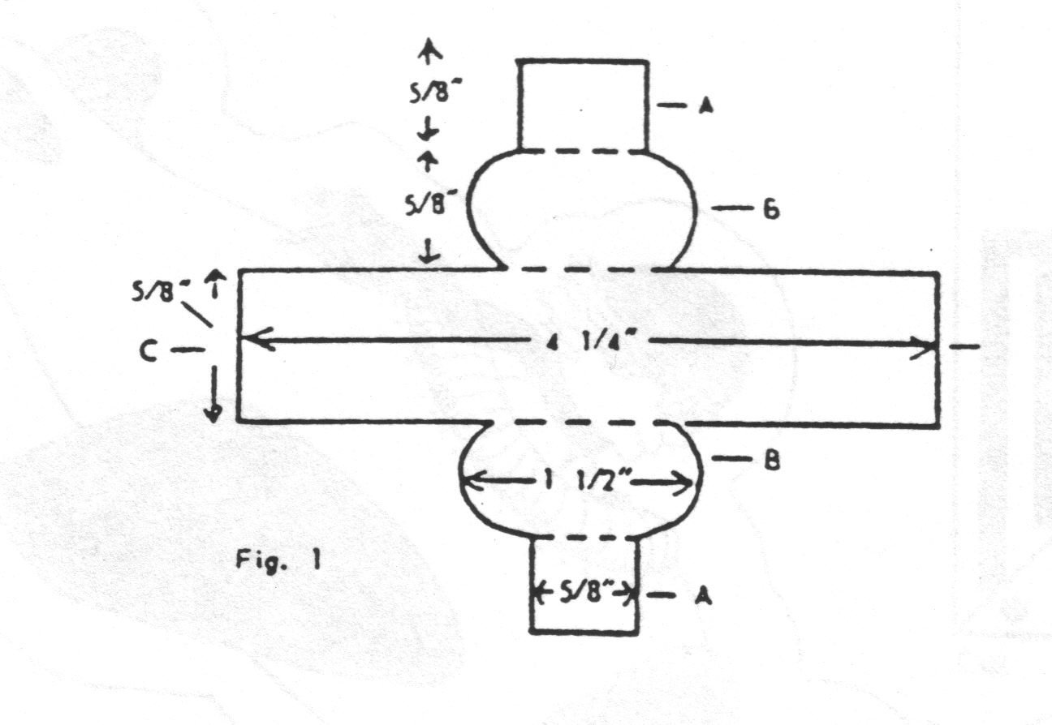
Fold Flaps A & B toward the center strip.
To form the sides, place Flaps A together and glue.
Insert the marble between the sides; then glue the ends C and D together to form a bean-shaped roller with the marble on the inside. (Fig. 2)
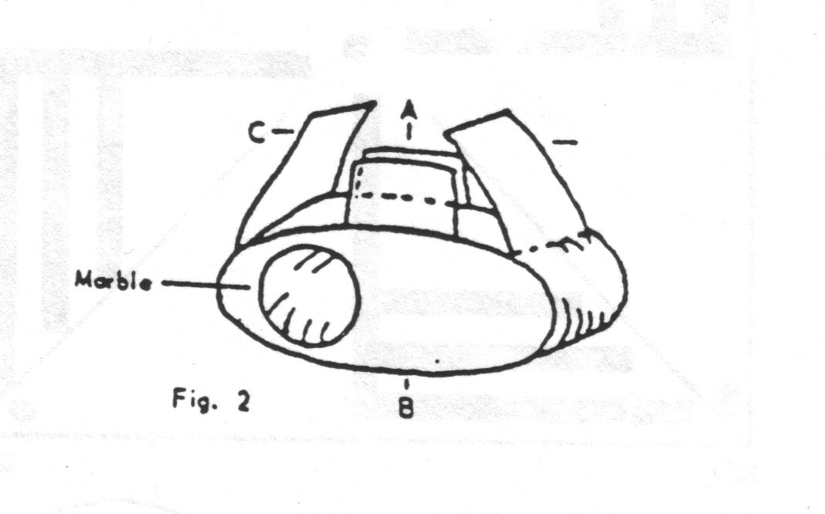
To operate your racer, release it on an inclined flat surface – it will roll down end over end with an erratic motion.
You could also race rollers against each other.
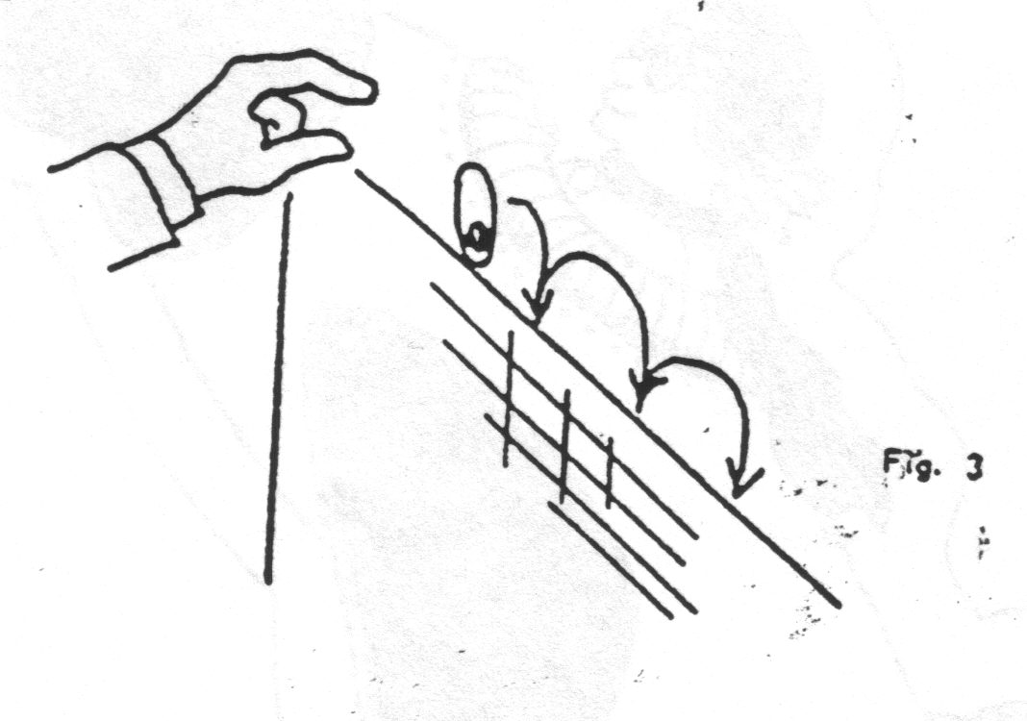
A ramp makes the perfect place to operate your racer.
This project takes about 20 minutes, and younger boys may require some help in folding and gluing.
You could also use larger marbles – just adjust the size of the paper pattern.
Marble Raceway
Alice, Golden Empire Council
This is a fun project using various materials to create a “raceway” for marbles. It also fits with Invention Convention or Recycling themes – or with Webelos Engineer or Scientist - Alice.
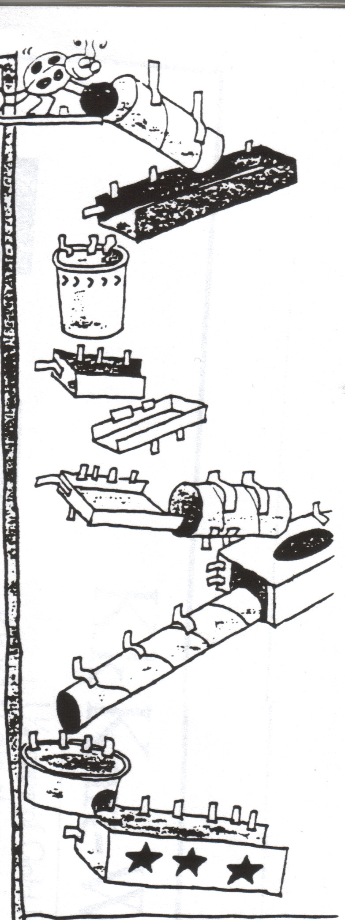
Materials:
A blank wall, large piece of cardboard, or box lid
Cardboard tubes, paper cups, egg cartons, small boxes, margarine tubs – any kind of throw-away material that a marble could roll through or down
Construction paper
Scissors
Masking or Duct Tape
Marbles
Directions:
Locate a suitable wall, panel sheet, or cardboard surface to hold your raceway.
Make “runs” for your marble cars using tubes, boxes, long strips of folded paper.
Be sure to construct side walls on your runs to keep the marbles on course.
Tape the “runs” to the wall or surface, making each new “run” slightly lower than the first, making a downward path.
Experiment with different lengths, angles, openings, chutes, turns, tunnels, zigzags or jumps.
Drop a marble into the opening at the top and watch gravity at work as the marble zooms, rolls and bounces along.
Build two side by side courses and have a marble race. Or try using balls of different sizes and weights. Experiment to see which will roll through faster, a Ping-Pong ball, a jacks ball, or a marble.
Your Emergency Kit on Wheels
Alice, Golden Empire Council
Every family should keep the following supplies either stored in a convenient place known to all family members. A smaller version of the Disaster Supplies kit should be kept in the trunk of the car. Keep items in air tight plastic bags. Change the stored water every six months so it stays fresh (Mark the date on your calendar, perhaps the First of January and the First of July)
Also rotate out food and replace batteries, clothes and shoes for children. Ask your pharmacist about storing prescription medications for your family (and pets)
- Water – a gallon a day per person – in a personal pack, use smaller containers that can be discarded to keep weight down
- Foods that don’t spoil, such as hard candies, meat sticks or jerky, canned juices, milk, meats, fruits and veggies, dried fruits, high energy foods such as granola bars, trail mix, special food supplies for infants, elderly or those on special diets
- First Aid kit – it should include sterile adhesive bandages in various sizes, 2” and 4” gauze pads, triangular bandages, roller bandages, small scissors, tweezers, needle and thread, moistened towelettes, antiseptic in disposable packages, tube of petroleum jelly, safety pins, soap, latex gloves, sunscreen, aspirin or non-aspirin pain reliever, anti-diarrhea medication, antacid, laxative, activated charcoal
- Tools: Mess kit, emergency preparedness manual, battery operated radio and flashlight with extra batteries, cash and change, manual can opener, utility knife, pliers, tape, compass, matches in a waterproof container, aluminum foil, flares, paper, pencil, shut off wrench for household gas and water, WHISTLE, map of area, plastic sheeting or black garbage bags, soap, personal hygiene supplies
- Clothing: Study pair of shoes, rain gear, space blanket, hat and gloves, sunglasses, thermal underwear in cold climates, extra outerwear if needed, change of socks
- Important telephone numbers and family records.
- Also keep special documents in an off-site location such as a safety deposit box or in a water/fire proof container: Insurance policies, deeds, stocks & bonds, passports, social security cards, immunization records, band and credit card numbers, inventory of household goods, important family records, such as birth, marriage, death certificates.
GAMES
Car & Driver
Alice, Golden Empire Council
- Boys work in pairs. One partner is the driver and stands directly behind the other with his hands on his partner’s shoulders.
- They walk through a course that has been set up previously. Use tape on the floor or signs to indicate making a turn, stopping for signals, taking a detour, etc.
- Begin with eyes open, but the “driver” can only direct his “car” by using his hands on the shoulders.
- After doing the course with eyes open, try it with the “car” having a blindfold or closed eyes, directed only by the “driver’s” voice.
- To make it even more challenging, have the vehicles cross over each other’s paths!
Auto Trip Musical Chairs
Alice, Golden Empire Council
Players are seated in a circle and each one is given the name of a part of a car (tires, gas tank, hood, steering wheel, tires, brakes.) One player begins as the storyteller, including various parts as he tells the story of the “trip.” “We went down the road till a Tire went flat…” As a car part is mentioned, the player with that part gets up and runs around his chair, then sits back down. (It helps the storyteller to have the car parts listed on the wall) The story continues, with the storyteller sometimes yelling “Blowout!” Then everyone, including the storyteller must leave their seat, race around the circle and find a different seat. Meanwhile, the den leader pulls one chair out of the circle. Whichever player is left without a seat becomes the new storyteller.
Bulls-Eye Race
Baltimore Area Council
Preparation:
- Make a track out of one 8-foot length of 6" wide x 3/4” thick plywood board.
- Use the traditional strip of wood running the length of the board for the lane.
- Paint 1-inch strips across the board every 6 inches in different colors (Red, yellow, blue, green, etc.) before you attach the center strip.
- Cut a 36x36” piece of butcher paper. Draw a bulls-eye on the paper using 6-inch wide rings.
- Give each ring a point value.
- Tape the bulls-eye flat to the floor.
- Raise the track a few feet off the floor. (The track could be braced on the seat of a chair.)
The Race:
Boys hold their pinewood derby cars at any starting line they wish (e.g., the yellow stripe) and then let it go.
The Object:
- The object is to have the car stop in the bulls-eye.
- If the car stops short, the boy should start his car higher up on the track.
- If the car rolls too far, he should start it on a lower stripe. Each boy gets two trial runs and then a scoring run.
- Points are awarded depending on where the car stops.
Grand Prix Race
Baltimore Area Council
Equipment:
- 2 foot x2-foot piece of cardboard for each team;
- Cones and other objects
Preparation:
Set up cones and objects to create a track.
Divide boys into teams of two.
Each team is given a car (2 x 2 piece of cardboard).
The Race:
- One Cub Scout from each team sits on the cardboard and scoots around a predetermined race track using his feet and hands.
- When he completes the course, the second boy on the team takes his turn.
Box mobile Derby
Baltimore Area Council
This is a fun game where Tiger Cubs in their Box Cars “drive” from pit stop to pit stop trying to accomplish each task. Use your imagination to come up with pit stop ideas!
Some Pit Stop Ideas:
- Staying in Your Lane: Tiger Cubs walk the edge of a wooden board or a taped line on the floor. If a boy strays out of his lane, he has to return to the start and try again.
- Backing Into a Parking Space: Tape a balloon to the wall and have Tiger Cubs back into it until it pops.
- Washing the Windshield: Have a damp washcloth hanging from a string. Tiger Cubs mush wash the windshield (their faces) with using their hands.
- Singing with the Radio: Tiger Cubs stop and sing any song as if they were singing with the radio.
- Gassing Up the Car: Have a small (8-oz. or less) glass of water for each boy to drink as he comes through this pit stop.
- Changing Tires: Have Tiger Cubs take off their old tires (shoes) and put on new (adult sized) tires before racing down a path and back. Then they put their original tires back on.
Transportation Charades
Baltimore Area Council
Before the meeting, write down different modes of transportation on slips of paper.
To play the game, each Cub, (Tigers with the help of their adult partners), acts out one type of transportation while the others guess what it is.
Red Light, Green Light
Baltimore Area Council
Materials: STOP and GO signs and rope for finish line (Signs are easily made by writing the word on construction paper; tape a pencil to the back for stability.)
- Boys line up on one side of the yard; den chief stands at the finish line on the other side.
- When the den chief holds up the GO sign, the boys may move toward the finish line.
- When the Den Chief raises the STOP sign, Cub Scouts must stop in their tracks.
- If they don’t stop, they must go back to the start position.
START YOUR ENGINES
Great Salt Lake Council
- Arrange the Cub Scouts in a circle, with one boy in the center.
- Each boy chooses the name of a car he would like to be.
- It can be the make of a vehicle such as Ford; or it can be a specific model like Explorer.
- The boy in the middle starts the game by saying “I would like to drive a Honda.”
- He can say any car that the boys have chosen.
- Now the “Honda” player needs to answer “I’d rather drive a _______” filling in another name of a car.
- Play continues until a person chooses a car that doesn’t belong, or is his own car.
- He then goes into the center and play starts over.
- You can also change it so that the player that misses is out and play the game elimination style.
READY, AIM, ROLL
Great Salt Lake Council
Materials needed:
Two old rubber tires and
Several tennis or ping pong balls.
Directions:
- Divide the group into two teams.
- Have the teams form two lines about 15 feet from the tires.
- The tires can be standing up or lying flat on the ground.
- Each player gets a chance to throw one or more balls into the tire.
- Remind them about ricochet.
- Each ball that lands in the tire if it is flat, or that goes through the tire standing up earns the team a point.
- The team with the most points wins.
BACK-TO-BACK RELAY
Baltimore Area Council
- Two boys stand back to back with their backs touching.
- They run together from the starting line to the finish line, with one boy facing forward and the other facing backward during the run.
- Then on the return, the one facing forward faces backwards. They must always keep their back touching.
BROKEN DOWN CAR RELAY
Baltimore Area Council
Divide the boys into two or more teams of eight boys.
Line them up single file at a starting point. You can make up other problems and actions for the boys to do.
- The first player one each team represents a flat tire. He hops to the goal and back.
- The second player is a broken radiator. He makes a hissing sound as he runs to the goal and back.
- The third player has water in his tank. He walks forward three steps and backward two steps until he has covered the course.
- The fourth player has a rundown battery, so the 5th Player pushes him.
- The sixth player lost his wheel. He moves on two hands and one foot.
- The seventh player can only move in reverse; so he runs backward.
- And the eighth player is in good shape. He runs fast!
Whirling Wheels
Santa Clara County Council
Equipment: 1 beanbag per Den.
Arrange the Dens like the spokes of a wheel, facing in a clockwise direction with the Denner in the center.
A beanbag lies at the feet of each Denner
When the leader gives the starting signal, The Denner
Picks up his beanbag,
Runs down the line of his Den and
Runs in a clockwise direction around the wheel and
Back to the outside end of the Den.
The beanbag is then passed up the Den to the Cub now at the center.
This continues until all the Cubs have had a turn.
Jet Car
Capital Area Council

Materials:
2” x 2” x 5” box,
9” balloon,
2 straws 1 ½” long,
1 straw 4” long,
2 wooden dowels 3” long and 1/8” in diameter,
4 milk bottle caps or other lightweight wheels,
2 rubber bands,
masking tape,
hammer and small nail.
Construction:
- Tape the two short straws on the bottom of the box to house the dowel axles.
- Make a small hold in the center of each bottle cap wheel with the hammer and nail.
- Force one wheel onto each axle.
- Wheels should fit tightly. Put each axle through a straw on the box bottom and attach the other two wheels.
- Insert the long straw section into the neck of the balloon about ¾”.
- Secure with a rubber band.
- Poke holes in the box so that the straw can mounted at an angle, aiming at the floor.
- Secure with a rubber band.
Use:
- Blow through the straw to inflate the balloon,
- Pinch off the straw to trap the air.
- Set the car on the floor and let it go.
Tire Grand Prix
Capital Area Council
Lay out a course in a safe, open area, and give each player an old tire.
Then have players race, rolling their tires around the course.
At each “pit stop” the driver passes the tire on to a fresh driver.
For added fun, allow player to kick, knock over, or in any way impede the progress of the opposing racers, while still trying to get their best time.
Alert safety guards to watch for unnecessary roughness.
Old tires can be borrowed, which alleviates the disposal problem after the race.
Going on a Trip:
Capital Area Council
Equipment for each team: one suitcase filled with a hat, coat, gloves, and any other desired clothing, one umbrella. (Keep the contents of the suitcases uniform in components and fastenings).
At a signal, first player from each team runs to the goal, opens the suitcase, puts on clothes, closes suitcase, opens umbrella and runs to starting point. There, he takes off all the items and player #2 puts them on. Player #2 races to the suitcase, undresses, repacks the suitcase and returns to the team. # 3 starts the process over, comes back and gives the items to #4, etc. This continues until each player has dressed. First team completed wins.
I Am Part of an Automobile
Capital Area Council
With players seated in a circle, someone starts off by saying, “I am a ______________.” and gives the name of some part of an automobile. The idea is to see how long you can keep going around the circle until you run out of parts. As long as one is able to name a new part, he may remain in the game. Keep going until only one is left in the circle. No part may be named twice.
Stock Car Racing
Capital Area Council
Active, indoors/outdoors - No equipment
The boys line up in lines
Each Cub is given the name of a car and when that car is called, he travels to the end of the area and back in the manner described
Examples are:
- Rolls-Royce – this never goes wrong – the cub runs
- Austin - has a flat tire – the Cub hops
- Morris – stuck in reverse – the Cub runs backwards
- Ford – very old model, can only go slowly, the Cub walks
- Mini – it’s a small car – the Cub runs, crouched down
- Hummer – pulls caravan, the Cub tows his den behind
When “Stock Car” is called – everyone runs
Make up the car names and actions as you wish
Car Relay
Santa Clara County Council
Divide your boys into teams of 6 and have them each select the part of an automobile they will be. Then tell them how they will race.
Steering – gear is broken – walk zigzag.
Flat tire –Limp.
Gas Tank – water in tank two steps forward, one step back.
Transmission – Can’t go forward – walks backward.
Battery – Dead – can’t go at all (See Tow)
Tow – Pushes 5th player by placing both hands on player’s waist.
Car Tire Games
Santa Clara County Council
Tire Sprint: Racers line up with forward edge of tire at the starting line. On signal, they push tire forward and continue to push it across finish line. If necessary, establish lanes.
Roll for Distance: Each player rolls his tire separately and is entitled to run to gain speed and momentum but must stop at the stopping line while the tire rolls forward by itself.
Roll for Accuracy; Same as above, except tire is rolled at a target of 2 sticks set 3-4 feet apart and approximately 20 feet away.
Moving Target: Players take two turns rolling tire parallel to other players 15 – 20 feet away who try to throw balls or beanbags or broomsticks through the tire as it rolls by.
Tire Wrestling: Place two tires on the ground so they touch each other. One contestant stands in each tire. As the signal, they wrestle to throw or push their opponent out of his tire. The winner is the first to cause the other to fall or step out of his tire, provided he himself remains on his feet in his tire.
Tire Bowling: Bowl, using discarded tires in place of balls, with milk cartons or tin cans for bowling pins. Arrange “alley” on the ground with the bowling line 20 – 30 feet from the pins. Each bowler rolls two tires. Score as in bowling. Or from Capital Area Council -
Use discarded tires in place of a ball and milk cartons, tin cans, or bleach containers for pins. Arrange “alley” on the ground with the bowling line 20 to 30 feet from the “pins”. Each bowler rolls two tires. Score as in bowling.
Tire Rolling Relay: Form teams and give the first player of each team a tire. Place a stake or chair opposite each team on the turning line. At the signal, the first player rolls his tire to the turning line, rolls it around the stake and back to the next player in line.
Through the Tire Relay: Establish a rolling line in front of the lines of dens. The first player of each team goes up to the rolling line with a tire. At signal he rolls his tire forward toward his team by giving it one shove. The players in turn then straddle-jump the tire. If the roller did not steer the tire exactly straight, the line must shift in order to be in line with their tire. If a player knocks the tire down in attempting to jump it, or if it falls over before he can jump it, he must recover the tire and give it to the player in front of him who rolls it for him and the rest of the team. The original roller then takes place at the front of the line. When the last man has jumped the tire, he rolls it to the starting line, and the action is repeated until the original roller has rolled the tire back to the starting line.
Car Games
Grand Teton Council
GEOGRAPHY GAME
- Players are seated in a circle.
- First player names a geographical term — city, river, country, animal, race, etc.
- Second person must give a geographical word which begins with the last letter of the first player's word.
- Continue thus around the circle.
- The same word is not to be given twice.
YOU'RE GOING TO TAKE A TRIP
- For this game you will need two teams of three or more boys.
- Each boy has blindfold so that they cannot see.
- One boy will be the leader of his team and will have to guide his teammates and pick up small flags along the way. (The Webelos leader has put these markers in the back yard ahead of time so that no one will know where they are.)
- Make two identical trails.
- The team that comes back with the most markers is the winner.
I PACK MY SUITCASE
- One boy starts the game by saying "I pack my suitcase and I put in ......(he says something like my shirt., or my toothbrush).
- The next player says I pack my suitcase and I put in ....repeats the first player's item and then adds his own.
- This continues and each boy who is not able to get all the previous items correctly is out of the game and
- The game continues until all but one boy have missed.
FIND IT ON A MAP
- Give each team a United States map.
- Have the first boy from each team step up to the map and you call out a city.
- The boys all get a predetermined time to find the city and whoever does gets a point (or only the team of the first boy to find the city gets the point.)
- Once the boy has found it, he gets one point for his team and the next boy steps up to the map.
- Call out another city.
- This continues until one team has 11 points.
PLOT YOUR ROUTE
- Give each boy a state map.
- Tell them you are leaving this city (where you live or meet) and going to..........(another city in the state)
- Have them plot the route you will need to take.
CUB GRUB
Twinkie School Bus
Great Salt Lake Council
Ingredients:
1 Twinkie
4 cookie crisp cereal pieces
1/2 vanilla wafer
2 mini marshmallows
2 red hots
Frosting (for glue)
Directions:
- Place Twinkie in the center of a small paper plate.
- Using the frosting “glue”
  - The cookie crisp cereal pieces to the Twinkie for wheels,
  - The vanilla wafer for the steering wheel,
  - The marshmallows for headlights placing a red hot in the center of each marshmallow to complete to lights.
Pinewood Derby Celery Racers
Great Salt Lake Council
Ingredients:
Celery
Canned Cheese
Carrots
Raisins
Toothpicks
Directions:
- Cut celery into 6” lengths.
- Slice carrots in 1/8” thick pieces.
- Pile cheese into center of the celery and
- Top of with a raisin for the drivers head.
- At each end of the celery stick use a toothpick as an axle and wheels.
You can use Peanut Butter instead of Canned Cheese if desired.
Snowball VW Bug Car
Great Salt Lake Council
Using the same method as above using Snowballs instead of Twinkies.
Cookie Wheels
Grand Teton Council
Ingredients:
Cookies (any small kind the size of Oreos)
prepared frosting
colored sprinkles or mini chocolate chips
Directions
- Sandwich two cookies together using frosting as glue.
- Frost the edges of the "wheel" and
- Roll in sprinkles or mini chocolate chips.
Speedy Donuts
Grand Teton Council
These were always a favorite of my troop when we went camping especially if the Webelos were along CD
Ingredients:
1 pkg. ready to bake biscuits
1 c. oil
Sugar & cinnamon mixed in a brown paper bag
Directions
- Separate biscuits and cut a hole in center (or pull apart with fingers to form a ring).
A two liter soda bottle top makes a great hole cutter CD
The following two steps are to be done by adults only
or maybe an older Den Chief
- Drop in hot oil and
- Turn to brown on both sides and remove from oil.
- Toss in the sugar and cinnamon mixture.
- They are ready to eat!!
Homemade Bike Energy Bar
Grand Teton Council
Ingredients:
1/4 cup butter, melted or oil
8 large egg whites, beaten
¾ cup whole-wheat flour
1/4 cup wheat germ
1/2 teaspoon baking powder
1/2 cup nonfat dry milk powder
3/4 cup rolled oats
1 teaspoon salt
3/4 cup brown sugar
2 cups chopped dried fruit
2 1/2 cups nuts, chopped
3/4 cup chocolate chips (optional)
1/4 cup sesame seeds
Directions
- Preheat oven to 350 degrees.
- Grease a 9x13 pan. Beat together eggs and oil.
- Sift together dry ingredients except fruit.
- Add flour to eggs, combine,
- Then stir in fruit, nuts, and chips.
- Spread evenly in pan,
- Bake 30 minutes, they are still soft when done.
- Cool, cut into 24 pieces, wrap in foil and freeze.
Frozen Wheels
Grand Teton Council
Ingredients:
Chocolate chip cookies
Chocolate or vanilla ice cream, softened
Colored sprinkles 01 mini chocolate chips
Directions
- Create a wheel by sandwiching ice cream between two cookies.
- Roll the edges of the "wheel" in colored sprinkles or mini chocolate chips.
- Freeze until ready to eat.

Zesty Appetizer Wheels
Grand Teton Council
Ingredients:
12 slices hard salami
1 (8 ounce) can crescent rolls
1/3 cup tbsps grated parmesan cheese
2 teaspoons Italian seasoning
Directions
- Preheat oven to 3 50°F.
- Open the dough to 2 rectangles,
- Press the perforation to seal.
- Sprinkle each rectangle with 3 tbsp parmesan and 1 tsp Italian seasoning.
- Lay 6 slices salami along the side of the rectangle.
- Roll the dough up and pinch the ends.
- Cut each roll into 8 slices.
- Place on cookie sheet and bake for 13 min or until golden brown.
- You can substitute 24 pepperoni for 12 salami slices.
Ice Cream "Lollipops"
Grand Teton Council
Directions
For each lollipop,
- Use a scoop to shape ice cream into a ball.
- Roll in shredded chocolate, chopped nuts, toasted coconut, or crushed candy or cookies.
- Insert Popsicle stick.
- Store in covered container in freezer.
SUNNY SODA
Grand Teton Council
Ingredients:
orange sherbet or vanilla ice cream
orange soda
Directions
- Scoop orange sherbet or vanilla ice cream into a tall glass.
- Top with orange soda.
Hamburger Surprise
Grand Teton Council
Ingredients:
Vanilla wafers (buns)
Small York Peppermint Patties (burgers)
Green coconut (lettuce)
White frosting, colored yellow and red (ketchup and mustard)
Directions
- Place York Peppermint Patty on vanilla wafer.
- Frost with "mustard," "ketchup," and top with "lettuce."
- Place 2nd wafer on top,
- Squeeze gently for a JUICY hamburger surprise.
Sun-Baked S 'mores
Grand Teton Council
Ingredients:
Graham Crackers,
Large marshmallows,
Chocolate bars
Aluminum foil
Directions
- Put large marshmallow on each of two cracker squares.
- Place & section of chocolate bar on each marshmallow.
- Cover with a second cracker.
- Wrap entire thing in aluminum foil.
- Place in a sunny spot for 1A hour or until melted.
- Unwrap and eat.
Nuts and Bolts
Grand Teton Council
Ingredients:
½ C Margarine
1 ¼ tsp seasoned salt
2 C Corn Chex
2 C Rice Chex
2 C Cheerios
2 C Pretzels
4 ½ tsp Worcestershire sauce
1 C mixed nuts
Directions
- Melt margarine in a large pan in the oven.
- Add seasoned salt and stir.
- Mix in remaining ingredients and stir until coated.
- Bake for 1 hour at 250o. Stir every 15 minutes.
“Wheelie Cookies”
Alice, Golden Empire Council
Ingredients:
1-1/2 cup all purpose flour
½ cup softened margarine or butter
¼ teaspoon of powdered sugar
½ teaspoon of baking powder
2 Tablespoons of milk
1 cup of pie filling or jam
Directions:
- Pre-heat the oven to 375 degrees.
- Mix flour, butter or margarine, powdered sugar, baking powder and a little milk. (Only enough for the dough to form – if the dough seems dry, mix in 1 teaspoon of milk at a time)
- Divide the dough into six equal parts.
- Shape each part into a ball, place on an ungreased cookie sheet and flatten slightly.
- Make an indentation about 1-3/4” across and ¾” deep in the center of each cookie – I use my finger or thumb.
- Fill each indentation with about 2 Tablespoons of either pie filling or jam.
- Bake until the edges begin to brown, about 20-25 minutes.
- This recipe makes 6 “Wheelies” – easy to double or even triple!
Racing Car Treat
Alice, Golden Empire Council
Each boy can build his own racing car.
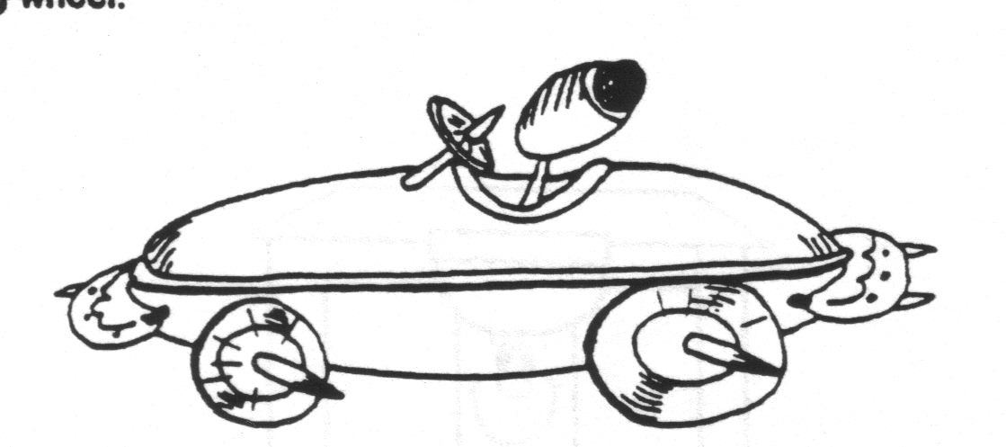
Begin with a hot dog bun sliced apart, with a slice of cheese in between – this makes racing “stripes” on the side of the “car.”
You could also add a hot dog, or slice the hot dog horizontally to make another “stripe” down the side of the car.
Make wheels out of carrot slices and attach with toothpicks.
Use pimento strips to outline the driver’s seat.
The “driver” is an olive on a toothpick.
Pickles can make bumpers and another carrot slice can make the steering wheel.
WEBELOS
Turning Your Webelos Into Boy Scouts
Baltimore Area Council
- Start early with your program for the first year boys to get all of them to Arrow of Light (A.O.L.).
- Do not wait for September to start new Webelos den into active program.
- Get together during the summer months to do some special activities. The Aquanaut can be completed right away.
- Pull the den together during the summer by doing small and simple service projects for school, church, or community.
- While doing regular programs with boys add those requirements for 'joining Boy Scouts'. Get boys into the outdoors as soon as they start the Webelos Program.
- Do as many activity pins outside as possible. Plan around a patio, yard, Garage, Park, Pool, a business or any other place.
- Have special Visitors over for den meetings to talk about specific skill activities.
- Spend sufficient time with each activity pin. Not one week, but two to four weeks.
- Try to get all the boys in the den to the Webelos badge at the same time. Make it special for them at their recognition pack meeting.
- Attend the monthly Roundtable meetings and 'Cub Leader Pow-Wow' to get activity pin ideas and help.
- Once into the program start planning ahead, up to six months, those activities you want to do. Work your program into your schedule, the seasons, the weather, the Boy Scout Troop and sudden changes. Always have a back-up plan.
- If a leader feels uncomfortable about doing an activity with the boys, get help: do not pass up the opportunity to learn
- Give boys a sample of the skills, activities, requirements that the Boy Scouts do.
- Start early to get boys ready for camping. Have a backyard Day Camp or overnighter.
- Look for Troops in your area that the boys may go to and visit. Go Camping with them. Have skills demonstrations with them.
- Take boys on meaningful tours and trips (more special than their earlier Cub outings).
- Now is the time to take boys out for hikes - in neighborhood, park, construction site, open fields.
- Know what your boys want and give them all they can take. Every Activity Pin if they so desire.
- Realize that the second year for Webelos is a short one. Know when to graduate them ahead of time.
- Plan well ahead for the Arrow of Light and get an O.A. (Order of the Arrow) ceremony or other special ceremony scheduled. Contact Troops for help.
- Be sure to fulfill all the requirements for Arrow of Light and those to get the boys started into Boy Scouts.
- Get parents involved, even more than before, so they will help carry boys into Boy Scouts.
- Visit more than one Troop in your area - early. Have parents go along. Also to get a better understanding of the Boy Scout Program.
- Having a Boy Scout Handbook to work from, refer to, show boys, get ideas from and get them prepared with is a great training aid.
- Be aware that boys are lost from the Boy Scout Program during the first year if not properly prepared.
- It is very important that boys experience camping before they join the Boy Scouts to make it more comfortable for them.
- Remember that a parent must be with a boy on campouts as Webelos, but let the boys live the experience themselves.
- Having and using a trained 'Den Chief' will add to the program and help leaders, too. The Webelos will enjoy having an older boy there.
- Use as many assistant leaders and parents as possible to help with any and all hands-on skills activities. A good safety factor, too.
- Get outside experienced help to give boys the 'Whittling Chit' Requirements and Demonstrations.
- Boys should start working towards proper uniforming for the Boy Scouts. A proper insignia placement is important.
- Having a den doodle for the boys is a good tracking and incentive tool to get them all into Boy Scouts.
- Work with the Webelos at the beginning of their second year, a little at a time, so that they know the Boy Scout Joining Requirements.
- Have them start working towards the Boy Scout Tenderfoot physical fitness requirements. This is the hardest requirement to fulfill.
- Get boys started in making out duty rosters and menus for campouts soon. They will have to do these on their own as Boy Scouts.
- Get all of your boys to Webelos Summer Camp after their first year. This will be their best Outdoor experience as a Webelos den.
- Games, Skits, Songs, Stories, Competition with each other and a den flag are very important parts of the Webelos Program.
- Letting the boys pick a patrol name, with a patch, instead of a den number will bring the boys closer to the Boy Scout Program.
- The most important part of the Webelos Program is having well trained leaders to pass on all those new skills to the
Keys to Cub Scouts continuing in Boy Scouts
Baltimore Area Council
  - Visit troop before moving up from cub scouts
  - Having friends in the Boy Scout troop
  - Going to summer camp the first summer as a boy scout
FITNESS
PHYSICAL SKILLS GROUP
Baltimore Area Council
Your body is a wonderful machine. It is much more complicated than the fanciest car or fastest computer. But your body needs the same kind of care that experts give to machines. What does that mean? It means that you must give your body the right fuels in a balanced diet. You must avoid putting harmful substances into it. Your body needs rest and exercise, just as a car needs maintenance. As you earn the Fitness activity badge, you will learn how to take care of the world's most wonderful machine - your own body.
Den Activities
- Invite the grade school gym teacher to your meeting. Get to know them on a personal basis. Why did they become a teacher? What kind of background do they have? What sports are they currently active in? What do they like about teaching kids?
- Invite a nurse, doctor or dentist to your den to answer questions about health. Have boys write the questions on cards so they are anonymous.
- Have your den write a skit depicting ways to say ‘NO’ to drugs & smoking.
- Have the den make a poster designed to encourage people to say "NO" to drugs & Smoking.
- Have a police officer involved with drug prevention attend a den meeting.
- Have the boys interview him and ask questions concerning drugs and alcohol.
- Have the boys find out what the policies are in their school about drugs and what would happen to students with drugs in their lockers, etc.
- Collect newspaper and magazine articles about accidents and crimes that are drug or alcohol related.
- Find out what some organizations are doing to stop use and availability of drugs, especially to, children.
- Check with the BSA council for a video, "Drugs: A Deadly Game."
Speakers –
- YMCA director
- heath class teacher
- personal trainer or coach,
- CPR instructor,
- marathon or race director,
- little league coach,
- gym instructor
Field Trips:
- Visit the local YMCA.
- Visit a local fitness club.
Test Your Heartbeat
Did you know that you can’t actually hear a heartbeat? The heartbeat itself is just a contraction of muscle and is perfectly quiet. What you can hear is the sound of heart valves snapping shut.
Here’s how to check your heartbeat:
1. Press the first two fingers of one hand over the radial artery in the wrist of your other hand. That’s the artery in the depression just below the base of your wrist. Move your fingers until you can feel the pulse of your blood.
2. Use a watch with a second hand, and count the number of beats in 10 seconds.
3. Multiply by 6. Now you know the number of beats per minute.
4. Run or exercise for 10 minutes or so. Take your pulse again, and see how much faster your heart is pumping.
Your resting heart rate can tell something about your overall health and fitness.
Physically fit people often have low resting heart rates.
Southern NJ Council
The material for this badge is organized somewhat differently.
Facts On Cigarette Smoking
- Cigarette smoking is addictive. It fulfills these three criteria:
  - Smokers develop a tolerance to nicotine (they need to smoke more and more for an effect.)
  - Smokers become dependent on it (they need it to feel comfortable.)
  - Smokers suffer withdrawal symptoms (physical and psychological discomfort) when they try to stop smoking.
- There are hundreds of chemicals in cigarette smoke. Three of the most damaging ones are:
  - Tars - damage delicate lung tissue and are considered the main cancer causing agent in cigarette smoke.
  - Nicotine - a poison found only in tobacco leaves. One drop of pure nicotine can be fatal to humans. It is a powerful stimulant to the brain and central nervous system that “hits” the brain within four seconds. But then it has a depressant effect on the cardiovascular system. It narrows the blood vessels cutting down the flow of blood and oxygen throughout your body. The heart has to pump harder, thus increasing the chance of heart disease. It raises the blood pressure and narrows air passages in the lungs, depriving the body of some oxygen.
  - Carbon Monoxide - replaces needed oxygen in your red blood cells. Even after one stops smoking, carbon monoxide stays in the bloodstream for days depriving the body of oxygen until the oxygen level in the blood returns to normal. Carbon monoxide is a product of cigarette smoking and also of gasoline engines.
- Some of the diseases caused by cigarette smoking are:
  - Chronic Bronchitis - an inflammation of the bronchi which are the breathing tubes in the lungs.
  - Laryngitis - an inflammation of the throat
  - Emphysema - a degenerative lung disease that destroys breathing capacity.
  - It is a contributing factor in cancer of the lungs, mouth and esophagus.
Activities That Will Help The Boys Understand The Harmful Effects Of Cigarette Smoking
            - Define ‘pollution.” (“Pol-lu-tion: to make unclean, impure, or corrupt; desecrate; defile; contaminate; dirty.” Webster’s New World Dictionary of the American. Language)
            - Discuss pollutants in the air in the outside environment. Use pictures from magazines or newspapers. Include: factory smoke, car exhausts, rocket launches, smoke from someone else’s burning cigarette and so on.
            - Explain how all living things need air to breathe.
              - Put a plant under an airtight container. What begins to happen?
              - Put ants or other insects in an airtight jar. Give them everything else the need to survive. What happens? Why? (When the ants’ activity begins to decrease, open the jar and set them free.)
            - Talk about the fact that smoking cigarettes is harmful to our health and how it “pollutes” the internal environment of our body (the lungs).
              - Blow smoke from a cigarette through a tissue. What did you observe? Wouldn’t that also make your lungs “dirty?”
              - Hold your breath and have someone check the time. Did you have to breathe very soon after you started holding your breath?
Demonstrate the effects of sick or injured lungs:
      - Light a candle. Ask a boy to stand a reasonable distance from the candle. Instruct the boy to take a deep breath, and then blow out the candle.
      - Relight the candle. Ask the boy to stand at the same distance from the candle. Instruct him to take a deep breath and blow out at least half of the breath before attempting to blow out the candle. With the breath that is left, ask the boy to blow out the candle. What happened?
Prescription Drugs
Ask the boys to define “drugs - (any substance, liquid, powder, or solid taken by mouth, inhaled, injected, or rubbed into the skin, that affects the way the body or the mind naturally works.)
Define “prescription drugs” - (medicines that, legally, can be purchased only on the order of a doctor or a dentist, a) for specific reasons, b) for a specific person, and c) prepared by a specially trained person called a pharmacist.)
Have the boys talk about the last time they went to the doctor or dentist and were given medicine. What was the problem? What medicine was given? Did it make them feel better?
Bring in empty, clean bottles that once contained prescription medicines. Choose something appropriate, e.g. an antibiotic from a recent illness, prescription vitamins or fluoride tablets
Note:
• the label,
• the name of the one particular person,
• the name of the medicine,
• the amount and the time to be given,
• the name of the doctor, the date
• the prescription number,
• the number of refills, if needed, and
• the pharmacy name, address and phone number.
Discuss some of the considerations the doctor must make before he can order your medication:
      - age,
      - weight,
      - general health of the person, and
      - severity of the condition.
A drug may affect different people in die different ways! Have the boys make reports on the discovery of drugs/medicines that have helped mankind. (Ex. measles vaccine, polio vaccine, penicillin, and so forth.)
Stress that medicine may be taken only under the supervision of a parent, physician, nurse, or specifically designated adult.
Have the boys list safety rules to be followed when taking medicine. Put these on a large poster to be displayed at the Pack Meeting.
Be sure they include the following rules:
            - Take medicine as directed. -
            - Finish the entire prescription.
            - Discard any unused medicines.
            - Never share your medicines with anyone else.
            - Keep medicine in a safe place, out of the reach of children.
            - Keep medicines in their original container.
            - Do not take several medicines at the same time unless the doctor is aware of all of them.
            - Mixing drugs and alcohol can be fatal.
            - Never describe medicine as “candy.”
            - Never give medicines in the dark.
            - Never give medicine from an unlabeled container. When in doubt - throw it out.
Non-prescription drugs
Define the term “non-prescription drug” (Medicines that do not require a doctor’s order or the assistance of a pharmacist. They can be found on open shelves in a drug store or supermarket.)
Take the boys to the local supermarket and have the boys make a survey of the drugs they find there. Ask them to read the labels and list:
            - The name of the product.
            - The condition for which it is to be used.
            - Is it a liquid, tablet, capsule, cream, or spray.
            - Any warnings or cautions listed on the container.
Was there more than one product that could be used for the same condition?
Locate and list 3 substances which are socially acceptable, contain a drug and can be bought in supermarkets.
- Cigarettes (tobacco contains nicotine)
- Coffee, tea, cocoa, cola (all contain caffeine)
- Beer, wine, whiskey (all contain alcohol)
Have the boys report on two TV commercials dealing with non-prescription medication (aspirin, cold preparations, etc.) In the report answer the following questions:
            - Does the medicine always seem to make the people better and happier?
            - Can that be true always?
            - Why would the manufacturer want people to believe that?
            - Are they always completely honest?
            - Compare ads for brands of aspirin.
            - Can they all be the best?
Facts on alcohol
- Alcohol is a drug that affects the way the body naturally functions. It is a depressant that slows the body processes.
- It is the oldest and most abused drug in the world.
- There are predictable, though varying physical effects upon everyone who drinks alcohol. (This is why the law has set a specific blood alcohol level for defining drunkenness while driving.) The brain is the control center of the body.
              - The brain is the organ most affected by the presence of alcohol.
              - Alcohol is a drug that depresses the central nervous system, thus reducing the activity of the brain.
              - Alcohol arrives in the brain almost as soon as it is consumed.
              - The bloodstream carries alcohol to the brain.
              - It keeps circulating through the brain until the liver has had time to change all of the alcohol into carbon dioxide and water for release from the body.
              - It affects the higher functions of the brain judgment, learning, and behavioral control. It then affects vision, coordination, and speech.
Too much alcohol in the bloodstream kills by depressing the breathing center. This means that a person who drinks too much alcohol in one day can die. This is called “acute alcohol poisoning.”
Related Activities
• Have a dietitian come talk to the den.
• Visit a dentist office.
Gathering Activity:
As the Scouts arrive, ask them to complete the table,
Filling in the names of the foods they ate that day.
Scout with most balanced chart wins (an ice cream sundae???)
Last column doesn’t count.
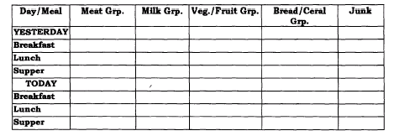
Physical Activities
Trees in the Wind: Gather the den around you in a circle, three feet or more between individuals. Scout stands looking at the back of the Scout next to him. They then run slowly around the circle, bending left, right, forward, and back as though swaying in the breeze. One the command, “reverse”, they turn around and run in the opposite direction.
Russian Hop: Scouts squatting, ready to move around the circle, feet together, hands folded around chest. Move around circle, leaping upward and forward off both feet. As hop is complete, Scout returns to squat position with arms folded across chest.
Tortoise and Hare: Scouts stand at attention, then they start jogging slowly in place. When you say “Hare”, the tempo doubles, knees lifting high, arms pumping vigorously. When you say “Tortoise”, the tempo slows to an easy jog. Vary the commands for some fun.
Inchworm: Scouts assume push-up position, body extended, face down, arms extended fully, hands on floor, fingers spread, pointed forward. Hold hands stationary and walk feet up as close to hands as possible. Then feet stationary, walk hands forward to starting position. Repeat the sequence.
Gorilla Walk: Scouts’ feet are spread apart, same width as their shoulders. Bend at the waist, grasp ankles, legs straight. Walk forward holding firmly to ankles. Keep legs straight. Conduct a race for speed.
Sawing Wood: Scouts pair off facing each other. Grasp hands at shoulder height, fingers interlaced. With a vigorous action, Scouts pump arms alternatively as though sawing wood.
SCIENTIST
TECHNOLOGY GROUP
This is the second month for Scientist. Last month I published a week by week schedule for this badge. So if you want some more ideas and helps go back to the December theme issue. CD
Timucua District, North Florida Council
Remember the Scientist Activity Badge is a "doing" badge, not a "watching" badge.
For best results, follow this procedure:
- Demonstrate the experiment.
- Explain the experiment.
- Ask questions to test understanding.
- Allow Webelos to do tile experiment.
- Have each boy log the experiment.
- Have each boy explain tile experiment.
- Ask again for questions
What does a scientist do?
A scientist studies things to learn how they behave and why.
Scientists try to find out the laws of nature about the things they study. People can use these rules or laws in making things.
While working on this activity badge, you will learn a few of the main ideas in physics. Physics is a science with several branches.
One of these branches will be weather. You can learn a little about weather in these activity badge requirements.
Another branch of physics is called optics. You will have a chance to learn something about sight and find out how your eyes work.
Scientists learn a lot by experimenting or trying things out. Try things for yourself.
Scientists take nothing for granted.
They may be sure an idea is true, but they always test it, if possible, to make certain they are right.
Scientists And Engineers
Aren't they the same thing? Not quite. Though they use many of the same ideas and methods, scientists and engineers are somewhat different.
What do scientists want? Scientists want to know how the universe works. They may see it as an enormous jigsaw puzzle to solve for its own sake. Some things they find are useful right away, others not (though much of what scientists have found in the past has turned out to be useful in some way). Though they certainly want to help people, their major goal is understanding, not usefulness.
What about engineers? Engineers try to use the facts of science and math to do things that are useful to people. Many engineers are designers -- designing the many products that we use in the world, from computers to cars to camera lenses.
What do they have in common? Quite a few things, actually. Scientists and engineers both use the facts and methods of science, and both often use MATH and COMPUTERS in their work.
PENDULUM PHENOMENON, An Optical Illusion
Fasten a white disc, 3/4-in diameter on a 3 foot piece of white thread. Have someone hold the thread so the disc can swing like a pendulum. Start the disc swinging in a perfectly straight line and view it from a distance of three feet against a plain wall. Notice how the disc swings in a line like a pendulum. Hold a sunglass lens over one eye. Observe the path of the swinging object again. The movement will no longer be in line but in a circle. If you switch the lens to the other eye, the movement will appear to be in the opposite direction.
Principle demonstrated: Shows how important it is for the eyes to receive similar images.
HYDROMETER
This measures the density of a liquid. An object can float in a liquid only if it is less dense than the liquid. Prove this by placing a fresh egg in a glass of water. The egg will sink. Then add 1 tablespoon of salt to the water and the egg will float. Try sticking a thumbtack into a pencil eraser and place the pencil in water, point up. Mark the waterline on the pencil. Add salt to the water. The pencil will ride higher in the water.
WHY? BECAUSE SALT WATER IS MORE DENSE!
PASCAL'S LAW
"The pressure of a liquid or a gas like air is the same in every direction if the liquid is in a closed container. If you put more pressure on the top of the liquid' or gas. the increased pressure will spread all over the container."
A good experiment to demonstrate air pressure is to take two plumber's force cups (plumber's friend) and force them firmly against each other so that some of the air is forced out from between them. Then have the boys try to pull them apart.
When you drink something with a straw, do you suck up the liquid? No! What happens is that the air pressure inside the straw is reduced, so that the air outside the straw forces the liquid up the straw. To prove this fill a pop bottle with water, put a straw into the bottle, then seal the top of the bottle with clay, taking care that the straw is not bent or crimped. Then let one of the boys try to suck the water out of the bottle. They can't do it! Remove the clay and have the boy put two straws into his mouth. Put one of the straws into the bottle of water and the other on the outside. Again he'll have no luck in sucking water out of the bottle. The second straw equalizes the air pressure inside your mouth.
Place about 1/4 cup baking soda in a coke bottle. Pour about 1/4 cup vinegar into a balloon. Fit the top of the balloon over the top of the bottle, and flip the balloon so that the vinegar goes into the bottle. The gas formed from the mixture will blow the balloon, up so that it will stand upright on the bottle and begin to expand. The baking soda and vinegar produce C02, which pushes equally in all directions. The balloon that can expand in all directions with pressure, will do so as the gas is pressured into it.
For this next experiment you will need: A medicine dropper, a tall jar, well filled with water; a sheet of rubber that can be cut from a balloon; and a rubber band. Dip the medicine dropper in the water and fill it partly. Test the dropper in the jar - if it starts to sink, squeeze out a few drops until it finally floats with the top of the bulb almost submerged. Now, cap the jar with the sheet of rubber and fix the rubber band around the edges until the jar is airtight. Push the rubber down with your finger and the upright dropper will sink. Now relax your finger and the dropper will rise. You have prepared a device known as a 'Cartesian Diver'. The downward pressure on the rubber forces the water up into the bottom of the diver, compressing the air above it, producing the effects of sinking, suspension and floating, according to the degree of pressure applied.
DANCING RAISINS
Fill a 12 ounce glass three fourths full of water. Add a tablespoon of baking soda and stir until clear. Drop raisins into the glass. Pour vinegar into the glass. Use as much vinegar as it takes to make the raisins come to the top of the water. Bubbles will appear, and the raisins will "dance."
Mixing vinegar and baking soda together forms a gas called carbon dioxide. Bubbles of carbon dioxide stick to the sides of the raisins, act like air bags, and float the heavy raisins to the surface. At the surface the bubbles break, the raisins sink again, and the process starts all over.
CHARCOAL CRYSTAL GARDEN
This is the classic way I did it when I was a wee lad. Colorful, small, delicate crystals grow on a charcoal or brick surface. You can also use pieces of sponge, coal, or crumbled cork to grow the crystals on. Crystals are formed because the porous materials they grow on draw up the solution by capillary action. As the water evaporates on the surface, deposits of solids are left behind, forming the crystals. As more solution is drawn up, it passes through the crystals that have already formed, depositing more solids on their surfaces, causing the crystals to grow.
FLOATING EGG SALTY MAGIC
The salt water of the seas is much denser than the fresh water of rivers and lakes, and therefore it is easier to float in the ocean. Show this by filling two glasses half full of water. In one of them, mix in about 10 heaping teaspoons of salt.
Try floating an egg in each glass. In which glass does the egg float?
Now take the eggs out of both glasses. Carefully and slowly, pour the fresh water into the salt water glass. Gently lower an egg Into the water. It should float (remain suspended) at the salt water level
BERNOULLI'S PRINCIPLE
MATERIALS:
two Ping-Pong balls,
two feet of thread,
some mending tape and
a drinking straw.
PROCEDURE: Tape each ball to an end of the thread. Hold the center of the thread so that the balls dangle about one foot below your fingers and about one or two inches apart. Have the boys’ blow through a straw exactly between the balls, front a distance of a few inches. Instead of being repelled, the balls will be attracted to each other.
EXPLANATION: The air current directed between the Ping-Pong balls reduces the intervening air pressure. Stronger pressure from the far sides pushes the balls together. The strength of the air from the straw will determine how close the balls will come
FOAMING FOUNTAIN
Place two teaspoonfuls of baking soda in the bottom of a quart glass bottle. Drop a burning match into the bottle. It will continue to burn. Next pour four teaspoonfuls of vinegar on top of the baking soda, being careful not to pour directly onto the match. Watch what happens. The seething, foaming mass is carbon dioxide, released from the soda by the vinegar.
What happens now to a lighted match? Why? Is carbon dioxide gas heavier than air? Than oxygen? Tip bottle slowly over it lighted candle. What happens? The heavy gas can even be poured so the flame flutters and may go out. This is the principle behind some fire extinguishers.
BATTERY
Alessandro Volta, an Italian physicist, produced electricity by chemical reaction in 1800. He did this with a device that became known as a voltaic cell. It was the first wet cell battery. Volta's battery was made with pairs of zinc and silver pieces. The electric current ran from the zinc to the silver through pieces of board soaked in salt water. You can make your own simple voltaic cell.
MATERIALS:
piece of copper wire
fresh lemon
paper clip.
PROCEDURE:
Straighten out the paper clip and copper wire. They should be about the same length.
Thrust both wires deep into the lemon. They should be side by side, but not touching.
Put the free ends of the wires to your tongue. The slight tingle and metallic taste you feel is due to the passage of electrons through the saliva on your tongue. The acid in the lemon acted as an electrolyte. An electrolyte is a substance that is not metal that carries electricity. The chemical reaction caused electrons to build up on one of the wires and decrease on the other wire.
CONCLUSION:
When you put the free ends of the wires to your tongue, you closed the circuit between the two wires. Electrons flowed from the wire with more electrons, through your saliva that acted as a conductor, to the wire with fewer electrons. The entire system of lemon, wires, and saliva is a simple battery. It is similar to the first battery made by Alessandro Volta.
ATMOSPHERIC PRESSURE
We live under a blanket of air called the earth's atmosphere. The air in the atmosphere exerts pressure of almost fifteen pounds per inch on every surface of earth.
Hanging Water - Fill a glass to overflowing and lay a piece of cardboard atop it. Support the card with one hand, turn the glass upside down, and remove your hand from the card. The card does not fall. It remains on the glass and allows no water to escape. Why? The air pressure from below the cardboard is greater than the pressure of the water above and presses the card tightly against the glass.
THE BEAUFORT WIND SCALE
The Beaufort Wind Scale was originally devised by Sir Francis Beaufort to describe wind speed in chart form. By watching the effect of wind on objects in the neighborhood, it is possible to estimate its speed.
Copy the scale on a large sheet of cardboard and hang it in your den meeting place.
#  0  1  2  3  4  5  6  7  8  9  10  11  12 | Title Effect of Wind  Calm Smoke rises vertically  Light Air Smoke drifts  Light Breeze Leaves rustle  Gentle Breeze Flags fly  Moderate Breeze Dust, loose paper  raised  Fresh Breeze Small trees sway  Strong Breeze Difficult to use umbrellas  Moderate Gale Difficult to walk  Fresh Gale Twigs break off trees  Strong Gale Slight damage to roofs  Whole Gale Trees uprooted  Storm Widespread damage  Hurricane Devastation | MPH  < 1  1 - 3  4 - 7  8 - 12  13 - 18  19 - 24  25 - 31  32 - 38  39 - 46  47 - 54  55 - 63  64 - 75  Above 75
Bottle Racer
Alice, Golden Empire Council
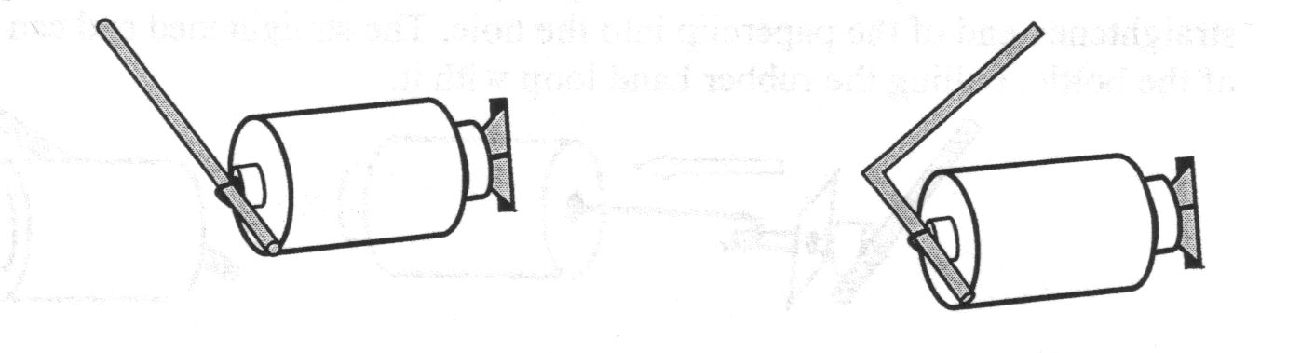
Materials:
Small plastic bottle
Rubber band
Pony Bead
Straw
Square of stiff paper, 1”x 1”
1-1/4” long section of a coffee stirrer straw
Paper clip, unbent to form a hook
Nail or drill to make a hole in the plastic bottle
A strip of paper to cover the bottle (optional)
Markers to decorate the paper (optional)
Directions:
- If using a nail, a roofing nail is thick enough to make a 1/8” hole in the center of the bottom of the bottle. If using a drill, use a 3/16” drill bit (about a ¼” hole) Hole needs to be large enough to insert and pull out the rubber band.
- Fold the square of paper in half on the diagonal, making a triangular shape. Insert the 1-1/4” straw piece into the fold and put aside for step #6.
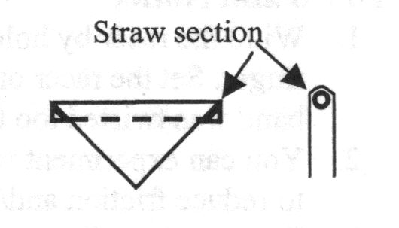
- Insert the rubber band into the pony bead and pull out a small loop. Put the straw into the loop till the rubber band is about an inch from the end of the straw. Then slide the bead along the rubber band till it is flush against the straw.
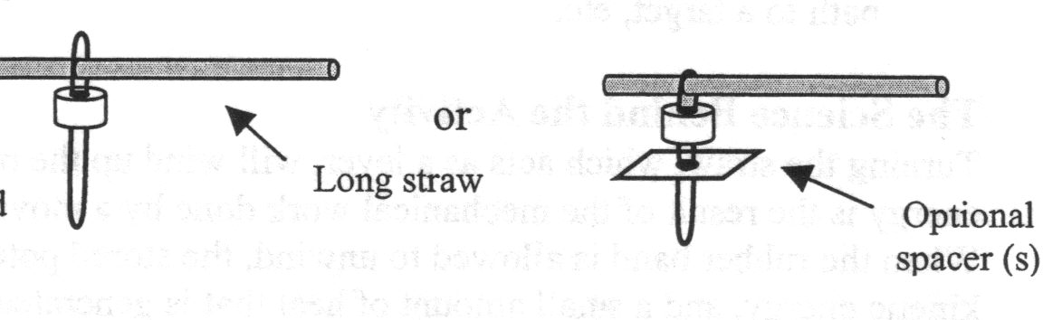
If you want to reduce the friction of the bead, you could add a spacer made of a ½” square of stiff paper or plastic. You could also try the racer with and without the spacer to see which bottle will roll smoother and/or farther.
- For a 1/8” hole: Insert the rubber band and keep feeding it into the hole. Use a partly unbent paperclip with a hooked end.
For a ¼” hole, hook a partly unbent paperclip over the rubber band and then insert the straightened end of the paperclip into the hole. The straightened end can then be pulled out from the inside, along with the rubber band loop.
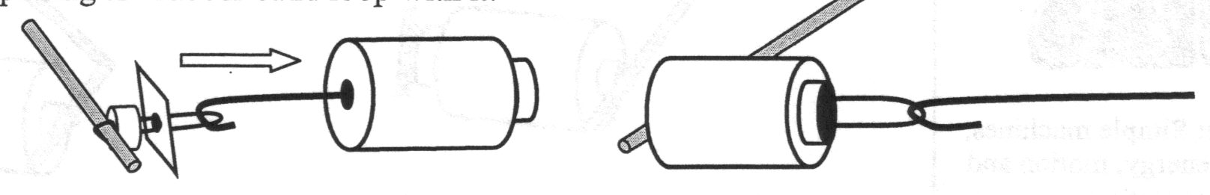
- 5. Put the stiff paper triangle with a straw section from step #2 into the loop of the rubber band that you pulled out of the bottle. The triangle should have its right angle corner pointing into the mouth of the bottle. Jam the triangle into the mouth of the bottle, holding the rubber band in place.
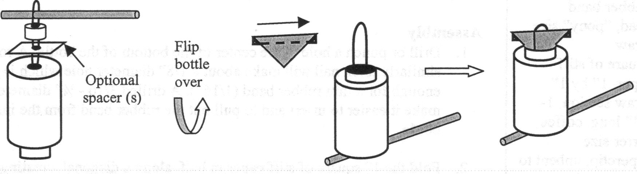
- If you want to decorate your racers, use the thin piece of paper and markers. Tape or glue the paper to the side of the bottle.
- Wind the bottle racer by holding the bottle and spinning the straw around the pivot point with your finger. Set the racer on the table or floor, then let go.
Experiment with winding the racer tighter or looser, or adding spacers to see how the racer changes the way it spins.
You could also set up a finish line and have races. Did you notice that one bottle racer has a bent straw and one a straight straw? See what happens with both designs. You could also try to hit a target, travel a curved path, or go a minimum distance.
Want to make a real racer? Use a pair of CD’s as wheels attached to the side of your bottle racer. A CD wheeled bottle racer can cover distances over 100 feet on a smooth, level surface!
How it works:
Turning the straw, which acts like a lever, winds up the rubber band and stores potential energy. The energy is the result of the mechanical work done by the moving finger as it applies force over a certain distance. When the rubber band is allowed to unwind, the stored potential energy is turned into the energy of motion, kinetic energy and a small amount of heat that is generated by the friction of the bottle with the surface it touches – as well as the air it moves through. If the rubber band is wound too tightly, the bottle will spin with enough force to lift it from the floor or table. This reduces the friction between the bottle and the surface and the bottle will rotate rapidly, often moving around in a circle instead of moving in a straight direction.
POW WOW EXTRAVAGANZAS
Let me know as soon as your date is set. I will post whatever I receive! CD
Southern NJ Council
Rock Around the Pack
Commissioner Dave is the Pow Wow Chair this year!!
January 19, 2008
Lakeside Middle School, Millville, NJ
Call Southern NJ Council, 856-327-1700, extension 32, or visit the website, www.snjscouting.org for more information

Santa Clara County Council
University of Scouting
January 19, 2008
Some where in Santa Clara county Council territory
Sakiko or Gary, please help!!
More information.- www.scccbsa.org or 408-280-5088 or 302 622 3300 or write jonathan@scccbsa.org

San Gabriel valley Council
Long Beach Area Council
Verdugo Hills Council
The Save the Date Flyer makes me think it will be a western theme
February 2, 2008
Somewhere in Southern California???
More information.- The San Gabriel Valley Council site was the only one with any info – www.sgvcbsa.org or
626-351-8815
Maybe Julie will fill me in with all the needed info!!

WEB SITES
Alice, Golden Empire Council
www.nascar.com/games - trivia challenge, a pit stop game and other online games to play
www.team.net/www/museums find an auto museum in your are by clicking on United States, then scroll down to your state. Also click on separate museum links, sites for educators, games, photos, kid’s sites and tours. Some even link you to state curriculum standards and funding for children’s activities or classes
www.loc.gov/rr/scitech/mysteries/auto.html
information about the history of the automobile, links to kid’s pages, games, photo archives
www.modelt.org/kid1.html comparisons of modern cars and old ones; true stories of early drivers, information and quotes from and about Henry Ford
www.auto.howstuffworks.com/engine1.htm
great moving graphic that shows how the internal combustion engine works
www.amazingfacts.com amazing facts about almost anything, including automobiles
ONE LAST THING
Gilbert's Pinewood Derby Prayer
by Peggy Porter
http://usscouts.org/usscouts/pinewood/gilbert.asp
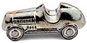
Gilbert was eight years old and had been in Cub Scouts only a short time. During one of his meetings he was handed a sheet of paper, a block of wood and four tires and told to return home and give all to "dad". That was not an easy task for Gilbert to do. Dad was not receptive to doing things with his son. But Gilbert tried.
Dad read the paper and scoffed at the idea of making a pine wood derby car with his young, eager son. The block of wood remained untouched as the weeks passed.
Finally, mom stepped in to see if dad could figure this all out. The project began. Having no carpentry skills, dad decided it would be best if he simply read the directions and let Gilbert do the work. And he did. Dad read aloud the measurements, the rules of what Gilbert could do and what he couldn't do. Within days his block of wood was turning into a pinewood derby car. A little lopsided, but looking great (at least through the eyes of mom).
Gilbert had not seen any of the other kids cars and was feeling pretty proud of his "Blue Lightning", the pride that comes with knowing you did something on your own. Then the big night came. With his blue pinewood derby in his hand and pride in his heart he headed to the big race.
Once there this little one's pride turned to humility. Gilbert's car was obviously the only car made entirely on his own. All the other cars were a father-son partnership, with cool paint jobs and sleek body styles made for speed.
A few of the boys giggled as they looked at Gilbert's, lopsided, wobbly, unattractive vehicle. To add to the humility Gilbert was the only boy without a man at his side. A couple of the boys who were from single parent homes at least had an uncle or grandfather by their side, Gilbert had "mom".
As the race began it was done in elimination fashion. You kept racing as long as you were the winner. One by one the cars raced down the finely sanded ramp. Finally it was between Gilbert and the sleekest, fastest looking car there.
As the last race was about to begin, this wide eyed, shy, eight-year-old asked if they could stop the race for a minute, because he wanted to pray. The race stopped, Gilbert hit his knees clutching his funny looking block of wood between his hands. With a wrinkled brow he set to converse with his Father. He prayed in earnest for a very long minute and a half. Then he stood, smile on his face and announced, 'Okay, I am ready."
As the crowd cheered, a boy named Tommy stood with his father as their car sped down the ramp. Gilbert stood with his Father within his heart and watched his block of wood wobble down the ramp with surprisingly great speed and rushed over the finish line a fraction of a second before Tommy's car. Gilbert leaped into the air with a loud "Thank you" as the crowd roared in approval.
The Scout Master came up to Gilbert with microphone in hand and asked the obvious question, "So you prayed to win, huh, Gilbert?"
To which this young boy answered, "Oh, no sir. That wouldn't be fair to ask God to help you beat someone else. I just asked Him to make it so I don't cry when I lose."
Children seem to have a wisdom far beyond us. Gilbert didn't ask God to win the race, he didn't ask God to fix the outcome; Gilbert asked God to give him strength in the outcome. When Gilbert first saw the other cars he didn't cry out to God, "No fair, they had a father's help". No, he went to his Father for strength.
Perhaps we spend too much of our prayer time asking God to rig the race, to make us number one, or too much time asking God to remove us from the struggle -- when we should be seeking God's strength to get through the struggle.
Gilbert's simple prayer spoke volumes to those present that night. He never doubted that God would indeed answer his request. He didn't pray to win, thus hurt someone else -- he prayed that God supply the grace to lose with dignity. Gilbert, by his stopping the race to speak to his Father also showed the crowd that he wasn't there without a "dad", but His Father was most definitely there with him. Yes, Gilbert walked away a winner that night, with his Father at his side.
I can do all things through Christ which strengtheneth me.
Philippians 4:13
From Capital Area Council
I included this so you can all the directions on one page CD

