I need Pow Wow Books
My resources are a low right now. My Pow Wow books from last fall have run out. If your council had a Fall Pow Wow and you have a CD, I will be glad to swap you copies of those I receive this month for one of yours. I am counting on Scouter Jim for a copy of Great Salt Lake’s and Rachel for Sam Houston Area's Pow Wow Books. Pretty, Please! But I need more - I did receive Utah National Parks and it is great as usual. Looking for a Heart of America. I am interested to see what is in the books to do after themes run out and Cub Scouts 2010 begins. E-mail me at davethecommish@gmail and we can set up a transfer..
FOCUS
Cub Scout Roundtable Leaders’ Guide
Let's create holiday magic through art! Cub Scouts will use their artistic abilities to make holiday decorations, gifts, or cards. Boys can display their artwork at a pack art show A den or pack can take their art show to a nursing home, a children's hospital, or a community center. Take a trip to an art museum so the boys can appreciate the great artwork of others. Let the boys explore different forms of art at a musical or performing arts show This is an ideal time to work on the Art belt loop and pin.
CORE VALUES
Cub Scout Roundtable Leaders’ Guide
Some of the purposes of Cub Scouting developed through this month’s theme are:
- Respectful Relationships. As Cub Scouts discover their own talents, they will gain more respect for the different talents of those around them.
- Spiritual Growth. Cub Scouts will develop an appreciation for Gods works of art.
- Friendly Service. Cub Scouts will make the lives of others more cheerful when they create art pieces to share and give.
The core value highlighted this month is:
- Faith,. Through creating artwork related to the holidays, Cub Scouts will gain more understanding of their own religious traditions..
Can you think of others??? Hint – look in your Cub Scout Program Helps. It lists different ones!!
Believe it or not, I can actually draw.
- Michelangelo
COMMISSIONER’S CORNER
Well It is the end of another month and I am pushing hard to get Baloo done.. Started early this month. And even Alice had all her stuff to me earlier than usual. But then last week was Pack family Camping and work beckons and …
Received an E-mail from Bill Smith's son that he had a stroke and was now going Hollywood - That is entering Rehab! I got the impression his Dad was just as feisty as ever and not going t let this neat him. But let's all help by including bill Smith, The Roundtable Guy, in our prayers.
This will be your Scouts' Last Chance for the Boys' Life Reading Contest and earning the neat patch for 2009. Don’t let it slip by if they have done the work and are just procrastinating (or in Cub age lingo - being lazy!!)
And it's time for the greatest audience Participation - The House Where Santa Lives!! It is still on page 5-6 of the How-To Book.
Cub Scouts - 2010
According to my Scout Exec - In one of the general sessions at Top Hands they spent about an hour discussing the new Cub Scout 2010 launch. There was not any printed information for me to pick up for you (or for anyone for that matter). What they did was put everything, including the presentation at Top Hands, on a website. There is a lot of stuff on the site. As the year moves on this will be the official place for all new information, it will have a discussion board, etc.
Check it out…
http://www.scouting.org/cubscouts2010.aspx
We all should start getting ready for next year -
look through the material.
Character Connections Ideas from Program Helps
Sam Houston Area Council
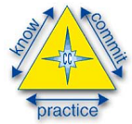
Sam Houston Area Council
Faith. When Cub Scouts see the differences in various works of art, it helps them to understand and appreciate the different belief systems around them.
Respect. Regardless of a price tag, Cub Scouts learn that all forms of art are valuable and should be shown signs of respect.
Months with similar themes to
Works of Art
Dave D. in Illinois
Month Name | Year | Theme
Art Focus
October | 1940 | Cub Artists
October | 1947 | Cub Scout Artists
February | 1959 | Carnival of Colors
October | 1996 | Animation Creation
December | 2001 | Works of Art
Holiday Focus
Go to the December theme in any CS Program Helps or Pow Wow CD. Or any December Theme issue of Baloo's Bugle
THOUGHTFUL ITEMS FOR SCOUTERS
Thanks to Scouter Jim from Bountiful, Utah, who prepares this section of Baloo for us each month. You can reach him at bobwhitejonz@juno.com or through the link to write Baloo on www.usscouts.org. CD
Prayers
God's Works of Art
CS Roundtable Planning Guide
"Wonders of white snow and shining stars, oceans with their ever changing colors, rolling hills and rocky mountains, beautiful flowers and majestic trees, all creatures on the earth … We thank you, God, for your works of art." AMEN
Sam Houston Area Council
Thank you for the wonderful palette of colors that decorate our world. Help us remember to keep our world as beautiful as you created it. Amen.
God’s Greatest Work of Art
Scouter Jim, Bountiful UT
I will praise thee; for I am fearfully and wonderfully made: marvelous are thy works; and that my soul knoweth
right well. Holy Bible, Psalms 139:14
There is a common saying, “God doesn’t make junk.” Across this nation, there are many wonderful natural beauties to be seen. Even in the barren areas of the West, there are sculptures of rock and stone in the American landscape. On the canvas of the earth, our maker has painted wonder and diversity. There is also music in the sounds of nature, the crashing of ocean waves and the gentle song of a mountain bird. There is also dance among nature’s creatures. All of these have been made for the enjoyment of the makers greatest creation, man.
I have a neighbor, whose hobby it is to restore “Model A” cars. Most of these have not been manufactured new for almost a century. My neighbor will take a rusty frame of a car and shape it into a wonderful work of art, adding the parts that are missing. The object is to keep as much of the original car as possible, but the rotten cankered parts have to be removed for progress to be made on the whole. Some boys have cankered parts of their lives. It is not always possible to remove all of it, but the effort must be made to fight poverty and lack of education.
Many of us spend a great part of our day, tearing ourselves down and examining our flaws through a microscope, when we should be using a telescope to look to the heavens. As one writer put it, God is in the “Restoration Business,” not the “Junk Business.” God is all about building us up, not tearing us down. Scouting is about building men out of boys, This is not the military organization, where the boys need to be broken down first before being built up again. Life has broken many of the boys down, they don’t need help from leaders they respect to do that. Boys come in all sizes and all abilities, and each comes with a special set of gifts. During the Holiday season, when many people are concerned with gifts, don’t overlook those given by a higher power. Help boys share the gift of art that is in them with others. Take care of God’s Greatest Works of Art.

Quotations
Quotations contain the wisdom of the ages, and are a great source of inspiration for Cubmaster’s minutes, material for an advancement ceremony or an insightful addition to a Pack Meeting program cover
The true work of art is but a shadow of the divine perfection. Michelangelo
Anyone who has never made a mistake has never tried anything new. Albert Einstein
Far away there in the sunshine are my highest aspirations. I may not reach them, but I can look up and see their beauty, believe in them, and try to follow where they lead.
Louisa May Alcott
Let the world know you as you are, not as you think you should be, because sooner or later, if you are posing, you will forget the pose, and then where are you? Fanny Brice
It took me a long time not to judge myself through someone else's eyes. Sally Field
The way you treat yourself sets the standard for others.
Dr Sonya Friedman
It's surprising how many persons go through life without ever recognizing that their feelings toward other people are largely determined by their feelings toward themselves, and if you're not comfortable within yourself, you can't be comfortable with others. Sidney J. Harris
Every individual has a place to fill in the world, and is important, in some respect, whether he chooses to be so or not. Nathaniel Hawthorne
There is only one corner of the universe you can be certain of improving, and that's your own self.
Aldous Leonard Huxley
Self confidence is the first requisite to great undertakings. Dr. Samuel Johnson
At bottom every man knows well enough that he is a unique being, only once on this earth; and by no extraordinary chance will such a marvelously picturesque piece of diversity in unity as he is, ever be put together a second time. Friedrich Wilhelm Nietzsche
If only you could sense how important you are to the lives of those you meet; how important you can be to people you may never even dream of. There is something of yourself that you leave at every meeting with another person.
Fred Rogers
The greatest success is successful self-acceptance.
Ben Sweet
You don't have to be great to start, but you have to start to be great. Zig Ziglar
You can do what you have to do, and sometimes you can do it even better than you think you can.
President Jimmy Carter Jr.
Nurture your mind with great thoughts, for you will never go any higher than you think. Benjamin Disraeli
If you want a quality, act as if you already had it.
William James
Sam Houston Area Council
A good picture is equivalent to a good deed. Van Gogh
All art is an imitation of nature. Seneca
Art is like reading a good book, only you decide how it is going to end. J. Kleykamp
Creativity is allowing yourself to make mistakes. Art is knowing which ones to keep. Scott Adams
If you are seeking creative ideas, go out walking. Angels whisper to you when you go for a walk. Raymond Inmon
Every artist dips his brush in his own soul, and paints his own nature into his pictures. Henry Ward Beecher
We make a living by what we get, but we make a life by what we give. Winston Churchill
TRAINING TIP
Pack Meetings
Bill Smith, the Roundtable Guy
NOTE: Bill Smith, the RT Guy, recently had a stroke and is now (as his son said) going Hollywood and in rehab. This column was first published in 2005. Please keep Bill and his family in your prayers. Drop him an electronic get well card at the address below. CD
Training Tips
Pack meetings set the stage for everything else in Cub Scouting: the den meetings, the home and family activities, the service projects, outdoor action, and even an introduction to the Boy Scout program. You might think of pack meetings as the gateway to Scouting.
Without pack meetings, those other things might not happen at all.
First, don't think of your meeting as a 'meeting'. Start to think in terms of a one night show, a production. Meetings are dull, we go to them every day and rarely (if ever) look forward to them. A show, however, is entertainment! People want to be entertained, and while they'll forget to go to your meeting, they'll remember that they have tickets to your show!
Sean Scott
http://scouting.argentive.com/
Role model
You may honestly believe that you're doing this for all the boys in your community, but the truth is that the person who benefits the most from your work as a as Cub Scout leader happens to live with you. Your Cub Scout son sees what you do, he is aware of your commitment and attitude and he will end up copying a good portion of what he sees and admires in you. Your first responsibility as a pack leader is to be a good Akela to your son. So put on a good show for him. Let him see you doing your best, planning ahead, being a good team member, and especially having fun while doing all this: the sort of life you would like him to emulate. Be a good role model.
Den Support
The pack meeting must provide an arena for your dens to show their stuff. Strong dens perform regularly at pack meetings in ceremonies, skits, and other activities that can be seen and appreciated by parents. When den leaders and Cub Scouts look forward to their parts in an upcoming pack extravaganza the den meetings take on a focus and excitement that just makes Cub Scouting fun. When dens have no part in pack meetings, they tend to fill their den programs with rank advancement - this, in turn replaces the family and parent participation. This can weaken the whole program and structure of the pack.
Family Support
The heart and soul of the Cub Scout program takes place in the boy's home with his family. Activities at the pack meeting must exalt the family's part in the program. Be generous with your recognition of the parents' contribution to the boys' advancement and their help with all phases of the program. As a general rule, you probably can never heap too much praise and accolades on parents.
Communication
Your highest attendance usually occurs at pack meetings, making them excellent locations to get the word out. The trick will be to do it without messing up the flow of fun and idealism that you want in your pack meeting programs. Long, boring announcements are killers so you will want to replace them with better communication methods. Newsletters and flyers are great for explaining details like dates, times and meeting places of upcoming events.
Posters and banners set up around the meeting room can emphasize future activities. It is amazing how something as simple as a few ribbons and a small fan can draw attention to a notice on poster board. Wrap your promotions for Service Projects, Friends of Scouting Appeals, and Summer Camp registration in skits, run-ons, and parodies of songs or TV commercials. Use ceremonies to honor contribution of parents and others.
Basic Rules
VIOLATE THESE AT YOUR OWN RISK!
PLAN IT
Lack of planning ruins more pack meeting than any thing else. Plan everything down to the last detail.
Who is going to do what, when, for how long?
Get as many of the participants (the TEAM) involved in planning as possible. This will help ensure that each member knows his or her part and is willing to do it.
Remember to plan the little things like pre opening activities, cheers, and run-ons. The more you plan, the more spontaneous everything will play out and the more prepared you will be when something unexpected happens.
Write it all out and give a copy to everyone involved.
TEAM LEADERSHIP
A whole bunch of jobs have to be done to make a pack meeting work:
Master of Ceremonies - someone to introduce each star performer and lead the applause.
Cheer master - someone to lead the sparklers, the audience participation stunts and support all the acts.
Award Presenter - someone to open the envelopes, call up the honored, and conduct the ceremonies.
Director - someone to keep track of who is up next, cue the acts, and keep the whole gang on schedule.
Stage Manager - someone to make sure that all the props are in place, the color guard has the flags, the artificial campfire is plugged in and the badges are ready.
Song Leader - in case the Cheer Master isn't up to a quick round of Do Wah Ditty.
Information Manager - someone to distribute newsletters and flyers, or stage gorilla theatricals to promote some noble Scouting cause.
You can double up or rotate and share some of the functions but you should involve all the Assistant Cubmasters and most of your Pack Committee in these jobs. You will also need a few people to do run-ons, help with ceremonies, and handle the lights.
KEEP IT MOVING
A successful pack meeting grabs and holds the attention of everyone there: the Tigers, Cub Scouts and Webelos as well as the parents, and siblings. You do this with short fast-moving bits. You change the mood of the audience with every dramatic and comedic trick you can borrow or copy or invent. Keep the pace changing with faster or slower sparklers or audience participation gags. Use the entire room so that if someone leads a song from the north end of the hall, the following den skit enters from the southeast corner. Move the center of attention around with action, sound, and lighting.
Dead time is a killer. Make sure that when one bit is finished, the next participant is ready with a cheer, a magic trick or presentation. Don't let them sit still for the entire meeting - sprinkle in lots of stunts that get everyone standing, jumping, applauding, and shouting.
BUILDING BLOCKS
Pack meetings are constructed from a variety of building blocks that you should use effectively. Here are some of the common ones:
- Ceremonies - Main elements of your program. Build everything else around these. The openings and closings frame the program. Advancement and graduations are your highlights.
- Den presentations - Headline acts. Set these up carefully so that they cannot fail. Good den presentations build pack membership and retain good den leaders.
- Games - Bundles of FUN for everyone. Involve parents and all family members. These are the activities that will be remembered long after the meeting.
- Sparklers - Mood changers. Use these to build excitement and intensity or to settle things down for a more serious bit.
- Songs - More effective mood changers. Songs can be just plain fun or can make a closing ceremony very special.
- Costumes - Great for setting up the theme of the month. You don't have to be in uniform every meeting.
- Promotion - Create enthusiasm for upcoming special events. Think of TV commercials, movie trailers, or circus parades.
- Visitors - New families, someone from the Chartered Organization or a neighboring Scout Troop should be introduced with proper fanfare and even a special cheer. Caution: be careful about letting them speak.
FLOW and MOOD SETTING
Each part of the meeting sets a tone or mood that will carry on to the next part. The opening ceremony will catch the attention of the audience and things usually begin in a subdued and attentive mood. You usually want to build the fun and excitement before you bring on a high-light event like a den skit. You can do this with sparklers, audience participation stunts, and games. If things get a bit dull, liven them up with cheers and run-ons. If the boys get too rambunctious, use a song or story to bring the mood down to earth. You may want to set a serious tone for a graduation ceremony or a closing so choose your stunts and gimmicks accordingly. A good team of leaders can, with a bit of practice, become expert at this.
VARIETY
Variety and surprise can do a lot to make your meetings successful. Vary the pace throughout each meeting and vary the elements, themes and moods from month to month. When the boys and parents start wondering what will this crazy bunch of leaders do next, then you have reached top form.
What are YOU going to do now?
Go get ‘em. We need all the help we can get.
The best gift for a Cub Scout.......
......get his parents involved!
- Also, be sure to visit Bill’s website
http://rt492.org/
to finds more ideas on everything Cub Scouting.
NOTE - Some of us have trouble with this site on Internet Explorer but it runs great on Firefox!!
Have any Comments for Bill
just click right here!
PACK ADMIN HELPS
Den Discipline
Utah National Parks Council
Does the idea of a six highly energetic boys jumping on your couch, bouncing off your walls, painting the cat and causing all kinds of mayhem just make you want to pull your hair out? Don’t worry – every Cub Scout leader has felt like that at one time or another.
For the sake of your sanity, not to mention your house or your cat, you will need to come up with some guidelines of behavior for the den. This is known as den discipline. It is important to remember that discipline is not punishment. Discipline is making the Cub Scout responsible for his own behavior – telling him that if he chooses a certain course of action, what the specific consequences of that action will be. Discipline is training given to a child to mold or correct his behavior. As a den leader, you need to spell out for the boys what is acceptable behavior and what is not. Also, let them know the consequences for acceptable and unacceptable behavior.
A den code of conduct (or den rules) should be established in an open discussion with the boys. Some of their ideas may be silly to you, but don’t judge too harshly. Many of their ideas that relate to safety, respect for property and relationships with others will be along the same lines as yours. You may need to make suggestions for things the boys don’t bring up. And they’ll be delighted if you decide to throw out a rule or two. You should also discuss the consequences of breaking the den code of conduct. What should be in your den code? Things that are important to you and your boys. Since every den is different, every den code will be different. Here are some suggestions to help you get started.
- No put-downs, name calling, or crude language.
- No physical aggression.
- You are a guest in this house, please act like one. (Try to be on your best behavior.)
- Be on time.
- Wear your uniform.
- Bring your book.
- One person speaks at a time and everyone listens.
- No running inside.
- Share, take turns.
- Leave the cat (or dog or hamster or fish) alone.
A few rules are enough to start, but more may need to be added as you go along. Cub Scouts may want to write out their den rules and sign on a line at the end of the list. This is a way of sharing with parents the expectations of their sons. A large poster can also be placed at the den meeting site to remind boys of the code.
Now that the rules have been established, stick to them. Be fair. Don’t let one boy get away with doing something you would discipline another boy for doing. Be consistent. Don’t warn and threaten but take action quickly. Don’t send a boy home unless he oversteps the disciplinary bounds you have drawn. If you do send a boy home, call his parents immediately and tell them why.
Here are a few ideas to keep your den meetings
running smoothly.
- Use the Cub Scout SIGN as a signal for quiet. When boys see this symbol, they should stop what they’re doing, be quiet and raise their own arm in the sign.
- Keep den meetings going at a FAST PACE, with lots of variety and fun things to do. Plan more than you think you will need. Get assistants and den chiefs involved.
- Treat boys IMPARTIALLY. Boys expect fair treatment and your example becomes their model. If you make promises, keep them.
- DON’T CRITICIZE a boy in front of the den. Wait until you can talk to him alone.
- Give boys opportunities to make CHOICES as often as possible. Involve them in planning.
- Take some time to EVALUATE your den meetings. What went well? What didn’t go so well? How can I do this differently next time?
- Focus on the POSITIVE. Catch boys being good, helping others, keeping the den code of conduct. Baden-Powell said “A pat on the back is a stronger stimulus than a prick with a pin Expect a great deal of your boys and you will generally get it.”
When asked what tricks, programs or guidelines were used in their den to promote discipline, one leader said “Well, we have our good days and our bad days. Sometimes we just have to remember they are little boys that need to use their bodies. So, we always try to have at least one activity each den meeting that gets them moving! Normally, den meetings are full of various activities, so the boys have a good chance to work off that energy.
“Most of the years we have taught, the boys got along fine. But we had one year when that was not so. The first time we had two boys collide physically, we let them know it would
not be tolerated. We told them we are like brother wolves in a den and we support each other. I said if it ever happened again the parents would be informed and they would possibly attend our future meetings. No more problems!”
Some den leaders use little “pats on the back” to help with den discipline and reward boys who are doing good. Here are a few things that have worked.
Print up “SCOUT BUCKS.” These can be anything from a fancy piece of paper with cool graphics that looks like money to a slip of paper that says “Scout Bucks” on it. Distribute these to the boys when you catch them doing something good. You can also give them out for being on time, wearing their uniform and bringing their book. At the end of den meeting (or the end of the month or another time you designate), boys can go to the den store and buy something. This store can be a box that you have filled with small toys, candies, gift certificates or coupons for free goodies, scout paraphernalia, etc.
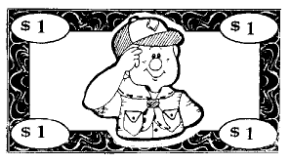
“BEAR STUMPS” Each boy is given a block of wood that doubles as a stool at den meeting. He earns nails that will be hammered into the stump if he meets the following requirements:
- Red: He must attend den meeting.
- Blue: He must wear his Scout uniform.
- Green: He must bring his book to den meeting.
- Yellow: He must be represented by at least one member of his family at pack meeting.
- White: He must meet the requirements of a “Bear Necessities.” challenge. This challenge, a charge to do something to make the world just a little bit better, is written down and sent home with the boy.
- Silver: He must do three good deeds for the week, without being asked. (Chores do not count.)
- Gold: He must have done one good deed, that includes a sacrifice of at least one hour, with no expectation of reward.
The den leader hands out the nails before the meeting begins, and the Bear Cubs can only hammer before the meeting and after the closing prayer. If hammer or nails are misused, the Bear loses his nails for that week. The boys are challenged to see how creatively they can decorate their stump. This can be adapted for Wolf dens and Webelos dens too.
Give each boy a whole piece of shoestring LICORICE at the beginning of the meeting. Every time you need to discipline the boy, cut off two inches. He gets whatever is left at the end of meeting time for a treat. A variation of this method would be to give each boy a small cup and three or four M&M’s when he arrives. When you catch him doing good (waiting his turn, helping someone else, volunteering to do something, etc.) reward him with a few more M&Ms to keep in his cup. When the meeting is over, he gets to keep the goodies in the cup.
The GOOD CONDUCT CANDLE is an oldie but goodie. A candle is lit as the meeting begins. If the boys misbehave, the candle is extinguished. Use your den code of conduct as a basis of when to keep the candle lit and when to blow it out. You determine if the behavior is suitably changed so that the candle can be lit again. When the candle is burned down to a certain level, a reward is given. It can be a pizza party, a day at the park or pool, or a day of games. Help the boys decide what the reward will be, then they will work for it. This method has several disadvantages. Most schools and some churches do not allow open flames. Open flame is dangerous around any group of young kids. Then, what do you do for discipline once the candle is blown out?
Use carnival or homemade TICKETS. Give each boy three tickets at the beginning of the meeting. Have him sign his name on the ticket. When he breaks a rule, he has to give up a ticket. Tickets left at the end of the meeting can be placed in a bank. At the end of the month, add up who has the most tickets, and he gets a special treat.

Use a MARBLE JAR. Give each boy three marbles at the beginning of the meeting. When he breaks a rule, he gives up a marble. The marbles left at the end of the meeting go into a jar with a line drawn around it at a height determined by the leader. When the marbles go over the line, the den gets a special treat. Adjust the size of the jar to make this happen every two months or so.
Use a POINT SYSTEM. Award points for every part of the uniform worn by the boy (shirt, neckerchief, slide, belt, pants, socks, tucking in shirt), a point for coming, bringing their book and anything they passed off at home. Additional points can be awarded as you see fit (pack meeting attendance, helping without being asked, performing a service project etc.). When the boy earns a set amount of points, he can choose a gift from the Scout bag. The bag contains different items from the Scout Shop, Wal-Mart, Harbor Freight, dollar store, etc. When a boy earns his Arrow of Light, he is allowed to pick his own party (within reason - no Disneyland!)
An Indian COUP and beads can be used in conjunction with any of the above methods. The boys can make their own coups out of leather or vinyl. They can be worn on their belts, around their necks, or displayed on a board. he boys can earn beads for:
- Attending den meeting
- Passing off achievements and electives
- Advancement
- Denner service
- Coming in uniform
- Bringing his book
- Attending pack meeting
- Bringing a snack
- Almost anything else – beads are cheap!
The real keys to your discipline system are:
- HAVE ONE. Don’t wait to see if you need one, you do! If you wait until you need it, it’s too late!
- Make sure everyone (Cubs and parents) KNOWS what it is. Explain it at the parents’ meeting, in a note sent home with the boys, and at your first den meeting. Remind when necessary.
- STICK TO IT. Plan on the boys (and maybe the parents) testing you to see if you mean it. Be ready for it. They expect you to do what you say you will do. You lose all credibility if you don’t.
SPECIAL OPPORTUNITY
Art
http://usscouts.org/advance/cubscout/academics/art.asp
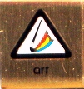
The requirements listed below are taken from the Cub Scout Academics and Sports Program Guide (34299B) 2006 Printing
Note:
Webelos that earn the Art Belt Loop while a Webelos Scout also satisfy requirement 11 for the Artist Activity Badge.
Belt Loop
Complete these three requirements:
- Make a list of common materials used to create visual art compositions.
- Demonstrate how six of the following elements of design are used in a drawing: lines, circles, dots, shapes, colors, patterns, textures, space, balance, or perspective.
- Identify the three primary colors and the three secondary colors that can be made by mixing them. Show how this is done using paints or markers. Use the primary and secondary colors to create a painting
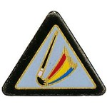
Academics Pin
Earn the Art belt loop, and complete six of the following requirements:
- Visit an art museum, gallery, or exhibit. Discuss with an adult the art you saw.
- Create two self-portraits using two different art techniques, such as drawing, painting, printmaking, sculpture, or computer illustration.
- Demonstrate how to make paper. Make a sample at least 4 inches by 4 inches.
- Make a simple silkscreen or stencil. Print a card or T-shirt.
- Create a freestanding sculpture or mobile using wood, metal, soap, papier-mâché, or found objects.
- Create an object using clay that can be fired, baked in the oven, or hardened in water.
- Photograph four subjects in one theme, such as landscapes, people, animals, sports, or buildings.
- Make a collage using several different materials.
- Use your artistic skills to create a postage stamp, book cover, or music CD cover.
- Use a computer illustration or painting program to create a work of art.
- Display your artwork in a pack, school, or community art show.
Boys’ Life Reading Contest for 2009
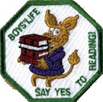
SAY ‘YES’ TO READING
Enter the 2009 Boys’ Life Reading Contest
Write a one-page report titled “The Best Book I Read This Year” and enter it in the Boys’ Life 2009 “Say Yes to Reading!” contest.
The book can be fiction or nonfiction. But the report has to be in your own words — 500 words tops. Enter in one of these three age categories:
- 8 years old and younger
- 9 and 10 years old
- 11 years old and older
First-place winners in each age category will receive a $100 gift certificate good for any product in the Boy Scouts official retail catalog. Second-place winners will receive a $75 gift certificate and third-place winners a $50 certificate.
Everyone who enters will get a free patch like the one shown above. (And, yes, the patch is a temporary insignia, so it can be worn on your Cub Scout or Boy Scout uniform shirt, on the right pocket. Proudly display it there or anywhere!) In coming years, you’ll have the opportunity to earn different patches.
The contest is open to all Boys’ Life readers. Be sure to include your name, address, age and grade in school on the entry.
Send your report, along with a business-size, self-addressed, stamped envelope, to:
Boys’ Life Reading Contest
S306
P.O. Box 152079
Irving, TX 75015-2079
Entries must be postmarked by Dec. 31, 2009 and must include entry information and a self-addressed, stamped envelope.
See 2008's winners posted at - http://boyslife.org/home/7322/2008-boys-life-reading-contest-winners/
For more details go to www.boyslife.org
Knot of the Month
Baloo's Archives
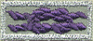
Adult Religious Recognitions
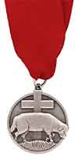
What is the adult religious recognition program?
An adult religious recognition award is presented by nomination only. The recognition is presented to worthy adults for their outstanding service to youth both through their religious institution and one of the national youth agencies. Recipients of these awards are unaware that they are being nominated. They are nominated to receive an award by submitting the required application, letters of recommendation, and resume. Please check eligibility requirements for specific awards. Self and spousal nominations are usually not allowed.
Essentially every denomination that has Youth Awards has at lest one Adult Award. For example, the Lutherans have the Lutheran Lamb award (seen above) for members who are nominated and qualify. There is a minimum ten year tenure requirement for nomination. The recipient may wear the Adult Religious Emblem Square Knot. We, also, have the Shepherd of Youth Award. Both Lutherans and non-Lutherans who work with a unit chartered to a Lutheran Organization are eligible for this award. The tenure requirement is only five years. Some denominations do not have this dual award set up but simply present their Adult Award to all who deserve it. For example, I have two Scouting friends, an Episcopal Priest from Detroit area who I met at Philmont Training Center this summer, and Fred, a retired Scouting Executive in Virginia who was my first Scoutmaster in 1960, Troop 227, Washington Township, Bergen County, NJ, who both claim to be the only Christian to have received the Shofar Award for Adult Scouting with Jewish Scouts.
For complete listings of Adult Religious Recognitions for BSA Leaders go to National’s site at http://www.scouting.org/scoutsource/Awards/ReligiousAwards.aspx
or US Scouts site at http://www.usscouts.org/awards/religadult.asp
Many of these awards are coordinated by P.R.A.Y. Check their website for info, too www.praypub.org
The purple square knot on a silver background is worn by those whom have received a religious award as an adult member of the BSA. The awards are not BSA awards and are presented by religious organizations for long tenure of service to Scouting, the religion, and the community. With one exception all of these awards require a nomination. Self-nomination is not allowed.
Only one Adult Religious Award square knot is worn regardless of how many awards have been received. It is possible, for example, to receive two or three levels of awards in some faiths or to receive awards from more than one faith.
So, if you now someone who is deserving of receiving the Adult Award from his faith – check it out and begin the nomination process.
GATHERING ACTIVITIES
Note on Word Searches, Word Games, Mazes and such – In order to make these items fit in the two column format of Baloo’s Bugle they are shrunk to a width of about 3 inches. Your Cubs probably need bigger pictures. You can get these by copying and pasting the picture from the Word version or clipping the picture in the Adobe (.PDF) version and then enlarging to page width. CD
Mystery Art Work
Sam Houston Area Council
Materials:
12x18 or 11x17 paper,
pencils/crayons/markers
Directions
- As families arrive (pack meeting) or Scouts arrive (den meeting), give each person a large sheet of paper (12x18 or 11x17) folded the opposite direction every two inches or so (accordion fold).
- Each person will begin the drawing at one end of the paper, then find someone else to draw the next section (without seeing the previous section), and
- Then someone else to draw the next section until the entire paper is a masterpiece done by several Scouts and/or family members.
- The paper can be unfolded and then each person can be creative in determining what was drawn.
Pack Meeting Art Gallery
Alice, Golden Empire Council
Set up your pack meeting as an art gallery – with art work created by the boys matted and hung, or placed on a table or column – in other words, give each work of art a “presence” so it can be appreciated by pack families – be sure to have a label for each, giving the name and den of the artist, the medium(s) used and the date created – just like a real museum or gallery would do! See the Theme Related section for a description of what to put on the “caption” for each work of art. Have music playing in the background and finger foods available for people to taste, just as they would at a real exhibition “opening.” The boys could also have a name badge to indicate they are “featured artists” and could be stationed near their work of art, or could be “interviewed” to share how they did their art. Another idea, if you have access to copying, would be to create a “catalog” or brochure with a picture of each artist, a short bio and a representative sample of his art.
Give each person a “focus” square to use to focus on different parts of each work of art as they enter the meeting.
Art Terms Word Search
Utah National Parks Council
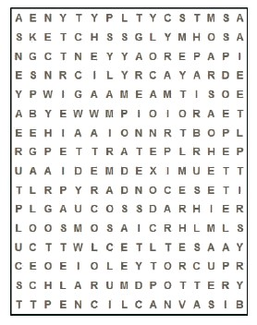
Try to find the following art terms, up down, forward, backward and diagonally:
acrylic airbrush brush
canvas cartoon clay
collage decoupage drawing
easel hue intensity
mixed media mosaic mural
oil paint palette
paper pastel pencil
photography pottery primary
sculpture secondary shade
sketch tertiary tile
tint watercolor wood
Art Can Tell a Story
Alice, Golden Empire Council
Choose one or more images of Rockwell’s Scout paintings from Google images –ones that tell a story that might interest the boys. Print off a copy of the painting(s) Talk about how stories are shared – using your voice, reading a book – then tell them that some stories are told without using any words at all.
Now give the boys a painting to look at for a few minutes – ask them to imagine what the story behind the painting might be. Have them share their ideas. Prompt them with questions about how the people seem to feel, items in the background that help tell the story, expressions on the faces of the subjects. Have them look for details (such as the boy up in the window looking down on the scouts going hiking).
Tell them that Norman Rockwell, a great friend of scouting, did these paintings. Share with them this quote from Norman Rockwell: "I showed the America I knew and observed to others who might not have noticed." Remind them that an artist always keeps his eyes open, and looks for stories or shapes or color all around him. Only then should you tell them the actual title of the painting.
Look for your favorite Rockwell’s on Google images – Here are some of mine! Just enlarge them so you can see the details- Alice
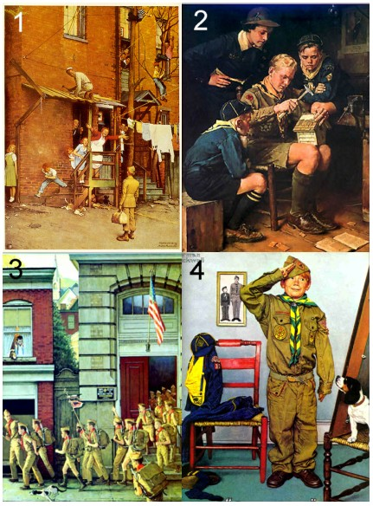
The titles and dates of the paintings are:
- “Homecoming G.I.”, 1945;
- “America Builds for Tomorrow,” 1938;
- “Scouting is Outing” 1968
- “Can’t Wait” 1972.
But don’t tell the boys the title – see what wonderful stories they can come up with first! Alice
Art Match-Up
Utah National Parks Council
Setup:
- Print off from the Internet, or copy from a book, one well-known work of art from each of several famous artists;
- Number each item and post them around the room.
- Then on a piece of paper for each participant, list each artist’s name and separately the titles of the art pieces.
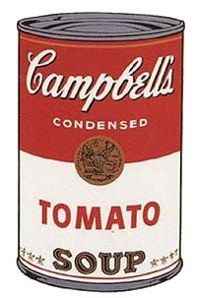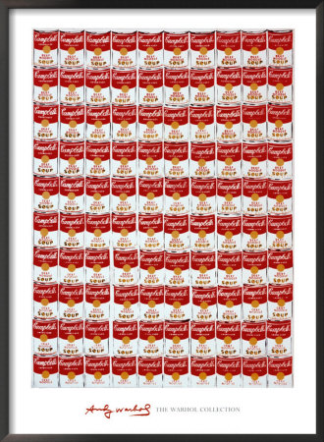
Play: The object is for each participant to correctly match the artwork with both the artist’s name and the work’s title. Give a prize to those that get the most (or all) correct.
Go the end of Baloo for some examples
(cover answers to copy for play):
- Andy Warhol - 100 Soup Cans
- Pierre Auguste Renoir - Le Moulin de la Galette
- Georges-Pierre Seurat- A Sunday Afternoon on the Island of La Grande Jatte
- Monet - Impression Sunrise
- Salvador Dali – The Persistence of Memory
- Thomas Gainsborough - Pinky, Blue Boy
- Vincent Van Gogh - The Starry Night
- Frédéric Auguste Bartholdi- Liberty Enlightening the World (more commonly known as ‘The Statue of Liberty’)
- Dale Dhihuly - Sun and Moon
- Grant Wood - American Gothic
- Leonardo DaVinci – Mona Lisa
- Auguste Rodin - The Thinker
- Michelangelo - Pieta
- Pablo Picasso – Three Musicians
Come up with more of your own!
Statues
Utah National Parks Council
This is a great gathering activity as it can easily involve more people as they arrive, and it helps to get the wiggles out before the start of the Pack Meeting.
Designate a playing area. Select one player to be the museum ‘curator’ who stands at one end of the play area. All other players are ‘statues’ lined up at the opposite end.
When the Curator has his back to the Statues, they attempt to race across the field to tag the Curator. But, when the Curator turns around to face the Statues, they must freeze in their position and hold the pose for as long as the curator gazes at them. Though the Curator can approach and investigate the Statues, he must be careful; when his back is turned to any Statues, they may move toward him. If a Statue is caught moving while the Curator faces it, the Statue must return to the starting line (or be eliminated).
The first Statue to tag the Curator becomes the new Curator and the game starts again. The fun is largely on the side of the Statues in this game, but the Curator can have his own fun by trying to get the Statues to laugh while they're frozen. Getting them to crack a smile or move while ‘frozen’ could send them back to the starting line!
OPENING CEREMONIES
The Flag is a Work of Art
Baloo's Archives
Set Up: Six Cub Scouts. The first 4 each have one baggie as follows: Cub #1 - Red pieces of paper, Cub #2 - Blue pieces of paper, Cub 33 - White pieces of paper, Cub #4 - Silver stars. The other two Scouts pull out the flag and lead the Pledge of Allegiance.
The stage is set with a large kettle and campfire. Inside the kettle and against one side is a folded flag out of sight of the audience.
CM or Den Chief or Leader or Cub Scout – One of the most beautiful works of art is our American Flag. It is a work of art that has been sculpted, molded and painted by the history of our country. Listen up as our Scouts create one of these masterpieces for us.
- First we’ll add the color red that stands for courage true. (Pours red paper cut into small squares into the kettle)
- And then we’ll add for loyalty a dash of heavenly blue. (Pours blue paper cut into small squares into the kettle)
- For purity we'll now mix in a layer of snowy white. (Pours white paper cut into small squares into the kettle)
- To our collage – a pinch of stars – to make it come out right. (Pours stars into the kettle.)
- We'll stir and stir and you will see as we reveal the palette, that what we’ve made is Old Glory. (With Cub 6 - Pulls out the flag, opening it up to display.)
- (After helping 5 pull out the flag) Our flag is the most beautiful flag in the world. Let’s always be loyal to it. Will everyone please stand join in the Pledge of Allegiance to our flag? (Lead Pledge of Allegiance with all the usual commands.)
Art is Everywhere Opening
Alice, Golden Empire Council
Each boy should hold up an example of the kind of art as he talks about it – they could be drawn by the boys, or downloaded from google images (or elsewhere on the net), or the boys could use examples of art found in their own homes.
Narrator: This month, our theme has been Works of Art. The boys have explored all kinds of art – and found that not all art is found hanging in a museum or art gallery.
- I learned that art is found in Nature – in the shape of a leaf, the color of a bird’s wing, the form of a wave.
- I learned that art is sometimes found in stories of everyday life – like many of the paintings by Norman Rockwell.
- I learned that art can be found all over the world – in museums like the Hermitage in Russia and the Museum of Modern Art in New York City.
- I learned that every culture has their own unique kind of art – from the jade carvings in China to the woven blankets of the Navajo in Arizona.
- I learned that art is even found in buildings and structures – sometimes in their shape, like the Transamerica Pyramid, and sometimes as details like window frames or railings made to fit just that structure.
- I learned that art can be found in ordinary objects, something as simple as a bolt – if you look at it from another angle or concentrate on details.
Narrator: So what did you learn about art this month?
ALL: Art is Everywhere!
Narrator: Art is even found in the flags each country has chosen. There is meaning in the colors, designs and even the shapes shown on a flag. In the United States, the stars represent each of the 50 states. The red and white stripes represent the original 13 colonies. Through long tradition, red has come to represent courage, white stands for purity, and blue stands for vigilance and justice. Please join me now as we salute our flag.
More boys and subjects could easily be added, such as book illustrations, postage stamps, dishes and serving pieces, “found” art. Alice
God’s Works Of Art
Utah National Parks Council
Setting – 10 Cub Scouts with large letters for the phrase “W-O-R-K-S O-F A-R-T” – and on the back of each letter what the Scout will say printed in LARGE letters. Front could also have a picture (drawn by the Scout) of the one or more of the items he will name.
- W - Wonders of White Snow
- O - Ocean waves, small and large
- R - Rolling hills and Rocky mountains
- K - Kangaroos, Kookaburras, Koalas and other critters
- S - Shining Stars in the Sky
- O - Opals, Onyx and other gems
- F - Fruits, Flowers and Forests
- A - Aurora Borealis in Alaska
- R - Refreshing Rainfalls and Radiant Rainbows
- T - Towering Trees and Tiny Thornbushes
ALL: These are all God’s Works of Art!
Works Of Art I
Sam Houston Area Council
Setting – 10 Cub Scouts with large letters for the phrase “W-O-R-K-S O-F A-R-T” – and on the back of each letter should be written what the Scout will say. Front could also have a picture drawn by the Scout or a famous work of art.
Narrator: Welcome to our “Works of Art” evening!
- W means that we WILL do our best to create a masterpiece.
- O means that we’ll OFFER to help others.
- R means that we’ll REACH out to everyone.
- K means that we’ll KNOW how to be kind.
- S means that we’ll SMILE.
- O means that we’ll take the OPPORTUNITY to share our talents.
- F means that we’ll have FAITH in our Friends.
- A means that we’ll learn from AKELA.
- R means that we’ll RESPECT everyone’s work.
- T means that we’ll be THANKFUL for all that we enjoy at this time of year.
Narrator: Please join our Scouts as we salute one of America’s masterpieces – our American flag – with the Pledge of Allegiance.
Works Of Art II
Utah National Parks Council
Setting – 10 Cub Scouts with large letters for the phrase “W-O-R-K-S O-F A-R-T” – and on the back of each letter what the Scout will say should be printed in LARGE letters. Front could also have a picture drawn by the Scout or a picture of a famous work of art selected by the Scout.
- W – Welcome to Pack Meeting…
- O – Our theme for this evening…
- R – Revolves around color, canvas and clay,
- K – Kinetic or static, or any ol’ way.
- S – Simple or highly complex,
- O – Original or adapted effects,
- F – Fancy or plain; any thought from your brain.
- A – Acrylic, watercolor, chalk or pencil…
- R – realize, each, their potential…
- T – Together or apart, as works of art!
Holiday Art Opening
Utah National Parks Council
Setting – 8 Cub Scouts each holding the specified item and a card with their part written in LARGE print.
- (holding a paintbrush) I can paint a picture of Santa in his sleigh…
- (holding clay) I can mold a menorah or a dreidel out of clay…
- (holding a piece of construction paper) I can take some scissors and cut out a shining star…
- (holding popsicle sticks) I can make a model of the manger from afar.
- (holding crayons) I can color a drawing of the Kinara for Kwanzaa.
- (holding a camera) I can take pictures of the festival of Hanukkah.
- (holding a heart cut from red paper) No matter which celebration means the most to your heart,
- (holding a finished art piece) You can make it more fun creating holiday art.
AUDIENCE PARTICIPATIONS & STORIES
Art is Everywhere!
Alice, Golden Empire Council
Divide the audience into four groups. Demonstrate the action and phrase for each group. Remind them to say their phrase each time they hear their word.
- LINE – Say “ Follow that line” as they mimic drawing a line with their hand
- COLOR - Say “Life’s a Rainbow” while making a rainbow with your hand
- SHAPE – Say “ Shape Up!” while making a shape using your hands.
- ART – Everyone says – “Art is Everywhere!” while spreading both arms wide.
Narrator should pause and leave time
each time he reads a word in Capital letters
Every artist soon learns there are certain elements in ART. LINES are basic to ART – no matter what COLOR or SHAPE you want to draw or paint, you must use a LINE. To make a SHAPE you must draw a LINE to mark off the SHAPE. And no matter what COLOR you want your finished ART to be, you need to make sure your LINES make the right SHAPE. In fact, sometimes, you may create ART using only a pencil or pen and paper – with no COLOR at all! You can just use LINES to make some interesting ART – LINES can be short or long, curved or straight, bold or narrow. Of course, COLOR helps make your ART look more realistic – sometimes! But some artists have just used drips of paint to make ART that is abstract but has lots of COLOR. Some artists use SHAPES to make abstract ART – circles, or squares, rectangles or triangles, or even a unique SHAPE – put together, they can make a work of ART. In fact, you will find almost any SHAPE even in nature. So keep your eyes open – Look for LINE, and SHAPE and COLOR – Because ART is everywhere!
Holiday Masterpiece
Sam Houston Area Council
Divide the audience into 6 groups. Assign each group one of the words listed below. When their item is mentioned in the story, the assigned group should shout the designated saying. Have a practice session before starting the story.
CANDLE(S): "Flicker, Flicker"
TREE(S): "Standing Tall!"
GIFT(S): "Thank You!"
FAMILY: "I love them!"
FOOD: "Yum, Yum"
HOME: "Home Sweet Home"
DRAW(ING): Everyone says “Work of Art!”
Let’s imagine you are each DRAWING a picture of a holiday scene. Let’s start with your HOME, a place to come in from the cold. Add some TREES outside with a bit of frost on the branches. Because the lights are lit inside your HOME, you can see your FAMILY through the windows. Who will you have in your DRAWING of your FAMILY? And what is your FAMILY doing on this chilly night at HOME? Will you DRAW them playing games together or wrapping GIFTS or sharing their favorite FOOD?
Let’s imagine more.
Add some CANDLES to your drawing. Make them shiny and bright. Are the CANDLES lit for Hanukkah or for Kwanzaa? Or will you draw a Christmas TREE with CANDLE lights for your FAMILY in your HOME?
Draw some GIFTS under the TREE or near a Menorah lit with CANDLES. You might draw some homemade GIFTS made for Kwanzaa. These GIFTS will be for your FAMILY that you drew inside your HOME.
We can’t forget the FOOD in this picture! Preparing and eating FOOD is an important part of a FAMILY’S holiday fun! What kinds of FOOD will you DRAW? The FOOD for Kwanzaa might be corn and fruit and vegetables. You might DRAW a turkey all shiny and brown for Christmas dinner. Or maybe your FOOD will be crispy latkes, with applesauce on top. You can each imagine your favorite FOOD in your DRAWING – something yummy that you can share.
When you finish with all the details, your DRAWING may have CANDLES, it may have TREES, and it may have FOOD and GIFTS and HOME and other things your FAMILY enjoys. Make it your masterpiece.
Now that you’ve imagined your DRAWING and created it in your mind, you might be ready to put your special DRAWING on an actual piece of paper. DRAW the picture that you imagined for your FAMILY. It could even be your GIFT to them for the holidays.
In closing, use this opportunity to send each boy home with “special” piece of drawing paper that he can use to draw his masterpiece for his family at home.
Why Santa Has A Beard
Utah National Parks Council
Divide the audience into four groups. Demonstrate the action and phrase for each group. Remind them to say their phrase each time they hear their word.
- SANTA - Hold hands on stomach while saying “HO-HO-HO!”
- NORTH POLE - Fold arms, holding self while saying “BRR-R-R”
- SLEIGH - Wave right arm once while saying “SWOOSH-H-H”
- WORKSHOP - Cover ears while shouting "BANG, BANG, CLATTER, CLATTER”
There are twice as many SANTAs in the story as any
of the other three. Maybe make SANTA something
for all to do?? CD
You've all heard many stories about SANTA and his WORKSHOP at the NORTH POLE. You have also heard stories about his SLEIGH and reindeer. But there is a story about SANTA that very few people know, so if you listen very closely, I'll tell you about how SANTA decided to grow a beard.
Everyone knows the weather is very, very cold at the NORTH POLE where SANTA has his WORKSHOP. He works very hard throughout the year with his little elves, making toys for his Christmas Eve visit. Like everyone else, SANTA needs relaxation, and a chance to get away from it all. His way to relax is to take a leisurely ride in his SLEIGH. With such cold weather at the NORTH POLE, SANTA always had to bundle up tightly before taking a SLEIGH ride. Once he forgot to wrap his heavy wool scarf around his face while he went SLEIGH riding. When SANTA returned from his SLEIGH ride and walked into the WORKSHOP where Mrs. Claus and the elves were happily working, he had icicles hanging down the sides of his face and chin, just like a beard.
When Mrs. Claus looked up and saw him, she squealed with delight, "Why SANTA you look absolutely marvelous with your sparkling white icicle beard." Well, when SANTA saw how much this please Mrs. Claus, he was very flattered and decided right then and there to grow a long, flowing white beard and mustache. And that is what he did.
By doing this SANTA caused two things to happen. He made himself so handsome that whenever Mrs. Claus passed him by at the NORTH POLE WORKSHOP, she gave him a big smile. This made SANTA blush so much, that to this day, he is still blushing. That's why his cheeks always look rosy. And now he doesn't have to wrap a scarf around his face when he goes SLEIGH riding at the NORTH POLE. Mrs. Claus has even started going on SLEIGH rides with SANTA because she is so very happy that he grew his beard.
For little ones:
A Boy In A Toy Store
Utah National Parks Council
Have everyone follow your actions as you sit and read the story. Once you start a motion, keep it going until you stand up.
This is the story of a boy whose mother left him in a large store. Apparently, the boy had been left for some time and was bored with his surroundings, so he tapped his foot to show his irritation. (TAP YOUR FOOT) He pulled a stick of chewing gum from his pocket. He unwrapped it and started to chew. (CHEW) He became tired of waiting for his mother and walked into the toy department. As he entered the door he saw a small lion whose head was nodding up and down. As he watched it, he, too, started to nod. (NOD) Becoming interested in the playroom, the boy picked up a horn and squeezed it in his right hand. (OPEN AND CLOSE YOUR RIGHT HAND) He then picked up a drum stick upon a hobbyhorse and started to ride. (ROCK BACK AND FORTH) When his mother found him, she jolted him to his feet. (STAND UP) But he had had a good time, so he waved to the salesperson (WAVE), while his mother tugged at his arm to hurry him along.

LEADER RECOGNITION
Thank You, Scout Volunteers
Alice, Golden Empire Council
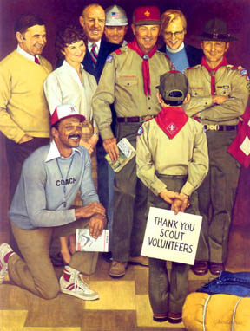
Thank You, Scout Volunteers
Joseph Csatari (1983)
This month we want to recognize some very special people – those wonderful volunteers who help the boys learn and grow and learn about the world. They help us learn about everything from first aid to basketball to how to honor the flag. They teach us new skills, help us practice and perfect them, keep track of our scout advancement, and drive us to exciting field trips – and they make it all fun, too.
The famous painter, Joseph Csatari, understands how much Scouts appreciate those who make scouting happen – he painted this special picture to honor volunteers in 1983. And we would like to paint a picture of some special volunteers in our pack tonight. (Name each person and describe specifically how they have helped. You might even want to give them a certificate with this picture on it)

We Appreciate You
Sam Houston Area Council
Your willingness to give without asking in return
Your dependability and heartfelt concern,
The many kind things you do and you say
To warm others lives day after day,
Make your gift of time beyond compare
Thank you for being a wonderful volunteer.
Materials:
Small wrapped box
Ask each Scout to write a small note of thanks to the den leader, and tuck it in the box. If a parent, ask the den leader/Cubmaster to write a note and tuck it in the box.
Cubmaster: There are some truly artistic parents and leaders in our group tonight. They have given their time to make sure our event was a success and that you all had fun. They have made our pack special by volunteering their time, and we would like to honor them with a gift. (Call adults forward and present award.) Thank you for making the gift of yourself to our pack.
ADVANCEMENT CEREMONIES
Note from Commissioner Dave
Please be careful when doing Advancement ceremonies in December. The awards should never be presented as gifts. The Scouts have earned them. Gifts are often undeserved. Don’t confuse our Scouts. Make sure the Scouts and the audience knows all awards were earned.
A Work of Art
Alice, Golden Empire Council
Cubmaster: This month, the boys have been learning about works of art. Even talented artists don’t just create art – they have to study and work – just as the boys don’t advance without studying new skills and practicing to perfect them.
When a boy first joins Cub Scouting, he has much to learn; just as an artist decide what kind of art to make and then gather the materials, each new boy makes a decision to join Scouts. He and his family gather together a uniform, a book and the things that each boy must learn to earn the Bobcat. Let’s have _______come forward with his parents – they have studied the requirements and _____ has learned what it means to be a Scout. (Give the award to the parent to present to the boy, and have the boy present the Parent's pin to a parent.) Lead Cheer.
Just as an artist learns about color, line, shape and form, and has adults to help him learn the basics, a Tiger Cub has an adult partner to help him learn the basics. Let’s have ______ come forward with his adult partner to receive his Tiger Cub Badge –his adult partner has helped him learn by doing activities in the den and the family, and they have gone out in the world to “see” new things. (Follow as above) Lead Cheer.
Once he learns the basics, an artist must begin practicing all kinds of skills – just as the Wolf Scout learns and practices many things that may be new to him. We have a Wolf Scout who has completed all 12 Achievements and is learning all kinds of useful skills. Please come forward with your parents ___________. (As above) Lead Cheer.
Artists who have learned the basics and practiced the skills needed to create works of art must continue to learn – there are lots of techniques to practice, new equipment to learn about, new forms of art to explore. The Bear Cub Scout is like the artist – he is learning about more difficult skills, how to use a knife safely, how to be fire safe. We have a Bear who has completed 12 of the 24 possible Achievements and has learned many useful new skills. Please come forward with your parents ___________. (As above) Lead Cheer.
An artist who has learned the basics, practiced and worked hard to perfect techniques and use the equipment properly can begin to develop a personal style. The Webelos Scout is beginning to take on more personal responsibility, learning to explore the world on his own, and working to make a difference in his own unique way. Please come forward with your parents ____________. (As above) Lead Cheer.
The artist who has learned, practiced and honed his skills, and developed a personal style can begin to create a whole body of art work – he has enough quality work to have an exhibition. In Cub Scouts, the Webelos who has learned, practiced, and honed his skills, and developed the personal sense of responsibility to be a leader will earn the Arrow of Light. It is the highest award in Cub Scouting and the Arrow of Light pin is the only Cub Scout award that can be worn on the Boy Scout uniform. We have a scout here tonight who has completed all the required Activity pins is ready to receive the Arrow of Light Award. Please come forward ______ . (At this point, segue to a special ceremony for the presentation of the Arrow of Light.)
Other patches or belt loops can be worked into the appropriate rank section. Cheers or Applauses should be done after each rank AND at the end. Alice
The Artistic Rank Advancement
Utah National Parks Council
Sam Houston Area Council
Scene: Display of Cub Scouts’ art works (preferably done by the candidates). Make a copy of large Cub Scout emblem, and cut it up into pieces like a jigsaw puzzle (one piece for each participant). On the back, write a number and attach a piece of double sided tape or looped tape. On a large poster board, lightly trace the outline of the emblem and each puzzle piece, with corresponding number.
Note: If you have many candidates, prepare a puzzle for each rank emblem, rather than using the Cub Scout emblem.
Cubmaster: (Points to the art display) As you can see from all the artwork displayed here, our Cub Scouts are very creative. We need some help from these creative young men to finish another work of art for us tonight. They have been working hard to complete their rank requirements, and are now ready to help fill in our picture.
Will the following boys please come up with your parents to receive their (name of rank) rank?
(CM hands the boy his rank and a puzzle piece. With his parents, the boy places the puzzle piece on the board. Continue for each rank and have each boy add to the picture until it is complete)
The Cubmaster then concludes: Our budding young artists together have completed our portrait of the Cub Scout emblem. Congratulations to them for their success.
Christmas Advancement Ceremony
Utah National Parks Council
Preparation: Have a Christmas tree with various colored lights. (This can be a cardboard tree with holes for the lights.) The bulbs should be unscrewed slightly so that they can be easily turned on at the proper time. If you want to (not required) color coordinate the lights with the ranks - Bobcat - blue, Tiger - orange, Wolf - red, Bear - blush-green, Webelos - yellow(gold).
Cubmaster: As we look at our tree this evening, we see that it is dark, with only one light on. (Screw in top light.) This is the light which represents the Webelos Arrow of Light Award.
Let us see if there are boys here tonight who can help light the way to the top of the tree, to the highest rank in Cub Scouting.
The first step along the Cub Scout trail is the BOBCAT. (Turn on light at the bottom. If there are any Bobcats to be inducted do it here.). Once a boy has achieved this honor, he is ready to climb.
There are 5 achievements to complete for the Tiger Badge. They are Making My Family Special, Where I Live, Keeping myself Healthy and Safe, How I Tell It, and Let's Go Outdoors. Each one has three parts - family, den and go-see-it. (Call boys who have earned Tiger badges and parents up front. Present badges to parents to present to boys. Do usual pack protocols. Lead cheer!)
There are 12 achievements to complete for the rank of Wolf. Some of these require knowledge of the United States flag, of keeping strong, of safety and being useful to the family. The following boys have completed these requirements: (Call boys who have earned Wolf badges and/or arrow points and parents up front. Present badges to parents to present to boys. Do usual pack protocols. Lead cheer!)
Thank you boys. We are now able to turn on the light representing the Wolf rank. (Turn on next light.)
As the boy grows older and stronger, he is able to climb higher. But just as it is a little more difficult to climb the upper branches of a tree, so the achievements are a little more difficult for the Bear rank. (Call boys who have earned rank badges and/or arrow points and parents up front. Present badges to parents to present to boys. Do usual pack protocols. Lead cheer!)
These boys have helped us light our tree, but it’s still not quite as it might be. Since they have received help from their parents and leaders, let us turn on a light for them, too. (Turn on another light.)
Now the boys have reached 4th grade or 5th grade and have more climbing to do. This last climb will bring them to the top of the tree and the coveted Arrow of Light. To reach there they must attain the Webelos Award. In order to reach the Webelos Award they must first earn activity badges. (Call boys who have earned Webelos Activity Awards and parents up front. Present badges and awards to parents to present to boys. Do usual pack protocols. Lead cheer!)
Thank you boys as you have learned throughout Cub Scouting you have helped to make the world brighter. (Turn on another light.) And now the boys who have earned their Webelos badge and have begun to learn what Scouting really is. (Call boys who have earned the Webelos badge and parents up front. Present badges to parents to present to boys. Do usual pack protocols. Lead cheer!)
Now our tree is complete. As you have seen, it has taken boys plus parents and leaders to complete it. With the same effort you have shown before, keep working for the highest rank in Cub Scouting. Congratulations to you and your parents for the fine work you have done.
SONGS
How to Be an Artist
Sam Houston Area Council
to the tune – Row, Row, Row Your Boat
Use, use, use your brain,
Put your mind in gear.
Bright ideas aren’t a strain,
You’ll have some, never fear.
Think, think, think so hard,
Service you can give.
Help some other people and
Your life’s more fun to live.
Do, do, do your best,
Do a good deed, now.
It will make you happy and
Cub Scouting will show you how.
Sharing From Our Heart
Sam Houston Area Council
to the tune – Jingle Bells
There’s so much we can share
And so much we can do
Showing that we care
Creating just for you
We’re making works of art –
They put us to the test
We grow and share right from our heart
We really do our best!
Chorus:
Oh!! Sketch it here
Paint it there
Mold it out of clay
Oh it’s great as we create... each and every day – ay!
Sketch it here
Paint it there
Mold it out of clay
Oh it’s great as we create... each and every day!
If You Want to Draw Like an Artist
Alice, Golden Empire Council
Tune – My Bonnie Lies Over the Ocean
If you want to draw like an artist –
You have lots of things you must learn –
And lines are so basic to drawing,
They’re straight, thin or bold or they turn
Chorus:
Draw it, Draw it –
Take note of your world as you draw, you draw
Draw it, Draw it –
Let everyone see what you saw!
In Nature you might see a short line
Or maybe a line that is long
It could be a line that is jagged
And a bold line might never be wrong
Chorus
You also use shapes as you’re drawing
They could be in circles or squares,
Or any shape ge-o-metric
They could be in singles or pairs
Chorus
Some shapes are known as organic –
You might use irregular lines –
Or go with a shape three dimensional –
It’s up to the artist to pick!
Chorus
You also must pick out your colors –
Colors can be dull or bright –
They’re known as cool or warm ones –
But choose them to work in the light.
Chorus
If you put these elements together -
Use shapes, lines and color to draw,
You can share what you have looked at –
Let EVERYONE see what YOU saw!
Chorus
At The Museum
Sam Houston Area Council
to the tune: Yellow Rose of Texas
When I see a fuzzy picture,
A-hanging on the wall,
They say it is a masterpiece,
I cannot tell at all.
I squint and clean my glasses,
I look and gaze some more.
But it still looks the same to me,
Just as it did before.
Masterpiece
Sam Houston Area Council
to the tune – Down By the Station
Here with my paint brush, paint, and empty canvas...
How will my picture look, after the paint dries?
So I’ll just get busy and my best I will do...
And I’ll see a masterpiece right before my eyes!
The Story of Scouting
Alice, Golden Empire Council
Tune: Battle Hymn of the Republic
Baden-Powell’s the founder – and he told the story, too -
Not just around the campfire, but in pictures that he drew
He showed his scouts the how-to and the way that nature looks
When he put his many sketches both on covers and in books
Chorus:
Scouting’s story told in art work
Scouting’s story told in art work
Scouting’s story told in art work…
By those who love it best
Norman Rockwell loved to show the scouting story, too
He showed the pride and wonder, and excitement as he drew,
He caught the acts of service and the humor that he knew
And he showed in paint the valor of a well-trained scouting crew!
Chorus
Now you can tell the story – share in Scouting what you learn,
Of hikes and conservation, Or of “Doing a Good Turn,”
Just take up pen or pencil, or a cam-era or clay,
And show YOUR Scouting story in your own artistic way
Chorus
(Pause a little and SPEAK the word YOUR
before starting the chorus)
Look & Find the Art
Alice, Golden Empire Council
Tune – Row, Row, Row Your Boat
Look, look, look around –
Art is everywhere
In the clouds or on the ground,
Art is everywhere!
Look, see, save it up
Keep the memory
Then you draw a work of art
And everyone can see
Look, see, gather up
Objects on the ground
Put together with some thought,
“Found Art” is what you’ve found!
Use your eyes, your fingers, too –
Imagination’s key –
And when you’ve made a work of art –
You can share with ME!
When You’re Helping and You Know It
Sam Houston Area Council
to the tune – When You’re Happy and You Know It
When you’re helping and you know it, lend a hand
When you’re giving and you show it, things are grand
If you’re helping and you’re giving
Then you help make life worth living
Keep on helping; Keep on giving; Take a stand
Creating Art
Utah National Parks Council
Tune: Here We Go ‘Round the Mulberry Bush
Creating art is fun to do,
Fun to do, fun to do,
Creating art is fun to do,
To do, to do, to do!
Molding clay is fun to do,
Fun to do, fun to do,
Molding clay is fun to do,
To do, to do, to do!
Brushing paint is fun to do,
Fun to do, fun to do,
Brushing paint is fun to do,
To do, to do, to do!
Using my hands is fun to do,
Fun to do, fun to do,
Using my hands is fun to do,
To do, to do, to do!
Audience Participation, Songs and
I Can Be An Artist
Utah National Parks Council
Tune: I’m A Little Teapot
I can be an artist, it’s so fun
Drawing, painting, sculpting,
it can all be done
I can sing and dance and sculpt with clay
Art is so much fun, it feels like play.
Oh Christmas Tree
Utah National Parks Council
Tune: O Tannenbaum
Oh, Christmas tree! Oh Christmas tree!
Your needles falling down on me.
Oh Christmas tree! Oh Christmas tree!
Your needles falling down on me.
"It’s freshly cut," the salesman said.
But now you’re home, I see you’re dead.
Oh Christmas tree! Oh Christmas tree!
Your needles falling down on me.
Oh Christmas tree! Oh Christmas tree!
You fell over on my TV.
Oh Christmas tree! Oh Christmas tree!
You fell over on my TV.
The cable lines are in a pinch,
I can’t watch Snoopy or the Grinch.
Oh Christmas tree! Oh Christmas tree!
You fell over on my TV
Oh Christmas tree! Oh Christmas tree!
There’s something under you I see.
Oh Christmas tree! Oh Christmas tree!
There’s something under you I see.
Is it a present gaily wrapped?
No, it’s a blob of gooey sap.
Oh Christmas tree! Oh Christmas tree!
There’s something under you I see.
A Hanukkah Song
Utah National Parks Council
Tune: Three Blind Mice
Greater St. Louis Area Council via Baloo’s Bugle
Eight bright lights, eight bright lights,
See how they glow, see how they glow,
They call to mind the Maccabees,
The struggle for our liberties,
The glory of their victories,
Eight bright lights.
STUNTS AND APPLAUSES
APPLAUSES & CHEERS
Sam Houston Area Council
The Masterpiece Cheer.
Everyone yells, “What a Masterpiece!”
The Magnificent Cheer.
Pretend to paint, step back, spread arms, and say “Oooooooooo, Ahhhhhhhhh, Magnificent!
Alice, Golden Empire Council
Artist Applause - Tell and show everyone how to hold up their “artist’s palate” in their left hand. Now everyone takes a “brush” in their right hand. Then shout, “I’ve captured it! I’ve captured it! I’ve captured it!
The Elements of Art Applause - Divide the audience into three groups and assign each group a WORD and an action. Demonstrate each one first:
- LINES – “Draw” a line in the air with one hand, starting at the waist and going up into the air
- COLOR - Each person points proudly to a color they are wearing
- SHAPE - Each person “makes” a shape with their hands, like a square, circle, etc.
Tell the group to say and demonstrate their phrase when you point to them.
Also tell them that if you open your arms wide to include everyone, they should shout “It’s a Work of Art”.
Now point to each group several times, in various order, then end have everyone shout the last phrase.
Continuous Sketch Applause - Explain that you will start at one end of the room, and each person in the audience will continue the line drawn in the air by the person next to them – a “sketch” drawn in air that continues from you all the way through the audience – with the last person coming back to you to end the “sketch.” Then everyone can shout “It’s done!” (Similar to doing the wave in a stadium)
Utah National Parks Council
Work of Art Cheer - Pose like “The Thinker” for a moment, then say, “I’m a Work of Art!”
Magnificent Painting - Pretend to paint, step back, spread arms, and say “Oooooooooo, Ahhhhhhhhh, Magnificent!”
Paintbrush Applause - Clap using just your index fingers (your paint brushes!).
Modeling Clay Cheer - Pretend to mold some modeling clay into a figure. Say, “I’m a model citizen!”
Dreidel Cheer - Spin a dreidel on a table or desk. When it lands, all yell “Happy Hanukkah!”
Santa Cub - Put hands on belly, lean back slightly while saying “Ho, ho, ho. Merry Cubbing.
Christmas Bells - Pretend to hold a bell rope, then have the left side of the audience say “DING” on the down stroke and the other side of the audience to say “DONG” on the upstroke. Repeat three times.
Jack in the Box - Unwrap the package, open the lid, and say, “Boing.”
Snowball Cheer - Leader throws a wad of white paper into the air. As it hits the ground, all say “Happy Holiday!”
RUN-ONS
Sam Houston Area Council
A Cub Scout is seated and sketching in a book (or on canvas on an easel). Different Scouts come in one at a time and ask, “What are you doing?” The Cub Scout answers, “Drawing.” All the Scouts stand around and watch after they have asked the question. The first Scout then asks, “What are you drawing?” The Cub Scout answers, “A crowd.”
You Know You’re an Artist When:
Alice, Golden Empire Council
This can be an ongoing walk-on about Art
Give someone the list and have him walk-on during the pack meeting at various times and read just one.
Or it can be a skit - Have each boy in the den learn two and have them stand there like a conversation and exchange the lines. Modify some of the lines to make it a conversation, "You are a real artist …", "Oh, yeah well at least I don’t …"
You know you’re an artist when:
- You butter your toast with your fingers, just to feel its texture.
- You talk about going to a show where the pictures don't move.
- You know what shade of green the lichen on the trees is.
- It’s hard to find a nice outfit to wear – they all have paint stains on them.
- You love blank books – you can fill them with your drawings.
- You sometimes bump into things because you are busy observing the world around you so you can draw it.
- You carry colored pencils instead of pencils and pens.
- You do judge a book by its cover.
- You choose library books because of their illustrations.
- You watch the latest kids' digital animation movies and drool over the effects as much as the story.
- You draw or paint more than you talk.
- You draw your letters instead of write them.
- You know the difference between beige, ecru, cream, off-white, and eggshell.
- You know all the colors in the big crayon box.
- You never look at a person's face as a whole. You break it up into shadows and lines and shapes, and think how they would look as a drawing.
Utah National Parks Council
Cub 1: What's red and white, and red and white,
and red and white?
Cub 2: A candy cane?
Cub 1: No, Santa Claus rolling down a hill.
Cub 1: What is red, white, and blue?
Cub 2: Santa Clause with a cold!
Cub 1: No! A sad candy cane.
Cub 1: Why did Santa only take seven reindeer on Christmas Eve?
Cub 2: Comet had to stay home and clean the sink.
Cub 1: What do you have in December that you don't have in any other month?
Cub 2: The letter "D".
Cub 1: What do you call a chicken at the North Pole?
Cub 2: Lost.
JOKES & RIDDLES
Alice, Golden Empire Council
Q: What kind of paper would a cat artist use?
A: That’s easy – SCRATCH paper
Q: What would you call a dog that’s a cross between a Pekingese and a Lhasa Apso?
A: You call is a PEEKASO, an abstract dog. (Picasso)
Q: Why should you take a pencil to bed?
A: To draw the curtains!
Q: Why did the picture go to jail?
A: Because it was framed.
Q: What's taken before you get it?
A: Your picture.
Sam Houston Area Council
Knock-Knock.
Who’s there?
Riddle.
Riddle who?
Riddle things mean a lot!
The Art Collector
Utah National Parks Council
I think this could easily become a simple skit CD
A famous art collector is walking through the city when he notices a mangy cat lapping milk from a saucer in the doorway of a store. He does a double take. He knows that the saucer is extremely old and very valuable, so he walks casually into the store and offers to buy the cat for two dollars.
The storeowner replies, "I'm sorry, but the cat isn't for sale."
The collector says, "Please, I need a hungry cat around the house to catch mice. I'll pay you 20 dollars for that cat."
And the owner says "Sold," and hands over the cat.
The collector continues, "Hey, for the twenty bucks I wonder if you could throw in that old saucer. The cat's used to it and it'll save me from having to get a dish."
The owner says, "Sorry buddy, but that's my lucky saucer. So far this week I've sold sixty-eight cats."
Impressions—An Artsy Joke
Utah National Parks Council
This would be a great two person run-on CD
A wealthy man commissioned Pablo Picasso to paint a portrait of his wife. Startled by the nonrepresentational image on the final canvas, the woman's husband complained, "It isn't how she really looks."
When asked by the painter how she really looked, the man produced a photograph from his wallet.
Returning the photo, Pablo observed, "Small, isn't she?"
SKITS
Artistic Genius
Sam Houston Area Council
Setting – Three or more judges; Painters
Scene – Canvasses; Easels (chairs); Sign announcing “Art Competition Today”
Judges walk around an art show and examine the different pieces on display. They comment on the brightness, color, technique, and brush strokes of each.
They select one for first prize, and comment about the genius, imagination, and beauty of the picture.
The artist is summoned, and the winning picture is shown to him. The painter exclaims, “Oh, my goodness that got in by mistake! That is the canvas I clean my brushes on!”
Variation: To extend the skit and bring in more players, the judges can award second and third places to other artists with ridiculous names. You can add silly painting subject matters, etc., for the winners to describe their winning canvasses.
Let your Cub Scouts make the competing canvasses (use newspaper, painted completely white. Let dry, allow boys to create masterpieces, then wrap over appropriate size piece of cardboard and tape on the back.)
Baden-Powell’s Sketch Book
Alice, Golden Empire Council
The Narrator is “Baden-Powell – Try to borrow a campaign hat, maybe add a BP mustache. BP is sitting and remembering….
BP: Hello there – my name is Baden-Powell. You might remember me as the founder of Boy Scouts – and I certainly did like to get out in nature! (First Cub Scout comes out with a large magnifying glass and pretends to be looking at nature)
Cub #1: What a curious seed pod! I must make a sketch of that so I can study it in detail! (Boy takes out a pencil and pretends to be drawing) Now I can remember exactly what it looks like! (Cub #1 moves off)
BP: One time, I disguised myself as a real nature lover - an eccentric lepidopterist – that’s a Butterfly Collector. (Second Cub comes out with a butterfly net, a colorful pair of socks, or shirt – something eccentric, maybe a huge pair of glasses)
Cub #2: (Pretending to see a butterfly, making motions to catch it in his net) Aha! Now, I’ve got you! I’ll just make a little sketch….(begins to draw)
BP: But I wasn’t just drawing a butterfly – the enemy soldiers got so used to seeing me and my butterfly net that they paid no attention as I sketched the Austrian Fortifications…
Cub #2: (Turning to face the audience – Talking as if he is telling a secret, but loud enough for everyone to hear) Perfect! I’ve drawn this map right into my sketch of this butterfly – I’ll get this back to the general….. (he walks off)
BP: I was always curious about how things worked. One time, in Germany, I pretended to be a consulting engineer….
Cub #3: (Wearing a hard hat and carrying an impressive bunch of “blueprints” ) I’ve been asked to check out these designs and make any needed changes in the building. Let’s see now…. (He begins to look around and pretends to make changes to the drawings as he walks around – then slowly walks off….)
BP: Yes, I really pulled the wool over their eyes. When the British High Command got those sketches, they knew the Germans were planning to build a whole fleet of ships....my sketches helped defeat the enemy! Oh, and at Mafeking….
Cub #4: (Looking like a soldier, acting like he is peering out from behind things to see) If I can just get a good look at where the enemy has their big guns, and how many soldiers they have, we can make a plan to win the conflict…. (He begins to “sketch” what he sees
BP: Those sketches did help – but I also had a lot of fun bluffing the enemy. We were far outnumbered by the Boers at Mafeking, so we used a game of Bluff, like you boys still play today. We got groups of townspeople to lay out “bombs” all around Mafeking….
Cub #5: (Comes out with another Cub, both holding a box that they are very careful with. The make the motion of carefully putting down their bomb, digging a hole, then putting the box in it) Remember, let everyone think that this is really a bomb – that it might go off if we aren’t VERY careful.
Cub #6: (Laughing) The Boers will never guess that these boxes are just filled with sand! (Both Cubs move off)
BP: (Laughing) And just to make sure the Boers believed we had planted bombs everywhere, we stuck dynamite into an ant- hole and set it off when a Boer dispatch rider went by on his bike. He flew off to report that our bombs were so sensitive they went off when he just pedaled down the road!
After the war, I had fun making sketches for the Scouting for Boys books – it was a good way to show the boys how to do knots or practice other outdoor skills….
Cub #7: (Brings out a rope and begins to look at his “book” as he makes a knot) I sure am glad Baden-Powell made these sketches – it makes it a lot easier to learn how to make knots!
BP: Yes, I found lots of useful ways to use art in scouting… drawing from nature, showing how to do something, or even just having a picture to remember a scene or a person – (looks out at the boys and points to them) you boys should practice sketching, too. I required my scouts to make a sketch every day – helped train them to be observant!
(Looks away, starts to walk off, then turns around to say..)
BP: Remember, Art is Everywhere! Oh, and remember to always have a sense of humor - don’t take yourself too seriously. I had fun drawing this caricature of myself!
(Shows the Self Portrait then walks off)
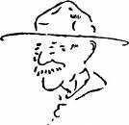
AMERICA THE BEAUTIFUL
Great Salt Lake Council
SET UP:
- Den Leader (DL) and 7 Cub Scouts
- Curtains on stage - behind which is U.S. Flag (Either a painting, or a print or a real flag opened out flat - blue in upper left corner).
- Artist’s Smock for each Cub, large paint brush and paper palettes.
STORY:
DL: We are honored to have as our guests a group of famous artists, who are going to combine their efforts and talents to paint us a great masterpiece. As they are introduced they will tell you what their contributions will be.
- I will paint for you the tradition and charm of New England, showing you the fishing and boating industries of its rugged coast and its historic heritage. (Steps behind curtain.)
- I will portray through my brush the tremendous harbors of New York City; the melting pot of peoples from many lands that make up its teeming population. (Steps behind curtain.)
- My artistry will show you the charm of our Southland, the beauty of its magnolias and azaleas, the strength of its struggle through and after the Civil War years; and the contrast of the serenity of Kentucky’s bluegrass country with old New Orleans at Mardi Gras time. (Steps behind curtain.)
- May I add to our canvas just a little of the beauty of our great Midwest; cosmopolitan Chicago; Detroit, the automobile capital of the world; the waving grain of the rolling plains; and the deep blue of the ten thousand lakes of Minnesota. (Steps behind curtain.)
- Our great South and Mid-west will be a task to portray, BUT no mere picture can convey the majesty of the Grand Canyon, the beauty of the Painted Desert, the expansiveness of Texas or the splendor of the Colorado Rockies; the fantastic land of geysers, Yellowstone Park, or the Great Salt Lake in Utah. (Steps behind curtain.)
- Our beautiful West Coast reaches from the hot Mexican border to the cold snows of Alaska. In between, we find Hollywood’s glamour, the Golden Gate Bridge of San Francisco, towering redwood, sequoia, and Douglas fir trees, the beauty of Oregon’s Crater Lake, and majestic Mt. Rainier in Washington. Where once rough, tough gold prospectors were found in Alaska, now tourists spend happy summers experiencing, among other things, Denali and the wilderness of our largest state. (Steps behind curtain.)
- I will complete our picture with the waves of the famous Waikiki Beach, with Diamond Head volcano in the background of the exotic metropolis of Honolulu. Our newest State, Hawaii, with its blue waters and active volcanoes makes for a lush tropical paradise. (Steps behind curtain.)
DL: And now for the unveiling. May I present our great masterpiece!
As the curtains are slowly parted and “America the Beautiful” is played, the flag is solemnly shown,
with the “artists” standing on each side of the
United States Flag they just “painted”.
CLOSING CEREMONIES
Our Masterpiece of Togetherness
Sam Houston Area Council
Materials:
Distribute a three foot piece of rope to each boy.
Directions
Have the Scouts form a large circle.
Have ach Scout tie his rope with a square knot to the person’s rope on his left (den chiefs can help boys with knot tying).
When all the ropes are tied, hold onto the rope with the left hand and raise the right arm in the Cub Scout Sign.
Cubmaster says, “Here we all are together in our nice big Cub Scout circle – it is a bond between our families and friends in this wonderful month of December. We have created masterpieces this month. May we continue to do so. Please join me in the Cub Scout Promise.”
Holiday Art Closing
Utah National Parks Council
Essentially the same objects as an opening
but different words. CD
- (holding paintbrush) Tonight, we have painted …
- (holding clay) we have molded and shaped…
- (holding a piece of construction paper) We have cut and beaded…
- (holding popsicle sticks) and we’ve glued and we’ve taped.
- (holding crayons) We’ve used color and texture,
- (holding a camera) we’ve taken pictures so bright.
- (holding a heart cut from red paper) we’ve been touched by our Holiday art…
- (holding a drawing of a moon or the night sky) and wish to all a good night.
GIFTS Closing Ceremony
Utah National Parks Council
Set Up: Deb Chief (DC) or Den Leader (DL) and 6 Cub Scouts. Be sure boys have learned their parts or create cards with pictures on the audience side and the words on back in LARGE type.
DC/DL: What you are is God's gift to you. What you make of yourself is your gift to God. Make it a good gift.
- Work while you work.
- Pray while you pray.
- One thing at a time, that is the way.
- All that you do,
- Do with all your might.
- Things done halfway are not done right.
All: (Together) Do Your Best!
Cubmaster’s Minutes
Works of Art
Sam Houston Area Council
This month our theme has been "Works of Art." And we have many on display here at our meeting tonight. They are all wonderful masterpieces. I have often wondered about why we say “works” of art.
I think it’s because when we really focus on creating something that is telling something about ourselves and how we see things, we want it to be just right. We focus, we plan and we work to make it the best that it can be. If we could do that with other things that we do, think of how many more masterpieces we could create – the best made bed or the neatest homework. Work is part of all of our lives and how we do our work, shows a bit of us.
Don't Give Up
Sam Houston Area Council
To be good, or even great, at anything, you have to believe you can do it and then you have to practice until you can. There’s no easy way to become an expert at anything. You have to keep at it. There may be times when you think you can’t make it, but don’t give up. Few things come easily the first time. Keep going. Don’t give up. And always remember to Do Your Best.
Positive Perseverance
Utah National Parks Council
You may have heard the saying, “You can’t rush art.” This refers to the fact that great art takes time. Few realize that artists rarely ‘get it right’ on the first try. Before an artwork is finished, it has usually gone through multiple drafts and revisions that viewers never get to see. Such work takes not just perseverance, but faith. Keeping their mind’s eye on what their art piece will eventually become, artists are often driven by that positive perseverance to complete their work.
In your own life, you will face tasks that seem too big or too time-consuming. But if you keep a positive attitude to persevere and have faith, you will succeed in all that you attempt.
Learning to Focus
Alice, Golden Empire Council
Even a trained and talented artist must first decide what he wants to create before he can begin. An artist often creates a “focus” area using his hands (demonstrate) in order to find the specific part of a scene he wants to draw or paint. Focus can also be used to “see” a finished work of art – to focus on the various parts that make the whole. Let’s remember to use focus in our lives as well – to “see” the most important parts, to determine priority and to recognize what we really need and want to work on.
THEME RELATED STUFF
Tips for Making Art with Boys
Alice, Golden Empire Council
Choose a subject that will interest the boys to start with – they might enjoy going outside to find something colorful, with an interesting shape, or that they are curious about. Use questions to get them thinking about what they want to focus on in a scene, what materials they might like to use (watercolors for a sunset, crayons for a curious seed pod), and what size they want to draw their subject.
Learn something about the kind of art you are going to make – check with pack and den families, ask a local teacher, or check with a children’s librarian for some great books to help you plan and carry out projects successfully.
Make sure you have enough help. Ask a parent to come and help.
Plan your time carefully – allow about a third more time than you think you will need. Be sure to stop in plenty of time to allow for clean-up. You can always continue the project at another meeting.
Leave plenty of room for the boys to work without crowding each other.
Provide containers for art materials and equipment for each boy. Use Styrofoam trays to hold a selection of markers, pencils, a pair of scissors, glue, and materials for each boy. Use plastic egg carton sections, four to six per boy, to hold paint – it won’t absorb into the carton, and holds only a small amount of paint. Use cheap paper plates for individual palates for each boy. Squirt out only a small amount of paint at a time, and only two or three colors at a time!
Provide large shirts (ask each boy to bring an old shirt of dad’s) to cover up when working with paint.
Prepare the area – work outside or cover surfaces with plastic – cheap paint covers or rolls from large box stores work great! Newspapers can also cover both the work surface and the floor underneath.
Separate the art project into smaller pieces – real artists don’t just start out painting on the canvas. They make drawings and studies of sections of the art work first. They try out various color combinations, take a small amount of two paints and swirl them together to decide on what colors they want to use in the finished piece.
Show the boys how even famous artists use “cartooning” to lay out a project on a small scale and then enlarge to full size. (See the cartooning idea)
Another way to make a copy or trace the outline of a picture is to tape it onto a window, then tape the second sheet of paper over it – the light coming through the window will act like a light box, letting you see the original to outline onto the second page.
Be supportive, but don’t try to tell the boys that you love everything they do – they’ll know it’s not true anyway! Instead, mention things you really do like – the colors the boy chose, the way he laid out his art work, the careful way he worked on it, his willingness to try something new, what he learned from the first effort that will help him when he tries it again. Making art can provide “golden moments” to point out some important principles of Scouting, such as resourcefulness, perseverance, respect and positive attitude.
Start with a small piece of artwork - have each boy make a Christmas card, using a regular sheet of paper folded in fourths. You can also make an envelope using a template at http://desktoppub.about.com/library/weekly/envelope.pdf You could also make Twig Easels to display the art work created by the boys. See www.enchantedlearning.com for directions.
If you have too much competitiveness within your pack or den, choose a “collaborative” piece of art to work on – where everyone has to work together. See ideas in Theme Related. Or choose Norman Rockwell or other art works that demonstrate cooperation or whatever principle you want to show.
Proudly display art work made by the boys– see ideas under Gathering Activities and be sure to include a label or “caption” for each work of art. See Art Gallery Code Breakers for information.
Take a picture of each boy with his art work and present it to him at the Pack Meeting.
Remind parents of advancement, elective or activity pin requirements that can be signed off with projects done this month.
Norman Rockwell – The Scout Artist
Alice, Golden Empire Council
Norman Rockwell has done hundreds of works of art with Scouting as the theme. He began illustrating stories and covers for Boy’s Life magazine in the same year that Boy Scouts of America was founded. In fact, he became art director for the magazine in 1913. He also did illustrations for “The Boy Scout Hike Book” by Edward Cave and “Boy Scouts Courageous” by Franklin K. Mathews.
In 1916, he moved to the Saturday Evening Post, but he continued painting Scout pictures throughout his life.
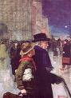
After serving in the Navy in WWI, he was commissioned by the Red Cross in 1918 to paint four covers of scouts for their monthly magazine. They wanted to honor the service given for free by scouts throughout the war. This painting illustrates the famous story of an unknown Boy Scout guiding BSA founder William Boyce through the London fog, and is titled “The Daily Good Turn.”
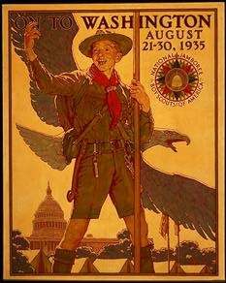
Starting in 1925, Rockwell illustrated an annual Boy Scout calendar, the most popular calendar for many years – he continued to do this calendar for the next 52 years! For the first four years, he did the illustrations for free.
In 1938, Norman Rockwell was awarded the Silver Buffalo for “Distinguished Service to Boyhood.”
Baden-Powell – An Artist Scout
Alice, Golden Empire Council
Baden-Powell was not only the founder of Boy Scouts – he was also an artist. He made sketches throughout his life – to record a beautiful scene or the detail of a leaf or other natural object. He taught his scouts to sketch details of nature to learn more about the world around him – they spent part of every day learning to sketch.
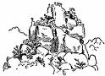
At Mafeking, his sketches of the terrain, enemy locations and equipment were invaluable in planning the military campaign – and helped make Baden-Powell a hero! See www.pinetreeweb.com/B-P.htm Sketches from Mafeking
He also loved drama and theater, so he would take on a “role” and act the part while he made sketches of enemy fortifications. When turmoil developed in the Balkans, Baden-Powell traveled there in disguise as an eccentric lepidopterist (Butterfly Collector). In this disguise he would walk around the countryside carrying a large butterfly net and sketch pad; eventually he was able to walk right up to the Austrian Fortifications and sketch the layout, incorporating the sketch into a larger sketch of a butterfly - so he was never found out!
In Germany, disguised as a consulting engineer, he was able to gain access to a restricted area in Hamburg and sketch exactly what he saw. His drawings were so accurate that the British High Command had no doubt that a massive ship building facility was building a fleet of war ships.
Many of his sketches appear on the cover and inside manuals for the scouts, such as the one below.
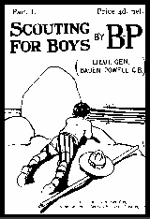
Self Portrait
Check for other images of sketches made by Baden-Powell at the scouting websites. If you google for art by Baden-Powell, you will discover even paintings and sculpture that he created!
Art Gallery Code Breakers
Alice, Golden Empire Council
Every work of art in a museum or art gallery has a “caption” – a label about the item and the artist and/or origin of the item. Teach the boys how to decode the label while visiting an art gallery. (Younger scouts will only be interested in some of the information – but be sure to point out the labels when you look at works of art with the boys) Or use this information to create a professional caption for the art work created by the boys and displayed at the pack meeting. Here’s the information found on the caption for a piece:
- Title always appears in bold; if there is no title, the word Untitled will appear.
- Date or even a range of dates when the work of art was made
- Artist – both the name and nationality are usually given
- Country or Culture – where the work of art originated or was found; specific city or region is sometimes noted
- Medium and Dimensions – Materials used to create the work or art are given, followed by the dimensions in both inches and centimeters, or feet
- Credit Line – How the work of art came to be on display - may be a “Bequest,” or “Gift,” from a person or organization; Could also be “On Loan” from another person, family or collection, or it could be a “Purchase” made from a fund. The same piece of art could have a different caption in different places – for example, the credit line could be “Gift from Carl Jones Family” at one exhibit and “On loan from Spencer Gallery” at another place and time. Often, the year when the piece was acquired will also be given.
- Accession Number – In museums and large gallery collections, every piece of art or item they own is given a number that refers to the year it was acquired, what collection it is part of, possibly how the piece was acquired – it’s a code within a code!
- Copyright – works of art made after 1900 may have been copyrighted – look for the symbol ©
- Description of piece – usually written by a staff member of the gallery or museum, or the curator of the exhibit
You might make a pre-visit if your den is visiting an art gallery, and give each boy a list of “treasures” to find – for example, “Write the name of a piece of art made from several materials” or “Where was the large stone container in the display case found?” or “Find two pieces of art by Clayton Jones.” You could use this same idea with pack family art work displayed at the pack meeting.
A Sampler of Art Work
Alice, Golden Empire Council
Let each boy create a “sampler” of different ways to create art – choose a different style or medium for each den meeting. Begin each project by showing a sample of art work (Google images) and telling a little about the artist. By using small “card-size” paper, each boy can make a several paintings using different styles during the month. They can then be displayed on the small Twig easels shown on the enchanted learning website.
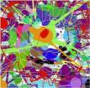
Jackson Pollock is an American painter known for his “drip” paintings – these could be interesting for the boys – and a fun technique for them to try as well. Spread plastic on the table and give each boy a piece of paper. Use small squeeze bottles, one color to a bottle, to apply the paint. Let drops and squiggles fall across the paper – boys can overlap colors, use several layers of colors and try different kinds of patterns as they drip the color. Anything goes! Be sure to let the art work dry completely.
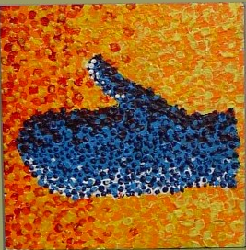
Georges Suerat was a French painter who developed a style using dots of primary colors to create a painting that seemed to have many different colors. Have each boy make a simple drawing first, adding the dots of paint to fill in the design. To create a small sample, use small pieces of sponge dipped in a color, then pick up the paint using the eraser end of a pencil or the opposite end of a paint brush applied as separate dots. Keep the paint colors separate to avoid a muddy picture.
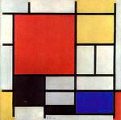
Piet Modrian was a Dutch artist who developed an abstract style using bold lines and blocks of primary colors, although he had done other styles of painting earlier in his life. Notice that the lines seem to be continuing off the edge of the page. To make a Modrian style painting, boys could either use a ruler to create various squares or rectangles, or plastic or heavy paper patterns to draw around. Start with pencil, then go over the lines, using a ruler, with a black marker. Then some squares can be filled in with bright primary colors, leaving some squares white.
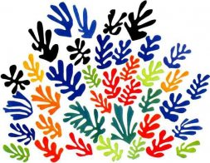
Henri Matisse was a French artist who after painting for many years, began to cut curvy shapes out of colored paper to create his art. Although this piece may remind you of leaves, he often cut very abstract but simple shapes out of solid colors, then pasted several shapes on a white background. Although his art work may make you think of something very realistic, the separate pieces may not look like anything specific. Encourage the boys to choose two or three favorite colors of paper, then cut out a few curvy shapes to create their own Matisse. Notice that there is space left around each colored shape – they do not overlap.
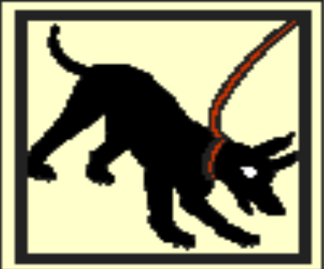
This mosaic of a dog was found on the floor of a house in Pompeii, Italy, buried under ash from an ancient eruption. Many of these “Beware of Dog” mosaics were found at the threshold of houses. This is from the www.enchantedlearning.com website, intended as a coloring page. But boys could also use the coloring page as a template to make a mosaic using small colored paper squares or even the dots from a paper punch!
These are just some examples and ideas on how to easily create art with the boys. Just be sure to keep the size small so a project can be completed quickly. Check the Websites for lots of other project ideas. Alice
TIGERS
Baloo’s Archives
Achievement 4, How I Tell It
This requirement is about Communication. Getting our Tigers to talk with others and be positive in what they say. They may learn how to carry on conversations and a little about mass communication.
Tigers can learn there are many modes of communication – when we talk, write, dance, sing or draw pictures. We communicate too with our faces when we frown or smile and our bodies with how we stand or move our arms.
Our uniforms and beads (on our Tiger totems) and patches communicate information about who we are and what we like to do.
Adults communicate through newspapers, magazines, books (Harry Potter) TV and radio. Be open to showing all these to your Tigers to help them Search, Discover and Share.
Achievement 4 Family Activity
4F - At a family meal, have each family member take turns telling the others one thing that happened to him or her that day. Remember to practice being a good listener while you wait for your turn to talk.
Mealtime conversations should be kept positive. Sharing your day’s activities could be become a regular family activity. Try to do this at a meal when everyone is there. Sharing amongst family members is always good so try to keep doing it even if only a few members are present.
The requirement helps promote Family Understanding, one of the Ten Purposes of Cub Scouting!!
This requirement involves doing a Character Connection on Respect. There are three elements to every Character Connection. A Tiger must first know what is correct, then practice doing it and finally commit to doing it in the future. If you want more info on Character Connections there is a BSA Bin Item 13-323A or go to Bill Smith’s Virtual roundtable at http://rt492.org/
For the Respect Character Connection –
Know – Have the Tiger discuss how he can show respect while talking with others. How to listen respectfully. How he may interrupt and still be respectful.
Practice – Have him participate in a family conversation (The one for this requirement would be great!!) Then discuss how he and others showed respect.
Commit – Have him discuss how it felt to be respected while he talked and how he felt showing respect o others. Have him make a list of three things to remember to help him talk respectfully.
Achievement 4 Den Activity
4D - Play "Tell It Like It Isn't" - This is the old “Whistling Down the Alley” game where the boys line up and pass a secret along. By the time it gets to the end, it usually is different than the start. The more boys the more fun. The Adults should join in, too, to make the line longer.
After the game discuss how things your Tiger may hear may not always be accurate. That messages change as they are passed from person to person. Discuss, too, how unkind words (gossip) can do harm and is often untrue. Cubs should only try and say things that are true. Honesty is a core value of Cub Scouting.
Achievement 4 Go and See It
4G - Visit a television station, radio station, or newspaper office. Find out how people there communicate with others.
This is very easy. Where I live we have a great radio station, WJBR (www.wjbr.com) that invites Scouts up to tour. They used to tape them saying the Pledge of Allegiance. Then every day at 7:00 AM, they used to play a tape of a group (school class, Den, Troop, Club). They even came to my roundtable and had us one morning saying the Pledge. I really like it when I hear a Tiger Den; they are so honest and excited. And most say it correctly – saying “One Nation Under God” as a continuous phrase without a pause. Of course it helps that the morning DJ, Michael Waite, grew up in Indiana, the Heartland of America, and his former assistant, Mr. Rhoads is an experienced Philmont trekker!! I have heard the Pledge said on several other area stations so maybe there is one by you.
Our local newspaper encourages tours. When my son’s Den went for Communicator, they inserted a picture of the Den on the front page and ran enough copies so each Scout could get one!!
Tiger Games
The Tiger’s Roar
Utah National Parks Council
This noisy game is played outside.
Directions
- All Tiger Cubs line up side by side.
- At the signal, they roar as loudly as they can and run
- as fast as they can.
- They run as long as they can roar without taking another breath.
- When they can no longer roar, they must stop.
- Try variations in the movements: skipping, hopping, giant steps, etc.
Tiger Feet Relay
Utah National Parks Council
Materials needed:
Large piece of cardboard,
Empty tissue boxes,
Craft paint or orange spray paint,
Glue
To make the feet
- Make two pairs of feet, one pair for each relay team.
- Draw the outline of a tiger foot about 14 inches long. Use a template to trace all feet the same size.
- Cut Out the Tiger feet
- Cut the tissue box into halves and glue them down on the tiger feet with the bottom facing up. Make sure the back of the box is open so your feet can slip into the pocket made by the box.
- Decorate your tiger feet.
Directions to Race
- Divide the group into two teams.
- The first player on each team puts on the tiger feet, races to a point, comes back and hands the feet to the next racer.
- The first team finished is the winner.
PACK AND DEN ACTIVITIES
Pack & Den Activities
Alice, Golden Empire Council
- Teach the boys some Holiday songs and sing them at the Pack Meeting.
- Gather your pack families and go caroling in a neighborhood or at a local retirement or care home. Be sure to have music and words and flashlights so everyone can participate. Share hot cocoa and cookies at the end.
- Visit a local art gallery – call ahead to arrange a docent who can share information with the boys.
- Provide every boy or family member with a “focus” square – a 4” square cut from heavy paper or an old file folder. It can be used to focus on parts of a work of art, or to focus on parts of a scene that could become part of an art project. Make sure the boys know that professional artists sometimes use their hands to create a “focus” square to help them decide on a subject.
- Ask a local artist or artist/educator to visit your den or pack and do a short art lesson with the boys.
- Throughout the month, focus on a different kind of art or music each meeting – such as painting, drawing, clay or multi-media (a combination of different materials), or even “found” art – made from items that are “found” even as trash!
- Check with local art galleries, your librarian, or school/college art departments to find an artist, an easy to visit “gallery” or a docent to help the boys understand what they see.
- Look for talent in your pack family – ask parents, grandparents and siblings to share their art work or musical talent with the boys and/or at the pack meeting.
- Share the exciting stories of how Baden-Powell used art – even as a spy! Let the boys follow the example of Baden-Powell and begin a sketchbook of things found in nature, or to keep a visual record of something. More ideas under Theme Related.
- Invite Chartered Organization Reps to your Holiday party and share scrapbooks and projects with them. Give them thank you cards made by the boys and showing their creative artistry.
- Arrange to offer the boy’s art work to residents of a care home, or as wall art for a community organization.
- Visit an art store and learn about how art is matted and framed to make it stand out.
- Let each boy choose a subject – and ordinary subject or some Holiday theme to use for a work of art.
- Supply art materials for the boys to use – ask families and local businesses or a teacher’s resource store for obsolete forms, faded or torn papers, partially used materials.
- Make sure each boy brings a large shirt (maybe one of dad’s) so he can participate in art projects without ruining his uniform shirt. Thrift stores are also a good source for den leaders.
- Choose a specific thing as the base for an art project – it could be a box, stationery, even a tie – with everyone getting blank materials to add their own design.
- Choose some part of Nature as the theme – for example, each boy could choose a season to represent using whatever materials appeal to him.
- Use the “Scouting” art made by Norman Rockwell as the focus to learn about how art is made, how the artist chooses a subject and tells a story. See Theme Related.
- Let each boy choose a favorite work of art and tell why it appeals to him, what he notices about it. Display a printout or copy of the art and his comments about the work at the Pack meeting.
- Encourage boys to use the camera to select and make a permanent record of the “art” they see in their everyday environment.
Big, Bigger, Biggest
Alice, Golden Empire Council
Artists use a technique called “cartooning” to transfer their original small drawing of a project to the final surface and a larger size. Ever wonder how they can make sure the finished, larger wall-size mural can look just like their original small drawing?
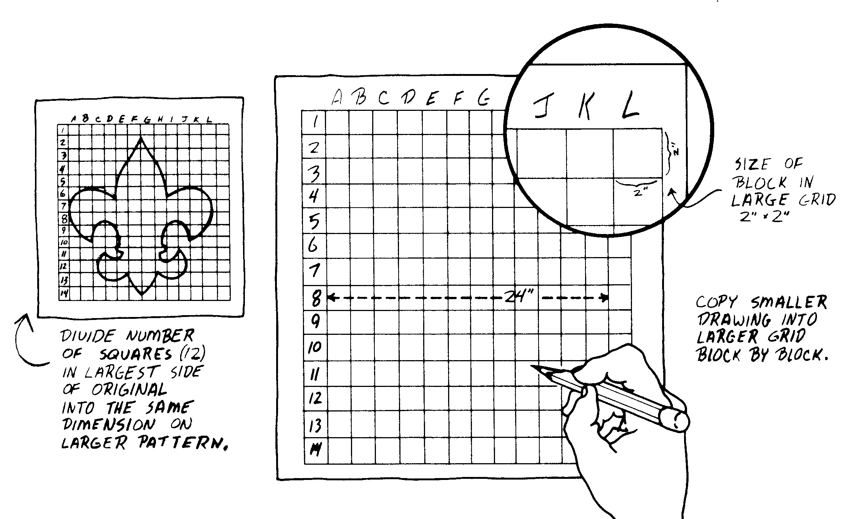
They use a grid of squares superimposed on the small drawing, then use a scale such as 1” equals 1 foot to make a grid and a drawing large enough to fit the finished space. Then its fairly simple to transfer just one square at a time to a larger grid, because instead of having to draw the whole scene at once, you can focus on just whatever line is in a single square. When all the squares have been filled in, you have a copy or a larger copy of the original. For Wolf boys, you can combine this project with Ach. #2 to make a drawing of a state flag.
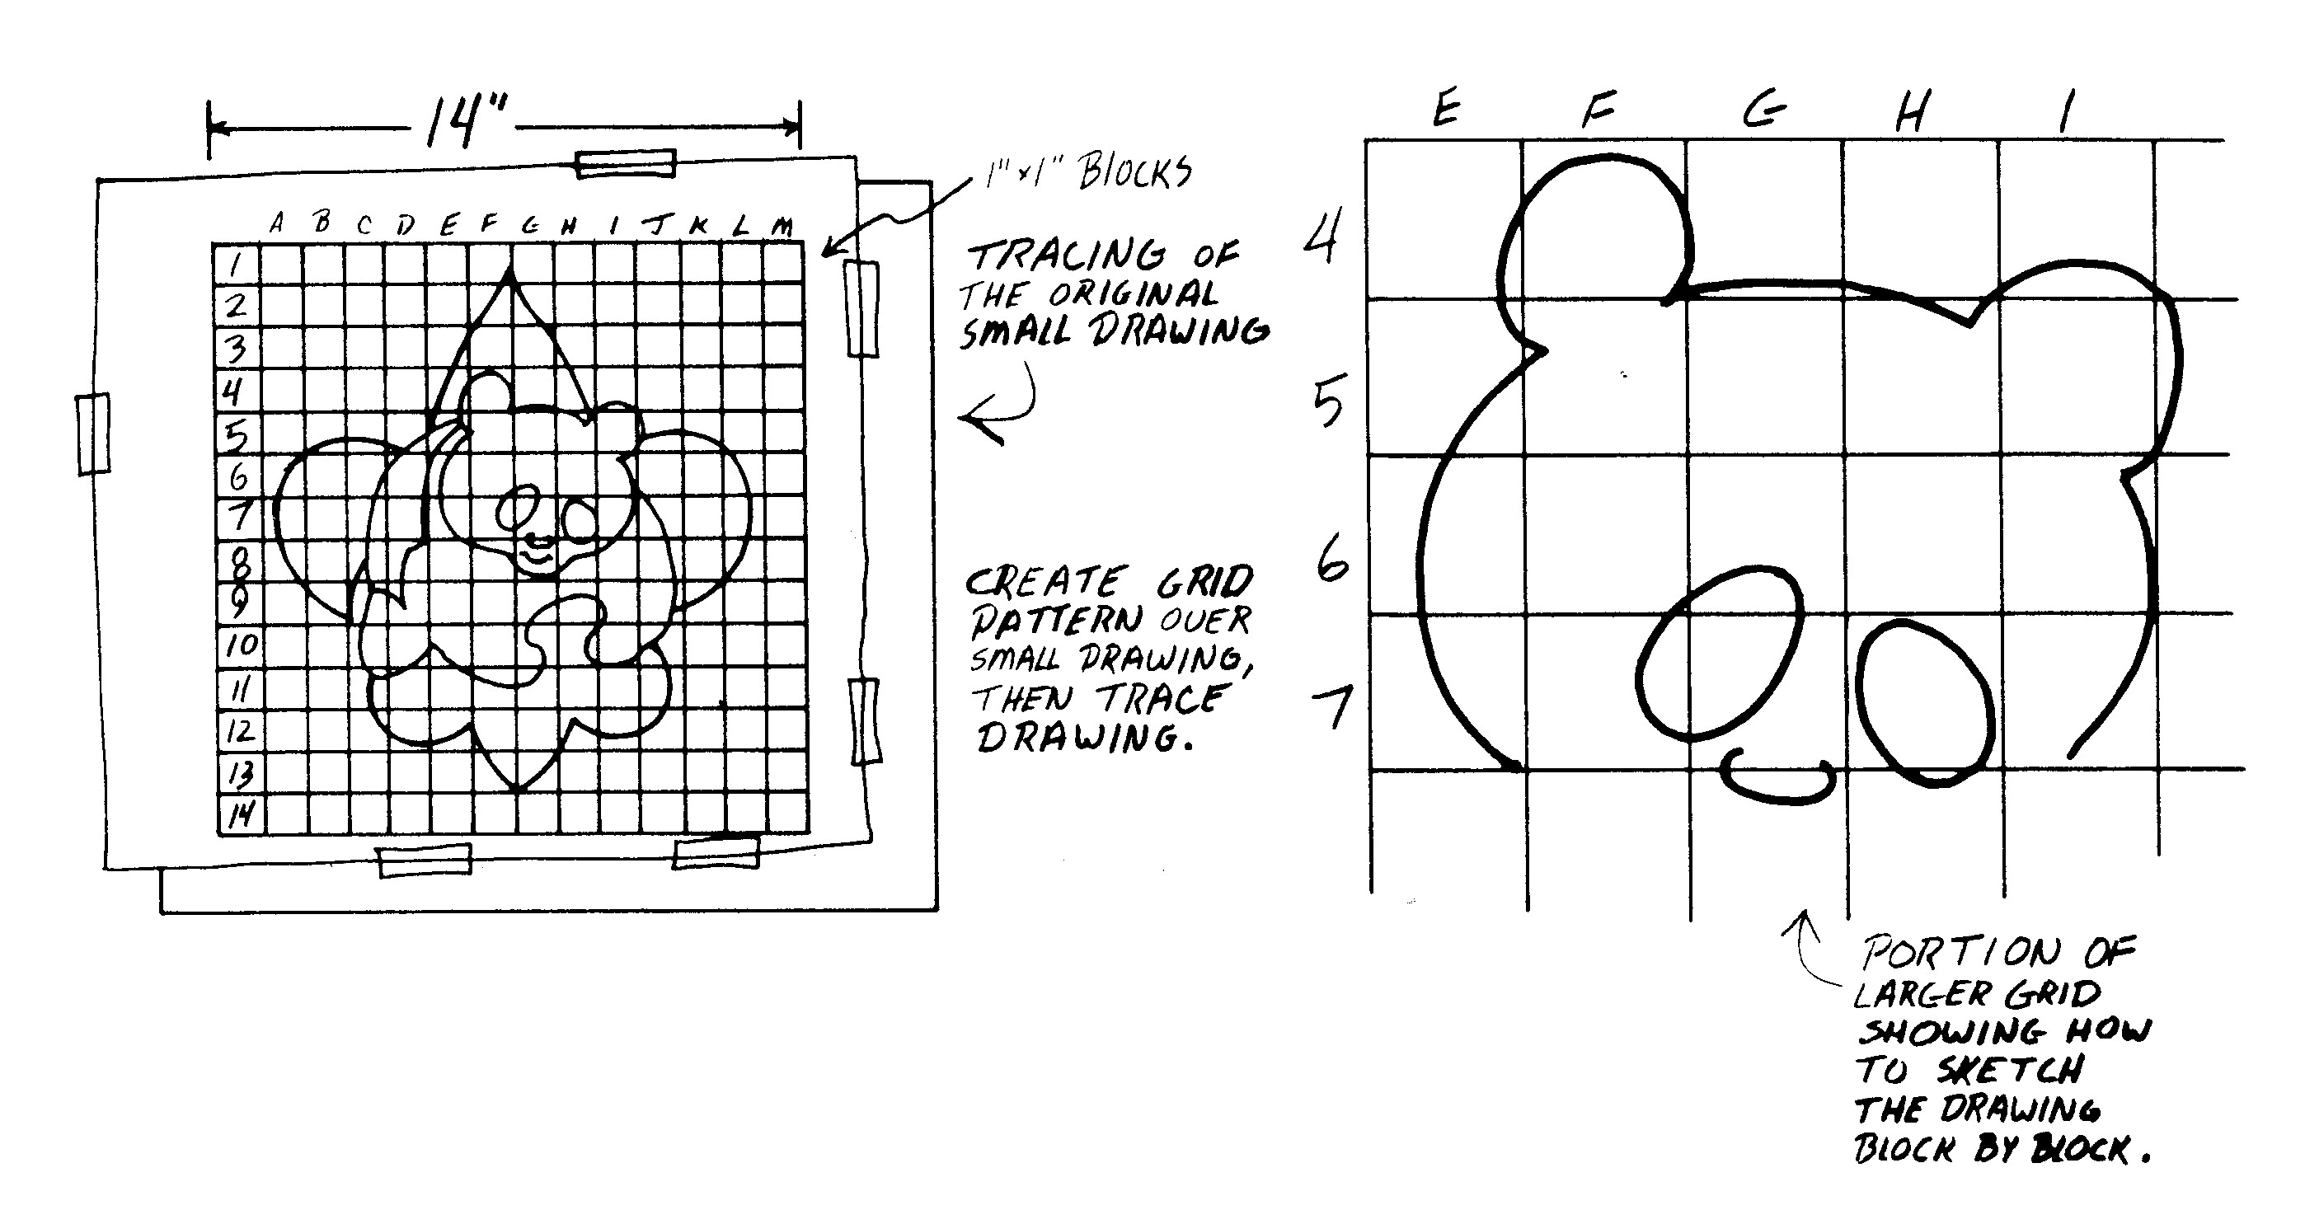
Spinning Color Wheel
Sam Houston Area Council
Materials:
White cardboard
Markers to create colors
Pencil
Scissors
Directions
Cut a circle about 4 inches in diameter from white cardboard.
Use this to draw a color wheel showing primary and secondary colors as shown in the Wolf Cub Scout Book.
Push a pencil stump through the center of the circle and spin it like a top.
The colors disappear as if by magic!
Why does it do that??
The colors on the disc correspond to the colors of the spectrum of which sunlight is composed. On rotation, our eyes see the individual colors for a very short time. But our eyes are too slow to distinguish between the rapidly changing color impressions, so the colors merge and the brain perceives them as one solid color.
Pack Meeting Invitation
Utah National Parks Council
This council has an invite for each theme in their book.
I will run them for you to see. CD
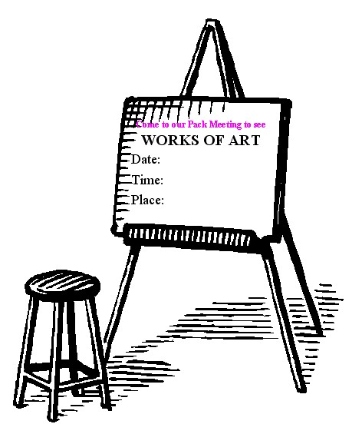
Crayon Kookies
Sam Houston Area Council
Materials:
Old crayons, broken into small pieces (paper removed),
Paper muffin cups
Muffin pan
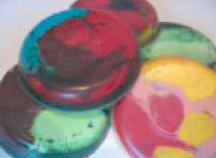
Directions
Put broken crayon pieces in the bottom of paper muffin cups and
Place the muffin cups in a muffin pan.
Bake at 400 degrees, just until the crayons begin to melt. This takes about five minutes.
Remove from the oven and cool completely.
Remove the paper cup.
These are great for leaf rubbing and scratch boards.
Palette Neckerchief Slide
Sam Houston Area Council
Materials:
1/4" X 2" X 2" pine, plywood, or masonite
Drill and 1/4" bit
Sandpaper
Toothpicks (flat or round),
White acrylic paint,
Acrylic paint or fabric paint in various colors,
1/2” diameter by 3/4" long PVC piece
Note: For younger children use stiff cardboard or foam core instead of wood, or prepare the wood pieces for them.
Directions
- Cut Artist's Palette from wood
- Drill 1/4" hole
- Smooth all edges and paint white.
- Use half of a toothpick for the paintbrush. Dip tip in paint and allow to dry.
- Glue brush on palette.
- Drop some thick drops of acrylic fabric paint onto the palette to look like the artist's paint. Let it dry.
- Glue a section of PVC pipe on the back.
Cub Scout Silhouettes
Sam Houston Area Council
As a personal gift for parents from their Cub Scout
you can make Cub Scout silhouettes.
Materials:
Large (12 X 18) black and white sheets of construction paper (enough for Scouts in den),
Pencil,
Light chair,
Tape,
Scissors,
Light for shining to get the Cub Scout shadow
Directions
- Each Scout sits in a chair that has been turned parallel to a wall.
- On the wall to his side is the black paper attached to the wall so that it won’t move.
- The light should shine on the boy coming from the side so that his shadow falls on the black paper.
- The light and the Scout may have to be adjusted so that the shadow is as clear as can be.
- A den leader, with a pencil, can then trace the shadow onto the black paper.
- The outline can be cut out by an adult and then the Cub Scout can glue the black cut out silhouette onto the white paper.
Pasta Snowflakes
Sam Houston Area Council
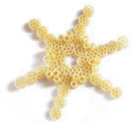
Materials:
Waxed paper
Pasta (wagon wheels, bow ties, and other desired shapes),
String,
Glue,
Toothpicks
Directions
- Arrange the pasta into snowflake shapes on waxed paper.
- Dip a toothpick into glue and
- Glue each piece of pasta together.
- Let the glue dry completely.
- Peel away the waxed paper and
- Tie a string from the snowflake.
- Hang from a window or the ceiling.
December Collage
Sam Houston Area Council
Materials:
12 X 18 sheets of construction paper
Scissors,
Glue
Magazines, newspapers
Additional colored paper for cutting shapes, etc
Directions
- Depending on the religious make up of your pack, you may have some boys who celebrate Christmas, Hanukkah, Kwanzaa, etc... This activity is an opportunity for to put together a work of art that talks about their December celebrations and traditions. These collages can be displayed at pack meeting or could be displayed at your chartered organization or at a nursing home.
- Give each Scout a large 12 X 18 sheet of construction paper
- Then tell the group, they need to create a collage that will tell other people who look at the paper just what their December celebrations and traditions are.
- Scouts could use magazines, newspaper, die-cuts, or make their own cut outs to add to the collage.
Snow Art
Sam Houston Area Council
Make snow to paint on pictures with this easy recipe.
Scouts can make pictures or cards to share or
display their artwork at the pack meeting
Materials:
1 C salt
1/2 cup flour
3/4 cup water
Large bowl
Light blue construction paper
Paint brushes
Directions
- Mix the salt, flour, and water in a large bowl
- Draw a winter scene on the light blue paper
- You might include snowmen, snowflakes, snow-covered mountains, or evergreen trees.
- Then paint the “snow” on top of your picture.
- When it dries, it will sparkle.
Soda Straw Ball
Sam Houston Area Council
Materials:
8 brightly colored soda straws per ball
Scissors,
String
Glue
Glitter
Paintbrush
Directions
Cut eight brightly colored soda straws in half
Lay the 16 pieces in a pile with the ends even.
Tie one end of a piece of heavy-duty thread around the center of the straws.
Pull the thread as tightly as you can.
Make several knots to hold the straws firmly.
Arrange the straws so that they fan out like a ball.
Cut off the ends of any pieces that are out of line.
Apply a little glue to parts of the ball with a paintbrush.
Sprinkle on glitter.
Continue until you have added all the sparkle you want
Your Name In Holiday Lights
Utah National Parks Council
Materials
Craft foam or construction paper in various colors;
Green construction paper;
Green yarn;
Stapler;
Scissors;
Pinking shears;
(Does anyone still know what these are?? My Mom had a pair that I played with a lot. CD)
Markers
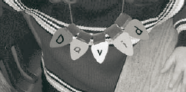
Directions
- Cut light bulb shapes from construction paper or craft foam.
- Cubs write one letter of their name (or a holiday saying) on each bulb.
- Use pinking shears to cut green strips of paper and fold them over yarn and staple to the bulbs to attach to the ‘light string’.
- Wear as a necklace or string as decoration.
“COOL WHIP” Snowman
Utah National Parks Council
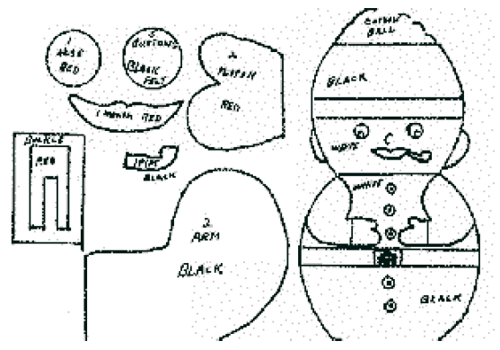
Materials
2 small cool whip containers with lids
2 medium containers with lids
Black Electrical Tape
5 gold sequins
2 - 17 mm moveable eyes
1 cotton ball for top of hat
red felt
black felt
Directions
- Crochet scarf and earmuffs or cut from scraps of fabric.
- Place lids on all containers.
- Spray one small one with black paint.
- When paints dry, glue two small containers together lid to lid. Repeat with medium containers.
- Glue bottom of small white container to bottom of a medium container.
- Place electrical tape around containers where lids fit together.
- Glue features in place as pictured.
- Glue a gold sequin in center of each button.
- Glue earmuffs to sides of head and tie scarf around neck.
EGG CARTON CHRISTMAS TREE
Utah National Parks Council
Materials
Cardboard
3 egg cartons
stapler
silver garland
small Christmas balls
ribbon

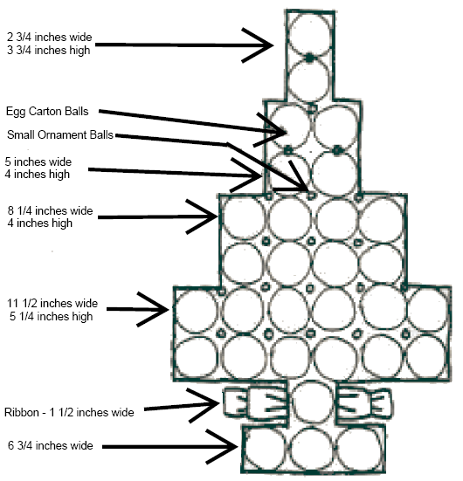
Directions
- Cut a base from cardboard following measurements shown,
- Staple egg carton balls bottom up to cardboard.
- Place silver garland around edges and in between egg carton balls.
- Staple a bow to either side of stem.
- Glue small ornaments on between egg carton balls.
- Match color of ribbon, and ornaments to color of egg cartons.
LIGHT SWITCH PLATE ART
Utah National Parks Council
Create your own colorful and festive switch plate!
This makes a great gift too.
Materials
White light-switch plate (available at a hardware store, inexpensive ones are less than 25 cents each);
Acrylic paints
Directions
- Provide smocks or paint shirts for the boys, and cover the work area with newspaper. The easiest method of painting is the splatter technique. This is best done outside because of the flying paint.
- Dip paintbrush deeply in paint and then, holding the tip of the handle, wave the brush down and sideways above the switch plate.
- Motion of the brush should be quick and short.
- Repeat this process with different colors until the switch plate is completely covered.
- Try painting another switch cover with a repeating pattern, such as dots, stripes, circles, spirals, or triangles.
MARBLE PAINTING
Utah National Parks Council
Create a work of art with marbles. Make your
own greeting cards!
Materials
Paper;
Paper plates;
Tempura paints;
Marbles;
Plastic spoons.
Directions
- Cut a sheet of paper to fit on a sturdy paper plate.
- Pour small amount of tempura paint into individual containers for each color, or use a foil-lined muffin tin.
- Drop marble into one color paint and roll it around with the spoon.
- After the marble is well coated with paint, transfer it onto the paper plate with the spoon.
- Grip the edge of the paper plate, and move the marble around the plate until the paint wears off.
- Try using two or more marbles at the same time.
- To keep the colors from mixing in the containers, use a different marble for each color.
- Remove the artwork from the paper plate and hang to dry.
CANDY HOLIDAY TRAIN
Utah National Parks Council
Materials
Glue;
A roll of candy (like Lifesavers or Rolos);
4 wrapped peppermint candies;
A wrapped caramel;
A wrapped chocolate kiss;
(Optional), a short length of yarn.
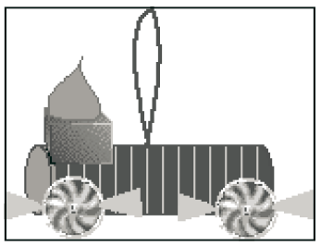
Directions
- Glue four wrapped peppermint candies to a roll of candy; the peppermint candies are the wheels of the train.
- Glue a wrapped caramel to the top, at one end the train.
- Glue a wrapped chocolate kiss on top of that.
- To use the train as a tree ornament, glue a loop of yarn to the top of the train.
SNOWMAN PIN OR NECKERCHIEF SLIDE
Utah National Parks Council
Materials
Large white buttons with two holes;
Pinback pins (or a small piece of cardboard and 1/2” PVC pipe or a slice of milk jug handle);
Black felt or craft foam;
Cloth ribbon;
Glue gun.
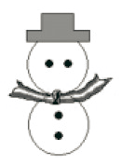
Directions
- Lay out two buttons face down, one above the other.
- Align the holes of the top button horizontally to form eyes.
- Align the holes of the bottom button vertically.
- Attach a pin-back pin onto the back of the buttons using a hot glue gun.
- If you are making a neckerchief slide, attach a small piece of cardboard as a backing and then a section of PVC pipe, or a section of a milk jug handle.
- Cut out felt into the shape of a hat, and glue onto the front.
- Tie a ribbon between the two buttons for the scarf.
Window Art
Sam Houston Area Council
Decorate a window or sliding glass door
with removable paints!!
Materials:
Clear dishwashing liquid
Premixed Tempura paints
Directions
- For each color of paint, mix approximately 1 tablespoon of dishwashing liquid with 1/2 tablespoon of paint
Mixture should have consistency of house paint. Use only clear dishwashing liquid, otherwise the paint color will change. Use foil-lined muffin tins or plastic containers for holding the different colors.
- Using a different paintbrush for each color, apply paint on the window or sliding glass door. Try to avoid painting the sills and woodwork – masking tape can be applied beforehand.
- To remove the dried paint or fix a mistake, wipe off paint with a moist paper towel.
Letters to our Troops
Alice, Golden Empire Council

Write a Letter to our Troops if you didn’t do it last month – you can either use the template on http://www.flagsacrossthenation.org/our-projects/letters-to-the-troops/ , or you can make up your own – (boys can design a flag or patriotic scene to be colored in by scouts or siblings); add a short letter, put your name and age on the back, and then mail to

Flags Across the Nation,
9426 Duckhorn Dr.,
Charlotte, N.C. 28277.
For younger siblings, or those who don’t feel comfortable writing a letter, click on projects at the website – they have downloadable coloring pages that can be done and also are sent to troops! This is a great project to share with other groups as well- and it fits the Works of Art theme!
2010 Freedom Art Contest
Alice, Golden Empire Council

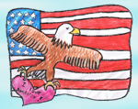
Challenge the scouts to enter a piece of patriotic art in the 2010 Freedom Art Contest – in support of Letters to our Troops. Every child who enters will receive an acknowledgement gift. For details go to: www.flagsacrossthenation.org/about-flags
You can use art to introduce this project – I showed the Norman Rockwell “G.I. Homecoming from 1945 and contrasted it with how troops return in 2009 – usually without fanfare, unless at their hometown. And because the whole country isn’t personally involved in this war, troops may feel more isolated and lonely. A great reason to write Letters to the Troops! Alice
MORE GAMES AND ACTIVITIES
Utah National Parks Council
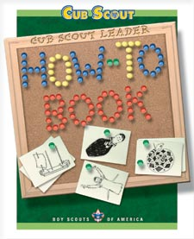
The GREATEST Audience Participation ever -
- The House Where Santa Lives, p, 5-6
Games From the Cub Scout Leader How-To Book –
- “Art Consequences” p. 2-25
- “Five Dots” p. 2-26
- “Wiggles” p. 2-26
- “Hanukkah Peanut Hunt” p. 2-29
ADVANCEMENT IDEAS
From Program Helps via
www.cubroundtable.com
If you follow the grid on the inside of the cover in the front of Cub Scout Program Helps, your Cub Scouts can complete earning their Rank Awards (Tiger, Wolf, Bear) by the Blue and Gold in February.
Tigers –
Ach:
Den Meetings - 1F, 1G, 4D
At Home - 4F
Elect. 1, 5, 11, 15
Wolf-
Ach
Den Meetings - 2b, 4c, 5d, 5e
At Home - 4a, 4b, 4d; 4e, 4f, 5 a-c
Elect. 11b, 12a
Bear –
Ach
Den Meetings- 3f; 15a, 15b, 16a, 24b
At Home - 10a-b, 19a-d
Elect - 9a
Alice, Golden Empire Council
The Art Belt Loop and pin or Music Belt Loop or pin would be a great fit for this theme. Boys can learn about different forms of art, different materials used to create art, and do lots of hands-on art for decorations, gifts or as part of a service project. Some waste treatment or water districts sponsor art contests using items being recycled – or check with your local recycling program. Consider using art to create gifts for family and friends, or using music to bring joy to others. Each boy could use a piece of art to demonstrate his faith and earn the religious scout award. If your Chartered Organization is faith-based, you could do a collaborative art project based on a religious theme or showing a Christmas subject.
Tiger Cub Achievements
Ach. #4F – Before dinner, have each person make a drawing or coloring page about a chosen subject – share your art work one at a time with each other during dinner. Ach. #4D – Leader describes something, (without showing the object) and each boy draws what he “hears” described – then compare how differently each person “heard” the description.
Ach. #4G - If you visit a TV station or newspaper office, find out how they use art to “tell the story.” Do they use photos, sketches, pictures of art work?
Ach. #5F – Go outside and watch, listen and even smell the weather – make a drawing, water color or some other form of art to show what you observed, or to demonstrate how it made you feel.
Ach. #5G – Take a hike with your den and make an art project – it could be drawn from memory, photographed, or an artistic display of some items from nature you have collected – try making a collage of items.
Tiger Cub Electives
Elect. #1- Draw a picture of a family celebration to share with your den.
Elect. #2 – Make a holiday decoration or a gift for someone using art.
Elect. #4 – Make a frame to display a family picture.
Elect. #5 – Make a mobile to show what your family is like – you might want to look at mobiles made by Alexander Calder, an American artist famous for his mobiles.
Elect. #6 – Learn and teach one of the “Art” songs to your family or den.
Elect. #12 – Make a friendly greeting for someone.
Elect. #14 – With your adult partner, read about art or a specific artist or kind of art.
Elect. #15 – Learn about color by using primary colors to make secondary colors.
Elect. #16 – Share you hobby if you like to draw, paint, make sculptures.
Elect. #39 – Visit a place where adults use art in their work.
Elect. #47 – Demonstrate recycling by making a work of art out of recycled items.
Wolf Achievements
Ach. #2d – Use artist cartooning grids to make an enlarged copy of the flag of your state.
Ach. #10c – Plan a walk with your family, or visit a zoo or wooded area. Create a work of art to share what you saw and felt. If you visit a museum with your family, choose your favorite work of art, buy a postcard to share a work of art, or make your own art inspired by what you saw.
Ach. #10d - Read a book or Boy’s Life article about art or an artist with your family (Norman Rockwell has been featured in Boy’s Life many times) Ach. #10e – Decide with Akela to watch a TV program about art
Ach. #11c - Demonstrate your religious beliefs by doing a drawing, making a sculpture of clay or in some other artistic way.
Wolf Electives
Elect. #2 – If your den puts on a skit about art, or an artist such as Rockwell or Baden-Powell –See Theme Related for ideas.
Elect. #6b – Choose a book about art or an artist to read;
Elect. #6c – Decorate your book cover with art – choose something that fits with the subject.
Elect. #9a – Help make and put up decorations for a home or den party;
Elect. 9b, c – Use your artistic talent to make a gift for someone.
Elect. #12 - Do the requirements in to Be An Artist.
Bear Achievements
Ach. #2 – Look over the requirements for the religious emblem of your faith – see if you can use an art project to demonstrate your beliefs.
Ach. #3b – Choose two famous American artists, such as Norman Rockwell, and learn all about them.
Ach. #3c – when you visit old homes, take note of the art you see hanging on the walls, or as part of the woodwork or design of the home;
Ach. #3d – Visit a place of historical interest and see if art is part of the building or look for works of art showing the building.
Ach. #3e – Sketch a picture of your state flag as you learn about a state of your choosing.
Ach. #5a – Choose a bird or animal that you like and make a poster about it.
Ach. #8c – Draw a sketch, make a drawing or painting, or take a photo that can be added to an existing den or pack scrapbook – use what you have learned about making a work of art.
Ach. #9a – With an adult, bake some cookies, then present them as a gift with a card you have made.
Ach.#17a – With an adult, choose a TV show to watch – look for one about art or an artist;
Ach. #17c – Visit a newspaper office or TV station and find out how they use art in their work;
Ach. #17d – Use a computer to get information and write a report about a type of art, a specific artist, or an art museum.
Bear Electives
Elect. #9a – Do an original art project – use the ideas in the book or in Baloo; you can get credit for more than one.
Elect. #9b – Visit an art museum or gallery with your den or family.
Elect. #9c – Go to a favorite outdoor location and draw or paint it.
Elect. #11 – Do any or all of the requirements to study how you can make art with the camera.
Webelos Activity Pins
Craftsman (assigned) If making something from wood, leather, or clay, practice art skills by making a drawing of the planned piece.
Artist includes excellent information about how to choose a medium, how to work with the materials and equipment and how to prepare it for framing or display. Ideas about computer designs are included in the Webelos book. While making gift cards, gift wrap, or an actual gift for the Season, boys could sign off much of this activity pin.
Communicator #4 – art could be shown to be a form to communicate, especially using the art work of Norman Rockwell in illustrating stories. Communicator #8 – using a computer, write an article about a den activity if you visit an art museum, gallery or studio.
GAMES
Artist's Game
Sam Houston Area Council
Players sit around a table, each with paper and pencil. The right hand Scouts draws a picture, in separate firm strokes, of an ordinary figure or head, putting in his strokes in unusual sequence so that for a long time it is difficult to see what he is drawing. Each player looks over to see what the man on his right is drawing and copies it stroke by stroke. When the right-hand artist has finished his picture, compare all the rest with it
Find the Shadow
(Goes along with Cub Scout Silhouettes)
Sam Houston Area Council
Required
At least four players.
A blank wall for a screen and
A bright light that can cast a focused beam.
Object
To identify the other players by their shadows.
The Play
- Choose a player to be "it."
- "It" sits on the floor in the middle of the room, facing the blank wall.
- Place the light behind “It,” shining on the wall, and turn the other lights off.
- One by one, the other players pass behind “It” and in front of the light.
- Looking straight ahead at the shadow on the wall, “It” tries to call out the name of the player behind him.
- Players may disguise their shadows in any way to confuse "It."
- The player whose shadow is identified correctly becomes the new "It."
Invisible Space
Sam Houston Area Council
This is a pantomime game I which an invisible piece of space can be squeezed, squashed, twisted, or rolled into any imaginable object.
The Play
- To begin the game, have all the Scouts stand in a circle.
- The leader quietly pulls a chunk of invisible space out of his pocket and begins to shape it into a large pretend object, such as a fishing pole, baseball bat, or dog.
- The leader then passes the object to a neighboring Scout, who transforms it into another form and passes it along.
- Each Scout should take about 30 seconds to transform the shape.
- When the object gets back to the leader, he gently squeezes it into its original shape and puts it in his pocket.
- You may want to give the Scouts categories of objects such as holiday decorations or holiday gifts.
Paper and Crayon Relay Race
Sam Houston Area Council
- Divide Scouts into 2 to 5 teams, depending on the size of the group.
- Each team is numbered off and given a crayon.
- On signal, all #1 players run to the leader, who whispers the name of an object they must draw and gives each artist a piece of paper.
- On signal, they run back to their team and immediately begin to draw the object with the crayon.
- When team members correctly guess the object, the artist runs back to the leader.
- First team to send the artist back earns a point.
- The #2 players become the artists and the game continues.
Paintbrush Relay
Sam Houston Area Council
Divide the Scouts into two teams.
The first Scout on each team is given a long feather (such as a turkey feather), that is his paintbrush.
At a signal, each throws his paintbrush, javelin style, towards the finish line.
As soon as it touches the ground, he picks it up and throws it again, and continues to throw it until it crosses the finish line.
The Scout then picks up his paintbrush and returns to the starting line where he passes it to the next Scout in line.
Play continues until a team has all its players finish.
Art, Art, Masterpiece
Utah National Parks Council
Play this game just like Duck, Duck Goose.
Candy Cane Pass (Relay Race)
Utah National Parks Council
Supplies: 4 candy canes per team (have several extras in case of breakage)
Play:
- The first player of each team holds 4 candy canes, one between each of his fingers on one hand.
- On ‘Go!’ he passes the candy canes to the next teammate in line – no using of the other hand to help!
- The relay continues down the line, teammate to teammate, without dropping the candy canes.
- If any candy canes are dropped, the relay starts over for that team.
- The first team to complete the relay wins.
Christmas Card Match-Up
Utah National Parks Council
Equipment: Several old Christmas cards cut diagonally into two, and divided into two carrier bags with one half of each card in each bag.
Setup:
- Take one bag and spread its cards in various places around the hall.
- Players are divided into two teams.
Game Play:
- Give one half-card to the first player of each team.
- Each player goes off to find the matching half and bring it back to their team.
- The next player is given another half-card.
- Play continues until all cards are matched.
- The team with the most complete pairs collected at the end wins.
Snowball Drop
Utah National Parks Council
Equipment: White Ping Pong ball, table.
Setup:
- Divide the participants into teams of 3-6.
- Each team kneels on opposite sides of a table.
Game Play:
- The object is to blow a “snowball” (ping pong ball) so that it will ‘drop’ off the edge of the table on the opponent's side.
- This scores one point. No one is allowed to touch the snowball or the table in any way.
- First team to score three points wins.
- Repeat play for the other participants, as needed.
Mitten Match Game
A Memory Game
Utah National Parks Council
- Make several copies of mittens and have children color each pair to match each other but be different from the other pairs of mittens.
- Cut them out,
- Then turn all mittens upside down and
Have the children take turns finding the mates. (ala Memory or Concentration)
CUB GRUB
Pixie Stix “Sand Art”
Utah National Parks Council
Ingredients
Pixie Stix or flavored sugar—(Koolaid mixed with sugar or sugar with food coloring in it)
Clean small jars (like baby food jars).
Directions
- Pour Stix into jars to make different colored layers like sand art. The sticks allow children to pour mounds or make indentation very easily.
- You do need about five sticks of each color per layer.
- Give it as a gift.
Edible Reindeer
Utah National Parks Council
Ingredients
Bread,
Peanut Butter,
Pretzel Twists,
Raisins or chocolate covered raisins,
Red M&Ms.
Directions
- Cut bread into triangle shape and spread on peanut butter.
- Use pretzels for ears, raisins for eyes and a red M&M for a nose.
Snowball Cookies
Utah National Parks Council
Ingredients
1 c Butter or margarine
1/2 c Sugar, powdered; sifted
1 teaspoon Vanilla
2 1/2 c Flour; sifted
1/4 teaspoon Salt
3/4 c Pecans, chopped
Directions
- Cream the butter in large bowl.
- Add sugar, cream until light.
- Stir in vanilla.
- Sift flour and salt; mix in.
- Stir in nuts.
- Shape into balls.
- Place on ungreased cookie sheet.
- Bake 15 minutes at 350.
- Roll in powdered sugar straight out of oven.
- Roll again when cool.
- Makes about 36 cookies
Apple Santa
Utah National Parks Council
Ingredients
1 red apple,
6 large marshmallows,
3 red gumdrops,
2 green or black gumdrops,
Toothpicks,
Tube frosting or food colors.
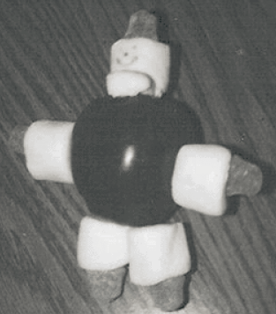
Directions
- Poke a toothpick through 5 of the large marshmallows.
- Place the gumdrops at one end of each toothpick, next to the marshmallow.
- Insert the assembled toothpicks into the apple as arms (red gumdrops) and legs (black or green gumdrops).
- Cut the last marshmallow to create a beard and skewer it with the toothpick beneath the full marshmallow head (opposite the end with the red gumdrop).
- Attach the head to the apple using the toothpick.
- A face can be drawn with frosting from a tube or by dipping a toothpick in food coloring.
Food Pyramid Christmas Tree
Utah National Parks Council
Ingredients
Pretzel Sticks,
Apple Slices,
Celery Sticks,
Peanut Butter,
Cheese Stars,
M&Ms
Directions
- Spread the peanut butter in the celery sticks.
- Insert the pretzel sticks into the peanut butter to resemble branches.
- Place one apple slice at the bottom of the tree as a Christmas tree skirt.
- Place a cheese star at the top and decorate with M&M ornaments.
- All of the food groups are represented in the tree.
Patriotic Quencher
Sam Houston Area Council
Ingredients –
3 ounces cranberry juice
3 ounces sports drink (blue)
3 ounces sugar free 7-Up (or Sprite)
Ice cubes
Directions –
- Place the ice cubes in the bottom 3rd of a tall 12 ounce clear glass.
- Pour the cranberry juice in to fill the bottom 3rd.
- Place a few more cubes in to the middle and
- Pour in the blue sports drink to fill the glass 2/3 full.
- Place the final 3rd of ice in the glass.
- Pour in the diet 7-Up or diet Sprite.
When poured carefully, this makes a red, white and blue drink. It separates by using the drink with the highest sugar content on the bottom, and the least on top.
WEBELOS
REMEMBER TO PLAN
Utah National Parks Council
One of the most important things about being a Webelos Leader is planning. As a Webelos leader you don’t have to be overly concerned with the monthly themes. Your focus is helping the boys fulfill the requirements and earn activity badges (yes, they look like pins but they are referred to as badges), to prepare them to receive the Arrow of Light Award and transition into Boys Scouts.
In addition to ideas in Baloo and the Webelos Leader's Book there are many sources that can help you as you plan your den meetings.
- Fast Start Training
- New Leader Essentials and Leader Specific training
- Monthly Roundtable Meetings
- Pow Wows and other special events
- Craft and family Magazines
- Boys’ Life magazine
- Special interest library books
- Internet sites - Do not limit yourself to Cub Scout sites. Search the internet using a topical search.
- Parents and grandparents with special skills
In short, just keep your eyes open. The world is full of fascinating things to learn and do. When you become familiar with the activity badges, you will begin seeing things that apply to those badges all around you.
KEEP GOOD RECORDS
Utah National Parks Council
Do not rely on the books the boys carry as your record of what they have earned. You need to keep a current record for each boy as he completes each requirement. This is in addition to signing the book so that the parents can have access to the progress of their son.
Every leader has his or her favorite record keeping method. Some use charts (one for each boy), which can be obtained through a variety of sources. Some use computer programs, which can be downloaded from a number of internet sites. What is important is that you find a method and use it consistently. Keeping track as you go is much easier that trying to sit down once a month and trying to remember which boy earned which award. That type of record keeping is not accurate and is a recipe for disaster.
Another type of record you want to keep is a record of the activities you do for each badge. If you serve as Webelos Den Leader for any length of time, you will return to each badge and repeat it with a new crop of boys. Creating an accurate record of the activities you have done gives you a quick reference when it is time to repeat the badge. This makes your second year as a Webelos Den Leader a breeze.
You might want to make a file folder for each badge. That will give you a place to file your old planning sheets and items you may have created to enhance the requirements. You will be glad you took the time to do this when you start on that badge again and find the work is almost done!
CRAFTSMAN
TECHNOLOGY GROUP
An Anniversary Medal Project
Alice, Golden Empire Council
Sheet metals are available at craft stores – you can buy single 5x5” sheets or even less expensive rolls of tooling foil. Using a sheet and simple tools such as those used for some leather work, or even a blunted, sharpened pencil and craft sticks, boys could re-create the badges made by Baden-Powell for his first Brownsea Scouts. (The website has an even better idea – use the capped end of a ball point pen!)
To start, you need to make a good copy of the Scout symbol below – it could be done as a two part project with the eagle as a separate piece to be joined to the bottom “fleur.” You could also make just the “fleur” part, which resembles the one done by Baden-Powell. Make a copy of the pattern the size of the finished project for each boy.
Cut the foil into squares the size of your project, leaving about an inch all around. An adult should do the cutting, and the edge can be rolled and/or taped with duct tape to make sure no one gets cut.
Make a pad out of a stack of newspaper. Tape the pattern to the back of the foil and trace the outline using the capped ball point pen.
Once you have the pattern to follow, start using the various tools to make the pattern three-dimensional. Plan which parts need to “stick out” the most and do them first. Rubbing wax paper on the back side of the foil helps the “tool” to move easily. Check at your craft store for directions, or go to: www.whimsie.com/copper%20foil.html
Be sure to share the story of the badge below with the boys before you start the project. And point out that this year marks 100 years of Scouting in America. This project could even be a gift for a Dad, Grandad or Scout Leader who is passionate about scouting and/or history.
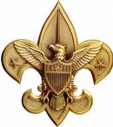
The familiar “fleur” shape of the Scouting symbol was shown in a Baden-Powell sketch of a Boy Scout in Part One of Scouting for Boys, but the sketch had originally been drawn for his The Boys Scouts Scheme, published in 1907. Baden-Powell actually made badges for his first Brownsea scouts out of a sheet of brass. He did not use the term “fleur” and instead said: "The crest is a lily, the emblem of peace and purity. The history of the Fleur-de-Lys ... as a badge goes back many hundreds, if not thousands or years. In ancient India it was used as symbol meaning life and resurrection, while in Egypt it was the attribute of the god Horus, about 2000 years before Christ.
The actual meaning to be read from the Fleur-de-Lys is that it points in the right direction (and upward) turning neither to the left nor the right, since these can lead backwards again.
Furthermore, the three points of the Fleur-de-Lys reminds the Scout of the three points of the Scout's Promise."
Snowman Slide
Utah National Parks Council
Craftsman Requirement 4 (1 of 4)
Materials:
One 1½” pom pom
One 1” pom pom
Small bit of orange chenille stem
3 mm brown chenille stem
Two 4 mm black beads
Three 6 mm black beads
6” piece of ¼” ribbon
Tacky glue or low temp hot glue
Small piece of tubing, PVC or
chenille stem for loop back
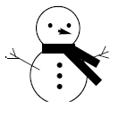
Directions
- Glue pom poms together
- Use the small beads for the eyes of the snowman. Glue these to the smaller pom pom.
- Put a bit of glue onto the tip of the orange chenille stem and press it into the pom pom for the nose.
- Glue the 6 mm beads to the body for the “buttons.” Wrap the ribbon around the neck and glue into place for a scarf.
- Use the small brown chenille stem to form “stick arms”. Glue into place just like to you did the nose.
- Glue the PVC or tubing to the back of the snowman.
- Let dry if needed.
Ring Toss Game
Utah National Parks Council
Craftsman Requirement 2, partial
Materials for each boy:
Two 12” squares ½” MDF or plywood
Two 3” squares ½” MDF or plywood
12” length of 1” dowel or broomstick
Wood screw
Paint or stain
Wood glue
Sandpaper

Directions
- Prepare 12” square by cutting to size and drilling a pilot hole in the center. Since the boys need to use a hand saw for this badge you may want to cut the MDF into a 12” strip, mark it off at 12” intervals and then mark and drill the holes.
- Prepare 3” square by drilling a 1” hole in the center that will accommodate the dowel, but still fit snugly.
- Prepare the dowel by drilling a pilot hole in the center of one end.
- Allow the boys to cut the 12” square, using a handsaw.
- Have the boys sand all the pieces.
- Press the dowel into the 3” square (be sure to use the end with the pilot hole).
- Make sure the end of the dowel is flush with the bottom of the MDF. Put a small amount of glue on the bottom of the MDF.
- Align the pilot holes on the dowel and the 12” square and fasten together with the wood screw. Make sure the dowel is firmly against the 12” square.
- Wipe away any excess glue that may have squished out from under the 3” square.
- Finish with paint or stain.
- Repeat the process for the other ring toss peg.
- “Rings” can be made by attaching the ends of 12 inches of stiff nylon rope with electrical tape to form a circle.
Tin Punch Ornament
Utah National Parks Council
DOUBLE TAKE:
Craftsman Requirement 4 (1 of 4 parts) and
Citizen Requirement 8 (do a good turn)
Make several of these ornaments. Use them to decorate a tree for a nursing home, or other needy person or group. (Plan ahead of you are going to ask for the corporate donation of a tree.)
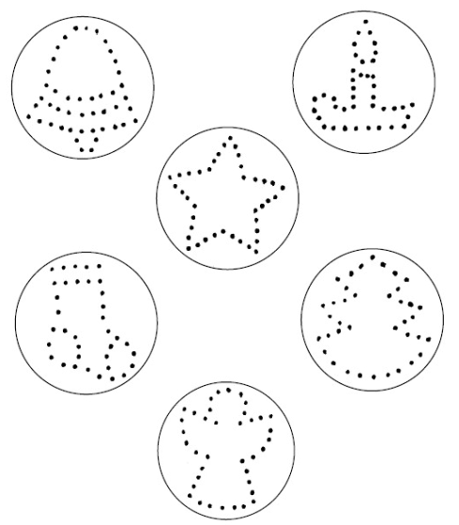
Materials:
Lids from frozen juice concentrate cans
6” of ribbon or braid for each lid
10” of pre-gathered lace per lid
Scissors
Low temp hot glue gun
Hammer (have each boy bring one from home)
Piece of scrap wood for each boy
Masking Tape
Paneling or finish nails
Tin punch patterns (attached)
Directions
- Remove any ink from the lid by using a small amount of nail polish remover and a cotton ball. Let dry. (Do this in advance at home.)
- Select the pattern you wish to use and cut it from the sheet along the solid line.
- Attach the pattern to the gray side of the lid using small bit of masking tape, being careful not to cover any of the pattern dots.
- Place the lid with the pattern on the scrap wood. Using the hammer and nail, punch a hole through every dot. It only takes 2-3 strikes per hole. Hammer just until the lid is pierced. Try not to hammer the nail into the wood.
- When you think all the holes are finished, turn the lid over and check for any holes you may have missed or punched incompletely.
- When you are satisfied that all the holes have been punched, remove the pattern and tape.
- Bring the ends of the ribbon or braid together to form a teardrop-shaped loop.
- Place a small mound of hot glue on the top, center back of the ornament and push the ends into the glue. Hold a few seconds until cool.
- Beginning at the ribbon, begin attaching the lace around the back of the ornament with hot glue.
- Glue in small sections, attaching the lace as you go.
HINT: Do not stretch the lace as you go or the lace will have a tendency to “cup” when finished. It is really best to push the lace toward the already glued area as you are attaching it to the ornament.
- Overlap the ends of the lace as you finish the ornament. Trim as needed.
Sam Houston Area Council
The requirements for the Craftsman activity badge include projects in wood, leather, and tin. This activity helps the boys develop confidence in their abilities by encouraging them to use their talents and skills for more advanced handicraft projects, or perhaps to develop a hobby in one of these mediums.
SUGGESTED DEN ACTIVITIES:
- List tools needed to complete badge.
- Make a tool chest or bench hook for sawing.
- Visit furniture factory, lumber mill or lumberyard.
- Select projects to work on.
- Have a birdhouse building contest
- Invite someone to give a demonstration on the safe use of tools.
- Discuss finishing methods for wood projects: Sanding, filling holes and scratches, the various types of finishes, such as shellac, stain, lacquer, varnish and enamel.
SUGGESTED PACK ACTIVITIES:
- Exhibit tools.
- Show wood, leather, and tin craft projects done by the boys.
- Demonstrate the proper use of wood tools, leather tools, and metal working tools.
BOARD SAWING CONTEST
Give each boy a small handsaw, pencil, ruler, and a 2”x4” board (any length). On the word go, each boy is to mark and saw his board in half. Note: Judge the contests on skill and speed.
Safety first: Used safety goggles when using tools
BLANK-OUT GAME
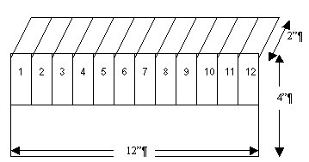
Materials:
Cut a 12” x 4” piece of ¼” plywood
Cut twelve 1” x 2” pieces of ¼” plywood
Cut twelve ¾” by 3” strips of thin leather
Assembly Directions
- Sand the edges very well, so that there are no sharp edges.
- Mark 1” x 2” rectangles across the top half of the 4”x12” board with a fine- tipped sharpie marker.
- Use rub-on numbers to put the numbers 1 through 12 into the twelve drawn boxes.
- Brush-on a light colored lacquer stain over all of the wooden pieces.
- When dry, place the twelve 1”x 2” pieces over the twelve drawn boxes and
- Glue the leather strips so that they form hinges and allow the small pieces of wood to all neatly uncover and also cover.
Game Directions
- The game starts with all of the numbers uncovered,
- The goal is to cover all of the numbers.
- On each roll of the dice, your dice tell you what number(s) you can cover up. E.g. a roll of 1 and 3, would allow you to either cover 1 and 3 or just cover 4.
- If all dice numbers rolled are already covered, you must start all over.
WATER ROCKET LAUNCHER
Materials:
3 each - ¾” PVC Cap
One - ¾” PVC Tee joint
One - ¾” x ½” threaded Tee joint
5’ of ¾” PVC schedule 40 pipe
One - ½” x 8” threaded riser pipe
One - ¾” 90 degree ell (“L) joint
1’ electrical tape
One tire inner tube valve
PVC pipe cement or epoxy
Important: use protective gloves and
goggles when gluing!!!
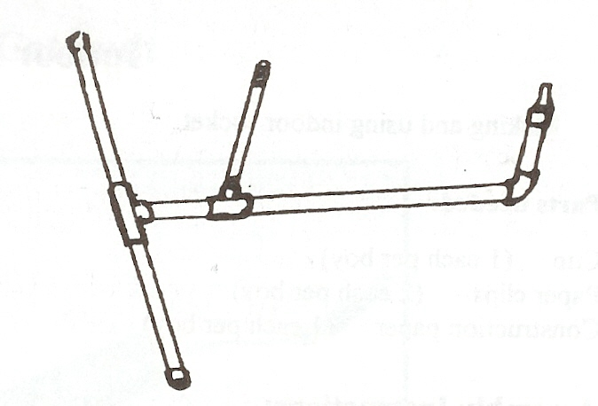
Assembly Instructions:
With a hack saw, cut the 5’ PVC pipe into
Two - 6”,
two - 12” and
one - 8” length.
Drill a ½” hole in the middle of one ¾” Cap.
Push the valve stem into this hole and trim the rubber so that it will have a tight seal.
Glue this cap to one 6” pipe, being careful to have the pipe end push the rubber to be tightly sealed against the cap.
Assemble the rest of the launcher as shown, and glue the joints.
Wrap the threaded riser pipe where it joins the threaded Tee, so that there is a tapered, water-tight connection when a 2 liter bottle, with a few cups of water in it, is pushed onto it.
PVC RECORDER
Materials:
14” long - ½” PVC pipe,
½” diameter dowel,
craft glue, hand drill
Assembly Instructions:
A recorder is a flute-like instrument where you blow into the end to create sounds as the air whistles over the holes that you cut.
Cut a ½” PVC pipe to just under 14” in length.
Before inserting the plug, the 1” long dowel needs to be shaved off squarely on one side, about 1/16th inch, so that air can pass through when it plugs the end.
Plug one end of the pipe tightly with the inch-long dowel and glue it in place with craft glue.

The shaved side of the plug directs air over the first small hole that makes the whistling sound. Make holes as shown below:
- 3/8” square hole 1” from the mouthpiece end (drill 3/8” and square it with a knife)
- 3/16” round hole 7.5” from the mouthpiece end
- 7/16” round hole 8.5” from the mouthpiece end
- ¼” round hole 9.5” from the mouthpiece end
- 3/16” round hole 10.5” from the mouthpiece end
- ¼” round hole 11.5” from the mouthpiece end
- ¼” round hole 12.75” from the mouthpiece end
SLIDE WHISTLE
Similar to the recorder shown above, use a 12” long piece of 1” PVC pipe and make a similar plug and first hole. Do not cut the fingering holes. Cut a 10” length of ½” PCV pipe and drill a small hole in the end, and attach a small piece of wire. Wrap a few turns of electrician’s tape around the end of the slide. Slide that smaller pipe into the open end of the whistle and listen to how the pitch changes when you blow on the whistle and move the slide in and out.
DRIVING YOU CRAZY
Materials:
One 4’x 8’ piece of ¼” plywood
One 8’ 2x4 pine lumber
Ten 1.5” wood screws
Small box of 6 penny nails
One large ball bearing
Elmer’s Glue
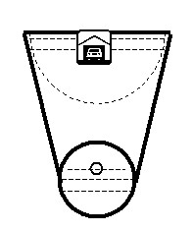
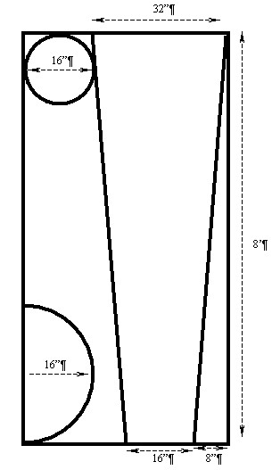
Assembly Instructions:
- Cut the plywood into the shapes shown at bottom right of this page. Drill a hold large enough to put the ball bearing through, two inches above the center of the 16” disk.
- Cut the 2x4 into 28” and 13” lengths.
- Sand and paint the 16” disk to look like a steering wheel.
- Sand and paint the long trapezoid to look like roadways and green scenery.
- Sand and point the 16” radius half circle black.
- Nail through the top of the roadway sheet of plywood into the 2” side of the 13” long 2x4, centered under the short end of the trapezoid and flush with the end of the plywood. Nail through the top of the roadway sheet of plywood into the 2” side of the 28” long 2x4, centered under the long end of the trapezoid and flush with the end of the plywood.
- Center the “steering wheel” to the top surface of the roadway sheet of plywood, and drill tap holes for the screws to go into the 2x4. Affix the steering wheel with four screws.
- Align the top of the rocker half circle to the top surface of the roadway sheet of plywood, and drill tap holes for the screws to go into the 2x4. Affix the rocker with six screws.
Decide on a destination for the ball bearing near the large end and drill a hole or build a “garage” to “drive to” and “park” the ball bearing in. Add obstacles as desired. Pop the ball bearing through the hole in the steering wheel and drive it by turning the steering wheel and lifting or lowering the wheel.
Patrol Table Plans
Note: the materials list shows how to cut all of the pieces out of one 4' x 8' sheet of 5/8" plywood. The plywood should be exterior grade with one smooth sanded surface. All cut edges need to be sanded. The cleats should be fastened with waterproof glue and rust resistant screws. A good penetrating oil finish will further prevent splinters and improve the life of the table. The layout of the plywood board has been moved to the end of Baloo.
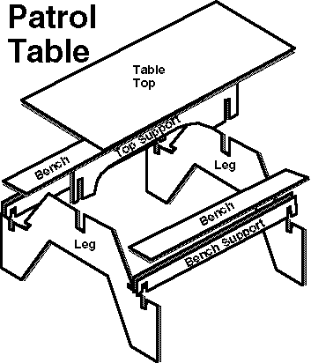
Materials:
4'x8' sheet of 5/8" exterior plywood
with one smooth sanded surface.
Exterior penetrating finish
1" Rust resistant screws
Waterproof glue
Notes:
- When cutting top support you may use an 8 inch radius for the curved section.
- Bench Supports have a 2"x5/8" slot for legs centered 2 11/16'" from each end.
- Legs have a 2"x5/8" slot for bench supports centered 2 11/16" from each end.
- Legs have a 5"x5/8" slot for the top support centered in top.
- Top support has 7"x5/8" slot for legs centered 2 11/16" from each end.
- Legs have a 1"x5/8" notches to lock the benches in place.
- The cleats are positioned to keep benches and top from sliding.
- Fasten the cleats in place with rust-resistant screws and water-proof glue.
- Finish with a nontoxic penetrating exterior finish.
Make Your Own Leathercraft Mallet:

When you are tooling or stamping imprints into leather, you need a wooden mallet to hammer on the metal tools. You could buy a mallet, but what fun is that?
Materials for each mallet:
10” long piece of 7/8ths inch diameter dowel (oak is best)
2 inch diameter limb, approved to be pruned from someone’s yard
Hand saw
sharp knife
Drill with 7/8ths inch bit
Carpenter’s wood glue or Elmer’s Glue
Assembly Instructions:
- Cut the 2” diameter limb into 4” to 5” lengths.
- Sand the faces if the cut wasn’t straight.
- Hand drill a little over halfway into the exact center of the mallet head.
- With your knife, slightly carve the tip of the dowel, so that it will go more smoothly into the hole. Don’t carve off too much; just enough not to “catch”.
- Coat the inside of the hole with wood glue.
- Hammer the dowel into the mallet head that you made until it goes all the way in. Do not use a metal hammer directly onto the wood of the dowel. Place a scrap piece of 2x4 over the end of the dowel, put the mallet head on the ground and hammer the dowel in as far as it will go.
Leathercraft Lacing
Many fun leather projects are available, and some of the most useful required lacing together pieces of leather. Billfolds, coin purses, etc. are good examples. Simple lacing is OK, but it looks a lot better if you do a more professional stitch, and these boys are capable. A leather lacing needle makes it easier.
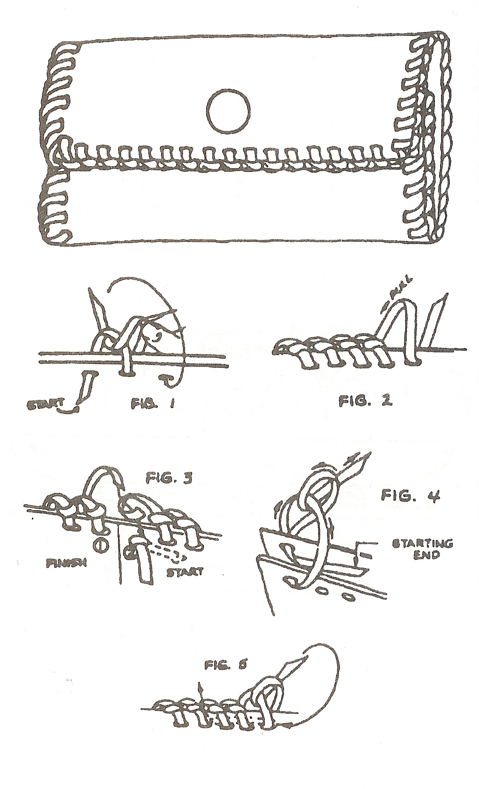
To lace an item that will finish lacing at the same place where you start: Push the lacing through the first hole and pull all but 1” through the hole. Bring the lace over the edge (without a twist) and go into the next hole, leaving a small loop. Go through the loop front to back, then tighten the stitch from the back, removing the loop. Continue lacing in this manner. When you get back to the start, pull the original lacing out of the starter hole and add one more stitch through that hole. Remove the starting lace from the next loop and thread the needle down through this loop. Pull both ends through hole 2 to the inside and cement in place.
SCIENTIST
TECHNOLOGY GROUP
The Science of Light and Color
Alice, Golden Empire Council
You have to have light to see color. When light shines on an object, some colors bounce off the object and others are absorbed. We see only the colors that bounce off or are reflected with human eyes. The rays of the Sun actually contain all the colors of the rainbow mixed together – it’s known as white light. When this white light strikes a white crayon, it appears white because it absorbs no color and reflects all the colors equally. Black absorbs all colors equally and absorbs none of them, so while an artist considers black to be a color, scientists consider black to be the absence of all color.
Light rays contain color, and light is made up of electromagnetic waves. These waves spread out from any light source at tremendous speed (186,000 miles a second), and different colors have different wavelengths. The longest wavelength of light that humans can see is red, and the shortest is violet. Ultraviolet has an even shorter wavelength, but can’t be seen by humans. Some birds and bees can see ultraviolet. Humans also cannot see Infrared, which has a longer wavelength than red – but they can feel the heat that is generated. Here’s a project to have some fun with color and light.
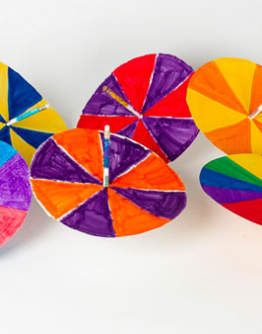
Trace circles on heavy paper, poster board or even file folders. With a ruler, divide each circle into eight pie-shaped sections. Punch a hole in the center large enough to hold a pencil. Color each section with different colors, your choice. Insert a pencil in the hole and tape in place. Twirl the pencil between your palms to spin the spinner and make the colors appear to mix. Create spinners with different colors and color combinations. Try making one with the colors of the rainbow. Spin at different speeds. What different colors and effects can you create? Can you guess why? Think about how light reflects or absorbs different colors and see if you can explain what happens.
Utah National Parks Council
When you are doing this badge keep in mind that you are “scientists”. Before you do a demonstration or experiment tell the boys what you are doing and have them predict the outcome. Be sure to compare the real outcome to their hypothesis. This is the basis of the scientific method in Science Belt Loop Requirement 1.
Bernoulli’s Principle
Utah National Parks Council
Scientist Requirement 1
Part #1
Materials:
3”x5” pieces of paper
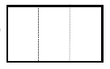
Directions
- Fold the 3x5 paper into thirds, along the dotted lines as
- shown.
- Open the paper and stand it on the table top to form a small “table”.
- Place the paper table along the edge of a smooth table.
- Have the boys kneel and blow in the opening under the table.
- Observe what happens (the paper table should collapse).
Part #2
Materials:
1½-2”x8” pieces of paper
Directions
- Using the short edge, hold the strip of paper on your chin with your index finger.
- Let the paper drape over your finger and hang down like a goatee.
- Blow straight out and slightly down.
- Observe what happens (the paper floats straight out).
Part #3
Materials:
Straw for each boy
Drinking glass or other cylindrical object
Box or other square object
Pieces of paper cut to ½” x 4”
Tape
Directions
- Tape the narrow end of the paper to the tabletop.
- Then bend the paper so it is standing upright.
- Let the boys blow on the paper with the straw.
- Now place the square or flat object in front of the paper.
- Allow the boys (one at a time) to blow on the surface of the flat object and observe that the paper does not move.
- Replace the square object with a glass and allow the boys to blow on the glass.
- The paper will move.
- This action demonstrates how the air flows evenly around the glass and comes back together on the other side and moves the paper.
Tennis Ball Launcher
Utah National Parks Council
Scientist Requirement 3, partial
Materials:
Tennis ball
Basketball
Directions
- ”Stack” the tennis ball on top of the basketball.
- Hold them together and then drop them at the same time, making sure you’re out of the way.
- The tennis ball will shoot straight up; the basketball will stop dead.
You can do the same thing, with even more impressive results, with a ping pong ball and a large super ball.
- If the super ball is as large as a tennis ball, place the ping pong ball on top of it and let the two of them go. Don't forget to stand back.
NOTE: You probably want to do this activity outside.
You may also want to have more than one set of balls so the boys can give it a try.
Just be sure to have the boys stand far apart.
Yardstick Break
Utah National Parks Council
Scientist Requirement 5
Materials:
Yard stick for each boy,
plus an extra for demonstration purposes
Several sheets of newspaper
Small table
Directions
- Lay the yardstick on the table with 5-6 inches hanging over the edge.
- Cover the table with 5-6 sheets of newspaper. Make sure the entire table top is covered and you can only see the part of the yardstick that is hanging off the table.
- Demonstrate that if you push slowly down on the end of the yardstick that the yardstick lifts the paper.
- Reposition the paper as before.
- Quickly and firmly strike the exposed end of the yardstick (the stick will break).
- Ask the boys why they think the yardstick broke this time.
Explanation
The yardstick broke because the atmospheric pressure on the surface of the paper held the yardstick down. By striking the stick quickly, you don’t give the air enough time to move out of place and so the yardstick is held in place. You can break one yardstick 2-3 times.
- Let each boy have a turn breaking a yardstick.
They LOVE this!
Stomp Rocket
Utah National Parks Council
Scientist Requirement 8
Materials:
5 ft. of ½” schedule 40 PVC
One 90° ½” elbow
Small saw to cut PVC
8½”x11” pieces of paper
7/8 “ I.D. (inside diameter) plastic tips
Masking tape or clear packing tape
Cloth duct tape
Transparent tape
Cardstock of various colors (Cut 2”x3” rectangles, then cut diagonally)
Several empty 2-liter soda bottles
Markers (optional)
Scissors
Directions for Launcher
- Cut the PVC into a 4’ and a 4” length (save the scrap piece).
- Connect these two pieces with the elbow. If you don’t have PVC adhesive, don’t worry; just twist these together until they are snug.
- Using duct tape, tape the empty soda bottle snugly onto the end of the 4” piece of PVC. This is the launcher. Preassemble this at home and bring it to the meeting with you. You will also want to bring extra soda bottles since they do burst after several stomps. The bottles last longer if the boys stomp with one foot.
Directions to build rocket
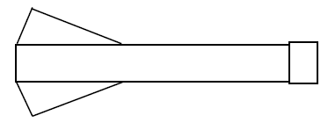
- Wrap a piece of notebook paper tightly around the leftover piece of PVC to form an 8½” roll.
- Slide the roll off the PVC.
- Using your finger, with a twisting motion tighten one end slightly so that it just fits inside the plastic tip.
- Place the tip on the end of the paper.
- Now use your finger to slightly loosen the other end of the roll so that it fits easily over the end of the PVC. The bottom edge will be slightly uneven.
- Use the masking or packing tape to tape the plastic tip to the paper.
- Use transparent tape to secure the side seam of the rocket.
- Trim the bottom edge, if desired, until it is even.
- Use the markers to decorate the rocket.
- Attach the cardstock fins to the rocket with transparent tape. Three to five fins, evenly spaced around the rocket work the best. NOTE: Attach the fins to the rocket along the diagonal cut (the edge opposite the right angle of the triangle).
Directions to launch rocket
- Go to an open area with a firm surface.
- Place the rocket onto the end of the launcher. Hold the launcher at arms length with the rocket pointing up and the soda bottle resting on the ground.
- Now STOMP in the center of the soda bottle and watch the rocket go! Remember to wear protective eyewear.
- Retrieve the rocket. Blow into the pipe to reinflate the soda bottle and launch again.
Toothpick Balance
Scientist Requirement 11 (one of three tricks)
Materials:
Toothpick for each boy (round works best)
Spool of floral wire
Needle nose pliers
Directions
- Cut the wire into lengths of 12-18 inches (one for each boy)
- Using the pliers, make a tiny loop in one end of each wire. I usually do this before the meeting. Insert the tip of one toothpick into the tiny loop and pinch the loop onto the toothpick with the pliers. Now bend the wire to form a large letter “c” with the toothpick at the top. Practice balancing the toothpick on your fingertip.
- Give each boy a toothpick and challenge him to balance it on the end of his finger. Discourage them from sticking the toothpick under their fingernail.
- After a few attempts show them that you can do it using the toothpick with the wire you prepared ahead of time.
- Fasten a wire to the end of each boy’s toothpick and challenge him to try again to balance his toothpick.
- The wire must hang below the toothpick, but does not have to be in the exact shape of a “c”. Allow the boys to bend their wire into different shapes and observe the results.
Optical Illusion Tops
Utah National Parks Council
Scientist Requirement 12
Materials:
2” plastic top for each boy. Be sure the top of the top is flat (see suggested top profile at right).
Several 3” circles of white cardstock or poster board with a hole punched in the center
Markers
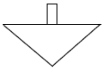
Directions for the Leader
- In advance, prepare some of the cardstock circles by coloring them with different patterns so that you can demonstrate the concept to the boys (patterns are included for your use).
- Place the colored discs over the stem of the top. Ask the boys to predict what they will see. Spin the top and observe.
- Allow the boys to create their own patterns and try them out. Remind them that geometric shapes are the best. It is also more effective if you limit yourself to two or three colors per disc.
Directions for making and coloring tops
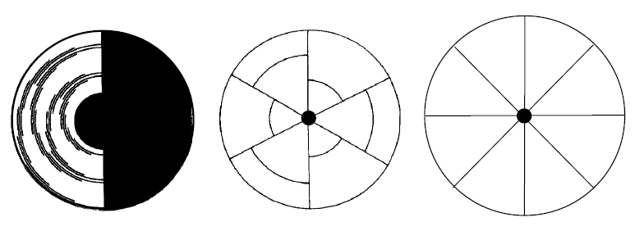
- Copy circles at right onto white cardstock.
- Leave the top circle black and white.
- Color the circle in the middle with two or three different colors (I suggest primary colors).
- Color the circles that are divided into wedges any color you like.
- Cut out additional circles and make patterns of your choice. Experiment-it’s fun! • Once you color them, laminate them so you can use them over and over. You do not necessarily need to laminate the ones that the boys will do.
Sam Houston Area Council
Scientists do what Webelos Scouts do best – ask questions and find out more about how things work. The Scientist Activity Badge allows Webelos to see a glimpse of the things that confront scientists every day, and ask “why did that happen?” In earning this badge they will be exposed to the notion of experimenting as a way of answering scientific questions. They will learn that they are the next generation of experimenters, and will learn about famous scientist and their experiments. They will learn that the universe is full of magical things waiting patiently for our wits to grow sharper.
SUGGESTED PATROL ACTIVITIES
- Invite a weather expert to talk to the patrol or visit a weather station to learn about weather and air pressure.
- Discuss the various branches of science and how they differ.
- Make an optical illusion from the Webelos handbook and show how the eyes converge. Visit an eye specialist and learn how the eyes work.
- Use Magnifying lenses, prisms to see how light moves through glass.
- Visit an airport and ask an expert to explain flight principles.
- Have a slow-motion bicycle-riding contest to illustrate balancing skills.
- Do the Inertia experiments in the Webelos Scouts book.
PASCAL’s LAW OXYGEN METER
Materials:
Tall drinking glass Pie Pan
Plastic wrap Votive Candle
Two pencils Masking tape
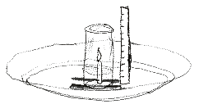
Assembly Directions
- Place a votive candle in the middle of a pie pan.
- Add about ¾ inch of water in the pie pan.
- Put two pencils in the bottom of the pan, one on each side of the candle.
- Place a strip of masking tape up the side of a tall glass (actually made of glass).
- You will use this apparatus to test the relative amount of oxygen in the air.
- After collecting an air sample, cover the opening of the glass with plastic wrap until it is time to measure. A glass with a smaller width works best.
- To measure the oxygen content, light the candle,
- Remove the plastic wrap and quickly place the glass upside down over the candle and into the pan, resting the rim upon the pencils.
- As the candle burns up the oxygen supply, the water level inside the glass will rise, due to the drop in air pressure inside the glass.
- When the water inside stops rising, mark the masking tape.
- Take air samples at various places and repeat the experiment to see how the oxygen content differs.
- Examples of places to take air samples: In a forested area; in your backyard; near the exhaust pipe of a running car; in your bedroom, near a highway.
BERNOULLI’s VACUUM
Materials:
3’ x 4’ piece of 3/8” plywood (very flat)
One 3/8” x 3” carriage bolt
Two 3/8” x 1” carriage bolts
Three 3/8” nuts
Three 3/8” flat washers
Three 3/8” split washers
1 foot length of 1” wide flat braided rope or strap
One 8’ long 2x2 pine board (straight)
Small box of 6 penny nails
Assembly Directions
- Cut the 3’x 4’ plywood into one 3’x 2’ rectangle and one 2’x 2’ rectangle.
- Cut a 20 inch circle in the center of the 3’x 2’ piece of plywood, and drill a 3/8” inch hole at the very center of the disk that you cut. Through this hole run a 3 inch long 3/8” carriage bolt. Attach the bolt firmly with a wide flat washer, a split washer and a nut. Sand the disk well.
- Cut a 16” round hole out of the center of the 2’x 2’ piece of plywood. Cut and make a 2’x 2’ frame with the 2x2. Center the frame on the 3’x 2’ pieces of plywood (6” on each side), and complete the sandwich of the frame with the 2’x 2” piece of plywood. Use two saw horses and clamp the plywood to the saw horse with the 18” hole side up. This frame is for safety.
- Cut a 10” disk out of the 16” round disk, and sand this 10” disk well. Drill two 3/8” holes, 6” apart on the 10” disk. Counter-sink the holes on one side of the disk with a ½” bit, so that the carriage bolt heads will not be higher than the surface of the disk. Poke two holes near the ends of the braided rope, large enough for the 3/8” bolts to pass through (try not to fray the rope). Pass the bolts through the holes and through the braided rope, and secure with flat washers, split washers and nuts. The secured rope should make a handle that your hand can grasp.
- Chuck the bolt of the 20” disk into a hand drill and have an adult reach under the frame and raise the disk through the 20” hole. Spin up the disk and push it against the 16” round hole (Bernoulli may help a little in keeping it in place). Have a boy wearing goggles and gloves approach the flat spinning surface with the flat side of the 10” disk. They will first notice that the moving air cushion makes it difficult to push the disk all the way to the surface of the spinning plywood. As they try to pull the disk away, they will notice that the Bernoulli effect makes it harder to do.
NEWTON’s CRADLE OF MARBLES
Materials:
Two feet of 1” diameter clear plastic tubing
7 ball bearings (or marbles)
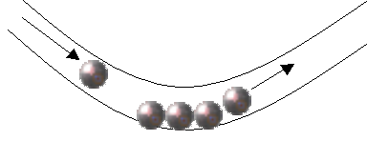
Directions
Place 4 marbles in the plastic tube touching each other.
Have one Scout hold the tube in a U shape.
S
N
Roll one marble in one end and when it hits, one marble from the other end will jump.
When it calms down, try rolling in two marbles.
MAKE A MAGNET
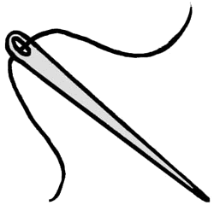
You can make your own magnet with a needle. Needles are made of steel, and steel has a lot of iron in it.
- Hold the needle at the end that has the eye, while wearing gloves. Gloves are for safety and so that you don’t ground the needle.
- With a bar magnet, stroke the needle from the eye toward the sharp end.
- Remove the bar magnet from touching the needle and stroke it again in same manner.
- Do this over and over again at least thirty times to assure that you have magnetized the needle.
- If you touch the needle to a metal paperclip now, you should be able to pick it up.
- Move the south pole of the bar magnet near the needle and see which end of the needle is magnetized as a north pole magnet.
GIVE ME SOME STATIC (ELECTRICITY)
- Charge a plastic comb with static electricity by rubbing it with wool, nylon or fur to ionize the comb.
- Dip the comb into some Rice Krispies. They will be attracted to the comb.
- But watch closely – one by one the bits will shoot off, as if shot from a gun. The same molecules that attracted one another are now opposing each other.
- Recharge the comb and touch a loose fluorescent bulb. Watch the static electrical field excite and light the bulb where you touch it.
WATER ROCKETS
Materials:
2-liter soft drink bottle(s) Construction paper
Fishing line Ping pong ball
Toilet paper roll tube Clear packaging tape
Scissors Surveyors ribbon
Science shows us why water rockets work. Newton’s Third Law of Motion tells us that at the moment the water rocket leaves the launch pad, the force on the plastic bottle upward is equal to the force that the air pressure pushes against the water to move it out the bottom of the bottle’s spout. Since the weight (mass) of the bottle is so much lighter than the weight (mass) of the water, the bottle accelerates upward much faster than the speed of the water shooting out of the spout (if you don’t fill the bottle very full of water).
Decorate your 2-liter soft drink bottles.
A nose cone and tail fins can help with aerodynamics.
A parachute would help it float in the air.
Awards can be given for highest flight, longest hang time.
Let the boys come up with ideas for how to decorate their rockets.
The plans for a Water Rocket Launcher are in the Craftsman section.
Only pour a few inches of water into the bottles.
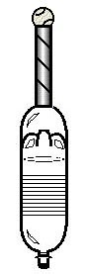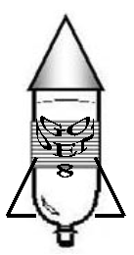
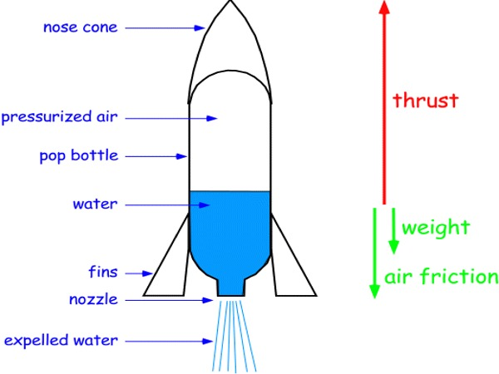

CENTRIFUGAL AND CENTRIPETAL FORCES
I bet that you can put a bucket of water over your head UPSIDE DOWN and not get wet.
Take your bucket of water, and begin to swing it back and forth.
When you are moving it fast enough not to slosh, swing it in a circle up over your head and down again.
You won’t get wet unless you stop suddenly.
This works because of the centrifugal force that pushes the water away from the center of any circle it is spinning around. The faster you spin, the more centrifugal force it has.
Renowned golf coach, Harvey Penick, had his students practice their golf swings by taking a bucket of driving range balls and swinging it like they would swing a golf club. If the balls fell out of the bucket, then they were not swinging correctly.
So, what is centripetal force? Centripetal forces are those forces that keep a rotating object from flying off into space.
For an orbiting satellite, its centripetal force is the earth’s gravitational pull.
For Mr. Penick’s bucket of golf balls, the centripetal force is caused by the bones and muscles in your arm and hands that prevent the bucket from flying through the air and onto the putting green.
ARISTOTLE’s BALANCE
Materials:
Broomstick (without a broom)
One 8’ 4x4 piece of lumber
Tennis racquet
To the Greek philosopher Aristotle, happiness is achieved through living life in moderation and in balance. The world is stable when it is in balance, and many of the scientific laws used in this Scientist Activity Badge are based on equal, balanced forces.
For this activity the object that the boys will balance is themselves. Place the 4x4 piece of lumber on the floor, with plenty of space around it. First, line up the boys at one end and see if they can walk across the board without falling off. Next, have them walk across carrying a broomstick for help with balance.
Follow this by having them do these two things blindfolded with their neckerchiefs.
Finally, have them cross the board backwards and blindfolded.
Have them see if holding other safe objects in their hand, like a tennis racquet, help them with their balance.
And for those that really do well on this, have them try to do it while carrying a heavier box in their arms or items of different weight in each hand.
Once they have mastered this balance beam, hang various safe objects (e.g. a tennis racquet) on one end of the broomstick. Let them discover where they must place their finger under the broomstick, so that it all balances. Then walk across the balance beam again without dropping it.
OPTICAL ILLUSIONS
Perceptions can be wrong:
Be sure to gather up a big collection of optical illusions. The Webelos will really enjoy this
QUESTIONS THAT MAKE YOU WANT TO EXPERIMENT
Here are several scientific situations that will make you want to try them to see if what you think should happen, is actually correct.
HOSES
Situation: Wind up a hose into a circle, so that water has to go around and around before it shoots out the end.
When the water exits the hose, does it leave following a curving path like the hose it just left, or does it come out in a straight line?
Answer: Water comes out initially in a straight line, regardless of the shape of the hose.
BIG AND LITTLE FALLING ROCKS
Situation: Hold two rocks of different weight, so that the under sides of the rocks are exactly the same height off of the ground.
Drop them both at the same time. Which one will hit the ground first?
Answer: both rocks should hit the ground at the same time, unless one is much more aerodynamic than the other, since gravity accelerates them both equally.
MAGNETIC ATTRACTION
We all know that two magnets of opposite poles will attract each other. Attach one bar magnet to a toy car.
Hold a second magnet on the ground near the car. Will the car move toward the other magnet?
Yes, the car should move.
Now, firmly attach both magnets to the same car, with opposite poles close, but not touching each other.
Will the magnetic attraction of the magnets cause the car to move?
No. The only thing that might happen is that the glue holding the magnets to the car may give way from the stress of the magnetic attraction.
GYROSCOPIC BATTLING TOPS
Study the rotational inertia of gyroscopes by having the boys spin tops. Draw a chalk circle and have two boys spin their tops into the circle. The last top left standing in the circle is the winner as they bump each other and wobble around the circle.
POW WOW EXTRAVAGANZAS
Let me know as soon as your date is set. I will post whatever I receive! CD
Catalina Council
Happy Birthday, BSA
100 Years,
The Future Is Bright
November 14, 2009
LDS East Stake Center,
6901 E Kenyon Drive, Tucson
For detailed information call 520-750-0385
or go to www.catalinacouncil.org

Sam Houston Area Council
Akela's Trail of Friendship
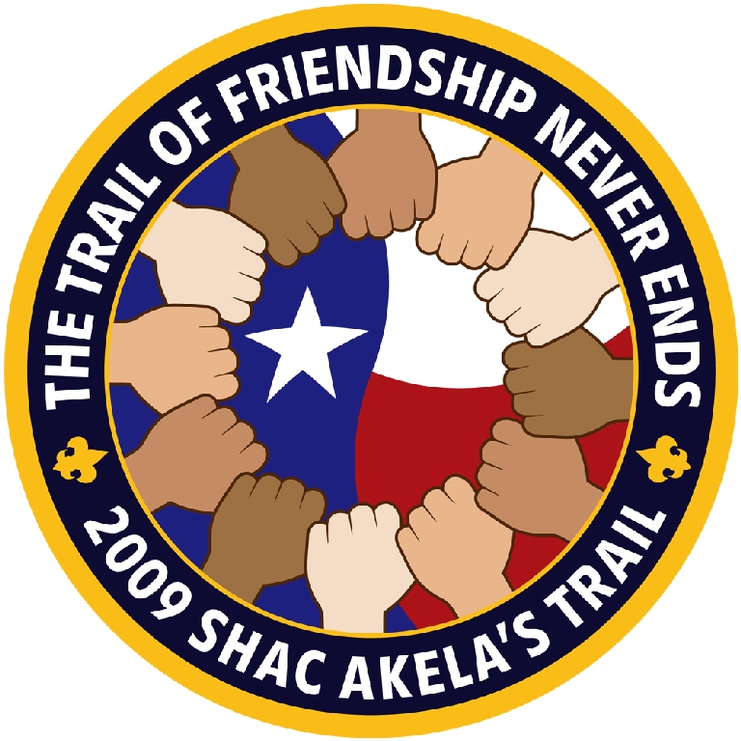
November 7, 2009
Spring Woods High School, Houston, TX 77080
Call Sam Houston Area Council, (713) 659-8111, or visit http://www.shac.org/Home/Training/AkelasTrail/ for more information. On-line registration!
Theodore Roosevelt Council
South of the Equator
November 14, 2009
Wantagh Memorial Congregational Church
Wantagh Avenue, Wantagh, Long Island, NY
For detailed information call 516-799-8110
or go to http://www.trcbsa.org/
Southern NJ Council
Back to the Future
Where Tradition Meets Tomorrow
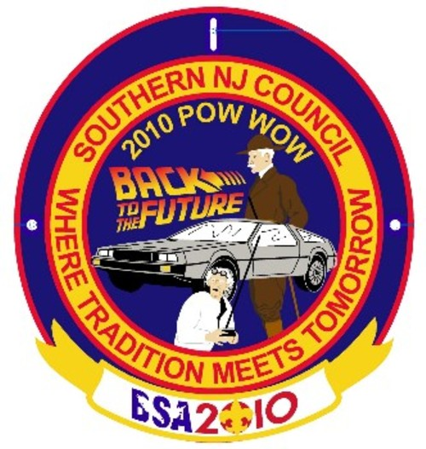
January 23, 2010
Lakeview School, Millville, NJ 08332
Call Southern NJ Council, 856-327-1700, extension 32, or visit the website, www.snjscouting.org for more information

WEBSITES
Where can you go to find answers about the Cub Scout Program online. After you check out National's site, www.scouting.org, go to
Don De Young’s Virtual Cub Leader Handbook,
http://www.geocities.com/~pack215/home.html
Yes, there are monthly theme ideas in Baloo’s Bugle, but there is so much more than that to Cub Scouting and a running a great program than the themes.
Utah National Parks Council
Art Junction:
http://www.artjunction.org/
(A collaborative art space for teachers and students.)
Geometry Through Art:
http://mathforum.org/~sarah/shapiro/
(This site has art lessons integrated with math.)
Graphics Den: http://www.actden.com/grap_den/
(Includes art lessons and a gallery for older students.)
How to Draw a Cartoon Character:
http://www.garyharbo.com/activity.html
Kinder Crafts, Crafts for Kids:
http://www.zoomschool.com/crafts
(Tons of craft projects for preschool, kindergarten and elementary school children, using materials found around the house.)
General Resources about art:
Alice, Golden Empire Council
www.enchantedlearning.com great beginning point for art projects, information about different artists, different styles of art, using different mediums such as acrylics or watercolors, mobiles; also a listing of an artist for each letter of the alphabet, artists from different countries, various themes such as animals or food to connect with art. Coloring pages, Artist a month calendars to download (could be used for a family gift) Timeline of art from pre-historic to present day. Ideas for making an easel to work on or a twig easel to display small works of art.
www.princetonol.com/groups/iad/lessons/.../for-kids.htm used with PBS Art for Kids shows; click on the “Art Museums USA” bar for links to art museums all over the United States, including online virtual gallery tours. There’s a separate category of Kid’s Museums and a Top Ten Online Art Museums for Kids that links to some great resources. On the home page, you can also explore different kinds of art, different artists, cultures and all kinds of games and art activities. You can explore daVinci’s workshop, learn how to create action figures, landscapes and illustrations for stories.
www.metmuseum.org/explore/index.asp Printable features, photos of art work and teacher or parent guides. Explore the world from prehistory to the present with the Met's collection as your guide when you click on the Heilbrunn Timeline of Art History – you can use to look for examples of art from different cultures, times or different kinds of materials. Under Explore to Learn, find such fun stuff as an interactive purple hippo (Learn about Color) or Aaron’s Awesome Adventure, about a boy who visits the Metropolitan to tell kids that looking at art can be fun.
www.crayola.com/ free coloring pages, games for kids, lesson guides, and an online art exhibition, craft ideas for kids to try.
www.artkidsrule.com/ glossary of art terms, tutorials for adults and kids doing all kinds of art, index of art activities and resources, interactive art lessons and games on the Art Arcade
Art Projects and Crafts:
Alice, Golden Empire Council
www.kinderart.com/recycle/ All kinds of art projects using recycled materials, including an art caddy to transport art. Great information about working with various kinds of clay.
Also check out the Enchanted Learning site above for a variety of projects.
Interactive art for kids:
Alice, Golden Empire Council
www.nga.gov/kids/kids.htm information about specific artists or works of art. Find some questions you might ask the boys to think about. Also, NGAkids Jungle is an interactive art activity for kids of all ages
www.ramogames.com/games/Word-Art-Match-Game.htm Interactive games about art; match photos of real artwork with the country of origin, or play art word match games. Lots of ideas you could spin off into hands-on games to play indoors or outdoors
www.epcomm.com/center/point/point/htm Practice pointilism online on these pages
Specific Artists:
Alice, Golden Empire Council
www.pitt.edu/~poole/eledArt.html look up specific artists for biographical information, some visuals of their work, museums that have their art work
www.calder.org/home biographical and visuals of work by life period; lots of photos; how to teach to kids
Norman Rockwell:
www.scouters.us/homeart.html biography of Rockwell and a great list of his Scouting art work by date and indexed by subject to make it easy to find a picture that fits the situation
www.best-norman-rockwell-art.com/norman-rockwell-boy-scouts.html the story (with art work and photos) of how Norman Rockwell and Scouting came together and prospered
Baden-Powell:
www.scouting.org.za/seeds/bluff.html The African seeds of Scouting; even more stories about how Baden-Powell used bluff to outlast the Boers at Mafeking; Be sure to check this one out – go to the stick and stone arrows at the bottom of each page to see a sketch by BP on almost every page; stories about the scouts who were also heroes of Mafeking; also sketches and stories about African culture, woodcraft skills, and personal stories of BP in Africa – very even handed.
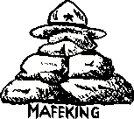
(By the way, I learned something I didn’t know – Mafeking means The Place of Stones - Alice)
www.scouting.milestones.btinternet.co.uk/bpbooks.htm A great walk through history with the scouting manuals that BP produced and illustrated – I love the Wolf Cub Scout manual! Wonderful resource about all kinds of Scouting history, from the first badges BP made from a sheet of brass to how the word “scout” came to be used; the most complete history of scouting and BP with lots of sketches and photos.
http://clipart.usscouts.org/library/ Part of the usscouts website; scroll down to find a subject that fits to see various sketches, portraits and information about Baden-Powell, especially as an artist.

ONE LAST THING
The Buzzard, the Bat, and the Bumble Bee
Fellow Proton Patient - Nell from Oregon
THE BUZZARD:
If you put a buzzard in a pen that is 6 feet by 8 feet and is entirely open at the top, the bird, in spite of its ability to fly, will be an absolute prisoner.
The reason is that a buzzard always begins a flight from the ground with a run of 10 to 12 feet. Without space to run, as is its habit, it will not even attempt to fly, but will remain a prisoner for life in a small jail with no top.
THE BAT:
The ordinary bat that flies around at night, a remarkable nimble creature in the air, cannot take off from a level place.. If it is placed on the floor or flat ground, all it can do is shuffle about helplessly and, no doubt, painfully, until it reaches some slight elevation from which it can throw itself into the air. Then, at once, it takes off like a flash..
THE BUMBLEBEE:
A bumblebee, if dropped into an open tumbler, will be there until it dies, unless it is taken out. It never sees the means of escape at the top, but persists in trying to find some way out through the sides near the bottom.. It will seek a way where none exists, until it completely destroys itself.
PEOPLE:
In many ways, we are like the buzzard, the bat, and the bumblebee. We struggle about with all our problems and frustrations, never realizing that all we have to do is look up!
That's the answer, the escape route and the solution to any problem! - Just look up.
Sorrow looks back, Worry looks around, But faith looks up! Live simply, love generously, care deeply, speak kindly and trust in our Creator who loves us.

After being missing for awhile, the monthly patches have returned. November was not on www.scoutstuff.org

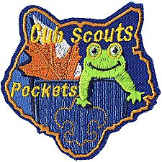



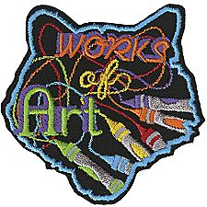
Pictures for Art Match-Up in Gathering Activities
You would do better to find these (or others you like) on the internet and print large full-color pictures.
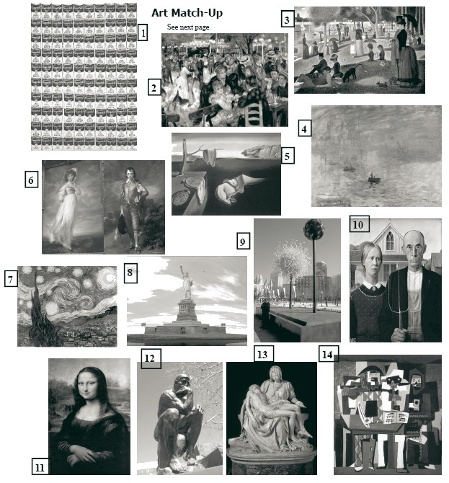
A Work of Art by God
Talk about the beauty of God's creation!! You can just imagine his big paint brush splashing all these colors on the hills east of Tehachapi, California. Apparently the abundance of rain there this spring (March 2005) has allowed the proliferation of these beautiful flowers. This is a major mountain pass from the central valley of California into the Los Angeles Basin. It is truly a spectacular sight!! Traffic really slows down as people drive through this normally colorless spot.
(from http://www.snopes.com/photos/natural/flowers.asp )

It is real - see http://www.snopes.com/photos/natural/flowers.asp

