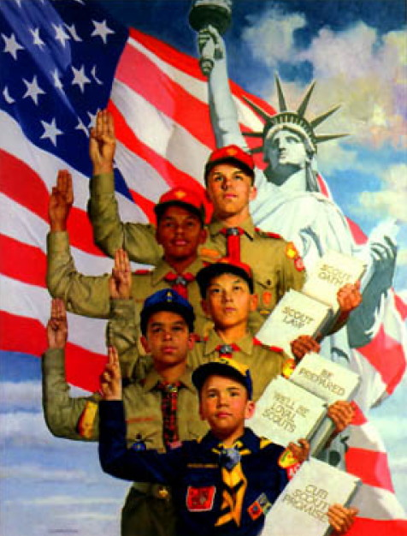
FOCUS
Cub Scout Roundtable Leaders’ Guide
July is the time for fun and relaxation. And it's the time to remind ourselves of the reasons we can relax and have fun as families and as a pack. The freedom we enjoy in this country makes this month special. Cub Scouts will be learning about flag etiquette and patriotic ceremonies. Boys can express their pride as citizens of the United States by participating in an Independence Day parade. It is also an ideal time to remind the boys to give back to this land where we work and play Conduct a den or pack conservation project as a birthday present to America.
Cub Scout Program Helps
Celebrate America's freedom established on July 4, 1776, with patriotic songs, games, and family fun. Discover what makes America so special to us. Decide on a birthday present your pack can give to America by doing a service project and a "Good Turn for America." Participate as a den or pack in an Independence Day parade. Enjoy the beauty of our country by participating in outdoor activities. Have a pack barbeque or family gathering and share some family heritage about coming to our great nation. Design and serve a birthday cake and sing to America! Earn the Citizenship and Heritage belt loops and pins.
CORE VALUES
Cub Scout Roundtable Leaders’ Guide
Some of the purposes of Cub Scouting developed through this month’s theme are:
- Good Citizenship. Boys will develop the habits and attitudes to be better citizens when they learn about some of the ideals. traditions, and symbols of our country.
- Character Development. Boys will grow in character by giving back to the communities where they live.
- Preparation for Boy Scouts. By learning and participating In flag ceremonies, the Cub Scouts will develop pride in America as all Boy Scouts should.
The core value highlighted this month is:
- Citizenship, Boys will gain respect for the American Flag through practicing flag courtesies and ceremonies.
Can you think of others??? Hint – look in your Cub Scout Program Helps. It lists different ones!! All the items on both lists are applicable!! You could probably list all twelve if you thought about it!!
YOUTH PROTECTION UPDATE
Youth safety is the No. 1 concern of the BSA.
To increase awareness of this societal problem and to create even greater barriers to abuse than already exist today in Scouting, the Boy Scouts of America is implementing several important changes to further enhance its Youth Protection policies:
Effective June 1, 2010:
- Youth Protection Training is required for all registered volunteers.
- New leaders are required to take Youth Protection Training before they submit their application for registration. The certificate of completion for this training must be submitted at the time application is made and before volunteer service with youth begins.
- Youth Protection Training must be taken every two years. If a volunteer's Youth Protection Training record is not current at the time of recharter, the volunteer will not be reregistered.
Please CLICK HERE for steps to ensure these policies are fully implemented.
To visit the BSA ON-LINE TRAINING CENTER click the underlined words
To find out more about the Youth Protection policies of the Boy Scouts of America and how to help Scouting keep your family safe, see the information available in any of the Cub Scouting or Boy Scouting handbooks, or go to http://www.scouting.org/Training/YouthProtection.aspx.
COMMISSIONER’S CORNER
Bill Smith, the RT Guy on CS 2010 Changes
Hi Dave,
Here is my TT for June. It's on my assessment of the new Cub Scout program - or at least what is available for downloading.
I feel very positive about the program. These are big changes and will need a lot of district and council support come September. I hope it will be there.
I particularly like the den meeting plans. One of them - I think it's the October one - reminded me of my wife's first den meeting back in the 1960s. The boys were practicing the Feats of Skill (Wolf #1) and one Cub did a front roll (1C) and as he came up, smashed his forehead into the corner bead of a wall. The meeting suddenly morphed into a field trip to the local ER for stitches and snacks.
Again, thanks Dave, for providing me the opportunity to rant and rave about my favorite activity. It's been a fabulous trip!
Bill
Read all his comments under Training Topics
And speaking of CS 2010 Changes -
Obviously Baloo will change a little. And I will need some help. With the monthly emphasis on a Core value, I will new material that supports that Core Value. A frequent contributor, Wendy, has sent me some cooperative games for September. Maybe YOU have some ideas that support various Core Values. Send them on out to me - davethecommish@gmail.com. And thank you Wendy for giving me this idea.
Months with similar themes to
Celebrate Freedom
Dave D. in Illinois
Month | Year | Theme
January | 1943 | Do Your Bit
October | 1951 | Strong for America
February | 1955 | Let Fredom Ring
July | 1964 | Our American Heritage
February | 1966 | Strong for America
February | 1971 | Our American Heritage
June | 1976 | Historical Flags
July | 1976 | July 4th Picnic
December | 1978 | Duty to God & Country
February | 1989 | Strong for America
September | 1989 | Our American Heritage
February | 1993 | Old Glory
June | 1994 | Strong for America
July | 1999 | Our National Treasures
July | 2006 | Red, White and Baloo
July | 2007 | The Rockets Red Glare
THOUGHTFUL ITEMS FOR SCOUTERS
Thanks to Scouter Jim from Bountiful, Utah, who prepares this section of Baloo for us each month. You can reach him at bobwhitejonz@juno.com or through the link to write Baloo on www.usscouts.org. CD

Roundtable Prayer
CS Roundtable Planning Guide
“This is our country. We pray to be strong In our beliefs and support our freedom, established and maintained by our Constitution. May the symbols of our country continue to inspire and encourage respect and freedom for all. Amen.”

Although no sculptured marble should rise to their memory, nor engraved stone bear record of their deeds, yet will their remembrance be as lasting as the land they honored. Daniel Webster

Celebrate Freedom
Scouter Jim, Bountiful UT
As I sit at my desk and write this, it is mid-May. Next to me are two small American flags, one each for a soldier that has served his country in times of war. One to be place exactly one boot distance from the headstone of a warrior of the War of 1812. The other to be placed in an urn at the mausoleum of a soldier of World War II.
Next year there may be another for my father a veteran of the Korean War who after surviving Pork Chop Hill in the Korean War, came home to family, something many of his comrades did not do.
Among the veterans of my family are nine uncles, (seven served in World War II at the same time), and one grandfather. Among those men are two Purple Hearts. My great-grandmother died during the time my grandfather was Missing In Action, never knowing he was alive in a hospital in France. Among my distant ancestors, for which I may be proud, are many veterans who served in the Revolution including one with General Washington at Valley Forge.
November is Veterans' Day (formerly Armistice Day) A day of remembrance started after the implementation of an armistice, temporary cessation of hostilities, ended World War I until the final peace treaty, the Treaty of Versailles, was signed in 1919. The Armistice was signed at the 11the hours of the 11th day of the 11th month in 1918. In 1919, President Wilson declared November 11 to be Armistice Day, a day of solemn pride in the heroism of those who died in the country's service and with gratitude for the victory. In 1954, President Eisenhower changed the name to Veteran's Day to honor all American veterans.
May is Memorial Day, originally called Decoration Day, a day of remembrance for those who have died in our nation's service. Memorial Day was started after the Civil War with idea it would be a day to decorate the graves of the veterans. The tradition of decorating the graves goes back to the ancient Greeks.
June is Flag day, a time to remember our nation's symbol. It is a month to fly the flag and learn of its history.
July is Independence Day, a time for celebrating the freedoms that valor and blood have won for us. July 4th is the date the Declaration of Independence was signed.
As we watch the parades and salute the soldiers in them, remember, that not all the soldiers who have served are there. Some did not walk off the plane when they came home, but were solemnly escorted and draped in red, white and blue. Thankfully, this is not paper upon which I write, so the water spots from my tears will not be visible as water spots upon the paper.
Remember that “freedom is never free, sometimes it has to be bought with the lives of our finest heroes. Fly the flag, salute the flag, and honor those who served, by respecting what they sacrificed for.

Quotations
Quotations contain the wisdom of the ages, and are a great source of inspiration for Cubmaster’s minutes, material for an advancement ceremony or an insightful addition to a Pack Meeting program cover
He that would make his own liberty secure, must guard even his enemy from opposition; for if he violates this duty he establishes a precedent that will reach himself.
Thomas Paine
Freedom has its life in the hearts, the actions, the spirit of men and so it must be daily earned and refreshed - else like a flower cut from its life-giving roots, it will wither and die. Dwight D. Eisenhower
The patriot's blood is the seed of Freedom's tree.
Thomas Campbell
Nothing is more difficult, and therefore more precious, than to be able to decide. Napoleon Bonaparte
Those who deny freedom to others deserve it not for themselves. Abraham Lincoln
My definition of a free society is a society where it is safe to be unpopular. Adlai Stevenson, speech, Detroit, 1952
We on this continent should never forget that men first crossed the Atlantic not to find soil for their ploughs but to secure liberty for their souls. Robert J. McCracken
You have freedom when you're easy in your harness.
Robert Frost
For what avail the plough or sail, or land or life, if freedom fail? Ralph Waldo Emerson
Those who expect to reap the blessings of freedom, must, like men, undergo the fatigue of supporting it.
Thomas Paine
In the truest sense, freedom cannot be bestowed; it must be achieved. Franklin D. Roosevelt
Liberty is always dangerous, but it is the safest thing we have. Harry Emerson Fosdick
Freedom is not enough. Lyndon B. Johnson
Liberty has never come from the government. Liberty has always come from the subjects of it. The history of liberty is a history of resistance. Woodrow Wilson
The sound of tireless voices is the price we pay for the right to hear the music of our own opinions. Adlai Stevenson, speech, New York City, 28 August 1952
We must be free not because we claim freedom, but because we practice it. William Faulkner
They that can give up essential liberty to obtain a little temporary safety deserve neither liberty nor safety. Benjamin Franklin, Historical Review of Pennsylvania, 1759
No man can put a chain about the ankle of his fellow man without at last finding the other end fastened about his own neck. Frederick Douglass, speech, Civil Rights Mass Meeting, Washington, D.C., 1883
Let freedom never perish in your hands. Joseph Addison
Who speaks of liberty while the human mind is in chains? Francis Wright, 1828
Liberty, when it begins to take root, is a plant of rapid growth. George Washington
I believe there are more instances of the abridgment of the freedom of the people by gradual and silent encroachments of those in power than by violent and sudden usurpations. James Madison, speech, Virginia Convention, 1788
Liberty doesn't work as well in practice as it does in speeches. Will Rogers
Order without liberty and liberty without order are equally destructive. Theodore Roosevelt
We cannot defend freedom abroad by deserting it at home. Edward R. Murrow
Freedom is nothing else but a chance to be better.
Albert Camus
The greatest dangers to liberty lurk in insidious encroachment by men of zeal, well-meaning but without understanding. Louis D. Brandeis
Liberty means responsibility. That is why most men dread it. George Bernard Shaw, Man and Superman, "Maxims: Liberty and Equality," 1905

TRAINING TOPICS
I Like the New Delivery Method
Bill Smith, the Roundtable Guy
This is Bill's last column. His input will be sorely missed. Please keep Bill in your prayers. His 80th birthday is this June (I do not know the date) - send him an E-card if you can!! He is still recovering from a stroke but can, obviously, still inspire with his stories and examples. CD
Editor's Note
We at Baloo and the U.S. Scouting Service Project support volunteers who are the foundation of successful Scouting. While we do promote the official programs of accredited Scouting Associations, we also respect individual views from experienced volunteers that may be critical of official programs and we will from time to time share them with you.
Sharing the view does not necessarily constitute endorsement. CD
As I write this, the new Cub Scout Den & Pack Meeting Resource Guide has been available online now for about a week. By the time this issue of the Bugle is out, I expect that a lot more material to be published and ready, both physically and on the net, for the annual pack planning meetings.
Enough material is out to indicate what is going on at National and to speculate what might happen as a result of the changes. It will take significant time for program support agents in districts and within the packs to organize and prepare to take advantage of these changes. Making the program available four months before it goes into effect is a good start, and a change for how National often does things.
My first impression is one of surprise and admiration for the quality and quantity of the work that has gone into this project. The plans that I have examined are well written, well structured and intelligently presented. There is more and concerted attention paid to the aims and purposes of Cub Scouting. Also, there is much more support for parent and family inclusion in the program than I expected. I am impressed.
I wish National would be more open and identify the people who make good things happen. In all my years of Scouting (some of them actually spent working on National projects) I never got a clear idea of who did what there. Good councils and districts often publish organization charts - some even include phone numbers and email addresses. National never seems to do that. I wonder why.
The Den Meeting Plans are especially well done. The den program is firmly based on the boys’ books rather than on themes. The books - Tiger, Wolf, Bear and Webelos - are full of adventures, challenges and fun. The various den plans I have studied use these with imagination and flair. The authors of the Deb Meeting Plans have been able to restore the spirit and the delight that were always supposed to be there in both the requirements and the electives. I was a bit apprehensive that advancement in a den setting would be more like a continuation of school work. The pros and volunteers responsible for these plans have been able to work a bit of magic here. Kudos to them! A good den leader will have a great time with these plans. There is enough flexibility built in to allow for making great use of local resources. More experienced and adventurous den leaders should have few difficulties building on this framework.
The home assignments are significant additions to a den leader’s arsenal. I always encourage more advancement to be completed at home and I recognize that some den leaders find this to be a difficult procedure. Den leaders who use these tools should now get more cooperation from parents and the boys should get better Cub Scouting. Even more surprising (and welcome) are those instances where Webelos Activity Badge requirements are recommended to be completed at home and signed off by parents.
Certainly den meetings needed this sort of boost. Up to now, the recommended den program was dominated by themes which failed to support the quality ideas in the boys’ books.
The Pack Meeting Plans, though, are something of a disappointment. Removing themes left a big hole in pack meeting programs. The attempts to fill the hole with homilies and guest speakers just doesn’t cut it. This has resulted in reducing the pack meeting to just a meeting - nothing more than an ordinary, plain, very dull meeting. A Pack meeting must be more than that. It should be a show - a party - a joyous community celebration that catches and holds the attention of parents, Cub Scouts and siblings every month. The last thing we need is another dull meeting. Themes, at the very least, provided a basis for a party.
As our good friend, Sean Scott has oft reminded us:
First, don't think of your pack meeting as a 'meeting'. Start to think in terms of a one night show, a production. Meetings are dull; we go to them every day and rarely (if ever) look forward to them. A show, however, is entertainment! People want to be entertained, and while they'll forget to go to your meeting, they'll remember that they have tickets to your show!
Pack meetings make poor venues to teach things like Character Connections or Ideals. You can celebrate them and even promote them there but the explanation and teaching is much better accomplished elsewhere. Where? Anywhere else. If you think about it carefully, not much real Cub Scouting takes place at a pack meeting. There just isn’t the time nor the tools to make it happen with such a diverse audience. Instead it is the introduction to all the rest of the program: the den meetings, the home and family activities, the service projects, outdoor action, and even to the Boy Scout program. You might think of pack meetings as the gateway to Scouting.
Without pack meetings, those other things might not happen at all.
Den Support at pack meetings. The pack meeting should provide an arena for your dens to show their stuff. Strong dens perform regularly at pack meetings in ceremonies, skits and other activities that can be seen and appreciated by parents. Unfortunately, the November plan injects a den skit, cold, immediately following the CM reads (that’s right, READS) the announcements. No cheers, no run-ons, no fun songs, no set-up at all. Just, “Get out there, kids, and open the show.” Good, well trained Cubmasters should easily work around these problems.
Pack outings and other special pack programs are still recommended and haven’t changed much. I wonder how the same people who are doing such a great job with den programming could make such a mess of pack meetings.
However, I am impressed with how the program is packaged and presented. Most plans and support information is easily downloadable, making it instantly available to any leader on line. Navigation is a bit hit or miss but I could usually get where I wanted to go. There appears to be a feedback channel being established that will permit upward communication from unit leaders directly to those at National. There will be many good ideas generated in local packs and dens as leaders gain experience using these plans. This can only lead to good things. For the first time that I remember, the internet is being used intelligently by National to really promote unit programming rather than to promote some obscure agenda of a high-ranking pooh-bah in Irving.
I haven’t seen anything yet on Roundtable or training. Good Roundtables will be essential in getting this whole project off the ground and up in the air. The track records of Key-3's and RT Administrators are quite weak when it comes to Cub Scouting and following National’s suggestions. I regularly visited Roundtables as I traveled and I rarely saw the old CS RT Planning Guide being followed. Too often, the meetings were run by one of the district Key-3 for their own personal agendas. It probably doesn’t matter what is in the new guide if the districts won’t follow it. We need a good shake-up there.
Training is another matter. Thanks much to Wood Badge influence, there is a discipline in most district training teams to faithfully follow the manuals and directives. Also the current Cub Scout Position Specific manual is (at least in my estimation) the best training to come out of Irving (or North Brunswick) in the last half-century. This last one was produced by a group headed by Ted Rohling of the Alamo Area Council. The professionalism and adherence to standards of adult learning practices mark Ted as the top suspect in why it works so well. I hope that he is still involved.
All in all, I am confident that things are improving and Cub Scouting is safe, alive and thriving. There are good people in charge, not only in our dens and packs, but also in the committees and task forces that generate the program material.
This will be my last Training Tip. My age and health are finally catching up with me to the extent that I can no longer pretend that I could put out a quality column.
I certainly have enjoyed and value my association with Dave and all the gang who work on the Bugle. Dave, especially has been a special part of my Scouting life for the past several years. His dedication is an inspiration for all of us.
Come October, I will have completed my 48th year as an adult Scouter. It’s probably time I started taking it easy.
I am interested in learning about the experiences that CS leaders have with the CS-2010.
Reach bill smith at wt492(at)wtsmith.com.
What are YOU going to do now?
Go get ‘em. We need all the help we can get.
The best gift for a Cub Scout.......
......get his parents involved!
- Also, be sure to visit Bill’s website
http://rt492.org/
to finds more ideas on everything Cub Scouting.
Have any Comments for Bill
just click right here!
PACK ADMIN HELPS
Plan a Summer of Fun!
Get them OUTDOORS
Three quarters of
SCOUTING is OUTING
Kommissioner Karl
If your pack has not already planned some activities this summer, DO IT NOW! Go fishing or hiking in June, day camps and Resident Camp are in July, and have an ice cream social, family picnic or family camping overnight in August. Remember, you will need to promote and remind parents of your events to make sure they remember to attend!
Where to go – What to do?
Summer program is very important in northern areas. By not having an outdoor program for Cubs, you are missing out on the best three months of weather you get! Outings can be den, pack or family oriented. Here are a few ideas:
- Family Overnight campout at an approved Cub Scout facility. These should have flush toilets for the convenience of younger boys and family members less comfortable with camping. Be sure your destination is approved by calling the Council office and asking if the facilities meet the Guide To Safe Scouting. requirements.
- Amusement Parks – almost everyone has an amusement or water park someone close. Call the park and ask about discount to groups or scouts. Many have special days with low rates just for scouts and families.
- Family Picnic – a bring a dish, softball/volleyball/ scavenger hunt can be great fun, with very little work. There are a number of facilities to go to in the area, including pavilions for sunny or wet days. Check with the park department to see if you reserve a pavilion – or if it is first come first serve. You may need to send someone there early to make sure you get your spot.
- Day Hike and campfire – have them brush up on all the skits you taught them from Roundtable and come out for a big campfire. Plan a short walking hike to areas of interest ahead of time. Many County and State parks (For you Ohioans - like Fort Laurens in Zoar, and the Towpath trail) are great places to take short hikes – before settling in for a campfire or picnic.
- Parent-Son baseball game – nothing caps off the baseball season like a parent- son baseball game. You can divide up the teams – with a parent going to one side and the son to other team. This usually keeps things calm for those that are overcompetive. You can play parents against the boys (usually great fun) but adults play opposite handed. They bat and throw with there non-dominant hand. Ok to catch the ball with either hand. If you have a Mom that was a softball champion, you may have her bat opposite handed too.
- County and state parks often have ample facilities for a pack, a great nature lodge, and fishing. Usually there is a great picnic area. Call your park for information.
- A pack fishing derby is enormous fun. A few trophies is all it takes. Make sure to give out prizes for the biggest and most fish. Don’t know how to do this? Find a local fishing derby and have your pack go and participate with everyone else in the community.
- Derby Days – hold a raingutter regatta, space derby – and second pinewood derby race – for no prizes. Have a Dad’s division so they can build their own car and leave Jr’s alone next year.
- Look for District or Council summertime events to take part in as a pack. Day camps, resident camps, Parent-Child campouts. These count toward your award, and make planning a whole lot easier.
- Minor league Ball games – Most minor league ball teams hold a scout night with a sleepover in the outfield. Check out your local team!! And the cost is usually very reasonable. The Wilmington Blue Rocks are about $6 a ticket. Or if not a sleepover – a fireworks night!!
Or how about an
Inter-Pack Sports Day.
Get together with another pack (or two or three or more) and plan a day of sporting adventures. Solicit ideas for large group games from the participants. Fill in with other games from the How To Book. Suggestions could include - holding races – crab walk, gorilla race, kangaroo race (See Bear book), an inter-pack kickball or volleyball tournament.
Ask, too, for individual things boys (and/or siblings) can do – e.g. fishing, physical fitness course (See Wolf book), and/or a specialty hike along a marked trail, disc golf.
The CS Academics and Sports Program Guide has a plan for setting up a Pack Sports Event or Tournament and the Special Pack Activities section of the How To Book has ideas for Cub Scout Field Day, Summer Celebration, Welcome to the Midway, and Western Rodeo. All these could be blended into a special program of activities selected just for your group.
Maybe you want to teach them how to play Ultimate and hold a game. Or choose another sport.
Program is only limited by your imagination. Take the time and add summertime program to your calendar. This is especially important if you are doing any kind of spring recruiting. You need a summertime program to remind the new parents and boys why they joined Scouting.
Need an Incentive???
Although many consider Cub Scouts to be a 9 month program – the secret is that the most successful Pack programs usually have some type of summer program. These can be loosely organized outings for the whole family. Or, you can continue your program of pack meetings and events in the summer as well. National recognizes this extra effort with the National Summertime Pack Award.
The National Summertime Award
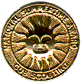
Incentive for summer planning is the National Summertime Pack Award, an attractive, full-color certificate, and the National Summertime Pack Award streamer for the pack flag. These can be earned by packs that conduct three summer pack activities - one each month during June, July and August.
Dens with at least 50 percent of their members at the three summertime activities receive a den participation ribbon. Individual Cub Scouts who attend all three activities can be recognized by their pack with the National Summertime Award pin.
The Cubmaster or pack committee secretary should keep a record of all summer pack activities on the chart in the National Summertime Pack Award Planning Guide. Submit the application section of the record sheet for approval by the camping and activities or Cub Scout committee of the local council. Make arrangements for the den, pack and individual Cub Scout awards to be presented at an early fall pack meeting.
SPECIAL OPPORTUNITY
Good Turn For America
Catalina Council
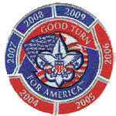
A Service Project this month would be a great tie in with the theme, Celebrate Freedom." For info on "Good Turn for America" check out the December 2009 issue of Baloo's Bugle http://usscouts.org/bbugle/bb0912.pdf
or their website, www.goodturnforamerica.org .
The United States Heritage Award
Catalina Council
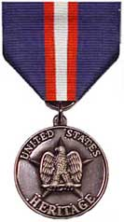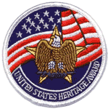
Editor's Note
Over the years thousands of Scouters and Scouts earned the United States Heritage Award. In recent years there were reports of difficulties with the program. However, in 2009, the program came under new management with new personnel and is once again available to the Scouting community. CD
The United States Heritage Award was designed by Scouts and adults to give youth recognition for learning about the heritage of the United States of America. By completing this award, it is hoped participants will not only increase their understanding of the United States but also foster greater sense of patriotism through service in local communities.
The award may be earned by any youth in the United States. A medal and patch can be awarded to each youth that successfully completes the requirements for the award. All requirements may be completed with a unit, group, family, or individually.
There is a silver medal for youth 6 - 10, and a gold medal for youth 11 - 18. Adults can also earn the gold medal. More information, worksheets, and adult guides are available at: www.nationstrails.com .
Award
A silver medal and patch can be awarded to each youth that successfully completes the requirements for the award. The request form must be completed to purchase the medals and patches. All requirements may be done with a unit, group, or individually.
Requirements
To earn the Silver United States Heritage Award a youth must:
- Tell when the Declaration of Independence was adopted.
- Learn the first verse of the national anthem “The Star Spangled Banner”.
- Know the Pledge of Allegiance. Explain what it means.
- Learn about the United States Flag.
  - What colors does the United States flag have?
  - How many stars are on the blue rectangle (canton)?
What do the stars symbolize?
  - How many stripes are on the flag?
What colors are the stripes?
What do the stripes symbolize?
  - How do you show respect for the United States flag?
- Make a list of the original thirteen states of the United States of America.
- Know who is the current President of the United States of America.
- My America. Do one of the following:
  - Write a short story or poem about one of the following topics :
Why America Is Special To Me,
What It Means To Be Free,
If I Were President…
  - Draw a picture of a famous person in American History and tell what they did.
Render a service that benefits a neighborhood or community
For more information go to –
http://www.nationstrails.com/awards/
Boys’ Life Reading Contest for 2010
http://boyslife.org/
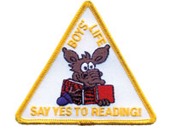
SAY ‘YES’ TO READING
Enter the 2010 Boys’ Life Reading Contest
Write a one-page report titled “The Best Book I Read This Year” and enter it in the Boys’ Life 2010 “Say Yes to Reading!” contest.
The book can be fiction or nonfiction. But the report has to be in your own words — 500 words tops. Enter in one of these three age categories:
- 8 years old and younger
- 9 and 10 years old
- 11 years old and older
First-place winners in each age category will receive a $100 gift certificate good for any product in the Boy Scouts official retail catalog. Second-place winners will receive a $75 gift certificate and third-place winners a $50 certificate.
Everyone who enters will get a free patch like the one shown above. (And, yes, the patch is a temporary insignia, so it can be worn on your Cub Scout or Boy Scout uniform shirt, on the right pocket. Proudly display it there or anywhere!) In coming years, you’ll have the opportunity to earn different patches.
The contest is open to all Boys’ Life readers. Be sure to include your name, address, age and grade in school on the entry.
Send your report, along with a business-size, self-addressed, stamped envelope, to:
Boys’ Life Reading Contest
S306
P.O. Box 152079
Irving, TX 75015-2079
Entries must be postmarked by Dec. 31, 2010 and must include entry information and a self-addressed, stamped envelope.
See 2009's winners posted at - http://boyslife.org/home/12652/2009-boys-life-reading-contest-winners/
For more details go to http://boyslife.org/
Knots of the Month
Another year is almost. Now might be an appropriate time to honor your pack's long term leaders. If they have at least 5 years total as a Youth in Boy Scouting (Cubs, Boy Scouts, Exploring, Venturing) and as a Leader they qualify (Or simply 5 years as a leader). CD
Veterans Recognition
Baloo
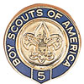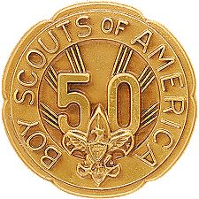
The Veteran Award is an adult recognition. However, tenure earned as a youth may be included in the total number of years registered.
After 5 years of registered service in the Boy Scouts of America, an adult may, upon application, receive the designation of “Veteran,” provided the person agrees to live up to the Scouting obligations; to keep local Scouting authorities in the community in which residing informed as to availability for service; and further, to be as active in the promotion of the cause of Scouting as circumstances and conditions permit. Service in Scouting organizations other than the Boy Scouts of America does not count toward veteran recognition.
An individual must currently be a registered member of the Boy Scouts of America in order to receive an award.
An adult designated veteran shall pay the regular registration fee if desiring to continue to retain active connection with the movement.
Scouters desiring recognition as 5-, 10-, 15-, 20-, 25-, 30-, 35-, 40-, 45-, 50-, 55-, 60-, 65-, 70-, 75-, or 80-year veterans must have maintained an active registered relationship for the required number of years, paying the annual registration fee. The pin is for civilian wear only.
The records of the national office and local councils shall determine eligibility. The periods of service claimed for veteran recognition need not be continuous.
Application should be made to your local council. I was unable to find a form to apply for the award on National's Website (www.scouting.org) I did find several council's with forms posted but none had a number I could locate on National's site. Some Council sites with forms are:
http://www.gpc-bsa.org/FormsLinks/stuff/VeteranAppl.pdf
http://www.directservicebsa.org/pdf/28-701.pdf
http://www.utahscouts.org/training/adultawards/VeteranApplication.pdf
http://www.hvcbsa.org/advancement/docs/veteran_application.pdf
This is a great way to recognize long serving members of your unit or district. Most people do not know this Award is available.
Next few Months -
Earning your Trained Patch and Service Stars!!
GATHERING ACTIVITIES
Note on Word Searches, Word Games, Mazes and such – In order to make these items fit in the two column format of Baloo’s Bugle they are shrunk to a width of about 3 inches. Your Cubs probably need bigger pictures. You can get these by copying and pasting the picture from the Word version or clipping the picture in the Adobe (.pdf) version and then enlarging to page width. CD
Fourth of July Maze
Baltimore Area Council
Go to the back of Baloo and see a really great Fourth of July Maze that my friend Pat had in the Baltimore Pow Wow Book CD
Respect to Our Flag
Baltimore Area Council
Divide into Dens giving each group paper and pencil. At the start, each will write as many different ways of showing respect to our flag as they can remember. The team with the most correct methods in a given time is the winner. Example: “Never let the flag touch the ground.”
Our Flag (True or False)
Baltimore Area Council
Divide into two or more small teams. Give each team a given time to mark and hand in their paper. You might enjoy making up your own lists:
- T F The Grand Union flag was partly British.
- T F The Betsy Ross flag had 15 stars.
- T F Our flag once had 15 stripes.
- T F June 14 is Flag Day.
- T F We now have one star for each state.
- T F If in uniform, salute the flag when it passes.
- T F If not in uniform, salute just the same.
- T F Stand when “America” is played.
- T F Do not fly the flag after sunset.
- T F The flag may be used as a table cover.
Presidential Nicknames
Catalina Council
Have the Cubs figure out which President had which nickname. A great to have parents help them complete.
- Long Tom A. Eisenhower
- Silent Cal B. Taylor
- Jemmy C. Cleveland
- Old Hickory D. Pierce
- Old Rough And Ready E. Buchanan
- Handsome Frank F. Jefferson
- Ike G. Madison
- Old Buck H. Jackson
- Grover The Good I. Coolidge
ANSWERS: 1F, 2I, 3G, 4H, 5B, 6D, 7A, 8E, 9C
4th of July Word Search
Baltimore Area Council
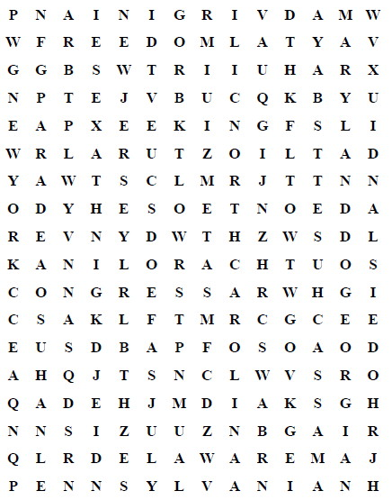
Congress Connecticut Delaware
England Fireworks Flag
Freedom Georgia July
King Liberty Massachusetts Bay
Maryland New Hampshire New Jersey
New York North Carolina Parade
Pennsylvania Rhode Island South Carolina
States Taxes United
Virginia
Pledge of Allegiance Poster
Catalina Council
Provide stickers, images cut from magazines, etc. Have the kids make a poster showing the Pledge of Allegiance with colored paper and stickers. Here is a sample -
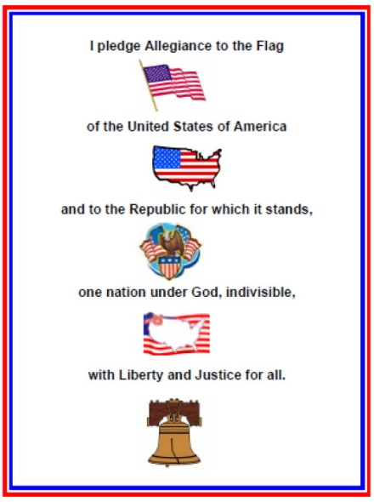
U.S. Symbols Crossword
Catalina Council
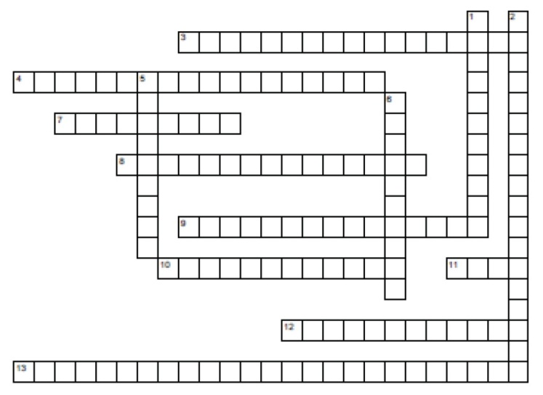
Across
3. Honors the author of the Declaration of Independence.
4. Honors the first President.
7. Seen in the air and on coins.
8. She lifts a torch
9. Honors the author of the Emancipation Proclamation ·
10. The first ten amendments
11. AKA "Old Glory" or "The Star Spangled Banner"
12. "We the people"
13. "We hold these truths to be self evident"
Down
1. Let freedom ring
2. Words to salute the flag
5. A symbol full of symbols
6. Where the President lives
Answers
Across
3. Jefferson Memorial
4. Washington Monument
7. Bald Eagle
8. Statue of Liberty
9. Lincoln Memorial
10. Bill of Rights
11. Flag
12. Constitution
13. Declaration of Independence
Down
1. Liberty Bell
2. The Pledge of Allegiance
5. Great Seal
6. White House
U.S. Symbols Word Search
Catalina Council
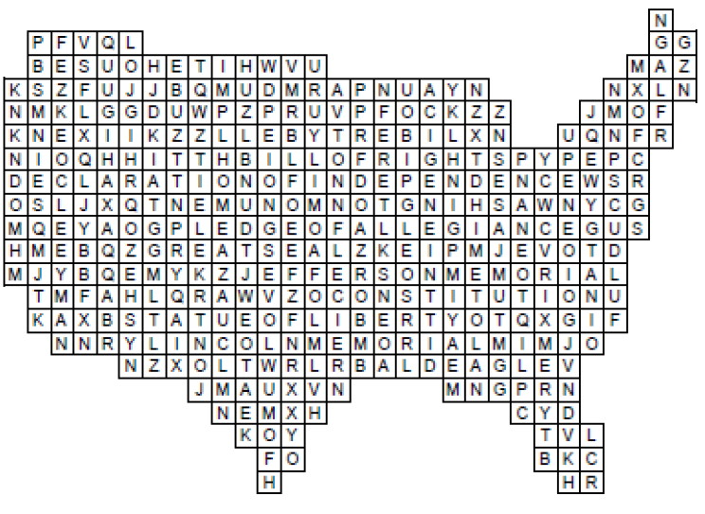
Jefferson Memorial Washington Monument
Bald Eagle Statue of Liberty
Lincoln Memorial Bill of Rights
Flag Constitution
Declaration of Independence Liberty Bell
The Pledge of Allegiance Great Seal
White House
Flag Quiz
Great Salt Lake Council
- The flags of what five countries flew over our country before it became the USA?
- What was the English flag of the 13 colonies called?
- When the colonists decided on a flag of their own, what did they call it?
- How did it differ from the Queen Anne flag?
- What was the name of the flag made after the Declaration of Independence?
- How did the flag differ from the Grand Union flag?
- What was the most strips the American flag had during the War of 1812 and why?
- Why was the flag changed back to 13 stripes?
- When the U.S. flag is folded properly, what part of the flag is showing?
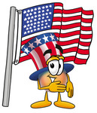
- How many stars and stripes did the flag have when Francis Scott Key wrote “The Star Spangle Banner? “
- When did the U.S. flag get its fiftieth star?
- How is the flag saluted?
- When carried in a parade with other flags, where should the U.S. flag appear?
- Who was the astronaut that placed the U.S. flag on the moon?
- On Memorial Day, the flag is flown at half-mast until noon. True or False?
Answers:
Spain, France, Holland, Sweden, England 2. Queen Anne Flag 3.Grand Union Flag
4. 13 strips of red & white 5. Old Glory 6. The Union blue with 13 stars instead of the crosses of St. George & St. Andrew 7. 15 stripes, 2 more states were added 8. The flag was loosing its shape and beauty 9. The blue field 10. 15 stripes & 15 stars 11. July 4, 1960 12. By uniformed personnel using organization’s hand salute. By person not in uniform, right hand over their heart. If wearing a hat, place over heart 13. In front center of the marching line of flags 14. Neil Armstrong 15. True
CROSSWORD
Great Salt Lake Council
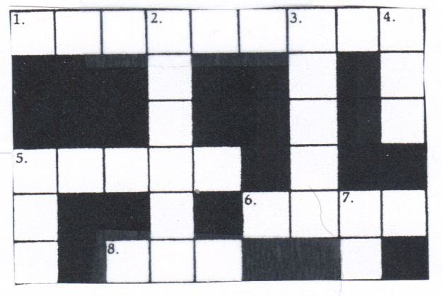
Across
1. The leader of the United States is called
the _________________
5. There are ______states in the United States
6. It is red, white and blue and has 50 star
8. The abbreviation for United States of America
Down
2. The United __________of America
3. “All men are created___________”
4. “I pledge allegiance to ____ flag
5. “….with liberty and justice ____all.”
7. George Washington cut down a cherry tree
with an ______
Presidential Firsts
Catalina Council
- Who was the first and only president to serve more than two terms?
  - Herbert Hoover
  - Franklin Roosevelt
  - Ronald Reagan
  - Dwight Eisenhower
- Who was the first president to occupy the White House?
  - George Washington
  - John Adams
  - Woodrow Wilson
  - Zachary Taylor
- Who was the first president to speak over the radio?
  - Grover Cleveland
  - William Taft
  - Franklin Roosevelt
  - Ulysses Grant
- Who was the first president to be born in a log cabin?
  - Andrew Jackson
  - Dwight Eisenhower
  - Theodor Roosevelt
  - Abraham Lincoln
ANSWERS: 1.B 2.B 3.C 4.B 5.A
Name That State
Catalina Council
Our country is blessed with some of the most wonderful places on earth. Many of them have been saved by becoming National Parks. You have probably heard of most of these places but do you know in which state each is found?? Try your luck!
- BADLANDS
  - Montana
  - Wyoming
  - South Dakota
- MOUNT RUSHMORE
  - Colorado
  - South Dakota
  - Wyoming
- MAMMOTH CAVE
  - Virginia
  - Kentucky
  - Tennesee
- BRYCE CANYON
  - Idaho
  - Utah
  - Arizona
- GLACIER PARK
  - Colorado
  - Nevada
  - Montana
- ZION
  - Nebraska
  - Utah
  - Arizona
- CARLSBAD CAVERN
  - Oklahoma
  - New Mexico
  - Utah
- GRAND CANYON
  - Idaho
  - Wyoming
  - Arizona
- YOSEMITE
  - Utah
  - California
  - New Mexico
- CRATERS OF THE MOON
  - Utah
  - Idaho
  - Minnesota
- MOUNT RANIER
  - Idaho
  - Oregon
  - Washington
Answers - 1c, 2b, 3b, 4b, 5c, 6b, 7b, 8c, 9b, 10b, 11c
Our National Treasures Word Search
Catalina Council
This puzzle contains words and phrases related to our National Treasures. See how many you can find.
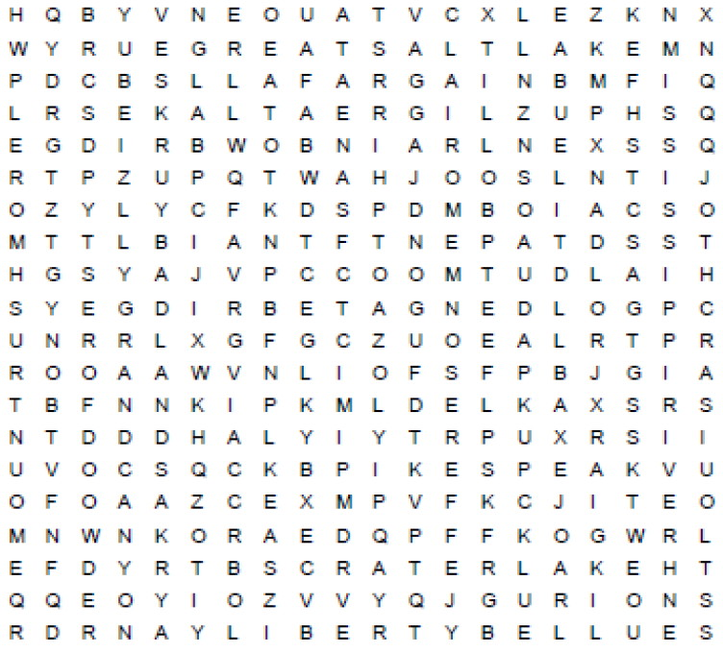
BADLANDS CAPE COD CRATER I.AKE
GOLDEN GATE BRIDGE GRAND CANYON
GREAT LAKES GREAT SALT LAKE
JEFFERSON MEMORIAL LIBERTY BELL
MISSISSIPPI RIVER MOUNT RUSHMORE
NIAGARA FALLS YELLOWSTONE PARK
RAINBOW BRIDGE REDWOOD FOREST
ROCKY MOUNTAINS ST LOUIS ARCH
STATUE OF LIBERTY YOSEMITE FALLS
WASHINGTON MONUMENT PIKES PEAK
America's Symbols Quiz
Catalina Council
- The right hand of the Statue of Liberty holds a torch. What does the left hand hold?
- Which is taller ...the Statue of Liberty or the Washington Monument?
- What words are inscribed on the ribbon held in the mouth of the eagle on the Great
- Seal of the United States?
- In the Great Seal, what is the bald eagle carrying in its talons?
- What denomination of currency has the Great Seat
- printed on it?
- How many people can fit inside the head of the Statue of
- Liberty?
- What is the U.S. motto?
- Francis Scott Key was inspired to write the "Star Spangled Banner" when he saw the flag still flying over what fort?
- Name the four U.S. Presidents carved in the Mount Rushmore Memorial in South Dakota.
- The Declaration of Independence says that all men are created ___________?
Answers:
1. Book
2. The Washington Monument
3. "E pluribus unum" (one out of many)
4. Arrow symbolizing war and
olive branch symbolizing peace.
5. The dollar bill
6. 40
7. In God We Trust
8. Fort McHenry
9. George Washington, Teddy Roosevelt,
Thomas Jefferson, and Abraham Lincoln
10. Equal
OPENING CEREMONIES
Hard Work Flag Ceremony
Baltimore Area Council
Equipment: American Flag
- When we think of our freedoms, , we think of long, hard days worked by the patriots to set us free in the American Revolution.
- These patriots earned our freedoms and built our country with hard work.
- In Cub Scouts we learn about the importance of work and service.
- Patriots, soldiers , veterans, and all workers help maintain our freedoms through their efforts.
- Each year our nation honors those who first earned out freedoms on the Fourth of July. The anniversary of the day the Declaration of Independence was signed.
- Some Americans celebrate the Fourth of July with a picnic or rodeo during the day and fireworks at night.
- Please stand now and repeat the Pledge of Allegiance to the flag in remembrance of the contribution of patriots, veterans, and all workers in our country.
Patriotic Opening
Baltimore Area Council
In this ceremony, four Scouts take part. Room is in complete darkness. Spotlight is on the flag with color guards on one side of the room. Three colored candles red, white and blue are on the table.
- (Lights red candle) The red of my flag is the lifeblood of brave men, ready to die or worthily live, for this, our country.
- (Lights white candle) The white of my flag is for purity, cleanness of purpose, thought, word and deed.
- (Lights blue candle) The blue of my flag is for truth and justice, like the eternal blue of star filled heavens.
- (ALL SALUTE) This is My flag - the flag of America, home of liberty, land of opportunity, where men of all races and creeds live in friendship and peace together. Let us all now Salute it and say the Pledge of Allegiance.
CM: TWO! Lights! Thank Cubs. Lead Cheer, begin meeting agenda
I Am Your Flag
Baltimore Area Council
Set Up:
Flag is already up front on stage
Have a person (adult) positioned off stage, out of sight. Person should be a good speaker. A microphone would be great.
Have a den of Cubs enter and begin to walk by the flag. Flag begins to talk to the Cubs.
Hey Cubs!! Do you know who I am?? (Cubs look bewildered. They figure out it is the flag)
I was born June 14, 1777. I am more than just cloth shaped into a design. I am the refuge of the world’s oppressed people. I am the silent sentinel of Freedom. I am the emblem of the greatest sovereign nation on earth. I am the inspiration for which American patriots gave their lives and fortunes. I have led your sons into battle from Valley Forge to the jungles of Vietnam. I walk in silence with each of your Honored Dead to their final resting place beneath silent white crosses, row upon row. I have flown through peace and war, strife and prosperity, and amidst it all I have been respected.
My red stripes symbolize the blood spilled in defense of this glorious Nation. My white stripes signify the burning tears shed by Americans who lost their sons. My blue field is indicative of God’s heaven, under which I fly. My stars, clustered together, unify 50 states as one, for God and Country. “Old Glory” is my nickname, and proudly I wave on high.
Honor me, respect me, defend me with your lives and fortunes. Never let my enemies tear me down from my lofty position, lest I never return. Keep alight the fires of patriotism: strive earnestly for the spirit of democracy. Worship Eternal God, and keep His Commandments, and I shall remain the bulwark of peace and freedom for all mankind.
"I Am Your Flag," was written by Marine Master Sergeant Percy Webb for a flag booklet distributed in 1933.
God Bless America
Great Salt Lake Council
Arrangements: American Flag posted, after the regular presentation of colors. House lights are dimmed and Flag is spotlighted. Narrator reads the following after the Pledge of Allegiance has been recited.
CM: “God Bless America” is a prayer that is in every heart. While the statesmen of the world are seeking paths to peace, we can ask ourselves, “What is the strength of America? What are the secrets of our nation’s power?”
- An agriculturalist might have you believe America’s strength lies in its soil.
- A merchant would say that a nation’s power rests in its commerce.
- A manufacturer might say that it is in technology, in machinery and in the skilled labor to operate plants to produce manufactured products.
- A politician might contend that a nation’s strength is in national policies.
- An educator might declare that knowledge is a nation’s power and that our country’s greatness is in its learning.
- A scientist would say that a nation’s power is in science, in the products of the laboratory.
- The military man most likely would insist that a nation is great according to its weapons and military strength.
CM: America’s real strength is the character of her people.
- It took character to survive that first winter at Plymouth Rock and that other winter at Valley Forge.
- It took character to pack your things into a rickety wagon and push off into a land of vague promise and specific terror.
- It took character to tell a nation that slavery was wrong; to say that might is not right.
CM: Because character is needed today more than ever before, The Boy Scouts of America organization is concerned about building strong character in boys. We want to guarantee that America is as strong in this space age as it was at its birth.
Please join me in the Pledge of Allegiance
CA/CC: Will everyone please stand and join me in singing “God Bless America.”
I Made A Promise
Great Salt Lake Council
Preparation: Five boys are needed for this ceremony. Each should have his part printed on a small card he can conceal in his hand or have the part memorized.
- I made a promise. I said that whatever I did I would do the best I could.
- I made a promise to serve my God and my country the best I could.
- I made a promise to help other people the best I could.
- I made a promise to obey the Law of the Pack the best I could.
- I have done my best, and I will do my best because I am the best. I am a Cub Scout.
DL: Will everyone now join us in repeating the Cub Scout Promise.
That's What It Means to be an American
Catalina Council
Setting: 4 uniformed Cub Scouts, carrying suitable props (such as a megaphone, nightcap, church model, and a star) speak the following lines.
- You can say anything you want to say, whoever you may be. Some things cost a lot of money, but speech is free.
All: That's what it means to be an American.
- You can write anything you want and dare to disagree.
All: That's what it means to be an American.
- You can't be put in prison, unless you've been fairly tried. You can choose your place of worship with your family by your side.
All: That's what it means to be an American.
- You can dream any dream you want to dream, and make it all come true. We live in a land where liberty is meant for you and me.
All: That's what it means to be an American.
CM: Now let us all honor or country by saluting our flag and saying The Pledge of Allegiance.
AUDIENCE PARTICIPATIONS
Service to Country
Catalina Council
Divide audience into five parts. Assign each part a word and a response. Instruct them they are to say the response whenever they hear the word. Practice as you make assignments. Then read the story. After each of the words is read, pause for the group to make the appropriate response.
ARMY - Be all you can be!
AIR FORCE - No one comes close!
NAVY - Can do!
MARINES - Semper Fi!
COAST GUARD - Always ready!
CUB SCOUTS (Everyone) - Do Your Best!
In the United States of America, we have several different branches of the military, all prepared to defend our freedom. There is the ARMY, the NAVY, the AIR FORCE, the MARINES, and the COAST GUARD.
All these different groups have mottos and slogans, just like CUB SCOUTS. Part of the CUB SCOUTS Promise includes duty to God and country, and certainly, all the men and women who serve in the ARMY, the NAVY, the AIR FORCE, the MARINES, and the COAST GUARD demonstrate their duty to God and country in a big way.
As CUB SCOUTS, we take pride in being good citizens, in honoring our flag, and in helping others. One day, some of you may choose to join the ARMY, the
NAVY, the AIR FORCE, the MARINES, or the COAST GUARD. But, for now, we give thanks and appreciation for those who help protect and defend our country, while we learn to be the best we can be as CUB SCOUTS.
Scouting Across America
Catalina Council
Divide audience into seven parts. Assign each part a word and a response. Instruct them they are to say the response whenever they hear the word. Practice as you make assignments. Then read the story. After each of the words is read, pause for the group to make the appropriate response.
CHICAGO: “The windy city”
TEXAS: “Howdy, y’all”
INDIANAPOLIS: “Vrroooommm!”
HAWAII: “Aloha”
COLORADO: “Climb the Rockies!”
ALASKA: “Brrrr”
CALIFORNIA: “The Golden State”
CUB SCOUT(S): (ALL) “Do your best”
With the limited hits (only two per word in the story), I would do this with a "cheerleader" for each word. Give each one a sign with the response and have him/her get everyone to yell when the word is called. CD
Boy Scouting was brought to America in 1909 by a CHICAGO businessman. CUB SCOUTS started in 1930, and the program quickly spread throughout the states. You can picture the boys in TEXAS being helpful to their neighbors. Imagine HAWAIIAN CUB SCOUTS having a spectacular regatta or the CUB SCOUTS in INDIANAPOLIS having super speedy Pinewood derby cars.
In COLORADO, the hiking is fantastic, and in ALASKA, skiing belt loops abound. The Blue & Gold of CUB SCOUTS is seen in CALIFORNIA'S blue skies and historic gold strike. All across our great nation, from CHICAGO to COLORADO, INDIANAPOLIS to ALASKA, and TEXAS to CALIFORNIA and HAWAII, CUB SCOUTS are all doing the same things:
Learning new skills, doing good deeds, and having FUN!
Joey’s First Parade (St. Louis Area Council)
Catalina Council
Divide audience into five parts. Assign each part a word and a response. Instruct them they are to say the response whenever they hear the word. Practice as you make assignments. Then read the story. After each of the words is read, pause for the group to make the appropriate response.
MARCH - Stomp, stomp, stomp your feet!
CLOWN - Laugh out loud!
PARADE - Hooray!
DOG - Argh, Argh!
LEGS - Sooo Tall!
Joey awoke and looked at the calendar. Yep, today was the Fourth of July and Joey was excited. Today, he would MARCH in his very first PARADE. There would be floats and bands to celebrate America's Independence Day. As Joey arrived downtown, he could see everyone lining up for the PARADE. He finally found his group and the Cubmaster.
The Cubmaster said, "Hi Joey! Are you excited and ready to MARCH in the PARADE?" "I sure am!" said Joey. Suddenly Joey hears a loud whistle and the PARADE was on its way. Joey stood as tall as he could, proud to be a Cub Scout. There were so many people along the streets as they MARCHED.
Up ahead of him he could hear the laughter of people and he longed to know what was so funny. Joey moved toward the front of his group and stretched to see. Then without warning there was in front of him, two LEGS. That's all he saw, was two LEGS. The crowd was laughing and they became louder as Joey followed the LEGS up into the air. High up on the tallest LEGS he had ever seen was a CLOWN. Wow! The CLOWN leaned over and patted Joey on the head. What a terrific trick and what long LEGS! The CLOWN was holding onto the smallest DOG he had eve r seen barking up at him. That's what is so funny and Joey began to laugh. The tallest CLOWN in the world was taking the smallest DOG in the world for a walk in the PARADE! As he ran to join his group, Joey watched the CLOWN and DOG to the end of the PARADE.
That night Joey's dad tucked him into bed. Dad asked how his day had been. Did he have a great time in the PARADE?
"Oh, it was great, Dad!" Joey said "and I know exactly what I want to be when I grow up." "Really, what is that Joey?" Dad asked.
"I want to be a CLOWN" Joey exclaimed.
"Goodnight Dad."
Dad chuckled as he turned off the lights. "Goodnight Joey".

LEADER RECOGNITION
Because The Scout
Sam Houston Area Council
Because our Cub Scouts have a need,
we have an obligation.
Because our Cub Scouts have a choice,
we must be his better choice.
Because our Cub Scouts have high expectations,
we must excel.
Because our Cub Scouts want to explore,
we must be his guide.
Because our Cub Scouts want to belong,
we must provide inclusion.
Because our Cub Scouts are searching for direction,
we must be his compass.
Because our Cub Scouts encounter times of turmoil,
we must be his safe haven.
Because our Cub Scouts are tomorrow's young men,
we must care today.
Because of our Cub Scouts…
We exist.
Materials –
- Compass – made into a neckerchief slide, OR a usable one, OR a small pretend one mounted on some type of display material.
- Write underneath – thanks for guiding our path OR thanks for leading the way.
Cubmaster – There have been some leaders this year who went out of their way to make sure we had a great program for our Cubs. They really provided real direction to our pack, and I would like to thank them. (Call forward appropriate adults/leaders and present them with the compass.)

ADVANCEMENT CEREMONIES
Fireworks
Baltimore Area Council
CM: When we think of the 4th of July, our first thoughts are of fireworks, picnics and having fun. We tend to forget the real reason for this holiday. AI1 of the fun things we do are in celebration of our American independence and freedoms. We might think of the fireworks we all enjoy as representing the battles Americans fought 200 years ago… battles that won the freedoms we all enjoy today.
In Cub Scouts, each boy must fight his own battles to accomplish the achievements required to earn ever higher ranks. Let’s use fireworks to represent these battles.
The sparkler represents the new Bobcat... a boy eager to join the Cub Scout pack. He has a fiery enthusiasm as he begins his battle for the Wolf rank. Will the following boys and their parents please come forward and prove their readiness to join pack ____? (Lead Cheer)
The firecracker represents a boy who has fought and conquered the 5 achievements required for the rank of Tiger. He, with the help of his adult partner, has fought well. Will the following boys and their parents please come forward and receive the Tiger badge? (Lead Cheer)
The bottle rocket represents a boy who has begun to take off and completed the 12 achievements required for the rank of Wolf Cub. He, with the help of his den leader and parents, has begun to soar. Will the following boys and their parents please come forward and receive the Wolf badge? (Lead Cheer)
As a boy gains in years and experience, he uses the things he has learned to help in fighting increasingly difficult battles. Such is the case with the Cub Scout who has fought his way to the Bear Cub rank. We represent him with the aerial bomb. He has reached new heights of learning, ending in an explosion of new abilities. Will these boys and their parents please come forward? (Lead Cheer)
The brilliance and color of the roman candle is representative of the boy who is ready to receive his Webelos award. He is now mature enough to begin the battles for the remainder of his 2.0 activity pins and to work towards the greatest victory in Cub Scouting - the Arrow of Light. Will the following boys and their parents please come forward? (Lead Cheer)
And now, the skyrocket, representing the Webelos Scout who has fought his way to the top. He has soared to the highest point in Cub Scouting . . . the Arrow of Light. Victory is his. He is now prepared to approach the adventures of Boy Scouts. (Lead Cheer)
All of our Cub Scouts are continuously fighting their biggest battle - learning to live with themselves. Victory is theirs when they follow our motto . . . Do your best. (Lead Blastoff Cheer ending with skyrocket OOoohh - AAaahh)
Freedom Symbols of Our Country
Catalina Council
In our American history, we are fortunate to have many freedom symbols which have special meaning to American citizens. Tonight I would like to tell you a little about one of these symbols as we honor those boys who are advancing along the Cub Scouting trail.
The Statue of Liberty stands 305 feet high in New York Harbor, welcoming people of other lands to become citizens of our democracy. The statue was given to the United States by France as a token of friendship. Each year hundreds of tourists go to see Miss Liberty. The inscription at the base of this statue was written by Emma Lazarus, and reads in part: "Give me your tired, your poor, your huddled masses yearning to breathe free; the wretched refuse of your teeming shores; send these, the homeless, tempest tossed to me. I lift my lamp beside the golden door".
There is a golden door to Scouting which is open to all boys. By walking through that door to Scouting, boy has an opportunity to grow in many ways and learn about citizenship, character and physical fitness. The boys who wish to walk through that door to Scouting tonight are (read names). Will you and your parents please come forward. (Continue with regular Bobcat induction Lead cheer at end).
Our American flag is much more than the red, white and blue cloth of which it is made. It is the symbol of America. It stands for the past, the present and the future of our country. When we show respect for the flag, we are showing respect for all that is America, our land, our people, our way of life. When the 13 original colonies set out to become a free country nearly 200 years ago, their men and women needed a rallying point - a flag. "We will take the stars and blue union from heaven", the great George Washington is reported to have said, "red from our mother country, separating it by white stripes thus showing that we have separated from her, and the white stripes shall go down to posterity representing liberty". Learning the Pledge of Allegiance to the Flag and showing your pride in AMerica is one of the requirements for a boy to earn the Tiger rank. Tonight we have some boys who have completed all 5 achievements for their Tiger Badge. (Call boys and parents forward and present badges and cards to parents to present to Tigers. Lead Cheer.)
The Declaration of Independence is one of many documents which established freedom in America. It was on July 4, 1776, that the Continental Congress met in Philadelphia and announced the separation of the 13 colonies from England. In America, we have a government of the people, by the people and for the people. Not for just some of them, but for all people...the people to whom the Declaration of Independence refers when it says "all men are created equal", not equally talented or equally rich, but equal under law, and under God. All Scouts have an equal opportunity to advance in rank and earn badges. OurWolfs are beginning to work alittle more independently and to demonstrate their "Duty to God." The following boys have completed all 12 Achievements and earned their Wolf Badge. Some have completed enough Electives to earn Arrow Points to wear under the Wolf badge. (Call boys and parents forward and present badges and cards to parents to present to Wolfs. Lead Cheer.)
One of the most beloved of our freedom symbols is the Liberty Bell. The Liberty Bell was rung in 1776 calling the people of Philadelphia to the signing of the Declaration of Independence. During the British occupation of Philadelphia, the bell was hidden beneath the floor of the Zion Reformed Church in Allentown, Pennsylvania. Sixty years later, as the bell was tolled for the death of Chief Justice John Marshall, it cracked. Since that time it has been on display in or near Independence Hall, Philadelphia, for all Americans to see. The bell is old, but the crack is plain to see, along with this inscription: "Proclaim liberty thought the land". A study of our American Heritage is one of the twelve requirements for a boy to earn the Bear badge. The following boys will receive that badge tonight. (Call boys and parents forward and present badges and cards to parents to present to Bears. Lead Cheer.)
The Pioneer Trail
Baltimore Area Council
Prop: A wall sized map of the United States (or facsimile)
CUBMASTER: The pioneers who traveled west across the great United States had many obstacles and tasks to take care of on their trek. One, of the starting points for the Oregon Trail was Independence, MO. ) http://www.isu.edu/~trinmich/independence.html) Much as our Bobcat award, is the first stop on the Cub Scout Trail. Will the following boys and their parents please come forward.
(Present awards to parents to present to Cubs, Lead Cheer)
Heading west, the travelers came to Chimney Rock in Nebraska (http://www.isu.edu/~trinmich/Chimney.html). The next for Cub Scouts is the Tiger Badge. To earn it, a Tiger must complete 5 achievements. He learns to work with his den leader and adult partner to do the Family activity, the Den activity and the go-see-it for each achievement, just as the pioneers learned to work together to begin their journey. Will the following boys and their parents please come forward?
(Present awards to parents to present to Cubs, Lead Cheer)
Moving westward they came to Fort Laramie, Wyoming. (http://www.isu.edu/~trinmich/FtLaramie.htm) Next for Cub Scouts is the Wolf rank achievement which is met by completing 12 requirements. It requires parent help to keep the boys on the trail; just as the pioneers banded together and helped each other stay on the route west. Will the following boys and their parents please come forward.
(Present awards to parents to present to Cubs, Lead Cheer)
Further west was Council Bluffs, Idaho (http://www.isu.edu/~trinmich/00.n.council.html) Many more challenges were met on the road to here, just as there are harder challenges on the trail to the Bear rank. We have several boys who have met these challenges. Will the following boys and their parents please join me?
(Present awards to parents to present to Cubs, Lead Cheer)
As they neared the end of the journey they came to Whitman Mission in the state of Washington. (http://www.isu.edu/~trinmich/Whitman.html) Now they were over the Rockies and experiencing different challenges, just as the Cubs begin to work on Activity Awards rather than achievements to earn their Webelos Badge. We have several boys who have met these challenges. Will the following boys and their parents please join me?
(Present awards to parents to present to Cubs, Lead Cheer)
The end of the trail was Oregon City, Oregon (http://www.isu.edu/~trinmich/Oregoncity.html) The final rank of Cub Scouting is the Arrow of Light. This is the only Cub Scout rank that transfers to your Boy Scout Uniform. Just as the pioneers spent many days on the trail, many, many days of effort have been put forth to reach this goal. We have some boys tonight who have reached this highest Cub Scout award. Let us honor them tonight. Will the following boys and their parents please come forward?
(Present awards to parents to present to Cubs, Lead Cheer)
One final cheer for all!
Stars and Stripes
Catalina Council
Equipment: A ceremony board resembling the American flag with a large blue field for stars. A gold star with the name and awards of each recipient is attached to the board in the field.
Cubmaster: Several of the Cubs here tonight have been "shining" examples of Cub Scout citizens. They have done their part to help the Pack go by completing advancement requirements and earning awards this month. Each of them is represented by a gold star on our special flag and we honor them tonight. (Call forward each recipient with his parents and present badges to parents to give their sons.)
Lead a Cheer after each award (or group of awards)
Freedom Symbols Advancement
Great Salt Lake Council
Props- costumes for Uncle Sam, Yankee Doodle and Lady Liberty (or if you get creative, add more symbols and separate out the presentations even more. CD)
Cub Master: “Ladies and Gentleman, we have some honored guests here tonight. I would like to introduce Uncle Sam, Yankee Doodle, and Lady Liberty. Each of these individuals are an important symbol to us in the U S A. Tonight they are here to present some other symbols to some deserving young men. These symbols represent hard work, diligence, and jobs well done.”
Yankee Doodle: “We have some Cub Scouts who have earned some special awards. Would the following Cub Scouts and parents please come forward?” (First call the names of those receiving Bobcat badges. Then after that presentation is complete, call those receiving Tiger badges.) Have CM or CA lead cheer for each group.
Lady Liberty: “I would like to call forward those Cub Scouts who have been working for some time and have achieved much. I would like to present them with their awards. Would the following Cub Scouts and parents please come forward?” (First call the names of those receiving Wolf badges. Then after that presentation is complete, call those receiving Bear badges.) Have CM or CA lead cheer for each group.
Uncle Sam: “I would like to recognize some of the older boys in this group. You have given unselfishly of yourself and for your loyal support over the years. I would like to present you with your awards.” Would the following Cub Scouts and parents please come forward?” (Call the names of those receiving Webelos badges, activity badges, or compass points and their parents.) Have CM or CA lead cheer for each group.
Cub Master: “I would like to thank our three guests for coming to help us tonight. And a special thanks to all the boys who have worked so hard to be examples and role models of good American citizens!”
Uncle Sam Calls on You - Advancement
Baltimore Area Council
Equipment: Uncle Sam costume. (Hat, mustache and name tag should be sufficient.)
Cubmaster: Ladies and gentlemen, tonight, it gives me great pleasure to acknowledge the efforts of some of our youngest Americans. (In a booming voice) Uncle Sam wants YOU (point index finger at the audience and call the scout's name(s)) to come forward and receive your Bobcat badges. Uncle Sam wants your parents to come forward too.
Cubmaster: Boys, please show that you are ready to become Bobcats by joining me in the Cub Scout Promise. (Lead in the Promise). Fine. I am proud of your efforts and pleased to present your Bobcat badges. (Cubmaster present badges to the parents to pin on son's shirt) Lead Cheer
Cubmaster: And now Uncle Sam wants YOU (point index finger at the audience) and call scout's name(s) to come forward with your parents. I am very glad that you have completed the 5 achievements to earn your Tiger badge(s). I know your parents have helped a lot, So I will give them the honor of pinning on your new badge. (Present badges to parents). Lead Cheer
(Continue in same fashion for Wolf badges, Arrow Points, Bear badges, Arrow Points, Activity Awards, and Webelos badges.) Lead Cheers after each step.
Cubmaster: (After all awards are presented) All of you Cub Scouts do your country great honor by your dedication to the Cub Scout Promise and the Law of the Pack. And now, I want YOU - all of YOU- to enjoy the rest of the meeting. Lead one final Cheer
SONGS
Grand Old Flag
Catalina Council
Music and lyrics by George M. Cohan
You’re a grand old flag,
You're a high flying flag
And forever in peace may you wave
You’re the emblem of The land I love,
The home of the free and the brave.
Every heart beats true
Under the red white and blue,
Where there’s never a boast or a brag
But should auld acquaintance be forgot,
Keep your eye on the grand old flag!
This Land Is Your Land
by Woody Guthrie
Baltimore Area Council
Chorus:
This land is your land,
This land is my land,
From California,
To the New York Island,
From the Red Wood Forest,
To the Gulf Stream waters,
This land was made for you and me.
As I went walking that ribbon of highway,
I saw above me that endless skyway,
I saw below me that golden valley,
This land was made for you and me.
I roamed and rambled,
and I followed my footsteps,
To the sparkling sands of her diamond desert,
All around me a voice was sounding,
This land was made for you and me.
When the sun came shining,
then I was strolling,
And the wheat fields waving,
and the dust clouds rolling,
A voice was chanting as the fog was lifting,
This land was made for you and me.
One of Woody Guthrie's best. And Arlo sings it every time at his concerts!! He is trying to convince his kids that since he sings his Daddy's songs, they should sing his (Alice's Restaurant) and get him out of the "Groundhog Day" scenario of singing all 17 minutes (or more) of "Alice's Restaurant" every day).
(I know, TMI (Too Much Information) CD
This Old Flag
Catalina Council
(Tune: This Old House)
This old flag is my protection;
This old flag is my birthright.
This old flag is full of beauty
May it fly both day and night.
It’s an honor to salute it,
And, with pride, we hold it high.
We will keep it flying o’er us,
Like a symbol in the sky.
Ain’t gonna allow no one to tramp it,
Ain’t gonna allow no one to ‘buse it,
Ain’t gonna allow no one to shun it,
Ain’t gonna allow no one to use it,
Ain’t gonna allow no one to down it
For some other flag to use.
Going to keep that old flag flying,
And we dare you to refuse.
This Is My Country
Baltimore Area Council
This is my country!
Land of my birth.
This is my country!
Grandest on earth.
I pledge thee my allegiance,
America the bold
For this is my country
To have and to hold.
You are my Homeland
Catalina Council
(Tune: You are My Sunshine)
You are my homeland,
You are a great land.
You make me happy,
You make me free.
Your flag I’ll honor,
And pledge allegiance.
The U-S-A is good to me.
If You Love This Land Of Ours
Catalina Council
(Tune: If Your Happy and You Know it Clap Your Hands)
If you love this land of ours,
Clap your hands (do motions)
From sea to shining sea,
Clap your hands
If you love it’s rocks and rills
And its woods and purple hills
If you love this land of ours,
Clap your hands
I’m Proud to Be An American
Catalina Council
(Tune: My Bonnie Lies Over the Ocean)
America lies ‘tween two Oceans
It’s such a great place to see
America is a grand nation
That’s why I’m proud to be....
Chorus:
Ame-ri-can Ame-ri-can,
I’m proud to be an Amer-ican
Ame-ri-can, Ame-ri-can,
I’m proud to be American.
America has fifty sta-tes
As different as any could be
And though we’re unique and different
We’ve strength in our di-versity
(Chorus)
America stands as a banner
Round the world of what is just
And why is clear in our motto
It’s because In God We Trust.
(Chorus)
The USA Forever
Catalina Council
(Tune: Dixie)
Come all who live in the USA,
Join in our song and sing today,
Work away, work away,
For the land of the free.
United, firm with every state,
To make a nation good and great,
Work away, work away
For the land of the free.
CHORUS
The USA forever, Hooray, Hooray!
The stars and stripes shall wave above
The USA forever.
Hooray, hooray, the USA forever.
Hooray, hurry, the stars and stripes forever!
The North and South, the East and West,
We love them all, for all are best,
Work away, work away,
For the land of the free.
United States and hearts and hands,
Will make the greatest of all the lands.
Work away, work away,
For the land of the free.
CHORUS
Hurrah For The Flag
Catalina Council
(Tune: Stars and Stripes Forever)
Hurrah for the flag of the free,
May it wave as our standard forever,
The gem of the land and the sea,
The banner of the right.
Let despots remember the day
When our fathers with mighty endeavor,
Proclaimed as they marched to the fray,
That by their might,
More "Celebrate Freedom" songs
from the Cub Scout Song Book:
Catalina Council
- America
- The Star Spangled Banner
- God Bless America
- America, the Beautiful
- Battle Hymn of the Republic
- Make America Proud of You
- This Land is Your Land
Celebrate July
Baltimore Area Council
Tune: Little Tommy Tinker
Lets plan a picnic now,
To celebrate July,
With lots of good hotdogs
Yum, Yum!
There’s plenty to go around.

The Scout Law
Baltimore Area Council
Tune - Yankee Doodle
TRUSTY Tommy was a Scout,
LOYAL to his mother,
HELPFUL to the folks about, and
FRIENDLY to his brother,
COURTEOUS to a girl he knew,
KIND to his rabbit,
OBEDIENT to his father, and
CHEERFUL in his habits,
THRIFTY saving for a need,
BRAVE and not a faker,
CLEAN in thought and word and deed, and
REVERENT to his maker.
America’s for You and Me
Baltimore Area Council
Tune: Clementine
Once a year, we have a party
A celebration for the states.
In honor of our country’s freedom
And lady Liberty in bay.
We shoot fireworks, sing “Happy Birthday”
Celebrate the whole night long.
For we’re proud to be Americans.
Yes, America’s for you and me.
I Love America
Baltimore Area Council
Tune: Battle Hymn of the Republic
I love this great America,
The land that God has blessed,
Where the hope that stirs the hearts of men
will never be suppressed.
Through the flame of faith came forth a
nation choice above the rest,
This great America!
Chorus:
Glory to the land of freedom,
Glory to the land of freedom,
Glory to the land of freedom,
I love America.
I love this great America, the land of liberty.
For I know the price of freedom countless others paid for me
Do we hear their call to carry on and serve as valiantly?
This great America!
STUNTS AND APPLAUSES
APPLAUSES & CHEERS
Catalina Council
ABC Cheer - Divide the audience into three groups. They each say, “America,” “Beautiful,” and “Country.” Point to different groups. Vary speed.
USA-BSA Cheer Two groups.
One group yells, “USA!”
The other group yells, “BSA!”
Repeat three times.
Then both groups yell together, “That’s us!”
George Washington
“That was great! I cannot tell a lie!”
Abe Lincoln
“That was great--honestly!”
USA Cheer
Shout "USA" and thrust right hand with doubled fist skyward, then shout "Hooray, onward and upward."
America Cheer
Spell A-M-E-R-I-C-A three times
the Cub Scouts, Cub Scouts U.S.A.
Liberty Bell Cheer #1
Ding! Dong! Let freedom ring!
Liberty Bell Cheer #2
Divide group into two parts – the Dings and the Dongs. Alternate yelling (3X or more)–
Ding – Dong – Ding – Dong – Ding – Dong
Then all yell - Let freedom ring!
Liberty Bell Cheer #3
Ding, Ding, Ding, Dong!
Eagle
Lock thumbs,
Flutter fingers like wings,
Shout "Cree, cree!"
Politician Applause
Pat yourself on the back.
Mount Rushmore
Shout Washington, Jefferson, Lincoln, Roosevelt!
Constitution (Shout)
“We the people, APPROVE!”
Paul Revere
Pretend to be riding a horse
While moving up and down say
”The British are coming! The British are coming!”
RUN-ONS
Catalina Council
Cub 1: Where was the Declaration of Independence signed?
Cub 2: At the bottom.
Cub 1: Can you name the capital of every state?
Cub 2: Sure. Washington D.C.
Sergeant: Why didn’t you stop when I yelled, “Company, halt”?
Recruit: Well, I’ve been here for 6 weeks, and I didn’t think I was company anymore.
Cub #1: I’d like to speak to the general.
Cub #2: I’m sorry, but the general is sick today.
Cub #1: What made him sick?
Cub #2: Oh, things in general.
JOKES & RIDDLES
Baltimore Area Council
Q - What did Delaware when Mississippi lent Missouri her New Jersey?
A - I don’t know. Alaska.
Q - What did Paul Revere say at the end of his famous ride?
A - Whoa.
Dink: Do you know what time it is?
Duff: Nome, I don’t.
Dink: Alaska ‘nother person.
Q - What did Tennessee?
A - Whatever Arkansas. (Arkan saw.)
Q - Which three states have the most ducks?
A - North Duckota, South Duckota, and Kenducky.
Q - Where do they grow the green vegetable that is put in gumbo?
A - Okrahoma.
Q - What did Delaware?
A - Her New Jersey. (new jersey)
Q - Where does Maryland?
A - I don’t know. Alaska. (I’ll ask her.)
SKITS
How Did You Get Here?
Baltimore Area Council
Personnel: Chief, 4 or more Cubs (any number of Cubs can participate by dividing the lines accordingly.)
Equipment: As indicated in skit.
Setting: The Den Chief introduces this skit by saying "Transportation played a very important part in the settling of America. How did you get here?"
Cub #1: If the Pilgrims came over on the Mayflower, how did the Scouts get here?
Cub #2: I don't know, how?
Cub #1: On handy crafts. (As he says this, a Cub comes on stage with a sample of a handicraft project and a sign identifying it.)
Cub #3: If the Pilgrims came on the Mayflower and the Scouts came on handy crafts, how did the doctors get here?
Cub #4: I don't know, how?
Cub #3: On blood vessels. (Cub dressed as a doctor enters.)
Cub #1: How did the students get here?
Cub #2: On scholar ships. (Cub enters carrying a load of books.)
Cub #1: How did all the ordinary people get here?
Cub #4: On citizen ships. (Cub enters carrying a poster that says "Don't forget to vote".)
Cub #1: I know how the barbers got here.
Cub #2: How?
Cub #1: On clipper ships. (Cub enters dressed as a barber with a towel, razor, etc.)
Cub #3: How did all the movie stars get here?
Cub #4: On a show boat. (Cub enters dressed well, wearing sun glasses.)
Cub #2: I'll bet you can guess how all the hot heads got here. (Cub runs on stage, shaking his fist and pretending to quarrel with everyone.)
All: On steam ships, of course.
(They bow as curtain closes.)
Fireworks Skit
Alice, CS RT Commissioner
Pioneer District, Golden Empire Council
A Cub Scout stands looking up into the sky..
Cub #1: “Oooh, Ahhhh!”
Cub #2: (Walks up to Cub #1, follows his lead and looks up) “What are you looking at?”
Cub #1: “Fireworks! Want to watch with me?”
Cub #2: “Yeah!”
Cub #1 and #2: “Oooooh, Ahhhh!”
Cub #3: (Walks up to Cub #1 and #2, looks up) “What are you looking at!”
Cub #2 “Fireworks! Want to watch with me?”
Cub#3: “Yeah!”
Cubs #1, #2, #3: “Ooooh, Ahhhh!”
Cub #4: (Walks up to Cub #1, #2, #3, and looks up) “What are you looking at?”
Cub #3: “Fireworks! Want to watch with me?”
Cub #4: “Yeah!”
(Repeat till only one Cub remains)
Last Cub: (Walks up to group) “What are you all looking at?”
All: “Fireworks!”
Last Cub: “Those aren’t fireworks – they’re fireflies!”
Cub #1 “Oh - I just thought the fireworks were really far away!” (Walks off)
Constitution Skit
Catalina Council
Scene: Philadelphia, 1787
Characters: Narrator, 4 Cub Scouts in colonial dress, some extra Scouts.
Narrator: "While it's true that our constitution was written by truly great men, it still took 11 years to finish. Let’s look in on some of these men as they go about their work. Here comes Ben Franklin and Samuel Adams."
Sam: "Let's have pizza tonight."
Ben: "I don't like pizza. How about tacos?"
Sam: "But I don't like tacos. Let's have hamburgers."
Ben: "We always have burgers."
(The two walk off stage still arguing.)
Narrator: (flustered) "Simply a difference of opinion, ladies and gentlemen. Don't worry, they'll work it out. Look there's Thomas Jefferson and John Adams."
John: "I tell you the Yankees are the best!"
Tom: "No way, it's gonna be the Braves this year."
Narrator: "Wait a minute you two, are you talking about baseball."
Tom and John: "Yes!"
Narrator: "Baseball hasn't been invented yet!"
John and Tom: "OH!" and then walk off arguing about football.
Narrator: "I don't know what's going on here. Wait, they're gathered together! Now what are they arguing about?"
(The four Scouts plus the extras
are gathered around a table.....)
Tom: "At least we agree on something...The Constitution of the United States!"
Old Glory
Baltimore Area Council
Setting: Cubs form a semi-circle around a large pot. An American flag is folded and hidden down in the pot. Each Cub is holding the ingredients which he adds.
Personnel: 6 Cubs, Den Chief (DC) or Den Leader (DL)
- We are going to fix for you,
A treat that is really grand.
And make for you a recipe,
The greatest in the land.
- First, we'll put in a heaping cup of red for courage true. (Throws in red paper confetti.)
- And then we will add for loyalty, a dash of heavenly blue.
(Throws in blue paper confetti.)
- For purity, we will now sift in a layer of snowy white. (Throws in white paper confetti.)
- We will sprinkle in a pinch of stars, to make it come out right. (Adds glitter.)
- (Using a large spoon to stir pot.) We will stir and stir and then you will see that what we have made is...
(Two boys reach in and pull out the flag, holding it high.)
All Cubs: Old Glory! (loud and clear)
Our flag is the most beautiful flag in the world. Let us always be loyal to it.
This could easily be adapted to an opening by
having someone lead the Pledge of Allegiance
after the Cubs last statement. CD
CLOSING CEREMONIES
Meaning of Our Flag
Catalina Council
Materials:
1 piece of construction paper in red, blue and white
1 piece of white paper cut to be a star
1 flag
5 scouts
Each Scout uses one of the items above. Write the words each should say on the back of their items.
Leader: Today, as we leave, let's all keep in mind our flag and the meaning therein we can find.
- The red is for blood of Americans true,
who gladly would give up their lives for you.
- The white is for purity, in both thought and deed,
a rule of conduct we all might well heed.
- The blue is for justice, for all, not one,
a tenet we fought for and so dearly won.
- The Star is a symbol of God's guiding hand,
over the union and this mighty land.
- There isn't a one our flag won't protect;
don't you think we could show it greater respect?
Patriotic Closing
Baltimore Area Council
Arrangements:
Three Cubs and the Cubmaster (CM)
Three flashlights with colored tissue paper (one thickness) banded over the lens.
Red colored tissue on #1
Blue colored tissue on #2
White tissue on #3
The American Flag.
Three Cubs.
- (Turn Light on) The red of my flag is the 1ifeblood of brave men ready to die or worthily live for this, our country.
- (Turn Light on) The white of my flag is for purity; cleanliness of purpose, thought, word and deed.
- (Turn Light on) The blue of my flag is for truth and justice, like the eternal blue of the star-filled heavens.
- My flag... the flag of America... home of liberty, land of opportunity, where men and women of all races and creeds live together in peace and friendship.
CM: As we journey homeward today, let us remember that each of us represent the freedom of America; it’s one-ness is unique in the entire world, just as each of us are unique. We are all one family, together. Smile at those around you. Enjoy the freedom to be friendly without someone questioning your motives. Do your best to help other people enjoy this wonderful land of ours.
America The Beautiful
Baltimore Area Council
This evening we have shared our respect for our great country. We have seen some of the glory that is the United States. The most fitting end to our meeting is to sing “America the Beautiful”. In this great song we sing of the glory of our great land, but the last two lines of every verse have an acknowledgement of God who guides us all.
Just to recall the last two lines of the first verse.
“America, America,
God shed his grace on thee.
And crown thy good with brotherhood,
From sea to shining sea.”
Everyone please stand and join me in singing “America the Beautiful.”
Meaning or Our Flag
Great Salt Lake Council
Preparation: 1 piece each of construction paper in red, blue and white and 1 white 5-pointed star. Cub Scouts stand by the Flag as they say their part which can be written on the back of their prop.
DL: Today as we leave, let’s all keep in mind our Flag and the meaning therein we can find.
- The red is for blood of Americans true, who gladly would give up their lives for you.
- The white is for purity in both thought and deed, a rule of conduct we all might well heed
- The blue is for justice for all, not one, a tenet we fought for and so dearly won.
- The star is a symbol of God’s guiding hand, over the union and this mighty land.
- There isn’t a one our Flag won’t protect, don’t you think we could show it greater respect
This Is My Country
Catalina Council
Set Up: Six Cubs up front. Each points to appropriate body part when he names it.
- This is my country. I will use my eyes to see the beauty of this land.
- I will use my ears to hear its sounds.
- I will use my mind to think what I can do to make it more beautiful.
- I will use my hands to care for it.
- I will use my feet to serve it.
- With my heart, I will honor it.

Flag Folding Ceremony

The flag folding ceremony described by the Uniformed Services is a dramatic and uplifting way to honor the flag on special days, like Memorial Day or Veterans Day, and is sometimes used at retirement ceremonies.
Here is a typical sequence of the reading:
(Begin reading as Honor Guard or Flag Detail is coming forward).
The flag folding ceremony represents the same religious principles on which our country was originally founded. The portion of the flag denoting honor is the canton of blue containing the stars representing the states our veterans served in uniform. The canton field of blue dresses from left to right and is inverted when draped as a pall on a casket of a veteran who has served our country in uniform.
In the Armed Forces of the United States, at the ceremony of retreat the flag is lowered, folded in a triangle fold and kept under watch throughout the night as a tribute to our nation's honored dead. The next morning it is brought out and, at the ceremony of reveille, run aloft as a symbol of our belief in the resurrection of the body.
(Wait for the Honor Guard or Flag Detail to unravel and fold the flag into a quarter fold--resume reading when Honor Guard is standing ready.)
- The first fold of our flag is a symbol of life.
- The second fold is a symbol of our belief in the eternal life.
- The third fold is made in honor and remembrance of the veteran departing our ranks who gave a portion of life for the defense of our country to attain a peace throughout the world.
- The fourth fold represents our weaker nature, for as American citizens trusting in God, it is to Him we turn in times of peace as well as in times of war for His divine guidance.
- The fifth fold is a tribute to our country, for in the words of Stephen Decatur, "Our country, in dealing with other countries, may she always be right; but it is still our country, right or wrong."
- The sixth fold is for where our hearts lie. It is with our heart that we pledge allegiance to the flag of the United States of America, and to the republic for which it stands, one nation, under God, indivisible, with liberty and justice for all.
- The seventh fold is a tribute to our Armed Forces, for it is through the Armed Forces that we protect our country and our flag against all her enemies, whether they be found within or without the boundaries of our republic.
- The eighth fold is a tribute to the one who entered in to the valley of the shadow of death, that we might see the light of day, and to honor mother, for whom it flies on mother's day.
- The ninth fold is a tribute to womanhood; for it has been through their faith, love, loyalty and devotion that the character of the men and women who have made this country great have been molded.
- The tenth fold is a tribute to father, for he, too, has given his sons and daughters for the defense of our country since they were first born.
- The eleventh fold, in the eyes of a Hebrew citizen, represents the lower portion of the seal of King David and King Solomon, and glorifies, in their eyes, the God of Abraham, Isaac, and Jacob.
- The twelfth fold, in the eyes of a Christian citizen, represents an emblem of eternity and glorifies, in their eyes, God the Father, the Son, and Holy Ghost.
When the flag is completely folded, the stars are uppermost, reminding us of our national motto, "In God we Trust."
(Wait for the Honor Guard or Flag Detail to inspect the flag--after the inspection, resume reading.)
After the flag is completely folded and tucked in, it takes on the appearance of a cocked hat, ever reminding us of the soldiers who served under General George Washington and the sailors and marines who served under Captain John Paul Jones who were followed by their comrades and shipmates in the Armed Forces of the United States, preserving for us the rights, privileges, and freedoms we enjoy today.
This Flag Folding Ceremony is from the
US Air Force Academy
Our American Heritage
Catalina Council
Setting: Cub Scout (or Den Chief) stands blindfolded, gagged, and bound before the audience. Cubmaster (CM) or Den Leader (DL)leads ceremony.
CM: This is an American boy. The American Revolution won him freedom.
(Cubmaster unbinds him)
CM: The Constitution guarantees him free speech.
(He removes the gag.)
CM: A free education gives him the ability to see and to understand.
(He removes the blindfold.)
CM: Let us help Scouting teach him to preserve and enjoy his glorious heritage and to become a good citizen. Turn off lights, spotlight American Flag, and repeat the Pledge of Allegiance.
Valley Forge Closing
Utah National Parks Council
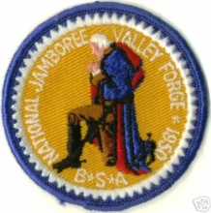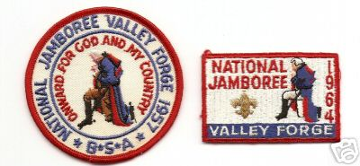
(If a picture of George Washington in Prayer at Valley Forge is available, it would make a great backdrop – the boys could also make a snowy scene with trees as an art project)
- During the raw, hard winter of 1777, George Washington and his raged troops were forced to retire to winter quarters in a valley northeast of Philadelphia, named for a small iron mill, Valley Forge.
- Here no muskets were fired. No bayonet drew blood. No mortal enemy was faced. Still, in this little piece of Pennsylvania the fiercest battle of the Revolution raged.
- It was bitter cold, with icy winds howling and snow covering the ground. Half-starved and ill-clothed, a discouraged army of men huddled around campfires or under inadequate blankets trying to keep warm. Surely each man questioned if enduring all this was worth it.
- General Washington sent this urgent plea to his commanders: “impress on the mind of every man, from the first to the lowest, the importance of the cause and what it is we are contending for.” What was that cause? Why were they fighting? Why were they freezing and starving and dying in a winter army camp?
- They were fighting for freedom! They were fighting for the right to live as they wanted; the right to establish a new way of life - the American way of life; to found a new nation; the right of free speech and religion; the fight of political freedom – freedom from oppressive taxes without representation. These were rights and freedoms they cherished above life itself.
- It was here in Valley Forge, in the face of bitter cold, hunger, hardship and disease that this nation’s will for independence and freedom was, as the name implies, forged and shaped and refined. How grateful we are for this nation and its freedoms. Please rise – and as you salute the flag, remember those men and women who still forge on, to secure our freedoms today. Color guard, retrieve the colors.
(If boys are to read this, make sure they practice ahead of time so they won’t stumble over unfamiliar words. An alternate idea would be to have an adult or adults read the narration, and boys could hold up pictures they have drawn, colored in or that have come from the internet and that fit each narrative. Another idea would be to have the boys act out the narration – while others hold up the quote from Washington, and posters with the rights listed on them)
PS – CD was one of the 55,000 Scouts at the 1964 Jamboree. We saw “Pa” and “Hoss” Cartwright
and heard Lanny Ross sing!!
Cubmaster’s Minutes
Fireworks
Great Salt Lake Council
BOOM!! SIZZLE!! Oooh! Aaah! Don’t you just love a good fireworks display on the Fourth of July? The colors are so beautiful, lighting up the night sky. But did you ever stop to think how boring it would be if all the fireworks were exactly the same? You’d have to sit there in your lawn chair for 20 minutes watching one after the other, every single one being red or yellow or green. You’d be ready to go home in just a little while. What really makes a fireworks show interesting is its variety, when you never know what’s coming next. That’s true for our wonderful United States, too. Americans come in all sizes and shapes and colors. We have different religious beliefs, different family customs, and different ideas about everything. But our differences are good, because they make it possible for us to learn new things from one another. Our differences make us a better people. If everyone were just like us, life would be boring. But when people are different, and when they respect each other’s differences, then life is rich and exciting, just like a good fireworks display.
Freedom
Trapper Trails Council
We shouldn’t take our freedom for granted. Our right of free speech, to worship as we choose, and to enjoy the freedom we have as Americans. Our freedom is often taken for granted. There was a time in our history when man could only hope for these freedoms. And now they have become reality. Our freedom is a result of courage and sacrifice of thousands of our forefathers. Let us remember what is cost these men to provide our freedoms today and help our land free for those citizens of tomorrow.
God Bless America
Catalina Council
Arrangements: American Flag posted, after the regular presentation of colors. House lights are dimmed, and flag is spot lighted. Narrator reads the following after the Pledge of Allegiance has been recited.
Narrator: "God Bless America" is a prayer that is in every heart. While the statesmen of the world are seeking paths to peace, we can ask ourselves, "What is the strength of America"? What are the secrets of our nation's power?
An agriculturalist might have you believe America's strength lies in its soil. A merchant would say that a nation's power rests in its commerce. A manufacturer might say that it is in technology, in machinery and in the skilled labor to operate plants to produce manufacturer's products. A politician might contend that a nation's strength is in national policies. An educator might declare that knowledge is a nation's power and that our country's greatness is in its learning. A scientist would say that a nation's power is in science, in the products of the laboratory. The military man most likely would insist that a nation is great according to its weapons and military strength.
But America's real strength is the character of her people. It took character to survive that first winter at Plymouth Rock and that other winter at Valley Forge. It took character to pack your things into a rickety wagon and push off into a land of vague promise and specific terror. It took character to tell a nation that slavery was wrong, to say that might is not right.
Because character is needed today more than ever before, the Boy Scouts of America is concerned more than ever about building strong character in boys. We want to guarantee that America is as strong in this space age as it was at its birth. Will everyone please stand and join me in singing “God Bless America”?
THEME RELATED STUFF
The United States Flag
Catalina Council
The flag of the United States is one of the oldest national standards in the world.
General George Washington first raised the Continental Army flag in 1776, a red-and-white striped flag with the British Union Jack where we now have stars.
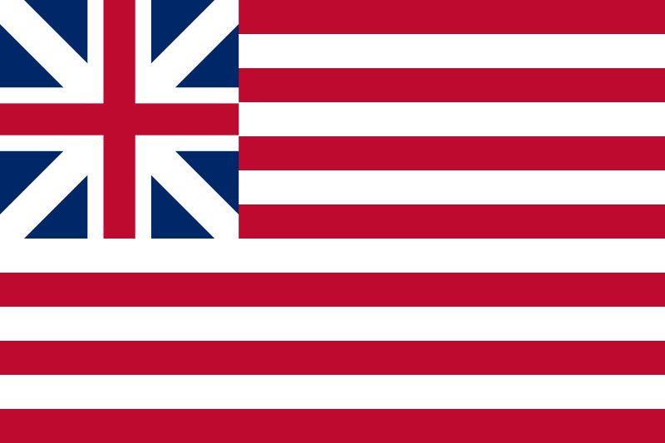
Several flag designs with 13 stripes were used in 1776 and 1777, until Congress established an official design on June 14, 1777 — now observed as Flag Day. The act stated, “That the Flag of the thirteen United States be thirteen stripes, alternate red and white, that the union be thirteen stars, white in a blue field, representing a new constellation.”
Washington explained it this way: “We take the stars from heaven, the red from our mother country, separating it by white stripes, thus showing that we have separated from her, and the white stripes shall go down to posterity representing liberty.”
The First Flag:
Catalina Council
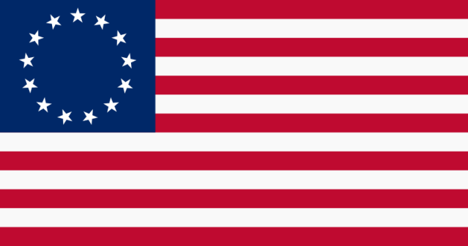
No records confirm who designed the original Stars and Stripes, but historians believe Francis Hopkinson, one of the signers of the Declaration of Independence, probably modified the unofficial Continental flag into the design we now have.
The State Navy Board of Pennsylvania, on May 29, 1777, commissioned Betsy Ross to sew flags for Navy vessels. Legend credits Ross with having sewn the first flag to meet the specifications outlined by Congress, while changing the stars from six points to five to speed her work. (See how to cut a five pointed star in one snip under "Pack and den Activities.")
The flag was first carried in battle at Brandywine, Pa., in September 1777. It first flew over foreign territory in early 1778, at Nassau, Bahama Islands, where Americans captured a fort from the British.
After Vermont and Kentucky became states in the 1790s, Congress approved adding two more stars and two more stripes to the group that represented the original 13 colonies, now states.
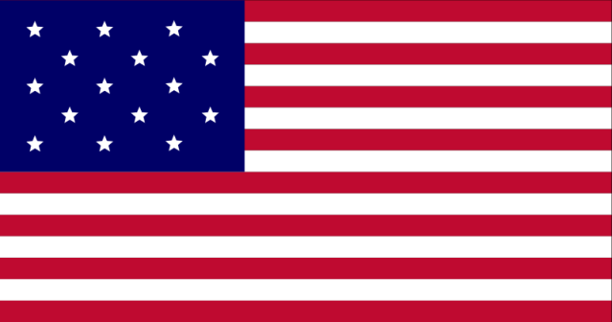
This was the Star Spangled Banner” of which Francis Scott Key wrote in 1814. 1818 Law Sets Final Form
As other states entered the Union, it became obvious that stripes could not be added continually, so in 1818 Congress reestablished the 13-stripe flag for the original 13 colonies and allowed for additional stars for new states.
The law specified that stripes should be horizontal, alternately red and white, and the union, or canton, should display 20 stars for the states then in the union. But it did not specify color shades or arrangement of the stars, and wide variation persisted.
During the Civil War, gold stars were more common than white and the stars sometimes appeared in a circle.
The first time the Stars and Stripes flew in a Flag Day celebration was in Hartford, Conn., 1861, the first summer of the Civil War. In the late 1800s, schools held Flag Day programs to contribute to the Americanization of immigrant children, and the observance caught on with individual communities. As a patriotic custom, the Stars and Stripes still flies in front of schools when classes are in session.
In 1916, the president proclaimed a nationwide observance of Flag Day, but it was not until 1949 that Congress voted for Flag Day to be a permanent holiday. When the 49th and 50th stars were added in 1959 and 1960, the standards of design became even more precise. The regulated design calls for seven red and six white stripes, with the red stripes at top and bottom.
The union of navy blue fills the upper left quarter from the top to the lower edge of the fourth red stripe. The stars have one point up and are in nine horizontal rows. The odd-numbered rows have six stars. The even-numbered rows have five stars, centered diagonally between the stars in the longer rows.
TIGERS
Not sure how many Tigers anyone has at this point in time. Last year's Tigers should have been promoted to Wolf June first. You may or may not have done a spring recruitment.
Tiger Games
Long Beach, Verdugo Hills & San Gabriel Valley Councils
Huff, Huff, Tiger
Have Tigers stand or kneel around a table so they are chin-level with the table top. Place a ping-pong ball in the center of the table. All Tigers try to keep the ball from rolling off the edge of the table by blowing hard to keep it on the table. The person closest to the spot where the ball rolls off the table is out. In the end there will be only two Tigers blowing the ball back and forth. One will eventually prove to be a bigger "blow hard."
Balloon Race
Divide the boys into even teams. Establish a goal and line the teams up opposite the goal. Each team member must take a filled balloon to the goal and back, keeping it in the air and NOT using their hands. Hands may be used to hand off the balloon to the next player in line.
Rolling On Home
Create a mode of transportation by using PVC pipes and a 2'x4' plywood. Lay 4 or 5 lengths of pipe on the floor and set the plywood on top. One Tiger sits on the plywood while the other Tigers "push" him by rolling the pipes. As the rider moves, the other Tigers must pick up the pipe and lay it ahead of the rolling Tiger. This becomes a team effort game.
Pass the Block
The Tiger Cubs and their adult partners sit in a circle. The host pair starts the music and the players pass a wooden block around the circle. When the host pair stops the music, the person holding the block is out of the game. This continues until there is just one remaining person who is the winner.
Bat the Balloon
Divide the Tiger Cubs into two teams. Have them sit in two rows facing each other with their legs stretched out in front, one hand held behind their back, and the bottoms of their feet touching the bottoms of the feet in front of them. The host partner tosses a balloon between the two rows of boys. A team scores 1 point when it hits the balloon over the heads of the other team (high enough that the other team cannot return it). The winning score is 5 points. (Variation: The host partner tosses in two balloons.)
PACK AND DEN ACTIVITIES
Den and Pack Activities
Catalina Council
- Have a Pack picnic or BBQ.
- Learn flag etiquette.
- Do a service project to benefit the community to earn the Good Turn for America award.
- Participate in an Independence Day parade.
- Learn about and share family heritage.
- Hold a patriotic cake bake.
- Hold a patriotic song fest.
- Visit your local Congressman
- Invite a politician to speak at the Pack meeting
- Invite a historian to speak at the Pack meeting
- Visit a local historical site
Neckerchief Slide
Baltimore Area Council
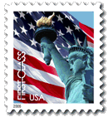
Materials: One postage stamp, one piece of lightweight wood, one piece of 2-by-2-inch PVC pipe, paint, glue
- Choose a new or canceled postage stamp.
- Cut a piece of thin wood (about 2 inches larger in diameter than the stamp).
- Paint the wood a color that will look nice with the stamp.
- Glue the stamp to the front of the wood.
- When dry, paint over the stamp with white glue to give it a shiny effect and to protect it.
- Attach the PVC pipe to the wood.
Firecracker Napkin and Utensil Holder
Catalina Council
Materials:
- 4 cardboard tubes
- Red, white, blue and black construction paper
- 2 stems each of blue and gold glittery chenille
- 5.5" x 5.5" piece of sturdy cardboard
- 2 lids from milk jugs, salad dressing, or other bottles that will fit snugly inside the cardboard tubes
- Glue stick
- Scissors
- Hot glue gun (where indicated)
- Pencil
Directions:
- Cover top 1/3 of each cardboard tubes with blue construction paper.
- Cover bottom 2/3 of cardboard tubes with white construction paper.
- Use a pencil to draw 12 stars on a piece of white construction paper.
- Cut the stars out and glue them to the blue sections of the cardboard tubes, pencil marks should be facing down toward tube so that they cannot be seen.
- Cut strips from red construction paper and glue around the tubes onto the white construction paper. Trim ends where needed.
- Cover the cardboard square with black construction paper.
- Hot glue bottle lids into the bottom of each cardboard tube so that he flat end of the bottle cap is facing out/down. This will serve as the bottom of your utensil holder and will give you something to glue onto.
- Glue all four firecracker utensil holders onto the black square, leaving about an
- inch in the center where you will place your napkins. Let dry completely.
- Use hot glue gun to add a border of glittery blue chenille around the tops of each utensil holder, and glittery gold around the border of the black base.
- Fill utensil holders with plastic forks, knives and spoons and place napkins in the center.
Tips:
- For the cardboard square, we used cardboard from a juice box package as it is quite thick and sturdy.
- Plastic milk jug lids are the perfect size for this project; however you can try other lids such as salad dressing bottles.
- Fancy this up even more by adding glitter or glitter glue to the black construction paper base.
Liberty Bell Slide
Catalina Council
Materials:
- Small wooden and plastic bells
- Hole Saw
- Plywood or paneling
- ½” PVC pipe
- Saw or PVC cutter
- Hot glue gun and glue sticks
- Paint
Directions:
- You can get small wooden and plastic bells from a craft store. Cut these in half.
- Using a 1-1/2 inch hole saw, cut the background plates out of 1/8-inch plywood or paneling. (Check with the local lumberyard to see if they have a broken/damaged piece they can give you.)
- For the neckerchief loop, use 1/2-in PVC plumbing pipe. You can cut this with a saw easily, but there is also a tool specifically designed to cut PVC pipe. Check with the people in the den or a local plumber and someone should be able to come up with the loops pretty easily.
- Hot glue the bell half and the loop to the background.
- Paint the background and the bell.
Can-do Stilts
Catalina Council
See Wolf Book, Elective 7, "Foot Power." CD
Materials
- Puncture-style can opener
- 2 (29-ounce) cans of tomato sauce
- Acrylic paint in white, red, and blue
- Paintbrush
- Star shapes cut from household sponges
- Disposable pans or plates
- Tape
- 2 (5-foot) lengths of cotton or nylon clothesline
- Skewer
Directions:
- Puncture a can in opposite spots on its side, as shown.
- Drain it by blowing into one hole to force the sauce out of the other.
- Repeat with the second can.
- Wash both cans under running water to clean them, inside and out.
- Remove their labels and let them dry.
- Paint both cans white.
- When they're dry, dip dampened sponge stars into pans or plates of red and blue paint.
- Apply the stamps to the cans and let them dry.
- For the handles, tape one end of a length of clothesline to a skewer.
- Push it through one hole and out the other, as shown.
- Have your child stand on the can, holding the line's ends.
- Knot the line at hip level and trim. Repeat for the other stilt.
Firecracker Hat
Catalina Council
Materials:
- Pencil
- Yardstick •
- Scissors
- 1 - 18 by 24 inch sheet of red poster board
- Red, white, and blue curling gift wrap ribbon, 3/4 inch wide
- Masking tape and Scotch tape
- Glue stick
- Yellow and orange crepe paper
- 1 white or silver pipe cleaner
- Pushpin
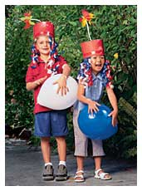
Directions:
Step 1:
- Cut a 7 by 24 inch rectangle from red poster board.
- Using the yardstick, draw a line across the long end of the rectangle, 2 inches beneath the top edge.
- Draw vertical lines at 2 inch intervals across the top edge, as shown below in 1.

- Cut along each vertical line to form tabs.
- Place the yardstick across the bottom of the tabs and bend the tabs over the stick.
Step 2:
- Cut 20 lengths of ribbon, each 20 inches long.
- On a table, lay a 12 inch piece of masking tape sticky side up.
- Press 10 of the ribbons onto the tape, as shown in 2.
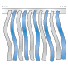
- Repeat with a second 12 inch piece of masking tape.
Step 3:
- With the ribbons hanging down, press the 2 ribbon/tape strips along the tables edge of the red rectangle, leaving 5 inches between the strips for your child's forehead, as shown in 3.
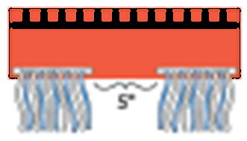
- Roll the rectangle into a tube. Scotch tape the edges to form a cylinder that will fit comfortably.
Step 4:
- Place the cylinder, with the tabs folded in, onto the remaining poster board.
- Trace around it and cut out the circle.
- Coat the outer 2 inches of the circle with glue.
- Press the tabs of the hat down onto the glue coated portion of the circle and hold in place for a few seconds.
- Turn the hat right side up to dry. If necessary, lay a magazine across the top to flatten the hat as it dries.
Step 5:
- Cut five strips of crepe paper, each 8 to 10 inches long.
- Stack the strips and wrap them with a pipe cleaner, as shown in 5.

- Pull tight and arrange the crepe paper to form a flower shape.
Step 6:
- With a pushpin, poke a hole in the center of the hat top.
- Thread the bottom 1 1/2 inches of the pipe cleaner through the hole.
- On the inside of the hat, bend the tip against the underside of the hat and masking tape it in place.
Uncle Sam Neckerchief Slide
Materials:
- Scraps of red, white and blue craft foam
- Scrap of flesh-color felt
- Two wiggle eyes (7mm)
- Small red pompom (5 mm)
- Gold glitter paint or glitter glue
- Black fine-line permanent marker
- Glue
- Pink powder blush
- Q-tip
- 1/2” PVC pipe
Directions:
- Cut out patterns.
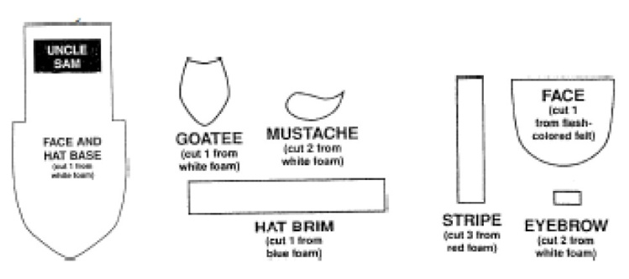
- Use markers to draw dashed lines along edges of beard, mustache and goatee. (You may want to tell the boys to make dots instead of dashes)
- Glue stripes on hat base and glue hat brim on too.
- Glue flesh face pattern on under brim.
- Add eyes and pompom nose.
- Glue on mustache, goatee and eyebrows.
- With q-tip dipped in powder blush, give him rosy cheeks.
- With gold glitter squeeze paint, add small stars (dots) onto hat brim.
- Let dry. Add slide back.
Flag Tie Slide
Catalina Council
Materials:
- Plastic bottle
- Plastic curtain ring
- Hot glue gun
- Acrylic or model paint
Directions:
- Using this drawing, have the Cub Scouts make a paper pattern.
- Trace it onto a plastic bottle and cut out.
- On backside of plastic, using coarse sandpaper, rough up the plastic in the area where you will hot glue the curtain ring.
- Glue ring to the back for the tie slide. Paint a flag on the front.
Crepe Paper Flag
Catalina Council
Materials:
- 11"x14" piece of white poster board or cardstock
- 4 24"-long pieces of red crepe paper streamers
- 3 24"-long pieces of white crepe paper streamers
- 1 20"-piece of blue crepe paper streamer cut into 4 equal
- strips extra piece of white crepe paper streamer,
- approximately 8" long
- 6"x6" square of white or blue construction paper
- Scissors
- Ruler
- White craft glue
- 18" long piece of white yarn
- Shipping tape
Directions:
- Trim the poster board to 9 ¾" x 14".
- At the 9 ¾" end of the poster board, measure out ¾" segments, you should have 13 all together.
- Use a pencil to draw a line upward from each measurement to use as a guide for your flag's stripes. (See photo.)
- Cut the four strips of red crepe paper streamers in half (lengthwise) to create a total of 8 24"-long strips. (See photo.)
- Cut the three strips of white crepe paper streamers in half (lengthwise) to create a total of 6 24"-long strips.
- Apply glue the first section of the poster board using your penciled line as a guide. (See photo.) Take one of your strips of red streamer and position it about a ½" of the streamer so that it hangs over the top of the poster board. (See photo.) Place the streamer over the glue on the poster board, patting it down flat.
- You will have a considerable amount of streamer left hanging over the edge of the poster board.
- Repeat step 6 using a white strip, overlapping the red strip slightly. (See photo.)
- Repeat steps 6 and 7 until all strips are in place. You will have one extra red strip left over. Save for another project.
- Glue the blue strips of crepe paper onto the 6"x6" construction paper and trim off excess. (See photo.) Glue the blue covered square to the upper left-hand corner of the flag.
- Use white glue to add "star" dots onto the blue square. (See photo.) If you want to be historically accurate, add 50 stars, alternating rows of 6 and rows of 5. There should be 5 rows of 6 stars and 4 rows of 5 stars.
- Tear the last piece of white crepe paper into 1" squares and wrap them around the end of a pencil eraser. (See photo.) Press each one onto the glue dots and allow to dry.
- Turn flag over and apply some glue to the top, then bend over the excess crepe paper and glue in place. (See photo.)
- Attach yarn hanger by using shipping tape.
Famous President Figures
Catalina Council
The body of each figure is made from a wax paper box set on end. Cover 3 1/2 “ at upper end of box with flesh colored construction paper for face. Features, beards, mustaches and hair are cut from colored paper.
Washington: 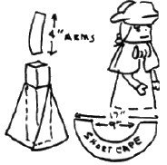
Cut an 8 1/2" x 12” piece of blue construction paper for long cape. Wrap around body and trim at front edge at angle so it flares slightly.
Short shoulder cape is made from an arc—shaped piece (as shown) about 17” across. Wrap around body, trim as desired and glue.
Cut slightly curved arms and glue under cape.
Add white gloves and ruffle at neck.
Hat is two pieces of paper 3” x 7” shaped as shown.
Cover exposed portion of head with matching paper. Add Cotton hair under hat.
Teddy Roosevelt: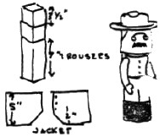
Use brown .wrapping paper. Wrap 7"x10" piece high around body.
Add 1 1/2" black paper strip for boots.
For jacket, cut 5”xlO” strip and cut a 2” slit in center. Cut into two pieces as shown. Overlap and glue in place. Add black paper collar, belt and buttons.
Add paper arms with black gauntlets. Cut the glasses from paper. Add thread chain.
For hat, cut 6” brown circle. Trace around head portion of box at center and cut out. Push hat brim over head. Make crown from a 3 1/2" x 10" piece of brown paper and shape by folding down top.
US Grant: 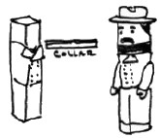
Use blue paper. Cut 7”xlO” for trousers and wrap around body. Cut 3" x 10" strip of white for collar. Fold down 1/2" strip along one long side and cut collar notches at center. Wrap around body and fasten.
Jacket is 4 1/2" x 10" strip wrapped around body, with lapels folded down and glued. Add gold paper buttons and chevrons.
Glue arms with white gloves in place, hat is same as Roosevelt's, with 5 1/2" blue circle for brim and 3 1/2" x 10" blue tube for crown.
Lincoln: 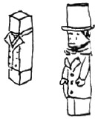
Use black paper for clothing. Make trousers same as Grant.
For collar, wrap 4”xlO” strip of white around neck.
For vest use 5”xlO” strip with ‘V’ at center, wrapped around body and glued. Coat is 7”xlO” piece wrapped around and folded back and trimmed for lapels. Add Black tie, coat buttons and arms with white gloves.
Cut 5 1/2" black circle for hat brim. Cut 3 1/2" x 10" piece of back, roll into tube for hat.
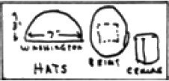
Parade Wavers
Baltimore Area Council
- Fold a red paper plate in half.
- Glue one large blue and one large white star cut from construction paper onto the front and the back of the folded plate.
- Glue about 2 feet of red, white, and blue crepe paper streamers to the inside of the folded plate, alternating colors. These streamers should be glued near the center of the inside fold so that they remain secure while waving.
- Staple or glue the unfolded edges of the plate together.
- Attach a tongue depressor or paint stick for a handle by gluing one end of the stick to the back side of the plate.
Uncle Sam Windsock
Baltimore Area Council
- Curve the ends of a half sheet of white poster board back until they overlap slightly.
- Staple the ends in place.
- Paint or draw vertical stripes in red around the top half.
- Glue a dark blue paper strip around the middle of the cylinder, covering the ends of the red stripes.
- Draw a face on the bottom half of the cylinder.
- Red, white, and blue streamers can be glued to the inside of the bottom of the cylinder.
- For the hat rim, cut a blue circle larger than the cylinder’s diameter.
- Center the cylinder atop the circle, draw the outline of the cylinder’s diameter onto the blue circle, and then cut that outline from the interior of the blue circle.
- Slide the resulting blue “loop” onto the cylinder and tape in place.
MORE GAMES AND ACTIVITIES
Sam Houston Area Council
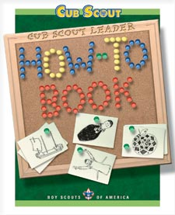
From the Cub Scout Leader How-To Book –
- -Summer Celebration, page 6-18, or Pack Picnic, page 6-22 - Great ideas for big pack parties outdoors!!!

Want to check something in the "How To Book," and your copy is not available?? Want to copy something quick to use at a meeting?? You can find the "How To Book" at this address on National's Web Site -
http://www.scouting.org/filestore/hispanic/english/33832_WEB.pdf
ADVANCEMENT IDEAS
From Program Helps via
www.cubroundtable.com
By now most of your Tiger, Wolf, and Bear Cub Scouts have earned their rank. So you can spend your meetings doing Electives for Arrow points!!!
Tigers –
Ach:
Elect. 22, 29, 37
Wolf-
Ach 2a
Elect. 9a
Bear –
Ach 3, 17b
Elect. 11
GAMES
Uncle Sam Wants You!... To Clean Your Room!
Baltimore Area Council
Materials: . 60 or more bean bags or sock balls.
- Divide playing area in half.
- Scatter half the sock balls on each side.
- Akela tells the group when to start.
- The object is to have nothing on your side of the playing court.
- The boys all try to throw all the sock balls off of their side or "room" onto the other teams side or "room".
- After about three minutes, Akela yells "Stop".
- The boys then count how many objects are left in their "rooms".
- The team with the fewest wins!
Uncle Sam Game
Baltimore Area Council
Materials: . Four to five different colored flags (each boy needs a flag, or strip of material)
- One player is "Uncle Sam", he stands in the middle.
- All the players are at one end of the playing area, they chant "Uncle Sam, Uncle Sam, may we cross to your great land?"
- Uncle Sam answers, "Yes, if you're wearing (name a color, e.g blue)."
- Players wearing that color flag get to freely pass to the other side without getting their flags pulled.
- On the signal "Go" from Uncle Sam, the rest of the players try to run to the other side without their flags being pulled.
- Tagged players become Uncle Sam’s helpers.
- Begin again, this time Uncle Sam calls out another color.
- Keep going until all players are caught but one. This player is the new "Uncle Sam" for the next round.
Flag Folding Relay
Catalina Council
- Divide the boys up into two teams.
- Have two 3’ by 5’ (approximately) flags. Mark a corner for where the stars would be on a US Flag. (I would not play this game with real US Flags - CD)
- Give one to each team.
- On signal first boy hands the star side of the flag to the boy behind him and folds the flag.
- When it is folded, the second boy unfolds the flag and hands the star side of the flag to the boy behind him while he now folds the flag.
- Play continues until each boy has folded the flag.
- First team to have each member fold the flag wins.
Stars and Stripes (Like Duck, Duck, Goose)
Catalina Council
Boys sit in a circle with one boy standing.
The standing boy walks around the outside of the circle and taps each sitting cub on the floor and calls each one of them either a star or a stripe.
If the boy is a stripe, he must get up run around the circle being chased by the 1st boy and sit back in his spot in the floor without being tagged by the 1st boy. If he gets tagged, he now walks around the circle naming everyone and play begins again.
Flag Tag Relay
Catalina Council
Equipment:
- Buckets of sand
- Small American flags
Directions:
- To set up the race, divide the group into 2 teams. For each team, place a bucket of sand filled with small American flags (1 per teammate) on the far side of the yard.
- On cue, the first kid from each team races to the appropriate bucket, plucks a flag, and marches back to his team as quickly as possible (no running allowed!) to tag the next person.
- The game continues in this way until all the members of one team have returned to the starting line with a flag in hand.
- At day's end, make everyone a winner by letting all the kids take home their flags as favors.
Ring Toss and Other Games
Catalina Council
- For this game, contestants need the tossing skills of a Frisbee player and the good aim of a seasoned horseshoe pitcher.
- For the scoring poles, you'll need nine dowels. Set them in the ground in three rows, each composed of three dowels and spaced 2 feet apart. Decorate the planted poles by wrapping them with red, white and blue crepe-paper streamers.
- For the rings (you'll need three per team), use a dozen sturdy paper plates. You can either purchase colored plates or spray paint plain ones. Cut out a large circle from the center of each plate.
- Then, place two of the plates face-to-face and tape together all the way around the rims. Repeat for the remaining five rings.
- During the game, members from both teams have three attempts each to toss a ring around one of the poles. (It's fun to alternate turns between the two teams.) Kids should be allowed to stand a little closer to the poles than their adult teammates.
- A ring that lands around a pole in the nearest row is worth 10 points; a ringer in the middle row earns 20 points; and a ringer in the far row earns 30 points.
- The team that accumulates the most points wins.
50 States
Catalina Council
- Mark the names of the states on paper plates.
- Spread out the paper plates on the floor.
- At the signal everyone scrambles to stand on a different plate.
- A state is called and that plate is removed. If someone is standing on that plate they are removed too.
- Last person left on the last plate is the winner.
- For a shorter version use less states, but keep track of the ones used.
Treasure Hunt
Catalina Council
The den may not be able to travel to the end of the earth physically, but they can certainly go anywhere they want on a map.
For this game, identify some major sites of some well known National Treasures. Write down the names of your treasures and toss them into a treasure chest covered in red, white, and blue (shoe box, for example).
You also need an atlas or a pretty large map of the United States. Have each boy pick a treasure from the chest and find the place on the map or in the atlas.
You probably will have to be ready to supply a state, district, or territory name, but start without that information to see how well they do.
American Heritage
Catalina Council
Make posters of well- known American symbols and pass them out around the room.
Number each poster. Give each person a piece of paper, which is also numbered. Ask them to identify the posters and write the proper name by the number.
Suggestions are: American Flag, the White House, the Washington Monument, Lincoln Memorial, Uncle Sam, the Statue of Liberty, bald eagle, the Presidential Seal, etc.
Popcorn Relay
Catalina Council
Fancy footwork is the ticket to success in this event. And everyone's got a unique shuffle, waddle or twist, making this relay, adapted from THE BIG BOOK OF KIDS' GAMES (check with your local library), as much fun to watch as it is to run.
- Beforehand, prepare a pair of plastic or paper cups for each runner. Use a tack or a small nail to poke a hole in the center of each cup bottom. Push one end of a thick rubber band through the hole and into the cup.
- Then, slip a paper clip on the end of the band inside the cup, and gently pull the other end until the clip rests on the bottom of the cup.
- The rubber band, worn around the ball of the foot, holds the cup in place atop a player's shoe.
- Just prior to the race, a member from each team is issued a big bag of popcorn and charged with filling teammates' cups from the moment the starting whistle blows until the relay ends. These individuals stand alongside their teams, behind the starting line.
- Two large, shallow boxes are set 5 yards beyond the starting line, opposite the teams.
- When the whistle blows, the first person in each team's line sprints to the appropriate box and empties his cups into it, trying to lose as little popcorn as possible along the way.
- He then runs back to tag the next person in line. The new runner heads to the team box, and the first runner goes to the end of the line.
- The relay continues for 2 minutes or until one of the bags is emptied. Then, the popcorn in each box is measured with a ruler (or by cupfuls) and the team with the most is declared the winner.
Buzz Bomb Balloon
Baltimore Area Council
- Place a Target. (made of cardboard, or painted on fabric) in the center of the room.
- Give each participant a balloon. (different colors are best or have them write their name on it in marker.)
- Have them blow up the balloon.
- On the count of three everyone releases the balloon.
- When the balloons finally land, the one closest to the target wins!
Whistling Contest
Baltimore Area Council
When fairs were held in Colonial times one of the attractions was a whistling contest.
Contestants were given tunes to whistle. If they laughed or lost the tune, they were out of the contest. Try it using tunes the boys know. To add a little excitement, have the boys put soda crackers in their mouths….
CUB GRUB
Cheese Dog Roll-Ups
Baltimore Area Council
Ingredients
1 can refrigerator crescent dinner rolls,
8 hot dogs
8 strips cheddar cheese
Directions:
- Preheat oven to 375 degrees
- Separate rolls into 8 triangles of dough.
- Cut narrow slit lengthwise in each hot dog and
- Put a strip of cheese in the slit.
- Place hot dog on wide end of dough triangle and roll up.
- Cook on ungreased cooking sheet, cheese side up for 10-15 minutes or until brown.
Cinnamon Toast
Baltimore Area Council
Ingredients
1 slice of bread
Soft margarine
1 tsp. Sugar
¼ tsp. cinnamon
Directions:
- Toast bread in toaster.
- Spread at once with butter.
- Sprinkle on sugar and cinnamon.
(Or mix ¼ cup sugar, 1 T. cinnamon and use shaker.)
Grilled Cheese Sandwiches
Baltimore Area Council
Ingredients
1 slice American Cheese 2 slices bread
1 T. butter or margarine
Directions:
- Put the cheese between bread slices.
- Melt butter in skillet.
- Toast the sandwich over low heat.
- Flip the sandwich over with a turner (Ted?).
- When both sides are toasted, eat and enjoy.
Tootsie Rolls
Baltimore Area Council
Ingredients
2 tablespoons margarine (room temperature)
2 squares of chocolate melted
½ cup corn syrup 3 cups powdered sugar
1 tsp vanilla ¾ cup dry powdered milk
Directions:
- Put all ingredients in Ziploc bag,
- Knead until well mixed.
- Roll into ball or log shapes.
Dump Cake
Baltimore Area Council
Ingredients
l/2 cup brown sugar
1 egg
1 can cherries
1 cake mix
1 stick margarine
Directions:
- Spray pan with non stick cooking aerosol.
- Spread brown sugar evenly on bottom of pan.
- Cut margarine into thin pats, distribute evenly in pan.
- Add cherries in juice.
- Mix beaten egg with cake mix and spread over cherries.
- Bake at 400 degrees for 25 minutes or until brown.
BBQ Wieners
Baltimore Area Council
Ingredients
1 package of wieners
Directions:
- Cut wieners into bite size pieces.
- Place in pan on the stove and let brown, but not dark.
- Add 1½ cups of your favorite BBQ Sauce.
- Let simmer for 15 minutes.
(We used to do this in camp with a #10 can on a fire CD)
Watermelon Pop Stars
Catalina Council
Ingredients:
Watermelon
Popsicle sticks
Star-shaped cookie cutter
Instructions:
- Use a cookie cutter to cut juicy star shapes from 1-inch-thick slices of seedless watermelon.
- Insert a Popsicle stick into each star, then set the pops on an aluminum foil-lined baking sheet.
- Cover the stars with another sheet of foil and freeze for 1 hour or until firm.
Edible Eagles
Catalina Council
Ingredients:
1/4 cup of white chocolate chips
6 large marshmallows
Finely shredded coconut
Chocolate sandwich cookie (we used a chocolate covered Oreo)
6 Cashews
Black decorators' gel
Instructions:
- Melt 1/4 cup of white chocolate chips according to the package directions.
- For each bird, drop a large marshmallow into the melted chocolate, using a spatula to coat it well.
- Remove the marshmallow from the chocolate and roll it in finely shredded coconut, leaving one end uncovered.
- Immediately set the marshmallow, coconut free end down, atop a chocolate sandwich cookie.
- Let the chocolate set a bit, then use a toothpick to make a hole in the side of the marshmallow and insert a cashew for a beak.
- Finally, add black decorators' gel eyes.
Fruit Flag
Catalina Council
Ingredients:
29 large strawberries
30 large blackberries
7 or so large bananas
Lemon juice
Instructions:
- Hull and halve 29 large strawberries and set them aside.
- Arrange 30 large blackberries, as shown, in the upper left corner of a serving tray or cutting board (it should be at least 8 by 13 inches).
- Cut 58 banana slices, 3/4-inch-thick, into a bowl.
- Sprinkle on lemon juice and toss the slices gently with a rubber spatula to keep them from browning.
- Assemble the banana slices in rows as shown and top each slice with a strawberry half.
Crispy Cheese Stars
Catalina Council
Ingredients:
Flour tortillas
Sliced cheese (cheddar, provolone, or mozzarella)
Chili powder or paprika
Instructions:
- Heat the oven to 350º.
- Use the larger cookie cutter to cut out stars from flour tortillas (about 5 per 10-inch tortilla).
- It's easy for kids to do if you use a rolling pin to roll back and forth over the cutter.
- Bake the stars on a foil-covered cookie sheet for 5 minutes.
- Use the smaller cookie cutter to cut out an equal number of cheese stars from the sliced cheese and place them atop the tortilla ones.
- Bake the stars for 2 more minutes or so until the cheese melts.
- Sprinkle the stars with chili powder or paprika and let them cool before serving.
Star Cookies
Catalina Council
Ingredients:
Blue and red food coloring
Your favorite cookie dough
Instructions:
- Use food coloring paste to tint one third of the dough red and another third blue, kneading the dough to evenly distribute the color.
- Leave the last third untinted.
- Chill the dough until it's firm, then roll out each color and cut out a bunch of larger stars.
- With a medium-size cutter, cut a star from the center of each large star.
- Now use the medium stars to fill in the centers of contrasting larger stars. lightly pressing them in place.
- Lightly press the medium stars into the larger stars' centers.
- Using a third, smaller cutter, you can even create tricolored stars.
All American Hot Dog In A Blanket
Catalina Council
Ingredients:
3 Tablespoons softened margarine
6 slices bread
6 slices cheese
6 hot dogs
Toothpicks
Instructions:
- Spread margarine on one side of each slice of bread.
- Place buttered side of bread down on baking sheet.
- Top each bread slice with cheese.
- Then put hot dog diagonally across cheese slice.
- Fold opposite diagonal corners over hot dog and secure with toothpicks.
- Bake at 375 degrees for about ten minutes or until golden brown.
Red, White, and Blue Delight
Catalina Council
Ingredients for the Blueberry Sauce:
1 pint fresh blueberries, rinsed
1 tablespoon water
1/2 cup sugar
1 1/2 tablespoons lemon juice
1 1/2 tablespoons cornstarch
Ingredients for the Dessert:
1 pint strawberry sorbet
1 container (1 1/2 quarts) vanilla ice cream
Fresh blueberries and strawberries for garnish
Instructions:
- Combine the blueberries and the water in a medium-size saucepan.
- Partially cover the pan, then bring the mixture to a simmer over medium heat.
- Continue simmering the berries until they begin to break down, about 2 minutes.
- Stir in the sugar and cook the berries until they become soft, about 1 to 2 minutes more.
- Stir together the lemon juice and cornstarch in a small bowl until evenly blended.
- Stir the mixture into the berries, then cook them at a low boil, stirring constantly, for 1 1/2 minutes.
- Remove the sauce from the heat and transfer it to a medium-size bowl.
- When the sauce is cooled, cover it and place it in the refrigerator to chill.
- Line a 9- by 5-inch metal loaf pan with two sheets of crisscrossed plastic wrap, leaving a 3-inch overhang on all sides, then chill the pan in the freezer for 10 minutes.
- Place the container of sorbet in the refrigerator for 30 minutes to soften, then spoon the sorbet into the pan and mold it, using a sheet of plastic wrap to smooth the top as needed.
- Cover it with foil and freeze it for 2 hours.
- The last 30 minutes, soften the vanilla ice cream in the refrigerator.
- Remove the pan from the freezer, add half the vanilla ice cream, mold it, cover it with foil, and freeze it and the remaining ice cream for 30 minutes.
- For the third layer, mix the remaining ice cream with 3/4 cup of the blueberry sauce, and add it to the pan.
- Freeze the dessert for one more hour.
- Chill a platter in the refrigerator for 15 minutes.
- Right before serving, thin the remaining blueberry sauce with a spoonful of water or orange juice.
- Invert the dessert onto the platter, unwrap it, and garnish it with fresh berries.
- Use a sharp knife to slice the dessert, and serve it with the sauce. Serves 10.
“Hamburger” Cookies
Catalina Council
Ingredients:
1/4 cup shredded coconut
Green food coloring
24 vanilla wafers
12 small chocolate mint patties (round)
Instructions:
- Put the coconut in a small container that has a lid.
- Add a few drops of the food coloring, put on the lid, and shake until the coconut turns green.
- Put twelve wafers flat side up on a baking sheet.
- Place a mint on top of each wafer.
- Bake the wafers at 325 degrees for one minute.
- Immediately sprinkle each wafer with coconut (lettuce).
- Top with remaining wafers, flat side down, and you will have hamburger looking cookies!!!
WEBELOS
Joe Trovato, WEBELOS RT Break Out Coordinator
Westchester-Putnam Council
Have a question or comment for Joe?? Write him at
webelos_willie@yahoo.com
There is an underscore between Webelos and Willie

Independence Day
The 4th of July has always been one of my favorite holidays. Not because of the professional fireworks displays (although they are great fun to watch), Bar-B-Qs (love them) and family get-togethers, but because of the large number of American Flags that all proud Americans display to celebrate the birth of the United States! What a grand sight! Make sure your Webelos are aware of the history of our Flag, the respect due it, and the part it plays in all scouting events. A great website where you can get this information is www.usflag.org
For Webelos badge requirement 6, you must plan and lead a den flag ceremony, using the U.S. flag. Have your Webelos develop their own ceremonies for “Old Glory” to present at a den or pack meeting, or at your town’s Independence Day celebration!
Give your Webelos Scouts these guidelines to help make the planning go smoothly:
- Who will carry the flag?
- Who will be the color guards and what formation will they make?
- Who will give the directions for the ceremony?
- What song will be sung? Who will start the song?
- Who will say or read any extra parts?
- After the Pledge of Allegiance, will the Law of the Pack, Cub Scout Promise, and/or Outdoor Code be recited?
- In what order will the parts of the ceremony take place?
- When will the group practice?
- Where will the flags be placed at the end of the ceremony?
Use their planning and practice to illustrate for them how to treat the Flag, including, applicable:
- The U.S. Flag is always displayed to the far right of other flags, or in the center and higher than all others.
- The U.S. Flag is displayed in a stand to the speaker's right as he faces the audience in an auditorium.
- The U.S. Flag is raised briskly and lowered slowly.
- When posting flags in stands, the U.S. Flag is always the last one posted and the first one lifted.
- When raising flags on flag poles, the U.S. Flag s always the first one raised and the last one lowered.
- The U.S. Flag should not be carried flat or horizontally.
- The U.S. Flag should not touch anything below it, should not have anything placed on or above it, should not be used to cover anything, and should be kept clean.
- When displayed after dark, the U.S. Flag should be illuminated.
- When no longer suitable for display, a U.S. Flag should be burned in a special flag retirement ceremony.
Here are some Flag ceremony starters:
- Have the Webelos Scouts give the Cub Scout salute and repeat the Pledge of Allegiance to the flag.
- Parade the U.S. flag and the den flag past the line of Webelos Scouts, who stand at attention and salute.
- Plan a ceremony on the history of the flag. Each boy in the den can make and color a different paper flag to show how our present flag developed out of earlier flags.
- Have the Webelos Scouts march past the flag, giving the proper salute.
WEBELOS Leader Book
by Commissioner Dave
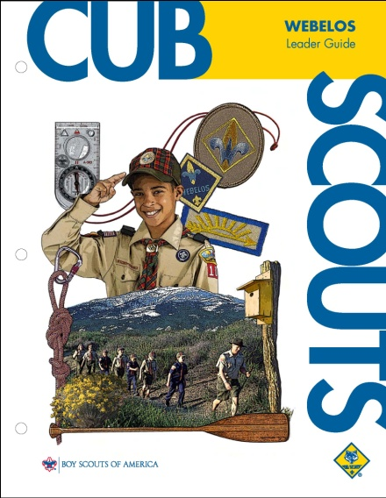
I have received a copy of the WEBELOS Leader Book and spent awhile looking at it.
- Most (or maybe all) the activities ideas for doing the requirements are there.
- The meeting schedule without many details is copied from the NEW Den and Pack Meeting Resource Guide. The meeting details are in the Den and Pack Meeting Resource Guide.
- The old schedule and den meeting plans are gone. (except for the LDS section)
- I have not been able to find it on National's Websites to download.
- I like the picture of Mount Baldy at Philmont on the cover!!! ☺
Conclusions -
- This is a valuable tool for every WEBELOS Leader.
- If you have the old one and download the meeting plans from National's Websites,
http://www.scouting.org/scoutsource/CubScouts/Leaders/DenLeaderResources/DenandPackMeetingResourceGuide.aspx , you do not need to purchase the new book.
- If you do not have the old one, you need to get a copy of the new one (bought or borrowed from a former Webelos Leader)

Earning the
World Conservation Award
The Cub Scout version of the badge consists of a two-inch embroidered emblem and is worn as temporary patch, centered on right pocket. This award can be earned only once while you are a Cub Scout. Requirements mandate participation in a Den or Pack conservation project and, for Webelos, completion of the Forester, Outdoorsman, and Naturalist Activities Badges. Summer makes for a good time to complete a conservation project. Webelos Scouts participating in the Conservation Good Turn can also meet some advancement requirements. Here are some suggestions:
- Plant grasses, trees, shrubs, and ground cover to stop soil erosion.
- As a den or pack, adopt a park. Remove litter and garbage from a favorite neighborhood recreation area or park.
- Organize or participate in a recycling program in your neighborhood, or visit a recycling center.
- Participate in a beach or waterfront cleanup. Record the items collected and determine the possible harmful effects to wildlife. With youth participation, develop a plan to educate the public about the dangers posed to wildlife.
- From a local, state, or national organization that is concerned about environmental protection, obtain suggestions for den and pack projects to improve the environment.
- Contact the camp ranger or BSA local council property superintendent for information about camp needs and plans. Establish a nature trail, plant vegetation, or carry out other needed projects as requested by the camp ranger.
Joe gives great advice for Aquanaut and Geologist but the best place to earn these??
You got it -
Webelos Resident Camp!!
Sign your son up NOW!! CD
AQUANAUT
PHYSICAL SKILLS

Den Activities
- Discuss the importance of the buddy swimming system.
- Have a demonstration of mask, fins, and snorkel by an expert.
- Take the den swimming. Let them try to pass the 100-foot requirements, and surface dive and snorkel optional requirements.
- If a rowboat is available, have boat safety methods and rowing techniques demonstrated by an expert. Give boys a chance to practice the methods. Invite parents to come along.
- Teach the four basic rescue methods. Let boys’ practice reaching and throwing a lifeline for rescue.
- Practice rescue breathing on dummy.
- Go to a swim meet or diving exhibition.
- Go to a canoe or sailboat race.
- Invite an expert to explain how to handle emergencies in the water. (Contact a swim instructor, the YMCA or Coast Guard)
- Visit a boat yard.
- Have a quiz on boat safety rules.
- Study the safe swim defense plan.
- Learn about water pollutants in lakes and rivers in the area. How do they affect water consumption and recreation?
- At the end of the month, have a family splash party where Webelos Scouts can demonstrate proficiency in swimming, snorkeling, boating, and water rescue. Include games that the whole family will enjoy playing.
- Have a pack meeting at a local pool.
- Have a splash party for your Webelos and allow them to bring their friends (a good recruiting idea). Alternately, have a parent and scout swim coupled with swim tests and instruction in fins, mask and snorkel.
- Know the rules of small-boat safety and practice at a local body of water. Watch the sun set from offshore.
- Invite a scuba diving expert to a den meeting to tell about his equipment and activities.
- Ask Boy Scouts to demonstrate and teach water rescue techniques.
- Use squirt guns to put out candle flames.
- Try to drive a nail into a piece of wood underwater in a washtub.
- Have a water sponge fight. A big bucket of water and everyone gets two sponges to throw. Less messy to cleanup than balloons.
- Have a bottle cap war. Give each scout a bottle cap. Set out a bucket with a large circle around it to denote the free zone. Scouts fill their bottle caps and go splash others outside the circle.
Aquanaut Games
Aqua Hunt
Scatter diving rings all over the pool bottom. On signal, players put on masks, fins, and snorkels and begin search. The one who retrieves the most rings wins.
Flapping Fins Race
On signal, players put on fins (no masks or snorkels) and race to the other side of the pool and back.
Table Waiter Race
Each swimmer carries a paper plate with a cork on it. He starts in the water and goes toward the finish line with the plate held at shoulder level with one hand. He may replace the cork if it falls off.
Guess the Rule On separate slips of paper, write the 8 Safe Swim Defense rules - See Guide to Safe Scouting. Put the slips in a bag and ask the first scout to pick one. He reads his directions silently and pantomimes the action. The player who first guesses what he is doing becomes the next performer.
Bottle
Done correctly, this is like a “covert operations” version of Steal The Bacon. You’ll need a CLEAR plastic 2 liter bottle and a swimming pool. Make sure the Coke/Mountain Dew/etc wrapper is peeled off the bottle! Here’s what you do.
The game leader fills the 2 liter all the way to the top (with pool water) and puts the cap on very tightly. Then the game leader divides the group into two teams. Also, assign each team an “end” of the pool. Finally, a chair is placed on either end of the pool as the “goal.” You’re ready!
Have the teams lined up on different sides of the pool. The players need to be facing AWAY from the pool WITH their eyes closed. The game leader then throws the bottle into the pool. When it splashes in the pool, players can turn around, open their eyes, and jump in after it!
The object is to get the bottle to the other’s teams’ chair (goal). If they can put it in the chair, they get a point. (After each point is scored, the players must exit the pool, and the game leader starts the second round the same way he/she started the first round.) First team with 3 points wins.
Here’s the trick, though. The 2 liter is hard to see if it is totally filled with water! The players are allowed to be “sneaky” with the bottle if they have it. Many times, a team scores while the other team is trying to figure out who has it!
Atomic Whirlpool
Have everybody get in the pool and line up single file along the edge with very little space between them. Have everyone walk for a couple of minutes, then jog another couple of minutes, then "run" around the edge another couple of minutes.
If done right the water will "carry" them around the pool. Finally, tell them to turn around and go the other way. It is almost impossible to go against the current.
Life Preserver Throw
Throw a weight attached to a rope. Award points for distance and accuracy.
Pool Volleyball
Stretch a rope across the pool and play volleyball using a large beach ball.
REMEMBER
THE 8 POINT SAFE SWIM DEFENSE,
http://www.usscouts.org/safety/SSD_slides.pdf http://macscouter.com/usscouts/safety/SSD_handout.pdf
HAVE FUN AND BE SAFE
Take the on-line Safe Swim Defense Training at National's On-Line learning Center - http://olc.scouting.org/index.html
GEOLOGIST
OUTDOOR GROUP

Working on a geologist badge can be great fun and July is a good time to do so, because it is best to do most of the requirements outdoors (somehow I bet having a volcano “erupt” in my kitchen would not go over well with the rest of the family). Clean up is easier and it’s more fun! If you are not a geologist at heart, there are many organizations that will do the heavy lifting. In the Hudson Valley, New York area, a number of non-profit environmental organizations such as the Westmoreland Sanctuary in Bedford Corners, (http://www.westmorelandsanctuary.org/scouts.htm) do a great job, usually for a minimal contribution and cost of material.
DEN ACTIVITIES
- Go on a treasure hunt for rocks and minerals and start a rock collection.
- Make a volcano.
- Visit a cemetery (especially if rocks are hard to find in your area).
- Visit a geology exhibit, museum or collection.
- Visit an industry that uses geological materials.
- Visit a jewelry shop.
- Invite a geologist to come to den meeting and talk to the den about what he does and also why he became a geologist.
- Invite a contractor come to talk to boys about minerals used in home building.
Fulfilling Badge Requirements
#1: | Requirement: Collect five geologic specimens that have important uses.  Activity: Excavate clay blocks with gems inside.  Pour 2 to 3 inches of clay slurry in a container, such as a Handi-Wipes plastic container. Mix in 5 or 6 different polished stones or rock specimens. Let dry a month.  Scouts chip off clay to find gems - a good start to a rock collection, too.
#2: | Requirement: Rocks and minerals are used in metals, glass, jewelry, road-building products, and fertilizer. Give examples of minerals used in these products.  Game: Scavenger hunt to find items that contain specific minerals and rocks.
#3: | Requirement: Make a scale of mineral hardness for objects found at home. Show how to use the scale by finding the relative hardness of three samples.  Activity: Build hardness scale. Test it on rocks that the scouts bring.
#4: | Requirement: List some of the geologic materials used in building your home.  Activity: Hand out colored index cards with the materials listed - Aluminum, Calcium, Silicon or Boron, Lead or Zinc, Iron, Copper. Have a contest - which team can correctly locate the materials first. They have to stick the card on the part of the house that matches the card.  Aluminum (windows, doors), Calcium (cement), Silicon or Boron (glass), Lead or Zinc (pipes), Iron (nails, screws), Copper (gutters or wiring).
#5: | Requirement: Make a drawing that shows the cause of a volcano, a geyser, or an earthquake.  Create an earthquake - put a large book on carpet and attach a rubber band to it. Set up LEGO people on the book. Pull the rubber band until the book finally moves in a jerk.  Create a geyser - Boil water in a teakettle and the steam coming out is just like a geyser.  Create a volcano - using 2 paper cups, cut the bottom out of one cup and cut almost the top half off the other. Lay out a large piece of plastic wrap to work on. Put the bottomless cup upside down over the topless cup - its rim should not quite touch the table. Put a few drops of liquid detergent into the cup. Add a few drops of red food coloring. Fill about 2/3 of inside cup with vinegar. Put about 1/4 teaspoon of baking soda, and mix quickly. The volcano will 'boil over'.
#6: | Requirement: Explain one way in which mountains are formed.  Activity: Explain 3 ways - volcano, erosion, and uplift. We chose volcano.  For erosion, explain that water dissolves rock over time. Have a race with each scout putting a SweetTart in his mouth and dissolve it - no chewing.  For upheaval, have each scout make a playdough pancake and then stack them. Push the sides together to cause upheaval. Cut it to show the buckled layers.
#7: | Requirement: Describe what a fossil is. How is it used to tell how old a formation is? Find two examples of fossils in your area.  Activity: Excavate clay blocks with fossils inside.  Clean some chicken bones and/or fish bones. Bleach them and dry them.  Pour a 1/4 inch layer of clay slurry in a container for each scout or pair of scouts and let dry for 3 days. Pour in a 2nd layer and dry 1 day. Press 3 a few chicken bones, fish bones, or plastic items into the clay. Let dry 2 days. Cover with another layer of slurry and dry 3 days. Pour a 4th layer on top and let dry for at least a month.  Scouts carefully chip away the layers to find fossils.
More Activities
I especially like the Paleo Cookie Dig, because you can eat the geological findings when you are through! JT
PALEO COOKIE DIG
Make a pan of rice krispy bars, with deposits of 'fossils' - M&Ms, peanuts, chocolate chips, sunflower seeds, etc. Don't put in an even amount of these and don't space them out evenly.
- Explain that the concept of systematic investigation of an area of soil is dividing the area into squares called "quadrants". Now cut the pan of cookie bars into quadrants.
- Give each participant a quadrant on a paper plate and ask him to carefully pick it apart using a toothpick. All 'finds' from his quadrant should be grouped by type.
- The rice krispies are also placed in a large pile (on the plate).
- After digging apart their quadrants, have them count how many of each type of material is on their plate.
- Construct a bar graph using circle stickers on a poster board grid.
- Challenge them to analyze the graph to see if all the quadrants were the same or different
VOLCANO ANALYSIS
Label the picture with these items:
- ash cloud - the cloud of ash that forms in the air after some volcanic eruptions
- conduit - a passage through which magma (molten rock) flows in a volcano
- crust - the Earth's outermost, rocky layer
- lava - molten rock; usually comes out of erupting volcanoes
- magma chamber - contains magma (molten rock) deep within the Earth's crust
- side vent - a vent in the side of a volcano
- vent - an opening in the Earth's surface through which volcanic materials erupt
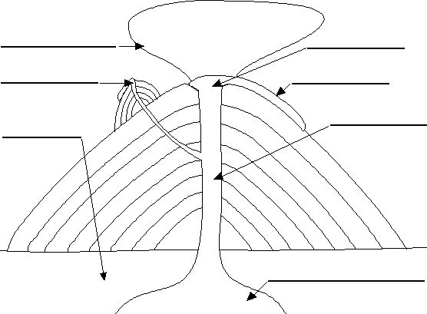

EROSION
Erosion can be modeled by using a pitcher to slowly pour a stream of water over the hills that you formed. Notice small valleys forming and how they don’t always form straight lines.
MAKING YOUR OWN VOLCANO
Materials:
Plywood for volcano base
Salt dough, plaster or paper-mâché
Empty 2-liter bottle
Paint, sealant (if you want to reuse)
Liquid dishwashing soap
Baking Soda
Red food coloring
White vinegar
Teaspoon
1/4 cup measure
Directions:
1. Use a sheet of plywood at least 8 inches wider and longer than your planned volcano to make the base, to prevent the lava from staining surfaces during eruptions
2. Use salt dough, plaster or paper-mâché to form a mountain around an empty 2-liter bottle placed upright at the center of the plywood base. Be sure to leave the lid off.
3. Form the model volcano’s open top tightly around the mouth of the bottle.
4. Make ridges and channels beginning at the volcano’s top and ending at the base of the volcano for the lava to flow through.
5. Let the volcano dry completely, then paint it with acrylics or spray paint. Plastic aquarium plants can be clipped and glued to the volcano for trees.
6. Spray the volcano and plywood with a clear sealant after the paint has dried
7. Mix 1 tbsp liquid dish washing soap, 1 tbsp baking soda and a few drops of red food coloring in a cup
8. Pour the mixture carefully into the bottle.
9. Set the volcano in an open area, preferably outside.
10. Pour (let and adult do this) 􀀁 cup white vinegar into the bottle and stand back to watch your volcano erupt!
Tips:
- Use wadded-up newspaper balls around the bottle to give the volcano its shape under a layer of plaster or papier-mâché paste, but make sure the surface layer of the volcano is solid, so that it can be sealed for re-use.
- If the lava is too thick, add 1 tbsp. water to the soap mix.
- To re-use the volcano, simply clean it off with a damp rag.
- Do not attempt to seal the bottle once the vinegar is added to the baking soda mixture--the resulting pressure could cause the bottle to explode
DEN MEETING DISCUSSION ON MOUNTAINS
- What are all mountains made of? Rocks
- How do mountains differ? Show them pictures of the Himalayas, the Rockies, and the Appalachians. Explain that some mountains are very steep with jagged cliffs and high peaks, while others look more like low, tree covered hills.
- What's the difference between a mountain and a mountain range? Explain that sometimes a mountain, such as a large volcano, may stand alone. But most mountains form clusters, with many grouped very close together. These mountains form a mountain range.
- Do mountain ranges exist underwater? Yes, some of the longest mountain ranges in the world are beneath the oceans. Some of the peaks in these ranges, which are usually volcanic peaks, stick up through the surface, forming islands.
- What is the highest continental mountain in the world? Mt. Everest, in Tibet and Nepal. It is 29,028 feet high.
- What is the tallest oceanic mountain in the world? Mauna Kea, on the island of Hawaii. It rises 33,476 feet off the ocean floor.
- How does the temperature affect the types of plants that grow on a mountain? Near the bottom of a mountain where the air is warmer, there are many plants and some of them are very tall. As you get higher and the temperature gets colder, there are fewer plants and most are short and stubby. At the very top of a high mountain, it is too cold for most plants, including trees, to grow. On the tops of high mountains, you'll find either bare rock or rock covered with ice and snow.
- Can you name some animals that live on mountains? Mountain sheep, mountain goats, giant pandas, pikas, mountain quail, snow leopards, etc. Explain that some of these animals have special adaptations for mountain life.
- Where do mountains exist today? Point out major mountain ranges on a map of the world.
- What are 3 types of volcanoes? Shield, cinder cone, composite
POW WOW EXTRAVAGANZAS
Let me know as soon as your date is set. I will post whatever I receive! CD
Sam Houston Area Council
Following Akela's Trail into the Next Century
Probable Date - November 6, 2010
Location - TBA
Call Sam Houston Area Council, (713) 659-8111, or visit the website, http://www.samhoustonbsa.org/akelas_trail.php ,for more information
Southern NJ Council
Improving Your 'Scoutability"
January 22, 2011
Lakeview Middle School, Millville, NJ 08332
Call Southern NJ Council, 856-327-1700, extension 32, or visit the website, www.snjscouting.org for more information
WEB SITES
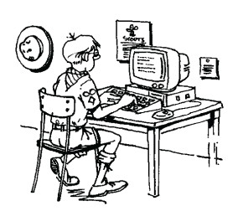
Utah National Parks Council
www.Familyfun.com
Dollar Tree Stores online: www.dollartreedirect.com
Or call toll free 1-800-877-530-TREE (8733)
For pix or crafts try www.googleimages.com
Also, check your local thrift stores and yard sales for back issues of Pow Wow books and other Scouting materials
Lots of good Cub Scout info - www.kismif.org
ONE LAST THING
Are you a Boss or a Leader?
Great Salt Lake Council
The boss drives his men;
The leader coaches them.
The boss inspires fear;
The leader inspires enthusiasm
The boss depends on authority:
The leader on goodwill.
The boss says “I”:
The leader says “We”.
The boss assigns tasks;
The leader sets the pace.
The boss says “Get here on time!”
The leader gets there ahead of time.
The boss fixes blame for the breakdown;
The leader fixes the breakdown.
The boss knows how it’s done;
The leader makes it a game.
The boss says"Go!"
The leader says "Let’s go!"
The world needs leaders, but nobody wants a boss.

By Waite Phillips
The Gentleman who donated
Philmont Scout Ranch to the BSA

Fourth of July Maze
Baltimore Area Council

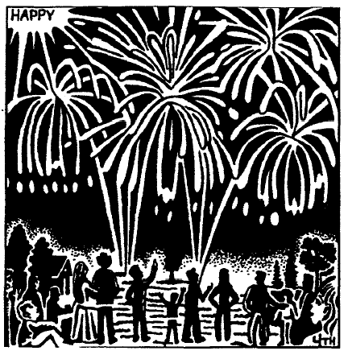

Find more mazes like this one at
http://britton.disted.camosun.bc.ca/mazedthings/mazedthings.html

