FOCUS
Cub Scout Roundtable Leaders’ Guide
Jump in and make a big splash with fun activities that explore water and waves. Cub Scouts can board an imaginary submarine and explore the depths of the ocean. They can make their own boats and race them at the pack's raingutter regatta. A den or pack may take a trip to the beach or a swimming pool. And all these adventures are much more fun with friends. Teach the boys water safety and practice the buddy system. This is an ideal month to work on the Swimming belt loop and pin.
Cub Scout Program Helps
Jump in and make a big splash exploring water and waves. Adventure awaits in one of Earth’s final frontiers, the depths of the ocean. Creatures never imagined can be found there. What does the ocean floor look like? The den could discover what makes a boat float, learn about different sea vessels, even make their own boats. The pack can celebrate with a beach party (no beach required) and family picnic. Top it off with a raingutter regatta. Earn the National Summertime Pack Award. This is a fun month to bring a friend! Teach water safety and practice the buddy system while having fun and earning the Swimming belt loop and pin.
CORE VALUES
Cub Scout Roundtable Leaders’ Guide
Some of the purposes of Cub Scouting developed through this month’s theme are:
- Fun and Adventure. Cub Scouts love water and being outdoors. Having fun activities to do in the water will be a hit with the boys
- Sportsmanship and Fitness. Cub Scouts will practice the swimming skills and use good sportsmanship when playing fun games in the water.
- Personal Achievement. Boys will gain confidence in themselves as they improve their swimming skills.
The core value highlighted this month is:
- Perseverance, Boys will discover that they must continue to work hard in order to improve their swimming strokes or regatta boat designs.
Can you think of others??? Hint – look in your Cub Scout Program Helps. It lists different ones!! All the items on both lists are applicable!! You could probably list all twelve if you thought about it!!
YOUTH PROTECTION UPDATE
Youth safety is the No. 1 concern of the BSA.
To increase awareness of this societal problem and to create even greater barriers to abuse than already exist today in Scouting, the Boy Scouts of America is implementing several important changes to further enhance its Youth Protection policies:
Effective June 1, 2010:
- Youth Protection Training is required for all registered volunteers.
- New leaders are required to take Youth Protection Training before they submit their application for registration. The certificate of completion for this training must be submitted at the time application is made and before volunteer service with youth begins.
- Youth Protection Training must be taken every two years. If a volunteer's Youth Protection Training record is not current at the time of recharter, the volunteer will not be reregistered.
Please CLICK HERE for steps to ensure these policies are fully implemented.
To visit the BSA ON-LINE TRAINING CENTER click the underlined words
To find out more about the Youth Protection policies of the Boy Scouts of America and how to help Scouting keep your family safe, see the information available in any of the Cub Scouting or Boy Scouting handbooks, or go to http://www.scouting.org/Training/YouthProtection.aspx.
COMMISSIONER’S CORNER
While prepping this issue, I thought of the old chant, "The King is Dead. Long Live the King." Yes, one way of delivering the program is gone but a new one is here. We should not bemoan the past but step boldly forward using the new delivery method. Just as our forbearers did when a new King was crowned.
I am a Lutheran, a denomination not known for change. There is the old joke, "How many Lutherans does it take to change a light bulb?? Answer - "Change!!! Change!!! You want us to change!!!" That is not the proper response. Remember, jet planes have no rear view mirrors (Thank you Bob Scott) and let's Zoom off into the future with our Cubs!
And speaking of CS 2010 Changes -
Obviously Baloo will change a little. And I will need some help. With the monthly emphasis on a Core value, I will new material that supports that Core Value. A frequent contributor, Wendy, has sent me some cooperative games for September. Maybe YOU have some ideas that support various Core Values. Send them on out to me - davethecommish@gmail.com. And thank you Wendy for giving me this idea.
We plan to highlight meetings 1 & 2 for each of the 5 ranks and the September Pack Meeting in the August issue. Then 3 & 4 and the October Pack Meeting in September's issue, then 5 & 6 ... Well you get the picture.
Yes, by next month, we will all be doing the exact same things! Not all doing it the same week but all doing it the same.
Months with similar themes to
Waves of Fun
Dave D. in Illinois
Month Name | Year | Theme
January | 1951 | Rivers
July | 1967 | Cub Scout Water Fun
March | 1968 | Rivers of the World
July | 1970 | Old Swimming Hole
August | 1971 | Cub Scout Water Fun
July | 1974 | Water Fun
August | 1977 | Water Fun
March | 1984 | Wheels, Wings & Rudders
March | 1994 | Wheels, Wings & Rudders
August | 1994 | Water Fun
July | 1995 | Water Carnival
July | 1996 | Water Fun
August | 1999 | Splish, Splash
June | 2001 | Wet & Wild
July | 2004 | Fin Fun
April | 2005 | Waterways of the USA
July | 2008 | H2 OHhhhhh!
August | 2010 | Waves of Fun

THOUGHTFUL ITEMS FOR SCOUTERS
Thanks to Scouter Jim from Bountiful, Utah, who prepares this section of Baloo for us each month. You can reach him at bobwhitejonz@juno.com or through the link to write Baloo on www.usscouts.org. CD

Roundtable Prayer
CS Roundtable Planning Guide
“We are grateful, dear God, for your gifts of the sun and the sand and the sea. We pause to give thanks as we run and play enjoying in awe your beauty.”
He that will learn to pray, let him go to sea.
George Herbert
The sea hath no king but God alone.
Dante Gabriel Rossetti, The White Ship
Waves of Fun
Scouter Jim, Bountiful UT
As I write this I am sitting in the second driest state in the United States. And yet, I also live in a valley of one of the world's great inland seas, The Great Salt Lake. As a boy, we would travel to the Great Salt Lake and learned that its salt content was 33% as we bob like corks in the waves. The salt has been mined from it and is now down to only about 16%. The only life the lake supports are brine shrimp, which as a young Cub Scout, I could order as “Sea Monkeys” for ads in the Boy’s Life magazine. The water from the lake is placed in great evaporation ponds and the minerals extracted. There is a small amount of gold extracted from the briny waters. The mountains are filled with trace amounts of gold that are carried down into the water from the stream, rivers and lakes that feed the Great Salt Lake, known as the Great Basin.
I have collected patches though out my many years in Scouting. One of the oldest is from 1971, nearly forty years ago. It was a Conservation Camporee on the Antelope Island in the middle of the Great Salt Lake. We camped on the beach and built our fires with sage brush and buffalo chips. The conservation part was this group of many hundred boys and leaders built a trail that is still in use today. We lined it with rocks, handing them up the steep incline from boy to boy. I have been able to take my family to the state park that now comprises the whole island and look with pride at what was accomplished by a bunch of twelve and thirteen-year-old boys and their dedicated leaders.
August will find me in one of the mountain canyons above the Salt Lake valley, while the Webelos age boys of my pack swim and earn their Aquanaut pin and canoe on the small lake in the camp. This is beautiful tree lined canyon that is full of fun and adventure. But with all there is to do, BB guns, archery, hikes, nature, we go there to swim.
As a father, one of the great privileges of my life is that I was able to be my youngest son’s Cubmaster. One year after he graduated to the New Scout Patrol in Boy Scouts, he was at the same camp the same time I was with my Webelos. I was able to see him on the lake in the canoe, as I lead my group of boys around the camp. He has grown and is now the Den Chief for the Webelos, and will go back to camp again with me. Water has brought me closer to my son during these camping experiences.
Water is fun; however, it must be respected. One year I took a large group of Cub Scouts up the canyon to Scout Camp. Among that group were two special needs young men. One who had been born with Down’s syndrome kept throwing rocks and sticks in the fast flowing river that runs through the canyon. At one point, his brother who was there to keep track of him, came to me and told me he didn’t know where he was. I had nightmares of him in the river. As it turned out, he had hiked nearly a mile up canyon to the Webelos camp and all was well. However, Safe Swim Defense, and Safety Afloat teach us to be aware of the dangers of Water. Please be careful out there.
Note from CD -
Scouter Jim has a growth in his brain.
Please add him to your prayer lists.

Quotations
Quotations contain the wisdom of the ages, and are a great source of inspiration for Cubmaster’s minutes, material for an advancement ceremony or an insightful addition to a Pack Meeting program cover
We never know the worth of water till the well is dry. Thomas Fuller, Gnomologia, 1732
A lake carries you into recesses of feeling otherwise impenetrable. William Wordsworth
A lake is the landscape's most beautiful and expressive feature. It is earth's eye; looking into which the beholder measures the depth of his own nature. Henry David Thoreau
The sea pronounces something, over and over, in a hoarse whisper; I cannot quite make it out. Annie Dillard
The true peace of God begins at any spot a thousand miles from the nearest land. Joseph Conrad
Never a ship sails out of the bay
But carries my heart as a stowaway.
Roselle Mercier Montgomery, The Stowaway
I believe that water is the only drink for a wise man.
Henry David Thoreau
The cure for anything is salt water - sweat, tears, or the sea. Isak Dinesen
Filthy water cannot be washed. African Proverb
Every time we walk along a beach some ancient urge disturbs us so that we find ourselves shedding shoes and garments or scavenging among seaweed and whitened timbers like the homesick refugees of a long war.
Loren Eiseley
For whatever we lose (like a you or a me),
It's always our self we find in the sea.
e.e. cummings
Most of us, I suppose, are a little nervous of the sea. No matter what its smiles may be, we doubt its friendship.
H.M. Tomlinson
The only cure for seasickness is to sit on the shady side of an old brick church in the country. Author Unknown
Though inland far we be,
Our souls have sight of that immortal sea
Which brought us hither.
William Wordsworth, Intimations of Immortality
Ocean: A body of water occupying two-thirds of a world made for man - who has no gills. Ambrose Bierce
The sea has never been friendly to man. At most it has been the accomplice of human restlessness. Joseph Conrad
Praise the sea; on shore remain. John Florio
Rivers are roads which move, and which carry us whither we desire to go. Blaise Pascal
The great sea makes one a great sceptic. Richard Jefferies
And thou, vast ocean! on whose awful face
Time's iron feet can print no ruin-trace.
Robert Montgomery, The Omnipresence of the Deity
Why do we love the sea? It is because it has some potent power to make us think things we like to think.
Robert Henri
I hate to be near the sea, and to hear it raging and roaring like a wild beast in its den. It puts me in mind of the everlasting efforts of the human mind, struggling to be free and ending just where it began. William Hazlitt
There is nothing so desperately monotonous as the sea, and I no longer wonder at the cruelty of pirates.
James Russell Lowell
The lakes are something which you are unprepared for; they lie up so high, exposed to the light, and the forest is diminished to a fine fringe on their edges, with here and there a blue mountain, like amethyst jewels set around some jewel of the first water, - so anterior, so superior, to all the changes that are to take place on their shores, even now civil and refined, and fair as they can ever be.
Henry David Thoreau
The Bear Lake Monster
The story was written in 1868 by Joseph C. Rich and was sent to the Deseret News Newspaper. It goes as follow:
"The Indians have a tradition concerning a strange, serpent-like creature inhabiting the waters of Bear Lake, which they say carried off some of their braves many moons ago. Since then, they will not sleep close to the lake. Neither will they swim in it, nor let their squaws and papooses bathe in it.
Now, it seems this water devil, as the Indians called it, has again made an appearance. A number of our white settlers declare they have seen it with their own eyes. This Bear Lake Monster, they now call it, is causing a great deal of excitement up here. S. M. Johnson at South Eden was riding along near the Lake the other day when he saw something a number of yards out in the lake which he thought was the body of a man. He waited for the waves to wash it in, but to his surprise, found the water washed over it without causing it to move. Then he saw it had a head and neck like some strange animal. On each side of the head were ears, or bunches the size of a pint cup. He concluded the body must be touching the bottom of the lake. By this time, however, Johnson seems to have been leaving the place so rapidly he failed to observe other details.
The next day three women and a man saw a monstrous animal in the lake near the same place, but this time it was swimming at an incredible speed. According to their statement, it was moving faster than a horse could run.
On Sunday last, N. C. Davis and Allen Davis of St. Charles; Thomas Sleight and James Collings of Paris, with six women were returning from Fish Haven when about midway from the latter place to St. Charles, their attention was suddenly attracted to a peculiar motion of waves on the water about three miles distant. The lake was not rough, only a little disturbed by the wind. Mr. Sleight ways he distinctly saw the sides of a very large animal that he would suppose to be not less than 90 feet in length. Mr. Davis doesn't think he was any part of the body, but is positive it must not have been less than forty feet in length, judging by the waves it rolled up on both sides of it as it swam, and the wave it left in the rear. It was going south, and all agreed it swam with a speed almost incredible to their senses. Mr. Davis says he never saw a locomotive travel faster, and thinks it made a mile a minute. In a few minutes after the discovery of the first, a second followed in its wake, but seemed much smaller, appearing to Mr. Sleight about the size of a horse. A larger one followed this, and so on until before disappearing, made a sudden turn to the west a short distance, then back to its former track. At this turn Mr. Sleight says he could distinctly see it was of a brown color. They could judge somewhat of the speed by observing known distances on the opposite side of the lake; and all agree that the velocity with which these monsters propelled themselves, was astounding. They represent the waves rolling up on each side as about three feet high. This is substantially their statement as they told me. Messengers Davis and Sleight are prominent men, well known in the country, and all of them are reliable persons, whose veracity is undoubted. I have no doubt they would be willing to make affidavits to their statements.
Was it fish, flesh. or serpent? Amphibious, or just a big fib, or what is it? I give up, but live in hopes of some day seeing it.
The Deseret News ran the story July 31, 1868. Great excitement followed. A news staff member during the next month quizzed many Bear Lake people and found hardly a person who doubted it.
However, the inevitable skeptics did appear on the scene.
The Indians had taken a great deal of interest in stories of the monster and claimed that their ancestors told them about a monster. They were telling some pretty good-sized stories about the creatures.
In 1874, a traveler named John Goodman came through the Bear Lake Valley. He described an Indian legend about two lovers whom, upon being pursued by some of their fellow tribesmen, plunged into the lake and were changed by the Great Spirit into two large serpents. However, this is just a legend.
The description of the Monster was the following: A creature with a brown-colored body, somewhat bigger in circumference than a man, anywhere from 40 to 200 feet long. Its head was shaped like a walrus without tusks or like an alligator's, and the eyes were very large and about a foot apart. It had ears like bunches, about the size of a pint cup. It had an unknown number of legs, approximately eighteen inches long, and it was awkward on land, but swam with a serpent-like motion at a speed of at least sixty miles an hour. No one ever described the back part of the animal since the head and forepart was all that was ever seen. The rest was always under water.
Make believe? No one knows for sure. Come on up to Bear Lake and find out for yourself.
TRAINING TOPICS
Water Fun – Water Safety
Bill Smith, the Roundtable Guy
FUN
Dive right in as Cub Scouts spend a month learning about water, our most precious resource. Learn about marine life. Dens can visit a water treatment facility, local aquarium or fish farm. Cub Scouts may even want to prepare their own aquarium or fish bowl and "adopt a gold fish".
This is also an excellent opportunity to teach our Cub Scouts about water conservation. Don't forget learning about water safety. Enjoy water games; hunt for shells and experience all the beach has to offer. Cub Scouts love to get wet.
What could be better than a water carnival complete with games, competition, and safe swim demonstrations? This would be a great time to work on the Wildlife Conservation, Fishing, or Swimming belt loop and pin. Have an outdoor Cub Scout rain gutter regatta race.
When one imagines Boy Scouts camping, there is usually water in the picture. It may be swimming, a canoe pulled up to a lake shore camping spot or white water rafting. A boy should be ready to participate in all these, safely and confidently, as soon as he joins a troop. Cub Scouting provides an age appropriate, graduated program of aquatics:
    - Wolf - Achievement 1h - Swim as far as you can walk in fifteen steps.
    - Wolf - Elective 19 - Fishing.
    - Bear - Elective 5 - Boats.
    - Bear - Elective 19 Swimming - Introduces the Buddy System / Plan.
    - Webelos - Aquanaut Activity Badge.
    - Webelos - Readyman Activity Badge - Safe Swimming.
Swimming
Swimming is not only lots of fun but the ability to swim is an important physical skill. It is worth the effort of every Cub Scout leader to ensure that each of their charges gets the opportunity to learn to swim.
Check out local community services like the YMCA, Red Cross etc. for swim classes. Put swimming in your annual pack plans.
Also when a boy graduates to a troop he will need to be able to swim in order to fully participate in the troop program.
Second Class requirement 7b states:
Demonstrate your ability to jump feet first into water over your head in depth, level off and swim 25 feet on the surface, stop, turn sharply, resume swimming, then return to your starting place. Until they are able to do this they cannot advance. If a Scout can not swim, there is so much that he misses out on, troop's trip to Florida Sea base, and other high adventure sites, canoe trips, white water rafting etc.
Fishing
If you have never taken your den fishing, you are missing one of the great joys of Cub Scouting. It's a blast to take any bunch of kids fishing, especially when you have a place where they might actually catch some fish.
Longhorn Council runs a successful Cub Scout Trout-O-Ree in conjunction with the Texas Parks & Wildlife Junior Angler Education Program
Tiger Cubs, Cub Scouts, and Webelos Scouts may complete requirements for the Fishing Belt Loop or Sports Pin in a family, den, pack, school, or community environment. Tiger Cubs must work with their parents or adult partners
The Cub Scout Leader How-To Book has some splendid water related activities in chapter 14 that include fish and other aquatic life.
Boating
The Boating Elective in the big Bear Book has all sorts of skills and experiences for a growing boy. Operating a rowboat or sail boat are not only adventures, but they also let a boy discover the mechanics of force and motion.
Cub Scout canoeing is restricted to council run camping programs to ensure qualified leadership and safe conditions. If you are lucky enough to have a canoe program in your council Cub camp, then your boys are in for a great adventure.
For many years, Cub Scouts and Webelos were not allowed to canoe. My wife Shirley and I had been volunteering at a local Easter Seal camp where we discovered that children sitting in the bottom of a canoe were more stable and secure than when sitting in row boats. Even the most severely disabled went canoeing with us and had a great time. They just didn’t weigh enough to tip the canoe.
Shirley, an avid canoeist, was on our council Executive Board and she convinced the leadership to apply for a program variance to permit us to include canoes at our Council Day Camp where we had a small pond.. The variance was approved by National and the program was a great success. We even ran occasional Saturday camps so working parents could canoe with their boys.
Eventually National included canoes as a camp program for Cub Scouts, pretty much along the lines of Shirley’s request.
SAFETY
First of all, get your copy of Guide to Safe Scouting, read it and carry it with you.

Safe Swim Defense
Before a BSA group may engage in swimming activities of any kind, a minimum of one adult leader must complete Safe Swim Defense training, have a commitment card (No. 34243) with them, and agree to use the eight defenses in this plan.
Click Here -
Register, Log in,
Take the Course, Get Credit.
Safety Afloat
Safety Afloat has been developed to promote boating and boating safety and to set standards for safe unit activity afloat. Before a BSA group may engage in an excursion, expedition, or trip on the water (canoe, raft, sailboat, motorboat, rowboat, tube, or other craft), adult leaders for such activity must complete Safety Afloat Training, have a commitment card with them, and be dedicated to full compliance with all nine points
of Safety Afloat. [Note: Cubs and Webelos are not permitted on excursions, expeditions or trips.]
Click Here -
Register, Log in,
Take the Course, Get Credit.
Personal Flotation Devices (PDF)
Every child must wear a Coast Guard approved Personal Floatation Device when on the water.

To work right, a PFD must fit snugly on a child. To check for a good fit, pick the child up by the shoulders of the PFD. If the PFD fits right, the child's chin and ears will not slip through.
Children and PFDs United States Coast Guard
Cold Water
Even when the weather is warm and sunny, the water may be cold – and dangerous. Beware of exposing Cub Scouts to water temperature under 60 degrees F. The American Canoe Association tells us that more than half of the fatal boating accidents in Pennsylvania occur when the water is cold
I have been a canoe instructor with both the American Red Cross and the ACA. I know, first hand, that cold water can be extremely dangerous.
Once while attempting to free a stuck canoe, I slipped and fell into water under 40 degrees F. The current was not fast – less than brisk walking speed – and the brook was hardly twenty feet wide at that point but I was powerless to extricate myself. The cold water had effectively paralyzed me. I could not swim nor could I grasp hold of the paddles that my companions reached out towards me. I just hung in my PFD and went with the flow until an eddy washed me close enough to the bank where others could drag me ashore.
Currents and Low-Head Dams
Cub Scouts and Webelos should do all their boating on flat water with no current. Moving water, even a slow current of one or two miles per hour, can exert enormous force on a child. A boat or raft full of water can weigh over a thousand pounds and could crush the body of a child caught in its path. Taking Cub Scouts on moving water is just plain foolish.
For this and other reasons, trips and excursions on water are not permitted for Cub Scouts and Webelos.
Some notes for current and future
Boy Scout leaders.
Especially dangerous situations occur at the many low-head dams common on rivers in just about every state. These dams are small, ranging from 6 inches to a few yards in height. They produce hydraulic effects that trap unwary boaters, where escape is almost impossible. Rescue is difficult and perilous, even for trained personnel.
In sum, [low-head dams] combined with the hydraulic current create a nearly perfect drowning machine.
Minnesota Department of Natural Resources
The real danger is that these dams slow the general flow of the rivers creating an impression of placid, safe waters. Every year many people, sometimes Scouts, perish in these traps.
Suite101 writer, Alan Sorum, Manager for the Municipality of Skagway, an Alaska Borough and immediate past Port Director and Harbormaster for the City of Valdez, Alaska has an excellent article on low head dams.
Some more links on Water Fun – Water Safety.
Red Cross Aquatics General Aquatics Information
Wisconsin Dept. of Natural Resources. More on PDF
Camp and Fish - Interesting stuff for Packs
Longhorn Council Trout-O-Ree
American Canoe Association – Cold Water.
What are YOU going to do now?
Have you taken Safe Swim Defense and
Safety Afloat on-line??
The best gift for a Cub Scout.......
......get his parents involved!
- Also, be sure to visit Bill’s website
http://rt492.org/
to finds more ideas on everything Cub Scouting.
This column was a rerun of one of Bill's from 2008. He has officially retired from Baloo's staff - and will be sorely missed. He wrote me last month - "Come October, I will have completed my 48th year as an adult Scouter. It’s probably time I started taking it easy. But I am interested in learning about the experiences that CS leaders have with the CS-2010. Reach Bill Smith at wt492(at)wtsmith.com.
Send him a Thank you for all he has done - his website and contributions to Baloo. CD
Have any Comments for Bill
just click right here!
PACK ADMIN HELPS
Cub Scouts NEW Delivery Method
Out with the old and in with the new!
Our youth desire a program that is relevant, FUN, current, contemporary and exciting – without losing the history, tradition and folklore that has long been the foundation of this great Movement.
Using the new delivery method, ONE leader** with
- the appropriate rank handbook
- and a series of den meeting plans that are focused on handbook activities
can deliver just such a program to the den.
** NOTE Star, Star, Asterisk (major emphasis) - Although one leader can develop and deliver an effective program, two deep leadership is required at all meetings. A second adult must be present at all meetings. See the Youth Protection Rules that you learned when taking the now required Youth Protection Training. And a second registered leader would be great so you can share the workload or have someone to fill in if you are on a trip or not feeling well.
Note the phraseology - This is a
NEW Delivery Method – NOT A New Program
The Cub Scouting program is the same…
only the delivery method is new.)
- Cub Scouts New Delivery Method, is handbook-based and promises to deliver unit retention through activities that lead to youth advancement.
- To successfully implement the change in the delivery method, adult leaders (specifically Den Leaders) are being provided with den meeting plans and associated training to enable them to conduct highly effective den and pack meetings.
What hasn’t changed…
- Cub Scout Handbooks
- Advancement Requirements
- Electives
- Academics & Sports Belt Loops and Pins
- Family-related achievements and activities

In fact, a concern with many across the program was the lessening of family-based activities and home assignments. While the contrary is true;
The meeting plans provide the den leader with specific support to organize and conduct their den meetings AND to communicate with families and adult partners.
There are detailed instructions in each plan for boys and parents to follow between meetings, when needed.
Actually, those who’ve used this program have found that family participation increases because so many of the achievements and electives in the handbooks call for family participation.
Arrow points & belt loops are worked with the family.
What has changed…
Program Helps are eliminated. They are replaced with
Den & Pack Meeting Resource Guide
This new book contains
- Den meeting plans
- Pack meeting plans
- Key meeting information
Roundtable Meetings
- Minor change from themes to core values
- Focus is still on
- Training
- Den and Pack planning
- Key events planning
- Ideas for next month’s core value
In Review…
- One leader**(see previous note on Two Deep Leadership) , a handbook & a series of den meetings can successfully deliver relevant, FUN, current, contemporary and exciting program without losing the history, tradition and folklore that has long been the foundation of this great Movement.
- Increased retention should result through activities focused on advancement in the den meetings
- Focus has been placed on providing adult leaders with the needed plans and training support to be successful.
What Resources and Materials are available for success?
- Den and Pack Meeting Resource Guide
- Cub Scout Leader Book
- Webelos’ Leader Guide
- Ceremonies for Dens and Packs
- Cub Scout Roundtable Guide
- Cub Scout Academics & Sports Program Guide
- Cub Scouts Leader “How-to” Book
Let's take them one at a time -
Den & Pack Meeting Resource Guide
Lends great support to Cubmaster and Den Leaders
It is the only completely NEW resource
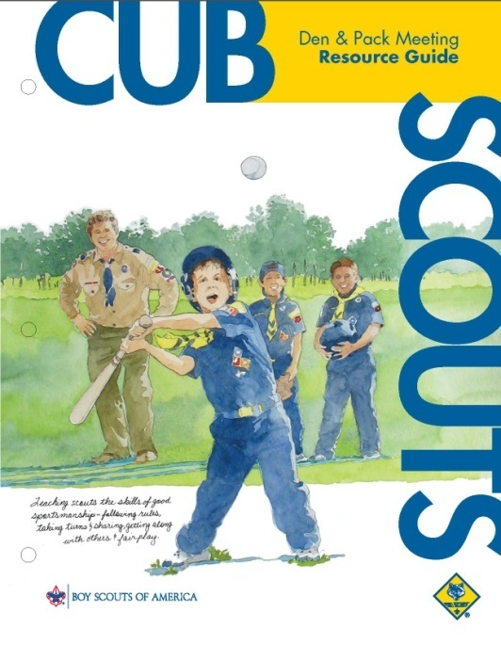
Four Major Sections
- Overview of Cub Scouting and Using the Den & Pack Meeting Resource Guide
- Den Meeting Plans
- Pack Meeting Plans
- Resources, Forms and Applications
Section 1 - Overview of Cub Scouting and Using the Den & Pack Meeting Resource Guide
- Introduction
- Overview of Cub Scouting
- Delivering the Cub Scout Program
- Other Awards Cub Scouts Can Earn
The “Overview of Cub Scouting and Using the Den & Pack Meeting Resource Guide” should be reviewed prior to any Cub Scout activities as it provides the fundamental purpose, methods, and ideals of Cub Scouting as well as the structure of how the program works and key tips about conducting den and pack meetings. This section includes:
- Purposes of Cub Scouting
- Methods of Cub Scouting
- Ideals of Cub Scouting
- Tips for conducting Den and Pack Meetings
The Introduction outlines the overall AIMS of Scouting
In Part 1, Introduction, there’s a brief overview of the program and outlines the overall aims of Scouting, which continue to be:
- To develop a boy’s character
- Train him in good citizenship
- And, encourage him to become more fit – physically, mentally and morally.
The Overview of Cub Scouting
Part 2, Overview, serves as a reminder to Den and Pack Leaders that Cub Scouting is
- Year-round,
- Family-oriented
- Part of the Boy Scouts of America program designed for boys to work together with parents, leaders and organizations to achieve the 10 purposes of Cub Scouting
10 Purposes of Cub Scouting
- Character Development
- Spiritual Growth
- Good Citizenship
- Sportsmanship & Fitness
- Family Understanding
- Respectful Relationships
- Personal Achievement
- Friendly Service
- Fun and Adventure
- Preparation: Boy Scouts
Methods of Cub Scouting Section
The “Methods of Cub Scouting” section outlines the eight specific methods to achieve Scouting’s aims of helping boys and young adults build character, train in the responsibilities of citizenship, and develop personal fitness. These methods are incorporated into all aspects of the program and it’s through these methods that Cub Scouting happens in the lives of boys and their families.

The 8 Methods of Cub Scouting
  - The ideals: The Cub Scout Promise, the Law of the Pack, and the Cub Scout sign, handshake,motto, and salute all teach good citizenship and contribute to a boy’s sense of belonging.
  - The den: Boys like to belong to a group. The den is the place where boys learn new skills and develop interests in new things. They have fun in den meetings, during indoor and outdooractivities, and on field trips. As part of a small group of six to eight boys, they are able to learn sportsmanship and good citizenship. They learn how to get along with others. They learn how to do their best, not just for themselves but also for the den.
  - Advancement: Recognition is important to boys. The advancement plan provides fun for the boys, gives them a sense of personal achievement as they earn badges, and strengthens family understanding. Cub Scout leaders and adult family members work with boys on advancement projects.
  - Advancement: Recognition is important to boys. The advancement plan provides fun for the boys, gives them a sense of personal achievement as they earn badges, and strengthens family understanding. Cub Scout leaders and adult family members work with boys on advancement projects.
  - Family involvement: Family involvement is an essential part of Cub Scouting. When we speak of parents or families, we are not referring to any particular family structure. Some boys live with two parents, some live with one parent, some have foster parents, and some live with other relatives or guardians. Whomever a boy calls his family is his family in Cub Scouting.
  - Activities: In Cub Scouting, boys participate in a wide variety of den and pack activities, such as games, projects, skits, stunts, songs, outdoor activities, and trips. Also, the Cub Scout Academics and Sports program and Cub Scouting’s Fun for the Family include activities that encourage personal achievement and family involvement.
  - Home- and neighborhood-centered: Cub Scouting meetings and activities happen in urban areas, in rural communities, in large cities, in small towns—wherever boys live.
  - The uniform: The Cub Scout uniform helps build pride, loyalty, and self-respect. Wearing the uniform to all den and pack meetings and activities also encourages a neat appearance, a sense of belonging, and good behavior.
  - Making Character Connections: Throughout the program, leaders learn to identify and use character lessons in activities so boys can learn to know, commit, and practice the 12 core values of Cub Scouting. Character Connections are included in all the methods of Cub Scouting and are the program themes for monthly pack meetings.
The Core Values of Cub Scouting
Since its origin, the Scouting program has been an educational experience concerned with values. In 1910, the first activities for Scouts were designed to build character, physical fitness, practical skills, and service. These elements were part of the original Cub Scout program and continue to be part of Cub Scouting today
Character development should extend into every aspect of a boy's life. Character development should also extend into every aspect of Cub Scouting. Cub Scout leaders should strive to use Cub Scouting's 12 core values throughout all elements of the program—service projects, ceremonies, games, skits, songs, crafts, and all the other activities enjoyed at den and pack meetings
12 Core Values of Cub Scouting
And the Pack meeting month of emphasis
- Cooperation September
- Responsibility October
- Citizenship November
- Respect December
- Positive Attitude January
- Resourcefulness February
- Compassion March
- Faith April
- Health and Fitness May
- Perseverance June
- Courage July
- Honesty August
Character Connections™
The goals of the Cub Scout leader are
    - to seek out and maximize the many opportunities to incorporate character development
    - to convince the young Cub Scout that character is important to the individual, to his family, community, country, world, and God
Character development should not be viewed as something done occasionally as part of a separate program, or as part of only one area of life. For in reality, character development is a part of everything a Cub Scout does. Character development lessons can be found in every aspect of the Cub Scouting experience.
When it comes to developing character, the complete person must be considered. Character development involves at least three critical areas:
- Know (thought)
- Commit (feeling)
- Practice (behavior)
In Cub Scouting, addressing these three critical areas and relating them to values is referred to as Character Connections.
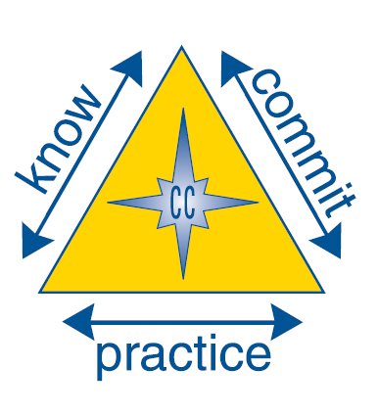
Part 3 of the Overview section is “Delivering the Cub Scout Program” and it reminds us that part of the inherent strength of the Cub Scout program is its organization. At its most basic, Cub Scouting continues to consist of:
- A boy—The individual boy is the basic building block for Cub Scouting and is its most important element. It is only when each boy’s character, citizenship, and fitness are enhanced that the program is successful.
- A den—Each boy belongs to a den of similarly aged boys. The den is the boy’s Cub Scout family where he learns cooperation and team building, and finds support and encouragement.
- A leader—Adult leadership is critical to achieving the purposes and aims of Scouting. By example, organized presentations, and one-on-one coaching, the boy learns the value and importance of adult interaction.
- A pack—Each den is part of a larger group of boys of different ages and experience levels in Cub Scouting. The pack provides the resources for enhanced activities, opportunities for leadership, and a platform for recognition.
While there are other parts which are vital in the administrative support of the program and adult leaders, they are more or less transparent to the boy in the program.
“Delivering the Cub Scout Program”
In this section, the following topics are included so that there is consistency for new and veteran Den Leaders in their responsibilities and management of the Den.
- Responsibility to the Boys
- Den Leader Responsibilities
- Cubmaster Responsibilities
- Role of Training
- Why the Method Underlying the Resource Guide Works
Responsibilities to the Boys
All Cub Scout leaders have certain responsibilities to the boys in Cub Scouts. Each leader should:
- Respect boys’ rights as individuals and treat them as such. In addition to common-sense approaches this means that all parents/guardians should have reviewed How to Protect Your Children From Child Abuse: A Parent’s Guide, and all youth leaders should have taken the BSA’s Youth Protection training.
- See that boys find the excitement, fun, and adventure that they expected when they joined Cub Scouting.
- Provide enthusiasm, encouragement, and praise for boys’ efforts and achievements.
- Develop among the boys a feeling of togetherness and team spirit that gives them security and pride.
- Provide opportunities for boys to experience new dimensions in their world.
Den Leader Responsibilities
In addition to the leader’s general responsibility to the boys in Cub Scouting, the den leader has certain other leadership responsibilities that may be summarized as follows:
- Work directly with other den and pack leaders to ensure that their den is an active and successful part of the pack.
- Plan, prepare for, and conduct den meetings with the assistant den leader and den chief (if Wolf, Bear or Webelos den leaders) or adult partners (if Tiger Cub den leaders).
- Attend the pack leaders’ meetings.
- Lead the den at the monthly pack activity.
- Ensure the transition of their Cub Scouts to a den of the next rank (or to a Boy Scout troop if Webelos) at the end of the year.
Cubmaster Responsibilities
Den leaders and Cubmasters (with supporting unit committee members) represent the leadership team that makes the pack go. In general, the Cubmaster is the guiding hand behind the work of other pack leaders and serves as program adviser to the pack committee. He or she is a recruiter, supervisor, director, planner, and motivator of other leaders. The Cubmaster’s main responsibilities are:
- Work directly with the pack trainer, den leaders, den chiefs, and pack committee chair and members to make sure that all dens are functioning well.
- Plan the den and pack programs with the help of other leaders.
- Lead the monthly pack meeting with the help of others, involving all dens in some way.
- Coordinate pack membership, recruiting, and transition.
Role of Training
Core to succeeding with these responsibilities is the concept that every Cub Scout deserves a trained leader. Being a trained leader helps you deliver the program in a way that is effective and efficient with a focus on the core objectives for the boy.
Becoming a trained leader requires completion of the following training:
- Youth Protection
- Fast Start
- This Is Scouting
- Leader Position-Specific
Consult with your pack trainer or visit www.myscouting.org for training options.
Why the Method Underlying the Resource Guide Works
Success of the Cub Scout program, defined as developing character, building citizenship and developing personal fitness, is demonstrated by a cascading process of outcomes. That cascading process looks like this:
The longer a boy STAYS INVOLVED in Scouting, the more the attributes of character, citizenship and fitness are demonstrated.
The pilot proved that Boys who advance at the same rate with their peers were more likely to STAY INVOLVED in the program than boys who fall behind or do not advance.
Program focused on advancement increases the likelihood of retention.
Den Meeting Plans
The Den Meeting plans are designed around the school year and if followed will result in boys in the den advancing in rank. The plans are developed around the following:
- Two den meetings per month, in addition to the pack meeting and other outings or activities.
- Beginning the Scouting year in September
- Resulting rank advancement by the annual blue and gold banquet, (which is usually in February)
- Continuing den and pack meetings through the school year and summer
- The plan supports other start dates; however, if starting later than September, it may be necessary to have more than two meetings per month if rank advancement by the blue and gold banquet is the objective.
Supplemental Den Meeting Plans
- Dens meeting more than twice per month
- Used in conjunction with
- The Summertime Pack Award
- Electives
- Academics & Sports belt loops & pins
- Individual and/or group awards
- Supplemental meeting plans are used to support dens that meet more than twice per month or for dens that meet year-round. These should be used after rank advancement is achieved to continue working toward electives, any Academics and Sports belt loops/pins, and other individual and group awards.
- Supplemental meeting plans are used to support dens that meet more than twice per month or for dens that meet year-round. These should be used after rank advancement is achieved to continue working toward electives, any Academics and Sports belt loops/pins, and other individual and group awards.
Special Moments
Throughout the Resource Guide, leaders will find many ideas for helping them to capture the moment and gently give boys a glimpse into the deeper purposes within the FUN of Cub Scouting. These ideas may include:
- Cubmaster’s and Den Leader’s Minutes – These are one or two minute stories that emphasize the values, ideals and character of Cub Scouts.
- Reflecting – This is a great method for leaders to guide their Cub Scouts to discovering a deeper purpose of an activity.
- Character Connections – These are discussions relating activities, projects or events to one of the 12 core values of Cub Scouting. And this the Know, Commit, Practice discussed earlier.
Other Awards Cub Scout Can Earn
Part 4, Other Awards, provides a list of other opportunities besides advancements for your Cub Scouts to earn awards and receive recognition.
Section 2 - Den Meeting Plans
This section is broken out into 6 main parts –
Part One is a general overview for Den Leaders and includes the:
- Den Meeting Introduction
- Den Leader Responsibilities
- Den Meetings and Den Meeting Plans
- Helpful Hints for Den Leaders
- Den Meetings overview
Parts 2 through 6 provide detailed Den Meeting plans for each rank
- Part 2 – Tiger Den Meeting Plans
- Part 3 – Wolf Den Meeting Plans
- Part 4 – Bear Den Meeting Plans
- Part 5 – Webelos Den Meeting Plans
- Part 6 – Arrow of Light Den Meeting Plans
Parts of a Den Meeting All Den Meetings (and Pack Meetings) now have the same seven parts:
The Seven Parts of a
Cub Scout Meeting
- Before the Meeting
- Gathering Time
- Opening
- Business Items
- Activities
- Closing
- After the Meeting
These 7 parts are explained in detail in the Den & Pack Meeting Resource Guide and in Position Specific Training.
Do, Home Assignment, Verify
An important element added to each of sections two through six, which are the actual Den Meeting Plans for each rank, are the Do, Home Assignment, and Verify terms.
These are terms used to guide boys, parents and the Den Leader to ensure that the boys –
- Do – Activities to be done during the den meetings
- Home assignments – Activities that are done with the boys’ parent or adult partner. **
- Verify - A reminder to the Den Leader to verify completion of home assignments.
** Den Leaders need to be aware that with the current family dynamic that many of our boys may face, it may be necessary to set aside time that he or she can offer support to them in doing their home assignments during a den meeting or at another time. Home assignments are important to advancement… And advancement is vital to retention!
Tiger (Wolf, Bear, …) Letter Template
These letter templates provide an excellent way for the Den Leader to keep all the parents informed about the progress of the Den and their son. The Templates cover the whole year but may be easily modified to cover whatever time span of info you wish to send home that week. Check them out!!!
Section 3 – Pack Meeting Plans
This section provides guidance on planning and executing the monthly pack meetings for Cubmasters and committee members. It is important for den leaders as they may have pack meeting responsibilities for themselves or their den members.
Pack meeting are now based on the Core Values (see table earlier in this article).
The pack meeting is the culmination of four or five weeks of den activities of all the dens. Dens may participate in the pack meeting by presenting a song, skit, ceremony, or other presentation. Boys will receive their advancement badges and other recognition items, such as patches for day camp participation, Cub Scout Academics and Sports belt loops and pins, and other awards. Every boy has a chance to be individually recognized. Be sure to recognize parents who have helped during the month, either in the dens or with the pack committee.
In each month’s pack planning pages, there are suggestions for topics for the pack leaders’ planning meeting. All leaders—den leaders, assistant den leaders, Cubmasters and assistants, and all committee members—are invited to this monthly meeting. Make the meeting fun as well as informative.
During the monthly pack leaders’ planning meeting, you will finalize the upcoming pack meeting and will plan in detail the next month’s pack meeting. This meeting is usually held one or two weeks before the pack meeting.
Section 4 – Resources, Forms and Applications
This section provides reference material for all leaders to help them find what they need.
BSA Forms and Applications may be found at
http://www.scouting.org/scoutsource/CubScouts/Leaders/Forms.aspx
Other Literature Updates And Revisions
Cub Scout Leader Book 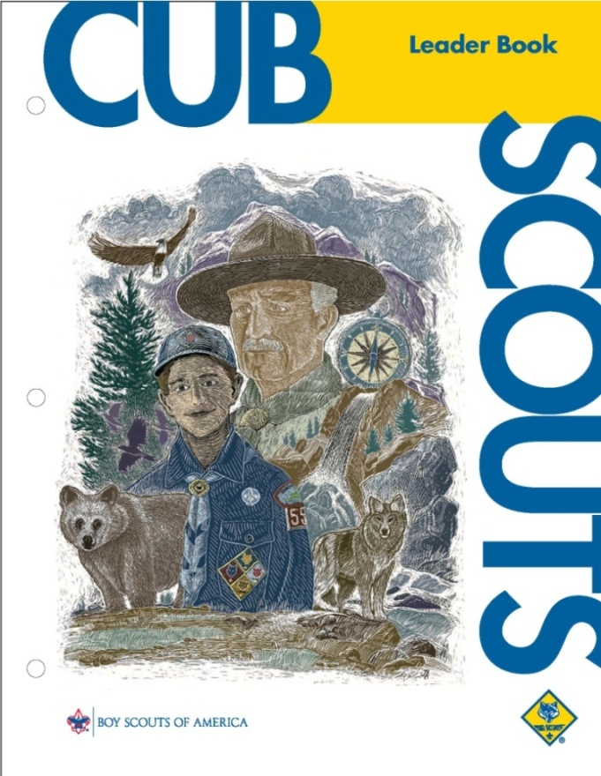
- Reorganized and rewritten. No content has been eliminated but substantial duplication has been removed. Major sections now include:
- Cub Scouting Basics (Aims, Purposes, etc.; Working with CS-age boys, boys with disabilities)
- The Cub Scouting Program (Organization, introduction to ranks, advancement, etc.)
- Leaders and Families (selection and training of leaders, leader roles and responsibilities, etc.)
- Administration (membership, pack planning, re-chartering, insurance, etc.)
- Cub Scout Activities (Health & safety, outdoor activities, camping, etc.)
- Appendix (Resource list, resources are online and Unit Leader Enhancements
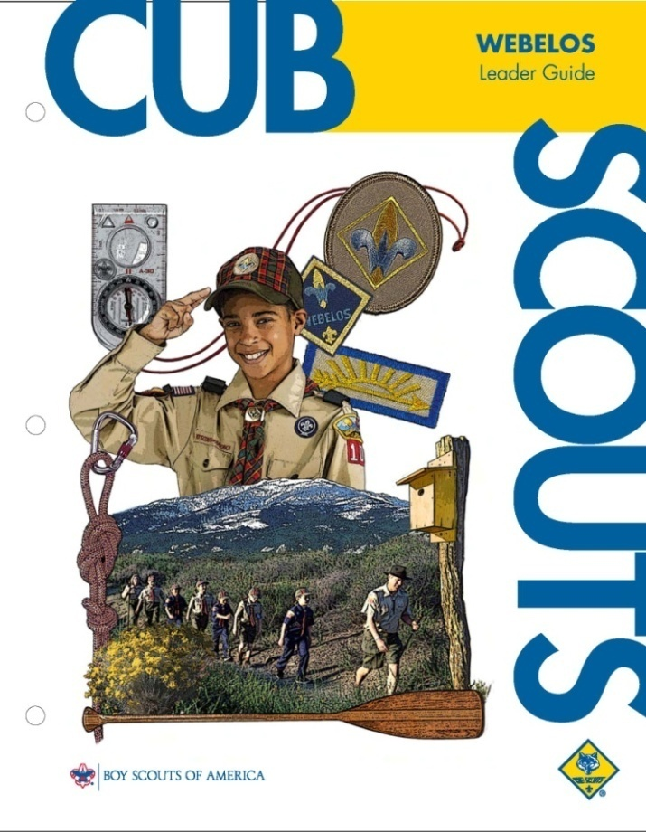Webelos Leader Guide
- Introduction has been edited to reflect the existence of the Den & Pack Meeting Resource Guide and the included den meeting plans.
- The schedule in the Den & Pack Meeting Resource Guide replaces old Plan B, Webelos Den starting in September. (If you have a different start date, you will need to adjust)
- There is a schedule for dens in LDS units.
- Suggested crafts, experiments, and other activities for each of the Activity Awards is unchanged.
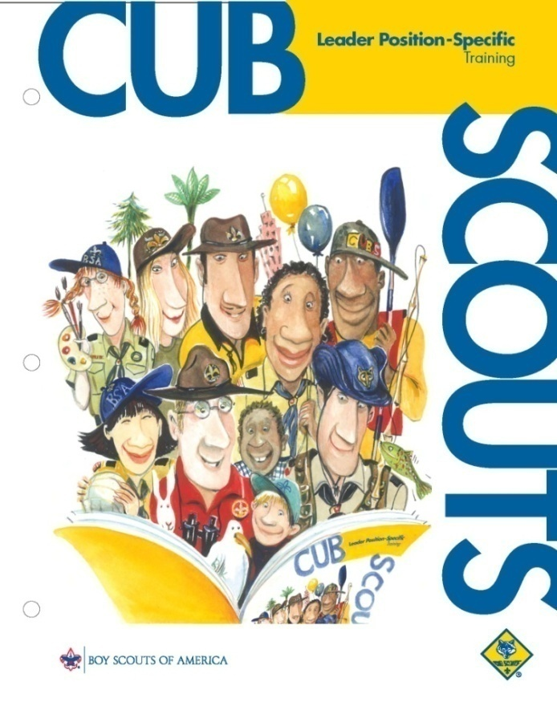
Leader Position-Specific Training
- Position Specific Training for Den Leaders has been rewritten with two fundamental changes:
- Recognize the existence of the Den & Pack Meeting Resource Guide and the included den meeting plans
- Reorganized to bring together all of the basics of den leadership into one module with separate, smaller mini-modules to deal with the rank-specific differences.
- Cubmaster, Pack Committee and Pack Trainer are fundamentally unchanged.
- The PowerPoint slides are now included in a CD format rather than the past DVD for ease of access. File formats are included to support multiple generations of Windows and the “Say” and “Do” content of the book is included in the “notes” field within PowerPoint.
- On-line version is now available
Roundtable Planning Guide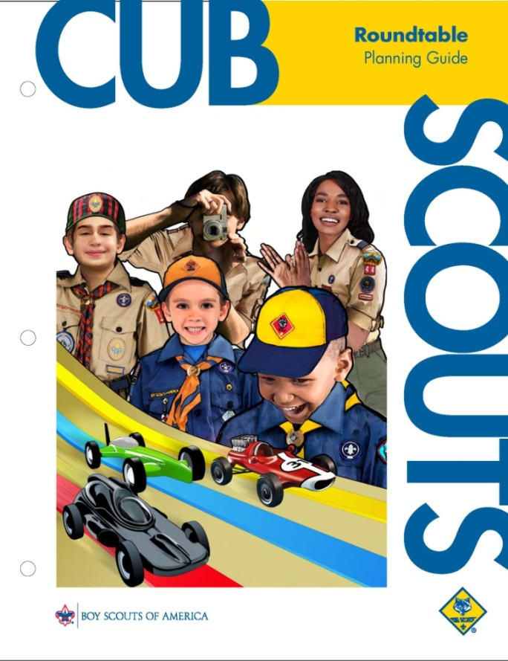
This is an annual publication. It is issued evry year providing agendas for 12 roundtables from September through August
- This year's CS RT Planning Guide was prepared using the 12 core values as the bases of the Roundtables
- There are four special Roundtables where the whole evening is devoted to a single topic. These include – Blue and Gold Banquets, campfires, Derbies, and Sports
- The basic format and purpose of Roundtable is unchanged.
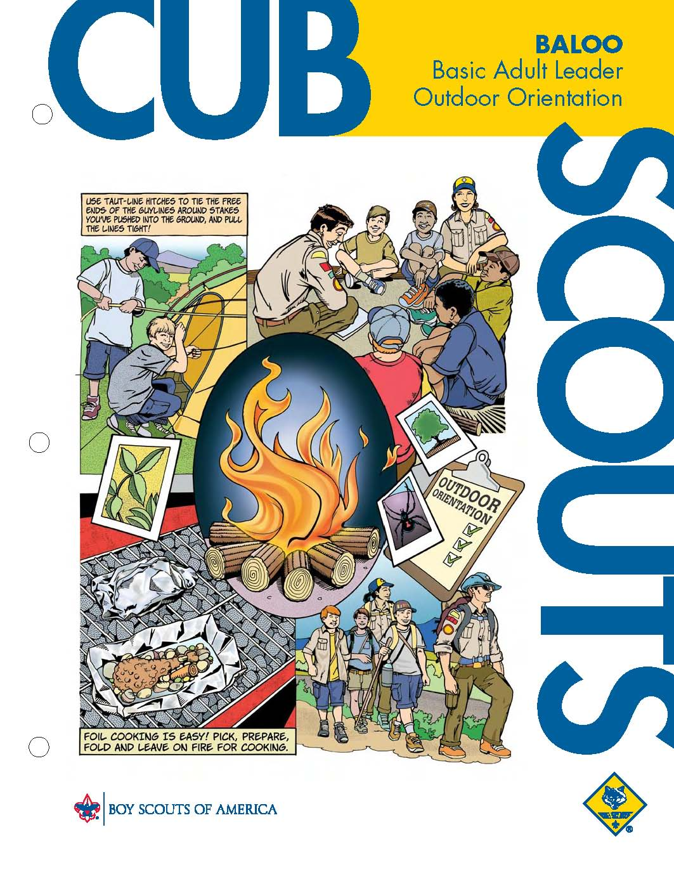 BALOO
Basic Adult Leader Outdoor Orientation
- Revised where needed to match Leader Book page changes
- Majority of B.A.L.O.O. course syllabus is unchanged
Resources & Support Online
- The PowerPoint & Script used for the Webinars
http://www.scouting.org/scoutsource/CubScouts.aspx
- YouTube Video on the change in delivery method:
http://www.youtube.com/watch?v=WtZGCglIlns
- FAQ’s
http://www.scouting.org/scoutsource/CubScouts/Leaders/NewDeliveryMethod/FAQ.aspx
- Cub Scout Leader Webinars this fall!
Watch your mail box for announcements
- Email support direct from National Council:
program.content@scouting.org
- Anything else?? It probably can be found at
www.scouting.org/cubscouts
SPECIAL OPPORTUNITY
Softball Belt Loop & Pin
www.USScouts.org

Webelos Scouts that earn the Softball Belt Loop while a Webelos Scout also satisfy part of requirement 4 for the Sportsman Activity Badge.
Belt Loop
Complete these three requirements:
- Explain the rules of softball to your leader or adult partner.
- Spend at least 30 minutes practicing softball skills.
- Participate in a softball game.
Sports Pin
  - Earn the Softball belt loop,
and
  - Complete five of the following requirements:
- Compete in a pack or community softball tournament.
- Demonstrate skill in the following throwing techniques: overhand, sidearm, underhand, and the relay throw.
- Demonstrate skill in the following catching techniques: fielding a ground ball, fielding a pop-up, catching a line drive.
- Demonstrate correct pitching techniques and practice for three half-hour sessions.
- Demonstrate correct hitting techniques, including bunting. Practice for three half-hour sessions.
- Explain the rules of base running and demonstrate skill in the following sliding techniques: the straight-in slide, the hook slide, and the headfirst slide.
- Learn and demonstrate base coaching signals.
- Learn about one defensive position (shortstop, catcher, etc.) and practice at that position for three half-hour sessions.
- Attend a high school, college, or community softball game.
Go to: http://usscouts.org/advance/cubscout/sports/worksheets/Softball.pdf for a worksheet that may be used while earning these awards.
Swimming Belt Loop & Pin
Webelos Scouts that earn the Swimming Belt Loop while a Webelos Scout also satisfy requirement 8 for the Aquanaut Activity Badge and part of requirement 3 for the Sportsman Activity Badge.
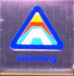
Belt Loop
Complete these three requirements:

- Explain rules of Safe Swim Defense. Emphasize the buddy system.
- Play a recreational game in the water with your den, pack, or family.
- While holding a kick board, propel yourself 25 feet using a flutter kick across the shallow end of the swimming area
Sports Pin
  - Earn the Swimming belt loop,
and
  - Complete five of the following requirements:
    - Practice the breathing motion of the crawl stroke while standing in shallow water. Take a breath, place your head in the water, exhale, and turn your head to the side to take a breath. Repeat.
    - Learn 2 of the following strokes: crawl, backstroke, elementary backstroke, sidestroke, or breaststroke.
    - Learn two of the following floating skills: jellyfish float, turtle float, canoe (prone) float.
    - Using a kickboard, demonstrate 3 kinds of kicks.
    - Pass the "beginner" or "swimmer" swim level test.
    - Visit with a lifeguard and talk about swimming safety in various situations (pool, lake, river, ocean). Learn about the training a lifeguard needs for his or her job.
    - Explain the four rescue techniques: Reach, Throw, Row, and Go (with support)
    - Take swimming lessons.
    - Attend a swim meet at a school or community pool.
    - Tread water for 30 seconds.
    - Learn about a U.S. swimmer who has earned a medal in the Olympics
    - Demonstrate the proper use of a mask and snorkel in a swimming area where your feet can touch the bottom.
Go to http://usscouts.org/advance/cubscout/sports/worksheets/Swimming.pdf for a worksheet that may be used while earning these awards.
NOTE:
Swimming activities done by Cub Scout Packs must be done in accordance with the rules in the "Safe Swim Defense", described in the Guide to Safe Scouting (#34416B). That program is available for viewing by Clicking Here. Those rules are not mandatory for individuals or families, of course, swimming in private or public pools, lakes, or beaches, although families are encouraged to use as much of them as appropriate. They ARE mandatory for all Cub Scout aquatic activities, trips to swimming pools arranged as Den or Pack meetings or outings.
Included in the Guide to Safe Scouting (#34416B) is a procedure and standards for classifying swimming ability. Requirement 2 for the Swimming Belt Loop, listed above, refers to the following, taken from the Guide.
Beginner Test
Jump feet first into water over the head in depth, level off, swim 25 feet on the surface, stop, turn sharply, resume swimming as before, and return to starting place.
The entry and turn serve the same purpose as in the swimmer test. The swimming can be done with any stroke, but no underwater swimming is permitted. The stop assures that the swimmer can regain a stroke if it is interrupted. The test demonstrates that the beginning swimmer is ready to learn deepwater skills and has the minimum ability required for safe swimming in a confined area in which shallow water, sides, or other support is less than 25 feet from any point in the water.
Swimmer Test
The swimmer test demonstrates the minimum level of swimming ability required for safe deep-water swimming. The various components of the test evaluate the several skills essential to this minimum level of swimming ability:
Jump feet first into water over your head in depth. Swim 75 yards in a strong manner using one or more of the following strokes: sidestroke, breaststroke, trudgen, or crawl; then swim 25 yards using an easy, resting backstroke. The 100 yards must be swum continuously and include at least one sharp turn. After completing the swim, rest by floating.
The test administrator must objectively evaluate the individual performance of the test, and in so doing should keep in mind the purpose of each test element.
"Jump feet first into water over your head in depth,
The swimmer must be able to make an abrupt entry into deep water and begin swimming without any aids. Walking in from shallow water, easing in from the edge or down a ladder, pushing off from side or bottom, and gaining forward momentum by diving do not satisfy this requirement.
"...Swim 75 yards in a strong manner using one or more of the following strokes: sidestroke, breaststroke, trudgen, or crawl..."
The swimmer must be able to cover distance with a strong, confident stroke. The 75 yards must not be the outer limit of the swimmer's ability; completion of the distance should show sufficient stamina to avoid undue risks. Dog-paddling and strokes repeatedly interrupted and restarted are not sufficient; underwater swimming is not permitted. The itemized strokes are inclusive. Any strong side or breaststroke or any strong overarm stroke (including the back crawl) is acceptable.
"...swim 25 yards using an easy, resting backstroke..."
The swimmer must perform a restful, free-breathing backstroke that can be used to avoid exhaustion during swimming activity. This element of the test necessarily follows the more strenuous swimming activity to show that the swimmer is, in fact, able to use the backstroke as a relief from exertion. The change of stroke must be accomplished in deep water without any push-off or other aid. Any variation of the elementary backstroke may suffice if it clearly allows the swimmer to rest and regain wind.
"...The 100 yards must be swum continuously and include at least one sharp turn..."
The total distance is to be covered without rest stops. The sharp turn demonstrates the swimmer's ability to reverse direction in deep water without assistance or push-off from side or bottom.
"...After completing the swim, rest by floating."
This critically important part of the test evaluates the swimmer's ability to maintain himself in the water indefinitely even though exhausted or otherwise unable to continue swimming. Treading water or swimming in place will further tire the swimmer and therefore is unacceptable. The duration of the float test is not significant, except that it must be long enough for the test administrator to determine that the swimmer is resting and likely could continue to do so for a prolonged period. Drownproofing may be sufficient if clearly restful, but it is not preferred. If the test is completed except for the floating requirement, the swimmer may be retested on the floating only (after instruction) provided that the test administrator is confident that the swimmer can initiate the float when exhausted.
Boys’ Life Reading Contest for 2010
http://boyslife.org/

SAY ‘YES’ TO READING
Enter the 2010 Boys’ Life Reading Contest
Have your boys do this with their Summer Reading List from School – Get two things done at the same time - CD
Write a one-page report titled “The Best Book I Read This Year” and enter it in the Boys’ Life 2010 “Say Yes to Reading!” contest.
The book can be fiction or nonfiction. But the report has to be in your own words — 500 words tops. Enter in one of these three age categories:
- 8 years old and younger
- 9 and 10 years old
- 11 years old and older
First-place winners in each age category will receive a $100 gift certificate good for any product in the Boy Scouts official retail catalog. Second-place winners will receive a $75 gift certificate and third-place winners a $50 certificate.
Everyone who enters will get a free patch like the one shown above. (And, yes, the patch is a temporary insignia, so it can be worn on your Cub Scout or Boy Scout uniform shirt, on the right pocket. Proudly display it there or anywhere!) In coming years, you’ll have the opportunity to earn different patches.
The contest is open to all Boys’ Life readers. Be sure to list your name, address, age and grade in school on the entry.
Send your report, along with a business-size, self-addressed, stamped envelope, to:
Boys’ Life Reading Contest
S306
P.O. Box 152079
Irving, TX 75015-2079
Entries must be postmarked by Dec. 31, 2010 and must include entry information and a self-addressed, stamped envelope.
See 2009's winners posted at - http://boyslife.org/home/12652/2009-boys-life-reading-contest-winners/
For more details go to http://boyslife.org/
Knots of the Month
Have a Roundtable Commissioner or Unit Commissioner you think is great, see if have already earned these and if not, help them along. Fill out their paper to get them the honor they deserve! CD
Arrowhead Honor and Commissioner’s Key for Roundtable Commissioners
www.usscouts.org
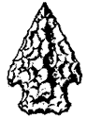
Arrowhead Honor for Roundtable/Huddle Commissioner
This Award can be earned for service as:
Cub Scout, Boy Scout, Venturing, or Varsity Roundtable (Huddle) Commissioner,
Requirements
- Review all material in the current
Cub Scout Roundtable Planning Guide
- Review all material in the
Cub Scout Program Helps (HHMMm – Den and Pack Meeting Resource Guide??)
- Recruit a roundtable staff.
- Lead staff in preparing a 1-year roundtable outline.
- Supervise the staff in conducting these roundtables
- With the district commissioner and district executive, develop and use an attendance promotion plan.
- Attend a council commissioner conference, roundtable, or planning conference.

Commissioner’s Key for Roundtable Commissioners
This Award can be earned for service as:
Cub Scout, Boy Scout, Venturing, or Varsity Roundtable (Huddle) Commissioner,
Requirements
Training
- Complete the three session training program outlined in Commissioner Basic Training Manual
- Complete personal coaching orientation including the orientation projects.
- Complete Basic Training for Cub Scout or Boy Scout Roundtable Commissioners and staff
Tenure
Complete 3 years as a registered commissioner within a 5-year period.
(Tenure for one award cannot be used for other awards.)
Performance
- Earn the Arrowhead Honor Award.
If a Commissioner has already earned a Scouter’s Key in another position, in lieu of sewing a second one of these square knots on the uniform, devices should be attached; a Commissioner’s Device is used for this award.
GATHERING ACTIVITIES
Note on Word Searches, Word Games, Mazes and such – In order to make these items fit in the two column format of Baloo’s Bugle they are shrunk to a width of about 3 inches. Your Cubs probably need bigger pictures. You can get these by copying and pasting the picture from the Word version or clipping the picture in the Adobe (.pdf) version and then enlarging to page width. CD
Radio
Alice, Golden Empire Council
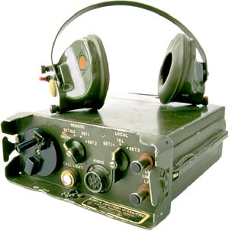
Display a short wave set-up and let families listen in. If you’re lucky enough to have a short wave operator in your pack family, ask them to come and share their hobby. You could also check with local clubs, on the internet, or with your librarian.
Squirt Ball:
Wendy, Chief Seattle Council
Using a squirt gun, try to squirt a ping pong ball off the top of a water bottle. Boy with fewest squirts wins.
Sponge Ball Tag
Wendy, Chief Seattle Council
Choose 2-4 player to be it, and give them sponge balls. They throw the balls at the other players, trying to tag them. If a player is hit, he is now it.
Making Waves Word Search
Alice, Golden Empire Council
This puzzle is filled with words that describe waves, something you find near waves, or something that creates or reacts with waves. Words can be found in any direction.
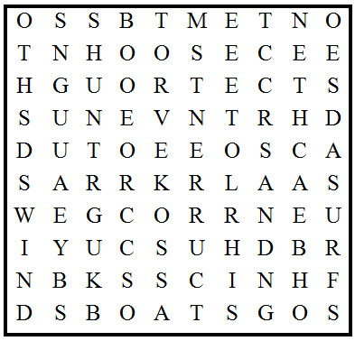
CREST BEACH TIDES
TROUGH BUCKET SHOVEL
SAND CURRENTS ENERGY
WATER WIND BOATS
ROCKS SURF MOON
SUN
Set Up All Kinds Of Water Fun Games –
Alice, Golden Empire Council
If your pack or den is meeting at a park or swim center, plan for all kinds of water fun. (See Wendy's List next in this column CD) Check the Games section of Baloo or the Program Helps ideas. Or just set out all buckets, sponges, hula hoops, containers, spoons, cups and bowls and have a contest to see who invents the best game!
Displays
Alice, Golden Empire Council
- Set up experiments that the boys have done during the month – each boy or den can describe and demonstrate an experiment as families come by - see some ideas under Theme Related; other ideas in Web Sites
- Have pictures of “Making Waves” Service Projects to share with everyone – see if a representative from an organization you teamed with can come make a presentation.
Bait Casting:
Wendy, Chief Seattle Council
Use a fishing pole with reel and a 2-inch piece of dowel or broom stick at the end of the line as a lure. Mark four or five targets, each about three feet in diameter and about 10 feet apart. Give each player two casts per target. Score one point for each hit.
Sponge Ball Catch
Wendy, Chief Seattle Council
Equipment: sponge balls, plastic bowls
Directions: Divide the boys in pairs. One boy has a sponge ball; the other boy holds a plastic bowl on his head. The boy with the sponge tosses it into the bowl. After a few minutes the boys switch roles. After a certain time, the team with the most successful catches wins.
Water Showdown
Catalina Council
Whoever said all pre-opening activities have to be done inside? No one! Try this one.
As the folks arrive, pair them off for the great showdown. Take them outside where you have enough water pistols handy to run water pistol duels. Each person gets up to five squirts at the "bad guy."
Water Word Search
Catalina Council
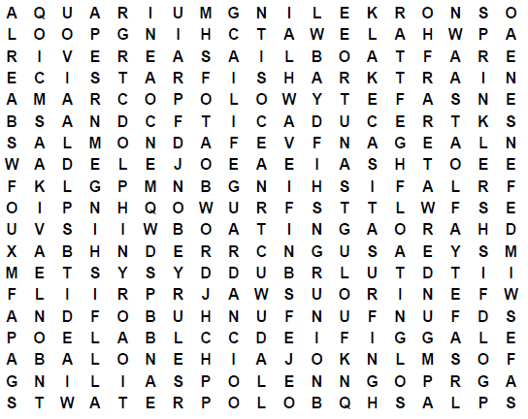
ABALONE LIFEGUARD SPRINKLERS
AQUARIUM MARCO POLO SALMON
BEACH OBEY RULES SAND
BOATING OCEAN SHARK
BUDDY SYSTEM PFD SNORKELING
CANOE POLE SPLASH
DOLPHIN POOL STAR FISH
FIN RAFT SURFING
FISH RAIN WHALE WATCHING
FISHING RIVER TUNA
FLOATING ROW BOAT UNDER WATER
FUN FUN FUN CASITAS WADE
GOLDFISH SAFETY WATER POLO
GRUNION SAFETY AFLOAT WAVE
JAWS SAIL BOAT TIDE
LAKE SAFE SWIM DEFENSE SAILING
The Hidden Fleet
Baltimore Area Council
Go Forward, Backward or Diagonally to find the names of the fourteen different kinds of ships below:
(We've done the first one, to show you how)
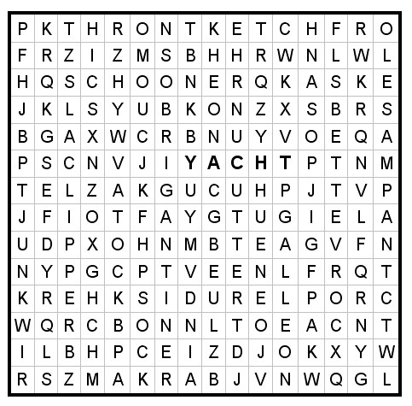
YACHT SLOOP CUTTER
KETCH GALLEON BARK
SCHOONER CLIPPER JUNK
TUG CANOE BRIGANTINE
CORVETTE SAMPAN.
School of Fish
Voyageur Council
Pin pictures of fish on people as they arrive. Have cutouts of swordfish, tuna, trout, catfish, etc. On a signal, they are to see which “school of fish” can assemble first.
Scrambled Water
Longhorn Council
When you unscramble the following words, you will know eight kinds of bodies of water.
KEAL NECOA YOUBA
DROJF FULG GOANOL
NOPD VERIR
Answers: lake, ocean, bayou, fjord, gulf, lagoon, pond, river
Underwater Words
Longhorn Council
How many words can you make from the letters in the word UNDERWATER? Who can make most words? How about the longest? (At least 80 are possible! Probably even more.)
It’s Raining Cats and Dogs!
Alice, Golden Empire Council
Using the list of Water Proverbs under Theme Related, you can:
- Put half of a water saying on one person’s back and they must locate the person with the other half of their saying by asking only questions that can be answered with “yes” or “no”.
- Have individuals, families or dens pick a water saying out of a bag – they then act out their saying as Charades. Winning person or team gets the most correct answers and has first chance at the refreshment table.
- Have each team (den, family, or boy and parent) pulls a phrase out of a bag and explain the meaning of the phrase – give an extra point for a good example.
Have an H2O Olympics:
Alice, Golden Empire Council
Use teams made up of dens or families. Have the following “events” set up around the room, and have a “judge” keep track of each team’s scores:
- Pole Vaulting – Over the Top – Fill a clear plastic cup with water to the brim. Add pennies one at a time till the water spills over the top.
- Balance Beam – Using an eyedropper, add drops of water to a penny’s surface. Continue till the water spills over or the drop collapses.
- Sculling Contest: Bubble Power – Cut out two boat shapes from a piece of cardboard (see pattern); Cut a small notch in the center rear of each boat and place a soap chip there. Boat shape can be altered by the team with scissors. Put boats in a tray filled with water and on signal, each team lets their boat go to see which one goes fastest.
- Backstroke Competition – See which team can suspend the most paper clips on the surface of the water. (Hint: Lay the paper clip on the tines of a fork and lower clip into the water) Use a magnifying glass to get a better idea of what’s happening on the surface of the water.
These would also make great den games!
Build a River
Alice, Golden Empire Council
The object of this activity is to put together all the components of a river (or ocean, or stream, or lake – whatever is most common in your area)
- Make up sets of cards with things that make up a river (or whatever body of water you are using) written on them – For a river you may have - water, riverbank, rapids, waterfalls, sand, mud, various kinds of fish, turtles, birds, insects, various kinds of plants, bushes, flowers, trees, pebbles, boulders, bridges, beaches, swimming hole, beaver dam, marshy area, snag in water, sand bar, man-made dam, etc. Make enough sets for each den, family or assigned group to have one.
- Each completed “river” is made by people holding cards or taping them to the wall.
- Once the “river” is completed, the group chooses a name for their “river,” as well as characteristics for their river.
- They should also come up with a conservation project to maintain or improve their river’s health.
- Each group gets to share their project with the whole pack.
Mink in a Maze
Voyageur Council
Every wild animal must live in its chosen habitat. The mink prefers a riparian habitat. Can you help it find its way to the pond at the center of the maze?
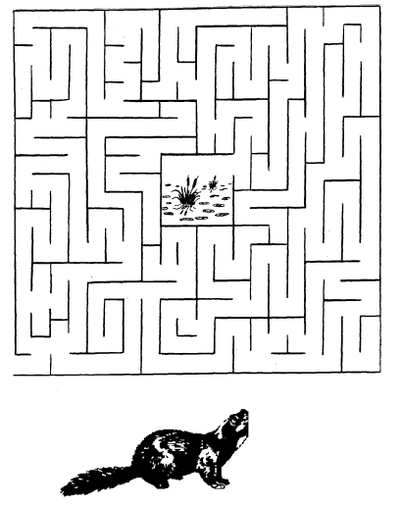
How Many Words
Baltimore Area Council
- Give each boy a pencil and a piece of paper.
- See how many words they can make out of the letters in the word “RIVERBOAT.”
- Each letter may be used only once (except “R” which may be used twice since there are two of them).
- “RIVER” and “BOAT” do not count.
Crossing the Quick Sand
Circle Ten Council
Place small pieces of masking tape on the floor to from a twisty line of stepping-stones with some close together and others far apart.
Each Cub in turn tries the course while balancing a tennis ball on a flat board.
Float the Needle
Have bowl of water and a needle and challenge boys to try to make the needle float.
After they have tried and failed, place a small piece of tissue on water and the needle on top of that. As the tissue gets wet, it will sink to the bottom. The surface tension of the water will allow the needle to remain afloat.
Ocean Objects Word Search
Voyageur Council
Find these things that can be found in or on the ocean. Look up, down, across, backwards and diagonally:
BOAT OCTOPUS BREEZE
PELICAN CORAL SALT
CRAB SAND EEL
SEA FISH SHARK
FLOTSAM SHIP FOG
STORMS GULL SUB
ICEBERG WAVES LIGHTHOUSE
WHALES
The remaining 13 letters, in order, spell the name of a beautiful sea.
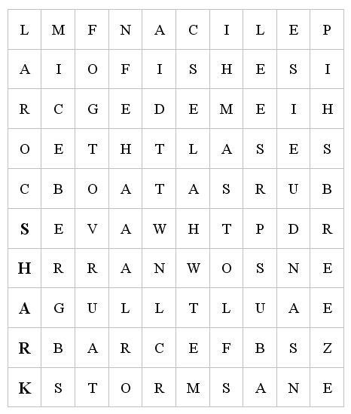
Fishing in the Tropics
Place a dishpan with many plastic or rubber items in the bottom, on the floor in the middle of the room.
Provide a fishing pole consisting of a stick about two feet long, on one end of which is fastened a string with a hook. Velcro works great. Be sure you put Velcro on the items in the sea.
As they arrive, give each Cub Scout three minutes to snag as many “fish” as he can, and award a small prize when finished.
OPENING CEREMONIES
Ship Shape Opening Ceremony
Wendy, Chief Seattle Council
Using a slide whistle, penny whistle, or just someone that can whistle loudly, Boatswain whistles to call everyone to attention. (attention whistle: starting note, up 3 notes, then back down to the first note)
Boatswain: All hands on deck! All hands on deck!
(Cubs assemble in front of the Boatswain)
Boatswain: Prepare to post the colors!
(Color guard goes to the back of room where the flag is. The rest of the cubs assemble an honor guard, in either 1 long line, or 2 parallel lines.)
Boatswain: Reads flag ceremony as usual.
(Color guard walks past the honor guard while walking the flag up to the front of the room.)
Boatswain (after the flag ceremony and the audience is seated) All hands, return to posts!
(Cubs go back to their seats.)
Listen to a Boatswain’s whistle:
- http://www.audiosparx.com/sa/archive/Man-Made/Whistle-sounds/Boatswain-whistle/60500
- http://www.npc.navy.mil/NR/rdonlyres/7372EC50-1DF8-4323-93A0-C62F5247C7F3/0/BMCAllHands.mp3
Other military calls/music:
- http://www.npc.navy.mil/CommandSupport/NavyMusic/AUDIO.htm
Making Waves
Alice, Golden Empire Council
Set up: Boys could draw pictures to go with their text, or use online images as used below. A team of boys could also do each section. The final picture should be a photo or drawing of a service project completed by the boys.
Narrator: This month, the boys and their families have been learning all about Making Waves – and we’d like to report to you!
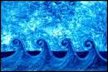
Cub #1 – Some waves are found in the water. They are formed by wind, location and time. A wave is really just energy.
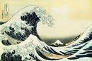
Cub #2 - Every wave “falls over” when it gets too big – when the height of the wave is one/seventh the length of the wave.

Cub #3 - Waves are fun to play in – but the energy of waves can be strong enough to throw huge boulders into the air or wreck houses near the shore.

Cub #4 – Some waves are made up of sound – the sound starts in one place and moves out in all directions.

Cub #5 – Waves of sound let us enjoy music, use Doppler radar to see the weather, and send information across the world.
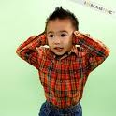
Cub #6 – But sound can also be too strong – we found out that even kids can have hearing loss from too much noise!
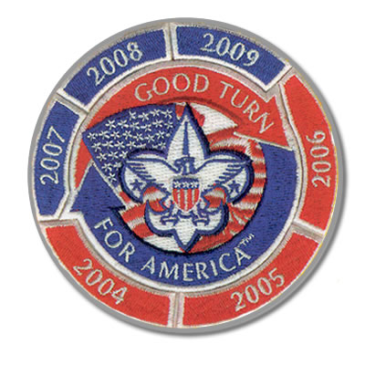
Cub #7 – We also discovered that we could have Waves of Fun while Making Waves – doing service! This month we……(describe service)
Narrator: And now we would like to share another way to make waves – Scouts are always ready to show their flag and watch it wave proudly. Please join us now in saluting our flag..(Continue with Flag Ceremony)
The Six “Ships” of Scouting
Baltimore Area Council
A True Scouting Classic! CD
Arrangement: 6 Cub Scouts hold large cardboard cutouts of ships, on which have been printed the following words; SCHOLAR-SHIP; FELLOW-SHIP; FRIEND-SHIP; SPORTSMAN-SHIP; WORKMAN-SHIP; STATESMAN-SHIP on the front and their parts on the back in LARGE print.
Cubmaster: Tonight, Den __ would like to tell you about the Six Ships of Scouting. These are ships that were launched to sail the Waterways of the USA – strong and mighty... ships that will last forever.
- SCHOLAR-SHIP. This ship is very important on the Sea of Education. On her deck stand such officers as Ambition, Determination, Intelligence and Application. Her flag bears symbols of the letter “A” and the plus sign.
- FELLOW-SHIP. This ship stands for good spirit, fine cooperation and never-failing unity. Its flag floats high - the flag of Scouting.
- FRIEND-SHIP. This is the most handsome ship of all. It is true blue and its flag is golden - since friendship itself is golden.
- SPORTSMAN-SHIP. This is the ship that’s fair and square. It never veers from its course. Its flag is never at half-mast.
- WORKMAN-SHIP. This ship’s every line, every part, every mast, represents the best that a person can give. Its flag wears a laurel wreath.
- STATESMAN-SHIP. This ship represents wise guidance, constant counsel, unselfish interest and sincere endeavor. Its flag is white for purity.
Cubmaster: And there you have six strong and sturdy ships to brave the Waterways of the USA. Three cheers for the Scouting ships!
WATER 101 OPENING
Santa Clara County Council
Arrangement: Cubmaster is dressed in a long laboratory coat and slacks that are easy to remove, holding a clipboard, and carrying a briefcase. (He is wearing beach clothes underneath the slacks)
Cubmaster: (Very seriously): Welcome to our Water 101 college pack meeting. I am Professor Cubmaster and I hope that you are all prepared to listen closely and take notes. We are here today to learn about a very important substance--H₂O, otherwise known as water. Now the first thing we will study is the molecular structure...
Pack Committee Chair: (Runs in to interrupt Cubmaster) Excuse me, Professor, but today’s pack meeting is Waves of Fun. We are supposed to have fun with water, not lecture in Water 101.
Cubmaster: Oh, but I’m sure my secretary told me about a Water 101 lecture I was to give today. (Consults pocket calendar.) How embarrassing. That’s next week. Luckily, every good Scouter comes prepared for nearly everything. Excuse me a moment. (Cubmaster goes away and comes back in beach-going clothes. He opens his briefcase, pulls out sandals, a beach towel, snorkel and fins. He also takes out a small water squirter and squirts the committee chair.) Today we are going to have water activities. It’s going to be fun! Who’s ready to join me??
Waves of Fun Opening
Catalina Council
Personnel: 7 Cub Scouts
Equipment: 1 small wading pool filled with water, plastic letters cut from milk containers to spell out WAVES OF FUN and 1 small fishing pole with an oversized hook attached.
Setting: Have each boy come up and hook a letter, then proceed to get in order to spell out " WAVES OF FUN ".
Boys say in unison:
Now that special time of year is here.
What we want to do is very clear!
Cub Scout games out in the sun,
Cub Day Camp should be fun!
But you could make our day so fine.
Just give us a little water and lots of time!
Raingutter Regatta Opening
Baltimore Area Council
Set Up - Have the boatswain (a good whistler) give a long, drawn-out note, dropping to a lower tone near the end, to welcome the Skipper (Cubmaster) aboard. Cubmaster then calls for each ship’s crew section (Den) to give its Den yell. The entire crew (Pack) then stands, pledges allegiance to the flag and sings “Row, Row, Row Your Boat” as a round.
Seaside Opening
Catalina Council
Personnel: 5 Cub Scouts
Equipment: A beach bucket and shovel with empty squirt guns for each Cub and Den Leader
Setting: The Cubs come in and line up carrying their buckets and shovels. The squirt guns are inside the buckets out of view of the audience. It would also add to the effect if the Cubs rolled up their pants legs (or wear shorts) and have bare feet. They could also pantomime actions.
- Here at the beach there is so much to see! Look at the ocean there is a sailboat!
- Yeah! They’re great. But the waves are really fun. I love to run into the water and let the waves push over me.
- Do you know what I like? I think the seagulls are cool! They attack when you sit down to have lunch.
- Yeah! But have you ever been able to find a starfish at the edge of the water? That’s really cool!
- Do you know what else is fun! Hunting for clams. They bury themselves in the sand and when you get close to getting them— they squirt!!
Cubs reach in their buckets and
use their squirt guns to ‘squirt’ the audience.
Then have CM finish opening Flag salute and Pledge
Safe Swim Opening
Voyageur Council
Arrangement: Make card for each letter. Write the line for each boy in LARGE print on the back. The boys can carry water activity toys such as inner tubes, balls or snorkeling equipment.
- S S is for Scouts, we have fun.
- A A is for Activities, out in the sun.
- F F is for Friends, your buddies in the pool.
- E E is for Excitement, but keep your cool.
- S S is for Safety. That must come first.
- W W is for Water, not only for thirst.
- I I is for Instructions we follow with care.
- M M is for Merriment we all love to share.
ALL Putting them all together and we have SAFE SWIM. Let’s be safe and we will all win.
Spirit of Scouting
Setting: Before the opening ceremony, place a candle at one side of the stage or room but in view of everybody. When the time for the opening ceremony, the Cubmaster make the following statement.
Cubmaster: (light candle) This candle represents the spirit of Cub Scouting. It is going to burn throughout our meeting, representing the fun and friendship we have enjoyed together here. Let’s all stand and give the Pledge of Allegiance to the Flag.
OCEAN
Circle Ten Council
Have large cards with the letters O C E A N on them for the Cubs to hold and read from.
- O – O is for Old Glory that we wave with pride.
- C – C is for colors we see each night with joy.
- E – E is for evenings that give us pleasant thoughts.
- A – A is for awareness of the beauties of the sea.
- N – N is for Neptune, the mythical God of the sea, who rules his kingdom with love.
Leader: Put it all together, it is OCEAN; it borders our land and gives us much to be thankful for.
Cub Scout Fish Opening
Voyageur Council
Arrangement: 8 Cub Scouts holding cardboard pieces, which make a fish when put together. Each part is lettered, so that all together they spell CUB SCOUT, C being the head of the fish and T the tail. Each boy’s lines are written on the back of his card in LARGE print.
(Boys enter one at a time and repeat their lines in order.)
- (Head of Fish) C is the part we build on. It stands for COURTESY in Cub Scouting and all through life.
- U is next. This part stands for UNITY, because united we are strong.
- B is the next added. That stands for BRAVERY in all our thoughts and all our deeds.
- S is next and that stands for SAFETY. We learn it and use it.
- C adds some more and it stands for CHURCH--the one of your choice.
- O is building it stronger, and it stands for OUTDOOR life, which is full of fun and adventure.
- U is near the finish and it stands for UNDERSTANDING, something that all our families have.
- (Tail of Fish) T is the tail that guides us. It stands for TRUTH in all things.
All: Will everyone rise and please join us in the Pledge of Allegiance?
Swim Party Opening
Capital Area Council, TX
This opening is for use if you are having your pack event at a swimming facility.
Have all the boys stand around the edge of the shallow end of the pool or the side of the beach.
On signal, they are to jump or wade into the water and make a circle in the pool.
CM Now that we are all together, please repeat the following pledge after me:
"As a Cub Scout:
I promise to be careful in the water
I will observe water safety rules at all times,
When I am with a group around water I will encourage others to do the same.
CA Please join us in the Pledge of Allegiance.
AUDIENCE PARTICIPATIONS
On The Beach
(a MadLibs)
Baltimore Area Council
Create a list ahead of time of the types of words needed for the story, and ask the audience to provide the words to fill in the blanks in the story. The narrator reads the story. Filling in the blanks with the words provided by the audience.
Plural Noun
Body Part
Verb
Body Part
Noun
Noun
Plural Noun
Adjective
Verb
Plural Noun
Exclamation
Person in Room
Noun

If you want to en_{j}oy yourself at the beach, you should bring your _plural noun_. Before exposing your skin to the sun, you should put suntan oil on your _body part_ . Rub it on your face; then smear it all over. Be sure that it's rubbed in thoroughly. Then go into the salt water and _verb _. When you come out of the water, don't dry your _body part_. Lie down on a(an) _noun_ and soak up the rays. It's fun if you bring a(an) _noun_ to play with at the beach, l like to build _plural noun_ with sand. You see all sorts of bodies at the beach. Some are _adjective_ like your own. You can _verb_ on the beach. Some beaches allow you to sunbathe without your _plural noun_, _exclamation_ ! My friend, _person in room_ went to a beach without his/her _noun_ and got so sunburned that he/she had to walk home.
Fisherman’s Luck
Circle Ten Council
In this audience participation, the audience will be divided into the necessary number of groups and each group will say the following lines when their name is called:
Fisherman Great day for fishing
Fish Bubble, Bubble
Worm Wiggle, Wiggle
Reel Everyone pretends to reel in a fish
Once there was a FISHERMAN who went FISHing on a sunny April day. He was hoping to catch a big FISH. He found a nice spot and stopped along the river.
The FISHERMAN put the REEL on his rod, and a worm on his hook and started to FISH. He patiently waited and waited, but no FISH came to eat the WORM on the hook. The FISHERMAN decided to leave his hook and WORM in the water and take a little nap. He was awakened by the screeching sound of his REEL; sure enough he had hooked into a great big FISH.
The FISHERMAN wounded in the REEL and to his surprise he found a stick on the end of his hook. The WORM was gone. So the FISHERMAN put another WORM on his hook and tossed his line into the water. Again he was awakened by the sound of the REEL, this time he found a tin can on his hook. “This is getting frustrating” he said, “I really want to catch a FISH before I run out of WORMs”.
One last time the FISHERMAN threw this line into the water and set his rod and REEL beside him. The sound of the REEL woke him once again. This time however he could not REEL in his FISH he knew for sure that his WORM was ling gone. He REELed and REELed until finally a large black fin rose out of the water. The FISHERMAN has caught a submarine. Riiinnnng . . . . went the alarm clock the FISHERMAN rolled over and said “six thirty in the morning”. The whole trip had only been a dream.
IN SEARCH OF SUN SCREEN
Sam Houston Area Council
Divide the audience into four groups. Assign a part to each group and have them practice. As narrator, read the story, they respond to the appropriate word.
Timmy: “I love to swim”.
Cub Scouts: “Do your best”.
Swim/Swimming: “Splash, splash, splash”.
Sun Screen: “Aaaaaaaaa-Oooooooo”.
The day of the summer Pack meeting was hot and dry. That was good because it was to be a SWIMMING party. The CUB SCOUTS and their families were to meet at the Miller’s house at noon. TIMMY started getting ready at 9 O’clock in the morning. He loved to SWIM. He had just completed SWIMMING lessons at the local SWIMMING pool and had his card stating that TIMMY had passed Advanced Beginners. He knew all his CUB SCOUT friends would be surprised. It was just last year that TIMMY could not SWIM at all.
TIMMY found his SWIMMING suit and towel and even his thongs without any trouble. But search as he might he could not find his SUN SCREEN. This was terrible. All the CUB SCOUTS had learned the importance of always using SUN SCREEN at one of the Den meetings. TIMMY knew that he must protect his skin from the intense summer sun while he was young so that he would not get skin cancer when he got older. Also, he did not want to get a bad sunburn. One of his friends in CUB SCOUTS had fallen asleep in the sun and couldn’t sit down or lay in bed comfortably for a week!
“Where are you, SUN SCREEN?” asked TIMMY as he started looking through the house again. It was almost time for the SWIMMING party. He didn’t want to be late. That was when he found it. Way in the back of a bathroom drawer, there was the SUN SCREEN. He grabbed it but to his dismay, the tube felt very light. Oh, no! The SUN SCREEN tube was empty. TIMMY could not squeeze out even one little drop. What could he do? There was no time to go to the store before meeting the CUB SCOUTS for the SWIMMING party. And he knew he should never go SWIMMING without his SUN SCREEN.
Just then, TIMMY’s big brother Weston came bursting through the kitchen door. “What’s the matter”, he asked when he saw TIMMY sitting dejectedly in the living room? I’m all out of SUN SCREEN. I can’t go SWIMMING with the CUB SCOUTS, was the reply. “Here, you can use mine”, said Weston, tossing his little brother a new tube of SUN SCREEN. TIMMY couldn’t believe it. Just that fast was his problem solved. “Thanks, Wes!” TIMMY shouted as he headed out the door to the SWIMMING party with the CUB SCOUTS. And for a whole week he didn’t say anything bad about his brother!
Water
Capital Area Council, TX
Narrator reads story. When audience hears a "water" word, they do a wave, like at sporting events.
One upon a time, there lived a poor merchant from Botany Bay. He sailed across the Seas to distant lands. He traveled with his dog, Bruno. During Ocean voyages, he missed his family.
On one of these Sea journeys, the poor merchant traveled to the island of Catomania. He heard a loud caterwaul as he entered the Bay. The island had a terrible problem. Too many cats! The king begged him to help. The poor merchant let loose his trusty Bruno. Bruno chased the cats on board the ship in the Bay.
The poor merchant quickly set sail for the high Seas, with a shipload of cats. At the next port, the island of Micea, he found another island with a problem. They had never seen a cat before. The island was run over with Sea gulls. There was practically not a place to land his ship because the gulls covered the Water's edge. He was able to sell all of the cats to the inhabitants of Micea. The cats who were hungry after the long Ocean journey, gobbled up all of the gulls but two who flew to the top mast of the poor merchant's ship in the BAY.
The merchant sailed for many days in the Ocean. When he reached America, he brought out his caravan of camels. They pulled his ship right to the Rio Grande River in Albuquerque. He found the pioneers wrestling with a plague of locusts. The quick-thinking merchant threw a stone at the giant gulls. They swooped down and hungrily devoured the locusts. The pioneers who were still settling in, didn't have much to trade, so he let his camels have a drink from the River and was on his way again.
The next stop was an island called Waterworld. There was so much Water, the islanders had a hard time eating, sleeping, working or playing. The camels smelled the Water as soon as they made port and stampeded. Soon, the excess Water was gone. The islanders thanked the merchant by presenting him with a cargo hold full of umbrellas. They wouldn't he needing them anymore.
When the merchant arrived home, his family Rained tears of joy. The tears poured for days and days. The wise merchant who knew it never Rains but it pours, sold the cargo hold of umbrellas to the good citizens, and became the now rich merchant from Botany Bay.
Robinson Crusoe's Diary
Capital Area Council, TX
This is a nonsense game that never fails to crack them up - the sillier, the better! Names of objects are written on slips of paper and dropped into a container. As "Mr. Crusoe" reads his diary, each "sailor" takes turns drawing from the container to fill in the blanks.
Copy these phrases on slips of paper:
A ship | A dove | A bonfire
A big tree | Dandelions | A wild goat
30 cannibals | A loud noise | Some gunpowder
My tent | A strong fence | A chest of gold
A goatskin | A pile of straw | A piece of canvas
My fieldglasses | All my belongings | A table and chair
A cup of goat's milk | The top of the hill
"This morning I woke up early and ate my breakfast, which consisted of and . Afterward, I took my saw and hammer and built . Since I was shipwrecked and alone, I had to go hunting in the woods to see what I might have for lunch. I forgot my gun, so I had to capture with my bare hands. I also tried to catch to but could not run fast enough. I went home to my cave, sat down in and ate my lunch. Since my clothes were all lost as sea, I decided to make myself something to wear. I made a pretty neat hat from and a coat out of . I decided to wrap my feet in . Suddenly, I heard a and rushed out and climbed into . I looked through just in case I might see . I didn't but there on the beach I saw dancing in wild glee around . Running up the trail toward my hideout was crying out and looking very frightened. I hid the poor thing behind . I then found my gun, loaded it with and stood guard over . When it seemed safe, I got busy and built all around . Then I finally lay down in my comfortable bed, mad of , and slept soundly.
Joe Makes a Splash
Catalina Council
Divide the group into four smaller groups and assign each group one of the words listed below. Read the story pausing as each of the key words is read. When one of the words is read the group assigned to that word stands and makes the appropriated response.
Joe - "Oh, no!"
Water - "Splish, splash"
Afraid - slap hands to side of face
and say "Aaaaahhhhhhhh"
Scout - "Do your Best"
JOE had a problem and he didn't know what to do about it. JOE had been a Cub SCOUT for several years and really enjoyed all the fun activities. But now JOE was a Webelos SCOUT. Now, this does not really sound like a problem, does it? But , as a Webelos SCOUT, JOE would soon be working on his Aquanaut Activity Badge. This meant that JOE would need to go swimming. And JOE was AFRAID of WATER!
Now, this had not always been the case. When JOE was a little boy he was not AFRAID of WATER. He was about 5 years old when it happened. He had been playing in the backyard, splashing in the WATER in his little play pool. WATER was fun to play in. But when JOE was climbing into the WATER one time he slipped and fell. he hit his head on the slide and almost drowned. If his mother had not been close at hand, it could have been much worse. But ever since that time, JOE was AFRAID of WATER.
Now, JOE was in SCOUTs. How could he tell them that he was AFRAID of WATER? How would he ever be able to earn his Aquanaut? But JOE's SCOUT leader was both smart and understanding. He had talked to JOE's mother and knew about the WATER problem. And he knew what to do. He used the Ethics in Action book and found one of the games that could be adapted to help the other boys understand that JOE had good reason to be AFRAID of WATER. Together, the SCOUTs played a game about being AFRAID, and then talked about how they felt. JOE was able to share his feelings without being made to feel ashamed. The other SCOUTs were able to understand how it felt to be AFRAID of WATER, and they did not tease JOE.
When it was time for the Webelos SCOUTs to work on their Aquanaut, JOE's SCOUT Leader gently guided him into the WATER. This was not easy for JOE, but with time and support he was gradually able to overcome being AFRAID of WATER and finally even earned his Aquanaut. None of the SCOUTs make fun of JOE. And when it was time for JOE to receive the award, all the SCOUTs stood and cheered. They had all learned that it's o.k. to be AFRAID. And how people feel is most important of all.
At the Beach
Catalina Council
Divide the audience into groups, and assign each group one of the words listed below. Have all members of the group stand up and say the appropriate phrase when their word is said during the story. Alternatively, have a leader for each word, and everyone says the appropriate phrase for each key word.
BEACH Shade eyes with one hand and say,
“Sand, sand, everywhere!”
CUB SCOUT Stand, Cub salute and say, “Do
Your Best!”
SWIM Make swimming motions with your
arms while saying, “stroke, stroke.”
WATER “Splash, splash!”
FOOD “Yum, yum!”
KIDS “Are we there yet?”
Summer time had arrived at last. School was out and the KIDS in the Black family were all looking forward to the first trip to the BEACH. All of the chores were done and it was time to pack the car. Mother was trying to pack the FOOD in the picnic basket, but was having trouble getting the sandwiches wrapped before the KIDS could grab them. “Why don’t you KIDS go out to the car and help your father while Chad stays here to help me get the FOOD ready?” Mother suggested. As soon as the KIDS had left the kitchen, Chad, a helpful CUB SCOUT, said, “What can I do to help, Mother?” “Get some WATER and ice for the punch, Chad,” said Mother. Together Mother and her helpful CUB SCOUT managed to finish packing all the FOOD in less than 10 minutes.
Meanwhile, Father had finished packing the car. “OK, KIDS, it’s time to get in the car and drive to the BEACH,” Father said. “It will take us about half an hour to drive to the BEACH, so relax and enjoy yourselves, KIDS.” When they finally arrived at the BEACH, the KIDS couldn’t wait to get in the WATER and SWIM. Chad, the ever-helpful CUB SCOUT, volunteered to watch the younger children while Mother and Father spread the picnic blanket on the BEACH and unpacked the FOOD. “Hold my hand, Jimmy,” said Chad, the watchful CUB SCOUT. “Don’t get in the WATER over your knees, because you don’t know how to SWIM. We’ll wade right here in the shallow WATER near the rocks on the BEACH.” “Lunch is ready,” called Mother. “Come and get your FOOD.”
After they had finished the delicious FOOD Mother had packed, the KIDS decided to build a sand castle on the BEACH, near the WATER. When it was time to leave the BEACH and head for home, Chad, the helpful CUB SCOUT helped gather the toys, while his parents loaded the leftover FOOD. “Thanks for taking us to the BEACH, Mom and Dad!” chorused the KIDS. “We sure had a good time SWIMMING and playing on the BEACH.” “And thanks for helping us at the BEACH, Chad. We’re glad to have a CUB SCOUT in the family,” Mother and Father told their oldest son.

LEADER RECOGNITION
Because The Scout
Sam Houston Area Council
Because our Cub Scouts have a need,
we have an obligation.
Because our Cub Scouts have a choice,
we must be his better choice.
Because our Cub Scouts have high expectations,
we must excel.
ADVANCEMENT CEREMONIES
Waves of Fun Advancement Ceremony
Alice, Golden Empire Council
Set up: Create a beach scene using waves drawn or cut from paper against a wall (if done inside) or a scene with real sand, a backdrop of waves and various items that could be washed up by the waves. (A child’s wading pool could be used to contain your scene) It would be really effective to have the sound of the waves crashing, from a tape or CD playing in the background. (Or do it on a beach at camp or a nearby lake, or ?? CD)
Cubmaster: Welcome to the Beach. Pack __ Cubs and Webelos have really been making waves and earning advancements this past month. Let’s check and see what those waves have washed up on our beach! (Info. about awards can be attached to the item, or could even be hiding under the item if they are safely enclosed in a sealing bag. Here are some suggested items and scripts that could be used)
If you want to go for “natural”
- Shells - an award could be under each one of a group; could also be used to refer to Tiger Cubs or new scouts just beginning to “collect” knowledge about the world of scouting
- Rocks - Variety and colors could be used for each rank; you could refer to the power of the wave to move rocks, and the growing power of the boys to make things happen in their world
If you want to go for “human fun”
- Shovel – A way to dig in and learn new skills
- Bucket - Growing ability to learn and tackle new skills as a Wolf, Bear, Webelos scout
- Sun Block - Learning how to safely use skills, new tools; or recognize adults for getting Youth Protection Training (new guidelines requirement)
- Beach Towel - just as the towel is a useful “tool” at the beach (to dry off and cover up), older scouts are learning how to make their way along the scouting trail and use the tools they are discovering – new skills and experiences
- Surf Board or Body Board – Webelos or Arrow of Light boys are using the experience and tools they have learned about in scouting to move out into the larger world and “test the waters”
- Beach Umbrella - Recognizing the pack leaders, pack committee, or special parents who cover all the “bases” to make sure the program runs smoothly and boys are able to advance
(I’m sure you can come up with other and better ideas
– just go for it! Alice)
At the end, with all the items removed, the Cubmaster can point out that Scouts always leave everything better than is was when they came. You might follow up with the Living Circle and the “Do Your Best” motto.
Waves of Fun Advancement Ideas
Catalina Council
- Cut shark fins from black poster board and staple to the side of a 2x4. Spread a blue tarp on the floor and crumple it to look like waves in the ocean. Put shark fins around the tarp between the waves. Make a narrow bridge across the water by putting an 8" length of 2x4 on top of a block at either end. Nail it to be firm. Tell boys receiving the awards that they must walk across the bridge without falling in the water to receive their award. You can liken the sharks to the 5 national concerns, or you can liken them to the bad things in the world and the bridge can be how Cub Scouts helps to keep you safe from them. Mom and Dad can help hold the boy’s hand, just as they do during the scouting trail.
- Attach awards to oars. Might write on awards You “OAR” fantastic
- Attach awards to small boats. Float in a small swimming pool. Boy can retrieve his boat. Make the boats out of cork with toothpick sails. Glue penny on bottom for weight - “You sailed away with first place” or “Congratulations on sailing away with your Bear badge!”
Waterways Advancement Ceremony
Jim Jones, Great Salt Lake Council
I want to thank Jim for sending me his original ceremony for this theme to share with all Baloo Readers. CD.
Set Up – All parts are read by same person, or it could be broken up amongst Den Leaders, Assistant CM(s) and others. No props are required but pictures illustrating the various waterways would add to the ceremony (and the words could be placed on the back of the picture). If you want to get really creative, have the CM and an Assistant dress up as Lewis and Clark and modify the text to have them telling the story of their journey.
In 1804 Meriwether Lewis and William Clark began a journey at the request of President Thomas Jefferson to explore the west in search of a water route to the Pacific Ocean. Much of their journey was traveled on the great waterways and rivers of North America.
Tonight we honor others on their own journey of discovery. Will the following Cub Scouts and their parents please come forward? (Call forward all the Cub Scouts receiving their Bobcat Award.) These Cub Scouts represent the trickles of water from melting snow and ice that are the headwaters of America’s rivers and waterways. These Cub Scouts have earned the Bobcat Badge. (Present Bobcat Badges)
As these trickles of water come together they form small rivulets. As Bobcats grow they may come together in the Tiger Den. Would the following Cub Scouts please come forward with their parents? (Call those Cub Scouts forward that are receiving their Tiger Badges.) These boys represent those rivulets. Each of these Cub Scouts has earned his Tiger Cub Badge. (Present Tiger Cub Badges.)
As these rivulets grow and move forward in their flow, they become streams. Would the following Cub Scouts please come forward with their parents. (Call those boys forward that are receiving their Wolf Badges.) These boys have grown and progressed in their Scouting journey of discovery and earned the Wolf Badge. (Present Wolf Badges.)
The streams grow and join becoming the rivers that are the tributaries of the great American Waterways. The Bear Den represents those tributaries. Would the following Cub Scouts please come forward with their parents. (Call forward the Cub Scouts receiving the Bear Badge.) These boys represent those tributaries in their own journey of discovery. They have earned the Bear Badge. (Present Bear Badges)
When those tributaries come together to form the great American Waterways, the journey is almost complete. Would the following Cub Scouts please come forward with their parents? (Call forward Cub Scouts receiving the Webelos Badge.) These boys represent Lewis and Clark’s Mississippi River. Each of these Cub Scouts has earned the Webelos Badge. (Present the Webelos Badge.)
Would the following Cub Scouts please come forward with their parents? (Call forward the Cub Scouts that are receiving the Arrow of Light.) The greatest Waterway in America is the Mississippi River. This is the beginning and ending point of Lewis and Clark’s journey of discovery. As great as the Mississippi River is, it eventually empties into the Gulf of Mexico ending its journey. Tonight these Cub Scouts are ending their journey of discovery in Cub Scouting and receiving their Arrow of Light, Cub Scouting’s highest honor. (Start your Pack’s traditional Arrow of Light Ceremony here)
Fishing Trip Advancement Ceremony
Baltimore Area Council
Setting: The Cubmaster, or whoever is going to lead the advancement ceremony, is starting down memory lane of a recent fishing trip that he made. He starts to relate it to Cub Scouting.
Props: Cubmaster will need clothing for fishing, a pole that is hooked up with a magnetic hook. Cub Lake (some type of tub container to be the fishing hole). Advancements on fish as described below.
Cubmaster: Well, before I tell you who is getting awards tonight, I want to tell you about my latest fishing trip. You all know that any good fisherman will get up before dawn to prepare himself to go fishing. That is when this day started for me. There are seven things I have to do to get ready for a fishing trip, and as I was doing these things, I remembered the seven requirements that my son had to do to get his Bobcat Badge. Just like I prepared to go fishing, my son had to prepare himself to be a Cub Scout.
Call up Cub Scouts and their parents who are getting their Bobcat Badges.
Scouts, here at Pack ____, we are really proud of your accomplishment of completing the 7 requirements for the Bobcat Badge. And just like I have to have a license to go fishing, you have to become a Bobcat to go on in Scouting. Scouts, tonight I'm presenting your parents with your Bobcat Badge. When they give it to you, I want you to always remember how you prepared yourself for Scouting.
Present badges on pretend fishing licenses to the parents
Well, let me continue on with my fishing trip. You won't believe the trouble that I had! Before I even got to the lake, I got lost, and had to look at a map. I then had to make a phone call because I forgot to leave a note to let my family know where I was going to be. Then, once I was at the lake, things didn't get any better. I dropped my bait bucket, I cut my finger. I got knots in my fishing line, I even had to go back to the car for the lunch that I had packed. But you know, some nice things did happen to me too. The day was beautiful, birds were out singing in the trees, and the trail to the lake was clean. I saw some really neat plants growing along side of the path, and I found a really great rock for my son's collection.
Oh, yes you are probably wondering what all of this has to do with Scouting. Well, as I was having all of these problems I remembered the that Tiger Cubs had to look at a map and go Outdoors.
And I thought of the 12 Achievements that Cubs have to do to get their Wolf and Bear badges. And you know, some of the things that they had to learn I needed that day. The first aid for my cut finger, the knots in my line, and the lunch I did remember to pack. In Cub Scouts, boys get a really good understanding of nature and how to take care of the land around them. That path was so clean I bet some fisherman who had been in Cub Scouting had come before me.
So I did go fishing, and caught (insert number of Tiger, Wolf and Bear advancements that you have) really nice fish. Here let me show you.
Cast your line into Cub Lake and catch fish for the Tiger Badge(s), Wolf badge(s), and the Bear Badge(s)
Call up the Cubs with their Parents. If a large number, You may wish to separate by rank. Be sure very boy receives individual recognition.
Scouts, you are receiving your Tiger Badge tonight, and, along with your parents, your Pack is really proud of you and the work you have done. Congratulations.
Scouts, you are receiving your Wolf Badge tonight, and, along with your parents, your Pack is really proud of you and the work you have done. Congratulations.
Scouts. you are receiving your Bear Badge tonight and you have shown us that you take your Cub Scouting seriously. Congratulations.
Well, my fishing trip continued on for a few more hours and I continued to think about Cub Scouting. I thought about how each of the Webelos Scouts earn the different Activity Badges, the badges give the Scout a taste of what Boy Scouting will be like. They just sort of cover what a Scout that is in 4th and 5th grade needs to know.
Will our Webelos leader please come up here tonight. I'm going to go fishing and see if I can find any Webelos Activity Badges down here. Yes there do appear to be a few.
Have Webelos Leader give out the badges to the boys
I want to thank each one of you tonight for coming along with me on this trip, Scouting and fishing sure do have a lot in common, don't you agree?
SEA ADVENTURES
Circle Ten Council
Cubmaster (CM): When a boy wanted to be a sailor, he would hire himself on as a cabin boy. There he learned the terminology of the ship. He learned his knots and the rigging.
Assistant Cubmaster (CA): When a boy wants to become a Cub Scout, he must learn the basics of Scouting. When he learns the Promise, the Law, the sign, the salute, the handshake, the meaning of Webelos, and the motto, a boy then becomes a Bobcat. Will the Bobcat recipients please come forward with their parents?
(Present awards to parents to pin on their son)
CM: A sailor quickly learned to use maps and charts so he could see where they are and where they are going. So too, does a Tiger Cub Scout grow. He learns about his town by looking at a map and going places in the town. After he finishes this and the other four Achievements, he is recognized as a Tiger. Would our Tiger Cubs and their parents please come forward?
(Present awards to parents to pin on their son)
CA: A sailor boy’s knowledge of the sea did not end there. As he traveled about the world, he saw many different types of ships and their uses. His world would become larger. So too, does a Cub Scout grow. He learns about his national flag, about his family and world, about tools, and about many other things. It is then that he is recognized as a Wolf. Would our Wolf Cubs and their parents please come forward?
(Present awards to parents to pin on their son)
CM: A sailor even today has to know the methods of ship communication, whether it be flags or radio. He needs to know about radar. A Bear needs to be more aware of God and worship, more about wildlife and the environment, more about family life and more about strengthening his body. Will our Bear rank recipients and their parents please come forward?
(Present awards to parents to pin on their son)
Webelos Leader 1(WL 1): A sailor soon learns about tides and the sea currents. He learns to use these to travel. A Webelos Scout must earn several different kinds of activity badges to help prepare him for the future. Will our Webelos and their parents please come forward?
(Cubmaster presents awards to parents to pin on their son)
WL 2: Finally, a sailor has a destination, a goal; he must know where he is and how to get where he is going. He uses the constellations and the North Star to guide him. He uses a compass and a sextant to chart his course. So, too, does a Webelos Scout. He has earned more activity badges to give him skills for the future. He has visited Boy Scout troops, as he plots is course. He has filled out a Boy Scout application form. He is deciding on his goal, maybe even an Eagle Scout. Will our Arrow of Light recipients and their parents come forward?
(Cubmaster presents awards to parents to pin on their son)
Goin' Fishin' Advancement
Baltimore Area Council
This ceremony can he used indoors or at the waterfront.
If you are indoors,
Pin the badges that were earned to a cardboard fish.
Make a fishing pole out of a dowel, string, and a paperclip hook.
Put paperclips bent into circles into mouths of the fish.
Make the fish different colors according to the badge pinned to it and tell each boy who earned an advancement to go fishing for a (color) fish. (e.g. red fish for Wolf)
Make a statement about the boys’ achievements and have the parents help the boy if needed.
If you are at the water, you could use the same process or you could use the water instead of a bucket to put the fish in. Simply wrap the badges tightly in aluminum foil and have the one who swims best in the water with the badges. When the boy casts his line out, the swimmer can attach the proper badge to the hook and give it a tug.
SCHOOL OF FISH ADVANCEMENT
Circle Ten Council
Equipment: A poster board or a sheet colored blue imitating water gradually getting deeper, five different size fish made of cardboard, awards.
Setting: Cubmaster is in front of room with water behind him.
Cubmaster: The small fish starts out in shallow water (Place smallest fish in shallow water) and the first step is to learn how to maneuver in the water, just as our beginning Scout is becoming familiar with Cub Scouting. The first part of becoming a Cub Scout is that of a Bobcat. Would the following boys please come forward with their parents? (Award badges)
Tiger Leader: As our small fish grows (place the next fish further out in the water) he moves a little further into the water finding new adventures and discovering new areas. Just as our fish is developing so is our Cub Scout. The next step is that of a Tiger. Would the following boys please come forward with their parents? (Cubmaster awards badges and/or arrows)
Wolf Leader: As our small fish becomes stronger and larger (place the next fish further out in the water) he moves further into the water finding new adventures and discovering new areas. Just as our fish is developing so is our Cub Scout. The next step is that of a Wolf. Would the following boys please come forward with their parents? (Cubmaster awards badges and/or arrows)
Bear Leader: Our fish has grown into a larger fish (place 3rd fish further out in the water) and has moved out further into the water becoming more acquainted with the other fish and is learning to maneuver faster in the water. Just like the fish, the Cub Scout is learning and meeting more challenges and is becoming more acquainted with the pack. The next step is that of the Bear. Would the following boys please come forward with their parents? (Cubmaster awards badges and/or arrows)
Webelos Leader Our fish has finally reached the stage where he can go into the deepest water (place largest fish in the deepest water) and has learned quite a lot about the water and what lies in it. This stage of growth is like that of the Webelos. The Webelos has matured and learned much about the pack and is ready to move on into Boy Scouting. Would the following boys please come forward with their parents? (Cubmaster awards Webelos badge and/or activity pins)
Assistant Cubmaster Just as the fish has developed and has gone out into deeper water, we know our Cub Scouts have learned and developed as we send them on into Boy Scouting and beyond.
Advancement -Water Fun
Catalina Council
Personnel: Cubmaster (CM), various adults in costume
Equipment: Various items used in the water:
Mask
Snorkel
Fins
Ski tube and/or skis
Have leaders wear these items.
Cubmaster needs a fishing hat and a vest available.
Enough dowel rods with string attached to badges in plastic sealed bags and awards for cubs
Setting: Cubmaster in front of audience.
CM: Water Fun is something that is enjoyed by nearly everyone. We have some special people here tonight to show you ways to have fun in the water. (The following are fun ways to show the items)
- Maskman - the person who does not want to get water on his face. The person who does not want to be seen.
- Snorkeler - The next person thinks he/she is a shark. They think they are a part of the great white shark family and are a member of the JAWS fan club.
- Finner - this person only walks on the beach and leaves big prints in the sand thinking that everyone will think Big Foot has reappeared.
- Tuber - someone who thinks they can swim but really can’t. Someone who has always wanted to drive on water but has not yet figured out how to do it.
- Skier - This person is ready for water and snow. Or does this person like big shoes that make a lot of noise.
These are just a few items that can be used to have fun in water. Another Thing that is very popular in water is fishing. (Put on a fishing hat and jacket if available).
In this fish tank I have caught some badges for Cub Scouts who have advanced in rank. (Pull out badge and call boy forward with his parents.)
Arrow of Light Ceremony
Baltimore Area Council
PERSONNEL: Webelos Leader or Cubmaster; Webelos Scout(s); parents.
EQUIPMENT: Ceremony board (see illustration)
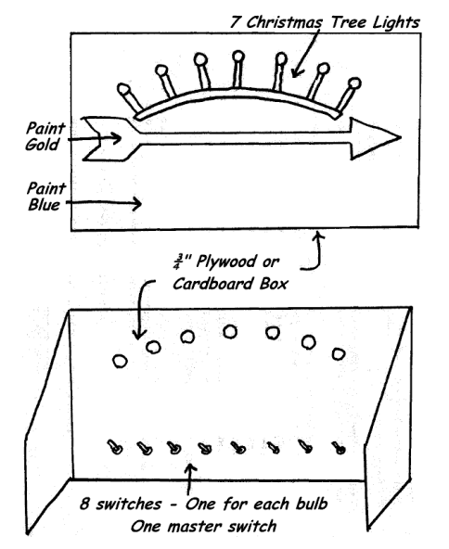
ARRANGEMENT: Room is in darkness. Leader introduces Webelos Scout(s) who are receiving Arrow of Light, and explains they have met the requirements to receive the highest award in Cub Scouting.
LEADER: The purpose of Cub Scouting is to light the way to Boy Scouting.
The first rank in Cub Scouting is Tiger. (Turn on first light) A First Grade Cub Scout must complete 5 Achievements to earn this rank.
Before becoming a Bobcat a Cub Scout learns the Cub Scout Promise, the Law of the Pack, the Cub Scout sign, handshake; motto and salute. (Turn on second light)
The rank for second grade (eight year old) Cub Scouts is Wolf. (Turn on third light) Twelve achievements are required to earn the Wolf badge. Then he works on arrow Points until he is in third grade (nine years old). He can earn as many Arrow points as time and ambition will allow.
Twelve achievements are required for the Bear badge. (Turn on fourth light) You can see that as a boy progresses in Cub Scouting, his way becomes lighter. After receiving his Bear badge, he works on Arrow Points until he is in fourth grade (10 years old)
Now he becomes a Webelos Scout. (Turn on fifth light) They wear the Webelos tri-colors on their sleeve and work on Activity Badges to pin to the Tri-colors. To earn the Webelos badge, he must earn the Fitness and Citizen Activity Badges, plus one additional Activity Badge. Webelos stands for “We’ll Be Loyal Scouts” and it is the name of the Indian tribe of which Akela is chief. The Webelos Scout is older. He can do more for himself. His parents no longer sign for his advancement; his Webelos Leader does this.
When he is in fifth grade, he works on the Arrow of Light Award. (Turn on sixth light) To receive this award, he must earn the Outdoorsman and Readyman Activity Badges and at least four more Activity Badges. He learns the Scout Oath, the Scout Law, the Scout Motto, Slogan, Sign, Salute and Handclasp. He learns the parts of the Scout badge. He understands and supports the Outdoor Code. He plans and leads a flag ceremony at a Pack meeting. Now he has earned the Arrow of Light award, the highest award a Cub Scout can earn. (Turn on seventh light) His path to Boy Scouting is now fully lit.
Let’s review his path to Scouting. (Turn out all lights) This is what his path looked like before he entered Cub Scouting. (Turn on all lights) This is what his path is like now that he ‘ has progressed through the ranks of Cub Scouting to the Arrow of Light.
Goodbye Cub Scout… Hello Boy Scout.
“Water Adventure” Graduation Ceremony
Baltimore Area Council
Note: This may be adapted to be an advancement for any Cub Scout rank advancement
Setting:
- Side view of a ship (USS WEBELOS) is cut from cardboard. Cubmaster, Webelos Leaders and Bear Leaders dressed as Ships Officers.
- Bear Dens are standing to the side of the ship.
- The Cubmaster and new Webelos Leader/s are standing behind the ship.
Cubmaster: (blows whistle). Bear First Mate, is your crew assembled and ready to board?
Bear Leader: Aye, aye, Sir!
Cubmaster: Webelos First Mate, are you ready to receive your new crew?
Webelos Leader: Aye, aye, Sir!
Cubmaster to Bears: Bears, are you prepared to board the Webelos Ship and continue along the trail that will lead to the USS Arrow of Light? (Prompt boys to say “Aye, aye, Sir!”) Before boarding the Webelos Ship, would you all raise your right hands in the Cub Scout Sign and recite the Cub Scout Promise? (CM leads boys in the promise)
Welcome aboard! (Motion the Bears toward the ship) Webelos First Mates, meet the new crew of the USS WEBELOS .
(Suggestion: Cubmaster can present the new Webelos with their neckerchiefs; the Webelos Leader with his/her badge of office, or the Den flag.)
SONGS
Raingutter Regatta
Wendy, Chief Seattle Council
(Tune: My Bonnie Lies Over The Ocean)
We're having a Cub Scout regatta.
We've sanded and painted our boats.
I put on so much decoration,
I sure hope that my boat still floats.
Chorus:
Sail on, sail on,
Sail on little sailboat, sail on, sail on.
Sail on, sail on,
Sail on little boat 'til you've won.
My boat sails along the rain gutter.
I blow it with all of my might.
But I can't steer the sail for the rudder,
So it bounces first left and then right.
Chorus
It got to the end of the gutter,
But somebody pulled out the plug.
The water is rapidly draining.
My little boat goes down - glug, glug!
Chorus
There’s A Hole In The Bottom Of The Sea
Baltimore Area Council
There’s a hole in the bottom of the sea
There’s a hole in the bottom of the sea
There’s a hole, there’s a hole
There’s a hole in the bottom of the sea
There’s a log in the hole in the bottom of the sea
There’s a log in the hole in the bottom of the sea
There’s a hole, there’s a hole
There’s a hole in the bottom of the sea
There’s a bump on the log in the hole
In the bottom of the sea
There’s a bump on the log in the hole
In the bottom of the sea
There’s a hole, there’s a hole
There’s a hole in the bottom of the sea
Keep building as long as your imagination let’s you. Be sure to repeat all the items each time.
There’s a frog on the bump on the log in the hole …
There’s a fly on the frog on the bump on the log …
There’s a wing on the fly on the frog on the bump…
There’s a flea on the wing on the fly on the frog …
After this you could have
A wing on the flea,
A hair on the wing,
But at Camp No-Be-Bo-Sco in the 60’s under the direction of “Golden” Eddie (Stoeffels) we would continue with –
There’s a truck on the flea on the wing on the fly …
There’s a tire on the truck on the flea on the wing …
And somehow we would wind up with
There’s a charge in the proton in the atom …
I don’t remember it all. Sorry. However you do it -
- Have Fun
- Make sure your Cubs are having fun, don’t drag it out too long. Commissioner Dave
If you are a No-Be-Be-Sco Alumnus or just a fan or a nosy Scouter - check out the Sand pond Society to see what No-Be Alumni are up to -
http://sandpondsociety.org
or http://nobebosco.org/
Waves Course Syllabus Song
tune of “Scotland the Brave”
Here’s a song all about the science of waves:
http://www.haverford.edu/physics/songs/wavessong.htm
You can copy the words and listen to it being sung.
Take Me Out to the Ocean
Alice, Golden Empire Council
Tune – “Take me out to the ballgame”
Take me out to the ocean,
Let me play in the waves,
I’ll follow that wave to the top of the crest,
Then watch it collapse –I’ll jump in with the best!
Or I’ll bob, bob, bob in the ocean,
The current will move underneath
And I’ll spend the day at the beach –
In my floating “wreath.”
Scout Wetspers
Wendy, Chief Seattle Council
(Oh, Tannenbaum)
Softly fall the rains today
As our campsite floats away
Silently, each Scout should ask
"Did I bring my SCUBA mask?
Have I tied my tent flaps down?
Learned to swim so I won't drown?
Have I done, and will I try
Everything to keep me dry?
SuperCalifornianExpertSurferoftheOcean
Wendy, Chief Seattle Council
(Tune: Supercalifragilistic)
Chorus:
SuperCalifornianExpertSurferOfTheOcean,
Even though most of them don’t use a suntan lotion
When they hit the waves too hard
They sure do cause commotion.
SuperCalifornianExpertSurferOfTheOcean,
Hum, diddle, diddle, diddle
Hum, diddle, I (up half-tone)
Hum, diddle, diddle, diddle
Hum, diddle, I
Because I was afraid to surf
When I was just a lad
My father took my board away
And told me I was bad
But then one day I learned a word
That every surfer knows
The biggest word you ever heard
And this is how it goes: Chorus
Chorus:
Water, Water, Everywhere
Wendy, Chief Seattle Council
(Tune: Row, Row, Row Your Boat)
Water, water everywhere,
But not a drop to drink.
Pull the plug and watch it swirl
Slowly down the sink.
Water, water everywhere,
There are puddles on the floor.
Watch the crazy Cubmaster
Go sliding out the door.
Water, water everywhere,
Make a regatta boat.
Put it in the rain gutter
And watch it float and float.
Water, water everywhere,
Rain is falling down.
Catch some raindrops in your mouth
And watch your tonsils drown.
Water, water everywhere,
And now our song is done.
Hit us with water balloons,
Getting wet is really fun!
Giant Soaker
Wendy, Chief Seattle Council
(Tune: Are You Sleeping)
Giant Soaker, Giant Soaker,
Super deluxe water gun,
Saw it at the store,
As I walked in the door.
I want one, I want one.
Giant Soaker, Giant Soaker
Sure looks fun, that water gun.
Squirt it at my brother,
Maybe squirt my mother.
Watch them run! Watch them run!
Giant Soaker, Giant Soaker
Here I come, here I come.
I’m bringing all my money
To buy that shiny funny
Water gun, water gun.
Giant Soaker, Giant Soaker,
Now I’m wet, dripping too.
Aimed it at my brother
Didn’t know my mother
Bought one too, she soaked me through.
The Happy Water Gun
Wendy, Chief Seattle Council
Tune: The Happy Wanderer
I love to shoot my water gun
At all the kids I see.
But when I shoot my water gun,
They all shoot back at me.
(Chorus)
Wateree, Waterah, Wateree
Waterah, ha, ha, ha, ha, ha
Wateree, Waterah
They all shoot back at me.
I shoot that water everywhere
I shoot it in the tree.
My neighbor’s cats a victim
Of my aqua-tillery
(Chorus)
O, my I keep my water gun
Until the day I die.
And in my coffin one last squirt
Hits someone in the eye.
(Chorus)
Sailing, Sailing
Baltimore Area Council
Sailing, sailing over the bounding main
Where many a stormy wind shall blow
‘Ere Jack comes home again
Sailing, sailing over the bounding main
Where many a stormy wind shall blow
‘Ere Jack comes home again
Propel Your Craft
Baltimore Area Council
Tune: Row, Row, Row Your Boat
Propel, propel. propel your craft
Smoothly through the liquidy solution,
Ecstatically, ecstatically. ecstatically, ecstatically
Existence is but an illusion,
Cub Sailors
Wendy, Chief Seattle Council
(Tune: My Bonnie Lies Over the Sea)
The Cub Scouts sailed out on the ocean
One weekend with all of the pack
They didn’t remember the compass
Oh, please bring that Cub Scout Pack back.
Chorus:
Bring back, bring back
Bring back those Cub Scouts back home to me
Bring back, bring back
Bring those Cub Scouts to me.
They sailed till they reached Honolulu
They landed with nobody hurt
They went to a Hawaiian luau
Dressed up in blue and gold grass skirts
Chorus
They headed back home one gray morning
Got caught in a bad hurricane
They last report we heard of them
They were sighted off the coast of Spain.
Chorus
He Waded in the Water
Wendy, Chief Seattle Council
(Tune: Battle Hymn of the Republic)
He waded in the water and he got his feet all wet
He waded in the water and he got his feet all wet
He waded in the water and he got his feet all wet
But he didn’t get his (clap, clap) wet (clap) yet.
Chorus:
Glory, glory, hallelujah!
Glory, glory, hallelujah!
Glory, glory, hallelujah!
He didn’t get his (clap, clap) wet (clap) yet.
He waded in the water and he got his ankles wet (3x)
But he didn’t get his (clap, clap) wet (clap) yet.
Chorus
He waded in the water and he got his knees wet (3x)
But he didn’t get his (clap, clap) wet (clap) yet.
Chorus
He waded in the water and he got his thighs wet (3x)
But he didn’t get his (clap, clap) wet (clap) yet.
Chorus
He waded in the water and he finally got it wet (3x)
He finally got his bathing suit wet!
Row, Row, Row Your Boat
Baltimore Area Council
Row, row, row your boat
Gently down the stream.
Merrily, merrily, merrily, merrily,
Life is but a dream.
Blub blub blub your sub
Gently ‘neath the stream
Ha ha fooled you all
I’m a submarine
Propel Propel Propel your craft
Passively down the liquid solution
Ecstatic ecstatic ecstatic ecstatic
Existence is but an optical illusion
BLOW YOUR BOAT
Circle Ten Council
Tune: Row, Row, Row your Boat
Blow, Blow, Blow your boat,
Fast along the waves.
Do your best, do your best,
We're the Cub Scout braves.
Blow, Blow, Blow your sail,
Passing others by
Do your best, do your best,
Aye-Aye-Aye
Little White Duck
Baltimore Area Council & Circle Ten Council
There’s a little white duck sittin’ in the water,
A little white duck, doin’ what he oughter.
He took a bite of a lily pad, flapped his wings
And he said I’m glad that I’m a little white duck
Sittin’ in the water, quack, quack, quack.
There’s a little green frog, swimmin’ in the water
A little green frog, doin’ what he oughter.
He jumped right off the lily pad the little duck bit
And he said I’m glad that I’m a little green frog
Swimmin’ in the water, croak, croak, croak.
There’s a little black bug, floatin’ on the water
A little black bug doin’ what he oughter
He tickled the frog on the lily pad that the little bug bit
And he said I’m glad that I’m a little black bug
Floatin’ on the water, chirp, chirp,
There’s a little red snake lyin’ in the water
A little red snake doin’ what he oughter
He frightened the duck and the frog so bad
He ate the bug and he said I’m glad that I’m a little red snake
Lyin’ in the water; ssss, ssss, ssss.
Popeye the Sailor Man
Santa Clara County Council
I’m Popeye, the sailor man.
I’m doing the best I can.
I eat all my spinach,
I fight to the finish.
I’m Popeye, the sailor man.
Paddle Song
Baltimore Area Council
Start out softly as if the canoes are at a great distance. Each time, get a little louder as the canoes pass you, then gradually get soft again as the canoes disappear from sight.
Our paddles keen and bright,
Flashing like silver.
Swift as the wild goose flight,
Dip, dip, and swing.
Dip, dip, and swing them back,
Flashing like silver.
Swift as the wild goose flight,
Dip, dip, and swing.
Columbus Song
Circle Ten Council
(Tune: Yankee Doodle)
In fourteen hundred and ninety two
Columbus sailed from Spain
With three small ships and eighty men
Across the bounding main
Chorus:
“Sail on and on,” he said
“There’s nothing you should dread.”
“We’ll find that New World soon I’m sure!”
“Just think what lies ahead!”
Columbus was a sailor fine
He knew his navigation
And even though his men were scared
He was their inspiration.
Shipwrecked Cub Scouts
Longhorn Council
(Tune: Gilligan’s Island Theme)
Our pack set sail on the sea one day,
In search of coins of gold.
A group of hearty Cub Scouts,
And leaders true and bold.
The weather started getting rough,
The tiny ship was tossed.
If not for the courage of our Cubmaster,
The whole pack would be lost.
Our boat touched ground on a rocky isle
And up walked a tall old man.
He tossed a towel to dry us off,
And raised high his right hand.
He said, “You’re a sharp pack of Cub Scouts,
Your courage brave and sure,
To sail out on a sea like this
On a Scouting adventure.”
He gave directions to get home.
We set sail with good cheer.
We reached home with the setting sun,
And tied up to the pier.
We looked in the bottom of the boat
And saw the old man’s towel.
His name was stitched along the hem,
The name was Baden-Powell.
Lobster Mash
Santa Clara County Council
Tune – Monster Mash
I was down by the ocean late one night
When my eyes beheld an unusual sight
Hoards of lobsters began to rise
And suddenly to my surprise
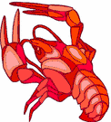
(they did the mash) They did the lobster mash
(they did the mash) It was a seaside smash
(they did the mash) It caught on in a flash
(they did the mash) They did the lobster mash
From my front-row seat at sandcastle west
To the briny deep, beyond the wave crests
The fish all came from their humble abodes
To share in the dance and twinkle their toes
(they did the mash) They did the lobster mash
(they did the mash) It was a seaside smash
(they did the mash) It caught on in a flash
(they did the mash) They did the lobster mash
The dolphins were having fun, the party had just begun
The guests included Marlin and Nemo, his only son.
The scene was rocking, all were digging the sound
Of the lobster claws clicking as all twirled around.
The whales and jellyfish were starting to scream
When a wave crashed loudly, and I awoke from my dream
(of the mash) It was the lobster mash
(oh yes the mash) It was a seaside smash
(you know the mash) It was gone in a flash
(it was the mash) My dream lobster mash.
Give Me A Pond
Baltimore Area Council
Tune: Home On The Range
Oh, give me a pond. on a hot summer's day.
Where the frogs and the crayfishies play.
I'll fish and I'11 swim: 'till it's time to go in;
Sopping wet. dripping all of the way.
Splish, splashing. I go.
All wet from my head to my toe.
Skipping stones 'cross the top;
Hope I never need stop;
I'm one happy-go-lucky. wet fellow!
Skin Diver’s Song
Longhorn Council
Tune: Sailing, Sailing
Diving, diving, into the deep blue sea,
And many a fish we’ve scared away
On that you will agree.
Diving, diving, into the ocean blue,
With flippers, and mask and oxygen gas
We’ll have adventures true!
Water Sports
Baltimore Area Council
Tune: Yankee Doodle
Water sports are what we like.
For summer, spring and fall.
When summer comes you now must know.
We'll have a great big ball.
Chorus:
Cub Scouts always having fun,
Cub Scouts in the water,
Swimming, diving, fishing, too.
Safely like we "otter".
Rivers and lakes, oceans and streams,
And even swimming pools.
Back stroke, breaststroke, and butterfly,
We'll follow safety rules.
Chorus
Jaws
Catalina Council
Tune: Do Re Mi
JAWS a mouth, a great big mouth
TEETH the things that make a crunch
BITE the friendly shark’s “Hello”
US his favorite juicy lunch
BLOOD that turns the ocean red
CHOMP oh what a tasty treat
GULP that means the shark’s been fed
That will bring us back to
JAWS! JAWS! JAWS! JAWS!
Singing in the Rain
Capital Area Council, TX
We're singing in the rain, just singing in the rain.
What a glorious feeling, we're happy again.
Thumbs up! [Group echoes.]
A-root-ta-ta, root-ta-ta. root-ta-ta-TA
Add each of the following, in turn
and keep doing all previous motions:
Thumbs Up,
Arms Out,
Elbows In,
Knees Bent,
Knees together,
Toes together,
Butt out,
Chest out,
Head Back,
Tongue out
Scout Wetspers
Capital Area Council, TX
Tune - Oh, Tannenbaum
Softly fall the rains today
As our campsite floats away
Silently, each Scout should ask
"Did I bring my SCUBA mask?
Have I tied my tent flaps down?
Learned to swim so I won't drown?
Have I done, and will I try
Everything to keep me dry?
Outdoor Fun Song
Capital Area Council, TX
Tune:- Camptown Races
Cub Scouts have their outdoor fun,
Doo-dah, doo-dah!
Play their games and sing and run,
Doo-dah, doo-dah!
Chorus:
Going to play their games,
Going to sing their songs,
Cub Scout boys have lots of fun,
‘Cause they all belong.
Cub Scout leaders have fun too,
Doo-dah, doo-dah!
Dressed up in their gold and blue,
Oh, doo-dah day!
Chorus:
Cook the food and eat it all,
Doo-dah, doo-dah!
In the outdoors, have a ball,
Oh doo-dah day!
Chorus:
Swim and splash in the swimming pool,
Doo-dah, doo-dah!
So glad there isn’t any school,
Oh, doo-dah day!
Chorus:
Ain't Gonna Rain No More
Catalina Council
CHORUS:
Oh, it ain't gonna rain no more, no more
It ain't gonna rain no more
So how the heck
Can I wash my neck?
If it ain't gonna rain no more.
Peanut sat on a railroad track,
Its heart was all a-flutter
'Round the bend came number nine.
Toot! Toot! Peanut Butter.
CHORUS
Pig sat on a railroad track
Chicken between its legs
Along came the 409
and choo-choo ham and eggs
CHORUS
An old man lived by the sewer,
And by the sewer he died
They couldn't call it murder
So they called it sewer-side
CHORUS
Mary had a little lamb
She kept it in the closet
And every time she let it out
It left a little deposit
CHORUS
Thirty days has September
June and no wonder
All the rest have peanut butter
Except Grandma and she rides a tricycle
CHORUS
At The Pool
Catalina Council
(Tune: Three Blind Mice)
At the pool
At the pool
We keep so cool
We keep so cool
We swim around and we look so cute
I'm glad I remembered by bathing suit
My birthday suit would get me the boot
At the pool
This Sand Is Your Sand
Capital Area Council, TX
Tune: This Land is Your Land
This sand is his sand,
This sand is our sand,
On a beach this crowded
We should bring some canned sand!
And all around us
Beach blankets crammed, jammed.
There’s not a sandy spot left free!
We begged our parents
To take us swimming,
Packed pails and shovels –
The car was brimming!
We piled the food in
We brought the dog too.
What fun the beach would be to see!
The heat was driving,
Was tough surviving,
Bumper to bumper
When at last arriving.
No one went swimming
Or felt like playing,
Back home is where we’d rather be!
This sand is my sand,
This sand is your sand,
Right in our backyard,
Aren’t sandboxes great?
No crowd of kids with
Their pails and shovels.
This sand is just for you and me!
STUNTS AND APPLAUSES
APPLAUSES & CHEERS
Wendy, Chief Seattle Council
Buccaneer Applause:
"Yo, Ho, Ho, And a Bottle of Coke!"
Deep Sea Diver/Non-Swimmer Applause:
"Blubb, blubb, blubb!"
Fish Yell:
Open and close mouth several times
without making any sounds.
Alice, Golden Empire Council
It goes without saying – you have to do the “Wave” applause! The old standby – with people standing and waving hands and arms in “waves” across the room.
Waves of Sound Applause – Add on sound to the Wave – Leader indicates the soft start, building to a loud noise, then decreasing back down as the “wave” travels across the room.
Vuvuzela Applause – Have balloons with hex nuts ready to go, all blown up – let everyone make this noisy applause!
What a Boat! Applause - Everyone stands, shades their eyes to see a “boat” in the distance, then yell “What a Boat!”
Water Balloon Applause – Leader tells everyone to pick up their water balloon, balance it as it wobbles in their hands, then rear back and throw. Wait a second then everyone yells “SPLAT!”
Water Balloon Relay Applause – Divide the audience in half. The first half acts out the water balloon applause above. Following “Splat” the other half of the audience yells “I’m ALL WET!”
Catalina Council
Faucet Applause Drip, Drip, Drip"
Water Applause Hold your throat as if parched for a drink and say "water, water, water"
Undersea Applause Hold your nose, bend your knees, and then pretend to sink underwater, saying "Glub, glub, glub,"
Ocean Applause Best done with a large group;
Have first row sway from side to side;
Second row sways in opposite direction;
Third row same as first, etc.
The have them add sound effect:
SWOOSH, SWOOSH, SWOOSH!!
Caught Fish Hold out left hand, palm up, and make flopping, gasping motions with the right hand on the palm of the left hand.
Clam Fold hands together, interlocking fingers. Make noise by pressing palms together.
Clam Clap Roll up your sleeves. Double up your fists with your left arm in front of your face and right arm overhead. Then silently open and close your right fist.
Fish Say “how, how, how, flop, flop, flop”
while making flip flop motion with hands.
Fisherman Pretend to reel out some line, let it drift, yank your pretend pole back and start to reel in the fish. Struggle with it for a short time and say:
"I'VE GOT IT!!! I'VE GOT IT!!!"
Guppy Suck in both sides of your mouth and make a kissing noise three times.
Jaws(Shark) Cheer Chomp, Chomp, Chomp.
Jaws (version 2) Hold arms to cover face
(Hands holding elbows) yell "AAAAAH, HELP!"
Swimmer's Belly Put both hands out in front of you and slap your hands together once. Look both ways and say,
"Where's the water, where's the water."
Little Swimmer’s Raise hands up but not arms,
“splash, splash, splash!”
Big swimmer’s Swing arms all around,
“splash, splash, splash!”
Dog-paddle: Paw air with hands, kick feet,
“bark, bark, bark!”
Shark One elbow up like a fin, “dum, dum, ta, dum!”
Life Guard Pinch nose with one hand,
other arm is straight up, “I’m coming!”
Baltimore Area Council
Buccaneer Applause: “Yo, ho, ho and a bottle of Coke”,
Deep Sea Diver Applause: “ Blubb, Blubb, Blubb”.
Water Cheer: “How, How, How, Water, Water, Water, Glug, Glug, Glug, Ah-hhh”
Clam Clap: Ask everyone to roll up his sleeves in preparation for this strenuous applause. Double up your fists with your left arm in front of your face and right arm over-head. Then silently open and close your right fist.
Motorboat Applause: Flutter tongue on roof of mouth.
Seal Applause: Extend your arm straight out in front of you and clap with stiff arms while saying, “‘Arf, arf, arf, arf
Beach Cheer: Divide your audience into 3 groups. When you point to group 1, they yell “Sand.” When you point to group 2, they yell “Surf” And when you point to group 3, they yell “Sun.”
Southern NJ Council
Water Sprinkler Applause Make fist with the right hand with thumb sticking out. Place end of thumb on end of nose. Rapidly open and close fist while saying "Choo, choo, choo, choo," etc. sounding like a water sprinkler and turning around as you go. After a complete turn spin back around the opposite direction, again like a water sprinkler, saying "Wheeee."
Longhorn Council
Surfboarders Cheer: Pretend to be riding a surfboard, run it onto the beach, jump off, spread arms wide, say “Success!”
Diver’s Cheer: Same idea as Surfboarders Cheer, but jump off and say “Kersplash.” “Perfect!”
The Wave: Start with one side and let the wave go around the room twice.
Swimming: Pretend to swim using the breaststroke, clap hands together as you put your arms forward.
Big Rain Applause: Start tapping one finger from each hand. Build quickly one finger at a time until you are clapping both hands. Then reverse and have storm fade away.
Beach Cheer: Divide the audience into three groups. When you point to group one, they yell "Sand!" When you point to group two, they yell, "Surf!" When you point to group three, they yell, "Sun!"
Motor Boat: Pull on starter cord a few times while fluttering tongue on roof of mouth. Then start the sound of a motorboat.
Capital Area Council, TX
Water Cheer: “Wet, wet, wet, water, water, water, ah-hhh”
OCEAN APPLAUSE - Best done with a large group; have first row sway from side to side; second row swaying in opposite direction; third row same as first, etc. Then have them add sound effect: SWOOSH, SWOOSH, SWOOSH!!
RAINSTORM APPLAUSE - Start by gently patting knees alternately to simulate rain falling. Increase the noise by switching to hand clapping as the storm reaches its height. With a hand signal, have everyone shout “”BOOM” to represent thunder. Gradually decrease the hand clapping and then pat the knees as the storm subsides.
Backyard Pool Cheer - Don't stand up for this cheer. Lean back in your floating pool chair, take sip of your tall cool drink and say "Ahh, this is the life."
RUN-ONS
Daffy Definitions by a Sailor
Alice, Golden Empire Council
- Current – Tidal flow that carries a boat away from where you’re aiming, OR toward a hazard.
- Tides - The rise and fall of ocean waters. There are two tides of interest to mariners: Low tide always comes when you want to enter port and there’s only mud or High Tide when you want to leave port and the water pushes you back.
- Grounding - The embarrassing situation in which a sailor returns to shore without leaving his boat.
Catalina Council
Water! Water! - a classic run on
- A man, crawling across the stage: "Water, water!!"
- Someone walks by, and the crawling man tugs on his pant leg. "Water, Water!"
- Man walking by: "Sorry." He continues walking.
- Another man walks by, the crawling man tugs on his pant leg: "Water, Water!"
- Man walking by: "All I've got is this beef jerky, sorry." He keeps walking.
- Another man walks by, the crawling man tugs on his pant leg: "Water, Water!"
- Man walking by: "No, I don't have any." He keeps walking.
- The crawling man sees a cup of water at the other end of the stage. "Water!!"
- He painfully crawls over there. "Water! Water!"
- When he reaches the water, he quickly stands up, dunks his comb in it, and uses it to comb his hair.
Longhorn Council
Cub 1: Why do fish have schools?
Cub 2: So the buoys and gulls can get an education.
Cub 1: Do they have Scouts too?
Cub 2: Sure Buoy Scouts and Gull Scouts.
Cub 1: What do buoy scouts do?
Cub 2: Make sure the coast is clear.
- Why do you keep doing the backstroke?
- I just had lunch and I don’t want to swim on a full stomach.
Cub 1: They say that swimming is one of the best
exercises for keeping the body slim and trim.
Cub 2: Yeah. Right!
Cub 1: Why do you say that?
Cub 2: Well, did you ever see a whale?
Cub 1: What is the first thing the fisherman caught after
running to the river?
Cub 2: His breath!
Cub 1: Do you know what sea monsters eat?
Cub 2: Sure. Submarine sandwiches!
Cub 1: What ship is always managed by more than one
person?
Cub 2: A partnership
Cub 1: What do you call a baby whale?
Cub 2: A little squirt.
Santa Clara County Council
Cub 1: I’ve eaten beef all my life and now I’m as strong as an ox.
Cub 2: That’s funny. I’ve eaten fish all my life and I can’t swim a stroke.
What stays in bed most of the day and sometimes goes to the bank? A stream.
Where can you find an ocean without water? On a map.
What do sea monsters have for dinner? Fish and ships.
What do you call a thing that sits on the bottom of the ocean and twitches? A nervous wreck.
When is a ship like snow? When it’s a-drift.
What gets wetter the more it dries? A towel.
What kind of lights did Noah’s ark have? Floodlights.
Where is the ocean the deepest? On the bottom.
Did you hear about the pelican that switched from sardines to herring? The smaller fish just didn’t fill the bill.
Circle Ten Council
Boy: How many fish have you caught?
Fisherman: None yet. But I've only been fishing for an hour.
Boy: That's better than the man who was fishing here yesterday.
Fisherman: How's it better?
Boy: It took him five hours to do what you've done in just one!
Great Salt Lake Council
Scout 1: Where do rivers keep their money?
Scout 2: In their banks!
Father: How are your test scores, Son?
Son: Underwater, Dad.
Father: What do you mean, underwater?
Son: You know, below C level.
Scout 1: Why can’t you get two elephants into a pool at the same time?
Scout 2: They only have one pair of trunks.
Doctor: Take the green pill with a glass of water after getting up. Take the blue pill with a glass of water after lunch. Then just before going to bed take the red pill with another glass of water.
Patient: Exactly what is my problem, doctor?
Doctor: You’re not drinking enough water.
Web Ldr: Where did you take your bath?
Webelos: In the spring!
Web Ldr: I didn’t ask you when . . . I asked you where!!!
Capital Area Council, TX
Cub 1: Are there any athletes in your family?
Cub 2: My brother has been swimming for five years.
Cub 1: He must be pretty tired.
Cub 1: My mother does bird imitations.
Cub 2: Really? How does she do that?
Cub 1: She watches me like a hawk.
JOKES & RIDDLES
Alice, Golden Empire Council
Q: I am found in the sea and on land but I do not walk or swim. I travel by foot but I am toeless. I'm never far from home. What am I?
A: A snail
Q: I run but never walk. I have a mouth but never talk. I have a bed but never lie. What am I?
A: A river
Q: I am a river 1000 times bigger than the Mississippi, but I have no banks. Ships use me to increase their speed. I change the climate in England. What am I?
A: The Gulf Stream Current
Q: I travel the ocean, but don’t need a boat. I am often found by the beach. I give milk but don’t eat grain. What am I?
A: A coconut
Q. Why do fish live in salt water?
A. Because pepper makes them sneeze!
Q: Which vegetable would you never want in your boat?
A: That’s easy – a leek!
Q: What do you call it when two people are threatening each other with oars?
A: Rowed Rage
Catalina Council
Water! Water! - a classic run on
- A man, crawling across the stage: "Water, water!!"
- Someone walks by, and the crawling man tugs on his pant leg. "Water, Water!"
- Man walking by: "Sorry." He continues walking.
- Another man walks by, the crawling man tugs on his pant leg: "Water, Water!"
- Man walking by: "All I've got is this beef jerky, sorry." He keeps walking.
- Another man walks by, the crawling man tugs on his pant leg: "Water, Water!"
- Man walking by: "No, I don't have any." He keeps walking.
- The crawling man sees a cup of water at the other end of the stage. "Water!!"
- He painfully crawls over there. "Water! Water!"
- When he reaches the water, he quickly stands up, dunks his comb in it, and uses it to comb his hair.
Longhorn Council
Cub 1: Why do fish have schools?
Cub 2: So the buoys and gulls can get an education.
Cub 1: Do they have Scouts too?
Cub 2: Sure Buoy Scouts and Gull Scouts.
Cub 1: What do buoy scouts do?
Cub 2: Make sure the coast is clear.
- Why do you keep doing the backstroke?
- I just had lunch and I don’t want to swim on a full stomach.
Cub 1: They say that swimming is one of the best
exercises for keeping the body slim and trim.
Cub 2: Yeah. Right!
Cub 1: Why do you say that?
Cub 2: Well, did you ever see a whale?
Cub 1: What is the first thing the fisherman caught after
running to the river?
Cub 2: His breath!
Cub 1: Do you know what sea monsters eat?
Cub 2: Sure. Submarine sandwiches!
Cub 1: What ship is always managed by more than one
person?
Cub 2: A partnership
Cub 1: What do you call a baby whale?
Cub 2: A little squirt.
Santa Clara County Council
Cub 1: I’ve eaten beef all my life and now I’m as strong as an ox.
Cub 2: That’s funny. I’ve eaten fish all my life and I can’t swim a stroke.
What stays in bed most of the day and sometimes goes to the bank? A stream.
Where can you find an ocean without water? On a map.
What do sea monsters have for dinner? Fish and ships.
What do you call a thing that sits on the bottom of the ocean and twitches? A nervous wreck.
When is a ship like snow? When it’s a-drift.
What gets wetter the more it dries? A towel.
What kind of lights did Noah’s ark have? Floodlights.
Where is the ocean the deepest? On the bottom.
Did you hear about the pelican that switched from sardines to herring? The smaller fish just didn’t fill the bill.
Circle Ten Council
Boy: How many fish have you caught?
Fisherman: None yet. But I've only been fishing for an hour.
Boy: That's better than the man who was fishing here yesterday.
Fisherman: How's it better?
Boy: It took him five hours to do what you've done in just one!
Great Salt Lake Council
Scout 1: Where do rivers keep their money?
Scout 2: In their banks!
Father: How are your test scores, Son?
Son: Underwater, Dad.
Father: What do you mean, underwater?
Son: You know, below C level.
Scout 1: Why can’t you get two elephants into a pool at the same time?
Scout 2: They only have one pair of trunks.
Doctor: Take the green pill with a glass of water after getting up. Take the blue pill with a glass of water after lunch. Then just before going to bed take the red pill with another glass of water.
Patient: Exactly what is my problem, doctor?
Doctor: You’re not drinking enough water.
Web Ldr: Where did you take your bath?
Webelos: In the spring!
Web Ldr: I didn’t ask you when . . . I asked you where!!!
Capital Area Council, TX
Cub 1: Are there any athletes in your family?
Cub 2: My brother has been swimming for five years.
Cub 1: He must be pretty tired.
Cub 1: My mother does bird imitations.
Cub 2: Really? How does she do that?
Cub 1: She watches me like a hawk.
SKITS
How Did You Get Here?
Baltimore Area Council
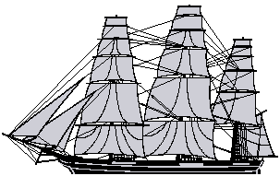
This skit was in last month's Baloo's Bugle.
It has a lot of really bad puns in it. Check it out. CD
Water! Water!
Wendy, Chief Seattle Council
Cast: Several Cub Scouts.
Props: Sahara Desert scenery (have Cubs draw cactus for background.), A glass of water, comb.
Set up: One Cub Scout sitting with a glass of water.
Cub Scout #1:[Crawls across stage gasping]:Water! Water!
[Collapses about one fourth of the way across]
Cub Scout #2: [Does same as #1, but he gets a little further before he collapses]: Water! Water!
Cub Scout #3: then Cub Scout #4. [All do the same as #1 but each gets a little closer to the glass of water before collapsing.]
Last Cub Scout: [Crawls across the stage, panting and asks for water.) Water! Water!
[When he reaches the boy with the glass of water, he drags himself up onto his knees and pulls a comb from his back pocket, dips it in the glass and combs his hair.]
Enlarging Machine
Wendy, Chief Seattle Council
Props: Blanket (held up by two people) small rock, large rock, small spoon, large spoon, stick, other big and small versions of the same object as needed, bucket of water.
Players: Professor, 2 people holding up the sheet, Person hiding behind the sheet.
Set Up: Set up a sheet as a backdrop, and hide a Scout behind it with the large objects, and a bucket of water(or crumpled paper. sponges, or other non-harmful substance. The Professor will be in front of the sheet with the small objects.
The Professor walks out and announces that he has developed a wonderful Enlarging Machine that will make anything - anything - bigger.
As the Scout behind the machine makes 'machine' noises, he explains that simply tossing an object over the sheet operates the machine. The machine will then return the object in a much larger form.
The Professor will demonstrate his fantastic invention, but he needs volunteers to help.
One by one, the volunteers come forward. The Professor hands them an object which they throw over the sheet.
The machine then makes noises, and the larger object is tossed back. Each time, the Professor exclaims about the value and capability of the machine.
At this point the accomplice stands up and claims the machine is a fake and proceeds to pretend to spit over the machine.
He is instantly drenched by a bucket of water.
I like this approach. The person who gets wet is obviously part of the skit. No one is embarrassed. CD
Water Shortage:
Wendy, Chief Seattle Council
The scene opens with an opaque glass on a table.
Guys enter one at a time, (all in pajamas, if you want) as if there is a mirror, and do different things with the water.
- Combs hair dipping comb in and out of cup;
- Cleans ears with Q-tip after dipping it in water glass
- Rinses and spits pretends to spit out toothpaste;
- (Maybe use a leader for this one) Comes in to take an Advil or aspirin and drinks the water!
Idea from Young Life
http://www.thesource4ym.com/skits/skit.asp?ID=61
You could combine the ideas from “Water Water” and “Water Shortage.” Have 4 boys crawl across the stage, desperate for water. When they finally reach the glass of water, the first combs his hair, dipping the comb in the water. The second guy cleans his ears, the third brushes his teeth, and the fourth takes an asprin.
Fishing
Wendy, Chief Seattle Council
Cast: 2 Cubs
Setting: 'Two Cubs are rowing an imaginary boat
Cub #1: Whew! It sure is a long way out here.
Cub #2: Yep (Puts hand to eyes) I can't see the shore anymore. Ready to start fishing?
Cub #1: I think so. Looks like a good spot to me.
(Both ready imaginary rods, reels, hooks, worms, etc. and start fishing. Immediately they both start to catch fish, recast and catch more. Continue for several casts)
Cub #2: I told you this would be a good spot.
Cub #1: Sure is, the boat's full. Guess we have our limit, better get back.
Cub #2: OK. (Gets oars ready)
Cub #1: Did you use a map to get here?
Cub #2: How are we ever gonna find our way back'?
Cub #l: Oh. that's easy. I'll Just mark the spot with a big X right here on the side of the boat!
(Makes mark, both row away quickly)
The Fishing Trip
Wendy, Chief Seattle Council
Set Up:
- Make a cardboard cutout of a boat and a sign that says “Boat Dock”.
- The scene starts with the boat about 10 feet away from the boat dock.
- The Cub Scouts and their Den Chief are on their way to go fishing.
Cub #1: Stops at the dock then walks out across the water and gets in the boat.
Cub #2: Hey wait for me! (He walks out to the boat.)
Den Chf: Oh well... (Steps into the water and pretends to fall in and drags himself out)
Cub #3: Hey wait up. Here I come.
(Walks out to the boat.)
Den Chf: (Tries and fails again.)
The sequence continues until all the boys are in the boat and only the Den Chief remains on shore.
Cub #1: Should we tell him where the rocks are?
Synchronized Swimming Skit:
Wendy, Chief Seattle Council
This may be too complicated for cubs to do, but Scouters could perform the skit.. http://www.youtube.com/watch?v=f86qKQJg3Z8&feature=related
Automatic Boy Wash
Catalina Council
Set Up: The narrator reads the script while the Cubs (4-6) take the parts of the boy going through the boywash, the water and soap dispensers, as well as the brushes for the boywash, and the boy who is the final product.
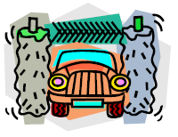
Narrator: How great it would be if there were automatic boy washes just as there are automatic car washes. First we would take the average boy in from play.
(A boy comes on stage as filthy and dirty as he can be),
and put him through car wash. First the Water and Soap Dispensers.
Scene #1 - WATER AND SOAP DISPENSERS:
Squirt water and blow bubbles on the dirty boy.
Then would come the brushes
Scene #2 - BRUSHES:
Brush boy front and back ,
(dirty boy sneaks off stage and
a clean and tidy Cub takes his place).
Narrator: There is only one problem!
(Clean boy exits stage, dirty boy returns)
In two minutes he'll be back at the car wash again!!
Dirty Cubs return!!
Facts of Water
Catalina Council
Personnel: Six Cub Scouts
Equipment: Buckets of water the Scouts can hold while speaking.
- Did you know that watermelon isn’t called that for nothing? It’s 97% water.
- Did you know that during a lifetime, you will drink about 16,000 gallons of water?
- Did you know if all the valleys and mountains on land and on sea were leveled, water would cover the entire earth two miles deep?
- Did you know that waterpower is no idle phrase? Water flowing at 10 miles an hour can move a rock 10 feet thick.
- Did you know that water helps regulate climate: It absorbs heat in summer and releases it in the winter.
- Did you know that a birch tree releases about 70 gallons of water into the atmosphere each day, almost the amount a person uses in his home each day?
Waterways
Baltimore Area Council
This could easily be adapted for an Opening CD
Props: A picture indicating each boy’s sentence. Text can be cut and pasted to back of picture.
- (holds up picture of a lake) A waterway is any navigable body of water. These include rivers, lakes, oceans, and canals. In order for a waterway to be navigable, it must meet several criteria:
- (holds up picture of a sailboat with a big keel) The waterway must be deep enough to allow the draft depth of the vessels using it;
- (picture of boat pushing barges on the Mississippi) The waterway must be wide enough to allow passage for the beam width of the vessels using it;
- (picture of Niagara Falls) The waterway must be free of barriers to navigation such as waterfalls and rapids, or have a way around them, such as canal locks;
- (picture of whitewater rapids) The current of the waterway must be mild enough to allow vessels to make headway.
- (picture of a cruise ship) Vessels using waterways vary from small animal-drawn barges to immense ocean tankers and ocean liners, such as cruise ships.
- (picture of barge on canal) At one time, canals were built mostly for small wooden barges drawn by horses or other draft animals. Today, major canals are built to allow passage of large ocean-going vessels. See Ship Canal.
Who Am I
Baltimore Area Council
Set Up: This is a spin off from Family Feud. The teams play the game for real. Respond to answer for the MC means for him to say something witty about the response. The Master of Ceremonies (MC) enters first
MC: Welcome to our show. Tonight our two teams are back stage, ready and anxious to begin. So lets bring out the first team… The CUBBIES! (Cub Scouts run out and take their place on one side of stage. As they run out the Master of Ceremonies assistant holds up a sign that says “CHEER”; This sign is to be held up each time the audience is to participate with a cheer).
Now, let’s bring out the second team… The C. P.’s - The Cubbies Parents. (Cheer)
The captain of each team has a bell, if you know the answer to the question - ring the bell. The Team to get the most correct answers of course is the winner. Now, if you are ready we will begin. (Teams both answer “READY”) We have celebrities here to ask the questions. Do not ring your bell until the entire question has been asked. First Celebrity please step forward. By the way, just a little clue, each of the Celebrities has something to do with water.
FIRST CELEBRITY: (Wearing a hat to depicting Columbus) I sailed the ocean blue in 1492 . . . Who am I?
MC: (Respond to answer) Now for the second Celebrity.
SECOND CELEBRITY: (Wearing hat to depict John Paul Jones) On many ships I did sail, in battle I must not fail! I fought hard through the night. You can quote my words, “I’ve just begun to fight.”
MC: (Respond to answer) Will the third Celebrity please come out?
THIRD CELEBRITY: (Wearing hat to depict Popeye) I love to sail, it is true. To make me strong I eat my spinach too!…Who am I?
MC: (Respond to answer) As our next celebrity comes out, listen very carefully as he whistles a tune to tell you who he is.
FOURTH CELEBRITY: (Wearing hat to depict Gilligan from Gilligan’s Island) Enters whistling Gilligan’s theme song.
MC: (Respond to answer)
MC: Both teams have done your best, however, the winner is (name team). (Cheer) (To the losers) You have tried hard, and you are a winner, too. So here’s a refresher for you, (assistant runs out with a bucket and it looks like he is going to throw water on the losers. (Ham this up) But when he finally goes to throw the contents only some confetti (or another gag item) comes out..
A Ship Like This
Baltimore Area Council
Characters: 3 boys
Scene: Aboard an ocean liner. A small table with a chair on each side. Mr. Niffy, who is very unhappy, sits in the right hand chair. He picks up a book, signs, puts down the book. Looks around. Taps the table with his finger tips. Tries to read again. Mr. Tiffy enters left.
Mr. Tiffy: Good Morning, Mr. Niffy. How are you, today?
Mr. Niffy: Oh, oh, I just don’t know.
Mr. Tiffy: May I sit down?
Mr. Nifty: Of course! Of course! Do whatever you wish. Anything you do is all right with me.
Mr. Tifty: Did you sleep well last night?
Mr. Niffy: No, no, not a wink!
Mr. Tiffy: Were you seasick?
Mr. Nifty: No, no, I wasn’t seasick.
Mr. Tiffy: Well, what’s your problem?
Mr. Nifty: I’m afraid.
Mr. Tiffy: Afraid of what?
Mr. Nifty: I’m afraid this ship will sink.
Mr. Tiffy: Oh, come on. That’s a silly fear. A ship this size doesn’t sink!
Mr. Nifty: Oh, I read about a ship that sank.
Mr. Tiffy: Here comes the Steward. Let’s talk to him.
Mr. Niffy: All right.
Mr. Tiffy: Pardon me, Steward.
Steward: Good Morning, gentlemen! May I help you?
Mr. Tiffy: I hope so. We have a question. Maybe you can answer it and put our minds to rest.
Steward: I’ll answer if I can.
Mr. Tiffy: Does a ship like this sink very often?
Steward: Oh, No! (Men smile happily.) A ship like this sinks only once!
Man Fishing
Baltimore Area Council
A man was fishing and catching fish like crazy. Two men were watching him and wondering what his secret was. They asked him what his secret is and he, just mumbles. They keep watching him reel in the fish and they again ask him what his secret is and he just mumbles. They ask a third time. He spits something into his hand and answers "Keep the worms warm".
I’ve seen this done with a whole den/patrol asking the man one at a time. It is, also, good in the winter if they pretend they are ice fishing. CD
The Fisherman
Baltimore Area Council
Cast: 2 Cubs
Setting: A fish market, customer and merchant
Customer: I want you to do me a favor.
Merchant: What is it Mr. Bigwig?
Customer: I just got back from a fishing trip.
Merchant: Did you catch anything?
Customer: No, and that's the catch. My wife said I wouldn't and I'm in the doghouse. I said I would catch six fish. Merchant: Well, how can I help you.
Customer: Let me have six of those medium size trout there.
Merchant: Wrap 'em up?
Customer: No, don't make a liar out of me. Pitch `em to me one at a time.
Merchant: Well, I don't understand but here goes. (Tosses the fish to the Customer) What was that for?
Customer: Very simple. I caught them, didn't 1?
Merchant: (Grinning) You're right Mr. Bigwig. Good Luck. (Customer leaves)
Fishing
Baltimore Area Council
Cast: 2 Cubs
Setting: 'Two Cubs are rowing an imaginary boat
Cub #1: Whew! It sure is a long way out here.
Cub #2: Yep (Puts hand to eyes) I can't see the shore anymore. Ready to start fishing?
Cub #1: I think so. Looks like a good spot to me.
(Both ready imaginary rods, reels, hooks, worms, etc. and start fishing. Immediately they both start to catch fish, recast and catch more. Continue for several casts)
Cub #2: I told you this would be a good spot.
Cub #1: Sure is, the boat's full. Guess we have our limit, better get back.
Cub #2: OK. (Gets oars ready)
Cub #1: Did you use a map to get here?
Cub #2: How are we ever gonna find our way back'?
Cub #l: Oh. that's easy. I'll Just mark the spot with a big X right here on the side of the boat!
(Makes mark, both row away quickly)
THE FISHING TRIP
Circle Ten Council
Set Up:
- Make a cardboard cutout of a boat and a sign that says “Boat Dock”.
- The scene starts with the boat about 10 feet away from the boat dock.
- The Cub Scouts and their Den Chief are on their way to go fishing.
Cub #1: Stops at the dock then walks out across the water and gets in the boat.
Cub #2: Hey wait for me! (He walks out to the boat.)
Den Chief: Oh well... (Steps into the water and pretends to fall in and drags himself out)
Cub #3: Hey wait up. Here I come. (Walks out to the boat.)
Den Chief: (Tries and fails again.)
The sequence continues until all the boys are in the boat and only the Den Chief remains on shore.
Cub #1: Should we tell him where the rocks are?
CLOSING CEREMONIES
Ship Shape Closing Ceremony
Wendy, Chief Seattle Council
Using a slide whistle, penny whistle, or just someone that can whistle loudly, Boatswain whistles to call everyone to attention. (attention whistle: starting note, up 3 notes, then back down to the first note)
Boatswain: All hands on deck! All hands on deck!
(Cubs assemble in front of the Boatswain)
Boatswain: Prepare to retire the colors!
(Color guard goes to the front of room where the flag is. The rest of the cubs assemble an honor guard, in either 1 long line, or 2 parallel lines.)
Boatswain: Reads flag closing ceremony as usual.
(Color guard walks past the honor guard while walking the flag to the rear of the room.)
Boatswain (after the flag ceremony and the audience is seated) All hands, dismissed (or refreshments)!!
(Cubs and parents leave or line up for refreshments.)
Making Waves
Alice, Golden Empire Council
Set up: Use a blue sheet or large piece of fabric or paper for a “sky” backdrop. Now cut out or paint a large half-circle of orange and place it at the bottom of the sky, to make your setting sun. Make a series of waves – you can cut a row of waves out of cardboard by connecting this kind of shape. Have the boys paint each row using a variety of blues, greens and whites.

To make your waves look more authentic, give each boy a paper plate with several drops of various blue/green/gray/white colors – instead of mixing the paint, just sweep the brush through all the colors and let the colors get mixed only as it happens on the wave. After the paint is dried, use a sponge lightly dipped in white to put the finishing touches on the crest, or whitecap.
Even if you have used the exact same pattern for all your rows of waves, the varied colors and placing each row slightly offset from the one in front and back will make your waves look good. The setting sun can just be going “into the waves.”
Cubmaster or Narrator: During this hundredth anniversary year of Boy Scouts of America, Cubs and Webelos have really been making waves – getting out in the community and giving service. We’d like to share some experiences.
(Boys can enter the “scene” from the sides wearing various gear, such as face masks, snorkel gear, a plastic float tube, a body board or surf board, or even a “boat” or kayak carried by several boys – as if they were just emerging from the water. Each boy can talk about some way that scouts can “make waves” by doing service. Use projects that your unit has done, or share some of the ideas on the Good Turn for America website) www.goodturnforamerica.org/
After several ideas have been shared, all the boys line up.
Assistant Cubmaster: As you can see, today’s scouts are following in the tradition of that unknown scout who so impressed William Boyce – the founding of Boy Scouts of America was a direct result of an English scout who showed him the way through thick London fog and refused payment. He told Boyce that it was his “Good Turn for the Day!” We hope that each of you will follow that example and always be ready to serve!
All boys: “Make some waves – Do a Good Turn!”
Beach Party
Voyageur Council
This can be done two ways –
- First - Cubmaster carries a water squirter and a beach towel. Now he lays them down after wringing out some imaginary drops of water from the towel and proceeds to talk.
- Second - Have Five cub Scouts dressed in beachwear and have each one say a part with appropriate pictures and actions.
Cubmaster - Well we've come to the end of another fun, fishy, delightful pack meeting. In planning a successful activity for Cub Scouts age boys, there are five essential ingredients to include:
  - First is ACTION. Boys find it impossible to sit and do nothing. Action makes everything much easier. Today we had ACTION!
  - Second is SOMETHING TO WATCH. Watching and helping celebrate another's accomplishments and hard work is one of the best ways to have fun watching
  - Third is having SOMETHING TO TALK ABOUT. It's fun for Scouts to hear adults telling stories and fun for them to do things that are worth talking about later. I think we accomplished that today.
  - Fourth is SOMETHING TO LAUGH AT. We all need to enjoy laughter, and sharing fun experiences is one of the best ways to do that. Did we succeed with laughter?
  - Fifth is SOMETHING TO HELP WITH. Parents, leaders and family members are involved in helping Cub Scouts move along on their trail toward Bobcat, Wolf, Bear, Webelos, and Arrow of Light. But just in case you missed out on helping this week, we have one more chance -- after the retiring of the colors, you can all HELP with the cleanup!
Transportation of Smiles
Baltimore Area Council
Set Up: 6 Cubs carrying posters of barges each with one of the following letters S-M-I-L-E-S and 2 Cubs carrying cartoon tug boats with smiles on both ends of the line.
- Something that should be transported every day, is a smile from one another as we hurry on our way,
- While carrying SMILES we’re transporting a valuable treasure
- For the value of transporting a smile to others we can’t even measure.
- That smile we give from the heart can lighten someone’s load,
- Making brighter his day as he travels down life’s road.
- So carry a smile with you wherever you go
- And transport to others a friendly glow.
- It only takes a mile with curves at beginning and end to give others smiles and win for us a friend.
Three Important Things
Catalina Council
Personnel: 4 Cubs or all may be read by a Leader or Cubmaster
Equipment: Cub Scout badge, Handbook, and Candle
- To the sailor, three things were essential - a compass, a sextant, and a flag to tell which way the wind blew.
- To Cub Scouts, these three things are important - (show items) a badge, a handbook, and a candle.
- The badge tells who you are and where you are going’ the handbook tells how to get where you are going, and the candle is a symbol of the light of Scouting.
- It is a light that must be kept burning in the heart of every Scout.
Conservation
Longhorn Council
Cubmaster (holding picture of large local waterway (or a small one or a famous one (e.g. Mississippi, Hudson, or Delaware River or one of the Great Lakes)): The Waterways of the USA are great and beautiful. The Waterways and the rest of America is ours to enjoy. Surely we want to preserve it for the thousands of boys who will come after us. Let us close our meeting by standing and repeating in unison a pledge that will remind us to conserve our H2Ohhh! And waterways and other wonderful parts of our country for those who follow us. (Repeat the Outdoor Code.)
OUTDOOR CODE:
As an American, I will do my best to:
Be clean in my outdoor manners,
Be careful with fire,
Be considerate in the outdoors,
And be conservation minded.
Nature And The Good Visitor
Longhorn Council
Committee Chairman: Our pack meeting tonight brought us all together to think about the waterways near our town and the outdoor opportunities they provide. We can enjoy the waterways and the great outdoors but we must think of others who will follow us. Wherever you go in the great wide world of nature, try to be a "good" visitor who will leave the plants and the creatures for others to enjoy after you leave.
- The only shots I took were snapshots.
- I tried to walk on pathways to keep off plants.
- When I see animals or birds, I try to remember that I am a guest in their living place and I don't do anything to them but look at them.
- The one big thing I always do when I am ready to go home is to look and see that all fires are out in nature's backyard.
Cubmaster: With Cubs and Webelos like you to help keep our friends on the ball, I'm sure that the beauties of nature will be around for years to come. Thanks Cubs, Good night.
Closing - Pebbles
Catalina Council
Personnel: Cubmaster (CM), Cub Scouts (enough to make a circle around the pool)
Equipment: Small wading pool filled with water, 1 Pool candle meant for floating (purchase at a pool supply store)
Setting: Make a circle around the wading pool
CM: Have you ever taken pebbles and thrown them in a quiet stream or lake? If you have, you probably noticed that each wave started by each pebble was influenced by the waves started by other pebbles. Through the ideals of Scouting, the things we do, the friends we make, we can have great influence for good on those with whom we associate.
Cubmaster carefully lights a candle and gently places it in the pool. He lets everyone stand silent for a minute or two then leads them in the Cub Scout Benediction.
May the guiding light of Akela,
And The Spirit of Cub Scouting,
Be with you and me,
Until we meet again.
NET CLOSING
Santa Clara County Council
Form a net by clasping hands in any criss-cross design making sure everyone is caught in the net (part of the net). Boys shake each other’s hand that they are holding and say “Do Your Best.”
Water Fun Closing
Capital Area Council, TX
- Well, we sure had fun getting you wet.
- We had the best time ever yet.
- Thanks for helping in our little party,
- And joining us as
- The water fun was, oh, so grand,
- But now we change from sea to land
- Join us again next month
Cubmaster’s Minutes
Wave Upon Wave
Alice, Golden Empire Council
We all know that it’s lots of fun to play in the waves. But we have also learned that there is a lot of energy in every wave – and that energy can be destructive. Boys are like that too! So this next month, remember that each of us has a lot of energy. And lots of power is available to us, especially when we band together as families or scouts. Let’s commit now to use our energy and power to be constructive – to Make Waves in a positive Way.
Three Important Things
Capital Area Council, TX
To the sailor, three things were essential - a compass, a sextant, and a flag. The compass to tell them where they were heading during the day. The sextant to tell them where they were at night, And the flag to tell them which way the wind is blowing
To Cub Scouts, these three things are important - (show items) a badge, a handbook, and a candle. The badge tells who you are and where you are going' the handbook tells how to get where you are going, and the candle is a symbol of the light of Scouting. It is a light that must be kept burning in the heart of every Scout.
Togetherness Closing Thought
Capital Area Council, TX
Summer is a good time for the family to do many thing together and enjoy the beauty about them. A family that shares a lot of experiences is one that will always be a "together" family, even in later years when you are miles apart. Think about it! There's no better feeling than that of belonging. I am happy to see so many here tonight taking advantage of this summer Pack meeting. Good night and see you next month.
Captain Of All Scouts
Capital Area Council, TX
Now may the great Captain of all Scouts
Who created the seas and all things that live therein
And Who gave us dominion over them
Be with us till we meet again.
Starfish Cubmaster’s Minute
Catalina Council
A friend of mine was walking on a beach one day when he saw a native bend down and throw a starfish back into the ocean. He asked the native why he was doing it. “You see, it’s low tide right now and all of these starfish have been washed up onto the shore. If I don’t throw them back into the sea, they’ll die up here from lack of oxygen.” “I understand,” my friend replied, “but there must be thousands of starfish on this beach. You can’t possibly get to all of them. There are simply too many. And don’t you realize this is probably happening on hundreds of beaches all up and down this coast? Can’t you see that you can’t possibly make a difference? “The local native smiled, bent down and picked up yet another starfish, and as he threw it back into the sea, he replied, “Made a difference to that one!”
Remember to be Grateful
Baltimore Area Council
In this area, everything we do affects the Chesapeake Bay and its wildlife. We should remember that we have a lot to be grateful for. Not only Maryland's natural resources, but also our families, friends, and neighbors. Please remember this as we leave here tonight and we'll all be in a better world.
I am sure there most of us live near a body of water we could use in this minute. CD
LIFE IS LIKE A RIVER
Santa Clara County Council
As we go through life, let us be ever reminded that life is like a river rushing to the sea, flowing sometimes slow, sometimes fast and yet able to go in different directions. As the water flows, it may stumble but yet continue to flow until it eventually finds its way again. The water may run clear and clean or dark and dirty. And so it is in life, except you are given the choice to choose which direction you will go. Choose wisely.
“WORK WHILE YOU WORK”
Santa Clara County Council
Tonight we’ve had a lot of fun at our “H2Ohhhh!” pack meeting. Here’s a thought to take home with you.
Work while you work, play while you play;
One thing at a time, that is the way.
All that you do, do with all your might;
Things done halfway are not done right.
Now Cub Scouts, go out and do your best!
MAKE A FEW WAVES
Santa Clara County Council
When fog prevents a small-boat sailor from seeing the buoy marking the course he wants, he turns his boat rapidly in small circles, knowing that the waves he makes will rock the buoy in the vicinity. Then he stops, listens and repeats the procedure until he hears the buoy clang. By making waves, he finds where his course lies. Often the price of finding these guides is a willingness to take a few risks, to “make a few waves.” A boat which always stays in the harbor never encounters danger, but it also never gets anywhere. I challenge each of you to make waves and diligently seek your goals in life. Set your sails for new and exciting horizons.
WATER
Circle Ten Council
"We've had plenty of fun with water tonight, but as we leave, let's take a moment to remember what a precious resource water is, especially in the heat of the summer. We play in it, we bathe in it, and we drink it. We eat the fish that live in it. We use water to irrigate our crops and our lawns. Without water, our earth would be as lifeless as the moon. Let's all do our best this month to help conserve this great natural resource.
Candle
Circle Ten Council
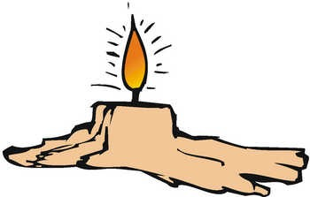
Throughout our meeting this evening, this candle, which represents the spirit of Cub Scouting, has burned. Look steadily at it for a moment. (Pause) Now close your eyes. The image remains with you. Now open your eyes. We will blow out the light. As the image of the light remained in our memory, so will the spirit of Cub Scouting stay with us. The evening of fun and good cub scouting will not soon be forgotten.
Mutiny
Baltimore Area Council
Mutiny is a word we hear connected with pirates on the waterways. It is the act of insurrection or a refusal to obey the authority of the captain of the ship. It is often the cause of a disastrous end to all involved.
As Cub Scouts, our promise to obey The Law of the Pack and to live up to the Cub Scout Promise can only lead to a better life as a good citizen of this great country of ours. Let us not be mutineers, but strong supporters of the Boy Scouts of America.
THEME RELATED STUFF
Fun Facts about Sound Waves
Alice, Golden Empire Council
- Aristotle first observed sound waves in 350 BC, when he saw a vibrating string as striking the air, and reasoned that air was needed to conduct the sound “waves.”
- About 500BC, Pythagoras noticed that when a musician plucked a stringed instrument, the sound stopped when the vibration of the strings stopped, and that shorter strings vibrated more rapidly, make a higher pitched sound.
- Roman philosopher Boethius compared sound conducted through air to the waves caused by dropping a pebble into calm water – and even though we know today that they are different kinds of waves, this was the first time man recognized that sound moves as a wave.
- Heard of Doppler Radar on the weather report? The difference in pitch that happens when a sound moves toward or away from a stationary object was first noted by Christian Doppler in 1842.
- Sound originates at one point and travels equally in waves in all directions.
- Most of the time, your ears hear the same sound differently because your head absorbs and reflects a little bit of the sound as the sound wave hits your body.
- If two waves of sound with the same shape meet each other traveling in opposite directions, they will cancel each other out. This is the principle used in “White sound” and headphones used in industrial areas to reduce the noise level.
- Almost 30 million Americans have hearing loss.
- Loud music and noises are affecting many young people – more than five million kids aged six to nineteen have hearing loss directly related to noise exposure
- Over the last 10 years, the percentage of 2nd graders with hearing loss has increased 2.8 times; hearing loss in 8th graders has increased over 4 times!
Fun Facts About Currents, Tides & Waves
Alice, Golden Empire Council
- The highest tides in the world are at the Bay of Fundy, which separates New Brunswick from Nova Scotia. At some times of the year the difference between high and low tide is taller than a three-story building.
- The Kuroshio Current, off the shores of Japan, is the largest current. It can travel between 40-121 km/day at 1.6-4.8 kph, and extends some 1,006 m deep.
- The Gulf Stream is a well known current of warm water in the Atlantic Ocean. It moves 100 times as much water each day as all the rivers on earth, and flows 300 times faster than the Amazon River, the world’s largest river.
- The density of sea water becomes more dense as it becomes colder, right down to its freezing point of F unlike fresh water which is most dense well above its freezing point of 32 degrees.
- River and stream currents carry about 44% of the toxic contaminants that end up in the ocean.
- More than 90% of the world’s trade travels on currents, carried by ships.
- Ocean energy is renewable, and uses tides, waves, winds, currents and thermal heat and temperature differences in the water to generate the energy.
- One of the world’s most suitable tidal energy sites is the estuary of the river Rance, in western France, where the difference between high and low tides averages 8.17 metres, peaking at 13.5 metres during the equinoxes.
- Ocean tides would be a clean and inexhaustible energy source, and always constant and predictable.
- Ocean energy has been recognized in the Energy Bill of the United States.
- Ocean energy has the potential to deliver ten million terra-watt hours of electricity per year.
- The ocean can produce two types of energy: thermal energy from the sun's heat, and mechanical energy from the tides and waves.
- The speed of sound in water is 1,435 m/sec - nearly five times faster than the speed of sound in air.
- The world's first commercial wave farm using waves for energy opened in 2008 at the Aguçadora Wave Park in Portugal.
- There are currently two commercial-sized tidal energy sites operating in the world - one located in La Rance, France; the other in Annapolis Royal, Nova Scotia, Canada. There is a third experimental 400 kW tidal energy “barrage” (a kind of dam) operating in Kislaya Guba, Russia
- Energy using the difference in water temperature from solar heating on the surface compared to colder deep water temperatures is also a potential energy source. The Ocean Thermal Energy Conversion (OTEC) system must have a temperature difference of at least 77°F to operate, limiting its use to tropical regions. There is an experimental plant in Kona Hawaii, but technology needs to be developed to make it more efficient.
- Without the Gulf Stream, a warm current of water, England and other places in Europe would be much colder than they are.
Water Sayings:
Alice, Golden Empire Council

Here’s a list of some water sayings from around the world. See how many you have heard and how many you can explain.
- Even if you sit on the bottom of the sea, you cannot be a fish. (Africa)
- Have an umbrella ready before you get wet.
- A drop in the bucket
- Blood is thicker than water
- Break the ice
- Down the drain
- Finding your sea legs
- Having a ripple effect
- If a crocodile deserts the water, he will find himself on a spear (Africa)
- It’s all water under the bridge
- Like water off a duck’s back
- Make a big splash
- Somebody is all wet
- Steamed up..
- Still waters run deep
- The stone in the water knows nothing of the hill which lies parched in the sun (Africa)
- The well’s run dry
- Treading water
- Wet behind the ears
- When it rains it pours
- Watered down…

How many more can you think of?
Fun Facts About Water:
Alice, Golden Empire Council
- Water, either liquid or frozen, covers about 75% of the earth’s surface.
- About 30% of the earth’s fresh water is in groundwater and 70% is in ice (including ice caps, glaciers, permanent snow, ground ice, and permafrost)
- They don’t call it watermelon for nothing – its 97% water!
- The human body is 70% water!
- A birch tree can release about 70 gallons of water into the atmosphere each day.
- Water flowing at 10 miles an hour can move rocks 10 feet thick.
- In Northern Chile, years go by without a drop of rain.
- In parts of India, they get more than 400 inches a year of rain.
- If all the land on the earth and under the sea were leveled out, water would cover the entire earth two miles deep!
- Water has polar properties – a positive and a negative, while oil has no polar properties, which is why “Water & Oil don’t mix.”
- One third of the earth’s annual precipitation runs off into the ocean.
- It takes at least 600 gallons of water to make a hamburger – water for the cow to drink, water to grow what he eats, water to process the meat. Add to that the following things you eat with your burger:

Bag of hamburger buns – 150 gallons

Head of lettuce – 6 gallons

Tomatoes – 3 gallons

French Fries – 6 gallons

Here are some more products and the amazing amounts of water it takes to produce a serving:
Almonds: 12 gallons
Orange: 14 gallons
Milk: 65 gallons
Rice : 35 gallons
Watermelon: 100 gallons
1 Egg: 120 gallons
Loaf of bread: 150 gallons
1 Car: 39,000 gallons
Saving Water in the House:
Alice, Golden Empire Council
- Replace older toilets with high efficiency models – Check with local water utility for possible rebates.
- Toilet Devices are a less expensive alternative – They reduce the amount of water needed by filling up space in the tank.
- Showerheads - Install a water efficient showerhead that uses no more than 2.5 gallons of water per minute. (Half what a normal showerhead uses)
- Aerators - Low-flow aerators on your kitchen and bathroom faucets are easy to install and reduce water use and splashing . Your water company may provide them free!
- Clothes washers – Newer models typically use about 30% less water and between 40 to 70% less energy – and rebates may be available!
Water Waste Prevention:
Alice, Golden Empire Council
- Fix running toilets - A "running" toilet can waste two gallons of water per minute. A silent leak in a toilet can waste up to 7,000 gallons of water per month. To find silent leaks, put food coloring in the tank. Do not flush. Check the toilet bowl ten minutes later. If you see color in the bowl, the tank has a silent leak. Also, teach every member of your family where to shut off water at the toilet when making repairs or in case of a clog. Let your scout help fix the leak for credit in advancement or electives. Ask a home store or hardware store for instruction.
- Fix leaking faucets - a slow steady drip (100 drops per minute) - wastes 350 gallons per month. A small stream wastes 2,000 to 2,700 gallons of water per month. Replacing worn washers in your faucets will usually stop leaks.
- Look for hidden leaks. Turn off all running water in the house.. Don't use any water for 30 minutes, then read the water meter. If it shows water used, you have a hidden leak that needs repair.
- Save the water when running a faucet to get hot or cold temperature - put a gallon jug under the faucet. You can then use this water for other things around the house.
- Insulate hot water pipes and your water heater where possible to minimize water waste while waiting for hot water.
- While brushing your teeth, turn off the tap. Use a cup for water; run the tap only to rinse the toothbrush.
- When showering and washing hands, wet your body. Turn off the water, apply soap, and then turn on the water to rinse.
- When washing dishes by hand, instead of running water to rinse dishes, fill the kitchen sink and dip dishes in water to rinse. Automatic dishwashers are more efficient than hand washing dishes, but wash only full loads.
- Fill the sink or a bowl with water to wash fruits and vegetables.
- Keep a container of water in the refrigerator rather than running tap water for a cool drink.
- Operate the disposal only when necessary. Consider composting food waste in your garden.
Saving Water in the Yard
Alice, Golden Empire Council
- Water less frequently but more deeply. Think of your soil as a reservoir that holds water for your plants.
- Adjust your water controller according to the seasons.
- Reduce runoff caused by long water application times. Three five-minute applications with an hour in between will allow the soil to absorb more of the applied water that one 15-minute application, and prevent runoff.
- Exchange your irrigation controller for a Water-Smart Irrigation Controller. You may be eligible for a rebate from your local water district!
- Routinely check your irrigation system for leaks, broken or misdirected heads.
- Choose drip irrigation. Drip irrigation systems apply water at gallons per hour instead of minutes!
- Select plants that are adapted to your climate. Plants native to your area will need no water once established. Check with a local nursery or master gardener..
- Group plants according to their high, medium, or low water needs.
- Apply mulch to your garden – use at least 3 inches to maintain moisture, suppress weeds, protect the irrigation system and give a finished look to the garden. Never apply mulch right up against the main stem or trunk of a plant.
TIGERS
Circle Ten Council
Safety in the Sun/ Fun in the Water
There are some really good ideas here for Family Water Safety. Don’t skip this section just because you don’t have a Tiger!! CD
Family Activity
Remember to SLIP, SLOP, SLAP and WRAP!
SLIP on a shirt. SLOP on sunscreen. SLAP on a hat. WRAP on sunglasses
As a family where ever you choose to go for water fun. Discuss the rules for each of those locations. From - www.redcross.org
BEACH SAFETY
Protect your skin: Sunlight contains two kinds of UV rays -- UVA increases the risk of skin cancer, skin aging, and other skin diseases. UVB causes sunburn and can lead to skin cancer. Limit the amount of direct sunlight you receive between 10:00 a.m. and 4:00 p.m. and wear a sunscreen with a sun protection factor containing a high rating such as 15.
Drink plenty of water regularly and often even if you do not feel thirsty. Your body needs water to keep cool. Avoid drinks with alcohol or caffeine in them. They can make you feel good briefly but make the heat's effects on your body worse. This is especially true with beer, which dehydrates the body.
Watch for signs of heat stroke: Heat stroke is life threatening. The victim's temperature control system, which produces sweating to cool the body, stops working. The body temperature can rise so high that brain damage and death may result if the body is not cooled quickly. Signals include hot, red, and dry skin; changes in consciousness, rapid, weak pulse, and rapid, shallow breathing. Call 9-1-1 or your local EMS number. Move the person to a cooler place. Quickly cool the body by wrapping wet sheets around the body and fan it. If you have ice packs or cold packs, place them on each of the victim's wrists and ankles, in the armpits and on the neck to cool the large blood vessels. Watch for signals of breathing problems and make sure the airway is clear. Keep the person lying down.
Wear eye protection: Sunglasses are like sunscreen for your eyes and protect against damage that can occur from UV rays. Be sure to wear sunglasses with labels that indicate that they absorb at least 90 percent of UV sunlight.
Wear foot protection: Many times, people's feet can get burned from the sand or cut from glass in the sand.
HOME POOLS
Learn to swim. The best thing anyone can do to stay safe in and around the water is to learn to swim--this includes adults and children. The American Red Cross has swimming courses for people of any age and swimming ability. To enroll in a course to learn or improve your ability to swim, contact your local Red Cross chapter.
Never leave a child unobserved around water. Your eyes must be on the child at all times. Adult supervision is recommended.
Install a phone by the pool or keep a cordless phone nearby so that you can call 9-1-1 in an emergency.
Learn Red Cross CPR and insist that babysitters, grandparents, and others who care for your child know CPR.
Post CPR instructions and 9-1-1 or your local emergency number in the pool area.
Enclose the pool completely with a self-locking, self-closing fence with vertical bars. Openings in the fence should be no more than four inches wide. If the house is part of the barrier, the doors leading from the house to the pool should remain locked and be protected with an alarm that produces sounds when the door is unexpectedly opened.
Never leave furniture near the fence that would enable a child to climb over the fence.
Always keep basic lifesaving equipment by the pool and know how to use it. Pole, rope, and personal flotation devices (PFDs) are recommended.
Keep toys away from the pool when it is not in use. Toys can attract young children into the pool.
Pool covers should always be completely removed prior to pool use.
To learn more about home pool safety, you can purchase the video. It Only Takes a Minute from your local Red Cross chapter.
If a child is missing, check the pool first. Go to the edge of the pool and scan the entire pool, bottom, and surface, as well as the surrounding pool area.
SAFETY IN, ON AND AROUND THE WATER
Maintain constant supervision. Watch children around any water environment (pool, stream, lake, tub, toilet, and bucket of water), no matter what skills your child has acquired and no matter how shallow the water.
Don't rely on substitutes. The use of flotation devices and inflatable toys cannot replace parental supervision. Such devices could suddenly shift position, lose air, or slip out from underneath, leaving the child in a dangerous situation.
Enroll children in a water safety course or Learn to Swim program. Your decision to provide your child with an early aquatic experience is a gift that will have infinite rewards. These courses encourage safe practices. You can also purchase a Community Water Safety manual at your local Red Cross.
Parents should take a CPR course. Knowing these skills can be important around the water and you will expand your capabilities in providing care for your child. You can contact your local Red Cross to enroll in a CPR for Infants and Child course.
LAKES AND RIVERS
Learn to swim. The best thing anyone can do to stay safe in and around the water is to learn to swim--this includes adults and children. The American Red Cross has swimming courses for people of any age and swimming ability. To enroll in swim course, contact your local Red Cross chapter.
Select a supervised area. A trained lifeguard who can help in an emergency is the best safety factor. Even good swimmers can have an unexpected medical emergency in the water. Never swim alone.
Select an area that is clean and well maintained. A clean bathhouse, clean restrooms, and a litter-free environment show the management’s concern for your health and safety.
Select an area that has good water quality and safe natural conditions. Murky water, hidden underwater objects, unexpected drop-offs, and aquatic plant life are hazards. Water pollution can cause health problems for swimmers. Strong tides, big waves, and currents can turn an event that began as fun into a tragedy.
Make sure the water is deep enough before entering headfirst. Too many swimmers are seriously injured every year by entering headfirst into water that is too shallow. A feet first entry is much safer than diving.
Be sure rafts and docks are in good condition. A well-run open-water facility maintains its rafts and docks in good condition, with no loose boards or exposed nails. Never swim under a raft or dock. Always look before jumping off a dock or raft to be sure no one is in the way.
Avoid drainage ditches and arroyos. Drainage ditches and arroyos for water run-off are not good places for swimming or playing in the water. After heavy rains, they can quickly change into raging rivers that can easily take a human life. Even the strongest swimmers are no match for the power of the water. Fast water and debris in the current make ditches and arroyos very dangerous.
OCEAN SAFETY
Learn to swim. The best thing anyone can do to stay safe in and around the water is to learn to swim--this includes adults and children. The American Red Cross has swimming courses for people of any age and swimming ability. Contact your local Red Cross chapter for information on courses.
Stay within the designated swimming area, ideally within the visibility of a lifeguard.
Never swim alone.
Check the surf conditions before you enter the water. Check to see if a warning flag is up or check with a lifeguard for water conditions, beach conditions, or any potential hazards.
Stay away from piers, pilings, and diving platforms when in the water.
Keep a lookout for aquatic life. Water plants and animals may be dangerous. Avoid patches of plants. Leave animals alone.
Make sure you always have enough energy to swim back to shore.
Don’t try to swim against a current if caught in one. Swim gradually out of the current, by swimming across it.
WATER PARKS
Learn to swim. The best thing anyone can do to stay safe in and around the water is to learn to swim--this includes adults and children. The American Red Cross has swimming courses for people of any age and swimming ability. To enroll in a swim course, contact your local Red Cross chapter.
Be sure the area is well supervised by lifeguards before you or others in your group enter the water.
Read all posted signs. Follow the rules and directions given by lifeguards. Ask questions if you are not sure about a correct procedure.
When you go from one attraction to another, note that the water depth may be different and that the attraction should be used in a different way.
Before you start down a water slide, get in the correct position -- face up and feet first.
Some facilities provide life jackets at no charge. If you cannot swim, wear a Coast Guard-approved life jacket. Check others in your group as well.
Den Activity
BUCKET BRIGADE RELAY - Play outdoors. Divide den into two teams. Give each team two pails, one filled with water and one empty. Place the empty bucket some distance from each team. On signal, the first player in each team carries the full pail to the empty one and pours the water into it, and then returns to the next person in line with the full pail. The next boy repeats the same actions, and so on until all have carried the water. This is not a speed contest. The winning team is the one that has the most water in one pail when all the members have finished.
GO FISH - Trace six to ten fish on construction paper and cut out. Attach a paper clip to the top of each fish. Draw eyes, mouth, and fins with a marker. Tie a magnet to a 15-foot length of string. Tie the other end of the string to a stick. Place the fish in a box. (An old fish tank is even more fun.) To make the game harder, put the fish in a metal coffee can (the magnet sticks to the sides and the fish drop off). See how many fish you can catch by having the magnet catch on the fish paper clips. Whoever catches the most fish in a given time limit wins.
EEL RACE - Choose teams of four. Everyone gets down on hands and knees and the teams line up behind their leader. The second member grasps the leader by his ankles, and the player behind him grabs hold of his ankles, etc. When the starting signal is given the eel's race across the room, turn around and return to the starting point without breaking the hand and ankle hold.
STEAL THE TURTLE - Play in Waist deep water. Divide boys into two equal teams that line up facing each other 20 feet apart. Each team member is given a number. A leader tosses a large rubber ball in the middle of the play area and calls out a number. The opposing players with that number race for the ball. The player who gets it and returns to his place without being tagged by the opposing player scores one point. When both boys are back at their places, the leader calls out another number. For a real scramble, call all numbers at once.
IN THE SEA - Arrange partners around in a circle. Have the leader, call out "in the sea" when this is done all players are to jump into the circle. When he calls "on the beach" all player then jump back out of the circle. Anyone making a mistake is out of the game. The last player is the winner.
GRAB THE FISH TAIL - Boys and their partners line up in a single file, holding each other around the waist. The first boy is the fish's head; the last person is the tail. When all are ready the leader says, "Go." The head tries to catch the tail. The tail tries to avoid being caught. The boys must keep hold on each other. The longer you can make this fish, the more fun you will have!
Go See It
Go to a water park Go to a pool
Visit a Lake Visit a fish farm
PACK AND DEN ACTIVITIES
PACK & DEN ACTIVITIES
Alice, Golden Empire Council
Make some waves for your August Summertime Pack activity – have a pack swimming party and barbeque. Make sure to keep a record of who attends – turn in your pack info so your pack and boys can earn the Summertime Activity Award!
Take advantage of some heavenly waves –watch the Perseids Meteor Shower - It peaks this year on August 12th. For more info, go t o: www.stardate.org/nightsky/meteors/
Annoyed by “waves” of mosquitos ? what is annoying for your Scouts can kill in Africa – check out the “Nothing But Nets” service project to provide low-cost mosquito netting and save lives. Go to: www.nothingbutnets.net/partners-people/boy-scouts-of-america.html
Teach water safety – learn all about the need for children to wear a life vest anytime they are near natural bodies of water – check to see if there is a free or low-cost rental of life vests in your area (In Sacramento, which is surrounded by rivers, the Metro Fire Dept. offers free loan of life vests in all sizes for a day, a weekend or even longer)
Head out to the water – river, lake or ocean – but remember Safe Swim Defense and follow the Buddy System!
Build some boats and have a Raingutter Regatta – use a kit or make your own; you can even make a boat from a Styrofoam cup, a toothpick and a lump of clay!
Explore the ocean floor without getting wet – check at your library for National Geographic maps of the ocean floor. You will find mountains and valleys and deep crevasses. Boys could even make a model of a section of the ocean floor to display at the Pack meeting.
Learn all about waves, currents and tides. See some ideas in Theme Related.
Arrange to visit a local waterway, park with a lake or river or conservation area – learn all you can about how the water is used, where it comes from, how it can be protected (Check with regional park rangers for a rancher-led hike and activity)
Visit and learn about a National Park with water – right on your computer – all kinds of information, games and interactive activities. Go to: www.rps.gov/index.htm and click on “kids”
Learn all about sound waves – ideas in Theme Related and under Web Sites.
Visit a short wave radio operator - learn how the radio works, how it helps in your community, the history and uses of short wave.
Make plans now to participate in the 53rd Annual JOTA – Jamboree on the Air will be held on Oct. 16-17, 2010. For info, go to: www.scouting.org/filestore/intl/pdf/130-218.pdf
Make waves doing community service – here are some possibilities:
- Have a car wash to benefit a community project
- Collect books for a shelter
- Donate socks and toiletries for homeless
- Recycle cans and bottles as pack families – see how much you can earn for a worthwhile community charity while you keep trash out of the water!
- Send teams of parents and boys to fix leaky faucets, make repairs and clean up for the elderly in your community
- Spend a day cleaning up a river, lake or ocean beach nearby
- Clean up or landscape around your Chartered Organization location
- One council is collecting spare change (lots of people don’t want to keep pennies) – decide on your own goal
- Stencil drains to warn people that the water or whatever they dump will lead to the bay, river or ocean
- Volunteer to serve as go-fers, hand out water bottles, or help in some other way at a community event
- Put your heads together and brainstorm the best project you can think of – and do it!
Make some “constructive waves” by doing a fundraiser to help relief efforts following destructive waves – help is still needed in areas that have been hit by tsunami and storm surges.
Make “waves” as Scouts – proudly wear your uniforms and attend a community event.
Ice Cube Activities
Wendy, Chief Seattle Council
Have ice cube races. Make colorful cubes with food dye. Devise an incline using a smooth surface like a vinyl tile or garbage bag. Race the ice cubes down the incline.
Alternative: Using a squirt gun or squirt bottle, propel cubes along race track or obstacle course.
Freeze large blocks of ice in trays without dividers (Remember those?). Unmold and allow scouts to sprinkle salt on them. Observe the fantastic shapes produced by the uneven melting.
Create ice cube rivers. Make a sand mountain and place ice cubes on top. Watch the melted water make rivers down the side of the hills.
Create ice cube pictures on the hot sidewalk. Look at the design made by the melted cube on the walk.
Ice Cube Painting. Make ice cubes in an ice cube tray. When halfway frozen, stick a Popsicle stick in. When ice is completely frozen, you are ready to begin. Sprinkle some powdered paint on a piece of paper. Use different colors. Give each scout an ice cube with stick and let him rub or drag it on the paper. Ask them what is happening to the powdered paint. What has happened to the ice cube?
Make a Styrofoam Boat
Alice, Golden Empire Council
Version #1 – Still cheap, but requires more stuff.
- Cut a Styrofoam block to the same length as your pencil or dowel. You can also use several layers of meat trays. The block should no more than about a third as high as it is long, and no more than half as wide as it is long.
- Stick a pencil or dowel down into the middle of the piece of Styrofoam for a mast. It should go at least halfway down into the Styrofoam.
- Cut a piece of paper into a triangle. One short side should be about three-quarters of the length of the mast. The other short side should equal about half the length of the Styrofoam boat.
- Hold the triangle against the mast so the long side faces away from the mast. Tape the triangle to the mast by the upright short side.
- You can adjust the sail by turning the mast. This version will last through several sailings if you’re careful about turning the mast. If the hole gets too big, fill in with a wedge of folded paper or some hot glue.
Version #2 - Alice's favorite version – even simpler!
- Take a Styrofoam cup and cut out two shapes - the sail should be cut out of the curve and the base of your boat can be cut out of the same cup.
- You will need a toothpick for the mast - push the mast through your sail – it will go easily into the curved part. Then stick the mast down into the boat shape and attach it either with a big dab of hot glue and a penny on the very bottom, or by sticking a glob of clay to the bottom to hold the mast in place. (You will also need the weight to stabilize your boat)
- This is a quick, cheap, and fun version. But you can also decorate it using sharpies or stickers. And the best part is, if your boat sinks, it’s easy to make another. You might even have a contest and try having the boys experiment with different models and designs!
Sound Wave Experiments
Alice, Golden Empire Council
Sound is energy that travels in waves – invisible waves. There is always some kind of vibration, which travels through the air, water or some other “medium” to create what we hear as sound. When we don’t see a vibration, but hear a sound, it’s because when sound arrives in the ear canal, it vibrates the eardrum. The vibration that makes the sound of a voice comes from the vibration of our vocal chords. If you could magically make sound waves visible, they would look a lot like a slinky being pulled back and forth!
Here are some fun ways to learn about the energy of sound waves and how they travel.
- Drum with paper clips on the top. (This can be made with wrapping paper over a coffee can if you don’t have a real drum) Tap on the drum and see what happens to the paper clips.
Tap on the drum. What do you see? What do you hear?
- Touch side of your throat and say ahh. What do you feel as you say ahh? What do you hear?
- Steel yardstick or ruler on edge of a table. Hold one end of the ruler firmly against the top of the table. Snap the other end. What do you see? What do you hear?
- Rubber band strung between two nails. Pluck the rubber band. What do you see? What do you hear?
- Strike a fork with another utensil and bring it close to the ear. What do you hear? What do you see?
- Tuning fork in water. Gently strike the tuning fork on the pad and then place it in the water. Describe what you observe. What do you see? What do you hear?
Sound Waves – Make your own Vuvuzela
Alice, Golden Empire Council
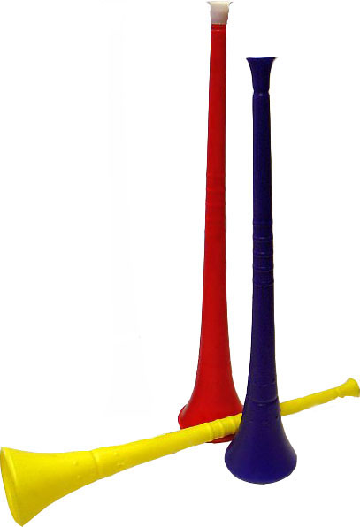
If you have been watching the World Cup of Soccer from South Africa, you have heard the sound of the traditional Vuvuzela – a horn that many find totally annoying! But your science teacher could probably show you have to make your own! Make sure there is adult supervision! Here’s how to do it:
Materials:
9-11” latex balloons (like the ones from the Party store or Dollar store used with helium) – and clear ones are more fun!
Some 1/4” hex nuts – one for each balloon
Directions:
Squeeze a hex nut through the mouth of your balloon, but make sure it’s all the way in – you don’t want to suck it out and choke on it!
Blow up your balloon, then tie it off.
Grip your balloon at the stem end, like a bowling ball – the neck of the balloon will be in your palm and your fingers and thumb will be going down the sides of the balloon.
Hold the balloon, palm down, and swirl it in a circle – at first, the hex nut may bounce around, but it will soon begin to roll around in the balloon.
Once your hex nut begins to spin, use your other hand to stabilize the balloon – you don’t need to continue swirling the balloon – the hex nut will keep spinning for a while on its own!

AND….making a wonderful, annoying buzzing, screaming sound that most parents will hate! It’s your very own Vuvuzela!
What happens when you change the size of the balloon or the size of the hex nut? Try using a marble instead of a hex nut. Does the marble make the balloon "scream?" Experiment with other objects whose edges may vibrate against the balloon.
Now, this isn’t just a way to annoy parents –
Every science teacher knows about “The Screaming Balloon” but this experiment actually demonstrates the science of motion and sound. Centripetal force is what keeps the hex nut rolling in circles, and the six flat edges of the hex nut cause it to vibrate inside the balloon. It really does sound a lot like the Vuvuzela! Check out a Steve Spangler video at:
For more info go to -
www.stevespangler.com/teaching.../make-your-own-vuvuzela-sound/
Wave, Current, or Tide?
Alice, Golden Empire Council
All three “drive” the oceans to move. All three have motion and energy potential, but each one is different – here’s the scoop on what is what!
Waves
Waves are actually energy – the water is only moving in a small circle as the energy, or WAVE passes. Every wave can be measured from it’s crest, or high point to its low point or trough. Waves are affected by wind speed, location and duration. The largest waves are found in the open ocean. As they get closer to shore, most big waves have broken down in size and speed. And every wave does “fall over” when it gets too big – when the height of the wave is one/seventh the length of the wave. Then you’ll see “white caps,” a mix of foamy bubbles of air and water.
As the crest of the wave falls over, it creates an “air pocket” – really good surfers can crouch inside this “pocket” as they ride large waves to shore. But large waves can also be very dangerous – they can hurl a 135 pound boulder more than 100 feet in the air! And the waves from a winter storm can damage buildings to a great height along the shore.
Here are two fun ways to demonstrate a wave:
Experiment #1 – Bouncing Rubber Ducky
Materials: A bathtub or large tub half full of water; Something that can float on top the water - a bottle of shampoo or a rubber ducky!
Directions: After you fill the tub with water deep enough for the item to float and not touch the bottom, use your hand to make some waves. Put your hand in the water and swish it from one end to the other – you’ll see a wave in front of your hand. When the wave hits the end of the tub, it will seem to bounce back, moving back to where it started.
Make another wave, but this time, watch the rubber ducky (or whatever) instead of paying attention to the water. What happens? Does the rubber ducky move with the wave? Nope! It just stays in the area and bobs up and down.
So….It’s not water moving from one end of the tub to the other, just the energy you made when you pushed your hand through the water. Most of the water is just moving up and down like the rubber ducky! When you pushed on the water with your hand, a little bit of water moved because of the energy of that push – but the water only moved a short distance, then the energy pushed on the water in front of the first water, that water pushed water in front of it, and so on. Each bit of water only moved a little, but the ENERGY of your push was transferred from one end of the tub and back again.
Practical application: Remember this the next time you are body surfing if you live near an ocean, or when you are competing to see whose model boat can reach a finish line first! Or even better, as you bob up and down in your water ring at the beach!
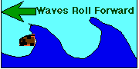
Experiment #2 – End to End
Materials: One long rope, any kind
Directions: Lay your rope out on the ground, and it’s best not to have kinks in it. Now, pick up one end of the rope and give it a good snap. You’ll see a ripple, or set of “waves” all along the length of the rope. The energy of your snapping the rope moves to the other end of the rope and forms the ripples, or waves!
Currents
A current is the motion of water. And currents are what move boats along rivers and oceans to bring products and people from place to place. The speed and direction of a current can be measured. Watch rainwater flowing down the street, or water in a stream – you are watching a current!
But we usually think of ocean currents, and they are affected by tides, winds, temperature, how dense the water is, and also by the shape of the bottom of the ocean – like underwater mountains or gullies.
Wind only affects currents on the surface of the ocean, when warm air from the tropics moves toward the cold air of the poles. In the Northern Hemisphere, winds move clockwise, and in the Southern Hemisphere, they move counter-clockwise.
Warm water currents move along the surface from the equator towards the poles, and cold water at the poles sinks and moves toward the equator. Mixing of the two temperatures causes currents, and it also helps replenish oxygen in the water. The Gulf Stream is a huge current of warm water that flows through the Gulf of Mexico and affects the water and air temperature throughout Europe.
Both water temperature and water density create currents. Water with more salt is denser, and mixes slowly with water that has no salt or less salt. You can see this at the mouth of rivers, especially large rivers like the Amazon, where fresh water flows in from the river and mixes with the saltier ocean water. These currents are slower, because the mixing takes longer.
Tides
Tides are the rise and fall of water level due to the pull of gravity from the moon and by the earth spinning. The amount of water doesn’t increase or decrease – the level just changes. As the earth turns, the moon pulls at the water directly beneath, causing the water to rise. On the opposite side of the earth, the water also rises, because the spinning of the earth causes the water to “bulge” out and get deeper.
About six hours later, the earth has turned 90 degrees as it spins, so that the pull of the moon is reduced – the ocean level falls to its lowest point, and the water is at “low tide.”
Tides are also affected by geography – where the tide is forced through a narrow mass of land, tides can be very high or low. Also, tides near the equator rise and fall less, because the water is spread out over a huge area. But closer to the poles, the water is more confined, so high tide is a bigger contrast with low tide. The largest tides in the world are at the Bay of Fundy in Nova Scotia. If you want to demonstrate how tides work, try these two experiments:
Experiment #1 – Tides
Materials: Plastic bowl larger than your ball, water, plastic ball to represent the earth
Directions:
Put the bowl on a flat surface and fill it half-way with water. Put the bowl in the water so it floats.
Now push the ball down with both hands – what happens to the water? It rises just like the tide does – this is the “high tide” that happens twice every 24 hours.
Let the ball rise again by taking your hands off the ball – what happens to the water now? This is just like “low tide” – the tide rises and falls, just like the level of your water – but there isn’t more water, just a change in level.
Your “tide” in the bucket was caused by the push of your hands on the ball – in real life, tides rise and fall because of the pull of gravity from the moon and by the earth spinning.
Is it a hot day? Feel like taking a chance on getting wet? Here’s a fun experiment to show the Tidal Bulge of the earth.
Experiment #2 – The Tidal Bulge
Materials: Small round water balloons for each person, water, string
Directions: Fill the balloons with water. Tie the balloon shut tightly with a string. Make sure your string is securely attached.
Now comes the fun! Swing the balloon around over your head – the shape of the balloon will change and become longer.
This is exactly what happens when the earth is rotating around the sun. The water is distorted by the gravity of the sun and/or moon and will bulge outward.
And if your balloon has a weak spot, or you didn’t tie the string securely, you will get WET!
Experiment #3 - The Tidal Bulge (This is a more scientific version, and more complicated – but you won’t get wet!
Materials: Plastic ball and bowl as above; strong glue; three pieces of string – one 8 inches long and two 16 inches long; hand drill
Directions:
Glue the 8in length of the string to the ball – make sure it’s completely set and dry.
Ask an adult to drill two holes in the rim of the bowl, one on either side. Thread a long string through each hole and knot around the rim.
Fill the bowl half full of water and float the ball in the middle.
Have a friend pull on the string attached to the ball – this represents the pull of the moon on the earth. The water will be higher on one side.
Now have one person hold the ball in place, while each of you pull on the two longer strings. The ball will begin to change shape, showing how the tidal bulge shows on each side of the earth.
To see how the Tidal Bulge moves around the earth, have your friend slowly turn the ball.
I am sure we have all seen some of the info on BP's well in the gulf of Mexico. Catalina Council has some great activities to help your Scouts understand what is going on down there. Who knew when they put this together 7 or 8 months ago?? CD
Oil Slick Activity
Catalina Council
- The day before, put two teaspoons of paprika into a small container of cooking oil. Wait for particles to settle on the bottom. It will be slightly tinted.
- Discuss oil spills, how they happen and the damage they can do.
- Pass out little rocks, sand and shallow pans that represent materials to make a model waterway. Describe a scenario of a large tanker leaking all its cargo. Make a waterway and put water in it.
- Pass out materials to represent:
  - Containment Booms - strings to corral the oil.
  - Skimmers - eye droppers used to vacuum off the surface of the water.
  - Chemical Dispersants - spray bottle with detergent and water to cause oil to break up and sink.
  - Absorbent Towels - paper towels used to clean rocks and shoreline.
- Make an oil spill by pouring oil into the model waterway.
- Challenge the cubs to clean as much oil as possible without destroying the environment of the waterway.
Oil Spill Cleanup Activity #1
Catalina Council
            - Discuss the damage a quart of oil can do to the area around you. Show them how small a quart is.
            - Pour water into a cup 3/4 full.
            - Then add 10 drops cooking oil on the surface.
            - Discuss the damage this could do to birds,
fish or very small organisms.
            - Examine a dry feather under a magnifying glass.
            - Dip the dry feather into plain water.
            - Dip the feather into the oil topped water.
            - Try to clean the feather with the detergent,
rinse and dry it.
            - Discuss how this is like a bird in an oil spill.
Oil Spill Cleanup Activity #2
Catalina Council
- Poke 5-6 holes in the bottom of a plastic cup.
- Pour ½ cup sand into the holey cup. This represents an underground aquifer.
- Measure ½ cup of water and pour it into the sand, catch the water as it comes through the holes.
- Measure the caught water. Explain that some water remained between particles of sand.
- Use red food coloring to represent oil. Place several drops of the red coloring onto the sand. Imagine that there is a pump or a well nearby that someone uses for drinking water. Would you want to drink it?
- Pour ½ cup of water into the cup of sand to represent rainfall. Notice the color of the drainage water.
- Pour additional ½ cups until the water is clear. How many cups did it take?
Sudsy Pollution Activity
Catalina Council
- Draw a duck on the outside of a plastic bag.
- Stuff the bag with bits of plastic wrap or wax paper and tie or staple it shut.
- Fill a large bowl or tub with water, float the “duck” on the water.
- Add some detergent to the water. What happens?
(The duck sinks.)
Discuss why the duck sank.
- Explain that the plastic wrap is water repellant just like a duck’s feathers. The oily feathers of the duck help it float. Detergent helps water stick to oil. This is, of course, helpful when washing dishes, but is deadly for the duck. Oil And Water Don’t Mix.
- People are usually shocked at the amount of damage to the environment that occurs during a large oil spill. However, they are less concerned about how their own behavior might cause oil damage to the environment.
- Used car engine oil is a major source of oil pollution entering our nation’s waterways. The accumulated amount of oil leaking daily from cars onto the world’s roads and parking lots, and the oil being improperly disposed of on the ground or down storm drains by people who change their own oil, is tremendous and much of this eventually washes into the oceans and waterways.
- Used engine oil is quite toxic. During its time in the car’s engine, it picks up heavy metals such as lead, zinc, arsenic, chromium and cadmium. These toxic metals can cause significant damage to organisms.
- Many people don’t realize that used motor oil never wears out; it simply gets dirty, and if recycled and cleaned, can go on being used forever.
- Did you know?--
  - One quart of oil dumped in the water fouls the taste of 250,000 gallons.
  - One pint can cause an oil slick one acre in size.
Here's a great series of things to do on the Oceans
that surround us!!! CD
Conserve Our Oceans
Catalina Council
Oceans cover about 70% of the Earth’s surface and they contain about 97% of the world’s water.
In addition oceans are important because:
- Oceans are fun places for recreation.
- Oceans provide a means of transportation for ships.
- Oceans contain valuable minerals and other resources.
- Oceans are home to thousands of animals.
- Oceans provide food in the form of fish and other products.
- Oceans provide fresh water through the water cycle.
Oceans At Risk
Catalina Council
For thousands of years, the oceans have served as a renewable resource. Today, the viability of our oceans are threatened due to human- caused pollution. For years, oceans have been used as giant trash cans. Waste that was disposed of in the ocean was broken down by bacteria in the water and then fish and aquatic plant life were able to use it as food.
Today, however, we are dumping more trash into the ocean than it can absorb and too much of it is non-biodegradable, (meaning bacteria can’t break it down). More harmful chemicals are being dumped into our oceans as well.
Ocean Currents
Catalina Council
- Ocean water is always on the move. It moves east to west, north to south, south to north and top to bottom.
- Tidal currents are caused by the daily rise and fall of the tides, winds and shifting warm and cold water.
- Currents in the ocean are like rivers. Water in an ocean current constantly flows in the same direction.
Ocean Current Bottle Activity
Catalina Council
- Gie each cub a plastic liter bottle (or smaller) with a tight fitting lid.
- Have them fill the bottle 3/4 full with water.
- Add drops of blue food coloring and one inch of cooking oil to the water.
- Add a tiny plastic or foil cut out of a fish in the water (optional).
- Hot glue the lid on for them.
- Tilt the bottle to and fro.
- What happens? Does it simulate an ocean current?
WATER SAFETY
Circle Ten Council
Before you take your pack or den out for any water-related activities, please read:
Safe Swim Defense
Home Swimming Safety Rules
Water Rescue
Safety Afloat
PLAY SAFE AND HAVE FUN
Circle Ten Council
Most cities offer recreation swimming at their pools with qualified lifeguards on duty. Call your city's parks and Recreation Department or community Services office for specific locations, hours and fees. Some YMCA offices open pools outside their normal facilities for more affordable fees. Call the YMCA near you for more information. Some pools require letting them know ahead of time if you are planning to bring a large group so that they can arrange to have more lifeguards on hand.
Things to Do
Alice, Golden Empire Council
- If you’re lucky enough to have a rainy day for your den meeting, take a rainy day hike – dress properly and use all your senses to really appreciate the rain!
- On a rainy day, make some quick paper boats and sail them in the gutter.
- Take a hike along a stream, or even in it, if it’s safe and you have the right footgear. Look for differences in the water color, flow, what animals and plants grow along the stream, what kind of rock, sand or soil the stream runs along. Try a silent hike to really enjoy the sound of the water – anyone who spots something interesting just stops and raises their hand so everyone can enjoy the discovery. Bring along a bag to pick up man-made trash and keep the stream beautiful.
- Try the Incredible Journey under “Theme-Related.” Have a discussion about your journey when you’re done.
- Call your local water utility for a guest speaker, or arrange a visit – they always have lots of great ideas, brochures and sometimes even posters to share!
- Do a water-related service project, such as stenciling “Do not dump-Drains to River” signs by storm drains. Contact your local water utility or go to Project WET or a local Creek Support group for great local ideas. (There are even grants available to pay for needed supplies) See website for info.
- To demonstrate how essential water is for our bodies, have each boy make a full-size outline of his body, fold it into tenths, and then color in 7 of the 10 spaces with blue to visually show that 70% of our bodies is water!
- Show the different forms water can take by filling a glass with water, (liquid) then putting it in the freezer for a few minutes – when you bring it out, a temporary fog cloud will form (gas). Finish up with a popsicle treat (solid).
- Have a “guest expert” from your pack or outside teach boys how to fish, boating and water safety, or how to make knots that are used in a marine environment.
- Invite a handyman to show the boys how to make simple repairs, find leaks, or install water saving devices. Then boys and parents can make changes in their own homes.
- Check with your local water resources department and the US Environmental Protection Agency for some great posters, brochures, charts, information and activities you can share with the families in your den and pack. (On their websites, look for a section specifically for KIDS; they may also have a section for parents or teachers)
- Using brochures from the local water department or hints created from the material under “Theme-Related,” have a den or pack share water saving hints with the pack or their neighborhood.
- Cubs or dens could set up a display to demonstrate the amount of water used and saved when leaks are fixed or out-dated equipment is replaced. (Seeing a five gallon container of water makes a strong impact, especially if paired with the cost over a month or year of a simple dripping faucet)
IDEAS FOR PACK ACTIVITIES:
Baltimore Area Council
- Visit the Baltimore Aquarium (or one near you)
- Have a water balloon battle
- Visit the Goddard Space Flight Center (or another NASA installation)
- Visit the Flag House (or see the Star Spangled Banner from Fort McHenry at the Smithsonian or the Betsy Ross House or something else historical for the Fourth of July)
- Hold a Raingutter Regatta (Check it out in this section!)
- Visit the C & O Canal (or another water based historical attraction near you. We visited an historic canal near Dayton, OH a few years ago)
IDEAS FOR DEN ACTIVITIES:
Baltimore Area Council
- Help clean up a stream
- Go Fishing
- Go for a hike in a local park (Take plastic grocery bags and leave the place looking better than you found it!)
- Make blue gelatin with gummy fish for a snack
- Hold walnut shell boat races
Water Fun Ideas
Capital Area Council, TX
A water carnival A fishing derby
A raingutter regatta A backyard beach party
A sea adventure pirate night A trip to a water theme park
A swim and picnic day at your local park
A visit to the local swimming pool
Raingutter Regatta
Baltimore Area Council
(See Cub Scout Activities Book for additional help)
Copy the picture and enlarge it for easier use CD
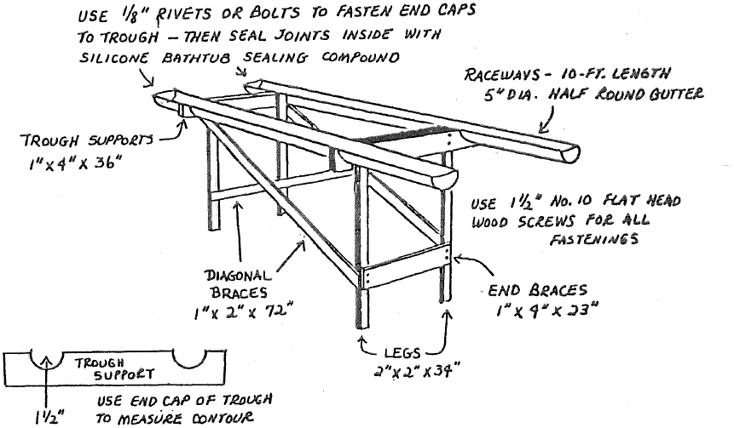
Ahoy mates! You’re watching the sailing regatta of the century! Although the waterways are only 10-foot lengths of rain trough filled with water and the ships are a mere six inches long, each race can be an exciting event. This is a very popular Pack race. Each Cub Scout makes his own boat (with a parent’s or grandparent’s help) to enter in the race.
The raceway consists of a simple frame that supports two 10-foot lengths of rain trough filled with eight gallons of water. The frame is designed so It can be assembled and disassembled quickly. The illustration shoes you what it looks like. The material sizes and fastening details follow.
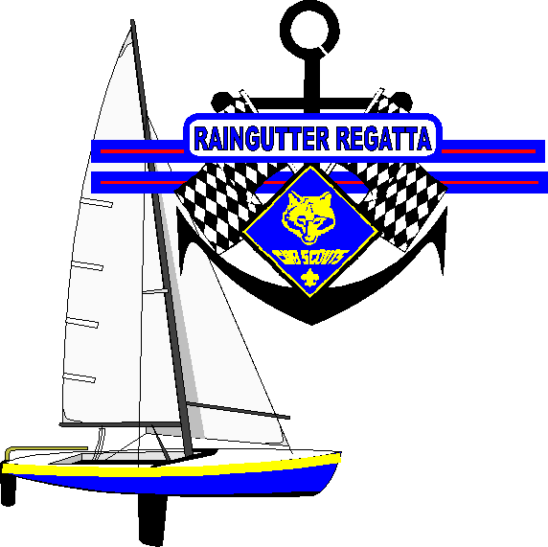
Materials Needed for Double Raceway:
- 2 - 10 ft. lengths of 5” diameter half round gutter
- 4 - End caps for gutter and rivets or bolts to attach end caps to gutter
- 2 - Trough supports 1” x 4” x 36” long boards. Cut them out so that gutter fits snuggly
- 2 - End braces - 1” x 4” x 23”
- 4 - Diagonal braces - 1” x 2” x 72”
- 4 - Legs - 2” x 2” x 34”
- 1½” #10 flat head wood screws for all fastenings (Bolts could be used to fasten the braces on the legs to allow for easier disassembly for storage.)
Fishing Derby
Baltimore Area Council
There are a lot of good games listed here as alternate activities, don’t miss them!!
Also, there are many specifics for Maryland in here, but I am sure if you check with your local state officials you will find many of the same programs wherever you live. Go to the “My Home State” Baloo for the list of state websites for kids if you don’t know where to start. CD
There are two kinds of Cub Scout Pack fishing derbies: both are fun for boys and parents.
- One is a partner-and-son fishing trip to a nearby lake or river where adults and boys can fish off the bank or in boats. Small prizes are awarded for the biggest fish, smallest fish and best string.
- The other type is a family outing with games and contests related to fishing. The ideas listed here are for this kind of derby.
We are quite lucky in the State of Maryland, that the Department of Natural Resources (DNR) and Fisheries has a program called "Hooked on Fishing not on Drugs", where the DNR will supply on a loan basis, rods and reels to Scout units, free of charge. The DNR also has other resources such as booklets on fishing for youth, the State laws on fishing in Maryland, and other literature. The Fisheries can stock ponds and streams for events if open to the public. The also have flyers, posters, and other items that can be used in your derby. The DNR police are a good source who will visit a Pack Meeting and explain fishing laws, conservation, water safety, etc.
In the Baltimore Area Council, the Bass Masters will do demonstrations on casting and fishing methods. This organization has several programs depending on the local group which the boys can win prizes and other awards. In the past, the owner of a local bait shop has supplied worms or bait for Scouting activities. The State of Maryland has several other programs which are coordinated through the DNR, one such program is "My First Fish" for anyone catching their first fish in Maryland. A form is filled out and a certificate is sent to the fisherman. A second is, “Catch and Release,” if the Cub catches and then releases a fish (alive) there is a patch and certificate available that can be obtained from the DNR.
The fishing derby committee should follow Cub Scout guidelines for planning special events. Planning includes securing a site, arranging for transportation, planning activities and obtaining prizes and arranging for food and equipment. Try special promotional gimmicks such as invitations in the shape of a fish.
Make identifying signs for each contest area. Use ropes, posts, colored streamers, and colorful signs to mark game areas. Consider using a public address system to control the activities, if necessary and a tape player to provide lively music.
Suggested Fishing Derby Schedule
1:00 - 2:00 Gathering-time activities
2:00 - 3:30 Special contests
3:30 - 3:45 Awards ceremony
3:45 - 5:00 Free time for fishing
5:00 - 6:00 Meal and clean-up
You do not need to buy a lot of expensive equipment to start with. You just need a rod and reel (or a cane pole), some line and hooks and a few weights and floats. You also need a disgorger, or "hook-out", which is a metal or plastic tool used to take a hook out of the fishes mouth without hurting the fish.
Tackle for the Job
What about bait? To catch fish, anglers (fishermen) use some sort of food, or bait, to tempt fish to bite on the hook. Bait can be real food, either alive or dead. It can also be an imitation, which is used to trick the fish. Artificial flies and lures are in this category. So is a piece of aluminum foil attached to the line.
Knots - Fishing line is quite smooth and you will need to learn how to tie special knots that do not slip when tying a hook onto the line. Always make the line wet before tightening the knot. Test the knot by pulling from both sides before you start fishing. Have a fisherman teach you knots that can be used to tie your hook onto you line and then practice them. Or find pictures that show the knots and practice them.
Games for your Fishing Derby
You may want to have some alternate activities ready to go in case the fish are not biting that day. Or younger Scouts become restless.
Guessing Contest: How many fish eggs are in the jar? Use marbles for the eggs. The winner gets the jar of marbles.
Snapping Fish Game: This game requires several fishing poles with sinkers and a piece of foam rubber attached to a 3 -by-4 foot line. Also, have several mousetraps set to spring. Object of the game is to set off a trap by hitting it with the foam rubber without getting the line caught in the trap.
Fish & Net Game: Three to five Cubs join hands to catch fish (Cubs) by surrounding individual players. Those who are caught become a part of the "net". The last five Fish caught make up the net for the next game.
Sardines: Select one Cub to be "It". He hides while the other players count to 100. Then they all search for him. When someone finds ``It" they hide with him. Continue until the last Cub locates "It". The first Cub that found "It" is the new "It" for the next game.
Fishpond Games: An infinite variety of games are possible with a "hook", a line, and a pole. Make hooks from coat hanger wire, paper clips, magnets, or even sticky gloop. Cut fish from felt, cardboard, wood, or sheet metal. The players can catch the fish by hooking them and lifting them out of the Ocean or stream. Fish can be marked with different point values or different colors can be worth different points, or even feats of skill (do a head-stand or hand-stand).
Crab Relays: Have the first Cub in each line sit on the floor with his back to the finish line. On a signal, he walks backwards on his hands and feet with his body parallel to the floor. When he reaches the finish line, he stands up and runs back and touches the next player. Who repeats the action, the first team to finish wins.
Rope Throw Rescue: Each Den has a coil of rope or clothesline and adults representing drowning persons whom must be rescued. The Cubs in turn throws the rope to a drowning person, who grabs it and let go. The player recoils the rope and hands it to the next player. Repeat until all have been rescued.
There is so much that can be done at a Pack Fishing Derby. Let your imagination run wild. Other games can be: Harpooner, where a Cub takes aim at a whale with a broomstick (harpoon). There is also the Fish Market where the Cubs throw slippery fish to their teammates who have to stack them (The fish are small nerf footballs that were soaked in baby oil). Casting competitions, mend fishing nets. A chowder race where each Den has to put an ingredient into the pot to complete the chowder. The derby can also be ended with a Crab Feast or Clam Bake.
Special Contests
Reeling Relay: Dens and families are arranged in relay fashion. The first player on each team has a fishing pole and reel. On signal, he places the fishing pole and reel on the ground in front of him, takes the plug and runs to a line 25 feet away, unwinding the line as he goes. He then runs back, sits on the ground, and reels in the line. The next member follows and so on, until all have played. First team finished wins.
Fishing Relay: The "fishpond" is a large cardboard box turned upside down, with slots cut in the bottom. In each slot, insert a "fish" cut from cardboard. On each fish mark a length and weight for it. For each team, you need a cane pole with a 3-foot string and a bent paper clip for the hook. Team members line up relay fashion, with the first member holding the pole. On signal he runs to the fishpond and catches a fish. A judge records the length and weight. The team with the greatest weight total of fish wins.
Rowing Relay - Players on each team sit or kneel in a large cardboard box and propel themselves to the goal line and back by using two short broomsticks with rubber tips.
Go fishing in the Lake: Prizes could be given for biggest fish caught, littlest fish, most fish caught, longest fish caught, etc. Inexpensive fishing tackle might be used for prizes.
The Incredible Journey
Alice, Golden Empire Council

“I did this with my den and they had a great time and wanted to continue the game” – If you ever get the chance to take the Project WET workshop, don’t hesitate – Lots of great ideas!” Alice

Materials:
- 9 large dice (could be made from 6” sq. boxes) marked with numbers 1-6;
- 9 signs to mark stations (could include appropriate pictures) with a list of where the drop goes next or why it stays at that location; chenille stems for each person;
- 9 different colors of pony beads, one for each station, enough for every person to add a bead each time;
- Bell or whistle to mark time to change stations or roll the dice again

Set Up: Make station signs, including the following possible moves for the water drop:

Soil Station:

#1 - water absorbed by plant; (plant)

#2 – Soil saturated, water runs into river; (river)

#3 – water filters into soil; (ground water)

#4-water evaporates into clouds; (clouds)

#5-water evaporates into clouds; (clouds)

#6-water stays in puddle on surface; (stay)

Plant Station:

#1, #2, #3, #4: water leaves the plant thru transpiration, evaporating (clouds)

#5 , #6: water is used by the plant (stay)

River Station:

#1-water flows into a lake (lake)

#2-water filters into soil (ground water)

#3-water flows into ocean (ocean)

#4-an animal drinks water (animal)

#5-water evaporates in heat (clouds)

#6-water stays in the river current (stay)

Clouds Station:

#1-water condenses and falls on soil (soil)

#2-water condenses into snow, falls on glacier (glacier)

#3-water condenses, falls into lake (lake)

#4-water condenses, falls into ocean (ocean)

#5-water condenses, falls into ocean (ocean)

#6-water clings to dust particle (stay)

Ocean Station:

#1, #2: water evaporates into clouds (clouds)

#3, #4, #5, #6: water remains in ocean (ocean)

Lake Station:

#1-water filters into soil (soil)

#2-an animal drinks the water (water)

#3-water flows into a river (river)

#4-water evaporates into clouds (clouds)

#5, #6: water remains in the lake (lake)

Animal Station:

#1, #2: water excreted as feces, urine (soil)

#3, #4, #5: water is evaporated from body (clouds)

#6-water incorporated into the body (stay)

Ground Water Station:

#1-water filters into a river (river)

#2, #3: water filters into a lake (lake)

#4, #5, #6: water stays underground (stay)

Glacier Station:

#1-ice melts and water filters into ground (ground water)

#2-ice evaporates into clouds (clouds)

#3-ice melts and water flows into river (river)

#4, #5, #6: ice stays frozen in glacier (stay)

Directions:
- Be sure and explain that this game allows each boy or team to be a single drop of water – using the dice and moving from station to station, the boys will learn all the different ways the water drop can travel.
- They will also learn that the drop may stay in the same form, at the same station, such as “clouds,” just as a real drop of water might do.
- Divide the group so each one starts at a different station.
- They pick up a bead and put on their pipe cleaner, then roll the dice to see what the drop of water is going to do next.
- The six numbers under each station are the six numbers on the die. The word in parentheses is the station where the drop of water (Cub Scout) goes next.
- They must wait for the whistle or bell before moving to the next station (or picking up another bead and rolling the dice again if there water drop was told to stay in the same form).
- Remind the boys that they must do whatever the number on the dice tells them to do, even if that means they stay at the same station for another turn – if that happens, they get another bead of the same color, then roll the dice again.
- Now, if you are used to boys, you will expect quite a reaction to the Animal Station, #1 and #2 – that whole “bathroom humor” thing. But just remind them that all animals, including Scouts, must have water to survive!
- Be SURE to demonstrate playing this game, starting at a station, adding a bead, rolling the dice and the various instructions the boys might have to follow – make sure everyone understands so they can have fun and learn!
- You may want to set a specific time limit of 10 minutes, or you might let the boys keep playing till everyone has had a chance to move around to most stations.
- After the game, let everyone compare their bead bracelet and talk about why there was a difference between stations – do they think their water drop moved in a way a real one might?
- Lead a discussion about why they may have stayed in a location more than one turn – do they think that would happen in real life?

Go to the Project WET website, www.projectwet.org for more great ideas!!
Giant Wind-Up Water Bug
Baltimore Area Council
Materials: Two Styrofoam meat trays, 3" long light thin rubber bands, pencils, scissors, white glue, sharpie marker, colored pencils or markers.
Instructions:
- Cut the bottoms of the meat trays out and glue them together, making sure that one of the trays has the smooth side out.
- Transfer the bug and paddle wheel patterns to the smooth side. Use carbon paper or trace to another sheet of paper, blacken the backside of the tracing with a #2 pencil or crayon and then trace over the pattern with a dull pencil.
- Cut your bug out of the Styrofoam being sure to include the notches in the legs for the rubber band.
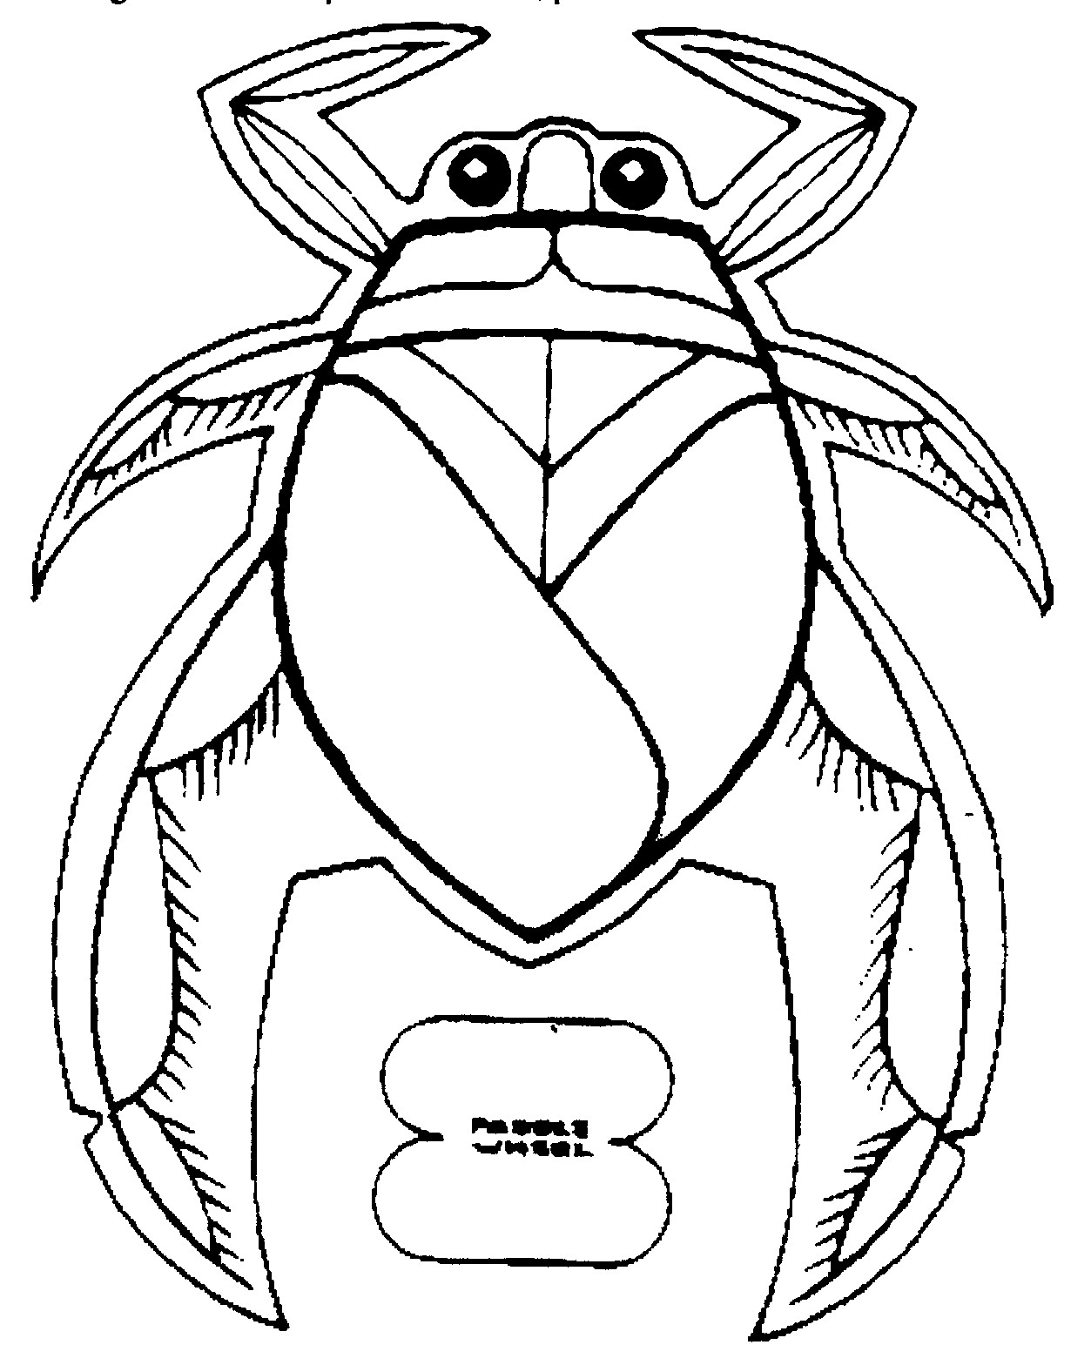
- Decorate the bug with colored markers or pencils.
- Stretch the rubber band between the legs. A thin rubber band that fits without stretching much is essential.
- Slip the paddle wheel in the middle of the rubber band loop and wind up gently. Placing the paddle wheel off center will cause the bug to travel in circles.
- A toddler's swimming pool is the ideal place to release your bugs. Try having a Den race.
4 Hats, One “River”
Alice, Golden Empire Council

Materials:
- Four sets of cards as above, including some blank ones, based on whatever body of water is most common in your area.
- Four hats to represent four different kinds of people who would use the water. The farmer could wear a straw hat, the fisherman a cloth hat with lures on it, the recreational user could wear a baseball cap, and the industrial user would wear a hard hat.

Instructions:
- Divide the group into four sections; each one chooses a spokesman, who wears their hat.
- The group gets a set of the cards, plus some blank ones they can fill in themselves.
- Each group can decide what features would be good for their use, and what would be harmful.
- After 5 minutes, each spokesman can report on what the group decided.
- To use the cards as part of competition between groups, each person chooses a card when it's their turn to wear the hat, then posts the card on the wall, and the other groups get a chance to compete to tell whether the card represents something good or bad for the group represented by the hat; they have to also tell why.
- If there isn't anyone in the other three groups that can supply an answer, the group that chose the card gets a point.
- After each boy has had a turn to wear the hat and ask for answers, tally the points to find the winner.

This could also be used as a den game.
This is how Alice did it -
When I did it as a Den Game, Each boy got a turn to wear the hat for his group, and chose a card for their river or stream or whatever. Then they told the group why it was a good thing or a bad thing for their water environment.
Another way to play would be to have each boy in the den have a turn to pick a hat to wear. Then he chooses a card and explains why it would be good or bad for the fisherman, farmer, recreational user or industrial user of water (whatever hat is wearing)
Octopus Tie Slide
Baltimore Area Council
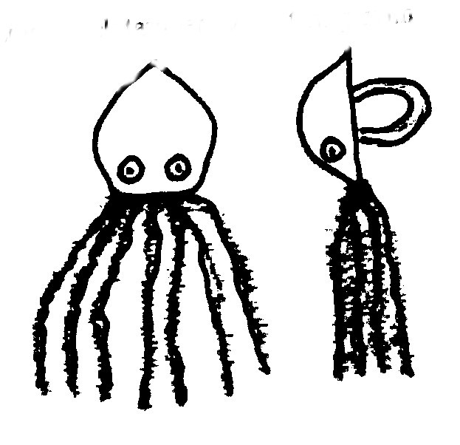
Materials: English walnut shell carefully halved; small wiggle eyes; black chenille stems, black tamper evident ring from a soda bottle; hot glue; craft glue; black acrylic paint.
Instructions:
- Paint the exterior of half a walnut shell black. Let dry.
- Consider the pointed end of the shell as the top and use craft glue to attach the eyes approximately a fourth of the way up from the bottom. Let dry.
- Cut 4 chenille stems in half. Bend each piece in half. Hang them on the soda ring. Put some hot glue into the shell. And carefully press the eight legs and ring into the glue, extending them from the rounded end.
- When the glue is dry, fill the rest of the shell with hot glue.
Balloon Powered Boat
Longhorn Council
You will need: 1/2 gallon milk carton (need 1/2 for each boat); A drinking straw that bends; Heavy-duty tape; A long balloon; Scissors; A nail.
- Cut one side from the carton to make the boat.
- Trim the straw so the part that bends is exactly in the middle. The straight parts should be about 2 inches each.
- Tape one end of the straw inside the balloon. Secure the tape tightly but don’t collapse the straw.
- Using the nail, poke a hole in the bottom of the carton (the stern of the boat).
- Insert the balloon straw “ari jet” through the hole in the stern. Pull the straw through and bend it at a ninety-degree angle.
- Blow up the balloon. Then hold the end of the straw with a finger. Launch the balloon boat in the water.
Bubble Fun
Capital Area Council, TX
Blow a soap bubble and watch it float in the air. Blow gently to keep it aloft without popping it. Have a contest to see who can keep a bubble in the air longest, or how far you can blow your bubble before it bursts.
Basic Bubble Solution
1 cup Joy or Dawn
3-4 Tablespoons glycerin (optional, available at drugstore)
10 cups clean cold water (up to 50% more on dry days)
Directions
- In a clean pail, mix the ingredients well.
- Do not stir too much, you don't want froth on the top.
- Leave it overnight if you have time.
- You don't have to have glycerin but it makes the bubbles last longer and you get larger without breaking.
Giant Bubble Wand
- Thread the string through both of the straws and knot the ends.
- Lay the straws and string down in the BUBBLE SOLUTION.
- Gently lift up the straws, one in each hand.
- Spread the straws apart as you lift, and a giant bubble will form.
- Wave your arms across in the air, and it will be set free, to float up, up, and away!
Assorted Wands
- Twist thin wire (from hangers?? CD) into fun shapes.
- Use beads for handles for smaller wands.
Tub Time Toy
A tub-time toy that doesn’t need batteries.
It does move on its own.
Longhorn Council
You will need: Waxed cardboard (e.g. milk or ice-cream cartons, butter boxes); Scissors; Pencil; Ruler; Waterproof tape (duct tape or strong packing tape); Bar of Ivory soap.
- If you are using cardboard from food container, wash out the carton well.
- Cut a 2" by 3" rectangle out of one side of your carton. Find the center of a short side of the rectangle, and then use a ruler to mark a straight line from this center point to the corners at the opposite end. Fold up along these lines.
- Tape up the end of the boat with the waterproof tape.
- Cut a very small wedge from the soap. Then cut a hole in the back of your boat, making it smaller than the wedge.
- Put the boat in a half-full sink, bathtub or other quiet water. Place the soap wedge into the hole in the boat so that the point of the wedge is toughing the water. The rest of the wedge sits on top of the boat. Now watch your boat move forward.
No Care Aquarium
Longhorn Council
You will need: Two 9" paper plates; Small amount of sand or aquarium gravel; Two shades of green construction paper; 8" square of clear sandwich wrap; Glue; Scissors.
- Cut center out of one plate and glue clear sandwich wrap on inside.
- Cut a circle of green construction paper and glue it inside the other plate.
- Spread a light coat of glue over a 1” strip at the bottom of the green circle. Sprinkle sand over the glue. Let dry and shake off excess sand. Optionally, you may want to use aquarium gravel (you will need more glue for gravel).
- Draw several fish or cut out some pictures of fish from a magazine. Glue them above the sand on the green circle. Use lighter shade of green for seaweed. A few wavy lines made with a dark green marker will make the water look as though it’s moving.
- Staple the plates together or sew them together with colored yarn.
- Now you can see the aquarium picture through the clear sandwich wrap.
VARIATION: In place of clear wrap, use clear blue cello wrap (used to wrap fruit baskets and the like, available at a craft store). You will not have to use the construction paper circle.
Beach Ball Neckerchief Slide
Santa Clara County Council
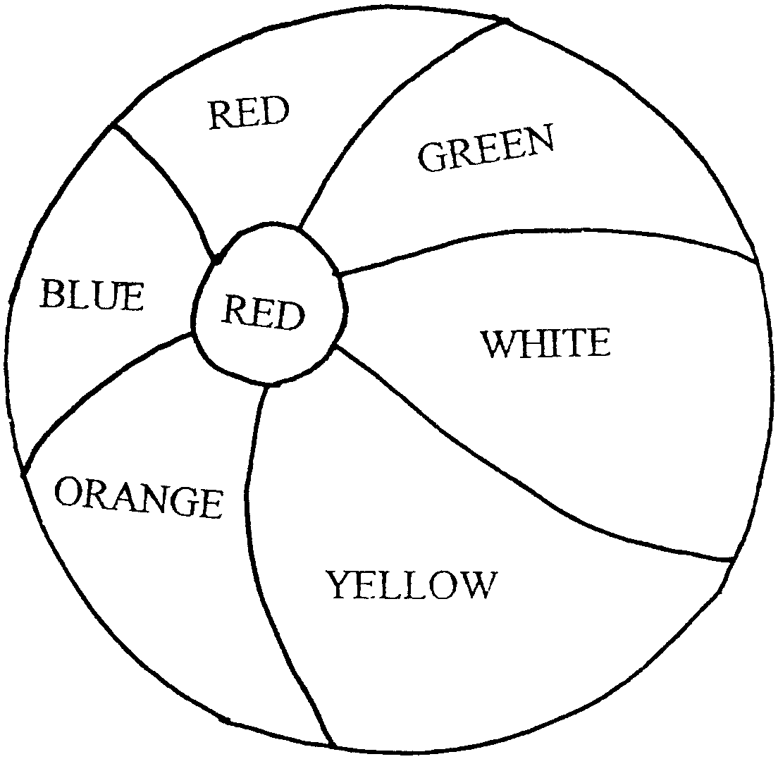
You will need:
One half-ball-shaped wood piece 1 1/2" diameter* (available at a craft store);
Acrylic paint or permanent markers;
1/2" section of 1/2" PVC pipe;
Thick craft glue or low temp glue gun.
*If you cannot find half-ball shapes, cut a wooden ball in half. Be careful, it is small and craft wood shapes are usually hardwood. Adult should do this.
- Paint the wood piece like a beach ball.
- Let it dry.
- Glue the PVC pipe section onto the flat side of the 'beach ball'.
Rope Neckerchief Slide
Santa Clara County Council
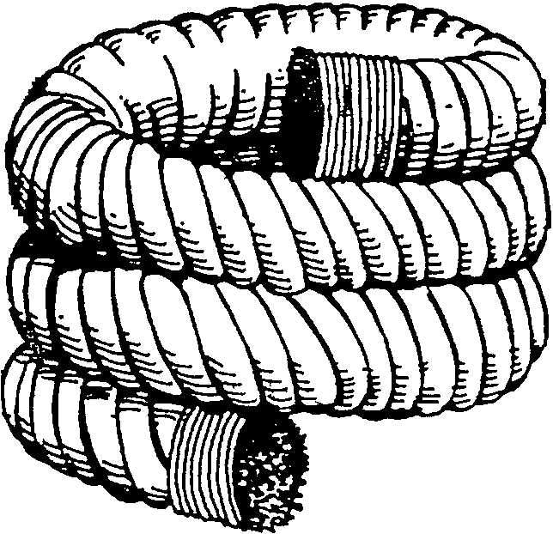
You will need a piece of rope about 8-inches long and a whipping cord.
Whip both ends of the rope (Bear Achievement 22).
Lay a bead of low temp glue along the rope and coil the rope in a circle. It may be easier if you wrap the rope around a 1/2" dowel, being careful not to glue the rope to the dowel.
Buoy Key Ring
Longhorn Council
You will need a large enough piece of cork and twist ties
It floats, so it’s a good gift for anglers and boaters.
- Drill a hole through the middle of a cork.
- Insert a large plastic coated twist tie through the hole in the cork.
- Thread the key onto one end and securely twist the ties together.
- Test for buoyancy in a sink filled with water. If it sinks, try a larger cork or add another one.
Footprints in the Sand
Santa Clara County Council
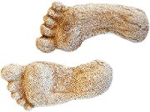
Capture that barefoot-on-the-beach feeling -- and a record of your feet -- with this simple plaster-casting project.
Supplies: Plaster of Paris, small bucket, freshwater, 4-inch lengths of string (optional)
Directions:
Choose a site to cast your molds -- the moist, hard-packed sand near the water's edge works best.
Firmly press both feet into the sand. The prints should be about 1/2 inch to 2 inches deep. (If your child can't press down that hard, he can use his finger to dig down into the print, following its shape.)
Mix up the plaster, according to the directions on the package, so that it has a thick, creamy consistency. Pour the wet plaster gently into the footprints.
To make hangers, tie a knot about a half-inch in from each end of the pieces of string. As the plaster begins to harden, push the knotted ends into the plaster and let dry.
After 20 to 25 minutes, gently dig the footprints out of the molds and brush away any excess sand. Set sole-side up in the sun for about an hour to let harden.
Jet Boat I
Santa Clara County Council
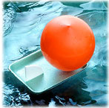
Kids will love being the captain of this balloon-powered jet boat - perfect for racing in pools, ponds and bathtubs.
Supplies: Plastic pipe elbow, 1/2 inch in diameter, and its accompanying plastic nut (ask at your local hardware store); Two 5 1/2 x 8-inch Styrofoam food trays; Balloon; Rubber band
Directions:
Thread the nut on the plastic pipe elbow. Then cut a hole in the bottom of one of the trays and push through the elbow's non-threaded end.
Stretch the balloon over the threaded end. Next, secure the elbow underneath the tray with the rubber band, wrapping it around several times.
Cut a rudder from the other tray, and insert it through a slit cut in the stern of the boat.
Tips: To operate the vessel, inflate the balloon by blowing into the elbow. Block the end of the pipe with your finger as you set the boat in the water, then release it and watch the boat zip away.
Yacht Tie Slide
Baltimore Area Council
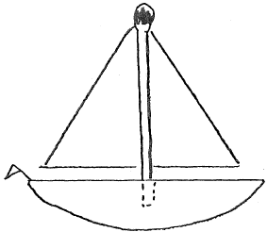
- The hull is whittled from white pine or balsa. The mast is a burned match. The boom is a toothpick. The sail is a triangle of white or red fabric.
- Whittle and sand hull, It is flat on back and curved on front,.
- Drill 3 holes, one in top for match mast, 2 in back for plastic or metal ring cut in half.
- Glue mast in place. Glue boom to lower edge of sail.
- Glue sail and boom mast and let glue dry,
- Glue ring in place, While it is drying, make small flag for stern from construction paper triangle (tiny) glued to straight pin,.
Build a Boat
Baltimore Area Council
Materials: Wood shingle, lollipop stick, colored paper, rubber bands, glue
Directions:
- Cut Cardboard template
- Trace on to Shingle
- Cut out boat outline
- Make Paddle

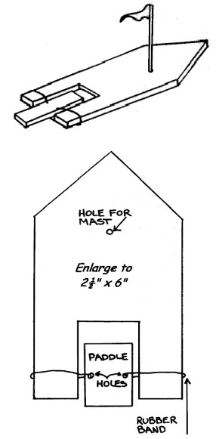
- Drill holes for the Rubber Bands
- Drill Hole for Mast
- Mount Mast
- Cut out flag, attach to stick, & Glue
- Wind Paddle Up
- NOW... LAUNCH YOUR BOAT!
Leather and Button Puzzle
Baltimore Area Council
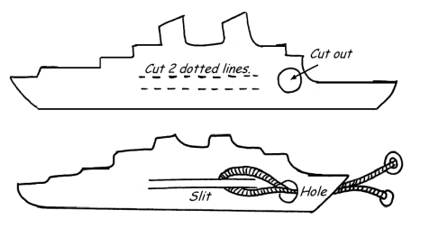
Trick: Remove string and button without untying buttons.
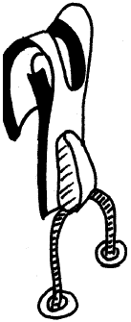
Trace the ship pattern on vinyl. Make 2 parallel cuts as per diagram) in center of strip of vinyl. At end cut hole, slightly larger then the width between the slits. Pass heavy string under slits, through the hole, and fasten buttons to loose ends of string. Buttons need to be too large to fit through the hole
To solve the puzzle, fold the vinyl, pulling the slit away from the body of the vinyl. Fold the slit material in half and pass it through the hole with the string pinched at the end of the folded slit. Once the slit and string are through the hole, the button on the end of the string can be pulled through the loop of vinyl and removed. Reassemble by reversing the process.
Jet Boat II
Baltimore Area Council
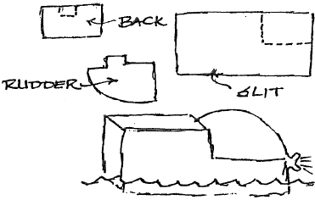
Materials:
Quart milk carton Tape
Scissors Balloon
Cut carton on dotted lines as shown and remove cut section. Make slit near front bottom for rudder, made from cut out section, and notch in rear as shown. Tape rudder in place. Place blown up balloon in boat and watch it go!
Submarine
Baltimore Area Council
Materials:
2 Plastic bottles Scissors
Adhesive tape 12” Piece of plastic tubing
24” Piece of plastic tubing Clay
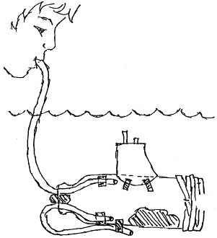
Directions:
- Remove cap from bottle.
- Cut around bottle 2” from bottom.
- Push both pieces of tubing into the bottle through the neck and secure as shown.
- Bend the short piece around and tape it to the outside of the bottle.
- To make it float properly add a large wad of clay inside bottle as shown. Be careful not to plug tubes.
- Use a second piece of clay to make the top air-tight.
- Replace bottom of bottle and tape tightly.
- Use second bottle to make conning tower, tape in place.
- Place sub in water.
- Blow into long tube to make it rise and suck air out to make it sink.
Wave Maker
Circle Ten Council
Fill a clean, empty, clear plastic soda bottle half full of water. Add some blue and/or green food coloring, twist on the lid and shake it to mix the coloring well. Now add vegetable oil nearly to the top (leave about 1” air space). Swirl the bottle while it is standing up or lay it on its side to watch the waves. Try creating large bubbles by turning the bottle over and over a few times. Really shake it up to create millions of tiny bubbles.
Sand Paperweight
Circle Ten Council
Mix some small shells and colored aquarium gravel into some sand. Pour this mix into a clean baby food jar. Spray paint the lid and screw it on tight. Set jar upside down on the lid for a paperweight.
Fish Tank Neckerchief Slide
Baltimore Area Council
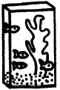
Materials needed: Empty Tic Tac container, construction paper, glue, scissors, colored fish tank beads or plastic gravel or craft melting beads, PVC pipe ring.
Directions:
- Carefully remove lid from Tic Tac container.
- Inside glue blue construction paper to the back.
- Spread glue on the bottom of the container and put in the colored fish tank beads or plastic gravel or craft melting beads as a colorful base.
- Use construction paper to make small fish and underwater plants.
- Glue the plants and some of the fish to the inside of the box. Put them on both the front and back of the box to give the tank a dimensional look.
- Glue PVC pipe ring to the back.
Huck Finn’s Log Raft
Baltimore Area Council
Materials:
11 twigs of equal thickness liquid white glue
1 sheet of white paper colored crayons or markers
wax paper.
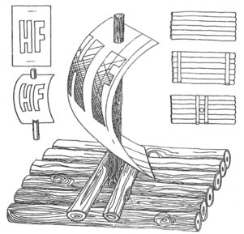
Directions:
- Cut twigs a little longer than logs shown In illustration,
- Place six twigs on sheet of wax paper.
- Clue the twigs together with glue to form raft.
- Cut two twigs to fit the width of the six glued twigs.
- Glue these two twigs near the ends of the raft.
- Let the raft dry overnight. When dry turn upside down.
- Cut a twig to form the mast and glue it standing up to the center of the raft.
- Cut a twig to form the last two twigs to fit the width of the raft.
- Clue the remaining two twigs to both sides of the mast.
- Dry overnight.
- Cut the sail from white paper, decorate. Push sail through standing twig.
- Have a Den race with the boats in your Raingutter Regatta track.
Make a Paper Boat (and tell a story!)
Baltimore Area Council
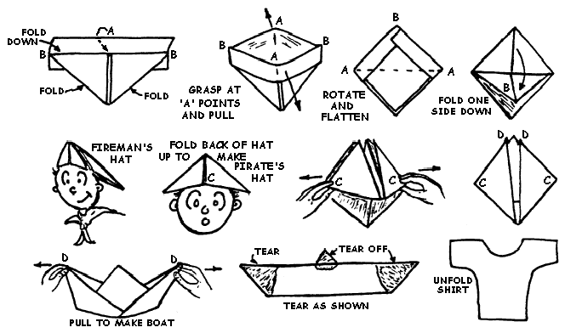
Folding Instructions: Take a full sheet of newspaper, folded on the center crease with the folded edge away from you. Take the two upper corners and fold them so that they meet at exact center. Fold the remaining flaps up, one on each side. Fold and tuck in the remaining points. Continue refolding following the illustrations outlined below to make two hats, then the boat.
After completing the boat, you can tell a funny story as you tear the boat apart (as shown in the last two steps).
“It was a dark and stormy night, and a ship was being tossed around off shore. The ship hit a rock, and the bow was ripped off (tear off one end of the boat as shown). Then it was whipped around, and the stern was demolished (tear off the other end of the boat). To make things worse, a bolt of lightening came and knocked off the mast (tear the top point off the boat). The boat then sank, and all that was ever found (here’s where you unfold the remains of the paper boat) was the Captain’s shirt.”
Practice the story and tearing off the pieces several times by yourself before you try to tell it in front of an audience!
Gone Fishing
Catalina Council
Materials:
2 Sheets of craft foam
Pen
Cardboard
Scissors
Metal paperclips
Ruler or stick about 12" long
String or Plastic lanyard (Rex lace)
Magnet, rectangular or horseshoe shaped (need to be able to tie string to it)
Instructions:
- Draw up a simple fish outline on a piece of cardboard. Then cut it out.
- Trace around the fish on the craft foam.
- Cut the fish out.
- Draw faces on the fish.
- Open a paper clip end slightly. Poke it through the fish's mouth. Pull the fish all the way around the paperclip until it "drops" into the open area. Close the paperclip.
- Repeat for the rest of the fish.
- Tie a string on one end of the ruler or stick. (Note: Works great with a ruler that has a hole in the end!)
- On the other end of the string, tie the magnet on.
- Now go fishing!
Shingle Sailboat
Catalina Council
Materials:
Wood shingles
Sticks
Wax paper
Instructions:
- Cut hulls from wood shingles.
- Use sticks for mast and waxed paper for sails.
Bubble Stuff:
Catalina Council
Materials:
Soda straws
String
Instructions:
- Thread the string through 2 straws.
- Hold 1 straw in each hand and dip the whole thing in your formula.
- Lift it out slowly.
- If you have a friend to help, you can make this loop 5 or 6 feet long.
- Hold it out tight.
- Lift it in the wind.
Bubble Fun - Solution
Catalina Council
There are many recipes for bubble solutions on the web. Most require glycerin. The solution that I like best uses corn syrup instead.
Materials:
2 parts Joy dish washing soap
3/4 part corn syrup
6 parts water
Dishpan or other large flat pan
Instructions:
- Stir together the water, Joy dishwashing liquid (this brand works the best) and 3/4 part corn syrup.
- Store in a covered container.
Fish Tie Slide
Catalina Council
Materials:
PVC pipe
Plastic fishing lure
Fishing line
Instructions:
- Tie plastic fishing lure to the ring as if it is “caught” in fishing line.
- The fish still wiggles as you move while wearing it.
Water Bottle Holder
Catalina Council
Hydrate in style with the help of this hands-free bottle holder that fits most any 16- to 20-ounce bottle. The less-is-more design is easy to duplicate and features a rubber O-ring that costs under a dollar at a hardware store.
Materials:
- Clear Nail Polish
- Feet of cotton or polypropylene belt webbing (available at fabric stores) for the strap. Note: smaller kids may want shorter straps
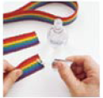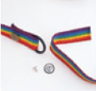
- 1 rubber O-ring from the hardware store plumbing department (ours was 1 1/8 by 7/8 by 1/8 inches). Take a bottle to the store to test the fit before you buy.
- No-sew dungaree buttons
(available at fabric stores)
Instructions:
  - To prevent fraying, brush clear nail polish (supervise younger kids) onto both ends of the webbing and allow it to dry.
  - Feed 2 to 3 inches of the webbing through the O-ring and secure with a dungaree button. (Push the tack through the webbing, place the button on the point, and press firmly together.)
  - Repeat for the other end of the webbing. Be careful not to twist it before you attach the second button. Decorate the strap if you like. Slip the O-ring over the neck of the water bottle.
Foam Sailboat
Catalina Council
Materials:
Styrofoam trays
Drinking straw
Glue
Construction paper
Instructions:
- Cut two copies of hull from foam tray. Make hole in center of one copy, insert and glue the drinking straw mast. Glue that copy to the second one.
- Cut sail from construction paper, make holes for mast, and slip over mast.
MORE GAMES AND ACTIVITIES
Sam Houston Area Council
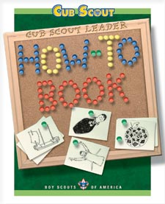
From the Cub Scout Leader How-To Book –
- -Water Games – pages 3-42 to 3-47
- -Fun with Water and Aquatic Life – pages 4-14 to 4-16
- -How to hold a Water Carnival – pages 6-14 to 6-15
- -How to hold a Raingutter Regatta – pages 6-32 to 6-33
- -How to hold a Fishing Derby – pages 6-37 to 6-38

Want to check something in the "How To Book," and your copy is not available?? Want to copy something quick to use at a meeting?? You can find the "How To Book" at this address on National's Web Site -
http://www.scouting.org/filestore/hispanic/english/33832_WEB.pdf
ADVANCEMENT IDEAS
From Program Helps via
www.cubroundtable.com
Tigers –
Ach:
Elect. 35, 40
Bobcat - 1 (partial), 5
Wolf-
Ach 1g, 2b
Elect. 5f, 20b
Home - Ach 7, Elective 19, 23
Bear –
Ach 15b
Elect. 15e, 19d
Home - Ach 12a, Elective 1a, 16d
Wendy, Chief Seattle Council

Tiger Cub Achievements
Ach. #2F – Look at a map of your community with an adult. Locate creeks, lakes, water resources.

Tiger Cub Electives
Elec. #6 – With your partner, learn a song about water and teach it to your family or den.
Elec. #7 – Make a xylophone with glasses that have different water levels. Play xylophone with a spoon.
Elec. #14 - Together with your adult partner, read a short story or a magazine article (look for one about water resources, water safety or water usage).
Elec. #15 – Mix secondary colors using water colors, or drops of food coloring in glasses of water.
Elec. #16 – Shell collection.
Elec. #17 – Make a model of a boat.
Elec. #25 – Snacks: Ocean bottom crackers.
Elec. #29 –Get ready for days in the sun by using sun block to stay safe.
Elec. #31 – Learn about an animal that lives in the water.
Elec. #34 – With your adult partner, think of a way to conserve water and do it for one week.
Elec. #35 – Play an outdoor game involving water.
Elec. #40 - Together with an adult partner, go swimming or take part in an activity on water;
Elec. #41 - Visit a boat dock

Wolf Achievements
Ach. #1h -- Swim as far as you can walk in fifteen steps.
Ach. #3a – Make a chart and keep track of your health habits, including drinking lots of water, for 2 weeks.
Ach. #6b, c – Shell collection.
Ach. #7e – Choose three articles about how people are protecting our water resources.

Wolf Electives
Elec. #4f – Play a wide area game involving water.
Elec. #5f – Make a boat with a rubber band propeller.
Elec. #5g, h, i – Make or put together some kind of boat.
Elec. #6b – Choose a book about water or water sports.
Elec. #7b – Make a pair of puddle jumpers and have fun with water.
Elec. #11d – Learn words for 3 songs about water.
Elec. #11f – Sing a song about water with your den.
Elec. #12c – Mix secondary colors using water colors, or drops of food coloring in glasses of water.
Elec #12f – Make a poster about water usage;
Elec. #15c – Use water to grow something.
Elec. #18d,e – help lay out an obstacle course or Adventure Trail with some water related activities included.
Elec. #18f – Take part in 2 Summer activities with your den.
Elec. #19 – Fishing (Do all as part of the World Conservation Award).
Elec. #20b – Learn safe boating rules.

Bear Achievements
Ach. #3d – Visit a place of historical interest in your area, especially if there is a water resource included.
Ach. #4c – Choose two folklore stories that have something to do with water.
Ach. #5a – Make a poster about an animal that lives in the water.
Ach. #6d – Find out the ways water is used in your home and with an adult find and repair water-wasting areas in your home.
Ach. #11b – Tell what to do in case of a water accident.
Ach. #15c – Select a game about water or that uses water.
Ach. #17b – Play charades pantomiming water uses.
Ach. #18 g – If you write about an activity on or near the water or where you visited an area near water or water resources.
Ach. #21b,d – Make a model of a river or lake.
Ach. #21f – Build a boat.
Ach. #22b – Learn how to make knots that are used in working near water, and how they are used.
Ach. #23 – Do any of these involving water sports.

Bear Electives
Elec. #2c, d, e – Make a rain gauge and learn about clouds.
Elec. #5 – Boats.
Elec. #7d – With an adult, make a water wheel.
Elec. #8a,b,c -- Make a xylophone with glasses that have different water levels. Play xylophone with a spoon.
Elec. #9a,c – visit a favorite outdoor location near water and
paint or draw it; show artwork at pack night.
Elec. #12d – Make a water scope and identify 5 kinds of water life.
Elec. #12g – Shell collection.
Elec. #15 – Soil & Water Conservation. Do all as part of World Conservation Award.
Elec. #17c, e – Repairs: do and discuss how the chore will help conserve water.
Elec. #19 -- Swimming.
Elec. #22b – Shell collection.
Elec. #23e – Choose a water location or point out water features along the route.
Alice, Golden Empire Council
If the den or pack are having a Raingutter Regatta or planning a boat activity, boys can build a boat to participate. Fishing and Swimming are obvious possibilities for Belt Loops and Pins. You could also learn about Sound Waves and how sound waves are carried around the world. A pack or den could explore Making Waves by giving service in your community. Boys or dens can share science experiments with the pack.
Tiger Achievements:
Ach. #1G – Visit a museum or historical location in your area – look for ways that sound came into family homes – are they different than how you hear sounds in your modern home? (check out the picture in your Tiger book)
Ach. #2F - Use a map of your community and locate places where you might have “waves of fun” or hear sound waves, or where you might be able to “make waves” by doing service
Ach. #3G – go see a sports competition in the “waves” – like a swim competition
Ach. #4G – If you visit a television or radio studio, you can learn about how sound waves go out over the air – or ask about how a television picture is transmitted to your home.
Tiger Electives
Elect. #6 – Demonstrate sound waves by teaching a song to your family or den and singing it together.
Elect. #7 – Play along with a musical instrument – see some ideas about sound waves under Theme Related
Elect. #10 or #11 – “Make waves” in your community by serving others
Elect. #17 – Make a model boat if you are having a Raingutter Regatta, or help make a model of the ocean floor
Elect. #25 – Make a snack to share – try one of the Cub Grub ideas, or the Ocean Bottom crackers on pg.108 of your book
Elect. #29 – Remember to be safe in the sun!
Elect. #35 – Play a game outdoors with your family or den
Elect. #40 – Fun in the Water
Wolf Achievements:
Ach. #1h, i – Using a basic stroke, swim 25 feet; Treat water for 15 seconds or as long as you can.
Ach. #7- “Make waves” by doing service in your community while doing the requirements.
Ach. #8e – if your family, den or pack have an outdoor meal, help to plan and prepare it.
Wolf Electives:
Elect. #2c – make sound effects for a den skit – or demonstrate sounds at the pack meeting
Elect. #5f – make a model boat with a rubber band propeller Elect. #5g,h,i – put together a model boat for fun or for a raingutter regatta
Elect. #6b – choose a book about waves – sound or water
Elect. #18 – Take part in two summertime pack events with your den
Elect. #19 – Fishing – do all the requirements and you’re on the way to the World Conservation patch!
Elect. #20b – Know boating safety rules
Elect. #22e – Invite a boy to join Cub Scouting or help a new boy do the Bobcat Trail
Elect. #23 – If your family or pack goes camping, work on any or all of the requirements
Bear Achievements:
Ach. #6 – Make “waves” by doing any or all of the requirements as a service to your community
Ach. #9b – With an adult, make snacks for a den meeting – try one from Cub Grub or your book; Ach. #9g – with an adult, cook something outdoors
Ach. #10a – go on a day trip with your family – to enjoy some waves at the beach, or to visit a science museum and learn more about sound waves
Ach. #11b – Tell what to do in a water accident
Ach. #12 – do any or all of the requirements to enjoy the outdoors with your family
Ach. #21a, b, d, f – Build a model from a kit (Raingutter Regatta boat); Build a display for your model; Make a model of a mountain (under ocean) or a river; Make a model of a boat
Ach. #23d, e – watch a water sport on TV or attend a water sporting event with family or den
Ach. #24a – Help a boy join Cub Scouts or complete the Bobcat Trail
Bear Electives:
Elect. #3 – Build a crystal or diode radio, or make and operate a battery powered radio – learn about how the sound waves are transmitted from your radio
Elect. #5 – Boats – do any or all of the requirements
Elect. #7c – With an adult’s help, make a waterwheel; display at pack meeting to show how water in motion can make energy
Elect. #8a,c – demonstrate sound waves by making and play a homemade musical instrument
Elect. #15e – As a den, visit a lake, stream or ocean. Plan and do a project to clean up this source of water; name 4 kinds of water pollution
Elect. #19 – do any or all of the Swimming requirements – you must have an adult with you who can swim.
Elect. #20 – Earn a new Sports pin – try Fishing or Swimming
Elect. #25 – Camping – do any or all of the requirements
Webelos Activity Pins:
Naturalist & Forester (assigned)
Aquanaut - do the requirements during the warm summer weather
Athlete #9 – swim a quarter mile in pool or lake and decrease your time over a 30 day period
Scientist #5, #7 – Show the effects of atmospheric or water pressure – check out the experiments under Theme Related
GAMES
Sponge Ball Wars
Wendy, Chief Seattle Council
Fill two five gallon buckets with water. Place sponges – the number of sponges is up to the pack – in each bucket. Divide the boys and adults into two teams. Mark a dividing line between the teams. Put one bucket of sponges on each side of the line about five to six feet back. When you yell “Sponge Wars!” the teams begin throwing the wet sponges across the line onto the other teams territory.
Rules:
- You can only throw one sponge at a time.
- The object is to get as many sponges as possible on the other team's side.
- You may pick up sponges that have been thrown on your side and throw them back as long as you only throw one at a time.
- At the end of one minute the leader yells peace and all sponge throwing stops.
- The team who has the fewest sponges on their side wins.
Kid Classic: Spray-bottle Capture the Flag
Wendy, Chief Seattle Council
Teams must defend water balloon "flags," while trying to stomp the opposition's!!
What you need:
Two water filled balloons
One spray bottle per player
4 players (or more) divided into two teams
How to Play:
- Divide everyone into two teams.
- Each team must defend a flag (a water balloon) while trying to capture (and stomp on) the opposing team's.
- Instead of tagging opposing players to "freeze" them, you squirt them with a spray bottle.
- To release teammates from a freeze, you have to squirt them again.
The Great Foot Freeze
Wendy, Chief Seattle Council
Here's a silly group icebreaker that will cool players off in a hurry.
What you need:
Wading Pool
Water
Ice Cubes
Plastic Bowls
How to Play:
- Fill up the pool and dump in several trays, or a bag, of ice cubes.
- Players then sit around the edge of the wading pool with their feet poised over the water.
- At the word "Go," players race to move the cubes out of the water and into their bowls within a designated time period. The catch is, they can only use their feet.
- The winner by a foot, of course, is the person who has the most ice cubes in his bowl when the time is up.
- Alternatively, players can collect marbles with their feet, instead of ice cubes.
Squirt
Catalina Council
This is an indoor water game. Players sit in a large circle; "it" stands in the middle of the circle with a squirt bottle of water. "It" chooses a category and writes one choice from that category on a piece of paper (not seen by the other players). "It" goes around the circle, pointing the squirt bottle at each player, who in turn makes a guess from the chosen category. The person who guesses the right one gets a squirt in the face and becomes the new "it".
Sample categories: Kinds of soup, colors, kinds of pie, kinds of cars, sports teams, boys' names, girls' names, states in the U.S., countries in the world, vegetables, fruits, T.V. shows, sports celebrities, kinds of ice cream, etc.
Balloon Toss
Catalina Council
Have everyone stand around a sheet and hold onto the edge. A bunch of water balloons in the center of the sheet are repeatedly tossed up and then caught in the sheet. Object is to see how long you can keep them bouncing before they all break or fall on the ground.
Balloon Bust Relay
Catalina Council
Divide group into an appropriate number of relay teams. A member of each team runs to a chair, puts a water balloon on it, and sits on the balloon until it breaks. Then he runs back to his team and the next one in line goes.
Throw And Catch
Catalina Council
Divide the group into pairs with each set having a water balloon. Start throwing and catching close together.
Move a step back each time. The winners are the partners that made it the farthest apart before their balloon broke.
Over And Under Relay
Catalina Council
The first person in line passes a water balloon over his head to the second person who passes it through his legs, etc.
This pattern keeps repeating until the balloon reaches the last person in line.
The last person in line brings the balloon to the front and starts over.
Fireman's Game
Catalina Council
String a 1-gallon milk jug between trees.
Cub Scouts use garden hoses to try to move jug to opponent's trees.
Squirt Relay
Catalina Council
Use 2 garden hoses or 2 water guns.
The first player in each line squirts a balloon (or light ball) to a line several feet away and then brings the equipment back to the next player.
Water Jug Relay
Catalina Council
Equipment:
2 - 6-oz or 12-oz bottles;
2 - 1-gallon plastic jugs;
2 - large water buckets filled with water;
2 - small funnels;
2 - paper, plastic or tin cups.
Directions
- Form two parallel teams.
- In front of each team about 25 or 30 feet away is the full water bucket, funnel and cup.
- First boy on each team is handed an empty bottle. On the word "go" he runs down to the water bucket, puts the funnel in the bottle and proceeds to fill his bottle with cups of water.
- When bottle is filled, boy runs back and pours water from bottle into plastic jug, gives the empty bottle to next boy in line.
- This continues in the same manner until one of the teams has filled their jug.
Hop Relay
Catalina Council
- Each team starts with a full cup of water.
- Each player in turn hops to the end and runs back holding the cup of water.
- The winner is the team with the most water left in the cup.
Whale on the Beach
Baltimore Area Council
Object: To get your whale across the finish line alive.
Materials: Teams of 4 to 8 boys, one adult "whale" for each team, a blanket or tarp for each team, a spray bottle for each team, water, markers for start and finish lines
How to play: Explain that in order to keep their whale alive, the boys must be gentle and quick. They must place the whale on the blanket or tarp, leaving its hands and ankles over the edges. wetting those areas with the spray bottle to keep the whale moist. When moving the whale they must keep it only 4 to 6 inches off the ground, (in order to reduce injury if dropped). Remind them that the faster they go, the more apt they are to injure the whale.
When the signal is given, the whales should become limp, not helping the boys move him. It is up to the individual whale to decide if it survived based upon the boys actions.
Drowning River
Baltimore Area Council
Object: To be the player that stays out of the stream.
Materials: 2 sticks to mark the banks of the stream
How to play: Position the sticks about a foot apart. These become the banks of the "Drowning River." Players agree beforehand whether or not to allow running jumps. Each player then takes a turn leaping over "the stream." Eliminate players who do not successfully make the jump and fall into the stream.
After all the players jump, move the sticks farther apart to widen the banks. Again, any players who fail in their jumps are out. Continue to widen the banks after each round of jumps - the winning player stays out of the stream.
CRAB RACE
Circle Ten Council
This activity requires a hula-hoop for each group of four boys. Have each group of four climb inside a hula-hoop, back to back. The teams must then race to a finish line. The boys must keep their hands outside the hula-hoop while they race, holding it up only with their bodies.
SPONGE RELAY RACE
Circle Ten Council
You'll need 2 sponges, 2 buckets, 2 bowls and water. Have boys line up in two teams and the boys at the front of each row hold a bucket of water with the sponges in it and the boys at the end of each row hold a bowl. The first boy takes a wet sponge out of the bucket and hand it to the next boy and so on till it reaches the last boy in his row who squeezes the water out of the sponge and into bowl. He then races it back to the front and puts it back into the bucket starts over again. Play continues until the water is gone or a certain time is up. The team, who has the most water in the bowl at the end, wins the game.
Blub, Blub, Blub
Baltimore Area Council
Materials: Cub Scouts. Leader
How to play: Cub Scouts sit in a circle or semi-circle. The leader walks in front of the players and suddenly points at one of them and says, "blub. blub, blub." The person pointed to must say, "blub," before the leader has finished the third "blub." If he fails, a point is counted against him. If the leader points but doesn't say anything, the Cub Scout must not say anything either. If he does say, "blub," a point is counted against him. The boy with the fewest points against him at the end of the allotted time is the winner.
Maybe you could play this with a boy doing the pointing, then after a set period of time, the boy with the fewest points becomes the next pointer. CD
Fish Gobbler
Santa Clara County Council
This is a fun game for active children. You will need a big area where all the children can spread out. When the caller (known as the Fish Gobbler) shouts, “Ship,” all the children run towards the wall to which he points. On the shout “Shore,” they quickly change directions and run toward the opposite wall. On the signal “Fish Gobbler,” the kids quickly drop to the floor on their stomachs and like arms, legs, or bodies together with one or more friends. The Fish Gobbler moves around the room with arms outstretched like a big bird swimming toward the other players not touching them. The children are all “safe” as long as they are all physically linked together. Once the Fish Gobbler sees that everyone is linked to someone else, the signal “Rescue” is called. At this moment all the children jump to their feet, joining hands, and yell “Yah,” raising their joined hands over their heads. The game ends when the children are ready to move on to another game. Other calls could be added, such as “Sardines” (everyone runs to a central point to make the tightest group possible by either lying on the floor or forming a giant standing hug); “Fishermen All” (everyone sits on someone else’s knee or knees).
This game can be adopted for playing in a swimming pool. Instead of running to the wall, they can swim to the wall, and join hands and legs while trying to float on the water.
Beachless Beach Party
Longhorn Council
You may want to combine this with a Raingutter Regatta and/or family picnic.
PREPARATION:
You should have two or more beaches, depending on the size of your group. For the pack meeting, each den can have a beach--part of the decorations can be done at the den meetings. If this beach party is for the den only, each family can have a beach, or combine families. Name the beaches like Palm Beach, Santa Cruz Beach, Waikiki Beach, etc.
Have each den decorate its beach – they should use their imaginations. They could choose a theme for their beach, such as palm leaves for Palm Beach. Arrange some chairs, umbrellas. If the meeting is held outside, add benches and picnic tables.
At your planning meeting have dens and leaders and whoever wants) pick games to run on the day of the event. Some ideas for games for your Beachless Beach Party are -
Swimming Race: One player from each beach. Each player should have before him a deep pie pan filled to the brim with water, with four or five Lifesavers at the bottom. He must get these candy pieces out with his mouth. His hands must be behind him.
High Dive: One player from each beach. Each is provided with a pitcher of water. On the floor at their feet is an empty tumbler. The player has to stand and try to fill the tumbler. The player who gets the most water into the tumbler wins. In case of a tie, time is taken into consideration.
A Clam Dig: This is a team game. A box of sand will be necessary. Hide 10 small clam (or other) shells or peanuts in the sand for each team. Give each team a spoon and a bowl. Give a signal to go, first player runs across the room to the sand pile, digs out one clam (or peanut), puts it in his team’s bowl, and returns. Next player does the same. Keep going until all ten are found.
Sailboat Race: Stretch as many strings across the room as you have teams. On each string, place a paper cone. Each player is a to blow his boat from one end of the string to the other end. He then pushes the cone back with his hand to the starting point for the next player. The game proceeds in a relay fashion.
Snorkel Race: You will need a pair of old swimming flippers for each team. If you can’t find them, use pairs of large size shoes and limit the race to children. Set a turning point at a short distance for each team. Run the course in a relay fashion.
Backyard Water Frolic: Have a den backyard water day. Include parents and siblings. Make sure children bring swimsuits or changes of clothes, and towels. Set up one area in the backyard for a water war, one for sprinklers and hoses, and one for a water slide. For the water war, you’ll need squirt guns, basters, squirt bottles, plastic pails, and sponges. Set up the hose and sprinkler in another area. If possible, poke holes in an old garden hose so there’s lots of spray to run through. Make a slippery water slide by cutting several large plastic garbage bags open to form long rectangles and taping them together with waterproof tape. Place the “slide” on the lawn, preferably on a gentle incline. Set a hose at one end to create a rush of water. Let the kids start off with a water war. Divide them into teams. At the signal “Go!” they can squirt the water guns, throw the sponges, or even haul around the pails full of water to get their opponents soaking wet. Include parents--Children will love soaking adults. (Of course you soak them too.) Caution children to avoid squirting in the face. Let the kids give the water slide a try. To prevent long lines at the slide, divide the kids into teams and have one team play in the sprinkler and the other on the slide. Switch after a time. For a snack, serve watermelon. Can they guess how many seeds are in it? Have a watermelon seed spitting contest--see who can spit the furthest or most accurately. By the end of snack, kids will be sticky--they can run through the sprinkler again.
Fishing Game
Longhorn Council
This is probably too simple to be called a craft, but the game is fun. Make a lot of fish and have your fishing derby.
You will need:
Fishing Pole: Tie yarn or string to a dowel or stick.
Bend a paper clip for a fishing hook.
To make Fish, it’s better to use stiff paper.
Fold paper in half.
Draw a fish.
Cut a hole close to the head end of the fish.
Play game –
Scatter fish on the floor
Go fishing.
Who Are You?
Alice, Golden Empire Council
Here are some more riddles to add to the game on page 10 Jul 08 of Program Helps:
- I have dense, oily fur and build a home of sticks with an underwater entrance.
- I can travel without water 10 times longer than a human can.
- I have spongy skin and accordion-like stems to hold great volumes of water, and spines to protect it.
- I have six wax-coated feet and can be found on still water.
- I wear a matted feather coat to keep out wind and water, and use my wings for flippers.
- I live in water, and create a limestone house out of materials I filter from the water – when my limestone doors close, I can stay out of water for many hours.
- My leaves have a wax-like coating to limit water loss, and my buds have a chemical and protective layer to keep them from freezing.
- I must swim constantly to stay in one place, and I take oxygen from the water with gills.

Answers:

Beaver,

Camel,

Cactus,

Pond Skater or Water Strider,

Penguin,

Barnacles,

Pine tree,

Trout
Over the River Game:
Alice, Golden Empire Council

Materials: A hose with a water source

Directions: One person holds the stream of water very low to the ground and everyone lines up and skips over it. Then the stream gets higher, little by little, as everyone skips over it. When a person touches the stream of water, they are out. Last person wins.
Colors
Longhorn Council
Determine the boundaries. Begin at one end, where the player who is “It” stands. The safe zone is at the other end. “It” stands facing away from the water, on the shore. The other players stand in the water or tread water in a line close to “It.” Each of the players in the water thinks of a color and whispers it to a neighbor who is on the honor system and keeps it secret. Don’t let “It” hear the color. “It” starts by calling out colors: “Red, blue, turquoise...” Those in the water listen for their colors, and when they hear theirs, they have to swim quickly out to the safe zone. As soon as “It” hears someone move in the water, he turns around, jumps in and tries to catch the fleeing player or players. If a player is caught before reaching the safe zone, that player becomes “It.” Instead of colors, try cars, baseball teams, animals, etc.
T-Shirt Relay
Longhorn Council
Divide the group into two teams. Have a large T-shirt for each team. Each team member must put on the shirt before swimming his lap in a relay race. It doesn’t matter if the shirt is on inside out.
Gold Rush
Longhorn Council
Scatter pennies or iron washers painted gold in water between knee and waist depth. On signal, players try to get as many “gold nuggets” as they can within a specified time.
Touch
Longhorn Council
Divide group into two equal teams and line them up in parallel lines about 6' apart. The leader calls out the name of an object that is the same distance from both teams--a ball, diving board, edge of the pool, etc. In a relay fashion, all players swim or run to touch the object and return to their places. First team back gets one point.
Frogs In The Sea
Longhorn Council
This is a good game that can be played at a den meeting or in shallow water. Players form a circle around one or more players who sit with their feet crossed. The players in the circle skip (if on land) or walk (if in water) close to the frogs and try to tap them on the head as they repeat the words, “Frog in the sea can’t catch me.” The frogs try to tag the players without rising or uncrossing their feet. If a player is tagged, he changes places with the frog that tagged him.
Statues On The Wall
Longhorn Council
This is a fun backyard game. Have the Scouts stand against a brick wall (the side of a house or building). Spray water from a water hose on them and all around them. When they move away from the wall, it will have the outlines of their bodies on it. Stand back and try to guess what the shapes look like. Make up a story to go along with the shapes.
“Fifty Yard” Swim
Longhorn Council
Each boy hops on one foot carrying a paper cup of water. First one over the finish line with the most water in his cup wins. Use a distance that fits your Den.
Bailing Out The Ship
Longhorn Council
Divide den into two teams. Each team has a container of water at the starting line, one spoon, and an empty cup. The cup has a line marked about 1" from the bottom. Place it about 20 feet away. Each player takes turns carrying a spoonful of water from the team’s container to its cup. The first team that can fill their cup to the line is the winner.
Water Balloon Bounce
Longhorn Council
You will need a tarp, sheet or blanket for each team, or teams can take turns. Players hold the tarp at the edges. 3 water balloons are placed in the center of the tarp. By quickly snapping the edges of the tarp outward the balloons are tossed into the air. A point is scored each time the balloons are successfully tossed and re-caught. Balloons must go up at least 8 feet in order to score a point. The game ends when a balloon breaks or is dropped. The team that makes the greatest number of successful tosses is the winner.
Quarter Drop
Longhorn Council
Have the Scouts form 2 teams. For each team, place a gallon jar 2 to 3 feet in front of the line. Fill each jar with water and place a smaller glass jar in the bottom of the gallon jar. Have each boy try to toss a quarter or iron washer into the jar and into the smaller jar. The team with the most quarters in the smaller jar wins.
Sink The Boat
Longhorn Council
Provide a bucket filled with water and float a small pie plate on it. Have boys stand back about 5 feet and give them 5 small balls made of aluminum foil. (Foil is easy to retrieve because it floats.) Boys take turns throwing 5 balls. Give points for each ball that lands in the pie plate and stays there when thrown from the starting line.
Submarine Dive
Longhorn Council
Draw ahead of time a number of 18" circles with sidewalk chalk. These are submarines. There should be one less submarine than the number of the boys. The Cubs hop, walk or run around the play area according to the directions given by the leader. When he calls “Submarine Dive,” each Cub tries to get into a submarine. The one Cub who is left out stays on a submarine for the next game and so gradually, the submarines become occupied. The winner is the one who gains the last vacant submarine.
Boat Race
Longhorn Council
With a stick for each team, relay teams push an object around two markers and back home. The harder the object is to control, the better. Use spoons, balls, balloons, or lemons or potatoes (they don’t roll straight). As a variation, pretend you are the wind and blow the boat around the course.
Fishing Derby
Longhorn Council
You will need magnet on a string, metal washers of different sizes and colors for different values. Draw a large circle on the floor. In this circle scatter metal washers. Divide players into equal sized teams--two or more. One player from each team wears a blindfold, is given a magnet on a string and directed by his team. On signal, the blindfolded players are directed into the circle by their team who try to get them to “catch” one of the more highly valued washers. He returns to his team with the washer. Another player is blindfolded and takes his turn. This continues until all have had a turn. The winner is the team with the highest point count as determined by the washers they “caught.”
Bait Casting
Longhorn Council
Use a fishing pole with reel and a 2-inch piece of dowel or broomstick at the end of the line as a lure. Mark four or five targets, each about three feet in diameter and about 10 feet apart. Give each player two casts per target. Score one point for each hit.
Over and Under the Waves
Baltimore Area Council
Divide teams equally and line up in relay formation. The first Cub Scout on each team is given a large ball. On signal, he passes the ball overhead to the second, player who passes it between his legs to the third, who passes it overhead, and so on to the end .of the line. The last player runs to the head of the line and passes it as before. The first, team back in its original order wins.
Crossing the River
Baltimore Area Council
With stones or stakes, mark out a ‘river’ 10 ft. wide. Divide the Den into two teams and have both teams on one side of the river. The Den leader or Den chief puts the ball in play by throwing it high into the air. Whoever catches it before it touches the ground shares its magic properties and is able to walk across the river. From the other side he throws the ball over to one of his own team while the others try to intercept the ball and gain passage across the river. Anyone stepping into the river in the excitement of the game loses a life. When he has lost three lives, he is considered drowned and is out of the game. The team that gets its members safely across first is the winning team.
Raft Race
Baltimore Area Council
Line up the Dens for a relay race. The first Cub Scout in each line is the “skipper.” He stands with each foot on a large pad of newspapers. The second Cub Scout is the “passenger” and he stands on the same papers with his skipper. On signal, the skipper bends over and grasps the papers with each hand. By shifting their weight and sliding the papers forward, the two boys maneuver themselves to the goal line without stepping off of the pads. On reaching it, the passenger runs back to his team with the newspapers and brings the next boy across the river. The first team to cross the river wins.
Leaking Relay
Baltimore Area Council
Items needed: Bucket of water, Two cups with holes in the bottom and sides (equally), and two containers about half gallon size.
Divide into two teams. First player on each team fills his cup with water from the bucket, then places the leaking cup over his head and runs around a previously marked course. When he gets back to the beginning he pours into the empty container, whatever water is left in his cup then hands the empty cup to the next player. The team that fills their container first wins.
Water Slides
Baltimore Area Council
Make a simple backyard water slide by laying a sheet of plastic down a gentle slope. Use giant staples made from hangers or stiff wire to fasten the edges, and make sure there is a safe way to stop at the end (bumpers of hay or a big, level grassy area). Run a sprinkler at the top, get it good and wet, and you are ready to slide! For safety sake, only slide lying down feet first.
Variation: Do this on level ground and do running slides, or play tug-o-war!
Water Balloon Volley Ball
Play volleyball except use a water balloon for the ball and have the teams use a bath towel to catch and throw the balloon. Have two boys to a towel. Play outside!!!
Sponge Wars
Fill two five gallon buckets with water. Place 30 sponges – the number of sponges is up to the pack – in each bucket. Divide the boys and adults into two teams. Mark a dividing line between the teams. Put one bucket of sponges on each side of the line about five to six feet back. When you yell “Sponge Wars!” the teams begin throwing the wet sponges across the line onto the other teams territory.
Rules:
- You can only throw one sponge at a time.
- The object is to get as many sponges as possible on the other teams side.
- You may pick up sponges that have been thrown on your side and throw them back as long as you only throw one at a time.
- At the end of one minute the leader yells peace and all sponge throwing stops.
- The team who has the fewest sponges on their side wins.
Hidden Object
Longhorn Council
Maybe after playing this they will be more able to find pollution (litter) and pick it up on hikes and camping trips.
Equipment: 1 thimble, ring or coin
Formation: Scatter
Send boys out of the room. Take a thimble, ring or coin and place it where it is perfectly visible but in a spot where it is not likely to be noticed. Let the boys come in and look for it. When one of them sees it, he should quietly sit down without indicating to the others where it is. After awhile, if no one else has found it, have him point it out to the group to make sure he really saw it.
Earth, Water, Air and Fire
Longhorn Council
Equipment: 1 bean bag
Formation: circle
- The Pack or den sits in a circle with one Cub in the center holding the bean bag. He throws the bag at someone and shouts 'Earth!', 'Water!', 'Air!' or 'Fire!'.
- If it is 'Earth', the chosen Cub must reply with the name of the animal, before the center Cub counts to ten.
- If it is 'Water!', he must think of a fish,
- If 'Air!' - a bird and
- If 'Fire' - whistle for the Fire Engine.
Note: Once a creature has been named, it may not be called again. If the Cub cannot reply in time, he changes places with the thrower.
WATER CARNIVAL GAMES
Circle Ten Council
Floating Target
Float a pie plate in a tub of water. Give each player ten beans. In turn, the players try to toss their beans into the plate from a distance of about five feet. Score 10 points for each bean that stays on the plate.
Penny Drop
Pour water about six inches deep in a bucket and drop in a dime. Each player is given six pennies. In turn, players drop their pennies in the water, trying to cover the dime with the penny. The successful player wins the dime.
Water Balloon Race
Give each player a balloon filled with water and a 30-inch-long string. The players tie one end of the string to the neck of their balloon and the other end to one ankle. On a signal, all players move toward the finish line 20 feet away, dragging their balloons behind them. A player whose balloon breaks must step out of the game. The winner is the first person whose intact balloon crosses the finish line.
Sand Castles
Locate a nice sandy area and bring lots of water, molds (cans, buckets, etc) and modeling tools (rakes, spoons, shovels, etc) and spend some time making sand creations. Have each Den or each family create something.
Alka-Seltzer Shoot-Out
Drill a hole in several Alka-Seltzer (or generic) tablets. Tie a string through them, put one on each boy’s neck and turn the boys loose with squirt guns to squirt each other’s tablets. When your tablet is gone, you are “out”. NOTE: This does not stain or hurt most fabrics, grass, sidewalks, skin, etc, but be careful of eyes and fine fabrics. Once everyone is wet, the tablets will not last long, so switch to a “squirt tag” game for a few minutes - if someone squirts you, you are “it” until everyone is caught. The last Scout caught starts as “it” for the next round.
Water Balloon Relay:
Form two lines about 8 - 10 feet apart, facing each other. Let’s call one line A, B, C, D, ...and the other is 1, 2, 3, 4, ... “A” takes a water balloon and tosses it to “1” who tosses is to “B” who tosses it to “2”, then “C” and so on to the last person who tosses it in a basket. The goal is to see how many can be passed unbroken in a set time limit.
Mini-Firefighter’s Tug-O-War:
Perhaps you’ve seen those battles where teams of Firefighters try to push a barrel on a cable using the powerful streams from the fire hoses. It’s easy to do this on a smaller scale by punching two holes in the middle of two foam plates. Fasten the plates together back to back, then string a thick cord through them and tie it about 5 - 6 feet off the ground, as tight as you can. Mark the center, or two “end zones”. Arm the Scouts with squirt guns or bottles (have quick refill barrels ready). Divide into two teams and set the teams to push the plate with water pressure alone. The team who pushes past the centerline or into the other team’s end zone is the winner.
Water Balloon Toss:
Form two lines standing 4 - 5 feet apart with Scouts facing toward each other. Each pair of Scouts is given a water balloon. Scouts toss the balloon back and forth from one side to the other. Once the balloon has been tossed from one side to the other and back, the Scouts take one step backward. When the balloon is dropped to the ground or bursts, that team is to sit down. The winner is the team left standing the longest.
Biathlon:
Instead of skiing and shooting, or biking and swimming, this biathlon involves running and squirting! Using squares of paper towels, draw a number or letter per Scout on each paper towel. (Use water-based markers - it’s fun to watch them run!) Stick the paper towels up around the yard or park. Each Scout starts on a signal, running the course and squirting his number only on the towels. Scour by total time, minus a second for each missed towel.
Lemon Derby
California Inland Empire Council
Besides the built-in excitement of this timed event, this quirky race comes with a twist. Each scout must use a stick to roll a lemon to the finish line. Unlike a ball, which rolls true, this fruit has a tendency to wobble and weave. So the key to winning may be simply staying the course.
Squirt-Tac-Toe
California Inland Empire Council
Make a tic-tac-toe board on the sidewalk with sticks or chalk. Each player use a water quarter to make the X's and O's. Work quickly, because when an X or O dries up, it doesn't count! The hotter the day, the quicker you have to be.
Clap and Splat
California Inland Empire Council
Toss a water balloon straight up, and see how many times you can clap before catching it. Take turns. If you drop the balloon and it doesn't break, you get to go again. If the balloon breaks, you're out. The person who can clap the most times and make a successful catch wins.
Marathon Melt
California Inland Empire Council
Divide into pairs. Everyone has to keep one hand behind his back. Each pair gets one ice cube. See which pair can find a way to melt the ice cube first!
Soapy Toes
California Inland Empire Council
Fill a kiddy pool with soapy water. Dump in a bunch of marbles. Set up chairs around the pool and dip in your feet. See who can fish out the most marbles with his toes!
Water Yo-Yo
California Inland Empire Council
Cut a large rubber band in half. Tie one end to a filled water balloon. Hold the other end and yo!
Little Squirts
California Inland Empire Council
Supplies: a slopped sidewalk or driveway for this game. Draw start and finish lines with sidewalk chalk. On 'Go' each player places an ice club on the start line and squirts the cube with a water squirter to help it cross the finish line.
Catch or Splash
California Inland Empire Council
Fill a bunch of water balloons and choose someone to be the tosser. The tosser stands about 10 feet in front of the rest of the players. He tosses a balloon to the players and shouts out a number between 1 and 5. The player who catches the balloon wins that many points. If a player breaks the balloon, he loses that many points. The first player to 10 wins.
Wet Potato
California Inland Empire Council
Pass around a bucket of water while music plays. When the music stops, whoever has the bucket dumps it on his head!
Volleyball
California Inland Empire Council
Two players stand one each side of a volleyball net, holding a towel between them. Serve a water balloon to the other side by placing it in the towel and launching it over the net. The players on the other side must catch the balloon in their towel and then launch it back. If the balloon breaks on your side, the other team gets a point. If a team launches the ball out-of-bounds, the other team gets a point. Play to 10 points.
Who Wants to Be a Chill-ionaire?
California Inland Empire Council
Pick one person to be the host and give him a squirter. Everyone else lines up. The host asks the first person a question. If he gets it wrong, he gets squirted and goes to the back of the line. If he gets it right, he gets to be the next host. The original host goes to the end of the line.
Save the Soda
California Inland Empire Council
Each player gets 3 sponges and an empty 2- liter soda bottle. Set up the bottles on the ground. Each player tries to protect his own bottle while trying to knock down the other players' bottles with the sponges. The player with the last standing bottle wins!
Beat It Ball
California Inland Empire Council
Gather as many soft balls as you can to play this wild game. Divide into 2 teams. Make a line down the middle of a swimming pole with a rope or string of floats. Put half the balls on each side of the line. Choose a timekeeper. On "Go!" players throw as many ball as they can to the other side. After 3 minutes the timekeeper yes "Stop!". Whichever team has the fewest number of balls on their side wins.
Rainy Relay
California Inland Empire Council
Try to pour water from your paper cup to a partner's. The trick? They both have to hold the cups on their head!
Balloon Bombs
California Inland Empire Council
Players stand in a circle, an arm's length apart. Start passing water balloons quickly around the circle (You may have to toss them). If a balloon breaks, the last person who touched it has to sit down, and pay continues over his head. The last person standing wins.
Tug-Of-War
Capital Area Council, TX
Play in water that is chest deep for Cub Scouts. If playing with adults, divide them equally between the teams. Use a sturdy rope, with a colored ribbon tied to the center of the rope. Anchor a float or other permanent marker to show the center of the play area. Play like standard tug-of-war with the winner being the team that pulls the other team past the center float.
Duck Tag
Capital Area Council, TX
This tag game is fun for even the non-swimmers because it does not require special skills and can help them feel comfortable in the water. Play in water no higher than waist deep and in an area with a level bottom. Play like regular tag, except that a player is safe if he ducks completely under water when “it” tries to tag him. A player does not have to stay under water more than two seconds, and then can safely come up without being tagged. “It” must go after someone else when his quarry ducks under water.
Dodge Ball
Capital Area Council, TX
Play in waist to chest-deep water. Divide players into two teams. One team forms a large circle, and the other team gets inside. The circle players try to hit their opponents with a beach ball or soft foam or rubber ball. Score one point for each hit. The inside players are allowed to swim in any direction or go under water to avoid being hit, but cannot leave the circle. Outside players cannot advance forward to hit a player. At the end of a specified time, teams change places.
Sharks And Whales
Capital Area Council, TX
Play in waist to chest-deep water. Divide group into two teams, the “sharks” and the “whales.” The teams line up facing each other about 10 feet apart. Behind each other is its home base – the side of the pool or a rope tied to buoys, or other designated area. When the leader calls “sharks” they swim or run after the whales, trying to tag them before they reach their base. If a whale is caught, he must join the sharks for the next round. Leaders should alternate the calls of “sharks” and “whales”.
The team with the most players after a specified time is the winner.
Paddlewheel Push
Capital Area Council, TX
To play this water game you will need at least one foam or plastic kickboard but more boards will allow more boys to play at the same time. Pair off, trying to match basic size and strength of the boys. Play in waist-deep water. Opponents grasp opposite ends of a kickboard. On signal, both boys start kicking, trying to force the opponent backward. Boys should not stand and shove the board, but should swim and kick legs to move forward.
Candle Race
Capital Area Council, TX
This is a fun game for swimmers and non-swimmers. Play in chest-deep water. Players line up side-by-side in the water about an arm’s length apart, all facing the goal line. Adult leaders (only) will hand each player a small, lit candle. On signal, all swim or walk at once toward the goal, carrying the lighted candle. The object of the game is to complete the race first and keep the candle lit. The player is disqualified if his candle becomes extinguished, except if another player splashes it and extinguishes it, in which case that player is out. Leaders should apply drip guards at the base of each candle to avoid getting wax drippings onto hands or into the water. Afterwards, leaders safely handle and extinguish the candles.
Save Me
Capital Area Council, TX
This is a practice game for the “throw” rescue method. Divide into 2 teams. Teams select their strongest swimmer, and with leader approval these boys represent their teams by competing against each other. In chest-deep water about 25 feet from the edge, weight and sink an over-size tee shirt (one for each team). Give each team a 30-foot rope. On signal, each team’s best swimmer swims to the shirt, retrieves it from the bottom, and puts it on. He then calls to teammates, “Save me!” whereupon the other den members cast their coiled rope to him. The swimmer must act like a non-swimmer, and not swim or walk to reach it. The team must keep trying to cast the rope directly within reach of the swimmer. When he grabs the rope, the other team members pull him to shore. First team to “save” its “victim” wins.
Water Kickball
Capital Area Council, TX
The rules are the same as regular kickball, but use a small wading pool at each base and a “Slip n' Slide” from third base to home plate.
Baseball Variation: Batter uses a Nerf bat and the pitcher uses sponges dipped in a bucket of water.
PFD Switch
Capital Area Council, TX
Teams arrange themselves with half their players facing the other half at opposite ends of the pool or swim area. The first racer wears a PFD (Personal Flotation Device). On signal, he and his mate from the other end of the pool race towards each other to meet in the middle where the "dressed" swimmer removes the PFD and his teammate puts it on.
Sink The Ship
Capital Area Council, TX
Have a large bowl full of water set on a table in the room. In the bowl place a small plastic boat. If you don't have a boat, a Styrofoam bowl or other suitable container can be used. Next to the large bowl have a smaller bowl full of marbles. You could also use small rocks, or other suitable small heavy objects.
The object is to guess how many marbles (rocks, etc.) it will take to sink the ship. Have pieces of paper and pencils available for people to record their guesses. After everyone has had a chance to guess, gather everyone around and put the marbles into the ship one at a time. Keep count and determine how many it took to sink the ship. Determine whose guess was the closest and award an appropriate prize.
Feed the Seals
Capital Area Council, TX
Divide the den into two teams. One group, the seals, gets down on their knees. The keepers stand above them. The keepers hold a leaf or slip (small) of paper cut like a fish, which represents the fish. On signal, the keepers drop their 'fish' and the seals try to catch them by slapping them between their palm. Seals are not allowed to grab fish with their fingers. Also, seals may not move their knees, although they can bend their bodies. Seals continue catching fish until the miss one, or the one who catches the most fish wins.
Air Raid
Wendy, Chief Seattle Council
Description
First begin by marking out a starting line and a finishing line approximately 50 feet apart.
Find 5 or 6 obstacles that are large enough to be hidden behind, for example a table or a wheelbarrow.
Place the obstacles approx. 10 feet apart in a zig-zag pattern between the start and finish.
Assign two people to be the "Bombers " and give them each a bucket full of water and about 10 small sponges. (It works good to cut those big sloppy car sponges into three and use those. It is also possible to use water balloons but I find that they create more garbage and hurt more which is sometimes a consideration).
Place one of the "bombers' 10 feet past the finish line and one halfway between the lines.
The Play
The object of the game is to get from the start to the finish without getting hit by a wet sponge by going from obstacle to obstacle.
Obviously the job of the "bombers" is to try and hit the runners.
The "halfway bomber" is only allowed to try and hit the runner until the runner has passed them and then they must cease fire.
For every obstacle that the runner gets to they receive an assigned point value.
Their total points equals their score.
Everyone's wet, everyone's happy.
Wet Ball
Wendy, Chief Seattle Council
Using a spray bottle, squirt water at a balloon moving it upwards through the air and into a trash can.
Required Items
Container with 3 inflated balloons
39-gallon trash can
1 high power spray bottle filled with water (plus a backup)
Directions
- Prior to game start, contestant picks up a balloon in one hand and a spray bottle in the other, then stands in designated start zone.
- Once game begins, contestant may release the balloon into the air and start spraying water at the balloon, propelling it towards the trash can.
- If the balloon hits the ground, it's out of play. Contestant may pick up this balloon and reuse it, or pick up a new balloon on another attempt from the start zone.
- If contestant's body or the water bottle touches an airborne balloon after its release, the attempt will not count.
- Contestant must get one balloon into the trash can from the designated start zone.
- Contestant may not cross starting line before releasing the balloon or the attempt will not count.
- Balloon must remain in trash can to score. If a balloon bursts inside the trash can, the balloon will still count as a score.
- To complete the game, contestant must move one balloon through the air and into the trash can using only the water from the spray bottle within the allotted 60 seconds.
- Any balloon that breaks the plane of the top of the trash can within the 60-second time limit may count toward completion of game.
Duck, Duck, Squirt
Wendy, Chief Seattle Council
All the players sit in a circle, except for the one who is "it." He must walk around the circle tapping players and saying "Duck, Duck, Duck..." Instead of saying "Goose," he squirts a water gun at a sitting player, who then jumps up and begins the chase. The wet player chases the “it” and tries to tag him before he gets to the wet player’s place. Alternatively," it" can drip water from a sponge, and say “Drip, drip, drop.”
Dribble, Dribble, Drench…
Alice, Golden Empire Council
This is a variation of Duck, Duck, Goose. “It” goes around the outside of the circle with a plastic cup or pitcher of water. Whenever they say “Dribble,” they just dribble a little water on the head of the other player. But when they say “Drench” – well, you know what happens!
Make some Waves!
Alice, Golden Empire Council
Equipment: Parachute or large sheet; a different colored ball, kick sack or even a rolled up sock for each player.
Directions:
- Hold your parachute or sheet from the edges at waist height. Add all the “balls” in the middle.
- Now make “waves” by shaking the parachute or sheet. Everyone shakes the fabric, trying to make the balls or socks fall off.
- The winner is the one whose ball or sock is left on the sheet.
Water Balloon Jai Lai
Alice, Golden Empire Council
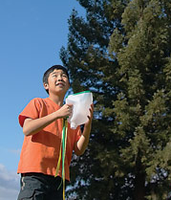
This is a simple variation using plastic milk cartons.
Just cut the bottom off the carton, turn it upside down, and you have your “catcher.”
Now, to make this a “cool” possibly WET game, blow up a water balloon to use as your ball!
Want even more fun? Fill a lot of water balloons, and have them going all at once!
Someone is sure to get wet!
Here Come the Waves!
Alice, Golden Empire Council
Equipment: Sprinkler and Hose; swim suits for everyone; a hot day
Directions: Hook up your sprinkler, but don’t turn it on. Challenge the boys to strike funny poses of what they might be doing at the beach. Explain that they must freeze in place when you yell “Here come the waves!” Then quickly turn on the water – who got “caught by the wave?”
Caught by the Wave
Alice, Golden Empire Council
This is a variation on Tag – and one person is “It” The “Wave” is a wet sponge, which must be used to tag the other players. There won’t be any doubt about who got “caught by the wave” – they’ll have a big, wet spot!
A Drop at a Time
Equipment: Two buckets or tubs and a turkey baster for each team.
Directions: Each team starts with a full bucket of water, and an empty bucket at the finish line. Each person in the team takes a turn sucking water out of the full bucket, racing to the finish line, and transferring as much water as they can out of the turkey baster. The winning team is the one that empties their bucket first. You can also use those “Water bombs” or sponges instead of a baster.
CUB GRUB
Edible Aquarium
Wendy, Chief Seattle Council
Make an edible aquarium in a cup. This is a great party treat you can make with your child.
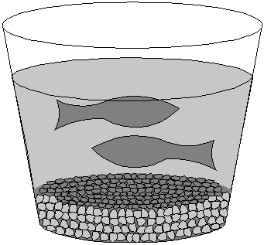
You will need:
Blue Jell-O Gummy fish
Graham crackers clear plastic cups
- Crush graham crackers into crumbs for the aquarium “gravel.”
- Put about ½ inch of crumbs into the bottom of each clear plastic cup.
- Make blue Jell-O according to the directions on the box.
- Pour into clear plastic cups. Let them cool in the refrigerator until partially set - about an hour.
- When they’re partially set, place a few gummy fish in each cup.
- Put them in the refrigerator until they’re completely set. Eat and enjoy!
Variations include:
- Frozen fish-Popsicles (just freeze the Jell-O in Popsicle molds - add the gummy fish when they are partially set - unmold very gently when entirely frozen). These are really messy to eat and are best eaten outside.
- An entire punch bowl of fish Jell-O (made like the cup o’ fish)!
Edible Raft
Wendy, Chief Seattle Council
Ingredients:
Fig Newton cookies pretzel sticks
Fruit roll-up sheets 4 sm. pkgs. Blue Jell-O
2 ½ c. boiling water
- Completely dissolve gelatin in boiling water or juice.
- Pour into 13”x9” pan. Chill until firm or about 3 hours.
- To remove, dip pan in warm water about 15 seconds.
- Cut into 3” squares.
- Lift gelatin blocks from pan and put on plates.
- Top each square of blue gelatin with a Fig Newton raft.
- Cut a square of fruit roll-up and push the pretzel stick through it twice for a mast and sail. Stand a pretzel stick and sail assembly in each Fig Newton.
Waves of Fun Parfait
Alice, Golden Empire Council
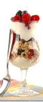
This one is really simple.
Just layer vanilla yogurt with fruits and granola. If you want to really have waves, use a drop of blue food coloring in the yogurt, and use blueberries to add even more blue. But feel free to add any fruit that the boys like. And to make it more fun, use a clear cup and make sure each layer has a wave to it.
Making Waves Cupcakes
Alice, Golden Empire Council
Ingredients:
8 vanilla cupcakes baked in blue paper liners
6 mini vanilla wafers
3 cups of white frosting
yellow, red and blue food coloring
1/4 cup of chocolate frosting
Dots gumdrops;
Yellow, green and blue fruit chews
Jolly Rancher, Starburst, Laffy Taffy;
Chocolate frosted doughnuts for inner tubes;
Candied spearmint leaves or gum

Directions
Here’s how to make various decorations:
- People – cut with a serrated knife from the sides of the vanilla wafers for arms, trim down a wafer to make a torso that will fit into the doughnut;
- Flippers - microwave fruit chews for 2-3 seconds to soften, then roll out to 1/8 “ and cut into triangles. Use a pastry wheel to make the zigzag ends and score one side with a small knife to make the ridges.
- Reeds – Sprinkle work surface with sugar, and roll out spearmint leaves, then cut into zigzag grass shapes using scissors (you could also use green fruit leather)
- Bikini top – trim 1/4 inch from the flat end of two gumdrops.
- Soda bottle – Cut a colored gum drop in half lengthwise, then cut a notch from each side at the rounded end to form a bottle shape
- Inner Tubes - Arrange chocolate doughnuts on top of frosted cupcakes at different angles. Add some more blue frosting to make waves around the inner tubes.
- Frosting – Tint 2 Tbls. of the frosting yellow and 2 Tbls. red. Spoon each color into a separate small ziplock bag and do the same with the chocolate frosting. Spoon the remaining frosting into a bowl, tint with blue food coloring and stir only slightly, so that there are still white streaks in the blue frosting.
To make Cupcakes
- Spread a dollop of the white-blue frosting on top of each cupcake and spread to cover the top.
- Using the back of a spoon, pull the frosting in an upward motion to make spiky waves.
- Add the green spearmint reeds and use some chocolate-covered nuts as rocks or rock candy as rocks, spacing them randomly on top of the remaining cupcakes. (Leave some of the cupcakes unadorned for the water.)
- Place a torso vanilla wafer, pointed side up, in the center of a doughnut.
- Snip a very small (1/16-inch) corner from the bags with the chocolate, red, and yellow frostings.
- Pipe a dot of chocolate frosting on each side of the torso vanilla wafer near the top.
- Attach the vanilla wafer arms, cut side toward the center, on either side of the torso.
- Place a red gumdrop, flat side down, above the torso to support the head, add a drop of frosting to the gumdrop, and place a whole vanilla wafer for the head on top of the gumdrop, letting it rest on the torso.
- Repeat with 2 more of the chocolate doughnut cupcakes.
- Using the chocolate, red, and yellow frostings, pipe hair and features on the 3 vanilla wafer faces and torsos.
- For the woman tuber, pipe red frosting lines for the bikini straps and attach the trimmed red gumdrops, cut side down, to the frosting lines..
- Insert flippers at the base of the 3 doughnuts with vanilla wafers and add 2 flippers upright in the center of the remaining cupcake inner tube, using frosting to secure.
- Arrange the cupcakes on a blue platter or on top of some blue cellophane to look like water, if desired.
Making Waves Dirt Cups –
Alice, Golden Empire Council
Instead of chocolate cookies, use vanilla or lemon ones, crushed to make “sand.”
Instead of chocolate pudding, use vanilla pudding tinted with blue;
Add gummy fish and sea creatures.
Banana Boats 1
Catalina Council
Ingredients:
Bananas
Marshmallows
Chocolate bits
Nuts
Raisins
Instructions:
            - Use one banana per person along with small marshmallows, chocolate bits, nuts and raisins (may substitute other items if you wish).
            - Peel back one strip of peeling, but do not remove.
            - Scoop out a hole, and fill with whatever desired.
            - Bring peeling back up, wrap in foil, and place on hot coals 5 to 10 minutes.
Banana Boats 2
Catalina Council
Ingredients:
Bananas
Marshmallows
Chocolate Chips
Instructions:
            - Slice down each banana from end to end.
            - Make a second cut about 1-inch apart.
            - Open one end so you lift up and peel.
            - Slice the banana in 1/3’s, add marshmallows and chocolate chips.
            - Lay the peel back and wrap in tin foil.
            - Lay slit side up and cook about 10 minutes over coals.
            - Eat with spoon.
Pepperoni Pizza Boat
Catalina Council
Ingredients:
12 sub sandwich buns
2-cans of pizza sauce
1 to 2 bags of pepperoni
1-lb of grated mozzarella cheese
1 box oven with coals
Recipe makes 24
Instructions:
- Cut buns in half length wise.
- Spread a good amount of sauce on each.
- Sprinkle on some cheese.
- Add the pepperoni and place on a baking pan.
- Set into a box oven with approximately 7 - 9 coals.
- Cook until the cheese is melted.
Deviled Egg Boats
Catalina Council
Ingredients:
5 boiled eggs
10 toothpicks
1-Tbsp. sweet pickle
2-Tbsp. chopped olives
3 to 4-Tbsp. mayonnaise
3 pasteurized cheese slices
1 to 2-Tbsp. vinegar to taste
Instructions:
- Carefully cut eggs lengthwise and remove the yolks.
- Put yolks into a small bowl and mash with a fork.
- Add the rest of the ingredients and mix well.
- Spoon back into egg white boats.
- Cut cheese in half diagonally and stick toothpick through the middle of the triangle cheese and poke in the middle of yolks.
Beachy Dessert Recipe
Catalina Council
Ingredients:
Instant Vanilla pudding
Milk (per instructions on pudding)
Vanilla wafers (cookies)
Ziploc bag, freezer or storage
Rolling pin
Miniature umbrellas (find at party supply store)
Small bounce balls (to look like a beach ball)
Clear plastic drinking cups
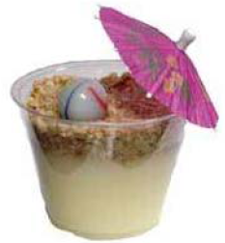
Instructions:
- Follow the directions on the package of instant vanilla pudding.
- Divide the pudding between the clear plastic drinking cups (box directions will give you number of servings).
- Place cups in refrigerator.
- Place vanilla wafers in Ziploc bag. Break the wafers up a bit.
- Use the rolling pin to roll the wafers into very small pieces.
- Sprinkle the sand across the top of all the cups. You will want about 1/4" of sand on top of the pudding.
- Place back in refrigerator until time to serve.
- At party time, remove cups from refrigerator, add a small bounce ball and an opened miniature umbrella to the cup.
Seedless Watermelon Ice Cream Cake
Great Salt Lake Council
Ingredients:
1/2 to 1 Gallon Lime Sherbet
1/2 to 1 Gallon Raspberry or Strawberry Sherbet
1 Metal Bowl (amount of Sherbet depends on what size bowl you use)
Freezer
Directions
- Take the lime sherbet and soften just enough to work with and spread it around the edges of the metal bowl until sides are completely covered about 1/2” thick.
- Freeze for about 45 minutes or until firm.
- When frozen take the pink sherbet and soften just enough to be able to fill in the rest of the bowl.
- Freeze for 45 minutes or until firm.
- When frozen or when you’re ready to serve remove cake by filling sink with just enough hot water so that when you set the bowl in the water it will not go over the sides of the bowl.
- Let sit for about 1 minute and then tip bowl onto a plate. Slice like a watermelon.
Red, White and Blue Pops
Great Salt Lake Council
Ingredients:
2 cups blue Kool-aid
2 cups red kool-aid
1 cup frozen whipped topping
1 cup vanilla yogurt
12 – 5 oz paper cups
12 popsicle sticks
Freezer
Directions
- Divide the blue kool-aid among the 12 paper cups.
- Place in the freezer until partially frozen, about 30 to 40 minutes.
- Mix together the whipped topping and the yogurt.
- Divide the mixture among the 12 cups.
- Set a popsicle stick in each cup and return them to the freezer for another 45 minutes.
- Add the red kool-aid to the 12 cups and return to the freezer until frozen solid.
- To remove the popsicle from the paper cup, run under warm water over the outside of the cup.
Bears on a Raft
Baltimore Area Council
Ingredients: Graham crackers, gummy bears, icing
Use icing to let the boys glue 3 or 4 gummy bears to a square of graham cracker.
Splish Spash Slushies
Longhorn Council
Ingredients –
2 - 12 oz cans of frozen juice concentrate, thawed, any flavor
1 - 32 oz bottle clear soda (7-Up, ginger ale, Mountain Dew)
Small paper cups or zip-top freezer bags (sandwich size).
Directions -
- Mix together the thawed juice concentrate with the soda.
- Ladle 1/2 cup of the mixture into each paper cup or zip-top bag.
- Place in the freezer for at least 30 minutes.
Makes approximately a dozen treats.
Dreamsicles
Longhorn Council
Ingredients –
1 6-oz can frozen juice
2 cups plain yogurt
1 tsp vanilla
1 envelope unflavored gelatin
1/2 cup very hot water
1 banana
10 strawberries
8 small paper cups
8 popsicle sticks
Directions –
- Mix the yogurt, fruit juice and vanilla in a big bowl.
- Dissolve gelatin in the hot water.
- Add the gelatin to the vanilla, yogurt and fruit juice and stir.
- Mash up the fruit and mix it in with the rest of the stuff.
- Pour the mixture into eight small paper cups. Cover each cup with foil. Poke a popsicle stick through the center of the foil on each cup.
- Freeze for 4 hours or until frozen hard.
- Peel off paper cup and EAT!! 8 servings.
Quick Fruit Dip
Longhorn Council
This tastes good on a sunny day. And it’s easy to make too.
Ingredients –
1 cup plain yogurt
2 Tbsp brown sugar
Fruit (apple wedges, strawberries, grapes, banana slices, pineapple chunks)
Directions –
Mix the yogurt and sugar in a small bowl. Serve with any of the fruit above!
Cup O’Fish
Santa Clara County Council
Ingredients, Supplies:
Blue gelatin dessert,
gummy fish,
clear plastic cups
Directions:
Make the blue gelatin dessert according to the directions on the box.
Pour into clear plastic cups.
Let cool in refrigerator until partially set – about an hour.
When partially set, place a few gummy fish in each cup.
Put them in the refrigerator until they’re completely set.
Eat and enjoy!
Tuna Boats
Santa Clara County Council
Ingredients, Supplies:
Rolls
Tuna salad (made to boys’ taste)
Cheese slices
Toothpicks or uncooked spaghetti for masts
Directions:
Hollow out top of roll.
Fill with tuna salad.
Cut cheese into triangles for sails;
put on toothpicks or spaghetti noodles and insert into rolls.
Ice Cream Sandwiches
Longhorn Council
Ingredients –
1 pint ice cream
12 large or 20 small cookies
Sprinkles
Directions –
- Remove the ice cream from the freezer and put in the refrigerator for about 10 minutes, until it softens slightly.
- While the ice cream softens, put the sprinkles on a piece of waxed paper.
- Remove the ice cream from the refrigerator. Place a large scoop of ice cream on top of 6 large cookies (or 10 smaller cookies). Then press another cookie on top.
- With a tablespoon, smooth the sides of the ice cream sandwich. Then roll the sides in the sprinkles.
- Serve right away, or wrap the sandwiches individually in waxed paper or plastic bags and place them in the freezer until you’re ready to serve them. Makes 6 to 10 sandwiches.
Sand Dollar Cookies
Longhorn Council
Ingredients –
DOUGH:
1/2 cup (1 stick) butter, at room temperature
1/2 cup sugar
1 large egg
1 tsp almond extract
1/4 tsp salt
1 1/2 cups all-purpose flour
TOPPING
1 large egg white
1/4 cup sliced almonds
Directions –
- Put the butter and sugar in a mixer bowl.
- have an adult use an electric mixer and beat them on medium speed until the sugar and butter blend together into a soft ball.
- Break the egg into the batter.
- Add the almond extract and salt. Mix until blended.
- With the mixer on medium speed, add the flour a little at a time. When all the flour has been blended, the dough should look crumbly.
- Turn the dough out onto a clean surface. Knead the dough until it is smooth and shiny, 3 to 5 minutes. (Kids like kneading the dough.)
- Shape the dough into a thick log and wrap it in a piece of plastic wrap. Refrigerate for 1 hour.
- After the dough is chilled, place an oven rack in the center of the oven. Preheat the oven to 350.
- Unwrap the dough on a cutting board.
- Using a knife, carefully cut the log into 1/2-inch-thick slices.
- Put the slices about 1 inch apart on the cookie sheet.
- Put the egg white into a bowl. Beat the egg white with the electric mixer until it’s very foamy and white. Use your finger to rub egg white over the top of each cookie. (Wash your hands before and afterward.)
- Sprinkle the tops with the almonds.
- Bake until the cookies are golden, about 10 minutes.
- Cool on a cooling rack. Makes 36 cookies.
I am not sure why these are called Sand Dollar Cookies – I don’t see five marks being made in the cookies. CD
WEBELOS Leader Book
by Commissioner Dave
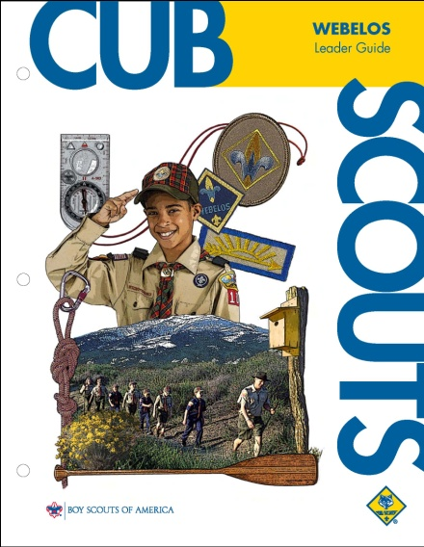
I have received a copy of the WEBELOS Leader Book and spent awhile looking at it.
- Most (or maybe all) the activities ideas for doing the requirements are there.
- The meeting schedule without many details is copied from the NEW Den and Pack Meeting Resource Guide. The meeting details are in the Den and Pack Meeting Resource Guide.
- The old schedule and den meeting plans are gone. (except for the LDS section)
- I have not been able to find it on National's Websites to download.
- I like the picture of Mount Baldy at Philmont on the cover!!! ☺
Conclusions -
- This is a valuable tool for every WEBELOS Leader.
- If you have the old one and download the meeting plans from National's Websites,
http://www.scouting.org/scoutsource/CubScouts/Leaders/DenLeaderResources/DenandPackMeetingResourceGuide.aspx , you do not need to purchase the new book.
- If you do not have the old one, you need to get a copy of the new one (bought or borrowed from a former Webelos Leader)
WEBELOS
Joe Trovato,
WEBELOS RT Break Out Coordinator
Westchester-Putnam Council
Have a question or comment for Joe??
Write him at
webelos_willie@yahoo.com
There is an underscore between Webelos and Willie
A Camping We Will Go!
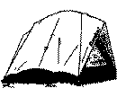
August is all about outdoors. In addition to working on the World Conservation Award I talked about last issue, as well as the Naturalist and Forester activity badges which are this month's themes, Webelos summer resident camp is the place to be! Check your council website for resident camp programs, or if the program doesn't fit your or your scouts' schedules, just Google® “Webelos sresident camp” and you'll find that there are many within a short driving distance from your town.
In addition, use the summer to do some den camping! Webelos dens (especially second year Webelos) should camp as a den in addition to any Pack camping so that they may learn to work as a team and use (or learn) the knowledge and skills that are part of Outdoorsman, Naturalist, Forester, and Readyman. Remember, that even when camping as a den, each Webelos scout needs to be accompanied by an adult responsible for him on each camping trip.
For you first year Webelos Den leaders (Bear leaders this past year) who may be new to camping and not sure about resident camp, try a backyard campout where you can BBQ dinner and, with the help of an outdoor fire pit, have an evening camp fire. S'mores made on the fire pit or on a gas grill can be a great way to ease yourself and your Webelos into camping.
Make sure to provide each scout and parent with a personal packing list for the overnight campout. The den can borrow tents, lanterns and other items from parents or the local boy scout troop.
Sample Personal Packing List
(You should add or subtract depending on the time of year and the evening weather in your neck of the woods. I know that up in the Adirondacks, where my Council hold its summer WEBELOS resident camp, it can get downright chilly at night! JT)
PERSONAL GEAR
- ___ Scout Book
- ___ Scout uniform (wear it on arrival)
- ___ Pants, shirt, underwear,
- ___ 2 pair of socks for each day
- ___ Warm jacket
- ___ Pajamas or short pants for sleeping
- ___ Hat
- ___ Stocking hat for warmth at night
- ___ Rain Gear (coat and pants)
- ___ Sleeping Bag
- ___ Sleeping Pad
- ___ Pillow
- ___ Flashlight (extra batteries)
- ___ Mess Kit with Silverware
- ___ Canteen or Water Bottle
- ___ Bug Spray
- ___ Washcloth, small towel
- ___ Toothbrush and paste
OPTIONAL
- ___ Tent (check with your den leader)
- ___ Laundry Bag
- ___ Walking Stick
- ___ Backpack
- ___ Sunscreen
- ___ First Aid Kit
- ___ Watch
- ___ Lantern (Extra Batteries)
Do NOT Bring
- Snack food or drinks
- Electronics
- Matches or other fire starting items
The Outdoor Code
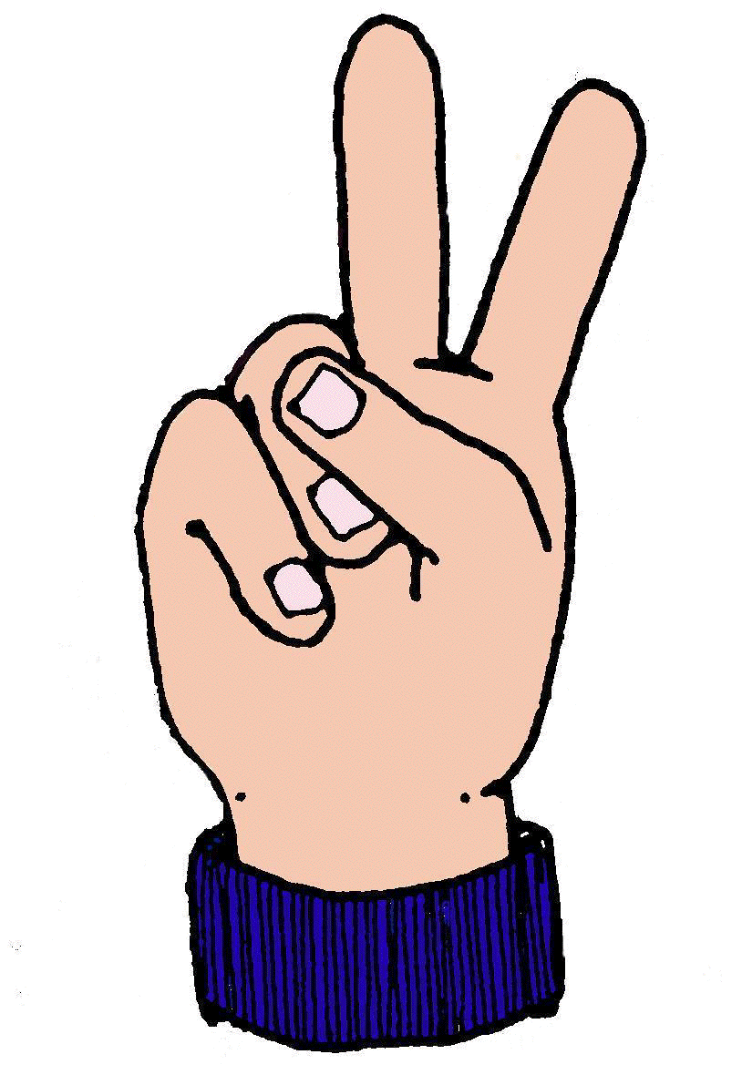
Finally, because one of the requirements for the “Scout Badge” is to know and explain the “Outdoor Code” a summer campout would be a great time to go review the code. Maybe end each of your meetings and the campout by reciting the code.
As an American, I will do my best to -
Be clean in my outdoor manners.
- I will treat the outdoors as a heritage.
- I will take care of it for myself and others
- I will keep my trash and garbage out of lakes, streams, fields, woods, and roadways.
Be careful with fire.
- I will prevent wildfire.
- I will build my fires only where they are appropriate.
- When I have finished using a fire, I will make sure it is cold out.
- I will leave a clean fire ring, or remove all evidence of my fire.
Be considerate in the outdoors. and
- I will treat public and private property with respect.
- I will use low-impact methods of hiking and camping.
Be conservation minded
- I will learn how to practice good conservation of soil, waters, forests, minerals, grasslands, wildlife, and energy.
- I will urge others to do the same.
Note: The new Webelos delivery method provides twice monthly meeting plans for each Webelos den from September through May, followed by planned summer activities. Starting next month This month's badges – Forester and Naturalist - also are part of the second and third meeting plans for first year Webelos under the new format. You can check all this out at
http://www.scouting.org/scoutsource/CubScouts.aspx
JT
NATURALIST

Naturalist helps to introduce the scout to nature and is good preparation for Boy Scouting where there are a number of merit badges that deal with plants, animals, insects, soil, etc. Summer and Fall are great seasons (along with Spring) for outdoor activities. Check out nature-oriented parks in your area where you can have the scouts learn about nature and do many of the activities. In the Westchester-Putnam Council, we are fortunate to have a number of such parks. One great park is the Trailside Nature Museaum at Ward Pound Ridge Reservation in Cross River. http://www.westchestergov.com/parks/parkslocations02/wardpoundridge.htm
Den Activities
- Make an ant farm.
- Make an insect study laboratory
- Make bird feeders and observe the birds.
- Make terrariums.
- Start a nature collection
- Invite a conservationist to a meeting.
- Make a leaf collection.
- Take a bird watcher's hike, identify birds.
- Collect tadpoles; keep in terrarium; watch them grow.
- Study wildlife homes.
- Make a list of plants in your area.
- Learn to identify poisonous plants
- Take a hike and look for animal tracks.
Nature Scavenger Hunt
Divide the scouts into two teams and give each team the list. Allow about 15-20 minutes to see how many items each team collects. Caution them not to kill anything (e.g. the leaf must be on the ground not ripped off a branch)
- Something green
- Something blue
- Something that looks old
- Something new
- Something old
- Something gold color
- Something alive
- Something dead
- Something red
- A tree leaf
Now ask the scouts to make a “natural” piece of artwork or collage out of what they collected.
Sponge Garden
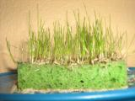
A sponge is an ideal surface on which to grow seeds due to its ability to hold water in its many small cavities. Soak the sponge and place it in a shallow dish of water. Sprinkle seeds over the top surface of the sponge. Try the seeds of grasses, sweet alyssum, coleus, and any other small seeds left over from planting a flower garden. The shoots of almost any plants will be an attractive display. Remember to keep water in the dish so that the sponge doesn't dry out. Also once the seeds begin to sprout, all the food in the seeds will be gone and you will need to add some liquid plant food to the water.
Rare Bird Facts

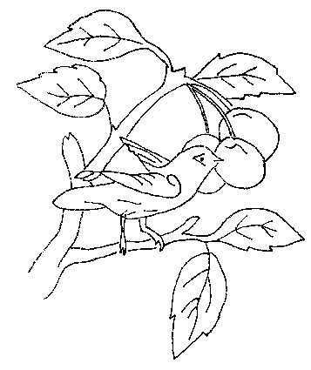
Fill in the correct answer(s)
- What is the fastest flying bird?
- How high can birds fly?
- What is the New York State Bird?
- What bird became extinct in the last 75 years?
- Why do all birds build nests?
- Name two "major league" birds.
- Which birds can fly backwards?
- What bird is famous for its deliveries?
- What is the largest bird in North America?
- What is the smallest bird in the world?
- List three birds that cannot fly.
- What color is a bluebird?
Answers:
- Swifts have been timed at 200 mph.
- A vulture has been seen flying at 25,000 feet, but most birds rarely fly above 3,000 feet.
- Bluebird (New Jersey is the Eastern Goldfinch!! – To get your home state see: http://www.50states.com/bird/ for a list).
- Passenger Pigeon
- Birds build nests to "house" their eggs while they incubate
- Cardinal and Oriole
- Hummingbirds or any bird using fluttering flight
- Stork
- Trumpet Swan
- Bee Hummingbird of Cuba - 2.25" long
- Kiwi, Penguin, Ostrich
- It appears blue because of reflection and diffraction of light due to the structure of feathers
Wildlife Conservation Belt Loop
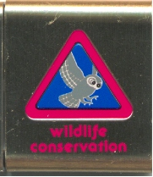
Complete these three requirements:
- Explain what natural resources are and why it's important to protect and conserve them.
- Make a poster that shows and explains the food chain. Describe to your den what happens if the food chain becomes broken or damaged.
- Learn about an endangered species. Make a report to your den that includes a picture, how the species came to be endangered, and what is being done to save it.
Don't Forget: Webelos Scouts that earn the Wildlife Conservation Belt Loop while a Webelos Scout also satisfy requirement 13 for the Naturalist Activity Badge. JT
Milk Carton Bird Feeder
A good project is to put together a simple bird feeder, here is one I've used with success.
To make a Milk Carton Bird Feeder, you will need:
- milk or juice carton
- craft knife or scissors
- wax pencil or crayon
- ruler or straight edge
- two small lengths of double-sided tape
- two bamboo skewers or straight, small diameter twigs to use as perches
- bird seed
- hole punch
- twine to make a hanger
Instructions:
  - Use the wax pencil and ruler to draw the shape of the opening on the front of the milk carton, as shown in the diagram at right. The opening looks like the outline of a house with a peaked roof. You should allow about two inches at the bottom of the carton to hold a good amount of seeds.
  - Use the craft knife to cut out the opening. Younger children will need an adult to help with this part.
  - Using the top of the peak as a center point, fold the piece of milk carton that you just removed in half along its length. Make a half inch cut from the point of the peak down the center fold. Fold up a half inch flap on either side of this cut, as shown in the diagram at right.
  - Attach a length of double-sided tape to each flap.
  - Insert this roof piece into the top of the opening and use your fingers to press the flaps against the inside of the milk carton until the double-sided tape holds securely.
  - Poke a bamboo skewer or thin straight twig through the wall of the milk carton, just below the left side of the opening. Repeat on the right side. Poke skewers all the way through and out the back wall of the carton. This keeps the perches straight and secure.
  - Use a hole punch or a skewer to punch two holes through the top line of the carton.
  - Thread twine through the two holes to make a hanger.
  - Fill the bottom of the feeder with a small bird seed mixture. Hang your milk carton bird feeder from a tree branch that you can reach easily when you need to add more bird seed.
Birdhouse Tie Slide
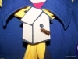
Materials needed:
1 piece 1 ½ “ x 2” balsa wood glue
2 pieces 3/8 “ x 1 ¼ “ balsa wood
½” PVC pipe
1 piece ¼ “ x 3/3 “ wood dowel
brown, black and red markers
Exacto knife if wood is not pre cut
Directions:
- Cut the pitch for the roof of the birdhouse at the 1½” end of the wood.
- Measure about ½” from the top corner down and center of the piece (figure A).
Figure A
- Glue on the 2 pieces of balsa at the top to form the roof of the birdhouse.
- Now, draw lines to give the appearance of wood shingles (figure B).
Figure B
- Glue the dowel for the perch about ¼” from the bottom center.
- Draw a ½” circle and fill in with black marker to show the birdhouse entrance (figure C).
Figure C
- Glue the ½” PVC pipe in back about ¾” from the top of the birdhouse as the neckerchief slide back.
- Color the roof top with red marker.
FORESTER

Boys and trees are a natural mix. Get out and see how many different trees you can find in your neighborhood and nearby parks.
DEN ACTIVITIES
- Collect leaves for identification. Scouts may mount them or make leaf prints.
- Plant a memorial tree in someone's backyard.
- Make a tree survey in your area.
- Ask a fireman or forest ranger to tell scouts how wildfires may be prevented and how they are controlled.
- Prepare an exhibit for your pack meeting include a poster of a tree's life history, leaf prints, samples of wood.
- Service Project: Ask your local park if your den can plant trees if they provide them. They park will designate where to plant them. (We did this one at Lasdon Park in Somers, NY with another den. My son (an Eagle Scout) and I still go by the park to check on the trees we planted ten years ago! JT)
Tree Treasures

Find the tree name hidden in the following sentences:
- The ranger's map led us safely through the woods.
(Maple)
- Will owls hoot in daylight?
(Willow)
- It's fun to hike and tramp in every direction.
(Pine)
- Forest rangers wear white helmets.
(Elm)
- We saw a honey bee checking clover blossoms for honey. (Beech)
- Many forest fires are caused by human carelessness.
(Fir)
- We got soaked when we were caught in a cloudburst.
(Oak)
- The boy's face darkened when she kissed him on the cheek. (Cedar)
Parts of a Tree
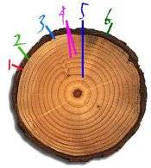
Each layer of a tree cookie (cross-section) can tell us something about the tree's life and the climate in which it grew. Write the correct parts of the trees in the appropriate blanks.
The answers are -
- cambium
- growth ring
- heartwood
- outer bark
- phloem
- xylem
Item 1 is called the ____________.
It is a layer or zone of cells, just one cell thick, inside the inner bark. This produces both the xylem and phloem cells. This is where diameter growth occurs, and where rings and inner bark are formed.
Item 2 is the ____________ or inner bark.
It carries sugar made in the leaves or needles down to the trunk and roots, where it becomes the food the tree needs for growth.
Item 3 is the ____________ or sapwood.
It carries the sap up from the roots to the leaves. Sapwood gives a tree its strength.
Item 4 is a ________________.
The lighter portion is called the "early wood" (because it grows in the spring), and the darker portion the "late wood" (which grows in the summer). Together, they represent one year of growth.
Item 5 is the ____________.
This develops as a tree gets older. It used to be sapwood, and gives the trunk support and stiffness. It is often darker than sapwood, since its water-carrying tubes get clogged up. This tree has not developed this yet.
Item 6 is the ________________.
This layer protects a tree from insects and disease, excessive heat and cold, and other injuries.
Answers:
1.Cambium 2. Phloem 3. Xylem
4.Growth Ring 5. Heartwood 6. Outer Bark
FOREST QUIZ
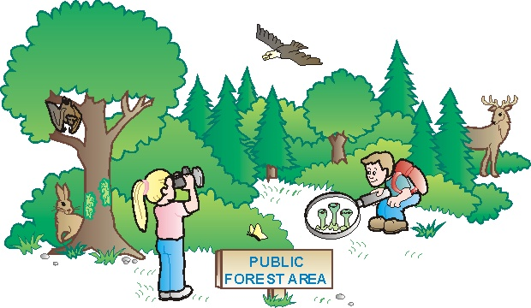
- Tree used by fortuneteller PALM
- Tree representing a point in time DATE
- Tree wasting away in grief PINE
- Tree that’s a body of water BAY
- Tree left after a fire ASH
- Tree that will keep you warm FIR
- A crying tree WEEPING WILLOW
- A canine tree DOGWOOD
- Tree we chew GUM
- A double tree PEAR
- Fisherman’s tree BASSWOOD
- Tree near the sea BEECH
- Tree with a color REDWOOD
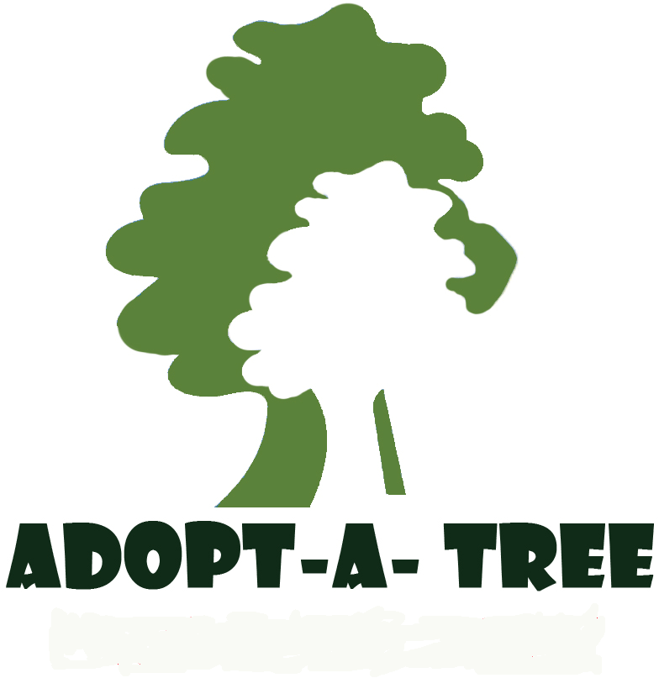
The best way to learn tree identification is to get to know one tree, or a few trees, very well. In this way, you’ll become accustomed to observing those things that make each tree special.
Select trees that are near your home so you can have daily contact. Find out what is going on in, under and around the trees. Select more than one kind of tree to compare the action that takes place with each type.
- With a notebook in hand, visit the adopted trees.
- Describe the trees as they are right now, today.
- Look at their physical characteristics (size, leaf shape, bark color, and other features).
- Look to see whether they are alive. How can you tell?
- Listen to find out if they make any noises.
- Smell to find out whether they have an odor. Do different parts of the tree smell differently? The leaves? The bark? Does the smell change during the day or during different seasons?
- Repeat the visits throughout the month and compare observations.
- Look to see how the trees have changed. Look to see how the trees remain the same.
- Are there any animals calling the trees home?
- Did the leaves turn colors before the fall?
- Keep your notebook and come back to the trees when you are older and see how they have
POW WOW EXTRAVAGANZAS
Let me know as soon as your date is set. I will post whatever I receive! CD
Sam Houston Area Council
Following Akela's Trail into the Next Century
Probable Date - November 6, 2010
Location - TBA
Call Sam Houston Area Council, (713) 659-8111, or visit the website, http://www.samhoustonbsa.org/akelas_trail.php ,for more information
Southern NJ Council
Improving Your 'Scoutability"
January 22, 2011
Lakeview Middle School, Millville, NJ 08332
Call Southern NJ Council, 856-327-1700, extension 32, or visit the website, www.snjscouting.org for more information
WEB SITES
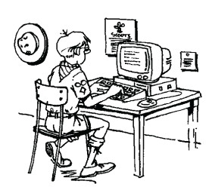

Camp No-Be-Bo-Sco
in New Jersey!!!
If you are a No-Be-Be-Sco Alumnus or just a fan or a nosy Scouter - check out the Sand pond Society to see what No-Be Alumni are up to -
http://sandpondsociety.org
or http://nobebosco.org/

Wendy, Chief Seattle Council
A great place for songs, games, activities, crafts and more -
http://www.ultimatecampresource.com/
More Water Games:
http://www.ultimatecampresource.com/site/camp-activities/water-games.page-1.html

Alice, Golden Empire Council

http://ga.water.usgs.gov/edu
Water Science for Schools (USGS): All about water!
U.S. Geological Survey site: interactive games, general info. About water and the water cycle in several languages, water usage, picture gallery, maps showing water usage by state

cgee.hamline.edu/watershed/action/projects/ Center for Global Environmental Education Watershed Action Plan one stop help in planning and organizing service-learning projects to prevent water pollution in your watershed; everything from scientific background information or to local experts or stencils for storm drain signs.

http://www.projectwet.org contacts and ideas for water projects, , contacts with state ProjectWET workshops, click on KIDS for activities for kids, activity books for kids for $1 or less. Also check with teachers for a local presenter with lots of ideas to share.

www.earthobservatory.nasa.gov/Library.Water great diagrams showing the water cycle, earth from space showing huge volume of water, other facts and activities
www.rps.gov/index.htm great website to locate parks, get updates and info. Kids can register as Jr. Rangers and enjoy interactive mysteries, games and other activities
Making Waves with water:
www.virtualnjshore.com/tbwaves.html great explanation and pictures of how waves, currents and tides operate and affect us
www.oceanservice.noaa.gov/education/kits/currents/03coastal1.html check out some great information for teachers (Den Leaders) or students; interactive games and project ideas
www.eia.doe.gov/kids/energy.cfm?page=hydropower_home good illustrations and explanations of how energy can be harnessed from the ocean
www.boyslife.org/.../make-the-ultimate-raingutter-regatta-racer/
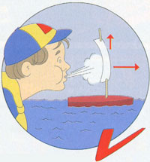
If your pack is doing a regatta, check out these great ideas for making a winner – from Boy’s Life magazine
You should also check in the How To Book for ideas on having a great regatta. Some packs have the boys make a stand for their boat as well.
Making Waves with Sound:
www.stevespangler.com/teaching.../make-your-own-vuvuzela-sound/ Video of a favorite experiment from science teachers – the Screaming Balloon – this is also a great website for science and kids ideas!
www.scouting.org/filestore/intl/pdf/130-218.pdf All about the annual Scout Jamboree on the Air; shortwave radio info.
www.science.pppst.com/sound.html sound experiment ideas, free presentations, online games for kids about sound
www.dangerousdecibels.org All kinds of information about hearing loss and loss prevention – it’s an issue for kids!
Making Waves with Service:
www.goodturnforamerica.org/ Individuals, dens, packs, troops, community organizations can team up to do service all over the world – and to report service hours! Check it out.
www.nothingbutnets.net/partners-people/boy-scouts-of-america.html BSA project to provide sleeping nets and prevent malaria

Utah National Parks Council
www.Familyfun.com
Dollar Tree Stores online: www.dollartreedirect.com
Or call toll free 1-800-877-530-TREE (8733)
For pix or crafts try www.googleimages.com
Also, check your local thrift stores and yard sales for back issues of Pow Wow books and other Scouting materials
Lots of good Cub Scout info - www.kismif.org

ONE LAST THING
Everything I Need to Know About Life,
I Learned from Noah's Ark
Alice, Golden Empire Council
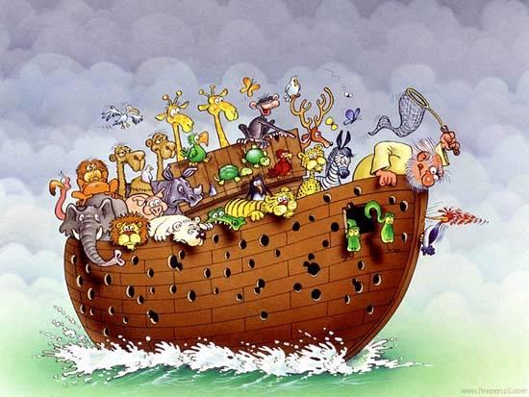
- Don't miss the boat.
- Remember – We’re all in the same boat.
- Plan ahead. ! It wasn't raining when Noah built the Ark.
- Stay fit. When you're 600 years old, someone may ask you to do something REALLY big.
- Don't listen to critics; just get on with the job that needs to be done.
- Build your future on high ground.
- For safety's sake, travel in pairs.
- Speed isn't always an advantage. The snails were on board with the cheetahs.
- When you're stressed, float a while.
- Remember, the Ark was built by amateurs; the Titanic by professionals.

