CORE VALUES
Cub Scout Roundtable Leaders’ Guide
The core value highlighted this month is:
- Respect: Showing regard for the worth of someone or something. Through interacting with pack families, Cub Scouts will develop appreciation and respect for different families and traditions. Through pack service projects, they will learn to treat the environment with care.

COMMISSIONER’S CORNER
Respect - there are many applications of the word -
Respect the Flag
Respect others
Respect the environment
Respect your elders
Respect the other team
Respect the beliefs of others
Respect for other cultures and traditions
I really did not know where to begin!! But after looking at this list and getting an E-mail from Wendy, I decided I make this a traditional December issue with various holiday traditions that occur in December - CHRISTmas, Hanukkah, Kwanzaa, and others if I fins appropriate material (or you send it to me (for next year?).
Certainly respect is more than Aretha sang about when I was a teenager. (Click here)
I am looking for different ways to present the achievements. So if you have come up with ideas for den meetings centered around the achievements & electives, please email them to davethecommish@gmail.com so we can include them in Baloo. And if anyone has any good ideas for Character Connection discussions, please email those, too.
From Scouter Jim -
As leaders, it is well that we remember that our young Cub Scouts give their first salutes in uniform as Americans with two fingers. They will advance in Scouting and start giving three finger salutes as Boy Scouts. Some will go on to serve their county and start to give four finger salutes, but their first salutes in uniform will always be as Cub Scouts with two finger against the hat. The Character Connection for December is Respect. There may be no better way to teach respect for the county, the flag, and those who serve in uniform that to teach the importance of that first salute to the flag. Teach boys to wear their uniforms with pride and to be respectful of the flag and to give a crisp proper salute when they honor it.
TABLE OF CONTENTS
In many of the sections you will find subdivisions for the various topics covered in the den meetings
CORE VALUES 1
COMMISSIONER’S CORNER 1
THOUGHTFUL ITEMS FOR SCOUTERS 2
TRAINING TOPICS 2
ROUNDTABLES 2
DEN MEETING TOPICS 2
PACK ADMIN HELPS - 2
LEADER RECOGNITION, INSTALLATION & MORE 2
SPECIAL OPPORTUNITIES 3
Service Stars (Year Pins) & Attendance Awards 3
Attendance Award - 3
Boys’ Life Reading Contest for 2010 4
Knot of the Month 4
GATHERING ACTIVITIES 4
OPENING CEREMONIES 4
AUDIENCE PARTICIPATIONS 5
ADVANCEMENT CEREMONIES 5
GAMES 5
SONGS 5
STUNTS AND APPLAUSES 6
"Applauses & Cheers, Run-Ons, and 6
SKITS 6
CLOSING CEREMONIES 6
Cubmaster’s Minutes 7
CORE VALUE RELATED STUFF 7
DEN ACTIVITIES 7
DEN MEETINGS 9
TIGER 9
WOLF 12
BEAR 18
WEBELOS DENS 21
Respect 21
Meeting Planner 22
Gathering 22
Flag Ceremony 22
Den Activities 23
WEBELOS RANK 23
Family Member 23
Citizen 25
Artist 27
ARROW OF LIGHT 30
Readyman 30
ADDITIONAL ADVANCEMENT IDEAS 33
Tiger Achievements 33
Tiger Electives 33
Wolf Achievements 34
Wolf Electives 34
Bear Achievements 34
Bear Electives 34
Webelos Activity Pins 35
CUB GRUB 35
POW WOW EXTRAVAGANZAS 37
WEB SITES 37
ONE LAST THING Error! Bookmark not defined.

THOUGHTFUL ITEMS FOR SCOUTERS
The "Thoughtful Items" and "Quotations" are in the Pack and Leader Hints Edition Dave

TRAINING TOPICS
The "Training Topics" are in the Pack and Leader Hints Edition Dave

ROUNDTABLES
The "Roundtable Hint" is in the Pack and Leader Hints Edition Dave

PACK ADMIN HELPS -
The "Pack Admin Helps " are in the Pack and Leader Hints Edition Dave

LEADER RECOGNITION, INSTALLATION & MORE
The "Leader Recognition" section is in the Pack and Leader Hints Edition Dave

DEN MEETING TOPICS
Wendy, Chief Seattle Council

From Bob Scott at National in answer to my question on the role of Roundtables with the new delivery system -
Dave, you have it right.
No changes to roundtable’s role, how it's executed, etc.
Bob Scott , Innovation Coordinator - CS 2010

SPECIAL OPPORTUNITIES

Service Stars (Year Pins)
& Attendance Awards
www.pack132.us
www.usscouts.org , www.scouting.org ,
& Baloo's Archives
We all want our Scouts to attend everything. We want them to stay with the program. So don’t forget to recognize them for being there another year and for being at "everything."
Service Stars

Service stars are Gold metallic numbered stars worn with colored background to indicate years of service in Scouting. The sample above is a two year Service Star. Cub Scouts and Webelos Scouts wear stars with gold background, centered 3/8 inch above the left pocket. Service stars are calculated based on registration information. That's the reason why they are called "service stars". They are not based on "graduation" or "movement" from one program element to another (from Wolf to Bear, for instance) nor from program to program (from Cub Scouting to Boy Scouting, for instance). Each year of service is calculated based on the anniversary of the Scout's date of registration.
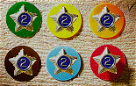
There are six Official BSA service star backings:
- Orange for Tiger Cub youth (Discontinued in 2001)
- Yellow for Cub Scout youth
- Green for Boy Scout youth
- Brown for Varsity Scout youth
- Red for Exploring/Career Awareness Exploring or Venturing/Sea Scouting youth
- Light Blue for all adult service, Regardless of program
Placement
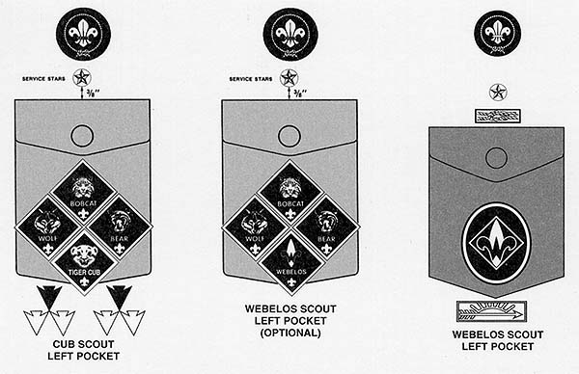
Stars are worn 3/8 inch above the top of the left pocket. Or 3/8 inch above the top Square Knot recognition.
Only the correct total number of years should be worn. When your son receives his 2nd year Service Star, remove the first and put it in your "Memory Box"
Note for adults on wearing Service Stars
An adult has the option to wear the appropriate color backgrounds for their youth service and blue for their Adult service or they may combine all adult and youth service and wear only the light blue Scouter's service star background.
For example,
I could wear service stars in one of the 2 options:
Service broken down by program | All service in star(s) with blue background
- 3 yr - yellow background (Cub Scout youth)  - 7 yr - green background (Boy Scout youth)  - 24 (a 20 year pin and a 4 year pin) years - light blue background (Adult service) | - 34 (a 30 year pin and a 4 year pin) years - light blue background (Adult service)

Attendance Award -
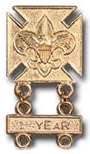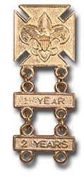
This is often wrongly called "The Perfect Attendance Award" My Pack always called this the "Good Attendance Award." Every Scout is expected to attend all Den and Pack meetings. However, most Packs recognize that Cub Scouts (Tiger Cubs, Cub Scouts, Webelos Scouts) are involved in other activities and may have scheduling conflicts. Since you know your community best, the Pack committee sets the requirements for this award. National Council has not established requirements for this award. You should make the requirements challenging but doable.
Sample Requirements:
I found several packs on the web with the same list of requirements, whether they all actually decided to do the same thing or simply copied from one another,
I do not know. CD
To earn the attendance award,
A Scout cannot miss more than:
- One regularly scheduled Pack meeting during the program year (September through August).
- Two regularly scheduled Den meetings during the program year (September through August).
A Scout must
- Earn the Summertime Fun Award
- Attend at least one Camping trip (The Pack has two and Webelos have one more)
- Attend a Day Camp or Resident camp
- Attend at least 2/3rd of special Pack activities (trips, picnics, Scouting for Food, ball games, …)
Remember, the Pack sets the requirements.
If you don’t like these, write your own.
Other Information:
- The awards could be presented at the last Pack meeting of the program year or the first of the next year. Presentation at the first gives you awards for the first meeting of the year when you should have lots of new Cubs who will be impressed with seeing what they can earn!!!
- The Official BSA Insignia Guide simply says the award is worn on the official uniform above the left pocket. It does not give a distance above. I would put it about the same height as the Service Star. Let the year bars dangle on the pocket flap.

Boys’ Life Reading Contest for 2010
http://boyslife.org/
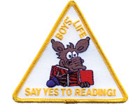
SAY ‘YES’ TO READING
Enter the 2010 Boys’ Life Reading Contest
Write a one-page report titled “The Best Book I Read This Year” and enter it in the Boys’ Life 2010 “Say Yes to Reading!” contest.
The book can be fiction or nonfiction. But the report has to be in your own words — 500 words tops. Enter in one of these three age categories:
- 8 years old and younger
- 9 and 10 years old
- 11 years old and older
First-place winners in each age category will receive a $100 gift certificate good for any product in the Boy Scouts official retail catalog. Second-place winners will receive a $75 gift certificate and third-place winners a $50 certificate.
Everyone who enters will get a free patch like the one shown above. (And, yes, the patch is a temporary insignia, so it can be worn on your Cub Scout or Boy Scout uniform shirt, on the right pocket. Proudly display it there or anywhere!) In coming years, you’ll have the opportunity to earn different patches.
The contest is open to all Boys’ Life readers. Be sure to list your name, address, age and grade in school on the entry.
Send your report, along with a business-size, self-addressed, stamped envelope, to:
Boys’ Life Reading Contest
S306
P.O. Box 152079
Irving, TX 75015-2079
Entries must be postmarked by Dec. 31, 2010 and must include entry information and a self-addressed, stamped envelope.
See 2009's winners posted at - http://boyslife.org/home/12652/2009-boys-life-reading-contest-winners/
For more details go to http://boyslife.org/

Knot of the Month
The "Knot of the Month " is in the Pack and Leader Hints Edition Dave

GATHERING ACTIVITIES
"Gathering Activities" for large groups and getting groups to know each other are in the Pack and Leader Hints Edition. Those good for dens (e.g. word searches, puzzles, mazes) are here. Dave
Note on Word Searches, Word Games, Mazes and such – In order to make these items fit in the two column format of Baloo’s Bugle they are shrunk to a width of about 3 inches. Your Cubs probably need bigger pictures. You can get these by copying and pasting the picture from the Word version or clipping the picture in the Adobe (.pdf) version and then enlarging to page width. CD

It’s All About Respect Word Search
Alice, Golden Empire Council
The words below can be found in any direction. Each word either describes an aspect of respect or names something a person should have respect for.
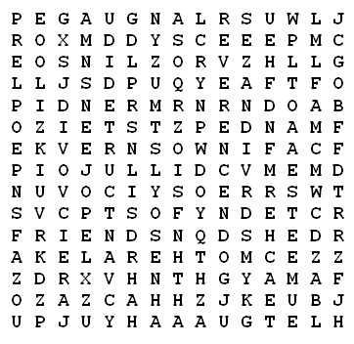
AKELA COUNTRY COURTEOUS
ELDERLY ESTEEM FATHER
FRIENDS KINDLY LANGUAGE
MANNERS MOTHER PEOPLE
POLITE POSSESSIONS REVERENCE
SELF TEACHER
Respect to Our Flag
Baltimore Area Council
Divide into Dens giving each group paper and pencil. At the start, each will write as many different ways of showing respect to our flag as they can remember. The team with the most correct methods in a given time is the winner. Example: “Never let the flag touch the ground.”

OPENING CEREMONIES
"Opening Ceremonies" are in the Pack and Leader Hints Edition Dave

AUDIENCE PARTICIPATIONS
"Audience Participations" are in the Pack and Leader Hints Edition Dave

ADVANCEMENT CEREMONIES
"Advancement Ceremonies" are in the Pack and Leader Hints Edition Dave

GAMES
“Show Me Some Respect” Relay Game
Alice, Golden Empire Council
I made up this game last month, when I had some boys who needed this Character Connection Value, others who needed some of Wolf Ach. #1 or to review or finish Ach. #2 – Flag – so I combined it all into a game. But you could use it for a fun way to remind everyone of what respect really means. Feel free to change the format. Alice
Materials:
- At least 7 cones, 2 liter bottles or even water bottles (weight them so they will stay standing);
- Labels to tape on your cones – Respect for Flag, Respect for the Environment, Respect for Parents, Respect for Teachers, Respect for someone different, Respect for Self;
- Basketball or any large ball
Directions:
- Divide the boys into two teams, lined up at the starting line with some space between the teams.
- Your finish line could be a basketball hoop, or just a marker.
- Cones are laid out, with signs attached, between the two lines of boys, and with plenty of space between each cone.
- Explain the game first, then demonstrate with one boy.
- Now, pass the ball to the first boy in each team in turn (If you have a Wolf den, you can use the chest pass, overhead pass and bounce pass, and sign off part of Ach. #1 as well)
- After getting the ball, the boy must name some way to show respect for….
- If he comes up with a correct idea, he moves to the first cone.
- Ideas cannot be repeated, but if a boy is stuck, his teammates can help him.
- The idea is to get the whole team to the last cone, one boy at a time.
- After you have passed the ball to each boy on both teams, start the next category with the other team, so the advantage of first response changes from team to team.
- When every team member has made it through the course, give everyone a “High Five” for “Showing You Some Respect!” And of course, talk a little more about Respect.

SONGS
Are You Listening?
Wendy, Chief Seattle Council
Tune: Frere Jacques
Are you listening?
Are you listening?
Do you hear?
Do you hear?
From each other we’ll learn.
You talk, then it’s my turn.
One by one,
That’s how it’s done.
Golden Rule
Wendy, Chief Seattle Council
Tune: She’ll be Coming Round the Mountain
Oh, we’ll all be sure to use the Golden Rule,
Playing sports, at home, at church, or when at school.
We’ll all treat one another
Like a sister, friend or brother,
We will always choose to use the Golden Rule.
Respect
Julie and Wendy, Chief Seattle Council
Tune: Twinkle, Twinkle Little Star
R-E-S-P-E-C-T,
What's it mean for you and me?
Honor, care, civility,
Even when we disagree.
Those that fight are bound to fall,
United we can do it all.
R-E-S-P-E-C-T,
We are Cubs and we agree:
Keep the promise, Do our best,
Give goodwill and all the rest.
I'll do for you, you do for me,
That's how we build community.
Manners
Alice, Golden Empire Council
Tune of “Bring Back My Bonnie”
We always try hard not to argue,
We always try hard not to fuss,
We always try hard to be honest,
And listen when folks talk to us!
Chorus:
Manners, Kindness,
They both leave a smile on your face, your face
Manners, Kindness,
They both leave a smile on your face!
We know how to play well with others,
We share and we take just one turn,
We’re careful with toys that we borrow,
Good manners are easy to learn!
Chorus
We always say “Please” and then “Thank You”
We don’t interrupt if you please,
We never make someone unhappy,
Cause we never taunt them or tease.
Chorus

STUNTS AND APPLAUSES

"Applauses & Cheers, Run-Ons, and
Jokes & Riddles" are in the Pack and Leader Hints Edition Dave

SKITS
"Skits" for the Pack Meeting are in the Pack and Leader Hints Edition Dave
Manners Good or Bad?
Alice, Golden Empire Council
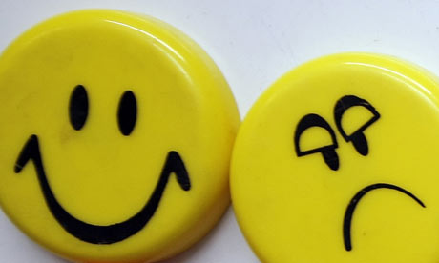
Divide boys into teams of two boys. Assign adult parts as needed. Use the Role Playing suggestions under Den & Pack Activities and have the boys act out talking on the phone, answering the door, receiving a gift. For the first role play in each circumstance, the boys should really “ham up” doing the WRONG thing
One way to do this is to make a Happy/Frowny face on a stick for each judge. One side has a happy face, the opposite side is frowny. Just before the skit, pass out one of each face to a team of “judges,” including some parents. The other way would be to simply ask the audience to give a “Thumbs Up” or “Thumbs Down” after each role play.
After each role play, the leader or Cubmaster can then turn to the audience or “judges” and ask “Were those manners good or bad?”
As an example:
Answering the Door Role Play
Sound of a doorbell or knock.
Cub #1 – (Opening the door) “What do you want?”
Cub #2 – “I came to bring a file to your Dad.” He’s expecting me.”
Cub #1 – (turns around and yells at the top of his voice) “Hey Dad – there’s a guy here for you.”
Dad - (From a distance) “Who is it?”
Cub #1 – “Who ARE you?”
Cub #2 – “I’m Mr. Jones from the office.”
Cub #1 – (Yelling at the top of his lungs) “It’s some guy names Jones.”
Cubmaster or leader asks for a vote – Good Manners or Bad? If this is in a den meeting, give the boys a chance to tell what was wrong with the Role Play. If at the Pack Meeting, have the two boys go off a little, then return and do the Role Play with better manners, for example:
Sound of a doorbell or knock.
Cub #1 –“Someone’s at the door – should I get it? (Opening the door) “Hello – Can I help you?”
Cub #2 – “I’m Mr. Jones - I came to bring a file to your Dad.” He’s expecting me.”
Cub #1 – “Wait just a minute – I’ll get my Dad. (leaves to go to where his Dad is and gives the message) “Hey Dad – Mr. Jones is here for you.”
Father (Cub #3 or Leader) “ Thanks, son.”(Goes to greet and thank Mr. Jones)
Hints for the Role plays
You get the idea – be as rude as possible in the first role play, then do it the right way.
If you are doing this in your den, discuss what is wrong with the first role play, why we should do it the right way, and how respect is shown.
If you are doing this at pack meeting, be sure to practice so everyone knows their role. And be sure to be as rude as possible in the first role play – and teach the boys to wait for laughter before they continue their skit.

CLOSING CEREMONIES
"Closing Ceremonies" are in the Pack and Leader Hints Edition Dave
Here is a great
Den Meeting Closing Ceremony
Living Circle Ceremony
Great Salt Lake Council
I remember learning this ceremony at my first Den Meeting at Mrs. Kneale’s house in September 1957. We still teach it to our dens. CD
Based on an Indian custom, the living circle may be used alone or as a part of another ceremony. It reminds a Cub Scout of the fine friendships he is making in Cub Scouting.
Hold out your left hand—palm down, and thumb out.
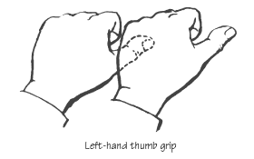
Hold the thumb of the boy on your left and form a connected circle.
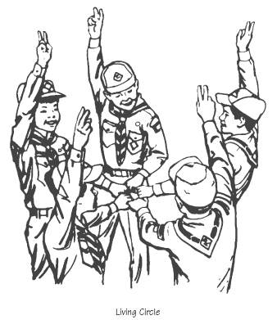
Then say the following as a football team may do after a time out or entering the field at start of the game.
Action Say
Phonetic spelling of Akela
Raise the circle AH
Lower it KAY
Raise it LA
Lower it WE’LL
Raise it DO
Lower it OUR
Raise it BEST!
Release Hands
Here is another picture of a Living Circle -
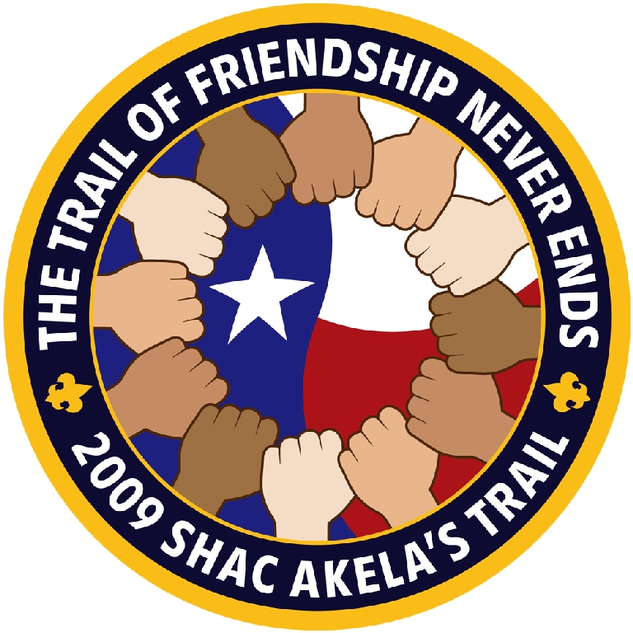

Cubmaster’s Minutes
"Cubmaster's Minutes" are in the Pack and Leader Hints Edition Dave

CORE VALUE
RELATED STUFF
Connecting Core Values with Outdoor Activities
Catalina Council
- Show respect for the history of your area. Hike to a museum or historical building and learn about the history of your community. Take a historical hike.
- Show respect for the environment. Clean up trash in a designated area. Observe a certain species of animals to see how they live together and what nature laws they obey.
- Show respect for the flag. Raise the flag at the local school every morning for a specific period of time. Lead a flag salute at Sunday School. Do some community cleanup projects. Offer to lead a flag ceremony at a community event or recreational league game.
- Show respect for your competition. Play a team sport and demonstrate good sportsmanship. Refrain from calling the opposition names.
- Show respect for your leaders, both youth and adult. Hold a ceremony to inaugurate the Denner or to graduate Wolfs to Bears or Bears to Webelos, complete with “tux”, “top hat”, and “judge”. Conduct a ceremony to honor your den leaders.
- Show respect for our Founding Fathers. Re-enact an historical event, (e.g. the signing of the Declaration of Independence). The boys could even be in costume with a huge feather pen.
- Show respect for the government. Visit a local governing body, city council, county commission, school board- to see government in action. Have lunch with the mayor or chief of police.
- Show respect for authority. Have the Cubs make up “laws” (e.g. a Den Code of Conduct) to govern their den or tent city on a camping trip. Discuss why it’s important to understand how good law benefits all citizens.
The Story of Mansay, the Pebble Shooter
Alice, Golden Empire Council
Long ago in Laos, the Land of a Million Elephants, there once lived a 10-year-old orphan named Mansay, who managed to get by with the help of kind villagers who provided him rice and fish. The boy was born lame and could not walk, but other boys in the village included him in their games as much as they could.
You might think Mansay wouldn't be much of a playmate, but he was the champion in at least one game. He had become very skilled at shooting pebbles. He would practice flicking pebbles at faraway targets and could hit tree trunks he could barely see, as well as leaves in the highest branches of tall teak or palm trees. Younger boys gathered mounds of pebbles for him and watched, making each challenge more difficult than the next, but he nearly always hit his mark.
One morning Mansay amused himself by shooting pebbles at a broad banyan leaf , making holes like the shape of a boy. The banyan leaf cast a dark shadow on the ground, and when sunlight shone through Mansay's holes and the wind ruffled the leaf, the circles of light that fluttered on the ground seemed to dance. When the village boys came that day, they were delighted with the show. They built a cart for Mansay with wheels and moved him to the shade of a large spreading banyan tree with many overlapping banyan leaves where he could create a more dramatic display. First he flicked his pebbles to make the outline of an elephant in one leaf, then a baby following its mother in another, and before long he had brought to life an entire herd of elephants that seemed to charge whenever the breeze blew.
The boys were so enjoying the sport they didn't hear a procession approach. It was the king - on his way to visit a nearby city. Frightened at the sudden appearance of marching guards, the boys quickly rolled Mansay's cart out of sight and hid themselves behind the trees.
The cool shade of the spreading banyan tree looked inviting to the King in the heat of the day, so he commanded his men to stop and rest. When the wind blew, he was startled to see images of elephants on the ground moving about as if they were alive. He called to his guards, "What art is this? Whoever created this wonder - Find them!" But all the boys could hear was the King's commanding voice saying: "Find them!" and they fled home as fast as they could, leaving poor Mansay behind.
Soon Mansay was discovered and, trembling, was brought before the King. Though most everyone in Laos knew the King to be a good and just, and that he had settled treaties with their neighbors and brought peace to the land, any king can be fearsome and unpredictable. "Who has done this?" said the King in a commanding tone, pointing to the images on the ground.
"I did," Mansay whimpered, not knowing what else to say."Ah, so it was you?" said the King, stroking his chin. "Prove it." He told his guards to gather some pebbles. "Make another picture," he ordered. Just then a songbird landed on a low branch. Mansay flicked pebbles onto a banyan leaf in the shape of the bird. He placed the body of the bird on one side of the leaf where it was bent and its head on the other so that when the wind blew, the image of the bird on the ground appeared to sing.
The King laughed heartily and clapped his hands. "My son," said the King, "you have a remarkable talent." He was silent for a moment, then said, "Yes…I know exactly what you can do for me." He ordered his guards to lift Mansay onto an elephant. Silently riding in the King's procession, Mansay did not know where he was bound or why. After traveling for a number of days, the grand buildings of the capital of Laos, home to the king's castle and the pride of Southeast Asia, came into view.
"Now young man," said the King to Mansay- after he had been bathed and dressed in wonderful clothes - "I have an important job for you. Soon I will meet with my councilors. One of them is a man I am fond of but who talks too much, and I need him to be silenced so I can hear what the others have to say. I've arranged for a curtain to be hung behind my throne and you will sit behind the curtain. There is a hole in the curtain. You'll be able to see the councilor I'm talking about because he'll be seated right across from you. Let him speak for ten seconds. Then you are to shoot a mud pellet through the hole, directly into his mouth. Whenever he opens his mouth to speak, you must do it again."
Mansay was carried to a chair behind the curtain and handed a basket of mud pellets. As soon as the King opened a question for his councilors to debate, one councilor seized the opportunity to talk. After ten seconds - thwop! – something revolting flew into his mouth. He immediately closed his mouth and swallowed the vile thing, whatever it was. As soon as he had rinsed the taste down his throat as best he could by swallowing, he found another opportunity to speak. But when he opened his mouth –thwop! - again a terrible tasting thing - was it an insect? - flew in. He had no choice but to swallow that disgusting thing, too, as quickly as possible so none would be the wiser. And so it went for the rest of the meeting, much to his confusion.
"My friend," said the King, slapping the councilor on his shoulder at the end of the meeting, "I can see you finally realized how important it is to allow others to speak. I'm pleased and impressed with you!"
"Well, I…actually…" said the councilor. "Actually what?" "Oh, um nothing, I mean... Yes, um, what I've always said...That it's a wise man indeed who will listen to what others have to say."
"Good man!" said the King, smiling. And from then on, the councilor held his tongue and council meetings were much improved.
Mansay was invited to stay at the castle for as long as he liked – and he never lacked for food or shelter or an audience for his pebble throwing! And of course, the councilor learned that one way to show Respect for others is to let them have their turn to speak!

DEN ACTIVITIES
Planning & Service Project Ideas
Wendy, Chief Seattle Council
http://www.goodcharacter.com/SERVICE/service.html
http://www.scoutingmagazine.org/issues/0911/d-csc.html
Service Project Ideas for December:
Collect food and clothing for your local food bank.
Collect toys for children in the hospital.
United Way Service Opportunities: http://liveunited.org/take-action/volunteer
Litter Collection (Wolf Ach. #7d)
Beautify the area where you meet (Bear El. #14c).
Rake leaves & clean gutters for elderly people.
Visit an assisted living facility: sing holiday songs, bring
decorations and holiday cards.
Make cookies & holiday cards for police officers & fire
fighters.
Write letters/holiday cards to service personnel:
By December 10th: http://www.redcross.org/holidaymail/
anytime:http://www.give2thetroops.org/, http://www.flagsacrossthenation.org/
http://www.letssaythanks.com/Home1024.html
More project ideas: http://www.goodturnforamerica.org/
Alice, Golden Empire Council
Make some Art to Share – After talking about different ways to show respect for people or things, each boy chooses a topic and creates a piece of art that shows Respect for someone or something. Let each boy explain his version of Respect – you could also create labels and display at the Pack Meeting. Possible topics: Respect for Self, Others, Those who are different, Parents and Leaders, Other Cultures, the Elderly, the Environment, the Flag, the Law, or even Possessions and their care.
Help clean up, improve landscaping and repair gravestones in a local cemetery. You could also help to document names on historic grave sites.
November is American Indian Heritage Month - Learn about how they showed respect for nature and their country. You could definitely spend more than one month working on this idea – you might want to focus on a tribal group native to your area, and explore in what ways they showed respect for their environment.

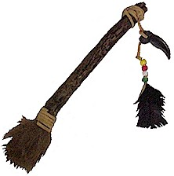
Make a “Talking Stick” to remind everyone to take turns talking. The idea is that a boy can only speak when he is holding the “talking stick” – and everyone must take turns with it.
Have a workshop to make gifts for family or to give to a local charity. Some ideas would be: making play-doh for young children,(Cub Grub section), bath salts for women, pencil holders and/or desk sets for men. (Instructions under Value Related Activities in Oct. Baloo) You can get lots of other ideas in the How To Book – or check to see what suggestions the charity might have. Boys can also make Holiday cards and wrapping paper.
Manners:
Alice, Golden Empire Council
Having the cubs work on their Manners and earning the new Good Manners Belt Loop and, maybe, the Pin, too, would be a great way to have them learn and show respect. Alice
Role Play Good Manners on the phone -
Using phones (not plugged in or turned on), let boys role play how to use the phone, how to ask for a friend, how to politely handle a wrong number, how to answer the phone.
Manners Role Play @ the Door
Role play answering the door – if you know who is there and you have been asked to answer it. How do you greet a friend? How do you greet an adult? How do you let a parent or family member know someone is there to see them? And after a friend’s visit, role play the right kind of comment: Say “Thanks for coming.” And if you are the friend who came to visit, say something like, "Thanks for having me."
Manners Role Play with a Gift
Talk about how we can make someone feel good by accepting a gift graciously. Role play some ways to show your appreciation? "Thank you," "it's beautiful!", "It's just what I wanted," "I love it!" Even if you aren’t thrilled with the gift, you can say something like “Thank you for thinking of me.” Another way to show gratitude is to send a thank your card. Ask each boy to think of something he has been given or something that has been done for him – then each boy can use construction paper, markers, stickers, etc. to make a Thank You card for that person.
Tell the story of Mansay, The Pebble Shooter.
Point out that this story is from Laos and that many of our best stories come from other cultures. Make sure the boys understand the moral of this story and how it relates to Good Manners and showing respect for others by letting everyone have their say, and not “hogging” the conversation. And if the boys are really clever, they might be able to figure out how to use this story as a puppet show or skit!
"Pack Activities" are in the Pack and Leader Hints Edition Dave

DEN MEETINGS
Wendy, Chief Seattle Council
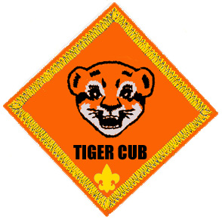

TIGER
Tigers are working on Ach. #2 and Ach. #4 this month.
Meeting #7
Do: Ach. #4F Respect Character Connection
Ach. #2G Police or Fire Station Field Trip
Verify Ach. #4F Meal Conversation
Meeting #8
Do: Ach. #4G Field trip to newspaper, radio,
or TV station
Media/Communication Ideas
Activities:
El. 20 Public Service Announcement. Have the boys write and perform a public service announcement at pack night.
Videotape a skit or demonstration for pack night.
How To Make Your Own Newspaper
Baloo's Bugle, December 2004
Get started: Think of a name for your newspaper and decide which stories to include.
Gather the Facts: Interview people who have information. Visit the location where the story is taking place.
Write the story: Make an outline or rough draft first--all news reporters do that. Put the basics of WHO, WHAT, WHERE, WHEN, WHY, and HOW at the beginning. Write a headline that tells the story in a few words. (Don't insist too much on correct writing style. If the boys enjoy writing, encourage them!)
Set up Pages: Set the words in columns, if you wish. Most papers use a column format.
Put it together: Begin to paste up the paper with articles and illustrations. Use glue stick or clear tape to hold in place.
Print your newspaper: Make one photocopy. If it looks good, make as many copies as needed. If dark lines show, use liquid correction fluid to cover. Make photocopies from corrected version. Deliver the newspaper to readers. (Have enough copies made for each boy in the pack. Some copying companies will give Scouters a discount. Others will give you a discount if you make at least 1000 copies, which is not difficult to do with the pack bulletin.
DEN NEWSLETTER
Baloo's Bugle, December 2004
The den’s newsletter can be whatever the boys want to make it. Ask each boy to write at least one story for the paper. Here are a few possible topics:
  - A report on a recent den field trip.
  - Brief impression of a recent den or pack event.
  - Directions for playing the writer’s favorite game.
  - A report on an interview with the den leader.
  - A one- or two-paragraph description of each den member written by himself.
  - An interview with the den chief, who tells why he likes Boy Scouting.
  - A story on what the den plans to do for the Blue and Gold Banquet.
If you have an artist in the den, he may want to draw a cartoon or some other illustration. A boy interested in photography might choose to take photos of den activities.
Recruit boys and parents who have access to a computer to help produce some or all of the newsletter electronically using graphics and word processing programs.
Printing
Southern NJ Council
You can make designs and use them over and over to make greeting cards, gift wrapping, banquet programs and menus and stationary. Cover the table where you are working with newspapers because you must press down hard when printing to make a clear print. Design will print the reverse of what is seen on the block so if there is lettering or a design that has a right or left, it should be glued to the block backwards. Here are some ideas -
Potato Printing
Potatoes make good block prints, if used right away. They are easily carved, but last only a day or two. One potato makes at least two designs.
- Cut potato in half with one straight cut
- Blot the surface to remove as much moisture as possible.
- With an orange stick or pencil, trace design on potato.
- Cut away all parts without any design on them. Cut outline at least 1/3" deep to provide a good printing surface.
- Again remove additional moisture.
- Place paper to be printed on a pad of newspaper or a water-soluble printer's ink on design.
- Transfer potato design onto paper. Press had but do not move the potato or the design will smudge.
Potato Stamp Tip
Baloo's Bugle, December 2004
You can make the potato stamp in a couple of ways. One way is to cut the potato in half and carve a design on one-half. This should be a raised design, so you cut away what you do not want to see. There is a safety issue here of using knives. Plastic ones work if the potato is a softer variety.
Another way to potato stamp is to use cookie cutters. You push the cookie cutter all the way into the potato and cut off the excess with a butter knife. This can make better shapes and is a lot safer for the Cubs.
Leaf Printing
Trees shrubs, flowering plants and weeks offer an infinite source of leaf designs for printing. Use an inked stamp pad, place leaf, veins side down on pad. Lay a piece of newspaper over leaf and rub fingers over it. Remove leaf and place it on surface to be printed. Pace clean newspaper on tap and rub.
Crayon Rubbing
Place leaves veins side up on paper or textured surface, such as burlap, wood or leatherette. Cover with sheet of plain paper and rub crayon held sideways. Outlines and veining of leaves will stand out.
Printing With Sponges
On a dry plastic sponge draw or trace your design. Cut cleanly along the lines. Place poster paint in a dish, brush the paint onto the flat part of the sponge and stamp it on your paper.
Printing With Odds And Ends
Interesting and easy prints can be made with odds and ends from around the house. You will be surprised with the patterns you can make by pressing the bottom of a spice can or a bottle on an ink pad and then stamping your paper. Other things such as:
Matchbox Half an Onion Your hand
Buttons Coins Kitchen Utensils
Fork Toothbrush
Crafts:
MEMO HOLDERS
Southern NJ Council
Craft Stick –
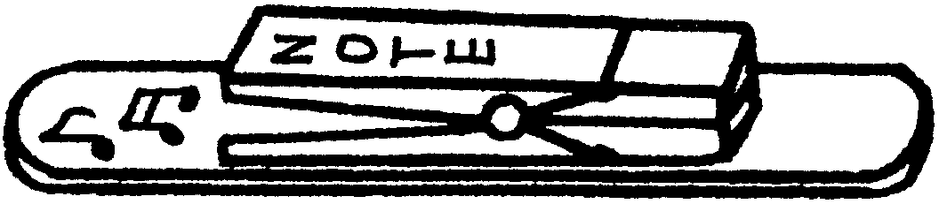Materials: One large craft stick (tongue depressor); 1 spring-type clothes pin; Markers; Glue; Strip magnet.
Directions:
- Glue a clothespin near the end of the craft stick.
- Decorate with markers.
- Attach magnet on back.
Paint Stick
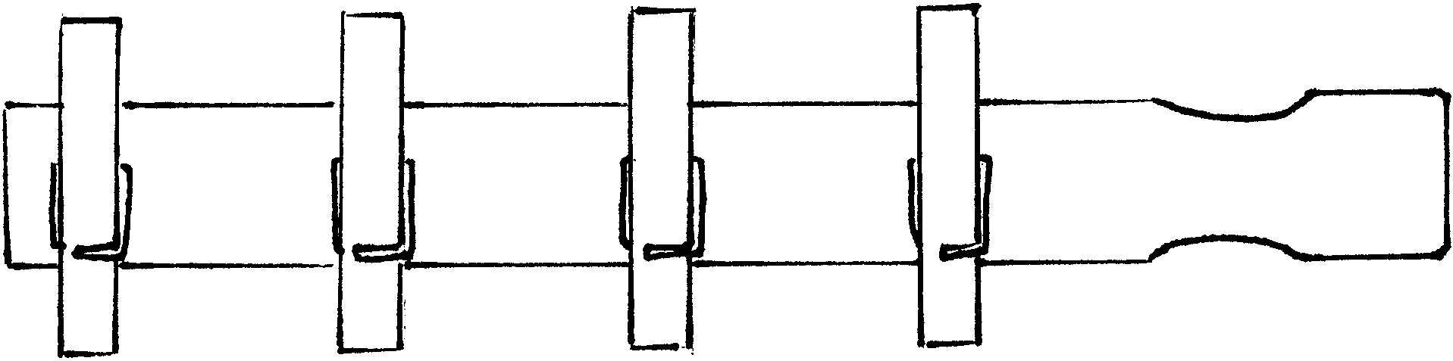Materials: One paint stick (for quart or gallon can, about 14” long); Several spring-type clothes pins, Paint; Permanent markers; Glue; Strip magnet.
Directions:
- Paint the paint stick. Use any wood or acrylic paint.
- Attach clothespins. If desired, paint or decorate the clothespins before you glue them on the paint stick.
- Decorate with markers
- Attach magnet strips on the back of the paint stick.
Paper cup Telephones
National Capital Area Council
Make a small hole in the base of each cup. Insert one string from the outside to the inside of each set of cups and secure it with a piece of tape. Let the Cub and his partner talk to each other. Be sure to keep the string taut but don't pull so hard that the string comes untaped. Suggest they have a code word to indicate they are done talking, so each knows when to change from listening mode to speaking mode.
Family Communications Center
Baltimore Area Council
Create a message center using a wooden coat hanger and metal cup hooks.
Screw the cup hooks into the bottom of the wooden coat hanger, spacing them equal distances and using one for each member of the family.
Decorate the hanger any way you want, using Feathers, ribbon, seeds, dried flowers, material, etc.
Old Fashion Telegraph Set
Baltimore Area Council
Supplies: 2 wood blocks 2 nails
3 screws 1 dry cell battery 2 wires
2 metal tin can strips (Note: These cannot be from an aluminum can. Test it with a magnet first.)
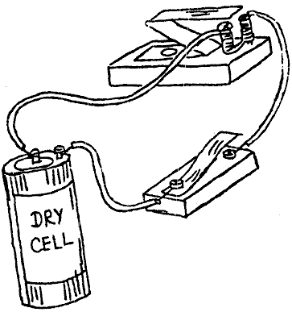
- Using supplies, assemble, as illustrated.
- Bend the metal “Z” (sounder) so that it attaches itself to the nails when the key is pressed.
- After the boys have completed their old fashion telegraph set, they can have fun sending messages to each other using the Morse Code chart below.
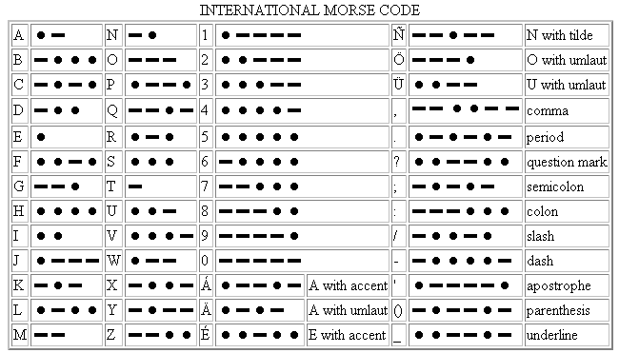
Historical Note: Samuel Morse became interested in telegraphy in 1832, and worked out the basics of a relay system in 1835. The equipment was gradually improved and was demonstrated in 1837. Morse developed “lightning wires” and “Morse code”, and applied for a patent in 1840. A line was constructed between Baltimore and Washington and the first message, sent on May 24, 1844, was “What hath God wrought!”
On May 24 2004, the 160th anniversary of the first telegraphic transmission, the International Telecommunications Union added the “@” (the “commercial at” or “comma at”) character to the Morse character set and is the digraph “AC” ( probably to represent the letter a inside the swirl appearing to be a C).
It is notable since this is the first addition to the Morse set of characters since World War I probably, due to its popularity in e-mail addresses.
Games:
Noodlegrams
Simon Kenton Council
In a saucer place a tablespoonful or more of uncooked noodles. Each person must try to compose a ten word message out of the alphabet noodles. This could be done in couples or singly as gathering time activity.
Jigsaw Puzzle Ads and Comics
National Capital Area Council
Cut up full page color pictures from magazines. Have at least one puzzle per scout. As each scout arrives, hand him one to put together. If time permits, let the scouts exchange puzzles.
Save one week of comics from the local paper. Cut up each comic strip, panel by panel and mix them up. Give each person a panel as they arrive. Each participant must find the other panels and place them in the correct order. Have the comic strip panels ready for inspection, or place the panels at a designated place before the meeting. The order of each comic strip may be peculiar. Lots of surprises await you.
Newspaper Boy
Baltimore Area Council
This is played with at least eight players and folded newspaper. One player is designated “It” and gets the newspaper. The other players form a circle holding hands. “It” walks slowly around the outside of the circle, chanting: “Extra! Extra! Read all about it!”
While chanting, "It" drops the newspaper behind a player in the circle. That player then picks up the paper as quickly as possible and chases “It” around the circle. “It” tries to get back to the empty spot in the circle left by the chaser before being tagged. If “It” succeeds, the chasing player then becomes “It.”
Songs (Tiger E6):
Commercial Mix-Up
York Adams Area Council
Tune: Farmer in the Dell
Last night I watched TV, I saw my favorite show
I heard this strange commercial, and I can't believe it's so
Feed your dog Chiffon. Comet cures the cold
Use S-O-S pads on your face to keep from looking old.
Mop your floors with Crest. Use Crisco on your tile
Clean your teeth with Borateem, it leaves a shining smile
For headaches take some Certs. Use Tide to clean your face
And do shampoo with Elmer's Glue, it holds your hair in place
Perhaps I am confused, I might not have it right
But one thing that I'm certain of, I'll watch TV tonight!
THE MORE WE COMMUNICATE
Southern NJ Council
Tune: The More We Get Together
The more that we communicate,
Communicate, communicate,
The more that we communicate,
The happier we’ll be.
Then you know what I know,
And I’ll know what you know.
The more that we communicate,
The happier we’ll be.
By telephone or e-mail,
By signal code or snail mail,
The more that we communicate,
The happier we’ll be.
Communication
Baltimore Area Council
(Tune: You Are My Sunshine
Communication gets information,
Across to people both far and near.
May be letter, a TV program,
Or a radio that you hear.
Communication is conversation
Between two people or maybe more.
By telephone or walkie-talkie, or a
Neighbor standing at your door.
Communication can cross the nation,
Or cross the ocean by satellite.
The world seems smaller, news travels
Quicker than we ever dreamed it might.
Treats:
Edible messages:
Wendy, Chief Seattle Council
- Use letter-shaped cereal to make words and sentences, then you can eat them.
- Spread peanut butter or frosting on graham crackers, top with words made from letter cereal, and eat.
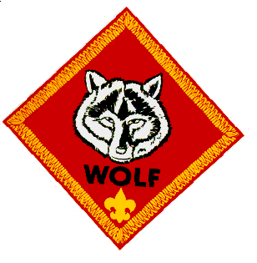

WOLF
Wolves are working on Ach. #6, Ach. #7, Ach. #8,
and Electives #9 and #17 this month.
Meeting #7
Do: Ach. #7a Respect Character Connection
Ach. #7b Discuss how land, water, and air get dirty with your family.
Ach. #7c Recycling.
Ach. #7d Litter collection.
Ach. #7e Conservation stories.
Ach. #7f Saving energy.
El. #9b,c Finish picture frame.
El. #17b,c Wrap the frame, and tie a string or ribbon around it.
El. #17a Overhand and Square Knot.
Verify Ach. #4e Chore Chart, and
Ach. #7e Conservation Stories.
HA: Ach. #4e. Chore chart (if not completed).
Ach. #6b Start a collection.
Ach. #8c-e Cooking.
Note: The only way the boys can complete Ach. #7a and #7b is if their parents attend a den meeting. These achievements should be discussed with the boys’ families.
Meeting #8
Do: Ach. #8a Food Pyramid.
Ach. #8b Meal Planning.
Ach. #6a Positive Attitude Character Connection.
Ach. #6c Collection show & tell.
Verify Ach. #4e Chore Chart and Ach. #8c-e Cooking.
Note: The only way the boys can complete Ach. #6a is if their parents attend den meeting. This achievement should be discussed with the families.
Conservation Ideas
Science Articles (conservation stories for Ach. #7e):
Here are two sources of stories:
http://www.sciencenewsforkids.org/pages/search.asp?catid=7
http://kids.nationalgeographic.com/kids/
Games
Litter Sweep Relay
Baltimore Area Council
Object: To be the first team to make a clean sweep of all the litter.
Materials: A broom for each team and a small pile of dry trash: soda cans, paper, small plastic bottles, etc.
How to play: Divide into two teams and give each team a broom and a small pile of dry trash - soda cans, paper, small plastic bottles, etc. At the start signal, the first boy on each team sweeps the trash to a certain point and back. The next team member then takes over, and so on until all have run. The first team finished wins. If a boy loses any trash he must sweep back and pick it up.
Above and Below
Longhorn Council
The Idea of the Game: After some discussion about pollution and what are ways we have polluted out environment, you can play this game where you come up with ways we have polluted our environment and ways we are trying to save our environment and are they above or below (meaning is it visible to us).
Examples:
Pollution: litter on highways - above,
Garbage on the floor of the sea - below,
Saving our environment: Planting a tree – above
Equipment: None
Formation: Circle
Directions:
- Arrange the players in a circle.
- Call out ways we pollute the environment or save our environment that are found above or below.
- When you call something that signifies above, the players stand; if below, they sit down.
- Failure to do this eliminates the players who miss.
- The list of things to be named should be carefully worked out in advance to keep the game going smoothly.
Earth, Water, Air and Fire
Longhorn Council
Equipment: 1 bean bag
Formation: circle
- The Pack or Den members sit in a circle with one Cub in the center holding the beanbag.
- The Cub in the center throws the bag at someone and shouts 'Earth!’ 'Water!’ 'Air!' or 'Fire!’
- If it is 'Earth', the chosen Cub must reply with the name of an animal, before the center Cub counts to ten.
- If it is 'Water!’ he must think of a fish,
- If 'Air!' - a bird and
- If 'Fire' - He whistles for the Fire Engine.
- Can be done with Paper, Plastic, and Metal (or Aluminum). Boy names something made from that material that can be recycled. Use Rock as the ringer, boy can say, "Thud" or some other sound he thinks a rock makes when it lands.
Note: Once a creature has been named, it may not be called again. If the Cub cannot reply in time, he changes places with the thrower.
QUIET RECYCLE ACTIVITY
Circle Ten Council
Unscramble our recycling world. Have the boys unscramble the word in the highlighted box below to spell how our state will look if we all recycle our waste.
Litter Reduce Cardboard Compost Reuse
Landfill Recycle Ecology Resources Glass
Aluminum Newspaper
1. ecreyle ___ ___ ___ ___ ___ ___ ___
2. tltrei ___ ___ ___ ___ ___ ___
3. locyoge ___ ___ ___ ___ ___ ___ ___
4. drecue ___ ___ ___ ___ ___ ___
5. erruosecs ___ ___ ___ ___ ___ ___ ___ ___ ___
6. bocadrdra ___ ___ ___ ___ ___ ___ ___ ___ ___
7. lsgsa ___ ___ ___ ___ ___
8. pcmoots ___ ___ ___ ___ ___ ___ ___
9. umualimn ___ ___ ___ ___ ___ ___ ___ ___
10. uesre ___ ___ ___ ___ ___
11. apwreesnp ___ ___ ___ ___ ___ ___ ___ ___ ___
12. fladlinl ___ ___ ___ ___ ___ ___ ___ ___

BONUS word _____ _____ _____ _____ _____
Bonus word answer: CLEAN
Other sources -
- 1999 Santa Clara Pow Wow Book “Pollution Solution” p. 6-7; 16-17. http://www.macscouter.com/CubScouts/PowWow99/SCCC/April99.pdf
- ’01 Baloo’s Bugle “Save it for Us” p. 13-15. http://usscouts.org/usscouts/bbugle/bb0103.pdf
- ’01 Santa Clara Pow Wow Book “Save it for Us” p. 6; 11; 16-17. http://www.macscouter.com/CubScouts/PowWow01/April01.pdf
Crafts & Activities
Conserve Energy Door Hanger
Great Salt Lake Council
Enlarge the elephant and copy it on card stock, color and hang on doorknobs to remind people to turn off the lights.
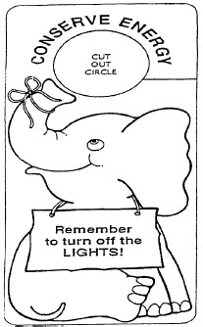
Encourage boys to come up with their own ideas for pictures for the door hangers. CD
Other sources -
- ’04 Baloo’s Bugle “Cubservation” p. 10. http://usscouts.org/usscouts/bbugle/bb0403.pdf
- 1999 Santa Clara Pow Wow Book “Pollution Solution” p. 19-26. http://www.macscouter.com/CubScouts/PowWow99/SCCC/April99.pdf
- ’01 Baloo’s Bugle “Save it for Us” p. 6-10. http://usscouts.org/usscouts/bbugle/bb0103.pdf
- ’01 Santa Clara Pow Wow Book “Save it for Us” p. 21-25.. http://www.macscouter.com/CubScouts/PowWow01/April01.pdf
Snacks
Incredible Edible Landfill
Our Special Thanks to:
Maurita Hudson, Educator
Dearborn County Solid Waste Management District
Aurora, IN
You should copy this picture and enlarge to full page.
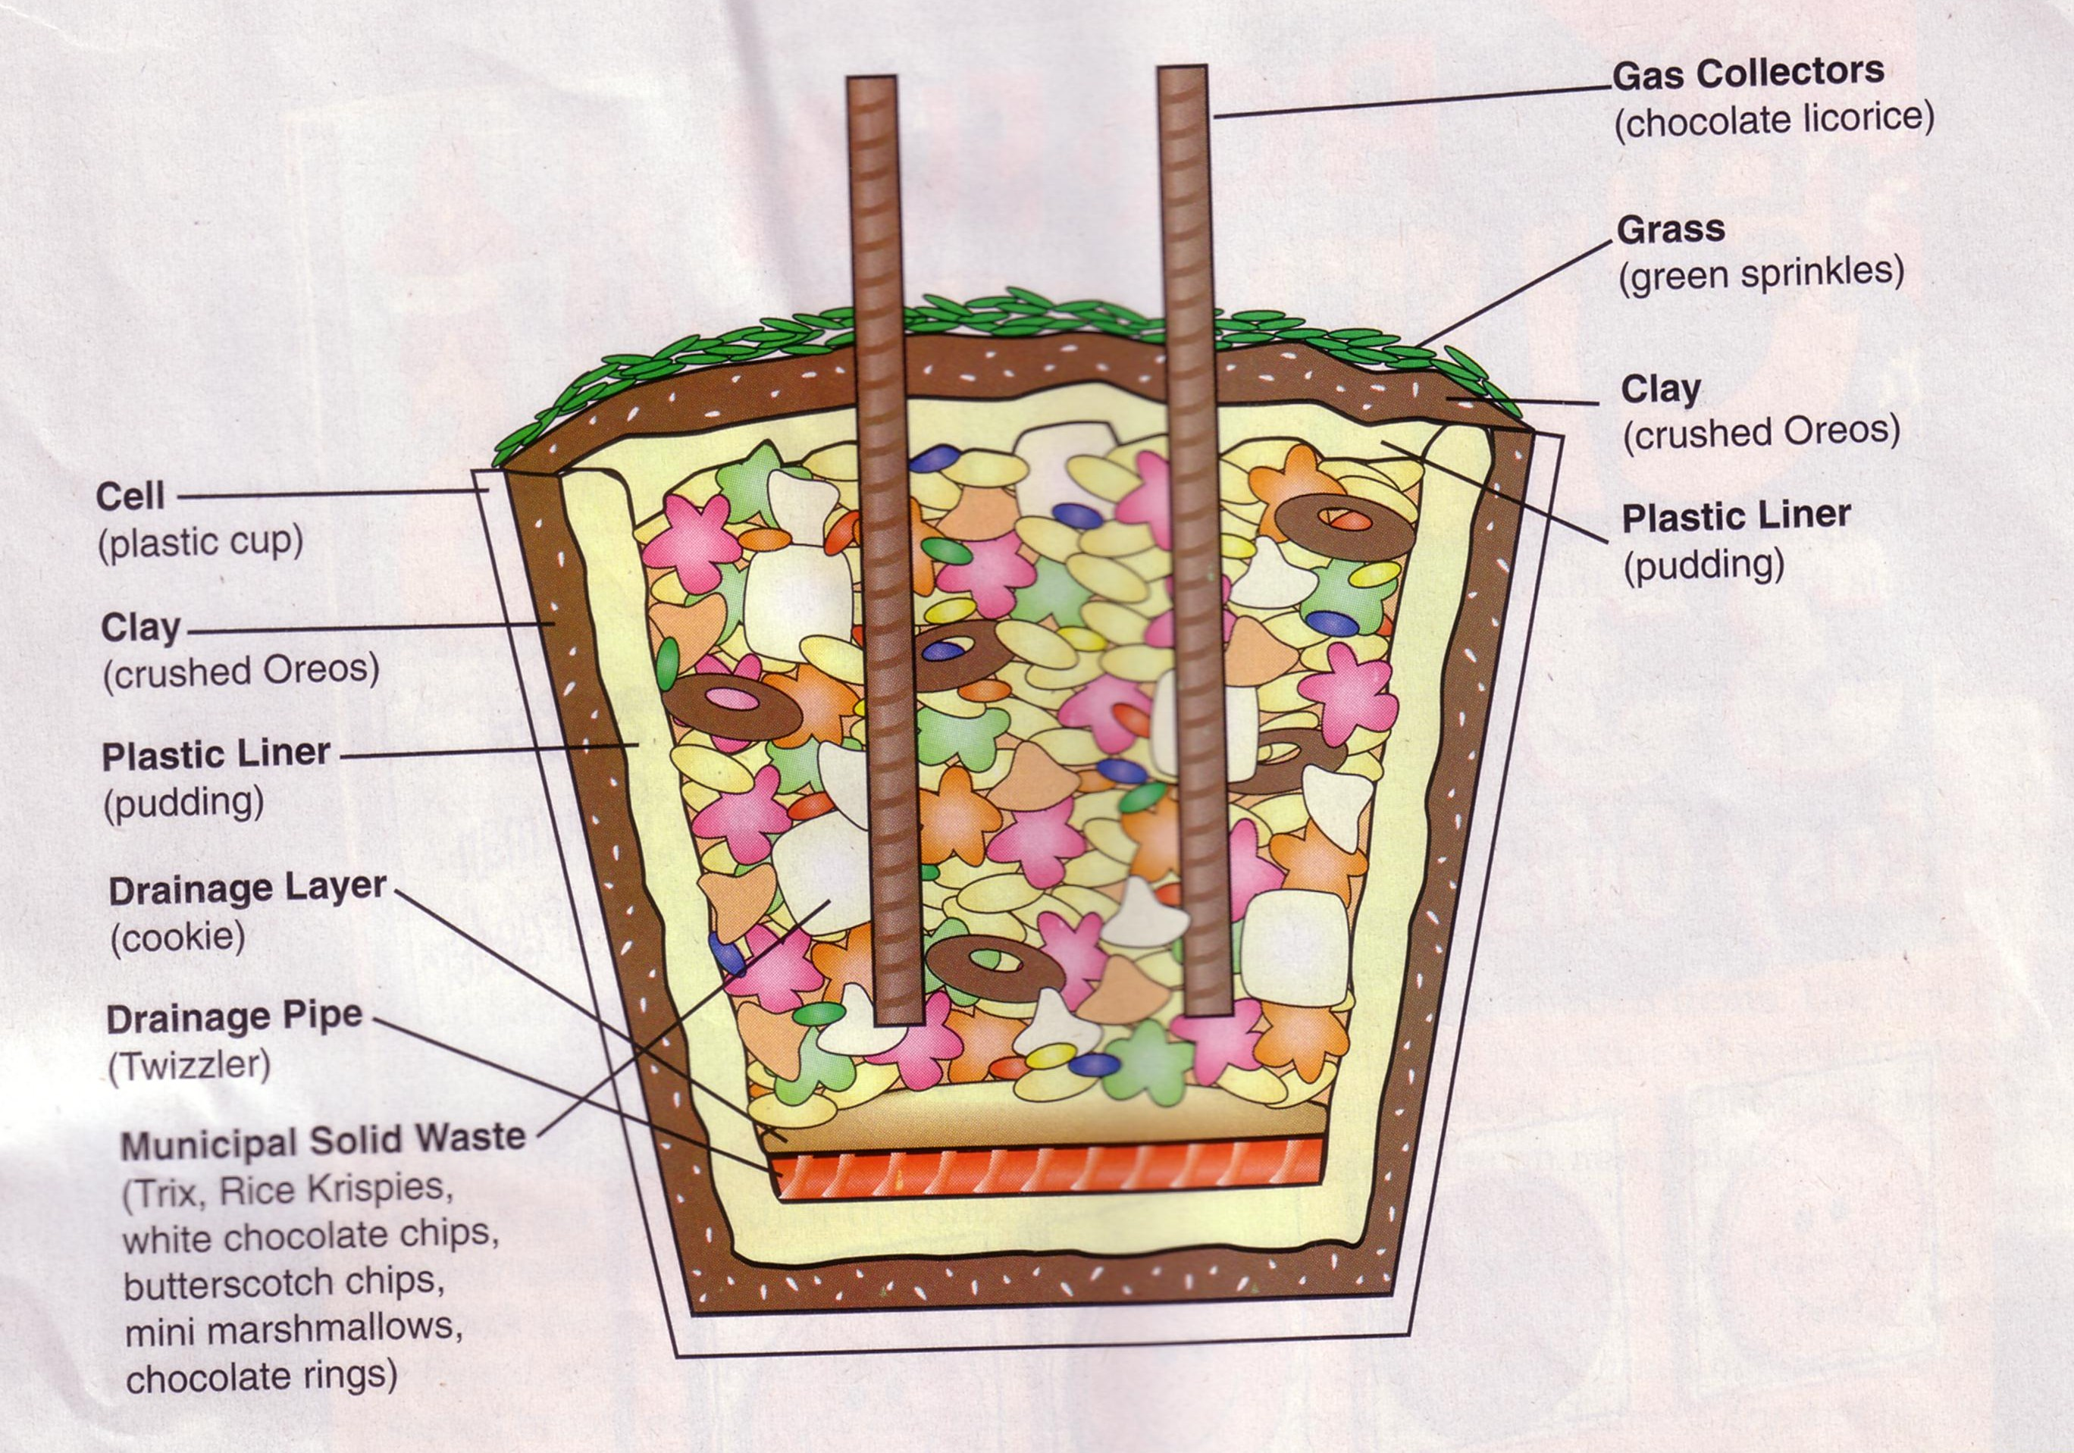
Materials
Base layer
Plastic cup or container"
1 tsp. Oreo cookie crumbs
2 tsp. vanilla pudding
Two 4" Twizzlers®
One shortbread cookie
Municipal waste (middle layer)
1 tsp. Trix® cereal
2 tsp. Rice Krispies® cereal
1 tsp. white chocolate chips
l tsp. butterscotch chips
Six mini marshmallows
Four chocolate rings
1 tsp. mini M&M's®
Chocolate syrup
Final Cap (top layer)
2 tsp. vanilla pudding
1 tsp. Oreo cookie crumbs
1 tsp. green sprinkles
Two 4" chocolate licorice pieces
*Designer used clear Solo® cups.
Instructions
Add each ingredient in order listed to plastic cup.
The layers of a landfill are described below.
Base layer
Layer 1 (cell): Landfills range in size from four to six acres of land. The area, or cell, must be free of debris and able to hold the weight of the landfill mass. This is represented by the plastic cup.
Layer 2: This layer is three feet of clay which prevent fluids from seeping out of the landfill. This is represented by pressing 1 tsp. of Oreo cookie crumbs firmly into bottom of cup.
Layer 3: This layer is a thin liner of plastic which is designed to prevent leaks in the ground beneath the landfill. This is represented by adding 2 tsp. of pudding.
Layer 4: These are pipes that make the leachate collection system. They collect leachate which is a liquid that is squeezed out of the garbage leachate then travels to a treatment pond. This is represented by laying two Twizzlers across pudding.
Layer 5: This is a drainage layer that protects the pipes from being damaged. This is represented by laying the shortbread cookie on top of the Twizzlers. (Note: No trash has been added yet. Layers 1-5 are designed to protect the environment by disposing of garbage safely.)
Municipal waste (middle layer)
Municipal solid waste is all of the garbage from peoples' homes and businesses.
Layer 6: This layer is composed of the following:
- Organic waste (Trix) is yard waste and food scraps.
- Paper (Rice Krispies) consists of cardboard, newspaper, and, packaging products.
- Plastics (white chocolate chips) include milk and soda bottles and food containers.
- Glass (butterscotch chips) range from bottles to old building windows.
- Metals (mini marshmallows) include tin and aluminum cans and appliances or sheet metal.
- Tires (chocolate rings) include those from cars and trucks.
- Other garbage (mini M&M's) contains old toys, shoes, and clothing.
This is represented by adding 1 tsp. Trix, 2 tsp. Rice Krispies, 1 tsp. white chocolate chips, l tsp. butterscotch chips, six mini marshmallows, four chocolate rings, and 1 tsp. mini M&M's. Spread evenly.
Layer 7: This layer is the leachate that forms. It seeps through all of the layers to the pipes which filter the liquid out of the landfill. This is represented by squirting chocolate syrup around the edge of the cup.
Final Cap (top layer)
This outermost layer prevents rainwater from entering the landfill and keeps gases from leaving and polluting our air.
Layer 8: This layer is the top plastic barrier that seals the landfill. This is represented by adding 2 tsp. of pudding.
Layer 9: This layer is five to seven feet of soil. This is represented by sprinkling 1 tsp. of Oreo cookie crumbs onto pudding.
Layer 10: This layer is grass which prevents soil erosion. This is represented by adding 1 tsp. of green sprinkles.
Gas collectors. These pipes are placed in the closed cell and act as methane gas collectors. They prevent fires by collecting the gas produced from decaying trash. This is represented by inserting two chocolate licorice pieces vertically into the cup.
Maurita was kind enough to share some secrets:
- The Solo cups she uses are 9 or 10 oz ones with hard plastic side. Very wide at the top.
- She, also, told me to keep talking during the assembly. Ask boys what impermeable, leachate, organic, perforated mean Start a discussion about what can become leachate. She says these usually get to be fun Ask them what some of the items represent before you tell them (e.g. ask what the chocolate cereal rings look like (tires))
DIRT PIE
Circle Ten Council
Ingredients
1.25# package Oreo's
1/2 stick margarine
8 oz cream cheese
1 cup powdered sugar
3.5 cups milk
2 sm. boxes instant vanilla pudding
12 oz Cool Whip
Directions
- Crush Oreo's until fine.
- Cream margarine, cream cheese and powdered sugar together.
- Mix milk and pudding and combine with margarine mixture.
- Mix well, and then add Cool Whip.
- Thoroughly clean out a new plastic flowerpot with soap and hot water.
- Alternate layers of Oreo crumbs and pudding mixture in the containers
- Have Oreo's on both the bottom and top layers.
This cake looks especially good if you add gummy worms for special effect.
Food Ideas
Taco Tie Slide:
Wendy, Chief Seattle Council
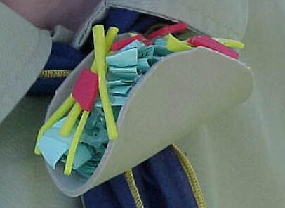
Materials
4" Tan Craft Foam
Red Craft Foam
Yellow Craft Foam Green Paper
PVC ring
Hot Glue
Scissors
Directions
- Cut 4" diameter circle from tan craft foam for taco shell.
- Cut thin strips of yellow craft foam for shredded cheese.
- Cut irregular shapes of red craft foam for tomato.
- Tear green paper into irregular shapes and wad up for lettuce.
- Fold taco shell in "U" shape.
- Using hot glue, attach cheese to bottom, then tomato, and finally lettuce on top.
- Make sure sides of taco are held in place, if not put on more hot glue.
- Hot glue a PVC ring to the back.
Bacon & Eggs Tie Slide:
Wendy, Chief Seattle Council
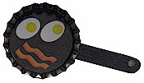
Materials
Bottle Caps
Can't find classic bottle caps??
Go to MakingFriends.com and you can buy them for less than 10 cents apiece. Unbelievable!! Of course, I never thought about buying crickets either until my daughter adopted an Anole CD
Bacon & Eggs
Scissors
Paint & Brush
Tacky Glue
1/2 Mini Craft Stick
3/4" PVC pipe about 1/2" long (for loop)
Low Temp Hot Glue Gun and Glue Sticks
Instructions:
- Have the boys draw bacon & eggs (or pancakes or ... ) on piece paper that will fit in the cap.
- You can cheat here a little. Click this link
- Glue the picture to inside of bottle cap.
- Break mini craft stick in half.
- Paint black to look like a pot handle.
- Glue to back of bottle cap.
- Glue on a PVC pipe
Collection Ideas
Collecting
Denver Area Council
All kinds of collections can be found in boys' pockets! Collecting is a very big part of every boy's life!
Sports cards
Rocks
Star Wars items
Patches
Stamps
Coins
The list could go on and on. The Cub Scout program encourages collecting: Wolf trail: Achievement. 6. ‘Start a Collection’ Bear trail: Elective. 22. ‘Collecting Things’ Webelos: wood samples, insects, rocks and minerals. You could take your den on field trips to special places to obtain information about collecting.
- Rock quarry: rocks, gems, minerals
- Butterfly Pavilion: insects, butterflies
- Sports groups: sports cards
- Scout Service Center: patches
- Post Office: stamps
- Federal Mint: coins
Other ideas for collecting: Take a hike with a purpose. If you can’t collect the actual items, then bring along a camera to take pictures of the items. The pictures could be labeled and put inside an album. Check your Boys’ Life magazine – there are lots of suggestions for collections.
- Internet – surf the net for suggestions on collections.
- Collector’s exhibits – family members – check out your attic or basement.
- Have fun with collections – you never know when it might turn into a lifelong hobby or occupation.
Games
Kim’s Game
Baloo's Archives
Modeled after the tests of Kim in the Rudyard Kipling book, this game has many variations, each of which helps hone boys’ memory and powers of observation.
Materials:
Tray,
cloth cover or trash bag,
10 to 20 different common objects, (For working with collections, make the items all part of a collection - e.g. different matchbox cars, computer items, shells and beach items, travel souvenirs, baseball memorabilia.)
Scorecard and pencil for each player
To Play:
Arrange the objects in an orderly fashion on a tray or table.
Keep the objects covered until the game begins, and
Then have the players study the objects silently for one minute. NO WRITING AT THIS TIME.
Cover the objects again, and
Each boy now writes down the names of as many objects as he can remember. Boys can compete individually or work as teams. Set a time limit.
Hidden Treasures
Sam Houston Area Council
Before the pack meeting or den meeting, place several small items in a cloth bag or a box with a hole in the side for a hand to reach in and feel the items. Items could be marbles, keys, paper clips, comb, etc… (Difficulty should depend on Scout’s age.) You could have several different “collections” if you have a large pack. As the Scouts arrive, direct them to the different stations and tell them the items inside the bags/box are items you might find in a Cub Scout’s pockets. Can he guess them without seeing them? A small pad of paper and a pen next to the bag/box would help them write down their guesses.
Who Collects What?
Catalina Council
1. Rock Hound A. Stamps
2. Folk Singer B. Recipes
3. Numismatist C. Times Table
4. Ham Radio Operator D. Coins
5. Cook E. Old Furniture
6. Lexicographer F. Call Numbers
7. Philatelist G. First Editions
8. Antique Collector H. Ballads
9. Railroad Buff I. Obsidian
10. Book lover J. Words
Answers: 1-I, 2-H, 3-D, 4-F, 5-B, 6-J, 7-A, 8-E, 9-C, 10-G

More Ideas:
- ’09 Baloo’s Bugle Pockets p.12-13; 37-39. http://usscouts.org/usscouts/bbugle/bb0908.doc
- ’00 Santa Clara Pow Wow Book “Getting to Know You” p.1;4. http://www.macscouter.com/CubScouts/PowWow00/Sept00.pdf
- ’04 Baloo’s Bugle “Cub Scout Collectors” p.15-16. http://usscouts.org/usscouts/bbugle/bb0410.pdf
- Marble Roll Relay: http://familyfun.go.com/games/indoor-outdoor-games/game/ff1107-roll-out-the-marble/
Activities
Show-n-Tell
Southern NJ Council
Yeah, I know. It sounds like something for a group of kindergartners. But really, this works too. We've talked before about how difficult it is for people to speak in front of others so you know this helps them warm to the idea. And, believe it or not, this is also a fun thing to do. (I know, because I sat through just the same thing when my son was in Cub Scouts. The boys really enjoyed doing it and the parents and families that "came out to the program" thought it was really neat too. And as I recall, the parents had to bring in and talk about their collections, too.
PACK FAMILY HOBBY DISPLAY
Southern NJ Council
Have a family hobby corner at the pack meeting. Ask each family to bring a sample of what they collect as a family or things that represent their hobby. Families who like baseball can bring baseball equipment, uniform, baseball cards, photos and maybe some trophies. Families who like movies can bring movie posters and movie paraphernalia including popcorn! Families who collect seashells can bring some in a box. It doesn't have to be a "formal" hobby - it's something a family does together. How about a family who buys T-shirts where they go? Set a time during the meeting for families to go around and admire each other's hobby. Family members can take turns staying at the "booth" to explain about the hobby
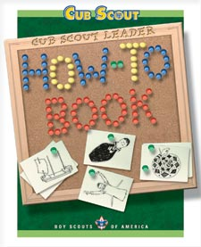
Commissioner Dave
The How To Book has lots of information on collections -
Leaf Collections, p. 4-11
Collecting Rocks and Minerals, p. 4-14
Collecting Seeds, p. 4-6
Collecting Shells, p. 4-16
Collecting Insects, p. 4-17
And an Insect House - p. 4-18
More Ideas:
’09 Baloo’s Bugle Pockets p. 30-36. http://usscouts.org/usscouts/bbugle/bb0908.pdf
’00 Baloo’s Bugle Pockets p. 9-11. http://usscouts.org/usscouts/bbugle/bb0008.pdf
’04 Baloo’s Bugle “Cub Scout Collectors” p.11-13. http://usscouts.org/usscouts/bbugle/bb0410.pdf
Crafts
Collection Box:
Paint an egg carton. Decorate with ribbon, stickers, and markers if desired. Store tie slides, seashells, rocks, etc. in the box.
Leaf Collection Book:
Using an iron, press fall leaves between 2 sheets of wax paper. (Protect iron by putting clean paper beneath and on top of the wax paper sheets.) Assemble into a book.
Felt Patch Holder:
Tacky glue ribbon to the two long edges, and one short edge of a felt rectangle. Wrap the un-ribboned edge around a hanger, and hot glue. Pin patches onto the felt. (Variation of design under Ach. #6b in the Wolf Book.) The beauty of this patch holder is that it can hang in a closet.
Snacks
Chocolate-Peanut Butter S’mores Fondue
Sam Houston Area Council
What are S'Mores but a collection of some of our
very favorite things to eat?? CD
Ingredients –
½ cup milk
1 2/3 cup (11 oz pkg) peanut butter and milk chocolate morsels
1 jar (7 oz) marshmallow crème
1 cup graham cracker crumbs
8 Granny Smith apples, cored and sliced
Directions –
- Heat milk in medium, heavy-duty saucepan over medium-high heat until hot (do not boil).
- Reduce heat to low.
- Add morsels; stir until smooth.
- Whisk in marshmallow crème until smooth.
- Remove from heat.
- Pour chocolate mixture into fondue pot or serving bowl.
- Place graham cracker crumbs in a separate serving bowl.
- Dip apple slices in to warm chocolate mixture, and then into graham cracker crumbs.

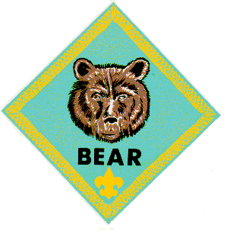

BEAR
Bears are working on Ach. #9, Ach. #11, and Ach. #22d this month.
Meeting #7
Do: Ach. #9a Bake cookies. (Could make Christmas/or Holiday cookies)
Ach. #9b Make snacks.
Ach. #9d Junk food list.
Ach. #9e Make trail mix.
HA: Ach. #9c Prepare part of your breakfast, part of your lunch, and part of your supper.
Note: It might be more fun to spread these out over several den meetings, rather than doing all the cooking in one meeting.
Meeting #8
Do: Ach. #11a Dealing with accidents and fire.
Ach. #11b Water accidents
Ach. #11c School bus accident
Ach. #11d Car accident
Ach. #11g Courage Connection
Verify Ach. #9c Cook part of breakfast, lunch, & supper.
HA: Ach. #11e Home escape routes & fire drill.
Notes from Wendy:
- For Ach. #11a, I have the boys practice wrapping themselves and each other in a blanket or coat to put out the flames, in addition to acting out the other emergencies.
- For Ach. #11b, I have the “victim” kneel on a plastic grocery sack. The “rescuer” holds out a broom, or tosses a rope to the victim, and pulls him to safety. Have the boys exchange rolls, and do the rescue again, so everyone gets a chance to do each role.
Cooking & Food Ideas
See the food ideas in the Wolf section above.
Emergency Ideas
Emergency Preparedness Award
From www.scouting,org and
www.usscouts.org
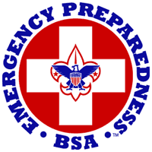
Emergency management, emergency preparedness, and disaster services are common throughout the United States—we take care of each other. By whatever name, these activities encompass mitigation, preparedness, response, and recovery related to any kind of disaster, whether natural, technological, or national security. Emergency preparedness means being prepared for all kinds of emergencies, able to respond in time of crisis to save lives and property, and to help a community—or even a nation—return to normal life after a disaster occurs.
It is a challenge to be prepared for emergencies in our world of man-made and natural phenomena. The Emergency Preparedness BSA program is planned to inspire the desire and foster the skills to meet this challenge in our youth and adult members so that they can participate effectively in this crucial service to their families, communities, and nation.
The emergencies of today's world demand more than ever that our young people and adults be trained as individuals and as units to meet emergency situations. The importance of this training is not new to the Boy Scouts of America, as Scouting has always taught youth to be prepared for all types of emergencies. Since Scouting began in the United States, Scouts have responded to the needs of their communities and nation in time of crisis.
From its beginning, the Scouting movement has taught youth to do their best, to do their duty to God and country, to help others, and to prepare themselves physically, mentally, and morally to meet these goals. The basic aims of Scouting include teaching youth to take care of themselves, to be helpful to others, and to develop courage, self-reliance, and the will to be ready to serve in an emergency.
In addition to the millions of youth and adults who are active members of the Boy Scouts of America, millions of former members were trained in Scouting skills that prepare them for meeting emergencies. They are a built-in source of help to meet the challenge of readiness for any emergency situation. As Scouting units across the country begin planning an emphasis on emergency preparedness, this foundation of former members can be a resource for support—a trained group to help assure a response that will benefit the homes and communities of our nation.
When an emergency occurs, it affects every youth and adult member of BSA in the immediate area, creating the responsibility to respond first, as an individual; second, as a member of a family; and third, as a member of a Scouting unit serving the neighborhood and community. Because of these multiple levels of responsibility, the Emergency Preparedness BSA plan includes training for individual, family, and unit preparedness. Special training in all three areas is a prerequisite for BSA members conducting any type of emergency service in their communities.
Individual Preparedness
The primary emphasis of this initial step in the program is to train members to be mentally and emotionally prepared to act promptly and to develop in them the ability to take care of themselves. Teaching young people to know and be able to use practical survival skills when needed is an important part of individual preparedness.
Family Preparedness
Since family groups will be involved in most emergency situations, this part of the plan includes basic instructions to help every Scouting family prepare for emergencies. Families will work together to learn basic emergency skills and how to react when faced with fires, floods, hurricanes, tornadoes, explosions, warning signals, fallout protection, terrorism attacks, and other emergency situations.
Bear Cub Scout Requirements
- Complete Bear Cub Scout Achievement 11*—Be Ready. The focus of this achievement is the best way to handle emergencies.
- Make a small display or give a presentation for your family or den on what you have learned about preparing for emergencies.
- With your parent or guardian's help, complete one of the following activities that you have not already completed for this award as a Tiger Cub or Wolf Cub Scout:
  - Take American Red Cross Basic Aid Training (BAT) to learn emergency skills and care for choking, wounds, nose bleeds, falls, and animal bites. This course includes responses for fire safety, poisoning, water accidents, substance abuse, and more..
  - Put together a family emergency kit for use in the home.
  - Organize a safe kids program such as McGruff Child Identification program. Put on a training program for your family or den on stranger awareness, Internet safety, or safety at home.
* Achievement and elective numbers could change; the achievement or elective title determines what the requirement is.
A good resource for information is www.ready.gov
When a member has fulfilled the requirements appropriate to his age/program segment, a completed application is submitted to the council. Upon approval, an Emergency Preparedness pin is awarded. The pin may be worn on civilian clothing or on the uniform, centered on the left pocket flap. The award may be earned more than once; for instance, as a young person advances through the ranks and is capable of more complex preparedness activities, but only one pin may be worn. You can get the application at http://www.scouting.org/scoutsource/Media/Publications/EmergencyPreparedness.aspx
See the requirements for Tigers, Wolfs,
Webelos and Leaders to earn the award at http://usscouts.org/advance/EmergPrep.asp
Home Hazard Hunt:
Wendy, Chief Seattle Council
Deliberately set up hazards as listed in Wolf Ach. #9b around your meeting area. Lead the boys around the area, and have them write down all the hazards they can see. Lead them around a second time. Show them all the hazards, discuss them, and how to make things safe.
Fire Safety Ideas
Games:
Fireman Relay
San Gabriel, Long Beach Area, Verdugo Hills Councils
- You will need a set of Dad’s old clothes (or big boots, pants, and suspenders), a bucket and a log for each team.
- Put blue or white crepe paper streamers 2 to 3 feet long in each fire bucket.
- Players form two teams.
- First player puts on a “fireman’s suit” (old clothes) on top of his own.
- He picks up a bucket and runs to a spot about twenty feet away where a log represents a “fire.”
- He pours the “water” (streamers) on the fire, refills the bucket (replaces streamers), and runs back to his team.
- He takes off his “fireman’s suit” and gives it to the next player. The team that finishes first is the winner.
Fireman, Save My Child
San Gabriel, Long Beach Area, Verdugo Hills Councils
- You will need a drinking straw for each player.
- Cut paper (the children) into squares of various sizes (2” to 4” square). Or cut pictures of children out of magazines and newspaper ads.
- The players are divided into two teams.
- Scatter paper squares on a table, about 15 to 20 feet away from the start line.
- Place a container for each team about 10-15 feet from the table (the course is like a triangle).
- On signal, the first player from each team runs to the table with his straw and picks up a square by sucking up the paper against his straw.
- While holding the square this way, each player runs to his respective container and deposits his paper in it.
- If he drops the square on his way, he must stop and pick it up by sucking it up with his straw.
- Run this relay style or set a time limit and let everyone play at the same time. When done count the square pieces in the containers.
Other sources -
- 2005 Baloo’s Bugle “To the Rescue” p. 17-20.http://usscouts.org/usscouts/bbugle/bb0509.pdf
- 2001 Santa Clara “Home Town Heroes” p. 15. http://www.macscouter.com/CubScouts/PowWow01/Nov01.pdf
- 2010 Baloo “Responsibility” p. 14-15.
Fire Fighter Games & Crafts:
Pencil Holder and/or Desk Set
Alice, Golden Empire Council
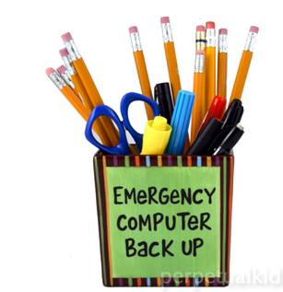
- Pencil holders can be made from any round or square container that is tall enough to hold pencils, pens & scissors – this one is simply covered with wrapping paper or even contact paper, with a cute sign added. But boys could also cover a can or frozen juice container by gluing yarn or even rocks around the outside. If you use yarn or paper, finish with several coats of white glue diluted with water to protect the covering.
- If you want to make a desk set, you can also make small containers to hold paper clips, etc.
- A desk mat can be made of a piece of cardboard covered with matching paper.
- You could also make a matching picture frame, using cardboard and the same covering technique and materials.
Fire- Triangle Experiment
Baltimore Area Council
- Fire requires three things: air, fuel, and heat.
Take away any one and the fire goes out.
- Demonstrate this with a wooden match and bottle.
- Have a Cub Scout (or a parent at the Den Meeting) strike a match (creating heat by friction).
- Let it burn a moment (using oxygen to burn the wood or fuel), and then drop it into the bottle and place his hand over the top. This cuts off the oxygen and the hatch goes out even though there is still plenty of fuel.
- Have a Cub Scout strike a match and dip it into a glass of water. The water cuts off the air and cools the fuel, extinguishing the fire even quicker
Other sources -
- http://www.amazingmoms.com/htm/party_firefighterparty.htm
- http://familyfun.go.com/parties/birthday/feature/famf58birthday/famf58birthday2.html
- Fire Fighter Hat: http://www.makingfriends.com/firemans_hat.htm
Songs
One Dark Night
Tune: "There'll Be a Hot Time in the Old Town Tonight"
Tell everyone we are going to sing the song three times
Once loud
Once at normal volume
Once whispering
However, the FIRE! FIRE! FIRE! , is always yelled at top volume.
One dark night when we were all in bed,
Old lady Leary left a lantern in the shed,
And when the cow kicked it over,
She winked her eye and said:
"There'll be a hot time in the old town tonight.
FIRE! FIRE! FIRE!
Fire Prevention
Baltimore Area Council
Tune: Clementine
Check your hallways, check your closets,
And underneath the stairwell, too.
For if you’ve piled lots of junk there,
A big fire may call on you.
Dirty paint rags, piled up papers,
Frayed extension cords won’t do.
Fire prevention is the answer,
All cub Scouts must follow through.
Prevent Fires
Baltimore Area Council
Tune: Are you Sleeping?
Prevent fires, prevent fires,
Do your part, do your part,
Check your house for hazards,
Check your house for hazards,
You’ll be smart. You’ll be smart.
Hunt for hazards, hunt for hazards,
Clean them out, clean them out.
Help protect your family,
Help protect your family,
Have no doubt, have no doubt.
Treats:
Firehouse Chili Dog Casserole
San Gabriel, Long Beach Area, Verdugo Hills Councils
“It's like eating a chili dog, but with a fork."
Ingredients:
- 8 hot dog buns
- 8 hot dogs
- 1 (15 ounce) can chili
- ¼ cup chopped onion
- 1 tablespoon prepared mustard
- 2 cups shredded Cheddar cheese
Directions
  - Preheat oven to 350°F (175°C).
  - Lightly grease a 9x13” baking dish.
  - Tear up the hot dog buns and arrange the pieces in the bottom of the dish evenly.
  - Slice the hot dogs into bite size pieces and layer the pieces over the buns.
  - Pour the chili over the hot dogs,
  - Sprinkle with the chopped onion,
  - Then spread some mustard over the chili and the onion.
  - Top off with the cheese.
  - Bake at 350°F (175°C) for 30 minutes.
  - Original recipe yield: 6 to 8 servings
Firefighter Chili Cheese Dip
San Gabriel, Long Beach Area, Verdugo Hills Councils
Ingredients:
- 1 (8 ounce) package cream cheese, softened
- 1 (15 ounce) can chili
- 1 cup shredded Cheddar cheese
Directions
  - In the bottom of a 9” microwave safe round baking dish, spread the cream cheese.
  - Top the cream cheese with an even layer of chili.
  - Sprinkle Cheddar cheese over the chili.
  - Heat in the microwave on high heat 5 minutes, or until the cheese has melted.
  - Serve with your favorite chips or vegetables.
Fire Safety Websites:
- For Kids
http://www.usfa.dhs.gov/kids/flash.shtm
- For leaders:
http://www.usfa.dhs.gov/kids/parents-teachers/resources.shtm

WEBELOS DENS

Respect
Joe Trovato,
WEBELOS RT Break Out Coordinator
Westchester-Putnam Council
Have a question or comment for Joe??
Write him at
webelos_willie@yahoo.com
There is an underscore between Webelos and Willie

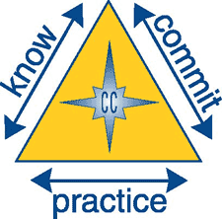
This month’s core value of Respect is important not only for Webelos – boys learning to be young men – but also for adults, who sometimes forget that we serve as examples for the youth. What is respect? Simply put, respect is acknowledging the worth of someone or something. Webelos can show respect by being courteous and showing good manners during meetings. Hopefully, you have established a den code of conduct (if not, this is a perfect time to do so – see the Cub Scout Leader handbook for details). You can tie in respect to the code.
Throughout activities this month, make sure that Webelos become aware of the meaning of respect, why it is important, and have the opportunity, through their activities to practice being respectful. One good place/time is during a flag ceremony. Another is to set some time apart, perhaps at the end of each meeting and ask the boys what interested them about the activity badge? Invariably, some will interrupt or shout out, which will give you an opportunity to focus on a valuable example respect and engage them in conversation. When speaking with family members, friends, other scouts or scout leaders, how do you show respect? How do you listen respectfully? How can you interrupt people and still be respectful? After the conversation, have the scouts discuss how you and they showed respect. Ask them to give examples of situations they have witnessed where people failed to show respect. How does it feel when people listen to you with respect? Have them each list one thing to remember that will help them speak with others and listen respectfully.

Meeting Planner

In December first year Webelos continue work on the Citizenship Activity Badge and Belt Loop. Respect for the flag is a good lesson. See page 15 last month’s den edition of Baloo’s Bugle for information on flag etiquette. They also work on the Artist Activity badge. Perhaps a poster or other art demonstrating respect can be made part of your meeting plans.
Second year Webelos working toward the Arrow of Light, will work on the Readyman Activity Badge.

Gathering
Native American “Talking Stick”
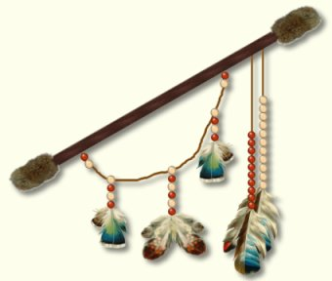
One very good gathering activity that ties into this month’s core value of respect along with Native American lore is to make a Native American “Talking Stick” for use by your Webelos during discussions. The Talking Stick is a tool used in many Native American Traditions when a council is called. It allows all council members to present their Sacred Point of View. The Talking Stick is passed from person to person as they speak and only the person holding the stick is allowed to talk during that time period. Every member of the meeting must listen closely to the words being spoken, so when their turn comes, they do not repeat unneeded information or ask impertinent questions. Native American children are taught to listen from age three forward; they are also taught to respect another's viewpoint. This is not to say that they may not disagree, but rather they are bound by their personal honor to allow everyone their Sacred Point of View.
When using an Indian talking stick it is important for all to agree that the individual who has the stick is to be allowed to speak without interruption until they are finished.
I used the Talking Stick with great success for my Webelos den. It made discussions take on an air of importance and focused everyone’s attention on the leader or scout who was speaking (which means he held the Talking stick).
The Cub Scout Leader How-To Book (page 13-1) provides that “A talking stick can be a dead branch from a tree, a dowel rod, or even a shortened broomstick handle. Let the den members decorate the talking stick so that it represents them and they value it. Use markers, paints, or stickers to enhance the stick. Boys may want to hang feathers, beads, or shells on leather strips from their talking stick.

Flag Ceremony
Respect for the Flag
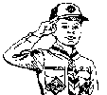
The Meaning of the Pledge of Allegiance
A couple of years ago, while working on putting together a ceremony, we came across a recording from the old Red Skelton Show, where Red gave us a short story about a teacher he knew when he was a boy, who, when he saw the boys and girls saying the Pledge of Allegiance as memorized, explained the meaning of the Pledge of Allegiance to his class. We’ve since adapted it for Webelos to use at Pack Meetings. With a bit of practice at your den meeting, this will work fine. Feel free to simply it further if need be, or have the boys use their own definitions. If you want to see Red in action, you can find the video on You Tube right here.
Begin your opening ceremony in the usual way with the American and Pack Flags facing the Pack. Have the Webelos Scouts as a color guard on the left and right of the flags. After the Cubmaster begins the ceremony, each Webelos scout reads one (or two) of the entries from an index card. Microphones are good, if you have them!
CM: We often recite the Pledge of Allegiance without really listening to or understanding the meaning of the words we are saying. As we stand, with the Cub Scout salute, let’s listen, before we recite the Pledge.
Webelos Scout #1: “I - Me, an individual”
WS2: “Pledge - Dedicate myself”
WS3: “Allegiance - My love and devotion”
WS4: “To the Flag - Our standard - Old Glory - a symbol of freedom. Freedom is everybody's job!”
WS5: “Of the United - United - that means we have all come together”
WS6: “States of America - States - individual communities that have united into fifty great states - fifty individual communities with pride and dignity and purpose; all divided with imaginary boundaries, yet united in a common purpose - love for country.”
WS7: “And to the Republic - Republic, a state in which power in given to representatives chosen by the people to govern; and the government is the people; and it's from the people to the leaders, not from the leaders to the people.”
WS8: “For Which it Stands - This is what our Flag stands for - Our United States”
WS9: “One Nation Under God - meaning so blessed by God”
WS10: “Indivisible - Incapable of being divided”
WS11: “With Liberty – The right to live one's own life without threats or fear.”
WS12: “And Justice - Dealing fairly with others.”
WS 13: “For All - For all - which means, it's as much your country as it is mine.”
CM: Now Scouts, ladies and gentlemen, boys and girls, let us recite the Pledge of Allegiance in a way that shows we understand its meaning.

Den Activities
These activities supplement the Den Meeting plans in the Den and Pack Meeting Resource Guide and on-line at www.scouting.org/cubscouts . They can be used for the gathering or to reinforce/satisfy badge requirements.

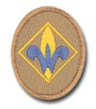

WEBELOS RANK
Meeting #7
Do: Citizenship #2: Names of president, vice president, governor, and head of local government.
Citizenship #3: U.S. Flag history, retirement.
Citizenship #4: Respecting the flag; flying the flag; saluting the flag.
Citizenship #5: Pledge of Allegiance.
Citizenship #6: National Anthem.
Citizenship #7: Rights & duties of citizens; saving natural resources.
Citizenship #9: Helping law enforcement.
HA: Citizenship #8 Citizenship Belt Loop
http://usscouts.org/advance/cubscout/academics/citizenship.asp
Meeting #8
Do: Citizenship #1: Citizenship character connection.
Citizenship #2: Names of president, vice president, governor, and head of local government.
Citizenship #3: U.S. Flag history, retirement.
Citizenship #4: Respecting the flag; flying the flag; saluting the flag.
Citizenship #5: Pledge of Allegiance.
Citizenship #6: National Anthem.
Citizenship #7: Rights & duties of citizens; saving natural resources.
Citizenship #9: Helping law enforcement.
Citizenship #10: Community leader visit, or
Citizenship #12: Talk about a boy who is a good citizen.
Citizenship #8 Finish service project
Verify: Citizenship #8 Citizenship Belt Loop
Do: Artist #1: Art occupations.
Artist #4: Primary & secondary colors.
Artist #7: Sculpture.
Artist #9: Art construction.
(Could make holiday art.)

Family Member
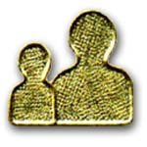
Sample Home Safety Check List

Stairways, Halls, and Outdoor Steps
- Stairways with three or more steps have a strong handrail.
- Stairs/halls are kept free from boxes, toys, brooms, tools, etc.
- Gates at top and bottom of stairs prevent children from falling.
- The head and foot of stairs have no small or loose rugs.
- Stair carpeting or covering is fastened securely.
- Stairways & halls have good lighting, controllable at each end.
Kitchen
- Matches are kept where children cannot get them.
- Knives & sharp instruments are kept in knife drawers or holder.
- Can openers don't leave sharp edges on cans.
- Disinfectants & cleaning products are out of reach of children.
- Pan handles are turned away from stove edges.
- Spilled grease, water, or bits of food are wiped up immediately.
- Pot holders are within easy reach.
- A fire extinguisher is mounted near the stove.
Bathroom
- Tub and shower are equipped with strong handholds.
- Tub floor has non-slip surface.
- Poisons are marked, sealed shut, and out of reach of children.
- Medicines are out of reach of children in childproof containers.
- No one takes medicine in the dark.
Attic and Basement
- Ladder is strong, solid, and sturdily constructed.
- Stairway is sturdy and well lighted.
- Walls and beams are free from protruding nails.
- Fuses or circuit breakers are the proper size.
- Rubbish & flammable materials are in covered metal cans.
- Wastepaper is kept away from furnace and stairs.
Living Room and Dining Room
- Furniture is placed to allow easy passage in an emergency.
- Fireplace screen fits snugly.
- Rugs are fastened or laid on non-slip pads.
- Rugs are kept from curling at their edges.
- Fire in fireplace is extinguished at bedtime.
- Candles are in stable holders and fully extinguished after use.
Bedroom
- Smoke alarm has fresh battery or electrical connection & is tested regularly.
- Carbon monoxide detector has fresh battery or electrical connection and is tested regularly.
- Furniture placement for clear passage between bed and door.
- Light switch or lamp is within easy reach from bed.
- A night-light illuminates bedroom or hall.
- Bureau and dresser drawers are closed when not in use.
- Bar across bunk beds helps prevent falls.
- Children are taught not to lean against windows or screens.
- Sturdily screen low windows to prevent children from falling.
- Smoking in bed is prohibited.
- Gas and electric heating devices are turned off at bedtime.
Nursery
- Bars on cribs are closely spaced.
- Crib is approved by Consumer Products or similar.
- Crib is free from sharp edges or corners.
- Sleeping garments and covers keep baby warm without danger of smothering.
- Pillows are kept out of bassinet or crib.
- No thin, plastic material is in or near the crib.
- Children are taught not to give marbles, etc. to younger children.
- Toys are sturdy & have no sharp edges.
- Nontoxic paint is used on baby furniture and toys.
- All houseplants are nonpoisonous.
General
- At least one smoke detector in each bedroom & garage.
- Stepladders are in good repair and stored out of the way.
- Window screens and storm windows are securely fastened.
- Kerosene, gasoline, paint thinners, and other volatile materials are stored outside in special, clearly marked metal containers.
- Oil mops, dust rags, painting equipment, and other oily materials are stored outside in open metal containers.
- Matches are extinguished before they're thrown away.
- Children are never permitted to play with matches.
- Fire extinguishers are readily available.
For Emergency
- Know how to get emergency help (911, poison control, etc.).
- Be able to find water, gas, & electric shutoffs. Check annually.
- First aid kit approved by your doctor/American Red Cross.
- Know basic first aid procedures.
- Have a fire escape plan from your home.
- Emergency water supply.
- Handheld flashlights readily available.

Citizen
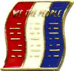
GAMES AND ACTIVITIES

UNITED STATES GAME
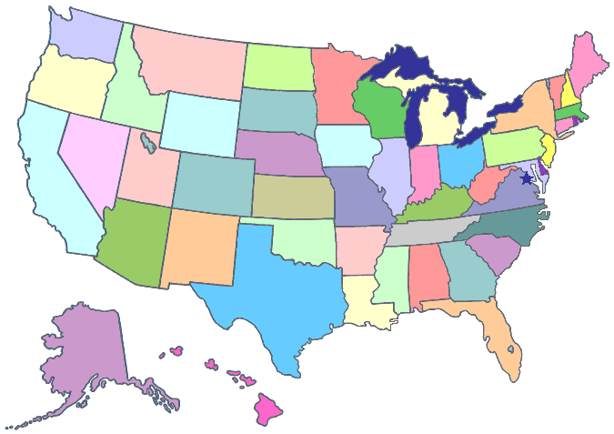
Have the boys make a list of as many states as they can remember. After 5 minutes the one with the longest list wins.
GEOGRAPHY GAME
Divide into teams. One team picks out a place on the US map. They call out the name and challenge the other team to find it in 2 minutes. If the other team finds the location in the time limit, that team gets a point. If they do not find the location, then the team that chose the location gets the point. The game ends when one team has 5 points (or as many points as you want to play to). If you use a computer, check out this clickable map that may be used to play this game. http://hua.umf.maine.edu/Chinese/maps/usmap.html
SCOUT LAW STUDY GAME


Materials: Scout Law written out (on paper, chalkboard, white board, etc), a current newspaper copy (one per team), scissors
Divide the Webelos Scouts into teams, each with the same day's issue of a newspaper. On the signal, the teams start a search for news items that illustrate the twelve points of the Scout Law [A Scout is Trustworthy, Loyal, Helpful, Friendly, Courteous, Kind, Obedient, Cheerful, Thrifty, Brave, Clean and Reverent.]. The Scouts then cut out the articles. The team with the most clipped articles wins. Then, have a spokesman from each team discuss why they chose the articles they did and how those articles do illustrate the Scout Law.
Great Documents Quiz

How much do you know about two of the greatest documents ever written: the Declaration of Independence and the Constitution of the United States?
- The first words of the Declaration of Independence are:
  - "We hold these truths to be self evident..."'
  - "We, the People of the United States..."
  - "When in the course of human events..."
  - "Four score and seven years ago...""
- The first draft of the Declaration of Independence was written by:
  - John Hancock
  - Button Gwinnett
  - George Washington
  - Thomas Jefferson
- The Constitution of the United States was signed in what year?
  - 1776
  - 1492
  - 1787
  - 1620
- What is the minimum age for a President of the United States, and in what document is this stated'?
- Which amendment to the Constitution provided for the abolition of slavery'?
  - Tenth Amendment
  - Thirteenth Amendment
  - Third Amendment
  - Sixteenth Amendment
- A Senator serves a term of:
  - Six years
  - Four years
  - Two years
  - Light years
- What is the maximum number of years a President may serve?
- Which amendment to the Constitution guarantees freedom of speech:
  - Fourteenth Amendment
  - First Amendment
  - Twenty-ninth Amendment
  - Fifth Amendment
- What legislative body has the sole power to impeach a President?
Answers:
1-c, 2-d, 3-c, 4-Age 35. as stated in the Constitution,
5-b, 6-a, 7-Ten years (two terms plus the remainder of a predecessor's term if 2 years or less),
8-b, 9-House of Representatives
More Citizenship Resources
Citizenship ideas:
http://usscouts.org/usscouts/bbugle/bb0908.pdf p. 44-51.
http://usscouts.org/usscouts/bbugle/bb0809.pdf p. 43-49.
http://www.scoutingthenet.com/Webelos/Citizen/
Games & Gathering Activities:
2001 Baloo’s Bugle “American ABC’s” p. 3.
2001 Santa Clara “American ABC’s” p. 5, 15-16.
http://www.scoutingthenet.com/Training/Roundtable/Handouts/09/01/
2009 Baloo’s Bugle “American ABC’s” p. 7-9; 23, 31-34.
http://www.scoutingthenet.com/Training/Roundtable/Handouts/01/06/
2000 Santa Clara “Sea to Shining Sea”p.8. http://www.scoutingthenet.com/Training/Roundtable/Handouts/00/06/
Patriotic Activities:
http://familyfun.go.com/4th-of-july/ http://www.makingfriends.com/Patriotic.htm
For even more Citizenship stuff see
The 2001 & 2009 theme “American ABCs”: http://usscouts.org/usscouts/bbugle/bb0106.pdf
http://usscouts.org/bbugle/bb0901.pdf
2006 theme “Red, White, & Baloo”: http://usscouts.org/usscouts/bbugle/bb0606.pdf
2010 theme “Celebrate Freedom”: http://usscouts.org/bbugle/bb1006.pdf
2000 theme “Sea to Shining Sea”: http://usscouts.org/usscouts/bbugle/bb0006.pdf
Law Enforcement Ideas
Crime Prevention Award:
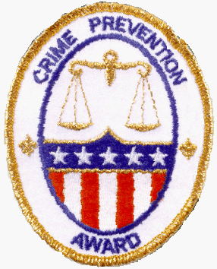
http://usscouts.org/advance/CrimePrevGuide1.asp
http://www.boyscouttrail.com/content/award/award-532.asp

Games:
Follow the Clues
Timucua District, North Florida Council
This activity will take a little time to put together and has to be based on where you will meet when you run the activity. List out a bunch of things that are in the meeting place and a clue as to what each is. Depending on the boys’ level, you can make the clues appropriately hard/easy.
For example:
- Den Flag – Blue cloth with Number 4 on it that says what our Cub Scout group is.
- American Flag – A flag that stands for the nation.
- Advancement Poster – Where we track how well you are doing learning new things and completing activities.
- Craft Table – Where we gather to make special items with glue and paper.
- Supplies Box – Where the Den Leader stores materials for the Den Meetings
- Stairs – The up & down machine you used to get to the basement.
- Good Conduct Candle – What should stay shining bright throughout the meeting.
- Main Door – The entry way to the meeting.
Write out the clues on separate index cards (or inside folded sheets of paper) and attach each clue to an object to which the clue doesn’t refer. (In other words, don’t put the den flag clue on the den flag).
As each boy arrives, give him a sheet of paper with a starting point for him to follow the clues.
Explain that at his starting point he will find a clue to another object in the room and that he’s to go to that object, write down what it is, and then follow the new clue at that object to get to the next one until he has followed all of the clues that lead back to his starting point.
After the opening ceremony, have the boys take turns reading off the objects to which the clues led them until all of the objects have been identified.
Who am I?
Wendy, Chief Seattle Council
One person is chosen to be guesser, and goes into the middle of the circle of players. The guesser is blindfolded. A leader spins the guesser, and the circle spins in the opposite direction. When the spinning stops, the guesser points in the direction of the circle, and says the name of an animal. The person he points to makes the noise that animal makes. The guesser tries to guess who made the animal noise
Assassin:
Wendy, Chief Seattle Council
Players sit in a circle, with legs crossed. Children put heads down, and close their eyes. A leader walks the circle, and taps one child on the head to choose the assassin. Everyone opens their eyes. The assassin eliminates the other players by winking at them. If you are winked at, silently count to 10, then put your feet into the middle of the circle. If the assassin eliminates everyone, he wins. The assassin can be “witnessed.” If a player thinks he knows who the assassin is before he gets winked at, he can say he has a suspect. For example, “I suspect that Tommy is the assassin.” If Tommy is not the assassin, then the accuser is eliminated
Bomb Squad:
Wendy, Chief Seattle Council
Leaders hide 3 alarm clocks in 3 different places. The clocks are set to ring at intervals of 5, 6, and 7 minutes. Players must find the clocks before they all ring, and the “bomb” go off. A less scary version is to just challenge the boys to find the alarm clocks before they go off
More Resources
- 2005 Baloo’s Bugle “To the Rescue” p. 19. http://usscouts.org/usscouts/bbugle/bb0509.doc
- 2002 Baloo’s Bugle “Kids Against Crime” p. 3-9. http://usscouts.org/usscouts/bbugle/bb0210.pdf
- 2002 Tatanka District “Kids Against Crime” p. 4-5. http://pages.prodigy.net/lisabackussmith/Handouts/Kids%20Against%20Crime.PDF
- 2010 Baloo, Responsibility, p. 50.
Den Activities:
Thumbprint Art:
Wendy, Chief Seattle Council
Using stamp pads, boys ink their thumbs and make thumbprints. Add details with markers or pencils to make thumbprint people
More Activity Resources
Kids Against Crime -
- Baloo's Bugle - http://usscouts.org/usscouts/bbugle/bb0210.pdf
- 2002 Tatanka District RT
http://pages.prodigy.net/lisabackussmith/Handouts/Kids%20Against%20Crime.PDF
Treats:
Thumbprint Cookies
Wendy Chief Seattle Council
These were a big hit at RT!!
Ingredients:
1 c. butter
2 c. flour
1 tsp. vanilla
1/2 c. powdered sugar
3/4 c. quick oats
Strawberry or grape jam
1 tsp. vanilla
Directions
- Beat butter, sugar, vanilla until fluffy.
- Add flour, oats, mix well.
- Chill dough.
- Remove from refrigerator, form into 1 inch balls and place on baking sheet.
- Press thumb into center of each ball and fill with jam.
- Bake at 350 for 15 minutes.

Artist
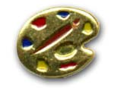
Ideas for Den Activities
- Let the Webelos Scouts realize that they are artists most of the time. Let them try some new things that perhaps they haven’t tried before.
- -Invite a local artist or an illustrator to come speak at your den meeting to talk about their career as an artist or illustrator.
- Visit an art museum.
- Have the boys sculpt with a material they may have never used before.
- Have the boys study a color wheel and let them mix some colors.
Scrapbooking
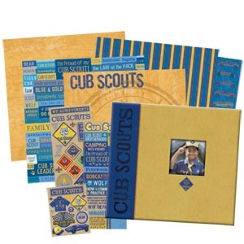
Check out this great article on scrapbooking in Scouting Magazine. http://www.scoutingmagazine.org/issues/0110/a-skrp.html
Rainbow Crayons
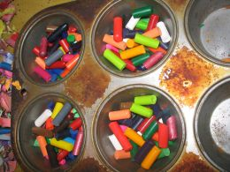
Gather a bunch of broken crayons or ask scouts to bring in any broken crayon pieces. In a muffin pan, have scouts put muffin cups and add broken crayon bits. Put the pan in the oven to melt all the bits together. Take it out, let cool, and then each scout has a rainbow crayon for leaf rubbing or other art work.
Artist Word Search
Circle each work in the list, and then find the secret word!
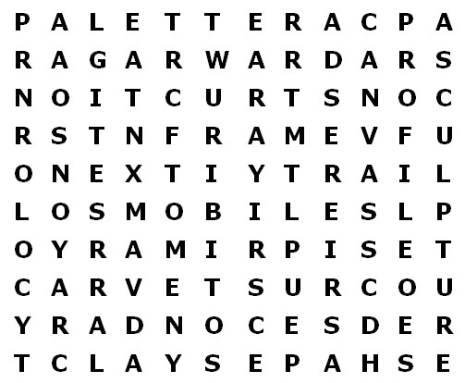
Acrylic Art Canvas Care
Carve Clay Construction Color
Crayons Crust Draw Frame
Mobile Next Paintbrush Palette
Primary Profile Rag Red
Rose Sculpture Secondary Shapes
Secret Word: To find the secret word, circle all the words in the word list then read the remaining letters from left to right and top to bottom.
Palette Neckerchief Slide
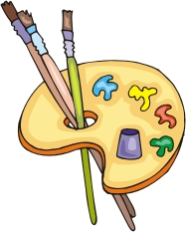
Materials:
¼” x 2 “x 2” block of pine
Drill and ¼” bit
Toothpicks (round or flat)
Paint (red, yellow, blue)
Plastic pipe
Directions
- Cut an artist palette from a small piece of wood.
- Drill a ¼” hole for the thumb.
- Smooth all edges and paint white.
- Use ½ a toothpick for the paint brushes.
- Dip each in a different color of paint.
- Allow to dry and the drip of paint will appear to be the brush bristles.
- Epoxy the brushes into the hole.
- Epoxy the plastic pipe on bottom of the palette and allow to set completely.
- Drop some fairly thick acrylic paint onto the palette to look like artist’s paint.
Mobiles

- Mobiles can be made from anything: found objects, sea shells, paper cutouts, airplane models, and origami figures, bake clay, etc.
- Let the scouts’ imagination run wild on this one. The only recommendation is that a common theme be used on each mobile – winter, space, Scouting, etc.
- Perhaps, with the Blue & Gold celebration coming up, each scout may make a mobile illustrating the history of Scouting.
- Each table can then have its own mobile.
- The Webelos Scout book recommends hangers; however, tree branches or doles of different lengths/thickness work fine.
More Artist Ideas
Abstract Paper Sculpture #1:
http://familyfun.go.com/crafts/paper-sculpture-674363/
- Slit straws can also be used to join pieces together. To make the joiners, cut a straw into 1”-2” pieces, then cut slits in both ends.
- Because cardstock and poster board are sturdier than paper, I think it would be better to use them so the sculpture holds its shape better. It’s important to create a sturdy base for the sculpture.
- To make an abstract Christmas sculpture, cut out shapes from old Christmas
- cards. Alternatively, boys could cut out scout related pictures/shapes and put them together to make a scouting sculpture.
Abstract Paper Sculpture #2:
http://www.makingfriends.com/sculpture/sculppaper.htm
- It might be worth a trip to the copy shop to precut lots of paper strips using their paper cutter, and to photocopy shapes onto plain or colored paper. That will allow the boys to spend more time constructing their sculptures (which is the part they will enjoy the most), and less time cutting.
- To make a Christmas sculpture, use red, green, yellow, and/or themed scrapbook paper. Using cookie cutters as a pattern, cut shapes from the paper. Add ribbon if desired.
- To make a winter scene, use blue and white papers. Cut snowflakes the traditional way. Cut out snowmen, trees, reindeer, and stars using cookie cutters. To make a 3D snowman, stack 3 cylinders horizontally on top of each other, biggest to smallest. Draw snowman features on snowman before gluing/taping. I used a piece of poster board as the base for my winter sculpture.
Make your own Masterpieces:
http://familyfun.go.com/crafts/make-your-own-masterpieces-709575/2/
I made a Jackson Pollack by laying wrinkled tin foil in a cake pan, and then rolling marbles that had been dipped in paint over the foil. Wendy
Tiny Easel:
http://familyfun.go.com/crafts/tiny-easel-673070/
I made the shelf from a folded strip of cardstock glued across the front 2 legs of the easel. To keep the legs from sliding apart, glue another strip of cardstock to the back of the shelf and the back leg.

- http://www.scoutingthenet.com/Webelos/Artist/
- http://usscouts.org/usscouts/bbugle/bb1004.pdf April 2010 Baloo’s Bugle p. 44-47.
- http://usscouts.org/usscouts/bbugle/bb0904.pdf April ‘09 Baloo’s Bugle p. 47-51.
- http://usscouts.org/usscouts/bbugle/bb0505.pdf May ’05 Baloo’s Bugle p. 32-4.
- http://usscouts.org/usscouts/bbugle/bb0405.pdf May ’04 Baloo’s Bugle p. 25-27.
- http://usscouts.org/usscouts/bbugle/bb0305.pdf May ’03 Baloo’s Bugle p. 14-15.
Artist Games
- ’09 Baloo’s Bugle “Works of Art” p. 8-10;31-34. http://usscouts.org/usscouts/bbugle/bb0911.pdf
- ’01 Baloo’s Bugle “Works of Art” p. 6-8. http://usscouts.org/usscouts/bbugle/bb0111.pdf
- ’01 Santa Clara Pow Wow Book “Works of Art” p. 5;15-17. Holiday Pictionary would be good. http://www.macscouter.com/CubScouts/PowWow01/Dec01.pdf
Artist Crafts & Activities Ideas
- ’09 Baloo’s Bugle “Works of Art” p. 21-31. http://usscouts.org/usscouts/bbugle/bb0911.pdf
- ’01 Baloo’s Bugle “Works of Art” p. 11-14. http://usscouts.org/usscouts/bbugle/bb0111.pdf
- ’01 Santa Clara Pow Wow Book “Works of Art”
http://www.macscouter.com/CubScouts/PowWow01/Dec01.pdf
Snacks
Mondrian Jell-o
Wendy, Chief Seattle Council
Create a Mondrian-like work of art using rectangle & square Jell-o jugglers, separated by black licorice rope.
Edible Art:
http://familyfun.go.com/recipes/edible-art-709317/
http://www.ehow.com/about_4739840_edible-art-supplies.html
Toast Paintings:
http://www.parentsconnect.com/do/artistic_taste.jhtml
Edible Play Dough:
http://www.familycorner.com/family/kids/crafts/edible_play_dough.shtml
http://www.makeplaydough.com/edible_play_dough/
The chocolate dough get soft and sticky
from the warmth of the hands.
Edible Art Supplies:
http://www.create-kids-crafts.com/kids-food-crafts.html
Art Cookies:
http://artsmarts4kids.blogspot.com/2007/12/create-your-own-edible-painting.html
Egg Yolk Paint:
http://allrecipes.com/recipe/egg-paint/Detail.aspx
http://www.ehow.com/how_2174962_edible-egg-yolk-paint-cookies.html

ARROW OF LIGHT


Readyman
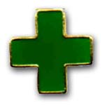
Readyman is required for the Arrow of Light. What is a Readyman. Simply said, someone who is always ready to do whatever is needed to help someone or himself. Similar to the Boy Scout who follows the motto, “Be Prepared,” a Webelos Readyman knows his stuff and is not afraid to help.
Meeting #7
Do: Readyman #1: Courage character connection.
Readyman #2: First aid & accidents.
Readyman #3: How to get help quickly.
Readyman #11: Home fire escape plan.
Readyman #13: Where are home accidents most likely
HA: Readyman #3 Post emergency numbers by phone;
Readyman #11: Home fire escape plan.
Meeting #8
Do: Readyman #4: Heimlich maneuver.
Readyman #5: Show what to do for “hurry cases.”
Readyman #6: Show how to treat shock.
Readyman #7: First aid.
Verify: Readyman #3 Post emergency numbers by phone;
Readyman #11: Home fire escape plan.
Who Do You Call?
Label four areas of a room with 911, Police Department (non-emergency), Poison Control, and Fire Department (non-emergency). Prepare cards with situations (some emergency and some not). Give boys 3 seconds to decide which corner to go to. Give a point for each correct decision.
Examples:
- Your brother drinks dish soap.
- Your den would like a paramedic to teach basic first aid.
- Your uncle collapses at a family gathering.
- Your friend falls from his bike and cannot move his leg.
- Your den would like a tour of the local police station.
- Flames are coming from your neighbor’s garage.
- A car in front of your house hits a young child.
- Your baby sister eats a bottle of aspirin.
Wallet First Aid Kit
Use a nylon wallet
- With a red marker draw on the wallet a red cross.
- Put in the wallet Band-Aids (different sizes), gauze pad (2” x 2”), antiseptic swabs, safety pins, for example.
- Cut a credit-card shaped piece out of stiff paper. On it write your name, address, emergency contact number, and personal information like your birth date, allergies and blood type.
- On the back, tape four quarters for an emergency phone call. (You do not have to pay for a 9-1-1 call.)
Den Activities
- Visit your local ambulance service or fire department rescue squad.
- Ask a member of the local Red Cross or emergency trauma team to visit your den and show you how to save lives by learning: Hurry cases, shock, other minor emergencies.
- Learn how to get help from the local authorities such as the police, fire department, ambulance, or hospital, contact the police department to find out how to report or summon help in these situations.
- Ask a First Aid Merit Badge Counselor from a Scout Troop in your area to attend the meeting and explain the items in a first aid kit, or have him shoe what to do for “hurry cases.”
- Invite a Scout Troop to your meeting to show first aid for cuts and scratches, burns and scalds, and choking.
- Invite a police officer to speak on bicycle safety.
- Have a swim instructor go over the safe swim defense plan.
Games
Fire Hazard Hunt
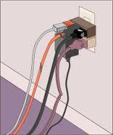
- Prepare for this game by creating some fire hazards in and around your meeting place -- matches left carelessly within reach of children; outside door blocked by a chair, oily rags in a pile in the garage; grease spilled near stove burner, newspaper piled near furnace; fireplace screen away from fireplace; frayed electric cord, etc.
- Ask boys to find and list on paper as many hazards as they can find.
- At the end of the game, check findings and explain the hazards.
- Urge Webelos to check their own home.
Fireman. Save My Child
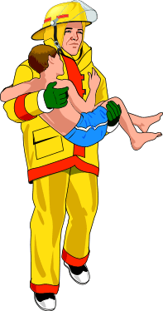
- Divide den into two teams. One member of each team (the “child”) sits on an old throw rug or heavy cloth about 2’ x 3’ about 15 feet from his team.
- Each of the other players has a four foot length of rope.
- On signal, the boys tie their ropes together with square knots to form a rescue rope.
- When all ropes are tied, a player throws the rescue to the child and the team pulls him to safety.
- The den that ties all knots correctly and first pulls its child to safety is the winner.
Webelos First Aid Kit

Every home and car should have a first aid kit. Then first aid supplies will be there if they are needed. Check your family's home or car first aid kit. For requirement 12, Webelos will have to explain how the items should be used. At a den meeting, go over the things that should be in a first aid kit. The items listed below are from the Webelos Scout Handbook.
Note: For a first aid kit in a car, also include a small flashlight and spare batteries, hand cleaner in packets, a white handkerchief (to attach to the car so you can attract attention if the car is disabled), a blanket, and a large red and white sign that can be placed in the front or rear window that reads "Send Help!"
Item | Use
Tweezers | Remove splinters
Box of adhesive bandages (different sizes) | Keep wound clean
Twelve each of 3-by-3-inch and 4-by-4-inch sterile pads | Larger wounds
Roll of I-inch and roll of 2-inch adhesive tape | Hold pad in place
Scissors | Cut gauze or tape
Safety pins | Secure triangular bandages
Two 1-inch roller bandages | Hold pads in place
Two 2-inch roller bandages | Hold pads in place
Three triangular bandages | Hold pads in place
Three cravat bandages (a cravat bandage is made  by folding a triangular bandage or Scout neckerchief) | Sling or to hold pad in place
Two 17-inch splints of thin board | Immobilize break or sprain
Two 30-inch splints | Immobilize break or sprain
Calamine lotion | Minor skin rash
Latex gloves | For bleeding or wound care
Mouth-barrier device | Rescue breathing or CPR
Readyman Ideas
For games, crafts, & treats, see the emergency ideas in the Bear section above.
Mini First Aid Kit I
Wendy, Chief Seattle Council
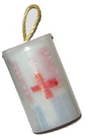
Materials to build it
Plastic Film Canister or Pill Bottle
Label
Paint/markers
PVC Ring (If making a neckerchief slide)
Hot Glue
First Aid Supplies
Two Gloves
1 2"x2" gauze bandage
Medical tape (roll a 2' length on a straw)
2 quarters
3 Band-Aids
Directions
- If you can find supplies that are small enough, you can fit it all in one film canister. Otherwise, glue two lids together and let dry.
- Attach a ring to the canister with hot glue.
- Make a label for the front with either "First Aid Kit" or the symbol for first aid, a red cross.
- Put items inside canisters.
Mini First Aid Kit II
Recycle a film canister (or pill bottle) and transform it into a handy Mini First Aid Kit for kids to wear on their belt.
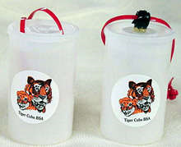
What you'll need:
Fuji film canister
Scissors
Colored pony bead
First Aid or Cub Scout sticker
Plastic lanyard (Gimp)
Midget Tootsie Rolls
Alcohol swab
Band-Aid
Q-tip
Hot glue or "Glue Dots" (A & W Products)
How to make it:
- Adhere the pony bead to the top of the film canister using either hot glue or Glue Dots.
- Place a sticker on outside of canister.
- Lace the plastic lanyard through lid.
- Tie a knot. You can also use a hole punch and punch 2 holes in the lid then string the lanyard through.
- Tie a knot.
- Cut a Q-tip in half.
- Put Tootsie Rolls, alcohol swab, a Band-Aid, 1/2 Q-Tip inside the canister. Secure the lid.
- Put your Mini First Aid Kit on your belt. If you get hurt or lost from the group, clean the spot with the alcohol wipe, put on a Band-Aid, and eat a Tootsie Roll.
For another idea on this item see -
http://www.makingfriends.com/lanyard_firstaidkit.htm
For more things to make with Film Canisters of Pill Bottles go to The Film Can Page
The Emergency Preparedness Award

Cub Scouts may earn this award, and for Webelos, earning Readyman is an important first step. Emergency preparedness means being prepared for all kinds of emergencies, able to respond in time of crisis to save lives and property and to help a community return to normal life after a disaster occurs. To encourage Scouts of all ages to be prepared for emergency situations, the BSA has approved an Emergency Preparedness Award program for members of all ages.
Note: All emergency activities carried out by Scouting units must be appropriate for the ages and abilities of the young people involved. Units should participate only under the supervision of their own leaders, and plans for unit help must be coordinated with community agencies responsible for disaster preparedness.
The Emergency Preparedness Award has different requirements for Tiger, Wolf, Bear, Webelos, and adult leaders.
To earn the award, Webelos must:
- Earn the Readyman activity badge from the community badge group.
- Build a family emergency kit, with an adult family member participating in the project.
- With your parent or guardian's help, complete one of the following that you have not already completed for this award as a Tiger Cub or Wolf or Bear Cub Scout:
- Take a first aid course conducted by your local American Red Cross chapter.
- Give a presentation to your den on preparing for emergencies.
- Organize a training program for your Webelos den on stranger awareness, Internet safety, or safety at home
When a member has fulfilled the requirements, a completed application is submitted to the council. Upon approval, the Emergency Preparedness Award, No. 19-304 is awarded. The pin may be worn on civilian clothing or on the uniform, centered on the left pocket flap. The award may be earned more than once; for instance, as a young person advances through the ranks and is capable of more complex preparedness activities, but only one pin may be worn.
Treats
Band aid Treat:
Wendy, Chief Seattle Council
- Break a large rectangular graham cracker into 4 small rectangles.
- Put a small marshmallow in the center of each of the small rectangles.
- Microwave 10-15 seconds.

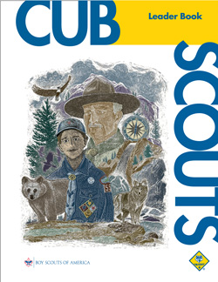

ADDITIONAL ADVANCEMENT IDEAS
Alice, Golden Empire Council
Someone wrote and asked me why Alice and I have this section with all the advancement in the new Resource Book. These are additional ideas. Maybe your Cubs did some advancement in camp and you got to skip a section. Maybe your den is above average and streaking through the program. Maybe you want some ideas to tie into the Core Value of the month. Maybe your presenter or field trip for that week fell through and you need a Plan B. Here are ideas you can use!! CD and Alice
Since the Value for November is RESPECT, every rank could work on any one of several Belt Loops and Pins – Disabilities Awareness, (respect for those who are different) Good Manners, (Showing respect for self and others by your behavior) Heritages or Language & Culture (showing respect for other cultures and ethnic groups). And of course, Sports Belt Loops should include Respect – both in showing good sportsmanship and in following the rules. Respect for safety rules is especially important, sometimes life-saving, in winter sports. Respect for the environment is also a big part of the World Conservation Award and the Leave No Trace Award. The suggested advancement or elective ideas here are based on the Value of Respect.

Tiger Achievements
Ach. #1F – Talk about how having chores helps us to show respect for yourself, your possessions, and other family members and their possession. Ach. #1D – As you work on a family scrapbook, you can gain new respect for your talents and those of family members.
Ach. #2D – As you practice the pledge and participate in flag ceremonies, you can show respect for country and flag.
Ach. #3D, G – Show respect for your body when you learn how to take keep healthy and safe, and get enough exercise.
Ach. #4F – Character Connection for Respect –Discuss how to deal with family members and others in a respectful way.

Tiger Electives
Elect. #1 – Share with you den how your family celebrates the holidays – learn how other people have different ways of celebrating, and respect the differences.
Elect. #2 – Make some decorations for a celebration – you might choose a different culture and learn more about how they celebrate.
Elect. #5 – Make a family mobile, and focus on the talents and interests that make each one special, and worthy of respect.
Elect. #6 – Sing one of the songs about Respect. Elect. #8 – Get to know the people who lead or teach at your place of worship – talk about how to show them respect
Elect. #9 – Help a new girl or boy get to know other people – remember to treat them with respect
Elect. #18 – Learn to sew on a button, and practice other ways to take care of your clothing Elect. #24 – One way to show respect is to help the adult who is preparing a family meal to set the table and clean up afterward-and to appreciate their work!
Elect. #26 – Practice good phone manners and always use them!
Elect. #33 – Show your respect for your home or your neighborhood by playing Cleanup Treasure Hunt.
Elect. #34 – Conserving electricity and water for a week shows your respect for the environment. Elect. #37 – Take a bicycle ride with your adult partner – be sure to respect your body by wearing a helmet, and respect the environment by carrying out any trash.
Elect. #46 – Healthy teeth and gums, and regular visits to the dentist show you have respect for your body.
Elect. #47 – Reduce, reuse and recycle to show your respect for the environment.

Wolf Achievements
Ach. #2a,b,e, f, g – Always show respect for the flag when participating in a flag ceremony; Ach.#2c – Tell how to respect the flag.
Ach. #3a,b,c – Show respect for your body by practicing good health habits
Ach. #7a- Character Connection for Respect; Ach. #7b-f – Show your respect for the world and your environment by completing these requirements.
Ach. #8a, b – Show your respect for your body by learning about the Food Guide Pyramid and using that information to plan good family meals.
Ach. #9d, e – Show respect for your body by practicing good rules of street and bike safety.
Ach. #10d – Read a book or article about another culture or the way they celebrate their holidays.
Ach. #12 – as you study the different scenarios, talk about how respect for yourself or others would affect your answers

Wolf Electives
Elect. #1c – Learn to use American Sign Language – it will help you learn to be respectful of someone who uses ASL. Elect. #1d – Use American Indian Sign Language to tell a story – this is a different kind of code than the Navajo Code Talkers used in WWII.
Elect. #2 – Participate in a skit about Respect.
Elect. #6c – Learn how to take care of books – to show you respect your possessions.
Elect. #10 – You can study how American Indians showed respect for their environment as you do these requirements.
Elect. #11a,b – Learn to sing a patriotic song to show your respect for your country.
Elect. #13e – Feed wild birds – but show your respect for nature and the environment by continuing to feed bird while natural food is scarce.
Elect. #14a, c – To show respect for a pet, learn more about it from a book and share with your den; also, remember that every pet needs good care from an owner who loves and respects them.
Elect. #19d, e - When fishing, respect safety rules and laws where you live.
Elect. #20b, d, e – Know and respect safety rules and courtesy codes when boating, skiing or ice skating – it not only shows you respect others, but also the dangers of winter sports.
Elect. #22e – Invite a boy to join Cub Scouts or complete his Bobcat – show him respect and be an example of respect to him.

Bear Achievements
Ach. #2 – As you learn more about your religious faith and those who lead it, your respect for both leaders and principles can grow.
Ach. #3a, b – Respect for your country and those who are or have improved our way of life will be strengthened as you learn more about them. Ach. #3f, g, h, i – whenever you participate in a flag ceremony, remember to show your respect with your actions.
Ach. #5a, b – respect for animals can be shown by learning about them, and by being careful to build a bird feeder or birdhouse that will be appropriate for a particular species – these activities can also be used to earn the World Conservation Award – showing respect for our world and environment.
Ach. #6 – any of the requirements will show respect for our planet – the only one we have!
Ach. #7b, f – know how you can show respect for law enforcement by helping in safe ways.
Ach. #8g – Character Connection for Respect. Ach. #8b – Be respectful as you talk to someone who was a Cub Scouter a long time ago – ask how they showed respect to their leader, parents, teachers and country when they were a Cub. Ach. #8d, e – Find out about your family history or community history – it will help you respect people who lived in different times.
Ach. #10a – On a day or evening trip with your family, be courteous and use good manners
Ach. #14a,f – Show respect by following all safety rules when riding a bike; Ach. #14c, d, e – Show respect for your bike by learning to take care of it, and always protecting it from theft.
Ach. #15 – Remember to follow the rules and be a good sport when playing a game, to show you have self respect and respect for others.
Ach. #17a – While watching a TV show with an adult, watch for examples of respect or lack of respect. Ach. #17d – When using a computer, respect family rules and rules you have been taught about internet safety
Ach. #19a, b, d – Show that you respect the rules of knife safety, and also that your know how to take care of a pocketknife.
Ach. #20a – Show how to use and take care of four tools and put them away properly
Ach. #23 - While playing or watching any sport, follow the rules and be a good sport to show your respect.
Ach. #24 – Whenever you are serving as a leader, show respect for yourself and others.

Bear Electives
Elect. #5 – Know and follow safety rules on the water and around boats – show respect for your environment and the possible dangers.
Elect. #15- Learn how to take care of water and soil – use these activities as part of the Cub Scout World Conservation Award requirements.
Elect. #20 a, b, c – Follow the rules of safety and courtesy when participating in winter sports
Elect. #24 – Do any or all of these requirements as you learn how American Indians have shown respect for their environment and their country.

Webelos Activity Pins
Webelos Badge – While earning this badge, show respect by wearing the uniform properly, showing respect towards the flag at all times, and demonstrating respect for the Scout Oath and Scout Law.
Athlete #3, 4 – Show respect for yourself and your body by learning what you can do to stay healthy and by beginning physical workouts with stretching to protect your body.
Citizen #4, #9. #14 – Explain why you should respect the flag, and show how to do it; tell what you can do to show respect for the law and help law enforcement agencies.
Communicator #9, 10 – as you learn about another way to communicate, or using another language, be respectful to everyone – ask for ideas on how respect can be shown to those with other ways of communicating. Communicator #11- #14 – As you use the internet, be sure to have respect for yourself and others; follow family and general rules of internet safety.
Craftsman #1 – Explain how to safely handle tools – respect the potential danger of ignoring safety rules.
Engineer #4 – Explore property lines with a civil engineer and learn how respect for property rights is maintained.
Family Member #5 – During family meetings, show respect for yourself and others, especially in what you say and how you say it. Family Member #9, 10, 13 – Learn how to clean your home, take care of your clothes and dispose of trash and garbage – proper care of your possessions is part of being respectful.
Fitness # 5-#8 – Learn about and tell an adult why you should avoid tobacco, alcohol and drugs – and how avoiding such things can help encourage self-respect.
Handyman #2 - #10, #15 – Demonstrate respect for possessions by learning how to take care of them; clean and properly store hand tools or garden tools.
Naturalist #1 – Respect Character Connection. Naturalist # 12, 13 – Clean up litter in your neighborhood to make it safer for animals; earn the Wildlife Conservation Belt Loop.
Outdoorsman #5, #6 – Discuss how to follow Leave No Trace; do an outdoor conservation project with your den or a Boy Scout troop.
Showman #2 – Write a puppet play about Respect. Showman #16 – Give a monologue about Respect.
Sportsman #2 – Explain what good sportsmanship is.

CUB GRUB
Tortilla Snowflakes
Wendy, Chief Seattle Council
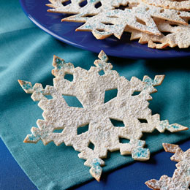
Ingredients
6 flour tortillas
Canola or vegetable oil for baking
Confectioners' sugar
Edible glitter (optional)
Instructions
- Heat the oven to 400 degrees. Warm the tortillas (about 15 seconds) in the microwave.
- Individually fold the tortillas in half once and then in half again, so that you end up with a shape that resembles a wedge of pie (it will be thick). Using clean scissors, cut triangle, circles, or squares out of the edges, as if you were making paper snowflakes. Unfold the tortillas.
- Lightly brush the tops of the snowflakes with canola or vegetable oil and place them on a cookie sheet slightly apart.
- Bake them until lightly browned and crisp (about 4 minutes). Sift confectioners' sugar on the snowflakes while warm. For an extra sparkly effect, you can sprinkle on a bit of edible glitter. Makes 6.
Notes from Wendy
- Cutting the tortillas with scissors really does work.
- We have sometimes sprinkled the snowflakes with white sugar that has been dyed with food coloring to make blue snowflakes when we are doing Bear Ach. #4 Tall Tales. (Blue Snow turned Babe, Paul Bunyan’s ox, blue.)
Ice Cream Sandwiches
Alice, Golden Empire Council
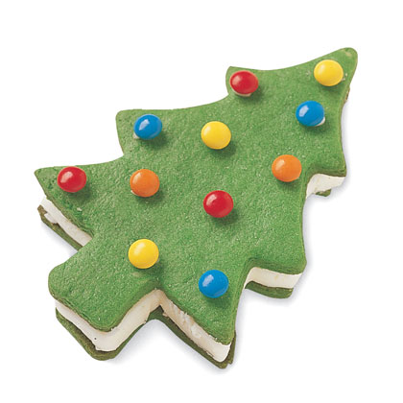
Ingredients:
3 1/2 cups all-purpose flour,
1/2 tsp. salt,
1 cup unsalted butter, softened,
2/3 cup sugar,
1 large egg,
1 tbsp. light corn syrup,
1 tbsp. vanilla extract
Directions:
Cream the butter and sugar together;
Then stir in the egg, corn syrup and vanilla or other flavoring and food coloring, either paste or liquid. (If you are making more than one color of dough, add paste coloring to the divided dough and knead in the coloring)
Mix the flour and salt together and add one third at a time till thoroughly mixed.
Pat the dough into two disks, wrap in plastic and refrigerate for 1to 2 hours, or until firm enough to roll.
Soften at room temperature for 5 minutes if too firm.
Preheat oven to 375 degrees; Roll one disk of dough between two sheets of waxed paper so you don’t have to add additional flour.
Roll to ¼ inch thickness.
Remove the top sheet of waxed paper and cut out the dough with a cookie cutter.
Transfer to a baking sheet, about one inch apart and bake for 8 to 10 minutes or until cookies start to brown lightly.
Remove the baking sheet to a wire rack and cool for 5 minutes; cool completely.
Makes 15-20 cookies.
Attach candy with icing to half the tree shapes – leave the other half plain.
Cut a half inch thick slice off an ice cream block and cut out the tree shapes with a cookie cutter.
Sandwich the ice-cream trees between the cookies, wrap in plastic bags, and freeze.
Makes 24 Ice Cream Sandwiches.
Here are some other variations:
- Chocolate Dough: After the last third of flour has been added to the dough, mix in 1 ounce melted, slightly cooled unsweetened chocolate. Use your hands to knead in the chocolate.
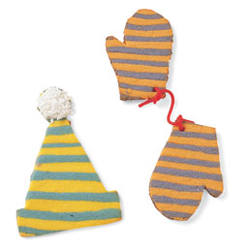
- Striped Dough: This colorful dough is perfect for the Hat & Mittens cookies. Divide the cookie dough in half and tint each a different color. Pat each half into a rectangle, about 5 by 7 inches, wrap in plastic, and refrigerate or freeze until firm. Roll each piece between two sheets of waxed paper to form rectangles that measure 8 by 11 inches and are about 1/4 inch thick.
Stack directly on top of each other. Using a sharp knife, cut the dough into strips about 1/2 inch wide. Turn each strip on its side with the stripes facing up. Place one strip near the end of a large piece of waxed paper. Press the next strip of dough parallel to the first strip, alternating the color. Place a piece of waxed paper on top of the stripes and roll over the top to make them adhere. Remove the top piece of paper and cut out shapes as desired.
- Marbleized Dough: Lightly press together any scraps of the striped dough to achieve a marbleized look.
Holly Jolly Dip
Alice, Golden Empire Council
Goes especially well with veggies.
Ingredients:
1 whole roasted red pepper (from a jar),
1 cup crumbled feta,
1 small clove garlic,
2 tablespoons olive oil

Instructions:
- Combine all the ingredients in a food processor.
- Pulse for 10 seconds,
- Scrape down the sides,
- Then repeat until combined, about 1 minute.
- Makes 3/4 cup.
Crunchy the Snowman
Alice, Golden Empire Council
Ingredients:
Bag of 8-inch pretzel rods,
1 cup white chocolate chips, mini chocolate chips, orange decorators' gel, fruit leather (various colors), gummy rings, gumdrops
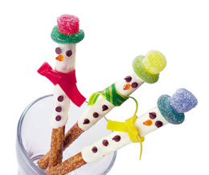
Directions:
- Melt chocolate chips in the top of a double boiler.
- Dip one end of an 8-inch pretzel rod in the melted chocolate and use a plastic spoon or knife to spread the chocolate two thirds of the way down the rod.
- Set the pretzels on a sheet of waxed paper and press on mini chocolate chips for eyes and buttons.
- Use orange decorators' gel to add a carrot nose.
- When the chocolate has hardened, stand the pretzels in a mug or glass and tie on strips of fruit leather for scarves.
- For each hat, stretch a gummy ring over the narrow end of a gumdrop and secure it on the pretzel rod with a dab of melted chocolate.

POW WOW EXTRAVAGANZAS
Cape Cod and Islands Council
Pow Wow - 21st Century
October 16, 2010
Christ the King Parish Hall, Mashpee, MA
Call Cape Cod & Islands Council, (508) 362-4322, or visit the website https://www.scoutscapecod.org/training/pow-wow.html ,for more information
Chief Seattle Council
Program and Training conference
October 16, 2010
North Seattle Community College, Seattle, WA
Call Chief Seattle Council, (206) 725-5200, or visit the WEBSITE http://www.seattlebsa.org/Training/2010-Program-Training-Conference, for more information
Sam Houston Area Council
Following Akela's Trail into the Next Century
November 6, 2010
Call Sam Houston Area Council, (713) 659-8111, or visit the website, http://www.samhoustonbsa.org/akelas_trail.php ,for more information
Baltimore Area Council
Looking to the Future
November 6, 2010
Location - Overlea High School, Baltimore. MD
Call Baltimore Area Council, 443-573-2500, or visit the website, www.baltimorebsa.org ,for more information
Cascade Pacific Council's Powwow
Scouting, The Final Frontier
November 13, 2010
8 AM-4 PM
Southridge High School
Beaverton, OR
Contact powwow@cpcbsa.org
Great Salt Lake Council
November 13, 2010
Stansbury High School
5300 Aberdeen Road
Stansbury, Utah (Tooele County)
Southern NJ Council
Improving Your 'Scoutability"
Postponed - University of Scouting under development

WEB SITES
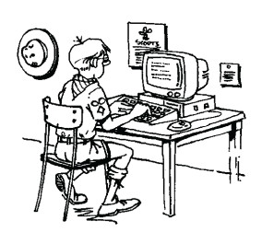
Alice, Golden Empire Council
www.jewfaq.org/holiday0.htm billed as a “gentile’s guide” to Jewish holidays, games, etc. Good source if a family or leader wants to include Chanukah as one of the holidays in a pack or den presentation.
www.santas.net/aroundtheworld.htm Christmas traditions around the world by country.

ONE LAST THING
Have You Ever Seen A Baby Porcupine?
George, SNJC Advancement Chair

Fable of the porcupine
It was the coldest winter ever - many animals died because of the cold. The porcupines, understanding the situation, decided to group together. They covered and protected themselves; but the quills of each one wounded their closest companions even though they gave off heat to each other.
So they began to distance themselves from each other and began to die, alone and frozen. So they had to make a choice: either accept the quills of their companions or disappear from the Earth.
They decided to go back to being together. This way they learned to live with the little wounds that were caused by the close relationship with their companions, and appreciate the warmth; this way they were able to survive.
Moral of the story:
The best relationship is not the one that brings together perfect people, but the best is when each individual learns to live with the imperfections of others and can admire the other person's good qualities.
I wish we could all make the same choice as these porcupines. None of us is perfect, we all have flaws or differences but that is what makes the world go round. Instead of all the hate we should make the choice to accept everyone for who they are, there are always lessons to be learned if we only open ourselves to learning them.
