CORE VALUES
Cub Scout Roundtable Leaders’ Guide
The core value highlighted this month is:
- Positive Attitude: Being cheerful and setting our minds to look for and find the best in all situations. Through participating in a derby, boys will see the importance of having a positive attitude, regardless of the outcome of the race.

COMMISSIONER’S CORNER
Pow Wow Books needed (REALLY NEEDED) I need ideas for Baloo for the Core Values. This month is mainly Pinewood Derby not Positive Attitude. Please help. Thanks to Jim, Pat and Bill, I have Great Salt Lake, Baltimore and Cascade Pacific.
Do Your Best – A Bite at a Time
Alice, Golden Empire Council
Remember that old joke about “How do you eat an Elephant? This month, we can help boys be successful by teaching them to:
* Break a project down into sections
* Learn a new skill to do a project
* Practice the skill on a sample first
We can also teach them about the power of Positive Thinking – every athlete knows that even a difficult task becomes easier and more often fun if they first THINK they can do it and then do their best.
Cub Scouts can learn to take pride in their accomplishments and know that doing their best is more important than winning or losing.
I am looking for different ways to present achievements. So if you have come up with ideas for den meetings centered on the achievements & electives, please email them to davethecommish@gmail.com so we can include them in Baloo. And if you have good ideas for Character Connections, please email those, too.
Well it has been quite a month at Lake Woebegon. OOops, that is Garrison's line not mine. Two camping Trips, Wood Badge staff weekend, RV decided to leak gasoline, and much more. Enjoy Baloo and have a great holiday season.
TABLE OF CONTENTS
In many of the sections you will find subdivisions for the various topics covered in the den meetings
CORE VALUES 1
COMMISSIONER’S CORNER 1
THOUGHTFUL ITEMS FOR SCOUTERS 2
Roundtable Prayer 2
Positive Attitude 2
Quotations 2
TRAINING TOPICS 3
Snips and snails and puppy dog tails. 3
ROUNDTABLES 6
PACK ADMIN HELPS - 6
Don't Forget The Purpose Of The Pack Meeting: 6
Den Discipline with Positive Attitude 6
Every Car A Winner 7
LEADER RECOGNITION & INSTALLATION 7
SPECIAL OPPORTUNITIES 8
100th Anniversary Commemorative Patch 8
Knot of the Month 10
100th Anniversary Commemorative Patch 10
GATHERING ACTIVITIES 11
OPENING CEREMONIES 13
AUDIENCE PARTICIPATIONS 14
ADVANCEMENT CEREMONIES 16
SONGS 21
STUNTS AND APPLAUSES 22
APPLAUSES & CHEERS 22
RUN-ONS 23
JOKES & RIDDLES 24
SKITS 24
GAMES 25
CLOSING CEREMONIES 25
Cubmaster’s Minutes 25
CORE VALUE RELATED STUFF 27
MORE GAMES AND ACTIVITIES 30
CUB GRUB 30
POW WOW EXTRAVAGANZAS 30
WEB SITES 30
ONE LAST THING 31

THOUGHTFUL ITEMS FOR SCOUTERS
Thanks to Scouter Jim from Bountiful, Utah, who prepares this section of Baloo for us each month. You can reach him at bobwhitejonz@juno.com or through the link to write Baloo on www.usscouts.org. CD

Roundtable Prayer
Scouter Jim
Father in Heaven, lead us to soar with eagles and discover the power within ourselves and come to know that we were born to succeed and Do Our Best. Amen

Positive Attitude
Scouter Jim, Bountiful UT
President Dieter F. Uchtdorf, a member of the Presidency of the Church of Jesus Christ of Latter–Day Saints and a former pilot told the following story at Brigham Young University on 11 November 2003, the 100th Anniversary of manned flight:
On December 17, 1903, a dream of mankind was fulfilled as Wilbur and Orville Wright made the first controlled, powered flight. The distance was about 120 feet, or 37 meters—about half the length of a 747 jumbo jet—and the duration was about 12 seconds. That’s shorter than the time it takes me to climb the stairs leading up to the 747 cockpit. By today’s standards, it was a very short flight, but at that time it was an accomplishment that few believed would ever be possible.
Wilbur and Orville had parents who encouraged education, religion, and family values. Both brothers had their share of serious illnesses. They went through difficult times of trouble, perplexity, and even despair, wondering if they would ever succeed. They tried different vocations as printers, bicycle repairmen, bicycle manufacturers, and, eventually, aircraft inventors. Throughout their lives, whenever they picked a project to work on, they were focused and worked as a team.
The Wright brothers committed themselves to do what no one else had ever done before. They took time to do their homework. They were humble and smart enough to appreciate and learn about the work of others who went before. And they tackled the problem line upon line, precept upon precept. They realized that there were three main requirements for a practical flying machine: first, the pilot had to be able to control the aircraft; second, the wings had to produce lift; third, it had to be powered by an engine to stay aloft.
They had their goals defined and worked diligently on them one day at a time. Leonardo da Vinci said, “He turns not back who is bound to a star.”
President Uchtdorf goes on to explain how to apply the principals the Wright Brothers used to fly in our lives.
- You Have to Learn to Control Yourself.
- Your Attitude will determine your lift and altitude.
- You need to find and trust the true source of Divine power.
As we conclude the 100th Anniversary of the Boy Scouts of America, these basic principals can be taught to our Cub Scouts. We want our youth to be able to soar with the Eagles, not scratch with the chickens. We need to direct their eyes upward and forward as we teach them to do their best. We cannot teach a positive attitude to our boys, unless they see that attitude reflected in our own lives.
In order to have a positive attitude, we need to give ourselves the tools we need to succeed. Have you attended Basic Training? Do you attend Roundtable? Do you have a current copy of the Program Helps? How about going to Wood Badge Training? When you know what you can do, you will have a positive attitude in your position. Go Soar with the Eagles. Shoot an Arrow toward the light of a higher power

Quotations
Quotations contain the wisdom of the ages, and are a great source of inspiration for Cubmaster’s minutes, material for an advancement ceremony or an insightful addition to a Pack Meeting program cover
We awaken in others the same attitude of mind we hold toward them. Elbert Hubbard
Be enthusiastic. Remember the placebo effect - 30% of medicine is showbiz. Ronald Spark
A cloudy day is no match for a sunny disposition.
William Arthur Ward
People who laugh together generally don't kill each other. Alan Alda
Your attitude is an expression of your values, beliefs and expectations. Brian Tracy
The person who sends out positive thoughts activates the world around him positively and draws back to himself positive results. Norman Vincent Peale
Action is a great restorer and builder of confidence. Inaction is not only the result, but the cause, of fear. Perhaps the action you take will be successful; perhaps different action or adjustments will have to follow. But any action is better than no action at all. Norman Vincent Peale
Any fact facing us is not as important as our attitude toward it, for that determines our success or failure. The way you think about a fact may defeat you before you ever do anything about it. You are overcome by the fact because you think you are. Norman Vincent Peale
Believe in yourself! Have faith in your abilities! Without a humble but reasonable confidence in your own powers you cannot be successful or happy. Norman Vincent Peale
Change your thoughts and you change your world.
Norman Vincent Peale
Formulate and stamp indelibly on your mind a mental picture of yourself as succeeding. Hold this picture tenaciously. Never permit it to fade. Your mind will seek to develop the picture... Do not build up obstacles in your imagination. Norman Vincent Peale
Four things for success: work and pray, think and believe. Norman Vincent Peale
If you paint in your mind a picture of bright and happy expectations, you put yourself into a condition conducive to your goal. Norman Vincent Peale
Watch your manner of speech if you wish to develop a peaceful state of mind. Start each day by affirming peaceful, contented and happy attitudes and your days will tend to be pleasant and successful. Norman Vincent Peale
When you pray for anyone you tend to modify your personal attitude toward him. Norman Vincent Peale
A positive attitude may not solve all your problems, but it will annoy enough people to make it worth the effort.
Herm Albright, quoted in Reader's Digest, June 1995
Wherever you go, no matter what the weather, always bring your own sunshine.
Anthony J. D'Angelo, The College Blue Book
Attitude is a little thing that makes a big difference. Winston Churchill
Happiness is an attitude. We either make ourselves miserable, or happy and strong. The amount of work is the same. Francesca Reigler
Say you are well, or all is well with you,
And God shall hear your words and make them true.
Ella Wheeler Wilcox
The greatest discovery of my generation is that a human being can alter his life by altering his attitudes.
William James
Could we change our attitude, we should not only see life differently, but life itself would come to be different. Katherine Mansfield
The human spirit is stronger than anything that can happen to it. C.C. Scott
If you have the will to win, you have achieved half your success; if you don't, you have achieved half your failure. David Ambrose
You must start with a positive attitude or you will surely end without one. Carrie Latet
Keep a green tree in your heart and perhaps a singing bird will come. Chinese Proverb
Excellence is not a skill. It is an attitude. Ralph Marston
Happiness is a conscious choice, not an automatic response. Mildred Barthel
Our attitude toward life determines life's attitude towards us. Earl Nightingale
Kids' Positive Views of the Bible
Alice, Golden Empire Council
- In the beginning, which was close to the start, there wasn’t anything except God, darkness and some gas. And the Bible says “The Lord thy God is ONE – but I’m positive he had to be much older than THAT!
- When God made the world, he said “Give me some light!” Somebody gave it to Him – so he made Adam and Eve. But they didn’t have to wear clothes. And they weren’t embarrassed, because God hadn’t invented mirrors yet!
- When the Old Testament was done, they started the New Testament. Jesus was the Star. He was born in a barn in the town of Bethlehem. I wish I had been born in a barn, too, because then, when my mother says to me, "Close the door. Were you born in a barn?" I could say, "As a matter of fact, I was."
- When a Sunday School teacher assigned her 2nd grade class to memorize Psalm 23, one little boy just couldn’t get it done – even though he practiced and practiced. But he did have a Positive Attitude – when it was his turn to say his part, he stepped up and proudly said, “The Lord is My Shepherd – and that’s all I need to know!”

TRAINING TOPICS

Snips and snails and puppy dog tails.
Bill Smith, the Roundtable Guy
Working with a den of young boys can be a challenge. To make it a bit less daunting, new leaders should become a bit familiar with what else besides snits and snails go into the make-up of boys.
Boys are different.
Do Your Best. When we think of the Cub Scout motto, we usually concentrate on the word “best.” However the verb “do” more accurately describes boys. Boys are involved with doing things. One time National Cub Scout Director Bud Bennett reminded us:
If three boys are standing, talking, they are talking about doing something, If three boys are walking, they are on their way to do something. If they are running, they have just done something.
Action is important. Boys seem to be most comfortable at our meetings when things are happening and especially when they are part of the action.
Even when boys make things, they expect their creations to do something. Again, Bennett said:
Did you know that when a boy makes or builds something - like a model plane, a boat or a car - he often imagines it in action: flying, sailing or racing, as he works on it?
His mind is as active as his hands.
Boys Needs
The emotional needs of boys between 1st and 4th grades are basically the same. All boys (in fact, all people) have:
- The need to be loved.
- The need to be accepted.
- The need to be noticed.
- The need to belong.
- The need to be praised and encouraged.
- The need to be safe and secure.
- The need to let off steam.
- The need to express themselves.
- The need to experiment (and make some mistakes in the process.)
- The need to have fun.
How each boy tries to fulfill these needs is what really makes him unique. One boy may be very timid and quiet and another loud and rowdy, but both are afraid they won't be loved. We usually notice the rowdy one, but both need our care and attention.
If a boy wants to be noticed and receives a lot of attention from you when he misbehaves, his need to be noticed is fulfilled. He will probably continue his inappropriate behavior because it best fulfills his need.
Well then, what's a den leader to do? Boys will be boys and will probably get into trouble. How can you deal with misbehavior, build up their self-esteem and still maintain some kind of order in your den? You need a plan of discipline.
Indian Nations Council Pow Wow - 1994
DISCIPLINE AND PUNISHMENT
Correcting bad habits cannot be done by forbidding or punishment. Robert Baden-Powell
Discipline is the process of learning. Den discipline is a cooperative process where the boys behave in such a manner that both the boys and the leaders win: both achieve their objectives. The boys have fun, do exciting new things and feel good about themselves. The leaders achieve the aims of scouting, the boys are safe and they all get through the meetings with a minimum of damage and tears.
Punishment is the opposite. Punishment happens when discipline fails. Punishment is adversarial: either, the leader wins, the boy is punished and the boy loses or the leader backs down and the boy wins. .
It is risky to order a child NOT to do something. It immediately opens to him the adventure of doing it
Robert Baden-Powell
Children need to develop self esteem. They need to win and feel good about themselves. When a leader uses punishment or the threat of punishment to control behavior, every time the leader wins, the boy loses and is motivated to misbehave in an attempt to win next time.
Scouting relies totally on positive reinforcement.
The Cub Scout Leader Book contains the official word on Cub Scout discipline. Every leader should read it and follow its recommendations.
A few years ago, we presented six essentials for a Cub Scout leader to get through their meeting or activity with a minimum of damage and tears. Here they are again in abbreviated form.
Well planned programs.
The first, and most critical, step toward controlling the behavior of the boys is to plan a good program. Boys, who are having a good time, rarely cause trouble.
Get and hold their attention.
You will get nowhere if you lose control of your meeting. Wearing your Scout uniform, ceremonies, the Cub Scout sign are all useful. Keep activities short, simple and fun.
They know what’s expected of them.
Boys often misbehave just because they are not sure how they are expected act. They are imaginative and invent their own standards of behavior. You don’t want that.
You will need a Code of Conduct – a set of rules that we all follow at our meetings..
A boy carries out suggestions more wholeheartedly when he understands their aim.
Robert Baden-Powell
Give each boy individual attention.
Use each boy’s name a lot. Children crave attention and, the last time I priced it, attention was an inexpensive commodity.
Build a team.
Build pride in your den. Use lots of standard team building gimmicks like den flags, doodles, cheers, secret codes etc.
Uniform inspections instill pride in appearance and this spills over to pride in conduct.
Empowerment
Give each boy a chance to lead or star. There are opportunities in each of the boys’ books for leadership roles. Use them in your den programs. Skits and ceremonies at pack meetings give boys opportunities to stand out. Make sure that each of your boys gets these chances. Use the denner, change denners regularly.
For several years I was a range master (bb-guns and archery) at one of our Cub Scout day camps and other council run activities. I estimate the well over a thousand boys went through my purview.
Now misbehavior cannot be permitted on a shooting range. There is zero tolerance for disobeying the rules. The consequences of misbehavior are just too extreme. My approach to discipline relied heavily on the first three of those six essentials. I had too little time with each group to develop and use the other three methods.
Program.
Shooting bb-guns or arrows seems to captivate boys’ attention. I don’t know why this is so but it works. We made sure our equipment was ready and visible. Targets were up and that the boys knew it as they entered the range.
Attention.
I insisted on respect for the Cub Scout sign. We can’t begin shooting if you don’t pay attention. I adopted a new persona – Big Bad Bill, the Rangemaster. The kids loved calling me by my title even though some parents disapproved.
Rules.
Range rules are pretty much the same at every Scout camp but I made sure that they knew the reasons for each one. For example: why does everyone have to get permission from me to enter or leave the range? Because we can’t shoot if I even think that someone is missing and could possibly be down range.
Yet of all these boys – many brand new Tigers – I had only one near case of misbehavior. He was a very young Cub Scout who had pinched his finger in the lever action of the bb-gun. He was lying on his mat in obvious pain still holding onto his gun with his good hand. One of his leaders called to me that she had some ice in their cooler and to bring him over to where she was. The boy refused to get up or to let go of the gun no matter what I did.
Finally through his tears he told me that he hadn’t put the gun on safety and Big Bad Bill had told him never to leave a gun unless the safety was on. Once we got that straightened out we got everything fixed up and ten minutes later he was back on the firing line plinking away at targets.
Finally, here is a list of positive statements from both Indian Nation and Orange County Councils.
I like you! I can tell you really worked on this.
Way to go! I'm glad you're here today!
Sensational!! I'm glad you're in my den!
That's right! That was the best ever!
Super! I thought of you during the week.
Great! You must have been practicing.
Nice job! You figured that out fast.
Fantastic! I knew you could do it!
Outstanding! Now you've got the hang of it.
I'm proud of you! You're really sharp today!
Good thinking! I like the way you did that.
WOW! Thank you for helping.
I think you're neat! Cool!
I'm glad you thought of that.
You are a good listener.
You're on the right track now.
Use them liberally at every meeting.
POW WOW BOOKS
NEEDED
If you have a pow wow book with program Materials for core values - please drop me a note and I will tell you how to get it to me -
davethecommish@gmail.com
DEN MEETING TOPICS
Wendy, Chief Seattle Council

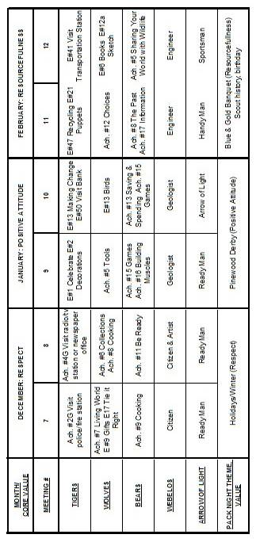

From Bob Scott at National in answer to my question on the role of Roundtables with the new delivery system -
Dave, you have it right.
No changes to roundtable’s role, how it's executed, etc.
Bob Scott , Innovation Coordinator - CS 2010

ROUNDTABLES
Beverly, Capital Area Council
Beverly is one of the nice ladies behind the counter at her council service center (No one says Headquarters anymore) that greet people as they arrive.
(That is her description not mine

"Announcements, announcements,
announ-n-n-n-n-n-ncements!"
We have all probably sung the song (or had it sung to us when we said the dreaded “a” word). The question is – how do you handle announcements at your roundtable? Are they all at the beginning or the end? Interspersed throughout? Do you or your staff make them all or do you let other folks have “ 5 minutes” ? This is something that has plagued RTCs since someone on the district or council level realized there would be a large gathering of Scouters in one place and it would be a perfect time to talk about _____ (insert your choice: popcorn, camporee, recharter, building campaign, etc., etc., etc.). We have had moderate success over the years and I would like to share a few suggestions that have worked:
- Impress upon your DE, District Commissioner and District Chairman that cub roundtable is designed to run for a certain amount of time and all of that time is chock full of program ideas. Any additions should be brought to your attention no later than 24 hours before roundtable so you can schedule time on the agenda. No more grabbing you 5 minutes before the opening to tell you “so & so is here from _____ and they need 10 minutes”. And you need to keep reminding people of your “announcement policy” – at the commissioners’ meeting, district committee, anytime someone tells you they want time out of your program.
- We used to scatter the announcements throughout the roundtable – doing one or two at a time and using the theme of the month for fun (a Pony Express rider for a western theme, pulling them out of Santa’s sack, etc). Now, with no themes, it will be a little harder. But…you could have a roving reporter from KCUB interrupting with “breaking news” (or you could still use the Pony Express rider).
- Give district folks 2 minutes to speak and the opportunity to provide a handout. And have someone time them (and yank them off stage, if necessary). I used to give my DE one minute and stand beside him, looking at my watch. He learned to get it said in a minute, after a few tries.
- If you can avoid a joint session where at least half of the announcements do not apply to your cub leaders, do so. It will be hard to convince the Key 3, but the information that needs to go to all leaders can be said twice – once in your roundtable and once in the Boy Scout Leader roundtable. And you get to set the spot on the agenda (that won’t completely drain the energy out of the room).
The thing we need to keep in mind and to impress on others is that, with all cub leader-specific training being done online, roundtable is the only chance for cub leaders to get hands-on experiences, to ask questions, and to have a chance to exchange ideas with other leaders. Anything that takes time from your program takes these opportunities away from the new leaders and, ultimately, affects the program delivered to the boys.

PACK ADMIN HELPS -

Don't Forget The Purpose
Of The Pack Meeting:
Cubmaster in Cascade Pacific Council
The Pinewood Derby is the Pack Meeting for the month in which it occurs. Make sure you are giving out the regular awards the boys have earned that month (this includes any belt loops, segments, etc). Some Cubmasters think that there isn't enough time on Pinewood Derby night but the purpose of Pack Meeting still is to recognize the boys. Awards can be done, quickly but still fun. I make a Cubmaster car, which I make slow on purpose. I build it up 2 or 3 months in advance. No one will beat my car, etc. On race day the boys have to race my car to get their award. They love it!!
Below are some more ideas for giving out pack awards and staying with the theme of the evening.

Den Discipline with Positive Attitude
Alice, Golden Empire Council
Focus on the POSITIVE. “Catch” the boys being good, helping others, keeping the den code of conduct. Baden-Powell said “A pat on the back is a stronger stimulus than a prick with a pin. Expect a great deal of your boys and you will generally get it.” Set a goal to say at least one good thing about each boy at every den meeting. But don’t give undeserved compliments – boys know when the praise is genuine! Remember,
“It’s better to build boys than repair men.”
DON’T CRITICIZE a boy in front of the den. Wait until you can talk to him alone. You might want to have a signal so that your assistant can ask a boy to come with her – make sure this is done without sounding angry or as if punishment is in store. Often, removing a boy from the action will defuse the situation. The other adult can simply take the boy to another location and have him help set up for another activity or discuss what happened in the den meeting.
USE POSITIVE WORDS –
- Be specific about what a boy does right – “Thank you for remembering to pick up your mess!” rather than just “Good Job”
- Be sincere and don’t exaggerate – “I really like the colors you used in that drawing” rather than “That’s the best drawing I’ve ever seen”
- Be Immediate with praise so you can reinforce good behavior.
- Share the Praise – while criticism should be done in private, praise is GREAT to SHARE. Share it by saying “I like the way John is putting the cap back on his markers”
You can also Share Praise by adding stickers or beads to a Den Doodle or Individual Boy’s Coup Stick.
And don’t forget to Share with Parents – send an email to let them know when their son is doing a good job or being a good example!
COUPONS – Enlarge and photocopy the coupons below, consisting of a front and back cover and six pages of various coupons. Use as an award for the Cub Scouts. As a boy achieves goals of good behavior, he is awarded “coupons,” which are compiled by the Den Leader. At the end of the month, (or whatever time you have decided) he receives the assembled coupon book. Coupons can be redeemed for treats, tokens to “purchase” incentive items, special privileges, such as helping make a den treat. Assemble the cut out pages, fastening with a staple and threading yarn through punched holes.
Note from Alice: I think a really good way to use these coupons would be to fill them in as a note to send home to parents – Parents need to know when their son has shown a Positive Attitude!
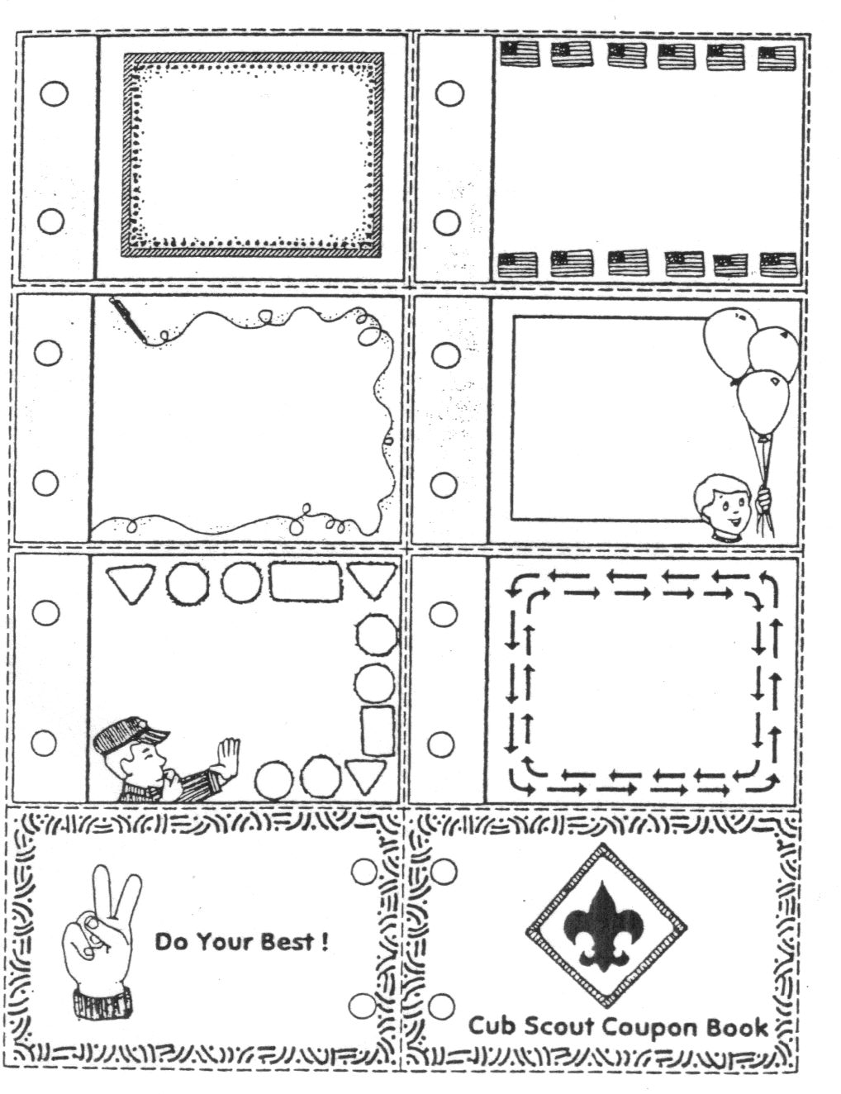

Every Car A Winner
Alice, Golden Empire Council
Some Packs give an award to every car – choose two or three judges ahead of time (this would be a great way to involve your chartered organization and avoid any perception of favoritism). Make up certificates that can be easily filled in with a description. To get you started, here’s a list of possible “categories” – and even the slowest car has a name with a positive spin- but don’t use the words “slowest car!” You can also go to http://www.agentz.com/scouts/samples.shtml for some great images you can download to use as ribbon centers, or even download certificates created especially for Pinewood Derby!
- Best Paint Job
- Most Colorful Paint Job
- Shiniest Paint Job
- Best Use Of Color
- Most Realistic Paint Job
- Most Original Design
- Coolest Design
- Most Unique Design
- Fastest Car In The Pack
- Fastest Car In The Den
- Sportiest Looking
- Best Workmanship
- Best Use of Imagination
- Most Aerodynamic Car
- Best Detail
- Most Humorous Car
- Best Use of Decals
- Smoothest Finish
- Most Futuristic Design
- Most Patriotic
- Best Wedge Shape
- Best Driver In the Car
- Judge's Favorite
- Best of Show
- Most Artistic
- Sportiest Design
- Most Creative Use of Material
- Best Fuel Economy (slowest car)

LEADER RECOGNITION & INSTALLATION
The Cub Scout Wheel
Cubmaster Recognition Ceremony
Cascade Pacific Council
PERSONNEL: 1 Cub Scout, 1 Parent, 1 Leader, 1 Pack Committee Member, 1 Person from community, 1 person from Sponsoring Org., 1 Cubmaster, 1 Narrator.
EQUIPMENT: Wheel with 7 candle holders on it.
ARRANGEMENT: All persons mentioned above stand behind wheel holding an unlit candle. As they read their part they light their candle from the Spirit candle and blow out the candle they were holding. (Alternate - one person does all the reading and each person lights a candle when their part is read).
Cub Scout: The first spoke of this wheel is the Cub Scouts from Tiger Cubs through Webelos: Boys 6-10 years old learning and growing together - developing confidence, skills and respect for others.
Parent: The second spoke of this wheel is the Parents: offering encouragement and assistance to their son as well as the leaders, pack and other boys.
Leader: The third spoke of this wheel is the Leaders: donating time, understanding and energy to teach Scouting skills.
Comm Member: The fourth spoke of this wheel is the Pack Committee: helping to plan, prepare and support all Pack activities.
Community: The fifth spoke of this wheel is the community: providing meeting places and points of interest for learning.
Chartered Org: The sixth spoke of this wheel is the chartered organization: donating supplies and finances in support of the pack.
Narrator: Just like any wheel, which needs a hub to hold the spokes together, so does our pack. The hub of Pack ____ is Cubmaster _______. He keeps our Pack rolling.
The long hours ________ puts in, his pride and never ending dedication is what has made this assembly of Cubs, Parents, and Leaders a Pack.
Would __________ please come forward. Cub Scouts stand and give your Cubmaster the Scout salute.

SPECIAL OPPORTUNITIES

100th Anniversary
Commemorative Patch
www.Scouting.org/100years
A Year of Celebration,
A Century of Making a Difference
Requirements must be completed by December 31, 2010
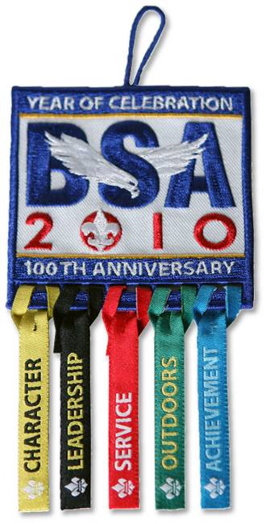
Every Scout, adult leader, and Scouting alum should have the chance to be part of our biggest milestone yet—our 1OOth Anniversary Celebration. Cub Scouts will be a big part of that! We want keep Cub Scouts excited about Scouting while giving them a chance to make a difference—and earn recognition—at an important time in our history. Through A Year of Celebration, A Century of Making a Difference, we will do just that.
By demonstrating dedication to five of Scouting’s core values, Cub Scouts and others can earn award ribbons to hang from the 100th Anniversary Commemorative patch. A Year of Celebration, A Century of Making a Difference is fun, engaging and—most importantly—shows America the impact of Scouting through its commitment to these values. A Year of Celebration will be in effect from Sept. 1, 2009, through Dec. 31, 2010.
Program Objectives
- Provide every Scout, leader, and alumnus a fun and meaningful way to participate in the 1OOth Anniversary and earn recognition!
- Increase awareness of Scouting’s value to the nation by promoting A Year of Celebration activities and by sharing the participation outcomes.
- Engage individuals in fun activities and reward their contributions to Scouting—helping improve both Scout and volunteer retention.
- Spark conversations about Scouting’s values, history, and programs—for both positive public awareness and Scout and volunteer recruitment. The more people talk about Scouting, the more they will want to join in!
- Increase overall participation in our 1OOth Anniversary Celebration by working closely with other national engagement programs.
- Help build stronger local council and unit ties through an exciting and easy-to-use celebration program.
Cub Scout Patch Requirements
National has posted -
Individual Tracking Cards so each Scout can track his progress
http://ww2.scouting.org/100years/100years/sitefiles/1000/YourSource/PlanningTools/YOC/YOC_Tracking_Cards.pdf
Tacking Charts so Dens or Packs can track everyone's progress
http://ww2.scouting.org/100years/100years/sitefiles/1000/YourSource/PlanningTools/YOC/YOC_Chart_Letter.pdf
LEADERSHIP
Scouting has a proud tradition of producing great leaders. Self-determination, teamwork, and preparedness are synonymous with Scouts everywhere. For Scouting’s 1OOth Anniversary, let’s celebrate this tradition of developing youth leaders.
The Year of Celebration Leadership Award encourages Scouts to explore and reflect upon the qualities of a good leader. The award recipients will work on leadership skills. The Leadership Award rewards participants for reflecting upon and sharing leadership lessons and skills. Scouts earning this award will look to role models, lead groups, and participate in leadership-building activities. Adults and alumni will build their unit leadership skills by emphasizing membership growth, volunteering, and providing role models.
Complete three of the five requirements in each category to earn the ribbon.
- Explain what makes a good leader and give an example of a Scout (past or present) demonstrating those qualities. Ask your parent or den leader what makes a good leader.
- Practice being a leader such as being a denner for one week. Write or tell your parent or den leader about what you did during that week.
- Get a friend to join Cub Scouts.
- Organize the den to set up and take down chairs at the pack meeting.
- With the approval of your den leader, plan and lead a den activity.
ACHIEVEMENT
Achievement in Scouting builds self-esteem and fosters collaboration with others. With every rank advanced and award earned, Scouts develop pride in themselves and their units. More than just getting a patch, Scouting’s myriad of awards challenge Scouts to excel, have fun, and grow into healthy, prepared adults. In addition to advancement, the award recipient makes an active effort to reflect on personal achievements and those of other Scouts.
The Year of Celebration Achievement Award highlights the possibilities for personal achievement. Scouts will pursue rank advancements, religious emblems, as well as engage adults and alumni in conversation about their own achievements in Scouting.
Complete three of the six requirements to earn the ribbon.
- Choose something you'd like to do better, and work on it for a week. Write or tell your parent or den leader about your progress.
- Earn one Cub Scout Academics belt loop and one Cub Scout Sports belt loop.
- Complete one achievement or activity badge for your rank.
- Complete one elective for your current rank.
- Complete one Cub Scout Sports or Academics pin, or the BSA Emergency Preparedness Award or the BSA Physical Fitness Award.
- Attend an event at an Adventure Base 100 tour site. Invite and bring a friend with you.
COMMUNITY SERVICE
Scouting’s contribution to society is most visible in the movement’s commitment to community service. Service is interwoven into many of Scouting’s honors and is mandatory for earning the higher rank advancements. Through service, Scouts demonstrate that they provide an essential function to their communities.
The Year of Celebration Community Service Award rewards recipients for providing time and resources at no charge for the good of their local community. More than just engage in service, the award recipient must also share their thoughts about why service is crucial to our society and how Scouts today fulfill a 100-year-old legacy of serving communities.
Over the years, the Boys Scouts of America has partnered with several national organizations to accomplish some great service projects. If you are looking for service project ideas, consider the following options:
Nothing But Nets Scouting For Food
Habitat for Humanity Our National Parks
American Red Cross Arbor Day Foundation
Take Pride in America The Salvation Army
Cell Phones for Soldiers Preserve Our Waterways
2010 US Census
Complete three of the five requirements to earn the ribbon
. * Make sure that all service hours are recorded online for ―Good Turn For America.‖
- With your parent or den leader, identify a person who serves the community. Write or tell about what that person does for others.
- With your family or den, help plan and carry out a community service project. Write or tell about the project.
- With your family and/or den, clean up your Pack’s chartering organization’s parking lot, a neighborhood park, the school grounds, or other public area.
- Participate in a nature beautification project such as a tree or natural vegetation planting.
- Give service to a community organization such as a food bank or feeding station.
CHARACTER
Scouting is a character-building enterprise. Youth learn that personal responsibility and integrity are essential to accomplishing one’s goals. They learn to do good turns without expectation of reward. They learn to be brave when challenged to do the right thing.
The Year of Celebration Character Award rewards recipients for engaging in an active conversation about living by the Scout Law. The award involves elements of citizenship, family life, and personal fitness. Scouts will reflect on their own character and values. Adults and alumni will rediscover the impact Scouting makes on their own character.
Complete three of the five requirements in each category to earn that patch.
- Talk to your parent or den leader about the Cub Scout Promise or Law of the Pack. What does it say about the kind of character a Scout should have?
- With your family or den, plan and carry out a game that helps demonstrate one of the Character Connections(TM). Write or tell about your experience.
- Talk to your parent or rabbi, minister, cleric, or other religious leader about how trust in God provides inner strength and confidence.
- Talk to your parent or den leader about honesty. Talk about why it is important to be honest in everything you say and do.
- Become a friend of a boy who is being left out of the group. Discuss how compassion and cooperation are essential to good character.
OUTDOORS
From campouts to High Adventure, Scouting happens outdoors. Since its inception, Scouting has centered on teaching values through working and playing outside, and fostering respect and understanding of one’s natural surroundings.
The Year of Celebration Outdoors Award is geared toward getting individuals active in nature. The recipients must participate in outdoor activities and show growth in personal outdoor skills. They must also demonstrate increased knowledge of nature. Scouts must show understanding of the impact humans can have on ecosystems and why one must Leave No Trace when experiencing the outdoors. Adults and alumni are encouraged to share their outdoor Scouting experiences with Scouts, as well as non-Scouts of all ages. The Award centers on principles of stewardship, discovery, and personal fitness.
Complete three of the five requirements to earn the ribbon.
- With your family or den, help plan and carry out an outdoor activity. Write or tell about your experience.
- Describe to your parent or den leader the different kinds of plants and animals you can find around your neighborhood.
- Earn Cub Scouting’s Leave No Trace Awareness Award or the Cub Scout Outdoor Activity Award.
- Go on a hike with your family or den.
- Participate in a district or council outdoor experience (day camp, resident camp, etc.).

Knot of the Month

100th Anniversary
Commemorative Patch
(Something different this month)
Requirements must be completed by December 31, 2010

The picture above is a button you can download from National's site. It is intended to be used as a link to the on-line award requirements. Try it - it works!!!
Adult Leader Patch Requirements
By completing three of the five requirements, adult Scouting Leaders can earn each of five award ribbons. A Year of Celebration will be in effect from Sept. 1, 2009, through Dec. 31, 2010.
LEADERSHIP
- Help organize a new unit.
- Compile a list of all adult and/or alumni e-mail addresses in your unit, get their permission, and submit the list to your local council Scout service center so Scouting communication can be improved.
- Actively support a unit in at least two activities related to the BSA 1OOth Anniversary.
- Recruit a new adult volunteer, or find a Scouting alumnus, who registers with the BSA.
- Help any registered youth with their Year of Celebration Leadership award.
ACHIEVEMENT
- Actively serve on one advancement review for any Scouting program or participate in any rank advancement award ceremony.
- Earn any BSA training award, BSA Emergency Preparedness Award, or BSA Physical Fitness Award.
- Help any youth member with advancement toward rank.
- Be a registered member of a Centennial Quality Unit.
- Help any youth member earn any 1OOth Anniversary Year of Celebration award.
- Attend an event at an Adventure Base 100 tour site. Invite and bring a friend with you.
COMMUNITY SERVICE
Over the years, the Boys Scouts of America has partnered with several national organizations to accomplish some great service projects. If you are looking for service project ideas, consider the following options:
Nothing But Nets Scouting For Food
Habitat for Humanity Our National Parks
American Red Cross Arbor Day Foundation
Take Pride in America The Salvation Army
Cell Phones for Soldiers Preserve Our Waterways
2010 US Census
* Make sure that all service hours are recorded online for “Good Turn For America.”
- Be an active participant in Scouting For Food or another food drive or help with a Salvation Army service project.
- Be an active participant in the Nothing But Nets project found on the national 1OOth Anniversary Web site.
- Be an active participant in a Take Pride in America project or a project benefiting the National Parks Stewardship Awards program.
- Be an active participant in an American Red Cross or a Habitat for Humanity project.
- Be an active participant in any unit’s service project.
CHARACTER
- Work with any youth so he achieves a religious emblem.
- Do a Good Turn for seven consecutive days.
- Participate in a discussion on good character at a unit meeting.
- Help any youth member achieve his Year of Celebration Character patch.
- Learn about and participate in a flag retirement ceremony.
OUTDOORS
- Participate in a unit, district, or council outdoor event.
- Assist a unit in an outdoor conservation project.
- Attend camp with a unit (Cub Scout day camp, summer camp, Venturer camp, etc.).
- Attend a professional (major or minor league) baseball game, or another public event, in uniform with a unit.
- Visit the “Get in the Game Geocaching” page at www.Scouting.org/100years, the 1OOth Anniversary Web site and participate in a BSA 1OOth Anniversary geocaching activity.

GATHERING ACTIVITIES
"Gathering Activities" for large groups and getting groups to know each other are in this edition. Those good for dens (e.g. word searches, puzzles, mazes) are in the Den edition. Dave
Note on Word Searches, Word Games, Mazes and such – In order to make these items fit in the two column format of Baloo’s Bugle they are shrunk to a width of about 3 inches. Your Cubs probably need bigger pictures. You can get these by copying and pasting the picture from the Word version or clipping the picture in the Adobe (.pdf) version and then enlarging to page width. CD
Alice, Golden Empire Council
Display of Collections and Talents for everyone to enjoy–
Think outside the box – every boy has talents, whether in sports, or art, or scholarship – or a passion or interest, such as Space, Magic - Make sure each boy has a way to be highlighted and that tables and easels are available for displays. (Ask for a Pack Committee Volunteer to work with all the boys during the month so they learn how to display and label their items) Be sure and take a photo of each boy by his display.
Display the various Belt Loops & Pins available – Do a countdown to see how many people think they would fit in each Belt Loop category – which Belt Loop they think they could have already earned with what they know!
Or make a “Bingo Card” on the wall and collect signatures of those for whom a subject belt loop or pin might be an interest or passion (Extra Bonus: You can get a great list of possible “guest experts” to help dens or individuals complete Belt Loops & Pins – AND you make parents and boys aware of the many categories available!
We Appreciate YOU for……
Have a Wall of Appreciation or Give out special fun awards to parents, grandparents, leaders, community donors – all the people who have helped make your den or pack keep going!
Favorite Moments in Scouting
As people come in, have them write a short description on a 3X5 card – ask them to write their favorite activity, treat, field trip of the past year – Share them on a wall display, or as part of a special page in the pack scrapbook at the Blue & Gold Dinner in February.
Next Time……
Prepare cards or an enlarged wall display with various scenarios that appear to be negative, such as “I didn’t have time to finish my homework and got a zero on the assignment.” Assign each person or team of people to think of something they could do to turn the negative result around the Next Time. Their solution should begin with the words “Next time I will….”
During the month, leaders and parents should be asked to look for examples when they might set a Positive tone by saying “What could you do Next Time?”
Display the Results of your “Find the Letter” activity – with a title of “Take Another Look”
During the month, each boy, team of boys, den or family try to find objects that “make” each letter of the alphabet. They can either bring in the object, make a drawing or take a photograph of the object – and display them at the Pack Meeting. Allow time for everyone to enjoy the displays. (See ideas under Value Related)
You could even ask a pack parent photographer to take a photo of each person or group next to their display, and add this to the pack scrapbook. The idea is that in order to “see” the letter, you have to take another look – look at something with fresh eyes. And that’s just what you do when you “look” at something with Positive Attitude! Be sure and make the connection. And try the P&A treats under Cub Grub.

A Face in the Crowd
As a fun backdrop for the Pinewood Derby, roll out a large piece of paper. Have the boys paint the bottom a dark color to represent the “stadium seating” for the race. Assign each den a “seating section.”
For the “crowd” just make lots of circles – but to make it really fun, get small school pictures from each parent and fill in some of the faces in the crowd with the boy’s own faces – and give a special fun prize to each boy when he finds his own face!
Or each boy could fill in the details to make his own “face in the crowd” – and let parents try to find their own son’s face!
Every den in the pack could also work on a “section” of the seating – to make a large backdrop mural for the races.
Road Sign Game
Cascade Pacific Council
Road signs like these are important to drivers, Can you think of some games that can be played to help you learn the signs?? Or maybe have your Cubs create a game or three??
HHHMMmmmmm - this looks like the start of a BINGO board to me. Just add in a few more signs and produce some cards with the signs in different orders. CD
How about Road Sign Dominoes for gathering?
Hide the signs around your meeting area and then have the boys find them and mark them off on a card.
What else can you think of creating??
Transportation Quiz
Cascade Pacific Council
- A form of transportation that does not run on wheels is_____.
Skateboard Snowmobile
Blade skates Tank
- The inventor of the wheel is unknown, but the first record of a wheeled vehicle goes back 5,000 years to ancient ______.
Babylonia Sumer Egypt Greece
- The wheel is a form of a simple machine called the______.
Pulley Wedge Screw Lever
- The earliest wheels were made of ______.
Joined wood slabs Bronze Chiseled stone Iron
- The first important improvement in construction was the ______ wheel.
Wire Disk Welded Spoked
- A major improvement in the wooden wheel was _______
an iron rim Harder wood
Flat area elimination Axle lubrication
- Starting with the 13th century, a person who made and repaired wheels was called a _________
Wheelwright Wheelie
Wheeler-dealer Wheelsman
- Around 1830, a new kind of wheeled vehicle began to appear, the ________.
Steamboat Stanley steamer
Shaftmobile Steam locomotive
Answers: (1) Snowmobile (2) Sumer (3) Lever (4) Joined wood slabs (5) Spoked (6) An iron rim (7) Wheelwright (8) Steam locomotive
Gathering
Cascade Pacific Council
One den of Cub Scouts acts as taxi cabs, wearing yellow TAXI signs on their caps and holding cardboard steering wheels. As people arrive, the den chief calls for a cab. One of the taxis ‘drives’ guest to a seat, as the guests puts his hand on the taxi’s shoulders.
Do You Know Cars?
Cascade Pacific Council
Each of the definitions below describes a car. Can you name them? (You may need your parents' help, some of these are no longer manufactured!! CD)
- Our 16th President?
- River in New York?
- First Colony in New England
- Indian Chief
- Theater in which Lincoln was shot
- A spotted horse
- A hawk
- A motherless calf
- A wild horse
- One who travel and finds new things
Answers
1. Lincoln; 2. Hudson; 3. Plymouth; 4. Pontiac; 5. Ford; 6. Pinto; 7. Falcon; 8. Maverick; 9. Mustang; 10. Explorer
Wheels Scramble
Cascade Pacific Council
Unscramble the following words of things with wheels.
- niart________
- rac ________
- kbie ________
- sbu ________
- elcryootm _________
- ngawo _________
- ktcru _________
- cramep _________
Answers: 1. train; 2. car; 3. bike; 4. bus; 5. motorcycle; 6. wagon; 7. truck; 8. camper.
Fun for All Pre-Opener
Cascade Pacific Council
Pictographs are pictures that stand for words and thoughts. And that’s the whole idea — People everywhere understand their meaning without requiring any words. The following signs are commonly found along highways, in picnic areas, at lake and beach resorts, and in hotels, bus depots, railroads stations, airports, campgrounds, and other public places.
Below are pictographs of international travel signs. Make copies to be used for the pre-opening activity. Give a copy to each person as they arrive for the Pack Meeting and have them guess the meaning of each sign. If desired, prizes can be given for various levels of accuracy. The prizes need not be more elaborate than pieces of candy or something that goes along with the theme. Have fun with this one!
International Pictographs
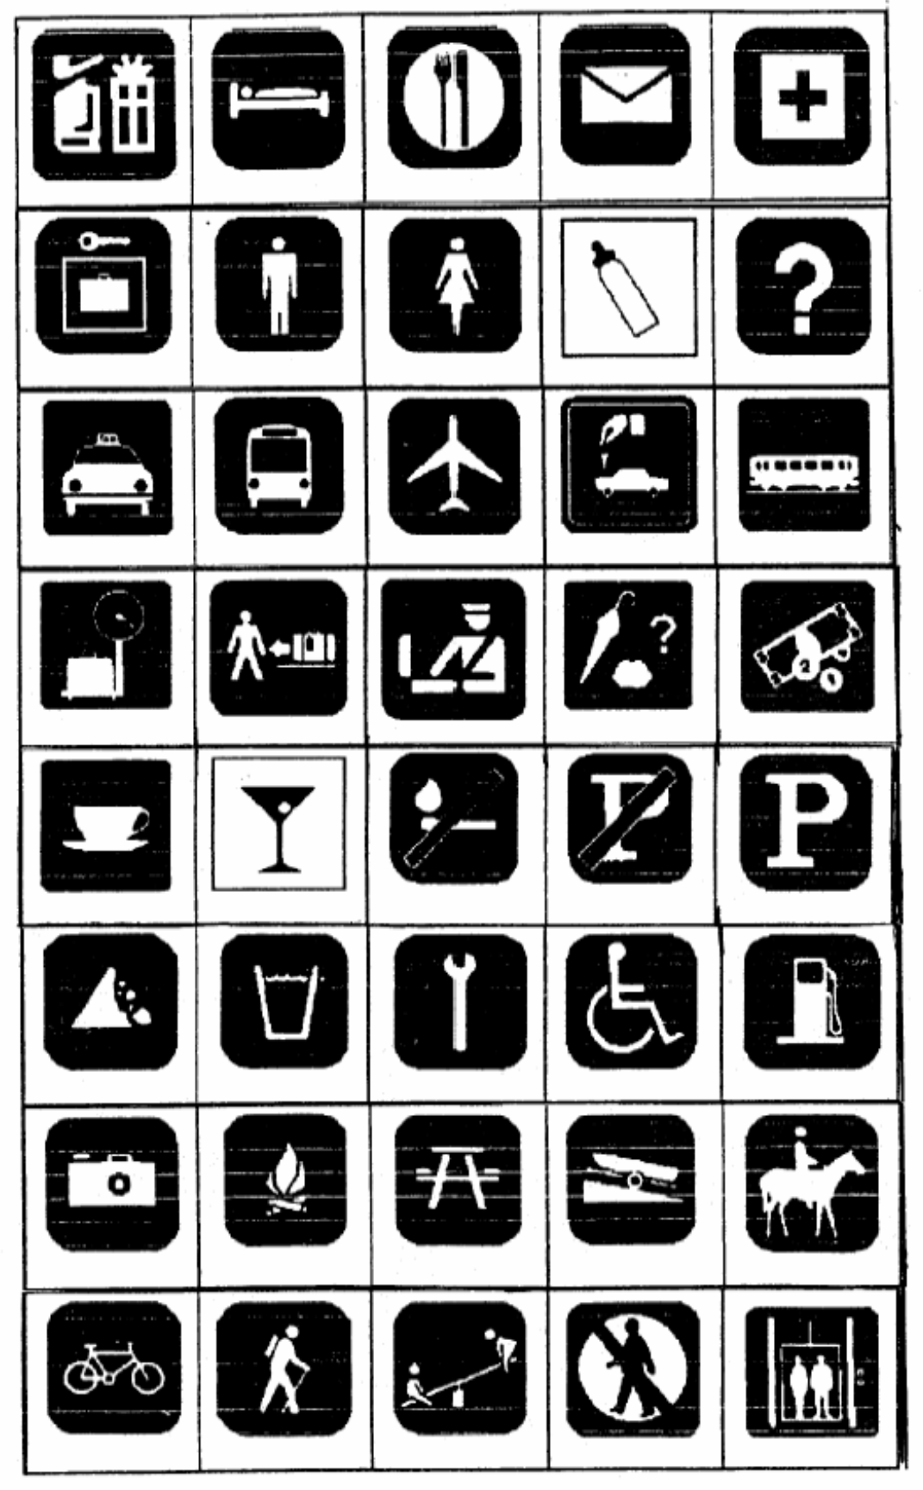

Key:
Left to right top to bottom:
gift shop - hotel information - restaurant - mail - first aid - baggage lockers - men's toilets- women's toilets - nursery – information - taxi stand - bus transportation - air transportation - car rental - rail transportation - baggage check-in - baggage claim - customs - lost and found - currency exchange - coffee shop - bar - no smoking - no parking - parking - falling rocks - drinking water - mechanic - handicapped - gas station - viewing area - campfires - picnic area - launching ramp - horse trail - bicycle trail - hiking trail - playground - no entry – elevator

OPENING CEREMONIES
I’m Positive
Alice, Golden Empire Council
(Boys should be very enthusiastic when they say their lines –
practice being Positive!)
CM/DL: So, what do you think is going to happen tonight?
Cub #1: I’m positive this is going to be a great pack meeting!
Cub #2: I’m Positive it will be exciting watching the races! (Take out “the races” if you aren’t having a Pinewood Derby this month)
Cub #3: I’m Positive we can all have a great time!
Cub #4: I’m Positive we can all cheer each other on!
Cub #5: I’m Positive everyone will do their Best!
Cub #6: I’m Positive we can all be winners!
CM/DL: Hey, that sounds great! So, you think we’ll all have a good time?
ALL: We’re POSITIVE!
Things That Go
Cascade Pacific Council
Cub Scouts line up and hold their posters up as indicated below. On the front (facing audience) is the appropriate picture. On the back in LARGE print is the Cub's part.
- (word "GO") The things that take us where we want to go and were all invented by men whose Positive Attitude enabled them to succeed. They kept on trying despite disappointments and failures along the way. Here are just a few examples -
- (Model-T Ford) Henry Ford was an important man, for he helped invent the car, He made it in mass production, and made it to go long and far.
- (Spirit of St. Louis plane}"'Lindberg was a man whom we've all read about, He helped build a plane that made the world all shout.
- (Steamship) Robert Fulton did his part in making something that would go, The steamship made him famous, about steam he sure did know.
- (Steam Engine) James Watt, too, became famous, for something that would go, His improvements on the steam engine, year after year did grow.
- (Large wheel with the word "THANKS" for spokes) So you see men such as these, with a positive attitude knowing they could succeed, helped our country to grow, And we're thankful to them, for inventing things that go.
- (U.S. map) So, as we're thinking about the men who helped our nation grow and go, Let us now salute the flag, ever thankful for all that we know.
- Will the audience please rise. Those in uniform, salute. Those not in uniform, place your hand over your heart. Please join me in the Pledge of Allegiance.
Models for the Future
Cascade Pacific Council
The Cubmaster shows a model of a futuristic car and says:
Cub Scouts, here is a great looking car. It is the builder's vision of what cars may look like in the future. We can't be sure that he's right. But we can be sure that the world is going to need good men in the future. And we can be sure that we will all be good men if we keep a positive attitude and remember to follow the Cub Scout Promise. Let's remember that as we stand and repeat the Promise. (Leads audience in the Cub Scout Promise.)
(This could also make a great
Cubmaster's Minute for Closing.)
Pinewood Derby - Opening Ceremony
Cascade Pacific Council
- P - A Pinewood Derby is fun for all. But the whole family must answer the call.
- I - I entered the competition to win or lose, or whatever my doom.
- N - Neatly I painted my car with dad's expert help, but I ran it myself.
- E - Excitement ran all through the night. No matter who won, it will be all right.
- W - We would all lie to come in first, but if not, our bubble won't burst.
- O - On with the races, don't hesitate. The Pinewood Derby didn't wait.
- O - Open the gates, down the track, then we rest. For, being Cub Scouts, we've done our best.
- D - Don't mind tonight, where your car places, Cub Scouting will help you through life's races.
Pinewood Derby - Opening Ceremony
Cascade Pacific Council
Cubmaster:
If you take a moment tonight to contemplate these cars, you will realize that an awful lot of painstaking work went into each one. There is much creativity and ingenuity represented here. I don't know, but I imagine that each car was designed to be the fastest. Of course, not all cars will win. As we begin our pack meeting, keep in mind that in Cub Scouting, as in life, the victors are those who put forth earnest effort. As a great marathon runner from Kenya, a country in Africa, once said "To win is to finish. To finish is to win." Please join me in the Pledge of Allegiance.
Block of Wood
Cascade Pacific Council
Equipment: A long table with a cloth covering the top and front and side A block of wood A variety of wood working tools A piece of wood carved and finished.
CM: You see this block of wood (holds up the block of wood, uncarved) which is much like a boy as he enters the Cub Scouting program. It is just a block of wood. It is plain and does not suspect what it can become.
Now, let’s look at a piece of wood (holds up the wood that is carved) that has been lovingly shaped, sanded, stained, and finished in every way to become something useful and beautiful. What makes the difference between the uncut block of wood and this fine piece of wood?
A patient wood worker, using tools that are properly cared for, follows a pattern to shape a block of odd into something

AUDIENCE PARTICIPATIONS
The Big Race
http://usscouts.org/pinewood/cspdsong.asp
Divide the group into four smaller groups and assign each group one of the words listed below. Practice as you make assignments. Read the story.
After each of the words is read pause for the group to make the appropriate response.
Narrator reads the following like a radio announcer with a lot of enthusiasm! The audience is divided into groups. As their assigned word is read in the story, they make the sound:
WHITE = Whiz!
RED = Zoom!
YELLOW = Zip!
BLUE = Ca-Chunk!
The cars are ready.
The flag us up.
The race is set to go.
The flag goes down,
The cars are off...
They're running toe to toe!
The WHITE _____ is ahead.
The RED _____ goes by.
Here comes the YELLOW _____ now.
Here comes another one - it's BLUE _____.
Whew, it sounds bad, wow!!
The last lap now.
The RED _____ is leading,
The YELLOW _____ and WHITE _____ close behind.
I'm looking hard -- I see the BLUE _____.
So far back, it's hard to find!
The finish line is just ahead.
That BLUE _____ is coming up fast,
I can't tell why ...
The crowds on its feet ...
They're yelling -
The WHITE _____, the RED _____,
The YELLOW _____, the BLUE _____,
HAVE ALL FINISHED IN A TIE!!
The New Car
Cascade Pacific Council
Tonight I’m going to read a little story about a couple that go shopping for a new car. But the story is really rather dull. I’d like you to help me make the story livelier by joining in when I read certain words. Whenever I say these key words, please follow these instructions; it’ll help the story a lot!
- If you have blue eyes, whenever you hear the word BLUE pat the top of your head.
- If you have brown eyes, whenever you hear the word BROWN pat the top of your head.
- If you hear the word LEFT and you’re left-handed, clap your hands.
- If you’re right-handed, clap when you hear RIGHT.
- If you’re under 20, stomp your feet when you hear the word NEW.
- If you’re over 20, stomp your feet when you hear the word OLD.
- If you’re a male, stand up when you hear MAN.
- If you’re a female, stand up when you hear WOMAN.
At this point the Narrator should practice with the audience, calling out the cue words having them respond with the appropriate action. The Narrator begins the story slowly and picks up speed Narrator pauses after each key word.
One day a MAN and a WOMAN went looking for a NEW car. Their OLD one, which was a muddy BROWN, was not running well. It LEFT much to be desired in the way of speed and safety, and they wanted another one RIGHT away. They wanted a bright BLUE one. As they walked into the dealership, the WOMAN noticed a BLUE sports car on the showroom floor. “Darling” she said, “Look at that lovely NEW car RIGHT over there. Wouldn’t it be perfect for us?’ “You may be RIGHT. It’s a lot better looking than our OLD BROWN buggy. Unfortunately there’s one problem. I’ve LEFT all my money at home,” said the MAN. “You LEFT it at home?” asked the WOMAN. “Yes, it’s RIGHT in the pocket of my NEW BROWN suit.” said the MAN. “Your NEW BROWN suit? Why I took that suit to the cleaners just this morning and I didn’t notice any money in any of the pockets,” said the WOMAN. “But I’m certain I LEFT my money in the inside RIGHT pocket of my NEW BROWN suit,” the MAN said as he scratched his head in wonder. “Now wait a minute. Are you saying I’m not RIGHT? Are you saying I’m lying about this? MAN, oh MAN, oh MAN! You have a lot of nerve!” shrieked the WOMAN. “Let’s not argue. We’re here to look at cars, and that BLUE one in the corner is a RIGHT nice model. And just think, if we buy the NEW BLUE car, we’ll never have to worry about our OLD BROWN one again!” After looking at the price of the NEW BLUE-car, and figuring out what they could get as a trade on their OLD BROWN one, the MAN and the WOMAN decide buying a NEW car would be the RIGHT move for them. But before they LEFT the dealer, they started questioning their decision. Would they be better off with their OLD BROWN car if the NEW BLUE one didn’t run RIGHT? Or what about a NEW BROWN one? How long before they thought of the NEW car as an OLD car? and would they ever feel BLUE about trading in their BROWN auto? BLUE or BROWN, OLD or NEW, what was RIGHT and which car did they want to be LEFT with? The MAN and the WOMAN were so confused that they decided to sell their car and buy themselves bicycles. And that’s just what they did. And they knew it was RIGHT... LEFT... RIGHT... LEFT (The narrator continues alternating between RIGHT and LEFT until the audience realizes they are applauding the end of the story.)
The Big Wheel
Cascade Pacific Council
Divide the group into four smaller groups and assign each group one of the words listed below. Practice as you make assignments. Read the story.
After each of the words is read pause for the group to make the appropriate response.
Big Wheel: "Spin, spin"
Canoe: "Paddle, paddle"
Airplane: "Zooooom"
Car: "Rattle, rattle, rattle"
Man has invented different things that go and provide him with transportation down through the years. The Indian made his CANOE, which took him from place to place and served its purpose well. Men like Henry Ford invented the CAR, which today is the most popular type of transportation. There were men like the Wright brothers, who pioneered the invention of the AIRPLANE. And there is a group of people, called the BIG WHEELS, who really don't go anyplace or do anything, but they like to feel important.
This story is about one of those BIG WHEELS who just sat and spun his wheels and felt so important while he was doing nothing at all. Everyone around him was working on new and better types of CANOES, designing new and more efficient CARS, and designing and testing newer and faster AIRPLANES. But our BIG WHEEL just sat around feeling important, not doing anything to help anybody, while everyone else was doing the work.
Somehow, he always seemed to get by and fool people into thinking that he was important because everyone around him was making progress. The BIG WHEEL depended on their brains and energy to make him look good. Finally, one day, something happened that changed things overnight for the BIG WHEEL.
Everyone who had been working on CANOES, and CARS, and the AIRPLANES decided it was time to teach the BIG WHEEL a lesson. They were tired of him doing nothing except acting important. So they all became very busy and didn't pay any attention to him. When something came up, the BIG WHEEL found he couldn't rely on the others to answer questions and make him look important. Finally the BIG WHEEL realized he could not accomplish anything without help from the others. He realized he was making no contribution to the world at all. He was just sitting there spinning his wheel, while the others accomplished a lot on CANOES, and CARS, and the AIRPLANES. BIG WHEEL felt very bad.
It was a hard lesson when BIG WHEEL finally realized something he should have known all along—if you're going to get anyplace in this world, you can't expect other people to do all the work for you. But it was a good lesson, too. Because when the BIG WHEEL, really look deep down within himself, he realized that, like the CANOE makers, and the CAR workers, and the AIRPLANE people, he too had special talents that he could use to contribute to the world.

ADVANCEMENT CEREMONIES
Positive Attitudes Past, Present & Future
Alice, Golden Empire Council
(This is set up for rank advancements – but you can use the same idea to give other awards such as Belt Loops, Activity Pins and special patches – just connect the boy’s Positive Attitude to the historical example.)
Cubmaster: This month, the boys in our Pack have been exploring Positive Attitude – and there are also many great examples in history.
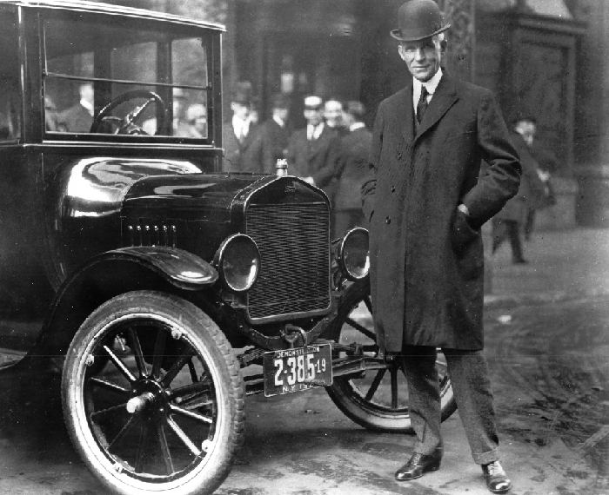
Henry Ford had set himself the goal to produce a basic, sturdy, reliable vehicle, and in spite of the failure of his first TWO companies and many other design and production challenges, he kept a positive attitude and met his goal.
In Scouting, the basic goal is to earn the Bobcat badge – and a Positive Attitude helps new scouts memorize the Promise and Law and learn what’s required. (Calls up boys and parents – Presents the badge to the parent to pin on the boy, and the parent pin to the boy to pin on the parent. Leave time for a photo and cheer)
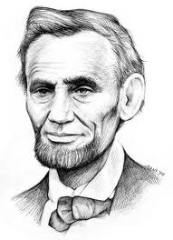
One of the greatest examples of a positive attitude is Abraham Lincoln. If you want to learn about somebody who didn't quit, and kept on trying look no further. Born into poverty, Lincoln was faced with defeat throughout his life. He lost eight elections, twice failed in business and suffered a nervous breakdown. He could have quit many times - but he didn't and because of his positive attitude, he became one of the greatest presidents in the history of our country. Even in the darkest days of the Civil War, when the Union was losing, he remained positive, knowing that right would win. Our Tigers have shown a Positive Attitude in completing their five achievements. (Calls up boys and parents – Presents the badge to the parent to pin on the boy, and the parent pin to the boy to pin on the parent. Leave time for a photo and cheer)
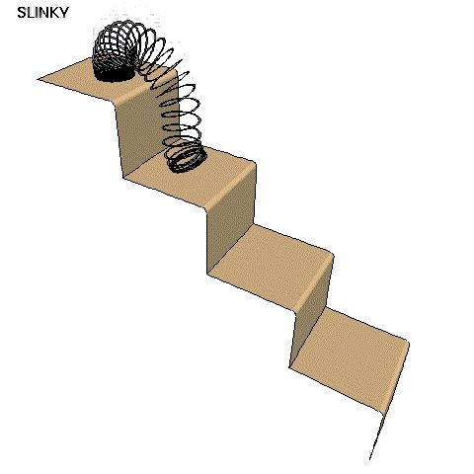
The Slinky is a fun toy famous for traveling down stairs – but we have some scouts who have been heading UP – and advancing in scouts. And they showed the same Positive Attitude that Richard James had when he invented the Slinky in 1943 – he took an accident with a tension spring, added a lot of hard work and creativity, and only a little cash, and came up with a winning idea. Scouts also had to invest hard work to take their next step up – the Wolf Badge. (Calls up boys and parents – Presents the badge to the parent to pin on the boy, and the parent pin to the boy to pin on the parent. Leave time for a photo and cheer)
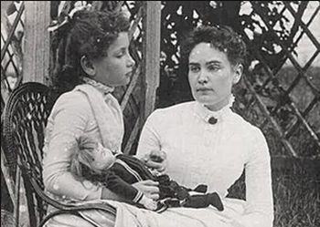
Helen Keller and her teacher Anne Sullivan were both examples of real Positive Attitude – Helen lost her hearing and sight as a small child, and without her teacher, she would have been trapped in a silent dark world. It took hard work and a positive attitude to find a way to communicate. And we have some scouts in our pack who can communicate their Positive Attitude in their actions – they have completed all the requirements to earn their Bear Badge. (Calls up boys and parents – Presents the badge to the parent to pin on the boy, and the parent pin to the boy to pin on the parent. Leave time for a photo and cheer)
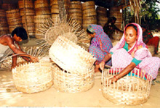
Sometimes it takes only a little Positive Attitude to overcome the feeling that one person can’t solve the world’s problems. Professor Mohammad Yunus discovered this when he met a poor mother during a famine in Bangladesh and found out that only 22 cents in American money kept her from being able to purchase supplies and stop paying terrible interest to lenders – Yunus began the Gameen Micro Credit system, which led to other micro credit organizations, and has allowed millions to get out of poverty. For Webelos Scouts, it also takes some Positive Attitude and work to complete their Activity Pins and keep moving toward their goal. (Calls up boys and parents – Presents the badge to the parent to pin on the boy, and the parent pin to the boy to pin on the parent. Leave time for a photo and cheer)
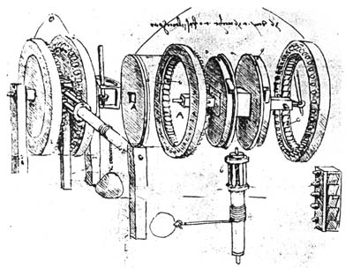
Leonardo daVinci didn’t invent the first car, but he drew designs that have since been built and shown to work. He used a gear shift and direction changing gears, with jack and ball bearings to move gears smoothly in a mechanical engine. He also understood the value of inter-changeable parts long before Henry Ford! And he kept a Positive Attitude as he filled page after page with new ideas! While working toward the Arrow of Light badge, boys in our pack have spent some time learning a little about engineering – and applying Positive Attitude to complete all the required Activity Pins for their Arrow of Light.
We want to recognize the extraordinary effort required to achieve this goal.
(Move into a more substantial ceremony to present
the Arrow of Light, including parents, younger scouts
in the pack, Webelos leaders and the boy’s new
Boy Scout leader – make sure everyone understands
that the Arrow of Light is the only award allowed
to be moved onto the Boy Scout shirt)
Note: An adult volunteer might want to build a Crossover Bridge for the pack, possibly with the help of the boys – check out the example in Webelos section, which uses all the Points of the Scout Law, which are very close to the Values.
P & A Advancement
Alice, Golden Empire Council
Preparation: Gather a group of various items that start with either P or A – Display them on a table, with an award or description of an award and who is to receive it on each item.
Cubmaster: Well, we have an interesting mix of things here on our table tonight. Wonder what it’s all about?
Assistant Cubmaster or Den Leader: (Looking at the stuff, and picking up one of the items) Well, there seems to be something attached to this one. (Hands it to CM)
Cubmaster: Well, this is for (Calls up the boy by name) And it seems to be an award – so let’s get your parents up here, too!
(Reads what the award is for, has boy pin the parent with the parent pin and the parent present the badge to their son)
Continue on through the items (Pre-arrange so you save important awards for last). When all the awards have been given out, ask if anyone has figured out what’s this collection has in common. If no one has an idea, the Cubmaster can explain:
Cubmaster: Well, these items did have something in common. The name of each item begins with the letter “P” or “A” – that stands for “Positive Attitude!” And this month, each of the boys has demonstrated Positive Attitude in learning new skills, perfecting old ones, and completing requirements to earn badges and awards. And that Positive Attitude is part of scouting – don’t forget our Motto – Always “Do Your Best!”
Traveling Advancement Ceremony
Wendy, Chief Seattle Council
Props: Large pictures/posters of cars that match the descriptions
Cubmaster: The boys in our pack have not just been spinning their wheels and not going any place. We'll see tonight how many of them are reaching their destination.
Our Bobcats have really been "wheeling along" (picture of a small economical car (Volkswagen or similar) and learning the "rules of the road." Will _________ and their parents wheel on up here and receive your Bobcat license that will keep you on the Cub Scout road?
Our Tigers have been pedaling along (picture of bicycle or pedal car) and completed their requirements. (Have boys and their parents pedal on up for their Tiger rank.)
"Chugging along"(picture of a Jeep (SUV) (Not Hummer or Land Rover)) over the mountains and through the woods are our Wolves. Some of them tonight are ready to pull up at the top of Wolf peak. (Have boys and their parents "come on up" to Wolf peak for their Wolf rank.)
We also have some Wolfs who are really loading up and have earned some Gold and Silver Arrows. (Call boys and their parents forward.)
Not to be outdone, is our Bears who are really "cruising along"(picture of a Police cruiser or luxury automobile) this month. Some have cruised right through the Big Bear Book and earned their Bear. Will ________ and their parents park their wheels and come up here to receive their license to continue cruising through their BEAR year?
The following boys have done some extra cruising and earned their Gold and Silver Arrows. (Call boys and parents forward.)
Our Webelos really "zoomed" around this month. (Picture of a sports car (Corvette)) learning to be good Citizens(first year) and Communicators (second year) Let's have them zoom up here and tell us about the exciting month they had.
Advancement Ceremonies
Pinewood Derby Advancement
Cascade Pacific Council
Equipment: Pinewood Derby track, badges of rank, or decals, and awards to be given. Put decals or actual badges of rank on cardboard and attach to 8 inch long sticks. Tape or tack these to side rails of derby track in ascending order - Bobcat, Wolf, Bear, Webelos, and Arrow of Light. At the appropriate places on the track, have the badges and arrow points.
Cubmaster: We’ve all had a great time tonight watching the pinewood derby cars race down this track. They really speed downhill, don’t they? Well, you can go uphill on this track too. It’s a little harder, but it’s worth the climb from Bobcat to Tiger to Wolf to Bear, etc. Some of our Cub Scouts have been climbing this course, and now we are going to show how far they have progressed. (Read names) When boys and parents arrive, give the badge to the parents, who then gives it to their son. Repeat for all the ranks and arrowheads.
(When boys and parents come forward, remove the awards from the track and have the parents pin the badges on. Repeat for Bears and Webelos.) Lead a cheer for each group.
Race Car Advancement Ceremony
Cascade Pacific Council
The Cubmaster enters after a brief absence wearing a helmet and racing clothes. He carries with him a tool chest.
A race car teams need lots of tools to keep their cars running fast. They also need awards for the races they finish. I’11 bet that a tool chest this big holds lots and lots of awards.
The Cubmaster then proceeds with the award ceremony calling on the Chief Mechanics (Assistant Cubmaster and Den Leaders) to help him/her.
Carving the Pinewood Racer
Cascade Pacific Council
The advancement ceremony at a derby should
be short effective and to the point.
Equipment - one uncarved Pinewood Derby wood block, one finished Pinewood Derby racer
The Cubmaster holds up a block of wood in one hand and a finished car in the other. "Just as we carve a rough block of wood into a sleek pinewood racer, so we turn a rough boy into a Cub Scout. WE do it with challenges in the form of advancements. This month, we honor those Cubs who have worked hard to complete the various requirements for their awards." (Beginning with Bobcat, Tiger, Wolf, then Bear and Webelos, call each boy to the front WITH his parents. Present the award to parents who present it to their son. The Cubmaster gives the Cub Scout handshake to each boy and congratulates parents.)
Pinewood Derby Advancement
Cascade Pacific Council
Personnel: Cubmaster, Advancing Cub Scouts and their parents
Equipment: Pinewood Derby Track, Badges of Rank or decals of them and awards to be given to the boys.
Set Up:
Put decals or actual badges on stiff cardboard and attach to eight-inch-long sticks.
Tape these on the track or on the side rails of the derby track in ascending order, Bobcat near the bottom, then Tiger, Wolf, Bear, Webelos, and Arrow of Light. If you have a boy graduate into a Scout Troop, have a Scout Badge at the top.
At appropriate place on the track tape the badges and arrow points to be presented. (Fix everything ahead of time so there won’t be a boring time after the derby and before the awards.)
Cubmaster - We've all had a great time tonight watching the pinewood derby cars race down this track. They really speed downhill don’t they? Well, you can go up hill on this track too. It is a little harder, but it is worth the climb from Bobcat to Tiger to Wolf to Bear to Webelos and to Arrow of Light.
Some of our Cub Scouts who have made the climb as far as Tiger, please come forward with your parents. When boys and parents have assembled remove their awards from the track and have the parents pin badges on. Do the same for the Wolf and Bear badges and the arrow points.
Have Webelos Den Leader take over for the Webelos badge and Activity badges. Cubmaster resumes if you are graduating a boy into the troop.
Grand Prix Advancement Ceremony
Cascade Pacific Council
Personnel:
Cubmaster dressed as a race car driver
(e.g., wearing a helmet and gloves and boots)
Four adults
Equipment:
- Four black-and-white checkered racing flags
- Four 3-ft. dowels
- Toy car
- Stop sign
- Wheel from toy car
Set Up:
- Fasten checkered flags to the dowels.
- Attach awards to the items listed below.
- Create other awards as needed.
- Create a tunnel for boys to walk through to receive awards by having four adults hold flags.
Awards Sayings
CAR: “You zoomed right into first place when you earned your _____.”
STOP SIGN: “Way to go for earning your _____. There’s no stopping now!”
WHEEL: “You’re on a roll now. We’ll (wheel) be proud to award you your ______.”
Car Show Arrow of Light Ceremony
Scouter Jim, Great Salt Lake Council
Props: Review “How-To-Book” on Cubanapolis 400 racing, page 6-18 for instructions on assembling a car from a box. Prepare a color or emblem (meaning) for various parts of the car, such as sides, wheels, headlights and tail lights, door, steering wheel, and key. If there is more than one boy, prepare extra cars and adjust ceremony. Have 4-6 items of information obtained about the Cub(s) ahead of time to surprise them during the ceremony.
Cubmaster - Tonight, we are going to assemble an “Arrow of Light” car. The frame for the car gives it structure and stability. Compare this structure to the requirements needed for the Arrow of Light. The color of the pack “Arrow of Light” car is very important. Give the car some color --either the colors/values, emblem, etc. and explain the meaning of the Arrow of Light.
There are lots of things on the inside of a car that helps it to run at high efficiency. I wonder what our “Arrow of Light” car has that helps it run at full throttle? Pull items out of box and display items highlighting the Cub.
Every car has great wheels. Wheels help the car roll down the road. Our Webelos den leader helps our “Arrow of Light” car roll down the road. We would like our den leader to come share with us an activity/service that helps our “Arrow of Light” car. Den Leader can then put on wheels.
Headlights light the way to move forward and tail lights show us where the car is ahead of us. On our “Arrow of Light” car, we would like the parents to share some service/activity that is unique about their son. Parents then put the headlights and tail lights on the car.
We have a door here. It needs to be put on. The only person who can open this “Arrow of Light” car is _____. Will Cub _______ share a favorite experience he did to earn the Arrow of Light award and open the door? Cub then puts on door and states the Scout Oath or Law.
This car is about done. We still need two things, a steering wheel and key. On the Steering wheel have the pin and patch. The Cub then gives the pin to his mom with the “Mother’s Salute,” after which, the Father can present the award with the Cub Scout or Scout handshake.
The Cub can start the car with the key by leading everyone in his favorite cheer! The boy can then take his car home.
Lead cheer.
Advancement Ceremony Ideas
Wendy, Chief Seattle Council
- Trouble - The Cubmaster and the Assistant Cubmaster dress up as a NASCAR pit crew. Announce that they see a Cub scout car in trouble. Drive over and pick him up and them carry him up front to give him his award. Announce that he is ready to reenter the Cub Scout race.
- Remote Control - Have someone hide and drive the awards in with a remote control car. When it time to present an award it is driven on from off stage.
- Here it Comes! - If you are doing the Pinewood derby this month, attach awards to a Pinewood Derby car and send-it down the track to the recipient.
- Wheely Proud - Clean out a wheelbarrow. Announce that we are "Wheely proud of our Cub Scouts that have earned awards". Go out into the audience and put them in the wheel barrow and bring them up front to award them.

Checkered Flag
Wendy, Chief Seattle Council
Prop: Checkered flag. )I made one from a yard of Checkered Print bought for $2 at a material store. Attach to a pole or dowel) or a banner/flag for each rank being awarded.
Presentation:
Cubmaster explains that it is customary and traditional for the winner of a NASCAR race to take a victory lap around the course with the flag waving then to come up to the winners’ circle with those who made it possible for the winner to win. There the winner would be awarded his trophy for the accomplishment.
- Name the first boy (or group of boys) to receive rank advancement (or other awards).
- Give him the flag and have him run around the outside of the audience with everyone cheering and whistling.
- After he completes the lap have him bring his parents up to the winners circle to receive his award.
- Present the award to the parents to present to their son.
- Lead a cheer.
WEBELOS CROSSOVER CEREMONY
Alice, Golden Empire Council
INTRODUCTION. This bridge can be used for both Arrow of Light and Tiger crossovers. (For the Tiger ceremony, we change the placarding on the girders to "Search," "Discover," and "Share" and we change eight planks to the eight steps to the Bobcat Badge. (Easily done by having the Tiger wording on the reverse of each board.) If you want to build one, check the sketch—it can be made with 3/4-inch birch plywood and wood screws, but a more substantial version would use solid 2X4 planks wood planks and reinforced [I-beam] girders. –
SETUP. Pre-measure the locations of the two end stanchions so that they are on stage by themselves but are the right distance apart for when the boys bring out and insert the three girders. (Or mark the location with tape on the floor, so it can’t be seen by the audience) You should have the girders and planks (backstage) organized in their order of presentation so that a leader can easily hand them to the boys to carry out and present to the audience.
For each girder, two boys carry it out to the front of the stage, announce what it says, and place it in the slots of the stanchions. We place the "God and Country" girder in the forward-most slots so it remains visible throughout the ceremony. The boys bring out the planks (one per boy) and keep rotating themselves through if there are more planks than boys. We install the planks from "Cub Logo stanchion" to "Scout Logo stanchion."
EMCEE: Tonight we stand at a crossroad—the end of one journey that leads to the beginning of another. Our Webelos Scouts have come to the end of the Cub Scouting trail and they will now start down the trail of Boy Scouting—the trail of the Eagle Scout. To symbolize this transition, they will cross the bridge from Cub Scouts to Boy Scouts. Before you are the stanchions that represent Cub Scouts and Boy Scouts—there is a gap that separates them. This gap must be filled in—filled in with the recognition and knowledge of what this Boy Scout program is that they are about to begin.
The Webelos 2 can build the bridge. They hold a cross piece so the word faces out and they read that portion of the Scout Law, one point at a time. When they have finished reading, they put the cross piece onto the bridge. (There are pegs on the supports and holes in the cross pieces). When the scout law is finished, the bridge is built by those who will be using it.
Before each scout steps onto the bridge, he turns to face the younger scouts who are near the right end of the bridge. The CM can remind the boy that he began this journey as a Bobcat and that those boys who are just beginning are looking to him as an example.
The Cubmaster and the den leader remove the blue shoulder loops from his uniform. The scout crosses the bridge, stopping in the middle to look toward his parents – The CM can remind the boy that his parents have been there to support him on his journey, and will be there to guide him in Boy Scouts as well. When the boys reaches the end of the bridge, the parents can add the red shoulder loops to their boy’s uniform. The Scoutmaster could also present the new neckerchief and/or book and give the Boy Scout Handshake to the new Boy Scout.
The new Boy Scout can now give the Scout Sign and Promise with any other Boy Scouts in attendance. SM should explain that when a Scout raises his hand in the Scout Sign, his three fingers stand for the duties he promises to uphold as a Scout in the Scout Promise.
And here’s a drawing of the plan showing how the different parts of the Bridge fit together:
Crossover Bridge Plan
Alice, Golden Empire Council
Get started NOW on a great Crossover Bridge –you could even have the 2nd Year Webelos help with the construction! My favorite Bridge plan is the one at http://www.usscouts.org/bbugle/bb0301/bbad.html - It uses two stepped end stanchions with three slots in each, three girders, and 12 planks that represent the 12 points of the Scout Law. It can be assembled and disassembled very quickly and easily. For Tigers, just put the Tiger wording on the reverse side of the girders and planks. Then the same bridge can be used for the Tiger Crossover Ceremony.
WEBELOS -to- Boy Scouts Bridging Ceremony
Del-Mar-Va Council
I picked this up at Del-Mar-Va Council Pow Wow a few years ago and it has become my favorite bridging ceremony. The bridge I made for this ceremony generally gets used several times each year as other Packs in my district borrow it for the ceremony. CD
Props –
4 - 5 to 6 foot 4 X 4's (or 2X6’s) for foundation notched to interlock
5 - 4 foot 2x10's - one plain, one yellow, one blue, one green, one red
All words are spoken by same person (Narrator, Cubmaster) but you could divide them up amongst several leaders.
Narrative
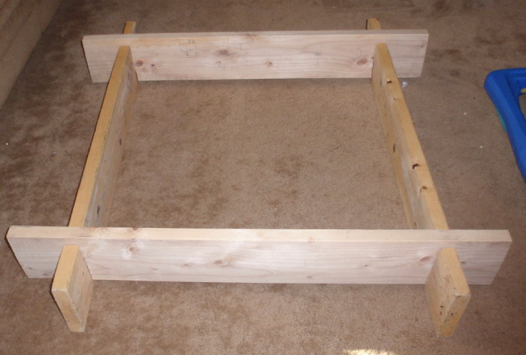
WEBELOS leader, will you please place the first post on the stage in a North/South direction. (WL places post)
WEBELOS Asst. leader, please place the second post on the stage three feet away from the first post in the North/South direction. (WA places post)
These two posts placed here are symbolic of the foundations of Scouting that these WEBELOS leaders have instilled in their WEBELOS Scouts through activities and outings as represented by the natural brown color.
Scout Master (name) and Assistant Scout Master or Senior Patrol leader), please place your posts in an East/West direction 3 feet apart over the North/South posts that are already in place. (SM and SPL place posts)
As represented by the structure assembly, Boy Scouting will build on the Scouting foundation begun in WEBELOS. These leaders have set the stage for bridging the boys from Cub Scouting into Boy Scouting.
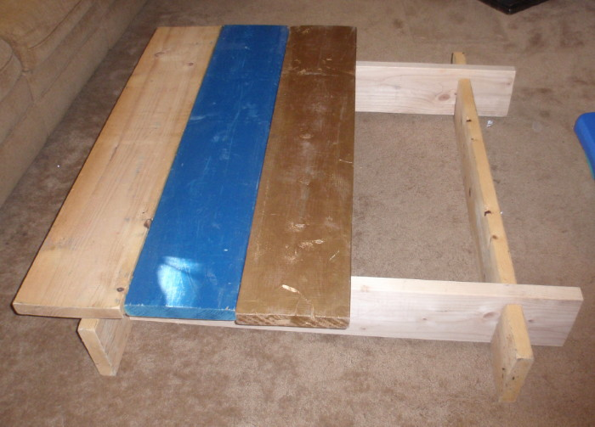
WEBELOS Scout (name), will you and your parents please bring the unfinished plank forward and place it across the east/west posts. (Scout places plank)
This unfinished plank represents the boys as they arrived in Cub Scouting, full of potential but unfinished.
WEBELOS Scout (name), will you and your parents please bring the blue plank forward and place it snuggly against the unfinished plank. (Scout places plank)
This Blue plank represents the Wolf and Bear years of Cub Scouting where with the help of their parents the Scouts became true blue and loyal friends.
WEBELOS Scout (name), will you and your parents please bring the gold plank forward and place it snuggly next to the blue planks. (Scout places plank)
This Gold plank represents their golden years in Cub Scouting as Webelos learning important skills through activity badges and culminating in the Arrow of Light.
WEBELOS Scout (name), will you and your parents please bring the green plank forward and place it next to the gold plank. (Scout places plank)
This green plank represents their new beginning as Boy Scouts, who will soon be green Tenderfoot scouts, anxious to begin the Boy Scout trial toward Eagle.
WEBELOS Scout (name), will you and your parents please place the final plank onto the bridge. (Scout places plank)
This last plank is red the predominant color in the Eagle Scout Badge and represents the fact that as they step off the bridge from Cub Scouting to Boy Scouting they are beginning of their journey to becoming Eagle Scouts.
Webelos entering Troop (number), please assemble with your parents at the unfinished board of the now completed Bridge to Scouting?
As we present you with your Pack graduation Certificate, will each parent please remove your sons Webelos neckerchief and slide.
Scoutmaster invites boys across the bridge, calling each by name and (performing whatever ceremonies are customary for your pack and troop)
After all have crossed - Pack (number) please stand and show your pride to the new Boy scouts from this Pack. (Cheer (Blast Off), Applause)...
We are very proud of you all.

SONGS
Positive Attitude
An Alice, Golden Empire Council, original!!
(Tune: Cub Scout Spirit)
(Each person should strike an “attitude” as they sing the Attitude lines)
I’ve got an Attitude And it’s Positive,
It’s Positive, It’s Positive
I’ve got an Attitude And it’s Positive,
I know I can learn something NEW!
I’ve got an Attitude And it’s Positive,
It’s Positive, It’s Positive
I’ve got an Attitude And it’s Positive,
I know that I can IMPROVE!
I’ve got an Attitude And it’s Positive,
It’s Positive, It’s Positive
I’ve got an Attitude And it’s Positive,
I know I can do my BEST!
Take Me Out To The Derby
Wendy, Chief Seattle Council
Tune - Take Me Out To the Ball game
Take me out to the derby
Take me out to the track
Buy me some paint and gra-a-phite
I don't care if it's purple or black
So it's vrrroom, vrroom, vrroooom to the derby
See if you set the pace
Cause its 1, 2, 3 start your car
At the Pinewood race.
Take Me Out To The Derby II
Wendy, Julie, & Joanne Chief Seattle Council
Tune - Take Me Out To the Ball game
Take me out to the race track,
Let me go ‘round and ‘round.
Wave the flag to start the race.
Engines start roaring, and oh what a sound!
Then it’s vroom, vroom, vroom go the race cars,
Speeding ‘round the track.
And it’s 3, 2, 1 lap to go.
Looks like I’m in front of the pack!
So it’s one more lap for the trophy,
One more lap for the win.
Soon the checkered flag will wave.
The crowd will cheer and make such a din.
Oh my gosh, it looks like an oil spill.
Now it’s all on my tires.
And it’s smash, bash, crash go the cars
At the old race track!
So I didn’t win any trophies,
But I’m okay with that.
“Cause there’s lots more races to go
and you know that I’ll be back!

STUNTS AND APPLAUSES

APPLAUSES & CHEERS
Alice, Golden Empire Council
Positive with Attitude Applause
Leader: Say I’m Positive!
Audience: I’m Positive!
Leader: Now do it with Attitude!
Audience: (Strike a pose with attitude)
I’m Positive – with Attitude!
Good & Positive Cheer
- Say “I’m Good!”
while pointing both thumbs toward yourself
- Say “You’re Good!”
while pointing to someone else
- Say “I’m Positive!”
Lemons & Lemonade Applause
- Divide audience into two groups.
- Assign one group to say “Lemons” and act out picking a lemon and smelling it.
- Assign the second group to say “Lemonade” and make the motion of twisting a lemon on a squeezer and stirring a glass of lemonade.
- Then take turns pointing to each group at random several times.
- End with the leader saying – “You’ve just made lemonade out of a lemon – Positive Attitude in Action!”
Do Your Best Applause
Leader: Who Did Their Best?
Audience: We All Did!
Leader: Who was a Winner?
Audience: We All Were!
Flintstone Applause:
Put hands over head, shake the whole body, then yell “Yabba-Dabba-Do!”
Volcano Applause:
Twirl your hands while making a rumbling sound, then throw up your hands and shout “Brrrrrrrmmmmm!”
Wendy, Chief Seattle Council
Flag Cheer
Get Ready... Get set… Cheer! (Wave the checkered flag for 5 seconds while everyone cheers. Or, wave a green flag for people to cheer, and wave a red flag when it’s time to stop.)
Flat Tire Cheer
Pretend you’re driving a car: chug-chug putt- putt-BANG” then - SSSSSSS like air coming out. Start out loud and get softer.
Pinewood Derby Applause – Hold your right hand over your head, bring it down as if it were a car coming down a hill, or track, while saying, “swooooosh” then “thud” (or a loud clap) as it hits the bottom of the track.
Cascade Pacific Council
All Temp-a Cheer: 1/3rd of the audience is HOT, 1/3rd is WARM and 1/3rd is COLD, when you point to that part of the crowd, they yell their temperature
Checkered Flag: Wave arm in figure 8 motions.
Chip, Chop: Divide audience into two sides. One says “Chip,” the other “Chop” After a few iterations, all yell, “Timber.”
Construction Flagger: Wave your arms and yell “Slow down!”
Cubs are Cool Cheer: Cubs are so cool, they can even freeze the atmosphere with this cheer.
Brrr, (clap, clap) it’s cold in here!
There must be some Cub Scouts in the atmosphere!
I said, Brrr, (clap, clap) it’s cold in here!
There must be some Cub Scouts in the atmosphere!
Electric Drill (or Chain saw): Make Brrrrrr sound for as long as you can.
Glue: Clap hands together and they get stuck, struggle to pull them apart.
Harley Cheer: Get on your motorcycle, kick start a couple of times saying, “Vroom Vroom”! Then give it the GAS and pretend to drive away yelling, "And Away We Go!".
Motorcycle Applause: Have everyone stand up, pretend to get onto a motorcycle, rev up the engine, and say “Tally Ho and away we go!”
Nail Pounding Cheer: Start by pretending to drive a nail with a hammer, then hit your thumb. Make appropriate motions. Words go “Bang, Bang, Bang, Ouch.”
Pinewood Derby: Hold your right hand over your head and bring it down as if it were a car coming down a track, while saying: “Swoooooosh,” then “Thud” as it hits the bottom of the track.
Pinewood Derby Cheer II: Cubmaster yells, ‘Start your engines,” Everyone places their car at the top of the ramp (they raise their hands up in the air, fingers straight, palms down). Then the cars go down the ramp Everyone moves their hands in the shape of the track going “Whooooosh” all the way. It all ends as the car hits the bumper at the end. Everyone gives one big, loud clap.
Pinewood Derby Winner Cheer: (To recognize a particular person) Do as above, but at the end, yell out “_________ is the winner!!! (Repeat three times)
Pop a Wheelie Cheer: Pop wheelie leaning way back and saying, “EERRRRTTT!”
Race Car Cheer: Move hand forward like a race car moving down a race track and shout “V-V-R-R-o-o-o-m!” Or shout "ZZZRRRrrrrrrOOOOOOOOOOOOMMMMMM" Do it three times (at least!)!!
Round of Applause: Clap your hands and make hands go into a big circle in front of you.
Rubber Tree: Pretend to hold axe to chop tree. Every time you swing it bounces back. Make bouncing noise - “Boing, Boing”
Sandpaper: Rub hands together as loud as you can
Spirit Cheer: Divide the group into two sections. The first section chants: We’ve got spirit, yes we do! We’ve got spirit, how ‘bout you?
The first section points to the other group. The second group responds by yelling the chant even louder. Repeat two or three times.
Super Glue: Hands get stuck on first clap and can’t be pulled apart. Have pack yell something for help (Home Depot, Lowes, Mr. Fix-It, be original)
Trucker: Pretend you are driving a big rig. Reach above your head and pull the horn cord, make a loud, deep “HONNK! HONNK!”

RUN-ONS
Alice, Golden Empire Council
Cub #1: Mark Twain sure knew how to have a Positive Attitude.
Cub #2: Really – what did he do when people didn’t like his stories or jokes?
Cub #1: He said “keep away from people who belittle your ambitions….really great people make you feel that you, too, can become great.
Cub #1: How can a doctor tell your blood type?
Cub #2: That’s easy – an optimist is always O-Positive and a pessimist is always B-Negative!

Wendy, Chief Seattle Council
- What happened to the frog’s car when it parked in the handicapped spot?
- What?
- It got toad!
Joe: I saw you running alongside your bike this morning.
Moe: Yes, I was late and didn’t have time to get on.
Teacher: Jimmy, your drawing of a stagecoach is very well done, but it has no wheels. What holds it up?
Jimmy: The bad guys!
Knock, Knocks
Wendy, Chief Seattle Council
Knock, knock.
Who’s there?
Noah.
Noah, who?
Noah how to build a fast pinewood derby car?
Knock, Knock.
Who’s there?
Targets.
Targets, who?
Tar gets all over my shoes when I walk down the street.
Knock Knock Jokes with Positive Attitude
Alice, Golden Empire Council
Sheri Lewis, the beloved ventriloquist, has said that making up and telling knock knock jokes can help develop self confidence and a positive attitude about life in children
Knock-knock.
Who's there?
Orange hew.
Orange hew who?
Orange-hew glad someone likes you enough to tell you a knock-knock joke today?
Knock Knock
Who's there?
K-9
K-9 who?
K-9, B-6, O-74...BINGO!
Knock Knock
Who's there?
Ida
Ida who?
Ida like to be your friend!
Knock Knock
Who's there?
Anti
Anti who?
Ant I cute, adorable, smart, and cool?
Knock Knock
Who's there?
Wa
Wa who?
Boy you are really excited to see me!!

JOKES & RIDDLES
I’m Positive One Liners
Alice, Golden Empire Council
- I’m positive – You’re stuck with your debt if you can't budge it.
- I’m positive – If you have corduroy pillows you can always make headlines!
- I’m positive – A successful diet is the triumph of mind over PLATTER.
- I’m positive – a gossip is someone with a great sense
of RUMOR.
- I’m positive – reading while sunbathing makes you WELL, RED.
- I’m positive – when two egotists meet, it’s an I for an I.
- I’m positive – in a democracy, your vote counts.
In feudalism, your count votes.
- I’m positive – a Will is a DEAD GIVEAWAY!
- I’m positive – A chicken crossing the road is poultry
in motion!
- I’m positive – a boiled egg in the morning is hard
to beat!
Gasoline Alley Jokes
Wendy, Chief Seattle Council
Cub # 1: What words would you write on an old Car’s
headstone?
Cub # 2: Rust in Peace!
Cub # 1. How many elephants can you get into a small
car?
Cub # 2. Four, two in the front and two in the back
Cub # 1. How many rhinoceroses can you get into a small
car?
Cub # 2. None, it’s full of elephants.
Cub # 1: Stop! This is a one way street.
Cub # 2: Well, I'm only going one way.
Cub 1: Did you hear about the wooden car with the
wooden wheels and the wooden engine?
Cub 2: No, I didn’t hear. What happened?
Cub 1: It wooden go!
Cub 1: I’ve come to buy a car, but I don’t remember the
name. It starts with a “T”.
Cub 2: Sorry, we don’t have any cars that start with tea.
All our cars run on gasoline.
Cub 1: Son, here are the keys to my magic car.
Cub 2: Is it really magic?
Cub 1: Yes, one speeding ticket and it will disappear!
Cub 1: This is a ticket for speeding.
Cub 2: Wonderful! When do I get to use it?
Cub 1: What kind of shot do you give a sick car?
Cub 2: A Fuel Injection
Cub 1: What happened when the wheel was invented?
Cub 2: It caused a revolution!
Cub 1: When is a car not a car?
Cub 2: When it turns into a garage.
Cub 1: What do you get when you cross a motorcycle
and a funny story?
Cub 2: A Yamaha ha ha ha!
Cub 1: Why did the Cub Scout take peanut butter bread
with him in the street?
Cub 2: He was looking for traffic jam.
Cub 1: Why can’t bicycles go as fast as cars?
Cub 2: Because they are “two” tired.
Cub 1: What did the jack say to the car?
Cub 2: “Can I give you a lift?”
Cub 1: What part of a car is the laziest?
Cub 2: The wheels. They are always tired.
Cub 1: What driver doesn’t have a license?
Cub 2: A screw driver.
Cub 1: What has a head, can’t think, but drives?
Cub 2: A hammer

SKITS
Al Pine’s Car Lot Skit
Wendy, Chief Seattle Council
People and Gear - One Announcer (Al Pine), probably an adult and about 6 Scouts. Props as listed in the skit.
Al Pine: Hi there! My name is Al Pine from Al Pine’s Car lot and have I got the cars for you! I’ve got a whole fleet of vehicles to meet your every need and wish.
Are you feeling a touch sad? We have Pickups! (Two Scouts come in carrying signs that read “Atta Boy!” and You’re doin’ great!”)
Ready for some action and adventure? We have Off Road Vehicles! (Two Scouts enter driving toy cars up and over things, making sounds...)
How ‘bout games and competition? We’ve got Derby Cars! (Two Scouts driving derby cars in and down the center of the room, wearing Cub hats)
And of course, everyone loves a classic (One Scout driving and waving and old fashioned car, in and out)
We have Limousines for those who achieve their goals,( Create a cardboard limo and drive it through the meeting)
And what would a Cub Scout meeting be without a delivery van full of........Announcements (Cardboard van enters with all the Scouts (who were in the skit) singing the Announcement song.)
So, Come on over to Al Pine’s Car Lot for a whole lot of Cub Scout fun!

GAMES
Park Your Car
Wendy, Chief Seattle Council
- Mark out a parking lot on a driveway, floor, or tabletop
- Push pinewood derby cars or toy cars into the parking spaces.
- Count the score from the area where the front
wheels sit.
- Call the space where you will park and if the car stops there, score an extra 10 points.

CLOSING CEREMONIES
A Simple Block of Wood
Cascade Pacific Council
Characters: Each Scout holds a the designated prop in front of him
Cub # 1: A rectangular block of wood.
Cub # 2: A pinewood derby racer right from the box
Cub # 3: A partially done racer with a little paint.
Cub # 4: A finished Pinewood Derby Racer
Cub # 5: A finished Pinewood Derby Racer
Setting: Each boy walks on to the stage to read his part- The last scout runs onto the stage shouting his line.
Cub # 1: I’m only a simple block of wood, Cut from a tree so tall. Unlike the tree that thundered down, No noise would I make should I fall.
Cub # 2: But in the hands of a wide eyed boy, Armed with a knife and a saw. There are many shapes that I can take, Some wide, some short, some tall.
Cub # 3: A little paint, a line or two, Nothing fancy, but not too plain. No two alike, made with loving hands, We are all of the tree that remains.
Cub # 4: Like each little boy’s life, starting with form. Like a block of wood cut from a tree, The loving hands of leaders like you, Help us each to be what we shall be.
Cub # 5: And I’m gonna be a racer!
Indian Blessing
Wendy, Chief Seattle Council
Directions:
- Adult leader says the words and demonstrates the signs used in the ceremony. Or have six Cubs up front, one for each line and sign.
- Then the audience stands and everyone does this together.
May the spirit of Scouting (Boy Scout sign)
And the light of Akela (Cub Scout sign)
Be with you and me (Points finger)
Until our paths (Both arms out)
Cross (Arms crossed)
Again (Index and middle finger on right hand together.
Touch back of left wrist, then left elbow, then left shoulder.)

Cubmaster’s Minutes
Tires
Wendy, Chief Seattle Council
Hold up a tire advertisement. Cub scouts, tire manufacturers are constantly working to make a better tire; one that can withstand the pounding and abuse that high-speed driving demands. In other words, a tire that “can take it”. Like the tire, you and I are put to the test every day. When things are going along smoothly, it’s not hard to get along. The real test is how we’ll do when the going gets rough; when things do not turn out the way we want them to. At times like these, the Cub Scout Promise can help you carry on with the right attitude and do your share without grumbling or griping. It will help you meet the test. Can you take it?
Henry Ford
Cascade Pacific Council
Henry Ford is certainly an example of positive attitude - He built his first vehicle, called the Quadricycle, in 1896, and with two other investors founded the Detroit Automobile Company in 1899. But that company folded in 1900. Then in November of 1901, along with five other investors, he started the Henry Ford Motor Company. But after only four months, he left or was forced out of that company. When he left, he took with him his tools and rights to his name. In 1903, he again started the Ford Motor Company. He continued to work on new models and techniques, even visiting other countries to see their methods. In 1909, Henry Ford finally produced the “Model T” - a basic, sturdy, inexpensive car that was reliable and available to the ordinary family. But he kept on looking for even better designs and cheaper, more efficient methods. He introduced the moving assembly line in 1913, and by 1925, his basic car reached the unbelievable low price of only $260. He had set himself the goal to produce a basic, sturdy, reliable vehicle, and in spite of the failure of his first two companies and many design and production challenges, he kept a positive attitude and met his goal. Cub Scouts, too, have goals to reach – some they choose for themselves and some are requirements for advancement. And in spite of challenges, they can learn to keep a positive attitude and keep focused on their goal. Let’s make sure that we as adults also model a positive attitude when we play and work with Cub Scouts – keep focused on your goal!
Do Your Best
Cascade Pacific Council
When you give the Cub Scout Promise, the words “Do your Best” are often lost among all the other very important words. Let’s stop for a minute and carefully consider these words.
Best describes effort and action above our usual performances. You are the only person who can possibly know whether or not you have done your best. Every time you repeat the promise, you agree to do your best. Your best is just that: The very best that you can do. Think about the meaning of the promise that you repeated at the beginning of the Pack Meeting. Decide that you will always do your best, no matter what the job is that is facing you.
Keeping Fit
Cascade Pacific Council
Cub Scouts, I hold in my hand a pocketknife. This is a valuable tool because it can be used for many useful things. It is a dependable tool as long as the blade is kept sharp and free from rust and the working parts are in good condition. But, if it is neglected and becomes dull and rusty, it can be a dangerous tool. The same principle can be applied to ourselves. We have a body, which when kept in good condition, will serve us well. If we get plenty of exercise, eat the proper foods, and have good health habits, we will be able to enjoy to the fullest the things we do. But if we fail to take care of ourselves, we can become rusty and dull like the neglected knife. Keeping fit is hard work and you may feel you will never get there but keep a Positive Attitude by remembering the Little train that could (I Think I can. I Think I can.) Then do your best to keep fit and you will succeed!
The Ant & Positive Attitude
Alice, Golden Empire Council
You all know that the Cub Scout Motto is “Do Your Best.” But if you ever start to feel like you aren’t old enough, important enough, or experienced enough to make a difference, even if you do your best, go outside and look for an ant. Here is a tiny creature that can be squashed underfoot, washed away by a little stream of water, or easily buried by a spoonful of dirt. But he never gives up – wash him away with a little water, and he will struggle back to his feet and search for the ant trail. Buried under a shovel of dirt, he will dig his way out and continue on his way. Put a brick or a leaf in his path, blocking the ant trail, and he will find a way around or over the obstacle and continue on his way. So think of the ant if you are tempted to give up or think you can’t succeed – just pick yourself up, dig your way out, or find a way around, under or over that obstacle – and keep a Positive Attitude!
You Have a Choice
Cascade Pacific Council
You have a choice. You can be pleasant or unpleasant. You can approach life with a Positive Attitude knowing you can do it (Say I can do it in a strong sure sounding way) or a negative attitude, knowing you will fail (Say, It's too hard in a whining voice). Which do you choose? You can be grouchy and grumpy or you can be happy and cheerful. Which would you rather be? It is up to you. Tonight, we’re all winners. We had fun and enjoyed each other’s company. Let’s take that warm feeling of friendship home and keep it close to our hearts until our meeting next month!
Do Your Best
Cascade Pacific Council
Our lives are made up of many different acts or parts. As young boys, you act the part of a Webelos, Bear, Wolf, Tiger, or Bobcat. In school, you act the part of the student. At home, you act the part of a son and maybe a brother. Whatever part you act, keep a positive attitude, do what is right and, always, do your best. You too may someday be a good parent and a good citizen like all the adults around you today. See you next month!
Our Pinewood Derby
Cascade Pacific Council
At the conclusion of our Pinewood Derby I would like to say that we were all winners here tonight. Dad has more respect for his son whether he was a humble winner or a graceful loser. Mom was proud of her son whether she gave him a hug of congratulations or comfort. The boys gained a better knowledge of competition; how to win, how to lose, how to be happy for a friend, who is taking home the trophy he himself wanted so badly. The leaders, in the pride they felt knowing that each of their boys had done their best. Building the car helped bring dad and son closer together. No, there are only winners here tonight. Thank you all for helping to mail the pack go and the Cub Scouts grow. Good night and congratulations to all of us winners.
Pinewood Closing
Cascade Pacific Council
Form a circle around a the derby track
"Coming together is a beginning. Keeping together is progress. Working together is success."
This is a quote from the famous carmaker, Henry Ford. All of the dens came together with a Positive Attitude to form the beginning of our pack.
Keeping a positive attitude and working together at our monthly pack meeting is progress.
Working together in Cub Scouting is surely a success story of which you can have a great part. Just remember the little train that Could - "I think I can. I think I can."
Let's remember this in the coming months.
Please repeat with me the Law of the Pack.
Thanks for coming out for our Pinewood Derby tonight. We've worked together and made every boy in Pack a winner!

CORE VALUE
RELATED STUFF
Connecting Positive Attitude with Outdoor Activities
Wendy, Chief Seattle Council
(Adapted from B.A.L.O.O. Appendix E)
- Hikes - Have fun even when it is hard to do. If possible, plan a hike that is challenging, lengthy, or has difficult terrain. Have boys explore how to make this a good experience with positive attitudes.
- Nature Activities - Visit a herpetologist or entomologist to talk about how insects and snakes contribute to world ecology. Relate this to having a positive attitude about everyone's place in the world.
- Service Projects - Make cheery cords for others. Mail these to an adopted elderly or shut-in person on a regular basis. Look for opportunities to serve friends or family members who are having a tough time.
- Games & Sports - Bowling and golf are good games that bring the importance of positive attitude to mind. Design a game where boys have to turn "don'ts" and "can'ts" into "do's" and "can's." Always have a good attitude, whether win or lose.
- Ceremonies - Discuss the positive attitude shown by the recipient of a public recognition (especially when it is for advancement).
- Campfires - Use a story about positive attitude. Talk about why we applaud and join in when others are performing. Discuss why it's important not to grumble or complain about your port in a skit or ceremony.
- Den Trips - Visit with someone who has overcome an adverse situation through positive attitudes. Thank others who show a positive attitude when they have to wait in line or take second choice on something.
- Pack Overnighter - Present boys with obstacles to overcome in order for the overnighter to happen (can't get campground we wanted, rain forecast for that weekend, not enough tents or sleeping bags, etc ). Guide them to a resolution, emphasizing a positive attitude.
Cub Scout Derbies
Cascade Pacific Council
- Derbies of one kind or another have always been a part of Cub Scouting. As early as 1939, the BSA Supply Division listed kits for model planes, boats, and airplanes. The derbies have been viewed as a way to get parents and sons to cooperate on a project.
- An early Cub Leader's Round Table contained instructions for holding a Kite Derby. Competitions included the 100 yard dash, novelty kites, altitude race, artistic kites, kite battle, and the messenger race. The BSA Supply Service offered a pamphlet entitled Kites to teach kite making.
- In April of 1937, Scouters were given the directions for making the Cubmobile. The original intention for the Cubmobiles was that they be any contrivance on wheels. According to the How to Book of Cubbing, "It may be drawn, pushed, or propelled by Cubs, or may be drawn by a trained animal-in fact, anything goes!" Most ended up patterned after the Soapbox Derby racers.
- The first reference to the Pinewood Derby in a Scout publication was in the October, 1954 issue of Boy's Life. The June, 1955 Program Helps listed "Wheels, Wings, and Things" as a theme. The Cub Scout Program Quarterly gave instructions for running the Pack Meeting Derby. The Supply Division's catalogs had kits available for $2.75 for a package of eight. Over 15 million kits were sold during the next 20 years.
- Regatta kits arrived in 1958 with kits for eight boats selling for $2.95. The rubber band driven Space Derby kits followed the start of the space race in 1961.
- Another derby was made available during the seventies; the Rocket Derby. The kits were later dropped from the Supply Division catalog.
Fun Facts about Fantastic Automobiles
Alice, Golden Empire Council
- Bertha Benz was the first woman driver, driving a car designed by her husband, with the first patent for a car, on the first car trip in 1888!
- Leonardo daVinci didn’t invent the first car, but he drew designs that have been built and shown to work utilizing the differential, gear shift and direction changing gears, the jack and the use of ball bearings to move gears smoothly and prevent friction from disabling a mechanical engine. He also understood the value of inter-changeable parts long before Henry Ford!
- Headlights didn’t appear on cars until 1906 – they used kerosene. But that car had no steering wheel! The driver had only a stick or shaft to steer with!
- The first self-propelled road vehicle was a tractor for the French army built in 1769 by Nicolas-Joseph Cugnot. It had three wheels and a top speed of 2.5 miles!
- Most American auto horns beep in the key of F.
- In Singapore a new car costs only $5 to license. As the vehicle gets older, the price goes up, and once the car is 8 years old, it is no longer allowed on the streets. These rules have almost wiped out pollution from cars in that country!
- Speaking of price, between 1968 and 1978, the price of the average American car doubled!
- For every 50 miles driven in an automobile, a person has a 1 in a million chance of being killed.
- In 1905 the Bosco Company of Akron, Ohio, marketed a "collapsible Rubber Automobile Driver." It was intended to scare thieves away. Modern drivers have sometimes used a dummy to access the faster lanes reserved for cars with more passengers – and paid a hefty fine if caught!
- The beloved London taxicabs with their high roofs were originally designed to keep gentlemen from knocking off their top hats as they entered and left the vehicles.
- In 1924 a Ford automobile cost $265!!
- The first automobile race in the U.S. was held in 1895, running from Chicago to Evanston. J. Frank Duryea won at an average speed of 71.5 miles per hour.
- A plumber named David Buick actually build the first General Motors car – he also invented the process where porcelain could adhere to iron, making the white or colored bathtub possible!
- Many people had arms broken by an engine backfire while hand cranking cars to start them before 1917 and the invention of the electric starter!
- On July 11, 1903, the Ford Motor Company sold the first car to Dr. E. Pfenning for $850 cash.
- In 1950 the United States had 70 percent of all the automobiles, buses, and trucks in the entire world – today, China is fast becoming a major car user!
- To manufacture a new car approximately 148,000 liters of water are needed!
- Henry Leland introduced “parts interchangeability” to the auto industry after learning the concept working in firearms factories.
- Brothers Charles and Frank Duryea set up the first American car manufacturing company in 1893.
- By 1908, 485 different companies were building “horseless carriages.”
- Electric cars are nothing new – Robert Anderson introduced an “electric carriage” in 1832 in Scotland.
- American George Selden never manufactured the internal combustion engine he designed in 1876 – but he collected royalties on his patent until 1895.
- In 1913, Henry Ford introduced the world's first moving assembly line, which allowed the same number of workers to build many more cars – and made a car that was cheap enough for the average family to afford – it was also reliable and easy to fix.
PACK ACTIVITIES
Alice, Golden Empire Council
At your monthly Pack Committee meeting, challenge each Den Leader to use Positive Feedback during the month – You might want to ask a professional teacher to do a short lesson and give specific examples of Positive Reinforcement.
Focus on the talents, interests and/or collections of each boy this month – Help each boy learn how to best display his unique talents in an interesting way. Teach boys how to make labels and let them practice explaining their collection or interests at den meetings.
Learn more about people who have shown Positive Attitude throughout history. Boys, dens or families can use a visit to the library or internet sites to find an example that each boy is interested in. Boys could also draw or print a picture of the person and tell or write something of their story for the den or pack meeting.
Build a new Crossover Bridge for the Pack –
Check out the plans under Advancement Ceremonies for a version you like and that may serve multiple uses (e.g. Tigers and Webelos) – or go to the How To Book (page 1-6) or the internet for more options.
Challenge each boy or family to tackle a new talent this month – they could take photos, make a display, or tell about what they did to use Positive Attitude in making a change.
Play the Positive Attitude Game – Check it out under the Meeting #9 plan for Bears.
Practice putting a “Positive” spin on everything during the month – If a boy has difficulty doing some requirement, teach him by example to use the words “Next time I could…” or “Maybe it would help if…..” or “Well, at least I did……” Look for opportunities to teach “positive spin” and encourage continued effort – and share the idea with parents so they can do it, too. See how many “positive spin” phrases or ideas the boys can come up with!
Pinewood Derby:
Visit a local museum devoted to cars old or new. Go to: www.team.net/www/museums/us.html or www.digital-librarian.com/car_museums.html to access lists of museums in various states and regions.
Check with local car clubs, racing associations, etc. for help in decorating for the Pinewood Derby – they often have large photos or models of cars, racing flags, pennants, and other great stuff. Tip: Check with your local librarian for contacts to local clubs of any kind.
Car Slide
Cascade Pacific Council
- Take apart a spring type clothespin
- Glue the flat sides together
- Cur two ¼” thick slices off a ½” diameter dowel for wheels
- Glue wheels on side toward front and back
- Glue on a colored round bead for helmeted driver’s head
- Attach ring on back – 1” length of ¾” PVC pipe works well but choice is yours
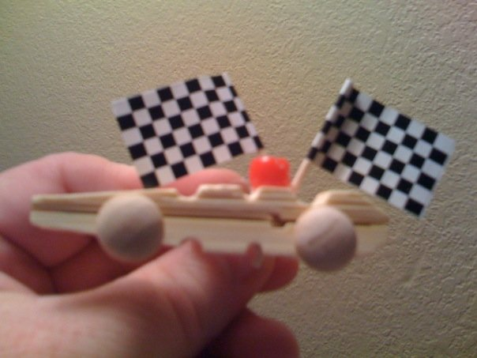
This slide can be used for several
Wolf and Bear Achievements
Homemade Pinewood Derby Awards
Wendy, Chief Seattle Council
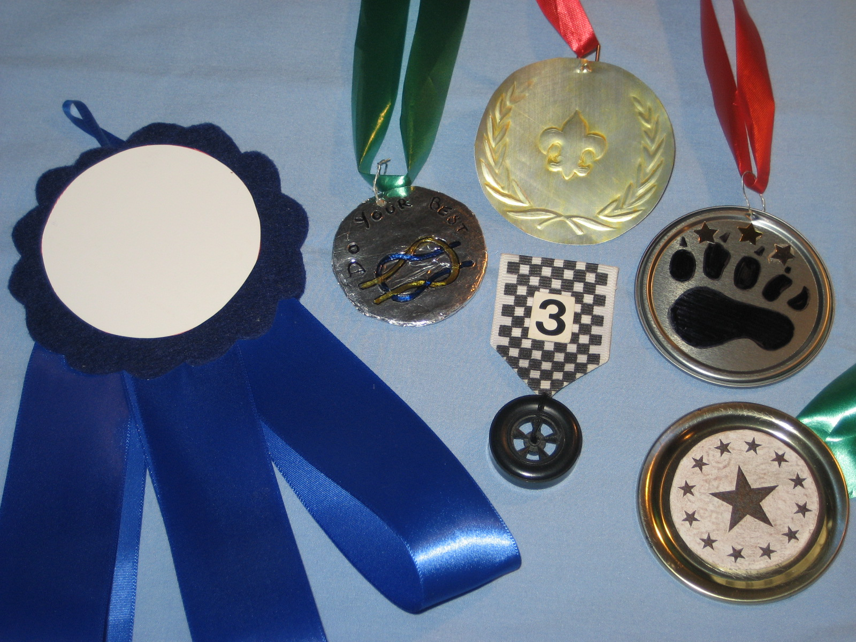
Ideas are based on ideas found in -
- May 2008 “Go for the Gold” Baloo’s Bugle p. 29-30, 38, 40
- Cub Scout How To Book p. 1-6
Medals can be made from:
CDs:
Tape pictures, awards to CD. Hang from ribbon.
Canning or Juice Can Lids:
Decorate by coloring with permanent markers; glue dot sequins or confetti to lid; or attach stickers.
Aluminum foil:
Cover cardboard circle with foil. Emboss using a pencil
Decorate as above. Punch hole through medal using a nail. Make wire jump ring by stripping the paper off a twist tie. Thread wire through hole, make small circle out of wire, twisting ends around the wire circle.
Thread ribbon through ring, and tape or staple
ribbon ends together.
Metallic poster board:
Emboss with pencils, color with permanent markers.
Add ribbon as described above.
Plastic coins:
Drill hole through coin, then make jump ring and attach
ribbon as described for aluminum foil medals.
Candy coins:
Tacky glue coins to ribbon.
Checked ribbon with wheel:
Start with a 2 ½” section of black & white checked ribbon. Fold the top raw edge to the back side, and glue. To make a point at the bottom of the ribbon,
fold the corners to the back side, and glue.
Sew a black derby car wheel to the point, passing the thread through the hole in the center of the wheel.
Blue Ribbon:
Cut a scalloped circle from stiff felt.
Glue folded ribbons to the back of the circle.
Glue a second scalloped circle so ribbon ends are sandwiched between
the 2 circles. Glue a white felt circle to the front medallion.
Embossed aluminum:
Cut the tops and bottoms off pop cans with scissors.
Cut up the long side of the cylinder.
This will yield a curled rectangle of aluminum.
Flatten the aluminum by pulling it gently over the corner of a table or counter. If you scrub off the color with steel wool, the boys will have an easier time seeing their embossed design when they work on the back side of the aluminum.
Trace the patterns or make numbers, letters, or pictures with a dead ball point pen, orange stick, or embossing tool, pushing hard.
To raise the numbers and letters, (mountain), work on the back side (colored side) of the aluminum. To create an indented line around the numbers and letters, work on the front of the aluminum (valley). The raised portions of the plate will look best if they are outlined by indented (valley) lines.
For example, I taped the picture of the fleur-de-lis to the aluminum from the pop can, and traced around the fleur-de-lis with a ball point pen. I removed the pattern, and went around the fleur-de-lis again with my pen. Then I flipped the aluminum over, and rubbed the inside of the fleur-de-lis with a craft stick to raise it.
Cut out the medal. Color with permanent markers, and attach to ribbon as described above for aluminum foil medals.
For my gold medal, I colored the whole medal with gold permanent marker. It was kind of streaky, so I dampened a paper towel with rubbing alcohol and wiped down the medal, which removed the streaks, and some of the color, leaving the aluminum a pale golden color. Some of the ink collected around the embossed areas, creating a nice effect.
Trophies can be made from:
Yogurt cup:
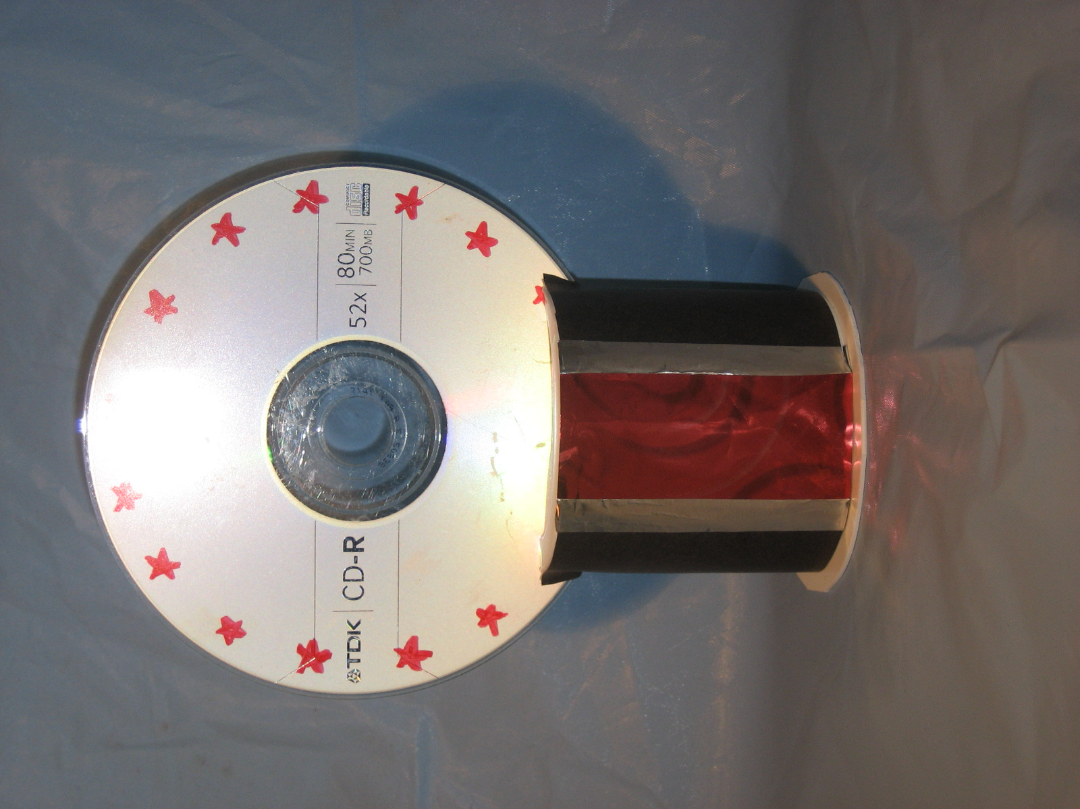
Cut a slit in the bottom of a yogurt cup.
Tape black construction paper around the yogurt cup.
Glue ribbon to the construction paper, covering the seam.
(Metallic ribbon looks especially nifty.)
Decorate a CD with permanent markers, if desired.
Push the CD into the slit in the yogurt cup.
Car Parts:
Spray car (or lawn mower) parts gold, and epoxy to wood bases. (Spark plugs, etc.)
Embossed Pop Can License Plates
Wendy, Chief Seattle Council
(variation on’07-’08 Program Helps Jan. p. 10)
See instructions above for Embossed Aluminum medals. Stop at end of paragraph where it says " . If you scrub off the color with steel wool,."
Make numbers and letters with a ball point pen, orange stick, or embossing tool, pushing hard.
To raise the numbers and letters, (mountain), work on the back side (colored side) of the aluminum. To create an indented line around the numbers and letters, work on the front of the aluminum (valley). The raised portions of the plate will look best if they are outlined by indented (valley) lines.
Color with permanent markers.

MORE GAMES AND ACTIVITIES
Wendy, Chief Seattle Council
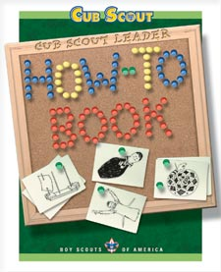
- Useful items from the How-To Book are referenced throughout Baloo's Bugle.
Want to check something in the "How To Book," and your copy is not available?? Want to copy something quick to use at a meeting?? You can find the "How To Book" at this address on National's Web Site -
http://www.scouting.org/filestore/hispanic/english/33832_WEB.pdf

CUB GRUB
"Cub Grub" recipes are in the Den edition. Dave
Treats with Positive Attitude
Alice, Golden Empire Council
For your Pack Meeting refreshments, ask everyone to bring in their favorite food item that starts with a P or an A – then share the bounty – and remember that you are really spelling out “Positive Attitude” – so tell everyone to say something positive about the resulting treat!
Examples: Pears, Peaches, Peas, Pineapple, peanuts, Pumpkin, Pickles, Potato Chips
OR Apples, Apple Rings (dried or candy version), Artichokes, Asparagus, American cheese, Angel Food cake, almonds, Ants on a Log
Want a longer list? Go to: www.wiki.answers.com/.../What_are_some_foods_that_begin_with_the_letter_P

POW WOW EXTRAVAGANZAS
Southern NJ Council
Improving Your 'Scoutability"
Postponed - University of Scouting under development

WEB SITES
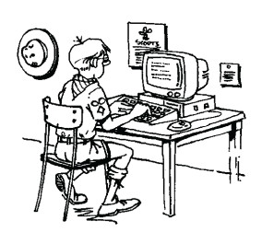

Scouting Resources
Last month I had a wrong web site listed for a United Kingdom Scouting Resource site
The correct site is -
http://www.scoutingresources.org.uk/index.html
Everything is there for all levels of program.
Positive Attitude Games
Experiential Learning Games Self-esteem Games that provide feel-good experiences. Find self-help techniques for children to manage their life successfully against all odds. Play this in groups and use group dynamics to sustain the growth momentum.
http://www.experiential-learning-games.com/self-esteemgames.html
Game Ideas for a Positive Attitude
http://www.ehow.com/way_5329550_game-ideas-positive-attitude.html
Positive Thinking Games
http://www.livestrong.com/article/156410-positive-thinking-games/
Learning Games and Activities for Kids
http://www.kids-activities-learning-games.com/
Pinewood Derby Web Sites
Wendy, Chief Seattle Council
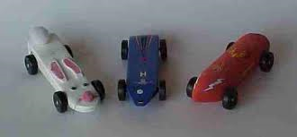
- Official Pinewood Derby Website -
Boy Scouts of America
http://www.pinewoodderby.org/
- www.USScouts.org Pinewood Reference Pages
http://usscouts.org/pinewood.asp
- Pinewood Derby Pack Night Ideas
There are a lot Car related and Pinewood Derby related ideas in the
December 2007 Edition of Baloo's Bugle, "Cub Scout Car Show."
- Pope's Pinewood Pages Portal
The Pope's have created their site by selecting information so that it does not duplicate what you can find elsewhere on the Internet. It includes original material on Pinewood Derby race management and race car design, 2-liter pop bottle rocket launcher, Cub Scout Roundtable, and other Scouting topics, as well as a few personal insights by Stan and Barb Pope.
Pope's Pages -
http://stanpope.net/pwportal.html
The book, " "Learn to Build A Winner"
http://stanpope.net/lbw_apl.html
- Crafts
Art-rageous cars: http://jas.familyfun.go.com/arts-and-crafts?page=CraftDisplay&craftid=11738
Toilet Tube Racer: http://jas.familyfun.go.com/arts-and-crafts?page=CraftDisplay&craftid=11416
- Car Party Ideas:
http://familyfun.go.com/parties/birthday/feature/famf1001_racecarbday/
- Pinewood Derby Driver’s License:
http://www.pinewoodpro.com/pinewood-derby-car-racing-license.htm
- Pinewood Derby Activities Manual by "A Bunch of Old Guys and a Track"
http://grandprix-race-central.com/downloads/activities_booklet.pdf
- Link to lots of pinewood derby websites with useful information:
http://www.scoutingthenet.com/Derbys/,
http://www.three-peaks.net/pinecar.htm
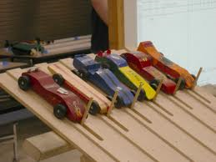

ONE LAST THING
Pinewood Derby Race
Peggy Porter
www.usscouts.org
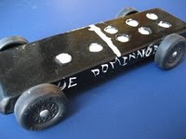
My son Gilbert was eight years old and had been in Cub Scouts only a short time. During one of his meetings he was handed a sheet of paper, a block of wood and four tires and told to return home and give all to "dad".
That was not an easy task for Gilbert to do. Dad was not receptive to doing things with his son. But Gilbert tried. Dad read the paper and scoffed at the idea of making a pine wood derby car with his young eager son. The block of wood remained untouched as the weeks passed. Finally, mom stepped in to see if she could figure this all out. The project began.
Having no carpentry skills, I decided it would be best if I simply read the directions and let Gilbert do the work. And he did. I read aloud the measurements, the rules of what we could do and what we couldn't do. Within days his block of wood was turning into a pinewood derby car. A little lopsided, but looking great (at least through the eyes of mom). Gilbert had not seen any of the other kids' cars and was feeling pretty proud of his "Blue Lightning", the pride that comes with knowing you did something on your own.
Then the big night came. With his blue pinewood derby car in his hand and pride in his heart we headed to the big race. Once there my little one's pride turned to humility. Gilbert's car was obviously the only car made entirely on his own. All the other cars were a father-son partnership, with cool paint jobs and sleek body styles made for speed.
A few of the boys giggled as they looked at Gilbert's lopsided, wobbly, unattractive vehicle. To add to the humility, Gilbert was the only boy without a man at his side. A couple of the boys who were from single parent homes at least had an uncle or grandfather by their side, Gilbert had "mom".
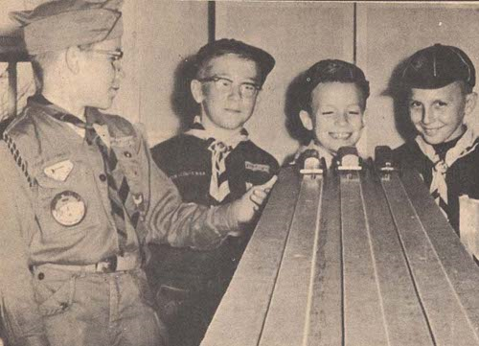
As the race began it was done in elimination fashion. You kept racing as long as you were the winner. One by one the cars raced down the finely sanded ramp. Finally it was between Gilbert and the sleekest, fastest looking car there. As the last race was about to begin, my wide eyed, shy eight year old asked if they could stop the race for a minute, because he wanted to pray. The race stopped.
Gilbert went to his knees clutching his funny looking block of wood between his hands. With a wrinkled brow he set to converse with his Father. He prayed in earnest for a very long minute and a half. Then he stood, smile on his face and announced, 'Okay, I am ready."
As the crowd cheered, a boy named Tommy stood with his father as their car sped down the ramp. Gilbert stood with his Father within his heart and watched his block of wood wobble down the ramp with surprisingly great speed and rushed over the finish line a fraction of a second before Tommy's car. Gilbert leaped into the air with a loud "Thank You" as the crowd roared in approval.
The Scout Master came up to Gilbert with microphone in hand and asked the obvious question, "So you prayed to win, huh, Gilbert?" To which my young son answered, "Oh, no sir. That wouldn't be fair to ask God to help you beat someone else. I just asked Him to make it so I wouldn't cry when I lost." -----
Children seem to have wisdom far beyond us. Gilbert didn't ask God to win the race, he didn't ask God to fix the outcome. Gilbert asked God to give him strength in the outcome. When Gilbert first saw the other cars he didn't cry out to God, "No fair, they had a father's help!" No, Gilbert went to his Heavenly Father for strength.
Perhaps we spend too much of our prayer time asking God to rig the race, to make us number one, or too much time asking God to remove us from the struggle, when we should be seeking God's strength to get us through the struggle.
"I can do all things through Christ which strengtheneth me." Philippians 4:13.
Gilbert's simple prayer spoke volumes to those present that night. He never doubted that God would indeed answer his request. He didn't pray to win, thus hurt someone else; he prayed that God supply the grace to lose with dignity. Gilbert, by his stopping the race to speak to his Father also showed the crowd that he wasn't there without a "dad", but he also went away a winner that night, with his Father at his side.
May we all learn to pray this way.
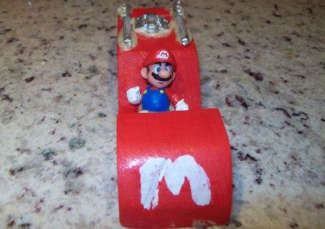

POW WOW BOOKS
NEEDED
If you have a Pow Wow book with Program Materials for core values - please drop me a note and I will tell you how to get it to me -
davethecommish@gmail.com

