CORE VALUES
Cub Scout Roundtable Leaders’ Guide
The core value highlighted this month is:
- Health and Fitness: Being personally committed to keeping our minds and bodies clean and fit. By participating in the Cub Scout Academics and Sports program, Cub Scouts and their families develop an understanding of the benefits of being fit and healthy.

COMMISSIONER’S CORNER
It has been another busy month here in Lake … Oooooppss, that is Garrison’s line not mine. I spent a weekend at National Camping School getting recertified for Webelos Resident camp Program Director. It was humbling – 50 plus over achieving fun loving Cub Scout leaders all in one place. All doing cheers, songs, and goofy Cub Scout stuff. I was honored to be asked to lead the campfire. But my usual stuff did not work. They knew all the tricks!!! Many thanks to Jane who introduced me to the group, exposing my secret identity of Commissioner Dave. It was great weekend and will keep me at the keyboard for a few more months.
Then the next weekend was Wood Badge staff. I am a Troop Guide this time. Sign up now for N5-334-11-1 (856-327-1700) if you want to do a spring course in New Jersey!!!
We have two new staffers –
Pat from Baltimore is on his second month doing the Special Opportunities
Felicia has started doing the Bear section.
I would like to get a Tiger and a Wolf coordinator, too!!
Just drop me a note and I will explain it to you.
More "Commissioner's Corner"
stuff is in the
Pack and Leader Hints Edition
Dave
TABLE OF CONTENTS
In many of the sections you will find subdivisions for the various topics covered in the den meetings
CORE VALUES 1
COMMISSIONER’S CORNER 1
THOUGHTFUL ITEMS FOR SCOUTERS 2
TRAINING TOPICS 2
ROUNDTABLES 2
PACK ADMIN HELPS - 2
LEADER RECOGNITION, INSTALLATION & MORE 2
DEN MEETING TOPICS 2
SPECIAL OPPORTUNITIES 3
Nutrition Loop and Pin 3
Kickball Loop and Pin 3
Internet Scout Patch 4
Boys’ Life Reading Contest for 2011 4
Knot of the Month 4
GATHERING ACTIVITIES 5
OPENING CEREMONIES 5
AUDIENCE PARTICIPATIONS 6
ADVANCEMENT CEREMONIES 6
GAMES 6
SONGS 7
STUNTS AND APPLAUSES 8
SKITS 8
CLOSING CEREMONIES 8
Cubmaster’s Minutes 8
CORE VALUE RELATED STUFF 8
Connecting Health and Fitness with Outdoor Activities 8
DEN ACTIVITIES 9
DEN MEETINGS 10
TIGER 10
WOLF 12
BEAR 14
WEBELOS 19
ARROW OF LIGHT 20
WEBELOS DENS 20
ARROW OF LIGHT 28
ADDITIONAL ADVANCEMENT IDEAS 29
Tiger Achievements 29
Tiger Electives 29
Wolf Achievements 29
Wolf Electives 29
Bear Achievements 29
Bear Electives 30
Webelos & Arrow of Light Activity Pins 30
CUB GRUB 30
WEB SITES 33
ONE LAST THING 34
The American Hero 34
"Keep Your Fork" 34

THOUGHTFUL ITEMS FOR SCOUTERS
The "Thoughtful Items" and "Quotations" are in the Pack and Leader Hints Edition. Dave

TRAINING TOPICS
Learn about the Resources that your council and district use to help you succeed. The "Training Topics" are in the Pack and Leader Hints Edition. Dave

ROUNDTABLES
The "Roundtable Hint" is in the Pack and Leader Hints Edition. Dave

PACK ADMIN HELPS -
Be sure to check out the item on a great resource, "Den Chiefs" in "Pack Admin Helps " this month. It is in the Pack and Leader Hints Edition. Dave

LEADER RECOGNITION, INSTALLATION & MORE
The "Leader Recognition" section is in the Pack and Leader Hints Edition Dave

DEN MEETING TOPICS
Wendy, Chief Seattle Council

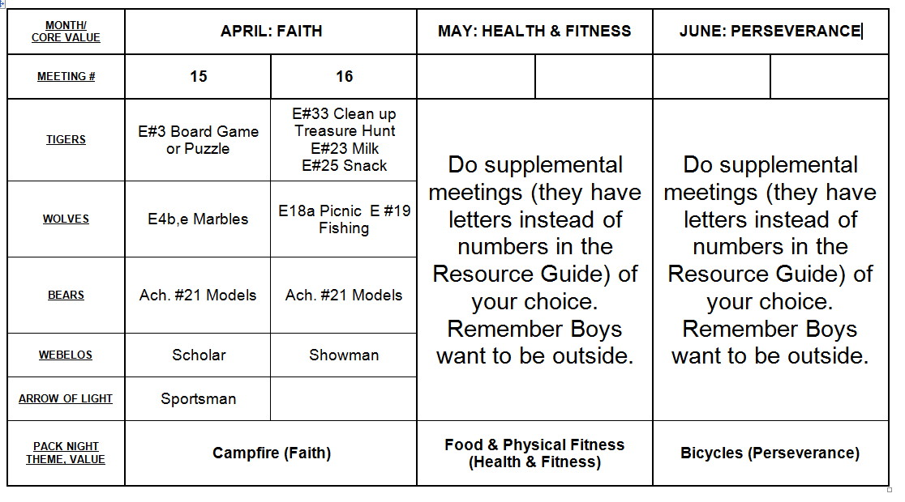

From Bob Scott at National in answer to my question on the role of Roundtables with the new delivery system -
Dave, you have it right.
No changes to roundtable’s role, how it's executed, etc.
Bob Scott , Innovation Coordinator - CS 2010

SPECIAL OPPORTUNITIES
Pat Hamilton, Baltimore Area Council
Let's welcome Pat to the Baloo's Bugle staff!!
He did a fine job with month's opportunities.
The plan from now on is to always have an Academics loop & pin, a Sports loop & pin and another award
Pat Hamilton, Baltimore Area Council
With May’s core Value being “Health and Fitness,” I thought this would be a good time to focus on a couple of new belt loops and pins that were introduced in 2009. They do a nice job of bracketing the two-sided approach to health and fitness: good nutrition and exercise.
from www.usscouts.org

Nutrition Loop and Pin
Requirements
Tiger Cubs, Cub Scouts, and Webelos Scouts may complete requirements in a family, den, pack, school, or community environment. Tiger Cubs must work with their parents or adult partners. Parents and partners do not earn loops or pins.
Nutrition Belt Loop
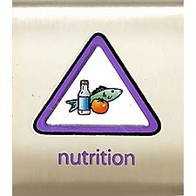
Complete these three requirements:
- Make a poster of foods that are good for you. Share the poster with your den.
- Explain the difference between a fruit and a vegetable. Eat one of each.
- Help prepare and eat a healthy meal of foods that are included in a food pyramid.
(With your parent’s or partner’s permission, see http://www.mypyramid.gov.) Note: Click on the link in the left column for “Kids (6-11y)” – Pat
Nutrition Academics Pin
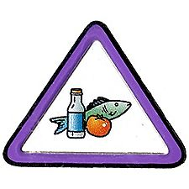
Earn the Nutrition belt loop, and complete five of the following requirements:
- Make a poster that shows different foods that are high in each of the vitamins. Using your poster, explain to your den or family the difference between a vitamin and a mineral and the importance of each for a healthy diet.
- Read the nutrition label from a packaged or canned food item. Learn about the importance of the nutrients listed. Explain what you learned to your den or family.
- Make a list of diseases that can be caused by a diet that is poor in nutrition.
- Talk with your school cafeteria manager about the role nutrition plays in the meals your school serves.
- With an adult, plan a balanced menu of breakfasts, lunches, and dinners for your family for a week.
- Make a list of healthy snack foods. Demonstrate how to prepare two healthy snacks.
- With an adult, go grocery shopping. Report to your den or other family members what you learned about choosing good foods to eat.
- Demonstrate how to safely prepare food for three meals.
- Demonstrate how to store leftover food to prevent spoilage or contamination.
- Help with a garden. Report to your den or family about what is growing in the garden and how you helped. Show a picture of or bring an item harvested from your garden.
- Visit a farm or ranch. Talk with the owner about how the farm or ranch produces food for families.
- Explain how physical exercise works with nutrition in helping people be fit and healthy. Demonstrate three examples of good physical activity.
For worksheets to help with earning these awards got to
http://usscouts.org/advance/cubscout/academics/nutrition.asp

Kickball Loop and Pin
Requirements
Tiger Cubs, Cub Scouts, and Webelos Scouts may complete requirements in a family, den, pack, school, or community environment. Tiger Cubs must work with their parents or adult partners. Parents and partners do not earn loops or pins.
Belt Loop
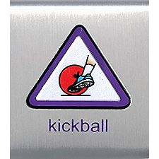
Complete these three requirements:
- Explain the rules of kickball to your leader or adult partner.
- Spend 30 minutes practicing the skills of kickball (pitching, kicking, base running, catching, throwing). This may be over two different practice periods.
- Play a game of kickball.
Sports Pin
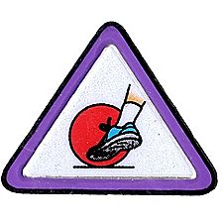
Earn the Kickball belt loop, and complete five of the following requirements:
- Demonstrate the following kickball skills: pitching, kicking, base running, catching, throwing.
- Explain the rules of base running.
- Describe the basic defensive positions in kickball (pitcher, catcher, infielder).
- Draw a kickball field to scale; include the starting defensive positions.
- Report to your den or family about the similarities between the rules of baseball and kickball.
- Explain the role of being the captain of a kickball team.
- Play five games of kickball using basic rules.
- Help set up a kickball field for a game.
- Serve as a referee for one game of kickball.
- Participate in a pack, school, or community kickball tournament or a supervised kickball league.
For worksheets to help with earning these awards got to http://usscouts.org/advance/cubscout/sports/kickball.asp

Internet Scout Patch
from www.usscouts.org
The Internet Scout Patch Program offered by the U.S. Scouting Service Project is undergoing a much needed update. In a very short time we will launch Version 2 of this program with updated requirements and supporting materials on this site. We also expect to offer a brand new patch with a spectacular design. Please check back again later for a great program that will help parents and Scouts alike to have a safer and better Internet experience..

Boys’ Life Reading Contest for 2011
http://boyslife.org/

SAY ‘YES’ TO READING
Enter the 2011 Boys’ Life Reading Contest
Write a one-page report titled “The Best Book I Read This Year” and enter it in the Boys’ Life 2011 “Say Yes to Reading!” contest.
The book can be fiction or nonfiction. But the report has to be in your own words — 500 words tops. Enter in one of these three age categories:
- 8 years old and younger
- 9 and 10 years old
- 11 years old and older
First-place winners in each age category will receive a $100 gift certificate good for any product in the Boy Scouts official retail catalog. Second-place winners will receive a $75 gift certificate, and third-place winners a $50 certificate.
Everyone who enters will get a free patch like the one on this page. (And, yes, the patch is a temporary insignia, so it can be worn on the Boy Scout uniform shirt, on the right pocket. Proudly display it there or anywhere!) In coming years, you’ll have the opportunity to earn different patches.
The contest is open to all Boys’ Life readers. Be sure to include your name, address, age and grade in school on the entry.
Send your report, along with a business-size, self-addressed, stamped envelope, to:
Boys’ Life Reading Contest
S306
P.O. Box 152079
Irving, TX 75015-2079
Entries must be postmarked by Dec. 31, 2011 and must include entry information and a self-addressed, stamped envelope.
For more details go to http://boyslife.org/

Knot of the Month
See The "Knot of the Month" in the Pack and Leader Hints Edition for information on Adult Religious Awards/Recognitions
Dave

GATHERING ACTIVITIES
"Gathering Activities" for large groups and getting groups to know each other are in the Pack and Leader Hints Edition. Those good for dens (e.g. word searches, puzzles, mazes) are here. Dave
Note on Word Searches, Word Games, Mazes and such – In order to make these items fit in the two column format of Baloo’s Bugle they are shrunk to a width of about 3 inches. Your Cubs probably need bigger pictures. You can get these by copying and pasting the picture from the Word version or clipping the picture in the Adobe (.pdf) version and then enlarging to page width. CD
Human Body
Westchester-Putnam Council
Name 10 parts of the human body
that have only three letters.
- .
- .
- .
- .
- .
- .
- .
- .
- .
- .

Eye, lip, ear, rib, hip, toe, arm, leg, jaw, gum
CLOTHESPIN MIXER
Utah National Parks Council
Equipment: Clip-on clothespins - 3 or 4 for each person.
Directions:
- Give everyone 3 or 4 clothespins.
- Tell them that the object of the game is to get rid of their clothespins without having anyone else pin THEIR clothespins on them.
- With everybody trying to get rid of his or her clothespins at the same time, as fast as possible, this is a rowdy and fun way to start a meeting.
Health & Fitness Round Robin
Alice, Golden Empire Council
Assign each den or family to focus on some part of Fitness or Health – Set up a Round Robin at the Pack Meeting for everyone to visit and find out about nutrition, healthy food, fun ways to exercise, places to go to walk, hike, or enjoy physical activity, fitness or food games.
Health & Fitness Word Search
Alice, Golden Empire Council
All the words in the puzzle have something to do with Health or Fitness – words can be in any direction.
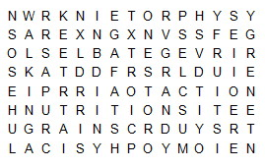
Action Dairy Diet
Energy Exercise Food
Fruits Grains Hiking
Muscles Nutrition Physical
Protein Vegetables Walking
Health & Fitness Activities
Alice, Golden Empire Council
Have a display of favorite Health & Fitness activities and local places to do them - Ask boys and parents to share their favorite places to do things – example: places where it’s safe to fly kites, favorite hiking, walking or bicycle trails, bowling alleys, farmer’s markets, etc.
SPORTS ANAGRAMS
Utah National Parks Council
The word or words in capital letters can be rearranged to make the name of a sport.
- This sport IS KING. (One word)
- MIND BATON in this game. (One word)
- There's a KEY CHOICE in this team sport.
(Two words)
- WIN GLOB at this sport. (One word)
- Ride horses through LOOP at this sport. (One word - the word "horses" in the clue is a hint.)
- SENT IN from this game. (One word)
- SNUG FIR board needed for this sport. (One word)
- KIT SANG about this sport. (One word)
- At this sport LOB ALOFT. (One word)
- LOLL BY VALE to watch this sport. (One word)
Answers: 1-skiing, 2-badminton, 3-ice hockey,
|4-bowling, 5-polo, 6-tennis, 7-surfing,
8-skating, 9-football, 10-volleyball

OPENING CEREMONIES
"Opening Ceremonies" are in the Pack and Leader Hints Edition. Dave

AUDIENCE PARTICIPATIONS
"Audience Participations" are in the Pack and Leader Hints Edition. Dave

ADVANCEMENT CEREMONIES
More "Advancement Ceremonies" are in the Pack and Leader Hints Edition. Dave

GAMES
Popcorn
Alice, Golden Empire Council
This is a game that is sometimes played with large groups and a playground parachute – but it can be fun for a smaller group too. And did you know that popcorn (without all the extras) is a great, healthy snack?
Equipment: A playground parachute (or a blanket can substitute); a ping-pong or bouncing ball for each player, numbered so it can be identified.
Directions: Each player puts their assigned ball on the “parachute,” then everyone lifts the parachute with both hands. On signal, everyone begins “pumping” the chute or blanket up and down to make the balls bounce off. When only one ball is left, that player becomes the winner.
Now have some popcorn for a treat!
Colored Eggs
Alice, Golden Empire Council
This game is a favorite in some parts of the country –
and it isn’t just for Easter. Alice
One person is the “Wolf.”
The other people line up next to each other, with the wolf facing them. Everyone in line picks a color in their mind.
Wolf: “Knock, Knock”
Line: “Who’s There?”
Wolf: "A big bad wolf with curly (or some other variation)hair"
Line: What do you want?"
Wolf: "Colored eggs".
Line: "What color?"
The wolf then says a color. Whoever had "picked" that color then runs around a selected area (to the far oak tree in the yard and back to the line, for example), with the wolf giving chase.
If the wolf catches the "egg", then that person becomes the wolf with the game starting over. If not, and all eggs make it back to line successfully, the wolf then calls out the next color, etc.
NOSE-CONE RACES
Utah National Parks Council
- Divide the den into teams.
- For each team, stretch a 15 foot length of string between two chairs.
- Before tying to the second chair, insert a paper cone cup with the tip cut off onto the string.
- Each boy on a team blows the cup the length of the string and returns it.
- Continue in relay fashion until all have raced.
Hinges Freeze Tag
Alice, Golden Empire Council
This is just a variation of Freeze Tag – but when each boy freezes, he has to be using at least three of his body “hinges” in the pose he makes!
Advancement Relay
Alice, Golden Empire Council
Set up a relay using two teams. Use requirements from the boy’s books – If you celebrate Frog Jumping Day, be sure to use the Frog Leap in the Wolf Book under Ach. #1- Feats of Skill.
You could also use the Elephant Walk from that same book, or the Crab Walk in both the Wolf book and in Bear Ach. #16c. Or if you have made any of the props in the Wolf Book Elect. #7 – Foot Power, those would be great to use, too. (Stilts, Puddle Jumpers and Foot Racers)
Or just make up your own active ideas –
the idea is to get moving and have FUN!
Pyramid Challenge
Alice, Golden Empire Council
- Before the meeting, prepare a list of foods.
- To play the game, spread several Hula Hoops out around the playing area. (or use masking tape to set off an area) Label each one - Fruits, Vegetables, Grains, Dairy, and Protein.
- Explain to the boys that when they hear you shout a food item, they should run and stand in the appropriate hula hoop.
- If the item you call out doesn’t fit any category, or would fit in more than one category, boys should stand in place.
- Here are some suggestions for your list:
Apples, Apricots, Bananas, Kiwi, Asparagus, Broccoli, Green Beans, Cereal, Flour, Milk, Cheddar Cheese, Cottage Cheese, Hamburger, Pasta, Spaghetti, Oatmeal, tortillas, Yogurt.
- Some tricky ones to use: Butter, Potato Chips, Brownies, Walnuts, Refried Beans, Ice Cream
- If boys disagree about where something fits, make a quick note so you can talk about it later!
Jump Rope Games
Practice jump roping first.
Relay - Use one rope for each team. Run and jump down to a line and back, handing the rope to next player.
Variations: Jump backward; run to line, jump 10 times and then run back; see how long you can jump; jump 2 boys in rope at the same time.
Elephant Soccer
Utah National Parks Council
- Cubs get into a circle with legs wide apart and their hands down in front of them with hands clasped together for trunks.
- Roll a ball across the circle trying to get it between someone’s legs.
- Use only trunks to keep the ball from going through legs.
Kangaroo Race
Utah National Parks Council
- Cubs pretend they are kangaroos with pouches.
- Give each Cub a bean bag to use as a pouch.
- After dividing into two teams, Cubs race each other across the floor on hands and feet with stomachs in the air (also known as a crab walk) with "pouches" perched on their stomachs.
- If the pouch falls off, the boy must put it back on before continuing.
Strive for Five Challenge
Alice, Golden Empire Council
This is a variation of Pyramid Challenge –
Take away all but two of the hula hoops.
- Explain that the boys should run to Fruits or Vegetables when you shout out an item that belongs.
- All other food items should leave the boys standing in place.
- You can use the same list as before – to make it trickier, add in items like: Fruit Punch, Apple Crisp, Vegetarian Lasagna, Broccoli-Beef Stir Fry, Cherry Pie, Banana Cream Pie, Apricot Jam.
Fruit Basket Game – a family favorite!
Alice, Golden Empire Council
- One person is chosen to be the caller.
- Everyone else sits in a circle on chairs.
- The caller gives each member, including himself, the name of a different fruit.
- When he calls out the names of two fruits, such as apples and pears, the two who were given the names of those fruits must change seats.
- The caller tries to slip into one of the seats, leaving someone else without a seat. The one without a seat is the new caller.
- At any time the caller may say, "The fruit basket tipped over." Then all must change seats, and the caller tries to get any empty seat, leaving another person as caller.
Mexican Hat Dance
Alice, Golden Empire Council
These two games celebrate Cinco de Mayo,
but also require physical activity.
After you play, try a Mexican treat from Cub Grub.
Materials:
- Sombrero
- Authentic music from Mexico
(check at the Library for a CD or tape)
How To Play:
- Boys make a large circle, with the sombrero in the middle.
- Whenever the music is playing, everyone in the circle dances around the circle.
- You might show the boys how men typically dance, with stomps and tapping of their feet, while calling out high-pitched phrases.
- Leader calls out a boy’s name – he goes to the middle of the circle and dances around the hat until another name is called.
Benito Juarez Says Game
Alice, Golden Empire Council
How To Play:
Before playing explain that Benito Juarez, a Zapotec Indian, was born and raised in extreme poverty. With hard work, determination, and strong love for his country, Juarez became the president of Mexico and defeated the French, who had occupied the country for five years.
Played similar to Simon Says.
Leader is "Benito Juarez" and directs different actions, like: "Benito Juarez says hop on one foot". Boys must hop on one foot and keep hopping till leader says "Benito Juarez says stop".
Repeat for additional activities such as take one baby step forward, step backwards, turn around, sit down.
Sometimes Benito Juarez will say "Benito Juarez says" and sometimes he won't. And of course, if you move when the leader doesn’t say “Benito Juarez says” – you got tricked and must go back to the start or you are out of the game.

SONGS
Head Shoulders, Knees and Toes
National Capital Area Council
Tune: “There is a Tavern in The Town”
Head, shoulders, knees and toes, knees and toes.
Head shoulders, knees and toes, knees and toes.
Eyes, your ears, your mouth and your nose.
Head, shoulders, knees and toes, knees and toes.
(Point to the body part you name)
3 ways to sing it:
- Faster as you go!
- Omit head and point to it, sing again and keep omitting until all you do is point.
- Substitute words: Head, shoulders, tummies tummies, thighs, tummies, thighs (Leaders appreciate this version!)
Bend and Stretch
National Capital Area Council
Bend and stretch, reach for the stars,
There goes Jupiter, there goes Mars,
Bend and stretch, reach for the sky,
Standing on tippy-toes oh! so high.
(When you sing bend, bend and touch your toes)
(When you sing stretch, stretch above your head)
(Wave hands above head for Jupiter and Mars)
(Stand on tip-toes)

My Hat, It Has Three Corners
National Capital Area Council
My hat, it has three corners,
Three corners has my hat,
And had it not three corners,
It would not be my hat.
Motions:
“My” = point to yourself
“Hat” = pat your head
“Three” = hold up three fingers
“Corners” = Form triangle with your hands
Singing:
- Sing the first time through with words only (no motions)
(“My hat it has three corners)
- Sing through the second time with words and motions.
(“My (point to yourself) Hat (pat your head) it has three (hold up three fingers ) corners (Form triangle with your hands)”)
- Substitute motions for words the third time through.
((point to yourself) (pat your head) it has (hold up three fingers ) (Form triangle with your hands)”)
We used to do this substituting one sign every time. Like substituting one more clap each round in BINGO CD

STUNTS AND APPLAUSES
"Applauses & Cheers, Run-Ons, and
Jokes & Riddles" are in the Pack and Leader Hints Edition. Dave

SKITS
"Skits" for the Pack Meeting are in the Pack and Leader Hints Edition. Dave

CLOSING CEREMONIES
Living Circle Ceremony
Great Salt Lake Council
I remember learning this ceremony at my first Den Meeting at Mrs. Kneale’s house in September 1957. We still teach it to our dens. CD
Based on an Indian custom, the living circle may be used alone or as a part of another ceremony. It reminds a Cub Scout of the fine friendships he is making in Cub Scouting.
Hold out your left hand—palm down, and thumb out.
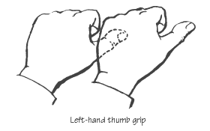
Hold the thumb of the boy on your left and form a connected circle.
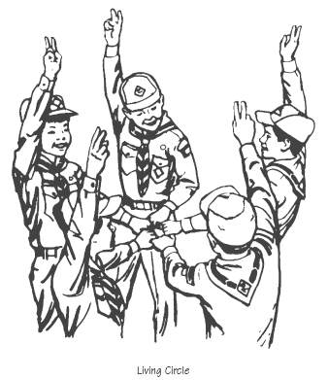
Then say the following as a football team may do after a time out or entering the filed at start of the game.
Action Say
Phonetic spelling of Akela
Raise the circle AH
Lower it KAY
Raise it LA
Lower it WE’LL
Raise it DO
Lower it OUR
Raise it BEST!
Release Hands
"Closing Ceremonies" are in the Pack and Leader Hints Edition Dave

Cubmaster’s Minutes
"Cubmaster's Minutes" are in the Pack and Leader Hints Edition Dave

CORE VALUE
RELATED STUFF

Connecting Health and Fitness
with Outdoor Activities
Wendy, Chief Seattle Council
(Adapted from B.A.L.O.O. Appendix E)
- Hikes - Go on an exercise hike with stations to do specific exercises. Many local parks already have these set up. Learn to take your pulse when walking to see how your body is reacting to the exercise.
- Nature Activities - Study what a certain species eats and how it lives; discuss how eating right relates to health. Harvest healthy food, with permission, at a pick-your-own farm or plant an edible crop.
- Service Projects - Make gifts using recycled materials. Make exercise equipment for a local shelter.
- Games & Sports - Challenge each boy to compete against himself to become more fit. Record initial abilities and record again at the end of a specific time period to see improvement. Give a fit youth award to all who improve. Most outdoor games and sports help to make bodies more fit.
- Ceremonies - Incorporate exercise equipment, real or prop, into a ceremony. The Cubmaster could jump rope across the room or lift "barbells' to find awards for the boys.
- Campfires - Plan an entire campfire around this theme. Use songs with physical movements. The opening and closing ceremonies could all use health and fitness themes.
- Den Trips - Visit a local water treatment facility to see how this vital fluid is made safe for drinking by the population. Visit a farm or other place where healthy food is processed. Visit a sporting event.
- Pack Overnighter - Boys plan the meals discussing good nutrition. Discuss the need for lots of water.

DEN ACTIVITIES
"Pack Activities" are in the Pack and Leader Hints Edition Dave
50 plus Ideas For Outdoor Den Meetings
Westchester-Putnam Council
Where Ichabod Crane lives!!!
- Backyard Breakfast Cookout
- Silly Track Meet (feather toss, balloon heave, standing broad jump, foot race (measure foot length), hopping race,.. etc.
- Visit the zoo or animal preserve
- Visit a farm
- Kickball game with regular ball or home-made ball of rags, etc.
- Lawn bowling tournament
- Parents take den to outdoor sporting event
- Ice or roller skate
- Treasure hunt
- Scavenger hunt for Cub Scout articles
- Safety inspection of everybody's bicycles
- Use pinewood derby cars (or similar), .roll on pavement to marked areas for points (on the idea of shuffleboard)
- Archery at a safe and approved archery range (school, scout or community run)
- Fishing at a local pond
- Visit a local historical spot
- Local geography day-use maps and go to principal civic buildings
- Invite a Scout, Venturer, or Explorer to talk about the National Jamboree or High Adventure Base and then demonstrate an outdoor scout skill .. .
- Visit a weather station
- Collect shells at the beach
- Woods hike for leaf collecting (don't defoliate the forest though!! !)
- Visit a County museum
- Night meeting to study the stars
- Visit a firehouse or police station
- Birdwatching contest to see who finds the most kinds, etc.
- Visit airport, train station or bus depot
- Bait casting practice with home-made fishing rods
- Play animal or nature charades
- Tour of a nature park of some sort (arboretum, botanical garden, preserved forest)
- Without a watch, each boy tries t o guess the time it takes him to walk around the block.
- Make sailboats to race on a pond
- Go rock collecting
- Ping-pong contest(or basketball free throw, &-golf, baseball toss)
- Build and hang tin can or other bird feeders
- Paper airplane flying contest (speed, distance, accuracy)
- Jump rope contest
- Catch butterflies (then let them GO!!!!)
- Visit a lapidary shop
- Challenge another den to a baseball game or other team event
- Clean up litter at local school or church grounds
- Plant a vegetable garden
- Visit an aquarium or planetarium or botanical gardens
- Make neckerchief slides from materials found on a nature hike
- Invite a lifeguard or Boy Scout to talk about and demonstrate water safety
- Walk around the neighborhood and look for hazards to the boys' safety
- Play Frisbee golf with your den
- Plant a tree and care for it
- Make solar graphics pictures
- Den "dinosaur egg" hunt (watermelon)
- Collect and recycle glass, paper and aluminum
- Find a fallen tree or a cut log and try to count the rings
- Build birdhouses and put them out for birds to use
- Visit your local -dump to see where the .trash goes
- Visit a bakery or pizzeria
- Collect insects (avoid bees) and see how many you can identify (LET THEM GO!!)
- Do a service project for your chartered organization
- Den family picnic
On the Storefront
Wendy, Chief Seattle Council
Home improvement stores sometimes have good wood projects for Mother’s Day at their free kids clinic. Here is what they have listed this month:
- Lowes:
http://www.lowesbuildandgrow.com/Home.aspx
Stick to your window Birdhouse Sat. April 23rd. (Wolf E13f, partial; Bear Ach. 5b)
- Home Depot: http://www.homedepot.com/webapp/wcs/stores/servlet/ContentView?pn=Kids_Workshops&langId=-1&storeId=10051&catalogId=10053&cm_mmc=THD_marketing-_-Clinics_site-_-Digitas-_-KidsClinics
- Michael’s:
Free Easter Make It –Take It activities: http://www.michaels.com/Store-Events/store-events,default,pg.html

DEN MEETINGS
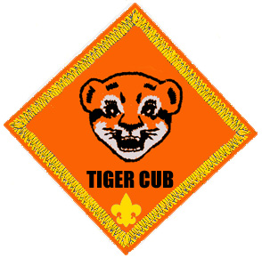

TIGER
Alice, Golden Empire Council
Tigers are working on electives as they should have completed the Tiger Achievements. Electives for Supplemental Meetings A & B include – E16, Collections and Hobbies; and E17, Make a model.
Supplemental Meeting #A
Do: E. # 16 With your den, show or tell about something you like to collect OR Tell your den about a favorite hobby or activity
The boy and his Adult Partner can each present a hobby or collection or talk about something like doing together.
You may have to do some education on this one. We have had a problem with our Wolf Den because boys (and their parents) will say they do not collect anything. Maybe they feel it has to be in an album or something to be a collection. When we talk with them they tell us about all their Hot Wheel cars or all their Transformers or all their …
Show them some easy ways to display a collection –
(Pictures from the Wolf Book)
I remember setting up a collection of pennies with one from each year I was alive as part of a requirement for something when I was a Scout. That should be pretty easy for a Tiger. (Maybe not for the Adult Partner!) They could try for one with each mint mark for each year, too. CD
Supplemental Meeting #B
Do: E. # 17 Make a model
HA: E. # 17 Finish the model
The model can be of anything. It can be a kit or homemade. It can be plastic or wood. The book suggests that a Pinewood derby car would qualify. If you already did a Pinewood Derby car, how about a Space Derby rocket or Raingutter Regatta boat?? Maybe the boy and Adult Partner can make a model of something from their collection or hobby??
Wendy, Chief Seattle Council
Electives that go with the Health & Fitness Value:
23 Milk
25 Healthy snack
35 Outdoor Game
37 Bike Hike
40 Swimming
45 Bakery Visit
46 Healthy Teeth & Gums
Supplemental Den Meetings that go with the
Health & Fitness Value:
D: Bakery field trip (E45)
G: Picnic (E22), Snacks(E25), Sunscreen (E29), and Outdoor Game (E35).
J: Bike repair shop and bike ride (E27).
O: Dentist or Dental Hygienist field trip (E46)
Mother’s Day:
Supplemental Den Meeting N: Picture Frame (E4)
Food:
Inside-out Sandwiches:
Wendy, Chief Seattle Council
Start with a soft bread stick.
Wrap lunchmeat, cheese, and lettuce around the bread stick,
Secure with a tooth pick.
Serve condiments (mustard, ketchup, spaghetti sauce) as a dip for the inside-out sandwiches.
Snails:
Wendy, Chief Seattle Council
Spread cream cheese on tortillas, and
Top with sliced tomatoes.
Roll up the tortillas, and
Slice into 1” mini-rolls.
These were a big hit at our Feb. Round Table. – W.M.
Pistachio Pudding Salad:
Wendy, Chief Seattle Council
Ingredients
1 3oz. box instant pistachio pudding
1 9 oz. container of Cool Whip
1 13 oz. can crushed pineapple with juice
1 banana, cut
Directions:
- Mix ingredients, and chill.
- Other canned fruits (mandarin oranges, fruit cocktail), and miniature marshmallows can also be used.
Pretzel Jell-o Dessert:
Wendy, Chief Seattle Council
http://www.cooks.com/rec/view/0,1813,153166-244201,00.html
Salty-sweet. Surprisingly good.
Tacos & Bridges:
Wendy, Chief Seattle Council
Choose one person to be the caller. At "Go," the whole group (number larger than 7, but not divisible by 3) mills about the play area, until the caller yells out "Tacos" or "Bridges." All players, including the caller, must then scramble to get into a three-person taco or bridge formation (see illustrations at http://familyfun.go.com/playtime/tacos-and-bridges-893247/ ). Whichever player is not in a trio becomes the new caller.
- Taco: Two players hold hands to be the taco shell, and a third player stands between them as the filling.
- Bridge: Two players make an arch for the bridge, and a third player crouches beneath them as the water.
- Variations:
Make spaghetti -- two players are noodles, sitting with legs outstretched, feet touching; the third sits in the middle as the meatball.
Swimming Ideas
See the Wolf section below.
Water Songs
Scout Wetspers
Wendy, Chief Seattle Council
(Oh, Tannenbaum)
Softly fall the rains today
As our campsite floats away
Silently, each Scout should ask
"Did I bring my SCUBA mask?
Have I tied my tent flaps down?
Learned to swim so I won't drown?
Have I done, and will I try
Everything to keep me dry?
SuperCalifornianExpertSurferoftheOcean
Wendy, Chief Seattle Council
(Tune: Supercalifragilistic)
Chorus:
SuperCalifornianExpertSurferOfTheOcean,
Even though most of them don’t use a suntan lotion
When they hit the waves too hard
They sure do cause commotion.
SuperCalifornianExpertSurferOfTheOcean,
Hum, diddle, diddle, diddle
Hum, diddle, I (up half-tone)
Hum, diddle, diddle, diddle
Hum, diddle, I
Because I was afraid to surf
When I was just a lad
My father took my board away
And told me I was bad
But then one day I learned a word
That every surfer knows
The biggest word you ever heard
And this is how it goes: Chorus
Chorus:
Water, Water, Everywhere
Wendy, Chief Seattle Council
(Tune: Row, Row, Row Your Boat)
Water, water everywhere,
But not a drop to drink.
Pull the plug and watch it swirl
Slowly down the sink.
Water, water everywhere,
There are puddles on the floor.
Watch the crazy Cubmaster
Go sliding out the door.
Water, water everywhere,
Make a regatta boat.
Put it in the rain gutter
And watch it float and float.
Water, water everywhere,
Rain is falling down.
Catch some raindrops in your mouth
And watch your tonsils drown.
Water, water everywhere,
And now our song is done.
Hit us with water balloons,
Getting wet is really fun!
Giant Soaker
Wendy, Chief Seattle Council
(Tune: Are You Sleeping)
Giant Soaker, Giant Soaker,
Super deluxe water gun,
Saw it at the store,
As I walked in the door.
I want one, I want one.
Giant Soaker, Giant Soaker
Sure looks fun, that water gun.
Squirt it at my brother,
Maybe squirt my mother.
Watch them run! Watch them run!
Giant Soaker, Giant Soaker
Here I come, here I come.
I’m bringing all my money
To buy that shiny funny
Water gun, water gun.
Giant Soaker, Giant Soaker,
Now I’m wet, dripping too.
Aimed it at my brother
Didn’t know my mother
Bought one too, she soaked me through.
The Happy Water Gun
Wendy, Chief Seattle Council
Tune: The Happy Wanderer
I love to shoot my water gun
At all the kids I see.
But when I shoot my water gun,
They all shoot back at me.
(Chorus)
Wateree, Waterah, Wateree
Waterah, ha, ha, ha, ha, ha
Wateree, Waterah
They all shoot back at me.
I shoot that water everywhere
I shoot it in the tree.
My neighbor’s cats a victim
Of my aqua-tillery
(Chorus)
O, my I keep my water gun
Until the day I die.
And in my coffin one last squirt
Hits someone in the eye.
(Chorus)

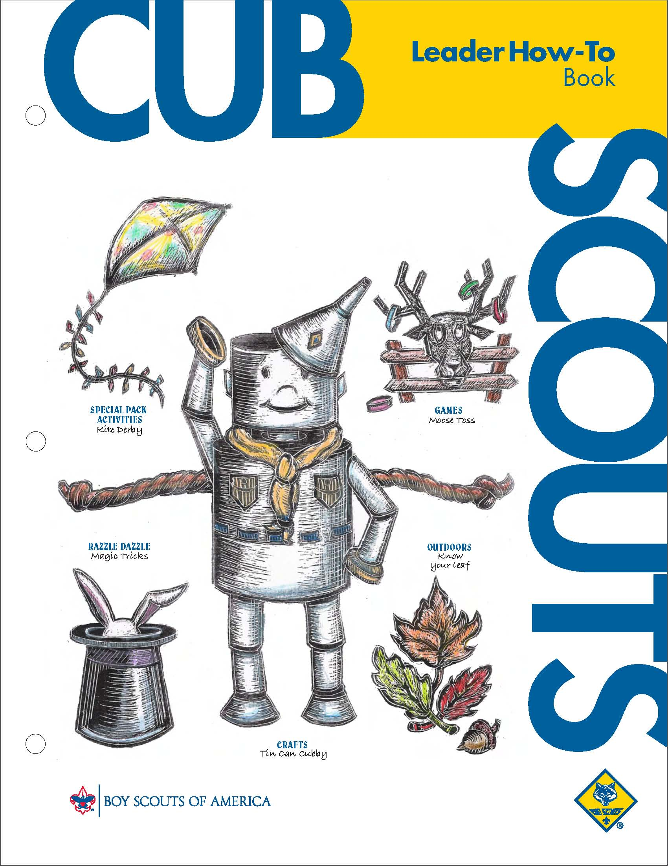
Modeling
Papier Mache, page 2-13
Clay Crafts and Modeling, page 2-20
Metal and Tin Craft, page 2-27
Woodcraft, page 2-32
Collections
Rock and Mineral collections, page 4-14
Collecting shells, p 4-16
Collecting insects, p 4-17
Picnic Ideas
Pack Picnic: p. 6-22 to 23.
Outdoor Games:, p. 3-11; 14-22.



WOLF
Alice, Golden Empire Council
Wolves are working on electives as they should have completed the Wolf Achievements. Electives for Supplemental Meetings A & B include – E5, Spare Time Fun, E13b, Birds, and E15 a&b, Grow Something
Supplemental Meeting #A
DO: Elective 10a, Read a book or tell a story about American Indians, past or present.
Elective 13b, Put out nesting material (short pieces of yarn and string) for birds and tell which birds might use it
Elective 15a and b, Plant and raise a box garden or flower bed – Gardening is a fun way to get some exercise in the outdoors!
NOTE: If you want to encourage birds and butterflies
to visit your garden, find out and plant some
flowers that attract them.
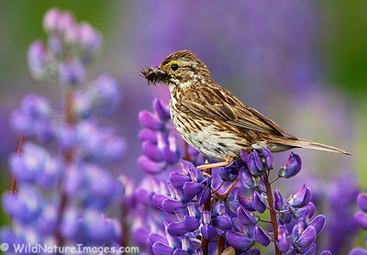
Here are some flowers that attract birds – often it’s the seeds they really enjoy ~ but the flowers also attract the bugs, butterflies and caterpillars that the birds LOVE to eat!
Sunflowers are really easy to grow, and birds love the seeds. You don’t even have to collect the seeds – just lay the flower head on a bird feeder, or wire it to a fence or branch where the birds can get at them!
Aster Calendula Cosmos
Cockscomb Coreopsis Larkspur
Cornflower Portulaca Zinnias
Snapdragon Purple Coneflower
Also, the easiest plants to grow are often the ones native to an area – and those same plants are part of the diet of area birds – so check with a gardener or nursery and plant some natives – they’ll also take less water!
Supplemental Meeting #5
DO: Elective 5, a-d, part 1 (Part 2 is next meeting), Spare Time Fun – GO FLY A KITE!!!

Have some active fun outdoors – make and fly a kite – But be sure to read and know the safety rules for flying a kite first!
Lots of great tips for easy, safe flight at:
www.nationalkitemonth.org/kids/howtofly.php
and for some great ideas on kids and kites, check out: www.kitesandkids.com/217/kite-flying-tips/
Wendy, Chief Seattle Council
Achievements that can be used as electives that go with the Health & Fitness Value:
1 Feats of Skill, do some of the parts not done by the Cub when earning his Wolf badge.
Electives that go with the Health & Fitness Value:
4f Wide Area or Group Game with Den or Pack
18 Parts a,d,e, Obstacle Race, Game Trail
20 Sports
Supplemental Den Meetings that go with the Health & Fitness Value:
D: Swimming (Ach. #1h, 1i) and Boating Rules (E20b), Swimming Belt Loop
G: Picnic & Games (E18a, E4)
N: Baseball or Softball (E20)
Mother’s Day:
F: Recipe Holder (E3a)
Swimming Ideas
- Safe Swim Defense (mandatory for swimming)
- Safety Afloat (mandatory for boating)
Swimming Belt Loop: http://usscouts.org/advance/cubscout/sports/swimming.asp
Baloo’s Bugle Issues for Water Themes
- July 2010 issue of Baloo’s Bugle, “Waves of Fun.”
http://usscouts.org/usscouts/bbugle/bb1007.pdf
- July 2008 issue of Baloo’s Bugle, “H2OHHHhhhh”
http://usscouts.org/usscouts/bbugle/bb0806.pdf
- July 2004 issue of Baloo’s Bugle, “Fin Fun”
http://usscouts.org/usscouts/bbugle/bb0406.pdf
Cup o' Fish
(Baloo’s Bugle 2001 Wet & Wild)
Make an edible aquarium in a cup.
Ingredients:
Blue Jell-O,
gummy fish, and
clear plastic cups.
Directions:
- Make blue Jell-O according to the directions on the box.
- Pour into clear plastic cups.
- Let them cool in the refrigerator until partially set - about an hour.
- When they're partially set, place a few gummy fish in each cup.
- Put them in the refrigerator until they're completely set.
- Eat and enjoy!
Variations:
- Frozen fish-Popsicle's (just freeze the Jell-O in Popsicle molds - add the gummy fish when they are partially set - unmold very gently when entirely frozen). These are really messy to eat and are best eaten outside.
- Aquarium: An entire punch bowl of fish Jell-O (made like the cup o' fish)!
Wackyball
Benton District Cub Scout Day Camp, Oregon
Materials
Bats: big plastic baseball bat, regular baseball bat, cricket bat, golf club, broom, pool noodle, tennis racquet, etc.
Balls: wiffle ball, football, golf ball, tennis ball, beach ball, sponge balls, etc.
Catching Equipment: baseball gloves, kitchen pots, oven mitts, buckets, re-usable grocery bags. etc.
Bases: paper or plastic plates.
Rules
Game is played like baseball, except players use the equipment above. You could have the player choose which bat to use, and the pitcher (adult) choose the best ball for the player’s ability and bat. Or you could specify that each team must use all the balls and bats when they are batting, and the players can figure out who uses which ball and bat. The outfielders try to catch the balls using the assorted catching equipment. You could also have the players run the bases in a different “wacky” order. Basemen can squirt runners with squirt bottles.
Recipe Holders
(Wolf Ach. #3a, E9b,c))
Wendy, Chief Seattle Council
Picture/Recipe Holder:
- Cut a 2”x 2” into cubes.
- Sand or file any rough edges smooth.
- Using pliers, coil one end of a 9” length of plastic coated bell wire into a flat spiral. (The spiral is essentially a big round, square, or diamond shaped paper clip.)
- Hammer a nail into a cube and remove to create a hole.
- Dip the straight end of the wire into tacky glue, and push it into the hole in the cube.
- Paint or decorate cube as desired. Place picture or recipe in the spiral.
Butterfly Recipe Holder
- Decorate a round coffee filter. (Paint it, or color with marker and spritz with water. Let dry.)
- Accordion pleat the filter, so that the filter is narrow in the center, and has 2 wings.
- Wrap a chenille stem around the middle hold it together, and to create antennae.
- Glue the butterfly to a clothespin.
- Glue the clothespin to a rock or piece of 2”x4”.
Mom Recipe:
- Have the boys write the ingredients in the “recipe” for their Mom on a recipe card, and put it in the recipe holder.
- Example: What ingredients are mothers made of?
  - “God makes mothers out of clouds and angel hair and everything nice in the world and one dab of mean.”
  - “They had to get their start from men's bones. Then they mostly use string, I think.”
(http://www.scrapbook.com/poems/doc/9347/409.html)
For more Mother’s Day ideas, see the Bear section below.
Water Games, page 3-42 to 3-44
Fun with Plants, page 4-6 to 4-9
Kites, page 2-10 to 2-13
Kite Derby: page. 6—38 to 6-39
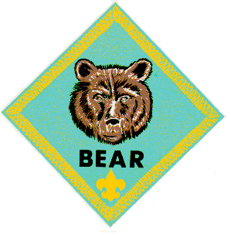

BEAR
Alice, Golden Empire Council
Bears are working on Elective 23, maps, the Map & Compass Belt Loop, and Achievement 19, Shavings and Chips, this month.
Supplemental Meeting #A
Do: Elective 23, a-e and Map & Compass Belt Loop
The Den and Pack Meeting Resource guide ahs some really advice and ideas for explaining how a compass works to your Bears.
Some Map Resources to Try
- Visit a AAA Office, or ask a parent with their coverage to obtain maps to use with this activity.
- Show the boys how to find information such as time zones, site maps of local stadiums and auditoriums and other useful facts in special pages of the phone book.
- Check with your local Chamber of Commerce or Better Business Bureau – they often have great maps of the local community
- Check with local public transit agencies – many boys don’t realize how buses, light rail and subway systems can take them from place to place – learning how to read the system maps is a very useful skill!
- Want a fun challenge? Check with a library, used book store, thrift store or a National Geographic fan – this publication has wonderful inserts that sometimes feature maps of states, regions, countries or special areas – and you can also see unusual maps such as maps of the seafloor, lunar surface, etc.
- City or County Recreation Departments, or National Parks – Sometimes the best way to see the details and relationship between areas of a park or nature area are the maps made for a nature center or park.
- USGS – If you are lucky enough to be near a regional office, you can go and purchase all kinds of great maps – especially topo maps; you can also order them online.
- Internet – This is a resource you can use if you can’t find the map you want somewhere else. Just google the name of the area you are interested in!
I had great fun with boys and maps one time – I got a variety of maps, everything from road maps to topographical maps, “maps” of stadiums or auditoriums – had them posted on the wall and assigned a team of boys to spend some time looking at “their” map to see what they could learn.
After a few minutes, we went around the room and talked about the different maps – the boys learned about using the map key or legend, how to pick out different features, how to estimate size and spaces covered – and they were better prepared to follow a map on a hike or family trip! Alice
Supplemental Meeting #B
Do: Achievement 19, a-d, Shavings and Chips.
This is the Achievement where your Bears earn their Whittlin’ Chip card and get permission to use a pocket knife. Chances are, you worked this one into the program earlier. Every Bear I ever knew could not wait to earn his Whittlin’ Chip card. I am surprised this was not an achievement chosen to be completed for the badge.
I recommend having an accomplished knife person, woodcarver or other, come and work with the boys. Make sure the guest knows to stress the rules. Safety and rules for use are the purposes of this achievement. Skill with a knife will come later.
Simple Slip Stick
for Knife Sharpening
Norm, a Grandad on his second time through Scouting
Here is an easy tool for your Cubs to make that will help them keep their knife sharp.
My son and I had over 100 Cubs make these when we did Whittlin’ Chip and Carving for Cubs at our council wide Baden-Powell Encampment. Over 100 Cubs, and no one got cut!!
Material
- 400 grit wet/dry silicon carbide paper (sandpaper with tougher grit to you and me)
- ¾” wide double stick foam tape (better) or carpet tape
- ¾” wide tongue depressors (sold now as craft sticks!)
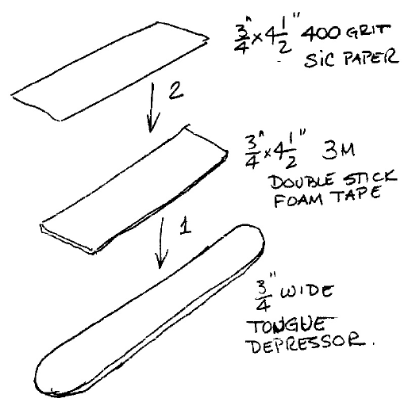
Instructions
- Cut a 4 ½” long piece of the tape
- Cut a piece of the sandpaper – ¾” by 4 ½”
- Stick tape to tongue depressor
- Stick paper to tape
- Your done
- Read instructions on knife sharpening in Scout books
Ach. 19 Meeting B Shavings & Chips
http://www.scouting.org/filestore/CubScoutMeetingGuide/bear/BearSupplementalMeetingB.pdf
Felicia, our newest staff member!!
Every Cub Scout looks forward to earning their whittling chip. If you haven't had time to cover this - now may be your last chance to allow your Bears to achieve this milestone. As a leader you don't have to handle it alone. It is recommended that you send a notice to parents/guardians prior to this meeting. Let them know that you're working with knives and the dates you plan on covering ach. 19. It is also a good idea to request that each boy bring an adult with him; to assist him and to evaluate if they believe he is ready for this responsibility.
Many packs like to do a more detailed discussion of knife safety using 2 - 3 den meetings or one 3 hour session. Some bring in a variety of knife types (including box cutters & scissors) to help boys recognize the need for care with all types of knives. (Photographs of knives or clip art can be effective as well). They discuss the purposes of each knife, how to safely use it, & if a cub scout is allowed to carry it.
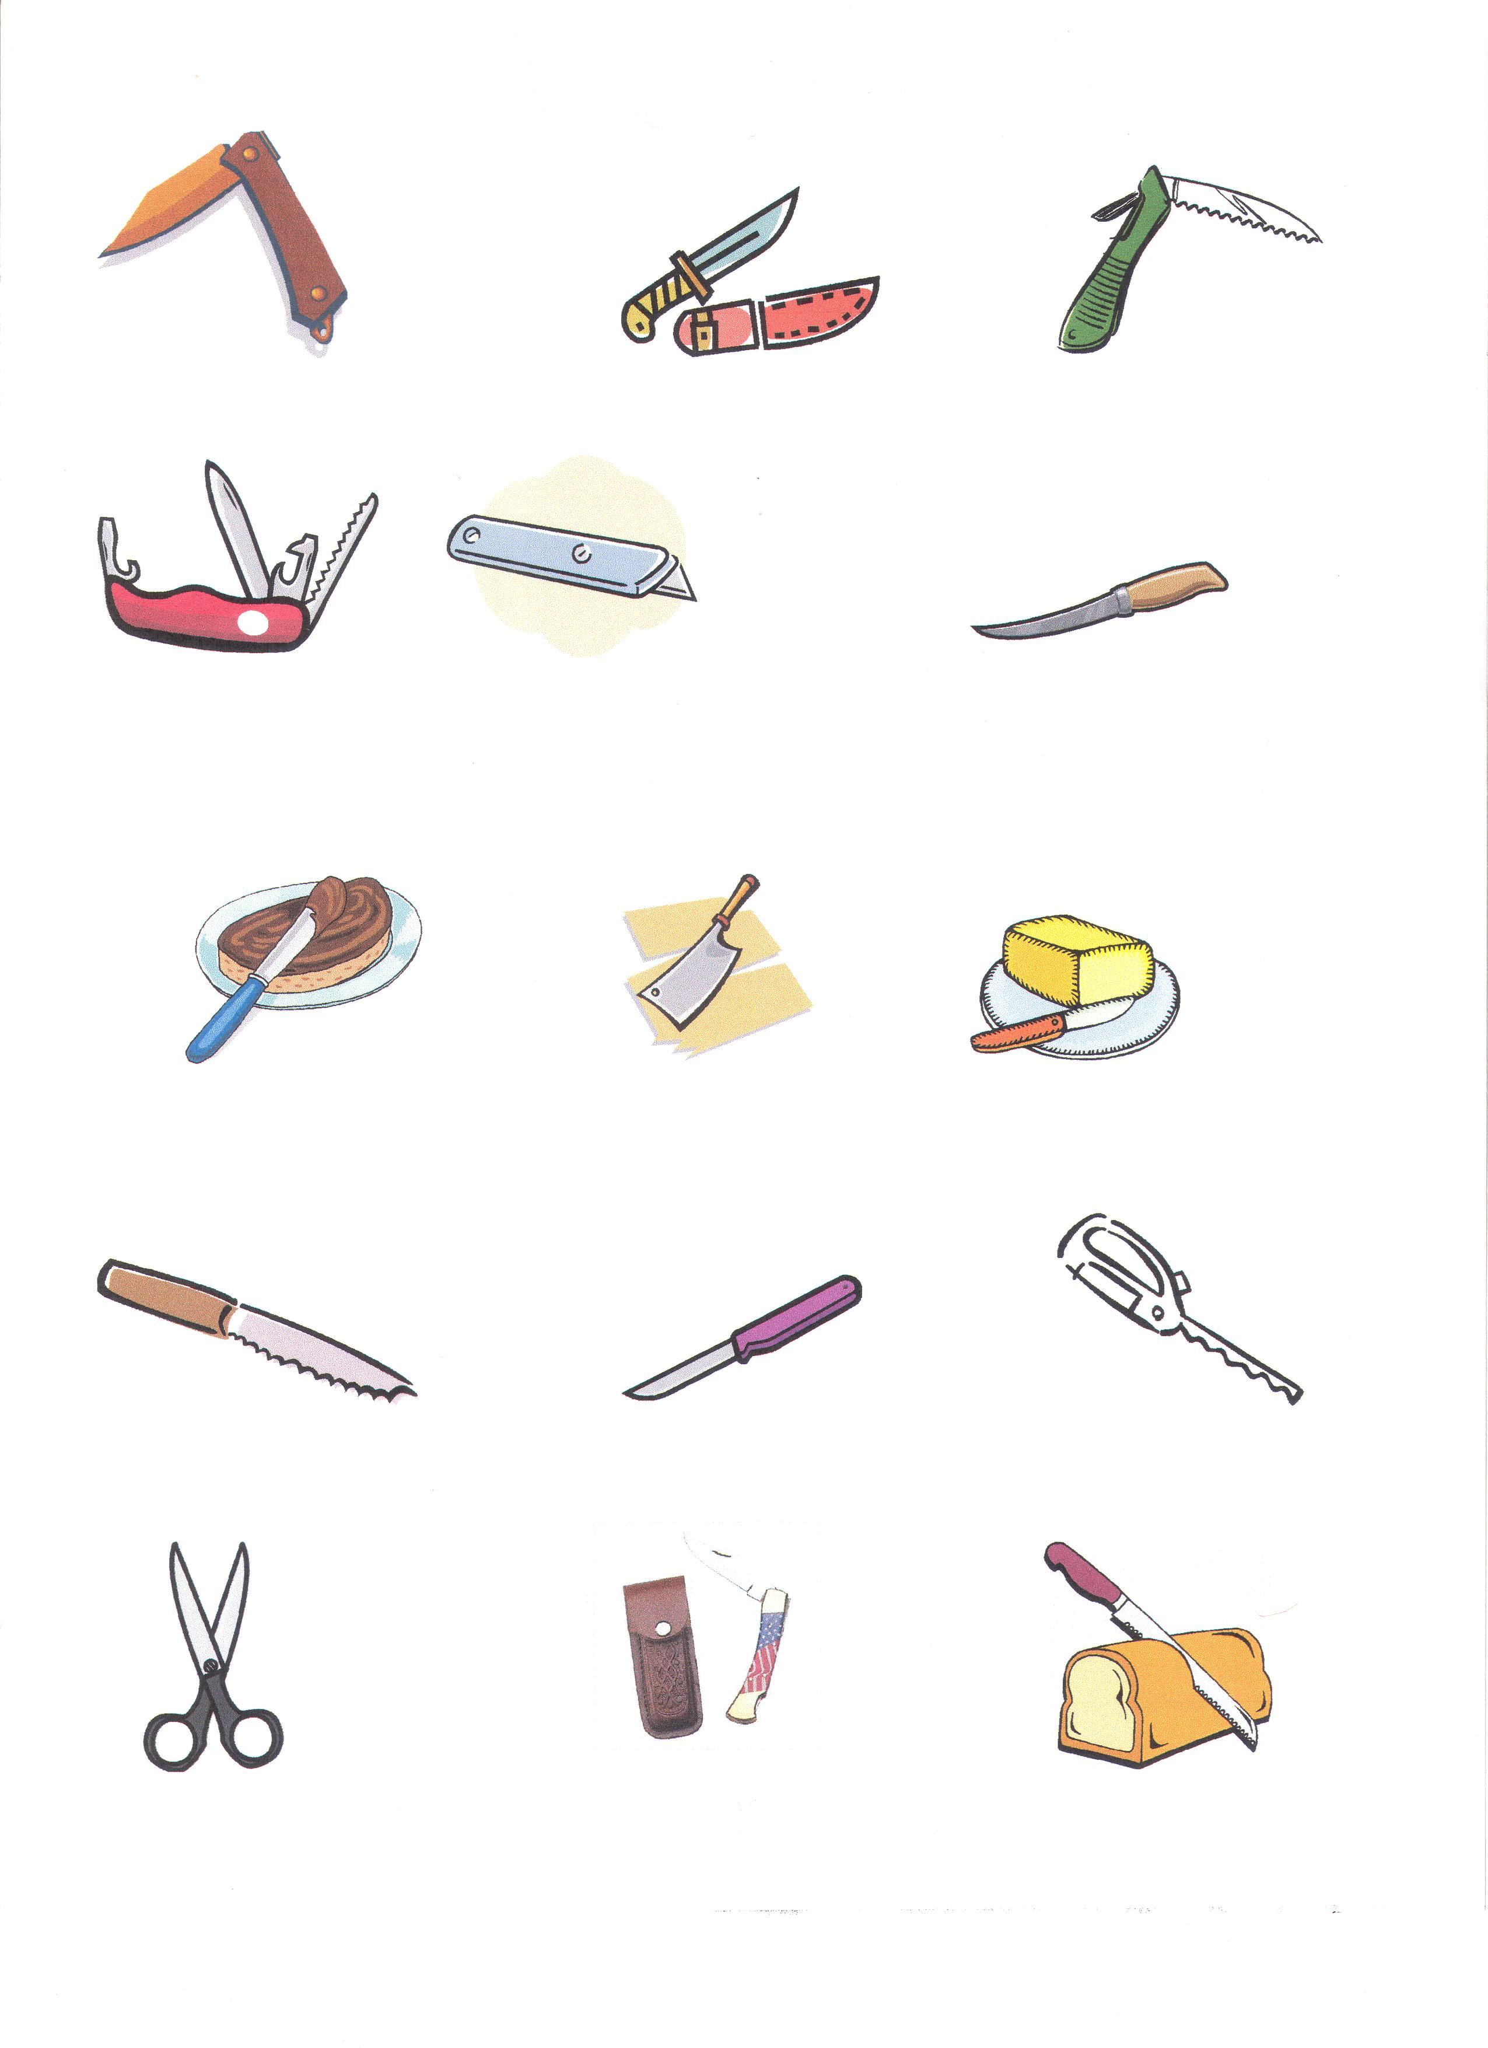
Passing a knife safely
Always close a pocket knife before passing it. If it is a fixed blade the passer holds the dull side of the blade and extends the knife handle to the other person. When the receiver has a hold of the handle he says, "Thank you," to let the passer know that the receiver has control of the knife. The passer say "Your Welcome," to let the receiver know that he has given control to the receiver of the knife. Until "your welcome" is said; both receiver & passer should have a safe but firm hold of the knife, to ensure it does not fall or slip.
Passing a knife safely exercise:
Materials: 1 plastic butter knife
1 tube of red lipstick
Directions: coat both sides of the knife blade's edge with red lipstick. Have the cub scouts form a circle & pass the knife safely around the circle as described above. If any have lipstick on them - they would have cut themselves with a sharp knife. Have both the pretend bloodied Cub Scout & the person who passed the knife to them try this exercise again (until they can pass the knife safely without getting lipstick on them).
Ach. 19 b & c Popcicle Stick Knife:
This is handy for those of you who meet in schools or other places that do not allow knives and it is an excellent way to teach knife sharpening skills. Let the boys know these knives are sharp and you can cut yourself with them. They must treat it with the same respect and safety consciousness they would a regular knife.
Materials for each boy:
a popcicle stick
a red crayon & a blue crayon (added by me – it is too easy to lose the edge you are working on.)
a sharpening stick (see 19b Bear book)
or a paint stick (or hand sized block of wood) w/ sandpaper (80 grit)firmly glued on.
a bar of soft soap (like Ivory)
Directions: Have the boys choose which side shall be the blade for their knife & color only the blade edge red. Have the boys color the edge that is the dull side of the blade and the handle edges blue. Following the directions for 19 b on knife sharpening they will create a blade only from the edge that is colored red. They will not sharpen any of the popcicle stick that has a blue edge. When they have finished they can use this knife to demonstrate how to make shavings & chips from the bar of soap. After they have demonstrated their knowledge: they can use the remainder of the bar of soap to do 19c, making a carving with their popcicle knife.
Ach. 19b A video demonstration on how to sharpen a pocket knife can be found at
http://boyslife.org/about-scouts/large-width/2247/how-to-sharpen-a-knife-or-ax/
A puzzle for Ach. 19, Shavings & Chips can be found and printed from the following link:
http://www.armoredpenguin.com/wordsearch/Data/best/scouts/shavings.01.html
Packs have the right to regulate the use and carrying of pocketknives. Most only allow them at outdoor events where a cub scout might have a need for the pocketknife. If any Cub Scout is seen, by an adult, in a situation where he demonstrates poor responsibility (which could possibly endanger himself and/or others), the pocketknife is confiscated and given to the highest ranking Leader available. (After the event, the boy’s parent/guardian receives the pocketknife). The Whittling Chip Card will have a corner torn from one of the four edges. If a Scout has all four corners removed, he must retake the Whittling Chip.
More details can be found at http://usscouts.org/bbugle/bb0407/bb-bl.html; or http://www.ehow.com/about_6644493_scout-pocket-knife-safety.html
Ach. 19 c Different types of materials for carving (recommended to Baloo's Bugle in 1998):
- Soap. Steven of Cattail Creek. The way soap reacts to inappropriate carving protects Cub Scouts from injury, teaching them to use safe carving techniques. Trying to force the blade deeper than it should be is a common cause of accidents. Cracking soap lets us know that the carver is trying to make too deep a cut. Which shows up in the soap coming off the bar in chunks rather than a curl. If the Cub makes a shallower cut, with the carving coming off in a smooth curl, the bar will seldom break.
- Basswood, balsa, or foam insulating board. Joe of Boulder Creek.
Basswood can be purchased at a good lumber yard.
Balsa can be found at a hobby shop.
- Insulating board will be at most lumber yards. Get the kind that's uniform foam, not beads (like a styrofoam). It can be found in thicknesses of 1" to 3". The drawback of foam is that it is hard to carve fine detail, but it sands great.
- Vermiculite & Plaster Mix, Chalk, Fruits or Vegetables. Robert of Ft. Worth.
Vermiculite & plaster combination. Mix the plaster as per the instructions, then add almost the same amount of vermiculite and let it set. You may have to experiment a bit to get a consistency you like. This gives you a lightweight medium that carves fairly easily.
- Chalk carves easily; however, because of size it is limiting in what you can carve.
- Fruits and vegetables. Easy to carve, delicious to clean up.
Some Packs have Rules for pocketknife use and tips for teaching whittling & safety on their web sites.
Here are a few: http://www.goodsearch.com/redirect.aspx?type=1&url=http:%2F%2Fwww.packsonline.com%2FNc%2FPack225%2FPack_HTML%2FDen_Announcements%2FDen_Ann_62299_73825.html;
http://www.goodsearch.com/redirect.aspx?type=1&url=http:%2F%2Fwww.pack913.org%2FBearDocs%2FWhittling%20Class.doc
These have in depth program outlines http://www.cubpack178.com/documents/whittling_chip_prog.pdf; http://www.goodsearch.com/redirect.aspx?type=1&url=http:%2F%2Fwww.kintera.org%2Fatf%2Fcf%2F{26ED7949-CF3D-4742-A4D7-6DBFA1D2FF45}%2FCS53%20-%20Whittlin%20Chip.doc; http://cubpack149.org/WhittlingChip.pdf
This one has carving patterns for bar soap: http://cubscoutpack97.org/PDF/WhittlingChip.pdf

Ivory Soap has a great page on soap carving. Find it at http://www.ivory.com/purefun_ivoryprojects_soapcarvingtips.htm .
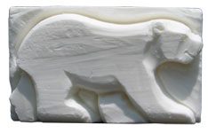
More Bear Ideas
Felicia
El. #14 Meeting J Landscaping
http://www.scouting.org/filestore/CubScoutMeetingGuide/bear/BearSupplementalMeetingJ.pdf
May is a good time to do elective 14, Landscaping. If you plan on planting seeds: you can use this opportunity to do El. 12 e (collect & label 8 types of plant seeds).
El. 14 d Make a green house from a 2 liter pop bottle
Materials:
clean & empty a 2 or 3 litter pop bottle with its lid
sturdy craft scissors (to cut bottle)
dirt/potting soil
seeds
water
Plate or leak proof pie pan to set it on
Directions: Cut the pop bottle in half. Set the top half off to the side. Punch 5 small holes in the bottom. Cut 3 – 4 vertical one inch slits. Start the slits from the cut side and cut 1 inch toward the bottom. Space the slits equally around the bottom half. Fill the bottom with 3 – 4 inches of dirt. Follow the directions for planting the seeds on your seed packet. Gently add some water or set the container in water. Then put the top on so it is on over/outside of the slits (the bottom part will be inside) and push the top on tightly. Note – when moving this – pick it up from the bottom. Set it on the plate to keep the area you place it in dry.
Other versions of this can be found at: http://www.education.com/activity/article/Soda_Bottle_Greenhouse/; http://www.wikihow.com/Make-a-Mini-Greenhouse
El. 14 d Make a green house from domed clear plastic containers
Materials:
A clean clear domed plastic container which has room for some plant growth
( such as: cake, pie, chicken, etc...).
dirt/potting soil
seeds
water
paper cups (if your container bottom is shallow).
Directions: Evaluate the depth of the bottom half of the container – if it is flat you definitely want to put the dirt & seeds in paper cups and set those on top of your bottom. If it is sufficiently deep. Fill it 3 inches with soil & plant your seeds in there. Water gently and put your clear lid over top.
More information can be found at: http://www.ehow.com/how_4704728_build-greenhouse-plastic-food-container.html
Here is a link to a flowering plants word search http://www.freeprintable.com/view/print.html?id=5888
El. #25 meeting R Let's Go Camping
http://www.scouting.org/filestore/CubScoutMeetingGuide/bear/BearSupplementalMeetingR.pdf
Leave No Trace Award (abbreviated below LNT) and
Cub Scout Outdoor Activity Award (abbreviated below OAA)
It is a great time to have a Spring Family Camp Out, earn elective points, work on the Hiking Belt loop/Pin, & start working on the cubs' Leave No Trace Award & Cub Scout Outdoor Activity Award.
- Why not do El. #25 a and prepare and discuss an essential camping kit?
- Do El. #25 b go on a hike ( OAA #1) practice & discuss the buddy system, what to do if lost, & importance of cooperation (OAA#3). (Hiking Belt Loop #3).
- Do El. #25 c participate with your den in front of a campfire (OAA# 10 ).
- Do El. #25 d participate in a pack overnight campout. Be prepared and help put up the tent & set up the site. Also OAA# 4
- Do El. #25 e Participate in a Cub Scouts' Own Religious Service ( OAA #12).
- El. #25 f or g If you are able: register for day or resident camp for this summer. Cubs must do one of these to receive their Cub Scout Outdoor Activity Award!
- El. #25 h Earn the Cub Scout Leave No Trace Award. Bears must do this to receive their Cub Scout Outdoor Activity Award! (Hiking Pin #3)
Bear cubs who do all of the OAA items above qualify for the OAA when they complete day or resident camp. (getting the OAA satisfies Hiking Pin #4)
Leave No Trace Award
Kindly note that #3 of the LNT requirements is different for each Rank.
Here is the link to BSA's Front Country Guidelines & requirements for the Cub Scout Leave No Trace Award. http://www.scouting.org/scoutsource/CubScouts/resources/LeavenoTrace.aspx
Make a personalized Leave No Trace Pledge Card
Scan the Cub Scout's Poster for LNT (#6) and shrink it down to business card size. Then copy & shrink the LNT pledge until it will fit on a business card. Print the poster on one side and the pledge on the other of a white card stock grade of paper. Have the boy sign the pledge & laminate.
You can laminate these with thermal laminating pouches (for business cards), an iron, & a dishtowel. Place the card in the laminate pouch – place the towel on an ironing board or heat safe surface – fold the towel over the card - iron the towel on top of the card on medium heat, check it after a minute of rubbing the iron around (if it is not sealed, increase the heat a little and try again) flip & iron the other side.
Wendy, Chief Seattle Council
Achievements that can be used as electives that go with the Health & Fitness Value:
9 Cooking
15 Games
14 Biking
16 Building Muscles
23 Sports
Electives that go with the Health & Fitness Value:
18 Backyard Gym
19 Swimming
Supplemental Den Meetings that go with the Health & Fitness Value:
L: Swimming (E19)
N: American Indians (E24), especially physical games
Mother’s Day
G: E12a solar prints
Swimming Ideas (E19)
See the Wolf section above.
American Indian Ideas (E#24)
E24b Games
2 Person Games:
- Bear Ach. #16b: 1 legged hand wrestle, and elbow wrestle are American Indian games.
- How To Book section 3, p. 30-32: Arm , Leg, & Stork Wrestling are American Indian games.
Run & Yell: Salish-Kootenai game. Boys take a deep breath, then yell and run. They run as far as they can while yelling. When they need to take a breath, they must stop. The boy that runs the farthest wins.
Zuni Stick Kick: ’07-’08 Program Helps Nov. p.8. Cut two 12” sticks from a broom handle or dowel and paint colorful patterns on the stick. Draw a circle on the ground, about 30” in diameter. Have den members stand outside the circle. On a signal, two players inside the circle begin kicking their sticks around the edge of the circle. If a stick touches the circle line, the player moves out of the circle and another player moves into the circle to take his place. Continue until everyone has had a chance to be inside the circle.
Suggestion: use a long rope to make the circle, and use cans instead of sticks. I wrapped corrugated cardboard around my cans to increase safety.
Ball Race: Played by Southwestern tribes. Each team gets a can (paint a stripe on one so the teams can tell which can is theirs). Each team gets a goal (a blanket on the floor). Like soccer, the object is to kick your can into the goal. Play with both cans at the same time. I wrapped my can in corrugated cardboard to increase safety.
Pokean: Make according to directions in the Bear book (E24), using strips of brown paper sack instead of corn husks. Use a rubber band to keep the top closed. I trimmed the ends of the strips to make points, and twisted them around a screw, which gave me something firmer to wrap a rubber band around. I removed the screw, and added feathers to the top.
Hoop & Stick: Throw a longer stick (spear) through a stationary or rolling hoop.
Dart & Hoop: Throw small feathered sticks through a stationary or rolling hoop. I used a rubber band to attach the feathers to the sticks. Wrapping the rubber band around toothpicks created a little space, which made it easier to put the feathers under the rubber band. Then I removed the toothpicks.
Zuni Ring Toss: Toss a small ring into a big ring.

Ajaqaq
Cardinal District RT Handout
Native American tribes such as the Inuit played this game (using a stick, hollow bone, or gourd ring, and a leather thong) during the dark winter months.
Materials:
8- to 10-in. stick,
12-in. yarn or string,
Top of a plastic margarine container cut into a ring
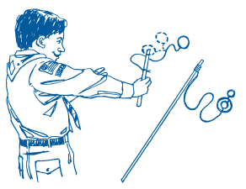
Directions:
- Wrap yarn around one end of stick; tie or glue in place to secure.
- Tie the other end of the yarn to the plastic ring.
- Holding the stick in one hand, toss the ring into the air and try to catch it on the stick.
- For a greater challenge, use a smaller ring or a shorter piece of yarn.
Ball & Cup: Tape a circle cut from a paper sack to the bottom of a toilet paper tube to make the cup. Tear small pieces of masking tape and stick them to the cup. Rub shoe polish on the tape to make it look like leather. Tie a large bead to a string. Punch a hole in the side of the cup, and tie the beaded string to the cup.
E24c Native American Homes
Pueblo: Paint boxes tan. Sprinkle sand/corn meal into paint before it dries to make it look like adobe. Glue on black paper windows and doors (no doors on lower levels to keep out enemies), and entrance holes in roofs. Add stick ladders.
Edible Tepee: http://jas.familyfun.go.com/arts-and-crafts?page=CraftDisplay&craftid=10075 Boys can also decorate a half circle of paper and shape it into a cone for a tepee, or use fruit leather.
Igloo: Glue sugar cubes together to make igloo.

Edible Igloo:
Trapper Trails Council
Ingredients:
1/2 apple, cored;
Miniature Marshmallows;
Peanut Butter
Directions
- Place apple cut side down on a plate
- Spread with peanut butter, cream cheese, or frosting all over the outside of the apple
- Cover peanut butter with the miniature marshmallows
- Add a tunnel entrance by slicing a banana in half the long way, and then cutting it into 1” – 2” chunks. Place the half-cylinder banana piece by the apple.
- Cover with peanut butter and marshmallows.

Wigwam:
Wendy, Chief Seattle Council
- Make a dome shaped-frame from cardstock or poster board. To make the frame, bend a strip of cardstock or poster board in a circle. Overlap the ends of the cardstock, and staple. Staple the ends of 3 or 4 more strips, evenly spaced around the circle, to make arches that cross over each other in the center.
- Glue a coffee filter over the frame.
- Glue grass, leaves, or paper to the coffee filter. I drew lots of lines on a brown paper bag using different colored brown crayons to look like sticks. Then I cut out squares and glued them to the coffee filter. When gluing, work from the bottom to the top (like shingles).
Plank House: Hot glue thin wood to rectangular box. Color Northwest Indian designs with crayons. Free wood is sometimes available at lumber stores.
Mother’s Day Ideas
Supplemental Den Meeting G: E12a solar prints
Use construction paper solar prints to make Mother’s Day Cards. To make the solar prints, collect leaves, and arrange them on the construction paper. Using removable tape, or a loop of masking tape, tape the leaves to the paper. Put the paper in a window, leaf side toward the sun. Leave for a week; then gently remove the leaves. The area under the leaves will be the original paper color, but the area around the leaves be faded. Tape or glue the solar prints to the front of the card.

Mother’s Day cards (Ach. #18e, Ach. #24d, partial)
- Purse-onable Mother’s Day Card: http://jas.familyfun.go.com/arts-and-crafts?page=CraftDisplay&craftid=11759
- Flower Mother’s Day Card: Separate a silk flower into the various layers. Lay 2 or 3 different sized flowers on a cardstock card. Using a pencil, punch a hole in the card where the center of the flower is. Using a brad, attach the flower to the front of the card. Color the brad with permanent markers, if desired.

WEBELOS
The Webelos den is working on Showman this month.
The Arrow of Light den should have graduated by now
Den Meeting #17
DO: The following Showman Music Requirements -
#6: Make 4 paper bag puppets for a singing group. With 3 other den members, sing a song with the puppets as performers.
And one of #8 through #15
- Showman #9 – Sing one song indoors and one sing outdoors (you could help entertain at an outdoor pack activity, such as a Kite Day, Pack Olympics, Hike and Picnic) You can sing alone or with a group. Tell what you need to do differently when singing outdoors. Outdoors is not an easy place to sing – check out the tips below:
Tips About Singing Outdoors
Any singer can tell you that it’s much easier to sing inside, where you don’t have to worry about wind, rain, noise from airplanes and traffic, an audience that might be scattered all around and/or talking amongst themselves, and where you can hear the other people in your singing group. But if you need to sing outdoors, here are some tips:
- Don’t SHOUT! - It’s really tempting, since you have trouble hearing yourself – but it won’t sound good!
- Don’t use a megaphone – every time you move your head, the sound gets lost for some people and comes in loud for another group – so no one really hears the words!
- Don’t try to sing loud – it’s more important to LISTEN carefully, especially if you are singing with other people.
- Stay close to the other singers, look at each other and Listen for their voices.
- Pretend you are singing just for yourselves or in a small room – that way, the outdoors won’t seem so challenging!
- Consider moving into the audience as you sing, if you are comfortable doing that. That way, the audience is more likely to listen and not talk.
- Sometimes it helps to have a wall behind you to keep the sound from getting lost behind you – the wall will also push the sound out in front of you
- If you can, practice outside first – if you can have someone stand towards the back and listen, they might be able to tell you where you need to sing each word more clearly
- Start out by inviting the audience to gather closer, or at least to listen carefully – sometimes, you can block off an area so that everyone sits close and together – if there are chairs, see if they can be put up ahead of time.
- Just plan on having fun – and be prepared to “go with the flow” – bad weather, noisy background, whatever – just remember, “The Show Must Go On!
Den Meeting #18
DO: The following Showman Puppetry Requirements -
#3, #11, #16-18, #20-23
- Showman #16 – Give a monologue or talk on a patriotic, humorous, or holiday subject or a subject of your choice.
Tips for Monologues
- Choose a subject that you like, or that fits the occasion, or that you already the group likes
- PRACTICE, PRACTICE, PRACTICE!
- Practice in front of a mirror to make sure you aren’t doing something to distract from the story.
- You can write your own monologue or talk – but make sure you know it well.
- If you write your own story, ask someone else to listen to it so they can suggest changes you might need to make.
- Exaggerate – use your voice to show emotion and excitement; use your body to emphasize the words; lengthen out the sound of an important word or to create mystery and keep people waiting to hear what happens next. Use your voice and actions to describe what’s happening, or the character you are describing or the character who is “speaking” – for example if you are talking about a “bad guy” make your voice sound evil – sinister and scary!
- If you need them, you can use notes – but have them on small note cards so everyone isn’t watching the paper instead of listening to you!
- Better to choose a short story and do it well, than to choose an exceptional story that is too long to remember well.
- Wear comfortable clothes so you are distracted or constantly messing with them.
- Look for stories from Baden-Powell, Campfire stories, Favorite Scout Stories, or for stories that fit a certain event or them – BSA has a lot of resources, or you can also “google” it!
- Here are a couple of possible monologues – but remember, write or choose one you feel comfortable with – and don’t be afraid to edit or re-write a story so it’s easier to perform!
Puppets, How To Book pp. 5 - 12 to 24

ARROW OF LIGHT
Your Webelos Arrow of Light Group should have graduated to Boy Scouts,. If not, make sure they are working to do that this month.
For ideas, see the Wolf section above and look in Joe's Webelos hints following this section.

WEBELOS DENS

Joe Trovato,
WEBELOS RT Break Out Coordinator
Westchester-Putnam Council
Have a question or comment for Joe??
Write him at
webelos_willie@yahoo.com
There is an underscore between Webelos and Willie

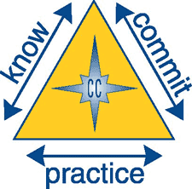
Core Value for May
Health and Fitness



Health and Fitness: Being personally committed to keeping our minds and bodies clean and fit.

“Motivation is what gets you started. Habit is what keeps you going.” -Jim Ryan

The core value of Health and Fitness is duplicated in the Scout Law in that a Scout is “Clean” and the Cub Scout Academics and Sports Program is the facilitator (along with the Health and Fitness Activity badge and a number of Webelos Badges) to accomplish this Core Value, as well as addressing the third aim of Scouting: the development of physical, mental and emotional fitness. Fitness includes the body (well-tuned and healthy), the mind (able to think and solve problems), and the emotions (self-control, courage, and self-respect).

With springtime here, combine fun and fitness. Doing outdoor activities with healthy snacks is an easy way to foster Health and Fitness. Have your Webelos Den
- Participate in a nature hike in your local area. This can be on an organized, marked trail, or just a hike to observe nature in your area.
- Participate in an outdoor activity such as a park fun day with organized games
- Complete a nature/conservation project in your area.
- Participate in a den or pack swim activity.
- Participate in an outdoor sporting event.
Book Corner
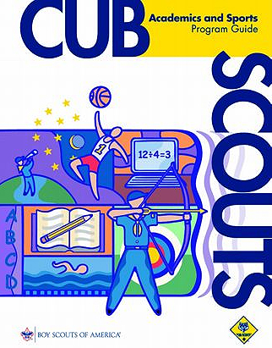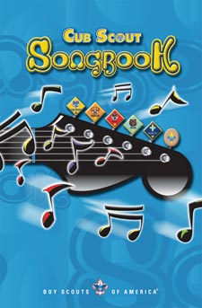

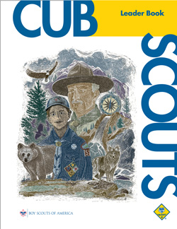

Purposes of the Cub Scout Academics and Sports Program

By taking part in the Cub Scout Academics and
Sports program, boys will

• Learn new physical skills and techniques
• Increase their scholarship skills
• Develop an understanding of sportsmanship
• Enjoy teamwork
• Develop physical fitness
• Discover new and build on old talents
• Have fun
• Do their best

Information on the requirements for the various sports belt loops and pins can be found in the Academic and Sports Program Resource Guide which may be found on-line at
http://www.scoutstuff.org/BSASupply/images/pdfs/34299_07_CS_SA_Guide.pdf , and on the US Scouting Service website (along with workbooks and other resources) at http://usscouts.org/usscouts/advance/cubscout/sports.asp.
Currently, recognition can be earned for the following 28 sports:
Archery, BB-Gun, Badminton, Baseball, Basketball, Bicycling, Bowling, Fishing, Flag Football, Golf, Gymnastics, Hiking, Hockey, Horseback Riding, Ice Skating, Kickball, Marbles, Physical Fitness, Roller Skating, Skateboarding, Snow Ski and Board Sports, Soccer, Softball, Swimming, Table Tennis, Tennis, Ultimate, and Volleyball.
Don’t Forget: If you plan on using a belt loop to satisfy a Webelos Activity Badge requirement, the belt loop must be earned WHILE a Webelos Scout, even if they had already been earned by the Cub Scout while a Tiger Cub, Wolf, or Bear. -JT

From the Cub Scout Leader Book
(page 4-4):

Practical Applications for Health and Fitness

• Eat and drink things that are good for you.
• Limit the amount of “junk food” in your diet.
• Maintain personal cleanliness.
• Make exercise a regular part of your life.
• Don’t smoke cigarettes or drink alcohol.
• Never use illegal drugs.
• Go on a hike.
• Ride a bike, skateboard, or scooter (always with appropriate safety gear!).
• Play on a sports team, such as one for basketball, baseball, football, or soccer.
• Practice an individual sport, such as swimming, gymnastics, skating, or tennis.
• Learn about mental fitness. Discuss how personal habits and media influences can affect mental alertness.

More from the Cub Scout Leader Book:

Check out: page 13-1 for more on teaching Health and Fitness; page 14-1 and 14-3 on the role of Physical Fitness in Safe Swim Defense and Safety Afloat.

http://www.scouting.org/filestore/hispanic/english/33221_WEB.pdf

The How-To Book is a great resource for Health and Fitness Activities, as well as this month’s Showman badge (see Razzle Dazzle in chapter 5). Check out page 6-22 for a sample schedule for a Troop Picnic with rules for picnic-friendly sports activities. There also many Fitness and Health-related crafts in chapter 2 and games in chapter 3.

http://www.scouting.org/filestore/hispanic/english/33832_WEB.pdf

The Cub Scout Song Book can help set the mood for Showman as well.

Let’s Get Camping
The weather is getting warmer; the days are longer, so the outdoors beckons. Hopefully, first year Webelos, now moving to work on Arrow of Light, have already done some family and pack camping. As they prepare for bridging to Boy Scouts next year, parents should consider personal camping equipment as potential gifts for their sons. The scout may use this equipment when he does an overnight with the den and with his parent/guardian on a Boy Scout overnight. What does a bridging Webelos scout need to be prepared for Boy Scouts? He may already have some equipment. The camping gear that was used in Cub Scouts is usually sufficient for the initial campouts with the troop, and there is no need to purchase new gear all at once. Need may also depend on the Troop he joins; however, the following list may be a helpful guide.

1. Tent – Usually provided by the Troop. Check with the Scoutmaster of the Troop your Scouts may join to determine whether a scout needs to provide his own tent.
2. Sleeping bag – Synthetic-filled version, rated for 20 degrees, and a waterproof compression bag. Try for less than 4 pounds. As an option for warmer weather, a fleece bag (a lightweight blanket plus a zipper) is nice.
3. Sleeping pad – Lightweight. Three-quarter length is usually sufficient.
4. Eating, water – Mess kit. Small lexan bowl, a cup, and a soup spoon, fork and knife. A couple of one-liter water bladder with drinking tube.
5. Day pack – Small backpack for day hikes. Small but sufficient to carry rain gear, lunch, and water bottles.
6. Rain suit – Lightweight but tough material, breathable. Avoid ponchos if at all possible. Don’t really keep you dry and are dangerous around camp fires.
7. Clothes – Quick-drying nylon hiking shorts and long pants (Scout pants - green or tan), and nylon or poly quick-drying t-shirts. The Scout nylon pants that have zip-off legs are popular. Some scouts like the shorts that have a mesh lining. Avoid cotton fabrics.
8. Warmth – Fleece jacket, and fleece or wool knit hat. Fleece pants and gloves are good if cool-natured. A fleece vest is useful in combination with some rain jackets. Again, avoid cotton fabrics.
9. Boots – Ankle high waterproof hiking boots. Synthetic or wool socks and synthetic liners.
10. Flashlight – Small, two AA batteries. Headlamps are popular, and the LED models claim to use up batteries more slowly.
11. Towel – An old household towel will do initially, but a quick-drying backpacking towel will be needed later.
12. Compass, whistle – A compass is needed for the hikes and orienteering, and the simple versions are best. A whistle is useful for some activities. Attach a loop of string.
13. If committed to Scouting, an overnight/trek backpack (internal frame is my preference, but most external frame backs are fine). A pack with a volume of 2600 to 3500 cubic inches is sufficient for most younger scouts.
Grab a catalogue or go on-line to see what’s available. Camping stores have wide varieties, but best prices are usually found at large department stores. Sales are often and the best way to get camping equipment
Get Your Webelos Outside

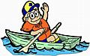

Day camp, Resident camp, Cub Parent weekends, Fun Pack Weekends, State and Local Parks.

Webelos Resident Camp
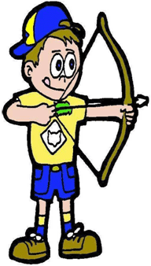
Now is the time to make plans to take your Webelos den to summer camp. Besides doing long term camping (perhaps for the first time without a parent present), the activities will make the week a memorable one and lots of fun! Themes for the week make for some interesting activities! Often, shooting sports like archery and bb shooting will only be available at resident camp. Webelos I’s (current Bears until June 1) usually will work on those activity badges that will help them to achieve the Webelos rank. Webelos II’s will work on those requirements to help them achieve the Arrow of Light as well as skills they will need when they cross over into a troop.
CUB SCOUT OUTDOOR ACTIVITY AWARD
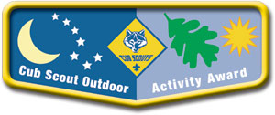
WEBELOS may earn this award by successfully completing the Outdoorsman Activity Badge (Webelos Handbook) and completing six of the outdoor activities listed below.
With the WEBELOS den, the pack, or family:
- Participate in a nature hike in your local area. This can be on an organized, marked trail, or just a hike to observe nature in your area.
- Participate in an outdoor activity such as a picnic or park fun day.
- Explain the buddy system and tell what to do if lost. Explain the importance of cooperation.
- Attend a pack overnighter. Be responsible by being prepared for the event.
- Complete an outdoor service project in your community.
- Complete a nature/conservation project in your area. This project should involve improving, beautifying, or supporting natural habitats. Discuss how this project helped you to respect nature.
- Earn the Summertime Pack Award.
- Participate in a nature observation activity. Describe or illustrate and display your observations at a den or pack meeting.
- Participate in an outdoor aquatic activity. This can be an organized swim meet or just a den or pack swim.
- Participate in an outdoor campfire program. Perform in a skit, sing a song, or take part in a ceremony.
- Participate in an outdoor sporting event.
- Participate in an outdoor Scout's Own or other worship service.
- Explore a local city, county, state, or national park. Discuss with your den how a good citizen obeys the park rules.
Get a Boy Scout Troop to help!!
Meeting Planner

This month’s meeting plans for First year Webelos work on the Scholar, Artist and Showman badges.

Meeting 17: Showman (music) Do: Showman 6, 8–15

http://www.scouting.org/filestore/CubScoutMeetingGuide/webelos/WebelosMeeting17.pdf

Meeting 18 Showman (Drama) Do: Showman 3, 11, 16–18, 20–23
http://www.scouting.org/filestore/CubScoutMeetingGuide/webelos/WebelosMeeting18.pdf
Consider visiting the Troop where your formally second-year Webelos (Now Boy Scouts) have bridged to. They’ll love to see you! -JT
Flag Ceremony for May

Although May provides a number of observances that may be incorporated into your Flag ceremonies, Memorial Day is, perhaps the most significant. You can find information on the following on the web:
• May 5 [every year]: Cinco de Mayo
http://www.mexonline.com/cinco-de-mayo.htm
• May 7, 2011 (Saturday): Kentucky Derby horse race
http://www.kentuckyderby.com/
• May 8, 2011: Mother's Day [2nd Sunday in May]
http://www.mothersdaycentral.com/about-mothersday/history/
• May 21, 2011: Armed Forces Day [3rd Saturday in May]
http://www.defense.gov/afd/military/history.html
• May 30, 2011 (Monday): Memorial Day (observed)
http://www.usmemorialday.org/backgrnd.html http://www.memorialdayorigin.info/
May Flag Ceremony (Memorial Day)
Follow your standard Color Guard process (for Den or Pack meeting. After the Cub Scout promise (or Boy Scout Law, and Oath, if this is a Webelos Den meeting) and before posting the U.S. Flag you may insert the following:
- During May, we celebrate many important holidays. Perhaps one of the most important is Memorial Day.
- This year, Memorial Day falls on Monday, May 30. Although we often think of Memorial day as the start of summer, as Americans, we should remember the real purpose of Memorial Day.
- Memorial Day is a United States federal holiday observed on the last Monday of May. Formerly known as Decoration Day, it commemorates U.S. soldiers who died while in the military service. First enacted to honor Union soldiers of the American Civil War, it was extended after World War I to honor Americans who have died in all wars.
- Please bow your heads in a moment of silence for all those who died defending our country. (Wait 10 seconds.) Please join me in reciting the Pledge of Allegiance (Scouts salute).
Den Meeting Helpers
These activities can be used for the gathering or to reinforce/satisfy badge requirements.
Webelos


SHOWMAN
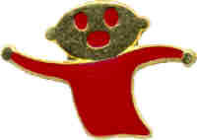
The Showman Activity Badge can be used to build up a Webelos confidence in getting up in front of his peers or at school. Articulation can also be taught with this badge.
There are three areas a Webelos can choose from to work on his Showman badge: puppetry, music, and drama.
RELATED BOY SCOUT MERIT BADGES
There are requirements for the following Boy Scout Merit Badges that can be adapted for Webelos. You can borrow the books from a local Troop’s library.
- Art
- Cinematography
- Graphic Arts
- Music
- Photography
- Theater
SHOWMAN IDEAS
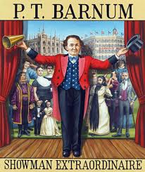

Have a story-telling session. Have each boy come prepared to tell the best true-life story he knows about something that happened to himself or a friend or family member. This is an opportunity to emphasize the importance of good listening and the value of sharing ideas.

Tell a funny or silly story and just as you get into the plot, ask the boy next to you to continue the story for a while. Let him carry it for a while and pass it to the next boy. It will be wacky for sure. It is fun to see the plot jump around, change and bounce back again.

Try to find a very simple but easy to do 'old melodrama' with the villain in black and sweet heroines etc., and see if the boys can do it pantomime using signs as language and exaggerated facial expressions to communicate the ideas. It could be real crazy and fun. The den could produce a video, one with a story or not, demonstrating an activity or skill or just about anything. It could be narrated and could be good entertainment for a pack meeting.

Scouts like silly or gross songs. (Songs about eating worms, etc. are great.)

Invite a drama teacher to speak, put on a program for the pack meeting.

Make puppets, and a stage. Write and put on a puppet show.

Visit a nursing home and perform music or a play.

Make a stage and costumes for a play.

Play Charades.

Assist with an advancement ceremony at your pack meeting.

Talk about sound effects and let the boys try some of them

Write a one-act play for pack meeting.

Plan a family entertainment night - let the boys show off their talent to their parents.

Exhibit props used or built such as puppets, costumes, etc.

NAME THAT TUNE
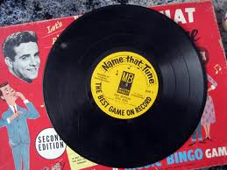

Record the first line of about 15 different songs on a tape player. The Webelos who can correctly name the most songs wins.

MUSICAL CHAIRS
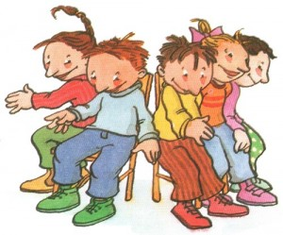

Cub Scouts move around chairs as music is playing. When the music stops, all must sit in a chair. However, there is always one less chair than there are boys. The boy not seated is out of the game. This game can be done with partners holding hands and remove two chairs each turn. This game can also be played without chairs by having the Cub Scouts sit on the ground when the music stops and having the last one down drop out. To make it more interesting have them balance books on their heads and kneel when the music stops. The last one down and anyone dropping his book is out.

CLOWN DRESS-UP RELAY


Divide den into two teams. Each team is given an old suitcase which is filled with old, oversized clothing that a clown would wear. Include a necktie, hat, hair, large shoes or slippers, baggy pants, gaudy shin, vest or sash, and of course... a red rubber nose. On signal the first two players open the case. Boy 1 pulls out all clothing and hands it to Boy 2 who dresses up. Boy 1 runs to the other side of the room, carrying the case with him. He removes the clothes, puts them back in the case, and then carries it back to his team. He now helps the next person get dressed. Repeat actions until all boys have dressed up. The first team to finish can be awarded a circus-type prize.

BALLOON ORCHESTRA
The players in the orchestra each hold a balloon. They blow up their balloons in unison, and then let out the air in a squeak at a time to the rhythm of some easily recognized rhythm such as "Blue Danube" or "Jingle Bells". To end the skit all fill their balloons with air and let go at the director’s signal.
MUSTACHES


There is probably no other disguise that can change a person’s appearance so quickly as a fine mustache. Behind a mustache you can be anybody--politician, detective, television star, or even the bearded circus lady. Dressing up is great fun, and every child should have a special drawer or box of old shoes, out-of-style hats, dresses, jewelry--and mustaches. Actually, a mustache can be the whole costume, as most of the time you really don’t need an elaborate disguise. Still, if you think that the mustache alone isn’t convincing, a large bath towel and a few safety pins can help round out your image. It’s so fun to imitate life--being the “baddy” with a pencil-thin mustache curled up at the end, or maybe the “goody” with a big floppy mustache. You won’t really feel the magic of your mustache disguise until you see yourself in a mirror!

Use heavy paper to make your mustache. If you want, you can glue yarn, fuzzy fabric, etc. to your paper mustache. It’s easy to invent a mustache. Draw the mustache pattern on a sheet of heavy paper like poster board or file folder. Cut out the mustache, and try it on for size. Be sure to make the two little hook cutouts that attach to your nose. Experiment until you get the hooks just right so the mustache will stay in place. That’s all there is to it. Now why not have a mustache party or maybe a mustache day?

MOVIE STAR WALK

This is best done in a large building with many obstacles. Divide the group into teams of six to eight people and tie them together at the wrist to form a “chain.” Use long balls of colored string or yarn to layout a course. Have each team follow their colored yarn wherever it goes without breaking their chain or the yarn. The first team with their yarn completely rolled up and their chain not unbroken wins.

ACTING

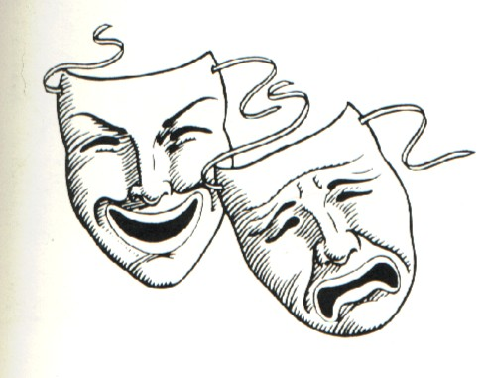

After discussing how things feel, everyone pantomimes an emotional reaction to feeling something and the others try to guess what he is feeling. Examples: Holding a snake, picking a prickly plant, hot sand on bare feet, something sticky.

SHOW BIZ BUZZ


Choose a number that the players cannot say aloud. For example choose number 5. Start off counting around the circle. When the counting reaches any number that includes a 5 or a multiple of 5, that player must name a television show instead of the number. Counting should be rapid. When a boy can’t think of a show, he is out. No show can be repeated. Start off with an easy number like 5. When they become good at it choose other numbers. You may want to change categories as well. How about movies, musical stars, musical instruments?

PUPPETRY
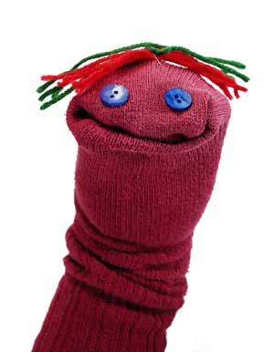

Making puppets can be really fun. Here are a few ideas. Try using plastic spoons, Eskimo finger masks, or paper bag puppets. There are endless possibilities. Have the boys decorate them with wiggle eyes, yarn for hair, and material or paper for clothes. Use markers, paint, construction paper, fun foam, felt, etc.
Follow these three basic rules for a great puppet show:
#1 - Think short - Remember most of the audience is young. Shows that are short and packed with a lot of action are better.
#2 - Think simple - This applies to everything in the show, characters, props, scenery, parts and action. Have fun while you are doing this, and it will be successful.
#3 - Think contrasts - Put tall characters next to short ones, happy next to sad, small movements next to fast action ones. Keep the boys busy and the audience entertained.

DANCING KNEE DOLLS
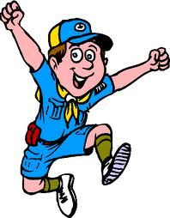

Paint faces on the knees of the performers. Use dresses (or pants and shirt) to dress the legs as dolls with the arms bulging out. The clothes can be made out of crepe paper, cloth, or real clothing. Cover the upper legs and body with a sheet.

In a darkened room, put on some music. Direct a flashlight (spot) onto each knee as the Knee dolls dance around.

STAGE DIRECTIONS

http://wiki.answers.com/Q/What_are_stage_directions

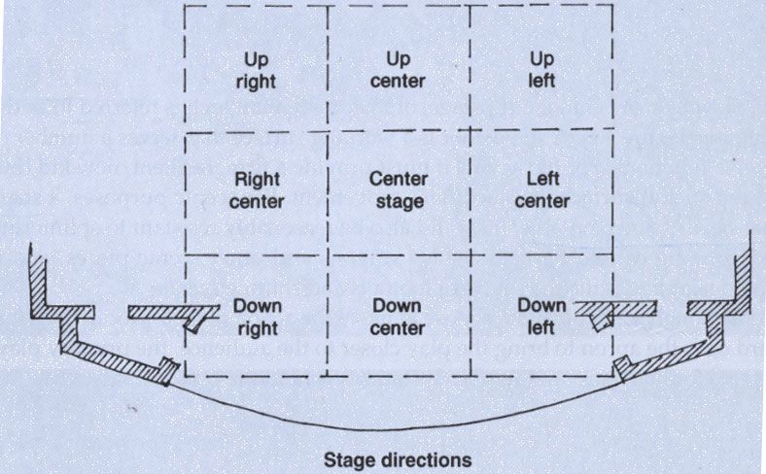

Stage directions are directions given to the actor(s) by the director. They involve the physical movement of the actors on stage. The actors are supposed to note the directions in their scripts. The Stage Manager is also supposed to write down all stage directions in their master book, known as the "Prompt Book". If there is any disagreement about where an actor is supposed to move, or how, the prompt book is the final word. If the director does not like the movement, or changes his mind, the prompt book is revised.
Terms:

- Upstage: moving away from the audience, towards the back of the stage.
- Downstage: Moving towards the audience, towards the front of the stage.
- Stage Right: Moving towards the Right (facing the audience)
- Stage Left: Moving towards the Left (facing audience).
- Cross: Crossing the stage to a predetermined position.
An example in a prompt book might look like:

"X (cross) DSL down stage left) to DSC (down stage center), X US (upstage), and out (exit) SR (stage right).

ARROW OF LIGHT

Most second year Webelos would have completed Arrow of Light requirements and bridged to Boy Scouts in February or March. Those Packs that may have delayed the event should continue the program with their second year Webelos.

ADDITIONAL ADVANCEMENT IDEAS
Alice, Golden Empire Council
Someone wrote and asked me why Alice and I have this section with all the advancement in the new Resource Book. These are additional ideas. Maybe your Cubs did some advancement in camp and you got to skip a section. Maybe your den is above average and streaking through the program. Maybe you want some ideas to tie into the Core Value of the month. Maybe your presenter or field trip for that week fell through and you need a Plan B. Here are ideas you can use!! CD and Alice
These Advancement Ideas are based on the
Core Value for April – Faith.
Some can be used in the den or in the family, and will help each boy to understand and practice the value. The Achievements, Electives or Activity Pins which are underlined also match the suggested activities for Meeting #15 or #16 for that rank.

Tiger Achievements
Ach. #2G – If you visit a police or fire station, ask how the men and women keep their bodies fit so they can do their jobs
Ach. #3G – Learn the rules of a game or sport. Then, go watch an amateur or professional game or sporting event – and now, as an extra challenge, practice some of the moves you see to help make your body more fit!
Ach. #5G – Go for a hike with your den – it’s a fun way to practice fitness!

Tiger Electives
Elect. #16 – Tell your den about a favorite activity that helps keep your body fit.
Elect. #23 – Find out what kind of milk your family drinks, and why. Find out the health reasons why people choose different kinds of milk, or may have to use a certain kind of milk.
Elect. #25 – Make a snack and share it with your family or den – choose one that is good for your body.
Elect. #29 – Talk with your adult partner about when you should use sunscreen. Find out whether you have any in your home and where it is kept. With your adult partner, look at a container of sunscreen and find out whether it still protects you when you are wet, how long it lasts, the expiration date. Talk about how using sunscreen is important to your health.
Elect. #35 – Play a game outdoors with your family or den – being outdoors is healthy!
Elect. #37 – Take a bike ride with your adult partner.
Elect. #40 – Together with an adult partner, go swimming or take part in a water activity. Be sure to go over Water Safety FIRST!
Elect. #44 – Visit a dairy, milk processing plant or cheese factory – find out how the products help keep your body healthy.
Elect. #46 – Visit a dentist or dental hygienist and find out why caring for your teeth is important for good health

Wolf Achievements
Ach. #1 – Do any of the Feats of Skill as a way to practice fitness.
Ach. #3a, b, c – Make a chart and keep track of good health habits for two weeks; Tell four ways to stop the spread of colds; Show what to do about a small cut on your finger
Ach. #8a, b – Study the Food Guide Pyramid and name some foods from each food group; Plan the meals your family should have for one day, using foods from at least three of the food groups at each meal.
Ach. #9e – Know the rules of bike safety – always wear a bicycle helmet!
Ach. #10c – Plan a walk with your family – doing something physical outdoors is great for health and fitness!

Wolf Electives
Elect. #2 – Help to plan and put on a skit about how to be fit and healthy.
Elect. #4f – Get moving outdoors – play a wide area or large group game with your den or pack. Check for ideas under Games.
Elect. #5a, b,c, d – Have some active fun outdoors – make and fly a kite – be sure to read and know the safety rules for flying a kite first!
Elect. #7a, b, c – Learn to walk on a pair of stilts; Make a pair of puddle jumpers and walk with them; Make a pair of “foot racers” and use them with a friend – each activity could be part of a physical relay game.
Elect. #11f – Sing a song about Health & Fitness with your den at the Pack Meeting.
Elect. #18a, b – Help plan and hold a picnic with your family or den; With an adult, help plan and run a family or den outing; (a kite flying activity, hike, bike ride)
Elect. #18d - help plan and lay out an obstacle race; you could use the requirements of Elect. #7 – Foot Power, the stilts, puddle jumpers and foot racers as part of an obstacle course.
Elect. #20 – Do any of the suggested activities to improve your fitness by getting physically active – but be sure to go over Sportsmanship and any Safety Rules for the activity FIRST! Many sports are represented in this section – check it out!
Elect. #23b, c, d - In order to stay healthy, make sure you are prepared for outdoor activities and camping by doing these requirements

Bear Achievements
Ach. #8b – If you talk with a long-ago scout, find out what kind of fitness activities they did – you might be surprised!
Ach. #9b, d, e, f – With an adult, make snacks for the next den meeting – choose a healthy one! Check the ideas in Cub Grub; make a list of junk foods you eat – then do the “Take Five” Challenge to make better choices; make healthy trail food for a hike; With an adult, make a healthy dessert for your family – see Cub Grub.
Ach. #12b, e – Go on a hike with your family, after you make sure you are prepared; Plan an outdoor family day that includes some physical activity
Ach. #13a, g – Go grocery shopping with an adult member of your family and compare prices of different brands and at different stores, and also compare prices based on nutritional value; With an adult, figure out how much it costs for each person in your home to eat one meal – choose a meal that has good nutrition value based on the Food Pyramid.
Ach. #14f, g – Ride a bike for 1 mile without rest – be sure to obey traffic and safety rules; Plan and take a family bike ride.
Ach. #15a, b, c – Set up equipment and play two outdoor games with family or friends; Play two organized games with your den; Select an (active) game that your den has never played, explain it and play it with them.
Ach. #16 – Do any or all of the activities – they will help you Build Muscles!
Ach. #18c – Keep a daily record of your activities for 2 weeks – look to see if you were following the rules for being healthy and fit.
Ach. #23c – Take part in one team and one individual sport to improve your fitness.
Ach. #24c – Plan and conduct a den activity with the approval of your leader – choose an activity that involves becoming fit or learning about being healthy.

Bear Electives
Elect. #5e - With an adult on board, and both wearing PFDs, row a boat around a 100-yard course that has at least two turns. Demonstrate forward strokes, turns to both sides, and backstrokes. Review Boating Safety Rules BEFORE you start!
Elect. #18a, d – Build and use an outdoor gym with at least three items from the list on page 250; Hold an open house so everyone can enjoy your gym!
Elect. #19 – Do any or all of the Swimming requirements – make sure you have an adult with you who can swim.
Elect. #20 – Choose any or all the requirements to help improve your fitness by physical activity. Read and follow the Safety Rules for any of the activities!
Elect. #25b – Go on a short hike with your den, following the buddy system and telling what to do if you become lost.

Webelos & Arrow of Light
Activity Pins
Aquanaut #1, 2, 3 4, 7, 8 – These requirements all involve physical activity and fitness.
Athlete #5, 6, 7, 8, 9, 10 – These activities not only require physical activity, they include working to improve your performance and fitness!
Communicator #2 – Prepare and give a talk to your den about a subject that has something to do with Health or Fitness.
Craftsman #2 – Make a set of foot racers (Wolf Book pg. 147) so your den or pack can have a fun relay.
Family Member #8, #11 – Make a list of fun things and plan a family fun night, choosing an activity that includes action and fitness; With adult supervision, plan, purchase and help prepare three meals for your family – make sure they are nutritious!
Outdoorsman #9 – Go on a three-mile hike with your Webelos den or a Scout troop after discussing with your Webelos Den Leader what you need to take with you.
Showman #6 – Make a set of four paper bag puppets for a singing group and put on a performance with three others (Try doing a song that has something to do with Health & Fitness, like the ones in this Baloo)
Showman #16 – Give a monologue or talk – if you choose a subject about Health or Fitness – you could start with the Fun Facts About Fitness under Theme Related.

CUB GRUB
Cheese & Fruit Kabobs
Alice, Golden Empire Council
Ingredients:
- Various fruits in season – berries, grapes, sliced bananas, kiwi fruit chunks, pineapple chunks, melon chunks
- Cheese cut into chunks or cut into small shapes with canapé cutters – jack cheese, cheddar, swiss cheese, or this a great way to introduce kids to some different cheeses
- Yogurt – strawberry, vanilla, or any choice that would fit with fruits and cheese
- Wooden skewers
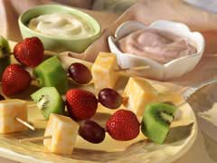
Directions:
- Prepare fruit ahead of time so it is in small pieces ready for the skewer – (for light fruits such as pears or banana, prevent discoloring by slicing into Fruit Fresh or pineapple juice)
- Cut cheese into slices or chunks
- Put ingredients into individual bowls or containers – Let each boy make his own choice of cheese and fruit for the skewers.
- Have yogurt in bowls to use as a dip.
Peanut Butter Pinwheels
Alice, Golden Empire Council
Check for Peanut Allergies!
- Spread creamy or chunky peanut butter and a little bit of honey on a fresh flour tortilla
- Sprinkle with granola, roll up the tortilla,
- Then slice it into bite-size pinwheels.
White-and-Green pizza
Alice, Golden Empire Council
This is a great way to get kids to eat spinach and try some different cheese – and if they help make it,
they are apt to give it a try!
Ingredients:
- 5 oz fresh (or frozen, defrosted) baby spinach
- Salt and pepper to taste
- 2 Tbs water
- 1 cup part-skim ricotta
- 1/2 tsp garlic powder
- 2 mini-pizza crusts (such as Boboli)
- 1/2 cup shredded reduced-fat mozzarella
- 2 Tbs grated parmesan
- 1 Tbs olive oil
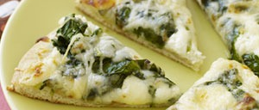
Directions:
- Heat oven to 450 degrees.
- Put spinach in a microwave-proof casserole dish. Season to taste, and sprinkle with water. Cover with plastic wrap, and pierce to vent. Microwave on high for two minutes.
- Drain cooked spinach well.
- Mix ricotta and garlic powder in a small bowl.
- Place the pizza crusts on an ungreased baking sheet.
- Spread half the ricotta mixture on each pizza crust.
- Top each pizza with cooked spinach, mozzarella, and parmesan.
- Drizzle with olive oil.
- Bake for 10 minutes, or until the cheese is melted.
- Cool slightly and cut each pizza in half to serve.
- This makes enough for four people.
Arctic Oranges
Alice, Golden Empire Council
Ingredients:
For each treat you will need
1 orange,
1 cup of orange juice and
1 cherry
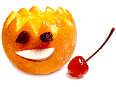
Directions:
- Cut the top off the orange in a zigzag pattern and hollow out the insides.
- Remove the seeds and combine the pulp with the juice in a blender.
- Set the hollowed out rinds in a muffin tin and fill with the blended mixture.
- Drop a cherry inside each orange.
- Freeze for 2-3 hours.
- Allow to soften for 5 minutes before serving.
Gobbeldy Gook
Alice, Golden Empire Council
Ingredients:
4 cups oat or crispy rice cereal
1 cup chopped peanuts
1 cup raisins or chopped dried prunes or apricots
1 cup sunflower seeds
1 cup chopped pretzels
3 tbsp. margarine, melted (optional)
Directions:
- Place all ingredients into a 1-quart sealable plastic bag,
- Seal and shake until mixed.
- Enough for 8 people – at least the first time – after they taste it, they might want more!
Some Tried & True Ideas
Alice, Golden Empire Council
- For Memorial Day Treats, give everyone a graham cracker, spread with whipped cream cheese, then provide sliced strawberries and blueberries – every one makes their own “flag” treat
- Kids like lots of veggies – but only if they are raw – offer a selection of bell pepper slices (try all the colors), jicama, carrots cut into coins or baby carrots, broccoli and/or cauliflower tops. Serve with a dip like Ranch Dressing.
- Pretzels are a great, non-fat treat – for fun, serve with whipped cream cheese or peanut butter and a selection of nut pieces, chocolate chips, raisins, cookie decors – Dip stick pretzels into the “glue” and then into small individual cups of the toppings.
Cinco de Mayo Recipes
Slow Cook Taco Soup
Alice, Golden Empire Council
Slow cook, then serve with tortilla chips
and a dollop of sour cream.
Ingredients:
- 1 pound ground beef
- 1 onion, chopped
- 2 cups water
- 1 (16 ounce) can chili beans, with liquid
- 1 (15 ounce) can kidney beans with liquid
- 1 (15 ounce) can whole kernel corn, with liquid
- 2 (14.5 ounce) cans peeled and diced tomatoes
- 1 (8 ounce) can tomato sauce
- 1 (4 ounce) can diced green chili peppers
- 1 (1.25 ounce) package taco seasoning mix
Directions:
- Brown the meat with the onion in a skillet.
- Add water, beans, corn, diced tomatoes, tomato sauce, green chili peppers and taco seasoning mix and stir to blend in the slow cooker.
- Cook on low for 8 hours.
Cinnamon Triangles & Fruit Salsa
Alice, Golden Empire Council
These cinnamon-scented tortilla triangles are best served warm with the fruity salsa - sure to delight kids of all ages.
Ingredients:
- 1 Fuji apple - peeled, cored and diced
- 1 cup sliced fresh strawberries
- 2 kiwis, peeled and sliced
- 2 bananas, peeled and sliced
- 1 tablespoon fresh lime juice
- 2 tablespoons sugar
- 1/2 teaspoon ground cinnamon
- 1/2 teaspoon ground nutmeg
- 1 cup oil for frying
- 6 (10 inch) flour tortillas
- 3 tablespoons sugar
- 1 tablespoon ground cinnamon
Cooking Instructions:
- Mix together the fruit, lime juice, sugar, cinnamon and nutmeg.
- Cover and chill for 20 minutes.
- Heat oil in a medium heavy saucepan to 375 degrees F
- Slice flour tortillas into triangles. Fry until golden brown, 2 to 4 minutes. Drain on paper towels.
- Place 3 tablespoons sugar and cinnamon in a large ziplock plastic bag. Drop fried tortilla triangles into the bag and shake to coat.
- Serve the cinnamon chips warm with the chilled fruit salsa.
Mother’s Day Brunch
Layered Cheesy Brunch for Mom
Alice, Golden Empire Council
Ingredients:
- 12 eggs, beaten
- 1 1/2 lbs ground breakfast sausage or
crumbled bacon
- 16 ounces shredded Cheddar
cheese, divided
- 7 slices white bread, torn into pieces
Directions
- Preheat oven to 350 dgrees F (175 degrees C).
- Adult should brown sausage in a large skillet over medium-high heat. Drain off grease, and set aside to cool.
- Have the boys crack the eggs. Pour the eggs into a lightly greased 9×13 inch baking dish.
- In a separate large bowl, combine the sausage, bread and 12 ounces of the cheese. Mix well and pour this into the egg mixture. Top with the remaining 4 ounces of cheese and cover with foil.
- Bake at 350 degrees F (175 degrees C) for 15 minutes, uncover, and bake until casserole is golden brown and bubbly.
- Serve with some sliced melon, grapes, strawberries or any fruit. Or you can have the boys make a nice green salad. Or boys could dip strawberries in chocolate for a special treat!
Hedgehog Buns
Alice, Golden Empire Council
Kids can help make these fun buns for Easter or any time. This is the “from scratch” version. But you can also use a pre-made yeast dough and just start from the shaping of the roll (#5) and complete the hedgehog with raisin eyes and nose and the slivered almonds.
Ingredients
- 2 cups all-purpose flour, divided
- 1 T. granulated sugar
- 1 envelope quick rise instant yeast granules
- 1/2 tsp. salt
- 1/2 cup milk
- 1/4 cup water
- 1 T. butter
- 1 egg, beaten
- ½ cup slivered almonds
- raisins for eyes and nose
- additional beaten egg to glaze the buns
Cooking Instructions
- In a large bowl, stir together 1 cup of the flour, sugar, yeast granules and salt.
- In a glass measuring cup or microwave-safe bowl, combine milk, water and butter. Microwave on high power for 1 to 1 1/2 minutes, stirring after 30 seconds, until hot to the touch but not boiling.
- Pour into the flour mixture and beat with an electric mixer or by hand with a wooden spoon to make a sticky, gooey dough.
- Add beaten egg and continue beating until the dough is well mixed and difficult to stir.
- Dump 1/2 cup of the remaining flour out onto a table, countertop or large cutting board. Knead in the remaining flour as needed by hand, until it becomes a smooth, non-sticky dough. This will take about 5 to 7 minutes. (Pinch the dough; it will feel like your earlobe when it's ready.)
- Place the dough in a buttered bowl and cover with plastic wrap. Let rise in a warm (not hot) spot for 45 minutes to 1 hour or until doubled in size.
- When the dough has doubled, take your fist and punch it down to deflate.
- Turn dough out onto a lightly floured surface and knead a few times until smooth.
- Cut into 8 equal pieces.
- Working with one piece at a time, roll it until it forms a smooth, compact ball.
- Then roll it so that it forms a point on one side--basically, a teardrop shape (the point will be the hedgehog's nose).
- Place on a greased baking sheet and repeat with the remaining balls of dough. Cover with plastic wrap and let rise again for about 30 minutes, till not quite doubled in size.
- Preheat oven to 375° F
- Now here comes the really fun part. On the pointy end of each bun, stick two raisin eyes and one raisin nose. Poke them in firmly without deflating.
- Brush the surface lightly with beaten egg to glaze. Finally, poke slivered almonds all over the back of each hedgehog bun for spines.
- Place pan in the oven and bake for 15 to 20 minutes, until golden brown on bottom and top.
NOTE: An alternate way to make the spines (if you don’t have the almonds or you have a picky eater who won’t eat nuts): Simply snip little cuts with a pair of scissors all over the surface of the bun after brushing with beaten egg. They'll puff up and become more prickly as they bake.

WEB SITES
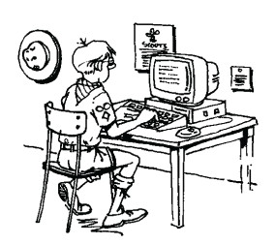

Health Fun for Kids
Fun Interactive Stuff for Kids From Health Experts at KidsHealth
www.kidshealth.org

Children Exercise - Take Action.
Join the Fight Against Childhood Obesity
www.healthiergeneration.org

Keep Kids Healthy & Fit
with these fun activities from PBS Parents
www.pbs.org/Parents

Kidnetic.com
Kidnetic.com – the cool site for kids and their parents to learn more about health, fitness and nutrition through fun games, recipes and articles.
www.kidnetic.com/ - Cached - Similar

PE Central: Web Sites for Kids
Web Sites for Kids. PE Central's LOG IT Program ... fitness, health, physical education, sports, and a host of other topics and trivia. ... BAM! also provides middle school health and science teachers with interactive activities that ...
www.pecentral.org/websites/kidsites.html - Cached - Similar

Children's health and fitness website - Captain Fit. The world's ...
The world's best selling fun kids health & fitness book. ... “I have spent some time at your website... impressive project and I do pray that success comes ...
www.captainfit.com/ - Cached - Similar

BAM! Body and Mind | www.bam.gov | Centers for Disease Control
Use the Activity Calendar to create your very own personalized fitness calendar. Check it out! Activity Calendar ... Department of Health and Human Services ...
www.bam.gov/ - Cached - Similar

CDC - Family Health - Websites for Kids and Teens
Mar 16, 2011 ... Below are CDC and other federal government health websites especially ... Kids.gov. View links to health, fitness, safety, and other topics ...
www.cdc.gov/family/kidsites/index.htm - Cached - Similar

Kids.gov - Health, Fitness, and Safety (Educators)
Mar 28, 2011 ... Have your students check out these sites. Dealing with Your Kids ..... PBS Teacher - Health and Fitness - Teachers can search the PBS ...
www.kids.gov/educators/ed_health.shtml - Cached - Similar

Food & Fitness
Ever wonder if some diets are really safe? Or how you can excel at sports? Get the lowdown on healthy eats, dieting, strength training, eating disorders, ...
http://kidshealth.org/teen/food_fitness/ - Cached - Similar

Health, Nutrition and Fitness Websites for Kids| LearningReviews ...
This is a list of more than 90 interactive websites designed to help kids develop and maintain physical fitness and mental and emotional ...
http://www.learningreviews.com/Health-Fitness.html - Cached - Similar

Family Friendly- Kids Health, Fitness, and Nutrition Resources ...
Resources for teaching kids about health, nutrition and fitness. ... Have a great healthy family website or link that you would like us to share? ...
http://www.nourishinteractive.com/parents_area/resources - Cached - Similar

Best Health and Fitness Websites - nutrition, articles, directory ...
Health and fitness site is one stop for all health related websites. ... Best Sites On Infant or Baby Health. Kids Health (20) Best Sites On Kids Health ...
www.healthfitnesssites.com/ - Cached - Similar
More "Web Sites" are in the Pack and Leader Hints Edition Dave

ONE LAST THING

The American Hero
A poem for Memorial Day by Roger Robicheau
The American Hero always comes through
To capture our hearts with a spirit so true
Some proudly are soldiers who march in harm’s way
Insuring our freedom, courageous they stay
While others come forth as civilians so brave
Determined in purpose, so steadfast to save
We should always keep clear a place in our heart
For each has a value beyond precious art
Their duty to country will not be surpassed
Please honor their courage, for some it’s their last
We live in a world which can be hard to bear
Thank God for these people, how greatly they care
Do ponder new heroes and what they will face
And pray for their safety no matter their place
Our heritage brings out the best, we all know
Our great book of heroes is destined to grow

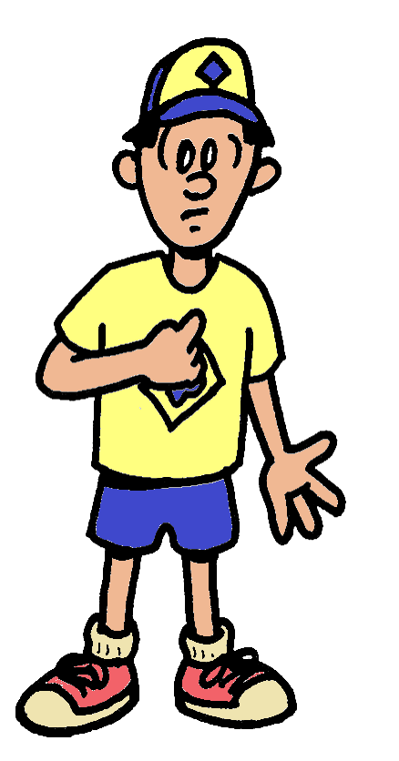

"Keep Your Fork"
There was a woman who had been diagnosed with a terminal illness and had been given three months to live. So as she was getting her things "in order," she contacted her pastor and had him come to her house to discuss certain aspects of her final wishes. She told him which songs she wanted sung at the service, what scriptures she would like read, and what outfit she wanted to be buried in. The woman also requested to be buried with her favorite Bible.
Everything was in order and the pastor was preparing to leave when the woman suddenly remembered something very important to her.
"There's one more thing," she said excitedly.
"What's that?" came the pastor's reply.
"This is very important," the woman continued. "I want to be buried with a fork in my right hand."
The pastor stood looking at the woman, not knowing quite what to say.
"That surprises you, doesn't it?" the woman asked.
"Well, to be honest, I'm puzzled by the request," said the pastor.
The woman explained. "In all my years of attending church socials and potluck dinners, I always remember that when the dishes of the main course were being cleared, someone would inevitably lean over and say, 'Keep your fork.' It was my favorite part because I knew that something better was coming...like velvety chocolate cake or deep-dish apple pie. Something wonderful, and with substance! So, I just want people to see me there in that casket with a fork in my hand and I want them to wonder - "What's with the fork?"
Then I want you to tell them:
"Keep your fork.... the best is yet to come".
The pastor's eyes welled up with tears of joy as he hugged the woman good-bye. He knew this would be one of the last times he would see her before her death. But he also knew that the woman had a better grasp of heaven than he did. She KNEW that something better was coming.
At the funeral people were walking by the woman's casket and they saw the pretty dress she was wearing, her favorite Bible and the fork placed in her right hand. Over and over, the pastor heard the question, "What's with the fork?" And over and over he smiled.
During his message, the pastor told the people of the conversation he had with the woman shortly before she died. He also told them about the fork and about what it symbolized to her. The pastor told the people how he could not stop thinking about the fork and told them that they probably would not be able to stop thinking about it either. He was right.
So the next time you reach down for your fork, let it remind you oh so gently, that the best is yet to come.

