CORE VALUES
Cub Scout Roundtable Leaders’ Guide
The core value highlighted this month is:
- Perseverance: Sticking with something and not giving up, even if it is difficult. Through participating in activities such as a bicycle rodeo, Cub Scouts learn the importance of practice and perseverance to improve new skills.

COMMISSIONER’S CORNER
“"Thankfully, perseverance is a good substitute for talent"
— Steve Martin
Well, I knew this was going to be a busy month and there was no way to get from one end to the other without help. And so I reached out to the regular Baloo contributors and they responded and produced an awesome issue of Baloo's Bugle. I have spent only a few hours tweaking (as compared to my usual several days). I was planning on two Wood Badge weekends, a night shift assignment at work (my first in 6 or so years), increased visits to my Mom, an overfull house, and more. I was not ready for what happened, but I know God knew and he helped me by having me ask for help before it happened.
So, many, many thanks to Wendy, Alice, and Pat for assembling this issue. And Felicia, Joe,
and Beverly for helping them out.
Also, please read my closing thought about a persevering Mother and Den Mother who is responsible for me helping you today.
More "Commissioner's Corner"
stuff is in the
Pack and Leader Hints Edition
Dave
TABLE OF CONTENTS
In many of the sections you will find subdivisions for the various topics covered in the den meetings
CORE VALUES 1
COMMISSIONER’S CORNER 1
THOUGHTFUL ITEMS FOR SCOUTERS 2
TRAINING TOPICS 2
ROUNDTABLES 2
PACK ADMIN HELPS - 2
LEADER RECOGNITION, INSTALLATION & MORE 2
DEN MEETING TOPICS 2
SPECIAL OPPORTUNITIES 3
Skateboarding Loop and Pin 3
Family Travel Loop and Pin 3
Cub Scout Outdoor Activity Award 4
Boys’ Life Reading Contest for 2011 5
Knot of the Month 5
GATHERING ACTIVITIES 5
OPENING CEREMONIES 7
AUDIENCE PARTICIPATIONS 7
ADVANCEMENT CEREMONIES 7
GAMES 7
SONGS 8
STUNTS AND APPLAUSES 9
SKITS 9
CLOSING CEREMONIES 10
Cubmaster’s Minutes 10
CORE VALUE RELATED STUFF 10
Connecting Perseverance with Outdoor Activities 10
The Picture of Perseverance 10
June – A month to celebrate Perseverance 10
Bikes & Bike Rodeo Ideas: 13
DEN ACTIVITIES 16
Mother’s Day Gifts 17
DEN MEETINGS 18
TIGER 18
WOLF 20
BEAR 22
Bear Ideas by Felicia 22
More Bear Ideas by Wendy 26
WEBELOS 28
ARROW OF LIGHT 28
WEBELOS DENS 28
ADDITIONAL ADVANCEMENT IDEAS 37
Tiger Achievements 37
Tiger Electives 37
Wolf Achievements 37
Wolf Electives 37
Bear Achievements 38
Bear Electives 38
Webelos & Arrow of Light Activity Pins 38
CUB GRUB 38
WEB SITES 41
ONE LAST THING 41

THOUGHTFUL ITEMS FOR SCOUTERS
The "Thoughtful Items" and "Quotations" are in the Pack and Leader Hints Edition. Dave

TRAINING TOPICS
Learn about the Resources that your council and district use to help you succeed. The "Training Topics" are in the Pack and Leader Hints Edition. Dave

ROUNDTABLES
The "Roundtable Hint" is in the Pack and Leader Hints Edition. Dave

PACK ADMIN HELPS -
Be sure to check out the item on a great resource, "Den Chiefs" in "Pack Admin Helps " this month. It is in the Pack and Leader Hints Edition. Dave

LEADER RECOGNITION, INSTALLATION & MORE
The "Leader Recognition" section is in the Pack and Leader Hints Edition Dave

DEN MEETING TOPICS
Wendy, Chief Seattle Council

From Bob Scott at National in answer to my question on the role of Roundtables with the new delivery system -
Dave, you have it right.
No changes to roundtable’s role, how it's executed, etc.
Bob Scott , Innovation Coordinator - CS 2010

SPECIAL OPPORTUNITIES
Pat Hamilton, Baltimore Area Council
Let's welcome Pat to the Baloo's Bugle staff!!
He did a fine job with last month's opportunities.
The plan from now on is to always have an Academics loop & pin, a Sports loop & pin and another award
Pat Hamilton, Baltimore Area Council
Our Roundtable Planning Guide says a good focus for the Perseverance Core Value is Bicycling. Unfortunately, I covered the Bicycling Belt Loop and Pin two months ago. So… in keeping with my theme of introducing the more recent Sports and Academics awards (those released in 2009), I thought I’d go with another activity that takes quite a bit of perseverance. For those of you that remember, Jan and Dean’s hit song Sidewalk Surfin’ hit the charts in 1964, about the time I started hitting the pavement (falling off of my homemade skateboard).
from www.usscouts.org

Skateboarding Loop and Pin
Requirements
Tiger Cubs, Cub Scouts, and Webelos Scouts may complete requirements in a family, den, pack, school, or community environment. Tiger Cubs must work with their parents or adult partners. Parents and partners do not earn loops or pins.

Skateboarding Belt Loop
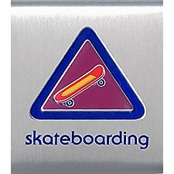
Complete these three requirements:
- Demonstrate to an adult the general rules for safe skateboarding by showing that you know how to wear the proper safety gear.
- Carefully demonstrate how to fall to help minimize injuries.
- Practice skateboarding for 30 minutes. This practice may be done in several periods.

Skateboarding Sports Pin

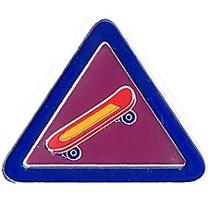
Earn the Skateboarding belt loop, and complete five of the following requirements:
- Figure out your skateboard stance—whether you are regular or goofy footed.
- Demonstrate proper stance, feet positions, knee bending, pushing off, turning, and stopping on flat ground.
- Using pictures, explain to your den or family the difference between street, skate park, and vertical skateboarding.
- List five ways skateboarders should be considerate and respectful of other people and their property when they are skateboarding.
- View a skateboarding video.
- Attend a pro skateboarder demonstration.
- Show that you know how to lubricate the bearings and keep your skateboard clean.
- Apply grip tape to your skateboard.
- Skateboard at a skate park for 30 minutes.
- Demonstrate three of the following maneuvers: ollie, nollie, frontside, grab, kickturn, carving.
- Describe how to determine a safe area to skateboard.
For worksheets to help with earning these awards got to
http://usscouts.org/advance/cubscout/sports/skateboarding.asp
Additional Resources
http://skateboard.about.com/
http://www.exploratorium.edu/skateboarding/
http://www.skateboardparks.com/

Family Travel Loop and Pin
from www.usscouts.org
With summer coming up and school letting out, many people are gearing up for a family vacation. The June Baloo’s Bugle is a perfect time to highlight the Family Travel Belt Loop and Pin.

Requirements
Tiger Cubs, Cub Scouts, and Webelos Scouts may complete requirements in a family, den, pack, school, or community environment. Tiger Cubs must work with their parents or adult partners. Parents and partners do not earn loops or pins.
Family Travel Belt Loop
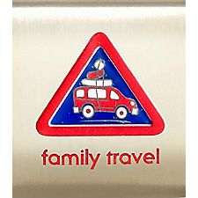
Complete these three requirements:
- Make a list of things you would take on a three day trip with your family, then pack these items in a bag or suitcase.
- With an adult’s help, figure out the cost and miles to complete a trip to a place of interest using the family car or public transportation.
- Research at least five places to visit during a trip to a place of interest. Explain what you learned to your family.
Family Travel Academics Pin
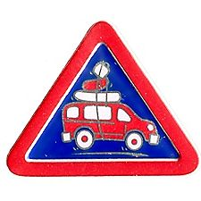
Earn the Family Travel belt loop, and complete five of the following requirements:
- Go on a trip with your family that includes at least one overnight stay. Keep a journal of your trip and then share it with your den leader.
- Play a travel game while traveling in a car.
- With an adult, review the Guide to Safe Scouting, chapter XII, “Transportation.” Then make a list of safety rules to follow when traveling in the car or while using public transportation such as a bus, plane, boat, and train. Share the list with your den.
- With the help of a parent or adult partner, use a computer to look up an airfare from your closest airport to a city in a foreign country. Calculate the total travel time, the day and time you will leave your home, and the day and time you will arrive at your destination.
- Visit a travel agent office or look up a travel Web site.
- Using pictures, explain to a family member how people’s forms of transportation have changed in the last 300 years.
- Visit with an adult who has driven in a different country. List five things that the adult found to be very different from driving in the United States
- Make a list of occupations that people have that are related to traveling. Describe the position you would like to try. Explain to a family member why you chose that occupation.
- Learn how to apply for a U.S. passport. With adult supervision, read an actual application and complete as much of the form as you can.
- Change $1,000 U.S. dollars into pounds, Euros, or pesos.
- With an adult, conduct a motor vehicle inspection of the car designated for traveling. Use the checklist provided in the Guide to Safe Scouting called "Annual Motor Vehicle Checklist." The appendix to the Guide can be found at: www.scouting.org/scoutsource/HealthandSafety/GSS/gssax.aspx.
For worksheets to help with earning these awards got to
http://usscouts.org/advance/cubscout/academics/travel.asp
Additional Resources
U.S. passport information: http://travel.state.gov/passport/passport_1738.html
U.S. currency conversions: http://finance.yahoo.com/currency
Maps: http://maps.google.com or http://www.mapquest.com
Which side of the road do they drive on?: http://www.rmf9.com/whichside.htm
Airplane restrictions: http://www.tsa.gov/travelers/index.shtm
Travel games for kids: http://www.kidsturncentral.com/summer/travelgames.htm
Printable games to take along on trips: http://www.momsminivan.com/printables.html

Cub Scout Outdoor Activity Award
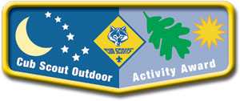
from www.scouting.org
Tiger Cubs, Wolf and Bear Cub Scouts, and Webelos Scouts have the opportunity to earn the Cub Scout Outdoor Activity Award. Boys may earn the award in each of the program years as long as the requirements are completed each year. The first time the award is earned, the boy will receive the pocket flap award, which is to be worn on the right pocket flap of the uniform shirt. Each successive time the award is earned, a wolf track pin may be added to the flap. Leaders should encourage boys to build on skills and experiences from previous years when working on the award for a successive year.
Requirements
All Ranks
Attend Cub Scout day camp or Cub Scout/Webelos Scout resident camp.
Rank-Specific
Tiger Cubs
Complete one requirement in Achievement 5, "Let's Go Outdoors" (Tiger Cub Handbook) and complete three of the outdoor activities listed below.
Wolf Cub Scouts
Assemble the "Six Essentials for Going Outdoors" (Wolf Handbook, Elective 23b) and discuss their purpose, and complete four of the outdoor activities listed below.
Bear Cub Scouts
Earn the Cub Scout Leave No Trace Award (Bear Handbook, Elective 25h) and compete five of the outdoor activities listed below.
Webelos Scouts
Earn the Outdoorsman Activity Badge (Webelos Handbook) and complete six of the outdoor activities listed below.
Outdoor Activities
With your den, pack, or family:
- Participate in a nature hike in your local area. This can be on an organized, marked trail, or just a hike to observe nature in your area.
- Participate in an outdoor activity such as a picnic or park fun day.
- Explain the buddy system and tell what to do if lost. Explain the importance of cooperation.
- Attend a pack overnighter. Be responsible by being prepared for the event.
- Complete an outdoor service project in your community.
- Complete a nature/conservation project in your area. This project should involve improving, beautifying, or supporting natural habitats. Discuss how this project helped you to respect nature.
- Earn the Summertime Pack Award.
- Participate in a nature observation activity. Describe or illustrate and display your observations at a den or pack meeting.
- Participate in an outdoor aquatic activity. This can be an organized swim meet or just a den or pack swim.
- Participate in an outdoor campfire program. Perform in a skit, sing a song, or take part in a ceremony.
- Participate in an outdoor sporting event.
- Participate in an outdoor Scout's Own or other worship service.
- Explore a local city, county, state, or national park. Discuss with your den how a good citizen obeys the park rules.
The award requirements are detailed in the Cub Scout Outdoor Activity Award brochure, No. 13-228.

Boys’ Life Reading Contest for 2011
http://boyslife.org/

SAY ‘YES’ TO READING
Enter the 2011 Boys’ Life Reading Contest
Write a one-page report titled “The Best Book I Read This Year” and enter it in the Boys’ Life 2011 “Say Yes to Reading!” contest.
The book can be fiction or nonfiction. But the report has to be in your own words — 500 words tops. Enter in one of these three age categories:
- 8 years old and younger
- 9 and 10 years old
- 11 years old and older
First-place winners in each age category will receive a $100 gift certificate good for any product in the Boy Scouts official retail catalog. Second-place winners will receive a $75 gift certificate, and third-place winners a $50 certificate.
Everyone who enters will get a free patch like the one on this page. (And, yes, the patch is a temporary insignia, so it can be worn on the Boy Scout uniform shirt, on the right pocket. Proudly display it there or anywhere!) In coming years, you’ll have the opportunity to earn different patches.
The contest is open to all Boys’ Life readers. Be sure to include your name, address, age and grade in school on the entry.
Send your report, along with a business-size, self-addressed, stamped envelope, to:
Boys’ Life Reading Contest
S306
P.O. Box 152079
Irving, TX 75015-2079
Entries must be postmarked by Dec. 31, 2011 and must include entry information and a self-addressed, stamped envelope.
For more details go to http://boyslife.org/

Knot of the Month
See The "Knot of the Month" in the Pack and Leader Hints Edition for information on Adult Religious Awards/Recognitions
Dave

GATHERING ACTIVITIES
"Gathering Activities" for large groups and getting groups to know each other are in the Pack and Leader Hints Edition. Those good for dens (e.g. word searches, puzzles, mazes) are here. Dave
Note on Word Searches, Word Games, Mazes and such – In order to make these items fit in the two column format of Baloo’s Bugle they are shrunk to a width of about 3 inches. Your Cubs probably need bigger pictures. You can get these by copying and pasting the picture from the Word version or clipping the picture in the Adobe (.pdf) version and then enlarging to page width. CD
Helmet Maze
http://www.bhsi.org :
Find your way through this maze to connect the helmet with the bicycle.
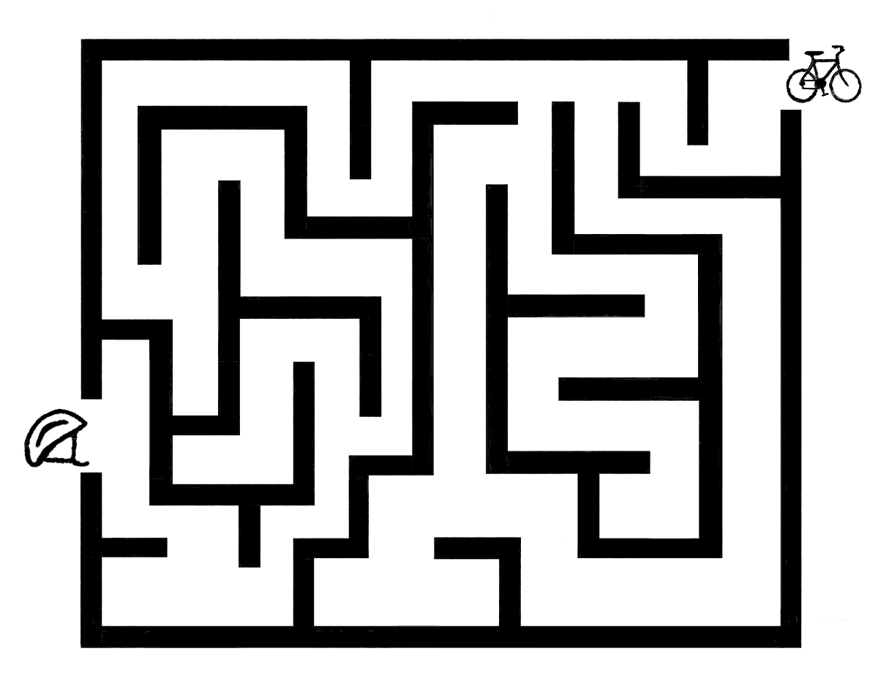
Wheeling Into Summer Word Search
Alice, CS RT Commissioner
Pioneer District, Golden Empire Council
Find the words below that have to do with Wheels – they may be up or down or on the diagonal.

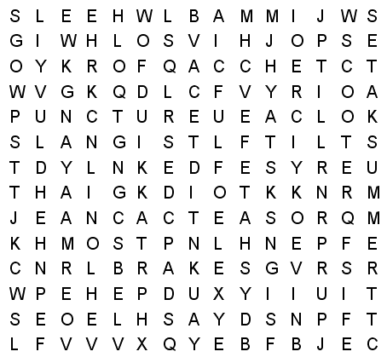
BICYCLE BRAKES CHAIN
FORK HELMET KNEE
LISTEN LOOK PADS
PUNCTURE SADDLE SAFETY
SCOOTER SIGNALS SIGNS
SKATES SPARE SPOKE
SPROCKET SUMMER TIRE
TRAFFIC WHEELS
Talent Mix Up
(Utah National Park Pow Wow)
Developing a talent can take real perseverance. See if you can Unscramble these talents.
1. gngnisi ________________
2. cangidn ________________
3. estinilgn _______________
4. muttrep _______________
5. simuc _________________
6. arepo _________________
7. urgtai _________________
8. mgnferropi_____________
9. wsoh _________________
10. oinpa ________________
11. ingcat________________
12. zooak ________________
13. uhimnmg _____________
14. dsmur _______________
15. wihstglin _____________
Answers: 1. singing, 2. dancing, 3. listening, 4. trumpet, 5. music, 6. opera, 7. guitar, 8.performing, 9. show, 10. piano, 11. acting, 12. kazoo,13.humming 14. drums 15. whistling
Make Marshmallow Catapults and have a competition among families. (Great Salt Lake Pow Wow Book)
You can practice PERSEVERANCE and have some fun – and if you’re lucky, you’ll catch a delicious marshmallow! Directions in the Value Related Section.
Make Friendship Wristbands
(Santa Clara County Council Pow Wow Book Nov. 2003)
Materials: For each, you will need two pony beads and a leather lace.
Step 1: Cut lace 5" longer than measurement around wrist. Trim lace ends at an angle.
Step 2: Tie a knot in one end of the lace. Thread on 2 pony beads. (To celebrate Best Friends Day in June, have each boy choose two beads, then exchange at least one bead with other boys- or let boys add more than two beads as a record of friendship - Alice)
Step 3: Thread the other end of the lace through the beads from the opposite direction. Tie a knot in this lace end. Adjust size of bracelet by pulling on knotted lace ends.
This could also be a good activity in a Den setting.
Bike Rodeo Theme:
What is it?
(Alice, Golden Empire Council)
Mount an unlabeled picture of a bike on the wall – number each part of the bike, or block out the labels on a labeled picture. As they enter, each person or family gets a sheet with a list of the parts of a bike. They must decide which number goes with the part on their list. Winner is the one with the most correct answers when the meeting starts. You can enlarge this image and then block out the names of each part.
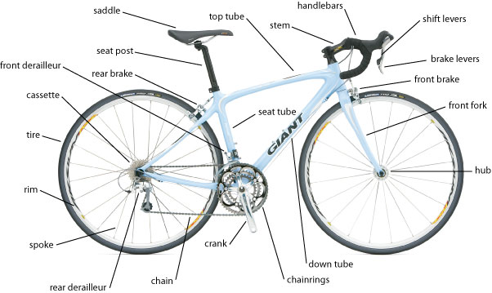
If you are having a Bike Rodeo, start off with a bike inspection to make sure everyone has a safe bike that fits– AND a Helmet! Bring together an expert from a bicycle shop or a local bicycle club, and check to make sure each person has a bike adjusted properly for size and safe to ride.
Set up a Perseverance Obstacle Course to navigate – each obstacle can be labeled with a possible challenge that could keep a person from going forward. This could be done either on a bicycle or on foot. Or try one of the suggested obstacles under Value Related.
Mouse on the Bike Maze
(Alice, Golden Empire Council)
Every bike rider needs to learn how to maneuver his bike to avoid hazards and stay safe – and to reach his destination safely.
Our Mouse on the Bike has broken the Number 1 Rule – he is not wearing a helmet – but YOU would never do that! See if you can help the mouse get to his destination safely.

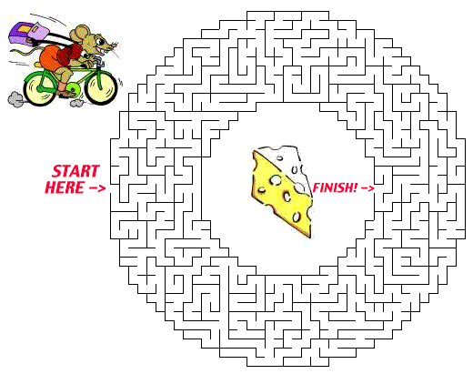

OPENING CEREMONIES
For Ideas for Den Opening ceremonies see the "Den and Pack Meeting Resource Guide" and "Ceremonies for Dens and Packs."
Pack Meeting "Opening Ceremonies" are in the Pack and Leader Hints Edition. Dave

AUDIENCE PARTICIPATIONS
"Audience Participations" are in the Pack and Leader Hints Edition. Dave

ADVANCEMENT CEREMONIES
For Ideas for Den Recognition ceremonies see the "Den and Pack Meeting Resource Guide" and "Ceremonies for Dens and Packs."
"Advancement Ceremonies" are in the Pack and Leader Hints Edition. Dave

GAMES
Paul Bunyan’s Perseverance Relay
Alice, Golden Empire Council
Materials: For each team you need: an egg carton and 12 plastic eggs dumped out on the ground, a bowl of water with bubble solution or dish soap; old-fashioned egg beater or wire wisk; frying pan; a “pancake” – could be packing peanuts, a circle of foam, or a circle of foam sandwiched between two pieces of brown paper and stapled, a large bowl filled with water “balls” and a large spoon, 7 lengths of pool noodles or newspaper logs
Directions: Have someone tell the story of Paul and his amazing feats – Details under Value Related or at: www.first-school.ws/activities/onlinestory/books/pbunyan.htm. Divide the group into two or more teams and tell them they are going to follow the example of Paul in a set of relay games. Set up each event at a station – one set of stations for each team. Line each team up and explain that the first boy in the line will start. Only when the first boy is at station #3 can the second boy start. The game continues in this way, with each boy waiting to start till the boy in front of him reaches station #3.
- Boy runs to the station, gathers all the eggs and puts them in the egg carton, closes the egg carton, then dumps the eggs out again.
- Boy must run to the station, then use the egg beater or whisk to make bubbles in his bowl of water and soap.
- Boy puts a pancake in the pan and flips it at least as high as the top of his head – he must flip and catch a pancake three times, then dumps the pancake out for the next boy.
- Boy runs to station and uses the scoop or big spoon to pick up 3-4 “water” balls from a large bowl (forming the Great Lakes) – then return the balls to the bowl for the next boy.
- Runs to the “Logging” station and stacks all the logs. Then he must kick them out of the stack for the next boy.
- Boy races back to the starting point as if he were wearing inline skates – hands behind back, and sliding each foot ahead one by one (The story is that Paul invited inline skating). When the whole team is back at the starting line in order, they yell, “Paul Bunyan!”
You could also take just one or two of these events and turn them into a relay - Alice.
WILDERNESS SURVIVAL
(Utah National Parks Pow Wow)
This game shows how animals in the wild that are weaker or slower will lose to those who are stronger. Each player needs a three-inch bolt with two nuts screwed onto it, and twenty pieces of candy. Let the boys challenge each other to a race. To start, the nuts must be screwed to the top of the bolt. On a signal, the boys must unscrew the nuts all the way until they come off the bolt. The boy who gets the nuts off first gets two pieces of the other Cubs candy.
BROOM SWEEP RELAY
(Utah National Parks Pow Wow)
Supplies for each team:
1 broom
1 balloon (inflated)
1 plastic cone
Directions:
Divide your den or pack into equal teams. Line up each team behind a starting line. Place a plastic cone about 40 feet from the starting line for each team. Give the first person in each team a broom and an inflated balloon.
On the start signal, the first person in each team puts the balloon on the floor and proceeds to sweep the balloon to the cone. He circles the cone and continues sweeping the balloon back to his teammates. He hands the broom to the next teammate and walks to the end of the line.
The next player sweeps the balloon to the cone, circles it and sweeps back to his team.
The balloon is to remain on the ground at all times. If the balloon pops, the player must restart from the starting line.
The first team to have all players complete the clean sweep with the balloon is declared the winner.
Have extra balloons (inflated) on hand in case one should pop. This game can also be played outdoors - fill the balloons with water for some wild fun.
PING-PONG BALL SHOOT OUT
(Utah National Parks Pow Wow)
Fill several 2-liter bottles with water to weight them down. Place them on a flat surface. Put a Ping-Pong ball on top of each bottle. Have a contest to see how fast each Cub can shoot the ball off the bottle with a squirt gun.
EAT AND WHISTLE
(Utah National Parks Pow Wow)
Players are divided into two teams and each person is given a cracker. At the signal, the first player on each team starts eating his cracker. He must finish it and whistle before the next player in line can start eating. The first team to finish, wins.
TOOTHPICK PICK-UP
(Utah National Parks Pow Wow)
Dump a pile of cocktail toothpicks on the table. Each player tries to pick up five toothpicks using the two corresponding fingers from each hand: right thumb and left thumb, right index and left index, etc.
ELEPHANT SOCCER
(Utah National Parks Pow Wow)
Cubs get into a circle with legs wide apart and their hands down in front of them with hands clasped together for trunks. Roll a ball across the circle trying to get it between someone’s legs. Use only trunks to keep the ball from going through legs.
KNOT-TYING CHALLENGE
(Utah National Parks Pow Wow)
Scouts to tie knots using bits of rope or from licorice laces. Bonus: it's both a snack and a game.

SONGS
Alice, Golden Empire Council
Perseverance
Alice, Golden Empire Council
Tune: If You’re Happy & You Know It
If you’re learning something new, Persevere.
When you keep on with your practice, never fear.
When you try to do your best, put your labor to the test. When you never give up trying You can cheer.
If you want to learn to juggle, You must start.
Break the actions down and try the simple part.
Once you master the beginning,
You will slowly feel you’re winning,
If you simply always work with all your heart.
If you’re good, then strive to be a whole lot better.
Start at “A” and go through every single letter.
If you only keep on trying,
You are sure to make the grade,
If your work and perseverance does not fade.
So remember – Don’t give up and simply sit.
When it looks like you will never ever fit.
And no matter what the challenge,
You can always find a way,
If you don’t give up you’re sure to be a Hit!
Start & Stick & Do Not Quit
(Alice-Golden Empire Council)
(Tune: Row, Row, Row Your Boat)
When you go to start a Task,
Be sure you Learn to Stick
If you want to “Do Your Best”
You cannot Start & Quit
First set your final goal
Then practice hard and long
Keep it up and try again
Then sing a victory song!
Cub Scout Rodeo
(tune: Jingle Bells)
Hopping on my bike, and with my helmet on,
Down the street I go, peddling fast not slow,
Waving to my friends
“Grab your bikes, let’s go!”
Peddle on to have some fun at our Bike Rodeo..Oh……
Chorus:
Cubs on bikes, Cubs on bikes, riding is such fun
The rodeo for bikes, you know is meant for everyone
Cubs on bikes, Cubs on bikes, riding is such fun
Safety first and practice, too, will make you #1!
Here are three FUN “Repeat After Me” songs – perfect for Repeat Day on June 3rd – and you will also need to PERSEVERE to get all the way to the end! - Alice
Froggy!
(A repeat after me song)
Dog! [repeat]
Dog, Cat! [repeat]
Dog, Cat, Mouse! [repeat]
Froggy! [repeat]
Itsy, bitsy, teensy, weensy, little, bitty Froggie! [repeat]
Jump, jump, jump, little Froggie! [repeat]
Gobble up all the little worms and spiders. [repeat]
Fleas and flies, scrumdillicious! [repeat]
Ribbit. ribbit, ribbit, ribbit, ribbit, ribbit, CROAK! [repeat]
FASTER! [repeat]
(Keep repeating faster and faster until you can't go on!)
The Bear
(tune: Sippin’ Cider)
Leader sings one line and audience repeats it
For the chorus, after every four lines,
the audience repeats the four lines
without pausing between lines.
The other day (repeat)
I saw a bear (repeat)
Out in the woods (repeat)
A-way out there (repeat)
Chorus: (repeat verse without stopping)
I looked at him (repeat)
He looked at me (repeat)
I smiled at him (repeat)
He smiled at me (repeat)
Chorus
He said to me (repeat)
Why don't you run? (repeat)
I see you ain't (repeat)
Got any gun (repeat)
Chorus
And so I ran (repeat)
Away from there (repeat)
But right behind me (repeat)
Came that bear (repeat)
Chorus
And then I saw (repeat)
Ahead of me (repeat)
A great big tree (repeat)
Oh, mercy me (repeat)
Chorus
The lowest branch (repeat)
Was 10 feet up (repeat)
I'd have to jump (repeat)
And trust to luck (repeat)
Chorus
And so I jumped (repeat)
Into the air (repeat)
But I missed that branch (repeat)
A-way up there (repeat)
Chorus
Now don't you fret (repeat)
And don't you frown (repeat)
"Cause I caught that branch (repeat)
On the way back down (repeat)
Chorus
That's all there is (repeat)
There ain't no more (repeat)
Unless I meet (repeat}
That bear once more (repeat)
Chorus
Billy Grogan's Goat
Leader sings one line and audience repeats it
For the chorus, after every four lines,
the audience repeats the four lines
without pausing between lines.
There was a man (repeat)
Now please take note (repeat)
There was a man (repeat)
Who had a goat (repeat)
Chorus
He loved that goat (repeat)
Indeed he did (repeat)
He loved that goat (repeat)
Just like a kid (repeat)
Chorus
One day that goat (repeat)
Felt frisk and fine (repeat)
Ate three red shirts (repeat)
Right off the line (repeat)
Chorus
The man, he grabbed (repeat)
Him by the neck (repeat)
And tied him to (repeat)
A railroad track (repeat)
Chorus
Now, when that train (repeat)
Came into sight (repeat)
That goat grew pale (repeat)
And green with fright (repeat)
Chorus
He heaved a sigh, (repeat)
As if in pain (repeat)
Coughed up those shirts (repeat)
And flagged the train! (repeat)
Chorus

STUNTS AND APPLAUSES
"Applauses & Cheers, Run-Ons, and
Jokes & Riddles" are in the Pack and Leader Hints Edition. Dave

SKITS
"Skits" for the Pack Meeting are in the Pack and Leader Hints Edition. Dave

CLOSING CEREMONIES
For Ideas for Den Closing ceremonies see the "Den and Pack Meeting Resource Guide" and "Ceremonies for Dens and Packs."
Pack Meeting "Closing Ceremonies" are in the Pack and Leader Hints Edition. Dave

Cubmaster’s Minutes
"Cubmaster's Minutes" are in the Pack and Leader Hints Edition. Dave

CORE VALUE
RELATED STUFF

Connecting Perseverance
with Outdoor Activities
Wendy, Chief Seattle Council
(Adapted from B.A.L.O.O. Appendix E)
- Hikes – Plan a hike where boys encounter obstacles similar to those an early explorer might have encountered. Talk about how pioneers and early explorers persevered to reach their destinations.
- Nature Activities - Study plants that survive difficult environments. Encourage boys to keep trying when an activity is difficult.
- Service Projects – Institute a tutoring program. Boys can plan rewards for the students who persevere until they finish.
- Games & Sports – Play a game related to pioneers and discuss their perseverance to complete their journeys. Tell boys that those who persevere improve their skills.
- Ceremonies – “Lewis and Clark” could conduct an awards ceremony. “George Washington” (or “Davy Crockett”) could also. After “crossing the Delaware” pioneers could deliver awards from a covered wagon.
- Campfires – Pioneer and frontier days are good themes to incorporate into your campfire plans.
- Den Trips - Visit a local gym and talk with a personal trainer. Visit a doctor and talk about education. Visit a local outdoor track facility and talk with a long distance runner. All of these people have demonstrated perseverance.
- Pack Overnighter – Plan some Dutch oven and open campfire cooking so boys experience something like pioneer life.

The Picture of Perseverance
Alice, Golden Empire Council
Here are some people that showed perseverance in their lives – do you recognize all the names? Is there one you really admire? Choose one to find out about and share with your family or den – or choose someone you admire for perseverance.
Ludwig von Beethoven Liz Murray
Amelia Earhart Laila Ali
Jennifer Howitt Galileo
Wilma Randolph Marie Curie
Jackie Robinson Terry Fox
Christopher Reeve Helen Keller
Itzhak Perlman Ray Charles
Martin Luther King, Jr. Marlee Matlin
James Earl Jones Cesar Chavez
Stephen Hawking Susan Butcher
Susan B. Anthony Nelson Mandela
Franklin Delano Roosevelt

June –
A month to celebrate Perseverance
NOTE: Many of these activities can also sign off Achievements, Electives or Activity Pin requirements – check under Den Activities to see the possibilities – Alice
1 – Flip a Coin Day - Caesar would take a coin and flip it to make decisions where the right choice was unclear. The correct answer was "heads", which of course carried HIS head on the coin! But here are some FUN reasons to Flip a Coin:
- Flip a Coin Hike - Go for a hike or walk around the neighborhood – but every time you come to a crossroads of any kind you take turns flipping a coin to decide your route – OR
- Flip a Coin – Make a Choice - Set out different activities and then boys take turns flipping – heads (yes), tails (no) – to decide what activities you are going to do.
- Flip for a Treat - have two different treats – and flip a coin to decide which one to eat!
2 – National Doughnut Day – National Doughnut Day honors the perseverance of Salvation Army "Lassies" of WWI - volunteers who made home cooked foods to boost troop morale – and they still provide support today to troops and victims of natural disasters.
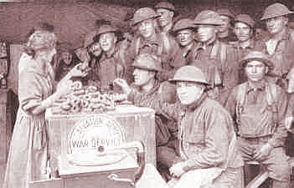
And they did show perseverance – in the beginning, they used a bottle to roll out the dough – and because they didn’t have a doughnut cutter, they cut their doughnuts into strips. Eventually, a retired French blacksmith fastened the top of a condensed milk can and camphor-ice tube to a wooden block so a doughnut with a hole could be made. Later, all sorts of other inventions were employed, such as the lid from a baking powder can or a lamp chimney to cut the doughnut, with the top of a coffee percolator to make the hole. Sometimes doughnuts were cooked inside the metal helmet of an American soldier – which may be one reason for the infantry being called “Doughboys.”
But even in the Civil War, the name was used - as a kind of “put-down” of the ordinary foot soldier – Both General Custer and his wife referred to the name in letters, and some soldiers mentioned that they, ordinary foot soldiers, had to wait for “the artillery to cross the bridge in their carriages.” And in the 19th Century, baker apprentices in England were called doughboys, and soldiers and sailors were used to a fried flour dumpling called “doughboys.”
But remember that all of those “doughboys” kept going – and because they did, that name became a badge of honor and affection. So… Celebrate by making some easy doughnuts for a treat – see Cub Grub. Cook the holes, too – then let boys choose which sprinkles to roll their holes or doughnuts in.
Make some doughnuts to share with the local military. Check with Pack families or a VFW post, military base or Salvation Army. In Sacramento, we have several choices, including Reserve units and a Coast Guard Station in addition to regular military bases.
3 - Repeat Day – And repeating is something you NEED to do in order to get good at a new skill or to improve your performance – So PERSEVERE – Repeat till you can Do Your Best! But a fun way to celebrate Repeat Day would be to do one of the “Repeat After Me” songs in the Songs section – or try the Repeat After Me Story – “I’m going to Keep Going.”
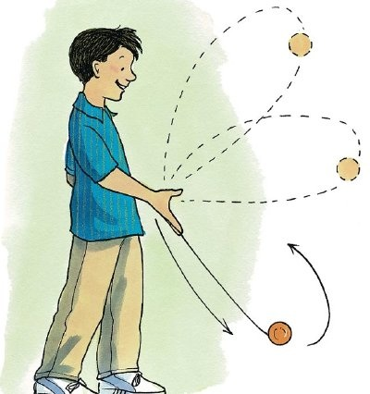 6 – National Yo-Yo Day – Learn a new trick - Great way to practice perseverance and have some FUN! Go to: http://entertainment.howstuffworks.com/easy-yo-yo-tricks.htm
Here are some fun facts about the Yo-Yo:
- It may have originated in China as early as 500-1000 B.C.
- Greeks were probably using a Yo-Yo even earlier than that!
- National Yo-Yo Day on June 6 honors the birthday of Donald F. Duncan Sr. – who manufactured the Duncan Yo-Yo.
- In 1992, Jeffrey Hoffman took a Yo-Yo into space aboard the shuttle Atlantis
- Presidents Kennedy, Johnson and Nixon showed off their Yo-Yo expertise while in office!
- The world’s largest Yo-Yo weighs 256 pounds - It’s on display at the National Yo-Yo museum.
- "Walking the Dog" or "Shooting the Moon" are the most popular Yo-Yo tricks.
8 – Best Friends Day – Best Friends are dependable– they work together and never give up! And being with a good friend can help keep you safe, too. Make sure the boys practice the Buddy System – especially if they are going swimming!
Or celebrate Best Friends Day in the den:
- Have treats that must be shared – one long length of licorice for example. The boys must agree how the treat will be divided, then come to Akela and explain BEFORE they can eat the treat!
- Another great food to share – make a giant sandwich that everyone contributes to, a fruit salad, a soup that everyone brings a veggie for, or, most fun of all, a giant ice cream sundae.
- Make cookies, then divide them into small baggies – give two to each person, but each boy shares one with a buddy.
- Prepare a “community” trail mix – have each person bring an item to add, then mix them all together while you talk about why that item is good to have. Then everyone gets to fill a snack bag with some trail mix and the den can go on a hike. OR Have everyone bring a snack to share on a den hike – two cookies, two boxes of raisins. Let the boys share or mix and match.
 14 – Flag Day – Many people have persevered in serving our country – and Cub Scouts can honor their service and sacrifice by learning how to display the flag with respect. It also takes perseverance to learn how to do a flag ceremony, raise and lower a flag, or fold the flag properly!
15 – Fly a Kite Day - This holiday commemorates that famous experiment of Benjamin Franklin, which took place on this day in 1752. But be sure to emphasize that scouts aren’t trying to attract lightning! In fact, make sure you don’t fly a kite with a storm approaching. And look for a safe place with lots of space, away from power lines. Check with a local kite shop or club for some ideas. And check the Wolf Book, Elective #5 for Kite Safety Rules, some patterns for kites, and a kite string reel you can make.
17 – Eat Your Vegetables Day – Now here’s something that your Mother probably perseveres at – trying to get you to eat your veggies. But you can persevere too – try at least a couple of bites of every new vegetable – you might even learn to like it!
18 - Here are two different third Saturday in June Celebrations - Flip a coin and decide how to spend that third Saturday – or let every den or boy try a different one and report on what they did –
First, World Juggler’s Day – always held on the Saturday closes to June 17th – and it certainly takes perseverance to get good at juggling. So give it a try! Here are some good tips:
- Start with scarves if you are brand new.
- Then throw and catch a ball from one hand to the other.
- Now add a second ball – use medium sized soft balls to practice.
- Once you have practiced and can do two balls really well, add a third ball.
- With the hand you write with, hold two balls in that hand and one in the other.
- Throw one of the two balls toward the other hand, and just before you catch it, throw the ball in the other hand.
- Practice over and over till you get really good! In other words, Persevere!
Second, Go Fishing Day – Fishing is a lot of fun – but it also takes perseverance! Sometimes it takes quite a while to learn how to bait a hook, cast a line without snagging it, or pick a good place and time to catch some fish. And you often have to wait a while for those fish to take the hook! But persevere – fishing can be a great hobby.
This year, Go Fishing Day is the day before Father’s Day – so you could celebrate both holidays at once!
19 – Father’s Day – Make sure to do something special for and with your Dad – yesterday was Go Fishing Day. And tomorrow is Ice Cream Soda Day – You could do all THREE for a wonderful celebration!
20 – Ice Cream Soda Day – I’m sure you can find the perfect thing to do to celebrate!
21 – Go Skate Day – And whether it’s ice skating, roller skating, inline skating or skateboarding – it requires perseverance to get really good! But be sure to WEAR A HELMET, and pads or guards that will keep you safe! And if you want to hear the Paul Bunyan version of how inline skating was invented, check out Paul Bunyan Day!
24 – Swim a Lap Day – Like all sports, swimming requires lots of practice, especially if you are afraid of the water. But persevere, and you can always improve your swimming skills! Don’t forget Safe Swim Rules – and never swim alone!
28 – Paul Bunyan Day - Bear Scouts will recognize Paul Bunyan as an American folklore character – but we think the story originated among French Canadians. Paul was a giant of man, with a gigantic blue ox called Babe – the story goes that he was a logger who used his enormous size and strength to perform amazing feats – and he didn’t give up – he knew how to Persevere! When the Axmen got into a fight and ruined all the flapjacks, Paul had to mine the ore to make the pan to cook a giant flapjack; he had to figure out a way to get lots of eggs and milk. He even had to figure out how to make a giant eggbeater and get enough wood to make a fire to cook his giant pancake – and he invented online skating to solve the problem – and that’s just one of his stories!
Go to: www.first-school.ws/activities/onlinestory/books/pbunyan.htm to watch and hear the whole story!
Here are some of his other legendary deeds:
- He created logging in the U.S.
- He scooped out the Great Lakes to water Babe, his ox.
- He cleared the entire states of North and South Dakota for farming.
- He trained ants to do logging work - Carpenter Ants.
- Babe's large footprints created Minnesota's 10,000 lakes.
Celebrate Paul Bunyan Day in a giant way. Learn more of his tales and tell them around a campfire!
29 – Camera Day – Celebrate Camera Day by taking pictures – with any kind of camera. But a digital camera is really easy to use, and you can print out the results very quickly.
The camera can capture moments and keep them forever. But it can take perseverance to learn how to use a camera – how to focus, use different angles and lighting, choose the right moment and position to take your photo, even what kind of film to use. It can also take lots of practice to learn how to show your photographs so they tell the story you want to show – how the picture is cropped, the kind of matting, even the kind of frame – or no frame at all.
And here’s a fun way to help the boys see how important it is to choose the right way to show your photos
- If boys have a photo they like, print out several copies of the same photo – they could be from online images
- Gather several different frames and mats that would fit the photo, OR
- You could even print out “matting” and “frames” from online images and cut out the center so you can “insert” the photo
- Let each boy try different matting and frames and decide which he likes best
- You could even display their favorites at the Pack meeting, with an explanation of why each boy made his choice
This is a good exercise in how to make choices, and the need to be open to try different things and persevere till you find the right solution.
30 – Meteor or Comet Day – AND Superman’s Birthday!
Check out the great ideas at NASA’s “The Space Place” – Scouts are listed as “Friends” – and they have all kinds of great ideas that are keyed to Advancement. They actually list the ideas by rank – Achievements, Electives, Activity Pins and even Belt Loops.
For Superman’s Birthday on the 30th, encourage pack and den families to watch the Chris Reeve’s – Superman, the Movie - and challenge the boys to find ways that the Superhero follows the Cub Scout Law. (Families might point out that he does Good Deeds all the time, and CHEERFULLY!) He saves Lois from a helicopter accident, rescues a cat from a tree, replaces an engine on Air Force One – all of it cheerfully, like a scout! In real life, Christopher Reeve also displayed perseverance after being thrown by a horse and suffering a devastating spinal injury that left him paralyzed. (Be sure to talk about what Perseverance means – that in spite of problems, obstacles and challenges, a boy can keep trying to Do Your Best – even without “Super powers!”)
A Parent’s Magic Bag of Tricks for Summer Traveling:
This is not, strictly speaking a magic trick – but parents will certainly appreciate this Magic Bag of Tricks when faced with a journey with children in a car, train or plane, or a long wait at a restaurant or doctor’s office!
There are some important rules:
- Use the bag only in these situations – otherwise, it will lose its appeal!
- Only one thing at a time for each child can come out of the bag!
- Everyone must share the “magical” things in the bag!
Any bag will do – but a colorful cloth one is extra special. It needs to have a secure closure, either a drawstring or a zipper. Use only unbreakable items, and put individual things in sealable plastic bags to keep them handy. Here are some suggestions of what to put in your bag:
Pads of paper, pencils, colored pencils, crayons, re-useable stickers and sticker books, stopwatch or small hourglass, matchbox type cars, finger puppets, trivia books, playing cards, dice, magnifying glasses, Rubik’s cube or other 3D puzzles, magnetic travel games, small plastic army men, animals, dinosaurs or action figures, Etch a Sketch, pipe cleaners, shoelaces, origami paper & directions, small blunt scissors, scotch tape, sidewalk chalk, balloons, jump rope, jacks or marbles, a small book of game ideas.
- For a car trip, add: inflatable ball, Frisbee, hacky sacks, clipboard or lapboard for each child, glow sticks, small flashlight (set a rule that no one can aim at the driver or rear-view mirror)
- For a restaurant bag: Add games that need a table to play, such as Pick Up Sticks, Slamwich card game
Try it – you will definitely like it! And the results of having a “Bag of Tricks” will certainly seem magical!

Bikes & Bike Rodeo Ideas:
Bike Rodeo How To
Here are some ideas for you do run a bike rodeo for your Cub Scouts. The boys and their parents need to be involved in this fun activity. Include traffic safety, bike safety, and bike skills in the activities you choose for the event. Your local Police Department, a Cycling Club or the California Automobile Association have information on how to do a Bike Rodeo. Also check some excellent resources on the web.
The rodeo should encourage the safety, bike skills and confidence a Cub needs to ride safely. A bicycle is a vehicle with the same rights and responsibilities as other vehicles on the roads. Biking is fun. In order for Cubs to know if their bikes are safe, contact your local police department. Many will send an officer out to do a bike safety checks. Stress the need to of bike safely - not foolishly. Instill good traffic habits from the start with young riders. Once a boy learns to ride a bike, he will never forget. If he learns good riding skills when he is young, they will follow him into adulthood. Bicycling is truly a life-long activity.
Equipment: 50 feet measurer or yard stick, Chalk, tape or sting - for lines, Traffic cones or weighted cans, Score sheets and pencils, Clipboards - for volunteers, Stop Sign, Bicycles and helmets
Organize so there is as little waiting as possible.
Divide the Cub Scouts and rotate them through the different areas.

Station One: Inspection Station –
The Cub Scout needs to have his bike checked for safety.
See the Webelos Readyman Bike Clinic Check sheet – Have
someone available to make needed repairs, or do this
inspection ahead of time – Bikes should be correctly
adjusted for size and in good repair for the Bike Rodeo.
Station Two: Helmet and bike check –Check the helmet fit and seat height. Have Each boy show how to lock his bike.
Station Three: Ride on the line – Make a wide line and have the Cub Scout ride his bike down the line. The line should be no longer than 12 feet.
Station Four: Safe Driving - Have the Cub Scouts ride their bikes around traffic cones. The leaders can choose the pattern of the cones.
Station Five: On the Street - Create an intersection on the parking lot. Have the Cub Scouts demonstrate how to cross an intersection safely.
Station Six: Steering - Make a circle with the tape. Have the Cub Scouts ride their bike around the circle, staying on the tape as much as possible.
Station Seven: - Recognition - Cub Scouts receive recognition for rodeo participation and have a snack.
This is just one suggested set of stations. The CAA has a set up that goes over the top five bad habits that cause the most injuries and deaths to children on bikes.
How To for Bike Rodeos:
www.bike.cornell.edu/pdf%20files/Bike_Rodeo_404.2.pdf
www.eduref.org/Virtual/Lessons/Health/Safety/SFY005.html http://www.bikebakersfield.org/bike_rodeo.htm
Summer Bike Safety
www.helmets.org
Here are some great tips for any parent or den leader to check before bikes come out for the Summer!

I'm going out for my first ride of the summer. Is there anything I need to do with my bicycle before I start?
Yes, and it will only take about ten minutes.
- First, clean the dust off of it. That helps you get back in touch with it, and remember anything you meant to do over the winter. While you are dusting, check for loose parts like saddle or handlebars. If your bike has quick release levers on the wheels, make sure they are snugly closed. Check the tires for wear or dry rot.
- You always need to inflate your tires. Inflate them to the pressure molded into the side wall. Soft tires make the bike harder to pedal, and you'll have more flats.
- Lube the chain. Squeaky chains actually will break from excess internal friction. In the meantime, they rob you of some pedaling energy.
- Adjust your saddle if necessary. Saddle adjustment can be important for comfort and to avoid pressure in the wrong places, particularly on the first rides of summer.
What about equipment?
What do I need for safety? A helmet, of course.
The helmet is the most important, yes. Make sure it is well adjusted, fits level, and won't slip around too much. In addition to that:
- Gloves protect your hands from chafing, and keep the skin intact if you crash.
- Bike shoes are good because they have rigid soles and spread the pedal pressure evenly. More of your energy gets to the pedal. Running shoes are fine for shorter rides.
- The top that you wear should have a close-fitting neckline. The ones that flop open or hang down are called "bee-catchers."
Anything special to do if I'm taking a child with me?
If you have children, review the basic safety rules with them while you are checking over their bike.
Designer Helmets
Wearing a helmet is a must, but it can be FUN, too! Just use strips of colored plastic tape to create stick on lightening bolts, initials, racing stripes, whatever!

We’re all set to go. Any advice for that first ride?
Ride around the block to be sure your bike is ready. Plan an easy first outing to avoid dragging in to the office on Monday with sore muscles. If the weather is hot, drink plenty of water and take it easy for the first few rides until your body is acclimated to the heat. And use sunscreen to prevent burning.
Summer riding is great fun. It is one of the four best seasons to ride a bicycle.
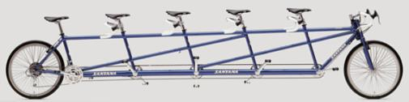
.
From
Santa Clara county Council
2007 Pow Wow Book
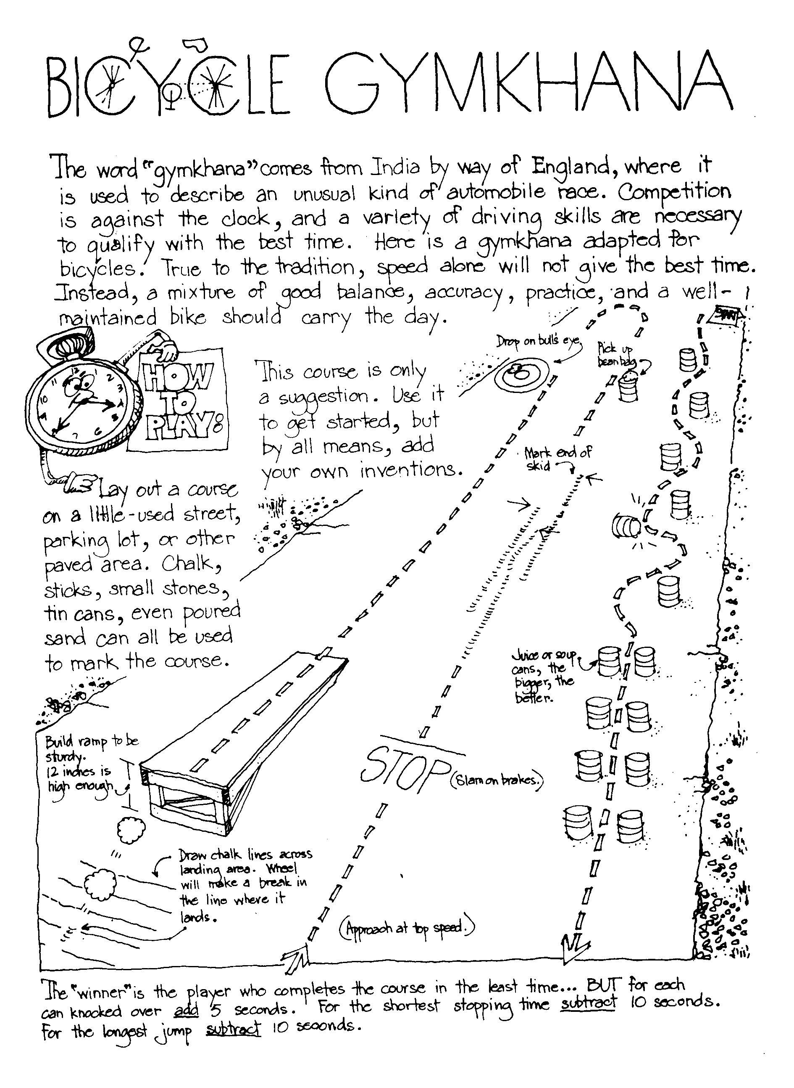

DEN ACTIVITIES
"Pack Activities" are in the Pack and Leader Hints Edition Dave
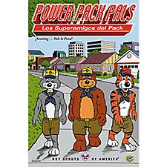 Focus on a very real problem that many kids face – Bullying. It not only takes adult and peer support, it takes a lot of perseverance to overcome bullying – whether the victim or the bully! Check out the Power Pack Pals comics from BSA at: www.scoutstuff.org These eight-page comic books feature TC, Akela and Baloo talking to kids about bullying. Available in Spanish or English for 20 cents a copy.
Celebrate Flip a Coin Day on the first - Caesar may have started the Heads/Tails idea as a way to make decisions, but a den could:
Go for a Flip a Coin Hike - Go for a hike or walk around the neighborhood – but every time you come to a crossroads of any kind you take turns flipping a coin to decide your route. Tiger Ach. #5G; Wolf Elect. #20o (partial); Bear Elect. #25; Webelos Outdoorsman #9
OR Choose an activity - Set out different activities and then boys take turns flipping – heads (yes), tails (no) – to decide what activities you are going to do. OR Flip for a Treat - have two different treats – and flip a coin to decide which one to eat!
Make some doughnuts for a treat - Celebrate National Doughnut Day on the third by making some easy doughnuts for a treat – see Cub Grub. Cook the holes, too – then let boys choose which sprinkles to roll their holes or doughnuts in. Tell the boys about the story behind the holiday – it’s a story of Perseverance! Check “June – A Month for Perseverance” under Value Related for details. Tigers might visit a bakery (Elect. #45), then make some of their own doughnuts – Elect. #25; Wolf Elect #9a (Den Party Treat); Bear Ach. #9b, f
Practice some Yo-Yo tricks – it’s actually a national holiday on the 6th. Learn a new trick - Great way to practice perseverance and have some FUN! Go to: http://etertainment.howstuffworks.com/easy-yo-yo-tricks.htm You might even have an older brother, dad or uncle that can come and teach some tricks. Check out some tips and Fun Facts about Yo-Yo’s in Value Related.
Review and practice the Buddy System – Play “Where’s My Buddy?” in the Games section. When the weather is warm, and swimming and outdoor activities take over, it’s important that the Buddy System and Safe Swim Defense are second nature! Wolf Elect. #23d; Bear Elect. #25b
Celebrate Best Friends Day on the 8th - Have treats that must be shared – one long length of licorice for example. The boys must agree how the treat will be divided, then come to Akela and explain BEFORE they can eat the treat! OR… Prepare a “community” trail mix – have each person bring an item to add, then mix them all together while you talk about why that item is good to have. Then everyone gets to fill a snack bag with some trail mix and the den can go on a hike. Tiger Elect. #25; Bear Ach. #9e OR Have everyone bring a snack to share on a den hike – two of everything - Let the boys share or mix and match.
Flag Day is June 14th – Practice folding the flag – And make no mistake, learning to fold the flag properly can be a real challenge for young scouts – it does take Perseverance!
A tip from a Sacramento scouter – teach young Cub Scouts to fold the flag on a table first – then graduate to holding the flag taut between several pairs of hands while folding it. Wolf Ach. #2g; Bear Ach.#3g,h

Celebrate Flag Day with a special outdoor flag ceremony –practice raising and lowering it with respect until you can do it right every time. Wolf Ach. #2 e, f; Bear Ach.#3f,g,h and i; Webelos Citizen #3, 4
Did you know June 15th is Fly a Kite Day? On this day in 1752, Ben Franklin did his famous experiment to prove electricity. BUT – be sure to go over the rules of Safe Kite Flying before you head out with your kites! Wolf Elec.#5a, b-e; Bear Ach. #10a or 12d –Kite Day; Webelos Craftsman #4 – Make a kite, or Family Member #8 – Plan a Family Kite Day.
Do a special “Eat Your Vegetables Day” in honor of the holiday on the 17th – Have every boy bring a veggie to share. Try some unusual ones, like Jicama – and see if you like a vegetable raw with a healthy dip! Tiger Elect. #25; Bear Ach. #9b, c; Webelos Fitness #4
Learn to walk on a pair of stilts – It will take some practice and perseverance to get really good! Wolf Elect. #7a
Learn to Juggle for World Juggler’s Day – always held on the Saturday closes to June 17th – and it certainly takes perseverance to get good at juggling. So give it a try! Check out the tips under Value Related.
Have a Den Fishing Trip – it could be a way to celebrate Father’s Day - This year, Go Fishing Day is the day before Father’s Day – so you could celebrate both holidays at once! Fishing is a lot of fun – but it also takes perseverance! Sometimes it takes quite a while to learn how to bait a hook, cast a line without snagging it, or pick a good place and time to catch some fish. And you often have to wait a while for those fish to take the hook! But persevere – fishing can be a great hobby. NOTE: Be sure every boy has an adult to share his fun! And don’t forget the Sunscreen! Wolf Elect. #19; Bear Ach. #12d- outdoor event or Elect. #5a, e – if you go fishing on a boat; Webelos Sportsman #3- Fishing.
Plan a special activity for Father’s Day – check the ideas under Value Related for two other great “holidays” that Dad might enjoy – Fishing Day and Ice Cream Soda Day. Combine all three for a wonderful day with Dad – as a den activity, you might want to choose the Saturday before Father’s Day.
Celebrate Go Skate Day on the 21st – And whether it’s ice skating, roller skating, inline skating or skateboarding – it requires perseverance to get really good! But be sure to WEAR A HELMET, and pads or guards that will keep you safe! And if you want to hear the Paul Bunyan version of how inline skating was invented, check out Paul Bunyan Day information in Value Related. Wolf Elect. #20e,f; Bear Elect. #20c or e; Webelos Sportsman #3
Camera Day is June 29th – But learning how to take good pictures can be a great skill anytime - with any kind of camera. Encourage boys to take pictures all month long, then they can choose their favorites to share. See some additional ideas under Value Related. Bear Elect. #11a, b, d
Here’s a fun way to show the boys how important it is to choose the right way to show off your photos:
- If boys have a photo they like, print out several copies of the same photo – they could be from online images
- Gather several different frames and mats that would fit the photo, OR
- You could even print out “matting” and “frames” from online images and cut out the center so you can “insert” the photo
- Let each boy try different matting and frames and decide which he likes best
- You could even display their favorites at the Pack meeting, with an explanation of why each boy made his choice
This is a good exercise in how to make choices, and the need to be open to try different things and persevere till you find the right solution. Bear Elect. #11c
30 – Meteor or Comet Day – AND Superman’s Birthday! Check out the great ideas at NASA’s “The Space Place” – Scouts are listed as “Friends” – and they have all kinds of great ideas that are keyed to Advancement. They actually list the ideas by rank: Achievements, Electives, Activity Pins and even Belt Loops.
For Superman’s Birthday on the 30th, encourage den families to watch the Chris Reeve’s – Superman, the Movie - and challenge the boys to find ways that the Superhero follows the Cub Scout Law. (Families might point out that he does Good Deeds all the time, and CHEERFULLY!) He saves Lois from a helicopter accident, rescues a cat from a tree, replaces an engine on Air Force One – all of it cheerfully, like a scout! In real life, Christopher Reeve also displayed perseverance after being thrown by a horse and suffering a devastating spinal injury that left him paralyzed. (Be sure to talk about what Perseverance means – that in spite of problems, obstacles and challenges, a boy can keep trying to Do Your Best – even without “Super powers!”) Wolf Ach. #10e; Bear Ach. #18f; Webelos Family Member #8
Learn a new skill, or practice and Persevere until you can “Do Your Best.” Choose any skill or talent you want to learn or improve on – it could be music, art, sports, nature related, or even one of the fun skills celebrated by a special holiday in June. Check for more details under Value Related.

Mother’s Day Gifts
Scouter Jim

Photo Pencil Holder
Material Plastic container (frosting container)
Piece of felt
Glue
Sticker, photos, clear contact paper (optional)
Stick photos around container in a collage completely covering container. Cover with contact
paper. Glue piece of felt to bottom of container. Decorate as you want.

Bath Salts
Materials Small decorative jar
Sea salt or table salt
Fragrance
Food coloring
Closeable plastic bag
Ribbon, flowers, etc
Poem
Bubble Wrap

Pour salt into several bags and add fragrance and coloring. Close bags and knead them until colors are mixed. Spoon layers of different colors until jar is full. Stir with a long object (like a skewer) to form a design on outside. Seal and decorate. Wrap in bubble wrap tied with ribbon.
Give to mom with a handmade card with “poem” see below.

When Motherhood gets difficult
And you’d like to slip into a coma-
Don’t! Instead, slip into a bathtub
And be renewed by the aroma
Of this gift for Mother’s Day
Lovingly made by your child.
Just soak away those tensions
until you feel mellow and mild.
Happy Mother’s Day!!

DEN MEETINGS
Now is a great time to get the boys outside while the weather is good, so this month we’re focusing on outdoor, and perseverance activities.



TIGER
Supplemental Den Meetings that go with the Perseverance Value (they require practice & patience):
F: Magic Fun
P: Sew a Button & Song Time
J: Visit a bike repair shop and take a bike ride with an adult partner. (also coordinates with the Pack Night Bike Rodeo)

Outdoor Supplemental Den Meetings:
G: Picnic, Outdoor Game, Sunscreen
J: Bike Ride & Bike Repairs

Outdoor Electives:
E4 Collects twigs and make a picture frame
E10 Help an older person with yard work
E16 Collect shells or rocks outside
E29 Sunscreen
E30 Plant a seed
E32 Birdfeeder
E33 Clean up Treasure Hunt
E35 Outdoor Game
E40 Swimming
E37 Bike Ride

Magic Ideas (Den Meeting F: Elective 19)
For more ideas, check out the ’08 “Abracadabra” theme at: http://www.scoutingthenet.com/scouting/Training/Roundtable/Handouts/08/03/

Gathering Activities:
Card Toss
Have boys stand about 6 feet away from a top hat, and try to toss cards into the hat. The boy that gets the most in wins. (How To Book p. 3-33) This is harder than it sounds.

Build card houses.
Many boys have not done this.

Magi c Tricks
How-To Book section 5 p. 49-58.

Rules of Magic
- Practice, Practice, Practice!
- Better one good trick than 10 not-quite ready ones!
- Don’t reveal the secret! (although some simple tricks between friends might be ok to share)
- Don’t repeat the same trick, unless repetition is part of the trick.
- Don’t try to make your audience look foolish.
- Know when to start (when people are waiting for something to happen) and know when to Stop – (before people get bored – Leave them wanting more!)
- Act the part – and Smile! (Your audience wants to have fun)
- Know what to do if the trick fails ~ see below:

And if the trick goes wrong:
Good magicians know that sometimes a trick doesn’t work – the earth is rotating too slowly, your hands are sweaty, it’s Friday the 13th – for whatever reason, a good magician just goes on. They either move on to another trick or use humor to keep the audience happy. Here are some Great Things to Say when your trick doesn’t work:
- Well, it worked in the Magic Store!
- It looked great from my side!
- The real magician will be here shortly!
- When I get this trick right, it won’t be a trick – it will be a miracle!
- That was actually a trick we magicians call misdirection – while I kept your attention by pretending to mess up the trick, my assistant sneaked by with an elephant for a trick I’m doing later. If you don’t believe me, go check in the other room!
- OK! On to the next trick!
- Hey, what do you expect? I got this trick out of Magic for Dummies!

Finger Power Magic Trick:
Cub #1: I have developed my magical powers so that I can mentally force your fingers to move, without even touching you.
Cub #2: I don’t believe it!
Cub #1: I’ll prove it to you. Clasp your hands together with your fingers intertwined. Now raise both your index fingers straight up in the air.
Cub #2: OK – but you can’t touch my fingers!
Cub #1: (Making a great show of waving your hands over the other person’s fingers – but never touching them –take a little time )
I command your fingers to move.
(and they will – not because of your command, but because they can’t stay up in the air very long in that position)

Disappearing Water (’02 April Santa Clara Pow Wow Book)
Pour a little water into a paper cup. Say you will make the water disappear. Ask someone to hold out a hand. Pour the cup into their hand. Instead of getting wet, the person will be left holding an Ice Cube instead. Say that you tried to make the water disappear - but it was too hard!
Secret: You will need to prepare the cup in advance. Take a piece of dry sponge, and cut it into a round shape so that it fits into your paper cup. Glue the round sponge to the bottom of the cup. Put an ice cube into the cup, just prior to performing the trick. Have a second cup of water ready. Pour a little water into the cup, so that the water doesn't touch the ice cube. The sponge will soak up the water. Pour the ice cube onto the person's hand.

Vanishing Coin Trick (kidzone website)
Effect:
The magician shows a glass, upside down, and a coin on a sheet of colored paper.
He puts a handkerchief over the glass and moves it over.
He pulls the handkerchief off and Abracadabra! the coin has disappeared.
Supplies:
A sheet of construction paper (1), a clear glass, a handkerchief and a coin.
Preparation:
Trace the glass onto the sheet of paper and cut the circle out. Then tape it to the glass so when you put it onto a piece of paper the same color it blends in.
Secret:
When you do the above put the glass onto a piece of paper and just basically move the paper covered glass over the coin while the whole thing is under the handkerchief so the glass covers the coin. Pull off the handkerchief. The coin will have "disappeared.

Magic Knot (how stuff works.com)
Tie a knot at one end of a handkerchief, and stuff it in your pocket. To start the trick, yank the handkerchief from your pocket, concealing the knot in your closed hand and letting the unknotted length of the hankie hang below. Tell the kids you are going to knot the hankie using only one hand and a magic word of their choosing.
Pull the unknotted end up toward your closed hand and secure it in place by holding your index finger over it. Say the magic word, and with a snapping motion, release the unknotted side by lifting your finger as you snap. Act confused and request another magic word. Tuck the unknotted end in the same position, and this time when you say the magic work and snap your hand, release the knotted end while keeping the unknotted end secure between your fingers.

Treats:
Edible Wands (’08 Buckeye Pow Wow Book)
½ cup white chocolate pieces or white frosting
1 teaspoon shortening
10 long pretzel logs, or pretzel sticks (for mini-magic wands)
Decorative candies or colored sugar (the kind you decorate cupcakes with

Melt the white chocolate with shortening (or just use frosting). Dip pretzels half way in chocolate, then roll in candy or sugar.

See also the Magic Cookie Bars in the Cub Grub section.

Button Crafts (Den Meeting P: Elective #18)

Sock Monsters: 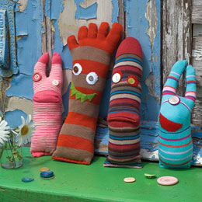
Eyes: sew buttons, and/or felt or fleece circles to colorful socks. Mouths: Cut mouths from felt or fleece, and glue to sock. Stuff socks with fiberfill, and stitch closed.

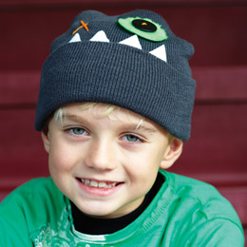
Monster Hats (Family Fun)
Materials: store-bought hat, buttons, embroidery thread, fleece, fabric glue. scissors
Instructions:
For eyes, use embroidery thread to sew on stacks of fleece circles and buttons, then add decorative stitches. Cut teeth from white fleece, then attach them with fabric glue to the hat's brim.

Fleece Scarves: (Family Fun)
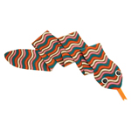Snake Scarf: Cut a long piece of fleece (ours measured 56 by 5 inches). Trim the fabric so that it's about 4 inches wide along the body and tapers to a point at one end for the tail and has a head shape at the other end. Sew on a fleece tongue. For eyes, sew on stacks of fleece circles and buttons with embroidery floss.

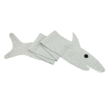 Shark Scarf:
http://familyfun.go.com/crafts/scarf-safari-973690/

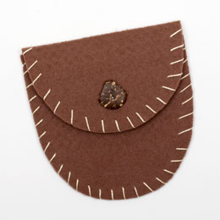Felt Pouch: http://familyfun.go.com/crafts/classic-camp-craft-pouch-675505/

Snacks
Peanut Butter Button Cookies
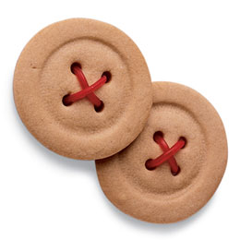
Ingredients:
1/2 cup peanut butter chips
1/2 cup smooth peanut butter (not natural)
1 cup unsalted butter, at room temperature
1/2 cup packed light brown sugar
1/2 cup sugar
1 large egg
2 teaspoons vanilla extract
1 teaspoon salt
2 1/2 cups flour
Red licorice strings (optional)
Instructions:
- Heat the oven to 375°. Microwave the peanut butter chips at medium heat for 1 minute. Stir the chips. If they're still not melted, microwave them for another minute, then stir them until smooth.
- In a large bowl, beat together the melted chips, peanut butter, butter, and both sugars with an electric mixer on medium-high speed until smooth and fluffy. Blend in the egg, vanilla extract, and salt. Gradually beat in the flour on low speed until a firm dough forms.
- Working with half the batch at a time, roll out the dough to a 1/4-inch thickness on a flour-dusted surface, using a lightly floured rolling pin. Cut out cookies with a 3-inch round biscuit cutter and transfer them to ungreased baking sheets. Reroll the dough scraps for additional cookies.
- Press the bottom of a small drinking glass into the center of each cookie to create a circular indentation. Then use the end of a drinking straw to cut four buttonholes in each cookie (twisting the straw a quarter turn each time will lift the dough from the hole).
- Bake the cookies until set and slightly golden on the bottom, about 8 to 10 minutes. Let them cool on the sheets for 1 minute, then transfer them to a wire rack to cool completely. Store the cookies in an airtight container at room temperature for up to 3 days.
- For a fun finishing touch, lace licorice string through the holes in each cookie. Starting from the back, thread a piece of licorice through the holes, crisscrossing it in front of the cookie. Trim the ends to about 1/2 inch long, leaving them loose at the back. Makes about 32 cookies.
You could also use sugar cookie dough instead. W.M.

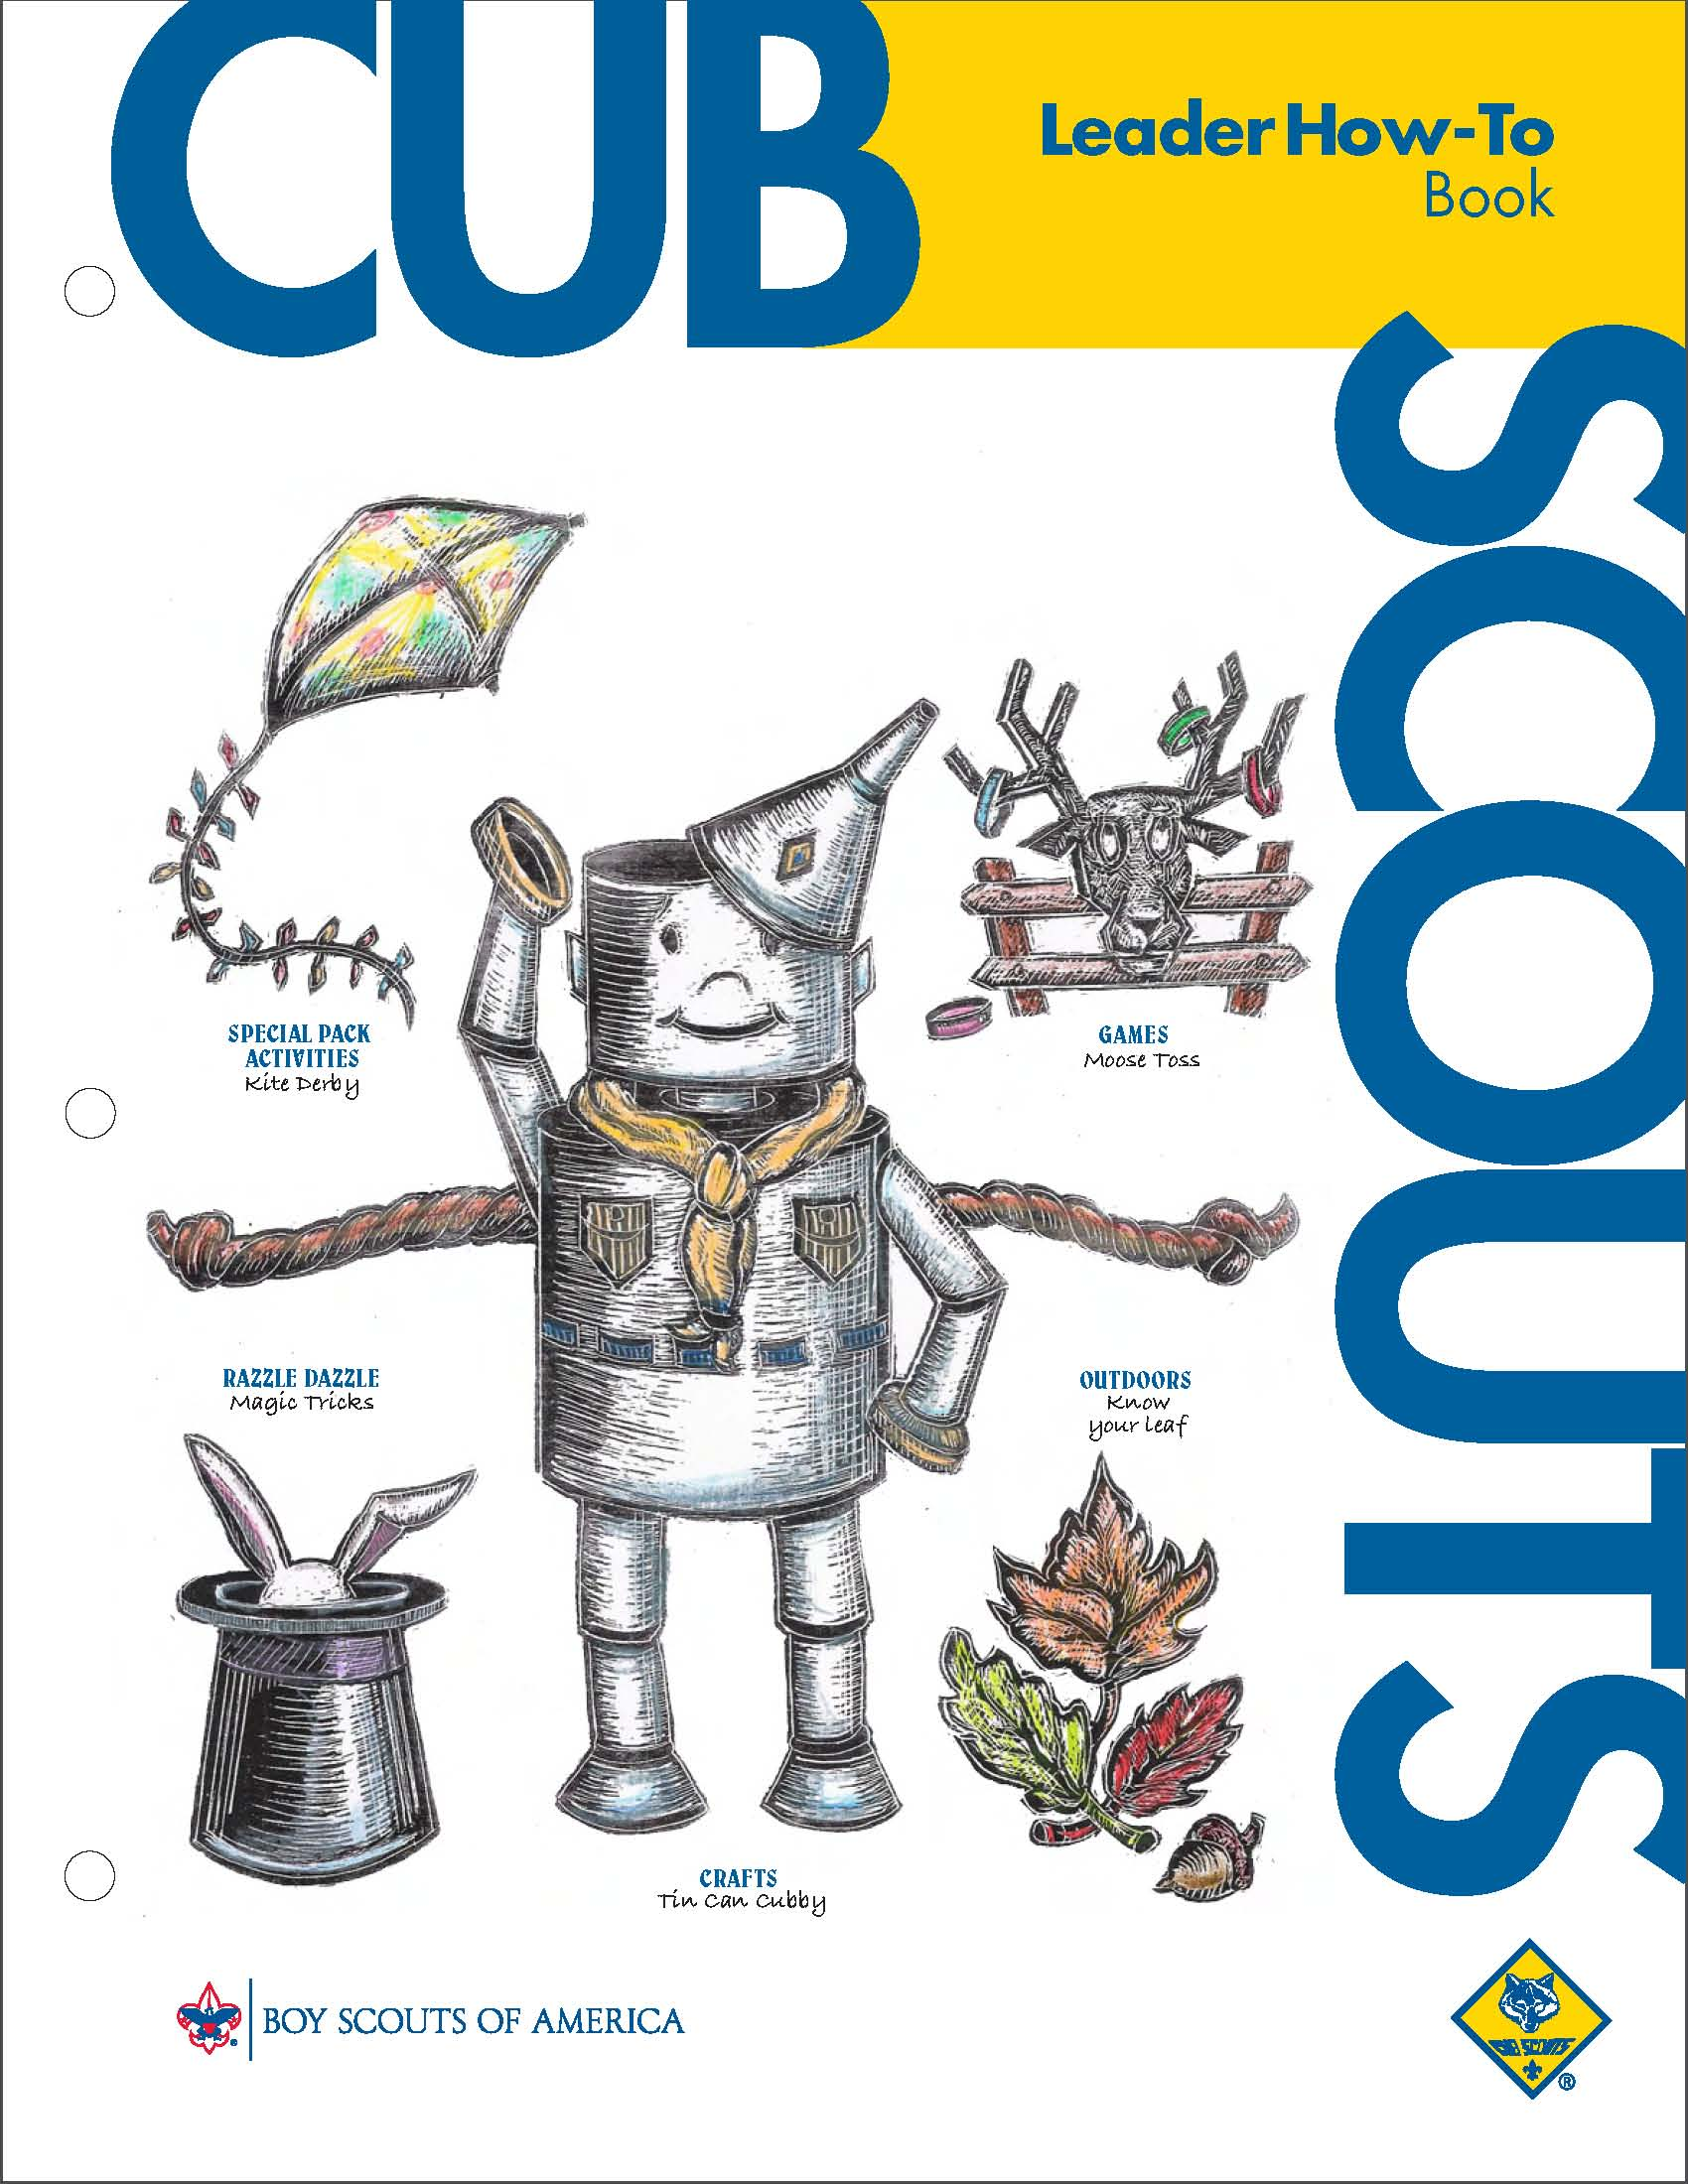
Bikes
Games: p. 3-11 to 13
Bike Rodeo: p. 6-11 to 12
Magic
Tricks, p. 5-49 to 58
Collections
Rock and Mineral collections, page 4-14
Collecting shells, p 4-16
Collecting insects, p 4-17
Picnic Ideas
Pack Picnic: p. 6-22 to 23.
Outdoor Games:, p. 3-11; 14-22



WOLF
Supplemental Den Meetings that go with the Perseverance Value (they require practice & patience):
A: Grow Something
H: Spare Time Fun (Kites)
Outdoor Supplemental Den Meetings:
A: Grow Something, and Birds
D: Swimming & Boating
G: Outdoor Adventure Fun
L: Grow Something (Garden Field Trip)
N: Sports (Baseball or Softball)
Outdoor Electives:
E4f Big Area Game
E5 Kites
E7b Puddle Jumpers
E13 Birds
E15 Grow Something
E18 Outdoor Adventure
E19 Fishing
E20 Sports
E23 Camping
Kite Ideas (Den Meeting H, E5)
How To Book section 2 p. 10-13, and section 6. p. 38-39.
For more kite ideas, check out the 2010 “Take Flight” theme: http://www.scoutingthenet.com/scouting/Training/Roundtable/Handouts/10/02/
and the ’03 theme “Soaring to New Heights”: http://www.scoutingthenet.com/Training/Roundtable/Handouts/03/08/

I have tried a variety of kites, and my favorite is Uncle Jonathon’s from Big Wind Kite Factory:
20 Kids * 20 Kites * 20 Minutes -
Uncle Jonathan's Easiest Classroom Kites Ever
http://www.bigwindkites.com/20kids/
Material list:
- 20 sheets of brightly colored 8 1/2" x 11" multipurpose printing paper. 20Lb. Bond is good.
- 20 8" bamboo skewers. Cut off sharp ends. Plastic coffee stirrers work quite well also.
- 1 roll of florescent surveyor's flagging plastic tape. Available at any hardware store. A plastic bag cut in a 1" wide spiral all around will also make a great tail.
- 1 roll 1/2"wide masking tape or any type of plastic tape.
- 1 roll of string. (min 200', 6 to 10 feet for each child.)
- 20 pieces of 1"x 3" cardboard for winding up the string.
- Scissors.
- Hole punch. (optional)
Directions:
- Fold a sheet of 8 1/2" x 11" paper in half to 8 1/2" x 5 1/2".
- Fold again along the diagonal line A in Fig.2. This diagonal line can be determined by making a mark at the top 1/2 inch from the fold and a mark at the bottom 3 in. from the fold and drawing a line between these marks.
- Fold back one side forming kite shape in Fig.3 and place tape firmly along fold line AB. (No stick is needed here because the fold stiffens the paper and acts like a spine.)
- Place bamboo skewer from point C to D and tape it down firmly.
- Cut off 6 to 10 feet of plastic ribbon and tape it to the bottom of the kite at B.
- Flip kite over onto its back and fold the front flap back and forth until it stands straight up. (Otherwise it acts like a rudder and the kite spins around in circles.)
- Punch a hole in the flap at E, about 1/3 down from the top point A. This hole can be reinforced with an additional piece of tape.
- Tie one end of the string to the hole and wind the other end onto the cardboard string winder.
- Go fly a kite!!!

Graham Cracker Kite
Catalina Council
Ingredients:
Graham Crackers, String Licorice, Colored Sugar, Sprinkles, Raisins, Chocolate Chips
Directions:
1. Frost half of a graham cracker.
2. One option is to use red string licorice and make a kite shape around the edges and middle of the cracker.
3. Decorate your kite.
4. Another option is to not use the licorice and use a
decorating set and decorate it any way you like.
5. You can put colored sugar, sprinkles, other fancy things
you buy in the store, raisins, chocolate chips, etc. on
your kite.

Plants & Gardening Ideas (Den Meeting A, E15)
What’s in the Dirt
Heart of America Council
Fill a pan with soil and place it in the sunlight. Water the soil to keep it moist. What do you see in the dirt? Is anything growing?
Terrariums
Alapaha Area Council
Terrariums are easy to make from plastic soda or water bottles. Clean off the entire label, then cut the bottle in half.
Put pebbles and potting soil in the bottom half. Plant some small plants and water sparingly. Use the top half with the cap on as a lid. Cut four 1” slits on the cut edge of the lid so it will fit over the bottom planted part. The plants will then water themselves from condensation on the inside of the bottle. They last a long time without care. You can add a ceramic or toy rainforest animal.

Games:
Wheelbarrow Race
Alapaha Area Council
Divide the den into pairs.
One boy in each pair “walks” on his hands while the other holds his legs as they race to a turning point.
Boys reverse positions, and new wheelbarrows race back on their hands to the starting line.

Treats:
Dirt Cups
A classic, from Barb at Pack 114
Crush 16 Oreo cookies and set aside. Pour 2 cups milk into medium bowl, and add 1 package instant Chocolate Pudding mix. Beat until well blended, 1-2 minutes. Let stand 5 minutes. Stir in cool whip and half of cookies.
To assemble, place 1 T crushed cookies in bottom of an 8-oz cup. Fill cups about 3/4 full with pudding mixture.
Top with remaining crumbs.
Optional garnish: place plastic flower in middle and put gummy worm halfway out of "dirt".

Gardening Websites:
Great planning ideas, and unusual containers for plants:
My first Garden: http://urbanext.illinois.edu/firstgarden/index.cfm
Good Tips for Gardening with Kids, taking into account short attention spans: http://aggie-horticulture.tamu.edu/kindergarden/pnote.htm

Wolf Meeting G – Outdoor Adventure Fun (E18d)
Alice, Golden Empire Council
Help plan and lay out an obstacle course. Use this idea or make your own.
An obstacle course is a good representation of why the boys need perseverance in their everyday lives – meeting and overcoming challenges instead of giving up.
- Include skills that take some practice, like some of the Ach. #1-Feats of Skill requirements – encourage the boys to try an extra time and always praise their effort – remind them they will get better with practice.
- Sometimes Perseverance means taking the time to do something the right way – so you could obstacles like a station where each boy has to put on a life jacket properly, or demonstrate the Buddy System for swimming with another boy, or tell one of the rules for safe fishing, flying a kite, or riding a bike.
- Label each obstacle with the name of some challenge that boys face every day – for example, bullying, or wanting to play instead of doing home or school work – or deciding not to try because another boy is a lot better than they are. You might even offer a choice of solutions and encourage and praise each boy for his efforts.
- After completing the Obstacle Course, give everyone a treat and spend a little time talking about the obstacles and making the connection to challenges the boys face in real life. See what kinds of solutions they can imagine.
Fun with Plants, page 4-6 to 4-9
Fun with Soil 4-12 to 4-14.
Rock & Shell Collections pp. 4-14 to 16
Kites, page 2-10 to 2-13
Kite Derby: page. 6—38 to 6-39

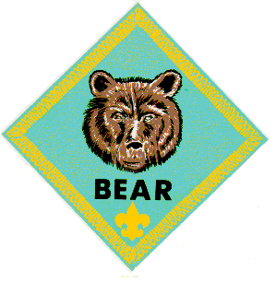

BEAR
Supplemental Den Meetings that go with the Perseverance Value (they require practice & patience):
B: Shavings & Chips
C: Tying it all Up
E: Magic
Outdoor Supplemental Den Meetings:
G: Nature Crafts (Solar Leaf Prints)
J: Landscaping
K. Farm Animals
L. Swimming
M. Boats
P. Family Fun (day trip)
Q. Family Outdoor Adventure (hike)
R. Camping
Outdoor Electives:
E2 Weather
E5 Boats
E7 Cubmobile
E9c Outdoor Art
E11b Outdoor Photography
E12 Nature Crafts
E14 Landscaping
E15 Water & Soil Conservation
E18 Backyard Gym
E19 Swimming
E20 Sports
E22 Collections (seed, leaf)
E25 Camping

Bear Ideas by Felicia
Felicia, French Creek Council
Please welcome Felicia. This is her first column. She has volunteered to write up activities for Bears every month. Could you do Tigers or Wolfs, please??
Meetings
Mtg Req # Subject
C Ach 22 Knots
E El 13 Magic
S Ach 4 Folk Tales
Bowline knot
Meeting C, Achievement 22, tying it all up.
For those of you who (like me) are not rope & knot experts learning rope work can require perseverance – practice & more guidance will make this achievement go smoothly. In Den Meeting Plan C, you will find helpful diagrams on how to do the knots. Here is a link to BSA's bear den plans. http://www.scouting.org/scoutsource/CubScouts/Leaders/DenLeaderResources/DenandPackMeetingResourceGuide/BearDenPlans.aspx Visually seeing someone walk you through the knot can be very helpful too. The internet has videos, so you can see someone tie any knot that is giving you trouble.

22a This video will help you master the technique of whipping the end of a rope (plus it teaches you 2 others). http://www.youtube.com/watch?v=YMq9KdOtSJ0

22b This link explains how to tie the 5 knots & more (plus it links to video lessons). http://www.2020site.org/knots/ Here is a cool link of animated knots recommended by Pack 152 in Kingsport, TN. http://www3.sympatico.ca/lar.richardson/nlknots.htm

22e (learn 3 magic rope tricks for elective 13d) In the Cub Scout Leader How-to Book 5-56 there is a disappearing knot trick.

Magician Tim Mannix teaches the arms crossed knot & the impossible knot on this site (be aware I would rate him pg – so it may be best to just use it to teach yourself & not the cubs how to do the tricks). http://www.ehow.com/video_4396907_magic-rope-trick-free-magic.html

Impossible knot You have the rope lying so the audience can't see the ends. There already is a knot in one end. You pick it up so the knot is secured between your fingers in the palm of your hand and the untied end is between your thumb & fingers. The rest of the line is making a loop hanging from your hand – you make a stirring motion and then snap the rope letting go only of the untied end. You complain about being rusty and try it again. Once more you do it and fail, complaining about a draft. Finally you move the untied end between your fingers to hold tight & put the knotted end between your thumb & fingers to let it fly. You snap the rope hard & voila, an impossible knot.

Magician Malik Haddadi shows some rope tricks on this site. http://www.ehow.com/videos-on_3202_do-rope-magic-tricks.html

Jumping Rings Trick Have a rope with 4 knots in it. The first knot is a slip knot, the rest are overhand knots. Have a ring tied in the middle overhand knot. Hide the end overhand knot in your hand so the audience only sees 3 knots. Tell them you can make the ring (which looks like it is in the end knot) jump to the center knot. Say a magic word and pull the slip knot out while sliding your hand off of the hidden knot – now it looks like the ring jumped to the center (when all you did was slide the rope).

Meeting E, Elective 13, Magic

Perseverance is definitely required to learn the slight of hand required for magic tricks. In the Cub Scout Leader How-to Book there are over 40 tricks. Mind Reader (5-56) is a neat one. I tell everyone that I can leave the room and name any object they select while I am gone. When I return my accomplice asks “was it ? and every time I say no. Then my accomplice names a black object & I say no – but now I know the next object is the one the audience selected. My accomplice then names the selected object and I say yes. Everyone is amazed.
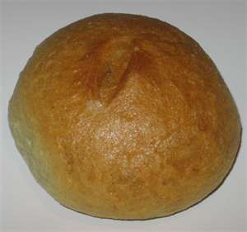
This site, from Activity TV, has Ryan Oakes performing & teaching how to do a disappearing card trick that is very cool. http://www.activitytv.com/469-toss-up-vanish Plus there are many other wonderful tricks taught here such as:
The Bouncing Bread Roll. Take a round roll and pretend to throw it on the floor. When your hand is below the table and out of site (without moving your upper arm or forearm) flip your hand upwards, tap your foot on the floor (to sound like bouncing bread) and using only your wrist & fingers toss the bread up into the air.
Rubber Pencil. Hold a pencil loosely horizontally and jiggle it up and down so it looks like it is made out of rubber.

This site has several neat tricks – including this one where you magically, accidentally tie a knot in a chicken bone. http://www.kidzone.ws/magic/abracachicken.htm

On this site Wayne Kawamoto gives his ideas on how to satisfy the magic electives. http://magic.about.com/od/beginningmagic/a/120706scouts.htm
Elective 13 c Puzzles
Here is an online tanagram puzzle. http://www.grand-illusions.com/articles/russian_puzzle/

To satisfy this you could use a Rubik's cube, wooden peg puzzles, Chinese puzzle boxes, disentanglement puzzles, which you may have around your house (or be able to borrow them from someone, if you ask around).

Riddles can also fulfill this elective. Such as the following from http://riddles.com/

Written by Jim Taylor
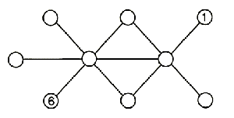
Can you arrange the numbers 1 to 9 in the circles so that each straight line of three numbers totals 18?
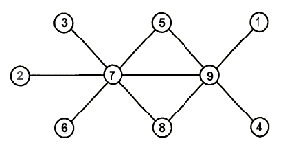
Written by Jim Taylor
- For some I go fast
- For others I'm slow.
- To most people, I'm an obsession
- Relying on me is a well practiced lesson.
- What am I?
Time
Written by Hans G
- A blue house is made of blue bricks.
- A yellow house is made of yellow bricks.
- A red house is made of red bricks.
- An orange house is made of orange bricks.
- What would a green house be made of?
Glass
Written by Jim Taylor
- There are 20 people in an empty, square room. Each person has full sight of the entire room and everyone in it. If you are not allowed to move in any way (other than your eyes). Where can you place an apple so that all but one person can see it?
Place the apple on
one person's head

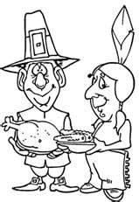
Meeting S, Achievement 4, Tale Tales

Here is an opportunity to discuss the steady persistence in a course of action despite difficulties, obstacles, or discouragement told in folk tales. This site talks about American folk lore. http://en.wikipedia.org/wiki/Folklore_of_the_United_States It refers to the perseverance of the Pilgrims as the struggled through their first winter, helped by Indians such as Squanto – leading to the celebration of Thanksgiving. Molly Pitcher endured 100 degree weather to haul water to soldiers & then operated a canon in the extreme heat. Casey Jones told his fellow engineer to jump out of the Train, knowing that the only way to save others' lives was for him to remain, blow the whistle and slowing the train as much as possible before its crash. Frontiersman Daniel Boone blazed the Wilderness Trail through hostile Indian Territory: later in life, he was captured be the Shawnee Indians & survived. Johnny Appleseed's planted apple orchards across the land. Geronimo, an Apache military leader, famous for his brave exploits & many evasions of capture while fighting both Mexican & US troops from 1858-86., Are some of the many that can be used to discuss perseverance.
A fun way to introduce tale tales to your den may be to watch one of the shorts on Disney's 2002 DVD American Legends. This features cartoons on Johnny Appleseed, Casey Jones, Paul Bunyan, & John Henry. Your den could read the story of (Paul Bunyan's) Babe the Blue Ox. http://americanfolklore.net/folklore/2010/07/babe_the_blue_ox.html Listen to or sing a song about John Henry. http://toneway.com/songs/john-henry
http://www.npr.org/programs/morning/features/patc/johnhenry/index.html#audio Or read a poem.
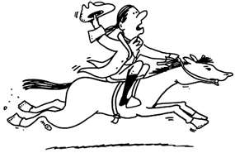Paul Revere's Ride
Henry Wadsworth Longfellow
Listen my children and you shall hear
Of the midnight ride of Paul Revere,
On the eighteenth of April, in Seventy-five;
Hardly a man is now alive
Who remembers that famous day and year.
He said to his friend, "If the British march
By land or sea from the town to-night,
Hang a lantern aloft in the belfry arch
Of the North Church tower as a signal light,--
One if by land, and two if by sea;
And I on the opposite shore will be,
Ready to ride and spread the alarm
Through every Middlesex village and farm,
For the country folk to be up and to arm."
The rest of the poem can be found at http://poetry.eserver.org/paul-revere.html Historians will tell you that this poem has inaccuracies in it & is more for fun than learning History.

This website has a pattern for cards to play a folk lore matching game.
http://strongarmor.blogspot.com/2009/05/cub-scouts-tall-tales-matching-game.html
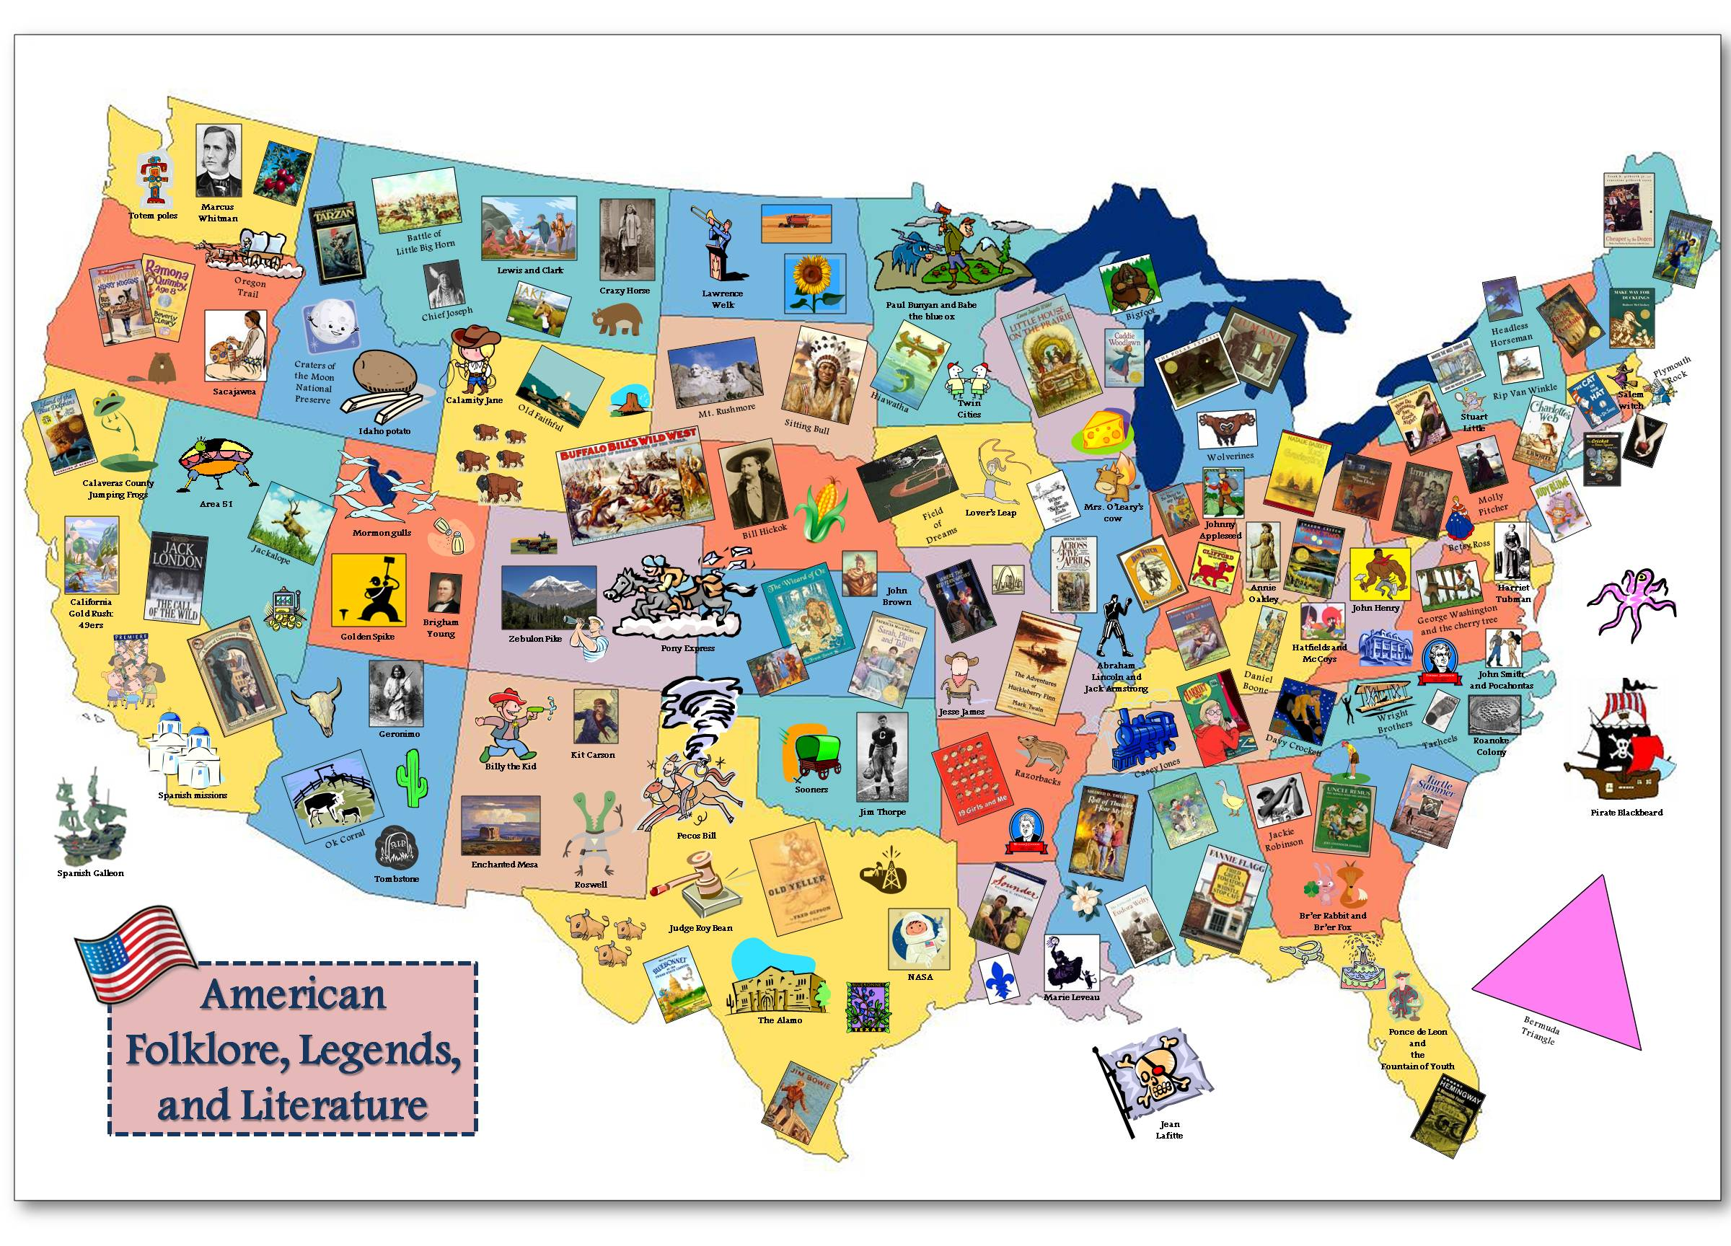
This wonderful map of American Folklore, Legends, & Literature was recommended by Pack 25 in Louisiana. It can help your cubs do Ach. 4 b. http://cardinalscholar.bsu.edu/307/1/American_folklore.jpg

This map is part of the GRMC "Resources for Teachers" collection of lesson plan ideas using maps for the K-12 educator. Teachers can print copies of the map to be used in the classroom. This is a sample of a culminating project where students create a map showing famous folklore and works of literature in the United States. This lesson is part of an instructional session provided to social studies class by the GRMC. Ball State University. (Unpublished)

Make Johnny Appleseed Apple Smiles for a snack. Take two apple wedges -smear them with peanut butter – add mini marshmallows for teeth.


For Craft Carve a Johnny Appleseed Apple Head Doll. Peel & core a large apple. Carve a face in it. Set it aside for several days until it is shrunken & all dried & wrinkly. When it is fully dehydrated, you can paint facial features on it. These sites have more info on making one of these dolls - including soaking them in salt water &/or lemon juice. http://www.mtnlaurel.com/Crafts/apple.htm http://www.suite101.com/content/how-to-make-an-apple-head-doll-a48226 http://www.elder-one-stop.com/apple-doll.html & http://familyfun.go.com/crafts/apple-dolls-666871/
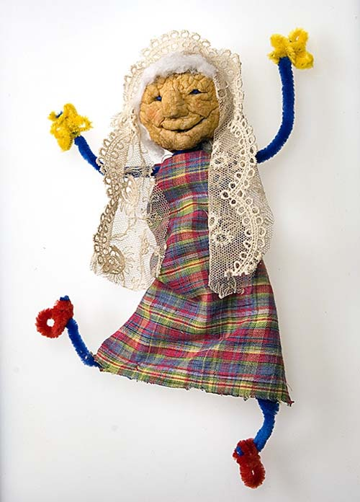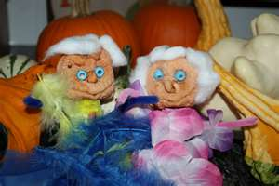

More Bear Ideas by Wendy

Carving Ideas (Den Meeting B, Ach. #19)
This den meeting was covered in last month’s Baloo. But I did want to suggest another carving material: floral foam or Styrofoam. Both are easy to carve and poke. And you can paint the Styrofoam so it looks like a rock carving. First, carve a bas-relief carving into a Styrofoam block. (Simple Mezzo-American designs work nicely for this project.) Then paint the block a medium toned rock color (gray, brown, etc.) Dip a toothbrush into contrasting paint. Hold the toothbrush over the Styrofoam, and rub a pencil across it so that paint spatters onto the block to create speckles. The finished effect looks remarkably like granite.

Plants & Gardening Ideas (Meeting J, E14)
See the Wolf section above.

Magic Ideas (Meeting E, E13)
For more ideas, see the magic section in the Tiger Den Meetings above.
And check out the ’08 “Abracadabra” theme at: http://www.scoutingthenet.com/scouting/Training/Roundtable/Handouts/08/03/

Magi c Tricks
How-To Book section 5 p. 49-58.

Seeing Spots Magic Trick:
You hold a cardboard with dots in front of your friend and ask how many dots are on the card. He’ll say One. “Fine” you say, flipping the card over. “Now, how many on this side?” He’ll look and say he sees 6 Dots. “Exactly,” you say. “But let’s check that other side again, shall we?” You flip it over and now he sees….THREE Dots! And the other side? Again, you flip the cardboard over and NOW he sees FOUR Dots! By this time, your friend is seeing spots.

You will need to prepare a big piece of cardboard first. On one side, use a marker to make two dots like this:
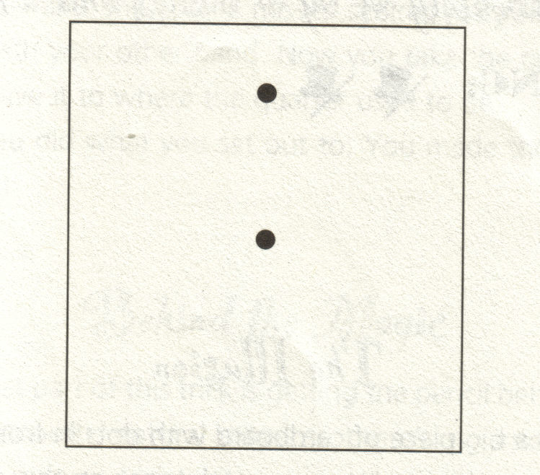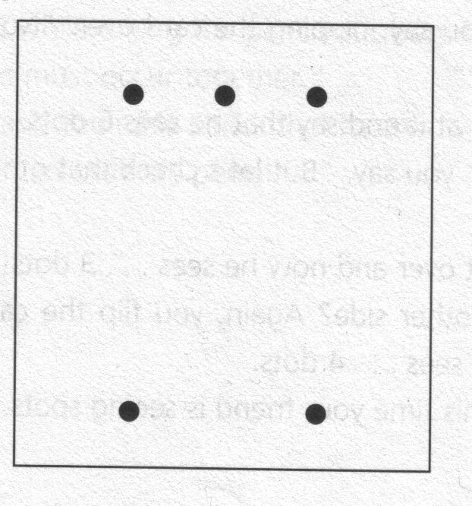
On the reverse side, put five dots in this pattern.
Here’s how to confound your friend:
- First, show him side A, but with your hand and fingers hide the TOP dot. All he will see is that center dot, so he’ll say that side A has One Dot.
- Now flip the card over, holding your fingers over the middle bottom space where there is NO dot. Your friend will say there are 6 dots, because he’ll assume there’s a dot where your finger is.
- Now, flip your card over to side A, but hold it right below the center dot, where a THIRD dot might me – but isn’t! You friend will “see” Three Dots on the card. Again, in his mind, he completes the pattern.
- Flip over to Side B, and hold the card so the top center dot is masked … and he will see ONLY Four Dots!
- It will seem to be quite a magical card you have there!

Cutting a Clown in Half Heart of America Council (Sept. ’04 Baloo’s Bugle)
Clown Pattern: http://usscouts.org/usscouts/bbugle/bb0409.pdf
Materials: Clown print, Thin cardboard, Scissors, Envelope
- Directions:
- 1. Color the clown and cut it out.
- 2. Then mount it on thin cardboard.
- 3. To prepare the envelope, cut off a strip (about 1 " wide) at each end.
- 4. Seal the flap, then cut two slots in the back of the envelope as shown in Fig. 1.
- 5. Show the clown and the envelope, but keep the back of the envelope towards you.
- 6. Insert the clown into the envelope.
- 7. As you do this, push the clown out the first slot and back through the second slot as shown in Fig 2.
- 8. Insert the scissors so that they appear as in Front View Fig. 3, and are positioned as shown in Rear View Fig. 3.
9. Now cut through the envelope, holding the two halves together. Let the scissors fall onto the table. Invite someone from the audience to pull out the clown, pulling the envelope halves apart after the clown has been removed.

Water Travel (from a book of magic tricks, which unfortunately, I don’t have the name of)
Materials: 2 paper bags, 2 paper cups, a jug of water.
Preparation: Cut the bottom out of one of the cups, and the top rim off the other cup, if necessary. Place the bottomless cup inside the other cup. Together, they should look like one ordinary cup.
Performance:
- Pick up the cup and pour some water into it.
- Tell the audience that you will make the water travel from one bag to the other. As you do, put the cup into the first gab, then pretend to take it out again right away, as if you are demonstrating what you are going to do. In fact, you should leave the bottom cup in the first bag and take out only the inner bottomless cup, which will contain no water.
- Place this cup in the second bag.
- Pick up the second bag, fold down the top, and toss it over your shoulder.
- Lift the cup out of the first bag, lift out the cup, and pout the water back into the jug.

Treats: See the Tiger Magic section

Knot Ideas (Den Meeting C, Ach. #22)
Games:
Save My Child
You will need 6 pieces of 4-foot long rope per team, a blanket (for indoor game) or a wagon (for outdoor game), and a broom handle or stout stick. The object of the game is to tie the ropes together to have a rope long enough to throw to someone out about 15 feet away and pull them to safety. One boy sits on the blanket or in the wagon and waits for his team to tie the ropes together using square knots or sheet bends. Once the rope is thrown to the waiting boy, he must tie a bowline in the end while the other boys tie a clove hitch around the stick. All pulling must be done on the stick and not the rope. The first team to pull the boy to safety with all the knots properly tied wins.
from Pack 114 library: https://people.creighton.edu/~bjs74318/bluejay/pack114/library/knotgames.html

Hauling Hitch: timber hitch with single half hitch
Each patrol is to pull logs or similar items across a space or distance using a timber hitch with a single half hitch for fastening on to the log. Winning patrol is patrol with all logs hauled with proper hitch. (http://gtsurber.tripod.com/games-knots.htm)

Knot Trail
Several lengths of rope are tied together with various knots and stretched between two trees. The patrol walks the rope and then attempts to list correctly all the knots including the ones holding the rope to the trees. One point for each correctly
named knot. (http://gtsurber.tripod.com/games-knots.htm)

Test of Strength
For this game, all players need practice ropes of the same thickness. Players sit in a circle holding their ropes. Each girl ties one end of her rope with a square knot to the rope of the girl on her left. When all knots are tied, lift the rope circle over your heads and down to the middle of your back. At a signal, lean back hard against the rope circle. (If any of the square knots aren’t correctly made, you’ll all fall over backwards!!)
Try this game making the knots behind your back instead of in front of you or tie with your eyes shut. (http://www.gseiwi.org/events/KnotsandKnotGames.pdf)

Licorice Challenge
Instead of using rope, use Twizzlers or licorice whips or other "whip"/shoelace candy. When the boy gets the knot right, he can eat it. Now, you have to be careful with this one - - don't use a "whip" that's really soft or sticky, especially in hot weather. The Twizzlers are just right, they don't stick to themselves and they don't melt readily - - and more boys like the flavor than do licorice. (http://guidezone.e-guiding.com/knot.htm)

Crafts:
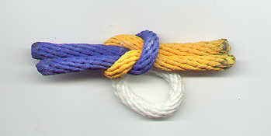
Knot Tie Slide: Dye cotton rope in appropriate colors, tie the knot, and use a little glue to hold it together. Attach a loop and you're set! If you're using nylon rope, you'll need to melt the rope ends a bit to prevent fraying.
From: http://cubclub.tripod.com/craft.html

Do Knot Disturb sign: Make a knot from colorful rope, and glue it to a foam or craft stick door hanger. Write “Do Knot Disturb” on the door hanger.

Helpful Hints:
It's helpful to have a knot board or 2 around. A lot of the kids keep asking "is this right?" when they haven't got anything close to right! With the knot board you can simply ask them if they think it looks like what's on the knot board. (http://guidezone.e-guiding.com/knot.htm)

WEBELOS

Puppets, pp. 5 - 12 to 24
Magic, pp. 5-49 to 58
Rock & Shell Collections pp. 4-14 to 16
Fun with Plants, 4-6 to 4-9
Fun with Soil, p. 4-12 to 14

ARROW OF LIGHT

Your Webelos Arrow of Light Group should have graduated to Boy Scouts,. If not, make sure they are working to do that this month.

WEBELOS DENS

Joe Trovato,
WEBELOS RT Break Out Coordinator
Westchester-Putnam Council
Have a question or comment for Joe??
Write him at
webelos_willie@yahoo.com
There is an underscore between Webelos and Willie

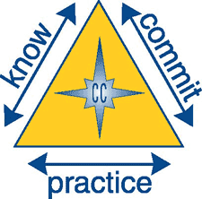
Core Value for June
Perseverance


Perseverance: Sticking with something and not giving up, even if it is difficult.

“Perseverance is not a long race; it is many short races one after the other.” –Walter Elliott

The core value of Perseverance can be worked into many of the Webelos programs and, as a leader; it is perhaps the one factor in success that sometimes is overlooked. You need to teach perseverance in a way that will allow scouts to apply this value both in scouting and in other areas of their lives. How many children simply quit trying in school or sports, because they are “not good at it’ or find it “too hard”? Perhaps the following approach, used in connection with the Athlete Webelos badge activity, may be applied to other situations and is one way to show that perseverance may lead to success.
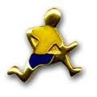
ATHLETE

- Know- Review the requirements for the Athlete Badge and decide which ones might be more difficult for you to do. Make a plan to complete one of the harder requirements.

- Commit- When doing the harder requirement, did you ever feel frustrated or angry? What did perseverance have to do with that? Name another type of task for which you will need to persevere.

- Practice- Practice perseverance by following your plan to do that requirement for the Athlete activity badge.

Currently, recognition can be earned for the following 28 sports:
Archery, BB-Gun, Badminton, Baseball, Basketball, Bicycling, Bowling, Fishing, Flag Football, Golf, Gymnastics, Hiking, Hockey, Horseback Riding, Ice Skating, Kickball, Marbles, Physical Fitness, Roller Skating, Skateboarding, Snow Ski and Board Sports, Soccer, Softball, Swimming, Table Tennis, Tennis, Ultimate, and Volleyball

Perseverance Activities
deseretpeakcubscouting.com

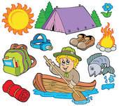

Also consider other outdoor activities which can be used to teach this month’s core value of Perseverance:

- Plan a hike where boys encounter obstacles similar to those an early explorer might have encountered. Talk about how pioneers and early explorers persevered to reach their destinations.

- Study plants that survive difficult environments. Encourage boys to keep trying when an activity is difficult.

- Institute a tutoring program. Boys can plan rewards for the students who persevere until they finish.

- Plays a game related to pioneers and discuss their perseverance to complete their journeys. Tell boys that those who persevere improve their skills.

- “Lewis and Clark” could conduct an awards ceremony. “George Washington” could also, after “crossing the Delaware”. Pioneers could deliver awards from a covered wagon.

- Pioneer and frontier days are good themes to incorporate.

- Visit a local gym and talk with a personal trainer.

- Visit with a doctor and talk about education.

- Visit a local outdoor track facility and talk with a long distance runner.

- Plan some Dutch oven cooking during a pack overnighter and open campfire cooking so boys experience something like pioneer life.

Reminder: Two-Deep Leadership Required
It is the policy of the Boy Scouts of America that trips and outings may never be led by only one adult. Two registered adult leaders, or one registered adult leader and a parent of a participant, one of whom must be 21 years of age or older, are required for all trips and outings. "e chartered organization of any Cub Scout pack,
Boy Scout troop, Varsity Scout team, or Venturing crew has the responsibility to stress to the committees and leaders of the unit that sufficient adult leadership must be provided on all trips and outings. JT

Eisenhower Leadership Patch

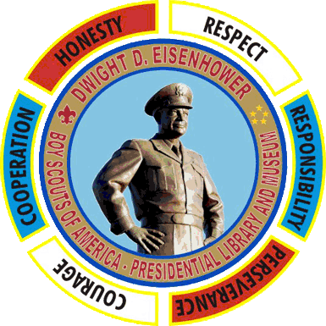

You may also want to check local historic sites that may have scouting programs that would help teach Perseverance, as well as other core values. If you live in the Abilene, Kansas area, the Dwight D. Eisenhower Presidential Library and Museum allows Scouts to earn the Eisenhower Leadership Patch through a joint program developed by the Eisenhower Presidential Library and Museum and the Coronado Area Council of the Boy Scouts.

Information about earning the Eisenhower Leadership Patch and the program curriculum are available online at www.eisenhower.archives.gov/Boy_Scouts/bsa_index.html.

Scouts may work on the Eisenhower Leadership Patch and up to two rockers during a single visit to the museum.

The worksheet for Perseverance may be found at
http://www.eisenhower.archives.gov/Boy_Scouts/eisenhower_leadership/cub_scouts/Perserverance.pdf

Book Corner

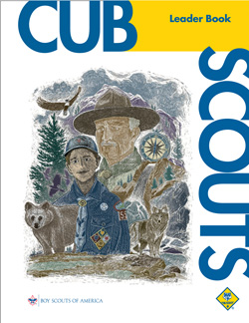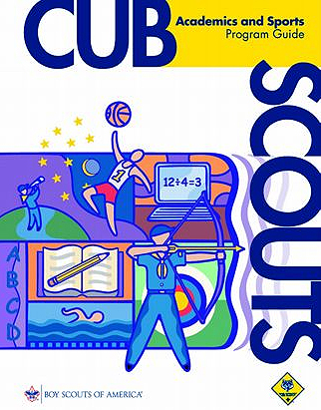

From the Cub Scout Leader Book (page 4-4):

Some Practical Applications:

• Finish what you start.
• Never give up.
• Continue to work hard even if you’re not successful at first.
• Work to get better at things you aren’t very good at.
• Set personal goals for improvement.
• Always do your best.

Academic and Sports Program Resource Guide

With the warm weather here it is a perfect time for outdoor games. Webelos Scouts can join in the fun by applying the Perseverance exercise use for the Athlete badge while practicing their skills in their favorite sports and by working on Sports Program belt loops and pins. A Bike Rodeo would be a fun pack activity, with boys working toward earning the sports belt loop or pin in Bicycling. Organize an ultimate tournament or a badminton tournament or any of the other Cub Scout sports. Information on the requirements for the various sports belt loops and pins can be found on-line at
http://www.scoutstuff.org/BSASupply/images/pdfs/34299_07_CS_SA_Guide.pdf. Recognition may be earned for 28 sports.

Welcome To New Webelos Leaders
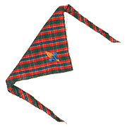
On June 1, Bear scouts become Webelos Scouts, and you dear leader, are now a Webelos Scout leader! What should you do to prepare? The BSA says:

1. Complete Fast Start training for Webelos den leaders. Your pack leadership (pack trainer) will facilitate this video–based training, or you can complete the training online under Cub Scouts/Adult Leaders/ Training at www.scouting.org . Youth Protection training for all Scouting volunteers is available through your local council Web Site.

2. Begin reading the Cub Scout Leader Book. (To start right away, you may need to borrow a copy briefly; until you can get your own.) This book describes your role as a Webelos den leader and will give more information on the following steps.

3. Get acquainted with your Cubmaster and pack trainer. These leaders will see that you have the information and material you need to get started off on the right foot.

4. Obtain (or borrow temporarily) the Webelos Leader Guide and begin reading it. This book describes projects that boys can do to complete requirements for Webelos activity badges.

5. Plan your first month’s den meetings. This is much easier with the new program meeting plans. Get help from the pack trainer, assistant Webelos den leader, den chief (an older Boy Scout or Venturer helper), the Webelos Leader Guide and Cub Scout Program Helps. The key to success is “KISMIF” (Keep It Simple, Make It Fun.”

6. Get acquainted with the families of the boys in your den. Hold a family orientation meeting. The Cub Scout Leader Book has a recommended agenda. You will need the families’ help, so get to know them early.

7. Get acquainted with the boys in your den. Establish a den code of conduct so that they will know what you expect of them. See the Cub Scout Leader Book for details.

8. Ask your Cubmaster to help you secure a Webelos den chief. Give your den chief meaningful responsibilities right away.

9. Obtain and begin wearing the Cub Scout leader uniform as soon as possible. It is attractive, comfortable, and suitable for all Cub Scout meetings and activities. Wearing the uniform properly is important in setting a good example for the boys. Your Cubmaster or pack trainer can tell you where to obtain the uniform and insignia.

10. Attend the monthly planning meetings held by your pack. These meetings are led by the pack committee chair and the Cubmaster, and are where pack plans are made.

11. Attend the monthly district Cub Scout leaders’ roundtable. You will receive many good program ideas and become acquainted with Webelos den leaders from other packs, who will share ideas and experiences with you. Your Cubmaster or pack trainer can tell you when and where the roundtable meets.

12. Attend Cub Scout leader basic training as soon as possible. There are two components to this training: Webelos Den Leader Specific Training, a specialized session to help you successfully plan a fun and exciting den program, and New Leader Essentials, which is attended by leaders in all program areas. These will give you the foundation you need to become an effective and successful leader. Every boy deserves a trained and qualified leader. Your Cubmaster or pack trainer can give you information about training sessions.

Don’t hesitate to ask for help. There are many people who want to help you provide
Remember, the goal of every leader is that Webelos Scout continues his Scouting experience as a Boy Scout. The key factor is a working partnership between the pack and the Boy Scout troop!
More help for new Webelos leaders next month.

Bear to Webelos Transition Ceremony
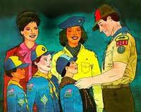
Make sure that your June pack meeting includes a ceremony acknowledging the transition of the bear den to a first-year Webelos den. The ceremony should be at a pack meeting so that the younger scouts can see the importance placed on the Webelos program, including its different approach as well as preparation for Boy Scouts.
The following a one variation of the typical ceremony used for this important occasion.

EQUIPMENT: Spirit of Scouting candle and holder, badges, colors and neckerchiefs.
PERSONNEL: Cubmaster, Webelos den and den leader, den chief.

Webelos den leader, Mr/Ms.______ , will you and the den please come forward and join me on stage.

Tonight we have (number) Bear Cub Scouts who have entered the fourth grade and are joining our Webelos den. Den Chief,________, escort Bear Cub Scouts,______ , and their parents to our awards table please. (Cubs' names) you have shown yourselves worthy of joining our Webelos den by working hard through the ranks of Wolf and Bear. We would now like to present to you the new parts of your Cub Scout uniform. (Webelos den leader presents parts as they are explained.)

Mr._______, please remove their neckerchiefs and replace them with the Webelos neckerchief. Next, place the Webelos badge of colors on their right shoulder. These colors will tell everyone that you are an older boy preparing for the adventures of Boy Scouting. The badge of colors will hold the activity badges that you earn as you explore some of the 20 Webelos activities with your den.

Parents, you have helped your sons along the Cub Scout trail this far. It is important that you continue to go along with your sons and learn about the Boy Scout trail in his Webelos den. We know that we will soon have the pleasure of seeing you present your son with activity badges, the Webelos badge, and finally, the Arrow of Light award, the highest in Cub Scouting,

Congratulations Scouts, & Parents, and remember to keep the spirit alive in all that you do.

Pack, how about a cheer for our new Webelos scouts, their parents, and especially for Mr/Ms.________ , their leader.

Cub Scout Day Camp
Cub Scout/Webelos Resident Camp

Don’t forget to get your Webelos registered for summer camp. I strongly recommend Webelos resident camp to get the scouts ready for Boy Scout summer camping. Webelos scouts (formally Bears before June 1st may be eligible for Webelos resident camping. Check with your local council or district office. If resident camp is unavailable a Webelos day camp should be the option.

Cub Scout day camp is an organized, one- to five-day theme-oriented program for Tiger Cubs and their adult partners, Cub Scouts, and Webelos Scouts. Day camp is conducted by the council/district under National Camp School leadership at an approved site during daylight or early evening hours. Day camps do not include any overnight activities. The day camp program is age-appropriate and theme-based and offers a variety of outdoor experiences, including sports.

Webelos Scout resident camping is a council-organized, theme oriented, overnight camping program.
It operates for at least two nights and is conducted under trained leadership at a camp approved by the council. In most cases, each youth member will be under the supervision of a parent or guardian. In all cases, each youth participant is responsible to a specific adult.

Resident camping typically includes the following outdoor program areas: Showmanship, Sportsmanship, Craftsmanship, Waterfront, Fitness, Campcraft, and Nature. Each year, councils change their overall theme to offer different adventures. Examples of themes include Sea Adventure, Space Adventure, Athletes, Knights, Circus Big Top, and Native Americans.

Meeting Planner


The scheduled monthly meeting plans for First Year Webelos ended with meeting 18. Your first year Webelos should be looking forward to being Second Year Webelos, and earning the Arrow of Light Award.

The first few meetings next year have Second Year Webelos working at home on the Family Member Activity Badge. Encourage them to work through this activity badge over the summer. You may start the badge with them, by giving them ideas to help them prepare.

Flag Ceremony for June
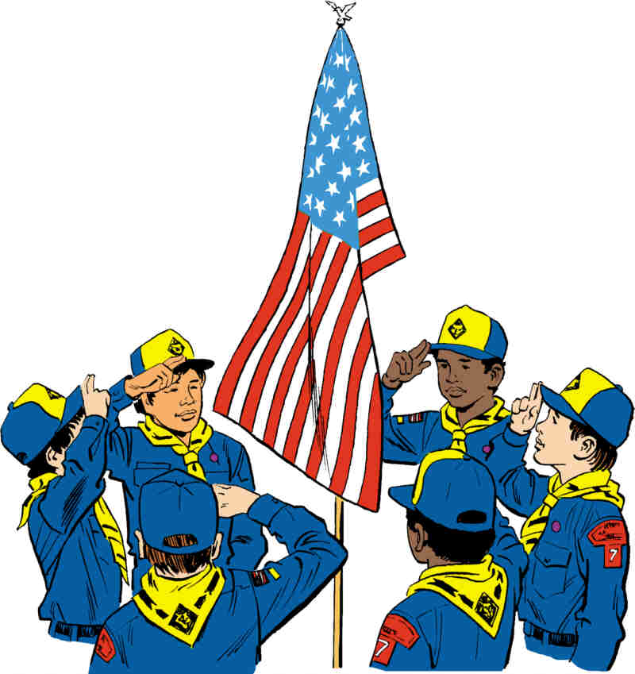

In June, Flag Day (the 14th) and Father’s Day (the 19th) may form the basis for your flag ceremony.
The following is a ceremony for Flag Day.
Follow your standard Color Guard process (for Den or Pack meeting. After the Cub Scout promise (or Boy Scout Law, and Oath, if this is a Webelos Den meeting) and before posting the U.S. Flag and reciting the Pledge of Allegiance, you should have three or four Webelos Scouts come up and read portions of the following tribute to Old Glory:
I AM THE FLAG OF THE UNITED STATES OF AMERICA. MY NAME IS OLD GLORY.
I FLY ATOP OF THE WORLD’S TALLEST BUILDINGS. I STAND WATCH IN AMERICA’S HALLS OF JUSTICE.
I FLY MAJESTICALLY OVER GREAT INSTITUTIONS OF LEARNING.
I STAND GUARD WITH THE GREATEST MILITARY POWER IN THE WORLD. LOOK UP! AND SEE ME!
I STAND FOR PEACE - HONOR - TRUTH AND JUSTICE.
I STAND FOR FREEDOM.
I AM CONFIDENT
I AM PROUD.
WHEN I AM FLOWN WITH MY FELLOW BANNERS MY HEAD IS A LITTLE HIGHER. MY COLORS A LITTLE TRUER.
I BOW TO NO ONE.
I AM RECOGNIZED ALL OVER THE WORLD.
I AM PROUD. MY NAME IS OLD GLORY.
DEAR GOD, LONG MAY I WAVE.
[Taken from a longer piece authored by Howard Schnauber, WWII Vet]
Den Meeting Helpers
Webelos

In addition to working on Family Member over the summer, the first meeting in September for Second Year Webelos will be focusing on Aquanaut and the swimming belt loop – two activities well suited for summer activities. A meeting with the parents at this time to get their help for summer activities may be in order. Another good activity for these meetings is to work on the Emergency Preparedness BSA Award for Webelos
AQUANAUT

Get to the pool with your den and parents if you can. One of the main points of this badge is to teach safety rules. These rules will be found at every Scout waterfront. The rules may not particularly impress a Webelos Scout this year at the neighborhood pool where he swims daily, but this summer and next year at summer camp, their value will become apparent to him.

Rules For Safe Swim
1. Secure adequate facilities.
2. Teach the Buddy system.
3. Maintain good discipline.
4. Follow pool rules.
5. Teach rescue methods
6. Use a qualified instructor (Check with a local troop).
(Always check in “Guide to Safe Scouting" for all the Safety Afloat and Safe Swim Defense information. Copies may be found at www.scouting.org .)
GAMES
Here are some games you can play at the pool:

Dog Race


Divide den into two teams and line up at poolside. First racer barks like a dog three times, then jumps in and swims to the other side doing the doggy paddle. When he touches the other side, he barks again like a dog. The next racer answers (barking three times) and jumps in. Repeat until all the "dogs" on one team are on the other side.

Nuts and Bolts



A good way to get used to being underwater is to toss a large bolt with a nut on it into waist-deep water. Scouts bend down to find the bolt and unscrew the nut while underwater.
If he can't finish the job, he must drop the bolt and come up for air. Then he goes down again. Hold up the two pieces when finished.

Thar She Blows

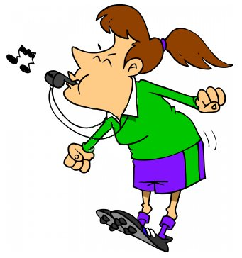
For this game you will need a whistle that will sink to the bottom, One player is given the whistle while the rest
turn their backs. The whistle is then thrown into the water. When it has sunk to the bottom, all players are allowed to turn around and start looking for the whistle. The winner is the player that can find the whistle and dive and retrieve it. The diver retrieving the whistle must blow it three times. The other players try to keep him from blowing the whistle. If they are able to, the game starts over. If the boy is able to blow the whistle, he gets to take a turn tossing the whistle.

Horse and Rider Game

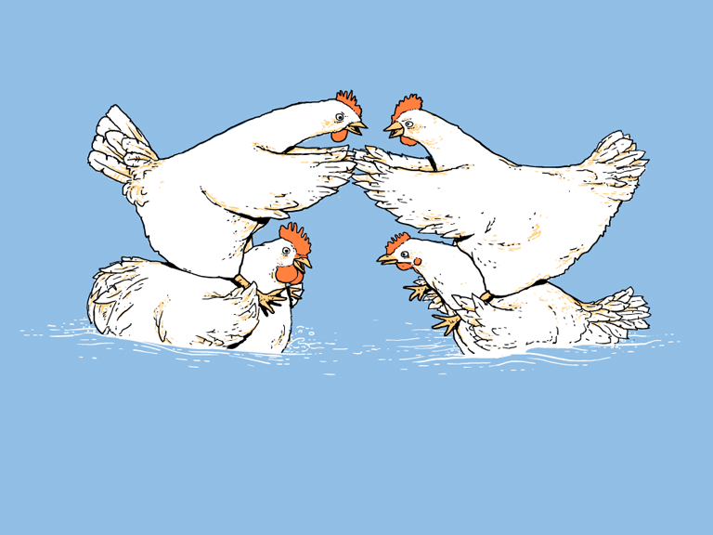

Pair the boys off and have the larger boys be the horses and the smaller boys be the riders. Obviously they start while in the pool. The boys that are the riders try to push and pull the other boys off. The last boy still on his horse is the winner. Teams can be chosen or this can be a real free-for-all.

Until you get to the pool, here are some activities that can be done at a meeting.

Lifeline Throw
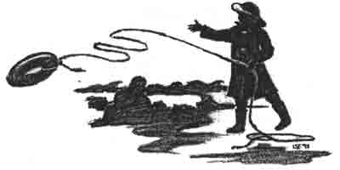

Tie a beanbag onto a 25-foot rope. Mark a circle on the floor with chalk. Throw for accuracy.

Rules for a Safe Swim
Match the phrase to the word that completes it:
1. Secure adequate __________
2. Teach the Buddy __________
3. Maintain __________ discipline
4. Follow pool __________
5. Teach rescue __________
6. Use a __________ instructor

methods
rules
System
qualified
good
facilities

Do's and Don'ts In and Around Water

Fill in the blank with DO or DON'T for each statement.
1. __________ learn how to swim from a qualified instructor.
2. __________ heck with your buddy to see if he knows how to swim.
3. __________ be a "show off" or bother others.
4. __________ swim with a buddy.
5. __________ dive into water without knowing its depth.
6. __________ get out of the water when you are tired or cold.
7. __________ swim alone.
8. __________ beware of sunburn. Cover up and use sun screen.
9. __________ dive into water without knowing what is under the water's surface.
SWIMMING BELT LOOP AND PIN
www.usscouts.org

Requirements
Tiger Cubs, Cub Scouts, and Webelos Scouts may complete requirements in a family, den, pack, school, or community environment. Tiger Cubs must work with their parents or adult partners. Parents and partners do not earn loops or pins.

Belt Loop 
Complete these three requirements:
- Explain rules of Safe Swim Defense. Emphasize the buddy system.
- Play a recreational game in the water with your den, pack, or family.
- While holding a kick board, propel yourself 25 feet using a flutter kick across the shallow end of the swimming area

Sports Pin 
Earn the Swimming belt loop, and complete five of the following requirements:
- Practice the breathing motion of the crawl stroke while standing in shallow water. Take a breath, place your head in the water, exhale, and turn your head to the side to take a breath. Repeat.
- Learn and demonstrate two of the following strokes: crawl, backstroke, elementary backstroke, sidestroke, or breaststroke.
- Learn and demonstrate two of the following floating skills: prone, facedown float, and back float. The purpose of the float is to provide the swimmer the opportunity to rest in the water.
- Using a kickboard, demonstrate three kinds of kicks.
- Pass the "beginner" or "swimmer" swim level test.
- Visit with a lifeguard and talk about swimming safety in various situations (pool, lake, river, ocean). Learn about the training a lifeguard needs for his or her position.
- Explain the four rescue techniques: Reach, Throw, Row, and Go (with support)
- Take swimming lessons.
- Attend a swim meet at a school or community pool.
- Tread water for 30 seconds.
- Learn about a U.S. swimmer who has earned a medal in the Olympics. Tell your den or an adult family member what you learned about him or her.
- Demonstrate the proper use of a mask and snorkel in a swimming area where your feet can touch the bottom

Swimming activities done by Cub Scout Packs must be done in accordance with the rules in the "Safe Swim Defense", described in the Guide to Safe Scouting (#34416B). That program is available for viewing HERE: http://www.scouting.org/scoutsource/HealthandSafety/GSS/gss02.aspx#_safe. Those rules are not mandatory for individuals or families, of course, swimming in private or public pools, lakes, or beaches, although families are encouraged to use as much of them as appropriate. They ARE mandatory for all Cub Scout aquatic activities, trips to swimming pools arranged as Den or Pack meetings or outings.

FAMILY MEMBER
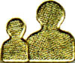
How Well Does Your Family Communicate?
Santa Clara County Council Pow Wow Book 2001
Answer these questions. Then take this home and go over them with your family.
- Does your family eat dinner together?
(a) Almost every night.
(b) Several nights a week.
(c) Only on special occasions.
- Is the TV off during dinner?
(a) Practically always.
(b) Unless the game is on.
(c) And miss our favorite shows?!
- Does your family eat breakfast or lunch together?
(a) Usually.
(b) About half of the time
(c) In our dreams.
- Do you know the best friends of each of your family members?
- (a) They are like family
(b) We’ve met.
(c) Friends???
- How much time do you spend talking with family members (average)?
(a) More than 20 minutes per day.
(b) 10 to 20 minutes per day.
(c) As little as possible.
- Do you know what each of your family members fear?
(a) Yes.
(b) I have a vague idea.
(c) They are fearless.
- When was the last time you told each of your family members that you loved them?
(a) Today.
(b) Within the last week
(c) They know without me telling them.
- Does your family make goals together?
(a) Yes
(b) Only for major things.
(c) Why? No one would follow through, anyway.
- Does your family plan activities together?
(a) Regularly
(b) Quite often.
(c) We don’t have time to do things together.
- Do you know what makes each of your family members happy?
(a) Sure do!
(b) Generally speaking.
(c) There is no such thing.
Give yourself
10 points for every (a) answer,
7 points for each (b), and
3 points for each (c)
Family Member Word Search
By Rich Smith

Directions
- Find the words in the puzzle that are listed below.
- The words are horizontal, vertical, and diagonal, forwards and backwards.
- All of the words are associated with the Family Member Activity Badge!
- Put the unused letters in the boxes to find a hidden message!
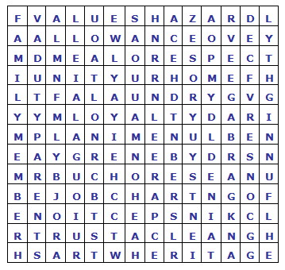

H I D D E N M E S S A G E
__ __ __ __ __ __ __ __
__ __ __ __ __ __ !

ALLOWANCE FUN NIGHT MEAL
BUDGET GARBAGE MENU
CHORES HAZARD PARENTS
CLEAN HERITAGE PLAN
CONSERVE HOME RESPECT
DUTY INSPECTION TRASH
ENERGY JOB CHART TRUST
FAMILY MEETING LAUNDRY UNITY
FAMILY MEMBER LOYALTY VALUES
What Does Your Family Spend Money On?

Requirement 3
Here is a list of things families may spend money on. In the box next to each item, guess and write down how much money you think is spent (per month). Then take this list home and ask a parent to fill in more accurate amounts. Which items did you get right? Which items really surprised you?
Estimated Actual
Item Cost Cost
- House payment or rent
- Car payment
- Gas, oil, tires, etc.
- Food
- Clothing and shoes
- Insurance: Life, Health, Auto, Home
- Medical and dental bills
- Schooling
- Church and charity donations
- Utilities: electric, gas, telephone, cable TV
- Savings
- Vacations
- Retirement funds
- Hair cuts
- Health and beauty supplies
- Cleaning supplies
- Repairs
- Family funds
- Hobbies
- Fun and recreation
I can help my family save money by:

Home Inspection
By Barb Stephens

First, locate unsafe conditions and eliminate all hazards promptly. The following questions will aid you in making an inspection of your home.
Hazard | YES | NO
- Do you have a strong, safe step ladder for reaching heights?
- Are halls and stairways safe and well lighted?
- Are means taken to prevent rugs from slipping, particularly on polished floors?
- Is a rubber mat provided for the bathtub to prevent slipping?
- Are metal boxes provided for storing matches out of reach of children?
- Do you have a screen for use in front of open fires?
- Are your furnace and stove pipes clean?
- Are all gas pipes and fixtures tight to prevent leaks?
- Do you have a cabinet which can be locked, for storing poisons and medicines out of reach of children?
- Are emergency numbers for police, fire and poison control posted by the telephone?

EMERGENCY PREPAREDNESS
BSA AWARD
 http://www.scouting.org/scoutsource/Media/Publications/EmergencyPreparedness.aspx

It is a challenge to be prepared for emergencies in our world of man-made and natural phenomena. The Emergency Preparedness BSA program is planned to inspire the desire and foster the skills to meet this challenge in our youth and adult members so that they can participate effectively in this crucial service to their families, communities, and nation.

Webelos Scout Requirements

- Earn the Readyman activity badge from the community badge group.
- Build a family emergency kit, with an adult family member participating in the project.
- With your parent or guardian's help, complete one of the following that you have not already completed for this award as a Tiger Cub or Wolf or Bear Cub Scout:
- Take a first aid course conducted by your local American Red Cross chapter.
- Give a presentation to your den on preparing for emergencies.
- Organize a training program for your Webelos den on stranger awareness, Internet safety, or safety at home.

Get the application here: http://www.scouting.org/filestore/pubs/pdf/19-602.pdf

ADDITIONAL ADVANCEMENT IDEAS
Alice, Golden Empire Council
Someone wrote and asked me why Alice and I have this section with all the advancement in the new Resource Book. These are additional ideas. Maybe your Cubs did some advancement in camp and you got to skip a section. Maybe your den is above average and streaking through the program. Maybe you want some ideas to tie into the Core Value of the month. Maybe your presenter or field trip for that week fell through and you need a Plan B. Here are ideas you can use!! CD and Alice
The advancement activities suggested here relate to the assigned Value for June– Perseverance. Belt Loops related to Art, Music, and almost any sports, as well as many of the Academics Belt Loops, require a boy to commit to lots of practice so he can Do his BEST –
in other words, perseverance!

Tiger Achievements
Ach. #2 D – Practice the Pledge of Allegiance with your den, and participate in a den or pack flag ceremony – it can take lots of practice to do it just right, so just persevere!

Tiger Electives
Elect. #3 – With your family, play a card or board game, or put a jigsaw puzzle together – it can require a lot of time and perseverance to put together a jigsaw puzzle with lots of pieces!
Elect. #6 - Along with your adult partner, teach a song to your family or den and sing it together. Check out the songs in this Baloo for some ideas.
Elect. #7 - Make a musical instrument and play it with others. The others can sing or have instruments of their own. The more you practice, the easier it will be.
Elect. #18 – Sew on a button – Be sure to keep your fingers out of the way of that needle!
Elect. #19 – Learn a magic trick and show it to your family or den. There are some simple tricks in the Den Review Tiger Section.
Elect. #30 – Plant a seed, pit, or greens from something you have eaten. You will have to make sure to keep it in a place where it can get light, but keep the soil a little moist so the plant will germinate – this can take patience and perseverance!
Elect. #37 – Take a bike ride with your adult partner – be sure to wear your HELMET! It can take some perseverance to keep going when your legs start to get tired.

Wolf Achievements
Ach. #1a,b, c, d, e – Feats of Skill – It might take a lot of practice for a Cub Scout to master some of these skills
Ach. #1h,i – Swimming 25 feet or treading water for as long as you can takes a lot of practice.
Ach. #2g – With the help of another person, fold the U.S. Flag – it takes practice to be able to do it right every time
Ach. #3a – Make a chart and keep track of your health habits for two weeks – you will need to remember to do this every day
Ach. #4e – After talking with your family members, make a list of your jobs and mark off when you have finished them. Do this for one month – it will take some perseverance!
Ach. #5c, d - Identify and use a Phillips head and standard screwdriver to drive in and then remove the right kind of screw; Use the pictures in your Wolf book to learn how to use a hammer, and show that you know how to do it. It will take some practice to do it right!
Hint: Both a screw and a nail are easier to drive in
if you make a “pilot” hole first.

Wolf Electives
Elect. #1d – Use 12 American Indian signs to tell a story – first make up your story, and then practice the signs till you can do them without looking – it will take some perseverance!
Elect. #5b, c, d –Make and fly a paper bag kite; make a fly a two-stick or three-stick kite. You will need to work carefully so your kite will fly – and it can take some trial and error to get a kite up in the air. Elect. #5a - BE SURE to do this FIRST – the safety rules for kite flying!
Elect. #7a – Learn to walk on a pair of stilts. Stand on something to get started, and the more your practice, the better you will get.
Elect. #10f – Learn 12 American Indian word pictures and write a story with them.
Elect. #11a, b, f – Learn the words and sing the first and last verses of America, or the first verse of the National Anthem; sing one of them with your den at a pack meeting.
Elect. 15a, b, c, d – Plant and raise a box garden, a flower bed, an indoor plant, or some vegetables. You will need to be patient and remember to take care of your plants regularly.
Elect. #17a,b, e, f – Learn to tie an overhand knot and a square knot; tie your shoes with a square bow knot; Tie two cords together with an overhand knot; Learn to tie a necktie.
Elect. #18d – Help plan and lay out an obstacle race; for even more challenge, have another den lay out a race for your den to do, and you lay out one for them to do!
Elect. #19b, c, f – Rig a pole with the right kind of line and hook, with bobber and sinker if needed, then go fishing; Bait your own hook and do your best to catch a fish when fishing with an adult or members of your family; Show you know how to use a rod and reel.
Elect. #20 – Do the requirements for any of the sports activities – But be sure to know and follow any safety rules that are required. If you are going boating now that the weather is warmer, be sure your go over Elect. 20b FIRST – so you know the boating safety rules.
Elect. #22b – Count to 10 in another language – it might take some practice.

Bear Achievements
Ach. #2 – Earn the religious emblem of your faith – it may take some time and effort.
Ach. #3h, i – Learn how to raise and lower the flag properly for an outdoor ceremony; then participate in an outdoor flag ceremony
Ach. #4c – Read two folklore stories and tell your favorite one to your den – choose one that demonstrates perseverance. (Check the many stories from Paul Bunyan Day under Value Related)
Ach. #6a – Save 5 pounds of glass or aluminum or 1 month of daily newspapers and turn them in at a recycling center – you’ll have to commit to a whole month – a good way to practice perseverance!
Ach. #8d, f – Trace your family back through your grandparents or great-grandparents; Start your own history and keep a journal for two weeks.
Ach. #13c – Keep a record of how you spend money for two weeks.
Ach. #14f – Ride a bike for 1 mile without rest. Be sure to obey all traffic rules – and remember to WEAR YOUR HELMET!
Ach. #17d – Use a computer to get information. Write, spell-check, proofread and print out a report on what you learned. (You might choose someone you admire and report on why you admire them and how they have shown perseverance)
Ach. #18c – Keep a daily record of your activities for two weeks.
Ach. #22b, c, d, e – Persevere in learning how to tie several knots; Learn how to keep a rope from tangling – practice till you can do it without thinking; Coil and rope and practice throwing it till you can consistently hit a two-foot square marker 20 feet away; Practice a magic rope trick till you can do it well enough so that an observer doesn’t see the trick.
Ach. #23a, b – Learn the rules and how to play three team sports or two sports in which only one person is on each side.

Bear Electives
Elect. #2 a, b, f – Commit to keeping a record for two weeks of temperature and weather conditions; Wind direction and weather every day at the same time for two weeks; Watching the weather forecast on TV every day for two weeks, then keeping a record comparing the forecast with actual conditions
Elect. #5 – Wearing a PFD, help an adult rig and sail a real boat; Help an adult repair a real boat or canoe; Know the signals for storm warnings; Help an adult repair a boat dock; With an adult on board, and both wearing PFDs, row a boat around a 100 yard course that has at least two turns and demonstrate other strokes as required.
Elect. #11 - Photography – Do any or all of these requirements – you will have to commit to practicing and taking and mounting several kinds of pictures – you can display your work at a Pack event in honor of Camera Day.
Elect. #13 – Magic – In order to learn the magic tricks, puzzles or rope tricks, or to put on a magic show, you will need to practice till you can do each magic trick very well! There are ideas in your book and also under both Tiger and Bear ideas in the Den Review section.
Elect. #19 – Swimming – Before you start, do Elect. #19d, and commit that you will never swim alone. Then do any or all of the requirements – you may have to practice over and over to get really comfortable and have good swimming skills.
Elect. #20 - Do any of the requirements, but commit to practicing and improving your skills and knowing and following safety and courtesy rules of the sport you choose.

Webelos & Arrow of Light Activity Pins
Several of the Activity Pins are a natural fit with Perseverance:
Artist #2 – Create a scrapbook (portfolio) of your Artist Activity Badge projects and show it to your den leader – requires commitment, taking care of and collecting art projects over a time period.
Athlete #1 – Perseverance Character Connection
Athlete #5a-e – Requires showing improvement in various activities after 30 days.
Sportsman #3, 4 – Requires earning Belt Loops in two different sports, so Perseverance is required.

CUB GRUB
Magic Cookie Bars
This is the favorite recipe using Eagle Brand milk –
the magic is that you can create a cookie without eggs –
and they taste great!
Ingredients:
1 1/2 cups graham cracker crumbs
1/2 cup (1 stick) butter or margarine, melted
1 (14-ounce) can EAGLE BRAND® Sweetened Condensed Milk
2 cups (12 ounces) semi-sweet chocolate chips
1 1/3 cups flaked coconut
1 cup chopped nuts
Directions:
- Preheat oven to 350°F (325°F for glass dish).
- In small bowl, combine graham cracker crumbs and butter; mix well.
- Press crumb mixture firmly on bottom of 13X9-inch baking pan.
- Pour EAGLE BRAND® evenly over crumb mixture.
- Layer evenly with remaining ingredients;
- Press down firmly with fork
- Bake 25 minutes or until lightly browned.
- Cool.
- Cut into bars or diamonds.
- Store leftovers covered at room temperature.
- Makes 2-3 dozen bars
- You can also substitute chocolate chips or nuts with: candy coated pieces, dried cranberries, raisins, mini marshmallows or butterscotch chips.
Out of the Hat Cake
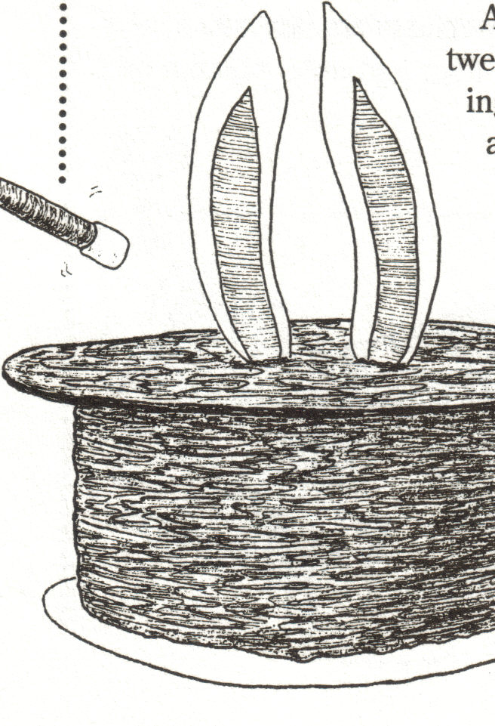
Great if you have a Magic Show!
Ingredients:
1 cake mix
1 recipe of dark frosting – if you use paste food coloring, you can even have black! Or you can use 1 can of dark chocolate frosting
Pudding or jam, your choice

Directions:
- Mix the cake as directed and bake in three 8-inch round pans.
- Reduce the baking time listed by 5 minutes.
- While the cakes cool, cut a 9-inch circle from cardboard.
- Then cut out a 6-1/2 inch circle from the center, leaving a 1-1/4 inch wide ring. This will be the hat brim of your Magician’s Hat.
- Cut the same size ring from waxed paper and attach to the cardboard with a glue stick.
- Cut out two bunny ears from white construction paper, and two inner ears from pink construction paper.
- Place a toothpick on the white ear so half of it extends below the ear.
- Now glue the pink inner ear on top of the white, sandwiching the toothpick in between.
- Assemble the 3 cake layers, putting more frosting, jam or pudding between the layers.
- Frost the cake and also cover the ring with frosting and place it on the cake.
- Smooth the frosting over the cake and ring so they look like one piece.
- Place the rabbit ears in the center of the cake.
- Now you have a Magician’s Hat, complete with the Rabbit!
Bike Themed Treats:
The Jell-O “Brain Without Helmet Treat”

Only your imagination limits you in the use of the famous Jell-O brain mold, a mold that you fill with gray or pink Jell-O to make a model of the brain. If you search for these on google you will get a lot of hits. I found them from $6.95 to $14.95 before I stopped looking and ordered some. Who could resist. Some sites even have recipes for making brain colored Jell-O!!!

Make one and use it for demonstration about how fragile your brain is – and why you MUST WEAR A HELMET - Then have a snack!
Cookie Wheels
Ingredients:
1-1/2 cups all purpose flour,
½ cup of softened butter or margarine,
¼ cup of powdered sugar,
½ teaspoon baking powder,
1 Tablespoon of milk,
1 cup of pie filling or jam (your choice of flavor)
Directions:
- Preheat the oven to 375 degrees.
- Mix the flour, margarine, sugar, baking powder and milk just enough milk to form a dough. If more milk is needed, add it by teaspoonfuls only.
- Divide the dough into 6 equal parts,
- Then shape into balls.
- Place on an ungreased cookie sheet; flatten slightly.
- Make an indentation 1-3/4 inches across and about ¾ inch deep, in the center of each flattened ball.
- Now fill each indentation with about 2 Tablespoons of filling.
- Bake until edges begin to brown (20-25 minutes). Makes 6 “Wheels”
Frozen Wheels
Trapper Trails
Ingredients
Chocolate chip cookies
Chocolate or vanilla ice cream, softened
Colored sprinkles or mini chocolate chips
Directions
- Create a wheel by sandwiching ice cream between two cookies.
- Roll the edges of the “wheel” in colored sprinkles or mini chocolate chips.
- Freeze until ready to eat.
Zesty Appetizer Wheels
Trapper Trails
Ingredients
12 slices hard salami
1 (8 ounce) can crescent rolls
6 tablespoons grated parmesan cheese
2 teaspoons Italian seasoning
Directions
- Preheat oven to 350°F.
- Open the dough to 2 rectangles, press the perforation to seal.
- Sprinkle each rectangle with 3 tbsp parmesan and 1 tsp Italian seasoning.
- Lay 6 slices salami along the side of the rectangle.
- Roll the dough up and pinch the ends.
- Cut each roll into 8 slices.
- Place on cookie sheet and bake for 13 min or until golden brown.
- You can substitute 24 pepperoni for 12 salami slices.
Road Course Obstacles
Santa Clara County Council
Ingredients:
1 Cub sugar
1/4 cup margarine
1/4 cup milk
1 1/2 cups quick oatmeal
1/4 cup chopped nuts
2 1/2 tablespoons creamy peanut butter
1/2 teaspoon vanilla
Directions:
- Combine sugar, margarine and milk in sauce pan,
- Boil 1 minute. Pour hot mixture over oatmeal and peanut butter.
- Add nuts and vanilla.
- Mix, drop by teaspoon onto wax paper.
- Let cool until firm
Doughnuts for Doughnut Day
Ingredients:
Regular dough (recipes below) or Canned Biscuits for the easy version;
Favorite frostings or glaze;
Various sprinkles,
Cinnamon sugar mixture,
Powdered sugar,
Chopped nuts.
There are two kinds of doughnuts – those made with yeast and “cake” doughnuts, which use baking powder or baking soda instead of yeast.
WARNING – When making doughnuts, only an ADULT should do the actual frying!
Easiest version: Use canned biscuits – let each boy cut out the doughnut holes. For extra fun, tell the story of Doughnut Day, and let the boys try some inventive ways to cut the holes in their doughnuts. See Value Related Section.
If you are making fried doughnuts, an ADULT should handle the frying – put doughnuts out on paper towels to cool, then let the boys add frosting, sugar toppings and/or sprinkles. Include the holes, too!
Homemade “Cake” Doughnuts
Ingredients:
4-1/2 c. flour,
4 tsp. baking powder,
1 tsp. nutmeg,
1/2tsp. salt,
2 eggs,
1 c.sugar,
1 T. melted butter - unsalted,
1 c.milk,
1 tsp. vanilla
Directions:
- Sift together dry ingredients
- Beat eggs with sugar till light, then add butter, milk and vanilla.
- Add dry ingredients and mix till it forms a soft dough – don’t overmix! If the dough is too soft to roll, chill it for an hour.
- Roll dough out to 3/8 inch thick on a floured surface and cut with doughnut cutters – or your own “invention.”
CUT STRAIGHT UP AND DOWN – DON’T TWIST THE CUTTER.
- Fry in oil heated to 370 degrees till golden brown on both sides – turn once, when the doughnut rises to the top. Don’t overload your fryer or pan – do just a few at a time!
- Drain over the oil to drain, then put on paper towels to drain the rest of the way.
- While still warm, add your glaze, frosting, and/or toppings.
Homemade Yeast Doughnuts
Ingredients:
2 cups milk,
1/2 c. unsalted butter,
1 c. sugar,
1 T. salt,
1 pkg. or 3 tsp. yeast,
1 tsp. sugar,
1/4 c. warm water,
1tsp. baking powder,
1/2 tsp. baking soda,
1 c. mashed potatoes with no salt or pepper,
3 egg yolks,
8 c. flour
Directions:
- Scald the milk (Heat till small bubbles form all around the edge of the pan)
- Stir in butter, salt and 1 c. sugar, then cool to lukewarm
- Sprinkle 1 tsp sugar, and yeast over water. Set aside for 5 minutes to “work.”
- Add to the milk mixture.
- Add baking powder, baking soda, potatoes, yolks, and 2 c of flour to milk.
- Beat with an electric mixer at medium speed until smooth. About 2 minutes.
- Add the remaining flour gradually, beating well.
- Place SOFT dough in a greased bowl, grease the top of the dough and cover. Let rise two hours. (I like to let mine rise in the oven – not turned on of course)
- Turn out the dough on a floured surface, roll to 1/4 inch thick, and cut with a floured cutter.
- Cover and let rise one hour.
- Fry a few at a time, (about 370 degrees) until golden on both sides.
- Drain, then glaze or frost or roll in the toppings of your choice. You can also eat them plain.
Some tips for finishing:
- If you want to glaze, mix 1/3 cup of boiling water with 1 cup of confectioners sugar.
- To “frost” or glaze doughnuts, hold the doughnut upside down in your hand and DIP into a bowl of the frosting or glaze.
- An easy way to add sprinkles or other coatings – put them in a bag and just shake one doughnut at a time in the sprinkles.
- NOTE: You can also freeze doughnuts – fry and drain them. When cool, lay on a cookie sheet, one layer only, and freeze till solid. Then just put the doughnuts in a zipper bag and freeze till you need them. When ready to eat heat, in a 400 degree oven for about ten minutes – then frost or glaze as desired.

WEB SITES
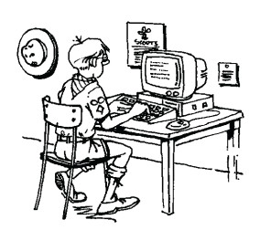

Here are some Persevrance Websites for you -

Wendy, Chief Seattle Council

Outdoor Games:
http://familyfun.go.com/playtime/sports-athletic-games/

Gardening: http://urbanext.illinois.edu/firstgarden/index.cfm
http://aggie-horticulture.tamu.edu/kindergarden/pnote.htm

Goal Setting & Perseverance: http://www.parents.com/parenting/better-parenting/style/how-to-teach-kids-perseverance-goal-setting/

Knots: https://people.creighton.edu/~bjs74318/bluejay/pack114/library/knotgames.html

http://gtsurber.tripod.com/games-knots.htm)
http://www.gseiwi.org/events/KnotsandKnotGames.pdf)
http://guidezone.e-guiding.com/knot.htm

Magic Tricks:
http://www.goodtricks.net/
http://www.kidzone.ws/magic/index.htm
http://funology.com/abracadabra/

More "Web Sites" are in the Pack and Leader Hints Edition Dave

ONE LAST THING

Near the top of one of the highest peaks in the Rocky Mountain range – are two natural springs. They are so close together and level in height, that it would not take a great deal of effort to divert one streamlet toward the other. Yet, if you follow the course of one of these streams, you will find that it travels easterly, and after traversing plateaus and valleys, receiving water from countless tributaries, it becomes part of the great Mississippi River and empties into the Gulf of Mexico.
If you follow the water from the other fountain, you will find that it descends gradually in a westerly direction, again combining with other tributaries until it becomes part of the Columbia River, which empties into the Pacific Ocean.
The terminal points of the two streams are more than five thousand miles apart, separated by one of the highest mountain range in the world. And yet in their onset, the two streams are very close neighbors. Very little effort would be required to make the easterly stream run west, or the westerly stream run east.
If you want to impact the course of a life, start at the beginning!
From “God’s Little Devotional Book for Women”

One of the great privileges of being a
Cub Scout leader is the opportunity to influence
the boys’ lives in a positive direction.
Thank you for all you do for your Cub Scouts.

An Example of Perseverance
My Den Mother (and my Mother)

(December 8, 1926 - April 17, 2011)
Ruth H. Lyons, 84, of Middletown, DE and formerly of Washington Township, Bergen County, NJ, passed away on Sunday, April 17, 2011 at Christiana Hospital in Newark, DE. Born on December 8, 1926 in Brooklyn, NY, she was the only child of the late Cord F. and Ottilie (Weiss) Kuhlmann.
Ruth graduated from W.C. Mepham High School in Bellmore, NY, Class of 1944. She enjoyed being a homemaker and throughout her life loved being involved in her two sons' activities. She was a long time Cub Scout Den Mother, Den Mother Coach, Roundtable Commissioner with the Boy Scouts and a Little League team mother.
She made sure we were all well fed on Dad's Policeman's salary. Our favorite treats included Spanish Rice (made with Minute rice) and Hot Dogs, a can of Spam sliced on top and cloves stuck in so it looked like a fancy ham, potato pancakes, and omelets made in Mom's special pan. (Yes, these are all inexpensive to make but she presented them as treats for us. I never realized all my favorites were inexpensive until many years later.)
She made sure my brother, Bill, and I both were confirmed at Zion Lutheran, whose confirmation class was known as "West Point of Lutheran (Mo. Synod) Confirmation classes," earned our Arrow of Light and Eagle Scout awards, graduated from High School. And that we knew what was right and wrong. And always recognized we were different. The old saying goes, Dave is right-handed and Billy is left-handed. After that, similarities end.
While living in New Jersey, she was an active member of Zion Lutheran Church in Westwood, NJ. Following her move to Delaware, she became actively involved with Faith Lutheran Church in Bear, DE. She would manually type the Zion Times, then count spaces and manually justify it. And then retype the whole thing.
She was an active member of the Blue Knights Motorcycle Club New Jersey One with her husband, Bill. Following his death, she continued to volunteer with their organization.
Ruth was an active member of the Jean Birch MOT (DE) Senior Center, where she and her husband started the first MOT Senior Center bowling league. As a member of the Senior Center she enjoyed teaching crocheting and in 2009 at the age of 82 was proud to have been the recipient of a blue ribbon at the Delaware State Fair for one of her prize crocheting pieces. She completed poster size crochet pieces of the Lord's Prayer, the 23rd Psalm, and the Last Supper and donated them to her and her sons' churches.
Ruth and her husband were avid travelers and together enjoyed visiting all 50 states and taking a cruise through the Panama Canal. She took pride that at age 67 she received the first motorized trike driver's license issued to a female in Delaware.
They believed strongly in family. Bill and I are the only two of our cousins that know all the others. And they were generous with those in need. Helping as they could even though Dad was a police officer and they were not well paid at that time. Ruth completed a family tree of her husband's family starting with his parents and including all 9 of his siblings and their children and grandchildren. After his death, she maintained this and became the honorary matriarch of the family. All the cousins would let her know what changes were occurring. And they would visit when they could. (Being an only child, she had a desire to marry into a large family. She used to kid that any person she dated who had two or less siblings, somehow never got a second date). She attended all the high school and college graduations, Eagle ceremonies, and marriages of her grandchildren and any of the other Lyons family members to which she was invited. Billy and I drove her to many of these.
In addition to her parents, she was preceded in death by her husband of 49 years, William S. “Bill” Lyons on April 17, 1997. She is survived by her two sons, David and his wife, Donna of Carney’s Point, NJ and William and his wife, Linda, of Middletown, DE; seven grandchildren, Peter (Chris), William (Melissa), Shaun (Kelley), Patrick, Daniel, Bernadette and Darby; 10 great-grandchildren, as well as many cousins and dear friends.
You can see the complete obituary and leave a note at
http://www.daniels-hutchison.com/index.cfm
If her picture is not on the him epage, search for Ruth Helen Lyons
She is interred with her husband at Delaware Veterans Memorial Cemetery in Bear.
Memorial contributions can be made to Faith Lutheran Church, 2265 Red Lion Road, Bear, DE 19901 or www.usscouts.org , the host for Baloo's Bugle, by going to the bottom of the page and clicking the make a donation button. Please specify Ruth Lyons memorial. We are now certified (not certifiable) and your donations will be tax deductible.

