CORE VALUES
Cub Scout Roundtable Leaders’ Guide
The core value highlighted this month is:
- Faith: Having inner strength or confidence based on our trust in God. With their family guiding them, Cub Scouts will grow stronger in their faith. Through den and pack activities boys will learn to understand and respect people whose faith is different from theirs.

COMMISSIONER’S CORNER
Faith is not belief without proof, but trust without reservation.
D. Elton Trueblood

Many thanks to Pat Hamilton, ACC – Roundtables in Baltimore Area Council and a long time friend of mine, for putting this issue together
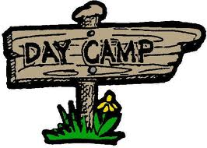
Remember: Three-fourths of Scouting is Outing! Make sure your boys get registered for Cub Scout Day Camp. Most Day Camps start registering right about now, and some of them fill up fast. Don’t be left on the outside lookin’ in!
Please! Pow Wow books are the life-blood of this publication. We need new ideas and material to keep Baloo’s bugle alive. I’ve been sending Dave my Pow Wow books for almost nine years now, and there are a few others that support as well. If you can’t get it in electronic format, let us know and we can help. –Pat

George Washington
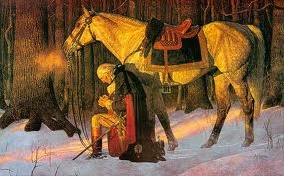
Wednesday, February 22 was George Washington's real birthday (along with Lord Robert Baden Powell’s), an appropriate time to consider the faith of America's most important founding father.
At age 13 George transcribed "110 Rules for Young Gentlemen," written by Ignatius of Loyola, founder of the Jesuits in the 1590's. George memorized them. They teach that man is God's servant who lives not for self, but for others. They became part of his character:
"Let your conversation be without malice or envy...
"When you speak of God or His attributes, be serious and speak with words of reverence.
"Let your recreations be manful, and not sinful.
At age 20, he wrote prayers to say each morning and evening. On Sunday mornings he prayed: "...pardon, I beseech Thee, my sins; remove them from Thy presence, as far as the east is from the west, and accept me for the merits of Thy son, Jesus Christ..."
At 23 Captain Washington was caught in a surprise ambush by the French and Indians near what is now Pittsburgh. Every British and American officer was shot but Washington though he rode back and forth across the battlefield. George later wrote to his brother, "By the all-powerful dispensations of Providence, I have been protected beyond all human probability or expectation, for I had four bullets through my coat, and two horses shot under me, yet escaped unhurt, although death was leveling my companions on every side of me."
On July 2, 1776 he told his troops: "The fate of unborn millions will now depend, under God, on the courage of this army. Our cruel and unrelenting enemy leaves us only the choice of brave resistance or the most abject submission. We have therefore to resolve to conquer or die."
Seven weeks later British General Howe had trapped Washington and his 8,000 troops on Brooklyn Heights, ready to crush them the next morning. Washington gathered every vessel from fishing to row boats and spent all night ferrying his army across the East River. By morning many troops were still exposed to the British.
"In a most unusual change in weather, the fog did not lift from the river. It stayed thick, covering Washington's retreat until the entire army had evacuated and escaped," writes William Federer in his inspiring book, "America's God and Country." Never again did the British have such a rare chance to win the war.
During the freezing winter of 1777 at Valley Forge, a dozen soldiers died a day, with many not having blankets or shoes. "Feet and legs froze till they became black," and were amputated wrote a Committee from Congress. A Quaker named Isaac Potts came upon Washington upon his knees in the snow, praying aloud for his beloved country. He thanked God for exalting him to the head of a great nation which was fighting at fearful odds.
The Quaker told his wife of the sight: "Till now I have thought that a Christian and a solider were characters incompatible, but if George Washington not be a man of God I am mistaken, and still more I shall be disappointed in God does not through him perform some great thing for this country."
On May 5, 1778 Washington learned that the French would join America as allies. The General told his troops, "It having pleased the Almighty Ruler of the universe to defend the cause of the United American States, and finally to raise up a powerful friend among the princes of the earth, to establish our liberty, and independence upon a lasting foundation, it becomes us to set apart a day for gratefully acknowledging the divine goodness..."
In 1781 Washington's southern army defeated a detachment of British troops. Lord Cornwallis was infuriated and began pursuing the outnumbered Americans. He waited the night at the Catawba River, which the U.S. troops had crossed just two hours earlier. Miraculously, a storm arose during the night causing the river to be uncrossable for five days. Cornwallis nearly overtook Americans at the Yadkin River, but another flood arose, allowing Americans to escape.
The French navy seized control of the Chesapeake Aug. 30, 1781, driving out British ships. Washington rejoiced and besieged Cornwallis' stronghold at Yorktown. With no ships to escape upon, Cornwallis surrendered.
Washington wrote Congress, "I take a particular pleasure in acknowledging that the interposing Hand of Heaven...has been most conspicuous and remarkable."
Washington had more near escapes than victories. Would God have protected him from bullets, and saved his troops with fog and floods - had he not been a praying man?
by Michael J. McManus, 2004
Each generation goes further than the generation preceding it because it stands on the shoulders of that generation. You will have opportunities beyond anything we've ever known.
Ronald Reagan

TABLE OF CONTENTS
In many of the sections you will find subdivisions for the various topics covered in the den meetings
CORE VALUES 1
COMMISSIONER’S CORNER 1
George Washington 1
TABLE OF CONTENTS 2
Roundtable Prayer 3
Quotations 4
Gratitude Quotes 4
A True Story about a Scout and his Faith 4
Seven Things I Learned 6
ROUNDTABLES 7
Have a Little Faith 7
Update Supplemental Pack Meeting Plans 8
Cubcast 9
DEN MEETING TOPICS 10
PACK ADMIN HELPS – 10
Journey to Excellence 2012 10
2013 National Jamboree Staff 11
CUBMASTER'S CORNER 11
Hello Cub Masters! 11
GATHERING ACTIVITIES 15
OPENING CEREMONIES 16
AUDIENCE PARTICIPATIONS & STORIES 17
LEADER RECOGNITION & INSTALLATION 18
Leader Appreciation Ceremony 18
10 Commandments of Ceremonies 18
Quickie Thank-You's 18
Leader Induction Ceremony 19
ADVANCEMENT CEREMONIES 19
SONGS 20
Faith Songs 20
Fun Songs 21
STUNTS AND APPLAUSES 21
APPLAUSES & CHEERS 21
RUN-ONS 22
SKITS 22
GAMES 23
Games About Trust & Faith 23
CLOSING CEREMONIES 25
CUBMASTER’S MINUTES 25
CORE VALUE RELATED STUFF 26
Connecting FAITH with Outdoor Activities 26
Quoting Baden-Powell on Faith 26
Trees & Faith for Scouters 27
Crazy Holidays 30
Fun Facts on Arbor Day 31
PACK & DEN ACTIVITIES 32
Faith Ideas 32
Religious Activities: 33
DEN MEETINGS 35
TIGERS 35
WOLVES 36
BEAR 37
WEBELOS DENS 43
ARROW OF LIGHT 55
ADDITIONAL ADVANCEMENT IDEAS 59
Tiger Achievements 59
Tiger Electives 59
Wolf Achievements 59
Wolf Electives 59
Bear Achievements 60
Bear Electives 60
Webelos & Arrow of Light Dens 60
MORE GAMES AND ACTIVITIES 60
CUB GRUB 60
FAITH IDEAS 60
APRIL FOOL’S IDEAS 61
WEB SITES 62
ONE LAST THING 63
St. George, Patron Saint of Scouting 63
From Kipling’s "The Law of the Jungle" 63
Wood You Believe? 64

THOUGHTFUL ITEMS FOR SCOUTERS
Thanks to Scouter Jim from Bountiful, Utah, who prepares this section of Baloo for us each month. You can reach him at bobwhitejonz@juno.com or through the link to write Baloo on www.usscouts.org. CD

Roundtable Prayer
George Washington
Most Gracious Lord God, from whom proceedeth every good and perfect gift, I offer to thy divine majesty my unfeigned praise & thanksgiving for all thy mercies towards me. . . . Bless our rulers in church and state. Bless O Lord the whole race of mankind, and let the world be filled with the knowledge of Thee and thy son Jesus Christ. Pity the sick, the poor, the weak, the needy, the widows and fatherless, and all that morn or are broken in heart, and be merciful to them according to their several necessities. Bless my friends and grant me grace to forgive my enemies as heartily as I desire forgiveness of Thee my heavenly Father. I beseech thee to defend me this night from all evil, and do more for me than I can think or ask, for Jesus Christ sake, in whose most holy name & words, I continue to pray, Our Father. [Amen.] Monday Evening Prayer, George Washington 1752, Age 20
From William J. Johnson, George Washington, The Christian (New York: The Abingdon Press, 1919).

Planting Seeds of Compassion
Scouter Jim, Bountiful UT
Congress shall make no law respecting an establishment of religion, or prohibiting the free exercise thereof; or abridging the freedom of speech, or of the press; or the right of the people peaceably to assemble, and to petition the Government for a redress of grievances.
United State Constitution, First Amendment
In December, 2011, the State of Utah was forced by the United State Supreme Court to ask the Utah Highway Patrol Association to removed 14 white roadside crosses that memorialized Utah Law Enforcement Officers who had lost their lives in the line of duty from State owned land. The Cross was deemed to be a religious symbol and thus violated the United States Constitution’s First Amendment.
Many American’s believe freedom of religion to mean “Freedom from Religion.” Most of the founders of the United States were men of faith, and it is hard to conceive that is what they believed when they wrote the Bill of Rights.
Many of those, we know as Pilgrims moved to the Plymouth Colony, seeking the right to worship, as they pleased. However, some of those were not as willing to extend that privilege to others. The Reverend John Lathrop, who also escaped England barely with his life, moved from Plymouth Colony to Barnstable, Massachusetts where he could worship according to his beliefs.
America has long been a refuse to Religious Refugees, who have come me to worship in freedom, when they were not able to do that in their own lands.
As I view photos of the cemeteries of Normandy, France and see row on row of white Crosses and Stars of David, memorializing men who died to save the world from a Nation that was exterminating millions of people, just because they did not like their religion.
Whenever I see a flag draped coffin, my heart is stirred with faith and thanksgiving. Many years ago, I attended the funeral of the father of a friend of mine. The man was a Prison of War in World War II. During his time of imprisonment he was asked by his captures to work on his day of Worship, with the phrase, “Work a Day for Hitler.” Rather than work a day, he started a movement that became known among his fellow captives as “Miss a day for Churchill.” As I attended this funeral and viewed the Casket Draped with the Union Jack (flag of Britain), I felt the same feelings of faith and thanksgiving I have whenever I view a flag draped coffin. It is the same feeling I used to get as I would drive by those white crosses memorializing Utah Police Officers.
April is a month of sacred religious holidays, Easter and Passover. During this month as we emphasis Faith and Thanksgiving, it is a good time to focus on those who have given their lives for our freedom. In our state we have both a Police Officers Memorial at our State Capital and a Fire Fighters Memorial at a State Fire Fighters Museum. This would be a good month to take Scouts to visit memorials for Police Officers, Fire Fighters, or Veterans. Let us teach these young men what these great heroes have done for American and the rights we have.

Quotations
Quotations contain the wisdom of the ages, and are a great source of inspiration for Cubmaster’s minutes, material for an advancement ceremony or an insightful addition to a Pack Meeting program cover
Faith is not without worry or care, but faith is fear that has said a prayer. Author Unknown

Faith is spiritualized imagination. Henry Ward Beecher

Faith is courage; it is creative while despair is always destructive. David S. Muzzey

Faith is a passionate intuition. William Wordsworth

Faith is putting all your eggs in God's basket, then counting your blessings before they hatch. Ramona C. Carroll

Faith is what makes life bearable, with all its tragedies and ambiguities and sudden, startling joys. Madeleine L'Engle

Be like the bird that, passing on her flight awhile on boughs too slight, feels them give way beneath her, and yet sings, knowing that she hath wings. Victor Hugo

Faith is raising the sail of our little boat until it is caught up in the soft winds above and picks up speed, not from anything within itself, but from the vast resources of the universe around us. W. Ralph Ward

As your faith is strengthened you will find that there is no longer the need to have a sense of control, that things will flow as they will, and that you will flow with them, to your great delight and benefit. Emmanuel

A little faith will bring your soul to heaven, but a lot of faith will bring heaven to your soul. Author Unknown

Faith is believing that the outcome will be what it should be, no matter what it is. Colette Baron-Reid

Faith can move mountains, but don't be surprised if God hands you a shovel. Author Unknown

Faith is believing in things when common sense tells you not to. George Seaton

Faith is taking the first step even when you don't see the whole staircase. Martin Luther King, Jr.

Gratitude Quotes
Baloo’s Archives
"When asked if my cup is half-full or half-empty my only response is that I am thankful I have a cup." -Sam Lefkowitz

"If a fellow isn't thankful for what he's got, he isn't likely to be thankful for what he's going to get." -Frank A. Clark

"In everyone's life, at some time, our inner fire goes out. It is then burst into flame by an encounter with another human being. We should all be thankful for those people who rekindle the inner spirit." -Albert Schweitzer

"Today I can complain because the weather is rainy or I can be thankful that the grass is getting watered for free." Unk

"Thank God every morning when you get up that you have something to do that day, which must be done, whether you like it or not." -James Russell Lowell

"Things could be a lot worse, the stress of the situation always could be worse, but I am alive and I have a lot to be thankful for - so I shall not waste my days with stress and frustrations - Life is too short! " -Catherine Pulsifer

"Feeling gratitude and not expressing it is like wrapping a present and not giving it."- William Arthur Ward

"Gratitude is riches. Complaint is poverty." -Doris Day

"If the only prayer you said in your whole life was, 'thank you,' that would suffice." -Meister Eckhart

"Do not spoil what you have by desiring what you have not; but remember that what you now have was once among the things you only hoped for." -Epicurus

"When eating a fruit, think of the person who planted the tree." -Vietnamese Proverb

"Be thankful for what you have; you'll end up having more. If you concentrate on what you don't have, you will never, ever have enough." -Oprah Winfrey

"God gave you a gift of 86,400 seconds today. Have you used one to say 'thank you'?" - William Arthur Ward

One additional item from Alice, Golden Empire Council:

A True Story about a Scout and his Faith
www.donnfendler.com
In 1939, twelve year old Donn Fendler was hiking to the summit of Maine’s highest mountain when he became separated from his family. A dark storm enveloped the peak of mile high Mt. Katahdin, and he quickly lost his way.
He spent nine long days and nights in that rugged wilderness, all alone except for the wildlife he encountered as he tried to find his way out. Meanwhile, the entire state prayed for him – while hundreds of brave citizens and blood hounds searched the mountain. It was those prayers, Donn’s courage and faith, his Scout training, and his will to live that got him through the ordeal.
After a quick recovery from malnutrition and hundreds of scrapes, cuts and insect bites, Donn was honored with a huge parade in Millinocket, Maine. He also met the President of the United States and was the subject of a story in Life Magazine. But the greatest tribute to his faith and courage was the publication of “Lost on a Mountain in Maine” – the story of Donn Fendler as told by Joseph Egan – and enjoyed for almost 70 years.
Donn Fendler is now living in Tennessee. He still summers in Maine, but remains for a few weeks in the Fall so he can visit schools across the state to share his story and answer kid’s questions about his incredible experience. His memories are vivid, and he always has a positive message for children about faith, courage, being prepared, and having the will to live.
Since his brush with death in Baxter State Park more than seventy years ago, Donn Fendler has received thousands of letters, mostly from Maine school children, which he always answers. He still visits many schools every year. He attended the University of Maine and is retired from the U.S. Army.
Donn says his book was not dedicated to anybody, but if he was to dedicate the book today, it would be to the Boy Scouts of America. His appreciation of scouting is shown in his active involvement in scouting and in his giving credit to his scout training in helping him survive. He attained the rank of Life Scout.
Don’t forget to check in your pack and local area – it’s very possible you have a local example of faith that could be shared!

TRAINING TOPICS

Hail Den Leaders!
Bill Smith, the Roundtable Guy
About a dozen years ago I wrote the following bit about den leaders. I had noticed that pack organization charts always seemed to put den leaders at the very bottom of the hierarchy and I wasn’t sure that was where they belonged.
The program runs on DLs. Do anything to keep them happy and productive. Don't let anyone pile extra duties on them. They are not someone's personal messenger, or delivery boy and especially they are not your wait staff at the Blue and Gold Banquet. Their only job is to lead the dens.
Leading a den is a tough job! It’s a lot tougher than being a Cubmaster, or especially a Scoutmaster. I had those jobs for several years and each was a snap compared to the few months when I filled in for absent den leaders. Those Tuesday afternoons inexorably came around every week and I had to be ready each time with a newly planned program, all sorts of equipment for projects and games and I had to keep track of all the little marks in well-thumbed books or worry about what might be in books that never showed. I’ve never been a Webelos DL but it seems – at least on paper – to be even tougher. I’m not about to get in line for the job either.
As a Cubmaster, I just had to show up at the neighborhood elementary school once a month and try (not very hard) to make an absolute fool of myself. All I had to do was to wear orange gloves and wave my arms a bit and they would all sing Tarzan or Wetspers, and then introduce the dens: Here comes Den Four! They have a new skit for us!
As a Scoutmaster, I would show up every week to watch our cadre of Patrol Leaders and helpers put on their troop meetings. My only part was to recite one or two BP-like homilies at the end of the meetings. Our monthly campouts were even easier. All I ever did was to sit in my sort of comfortable camp chair, drink a never-ending supply of coffee and watch the boys play the wonderful game of Scouting.
I failed to mention all the help I got from the pack and troop committees. They took care of all the finances, the advancement, got the tour permits and booked the meeting places. They were wonderful for me as a CM or SM.
I’m not so sure that den leaders get that much help from their pack committees. Yet, I truly believe that:
In Cub Scouting, you’re either a den leader or your main job is to help den leaders. There is no other choice.
So, who should be helping den leaders?
Pack Leaders
One of the first things I learned as a Cubmaster was that the success of our pack depended a lot more on den leaders than on me. I gradually found ways to help dens and den leaders become successful. We made dens the stars of our pack meetings. We protected the DL corps from having extra jobs thrust on them. For example: let the DLs take care of the product sales or they could serve the food at the Blue and Gold.
Good Pack Trainers, Treasurers and Committee Chairs can do a lot to ensure that den leaders get the training, funding and support they need to make their programs successful.
Someone in the pack structure should be doing their best to line up assistant DLs and Den Chiefs.
Commissioners
Most Unit Commissioners totally ignore dens and den leaders even though the conditions of den programs are better indicators of unit health than most other items on their check lists. District Commissioners, as a rule, are even more oblivious to the concerns of den leaders.
Roundtable
Roundtables can be invaluable to den leaders. Most den leaders require a constant flow of ideas. Den programs consume program items at an alarming rate.
Until now, many RT have provided all sorts of program help on themes, projects and other activities. It is difficult to foresee how RT staffs will handle CS2010 but I have seen enough talent at dozens of Roundtables I have visited to be confident that they will do a great job. I just wish every RT was that good.
District/Council committees
It is difficult to imagine a Quality District without a lot of successful dens in the majority of the Cub Packs. District and even council committees can help by understanding how their calendars affect den leaders. I’ve seen some outstanding workshops and theme fairs over the years that provided den leaders with valuable help. Many DLs have reported that their best help came from Pow Wows or Universities of Scouting.
National programs
The National Council has an excellent track record of providing excellent resources for den leaders. Program Helps, the How-To Book and the CS Leader Book are just loaded with useful information. The current Job Specific training is particularly well done. I sincerely hope that the new organization will be able to maintain this quality.
No tribute to den leaders could be complete without this glorious poem by Julie H. Erickson, Lake Bonneville (now Trapper Trails) Council, Ogden, UT.
I Am a Den Leader.
I am a den leader.
I own a hot glue gun, a ring toss game, an American flag, and a 12 passenger van.
I know all about tour permits, permission slips, and registration forms.
I save bits of string, scraps of lumber, old tin cans, and a whole garage full of newspaper.
I am a den leader.
I get excited over paper sack kites that really fly, boys who remember to bring their books, and first aid kits that finally sell.
I laugh at Boy's Life jokes, cheer for my den kick ball teams, I sing Frankenstein songs at pack meetings, and once wept with a Cub who just found out parents are getting a divorce.
I am a den leader.
I have bribed new Cubs through the Bobcat trail, herded unruly boys along library tours, puffed my way up steep mountain tracks, and panicked when I looked down the other side. I have threatened to quit more than once.
But I am still a den leader
My patch says I'm "trained", but I know I still have a lot to learn from district and council leaders, Cubmasters, other den leaders, and especially my boys.
And I still have one more lesson to teach. I will not give up, especially on any of my boys.
So I am still a den leader.
I like to think there is a special place in heaven reserved for den leaders. Surely, they would have a need for bird feeders and barometers and someone who could love a dirty faced Cub Scout.
I hope when I die there is a hot glue gun plugged in and waiting.
For I am a den leader.
And a heart-felt thank you to every DEN LEADER, past and present! Bill.
******************************************
Read the following carefully, as the Den Leader's role has increased with the new delivery method. Take good care of your Den Leaders. CD

Seven Things I Learned
Bill Smith, the Roundtable Guy
Back in those early days when I was the Cubmaster of Pack 28 in Jackson, NJ, I took every Cub leader training available. I learned a lot about what I was supposed to do but there were some important subjects that were never covered in those training courses or covered so lightly and so quickly that I never really noticed how important they were.
These I learned by experience, sometimes by making mistakes but, more often, by heeding the advice of others, adding those things to my repertoire, and then seeing that their recommendations were valid.
Here is the first and, I think, the most important one.
Protect and Retain Den Leaders.
The program runs on Den Leaders. Very quickly, I discovered that most of the real work in our pack was done in the dens. A lot of the advancement, the communication with parents, the den spirit, the building of self esteem, and living the ideals of Scouting take place in the den.
Our job running pack meetings and pack activities was mostly to support and encourage the stuff that was going on in the dens and, through the dens, in the homes. Without the work done in the dens and the boys’ homes, we were nothing more than a monthly entertainment show. Only when our show supported and glorified the den achievements, did we became part of Cub Scouting.
Do anything to keep your DL happy and productive. Keeping den leaders is the most important responsibility of all those who support the Cub Scout program. I began to realize this when I was a new Cubmaster but it really struck home when I was given responsibility for membership of a large metropolitan council. When a den or a den leader fails, Scouting stops for those boys.
A good den leader is precious. To keep good den leaders happy and productive, it’s vital that they are, and feel that they are, valuable and successful. Dens and, in reflection their leaders, must shine at pack meetings and pack activities. Den flags, den cheers and den presentations must be the high lights of pack programs.
There are two classes of Cub Scouters: den leaders and those who help them. If you’re not one or the other, you probably aren’t helping the program much.
Get the best DL. Think of your recruiting like the NFL draft or your fantasy ball team. Den leaders should potentially be the stars of your team. Who has the rapport with the boys? Who seems to be imaginative and creative? Who is organized and goal directed? Who might get the cooperation and support of other parents? Who can bring fun and excitement to this den? Choose the best.
Support your DL.. Make sure they get trained. Sit with them through Fast Start and take them to training so you can be there to answer their questions and give encouragement. The Pack Trainer, the Cubmaster and the Pack Chair, all should be responsible for making sure this happens.
Help them getting assistance. Some den leaders like one or more assistant den leaders who are always there and others seem to prefer a continuation of what went on with Tigers and like a rotation of parental help. In any case, those who help at den meetings should at least go through Fast Start and as much other training as is practicable for your pack.
If at all possible, get them Den Chiefs (but more on that in months to come.)
Supply resource material. Your pack budget should cover the costs of at least the Den & Pack Meeting Resource Guide and a copy of the How-To Book for each den. If your leaders have access to the internet, provide them with the URL's of best resources. Build a good back library of Pow Wow books, back issues of Program Helps, other literature and CDs. Above all, get den leaders to your local Roundtable. If you feel your Roundtable needs improvement, rise up and make it better. Remember it’s your boys that benefit.
Don't let anyone pile extra duties on your DL. They are not someone's personal messenger or delivery boy and especially they are not your wait staff at the Blue and Gold Banquet.
When some new opportunity shows up in a Cub Pack that requires some organizing or record keeping it is customary to say, “Oh, the den leaders can do that.” That is courting disaster. There must be someone in every pack who stands firm and protects the dens.
Provide dens with star opportunities. Schedule regular spots at pack meetings for dens to perform. Leading ceremonies, acting out skits, leading songs, doing run-ons should make up a lot of your pack meetings. Expect displays of big projects and reports of special activities and go-see-its.
The opportunity to share the spotlight at the monthly pack extravaganza gives dens the incentive to prepare. Without this, dens often resort to mostly advancement work and den meetings resemble school more than Cub Scouting adventure.
DL’s only job is to lead the den. Leading a den is a long and tough job. Those Tuesday (or whenever) meeting times inexorably roll around every week, ready or not. The DL has to be ready with games, ceremonies, encouragement, materials, and all the other magic in his/her bag of tricks as the gang in blue burst through the door.
There is a strange belief that anyone can lead a den. People who run round-ups are fond of using that myth so they can collect the applications and go home. Yes, it’s easy to run one den meeting for any reasonably able adult who has taken Fast Start and has a copy of Program Helps firmly in hand. I have done it on occasion so I can imagine that most people can. However it’s not just one meeting. It’s years of meetings.
There will be days when thing go badly. There will be the boy who had a bad day at school, the boy being picked by an older sibling, one whose pet gerbil died, or the one whose parent are fighting. There will be times when the big game just doesn’t work and day when the material for that fabulous project is just plain wrong. When boys don’t bring their books; when parents forget their promises. It only takes a few of these –say the four in November – to make a DL question why on earth are we doing this anyway.
Yet, the best den leaders I have met (and I have met hundreds) revel in what they have accomplished. They have indelibly shaped the minds and spirits of each one of that gang in blue. I think that Julie Erickson described it best in her wonderful poem I Am A Den Leader.
I do wish that the only time den leaders quit before their boys cross over to troops is when they have won the lottery jack pot and have retired to Tahiti to bask in the sun and sip cold drinks. They deserve it.
What are YOU going to do now?
The best gift for a Cub Scout.......
......get his parents involved!
The greatest gift you can give your child
..... good self respect!
- Be sure to visit Bill Smith’s website at http://rt492.org/
To find more ideas on everything Cub Scouting.
Reach Bill Smith at wt492@wtsmith.com.

ROUNDTABLES


Have a Little Faith
Beverly, Capitol Area Council
This is a perfect month to highlight the Religious Emblems program. P.R.A.Y. has a great video that does not take a lot of time. If you have a Chaplain’s Committee in your district, invite someone to come in and do the presentation. Or ask someone from the council Relationships Committee. Just make sure you give them a firm time limit and have something really active and fun planned for after they get done. We have also asked our chaplains to set up an exhibit in the hall so the folks could talk to them during our snack break.
This month’s Core Value is perfect for the roundtable staff! We are constantly having out belief in our scouting job and ourselves tested –will anyone show up? Will the guy with the key be on time? Will the participants enjoy what we have planned for them? Will the staff be prepared? We have to believe the answer to all of these questions will be a resounding “Yes!” and move forward. IF we don’t have faith in ourselves and our abilities, no one else will either.
Promotion gets them there the first time.
Good program gets them to return.

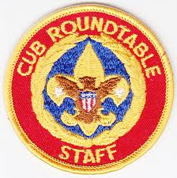

Update Supplemental Pack Meeting Plans
Commissioner Dave (with help from Kim)
National Council is continuing to add theme based pack meeting plans to the Core Value pack meeting plans on their web site. Soon there will be three supplemental Pack Meeting plans for each month. All the Pack Meeting plans will be posted on National's site at: http://www.scouting.org/scoutsource/CubScouts/Leaders/DenLeaderResources/DenandPackMeetingResourceGuide/PackMeetingPlans.aspx
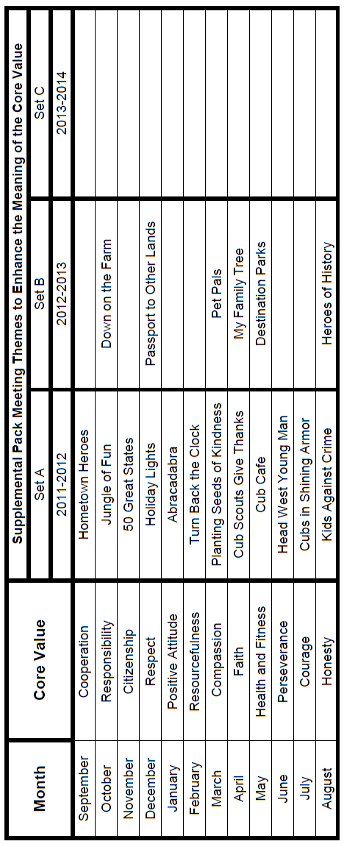
The years are a guess at how National will use the Supplemental Themes in the next several CS RT Planning Guides. But any theme is available to use any year.
Five of the agendas are already posted. Those titles are:
October | Jungle of Fun
November | 50 Great States
December | Holiday Lights
January | Abracadabra
February | Turn Back the Clock
The agendas for the seven others in the first batch are at National awaiting final review, approval, and posting.
Kim, the chair of the task force creating the plans and a friend of mine from two Philmont Training Center courses, said to me "I do want to stress that the focus is still the Core Value and the theme is just there as an enhancement." The theme pack meeting plans are specifically crafted to bring out the important points of the Core Value in a fun way. Eventually, there will be 36 alternate pack meetings posted, three for each Core Value, and with the existing Core Value based meeting you will have four total pack meetings for each Core Value from which to choose, thus providing variety so Cubs will not have to see the same thing every year. Also, it is planned that Roundtables will continue to provide new ideas for Pack Meetings each year that are based on the Core Values.
And don’t forget to use YOUR IMAGINATION, too!!!
A Big "Heap How" to you, Kim, and your Task Force,
for all the hard work to make this happen. I am publishing the themes as I receive them. Kim is waiting to tell me until each theme has a workable(not necessarily final) agenda so that I do not give you a theme and then they change their mind because the pack meeting plan does not work.

Upcoming:
- April's Core Value, Faith, will use "Cub Scouts Give Thanks."
Month's that have themes that might help you with Faith and "Cub Scouts Give Thanks" are:
Month | Year | Theme
November | 1942 | Thanksgiving
November | 1952 | Faith of his Fathers
December | 1960 | Guiding Stars
November | 1974 | Pilgrims
November | 1980 | Thanksgiving - Living and Sharing
November | 1984 | Turkey Day
November | 1992 | Turkey Day
December | 2000 | What do You do at Holiday Time?
November | 2003 | Pilgrims of Plymouth Rock
December | 2005 | Faith, Hope & Charity
December | 2007 | Celebrations Around the World
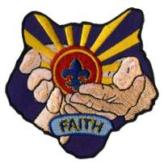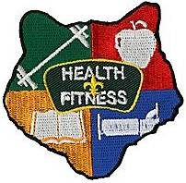
- May's Core Value, Health & Fitness, will use "Cub Cafe."
Month's that have themes that might help you with Health & Fitness and "Cub Cafe" are:
Month | Year | Theme
Food Themes
July | 1948 | Cub Scout Chefs
April | 1952 | Things that Grow
July | 1969 | Cub Scout Chefs
May | 1973 | Things that Grow
July | 1973 | Cub Scout Chefs
May | 1978 | Growing Food
July | 1978 | Come get it
May | 1982 | Things that Grow
June | 1987 | Come and Get It
March | 2000 | Cub Grub
December | 2004 | Holiday Food Fare
April | 2007 | Cub Cafe
Health Themes
October | 1939 | Health and Safety
January | 1982 | Adventure in Good Health
Fitness Themes
August | 1944 | Strength
May | 1946 | Keeping Fit
November | 1949 | Keeping Strong
May | 1952 | Strength and Skills
July | 1962 | Strength and Skill
June | 1967 | Feats of Skill
January | 1969 | Fit For America
January | 1972 | Feats of Skill
September | 1974 | Muscle Builders
January | 1976 | Tournament
June | 1977 | Muscle Builders
June | 1978 | Physical Fitness
August | 1981 | Physical Fitness
January | 1983 | Shape-Up (Winter Olympics)
March | 1985 | Step into Shape
July | 1986 | Strength and Skill
August | 1988 | Physical Fitness
April | 1994 | Shape Up
August | 2000 | Toughen Up
November | 2000 | Turn On the Power

Cubcast
Cubcast is an audio podcast featuring how-to and information topics for Cub Scouting leaders and parents. There is an RSS icon on the page where you can subscribe to ensure you do not miss an episode/edition. Old Cubcast broadcasts are archived and may be downloaded from the site. If reading on-line, click the picture to go to Cubcast -

In the current episodes for February 2012, Part 1, focusing on Compassion, features Nancy Ferrell, a Cub Scout leader for over 28 years who had held many volunteer leadership positions in councils all over the country. She currently serves on the Pack Meeting Plan Task Force.

Part 2, focusing on Special Needs Youth, features Carla Bigelo, a 30-year volunteer with the Mount Baker Council in Everett, Washington. Over the past 17 years, Carla has been a foster parent to more than 150 children, most of whom had special needs.

Cubcast may be heard at -
http://www.scouting.org/scoutsource/CubScouts/Leaders/Cubcast.aspx

Please let me know about Pow Wow's
and Pow Wow Books!!
I cannot do this job without your help!!!


DEN MEETING TOPICS
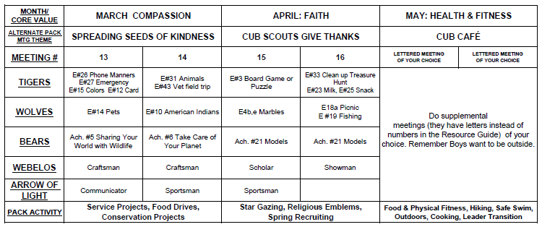
When a Den Meeting occurs depends on when you start your year and how often you meet. A Den that starts in August will be doing meetings 1 & 2 then, and 3& 4 in September. A den that meets three times a month will do 1, 2, and 3 in September. The pace is up to you!!

PACK ADMIN HELPS –

Journey to Excellence 2012
Jay Reeves, CS RT Commissioner,
Hiawatha District, Gamehaven Council, MN
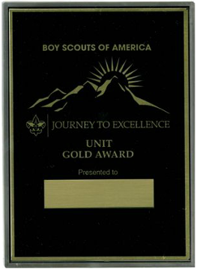
I know in my district, it can be a struggle to get Cub Scout Leaders "fully trained" for their positions. The process of taking "Fast Start", "This is Scouting", and then Leader Specific Training can be a challenge.
Item number 5 on the 2012 JTE Scorecard for Packs is "Trained Leadership".
In 2011 this reflected the requirements listed above. As of January 9, 2012, the requirements have been changed. Leader Specific Training is the only required training for each direct contact leader and Committee member. This program is available online at www.myscouting.org. Remember that a BSA membership number is not required to set up an account and that a Leader can return to the site to update their profile when they have it.
New Leaders must complete Leader Specific Training within three months of taking on their position. Remember also that a Leader changes positions, they need to take the Leader Specific Training for their new position. Leader Specific Training needs to be taken only once, it does not need to be renewed on a time basis.
Youth Protection Training is now a requirement for adult membership in the BSA and supersedes the training requirement for any position. YPT must be renewed every two years. Also, YPT has under gone a significant revision recently to reflect the requirement to notify appropriate law enforcement / child protection agencies immediately (along with your Council Scout Executive). It is worthy of renewal by everyone now regardless of their renewal date.
Change to JTE item number 6 "Day / resident camping"
For 2012, the camping item provides "Family Camp" as an eligible activity. This would be Pack based camping. In 2011, activities were required to be "Cub Scout" day or resident camp which by definition would be Council or District organized. This provides for flexibility to Packs with a strong outdoor program and an incentive for Packs who do not go Family Camping.
With this in mind, remember that in order for a Pack to go overnight camping, at least one registered Leader (on the outing) must be trained in Basic Adult Leader Outdoor Orientation (BALOO). This one day program (in most cases) is an introduction to camping and how to create a program that will engage the boys. It provides information on things like campfire planning, sanitation and camping gear. Along with local policies on taking your Pack to the outdoors and how Youth Protection Standards are applied to Cub Scout camping.
I've also been hearing the rumor that "Outdoor Skills for Webelos Leaders" (sometimes called "OWLS") would be folded into Boy Scout Leader "Introduction to Outdoor Skills" (OLS) and be eliminated as a separate program. As of this writing, the National Training site is indicating that this change will not be happening. OWLS is still able to be integrated into the OLS program but the skills are of sufficient difference that that freestanding OWLS program will continue to be made available for the foreseeable future.

2013 National Jamboree Staff
Finally, have you considered being on the 2013 National Scout Jamboree Staff? Be part of history as we build the permanent home of the Jamboree. The Jamboree needs people of many talents and skills as we build the second largest city in West Virginia on a mountain top. (Well, the second largest city for 10 days anyway!) Planning is underway to welcome 40,000 Scouts and Scouters in July of 2013! More information is available at: www.bsajamboree.org.
Jay Reeves
Cub Scout Roundtable Commissioner
Hiawatha District
Gamehaven Council
Rochester, MN

CUBMASTER'S CORNER
Pamela, North Florida Council
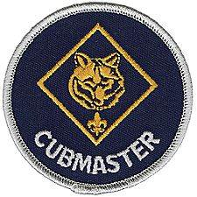

Hello Cub Masters!
It’s April and there are probably a hundred ideas you have for the upcoming months. Remember 3 things: PWP. PWP stands for: Plan with your committee, Work as a team, and (this is a big one… because we want EVERYONE there) Publish the plans early so everyone can join in! Events are not secrets or things we spring on parents the month before. The more the merrier and the sooner the faster you can find helpers for all your committees.
There are plenty of resources from your district (like Roundtable), council, Baloo’s Bugle, and published helps from the BSA for any idea you have. You do not have to reinvent the wheel. (You might tweak the ideas to your needs but you don’t have to invent it!) Do not forget: you are just the Master of Ceremonies. Don’t hog the stage but introduce the dens to do their parts and keep your Cub Master Minute to one minute (that’s why it’s called: Cub Master Minute and not a Cub Master Couple of Minute and stay on the stage till everyone falls asleep). Those announcements (if any) should stay short to no longer than 2 or 3 minutes. Things like signups for day camp or training dates should be in your Monthly Pack News Letters or at information table near your Check In table near the door for all to sign in near the entrance. (Yes, you’re supposed to have people sign in and give any new information like new emails or change of phone numbers when they check in at every Pack meeting.)
April is a great month to finalize those Tiger Cub Round Up plans and confirmation with your committee for May. This is a great way to get the Tigers in early, signed up for day camp, and involved with the monthly summer time pack events. Publish all your summer events in your April and May Newsletter so parents can plan! Encourage and remind all your Scouts to work towards the Summer Time Awards it will keep them active and excited about Scouting and encourage their friends to join in! To help your units grow use the Recruiting Patches and perhaps an award for the most recruits per den for the summer time! A certificate to somewhere and a simple wooden plaque with their name on it for most recruits bring a smile to any boys face and helps the “Pack Grow”!
One more award they all (including your leaders) can earn is the Religious Award. This award is for every branch of faith and there are booklets out there. You can order the booklets through your Scout Shop or www.scoutstuff.org . Religious awards programs are uniquely designed to build assets in youth and your adult leaders. Of course, the primary goal of religious awards is to help children grow stronger in faith, but a secondary goal is to help families and faith communities build positive assets in children. When young people work alongside counselors, mentors, and religious leaders, and when parents are encouraged to share their faith with their children, the religious awards programs help provide support mechanisms in their lives.

SPECIAL OPPORTUNITIES
Pat Hamilton, Baltimore Area Council
Our Core Value this month is Faith, and for most of us, the way we were brought up helps determine the degree and direction of our faith. I am highlighting the Language and Culture Belt Loop and Pin for the Academics program. The faith we learn when we are young can provide a firm foundation for our beliefs when we are older. On a lighter note, I think that having faith on our own abilities can be a big help when we are learning a number of different sporting activities. I decided to feature Roller Skating this month for the Sports Belt Loop and Pin.

Language and Culture Loop and Pin
The requirements listed below are taken from the Cub Scout Academics and Sports Program Guide (34299) 2009 Printing.
Webelos Scouts that earn the Language and Culture Belt Loop while a Webelos Scout also satisfy requirement 6 for the Scholar Activity Badge.
Requirements
Tiger Cubs, Cub Scouts, and Webelos Scouts may complete requirements in a family, den, pack, school, or community environment. Tiger Cubs must work with their parents or adult partners. Parents and partners do not earn loops or pins.
Belt Loop
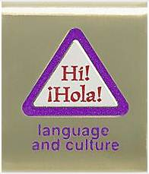
Complete these three requirements:
- With your parent's or adult partner's permission, talk with someone who grew up in a different country than you did. Find out what it was like and how it is different from your experience.
- Learn 10 words that are in a different language than your own.
- Play two games that originated in another country or culture.
Academics Pin

Earn the Language and Culture belt loop, and complete seven of the following requirements:
- Earn the BSA Interpreter Strip.
- Write the numbers 1-10 in Chinese or another number system other than the one we normally use (we use the Arabic system).
- Visit an embassy, consulate, or chargé d'affaires for another country.
- Make a display of stamps or postcards of another country. Explain the importance or symbolism of the things depicted to that country's culture.
- Learn 30 words in a language other than your own. Practice saying these words with your den or an adult family member.
- Learn a song in another country's language. Sing the song for your den or an adult family member, and then tell what the words mean.
- Say five words in American Sign Language. One of these words could be your first name.
- Visit a restaurant that specializes in recipes from another country.
- Watch a TV show or movie in a foreign language. Tell how easy or difficult it was to understand what was happening.
- With your parent's or adult partner's permission, interview an interpreter. Find out what his or her job is like.
- Make a list of 30 things around your home that were made in another country.
- Read a book or story about an immigrant to the United States.
If the Scout's native language is not English, then English may be used to satisfy the appropriate requirements.
For worksheets to help with earning these awards go to http://usscouts.org/advance/cubscout/academics/language-culture.asp

Roller Skating Loop and Pin
The requirements listed below are taken from the
Cub Scout Academics and Sports Program Guide (34299 - 2009 Printing).
Webelos Scouts that earn the Roller Skating Belt Loop while a Webelos Scout also satisfy part of requirement 3 for the Sportsman Activity Badge.
Requirements
Tiger Cubs, Cub Scouts, and Webelos Scouts may complete requirements in a family, den, pack, school, or community environment. Tiger Cubs must work with their parents or adult partners. Parents and partners do not earn loops or pins.
Belt Loop
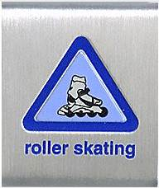
Complete these three requirements:
- Explain ways to protect yourself while roller skating or in-line skating, and the need for proper safety equipment.
- Spend at least 30 minutes practicing the skills of roller skating or in-line skating.
- Go skating with a family member or den for at least three hours. Chart your time.
Sports Pin
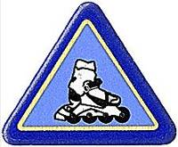
Earn the Roller Skating belt loop, and complete five of the following requirements:
- Participate in a pack or community skating event.
- Demonstrate how to disassemble and reassemble skates.
- Explain the proper clothing for roller or in-line skating.
- Spend at least 15 minutes, on two occasions, practicing warm up exercises before skating.
- Play a game of roller hockey.
- Learn and demonstrate two new roller skating skills: forward scissors, forward stroking, crossover, or squat skate.
- Participate in a roller or inl-ine skating skill development clinic.
- Demonstrate how to stop quickly and safely.
- Demonstrate how to skate backward. Skate backward for five feet.
- Play a game on roller skates, roller blades, or in-line skates.
For worksheets to help with earning these awards go to http://usscouts.org/usscouts/advance/cubscout/sports/roller-skating.asp

Religious Emblems
www.USScouts.org
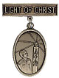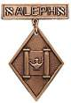
"A Scout is Reverent." All Scouts show this by being faithful in their duty to God. Some go further and give special service. This can qualify them for a religious emblem. Such an emblem is not a Scouting award. It is conferred on a Scout by his religious leader. Each faith has its own requirements for earning its emblem. Listed below are the BOY SCOUT and VARSITY SCOUT emblems and where to find out about them. Before writing or visiting your local council service center, check with your religious leader.
(Unless indicated otherwise below, awards listed may be earned by both Boy Scouts and Varsity Scouts.) Older Boy Scouts of Varsity Scout age (over 14), Venturers, and Sea Scouts (and in some cases, Explorers) are eligible for any awards that Varsity Scouts may earn.
Most of these groups also offer religious emblems for younger youth in the various Cub Scout Programs. For information on the awards available to Tiger Cubs, Cub Scouts, and/or Webelos Scouts. Click Here or got o http://usscouts.org/advance/cubscout/religious.asp .
Most of the awards consist of bar pins, ribbons, and pendants, and are worn on the uniform above the left pocket on formal occasions. In addition, the Religious Emblem Square knot, shown at the top of this page, may be worn on the uniform over the left pocket by youth or adults who earned any of the religious awards. One or more miniature devices are affixed to the knot to indicate which level(s) of the award was earned. For more information on the Youth Religious Emblem square knot patch go to http://usscouts.org/advance/cubscout/religious.asp#Chart or http://www.scouting.org/scoutsource/Awards/ReligiousAwards/chart.aspx. For information on the devices which are attached to the knot, Click Here or go to http://usscouts.org/awards/devices.asp.

FAQs about Religious Emblems
www.scouting.org
What are the religious emblems programs?
The religious emblems programs are programs created by the various religious groups to encourage youth to grow stronger in their faith. The religious groups—not the Boy Scouts of America—have created the religious emblems programs themselves. The Boy Scouts of America has approved of these programs and allows the recognition to be worn on the official uniform, but each religious organization develops and administers its own program.
I have a unit with children of all different faiths. How can I include the religious emblems programs for my unit?
The religious emblems programs should be presented to youth members and their families as an optional program for them to complete through their religious organization. Religious instruction should always come from the religious organization, not from the unit leader. Parents need to be informed of these programs and told where to get the information for their particular faith. Interested in making a presentation on the religious awards? Find sample scripts at www.praypub.org.
Do boys and girls participate in the same program?
It depends on the religion. Some religions have created programs that are used by both boys and girls. Other religions have created programs for members of separate youth agencies (i.e., Boy Scouts of America, Girl Scouts of the U.S.A., and Camp Fire Boys and Girls). Please check the specific eligibility requirements for each religious emblems program.
Do the youth have to belong to a religious institution?
It depends on the religion. Please check the eligibility requirements for your particular religious program.
Why doesn't my religious institution know about the religious emblems programs?
Although the religious bodies at the national level created the religious emblems programs, the local religious institution may not be aware of these programs. It may be helpful to write for more information or even obtain a copy of the curriculum to give to your religious leader.
If the religious emblems program for my faith has more than one level (for the different grade levels), may my child earn all of these recognitions?
Yes. Members can earn all levels of their religious emblems program. However, they must be in the appropriate program guidelines when they start and complete each level (they may not go backward and earn younger programs).
How is the emblem presented?
The emblem should be presented in a meaningful ceremony, preferably in the youth member's religious institution. Some emblems come with a sample presentation ceremony.
How long does it take to complete a program?
It depends on the program. Some programs may take three or four months, others longer.
Where is the emblem worn on the uniform?
The universal religious square knot is worn over the left shirt pocket of the Scout uniform. The medallion is pinned over the square knot for full uniform occasions.
How do we get started on these programs?
- Youth members must obtain the specific booklet for their religion. This booklet will contain information on all the lessons and service projects that they will need to complete. Each member needs to have his or her own booklet to document progress. Some religions also provide adult manuals for counselors and mentors. Check with your local council to see if it stocks these booklets in its store, or contact the religious organization directly (addresses and phone numbers are provided at http://www.scouting.org/scoutsource/Awards/ReligiousAwards/~/link.aspx?_id=9D5FA10AEB254061A248D13D459424FE&_z=z).
- Parents must review the specific guidelines for their particular program; age/grade requirements vary from program to program. Some programs require that the youth be an official "member" of the local religious institution, others may not. Each program determines who may serve as counselor (some require clergy, others allow parents or other family members). Be sure to look at specific eligibility guidelines!
- Families should talk to their religious leaders and show them the booklet before beginning any program. Most of the religious emblems programs require that they be completed under the auspices of that religious organization, and many require the signature of the local religious leader. Again, check the specific eligibility requirements for your religious program.
- The member needs to complete the requirements, obtain the proper signatures, and follow the instructions to order the emblem/award. (These emblems are not available in your local council.) The emblem can be presented at any time of the year and should be presented in a meaningful ceremony, preferably in the member's religious institution.
Who may serve as counselor?
It depends on the program. Some programs require clergy to serve as counselor, others allow a parent or family member. Please check the specific guidelines for your religious program.
How do I order the recognition items?
Each religious program has its own emblem. Follow the instructions in your recognition guidelines because the emblems come from different places and require submission of different information. These emblems will not be available in your local council!
What is the adult religious recognition program?
An adult religious recognition award is presented by nomination only. The recognition is presented to worthy adults for their outstanding service to youth both through their religious institution and one of the national youth agencies. Recipients of these awards are unaware that they are being nominated. They are nominated to receive an award by submitting the required application, letters of recommendation, and resume. Please check eligibility requirements for specific awards.
Which religious emblem square knot should I wear?
Cloth, silver knot on purple, No. 05007, may be worn by youth or adult members who earned the knot as a youth, above left pocket.
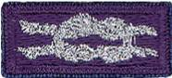
Cloth, purple on silver, No. 05014, may be worn by adult members presented with the adult recognition of a faith, above the left pocket. Adults may wear both knots if they satisfy qualifying criteria. (See the Insignia Guide, No. 33066D.)
NOTE: - Since the programs are similar or the same (as in the case of the PRAY Awards) for girls and boys in Boy Scouting, 4H, Girl Scouting, Campfire, etc., a female Venturer or Adult Leader who earned her religious award as a youth may wear the purple square knot on her uniform even though it was not earned as a member of the BSA. (My daughter Darby in New Mexico does this!!)
Per Mike Walton of www.USScouts.org, this applies to BOTH MALES AND FEMALES, youth and adult. If you earned a youth religious emblem as a youth member, whether or not it was earned or received as a BSA member does not matter. The youth religious emblem square knot represents ANY AWARD which youth members earned or received -- period.
So yes, a Girl Scout, 4Her, or Royal Ranger/Missionette who earned a youth religious emblem in those programs and then either becomes an adult or youth member of the BSA (to include Venturing/Sea Scouting) may wear that emblem formally with the BSA's field uniforms; and informally wear the square knot insignia on the uniform shirt.
Mike says he has been told when the next edition of the Uniform Guide for 2012 is printed, there will be text explaining this on the page which shows all of the various youth religious emblems.CD

Knot of the Month

Adult Religious Recognitions
Baloo's Archives
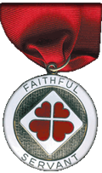
What is the adult religious recognition program?
An adult religious recognition award is presented by nomination only. The recognition is presented to worthy adults for their outstanding service to youth both through their religious institution and one of the national youth agencies. Recipients of these awards are sometimes unaware that they are being nominated. They are nominated to receive an award by submitting the required application, letters of recommendation, and resume. Please check eligibility requirements for specific awards. Self and spousal nominations are usually not allowed.
Essentially every denomination that has Youth Awards has at least one Adult Award. I chose to feature this square know because on Scout Sunday this year, I was awarded the Churches of Christ Faithful Servant award (seen above). There is a minimum ten year tenure requirement for nomination. The recipient may wear the Adult Religious Emblem Square Knot. We, also, have the Loving Servant and Joyful Servant awards for Cub Scout aged boys (and girls). Almost every denomination has a religious award available for its members. The requirements vary from denomination to denomination. There is a fairly comprehensive list available online.
For complete listings of Adult Religious Recognitions for BSA Leaders go to National’s site at http://www.scouting.org/scoutsource/Awards/ReligiousAwards.aspx
or US Scouts site at http://www.usscouts.org/awards/religadult.asp
Many of these awards are coordinated by P.R.A.Y. Check their website for info, too www.praypub.org
The purple square knot on a silver background is worn by those whom have received a religious award as an adult member of the BSA. The awards are not BSA awards and are presented by religious organizations for long tenure of service to Scouting, the religion, and the community. With one exception all of these awards require a nomination. Self-nomination is not allowed.
Only one Adult Religious Award square knot is worn regardless of how many awards have been received. It is possible, for example, to receive two or three levels of awards in some faiths or to receive awards from more than one faith.
So, if you know someone who is deserving of receiving the Adult Award from his faith – check it out and begin the nomination process.

Boys’ Life Reading Contest for 2012
http://boyslife.org/
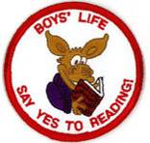
SAY ‘YES’ TO READING
Enter the 2012 Boys’ Life Reading Contest
Write a one-page report titled “The Best Book I Read This Year” and enter it in the Boys’ Life 2012 “Say Yes to Reading!” contest.
The book can be fiction or nonfiction. But the report has to be in your own words — 500 words tops. Enter in one of these three age categories:
- 8 years old and younger
- 9 and 10 years old
- 11 years old and older
First-place winners in each age category will receive a $100 gift certificate good for any product in the Boy Scouts official retail catalog. Second-place winners will receive a $75 gift certificate, and third-place winners a $50 certificate.
Everyone who enters will get a free patch like the one on this page. (And, yes, the patch is a temporary insignia, so it can be worn on the Boy Scout uniform shirt, on the right pocket. Proudly display it there or anywhere!) In coming years, you’ll have the opportunity to earn different patches.
The contest is open to all Boys’ Life readers. Be sure to include your name, address, age and grade in school on the entry.
Send your report, along with a business-size, self-addressed, stamped envelope, to:
Boys’ Life Reading Contest
S306
P.O. Box 152079
Irving, TX 75015-2079
Entries must be postmarked by Dec. 31, 2012 and must include entry information and a self-addressed, stamped envelope.
For more details go to http://boyslife.org/

GATHERING ACTIVITIES
Note on Word Searches, Word Games, Mazes and such –
In order to make these items fit in the two column format of Baloo’s Bugle they are shrunk to a width of about 3 inches. Your Cubs probably need bigger pictures. You can get these by copying and pasting the picture from the Word version or clipping the picture in the Adobe (.pdf) version and then enlarging to page width. CD
Show “Faith in Action” - Have every boy share some ways in which he demonstrates his personal faith – You could use photos of boys doing a service project, or write out stories of how a boy and/ his family have helped friends or neighbors, or how a boy serves in his own church.
Have a collection of “tree cookies” and various craft supplies – let everyone make a tie slide by adding a pvc length or other backing. Non-cubs could make a pin to wear, using a jewelry backing and decorating with googly eyes, markers, etc.
Give everyone a piece of paper and pencil and challenge them to name ways wood is used. Also check out the graphic, tree-shaped list (on the last page of Baloo’s Bugle) from http://www.idahoforests.org/arborday.htm – you might want to enlarge it, then cover it with green paper - till you’re ready to check everyone’s list of uses. This could be an individual, den or family competition.

Search for Faith
Words in this search all pertain to Faith – words may be in any direction.

D O G O H D M O F F Z C P A
N P N W B H B R C B S E L F
N O V L Z P I S O S C R U W
U E I Y U E I P N W Z T D V
S C J G N J J R F Q L A H B
Q N J D I Q F O I V F I S P
B A S L E L Z O D F H N V R
Y I E L V P E F E H U T T I
E L K B O F O R N H K R F N
R E N E R Y Y H C X U Z A C
U R V L N F A Z E S G L C I
S B V I W B B L T O U S M P
Z G C E R O K N T O L P X L
F H P F O L W O U Y R Z R E

Belief | Principle
Certain | Proof
Confidence | Reliance
Friends | Religion
God | Self
Hope | Sure
Loyalty | Trust
Post a wall of Gratitude – as people arrive at the pack meeting, give them a slip of paper to write down at least one thing they are thankful for. Post on the Wall of Gratitude.
Faith Bingo
Commissioner Dave
Give each person a Board. They are to go around and meet people. After meeting someone and learning their name, they are to ask them to sign a box. Each person can only sign one box!!! This is not a speed contest; there should be discussion and introduction before signing!! Here is a sample board- boxes may be changed to suit your group
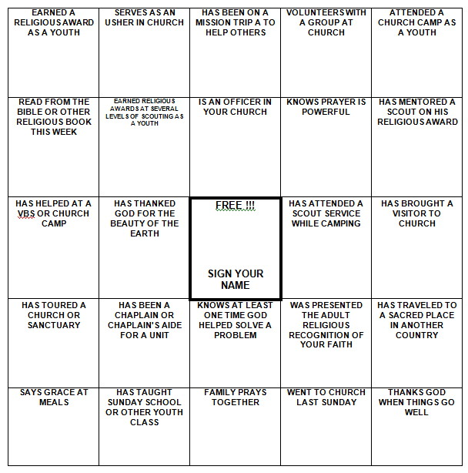
Be sure to enlarge the BINGO Board to fill a sheet of paper and put some directions on the sheet, too.
Emblems of Faith Puzzles
Commissioner Dave
Materials: Pictures of Religious Awards printed on card stock or pasted to thin cardboard..
- Cut the pictures into puzzle pieces - 4 or 6 per card.
- Give the boys puzzle pieces as they arrive.
- Have them try and complete the puzzle by talking with others and finding the others pieces.
- During Icebreaker have them show the completed puzzle and read the back. (Have tape available)

Please let me know about Pow Wow's
and Pow Wow Books!!
I cannot do this job without your help!!!

OPENING CEREMONIES
Where Faith is Found Opening
Alice, Golden Empire Council
Materials: Have each boy make a sign to hold with the letter he has been assigned. Alternately, you can simply download images or make letter signs. Write each boy’s part on the back of the sign in large letters.

Narrator: This month we have been learning all about Faith – see if you recognize these examples of where Faith is Found.
 | Cub #1: (holding up letter or posting on the wall) Follow the example of your religious leaders, your grandparents, or others who have great faith – it will help you find your own Faith.
 | Cub #2: (holding up letter or posting on the wall) Always look for examples of faith as you enjoy the outdoors – like the breeze, faith cannot be seen – but you can feel its presence.
 | Cub #3: (holding up letter or posting on the wall) If you want to have faith, learn to serve others – without complaining.
 | Cub #4: (holding up letter or posting on the wall) Trust in your God, your Country and Yourself – And always be a person that can BE trusted if you want to find Faith.
 | Cub #5: (holding up letter or posting on the wall) How you ACT will show what you really believe.  (All boys return and hold up their letters)  All: SHOW YOUR FAITH!
Narrator: As you can see, the boys have learned some important ways to really SHOW their faith. And we’d like you to join us in Showing how we feel about our Country – where every person can follow their own faith, and worship as they please…..
(Lead into the Flag Ceremony)

Cub Scouts Are Thankful Opening
Alice, Golden Empire Council
Before the meeting, each boy draws a picture, cuts out images from magazines, or uses online images to make a small poster of things he is thankful for.
Narrator: You can’t have Faith if you aren’t grateful for what you have. Let’s see what the boys are grateful for.
Boys hold up or post their picture one and a time and say “I’m thankful for…..”
Narrator: So you can see that our Cub Scouts Are Grateful – and there’s one more thing we are grateful for – to live in a free land where we can worship as we please.
Let’s prepare to honor our flag, the symbol of our freedoms.
(Lead into the Flag Ceremony)

The Cub Scouts are Coming
Pamela North Florida Council
One Cub Scout at a time trots urgently from the back of the room to the front shouting: “The Cub Scouts are coming! The Cub Scouts are coming!!”
Then two boys enter, carrying the United States Flag.
Cub Scout 1: “All rise! Color Guard Advance!” Scouts approach front. “Salute!”
Cub Scout 2: “Please join us in the Pledge of Allegiance!” and lead the pledge.
Cub Scout 3: “Color Guard post the colors.” (Cubs place flags in stands) “2” (This is the signal to stop saluting; hands lowered from salute) “Color Guard dismissed.” Scouts can march to the back or be seated.
Give Thanks
Pamela North Florida Council
Set Up: Have 10 Scouts with signs each with one of the letters from G I V E T H A N K S on front. On the back of the same paper write out speaking parts in Large Print.
Cub # 1: G is for the Glorious spring that offers hope to all.
Cub # 2: I is for the Importance our faith is to us one and all:
Cub # 3: V is for the Valiant people who saw hope in creating our country.
Cub # 4: E is for the Endless love of God.
Cub # 5: T is for the Trust we give to those who care for us.
Cub # 6: H is for our Homes to always be filled with love.
Cub # 7: A is for the Awe we have in Gods creations all around us.
Cub # 8: N is for Nature that God shares with us.
Cub # 9: K is for the Kindness for family and friends.
Cub # 10: S is for the Spirit that kept us strong and with eternal faith in God.
All: Tonight we give thanks to God above, for His guidance and his never-ending love. Please rise and join us in the Pledge of Allegiance.

AUDIENCE PARTICIPATIONS & STORIES
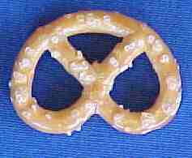
Make a Pretzel of Faith Tie Slide
Alice, Golden Empire Council
Prayer is an important part of faith – and here’s an interesting way to “wear” your faith on your neckerchief – make a pretzel tie slide!
Really simple – just mount a “perfect” pretzel on a piece of fun foam, or cardboard, or heavy duty paper. Background can be any color. Add a backing.
Be prepared to explain what the pretzel really means. Here’s the story:
A few weeks before Christmas in 610 AD, Brother Bachman was kneading bread dough while he watched the village children play in the snow. “Too bad they aren’t as interested in their prayers,” he thought to himself.
"If only there was some way to get them back to saying their prayers and coming to church," he said to himself. As he was finishing up the last loaves of bread, Brother Bachman was suddenly struck with a most original idea. He thoughtfully gathered up the leftover dough and began to form pencil-like strips, which he then twisted into a shape that looked like a child's arms folded in prayer. "Ah! A Pretiola!" he declared, which in Latin meant little reward.
He opened the bakery window and called out to the children. "Come in, come in say your prayers, and I will give you a Pretiola!" It didn't take much convincing. Soon each child had learned a prayer and proudly received a "little reward." Rushing home, the children excitedly told their parents. Word of Brother Bachman's idea soon spread through the village, and children and parents alike visited the chapel to receive a Pretiola.
The Christmas Prayer Service that year was especially festive and bright. The church was filled with families once again. And as the cheerful voices rose in prayer and song together, Brother Bachman smiled joyfully and thanked the Lord for little rewards.
The Pretiola soon found its way into Germany and Austria. It became a symbol of excellence used to reward worthy accomplishments as the church and youth programs flourished.
Through the centuries, Pretiola became known as "Pretzel" as we know it today. If you make a Pretzel Tie Slide, you can tell the story, too!

LEADER RECOGNITION & INSTALLATION

Leader Appreciation Ceremony
Margo, Frontier Council
MATERIALS: 4 Candles
Scouting is made up of many things, people, and ideas. Tonight we are going to take a few minutes to reflect on some of the more pertinent aspects of Scouting.
First - Scouting is a program. As depicted by our first candle it is a program dedicated to the development of character, citizenship, and the mental and physical fitness of our youth.
Second - Scouting is for the youth of our community. Young men who expect to learn, gain recognition by advancement, but most of all they expect to have fun with others of their own age.
Third - Scouting is the parents of our Scouts. For without parents taking an interest in the activities of their sons, taking them to meetings, and fulfilling their part of the Scouting program, we could not have Scouts.
But, as you can see, this leaves one lone candle. This candle represents the Leaders of Scouting. As I call your name would you please come forward.
Leaders, I light this candle for you, for you have been a faithful leader to us and we want you to know that your work, dedication, and tireless effort has been gratefully appreciated. For without your leadership as well as the leadership of all Cub Scout leaders. The first three candles - program - youth -and parents would be meaningless. Thank you!
I dug the following out of some of my old Baltimore Area Council Pow Wow books. When I wrote those books, I put a blanket acknowledgement in listing all the Councils’ Pow Wow books that I used for “research.” If you recognize something as yours and would like credit, please let me know. Dave has my e-mail address. –Pat

10 Commandments of Ceremonies
- Thou shalt have one every month
- Thou shalt Keep It Simple, Make It Fun (KISMIF)
- Thou shalt not repeat a ceremony, no matter how many adults want to (or how good you look in an Indian headdress)
- Thou shalt not ask Cub Scouts (or adults) to memorize or read a lot of big words
- Thou shalt be heard and seen by all
- Thou shalt include both child and his parent
- Thou shalt not forget Webelos Activity Badges (pins), to make them important also
- Thou shalt follow the Core Value or monthly theme
- Thou shalt understand the Cub Scout advancement
and how important it is to the boys
- Thou shalt use thy brain to come up with new ideas

Quickie Thank-You's
- Role of Lifesavers - You're a life saver
- Band-Aid glued to a board - Rescue Award
- Quarter glued to a board - Always prepared Award
- Magic Hat - For Pulling Things out of your hat when needed.
- Clothespin with wings and yellow stripes - Queen Bee Award (for female Cubmaster)
- Toothpicks - You were picked for the Job Award.
- Pick up Sticks - You Pick Up Our Spirits
- Old Boot - Don't get off on the Wrong Foot Award
- Blown up bag – It’s in the Bag Award
- Picture of Dog - Hotdog of Service
- Kite - you’re a high flyer
- Plastic Baseball painted silver and on ,a chain, or ribbon - You’re Really on the Ball
- Railroad Track - You are on the Right Track
- Face with a Hole for the Mouth - Loud Mouth Award
- Silver Star - Super Star Award
- Painted Rock - You're our Solid Rock
- Purple Heart - The Purple Heart Award
- Big Sucker - You got Suckered into this Award
- Spark Plug - You’re the Spark That Keeps us Going
- 'Head of Lettuce - Head of the Pack.
- Roll of Toilet Paper - You're on a roll
- Ice Cream Cone or Instant Coffee Creamer - You're the Cream of the Crop
- Banana - You're the Top Banana Award
- Telephone glued to an Ear – You Talked Our Ear Off Award
- Fan - You're our Biggest Fan
- Paper Plate painted Blue – Blue Plate Special
- Package of Yeast - You Rise Above all the Rest.'
- Puzzle - For Your Help in Putting it all Together. 4
- Fire Log - You Helped Turn our Flame into a Raging Fire.
- Rubber Glove stuffed with cotton, painted Silver and glued to a board - The Helping Hand Award.
- Legg's panty hose egg, painted silver then screwed onto a block of wood - Good Egg Award
- Plastic spoon painted Silver and glued to a board - Silver Spoon Award
- Toy Spatula glued to board - Flapjack Award.
- Picture of Retiring Den Leader - For Service Beyond the Call of Duty.
There are lots more of these floating around out there. If you have a favorite, let Dave know. There’s no such thing as too many recognition ideas!

Leader Induction Ceremony
Personnel: Pack Committee Chairman and new Pack leaders.
Equipment: Candles and candle boards described below
Committee Chairman: Before you is a ceremony board that has five candles on it. The top two, like the alert ears of a wolf, represent the two upright fingers of the Cub Scout sign. They mean TO OBEY and TO HELP OTHER PEOPLE.
The three candles at the bottom represent the folded three fingers of our Cub Scout sign. These three fingers stand for the three important letters in our law: F-H-G. These letters represent FOLLOWS, HELPS, GIVES. They also mean FAIR, HAPPY and GAME. And finally, they remind us of something each Cub Scout, represents - FREEDOM, HOME, and GOD.
All of our leaders want to do their best to teach Cub Scouts to learn to follow, to help, to give, to be fair and happy whatever the game might be and to respect their freedom, home, and God.
Will the new leaders of our Pack please come forward? (Pause while the new leaders gather at the front of the meeting place.) Please repeat after me:
I, (your name), promise to do my best, to help the Cub Scouts in my Den and in my Pack to do their best, to help other people, and to do their duty to God and their country, and to obey the Law of the Pack.
As chairman of this Pack, I take pleasure in presenting to you your registration cards and personally welcome you into active leadership in Cub Scouting. May the days ahead be: FUN, HAPPY, and GIVING.
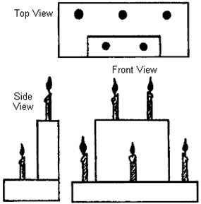

ADVANCEMENT CEREMONIES
Faith Advancement
Alice, Golden Empire Council
Gather gardening, fire building, cooking materials to use as props. You could either use just one type of material, or you could use gardening materials for the Tigers and Wolf den boys, Cooking materials for Bears and Fire Building materials for Webelos/Arrow of Light boys.
Each boy’s advancement items should be placed under (or in) an item, then brought out as the boys and their parents are called up. For example:
Gardening Theme:
Cubmaster: (pointing to gardening equipment) The boys in the Tiger den have been learning all about Faith this month - They planted some seeds – and watched them grow. I’d like to call up ____and his parents. (holds up seed packet and removes advancements – gives parent pin to boy to present, and advancement to parents to present to boy) ….
Continue calling up and presenting awards –
You could also refer to the planting directions (scriptures), trowel to prepare the soil (teaching of religious principles by parents and others), watering can (providing examples nourish faith),making sure plants have time in the sun (letting your faith “shine” by doing good deeds) etc.
Cooking Materials: Recipe gives directions (compare to Scriptures), Baking Powder or yeast as the way to raise the dough (help from parents and leaders), eggs, milk or other liquids to hold the ingredients together (examples from parents and others of how to live with faith) mixing or kneading (opportunities to practice faith, such as service projects, etc.)
Firebuilding materials: Shovel to prepare the area (that knowledge of right and wrong we all have), tinder (first stirrings of faith), kindling & fuel (ways we are taught by parents, teachers & leaders); match (spark that activates you faith when you have a chance to do good), need for air to keep fire going (need to keep doing good and obeying religious teachings for our faith to grow)
You get the idea – and you may have much better examples than mine! Alice

Advancement Ceremony
Pamela North Florida Council
Needed: 1 large candle in a stand many small candles, all in stands. Line up small candles in a line with the large candle at one end.
Akela: Our Webelos scouts have been very busy the past few months, completing activity badges towards their advancement. I would like the following Webelos scouts to please come forward. [call off names of scouts receiving pins]
Akela: Den Chief [name] will light one of the small candles for each activity badge as it is presented. The [activity badge name] activity badge has been earned by [scout names]. Please step forward to claim your pin and tell us one thing you did to earn this pin.
(Den Chief lights small candle. For each activity badge, Akela may change what he says. For example, for the Craftsman badge, he may ask each scout to tell what he built. For Sportsman, ask which sport he showed signals for and to demonstrate a signal now.once all pins are distributed)
Akela: Den Chief [name], I see we have one candle left. Should we light it now?
Den Chief: No, Akela, that big candle stands for the Arrow of Light.
Akela: That's right, [name]. This candle will remain unlit until we have a Webelos Scout who has completed the Arrow of Light requirements. Then we will light that candle. These small candles, representing the activity badge areas, are steps along the trail of Webelos Scouts. They are important in themselves, but they lead us to the Arrow of Light which signifies that a Webelos scout has reached the highest step on the Cub Scout trail and is fully prepared to continue on to the Boy Scout trail. Now, Den Chief [name], will you lead the Webelos Scouts in your den yell and then return them to their seats? (and Scouts are seated after yell.)
New Cub Scout Welcome Ceremony:
Pamela North Florida Council
This is a great one for your new Cubs that join the pack at your May Roundups!
Required: A burning fire and a few sticks for each new Scout. Prepare a campfire outside or a fake fire inside if you really have to. Have a stack of sticks well away from the fire, but in front of the audience to the right. Notes: Use this at the beginning or end of your first Pack meeting in September or even May when you get new batch of Tigers!
Akela: (standing by the stack of wood on the right) At this time, I would like all Scouts that are new to Pack [number] to please come up here with me. This fire represents the life of our Pack. As you can see, it is burning fairly well, but it is beginning to fade a bit. This fire needs new wood, new fuel to burn bright, just as our Pack needs new scouts to be strong and full of life.
I would like each of you to take 2 or 3 sticks from this pile and hold onto them.
Those sticks you have in your hands represent your energy, your eagerness, and your excitement to be part of this Pack. I bet you know what I want you to do with those sticks, and I bet you are very excited to do it! But, think about what will happen.
(Akela should now walk a bit closer to the fire, but still well away from it. The Scouts will soon line up in front of him but there may be some jostling.)
When you toss your sticks on the fire, what will happen?(the fire will burn brighter, the sticks will be burned, .. give Scouts time to give a reply.) Just as those sticks will make the fire hotter, bigger, stronger, and full of life, having you in our Pack will make us stronger and more full of life.Before you add your sticks to the fire, decide in your head and heart if you really want to join our Pack and learn our secrets and go on our adventures.
When you have decided to join, come and stand right here in front of me and make a single line behind the scout in front of you.(As the Scouts scramble to make a line, keep it safe.)
After you add your sticks to the fire, stand by Baloo( Den Leader) .
(Baloo should be on the left of the fire and makes sure Scouts stay well away from the fire. When all are finished)
Akela: Congratulations, you are now all part of the life of Pack [number].
Pack, please stand and make the Cub Scout sign and join me in the Cub Scout Promise.
Now join me in the Law of the Pack. Two!(end salute)
Now, how about a gigantic Pack [number] cheer for our new scout brothers?
You could soak the sticks in a copper chloride solution so they create blue-green flames when added to the fire.

SONGS

Faith Songs
Faith Is....
(Tune: Row, Row, Row Your Boat)
Each day the Sun will Rise,
Each night will bring the Moon,
The seasons too will come and go,
As Midnight follows Noon

Each seed can also grow,
When planted in the soil,
With water, sun and fertile earth,
And a gardener to toil

Winds blow upon the earth,
Unseen by human eyes
But on my cheek I feel the breeze
And that’s a solid prize

Just like the tiny seed
Your faith can also grow,
With every kind and trusting deed
By actions you can show.....

Faith, too cannot be held,
Its color does not show,
But when you walk in humble faith,
There is no doubt, you KNOW.

For The Beauty Of The Earth
(Traditional hymn)

For the beauty of the earth,
For the glory of the skies,
For the love which from our birth
Over and around us lies:
Lord of all, to Thee we raise
This our hymn of grateful praise.
For the beauty of each hour
Of the day and of the night,
Hill and vale, and tree and flower,
Sun and moon and stars of light:
Lord of all, to Thee we raise
This our hymn of grateful praise.

Fun Songs
CARING
High Hopes
(tune http://www.handsonus.com/hdemo/demo1200/1214dem0.mid)
Next time your found
With your chin on the ground
There's a lot to be learned
So look around.
Just what makes that little old ant
Think he'll move that rubber tree plant
Anyone knows an ant, can't
Move a rubber tree plant
But he's got high hopes
He's got high hopes
He's got high apple pie
In the sky hopes.
So any time your feelin' low stead of lettin' go
Just remember that ant
Oops there goes another rubber tree plant
Oops there goes another rubber tree plant.
When troubles call
And your back's to the wall
There a lots to be learned
That wall could fall.
Once there was a silly old ram
Thought he'd punch a hole in a dam
No one could make that ram scram
He kept buttin' that dam.
'Cause he had high hopes
He had high hopes
He had high apple pie
In the sky hopes.
So any time your feelin' bad stead of feelin' sad
Just remember that ram
Oops there goes a billion kilowatt dam
Oops there goes a billion kilowatt dam.
So keep those high hopes
Keep those high hopes
Keep that apple pie
In the sky hopes.
All problems just a toy balloon
They'll be bursted soon
They're just bound to go pop
Oops, there goes, another problem, kerplop.
Oops, there goes, another problem, kerplop...

Garden Song
by David Mallett
(tune http://www.gardenofsong.com/midi/gardensong5.mid)
CHORUS:
Inch by inch, row by row
Gonna make this garden grow
Gonna mulch it deep and low
Gonna make it fertile ground
Inch by inch, row by row
Please bless these seeds I sow
Please keep them safe below
'Till the rain comes tumbling down
Pullin' weeds and pickin' stones
We are made of dreams and bones
Need a place to call my own
'Cause the time is close at hand
Grain for grain, sun and rain
Find my way in nature's chain
Till my body and my brain
Tell the music of the land
Plant your rows straight and long
Season with a prayer and song
Mother Earth will make you strong
If you give her loving care

STUNTS AND APPLAUSES

APPLAUSES & CHEERS
Alice, Golden Empire Council
Gardener’s Faith: Each person digs a hole with their “trowel”, drops in a seed, covers the hole and then makes the motion of using a watering can. Then everyone puts their hands on their hips and says “It’s BOUND to GROW!”
Faith Is Applause: (This is a repeat after me applause)
The Sun will rise (Audience repeats)
The Seed will grow (Audience Repeats)
The Wind will blow (Audience Repeats)
I KNOW! (Audience Repeats Three Times)
Take a Hike Applause: (Leader says each item, audience says “Check!”
Water……………………….Check!
Snack……………………….Check!
Map…………………………Check!
Hat…………………………..Check!
Jacket………………………..Check!
ALL: Let’s Take a Hike!

Pamela North Florida Council
Good Turn Applause: Stand up and turn around.
Rainstorm Cheer: To simulate rain, have everyone pat one finger of the left hand and one finger of the right hand. Gradually increase the intensity of the storm by increasing the fingers hitting together. Decrease the number of fingers as the storm passes.
Relay: First person in row claps next person's hand and so on down to the end of the row.

RUN-ONS
Alice, Golden Empire Council
Letter to God
"Dear God, I didn't think orange went very good with purple until I saw the sunset you made on Tue. That was cool. Eugene."
Love Me, Love Me Not
The little girl came in tears to her mother.
"God doesn't love me," she sobbed.
"Of course, God loves you," the mother declared. "How did you ever come to get such an idea?"
"No," the child persisted, "He doesn't love me. I know--I tried Him with a daisy."
Not Necessarily….
Patient: So Doctor, you say if I believe I'm well, I'll be well. Is that the idea?
Doctor: That’s Right.
Patient: Then, if you believe you are paid, I suppose you'll be paid."
Doctor: Not necessarily.
Patient: But why shouldn't faith work as well in one case as in the other?
Doctor: There’s a big difference between having faith in God and having faith in you
Gray skies are just clouds passing over. Duke Ellington
A man was being chased by a tiger. He ran as hard as he could until he was at the edge of a cliff. Seeing a branch down below, he jumped down and grabbed the branch just as the tiger reached the cliff.
Just then a mouse came out and began to chew on the branch. Knowing he couldn’t survive the thousand foot drop, the man asked God to help.
“Will you do what I ask?” boomed the voice of God. The man said he would do anything to be saved.
The voice from heaven told the man he would need faith. The branch began to crack, the tiger growled above, and the voice from Heaven said “All right then, let go of the branch.”
The man looked down to the thousand feet drop and up at the tiger – then he looked up at Heaven and yelled – “Is there anyone else up there?”
!

SKITS
A Gardener’s Faith
I numbered the boys, and I made them Tigers – but just adapt to the rank and number of boys you have. If you have real props, that would be great – and some farmer hats or costumes would be great, too. But a good imagination and some real “acting out” – making big motions – can also tell the story – you could even add sound effects!

Narrator: Any farmer can tell you that it takes a lot of Faith to grow things – faith that in spite of sudden storms, wind, hail, drought, and everything else that can come along – you plant those seeds and have FAITH they will turn into bumper crops! So these young Tiger scouts are no different:
Tiger #1: I’ve got the packet of seeds to plant.
Tiger #2: I’ve got the shovel to turn over the earth.
Tiger #3: I’ve got the string to mark the rows.
Tiger #4: I’ve got the watering can to water our seeds.
Parent or Leader: OK, boys, first we need to turn over the dirt – great job!
(Boys make a show of digging, wiping their foreheads)
All: Boy this is hard work – I sure am thirsty!
Parent or Leader: OK, we’ll take a break to get a drink……(Boys get a drink)…..Well, time to get back to work – we have to mark the rows!
Tiger #5: How do we do this?
Tiger #6: Find some sticks – we have to have one at each end of the rows.
Tiger #7: Be sure it’s straight. Make a hole for each seed.
(Everyone makes a show of poking a finger in the ground, then dropping a seed in and covering it with dirt)
Tiger #4: OK – time to water our seeds. (He makes a show of walking along and watering.
Parent or Leader: Great job, boys – now all we need is sun, and regular watering, and weeding – and we’ll soon have all kinds of great food!
Tiger #1: Hey talking about food – all this work made me hungry – let’s get a snack.
(Everyone begins to walk off, but one Tiger says to another)
Tiger #3: Just think - by next week, we can have some carrots to munch on!
Parent or Leader: (Rolling eyes and looking toward audience) Now, that’s FAITH for you!
You could use the same kind of idea, but make the skit about catching a fish, or making a cake.

Cookies of Faith Skit
Use the scriptures in Cub Grub, and take turns “adding” ingredients after finding out what they are by finding the scripture. Start out by reading from a REALLY large recipe book (great place to hide the script). Follow every step, including turning on the oven. You could really ham it up, with paper chef hats an extra large bowl and spoon to stir with. Pretend to put your cookies on a large cookie sheet, then into an “oven” (cardboard box). Set the timer, then have someone make the sound of it ringing. Then make a great show of taking the cookies out of the oven, using the spatula to take them off the cookie sheet, waiting for them to cool, then taking a big bite and saying – YUMMMM!
If you want some real applause, finish up by giving everyone in the audience a cookie that you made earlier!

GAMES

Games About Trust & Faith
Alice, Golden Empire Council
Minefield – a classic Baden-Powell Game!
Objects are scattered in an indoor or outdoor place. In pairs, one person verbally guides his partner, a blindfolded person, through the minefield. Takes trust in your partner!
All Aboard Game
This classic “Trust Your Team” game involves having a space that gets smaller – but the group has to find a way to keep everyone “aboard.” You can use a space marked off with chalk or a line in the dirt, or pieces of newspaper that gradually get removed till there is only a small piece. Encourage the boys to figure out a way to keep everyone on – joining hands, holding hands behind backs, standing on one leg only.
Beach Ball Beginnings
It’s human nature to trust people you know more about – here’s a fun way to learn about others. Equipment: A blow-up beach ball on which you have previously written some questions or categories with a permanent marker.
Directions: Form a semi-circle or circle, depending on the size of the group. Ball is thrown randomly to everyone in the group. The person who catches it has to answer the question touching their left thumb. They also have to say their name. - This is a good activity to learn names and get to know new people, boys or adults. And once you make the ball, you can use it for a long time. Just to get you started, here are some suggested questions:
- What’s your favorite color?
- What do you like most about school?
- What is your favorite thing to do?
- Do you have a favorite sport?
- What is your favorite movie or TV show?
- How many people in your family?
- Do you have any pets?

Unravel the Knot Game
In a circle, people put their arms in and hold someone else's hand, then try to unravel the knot without letting go of hands. Make the connection that trusting in friends (staying together) is a great way to cement friendship and faith.
M & M Game
This is lots of fun and has a great ending! Boys are told to take 10 M&M’s. They can’t eat them till they are told. Now, go around and ask each person to tell something good about themselves for each M&M. When they’ve finished, everyone gets to eat their M&M’s. You could also offer bonus M&M’s for telling additional information – their favorite scouting activity, a way they have served a family member this week, some way they have honored their faith.
Toilet Paper Game
This is another classic scout game. Best for Bears or Webelos- and don’t do it till your group has developed some team feelings. Get a roll of toilet paper and explain to your group that they are going camping and need to take as much toilet paper as they think they may need for a three day trip. Once everyone has an ample supply, explain to the group that for every square in their possession, they must share something about themselves.

T-Shirt Testimony

Materials: T-shirt or T-shirt Shape for each boy; Markers, Stampers & Ink, various craft supplies.
Directions: This activity can be done with real T-shirts or just a T-shirt shape cut out of paper for each boy. (you can have each boy bring a white T-shirt, or get them for about $2 on sale at a craft store) You will need to discuss the project with the boys before you bring out the supplies. Shirts will be used to describe and validate each boy’s abilities and interests.
The shirt above used an Acrostic - a different word describing that person or an interest they have – one for each letter of the person’s name.
Another technique is to think of the shirt as having four “quarters” – then ask each boy to think of something to put in each space. Some ideas would be: a favorite family activity, a favorite color or sport, a special interest, a scouting event or activity. With either idea, I would have the boys plan out a draft sample before they begin on their final “shirt” – especially if they are doing a real T-shirt. If you use permanent markers or stampers and acrylic paint, you can “set” the design with an iron as soon as the paint or ink is dry.
Some boys might need help in defining their interests or abilities – as a Den Leader, you could ask parents for some ideas ahead of time.
True Blue Game
A game about Faith and Trust.
Materials: Cards with various situations on them; Red and Blue Poker-type chips, or a piece of paper and pencil to keep score.
Optional: Cut out some blue circles, or use colored adhesive dots and give each person a piece of paper to put their dots on and keep their own score.

Directions: Explain the game. Each person is trying to get as many points as possible. Points are earned according to what it says on the cards. Each card has a different situation where a choice would have to be made about the right thing to do.
If the card says you made the right choice, you earn blue dots (or chips). If you are using red and blue chips, you also give red chips for wrong choices and blue ones for right choices, as indicated on the card.
If you have only adhesive dots, give them out when a right choice is made – if a wrong choice is made, either take back the dots or cross them out with a marker.
The cards can be drawn from a stack, or taped to the wall and chosen by each boy in turn. The consequence, good or bad, is listed on the card.
Before you begin, give each boy a “free” blue dot, or chip or point – explain that when you meet someone for the first time, they will GIVE you trust – but then you have to EARN their trust from then on. And you can lose that trust if you don’t tell the truth or do something that makes it hard for them to trust you.
True Blue is like that too – you will GIVE a little trust, and they must EARN the rest.
Below are some sample cards:
Your Dad says he will give you a dollar to get some candy.  But he gives you $2 by mistake, and you spend it all!  Lose 2 points or get 2 red dots. | Your Dad says he will give you a dollar to get some candy.  But he gives you $2 by mistake, and you spend it all!  Earn 2 blue chips, dots Or points
The referee doesn’t see a foul you made.  You admit it and take the consequence.  Earn 3 blue chips, dots or points | You have to finish your homework before play – You say you’re done so you can play – you’ll finish later.  Lose 2 points or get 3 red dots

Your friend asks you to tell him the right answer on a test. You write it down and pass it to him.  Lose 3 points | Everyone is making fun of a new boy who wears a headpiece. You choose him for your team.  Earn 3 points
The Den Leader asks if you did the assigned homework. You admit you only did part of it.  Earn 2 points | The Den Leader asks if you were there the day they did an arrow  point activity – you lie and say yes.  Lose 3 points
Your Mom gives you credit for raking the leaves –but your brother did the job.  You take the cookies she offers as reward.  Lose 2 points | Your Mom gives you credit for raking the leaves –but your brother actually did it.  You take the cookies she offers as reward.  Earn 3 points
You already had your treat; your leader gives you another and you take it – no one saw you eat it.  Lose 2 points. | There’s a bowl of M&M’s on the table for a den game – you grab some when no one is looking.  Lose 2 points
A new boy joins the den – he stutters, so you don’t want to be his buddy.  Lose 3 points | A new boy who is really shy joins the den – you volunteer to be his buddy and help him earn Bobcat.  Earn 4 points
For this game to be most effective, talk about the ideas and responses after you play the game. Ask how boys would feel if they were in that situation. What would they do? Say?
In the game, each boy drew a card to earn or lost trust – what happens in real life?
What happens when people learn they can trust you? What if they can’t always trust you or count on you?
Which card situation would be hardest? Why? How does this relate to real life? What is one thing you are going to do today to help other people trust you?

Skit Idea:
You could use any of the scenarios above and have the boys act them out. You could ask the audience to vote on what the boy should do and toss out confetti or even small candies when they make the right choice.

CLOSING CEREMONIES
Alice, Golden Empire Council
Cubmaster: As we prepare to close this meeting, I’d like to quote something Baden-Powell had to say about religion and faith.
“Religion, briefly explained, means: First: know who God is; Second: use to the best the life He gave us, and do what He expects from us. This means mostly doing something for the others."
Cub #1: In our families we should spend time learning to know who God is.
Cub #2: And in Scouting, we need to “Do Our Best” with what God gave each of us.
Cub #3: We need to spend most of our time doing something for others.
Cub #4: Our flag is a symbol of men and women who have sacrificed for others – and some who have given their lives.
Cub #5: Will the audience please rise….(Go into the flag retrieval ceremony)
from Dave Manchester on usscouts.org
Closing – Cub Scout Native American Prayer
For that solemn moment towards the end of Den or Pack meeting, try this Cub Scout Native American Prayer:
Morning Star wake us, filled with joy.
To new days of growing to man from boy.
Sun, with your power, give us light.
That we can tell wrong and do what is right.
South Wind, we ask, in your gentle way.
Blow us the willingness of obey.
North Wind, we ask, live up to thy name.
Send us the strength to always be game.
East Wind, we ask, with your breath so snappy.
Fill us with knowledge of how to be happy.
West Wind, we ask, blow all that is fair.
To us, that we may always be square.
Moon, that fills the night with red light.
Guard us well while we sleep in the night.
Akela, please guide us in every way.
We'll follow your trail in work or play.
Closing – Den Candle
Boys are seated in a semicircle around the den ceremonial board. Den leader begins by reminding the boys that we use a candle to symbolize Akela, the good leader. She then lights a candle.
DEN LEADER: Boys of Den ____, this light means we will follow a good leader. It even means that we will do the right things when our leader isn't present because if we don't, our leader will lose faith in us. We will lose faith in ourselves, too, because we will not be doing our best. What is our Motto?
CUB SCOUTS: Do Your Best!
DEN LEADER: Let the memory of this flame stay in our mind to remind us to do our best. (blow our candle).

Closing – Great Master We Give Thanks
Boys in an inner circle, hands across chest. Adults in an outer circle behind the boys, hands across chest.
1st Den: For all the food that the Great Master provides for us we give thanks.
2nd Den: For all the beauty that the Great Master surrounds us, we give thanks.
3rd Den: For all of our parents and leaders who guide us, Great Master, we give thanks.
Cubmaster and Adults Together: (extend arms) And now Great Master guide us in love and friendship until we meet again.
Closing – I Made a Promise
Five boys are needed for this ceremony. Each should have his part printed on a small card he can conceal in his hand or have the part memorized.
Cub #1: I made a promise... I said that whatever I did I would do the best I could.
Cub #2: I made a promise...to serve my God and my country the best I could.
Cub #3: I made a promise...to help other people the best I could.
Cub #4: I made a promise.. .to obey the Law of the Pack the best I could.
Cub #5: I have done my best, and I will do my best because I am the best... I am a Cub Scout.
Den Leader: Will everyone now join us in repeating the Cub Scout Promise.

CUBMASTER’S MINUTES
Get Tough – Have Faith
Alice, Golden Empire Council
Want to be an example of faith? Well, you have to get tough. Be cheerful as you do the things you have to do. Look for the good in every situation and in every person. When the going gets tough – stay hopeful. Figure out what you CAN do; don’t worry about what you Can’t do! Have confidence – in yourself and in your beliefs – no matter how tough it gets. That’s what faith is all about!
Baden-Powell on Faith
Alice, Golden Empire Council
Baden-Powell was totally unembarrassed about the role of faith in character-building. At the heart of the Scouting and Guiding promises was their ‘duty to God’. When dealing with conflicts in the Scouting movement, B.P. recommended that people "...ask themselves the simple question, ‘What would Christ have done under the circumstances?’ and be guided accordingly." Baden-Powell saw a danger in Scouting that the recreational might overwhelm the spiritual side. So he wrote them… "Don’t let the technical outweigh the moral. Field efficiency, backwoodsmanship, camping, hiking, good turns, Jamboree comradeships are all means, not the end. The end is CHARACTER --character with a purpose...the active service of Love and Duty to God and neighbour."

A Boy
Heart of America Council
He is a person who is going to carry on what you have started. He is to sit right where you are sitting, and attend, when you are gone, to those things you think are so important. You may adopt all the policies you please, but how they will be carried out depends on him. Even if you have leagues and treaties, he will have to manage them. He will assume control of our cities, states and nation. He is going to move in and take over your churches, schools, universities, and corporations. All your work is going to be judged and praised or condemned by him. Your reputation and your future are in his hands. All your work is for him, and the fate of the nation and of humanity lies in his hands. It is well that we pay him some attention.
Reasons to Be Thankful
Margo, Frontier Council
If you can see, if you can walk,
If you can hear when others talk,
If you have food, enough to eat,
But skip expensive cuts of meat,
If you've a coat for when it's cold,
Though maybe out of style or old,
If you have friends, the kind who care,
If you have health, though only fair,
And have some cash, but not a bank full,
You've got ample reason to be thankful.

CORE VALUE RELATED STUFF

Connecting FAITH
with Outdoor Activities
Wendy, Chief Seattle Council
(Adapted from B.A.L.O.O. Appendix E)
- Hikes - Conduct an Interfaith hike. Hike to a place of worship. Participate in a "Ten Commandments Hike" (Google "Ten Commandments Hike" to get ideas for this.
- Nature Activities - Identify divinity in the big (mountains, rivers, horses) and small things (insects, birds, tree leaves, snowflakes) in nature
- Service Projects - Help clean up a local place of worship or help with one of their activities (e.g. feeding the homeless or conducting a blanket drive).
- Games & Sports - Remind boys that their physical abilities are a gift from God and reinforce that they should be thankful that they are so wondrously created.
- Ceremonies - Hold a trail devotion. Hold recognition ceremonies and pack celebrations outdoors in the beauty of nature.
- Campfires - Include an item related to Duty to God. Sing a song for the closing ceremony that incorporates faith, applicable to all members' faiths. Tell a story that incorporates the concept of faith.
- Den Trips - Take a field trip to a place of worship. Visit a nearby church or mission and learn about the history and faith of people who lived in your area earlier in history.
- Pack Overnighter - Conduct an interfaith service (even if the overnighter does not take place on a traditional day of worship) An after dark or sunrise service could also be planned.

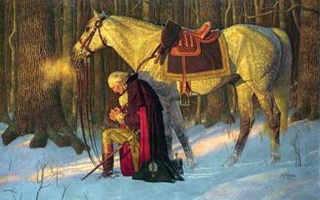

Quoting Baden-Powell on Faith
Alice, Golden Empire Council
"No man can be really good, if he doesn't believe in God and he doesn't follow His laws. This is why all Scouts must have a religion".
(Scouting for Boys, 1908)
"Scouting has been described as "a new religion". It's not, of course, a new religion: it's just the application to religious formation of the principle now accepted in non-religious formation, i.e. to point out a precise aim to the boy and give him the way to learn and practice by himself" [Quoted in Taccuino, a collection of B-P's writings and essays published in Italy. Dated January 1912]
"There is no religious side to the [Scout] Movement. The whole of it is based on religion, that is on becoming aware of God and His Service"
(Headquarters Gazette - November 1920)
"By Religion I mean not just a formal homage …to a Divinity, but a deeper acknowledgment of God as a Being perpetually inside and around us, and the consequent higher level of thought and action in His service"
"Scout Activities are the means by which you can lead the most accomplished street urchin to nobler feelings, and have the faith in God start in him"
"Love of God, love of your neighbour and respect of oneself as God's servant are the basis for any form of religion"
"Many difficulties may arise while defining religious formation in a Movement such as ours, where many religions coexist; so, the details of the various forms of expressing the duty to God must be left to those responsible of each single association. We insist however on observance and practice of that form of religion the boys profess"
"Nowadays the actions of a large part of youths are guided just in a small part by religious convictions. That can be attributed for the most to the fact that in the boy's religious formation the worry was on teaching instead of educating".
“Aids to Scoutmastership”, 1919
"If you really wish to find the way towards success, i.e. your happiness, you must give a religious base to your life. It's not simply attending church or knowing history or comprehending theology. Many men are sincerely religious almost without knowing it or having studied these things. Religion, briefly explained, means: First: know who God is; Second: use to the best the life He gave us, and do what He expects from us. This means mostly doing something for the others."
(Rovering to Success, 1922)
"I have been asked to describe in more detail what I had in my mind regarding religion when I founded Scouting and Guiding. I have been asked `Why must religion enter in it?'. My answer has been that religion needn't enter, because it's already inside. It is already the fundamental factor pervading Scouting and Guiding."
(from a speech to Scout and Guide commissaries, July 2, 1926)
The method of expression of reverence to God varies with every sect and denomination. What sect or denomination a boy belongs to depends, as a rule, on his parents' wishes. It is they who decide. It is our business to respect their wishes and to second their efforts to inculcate reverence, whatever form of religion the boy professes.
(Aids To Scoutmastership pg.36)

Trees & Faith for Scouters

Thoughts from Alice: Planting a tree is really a testament of faith – faith in the future and in God, as this first poem demonstrates – to share with scouts, you might just read the underlined verses – although there are good thoughts in every verse. This could be a monologue for a Webelos scout working on Communicator!
(OR Use the second poem by Kilmer)

Why does an old man plant a tree?
by Robert H Mealey
My friends quite often ask of me,
Why does an old man plant a tree?
It grows so slow it will not pay
A profit for YOU anyway.
Then why in storm and winter cold,
Do you plant when you are so old?
The answer seems hard to define,
When muscles ache and they are mine.
But I just cannot stand to see,
A space where there should be a tree.
So that in part as years unfold,
Is why I plant when I'm so old.
I know that animals, bugs and things,
Love trees, and so do such as go on wings.
So creatures wild that benefit,
Is one more reason I can't quit
From planting trees while I can hold,
My planting hoe, though I'm so old.
They say that those retired from labor,
Should fish and play and talk to neighbor.
They say also that folks in leisure,
Should do the things which give them pleasure.
And so the thought on which I'm sold,
I'll plant some trees though I'm so old.
As time goes on my trees will grow.
So tall and clean and row on row.
The furry folk will have a home,
The birds can nest, and kids can roam.
And all of this as I have told,
I planted trees though I'm so old.
And then there is my family,
Young folks who will follow me.
I'd like to leave them with some land,
Stocked with trees and looking grand.
These gifts I value more than gold,
So I plant some trees though I'm so old.
And taxes too for schools and roads,
With jobs and lumber for abodes.
I won't see these things, I won't be here.
But to my mind it's very clear.
The words of some who could be polled,
Might thank a man who is so old.
Man should be proud of what's his own,
And how he's managed what he's grown.
But management must be begun,
By planting seedlings one by one.
And so my pride I shall uphold,
I'll plant some trees though I'm so old.
So when my friends ask of me,
Why does and old man plant a tree?
Perhaps the lines above explain,
How aching back and limbs in pain,
May by commitment be controlled,
To plant my trees though I'm so old.

Here’s a second famous poem – and a trivia challenge for your scouts! They were included in One Last Thing from Dave Lyons, editor of the online Baloo’s Bugle. He’s a native of New Jersey, so he is very well acquainted with Kilmer. There’s also another lesson here – that “girly” name – and for a POET, too, belongs to a man who showed great courage under fire – so don’t be fooled by appearances! (And Joyce is actually an honorable male name in Great Britain, along with Kip and Evelyn, pronounced Eve-A-Lyn) For California scouts, introduce this poem on the way to the Redwoods.

Trees
By Joyce Kilmer (1886-1918)
I think that I shall never see
A poem lovely as a tree.
A tree whose hungry mouth is prest
Against the earth's sweet flowing breast;
A tree that looks at God all day,
And lifts her leafy arms to pray;
A tree that may in Summer wear
A nest of robins in her hair;
Upon whose bosom snow has lain;
Who intimately lives with rain.
Poems are made by fools like me,
But only God can make a tree

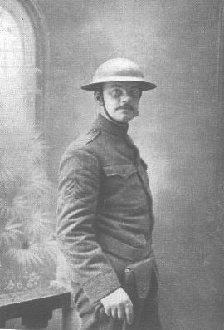
Alfred Joyce Kilmer (1886-1918), the noted American poet killed in action during World War I, was born in New Brunswick, New Jersey, on 6 December 1886. Educated at Rutgers College and Columbia University, Kilmer worked from 1909-12 for Funk and Wagnall, helping to edit their Standard Dictionary. In June 1908 Kilmer married Aline; they had five children. In 1911 Kilmer's first volume of poetry, entitled A Summer of Love, was published to acclaim.
Kilmer was something of a socialist, but he retained a deep religious sense throughout his life. A one-time Literary Editor of The Churchman newspaper, an Anglican journal, Kilmer himself converted to Catholicism in 1913.
In 1913 he joined The New York Times, also writing for The Nation and The New York Times
Sunday Magazine. The fame his writings brought him earned him an entry in Who's Who.
Although married and with children, Kilmer volunteered for service in 1917 for WWWI. Enlisting as a private with the 7th Regiment, National Guard in New York, he sought and received a transfer shortly afterwards to 165th Infantry (part of the famed Rainbow Division).
While in training at Camp Mills Kilmer was appointed Senior Regimental Statistician and, once on the Western Front in France, he earned promotion to Sergeant and was posted to the Regimental Intelligence Staff as an observer. In this post Kilmer would spend many dangerous nights gathering tactical information. (The assignment to observe and document enemy positions is something he shared with the founder of Scouting, Baden-Powell)
It was while out scouting for enemy machine guns near Ourcq that Kilmer was shot through the brain, on 30 July 1918. He was aged 31. He was posthumously awarded the French Croix de Guerre – (like our Medal of Honor)
Kilmer's best-known poem today is Trees (reproduced below), written in 1913. In it he demonstrated his deeply-held affinity for nature and for God. Although he intended to write a book based on his experiences on the Western Front his early death denied him the opportunity; he nevertheless wrote numerous war poems, one of which is Prayer of a Soldier in France
And Dave Lyon’s favorite Trivia Question while transporting Scouts on the NJ Turnpike: When we get to the Joyce Kilmer Rest Stop I ask, "Who was Joyce Kilmer?" I invariably get, "I don't know who SHE was." Then I reply, "You are wrong already

FAITH Character Connection
Carol at www.cubroundtable.com
Tiger Book
Character Connection - Faith
Achievement 5, “Let’s Go Outdoors” (Page 65)
- Practice - Do requirement 5F
- Know - Discuss things about the weather that you know to be true, but you cannot see at the moment, such as it's the sun still there although you only see clouds? Is the moon there, even though it is day? Can you see wind? Do you know that the rain will eventually stop? Do you have faith in other things you can't see?
- Commit - What makes it difficult to believe in things that you cannot see? What helps you to develop faith?
Wolf Book
Character Connection - Faith
Achievement 11, “Duty to God” (Page 94)
- Know- What is “Faith”? With your family, discuss some people who have shown their faith who have shown an inner strength based on their thrust in a higher power of cause. Discuss the good qualities of these people.
- Commit- What is “Faith”? With your family, discuss some people who have shown their faith who have shown an inner strength based on their thrust in a higher power of cause. Discuss the good qualities of these people.
- Practice - Practice your faith while doing the requirements for “Duty to God.”
Bear Book
Character Connection - Faith
Achievement 1, “Ways we Worship” (Page 26)
- Know- Name some people in history who have shown great faith. Discuss with an adult how faith has been important at a particular point in his or her life.
- Commit - Discuss with an adult how having faith and hope will help you in your life, and also discuss some ways that you can strengthen your faith.
- Practice - Practice your faith as you are taught in your home, church, synagogue, mosque, or religious fellowship.
Webelos Book
Character Connection - Faith
Requirement 8, “Faith” (Page 50-51)
After completing the rest of requirement 8,
do these (a, b, and c):
- Know. - Tell what you have learned about faith.
- Commit - Tell how these faith experiences help you live you duty to God. Name one faith practice that you will continue to do in the future.
- Practice After doing these requirements, tell what you have learned about your beliefs.
Cub Scout Roundtable Helps
- Do you think there are ways you can help during your church service? List the ideas and talk to your parents about what you would like to do. If you haven’t started the God and Me, God and Family, God and Country, God and Life series you might want to check on these to learn more about your faith.
- Many who have been in danger or lost rely on their Faith to keep the strong and overcome the hardships. Talk to your parents to learn how you can prepare yourself for an emergency. Memorizing Bible verses and songs can strengthen you even when you are sad or lonely.
- You learn that a neighbor is very sick and goes to a different church. Can you still care about them or help them? What would you learn from serving their needs? We are told to be servants, do you think you could be a servant to your family, friends, teachers, and others in your community?
Cub Scout Program Helps 2005-2006, page 6 Dec
Holidays provide an opportunity to explore our faith. What does faith mean? How does a person’s religion help him or her? How does your faith make you feel comfortable? What things will you do this month to support your religious beliefs?
2004 Pow Wow Book Cub Scouting Forever
by Great Salt Lake Council
- Faith - Having inner strength or confidence based on our trust in a higher power.
- Activity- A Blindfold Meal. At a planned outing, such as a den picnic, get everyone to eat a simple meal or undertake a simple activity blindfolded. Care needs to be taken that no one gets burnt or hurts him or herself. Afterwards encourage the Cubs to consider how wonderful their gift of sight is. This could develop into a discussion on the idea that there are different types of blindness. Blindness to the needs of others, blindness to the world that we live in, blindness to the obvious existence of God.
- Project- Keep a diary for a week. Make an eight-page diary covering one week for each Cub. (Two sheets of paper folded with the days and perhaps the dates). Get them to keep as accurately as they can an hour by hour time table of what they have done for the week: time they went to bed, got up, started breakfast, finished breakfast, left for school, got to school, etc.. Then at your next meeting (it might be helpful to have calculators) analyze how much time has been spent on each of a number of activities during the week. You might make a list like sleeping, eating, at school, doing homework, watching TV, Cub Scout activities, etc.. Produce a chart. Finally consider what this shows about priorities, inner discipline, etc…
2005 Pow Wow Book Cub Scouting Forever
by Great Salt Lake Council
Faith, Hope, & Charity
What Would Webster Say?
- Have each boy write down definitions of what they think Faith, Hope, and Charity mean. Compare boys' definitions with the definitions in the dictionary.
- Name a person or persons who demonstrates each of these qualities.
- Why should we want to develop these traits? What are some steps you can take to develop these qualities?
- What can you do each day to practice faith, hope, and charity?
Cub Scout Program Helps 2006-2007, page 8 July
Wolf Achievement 11A, “Duty to God”: Inspired by the beauty of the summer (Spring) months, Cub Scouts can complete the Character Connection for Faith.
Cub Scout Program Helps 2007-2008, page 10 Dec
Celebrations around the work involve many different faiths, as well as different versions of them. (Think Easter, Passover, and other Spring Festivals of the various Faith Traditions versus our traditional use of Christmas and Hanukkah for this activity.)
- What do you think faith is? (Not the denomination (e.g. Lutheran) but for what it stands and what your denomination believes.)
- How do you show your beliefs?
- Is one faith or belief better than another?
For the year ahead, many people rededicate themselves to their faith. This might be a good time to do Bear Achievement 2 and earn the religious emblem of your faith.
For other FAITH
Character Connection Activities go to ·
http://www.cubroundtable.com/assets/pdf-documents/2002-2010%20Character-Connections-Packet.pdf

April – A Month For Faith
Alice, Golden Empire Council
April 1 – April Fool’s Day Remember, God has a sense of humor! Enjoying a fun food experience together helps strengthen family or scouting ties. So plan to serve one of the fun recipes from Cub Grub - or check at the Family Fun website for more ideas.
April 3 – Find a Rainbow Day And even if you don’t have one in the sky – remember that Faith means always having hope and seeing the glass half full – so go find some rainbows! Be sure the boys know the traditional story about the First Rainbow.
April 5 – Read a Road Map Day Every scout should learn to read a map – it’s a skill that will put a positive outlook on any trip – and count towards requirements for the boys!
April 7 - Jewish Passover Begins at Sundown to commemorate the faith of the Jewish people in being obedient and being saved from harm. (Challenge the boys to work with their families to find out the whole story)
April 8 – Easter – Not just a “Fun, Hide the Eggs and Find Them Day” – it’s a religious holiday about Faith for many people.
Several other religious holidays are held in April: Theravadin, the Buddhist New Year (April 6-9, Jehovah’s Witness Lord’s Evening Meal (April 6), the Sikh New Year of Baisakhi (April 14).
April 9 First public library It opened in 1833 in Peterborough, New Hampshire. Visit a library and look for Information about how different religions practice their faith! Or combine with Encourage a Young Writer Day on the 10th – Ask the Children’s Librarian to suggest a young writer to enjoy.
April 10 – Encourage a Young Writer Day. Check out the various Achievements, Electives and Activity Pins where writing is required. Challenge the boys to do an acrostic about Faith – You write a phrase that fits with faith starting with each letter of the word. Write the word Faith from top to bottom on the left, then add the phrase for each letter.
April 13 – Thomas Jefferson’s Birthday in 1743 – he included references to Faith and God in the United States Constitution. Challenge the boys to find an example.
April 22 – Earth Day 2012 – Take on a project to help make the earth a better place! Lots of ideas at www.earthday.org or check for one in your local area.
April 23 – Home Run Day – Hank Aaron hit his first home run in 1954 – and he was a Scout, too! He was a great example of faith in action, and never forgot the cub motto - “Do Your Best!”
April 26 – Hug a Friend Day – Don’t forget what Baden-Powell said: “The most worth-while thing is to try to put happiness into the lives of others.”
April 27 – Tell a Story Day – Tell someone a personal story about Faith, or find a story about Faith to share with someone else. Check out the true story of a scout under AUDIENCE PARTICIPATIONS & STORIES - Better yet, ask families to share a story from their family history or heritage!
April 30 – National Honesty Day – If you aren’t honest, no one will have faith or confidence in what you say. In 1789, George Washington was inaugurated as the first US president – and he was known for his honesty and faith, even though he really didn’t chop down that cherry tree!

Crazy Holidays
Jodi, SNJC Webelos Resident Camp Director 06-11
April is:
- National Humor Month
- International Guitar Month
- Keep America Beautiful Month
- Lawn and Garden Month
- Poetry Month
- National Pecan Month
- National Welding Month
- Records and Information Management Month
- Stress Awareness Month
- Sexual Assault Awareness Month
Weekly Celebrations:
- Week 1 Library Week
- Week 1 Read a Road Map Week.
- Week 2 Garden Week
- Week 3 Organize Your Files Week
- Week 3 Medical Labs Week
- Week 4 Administrative Assistants Week
- Week 4 National Karaoke Week
Each Day:
1 April Fool's Day
1 International Fun at Work Day
1 International Tatting Day
2 Children's Book Day
2 National Peanut Butter and Jelly Day
2 Reconciliation Day
3 Don't Go to Work Unless it's Fun Day - we know your decision
3 Tweed Day
4 Hug a Newsman Day
4 Walk Around Things Day
4 School Librarian Day
4 Tell a Lie Day
5 Go for Broke Day
6 National Walk to Work Day - first Friday of month
6 Plan Your Epitaph Day - a little morbid if you ask me
6 Sorry Charlie Day
7 Caramel Popcorn Day - Most likely created by a popcorn maker, or an Ecard company.
7 No Housework Day
7 World Health Day
8 All is Ours Day
8 Draw a Picture of a Bird Day
8 Easter Day - date varies
9 Dyngus Day always the Monday after Easter
9 Name Yourself Day
9 Winston Churchill Day
10 Golfer's Day
10 National Siblings Day
11 Eight Track Tape Day - do you remember those?
11 Barbershop Quartet Day
11 National Submarine Day
12 Big Wind Day - this day blows me away!
12 Russian Cosmonaut Day
13 Scrabble Day
14 Ex Spouse Day
14 International Moment of Laughter Day
14 Look up at the Sky Day - don't you have anything better to do?
14 National Pecan Day
14 Reach as High as You Can Day
15 Rubber Eraser Day
15 Titanic Remembrance Day
16 National Eggs Benedict Day
16 National Librarian Day
16 National Stress Awareness Day
16 Patriot's Day - third Monday of the month
17 Blah, Blah, Blah Day
17 National Cheeseball Day
17 Pet Owners Independence Day
18 International Juggler's Day - also applies to multi tasking office workers
18 Newspaper Columnists Day
19 National Garlic Day
19 National High Five Day third Thursday
20 Look Alike Day
20 Volunteer Recognition Day
21 Kindergarten Day
22 Girl Scout Leader Day
22 National Jelly Bean Day
23 Lover's Day
23 National Zucchini Bread Day - they hold this at a time when you are not sick of all that zucchini.
23 Take a Chance Day
23 World Laboratory Day
24 Pig in a Blanket Day
25 East meets West Day
25 Executive Admin's Day (Secretary's Day) - date varies, Also called Administrative Professional's Day
25 World Penguin Day
26 Hug an Australian Day
26 National Pretzel Day
26 Richter Scale Day
26 Take Your Daughter to Work 4th Thursday
27 Babe Ruth Day
27 National Prime Rib Day
27 Tell a Story Day
28 Great Poetry Reading Day
28 Kiss Your Mate Day - guys, do not forget this one. Kiss her, then read her some poetry.
29 Greenery Day
29 National Shrimp Scampi Day
30 Hairstyle Appreciation Day
30 National Honesty Day

Fun Facts on Arbor Day
Alice, Golden Empire Council

State Trees & Arbor Days
- Alabama - Last full week in February (Longleaf Pine)
- Alaska - Third Monday in May (Sitka Spruce)
- Arizona - Last Friday in April (Palo Verde)
- Arkansas - Third Monday in March ( Pine)
- California - March 7-14 (California Redwood)
- Colorado - Third Friday in April ( Blue Spruce)
- Connecticut - April 30 ( White Oak)
- Delaware - Last Friday in April ( American Holly)
- District of Columbia - Last Friday in April (Scarlet Oak)
- Florida - Third Friday in January ( Cabbage Palmetto)
- Georgia - Third Friday in February ( Live Oak)
- Hawaii - First Friday in November (Kukui)
- Idaho - Last Friday in April ( Western White Pine)
- Illinois - Last Friday in April ( White Oak)
- Indiana - Last Friday in April (Tulip Tree)
- Iowa - Last Friday in April (Oak)
- Kansas - Last Friday in March (Cottonwood)
- Kentucky - First Friday in April (Tulip Poplar)
- Louisiana - Third Friday in January (Bald Cypress)
- Maine- Third full week in May ( Eastern White Pine)
- Maryland - First Wednesday in April ( White Oak)
- Massachusetts - April 28-May 5 ( American Elm)
- Michigan - Last Friday in April ( Eastern White Pine)
- Minnesota - Last Friday in April (Red Pine)
- Mississippi - Second Friday in February ( Southern Magnolia)
- Missouri - First Friday in April ( Flowering Dogwood)
- Montana - Last Friday in April (Ponderosa Pine)
- Nebraska - Last Friday in April (Cottonwood)
- Nevada - Southern: February 28; Northern: April 23 (Single leaf Pinyon)
- New Hampshire - Last Friday in April ( Paper Birch)
- New Jersey - Last Friday in April ( Northern Red Oak)
- New Mexico - Second Friday in March (Pinyon)
- New York - Last Friday in April ( Sugar Maple)
- North Carolina- First Friday following March 15 ( Pine)
- North Dakota - First Friday in May ( American Elm)
- Ohio - Last Friday in April (Ohio Buckeye)
- Oklahoma- Last full week in March (Eastern Redbud)
- Oregon - First full week in April (Douglas Fir)
- Pennsylvania - Last Friday in April (Eastern Hemlock)
- Rhode Island - Last Friday in April ( Red Maple)
- South Carolina - First Friday in December ( Cabbage Palmetto)
- South Dakota - Last Friday in April ( White Spruce)
- Tennessee - First Friday in March (Yellow Poplar)
- Texas - Last Friday in April (Pecan)
- Utah - Last Friday in April ( Blue Spruce)
- Vermont - First Friday in May ( Sugar Maple)
- Virginia - Second Friday in April ( Flowering Dogwood)
- Washington - Second Wednesday in April (Western Hemlock)
- West Virginia - Second Friday in April ( Sugar Maple)
- Wisconsin - Last Friday in April ( Sugar Maple)
- Wyoming - Last Monday in April (Cottonwood)

PACK & DEN ACTIVITIES

Faith Ideas
Alice, Golden Empire Council
Have a display of the BSA Family Award – if a Pack family has done the activities, ask them to bring pictures to display to share their experiences.

Invite local Boy Scouts who have earned their BSA Religious award to visit - ask them to share what they did to earn the award, what affect it had on their life, what cub scouts can do to prepare to honor their faith.

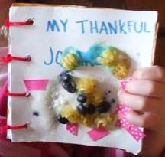
In the den each boy can make a paper journal – challenge him to write down one thing each day that he is thankful for. Since some boys hate to write, you could also have them draw or cut out a picture to show what they are thankful for.

Gather a collection of Religious Award workbooks from different faiths – your DE or local scout shop might be able to help with this. Encourage parents to use the workbook published for their faith to help the boys complete the BSA Religious Award.

Take a hike and look AND listen for examples of the wonders of creation. For an extra challenge, team up boys and give each an ABC list to fill in – A – Apple blossoms; B – BabyBird or Sounds;

Play one of the “Trust” games from the Game Section. Trust is one of the hallmarks of Faith - Be sure to encourage boys to respect and trust each other because they are scouts.
Make the connection between Faith and how the boys “Live” what they Believe:

CUBMASTERS:
Make sure to talk about specific activities a boy has done to earn an award or rank – As awards are presented at the Pack Meeting, the Cubmaster could relate personal experiences furnished by parents and den leaders.

Do the T-Shirt activity as explained in the Games Section – help each boy to recognize what he is good at, and how he helps other people and demonstrates his faith.

Arbor Day/Earth Day Ideas

Plan a special service project for Earth Day –
Check for local opportunities on community web sites or at your local library. You can also find great activity ideas at www.earthday.org or at www.apples4theteacher.com

Invite a garden expert to help pack families get started on a simple garden – if you don’t have a resource in your pack family, check with the local Extension Service for a Master Gardener. Nothing teaches Faith better than planting and nourishing a seed – and you will be helping your pack families to eat better and save money!

Plant a tree or trees, to celebrate Arbor Day – The date varies from state to state, based on optimum planting time, but many have chosen a date in April. Check the list in Value Related Ideas.
Trees are available from several sources. In Sacramento and many other places, a local Tree Foundation will provide trees and planting tips. Also Disney has a program to provide trees to plant for Earth Day, and check out the Family Activity Program with all kinds of great ideas – they can also be used with your den! Go to: www.arborday.org/explore/families

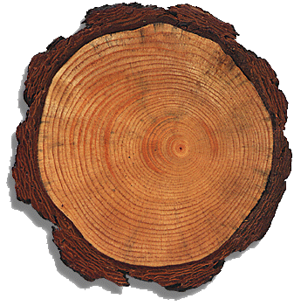
Have some fun with tree “cookies” – Cut slices from small tree branches – these cross-sections are great to explore the history of a tree. Discuss tree rings in general, then give each boy or person their own “cookie” to explore. Challenge them to find: a time when the tree was stressed; several years when sun, water and nutrients were just right, an example of some damage from fire, insects or other factor. Note: You can connect the changes in the tree rings with ways in which a boy’s faith is strengthened or tested, such as temptations, falling out with friends, or when faith is nourished by religious teachers or family service projects.
Play Hug A Tree Game – Learn to recognize “your” tree - In an area with many trees, boys take turns being blindfolded, led to a tree (for touch and feel) and then lead away. After removing the blindfold, the tree hugger tries to locate his tree. Talk about the differences in trees, and how those differences affect where they grow, how much water, sun, etc. they need, how animals and people (and even other plants) make use of different trees.

Religious Activities:

BSA recognizes many different faiths – Cub Scouts and the Pack families should be encouraged to honor and practice their faith – For information on the many BSA religious awards, go to:
http://www.scouting.org/scoutsource/Awards/ReligiousAwards.aspx

Learn about how different people celebrate their faith - Invite Religious leaders, Boys or Parents to come and share information about their faith or religion - One of the best months I had as a leader was when I had Baptist, Catholic, Muslim and LDS boys in my den, and their parents came to several den meetings to talk about how they lived their religion.

A Scout who honors his own faith will also reflect his beliefs – here’s a practical wood project to make an emergency road signal reflector. It will reflect light from another source, just as faith can be reflected from religious teachings. A reflector serves to protect from danger and to mark the right course - just as faith can.
Emergency Road Signal
Materials:
Two 1” hinges and screws (I have also used small strips of leather as hinges) ; Two small screw eyes; 12” plumber’s chain or wire; Glass reflectors or reflector tape; Two 4” X 24” X 3/4” boards; Sandpaper, Screwdriver, Hammer
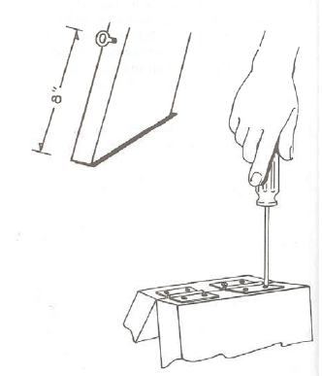
Procedure:
Cut the boards to length and sand edges smooth. Nail the reflectors to one side of each board or apply reflector tape in several strips on each board. Screw the hinges to the top of both boards. Measure 8” from the bottom of each board. Screw in a screw eye at that point
Attach the plumber’s chain or wire to the screw eyes. If your car breaks down at night, place the emergency signal on the highway a reasonable distance back from your car.
This project can be used for Webelos Craftsman or as a wood construction, something useful or a gift when made by Wolf or Bear Cub Scouts. But it can also refer to a Gospel principle. It fits with the idea that boys can reflect their beliefs and shine by showing their their faith to others.
(LDS version available using Stand for the Right song and Gordon B. Hinckley quotes – ask Alice: aretzinger@hotmail.com )

Gather a collection of Religious Award workbooks from different faiths – your DE or local scout shop might be able to help with this. Encourage parents to use the workbook published for their faith to help the boys complete the BSA Religious Award.

Invite local Boy Scouts who have earned their BSA Religious award to visit - ask them to share what they did to earn the award, what affect it had on their life, what cub scouts can do to prepare to honor their faith.

Attend special religious or Easter events as a Pack Family – or make sure that pack families know about local performances and activities such as: Easter Egg Hunts, performances of Handel’s Messiah.

Encourage pack families to work on the BSA Family Award – it includes suggestions for regular family meetings and activities, using principles of faith. The BSA Family Activity Book is available at Scout shops and online.
Wonders of Creation:
Scouting has always included lots of time in the outdoors, learning to understand and appreciate the wonders of creation – and being out in nature increases faith.

Take a hike and look for examples of the wonders of creation. For an extra challenge, team up boys and give each an ABC list to fill in – A – Apple blossoms; B – BabyBird or Sounds;

Celebrate Arbor Day – Plant a tree!
Trees are available from several sources. You could plant a tree, or more, in a local park, at your local school, or at your Chartered Organization location. In Sacramento and many other places, a local Tree Foundation will provide trees and planting tips. Also Disney has a program to provide trees to plant at schools for Earth Day. Check out the Family Activity Program with all kinds of great ideas – they can also be used with your den! Go to: www.arborday.org/explore/families
The date varies from state to state, based on optimum planting time, but many have chosen a date in April. Check the list in Value Related Ideas.

Give everyone a piece of paper and pencil and challenge them to name ways wood is used. Also check out the graphic, tree-shaped list from
www.idahoforests.org/arborday.htm on the last page – you might want to enlarge it, then cover with green paper - it till you’re ready to check everyone’s list of uses. This could be an individual, den or family competition.

Play Hug A Tree – Learn to recognize “your” tree - In a forested area, pairs take turns being blindfolded, lead to a tree (for touch and feel) and then lead away. After removing the blindfold, the tree hugger tries to locate his/her tree. Talk about the differences in trees, and how those differences affect where they grow, how much water, sun, etc. they need, how animals and people (and even other plants) make use of different trees
Go Fly a Kite – Be sure the weather is safe, and go over safety rules for kite flying. This is fun way to use the breezes in the air – and the wind is a great symbol of Faith – like faith, you cannot see, smell or taste the wind – but you can feel its presence! You can also see its effects – Just like Faith!

Work on the Outdoor Activity Award , since activities in the outdoors are a great way to introduce discussions about faith.

Faith in Family & Friends:
Loyalty and Trust are principles that scouts have always practiced – and Cub Scout/Webelos activities help boys develop strong family and peer loyalties, trust and trustworthiness.
Play one of the Trust Games – talk about loyalty and friendship.

Faith in Self:
Scouting helps develop confidence and skill through age-appropriate activities and working towards goals and achievement. If you have a strong faith in your God, you will have the confidence to try new things.

Have a Wall of Fame display at the Pack Meeting – Ask parents and leaders to furnish information about positive activities and scouting achievements of each boy.

Ask each boy what scouting activity or achievement he is proudest of, enjoyed, or was challenged by – share their comments with the Pack in a display.

CUBMASTERS: Make it a tradition to talk about specific activities a boy has done to earn an award or rank – As awards are presented at the Pack Meeting, the Cubmaster could relate personal experiences furnished by parents and den leaders.

Do the T-Shirt activity under games – help each boy to recognize what he is good at, and how he helps other people and demonstrates his faith.

Pack Service Scavenger Hike
Grand Canyon Council Pow Wow 2005
Instructions:
1. Divide into two teams. (depending on size of pack or group more teams can be added)
2. Each team must stay together and you must stay with your team leader.
3. You may not enter into a home if you don’t know the people that live there.
4. You can only sign off on one service per family.
5. Wash your hands after each chore.
6. You have 45 minutes.
7. You must return whether you have signed off on everything or not.
8. If you finish beforehand, you may start over.
9. Remember, serve with a smile.
10. Be careful and do your best!
11. Give a thank you card to the person that signs off on your sheet.
12. HAVE FUN!!!
13. Give a thank you card to each family for whom you perform a service.
14. Tell them thank you for helping us with our Service Scavenger Hike, from your neighborhood Cub Scouts
Materials:
NOTE: If doing teams, you will need two each.
• Windex
• Paper towels
• Flower (for planting)
• Trowel (for planting)
• Broom
• Dust rags (Swiffers work great!)
• Watering Can
• Wipes (for washing hands between chores)
• Wagon to haul the supplies
NOTE: We like to have teams, but you don’t have to divide into teams, you can all work together and have just as much fun!
Service Projects Ideas
• Wash a window
• Plant a flower
• Sweep a sidewalk
• Dust a room
• Empty a trash can
• Sing a song
• Get Mail
• Water plants or pull some weeds. (flowers, houseplants, garden)

DEN MEETINGS
Wendy, Chief Seattle Council




TIGERS
Wendy, Chief Seattle Council
Den Meeting #15: E3 Play a card or board game, or put together a puzzle.
Homework: E25 Make a snack to share with family or den.
E23 Find out what kind of milk their family drinks, and why.

Den Meeting #16: E33 Clean-up treasure hunt.
Verify: E25 Snack and E23 Milk.

Board Game Ideas
Leave No Trace Board Game (use with Trivial Pursuit style game): http://usscouts.org/usscouts/bbugle/bb0905.pdf ’09 Baloo’s Bugle “Camping” p. 30-32.

Bingo Board Maker: http://www.toolsforeducators.com/bingo/

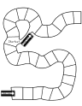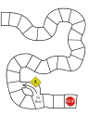
Board Game Templates: http://donnayoung.org/homeschooling/games/game-boards.htm
You could color in the plain race track boards and use them with the Leave No Trace game above. The boys could collect colored candies, pony beads, foam pieces, etc. instead of wedges.

Game Ideas referenced below are at:
Baloo’s Bugle (essentially an online Round Table for leaders): http://usscouts.org/usscouts/bbugle2010-2011.asp
’08 Santa Clara Pow Wow Book “Amazing Games”
http://www.macscouter.com/CubScouts/PowWow08/Themes.asp

More Games: ’08 Baloo’s Bugle “Amazing Games:” p. 8-10; 20-21; 26; 28-35.
’08 Santa Clara Pow Wow Book “Amazing Games” p. 2-6

Songs (Tiger E6): ’08 Baloo’s Bugle “Amazing Games:” p. 15-16.
’08 Santa Clara Pow Wow Book “Amazing Games” p. 19-22.

Snacks: ’08 Baloo’s Bugle “Amazing Games:” p. 35-6.

Edible Maze
Alice, Golden Empire Council
Ingredients:
Graham cracker for each boy, Frosting, Knives, Toothpicks, Various candies.
Directions:
- Each boy frosts (ices) his graham cracker,
- Then he “lays out” a maze by drawing with a toothpick on the frosting.
- Candies such as M&M’s can be used to show the pathway thru the maze.
- And then of course, they can eat the whole thing – maze and all!

Edible tic tac toe: make the board with licorice. Use life savers for Os, and another candy (different shape) for the Xs. (Wendy, Chief Seattle Council)

Edible Scrabble/Crossword Puzzles: use Alpha-bits cereal letters to make words. (Wendy, Chief Seattle Council)
(Note: Cheeze-It® Crackers are currently offering special edition Scrabble® crackers. –Pat)
Sometimes you can find edible games in the gummy fruit snacks isle of the grocery store.

Litter Ideas
Litter Treasure Hunt Variation: Assign point values to litter. More common items such as candy wrappers, pop cans, and water bottles get 1 point. Moderately common items such as plastic grocery bags and newspapers get 3 points. Award 5-10 points for unusual litter that is collected. Divide the boys into teams to pick up litter. The team that collects the most litter points wins. To score, look in the boys’ collection bags (usually a plastic grocery bag) and guesstimate the amount and kind of litter collected, and assign a point value for the sack. – Wendy, Chief Seattle Council

Trash grabbers: http://pbskids.org/zoom/printables/activities/pdfs/mechanicalgrabber.pdf

Ideas referenced below are at:
Baloo’s Bugle (essentially an online Round Table for leaders): http://usscouts.org/usscouts/bbugle2010-2011.asp
’08 Santa Clara Pow Wow Book, “Litter to Glitter”
http://www.macscouter.com/CubScouts/PowWow08/Themes.asp

Songs (Tiger E6): ’08 Baloo’s Bugle “Litter to Glitter” p. 12-14.
’08 Santa Clara Pow Wow Book, “Litter to Glitter” p. 7-10.
Snacks: ’08 Baloo’s Bugle “Litter to Glitter” p. 33-34.
Games: ’08 Baloo’s Bugle “Litter to Glitter” p. 8-9; 31-33; 43.
’08 Santa Clara Pow Wow Book, “Litter to Glitter” p. 5-6
Crafts: ’08 Baloo’s Bugle “Litter to Glitter” p. 23-31.
’08 Santa Clara Pow Wow Book, “Litter to Glitter” p. 2-5.
http://www.makingfriends.com/recycle.htm

TRASH (Julie R., Chief Seattle Council)
tune: Row, Row, Row Your Boat

Trash, trash, all around,
lying on the ground.
Pick it up, throw it out.
It's good for Puget Sound.

DO YOUR PART (Julie R., Chief Seattle Council)
tune: Frere Jaques
Plastic bottles and food wrappers,
Styrofoam, shouldn't roam.
On the ground it's litter.
Pick them up, they glitter.
We are smart,
and do our part.

WOLVES
Den Meeting #15:
E4b,e Marble games
Marble Belt Loop; http://usscouts.org/advance/cubscout/sports/marbles.asp
Verify E10a American Indian Book, E21 Computers

Den Meeting #16:
E18a Family Picnic
E19 Fishing

Marble Ideas
Marble games:
how to play marbles: http://www.landofmarbles.com/marbles-play.html

Sometimes shooting marbles can be hard for the boys. To make it easier, have the boys aim a short piece of pvc pipe at the target, and roll a marble down the pipe. Experiment with different angels to increase the marble’s speed.
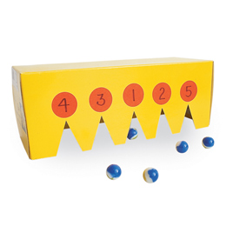
Box Targets:
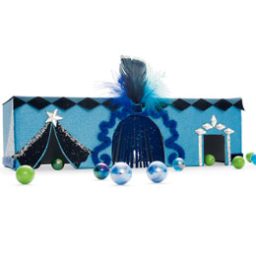
http://familyfun.go.com/playtime/box-scores-863585/
http://familyfun.go.com/playtime/marble-target-fun-house-708598/

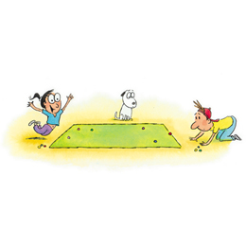
Marble Cliff Hanger: http://familyfun.go.com/playtime/marble-cliff-hanger-708301/

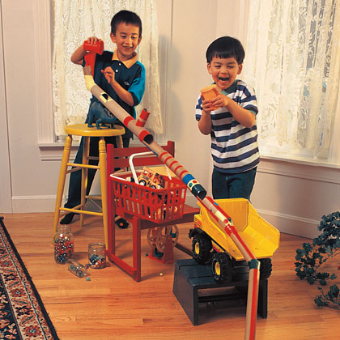
Marble Maze: http://familyfun.go.com/crafts/marble-maze-665946/


Marble Roulette: http://familyfun.go.com/playtime/marble-roulette-708304/
Marble Golf: (from “01 Baloo “Save it for Us” p. 3.)
This 9 hole golf course is laid out around the yard. Small tin cans are sunk into the ground. One to four players start
off and shoot marbles. They count the shots taken to get the marbles into the cans. Hazards may be small brushes, lengths of drain spouts, tubes through which the golfer must shoot, an upright 2 foot long board with a 4 inch hole. For a water hazard, sink a tin pie plate or other suitable container and fill with water. Use flags made from paper triangles glued to popsicle sticks. Golf rules should be observed in playing this game.

Giant Marbles: http://familyfun.go.com/playtime/giant-marbles-919494/
Devil’s Marbles: http://familyfun.go.com/playtime/devils-marbles-707483/
Treats: decorate cupcakes or cookies with gumballs (which look like marbles)

Fishing Ideas
‘04 Baloo’s Bugle “Fin Fun” p. 9-10.
’10 Baloo’s Bugle “Waves of Fun” p.54-55.

Ideas referenced below are at:
Baloo’s Bugle (essentially an online Round Table for leaders): http://usscouts.org/usscouts/bbugle2010-2011.asp

Fish in the Sea Game: All players but one stand behind a line. "IT" stands midway between the line and a goal line thirty feet away. He shouts "Fish in the ocean, fish in the sea; don't get the notion you'll get by me." The fish leave their line and try to cross the goal line without being tagged. Players who are tagged join "IT" and help catch others.
-- from the ’03 “Fun in the Sun” Desert District Round Table Handout

Crafts:’09 Baloo’s Bugle “Fun in the Sun” p. 27-28.

Snacks: ‘04 Baloo’s Bugle “Fin Fun” p. 22.
Swedish Fish and Goldfish crackers are obvious choices for snacks.
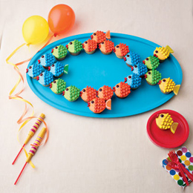
Fish Cupcakes:
http://familyfun.go.com/recipes/school-o-fish-cupcakes-984981/
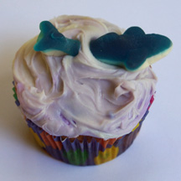
http://www.easycupcakes.com/category/ocean-and-sealife-cupcakes/

Faith Chant (Wendy, Chief Seattle Council)
Hopefully it's not too sacrilegious to compose a chant about faith, set to a military cadence.
Just because I cannot see,
Doesn’t mean it cannot be.
Evidence is all around,
In the sky and on the ground.
Ev’ry time I hit the trail,
I see God in hill and vale.
Trees and flowers speak to me,
Of the Presence I can’t see.
God’s here!
He’s near!
God’s here, He’s near.
Praise Him! (or Amen!)

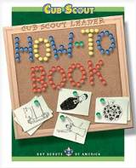
From the Cub Scout Leader How-To Book –
- Family Picnic: How To Book p. 6 – 22-23.
- Fishing Derby: How To Book: p. 6 – 37-38.



BEAR
Bear Ideas by Felicia
Bear April 2012 Faith

Den Plan Subject Activity
- Family Outdoor Adventure Achievement 12b & hiking belt loop
S. Tall Tales Achievement 4
A. Maps Elective 23a-e

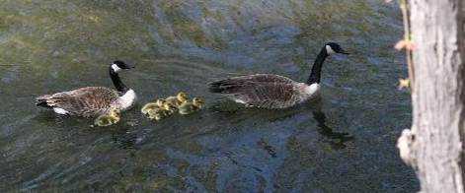

Lesson Plan Q - Family Outdoor Adventure – Acievement 12.
As the weather starts to get nice it is a good time to plan an outdoor activity, hike, or camp out.
If you would like to visit a Boy Scout Camp, here is a site that will tell you what is near you & what resources they have: http://usscouts.org/databases/camp/ocd.cgi
Order of the Arrow Where-To-Go-Camping Guides can be found here: http://scoutcamp.org/oa_guides.asp.


View of the Mississippi River from Fire Point
at Effigy Mounds National Park, Iowa.

If you would like to locate & visit a National Park in your area: Here is the National Parks Web site http://www.nps.gov/index.htm
Here are some links to help you find state parks: http://www.stateparks.com/usa.html; http://en.wikipedia.org/wiki/List_of_U.S._state_parks; *this one has links to each State’s official park web site http://www.americasstateparks.org/;
The National Wildlife Foundation offers a “Nature find” which may help you find more local areas to explore.
http://www.nwf.org/Get-Outside/NatureFind.aspx The Nature Conservancy http://my.nature.org/preserves/
Local Hikes.com http://www.localhikes.com/Default.asp?MSA=ALL

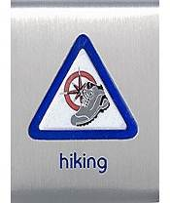
Hiking Belt Loop
Complete these requirements:
- Explain the hiking safety rules to your den leader or adult partner. Practice these rules while on a hike.
- Demonstrate proper hiking attire and equipment.
- Hike at least 30 minutes with your adult partner, family, or den.

Hiking Safety Rules:
- Always tell someone where you are going and when you will return.
- Never hike alone or at night; always use the buddy system.
- Dress properly for the weather and environment.
- Wear sun and insect protection.
- Take an extra pair of socks in case you need to change.
- Obey traffic signs and signals.
- Avoid hiking along roadways.
- Stay on the trail.
- Be alert to your surroundings.
- Don't litter as you hike.
- Be alert to dangerous animals, insects, and plants. Never touch a wild animal.
- Take 1 pint of water for each hour you will be hiking. Never drink untreated water

Remind your Bear Scouts
not to feed or play with real bears.
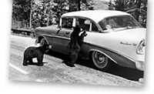
National Park Service Historic Photograph Collection:
Jack E. Boucher took this photo at Yellowstone National Park in approximately 1958.

Links for Hiking Pin requirements & work sheets:
- http://www.scouting.org/scoutsource/CubScouts/Cub%20Scouts/UniformsAndAwards/sanda/hiking.aspx;
- http://usscouts.org/advance/cubscout/sports/hiking.asp;
- http://www.boyscouttrail.com/content/content/cub_scouts_hiking_sports_pin_and_belt_loop-2036.asp;



The Sweet Sixteen of BSA Safety Procedures for Physical Activity is an aid to protect participants in Scout activities. These 16 points, which embody good judgment & common sense, are applicable to all activities & are set out in full detail at: http://www.scouting.org/scoutsource/HealthandSafety/Resources/sweet16.aspx.

1. QUALIFIED SUPERVISION
2. PHYSICAL FITNESS
3. BUDDY SYSTEM
4. SAFE AREA OR COURSE
5. EQUIPMENT SELECTION AND MAINTENANCE
6. PERSONAL SAFETY EQUIPMENT
7. SAFETY PROCEDURES AND POLICIES
8. SKILL LEVEL LIMITS
9. WEATHER CHECK
10. PLANNING
11. COMMUNICATIONS
12. PLANS AND NOTICES
13. FIRST-AID RESOURCES
14. APPLICABLE LAWS
15. CPR RESOURCE
16. DISCIPLINE


It’s always a good time to learn a new campfire song and teach it to your den. Below is a fun song. To hear & learn more entertaining songs check out these links. Even with songs you know are for kids: always preview the song before you let the kids watch (some people have less than family friendly versions). www.youtube.com/user/greenghoulie#g/search www.youtube.com/user/hcycamp#p/u www.youtube.com/user/ultimatecampresource#p/u


Tom T. Hall wrote Sneaky Snake
The following version is my favorite but it’s a little different from the original:

Now Boys and girls take warning, when you go by the lake
Keep your eyes wide open and look for sneaky snake"
Now maybe you won't see him and maybe you won't hear
But he'll sneak up behind you and drink all your root beer

And then sneaky snake goes dancin', wigglin' and a-hissin'
Sneaky snake goes dancin', a-gigglin' and a-kissin'
I don't like old sneaky snake, he laughs too much you see
And When he’s wigglin' through the grass, he tickles me under my knee

Here are some sites with the original version in its entirety:
- http://www.youtube.com/watch?v=CMxv7onpdCY&feature=related;
- http://www.youtube.com/watch?v=5W1QLA-pp34&feature=related;
- http://www.youtube.com/watch?v=MchhtofbgJI;

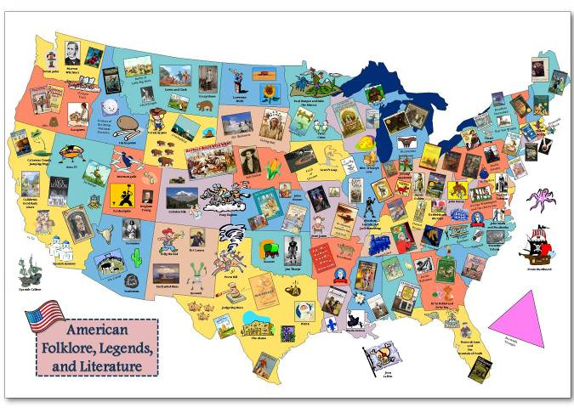
Meeting S - Tale Tales - Achievement 4

4b. This map of American Folklore, Legends, & Literature was recommended by Pack 25 in Louisiana. http://cardinalscholar.bsu.edu/handle/123456789/193992 for full-sized image
This map is part of the GRMC "Resources for
Teachers" collection of lesson plan ideas using maps
for the K-12 educator. Teachers can print copies
of the map to be used in the classroom. This is a
sample of a culminating project where students create
a map showing famous folklore and works of literature
in the United States. This lesson is part of an
instructional session provided to social studies class by
the GRMC. Ball State University. (Unpublished)

These sites talk about American folk lore.
- http://en.wikipedia.org/wiki/Folklore_of_the_United_States
- http://www.americanfolklore.net/

A fun way to introduce tale tales to your den may be to
- Watch one of the shorts on Disney's 2002 DVD American Legends. This has cartoons on Johnny Appleseed, Casey Jones, Paul Bunyan, & John Henry.
- Read a story of (Paul Bunyan's) Babe the Blue Ox. http://americanfolklore.net/folklore/2010/07/babe_the_blue_ox.html
- Listen to or sing a song about John Henry. http://toneway.com/songs/john-henry
http://www.npr.org/programs/morning/features/patc/johnhenry/index.html#audio


John Henry
When John Henry was a little baby
A sitting on his papa's knee
He picked up a hammer and a little piece of steel
Said, "Hammer's gonna be the death of me," Lord, Lord
"Hammer's gonna be the death of me."
Well, the captain said to John Henry
Gonna bring me a steam drill 'round
Gonna bring me a steel drill out on the job
Gonna whup that steel on down,...
John Henry said to his captain
"A man ain't nothin' but a man
And before I let that steel drill beat me down
I'll die with a hammer in my hand,...
John Henry was driving on the mountain
And his hammer was flashing fire
And the last words I heard that poor boy say
"Gimme cool drink of water 'fore I die,...
John Henry said to his shaker
"Shaker, why don't you sing?"
"I'm a throwin' nine pounds from my hips on down
Just listen to that cold steel ring,...
John Henry said to his shaker
"Shaker, why don't you pray?"
"'Cause if I miss this little piece of steel
Tomorrow be your burying day,...
John Henry, he drove fifteen feet
The steam drill only made nine
But he hammered so hard that he broke his po' heart
And he laid down his hammer and he died,...
They took John Henry to the graveyard
And they buried him in the sand
And every locomotive comes a roaring by, says
"There lies a steel driving man",...
- Read a poem. One like Paul Revere's Ride, by Henry Wadsworth Longfellow: which can be found at http://poetry.eserver.org/paul-revere.html Historians will tell you that this poem has inaccuracies in it & is more for fun than learning History.

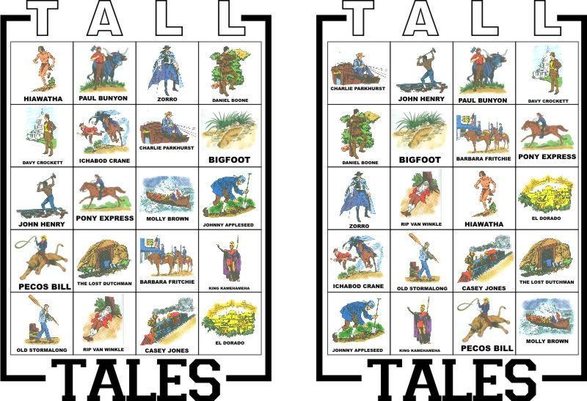

- Play a game like bingo above or a matching game.

The picture above is a Tall Tales Bingo Game that Tomi of the Pony Express district developed. More information can be found at: http://ponyexpresscubs.blogspot.com/2011/04/game-for-bear-achievement-4-tall-tales.html

This website has a pattern for cards to play a tall tale matching game. http://strongarmor.blogspot.com/2009/05/cub-scouts-tall-tales-matching-game.html



Make Johnny Appleseed Smiles for a snack.
- Make a large apple wedge, then cut a smaller wedge out from the middle of the peel-side (see photo). Take slivered almonds and push them into the apple so they look like teeth and the peel looks like lips.
- Take two apple wedges -smear them with peanut butter – add mini marshmallows for teeth. Food.com adds a dried apricot for a tongue.
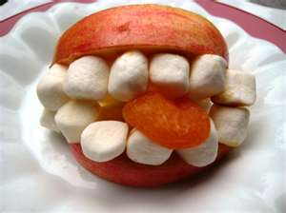

“Apple Dolls are folk dolls originating from early rural America when settlers made dolls from whatever was at hand.” http://appledolls.org/



For a Craft why not carve a Johnny Appleseed doll head. Peel & core a large apple. Carve a face in it. Set it aside for several days until it is shrunken & all dried & wrinkly. When it is fully dehydrated, you can paint facial features on it. These sites have more info on making one of these dolls - including soaking them in salt water &/or lemon juice. http://www.mtnlaurel.com/Crafts/apple.htm http://www.suite101.com/content/how-to-make-an-apple-head-doll-a48226
http://www.elder-one-stop.com/apple-doll.html & http://familyfun.go.com/crafts/apple-dolls-666871/

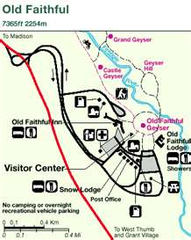

Supplemental Meeting #A – Maps -
Elective 23, a-e and Map & Compass Belt Loop

Park maps can be fun tools for studying maps & planning a hike. Many parks have their maps on their web sites.

Here are some web sites where you can access maps.
http://maps.randmcnally.com/
http://www.mapquest.com/
http://maps.google.com/
http://maps.nationalgeographic.com/maps this map is on actual photos of the earth.

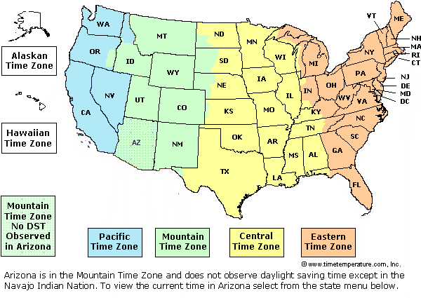

Time Zone Maps
http://www.timetemperature.com/tzus/time_zone.shtml
http://nationalatlas.gov/printable/timezones.html#one
http://www.worldtimezone.com/
http://www.time.gov/
http://www.worldatlas.com/webimage/countrys/namerica/usstates/timezone.htm

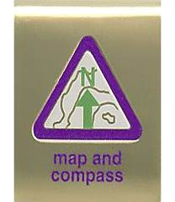
Map and Compass Belt Loop
- Show how to orient a map. Find three landmarks on the map
- Explain how a compass works.
- Draw a map of your neighborhood. Label the streets and plot the route you take to get to a place that you often visit.

Links for Map and Compass Pin requirements & work sheets:
- http://www.scouting.org/scoutsource/CubScouts/Cub%20Scouts/UniformsAndAwards/sanda/map_compass.aspx
- http://usscouts.org/advance/cubscout/academics/map-compass.asp
- http://www.boyscouttrail.com/cub-scouts/acadsports/map.asp

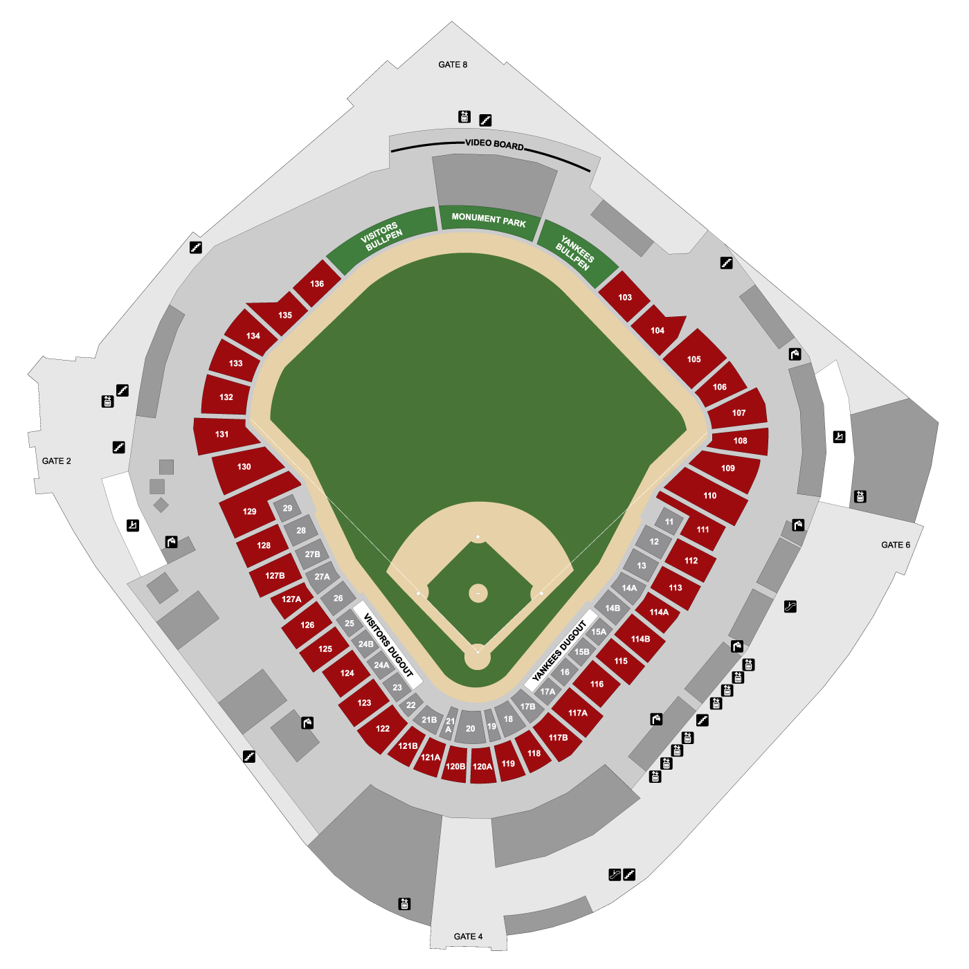
Alice, Golden Empire Council
Some Map Resources to Try
1. Visit a AAA Office (or ask a parent who is a AAA member) to obtain maps to use with this activity.
2. Show the boys how to find information such as time zones, site maps of local stadiums and auditoriums and other useful facts in special pages of the phone book.
3. Check with your local Chamber of Commerce or Better Business Bureau – they often have great maps of the local community


4. Check with local public transit agencies – many boys don’t realize how buses, light rail and subway systems can take them from place to place – learning how to read the system maps is a very useful skill!
5. Want a fun challenge? Check with a library, used book store, thrift store or a National Geographic fan – this publication has wonderful inserts that sometimes feature maps of states, regions, countries or special areas – and you can also see unusual maps such as maps of the seafloor, lunar surface, etc.
6. City or County Recreation Departments, or National Parks – Sometimes the best way to see the details and relationship between areas of a park or nature area are the maps made for a nature center or park.
7. USGS – If you are lucky enough to be near a regional office, you can go and purchase all kinds of great maps – especially topo maps; you can also order them online.


8. Internet – This is a resource you can use if you can’t find the map you want somewhere else. Just search the name of the area you are interested in!


I had great fun with boys and maps one time – I got a variety of maps, everything from road maps to topographical maps, “maps” of stadiums or auditoriums – had them posted on the wall and assigned a team of boys to spend some time looking at “their” map to see what they could learn. After a few minutes, we went around the room and talked about the different maps – the boys learned about using the map key or legend, how to pick out different features, how to estimate size and spaces covered – and they were better prepared to follow a map on a hike or family trip! Alice

WEBELOS DENS

Joe Trovato,
WEBELOS RT Break Out Coordinator
Westchester-Putnam Council
Have a question or comment for Joe??
Write him at
webelos_willie@yahoo.com
There is an underscore between Webelos and Willie

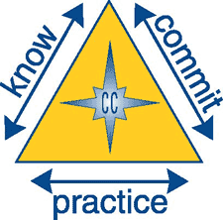
Core Value for April
Faith

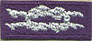

Faith: Having inner strength and confidence based on our trust in God.

“Faith is taking the first step even when you don't see the whole staircase.” - Martin Luther King, Jr.

The core value of Faith dovetails nicely with the Boy Scout Law, "A Scout is reverent." All Scouts show this by being faithful in their duty to God.

One way to work Faith into your program is to have your scouts work on the religious emblem for his faith. The US Scouting Service Project has a wonderful website with information on all emblems.

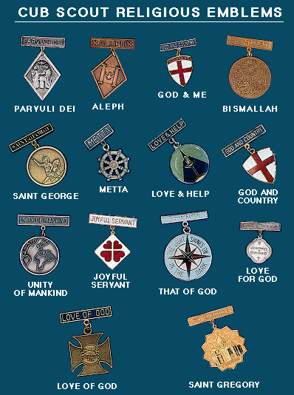

http://usscouts.org/advance/cubscout/religious.asp

Your local Council can help find counselors for various faiths for the diverse Webelos dens.

What more can you do?

Take a field trip to an historic place of worship. Visit an early church or mission and learn about the history and faith of people who lived in your area earlier.

As you work on badges, belt loops or pins, remind boys that their physical abilities are a gift and reinforce that they should be thankful for these gifts.

Of course, Webelos requirement #8 is on Faith.

- Faith:
Do either of these:
  - Earn the religious emblem of your faith OR
  - Do two of these:
    - Attend the mosque, church, synagogue, temple, or other religious organization of your choice and talk with your religious leader about your beliefs. Tell your family and your Webelos den leader what you learned.
    - Discuss with your family and Webelos den leader how your religious beliefs fit in with the Scout Oath and Scout Law, and what character-building traits your religious beliefs have in common with the Scout Oath and Scout Law.
    - With your religious leader, discuss and make a plan to do two things you think will help you draw nearer to God. Do these things for a month.
    - For at least a month, pray or meditate reverently each day as taught by your family, and by your church, temple, mosque, synagogue, or religious group.
    - Under the direction of your religious leader, do an act of service for someone else. Talk about your service with your family and Webelos den leader. Tell them how it made you feel.
    - List at least two ways you believe you have lived according to your religious beliefs.
Then, do all of these:
  - Know: Tell what you have learned about faith.
  - Commit: Tell how these faith experiences help you live your duty to God. Name one faith practice that you will continue to do in the future.
  - Practice: After doing these requirements, tell what you have learned about your beliefs.

If you earned your faith's religious emblem earlier in Cub Scouting, and your faith does not have a Webelos religious emblem, you must complete requirement 8e.
Completion of requirement 8e does not qualify a youth to receive the religious emblem of his faith

The Boy Scout Trail provides a worksheet that may be helpful at http://www.boyscouttrail.com/external_frame.asp?goto=http://www.boyscouttrail.com/webelos/w2/religious_requirements.htm

Webelos Den Leader
RT Breakout


Planning a Den Outdoor Activity

With April come warmer weather and its time to plan den outdoor activities. Webelos dens should consider day hikes, overnight camping, camping with a Boy Scout troop as well as field trips that relate to activity badges. At your local round table, share ideas for outdoor activities with other Webelos leaders. Has your Webelos den had a particularly successful activity? Share the particulars with other leaders. You’ll find that most successful outdoor activities are:

- Parent/youth or family oriented.
- Conducted with adult supervision.
- The Cub scouts are asked to do their best.
- The activity is discovery based.
- Advancement occurs as a natural part of the activity, but is not the focus of the activity.

What else do you need to know? Here are some important considerations from the Cub Scout Leader Book and the Guide to Safe Scouting:

- Two-Deep Leadership Required: It is the policy of the Boy Scouts of America that trips and outings may never be led by only one adult. Two registered adult leaders, or one registered adult leader and a parent of a participant, one of whom must be 21 years of age or older, are required for all trips and outings.

- Obtain written permission forms from a parent or guardian for all activities held away from the regular den and pack meeting places.

- File a local tour permit if necessary. Check with your local council.

- Plan ahead for adult supervision and in case of an emergency.

- Check out the site before hand.

- Use the buddy system. Coach the boys in advance on what to do if they get lost.

- Carry a first aid kit and make sure that adults know how to use it.

- Arrange for adequate insured and safe transportation.

- Insure that the activity is “age appropriate” as set out in the Guide to Safe Scouting. www.scouting.org/HealthandSafety/GSS.aspx.

Also, don’t forget to have an alternative indoor activity in case of bad weather!

Basic Adult Leader Outdoor Orientation (BALOO) training is for any Cub Scout leader with a desire to plan and carry out any outdoor experience for the pack. When you complete this training you will have an increased level of confidence and the required knowledge of the resources available from the BSA to plan an age-appropriate den or pack overnighter.
Remember, a BALOO trained person needs to sign the Tour Permit that your Pack submits to the Council and attend the camping event that your Pack has planned.

BSA Policies: Standards for Privacy on Trips or Outings

To support the BSA policy of two-deep leadership on all trips and outings, the sleeping arrangements of male and female leaders must be addressed.
All leaders are expected to reflect high moral standards established by customs, traditional values, and religious teachings. Male and female leaders require separate sleeping facilities. Married couples may share the same quarters if appropriate facilities are available.
Male and female youth participants must not share the same sleeping facility. When tents are used, no youth will stay in the tent of an adult other than his/her parent or guardian. When housing other than tents is used, separate housing must be provided for male and female participants. Adult male leaders must be responsible for the male participants; adult female leaders must be responsible for the female participants. Adult leaders need to respect the privacy of the youth members in situations where the youth are changing clothes or taking showers, and intrude only to the extent that health and safety require. Adults need to protect their own privacy in similar situations.

And, since we’re planning outdoor activities and Summer is almost here. . . . . .

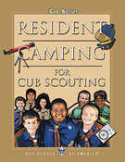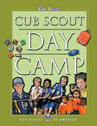

Make sure to offer your Scouts the option to attend Webelos Scout resident camping. It is a council-organized, theme oriented, overnight camping program. It operates for at least two nights (and often a week) and is conducted under trained leadership at a camp approved by the your council.
If resident camp is not possible, Day Camp should be an option. Day camp is an organized, multiple-day, theme-oriented program for Tiger Cubs and their adult partners, Cub Scouts, and Webelos Scouts. Day camp is conducted by the council/district under trained leadership at an approved site during daylight or early evening hours. Day camps do not include any overnight activities. The day camp program is age-appropriate and theme-based.
And still more on outdoor activities ……..

You may want to work into your den meetings and outings earning on the Cub Scouting’s Leave No Trace Awareness Award which is available to both Webelos Scouts and Leaders.
Information on the Award and the Cub Scout Leave No Trace Pledge may be found at
http://www.scouting.org/scoutsource/CubScouts/resources/LeavenoTrace.aspx

Book Corner
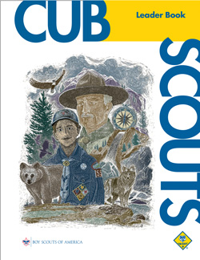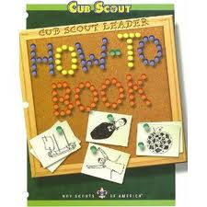
More on FAITH

From the Cub Scout Leader Book:

Cub Scouting Teaches Duty to
God and Country

The BSA believes that no member can grow into the best kind of citizen without recognizing an obligation to God, and encourages both youth and adult leaders to be faithful in their religious duties.

The Scouting movement has long been known for service to others. Scouting believes that patriotism plays a significant role in preparing our nation’s youth to become useful and participating citizens. A Cub Scout learns his duty to God, country, others, and self.

Check out pages 4-3, 4-4 and 8-3 of the Cub Scout Leader Book for more on FAITH. In addition, this core value is an excellent way to get your scout’s parent involved by having the parent assist the scout in obtaining the religious award for his faith. More on this on page 29-2.

http://www.scouting.org/filestore/hispanic/english/33221_WEB.pdf

The How-To Book is a great resource for this month’s Webelos meeting on Artist and Showman. Chapter 2 on Crafts and see Chapter 5 (page 5-12 all about puppetry) for all you need to know to help the boys meet the requirements for Showman 2, 3 and 7.

http://www.scouting.org/filestore/hispanic/english/33832_WEB.pdf

Meeting Planner


This month’s meeting plans for First year Webelos work on the Scholar, Artist and Showman badges.

Meeting 15: Scholar Do: Scholar 1, 5, 11, 12.
Artist 2, 8, 10
http://www.scouting.org/filestore/CubScoutMeetingGuide/webelos/WebelosMeeting15.pdf

Meeting 16 Showman (Puppetry) Do: Showman 2–5, 7, 11, 17, 20
http://www.scouting.org/filestore/CubScoutMeetingGuide/webelos/WebelosMeeting16.pdf

In March, Second year Webelos (Arrow of Light) work on Sportsman.

Meeting 15 Sportsman Do: Sportsman (Marbles belt loop))
http://www.scouting.org/filestore/CubScoutMeetingGuide/ArrowofLight/ArrowofLightMeeting15.pdf

Flag Ceremony

Arbor Day


National Arbor Day is generally celebrated on the last Friday in April, but some states may use a different day depending on the best planting time. It is a day to plant and dedicate a tree to help nature and the environment.
National Arbor Day is the Tree Planter's holiday, and has been celebrated since 1872. It began in Nebraska, a largely treeless plain back in the 1800's. It was started by J. Sterling Morton, a Nebraska newspaper publisher who encouraged Nebraskans to plant trees to beautify and enrich the almost treeless state. He offered prizes for the most trees planted...over a million trees were planted on that first Arbor Day.
The National Arbor Day Foundation provides millions of trees for planting. It is estimated that 18 million tress are planted each year on Arbor Day. More information may be found at the Arbor Tree Foundation website at http://www.arborday.org/index.cfm including how you can get 10 free trees to plant!
April Flag Ceremony
Follow your standard Color Guard process (see last month’s Bugle for a sample). After the Cub Scout promise (or Boy Scout Law, and Oath, if this is a Webelos Den meeting) and before posting the U.S. Flag you may insert the following:
Reader 1: In April we celebrate “Arbor Day.” “Arbor is the Latin word for “Tree.” The first Arbor Day was first celebrated in Nebraska in 1872
Reader 2: It was begun by J. Sterling Morton, a Nebraska newspaper publisher because Nebraska did not have many trees. More than 1 million trees were planted on that first Arbor Day.
Reader 3: Arbor Day is a day to plant a tree and help Nature. Over 18 million trees are planted every Arbor Day.
Reader 4: As Americans it is our duty to replenish our forests and treat the environment responsibly. Let us all recite the Cub Scout Leave No Trace Pledge (this can be distributed as part of the Pack or Den Gathering activity) followed by the Pledge of Allegiance:
Cub Scout Leave No Trace Pledge
“I promise to practice Leave No Trace front country guidelines wherever I go. I will plan ahead, stick to trails, manage my pet, leave what I find, respect other visitors and trash my trash.”

Den Meeting Helpers
These activities can be used for the gathering or to reinforce/satisfy badge requirements.
Webelos


SCHOLAR



The Scholar Activity Badge is an easy one for boys to earn if they are doing acceptable work in school. This is because more than half the requirements concern attendance, behavior, grades and service in school

RELATED BOY SCOUT MERIT BADGES

There are requirements for the following Boy Scout Merit Badges that can be adapted for Webelos. You can borrow the books from a local Troop’s library.

- Citizenship in the Community
- Personal Management
- Public Speaking
- Reading
- Scholarship

SCHOLAR IDEAS

Den Activities
- Invite a school teacher to your den meeting to speak about the importance of school.
- Prepare a chart of your local school system (or obtain one from the school system’s office or website) and explain and discuss it with the boys.
- Invite parents of Webelos to come to a den meeting and bring along such things as class pictures, yearbooks, and report cards. Allow each time to share information on his/her school days with the den.
- Tour a local high school or visit a local college campus.
- Have boys make a list of the things they lie about school and another list of things they don’t like. Discuss them.
- Visit a school board meeting. Let the board know you are coming and that the boys are working on their Scholarship Activities badge. The board may acknowledge this during the meeting.
- Plan a trip to the local library to have the librarian demonstrate the use of microfilm or microfiche machines and explain the book cataloguing process.

DO YOU KNOW YOUR ALPHABET?

What letter is:
- A vegetable? (P)
- A body of water? (C)
- Part of a head? (I)
- A female sheep? (U)
- Part of a house? (L)
- An insect (B)
- A drink? (T)
- An exclamation? (O)
- A bird? (J)
- A question? (Y)

SECRET SCHOLAR MESSAGE
-Barb Stephens

- If you ever saw a cow jump over the moon, write "Q" in spaces 1, 4, 15, 18. If not, write "R" in these spaces.
- If "X" comes before "H" in the alphabet, write "Z" in space 3. If "X" comes after "H," write "F" in space 3.
- If 13,467 is more than 10 dozen, write the letter "E" in spaces 2, 5, 9, 16, 19. If it is less than 10 dozen, write "K" in these spaces.
- If you like candy better than mosquitoes, indicate this with an "S" in 6 and 12. If not, leave these spaces empty.
- Close one eye and without counting on your fingers, write the 8th letter of the alphabet in space 7.
- If Shakespeare wrote "Twinkle, Twinkle, Little Star," put a "C" in space 22. If he didn't, write a "Y" in that space.
- If white is the same color as black, write nothing in space 8. If they are different colors, write an "M" in space 8.
- If 10 quarts equals one cup, draw an elephant in space 10. Otherwise, write an "N" in space 10.
- If summer is warmer than winter in the Northern hemisphere, put the letter "D" in space 21 and the letter "T" in space 11.
- If you think this is silly, write the first letter of the alphabet in spaces 14 and 20. Otherwise, write an "A" in those spaces.

1 | 2 | 3 | 4 | 5 | 6 | 7 | 8 | 9 | 10 | 11 | 12
13 | 14 | 15 | 16 | 17 | 18 | 19 | 20 | 21 | 22 | 23 | 24

HELPFUL HINTS FOR STUDYING

- Choose a regular time for study. Perhaps an hour or two after dinner so you can play a bit right after school.
- Make it a habit, just something you always do.
- Focus on your reading – no distractions like a phone in your room that might ring or alert you to a text from a friend.
- Listen carefully in class and take note, even if you thing you can remember what the teacher says. Proper note taking is a skill that you need to practice.

CAREERS IN EDUCATION


Materials needed:
Lots of old magazines, glue, construction paper, scissors
Have each boy choose one of the following careers in education and think of what may be involved in that career. Then, using old magazines have each boy make a collage of pictures that relate his ideas about the career. You may be surprised at a Webelos perception of these jobs. When the collages are complete, discuss them and clarify any misconceptions. Display the collages at the pack meeting.
Guidance Counselor
Health Services
Librarian
Principal
Social Worker
Sports Coach
Kindergarten Teacher
Elementary Teacher
High School Teacher
College Professor

BRAIN TEASERS



- If two cars start from Denver to drive to Colrado Springs, a distance of about 80 miles, if they are both the same make of car, and if both are being driven at the same rate of speed, and yet, while one of the cars makes the distance in 80 minutes, it takes the other one hour and 20 minutes. Can you expain the reason? (Answer: 80 minutes and one hour and 20 minutes are the same.)

- I walked up the street to the top of the hill and counted 50 windows on my right, I turned around and walked back and counted 50 windows on my left. How many different windows did I count? (Answer: Fifty. The windows on my right going up were the same windows that were on my left going down.)

- Papa Duck, Mama Duck, and Baby Duck went for a swim. Baby Duck said, “Aren’t we all four having a lot of fun? Why did Baby duck say four instead of three? (Answer: Baby Duck was too young to count.)

- Take the number of pennies in a dollar. Multiply by the number of thirds in a circle. Divide by the number of inches in a foot of string. Subtract the number of nickels in a quarter. (Answer: 20.)

Sign Language

“I love you.”
Scholar Requirement 6. While you are a Webelos Scout, earn the Cub Scout Academics belt loop for Language.

Alphabet

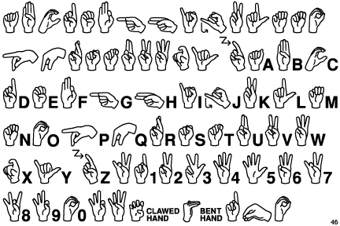

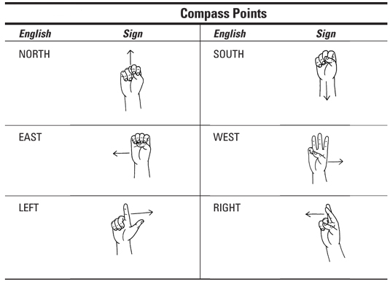

Chinese Numbers

1 2 3 4 5 6 7 8 9 10 

Games from other Cultures
A Game From Mexico


La Pirinola - A Game of Chance
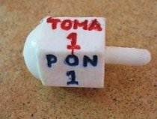

This game could also start as a craft with the den making a simple Pirinola. Using the following diagram as a ____ cut out the shape from a sturdy light colored foam board, separate it into six parts as shown and write the Spanish directions in each section.

They mean:
Side  1  2  3  4  5  6 | Spanish  Toma Uno  Toma Dos  Toma Todo  Pon Uno  Pon Dos  Todos Ponen | English  Take One  Take Two  Take All  Put One  PutTwo  All Put

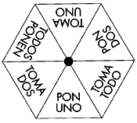

Punch a small hole in the middle, enough to have a sharp pointed pencil snuggly fit through. You now have a simple Porinola and can play the game!



How to Play:
(from www.scholastic.com )
To Start: Each person should have ten chips or counters. Each player puts two chips in the center, called the "pot."
To Play: Take turns spinning the Pirinola once each. When it comes to rest, read aloud the instructions on the highest part of the top. The player may be told to take one or two or all the chips from the pot. Or the player may have to put one or two chips into the pot. "Todos Ponen" means that every player places two chips into the pot. When only one or two chips remain in the pot, every player places two chips into the pot.
To Finish: Decide before you start how many rounds you will play. A player who does not have enough chips to play drops out of the game. The winner is the person with the most chips at the end of the game.

A Game from Ghana


Da Ga

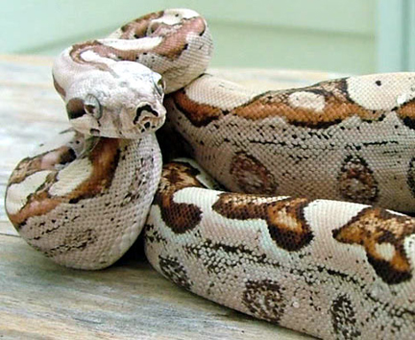

Number of Players
12 to 20 children
Recommended ages
8-12 years old
Origin
This game is from Ghana. Da Ga means "boa constrictor" which is found rarely in the United States.
How to Play
- Make an area about 10 feet square on the ground. This is called the “Home of the Snake".
- Choose one player to stand inside the "Home of the Snake." All the other players should surround this person.
- The first player reaches out and tries to touch any of the players. If touched, that player joins the player on the inside. The two hold hands and and then reach out (using only the free hand) to try and touch the other players.
- The remaining players must stay close to the outside of the home of the snake. While they are on the outside, they can sing, dance, or skip to avoid the players in the circle.
- The last player left begins to form a new snake in the next game.
Source: Hopson, Dr. Darlene Powell, Hopson, Dr. Derek S., and Clavin, Thomas. "Juba This and Juba That" Simmon and Schuster, 1996. p. 39

ARTIST



Cub scouts allows boys to learn and experiment. Boys love to draw, paint or otherwise create. Artist allows the boys to do so and try something that they haven’t tried. For many people, art is the way they make their living. For others, it is a recreational activity which develops into a lifelong hobby. The Artist Activity Badge won’t make an artist out of every Webelos Scout, but it should help each boy better understand how the artist works and what he’s trying to express.

RELATED SCOUT MERIT BADGES
- Architecture
- Drafting
- Pottery
- Model Design and Building

ARTIST IDEAS

- Attend an art exhibit or visit a museum
- Hold an “Art can be fun night” by inviting a local artist to the den meeting to work with the boys to draw/color/paint a simple landscape scene.
- Do leaf Scapes
- Have each boy prepare a color scheme for his bed room or other room in his home. Ask him to explain the reasons for the colors and why the color(s) chosen go together.
- Make soap carvings
- Visit a print shop where graphics are created and printed
- Ask a computer design specialist to demonstrate the techniques used in computer drawing
- Ask the boys to make a profile of a family member and an original picture at home.
- Have modeling clay and material on hand for making models.
- Invite an art teacher to your den meeting.
- Display silhouettes of each Webelos Scout that they have done at the den meeting at a Pack Meeting.

ART SHOW



Sponsor a den or pack art show that would encourage all boys to create something in various media for judging and display. Invite parents to judge and be part of the fun. Create awards for the judges to give:

- MOST KALEIDOSCOPIC -- using all or at least many different colors.

- MOST TRANQUIL -- anything that looks restful.

- MOST AUTOMOVISTIC -- relating to cars, hot rods, trucks, etc.

- MOST ACHROMATISTIC -- meaning free from color, a black and white picture.

- MOST CAPTIVATING -- catches your eye.

- MOST SYMBOLIC -- representation of a symbol or emblem.

- MOST DUPLICITIC -- a double, in pairs, using two as part of the design.

- MOST NATURALISTIC -- anything to do with nature: trees, flowers, animals, etc.

ARTIST’S QUIZ

Match the answers above to the clues below.
1. A primary paint color _____
2. Genius Kit _____
3. Arrangement of shapes or lines _____
4. A secondary paint color _____
5. Mixture of blue and yellow _____
6. Hanging shape _____
7. Mixture of blue and red _____
8. Add this color to make a lighter hue ______

- Violet
- Design
- White
- Blue
- Construction
- Green
- Orange
- Mobile
Answers: 1 d, 2 e, 3 b, 4 g, 5 f, 6 h, 7 a, 8 c

LINE DESIGNS
Circle Ten Council


Write your name on a large sheet of paper. Print or use cursive writing. Use crayons or markers to trace around the shape of the name. Continue to outline the shape until the paper is filled. For variations, try using a color scheme such as complementary colors, primary colors, rainbow colors, etc. You may choose to vary the thickness of the lines or incorporate other shapes into the design.

REPRODUCING BY GRIDS
Circle Ten Council
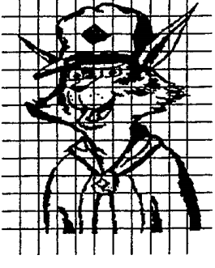
Before the copier was invented, how did the artists enlarge or shrink pictures and designs? They used a grid.
You can copy any picture by using a grid such as the one placed over Akela shown below.
Choose a picture you want to reproduce (start with simple designs). Decide on a convenient size grid. Either draw the grid directly onto the picture or onto a piece of hard clear plastic placed over the picture. Draw lines at the same intervals horizontally and vertically. For a larger picture, you may draw lines at wider intervals. If using a plastic grid overlay, attach it securely to the picture being copied.
Now decide on a grid for the enlarged picture. Decide on the size and draw a grid, same number of lines as the grid for the original drawing, but bigger. Using the picture of Akela shown here, if you use one-inch squares, the finished drawing will be about 11 by 14 inches. Draw the enlarged grid onto a piece of paper, making lines dark. Overlay with a sheet of paper, making sure you can still see the grid. Regular white paper or tracing paper works well. Secure the grid on the back of the paper with tape.
Now copy the drawing from the smaller grid to the larger. For instance, the top of Akela’s right ear is about two squares down on the first grid column. Mark that point on your enlarged grid and continue to do so for the entire drawing.
You may reduce the size of a picture using the same concept used to enlarge it.
Leaf Scapes
Heart of America Council

Using leaves, paint and your pen or pencil, you can make an interesting landscape. Diversification of leaf form is the key to the basic formation of these designs. Select many leaves and press until partially dry. Place on a sheet of construction paper until the design and pattern fits the individual taste and need. Hold various leaves in place with a straight pin. Lightly spray with various colors as your own individual creativity dictates. Remove leaves that have provided a stencil effect for the leaf scapes. Additional artistic effects may be obtained by using a brush or pen and appropriate colors. Mount and frame as desired. This activity would be a good way to study complimentary colors or shading and blending from the color wheel. It is also a way to make a design using both straight and curved lines. Press and dry many leaves of various species of trees. (Leaves can be dried between sheets of wax paper, weighted down with heavy books.) These leaves are carefully glued to construction paper and are again pressed to insure their adhesion to the paper. As leaves dry, their color s are frequently lost.
ARTISTS’ RELAY

Line the den members up in relay fashion. Have a large piece of paper for each team taped on the wall or hung on an easel. Have the first boy begin drawing an object or design on the paper, without talking to anyone about what he is to draw. Allow him 30 seconds, and then signal for the next boy.
This boy adds to the original picture or design. Each boy has thirty seconds to draw.
When each boy has had a turn or two (depending on how the picture is taking shape), signal; a stop. The den members should not confer about the drawing. When the signal is given to stop and all have “admired” their handiwork, have the first boy relate what the original object was to be and see what the finished project exactly looks like.
THE COLOR WHEEL
http://www.colormatters.com
A color circle, based on red, yellow and blue, is traditional in the field of art. Sir Isaac Newton developed the first circular diagram of colors in 1666. Since then, scientists and artists have studied and designed numerous variations of this concept. Differences of opinion about the validity of one format over another continue to provoke debate. In reality, any color circle or color wheel which presents a logically arranged sequence of pure hues has merit.
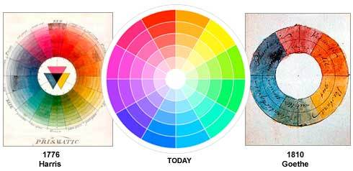
The 3-part color wheel.


Primary Colors: Red, yellow and blue.
In traditional color theory (used in paint and pigments), primary colors are the 3 pigment colors that cannot be mixed or formed by any combination of other colors. All other colors are derived from these 3 hues.
Secondary Colors: Green, orange and purple.
These are the colors formed by mixing the primary colors.
Tertiary Colors: Yellow-orange, red-orange, red-purple, blue-purple, blue-green & yellow-green.
These are the colors formed by mixing a primary and a secondary color. That's why the hue is a two word name, such as blue-green, red-violet, and yellow-orange.

COLOR CONTEXT
http://www.designmatrix.com



Which grey colored square is darker? Neither. They are the same. Why? When the same color is used in different contexts the perception of that color can change radically.

No Mess Plaster or Clay Sculpture
Circle 10 Council 1999 Pow Wow
Materials:
1 plastic bag (grocery or freezer are ideal)
2 cups of water Scissors
5 cups of plaster of Paris or clay of your choice
1 twist tie
Plastic knife
1 medium size mixing bowl
Measuring cup
Directions:
Before making your sculpture, decide if you want it to be a “representational” sculpture, meaning it looks like an object or figure, or if you want it to be an “abstract” sculpture, which is based on the real thing but does not look exactly like it.
Set your bag in the plastic bowl and pour 2 cups of water into it. Slowly add Plaster of Paris. Hold the top of the bag closed with one hand while squishing and squeezing the bag with your other hand until all the lumps of plaster are mixed with the water. Then, squeeze out all the air and use a twist tie to close the bag.
Lay the bag down on a smooth surface. At this point, the mixture will seem to be runny and won’t hold a shape. Suddenly it will begin to harden and feel warm. Quickly form your sculpture by pulling and pressing the mixture inside the bag.
Important - as you work, keep pulling the bag up from the plaster so it doesn’t become stuck in the plaster.
Let your finished sculpture dry for 30 minutes.
Carefully cut the plastic bag open and peel it away from the plaster sculpture you have made.
If you wish, you can use a plastic knife to draw lines or other designs on your sculpture.
Let harden for 24 hours.
Use sandpaper to smooth any rough spots.
If you wish to paint the sculpture, you will need to seal it with a clear acrylic spray first or the paint will not adhere well.
Instead of painting, you can glue on leaves, seeds, shells or other natural objects.
Use your imagination! Here’s a simple one to try!
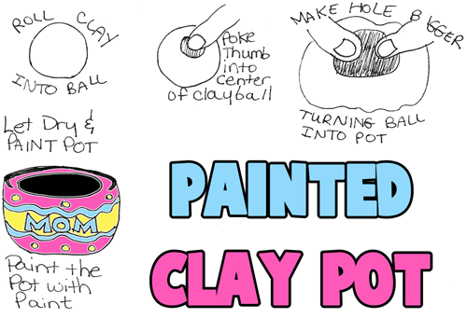
www.artiststhelpingchildren.org
PAINTER'S PALETTE TIE SLIDE
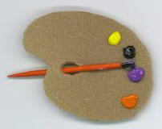
Materials:
Small Piece of Light Brown Fun Foam, Small Amounts of 5 Different Colors of Paint, 1 Small Paint Brush, 1/4" PVC Ring.
Supplies: Scissors, Pencil, Hot Glue Gun
Instructions:
- Trace Palette Pattern on Fun Foam and Cut Out.
- Place A Dollop Of Each Color Of Paint Around The Edge Of Palette
- Short Paint Brush by About 1 1/2". Sand Handle to Look like The Original and Paint to Match.
- Insert paint brush through thumb hole in palette and glue in place.
- Glue PVC ring to the back.

ARROW OF LIGHT

Most second year Webelos would have completed Arrow of Light requirements and bridged to Boy Scouts in February or March. Those Packs that may have delayed the event should continue the program with their second year Webelos.
SPORTSMAN

Sportsman Activity Badge: Requirements are set out in Arrow of Light Den Meeting 4. If you have not completed those in the den meeting, you can complete them this month.

SPORTSMAN IDEAS

- Have the boys play basketball, volleyball, table tennis, etc. 10-15 minutes each den meeting.
- Include some sports with each campout.
- Have a roller or ice skating party at a local rink
- Go fishing. Practice casting in the backyard.
- Remember that the boys must earn the belt loops as Webelos.
- Attend the Scout Day for the local professional teams.
- Have a bowling night.
MARBLES
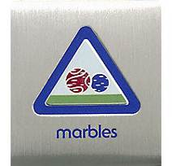
Belt Loop requirements:
- Explain the rules of Ringer or another marble game to your leader or adult partner
- Spend at least 30 minutes practicing skills to play the game of Ringer or another marble game.
- Participate in a game of marbles
Pin

Earn the Marbles belt loop, and complete five of the following requirements:
- Compete in a den, pack, or community marbles tournament
- Explain to an adult what lagging is. Demonstrate how to do it.
- Demonstrate the following shooting techniques: knuckling down, bowling, and lofting (also called plunking).
- Explain the correct way of scoring for a game of marbles.
- Play five complete matches of marbles using standard rules.
- Start a collection of marbles and show it at a den or pack meeting.
- Write a short report on the history of marbles and share it with your den or family.
- Explain the rules about shooters.
HOW TO PLAY RINGER

http://www.landofmarbles.com
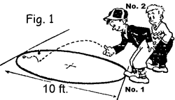
FIG. 1: To start a game of Ringer the children lag from a line, drawn tangent to the ring, to a parallel line across the ring, which would be 10 feet away. The child whose shooter comes nearest the line has the first shot. Players must lag before each game. Practice lagging, as the first shot may mean the winning of the game before your opponent gets a shot. In lagging, a child may toss his or her shooter to the other line, or he or she may knuckle down and shoot it.
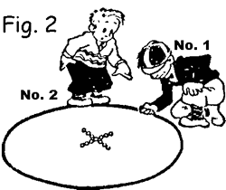
FIG. 2: This shows child No.1 who won the lag, preparing to knuckle down. His knuckle has not quite reached the ground, which is necessary before shooting. he can take any position about the ring he chooses. Notice how the 13 marbles in the ring are arranged at the start of the game.
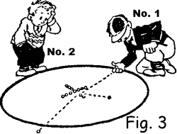
FIG. 3: child No.1 knocks a marble from the ring on his first shot and his shooter stays in the ring. He picks up the marble. As he has knocked one from the ring, he is entitled to another try. Players are not permitted to walk inside the ring unless their shooter comes to a stop inside the ring. Penalty is a fine of one marble.
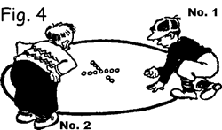
FIG. 4: Here we see child No. 1 continuing play. He "knuckles down" inside the ring where his shooter stopped on the last shot. This gives him the advantage of being nearer to the big group of marbles in the center of the ring for his next shot. Expert marble shots try to hit a marble, knock it out of ring and make their shooter "stick" in the spot.
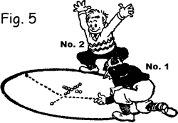
FIG 5: On this play, No.1 hit a marble, but did not knock it from the ring. At the same time his shooter, too, stays inside the ring. He can not pick up the marble, neither is he allowed to pick up his shooter. He must leave the shooter there until the other child has played.
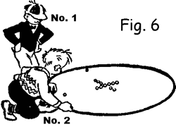
FIG. 6: child No. 2 may start by "knuckling down" anywhere at the ring edge. In this case he may shoot at the 11 marbles in the center or if he wishes, he may go to the other side and try for No.1's shooter or the marble that No.1 almost knocked from the ring.
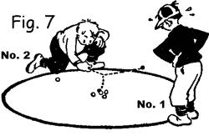
FIG. 7: child No.2 chooses to try for No. 1 child's shooter and knocks it out of ring, winning all the marbles No.1 has taken and putting No.1 out of that game. Or he could shoot as shown in Fig. 8.

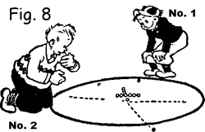
FIG. 8: child No.2 hits a marble but does not knock it out of the ring yet his shooter goes thru the ring and stops outside. The marble remains where it stopped in the ring, and as No.2 did not score, it is now the turn of No.1 to shoot again.
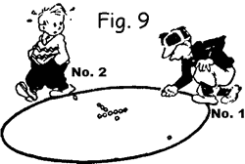
FIG. 9: No. 1 "knuckles down" inside the ring where his shooter stopped (Fig. 5). He is going to shoot at the marble nearest his shooter. By hitting it at the proper angle and knocking it from the ring he can get his shooter near the center of the ring for his next shot.
MARBLE GOLF
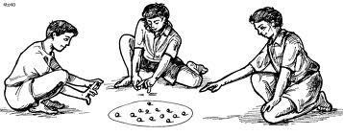
Set up this game and practice playing it for a future den or pack marbles tournament. For holes, bury baby food cans to the brim in the earth. Flags are paper triangles glued to craft sticks. Add water hazards and sand traps as you wish. Shots are taken in the approved knuckles down way for regular marbles. Winner is the Webelos who takes the fewest shots to get all the way around.
MARBLE TERMS
www.streetplay.com

A surprising number of terms in the American lexicon come from marbles. Aside from the obvious "all the marbles," there's "knuckle down," and "play for keeps." Here's a rundown of more popular terms used by marbles players, and a brief description of the many games people play with marbles.
Aggie either a marble made out of agate or a glass marble that looks like it's agate. A glass or imitation aggie is also called an immie.
Alley A marble made of marble. Alley is short for alabaster.
Bombsies Dropping your shooter on the target marble.
Histing Lifting your knuckle from the ground while shooting.
Keepsies Playing for keeps. You get to keep all the marbles you win.
Knuckle down To put one knuckle of your shooting hand in contact with the ground. Most players put the knuckle of their index finger on the ground. You position your shooter in the crook of the index finger and flick it out with your thumb.
Lagging A way of choosing who shoots first. Players roll their marbles toward a line in the dirt (the lag line). Whoever gets closest without going over gets to shoot first.
Mibs The target marbles in a game. Another name is Kimmies.
Playing for fair All marbles are returned to owner after the game.
Playing for keeps The winner keeps all the marbles after the game ("winner keeps, loser weeps").
Plunking Hitting the targets on the fly.
Taw Another name for a shooter. Shooters are often slightly larger than target marbles. In some games you shoot from behind a taw line.
SKULLY
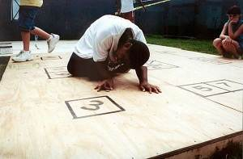
Growing up in the street of Manhattan, we played quite a few street games. Stickball, stoopball, and handball (both “American” and “Chinese” versions) were favorites. We never played marbles, but we did play “skully” which I have played with my Webelos Scouts with great success. Although there are varied rules, here is one version take from www.streetplay.com where you can find more information on this and other street games. (Maybe some dads who played these games can help out!)
Move quickly through a dangerous course, avoiding opponents, or blasting them clear out of the game zone. Always seek the safety of home bases. Complete the basic level and get transformed into a being with the power to eliminate your competitors. Sounds like a new video game, but it's the classic street game of skully.
Skully (a.k.a. skelly, skilsies, skelsies) was one of the most popular street games in the New York City area, and it is still played today, though not as widespread. It is typically played on the street using bottlecaps on a board (see below) drawn with chalk. Anywhere from 2 to 6 (or more) players can play. Each neighborhood has its own variations on the rules, but the basic theme is to use your fingers to shoot your piece (a bottlecap, poker chip, or other small item) through the course drawn on the street, then "kill" all the other players, leaving you the winner.
We use the name skully here because we believe it derives from the middle section of the board, called "the skull." Deadbox, a closely related game found in Philadelphia, PA, actually uses a board with a skull drawn in the middle.
Making and customizing a skully cap is an art unto itself. A number of techniques can be used to create colorful and particularly effective pieces. The skully board itself, its dimensions and variations, may vary from place to place, but the general design is fairly consistent--not unlike variations you see in baseball parks around the nation!
Rules

Make a skully board with chalk on a patch of available and relatively smooth street or sidewalk. The board consists of 13 numbered boxes, 1 through 12 on the periphery of the board, and a box labeled 13 in the center surrounded by a "dead man's zone" or "skull."
Start at a line outside the skully box and aim for the "1" box, flicking your bottlecap with your finger. If you get it in (without it touching any line), you keep your turn and shoot for the next box. You can also advance a box by hitting the cap of an opposing player. If you're close to another player's piece, you can try to blast the piece halfway down the block with your own. In some neighborhoods, you can replace your cap with a special heavy one (like from a juice or peanut butter jar) for this purpose, though you couldn't do this if someone calls "no blasting allowed."
After going from 1 to 13, you have to return, going from 13 to 1. After completing the full journey, you shoot back into 13 and then navigate the "skull," shooting your piece in the forbidden "dead areas" of the skull while declaring your new powers ("I am a killer diller").
From this point on, you hunt the other players. Only you (or other killers) can safely go within the skull. If you hit another player (3 times consecutively), they're out of the game. If they hit you, they become a killer too (or, if you decide beforehand, they're out of the game). The last person left wins.
Players may recall a number of words specific to the nuances of skully. From the obvious blasters, killers, and baby stuff to the more subtle pipsies, linesies and marksies, there is a rich lexicon of words attached to the game. And of course, everyone knows the one term in skully universal to all kid games: "do-over."
A serious set of rules with definitions of these words may be found at http://www.streetplay.com/skully/rules/

The Skully Board

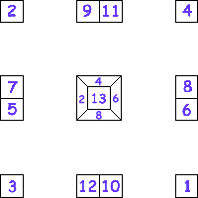

A skully board can be drawn on a street, playground, driveway, or even a basement floor... anyplace with enough room that's smooth. If making permanent marks is a problem ("painting Mom's kitchen floor" equals "trouble"), chalk does the job just fine. If you play a lot of skully, a painted board is better and more convenient. A great compromise we've used is electrical tape--it's excellent for drawing lines and easy to remove.
Drawing a skully board isn't just fun: it can also affect the game (depending on how big the boxes are), often giving the "designer" a home-court advantage. While a typical board is about 7-8' square with boxes about 10-12" square, these dimensions can vary wildly. Bigger boards favor stronger fingers, while smaller boxes stress accuracy. You can vary the dimensions based on the space you have and your skill.
Although the board's size can vary, the basic layout is constant. The numbered boxes 1, 2, 3 and 4 are the corners, the other boxes (5-12) are doubled in pairs in the middle of the side areas. 5 and 7 are paired, while 6 and 8 are directly across. 9 and 11 are always opposite 10 and 12, while 13 is always alone in the middle, surrounded by a "dead man's zone" or "skull."
The size of the 13 box in relation to the surrounding dead zone varies significantly, as seen in NYC boroughs. In the Bronx, the 13 tends to be quite small, while in Queens it's about the size of a normal box.
The Skully Cap

At first we used the bottlecap, (the twist-off variety, which didn't get dented by a bottle opener upon removal). Lots of glide, but very light, blastable. We found that new bottlecaps had new paint on them, and they glided better.
We then filled bottlecaps with wax, usually from a crayon. They were still fragile, but still glided well even with the additional weight. A weighted cap was good for blasting an unweighted cap, but when everyone's cap was weighted, it didn't much matter
The secret to making a good cap is the weight. The way to increase the weight and perhaps get an advantage you’re your opponents, is to place a penny or a nickel, depending on how much weight you want, in the bottom of the top before melting the wax in it. This would give you a small heavy top that would glide the length of the board and beyond if needed.

ADDITIONAL ADVANCEMENT IDEAS
Alice, Golden Empire Council
These are additional ideas. Maybe your Cubs did some advancement in camp and you got to skip a section. Maybe your den is above average and streaking through the program. Maybe you want some ideas to tie into the Core Value of the month. Maybe your presenter or field trip for that week fell through and you need a Plan B. Here are ideas you can use!! CD and Alice
All the ideas in this section are based on the assigned Value for April - Faith.
The ideas below are chosen from each rank because they fit the Value for April – Faith.
Some of these activities also fit Meeting Plan #15 and #16 – those are underlined.

Tiger Achievements
Ach. #5F – Go outside and watch the weather. Do the Character Connection for FAITH.
Ach. #5D - With a crayon or colored pencil and a piece of paper, make a leaf rubbing. Notice the shape, kind of edge, color of the leaf. Do you know what kind of tree the leaf is from?
Ach. #5G – Take a hike with your den – you might look and listen for signs of Spring.
These activities are also part of the Cub Scout Leave No Trace Award.

Tiger Electives
Elect. #6 - Along with your adult partner, teach a song to your family or to your den and sing it together – choose a religious song or a song about Faith.
Elect. #8 - Invite a religious leader from your place of worship to your home or to your den meeting
Elect. #10 - Along with your adult partner, help an elderly or shut-in person with a chore. Service is a way of showing your faith.
Elect. #14 - Together with your adult partner, read a short story or a magazine article. Choose a story about faith, or a person who has shown great faith
Elect. #30 - Plant a seed, pit, or greens from something you have eaten. Planting a garden or a seed is a way to show you have faith that it will grow.
Elect. #35 - Play a game outdoors with your family or den. Choose one of the Trust Games.
Elect. #36 - With your family or your den, go see a play or musical performance in your community. Many communities have special events for the Easter season.

Wolf Achievements
Ach. #4f – Visit an important place in your community and explain why it is important – you might visit a religious structure, maybe even for another faith. Or visit a local memorial building, park or statue and think about how those honored showed their faith.
Ach. #7d – With an adult, pick up litter in your neighborhood. Taking care of where we live shows our appreciation for nature and for what we have been given.
Ach. #10c – Plan a walk with your family – notice the beauty of the world and talk about your beliefs concerning creation and how to show appreciation for nature.
Ach. #10f – Attend a concert, play or other live program with your family. Family field trips help strengthen family ties; also talk about how performers need to have confidence and practice over and over to improve their talents. Faith is also strengthened by doing good things and giving service over and over.
Ach. #11a, b, c, d – Complete the Character Connection for Faith; Talk with your family about what they believe is their duty to God; Give two ideas how you can practice your faith-choose one and do it; Find out how you can help your church or other religious fellowship.

Wolf Electives
Elect. #5a, b, c, d, e – Learn the rules of safe kite flying; Make and fly a paper bag kite; a two stick kite; a three-stick kite; make and use a reel for kite string. Like Faith, the wind is something you cannot see, smell or touch – but you can feel its presence, and see its effects.
Elect. #6b – Choose a book about Faith, or someone who has shown faith – or read some scriptures!
Elect. #11d, e, f – Learn and sing three songs about faith, hymns or prayers; learn and sing a “grace” - a prayer before a meal; sing a song with your den at a pack meeting.
Elect. #15 – Do any or all of the activities of planting and growing – watching a seed grow into a plant is a great example of faith and how it can grow.

Bear Achievements
Ach. # 1a, b - Complete the Character Connection for Faith: Know some people in history who have shown great faith and discuss their faith with an adult; discuss with an adult how having faith can help you in life and how you can strengthen your faith; practice your faith as your are taught; make a list of things you can do to practice your faith, and check them off your list as you do them.
Ach. #2 – Earn the religious emblem of your faith. (Only Ach. #1 OR #2 are required)
Ach. #3a, b – Write or tell what makes America special to you – be sure to include the freedom to practice your religion; Find out about two famous Americans who have shown faith.
Ach. #6b – Plant a tree in your yard, at your chartered organization site, in a park or at a school – in honor of Arbor Day and to show your appreciation for the wonders of creation. Ach. # 8e – Find out some history about your community, especially the different religious groups that live there - and their buildings.
Ach. 9a – Make some Scripture Cookies, or Faith Cookies (CUB GRUB Section)
Ach. #10a – Go for a day out in nature or to an evening performance with your family.
Ach. #12 – Do any of the activities with your family; practice the principles of your faith in your relationships with your family, and take note of the beauties of creation around you.
Ach. #13c – keep a record for two weeks of how you spend your money; consider paying a tithe to your church and/or to help the needy.
Ach. #18f – Write about something you have done with your den; choose an activity that has something to do with the value of Faith.

Bear Electives
Elect. #14 – Do any or all of the requirements – landscaping is a way to beautify our surroundings and observe nature
Elect. #25 b, d – Go on a short hike with your den, taking notice of the wonders of nature; with your den, participate in a religious service during a scouting event.

Webelos & Arrow of Light Dens
Artist #10 – Create a collage that expresses something about you and your faith.
Citizen #11, #12 – Write a short story about a former US President or other great American, and include examples of their faith; Tell about another boy who is a good citizen and share some examples of how he lives his faith.
Communicator #8 – Write an article about a den activity – focus on a service project or some way that faith was demonstrated.
Forester #8 – Plant 20 forest seedlings in honor of Arbor Day, and tell what you did to take care of them.
Outdoorsman #2 – With your family or Webelos Den, help plan and take part in an evening outdoor activity that includes a campfire – be sure there is some inspirational or faith promoting component.
Showman: Music #8, #9 – Play four tunes on any band or orchestra instrument, reading from music; Sing one song indoors and one outdoors and tell what you had to do differently. For each of these, choose music that has some connection to faith or your religion

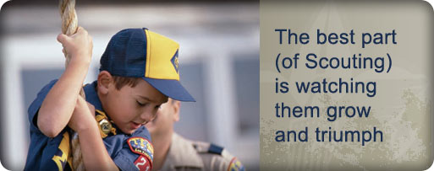

MORE GAMES AND ACTIVITIES
Wendy, Chief Seattle Council
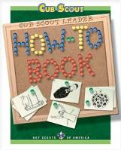
Want to check something in the "How-To Book," and your copy is not available?? Want to copy something quick to use at a meeting?? You can find the "How-To Book" at this address on National's Web Site -
http://www.scouting.org/filestore/hispanic/english/33832_WEB.pdf

CUB GRUB
Cub Grub Cookbook
This is a really great cookbook for Cubs -
http://balboaoaks.bsa-la.org/download/blog/Cub%20Grub%20Cookbook.pdf -
You can save a copy on your PC by selecting
File, Save As... in your web browser's menu bar.

FAITH IDEAS
Alice, Golden Empire Council
Prayer Pretzels
You can’t find an easier snack to fit the Value of Faith! Share pretzels in the traditional shape – after you tell the boys the story of how a village priest used the pretzel shape to remind the children to pray! Check it out under AUDIENCE PARTICIPATIONS & STORIES.

If you want a bigger challenge, pretzels are very easy to make – the trick is doing the twist to make them look like folded arms ready for prayer!
Faith Cookies
Use your favourite cookie recipe. Have all ingredients out and ready, and an easy-to-read copy of the recipe. Go over each step of the recipe with the boys, starting from setting the oven temperature. Let the boys do as much of the measuring and mixing as possible.
To fit the Faith theme, identify each ingredient as an ingredient of Faith -
Knowing what you believe/Scriptures = recipe
Other ingredients could represent hope, prayer, obedience, searching the scriptures, reading a story about faith, knowing a principle of your creed that pertains to faith.
After the cookies are baked, enjoy!
Scripture Cookies
To find each ingredient, look up scripture reference and fill in blank. Some clues are subtle, so check list of ingredients on bottom of page before making cookies.
Ingredients:
3/4 cup “The words of his mouth were smoother than ____” (Ps. 55:21)
1/3 cup “Come unto me all ye ends of the earth, buy ____ and honey” (2 Ne. 26:25)
1 1/2 cups “To what purpose cometh there to me … the ____ ____ from a far country?” (Jer. 6:20)
2 “As one gathereth ____ that are left, have I gathered all the earth” (Isa. 10:14)
2 cups “And Solomon’s provision for one day was thirty measures of fine ____” (1 Kgs. 4:22)
1 teaspoon “Take thou also unto thee principal spices, … and of sweet ____ half so much” (Ex. 30:23)
1 teaspoon “Ye are the ____ of the earth” (Matt. 5:13)
1/2 teaspoon “The kingdom of heaven is like unto ____ (Matt. 13:33)
3 cups “Nevertheless, … ____ for the horse” (D&C 89:17 or Gen. 1:13-14 –you will have to explain that oats are a grain and a plant bearing seed- the word oats doesn’t appear in the Bible)
1 cup “And they gave him … two clusters of ____” (1 Sam. 30:12)
Directions:
- Beat first four ingredients together.
- Mix in remaining ingredients.
- Drop by teaspoonfuls onto greased cookie sheet.
- Bake at 350° F (175° C) for 15 minutes.
Answers for Ingredients:
3/4 cup butter, 1/3 cup milk, 1 1/2 cups sugar (sweet cane),
2 eggs, 2 cups flour, 1 teaspoon cinnamon, 1 teaspoon salt,
1/2 teaspoon baking soda (leaven), 3 cups oats,
1 cup raisins

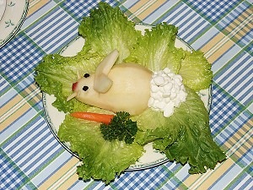 Bunny Salad for Easter
This is really easy – and tastes good, too!
The Bunny is a chilled pear half, features are made from raisins, dried cranberries, or whatever you like best. Ears can be cut from another pear slice, apple slices, or jicama, or use sliced almonds. The tail is cottage cheese. And be sure to add some carrots for your bunny to enjoy!

APRIL FOOL’S IDEAS

Spaghetti & Meatballs – Dessert Masquerading as a Main Dish
This was a lot of fun one year – you just make a yellow cake for the base, then make regular butter cream vanilla frosting – but tint it just slightly yellow. You’re going to squeeze it out to look like spaghetti – I didn’t have a decorating tube, but a sealing bag with a hole in one corner worked just fine – remember to do your spaghetti haphazardly, twisting on top itself so it looks realistic. It looks REAL!
The Meatballs are those great Ferrero Rocher chocolate candies (although I have seen chocolate malt balls used). I rolled them in some cocoa powder to make them look more realistic. Then just cover with “sauce” made from strawberry preserves and top with grated white chocolate for parmesan cheese.

Main Dish Masquerading as Dessert
Cupcakes or Cake “Meat Loaf”

1/2 lb. lean ground beef, 1/2 cup seasoned bread crumbs, 1 cup grated Monterey Jack cheese, 3 T. ketchup, 1 egg, 1/2 teaspoon celery salt, 1/4 t. pepper
“Frosting” 3 C. mashed potatoes, food coloring or beet juice
Directions: Heat oven to 375 degrees. Line 12 muffin tins cups with foil baking cups or use a loaf pan. In a large bowl, mix together meat loaf ingredients and divide evenly among cups.
Bake for about 15 minutes or until cooked through, with the filled muffin tins on cookie sheets. Adjust time for a meat “loaf.” Spread a generous amount of “frosting.” If you make a loaf, use a decorating tube for your “cake.”


Appealing New Treat
The latest scientific breakthrough from Family Fun magazine: pre-sliced bananas! When they peel one, they'll find the fruit inside is already cut into bite-size pieces.
Ingredients: Ripe banana (one with a few dark spots)
Directions:
- For each slice, insert the threaded needle through one of the fruit's "corners" (where the edges of the peel meet) and out an adjacent corner, leaving a small tail of thread dangling for later.
- Insert the needle back through the exit hole you just made and push it through to the next corner, pulling all but a small loop of thread along with it (see diagram). Continue from corner to corner until you return to the beginning, then push the needle out through the first hole you made.
- Gather the 2 thread ends and carefully pull them out simultaneously; the thread will slice through the banana. Repeat the threading for as many slices as you'd like, then get ready to wow your family with this new breed of snack food.

Ants on a tire (or toilet seat) (eew!):
Core apples, and slice into rings.
Spread peanut butter or cream cheese on the rings. Add raisins or dried cranberries for “ants”.

Jell-O Snakes (or worms)
Ingredients: 1 ½ cup apple juice, 3 oz. package flavored gelatin, 1 envelope unflavored gelatin, 5 ice cubes, small Ziploc bags
Directions: Pour half the juice into saucepan. Heat until boiling; Remove from heat. Add gelatin, and stir until dissolved.
Pour remaining apple juice into mixing bowl. Add unflavored gelatin, and stir until dissolved.
Add mixture to hot apple juice. Add ice cubes, and stir until melted. Refrigerate until the consistency of pudding, about 10-15 minutes.
Spoon gelatin into Ziploc bags. Cut ¼ inch off the corner of the bag. Squeeze a wavy line of gelatin onto a foiled cookie sheet.
Chill in refrigerator about 2 hours.
To keep snakes firm while serving, place them on a plate over ice cubes.

WEB SITES
And Other Resources
Faith Activity Badge
for British Scouts
Commissioner Dave
Beaver Magazine is published by the Scouting in England for Leaders of their youngest boys. This edition has an article on how to earn their Faith Award. It has lots of good ideas.
http://scouts.org.uk/documents/Magazine/decjan_09/beavdecjan09.pdf
Great Scout Sites
Great Salt Lake Council
http://www.scouting.org/scoutsource/CubScouts.aspx
http://www.boyscouttrail.com/cub-scouts/cub-scouts.asp
http://www.scoutingthenet.com/
http://usscouts.org/bbugle.asp
http://www.cubmaster.org/
http://meritbadge.org/wiki/index.php/Cub_Scout_Leader_Portal
http://www.macscouter.com/
http://www.makingfriends.com/scouts/scouts_boys.htm
http://crafts.kaboose.com/cub-scout/
http://www.boyscouttrail.com/cub-scouts/tiger-scout-activities.asp
http://www.google.com/imghp?hl=en&tab=wi –
Search for “cub scout coloring pages”
http://www.activity-sheets.com/scout/camp-coloring/index.htm
http://coloringbookfun.com/scouts/
http://coloringpages.nick-magic.com/boyscouts.html
http://www.artistshelpingchildren.org/popsiclesticksartscraftsideascraftstickskids.html
http://www.etowahcreek.com/slides.htm
http://www.boyscouttrail.com/content/activity/tiger_neckerchief_slide-1471.asp
http://scienceshareware.com/lilivw/cub-scout-neckerchief-slides.htm
http://cubclub.tripod.com/
http://cubclub.tripod.com/craft.html

There are lots of other web resources scattered through the various sections of this document. Rather than pull them into this section and disrupting the rest of the document, I decided to leave them with their related articles. –Pat

ONE LAST THING
(Actually… a couple of last things)

St. George, Patron Saint of Scouting
"Prepared and alert a Scout follows the lead
Of our Patron Saint George and his spirited steed."
- Baden-Powell in "Scouting for Boys"
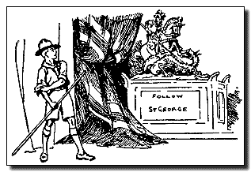
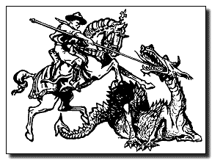
Two Drawings of Scouts in the role of Saint George.
From Baden-Powell, Scouting for Boys (1908)

SAINT GEORGE AND SCOUTING FOR BOYS
In Scouting for Boys, Baden-Powell wrote of chivalry and the knights of old. He tried to show Scouts a new path to chivalry and honor. Saint George was the Patron Saint of England, and of the Knights of the Garter, the oldest order of chivalry in Europe. They were familiar subjects to most English boys when B-P was writing. Here is what he wrote:
ST. GEORGE
They (the knights of the Round Table) had as their patron saint St. George, because he was the only one of all the saints who was a horseman. He is the Patron Saint of cavalry from which the word Chivalry is derived, and the special saint of England.
He is also the Patron Saint of Boy Scouts everywhere. Therefore, all Scouts should know his story.
St. George was born in Cappadocia in the year AD 303. He enlisted as a cavalry soldier when he was seventeen, and soon became renowned for his bravery.
On one occasion he came to a city named Selem, near which lived a dragon who had to be fed daily with one of the citizens, drawn by lot.
The day St. George came there, the lot had fallen upon the king's daughter, Cleolinda. St. George resolved that she should not die, and so he went out and attacked the dragon, who lived in a swamp close by, and killed him.
When he was faced by a difficulty or danger, however great it appeared—even in the shape of a dragon—he did not avoid it or fear it, but went at it with all the power he could put into himself and his horse. Although inadequately armed for such an encounter, having merely a spear, he charged in, did his best, and finally succeeded in overcoming a difficulty which nobody had dared to tackle.
That is exactly the way in which a Scout should face a difficulty or danger, no matter how great or terrifying it may appear to him or how ill-equipped he may be for the struggle.
He should go at it boldly and confidently, using every power that he can to try to overcome it, and the probability is that he will succeed.
St. George's Day is April 23rd, and on that day all Scouts remind themselves of their Promise and of the Scout Law. Not that a Scout every forgets either, but on St. George's Day he makes a special point of thinking about them. Remember this when April 23rd comes round again.

From Kipling’s
"The Law of the Jungle"
as taught by Baloo the Bear
Rudyard Kipling was a friend of Baden-Powell’s, and he borrowed heavily from Kipling’s Jungle Book theme and characters when he set up the Cub Scout program. I found this in a 1948 copy of “The Jungle Books.” It appears to have been dropped from some later editions, but it is apparent to me that this is where Baden-Powell got the idea for the Cub Scout Law of the Pack. –Pat

Now this is the Law of the Jungle --
As old and as true as the sky;
And the Wolf that shall keep it may prosper.
But the Wolf that shall break it must die.

As the creeper that girdles the tree trunk
The Law runneth forward and back --
For the strength of the Pack is the Wolf,
And the strength of the Wolf is the Pack.

.Next Month's Core Value -
HEALTH & FITNESS

Wood You Believe?
 | dye  oxygen  piano keys  rayon - books  fishing floats - inks  telephone books  varnish - atlases and maps  price tags - ping pong balls  tires - umbrella handles -signs  automobile instrument panels  space craft reentry shields - newspaper  photographic film - newspapers - posters  football helmets - toilet seats - guitars  road building materials - insulation | 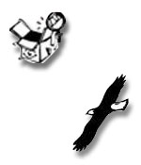

 | shatterproof glass - artificial vanilla flavoring  cork - vacuum cleaner bags - movies - stadium seats  adhesives - decorations - turpentine - camphor - waxes  fireworks - crayons - tannin - charcoal - pine oil - pitch  musical instruments - perches for birds of prey - toilet paper  milk cartons - flooring - bark for landscaping - cardboard  grocery bags - furniture - chewing gum - paper towels  oil spill control agents - Christmas trees - hockey sticks  wildlife habitat - cosmetics - roofs - baby foods - cider - vitamins  cooking utensils - photographic film - lacquer - pallets - rubber gloves | 

mulch - clean water - golf tees - egg cartons - nail polish - fence posts - toys
toothpaste - eyeglass frames - syrup - antacids - shampoo - rubber gloves
menthol - electrical outlets - medicines - energy for electricity - plates and bowls
sausage casings - torula yeast - rulers - wooden blocks - houses - notebook paper - oars
plywood - paper plates - computer casings - stain remover - coffee filters - toothpicks
movie tickets - carpet and upholstery backsides - imitation bacon - diapers - horse corrals
postcards - tax forms - sponges - shade - particle board - shoe polish - luggage - bowling alley lanes
postage stamps - colognes - animal bedding - irrigation piping - fruit pie filling - golf balls - game boards
suspending agent for drinking soda - pencils - dry wall - baby cribs - baseball bats - lumber - decoys - kites
magazines -ice cream thickener - step ladders - birthday cards - broom sticks - cider - ceiling tiles
crutches - backyard play sets - axe handle - food labels - 2 x 4's - candy wrappers
scenery - party invitations - disinfectants - cd inserts - gummed tape - fruit
railroad ties - shelter belts - puzzles - swings - baking cups

buttons - cutting boards
benches - bird houses
stereo speakers
garden stakes
stairways - beds
tables - barrels
window frames
bulletin boards
linoleum - seesaws
fishing boats - billboards
disposable medical clothing
church pews - totem poles – desks

 From www.idahoforests.org/arborday.htm

