http://www.USScouts.Org • http://www.MeritBadge.Org
Please submit errors, omissions, comments or suggestions about this workbook to: Workbooks@USScouts.Org
Comments or suggestions for changes to the requirements for the merit badge should be sent to: Merit.Badge@Scouting.Org
______________________________________________________________________________________________________________________________________________
1. Explain what citizenship in the world means to you and what you think it takes to be a good world citizen.
2. Explain how one becomes a citizen in the United States, and explain the rights, duties, and obligations of U.S. citizenship.
How:
Rights:

Duties:
Obligations:
Discuss the similarities and differences between the rights, duties, and obligations of U.S. citizens and the citizens of two other countries.
Country
Rights:
Duties:
Obligations:

Country
Rights:
Duties:

Obligations:
3. Do the following:
a. Pick a current world event.
In relation to this current event, discuss with your counselor how a country's national interest and its relationship with other countries might affect areas such as its security, its economy, its values, and the health of its citizens.
Security:
Economy:
Values:
Health:

b. Select a foreign country and discuss with your counselor how its geography, natural resources, and climate influence its economy and its global partnerships with other countries.
Geography:
Natural resources:
Climate:
4. Do TWO of the following:
a. Explain international law and how it differs from national law.
Explain the role of international law and how international law can be used as a tool for conflict resolution.
b. Using resources such as major daily newspapers, the Internet (with your parent's permission), and news magazines, observe a current issue that involves international trade, foreign exchange, balance of payments, tariffs, and free trade.
International trade:
Foreign exchange:
Balance of payments:
Tariffs:
Free trade:
Explain what you have learned:
Include in your discussion an explanation of why countries must cooperate in order for world trade and global competition to thrive.
c. Select TWO of the following organizations and describe their role in the world.
1 The United Nations and UNICEF
2 The World Court
3 Interpol
4 World Organization of the Scout Movement
5 The World Health Organization
6. Amnesty International
7. The International Committee of the Red Cross
8 CARE (Cooperative for American Relief Everywhere)
9. European Union
Organization:
Role in the international system:

Organization:
Role in the international system:
5. Do the following:
a. Discuss the differences between constitutional and nonconstitutional governments.
b. Name at least five different types of governments currently in power in the world.
1.
2.
3.
4.
5.

c. Show on a world map countries that use each of these five different forms of government.

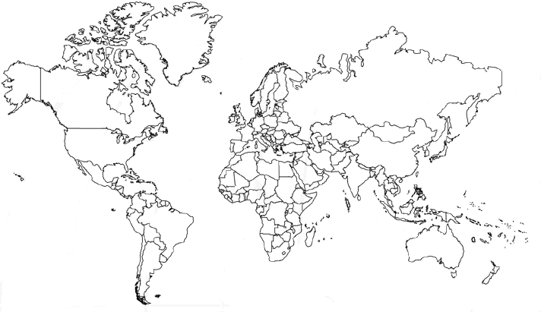
6. Do the following:
a. Explain how a government is represented abroad and how the United States government is accredited to international organizations.
Representation abroad:
Accreditation to international organizations.

b. Describe the roles of the following in the conduct of foreign relations.
1. | Ambassador
2. | Consul
3. | Bureau of International Information Programs
4. | Agency for International Development
5. | United States and Foreign Commercial Service

c. Explain the purpose of a passport and visa for international travel.
7. Do TWO of the following (with your parent's permission) and share with your counselor what you have learned:
a. Visit the website of the U.S. State Department. Learn more about an issue you find interesting that is discussed on this website.
b. Visit the website of an international news organization or foreign government, OR examine a foreign newspaper available at your local library, bookstore, or newsstand. Find a news story about a human right realized in the United States that is not recognized in another country.
News Story:

c. Visit with a student or Scout from another country and discuss the typical values, holidays, ethnic foods, and traditions practiced or enjoyed there.
Values:
Holidays:
Ethnic foods:
Traditions:
d. Attend a world Scout jamboree.
e. Participate in or attend an international event in your area, such as an ethnic festival, concert, or play.

When working on merit badges, Scouts and Scouters should be aware of some vital information in the current edition of the Guide to Advancement (BSA publication 33088).Important excerpts from that publication can be downloaded from http://usscouts.org/advance/docs/GTA-Excerpts-meritbadges.pdf.
You can download a complete copy of the Guide to Advancement from http://www.scouting.org/filestore/pdf/33088.pdf.

