http://www.USScouts.Org • http://www.MeritBadge.Org
Please submit errors, omissions, comments or suggestions about this workbook to: Workbooks@USScouts.Org
Comments or suggestions for changes to the requirements for the Belt Loop or Pin should be sent to: Advancement.Team@Scouting.Org
Cub Scout’s Name: Pack No. :
Webelos Scouts that earn the Weather Belt Loop while a Webelos Scout
also satisfy requirement 13 for the Scientist Activity Badge.

Cub Scout Weather Belt Loop (See the Pin Requirements below.)
Complete these three requirements:
1. Make a poster that shows and explains the water cycle.
2. Set up a simple weather station to record rainfall, temperature, air pressure, or evaporation for one week.
Recording | Day 1 | Day 2 | Day 3 | Day 4 | Day 5 | Day 6 | Day 7
Time
Rainfall
Temperature
Air Pressure
Evaporation
3. Watch the weather forecast on a local television station. Discuss with an adult family member what you heard and saw
Follow up by discussing the accuracy of the forecast.

Cub Scout Weather Pin
Earn the Cub Scout Weather belt loop, and complete five of the following requirements:
1. Explain to your den or an adult family member the meaning of these terms: weather, humidity, precipitation, temperature, and wind.
Weather
Humidity
Precipitation
Temperature
Wind.
2. Explain how clouds are made
Describe the different kinds of clouds - stratus, cumulus, cumulonimbus, and cirrus - and what kind of weather can be associated with these cloud types.
Stratus
Cumulus
Cumulonimbus
Cirrus
What kind of weather can be associated with these cloud types?
Stratus
Cumulus
Cumulonimbus
Cirrus
3. Describe the climate in your state.
Compare its climate with that in another state.
4. Describe a potentially dangerous weather condition in your community.
Discuss safety precautions and procedures for dealing with this condition.
5. Define what is meant by acid rain.
Explain the greenhouse effect.
6. With your parent's or adult partner's permission, talk to a meteorologist about his or her position. Learn about careers in meteorology. Share what you learned with your den or an adult family member.
7. Make a weather map of your state or country, using several weather symbols.
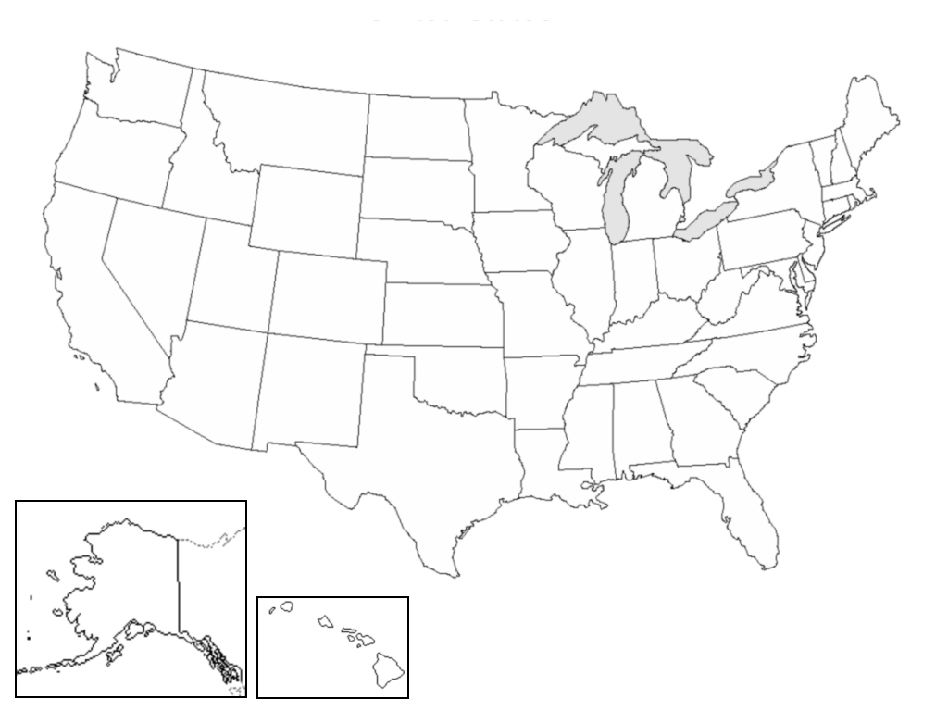
8 Explain the differences between tornadoes and hurricanes.
Tornados
Hurricanes
9. Make a simple weather vane. Make a list of other weather instruments and describe what they do.
10. Explain how weather can affect agriculture and the growing of food.
11. Make a report to your den or family on a book about weather.
12. Explain how rainbows are formed and then draw and color a rainbow.

Requirement resources can be found here:
http://www.meritbadge.org/wiki/index.php/Cub_Scout_Weather#Requirement resources
Important excerpts from the ‘Guide To Advancement’, No. 33088:
Effective January 1, 2012, the ‘Guide to Advancement’ (which replaced the publication ‘Advancement Committee Policies and Procedures’) is now the official Boy Scouts of America source on advancement policies and procedures.
- [ Inside front cover, and 5.0.1.4 ] — Unauthorized Changes to Advancement Program
No council, committee, district, unit, or individual has the authority to add to, or subtract from, advancement requirements. (There are limited exceptions relating only to youth members with disabilities. For details see section 10, “Advancement for Members With Special Needs”.)
- [ Inside front cover, and 7.0.1.1 ] — The ‘Guide to Safe Scouting’ Applies
Policies and procedures outlined in the ‘Guide to Safe Scouting’, No. 34416, apply to all BSA activities, including those related to advancement and Eagle Scout service projects. [Note: Always reference the online version, which is updated quarterly.]
- [ 4.1.0.3 ] ] — Who Approves Cub Scout Advancement?
A key responsibility for den leaders is to implement the core den meeting plans as outlined in the Den & Pack Meeting Resource Guide, No. 34409. For Wolf, Bear, and Webelos advancement, den leaders take the lead in approving requirements, though their assistants, and also parents who help at meetings, may be asked to play the role of “Akela” and assist. Parents sign for requirements that, according to meeting plans and instructions in the handbooks, take place at home. For the Bobcat trail and Tiger Cub achievements, parents (or adult partners) should sign in the boy’s handbook; the den leader then approves as progress is recorded in the den’s advancement record.
- [ 4.1.0.4 ] — “Do Your Best”
Advancement performance in Cub Scouting is centered on its motto: “Do Your Best.” When a boy has done this—his very best—then regardless of the requirements for any rank or award, it is enough; accomplishment is noted. This is why den leaders, assistants, and parents or guardians are involved in approvals. Generally they know if effort put forth is really the Cub Scout’s best.
- [ 4.1.2.2 ] — Cub Scout Academics and Sports Program
More than just a recognition opportunity, this program develops new skills, improves those existing, and otherwise enriches Cub Scouting. Details can be found in the Cub Scout Academics and Sports Program Guide, No. 34299. Activities include subjects like science, video games, collecting, and chess; and sports such as baseball, skateboarding, and table tennis. Each has two levels—a belt loop and a pin. Belt loops, which can be earned more than once, are awarded when each of three requirements is met. Cub Scouts may then continue with additional requirements and earn the pin. Archery and BB gun shooting are included, but can only be conducted at a council presented activity with certified supervisors.
Additional notes of interest:
- Tiger Cubs, Cub Scouts, and Webelos Scouts may complete requirements for all Academics and Sports Belt Loops and Pins (except shooting sports) in a family, den, pack, school, or community environment. Tiger Cubs must work with their parents or adult partners. Parents and partners do not earn loops or pins.
- “Akela” (Pronounced “Ah-KAY-la”) — Title of respect used in Cub Scouting—any good leader is Akela. Akela is also the leader and guide for Cub Scouts on the advancement trail. The name comes from Rudyard Kipling's Jungle Book. (See "Law of the Pack.")
- “Law of the Pack” — The Cub Scout follows Akela.
The Cub Scout helps the pack go.
The pack helps the Cub Scout grow.
The Cub Scout gives goodwill.

