# CUBS IN ACTION

*Scouter Jim, Bountiful UT*

After a long “El Nino” winter there were record snowfalls in the Mountains of Utah in 1983. During Memorial Day weekend, the snow in the mountains of Utah, began to melt too quickly and filled local streams to overflowing. One such stream, “City Creek” jumped its banks and flowed freely across the streets toward downtown Salt Lake City. City crews fought back with sandbags but were not match for a newly created urban river. More help was needed. It was Sunday, May 29, 1983. The need for help went out over via TV, radio and phone calls to local Church leaders. Residents quickly changed from Sunday clothes to work clothes and headed to volunteer. Thousands of volunteers including Cub Scouts and Boy Scouts flowed into Salt Lake City to fill and place sandbags to contain the tremendous runoff in a newly created river - State Street, Salt Lake City. One report said of the 40,000+/- sandbags that were filled, 22,000 were filled by volunteers. Likewise, through the spring and summer of 1983 communities all across Utah fought spring flooding with volunteers.

It is true that “Faith can move a mountain,” but sometimes God needs a hand in work gloves to get it done. The story is told of a religious leader who asked his congregation to gather at a widow’s home to move a pile of dirt in her yard. “Bring your faith,” he asked, “so we can watch God move a mountain, and bring your shovels, just in case he wants some help.”

Scouts and others volunteering is not unique to Salt Lake City or Utah. Throughout the nation, when disaster strikes, volunteers come forward and go into action. After the earthquake in Haiti, many organizations sprang into action. Among them **Cub Scout Pack 3513** in Salt Lake City, Utah. They wanted to help and started asking neighbors and friends for items so they could assemble hygiene kits to be sent to Haiti. They made signs asking people to “Make a Difference.” Word got out and a local TV station picked up the story. Donations came in from all over and when all was done, 1000's of kits had been assembled. It proves that it doesn’t take a well-organized group of seasoned citizens to spring into action. A small group of **Cub Scouts in Action** made a difference.

Shake the cobwebs of inaction off, put work clothes on, be **Helpful** and help get your **Cubs In Action**. Remember what it says in Isaiah, Chapter 11, verse 6 - “and a little child shall lead them.”

***A story of a truly helpful bridge builder - CD***

**The Bridge Builder**

By Will Allen Dromgoole

An old man, going a lone highway,   
Came, at the evening, cold and gray,   
To a chasm, vast, and deep, and wide,   
Through which was flowing a sullen tide.

The old man crossed in the twilight dim;   
The sullen stream had no fears for him;   
But he turned, when safe on the other side,   
And built a bridge to span the tide.

"Old man," said a fellow pilgrim, near,   
"You are wasting strength with building here;   
Your journey will end with the ending day;   
You never again must pass this way;   
You have crossed the chasm, deep and wide-  
Why build you a bridge at the eventide?"

The builder lifted his old gray head:   
"Good friend, in the path I have come," he said   
"There followeth after me today,   
A youth, whose feet must pass this way.

This chasm, that has been naught to me,   
To that fair-haired youth may a pitfall be.   
He, too, must cross in the twilight dim;   
Good friend, I am building the bridge for him."

**Table of Contents**

[CUBS IN ACTION 1](#_Toc431208367)

[BIOGRAPHY – 5](#_Toc431208368)

[Cub Scout Learning Library 7](#_Toc431208369)

[**Scout Law Word Search** 13](#_Toc431208370)

[*Pack 200, Cary, NC* 13](#_Toc431208371)

[Find the 12 Points of the Scout Law - 13](#_Toc431208372)

[**Scout Oath Word Search** 13](#_Toc431208373)

[*Commissioner Dave & www.superkids.com* 13](#_Toc431208374)

[Find phrases from the Scout Oath - 13](#_Toc431208375)

[**Scout Law Games** 13](#_Toc431208376)

[*Pack 200, Cary, NC* 13](#_Toc431208377)

[**Toss!** 13](#_Toc431208378)

[*Pack 200, Cary, NC* 13](#_Toc431208379)

[*Pack 200, Cary, NC* 14](#_Toc431208380)

[*Pack 200, Cary, NC* 14](#_Toc431208381)

[DEN MEETING TOPICS 14](#_Toc431208382)

[CHARACTER COMPASS 15](#_Toc431208383)

[PACK MEETING THEMES AND PLANS 15](#_Toc431208384)

[Pack Meeting Themes 16](#_Toc431208385)

[http://www.scouting.org/Home/CubScouts/Leaders/CubmasterResources/PackMeetingPlans.aspxUPCOMING MONTHS 16](#_Toc431208386)

[November Crazy Holidays 20](#_Toc431208387)

[From A to Z What Helpful Families Can Do 23](#_Toc431208388)

[Fun Facts About Being Helpful 23](#_Toc431208389)

[Need help finding a project? 23](#_Toc431208390)

[**BSA FACEBOOK PAGE** 24](#_Toc431208391)

[**SCOUTING MAGAZINE ON YOU TUBE** 24](#_Toc431208392)

[Check out cool stories and interviews For Example – 24](#_Toc431208393)

[Creek Stewart, Eagle Scout and host of "Fat Guys in the Woods" 24](#_Toc431208394)

[[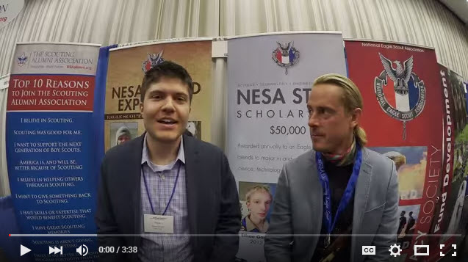](https://www.youtube.com/watch?v=jGugLDTJ5Qc) 24](#_Toc431208395)

[Mizzou Kicker and Eagle Scout Does it All 24](#_Toc431208396)

[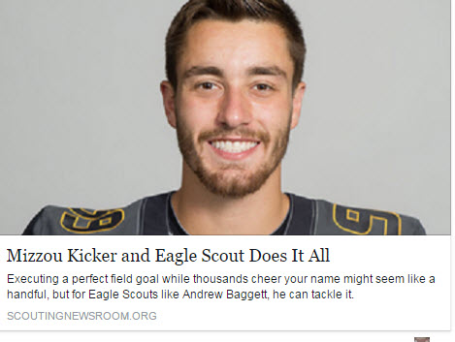 24](#_Toc431208397)

[CUBCAST http://www.scouting.org/Scoutcast/Cubcast.aspx 25](#_Toc431208398)

[September 2015 - Asking for Help 25](#_Toc431208399)

[If you’re a regular CubCast listener, as you should be, you know we always mention getting parents or others in the community involved with your den or pack. Yet some of us are still hesitant to ask. We don’t expect you to run a high- quality program all by yourself, so we asked self-proclaimed “unlikeliest den leader” and reporter Danny Heitman from the Istrouma Council in Baton Rouge, Louisiana, how he was able to acquire assistants and make den meetings a whole lot more fun! 25](#_Toc431208400)

[Listen Hear - http://www.scouting.org/filestore/scoutcast/cubcast/201509\_1/CC\_Sept\_Ask\_for\_Help.mp3 25](#_Toc431208401)

[September 2015 - How to Sell Popcorn When You're No Longer an Adorable Cub Scout 25](#_Toc431208402)

[Everyone knows Scouting is full of really cool activities like camping and kayaking and building robots, but like everything else on Planet Earth, it costs money. So another big part of Scouting is fundraising. It's not too difficult when you're a cute little Cub Scout, and you give a great big smile with those adorable chubby cheeks and start stumbling through your script. You're just so doggone precious, people gladly buy whatever you're selling. But what about when the Scouts get older and a little less adorable? Donovan Fisher, aka The Popcorn Scout, and his dad, Scott, with the Washington Crossing Council in Doylestown, Pennsylvania, are here to share with us Donovan’s secrets as the third highest selling Scout in 2013 with more than $23,000 in sales. Did Dad help? Let's find out. 25](#_Toc431208403)

[Listen Hear - http://www.scouting.org/filestore/scoutcast/resources/201509\_1/SC\_Sept\_FR\_When\_no\_longer\_Cute.mp3 25](#_Toc431208404)

[**How to find STEM experts for your next Scout meeting or event** 26](#_Toc431208405)

[**Rob Lowe tweets photo with Scouts: ‘They make the future look good’** 26](#_Toc431208406)

[**Is chivalry dead? In hilarious video, Eagle Scout tries to find out** 26](#_Toc431208407)

[**In Scoutbook webcast, get everything you need to know in one hour** 26](#_Toc431208408)

[**Philmont Advisor Skill School helps you know before you go** 26](#_Toc431208409)

[**Scouts help those left homeless by California’s Valley Fire** 26](#_Toc431208410)

[**How do you handle prescription medication on Scout trips?** 26](#_Toc431208411)

[**Parents finish Eagle Scout project for son killed in Afghanistan** 26](#_Toc431208412)

[**Extreme Makeovers, Round 11: Eagle Scout project before-and-after photos** 27](#_Toc431208413)

[**Tanner Mangum, BYU’s Hail Mary quarterback, is an Eagle Scout** 27](#_Toc431208414)

[**Things You Should Know: How to fly a flag at half-staff** 27](#_Toc431208415)

[**Walls, a board game devised in Game Design merit badge, now on Kickstarter** 27](#_Toc431208416)

[**Lee Berger, headline-making paleoanthropologist, is an Eagle Scout** 27](#_Toc431208417)

[**See’s Candies makes fundraising delicious and profitable (SPONSORED)** 27](#_Toc431208418)

[**Are these the toughest requirements for each merit badge?** 27](#_Toc431208419)

[**Neckerchief slides: What’s your go-to look?** 27](#_Toc431208420)

[**New Cub Scout leader training available at my.scouting.org** 27](#_Toc431208421)

[**Scout popcorn sales tips for when you’re no longer a little Cub Scout** 27](#_Toc431208422)

[**How to ask for help as a Cub Scout leader** 27](#_Toc431208423)

[**Check out this month’s cover of Alaska Airlines magazine** 28](#_Toc431208424)

[**Three Fires Council hosted largest welding lesson, Guinness World Records confirms** 28](#_Toc431208425)

[**How four Scouts combined to sell a quarter-million dollars in Scout popcorn** 28](#_Toc431208426)

[**Memories in ink: Inspiring story behind Scouting professional’s BSA tattoo** 28](#_Toc431208427)

[**10 ways a Mickman Brothers fundraiser can bring your unit a happy holidays (SPONSORED)** 28](#_Toc431208428)

[**Extreme Makeovers, Round 10: Eagle Scout project before-and-after photos** 28](#_Toc431208429)

[**#SummerofVenturing Day is Aug. 31, so share your adventures** 28](#_Toc431208430)

[TRAINING TOPIC 29](#_Toc431208431)

[BEING HELPFUL – NATIONAL GOOD TURNS 29](#_Toc431208432)

[DEN & PACK SERVICE PROJECTS 31](#_Toc431208433)

[GOING HIKING – PUTTING CUBS IN ACTION! 33](#_Toc431208434)

[SPECIAL OPPORTUNITIES 35](#_Toc431208435)

[MESSENGERS OF PEACE 35](#_Toc431208436)

[PROGRAM UPDATES 36](#_Toc431208437)

[**LEADER RECOGNITION** 45](#_Toc431208438)

[**~~THEME RELATED STUFF~~** 47](#_Toc431208439)

[ONE LAST THING 60](#_Toc431208440)

[That Little Cub Scout Who Follows Me 60](#_Toc431208441)

[Who Did It? 61](#_Toc431208442)

**The Cub Scout Core Values are now the  
 12 Points of the Scout Law.**

**The core value highlighted this month is:**

November's Core Value, **HELPFUL,** will use the theme, **CUBS IN ACTION**

**A SCOUT IS HELPFUL**A Scout is helpful. A Scout cares about other people. He willingly volunteers to help others without expecting payment or reward.

**HOW DOES “CUBS IN ACTION” RELATE TO**

**THIS POINT OF THE SCOUT LAW?**It is never too early in our lives to begin helping other people. Scouting has promoted being helpful to others since it began in 1907 in England. Being helpful to others is what William D. Boyce experienced one foggy night in London, when a Scout helped him find his way. Boyce was so impressed that the Scout helped him and refused a reward that he incorporated the Scouting program in America in 1910.   
  
Our Cub Scouts find active ways to help others in their neighborhoods and spread the goodwill of Scouting. By teaching and living the Scout slogan, "Do a Good Turn Daily," we are keeping the third point of the Scout Law: A Scout is helpful.

**Per our Founder, Lord Baden-Powell**

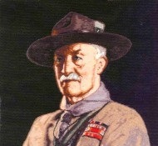

***Note –*** *The original Scout Law published in 1908 had 9 points. In 1910, the BSA added Brave, Clean, and Reverent. In 1911 B-P added* ***Clean*** *to his original list.*

**A SCOUT'S DUTY IS TO BE USEFUL   
AND TO HELP OTHERS.**   
And he is to do his duty before anything else, even though he gives up his own pleasure, or comfort, or safety to do it. When in difficulty to know which of two things to do, he must ask himself, "Which is my duty?" that is, "Which is best for other people?"---and do that one. He must Be Prepared at any time to save life, or to help injured persons. And he must do a good turn to somebody every day.

# BIOGRAPHY –

**Johnny Appleseed -   
Helpful Nurseryman**

*Scouter Jim, Great Salt Lake Council*

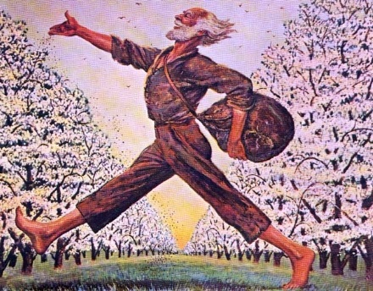

***Johnny Appleseed certainly was helpful in  
the settling of the American West CD***

One of America’s fondest legends is that of Johnny Appleseed, a folk hero and pioneer apple farmer in the 1800’s. There really was a Johnny Appleseed and his real name was John Chapman. He was born in Leominster, Massachusetts in 1774. His dream was to produce so many apples that no one would ever go hungry. Although legend paints a picture of Johnny as a dreamy wanderer, planting apple seeds throughout the countryside, research reveal him to be a careful, organized businessman, who over a period of nearly fifty years, bought and sold tracts of land and developed thousands of productive apple trees.

His adventures began in 1792, when John was eighteen years old. He and his eleven-year-old half brother, Nathaniel, headed west, following the steady stream of immigrants. In his early twenties, John began traveling alone, which is how he spent the rest of his life. Nathaniel stayed behind to farm with their father, who had also immigrated west. John continued moving west to Pennsylvania. From there he traveled into the Ohio Valley country and later, Indiana. He kept ahead of the settlements and each year planted apple seeds farther west.

He always carried a leather bag filled with apple seeds he collected for free from cider mills. Legend says he was constantly planting them in open places in the forests, along the roadways and by the streams. However, research suggests he created numerous nurseries by carefully selecting the perfect planting spot, fencing it in with fallen trees and logs, bushes and vines, sowing the seeds and returning at regular intervals to repair the fence, tend the ground and sell the trees. He soon was known as the “apple seed man” and later he became known only as “Johnny Appleseed”.

Over the years, his frequent visits to the settlements were looked forward to and no cabin door was ever closed to him. To the men and women he was a news carrier; to the children he was a friend. He was also very religious and preached to people along the way. His favorite book was his Bible. He made friends with many Indian tribes and was known to have learned many Indian languages well enough to converse. He lived on food provided by nature and he never killed animals. Though appearing poor, he was not a poor man. He accumulated more cash than he needed by selling his apple trees and tracts of land. He never used banks and relied instead on an elaborate system of burying his money. He preferred to barter and trade food or clothing rather than collect money for his trees. It was more important a settler plant a tree than pay him for it.

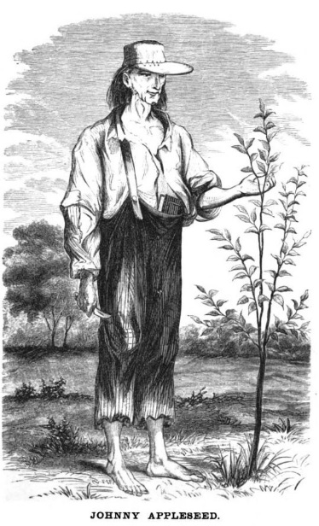

Johnny Appleseed cared very deeply about animals, including insects. Henry Howe documented stories about Johnny and animals -

* One cool autumnal night, while lying by his camp-fire in the woods, he observed that the mosquitoes flew in the blaze and were burned. Johnny, who wore on his head a tin utensil which answered both as a cap and a mush pot, filled it with water and quenched the fire, and afterwards remarked, "God forbid that I should build a fire for my comfort, that should be the means of destroying any of His creatures."
* Another time he made a camp-fire in a snowstorm at the end of a hollow log in which he intended to pass the night, but finding it occupied by a bear and cubs, he removed his fire to the other end, and slept on the snow in the open air, rather than disturb the bear.
* When he heard a horse was to be put down, he bought the horse, bought a few grassy acres nearby, and turned the horse out to recover. When it did, he gave the horse to someone needy, exacting a promise to treat the horse humanely.
* During his later life, he was a vegetarian.

Each fall he would travel east on foot and by canoe to acquire new seeds for new crops of trees. John never married but loved, and was loved, by those he lived among. No one knows how many millions of seeds he planted in the hundreds of nurseries he established in the Northwest Territory, now the states of Ohio, Michigan, Indiana and Illinois. Many of his seedlings traveled across the plains of North America in covered wagons to grow to feed families in the west. John Chapman worked the soil and left the land and everything and everyone else better than he found them.

Johnny Appleseed is described as a man of medium height, blue eyes, light-brown hair, slender, wiry, and alert. Folklore has also described him as “funny looking” because of the way he dressed. It is said he traded apple trees for settler’s cast-off clothing. He was known to give the better clothing to people he felt needed it more than he. This could be why legend says he wore only coffee sacks with holes cut out for his arms as clothing. He rarely wore shoes, even during the cold of winter. It is said he could walk over the ice and snow barefooted and that the skin was so thick on his feet that even a rattlesnake couldn’t bite through it. Another legend says he wore a mush pot on his head as a hat. This is unlikely since pots of the time were made of heavy copper or iron, but it is more likely he wore someone else’s castoff hat or made his own out of cardboard. He rarely sought shelter in a house, since he preferred to sleep on bare ground in the open forest with his feet to a small fire.

In 1842, Johnny made his last trip back to Ohio after spending 50 years walking throughout the countryside. While there, he moved into the home of Nathaniel, the half-brother with whom he began his remarkable journey. On March 18, 1845, he died of pneumonia at the age of seventy-one. He was visiting his friend, William Worth, in Indiana. Legend says it was the only time he was sick in his whole life. He is buried near Fort Wayne, Indiana.

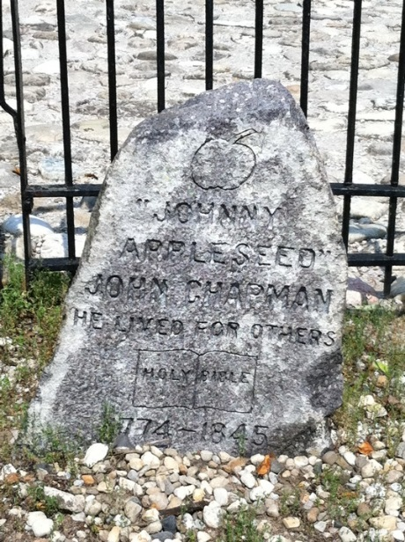

**How was Johnny Appleseed HELPFUL?**

* Planted apple trees
* Created nurseries
* Brought news.
* Taught about God
* Shared clothing and money with those in need

**For what other points of the Scout Law is he a good example –**

* Reverent – Favorite book – the Bible, taight about God
* Kind – did not harm animals, shared his closthing and money
* Friendly – Welcome everwhere
* Cheerful – smiling and singing
* Thrifty – saved his money

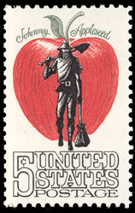

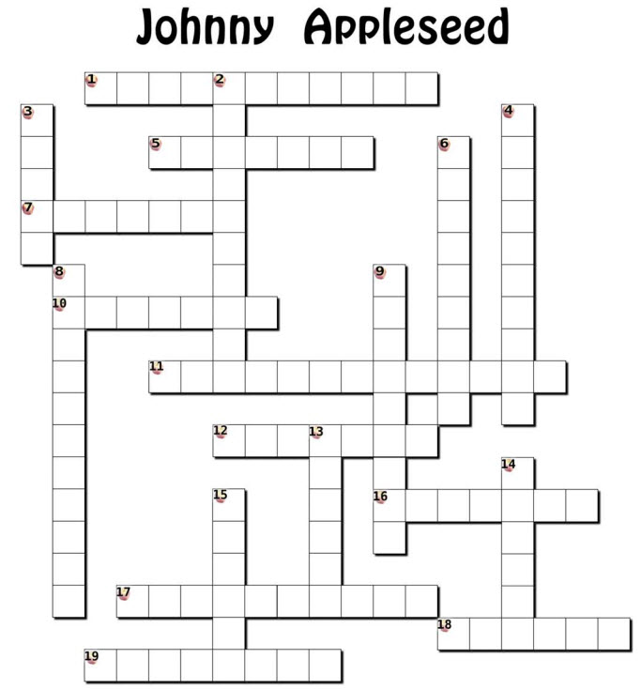

***(You will need to enlarge the crossword grid for boys to use it and see the numbers – CD)***

**ACROSS**

1 – Johnny Applessed's real name

5 – Johnny Appleseed made friends with both settlers and \_\_\_\_\_

7 – The bags he in which he carried his appleseeds were made of \_\_\_\_\_

10 – He never killed \_\_\_\_\_ for food

11 – State where he was born

12 – What he wore as a hat

16 – State in which he died

17 – Age when he died

18 – Where he put his money instead of banks

19 – Age when he began his adventure

**DOWN**

2 – Where he got most of his appleseeds

3 – His favorite book

4 – Who he and his half-brother were following west

6 – His half-brother's name

8 – What legend says could not bite through the skin on his feet

9 – Cause of his death

13 – He wanted to produce so many apple tress that no one would go ???

14 – Word for trading food or clothing for payment

15 – Where he preferred to sleep

**WORDBANK**

NATHANIEL JOHN CHAPMAN ANIMALS

BURIED PNEUMONIA SEVENTY ONE

EIGHTEEN MUSH POT IMMIGRANTS

RATTLESNAKE CIDER MILLS INDIANA

BIBLE MASSACHUSETTS BARTER

INDIANS HUNGRY LEATHER

FOREST

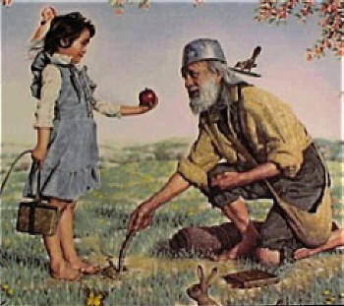

# Cub Scout Learning Library

**The NEW** [**https://cubscouts.org/**](https://cubscouts.org/) **!!!**

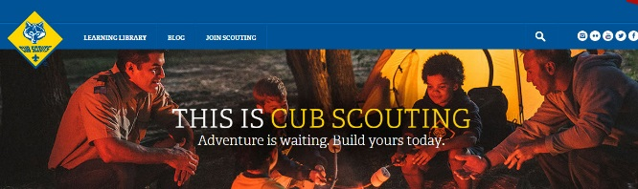

**This is the Cub Scout Learning Library –**Everything you could want to know for Cub Scouts is or will be here. And all within a click or 3 of the home page. National heard the message that although things were at [www.scouting.org](http://www.scouting.org) they were often buried too deep to be found.

This site has admin stuff and practical stuff. The new Den Leader Resource Books are here. You can download the pages for each Adventure for **FREE**

This website **is** a great resource. There are still parts under construction but what is there is **GREAT!!**



BSA seems to be working off the same plans that [www.USScouts.org](http://www.USScouts.org) and other "unofficial" Scouting websites use. They have seen what you the volunteers want and are delivering it. I hope they are successful and some of us old guys (I have my Medicare card) can retire from our web duties.

**Yes,** [**https://cubscouts.org**](https://cubscouts.org) **runs on a phone, too!!!**



**There are 3 tabs on top of the home page –**



* Learning Library
* Blog
* Join Scouting

1. **Learning Library** takes you where you can learn about your position and pick up hints. Besides specifics dens of each rank, other clickable links include -

**Den Meeting Basics**

[Your First Den Meeting](https://cubscouts.org/library/your-first-den-meeting/)

[Planning Den Outings](https://cubscouts.org/library/den-outings/)

[The Parts of a Den Meeting](https://cubscouts.org/library/parts-of-a-den-meeting/)

**Building Strong Dens**

[The Basics of Cub Scouts](https://cubscouts.org/library/the-basics-of-cub-scouts/)

Training (Under Construction)

**Den Planning And Administration**

Advancement Basics (Under Construction)

Advancement Requirements (Under Construction)

[Annual Planning For Your Den](https://cubscouts.org/library/annual-planning-for-your-den/)

Coordinating Your Den Plan with the Pack (Under Construction)

Tracking and Recognizing Advancement (Under Construction)

[Youth Protection Training](http://www.scouting.org/Training/youthprotection.aspx)

**Positive Youth Development and Working with Boys**

[Developmental Differences in Boys 7-11](https://cubscouts.org/library/developmental-differences-in-boys-7-11/)

Behavior and Discipline (Under Construction)

Positive Youth Development (Under Construction)

**Working With Special Needs Cub Scouts  
*(Advice is specific to each Special Need. Lots of research done in prepping these pages. CD)***

[Parents’ Prejoining Conference](https://cubscouts.org/library/parents-prejoining-conference/)

Leadership Techniques (Under Construction)

[Working With Specific Disabilities and Needs](https://cubscouts.org/library/working-with-specific-disabilities-and-needs/)

1. **Blog** takes you to a Cub Scout specific Blog similar to Bryan's Blog. The topics discussed here in September were:

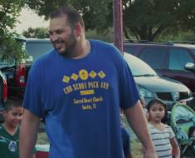  
[Scouting: A Priority for Family](https://cubscouts.org/scouting-a-priority-for-family/) Meet Juan. He grew up in Mexico and as a teenager immigrated to the United States. Having…[**READ MORE**](https://cubscouts.org/scouting-a-priority-for-family/)

[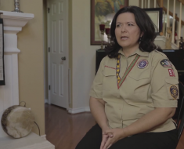](https://cubscouts.org/scouting-an-extension-of-family/)  
[Scouting: An Extension of Family](https://cubscouts.org/scouting-an-extension-of-family/) Meet Catherine, or as the Cub Scouts in her den call her, Ms. Cat. She’s a Scout mom,…**[READ MORE](https://cubscouts.org/scouting-an-extension-of-family/)**

[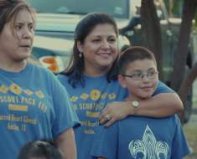](https://cubscouts.org/scouting-not-just-a-club-but-a-family/)  
[Scouting: Not Just a Club, but a Family](https://cubscouts.org/scouting-not-just-a-club-but-a-family/) Meet Becky. Her son just crossed over from Cub Scouts to Boy Scouts, and is about to…[**READ MORE**](https://cubscouts.org/scouting-not-just-a-club-but-a-family/)

[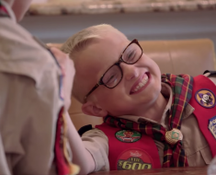](https://cubscouts.org/scouting-getting-the-most-out-of-family-time/)

[Scouting: Getting the Most out of Family Time](https://cubscouts.org/scouting-getting-the-most-out-of-family-time/) Meet Michelle, the proud mother of a Webelos Scout. She knows that life can be busy and…[**READ MORE**](https://cubscouts.org/scouting-getting-the-most-out-of-family-time/)

[](https://cubscouts.org/scouting-a-way-to-invest-in-your-family/)  
[Scouting: A Way to Invest in Your Family](https://cubscouts.org/scouting-a-way-to-invest-in-your-family/) Meet Lester and Apryl who’ve been involved in Scouting for a combined total of 23 years. Together,…**[READ MORE](https://cubscouts.org/scouting-a-way-to-invest-in-your-family/)**

[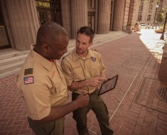](https://cubscouts.org/this-scout-dad-makes-a-terrific-case-to-join-cub-scouting/)  
[This Scout Dad Makes a Terrific Case to Join Cub Scouting](https://cubscouts.org/this-scout-dad-makes-a-terrific-case-to-join-cub-scouting/) Just outside of Minneapolis is the community of Prior Lake. And its local newspaper, the Prior Lake…**[READ MORE](https://cubscouts.org/this-scout-dad-makes-a-terrific-case-to-join-cub-scouting/)**

[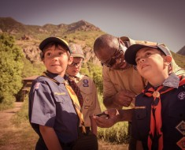](https://cubscouts.org/all-the-latest-resources-for-scouting-recruitment/)  
[All the Latest Resources for Scouting Recruitment](https://cubscouts.org/all-the-latest-resources-for-scouting-recruitment/) We’ve done it! We brought back the popular #CubChat Twitter chat event for a special conversation on…  
[**READ MORE**](https://cubscouts.org/all-the-latest-resources-for-scouting-recruitment/)

[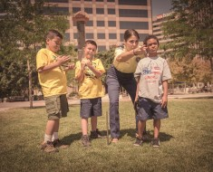](https://cubscouts.org/6-planning-tips-for-your-cub-scout-calendar/)  
[6 Planning Tips for your Cub Scout Calendar](https://cubscouts.org/6-planning-tips-for-your-cub-scout-calendar/) When it comes to leading a Cub Scout den or pack, from Blue and Gold to Day… [**READ MORE**](https://cubscouts.org/6-planning-tips-for-your-cub-scout-calendar/)

[](https://cubscouts.org/this-september-bring-a-friend-to-scouting/)  
[This September, Bring a Friend to Scouting](https://cubscouts.org/this-september-bring-a-friend-to-scouting/) By now, you’ve probably seen the #ShareScouting hashtag and maybe (hopefully!) even used it on your own…  
[**READ MORE**](https://cubscouts.org/this-september-bring-a-friend-to-scouting/)

1. **Join Scouting** takes you to [www.beascout.org](http://www.beascout.org)

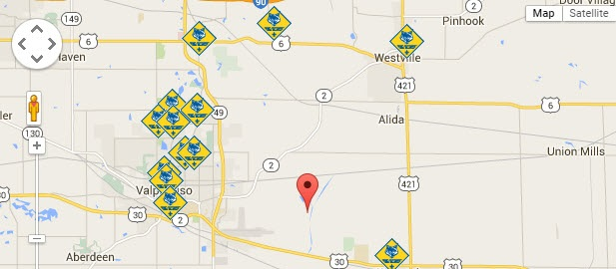

**Also, on the home page –**

[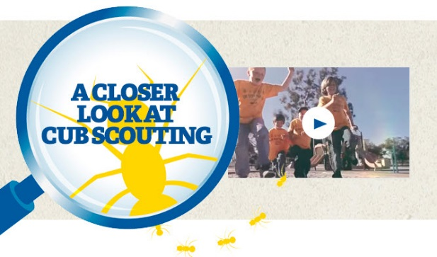](https://www.youtube.com/watch?feature=player_embedded&v=dqKFgk8SJlE)

This link takes you to a YouTube Video   
on Cub Scouting.  
<https://www.youtube.com/watch?feature=player_embedded&v=dqKFgk8SJlE>

**These Six Links take you to:**(From top left across, then down)

**[](http://www.cubscouts.org)**

[**www.scoutstuff.org**](http://www.scoutstuff.org) – The Supply Division site where you can find the location of your nearest National Scout Shop or buy all your Scout supplies

[**http://scoutingwire.org/**](http://scoutingwire.org/) - Where you can get the latest Scouting News from around the country. You can sign up to get notifications when things are posted here..

[**www.scouting.org/programupdates**](http://www.scouting.org/programupdates) **-** The great site where all the news about all the changes to Cub Scouting, Boy Scouting, and Venturing can be found.

[**https://www.scoutbook.com/**](https://www.scoutbook.com/) Where you can get the Scoutbook APP to track your son's Scouting Experience from Tiger to Eagle Scout. ***(He should start using it at latest when he graduates to Boy Scouts - CD)***

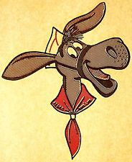

[**www.boyslife.org**](http://www.boyslife.org) **–** Go directly to the on-line edition of Boys'Life

[**http://scoutingwire.org/marketing-membership/**](http://scoutingwire.org/marketing-membership/) Get resources and materials to strengthen your unit at BSA's marketing and membership site. Learn the best practices and tips employed by the most successful units.

**COMMISSIONER’S CORNER  
& ROUNDTABLE HINTS**

~~~~

**ROUNDTABLE PLANNING**

*Here are some hints from a Roundtable Commissioner in Capital Area Council for planning your Roundtables –*

A new Scouting (and Roundtable) year has begun and it is time to take stock and “start over” once again. It is a good idea to review the past year’s roundtables – what worked, what did not, what to keep, what to scrap, what to add. Like the programs of BSA, roundtable should be continuously changing to meet the needs of our ever changing leaders. If you keep on doing what you have always done, you will continue to get the same results. So…as you look toward the new Scouting year, here are some things to keep in mind:

* **Plan: Annual** – look at the upcoming year as a whole. Put council events and local events on the calendar, highlight any months that will take a little extra on your part (workshops, outdoor settings, special guests)
* **Monthly –** monthly planning meetings are crucial to the success of your roundtable. They should be scheduled when the majority of staff can attend and all program details and assignments should be documented.
* **People: staff –** it is time to determine who is coming back (be sure to ask, don’t assume), who you want to recruit, what sort of training needs to be done, assignments.
* **Preparation**: the staff should be ready to go when they arrive at the roundtable location – and it is a good idea to be early enough to have the room set up when the first participant arrives. That way, the staff can visit with participants instead of running around, setting up program areas.
* **Page: -** the staff should all be on the same one – have copies of the agenda posted in several areas of the room so everyone can keep track of what’s next.
* **Punctual:** start on time, stop on time. The participants’ time is valuable and so is yours. If you continually delay the opening until everyone is in the room, the participants will realize this and find no reason to get there any earlier. Find something to do (like give away an inexpensive door prize) right after the opening, available only to those in their seats and see if this doesn’t spur the crowd to get a move on to get there on time.
* **Plan B (C, D)** – be ready for the unexpected (example: the council commissioner shows up at 6:45 and informs you that he needs “a little time on your program” and proceeds to talk for 45 minutes). Scouters are flexible, especially trainers! If you need to alter your agenda, take a deep breath and smile and carve away!
* **Have FUN!** If you are not having a good time at roundtable, it is doubtful your participants will.

***Here are some hints from my friend Wendy in Chief Seattle Council, concerning her Roundtables -***

Regarding round table meetings and material: I plan on including games, songs, skits, cheers, and alternative ceremonies to round out the Pack Meeting agendas on-line and info available in the Leader's resource books.

The content will be compatible with the theme/topic for pack night.  I will also suggest some alternative pack night themes/topics based on holidays, and the Adventures the boys are/have been working on.

For the den leaders, I plan on including games, snacks, and projects that coordinate with the new Adventures, and how to make working on the Adventures fun.  Many dens meet 3 times a month, and may need supplemental ideas.

Den Leaders and Cubmasters will still want fun games and gathering activities for their guys.  Cubmasters will still want fun and meaningful opening, closing, and award ceremonies.  Since the Cubmaster section indicates that dens are encouraged to contribute the fun bits of pack night -- games, songs, skits, etc. -- I want to provide the material to make it easy for them to do that.

Basically, I will be trying to make sure the dens/packs have plenty of fun options to do.

Wendy

**Roundtables Are Unit Service**

Let us see how the roundtable provides of Unit Service.

The Purpose of the Roundtable most certainly is unit service – It provides unit leadership the skill to do and the will to do. These include:

* The skills include techniques, information, program ideas (e.g. information on policy and events, and training opportunities)—the know-how that makes for successful unit operation.
* Will includes morale, enthusiasm, inspiration, and vision that renew the desire to serve youth.

The Roundtable commissioner and staff plan and conduct the RT meetings. They plan with knowledge of the annual council, district, and RT service plans. They meet with the district exec and commissioner to ensure the RTs are adapted to district plans.

They report on roundtable plans at each district commissioner staff meeting. Unit Commissioners (UC) can use this to promote roundtable attendance. The RT Commissioner can work with UCs to bring new leaders to roundtables. The RT Commissioner should work with UCs to follow up on units not participating. Evaluations of RTs at least twice a year with input and suggestions from unit leaders will keep RTs meeting unit needs..

Logging RT data into Commissioner Tools (e.g. Unit RT attendance) will let commissioners know which units may need help.

RT provides an opportunity for sharing experiences and enjoying fun and fellowship with other Scout leaders. As well as an opportunity to discuss problems. When skillfully executed, the roundtable experience will inspire, motivate, and enable unit leaders to provide a stronger program for their Scouts.

RTs are great places to teach basic skills to leaders. Leaders will use the skills once learned, but maybe embarrassed to ask for help in learning them. RT service allows many units to be helped at one time and provides immediate access to a commissioner instead of having to locate one and make an appointment.

Good roundtables foster a quality Scouting program, which is supported by good meetings at the unit levels. RTs model good meetings. Consistently good roundtables will inspire Scouters to create good unit meetings, and this tradition will in turn inspire strong roundtables.

The RT commissioner maintains the standards of the BSA, upholds national policies, promotes good uniforming, and the correct wearing of insignia. Properly and proudly worn by a commissioner, the uniform becomes a hallmark of friendly service to unit leaders and the example of a “good Scout” to the youth membership of their units. Its value must never be underestimated.



**TEACHING THE SCOUT OATH   
& LAW TO CUB SCOUTS**

**Scout Law Word Search**

*Pack 200, Cary, NC*

**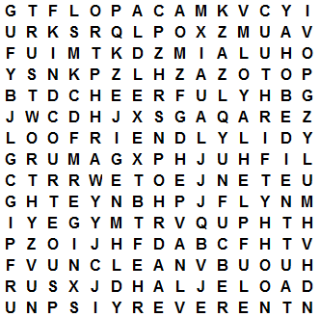**

## Find the 12 Points of the Scout Law -

TRUSTWORTHY OBEDIENT

LOYAL CHEERFUL

HELPFUL THRIFTY

FRIENDLY BRAVE

COURTEOUS CLEAN

KIND REVERENT

**Scout Oath Word Search**

*Commissioner Dave &* [*www.superkids.com*](http://www.superkids.com)

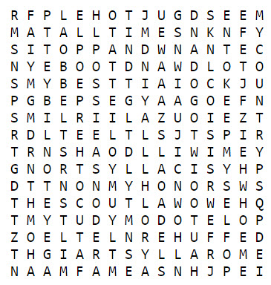

## Find phrases from the Scout Oath -

ON MY HONOR I WILL DO

MY BEST TO DO MY DUTY

TO GOD AND MY COUNTRY

AND TO OBEY THE SCOUT LAW

TO HELP OTHER PEOPLE

AT ALL TIMES TO KEEP MYSELF

PHYSICALLY STRONG

MENTALLY AWAKE AND

MORALLY STRAIGHT

**Scout Law Games**

*Pack 200, Cary, NC*



* Divide the den into two teams.
* Give each team a set of twelve 3 x 5 cards with each card having one word of the Scout Law printed on it.
* At the starting signal, have each team place the cards in the correct order of the Scout Law.
* The winning team is the team to first have their cards in the right order.
* Prepare 10 cards with phrases of the Scout Oath, too

On my Honor

I will do my best

To do my duty

To God and my Country

And to obey the Scout Law

To help other people

At all times

And to keep myself

Physically Strong, Mentally Awake,

and Morally Straight



**Toss!**

*Pack 200, Cary, NC*

* Turn each of the 12 Scout Law cards over on the grid so that the number side is up
* Place the cards in proper order – 1 through 12.
* In turn have each boy toss a bean bag or alternative onto one of the squares.
* The boy who threw the bag must now say the point of the law on which their bean bag landed.
* If they do not know it, the next in line may answer.
* Continue until the grid is completed.

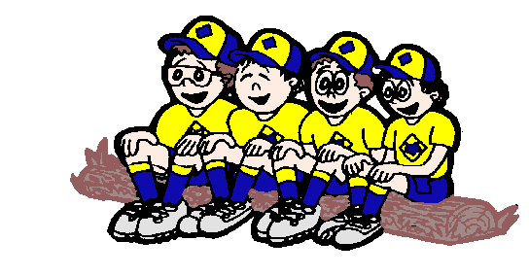

**Scout Law Circle**

*Pack 200, Cary, NC*

**Version #1 -**

* Form the boys into a circle with the Den Chief in the middle.
* Den Chief is to randomly point to a boy who gives the first point of the Scout Law (Trustworthy).
* Den Chief then points to another boy who ist o give the next point in order (Loyal).
* If a boy does not give the correct response by the time the den chief counts to five, he step backwards and sit down. He is out of the game.
* Play continues until there is only one boy left, or until everyone is stumped.
* If you get through the Law once, start over again until all are eliminated that are going to be eliminated.

**Version #2 -**

* Form the boys into a circle with the Den Chief in the middle.
* Den Chief is to randomly point to a boy who gives the first point of the Scout Law (Trustworthy).
* Den Chief then points to another boy who ist o give the next point in order (Loyal).
* If a boy does not give the correct response by the time the den chief counts to five, ask for a volunteer to tell the boy the correct answer. Then see if the boy who was stumped knows the next point. If not repeat process.
* Then move onto another Scout.
* Keep everyone involved. Hopefully they will absorb the Law and the proper order by participating.
* Provide small prizes (candies?) for those who answer correctly.
* If you get tired of going through the Law, start having them say the Oath.



**Pantomime, Charades, or Acting Out-**

*Pack 200, Cary, NC*

* Yes, make practice into a game of charades! Boys love to act silly.
* You could even have a session where they acted out the opposite of the law. For some reason, showing the wrong behavior sure is fun!
* When it is his turn, give a Scout a 3x5 card having one word of the Scout Law printed on it.
* The scouts could also put on an impromptu skit involving the Scout Law.

# DEN MEETING TOPICS

**YOU** are now using the CUB SCOUT ADVENTURE PLAN. Make sure you are familiar with the CUB SCOUT ADVENTURE PLAN materials. Just remember – Boys want to be active!! See, too, that they earn their awards ***(Never say GET. You get sick, you do not get awards – You earn awards. A little CD Philosophy)***.

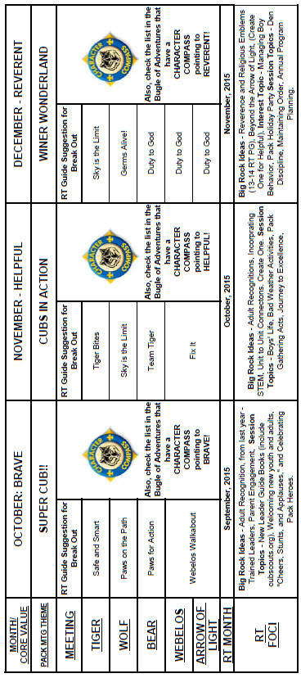

# CHARACTER COMPASS

**NOVEMBER -**ADVENTURES with a **CHARACTER COMPASS** pointing to **HELPFUL:**

**TIGER –**

* Tiger Bites (Core)
* Curiosity, Intrigue, and Magical Mysteries (Elec)

**WOLF –**

* Howling at the Moon (Core)
* Paws of Skill (Elec)

**BEAR –**

* Fellowship & Duty to God (Core)

**WEBELOS CORE –**

* (None)

**ARROW OF LIGHT CORE –**

* Camper (Core)

**WEBELOS & AOL ELECTIVES –**

* Fix It (Elec)



**DECEMBER -**ADVENTURES with a **CHARACTER COMPASS** pointing to **REVERENT:**

**TIGER –**

* My Family's Duty to God (Core)
* Sky is the Limit (Elec)

**WOLF –**

* Duty to God Footsteps (Core)

**BEAR –**

* Fellowship & Duty to God (Core)

**WEBELOS CORE –**

* Duty to God & You (Core)

**ARROW OF LIGHT CORE –**

* Duty to God in Action (Core)

**WEBELOS & AOL ELECTIVES –**

* Into the Woods (Elec)

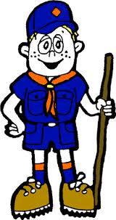

# PACK MEETING THEMES AND PLANS

[*www.scouting.org*](http://www.scouting.org)

**From National's Website for the new plans using the Core Values based on the Scout Law:**

Here are a few thoughts to consider around these new pack meeting plans. First, there is a plan for each month that corresponds with a point of the Scout Law. In addition, each plan has a theme to help make the pack meeting even more fun! The plans do not have to be used in a specific order.

**Tips for Utilizing the Plans**

* Pack meeting plans do not have to be done in any special order, but it is recommended that you include all of the points of the Scout Law each year. The pack planning meeting would be a good time to determine the order.
* There are pack meeting plans for multiple years posted on the website. It is your pack's choice of which one to select from each point of the Scout Law for each year.
* Pack meetings should not last longer than an hour. Adjust the plan to make it fit within the time. Research and experience tells us that Cub Scouts have a hard time sitting still for that long. Keep the meetings fun, active, and engaging.
* If you are comfortable with a costume to fit the theme of the meeting, go for it!
* Importantly, keep it simple and make it fun.
* The following required adventures have a requirement that suggests or requires completion at a pack meeting. Please plan accordingly as part of your annual program planning process. Work with your den leaders to plan when these activities will take place.

**Tiger**

* **Tigers in the Wild,** requirement 5. Participate in an outdoor pack meeting or pack campout campfire. Sing a song and act out a skit with your Tiger den as part of the program.
* **Games Tigers Play,** requirement 3. Make up a new game, and play it with your family or members of your den or pack.

**Wolf**

* **Council Fire,** requirement 6c. Create a den project from recyclables for a pack meeting.

**Bear**

* **Grin and Bear It**, requirement 2. Working with the members of your den, organize a Cub Scout carnival and lead it at a special event.
* **Grin and Bear It**, requirement 3. Help younger Cub Scouts take part in one of the events at the Cub Scout carnival.

**Webelos**

* **Stronger, Faster, Higher**, requirement 5. With adult guidance, lead younger Scouts in a fitness game or games as a gathering activity for a pack or den meeting.

**Arrow of Light**

* **Building a Better World (if chosen**), requirement 10b. Set up an exhibit at a pack meeting to share information about the World Friendship Fund.

**As a personal note:** *I have read some of the plans and they are excellent and just as complete as the new Den Leader Books. The games, and other stuff are right there. Including costuming ideas for that added PIZAZZ!! If you do not use themes and do not add PIZAZZ you are not doing your best for your pack.****GOOD JOB!!!*** *From CD*

Check them out at:  
<http://www.scouting.org/Home/CubScouts/Leaders/CubmasterResources/PackMeetingPlans.aspx>

Kim, the chair of the task force, says **"I do want to stress that the focus is still the Core Value and the theme is just there as an enhancement. The theme pack meeting plans are specifically crafted to bring out the important points of the Core Value in a fun way."**

# Pack Meeting Themes

|  |  |  |
| --- | --- | --- |
| **2015–2016 Pack Meeting Plans** | | |
| October | Brave | ["Super Cub!"](http://www.scouting.org/filestore/cubscouts/pdf/YEAR1/310-842(15)_October%20Brave_WEB.pdf) |
| November | Helpful | ["Cubs In Action"](http://www.scouting.org/filestore/cubscouts/pdf/YEAR1/310-842(15)_November%20Helpful_WEB.pdf) |
| December | Reverent | ["Winter Wonderland"](http://www.scouting.org/filestore/cubscouts/pdf/YEAR1/310-842(15)_December%20Reverent_WEB.pdf) |
| January | Trustworthy | ["The Great Race"](http://www.scouting.org/filestore/cubscouts/pdf/YEAR1/310-842(15)_January%20Trustworthy_WEB.pdf) |
| February | Friendly | ["Friends Near And Far"](http://www.scouting.org/filestore/cubscouts/pdf/YEAR1/310-842(15)_February%20Friendly_WEB.pdf) |
| March | Thrifty | ["Cubstruction"](http://www.scouting.org/filestore/cubscouts/pdf/YEAR1/310-842(15)_March%20Thrifty_WEB.pdf) |
| April | Cheerful | ["Strike Up The Band"](http://www.scouting.org/filestore/cubscouts/pdf/YEAR1/310-842(15)_April%20Cheerful_WEB.pdf) |
| May | Kind | ["My Animal Friends"](http://www.scouting.org/filestore/cubscouts/pdf/YEAR1/310-842(15)_May%20Kind_WEB.pdf) |
| June | Obedient | ["It's A Hit"](http://www.scouting.org/filestore/cubscouts/pdf/YEAR1/310-842(15)_June%20Obedient_WEB.pdf) |
| July | Loyal | ["Scout Salute"](http://www.scouting.org/filestore/cubscouts/pdf/YEAR1/310-842(15)_July%20Loyal_WEB.pdf) |
| August | Courteous | ["S'more Cub Scout Fun"](http://www.scouting.org/filestore/cubscouts/pdf/YEAR1/310-842(15)_August%20Courteous_WEB.pdf) |

|  |  |  |
| --- | --- | --- |
| **2016–2017 Pack Meeting Plans** | | |
| September | Helpful | ["To The Rescue"](http://www.scouting.org/filestore/cubscouts/pdf/YEAR2/310-842(15)_September%20Helpful_WEB.pdf) |
| October | Kind | ["Creepy Crawlers"](http://www.scouting.org/filestore/cubscouts/pdf/YEAR2/310-842(15)_October%20Kind_WEB.pdf) |
| November | Courteous | ["Cubs In Shining Armor"](http://www.scouting.org/filestore/cubscouts/pdf/YEAR2/310-842(15)_November%20Courteous_WEB.pdf) |
| December | Cheerful | ["Celebrate"](http://www.scouting.org/filestore/cubscouts/pdf/YEAR2/310-842(15)_December%20Cheerful_WEB.pdf) |
| January | Obedient | ["Cub Scout City Council"](http://www.scouting.org/filestore/cubscouts/pdf/YEAR2/310-842(15)_January%20Obedient_WEB.pdf) |
| February | Reverent | ["Passport To Other Lands"](http://www.scouting.org/filestore/cubscouts/pdf/YEAR2/310-842(15)_February%20Reverent_WEB.pdf) |
| March | Loyal | ["Our National Treasures"](http://www.scouting.org/filestore/cubscouts/pdf/YEAR2/310-842(15)_March%20Loyal_WEB.pdf) |
| April | Thrifty | ["Power Up!"](http://www.scouting.org/filestore/cubscouts/pdf/YEAR2/310-842(15)_April%20Thrifty_WEB.pdf) |
| May | Clean | ["A Picnic With Pizzazz"](http://www.scouting.org/filestore/cubscouts/pdf/YEAR2/310-842(15)_May%20Clean_WEB.pdf) |
| June | Brave | ["Roaming Reptile Alert"](http://www.scouting.org/filestore/cubscouts/pdf/YEAR2/310-842(15)_June%20Brave_WEB.pdf) |
| July | Trustworthy | ["Let The Games Begin"](http://www.scouting.org/filestore/cubscouts/pdf/YEAR2/310-842(15)_July%20Trustworthy_WEB.pdf) |
| August | Friendly | ["#CUBSCOUTS"](http://www.scouting.org/filestore/cubscouts/pdf/YEAR2/310-842(15)_August%20Friendly_WEB.pdf) |

**If you are using a paper copy the link to all the   
Pack Meeting Plans is:**

# <http://www.scouting.org/Home/CubScouts/Leaders/CubmasterResources/PackMeetingPlans.aspx>UPCOMING MONTHS

* November's Core Value, **Helpful**,   
  will use the theme, **Cubs in Action**
* **A SCOUT IS HELPFUL**A Scout is helpful. A Scout cares about other people. He willingly volunteers to help others without expecting payment or reward.
* **HOW DOES “CUBS IN ACTION” RELATE TO THIS POINT OF THE SCOUT LAW?**It is never too early in our lives to begin helping other people. Scouting has promoted being helpful to others since it began in 1907 in England. Being helpful to others is what William D. Boyce experienced one foggy night in London, when a Scout helped him find his way. Boyce was so impressed that the Scout helped him and refused a reward that he incorporated the Scouting program in America in 1910.

Our Cub Scouts find active ways to help others in their neighborhoods and spread the goodwill of Scouting. By teaching and living the Scout slogan, "Do a Good Turn Daily," we are keeping the third point of the Scout Law: A Scout is helpful.

|  |  |  |
| --- | --- | --- |
| **Month** | **Year** | **Theme** |
| **Potential "Cubs in Action" Months** | | |
| August | 1952 | Conservation |
| April | 1955 | Cub Scout Foresters |
| November | 1955 | America Beautiful |
| April | 1958 | Keep America Beautiful |
| May | 1965 | My Hometown |
| April | 1968 | Keep America Beautiful |
| September | 1971 | Conservation |
| May | 1972 | Beautiful America |
| May | 1974 | Keep America Beautiful |
| May | 1976 | SOAR |
| July | 1987 | America The Beautiful |
| April | 1999 | Pollution Solution |
| April | 1999 | Pollution Solution |
| April | 2001 | Save It For Us |
| April | 2004 | Cubservation |
| May | 2009 | Leave Nothing But Footprints |
| April | 2010 | Spring into Action |

|  |  |  |
| --- | --- | --- |
| **Month** | **Year** | **Theme** |
| **HELPFUL** (Themes for former CV Compassion are listed here) | | |
| December | 1940 | Good Will - Cub Style |
| December | 1941 | Giving Good Will |
| December | 1942 | Good Will |
| December | 1943 | Good Will Month |
| December | 1944 | The Other Fellow |
| December | 1945 | Follows - Helps - Gives |
| December | 1947 | Helps and Gives |
| December | 1948 | Goodwill |
| December | 1949 | The Other Fellow |
| December | 1950 | Helps (for institutions) |
| December | 1951 | Follows, Helps, Gives |
| December | 1961 | Follows, Helps, and Gives |
| September | 1965 | Barn Raising |
| December | 1969 | The Cub Scout Gives Good Will |
| December | 1971 | Cub Scout Gives Good Will |
| December | 1972 | Follows, Helps, Gives |
| December | 1975 | Cub Scout Gives Good Will |
| December | 1984 | Do a Good Turn |
| December | 1985 | Follows, Helps, Gives |
| December | 1986 | The Golden Rule |
| December | 1991 | Follows, Helps, Gives |
| December | 1992 | To Help Other People |
| December | 1995 | Do a Good Turn |
| December | 1996 | Helping Others |
| December | 1997 | The Golden Rule |
| July | 2002 | Inside Out and Backwards |
| December | 2003 | A Cub Scout Gives Good Will |
| March | 2004 | Walk In My Shoes |
| November | 2008 | Spreading Seeds Of Kindness |
| March | 2011 | Compassion |
| March | 2012 | Compassion |
| March | 2013 | Planting Seeds of Kindness |
| March | 2014 | Pet Pals |
| March | 2015 | Aware and Care |

* November's Core Value, **Reverent**,   
  will use the theme, **Winter Wonderland**
* **A SCOUT IS REVERENT**A Scout is reverent toward God. He is faithful in his religious duties. He respects the beliefs of others..
* **HOW DOES “WINTER WONDERLAND” RELATE TO THIS POINT OF THE SCOUT LAW?**As winter comes, it brings with it a wonderland of snow, peace, beauty, and holidays. All of us come from different backgrounds and celebrate many traditions; each of our traditions gives us an identity and a sense of belonging. When we share those traditions and accept others’ traditions, we expand our circle so everyone feels like they belong. Whether we celebrate Christmas, Hanukkah, Kwanzaa, or none of these, sharing valued traditions and holding true to what they stand for will help us understand others. But no matter who we are or how we celebrate, we are all part of a great organization that has taught us to show reverence for others and their beliefs. The twelfth point of the Scout Law – A Scout is Reverent.

|  |  |  |
| --- | --- | --- |
| **Month** | **Year** | **Theme** |
| **REVERENT** (Themes for former CV Faith are listed here) | | |
| November | 1942 | Thanksgiving |
| November | 1952 | Faith of his Fathers |
| December | 1960 | Guiding Stars |
| November | 1974 | Pilgrims |
| November | 1980 | Thanksgiving-Living & Sharing |
| November | 1984 | Turkey Day |
| November | 1992 | Turkey Day |
| November | 2003 | Pilgrims of Plymouth Rock |
| December | 2005 | Faith, Hope & Charity |
| December | 2007 | Celebrations Around the World |
| April | 2011 | Faith |
| April | 2012 | Faith |
| April | 2013 | Cub Scouts Give Thanks |
| April | 2014 | My Family Tree |
| April | 2015 | Soaring the Skies |

|  |  |  |
| --- | --- | --- |
| **Month** | **Year** | **Theme** |
| **Potential "Winter Wonderland" Months** | | |
| December | 1939 | Pack Christmas Party |
| December | 1946 | Cub Scout Santa Claus |
| December | 1952 | An Old-Fashioned Christmas |
| December | 1956 | Christmas In The Americas |
| December | 1957 | Happy Holiday |
| December | 1962 | The Magic of Christmas |
| December | 1963 | Old-Fashioned Christmas |
| **December** | **1964** | **Winter Festival** |
| December | 1966 | Yuletide Everywhere |
| **December** | **1968** | **Winter Wonderland** |
| December | 1974 | Old Fashion Christmas |
| **December** | **1976** | **Winter Festival** |
| December | 1980 | Happy Holidays |
| December | 1983 | Giving Gifts |
| December | 1987 | Happy Holidays |
| December | 1988 | Holiday Magic |
| December | 1990 | Giving Gifts |
| December | 1993 | Holiday Magic |
| December | 1999 | Holiday Magic |
| December | 2000 | What do … at Holiday Time? |
| December | 2001 | Works of Art |
| **December** | **2002** | **Winter Wonderland** |
| December | 2007 | Celebrations Around the World |
| December | 2008 | Holiday Lights |
| December | 2009 | Works of Art |
| December | 2012 | Holiday Lights |

**WEBELOS**

**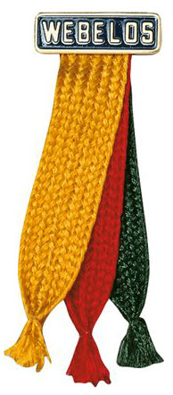**

**A History Lesson on Webelos Colors**

*Mike Walton,* [*www.USScouts.org*](http://www.USScouts.org) *In Response to a question from Barbara*

**Barbara wrote me -**"Dave -- our son is a Webelos I and is enjoying completing and earning the new Adventures toward his Webelos badge. Next year he will be working on the Adventures for his Arrow of Light. Our question is this, does it make a difference on which ribbon he displays the pins? Since there are three colors, gold, red, and green, there might be a uniform policy for what goes where.

I took this question to Mike Walton, our uniform guru at [USScouts.org](http://www.usscouts.org) .Check out his uniform website at - <http://www.scoutinsignia.com/patchtop.htm>

**In response Mike wrote -**The three badge colors represent the three programs in the BSA: Cub Scouting (the yellow/gold), Boy/Varsity Scouting (the red) and "Senior Scouting" (used to be Exploring and now Venturing, the green). These are the same three colors found in the "WEBELOS Tartan", an official tartan (plaid) color combination recognized in Scotland (and is also referred to as the "Boy Scouts of America Tartan", just so you know -- and if you get a chance to go to Scotland and request a woolen skirt and they ask you for the "family name" or the "tartan name" \*smiling\*). The BSA's "Pedro" jacket features that three color plaid color combination as well.

When the WEBELOS Badge colors were introduced in the spring of 1969, the then-Director of Cub Scouting answered this question in the following manner:

"There is a sequence for the placement of the 15 silver activity badges upon the Badge Colors. The first five should be worn on the central color, the gold (yellow) strand because the WEBELOS is transitioning from being a Cub Scout to a Boy Scout. The next five should be placed onto the green color because it is hopeful that the outdoors aspect of Boy Scouting will appeal to the WEBELOS Cub Scout and will whet his appetite toward becoming a Boy Scout. The final five should be placed onto the red color strand as a reminder of his goal toward earning the Arrow of Light and becoming a Tenderfoot Boy Scout." (Back in the day, we did not have a joining step called "Scout" and instead Arrow of Light recipients automatically became Tenderfoot Boy Scouts upon graduation from a Cub Scout Pack to a Boy Scout Troop).

I guess that bit of wisdom was not passed down, because the same question was asked in 1974, when the Cub Scout program was revised and there was this answer in SCOUTING magazine within the "Front Line Stuff" column: "WEBELOS Cub Scouts may wear the activity badges as earned in any manner on any of the three strands of the WEBELOS Badge colors. The most important part of the process is that he earns the badge and displays it on his uniform on the Badge colors."

And again in 2003, the same question was asked again in "Front Line Stuff" and someone from the Cub Scout Division answered in this manner: "The 20 multi-colored badges earned for participating in activities as a WEBELOS Cub Scout may be worn either on the WEBELOS Badge colors OR on the WEBELOS Cub Scout hat. The number of or which strand it is worn on first, second or last is up to the WEBELOS Cub Scout. On the hat, the activity badges should be worn on either side of the WEBELOS badge emblem in the center of the hat. Either all of the badges are worn on the hat or on the Badge colors and this is an option of the individual WEBELOS Cub Scout and his parents."

**So to summarize:**The 20 activity badges are worn, in any order that the WEBELOS Cub Scout chooses, on the WEBELOS Badge colors or alternatively on the WEBELOS Cub Scout hat *(personally, Mike & I think wearing them on the hat like pins one receives from Disneyland or some resort place is very tacky but at the time kids were wearing hat pins and it was very popular and "stylish")*.

The three strands represent the three program groups of the Boy Scouts of America. Alternatively, if he chooses to wear them on the WEBELOS Cub Scout hat, he wears one half on one side of the WEBELOS "tartan" or plaid hat.

I hope this bit of Scouting history and lore helps your son and you out, Barbara, and I hope it helps others who ask Dave or the local Scout Shop(tm) employee the same question. I'll put this together and add it to my Badge and Uniform Site later this month.

# November Crazy Holidays

*Jodi, SNJC Webelos Resident Camp Director Emeritus,   
2006-2011. Adapted from* <http://holidayinsights.com/moreholidays/index.htm>  
[http://www.brownielocks.com/month2.html](http://www.brownielocks.com/month2.html%20)

**November is:**

* **Aviation History Month**
* **Child Safety Protection Month**
* **International Drum Month**
* **National Adoption Awareness Month**
* **National Epilepsy Month**

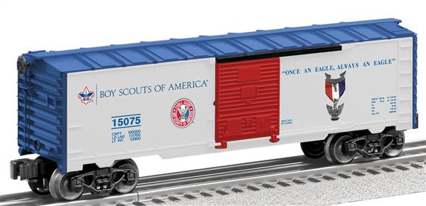

* **National Model Railroad Month**
* **National Novel Writing Month**
* [Native American Heritage Month](http://nativeamericanheritagemonth.gov/about/)

**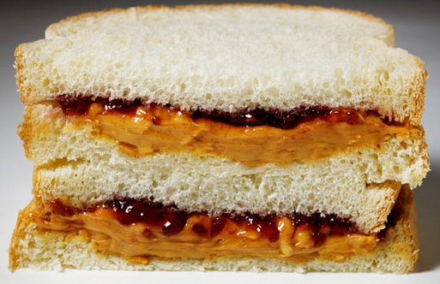**

* [Peanut Butter Lovers Month](http://nationalpeanutboard.org/the-facts/fun-facts/) *(Beware of Food Allergies ☺ – Pat)*
* **Adopt A Senior Pet Month  
  Adopt A Boxer Rescue has a special right now if you adopt a senior boxer –   
  check it out at**

[http://www.adoptaboxerrescue.com](http://www.adoptaboxerrescue.com/)  
[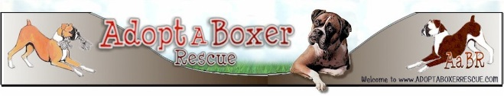](http://www.adoptaboxerrescue.com)

**Or on Facebook at –**

<https://www.facebook.com/adoptaboxerrescue?fref=ts>

[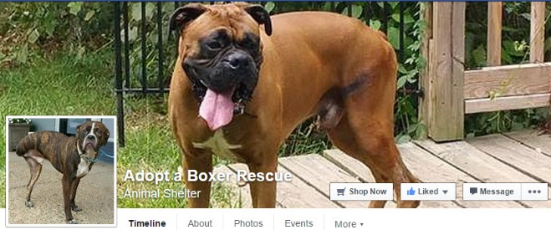](https://www.facebook.com/adoptaboxerrescue?fref=ts)

* **American & National Diabetes Month**
* [American Indian Heritage Month](http://www.firstnations.org/news/events/native_american_heritage_month_2015)
* **Banana Pudding Lovers Month**



* [Family Stories Month](http://imlostinbooks.blogspot.com/2009/11/family-stories-month.html)
* **Gluten-Free Diet Awareness Month**

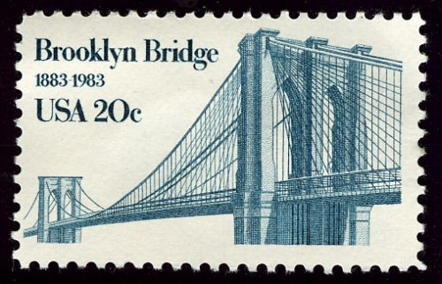

* **Historic Bridge Awareness Month**



* **Manatee Awareness Month**
* **Military Family Appreciation Month**
* **National Alzheimer's Disease Month**
* **National Diabetes Month**
* **National Family Caregivers Month**
* **National Georgia Pecan Month**
* **National Inspirational Role Models Month**
* **National Pomegranate Month**
* **National Scholarship Month**
* **Pancreatic Cancer Awareness Month**



* [Sweet Potato Awareness Month](http://holidaysofyear.com/sweet-potato-awareness-month/)
* [Vegan Month](https://www.facebook.com/WorldVeganMonth)

**Week Celebrations:**

* **National Fig Week: 1-7**
* **World Communication Week: 1-7**

[](http://www.scouting.org/sitecore/content/Home/HealthandSafety/SafetyThoughts/120504.aspx)

* **Drowsy Driving Prevention Week 1-8**

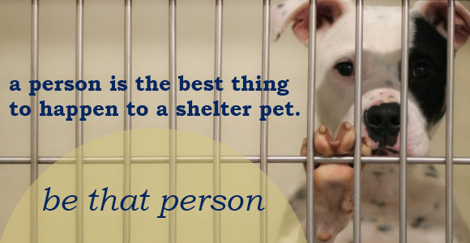

* National Animal Shelter Appreciation Week: 2-8

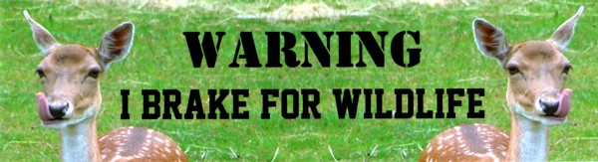

* Give Wildlife A Brake Week: 2-6 (First Week)
* Sherlock Holmes Weekend: 6-8

[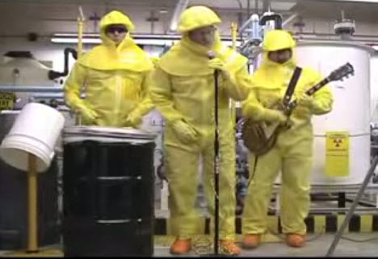](https://www.youtube.com/watch?v=mRc33sBjeSI)

"50 Ways to save a Millirem"  
Try this funny Rad Tech video at   
<https://www.youtube.com/watch?v=mRc33sBjeSI>

* [National Rad Tech Week: 8-14](http://www.asrt.org/events-and-conferences/national-radiologic-technology-week)
* Geography Awareness Week: 8-14
* World Kindness Week: 9-15
* National Young Reader's Week: 9-13
* National Hunger & Homeless Awareness Week: 14-22



* [National Bible Week: 15-21](http://www.catholicpublishers.org/?page=NBWK2015)
* American Education Week: 16-20
* National Global Entrepreneurship Week: 16-22
* National Farm-City Week: 20-26
* National Family Week: 22-28
* **National Game & Puzzle Week: 22-28**

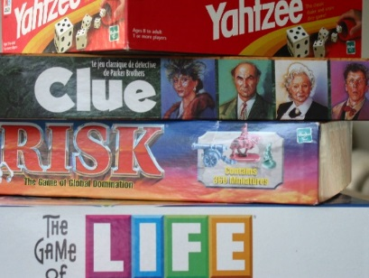

**Daily Celebrations:**

1 [All Saint's Day](http://holidayinsights.com/christian/saintsday.htm)

2 [All Soul's Day](http://holidayinsights.com/christian/soulsday.htm)

2 [Look for Circles Day](http://holidayinsights.com/moreholidays/November/lookforcirclesday.htm)

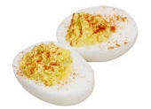

2 [Deviled Egg Day](http://holidayinsights.com/moreholidays/November/deviledeggsday.htm)

3 [Housewife's Day](http://holidayinsights.com/moreholidays/November/housewifeday.htm)

3 [Sandwich Day](http://holidayinsights.com/moreholidays/November/sandwichday.htm)

3 [U.S. Gen'l Election Day](http://holidayinsights.com/moreholidays/November/election-day.htm)- first Tuesday of November

4 [King Tut Day](http://holidayinsights.com/moreholidays/November/kingtutday.htm)

5 [Gunpowder Day](http://holidayinsights.com/moreholidays/November/guyfawkesday.htm)

5 [Guy Fawkes Day](http://holidayinsights.com/moreholidays/November/guyfawkesday.htm)

6 [Marooned without a Compass Day](http://holidayinsights.com/moreholidays/November/nocompassday.htm)

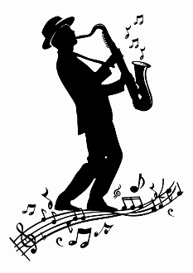

6 [Saxophone Day](http://holidayinsights.com/moreholidays/November/saxophoneday.htm)

7 [Book Lovers Day](http://holidayinsights.com/moreholidays/August/bookloversday.htm) - first Saturday of the month

7 [Bittersweet Chocolate with Almonds Day](http://holidayinsights.com/moreholidays/November/bittersweetchocolateday.htm)

8 [Cook Something Bold Day](http://holidayinsights.com/moreholidays/November/cooksomethingboldday.htm)

8 [Dunce Day](http://holidayinsights.com/moreholidays/November/dunceday.htm)

9 [Chaos Never Dies Day](http://holidayinsights.com/moreholidays/November/chaosneverdiesday.htm) - you've got that right

10 [Forget-Me-Not Day](http://holidayinsights.com/moreholidays/November/forgetmenotday.htm)

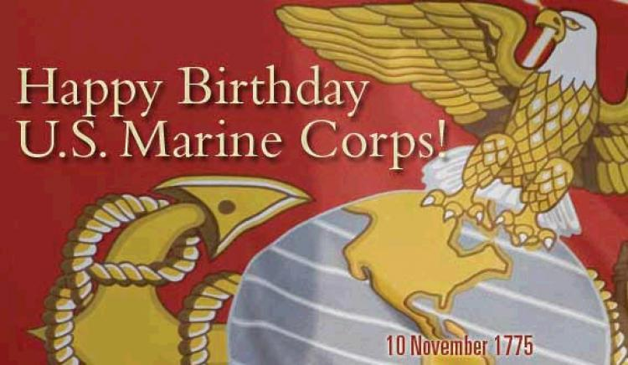

10 [USMC Day](http://holidayinsights.com/moreholidays/November/usmcday.htm)

10 [Young Readers Day](http://holidayinsights.com/moreholidays/November/youngreadersday.htm) second Tuesday of month

11 [Veteran's Day](http://holidayinsights.com/other/veteran.htm)

12 [Chicken Soup for the Soul Day](http://holidayinsights.com/moreholidays/November/csftsday.htm)

13 [National Indian Pudding Day](http://holidayinsights.com/moreholidays/November/indianpuddingday.htm)

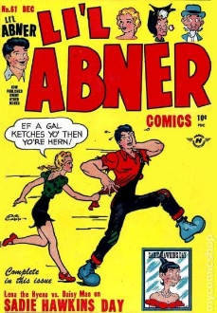

13 [Sadie Hawkins Day](http://holidayinsights.com/other/sadie.htm)

13 [World Kindness Day](http://holidayinsights.com/moreholidays/November/worldkindnessday.htm)

14 [Operating Room Nurse Day](http://holidayinsights.com/moreholidays/November/operatingroomnurse.htm)

15 [Clean Your Refrigerator Day](http://holidayinsights.com/moreholidays/November/cleanrefrigeratorday.htm)

15 [America Recycles Day](http://holidayinsights.com/moreholidays/November/americarecyclesday.htm)

15 [National Philanthropy Day](http://holidayinsights.com/moreholidays/November/philanthropyday.htm)

16 [Button Day](http://holidayinsights.com/moreholidays/November/buttonday.htm)



16 [Have a Party with Your Bear Day](http://holidayinsights.com/moreholidays/November/partybearday.htm)

17 [Electronic Greeting Card Day](http://holidayinsights.com/moreholidays/November/electronicgreetingcard.htm) - now who do you think created this day!?

17 [Homemade Bread Day](http://holidayinsights.com/moreholidays/November/homemadebreadday.htm)

17 [Take A Hike Day](http://holidayinsights.com/moreholidays/November/takeahikeday.htm)

17 [World Peace Day](http://holidayinsights.com/moreholidays/November/worldpeaceday.htm)

18 [Occult Day](http://holidayinsights.com/moreholidays/November/occultday.htm)

19 [Have a Bad Day Day](http://holidayinsights.com/moreholidays/November/haveabaddayday.htm)



19 [Great American Smokeout](http://holidayinsights.com/moreholidays/November/greatamericansmokeout.htm)

20 [Absurdity Day](http://holidayinsights.com/moreholidays/November/absurdityday.htm)

20 [Beautiful Day](http://holidayinsights.com/moreholidays/November/beautifulday.htm)

20 [Universal Children's Day](http://holidayinsights.com/other/children.htm)

21 [False Confession Day](http://holidayinsights.com/moreholidays/November/falseconfessionday.htm)

21 [World Hello Day](http://holidayinsights.com/moreholidays/November/worldhelloday.htm)

21 [National Adoption Day](http://holidayinsights.com/moreholidays/November/adoptionday.htm) - Saturday before Thanksgiving

22 [Go For a Ride Day](http://holidayinsights.com/moreholidays/November/goforarideday.htm)

23 [Eat a Cranberry Day](http://holidayinsights.com/moreholidays/November/eatacranberryday.htm)

23 [National Cashew Day](http://holidayinsights.com/moreholidays/November/cashewday.htm)

25 [National Parfait Day](http://holidayinsights.com/moreholidays/November/parfaitday.htm)

26 [Shopping Reminder Day](http://holidayinsights.com/moreholidays/November/shoppinreminderday.htm)

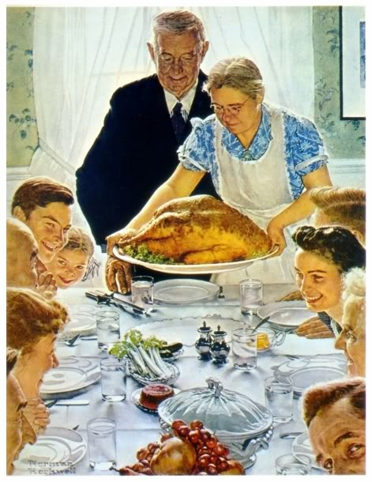

26 [Thanksgiving](http://holidayinsights.com/tday/index.htm) - Eat, drink, and be thankful.

27 [Pins and Needles Day](http://holidayinsights.com/moreholidays/November/pinsandneedles.htm)

27 [Black Friday](http://holidayinsights.com/moreholidays/November/blackfriday.htm)

27 [Buy Nothing Day](http://holidayinsights.com/moreholidays/November/buynothingday.htm) - always the day after Thanksgiving...does anyone abide by it!?!

27 [You're Welcome Day](http://holidayinsights.com/moreholidays/November/yourewelcomeday.htm) - the day after Thanksgiving

28 [Make Your Own Head Day](http://holidayinsights.com/moreholidays/November/makeyourownhead.htm)

28 [Red Planet Day](http://holidayinsights.com/other/redplanetday.htm)

29 [Square Dance Day](http://holidayinsights.com/other/squaredanceday.htm)

30 [Stay At Home Because You Are Well Day](http://holidayinsights.com/moreholidays/November/stayhomewellday.htm)

# From A to Z What Helpful Families Can Do

*Southern NJ Council*

1. **Adopt** a stream. park or roadside to clean up and keep beautiful.
2. **Bring** lunch to school in a lunch box. Save your paper bags.
3. **Care** for toys so they will last longer. Then you won't have to replace them and can pass them on.
4. **Donate** clothes that you have outgrown to a needy person or someone smaller.
5. **Encourage** others to join you in collecting glass, newspaper and aluminum to be recycled.
6. **Flatten** empty cans. boxesand other containers to they don't take up so much space
7. **Get** in the habit of turning off the water when you brush your teeth. Turn it on only to wet your brush and to rinse.
8. **Help** by caring about our wildlife & be very careful with matches.
9. **Insist** on buying products that are biodegradable (they rot or decompose when discarded.) Most plastics are not.
10. **Jog** or walk, ride a bike or scooter from place to place to save energy.
11. **Keep** jars of cold water in the refrig­erator so you won't have to run the tap water waiting for it to get cold.
12. **Look** for the recycled symbol on products you buy.
13. **Make** it a habit to cut each six-pack ring. These sometimes wind up in the oceans. Animals often get caught in them.
14. **Never** litter. Always put your trash in a trash can.
15. **Open** the blinds in the wintertime to let in the sun. Close blinds in the summer to keep out the sun's heat.
16. **Plant** a tree to stop soil erosion, give you shade and give birds a home.
17. **Quit** buying products that have a lot of packaging.
18. **Reduce** the amount of water you use to keep clean. Take showers, not baths.
19. **Save** energy by asking your parents to turn down the thermostat.
20. **Turn** off lights if you are the last person to leave a room. Turn off appliances if you are not using them.
21. **Use** products made to be used many times, such as sponges or cloth towels.
22. **Value** and appreciate your Earth. Realize that you can make a difference.
23. **Watch** what you pour in the drain. Hazardous waste can get into the ground water.
24. **eXamine** labels before using products Certain household cleaners can be dangerous.
25. **Yearn** to do what you can to help our environment. Grow up to be an adult who takes an interest, too.
26. **Zip** to close doors and windows if they are opened when the heater or air conditioner is on.

# Fun Facts About Being Helpful

*Alice, Golden Empire Council*

* Giving a smile is actually easier than giving a frown – it takes fewer muscles!
* In 2007, 163,000 volunteers at the National Park Service donated 5.4 million hours of time worth $101 million or the equivalent of 2,596 full time employees!
* 80% of the people in this county give to nonprofits.
* Only 10-12% of financial giving is provided by foundations and only 5-6% comes from corporations.
* Most of the money given by individuals is from middle and low income people, not the super wealthy!
* Eleven percent of households contributed to religious causes only.
* Twenty-one percent of households contributed to only secular causes.
* Thirty-four percent contributed to both religious and secular causes.
* Only 28.8% of the people in this country do the actual volunteer work for the many service organizations and projects in this country – so your time does matter!
* Recognition in front of their peers is the most valued form of “payback” for volunteers – so remember to recognize parents, leaders and others who help your scout program!
* The median amount of time that people volunteer is 52 hours a year, ranging from 21% who spend from one to fourteen hours up to the 28% who donate between one hundred and four hundred hours a year.

# Need help finding a project?

* Go to: <http://makeadifferenceday.com/> and click on Project Ideas on the left side.
* **Ask!** – Check with your chartered organization, school, church, local charities such as the American Red Cross, food banks, senior gleaners, neighborhood service organizations or local volunteer centers.
* **Check online** – google a type of giving you are drawn to, or go to the Points of Light website and use the interactive map to find a volunteer center near you – they have lots of projects and contacts.

**BSA SOCIAL NETWORKS**

**BSA FACEBOOK PAGE**

[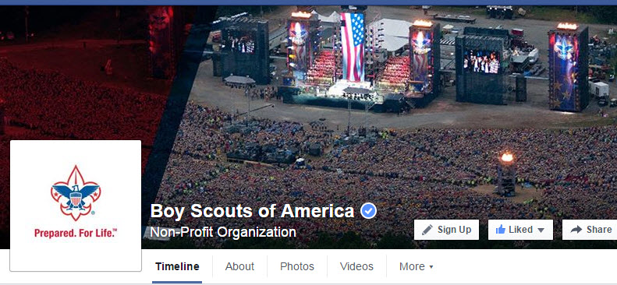](https://www.facebook.com/pages/Boy-Scouts-of-America/113441755297)

[BSA Facebook page link-html](https://www.facebook.com/pages/Boy-Scouts-of-America/113441755297)  
[https://www.facebook.com/pages/Boy-Scouts-of-America/113441755297](https://www.facebook.com/pages/Boy-Scouts-of-America/113441755297%20)

On the Facebook page you can read about –   
**New Online Training for Scout Leaders**

[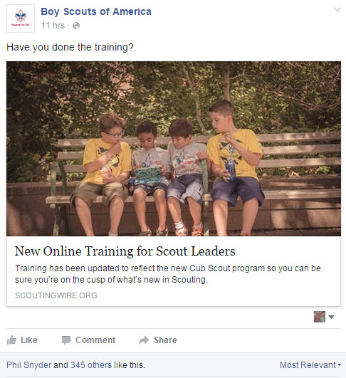](http://scoutingwire.org/why-this-new-online-cub-scout-training-gets-an-a/)

Go To <http://scoutingwire.org/why-this-new-online-cub-scout-training-gets-an-a/>

**SCOUTING MAGAZINE   
ON YOU TUBE**

[](http://www.youtube.com/user/scoutingmag)

[Scouting magazine You Tube Channel link-html](http://www.youtube.com/user/scoutingmag)  
<http://www.youtube.com/user/scoutingmag>

# Check out cool stories and interviews For Example –

# Creek Stewart, Eagle Scout and host of "Fat Guys in the Woods"

# 

Check it out at -   
<https://www.youtube.com/watch?v=jGugLDTJ5Qc>

# Mizzou Kicker and Eagle Scout Does it All

# 

Check it out at -   
<http://scoutingnewsroom.org/blog/mizzou-kicker-and-eagle-scout-tackles-it-all/>

# CUBCAST <http://www.scouting.org/Scoutcast/Cubcast.aspx>

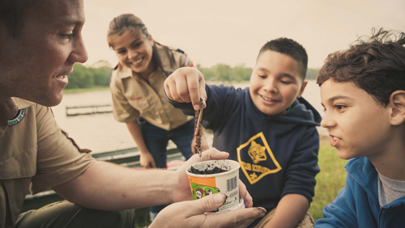

## September 2015 - Asking for Help

## If you’re a regular CubCast listener, as you should be, you know we always mention getting parents or others in the community involved with your den or pack. Yet some of us are still hesitant to ask. We don’t expect you to run a high- quality program all by yourself, so we asked self-proclaimed “unlikeliest den leader” and reporter Danny Heitman from the Istrouma Council in Baton Rouge, Louisiana, how he was able to acquire assistants and make den meetings a whole lot more fun!

## Listen Hear - <http://www.scouting.org/filestore/scoutcast/cubcast/201509_1/CC_Sept_Ask_for_Help.mp3>

SCOUTCAST  
<http://www.scouting.org/Scoutcast/Scoutcast.aspx>

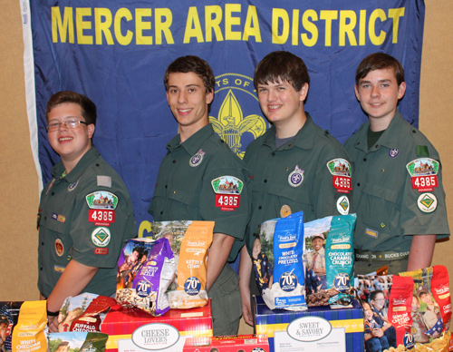

## September 2015 - How to Sell Popcorn When You're No Longer an Adorable Cub Scout

## Everyone knows Scouting is full of really cool activities like camping and kayaking and building robots, but like everything else on Planet Earth, it costs money. So another big part of Scouting is fundraising. It's not too difficult when you're a cute little Cub Scout, and you give a great big smile with those adorable chubby cheeks and start stumbling through your script. You're just so doggone precious, people gladly buy whatever you're selling. But what about when the Scouts get older and a little less adorable? Donovan Fisher, aka The Popcorn Scout, and his dad, Scott, with the Washington Crossing Council in Doylestown, Pennsylvania, are here to share with us Donovan’s secrets as the third highest selling Scout in 2013 with more than $23,000 in sales. Did Dad help? Let's find out.

## Listen Hear - http://www.scouting.org/filestore/scoutcast/resources/201509\_1/SC\_Sept\_FR\_When\_no\_longer\_Cute.mp3

*It is possible that by the time you get Baloo's Bugle and click the link, there may be new Cubcast and/or Scoutcast posted. Do not worry,* ***all*** *previous Cubcasts and Scoutcasts are available from the home page.*

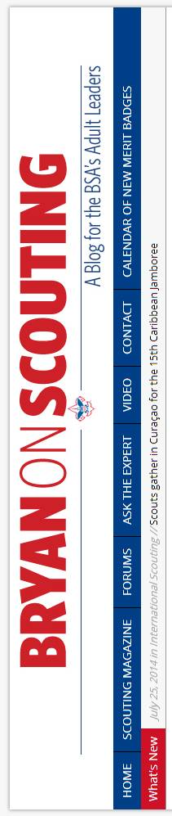**Bryans Blog   
July 2015**

“Bryan on Scouting” is the official blog of Scouting magazine, a Boy Scouts of America publication. Scouting magazine is published five times a year and is received by 1 million registered adult volunteers.

Bryan covers many topics every month. He keeps his Blog current and deals with the latest issues.

His articles this past month are listed below (Every title has a hyperlink). The articles in BLUE are of special interest for Cub Scout Leaders.

[**How to find STEM experts for your next Scout meeting or event**](http://blog.scoutingmagazine.org/2015/09/18/how-to-find-stem-experts-for-your-next-scout-meeting-or-event/)

September 18, 2015 // [9 Comments](http://blog.scoutingmagazine.org/2015/09/18/how-to-find-stem-experts-for-your-next-scout-meeting-or-event/)

[](http://blog.scoutingmagazine.org/2015/09/18/how-to-find-stem-experts-for-your-next-scout-meeting-or-event/)STEM experts are everywhere. Invite one to your next meeting. See if they'll set up a station at your camporee. Take your Scouts on a field trip. 

[**Rob Lowe tweets photo with Scouts: ‘They make the future look good’**](http://blog.scoutingmagazine.org/2015/09/17/rob-lowe-tweets-photo-with-scouts-they-make-the-future-look-good/)

September 17, 2015 // [6 Comments](http://blog.scoutingmagazine.org/2015/09/17/rob-lowe-tweets-photo-with-scouts-they-make-the-future-look-good/)

[](http://blog.scoutingmagazine.org/2015/09/17/rob-lowe-tweets-photo-with-scouts-they-make-the-future-look-good/)Rob Lowe, whose highly successful film and television career has spanned decades, tweeted a photo of himself with some Boy Scouts on Sept. 16. 

[**Is chivalry dead? In hilarious video, Eagle Scout tries to find out**](http://blog.scoutingmagazine.org/2015/09/16/is-chivalry-dead-in-hilarious-video-eagle-scout-tries-to-find-out/)

September 16, 2015 // [11 Comments](http://blog.scoutingmagazine.org/2015/09/16/is-chivalry-dead-in-hilarious-video-eagle-scout-tries-to-find-out/)

In a hilarious video, Eagle Scout Dave Jorgenson asks strangers whether chivalry is dead and what constitutes chivalry in their minds. The results are gold. 

[**In Scoutbook webcast, get everything you need to know in one hour**](http://blog.scoutingmagazine.org/2015/09/16/in-scoutbook-webcast-get-everything-you-need-to-know-in-one-hour/)

September 16, 2015 // [23 Comments](http://blog.scoutingmagazine.org/2015/09/16/in-scoutbook-webcast-get-everything-you-need-to-know-in-one-hour/)

The team behind Scoutbook, that revolutionary Scouting web app acquired by the BSA earlier this year, is hosting a live Scoutbook webcast. 

[**Philmont Advisor Skill School helps you know before you go**](http://blog.scoutingmagazine.org/2015/09/17/philmont-advisor-skill-school-helps-know-go/)

September 17, 2015 // [9 Comments](http://blog.scoutingmagazine.org/2015/09/17/philmont-advisor-skill-school-helps-know-go/)

[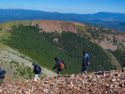](http://blog.scoutingmagazine.org/2015/09/17/philmont-advisor-skill-school-helps-know-go/)Philmont Advisor Skill School will get you ready for your Philmont trek. PASS is available at Philmont Scout Ranch and in a city near you. 

**NOTE: Obviously not a Cub item but a GREAT thing!!! WE previewed this at the Philmont Ambassador Seminar – It is fantastic!!! Mark Anderson and the Chief Ranger are personally doing this!!! Tell everyone in your council planning a trek about it!!! Have them contact your council's Philmont Ambassador or Philmont directly for info!!!**

[**Scouts help those left homeless by California’s Valley Fire**](http://blog.scoutingmagazine.org/2015/09/15/scouts-help-those-left-homeless-by-californias-valley-fire/)

September 15, 2015 // [8 Comments](http://blog.scoutingmagazine.org/2015/09/15/scouts-help-those-left-homeless-by-californias-valley-fire/)

[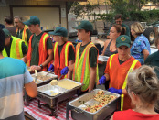](http://blog.scoutingmagazine.org/2015/09/15/scouts-help-those-left-homeless-by-californias-valley-fire/)Over the weekend, Troop 32 from Santa Rosa, Calif., cooked and served dinner for those left homeless by the Valley Fire burning nearby. 

[**How do you handle prescription medication on Scout trips?**](http://blog.scoutingmagazine.org/2015/09/15/prescription-medication-on-scout-trips/)

September 15, 2015 // [25 Comments](http://blog.scoutingmagazine.org/2015/09/15/prescription-medication-on-scout-trips/)

[](http://blog.scoutingmagazine.org/2015/09/15/prescription-medication-on-scout-trips/)What does your Scout unit do about prescription medication on Scout trips? Share your responses with the Scouting community in this Tuesday Talkback. 

[**Parents finish Eagle Scout project for son killed in Afghanistan**](http://blog.scoutingmagazine.org/2015/09/14/parents-finish-eagle-scout-project-for-son-killed-in-afghanistan/)

September 14, 2015 // [14 Comments](http://blog.scoutingmagazine.org/2015/09/14/parents-finish-eagle-scout-project-for-son-killed-in-afghanistan/)

Ryane Clarke's dream was to build a parking lot and prevent tragedies like the one that killed his childhood friend. His parents had to finish it for him. 

[**Extreme Makeovers, Round 11: Eagle Scout project before-and-after photos**](http://blog.scoutingmagazine.org/2015/09/14/extreme-makeovers-round-11-eagle-scout-project-before-and-after-photos/)

September 14, 2015 // [0 Comments](http://blog.scoutingmagazine.org/2015/09/14/extreme-makeovers-round-11-eagle-scout-project-before-and-after-photos/)

This week's batch of 17 projects includes a renovated baseball field, a specialized rabbit cage, a basketball court built in the Philippines and more. 

[**Tanner Mangum, BYU’s Hail Mary quarterback, is an Eagle Scout**](http://blog.scoutingmagazine.org/2015/09/11/tanner-mangum-quarterback-behind-byus-hail-mary-is-an-eagle-scout/)

September 11, 2015 // [5 Comments](http://blog.scoutingmagazine.org/2015/09/11/tanner-mangum-quarterback-behind-byus-hail-mary-is-an-eagle-scout/)

[](http://blog.scoutingmagazine.org/2015/09/11/tanner-mangum-quarterback-behind-byus-hail-mary-is-an-eagle-scout/)Tanner Mangum, the BYU quarterback behind two headline-making Hail Marys: against Nebraska and against Boise State, is an Eagle Scout. 

[**Things You Should Know: How to fly a flag at half-staff**](http://blog.scoutingmagazine.org/2015/09/11/things-know-fly-flag-half-staff/)

September 11, 2015 // [30 Comments](http://blog.scoutingmagazine.org/2015/09/11/things-know-fly-flag-half-staff/)

[](http://blog.scoutingmagazine.org/2015/09/11/things-know-fly-flag-half-staff/)As leaders of Cub Scouts, Boy Scouts, Sea Scouts and Venturers, it's important for us to know how to fly a flag at half-staff during times of mourning. 

[**Walls, a board game devised in Game Design merit badge, now on Kickstarter**](http://blog.scoutingmagazine.org/2015/09/10/walls-board-game-devised-game-design-merit-badge-now-kickstarter/)

September 10, 2015 // [6 Comments](http://blog.scoutingmagazine.org/2015/09/10/walls-board-game-devised-game-design-merit-badge-now-kickstarter/)

Scouts working on the Game Design merit badge created a board game, Walls, and now their Scoutmaster is turning to Kickstarter to bring it to the world. 

[**Lee Berger, headline-making paleoanthropologist, is an Eagle Scout**](http://blog.scoutingmagazine.org/2015/09/10/lee-berger-discovered-new-species-human-ancestor-south-africa-eagle-scout/)

September 10, 2015 // [8 Comments](http://blog.scoutingmagazine.org/2015/09/10/lee-berger-discovered-new-species-human-ancestor-south-africa-eagle-scout/)

[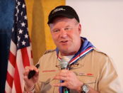](http://blog.scoutingmagazine.org/2015/09/10/lee-berger-discovered-new-species-human-ancestor-south-africa-eagle-scout/)Scientists in South Africa have discovered the remains of a new, humanlike creature. And Lee Berger, the man leading the team, is an Eagle Scout. 

[**See’s Candies makes fundraising delicious and profitable**](http://blog.scoutingmagazine.org/2015/09/09/sees-candies-makes-fundraising-delicious-profitable/) **(SPONSORED)**

September 9, 2015 // [0 Comments](http://blog.scoutingmagazine.org/2015/09/09/sees-candies-makes-fundraising-delicious-profitable/)

[](http://blog.scoutingmagazine.org/2015/09/09/sees-candies-makes-fundraising-delicious-profitable/)**Sponsored Post:** A See's Candies fundraiser is perfect for packs, troops, teams and crews looking to raise money for Scouting activities. 

[**Are these the toughest requirements for each merit badge?**](http://blog.scoutingmagazine.org/2015/09/09/are-these-the-toughest-requirements-for-each-merit-badge/)

September 9, 2015 // [66 Comments](http://blog.scoutingmagazine.org/2015/09/09/are-these-the-toughest-requirements-for-each-merit-badge/)

Each merit badge has at least one doozy — a sufficiently sized hurdle standing between a Scout and the merit badge. These are the toughest requirements. 

[**Neckerchief slides: What’s your go-to look?**](http://blog.scoutingmagazine.org/2015/09/08/neckerchief-slides-whats-go-look/)

September 8, 2015 // [22 Comments](http://blog.scoutingmagazine.org/2015/09/08/neckerchief-slides-whats-go-look/)

[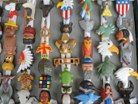](http://blog.scoutingmagazine.org/2015/09/08/neckerchief-slides-whats-go-look/)With these functional accessories, you and your Scouts are limited only by your imagination. What's your go-to look for neckerchief slides? 

[**New Cub Scout leader training available at my.scouting.org**](http://blog.scoutingmagazine.org/2015/09/08/new-cub-scout-leader-training-available-scouting-org/)

September 8, 2015 // [26 Comments](http://blog.scoutingmagazine.org/2015/09/08/new-cub-scout-leader-training-available-scouting-org/)

[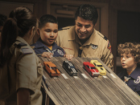](http://blog.scoutingmagazine.org/2015/09/08/new-cub-scout-leader-training-available-scouting-org/)The new, easy-to-access online training for Cub Scouting leaders at my.scouting.org will help you be prepared for your role as a volunteer. 

[**Scout popcorn sales tips for when you’re no longer a little Cub Scout**](http://blog.scoutingmagazine.org/2015/09/07/scout-popcorn-sales-tips-youre-no-longer-little-cub-scout/)

September 7, 2015 // [7 Comments](http://blog.scoutingmagazine.org/2015/09/07/scout-popcorn-sales-tips-youre-no-longer-little-cub-scout/)

[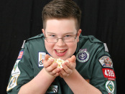](http://blog.scoutingmagazine.org/2015/09/07/scout-popcorn-sales-tips-youre-no-longer-little-cub-scout/)For precious little Cub Scouts, selling Scout popcorn is so easy it's almost unfair. Boy Scouts, on the other hand, need these Scout popcorn sales tips. 

[**How to ask for help as a Cub Scout leader**](http://blog.scoutingmagazine.org/2015/09/07/ask-help-cub-scout-leader/)

September 7, 2015 // [4 Comments](http://blog.scoutingmagazine.org/2015/09/07/ask-help-cub-scout-leader/)

[](http://blog.scoutingmagazine.org/2015/09/07/ask-help-cub-scout-leader/)As a Cub Scout leader, you know the importance of asking others for help. But that's easier said than done. The September 2015 CubCast is here to help. 

[**Check out this month’s cover of Alaska Airlines magazine**](http://blog.scoutingmagazine.org/2015/09/04/check-months-cover-alaska-airlines-magazine/)

September 4, 2015 // [9 Comments](http://blog.scoutingmagazine.org/2015/09/04/check-months-cover-alaska-airlines-magazine/)

[](http://blog.scoutingmagazine.org/2015/09/04/check-months-cover-alaska-airlines-magazine/)Passengers on Alaska Airlines this month are greeted by the image of a Scout on the cover of Alaska Beyond, the Alaska Airlines magazine. 

[**Three Fires Council hosted largest welding lesson, Guinness World Records confirms**](http://blog.scoutingmagazine.org/2015/09/03/three-fires-council-hosted-largest-welding-lesson-guinness-world-records-confirms/)

September 3, 2015 // [7 Comments](http://blog.scoutingmagazine.org/2015/09/03/three-fires-council-hosted-largest-welding-lesson-guinness-world-records-confirms/)

The BSA and the Three Fires Council in Illinois now hold the world record for the largest welding lesson, Guinness World Records officials confirmed. 

[**How four Scouts combined to sell a quarter-million dollars in Scout popcorn**](http://blog.scoutingmagazine.org/2015/09/02/four-scouts-combined-sell-quarter-million-dollars-scout-popcorn/)

September 2, 2015 // [67 Comments](http://blog.scoutingmagazine.org/2015/09/02/four-scouts-combined-sell-quarter-million-dollars-scout-popcorn/)

[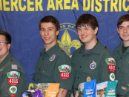](http://blog.scoutingmagazine.org/2015/09/02/four-scouts-combined-sell-quarter-million-dollars-scout-popcorn/)A group of four Scouts in New Jersey has combined to sell a quarter-million dollars in Scout popcorn. We asked them how. 

[**Memories in ink: Inspiring story behind Scouting professional’s BSA tattoo**](http://blog.scoutingmagazine.org/2015/09/01/memories-ink-inspiring-story-behind-scouting-professionals-bsa-tattoo/)

September 1, 2015 // [0 Comments](http://blog.scoutingmagazine.org/2015/09/01/memories-ink-inspiring-story-behind-scouting-professionals-bsa-tattoo/)

[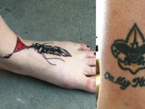](http://blog.scoutingmagazine.org/2015/09/01/memories-ink-inspiring-story-behind-scouting-professionals-bsa-tattoo/)You can see Amanda Smith's passion for Scouting on her skin. The senior district executive from Pittsburgh got a BSA tattoo to honor her late father. 

[**10 ways a Mickman Brothers fundraiser can bring your unit a happy holidays**](http://blog.scoutingmagazine.org/2015/08/31/10-ways-mickman-brothers-fundraiser-can-bring-unit-happy-holidays/) **(SPONSORED)**

August 31, 2015 // [6 Comments](http://blog.scoutingmagazine.org/2015/08/31/10-ways-mickman-brothers-fundraiser-can-bring-unit-happy-holidays/)

[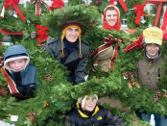](http://blog.scoutingmagazine.org/2015/08/31/10-ways-mickman-brothers-fundraiser-can-bring-unit-happy-holidays/)**SPONSORED:** The Mickman Brothers' Christmas Wreath Fundraising Program is designed to allow Scouts to actively support their activities in a no-risk way. 

[**Extreme Makeovers, Round 10: Eagle Scout project before-and-after photos**](http://blog.scoutingmagazine.org/2015/08/31/extreme-makeovers-round-10-eagle-scout-project-before-and-after-photos/)

August 31, 2015 // [0 Comments](http://blog.scoutingmagazine.org/2015/08/31/extreme-makeovers-round-10-eagle-scout-project-before-and-after-photos/)

This week's batch of 19 Eagle projects includes a climbing structure for goats, raptor cages, a turtle habitat, a brick patio with a koi pond and more. 

[**#SummerofVenturing Day is Aug. 31, so share your adventures**](http://blog.scoutingmagazine.org/2015/08/30/summerofventuring/)

August 30, 2015 // [3 Comments](http://blog.scoutingmagazine.org/2015/08/30/summerofventuring/)

#SummerofVenturing Day, a chance for Venturers from across the country to share photos, videos and stories from their summer adventures, is Aug. 31. 

#### **Blog Contributors**

[Bryan Wendell](http://blog.scoutingmagazine.org/author/bwendell/), an Eagle Scout, is senior editor of *Scouting* and *Eagles' Call* magazines.

 

[Gretchen Sparling](http://blog.scoutingmagazine.org/author/gsparling/) is associate editor of *Scouting* and *Eagles' Call* magazines.

#### **Get Email Updates**

To sign up to receive Bryan’s Blog in your E-mail –

Click the link that appears in every article. Bryan and Gretchen promise never to sell or otherwise exploit your email address. Join 6,162 other subscribers

TRAINING TOPIC

BEING HELPFUL –   
NATIONAL GOOD TURNS

**In November we have a real special opportunity, a chance to get out and help those who live near us and through the reach of the Scouting program – to help people everywhere. – I am speaking about -**

**Scouting for Food  
A National Good Turn**

*Adapted from Circle Ten Council*

**National BSA Good Turns - ORIGIN**

The Boy Scouts of America's Good Turn traces back to American businessman William D. Boyce who was lost in a London fog. A boy offered to take Boyce to the address he wanted and refused a tip, saying he was a Boy Scout. Boyce's curiosity was aroused. He later had the boy take him to Scouting's British founder, Lord Baden-Powell. From this chance meeting, the Boy Scouts of America was born.

Among many references to the Good Turn in BSA literature is this comment from the Boy Scout Handbook: "To people who know about Scouting, the daily Good Turn is one of the finest features of our movement. The record of Good Turns, small and large, that have been done by Scouts since the day Scouting was founded is truly impressive."

**NATIONAL GOOD TURNS**

The following list is compiled from the BSA's historical fact sheet and from Bob Peterson's book The Boy Scouts, An American Adventure. There is some inconsistency, and, on many of the earlier Good Turns, there is a certain degree of uncertainty as to whether the event was planned as a national program or just developed that way. In any case, here is a chronological listing.

**1912-**The first Boy Scout Good Turn promoted a "Safe and Sane Fourth of July."

**1917**-The day after war was declared on Germany, under the slogan "Every Scout to Feed a Soldier," BSA members were urged to plant vegetable gardens. In two plant-growing seasons, 12,000 Scout farms were established. At the same time, the BSA pledged to aid the American Red Cross and promised cooperation with the U.S. Navy by organizing Scout coastal patrols to watch for enemy ships. The BSA's most significant service during WWI was the sale of Liberty Loan bonds to help finance the war effort. Five bond drives were held, and, in each case, Scouts were called upon to follow up the regular canvas by adult volunteer salesmen. They sold a total of 2,238,308 bonds worth either $147,876,902 or $355,000,000, depending on the information source. Scouts also sold war savings stamps to a value of either $3 million or $53 million, again depending on the source. During WWI Boy Scouts collected peach pits and nut hulls which were burned to make charcoal for gas mask filters. More than 100 train carloads were gathered. Another WWI Good Turn involved a national census of standing black walnut trees. Its wood was prized for gunstocks and airplane propellers. The BSA located 21 million board feet, or enough to fill 5,200 railroad cars. Scouts served as dispatch bearers for government agencies and delivered 30 million (or 300 million, depending on source) pamphlets during WWI. Scouts also aided the American Red Cross and the United War Work Committee.

**1934**-President Roosevelt called on Boy Scouts to collect household furnishings, clothing, and other items to help the needy during the Depression. More than 1.8 million articles were collected. During WWII the BSA responded to 69 requests for help from the government. These requests included: 1941-Scouts distributed 1.6 million defense bonds and stamp posters; began the collection of aluminum and waste paper; conducted defense housing surveys; planted victory gardens; distributed air-raid posters; cooperated with the American Red Cross; and, by agreement with the Office of Civil Defense Mobilization, formed an Emergency Service Corps composed of older Scouts who served in three capacities: messengers, emergency medical unit assistants, and fire watchers.

**1942**-Scout projects included: delivery of millions of war-bond pledge cards-it was estimated they were indirectly responsible for sales of $1.8 million worth of bonds and stamps; collection of a vast amount of rubber, primarily old tires, estimated at either 5,898 tons or 30 million pounds; and continuation of scrap and paper drives. During the first drive, Scouts collected 5,000 tons of aluminum; other sources added another 17,400 tons of tin cans and 20,800 tons of scrap metals.

**1944**-Boy Scouts were sent to collect milkweed floss as a substitute for the kapok used in life jackets-total collection was 750 tons. An estimated 184,000 victory gardens were planted by Scouts. An estimated 126,000 Boy Scouts helped farmers with their harvests. The largest single war-effort project conducted by the BSA was the 1945 General Dwight D. Eisenhower Waste Paper Campaign. More than 700,000 Boy Scouts and Cub Scouts gathered 318,000 tons of paper; this brought the total paper collected during WWII to more than 590,000 tons. Scouts collected 10 million used books for military personnel.

Scouts collected 7,000 tons of used clothing that was distributed to refugees in Europe and China.

**1950-51**-Two million pounds of clothing for overseas relief was collected at the request of the American Council of Voluntary Agencies for Foreign Service and the United Nations.

**1952**-More than 1 million boys went house-to-house and placed 30 million Liberty Bell doorknob hangers and a million posters (in businesses) to remind citizens to vote in the presidential election. Scouts also cooperated nationally in securing blood donor pledges, collected clothing for worthy causes, distributed seeds for Asia, and aided in conservation projects and civil defense.

**1954**-A National Conservation Good Turn involved the distribution of 3.6 million copies of a conservation poster. In parks, rural areas, and wilderness areas, Scouts planted 6.2 million trees; built and placed 55,000 bird-nesting boxes; and arranged 41,000 conservation displays.

**1956-**The second national get-out-the-vote campaign was launched with 36 million doorknob hangers and 1.4 million posters distributed.

**1958-**National Safety Good Turns were conducted. The BSA delivered 40 million emergency handbooks prepared by the Office of Civil Defense Mobilization. Also, 50,000 posters were placed in post offices.

**1960**-The third national get-out-the-vote campaign was conducted.

**1970**-Project SOAR (Save Our American Resources) was initiated as an ongoing BSA project. It's estimated that during the year, 60,000 BSA units took part in SOAR-related conservation projects.

**1980-**Scouts distributed fliers urging support of the national census.

**1986-**An estimated 600,000 youth members distributed 14 million brochures to families informing them of the need for donated human organs and tissue and urging them to make a commitment to donate. Millions of other homes were reached through publicity and other promotional efforts.

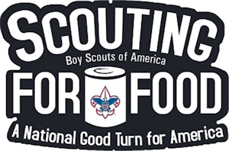

**1988-**The first Scouting for Food collection was completed. One million Scouts collected an estimated 65 million cans of nonperishable food.

**1989-1991**-The continuing Scouting for Food collection resulted in a combined total of an additional 209 million cans of food for people in need.

**2000** - The Boy Scouts of America committed itself to donating 200 million hours of community service as part of its support for "America's Promise" campaign.

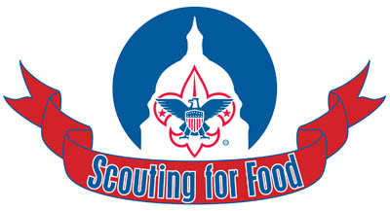

**What is Scouting for Food?**  
A Cub Scout promises to "give good will" and a Boy Scout promises "to help other people at all times." What better way is there to show our Scouting Spirit than by participating in the annual Scouting for Food drive?

Over the years, the Local Councils of the Boy Scouts of America have worked diligently to improve our communities and the welfare of the families who reside in these communities. One very special project begun recently has grown to be extremely important to many agencies, families and individuals. This "Good Turn" Event is known as the **Scouting for Food Campaign.**

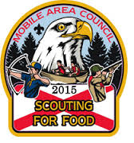

The mission of the project is to have all Scouts participate in the collection of food items to be given to needy people and families within the communities of the council. The goal is to have 100% participation from all units in this most important community outreach program. Cub Scout Packs, Boy Scout Troops, Varsity Teams, and Venturing Crews do make a difference when they support and participating in this annual Good Turn.

***In my area, Channel 6 WPVI, the local ABC affiliate has sponsored this drive and helped with publicity, placing food collection containers in stores and other stuff. The publicity helps the spread the word and increase participation. Commissioner Dave***

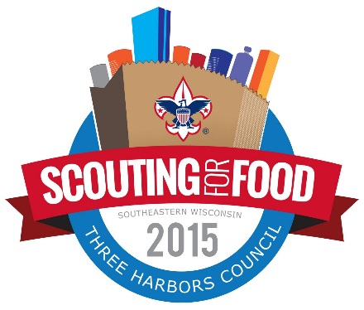

**How can you help?**

You can distribute and then collect the bags of food left on the porches and steps, from around your neighborhood.

Man collection sites

Help unload food drive items at the Network of Ministries, Salvation Army sites or Food Bank locations.

**CONTACT your council or district Food Drive chairmen for more details and a listing of assignments available.**

**More ways to be HELPFUL –**

# **DEN & PACK SERVICE PROJECTS**

*Steve Leth, Garden State Council*

***I thought this was a perfect time to run this article on Service projects as we get ready for the Holidays and we prepare to help others (e.g. Scouting for Food) CD***

. Along the trail of Scouting, we promise…to “HELP OTHER PEOPLE”, and that, “THE CUB SCOUT GIVES GOODWILL”. It is important for a Cub Scout to gain an understanding and experience the satisfaction in helping those less fortunate than himself.

Do the Cub Scouts really know the meaning of:

*“ I \_\_\_\_\_\_\_\_\_\_\_\_\_\_\_\_\_\_\_, promise to do my best*

*To do my duty to God and my country,*

*To help other people*

*To obey the Law of the Pack.”*

“To help other people” not only is said each time the Cub Scout Promise is recited, but should also be lived daily by all Scouts.

By organizing home and community service projects, you will be giving your Scouts the opportunity to “reach out” into a wider community, making them feel a part of their community, and to recognize the importance of good citizenship. Your pack could select one or more service projects to work on throughout the year. Thanksgiving and Christmas are common service project times of the year, but the need exists year round. Collect food and clothing in your neighborhood to donate to a shelter for the homeless; families need warm weather clothing, too. Perhaps your pack could adopt a family for a year; help them with their food, clothing needs, and presents during the holidays.

As stated on the BSA Web Site, <http://www.goodturnforamerica.org/> - “From barn raisings to soup kitchens, ordinary Americans have always made an extraordinary difference in the lives of their neighbors and in their communities by lending a helping hand. Today, America needs the service of its citizens more than ever. Hunger, lack of adequate shelter, poor health—these are issues that affect all of us. The Boy Scouts of America believes that we can do something about these issues—if we work together. That's why we've created Good Turn for America. Good Turn for America is a collaboration with The Salvation Army, Habitat for Humanity, American Red Cross, and thousands of other community organizations that focuses the power of volunteerism on these important community issues.”

Packs can arrange to do on going projects for which responsibilities can be rotated among the dens. Volunteer to pick up trash and litter once a month around your neighborhood or church; each den takes a turn. Organizations that serve food to the homeless on a regular basis may need volunteers as servers, or for bussing tables; pick one day a month with each den taking a month to serve.

Your den could provide entertainment and or companionship to the elderly in the nursing homes; wear costumes and present a skit or sing a few songs. Give a puppet show to boys and girls at the children’s hospital. Collect magazines and donate them to nursing homes or hospitals; gather games, books, and puzzles to take to a day care center. Rake leaves for an elderly couple in your neighborhood.

One great way to encourage the Scouts to “Do a good turn daily” is for you to set a good example at den and pack meetings through your words and deed. When the boys see the adults around them picking up the trash after refreshments at the pack meeting, or stopping to help someone, they’ll feel the need to repeat your lead.

Before beginning a service project two things are essential.

* Consider the boy’s age.
* Regardless of age, how mature are they?

You must have sufficient leadership, two deep obviously. Decide when you will be doing your service project; in the den meeting or on a weekend. Requiring every Scout to get to the location on their own usually means a parent has to come and stay giving you plenty of adults to help.

When you are ready to pick out a project, don’t do it alone.

Get the Scouts involved in decision making. Give them a few ideas and let them choose democratically.

Make contact with organizations and **GET PERMISSION**.

Set a date in advance and inform parents.

For safety, if parent is not present at service project, get a signed permission slip.

If service project is not for the chartered organization you are with and you must travel. **GET A TOUR PERMIT.**

Follow through with your plans.

Limit the awards or recognition to a verbal thank you or appreciation, or at most, write it up in the newsletter. Credit can be given in their Scout handbooks. Remember keep it simple. Boys should learn that the true reward is the feeling you get when you help.

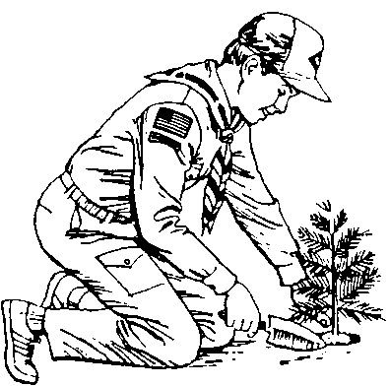Service, best exemplified by the daily Good Turn, has long been a tradition in Scouting. Good citizenship is best taught by service in action. To get the most Cub Scouting has to offer, boys should have opportunities to take part in den and pack service projects. This is one of the best ways to show boys that helping other people is not only beneficial to others, but is fun and rewarding for themselves. They will experience a warm feeling that comes from giving service to others.

Below are some suggestions for service projects that Cub Scouts will enjoy:

* Organize a spring cleanup.
* Assist a person with special needs or an elderly person in the neighborhood. Rake their yard, wash widows and screens, run errands.
* Conduct a paint and cleanup project at the building and on the grounds of the chartered organization.
* Paint drums or other containers with lids for use as litter containers.
* Adopt a stream. Clean debris and litter from a section of a nearby stream.
* Send a care package to American troops.
* Man a water station at a fun run.
* Help pack Red Cross Friendship boxes.
* Clean up the telephone poles of old signs.
* Donate a tree for Arbor Day to a park.
* Adopt a police or fire station and send Thank you's and goodies.
* Do a fire prevention program for a day care center.

These are only a few ideas for service projects. You'll find many more in Cub Scout and Webelos Scout Program Helps and other Scouting literature.

**Also, go to** <http://www.goodturnforamerica.org/> **and find others. Be sure to log your service hours here so everyone can see the good things our Scouts are doing.**

Cub Scouts like being helpful. Scouting has always emphasized the Good Turn, and boys are never too young to start doing things for others. Scouting can offer one antidote to the many messages focusing on self-interest that boys receive from the media and the culture in general.

There are many ways to be helpful. Some service projects are "behind the scenes," like cleaning up the church parking lot or making gifts for people the boys will never see. Other services are provided directly to individuals. Both forms of service are useful and should be encouraged.

**Putting Cubs in Action:**

*Alice, Golden Empire Council*

**Set a goal to have at least two outdoor activities each month for your den.**

**Move your den meetings to a park for the month.** Let the boys come up with ideas on how to make any changes needed – how can we keep papers from blowing away? What kind of treats can we choose? Where can we sit – what if the grass is wet?

**Challenge boy, dens and family to do something outdoors each day –** Set up a table at the pack meeting where they can share what they did.

**Collect ideas about outdoor activities and where to do them in your community** - Share the information with den and pack families, local libraries, TV lifestyle boards and shows.

**Have families without space for a traditional garden? Make window boxes** – they can be planted with a mix of veggies and flowers.

**Take advantage of experts -**  Bird Watchers, Park Rangers, Local hiking guides can all provide a GREAT den meeting – just meet them at the site!

**Set up a pack obstacle course –** Each den is assigned a segment – gather sports cones, old tires, ropes, boxes, all kinds of materials - when the entire obstacle course is ready, everyone gets to take a turn going through the entire course – We did this several times at Herms District Day Camp, and the boys loved it – they wanted to do it again and again!

**Go on a hike –** be creative and enjoy the season. You can go on a “Sound” hike, listening for the sounds of nature in Spring, looking for emerging plants and animals, a trash-collecting hike, an eye-spy hike where the boys have a list of things, either natural or man-made, to look for. Don’t collect natural items – just have boys stop and raise their arms whenever they find something to share!

**Have a Kite Day** – make sure that everyone can have fun – provide materials and instructions for some simple mini-kites that even young siblings can enjoy.

**Have a Pack Exchange of Outdoor and Sports Equipment** – or set up an equipment lending resource – set up guidelines for everyone to follow.

**Have a pack or den bike rodeo or check-up –** Review the rules of bike safety and the most common causes of accidents, check every bike for maintenance, safety and correct sizing, make sure everyone has a safe bike helmet that fits them – BEFORE boys get out on those bikes!

**Conduct a Service Project -** Here are some ideas -

* **Pick up the litter from a park or public place.**
* **Plant a tree for your charter organization.**
* **Build and set out bird houses or feeding stations in backyards, parks and other open spaces..**
* **Check with local organizers for Creek Week or Beach Clean-up activities in your area –** boys, dens or families can help clean up waterways – creeks to oceans – and often get a free T-shirt, lunch, admission to a local park or museum – and hours towards Good Turn for America!
* **Check with local parks or regional park districts to find a service project -** they often have a wish list of trails that need clearing, tables and benches that need painting, etc.
* **Do a small scale project –** Take boys with gloves, sunscreen, close-toe shoes and garbage bags and spend some time picking up trash – my den collected two trash bags in 20 minutes on one block! End with washing hands and enjoying a treat.
* **Help people decorate for the holidays –** an elderly neighbor could use help in setting up Christmas, Hanukah, or other holiday decorations. Maybe clearing and preparing the house, or even in planning what they want their display to look like.
* **Give a hand to Senior Gleaners or a local food bank –** Pack families that have surplus fruits or spring vegetables can have their boys “glean” food to deliver to Senior Gleaners. In rural areas, you can make arrangements with local farmers to glean fields and take the food products to Senior Gleaners, a local food bank, a homeless shelter or a service center for an organization like Salvation Army.
* **Help Habitat for Humanity –** BSA is a partner, and has a list of ways even Tigers, Wolves, Bears and Webelos can help – by making a welcome basket or stocking the pantry for a new homeowner, helping to landscape or plant trees, making wooden doorstops, key holders, picture frames or window boxes. And sometimes, you can even use scrap lumber from the site! Go to: [www.scouting.org/FILESTORE/marketing/pdf/02-842.pdf](http://www.scouting.org/FILESTORE/marketing/pdf/02-842.pdf)
* **Check out Jump Rope for Heart or Hoops for Heart** – <www.jumprope4heart.org>*. (Or other charitable fund raising events)* Many schools across the country participate in jumping rope or making hoops, getting sponsors, and having a lot of fun while being physically active. Click on the link to find out if local schools are participating and encourage your boys and families to participate.

**Conservation Projects**

* Build and set out bird boxes, feeding stations, birdbaths in backyards and parks.
* Plant shrubs to provide cover for wildlife.
* Plant grass seedling on bare ground in parks, schools or church yards to prevent erosion.
* Plant tree seedlings for shade, landscaping or ground cover.
* Make window boxes, and plant flowers; or plant tubs with trees or shrubs.
* Plant and maintain a flower garden in a park.
* Make litter bags for family¡¥s and neighbor¡¥s cars and boats.
* Make Outdoor Code posters to put up in school and explain the Code to others.
* Make a conservation display for school.
* Make anti-litter posters.
* Collect insects and find out which ones are harmful to farm crops and trees.
* Check with local Conservation office for a pack project.
* Pick up litter and build a litter scarecrow to display to the public.
* Collect glass, aluminum and paper for re-cycling.
* Adopt a park, lake or roadside rest and keep it litter free on a long-term basis.
* Have a "Fight Litter" parade with boys carrying signs urging the public to "Stash the Trash" or "Don't Be a Litterbug."

## **GOING HIKING – PUTTING CUBS IN ACTION!**

*Catalina Council*

What is the one of the first things boys want to do when they get outside? EXPLORE! What's one of the best ways of exploring? Go take a hike!

Now, we don't mean the kind of hike where you are lugging a 50 pound pack up a mountainside. Leave that for when the boys become Boy Scouts. We're talking about an easy, fun morning or day activity that everyone can enjoy. The hike does not even have to be on a trail. It can be along a city street. Bring the boys' mothers, fathers, sisters and brothers along! The more the merrier, IF you make it interesting. Here are some ideas:

**Hold the Front** The leader is followed by Cub Scouts in single file as they hike along the trail or roadside. The leader asks questions about things observed, such as "What is the name of that bird?" If the first Cub Scout in line answers correctly, he stays in his position. If he cannot answer, he moves to the end of the line and the next boy tries to answer the question. Each player who fails to give the correct response goes to the rear of the line. The object is to stay in the number 1 position as long as possible.

**I Spy** The leader says, "I spy a robin." All of the Cub Scouts who see the robin may squat, and the rest remain standing. The leader then points out the robin or asks one of the squatting Cub Scouts to do so. The group then continues hiking until another object of interest is seen.

**Follow the Odor (A Backyard Hike)** A few minutes before the hike begins, mark the trail by rubbing a large onion on different objects, such as trees, grass, bushes, swing set, light pole, etc. These should be located fairly close together. Explain to the boys that they are to follow their noses to find their way along the trail. Afterwards, discuss how animals use odors for finding food and marking their territories.

**Color Hike** Give each Cub Scout a list of colors to try and locate on the hike. The items can either be collected or simply noted. The boy who successfully locates all colors on the list is the winner.

**Sealed Orders** Give the den a set of sealed directions, with a new one to be opened at each spot along the way. Use simple directions, such as "Go north 50 paces and look under three rocks piled below the big scrub oak three." Under the rocks, they find the next note, directing them to "Go east and look in the tire swing on the left." Make each clue challenging, but not to difficult.

**Stop, Look, and Listen Hike** Hike for 5 minutes (or a certain number of steps). Stop, look, listen and then write down all that you see and hear. Make several different stops. The Cub Scout with the longest list wins.

**Animal Home Hike** Look for animal homes and discover the different ways they are built. Perhaps you will see a spider web, an insect gall, or a bird nest. You might even find the front door of some animal’s underground home.

**Take a Hike**

*San Gabriel Valley, Long Beach & Verdugo Hills Councils*

* NATURE HIKES - For observation, for listening.
* TREASURE HIKES - A trail laid out with treasure at the end.
* HISTORICAL HIKES - To historical landmarks.
* SNOOP HIKE - Explore, be aware, notice oddities, be snoopy.
* CRAFT HIKE - Gather nature items for a craft project.
* BABY HIKE - Look only for 'babies'. Make a list. Birds, fern, leaf.
* DETECTIVE HIKE - Spot and list all evidence of man in nature, even litter, which can be picked up and put in the litter bag you have with you.
* HEADS-TALES HIKE - Toss a coin each time you reach a crossroads. Turn left if the coin says heads, turn right if tales.
* BREAKFAST HIKE - Reach the destination in time to see the sunrise, and then cook breakfast.
* RAIN HIKE - Go dressed in raincoats and boots to observe nature in the rain.
* COLLECTING HIKE - Collect whatever your family show an interest in: rocks, leaves, shells, seeds, fossils, insects, oddly shaped sticks.

Hiking Along

*Baltimore Area Council*

Stop and Spot   
*While hiking, the leader stops and says: " I spot a \_\_\_\_\_\_," naming a familiar object. Everyone in the group who sees the object will raise his hand or sit down. This sharpens the skill of observation.*

Obstacle Course   
Some boys have never climbed a tree, walked a log, gone through a fence, or chinned themselves on a tree branch. To give them this experience, pick a trail which will provide such an obstacle course. Don't destroy property or trespass.

Penny Hike   
This is an adventure! Set a time limit. Start walking until you come to the end of the block or a fork in the trail. Stop and flip a coin; heads, left; tails, right. Boys can take turns flipping the coin. Keep a record of the turns (you can reverse the directions to get back to your starting point).

Memory Hike   
This game is played after a hike or a trip to the zoo or park. During the outing, tell the boys to observe everything very carefully so they can make a list of all that they have seen. Just after the outing, hand out paper and pencils and have the boys make their lists. See who was most observant.

Nature Hiking Games

1. Leaf collecting contest - most different ones
2. Matching leaves
3. Hike - use pebbles for counters. Agree on things to be discovered. Each discovery counts a point and counter is thrown away. First one out of counters wins.

**Here are some examples:**

Each specified bird 1 point

Each specified snake, insect, flower 1 point

Each specified tree 2 point

Each rabbit hole 2 points

Nest of (?) Bird 2 points

Tree struck by lightning 2 points

Cow or horse 1 point

Each animal track 2 points

**Take a Hike**

*Utah National Parks Council*

There are many kinds of hikes use your imagination or try:

* **Service Hike –** pick up trash along the way.
* **Historical Hike** - Go to such a place in your area and learn as you go.
* **Heads or Tails Hike –** Flip a coin at each cross road to decide the next direction.
* **Nature Hike –** Give the boys a checklist of things to look for. Like animal tracks, cloud formations, wildlife, vegetation,
* **Mini Hike** – Give each boy a magnifying glass and have him hike on his knees, examining plants, rocks, grass and insects along the way.
* **Stop, Look and Listen Hike** – have the boys stop every 100 steps and write down all that they see and hear.
* **Homes Hike** – Look high and low see how many homes you can find (webs, nests, holes).
* **Golf tee Hike –** Toss a golf tee in the air – hike in the direction indicated by the pointed end of the tee.
* **Rain Hike—**Don’t let rain scare you away. Dress the part and be off!

## **SPECIAL OPPORTUNITIES**

With the start of the Cub Scout Adventure Program, the requirements for awards that say things like, "Complete Wolf Achievement 7," need to be revised to send you to the new Adventures. We will be highlighting these changes here over the next few months.

To get a complete list now, you can go to <http://www.scouting.org/scoutsource/programupdates.aspx> of all the changes. Or you could go to [www.usscouts.org](http://www.usscouts.org) and get the changes for a specific award. All these changes have been described in previous issues of Baloo's Bugle.

## 

## **MESSENGERS OF PEACE**

*from* [*http://scouting.org*](http://scouting.org)



**Program Overview**

Launched in September 2011, Messengers of Peace is a global initiative designed to inspire millions of young men and women in more than 220 countries and territories to work toward peace. Using state-of-the-art social media, the initiative lets Scouts from around the world share what they’ve done and inspire fellow Scouts to undertake similar efforts in their own communities. The initiative is inspired by the World Scout Committee, administered by the World Scout Bureau, and driven by youth volunteers worldwide.

**Defining Peace**

In terms of the MOP initiative, peace encompasses three dimensions:

1. The personal dimension: harmony, justice, and equality
2. The community dimension: peace as opposed to hostility or violent conflict
3. Relationships between humankind and its environment: security, social and economic welfare, and relationship with the environment

Any Scout or Scouter who participates in a project that has had a significant impact on the community in any one of the three dimensions above can qualify as a Messenger of Peace.

**Submitting Projects**

Submitting MOP-related projects is easy for BSA units. All they need to do is check the Messengers of Peace box when entering a service project through the Journey to Excellence website: <http://www.scouting.org/Awards/JourneyToExcellence>. Doing so will add the project to the map on the Messengers of Peace website, <http://scoutmessengers.com> and will generate a unit certificate.

**Recognition Item**

Any Scout or Scouter who participates in a qualifying project is eligible to wear a Messengers of Peace ring patch around the World Crest on his or her uniform. To purchase these ring patches, a unit representative should take the unit certificate to the local Scout shop or council service center.

**Messengers of Peace Service Project Ideas**

Peace is more than the absence of war. It encompasses harmony between individuals, between communities, and between humankind and the environment. A Messengers of Peace service project is defined as any project that touches on one of these dimensions of peace:

1. The personal dimension: harmony, justice, and equality
2. The community dimension: peace as opposed to hostility or violent conflict
3. Relationships between humankind and its environment: security, social and economic welfare, and relationship with the environment

Here are sample project ideas:

**Personal Dimension**

* Host a holiday party for children of prison inmates.
* Collect books and magazines for inner-city schools.
* Conduct entertainment programs, including skits and plays, at a nursing home.
* Make and donate gift boxes to be distributed by Feed the Children.
* Assist organizations that provide home maintenance services for those in need.
* Clean a Habitat for Humanity house before the family moves in.

**Community Dimension**

* Create a community prayer garden.
* Replace graffiti with peace-related murals.
* Host conflict-resolution workshops in a local school.
* Plan a sports tournament that brings together kids from different segments of the community.
* Serve as “victims” for a county EMT or first responders training course.
* Assist in the packaging of medical supplies for developing countries.

**Environmental Dimension**

* Clean up a campground, a local park, a river, or a school parking lot.
* Assist with a shoreline-restoration project.
* Collect and dispose of household chemicals, batteries, and other potentially dangerous waste products from the residences of shut-ins.
* Remove invasive species and plant native trees in a park.
* Volunteer at a community recycling center.
* Clear brush from fire buffer zone.

For tips on conducting successful projects, visit [www.scouting.org/scoutsource/Awards/JourneyToExcellence/unit\_tips.aspx](http://www.scouting.org/scoutsource/Awards/JourneyToExcellence/unit_tips.aspx).

## **PROGRAM UPDATES**

Be sure to check out National's website   
for the latest on the   
Adventure Program Changes -<http://www.scouting.org/programupdates.aspx>

**What Has Happened / Is Happening -**

**Position-Specific In-Person Training Guides Available Now!** The training guides for

* [Den Leader](http://www.scouting.org/filestore/training/pdf/515-215.pdf) (<http://www.scouting.org/filestore/training/pdf/515-215.pdf> ),
* [Cubmaster/Assistant Cubmaster](http://www.scouting.org/filestore/training/pdf/511-503_WB.pdf) (<http://www.scouting.org/filestore/training/pdf/511-503_WB.pdf> ), and
* [Pack Committee](http://www.scouting.org/filestore/training/pdf/511-504_WB.pdf)  (<http://www.scouting.org/filestore/training/pdf/511-504_WB.pdf> )

are now available on Scouting University. You can access them via the adult training page of [www.scouting.org](http://www.scouting.org) .

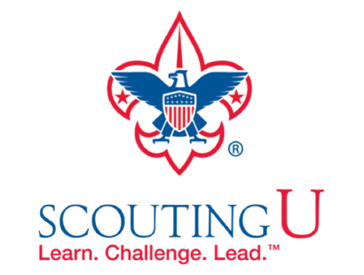

The online training for Den Leaders, Cubmasters, Committee Chairs and members, and Chartered Organization Representatives has been totally updated with help from volunteers from around the country. The new training is divided into shorter, more targeted modules so leaders can get the training they need, in the order they want, any time they need it. The new training is organized around the learning needed prior to the first meeting, in the first 30 days, and to be position-specific trained. This new training was developed to be implemented in conjunction with the BSA’s new learning management system. Keep an eye on MyScouting Tools (logging in through MyScouting.org ) for more information.

**A Typical Learning Plan has several parts –**

Here you can see the three parts of the CM Course -

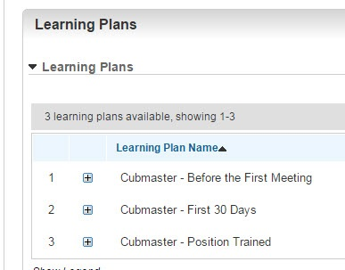

Each of these three parts is broken down into "bite sized" chunks:

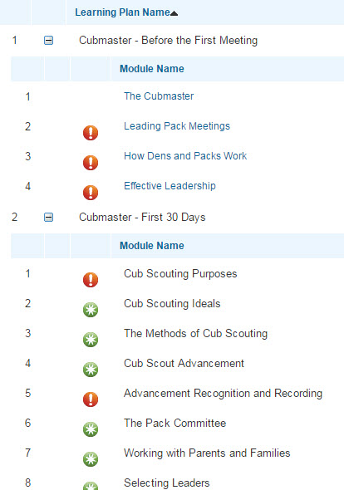

**Go check it out and get your   
people trained!!!**

**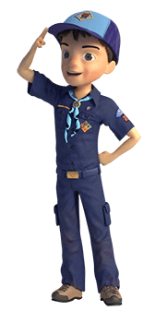**

program updates banner

# 

**TRACKING SPREADSHEETS FOR THE CUB SCOUT ADVENTURE PLAN**

* Tracking Spreadsheets are posted on the USScouts Advancement webpage ([www.usscouts.org](http://www.usscouts.org)). There are be links to them from other places on the site. These spreadsheets are similar in construction and user interface as the existing spreadsheets. The spreadsheets have be tested by the developer of the current spreadsheets and he said they are so good he sees no reason to develop others!!
* Utah National Parks Council has Excel spreadsheets posted for all the new Adventure Plan requirements on their Akelas Council Blogspot. [www.Akelascouncil.blogspot.com](http://www.Akelascouncil.blogspot.com) . Check them out.

The Advancement Excel Spreadsheet workbooks are distributed to Scouters for **FREE.**

**PLEASE** **do not download the files from either site to email or send them digitally to others.** They are for your personal / pack use only. If you would like to share these files with others, please copy / send the link to them and send them to the site so they can print off their own. We would love to have everyone that would like a copy to come here to get their own copy absolutely free. Both USScouts and Utah National Parks Council receive Ad money to help keep our websites open based on the number of people visiting our sites. Please help us maintain the sites by encouraging others to visit to obtain the needed files.

**THEME & PACK MEETING IDEAS**

***I used Hometown Heroes as the basis of this section – CD***

**GATHERING ACTIVITIES**

***Note on Word Searches, Word Games, Mazes and such –*** *In order to make these items fit in the two column format of Baloo’s Bugle they are shrunk to a width of about 3 inches. Your Cubs probably need bigger pictures. You can get these by copying and pasting the picture from the Word version or clipping the picture in the Adobe (.pdf) version and then enlarging to page width.* ***CD***

**Pack Gathering Activities.**

*2011-2012 CS RT Planning Guide*

A successful, planned gathering activity will get a pack meeting off to a good start. A good gathering activity has pack members and parents interacting with each other. They should require minimal preparation, be fun for the boys, and can be enjoyed by the entire family. Since the Cubmaster is busy preparing for the pack meeting, other members of the pack should lead the activity. This is a great opportunity to begin involving parents who are not in a formal leadership position to help with something. Gathering activities may be found in the Den & Pack Meeting Resource Guide, the Den Chief Handbook, the Cub Scout Leader How-To Book, Group Meeting Sparklers, and Boys’ Life. Plus the monthly Cub Scout roundtables.

**Helping Hands**

*Sam Houston Area Council*

* Give each boy a piece of paper with “HELPING HANDS” written across the top of it.
* Set a time for 5 minutes and have each boy write as many ways as he can think of for him to be helpful to others under each letter.
* The only words he can use must start with the letter.

**Just One Word**

*Utah National Parks*

You'll really have them at a loss for words with this one! Cut out the following letters from magazine or newspaper headlines (or draw black letters on paper and cut them out,)

**J N O O R S T U W**

Place the letters in any order on the floor or table (or any flat surface), Ask the players to rearrange the letters to spell "just one word".

If/when they give up, rearrange the letters to spell the three words, "Just One Word."

**Cub Scout Word Search**

*Capital Area Council*

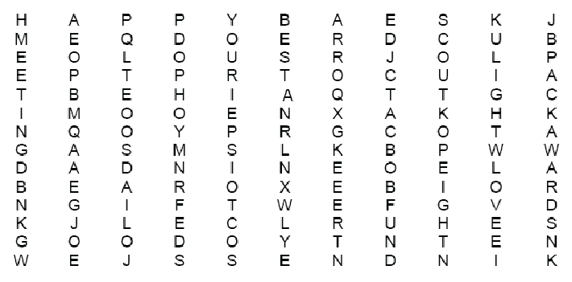

Find the following words in the puzzle above. Words may be diagonal, horizontal or vertical. Words may be forwards or sdrawkcab.

mom best kindness

happy arrow cub

fun of scout

meeting light snow

dad gift boys

wolf pack bobcat

Webelos helping den

tree other awards

do people ox

your nine send

**The Bean Game**

*Pam,   
from the CS program Enrichment Conference at Philmont*

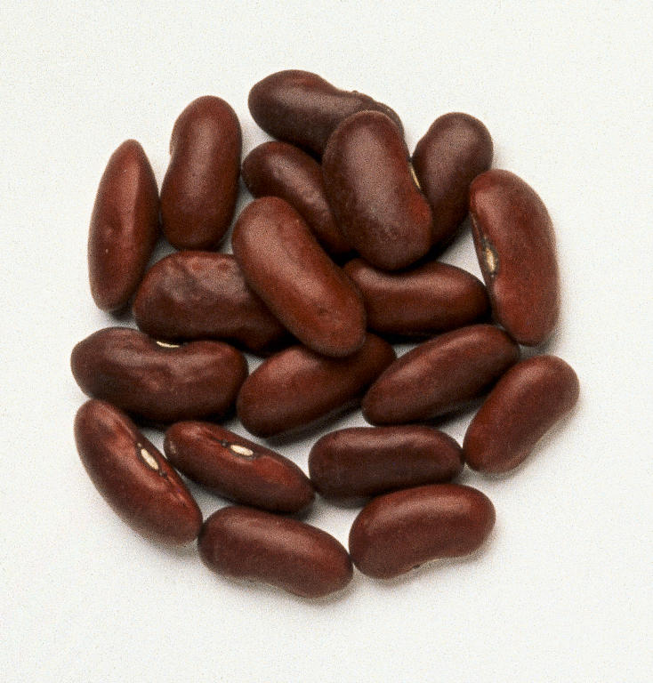

**Set Up:**

Place about 2 dozen dried beans (or large dried seeds to keep it theme related) in a snack or sandwich bag

Have a bag for each Cub Scout

**Object:**

To balance beans on the back of your hand

The person who can balance the most is the winner

**Instructions:**

*These are written for a right hander, reverse for a lefty*

* Pick up one bean with your left hand
* Transfer bean to your right hand
* Place bean on back of left hand
* While still balancing bean on back of left hand, pick up another bean with your left hand
* Transfer bean to your right hand
* Place third bean on back of left hand with first two beans
* Keep going (repeating) until one or more beans fall off your hand

**Being Helpful**

*Alice, Golden Empire Council*

**Have a display and information about this great idea.** Encourage pack families to share with neighbors, or with a local food bank; consider joining with the Garden Writers Association Foundation –go to: [**http://gardenwriters.org/gwa.php?p=index.html**](http://gardenwriters.org/gwa.php?p=index.html)

**Invite everyone to bring some “Seeds” of a kind idea to share with everyone –** Service project ideas, information about how to help provide food to others through Senior Gleaner projects, or Community Garden projects.

**Helpful Word Search**

*Baltimore Area Council*

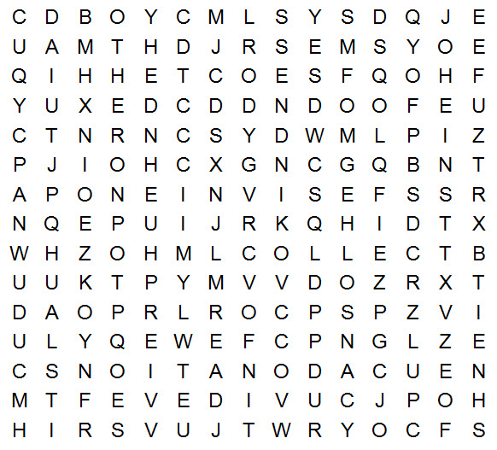

**Find the following words concerning being helpful in the grid.**

CANS CLOTHING COLLECT

HELP DONATIONS FOOD

COMMUNITY NEED KINDNESS

OTHER PEOPLE SEEDS

**Be Thankful and Helpful**

*Baltimore Area Council*

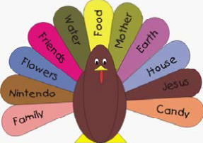

We all need to be reminded now and again to show gratitude for the many things we have. And for ideas of things to share to be helpful to others. This easily assembled turkey can help us remember the many things we enjoy.

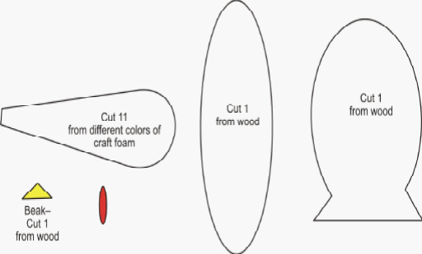

Cut the body from wood, paint and assemble it ahead of time As each family comes in have them cut out and write what they are thankful for on a foam tail feather. Present the turkey to your sponsoring organization for everyone to enjoy.

**OPENING CEREMONIES**

**OUTDOOR CEREMONY HINTS**

*Catalina Council*

Ceremonies are important, even in the outdoors. Outdoor pack activities usually call for an opening and closing ceremony (or closing campfire). Any outdoor pack activities which take the place of regular pack meetings should also include advancement ceremonies so awards can be presented promptly.

Remember these things when planning outdoor ceremonies:

* **Weather -** It is difficult to keep candles lit in winds or light rain. Have a backup plan with some type of protection*. New battery powered LED candles are excellent and simulate flames very well.*
* **Acoustics -** The wind sometimes carries voices in the wrong direction. Make sure the speaker can be heard.
* **Natural Surroundings -** Make the most of the surroundings to furnish background. Lakefront or open areas in the woods make good ceremony sites.
* **Length -** Make ceremonies short, especially if the audience is standing.
* **Flag -** Be certain the U.S. flag is secure. A normal flag holder will not be adequate in winds. Insist on respect for the flag, indoors or outdoors.

**10 Essentials Opening**

*Chief Seattle Council*

Cub scouts come in huffing and puffing, wearing backpacks.

**ALL:** (Remove packs) “Welcome to Pack Night!!! We've got the stuff needed to get our **Cubs in Action**”

*They unpack the appropriate items   
from the packs as they say:*

1. We’ve got some first aid for your Cub Scouting woes. (first aid kit)
2. We’re going to whistle up some exciting action tonight…(whistle)
3. Quench your thirst for fun and action…   
   (water bottle)
4. And give you some food for thought.   
   (granola bar)
5. We’ve got some bright ideas…(flashlight)
6. To help you map out your actions… (map)
7. And give you some direction. (compass)
8. As a matter of fact, you could say we’re all fired up. (matches)
9. We’re ready for Cub Scouting action and adventure, rain (rain gear)
10. Or shine. (sunscreen).
11. We can see you’re warming up to our Cubs in Action theme. (jacket/spare clothes)
12. And we think you get the point.” (pocket knife)

**CA/DL:** This opening Ceremony is based on the 10 essentials everyone should have on every hike or camping trip, so that if they get lost, they can take care of themselves until they are found.

**CM:** *Intro Pledge of Allegiance*

**Planting Seed of Helpfulness in Our Cubs**

*Alice, Golden Empire Council*

**Background -**

* A picture made by boys showing good soil, with rocky, dry soil along one side; several “seeds” drawn on paper
* Watering pail or picture of rain
* Picture of sun
* Pictures of “crops” – flowers, wheat, sunflowers, etc. *(Adjust number of seeds to the number of boys)*

**Narrator:** This month, our focus was on "A Scout is Helpful," the third point of the Scout Law. Being helpful has been compared to planting seeds. Let’s see what can happen to those seeds of helpfulness. The seed is an idea – we might hear about a service project from our den leader or a teacher. If we decide to help, we might want to find out what we can do.

**Cub Scout #1:** I heard about a canned food drive from my den leader, and I wanted to help.

**Cub Scout #2:** My neighbor is old and has trouble keeping her lawn cut. I wondered if I could help.

**Narrator:** Sometimes, when we hear about some service or see someone who needs help, we decide to try and find a way to do something. It’s like putting seeds in good soil, where they can grow. But sometimes, we are busy or the problem seems too big for us to do anything about, so we decide we can’t help. That’s like dropping a seed in rocky, dry soil, where it can’t grow. It will just dry up and nothing will come of it.

**Cub Scout #3:** I heard about the canned food drive, but I don’t have time to help – I have soccer practice, and a game on Saturday.

**Cub Scout #4:** I asked my dad, but he said the local food bank will take care of the problem.

**Narrator:** Where do you think these seeds ended up? *(Lets the audience decide where each boy should put his seed)* But just getting in the dirt doesn’t guarantee a seed will grow – it needs water and sunlight. The water could be compared to a willingness to figure out a way to help, a way to deliver what someone else needs.

**Cub Scout #5:** I wanted to help with the food drive, too – I decided to ask my neighbors if they could help, so we would get even more cans!

**Cub Scout #6:** I saw that my neighbor couldn’t take care of her lawn anymore, so I asked my dad if he could help me get the lawn mower started and figure out how to finish the job.

**Narrator:** *(holds up the watering can and adds the sun to the picture)* If we use our imagination and ask other people to be helpful, too, our seeds can keep growing.

**Cub Scout #7:** When I went to pick up cans from my neighbors, one of them said they had a grandma who needed help from the food bank sometimes. They said they were happy to help, and that made me feel good!

**Cub Scout #8:** It was a lot of fun to find a way that I could help – I collected coats from my family, kids at school, and neighbors, and donated them to a clothing drive. I had such a good time that I am going to do it again! And it made me very glad that I have my own warm clothes for the winter.

**Narrator:** So we discovered that the seeds of helpfulness are found in everyone but they can only grow when each person decides to do something for someone else. Then they can produce a crop of gratitude, and a desire to do more. We have learned to keep our eyes open for other opportunities to be helpful. *(Put up the picture or drawing of flowers or a food crop)* In the United States of America, we have a tradition of helping others. Let us honor that tradition by pledging allegiance to our flag.

**Outdoor Fun**

*Catalina Council*

Six scouts lined up across the front of the room each with a card having one letter from the words BOY FUN on front. Have the parts on back in LARGE type. Boys hold up cards with letters on them for audience to see while saying their lines.

1. B is for Boys in action with their families, dens, and packs
2. O is for Outdoors where we can be **HELPFUL** and have fun year round
3. Y is for **YOU** (emphasize) You can join us for our family, den, and pack activities
4. F is for Fun. By being **Cubs in Action**, that’s what we will have all year long.
5. U is for Using our skills to be **HELPFUL** and enjoying our surroundings.
6. N is for Nature. A place where **Cubs in Action** can be **HELPFUL** and make a difference as well as have fun.

**The Den Hike**

*San Gabriel Valley, Long Beach & Verdugo Hills Councils*

**ALL:** We are **Cubs in Action** going to see nature's treasures.

1. We will be **HELPFUL** in maintaining nature's balance.
2. Our **actions** will include observing and learning from nature's animals.
3. We will be **HELPFUL** in preserving nature's resources.
4. Our **actions** will include protecting natural things from harm.
5. We will follow the Laws of Nature.
6. How will we do all this?

**ALL:** We are going on a hike.

**Helping Other People**

*Sam Houston Area Council*

After the flags have been posted, but before the pledge, have parents or Den Chief/Den Leader read the following off of cards you have prepared.

1. Helping other people might be picking up a toy or a bottle that a boy dropped.
2. Helping other people might be playing with a younger brother or sister while mom is busy.
3. Helping other people might be telling a friend he did a great job when he did his best.
4. Helping other people might be shoveling a walk of someone not able.
5. Helping other people may be simple everyday things, even a smile, or difficult things like fighting for our country.
6. The people throughout history that have kept our country free helped other people, you and me. As we pledge our allegiance to the flag, let us be glad that others have helped other people. *Cub Scout leads the pledge.*

**Building A Better World**

*Capital Area Council*

11 Cub Scouts, each holding a card with a letter on the front and his line on the back.  Each speaker holds up his letter as he says his line.  Last line delivered by all.

**Den leader introduces this Opening by stating –** All this month we have been learning how a Cub Scouts can be HELPFUL and through being HELPFUL they can help build a better world. Now watch as our HELPFUL Cubs build a Better World -

1. B for BROTHERHOOD, boosting for each other's good
2. E for EVERY LAND to share in earth's riches everywhere
3. T for TRUSTFULNESS, trusting more and fearing less
4. T for TEAMWORK, for joining hands to put things through
5. E for EQUAL CHANCE for each nation to advance
6. R for REAL RESPECT in spite of race, creed, or sect.
7. W for WILL TO WORK for peace with faith and skill
8. for OPPORTUNITY to keep our speech and action free
9. R for REVERENCE for a guiding providence
10. L for LOVE TO SPREAD around when need and bitterness are found
11. D for DIGNITY of man devoted to a better plan.

**(All hold up letters)**

**Den leader -** There you have it - that is how you build A BETTER WORLD.

**Curious Flag**

*Utah National Parks Council*

**Personnel:** 1 Cub Scout in uniform, Person as “Voice”.

**Props**: American Flag, Table draped to hide “Voice”

**Setting:** Flag in stand near draped table where the “Voice” is concealed.

*Cub Scout walks by the flag and   
stops when the flag begins to speak.*

**Flag:** Hey! Cub Scout!

**Cub:** Who’s that?

**Flag:** Me, the flag!

**Cub:** What do you want?

**Flag:** Well, I’m taken lots of places, but what am I doing here?

**Cub:** This is our pack meeting. All the Cub Scouts get together once a month with their families to share ideas and have fun. In Cub Scouting we learn about the Stars and Stripes –that’s you. In doing this, we all get a renewed sense of certainty and confidence in the future of our country!

**Flag:** Scouting! Yes, there is hope after all, but I still don’t know why I’m here.

**Cub:** Why, you are the Guest of Honor! Without you and what you represent we couldn’t have Scouting at all!

**Flag:** Thank you, Scout

**Cub:** Anytime! *(Turns, salutes flag, and leads the audience in the Pledge of Allegiance.)*

**AUDIENCE PARTICIPATIONS**

**Helping Others**

*Capital Area Council*

Divide audience up into six parts.

Assign each part an action to do and say when their key word is read. Practice as you assign parts.

**Lights:** “Blink, blink, blink”

**Cub Scout:** "Do Your Best"

**Helping Other People:** "Warm Fuzzy"

**Pack:** Yell the Pack Number

**Old Lady:** "No, I Don't Want To Go"

**Tree:** "Ahhhhhhhhh"

Once upon a time, in a **CUB SCOUT PACK** a **CUB SCOUT** was learning about **HELPING OTHER PEOPLE**. The **CUB SCOUT** helped an **OLD LADY** across the street. But the **OLD LADY** did not want the **CUB SCOUT** to help her. The **OLD LADY** did not care that the **CUB SCOUT** had been learning about **HELPING OTHER PEOPLE** or that the **CUB SCOUT** and his **PACK** had set out to do good deeds. The **OLD LADY** just wanted to get a **TREE**. But the **CUB SCOUT** and his **PACK** were learning about HELPING **OTHER PEOPLE** and really wanted to **HELP OTHER PEOPLE** and so the **CUB SCOUT** helped the **OLD LADY** across the street. The **OLD LADY** thought what kind of a **PACK** is this?

The **OLD LADY** just wanted her **TREE** and pretty **LIGHTS**. The **CUB SCOUT** said, "Nice **OLD LADY**, my **CUB SCOUT PACK** and I are learning about **HELPING OTHER PEOPLE**. I'll help you get your **TREE** and put your pretty **LIGHTS** on, if you will just let me learn about **HELPING OTHER PEOPLE** by getting you across this busy street.” The **OLD LADY** sighed and smiled and said "Thank you.”

**The King’s Highway**

*Grand Teton Council*

Once a king had a great highway built for the members of his kingdom. After it was completed, but before it was opened to the public, the king decided to have a contest. He invited as many as desired to participate. Their challenge was to see who could travel the highway best. On the day of the contest the people came. Some of them had fine clothing, fine hairdos, or great food. Some young men came in their track clothes and ran along the highway. People traveled the highway all day, but each one, when he arrived at the end, complained to the king that there was a large pile of rocks and debris left on the road at one spot, and this got in their way and hindered their travel.

At the end of the day, a lone traveler crossed the finish line and wearily walked over to the king. He was tired and dirty, but he addressed the king with great respect and handed him a bag of gold. He explained, “ I stopped along the way to clear away a pile of rocks and debris that was blocking the road. This bag of gold was under it all, and I want you to return it to its rightful owner.”

The king replied, “ You are the rightful owner.”

The traveler replied, “ Oh no, this is not mine. I’ve never known such money.”

“ Oh yes,” said the king. “ You’ve earned this gold, for you won my contest. He who travels the road best is he who makes the road smoother for those who will follow.”

**BROKEN WATER JUG**

*Great Salt Lake Council*

***This was a little long for a Cubmaster's minute but it is a great story. Use it wherever you want. CD***

100 years ago a family lived in the St. George area. Water had to be carried from the creek everyday for the family's use. Two large pots were suspended across the carriers back on a stout stick. One of the pots had a crack in it, while the other pot was perfect and always delivered a full portion of water. At the end of the long walk from the stream to the house, the cracked pot arrived only half full.

All summer this went on daily, with the bearer delivering only one and a half pots full of water to his house. Of course, the perfect pot was proud of its accomplishments, but the poor cracked pot was ashamed of its imperfection, and miserable that it was able to accomplish only half of what it had been made to

do.

Finally it could bear it no longer and said to the bearer, "I am ashamed of

myself, and I want to apologize to you. I have been able to deliver only half my load because this crack in my side causes water to leak out all the way back to your house. Because of my flaws, you have to do all of this work, and you don't get full value from your efforts."

The bearer said to the pot, "Did you notice that there were flowers only on your side of the path? That's because I have known about your flaw, and I planted flower seeds, and every day while we walk back, you've watered them. I have been able to have these beautiful flowers to enjoy. Without you being just the way you are, there would not be this beauty for us all to look at"

It's the cracks and flaws we each have that make our lives together so very interesting and rewarding. Take each person for what they are, and look for the good in them.

**The Litter Bug**

*San Gabriel Valley, Long Beach & Verdugo Hills Councils*

Divide audience into four parts. Assign each part a word and a response. Instruct them they are to say the response whenever they hear the word. Practice as you make assignments. Then read the story. After each of the words is read, pause for the group to make the appropriate response.

PAPER Crackle, crackle

CANS Clatter, clatter

TRASH Dump, dump

LITTER BUG Toss and Throw

God put bugs in this world for many reasons, He made them to live in every kind of season. But the pesky **LITTER BUG**, with his **PAPER** and **CANS** Was made through neglected **TRASH** by the foolish man.

To keep our land beautiful, get rid of that **LITTER BUG**, So beach goers **CAN** again lounge on a clean, sand rug. Because of this pest, we must walk around in **PAPER** and **CANS** and **TRASH** on the ground.

Just who are the **LITTER BUG**S who mess up our land? Do you really ever see them toss that **PAPER** or **CAN**? And in dumping his **TRASH** he is very sly.

So most of the time it just appears there, As if it had dropped right out of thin air. Could it be we are so used to throwing things there, That we dump **PAPER** AND **CANS** without being aware?

Without even thinking when we toss **TRASH** and waste, We could be a **LITTER BUG** in all of our haste. So when you unwrap that gum or candy, Don't throw down the **PAPER** just because it is handy.

Next time stop and think when it's pop **CANS** you toss, 'Cause if you're a **LITTER BUG** it's also your loss If every single person would take note of his habit That pesky **LITTER BUG** we could certainly nab it.

Then that terrible bug we could surely stamp it out, With no more **PAPER** or **CANS** or **TRASH** about TO KEEP OUR LAND BEAUTIFUL WE MUST ALL DO OUR PART, By taking care of our **TRASH** properly from the start.

**Climbing the Mountain II**

*Catalina Council*

**The leader starts by saying:**Who wants to climb a mountain? Then just say what I say and do what I do. All set? Let’s go!

I think I’ll climb a mountain . (Audience repeats this and the following phrases.)

Let's pack. (Put imaginary things in you imaginary pack and throw over shoulder.)

Out the door! (Single clap to indicate the banging of door.)

Down the street! (Marching claps with both hands against thighs.)

Awfully big town. (Continue marching.)

In the country at last! (Speed up marching.)

Here’s a river. (Continue marching.)

And here’s a bridge. (Resume ordinary marching.)

Let’s cut across. (Swish palms together.)

Here we are at the foot of the mountain. Let’s start climbing. (Clap thighs more slowly.)

Lost! (Several slow marching stops and starts.)

There’s a tree, let’s climb it and look around. (Fast clapping to indicate running to tree, then arm motions for climbing, then hand to forehead and peer in several directions.)

Still lost. (Make slow climb down the tree, then several hesitant marching starts and stops.)

Look, there’s a cave! (Fast clapping for run to cave.)

This side is cold. (Feel with hand against imaginary side.)

This side is wet. (Feel other side.)

There’s a light! (Point with one finger into cave.)

There’s another light! (Point in same direction.)

They’re eyes! It’s a bear! (Rapidly reverse actions: coming down mountain, jumping stream, swishing palms across field, over bridge, through streets, ending with a loud clap for door closing back home.)

Back home! (Wipe brow with hand and go Phew)  
Safe at last! But wasn’t that a great climb.

**ADVANCEMENT CEREMONIES**

**Animal Tracks Awards Ceremony**

*San Gabriel Valley, Long Beach & Verdugo Hills Councils  
Catalina Council*

**Props -** Have various “animal tracks” available as each of the following are discussed.

**Cubmaster:** (In a secretive manner) We are gathered tonight to study the scene here in the forest. We have found many tracks in the dirt. The first animal track that we found was a fairly fresh one. The facts that we know are: it has a gray to brown coat, is spotted, has a short stubby tail, and belongs to the Lynx family. Could it be a Bobcat? (Call up Bobcats receiving awards and their parents)

**Cheer – Bobcat yowl**

The next animal we need to identify has the following characteristics: It is striped, orange and black. Stalks prey, belongs to the cat family. From all the above details I believe we are describing the Tiger family. (Call up Tigers receiving awards and their parents)

**Cheer – Tiger roar**

The next track was harder to trace as it belongs to the Canine family. It loves to eat game, travels in packs, and it especially loves to howl. It is more commonly known as the Wolf. (Call up Wolfs receiving awards and their parents)

**Cheer – Wolf howl**

This track is easier. It is larger in size than the other tracks. It is a mammal with shaggy hair, it loves to eat fruit, honey and game and especially fish. Bears are easy to identify. (Call up Bears receiving awards and their parents)

**Cheer - Bear growl**

This was the hardest track of all. It has been here the longest so it was harder to identify. It made deeper grooves like it was carrying something. The biggest clue was that it’s love of the outdoors and camping. Of course it could only be Webelos. (Call up Webelos receiving awards and their parents)

**Cheer – Yell “Do Your Best"**

It relieves my mind that the tracks have been identified and classified into groups.

Congratulations to all who received awards tonight!  
Lead one final cheer for all recipients and their parents

**Cub Scout Mountain**

*Baltimore Area Council*

**Props:** Stage steps (at least six steps to the top), cardboard or plywood false front of a mountain to fit across front of steps. Place a strip of paper with the appropriate rank on each step, Bobcat the lowest up to Arrow of Light. Copies of the Tiger, Wolf, Bear and Webelos books.

**Instructions:** Place steps sideways to the audience so they can see the 'mountain" but not the steps. Each Scout will be allowed to ascend to receive his award(s), rank and others.

**Cubmaster:** "Has anyone ever been mountain climbing? (Response) Well, the Scouts who have achieved awards will demonstrate how to climb a 'mountain' tonight. Before you can climb a mountain, you need to have the appropriate equipment. You need ropes, packs, first aid supplies, maps, hiking boots, and many other things, AND YOU NEVER GO CLIMBING ALONE!

'In Cub Scouring, in order to advance along the Cub Scout trail, you also need the appropriate equipment. Your book, your uniform, your Den and Pack, and you CAN'T do it alone. I have here some of the supplies for climbing to the top of the 'Cub Scout Mountain'. (Hold up the books)

'Will \_\_\_\_\_\_and his parents please come forward? You will be our first climb today. Do you feel rested for the climb? (Response) I know you are not prepared to go climbing, so here is a Tiger book. It won't get you to the top of Cub Scout Mountain, for that you will need different equipment. But, let's see how far it will help you climb. (Scout climbs up to the Tiger step and faces audience.)

'I now present this Tiger award to your parents to present to you. He makes the climb seem easy, but he has worked hard to reach that altitude on Cub Scout Mountain.

**NOTES:**

* You should start with the Bobcats First.
* Proceed with the other awards, each time letting the Scouts go to their 'altitude' before receiving their award. Let them show the audience how far they have climbed rather than announcing it.
* Arrow of Light recipients will reach the 'peak', and should be allowed to go to the top step, even if there are more than five steps.
* You may want to have graduating Scouts climb to the top and jump off onto the stage (i.e. Boy Scouting), or back down the other side, etc.

**Advancement Ceremony**

*Baltimore Area Council*

Cubmaster: Bobcats are like the raindrops of our Cub Scout nature. They are fresh and new and bring with them a clean excitement. Their enthusiasm helps keep us alive. Congratulations, \_\_\_\_\_\_\_\_ on earning your Bobcat rank. You are as welcome as rain. *(Have 6 inch cutout of raindrop, with this written on it. Laminate and give to the new Bobcat with his award)*

na00068_

\_\_\_\_\_\_\_\_ has earned his Tiger rank and we see he continues to grow. Just like a tree he has sprouted above ground breaking the layer of soil that nourished the seed. Now that he is above ground, he can see what lies ahead. His adult partner has nourished him in the spirit of Cub Scouting*. (Have 6 inch picture of an acorn, with above message on it. Laminate and give to the new Tiger with his award)*

\_\_\_\_\_\_\_\_ has earned his Wolf rank and we see he continues to grow. Just like a tree he has matured and branched out to reach new heights. Stronger than he once was, he can more easily withstand the winds of danger. His roots are becoming more firmly embedded in the healthy soil of Cub Scouts*. (Have 6 inch picture of tree, with above message on it. Laminate and give to the new Wolf with his award)*

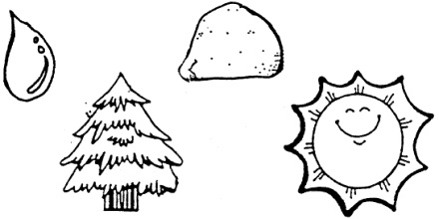

The Bear is the rock of Cub Scouting. \_\_\_\_\_\_\_\_ has earned his Bear rank. He is now solid and immovable in his commitment to the promises he makes in Cub Scouting. Just as a rock, a Bear is unchanging through bad weather, as well as good. *(Have 6 inch picture of a rock cut out with above message on it, laminate and give to the new Bear with his award.)*

The brightness of the Webelos is like that of the sun. His knowledge of scouting ideals is warm and welcome. By earning his Webelos rank, \_\_\_\_\_\_\_\_ has continued to shine day after day and helped others to grow. Congratulations and “Shine on!” *(Cut out 6-inch picture of sun with message on back laminate and give to the new Webelos scout with his award)*

**LEADER RECOGNITION**

**Pack Leaders and Pack Committee Induction**

**Chartered Organization Representative**: It takes many people with lots of different talents working together to make our pack go. Will the following people please come forward. *(Call the title and names of the pack committee chair, the pack committee members, the Cubmaster, the assistant Cubmasters, the den leaders, the assistant den leaders, the pack trainer, the Scout Parents unit coordinator, and the den chiefs.)*

These people have accepted the challenge and responsibility of working with the boys and families in our pack this year to achieve the aims of Scouting. These aims are building character, citizenship, and personal fitness in our boys.

Do you accept the challenges and responsibilities in assuming your position? *(Pause for the response.)*

Will you attend Cub Scout Leader Basic Training, Pow Wow, and Cub Scout roundtables so that the knowledge you find there can help make our pack meet the aims and purposes of Cub Scouting? *(Pause for the response.)*

Let’s all pledge to work with them in achieving this goal. Please stand, make the Cub Scout sign, and say the Cub Scout Promise together.

**Den Leaders’ Recognition**

**Preparation:** Make a special award or certificate for each leader. *(See Chapter 3 of “Ceremonies for Packs and Dens for ideas.)*

**NARRATOR:** Den leaders are regular people, just like you and me. They give a special gift to our children: their time. They attend training, attend Cub Scout leader roundtables, plan den meetings, meet with other pack leaders, watch for new ideas, call families, and play with our boys. The time that they spend helps mold our Cub Scouts into the type of men we wish them to become—responsible people who are strong in mind and character.

We want the best for our children. Tonight, we wish to thank those who have given their best. Will the following special people please come forward. *(Call the names of the den leaders and present each one with a special certificate or award.)*

**Cubmaster Recognition  
(and Assistants)**

**Preparation:** Make a special award or certificate for each leader. *(See Chapter 3 of “Ceremonies for Packs and Dens for ideas.)*

**NARRATOR:** Cub Scouts learn that Akela means leader. They honor Akela by listening to that person and following that person. One person who represents Akela to us is our Cubmaster. We listen to our leader’s words and follow the Cubmaster’s example of service. Our Cubmaster is enthusiastic and idealistic and tries to set the example by living these ideals. The question the Cubmaster uses as a guideline is, “What is best for the boys?”

We want to honor Akela and the Assistant Akelas tonight and thank our Cubmaster for guidance and inspiration. *(Present a special certificate or award.)*

**Appreciation for Service**

**Materials:** A certificate and a “Nice Job” pin

**NARRATOR:** Today, we would like to honor someone in our pack who has shown unselfish service by *(list the unselfish service)*. Will [Name] please come forward*. (Pause.)*

On behalf of our pack committee and chartered organization, I would like to present to you this certificate of appreciation for your service as *(list the role this person assumed). (Present the certificate.)* We also want to present you with a pin that can be worn only by those who have served Scouting in an extra special way. We feel you should have this pin in recognition of your service to our pack. *(Present the pin.)*

Please join me in showing an expression of our appreciation. (Lead an appropriate applause.)

**Leader Training—  
The Pack Helps the Cub Scout Grow**

**Materials:** A yardstick with a drawing of a Cub Scout mounted on the top and yellow and blue marking pens

**NARRATOR:** Today, we will be recognizing some of our leaders for helping our pack grow. Would the following leaders please come forward? *(Call the names.)*

One of the lines in the now retired Law of the Pack said, “The pack helps the Cub Scout grow.” These pack leaders are helping our Cub Scouts grow by taking extra time to learn about the Cub Scout program and things we can do in our dens and pack. (*Make comments about the training event that they have attended, such as Cub Scout Leader Basic Training, Pow Wow, Den Chief Training Conference, or   
Wood Badge.)*

Tonight, we are marking this growth with an inch for each training*. (Have leaders mark yardstick with alternating stripes of blue and gold.)* Please stand and join these leaders in saying the Law of the Pack. *(All give Cub Scout sign and say the Law of the Pack together.)*

Let’s show our appreciation of these leaders*. (Lead an appropriate applause.)*

**Leader Training Awards**

*Same here, showing genuine recognition and   
appreciation makes others want to do it, too. CD*

**Materials:** A small toy car or drawing of one for each leader (or present a flower)

**COMMITTEE CHAIR OR CUBMASTER**: Every month at our pack meeting, we recognize the Cub Scouts who receive awards. Today, we would like to recognize a leader who has received a special award. Will *[Name]* please come forward.

To receive this award, a leader must be trained, participate in special extra training, work as a leader in that position for a given period of time, and do several other requirements. It sounds like a lot of work, and it is, but this leader has had as much fun earning this recognition as you Cub Scouts and Webelos Scouts do while earning yours.

*[Name]* has earned *the (read the name of the recognition award earned).* He/she has received a certificate and a special square knot to wear on the uniform. As Akela, you have really helped our pack go and our Cub Scouts grow *(add “and our district glow,” if appropriate).*

We would like to present this special symbol of our thanks. *(Present the recognition item from the pack.)* Congratulations, and thank you again for all your hard work.

**U Are Important**

*2010-2011 CS RT Planning Guide*

*This is an adult recognition ceremony by Cub Scouts.*

**Arrangement:**Each Cub Scout holds up a sign with his word(s) on it, with the U missing from the word.

1. (C\_B SCO\_TS): We cannot spell Cub Scouts without U.
2. (YO\_TH): We cannot spell youth without U.
3. (ADVENT\_RE): We cannot spell adventure without U.
4. (S\_CCESS): We cannot spell success without U.
5. (F\_N): We cannot spell fun without U.
6. (O\_TDOORS): We cannot spell outdoors without U.

**ALL:** Clearly, our pack needs U! Thank you!

**~~THEME RELATED STUFF~~**

**~~Fun Facts About Heroes~~**

*~~Alice, Golden Empire Council~~*

~~If you need some help remembering heroes, this site lists heroes from various times – click on a specific name and you will be able to see a bio of that person, and click on values of that hero, their defining moments and stories of their failures. This is a Christian website, but with excellent information about the people they feature. The five values they identify as belonging to every hero are: they are fearless, they are applied (very committed), instructed (they have learned as much as they can), they are tireless, and they are humble. I love the fact that there is a link to “warts” - a great way to remind the boys that a true hero is not perfect, and has overcome failures. Lots of stories at:~~ [~~www.heroesofhistory.com~~](http://www.heroesofhistory.com) ~~.~~

**~~Honoring American Heroes  
Veteran’s Administration History~~**

*~~www.va.gov~~*

**~~1789~~** ~~– A law was passed to give money to soldiers who fought in the American Revolutionary War ~ many had fought without pay during the war.~~

~~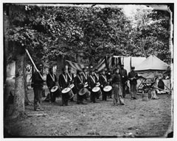~~

**~~1861~~** ~~– The Civil War broke out and Union veterans grew from 80,000 to 2 million!~~

**~~1862~~** ~~– President Lincoln started national cemeteries to honor the many Union dead from the Civil War.~~

**~~1865~~** ~~– President Lincoln gave his second inaugural speech. He asked Congress “to care for him who shall have borne the battle and for his widow, and his orphan.” This became VA’s motto.~~

**~~1912~~** ~~– The Sherwood Act gave pensions to veterans of the Mexican and Civil Wars when they turned 62, even if they were not sick or disabled.~~

**~~1930~~** ~~– President Hoover signed a bill creating the Veterans Administration (VA).~~

**~~1940~~** ~~– Congress created a law to help World War II veterans find jobs when~~

~~they came home from war.~~

~~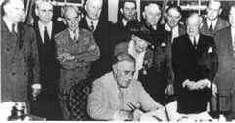~~

**~~1944~~** ~~–On June 22, President Roosevelt signed the GI Bill of Rights, which enabled veterans to go to college and buy a home without a down payment.~~

**~~1946~~** ~~– More hospitals were built to take care of veterans, including research facilities..~~

**~~1973~~** ~~– The Army gave 82 cemeteries to the Veterans Administration, which maintains the gravesites and provides honorable ceremony and maintenance.~~

**~~1988~~** ~~– Congress made the Secretary of the VA a cabinet post, allowing access to the President.~~

**~~1998~~** ~~– All eligible veterans could now enroll in VA’s health care system.~~

**~~The Story behind the Motto of the VA~~**

*~~www.va.gov~~*

~~Lincoln’s words became the VA motto in 1959  
with the words, “To care for him who shall have borne the battle and for his widow and orphan.” President Lincoln stated the government’s duty to care for those who are hurt or died defending our Country.~~

~~Here is a picture of the VA Seal.~~

~~~~

* ~~The eagle represents the United States.~~
* ~~The circle of 5 stars above the eagle stands for the U.S. Army, Navy, Marine Corps, Air Force, and Coast Guard.~~
* ~~The flags in the eagle's claws show America's history from 13 colonies to 50 states.~~
* ~~The gold cord is a symbol for those who died while serving our country. The eagle is holding the cord to keep the memory of those veterans alive.~~

**~~Some Great Rules To Follow   
If You Want To Become A Hero~~**

*~~Alice, Golden Empire Council~~*

* ~~Do your share to make your school, your community, and the world a better place. .~~
* ~~Take responsibility for what goes on around you.~~
* ~~Participate in community service.~~
* ~~Help take care of the environment.~~
* ~~Be a good neighbor.~~
* ~~Treat other people with respect and dignity.~~
* ~~Follow the rules of your family, your school, and your society.~~

**~~Some Ways to Help at a National Cemetery:  
(Contact local National Cemeteries to arrange activities)~~**

*~~Alice, Golden Empire Council~~*

* ~~Plan ceremonies for Memorial Day or Veteran’s Day~~
* ~~Donate helpful items such as golf carts used to transport visitors who need assistance in reaching a gravesite~~
* ~~Recruit volunteers for the cemetery~~
* ~~Raise and lower cemetery flags on national holidays~~
* ~~Play taps at burial ceremonies~~
* ~~Repaint or stain benches~~
* ~~Help with Welcome Home events.~~

**~~Hero True Or False~~**

*~~Alice, Golden Empire Council~~*

~~Tell the boys that you are going to read some statements (Or you could give each boys his own list) If the statement describes a hero, the boys can stand. If the statement does not fit the definition of what makes a hero, boys can remain seated. (Or have the boys circle the number in front of a correct statement) However you use the statements, be sure and discuss them with the boys afterwards – let everyone share their opinion, and make sure that the boys know these are just opinions – and everyone can have their own ideas. See if you can arrive at a definition that everyone agrees to.~~

1. ~~A hero is brave and strong.~~
2. ~~A hero is caring and thoughtful.~~
3. ~~A hero is selfish.~~
4. ~~A hero is never frightened.~~
5. ~~A hero wants to be rewarded for his or her actions.~~
6. ~~A hero makes mistakes.~~
7. ~~A hero is never silly.~~
8. ~~A hero is dishonest.~~
9. ~~A hero puts others before himself or herself.~~
10. ~~A hero stands up for himself or herself.~~
11. ~~A hero never gets angry.~~
12. ~~A hero is always a popular person.~~

**SONGS**

**CARING**

*Heart of America Council*

Tune: Dashing Through the Snow

Show caring to your neighbors.

Give friends a helping hand.

Always think kind thoughts.

Let your words be kind,

Caring for folks you know

Is the best way to show

That you love God and all of mankind.

**When We’re Helping We’re Happy**

*Grand Teton Council*

When we’re helping, we’re happy,

and we sing as we go.

For we like to help (name)

for we all love him(her) so.

**Do A Good Turn**

*Sam Houston Area Council*

Tune: Are You Sleeping

Do a good turn,

Do a good turn,

Do your best,

Do your best,

Do a kindly favor,

Be friendly to your neighbors,

Cheerful Cubs,

Cheerful Cubs.

**Do Your Best**

*Piedmont Area Council*

Tune: Are You Sleeping

When you do your best, When you do your best

You'll feel great, You'll feel great

Make and do for others, too, Make and do for others, too

Spread good cheer, Spread good cheer

**When You’re Helping And You Know It**

*Capital Area Council*

Tune: When you’re happy and you know it

When you’re helping and you know it, Lend a hand

When you’re giving and you show it Things are grand

If you’re helping and you’re giving

Then you help make life worth living

Keep on helping, keep on giving Take a stand

**Akela’s Council**

*Grand Teton Council*

Tune: Clementine

When Akela holds his council,  
And the campfire’s all aglow,  
We will form a friendship circle  
As we sing so sweet and low.

Oh Akela, brave Akela,  
True and fair Cub Scouts we’ll be.  
To our Scout Law and the Scout Oath,  
We will pledge our loyalty.

**Tommy the Cub Scout**

*Heart of America Council*

Tune: Frosty the Snowman

Tommy, the Cub Scout  
Was a very happy boy.  
With a uniform of blue and gold  
And a Den that gave him joy.

Tommy, the Cub Scout  
Earned his badges one by one.  
He did his best and met the test.  
A good citizen he's become.

He helps out other people when  
He sees they need a lot.  
He does his chores around the house  
And feeds his dog (named Spot).

Tommy, the Cub Scout  
Does his duty willingly.  
Someday he'll join a Boy Scout Troop  
And a fine man he will be.

**Doorways to Adventure**

*Baltimore Area Council*

(Tune: My Bonnie Lies Over the Ocean)

Let's follow the trail to adventure,

The trait every good Cub Scout tries.

With all of God's beauty around us,

The trees and the streams and the skies.

**(Chorus)**

Cub Scouts, Cub Scouts,

Adventures are part of Cub Scouting fun

Cub Scouts, Cub Scouts,

O’ won't you come have fun with us?

Let's open the door to adventure,

With adventures advancement is fun.

Cub Scouting is full of adventures,

It's exciting for everyone.

**(Chorus)**

And after we've had fun Cub Scouting,

Another door lies straight ahead.

We're prepared for the Boy Scouting trail,

And so we have nothing to dread.

**(Chorus)**

**Conservation**

*Chief Seattle Council*

(Tune: Allouette)

**Chorus:**

Conservation, we like conservation

Conservation means more for you & me.

Leader: Will we pick up all the trash?

Cubs: Yes, we’ll pick up all the trash.

All: Oh!

**Chorus**

Leader: Will we clean up city parks?

Cubs: Yes, we’ll clean up city parks!

Leader: Clean Up Parks

Cubs: Clean Up Parks

Leader: Pick up trash?

Cubs: Pick up trash!

All: Oh!

**Chorus**

Leader: Will we plant a dozen trees?

Cubs; Yes, we'll plant a dozen trees.

Leader: Dozen trees

Cubs: Dozen Trees

Leader: Clean Up Parks

Cubs: Clean Up Parks

Leader: Pick Up Trash

Cubs: Pick Up Trash

All: Oh!

**Chorus**

**STUNTS AND APPLAUSES**

**APPLAUSES & CHEERS**

*Sam Houston Area Council*

**Do A Good Turn Cheer**Have the group stand up for this cheer.   
They clap once,   
Then turn a ¼ turn and clap again,   
Then turn another ¼ turn and clap again,   
and continue until they have completed a full turn.

*Capital Area Council & Grand Teton Council*

* **Constitution Cheer:** We, the people, approve!
* **Bravo** (For an excellent performance) The cheer leader says: "That deserves a Bravo ! We'll do this in a circle." He then proceeds to have one end of the circle start with the 'BRR' sound and proceeds to point around the circle while they do the 'AVOOOO' sound. The sound level should rise as more of the circle comes in.
* **Canned Laughter**: Laugh when lid is removed from a can, and stop when lid is closed.
* **Good Turn Applause:**Stand up and turn around.
* **Great Job Cheer:**Have one half of the audience say "Great” and the other half say "Job." Alternate each side.
* **Ice Cube Cheer:**Shape an ice cube with a thumb and index finger, saying, "COOOOOOOL!"
* **Double Ice Cube Cheer:**Make an ice cube with a thumb and index finger of each hand, saying, “TOOOOO COOOOOOOL!"

*San Gabriel Valley-Long Beach Area-Verdugo Hills Councils*

**Watermelon Applause:**  Pretend you’re holding a watermelon, run it past your mouth while slurping and turning your head from right to left, then turn your head back spitting out seeds. *(repeated on purpose - CD)*

**Cantaloupe Applause:** Variation of Watermelon (above) cup hands to hold cantaloupe, take one big bite, then spit out only one seed!

**Grape Applause:** Use in conjunction with the Watermelon and Cantaloupe applauses. Hold an imaginary grape between thumb and first finger. Pop grape into mouth with appropriate sound.

**Southern Watermelon** – Say Ya’ll after spitting out the pits.

**Fruit Salad -** Pretend like you are eating a watermelon, spit out seeds, then a cantaloupe, then a cherry. *(for cherry, put finger in cheek bone and pop out of mouth)*

**Rainstorm Cheer:** To simulate rain, have everyone pat one finger of the left hand and one finger of the right hand. Gradually increase the intensity of the storm by increasing the fingers hitting together. Decrease the number of fingers as the storm passes.

*Baloo’s Archives*

**Southern Samurai Warrior Watermelon Cheer –**

* Hold watermelon in your hands (Upper arms at your sides, elbows bent hands in front of body, palms up)
* Toss watermelon into the air (Say wiiiish (or something like that))
* Pretend to pull out your sword from the imaginary sheath hanging from your belt.
* With two hands on the hilt of the sword, reach up and slice the watermelon in half above your head (say thooop or similar cutting sound)
* Put palms out again to catch the watermelon (Say Foooommpp or other sound to indicate the catch)
* Do standard watermelon cheer (see above)
* Say Ya’ll

**RUN-ONS**

*Catalina Council*

**Cub #1**: How would Akela start this campfire in the rain?  
**Cub #2:** I don’t know. With magic?  
**Cub #1**: No, with waterproof matches!

**Cub #1:** Why do you have that rock so close to your ear?  
**Cub #2:** Because, I’m listening to rock music!

**Cub #1:** Why are you tapping those two pebbles together?  
**Cub #2**: Silly - Now I’m playing rock n’ roll music!

**Cub #1**: What kind of rocks do you see in the Rio Grande?  
**Cub #2:** Wet ones!

**Cub #1:** What did the limestone say to the geologist?  
**Cub #2**: You stop taking me for granite!

**Cub #1:** What did the miner say to his girlfriend?  
**Cub #2:** I really dig you!

**Cub #1:** Why does a spider spin a web?  
**Cub #2:** Because he can’t knit!

**Cub #1:** What's the best way to make a fire with two sticks?  
**Cub #2:** Make sure one of them is a match.

**Cub #1**: This match won’t light.  
**Cub #2:** What’s the matter with it?  
**Cub #1:** I don’t know, I lit it before.

**Cub #1:** (Crawls on stage crying) Water, water!  
**Cub #2:** (Comes running with a glass of water.)   
 You poor thing, here’s some water.  
**Cub #1**: Thank You! (Pulls out a comb and uses the water   
 to comb his hair.)

**Teacher:** What is a geologist?  
**Student:** A fault finder!

**First Aid Instructor:** What’s the best way to avoid   
 infection from biting insects?  
**Cub Scout:** Stop biting insects!

Knock, knock.  
Who’s there?  
Roxanne.  
Roxanne who?  
I got Roxanne pebbles in my hiking boot!

**Definition of the day:**  
Rock n’ Roll - A boulder traveling downhill . . .

*Sam Houston Area Council*

**Bird Seed**

**Cub Scout #1:** May I have 25 cents worth of bird seed?

**Cub Scout #2:** How many birds do you have?

**Cub Scout #1:** None yet, but I’m gonna grow some!

**Do A Good Turn**

1. (comes on stage turning around)
2. (comes on stage doing forward rolls)
3. (comes on stage rolling over and over)
4. (comes on stage doing cartwheels)
5. What are you guys doing?

**Cubs #1-4**: Don’t you know a good turn when you see one?

**JOKES & RIDDLES**

*Heart of America Council*

**Boy 1:** What’s the date?

**Boy 2:** I don’t know.

**Boy 1:** Look at the newspaper.

**Boy 2:** No good. That’s yesterday’s paper.

Knock-knock.

Who’s there?

Accordion.

Accordion who?

Accordion to the paper, it’s going to snow (rain) today.

1. There were seven copycats sitting on a fence. One jumped off, how many were left?
2. None.

What does an envelope say, when it is licked?  
 *It just shuts up and says nothing, I think.*

What goes in one ear and out the other?  
 *A worm in a cornfield.*

*Alice, Golden Empire Council*

**MissingChild Run-On**

Cub #1: Mary’s mother has four children. Their names are Summer, Fall, Winter, and ? Who is the missing child?

Cub #2: (Looking very confident) I know this one!   
It’s Spring!

Cub #1: Sorry, the missing child is MARY!

***Or tell it as a riddle!!! CD***

Q.  What season is it when you are on a trampoline?  
A.  Spring-time!

Q.  Why is the letter A like a flower?  
A.  A bee (B) comes after it!

**Cub 1:** My mother does bird imitations.   
**Cub 2:** Really? How does she do that?   
**Cub 1:** She watches me like a hawk.

*San Gabriel Valley, Long Beach & Verdugo Hills Councils*

What kind of a dog has no tail? Hot dog.

What kind of an insect does your uncle like best? Ants

What's the double tree? Pear

What tree is nearest the sea? Beech

What is a calendar tree? Date

What tree will keep you warm? Fir

What tree is used in kissing? Tulip

**SKITS**

**Helpful Magic**

*Sam Houston Area Council*

**Set Up:**

Boy #1 is trying a magic trick.   
Boys 3, 4, and 5 are watching him   
Boy #2 enters, watches, then asks:

Boy #2: What are you doing?

Boy #1: I’m a magician!

Other: Yeah, he’s doing magic tricks.

Boy #2: Oh, really? (Watches, then asks) Why are you doing magic tricks?

Boy #1: I like to do magic tricks because that makes people happy and when people are happy they smile and I like to see people smile.

Boy #2: I can make magic!

Others: Oh, sure! No you can't.

Boy #2: Yes I can, but I need all of you to help with this magic trick. (Leaves)

Boy #1: I didn’t know he knew how to do magic tricks.

Boy #3: I’ll bet he doesn’t know any magic.

Boy #4: He probably won’t even come back.

Boy #5: He’s just showing off.

Boy #2: (Enters with gardening tools)

Others: Gardening tools?

Boy #5: You call that magic?

Boy #2: No! But with your help and these tools we can make magic.

Others: Oh, sure! Gardening tools aren’t magical. How can they make magic?

Boy #2: You said magic makes people happy, didn’t you?

Boy #1: Yes, but...

Boy #2: You said you like to make people happy so they will smile, didn’t you?

Boy #1: Yes, but...

Boy #2: Well, if we take these tools over to Mrs. Robinson’s and clean her front yard, I’ll bet she would be happy and she would smile the biggest smile you have ever seen.

Boy #3: Say, I think you have got magic. I’ll rake leaves.

Boy #4: I’ll go and get a lawn mower. I’ve always wanted to do magic tricks!

Boy #5: Me too! I’ll prune her shrubs. I really like Mrs. Robinson. I’d like to see her smile.

*(Boys agree and start to leave)*

Boy #1: Hey, what about my magic?

Boy #3: We all want to try (boy’s name) magic.

Boy #1: Oh well, I guess I’ll go too. Hey, wait for me.

**The Helpful Recycling Machine**

*Chief Seattle Council*

**Personnel:** 4 Cubs. In addition, another is hidden inside the machine.

**Equipment:** Large box made to look like, a recycle machine: other items mentioned.

**Jack:** Hey look, guys, a helpful recycle machine! It turns old worn out things into useful new stuff.

**Jim:** Let’s try it out! (Turns switch on)

**Bob**: Let’s see what it does with this rusty, old pocketknife.

*(Drops it into machine. Machine makes noise and shakes, then out comes a new, shiny pocketknife.)*

**All** Wow, it works Fantastic! That is really helpful.

**Tom:** Maybe it can recycle this old, torn handkerchief.

*(Drops it in and the machine shakes and  
 rattles and turns out a new hanky.)*

**Jim:** That’s really great! Here, machine, here’s an old, broken pencil for you.

*(Drops it in and the machine performs   
giving out a new one.)*

**Bob:** It’s your turn. Jack.

**Jack:** I wonder how this things works.

*(Steps up, peers inside, and the machine pulls him in.)*

**Jack:** Help!

**Others** Oh no! What should we do? (All look worried)

*The machine finally makes a very loud noise and out pops Jack. A sign on him reads REJECT.)*

**Tom:** Look! He has a sign around his neck. It says ‘REJECT’. A Cub Scout’s spirit is too strong and durable to ever be worn out.

**Jack:** Remember, to help save our American resources, follow this motto

**All:** Reduce, Reuse, Recycle!  
Use it up, wear it out, make it do, or do without!

**Always Do Good Turns**

*Sam Houston Area Council*

**Akela:**  “Now, (Cubs name), you know you should always do Good Turns.”

**Cub # 1:** I tried, honest!

**Akela:**  OK

*[Each Cub enters and says similar things to Akela]*

**Next to Last Cub:** [carrying a small frying pan with a “pancake” in it] I did a good turn!

*[He flips pancake over and catches it in pan]*

**Last Cub:**  But you should see the mess in the kitchen!

**Lost Money**

*Sam Houston Area Council*

**Cast:**  Several Cub Scouts

**Setting:** Cub Scout #1 is circling around and looking down at the ground.

Cub Scout #2: What are you doing?

Cub Scout #1: I dropped my money and I’m looking for it.

Cub Scout #2: Well, I’ll help you look.

Cub Scout #1: That would be great if you could help me!

*(Other Cubs come up one at a time and ask him what he is doing. He tells them he lost his money and they agree to help look. Eventually there are several boys circling around looking for the money on the ground.)*

Last Cub Scout: What are you doing?

Cub Scout #1: I’m looking for the money I lost.

Last Cub Scout: Where did you lose it?

Cub Scout #1: Down the street by those houses.

Last Cub Scout: Then why are you looking for it here?

Cub Scout #1: Because this is where the street light is.

**Water Conservation Skit**

*Chief Seattle Council*

**Equipment** cup,

**Personnel** 4 to how many scouts you want, water,   
announcer

**Preparation**Put half a mouth full of water in the last person's mouth. The person should not swallow, and should not let the audience notice they have water. Have another cup filled with water for the first person.

**Action**All the people except the announcer stand in a straight line, the last person will have the water in his mouth.

The announcer will start talking about water conservation and how water is very heavy on backpacking trips and these scouts have found a way around that. The announcer turns around and asks for a demo of one of the ways to conserve water.

The first scout says ok and all start brushing their teeth with their fingers. (The last person needs to practice before hand so water doesn't spill out.)

After everybody is done "brushing" have the announcer take a cup over to the first person. Let the announcer accidently spill some water out of the cup to show the audience there is water in there.

The first person rinses his mouth out with water and swallows the water. Then the first person will turn to the second and "transfer" water into the next scout's ear.

Repeat action down the line till last scout, who with great showmanship, spits the water out into cup a cup and proudly holds it up!!

**Around the Campfire**

*Catalina Council*

**Set Up:** Cubs sitting around a campfire

**Leader:** You did a good job on the hike this morning. Let’s see how much you saw. Which pine would you say had the sharpest needles?

**Cub 1:** The porcupine.

**Leader:** What’s the best way to prevent infection caused by biting insects?

**Cub 2:** Don’t bite any insects.

**Leader:** Where do you take your bath?

**Cub 3:** In the spring, of course.

**Leader:** I didn’t ask when, I asked where… It’s time for our snack. Where is it.

**Cub 3:** I don’t know! The bag had a hole in it and the snacks fell out a long time ago.

**Leader:** I cooked for the whole den last night, and what did I get? Nothing!

**Cub 5:** You’re lucky. We all got stomach aches.

*(Leader slowly walks away from the fire shaking His head.*

**One Step At A Time**

*San Gabriel Valley, Long Beach & Verdugo Hills Councils*

**Characters:** Senior Scout (like a Den Chief, Denner, etc.) 4 Cub Scouts.

**Setting:** All Scouts are on stage as the skit starts.

**Cub 1:** When I grow up I'm going to be the world's greatest broad jumper and jump like this! (Jumps about one 1 foot and falls down.)

**Senior Scout:** Well, you'll have to remember to take it one step at a time, one step at a time.

**Cub 2:** Well, I am going to be a high jumper and win a gold medal like this! (Jumps and falls flat.)

**Senior Scout:** Well just remember that you'll have to remember to take it one step at a time, one step at a time.

**Cub 3:** Well I am doing to be a world famous baseball player and hit homeruns like this! (Swings and falls.)

**Senior Scout:** Fine, fine, but remember to take it one step at a time, one step at a time.

**Cub 4:** I am going to be the world's best slam-dunker (dribbles imaginary ball across stage and slam-dunks it, falling.

**Senior Scout:** Sure, sure, but remember to take it one step at a time, one step at a time.

**Cub 1:** Say, what are you going to be when you grow up?

**Senior Scout:** Why I am going to be the greatest marathon runner that ever lived! (Turns to walk away and trips on shoelace.)

**Cubs** One step at a time! One step at a time!

**The Infantry is Coming!**

*Chief Seattle Council*

**Equipment**:A small tree or bush and about 5 scouts.

**Preparation**:Rehearse panic

**Action:** 3 scouts are loafing around waiting for something to happen

**Cub # 1:** (comes in shouting) The infantry is coming! The infantry is coming! Hurry! Hide! (he runs offstage, but no one else moves) *(5-10 second pause)*

**Cub # 2:** (comes in shouting) The infantry is coming! Look Out! They're coming fast! Quick! Hide yourselves! (he runs off, but no one else moves) *(5-10 second pause)*

**Cub # 3:** (comes in shouting) You guys! The infantry is corning! Hide! Look! Here it comes!

**Cub # 4:** (comes on holding the small tree and all of the scouts run offstage, screaming.)

**Cub # 4:** *With Small Tree Branch*: Wait! Wait! It's just an Infant Tree!

**CLOSING CEREMONIES**

**Goodwill Closing Ceremony**

*Capital Area Council*

**Set Up:** 8 Cub Scouts each with a sign with one of the letters on front. The words are written on the back in large print. Boys say their parts in turn.

1. **G -** Good Cub Scouts are friends to all.
2. **O** - On their honor to obey the Scout law
3. **O** - Once they show how HELPFUL they are
4. **D** - Doubled friendships will surely be found.
5. **W** - Working together being HELPFUL will make the world a better place.
6. **I** - Including as new friends -- boys from each faith and race.
7. **L** - Leaving behind them a path of good cheer from being HELPFUL.
8. **L** - Let's all practice being HELPFUL now and all through the year.

**Cub Scout Garden of Thoughts**

*Heart of America Council*

**Personnel:** 7 Cubs dressed in farmer’s hats, shirts, levis, etc., with garden tools.

**Props:** Large cut-outs of vegetables as indicated.

1. We’re Cub Scout farmers who’ve come your way to share with you, our garden of thoughts for the day.
2. **(holds up carrot)** Take care at all times, remembering to be HELPFUL and do your best each day.
3. **(holds up lettuce)** Let us always give a smile to others while being HELPFUL as we travel down life’s way.
4. **(holds up turnip)** Be sure to turn up at meetings and participate in pack activities.
5. **(holds up bean)** Learn to be HELPFUL and not to put things off, for it’s not fun being late.
6. **(holds up beet)** In life’s game, you can beat the odds if you strive to work with everyone.
7. **(holds up large package of seeds)** And now that we’ve planted some seeds of thought, we’ll say good night, for our meeting is adjourned.

**Do More Closing**

*Sam Houston Area Council*

**Prop:** A candle lit by the leader

1. This candle represents the spirit of Cub Scouting the world over. It burns today to show the friendship and fun we share.
2. But there is more that we should do to spread Spirit of Scouting. Listen:
3. Do more than belong. Participate
4. Do more than care. Be Helpful.
5. Do more than believe. Practice.
6. Do more than be fair. Be kind.
7. Do more than forgive. Forget.
8. Do more than dream. Work.
9. Do more than teach. Inspire.
10. Do more than live. Grow.
11. Do more than be friendly. Be a friend.
12. Do more than give. Serve.

**Take Time Closing**

*Sam Houston Area Council*

**Set Up:**

5 boys can each repeat two lines, or   
11 boys can each read a line.

1. Take time to think.   
   Thoughts are the source of power.
2. Take time to play.   
   Play is the secret of perpetual youth.
3. Take time to read.   
   Reading is the fountain of wisdom.
4. Take time to pray.   
   Prayer can be a rock of strength in time of trouble.
5. Take time to love.   
   Loving is what makes living worthwhile.
6. Take time to be friendly.   
   Friendship gives life a delicious flavor.
7. Take time to laugh.   
   Laughter is the music of the soul.
8. Take time to give.   
   Any day of the year is too short for selfishness.
9. Take time to do your work.   
   Pride in your work, no matter what it is nourishes the ego and the spirit.
10. Take time to be **helpful**  
    By helping we share our joys and they multiply.
11. Take time to show appreciation.   
    Thanks is the frosting on the cake of life.

**All:** Good night and take time going home.

**Cubmaster’s Minutes**

**The Warmth of Being Helpful**

*Heart of America Council*

A friend of mine once told me of being on a long business trip. His car broke down in the middle of nowhere and he was going to be late for a very important meeting. Just then a farmer came around the corner on a hay wagon, and pulled over to see what was wrong. The farmer and his son often fixed their own machinery and they were quickly able to get my friend’s car running again.

My friend offered to pay the farmer and his son for their help, but they refused. He insisted that they must take something because they had saved him so much by letting him get to his meeting on time.

The farmer replied that he and his son now had something far more valuable than the businessman could give them. They had been helpful to someone when they did not have to do so. That gave them a warm feeling. If they took money for being helpful (and kind), then it would simply be a job, and take the warm feeling from being helpful.

Keep your feelings of goodwill by being helpful. It will be the most valuable reward you will ever receive.

**Using Our Talents**

*Sam Houston Area Council*

Do you like to put together jigsaw puzzles? Some families find a lot of pleasure putting together a big jigsaw puzzle on a cold autumn night, with cups of steaming hot cocoa and fresh cookies nearby. The most important thing about a jigsaw puzzle is that all of the puzzle pieces must be there. If even one small piece has been lost, then the whole puzzle is incomplete, and that takes away a lot of the fun of seeing the puzzle come together.

The same thing is true for people. Each of us is a piece of the puzzle that makes up our family, our school, our church, our community. We each have special abilities and skills that no one else has. When you put your abilities together with those of everyone else, it makes a beautiful picture of friendship and cooperation. But if even one of the pieces is missing, then the whole picture is incomplete. Use your abilities to help others; don't let your piece be the one that makes the puzzle incomplete!

**Over Four Million**

*Sam Houston Area Council*

So we end this evening of celebrating Seeds of Kindness. But before we go, let us take in this thought...

Today in our country there are over 4.5 million youth and adults in Scouting. That's a good thing to know, a good thing to think about when we start wondering about the future. Four and a half million keeping a promise to “Do My Best,” to “Help Other People,” and “Respect God and Country.” Four and a half million following Baden-Powell's admonition: “Try to leave this world a little better than you found it.”

These 4.5 million can make the difference in tomorrow. These 4 and a half million will make the difference in the future of this country and in the future of the world around us.

**A Good Turn**

*Grand Teton Council*

In a past issue of the Scouting Magazine, there was a story about a Webelos Scout named Daniel Simon of Pack 381, Buffalo Grove, Illinois. Daniel earned a $750 gift certificate, and instead of spending the money on himself, he filled seven shopping carts with toys for other children who might not get anything that holiday season. It was a fine example of being helpful and generous.

For Daniel, the Scout Law and Scout Oath aren’t just words; they represent a way of life. Wouldn’t it be a great holiday tradition if we all followed Daniel’s example and performed some special helpful good turn for someone in need? That would bring a lot of joy to the people we served. It would also bring a lot of joy to us, knowing that we had done something to make someone’s life a little better.

When you ask the question, “How can I be helpful?” think about what you can do to give good will and help others. What better way to build good memories that will last forever?

**Good Turn Closing Thought**

*Capital Area Council*

Most of us are happiest when we are helping others and spreading goodwill and kindness. That is doing something good for others. Think, for a moment of a time when you were helpful to someone. Chances are it made you feel pretty good. Of course, we feel best when we do something for others without being found out. When we help others regularly, it soon becomes a habit and gets to be a natural thing. Once a Cub Scout establishes this habit, he learns the real meaning of a good turn.

**Starry Night**

*Capital Area Council*

*Dim or turn off room lights except   
for an electric candle or flashlight*

This is the season of lights and stars, when days are short and nights are long with beautiful stars.

Lord Baden-Powell, the founder of Scouting, once said this to his Scouts, “I often think when the sun goes down, and the world is hidden by a big blanket from the light of heaven. But the stars are little holes pierced in that blanket by those who have done good deeds in this world. The stars are not all the same size; some are big, and some are little. So some men have done great deeds, and some men have done small deeds, but they have all made their hole in the blanket by doing good before they went to heaven.”

Let’s remember when we look at the starry sky, to make our own hole in the blanket, by doing good deeds that spread seeds of kindness and help other people.

**CUB GRUB**

**OUTDOOR COOKING**

*Catalina Council*

Cooking and eating can be an outdoor adventure too. You don't have to camp out to get a taste of the camping adventure. There is just something about outdoor cooking that is special.

Cooking outdoors requires a different set of rules and equipment. Even cooking a hot dog or marshmallow just right without burning it can be a real challenge.

**Charcoal Stove**

*Catalina Council*

**Materials:**

Tin can (#10 or larger)

Roll-type can opener

Punch opener

Wire for handle

Three pieces sturdy wire screen

**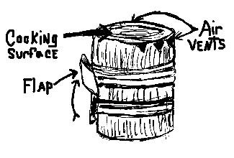**

***Note - This picture does not match directions but gives you an idea. I could not find a good picture to use. CD***

**Directions:**

1. Remove top of can with roll-type can opener.
2. Punch air holes with punch opener all around the can near top and bottom.
3. Stick ends of wire for handle through two of the holes at top and twist to make a handle.
4. Push wire screen half way down into can to make a grate. This will hold the charcoal near top for cooking and keep air under charcoal. To keep screen from slipping, cut second piece of screen into a coil, and put between grate screen and bottom of stove.
5. Make a stove top out of the third piece of wire screen. This supports your hamburger or the cook pot.

**To use:**

* Set the stove on cleared ground and put tinder on the grate.
* When tinder is burning briskly, drop charcoal into fire.
* Swing the stove by the handle now and then to keep the charcoal burning.

**Bug Snacks:**

*Chief Seattle Council*

**Ants on a Log:**

* Spread peanut butter or cream cheese on celery sticks.
* Add raisins or cranberries for “ants.”

**Ants on a tire:**

* Core apples, and slice into rings.
* Spread peanut butter or cream cheese on the rings.
* Add raisins or dried cranberries for “ants”.

**Peanut Butter Play Dough Bugs**

* Make a recipe of peanut butter play dough.
* Boys can use straight pretzels, small regular shaped pretzels, thin licorice, raisins, M & M’s , etc. to add antennae, eyes, legs, spots, and stripes, to their bugs.

Play dough recipes: <http://www.makingfriends.com/pro_edible.htm>

**Jell-O Snakes (or worms)**

**Ingredients**

1 ½ cup apple juice

3 oz. package flavored gelatin

1 envelope unflavored gelatin

5 ice cubes

small Ziploc bags

**Directions**

1. Pour half the juice into saucepan. Heat until boiling;
2. Remove from heat. Add gelatin, and stir until dissolved.
3. Pour remaining apple juice into mixing bowl. Add unflavored gelatin, and stir until dissolved.
4. Add mixture to hot apple juice.
5. Add ice cubes, and stir until melted.
6. Refrigerate until the consistency of pudding, about 10-15 minutes.
7. Spoon gelatin into Ziploc bags.
8. Cut ¼ inch off the corner of the bag.
9. Squeeze a wavy line of gelatin onto a foiled cookie sheet.
10. Chill in refrigerator about 2 hours.
11. To keep snakes firm while serving, place them on a plate over ice cubes.

**Backyard Ice Cream**

*Baltimore Area Council*

**Ingredients**

1 - 1 pound coffee can w/lid  
1 - 3 pound coffee can w/lid  
2 10” squares aluminum foil  
1 pkg. instant pudding  
1 qt. crushed ice

½ pint milk

1 - 13 oz. can evaporated milk

1 roll duct tape

1 pound rock salt (any flavor)

*For additional flavoring use fruit, chocolate chips, nuts, etc.*

**Directions**

* Into one pound can add the pudding mix, evaporated milk and enough fresh milk to fill can to the ¾ point.
* Stir very well.
* Place aluminum foil squares over can top and press plastic lid on.
* Secure lid with several wrappings of duct tape across top of lid and several more holding the lid on the sides.
* Place shallow layer of crushed ice into the 3 pound can.
* Sprinkle with rock salt.
* Place one-pound can in three pound can.
* Alternate layers of crushed ice and rock salt, filling the three-pound can.
* Secure lid with aluminum foil and cut tape as before.
* Roll or otherwise agitate the can for 20 minutes (perfect opportunity for a game!).
* Remove the ice cream and enjoy. Makes about a quart.

**Nelson's Stew**

*Catalina Council*

**Ingredients:**

Box of macaroni and cheese

1 can of chunky ham

**Directions:**

1. Heat water to boiling.
2. Add macaroni and cook until soft.
3. Make macaroni and cheese in accordance with directions on box.
4. Crumble can of chunky ham into mixture, mix thoroughly.

This is easy. Feeds 2 scouts per box of macaroni and cheese, 1 can of ham may be mixed with each 2 boxes of macaroni.

***I remember a card from the back of Mac and Cheese boxes when I was a SM that gave various meat and vegetable combinations to add to the box mix. My Scouts loved those meals. Wish I still had the card. CD***

**Camp Stroganoff**

*Catalina Council*

**Ingredients:**

1-1/2 to 2 pounds ground beef

Onion soup mix

2-3 tablespoons of ketchup

1 cup sour cream

1 can cream of mushroom soup

Noodles

**Directions:**

1. Bring pot of water to a rolling boil and cook noodles until done.
2. Brown meat and drain off grease.
3. Add remaining ingredients and simmer until meat is tender. If necessary, thin sauce with a little milk.
4. Serve over cooked noodles.

**Scout Tacos**

*Baltimore Area Council*

**Ingredients**

1 pkg. Taco Seasoning mix  
2 pounds hamburger  
1 15 oz. can Ranch Style Beans  
1 medium onion, chopped

Lettuce

Tomatoes

Cheese, shredded

**Instructions**

* Sprinkle salt in bottom of Dutch oven.
* Follow directions on Taco Seasoning mix.
* Be sure not to add too much water.
* Add beans.
* Cook until beans are hot.
* Serve mixture on Doritos or Fritos.
* On top, sprinkle lettuce, tomatoes, cheese & onions.

**Campfire Foil Dinner**

*Baltimore Area Council*

In a square piece of heavy duty aluminum foil, place enough of each of the following to make one serving:

sliced potatoes thin ground beef patty   
sliced carrots sliced onions   
salt pepper

Cook package on hot coals for approximately 15 minutes on each side. Chicken patties, breast & thighs, and pork chops are also good this way.

**Dutch Oven Cobbler**

**Ingredients**

1 White or Yellow cake mix   
1½ sticks butter or margarine  
brown sugar  
cinnamon  
2 cans apple filling (or whatever fruit pie filling you prefer)

**Instructions**

* Put pie filling into Dutch oven together with about 3/4 can of water.
* Sprinkle cinnamon over apples.
* Sprinkle dry cake mix evenly into Dutch oven.
* Do not mix or stir.
* Cut butter into l/4 thick squares and cover cake mix.
* Sprinkle cinnamon and brown sugar on top of butter.
* Place lid on Dutch oven. Put 4 pieces of hot charcoal under Dutch oven and 12 pieces on top of Dutch oven.
* Cook about 45 minutes or until you can’t resist the aroma.
* Peach cobbler can be made by using two cans of sliced peaches (29 oz. can) and eliminating the water.

**Just A Little Bit Different Trail Mix**

*Utah National Parks Council*

**Ingredients**

2 cups Quaker Oat Squares

1 cup small Pretzels

1 cup Almonds

½ cup Honey Roasted Peanuts

1 or 2 small packages of M&M’s

1 cup Craisins

**Directions**

* Mix them all together and
* Divide evenly into plastic baggies.

**A Pocket Banquet for One**

*Utah National Parks Council*

Here’s a complete meal for one that you can carry in your pocket… and you can prepare all of it before you leave for a hike. Then all you do is add water where necessary, heat it and feast!

**Soup –**Dehydrated soup (like Lipton’s Chicken Noodle – or your preference) packaged in a piece of strong foil. The foil can be molded into a soup bowl when ready to eat just add water and heat.

**Cocoa –**Pack enough instant cocoa mix for two or three cups in small envelopes of foil. Biscuits – Carry enough instant biscuit mix wrapped in foil to make two biscuits. Mix necessary amount of water right in the same foil. Puncture with knife so steam can escape when you put it next to the fire to bake.

**Main dish –**Wrap a quarter pound of beef steak, one potato, one onion, and one carrot (Potato, carrot, and onion cut into small pieces) in a piece of foil. Remember to add seasoning, a tablespoon of water +/-, and a pat of butter. Place foil package on coals. Roll wrap to seal liquids inside. Cook for ten minutes.

**Dessert –**Core one apple, add cinnamon and sugar. Wrap it in foil. Place it on coals, by the time you are ready for dessert, it will be baked, ready to eat.

**Wormy Apple Mix**

*Utah National Parks Council*

**Directions**

8.5 ounces Gummy Worms

6 ounces dried apple chunks

1 cup dry roasted peanuts

1 cup miniature marshmallows

1 cup raisins

**Directions**

* Mix all ingredients.
* And divide evenly into plastic bags.

**GAMES**

*Catalina Council*

How many times have you gotten outside only to have the boys "hack around." By providing games, the chances of someone getting hurt will be reduced greatly. The Cub Scout How-to Book provides a great number of games. Here are some ideas in addition to those:

**With a Little Help from my Friends Relay**

*Alice, Golden Empire Council*

* Form teams of 5-6 Cubs and/or family members or sisters and brothers.
* Each team makes a circle with one player in the middle and the others holding hands around that player.
* On signal, the team takes off as a group and runs to the finish line.
* Then they start back to the starting line, still holding their places.
* When the first player crosses the starting line, the team sends another player into the middle and the relay continues till everyone has a chance to be in the middle.
* Winning team finishes first.

**Wipe The Smile**

*Sam Houston Area Council*

* Players sit in a circle, making sure they can see everyone else.
* One player who is “It” starts the game by smiling widely, while all the other players are somber.
* “It” then uses his hand to wipe the smile off his face and throw it to another player who has to catch the smile with his hand and put it on.
* This new “It” can then wipe off the smile to throw to someone else--though he will probably choose to smug wildly at everyone for a few minutes before relinquishing his happy role.
* Meanwhile, all other players must sit stone-faced.
* One smirk and they're out.

**Thumb Catch**

*Sam Houston Area Council*

*This is game of fast reflexes and   
can be played with a very large group.*

* Players stand in a circle and each player puts his left hand out to the left with his hand in a fist and his thumb facing down, and his right hand out to the right with his hand open and his palm up.
* Your left thumb should be directly above the player to your left’s palm, and your right palm should be directly beneath the player to your right’s thumb.
* Have a person who is not playing count to three and say, “Go!”
* On the word “Go,” all the players should try to grab the thumb of the player on their right side and at the same time try to lift their own thumb fast enough to avoid being grabbed by the person on their left.
* Anyone whose thumb was grabbed is out and should leave the circle.
* Close the circle in and continue playing until there is only one player left.

**Who Stole the Cookies?**

*Baltimore Area Council*

Cubs sit in a circle and are numbered.

They start to alternately slap their own knees and then clap hands with the Cubs on each side of them.

The Cubs chant: Who stole the cookies from the cookie jar?

The Leader chants: Number (i.e. 5) stole the cookies from the cookie jar.

Number responds: Who me?

All reply: Yes, you!

Number 5 chants: Couldn’t be!

All reply: Then who?

Number 5 replies: Number (i.e. 12) stole the cookies from the cookie jar!

Number responds: Who me?

*And the game goes on -*

The idea of the game is to keep the, rhythm of slaps and claps going, while continuing the chant with new number being called each time. As the Cubs get used to the game, the leader can speed it up.

**Litter Sweep Relay**

*San Gabriel Valley, Long Beach & Verdugo Hills Councils*

* Divide into two teams and give each team a broom and a small pile of dry trash -soda cans, paper, small plastic bottles, etc.
* On signal, the first boy on each team sweeps the trash to a certain point and back.
* The next team member then takes over, and so on until all have run.
* First team finished wins.
* If a boy loses trash he must go back and sweep it up.

**20 Yard Dash**

*San Gabriel Valley, Long Beach & Verdugo Hills Councils*

Line up the dens for a relay race.

Have the contestants carry an egg in a teaspoon held with the arm extended.

The first in each line runs 20 yards and back to the next one in line.

**20 Foot Dash**

*San Gabriel Valley, Long Beach & Verdugo Hills Councils*

Have the relay runners roll lemons or hard-boiled eggs with a stick down the course and back and touch off the next player in line.

**Push - Catch**

*San Gabriel Valley, Long Beach & Verdugo Hills Councils*

Everyone is in a circle except for one person in the middle (usually a leader to start).

The person in the center has a ball that the leader throws to those in the circle.

The leader must shout out either Push or Catch.

The person to whom the ball is thrown must Do The Opposite Action that was shouted out. That is

If the leader shouts Push, the Cub must Catch the ball.   
If the leader shouts Catch the Cub Pushes the ball.

If an error is committed by either not doing the opposite or stumbling with the ball the Cub must sit down or step back and is eliminated from play.

***Variation:*** If the group gets really good at the game, the shouter must shout out 3 words (such as Push Catch Push) and the Cub must do the opposite of the middle one (or the first or last).

**Hiking Games**

*San Gabriel Valley, Long Beach & Verdugo Hills Councils*

**Stop And Spot Game -** While hiking, the leader stops and says: "I spot a \_\_\_\_\_\_," naming a familiar object. Everyone in the group who sees the object will raise his hand or sit down. This sharpens the skill of observation.

**Obstacle Course Game -** Some boys have never climbed a tree, walked a log, gone through a fence, or chinned themselves on a tree branch. To give them this experience, pick a trail which will provide such an obstacle course. Don't destroy property or trespass.

**Memory Hike Game -** This game is played after a hike or a trip to the zoo or park. During the outing, tell the boys to observe everything very carefully so they can make a list of all that they have seen. Just after the outing, hand out paper and pencils and have the boys make their lists. See who was most observant.

**Push-Out**

*Catalina Council*

Draw a circle about 8 feet in diameter.

All players except "It" must hold their arms across their chests and hop on one foot. "It" does not have to do either.

The others must try to push "It" out of the circle without using their hands or arms.

"It" dodges them, and he may push the hoppers out of the ring, using his hands or arms.

When a hopper is pushed out, unfolds his arms, or puts both feet down, he is out of the game.

The game goes on until all hoppers are disqualified or "It" is pushed out of the circle.

**Hint-*This is a team building game.*** Don't tell the boys but if the hoppers work together, they can push "It" out much easier than working alone.

**Litter Basketball**

*Chief Seattle Council*

**Equipment:**

Lots of crumpled newspaper, computer or copy paper, trash cans

**To play:**

* Divide the den into two teams and seat them behind a throw line.
* Place the trash cans about 10 feet away. (the distance depends on the motor skills of your boys.)
* On the signal to GO, Cubs fire their paper “basketballs” at the trash can goals.
* After a set amount of time stop the game.
* Count the number of “basketballs” in each trash can.
* The team with the most “basketballs” in the cans wins.
* Work together to collect the paper and place it in a recycle bin.

**Recycling Game**

*Chief Seattle Council*

* Divide boys into 2 teams.
* Give each team an identical set of items.
* Have the boys sort them into things that can be recycled, and things that can’t be recycled.
* Award points for each correct answer.
* Team with the most points wins.

**Scavenger Hunt**

*Chief Seattle Council*

* Make a list of things for the boys to find, but not pick up.
* Give a copy of the list to paired boys.
* See which pair can find the most things on the list in a set amount of time.
* Winning team must show where they found the items. Examples: a dandelion, a rock bigger than 2 inches, an insect, a spider web, etc.

**Tic Tac Toe Toss:**

*Chief Seattle Council*

* 2 players or teams toss milk bottle caps (2 colors) onto a tic tac to board.
* First player/team to get 3 in a row wins.

**Ping Pong Ball Bounce:**

*Chief Seattle Council*

* Write point values in bottoms of egg carton compartments.
* Bounce ping pong ball into the egg carton for point.
* Boy with most points wins.

**Pine Cone Bocce:**

*Chief Seattle Council*

* Make a distinctive mark on pine cones, one pine cone for each boy. (Paint a stripe, tie on string, etc.)
* Place target (rock) in open area.
* Boys toss pine cones toward target.
* The closest pine cone wins.

**Pebble Catch:**

*Chief Seattle Council*

* This game is played like jacks, but don’t tell the boys that!
* The first boy puts a pile of stones in front of himself (about 10 stones).
* He then tosses a stone into the air, and attempts to pick up 1 stone and catch the falling stone with the same hand.
* If he is successful, he tosses the stone again, and attempts to pick up 2 stones and catch the falling stone (with the same hand).
* The boy’s turn continues until he misses the falling stone.
* The next player takes his turn.
* The winner is the boy that can pick up the most stones and catch the falling pebble.

**Crabs, Crows and Cranes**

*Catalina Council*

***This game is a variation on Crows and Cranes.***

Split the boys into two teams, in two lines across the hall. There should be a gap of about ten feet between them.

Near each end of the playing field should be a home line for each team. One team is the crows, the other team is the cranes.

If you shout cranes, the cranes team must run to their home line without getting tagged by the crow team. Any member of the cranes that gets tagged has to join the crow team.

If you shout crows, the crow team has to run to their home line without getting tagged by the crane team. Any member of the crows that gets tagged has to join the crane team.

If you shout crabs they must all stand still. Anyone that moves must join the opposing team.

You start off each time with both teams lined up across the hall facing each other.

The game ends when one team has all the players. You can have a lot of fun rolling your RRRRR'S with this. CRRRRRRRRABS, CRRRRRRROWS, CRRRRRRANES.

**Leaf Games**

*San Gabriel Valley, Long Beach & Verdugo Hills Councils*

* Leaf collecting contest - most different ones
* Match leaves found to those on a Bingo type board

**Help me find what is missing, please   
A Kim's Game variation**

*Utah National Parks Council*

* Before meeting gather fifteen or twenty small items that pertain to outdoors, Such as pocket knife, compass, Frisbee, golf tee, baseball, magnifying glass, etc.
* Arrange them on a cookie sheet or a small table.
* Cover up the items with a towel, small blanket, or similar.
* Remove the cover and give boys 1 minute to study the items,
* Then have them turn around.
* Quickly remove one item.
* Have them turn back and try to identify the item that you removed.
* To make it more difficult, you can rearrange the items while they are turned away or rotate the tray.

**Helpful Scavenger Hunt**

*Baltimore Area Council*

**Object:** To find the all the items on a scavenger list.

**Materials:** An envelope with scavenger hunt directions, one for each scout.

**How to play:**

* Each boy is given an envelope with these directions: “The den leader is sick and needs a potion made up of the following: four acorns, five dandelion flowers, six pine needles, four ants, etc. (List other items found in the area.)
* Give the boys 15 minutes to find as many of the ingredients as they can and put them in their envelope.

## ONE LAST THING

## That Little Cub Scout Who Follows Me

*2011 - 2012 CS RT Planning Guide*

A careful Scouter I want to be,  
A little Cub Scout follows me.  
I do not dare to go astray  
For fear he’ll go the self-same way.

Not once can I escape his eyes,  
Whate’er he sees me do, he tries.  
Like me, he says he’s going to be—  
That little Cub Scout who follows me.

He thinks that I am good and fine,  
Believes in every word of mine.  
The base in me he must not see—  
That little Cub Scout who follows me.

I must remember as I go  
Through summer sun and winter snow,  
I am building for the years to be—  
That little Cub Scout who follows me.

**What Cubs Are Made Of**

Cub Scouts are made of all of these,  
Scarves of gold, patches on sleeves,  
Trousers of blue and well-worn knees,  
That’s what Cub Scouts are made of.

They’re partly Indians, of fringe and feather,  
And beads and buttons and bits of leather,  
With war-paint and freckles mixed together,  
That’s what Cub Scouts are made of.

They’re made of an oath, a pledge, and a prayer  
Of hands that are willing, of hearts that play fair,  
With something inside them that God put there,  
And that’s what Cub Scouts are made of.

*~Baltimore Area Council*

## Who Did It?

There is a story about four people. Their names are EVERYBODY, SOMEBODY, ANYBODY, and NOBODY. The story goes that there was a very important job that needed to be done. EVERYBODY was asked to do this job. Now ANYBODY could have done this job but NOBODY was willing to do it. Then SOMEBODY got angry about this because it was EVERYBODY'S job to do. Well, EVERYBODY thought that ANYBODY could have done it! But NOBODY realized that. EVERYBODY blamed SOMEBODY for not doing the job. Still NOBODY did it. The arguing got worse and finally NOBODY would talk to ANYBODY and EVERYBODY blamed SOMEBODY. What a shame that ANYBODY could have done the job and EVERYBODY could have helped SOMEBODY but yet NOBODY did it!

If there is something you know must be done, don't wait for ANYBODY else to do it or hope that SOMEBODY else will do it because NOBODY else will do it unless you show EVERYBODY else how to do it.

***Translating to Scouting terms -***

**Somebody, Everybody, Anybody, Nobody**

Once there were four Scouters. Their names were: Tom Somebody, Dick Everybody, Harry Anybody, and Joe Nobody. They were very active and busy people; but what they accomplished was a shame and Everybody knew it. For example, Everybody had a good idea. Everybody thought Somebody would follow it through. Somebody thought Anybody would work on it. Anybody thought Everybody should do it. So Nobody ended up working on it. Now they all belonged in the same district and a great contest was on. Who could produce the best pack? Everybody thought Anybody would win the prize. Anybody thought Somebody would win it. Somebody thought Everybody would win it. Nobody was the most qualified of the four. Nobody was very faithful. Nobody worked very hard. Nobody won the contest. Which of the four received the prize? Nobody - - But Nobody!

**RIP - Someone Else**

The pack was saddened this week to learn of the death of one of our most helpful and valuable members, Someone Else. Someone's passing creates a vacancy that will be difficult to fill. He had been with us for years and for every one of those years, Someone Else did far more than a normal person's share of the work. Whenever leadership was mentioned, we looked to this wonderful person for inspiration as well as results: "Someone else can do that job." When there was a job to do, a need to be filled, or a place of leadership, one name always mentioned was Someone Else. It is common knowledge that Someone Else was among the most helpful and largest givers of time and money in the pack. Whenever there was a financial need, everyone assumed that Someone Else would make up the difference. Now Someone Else is gone. We wonder what we are going to do. No longer can we say, "Let Someone Else do it." If it is going to be done, one of us will have to do it.