# PACK MEETING THOUGHTS

I could not find a previous month with a theme that was directly related to “Cub Scout City Council.”

The description of the theme says:

**HOW DOES “CUB SCOUT CITY COUNCIL” RELATE TO THIS POINT OF THE SCOUT LAW?**

A Cub Scout follows the rules of his family, school, and pack. He obeys the laws of his community and country. At this pack meeting we will have a mayor, council members, and lots of commendations for the great work that each Cub Scout has done this month.

Using this thought, I figured the Citizenship and Hometown Hero genre of themes would have good material for you Pack Meeting if you wanted to add to and/or modify the on-line Pack Meeting agenda.

|  |  |  |
| --- | --- | --- |
| **Potential for CS CITY COUNCIL** | | |
| September | 1960 | Cub Scout Citizens |
| September | 1972 | Cub Scout Citizens |
| October | 1980 | Cub Scout Citizen |
| July | 1983 | Stars and Stripes |
| October | 1988 | Cub Scout Citizens |
| February | 2003 | Uncle Sam Depends on You |
| July | 2006 | Red, White and Baloo |
| July | 2007 | The Rockets’ Red Glare |
| July | 2010 | Celebrate Freedom |
| November | 2010 | Citizenship |
| November | 2011 | Citizenship |
| November | 2012 | 50 Great States |
| November | 2013 | Your Vote Counts |
| November | 2014 | Give Goodwill |
| December | 2014 | Stars and Stripes |
| September | 2016 | To The Rescue |

|  |  |  |
| --- | --- | --- |
| **Hometown Hero Themes** | | |
| November | 2001 | Hometown Heroes |
| November | 2009 | Scout Salute |
| September | 2012 | Hometown Heroes |
| July | 2016 | Scout Salute |

# TABLE OF CONTENTS

PACK MEETING THOUGHTS 1

TABLE OF CONTENTS 2

GATHERING ACTIVITIES 2

OPENING CEREMONIES 7

AUDIENCE PARTICIPATIONS 10

ADVANCEMENT CEREMONIES 11

LEADER RECOGNITION 12

PATRIOTIC RECOGNITIONS 12

BECAUSE OUR CUB SCOUTS 13

SONGS 13

STUNTS AND APPLAUSES 17

APPLAUSES & CHEERS 17

RUN-ONS 17

JOKES & RIDDLES 17

SKITS 18

CUBMASTER’S MINUTES 22

CUB GRUB 24

GAMES 24

# GATHERING ACTIVITIES

***Note on Word Searches, Word Games, Mazes and such –*** *In order to make these items fit in the two column format of Baloo’s Bugle they are shrunk to a width of about 3 inches. Your Cubs probably need bigger pictures. You can get these by copying and pasting the picture from the Word version or clipping the picture in the Adobe (.pdf) version and then enlarging to page width.* ***CD***

**Liberty Bell Word Search**

*Catalina Council*

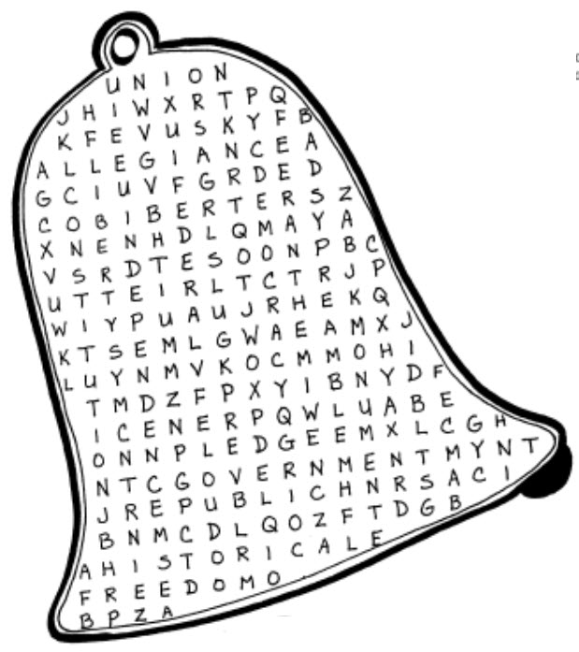

Allegiance Federal Government

Constitution Liberty Independence

Monument Republic Pledge

Union Anthem Democracy

Freedom Historical Preamble

**Respect to Our Flag**

*Baltimore Area Council*

Divide into Dens giving each group paper and pencil. At the start, each will write as many different ways of showing respect to our flag as they can remember. The team with the most correct methods in a given time is the winner. ***Example:*** “Never let the flag touch the ground.”

**Citizen Word Search**

*Catalina Council*

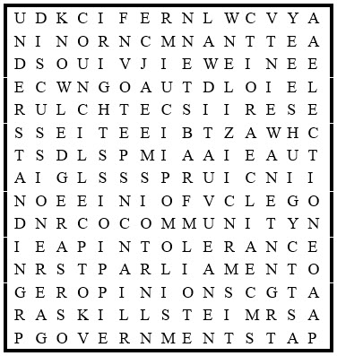

Citizen Community Council

Discussion Election Government

Injustice Intolerance Knowledge

Law Media Opinions

Parliament Participation Racism

Respect Responsibility Rights

Skills Understanding Views

Vote

**U.S. Symbols Word Search**

*Catalina Council*

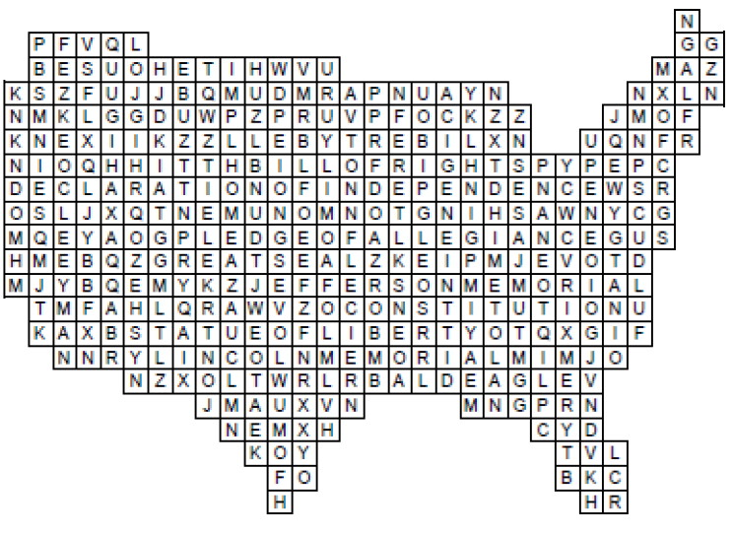

Jefferson Memorial Washington Monument

Bald Eagle Statue of Liberty

Lincoln Memorial Bill of Rights

Flag Constitution

Declaration of Independence Liberty Bell

The Pledge of Allegiance Great Seal

White House

**CROSSWORD**

*Great Salt Lake Council *

**Across**

1. The leader of the United States is called the _________________

5. There are ______states in the United States

6. It is red, white and blue and has 50 stars

8. The abbreviation for United States of America

**Down**

2. The United __________of America

3. “All men are created___________”

4. “I pledge allegiance to ____ flag

5. “….with liberty and justice ____all.”

7. George Washington cut down a cherry tree with an ______

**Our Flag (True or False)**

*Baltimore Area Council*

Divide into two or more small teams. Give each team a given time to mark and hand in their paper. You might enjoy making up your own lists:

1. T F The Grand Union flag was partly British.
2. T F The Betsy Ross flag had 15 stars.
3. T F Our flag once had 15 stripes.
4. T F June 14 is Flag Day.
5. T F We now have one star for each state.
6. T F If in uniform, salute the flag when it passes.
7. T F If not in uniform, salute just the same.
8. T F Stand when “America” is played.
9. T F Do not fly the flag after sunset.
10. T F The flag may be used as a table cover.

**Symbols of America**

**Challenge everyone to explain the symbolism of the Statue of Liberty – (***answers below)*

Enlarge pattern either as a visual aid or for an activity for everyone to make a model. There is even a story about the base of the statue!

For more information go to:

[**www.kids.nationalgeographic.com/kids/stories/history/statue-of-liberty/**](http://www.kids.nationalgeographic.com/kids/stories/history/statue-of-liberty/)

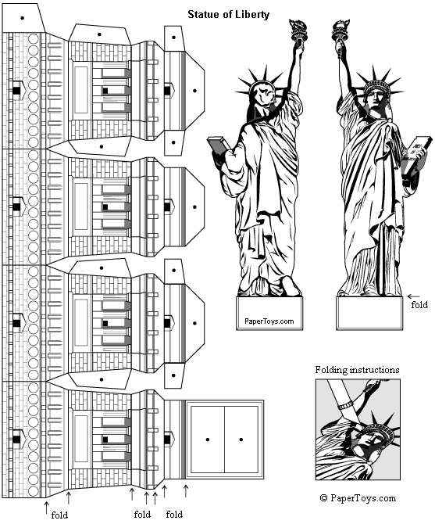

The Statue of Liberty has symbolized freedom throughout the world since she was unveiled in October 1886. While it was in use, she greeted all immigrants into Ellis Island, announcing that their journey to the "land of the free" has finally come to an end. Among the symbols included in the statue are:

* At her feet are chains of tyranny that have been broken off.
* In her right hand she holds a flaming torch, representing liberty.
* In her left hand, she has a tablet with the date July 4, 1776 inscribed in Roman numerals.
* There are seven rays in her spiked crown, symbolizing the seven seas and seven continents from which people seeking freedom would come.

**Presidential Nicknames**

*Catalina Council*

Have the Cubs figure out which President had which nickname. A great to have parents help them complete.

1. Long Tom A. Eisenhower
2. Silent Cal B. Taylor
3. Jemmy C. Cleveland
4. Old Hickory D. Pierce
5. Old Rough And Ready E. Buchanan
6. Handsome Frank F. Jefferson
7. Ike G. Madison
8. Old Buck H. Jackson
9. Grover The Good I. Coolidge

***ANSWERS****: 1F, 2I, 3G, 4H, 5B, 6D, 7A, 8E, 9C*

**Patriotic Word Search**

*Baltimore Area Council*

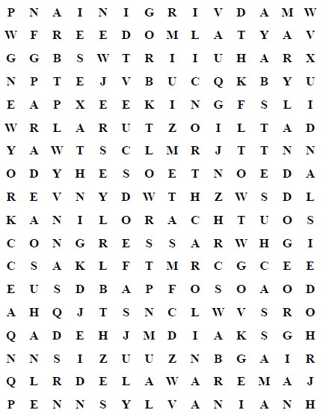

Congress Connecticut Delaware

England Fireworks Flag

Freedom Georgia July

King Liberty Massachusetts Bay

Maryland New Hampshire New Jersey

New York North Carolina Parade

Pennsylvania Rhode Island South Carolina

States Taxes United

Virginia

**U.S. Symbols Crossword**

*Catalina Council*

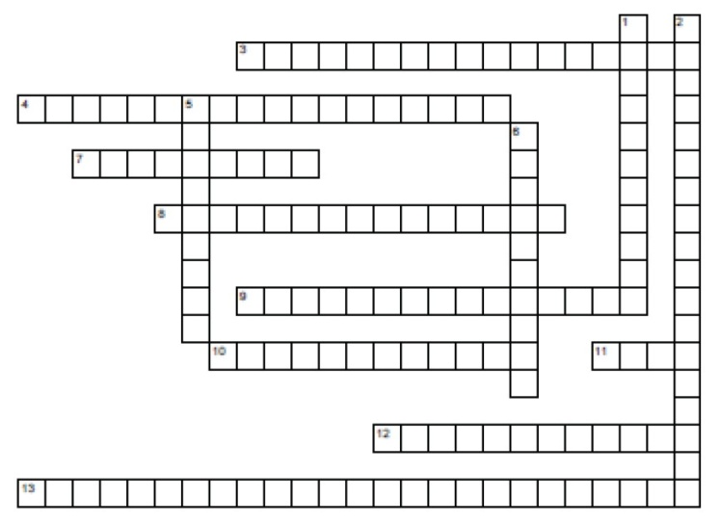

**Across**

3. Honors the author of the Declaration of Independence.

4. Honors the first President.

7. Seen in the air and on coins.

8. She lifts a torch

9. Honors the author of the Emancipation Proclamation ·

10. The first ten amendments

11. AKA "Old Glory" or "The Star Spangled Banner"

12. "We the people"

13. "We hold these truths to be self evident"

**Down**

1. Let freedom ring

2. Words to salute the flag

5. A symbol full of symbols

6. Where the President lives

***Answers***

***Across***

*3. Jefferson Memorial*

*4. Washington Monument*

*7. Bald Eagle*

*8. Statue of Liberty*

*9. Lincoln Memorial*

*10. Bill of Rights*

*11. Flag*

*12. Constitution*

*13. Declaration of Independence*

***Down***

*1. Liberty Bell*

*2. The Pledge of Allegiance*

*5. Great Seal*

*6. White House*

**Flag Quiz**

*Great Salt Lake Council*

1. The flags of what five countries flew over our country before it became the USA?
2. What was the English flag of the 13 colonies called?
3. When the colonists decided on a flag of their own, what did they call it?
4. How did it differ from the Queen Anne flag?
5. What was the name of the flag made after the Declaration of Independence?
6. How did the flag differ from the Grand Union flag?
7. What was the most strips the American flag had during the War of 1812 and why?
8. Why was the flag changed back to 13 stripes?
9. When the U.S. flag is folded properly, what part of the flag is showing?

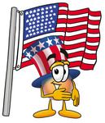

1. How many stars and stripes did the flag have when Francis Scott Key wrote “The Star Spangle Banner? “
2. When did the U.S. flag get its fiftieth star?
3. How is the flag saluted?
4. When carried in a parade with other flags, where should the U.S. flag appear?
5. Who was the astronaut that placed the U.S. flag on the moon?
6. On Memorial Day, the flag is flown at half-mast until noon. True or False?

*Answers:*

*Spain, France, Holland, Sweden, England 2. Queen Anne Flag 3.Grand Union Flag*

*4. 13 strips of red & white 5. Old Glory 6. The Union blue with 13 stars instead of the crosses of St. George & St. Andrew 7. 15 stripes, 2 more states were added 8. The flag was loosing its shape and beauty 9. The blue field 10. 15 stripes & 15 stars 11. July 4, 1960 12. By uniformed personnel using organization’s hand salute. By person not in uniform, right hand over their heart. If wearing a hat, place over heart 13. In front center of the marching line of flags 14. Neil Armstrong 15. True*

**Name That State**

*Catalina Council*

Our country is blessed with some of the most wonderful places on earth. Many of them have been saved by becoming National Parks. You have probably heard of most of these places but do you know in which state each is found?? Try your luck!

1. BADLANDS
   1. Montana
   2. Wyoming
   3. South Dakota
2. MOUNT RUSHMORE
   1. Colorado
   2. South Dakota
   3. Wyoming
3. MAMMOTH CAVE
   1. Virginia
   2. Kentucky
   3. Tennesee
4. BRYCE CANYON
   1. Idaho
   2. Utah
   3. Arizona
5. GLACIER PARK
   1. Colorado
   2. Nevada
   3. Montana
6. ZION
   1. Nebraska
   2. Utah
   3. Arizona
7. CARLSBAD CAVERN
   1. Oklahoma
   2. New Mexico
   3. Utah
8. GRAND CANYON
   1. Idaho
   2. Wyoming
   3. Arizona
9. YOSEMITE
   1. Utah
   2. California
   3. New Mexico
10. CRATERS OF THE MOON
    1. Utah
    2. Idaho
    3. Minnesota
11. MOUNT RANIER
    1. Idaho
    2. Oregon
    3. Washington

Answers - 1c, 2b, 3b, 4b, 5c, 6b, 7b, 8c, 9b, 10b, 11c

**Our National Treasures Word Search**

*Catalina Council*

This puzzle contains words and phrases related to our National Treasures. See how many you can find.

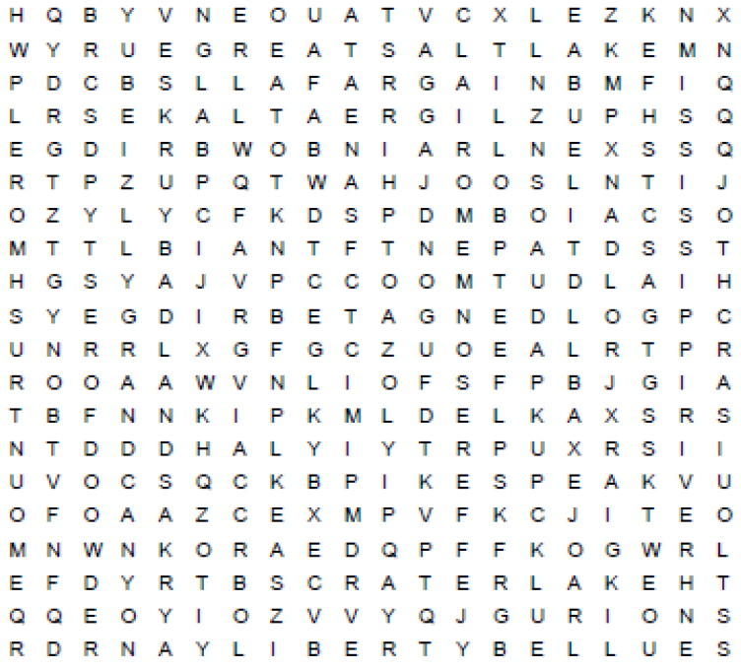

BADLANDS CAPE COD CRATER I.AKE

GOLDEN GATE BRIDGE GRAND CANYON

GREAT LAKES GREAT SALT LAKE

JEFFERSON MEMORIAL LIBERTY BELL

MISSISSIPPI RIVER MOUNT RUSHMORE

NIAGARA FALLS YELLOWSTONE PARK

RAINBOW BRIDGE REDWOOD FOREST

ROCKY MOUNTAINS ST LOUIS ARCH

STATUE OF LIBERTY YOSEMITE FALLS

WASHINGTON MONUMENT PIKES PEAK

**America's Symbols Quiz**

*Catalina Council*

1. The right hand of the Statue of Liberty holds a torch. What does the left hand hold?
2. Which is taller ...the Statue of Liberty or the Washington Monument?
3. What words are inscribed on the ribbon held in the mouth of the eagle on the Great
4. Seal of the United States?
5. In the Great Seal, what is the bald eagle carrying in its talons?
6. What denomination of currency has the Great Seat
7. printed on it?
8. How many people can fit inside the head of the Statue of
9. Liberty?
10. What is the U.S. motto?
11. Francis Scott Key was inspired to write the "Star Spangled Banner" when he saw the flag still flying over what fort?
12. Name the four U.S. Presidents carved in the Mount Rushmore Memorial in South Dakota.
13. The Declaration of Independence says that all men are created ___________?

***Answers:***

*1. Book*

*2. The Washington Monument*

*3. "E pluribus unum" (one out of many)*

*4. Arrow symbolizing war and  
 olive branch symbolizing peace.*

*5. The dollar bill*

*6. 40*

*7. In God We Trust*

*8. Fort McHenry*

*9. George Washington, Teddy Roosevelt,   
Thomas Jefferson, and Abraham Lincoln*

*10. Equal*

# OPENING CEREMONIES

**I Am an American**

*St. Louis Area Council*

**Equipment**

American Flag, and Pack Flags

12 cards with the statements below in **LARGE** print

Honor Guard, and 12 Cub Scouts to read the statements.

**Procedure**: The Honor Guard marches in, posts the flags, and then leads the group in the Pledge of Allegiance. Then the 12 Cub Scouts read their statements in turn.

1. My country gives us the opportunities to advance according to our ambitions and abilities. Education is for all. I am an American.
2. My country means love of freedom, faith in democracy, justice, and equality. I am an American.
3. My country believes in the worth of every person. I am an American.
4. My country gives us the privilege of expressing beliefs or opinions without fear of prosecution. I am an American.
5. My country is a democracy; it is our duty to keep it that way. I am an American.
6. My country promises life, liberty and the pursuit of happiness. I am an American.
7. My country is one that we should protect and defend. I am an American.
8. My country is and will always remain the land of the free and the home of the brave. I am an American.
9. My country needs informed, intelligent and active citizens. I am an American.
10. My country tries to meet its people's needs with abiding love and loyalty. I am an American.
11. My countries government is the servant not the master of the people. I am an American.
12. My country has a statue of liberty whose torch will burn brightly a long as we tend the flame of freedom. I am an American.

**Our American Heritage**

*Alapaha Area Council*

*A Cub Scout stands blindfolded, gagged, and wrists tied before the audience.*

**Cubmaster:** This is an American boy.

The American Revolution won him freedom.  
*(Cubmaster unties wrists.)*

The Constitution guarantees him free speech.  
*(Cubmaster removes gag.)*

A free education gives him the ability to see and to

understand.  
*(Cubmaster removes blindfold.)*

Let us help Cub Scouting teach him to preserve and enjoy his heritage and to become a good citizen.

Please join me in the Pledge of Allegiance.

**That's What It Means to be an American**

*Catalina Council*

**Set Up:** 4 uniformed Cub Scouts, carrying suitable props (such as a megaphone, nightcap, church model, and a star) and the Cubmaster (CM) or other adult leader.

**ALL** can be the 4 Cubs on stage or the whole audience if you cue the audience first.

Attach to the prop each Cub’s words in LARGE Print so they can speak them clearly.

1. You can say anything you want to say, whoever you may be. Some things cost a lot of money, but speech is free.

**All:** That's what it means to be an American.

1. You can write anything you want and dare to disagree.

**All:** That's what it means to be an American.

1. You can't be put in prison, unless you've been fairly tried. You can choose your place of worship with your family by your side.

**All:** That's what it means to be an American.

1. You can dream any dream you want to dream, and make it all come true. We live in a land where liberty is meant for you and me.

**All:** That's what it means to be an American.

**CM:** Now let us all honor or country by saluting our flag and saying The Pledge of Allegiance.

**Stars Opening Ceremony**

*Catalina Council*

1. When I look at the flag of red, white & blue,
2. I think of the stars above me & you.
3. I’ll Do My Best in all that I try,
4. As I reach for the stars way up in the sky.
5. I’ll do my duty to God & country too,
6. and help other people in all that I do.
7. Obey the laws of my family & pack,
8. I’ll keep reaching up & I’ll never look back.

**I Am Old Glory**

*Santa Clara County Council*

**Personnel:** Color Guard, Narrator, Cubmaster (CM)

**Setting:** The colors are advanced in the normal manner. A spotlight is shined on flag while the narrator speaks off stage.

**Narrator:** I am old glory. For more than 9 score years I have been the banner of hope and freedom for generation after generation of Americans. Born amid the first flames of America's fight for freedom, I am the symbol of a country that has grown from a little group of 13 colonies to a united nation of 50 sovereign states. Planted firmly on the high pinnacle of American Faith, my gently fluttering folds have proved an inspiration to untold millions. Men have followed me into battle with unwavering courage. They have looked upon me as a symbol of national unity. They have prayed that they and their fellow citizens might continue to enjoy the life, liberty and pursuit of happiness, which have been granted to every American as the heritage of free men. So long as men love liberty more than life itself, so long as they treasure the priceless privileges bought with the blood of our forefathers; so long as the principles of truth, justice and charity for all remain deeply rooted in human hearts, I shall continue to be the enduring banner of the United States of America.

**CM**: Please stand as we salute the flag and repeat the Pledge of Allegiance.

**A Salute To Our Heroes**

*Buckeye District SKC*

**Personnel:** Cubmaster (CM), Den Leader (DL) or other adults

**Setting:** The colors are advanced in the normal manner. A spotlight is shined on flag while the narrator speaks off stage.

**DL:** *(speaking from off stage and out of sight)*A great host of heroes, with the help of God, have kept me gallantly flying in the face of every threat and challenge to the democratic way of life I represent.

The blood spilled in battles great and small all over the world is in my red stripes.

The shining light of freedom is in my white stripes, penetrating the blackest night and filling the nations’ darkest hours with hope.

The vast infinity of the heavens is in my stars, inspiring mankind to continue climbing up the staircase of history to a world of glowing promise.

I am the emblem of man’s finest dreams. I am the last hope of peace on earth. I am the American Flag.

**CM**: Please stand as we salute the flag and repeat the Pledge of Allegiance.

**Four Freedoms Opening**

*Alice, Golden Empire Council*

***You will need either prints of the four paintings, or just enlargements from the Bugle. Print the boy’s part in large letters on the back of the picture. If you need more parts, break up the Narrator part. If pack families have actual prints, you could also have them displayed on easels or the wall.***

**Narrator:** In 1941, President Franklin Delano Roosevelt referred to Four Freedoms that every person is entitled to. In 1943, Norman Rockwell made a painting for each freedom as covers for the Saturday Evening Post. Many families put these four images on their walls, and a traveling exhibition of the paintings helped raise over $132 million in War Bonds.

**Freedom of Religion  
Cub #1:** The first immigrants to our country came seeking the freedom to worship as they pleased. Being a good citizen means we let everyone worship in their own way.

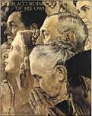

**Freedom of Speech  
Cub #2:** In America, we have the right to say what we think, even if others don’t agree with us. In some countries, even today, people can be put in prison or even killed for disagreeing with what the people in power say – so we should always be ready to defend the right to Free Speech.

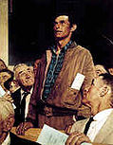

**Freedom from Want   
Cub #3 -** President Roosevelt said that every person had the right to have enough food, clothing and shelter – but even in America, some people don’t have what they need. Some citizens find ways to help others who are less fortunate.

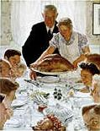

**Freedom from Fear  
Cub #4 –** In some countries, police can break into your home at any time – but in America, we have made laws to protect people so they can feel secure in their own home.

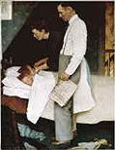

**Cub #5 –** Each person has the right to these freedoms – but part of being a good citizen is to protect our freedoms.

**Narrator:** Remember to use these four freedoms – each citizen is responsible to know what is going on, to vote for people and laws we support, and to allow everyone the same freedoms we enjoy.

One symbol of these freedoms for Americans is our Flag ***(Continue with Flag Ceremony)***

# AUDIENCE PARTICIPATIONS

**Service to Country**

*Catalina Council*

Divide audience into five parts. Assign each part a word and a response. Instruct them they are to say the response whenever they hear the word. Practice as you make assignments. Then read the story. After each of the words is read, pause for the group to make the appropriate response.

**ARMY** - Be all you can be!

**AIR FORCE** - No one comes close!

**NAVY** - Can do!

**MARINES** - Semper Fi!

**COAST GUARD** - Always ready!

**CUB SCOUTS** (Everyone) - Do Your Best!

In the United States of America, we have several different branches of the military, all prepared to defend our freedom. There is the **ARMY**, the **NAVY**, the **AIR FORCE**, the **MARINES**, and the **COAST GUARD**.

All these different groups have mottos and slogans, just like **CUB SCOUTS**. Part of the **CUB SCOUTS** Promise includes duty to God and country, and certainly, all the men and women who serve in the **ARMY**, the **NAVY**, the **AIR FORCE**, the **MARINES**, and the **COAST GUARD** demonstrate their duty to God and country in a big way.

As **CUB SCOUTS**, we take pride in being good citizens, in honoring our flag, and in helping others. One day, some of you may choose to join the **ARMY**, the

**NAVY**, the **AIR FORCE**, the **MARINES**, or the **COAST GUARD**. But, for now, we give thanks and appreciation for those who help protect and defend our country, while we learn to be the best we can be as **CUB SCOUTS**.

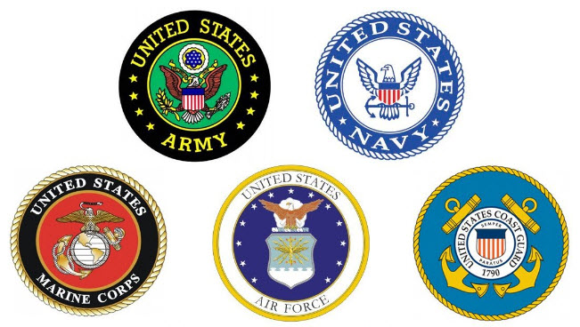

**Scouting Across America**

*Catalina Council*

Divide audience into seven parts. Assign each part a word and a response. Instruct them they are to say the response whenever they hear the word. Practice as you make assignments. Then read the story. After each of the words is read, pause for the group to make the appropriate response.

**CHICAGO:** “The windy city”

**TEXAS:** “Howdy, y’all”

**INDIANAPOLIS:** “Vrroooommm!”

**HAWAII:**  “Aloha”

**COLORADO:**  “Climb the Rockies!”

**ALASKA:** “Brrrr”

**CALIFORNIA:** “The Golden State”

**CUB SCOUT(S): *(ALL)*** “Do your best”

***With only 2 hits per word, I would do this with a "cheerleader" for each word. Give each cheerleader a sign with the response and have him/her get everyone to yell when the word is called. CD***

Boy Scouting was brought to America in 1909 by a **CHICAGO** businessman. **CUB SCOUTS** started in 1930, and the program quickly spread throughout the states. You can picture the boys in **TEXAS** being helpful to their neighbors. Imagine **HAWAIIAN** **CUB SCOUTS** having a spectacular regatta or the **CUB SCOUTS** in **INDIANAPOLIS** having super speedy Pinewood derby cars.

In **COLORADO**, the hiking is fantastic, and in **ALASKA**, skiing belt loops abound. The Blue & Gold of **CUB SCOUTS** is seen in **CALIFORNIA'S** blue skies and historic gold strike. All across our great nation, from **CHICAGO** to **COLORADO**, **INDIANAPOLIS** to **ALASKA**, and **TEXAS** to **CALIFORNIA** and **HAWAII**, **CUB SCOUTS** are all doing the same things:

Learning new skills, doing good deeds, and having FUN!

**Joey’s First Parade**

*St. Louis Area Council &Catalina Council*

Divide audience into five parts. Assign each part a word and a response. Instruct them they are to say the response whenever they hear the word. Practice as you make assignments. Then read the story. After each of the words is read, pause for the group to make the appropriate response.

**MARCH** - Stomp, stomp, stomp your feet!

**CLOWN** - Laugh out loud!

**PARADE** - Hooray!

**DOG** - Argh, Argh!

**LEGS** - Sooo Tall!

Joey awoke and looked at the calendar. Yep, today was the Fourth of July and Joey was excited. Today, he would **MARCH** in his very first **PARADE**. There would be floats and bands to celebrate America's Independence Day. As Joey arrived downtown, he could see everyone lining up for the **PARADE**. He finally found his group and the Cubmaster.

The Cubmaster said, "Hi Joey! Are you excited and ready to **MARCH** in the **PARADE**?" "I sure am!" said Joey. Suddenly Joey hears a loud whistle and the **PARADE** was on its way. Joey stood as tall as he could, proud to be a Cub Scout. There were so many people along the streets as they **MARCHED**.

Up ahead of him he could hear the laughter of people and he longed to know what was so funny. Joey moved toward the front of his group and stretched to see. Then without warning there was in front of him, two **LEGS**. That's all he saw, was two **LEGS**. The crowd was laughing and they became louder as Joey followed the **LEGS** up into the air. High up on the tallest **LEGS** he had ever seen was a **CLOWN**. Wow! The **CLOWN** leaned over and patted Joey on the head. What a terrific trick and what long **LEGS**! The **CLOWN** was holding onto the smallest **DOG** he had eve r seen barking up at him. That's what is so funny and Joey began to laugh. The tallest **CLOWN** in the world was taking the smallest **DOG** in the world for a walk in the **PARADE**! As he ran to join his group, Joey watched the **CLOWN** and **DOG** to the end of the **PARADE**.

That night Joey's dad tucked him into bed. Dad asked how his day had been. Did he have a great time in the **PARADE**?

"Oh, it was great, Dad!" Joey said "and I know exactly what I want to be when I grow up." "Really, what is that Joey?" Dad asked.

"I want to be a **CLOWN**" Joey exclaimed.

"Goodnight Dad."

Dad chuckled as he turned off the lights. "Goodnight Joey".

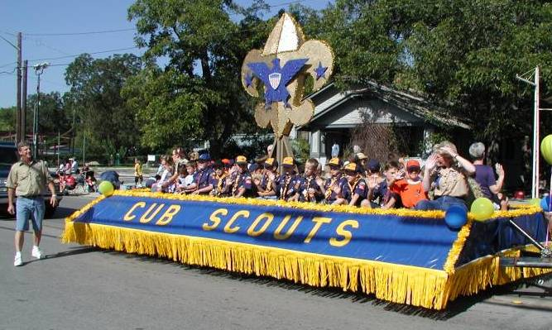

# ADVANCEMENT CEREMONIES

**Patriotic**

*Baltimore Area Council*

*This ceremony could be enhanced by having leaders portray the characters in costume. Feel free to change the characters and the badges they are awarding to fit your packs awards and available costuming.*

**CUBMASTER:** Ladies and gentlemen, we have some honored guests here tonight. I would like to introduce Uncle Sam, Lady Liberty, and Yankee Doodle. Each of these individuals is an important symbol to the people of our country. Tonight, they are here to present some other symbols to some deserving young men. These symbols represent hard work, diligence, and jobs well done.

**YANKEE DOODLE:** We have some Cub Scouts who have earned some special awards. Would the following Cub Scouts and parents please come forward? (Call the names of those receiving XXX badge their parents.)

**LADY LIBERTY:** I would like to call forward those Cub Scouts who have been working for some time and have achieved much. I would like them to present them with their awards. (Call the names of those receiving YYY Award and their parents.)

**UNCLE SAM:** I would like to recognize some of the older boys in this group. You have given unselfishly of yourselves. For your loyal support over the years, I would like to present you with your awards. (Call the names of those receiving ZZZ and their parents.)

**CUBMASTER:** I would like to thank our three guests for coming to help us tonight. And a special thanks to all the boys who have worked so hard to be examples and role models of good American citizens!

**Other character Ideas:**

* **A Minute Man** that rushes in to give awards: “I only have 1 minute….”
* **Betsy Ross:** CM introduces her saying “Heavens to Betsy! It’s Betsy Ross here to hand out some awards!”
* **Paul Revere** rides through on a stick horse saying “The British are coming! The British are coming! And so are the Bears (or Wolves, Tigers, etc.) I have just enough time to award… before riding off!”

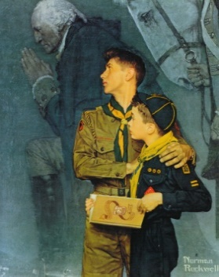

**Looking Back ~ Looking Forward**

*Alice, Golden Empire Council*

Enlarge the Rockwell print above and cut it into as many pieces as needed – one puzzle piece for each boy receiving an award.

(If you have a large group, or if you want to have a different focus for each rank, use a different patriotic Rockwell print for each rank) If you Google for Rockwell Scout paintings, you will find lots of choices. You can add a numbered post-it on top of each puzzle piece to make it easy to put together, with a matching numbered post-it on the wall showing where each piece should go.

**Cubmaster:** This month we are focusing on one of the three aims of Scouting – Particpatory Citizenship in our Country, States, Counties, and Cities and Towns. There are many parts to Citizenship – we all have rights and duties, and there are many ways to demonstrate good citizenship. Tonight we are honoring scouts who have demonstrated good citizenship as they advanced in rank, earned badges and pins and gave service in their homes and communities.

*Calls up boys one by one or in groups, along with their parents, to receive the award they have earned. Be sure to give some information about what the boy or boys have done, or ask them to tell about it (If you have warned them in advance) For rank advancement, follow the standard of handing the award to the parent to present to the boy, and the parent’s pin to the boy to pin on his parent.*

**Cubmaster:** We have seen tonight how the many parts of scouting are represented in the work the boys have accomplished. Just as we look back in history to the Father of our Country, George Washington, for an example of citizenship and service, we look forward to the example of each Cub Scout and Webelos Scout from our Pack – Well done, scouts!

**America the Beautiful**

*St. Louis Area Council*

Put the rank awards for the Cub Scouts on the back of cut out stars. Use masking tape, Velcro tape, or pins to attach the stars to the blue background. For the blue background, use blue poster board, butcher paper, or a blue blanket.

**Cubmaster:** To many of America’s citizens, the flag is very symbolic of “America the Beautiful”. For in its Red, White, and Blue, we see America working as a team, a nation under God. In the firth of our flag, the stars in a field of blue were meant to represent a new constellation in the heavens. Each new state added another star to the constellation.

Tonight we add some new stars to our own constellation. As we add more and more stars, the heavens become brighter as the rays light up the path to truth and knowledge through Scouting. Will our new stars please come forward with their parents as their names are called? (Boys add stars to the blue background after receiving their awards.)

*This ceremony could also be effective using the Flashlight Constellation Projectors from the Round Table Handout. Each boy shines his flashlight projector at the ceiling after receiving his award.*

**Flashlight Constellation Projector Directions**: Cover one end of a long cardboard tube with aluminum foil, and tape into place. Using a toothpick, poke holes in the foil to make a star shaped or constellation. Dim the lights in the room. Shine a flashlight up through the open end of the tube. Aim the tube at the ceiling and watch the stars/constellations light up the night!

*Note: I got the best results using longer tubes – paper towel, wrapping paper, or rolled poster board – and single bulb LED flashlights. –W.*

# LEADER RECOGNITION

## PATRIOTIC RECOGNITIONS

*Wendy, Chief Seattle Council*

* **Small Flag**: For a volunteers’ unflagging support of the pack.
* **Stars & Stripes**: give Starbursts and striped candy or gum to volunteers, for earning their “stripes”, and becoming pack “superstars.”

## BECAUSE OUR CUB SCOUTS

*Sam Houston Area Council*

Because our Cub Scouts have a need,   
we have an obligation.

Because our Cub Scouts have a choice,   
we must be his better choice.

Because our Cub Scouts have high expectations,   
we must excel.

Because our Cub Scouts want to explore,   
we must be his guide.

Because our Cub Scouts want to belong,   
we must provide inclusion.

Because our Cub Scouts are searching for direction,   
we must be his compass.

Because our Cub Scouts encounter times of turmoil,   
we must be his safe haven.

Because our Cub Scouts are tomorrow's young men,   
we must care today.

Because of our Cub Scouts…   
We exist.

**Materials –**

* Compass – made into a neckerchief slide, OR a usable one, OR a small pretend one mounted on some type of display material.
* Write underneath – thanks for guiding our path OR thanks for leading the way.

**Cubmaster –** There have been some leaders this year who went out of their way to make sure we had a great program for our Cubs. They really provided real direction to our pack, and I would like to thank them. (Call forward appropriate adults/leaders and present them with the compass.)



# SONGS

**God Bless America**

Irving Berlin, Original: 1918; Revised: 1938  
*Grand Teton Area Council Pow Wow Book*

*Spoken Introduction***While the storm clouds gather far across the sea,  
Let us swear allegiance to a land that's free,  
Let us all be grateful for a land so fair,  
As we raise our voices in a solemn prayer.**

*Everybody Sing***God bless America, land that I love  
Stand beside her and guide her  
Through the night with the light from above  
From the mountains To the prairies,  
To the ocean white with foam  
God bless America, My home sweet home  
God bless America, My home sweet home**

The unofficial national anthem of the United States was composed by an immigrant who left his home in Siberia for the USA when he was only five years old. The original version of "God Bless America" was written by Irving Berlin (1888-1989) during the summer of 1918 at Camp Upton, located in Yaphank, Long Island, for his Ziegfeld-style revue, Yip, Yip, Yaphank. "Make her victorious on land and foam, God Bless America..." ran the original lyrics. However, Irving decided that the solemn tone of "God Bless America" was somewhat out of keeping with the more comedic elements of the show, so the song was laid aside.

In the fall of 1938, as war was again threatening Europe, he decided to write a "peace" song. He recalled his lyrics of "God Bless America" from twenty years earlier, then made some alterations to reflect the different state of the world. Singer Kate Smith introduced the revised "God Bless America" during her radio broadcast on Armistice Day, 1938. The song was an immediate sensation; the sheet music was in great demand.

Berlin's file of manuscripts & lyric sheets for this quintessentially American song includes manuscripts in the hand of his longtime musical secretary, Helmy Kresa (he himself did not read and write music), as well as lyric sheets, and corrected proof copies for the sheet music.

These materials document not only the speed with which this song was revised, but also its author's attention to detail. The first proof copy is dated October 31, 1938; the earliest "final" version of the song is a manuscript dated November 2; and Kate Smith's historic broadcast took place on November 11. So, documents show the song's step-by-step evolution from the original version of 1918 to the tune we now know.

The manuscripts mentioned above are part of the Irving Berlin Collection, a remarkable collection that includes his personal papers as well as the records of the Irving Berlin Music Corp. It was presented to the Library of Congress in 1992, by his three daughters, Mary Ellin Barrett, Linda Louise Emmet, and Elizabeth Irving Peters.

What an amazing song! Isn't it wonderful that we have been so lucky to be connected with people who are able to put to words our deepest thoughts and emotions? Irving Berlin was truly inspired. Close your eyes and listen to his message. Does it not touch your soul? Can't you just see crashing waves- the majesty of the mountains? All of the beautiful people working every day, alive and free because of the dream of our beloved Founding Fathers?

As this song is being broadcasted through out the world on various occasions, there is this incredible overwhelming desire to jump up and sing with all the energy of the soul, knowing that if we did, the choirs of Heaven would be singing right along with us! Our people love our country, our Lord loves our country, and as long as we continue to fight for our gift of love and freedom, we will continue to enjoy the blessings of this, our sacred nation.

In 1940 Irving Berlin established the God Bless America Foundation, with all royalties from its performance earned by either Berlin or Miss Smith going to the **Boy Scouts and Girl Scouts.** That arrangement exists to this day. These organizations were chosen, to quote the contract, because "the completely nonsectarian work of the **Boy Scouts and Girl Scouts** is calculated to best promote unity of mind and patriotism, two sentiments that are inherent in the song itself."

**God Bless America, Kate Smith,   
and the Philadelphia Flyers**

An interesting chapter was added to the Kate Smith- God Bless America story in the twilight of her 50-year career. Officials noted that when the national anthem was played at the opening of Philadelphia Flyers' hockey games, the fans were not properly respectful, while they listened more quietly to Kate's record of God Bless America. Furthermore, a statistician noted that they won most games when the latter was played. Fans were given a surprise on October 11, 1973, at the season opener, when Kate Smith walked across the red carpet on the ice to sing her anthem in person. They beat the Toronto Maple Leafs 2-0. Announcer Gene Hart commented that Kate "brought chills and a standing ovation of three minutes. It fully met the ultimate definition of the word triumph." At critical games Kate was driven down from New York to repeat the favor. When the Flyers clinched the championship and won the Stanley Cup by defeating the Boston Bruins 1-0, even the Bruins skated over to shake Kate’s hand. She was called their talisman and good luck charm; she loved the free publicity! She repeated the role the next season, and the Flyers defeated the Buffalo Sabres to retain the Stanley Cup. In 1987 they erected a bronze statue in memory of their "rabbit's foot" or "secret ice weapon," who had died the previous year.

**I Am A Citizen**

*Alice, Golden Empire Council*

*Tune: My Bonnie Lies Over the Ocean)*

I’m learning to be a good citizen,  
I’m learning we all have some rights  
I’m learning each right has a duty  
I must keep them both in my sights.

**Chorus:**Rights and Duties  
They both go together,   
You know, You know  
Rights and Duties  
Good Citizenship I must Show

We all have a right to religion,  
To worship the way that we please,  
But that means I have to allow you  
Your choice, though I may not agree

**Chorus**

We all have the right to assemble  
To gather with people we know  
And all have the freedom of speaking  
If citizenship is to grow

**Chorus**

We each have the right to make choices  
And no one can threaten that choice  
I may not agree with your statements  
But each person can raise their own voice.

**Chorus**

*(Bet you can add on other verses about the rights and duties of citizenship! – Alice)*

**America the Beautiful**

*(Words by Katharine Lee Bates,   
Melody by Samuel Ward)*

**O beautiful for spacious skies,**For amber waves of grain,  
For purple mountain majesties  
Above the fruited plain!  
America! America!  
God shed his grace on thee  
And crown thy good with brotherhood  
From sea to shining sea!

**O beautiful for pilgrim feet**Whose stern impassioned stress  
A thoroughfare of freedom beat  
Across the wilderness!  
America! America!  
God mend thine every flaw,  
Confirm thy soul in self-control,  
Thy liberty in law!

**O beautiful for heroes proved**In liberating strife.  
Who more than self their country loved  
And mercy more than life!  
America! America!  
May God thy gold refine  
Till all success be nobleness  
And every gain divine!

**O beautiful for patriot dream**That sees beyond the years  
Thine alabaster cities gleam  
Undimmed by human tears!  
America! America!  
God shed his grace on thee  
And crown thy good with brotherhood  
From sea to shining sea!

**O beautiful for halcyon skies,**For amber waves of grain,  
For purple mountain majesties  
Above the enameled plain!  
America! America!  
God shed his grace on thee  
Till souls wax fair as earth and air  
And music-hearted sea!

**O beautiful for pilgrims feet,**Whose stem impassioned stress  
A thoroughfare for freedom beat  
Across the wilderness!  
America! America!  
God shed his grace on thee  
Till paths be wrought through  
wilds of thought  
By pilgrim foot and knee!  
The banner of the free!

**O beautiful for patriot dream**That sees beyond the years  
Thine alabaster cities gleam  
Undimmed by human tears!  
America! America!  
God shed his grace on thee  
Till nobler men keep once again  
Thy whiter jubilee!

**America (My Country, 'Tis of Thee)**

*(by Rev. Samuel F. Smith)*

My country, 'tis of Thee,  
Sweet Land of Liberty  
Of thee I sing;  
Land where my fathers died,  
Land of the pilgrims' pride,  
From every mountain side  
Let Freedom ring.

My native country, thee,  
Land of the noble free,  
Thy name I love;  
I love thy rocks and rills,  
Thy woods and templed hills,  
My heart with rapture thrills  
Like that above.

Let music swell the breeze,  
And ring from all the trees  
Sweet Freedom's song;  
Let mortal tongues awake;  
Let all that breathe partake;  
Let rocks their silence break,  
The sound prolong.

Our fathers' God to Thee,  
Author of Liberty,  
To thee we sing,  
Long may our land be bright  
With Freedom's holy light,  
Protect us by thy might  
Great God, our King.

Our glorious Land to-day,  
'Neath Education's sway,  
Soars upward still.  
Its hills of learning fair,  
Whose bounties all may share,  
Behold them everywhere  
On vale and hill!

Thy safeguard, Liberty,  
The school shall ever be,  
Our Nation's pride!  
No tyrant hand shall smite,  
While with encircling might  
All here are taught the Right  
With Truth allied.

Beneath Heaven's gracious will  
The stars of progress still  
Our course do sway;  
In unity sublime  
To broader heights we climb,  
Triumphant over Time,

God speeds our way!  
Grand birthright of our sires,  
Our altars and our fires  
Keep we still pure!  
Our starry flag unfurled,  
The hope of all the world,  
In peace and light impearled,  
God hold secure!

**Other Patriotic Songs**

* The Army Goes Rolling Along (Caison Song)
* God Bless The U.S.A.
* I Am Thankful To Be An American
* I Love You So
* Off We Go Into the Wild Blue Yonder
* Song of Freedom
* Star-Spangled Banner
* Stars and Stripes Forever
* Taps
* This Land is Your Land
* Yankee Doodle
* You're a Grand Old Flag

*Note: The link below provides full lyrics to the songs listed above.*

http://www.[scoutsongs](http://www.scoutsongs.com/categories/patriotic-songs.html).com/categories/patriotic-songs.html

**Grand Old Flag**

*Catalina Council*

*Music and lyrics by George M. Cohan*

You’re a grand old flag,  
You're a high flying flag   
And forever in peace may you wave  
You’re the emblem of The land I love,  
The home of the free and the brave.

Every heart beats true  
Under the red white and blue,  
Where there’s never a boast or a brag  
But should auld acquaintance be forgot,  
Keep your eye on the grand old flag!

**This Land Is Your Land**

by Woody Guthrie  
*Baltimore Area Council*

**Chorus:**

This land is your land,  
This land is my land,  
From California,  
To the New York Island,  
From the Red Wood Forest,  
To the Gulf Stream waters,  
This land was made for you and me.

As I went walking that ribbon of highway,  
I saw above me that endless skyway,  
I saw below me that golden valley,  
This land was made for you and me.

I roamed and rambled,  
and I followed my footsteps,  
To the sparkling sands of her diamond desert,  
All around me a voice was sounding,  
This land was made for you and me.

When the sun came shining,  
then I was strolling,  
And the wheat fields waving,  
and the dust clouds rolling,  
A voice was chanting as the fog was lifting,  
This land was made for you and me.

*One of Woody Guthrie's best. And Arlo sings it every time at his concerts!! He is trying to convince his kids that since he sings his Daddy's songs, they should sing his (Alice's Restaurant) and get him out of the "Groundhog Day" scenario of singing all 17 minutes (or more) of "Alice's Restaurant" every day).   
(I know, TMI (Too Much Information) CD*

# STUNTS AND APPLAUSES

## APPLAUSES & CHEERS

*Great Salt Lake Council*

**Ben Franklin –** act out flying a kite, working the string up into the air, and then scream when you get zapped

**Constitution** – “We the People Approve”

**George Washington –** I cannot tell a lie. That was great!

*Catalina Council*

**Abe Lincoln:** “That was great--honestly!”

**Eagle:** Lock thumbs,flutter fingers like wings,shout "Cree, cree!"

**Politician Applause:** Pat yourself on the back.

**Mount Rushmore: S**hout “Washington, Jefferson, Lincoln, Roosevelt!”

*Alice, Golden Empire Council*

**Flag Wave Applause:** Announce that in honor of Uncle Sam and his search for good citizens, we will do the Old Glory Wave Applause. Then do the regular “wave” where one group at a time starting from one side and going to other, creates a wave by waving both arms.

**Soldier:** Stand at attention and salute. Yell “Well done!”

**Salute the New Citizen!** To recognize the hard work of learning in order to pass the test to become a new citizen, have everyone stand, make a salute, and say “We salute you!”

*Wendy, Chief Seattle Council*

**Congressional Stamp of Approval:** Stamp feet, or pound left fist onto your right palm.

**Good Turn** (for service projects)**:** Spin in place while clapping.

## RUN-ONS

**Washington's Farewell Address**

*Great Salt Lake Council*

It is announced that a member of the pack has memorized Washington's Farewell Address and is about to do a dramatic portrayal of it. A boy emerges dressed as Washington and delivers his farewell address:

**Washington:** Bye, Mom!" (He exits the stage.)

**The Redcoats are Coming**

*How-to Book*

Several people run into the room during the meeting at different times, with frightened expressions. Each shouts “The redcoats are coming! The redcoats are coming!”

Later, toward the end of the meeting, two or three adults enter wearing red coats or jackets, and say “We’re the red coats.”

*Note: Adults could then make announcements.*

## JOKES & RIDDLES

*Baltimore Area Council*

Q: What did Paul Revere say at the end of his famous ride?

A: Whoa!

*Santa Clara*

Q: Where was the Declaration of Independence signed?

A: At the bottom.

*Great Salt Lake Council*

Q: What American has the largest family?

A: Washington: he is the Father of the Country.

Q: Why does the Statue of Liberty stand in New York harbor?

A: Because she can’t sit or lie down.

Q: Why is it impossible to send mail to Washington now?

A: Because he is dead.

Q: Can you send mail to Lincoln?

A: Yes, he left us his Gettysburg address.

Q: If Washington went to Washington wearing white wool socks and Washington’s wife waited in Wilmington, how many W’s are there in all?

A: There are no W’s in the word ALL.

Q: Where did General Washington keep his armies?

A: In his sleevies!

**More patriotic jokes:** <http://www.kidactivities.net/post/Patriotic-Red-White-and-Blue-Jokes.aspx>

# SKITS

**How Did You Get Here?**

*Baltimore Area Council*

**Personnel:** Chief, 4 or more Cubs (any number of Cubs can participate by dividing the lines accordingly.)

**Equipment**: As indicated in skit.

**Setting:** The Den Chief introduces this skit by saying "Transportation played a very important part in the settling of America. How did you get here?"

**Cub #1:** If the Pilgrims came over on the Mayflower, how did the Scouts get here?

**Cub #2:** I don't know, how?

**Cub #1:** On handy crafts. (As he says this, a Cub comes on stage with a sample of a handicraft project and a sign identifying it.)

**Cub #3:** If the Pilgrims came on the Mayflower and the Scouts came on handy crafts, how did the doctors get here?

**Cub #4:** I don't know, how?

**Cub #3:** On blood vessels. (Cub dressed as a doctor enters.)

**Cub #1:** How did the students get here?

**Cub #2:** On scholar ships. (Cub enters carrying a load of books.)

**Cub #1:** How did all the ordinary people get here?

**Cub #4:** On citizen ships. (Cub enters carrying a poster that says "Don't forget to vote".)

**Cub #1:** I know how the barbers got here.

**Cub #2:** How?

**Cub #1:** On clipper ships. (Cub enters dressed as a barber with a towel, razor, etc.)

**Cub #3:** How did all the movie stars get here?

**Cub #4:** On a show boat. (Cub enters dressed well, wearing sun glasses.)

**Cub #2:** I'll bet you can guess how all the hot heads got here. (Cub runs on stage, shaking his fist and pretending to quarrel with everyone.)

**All:** On steam ships, of course.   
***(They bow as curtain closes.)***

**Fireworks Skit**

*Alice, CS RT Commissioner*

*Pioneer District, Golden Empire Council*

*A Cub Scout stands looking up into the sky..*

**Cub #1:** “Oooh, Ahhhh!”

**Cub #2:** *(Walks up to Cub #1, follows his lead and looks up)* “What are you looking at?”

**Cub #1:** “Fireworks! Want to watch with me?”

**Cub #2:** “Yeah!”

**Cub #1 and #2:** “Oooooh, Ahhhh!”

**Cub #3:** *(Walks up to Cub #1 and #2, looks up)* “What are you looking at!”

**Cub #2** “Fireworks! Want to watch with me?”

**Cub#3:** “Yeah!”

**Cubs #1, #2, #3:** “Ooooh, Ahhhh!”

**Cub #4:** *(Walks up to Cub #1, #2, #3, and looks up)* “What are you looking at?”

**Cub #3:** “Fireworks! Want to watch with me?”

**Cub #4:** “Yeah!”

*(Repeat till only one Cub remains)*

**Last Cub:** *(Walks up to group)* “What are you all looking at?”

**All:** “Fireworks!”

**Last Cub:** “Those aren’t fireworks – they’re fireflies!”

**Cub #1** “Oh - I just thought the fireworks were really far away!” *(Walks off)*

**Constitution Skit**

*Catalina Council*

**Scene**: Philadelphia, 1787

**Characters:** Narrator, 4 Cub Scouts in colonial dress, some extra Scouts.

**Narrator:** "While it's true that our constitution was written by truly great men, it still took 11 years to finish. Let’s look in on some of these men as they go about their work. Here comes Ben Franklin and Samuel Adams."

**Sam:** "Let's have pizza tonight."

**Ben:** "I don't like pizza. How about tacos?"

**Sam:** "But I don't like tacos. Let's have hamburgers."

**Ben:** "We always have burgers."

*(The two walk off stage still arguing.)*

**Narrator:** *(flustered*) "Simply a difference of opinion, ladies and gentlemen. Don't worry, they'll work it out. Look there's Thomas Jefferson and John Adams."

**John:** "I tell you the Yankees are the best!"

**Tom:** "No way, it's gonna be the Braves this year."

**Narrator:** "Wait a minute you two, are you talking about baseball."

**Tom and John:** "Yes!"

**Narrator:** "Baseball hasn't been invented yet!"

**John and Tom:** "OH!" and then walk off arguing about football.

**Narrator:** "I don't know what's going on here. Wait, they're gathered together! Now what are they arguing about?"

*(The four Scouts plus the extras   
are gathered around a table.....)*

**Tom:** "At least we agree on something...The Constitution of the United States!"

**Old Glory**

*Baltimore Area Council*

**Setting:** Cubs form a semi-circle around a large pot. An American flag is folded and hidden down in the pot. Each Cub is holding the ingredients which he adds.

**Personnel:** 6 Cubs, Den Chief (DC) or Den Leader (DL)

1. We are going to fix for you,   
   A treat that is really grand.   
   And make for you a recipe,   
   The greatest in the land.
2. First, we'll put in a heaping cup of red for courage true. (Throws in red paper confetti.)
3. And then we will add for loyalty, a dash of heavenly blue.   
   (Throws in blue paper confetti.)
4. For purity, we will now sift in a layer of snowy white. (Throws in white paper confetti.)
5. We will sprinkle in a pinch of stars, to make it come out right. (Adds glitter.)
6. (Using a large spoon to stir pot.) We will stir and stir and then you will see that what we have made is...

***(Two boys reach in and pull out the flag, holding it high.)***

**All Cubs:** Old Glory! (loud and clear)  
Our flag is the most beautiful flag in the world. Let us always be loyal to it.

***This could easily be adapted to an opening by   
having someone lead the Pledge of Allegiance   
after the Cubs last statement. CD***

**CLOSING CEREMONIES**

**I Am Your Flag**

*Alapaha Area Council*

***This could be either an   
Opening or a Closing Ceremony.***

**Personnel:** 8 cubs in uniform, each holding a small American flag. Or Holding a poster with a picture of the flag and the words of their part on the back in LARGE print.

1. I am the symbol of the living America, the badge of its greatness, the emblem of its destiny.
2. I am faith. It is I who keep men mindful of their priceless heritage, life, liberty, and the right to pursue happiness.
3. I am hope. I represent the land of promise wherein, already man’s loftiest dreams have approached closer to realization than ever before elsewhere on this earth.
4. I am love. Each strand of fiber of my being is a memorial dedicated to the sacrifices of all those strong men and steadfast women who have lived and died in the nation’s service, that it might live forever.
5. I am tolerance. So long as I shall wave, all people under my protection may freely worship, think, write and speak, undaunted by the shadow of fear.
6. I am justice, tempered with mercy; for I am friend to the oppressed and downtrodden of every land.
7. I am a sign of the future. I wave over schools throughout the nation and in them the nation’s future is molded.
8. I am the flag of the United States of America…the last…the best hope for peace on earth.

**This Is My Country**

*Catalina Council*

**Set Up:** Six Cubs up front. Each points to appropriate body part when he names it.

1. This is my country. I will use my eyes to see the beauty of this land.
2. I will use my ears to hear its sounds.
3. I will use my mind to think what I can do to make it more beautiful.
4. I will use my hands to care for it.
5. I will use my feet to serve it.
6. With my heart, I will honor it.

**Patriotic Ceremony**

*St. Louis Area Council*

**Personnel:** Cubmaster and six boys. Each boy has a poster with a picture of the Freedom to which the words he will say apply on one side. And their part in LARGE letters on the other side.

**CM:** I asked myself a question today, “What does it mean to be an American?” There were several answers and they were all good.

1. Freedom to think and to say what I think.
2. Freedom to worship as I please.
3. Freedom to move about.
4. Freedom to try, and freedom to fail.
5. Freedom to stand up straight and look the world in the eye.
6. Freedom from want, and freedom from fear.

**CM:** These freedoms were not of my doing. They were here long before I was born. My forefathers and yours fought to win them. I have four guarantees they will remain, the Declaration of Independence, the Constitution, my fellow Americans, and myself. No man could ask for more.

**Patriotic Closing**

*Baltimore Area Council*

*Arrangements* Three flashlights with red colored tissue paper (one thickness) banded on one and blue colored tissue paper (one thickness) banded on the other; the third one will show as white. Three Cubs.

**Cub # 1:** (Turn Red Light on) The red of my flag is the 1ifeblood of brave men ready to die or worthily live for this, our country.

**Cub # 2:** (Turn White Light on) The white of my flag is for purity; cleanliness of purpose, thought, word and deed.

**Cub # 3:** (Turn Blue Light on) The blue of my flag is for truth and justice, like the eternal blue of the star-filled heavens.

**Cub # 4:** My flag, the flag of America... home of liberty, land of opportunity, where men and women of all races and creeds live together in peace and friendship.

**CM:** As we journey homeward today, let us remember that each of us represent the freedom of America; it’s one-ness is unique in the entire world, just as each of us are unique. We are all one family, together. Smile at those around you. Enjoy the freedom to be friendly without someone questioning your motives. Do your best to help other people enjoy this wonderful land of ours.

**Citizenship in Sights & Sounds**

*Alice, Golden Empire Council*

**Materials:** Images of symbols of our Country, either taken from online or drawn by the boys. Ideally, leaders or parents can work with each boy to learn about the image and write his part on the back of the image so he can read it as he holds it up.

Boys should also be ready to either sing “America” or one boy could lead the entire group in singing it – provide the words for those who may need help.

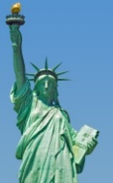**Cub #1:** We can see Citizenship in many sights. The Statue of Liberty was the first sight of freedom many immigrants enjoyed.

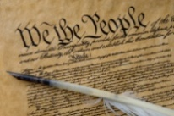 **Cub #2:** The Constitution of the United States made a bold statement of the rights of the citizen – it began We, The People…

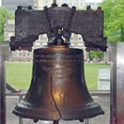**Cub #3:** The Liberty Bell was probably cast to ring at the first public reading of the Declaration of Independence on July 8, 1776 – it is recognized as a symbol of American freedom.

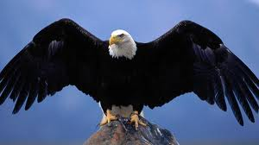 **Cub #4:** In one of the first battles of the American Revolution, the eagles were disturbed by the gunfire and rose up in flight – patriots said they were “shrieking for freedom.” The Bald Eagle became our national symbol, representing boundless freedom and strength.

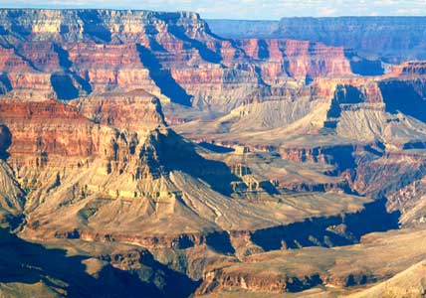 **Cub #5:** The National Parks and great public lands also represent the freedom of citizens to travel about and enjoy the many beautiful sights in this country. *(You could use an image of a beautiful place in your area)*

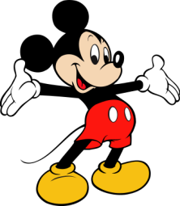**Cub #6:** Mickey Mouse is also a symbol of the freedom of citizenship in America. Because people are free to choose their occupation, and can feel secure in their homes, they have time for fun and creativity.

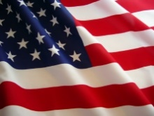 **Cub #7:** And of course, our flag is a symbol recognized by all citizens. The stripes represent the original 13 colonies, and each state is represented by a star.

**Cub #8:** But there are also many sounds of American Citizenship – as people worship as they please or assemble to debate their opinions. But there is one sound that brings all Americans together – the music of “America.”

*Cubmaster or another leader should invite the audience to join in singing, or the boys can sing the song together, followed by the closing flag ceremony.*



**Flag Folding Ceremony**

The flag folding ceremony described by the Uniformed Services is a dramatic and uplifting way to honor the flag on special days, like Memorial Day or Veterans Day, and is sometimes used at retirement ceremonies.

Here is a typical sequence of the reading:

(Begin reading as Honor Guard or Flag Detail is coming forward).

The flag folding ceremony represents the same religious principles on which our country was originally founded. The portion of the flag denoting honor is the canton of blue containing the stars representing the states our veterans served in uniform. The canton field of blue dresses from left to right and is inverted when draped as a pall on a casket of a veteran who has served our country in uniform.

In the Armed Forces of the United States, at the ceremony of retreat the flag is lowered, folded in a triangle fold and kept under watch throughout the night as a tribute to our nation's honored dead. The next morning it is brought out and, at the ceremony of reveille, run aloft as a symbol of our belief in the resurrection of the body.

(Wait for the Honor Guard or Flag Detail to unravel and fold the flag into a quarter fold--resume reading when Honor Guard is standing ready.)

* **The first fold** of our flag is a symbol of life.
* **The second fold** is a symbol of our belief in the eternal life.
* **The third fold** is made in honor and remembrance of the veteran departing our ranks who gave a portion of life for the defense of our country to attain a peace throughout the world.
* **The fourth fold** represents our weaker nature, for as American citizens trusting in God, it is to Him we turn in times of peace as well as in times of war for His divine guidance.
* **The fifth fold** is a tribute to our country, for in the words of Stephen Decatur, "Our country, in dealing with other countries, may she always be right; but it is still our country, right or wrong."
* **The sixth fold** is for where our hearts lie. It is with our heart that we pledge allegiance to the flag of the United States of America, and to the republic for which it stands, one nation, under God, indivisible, with liberty and justice for all.
* **The seventh fold** is a tribute to our Armed Forces, for it is through the Armed Forces that we protect our country and our flag against all her enemies, whether they be found within or without the boundaries of our republic.
* **The eighth fold** is a tribute to the one who entered in to the valley of the shadow of death, that we might see the light of day, and to honor mother, for whom it flies on mother's day.
* **The ninth fold** is a tribute to womanhood; for it has been through their faith, love, loyalty and devotion that the character of the men and women who have made this country great have been molded.
* **The tenth fold** is a tribute to father, for he, too, has given his sons and daughters for the defense of our country since they were first born.
* **The eleventh fold**, in the eyes of a Hebrew citizen, represents the lower portion of the seal of King David and King Solomon, and glorifies, in their eyes, the God of Abraham, Isaac, and Jacob.
* **The twelfth fold**, in the eyes of a Christian citizen, represents an emblem of eternity and glorifies, in their eyes, God the Father, the Son, and Holy Ghost.

When the flag is completely folded, the stars are uppermost, reminding us of our national motto, "In God we Trust."

(Wait for the Honor Guard or Flag Detail to inspect the flag--after the inspection, resume reading.)

After the flag is completely folded and tucked in, it takes on the appearance of a cocked hat, ever reminding us of the soldiers who served under General George Washington and the sailors and marines who served under Captain John Paul Jones who were followed by their comrades and shipmates in the Armed Forces of the United States, preserving for us the rights, privileges, and freedoms we enjoy today.

This Flag Folding Ceremony is from the  
[US Air Force Academy](http://www.usafa.af.mil)



**Valley Forge Closing**

*Utah National Parks Council*

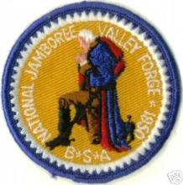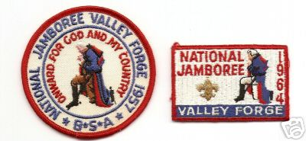

***(If a picture of George Washington in Prayer at Valley Forge is available, it would make a great backdrop – the boys could also make a snowy scene with trees as an art project)***

1. During the raw, hard winter of 1777, George Washington and his raged troops were forced to retire to winter quarters in a valley northeast of Philadelphia, named for a small iron mill, Valley Forge.
2. Here no muskets were fired. No bayonet drew blood. No mortal enemy was faced. Still, in this little piece of Pennsylvania the fiercest battle of the Revolution raged.
3. It was bitter cold, with icy winds howling and snow covering the ground. Half-starved and ill-clothed, a discouraged army of men huddled around campfires or under inadequate blankets trying to keep warm. Surely each man questioned if enduring all this was worth it.
4. General Washington sent this urgent plea to his commanders: “impress on the mind of every man, from the first to the lowest, the importance of the cause and what it is we are contending for.” What was that cause? Why were they fighting? Why were they freezing and starving and dying in a winter army camp?
5. They were fighting for freedom! They were fighting for the right to live as they wanted; the right to establish a new way of life - the American way of life; to found a new nation; the right of free speech and religion; the fight of political freedom – freedom from oppressive taxes without representation. These were rights and freedoms they cherished above life itself.
6. It was here in Valley Forge, in the face of bitter cold, hunger, hardship and disease that this nation’s will for independence and freedom was, as the name implies, forged and shaped and refined. How grateful we are for this nation and its freedoms. Please rise – and as you salute the flag, remember those men and women who still forge on, to secure our freedoms today. Color guard, retrieve the colors.

***(If boys are to read this, make sure they practice ahead of time so they won’t stumble over unfamiliar words. An alternate idea would be to have an adult or adults read the narration, and boys could hold up pictures they have drawn, colored in or that have come from the internet and that fit each narrative. Another idea would be to have the boys act out the narration – while others hold up the quote from Washington, and posters with the rights listed on them)***

*PS – CD was one of the 55,000 Scouts at the 1964 Jamboree. We saw “Pa” and “Hoss” Cartwright   
and heard Lanny Ross sing!!*

# CUBMASTER’S MINUTES

**God Bless America**

*Catalina Council*

**Arrangements:** American Flag posted, after the regular presentation of colors. House lights are dimmed, and flag is spot lighted. Cubmaster says the following to close the meeting.

"God Bless America" is a prayer that is in every heart. While the statesmen of the world are seeking paths to peace, we can ask ourselves, "What is the strength of America"? What are the secrets of our nation's power?

* An agriculturalist might have you believe America's strength lies in its soil.
* A merchant would say that a nation's power rests in its commerce.
* A manufacturer might say that it is in technology, in machinery and in the skilled labor to operate plants to produce manufacturer's products.
* A politician might contend that a nation's strength is in national policies.
* An educator might declare that knowledge is a nation's power and that our country's greatness is in its learning.
* A scientist would say that a nation's power is in science, in the products of the laboratory.
* The military man most likely would insist that a nation is great according to its weapons and military strength.

But America's real strength is the character of her people. It took character to survive that first winter at Plymouth Rock and that other winter at Valley Forge. It took character to pack your things into a rickety wagon and push off into a land of vague promise and specific terror. It took character to tell a nation that slavery was wrong, to say that might is not right.

We want to guarantee that America is as strong in this space age as it was at its birth, which is why the BSA focuses so much on character development. Will everyone please stand and join me in singing “God Bless America”?

**No One Can Pass Through Life**

*Alice, Golden Empire Council*

Robert Baden-Powell knew that “No one can pass through life, any more than he can pass through a bit of country, without leaving tracks behind, and those tracks may often be helpful to those coming after him in finding their way.” Let’s each make sure that OUR tracks lead other in the right pathway – towards being a good citizen!

**America Promises**

*Sam Houston Area Council*

America promises us freedom to worship, to learn, to assemble, and to debate any issue. It is a land where people from other countries can find a home, where there is work to do, where we can express our opinions, and where we are free to come and go as we please. Our wonderful heritage, earned for us by our forefathers, is sometimes taken for granted. Unless we cherish this legacy and use it wisely, it may be lost to future generations. People working together with imagination, vitality, and persistence, have produced marvelous inventions and wonders of technology beyond anything our forefathers might have dreamed of. Working together, we can preserve and protect our beautiful land for future generations.

**America the Beautiful**

*Baltimore Area Council*

This evening we have shared our respect for our great country. We have seen some of the glory that is the United States. The most fitting end to our meeting is to sing “America the Beautiful”. In this great song we sing of the glory of our great land, but the last lines of every verse have an acknowledgement of God who guides us all

“America, America, God shed his grace on thee.   
And crown thy good with brotherhood,   
From sea to shining sea.”

Everyone please stand and join me in singing “America the Beautiful.”

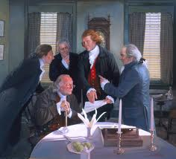

**A Scout is Obedient**

<https://johnscout.wordpress.com/>  
***Check out his blog for many more   
Scoutmaster Minutes!!***

[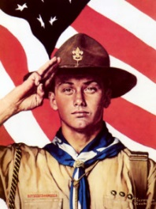](https://johnscout.files.wordpress.com/2010/06/r1944-scout-saluting-in-front-of-us-flag1.jpg)

**A Scout is Obedient.** A Scout follows the rules of his family, school, and troop. He obeys the laws of his community and country. If he thinks these rules and laws are unfair, he tries to have them changed in an orderly manner rather than disobeying them.

It took me a long time to realize how much this point of the Scout Law has affected me personally.  A Scout pays attention to his parents, teachers and Scout leaders.  I didn’t always get along with them, and I would challenge them when I thought I was right.  But I knew a Good Scout follows the rules.

It’s the second part of this point, however, that we forget about.  If you don’t think rules or laws are fair, you don’t just ignore them.  You work to change them.

Rules and laws help us all get along—in a family, troop or community.  Despite our best intentions, sometimes the rules or laws don’t work quite like they are supposed to.  That is when a Good Scout works to change the rules, not just follow them.

**A Scout Is Obedient**

*Troop 56, Indianapolis, IN*

[http:/t56.org/member/](http://t56.org/member/)  
Click on Scoutmaster Minute tab

A scout is obedient, but how important is it to be obedient? Do rules and laws really hold us back and keep us from enjoying life? The following story illustrates how laws support our lives and make them even better.

A boy and his dad took their kite one windy day, and began to fly it. The wind was strong, and soon the kite soared higher and higher. Within just a short while, they had let out all their line, and the kite was just a small dot in the sky. The boy, caught up in the excitement of flying the kite asked his dad, “isn’t the string holding the kite down? And if we let go of the string, will the kite go even higher?” To this his dad replied, “No, it is just the opposite. It is the string that holds the kite up. If we let go of the string, the kite would fall to the ground and be lost.”

Sometimes we look at laws and rules in the same way. We think they are holding us back, when in truth they are the very things that hold us up. We have a free society because of these rules and laws, and because people respect the laws. Good rules and laws are there to protect people. A great danger is to think disobeying the laws will give us more freedom. Instead, it is through disobedience that innocent people are hurt and suffer.

**A Scout Is Obedient**

www.macscouter.com

What's the seventh point of the Scout Law? That's right, "A Scout is obedient." Our handbook explains it this way: "A Scout follows the rules of his family, school and troop. He obeys the laws of his community and country. If he thinks these rules and laws are unfair, he tries to have them changed in an orderly manner rather than disobey them.

That tells us that some rules and laws may be unfair, doesn't it? Perhaps some are, but there must be some reason for them. Think about the reason before you try to change them or ignore them.

This month we're using some rules for water safety. The rules are called the Safe Swim Defense, and there is a good reason for all of them. It's to protect your life.

You may think you should be in a different swimming ability group. Well, if you can prove it, you'll be put in a higher group. But until then, stay with your buddy and your group. Obey our swimming supervisors. Our rules have only one purpose, to protect you. Remember that when you're in the water.

# CUB GRUB

**Cub Grub is in PART I of Baloo’s Bugle, Fun Stuff**

# GAMES

**Flag Tag**

*Baltimore Area Council*

* Give each player two “flags” – 1 x 16-inch strips of leather or vinyl cloth.
* Players loop their flags over their belts along the trouser seams, with only one inch behind the belt.
* On signal, each player tries to grab the others’ flags while protecting his own.
* Winner is the last player in possession of at least one of his own flags and the one who captured the most flags.

**Steal the Flag**

*Baltimore Area Council*

* Divide into two teams.
* The two teams line up about 20 feet apart facing toward the center and number off beginning at opposite ends;
* One person stands in the center of the playing field with his arms outstretched and loosely holding, in each hand, a corner of a flag. (use piece of old fabric for the flag).
* The leader calls out a number and the person from each team, who is that number, runs to the center and circles the person holding the flag.
* At any time, they try to grab the flag and run back to their spot in the line without getting tagged.
* If they are tagged before they get back, they must trade places with the person in the middle. Keep score by counting the number of times each team gets the flag safely back to their side.

**Stars and Stripes (Like Duck, Duck, Goose)**

*Santa Clara*

* Boys sit in a circle with one boy standing.
* The standing boy walks around the outside of the circle and taps each sitting cub on the floor and calls each one of them either a star or a stripe.
* If the boy is a stripe, he must get up run around the circle being chased by the 1st boy and sit back in his spot in the floor without being tagged by the 1st boy.
* If he gets tagged, he now walks around the circle naming everyone and play begins again.

**Adventures in Citizenship**

*Alice, Golden Empire Council*

Set up an Adventure Course – each boy must move around and do each task before he moves on. Examples of some challenges:

* Two boys work together to fold a flag properly;
* Boys show how to salute the flag in uniform and in street clothes;
* Tell one way to show respect for the flag; answer a question that new citizens must know; (You could also focus on American history as your theme)

At the end of the course, the boys could be rewarded with Patriotic Rice Crispy Treats! (Made with red & blue M&M’s)

**Follow My Tracks**

*Alice, Golden Empire Council*

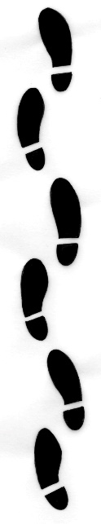 (Based on a quote from Baden-Powell)

**Materials:** Quite a few footprints with an action listed on the back. Here are some ideas:

* Did most of the weeding;
* Finished the whole job;
* Studied my spelling words;
* Played my new game – I’ll study in the morning;
* Put away all the tools where they belong;
* Told a funny story about the new kid getting lost on the way to class;
* Paid most of my tithing – I needed part of it to get my new game;
* Helped the new kid learn the Scout Law;
* Helped clean up the park;
* Mom and I passed out voter pamphlets;
* I walked away from a fight;
* Found a dollar on the shelf in the library so I got a soda;
* Said “No” when my friend dared me to steal a package of cards;
* I always wear my bike helmet;
* When the light turned red, I crossed in the middle of the block so I could be the first to get back to the building;
* I did most of the stuff for the Adventure, so I asked my Mom to sign it off.

*Note: See Citizenship Do’s & Don’ts for some more ideas you could use.*

**Instructions:**

* Divide into two teams.
* Mix up the footprints and stack them.
* Explain to each team that they can decide whether the action on that footprint would lead to “Good Citizenship” or “Needs Improvement”
* Each team takes a turn to get a footprint, reads it and puts it where they think that action would lead, without telling anyone what the footprint says.
* When all the footprints are gone, the team with the most footprints in the Good Citizenship pile is the winner – BUT …they must first read the back of each print out loud. The leader and the other team must agree that they chose the right pile for their actions.

Discuss the choices.

Then read Baden-Powell’s quote:   
 “No one can pass through life, any more than he can pass through a bit of country, without leaving tracks behind, and those tracks may often be helpful to those coming after him in finding their way.” Ask the boys to explain what they think it means. Which tracks would be helpful to others? Would some be harmful? Are there people who will follow your tracks? Which way will your tracks lead them?

**Citizenship Concentration**

*Alice, Golden Empire Council*

* On a blackboard, make a grid with four columns and seven rows.
* Using 3X5 post-its, put together your own concentration game on a chalk board.
* Write 14 questions about citizenship on the post-its in the first and third columns.
* Then put a second post-it over the questions, each top post-it with a number from 1-14.
* In Column two and four, RANDOMLY place the answers to the questions on post-its. Be sure it is RANDOM.
* Cover answers with post-its lettered A through M.
* The object is to match the correct letter and number.
* Keep some of the boys busy making the concentration “music”