CUB SCOUT ADVANCEMENT MODIFICATIONS MADE
On November 30, 2016, the BSA announced modifications to adventure requirements in response to feedback from Den Leaders who have run the new Cub Scouting program for a year. Dens may begin using the modified requirements immediately as they begin working on their next adventure
There is a PDF of the changes at: www.scouting.org/programupdates
Judy is placing a description of all the changes and their effects in Part IV – Den Meeting Helps of this month’s issue of Baloo’s Bugle.
The www.usscouts.org Advancement pages are being updated top reflect all the changes. I did notice that the Cub Scout Learning Library was not updated as of December 27, 2016 to chow Baloo the Builder as a Core (Required) Adventure and “Grin and Bear It” as optional.

TABLE OF CONTENTS
CUB SCOUT ADVANCEMENT MODIFICATIONS MADE 1
TABLE OF CONTENTS 1
ADMIN HELPS 2
YOUR BLUE & GOLD BANQUET 2
BE UP TO DATE 5
ROUNDTABLE HINTS 5
PROGRESS CHECK 5
CUB SCOUT RT SCHEDULE OF SESSIONS 7
LIONS 10
LION GUIDE AND PARENT ORIENTATION VIDEO 10
ORGANIZING FOR LIONS 10
NEW LION HUB 10
THE CHIEF SCOUT EXECUTIVE ON LIONS 11
MORE LION INFORMATION 11
CUB SCOUT LEARNING LIBRARY 13
The NEW https://cubscouts.org/ !!! 13
ADVENTURE PLAN TRACKERS 15
CUB SCOUT LEADER TRAINING 16
IN-PERSON TRAINING 16
ON-LINE TRAINING 16

ADMIN HELPS

YOUR BLUE & GOLD BANQUET
Kommissioner Karl
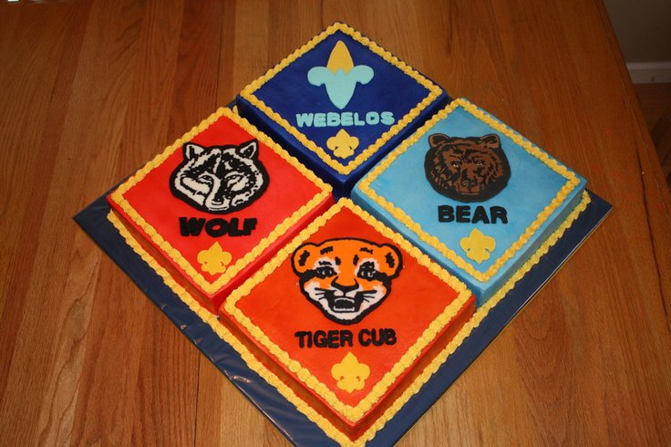
What a cake!!!
The Blue & Gold banquet is the highlight of the winter months for most Cub Packs. If yours isn’t, it probably needs help. Here are some simple guidelines to help you plan a successful Blue & Gold.
2 to 3 months before the Blue & Gold Banquet.
You need to make your final decision on your date & time with the Pack Committee. Ask some of the parents to help with the arrangements (this is your Blue & Gold Committee). This will make the job much easier. You will have a lot of ideas to share with each other.
Dates - Dates for the Banquet are usually set by the Pack Committee at the beginning of the calendar year. You may use the date that corresponds with your monthly Pack meeting. Some groups like to choose a Friday night, Saturday night or a Sunday afternoon.
Locations - Use your regular Pack meeting place. Some groups are allowed to use the Charter Organization facilities to hold their Blue & Gold dinner. Check with your Charter Organization to see if this could be a possibility for your Pack. Check with local Churches. Some local churches will allow you to use their Fellowship Hall to have your dinner. Don't be afraid to check with the church you attend or maybe that of another member of the Pack Committee. Other churches will allow you to use their Fellowship Hall if you use their Youth Group to help with the dinner. Some youth group raise money by preparing and serving dinners. This will help them earn money towards their mission trips. Check with your school - some areas will allow you to use the school.
Budgeting for the Dinner - Check with your Pack Committee to see what type of money has been set aside for the Blue & Gold Dinner. You may see if the Committee will set money aside from the Popcorn sales to pay for professional entertainment. You may decide to charge each family a small fee to cover the cost of the meal or entertainment.
Planning Your Menu
Cover Dish dinners - This is a fun way for families to show off their best dishes. It is fun to share your favorite dish with a friends. The down fall to this is - most parents work for money. If your dinner is on a week night it is hard to get home from work and prepare something for the dinner. This is why we see a lot more hot deli dishes in the grocery stores now.
Have a spaghetti dinner - Your committee could prepare a simple spaghetti dinner for the Pack. Ask for volunteers to help with the dinner. There is always a Parent or Grandparent that would enjoy helping with something like this. Don't be afraid to ask.
Check with a local restaurant - Local restaurants may have catering for family style meals. Often you can get a good deal on chicken or pizza if you mention you are from a Scout group.
Check with a local church youth group - Several area youth groups are always raising money for Mission trips. Contact your local churches to see if they do any dinners as fund raisers. Check with other parents from the Pack they may know of some groups looking for fund raisers. Often these are full dinners that cost under $5 per person.
Entertainment - Entertainment is the lynch pin of the Blue & Gold event. If you are skipping this, you are missing out on making the dinner something that everyone looks forward to. You may consider some or all of these options:
Skit night - Each Den Prepares a skit or song to present as part of the program. Great suggestions for skits can be found at Roundtable Meetings or at www.macscouter.com . It doesn't matter if the boys get it perfect. It is the pride they have performing for their parents and friends.
Poll your Parents - See if there are any parents with hidden talents. Again don't be afraid to ask if anyone would like to entertain at your dinner. You may find a Mariachi band member, a juggler, magician or storyteller.
Book outside entertainment - if your pack is big enough to add a small amount to the dinner cost, or if you budget some funds from the popcorn sale, you may consider hiring a professional entertainer. There are a lot of people out there to choose from. If you local school has a program, check with them to see who they have used. Check with local Colleges - They may have students that will perform for free, or maybe for only a small fee.
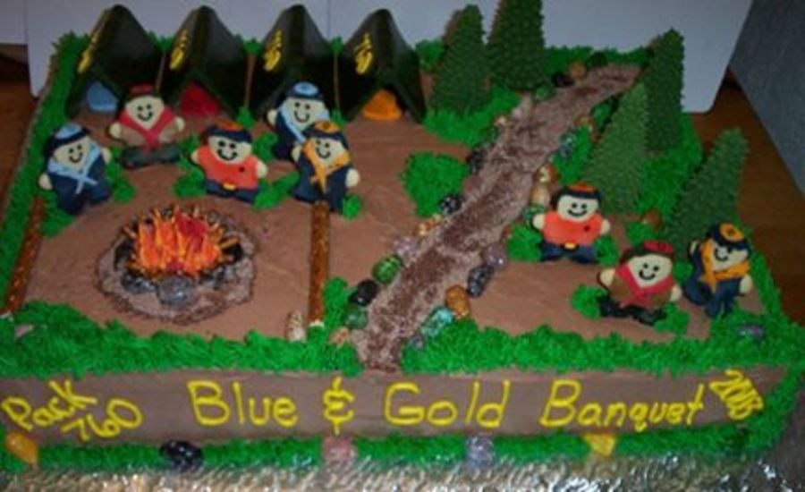
Another great cake!
4 - 6 Weeks before the Banquet
Send out flyers reservation flyers. You need to include the date, time, cost and location on your signup sheet. Always include a date when you need your RSVP turned back in by. It works best to collect the money ahead of time. You will always have a few people call at the minute wanting to attend. Always include a person’s name on the flyer that the family members may contact if they have a question. Make your den leaders responsible for collecting the flyers and money to turn into you.
Select a Theme for the Blue & Gold Dinner.
Your imagination does not even limit you here. There is a wealth of information of the internet for themes, decorations, and they often have complete instructions and pictures. Simply search for “cub blue & gold” and see what you like. There are also several other resources such as:
Scouting Magazines and Old Cub Scout Program Helps – When they were published, each year Program Helps provided a B&G theme idea. You can use these ideas as a building blocks for your B&G Banquet. I have recycled ideas from Program Helps many times.
Roundtable Meeting - Each month the Roundtable focuses on a theme that could be adapted for use for your dinner. The CS RT Planning Guide often calls for a Blue & Gold presentation in the Pack Admin breakout one month. In January the Roundtable will focus on the February theme, which you may want to consider for the banquet.
Traditional Blue & Gold - Many groups like to use the traditional Blue & Gold theme. Decorate your tables with Blue & Gold table clothes, placemats, napkins and balloons. This is great, and underscores the theme of a celebration of Scouting.
Use your imagination - Have fun with your ideas. You can use any type of theme you would like. Examples: Happy Birthday Cub Scouts, Fiesta, Celebrate Ohio Anniversary, Celebrate your Pack Founding Date (Milestone Marks), Red/White/Blue, Pirates, American History, Luau.
Plan Decorations
Use decorations that go along with your theme. The decorations could be made by the committee or ask the dens to help make the centerpieces for the dinner. Demonstrate the centerpiece project at your Pack Committee meeting and have each den make their own centerpieces for the banquet theme. This can be especially helpful if you are shorthanded. Purchase placemats or allow each den to make their own placemats for their families. Be sure the Scout makes enough for his entire family so no one is left out. If you want to go with purchasing, there are special Blue & Gold placemats at most Scout stores. Use Blue & Gold Balloons tied in the center of each table or on the backs of chairs. Plan for some special treats at each place setting: theme cookies, candy, nut cups.
Send Out Invitations.
Make sure you include a name and phone number for them to follow-up with. Unit Commissioners, your Church Minister, Chartered Organization Rep, District Executive, District Commissioner and District Chairman can all be invited. Be sure and contact the District Family Friends of Scouting Chair to schedule your FOS presenter, and confirm the time you have allotted them.
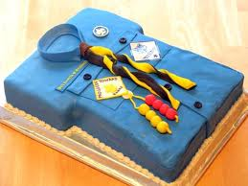
A shirt cake!!
1 to 2 Weeks before the Banquet
Finalize EVERYTHING - Get your final count together. Collect and balance your money from families ahead of time. You may have to call the den leaders and remind them that the counts are due. If you are having another group catering your banquet, call them and confirm the date and count for the dinner. Also check to see if they plan for any additional people. There is always a few people that will call the day before or the day of the dinner wanting to attend. Remind Pack Treasurer, which checks need to be issued and amounts the night of the dinner. Often your entertainment or caterer wants paid the night of the dinner. Make a sign in sheet. Check everyone in as they arrive, if any one owes money, collect it then.
Programs - The banquet is a special celebration. You should consider printing a simple program. Include all the award that the boys are receiving that night. Everyone likes to see their name in print. It is nice if the Den Leaders plan for the boys to get their rank badges during the Blue & Gold. It also a great time to print a small thank you to everyone that has helped put the dinner together. You should also include a thank you to the parents for their support during the year.
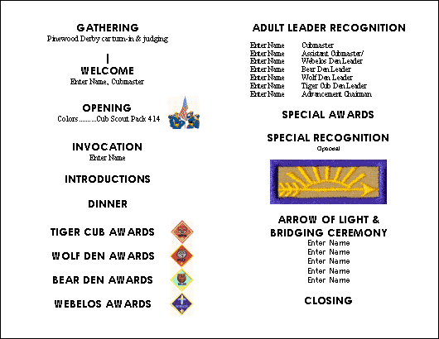
Blue & Gold’s are should be the showcase of your winter program. If your unit has special awards, you may want to give them out there. Other units plan the a father/son cake bake auction as a fund raiser to help pay for the entertainment. Be sure to recognize the Pack Committee at the banquet for a big round of applause. An “atta-boy” goes a long way to getting people to help in the future.
Check out http://pack414.godandscience.org/blueandgold.php for some great ideas for programs and such for your Blue & Gold Banquet.
http://www.scouting.org/scoutsource/CubScouts/Activities/Adults/bgbanquet.aspx And see what National has to say about Blue & Gold Banquets
What are YOU going to do now?
The best gift for a Cub Scout.......
......get his parents involved!
The greatest gift you can give your child
..... good self respect!
Look for more BLUE & GOLD Information in other parts of Baloo’s Bugle this month!!!

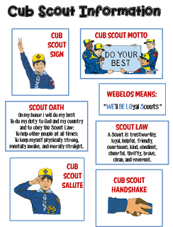
Go to http://strongarmor.blogspot.com/2015/06/cub-scouts-scout-oath-and-law-helps-and.html to get full size, full color (or black and white) printable versions

BE UP TO DATE
www.scouting.org/programupdates
The Program Updates page has been regrouped. Since the CS Adventure is in full swing, the emphasis on getting ready for it has been reduced. The downloads are still all there. And great information about three new Cub Leader courses at Philmont Training Center next summer.
There is a lot of information now on etting ready and implementing the changes to the Boy Scout program.
Check it all out – stay current!!

Same is true for Boy Scout Leaders!!

ROUNDTABLE HINTS

GREAT NEWS!!! – Jeff McHoul, ACC – RTs at Cradle of Liberty Council, is back!~
Thank you Jeff both for your service to our country and to the BSA!!

PROGRESS CHECK
Jeff McHoul, ACC – RTs, Cradle of Liberty Council
Whenever you set out on a journey you map your course and then prepare before you take your first steps. Six to seven months ago, Roundtable Commissioner Teams around our Country gathered together to map out the course of their Roundtable program for the Scouting year. Just as when you are on a trek, you stop from time to time to check your map and gauge your progress; January marks the midpoint of the annual cycle, and is a natural time to make a midpoint review of the progress you and your Team have made toward delivering a high quality and EPIC Roundtable program to the leaders of the District and Council.
When you conduct your progress check, one of the first questions that you must ask is where do you begin? One of the best places to begin is reflection. Gathering all of your planning notes and your calendar, to see just how well you have been following your original plan.
- Have you been making changes "on the fly", or have you made changes in response to participation or feedback?
- Have you included the input of the other members of the Roundtable Team in making changes, or have you been changing your plan by yourself without including your Team?
Then gather your Roundtable Team together all in one place at the same time. This can take place before or after a regularly scheduled Roundtable, although this may not be the best time. Ask them about their perception of how your Team has been following and executing the plan.
- Has the plan as originally laid out meet the needs of your participants?
- Have they been able to deliver their part as planned?
- How have their presentation parts been received?
- What has the feedback of the participants been?
It is also a good time at this point to review your original plan to see what has worked, what has not worked, and what you and your Team would like to change.
Or stated a little differently, conduct a Stop Start Continue evaluation of your plan and program to date.
And another good view point would be to determine if your program has been successful in delivering an EPIC experience by
- making every effort to deliver an exceptional experience
- making as much of your presentation hands-on as possible
- presenting program ideas that are simple, easy to reproduce, and support the program at every level
- providing examples of the method of delivery, that motivates and inspires Leaders
- delivering a concrete, realistic program that is truly "useable" by the leaders who attend and participate in your program
But there is still another way to check you course, and to determine if you are achieving your desired results - ask the leaders who participate in your Roundtable program on a regular basis. But what is the best way to do it? The answer is simpler than you think - ask them.
There are many ways to ask for feedback, and to be complete, you should use as many as you can. A few of the best methods include:
- E-mail surveys
- "Survey Monkey" on-line questionnaire
- Blind questionnaire
- Question and feedback session
- Breakout discussion groups
One other key to getting the highest number of responses possible, you should keep your number of questions to as few as possible to get the information that you desire. The greater the number of questions, the less likely you will receive any responses at all, so phrase you questions carefully. And don't be surprised by the information and types of responses that you receive.
Keep in mind that the responses that you receive from your participants may be very different than you expect, and present a view very different from the view of you and your Team - but don't despair. The responses that you receive represent the perception of your participants.
Discuss the responses that you receive from your participants with your entire Team to determine how the perception of your participants is lining up with your intent and your presentation plan. The information that you gather will be valuable in making any adjustments to your plan or the delivery method that you and your Roundtable Team have been using to execute your plan.
And remember why you present your Roundtable program in the first place - to support the Leaders of your District and Council, and to help them to succeed. That is our entire purpose for planning and presenting a Roundtable - to Help Units Succeed.
Just continue to deliver the best Roundtable program that you can, and make each one EPIC.
E - Exceptional & Experiential
You should strive to present an exceptional and experience based program
P - Personally & Program Relevant
Make the presentation personally and program level relevant to the Leaders who attend .
I - Instructional & Inspiring
Structure your program so that it is an instructional experience, providing examples of the method of delivery, that motivates and inspires Leaders
C - Concrete
Bring all of these components together at one place at one time, to deliver a concrete experience that provides Cub Scout Leaders with what they need to deliver a successful program at the Den and Pack level .

CUB SCOUT RT SCHEDULE OF SESSIONS
RT  Month | Program  Month | Pack Meeting Theme and Scout Law Point  Pack Meeting Plans at Scouting.org (1) |  | Roundtable Interest Topic and Scout Law Point  Per 2016-2017 Roundtable Planning Guide
 |  | Pack Meeting  Scout Law  Point | Pack Meeting  Theme | Roundtable  Scout Law  Point | Roundtable  Interest Topic
Dec  2015 | Jan  2016 | Obedient | Cub Scout City Council | Brave | Recognition
Jan  2016 | Feb  2016 | Reverent | Passport to Other Lands | Reverent | Duty to God
Feb  2016 | Mar  2016 | Loyal | Our National Treasures | Cheerful | STEM Activities
Mar  2016 | Apr  2016 | Thrifty | Power Up | Obedient | Aqua Cubs
Apr  2016 | May  2016 | Clean | A Picnic with Pizzazz | Clean | Cub Scout Hiking
May  2016 | Jun  2016 | Brave | Roaming Reptile Alert | Helpful | Cub Scout Camping
Jun  2016 | Jul  2016 | Trustworthy | Let the Games Begin | Kind | Campfire Etiquette
Jul  2016 | Aug  2016 | Friendly | #CUBSCOUTS | Courteous | Enjoying Nature

- Link to Pack Meeting Plans - http://www.scouting.org/Home/CubScouts/Leaders/CubmasterResources/PackMeetingPlans.aspx

RT  Month | DL Breakout Topics | WL Breakout Topics | CM Breakout Topic | Comm Breakout | CS Leader
Dec  2015 | Recognition in Dens | Recognition in Dens, Recognize leadership | How to recognize youth & adults | Recognizing Pack Adults | Why, how, & when we recognize youth  & adults
Jan  2016 | Combined Session - Duty to God  Duty to God Adventures & religious emblems
Feb  2016 | STEM Adventure Rqmnts (Hands On)  Discussion of STEM Nova & Supernova Awards | STEM Adventure Rqmnts (Hands On)  Discussion of STEM Nova & Supernova Awards | Combined Session - STEM -  Review STEM Nova and Supernova Awards on line. Then discuss |  | Overview of CS STEM Nova and Supernova
Mar  2016 | Review Reqmnts for water realated Adventures | Review Reqmnts for water realated Adventures | Adv Rqmnts, BSA Swim policies and local swim areas | Water Safety | Aquatic Adevntures, Areas, Safety
Apr  2016 | Preparing for a hike | Review Webelos Walkabout | The CM and Den & Pack Hikes | Hike Planning | Various Hiking Topics for all levels
May  2016 | Combined Session - CS Camping  BALOO Training, BSA Camping Rules, Types of Camps, Camp Logistics, Resources
Jun  2016 | Combined Session - Campfire Etiquette  Part 1 - Etquette, Safety, LNT  Part 2 - Program Material, Positive Emphasis, Resources
Jul  2016 | Nature is NATURE-al in Scouting | Nature is NATURE-al in Scouting | Combined Session - Nature  Nature is NATURE-al in Scouting  Safety, 2 Deep, Buddy System |  | Overview of Nature is NATURE-al

Cub Scout Adventures To Highlight at RT
RT  Month | Tiger Adventure | Wolf Adventure | Bear Adventure | Webelos Adventure | Arrow of Light
Dec
2015
Jan  2016 | My Family’s Duty to God | Duty to God Footsteps | Fellowship and Duty to God | Duty to God and You | Duty to God in Action
Feb  2016 | Backyard Jungle; Curiosity, Intrigue, and Magical Mysteries; Sky Is the Limit | Adventures in Coins; Air of the Wolf; Code of the Wolf; Council Fire; Digging in the Past; Germs Alive!; Grow Something; Motor Away | Baloo the Builder; Forensics; Fur, Feathers, and Ferns; Make It Move; Robotics; Super Science; A World of Sound | Adventures in Science; Build It; Earth Rocks!; Engineer; Into the Wild; Into the Woods
Mar  2016 | Floats and Boats | Spirit of the Water | Salmon Run | Aquanaut
Apr  2016 | Backyard Jungle | Paws on the Path | Fur, Feathers, and Ferns | Webelos Walkabout
May  2016 |  | Call of the Wild | Bear Necessities | Camper, Castaway
Jun  2016 | Tiger Theatre | Call of the Wild | Bear Necessities, Grin & Bear It, Roaring Laughter
Jul  2016 | Backyard Jungle, Tigers in the Wild | Call of the Wild, Grow Something, Paws on the Path | Fur, Feathers, and Ferns, Bear Goes Fishing | Webelos Walkabout, Into the Wild, Into the Woods

LIONS

LION GUIDE AND PARENT ORIENTATION VIDEO
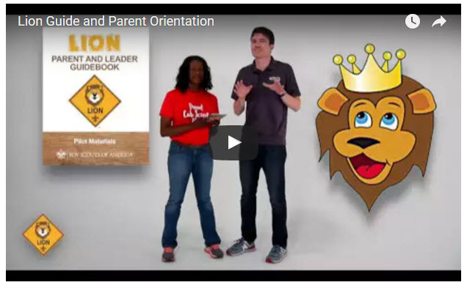
Video URL - https://youtu.be/YaIBTUO70JA

ORGANIZING FOR LIONS
From – New Birth of Freedom Council
For those packs that are thinking ahead about participating in the Lion Scouts program, having the right volunteers involved in delivering the Lion Scouts program will be important. Research shows that the most important person for a successful Scouting experience is a good leader. There are two new adult leader positions within the pack that are directly engaged in the delivery of the Lion Scouts program – a Lion Coordinator and a Lion Guide. Where do these positions fit into the current pack structure? What is the Lion Coordinator’s job description?
- Is an experienced and successful den leader
- Understands den and pack operations within the overall structure of Cub Scouting
- Demonstrates excellent communication and organization skills (and will remain in at least monthly contact with the Lion dens)
- Participates as needed in the unit’s School Night with all new Lions and their parents
- Assists the Lion guide in hosting the first orientation meeting for all the individual Lion dens in their pack
- Serves as a coach and mentor for Lion Guide

NEW LION HUB
Big Smiles
Build Bigger Futures
BSA has launched a new Lion Hub at:
http://scoutingwire.org/lion/

Available Lion Resources include:
PARTICIPATING COUNCILS
PROGRAM OVERVIEW
FAQS
The FAQ PDF is 13 pages long!!
Lots of great information!!
LION GUIDE AND PARENT ORIENTATION VIDEO
LION GUIDE AND PARENT ORIENTATION POWERPOINT
CONTACT US
LION PROMOTIONAL MATERIALS
(HELP SPREAD THE WORD!)
LION PROMOTIONAL VIDEO

THE CHIEF SCOUT EXECUTIVE ON LIONS
What We Know According to a 2014 U.S. Census Bureau report, 57 percent of kids ages 6–17 participate in at least one after-school extracurricular activity. This means that by the time they are eligible for Tigers, more than half of them already are engaged in some type of athletic, artistic or other program.
Often, children become attached to lifelong activities at an early age — that is certainly a goal we would have, as we know the long-term benefits of Scouting involvement include strong asset development in the areas of character and leadership. However, we also know that when youth participate in numerous activities at an early age, and miss joining Scouting, they are unlikely to do so at adolescence.
What will be important to learn in the next few years, if the initial entry point works at the kindergarten-age level, is will this cause losses at a different age, or will the program keep the same retention all the way through to Boy Scouting?
What we learn from the pilot Lion format could also help us assess and create a smoother transition from Webelos into Boy Scouting. Too many parents now see a barrier or obstacle, rather than a smoother transition. You will often hear parents say, “We did Cub Scouting, now we’re not sure if we are going to do Boy Scouts.” We do not have a seamless transition into Boy Scouts for a number of reasons. This pilot test will help us think through some of these issues.
We want to be sure that our Lion program delivers the right mix of character and leadership values and that we set the bar high. The program must be sustainable, we must have the right infrastructure to support it, and it needs to address in a meaningful way the needs of parents who want their kids to join Scouting at an earlier age.
You can rest assured that we will carefully evaluate our progress and keep you apprised of the results. Stay tuned for more.
Reprinted from "The Chief's Corner" on Scoutingwire.org

MORE LION INFORMATION
Bryan's Blog has written about Lions –
Go to http://blog.scoutingmagazine.org/2016/ and you can look them up. Here are a few -
Lion pilot program brings Scouting to kindergartners in nearly 200 councils
September 27, 2016
Answering the call of families who want a Scouting program for kindergarten-age boys, the BSA has expanded its Lion pilot program to nearly 200 councils.
In full gear: Here’s your first look at Lion Scouts T-shirts and hats
April 28, 2016
This week we get our first look at new T-shirts and caps to be worn by Lions — members of the pilot program for kindergarten boys set to roll out this fall.
Will Lions be part of the pack? (And answers to your other Lion questions)
April 15, 2016
Will Lions be part of the Cub Scout pack? By adding another year to the program, is the BSA concerned about "burnout"? And why was the Lions name chosen?
New details released about Lions, the pilot program for kindergarten boys
March 10, 2016
In Lions, the new pilot program for kindergartners, boys wear T-shirts instead of uniforms and earn adventure stickers instead of adventure loops.

There are slideshows on the web put up
by local councils. Some examples are:
WD Boyce Council has "Lion Cub Pilot Program" at: http://www.wdboyce.org/document/lion-cub-pilot-program/161325
Northern Star Council has a training slide show for District Coordinators and others at: https://www.signup4.net/UPLOAD/NORT26A/LION12E/District%20Lion%20Cub%20Coordinator%20Training.pdf
Councils have put up webpages about what their packs need to know to begin a Lions Program. Examples are:
New Birth of Freedom: http://seb.newbirthoffreedom.org/2016/03/22/were-approved-for-the-lion-scouts-pilot/
WD Boyce:http://www.wdboyce.org/cub-scouts/lion-cub-pilot-program/63360
Garden State (My Council): http://www.gardenstatescouting.org/lion-program-0
Garden State, also, has an FAQ PDF - http://www.gardenstatescouting.org/sites/default/files/Lion%20Program%20FAQ.pdf
And we have created a Facebook page for our units with Lions - https://www.facebook.com/GSCLion/
Selected FAQ's
National has posted a PDF file of FAQs about the LION program at http://www.scouting.org/filestore/pdf/Lion_FAQs.pdf

Cub Hub Blog Lion Posts
The items listed below are from the Cub Scout Learning Library . Check it out frequently for new lion and other new Cub Scout items. You can go to www.cubscouts.org and click on the Cub Hub Blog.

A Look at the Lion Uniform and Gear Lion uniform, shirts and hats! In case you’ve missed the Lion uniform images floating around the Digital Pack…
Will Lions Join Tigers and Bears? Oh My! — A Lions FAQ Lions: Answers to your top questions. We have seen a lot of great feedback, comments and questions from…
5 Questions (and Answers) for the New Lion ProgramMore Information on the New Lion Program As we mentioned earlier on the Cub Hub, Select councils will…
Lion Program will bring Scouting to Kindergarten BoysSomething Roaring in the Jungle There is an exciting new Scouting program called “Lion” for Kindergarten-aged boys…
CUB SCOUT LEARNING LIBRARY

The NEW https://cubscouts.org/ !!!
This is the Cub Scout Learning Library –
Everything you could want to know for Cub Scouts is or will be here. And all within a click or 3 of the home page. National heard the message that although things were at www.scouting.org they were often buried too deep to be found.
This site has admin stuff and practical stuff. The new Den Leader Resource Books are here. You can download some of the pages for FREE
This website is a great resource. There are still parts under construction but what is there is GREAT!!
Yes,
https://cubscouts.org
runs on a phone, too!!!

There are 3 tabs on top of the home page –
- Learning Library
- Cub Hub Blog
- Join Scouting
Plus – a magnifying Glass to start a search and Icons for various Social Media –
- Learning Library takes you where you can learn about your position and pick up hints. Besides specifics for dens of each rank, other clickable links include –
KEY
- All or most of material was placed on site this past month
- All or most of material was in place and listed as such in last month's Baloo's Bugle.
- Site / pages under construction
Den Leader
Den Meeting Basics
- Your First Den Meeting
- Planning Den Outings
- The Parts of a Den Meeting
- Getting Started
Three of the Core Adventures for the selected rank are listed here. Click on them and you will see / can download all the Leader's Guide pages for these three Adventures.
- Additional Required Adventures
The remaining Core Adventures for the selected rank are listed here. When you click them you get an intro to the Adventure but do not get the Meeting Plans and Resources. You see this note:
To get you started in delivering fun and engaging meetings, complete Den Meeting Plans are available here on the Learning Library for the Backyard Jungle and Games Tigers Play adventures. To obtain Den Meeting Plans for all other adventures, Den Leader Guides are available at your local Scout Shop, online at scoutstuff.org, or as an eBook through Amazon.
- Elective Adventures
All the Elective Adventures for the selected rank are listed here. When you click them you get an intro to the Adventure but do not get the Meeting Plans and Resources. You see the same note (above).
- Building Strong Dens
The Basics of Cub Scouts
- Advancement
- BSA Mission and Vision Statements
- Cub Scout Ages and Ranks
- Cub Scout Uniforming
- Den Flags
- Den Yells
- Leader Survival Kit
- Methods of Cub Scouting
- Purpose of Cub Scouting
- Roles and Responsibilities
- Scout Oath and Law
- What Is Cub Scouting?
- Training
- The Role of Training
- Youth Protection
- Den Planning And Administration
- Advancement Basics
- Advancement Requirements
- Annual Planning For Your Den
- Coordinating Your Den Plan with Pack
- Tracking and Recognizing Advancement
- Youth Protection Training
- Positive Youth Development and Working with Boys
- Developmental Differences Boys 7-11
- Behavior and Discipline
- Positive Youth Development
- Working With Special Needs Cub Scouts (Advice is specific to each Special Need. Lots of research was done to prep these pages.)
- Parents’ Prejoining Conference
- Leadership Techniques
- Working With Specific Disabilities and Needs
- The other positions are still under development:
- Cubmaster
- Committee Chair/Member
- Chartered Org Rep
- Parent / Adult Partner
- Cub Hub Blog takes you to a Cub Scout specific Blog similar to Bryan's Blog. The most recent topics discussed are listed here. There are more at www.cubscouts.org:
There were 2 new posts in
December 2016.
December 19, 2016
Star Wars Stuff Your Cub Scout Will Love There’s no denying the popularity of all things Star Wars among Cub Scouts That may be why…
December 19, 2016
Cold Weather Fun: Winter Camping! Have fun and stay safe in cold weather Feeling stuck inside is a surefire way to let…

- Join Scouting takes you to
www.beascout.org
This picture on https://beascout.scouting.org/ home page. Check it out!!
Also, on the home page –
Click for a YouTube Video on Cub Scouting.
https://www.youtube.com/watch?feature=player_embedded&v=dqKFgk8SJlE
And 6 picture links -
These Six Links take you to:
www.scoutstuff.org –The Supply Division site where you can locate your nearest National Scout Shop or buy your Scout supplies
http://scoutingwire.org/ - Where you can get the latest Scouting News from around the country. You can sign up to get notifications when things are posted here...
https://cubscouts.org/pinewood-derby-2016-photo-contest Takes you to a page that says promotion has ended. Pictures of entries that were received have been removed.
https://www.scoutbook.com/Where you can get the Scoutbook APP to track your son's Scouting Experience from Tiger to Eagle Scout.
www.boyslife.org– Go directly to the on-line edition of Boys 'Life
http://scoutingwire.org/marketing-membership/ Get resources and materials to strengthen your unit at BSA's marketing and membership site. Learn the best practices and tips employed by the most successful units.

ADVENTURE PLAN TRACKERS
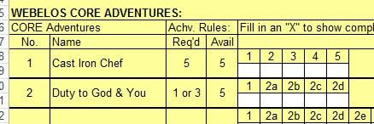
- Tracking Spreadsheets are posted on the USScouts Advancement webpage (http://usscouts.org/advance/cubscout/intro.asp). The spreadsheets were tested by a software developer who said they are so good he sees no reason to develop his own!!
- Utah National Parks Council, also, has Excel spreadsheets posted for all the new Adventure Plan requirements on their Akela's Council BlogSpot.
http://akelascouncil.blogspot.com/search/label/Tracking%20Sheet (The page starts with Arrow of Light scroll down for other ranks)
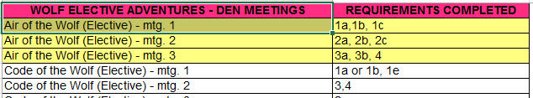
- A spreadsheet that correlates Meetings to Adventure requirements is available on the Utah National Parks' Akela's Council Blogspot at https://www.dropbox.com/s/yb8fweg7etnhqrt/WOLF%20BEAR%20WEBELOS%20REQUIREMENTS%20-%20MTGS.xlsx?dl=0 . It has all the Wolf, Bear, Webelos and AOL Adventure requirements.
These Advancement Spreadsheet workbooks are FREE for Scouters. But be COURTEOUS and observe the following -
PLEASE do not download the files from either site to email or send them digitally to others.
They are for your personal / pack use only. If you would like to share these files with others, please copy / send the link to them and send them to the site so they can print off their own. They would love everyone that wants a copy to get their own copy absolutely free. Both USScouts and Utah National Parks receive Ad money based on the number of people visiting the site. That ad money helps keep their websites open. Please help them (us) by encouraging others to visit to obtain files.

CUB SCOUT
LEADER TRAINING

IN-PERSON TRAINING
Position-Specific In-Person Training Guides Available Now! The training guides for
- Den Leader (http://www.scouting.org/filestore/training/pdf/515-215.pdf ),
- Cubmaster/Assistant Cubmaster (http://www.scouting.org/filestore/training/pdf/511-503_WB.pdf ), and
- Pack Committee (http://www.scouting.org/filestore/training/pdf/511-504_WB.pdf )

Are available on Scouting University. You can access them at http://www.scouting.org/training/adult.aspx .

ON-LINE TRAINING
On-Line Training for all Cub Scout positions has been available since October 25, 2015
The online training for Den Leaders, Cubmasters, Committee Chairs and members, and Chartered Organization Representatives is totally updated with help from volunteers from around the country. The new training is divided into shorter, more targeted modules so leaders can get the training they need, in the order they want, any time they need it. It is organized around the learning needed prior to the first meeting, in the first 30 days, and to be position-specific trained. This training was developed to be implemented in conjunction with the BSA’s new learning management system. Keep an eye on
my. Scouting Tools (log in at https://My.Scouting.org) for more information.
Go to the BSA Volunteer Training Team Facebook page (Link above) and.
Then you automatically receive the latest news!!
If you are having difficulties with
the training or system call
BSA Member Care at 972-580-2489,
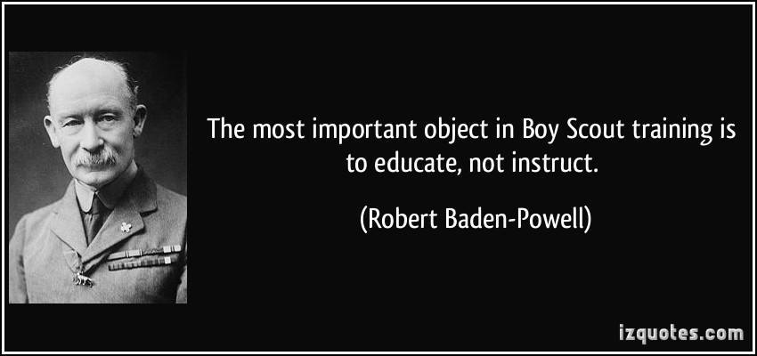
A Typical Learning Plan has several parts –
There is no need to complete more than one section at a time. Do what you have time to do.
Here you can see the three parts of the CM Course -
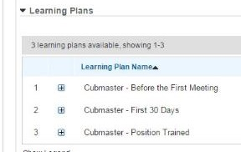

Each of these three parts is broken down into "bite sized" chunks:
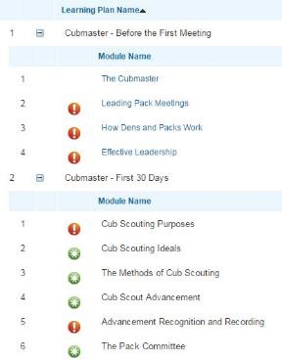
Go check it out and get your
people trained!!!

