# COMMISSIONER'S CORNER

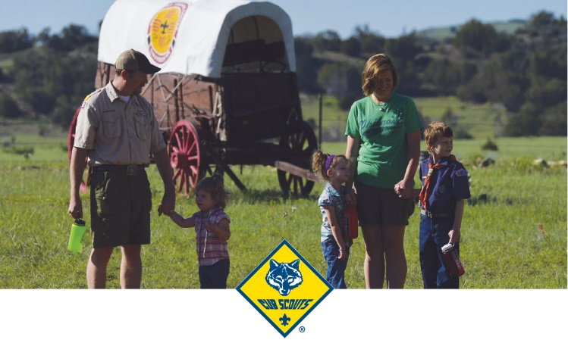

## 2017 CS EXTRAVAGANZA

**Sign Up Now!!**

Week 2: June 18–24, 2017

Week 7: July 23–29, 2017

Imagine attending the Philmont Training Center for a week and being able to interact with Cub Scout leaders from across the country, *and* being able to pick and choose which sessions to attend to improve your leadership skills! The summer of 2017 offers you that opportunity!

The 2017 Cub Scout Extravaganza at PTC! It’s your local council University of Scouting—but lasting for a week. Plan a program of your choice, designed to meet your needs by selecting from an assortment of Cub Scout leader topics ranging from outdoor skills to training administration … from den and pack management to Cub Scout fun and pizzazz. All of those, plus information on the Lion pilot program and the recently revised BALOO Cub Scout leader training experience. There is something for everyone!

Register now for an extravaganza week, and when you arrive at PTC, you’ll be able to get the most out of your time spent in Scouter’s paradise. Faculty comprises the Boy Scouts of America’s national-level volunteers and professional experts on the topics. It doesn’t get any better than this!

G to <http://www.philmontscoutranch.org/ptc.aspx>

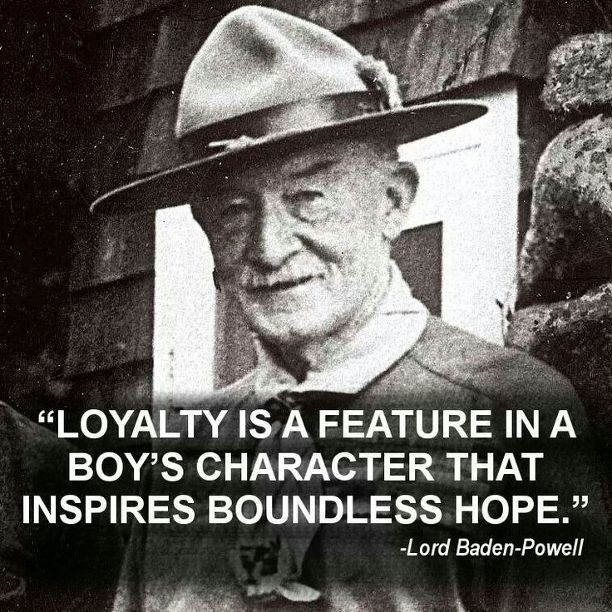

# TABLE OF CONTENTS

COMMISSIONER'S CORNER 1

2017 CS EXTRAVAGANZA 1

TABLE OF CONTENTS 2

CORE VALUES 2

**LOYAL QUOTES** 3

THOUGHTFUL ITEMS 6

Roundtable Prayer 6

AMERICA’S NATIONAL TREASURES 6

BIOGRAPHY 7

LORD ROBERT BADEN-POWELL 7

CUB SCOUT IDEAS 9

Cub Scout Spring Recruitment 9

TRACKING BOYS’ PROGRESS 10

DEN MEETING TOPICS 11

CHARACTER COMPASS 11

THEME RELATED STUFF 12

THEME RELATED ADVENTURES 12

PACK MEETING THEMES AND PLANS 12

PACK MEETING THEMES 14

UPCOMING MONTHS 14

CUBMASTER THOUGHTS 17

WOOD BADGE AND MY UNIT 17

WEBELOS 20

A History Lesson on Webelos Colors 21

MARCH CRAZY HOLIDAYS 22

March - A Month to Celebrate Loyalty 26

Fun Facts About Kindness: 28

Some personal rules for satisfying giving: 29

Fun Facts About Buzzards 30

TRAINING TOPICS 31

INVOLVING THE FAMILY 31

SPECIAL OPPORTUNITIES 35

STEM Awards for Cub Scouts 35

CUB GRUB 44

LAST THING 48

HONEY AND VINEGAR 48

REMEMBER YOUR ABCS 48

**One loyal friend is worth ten thousand relatives.** [Euripides](http://www.brainyquote.com/quotes/keywords/loyal.html)

# CORE VALUES

For March, the suggested Pack Meeting theme, **OUR NATIONAL TREASURES**, emphasizes the Scout Law point, **LOYAL.**

**The core value highlighted next month is:**

March's point of the Scout Law, **LOYAL,** will use the theme, **OUR NATIONAL TREASURES.**

**A SCOUT IS LOYAL**A Scout is true to his family, friends, Scout leaders, school, and nation.

**HOW DOES “OUR NATIONAL TREASURES” RELATE TO THIS POINT OF THE SCOUT LAW?**

A Scout is loyal. A Scout is true to his nation. America is blessed with many national treasures both manmade and natural. The Washington Monument and the Grand Canyon are only two examples. Explore the importance of the treasures around you.

**Per our Founder, Lord Baden-Powell  
the definition (or meaning) of the Scout Law point highlighted this month is:**[*https://en.wikipedia.org/wiki/Scout_Law*](https://en.wikipedia.org/wiki/Scout_Law)  
[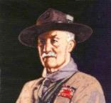](https://en.wikipedia.org/wiki/Scout_Law)

***Note –*** *Although Duty to God was part of B-P’s program, Reverent was not part of the Scout Law. The original Scout Law published in 1908 had nine points. In 1910, the BSA added Brave, Clean, and* ***Reverent****. In 1911 B-P added* ***Clean*** *to his list.*

**A SCOUT IS LOYAL**A Scout is **LOYAL** to the King, and to his officers, and to his country, and to his employers. He must stick to them through thick and thin against anyone who is their enemy, or who even talks badly of them. (Scouting For Boys, 1908)

Loyalty is a feature in a boy’s character that inspires   
boundless hope.  
 *– Lord Robert Baden-Powell*

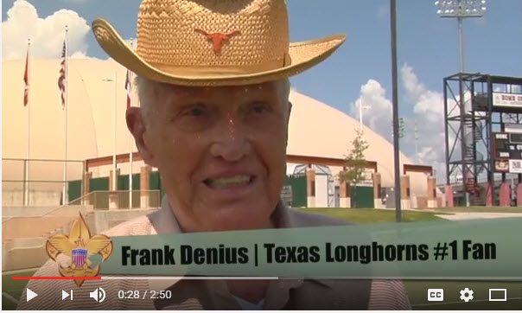

 In this video, the "Believe It Live It" team profiles Frank Denius, the University of Texas Longhorns No. 1 fan, and shows how he demonstrated loyalty with his service to his country in World War II. Go to URL <https://www.youtube.com/watch?v=KygPcKre1_c>

**LOYAL QUOTES**

*Quotations contain the wisdom of the ages, and are a great source of inspiration for Cubmaster’s minutes, material for an advancement ceremony or an insightful addition to a Pack Meeting program cover.*

A boy can learn a lot from a dog: Obedience, **LOYALTY** and the importance of turning around three times before lying down.   
Robert Benchley

Honesty and **LOYALTY** are key. If two people can be honest with each other about everything, that's probably the biggest key to success. Taylor Lautner

Love is friendship that has caught fire. It is quiet understanding, mutual confidence, sharing and forgiving. It is **LOYALTY** through good and bad times. It settles for less than perfection and makes allowances for human weaknesses. Ann Landers

The foundation stones for a balanced success are honesty, character, integrity, faith, love and loyalty. Zig Ziglar

You give **LOYALTY**, you'll get it back. You give love, you'll get it back. Tommy Lasorda

**LOYALTY** to the country always.   
**LOYALTY** to the government when it deserves it. – Mark Twain

I look for these qualities and characteristics in people. Honesty is number one, respect, and absolutely the third would have to be LOYALTY. – Summer Altice

I’ll take fifty percent efficiency to get one hundred percent **LOYALTY**. – Samuel Goldwyn

All I want is good, honest,   
loyal friends.   
Aviv Nevo

I have a **LOYALTY** that runs in my bloodstream, when I lock into someone or something, you can’t get me away from it because I commit that thoroughly. That’s in friendship, that’s a deal, that’s a commitment. Don’t give me paper – I can get the same lawyer who drew it up to break it. But if you shake my hand, that’s for life. – Jerry Lewis

If put to the pinch, an ounce of **LOYALTY** is worth a pound of cleverness. – Elbert Hubbard

I place an enormous premium on **LOYALTY**. If someone betrays me, I can forgive them rationally, but emotionally I have found it impossible to do so.  
– Richard E. Grant

All men are **LOYAL**, but their objects of allegiance are at best approximate. – John Barth

Where the battle rages, there the **LOYALTY** of the soldier is proved. – Martin Luther

A person who deserves my **LOYALTY** receives it..  
– Joyce Maynard

…it isn’t things and proximity, or even blood that holds us all together. What makes a family is love and **LOYALTY**. – Genevieve Dewey

**LOYALTY** and friendship, which is to me the same, created all the wealth that I’ve ever thought I’d have.  
– Ernie Banks

**LOYALTY** cannot be blueprinted. It cannot be produced on an assembly line. In fact, it cannot be manufactured at all, for its origin is the human heart — the center of self-respect and human dignity. It is a force which leaps into being only when conditions are exactly right for it — and it is a force very sensitive to betrayal.– Maurice Franks

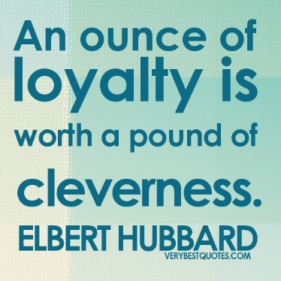

You don’t earn **LOYALTY** in a day. You earn **LOYALTY** day-by-day. – Jeffrey Gitomer

Honesty and **LOYALTY** are key. If two people can be honest with each other about everything, that’s probably the biggest key to success. – Taylor Lautner

**LOYALTY** and devotion lead to bravery. Bravery leads to the spirit of self-sacrifice. The spirit of self-sacrifice creates trust in the power of love. – Morihei Ueshiba

My whole thing is **LOYALTY**. **LOYALTY** over royalty; word is bond. – Fetty Wap

Success is the result of perfection, hard work, learning from failure, **LOYALTY**, and persistence.   
Colin Powell

Confidentiality is a virtue of the loyal, as **LOYALTY** is the virtue of faithfulness. Edwin Louis Cole

**LOYAL** and efficient work in a great cause, even though it may not be immediately recognized, ultimately bears fruit. Jawaharlal Nehru

Friendship is held to be the severest test of character. It is easy, we think, to be **LOYAL** to a family and clan, whose blood is in your own veins. Charles Eastman

I love dogs. They live in the moment and don't care about anything except affection and food. They're **LOYAL** and happy. Humans are just too damn complicated. David Duchovny

I am sustained by the tranquility of an upright and **LOYAL** heart. Peter Stuyvesant

Where would you be without friends? The people to pick you up when you need lifting? We come from homes far from perfect, so you end up almost parent and sibling to your friends - your own chosen family. There's nothing like a really loyal, dependable, good friend. Nothing. Jennifer Aniston

A man is a better citizen of the United States for being also a **LOYAL** citizen of his state and of his city; for being **LOYAL** to his family and to his profession or trade; for being **LOYAL** to his college or his lodge. Louis D. Brandeis

Horses know how to be loyal but still keep their distance. Sadie Jones

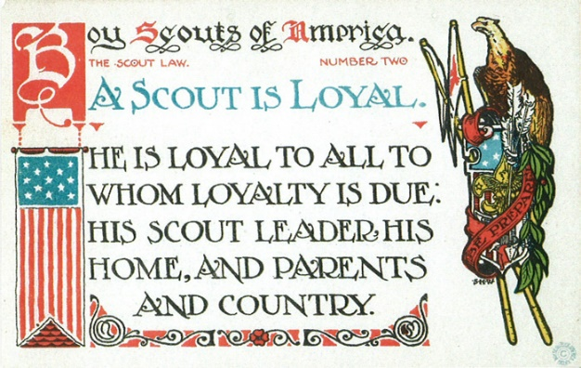

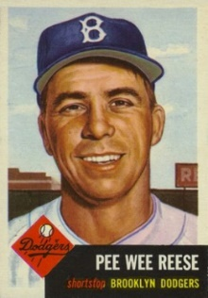 

**Brooklyn** was the most wonderful city a man could play in, and the fans there were the most **LOYAL** there were. Pee Wee Reese

# THOUGHTFUL ITEMS

***Thanks to Scouter Jim from Bountiful, Utah, who contributed to Baloo’s Bugle for many years. This is one of his writings. CD***

## Roundtable Prayer

*2008-2009 CS Roundtable Planning Guide*

O Lord, we thank you for all the blessings you have bestowed upon us and this nation. Help us do our duty to you and our county. Help us do our best to guide the youth so they can grow up to be good men for this great nation. **AMEN**

*Sam Houston Area Council*

We are thankful to live in this country where we have the freedom to worship as we wish. May we always remember that all of us are Your children. **Amen.**

## AMERICA’S NATIONAL TREASURES

*Scouter Jim, Bountiful UT*

One early morning, while waiting for the bus, after not working for a while, I realized I had missed road noise. As Scout Leaders, we are all about nature and the outdoors. When we think about Scouting, most think about quiet and solitude or the wilderness, the sound of a mountain stream, the call of wild birds. We don’t often think about the places we live, in the cities and towns of America. Roads as we know them are an invention of the last century. Many if not all of us have heard the song about Route 66, the road that crossed the country from Chicago across the country to Los Angeles. There is also the Lincoln Highway, the Dixie Highway and many other named roads. There are Scenic Byways all across the country, place to visit, with a history to tell

The street where I catch the bus every workday morning has a number, but just down the street it changes to a named road. Most people don’t remember why they call it “Orchard Drive.” On the far south end many years ago there were orchards where people would come from miles around to purchase fruit. On the far north end, there used to be a church owned farm with fruit trees and a small dairy, all of which, for the most part, were operated by volunteers with all the production of the orchard and dairy being processed and given to needy families. I remember being taken there by my father with my older brothers to do volunteer work. I did what little work a young lad could do, picking up branches and hauling them out of the fields after others had pruned trees. The orchards and the farm are now gone, replaced by urban sprawl and a subdivision.

There is another road in my county that runs east to west named Antelope Drive. Should you drive the road west from I-15to the edge of the Great Salt Lake, you would come to an entrance booth to the causeway to Antelope Island State Park. After paying a Park entrance fee, you could drive the road across the Great Salt Lake to a wonderful State Park with clean sandy beaches and its own herd of Buffalo roaming the Island.

I am not trying to brag about where I live. I am merely trying to raise the competitive spirit in the reader to say, *Oh yea, well you ought to see what we have around here. There is this great place right down the road. We have some wonderful history right here in our city park.* That is the reaction that this month is all about. Discovering the treasures our country has for all of us. Teaching boys about where they live and the reasons that things are the way they are. Where did your town get its name? I bet there is a story to tell there. Beyond the boundaries of your community, to the wonders of you state, what stories are there to tell? What places are there to visit near where you live? Beyond the boundaries of your state, what places of history and beauty are there in you region? Let us teach our Cub Scouts about the America, and the States and the towns where they live.

[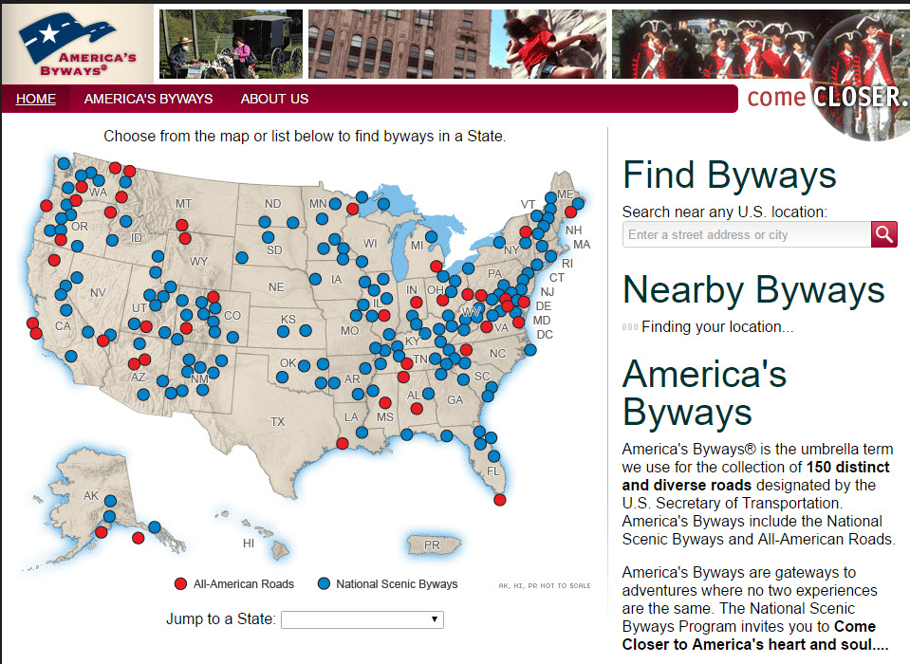](http://www.byways.org)

Web Link: <http://www.byways.org>   
America’s Scenic Byways

**Bless The Cub Scouts**

*Catalina Council*

(Tune: Bless This House)

Bless the Cub Scouts, Lord, we pray.

Keep us healthy all the day.

Let us know our Cub Scout sign,

Have it always on our mind.

If you do, we promise then,

We'll become good future men.

Hear our prayers at night and day,

Guide us, O Lord along your way.

Bless the Cub Scouts, Lord, we pray,

Keep us healthy all the day.

# BIOGRAPHY

## LORD ROBERT BADEN-POWELL

**A Loyal Son, Soldier, & Scouter**

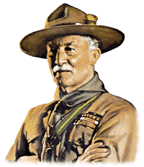

British military hero and founder of the Boy Scouts and the Girl Guides, Lord Robert Baden-Powell was a most LOYAL person to his Mother and his Country.

**Family Background and Education**

Baden-Powell was born on **Friday, February 22**, 1857 (Exactly 135 years after George Washington was born on **Friday, February 22**, 1732) in London to Henrietta Grace Powell and the Reverend Baden Powell, a professor of Geometry at Oxford. He was christened Robert Stephenson Smyth Powell. He was the eighth of the couple's children.

Baden-Powell's father died only three years after his birth, leaving his mother to raise nine children on her own. On September 21, 1869, his mother added Baden to the Powell family name in honor of her late husband. Thus, all the children's last names became Baden-Powell.

Throughout his life, Baden-Powell lavished praise on the powerful role his mother played in the family and celebrated motherhood as the most cherished of institutions.

His writing not only conveys a deep respect for his mother, but it also defines his vision of moral masculinity in terms of its relation to and respect for motherhood. After the death of his mother, he wrote, "A really good manly fellow is seldom to be found who is not also a good son to his mother. There is only one pain greater than that of losing your mother, and that is the pain your mother would suffer if she lost you. I do not mean by death, but by your own misdeeds."

In spite of difficulties in their relationship, Baden-Powell remained extraordinarily **LOYAL** to his mother throughout his life. As Tim Jeal observes in his monumental biography, her commanding presence shaped in large part the "anxieties and ambitions that drove Baden-Powell throughout his long life."

In 1870, Baden-Powell entered Charterhouse, an esteemed public school, and began his formal education. Even though he did poorly in his academic courses, he enjoyed and excelled at the more physical aspects of school life. As a student, he acted in numerous student productions and developed an intense appreciation for the outdoors, both of which he would draw on in his future roles as a military officer and leader of the Boy Scouts.

**Military Career**

Given his lack of academic success, Baden-Powell failed to gain admission to Oxford. But his exceptionally high placement on exams for an officer's commission in the British army prompted him to consider a career in the military. In 1876, he joined the British cavalry and departed for India, where he began his service with the 13th Hussars.

In India, Baden-Powell began his quick rise through the ranks, and by the time he was forty, he had attained the rank of full colonel. In 1888, he was appointed to serve in South Africa under his uncle. During the next 20 years, Baden-Powell served in conflicts in Africa and leading the 5th Dragoons in India. By 1899, tensions between the British and Boers in South Africa had increased, making war inevitable, and Baden-Powell was sent back to Africa to defend British outposts against the Dutch settlers.

Before Mafeking, it was noted in the biography, *Baden-Powell: Founder of the Boy Scouts* by Tim Jeal, that B-P was a formidable adversary to those that crossed him but he was extremely loyal to his friends.

In October 1899 Baden-Powell was in Mafeking, a small British trading settlement 650 miles north of Cape Town. Boers laid siege to him and his troops, and for 217 days, Baden-Powell withstood their attack and dramatically played up his role as heroic British commander outnumbered by a grim enemy. On the 100th day of the siege of Mafeking, B-P sent a telegram of **LOYAL** devotion to the Queen, who was anxious for their safety.

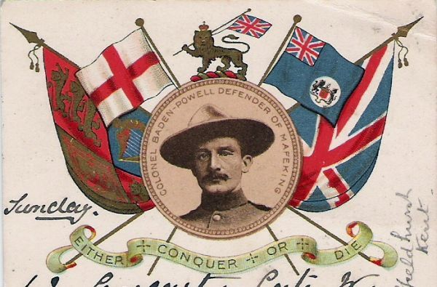

Baden-Powell's acting talents came in handy as he staged an elaborate and determined resistance. His actions earned him great fame as the "hero of Mafeking." As Michael Rosenthal observes, "In a war steeped in British blunder and embarrassment, he helped shaped an image of heroism in which nearly everyone could take refuge."

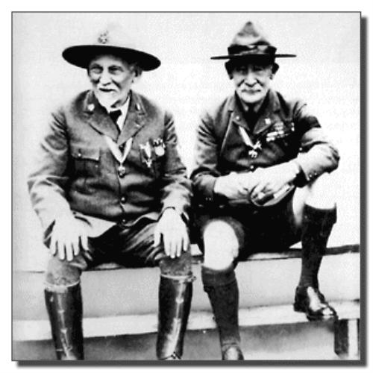  
*Dan Beard (L) and Baden-Powell(R)*

**The Scouting Movement**

After the Boer War, Baden-Powell returned home to Britain and was celebrated as a national hero. He continued to serve in the British army in Africa until 1907, when he retired to devote himself full time to the Boy Scouts. Since 1899, he had been writing pamphlets in the army to train soldiers, but it was not until his last few years in the military that he began to consider adapting such material for boys.

In 1907, Baden-Powell organized a camp on Brownsea Island for a group of boys of different social backgrounds. This experiment unofficially inaugurated the Boy Scouts movement. A year later, he published Scouting for Boys. In 1909, with his sister Agnes, he founded the Girl Guides.

By 1910, the scouting movement had spread all over Britain and throughout much of the British Empire. Baden-Powell remained **LOYAL** to his cause and the Boy Scouts, leading the movement until his death in 1941. He continued in his quest that Boy Scouting could help bring a permanent lasting peace to the world.

For his **LOYALTY** and services to the nation and to international scouting, Baden-Powell was knighted in 1909 and created a baron in 1929. In 1938, he returned to Africa, where he died on January 8, 1941.

# CUB SCOUT IDEAS

## Cub Scout Spring Recruitment

*New Birth of Freedom Council*

Recruitment should be a year round activity for all units. Whether the recruitment method is an activity such as a pack ice cream social, troop open house, or peer to peer campaign it’s important that the door is always open for a boy to join scouting. Primarily, there are two times every year that an extra emphasis is put into recruiting for packs, troops, and crews, during the fall and spring. In the fall packs are participating in the fall round-up and venture crews are hosting first-nighters. In the spring Troops actively work with Cub Packs to bridge over Arrow of Light Dens for them to join Boy Scouts.

During May of every year Kindergarten boys become eligible for the first time to join Cub Scouts and parents of boys for all ages are making decisions on what activities to get involved in for the following school year. It is important that we take advantage of this opportunity and plan a recruiting activity so we can ensure boys have the opportunity to join Cub Scouts when they are being offered all types of other activities.

Packs should set goals for recruiting a new Tiger Den and identifying a Tiger Leader to lead them in the spring so they are ready to go in the fall. As with most packs during the summer, weekly meeting have slowed down along with most pack activities. However, to actively engage your new scouts and leaders the National Summertime Pack Award is a simple and great award recognition program for the new scouts and the entire pack to participate in.

Please take a look at training video on the link below to gather some information on how your pack can have a very successful spring recruitment. This video was put together by the Central Region Commissioner, Lucia Cronin a volunteer that has had some great success with cub scout recruiting.

<http://www.youtube.com/watch?feature=player_embedded&v=QrSIIdqbt8A>

# TRACKING BOYS’ PROGRESS

**IN THE MODIFIED CUB SCOUT ADVENTURE PLAN**

Judy and I have found several places on the web where there are aids to use to track boys’ progress in the modified Adventure Plan. Judy is placing a more detail in Baloo’s Bugle, Part IV – Den Meeting Helps.

* **The Bobwhite Bather blog site** (<https://bobwhiteblather.com/mid-year-cub-scout-program-updates/> ) has a discussion of changes.
* **Cubmaster Tom,** responded providing links to documents he formatted to paste into the boys’ books for each modified Adventure. See example below:

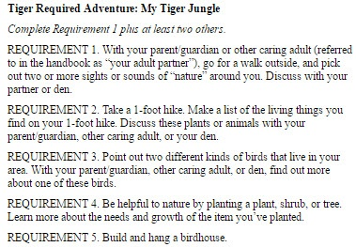

The complete Tiger document is at: <https://docs.google.com/document/d/1ka_AkwxDkKgNjLrAOUHzbQQqCkruDCC8RyxtMFvrFO8/edit?usp=sharing>. The links for the other ranks are in the comment on Bobwhite Blather.

* **Bert Bender, Atlanta Area Council, replied,**  
  Having finished several deep dives through the requirements changes, I’ve updated the page at <http://www.southfultonscouting.com/node/3557> to not only show exactly what got changed and what didn’t change, but now also add comments intended to be a practical guide to whether you need to look at the new 11/30/16 language, and whether when those might be a useful alternative.

Comments after some Adventures encourage (sometimes plead) that dens avoid the “easy button” approach. Doing the June 1, 2015 handbook elements will often result in better outcomes and experience in Cub Scouting.

* **Utah National Parks Council’s Akelas Council Blogspot** has revised paper tracking sheets (<http://akelascouncil.blogspot.com/>) Thanks to Celeste Hunt for creating these.

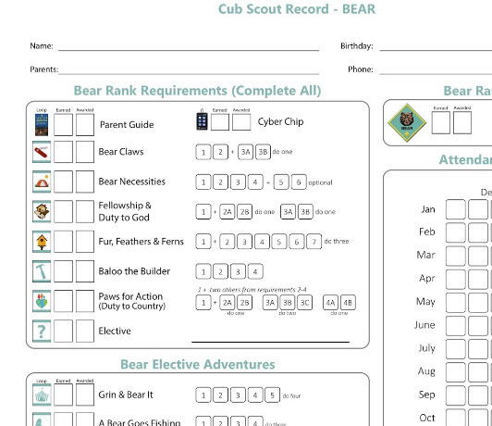

Celeste says, “Tracking, planning, and recognition are so important in Cub Scouts. This new tracking sheet helps you to be able to keep track of where each boy is at towards the Bear, Adventures, and Cyber Chip requirements. I print 2 copies of the tracker on cardstock for each boy. One for his book and one for my leader binder. I place it next to the trackers for the religious and other awards we are doing. I have tab for every boy with all his trackers. Complete information on each boy in one place. Not every boy is there every week. By doing this, I always know what each boy has done. If the parents ever have questions, I have a place to check, and I can always copy each tracking sheet to show them where their boy is.

# DEN MEETING TOPICS

Remember – Boys want to be active!!   
See, too, that they earn their awards   
***(Never say GET. You get sick, you do not get awards – You earn awards. A little CD Philosophy)***.

**Big Rock Ideas** – suggestions for Big Rocks that fit Interest Topics or seasonal activity. If years are next to an item (e.g. 13-14) that suggested Big Rock is in that Roundtable Planning guide and on-line at <http://www.scouting.org/scoutsource/Commissioners/roundtable.aspx>



# CHARACTER COMPASS

**MARCH -** ADVENTURES with a **CHARACTER COMPASS** pointing to **LOYAL:**

**TIGER –**

* Team Tiger (Core)
* Earning Your Stripes

**WOLF –**

* Council Fire (Core)
* Spirit of the Water (Elec)

**BEAR –**

* Grin and Bear It (Core)
* Forensics (Elec)

**WEBELOS CORE –**

* **None** (Core)

**ARROW OF LIGHT CORE –**

* Scouting Adventure (Core)

**WEBELOS & AOL ELECTIVES –**

* Project Family (Elec)



**APRIL -** ADVENTURES with a **CHARACTER COMPASS** pointing to **THRIFTY:**

**TIGER –**

* Backyard Jungle (Core)
* Floats and Boats (Elec)

**WOLF –**

* Council Fire (Core)
* Code of the Wolf (Elec)

**BEAR –**

* Fur Feathers & Ferns (Core)
* Make It Move (Elec)

**WEBELOS CORE –**

* Cast Iron Chef (Core)

**ARROW OF LIGHT CORE –**

* Building a Better World (Core)
* Camper (Core)

**WEBELOS & AOL ELECTIVES –**

* Art Explosion (Elec)
* Project Family (Elec)

# THEME RELATED STUFF

## http://www.orgsites.com/in/pack3092/tsalute.jpgTHEME RELATED ADVENTURES

All Adventures are fun. –

**ADVENTURES THAT INVOLVE STEM:**

|  |  |
| --- | --- |
| **TIGER –**   * My Tiger Jungle, * Curiosity, Intrigue, & Magical Mysteries, * Sky Is the Limit | **WOLF –**   * Adventures in Coins, * Air of the Wolf, * Code of the Wolf, * Council Fire, * Digging in the Past, * Germs Alive, * Grow Something, * Motor Away |
| **BEAR –**   * Baloo the Builder, * Forensics, * Fur, Feathers, & Ferns, * Make It Move, * Robotics, * Super Science, * A World of Sound | **WEBELOS / A of L –**   * Adventures in Science, * Build It, * Earth Rocks!, * Engineer, * Into the Wild, * Into the Woods |

**“OUR NATIONAL TREASURES” RELATED**

**TIGER –**

* Family Stories, Learning your family’s part in history (Elec)
* Rolling Tigers, Req 7 Famous Bicycle race or racer (Elec)
* Sky is the Limit, Req 8 (if where you visit is a National treasure) (Elec)

**WOLF –**

* Council Fire, Req 5, The person you talk to is a National Treasure. (Core)
* Duty to God Footsteps, Req 1a – The religious monument or site (Core)
* Hometown Heroes, They are the national treasures (Elec)

**BEAR –**

* Paws for Action, Req 1, Place of historical interest is a National Treasure. (Core)

**WEBELOS CORE –**

* NONE

**ARROW OF LIGHT CORE –**

* NONE

**WEBELOS & AOL ELECTIVES –**

* Looking Back, Looking Forward – Req 1 – Scouting is a National Treasure (Elec)
* Project Family, Perhaps your research will reveal a National Treasure in your family (Elec)



# PACK MEETING THEMES AND PLANS

[*www.scouting.org*](http://www.scouting.org)

**From National's Website for the new plans using the Core Values based on the Scout Law:**

Here are a few thoughts to consider around these new pack meeting plans. First, there is a plan for each month that corresponds with a point of the Scout Law. In addition, each plan has a theme to help make the pack meeting even more fun! The plans do not have to be used in a specific order.

**Tips for Utilizing the Plans**

* Pack meeting plans do not have to be done in any special order, but it is recommended that you include all of the points of the Scout Law each year. The pack planning meeting would be a good time to determine the order.
* There are pack meeting plans for multiple years posted on the website. It is your pack's choice of which one to select from each point of the Scout Law for each year.
* Pack meetings should not last longer than an hour. Adjust the plan to make it fit within the time. Research and experience tells us that Cub Scouts have a hard time sitting still for that long. Keep the meetings fun, active, and engaging.
* If you are comfortable with a costume to fit the theme of the meeting, go for it!
* Importantly, keep it simple and make it fun.
* The following required adventures have a requirement that suggests or requires completion at a pack meeting. Please plan accordingly as part of your annual program planning process. Work with your den leaders to plan when these activities will take place.

**Tiger**

* **Tigers in the Wild,** requirement 5. Participate in an outdoor pack meeting or pack campout campfire. Sing a song and act out a skit with your Tiger den as part of the program.
* **Games Tigers Play,** requirement 3. Make up a new game, and play it with your family or members of your den or pack.

**Wolf**

* **Council Fire,** requirement 6c. Create a den project from recyclables for a pack meeting.

**Bear**

* **Grin and Bear It**, requirement 2. Working with the members of your den, organize a Cub Scout carnival and lead it at a special event.
* **Grin and Bear It**, requirement 3. Help younger Cub Scouts take part in one of the events at the Cub Scout carnival.

**Webelos**

* **Stronger, Faster, Higher**, requirement 5. With adult guidance, lead younger Scouts in a fitness game or games as a gathering activity for a pack or den meeting.

**Arrow of Light**

* **Building a Better World (if chosen**), requirement 10b. Set up an exhibit at a pack meeting to share information about the World Friendship Fund.

**As a personal note:** *I have read most of the plans and they are excellent and just as complete as the new Den Leader Books. The games, and other stuff are right there. Including costuming ideas for that added PIZAZZ!! If you do not use themes and do not add PIZAZZ you are not doing your best for your pack.****GOOD JOB!!!*** *From CD*

Check them out at:   
<http://www.scouting.org/Home/CubScouts/Leaders/CubmasterResources/PackMeetingPlans.aspx>



# PACK MEETING THEMES

Kim, the chair of the task force, says **"I do want to stress that the focus is still the Core Value and the theme is just there as an enhancement. Pack meeting theme plans are specifically crafted to bring out the important points of the Core Value in a fun way."**

|  |  |  |
| --- | --- | --- |
| **2017–2017 Pack Meeting Plans** | | |
| Feb | Reverent | ["Passport To Other Lands"](http://www.scouting.org/filestore/cubscouts/pdf/YEAR2/310-842(15)_February%20Reverent_WEB.pdf) |
| Mar | Loyal | ["Our National Treasures"](http://www.scouting.org/filestore/cubscouts/pdf/YEAR2/310-842(15)_March%20Loyal_WEB.pdf) |
| Apr | Thrifty | ["Power Up!"](http://www.scouting.org/filestore/cubscouts/pdf/YEAR2/310-842(15)_April%20Thrifty_WEB.pdf) |
| May | Clean | ["A Picnic With Pizzazz"](http://www.scouting.org/filestore/cubscouts/pdf/YEAR2/310-842(15)_May%20Clean_WEB.pdf) |
| Jun | Brave | ["Roaming Reptile Alert"](http://www.scouting.org/filestore/cubscouts/pdf/YEAR2/310-842(15)_June%20Brave_WEB.pdf) |
| Jul | Trustworthy | ["Let The Games Begin"](http://www.scouting.org/filestore/cubscouts/pdf/YEAR2/310-842(15)_July%20Trustworthy_WEB.pdf) |
| Aug | Friendly | ["#CUBSCOUTS"](http://www.scouting.org/filestore/cubscouts/pdf/YEAR2/310-842(15)_August%20Friendly_WEB.pdf) |
| **2017–2018 Pack Meeting Plans** | | |
| Sep | Courteous | [How the West Was Fun](http://www.scouting.org/filestore/cubscouts/pdf/2017/310-842(17)_September_Courteous.pdf) |
| Oct | Thrifty | [A-Camping We Will Go](http://www.scouting.org/filestore/cubscouts/pdf/2017/310-842(17)_October_Thrifty.pdf) |
| Nov | Reverent | [Cubs Give Thanks](http://www.scouting.org/filestore/cubscouts/pdf/2017/310-842(17)_November_Reverent.pdf) |
| Dec | Kind | [Paying It Forward](http://www.scouting.org/filestore/cubscouts/pdf/2017/310-842(17)_December_Kind.pdf) |
| Jan | Helpful | [Jobs, Jobs, Jobs](http://www.scouting.org/filestore/cubscouts/pdf/2017/310-842(17)_January_Helpful.pdf) |
| Feb | Cheerful | [Abracadabra!](http://www.scouting.org/filestore/cubscouts/pdf/2017/310-842(17)_February_Cheerful.pdf) |
| Mar | Trustworthy | [Cub Scout Investigators](http://www.scouting.org/filestore/cubscouts/pdf/2017/310-842(17)_March_Trustworthy.pdf) |
| Apr | Loyal | [Cubs in the Future](http://www.scouting.org/filestore/cubscouts/pdf/2017/310-842(17)_April_Loyal.pdf) |
| May | Friendly | [Treasure Hunters](http://www.scouting.org/filestore/cubscouts/pdf/2017/310-842(17)_May_Friendly.pdf) |
| Jun | Obedient | [Wheel Into Summer](http://www.scouting.org/filestore/cubscouts/pdf/2017/310-842(17)_June_Obedient.pdf) |
| Jul | Brave | [Home of the Brave](http://www.scouting.org/filestore/cubscouts/pdf/2017/310-842(17)_July_Brave.pdf) |
| Aug | Clean | [Destination Parks](http://www.scouting.org/filestore/cubscouts/pdf/2017/310-842(17)_August_Clean.pdf) |

**If you are using a paper copy the link to all the   
Pack Meeting Plans is:**

<http://www.scouting.org/Home/CubScouts/Leaders/CubmasterResources/PackMeetingPlans.aspx>

# **UPCOMING MONTHS**

For March, the suggested Pack Meeting theme, **OUR NATIONAL TREASURES**, emphasizes the Scout Law point, **LOYAL.**

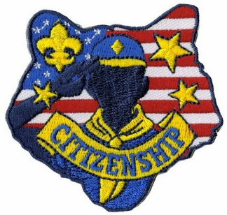

|  |  |  |
| --- | --- | --- |
| **Month** | **Year** | **Theme** |
| **LOYAL** (Selected Citizenship, Faith, and  Perseverance Theme Months) | | |
| September | 1960 | Cub Scout Citizens |
| October | 1980 | Cub Scout Citizen |
| July | 1983 | Stars and Stripes |
| October | 1988 | Cub Scout Citizens |
| November | 2001 | Hometown Heroes |
| February | 2003 | Uncle Sam Depends on You |
| November | 2009 | Scout Salute |
| November | 2011 | Citizenship |
| June | 2012 | Perseverance |
| September | 2012 | Hometown Heroes |
| November | 2013 | Your Vote Counts |
| December | 2014 | Stars and Stripes |
| July | 2016 | Scout Salute |

|  |  |  |  |  |  |
| --- | --- | --- | --- | --- | --- |
| **Month** | **Year** | | **Theme** | | |
| **American History** | | | | | |
| February | | 1962 | | Parade of Presidents | |
| September | | 1966 | | Cub Scout 49'ers | |
| October | | 1972 | | Discovery of America | |
| February | | 1973 | | Famous Americans | |
| June | | 1973 | | Flags of America | |
| October | | 1976 | | Outstanding Presidents | |
| June | | 1981 | | Flags of America | |
| November | | 1985 | | Parade of the Presidents | |
| September | | 1987 | | Flags of America | |
| November | | 1989 | | Parade of the Presidents | |
| October | | 1999 | | California Gold Rush | |
| **American the Beautiful** | | | | |
| February | | 1941 | | American Highlights |
| July | | 1955 | | Discovering America |
| November | | 1956 | | Life In Puerto Rico |
| April | | 1960 | | The Great Lakes |
| March | | 1963 | | Around the U.S.A. |
| April | | 1967 | | Mountians of America |
| July | | 1971 | | Travel around U.S.A. |
| February | | 1976 | | Horizons USA |
| October | | 1977 | | Discover America |
| November | | 1978 | | High Country USA |
| November | | 1981 | | Discover America |
| July | | 1991 | | High Country, USA |
| August | | 1996 | | High Country, USA |
| July | | 2001 | | American ABC's |
| February | | 2009 | | American ABCs |

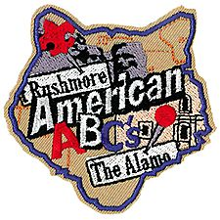



program updates banner

|  |  |  |  |  |
| --- | --- | --- | --- | --- |
| **Month** | **Year** | | **Theme** | |
| **American Patriotism** | | | | |
| October | | 1951 | | Strong for America |
| February | | 1955 | | Let Fredom Ring |
| July | | 1964 | | Our American Heritage |
| February | | 1966 | | Strong for America |
| February | | 1971 | | Our American Heritage |
| June | | 1976 | | Historical Flags |
| July | | 1976 | | July 4th Picnic |
| December | | 1978 | | Duty to God & Country |
| February | | 1989 | | Strong for America |
| September | | 1989 | | Our American Heritage |
| February | | 1993 | | Old Glory |
| June | | 1994 | | Strong for America |
| July | | 1999 | | Our National Treasures |
| July | | 2006 | | Red, White and Baloo |
| July | | 2007 | | The Rockets Red Glare |
| July | | 2010 | | Celebrate Freedom |
| June | | 2014 | | Over the Horizon |
| February | | 2016 | | Friends Near and Far |

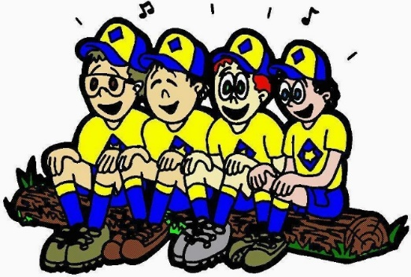

For April, the suggested Pack Meeting theme, **POWER UP**, emphasizes the Scout Law point, **THRIFTY.**

**The core value highlighted next month is:**

April's point of the Scout Law, **THRIFTY,** will use the theme, **POWER UP.**

**A SCOUT IS THRIFTY**A Scout works to pay his way. He uses time, property, and natural resources wisely.

**HOW DOES “POWER UP!” RELATE TO THE NINTH POINT OF THE SCOUT LAW, THRIFTY?**

A Scout protects and conserves natural resources. Scouts explore the science of energy through solar, electrical, wind, and even “Cub Scout” power. They will also discover how this energy is used in everyday life. They will explore different ways to conserve energy and protect the world we live in.

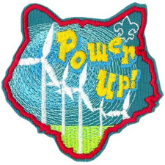

|  |  |  |
| --- | --- | --- |
| **Month** | **Year** | **Theme** |
| **Energy** | | |
| October | 1943 | Cubs as Scientists |
| September | 1946 | Cub Scout Engineers |
| April | 1954 | The Story of Oil |
| January | 1960 | Cub Scout Scientist |
| September | 1963 | Science Fair |
| October | 1975 | The World of Sound |
| March | 1983 | Energy |
| September | 1985 | Science Fair |
| April | 2002 | Forces of Nature |
| March | 2003 | Why Does it Do That? |
| March | 2007 | Baloo Skies |
| March | 2009 | When I Grow Up |
| January | 2010 | Power Up |
| **Energy Conservation** | | |
| May | 1976 | SOAR |
| April | 1999 | Pollution Solution |
| April | 2001 | Save It For Us |

|  |  |  |
| --- | --- | --- |
| **Month** | **Year** | **Theme** |
| **THRIFTY** (Themes for Conservation and others) | | |
| March | 1942 | Save It |
| September | 1948 | Round-Up and Conservation |
| August | 1952 | Conservation |
| April | 1955 | Cub Scout Foresters |
| November | 1955 | America Beautiful |
| April | 1958 | Keep America Beautiful |
| April | 1968 | Keep America Beautiful |
| September | 1971 | Conservation |
| May | 1972 | Beautiful America |
| May | 1974 | Keep America Beautiful |
| May | 1976 | SOAR |
| July | 1987 | America The Beautiful |
| April | 1999 | Pollution Solution |
| April | 2001 | Save It For Us |
| April | 2004 | Cubservation |
| March | 2006 | Cubstruction |
| May | 2009 | Leave Nothing But Footprints |
| April | 2010 | Spring into Action |
| June | 2015 | Go For The Gold |
| September | 2015 | Cubservation |
| March | 2016 | Cubstruction |

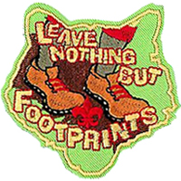

# **CUBMASTER THOUGHTS**

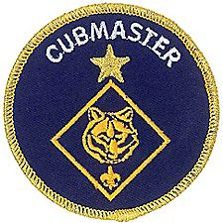

## WOOD BADGE AND MY UNIT

*Cubmaster Mark, Pack 161, Garden State Council*

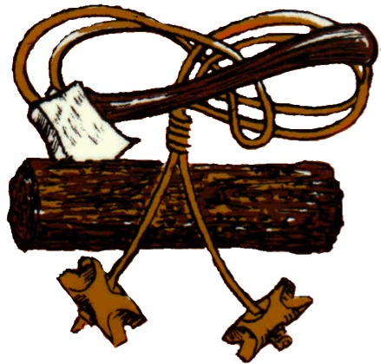

**In the beginning -  
there was a Cub Pack.**

A leader with seven boys who had no idea how a pack was supposed to run.

No idea about Roundtables, Unit Commissioners, District Executives, Position Specific Training or **Advanced Leadership Training.**

This Leader had no idea what was meant by program, how advancement worked, or that KISMIF was probably the best advice he will ever receive about running a successful program.

No tools, no experience, **just a desire to make a difference.**

Then someone mentioned a training course called

**Wood Badge.**

He was told it is the Mountaintop of Training and a life changing experience. A management course to help one be a better Leader and role model.

I have to say that when I signed up I was truly apprehensive as to what skills I would be learning. I thought I would be given an axe and a blanket, and be placed in the middle of nowhere, learning survival skills.

**I was completely wrong.**

Wood Badge NE-V-138, of course, the course I took, is the event that insured the survival of Pack 161, my unit. **My Cub Pack.**

It gave me the tools and instruction to overcome the obstacles that face every leader, new and experienced.

I realized the value of training, and brought a culture of training back to the pack.

**All** training events would be offered to **all** those, who like me, have decided to put on the uniform and lead. Opportunity to attend would not only be offered but encouraged. I would set the example by continuing my quest for learning. I would not say No for anyone. I would not assume they are too new, or too experienced. There is always something one can gain.

**Training brings quality.**

**Quality brings relevance.**

Training and quality brings an opportunity for those who are seeking to make moral and ethical choices over their lifetime.

NE-V-138 gave me the drive to inspire others to lead.

With more people leading in my unit, a synergy was created. The ideas and creativity produced by leadership became more diverse.

Our program was and is always fresh because of this wealth of effort.

**Diversity is inclusiveness.**

By offering a fresh and diverse program, our membership took off.

We have approached 100 scouts in the past five years, currently at 68, healthy, and vibrant.

We have 27 **UNIFORMED** leaders. Pants, shirts, belts, socks … EVERYTHING. Setting the example for the boys.

Of that 27, 8 will be attending this years Wood Badge course given by the Garden State Council,

N5-690-17

For more help be sure to check out –



**Imagine -**8 more highly trained, motivated individuals who will help our unit grow, and more importantly remain a relevant choice for families wanting to produce tomorrow’s leaders.

Of those eight who are taking N5-690-17, seven are Wolf and Tiger Leaders.

I am truly excited about what my unit will be able to accomplish in the next two to three years.

This bright future was born from one leader, who decided to dive in and receive the best training available.



**Wood Badge.**

Is there a course being offered in your council or neighboring council?

**Attend it   
Make a difference**The benefits to your unit will be   
immediate and profound.

**How do you find Wood Badge courses?**

* Ask at your local council. Check their website. Ask people at Roundtable (Commissioners, Executives, anyone) Look for Scouters with Wood Badge beads, woggles, and Neckerchiefs.



Go to [www.woodbadge.org](http://www.woodbadge.org) . They list scheduled courses that they know about. *Caution - The list is not complete*

The five sides of the pentagon represent the five central themes of Wood Badge:



The themes that follow encapsulate the course content of Wood Badge:

1. **Living the Values**

* Values, Mission, and Vision
* Aims and Methods

1. **Bringing the Vision to Life**

* Listening to Learn
* Communicating
* Giving and Receiving Feedback
* Valuing People and Leveraging Diversity
* Coaching and Mentoring

1. **Models for Success**

* Team Development Model
* Situational Leadership

1. **Tools of the Trade**

* Project Planning
* Problem Solving
* Managing Conflict
* Assessing Team Performance
* Managing Change
* Celebrating Team Success

1. **Leading to Make a Difference**

* Leaving a Legacy
* Learning the Greatest Leadership Secret



Live in or near Southern New Jersey??

Want to take your Wood Badge course with Cubmaster Mark and   
Commissioner Dave –

[](http://www.gardenstatescouting.org/woodbadge)

Go to  
<http://www.gardenstatescouting.org/woodbadge>

**Commissioner Dave** is Senior Patrol Leader and **Cubmaster Mark** is a Troop Guide for the Spring 2017 Wood Badge course being run in Garden State Council in NJ. Check it out at <http://www.gardenstatescouting.org/woodbadge>

# WEBELOS

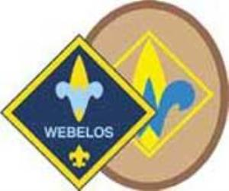



**Always an S** Webelos always ends with an S whether talking about one Webelos Scout or a den of Webelos. It is an acronym – **WE**’ll **BE LO**yal **S**couts. As the CS RT Commissioner who mentored me says – "If you don’t have an S at the end – then there is nothing to which to be loyal."

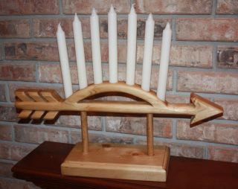

*Note: For Traditional units, Webelos Scouts / Dens means Webelos (4th grade) and Arrow of Light (5th grade) Scouts / Dens. For LDS Units where the Webelos experience is the 12 months a Scout is 10 years old, it is all inclusive.*

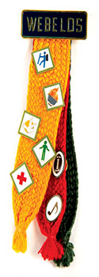



# **A History Lesson on Webelos Colors**

*Mike Walton,* [*www.USScouts.org*](http://www.USScouts.org) *In Response to a question from Barbara*

**Barbara wrote me -**"Dave -- our son is a Webelos I and is enjoying completing and earning the new Adventures toward his Webelos badge. Next year he will be working on the Adventures for his Arrow of Light. Our question is this, does it make a difference on which ribbon he displays the pins? Since there are three colors, gold, red, and green, there might be a uniform policy for what goes where.

I took this question to Mike Walton, our uniform guru at [USScouts.org](http://www.usscouts.org) .Check out his uniform website at - <http://www.scoutinsignia.com/patchtop.htm>

**In response Mike wrote -**The three badge colors represent the three programs in the BSA: Cub Scouting (the yellow/gold), Boy/Varsity Scouting (the red) and "Senior Scouting" (used to be Exploring and now Venturing, the green). These are the same three colors found in the "WEBELOS Tartan", an official tartan (plaid) color combination recognized in Scotland (and is also referred to as the "Boy Scouts of America Tartan", just so you know -- and if you get a chance to go to Scotland and request a woolen skirt and they ask you for the "family name" or the "tartan name" *smiling*). The BSA's "Pedro" jacket features that three color plaid color combination as well.

When the WEBELOS Badge colors were introduced in the spring of 1969, the then-Director of Cub Scouting answered this question in the following manner:

"There is a sequence for the placement of the 15 silver activity badges upon the Badge Colors. The first five should be worn on the central color, the gold (yellow) strand because the WEBELOS is transitioning from being a Cub Scout to a Boy Scout. The next five should be placed onto the green color because it is hopeful that the outdoors aspect of Boy Scouting will appeal to the WEBELOS Cub Scout and will whet his appetite toward becoming a Boy Scout. The final five should be placed onto the red color strand as a reminder of his goal toward earning the Arrow of Light and becoming a Tenderfoot Boy Scout." (Back in the day, we did not have a joining step called "Scout" and instead Arrow of Light recipients automatically became Tenderfoot Boy Scouts upon graduation from a Cub Scout Pack to a Boy Scout Troop).

I guess that bit of wisdom was not passed down, because the same question was asked in 1974, when the Cub Scout program was revised and there was this answer in SCOUTING magazine within the "Front Line Stuff" column: "WEBELOS Cub Scouts may wear the activity badges as earned in any manner on any of the three strands of the WEBELOS Badge colors. The most important part of the process is that he earns the badge and displays it on his uniform on the Badge colors."

And again in 2003, the same question was asked again in "Front Line Stuff" and someone from the Cub Scout Division answered in this manner: "The 20 multi-colored badges earned for participating in activities as a WEBELOS Cub Scout may be worn either on the WEBELOS Badge colors OR on the WEBELOS Cub Scout hat. The number of or which strand it is worn on first, second or last is up to the WEBELOS Cub Scout. On the hat, the activity badges should be worn on either side of the WEBELOS badge emblem in the center of the hat. Either all of the badges are worn on the hat or on the Badge colors and this is an option of the individual WEBELOS Cub Scout and his parents."

**So to summarize:**The 20 activity badges are worn, in any order that the WEBELOS Cub Scout chooses, on the WEBELOS Badge colors or alternatively on the WEBELOS Cub Scout hat *(personally, Mike & I think wearing them on the hat like pins one receives from Disneyland or some resort place is very tacky but at the time kids were wearing hat pins and it was very popular and "stylish")*.

The three strands represent the three program groups of the Boy Scouts of America. Alternatively, if he chooses to wear them on the WEBELOS Cub Scout hat, he wears one half on one side of the WEBELOS "tartan" or plaid hat.

I hope this bit of Scouting history and lore helps your son and you out, Barbara, and I hope it helps others who ask Dave or the local Scout Shop(tm) employee the same question. I'll put this together and add it to my Badge and Uniform Site later this month.

# MARCH CRAZY HOLIDAYS

*Claralyn, Golden Empire Council,   
Webelos Camp Prog Dir& Cub RT Comm Emeriti   
Adapted from*<http://holidayinsights.com/moreholidays/index.htm><http://www.brownielocks.com/month2.html>

**Did you Know?** March was named   
for the Roman God "Mars"

**March is**



* Irish American Month
* Music in Our Schools Month
* National Craft Month
* National Irish American Heritage Month



* National Nutrition Month
* National Peanut Month
* National Women's History Month



* [Red Cross Month](http://www.redcross.org/about-us/who-we-are/history)



* [Adopt A Rescued Guinea Pig Month](http://thepetloversguide.com/calendar-of-events/?mc_id=695)
* Deaf History Month (3/13 to 4/15)
* [Exotic Winter Fruit & Leeks and Green Onions Month](http://www.d6curriculum.com/teacher/wp-content/uploads/2012/02/sp12-explorers-calendars.pdf)

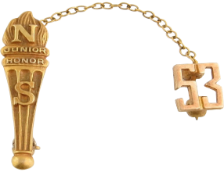

* [Honor Society Awareness Month](http://www.nhs.us/)
* [Expanding Girls’ Horizons in Science & Engineering Month](http://invma.org/expanding-girls-horizons-in-science-and-engineering-month/)

**Don't forget about the BSA's new program -**



**It is Co-ed!!!!**

**Check it out at -** <https://stemscouts.org/>

* [Music in Our Schools Month](http://www.nafme.org/)
* [National Athletic Training Month](http://www.nata.org/)



* [National Caffeine Awareness Month](http://www.caffeineawareness.org/)
* [National Eye Donor Month](http://restoresight.org/what-we-do/calendar-of-events/commemorations-and-observances/national-eye-donor-month/)



* [National Frozen Food Month](http://nfraweb.org/promotions/annual-calendar/march-national-frozen-food-month)
* National Kidney Month



* National Kite Month (3/28-5/3)

Check out all of these [kite designs!](http://www.instructables.com/id/DIY-Kite/)

* National Multiple Sclerosis Education & Awareness Month
* National Kidney Month
* National Nutrition Month



* [National Umbrella Month](http://cornerstoneconfessions.com/2015/03/31-ways-to-celebrate-national-umbrella-month.html)
* Optimism Month
* Poison Prevention Awareness Month



* [Quinoa Month](http://wholegrainscouncil.org/whole-grains-101/quinoa-march-grain-of-the-month)
* Save Your Vision Month

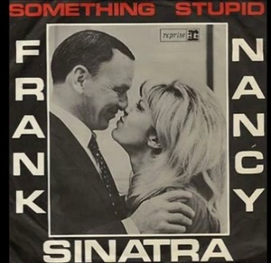

* [Sing With Your Child Month](https://www.musictogether.com/singmonth)
* Spiritual Wellness Month

**Weekly Celebrations:**

* National Cheerleading Week: 1-7
* [National Pet Sitters Week: 1-7](https://www.petsit.com/pet-sitters-international-celebrates-21st-professional-pet-sitters-week)
* National Write A Letter of Appreciation Week: 1-7
* Festival of Owls Week 3-5 (First Full Weekend)

[The Owl Page with Owl Calls](http://www.owlpages.com/owls/species.php)

[Owl Fun Facts](http://easyscienceforkids.com/all-about-owls/)

* Celebrate Your Name Week: 5-11
* National Procrastination Week: 5-11





* [Read an E-Book Week](https://www.ebookweek.com/): 5-11
* Return The Borrowed Books Week: 5-11
* Save Your Vision Week: 5-11
* Teen Tech Week 5-11 (usually 2nd week)
* National School Breakfast Week 6-10



* [No More Week 7-13](http://nomore.org/nomoreweek2015/)



* [National Rattlesnake Roundup](http://www.rattlesnakeroundup.net/calendar-of-events1.html): 10-12

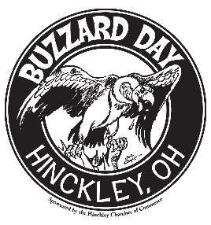

* [Turkey Vultures Return](http://www.hinckleyohchamber.com/buzzard-day-2015/): 11-17
* [National Girl Scout Week](http://www.girlscouts.org/en/about-girl-scouts/traditions.html) 12-18



* [Campfire USA Birthday Week](http://campfire.org/): 12-18 ( 2nd Full Week)
* National Agriculture Week: 12-18



* [International Brain Awareness Week](https://www.sfn.org/baw/): 13-19
* American Chocolate Week: 19-25 (Always 3rd Full Week)
* Health Information Professionals Week: 19-25
* World Folktales & Fables Week: 19-25
* Act Happy Week: 20-26 (Starts on 3rd Monday)
* National Cleaning Week: 26-4/2 (Last Week)
* National Youth Violence Prevention Week: 26-4/2 Link (Formerly in April)

**March Daily Holidays, Special**   
**and Wacky Days:**

1 [Ash Wednesday](http://holidayinsights.com/christian/ashwed.htm)

1 [National Pig Day](http://holidayinsights.com/other/pigday.htm)

1 [Peanut Butter Lovers' Day](http://holidayinsights.com/moreholidays/March/pbloversday.htm)

2 [Old Stuff Day](http://holidayinsights.com/moreholidays/March/oldstuffday.htm)

3 [I Want You to be Happy Day](http://holidayinsights.com/moreholidays/March/behappyday.htm)

3 [If Pets Had Thumbs Day](http://holidayinsights.com/moreholidays/March/petthumbsday.htm)

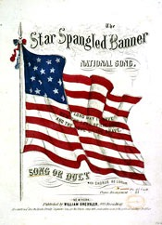

3 [National Anthem Day](http://holidayinsights.com/moreholidays/March/nationalanthemday.htm)

3 [Peach Blossom Day](http://holidayinsights.com/moreholidays/March/peachblossomday.htm)

3 [Employee Appreciation Day](http://holidayinsights.com/moreholidays/March/empappday.htm)

4 [Holy Experiment Day](http://holidayinsights.com/moreholidays/March/holyexperimentday.htm)



4 [Hug a GI Day](http://holidayinsights.com/moreholidays/March/hugagiday.htm)

5 [Multiple Personality Day](http://holidayinsights.com/moreholidays/March/multipersonday.htm)

6 [Dentist's Day](http://holidayinsights.com/moreholidays/March/dentistsday.htm)

6 [National Frozen Food Day](http://holidayinsights.com/moreholidays/March/frozenfoodday.htm)

7 [National Crown Roast of Pork Day](http://holidayinsights.com/moreholidays/March/roastporkday.htm)

8 [Be Nasty Day](http://holidayinsights.com/moreholidays/March/benastyday.htm)

8 [International (Working) Women's Day](http://holidayinsights.com/other/iwd.htm)

9 [Popcorn Lover's Day](http://holidayinsights.com/moreholidays/March/popcornlovers.htm)

9 [Panic Day](http://holidayinsights.com/moreholidays/March/panicday.htm)

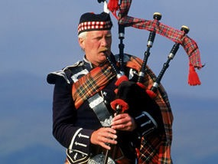

10 [International Bagpipe Day](http://every-day-is-special.blogspot.com/2015/03/march-10-international-bagpipe-day.html)

10 [Middle Name Pride Day](http://holidayinsights.com/moreholidays/March/middlenameday.htm)

11 [Johnny Appleseed Day](http://holidayinsights.com/moreholidays/March/appleseedday.htm)

Make a [Terra Cotta Apple Stash](http://www.dltk-kids.com/school/mpot.htm)

11 [Worship of Tools Day](http://holidayinsights.com/moreholidays/March/worshiptoolsday.htm) - guys, you can relate

12 [Girl Scouts Day](http://holidayinsights.com/moreholidays/March/girlscoutday.htm)

12 [Plant a Flower Day](http://holidayinsights.com/moreholidays/March/plantflowerday.htm)

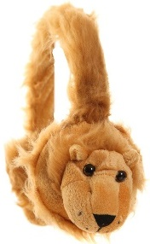

13 [Ear Muff Day](http://holidayinsights.com/moreholidays/March/earmuffday.htm)

13 [Jewel Day](http://holidayinsights.com/moreholidays/March/jewelday.htm)

14 [Learn about Butterflies Day](http://holidayinsights.com/moreholidays/March/butterfliesday.htm)

Craft a [Bulgarian Martenitsa Butterfly Craft](http://krokotak.com/2014/02/matrenitsas-butterflies-from-toothpicks/)

14 [National Potato Chip Day](http://holidayinsights.com/moreholidays/March/potatochipday.htm)

Fun recipes with [Potato Chips](http://firstwefeast.com/eat/2014/01/how-to-cook-delicious-things-with-chips/)



14 [National Pi Day](http://holidayinsights.com/moreholidays/March/piday.htm)- Why today? Because today is 3.14, the value of Pi.

Try these [Pi Activities](http://www.exploratorium.edu/pi/pi_activities/index.html)

15 [Everything You Think is Wrong Day](http://holidayinsights.com/moreholidays/March/everythingwrongday.htm)

15 [Ides of March](http://holidayinsights.com/other/ides.htm)

Ideas to include in a [letter to your kid](http://heartsforfamilies.org/blog/blog-march-2015-why-you-need-to-celebrate-absolutely-incredible-kid-day.aspx)

15 [Dumbstruck Day](http://holidayinsights.com/moreholidays/March/dumbstruckday.htm)



16 [Incredible Kid Day](http://holidayinsights.com/moreholidays/March/incrediblekidday.htm)

16 [Everything You Do is Right Day](http://holidayinsights.com/moreholidays/March/everythingrightday.htm)

16 [Freedom of Information Day](http://holidayinsights.com/moreholidays/March/freeinfoday.htm)

17 [Corned Beef and Cabbage Day](http://holidayinsights.com/moreholidays/March/corned-beef-cabbage-day.htm)

17 [Submarine Day](http://holidayinsights.com/moreholidays/March/submarineday.htm) - the hero sandwich or the boat??

Make a [mini-submarine](http://www.nsta.org/publications/news/story.aspx?id=40867)



17 [Saint Patrick's Day](http://holidayinsights.com/stpat/index.htm)

Yarn Wrapped [Rainbow](http://www.cuttingtinybites.com/2015/02/rainbow-yarn-wrapping.html)  - glue on round piece of pipe cleaner for a tie slide!

18 [Goddess of Fertility Day](http://holidayinsights.com/moreholidays/March/goddessfertilityday.htm)

18 [Supreme Sacrifice Day](http://holidayinsights.com/moreholidays/March/supremesacrificeday.htm)

18 [National Quilting Day](http://holidayinsights.com/moreholidays/March/quiltingday.htm)

19 [Poultry Day](http://holidayinsights.com/moreholidays/March/poultryday.htm)

20 [Extraterrestrial Abductions Day](http://holidayinsights.com/moreholidays/March/extabductday.htm)

20 [Proposal Day](http://holidayinsights.com/moreholidays/March/proposalday.htm)



20 [Earth Day](http://holidayinsights.com/other/earth.htm)

21 [Credit Card Reduction Day](http://holidayinsights.com/moreholidays/March/credit-card-reduction-day.htm)

21 [National Agriculture Day](http://holidayinsights.com/moreholidays/March/agricultureday.htm)

21 [Fragrance Day](http://holidayinsights.com/moreholidays/March/fragranceday.htm)

22 [National Goof Off Day](http://holidayinsights.com/other/goofoffday.htm)

23 [Melba](http://holidayinsights.com/moreholidays/March/melba-toast-day.htm) Toast Day

23 [National Chip and Dip Day](http://holidayinsights.com/moreholidays/March/chipdipday.htm)

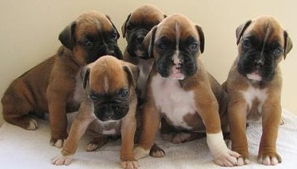

23 [National Puppy Day](http://holidayinsights.com/moreholidays/March/national-puppy-day.htm)

23 [Near Miss Day](http://holidayinsights.com/moreholidays/March/nearmissday.htm)

24 [National Chocolate Covered Raisin Day](http://holidayinsights.com/moreholidays/March/chocolateraisinday.htm)

Easy Crockpot [Chocolate Covered Raisins](http://www.food.com/recipe/easy-chocolate-covered-raisins-crock-pot-278661)

25 [Pecan Day](http://holidayinsights.com/moreholidays/March/pecanday.htm)

Kid’s Recipe Video [Mini Pecan Pie](https://www.youtube.com/watch?v=pt6nnww_SYM)



25 [Waffle Day](http://holidayinsights.com/moreholidays/March/waffleday.htm)

26 [**National Spinach Day**](http://holidayinsights.com/moreholidays/March/national-spinach-day.htm)

26 [Make Up Your Own Holiday Day](http://holidayinsights.com/moreholidays/March/makeholidayday.htm)

27 [National "Joe" Day](http://holidayinsights.com/moreholidays/March/joeday.htm)



28 [Something on a Stick Day](http://holidayinsights.com/moreholidays/March/somethingstickday.htm)

29 [National Mom and Pop Business Owners Day](http://holidayinsights.com/moreholidays/March/mpboday.htm)

29 [Smoke and Mirrors Day](http://holidayinsights.com/moreholidays/March/smokemirrorsday.htm)

30 [National Doctor's Day](http://holidayinsights.com/moreholidays/March/doctorsday.htm)

30 [I am in Control Day](http://holidayinsights.com/moreholidays/March/incontrolday.htm)

30 [Take a Walk in the Park Day](http://holidayinsights.com/moreholidays/March/walkinparkday.htm)

31 [Bunsen Burner Day](http://holidayinsights.com/moreholidays/March/bunsenburnerday.htm)

[Robert Bunsen Facts](https://www.famousscientists.org/robert-bunsen/) - he invented more than a burner!

31 [National Clam on the Half Shell Day](http://holidayinsights.com/moreholidays/March/clamshalfshellday.htm)



# March - A Month to Celebrate Loyalty

*Alice, Golden Empire Council*

**First Week:   
Newspapers in Our Schools Week**

Many newspapers have special sections during the year for students to use – and special programs for students to use newspapers in the classroom – those inserts can often be GREAT for scout activities (I have gotten inserts about Birds, Local Environmental Issues). Also, I was able to get signed up as a scout leader in order to get the same information and resources as they offer to local educators – so I had a built-in program I could use with my den with a little adjustment – worth a try! (Alice)

Look through the local newspaper for stories about people who are demonstrating compassion by doing good for others – or helping overcome prejudice and misunderstanding.

**Second Week:  
 Crochet Week**

There is a Humanitarian Aid project that delivers scarves or caps to help people keep warm -

***And it’s not just for girls!***

Did you know that becoming a Master Weaver in the British Isles was originally restricted to men and boys?

Boys can learn to do hand crochet, which can be used for several simple projects. Or invite a “guest expert” family member from the pack to come and talk about their experience in making scarves, caps and mittens – or baby clothes or even larger items as a service to those in need.



**American Red Cross Month**Visit a local office or invite a representative to come and talk about how they help people in need, and how even Cub Scouts can help do that job. You might be able to do a service project!

**March 1st**

**Share a Smile Day** – Now there’s a “little thing” that everyone can enjoy;

Want some fun??

Have a Smiling Competition to see who can smile the longest – without laughing!

Share some Apple Smile Treatsfrom Cub Grub.

**March 2nd**

**Dr. Seuss’ Birthday & Read Across America Day –** Combine both celebrations by reading “Horton Hears a Who” – it’s a book that teaches compassion by example in a really fun way! Horton hears a tiny voice one day and discovers a whole other world existing on a small speck of dust. Despite kangaroos, jungle monkeys and an eagle named Vlad Vladikoff, Horton saves his microscopic friends and helps them get the respect they deserve - "Because, after all, a person's a person, no matter how small."

**March 3rd**

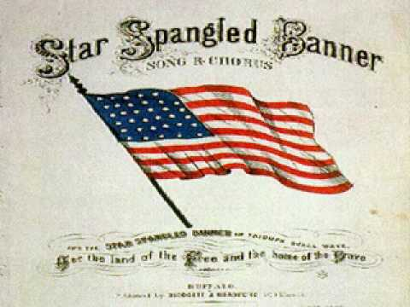

**National Anthem Day http://holidayinsights.com/artwork/flagusa.gif**

The *Star-Spangled Banner* is the national anthem of the United States of America. It was written by Francis Scott Key. National Anthem Day celebrates this song, and the rich history behind its creation. The song officially became our national anthem on March 3, 1931.

Celebrate today by proudly flying the flag. Also listen to and sing the *Star-Spangled Banner*.

**A rich history..........**   
Many people think the *Star Spangled Banner* was written during the Revolutionary War. It was actually written during the war of 1812 (1812-1814).

In August 1814, the British army detained Dr. William Beanes as a prisoner of war. He was a friend of Francis Scott Key. On Sept. 13, 1814, Francis Scott Key and a U.S. negotiator boarded a British vessel where Beanes was being held. He negotiated his friends' release. But then, Francis Scott Key was detained that day along with the negotiator. They were held until after the attack on Fort McHenry, which guarded the harbor and city of Baltimore.

He watched the bombardment of the fort from the ship. The next morning, he was ecstatic to see that the American flag was still flying over Fort McHenry. This historic event inspired Francis Scott Key to write "The Star-Spangled Banner" the following day (September 14, 1814).

**Correcting the confusion.........**   
Some people incorrectly assume that National Anthem Day is September 14, the day the song was written. This is incorrect. National Anthem Day is every March 3rd, in celebration of the day in 1931 that congress voted the *Star-Spangled Banner* our national anthem and President Herbert Hoover signed the bill.



**March 4th  
Hug A G.I. Day -** The men and women in our armed forces deserve our thanks and appreciation. They risk their lives for our freedom, and to keep us safe. A simple hug is a small thanks for this vital service to our country. Here are two simple ways to “give a hug:”

First, make up some little snack bags of those chocolate kisses and hugs – share them with local military personnel.

Second, “give a hug” by using this simple motion to say THANKS to military personnel wherever you see them – especially if you don’t feel comfortable giving a real hug. Use this sign to say “Thank you from the bottom of my heart” by placing your hand over your hear, then pulling it down and out, bending at the elbow hand flat, palm up, angled toward the person you're thanking – you can mouth the words if you want.



**March 6th**

**Oreo Cookies went on sale for the first time in 1912** Play the “Smack Dab in the Middle Game” in the GAMES section - and be a good friend – share some Oreos and milk with someone!

**March 12th**

**Girl Scout Day** recognizes and celebrates the birthday of GSA on March 12, 1912. Lady Olave Baden-Powell, the wife of Lord Baden-Powell, founded Girl Guides in England. On March 12, 1912 Juliette Gordon Low started the first Girl Scout group in Savannah Georgia with 18 girls. Here’s a way that Cub Scouts can help our sister organization – offer to help a local Girl Scout troop set up their cookie booth.

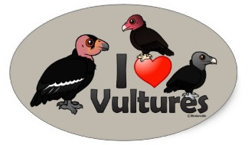

**March 13th  
Buzzard Day - I** bet you think of a buzzard as a “gross” bird – but have some COMPASSION – check out the Fun Facts About Buzzards. You will be surprised! (And it’s often the same way with people who are different, or groups you think you don’t like – if you find out about them, or get to know them, you might be surprised!) ***By the way – The California Condor is a Buzzard. And there is a large effort ongoing to save the California Condor.***

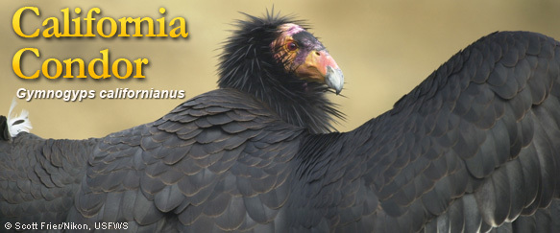

**March 16th**

**Freedom of Information Day –** Webelos working on the Communicator Activity Pin, and people who need information to help someone, will certainly celebrate this day!

**March 17th**

**St. Patrick’s Day –** The Patron Saint of Ireland was a kind man – and you can share his compassionate nature by making special cards to take to visit elderly or shut-ins. You could also take them a treat of some fruit, or even some scones! (See recipe in Cub Grub)

**March 18th**

**Johnny Appleseed Day –** Check out the fascinating story of John Chapman, who became known as Johnny Appleseed after he planted thousands of apple seeds all over America so that future settlers would have fruit and shade – and birds would have a place to nest. He was a great example of compassion, doing something for others without any payment or expectation – and because he knew he was providing something they might need and use! For more information and ideas, go to:  
[**http://www.applejuice.org/johnnyappleseed.html**](http://www.applejuice.org/johnnyappleseed.html)*or* [**www.enchantedlearning.com/school/.../Appleseedindex.shtml**](http://www.enchantedlearning.com/school/.../Appleseedindex.shtml)

**March 20th**

**First Day of Spring –** The perfect time to take a hike to look for signs of Spring – sights and sounds! See how many you can find!

**March 28th**

**Pencil with an eraser patented in 1858 –** Just imagine, before then, your pencil would have no eraser! And you can use a pencil with an eraser to make “Whoville” on a stick!

**March 28th**

**Something on a Stick Day –** Have some Hot Dogs on a Stick, or some Fruit Kabobs!

## Fun Facts About Kindness:

*Alice, Golden Empire Council*

* Giving a smile is actually easier than giving a frown – it takes fewer muscles!
* In 2007, 163,000 volunteers at the National Park Service donated 5.4 million hours of time worth $101 million or the equivalent of 2,596 full time employees!
* 80% of the people in this county give to nonprofits.
* Only 10-12% of financial giving is provided by foundations and 5-6% comes from corporations.
* Most of the money given by individuals is from middle and low income people, not the super wealthy!
* Eleven percent of households contributed to religious causes only.
* Twenty-one percent of households contributed to only secular causes.
* Thirty-four percent contributed to both religious and secular causes.
* Only 28.8% of the people in this country do the actual volunteer work for the many service organizations and projects in this country – so your time does matter!
* Recognition in front of their peers is the most valued form of “payback” for volunteers – so remember to recognize parents, leaders and others who help your scout program!
* The median amount of time that people volunteer is 52 hours a year, ranging from 21% who spend from one to fourteen hours up to the 28% who donate between one hundred and four hundred hours a year.
* Doing a good deed actually changes the body physically – endorphins create a feeling of well-being when a good deed is done.

## Some personal rules for satisfying giving:

*Alice, Golden Empire Council*

* **Give anonymously –** not knowing who the benefactor is leaves the receiver feeling loved by and grateful to all!
* **Keep your eyes and ears open – when you see or hear of a need, fill it!**
* **Be creative –** and let children offer their creative ideas as well.
* **Share the bounty – if you have season tickets to a sports event, concerts, theatre and can’t use them, share them.**
* **And of course, you can literally share the bounty –** flowers or produce from your garden, or even the seeds from a successful growing season!
* **Let everyone participate –** even the youngest children can make play doh (recipe in C Recipe
* Sr c:re This:
* f Share @ Share
* https:/lwww.diynab.Jral.com/homemade-playdough/
* 8+ Share - Tweet 403Total
* Shares
* 116,067
* READERS
* BOOKS
* 1/11
* 11lD3111
* DIYNolvrol.com
* Sim.pie
* Natural
* ade
* Dough
* Homemade Playdough: A Natural Recipe
* My family members love to get my girls Play Doh for their birthdays and
* Christmas. It always makes my girls happy. I don't mind it too much either-my
* kids get to use their hands to be creative in their play, and I always consider that
* a good thing.
* There's a problem with Play Doh though, and that problem is that it never lasts
* long at our house. The bright pink mixes with the soft yellow and the blue and
* orange mesh into a mess, and before I've even realized what's happening. we
* are stuck with seven cans of murky brown Play Doh.
* And as if the murky brownness isn't enough, my kids have a tendency to drop
* significant percentages of it on the floor. By the time they're finished playing
* and ready to put their Play Doh away, half of it ls dried out and has to be swept
* up.
* 2111
* 11lD3111
* For that reason, I don't often buy it. It's good fun, yes, but I don't typically spend
* money on thiDss that I lmowwon't last long. sure, store·bouS}lt play
* dough comes with cool play sets and amazing colors, but I just can't bring
* myself to buy it when I know that I can make it so cheaply at home.
* There are several recipes for homemade playdough. Many of them contain
* ingredients that I don't typically have en hand, so I opt for the simplest possible
* recipe. What I use could probably even be considered a salt dough recipe, but
* with a little extra flour it becomes soft enough to play with for hours.
* Homemade PlayDough Recipe
* DIYNotural.com
* Ingredients
* • 1 cup of flour (whatever kind you have on hand)
* • o/4 cup of salt
* • Sh cup of water
* 1/3CY2017 Homemade PlayDouftl: A Simple !l'ld All-Natural Recipe
* • 3 to 5 drops of natural food coloring (I use this brand)
* Instructions
* 1. Mix together the flour and the salt.
* 2. Mix together~ cup of warm water with a few drops of food coloring.
* 3. Slowly pour the water into the flour mixture, stirring as you pour. Stir
* until combined, then knead with your hands until the flour is
* completely absorbed. If the dough is too sticky, add more flour until it
* doesn't stick at all.
* If your kids are anything like mine, they'll enjoy playing with the homemade
* playdough, but they'll want a few toys to play with, too. I might not be able to
* come up with an intricate, all-plastic ice cream parlor or anything, but I can
* hand them some good old-fashioned kitchen utensils that make them just as
* happy. These are a few of the things I give my kids to use with their
* playdough:
* • Silverware
* • Rolling pins
* Save
* • Cookie cutters
* • Mason jar rings
* • Biscuit cutters
* Eventually, the homemade playdough will stop holding your kids' interest. This
* means you'll have to find something else to entertain them, and a place to store
* your play dough. I can't really help with the first part of that, but I can
* recommend that you keep your play dough in an airtight container.
* Use glassware with a lid, recycled plastic containers, or even old Play Doh
* containers. As long as your play dough can sit tight without being left out, it
* should last for several months or more.
* The next time you're stuck inside for a rainy day, get your children to help you
* make some homemade playdough! They'll enjoy making it, but not as much as
* https:/lwww.diynab.Jral.com/homemade-playdough/ 4111
* 1/3Ql2017 Hcmemade PlayDougi: A Simple aid All-Natural Recipe
* they'll enjoy playing with it.ub) or pick out pictures to use to make a picture dictionary for another child.
* **Make an inventory of the talents and supplies available to you –** you might be surprised at how much you have to offer!
* **Keep a “Giving” Diary –** it could be personal, family or a scrapbook for a den or pack project. Include pictures of preparations, and ask everyone how doing the service project made them feel**.**
* **Think about personal passions –** if you are especially interested in the environment, help clean up a local creek or “adopt” a local bus stop or neighborhood playground.Make a commitment to go by on a regular basis and pick up trash. Another environmental way to share seeds of kindness is by giving a gift of trees ($60) or a share of seedlings ($10), both thru Heifer International. (See websites)
* **Contact local volunteer bureaus for some ideas for a project you can do.** If you don’t know where they are, check with a local librarian – she will have a listing of local possibilities.
* **Recognize other people and what they contribute.** Every week choose people who quietly perform service – the church organist, the neighbor who takes in your garbage can – send them a thank you note or put a container of cookies or some flowers on their doorstep by way of saying “thanks for what you do.” Boys could also give service to a Cubmaster, grandparent, pack chair, or someone else who helps make the scout program go.

## Fun Facts About Buzzards

*Alice, Golden Empire Council*



* Buzzards are actually gentle birds – they can’t kill their prey. And if they disappeared, we’d be overrun with dead animals!
* Buzzards are actually vultures – and they can only hiss or grunt, since they don’t have voice box!
* They are the most graceful fliers in the world, even though they look ugly and awkward up close!
* Vultures are bald for a good reason – so the carrion (dead meat) they eat doesn’t stick to them.
* The naked red heads of the adult turkey vultures look like (surprise) turkeys!
* They can smell carrion from over a mile away. They also have good eyesight!
* During the hot summer months turkey vultures will “poop” on their feet to cool them off.
* Turkey vultures don’t build a nest, and they pick really hard to find places to use!
* Vultures mate for life.
* The California and Andean Condors are actually in the vulture family.
* As groups of vultures catch thermal updrafts they look like water boiling in a pot – so they are called kettles. Turkey vultures have been reported by aircraft pilots to rise to as high as 20,000 feet and soar for hours without flapping their wings.
* Turkey vultures can travel up to 200 miles a day, and they don’t eat while they are traveling!
* They are very large, but only weight 2-3 pounds, so they can “float” in columns of rising air for hours – and they don’t flap their wings, but just rock from side to side and ride the currents!
* Hawks look for “kettles” – groups of flying vultures – because they know the vultures always find the best thermals!
* Turkey vultures can swoop up to 60 mph in order to avoid being "mobbed" by ravens or jays.
* Turkey vultures can live up to 24 years.

# TRAINING TOPICS

## INVOLVING THE FAMILY

*Circle Ten Council*

The Boy Scouts of America has a deep interest in the strength of the family. Its own aim to develop boys, young men and women, into participating citizens possessing good character who are physically, spiritually, and mentally fit demands that the movement have an active concern for the family.

A child's attitudes, personality, and the foundation for emotional stability are formed at a very early age. The influence of the family is primary, not only in the sense that it precedes the influence of others, but also in the sense that it is of greatest importance.

The world changes and social norms change. Social pressures come from different directions. The family faces problems today that are far different from those faced by a family only two generations ago. The Boy Scouts of America is continually examining its relevance and effectiveness so that it remains useful as a support resource for the family.

**WHAT IS A FAMILY**

We all know that a family is much more than a Webster's definition.

* A family is people giving and receiving love. We seldom come straight out and say, 'Son, I love you. It doesn't matter if I don't like what you do, I LOVE you."
* A Family is people getting angry with each other, but still loving one another.
* A Family is loving the differences about each other.
* A Family is people talking and listening to each other…communicating.
* A Family is people caring about what happens to each other, and letting it show.
* A Family is people laughing and crying without feeling ashamed of it…expressing themselves naturally.
* A Family is people sharing with each other and with others.
* A Family is people reaching out instead of fencing in…to each other and neighbors and friends.
* A Family is a place for having fun, also for sharing sorrows and healing the hurts.
* A Family is people giving strength to each other; caring and letting it show; leaning on each other; feeling loyal to each other; in other words LOVING one another.

**Good family life is never an accident, but always an achievement by those who share it.**

**TODAY'S FAMILY**

In our new and changing times the role of the family has changed drastically. Where once the families worked together and played together, family values were automatically transferred to the offspring by just being in close contact.

Cub Scouting has been based on the traditional family but now is faced with a great variety of family forms. We must pay attention to the fact that a great percentage of our Cub Scouts come from non-traditional families. Types of families include adoptive, communal, extended, foster, same sex, shared, single parent and household headed by grandparents, aunts, uncles, or siblings. This is not the scenario of the typical beaver Cleaver household. However, as far as Scouting is concerned whomever a boy lives with is his family.

The family, whatever structure it is, still provides the base of security for today's youth. The caring, sharing, loving and the sense of belonging are what make good relationships. Along with the basic needs families face, they also must develop wholesome and strong personalities. It is with this in mind that Scouting helps the boy grow.

**WHAT CUB SCOUTING DOES FOR FAMILIES**

When parents work with their sons and share with them as they take part in Cub Scouting, family relationships are strengthened, discoveries are made, and each new day brings more exciting adventure.

As parents work with other adults in Cub Scouting, they make new friends and become acquainted with people they would not otherwise meet. Concern for the boys is a common bond between parents.

Community spirit is strengthened and community leadership is developed out of Cub Scouting adult efforts. Adults get a renewed sense of certainty and confidence when boys and adults work together in harmony with a purpose.

* Cub Scouting provides a rich opportunity for families to grow together.
* Scouting supports today's family with
* Specific programs
* Role models
* Surrogate parents
* Instrumental and incidental learning
* Social network
* Survival skills
* Facilities (camps for families, etc)
* Activities, events

**THE FAMILY'S RESPONSIBILITIES**

While you provide your interest, skill, and time in developing a good Cub Scout program, the family provides help by supporting the den and pack. Families can help in many different ways, but there are some specific things expected of all families.

**ADVANCEMENT RESPONSIBILITIES**

Parents are expected to work with their son on Adventures and other awards..

Parents are expected to give their son the opportunity to earn his awards. Who better than his parents knows when he has done his best?

Parents are expected to participate in all advancement ceremonies when their boy receives his awards. They should be asked to present his badge to him. Parents are a part of the advancement plan from start to finish.

**RESPONSIBILITIES TO THE PACK**

Parents are expected to support and take part in all pack activities.

The pack committee or the Cubmaster will occasionally call upon parents to help at pack meetings or with special pack activities may.

Parents are expected to help with pack finances by making sure their son pays his dues promptly. Suggest that parents provide ways for the boys to earn the amount needed for den dues. This will help teach the boys the value of money and the importance of carrying out financial obligations.

**RESPONSIBILITIES TO THE DEN**

Parents are expected to cooperate with the den leader in every way possible. This could include helping at an occasional den meeting on a specific project or activity, provide refreshments, transportation, telephoning, or assisting with den outings.

Parents can help the pack earn the National Summertime Pack Award as well as help the den qualify for the den participation ribbon.

Webelos parents (as well as Tiger, Wolf, and Bear) may be called upon to help lead in the teaching for an Adventure.

Parents are an important part of Pack and Webelos overnight campouts.

**PACK/DEN RESPONSIBILITIES TO FAMILIES**

It is easy to list all the things that families should do for the program, but it is important to remember that the Scouting program, as represented by packs and den, has duties towards the families as well. They include:

To provide a well-planned, year round program of activities in the den and pack, which meets the aims of Cub Scouting.

To provide trained, qualified and enthusiastic leadership for all activities

To provide training for parents and keep them informed.

To provide activities which strengthen the family and give them opportunities to work and play together.

**WHAT IS MEANT BY FAMILY PARTICIPATION?**

What is parent participation? It might be a mother helping her son make an Indian vest for his den stunt, or a dad hauling home some old scrap wood to assemble a den game chest for his son's den. It could be these and many other helpful things parents do. But wait…we didn't say parent cooperation, we said parent participation…and the two are entirely different things. Too many times we simply send our children to someone away from home to let others worry about them**. This is not true in the Cub Scout program because the entire family participates.**

Family participation is important to the success of a pack. Leaders must always remember that the Cub Scout program was designed for parent's op use with their sons. Parents simply do not let their son join Cub Scouting - they join with them.

It starts with you, the Cubmaster, den leader, pack committee member. Be prepared with a few simple rules and procedures that your pack has agreed on. If you want parents to participate and cooperate, tell them exactly what they're in for. What you want them to do, and what they can expect from the Cub Scout Program.

It isn't fair for leaders to expect cooperation and participation unless they have made it clear just what is expected. Families should know about these responsibilities before, not after, you have accepted the boy's application to join.

Someone from the pack should visit the home, or have a meeting with all new families, get to know the family, and discuss the Cub Scout program and purposes with them. Don't assume they know them. Some suggestions on topics to be covered:

Review the parent agreement on the boy’s application.

Review the parents supplement in the boy's handbook.

Review their responsibilities to the pack and den.

Some packs furnish a copy of the Cub Scout Family Book to each new family. This is an option that you could consider.

**FAMILIES CAN HELP!**

There are many different ways families can help.   
A few of these are listed below:

**At Den Meetings**

* Furnish refreshments
* Transportation for field trips
* Help on den projects
* Leadership for special activities
* Teaching Adventures

**At Pack Meetings**

* Attendance at meeting
* Serve on pack committee
* Lead a special activity
* Provide transportation for pack trips
* Support pack money-earning projects

**THINGS TO REMEMBER**

Start the families off slow. Maybe ask them to be judges at a pack or den function. Then move them up to transportation. Then maybe to help at day camp or twilight camp. Remember to go slow and to watch for signs of needing help. Don't burn out a volunteer because they couldn't say no. If they won't help directly with the pack why not offer a special bead for the boys to wear when their parent or parents attend functions. This will persuade the boys to ask their parents to come with them.

Again, make sure den leaders are aware of the family situation. This should include knowing custody arrangements, to avoid releasing the boy to the wrong parent in extreme cases. Be aware of too many Father/Son or Mother/Son events, which may exclude many of the boys. In some cases it is appropriate to have some parents who are willing to provide a surrogate parent situation where needed for events like Webelos campouts.

Remember that many pack involvement need not be a full time job. Parents can provide a phone chain or help in a bake sale. Activities should be parent friendly. Make sure that a couple of outgoing adults are near the door to greet everyone to make sure that families feel welcome and comfortable. Nametags are a big help. Thank families for coming. Make sure that siblings are made to feel welcomed too. If some parents seem awkward about joining in, ask them to do small task such as passing out nametags, selling tickets, serving refreshments. In this way, they become part of the group.

**ANOTHER IDEA FOR INVOLVING FAMILIES**

Parent/Guardian Meeting for the pack Before the annual program planning meeting for the pack, be sure to meet with the families for their input on what activities they would be interested in attending and supporting.

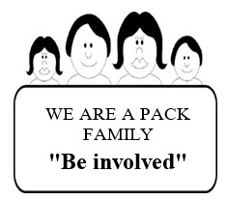

# **SPECIAL OPPORTUNITIES**

## STEM Awards for Cub Scouts

From [*http://usscouts.org/advance/nova/index.asp*](http://usscouts.org/advance/nova/index.asp)and[*http://www.scouting.org/stem/Awards/CubScout.aspx*](http://www.scouting.org/stem/Awards/CubScout.aspx)

**First –** Go to at least one of the two websites listed below the title of this item (I recommend the first one listed) and review the NOVA and Super NOVA Award requirements.

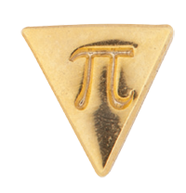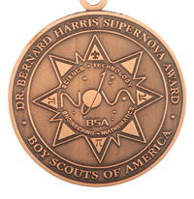

The Boy Scouts of America's NOVA Awards program incorporates learning with cool activities and exposure to science, technology, engineering and mathematics for Cub Scouts, Boy Scouts, and Venturers. The hope is that the requirements and activities for earning these awards stimulates interest in STEM-related fields and shows how science, technology, engineering and mathematics apply to everyday living and the world around them. Counselors and mentors help bring this engaging, contemporary, and fun program to life for youth members.

**The Nova Awards**There are four Nova awards for each level - Cub Scouts (includes Webelos), Boy Scouts, and Venturers. Each award covers one component of STEM—science, technology, engineering, or mathematics.

For their first Nova award, Scouts earn the distinctive Nova award patch. After that, a Scout can earn three more Nova awards, each one recognized with a separate pi (π) pin-on device that attaches to the patch. The patch and the three devices represent each of the four STEM topics—science, technology, engineering, and mathematics.

**The Supernova Awards**The Supernova awards have more rigorous requirements than the Nova awards. The requirements and activities were designed to motivate youth and recognize more in-depth, advanced achievement in STEM-related activities. *The Super NOVA requirements will be printed next month.*

For earning the Supernova award, Scouts receive a medal and certificate.

All requirements may be found in the Nova awards guidebooks, available through local Scout shops—one for Cub Scouts, one for Boy Scouts, and one for Venturers.

The requirements for each of the Nova and Supernova awards are also available on BSA's official web site, [Scouting.org](http://www.scouting.org). They are also available on the Advancement pages of the [USScouts.org](http://usscouts.org/advancementTOC.asp) (<http://usscouts.org/advance/nova/index.asp> *)* site.

The Advancement pages of the [USScouts.org](http://usscouts.org/advancementTOC.asp), also, have workbooks for use in documenting progress toward earning the various Nova and Supernova awards. There are links to the workbooks at the bottom of the requirements page for each award.

The requirements can be completed with a parent or an adult leader as the counselor (for the Nova awards) or mentor (for the Supernova awards). Each guidebook includes a section for the counselor and mentor.

**Cub Scout Science Nova Awards**The requirements printed in Baloo's Bugle are for information only to give you a taste of the Award Requirements. There are many hints and other supplemental information given on the Advancement pages of the [USScouts.org](http://usscouts.org/advancementTOC.asp) ([*http://usscouts.org/advancementTOC.asp*](http://usscouts.org/advancementTOC.asp)*)* and BSA's web site, [Scouting.org](http://www.scouting.org). Also, the Advancement pages of [USScouts.org](http://usscouts.org/advancementTOC.asp) contain worksheets to assist in completing the requirements.

 **Science Everywhere (Science)**

1. **Choose A or B or C and complete ALL the requirements.**
2. Watch an episode or episodes (about one hour total) of a show about anything related to science. Then do the following:
3. Make a list of at least two questions or ideas from what you watched.
4. Discuss two of the questions or ideas with your counselor.
5. Read (about one hour total) about anything related to science. Then do the following:
6. Make a list of at least two questions or ideas from what you read.
7. Discuss two of the questions or ideas with your counselor.
8. Do a combination of reading and watching (about one hour total) about anything related to science. Then do the following:
9. Make a list of at least two questions or ideas from what you read and watched.
10. Discuss two of the questions or ideas with your counselor.
11. **Complete ONE adventure from the following list. (Choose one that you have not already earned.) Discuss with your counselor what kind of science, technology, engineering, or math was used in the adventure.**

**Wolf Cub Scouts**

Adventures in Coins

Collections and Hobbies

Digging in the Past

Germs Alive

Grow Something

**Bear Cub Scouts**

A Bear Goes Fishing

Bear Picnic

Critter Care

**Webelos Scouts**

Camper

Earth Rocks

Maestro

1. **Act like a scientist! Explore EACH of the following:**
2. With your counselor, choose a question you would like to investigate. Here are some examples only (you may get other ideas from your adventure activities):
3. Why do rockets have fins? Is there any connection between the feathers on arrows and fins on rockets?
4. Why do some cars have spoilers? How do spoilers work?
5. If there is a creek or stream in your neighborhood, where does it go? Does your stream flow to the Atlantic or the Pacific Ocean?
6. Is the creek or stream in your neighborhood or park polluted?
7. What other activity can you think of that involves some kind of scientific questions or investigation?
8. With a parent or your counselor, use the scientific method/process to investigate your question. Keep records of your question, the information you found, how you investigated, and what you found out about your question.
9. Discuss your investigation and findings with your counselor.
10. Visit a place where science is being done, used, or explained, such as one of the following: zoo, aquarium, water treatment plant, observatory, science museum, weather station, fish hatchery, or any other location where science is being done, used, or explained.
11. During your visit, talk to someone in charge about science.
12. Discuss with your counselor the science done, used, or explained at the place you visited.
13. Discuss with your counselor how science affects your everyday life. Dens with an average attendance of at least half their members at the three summer pack events are eligible for a colorful den participation ribbon.

**Down and Dirty (Science)**

1. Choose A, B, or C and complete ALL requirements.
2. Watch an episode or episodes (about one hour total) of a show about Earth, the weather, geology, volcanoes, or oceanography. Then do the following:
3. Make a list of at least two questions or ideas from what you watched.
4. Discuss two of the questions or ideas with your counselor.
5. Read (about one hour total) Earth, the weather, geology, volcanoes, or oceanography. Then do the following:
6. Make a list of at least two questions or ideas from what you read.
7. Discuss two of the questions or ideas with your counselor.
8. Do a combination of reading and watching (about one hour total) about Earth, the weather, geology, volcanoes, or oceanography. Then do the following:
9. Make a list of at least two questions or ideas from what you read and watched.
10. Discuss two of the questions or ideas with your counselor.
11. Complete ONE adventure from the list. Choose one that you have not already earned.) Discuss with your counselor what science, technology, engineering, or math was used in the adventure.

**Wolf Cub Scouts**

Collections and Hobbies

Digging in the Past

Grow Something

**Bear Cub Scouts**

Super Science

Critter Care

**Webelos Scouts**

Adventures in Science

Earth Rocks

1. Investigate: Choose A or B or C or D and complete ALL the requirements:
2. Volcanoes Erupt:
3. How are volcanoes formed?
4. What is the difference between lava and magma?
5. How does a volcano both build and destroy land?
6. Build or draw a volcano model. If you build a working model, make sure you follow all safety precautions including wearing protective glasses for your volcano’s eruption. If you draw a volcano, be sure to draw a cross section and explain the characteristics of different types of volcanoes.
7. Share your model and what you have learned with your counselor.
8. Rock On!
9. What minerals are common in your state? Make a collection of three to five common minerals and explain how they are used.
10. Are these minerals found in sedimentary, igneous, or metamorphic rocks?
11. Explain or demonstrate the difference in formation of the three major types of rocks. Which types of rocks are common in your area?
12. Share your collection and what you have learned with your counselor.
13. Weather changes our world.
14. Make three weather instruments out of materials around your home. (Examples include a rain gauge, weather vane, barometer, anemometer, and weather journal.) Use these and another method that is readily available (i.e., thermometer, eyes, older person’s joints, etc.) for a total of four methods to monitor and predict the weather for one week. Keep a log of your findings. Which instrument provided the most accurate information?
15. Keep a weather journal for a week. Include your predictions and the predictions of a local meteorologist. Do your predictions match those of the local meteorologist? Do your predictions match the weather that occurred? How can the predictions become more accurate?
16. Discuss your work with your counselor.
17. Animal Habitats: Choose TWO of the following animal habitats and complete the activity and questions. At least one habitat should be close to your home (within 50 miles). Visit at least one of the habitats. Once you have completed the activity and questions, discuss the habitats and the activities with your counselor.

***Note –*** *There are paragraphs after each of these habitats telling what you must do. Check the Advancement pages of the* [*USScouts.org*](http://usscouts.org/advancementTOC.asp) *(*[*http://usscouts.org/advancementTOC.asp*](http://usscouts.org/advancementTOC.asp)*) or BSA's web site,* [*Scouting.org*](http://www.scouting.org) *for complete requirements.*

1. Prairie
2. Temperate Forest
3. Aquatic Ecosystem
4. Temperate or Sub-Tropical Rain Forest
5. Desert
6. Polar Ice
7. Tide Pools
8. Choose A or B and complete ALL the requirements.
9. Visit a place where earth science is being done, used, explained, or investigated, such as one of the following: cave, quarry or mine, geology museum or the gem or geology section of a museum, gem and mineral show, university geology department, TV or radio station meteorology department, weather station, volcano or volcano research station, or any other location where earth science is being done, used, explained, or investigated.
10. During your visit, talk to someone in charge about how people at the site use or investigate a particular area of science. How could this investigation make the world better?
11. Discuss with your counselor the science being done, used, explained, or investigated at the place you visited.
12. Explore a career associated with earth science. Find out what subjects you would need to study as you get older. What kind of education would you need in the future to help explore Earth? What types of people other than geologists explore Earth? Discuss with your counselor what is needed to have a career in earth science.

**Nova WILD! (Science)**

1. Choose A or B or C and complete ALL the requirements:
2. Watch an episode or episodes (about one hour total) of a show about wildlife, endangered species, invasive species, food chains, biodiversity, ecosystems, or wildlife habitats. Then do the following:
3. Make a list of at least two questions or ideas from what you watched.
4. Discuss two of the questions or ideas with your counselor.
5. Read (about one hour total) about wildlife, endangered species, invasive species, food chains, biodiversity, ecosystems, or wildlife habitats. Then do the following:
6. Make a list of at least two questions or ideas from what you read.
7. Discuss two of the questions or ideas with your counselor.
8. Do a combination of reading and watching (about one hour total) about wildlife, endangered species, invasive species, food chains, biodiversity, ecosystems, or wildlife habitats. Then do the following:
9. Make a list of at least two questions or ideas from what you read and watched.
10. Discuss two of the questions or ideas with your counselor.
11. Complete ONE adventure from the following list. (Choose one that you have not already earned.) Discuss with your counselor what kind of science, technology, engineering, or math was used in the adventure.

**Wolf Cub Scouts**

Digging in the Past

Grow Something

Spirit of the Water

**Bear Cub Scouts**

A Bear Goes Fishing

Critter Care

**Webelos Scouts**

Into the Wild

Into the Woods

1. Explore:
2. What is wildlife? Wildlife refers to animals that are not normally domesticated (raised by humans).
3. Explain the relationships among producer, prey, predator, and food chain. (You may draw and label a food chain to help you answer this question.)
4. Draw (or find) pictures of your favorite native plant, native reptile or fish, native bird, and native mammal that live in an ecosystem near you. Why do you like these? How do they fit into the ecosystem?
5. Discuss what you have learned with your counselor.
6. Act like a naturalist. Choose TWO from A or B or C or D or E or F, and complete ALL the requirements for those options.
7. Investigate the endangered species in your state.
8. Make a list, drawing, or photo collection of three to five animals and plants that are endangered.
9. Design a display to show at least 10 of the threatened, endangered, or extinct species in your state.
10. Discuss with your counselor the differences between threatened, endangered, and extinct species. Discuss how threatened animals or plants could become endangered or extinct. How might the loss of these animals or plants affect the ecosystem and food chain? What can be done to preserve these species?
11. Investigate invasive species.
12. Make a list, drawing, or photo collection of at least five mammals, plants, fish, birds, insects, or any other organisms that are invasive in your state or region of the country.
13. Design a presentation including at least one of the invasive species from your list. Explain where they came from, how they got to your area, what damage they are causing, and what is being done to get rid of them. Share your presentation with your counselor and your family or your den.
14. Discuss with your counselor what an invasive species is, how invasive animals or plants cause problems for native species, and how these invasive species could affect an ecosystem and food chain.
15. Visit an ecosystem near where you live.
16. Investigate the types of animals and plants that live in that ecosystem.
17. Draw a food web of the animals and plants that live in this ecosystem. Mark the herbivores, omnivores, and carnivores. Include at least one decomposer or scavenger.
18. Discuss with your counselor (using your food web drawing) how the animals or plants in the food web fit into a food chain. Which animals are predators and which can be prey? How does each plant and animal obtain its energy? Describe the energy source for all the plants and animals.
19. Investigate one wild mammal, bird, fish, or reptile that lives near you.
20. Create a diorama representing the habitat of this creature. Include representations of everything it needs to survive; its home, nest, or den; and possible threats
21. Explain to your counselor what your animal must have in its habitat in order to survive
22. Investigate your wild neighbors.
23. Make a bird feeder and set it up in a place where you may observe visitors.
24. Fill the feeder with birdseed
25. Provide a source of water.
26. Watch and record the visitors to your feeder for two or three weeks
27. Identify your visitors using a field guide, and keep a list of what visits your feeder.
28. Discuss with your counselor what you learned about your wild neighbors.
29. Earn the Cub Scout Outdoor Ethics Awareness Award OR the Cub Scout World Conservation Award (if you have not already earned them for another Nova award).
30. Visit a place where you can observe wildlife. Examples include parks (national, state, and local), zoos, wetlands, nature preserves, and national forests.
31. During or after your visit, talk to someone about:
32. The native species, invasive species, and endangered or threatened species that live there. If you visit a zoo, talk to someone about the ecosystems for different zoo animals and whether any of the zoo animals are invasive in different areas of the world. (For example, pythons are often found in zoos, but they are an invasive species in Florida.)
33. The subjects studied in school that enable him or her to work with wildlife. Examples of experts to talk to include forest ranger, wildlife biologist, botanist, park ranger, naturalist, game warden, zookeeper, docent, or another adult whose career involves wildlife.
34. Discuss with your counselor what you learned during your visit.
35. Discuss with your counselor:
36. Why wildlife is important
37. Why biodiversity is important
38. The problems with invasive species and habitat destruction

**Out of This World (Science)**

1. Choose A or B or C and complete ALL the requirements:
2. Watch an episode or episodes (about one hour total) of a show about the planets, space, space exploration, NASA, or astronomy. Then do the following:
3. Make a list of at least two questions or ideas from what you watched.
4. Discuss two of the questions or ideas with your counselor.
5. Read (about one hour total) about the planets, space, space exploration, NASA, or astronomy. Then do the following:
6. Make a list of at least two questions or ideas from what you read.
7. Discuss two of the questions or ideas with your counselor.
8. Do a combination of reading and watching (about one hour total) about the planets, space, space exploration, NASA, or astronomy. Then do the following:
9. Make a list of at least two questions or ideas from what you read and watched.
10. Discuss two of the questions or ideas with your counselor.
11. Complete ONE adventure from the following list. (Choose one that you have not already earned.) Discuss with your counselor what kind of science, technology, engineering, or math was used in the adventure.

**Wolf Cub Scouts**

Air of the Wolf

Collections and Hobbies

Germs Alive

Motor Away

**Bear Cub Scouts**

Robotics

A Bear Picnic Basket

Super Science

**Webelos Scouts**

Adventures in Science

Engineer

Game Design

1. Choose TWO from A or B or C or D or E or F and complete ALL the requirements for the options you choose.
2. Have a star party with your den, pack, or family.
3. Choose a clear night to investigate the stars. A fun time to watch stars is during a meteor shower.
4. Find and draw 5 different constellations.
5. Share your drawings with your counselor. Discuss whether you are always be able to see those constellations in the same place.
6. Explain how “revolution,” or “orbit,” compares with “rotation” when talking about planets and the solar system. Show these by walking and spinning around your counselor. Do the following:
7. Choose three planets to investigate (you may include the dwarf planet Pluto). Compare these planets to Earth. Find out how long the planet takes to go around the sun (the planet’s year) and how long the planet takes to spin on its axis (the planet’s day). Include at least TWO of these: distance from the sun, diameter, atmosphere, temperature, number of moons.
8. Discuss what you have learned with your counselor.
9. Using materials you have on hand (plastic building blocks, food containers, recycled materials, etc.), design a model Mars rover that would be useful to explore the rocky planet’s surface. Share your model with your counselor and explain the following:
10. The data the rover would collect
11. How the rover would work
12. How the rover would transmit data
13. Why rovers are needed for space exploration
14. Design on paper an inhabited base located on Mars or the moon. Consider the following: the energy source, how the base will be constructed, the life-support system, food, entertainment, the purpose and function, and other things you think would be important. Then do the following:
15. Draw or build a model of your base using recycled materials.
16. Discuss with your counselor what people would need to survive on Mars or the moon.
17. Become an asteroid mapper.
18. Eclipses
19. Investigate and make models or diagrams of solar and lunar eclipses.
20. Using your model or diagram, discuss eclipses with your counselor, and explain the difference between a solar eclipse and a lunar eclipse.
21. Visit or explore. Choose A or B and complete ALL the requirements
22. Visit a place where space science is being done, used, explained, or investigated, such as one of the following: observatory, planetarium, air and space museum, star lab, astronomy club, NASA, or any other location where space science is being done, used, explained, or investigated.
23. During your visit, talk to someone in charge about how people at the location use or investigate space science. Find out how this investigation could make the world a better place.
24. Discuss with your counselor the science being done, used, explained, or investigated at the place you visited.
25. Explore a career associated with space exploration. Find out what subjects you would need to study as you get older. Find out whether you must be an astronaut to explore space, and what other opportunities exist for people interested in space exploration
26. Tell your counselor what you have learned about space exploration while working on this award.



**Tech Talk (Technology)**

1. Choose A or B or C and complete ALL the requirements:
2. Watch an episode or episodes (about one hour total) of a show about anything related to Technology. Then do the following:
3. Make a list of at least two questions or ideas from what you watched.
4. Discuss two of the questions or ideas with your counselor.
5. Read (about one hour total) about anything related to Technology. Then do the following:
6. Make a list of at least two questions or ideas from what you read.
7. Discuss two of the questions or ideas with your counselor.
8. Do a combination of reading and watching (about one hour total) about anything related to Technology. Then do the following:
9. Make a list of at least two questions or ideas from what you read and watched.
10. Discuss two of the questions or ideas with your counselor.
11. Complete ONE adventure from the following list. (Choose one that you have not already earned.) Discuss with your counselor what kind of science, technology, engineering, or math was used in the adventure.

**Wolf Cub Scouts**

Finding Your Way

Motor Away

**Bear Cub Scouts**

Make It Move

A World of Sound

**Webelos Scouts**

Build It

Fix It

Movie Making

1. Explore EACH of the following:
2. Look up a definition of the word technology and discuss the meaning with your counselor.
3. Find out how technology is used in EACH of the following fields:
4. Communication
5. Business
6. Construction
7. Sports
8. Entertainment
9. Discuss your findings with your counselor.
10. Visit a place where technology is being designed, used, or explained, such as one of the following: an amusement park, a police or fire station, a radio or television station, a newspaper office, a factory or store, or any other location where technology is being designed, used, or explained.
11. Visit a place where technology is being designed, used, or explained, such as one of the following: an amusement park, a police or fire station, a radio or television station, a newspaper office, a factory or store, or any other location where technology is being designed, used, or explained.
12. The technologies used where you are visiting
13. Why the organization is using these technologies
14. Discuss with your counselor the technology that is designed, used, or explained at the place you visited
15. Discuss with your counselor how technology affects your everyday life.

**Swing! (Engineering)**

1. Choose A or B or C and complete ALL the requirements:
2. Watch an episode or episodes (about one hour total) of a show about anything related to motion or machines. Then do the following:
3. Make a list of at least two questions or ideas from what you watched.
4. Discuss two of the questions or ideas with your counselor.
5. Read (about one hour total) about anything related to motion or machines.. Then do the following:
6. Make a list of at least two questions or ideas from what you read.
7. Discuss two of the questions or ideas with your counselor.
8. Do a combination of reading and watching (about one hour total) about anything related to motion or machines. Then do the following:
9. Make a list of at least two questions or ideas from what you read and watched.
10. Discuss two of the questions or ideas with your counselor.
11. Complete ONE adventure from the following list. (Choose one that you have not already earned.) Discuss with your counselor what kind of science, technology, engineering, or math was used in the adventure.

**Wolf Cub Scouts**

Paws of Skill

Motor Away

**Bear Cub Scouts**

Baloo the Builder

A Bear Goes Fishing

**Webelos Scouts**

Adventures in Science

Engineer

Sportsman

1. Explore EACH of the following:
2. Levers
3. Make a list or drawing of the three types of levers. (A lever is one kind of simple machine.)
4. Show:
5. How each lever works
6. How the lever in your design moves stuff
7. The class of each lever
8. Why we use levers
9. On your own, design, including a drawing, sketch, or model, ONE of the following:
10. A playground fixture that uses a lever
11. A game or sport that uses a lever
12. An invention that uses a lever

*Be sure to show how the lever in your design   
will move something.*

1. Discuss your findings with your counselor.
2. Do the following:
3. Visit a place that uses levers, such as a playground, carpentry shop, construction site, restaurant kitchen, or any other location that uses levers.
4. Discuss with your counselor the equipment or tools that use levers in the place you visited.
5. Discuss with your counselor how engineering and simple machines affect your everyday life.

program updates banner**1-2-3 Go! (Mathematics)**

1. Choose A or B or C and complete ALL the requirements:
2. Watch an episode or episodes (about one hour total) of a show that involves math or physics.. Then do the following:
3. Make a list of at least two questions or ideas from what you watched.
4. Discuss two of the questions or ideas with your counselor.
5. Read (about one hour total) about anything that involves math or physics.. Then do the following:
6. Make a list of at least two questions or ideas from what you read.
7. Discuss two of the questions or ideas with your counselor.
8. Do a combination of reading and watching (about one hour total) about anything that involves math or physics. Then do the following:
9. Make a list of at least two questions or ideas from what you read and watched.
10. Discuss two of the questions or ideas with your counselor.
11. Complete ONE adventure from the following list. (Choose one that you have not already earned.) Discuss with your counselor what kind of science, technology, engineering, or math was used in the adventure.

**Wolf Cub Scouts**

Code of the Wolf

**Bear Cub Scouts**

Robotics

**Webelos Scouts**

Game Design

1. Explore TWO options from A or B or C and complete ALL the requirements for those options. Keep your work to share with your counselor. The necessary information to make your calculations can be found in a book or on the Internet. (See the Helpful Links box for ideas.) You may work with your counselor on these calculations
2. Choose TWO of the following places and calculate how much you would weigh there.
3. On the sun or the moon
4. On Jupiter or Pluto
5. On a planet that you choose
6. Choose ONE of the following and calculate its height:
7. A tree
8. Your house
9. A building of your choice
10. Calculate the volume of air in your bedroom.

*Make sure your measurements have the same units -   
all feet or* *all inches - and show your work.*

1. Secret Codes
2. Look up, then discuss with your counselor each of the following:
3. Cryptography
4. At least three ways secret codes or ciphers are made
5. How secret codes and ciphers relate to mathematics
6. Design a secret code or cipher. Then do the following:
7. Write a message in your code or cipher.
8. Share your code or cipher with your counselor.
9. Discuss with your counselor how math affects your everyday life.

**NEXT MONTH –**

**Super NOVA**

**STEM Awards!!!**

**Need more info?**

For additional information and the latest on the changes to these Special Opportunities for Cub Scouts, head to:



The [Advancement pages on USScouts](http://usscouts.org/advancementTOC.asp) (<http://usscouts.org/advance/nova/index.asp> ). Paul has already posted all the new requirements.

**Or** 

On National's Site go to [www.scouting.org/programupdates](http://www.scouting.org/programupdates) and look for the link to **"Updated Requirements for Cub Scout Awards."**

# CUB GRUB

**Cub Grub Cookbook**

This is a really great cookbook for Cubs -

<http://balboaoaks.bsa-la.org/download/blog/Cub%20Grub%20Cookbook.pdf>

You can save a copy on your PC by selecting   
**File, Save As...** in your web browser's menu bar.

**Cheese Dog Roll-Ups**

*Baltimore Area Council*

**Ingredients**

* 1 can refrigerator crescent dinner rolls,
* 8 hot dogs
* 8 strips cheddar cheese

**Directions:**

* Preheat oven to 375 degrees
* Separate rolls into 8 triangles of dough.
* Cut narrow slit lengthwise in each hot dog and
* Put a strip of cheese in the slit.
* Place hot dog on wide end of dough triangle and roll up.
* Cook on ungreased cooking sheet, cheese side up for 10-15 minutes or until brown.

**Cinnamon Toast**

*Baltimore Area Council*

**Ingredients**

* 1 slice of bread
* Soft margarine
* 1 tsp. Sugar
* ¼ tsp. cinnamon

**Directions:**

* Toast bread in toaster.
* Spread at once with butter.
* Sprinkle on sugar and cinnamon.   
  (Or mix ¼ cup sugar, 1 T. cinnamon and use shaker.)

**Grilled Cheese Sandwiches**

*Baltimore Area Council*

**Ingredients**

* 1 slice American Cheese
* 2 slices bread
* 1 T. butter or margarine

**Directions:**

* Put the cheese between bread slices.
* Melt butter in skillet.
* Toast the sandwich over low heat.
* Flip the sandwich over with a turner (Ted?).
* When both sides are toasted, eat and enjoy.

**Tootsie Rolls**

*Baltimore Area Council*

**Ingredients**

* 2 tablespoons margarine (room temperature)
* 2 squares of chocolate melted
* 1/2 cup corn syrup
* 3 cups powdered sugar
* 1 tsp vanilla
* 3/4 cup dry powdered milk

**Directions:**

* Put all ingredients in Ziploc bag,
* Knead until well mixed.
* Roll into ball or log shapes.

**Dump Cake**

*Baltimore Area Council*

**Ingredients**

* l/2 cup brown sugar
* 1 egg
* 1 can cherries
* 1 cake mix
* 1 stick margarine

**Directions:**

* Spray pan with non stick cooking aerosol.
* Spread brown sugar evenly on bottom of pan.
* Cut margarine into thin pats, distribute evenly in pan.
* Add cherries in juice.
* Mix beaten egg with cake mix and spread over cherries.
* Bake at 400 degrees for 25 minutes or until brown.

**BBQ Wieners**

*Baltimore Area Council*

**Ingredients**

* 1 package of wieners

**Directions:**

* Cut wieners into bite size pieces.
* Place in pan on the stove and let brown, but not dark.
* Add 1½ cups of your favorite BBQ Sauce.
* Let simmer for 15 minutes.

***(We used to do this in camp with a #10 can on a fire CD)***

**Watermelon Pop Stars**

*Catalina Council*

**Ingredients:**

* Watermelon
* Popsicle sticks
* Star-shaped cookie cutter

**Instructions:**

1. Use a cookie cutter to cut juicy star shapes from 1-inch-thick slices of seedless watermelon.
2. Insert a Popsicle stick into each star, then set the pops on an aluminum foil-lined baking sheet.
3. Cover the stars with another sheet of foil and freeze for 1 hour or until firm.

**Edible Eagles**

*Catalina Council*

**Ingredients:**

* 1/4 cup of white chocolate chips
* 6 large marshmallows
* Finely shredded coconut
* Chocolate sandwich cookie (we used a chocolate covered Oreo)
* 6 Cashews
* Black decorators' gel

**Instructions:**

1. Melt 1/4 cup of white chocolate chips according to the package directions.
2. For each bird, drop a large marshmallow into the melted chocolate, using a spatula to coat it well.
3. Remove the marshmallow from the chocolate and roll it in finely shredded coconut, leaving one end uncovered.
4. Immediately set the marshmallow, coconut free end down, atop a chocolate sandwich cookie.
5. Let the chocolate set a bit, then use a toothpick to make a hole in the side of the marshmallow and insert a cashew for a beak.
6. Finally, add black decorators' gel eyes.

**Fruit Flag**

*Catalina Council*

**Ingredients:**

* 29 large strawberries
* 30 large blackberries
* 7 or so large bananas
* Lemon juice

**Instructions:**

1. Hull and halve 29 large strawberries and set them aside.
2. Arrange 30 large blackberries, as shown, in the upper left corner of a serving tray or cutting board (it should be at least 8 by 13 inches).
3. Cut 58 banana slices, 3/4-inch-thick, into a bowl.
4. Sprinkle on lemon juice and toss the slices gently with a rubber spatula to keep them from browning.
5. Assemble the banana slices in rows as shown and top each slice with a strawberry half.

**Crispy Cheese Stars**

*Catalina Council*

**Ingredients:**

* Flour tortillas
* Sliced cheese (cheddar, provolone, or mozzarella)
* Chili powder or paprika

**Instructions:**

1. Heat the oven to 350º.
2. Use the larger cookie cutter to cut out stars from flour tortillas (about 5 per 10-inch tortilla).
3. It's easy for kids to do if you use a rolling pin to roll back and forth over the cutter.
4. Bake the stars on a foil-covered cookie sheet for 5 minutes.
5. Use the smaller cookie cutter to cut out an equal number of cheese stars from the sliced cheese and place them atop the tortilla ones.
6. Bake the stars for 2 more minutes or so until the cheese melts.
7. Sprinkle the stars with chili powder or paprika and let them cool before serving.

**Star Cookies**

*Catalina Council*

**Ingredients:**

* Blue and red food coloring
* Your favorite cookie dough

**Instructions:**

1. Use food coloring paste to tint one third of the dough red and another third blue, kneading the dough to evenly distribute the color.
2. Leave the last third untinted.
3. Chill the dough until it's firm, then roll out each color and cut out a bunch of larger stars.
4. With a medium-size cutter, cut a star from the center of each large star.
5. Now use the medium stars to fill in the centers of contrasting larger stars. lightly pressing them in place.
6. Lightly press the medium stars into the larger stars' centers.
7. Using a third, smaller cutter, you can even create tricolored stars.

**All American Hot Dog In A Blanket**

*Catalina Council*

**Ingredients:**

* 3 Tablespoons softened margarine
* 6 slices bread
* 6 slices cheese
* 6 hot dogs
* Toothpicks

**Instructions:**

1. Spread margarine on one side of each slice of bread.
2. Place buttered side of bread down on baking sheet.
3. Top each bread slice with cheese.
4. Then put hot dog diagonally across cheese slice.
5. Fold opposite diagonal corners over hot dog and secure with toothpicks.
6. Bake at 375 degrees for about ten minutes or until golden brown.

**Armpit Fudge**

**Ingredients:**

**Den Size Single Serving**

1 lb. Powdered sugar 1/2 cup powdered sugar

1 stick (1/4 cup) butter 1Tbsp butter

3 oz. Cream cheese 2 tsp cream cheese

½ tsp vanilla dash vanilla

1/3 cup cocoa 2 tsp cocoa

1 gallon Ziploc 1 sandwich size Ziploc

**Instructions:**

* Put all ingredients in Ziplock baggie and
* Squeeze out all the air.
* Place baggie under the arm and squish until all the ingredients are well mixed and creamy. (You can use your hands too to mix the ingredients.)
* Snip a corner and squeeze onto a graham cracker or straight into your mouth.

**Red, White, and Blue Delight**

*Catalina Council*

**Ingredients for the Blueberry Sauce:**

* 1 pint fresh blueberries, rinsed
* 1 tablespoon water
* 1/2 cup sugar
* 1 1/2 tablespoons lemon juice
* 1 1/2 tablespoons cornstarch

**Ingredients for the Dessert:**

* 1 pint strawberry sorbet
* 1 container (1 1/2 quarts) vanilla ice cream
* Fresh blueberries and strawberries for garnish

**Instructions:**

1. Combine the blueberries and the water in a medium-size saucepan.
2. Partially cover the pan, then bring the mixture to a simmer over medium heat.
3. Continue simmering the berries until they begin to break down, about 2 minutes.
4. Stir in the sugar and cook the berries until they become soft, about 1 to 2 minutes more.
5. Stir together the lemon juice and cornstarch in a small bowl until evenly blended.
6. Stir the mixture into the berries, then cook them at a low boil, stirring constantly, for 1 1/2 minutes.
7. Remove the sauce from the heat and transfer it to a medium-size bowl.
8. When the sauce is cooled, cover it and place it in the refrigerator to chill.
9. Line a 9- by 5-inch metal loaf pan with two sheets of crisscrossed plastic wrap, leaving a 3-inch overhang on all sides, then chill the pan in the freezer for 10 minutes.
10. Place the container of sorbet in the refrigerator for 30 minutes to soften, then spoon the sorbet into the pan and mold it, using a sheet of plastic wrap to smooth the top as needed.
11. Cover it with foil and freeze it for 2 hours.
12. The last 30 minutes, soften the vanilla ice cream in the refrigerator.
13. Remove the pan from the freezer, add half the vanilla ice cream, mold it, cover it with foil, and freeze it and the remaining ice cream for 30 minutes.
14. For the third layer, mix the remaining ice cream with 3/4 cup of the blueberry sauce, and add it to the pan.
15. Freeze the dessert for one more hour.
16. Chill a platter in the refrigerator for 15 minutes.
17. Right before serving, thin the remaining blueberry sauce with a spoonful of water or orange juice.
18. Invert the dessert onto the platter, unwrap it, and garnish it with fresh berries.
19. Use a sharp knife to slice the dessert, and serve it with the sauce. Serves 10.

**“Hamburger” Cookies**

*Catalina Council*

**Ingredients:**

* 1/4 cup shredded coconut
* Green food coloring
* 24 vanilla wafers
* 12 small chocolate mint patties (round)

**Instructions:**

1. Put the coconut in a small container that has a lid.
2. Add a few drops of the food coloring, put on the lid, and shake until the coconut turns green.
3. Put twelve wafers flat side up on a baking sheet.
4. Place a mint on top of each wafer.
5. Bake the wafers at 325 degrees for one minute.
6. Immediately sprinkle each wafer with coconut (lettuce).
7. Top with remaining wafers, flat side down, and you will have hamburger looking cookies!!!

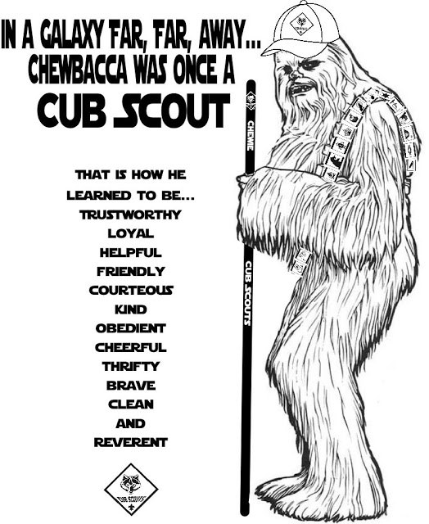

# LAST THING

## HONEY AND VINEGAR

*My Aunt Betty*

I heard a wonderful illustration the other day. A lady shared it with me. It is so good that I am eager to share it with all of you.

A man placed two identical jars on the table next to the Podium, each filled with a gold colored liquid.

He quoted 1 Samuel 16:7, "But Jehovah said to Samuel:" Do not look at his appearance and at the height of his stature, For not the way man sees is the way God sees, because mere man sees what appears to the eyes; but as for Jehovah he sees what the heart is."

These jars came from the same factory, were made of the same materials, and can hold the same amount. But they are different, "he explained.

Then he upset one and out oozed honey.

He turned over the other, and vinegar spilled out.

When a jar is upset, whatever is in it comes out. Until the jars were upset, they looked alike. The difference lay within, and could not be seen. When they were upset, their contents were revealed.

Until we are upset, we put on a good front. But when we are upset, we reveal our innermost thoughts and attitudes, for "out of the abundance of the heart his mouth speaks"   
(Luke 6:45).

What if someone tipped you over today?   
What would flow out?   
Would you reveal the "honey" of self-control and patience, or the "vinegar" of anger and sarcasm? "

"Above all things, have intense love for one another, because love covers a multitude of sins." (1 Peter 4:8).

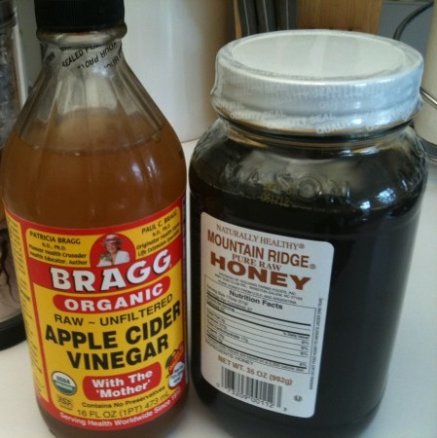

**TO ACHIEVE YOUR DREAMS,**

## REMEMBER YOUR ABCS

*York-Adams Area Council*

A - Avoid negative sources, people, things, and habits.

B - Believe in yourself.

C - Consider things from every angle.

D - Don't give up and don't give in.

E - Enjoy life today: yesterday is gone and tomorrow may never come.

F - Family and friends are hidden treasures. Seek them and enjoy their riches.

G - Give more than you planned to give.

H - Hang on to your dreams.

I - Ignore those who try to discourage you.

J - Just do it!

K - Keep on trying, no matter how hard it seems. It will get better.

L - Love yourself first and foremost.

M - Make it happen.

N - Never lie, cheat, or steal. Always strike a fair deal.

O - Open your eyes and see things as they really are.

P - Practice makes perfect.

Q - Quitters never win and winners never quit.

R - Read, study and learn about everything important in your life.

S - Stop procrastinating.

T - Take control of your own destiny.

U - Understand yourself in order to better understand others.

V - Visualize it. Want it more than anything.

X - Xccelerate your efforts.

Y - You are unique of all of nature's creations. Nothing can replace you.

Z - Zero in on your target, and go for it!