TABLE OF CONTENTS
TABLE OF CONTENTS 1
HELP WITH THE CUB SCOUT ADVENTURE PLAN MODIFICATIONS 1
ADMIN HELPS 2
CUB SCOUT SPRING RECRUITMENT 2
SPRING RECRUITING 2
BE UP TO DATE 4
ROUNDTABLE HINTS 5
CUB SCOUT RT SCHEDULE OF SESSIONS 5
LIONS 7
LION GUIDE AND PARENT ORIENTATION VIDEO 7
ORGANIZING FOR LIONS 7
NEW LION HUB 7
THE CHIEF SCOUT EXECUTIVE ON LIONS 8
MORE LION INFORMATION 8
CUB SCOUT LEARNING LIBRARY 10
The NEW https://cubscouts.org/ !!! 10
ADVENTURE PLAN TRACKERS 12
TRACKING BOYS’ PROGRESS 13
CUB SCOUT LEADER TRAINING 14
IN-PERSON TRAINING 14
ON-LINE TRAINING 14

HELP WITH THE
CUB SCOUT ADVENTURE PLAN MODIFICATIONS
On November 30, 2016, the BSA announced modifications to Adventure requirements in response to feedback from Den Leader feedback. Dens started using the modified requirements as soon as they began their next Adventure.
The BSA has placed PDFs that may be inserted into all Cub Scout Rank handbooks on www.scouting.org/programupdates. The PDFs are formatted to be printed book size. They have, also, sent printed copies to each National Scout Shop. They are available free for the asking by parents and scout leaders. (We at the Wilmington, DE shop have a great supply!! Stop in and say hello and ask for the ones you need. https://www.facebook.com/WilmingtonScoutShop)
The PDFs are at –
Tiger Addendum Wolf Addendum
Bear Addendum Webelos/A of L Addendum .
The www.usscouts.org Advancement pages have been updated to reflect all the changes.
The Cub Scout Learning Library will not be updated to show the changes. All updates to the Cub Scout Learning Library (www.cubscouts.org) are on hold as BSA assess its digital strategy.

ADMIN HELPS

CUB SCOUT SPRING RECRUITMENT
New Birth of Freedom Council
Recruitment should be a year round activity for all units. Whether the recruitment method is an activity such as a pack ice cream social, troop open house, or peer to peer campaign it’s important that the door is always open for a boy to join scouting. Primarily, there are two times every year that an extra emphasis is put into recruiting for packs, troops, and crews, during the fall and spring. In the fall packs are participating in the fall round-up and venture crews are hosting first nighters. In the spring Troops actively work with cub packs to bridge over 2nd year Webelos for them to join Boy Scouts.
During May of every year the kindergarten boys are becoming eligible for the first time to join cub scouts and parents of boys for all ages are making decisions on what activities to get involved in for the following school year. It is important that we take advantage of this opportunity and plan a recruiting activity so we can ensure boys have the opportunity to join cub scouts when they are being offered all types of other activities.
Packs should set goals for recruiting a new tiger den and identifying a tiger leader to lead them in the spring so they are ready to go in the fall. As with most packs during the summer, weekly meeting have slowed down along with most pack activities. However, to actively engage your new scouts and leaders the National Summertime Pack Award is a simple and great award recognition program for the new scouts and the entire pack to participate in.
Please take a look at training video on the link below to gather some information on how your pack can have a very successful spring recruitment. This video was put together by the Central Region Commissioner, Lucia Cronin a volunteer that has had some great success with cub scout recruiting.
http://www.youtube.com/watch?feature=player_embedded&v=QrSIIdqbt8A

SPRING RECRUITING
Spring is a great time to recruit new Cub Scouts, especially Tigers!! Five Year Olds are eligible for Lions and Kindergartners are eligible for Tigers after June 1.
The Pack is getting ready for its biggest adventure of the year – CAMP!!! Once a boy goes to camp and has a good time he will be hooked!!
As mentioned below, the key to retention through the summer is PROGRAM –
Does your pack have an active
Summertime Program –
If you do – Spring Recruiting will work for you.
There has been discussion in many places lately about Summer Programs. Packs responded that they run two activities per month so no one has to miss out on the award. My local pack runs two activities – one free (pool party, car wash, hike, walk, picnic, fishing derby) and one that has a charge (camp, baseball game (minor league games are best!!), zoo, aquarium, museum). And they encourage Den Leaders to hold a meeting each month to keep the boys focused.
Where can you do your Round Up Night?
- How about at the Little League Field?? You probably have more than a few parents and boys registered in Cubs and Little League – get permission to set up a booth at a field (near the refreshment stand?) and advertise that you will be there. Show parents how the two work together. Be ready to highlight s few sports-related Adventures to the parents.
- A Park with a playground in your town? It is spring time boys want to be outside not in a building. Set up some outside activities – volleyball, tin can walkers, stilts, make hot dogs, play games.
What do you need –
Besides all the applications and other usual stuff
- Pack Tee shirts – Have all your Cubs and leaders in their spiffy pack tee shirts and have shirts available for the new Scouts. Maybe even adjust your registration fee to include a tee shirt for all registrants that night!
- A calendar of all your summertime activities with complete details, contact names and numbers, and sign up forms. Have it cleared with council that any boys recruited will still be able to go to camp for the early registration fee. (Garden State Council offeres three free days for Spring recruits. Parents need only pay 40% of the fee to get aweek!!)
Why now (Spring)?
- You are away from the Fall frenzy when everything is starting up
- Five Year-olds and Kindergarteners are available and not swamped with a million other things yet.
- Most other organizations are slowing down or suspending for the summer
- Parents are not running around buying school supplies and signing kids up for other things
- Families are looking for activities to do together in the summer
- Summer is the best time to experience the outdoors where Scouting does its best job!
- You can have everything rolling (especially your new Lion and Tiger Dens!!) when you hold your Fall Join Scouting Night to really wow those who sign up then.
Adapted from the Greater Pittsburgh Council website,
http://www.gpc-bsa.org/
Key features of a Spring Roundup campaign:
- Five Year old and Kindergarten boys are invited early to join!
- Boys going into first grade may become Tiger Cubs anytime after the first day in June.
- First and second grade boys who were missed in the fall will be invited.
- National Council has helpful recruiting materials that should be available at every council headquarters
The key to success is, as always, PROGRAM! The council and districts offer great program opportunities like day camp which for many Cub Scouts, is a “mountain top” experience. By recruiting boys in May and June, they will be organized in time to experience Day Camp as well as opportunities for Parent and Son events and Cub Scout Resident Camps.
Of course other program opportunities will be important.
First packs need to:
- Organize the Lion and Tiger Dens and get them started on their Cub books. The new boys graduating from first to second grade can get caught up with their classmates by working on and earning their Bobcat badge.
- Provide fun activities such as a baseball game, a picnic or other activity, which are vital to keeping the interests of new boys who join.
Adapted from The Gerald R. Ford Council website
http://bsagrfc.org/
Pack Spring Roundup Coordinator Job Description
The Pack leadership appoints and/or recruits an individual to serve as the Pack’s Spring Roundup Coordinator. This name should be submitted to the appropriate District personnel.
This person should -
- Attend a District Unit Coordinators training / orientation (If your district has one)
- Determine the Packs Spring Rally / Tiger Cub Signup Night.
- Confirm date and secure permission for School Youth Talk and distribution of School Night flyers.
- Order appropriate School Rally flyers.
- Recruit additional leaders and parents as needed to help with the flyer distribution as well as with the actual Rally Night.
- Check-out what incentive may be available for Spring Recruiting and how to get them.
In going to various council websites to prep this article I found a lot of incentives being offered by councils.
* One council is offering FREE Handbooks to newly recruited Cub Scouts if the pack qualifies.
* Many councils are offering free council summer events for new Cub Scouts
* One council was giving free Tiger Tee Shirts
- Submit ALL NEW youth applications to your District Executive or the Boy Scout Service Center by a specified date
- Continue follow-up with potential NEW youth not signed up at the rally night.
- Promote NEW members and their parents to participate in the various council and district activities to be held over the summer months. Distribute flyer of activities and how they can sign-up to participate.
- Turn in recognition forms for those Cub Scouts which served as recruiters and brought in a NEW member to join the Cub Scout Pack
Like many other things in life, being Cub Scout leaders can be a joy or a chore. At times, things may look so hard that you may be tempted to say, 'I quit!' Then one of the boys looks up to you with a smile and says he loves Cub Scouting. That will instantly make you happy, and you will think you can go on for the next several years being a Cub Scout leader. Don't give up even when you want to. There are many people who would be happy to support you. For example, look around this room. Persevere through hard times for that smile on the boys' faces.
What are YOU going to do now?
The best gift for a Cub Scout.......
......get his parents involved!
The greatest gift you can give your child
..... good self respect!

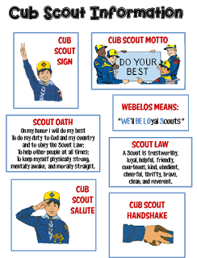
Go to http://strongarmor.blogspot.com/2015/06/cub-scouts-scout-oath-and-law-helps-and.html to get full size, full color (or black and white) printable versions
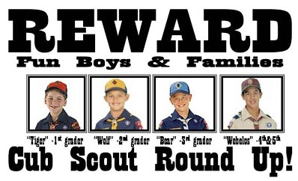

BE UP TO DATE
www.scouting.org/programupdates
The Program Updates page has been regrouped. Since the CS Adventure is in full swing, the emphasis on getting ready for it has been reduced. The downloads are still all there.
Philmont Training Center
Get great information about the Cub Scout Extravaganza at Philmont Training Center during the summer of 2017. It is being done TWICE, so ore people can have FUN.
There is a lot of information now on etting ready and implementing the changes to the Boy Scout program.
Check it all out – stay current!!

Same is true for Boy Scout Leaders!!

.

ROUNDTABLE HINTS

Keep Checking –
Jeff will be back soon!!

EPIC ROUNDTABLES -
E - Exceptional & Experiential
Strive to present an exceptional and experience based program
P - Personally & Program Relevant
Make the presentation personally and program level relevant to the Leaders who attend.
I - Instructional & Inspiring
Structure your program so that it is an instructional experience, providing examples of the method of delivery, that motivates and inspires Leaders
C - Concrete
Bring all of these components together at one place at one time, to deliver a concrete experience that provides Cub Scout Leaders with what they need to deliver a successful program at the Den and Pack level.

CUB SCOUT RT SCHEDULE OF SESSIONS
RT  Month | Program  Month | Pack Meeting Theme and Scout Law Point  Pack Meeting Plans at Scouting.org (1) |  | Roundtable Interest Topic and Scout Law Point  Per 2016-2017 Roundtable Planning Guide
 |  | Pack Meeting  Scout Law  Point | Pack Meeting  Theme | Roundtable  Scout Law  Point | Roundtable  Interest Topic
Apr  2016 | May  2016 | Clean | A Picnic with Pizzazz | Clean | Cub Scout Hiking
May  2016 | Jun  2016 | Brave | Roaming Reptile Alert | Helpful | Cub Scout Camping
Jun  2016 | Jul  2016 | Trustworthy | Let the Games Begin | Kind | Campfire Etiquette
Jul  2016 | Aug  2016 | Friendly | #CUBSCOUTS | Courteous | Enjoying Nature

- Link to Pack Meeting Plans - http://www.scouting.org/Home/CubScouts/Leaders/CubmasterResources/PackMeetingPlans.aspx

RT  Month | DL Breakout Topics | WL Breakout Topics | CM Breakout Topic | Comm Breakout | CS Leader
Apr  2016 | Preparing for a hike | Review Webelos Walkabout | The CM and Den & Pack Hikes | Hike Planning | Various Hiking Topics for all levels
May  2016 | Combined Session - CS Camping  BALOO Training, BSA Camping Rules, Types of Camps, Camp Logistics, Resources
Jun  2016 | Combined Session - Campfire Etiquette  Part 1 - Etquette, Safety, LNT  Part 2 - Program Material, Positive Emphasis, Resources
Jul  2016 | Nature is NATURE-al in Scouting | Nature is NATURE-al in Scouting | Combined Session - Nature  Nature is NATURE-al in Scouting  Safety, 2 Deep, Buddy System |  | Overview of Nature is NATURE-al

Cub Scout Adventures To Highlight at RT
RT  Month | Tiger Adventure | Wolf Adventure | Bear Adventure | Webelos Adventure | Arrow of Light Adventures
Apr  2016 | Backyard Jungle | Paws on the Path | Fur, Feathers, and Ferns | Webelos Walkabout
May  2016 |  | Call of the Wild | Bear Necessities | Camper, Castaway
Jun  2016 | Tiger Theatre | Call of the Wild | Bear Necessities, Grin & Bear It, Roaring Laughter
Jul  2016 | Backyard Jungle, Tigers in the Wild | Call of the Wild, Grow Something, Paws on the Path | Fur, Feathers, and Ferns, Bear Goes Fishing | Webelos Walkabout, Into the Wild, Into the Woods

LIONS

LION GUIDE AND PARENT ORIENTATION VIDEO
Video URL - https://youtu.be/YaIBTUO70JA

ORGANIZING FOR LIONS
From – New Birth of Freedom Council
For those packs that are thinking ahead about participating in the Lion Scouts program, having the right volunteers involved in delivering the Lion Scouts program will be important. Research shows that the most important person for a successful Scouting experience is a good leader. There are two new adult leader positions within the pack that are directly engaged in the delivery of the Lion Scouts program – a Lion Coordinator and a Lion Guide. Where do these positions fit into the current pack structure? What is the Lion Coordinator’s job description?
- Is an experienced and successful den leader
- Understands den and pack operations within the overall structure of Cub Scouting
- Demonstrates excellent communication and organization skills (and will remain in at least monthly contact with the Lion dens)
- Participates as needed in the unit’s School Night with all new Lions and their parents
- Assists the Lion guide in hosting the first orientation meeting for all the individual Lion dens in their pack
- Serves as a coach and mentor for Lion Guide

NEW LION HUB
Big Smiles
Build Bigger Futures
BSA has launched a new Lion Hub at:
http://scoutingwire.org/lion/

Available Lion Resources include:
PARTICIPATING COUNCILS
PROGRAM OVERVIEW
FAQS
The FAQ PDF is 13 pages long!!
Lots of great information!!
LION GUIDE AND PARENT ORIENTATION VIDEO
LION GUIDE AND PARENT ORIENTATION POWERPOINT
CONTACT US
LION PROMOTIONAL MATERIALS
(HELP SPREAD THE WORD!)
LION PROMOTIONAL VIDEO

THE CHIEF SCOUT EXECUTIVE ON LIONS
What We Know According to a 2014 U.S. Census Bureau report, 57 percent of kids ages 6–17 participate in at least one after-school extracurricular activity. This means that by the time they are eligible for Tigers, more than half of them already are engaged in some type of athletic, artistic or other program.
Often, children become attached to lifelong activities at an early age — that is certainly a goal we would have, as we know the long-term benefits of Scouting involvement include strong asset development in the areas of character and leadership. However, we also know that when youth participate in numerous activities at an early age, and miss joining Scouting, they are unlikely to do so at adolescence.
What will be important to learn in the next few years, if the initial entry point works at the kindergarten-age level, is will this cause losses at a different age, or will the program keep the same retention all the way through to Boy Scouting?
What we learn from the pilot Lion format could also help us assess and create a smoother transition from Webelos into Boy Scouting. Too many parents now see a barrier or obstacle, rather than a smoother transition. You will often hear parents say, “We did Cub Scouting, now we’re not sure if we are going to do Boy Scouts.” We do not have a seamless transition into Boy Scouts for a number of reasons. This pilot test will help us think through some of these issues.
We want to be sure that our Lion program delivers the right mix of character and leadership values and that we set the bar high. The program must be sustainable, we must have the right infrastructure to support it, and it needs to address in a meaningful way the needs of parents who want their kids to join Scouting at an earlier age.
You can rest assured that we will carefully evaluate our progress and keep you apprised of the results. Stay tuned for more.
Reprinted from "The Chief's Corner" on Scoutingwire.org

MORE LION INFORMATION
Bryan's Blog has written about Lions –
Go to http://blog.scoutingmagazine.org/2016/ and you can look them up. Here are a few -
Lion pilot program brings Scouting to kindergartners in nearly 200 councils
September 27, 2016
Answering the call of families who want a Scouting program for kindergarten-age boys, the BSA has expanded its Lion pilot program to nearly 200 councils.
In full gear: Here’s your first look at Lion Scouts T-shirts and hats
April 28, 2016
This week we get our first look at new T-shirts and caps to be worn by Lions — members of the pilot program for kindergarten boys set to roll out this fall.
Will Lions be part of the pack? (And answers to your other Lion questions)
April 15, 2016
Will Lions be part of the Cub Scout pack? By adding another year to the program, is the BSA concerned about "burnout"? And why was the Lions name chosen?
New details released about Lions, the pilot program for kindergarten boys
March 10, 2016
In Lions, the new pilot program for kindergartners, boys wear T-shirts instead of uniforms and earn adventure stickers instead of adventure loops.

There are slideshows on the web put up
by local councils. Some examples are:
WD Boyce Council has "Lion Cub Pilot Program" at: http://www.wdboyce.org/document/lion-cub-pilot-program/161325
Northern Star Council has a training slide show for District Coordinators and others at: https://www.signup4.net/UPLOAD/NORT26A/LION12E/District%20Lion%20Cub%20Coordinator%20Training.pdf
Councils have put up webpages about what their packs need to know to begin a Lions Program. Examples are:
New Birth of Freedom: http://seb.newbirthoffreedom.org/2016/03/22/were-approved-for-the-lion-scouts-pilot/
WD Boyce:http://www.wdboyce.org/cub-scouts/lion-cub-pilot-program/63360
Garden State (My Council): http://www.gardenstatescouting.org/lion-program-0
Garden State, also, has an FAQ PDF - http://www.gardenstatescouting.org/sites/default/files/Lion%20Program%20FAQ.pdf
And we have created a Facebook page for our units with Lions - https://www.facebook.com/GSCLion/
Selected FAQ's
National has posted a PDF file of FAQs about the LION program at http://www.scouting.org/filestore/pdf/Lion_FAQs.pdf

Cub Hub Blog Lion Posts
The items listed below are from the Cub Scout Learning Library . Check it out frequently for new lion and other new Cub Scout items. You can go to www.cubscouts.org and click on the Cub Hub Blog.

A Look at the Lion Uniform and Gear Lion uniform, shirts and hats! In case you’ve missed the Lion uniform images floating around the Digital Pack…
Will Lions Join Tigers and Bears? Oh My! — A Lions FAQ Lions: Answers to your top questions. We have seen a lot of great feedback, comments and questions from…
5 Questions (and Answers) for the New Lion ProgramMore Information on the New Lion Program As we mentioned earlier on the Cub Hub, Select councils will…
Lion Program will bring Scouting to Kindergarten BoysSomething Roaring in the Jungle There is an exciting new Scouting program called “Lion” for Kindergarten-aged boys…
CUB SCOUT LEARNING LIBRARY
Per my contacts at National Council, further development of the Cub Scout Learning Library (aka https://cubscouts.org ) is currently on hold as BSA assesses its digital strategy. Once that assessment is done and plan for moving forward is developed, additional on-line support for CS leaders will be available, either at cubscouts.org or a new site depending on the results.
The November 30, 2016, Adventure Plan changes will not be incorporated into this site.

The NEW https://cubscouts.org/ !!!
This is the Cub Scout Learning Library –
Everything you could want to know for Cub Scouts is or will be here. And all within a click or 3 of the home page. National heard the message that although things were at www.scouting.org they were often buried too deep to be found.
This site has admin stuff and practical stuff. The new Den Leader Resource Books are here. You can download some of the pages for FREE
This website is a great resource. There are still parts under construction but what is there is GREAT!!
Yes,
https://cubscouts.org
runs on a phone, too!!!

There are 3 tabs on top of the home page –
- Learning Library
- Cub Hub Blog
- Join Scouting
Plus – a magnifying Glass to start a search and Icons for various Social Media –
- Learning Library takes you where you can learn about your position and pick up hints. Besides specifics for dens of each rank, other clickable links include –
Den Leader
Den Meeting Basics
- Your First Den Meeting
- Planning Den Outings
- The Parts of a Den Meeting
- Getting Started
Three of the Core Adventures for the selected rank are listed here.
- Additional Required Adventures
The remaining Core Adventures for the selected rank are listed here. When you click them you get an intro to the Adventure but do not get the Meeting Plans and Resources. You see this note:
To get you started in delivering fun and engaging meetings, complete Den Meeting Plans are available here on the Learning Library for the Backyard Jungle and Games Tigers Play adventures. To obtain Den Meeting Plans for all other adventures, Den Leader Guides are available at your local Scout Shop, online at scoutstuff.org, or as an eBook through Amazon.
- Elective Adventures
All the Elective Adventures for the selected rank are listed here. When you click them you get an intro to the Adventure but do not get the Meeting Plans and Resources. You see the same note (above).
- Building Strong Dens
The Basics of Cub Scouts
- Advancement
- BSA Mission and Vision Statements
- Cub Scout Ages and Ranks
- Cub Scout Uniforming
- Den Flags
- Den Yells
- Leader Survival Kit
- Methods of Cub Scouting
- Purpose of Cub Scouting
- Roles and Responsibilities
- Scout Oath and Law
- What Is Cub Scouting?
- Training
- Youth Protection
- Den Planning And Administration
- Advancement Basics
- Advancement Requirements
- Annual Planning For Your Den
- Coordinating Your Den Plan with Pack
- Tracking and Recognizing Advancement
- Youth Protection Training
- Positive Youth Development and Working with Boys
- Developmental Differences Boys 7-11
- Behavior and Discipline
- Positive Youth Development
- Working With Special Needs Cub Scouts (Advice is specific to each Special Need. Lots of research was done to prep these pages.)
- Parents’ Prejoining Conference
- Leadership Techniques
- Working With Specific Disabilities and Needs
- Cub Hub Blog takes you to a Cub Scout specific Blog similar to Bryan's Blog. The most recent topics discussed are listed here. There are more at www.cubscouts.org:
Sorry, There were no new posts in
January 2017.
December Posts still available –
December 19, 2016
Star Wars Stuff Your Cub Scout Will Love There’s no denying the popularity of all things Star Wars among Cub Scouts That may be why…
December 19, 2016
Cold Weather Fun: Winter Camping! Have fun and stay safe in cold weather Feeling stuck inside is a surefire way to let…

- Join Scouting takes you to
www.beascout.org
This picture on https://beascout.scouting.org/ home page. Check it out!!
Also, on the home page –
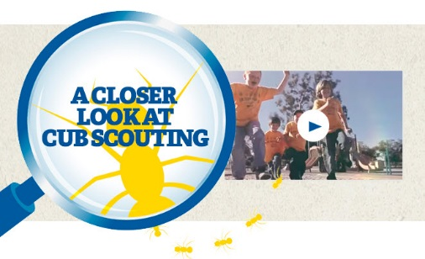
Click for a YouTube Video on Cub Scouting.
https://www.youtube.com/watch?feature=player_embedded&v=dqKFgk8SJlE
And 6 picture links -
These Six Links take you to:
www.scoutstuff.org –The Supply Division site where you can locate your nearest National Scout Shop or other local seller of Scout Stuff or buy your Scouting supplies on-line.
http://scoutingwire.org/ - Where you can get the latest Scouting News from around the country. You can sign up to get notifications when things are posted here...
https://cubscouts.org/pinewood-derby-2016-photo-contest A dead end with a note that says “Pictures of entries that were received have been removed.”
https://www.scoutbook.com/Where you can get the Scoutbook APP to track your son's Scouting Experience from Tiger to Eagle Scout.
www.boyslife.org– Go directly to the on-line edition of Boys 'Life
http://scoutingwire.org/marketing-membership/ Get resources and materials to strengthen your unit at BSA's marketing and membership site. Learn the best practices and tips employed by the most successful units.

ADVENTURE PLAN TRACKERS
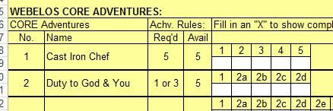
- Tracking Spreadsheets are posted on the USScouts Advancement webpage (http://usscouts.org/advance/cubscout/intro.asp). The spreadsheets were tested by a software developer who said they are so good he sees no reason to develop his own!!
- Utah National Parks Council, also, has Excel spreadsheets posted for all the new Adventure Plan requirements on their Akela's Council BlogSpot.
http://akelascouncil.blogspot.com/search/label/Tracking%20Sheet (The page starts with Arrow of Light scroll down for other ranks)
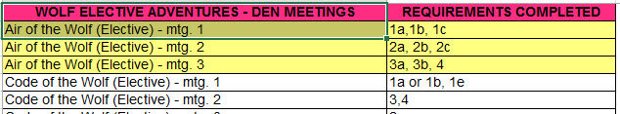
- A spreadsheet that correlates Meetings to Adventure requirements is available on the Utah National Parks' Akela's Council Blogspot at https://www.dropbox.com/s/yb8fweg7etnhqrt/WOLF%20BEAR%20WEBELOS%20REQUIREMENTS%20-%20MTGS.xlsx?dl=0 . It has all the Wolf, Bear, Webelos and AOL Adventure requirements.
These Advancement Spreadsheet workbooks are FREE for Scouters. But be COURTEOUS and observe the following -
PLEASE do not download the files from either site to email or send them digitally to others.
They are for your personal / pack use only. If you would like to share these files with others, please copy / send the link to them and send them to the site so they can print off their own. They would love everyone that wants a copy to get their own copy absolutely free. Both USScouts and Utah National Parks receive Ad money based on the number of people visiting the site. That ad money helps keep their websites open. Please help them (us) by encouraging others to visit to obtain files.

TRACKING BOYS’ PROGRESS
IN THE MODIFIED CUB SCOUT ADVENTURE PLAN
Judy and I have found several places on the web where there are aids to use to track boys’ progress in the modified Adventure Plan. Judy is placing a more detail in Baloo’s Bugle, Part IV – Den Meeting Helps.
- The Bobwhite Bather blog site (https://bobwhiteblather.com/mid-year-cub-scout-program-updates/ ) has a discussion of changes.
- Cubmaster Tom, responded providing links to documents he formatted to paste into the boys’ books for each modified Adventure. See example below:
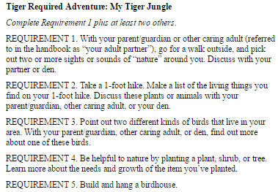
The complete Tiger document is at: https://docs.google.com/document/d/1ka_AkwxDkKgNjLrAOUHzbQQqCkruDCC8RyxtMFvrFO8/edit?usp=sharing. The links for the other ranks are in the comment on Bobwhite Blather.
- Bert Bender, Atlanta Area Council, replied,
Having finished several deep dives through the requirements changes, I’ve updated the page at http://www.southfultonscouting.com/node/3557 to not only show exactly what got changed and what didn’t change, but now also add comments intended to be a practical guide to whether you need to look at the new 11/30/16 language, and whether when those might be a useful alternative.
Comments after some Adventures encourage (sometimes plead) that dens avoid the “easy button” approach. Doing the June 1, 2015 handbook elements will often result in better outcomes and experience in Cub Scouting.
- Utah National Parks Council’s Akelas Council Blogspot has revised paper tracking sheets (http://akelascouncil.blogspot.com/) Thanks to Celeste Hunt for creating these.
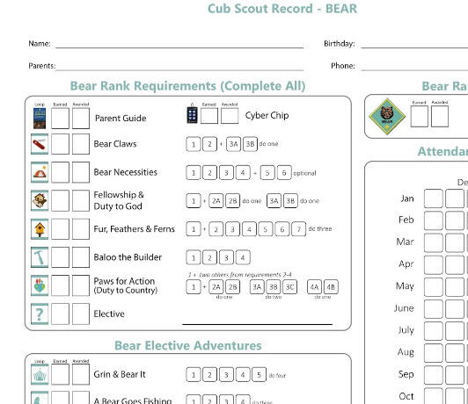
Celeste says, “Tracking, planning, and recognition are so important in Cub Scouts. This new tracking sheet helps you to be able to keep track of where each boy is at towards the Bear, Adventures, and Cyber Chip requirements. I print 2 copies of the tracker on cardstock for each boy. One for his book and one for my leader binder. I place it next to the trackers for the religious and other awards we are doing. I have tab for every boy with all his trackers. Complete information on each boy in one place. Not every boy is there every week. By doing this, I always know what each boy has done. If the parents ever have questions, I have a place to check, and I can always copy each tracking sheet to show them where their boy is.

CUB SCOUT
LEADER TRAINING

IN-PERSON TRAINING
Position-Specific In-Person Training Guides Available Now! The training guides for
- Den Leader (http://www.scouting.org/filestore/training/pdf/515-215.pdf ),
- Cubmaster/Assistant Cubmaster (http://www.scouting.org/filestore/training/pdf/511-503_WB.pdf ), and
- Pack Committee (http://www.scouting.org/filestore/training/pdf/511-504_WB.pdf )

Are available on Scouting University. You can access them at http://www.scouting.org/training/adult.aspx .
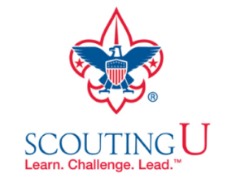

ON-LINE TRAINING
On-Line Training for all Cub Scout positions has been available since October 25, 2015
The online training for Den Leaders, Cubmasters, Committee Chairs and members, and Chartered Organization Representatives is totally updated with help from volunteers from around the country. The new training is divided into shorter, more targeted modules so leaders can get the training they need, in the order they want, any time they need it. It is organized around the learning needed prior to the first meeting, in the first 30 days, and to be position-specific trained. This training was developed to be implemented in conjunction with the BSA’s new learning management system. Keep an eye on
my. Scouting Tools (log in at https://My.Scouting.org) for more information.
Go to the BSA Volunteer Training Team Facebook page (Link above) and.
Then you automatically receive the latest news!!
If you are having difficulties with
the training or system call
BSA Member Care at 972-580-2489
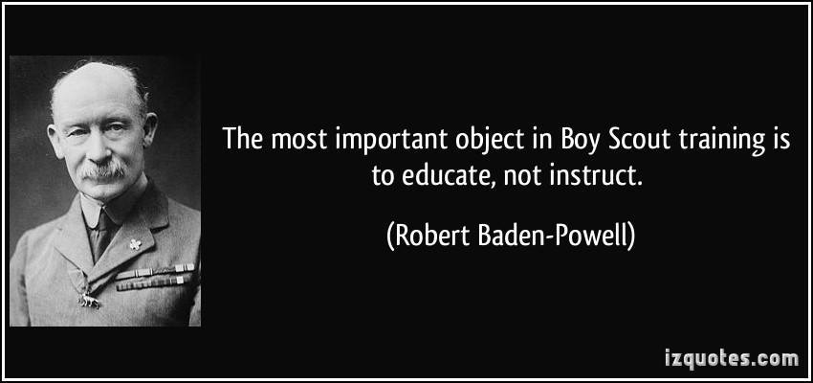
A Typical Learning Plan has several parts –
There is no need to complete more than one section at a time. Do what you have time to do.
Here you can see the three parts of the CM Course -
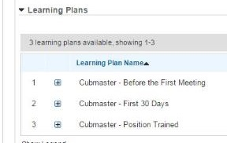

Each of these three parts is broken down into "bite sized" chunks:
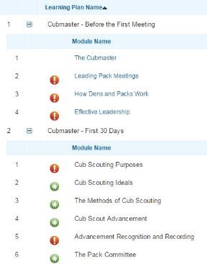
Go check it out and get your
people trained!!!

