TABLE OF CONTENTS
TABLE OF CONTENTS 1
HELP WITH ADVENTURE PLAN MODIFICATIONS 1
ADMIN HELPS 2
ANNUAL PROGRAM PLANNING 2
Annual Program Planning 5
The Sweet 16 of BSA Safety 7
BE UP TO DATE 8
ROUNDTABLE HINTS 9
A WORD ON THE 2017-2018 RT PLANNING GUIDES 9
ROUNDTABLE PLANNING 9
ROUNDTABLES ARE UNIT SERVICE 10
CUB SCOUT RT SCHEDULE OF SESSIONS 11
LIONS 12
LION GUIDE AND PARENT ORIENTATION VIDEO 12
ORGANIZING FOR LIONS 12
NEW LION HUB 12
THE CHIEF SCOUT EXECUTIVE ON LIONS 13
MORE LION INFORMATION 13
CUB SCOUT LEARNING LIBRARY 15
ADVENTURE PLAN TRACKERS 17
TRACKING BOYS’ PROGRESS 18
CUB SCOUT LEADER TRAINING 19
IN-PERSON TRAINING 19
ON-LINE TRAINING 19

HELP WITH ADVENTURE PLAN MODIFICATIONS
Last November, the BSA implemented changes to Adventure requirements in response to feedback from Den Leaders. Dens started using the new requirements as they began their next Adventure.
The BSA has placed PDFs that may be printed and inserted into all Cub Scout Rank handbooks on www.scouting.org/programupdates. They have, also, sent printed copies to all National Scout Shops. They are available free for the asking by parents and scout leaders. (At the Wilmington, DE, National Scout Shop we have a great supply!! Stop in, say HI! and ask for yours) https://www.facebook.com/WilmingtonScoutShop)
The book size formatted PDFs are at –
Tiger Addendum Wolf Addendum
Bear Addendum Webelos/A of L Addendum .
The www.usscouts.org Advancement pages have been updated to reflect all the changes.
The Cub Scout Learning Library will not be updated to show the changes. All updates to the Cub Scout Learning Library (www.cubscouts.org) are on hold as BSA assess its digital strategy.

ADMIN HELPS

ANNUAL PROGRAM PLANNING
“A common element of strong units is they all have a good annual program planned a year in advance (and it is) shared with all families in the form of a calendar.”
BSA Annual Program Planning Conference Guide, 2012

One thing that has not changed with the Cub Scout Adventure Program, is the need to hold an Annual Program Planning Conference for your Pack. The results will be different because of the Adventure Program but the need to do it remains unchanged.
The first thing –
Do Your Homework –
A month or two before the scheduled face-to-face conference, the Committee Chair and Cubmaster gather the following information:
- Key school dates
- Community event dates
- Your chartered organization's dates
- Personal dates that may affect your pack's activities such as the Cubmaster's anniversary cruise, the Chair's birthday
- Dates of District and Council events
- Collected Family Talent Survey sheets from all parents
- Last year's pack annual plan if you have one
They, also, get (or consider) the following:
- How can STEM activities be worked into this year's plan. For ideas you can go to Bryan's Blog on STEM and Annual Plan at http://blog.scoutingmagazine.org/2014/08/27/remember-stem-craft-units-annual-program-plan/

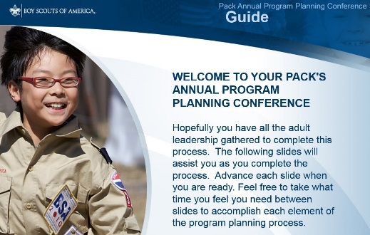
- Download the video on the Pack's Annual Program Planning Conference from http://www.scouting.org/filestore/membership/zip/BSA_Pack_Annual_Program_Planning_Conference_Guide.zip
They should review it and study it to make sure they are ready for the big day/night/event. You can use this power point ( or to be fancy - electronic program planning conference guide) to add some color to the Annual Program Planning Conference process. This narrated PowerPoint presentation, takes will take your pack leaders step-by-step through the planning process
- Review and establish JTE Goals for the Pack. Determine what activities are needed to have the Pack do better than this year. Anticipate changes to the JTE requirements for the next calendar year.
The JTE is a year round program of leading indicators to help you plot your course to a successful program (I hate it when my Cub Scout writing sounds like I am at work but it is true. And it is a GREAT tool!! CD) If you have not set up to monitor your progress on the dashboard go to the spreadsheet on National's website and you will get a great picture of your status. You fill in page 1 by answering questions and it completes your JTE form on page 2 (Kind of like when I do my income tax on Turbo Tax CD) Page 3 is a Unit Budget form, be sure to use that, also. The spreadsheet is at: http://www.scouting.org/scoutsource/Awards/JourneyToExcellence.aspx
- They should obtain the Boys' Life Annual program Planning materials. Some councils supply these, some do not. They are available directly from national at Things to order – http://www.scouting.org/filestore/magazine/pdf/331-057_LR.pdf
Important Material available here include –
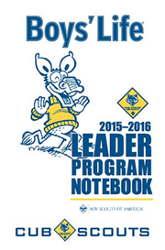
CS Leader Program Notebook (No. 331-014 $1.00)
The pocket-sized 4-inch x 6-inch 2015–2016 BOYS’ LIFE Cub Scout Leader Program Notebook is designed for Cubmasters and den leaders but is useful for all Cub Scout leaders. Its 100 pages include a guide to effective Cub Scout program planning; individual pages for each monthly core value; the pack’s annual PROGRAM PLANNING STEPS; 12 monthly calendars to write in important notes; full-page, fill-in-theblank outlines for each weekly den meeting; planning outlines for the monthly pack leaders’ meeting; the monthly pack meeting; requirements for the National Den Award; and a description of Journey to Excellence. The Cub Scout Leader Program Notebook is a valuable aid for all Cub Scout leaders. You can download the file at http://www.scouting.org/filestore/magazine/pdf/331-014.pdf BUT it is well worth the $1.50 to get the booklet as intended as a pocket notebook!!!
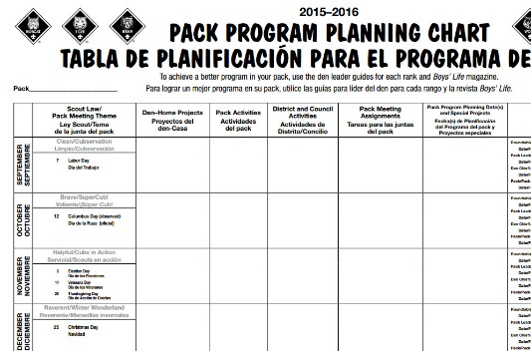
Pack Program Planning Chart (No. 331-017)
The poster-sized 17-inch x 22-inch BOYS’ LIFE Pack Program Planning Chart (English and Spanish) helps Cub Scout leaders plan the pack’s 2015–2016 annual program. The chart provides information for each month’s recommended Cub Scout core value and Webelos/Arrow of Light activity badges. Space is provided to write in den-home projects, pack program planning dates and special projects, Webelos activities, and dates for monthly meetings (roundtable, pack leader, den chief, and pack). Experienced pack leaders use the Pack Program Planning Chart to effectively plan the pack’s annual program. You can, also, download this chart at http://www.scouting.org/filestore/magazine/pdf/331-017_bilingual.pdf . But you really need at least 17X22 paper. Poster sizes will work even better if you have a source.
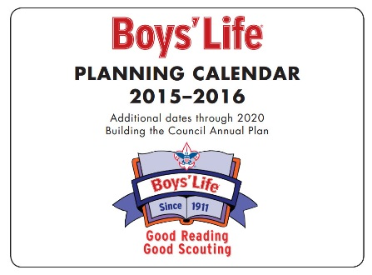
2015–2016 BOYS’ LIFE Council Planning Calendar
(No. 331-011 $1.50) - The popular BOYS’ LIFE Council Planning Calendar measures 8.5 inches x 11 inches. The fill-in-the-box calendar dates begin September 2015 and extend through December 2016. Additional calendar dates noting selected holidays and religious dates run through December 2020! Planning ahead? This is your calendar. You can, aslo, download this calendar at http://www.scouting.org/filestore/magazine/pdf/331-011.pdf
AND it all comes with
Pedro's Seal of Approval!!

Second –
Plan for success by selecting the right people to attend and picking the best possible date.
Inviting all the following:
- All pack committee members
- All den leaders and assistants
- All pack/den aids and den chiefs (optional)
- Chartered organization representative
- Your unit commissioner (optional)
- Anyone else you think might be helpful, (e.g. selected parents).
Selecting a date for the conference.
See when you can have the most people attend. My pack used to do a picnic. The leaders would meet and the parents not in the conference would watch the boys at a pool, or in a park. We could get the local troop to help, too. The more people, the better the result. The less people to complain about what was chosen and what was not chosen.
This is a Unit specific decision.
Sending out your invites early. This should help people keep from booking a date they told you they were available. Make the invite official. Have them know they are part of one of the most important Pack Events of the year.
Prepping your unit calendar with fixed dates – Just take the dates you collected and put them into your pack's master calendar—including den meeting dates, Roundtables, District Cuborees, Webelos Overnights, Your Pack and Committee Meeting nights, Town Celebrations in which you participate, Scouting for Food, everything you have uncovered while doing your homework. The date of Easter varies from year to year and we used to miss that one in our planning – so please make sure you look it up.
This can be done either on a hard copy or by plugging the information into an electronic calendar on a computer.
Third –
Hold your meeting
- Let the power point you down loaded drive the agenda. Or copy it, and go through the steps manually.
- Or, Use the agenda on National's site for a Pack Annual Program Planning Conference. - http://www.scouting.org/scoutsource/CubScouts/Leaders/ProgramPlanning.aspx
- Or, Follow the agenda in the Circle Ten Council article (that follows this one) on Annual Pack Planning Conferences.
- Or write your own using parts from all the above and your experience.
Fourth –
Tell everyone
- A research project done by Eli Lilly in Indianapolis, Indiana, showed that 1 of the 3 common elements of strong packs is (I will share the other two common elements in a bit. You try and guess them, please.):
They all have a good annual pack program planned a year in advance that is then shared with all families in the form of a calendar.
The important result of a shared annual program calendar is that your pack will attract more families, and Cub Scouts will stay for a long time.
- Get it in your newsletter. Don’t have a newsletter?? START ONE, NOW!!! BSA has a template available at http://www.scouting.org/scoutsource/CubScouts/Leaders/newslettertemplate.aspx
- Create a poster. Don’t know what to put on a poster. Try this sample from BSA –
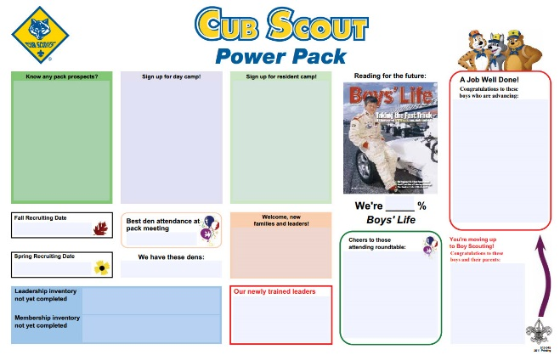
This poster is found at http://www.scouting.org/filestore/pdf/512-045_tab_WB.pdf
Fifth –
Monitor Implantation and Update the Plan as needed
Annual program planning is an ongoing process. Review the plan each month at your pack leaders' meeting to make sure you are still on track, to recruit chairs and other help, you participate in important meetings, or to make assignments or changes as needed.
Quarterly, do a three month look ahead to make sure all your great events will happen!!
Oh, those other two common elements of successful Packs???
- Training
- Having the right person in the position (Not just picking the first warm body)
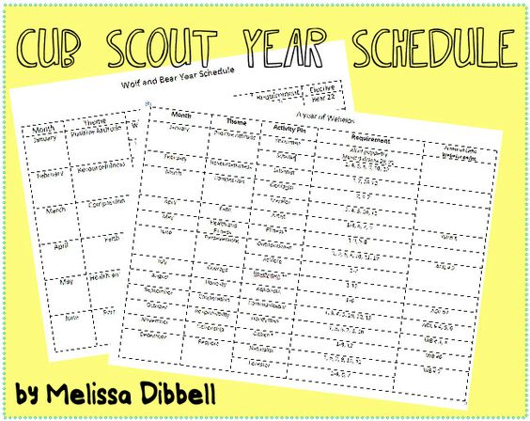
Check out Melissa’s Ideas at
https://www.pinterest.com/pin/533817362053100786/

Annual Program Planning
Circle Ten Council
A Year-Round Program
THE BASIS OF A SUCCESSFUL PACK
Program planning is a simple but critical part of your pack's success. Throughout the process remember your goal is to deliver a high quality program to each boy and his family. It should be fun, exciting and focused on the purposes of Cub Scouting.
Setting an annual program plan provides direction and sense of satisfaction and a feeling of accomplishment in a job well done. Planning also makes the best possible use of your valuable volunteer time.
Planning Steps:
One of the most important responsibilities of the pack committee is to keep the pack operating with a first-rate, year-round program. The quality of the program will depend largely on the pack committee giving the Cubmaster, the Cub Scout den leaders and Webelos den leaders the help they need.
Cub Scout program planning includes four steps, dependent upon one another, which usually guarantee a strong pack program. The steps are:
Annual Pack Program Planning Conference
Monthly Pack Leader's Meetings
Monthly Den Leader Meetings
Monthly meetings of each den leader with the den chief
Steps to having a great
Annual Program Planning Meeting
SET A DATE TO MEET - Set a date in August with the committee, including the Den Leaders and Webelos Leaders.
CHECK MEETING DATES - Before this time check with your chartering organization and school calendar to find available dates for pack meetings. They should be at the same time and date each month.
REVIEW LAST YEAR'S PROGRAM - Which activities worked and which did not? Decide what activities and special meetings you would like to do again. Also determine whether or not your budget was adequate for them.
REVIEW YOUR JOURNEY TO EXCELLENCE STATUS - The JTE is a year round program of leading indicators to help you plot your course to a successful program (I hate it when my Cub Scout writing sounds like I am at work but it is true. And it is a GREAT tool!! CD) If you have not set up to monitor your progress on the dashboard go to the spreadsheet on National's website and you will get a great picture of your status. You fill in page 1 by answering questions and it completes your JTE form on page 2 (Kind of like when I do my income tax on Turbo Tax CD) Page 3 is a Unit Budget form, be sure to use that, also. The spreadsheet is at:
http://www.scouting.org/scoutsource/Awards/JourneyToExcellence.aspx
SET NEW MEETING DATES - Review the available pack meeting dates with the pack committee and set dates for the coming year. Write pack meeting dates in your council calendar (extra copies are available through the Service Center for your committee members and den leaders). Be careful to avoid holidays and school breaks.
SET COUNCIL AND DISTRICT DATES - Review the council and district calendar and mark dates on your program schedule for district and council activities: Webelos Woods, Pinewood Derby, training sessions, and important meetings like roundtable.
SET SPECIAL PACK DATES - Set the dates for special activities your pack will be doing during the year and put them in your program calendar. These may include:
Pack Fundraiser (Product Sale)
Blue and Gold Banquet
Pinewood Derby
Friends of Scouting
Summertime Activities
Webelos and Tiger Graduation
Since June 1, 2003, adults giving leadership to a pack campout MUST complete the Basic Adult Leader Outdoor Orientation (BALOO). Please check council calendar for upcoming BALOO training sessions. (This is not required for council-run programs)
SCHEDULE YOUR MONTHLY COMMITTEE MEETING - Select dates for and schedule monthly meetings of your committee to meet and plan out the next month's activities and meetings (i.e. in September you should be planning for October). You should have a committee meeting every month.
REVIEW THE MONTHLY CORE VALUES - Choose the Core Value (Scout Law) emphasis for the month from the literature (Best is to use what is being presented at Roundtable) or rearrange them based on your local activities or choose a theme (OOoops, there is that word) of your own. Write them in your annual calendar so everyone knows what the month's Core Value emphasis is for both Cubs and Webelos.
SET A BUDGET - Based on the meetings and activities you have planned for the year, number of boys who are likely to advance, and the number of youth and adult members of the pack, figure out what your approximate yearly expenses will be. You will need to plan enough fund raising activities to cover these expenses. The Budget Planning Worksheet will help you calculate and plan your annual expenses and income to create a budget.
NOTE -
There is an electronic budget planning worksheet
in the Excel spreadsheet on National's website to
help you do this more easily
http://www.scouting.org/scoutsource/Awards/JourneyToExcellence.aspx
DISTRIBUTE THE PLAN - Cub Scouts and their families will better participate in meetings and activities if they have a copy of the calendar. Every family should receive a copy of the annual calendar so they can plan accordingly.
These are the basic steps your committee will need to follow to have a complete annual program plan and calendar. This calendar will help insure that everyone in the pack knows exactly what is happening from month to month during the year. More important, it will help you plan in advance and avoid being caught off guard by rapidly approaching deadlines.
Remember that September brings *** Join Scouting Night*** and the start of a full year of activities. When you go to Join Scouting Night, if you have a well thought-out plan and distribute it to your members, new and old, you will find it is easier to recruit not only boys but also adult leaders.
CHECK OUT THE
AT LAST FRONTIER COUNCIL, BSA
https://www.scoutingrocks.tv/IYOS
And while you are planning CAMPFIRES and your upcoming year, don’t forget to be safe. Follow the Sweet 16 of Safety from the BSA!! CD

The Sweet 16 of
BSA Safety
Commissioner Charlie B, Garden State Council and
http://www.scouting.org/scoutsource/HealthandSafety/Sweet16.aspx
These 16 safety points, which embody good judgment and common sense, are applicable to all activities:
- Qualified Supervision.
Every BSA activity should be supervised by a conscientious adult who understands and knowingly accepts responsibility for the well being and safety of the children and youth in his or her care. The supervisor should be sufficiently trained, experienced, and skilled in the activity to be confident of his or her ability to lead and teach the necessary skills and to respond effectively in the event of an emergency. Field knowledge of all applicable BSA standards and a commitment to implement and follow BSA policy and procedures are essential parts of the supervisor's qualifications.
- Physical Fitness.
For youth participants in any potentially strenuous activity, the supervisor should receive a complete health history from a health-care professional, parent, or guardian. Adult participants and youth involved in higher-risk activities (e.g., scuba diving) may have to undergo professional evaluation in addition to completing the health history. The supervisor should adjust all supervision, discipline, and protection to anticipate potential risks associated with individual health conditions. Neither youth nor adults should participate in activities for which they are unfit. To do so would place both the individual and others at risk.
- Buddy System.
The long history of the "buddy system" in Scouting has shown that it is always best to have at least one other person with you and aware at all times of your circumstances and what you are doing in any outdoor or strenuous activity.
- Safe Area or Course.
A key part of the supervisors' responsibility is to know the area or course for the activity and to determine that it is well suited and free of hazards.
- Equipment Selection and Maintenance.
Most activity requires some specialized equipment. The equipment should be selected to suit the participants and the activity and to include appropriate safety and program features. The supervisor should also check equipment to determine whether it is in good condition for the activity and make sure it is kept properly maintained while in use.
- Personal Safety Equipment.
The supervisor must assure that every participant has and uses the appropriate personal safety equipment. For example, activity afloat requires that each participant properly wear a personal flotation device (PFD); bikers, horseback riders, and whitewater kayakers need helmets for certain activities; skaters need protective gear; and all need to be dressed for warmth and utility as the circumstances require.
- Safety Procedures and Policies.
For most activities, common-sense procedures and standards can greatly reduce any risk. These should be known and appreciated by all participants, and the supervisor must assure compliance.
- Skill Level Limits.
Every activity has a minimum skill level, and the supervisor must identify and recognize this level and be sure that participants are not put at risk by attempting any activity beyond their abilities. A good example of skill levels in Scouting is the swim test, which defines conditions for safe swimming on the basis of individual ability.
- Weather Check.
The risks of many outdoor activities vary substantially with weather conditions. Potential weather hazards and the appropriate responses should be understood and anticipated.
- Planning.
Safe activity follows a plan that has been conscientiously developed by the experienced supervisor or other competent source. Good planning minimizes risks and also anticipates contingencies that may require an emergency response or a change of plan.
- Communications.
The supervisor needs to be able to communicate effectively with participants as needed during the activity. Emergency communications also need to be considered in advance for any foreseeable contingencies.
- Permits and Notices.
BSA tour permits, council office registration, government or landowner authorization, and any similar formalities are the supervisor's responsibility when such are required. Appropriate notification should be directed to parents, enforcement authorities, landowners, and others as needed, before and after the activity.
- First-Aid Resources.
The supervisor should determine what first-aid supplies to include among the activity equipment. The level of first-aid training and skill appropriate for the activity should also be considered. An extended trek over remote terrain obviously may require more first-aid resources and capabilities than an afternoon activity in a local community. Whatever is determined to be needed should be available.
- Applicable Laws.
BSA safety policies generally parallel or go beyond legal mandates, but the supervisor should confirm and assure compliance with all applicable regulations or statutes.
- CPR Resource.
Any strenuous activity or remote trek could present a cardiac emergency. Aquatic programs may involve cardiopulmonary emergencies. BSA strongly recommends that a person (preferably an adult) trained in cardiopulmonary resuscitation (CPR) be part of the leadership for any BSA program. This person should be available for strenuous outdoor activity.
- Discipline.
No supervisor is effective if he or she cannot control the activity and individual participants. Youth must respect their leaders and follow their directions.
Reference: The Sweet 16 of BSA Safety, No. 19-130
Scouting Safety is based on
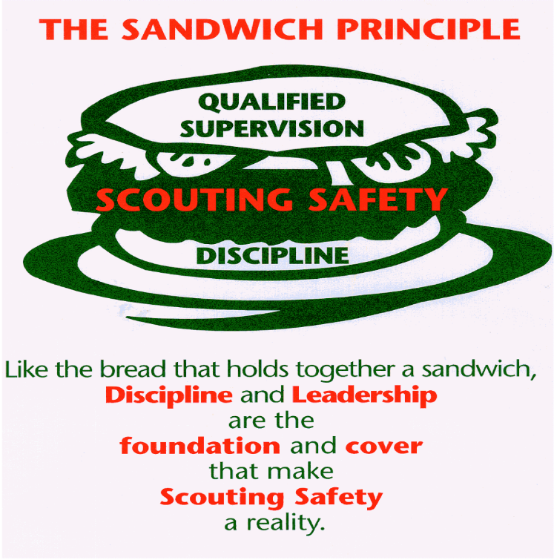
Look back at the Sweet Sixteen list and check out what 31 and #16 (the first and the last) are.
Everything is else is what you need to do to keep Scouts safe for a specific activity. Discipline and Leadership are what make everything else work.

BE UP TO DATE
www.scouting.org/programupdates
The Program Updates page has been regrouped. Since the CS Adventure is in full swing, the emphasis on getting ready for it has been reduced. The downloads are still all there.
Philmont Training Center
Get great information about the Cub Scout Extravaganza at Philmont Training Center during the summer of 2017. It is being done TWICE, so ore people can have FUN.
There is a lot of information now on etting ready and implementing the changes to the Boy Scout program.
Check it all out – stay current!!

ROUNDTABLE HINTS

A WORD ON THE 2017-2018 RT PLANNING GUIDES
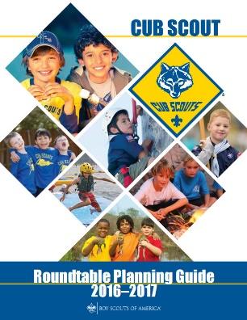
Usually the Cub Scout and Boy Scout Roundtable Planning Guides (RT PG) are issued at the BSA’s National Meeting which occurs annually near the end of May. This did not happen this year. For different reasons both RT PGs are delayed.
The BS RT PG is in final review. There were several personal events amongst the reviewers (e.g. deaths in family) that delayed the review. My fellow instructor and ACC-RTs, George Costigan, told me that all is set once final reviews are done. And I Thank him for asking me to join his team this year.
The CS RT PG appears to be further behind. I have unofficially seen drafts of the agendas and materials for the 12 months and there is good stuff planned to be presented. The topics selected are meaningful for Cub Scout Leaders.
I will be looking for the finished products so I can keep y’all (Thank you J. Clay Dean and Jimmy Phillips from Alabama and members of my patrol at Schiff Scout Reservation for NJLITC in 1963 with Mr. Walker, SM, and Ron Geddes, SPL.) informed.
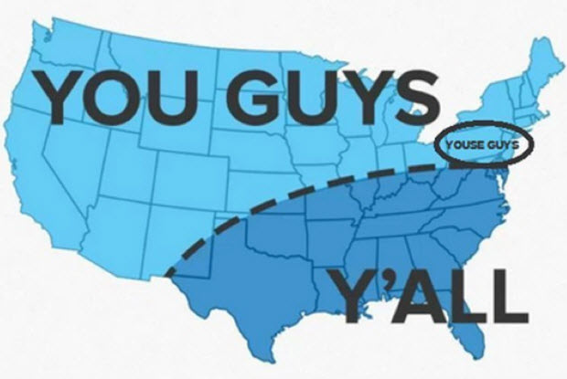
Commissioner Dave lives in the “Youse Guys” oval!

ROUNDTABLE PLANNING
Here are some hints from a RT Commissioner in Capital Area Council for planning your Roundtables –
A new Scouting (and Roundtable) year has begun and it is time to take stock and “start over” once again. It is a good idea to review the past year’s roundtables – what worked, what did not, what to keep, what to scrap, what to add. Like the programs of BSA, roundtable should be continuously changing to meet the needs of our ever changing leaders. If you keep on doing what you have always done, you will continue to get the same results. So…as you look toward the new Scouting year, here are some things to keep in mind:
- Plan: Annual – look at the upcoming year as a whole. Put council events and local events on the calendar, highlight any months that will take a little extra on your part (workshops, outdoor settings, special guests)
- Monthly – monthly planning meetings are crucial to the success of your roundtable. They should be scheduled when the majority of staff can attend and all program details and assignments should be documented.
- People: staff – it is time to determine who is coming back (be sure to ask, don’t assume), who you want to recruit, what sort of training needs to be done, assignments.
- Preparation: the staff should be ready to go when they arrive at the roundtable location – and it is a good idea to be early enough to have the room set up when the first participant arrives. That way, the staff can visit with participants instead of running around, setting up program areas.
- Page: - the staff should all be on the same one – have copies of the agenda posted in several areas of the room so everyone can keep track of what’s next.
- Punctual: start on time, stop on time. The participants’ time is valuable and so is yours. If you continually delay the opening until everyone is in the room, the participants will realize this and find no reason to get there any earlier. Find something to do (like give away an inexpensive door prize) right after the opening, available only to those in their seats and see if this doesn’t spur the crowd to get a move on to get there on time.
- Plan B (C, D) – be ready for the unexpected (example: the council commissioner shows up at 6:45 and informs you that he needs “a little time on your program” and proceeds to talk for 45 minutes). Scouters are flexible, especially trainers! If you need to alter your agenda, take a deep breath and smile and carve away!
- Have FUN! If you are not having a good time at roundtable, it is doubtful your participants will.
Here are some hints from my friend Wendy in Chief Seattle Council, concerning her Roundtables -
Regarding round table meetings and material: I plan on including games, songs, skits, cheers, and alternative ceremonies to round out the Pack Meeting agendas on-line and info available in the Leader's resource books.
The content will be compatible with the theme/topic for pack night. I will also suggest some alternative pack night themes/topics based on holidays, and the Adventures the boys are/have been working on.
For the den leaders, I plan on including games, snacks, and projects that coordinate with the new Adventures, and how to make working on the Adventures fun. Many dens meet 3 times a month, and may need supplemental ideas.
Den Leaders and Cubmasters will still want fun games and gathering activities for their guys. Cubmasters will still want fun and meaningful opening, closing, and award ceremonies. Since the Cubmaster section indicates that dens are encouraged to contribute the fun bits of pack night -- games, songs, skits, etc. -- I want to provide the material to make it easy for them to do that.
Basically, I will be trying to make sure the dens/packs have plenty of fun options to do.
Wendy

ROUNDTABLES ARE UNIT SERVICE
Let us see how the roundtable provides of Unit Service.
The Purpose of the Roundtable most certainly is unit service – It provides unit leadership the skill to do and the will to do. These include:
- The skills include techniques, information, program ideas (e.g. information on policy and events, and training opportunities)—the know-how that makes for successful unit operation.
- Will includes morale, enthusiasm, inspiration, and vision that renew the desire to serve youth.
The Roundtable commissioner and staff plan and conduct the RT meetings. They plan with knowledge of the annual council, district, and RT service plans. They meet with the district exec and commissioner to ensure the RTs are adapted to district plans.
They report on roundtable plans at each district commissioner staff meeting. Unit Commissioners (UC) can use this to promote roundtable attendance. The RT Commissioner can work with UCs to bring new leaders to roundtables. The RT Commissioner should work with UCs to follow up on units not participating. Evaluations of RTs at least twice a year with input and suggestions from unit leaders will keep RTs meeting unit needs..
Logging RT data into Commissioner Tools (e.g. Unit RT attendance) will let commissioners know which units may need help.
RT provides an opportunity for sharing experiences and enjoying fun and fellowship with other Scout leaders. As well as an opportunity to discuss problems. When skillfully executed, the roundtable experience will inspire, motivate, and enable unit leaders to provide a stronger program for their Scouts.
RTs are great places to teach basic skills to leaders. Leaders will use the skills once learned, but maybe embarrassed to ask for help in learning them. RT service allows many units to be helped at one time and provides immediate access to a commissioner instead of having to locate one and make an appointment.
Good roundtables foster a quality Scouting program, which is supported by good meetings at the unit levels. RTs model good meetings. Consistently good roundtables will inspire Scouters to create good unit meetings, and this tradition will in turn inspire strong roundtables.
The RT commissioner maintains the standards of the BSA, upholds national policies, promotes good uniforming, and the correct wearing of insignia. Properly and proudly worn by a commissioner, the uniform becomes a hallmark of friendly service to unit leaders and the example of a “good Scout” to the youth membership of their units. Its value must never be underestimated.

CUB SCOUT RT SCHEDULE OF SESSIONS
RT  Month | Program  Month | Pack Meeting Theme and Scout Law Point  Pack Meeting Plans at Scouting.org (1) |  | Roundtable Interest Topic and Scout Law Point  Per 2016-2017 Roundtable Planning Guide
 |  | Pack Meeting  Scout Law  Point | Pack Meeting  Theme | Roundtable  Scout Law  Point | Roundtable  Interest Topic
May  2016 | Jun  2016 | Brave | Roaming Reptile Alert | Helpful | Cub Scout Camping
Jun  2016 | Jul  2016 | Trustworthy | Let the Games Begin | Kind | Campfire Etiquette
Jul  2016 | Aug  2016 | Friendly | #CUBSCOUTS | Courteous | Enjoying Nature

- Link to Pack Meeting Plans - http://www.scouting.org/Home/CubScouts/Leaders/CubmasterResources/PackMeetingPlans.aspx

RT  Month | DL Breakout Topics | WL Breakout Topics | CM Breakout Topic | Comm Breakout | CS Leader
May  2016 | Combined Session - CS Camping - BALOO Training,  BSA Camping Rules, Types of Camps, Camp Logistics, Resources
Jun  2016 | Combined Session - Campfire Etiquette  Part 1 - Etiquette, Safety, LNT  Part 2 - Program Material, Positive Emphasis, Resources
Jul  2016 | Nature is NATURE-al in Scouting | Nature is NATURE-al in Scouting | Combined Session - Nature  Nature is NATURE-al in Scouting  Safety, 2 Deep, Buddy System |  | Overview of Nature is NATURE-al

Cub Scout Adventures To Highlight at RT
RT  Month | Tiger Adventure | Wolf Adventure | Bear Adventure | Webelos Adventure | Arrow of Light Adventures
May  2016 |  | Call of the Wild | Bear Necessities | Outdoorsman, Castaway
Jun  2016 | Tiger Theatre | Call of the Wild | Bear Necessities, Grin & Bear It, Roaring Laughter
Jul  2016 | Backyard Jungle, Tigers in the Wild | Call of the Wild, Grow Something, Paws on the Path | Fur, Feathers, and Ferns, Bear Goes Fishing | Webelos Walkabout, Into the Wild, Into the Woods

LIONS

LION GUIDE AND PARENT ORIENTATION VIDEO
Video URL - https://youtu.be/YaIBTUO70JA

ORGANIZING FOR LIONS
From – New Birth of Freedom Council
For those packs that are thinking ahead about participating in the Lion Scouts program, having the right volunteers involved in delivering the Lion Scouts program will be important. Research shows that the most important person for a successful Scouting experience is a good leader. There are two new adult leader positions within the pack that are directly engaged in the delivery of the Lion Scouts program – a Lion Coordinator and a Lion Guide. Where do these positions fit into the current pack structure? What is the Lion Coordinator’s job description?
- Is an experienced and successful den leader
- Understands den and pack operations within the overall structure of Cub Scouting
- Demonstrates excellent communication and organization skills (and will remain in at least monthly contact with the Lion dens)
- Participates as needed in the unit’s School Night with all new Lions and their parents
- Assists the Lion guide in hosting the first orientation meeting for all the individual Lion dens in their pack
- Serves as a coach and mentor for Lion Guide

NEW LION HUB
Big Smiles
Build Bigger Futures
BSA has launched a new Lion Hub at:
http://scoutingwire.org/lion/

Available Lion Resources include:
PARTICIPATING COUNCILS
PROGRAM OVERVIEW
FAQS
The FAQ PDF is 13 pages long!!
Lots of great information!!
LION GUIDE AND PARENT ORIENTATION VIDEO
LION GUIDE AND PARENT ORIENTATION POWERPOINT
CONTACT US
LION PROMOTIONAL MATERIALS
(HELP SPREAD THE WORD!)
LION PROMOTIONAL VIDEO

THE CHIEF SCOUT EXECUTIVE ON LIONS
What We Know According to a 2014 U.S. Census Bureau report, 57 percent of kids ages 6–17 participate in at least one after-school extracurricular activity. This means that by the time they are eligible for Tigers, more than half of them already are engaged in some type of athletic, artistic or other program.
Often, children become attached to lifelong activities at an early age — that is certainly a goal we would have, as we know the long-term benefits of Scouting involvement include strong asset development in the areas of character and leadership. However, we also know that when youth participate in numerous activities at an early age, and miss joining Scouting, they are unlikely to do so at adolescence.
What will be important to learn in the next few years, if the initial entry point works at the kindergarten-age level, is will this cause losses at a different age, or will the program keep the same retention all the way through to Boy Scouting?
What we learn from the pilot Lion format could also help us assess and create a smoother transition from Webelos into Boy Scouting. Too many parents now see a barrier or obstacle, rather than a smoother transition. You will often hear parents say, “We did Cub Scouting, now we’re not sure if we are going to do Boy Scouts.” We do not have a seamless transition into Boy Scouts for a number of reasons. This pilot test will help us think through some of these issues.
We want to be sure that our Lion program delivers the right mix of character and leadership values and that we set the bar high. The program must be sustainable, we must have the right infrastructure to support it, and it needs to address in a meaningful way the needs of parents who want their kids to join Scouting at an earlier age.
You can rest assured that we will carefully evaluate our progress and keep you apprised of the results. Stay tuned for more.
Reprinted from "The Chief's Corner" on Scoutingwire.org

MORE LION INFORMATION
Bryan's Blog has written about Lions –
Go to http://blog.scoutingmagazine.org/2016/ and you can look them up. Here are a few -
Lion pilot program brings Scouting to kindergartners in nearly 200 councils
September 27, 2016
Answering the call of families who want a Scouting program for kindergarten-age boys, the BSA has expanded its Lion pilot program to nearly 200 councils.
In full gear: Here’s your first look at Lion Scouts T-shirts and hats
April 28, 2016
This week we get our first look at new T-shirts and caps to be worn by Lions — members of the pilot program for kindergarten boys set to roll out this fall.
Will Lions be part of the pack? (And answers to your other Lion questions)
April 15, 2016
Will Lions be part of the Cub Scout pack? By adding another year to the program, is the BSA concerned about "burnout"? And why was the Lions name chosen?
New details released about Lions, the pilot program for kindergarten boys
March 10, 2016
In Lions, the new pilot program for kindergartners, boys wear T-shirts instead of uniforms and earn adventure stickers instead of adventure loops.

There are slideshows on the web put up
by local councils. Some examples are:
WD Boyce Council has "Lion Cub Pilot Program" at: http://www.wdboyce.org/document/lion-cub-pilot-program/161325
Northern Star Council has a training slide show for District Coordinators and others at: https://www.signup4.net/UPLOAD/NORT26A/LION12E/District%20Lion%20Cub%20Coordinator%20Training.pdf
Councils have put up webpages about what their packs need to know to begin a Lions Program. Examples are:
New Birth of Freedom: http://seb.newbirthoffreedom.org/2016/03/22/were-approved-for-the-lion-scouts-pilot/
WD Boyce:http://www.wdboyce.org/cub-scouts/lion-cub-pilot-program/63360
Garden State (My Council): http://www.gardenstatescouting.org/lion-program-0
Garden State, also, has an FAQ PDF - http://www.gardenstatescouting.org/sites/default/files/Lion%20Program%20FAQ.pdf
And we have created a Facebook page for our units with Lions - https://www.facebook.com/GSCLion/
Selected FAQ's
National has posted a PDF file of FAQs about the LION program at http://www.scouting.org/filestore/pdf/Lion_FAQs.pdf

Cub Hub Blog Lion Posts
The items listed below are from the Cub Scout Learning Library . Check it out frequently for new lion and other new Cub Scout items. You can go to www.cubscouts.org and click on the Cub Hub Blog.

A Look at the Lion Uniform and Gear Lion uniform, shirts and hats! In case you’ve missed the Lion uniform images floating around the Digital Pack…
Will Lions Join Tigers and Bears? Oh My! — A Lions FAQ Lions: Answers to your top questions. We have seen a lot of great feedback, comments and questions from…
5 Questions (and Answers) for the New Lion ProgramMore Information on the New Lion Program As we mentioned earlier on the Cub Hub, Select councils will…
Lion Program will bring Scouting to Kindergarten BoysSomething Roaring in the Jungle There is an exciting new Scouting program called “Lion” for Kindergarten-aged boys…
CUB SCOUT LEARNING LIBRARY
Per my contacts at National Council, further development of the Cub Scout Learning Library (aka https://cubscouts.org ) is currently on hold as BSA assesses its digital strategy. Once that assessment is done and plan for moving forward is developed, additional on-line support for CS leaders will be available, either at cubscouts.org or a new site depending on the results.
The November 30, 2016, Adventure Plan changes will not be incorporated into this site.
The NEW https://cubscouts.org/ !!!
This is the Cub Scout Learning Library –
Everything you could want to know for Cub Scouts is or will be here. And all within a click or 3 of the home page. National heard the message that although things were at www.scouting.org they were often buried too deep to be found.
This site has admin stuff and practical stuff. The new Den Leader Resource Books are here. You can download some of the pages for FREE
This website is a great resource. There are still parts under construction but what is there is GREAT!!
Yes,
https://cubscouts.org
runs on a phone, too!!!

There are 3 tabs on top of the home page –
- Learning Library
- Cub Hub Blog
- Join Scouting
Plus – a magnifying Glass to start a search and Icons for various Social Media –
- Learning Library takes you where you can learn about your position and pick up hints. Besides specifics for dens of each rank, other clickable links include –
Den Leader
Den Meeting Basics
- Your First Den Meeting
- Planning Den Outings
- The Parts of a Den Meeting
- Getting Started
Three of the Core Adventures for the selected rank are listed here.
- Additional Required Adventures
The remaining Core Adventures for the selected rank are listed here. When you click them you get an intro to the Adventure but do not get the Meeting Plans and Resources. You see this note:
To get you started in delivering fun and engaging meetings, complete Den Meeting Plans are available here on the Learning Library for the Backyard Jungle and Games Tigers Play adventures. To obtain Den Meeting Plans for all other adventures, Den Leader Guides are available at your local Scout Shop, online at scoutstuff.org, or as an eBook through Amazon.
- Elective Adventures
All the Elective Adventures for the selected rank are listed here. When you click them you get an intro to the Adventure but do not get the Meeting Plans and Resources. You see the same note (above).
- Building Strong Dens
The Basics of Cub Scouts
- Advancement
- BSA Mission and Vision Statements
- Cub Scout Ages and Ranks
- Cub Scout Uniforming
- Den Flags
- Den Yells
- Leader Survival Kit
- Methods of Cub Scouting
- Purpose of Cub Scouting
- Roles and Responsibilities
- Scout Oath and Law
- What Is Cub Scouting?
- Training
- Youth Protection
- Den Planning And Administration
- Advancement Basics
- Advancement Requirements
- Annual Planning For Your Den
- Coordinating Your Den Plan with Pack
- Tracking and Recognizing Advancement
- Youth Protection Training
- Positive Youth Development and Working with Boys
- Developmental Differences Boys 7-11
- Behavior and Discipline
- Positive Youth Development
- Working With Special Needs Cub Scouts (Advice is specific to each Special Need. Lots of research was done to prep these pages.)
- Parents’ Prejoining Conference
- Leadership Techniques
- Working With Specific Disabilities and Needs
- Cub Hub Blog takes you to a Cub Scout specific Blog similar to Bryan's Blog. The most recent topics discussed are listed here. There are more at www.cubscouts.org:
Sorry, There were no new posts in
January 2017.
December Posts still available –
December 19, 2016
Star Wars Stuff Your Cub Scout Will Love There’s no denying the popularity of all things Star Wars among Cub Scouts That may be why…
December 19, 2016
Cold Weather Fun: Winter Camping! Have fun and stay safe in cold weather Feeling stuck inside is a surefire way to let…

- Join Scouting takes you to
www.beascout.org
This picture on https://beascout.scouting.org/ home page. Check it out!!
Also, on the home page –
Click for a YouTube Video on Cub Scouting.
https://www.youtube.com/watch?feature=player_embedded&v=dqKFgk8SJlE
And 6 picture links -
These Six Links take you to:
www.scoutstuff.org –The Supply Division site where you can locate your nearest National Scout Shop or other local seller of Scout Stuff or buy your Scouting supplies on-line.
http://scoutingwire.org/ - Where you can get the latest Scouting News from around the country. You can sign up to get notifications when things are posted here...
https://cubscouts.org/pinewood-derby-2016-photo-contest A dead end with a note that says “Pictures of entries that were received have been removed.”
https://www.scoutbook.com/Where you can get the Scoutbook APP to track your son's Scouting Experience from Tiger to Eagle Scout.
www.boyslife.org– Go directly to the on-line edition of Boys 'Life
http://scoutingwire.org/marketing-membership/ Get resources and materials to strengthen your unit at BSA's marketing and membership site. Learn the best practices and tips employed by the most successful units.
Same is true for Scout Leaders!!

ADVENTURE PLAN TRACKERS
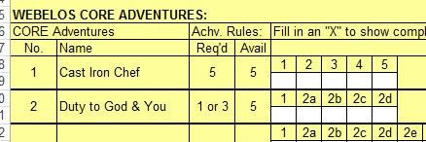
- Tracking Spreadsheets are posted on the USScouts Advancement webpage (http://usscouts.org/advance/cubscout/intro.asp). The spreadsheets were tested by a software developer who said they are so good he sees no reason to develop his own!!
- Utah National Parks Council, also, has Excel spreadsheets posted for all the new Adventure Plan requirements on their Akela's Council BlogSpot.
http://akelascouncil.blogspot.com/search/label/Tracking%20Sheet (The page starts with Arrow of Light scroll down for other ranks)
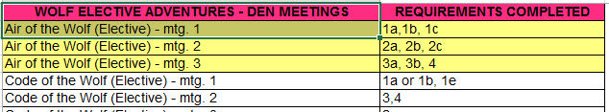
- A spreadsheet that correlates Meetings to Adventure requirements is available on the Utah National Parks' Akela's Council Blogspot at https://www.dropbox.com/s/yb8fweg7etnhqrt/WOLF%20BEAR%20WEBELOS%20REQUIREMENTS%20-%20MTGS.xlsx?dl=0 . It has all the Wolf, Bear, Webelos and AOL Adventure requirements.
These Advancement Spreadsheet workbooks are FREE for Scouters. But be COURTEOUS and observe the following -
PLEASE do not download the files from either site to email or send them digitally to others.
They are for your personal / pack use only. If you would like to share these files with others, please copy / send the link to them and send them to the site so they can print off their own. They would love everyone that wants a copy to get their own copy free. Both USScouts and Utah National Parks receive Ad money based on the number of people visiting the site. That ad money helps keep their websites open. Please help them (us) by encouraging others to visit to obtain files.

TRACKING BOYS’ PROGRESS
IN THE MODIFIED CUB SCOUT ADVENTURE PLAN
Judy and I have found several places on the web where there are aids to use to track boys’ progress in the modified Adventure Plan. Judy is placing a more detail in Baloo’s Bugle, Part IV – Den Meeting Helps.
- The Bobwhite Bather blog site (https://bobwhiteblather.com/mid-year-cub-scout-program-updates/ ) has a discussion of changes.
- Cubmaster Tom, responded providing links to documents he formatted to paste into the boys’ books for each modified Adventure. See example below:
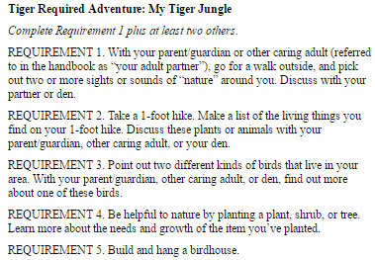
The complete Tiger document is at: https://docs.google.com/document/d/1ka_AkwxDkKgNjLrAOUHzbQQqCkruDCC8RyxtMFvrFO8/edit?usp=sharing. The links for the other ranks are in the comment on Bobwhite Blather.
- Bert Bender, Atlanta Area Council, replied,
Having finished several deep dives through the requirements changes, I’ve updated the page at http://www.southfultonscouting.com/node/3557 to not only show exactly what got changed and what didn’t change, but now also add comments intended to be a practical guide to whether you need to look at the new 11/30/16 language, and whether when those might be a useful alternative.
Comments after some Adventures encourage (sometimes plead) that dens avoid the “easy button” approach. Doing the June 1, 2015 handbook elements will often result in better outcomes and experience in Cub Scouting.
- Utah National Parks Council’s Akelas Council Blogspot has revised paper tracking sheets (http://akelascouncil.blogspot.com/) Thanks to Celeste Hunt for creating these.
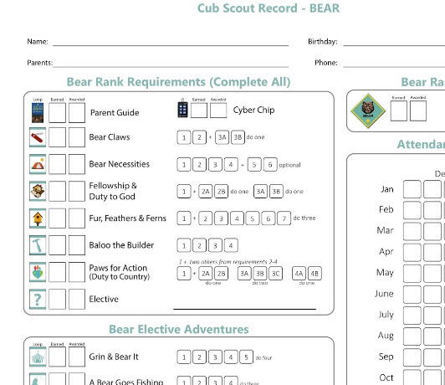
Celeste says, “Tracking, planning, and recognition are so important in Cub Scouts. This new tracking sheet helps you to be able to keep track of where each boy is at towards the Bear, Adventures, and Cyber Chip requirements. I print 2 copies of the tracker on cardstock for each boy. One for his book and one for my leader binder. I place it next to the trackers for the religious and other awards we are doing. I have tab for every boy with all his trackers. Complete information on each boy in one place. Not every boy is there every week. By doing this, I always know what each boy has done. If the parents ever have questions, I have a place to check, and I can always copy each tracking sheet to show them where their boy is.

CUB SCOUT
LEADER TRAINING

IN-PERSON TRAINING
Position-Specific In-Person Training Guides Available Now! The training guides for
- Den Leader (http://www.scouting.org/filestore/training/pdf/515-215.pdf ),
- Cubmaster/Assistant Cubmaster (http://www.scouting.org/filestore/training/pdf/511-503_WB.pdf ), and
- Pack Committee (http://www.scouting.org/filestore/training/pdf/511-504_WB.pdf )

Are available on Scouting University. You can access them at http://www.scouting.org/training/adult.aspx .

ON-LINE TRAINING
On-Line Training for all Cub Scout positions has been available since October 25, 2015
The online training for Den Leaders, Cubmasters, Committee Chairs and members, and Chartered Organization Representatives is totally updated with help from volunteers from around the country. The new training is divided into shorter, more targeted modules so leaders can get the training they need, in the order they want, any time they need it. It is organized around the learning needed prior to the first meeting, in the first 30 days, and to be position-specific trained. This training was developed to be implemented in conjunction with the BSA’s new learning management system. Keep an eye on
my. Scouting Tools (log in at https://My.Scouting.org) for more information.
Go to the BSA Volunteer Training Team Facebook page (Link above) and.
Then you automatically receive the latest news!!
If you are having difficulties with
the training or system call
BSA Member Care at 972-580-2489
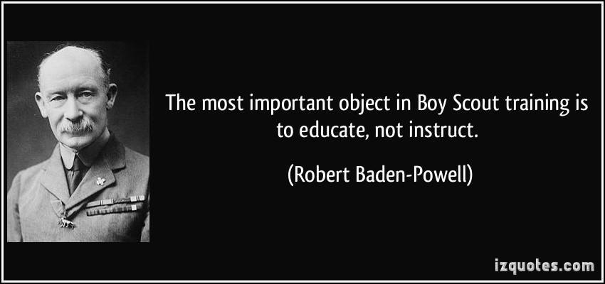
A Typical Learning Plan has several parts –
There is no need to complete more than one section at a time. Do what you have time to do.
Here you can see the three parts of the CM Course -
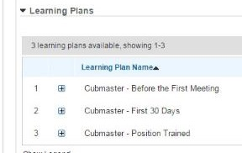

Each of these three parts is broken down into "bite sized" chunks:
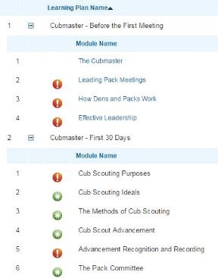
Go check it out and get your
people trained!!!

