FOCUS
Cub Scout Roundtable Leaders’ Guide
Try putting yourself in another's shoes! Cub Scouts will spend this month exploring the world and experiences of those who face challenges every day, challenges ranging from language and cultural differences to special physical or mental needs. By doing so, out Cub Scouts will become more aware of the diversity of the people on this earth. Cub Scouts can learn sign language or learn to sign the Cub Scout Promise or a song. You may choose to focus on one special challenge or need at each den meeting and bring various aids to underscore the themes, such as crutches, wheelchair, signs or posters printed in other languages, ear plugs or blindfolds. Cub Scouts may even want to create and run a disabilities awareness course at the pack meeting where boys can complete specific tasks at each station without the benefit of one or more senses.
CORE VALUES
Cub Scout Roundtable Leaders’ Guide
Some of the purposes of Cub Scouting developed through this month’s theme are:
- Character Development, Cub Scouts will learn to look beyond the physical differences of others.
- Spiritual Growth, Cub Scouts will learn that everyone is special to God.
- Personal Achievement, Cub Scouts will learn to set and achieve goals.
The core value highlighted this month is:
- Responsibility, Cub Scouts learn that it is our duty to care for others as well as ourselves.
Can you think of others??? Hint – look in your Cub Scout Program Helps. It lists different ones!! All the items on both lists are applicable!! You could probably list all twelve if you thought about it!!
COMMISSIONER’S CORNER
My employer is a big promoter of Walk America and The March of Dimes. We have earned many awards through the years for our support. In the late 80’s I was a very active Walker on one of our corporate teams. The local poster child was a boy whom I knew through Scouts. We saw him every summer at Day Camp being pushed around over the fields and through the woods by his friends. When you spoke with the boys in the den, they didn’t think anything about it. One of their friends was in a chair and needed to be pushed. They had been helping him for years in school, in Scouts, everywhere. He was completely accepted. That is the aim of this month’s theme to have our Scouts “Walk in their Shoes” and realize they are people, too. It is our job as adults to set the right example to do what is right. To not go too far overboard in trying to help but to not exclude either. And yes, the Cub Scout did become a Boy Scout and did earn his Eagle. And he did it in a troop with a Scoutmaster who was known for being very demanding of all his Scouts.
Busy, Busy Whirlwind of activity – This month was our Pow Wow and we had guests from other councils – Bucks County and Central NJ in particular. Two years ago we knew we had to so something to bring Pow Wow back to the extravaganza it should be. This year we doubled attendance from last year – 74 to 140 plus, and staff, also, was doubled. As chair, it was pretty neat seeing 200 plus dedicated Scouters all assembled for the fun and learning of Pow Wow!! Two weeks before that I was course director for Cub Scout Roundtable Commissioner and Staff Basic Training. And now we are into swing to get ready for a Philmont trek this summer. Sorry that Baloo is a little late this month.
Last month was a month of controversy, too. I learned a few things about writing for those you don’t know. I had a quote from Michael Gurian, a noted educator who had an article in Scouting in 1999. It apparently caused a lot of readers to think as I got a lot of comments. That’s a good thing. Then, last month, I reran some Engineering Badge material and didn’t proof it properly. The material was old and assumed all engineers were men. As a working engineer for 30 plus years, I know this isn’t true. One letter I received from a “Grumpy Complainer” has led to an E-mail friendship and two engineer badge projects shown in this issue. Thank you, Karen. This same “Grumpy Complainer,” was upset at which bridge I had named as the oldest modern suspension bridge. She thought it was the Brooklyn Bridge (which is far prettier than the Williamsburg). Anyway, a little research showed naming the oldest modern suspension bridge is a little like arguing which is better Texas or Texas A&M or Jets or Giants (If you live in NYC) or (well, you get the idea). I had named Williamsburg because I heard it on the radio that day when I was preparing Baloo. The point really is to get the boys although the facts may interest us adults, debating them does not help the boys. We need to use techniques that peak their curiosity.
The theme for May 2004 is “My Home State.” This presents a challenge for me. I don’t think everyone wants to learn all about New Jersey so Baloo will need some help. .Now New Jersey does have a website set up children to learn. It is http://www.state.nj.us/hangout_nj/ If you know of a similar website for your state, please send me the link. My goal is to have a list of 50 such websites in that issue of Baloo.
I still need Theme oriented Pow Wow Books. If your Pow Wow is set up by themes, I would be interested in trading you a CD of mine for one of yours. Write commissionerdave@comcast.net
Finally, I am sure you have all seen the little PayPal logo and the line to donate to US Scouts. We are in need of a new server. The current one has crashed several times in recent months. If everyone that downloads a copy of Baloo this month could authorize $5 (or $10) for US Scouts through PayPal, we would be well on our way to upgrading our service to you. Thank you.
PRAYERS AND POEMS FOR SCOUTERS
Pack Prayer
Circle Ten Council
Dear Lord we hope that Scouting and our different cultures and those values which we hold most dear - - language - respect - skills - abilities - health - wisdom - justice - will have played a role in equipping our boys to be tomorrow's leaders. We hope that today's children will be tomorrow's leaders, who will be able to usefully apply the knowledge and skills learned during their Scouting experience, and who will be able to appreciate the cultural experiences acquired through Cub Scout Pack ______. Amen
Cub Scout Prayer
Circle Ten Council
Tune: O Tannenbaum
Lord, in this evening hour I pray,
For strength to do my best each day.
Draw near to me that I may see,
The kind of Cub that I should be.
In serving other, let me see,
That I am only serving Thee.
Bless me, Oh Lord, in Thy great love,
That I may be a better Cub.
Roundtable Prayer
Cub Scout Roundtable Leaders’ Guide
Thank you, God, that you have made each of us unique. Help us to teach out Cub Scouts to celebrate their differences and to show respect for those who are different from them. Amen.
Resignation Letter
Author Unknown
Circle Ten Council
I am hereby officially tendering my resignation as an adult. I have decided I would like to accept the responsibilities of an 8 year old again.
I want to go to McDonald's and think that it's a four star restaurant.
I want to sail sticks across a fresh mud puddle and make ripples with rocks.
I want to think M&Ms are better than money because you can eat them.
I want to lie under a big oak tree and run a lemonade stand with my friends on a hot summer's day.
I want to return to a time when life was simple. When all you knew were colors, multiplication tables, and nursery rhymes, but that didn't bother you, because you didn't know what you didn't know and you didn't care. All you knew was to be happy because you were blissfully unaware of all the things that should make you worried or upset.
I want to think the world is fair. That everyone is honest and good.
I want to believe that anything is possible.
I want to be oblivious to the complexities of life and be overly excited by the little things again.
I want to live simple again. I don't want my day to consist of computer crashes, mountains of paperwork, depressing news, how to survive more days in the month than there is money in the bank, doctor bills, gossip, illness, and loss of loved ones. I want to believe in the power of smiles, hugs, a kind word, truth, justice, peace, dreams, the imagination, mankind, and making angels in the snow.
So.... here’s my checkbook and my car-keys, my credit card bills and my 401K statements. I am officially resigning from adulthood and if you want to discuss this further, you'll have to catch me first, cause, "Tag! You're it."

Beatitudes for Those Who Care
Sam Houston area Council
Blessed are you who take the time to listen to difficult speech for you help me know that, if I persevere, I can be understood.
Blessed are you who never bid me to "Hurry up," or take my tasks from me and do them for me. For I often need time rather than help.
Blessed are you who stand beside me as I enter new and untried ventures. For my failures will be outweighed by the times I surprise myself and you.
Blessed are you who understand that it is difficult for me to put my thoughts into words
Blessed are you who, with a smile, encourage me to try one more.
Blessed are you who never remind me that today I asked the same question twice.
Blessed are you who respect me and love me just as I am.

TRAINING TIPS
PIZZAZZ
Circle Ten Council
Anyone can hold a Den meeting, go through the crafts and activities and send the kids home. Anyone can hold a Pack meeting, give out the awards and advancement, and send the kid's home. BORING!
It’s the Pizzazz that keeps them coming back. It’s the songs, skits, stories, run-ons, and cheers that bring on the laughter, the sparkle in the eyes, the excitement. It’s the impressive ceremonies when the kids are recognized for achievement, that they will remember for years to come. Here are a few helpful hints -
Become a Song Leader
Santa Clara Council
Why songs? Remember the great times singing those songs in school or that song that rumbled the rafters at church? The feeling after these songs really lifted the spirits. Singing is fun! Songs can create enthusiasm or set a mood.
To be a successful song leader, all that is required are a few tips about how to lead songs. Voice? Don't worry about it! A voice like that of a crooner or an operatic star is not necessary. Never apologize. It's easy and it's fun to lead songs. Just follow these hints to be a song leader! A song leader must break the ice, particularly with a new group. Do things that will break down the reserve and get everyone into the group spirit. At the beginning of the first song period, announce that the group will do things together. Ask a Cub Scout to stand in front of the group and throw his neckerchief into the air and then catch it. Have him do this several times. Tell the group that they can yell as long as the neckerchief is in the air, but must stop instantly when the neckerchief is caught. Suggest such words as "yip-pee, wahoo, Akela, Wolf, Bear, Webelos" etc. Everyone should yell something.
Song Leading Tips
Begin with a song that everyone knows. Announce the name and the tune (if it isn't an original song).
Sing the first few bars, or sing the entire song. This will give the pitch and the proper tempo. If there is a piano and a pianist or a recording of the song, use them to teach the song.
Then start the song. How? Tell the group to begin singing after the first few words, then signal, such as a simple down motion with the hands is given.
What about hand motions? Start with simple up and down motions. Then use these motions to keep time with the rhythm and the syllables of the words as they are sung. The movement of the hands should indicate those notes that are to be prolonged or quickened. In the same way, raise or lower the hands to regulate the volume. Get into the proper swing and rhythm. Put some personality and pep into it. Put the entire body into song leading.

It has been my experience that this is the most difficult part of song leading to get someone to do – to move their arms in rhythm to the music. It is probably an inner fear from who knows where. Anyway, an older Scout Exec told me a secret once – give them a pair of special song leader’s gloves (Day-Glo orange, preferably) and most people lose their fear and move their arms. Commissioner Dave
Insist on quality, not volume. Expect everyone to sing.
Use songs that fit the occasion. Start with lively songs and end the program with something inspirational.
Songs should be taught in the weekly den meeting, using songbooks only until the words are learned. Everybody should be ready for some real singing at the monthly pack meeting.
If the first song doesn't measure up to expectations, "kid" the group along. Don't reprimand! For instance, try some competition. Put dens one and two against dens three and four... or boys against parents. Or moms against dads. Use a short song to get everyone into the proper spirit.
In small groups, someone can often begin a song and everyone joins in naturally without formal leadership.
Cheers and Applause's
Applause stunts are a great way to recognize a person or den in a pack meeting for some accomplishment they have performed. Be sure before you start that everyone knows and understands the applause stunt and how to do it. Applause stunts serve more than one purpose -- they not only provide recognition but also help liven up a meeting. Applause stunts need to be fun. Strive for quality of performance in your stunts.
Another important side effect of Applause stunts is they provide” wiggle time” for all the Scouts and siblings during the ceremonies so they sit still during the serious moments. It is a lot easier and a lot less stressful to lead a cheer and have fun than to be constantly reminding the Scouts to sit quietly. CD
Here’s a fun idea for you. Gather up all the cheers and applause's you can find, print them on card stock, cut each one out of the card stock page, and drop the whole bunch into a Cheer detergent box ~ empty of course. This is your “Cheer Box” for your Pack meetings. After skits or songs at the Pack Meetings, have a Scout come up, take a Cheer out of the Cheers Box, and lead it.
Den Yells
Why Den Yells??
- Gives every boy a chance to participate at the Pack Meetings
- Builds Den spirit and morale.
- Gives the boys a chance to let off steam in an organized fashion.
- If Den yells are worked out by the Dens, affords a chance for cooperative effort.

Sample Den Yells
Circle Ten Council
A good den yell can be a great morale booster. It can start competition between dens and get the pack meeting off to a great start. CD
North, South,
East or West
Den
Is the Best!
Show us some action!
Show us some spark!
All for Den
Stand up and bark.
United we stand
Divided we fall
Den_____is the best of all
We've done fine!
We've done well
Now for an ear splitting yell
Den____Den Den

Run Ons
Run-ons are a terrific way to add some pizzazz to a Pack meeting. For best results, arrange them ahead of time, without the Cubmaster, or whoever is running the Pack meeting, knowing about it. That way they look more spontaneous, and the Cubmaster can easily become part of the joke.

Here are a few classics:
A frantic figure runs on-stage.
a. It’s all around me! It’s all around me!!
b. What's all around you?
a. My belt!
A desperate figure runs on-stage.
a. They're after me! They're after me!
b. Who's after you?
a. The squirrels - they think I'm nuts!
A man (or lady) enters singing
a. Soap, Soap, Soap, …..
b. What are you doing?
a. Just singing a few bars!
Two people enter stage together (Or have one enter and ask the Cubmaster).
a. Have you seen my new pet pig?
b. No, what’s his name?
a. Ball point
b. Is that his real name?
a. No, it’s his pen name
For more hints on song leading and lots more stunts and applauses – Get a copy of “Creative Campfires” by Douglas Bowen. I own about five copies of this book because I am always loaning it out to other Scouters. Also, good are BSA’s “Group Meeting Sparklers,” and the Cub Scout Songbook. Recently I have seen quite a few books on cheers. Commissioner Dave
PACK ADMIN HELPS
Successful Pack Management
Cradle of Liberty Council
The following guidelines have been followed successfully by many packs. We suggest you use this as a checklist to determine where your pack operation can be improved.
- Enthusiastic parent participation.
- Good family attendance at pack meetings and activities.
- Regular monthly den leader/den trainer meetings.
- Pack administered by pack committee with work shared by many including all leaders.
- Pack secretary keep up to date records.
- Pack holds impressive graduation ceremonies.
- A pack treasurer handles financial affairs and keeps accurate records.
- Pack conducts at least one service project each year for community or the Chartered organization.
- Accurate advancement records are kept.
- Impressive ceremonies are used for induction of new families and for advancement.
- Cubmaster is executive officer and is responsible for program of the pack.
- Pack operates on the budget plan.
- Pack has an effective, year-round membership recruiting plan.
- Adult leaders are all trained.
- Adult leaders are properly uniformed.
- Pack has close working relationship with a Boy Scout troop.
- Adult leaders regularly attend monthly roundtables.
- Two deep leadership at all times.
- Badges are always presented at the pack meeting with parents involved.
Now that I have given you the list – you are probably saying that is great, but where can I go for ideas on how to do improve what we are doing? I have an answer - But first a short story – There is a Den Leader on my floor at work who told me one day he had to use his wife’s Girl scout books because BSA did not publish hardly anything. The next day he had TWO large travel bags full of books on his desk when he arrived at work. It took me three years to get him or his wife to a roundtable and when she got there she asked where have these been for the last three years?? Their pack is one of those that never shows up for training or anything district related. They leave their leaders out on a limb. So, since you are reading Baloo, I know you are not one of those but you might be surprised about how some other packs your friends at work or church belong to are operating and could gently nudge them with this information. Now, where can you go for ideas?? Commissioner Dave

Pack References
Cradle of Liberty Council
BSA Publications –
Cub Leader Book Den and Pack Ceremonies
Insignia Guide Guide to Safe Scouting
Group Meeting Sparklers CS Program Helps
Scouting Magazine Boy's Life Magazine
Cub Scout How To Book Cub Scout Handbooks
Webelos Leader Guide Cub Scout Songbook
Den Chief Handbook
Academics and Sports Program Guide
CS Roundtable Planning Guide
And I am sure there are more –
Besides books there are what BSA calls BIN items –
These are pamphlets and flyers on many aspects of the Scouting program. Some that come to mind are -
Leave No Trace Guidelines for Cub Scouts
Cub Scout Outdoors program
Selecting pack Leadership
Cub Scout Highlights, which gives you all the latest news and upcoming themes.
Then there are other sources -
Roundtable handouts
Internet – It is amazing what you can find using www.google.com I have found many songs and activities just by typing a line into Google. But be careful when using Internet sources, some are not carefully controlled.
And many, many other books –
The Golden Book Nature series
The Canyon Campfire Companions (I wonder when volume 3 will be issued??) and other Campfire Planning books
Storytelling books
Klutz Books – some that I have used very successfully – “The Rubber Chicken Book,” “Book of Magic,” “Book of Knots,” (There used to be a BSA version of this book), and their science books – “Bubble Gum Science,” “Magnetic Magic,” “Explorabook.”

There is just so much out there – enjoy but do not get overwhelmed!!

TIGERS
Let's Go Outdoors
Den Activity
Circle Ten Council
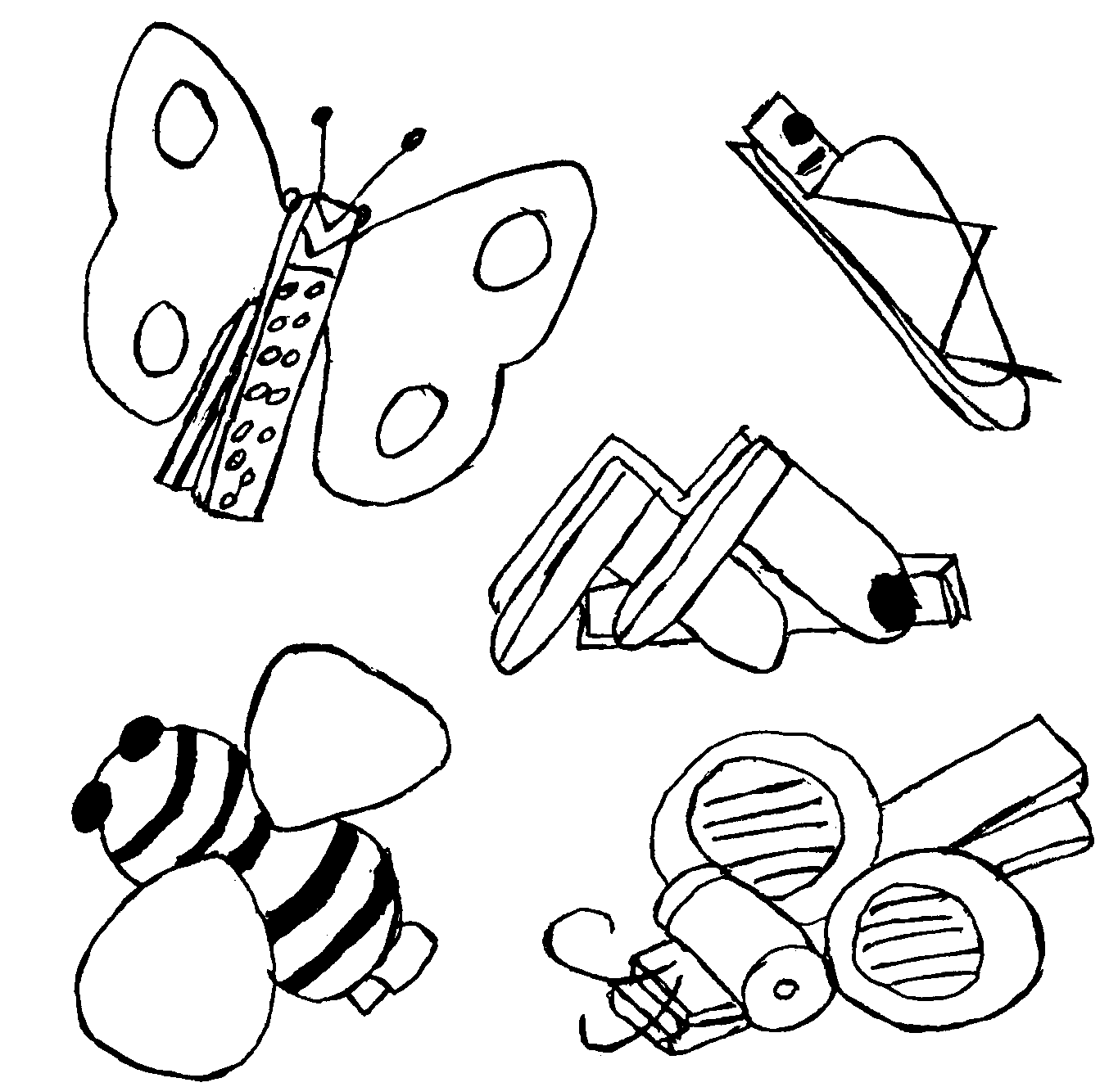
CLOTHESPIN BUGS
Use spring type clothespins. Paint them. Wings are made from construction paper, cut into symmetrical shapes. Slip wings into clothespins jaws and glue. Straight pins with colored round heads can be used for antennae. Bumblebee uses a 1 ½” Styrofoam ball or ping-pong ball cut in half and glued to top of clothespin. Pom poms can be used for eyes, paper clips can be used for legs, etc. OPTIONAL: Glue ½” magnetic strip to back of clothespin and make into a refrigerator magnet for mom for Mother’s Day.

Tiger Games
Circle Ten Council
SCORPION’S STING
A tag game in which “it” is the scorpion and walks on his hands and one foot. “It” has to keep the other foot in the air. This is the stinger and “it” tries to tag the other players with his stinger.
BUG TUG
Make 2 lines on the ground about 10 feet a part; the two opponents stand back to back between the lines. Both bend forward, reach between their legs and grasp each other’s wrists, they then start pulling each other towards their line.
Go See It Outing
Go on a short guided hike at a local nature center.
Design and conduct a nature scavenger hunt. Show samples of the 3 - 5 items on the list
Visit your local water treatment plant. What makes the water safe to drink?
Visit a planetarium. Learn about those stars in the sky. Discuss the aerospace program and how close we are to living up there.
Go fishing. Release your fish when you are done.
If possible, visit a trash to energy plant.

Let's Go Outdoors
Family Activity
Circle Ten Council
Energy Savers Game
Enlarge and copy game onto white cardstock. Let boys color and play with their family. This game is for two players. Cut out the playing pieces. Then roll a dice to determine number of moves.
(Click on the game picture. Then copy it to another document. Then enlarge it to fill the page)
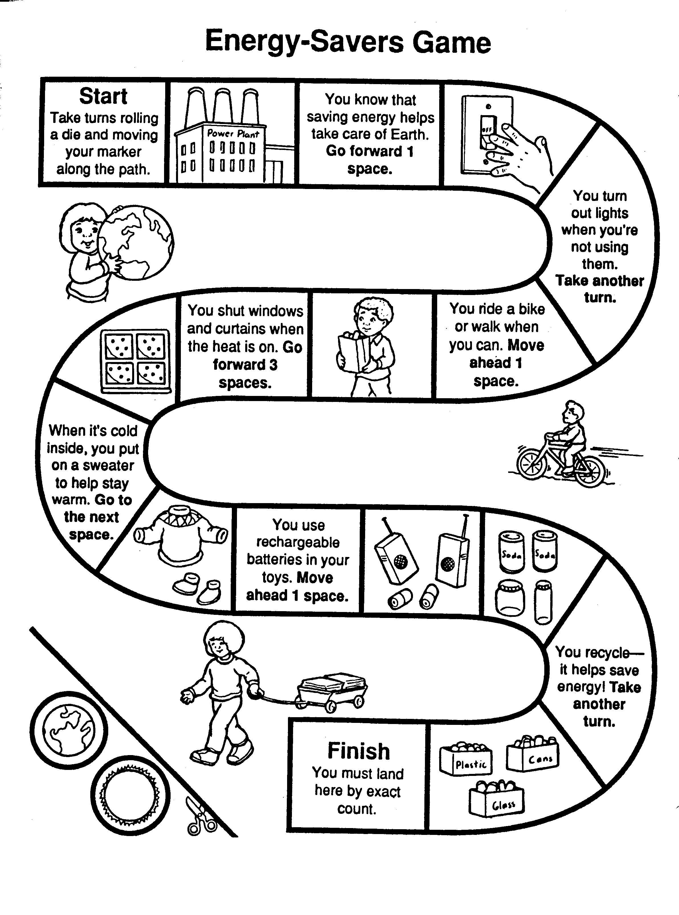
SPECIAL OPPORTUNITY
International Activity Patch
Circle Ten Council
Walk In My Shoes may, also, be applied to learning about another culture and how they do things. If you go that way then this patch may be just what you are looking for to inspire your Scouts. Please note that requirements are set by local councils and vary from council to council. When we had Canada for a theme a few years ago, I was unsuccessful in having my council tell me what we had to do. I now know who our Council’s International representative is and will be seeking him out to define requirements for this award. Commissioner Dave
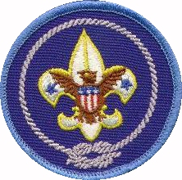
The International Activity Patch (No. 1440 is a 3-inch embroidered emblem worn as a temporary patch centered on the right pocket of the uniform shirt. Cub Scouts, Boy Scouts, Varsity Scouts, Venture Scouts and Scouters who participate in an international activity or program defined by local council can earn it.
Units have the opportunity to develop activities that meet requirements for the International Activity Patch! Council through a Unit’s District Executive must approve these activities in advance or there could be some disappointed Scouts.
Each local Council has the authority to determine requirements for the patch. There is no time restriction for earning the International activity patch.
Here are some examples of the criteria, which can be established for this patch:
General Requirements for Cub Scouts:
An international activity is an activity where boys learn about at least one other country in depth; including its customs, songs, games, and costumes. The activity should meet requirements for achievements and electives in the Cub Scout books. Also, the activity should help foster the "World Brotherhood" attitude of Scouting in both boys and leaders.
In a Pack:
An International activity that provides an in depth experience of one country. (E.g. Customs, flag, food, costumes music, games, etc.)
An International activity that provides an opportunity of learning about several countries in detail.
A Blue and Gold Banquet that centers on an International theme and uses ideas from one or more foreign countries. Ceremonies and other activities of event should have a flavor of "World Brotherhood".
A Scout-o-Rama booth where an International theme is developed. This booth could be centered on one country or several countries and should include flags and costumes. Games from other countries work well in this event.
In a Den or Family:
A four-week International activity that develops an experience of one country. For example: first week they learn about the flag and songs, second week they prepare food, third week they do a craft activity, and fourth week they play games.
A four week International activity that develops an experience where boys learn about several countries. Each week the boys could learn about a different country.
NOTE:
An individual may earn the patch if he/she participates in any scout meeting that is held in another country.
A family may earn the patch if they host Scouts or Scouters from another country in their home. At least one overnight stay would be necessary

PRE-OPENING
Language Differences
Circle Ten Council
How many words can you match up between the English that is spoken in America and the English that is spoken in the United Kingdom, Australia, New Zealand and South Africa? Draw a line to each match.

AMERICAN QUEENS
ENGLISH ENGLISH
Apartment Lorry
Automobile Telly
Baby crib Cold drink
Bangs (hair) Cling film
Bath robe Wireless
Blinkers, turn signals Bobby
Buddy (friend) Porridge
Candy Bar Removal van
Cookie Cheerio
Cross walk Chips
Dessert Fire Brigade
Diaper Frock
Dress Pudding
Emergency room Biscuit
Fire Department Mate
Flashlight Dressing gown
French Fries Cot
Garbage man Flat
Good bye Knackered
Mail Braces
Moving truck Trainers
Nurse Water Closet
Oatmeal Ice Lolly
Pacifier (Baby) Dummy
Policeman Sister
Popsicle Post
Radio Dustman
Restroom Torch
Saran Wrap Casualty
Sneakers Nappy
Soda Zebra Crossing
Suspenders Chocolate bar
TV Flickers
Tired Fringe
Truck Motorcar

ANSWERS:
1-Flat 2-Motor car 3-Cot
4-Fringe 5-Dressing gown 6-Flickers
7-Mate 8-Chocolate bar 9-Biscuit
10-Zebra crossing 11-Pudding 12-Nappy
13-Frock 14-Casualty 15-Fire brigade
16-Torch 17-Chips 18-Dustman
19-Cheerio 20-Post 21-Removal van
22-Sister 23-Porridge 24-Dummy
25-Bobby 26-Ice Lolly 27-Wireless
28-Water closet 29-Cling film 30-Trainers
31-Cold drink 32-Braces 33-Telly
34-Knackered 35-Lorry

OPENING CEREMONY
I CAN
Sam Houston Area Council
I CAN...Stand tall, in my heritage and believe fully in America!
I CAN…strive for the highest pinnacle - or any other spot I so choose - it is my decision, to be freely arrived at!
I CAN...worship at the church of my choice - read whatever books, articles, or newspapers 1 choose - select my own home, friends, job and associates!
I CAN...sleep peacefully - free from the fear of midnight persecution - secure in the protection of my rights!
I CAN...fail as well as succeed - this is true freedom!
I CAN...shape my own destiny - have my visions realized - achieve anything I really believe I can!
I CAN...fail and still be counted a man - gain strength and experience through mistakes - lose it all, and start over again as many times as my spirit is willing - until my dreams are reality!
I CAN...grow as large as my dominant aspirations - be as big as I am willing to pay the price to become!
I CAN ...own my own home - start a business - invest in my future - climb to the stars by constructing my own staircase!
I CAN...compete and receive in direct proportion to my efforts - thank others for assistance in my success - but look only to myself for my failures!
I CAN...raise my family in freedom - and freely change homes, jobs, friends, tastes - location, vocation, and avocation - but, most importantly - I can change myself!
I CAN...because I am an American!
I WILL USE
Sam Houston Area Council
- This is my country. I will use my eyes to see the beauty of this land.
- I will use my ears to hear its sounds.
- I will use my mind to think what I can do to make it more beautiful.
- I will use my hands to serve and care for it.
- And with my heart, I will honor it.

U Are Important
Circle Ten Council
Set Up – Six Scouts with signs lettered as indicated
We cannot spell: C_B SCO_TS without U
We cannot spell: YO_TH without U
We cannot spell: AD_LT without U
We cannot spell: S_CCESS without U
We cannot spell: F_N without U
We cannot spell: O_TDOORS without U
All: Clearly, Scouting needs U!

Save Our World, Share Our Culture
Circle Ten Council
Each Cub holds a poster with his letter on one aide and his part written on the other if needed. For a boy who may be to shy to speak or who's handicap may not allow him to speak. They can hold up the "&" poster and all the boys can say together "and. " If available boys could also be dressed in the traditional costumes of their cultures.
S Scouting brings all together.
A Adults help to teach us tolerance.
V Vision a world were we all care.
E Excitement and joy would fill the air.
& And
S Scouting makes us think about each other.
H Hoping our differences help us not hinder.
A Adults teach us to face challenges each day.
R Right and wrong we know the way.
E Each of us can make a difference.
ALL Peace can come to all of us, if we share our cultures and respect each other.
Leader Will everyone please stand for the Pledge of Allegiance.
PACK/DEN ACTIVITIES
Things To Discuss With The Boys
Circle Ten Council

Tips On Ways To Help The Handicapped -
Offer help when it looks as though it might be needed but do not insist on it if the individual refuses aid.
Don't "hover". Handicapped people do not wish to be treated as babies. Children react the same way. They want to be like you and me.
When a handicapped person falls, take it easy. Wait for them to give you a cue. If he can get up by himself, he may prefer doing that. If he needs a lift he will tell you which is the easiest way to get him back on his feet.
Crutches and wheelchairs are necessary accessories. Don't take them away from the handicapped person unless he indicates he would like to have them out of the way. Nothing is more irritating than to have your crutches grabbed quickly as soon as you hit the chair, leaving you stranded.
Vehicles are difficult even for the young and agile. The handicapped often need help here, again, let them tell you how to help. Those who do not need to be carried up the steps usually have methods of their own for making them. Do not pull an arm or push from behind unless such assistance has been requested. Precarious balance can be lost entirely with such tactics.
Relax. No matter what you do, if you are friendly and kind, the handicapped person is going to like you.
Have fun. Talk about the same things you would with any other person. A physical handicap does not necessarily limit your interests or dampen your sense of humor.
Be yourself. Don't be sticky sweet. Omit the piety.
Let common sense and consideration be your guide, and you will never err seriously. The disabled are just like you are, only with a physical difference that does not have to make them feel or think differently.
When in doubt ask - "May I help you?" "How can I help?"
Remember that it is a whole person that we are dealing with.
What You've Wanted To Know About
Helping Someone In A Wheelchair,
But Were Afraid to Ask!
Circle Ten Council

Provide a wheelchair and let the boys practice the correct way to handle a wheelchair by being the one who is physically challenged and non disabled. This will help to give them an understanding of what it is like to be wheelchair bound
In order to ensure the safety and the comfort of physically disabled people and non-physically disabled people when they are together, it is important to remember the following:
Find out the mechanics of the wheelchair.
Before you start pushing a person in a wheelchair, check for anything caught in the wheels - coats, blankets, scarves, hands, etc.
Check to see if the brake is off because a fast start with the brakes could jar the person right out of the wheelchair.
It is better to back down an incline or curb so the chair does not run away from you. To support it so it does not come down quickly, avoid pushing against the back of the chair because that is the person's back.
If you are going up one small step, tip the front wheels and move up. If there is more than one step go backwards.
If you must go up a flight of stairs with a person in a wheelchair, make sure you have adequate help; one person behind and two people on each side. Grab the chair where it is secure, where no parts will come off. For example, sometimes arms will pull off the chair in order to facilitate transferring.
To go through a swinging door: if the door swings in, push it open with your seat and pull the chair in backwards. If the door swings out, open the door hold and pull, push the wheelchair through.
Don't try and take the chair through loose sand, gravel, ice and snow. If it is necessary to go on rough ground, you may need to go slowly or quickly depending on conditions. Sometimes if you tip the chair on its rear wheels, it makes it easier.
When you are entering and exiting from an elevator, check to see that the elevator and floor are level - avoid bumps.
Be careful of elevator doors, some close very quickly.
You cannot usually turn a wheelchair in an elevator, so enter and exit the same way.
Wheelchair people don't like crowded elevators. They are smothered and claustrophobic. Wait for another.
While walking with a person in a wheelchair, be aware of the person and what he/she is interested in. If you are walking in a crowd, it is difficult to hear so keep in touch, lean over, make comments, and see if there is any place that the person would like to go.
Most people in wheelchairs don't like to go into the middle of a crowd. Skirt it. Remember the level you are at. It is full of noise, dust, dirt, kids, shopping bags, dogs, etc. This can be very claustrophobic, so be aware of the feeling.
If you want to talk to a person in a wheelchair, go somewhere where you can sit so that eye level is equal. Looking up is difficult and tiring. If it is impossible to sit down, stoop over, bend over or move a few steps away from the wheelchair, so that the back of the neck does not have to he held back for long periods of time.
Be aware of eye level for viewing. Just because you can see doesn't mean the person in a wheelchair can. Often bars, railings, block the vision. Bend down to their eye level and check out what they can see.
The person in a wheelchair has fears about whether the volunteer can handle the chair, so avoid dangerous positions; e.g. stairs, inclines and ramps. If you must stop at the top of the stairs, turn the chair sideways so that if the chair is bumped it won't go down, and put the brakes on.
If you are helping a person to stand up, give him a waiting time so their body can adjust to the new position. Don't let go until they say they are ready.
Check with the person on canes and crutches before you assist them. A too helpful arm can throw them off balance.
A person in a wheelchair is not an object sitting in a chair; it is a person. However, sometimes the person with a disability is the object of curiosity. Be aware of it. Don't panic yourself. Try to treat the situation as honestly as possible. Don't pretend the disability is not there.
When You Meet a Blind Person
Circle Ten Council
Treat a blind person as you would anyone else. He does the same things as you, but sometimes uses different techniques.
If you are not sure how much a blind person sees, ask. Not all blind people have total absence of sight. Most have some sight and make the best use of what vision remains.
Speak to a blind or visually impaired person in a normal tone of voice. Identify yourself and let him know you are addressing him by using his name or touching his arm. Be sure to indicate when you are leaving.
When walking with a visually impaired person, let him take your arm if he wishes. Pulling him by the hand is awkward and confusing.
Do not hesitate to use words like "see", "look", or "read". A blind person will use such words in his vocabulary as often as anyone else.
Describe your surroundings, whether it is the scenery from a moving car, an interesting incident on TV. or the layout of an unfamiliar room.
Give directions clearly and accurately. Pointing or using phrases such as "over there" will be of no assistance.
Never distract a dog guiding a blind person. The dog guide is responsible for the safety of its master and such interference could lead to unnecessary tragedy.
Avoid the impulse to rush to a blind person's aid. If you are not sure whether or not he needs your assistance, ask.
Remember, when you meet a blind person, common sense and courtesy can lead to an enjoyable friendship.
After going over these tips have a trust walk with have the boys blindfolded and the others leading based on what they have learned. Then have them switch places.
DISABILITIES AWARENESS DAY
Sam Houston Area Council
A disabilities awareness day will help boys understand that some people have special needs different from their own. Through activities, the boys will be able to see some of the challenges people with special needs might face.
BLINDFOLDED OBSTACLE COURSE
Set up a course along a string guideline with stations every 20 feet. Run the string guideline between posts, with the string 30 inches off the ground for the boys to hold on to as they go. (Make posts from PVC pipe set in No. 10 cans filled with plaster. Drill holes through the PVC pipe at 30 inches from the bottom of the can to run the string through the pipe). Remind the boys that they need to move slowly for safety reasons. Have adults at each station to direct the activities. Boys are blindfolded and move along the string from station to station.
- STATION #1: Boys must find a chair, sit on it, stand up, and then continue.
- STATION #2: Boys must pick up wads of paper on the ground and put them in a trashcan. Tell boys how many wads of paper there are so that they can try to find all of them.
- STATION #3: Boys peel an orange and eat it. Then they must place the peels in a trashcan.
- STATION #4: Boys pour a glass of water from a small pitcher and drink it.
WHEELCHAIR MANEUVERING
Borrow or rent a manually operated wheelchair. Set up a course that includes a left and right turn, a bump to negotiate over, and a transfer point for boys to move from the wheelchair to a bench and back without using their legs. Tie boys' legs together for added realism.
LIFE WITHOUT SOUND
Use heavy-duty headphones to cover the ears of each participant. Show each boy a written message that he must convey to another individual some distance away who also has his ears covered.
1 CAN'T USE THIS HAND
Each boy writes his name first right-handed and then left-handed. Have him put his dominant hand behind his back and make a peanut butter and jelly sandwich with only one hand.
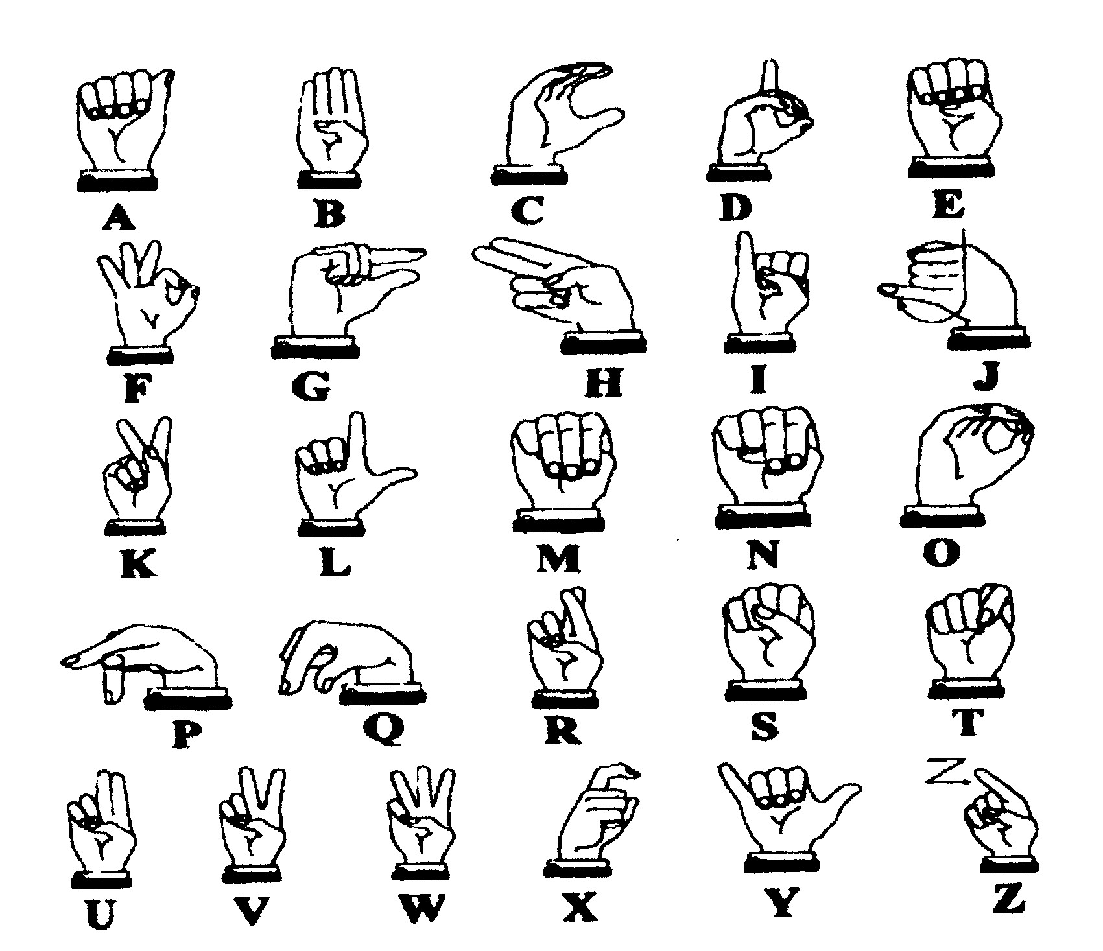
SIGN LANGUAGE
The manual Alphabet or Signing is a means of communication used by people who have a hearing impairment. See if you can read what the hands are saying in our message below.
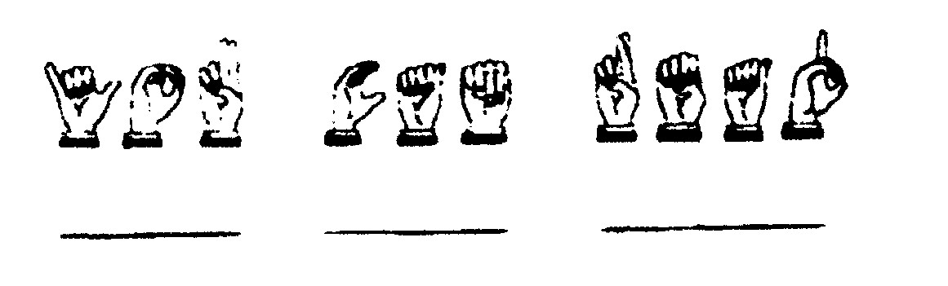
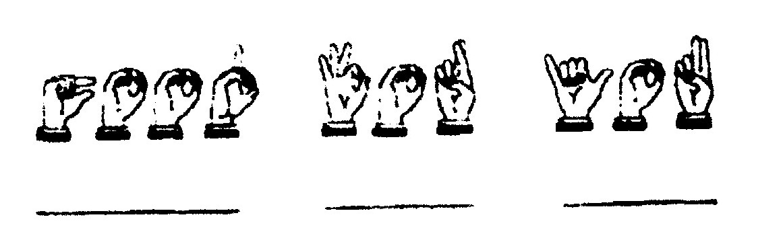

BRAILLE CARDS
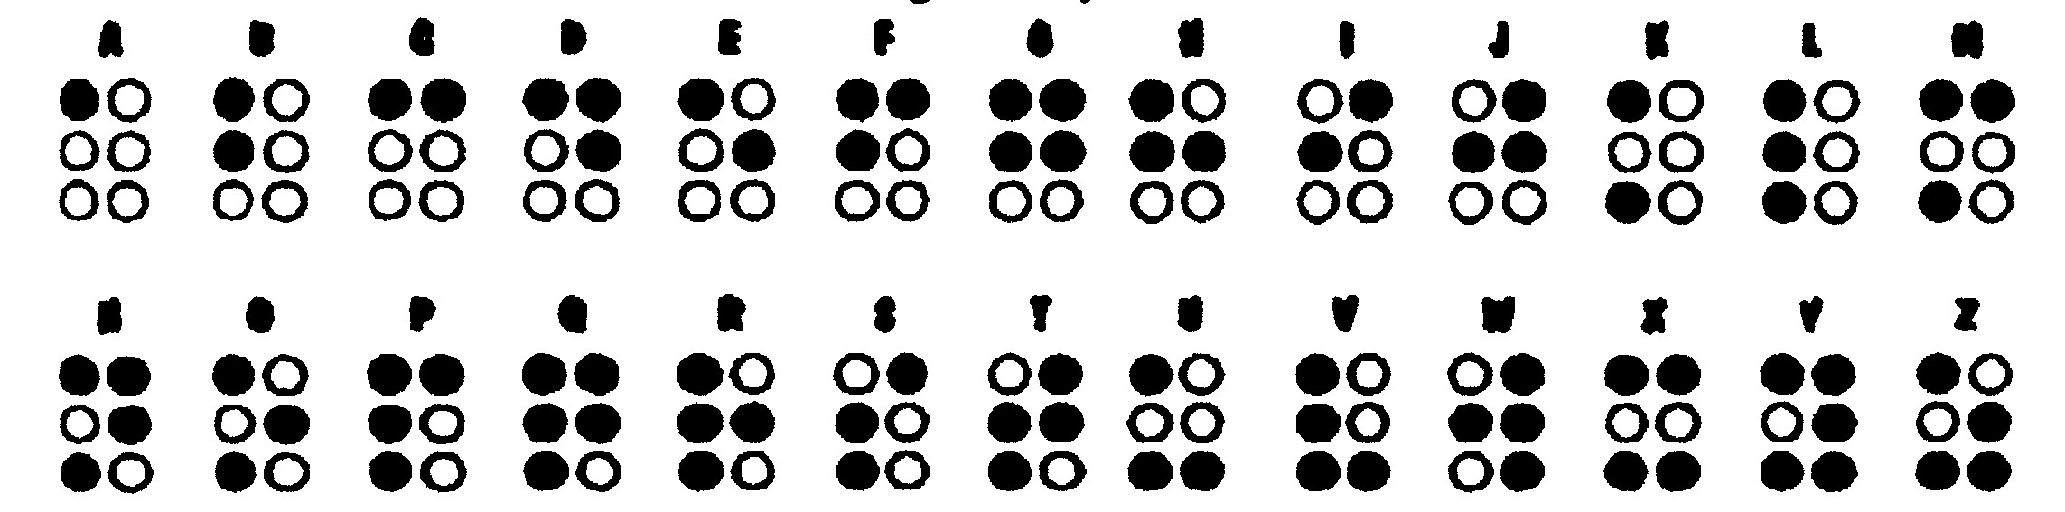
In the Braille alphabet, a pattern of raised dots represents each letter of the alphabet. A person can "read" through his fingertips by feeling the raised letters. Here is an alphabet written in Braille. The colored dots represent the raised dots. If you poke a pinpoint through the back of each of the colored dots, you can "raise" the letters. Try feeling the pattern with your fingers. Now try to write your own coded message in the Braille alphabet.
Have the boys glue seeds or lentil beans onto index cards. Write the letter on the back for
Reference. Use the cards to make messages. Try it blindfolded.
Popsicle Stick Plaques
Sam Houston Area Council
Write the Cub Scout Promise, Law of the Pack, or Motto on a Popsicle stick plaque and hang it on the wall or stand it on your desk. You may want to glue alphabet macaroni instead of writing with markers. Write or draw some other messages too.
Star Frame
Sam Houston Area Council
Materials: Thirteen Popsicle, sticks; cardboard; paint; _{f}ine-pointed permanent markers; star shapes (wood or craft foam); clear plastic sheet (like report cover or sheet protector). Photo of your hero, string, and glue.
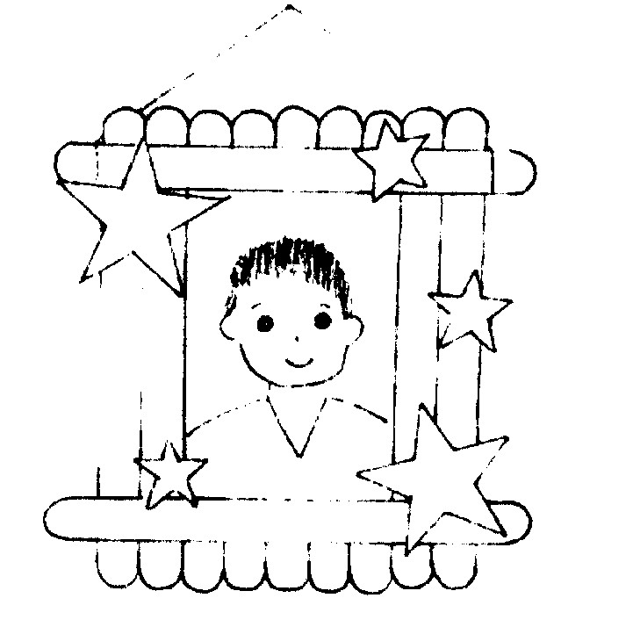
- Make a frame with 6 Popsicle sticks, two on each side, one on top and one on bottom.
- Cut cardboard to 2 1/2 x 3 1/2". Cover it with glue and lay the remaining 7 sticks side by side, touching each other. This is the backing.
- Paint the frame and backing (on the Popsicle stick side) any color you desire.
- If you are using wooden shapes, paint them.
- Draw design on the frame with markers. (First practice on paper and decide what you want to draw).
- Glue star shapes onto the frame.
- Put the photo of your hero behind the frame to see if it fits. If it's too big, trim the photo.
- Trace the photo on a clear plastic sheet. Cut the clear plastic. Tape it to the photo. This will protect the photo.
- Glue or tape the photo on the sides of the frame.
- Attach the backing.
- Tie string to the top horizontal Popsicle. Hang the frame.

AUDIENCE PARTICIPATION
THE MISSPELLED SMOKE SIGNALS
Sam Houston Area Council
LITTLE BEAR: "I'll get this right!"
DRUMS: (Hit thighs rhythmically)
SMOKE SIGNALS: "Pooff, Pooffl"
INDIAN: (War whoop)
MOTHER: "You can do it!"
LITTLE BEAR was a very hard working INDIAN boy. He studied hard to learn to play the DRUMS so he could send messages to his friends in other villages. But LITTLE BEAR had trouble with his lessons in SMOKE SIGNALS. After one particularly frustrating experience, LITTLE BEAR ran into his teepee and threw himself down on his buffalo skin bed. "What is the trouble, LITTLE BEAR," asked his MOTHER who was busy sewing new buckskins for his father. "MOTHER," why must INDIANS learn to do SMOKE SIGNALS?" LITTLE BEAR asked. "To communicate," she replied, “This is so the INDIANS from our tribe can talk to other villages."
"But we have the DRUMS," said LITTLE BEAR. "This may not always be enough," his MOTHER replied, "we also need the SMOKE SIGNALS." Now go on back and practice your SMOKE SIGNALS some more.
LITTLE BEAR left the teepee. He stopped by his DRUMS and sent a little message, but no one answered. So he made a little fire, just the right size to send SMOKE SIGNALS. He took out his blanket and when the fire was just right, he trapped the smoke and let out a nice little puff. But it just didn't look right. Then an old INDIAN said, "I see what you are doing wrong. You are not spelling it right." LITTLE BEAR looked surprised: he did not know you could misspell SMOKE SIGNALS. "Let me show you," said the old INDIAN. He took the blanket and held it a bit differently. As he released the SMOKE SIGNAL it floated softly into the sky. And it looked just right.
“I see," said LITTLE BEAR, "I was holding it wrong." He took the blanket and tried it himself. Once again a perfect SMOKE SIGNAL drifted into the afternoon sky. "Oh, thank you, thank you," he said turning to where the old INDIAN had stood. But the old INDIAN had disappeared. LITTLE BEAR ran to the teepee. "MOTHER," he called, "I can do it! Now I can communicate with DRUMS and SMOKE SIGNALS. MOTHER, who was the old INDIAN who help me?" But LITTLE BEAR'S MOTHER did not answer, she only smiled.

ADVANCEMENT CEREMONIES
Twelve New Things
Sam Houston Area Council
Arrangements: Have the large cardboard badges with stands for each. Start with all laying flat and .set each one up in turn. Alternate: Print and tape these to the back of the appropriate cards. Have a Cub of the appropriate rank bring a card up to the front of the audience, read the paragraph and then stand there until all cards have been read.
TIGER: My adult partner and I are having fun learning about the world around Cub Scouts and us. We enjoy the motto Search, Discover and Share. I am a Tiger.
(Present Tiger Awards)
BOBCAT: 1 have learned five new things. I can give the Cub Scout Promise and the Law of the Pack. I know what Webelos means. 1 promise to do my best. I am a Bobcat.
(Present Bobcat Awards)
WOLF: I have learned twelve new things. I grew physically and spiritually. I developed habits and attitudes of good citizenship. As I grew in mind and body, 1 also grew within my family. 1 learned to get along with others and gained a sense of personal achievement. It is fun being helpful and doing your best. I am a Wolf.
(Present Wolf Awards)
BEAR: I too have learned twelve new things. They required more skill and effort, but were fun and interesting. Many of the things I learned were preparing me to be a Boy Scout. The elective started giving me ideas about hobbies I might want to pursue in life. I am a Bear.
(Present Bear Awards)
WEBELOS: I am learning and understanding the requirements to become a Boy Scout. The Scout Oath and the Scout Law, and the parts of the Scout badge. I am learning about the outdoors through activities and the outdoor code. I have earned three activity pins. I am a Webelos.
(Present Webelos Awards)
SIGN ADVANCEMENT
Sam Houston Area Council
Personnel: Cubmaster, leader or guest who knows sign language.
Equipment: Display (felt hoard, poster, chalk board or overhead projector) of sign alphabet. Display in full view of audience. Signor is standing next to display for audience reference as Cubmaster speaks. Signor close captions)
CUBMASTER: "Speaking" is a form of communication most of us take for granted. If you can hear me speaking, then you probably have not had much reason to learn sign language. It is something very special to be able to speak, but make no sound, communicate with eyes and hands rather than voices and ears. It is indeed a talent, not just a trick for fun. For those who cannot hear; it is a way of life. In front of you is the sign language alphabet. Let's see if we can recognize our Scouts for their past month's achievements and learn a little of the silent language known as "Sign."
The first recipient comes, forward and is greeted by the Cubmaster. His award is announced vocally and then by Sign. Each award is presented in the same fashion.
CUBMASTER: 1 hope you have all learned just a little of the silent world of sign language. Maybe next time you see your fellow Scouts at a distance, you can talk to them without yelling or maybe next time you see two people speaking "Sign" you will understand a little better that special talent both share.

Cracker Jack
Circle Ten Council
Show the boys a box of cracker jacks. Inside you will find a prize. Draw each of the boys’ awards from the box. Let the parents Present the awards to their sons. After all the awards have been handed out say the following to the boys.
The label says that the prize is inside. I really think that the prize is on the outside. Why? You receive the prize in life when you go outside of your own box or comfort zone.
Sometimes going out of your way for others is the only way to really help others and feel accomplished in what you do.
This month we have learned how to help others and be aware of others differences. I hope that we will always think of others and how they would feel about the things we say or the actions we do. So thinking "This is the way we have always have done it" doesn't cut it any more. As Scouts, parents, and a community we can change the intolerance in the world today.
Acting Parts In Life
Circle Ten Council
CUBMASTER: Tonight we would like to congratulate boys in the pack on the advancements they have made over the last month. Would the following boys ___________please come forward with their parents to be presented with their award. After presenting the boys with their advancement say the following:
Our lives are made up of many different acts or parts. As young boys, you act the part of a Webelos, or a Cub. In school you act the part of a student. At home you act the part of a son. Whatever part you act, do what is right and do your best so you too someday may be a good parent and a good citizen just like all the adults around you today. Continue to advance and learn as you enjoy your Scouting program.
GAMES
KIM'S GAME IN THE DARK
Sam Houston Area Council
Out of sight of the immediate area, attach a line zigzagging between trees or stationary objects. Tie objects to the line along the way. Ten items is a good number. Blindfold each Cub Scout and lead him to the rope. Boys then proceed down the rope, holding on and remembering the objects they come across. No talking is allowed. When each boy reaches the end of the rope, the leader takes him out of sight of the course and removes his blindfold. Boys may work individually or as a group to see how many objects they can identify and remember.
Balloon Blowouts
Circle Ten Council
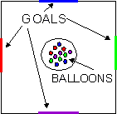
Blindfold half the players and give each a partner, who verbally and physically guides them, to simulate a blind person playing.
EQUIPMENT: Balloons of four different colors, 8 pylons, Badminton rackets.
OBJECTIVE: Starting with four balloons, put one balloon in each of the four goals
DESCRIPTION: Divide into four teams. The playing area is a large square. A goal for each team is made on each side of the square. At the center is a pile of balloons. The balloons of the color assigned to your team must go in each goal. Balloons are moved using the badminton rackets.
Wheelchair Buddy Relay
Circle Ten Council
EQUIPMENT: Wheelchairs, Anything to create obstacles
OBJECTIVE: To be the first team to complete the relay.
DESCRIPTION: The group is divided into two teams. Within each team, find a partner. One of the partners will be seated in wheelchair. The other will direct the wheel chair bound person through the maze without touching the obstacles. First team through wins.
Partner Shoe Scramble
Circle Ten Council
Have all the boys put their shoes in a pile 20 feet away from the starting line. Mix up the shoes so that no pairs are together. Divide into two teams.
On signal, the first boy:
Runs to the pile and picks out his shoes
He races back to the starting line carrying his shoes
Then the team helps him put his shoes back on.
Once he has put his shoes on he goes to the back of the line and the next boy goes.
The first team to all have their shoes back on is the winner.
Shoebox Relay
Circle Ten Council
Provide each relay team a pair of empty shoeboxes. On signal, one player from each team places his feet in the boxes and shuffles to the goal line and back. Make sure the adults participate too!
Walk In My Shoes Race
Circle Ten Council
Equipment: Really, really, really big gum boots or galoshes.
Description: Divide the boys into two teams. Have them take off their shoes and stand in two lines. Place the huge boots at the starting line and have the boys put on the "boots" race down to a turn-around point and return to give the boots to the next in line.
MUFFLED SOUNDS
Sam Houston Area Council
Divide the den into two teams and give each player two cotton balls to stuff into his ears. When all ears are covered, one leader steps outside the room where he/she cannot be seen and produces a series of sounds, - tinkling bell, sentence spoken in normal conversational tones, pan being scraped, barking dog, hammering on board, etc. When the leader
returns, each team huddles and writes a list of the sounds it heard. The sounds maybe tape-recorded in advance.

FUMBLE FINGERS
Sam Houston Area Council
Divide the den into two teams. Tell players to untie their shoelaces. Then tell them to put one hand behind their back (or tie one hand to their belt). On signal, each team tries to tie their shoelaces with each player using only one hand.
SHIPS IN THE FOG
Sam Houston Area Council
Divide the den into two teams and line them up relay fashion at one end of the room. For each team, set up a series of obstacles - chairs, tables, stools, etc. - between them and the other end of the room. Blindfold the first player on each team. On signal, the player starts for the other end of the room trying to avoid the obstacles. One of his teammates may call out directions ("go right," then "turn left," etc). When the player reaches the other end of the room, he takes off the blindfold and runs back to touch off the next player, who is already blindfolded. Continue until all team members have raced.
TIN CAN BOWLING
Sam Houston Area Council
Place empty 48-ounce juice cans against a wall - one per team - about 6 feet apart and with open end facing team. Teams are about 12 to 15 feet from cans take turns trying to bowl a rubber ball into their can without the ball bouncing out again. Let the boys bowl from wheelchairs, from a chair, or sitting or kneeling on the floor.

Body, Voice, Eyes
Baloo's Classics
This game is best played in a gym or some open area. Divide the Cubs into groups of three. Two of the boys are blindfolded, with the third being permitted to see. One of the blindfolded Cubs is the body; he can move but CAN NOT see or speak. The other blindfolded Cub is the voice, he can speak but can NOT see nor move. The third CUB is the eyes, he can see but CAN NOT speak or move.
For each team of Cubs, place a ball somewhere within the playing area. Also place one traffic cone somewhere in the playing area. Each team's goal is to guide their body to their team's ball, pick it up, and then touch it to the traffic cone. The voice and the eyes for each team will have to give the body directions to find the ball. This is much more difficult than it sounds as the eyes and voice need to be able to effectively communicate with each other in order to give directions to the body.

SONGS
Song of my Shoes
Tune: Battle Hymn of the Republic
Mt. Diablo Silverado Council
This song was first in Baloo a few years ago, It instantly became a favorite at our Roundtables. CD
My shoes have seen the glory of the growing of a Scout.
My shoes have been in water steppin' in and steppin' out.
My shoes have hiked through forest to the top of the mount;
My shoes are wearing out!
Chorus
Groovy, Radical, and Awesome (repeat 3x)
My shoes are wearing out!
My shoes have seen the bottom of the dirty fishy creek,
My shoes have been all covered with the gooey, muddy cake,
My shoes have seen the same old socks for seven days this week,
My shoes do really stink!
Chorus
Groovy, Radical, and Awesome (repeat 3x)
My shoes do really stink!
My shoes are torn and tattered climbing fences packed in rust,
My shoes are stained and spattered with some yucky insect guts,
My shoes are oozing slime and fill my Mom with disgust,
My shoes have bit the dust!
Chorus
Groovy, Radical, and Awesome (repeat 3x)
My shoes have bit the dust!
That's Why We Are In Cub Scouts
Circle Ten Council
Tune: Deep In The Heart Of Texas
The fun things in life,
Our family's delight!
(clap hands four times)
That's why we're in Cub Scouting.
We do our best,
To pass each test
(clap hands four times)
That's why we're in Cub Scouting.
Just me and my son,
Work, play and have fun,
(clap hands four times)
That's why we're in Cub Scouting.
We think our pack's great,
We keep it first-rate;
(clap hands four times)
That's why we're in Cub Scouting!
Bay Area Council Pow Wow, 1994
CATCH THE SCOUTING SPIRIT
Sam Houston Area Council
(Tune: Catch a Falling Star)
Catch the Scouting spirit
Put it in your heart
Never let it fade away.
Catch the Scouting spirit
Put it in your heart
Never let it fade away.
For someday soon you'll see
What's been accomplished
It will make you proud
And don't forget the fun
And fellowship there you'll
Get rewards beyond compare.
Catch the Scouting spirit
Put in it your heart
Never let it fade away.
GLAD I AM A MEMBER OF THE CUB SCOUTS
Sam Houston Area Council
(Tune: Oscar Meyer Weiner Song)
Oh. 1'm glad I am a member of the Cub Scouts.
T hat is something that I'm proud to be.
And, since I am a member of the Cub Scouts,
Something great will surely come to me.
Oh, 1 learn about the planet that I live on
And how I can help care for it each day.
The community around me 1'm exploring.
And, I find out how to live the Scouting way.
I try to serve my God and serve my country,
And help out other people everyday.
I’ll follow my Akela on my journeys.
And always give Goodwill along the way.
(Repeat first verse)
A SMILE IS QUITE A FUNNY THING
Sam Houston Area Council
(Tune: Auld Lang Syne)
A smile is quite a funny thing.
It wrinkles up your face,
And when it's gone you never find
It's secret hiding place.
But far more wonderful it is
To see what smiles can do,
You smile at one, he smiles at you
And soon one smile makes two.
He smiles at someone, since you smile,
And then that one smiles back,
And that one smiles until, in truth,
You fail in keeping track.
And since a smile can do great good
By cheering hearts of care,
Let's smile and not forget the fact
Those smiles go everywhere.
BE KIND TO YOUR - SCOUTING FRIENDS
Sam Houston Area Council
(Tune: Stars and Strips Forever)
Be kind to your -scouting friends.
That's a pledge from one Scouter to another.
Be kind to your leaders today,
`Cause by caring you follow Scouting's letter.
Scouting and friendship are grand,
And as we grow, the world will know,
We've made things better.
I AM SPECIAL
Circle Ten Council
Tune: Frere Jacques
I am special, I am special
Yes I am! Yes I Am!
I am very special
No one else is like me.
I am me! I am me!
CUB GRUB
All American Snack
Circle Ten Council
Amount to Measure Ingredient
3 cups thin pretzel sticks
4 cups wheat chex®
4 cups cheerios®
1 13 ounces salted peanuts
1 teaspoon garlic salt
1 teaspoon celery salt
½ teaspoon seasoned salt
2 tablespoons grated parmesan cheese
¼ cup melted butter
Preparation: In large mixing bowl or slow-cooking pot, mix together pretzels, cereals, and peanuts. Sprinkle with garlic salt, celery salt, seasoned salt, and cheese. Pour melted butter over all; toss until well mixed. Cover and cook in slow-cooking pot on low 3 to 4 hours. Uncover the last 30 to 40 minutes. Serve as appetizer or snack.
East Indian Snack
Circle Ten Council
Amount to Measure Ingredient
1 5 ounce can crisp Chinese noodles
1 6 1/4 ounces salted cashew nuts
2 cups rice chex®
1/8 cup toasted coconut
1 teaspoon curry powder
¼ teaspoon ground ginger
¼ cup melted butter
1 tablespoon soy sauce
Preparation: In mixing bowl or slow-cooking pot, mix together noodles, cashews, Rice Chex, and coconut. Sprinkle with curry and ginger. Add butter and soy sauce. Toss until well mixed. Cover and cook in slow-cooking pot on low 3 to 4 hours. Uncover the last 30 to 40 minutes. Serve as appetizer or snack.
Mexican Chex Mix
Circle Ten Council
Amount Measure Ingredient
1 bag (3.5 ounces) microwave popcorn
8 cups Corn Chex cereal
4 cups corn chips
2 cups bite-size cheese crackers
3 tablespoons margarine or butter, melted
1 teaspoon chili powder
1/3 cup grated Parmesan cheese
1/4 cup Bac O's bacon-flavored bits
Preparation:
Microwave popcorn as directed on bag.
Mix cereal, corn chips and crackers in 2-gallon resealable plastic food-storage bag.
Shake popcorn into cereal mixture, being careful not to add unpopped kernels.
Drizzle with margarine.
Shake to coat mixture.
Add remaining ingredients.
Shake gently to blend all ingredients.
STUNTS AND APPLAUSES
Run On/ Applause
Circle Ten Council
What do you give an elephant with big feet?
Plenty of room
What wears shoes but does not walk?
A footpath
How does a tennis player sneeze?
A-tennis-shoe! A-tennis-shoe!
What has one foot and four legs?
A bed
Why don't bears wear shoes?
So they can go BEAR-foot.
SKITS
We Are All Alike, We Are Cub Scouts
Circle Ten Council
Have the boy's list different ways that they have seen others being treated unfairly because of their physical challenge. Then have them give ways to correct the situation. Take three or four of those ideas and let the boys role play the situation for the entire pack. In this way they have the opportunity to share with the entire pack and help to develop empathy for the challenges experienced by others.
SECOND LANGUAGE
Sam Houston Area Council
Arrangement: One den member wears a sign reading "Mother Mouse. " Another has a sign reading "Cat. " All others wear signs reading "Mouse. "
MOTHER MOUSE: Come children, it's a beautiful day for a nice walk.
(Other mice respond. All making small talk while crossing the stage. Suddenly "Cat" jumps into the path in front of the mice)
MOTHER MOUSE: (in a loud voice) BOW WOW WOW! BOW WOW WOW!
(The cat screeches in fear and runs off)
MICE: Oh, Mother, we were so scared!
MOTHER MOUSE: Let that be a lesson to you, children. It pays to learn a second language.
Charades
Sam Houston Area Council
Characters: A whole den of Cubs
Have the Cub Scouts act out different objects that can be found in the outdoors. They can do animals such as a spider, snake, frog, etc. They can act out the sky, a stream, hot weather, etc. They can also act out objects such as a tree, grass, pretty flowers, stickers, etc. Have the audience try to guess what they are acting out. To confuse the audience you can mix up animals, weather and objects so they will not know what is coming next. If you choose what you are going to act out beforehand you can add some props to your skit.
LISTEN AT THE WALL
Sam Houston Area Council
(1st Cub walks along a wall just listening, listening. Others come along and see him)
2nd CUB: What do you hear?
1st CUB: (Dramatically) Listen!
(Others listen. But they don't seem to hear anything)
3rd CUB: 1 don't hear anything!
1st CUB: (More dramatically) Listen!
(Others listen)
4th CUB: (In a disgusted voice) I don't hear anything.
1st CUB: (With a faraway look) You know, it's been that way all day.
Making A Cub Scout
Circle Ten Council
CHARACTERS: Child, Two Leaders, Two Parents (or you can do it with five Cub Scouts – CD)
PROPS: You will need a large table for the child to lie on during the “operation.” The “doctor” can carry a large cardboard knife. Props to be “removed” are tacked to back of table, out of sight. Those to be “put in” can be placed nearby. (Props are listed where used.)
NARRATOR: We are about to instruct you in the method of making a Cub Scout. To complete this project, you will need one small eager boy, two interested parents, one patient Den Leader, and one courageous Cubmaster.
Each character enters as his name is spoken. Boy wears uniform under a large loose-fitting shirt and climbs up on the table. Others don surgical masks. As the narrator continues, the operation proceeds, with Cubmaster acting as doctor. Den Leader and parents hand him the things to be put in and take the things removed. When the boy is hidden under a sheet, he removes his shirt.
NARRATOR (continues):
Cover him with fun and good times
Hold up posters labeled “FUN” and “GOOD TIMES” and cover boy
We use laughing gas for anesthetic.
Use a tire pump labeled “Laughing Gas.”
Take out hate and put in Love.
Hate - lump of paper, so labeled. Love - big paper heart, labeled
Take out selfishness, put in cooperation.
Sign “I,” sign “WE
Take out idle hands, put in busy fingers.
Idle - empty rubber gloves.
Busy - glove full of flour.
Take out laziness, put in ambition.
Laziness - rag;
Ambition - blown up balloon.
After this pleasant operation, we have a “CUB SCOUT.”
Remove the sheet. Boy, in uniform, stands up and gives the Cub Scout sign.
CLOSING CEREMONIES
I'm A Boy
Circle Ten Council
- Everyone cannot be brilliant, everyone cannot be smart.
- I may not be a genius, but I can build a neat go-cart.
- I can dam a stream with boulders,
- I can climb trees to the top.
- I can run for blocks and blocks and never even stop.
- I can't solve a chemical equation or lecture on Newton's rule, but I can make a peanut butter sandwich that will really make you drool.
- I don't know much about flowers, but smelling them is a joy.
- I don't think I'm a failure.
All I'm a genius at being a boy.
SLOGAN CLOSING CEREMONY
Sam Houston Area Council
Arrangement: Cub Scouts hold up cards with slogans as they ready their lines.
- DO YOUR BEST in everything you do life's way.
- ALWAYS BE FRIENDLY to brighten others' day.
- GIVE AWAY YOUR SMILES for it is rewarding indeed.
- BE PREPARED to help others in their daily need.
- BE HONEST AND SINCERE toward others you meet.
- BE LOYAL AND TRUE, a most commendable feat.
- COUNT YOUR BLESSINGS, being thankful for each day, for life's wonderful opportunities that come your way.
- Good night to each and every one of you. May these thoughts stay with you, your whole life through.
THE MANY SIDES OF A CUB SCOUT
Sam Houston Area Council
DEN LEADER: We will try to show you the many sides to the little boys we so proudly call son, but remember, these are all one boy.
- 1'm the one all-full of dirt, so very sure that soap and water will hurt.
- I'm the one who lives in his dreams, always off on a cloud, at least that's how it seems.
- 1'm the show-off and athlete. I just can't stand to get best.
- I'm the pouter, sensitive and shy, but I try to make people think 1'm a real tough guy.
- I'm the angel, neat and obedient. Mom wouldn't trade a day with me for all the money in the mint.
- I'm the Cub Scout, the one we boys like best. That's cause I'm different from all the rest.
- So everyone please join us as we say the Promise we try to live by every day.
DEN LEADER: They're all these boys and even more. There are lots of surprises for you in store. So love the, protect them, and try to understand. It's a very hard job growing up to be a man!

Cubmaster’s Minutes
Walk In Baden-Powell’s Shoes
Circle Ten Council
As the nineteenth century ended, men on both sides of the Atlantic worried about boys, especially poor immigrant boys in the teeming cities, who seemed destined for delinquency or poverty. Ernest Thompson Seton, a Canadian naturalist, wildlife painter, and children's author, summed up these anxieties: "It is the exception when we see a boy respectful of his superiors and obedient to his parents, handy with tools and capable of taking care of himself, under all circumstances whose life is absolutely governed by the safe old moral standards." Seton looked around for "robust, manly, self-reliant boyhood," and found instead "a lot of flat-chested cigarette smokers, with shaky nerves and a doubtful vitality"—just as his British contemporaries found an alarming number of young men unfit for the draft.
These concerned men responded by creating a host of character-building organizations, the most powerful of which was the Boy Scouts. The organization grew out of Seton's newly created boys' group, the Woodcraft Indians, and the insights of an ebullient British war hero, Robert Baden-Powell. Lord Baden-Powell had returned to England from the Boer War in 1903 to find children devouring a soldiers' scouting manual he had written. Teachers urged him to revise the manual for boys, and Baden-Powell, inspired by Seton's Woodcraft Indians handbook, seized the challenge.
He envisioned a new organization that would draw on wartime scouting lore and ancient codes of chivalry to teach boys the Victorian virtues. King Arthur's Round Table, Baden-Powell understood, resonated in boys' souls, for it symbolized the marriage of strength and goodness, by contrast with today's "gangsta" culture, which defines manliness as violently predatory. The aim of this new organization, Baden-Powell wrote in 1906, "is to develop among boys a power of sympathizing with others, and a spirit of self-sacrifice and patriotism."
Baden-Powell believed that Scouting's core virtues of selflessness and the cheerful performance of duty were as valid for the poor as for the upper and middle classes. "Everything on two legs that calls itself a boy has God in him," he insisted, "although he may—through the artificial environment of modern civilization—be the most arrant little thief, liar, and filth-monger . Our job is to give him a chance." Respect for others, without class distinctions, was a scout's universal duty.
We are taught tolerance for others, respect for our difference, compassion for those less fortunate. We all walk in the same shoes. Those of a Scout and a Scouter. May we always remember to treat each other with goodwill. Goodnight.

WEBELOS
Athlete –
Physical Skills Group
Being Healthy
By Barb Stephens
Circle Ten Council
Good Health Habits Quiz
Circle the correct answer(s).
- Bathe/shower (everyday OR once per week) and especially after exercise.
- Wash your hair (1/month OR 2+ times/week).
- Wash hands (before eating OR after using the restroom) and when they're dirty.
- Eat right - (3 OR 4 OR 6) regular meals each day at regular times!
- Eat (just some OR a variety of) food from each of the 4 food groups.
- The average 10 year old should get at least (6 OR 9 OR 12) hours of sleep each night.
ANSWERS: 1. Everyday, 2. 2+ times, before eating and after using restroom, 3. 3 meals, 4. Variety, 9 hours

Clean & Strong
Circle Ten Council
Circle T for True or F for False.
T F | Our bodies "repair" themselves while we sleep.
T F | Clean clothes aren't necessary after a bath or shower - they are just in the morning.
T F | Use proper lighting for all activities including reading, TV viewing, and playing.
T F | Fitness is never just physical - it involves  both the mind and body together.
T F | Stand tall, and walk tall with shoulders  back and stomach in.
T F | It's OK to share drinking cups,  washcloths and towels.
T F | Different foods provide different nutrients,  and no one food can sustain us.
T F | Rushing meals or skipping meals can be harmful  to your body.
ANSWER: 1 - T, 2 - F, 3 - T, 4 - T, 5 - T, 6 - F, 7 - T, 8 - T

Volleyball Serve it Underhand
Circle Ten Council
The underhand serve is the easiest to master for volleyball. In a game you must put the ball into play from a 10 foot wide area behind the end line. Always practice with a line in front of you so you will learn not to cross it until you have released the ball.
For the underhand serve (if right handed), stands with your left foot about 13” in front of the right foot. Bend both knees a little, lift the ball in both hands out in front of your chest, to your right side. Hold the ball in the left hand and start to bring the right hand down. Close the finger of the right hand as if you were making a loose fist.
Keep your eyes on the ball. Bring right hand down, back, and up behind you. Step a quarter step forward on your left foot. Swing your right hand at ball. Just before you hit it, toss the ball up a little and drop your left hand away from it. (The rules say – release your left hand from the ball before hitting it.) Strike ball solidly with the palm side of your fist and follow through. (Of left handed, reverse from right to left.)
Once you master the serve, try using the heel of hand instead of fist. Close hand instead of your fist. Close your hand half-way so fingertips come just below the base of the fingers with thumb-tip beside the first joint of forefingers
The Athlete
Circle Ten Council
Tune: My Bonnie
They gave me a suit and a number
And sent me out on the field
They gave me a ball called the pigskin,
And shoes with some cleats, toe and heel
CHORUS
Muscles, Cramps, wracking my body with pain, with pain
I stand, wondering, if ever I’ll do this again!
Next time they gave me a racquet,
They sent me out on the court
Funny the things you encounter,
While trying to learn a new sport.
(CHORUS)
The ordeal was finally over,
At least, that’s what I thought,
When they shoved me the soccer equipment
I fainted dead on the spot!
(CHORUS)

Athlete Den Activities
Circle Ten Council
TOWEL PICKUP - Take off your shoes and socks. Pick up a towel with your toes.
PAPER PICKUP - Pick up a piece of paper from the floor without bending your knees
BOOK CARRY - Walk across the room with a book balanced on your head.
SKIN THE CAT - Clasp your hands in front of you. Try to step through the ring formed by your hands and finish standing upright with them clasped behind you. Return to your original position by stepping backwards through the ring.
TOE WRESTLING - Two wrestlers sit on the floor, facing each other with arms clasped around knees. When they are in this position, place a stick over each person’s elbows and under his bent knees. Their feet should be flat on the ground with the toes of one touching the toes of his opponent. The object is for one wrestler to get his toes under the toes of his opponent and roll him over backwards. If either wrestler breaks the handclasp above his knees, the other wins the contest.
SIDEWALK TENNIS - Played with a tennis ball on two squares of sidewalk or patch of level ground marked off in similar size. Ball is batted with the hands. Use regular tennis rules, except that there is no serving court
SUGGESTIONS FOR COMPLETING ATHLETE ACTIVITY BADGE
Requirement #1
Can be combined with the Fitness Activity Badge and the Sportsman Activity Badge. The subjects of being physically healthy, balanced diets, and bad effects of drugs, alcohol, and tobacco can be combined and signed off all together.
Requirement #2
Takes the longest amount of time to complete and sign off of all the Physical Skills Group. To earn the Physical Fitness Sports Pin, the boy needs to earn 60 points in a 90 day period. They must exercise or be involved in some activity for 30 minutes to earn one point. The boy can earn a maximum of five points in a day. Just remember 30 minutes for one point, 60 points total in a 90 day period.
You can pass off requirements 3 through 9 as part of this pin, use requirement 3 and 4 of the Sportsman badge to meet the requirement.
Engineer –
Technology Group
Model Monkey Bridge
Circle Ten Council
Based on a foot bridge found in the high mountains of India, the monkey bridge uses one thick rope to walk on and two others as hand ropes.
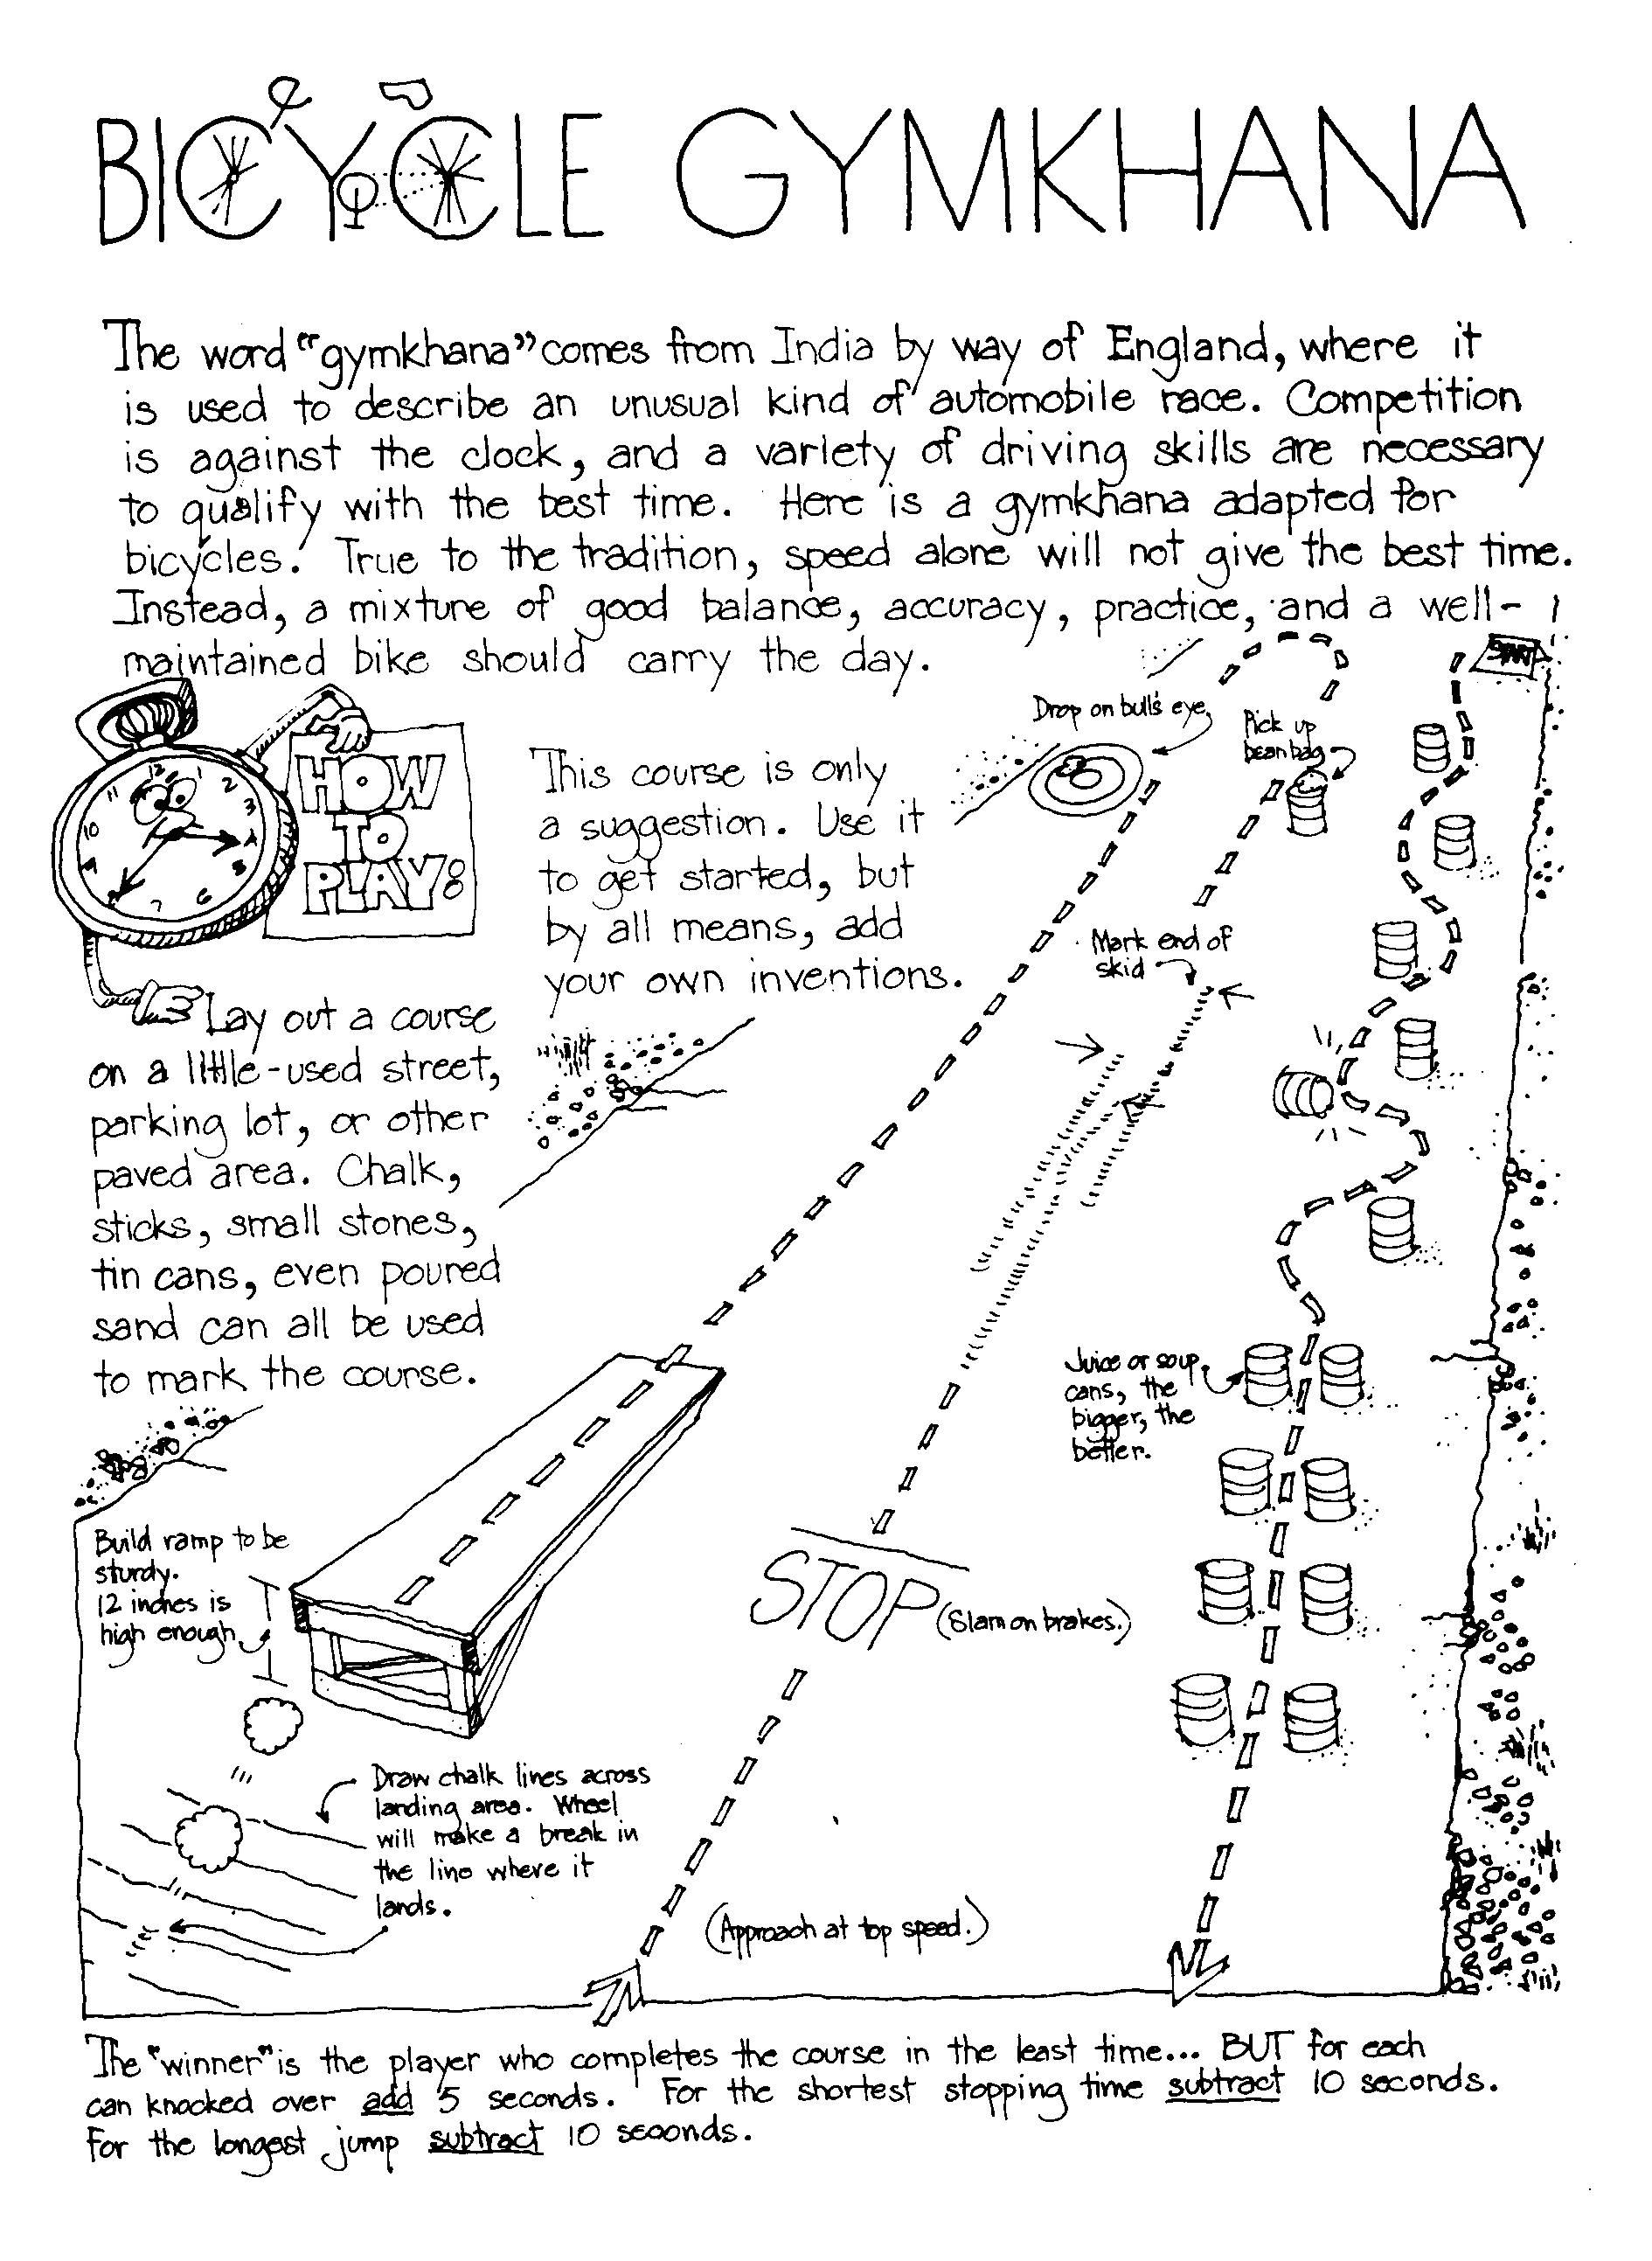
The same design and knots used in the full-sized version are used in this model. The monkey bridge is often built in Scout camp as part of the Pioneering merit badge.
You'll need some hemp cord, some pieces of strong string, four 1/4" dowels 10" long, and two 1/4" dowels 4" long. A piece of scrap lumber at least 30" long and 4" wide makes a good base.
Make the shear lashings first, about 4" from the top of the shear legs. Tie loosely so the legs can open. Add the crosspieces, fastened with square lashings about 2" from the bottom. All lashings begin and end with a clove hitch.
Stretch the cord between the supports and tack the ends in place. Add the hand ropes and fasten them to the same anchor. Paint or stain the wood to give the bridge a rustic look.
Speakers in the following Fields of Engineering
Circle Ten Council
You may be lucky enough to have some Moms and Dads of your Scouts who are Engineers. Invite them to speak about what they do. Perhaps, they could even take the den to see where they work and what they do. Or maybe there is a big local plant near you that has Engineers who would be willing to volunteer some time to show your den around. I live near a large Dupont facility and have met some of their staff and toured their Waste Treatment facility.
Here are some ideas about what engineers do -
Aeronautical Engineering - deals with the whole field of design, manufacturing, maintenance, testing, and the use of aircraft.
Industrial or Management Engineering - pertains to the efficient use of machinery, labor, and raw materials in industrial production.
Chemical Engineering - concern with the design, construction, and management of factories in which essential processes consist of chemical reactions.
Civil Engineering - is one of the broadest of the engineering fields dealing with the creation improvement and protection of the communal environment. Buildings, roads, bridges, airports and other constructions are just a few of the areas civil engineers impact.
Electrical Engineering - involves the use of electrical power, electrical machinery and communication, information, and control systems.
Geological and Mining Engineering - includes activities related to the discovery and processing of minerals.
Mechanical Engineering - speaks to the design and operation of all types of machinery.
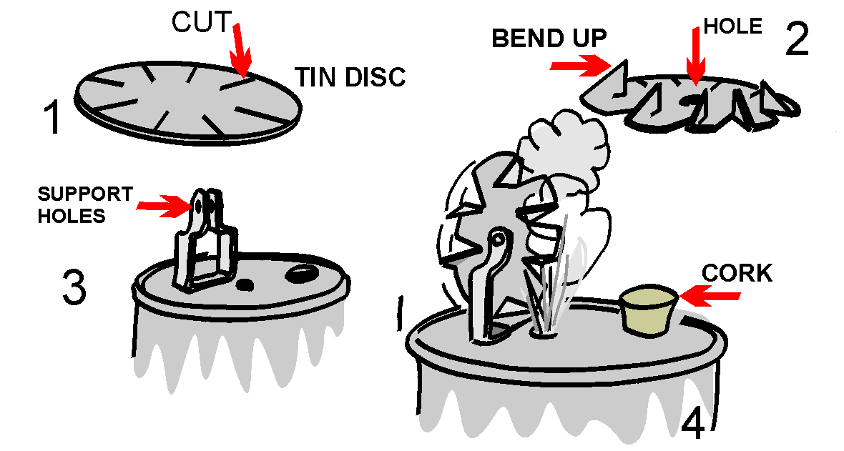
Safety Engineering - is concerned with the prevention of accidents.
Make A Steam Engine
Circle Ten Council
A Webelos Scout may get a graphic demonstration of the power of steam by building the simple steam turbine shown in this illustration. Materials needed are a tin can, a lid from a second tin can, a pair of tin snips, a sheet metal screw, a cork, a power drill, an extra piece of tin to make the support for the turbine wheel, a finishing nail, and a source of heat.
Assemble to look like the illustration.
Blueprint Symbols.
Circle Ten Council
Can be used in floor plans drawn for requirement 8 of the Webelos Engineer activity badge. Make a game of learning them by putting each one on a 3" x 5" card and using them as flash cards.

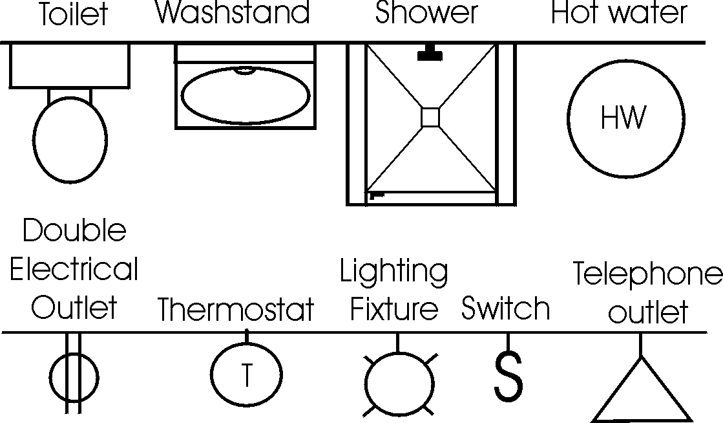
Paper Bridge Competition
Karen, Webelos Leader (and an engineer),
Pack 23, Suffern, NY
Materials:
2 rolls masking tape
2 stacks of newspaper (a good size Sunday paper will do)
4 chairs with backs
2 identical sets of books or blocks (for weight)
Divide the Den into two groups. Let an adult help each group if available. Give each group a roll of masking tape and a stack of newspapers. Set up the chairs in pairs about 4ft apart. Each group must make a bridge using the materials provided that spans from one chair to the other.
After a set amount of time (15 to 20 min), see how much weight each bridge can support without failing. The bridges may be a truss, suspension, or cable stayed bridge, but must span from one chair to the other without touching the ground in between.
Gumdrop Truss Bridge
Karen, Webelos Leader (and an engineer),
Pack 23, Suffern, NY

Side View Of Truss Bridge

End View Of Truss Bridge
Gumdrop
Toothpick

This is a fun project that illustrates the strength and rigidity of a truss bridge. You will need a box of round toothpicks and a couple of bags of inexpensive gumdrops (or spice drops). Scouts can work as pairs or individuals on this project. Each scout should start by assembling a single triangular panel using 3 gumdrops and 3 toothpicks. (It is important to notice the strength of the triangular shape.) From there they can extend the side panel of the truss by adding more toothpicks and gumdrops.
Once the single truss is about 4 panels long, the scouts can begin the second side truss. The two sides are then connected together by adding toothpicks between matching gumdrop node points. This short bridge span, which is about 8 inches long, will be very stiff and strong. Spanning the bridge between two stacks of books, or the like can test the strength. A cup full of pennies can be used to load the truss. After testing the strength, the scouts can extend the bridge length by adding more pieces. A second level of truss may be added for really long spans (2 ft or more). The scouts will enjoy testing out various different bridge configurations.
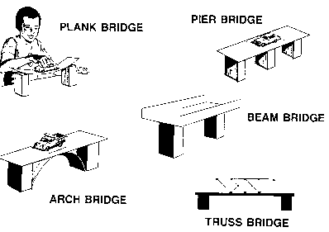
The Right "Man" (or Woman) for the Job!
Annawon, Cape Cod and Islands, and
Old Colony Council Pow Wow Book
Use a word from this list to fill in the correct answer.
Aeronautics Electrical
Chemical Physical
Computer Industrial
City Mechanical
Agricultural Civill
- An engineer who designs plants to make water safe to drink - __________.
- An engineer who designs machines in a factory - _________________.
- An engineer who tests new processes and checks old ones in a chemical plant - ________________.
- An engineer who plans new circuits and directs workers in an electrical plant - ________________.
- An engineer who designs and tests new space techniques - ________________.
- An engineer who designs and tests new techniques for new equipment for industry - ___________________.
- An engineer who designs and tests equipment for farmers and ranchers - __________________.
Bridges & Machines
Annawon, Cape Cod and Islands, and
Old Colony Council Pow Wow Book
Use a word from this list to fill in the correct answer.
Catapult Arch Bridge
Pulleys Suspension Bridge
Beam Bridge Levers
Plank Bridge Block & Tackle
Truss Bridge Pier Bridge

- A flat surface over two supports -
- A flat surface over three or more supports -
- A flat surface over an arched support -
- A flat surface with turned up edges -
- A bridge with sides made up of a series of triangles -
- A bridge that appears to hang from strong strung cables
- A pulley(s) and a rope or cable -
- A slingshot or other device used to project something -
Rubber Bands & Engineering
Rubber Band Strength
Annawon, Cape Cod and Islands, and
Old Colony Council Pow Wow Book
One of the requirements for engineer is to make a catapult. This requires the use of a rubber band or two, or a piece of tire inner tube. The rubber band is "elastic" and it stretches, but then returns to it's original shape. Before using materials in building, engineers must know the characteristics. Does it expand or contract? Is it weak or strong? Does it burn or not?
You can try an experiment to learn more of the characteristics of rubber bands and other elastic material. Get a collection of different sized rubber bands. Measure them for length, width and thickness (if you can). Make a chart that shows this information and mark each rubber band clearly so you know which is which. (Using colored rubber bands is best.)
Rubber  band | Original |  |  | Stretched
Rubber  band | Length | Width | Thickness | Length | Width | Thickness
With each rubber band, attach one end to a cup hook that is screwed into a board. Attach the other end to a known weight. How far down does each rubber band stretch? Does its thickness change? Does its width change? Which rubberband is the strongest? Which rubberband is the weakest? How can you tell?
Basketball Catapult
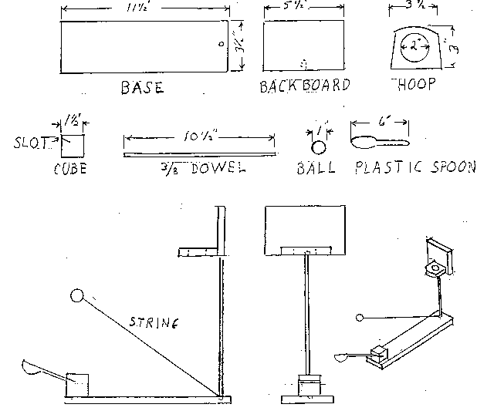
Annawon, Cape Cod and Islands, and
Old Colony Council Pow Wow Book
Instructions
- Base, backboard and hoop are made from a 1"x4" board.
- Drill holes in base and backboard 3/8" diameter and 1/2" deep.
- Cut a slot at a 15 degree angle in a cube block large enough for the handle of a plastic spoon.
- Cut hole for the hoop first; then finish cutting the hoop piece. (We used a slice of 2" diameter PVC pipe and screwed it into backboard.)
- Glue the hoop to the backboard; then glue dowel rod into backboard and base.
- Glue cube block to base and insert spoon into slot.
- Cut string and attach one end to dowel rod at base and the other end to any 1" sized ball (ping pong balls work well).

POW WOW EXTRAVAGANZAS
You can, also, find a list of Pow Wows on USScouts.org at http://www.cubmaster.org/PowWowsUSA.asp
If you want your Pow Wow listed –
E-mail commissionerdave@comcast.net and attach a sign up sheet or flyer. Thanks
Northeast Region
Hudson Valley Council
University of Scouting
March 6, 2004
Washingtonville Middle School
Washingtonville, New York
Training for everyone – Cub Leaders, Boy Scout Leaders, Commissioners and more!
There are no walk-ins allowed for this event
Call the Information Center, 914-388-4863, or visit the website, www.hvus.org for information.

Bucks County Council
University of Scouting
March 6, 2004
Bucks County Intermediate Unit
Doylestown, PA
Training for everyone – Cub Leaders, Boy Scout Leaders, Commissioners and more!
Call 215-348-7205 or visit their website, www.buckscountybsa.org
WEB SITES
Bike Rodeos:
www.dot.state.pa.us/bike/web/index.htm
www.bicyclinglife.com/safetyskills/
http://www.bikexprt.com/streetsmarts/
Adventure Cycling Association (800-721-8719)
Rocket Launch:
www.estesrockets.com
Places to go near Philadelphia that have overnighters:
Trexler-Lehigh County Game Preserve – www.gamepreserve.org
Battleship NJ - www.battleshipnewjersey.org
Franklin Institute – www.fi.edu
Philadelphia Zoo – www.phillyzoo.org
Academy of Natural Sciences - www.acnatsci.org/

Engineering Websites –
Twenty Greatest Engineering Achievements of the 20th Century http://www.greatachievements.org/
Maybe better for the adults than the Scouts but I liked it.
From Karen in Suffern, NY (an RPI grad)
National Engineer’s Week, February 22-28
The site for the week is www.eweek.com
Kaen says there are lots of good things for Scouts (and others) to do
A good resource for engineering projects is http://pbskids.org/zoom/sci/
Engineering School sites –
Valparaiso University, College of Engineering http://www.valpo.edu/engineering/
Rensselaer Polytechnic Institute – www.rpi.edu
Many of us have probably seen this but if you haven’t - This huge rock is located on highway 25 in Iowa, and kids used to put obscenities etc. on it. Since the rock was painted like this, it's been left alone. This rock is in Adair County, between Greenfield and I-80. Be sure to scroll all the way down to see all sides of the rock.
http://www.ticz.com/homes/users/bob/On-A-Rock/On-A-Rock.htm

Walk in My Shoes
A 4H Aging Awareness Project
This is an activity that reaches across generations and teaches young people about growing older and the physical changes that occur with age. The online activities enable youth to distinguish between the realities of aging and the stereotypes or myths that exist about older adults. With the help of an "immediate aging kit," youth learn to develop an awareness of the impact of physical and sensory changes on the lives of older people through "hands on" activities.

Many of the activities require input and assistance from an older friend or family member. Young and old are able to share, learn, and understand one another. Both groups benefit from the many activities found in Walk in My Shoes. This project will help young people:
Identify some of their own attitudes about aging and older people.
Dispel myths and stereotypes about older adults.
Learn about the aging process and the physical changes that affect older people.
Understand how living with physical and sensory changes affects older people.
Learn to communicate with older adults who have sensory losses.
Develop linkages across generations within families and communities.

http://www.urbanext.uiuc.edu/wims/wimsproject.html

