FOCUS
This month our boys will learn about the importance of conservation and ecology. Have a conservationist or park ranger come to your den or pack meeting to talk about the dangers and effects of pollution and littering. Take your den to visit a local government conservation or reclamation project. Your den can plan its own conservation project and work on the World Conservation Award. Don't forget collecting and recycling old toys and clothes for those who are less fortunate. Your den may want to collect aluminum cans to sell and donate the proceeds to be used on a conservation project.
CORE VALUES
Some of the purposes of Cub Scouting developed through this month’s theme are:
- Friendly Service, Cheerfully completing activities to help the environment can start a Cub Scout on a life-long mission of service.
- Fun and Adventure, Working together and keeping the outing in Scouting delivers the promise of fun and adventure.
- Preparing for Boy Scouts, by participating in service projects for the environment and being exposed to outdoor camping.
The core value highlighted this month is:
- Citizenship, Activities and conservation projects help Cub Scouts understand the importance of a citizen’s duty.
Can you think of others??? Hint – look in your Cub Scout Program Helps. It lists different ones!! All the items on both lists are applicable!! You could probably list all twelve if you thought about it!!
COMMISSIONER’S CORNER
The Cub Scout “Leave No Trace” Award was featured as a Special Opportunity in the October 2003 issue of Baloo’s Bugle, but I figured with this theme, it was time to remind you about the -
Cub Scout Leave No Trace Pledge
I promise to practice the Leave No Trace front country guidelines wherever I go:
- Plan ahead.
- Stick to trails.
- Manage your pet.
- Leave what you find.
- Respect other visitors.
- Trash your trash.
And to drop a hint that as you plan your spring Family Camping Trip, you work in some of the requirements for the award. If you want more information check the websites at the end of this issue, or Google “Cub Scout Leave No Trace Award.” I got over 10 pages of hits!!
Be sure to check out the Edible Landfill in the Cub Grub area. Maybe you would want to build these in a den meeting and then go visit your local landfill. The landfill trip was highlight of our son’s Bear year in Cub Scouts. A properly run landfill is a great place to visit and learn.
Using the Fiesta theme, our Wolf Den has almost completed the Language and Culture Belt Loop. Be sure to take advantage of all the opportunities like this that you can find for your den.
Final Request – don’t you hate letters that begin that way or are you happy, hoping they mean it and you will not receive any more ads from the company?? Anyway, the theme for May 2004 is “My Home State.” This presents a challenge for me. I don’t think everyone wants to learn all about New Jersey so Baloo will need some help. Now New Jersey does have a great website set up children to learn. It is http://www.state.nj.us/hangout_nj/ If you know of a similar website for your state, please send me the link. My goal is to have a list of 50 such websites in that issue of Baloo. Last month I received E-mails for Maine (the first one, thank you Kathy), Connecticut and Texas. That leaves 46 states to go!! Please help!
It was an interesting month for letters, too. I received nice input and great game from an Australian Scout Leader. Thank you Hayley. Questions from a 4H leader who wanted to know if she could use ideas she found in Baloo. Of course, we said yes, Baloo is for everyone. She found our site by searching on “moral skits.” How about that?? I gave her references to several other good Scouting Skit sites. Then there was a question on Climbing for Cub Scouts. I learned something in researching this. It is within the age-appropriate guidelines of the Boy Scouts (http://www.scouting.org/boyscouts/resources/18-260/chart.html ) to take Cub Scouts to commercial climbing gyms as long as they have equipment in the correct size for our young cubs and have professional supervision. Wow, a new opportunity. Outdoor climbing and climbing at Boy Scout camps is not considered appropriate.
And I must say thank you for the Baltimore Area Council and the Annawon, Narragansett, Old Colony, & Cape Cod and Islands (That’s one Pow Wow coordinated by all four councils) Pow Wow books I received this month. I still have Southern NJ books to offer in swap for your book. Just drop me an E-mail.
Finally, I am sure you have all seen the little PayPal logo and the line to donate to US Scouts. We are in need of a new server. The current one has crashed several times in recent months. If everyone that downloads a copy of Baloo this month could authorize $5 (or $10) for US Scouts through PayPal, we would be well on our way to upgrading our service to you. Thank you.
PRAYERS AND POEMS FOR SCOUTERS
I Am Just One Quite Small Kid
By Carol Shaw Lord
Great Salt Lake Council
I am just one quite small kid,
I am only but a boy,
Yet what I do can make a difference,
My actions can bring pain or joy.

I can bring a smile to friends
With the smile upon my face.
I can help to keep my world
A clean and lovely, safer place.

I'm only one, but I am one;
When other people hear my voice,
Some may come and join my quest
If I make the better choice.
A Cub Scout’s Prayer
Barbara Haig, Pack 231,
St. Sebastian Parish, Milwaukee, Wis.
Barbara wrote this prayer for the Home Alone theme but it could be used anytime. And we need to encourage our Cubs in their Duty to God every chance we get. CD
Hi God. Thank you for being with me throughout this day. I know my family loves me and will be home later. So for now, it’s just you and me.
Touch my hands with good ideas that will keep me busy. When I’m bored, bring me awesome sparks of imagination. Remind me that TV and video games are fun for a while, but art projects and music let my own creativity soar.
Touch my legs with energy. When I’m lazy, bring me outside games and sports that keep me active. Remind me that many people can’t run and jump, and that fresh air contains life.
Touch my eyes with vision. When I see a mess, even if it isn’t mine, bring me the patience to clean it up. Remind me that books and puzzles also can provide great workouts.
Touch my ears with listening. When someone calls on the phone, bring me the wisdom to really hear what they need. Remind me that sometimes I need help, too.
Touch my mouth with flavor. When I need a snack, bring me healthy choices. Remind me that I’ll probably have dessert at lunch tomorrow, so fruit or peanut butter is fine for now.
Touch my mind with responsibility. When I forget what I’m supposed to do, bring me a hint. Remind me that homework and chores come first, but I will have time to play when I’m done.
Touch my heart with peace and comfort. When I am afraid, bring me courage. Remind me that I am strong, I can handle things pretty well, and I know who to call in an emergency.
Thanks, God. The key that opened the door to this empty house opens the way to your love, because I know you are always with me. Amen.
Quotes
This three quotes came to me while preparing the final Pow Wow report and I wanted to share them with you. CD
Nothing worthwhile was ever accomplished without the will to start, the enthusiasm to continue and, regardless of temporary obstacles, the persistence to complete. Waite Phillips
Somehow I can't believe there are many heights that can't be scaled by a man who knows the secret can be summarized in four Cs. They are curiosity, confidence, courage and constancy, and the greatest of these is confidence. When you believe a thing, believe it all the way. Have confidence in your ability to do it right. And work hard to do the best possible job. Walt Disney
The words "perseverance'' and stubbornness'' are not synonymous but it is distressing to observe that many people do not recognize the difference. Waite Phillips
We Are Not Experts
Circle Ten Council
We are not experts. We're your next-door neighbors. We're not perfect, we are just parents like you. We don't have anymore spare time or energy than you do, we all work full time and juggle our families and our schedules and try to keep it all together as best we can. The only difference between us is that we believe in what Boy Scouting has to offer. So much so, that we contribute our time, our miles and our talents to help our sons and your sons grow in Scouting.
We complete authorization forms, budgets and registrations and fill our homes with boxes of paperwork that you will never see. We are required to take training the first year, as well as attend Roundtable meetings every month, so that we can meet our greatest challenge providing a variety of programs which meet the needs and interests of very individual boys. We try to involve parents who want us to understand that they don't have the time to drive on outings or help at meetings. We rejoice at the generosity of others. Sometimes we find ourselves going in too many directions. We run out of steam. We have memory lapses. Communication lines break down. Time slips by. But that doesn't mean we don't care.
So many evenings we spend on the phone, seeking advice and support from other leaders when disappointments or problems occur. "How do I keep my boy's attention?" "What are your ideas for the ceremony?" "How do you work with boys in three different grades?" Our dining tables are covered with bits of rope, menus, tour permits and merit badge cards for each and every boy in the troop. A couple of them won't show up and don't think to call and let us know. Sometimes we feel unappreciated. Yet, these boys can fill us with pride at their determination and accomplishments. Their smiles light up a room; and when they say "Thank You" it makes it all worth it. We help these boys build relationships. Some struggle more than others.
Trustworthy, Loyal, Helpful, Friendly - is encouraged by the Scout Oath and Law. And sometimes we too must learn these lessons over and over again with the boys. But we are willing to keep learning.
Please be patient if we appear distracted or frustrated or overwhelmed at times. Forgive us if we are not the kind of Boy Scout Leader you would be if you had the time.
Instead, provide us with encouragement or offer your help. Keep us in your thoughts and prayers. We are, after all, only mentors, role models, and leaders. Volunteers who have taken an oath to give these boys, your boys, the most precious gift we have to offer -- the gift of time.

TRAINING TIP
Scouting Is a Special Place
When preparing for a RT Training Highlight on “Scouting is a Positive Place,” I remembered this presentation from Scoutmastership Fundamentals and thought I would pass it on to you to think about. There are many good thought here for you as a leader and for your Pack committee to think about in how your unit operates and how you deliver the promise of Scouting. CD.
Educators and others often talk about providing youth with a "safe haven," a place where they can feel physically and emotionally secure. This is a place to grow, develop, learn, and to mature. We refer to this safe haven when we use the phrase "Scouting is a special place."
As adult leaders in Scouting, we have a special responsibility to youth. The Scouting program always has emphasized this role as one of the "Methods of Scouting."
Each of you should take a moment and think about what the phrase "Scouting is a special place" means. It is safe haven where boys should feel free from bullying, where each can achieve at his own rate and there is no limit to the number of top performers (Eagle Scouts, Arrow of Light holders). It is a place where each can use his God given gifts and not have to worry about what gifts others may have. A place where no one is left out.
There was a chart that went with this presentation. It had the following information:
Scouting is a special place. The rules are the ones we know well: the Scout Oath and the Scout Law. (Remember, this was a Boy Scout leader course, we could substitute the Cub scout Promise and Law of the Pack. CD)
We create a safe haven in Scouting, a place where everyone should feel physically and emotionally secure. We do this in several ways:
- We set the example for ourselves and others by always behaving as Scouts should. We live the Scout Oath and Law (Cub Scout Promise and Law of the Pack) each moment of each day, to the best of our abilities.
- We refuse to tolerate any kind of inappropriate put-down, name-calling, or physical aggression.
- We communicate our acceptance of each participant and each other through expressions of concern for them, and by showing our appreciation whenever possible.
- We create an environment based on learning and fun. We seek the best from each participant, and we do our best to help him achieve it.
Creating a Safe Haven. Creating a safe haven is best accomplished by personal example. Your attitudes, your example, and your expectations will set the tone. The process of reflection and other activities that bring Scouting's values through to youth will keep the message clear.
Delivering the Promise. After discussion amongst the participants, the session was summarized as follows:
- By being caring adults, creating a safe haven, and recognizing the differences in the ages and stages of youth development, we can create a special place in Scouting for boys. Reflection, the problem-solving process, and opportunities for meaningful community service each help to achieve this.
- Our goal as leaders is to bring the values of Scouting through. The way we do this is with an exciting program, challenging activities, and a real adventure for boys. We deliver the promise.
What do you think "the promise" is? Take a moment to think about it before reading further. “The promise" is the commitment we make to boys on the first two pages of the Boy Scout Handbook. The promise is the fun and adventure the boys are seeking through Scouting. To get them outdoors and let them have fun while learning. We don’t want to keep them cramped up in meetings, sitting around talking. They want to be and we want them to be doing things, especially doing things outdoors. Which is why it is so great that Cub Packs are now doing Family Camping several times a year and the new books have more outdoor requirements.

PACK ADMIN HELPS
Cub Scouting Teaches Boys To Reach Out
Circle Ten Council
Cub Scouting provides opportunities for boys to "reach out" into a wider community while maintaining a link with more secure foundations such as the home, religious organization, and school. It helps boys become full members of their communities as they take part in service projects and other community-related activities. They get to know their community better and recognize the importance of good citizenship.
"Be all that you can be" The United Sates Army used these words as its recruiting slogan. They captured the feeling that an individual can truly achieve and grow through the Army way of life. These are also words for Scouters to ponder. What a shame it would be to leave a boy behind and not give them an opportunity to achieve all of their potential, because we did not reach out to them.
We have a responsibility to insure that boys in our neighborhood and community have the opportunity to join in this movement. This means that we reach out to them and make the Scouting program available.
Recruiting doesn't just happen. Below you will find some ways to help in your recruitment effort.
Boys Recruiting Boys:
- Have a Pack Incentive
- Provide a “prize” to every boy who brings a friend to your Cub Scout “Fun” Recruiting Activity. Recruiting patches are also available in the Center for Scouting Scout Shop.
- “Prepare” your Scouts with information
- Provide your Scouts with “mini-pocket” calendars, which they can give to their friends at school showing the activities your pack has planned for the year. You could also provide information on activities that your pack conducted last year. Sell the “Fun” of Scouting to boys.
- Uniforms Worn to School
- Have your Scouts wear their Cub Scout uniform to school the day of your “Fun” recruiting activity.
- Conduct a “Bring a Buddy” Event
- Boys, who bring a buddy” to a special “bring a buddy” event such as a swimming party, game of bowling, etc could be rewarded with a discounted admission fee to the activity or provided with a special recognition at the event.
Adults Recruiting Adults:
Determine which families are currently not in the Pack
After you determine which families from your school are not in the Pack, assign another member of the Pack to call that family and invite them to your special “Fun” Recruiting Activity. You can use last year’s school directory as a guide.
Sell the Parents on the Value of Scouting
Citizenship training, helping other people, positive adult role models, learning responsibility, etc. are characteristics which all parents what for their children. Let the parents know how Scouting helps children grow up into responsible adults.
Talk to Parents at your School’s Open House in the Fall
Set up a booth or demonstration at your school’s open house in August or September. Spend some time talking to parents about the “Values of Scouting” as they attend this school activity. Provide then with list of open positions and the Commitment for that position. One example is shown below.
One Year Commitment Working Primarily With Adults
Chartered Organization Representative
Committee Chairperson
Treasurer
Secretary
Activities Chairperson
Advancement Chairperson
Membership Chairperson
Pack Newsletter Publisher
Pack Trainer
One Year Commitment Working Primarily With Youth
Cubmaster
Assistant Cubmaster
Webelos Den Leader
Asst. Webelos Den Leader
Bear Den Leader
Asst. Bear Den Leader
Wolf Den Leader
Asst. Wolf Den Leader
Tiger Cub Den Leader
Asst. Tiger Cub Den Leader
One Time Commitment - Plan & Execute Single Activity
Scouting for Food Coordinator
Pack Fundraising Activity Coordinator
Fall Safe-Bicycling Activity Coordinator
Mid-Year Holiday Party Coordinator
Pinewood Derby Coordinator
Pinewood Derby Concessions Coordinator
Blue and Gold Banquet Coordinator
Friends of Scouting Coordinator
Spring Picnic Coordinator
Scout Show Coordinator
Scout Show Ticket Sales Coordinator
Cub Scout Day Camp Coordinator
Webelos Resident Camp Coordinator
Summertime Activities Coordinator
And of course you can always add a few of your own depending on your activities; e.g. Rain-gutter Regatta Skipper, etc.
Adult Recognitions
Longhorn Council
After you recruit new adults, you need to hold onto them. Recognition is one of the best ways to keep them coming back. Here are some Innovative Recognition Awards to present to your leaders. CD
SOLID AS A ROCK AWARD - For the person who is solid in the Scouting Program. Just find a rock and give it to the person. The rock can be a unique shape or it can be embellished for the occasion.
ORDER OF THE BEAR AWARD - FOR SOMEONE WHO HAS DONE A “BEARRY” GOOD JOB. - Draw a Bear on a piece of cardboard or glue a stuffed bear on a piece of wood.
YOU’RE TREMENDOUS - for someone who has done a tremendous job for you. Cut out a tree from green poster board and glue it on a piece of cardboard.
GOLDEN ACORN AWARD - for someone who’s either a little nutty or who has done an outstanding job for the Pack or Den. Glue an acorn that has been painted gold on a piece of wood.
NUTTIN IS BETTER THAN SCOUTING AWARD - this can be used as a general award or recognition for anyone who has done anything for Scouting. Glue an acorn peanut, walnut, etc. on a tongue depressor, orange juice can lid, or piece of wood.
WE COULD KNOT DO IT WITHOUT YOU AWARD - Tie a small square knot out of rope and glue it on a plaque.
STICK-IN-THE-MUD AWARD -This is for that special someone who hasn’t given their all or tried their best at something. This should be extremely light hearted, so as not to embarrass or belittle anyone. Put a small stick in the middle of brown clay.
DAY CAMP CHAIRPERSON OR DRIVERS - Buy a miniature mini-van or make one from cardboard and personalize it.
For more ideas on recognitions see the affirmations listed with the Good Egg Awards ceremony. Many of these could be used for Adult Awards, too. CD
TIGERS
Family Activities –
Circle Ten Council
Discussion
Have a family talk about the ways people can care for the Earth in the home, school or community?
Name some natural resources found in the school, home or community?
Talk about ways he can help take care of the Earth?
Earth Walk
Take the family on an Earth (natural resources) walk around the neighborhood.
On the walk, ask the children to look for things the Earth provides (natural resources).
As resources are observed, have the children stop, look at the resources, then use their senses to describe them (what they see, how it feels, what it smells like, how it sounds).
Ask the children: "In what ways have people taken care of the natural resources in our neighborhood?"
Ask the children: "How have the natural resources in the neighborhood been changed to make life better for people?"
If possible, take children to areas where people have not cared for the Earth. (This could be a site with a lot of trash, absence of trees and grass, etc.)
Ask the children: "If some natural resources have been damaged, how can we repair or fix them?"
Come home and let the children draw a picture showing what they are going to do to help. Hang it for all the family to see and be reminded of what they are going to do to help the earth.

Den Activities
Circle Ten Council
Apple Birdfeeders
You'll need for each boy -
One apple,
3 feet of string
Birdseed or cereal for each boy.
Directions –
Cut lengthwise grooves in the apple on all four sides.
Cut the top off about 1/2-inch from the stem of the apple.
Scoop out some of the insides of the apple with a spoon, being careful not to break the skin.
Fill the center of the apple with birdseed or cereal.
Re-attach the top of the apple to the bottom using the string:
Criss-cross the string underneath the apple and tie it above the stem.
Use the remaining string to hang the apple outside where it will be protected from rain.
(Note: you could also use an orange, pear, nectarine or turnip, green tomato, gourd or firm squash.)
Trash Monster
You'll need for each Monster
Two paper lunch bags,
Construction paper,
Markers, scissors and glue.
Directions
Cut an oval opening in the bottom of one lunch bag.
Open the other lunch bag and slide the first one inside it so the hole is at the top (monster's mouth) and the other bag's bottom is on the bottom.
Decorate the bag, as you like with construction paper eyes and accordion-folded arms.
Or use markers.
Set the monster on a desktop and feed it small pieces of trash!
Milk Jug Bird Feeder
Need for each feeder:
Gallon milk jug with lid
Sharp pointed scissors
Pencils
Bird seed
String, optional
Directions
Rinse out an empty plastic gallon milk jug with lid.
Dry thoroughly.
Cut a window in the front of the jug, and make two small poke holes for the perches.
Insert pencils for perches and fill the bottom of the jug with birdseed.
You can either rest the bird feeder on a ledge or punch holes near the top, add string, and hang from a branch.
WHERE DOES GARBAGE GO
Circle Ten Council
This one would work well with every level of Cub Scout. The Bear Achievement, Take Care of Your Planet, came to mind immediately. The visual images are great and last longer with our Cubs. CD
Before the Den arrives, set up a recycling bin to look like a big garbage can.
Read the book "Where does garbage go?" up through the part about Americans generating 4 lbs. of trash a day. Ask the boys to name the kinds of things they throw away.
Let the boys hold a bag with four pounds of trash in it to see/feel how much trash it contains (4 lbs.). Line seven bags up in a row to show them how much trash one person makes every week (28 lbs.).
Demonstrate what goes into a landfill. Ask the boys to pretend that the bin (recycle bin you disguised earlier) surrounded by a white sheet is a hole in the ground (landfill). More than half of the trash in landfills is paper. Ask a boy to put the paper provided into the landfill. Repeat the procedure with the correct proportions of other landfill trash (glass, metal, plastic, food and yard waste, other).
Read the pages about how many communities now recycle. Why do they recycle? (By recycling, these people cut down on the amount of trash they send to the landfills. By throwing away less trash, the people help to make the Earth a cleaner place.)
Ask the boys to look at the landfill again and name the things in the landfill that cannot be recycled. After taking out "other" and "food and yard waste," remove the sheet and show them that the pretend landfill is really a recycling bin. All of the items remaining in the bin can be recycled.
Show the boys a poster that shows the recycling symbol ("chasing arrow"). Ask the boys if they have seen these symbols before? Where? What do they mean? Explain that the boys and their partner will now work together. They will be recycling detectives and will look for these symbols on different items in their home to determine if the items can be recycled or not. Explain that not ALL of the objects that can be recycled have the symbol on them (like magazines and some cardboard, etc.), but many of the objects do. Looking for the symbol is a very good way to try and figure out if you can put the object out for the recycling truck or take it to a recycling center. Have them bring their list to the next meeting to share with each other. Have each boy name one thing on their list and continue until all items on each list have been named.
Go See It Outing
Circle Ten Council
- Tour a fast food restaurant or small restaurant
- Tour an energy conservation home
- Tour a Wildflower center and learn about landscaping that will conserve water
- Tour Electric plant or company and have them explain ways to save energy
- Tour the local Water Company and ask for ways to conserve water.
- Tour the Gas Company and ask about ways to conserve during winter months.
- Tour the local or county landfill and have them talk about recycling.
This last one was a big hit with our Den when my wife and I were Den Leaders. CD

SPECIAL OPPORTUNITY

CUB SCOUT WORLD CONSERVATION AWARD
www.uscouts.org
What else could I possibly feature wit a theme like Cubservation?? CD
The World Conservation Award is worn on the uniform shirt, centered on the right pocket as a TEMPORARY patch. Only ONE Temporary patch may be worn at a time, but Cub or Webelos Scouts may wear the Progress Through Ranks (Immediate Recognition) or Webelos Compass Points Emblem suspended from the right pocket button in addition to any temporary patch sewn on the pocket.
The World Conservation Award provides an opportunity for individual Cub Scouts (or Boy Scouts, Varsity Scouts, and Venturers) to "think globally" and "act locally" to preserve and improve our environment. This program is designed to make youth members aware that all nations are closely related through natural resources and that we are interdependent with our world environment.
The Cub Scout version of the World Conservation Award can be earned by Wolf or Bear Cub Scouts, and by Webelos Scouts.
This award can be earned only once while you are in Cub Scouting (i.e. as either a Wolf Cub Scout, a Bear Cub Scout, or as a Webelos Scout).
As a Wolf Cub Scout, you can earn the Cub Scout World Conservation Award by doing the following:
Complete achievement #7 - Your Living World
Complete all Arrow Points in 2 of the following 3 Electives:
#13 - Birds
#15 - Grow Something
#19 - Fishing
Participate in a den or pack conservation project in addition to the above
As a Bear Cub Scout, you can earn the Cub Scout World Conservation Award by doing the following:
Complete achievement #5 - SHARING YOUR WORLD WITH WILDLIFE
Complete all requirements in 2 of the following 3 electives:
#2 - Weather
#12 - Nature Crafts
#15 - Water and Soil Conservation
Participate in a den or pack conservation project in addition to the above
As a Webelos Scout, you can earn the Cub Scout World Conservation Award by doing the following:
Earn the Forester activity badge.
Earn the Naturalist activity badge.
Earn the Outdoorsman activity badge.
Participate in a den or pack conservation project.
See Den and Pack activities sections for ideas for Conservation Projects.
I found out in preparing this issue of Baloo my council has a Conservation Award available for all three levels of Scouts. I am going to include the requirements for it in my RT edition of Baloo. CD
Maybe your council has an award, too! Check it out.
GATHERING ACTIVITY
SOMETHING NOT TO BE
Circle Ten Council
Fill in the missing letters in the spaces below. They spell something no one wants to be. What is it?
B O T T__ E S
T__ N S
S__ R I N G
S__ I C K S
P A P__ R
T__ A S H
R U B__ I S H
J__ N K
R A__ S
Answer: Litterbug
Now if you want to make it a little easier for the younger ones, maybe give them the list of letters in random order –
B E G I L R T T U
TREE LORE
Circle Ten Council
Twenty leaves (or pictures of leaves) of local trees are placed on a table. Either form small groups or have Scouts work on identifying the leaves individually as they arrive. The group or person with the most correct answers wins. This could, also, be adapted to use as a game during the meeting.
☺ “Gathering Activity” ☺
Great Salt Lake Council
Have garbage bags available for people as they come. Have them pick up the area around the building or meeting place. Have treats/prizes for the people who pick up the most. This could also go toward earning the conservation patches.

OPENING CEREMONY
CONSERVE
Circle Ten Council
Cub Scouts hold cutouts of cars made from poster board, with letters printed on back of each one to spell out the word: CONSERVE.
- C - Cars and buses and such were invented by men.
- O - Oil fields were discovered also by them.
- N - Nobody really worried about the amount of fuel this would take.
- S - So on no transportation did they put the brake.
- E - Eventually the amount of fuel used grew astonishingly.
- R - Raising on everyone's mind a great big doubt.
- V - Very soon the world's traffic was put to the test.
- E - Everybody to conserve fuel must now do their best!
ALLEGIANCE TO THE OUTDOORS
Circle Ten Council
SETTING: After presenting flags and Pledge of Allegiance, Den lines up across front of room.
NARRATOR: We are coming up on the time of the year when we start using the outdoors more and more whether we are hiking the trails of America or just going to the park. Each of us as Cub Scouts owes an allegiance to the outdoors just as we do our flag. Each Cub Scout should know and understand the outdoor code.
- As an American, I will do my best to be clean in my outdoor habits; I will keep my trash and garbage out of America's waters, fields, woods and roadways.
- Be careful with fire: I will build my fire in a safe place and be sure it is out before I leave.
- Be considerate of the outdoors: I will remember that the use of the outdoors is a privilege I can lose by abuse.
- And be conservation minded: I will learn to practice good conservation of soil, waters, forests, minerals, grasslands, and wildlife and I will urge others to do the same.
Campfire Opening
Longhorn Council
Four Cubs, Webelos or Scouters, facing the points of the compass with tinder and lighted candles or paper.
North: I bring to this fire tinder from the north and remind all of a Cub Scout’s first duty: Duty to God - to be reverent towards God, to respect the beliefs of others, and to live according to the teaching of his religion.
South: I bring to this fire tinder from the south and remind all of a Cub Scout’s second duty: Duty to Country - to be a good citizen, living by laws and customs of our nation, and to work together to solve our country’s problems.
East: I bring to this fire tinder from the east and remind all of a Cub Scout’s third duty: Duty to Self- to keep myself physically strong, mentally awake, and morally straight.
West: I bring to this fire tinder from the west and remind all of a Cub Scout’s fourth duty: Scouting Spirit and how it will show in the way we act and the things we do – and living every day according to the Cub Scout Promise and Law of the Pack we will collectively, with our individual gifts, light OUR campfire.
A B C X Y Z Opening Ceremony
Great Salt Lake Council
- A is for ACTION. Take Action to keep the world around you at its best. Take no action that will mar the beauty or destroy plants, animals or atmosphere.
- B is for BEAUTY. We are blessed with the beauty of nature all around us. Let us appreciate it.
- C is for CITIZENSHIP. Practice good citizenship by caring about the appearance of your home, neighborhood, and hometown.
- X is the unknown factor that could happen if we don't all work together to preserve our environment?
- Y is YOU! It is up to you to set the example for others.
- Z is for ZEST - Recycle, reuse, and pick up litter with zest and enthusiasm. Walk hand in hand with Mother Nature. She will always be your friend.
The Outdoor Code
Longhorn Council
PERSONNEL: Poster with the Outdoor Code on it. Have parents repeat the outdoor code. Explain it's meaning.
NARRATOR: Instruct pack to say a line from the Outdoor Code as you point to it.
PACK: As an American, I will do my best to be clean in my outdoor manners.
CUBMASTER: I will treat the outdoors as a heritage to be improved for our greater enjoyment. I will keep my trash and garbage out of America's waterways, fields and roadways.
PACK: Be careful with fire.
CUBMASTER I will prevent wildfire. I will build my fire in a safe place and be sure it is out before I leave.
PACK: Be considerate of the outdoors.
CUBMASTER: I will treat public and private property with respect. I will remember that use of the outdoors is a privilege I can lose by abuse.
PACK: Be conservation minded.
CUBMASTER: I will learn how to practice good conservation of soil, water, forests, minerals, grasslands and wildlife. I will urge others to do the same. I will use sportsman like methods in all my outdoor activities.
NARRATOR: Now Sing "America, the Beautiful."
I Am The World
Longhorn Council
NARRATOR: I am the world - Some call me Mother Nature. I am the mountains and the valleys and the land and the seas. All living things exist in me from the birds of the air to the fish in the waters. You see me in the beauty of the flowers and in the glory of the trees. When ever you roam to see the wonders of the world, the animals, the plants and the moon and the stars. All that is pleasant to see, remember that man is the only one who can really keep this world of nature for the next generation to see
(Ask Cubs and parents to recite together, "The Conservation Pledge"):
I give my pledge, as an American,
To save and faithfully to defend from waste,
The natural resources of my country, its soil and minerals,
Its forests and waters, and its wildlife."
Cub Scout Campfire Opening Ceremony
Longhorn Council
EQUIPMENT: Real or artificial campfire, seven candles.
PERSONNEL: Narrator and seven Cub Scouts (each with his part written on a dip paper).
Narrator: Welcome to the Cub Scout campfire. Akela is among us. Let us draw from this campfire with all its vibrancy and warmth, the secrets of Cub Scouting and the spirit of brotherhood.
- In its light we see new chances to be helpful and to do our best.
- From its warmth we strengthen the bonds of fellowship and learn how to get along with others.
- From the stones that ring the fire and keep its power in check, we learn how we can curb our tempers and become good citizens.
- From the smoke that rises out of the fire, we learn to lift our eyes upward and worship God.
- The spark that started this fire reminds us that little Good Turns can lead to greater deeds.
- Just as the fire needs wood to bum brightly, so do we need the care and love of our parents to bum brightly.
- In its leaping flames, we see the fun of Cub Scouting and the job of life.
CONSERVING OUR NATURAL RESOURCES
Circle Ten Council
Personnel: Seven Cubs
Props: Seven candles in a candleholder, (a half log with 7 holes drilled in it would fit the theme) a lighter or matches and a candle for the Cubs to use to light the candles in the candleholder.
Scene: The CM or DL lights the “lighter candle”. The Cubs each light a candle in the holder and read their part.
- We have been observing and studying Nature’s treasures.
- We will help to maintain nature’s balance.
- We will help and learn from nature’s animals.
- We will help and learn from nature’s resources.
- We will protect them from harm.
- We will follow the conservation pledge.
- Will you all please rise and join us in the conservation pledge.
- (All Cubs help with this)“I give my pledge as an American, to save and faithfully defend from waste, the natural resources of my country, its soil and minerals, its forests, water, and wildlife.”
- Thank you. Please be seated.

PACK AND DEN ACTIVITIES
Things to discuss when it comes to saving resources...
Circle Ten Council
Recycling - When an object can be shredded, melted or otherwise processed and then turned into new raw material -- for instance, aluminum cans can be melted down to make more cans, glass can make more glass, cardboard and paper make more cardboard and paper, plastic bags and containers can be turned into other plastic products. This takes some energy (very little for aluminum), but it is a good choice.
Reusing - When you find a use for an existing item - like decorating a bag and using it as a gift bag instead of buying wrapping paper; putting leftovers into a clean container from some other food; turning a used box into storage; decorating a can to hold pencils; saving packing peanuts and boxes and using them the next time you need to ship something or give a gift.
It is important to 'reuse' items wisely -- reusing packing peanuts to pack an item is by far the best way to use them. Recycling them, if it is available, would be the next best thing. Giving things in good condition that you no longer need to charity is another good way to reuse things like outgrown clothing or toys. Reusing is often the best way to save resources. This is something to consider year-round, not just around the winter holidays.
Shop Wisely - Can the container be easily recycled or reused? Will a larger container reduce the amount of packaging and perhaps cost less per serving? Is everything that can be recycled being recycled? Save resources (and money) by asking yourself if the item is something you really need, and if it is well suited for the task, and if it will last. Not only can this save you money, it can save you space and work, too. Five toys that are loved and played with are more fun than 10 toys that are broken or are boring to play with. And it's quicker to pick up 5 toys and put them away than to pick up 10.
After discussing ways to recycle do the following activities:
- Divide den into two teams. Open up a mystery trash bag at each table and identify which things can be recycled. Lift up the bag again and feel how much lighter it is when people take things out of the trash, which can be recycled
- Give the boys a pencil and paper. Tell them they are going to examine a specific tree.
Use the following procedure:
Ask them to use their senses to make observations about the tree. (Provide them time to do this silently, then discuss in the den)
- Have them touch and smell the tree.
Ask them to close their eyes and listen for sounds associated with the tree.
Next, have them look for signs of who or what uses the tree, and then discuss their observations.
Ask: "What could hurt the tree? How? Why?"
Pose the following "What if" questions for them to consider:
What if this tree (or all the trees in our community) were gone? What would be good/bad/interesting about that?
What if the birds that use this tree went away? What will be good/bad/interesting about that?
What if lots of trees were planted on the school grounds? What would be good/bad/interesting about that?
Ask: "Whose job is it to care for the tree? Why?"
This activity was adapted from a lesson written by: Phyllis Youngberg, a teacher at Burnt Mills Elementary School.
- When the weather is pleasant, ask the boys to go outside to sit and observe the area around them. They are to use their senses to observe other things in nature (sky, ground, plants, birds, etc.) Have them take a pencil and/ or crayons and paper and:
Draw a picture of themselves outside.
Draw their observations.
Draw or write about their feelings about nature. (Provide ample time for this.)
When the boys return inside, provide time, if needed, to complete their work. Then have them share their work. Use the opportunity to discuss the importance of taking care of all things that are provided by the Earth.
Conservation Projects
Longhorn Council
Whenever we take the boys out of doors, we need to be conservation minded. There are a lot of conservation projects available to Cub Scout aged boys. Check with your local forest preserves, chartered organization, and your local city government. When in the outdoors, we must always be aware of its beauty and how precious it is. With all the construction going on all the time, some of the natural habitats for many animals are being relocated. We should make sure the boys are aware of need for conservation and preserving our resources. There are many books written to help us with ideas for these projects and how to accomplish the planning and carrying out of them. Your local library is a great resource for some of these ideas. Your local Scout shop has books on taking the boys out into the great outdoors. Let’s not forget we need to give back to Nature all the beauty it has given to us.
Listed below are some typical conservation projects that Cub and Webelos Scouts can perform in the local community. Always secure permission from the proper authorities for those projects that are performed on public or private property.
- Build and set out bird boxes, feeding stations, birdbaths, or dust baths in backyard or park.
- Plant shrubs in yard or park that provide food or cover for wildlife.
- Plant grass seed on bare ground in park, yards, school or church yard to prevent erosion.
- Plant tree seedlings in yard or park for shade, landscaping, or ground cover.
- Work on Wolf and Bear conservation achievements or on Webelos-activity badges.
- Visit fish hatchery, game farm, game refuge, or sanctuary to see how fish and game animals are raised.
- Study different kinds of soils in yard or community.
- Visit a farm and find out how conservation practices help protect soil.
- Take window boxes and plant flowers or plant tubs with trees or shrubs.
- Plant and maintain small flower garden in front of home.
- Plant and maintain small flower garden in park.
- Make litterbags for family’s and neighbors’ cars or boats.
- Take Outdoor Code posters, put up in school, and explain the code to other boys and girls.
- Write a set of rules for pack, den, or family to follow when visiting parks or picnic areas.
- Write a set of rules or make posters or charts about how to prevent forest fires.
- Have a nature or conservation film shown at pack-meeting.
- Go fishing and find out what kinds of fish are found in the area.
- Take nature walks and learn to recognize trees, birds, and mammals.
- Help can or freeze locally grown food.
- Help in the family garden.
- Help distribute fire-prevention (or other conservation-subject) posters in the community.
- Make exhibit for pack meeting that show how wild animals are important source of food, clothing, and recreation.
Ideas for Speakers at your Pack Meeting
Great Salt Lake Council
Park Ranger Zoo Worker
Ecologist Astronomer
Wildlife Specialist
Take a Walk
Circle Ten Council
Different types of walks you can take with the boys.
RAINBOW WALK — look for items of different colors, try a color per block or every so often, or just plain color identification.
HAWKEYE WALK — a list of items to spot or pictures of items to look for.
SUNSHINE AND SHADOW WALK — play with the shadows, measure some, make creatures, and play shadow tag.
PHOTO WALK — take pictures before and have the boys look for certain items. Try weekly pictures to sequence spring development.
BINOCULAR WALK — make binoculars for toilet tissue rolls and use them on the walk to focus on items. It makes for a new look at the same old scenery.
ALIEN WALK — take your walk on this planet earth as if you were from another planet. Try to identify the things you see, not knowing their real name of purpose.
BINGO CARD WALK — on a bingo type card, with pictures or drawings of items, go for a walk to identify the items on the card.
SIGNS OF POLLUTION WALK — clean up the environment as you go using plastic gloves to protect hands.
ALPHABET WALK — make a list of things with letters of the alphabet and have the boys identify them.
Conserve Energy Door Hanger
Great Salt Lake Council
Enlarge the elephant and copy it on card stock, color and hang on doorknobs to remind people to turn off the lights.
Encourage boys to come up with their own ideas for pictures for the door hangers. CD
Paper Bag Kite
Longhorn Council
For the kite, use a brown paper grocery bag with rectangular bottom. Cut a piece of cardboard the same size as the bottom. Cut an oval shape in the center of the cardboard. Using the cardboard as a pattern, cut a matching hole in the bottom of the bag.
Punch a hole in each corner of the cardboard piece. Attach a long piece of string to each corner, Glue cardboard to bottom of bag, matching the oval openings. Take all free ends of the string and tie them together, so that all lengths are even. Tie them to the actual kite string, which is already wound around a piece of wood or other kite string holder. Decorate as desired. Have fun kite flying! !
Survival Kit
Longhorn Council
Material:
35mm film can
Inside:
1 chalk stub 4 paper clips
1 pencil stub 6 straight pins
2 safety pins 2 thumb tacks
1 black crayon 1 piece of string
2 kitchen matches 4 aspirin
1 band-aid
Outside:
1 piece of masking tape rubber bands
piece of sandpaper (glue to bottom)
Sit-Upon
Longhorn Council
Summertime cushion for picnics or backyard fun! This is a GREAT project.
Materials:
12 double pages of newspaper
Preparations:
Start at one side of double page, make a 2-½ inch fold and crease well.
Continue folding paper over and over until you have one strip.
Fold all 12 pages the same way.
Weaving:
Lay out 6 strips side by side.
Beginning approximately 4” from one side, weave remaining 6 strips of paper in and out.
Leave a 4” tail of each of the 12 strips on all sides.
Finishing Edges:
Start with all ends facing upward (every other one),
Make a 1 ” fold then fold over and tuck inside of strip beneath it, as shown.
Turn Sit-Upon over and do the same with the remaining ends.
All corners will be double-tucked (on top and bottom).
For more information on how to make these – just find a Girl Scout leader!! Or check the websites at the end of the issue. Many have great pictures to help you. These things are great !! You can take leftover bath or kitchen Sanitas (or similar) wallpaper, cover them so they last!! CD
Endangered Species
Longhorn Council
Choose an endangered species. Do a research project on that animal. Create a “science fair” board presentation and have displays around the meeting room. Dress like you are on safari.
Field Trips
Longhorn Council
Visit your local Nature Center to hike the trails and see various plants, animals and exhibits that they may have.
More Hikes
Longhorn Council
Color Hike - Using color charts from the paint store, one per person, find objects in nature to match each color as closely as possible. DO NOT COLLECT!
Inch Hike - Find as many objects as possible that measure one inch high, long, wide, or around. Take rulers with you. This helps to discover many small things.
Initial Hike - Find 3 objects in nature beginning with your first, middle, and last initials.
Home Hike - Look for spider webs, nests holes or other nature homes.
String Hike - Follow a string that has been laid out in advance to identify. Have nature objects along the way.
Sound Hike - Take a hike and listen for special sounds picked out before leaving the start.
Unnature Hike - How many things can you find that don’t belong in nature.
Track Hike - Take a hike looking for tracks. See how many you can find.
Baby Hike - How many baby animals or plants can you find?
Smells Hike - Take a hike looking for things that have different smells.
Insect Hike - Look for insects and compare their body shapes and sizes.
Leaf Hike - Look for how many different types of leaves you can find.
Stop. Look and Listen Hike - Hike for five minutes or a designated number of steps. Stop for one minute and write down everything you see or the sounds you hear.
NEWSPAPER HAMMOCK
Circle Ten Council
Instead of recycling old newspapers, why not turn them into a hammock? Here’s how.
This sounds like a great project for the den to make for their leader (or the Pack for the Cubmaster) for the next Pack Family Camping trip. CD
Materials:
LOTS of newspapers
Tape
An old bed sheet
Rope or strong clothesline cord
Scissors
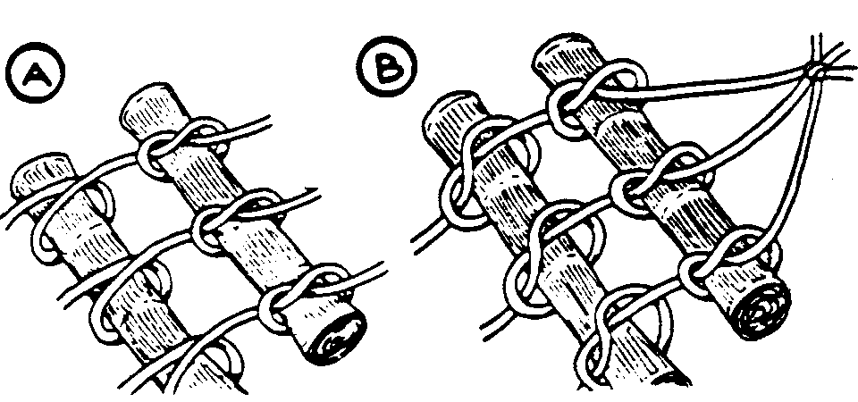
Directions:
- Make a stack of 30 sheets of newspaper.
- Roll up the stack the long way to form a tight, narrow tube.
- Tape the tube closed.
- Repeat step 1 until you have about 20 tubes.
- Cut three lengths of rope or clothesline, each at least 12 feet long.
- Lay the ropes parallel to one another.
- Now tie each tube, one by one, to the ropes.
- Tie over and under knots, leaving 2” to 3” between each tube (A).
- Remember to leave at least 3 feet at the end of each rope so you can hang up the hammock.
- When the hammock is long enough for you to lie in, tie the ropes together at each end (B).
- Hang your hammock between two trees in your back yard, or ask your mom or dad to help you hang it from your patio roof.
- Throw an old bed sheet over the hammock so you won’t get newsprint on your clothes.
COFFEE GROUND 'FOSSILS'
Circle Ten Council
What You Need
1 cup of used coffee grounds
1/2 cup of cold coffee
1 cup of flour
1/2 cup of salt
Wax paper
Mixing bowl
Some small objects to make impressions in the dough
Empty can or a butter knife
Toothpicks, optional
String to hang your fossil, optional
How To Make It
- Stir the together the coffee grounds, cold coffee, flour, and salt until well mixed.
- Knead the dough together and then flatten it out onto the waxed paper.
- Use the can to cut out circles of the dough or use the dull knife to cut slabs large enough to fit your "fossil" objects.
- Press your objects firmly into the dough. When you take the object out, you have your "fossil". If you want to hang the fossil, poke holes into the edge to hold the string.
- Let the fossil dry overnight and then hang it if you wish.
Tip - Bake them for a short period to get the "dough" to harden.
Milk Carton Bird Feeder
Baltimore Area Council
Materials:
3 half-gallon milk cartons make 2 feeders,
two 8" lengths of 3/16 inch wooden dowel,
pencil, utility knife, carpenter's square, stapler,
leather punch, wire coat hanger, wire cutters, pliers.
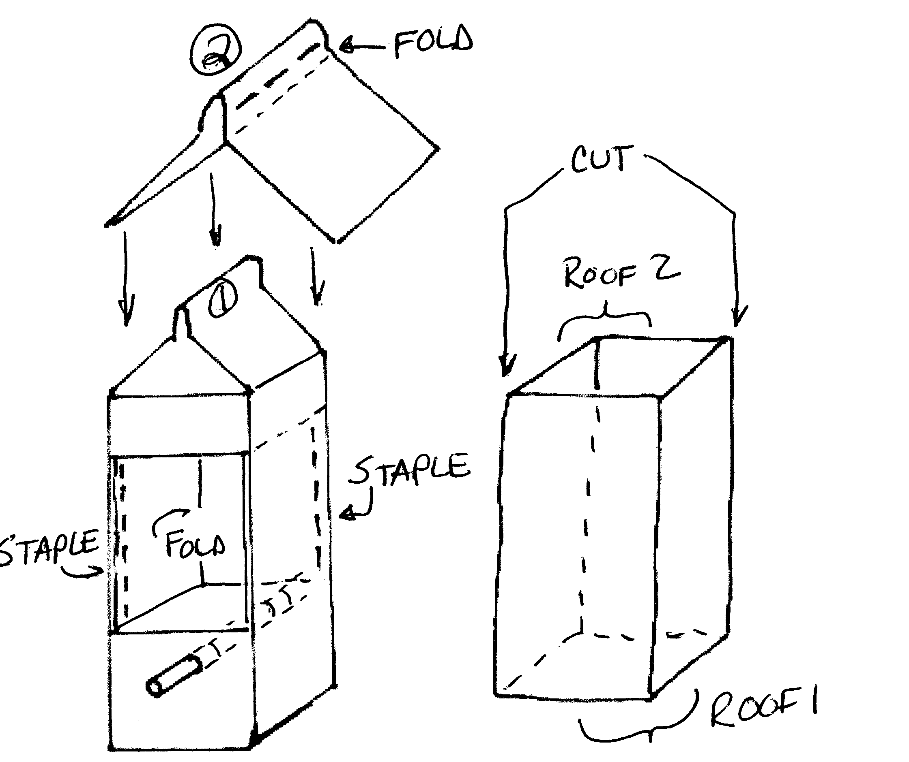
Instructions:
- Using the carpenter's square, mark 2 lines, one 2 1/4 inch from the bottom and one 11/4 inch from the top of the milk carton.
- Repeat on the opposite side of the milk carton.
- Have an adult set the utility knife so that the least amount of blade is exposed and cut all four of the lines you just drew.
- Now cut opposite corners between the lines to create a flap on each side of the milk carton.
- Fold the flaps in and staple them to form double thick walls.
- Use the pencil to punch a hole centered one half inch below each opening. Make the holes only big enough to insert the dowel.
- Cut the top and bottom of a second milk carton off and then cut apart at opposite corners to form two roof sections.
- Measure the top vertical portion of the milk carton.
- Using the carpenter's square and pencil score a line on either side of the fold inside of the roof section. These lines should be the same distance from the fold as the measurement you took of the top of the carton.
- Fold on the scored lines and attach the roof with staples as shown.
- Have an adult punch a hole in the center of the roof ridge with a leather punch.
- hAve an adult cut the coat hanger into two equal pieces with the wire cutters and bend each piece into a hanger for the two feeders.
- Fill with bird seed and hang outdoors where you can observe the birds that will flock to your feeder.
Ant Home
Longhorn Council
Materials: one-gallon jar or large peanut butter jar, soil and an ant hill, black paper.
- Fill a one-gallon jar with soil.
- Find an anthill and put as many of the ants and as much of the surrounding debris in the jar as you can collect.
- Place some cotton over the dirt and pour a little water in the ant jar every several days.
- Put lid with small holes in it back on the jar and cover the entire jar with black paper. The ants will make tunnels and can be observed by the Cubs.
Marshmallow on a Stick Neckerchief Slide
Longhorn Council
Materials: Floral wire, white beads, glue
Directions: Shape heavy floral wire to look like a roasting fork. . Glue white beads to end. (Using small forked twig, sharpen forks to fit beads & glue in place.) Epoxy finished stick to piece of plastic plumbers pipe big enough for neckerchief to pass through.

AUDIENCE PARTICIPATION
THE LITTERBUG
Circle Ten Council
Divide group into each of the characters. As the key word is said each group makes the corresponding sounds.
PAPER Crackle-Crackle,
TRASH Dump-Dump,
CANS Clatter-Clatter,
LITTERBUG Toss and Throw
God put bugs in this world for many reasons. He made them to live in every kind of season. But the pesky LITTERBUG with his PAPER and CAN was made through neglected TRASH by the foolish person. To keep America beautiful, get rid of the LITTERBUG, so beach goers can again lounge on a clean sandy rug. Because of this pest, we must woller around, In PAPER and CANS and TRASH all over the ground. Just who are these LITTERBUGS who mess up our land? Do you ever really see them toss that PAPER and CAN? Quite often the LITTERBUG is a sneaky guy, and at dumping his TRASH he’s oh so sly. So most of the time it just appears everywhere, As if it had dropped right out of thin air. Could it be we are so used to throwing things here and there, that we dump that PAPER and CAN without being aware? Without even thinking when we toss TRASH and waste, we could be an unconscious LITTERBUG in all our haste. So when you unwrap that gum or small piece of candy, don’t throw the PAPER on the ground just ‘cause it’s handy. Next time stop and think when a pop CAN you toss, cause if you’re a LITTERBUG, it’s also your loss. So if every single person would take note of his habit, that pesky LITTERBUG we could certainly nab it. Then that terrible bug we would surely stamp out, with no more PAPER or CANS or TRASH about. To keep America beautiful, we must all do our part, by taking care of our TRASH properly from the very start.
Noise Pollution
Longhorn Council
Divide group into each of the characters. As the key word is said each group makes the corresponding sounds.
THE FIRE SIREN (Moan)
THE POLICEMAN (Loud Whistle)
THE LIBRARIAN (SSSSh!)
THE DUCKS (Quack-quack)
THE DOG (Arf, Arf)
THE CHICKENS (Bok-Bok-Bok)
THE PIGS (Snort, Oink)
TWO BOYS (Row, Row, Row your Boat)
(If there is room, add in appropriate motions to accompany the sounds, e.g. marching feet for the boys, flapping wings for chickens, etc.)
It was a beautiful spring afternoon in the sleepy little town of Blodgettville. In the balmy air the fragrance of early tulips mingled with the rich aroma of skunk cabbages in nearby marshes. The only sounds to be heard were the faint moan of a FIRE SIREN in a neighboring village, the distant barking of a DOG, and the occasional whistle of the POLICEMAN at the main intersection. Within the town library, someone turned a page too loudly, and the LIBRARIAN said, "SSSH!” On the main road, at the outskirts of the town, a farmer was lazily driving his animals to market. Each time he hit a bump, the PIGS grunted, the CHICKENS squawked, and the DUCKS quacked. Yes, all was peaceful in the sleepy little town of Blodgettville.
Suddenly, TWO BOYS appeared on the quiet street. They were singing "ROW YOUR BOAT" and marching in time to the rhythm. They reached the c enter of town where the POLICEMAN blew his whistle to let them cross. Still singing, they marched up the steps of the library. The LIBRARIAN looked up quickly and said, "SSSH". EACH BOY took a book, then sat down at one of the tables. One of the boys looked around the almost empty library and said, "They'd do a lot more business in here if they had comic books!" Guess what the LIBRARIAN said? That's right, "SSSh".
Outside, the DOG'S barking could be heard more strongly. The POLICEMAN blew his whistle as a car approached the intersection, followed by the farmer's truck. As they started up again, the woman driving the car signaled a right turn. Oddly enough, her car made a left turn. The farmer slammed on his brakes, and there was a LOUD CRASH (everyone clap their hands together). Down went the tailgate of the truck and out tumbled the PIGS, the crates burst and out flew the CHICKENS and the DUCKS. The DOG, who by now was quite close, began an excited chase, barking wildly.
Frightened, the PIGS ran up the library steps, grunting followed by squawking CHICKENS, quacking DUCKS, and yelping DOG. The LIBRARIAN was so startled she had time to let out only one "SSSH", before a CHICKEN flew into her face. The BOYS jumped up and delightedly burst into song. In rushed the POLICEMAN, frantically whistling. From across the street, old Miss Spindle saw the disturbance, and called the FIRE DEPARTMENT.
So then, at that moment in the quiet library of the quiet town of Blodgettville, these things were going on: The PIGS were grunting, the CHICKENS were clucking, the DUCKS were quacking, the BOYS were singing, the FIRE SIREN was screaming, the POLICEMAN was whistling, and the LIBRARIAN was hopelessly saying over and over again "SSSh, SSSh!” And for a while at least, all these things were going on at the same time (EVERYBODY). But an hour later, everything was peaceful again in the sleepy little town of Blodgettville.
The PIGS, DUCKS and CHICKENS had somehow been caught and put back in the truck; the BOYS and DOG had gone home for supper, the FIRE TRUCK was back in the station house, and the POLICEMAN again stood at his post by the intersection.
And the LIBRARIAN?? Well, the LIBRARIAN looked around the library at the floating feathers, the muddy floor, the mixed up books, the overturned tables and the broken chairs.
And then, all of a sudden, the LIBRARIAN SCREAMED (EVERYBODY)

ADVANCEMENT CEREMONY
POLLUTION SOLUTION
Circle Ten Council
Although not specified here, you may wish to break this ceremony up and assign different parts to appropriate Den Leaders or other Leaders. CD
Narrator (Cubmaster) - This month our Cub Scouts have been learning about their environment and how to be part of the solution to pollution rather than contributors to the problem. They have learned to re-use, reduce, and recycle products in their home. They have participated in service projects to help fix existing problems in their neighborhoods and parks. Tonight we honor some of those service minded Scouts who have completed requirements for their rank advancements.
The Bobcat Trail is the beginning of the Cub Scout adventure. The boys attaining this rank have just begun to learn the meaning of service to others as they learned the Cub Scout Promise and Law of the Pack. (Call boys and parents forward.)
In attaining the rank of Wolf, boys learn about our "Living World" and how to protect it. They have made observations about how their neighborhoods get dirty, then gone into action to help be part of the solution to the problem. (Call boys and parents forward.)
The Big Bear Trail is full of choices, and some of those choices deal with "Taking Care of Your Planet" and "Sharing Your World With Wildlife." Boys attaining this rank have learned something of the interdependence of life on Planet Earth, that all living things need each other. (Call boys and parents forward.)
Learning the Outdoor Code is one of the requirements for attaining the Webelos Rank. In preparing for Boy Scouts, these boys will be spending more and more time outdoors, and their conduct toward the environment could impact generations to come. (Call boys and parents forward.)
The outdoor program is an important part of the Scouting movement. Be a leader in your school, your home, and your neighborhood to preserve this precious environment for our future.
CUB SCOUT SEEDLING
Circle Ten Council
STAGING: Cardboard trees and bushes in background.
CUBMASTER: Do you see that tree in my backyard? My first den & I planted that tree as a seedling the first year my oldest joined Cub Scouts. Look at it now! We did it as a conservation project to show how we can help our environment.
ASST CM: Wow, it sure has grown!!
CUBMASTER: A young Bobcat starting his Cub Scouting adventure may be like a young seedling just starting to grow like that one used to be in my backyard. We have several Cub Scouts that have earned the Bobcat rank.
ASST CM: Will the following boys and their parents please join us in the backyard. (Reads names)
CUBMASTER: These Cubs, like a planted seedling, have just started. Parents, I give you the Bobcat Badge to present to your sons.
CUBMASTER: A young Wolf has gone beyond the bobcat, like the seedling becoming a tree. His limbs extend high and become visible to the neighborhood reaching out to see and learn.
ASST CM: We have several Cub Scouts tonight that have earned the Wolf Badge, the second rank in Cub Scouting. Will the following boys and their parents come into the backyard. (Read Wolf names)
CUBMASTER: A Wolf Cub has accomplished more than the Bobcat. His experiences, skills, and knowledge have begun to extend beyond his home and have become visible to others. Parents, please present these Wolf Badges to your sons.
CUBMASTER: The Bear Scout, the third rank of Cub Scouting, has continued up the Scouting trail beyond the Wolf. He has become strong and straight as a young tree, not fully grown yet, but on his way. His search extends beyond his neighborhood into the town and country. His experiences could be fishing in a creek, a hike through town, or visit to local park or zoo. We have several Cub Scouts that have met the challenges of the Bear and will receive their awards tonight.
ASST CM: Will the following Cub Scouts and parents join us. (Read names)
CUBMASTER. The Bear Scout has matured and endured the challenges of the Cub Scout trail. His experiences and knowledge are nearly complete. His backyard is beyond his neighborhood. Parents please present these badges to your sons.
CUBMASTER: The Webelos Scout is coming to the end of the Cub Scout Trail. He is a fully-grown tree in the Cub Scout forest. He stands straight and tall. His backyard extends up and down the highways. His fun may include Canoeing at a Cub Scout camp, hiking in the woods, and camping overnight. We have several Cub Scouts here tonight that have met the Webelos challenges.
ASST CM: Will the following boys and their parents join us in our backyard.
CUBMASTER: The Webelos Scouts have almost completed the Cub Scout trail. They are knowledgeable, skillful, and confident. His backyard is almost limitless. Parents please present these badges to your sons.
Leaves On The Tree Limb - Advancement
Longhorn Council
Props:
A several-branched bare tree limb in a can of plaster or sand.
Green paper leaves (one for each boy receiving an award.)
CUBMASTER: This tree is a symbol of the natural beauty of our land. It also provides oxygen to our air and is a buffer against sun and wind. Mother Nature requires a long time to grow a beautiful tree. It requires nurturing such as sunshine and water and the protection from harm.
ASST CM: This tree represents our Cub Scouting program. In order for it to flourish and be protected, Cub Scouts and their parents must spend much time and effort. The boys receiving awards tonight have given time and effort, as have their parents. As each of you receive your award, you will place a leaf on our tree, and you will be able to see how much more attractive it is because of you.
(Call forward boys and parents receiving Wolf awards and arrow points, then Bear awards and arrow points; then Webelos awards and activity badges)
Be sure to include appropriate cheers!! CD
CUBMASTER: You have each helped nurture this tree, and it has become a part of you. Just as Mother Nature's trees endure for many years, you have gained values through your achievements and electives which will last you a lifetime. May you always stand tall and straight like a tree...and be a beautiful resource of our land.
CUBSERVATION CEREMONY
Great Salt Lake Council
It is really important that children grow up with a feeling of hope. They must know that their actions can make their corner of the world a better place. Have the boys do a service project, such as picking up trash in the neighborhood. Take pictures or a video of them while they are working. Then at pack meeting show the video or pictures with a slide show presentation while you play John Denver's "Rhymes and Reasons" (leave off the first verse). When you come to the just music part, have a boy read the poem by Carol Shaw Lord that is on the Prayers Section of Baloo. Tape the music with the voice over ahead of time to make sure it comes out just right.
After the reading the lights go up and the Cubmaster gives the awards.
CM: Yes boys, each of you is young and inexperienced. But even in the choices you make now, you can bring misery or happiness to those around you. With your work, enthusiasm and cooperation you can make your home and neighborhood a better place to live. Whether you are cooperative and helpful, or quarrelsome and negative, it is up to you.
Would the boys who helped us with our neighborhood clean up please come forward? I am proud of these boys for getting in and working to make the neighborhood better. Each of them has earned his World Conservation Award.
GOOD EGG AWARDS
Great Salt Lake Council
Put each boy's awards in a plastic egg and put the eggs in an Easter Basket. Along with the awards put in an affirmation. Write or tape each boy's name on the outside of the egg. Make a list to read from of what each boy has earned and his affirmation. As you give each boy his egg, tell which awards he is receiving and read the affirmation.
AFFIRMATIONS
Eggs-emplary!
You have gone the egg-tra mile!
You are doing egg-traordinarily well!
Your eggs-uberance is paying off!
No eggs-cuse can stand in your way!
Eggs-cellent!
You have egg-ceeded eggs-pectations!
You are egg-ceptional!
You are a great eggs-ample!
It is egg-citing that you have done so much!
You eggs-hibit great enthusiasm!
You could, also, use these Affirmations as Recognition Awards for your adult volunteers and leaders. CD
Explanation Advancement Ceremony for all Ranks
Longhorn Council
This ceremony is not theme related but you may want to put it away for use in the Fall or a Parents’ night when you are explaining about Cub Scouts. CD
CM: Have you ever wondered why most of the ranks in Cub Scouting are named tier animals? Think about the animals Bobcat, Wolf and Bear for a moment. What images come to mind? The Bobcat is a little smaller than most of his cousins in the wildcat family, but his features, especially his ever-alert ears, make him very distinctive and his movements are sleek and swift. We have several Bobcat Cubs here tonight who swiftly tracked the seven steps of what it takes to be a Cub Scout. Would the following boys and their parents please come forward? (Call the names of the boys who are to be awarded the Bobcat rank)
Wolf DL: The Wolf is a very intelligent animal and is known for his loyalty to the pack. He is quick to defend his territory much like a Cub Scout who is quick to stand up for what he believes is right. Would the following boys and their parents please come forward to accept the rank of wolf? (Call the names of the Cubs advancing.)
Bear DL: The Bear is one of the largest animals on our continent and for that reason is often feared, his strength is legendary and his senses are keen, but if you watch him closely you will probably see he has a sense of humor and likes to play. He also knows how to plan ahead as we see in his preparations for winter. We have some Cubs here tonight who have proven their strength and sharpened their senses and are now ready to be awarded the Rank of Bear. Would the following boys and their parents please come forward? (Call the names of the boys who are to be awarded the Rank of Bear.)
Webelos DL: The Webelos rank may not be named after an animal, but it does stand for something special. Who can tell me what Webelos means? (Pause for response.) Right! WE’ll BE LOyal Scouts. Part of being a Scout is being a friend to animals--a protector of their homes and their right to survive. Webelos are apprentice outdoorsmen, foresters and naturalists and they are learning what it means to be a Boy Scout. Would the following boys and their parents please come forward to be awarded the Rank of Webelos? (Call the names of the new Webelos.)
Webelos DL: Boys who have attained the Arrow of Light have made a commitment to live their lives by the Scout Oath. This commitment makes them the living of the Forest, the Ruler of the Roost, and the Leader of the Pack. Would the following candidates and their parents please come forward for the presentation of the Arrow of Light awards. (Call the names of the boys who are to be presented their Arrows of Light.)
Note on the word Webelos
Webelos always has the “S” on the end whether you are talking about one Webelos Scout or a den of 8 Webelos Scouts. To help remember this, just think without the ”S” there is nothing to which to be loyal. CD

GAMES
Litter Sweep Relay
Baltimore Area Council
Object: To be the first team to make a clean sweep of all the litter.
Materials: A broom for each team and a small pile of dry trash: soda cans, paper, small plastic bottles, etc.
How to play: Divide into two teams and give each team a broom and a small pile of dry trash - soda cans, paper, small plastic bottles, etc. At the start signal, the first boy on each team sweeps the trash to a certain point and back. The next team member then takes over, and so on until all have run. The first team finished wins. If a boy loses any trash he must sweep back and pick it up.
Creating Critters
Baltimore Area Council
Object: To create a new insect.
Materials: Scissors, glue, and a variety of colored construction paper.
How to play: Divide the boys into small groups. Give each group scissors, glue, and a variety of colored construction papers. Within a given time limit, each group designs and constructs a new species of insect. They must decide on a name for their bug, tell where it lives and what it eats. When all groups are finished, a spokesman for each group introduces their critter to everyone.
Animal Rescue
Baltimore Area Council
Object: To find the most animals in a given period of time.

Materials: North American animal names written an slips of papers.

How to play: Write the names of North American animals on slips of paper and hide the papers throughout the room. Tell the Cubs that the animals have lost both their memories and themselves and give the Cubs five minutes to find as many as they can. When they gather again at the signal, each Cub describes the animals he has found. In order to rescue the animals, the others must guess who they are from the descriptions. Tiger Cubs will enjoy the game if you hide animal pictures.
Nature Scavenger Hunt
Baltimore Area Council

Object: To find the all the items on a scavenger list.

Materials: Envelopes with scavenger hunt directions, one for each Scout.

How to play: Each boy is given an envelope with these directions: "The Den leader is sick and needs a potion made up of the following: four acorns, five dandelion flowers, six pine needles, four ants, etc. (List other items found in the area.) Give the boys I S minutes to find as many of the ingredients as they can and put them in their envelope.
SUN AND SEEDS
Circle Ten Council
Boys form a circle and kneel with hands over their faces as if they are sleeping seeds. One Boy is named the sun. He runs around the circle and touches a seed. The seed jumps up and chases the sun around the circle. The sun must make it to the seed's vacant place without being tagged. The seed then becomes the sun and tags someone else. If the sun is tagged by the seed before reaching the seed's place, he is the sun again.
Above and Below
Longhorn Council
The Idea of the Game: After some discussion about pollution and what are ways we have polluted out environment, you can play this game where you come up with ways we have polluted our environment and ways we are trying to save our environment and are they above or below (meaning is it visible to us).

Examples:
Pollution: litter on highways - above, Garbage on the floor of the sea - below,
Saving our environment: Planting a tree – above

Equipment: None
Formation: Circle

Arrange the players in a circle. Call out ways we pollute the environment or save our environment that are found above or below. When you call something that signifies above, the players stand; if below, they sit down. Failure to do this eliminates the players who miss. The list of things to be named should be carefully worked out in advance to keep the game going smoothly.
Earth, Water, Air and Fire
Longhorn Council
Equipment: 1 bean bag
Formation: circle
The Pack or Den members sit in a circle with one Cub in the center holding the beanbag.
He throws the bag at someone and shouts 'Earth!’ 'Water!’ 'Air!' or 'Fire!’
If it is 'Earth', the chosen Cub must reply with the name of an animal, before the center Cub counts to ten.
If it is 'Water!’ he must think of a fish,
If 'Air!' - a bird and
If 'Fire' - whistle for the Fire Engine.

Note: Once a creature has been named, it may not be called again. If the Cub cannot reply in time, he changes places with the thrower.

QUIET RECYCLE ACTIVITY
Circle Ten Council
Unscramble our recycling world. Have the boys unscramble the word in the highlighted box below to spell how our state will look if we all recycle our waste.
Litter Reduce Cardboard Compost Reuse
Landfill Recycle Ecology Resources Glass
Aluminum Newspaper
1. ecreyle ___ ___ ___ ___ ___ ___ ___
2. tltrei ___ ___ ___ ___ ___ ___
3. locyoge ___ ___ ___ ___ ___ ___ ___
4. drecue ___ ___ ___ ___ ___ ___
5. erruosecs ___ ___ ___ ___ ___ ___ ___ ___ ___
6. bocadrdra ___ ___ ___ ___ ___ ___ ___ ___ ___
7. lsgsa ___ ___ ___ ___ ___
8. pcmoots ___ ___ ___ ___ ___ ___ ___
9. umualimn ___ ___ ___ ___ ___ ___ ___ ___
10. uesre ___ ___ ___ ___ ___
11. apwreesnp ___ ___ ___ ___ ___ ___ ___ ___ ___
12. fladlinl ___ ___ ___ ___ ___ ___ ___ ___

BONUS word _____ _____ _____ _____ _____
Bonus word answer: CLEAN
DEAD ANT
Hayley Laidlow, Girl Guide Leader, Australia
To play you will need:
4-5 hula-hoops or mats (old car mats are perfect)
A marked area about 15m x 15m
How to play
- Set up the play area, randomly spreading the hoops / mats within it - these are the 'ant hills'
- Divide the group into 2 teams (the ants) and from each team choose 1-2 'ant killers' (depending on the size of the group)
- Explain the rules very carefully to the children (they can be a little confusing but once the game starts they will fall into place)
- Start playing!!!
RULES

ANTS - The aim of the game is to be keep your 'ants' (other team members) alive.
ANTKILLERS - The aim for the 'ant killers' is to eliminate all the ants.
To kill an ant, the ant killers tag the ant. Once an ant has been tagged he / she must lay on the ground with their legs and arms in the air (dead ant).
Once an ant is dead it can be revived by it's team mates - this is done by two team mates carrying the dead ant and placing it on an ant hill (one ant at either end using arms and legs for a safe carry). After the ant has been placed on the anthill it is revived and can continue playing.
Anthills are safe areas and so ant killers cannot tag ants when they are on ant hills.
Ant killers cannot tag ants when they are carrying a companion to an ant hill.
Ants must not stay on anthills longer than 5 seconds.
The winning team is the team with the most (or any!) ants left alive at the end of the game.
To make the game harder add more ant killers or have less ant hills!!!

In the Pond
Longhorn Council
Mark a big circle on the ground. This is the pond. The whole group stands around the edge. The leader is the referee. When he shouts "In the Pond," you all jump into the circle. When he shouts "On the Bank," you all jump out. But sometimes he will try and trick you by saying "On the Pond" or "In the Bank”. Anyone who moves, on a wrong order, is out of the game.

Hidden Object
Longhorn Council
This game can simulate picking up and finding pollution or discarded waste on hikes
Equipment: 1 thimble, ring or coin
Formation: Scatter
Send boys out of the room. Take a thimble, ring or coin and place it where it is perfectly visible but in a spot where it is not likely to be noticed. Let the boys come in and look for it. When one of them sees it, he should quietly sit down without indicating to the others where it is. After awhile, if no one else has found it, have him point it out to the group to make sure he really saw it.

PING PONG BALL SHOOT OUT
Great Salt Lake Council
Fill several 2-liter bottles with water to weigh them down. Place them on a flat surface. Put a ping-pong ball on top of each bottle. Have a contest to see how fast each Cub can shoot the ball off the bottle using a squirt gun.

NUGGETS IN THE BAG
Great Salt Lake Council
The den chief puts a certain number (known only to himself) of different sized rocks in a cloth drawstring Bag.
He closes the Bag. Each boy is given the bag for 15 seconds.
He examines it then passes it on to the next boy.
When all the boys have had a chance to examine the Bag, it is returned to the Den Chief.
The boys then try to guess the number of rocks in the Bag.
The boy who guesses the correct number (or closest to it) takes a turn putting the nuggets in the Bag.

SONGS
What Shall We Do With a Litter Dropper?
Circle Ten Council
(Tune: What Do We Do With a Drunken Sailor)
What shall we do with a litter dropper
What shall we do with a litter dropper
What shall we do with a litter dropper
Early in the morning?
Put them in the bin, let the garbage truck take them (say 3X)
Early in the morning.
What shall we do with the bottle smashers
What shall we do with the bottle smashers
What shall we do with the bottle smashers
Early in the morning?
Let the recycling truck take them (say 3 X)
Early in the morning.
What shall we do with the tin can tossers
What shall we do with the tin can tossers
What shall we do with the tin can tossers
Early in the morning?
Put them in the bin, let the garbage truck take them (say 3X)
Early in the morning.
What shall we do if they take no notice
What shall we do if they take no notice
What shall we do if they take no notice
Early in the morning?
Pitch right in and stop all littering, etc. (say 3X)
Early in the morning.
Recycle Song
By Sue Parr-Jourdain
Circle Ten Council
Tune of "Row, Row, Row Your Boat."
Pick, pick, pick it up
Put it in a can,
Please don’t litter, it makes us bitter
Don’t dirty up our land.
Re, re, recycle
Paper, plastic and glass
We’re the solution, to stop pollution
It will be a blast!
Cubservation
Baltimore Area Council
Tune: Allouette
Chorus:
Cubservation We like Cubservation.
Cubservation Means more for me and you.
Leader: Will- we pick up all the trash?
Cubs: Yes, we'll pick up all the trash.
All: Oh!
Chorus:
Leader: Will we clean tip city parks?
Cubs: Yes, We'll Clean up city parks.
Leader: Pick up trash?
Cubs: Pick up trash! All:
Oh!
Chorus:
Leader: Will we plant a dozen trees?
Cubs: Yes, we’ll plant a dozen trees
Leader: Clean up parks?
Cube: Clean up parks!
Leader: Pick up trash?
Cubs: Pick up trash!
All: Oh!
Chorus:
Leader: Will we clean up lakes and streams?
Cubs: Yes, we'll clean up lakes and streams.
Leader: Plant some trees?
Cubs: Plant some trees!
Leader: Clean up parks?
Cubs: Clean up parks!
Leader: Pick up trash?
Cubs: Pick up trash! All: Oh!
Chorus:
(Invent your own verses and continue.)
Save Our Resources
Baltimore Area Council
Tune: Put on Your Old Gray Bonnet
Pep up your Cub Scout spirit,
And shout so they'll hear it.
Our resources must be saved today.
If we share, not borrow,
We can shape tomorrow,
And be proud we helped along the way.
Picking Up Litter
Baltimore Area Council
(Tune: I've Been Working On The Railroad)
I've been picking up the litter,
All the live long day;
I've been picking up the litter,
Just to have a place to play.
Can't you see the littler basket,
Sitting on the sidewalk there?
Every little bit will help us, If you just show you care.
Won't you pick it up? Won't you pick it up?
Won't you pick it up today?
Help us clean it up. Help us clean it up.
Help to clean the U.S.A.!
Bring Back a Clean World
Circle Ten Council
Tune: My Bonnie Lies Over the Ocean
This song is in the CS Roundtable Leaders Guide for this theme, but Circle 10 has an extra verse so I would put it in Baloo. And even though my RT staff knows I have an aversion to songs based on “My Bonnie,” this one is too good to pass up. CD
The litter blows over the highway,
The litter blows over the park,
Unless we do something about it,
The world will be litterly dark.
Chorus –
Pick up, pick up,
Oh, pick up the litter you see, you see.
Pick up, pick up,
Oh, pick up the litter you see.
The cars that drive over the highway,
Are spewing exhaust in the air,
We're leading our world in extinction,
And yet just don't seem to care.
Chorus –
God gave us clean air for our breathing
But we just don't keep it that way,
Instead we pollute it from smokestacks
And breathe in the garbage each day.
Chorus –
Chicken Lips & Lizard Hips
Longhorn Council
Chorus:
Chicken lips and lizard hips and alligator eyes
Monkey legs and buzzard eggs and salamander thighs
Rabbit ears and camel rears and tasty toenail pies
Stir them all together; it's Mama's Soup Surprise.
Oh, when I was a little kid I never liked to eat,
Mama'd put things on my plate; I'd dump them on her feet,
But then one day she made this soup; I ate it all in bed,
I asked her what she put in it, and this is want she said.
Chorus:
I went into the bathroom and stood beside the sink,
I said I'm feeling slightly ill, I think I'd like a drink,
Mama said "I've just the thing, I'll get it in a wink,
It's full of lots of protein, and vitamins I think."
Chorus:
CUB GRUB
April 25th is National Zucchini Bread Day
This message courtesy of Great Salt Lake Council

Incredible Edible Landfill

Our Special Thanks to:
Maurita Hudson, Educator
Dearborn County Solid Waste Management District
Aurora, IN

You should copy this picture and enlarge to full page.

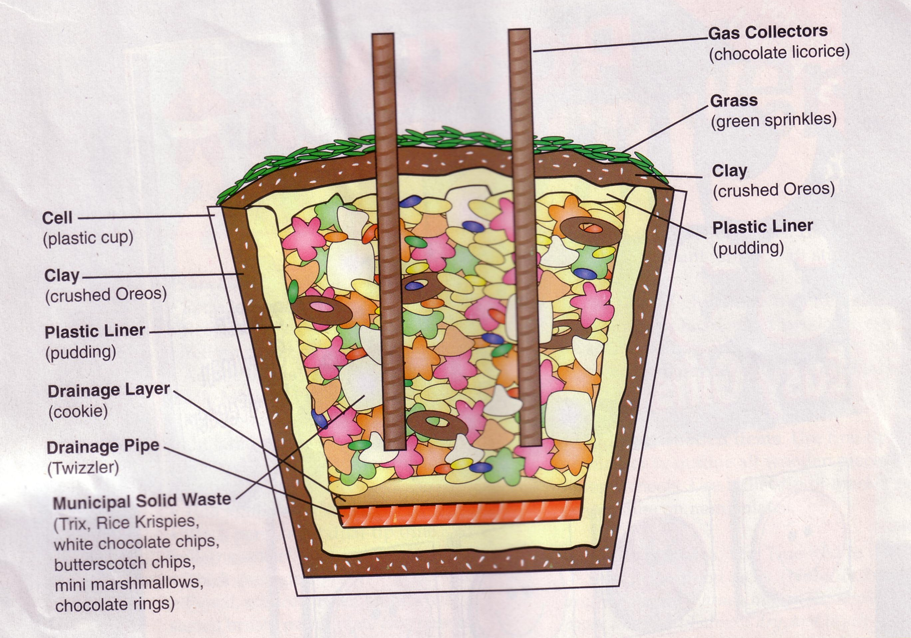
Materials
Base layer
Plastic cup or container"
1 tsp. Oreo cookie crumbs
2 tsp. vanilla pudding
Two 4" Twizzlers®
One shortbread cookie
Municipal waste (middle layer)
1 tsp. Trix® cereal
2 tsp. Rice Krispies® cereal
1 tsp. white chocolate chips
l tsp. butterscotch chips
Six mini marshmallows
Four chocolate rings
1 tsp. mini M&M's®
Chocolate syrup
Final Cap (top layer)
2 tsp. vanilla pudding
1 tsp. Oreo cookie crumbs
1 tsp. green sprinkles
Two 4" chocolate licorice pieces
*Designer used clear Solo® cups.
Instructions
Add each ingredient in order listed to plastic cup.
The layers of a landfill are described below.
Base layer
Layer 1 (cell): Landfills range in size from four to six acres of land. The area, or cell, must be free of debris and able to hold the weight of the landfill mass. This is represented by the plastic cup.
Layer 2: This layer is three feet of clay which prevent fluids from seeping out of the landfill. This is represented by pressing 1 tsp. of Oreo cookie crumbs firmly into bottom of cup.
Layer 3: This layer is a thin liner of plastic which is designed to prevent leaks in the ground beneath the landfill. This is represented by adding 2 tsp. of pudding.
Layer 4: These are pipes that make the leachate collection system. They collect leachate which is a liquid that is squeezed out of the garbage leachate then travels to a treatment pond. This is represented by laying two Twizzlers across pudding.
Layer 5: This is a drainage layer that protects the pipes from being damaged. This is represented by laying the shortbread cookie on top of the Twizzlers. (Note: No trash has been added yet. Layers 1-5 are designed to protect the environment by disposing of garbage safely.)
Municipal waste (middle layer)
Municipal solid waste is all of the garbage from peoples' homes and businesses.
Layer 6: This layer is composed of the following:
- Organic waste (Trix) is yard waste and food scraps.
- Paper (Rice Krispies) consists of cardboard, newspaper, and, packaging products.
- Plastics (white chocolate chips) include milk and soda bottles and food containers.
- Glass (butterscotch chips) range from bottles to old building windows.
- Metals (mini marshmallows) include tin and aluminum cans and appliances or sheet metal.
- Tires (chocolate rings) include those from cars and trucks.
- Other garbage (mini M&M's) contains old toys, shoes, and clothing.
This is represented by adding 1 tsp. Trix, 2 tsp. Rice Krispies, 1 tsp. white chocolate chips, l tsp. butterscotch chips, six mini marshmallows, four chocolate rings, and 1 tsp. mini M&M's. Spread evenly.
Layer 7: This layer is the leachate that forms. It seeps through all of the layers to the pipes which filter the liquid out of the landfill. This is represented by squirting chocolate syrup around the edge of the cup.
Final Cap (top layer)
This outermost layer prevents rainwater from entering the landfill and keeps gases from leaving and polluting our air.
Layer 8: This layer is the top plastic barrier that seals the landfill. This is represented by adding 2 tsp. of pudding.
Layer 9: This layer is five to seven feet of soil. This is represented by sprinkling 1 tsp. of Oreo cookie crumbs onto pudding.
Layer 10: This layer is grass which prevents soil erosion. This is represented by adding 1 tsp. of green sprinkles.
Gas collectors. These pipes are placed in the closed cell and act as methane gas collectors. They prevent fires by collecting the gas produced from decaying trash. This is represented by inserting two chocolate licorice pieces vertically into the cup.

Maurita was kind enough to share some secrets:

The Solo cups she uses are 9 or 10 oz ones with hard plastic side. Very wide at the top.

She, also, told me to keep talking during the assembly. Ask boys what impermeable, leachate, organic, perforated mean Start a discussion about what can become leachate. She says these usually get to be fun Ask them what some of the items represent before you tell them (e.g. ask what the chocolate cereal rings look like (tires))

DIRT PIE
Circle Ten Council
Ingredients
1.25# package Oreo's
1/2 stick margarine
8 oz cream cheese
1 cup powdered sugar
3.5 cups milk
2 sm. boxes instant vanilla pudding
12 oz Cool Whip
Directions
Crush Oreo's until fine.
Cream margarine, cream cheese and powdered sugar together.
Mix milk and pudding and combine with margarine mixture.
Mix well, and then add Cool Whip.
Thoroughly clean out a new plastic flowerpot with soap and hot water.
Alternate layers of Oreo crumbs and pudding mixture in the containers
Have Oreo's on both the bottom and top layers.
This cake looks especially good if you add gummy worms for special effect.
WORMS ON A BUN
Circle Ten Council
Ingredients
Hot dogs,
Hamburger rolls
Ketchup
Directions:
Cut the hot dogs into thin slices
Score the edges (about three cuts per slice).
Boil or microwave until the slices curl like wiggly worms.
Serve three or four worms to a bun
For an extra-icky touch, add a few squiggles of colored ketchup.
SEWER SODA
Circle Ten Council
Ingredients
1 qt Chocolate chocolate chip Ice Cream
3/4 c Chocolate syrup
1 liter Club soda
Large Spoon
4 Tall glasses & spoons
Straws
Directions
Let ice cream sit at room temperature until lit is easy to scoop.
Spoon ice cream into glasses until it is about halfway full.
Pour or squeeze about 3 tablespoons chocolate syrup into each glass.
Slowly fill almost to the top with club soda and stir well with a spoon.
Serve with a straw and tall spoon for excavating those luscious brown lumps.
Serves 4 sewage slurpers.
Gross serving suggestion! To make this slop especially disgusting, plop an unwrapped tootsie roll into each glass, the boys just love it!
Portable Hot Dogs
Great Salt Lake Council
With high fire danger, small children and serious hunger NOW, These dogs are ready when you are.
Before leaving home, place fully cooked hot dogs in one or more wide mouthed 1-2 gallon sized thermal jugs (24 dogs will fit in 1 gallon).
Pour enough boiling water to fill the jugs.
By the time you need them, the dogs will be steaming hot.
Bring tongs to lift out the hot dogs, as well as all the usual hot dog condiments.

Ladybugs On A Stick
Great Salt Lake Council
Ingredients
Red grapes cut in half Hulled strawberries
Mini chocolate chips Toothpicks cut in half
For each one,
Push 1/2 a red grape onto tooth pick half for the head.
Next push on a strawberry for the body
Score down the back to create wings.
For spots, push mini chocolate chips, point side in,
on the back of the ladybug.

STUNTS AND APPLAUSES
RUN ONS
Circle Ten Council
Cub 1: What did the big chimney say to the little chimney?
Cub 2: I don't know.
Cub 1: You're too young to smoke!
Cub 1: Everyone knows we should conserve energy. Can you name one way to do that?
Cub 2: By staying in bed all day!
Cub 1: What is the first thing you should do with a barrel of crude oil?
Cub 2: Teach it some manners!
Cub 1: Do you know what will happen when man pollutes outer space?
Cub 2: No, what will happen?
Cub 1: The Milky Way will curdle.
Cub 1: (reading statistics) Do you know that every time I breathe, someone dies?
Cub 2: Have you tried mouthwash?
Cub 1: What is blue and gold and covered with dirt?
Cub 2: A Cub Scout who has gone back to nature.

Longhorn Council
Just in case you find yourself in the woods with nothing to do, think about these riddles:
What flowers does everyone wear all year-around?
(Two lips)
When is a baseball player like a spider?
(When he catches a fly)
What’s the difference between an oak tree and a tight shoe?
(One makes acorns, the other makes corns ache)
What tree does everyone carry on their hand? (Palm)
Why is a dog’s tail like the heart of a tree?
(It’s farthest from the bark)
What kind of bird is present at every meal? (The swallow)
Why is the letter A like a sweet flower?
(Because a B (bee) is always after it)
What tree will keep you warm? (Fir)
A bear walks two miles west, two miles south, two miles east and ends up in the exact spot he began. What color is it?
(The bear is white! He must be at the North Pole if he ends up in the same spot at which he began, and bears at the North Pole are white)
How far can you walk into the woods?
(You can only walk halfway into the woods. After that you’re walking out of the woods)
Elephant Repellent
1st scout enters spreading imaginary elephant repellent.
2nd scout - What are you doing?
1st scout - Spreading elephant repellent.
2nd scout - There aren’t any elephants around here.
1st scout - Does a pretty good job, doesn’t it?
A Henway
1st scout enters petting an imaginary animal - want to pet my henway?
2nd scout - What’s a hen weigh?
1st scout - About 3 or 4 pounds.
Funny Proverb
As ye sow, so shall ye reap.”
Translation: What you seed is what you get!
You, Too??
Two guys rush together from opposite sides of stage.
One throws his arms out and grabs the other fellow,
First Guy - Thank God, I ran into you I’ve been wandering around out here for three day
Second Guy - I don’t know what you’re so excited about, I’ve been lost out here for over a week.
Great Salt Lake Council
- What is the best kind of paper for making kites?
- Why is a joke like a coconut?
- Why did the Cub Scout stand on his head?
- I asked my mother for some new sneakers for gym and what do you think she told me?
- Why does a hummingbird hum?
- When will a net hold water?
- What goes hoppity boom, hoppity boom?
ANSWERS TO RUN ONS
1. Fly paper
2. It isn't good until it's cracked.
3. His feet were tired.
4. Have Jim get his own sneakers.
5. It doesn't know the words.
6. When the water is frozen.
7. The Easter Elephant.

APPLAUSE
Circle Ten Council
Clean Air: Take a big sniff of air, exhale and say “AHHHHHHHHHHHHHHH!”
Noise Pollution: Raise hands and have everyone yell as loudly as they can. Lower hands and volume of yells go down. When hands are on floor, everyone must be extremely quiet. Do several times – raise and lower volume. Then, with hands on floor ask the Pack to listen to absolute quiet.
Reduce, Reuse, Recycle: Divide the audience into three sections. Have the first section yell, “Reduce!”, the second section yell, “Reuse!”, and the third section yell, “Recycle!” Alternate pointing at each section, pointing faster and faster.
Reverse Applause: Move hands away from each other.
Plant: Crouch near floor, take deep breath, hands together, like saying prayer with eyes closed, slowly rise upward spreading fingers and as you are on tip-toes, look up (to sun,) open eyes and exhale "Ahhhh."
Longhorn Council
Spider Applause: Walk all four fingers of one hand up the other arm and then scream ‘EEEEEKK!”
Great Salt Lake Council
RECYCLE: Pick up an empty soda can, stomp on it and throw into a recycling can
SPRING: Jump up and down and say "boing, boing, boing."
A TREE’S LIFE: Start as a seed, crouch on ground, stretch out arms and slowly stand to represent trunk and branches; sway with wind happily, shake fingers as you lose your leaves, shiver in cold during winter. Say "oh, no! Timmmberrrrr."
RECYCLE 2: Pat yourself on the back several times.
LITTERBUG: Slap back of hand several times with a frown on your face.
PICKING UP AFTER A LITTERBUG: Spot some trash, pick it up and put in can, clap, slide hands together as though you are brushing them off and smile big.
GARBAGE DISPOSAL: Turn you face up, open mouth, make gurgling sound, swallow big.
GARBAGE TRUCK: Start with hands over head together, lower arms, open, clap, lift up, open and make sounds of compressing garbage.
Baltimore Area Council
Beaver: Cut a tree by tapping front teeth together, slap your tail by slapping a palm against your thigh, then yell, "TIMBER!"
Bear: Growl like a bear four times, turning halfway around each time.
Bee: Put arms straight out and pretend to fly, while going "Buzz-z-z-z, Buzz-z-z-z."
Rainstorm Cheer: To simulate rain, have everyone pat one finger of the left hand and one finger of the right hand. Gradually increase the intensity of the storm by increasing the fingers hitting together. Decrease the number of fingers as the storm passes.

SKITS
BACK TO NATURE
Circle Ten Council
Decorate 8 large shopping bags; label 4 "Dirty Bugs", and the other 4 are "Tidy Bugs." Each boy carries one with his lines written on it near the top. If desired, they can also decorate a smaller paper sack like a bug to wear over their head.
- My name is Litter Bug Lou. And oh, what us litterbugs do!
- We clutter the country with papers and trash. At making a mess, we're really a smash!
- The roadsides and parks are scenes of our folly. We really enjoy it and think it quite jolly.
- To leave behind garbage, bottles and paper, as little memories of our daily labor.
- I'm Tidy Bug Ted of the Tidy Bug clan. We work to keep things spick and span!
- We pick up the litter wherever we are and always carry litterbags in our car.
- We'll wipe out Lou and all of his band and make America a beautiful land.
- Free of litter, trash and clutter. Won't you help us, dear Father and Mother?
Energy Savers
Longhorn Council
Characters: Six Cub Scouts in uniform; one den leader in uniform.
Setting: Den meeting place, decorated as desired. Den leader sits at a table. As skit opens, all “Cub Scouts arrive together and sit down. Johnny falls asleep.
Den Leader: Today, let’s take turns and tell how we can help to conserve energy in our homes.
- I know a good way. My mom doesn’t use her clothes dryer as much as she used to. She uses a new solar energy device called a clothesline and hangs her laundry outside to dry in the sunshine.
- My dad said that if we filled a plastic bottle with water and put it in the tank in the bathroom, it would cut down on the amount of water used for flushing.
- Did you know that if you take showers you use a lot less water than if you take baths? Mom even uses a timer, and we have learned to take 3-minute showers at our house.
- We keep the drapes closed on summer days and keep them open for light and warmth in the winter.
- We keep the damper in our fireplace closed whenever we aren’t using it. If it’s left open in the winter, the warm air in the house escapes up the chimney and that’s a waste.
Den Leader: (to last Cub Scout): Johnny, do you have anything to add about saving energy? (He turns to see that he is fast asleep.) I guess Johnny is the best energy saver of us all. (Curtain)
Keep America Beautiful Contest
Baltimore Area Council
Cast: Six Cubs in uniform.
Props: Comb and mirror for sixth Cub and a large box marked "TRASH!"
Scene: Five Cubs are sitting around a table tying knots or playing a simple game when the sixth Cub rushes in.
Cub # 1: (Runs in, very excited) Hey, you guys! Did you hear about the big contest?
Cub # 2: What contest? What's it about?
Cub # 1 : The "Keep America Beautiful Contest," that's what!
Cub # 3: Are there prizes? A contest is no good without prizes.
Cub # 1: Sure, lots of prizes. Neat ones like bicycles and CD players, and lots of other good stuff!
Cub # 4: (Gloomily) I bet it's hard. Contests with neat prizes are always hard.
Cub # 1: Nope! It's easy. Even the rules say it's SIMPLE - in big letters. The winner is the person who picks the easiest way.
Cub # 5: The easiest way to do what?
Cub # 1: The easiest way to keep America beautiful. That's what I've been talking about!
Cub # 6: (With a swagger) Ha! "Then I'm a cinch to win!
Cub # 1: Why's it so cinchy for you? What's your great way to keep America beautiful?
Cub # 6: (Takes out comb and mirror and combs his hair) See! That's the easiest way I know to keep America beautiful!
The other Cubs look at him, then at each other.
Quickly they surround him and carry or drag him to a large box marked "TRASH" and dump him in
Cub # 1: Like he said, guys, we're a cinch to win! That's the easiest way I know to keep America beautiful! (They exit. laughing while Cub #6 stands up in the trash box with a disgusted look on his face.)
Keep America Beautiful
Baltimore Area Council
Cast: Flower, Grass, Soda Can, Bottle, Cigarette Butt, Litterbug, Candy Wrapper, Trash Can, Cub Scout.
Setting: Flower and grass wave gently in breeze. Litterbug stands at left, laughing and throwing soda can at flower, bottle at flower, candy wrapper at grass, cigarette butt at grass.
Flower: Oh, what hit me? My petals are crushed. My upsweep is downswept.
Grass: You should complain. They buried me.
Soda Can: You think I like being thrown around? I could be used for tin craft by some Den Leader.
Bottle: Does the Pack Staff realize my potentiality? I could be used as a puppet or trick.
Cigarette Butt: To be lit up is one thing but to be tossed aside and not stripped is just too much.
Litterbug: (Laughs) I dirty America everyday, Ugly, Ugly, Ugly.
Candy Wrapper: Just look at me. 1 was meant to be so sweet and bring such happiness.
Cub Scout: (Sees litter trashcan sleeping) Wake up trash can, Litterbug was here.
Trash Can: Help, help, you'd think I was a SIimFast girl. No more than they are feeding me. All I ever do is wait. I've tried everything. I've even flipped my lid.
Cub Scout: People have got to realize this is one bug RAID won't kill. Only consideration by others will get rid of this pest. I'll start helping right now to eliminate that old Litterbug!
Litterbug: FOILED AGAIN! (Cub picks up trash.) Flower: (Sigh) What a relief! t thought you'd never come.
Cub Scout: Every Cub is honor bound to help Keep America Beautiful!
Grass: Adults help the Litterbug so much. Are they too old to be Cubs? Cub Scout: No one is either too old or too young to do their share in keeping America beautiful. This is the duty and privilege of every American.
Litter Hurts
Baltimore Area Council
A Scout comes out and begins talking about low impact camping and the importance of preserving nature.
As he walks around, he sees a piece of litter and picks it up.
He complains about the thoughtlessness of those who litter.
Next a Scout enters and drops lots of litter in his path.
Other Scouts rush the littering Scout and beat him up.
Finally they pick up the littering Scout and ask him if he has learned anything from this experience?
He answers painfully: "I learned that every litter bit hurts!" (Exit holding injured parts of body.)
EARTH DAY
Adapted from a poem by Hillol Ray.
Circle Ten Council
You may, also, want to consider this for an opening or closing ceremony CD
Set Up –
Divide into parts.
Have each boy hang a poster around his neck with a recyclable item.
E.g. -Bottles, can, newspaper, etc.
Each scout reads a pair of lines
Fresh air and clean water nourish our souls,
Without them, we suffer, and pay a heavy toll!
Banning pesticides and lead in gasoline -
Made the giant move to make the nature clean!
Recycling became a daily household chore -
To reduce costs and protect the seashore!
Reduction of emissions created the flow -
Of cleaner air, and polluters took a blow!
The situation has changed over twenty-five years,
And laws are in place to remove our fears!
Now, always think "Earth Is In Your Hands",
Here at home or in foreign lands!
So let us follow these few simple roles,
Conserve the water as much as you can,
While you are bathing or washing the van!
Recycle and prevent pollution at the source,
Plant the trees in open private space,
To create the shade and cool your face!
Well, now you know what you have to do -
And celebrate "Earth Day" without further ado!
The Highest Tree Climber In The World
Longhorn Council
Cast: 2 Friends (or add in different boys to ask the different questions) and a tree climber (who is not seen)
Setting: Campfire; (Tree climber is hidden in the woods and is able to ruffle a bush or tree.)
Cub 1: You know, they say there's this really good tree climber trying out for the Olympics. I wonder if he's practicing around here?
Cub 2: Call out and see!
Cub 1: Hey! Tree Climber! You around here?
Climber: Yep!
Cub 1: You practicing?
Climber: Yep!
Cub 1: How high are you?
Climber: Oh, not high. About 100 feet.
Cub 1: Wow! Can you go higher?
Climber: Yep! (Ruffles tree.) Now I'm at about 200 feet.
Cub 1: Fantastic! Can you go higher?
Climber: Yep! (Ruffles tree.) Now I'm at about 275 feet.
Cub 1: Neato! Can you go higher?
Climber: Yep! (Ruffles tree.) Now I'm at about 325 feet.
Cub 1: Great! Can you go higher?
Climber: Yep! (Ruffles tree.) Now I'm at about 400 feet.
Cub 1: Gee! I'm amazed!
Cub 2: Excuse me, Sir, but I have a book here that says that the highest tree in the world is only 360 feet high!
Climber: Ahhhhhh!!!!!! (Thump!)
Been Fishing
Great Salt Lake Council
DL Where have you been?
- We've been fishing down at the Jordan River.
DL Really? What kind of fish does it have in it?
- I caught this Sole [sole of shoe]
- I caught this Snapper [rubber band, old girdle, or slingshot]
- I caught this Shell fish [Shell oil can]
- I caught this Skate [roller skate]
- [Enters with a long line out the door and tugging on it.]
DL Wow, what have you got there?
- Just an old Crab. [Pulls Cubmaster or other leader in with hook in seat of pants – To avoid gray area concerns - make certain this is prearranged with the leader and they ham up their part].
Skit on Nature
Longhorn Council
Den Leader (labeled Mother Nature): Everything living, and properly cared for, grows. There are things that a tree needs to grow. It needs warmth, water, care, and protection. Cub Scouts grow. What does a Cub Scout need to help him grow?
- He needs food to grow. (Perhaps this is the largest cub)
- He needs a home for shelter.
- He needs a man to be his friend.
- He needs to go to school to grow mentally.
- He needs to go to church to synagogue to help him grow spiritually.
Den Leader: Where’s Johnny? Isn’t he in this skit?
- (Hurrying on stage) Here I am. A Cub Scout needs to be needed.
Den Leader: It’s not nice to fool Mother Nature!

CLOSING CEREMONIES
THIS APPLE IS THE WHOLE WORLD
Circle Ten Council
PROPS: Apple, Pocketknife, Table
*Because this ceremony involves the use of a pocketknife, an adult should handle this.
CUBMASTER: Earth Day comes in April and it reminds us to be careful with our home planet. There is also an old song about April showers bring May flowers. Together, these remind me of how precious and valuable water is, and how important it is to use it wisely. I
Imagine that this apple is the whole world. Three quarters of the world is covered with water, and only one quarter is covered by land. (Cut one-fourth section off of apple and place it down on the table.)
Out of the three quarters covered in water, only about three percent is fresh water and the rest is salt water, mostly in the oceans. (Cuts off thin sliver from apple, and places larger piece down on the table. Holds the thin sliver up for all to see).
Of this 3% slice, about two-thirds of that is generally not available. Most of that is frozen in the North Pole and South Pole, and other hard to reach places. (Cuts off two thirds of the thin sliver and puts larger piece down).
Only this thin sliver is left. All the fresh water that is available to life on the land's surface. This is all the fresh water we have. What would happen to us if we ruin this thin sliver by pollution? (Eats thin sliver in one bite).
We would be gone just like that. Be careful with the world. We need to save it for all these young people here tonight.
NATURE CLOSING
Circle Ten Council
Wood and water, wind and tree,
Wisdom, strength, and courtesy,
Scouting favor go with thee.
Conservation Closing
Longhorn Council
Cubmaster (holds picture of outdoor scene): All of this great and beautiful America is ours to enjoy. Surely we want to preserve it for the thousands of boys who will come after us. Let us stand and repeat in unison a pledge that will remind us to conserve these wonderful things for those who follow us. Please repeat the outdoor code with me.
OUTDOOR CODE:
As an American, I will do my best to:
Be clean in my outdoor manners,
Be careful with fire,
Be considerate in the outdoors,
And be conservation minded.
Nature And The Good Visitor
Longhorn Council
COMMITTEE CHAIRMAN: Our pack meeting tonight brought us all together to think about nature. We can enjoy the great outdoors but we must think of others who will follow us. Wherever you go in the great wide world of nature, try to be a "good" visitor who will leave the plants and the creatures for others to enjoy after you leave.
- The only shots I took were snapshots.
- I tried to walk on pathways to keep off plants.
- When I see animals or birds, I try to remember that I am a guest in their living place and I don't do anything to them but look at them.
- The one big thing I always do when I am ready to go home is to look and see that all fires are out in nature's backyard.
CUBMASTER: With Cubs and Webelos like you to help keep our friends on the ball, I'm sure that the beauties of nature will be around for years to come. Thanks Cubs, Good night.
A TREE IS A GOOD SCOUT
Circle Ten Council
Personnel: 6 Cubs and a narrator
Equipment: Each Cub hold a picture or drawing of a tree with his section of text on the back.
- Did you ever pause to think about how helpful a tree is?
- It provides a nesting place for birds, shade from the sun, and protection from the rain.
- It discards its dead branches, thus providing wood for building fires and for cooking food.
- A tree adds beauty to the countryside and to camping areas.
- We must admit that a tree gives a lot more than it receives.
- We can learn a lesson from the tree, by doing our best to always be helpful to others and by putting our fellow Scouts first and ourselves second.
Narrator: Remember the lesson we learn from the tree - To give to others more than we receive.

CUBMASTER’S MINUTE
A NATURALIST IS …
Circle Ten Council
No matter where you live, there is a world of undiscovered secrets of nature still waiting to be explored.
A naturalist is a student of natural history, which includes the many things found in nature, such as plants and animals. This month, our dens have (briefly review some of the den activities an the theme)... There are many more interesting activities to help you Cub Scouts learn more about the world of nature and to develop an appreciation of it.
A naturalist stands like Columbus on the prow of his ship with a vast continent before him... except that the naturalist's world can be at his very feet... a world to be investigated and discovered. It is as near as your own backyard; a nearby park, the woods and fields or even a country road. These places are inhabited by many kinds of insects, birds, plants, animals, trees and other forms of life. Continue exploring the world of nature and you will find many wonderful things that God has given us to enjoy.
Closing Thought
Longhorn Council
God created families. He also created our beautiful world for us to enjoy and care for. We have fun doing things together as families and in Cub Scouting. We have many opportunities to work and play together. Today let us be thankful for our own families and God’s beautiful world in which we live.
Good Night Closing Thought
Longhorn Council
No matter where you live, there is a world of undiscovered secrets of nature still waiting to be explored. A naturalist is a student of nature. This month our dens have gone on Outdoor Adventures to find what was waiting for them. There are many more interesting activities to help each of you Cub Scouts learn more about the world of nature and to develop an appreciation for it. One who studies nature stands like Columbus on the prow of his ship with a vast continent before him...except that the naturalist’s world can be at his very feet . . . a world to be investigated and discovered. It is as near as your own backyard, a nearby park, the woods and fields, or even a country road. These places are inhabited by many kinds of insects, birds, plants, animals, trees and other forms of life.
Continue exploring the world of nature and you will find many wonderful things that we have been given to enjoy. Think of the words of the song “America the Beautiful” for a moment. Oh beautiful for spacious skies, for amber waves of grain, for purple mountain majesties above the fruited plain.. . . . . . This is what God has given us--nature’s beauty. This is what we as Cub Scouts and Scouters will work to conserve, protect and enjoy.
WALK THROUGH THE WOODS
Circle Ten Council
The Cubmaster can simply read this or you can add music and trees in the background as props and have the boys in the dens walk out on stage as the words are being read.
When you walk through the woods, I want you to see,
The floating gold of a bumblebee
Rivers of sunlight, pools of shade
Toadstools sleeping in a mossy jade.
A cobweb net with a catch of dew.
Treetop cones against an azure blue.
Dancing flowers, bright green flies
Birds to put rainbows in your eyes.
When you walk through the woods, I want you to hear,
A million sounds in your little ear.
The scratch and battle of wind tressed trees
A rush as a timid chipmunk flees
The cry of a hawk from the distant sky
The burr of the leaves when a breeze rolls by
Brooks that mumble, stones that ring
And birds to teach your heart to sing.
When you walk through the woods, I want you to feel
That not we nor man could make this real
Could paint the throb of a butterfly's wing
Could teach the woodthrush how to sing
Could give the wonders of earth and sky
There's something greater than you or I
When you walk through the woods and the birches nod
Son, meet a friend of mine, named God.
The Gift Of Trees
Longhorn Council
The Indians believe that the secret of happiness comes from giving to others. Many, many moons ago when the Great Spirit first put man on the earth, man was frightened. “Where will I find food and water?” he asked. The trees laughed softly. “We are your brothers,” they said. “We will help you.”
The maple tree spoke up: “I will give you sweet water to drink and make into sugar.”
The elm tree said, “Use my soft bark to make your baskets and tie them together with my tough muscles.”
The hickory tree said, “My cousins and I will fill your baskets with sweet nuts.”
And he called the chestnut, beech, and walnut to help him.
The great pine tree whispered softly, “When you get tired, little brother, I will make you a bed.
My cousins the balsam and cedar will help me.”
There was sunshine in man’s heart as he set out to explore his new world. But soon he came to a deep, wide river. “How will I ever cross the river?” man asked. The trees laughed and laughed. “Take my white skin,” said the birch. “Sew it together with the muscles of the elm tree and you can make a boat that will carry you across the widest river.”
When the sun crossed the sky to his lodge in the west, man felt cold. Then the balsam fir tree whispered to him, “Little brother, there is much sun fire in my heart. Rub my branches together and you will make a fire.” So the man made fire. And that night he slept soundly on the branches of the great pine tree. The north wind blew cold, but there was sunshine in the heart of man.
Now when Indian children ask how they can repay their friends, the trees, a wise man answers, “They do not ask for payment. But you can give them care and attention. You can give love and care to every plant and flower that makes your life beautiful.”
WEBELOS

FAMILY MEMBER
Circle Ten Council
A definition of a family is “all the people living in the same house.” Families have many and varied faces. Some families are the traditional mother, father, and children, while others are one-parent families. Still other families consist of grandparents raising grandchildren. Even if a guardian is in charge of rearing a child, we hope that love and understanding is part of every family structure.
The family member activity badge helps each boy understand his family and his part in that family. This badge is geared to open each boy’s awareness of how the family works and what makes the family work well. Chores, laundry, grocery shopping, and house cleaning are all elements included in the family unit. Remember to stress that each boy is important to his own family and that his family is important to him.
PURPOSE
Circle Ten Council
Because of the importance of the family involvement in this activity badge. It’s a good idea to hold a parent’s meeting to explain the requirements and give some suggestion on how they can work with their son on this badge.
Remember that the parent should initial the completed requirements, but a review of the activities with the individual boys at a later meeting by the Webelos leader will ensure that all the activities were properly completed.
Another good approach is to let the boy’s plan a “Family Day: for a Saturday or Sunday afternoon of fun for their parents and siblings. The boy’s creativity and resourcefulness will amaze you and entertain everyone who attends.
Make sure the presentation of this badge at a pack meeting includes the family.
SUGGESTED DEN ACTIVITIES
Circle Ten Council
- Invite a fireman, policeman or security guard to a den meeting to talk about home safety. Perhaps he can also provide you with a home inspection sheet.
- Invite a home economics teacher or dietician to talk to your den. Perhaps your den could also plan a weeks worth of meals for a family and visit a retail food establishment and price the food required to sustain this family and see how it relates to the budget of a family budget.
- Tour a waste disposal facility; have an employee give a talk.
- Invite an energy conservation engineer to give a talk on energy.
- Make a list of fun activities that involve little cost; do them over several meetings.
- Invite someone from a professional home cleaning service to give a talk on how to properly clean things.
- Tour a fast food restaurant or small café.
- Have someone from OSHA or a plant safety committee give a talk after touring a manufacturing facility.
- Have a family relation’s teacher visit and talk.
- Switch chores with another family member for a month.
- Keep a personal budget for a month.
- Tour an energy conserving home that is built in the area.
- Visit with a local financial institution to find out how the monetary system works and how saving money as a family unit can be beneficial in the long run.
- Contact local public utility companies, or the environmental control agency to find out how our natural resources can be saved and what we as individuals within the family unit can do to conserve energy.
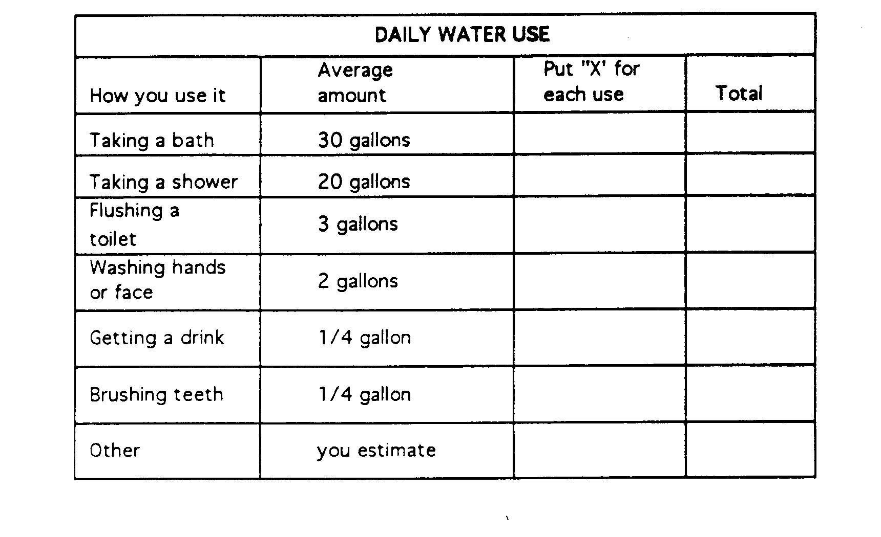
WATER YOU USE YOURSELF
Circle Ten Council
There is little danger of North America running out of water. But there is a danger that we will run short of pure water. You can help prevent this by using only as much water as you need. If you study how you use water now, you will be able to find ways to use less. Study the two charts below. Then keep this sheet with you for a DAY. Mark it each time you use water. You can use the back of this paper to do your figuring.
Remember that this is an estimate, not an exact measure of how much water you use. Therefore, you can use the average amount given in the second column when you do your figuring. For example, if you get six drinks of water a day, you would estimate 6 x ¼ - 1 ½ gallons. (Note: The averages assume you let the water run to get hot or cold. You wouldn’t for example, drink ¼ gallon of water each time you get a drink, but that much would run from the faucet if you let it run to get cold). Enlarge chart to desired size.
YOUR SHARE OF THE FAMILY’S WATER
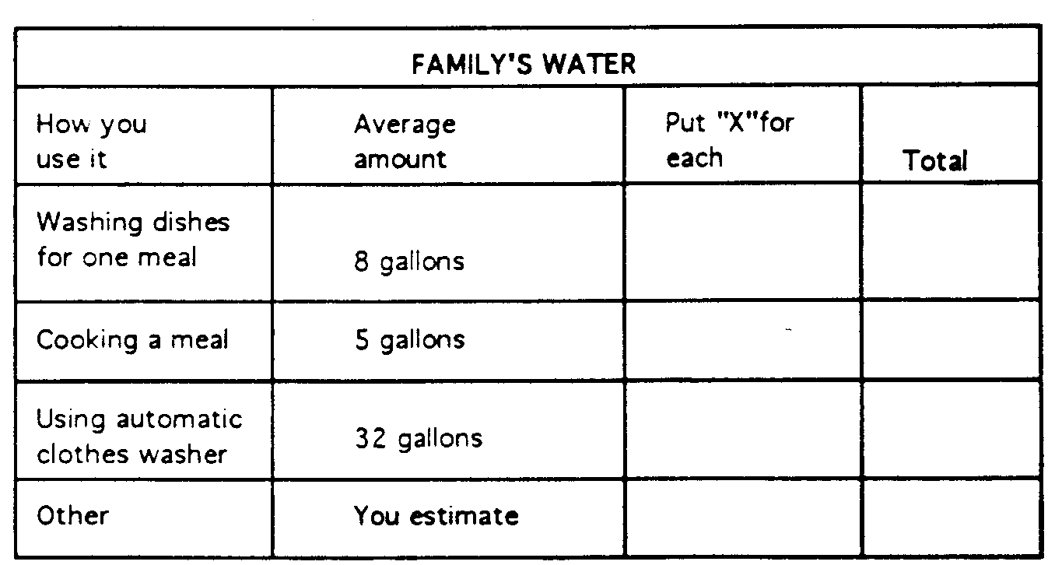
Some water is used for the good of everyone in your family, such as water for cooking and cleaning. This chart can help you estimate your share of that water. Suppose, for example, that there are five people in your family. If you estimate that water for meals, cleaning and other family uses equals 100 gallons, your share is 100 divided by 5, or equals 20 gallons. Enlarge chart to desired size.
Energy House
Circle Ten Council
This is one picture you will definitely want to cut and paste, them restore to fill a full sheet of paper before using. CD
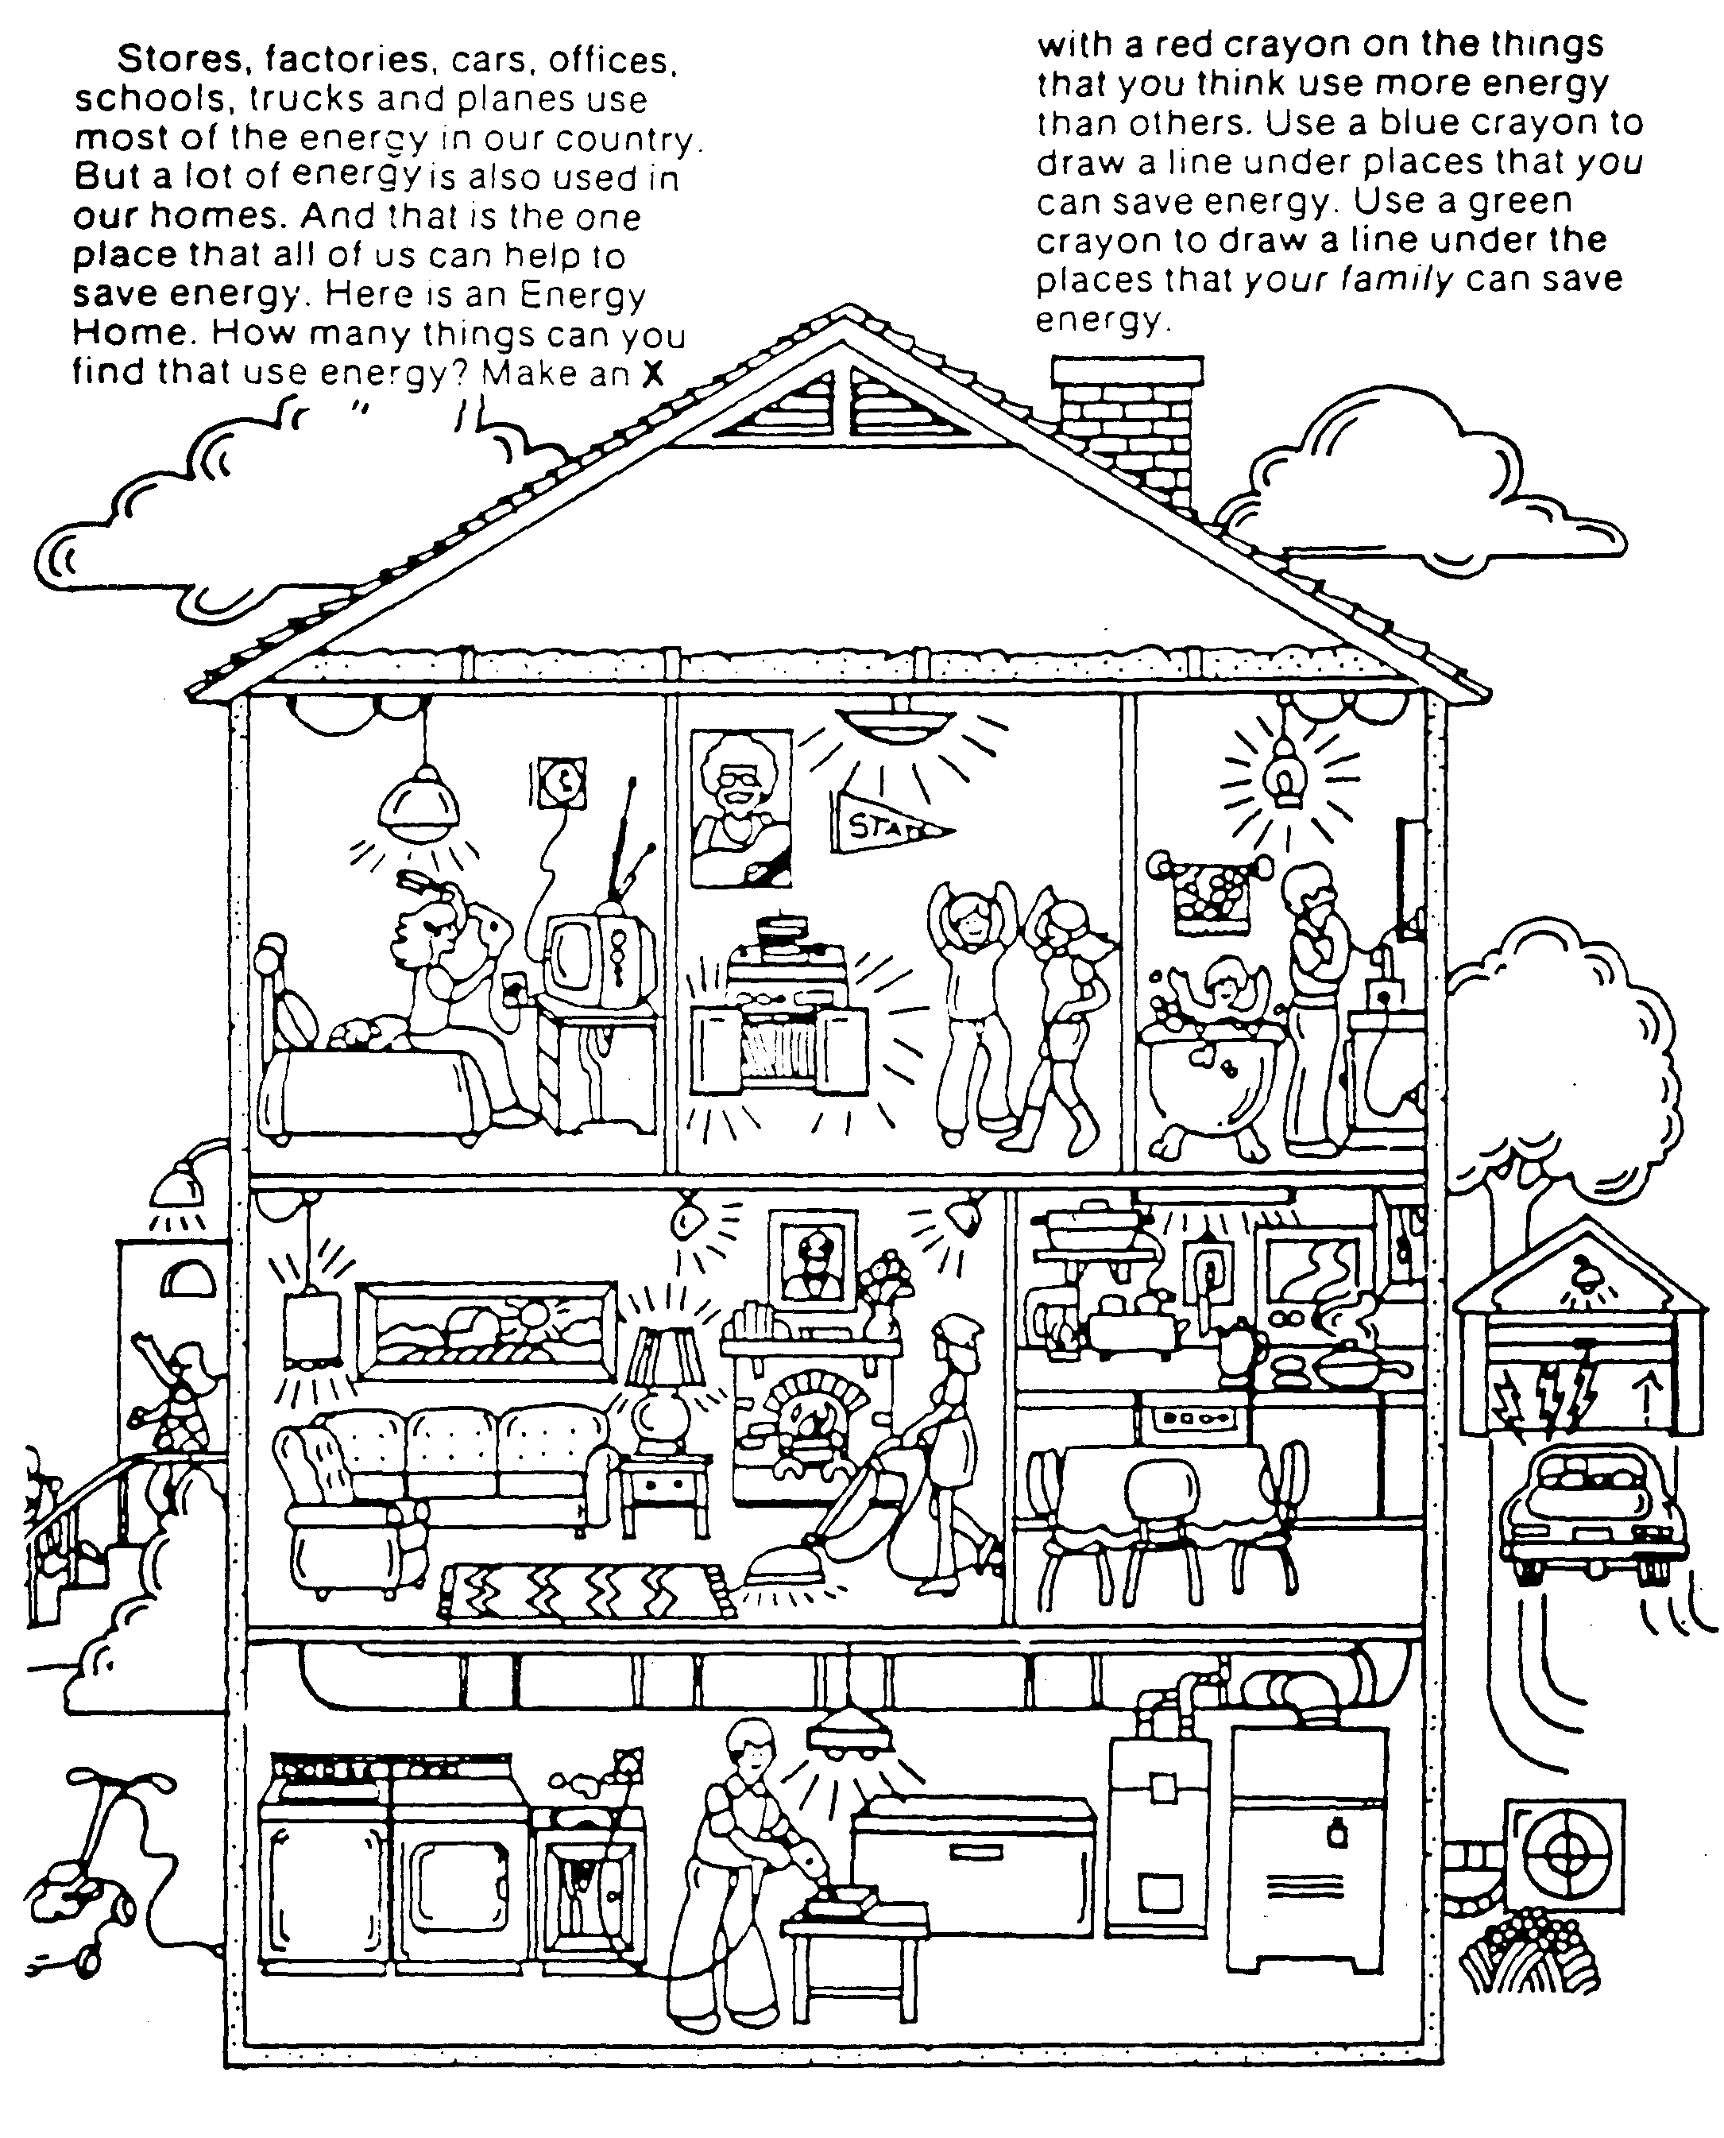
SPORTSMAN
Circle Ten Council
Sports are high on the list of favorites of Webelos age boys. You can be certain of instant interest by most members of your den. Chances are that they spend much of their leisure time in organized sports and loosely organized neighborhood games. Some of them probably know enough already about rules, scoring, and techniques for several sports so that they could pass the badge requirements easily.
But that’s not really enough. One of the prime purposes of Cub Scouting is encouraging good sportsmanship and pride in growing strong in mind and body. If your boys learn all the skills and rules involved in every sport this month, and don’t get an inkling of what good sportsmanship means…then the den, and you, have wasted your time.
Agree on the importance of learning sportsmanship. What does that mean in practice? It means that the least skilled gets just as much instruction and encouragement as the best athlete. It means that the better athletes learn not just to tolerate the awkward boy, but learn to help him. It means that all boys can win and loss with grace and good sportsmanship.
Your own example will help to achieve these goals. Put stress on the fun of the game, not on the winning. When you have den competitions, make up the teams so that the strength is about even. If you let boys choose teammates, there is a good chance that most of the best players will wind up on the same team. Encourage the less skillful players. Discourage others from belittling them. Sports in a Webelos den should be fun for all the boys.
BASEBALL GAME
Circle Ten Council
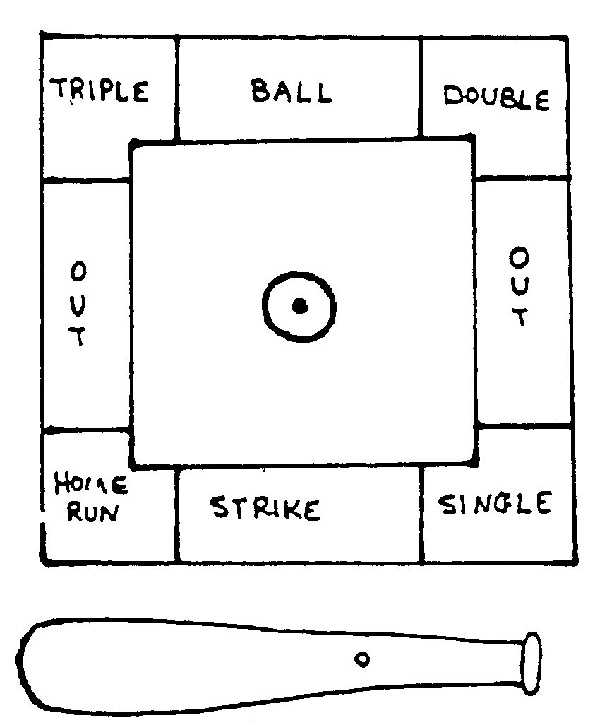
Need:
Sheet of cardboard (can be any size, must be square)
Marking pens
Paper brad
Let each of the boys make his own to take home.
Cut a large square from the cardboard. Using marking pens draw a baseball diamond on it like the one shown.
Mark home plate and three bases.
Outside of the baselines write as shown: Home Run, Strike, Single, Out, Double, Ball, and Triple.
Draw pitcher’s mound in the center.
Cut a bat shape spinner from cardboard.
Punch small hole in bat and center of pitcher’s mound.
Attach bat with paper brad to pitchers mound. Be sure that the hole is not too large or too small, needs to be large enough for the bat to spin freely.
Follow regular baseball rules when playing. Keep score. Each player keeps his turn until he has three outs.

WHAT ARE WE???
Circle Ten Council
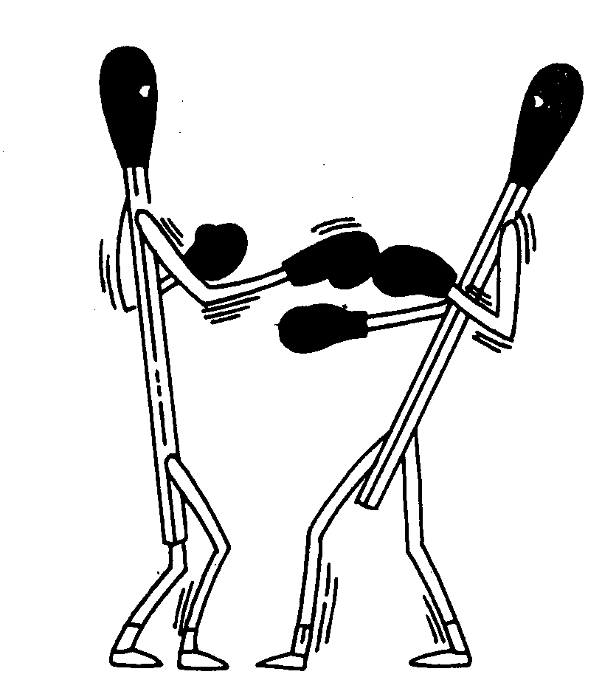
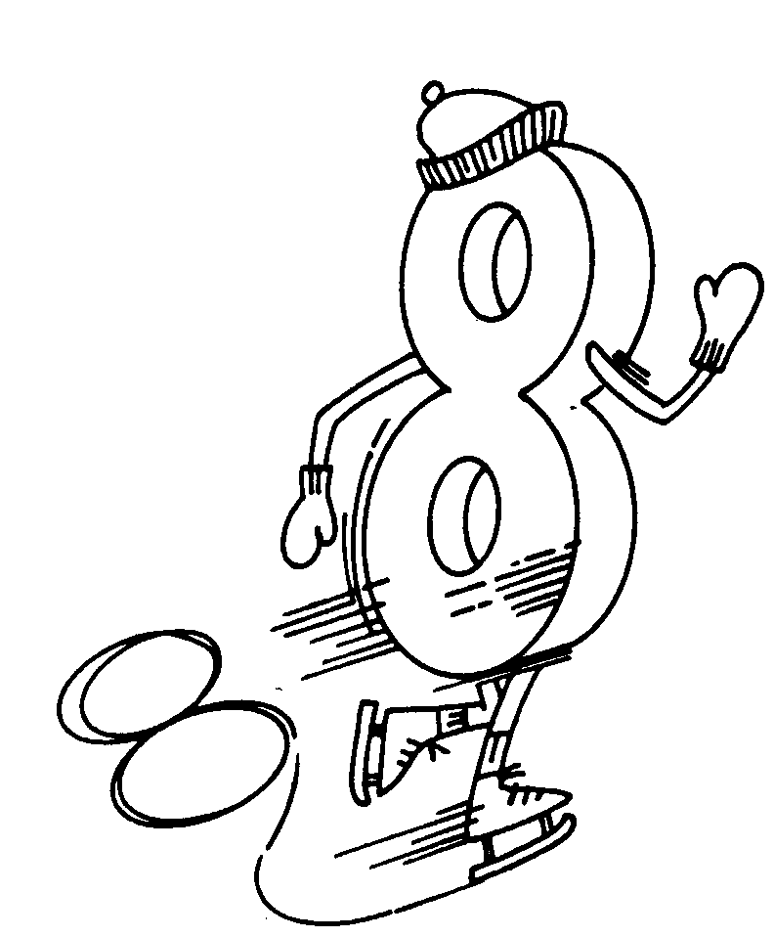
ANSWER :Boxing match, figure 8 skating
Den Meeting Ideas
Circle Ten Council
Demonstrate the signals of baseball and have the boys do them
Hold parent/son bowling contest
Discuss the rules and regulations of various sports
Attend a high school, college or professional sporting event
Have a Sports Sunday and watch a pro game on TV (combine with a backyard tailgate cookout)
Have a fishing derby
Play miniature golf
Have a referee talk to the boys about the rules of his sport
Walk a golf course and observe play (get permission first!)
Have archery practice using targets against bales of hay
Visit a tennis court or racquet club
Have a high school coach come and talk about what it takes to become a good athlete
SKI-SKATE TAG
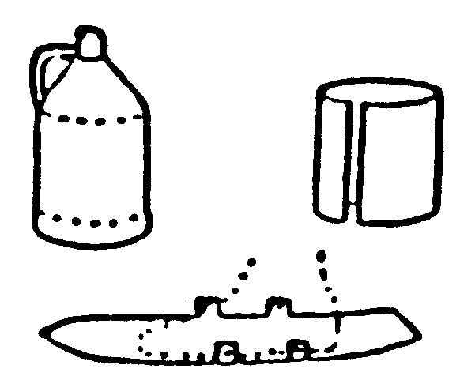
Circle Ten Council
For a pair of shorty skis, remove top and bottom of two gallon plastic bottles. Cut down seams and flatten into strips, curved at the ends. Stand on center of the plastic and mark width of shoe at the widest point. Mark small tabs on each side of foot and a second pair of tabs near ankles. Cut plastic to the width of foot with tabs attached. Trim skis to a point at the front. To fasten skis to shoes, punch holes in tabs. Bend tabs up and lace with ribbon or cord, lacing over tops of shoes and around ankles.
SOCCER BALL NECKERCHIEF SLIDE
Circle Ten Council

Materials:
Ping Pong ball
Plaster
Pop top ring or small ½” PVC pipe ring
Black acrylic paint
Directions:
Cut a ping-pong ball in half.
Fill the half of ball with plaster and
Insert pop-top or PVC ring for slide.
Decorate with black paint.
The same idea can be used to make a Basketball, etc.

POW WOW EXTRAVAGANZAS
You can, also, find a list of Pow Wows on USScouts.org at http://www.cubmaster.org/PowWowsUSA.asp
If you want your Pow Wow listed –
E-mail commissionerdave@comcast.net and attach a sign up sheet or flyer. Thanks
Northeast Region
Hudson Valley Council
University of Scouting
March 6, 2004
Washingtonville Middle School
Washingtonville, New York
Training for everyone – Cub Leaders, Boy Scout Leaders, Commissioners and more!
There are no walk-ins allowed for this event
Call the Information Center, 914-388-4863, or visit the website, www.hvus.org for information.

Bucks County Council
University of Scouting
March 6, 2004
Bucks County Intermediate Unit
Doylestown, PA
Training for everyone – Cub Leaders, Boy Scout Leaders, Commissioners and more!
Call 215-348-7205 or visit their website, www.buckscountybsa.org

WEB SITES
Leave No Trace
BSA has adopted Leave No Trace standards for cub Scouts and there s a Leave No Trace Award for Cub Scouts.
For more information –
http://www.scouting.org/cubscouts/resources/13-032/index.html
Or go to
Contact the Leave No Trace organization –
l-800-332-4100 or go to their home page @ www.lnt.org

Make A Woven Newspaper Sit-Upon
Teach A Child Beginning Basket weaving Skills With This Free Craft Project
http://www.basketmakers.org/topics/beginners/situpon1.htm

Another newspaper sit-upon site with pictures -
http://gsleaders.org/files/Newspaper_Sit.htm

Ideas for leaders
Here is a site I just found looking for sit-upons. There are some great ideas here –
http://gsleaders.org/files/index.htm

Scouts On Line
Providing Internet Service to Scouts around the world. Get a free website for unit.
http://www.scoutsonline.com/

Pack O Fun Magazine
This great Scout centered magazine has been around since my mom was Den Leader. I am a recent re-subscriber to the magazine but they have lots downloadable free craft ideas on their web site.
www.craftideas.com

Dearborn County Solid Waste Management
Source of the Incredible Edible Landfill. Lots of great Recycling ideas and projects and other ideas to inspire or Cubs to do Cubservation
www.dearborncounty.org/recycle.html

Other Incredible Edible Landfills
There are four different other Incredible Edible Landfills listed here. Plus tons of other good Scouting stuff -
http://scoutingweb.com/scoutingweb/Program/Science.htm

The York County (PA) Solid Waste Authority lets you choose to build either a veggie or a candy edible landfill -
http://www.ycswa.org/education/Presentations/

OUTDOOR CODE
As an American I will do my best to:
Be clean in my outdoor manners,
Be careful with fire,
Be considerate in the outdoors, and
Be conservation minded.

