FOCUS
Cub Scouting Roundtable Planning Guide
What’s special about your state? This month boys will find out. Cub Scouts will visit historic places, theme parks, museums, and zoos. Choose a city or historical site in your state to highlight. Design a game that features a special aspect of your home state. Take a trip, go to a ball game, or just have a family picnic in the park. Pretend you are someone important in the history of your state, and see whether anyone can guess who it is. How about some special local recipes that each den can prepare for the Pack Show? Invite a guest speaker who can share something special about your state with the boys. Use maps or collect tourist brochures to learn more about places to visit. Your local historical society or library is a great place to get started.
CORE VALUES
Cub Scouting Roundtable Planning Guide
Some of the purposes of Cub Scouting developed through this month’s theme are:
- Good Citizenship, Cub Scouts learn citizenship skills and develop pride in their state as they gain knowledge and respect for the history and cultures that make their state special.
- Sportsmanship and Fitness, Cub Scouts learn about the importance of these by using state resources with regard to outdoor activities.
- Respectful Relationships, One Country, 50 great states, celebrating uniqueness and identity.
The core value highlighted this month is:
- Positive Attitude, Boys will take pride in discovering wonderful facts about their state.
Can you think of others??? Hint – look in your Cub Scout Program Helps. It lists different ones!! All the items on both lists are applicable!! You could probably list all twelve if you thought about it!!
COMMISSIONER’S CORNER
This is going to be a really different issue of Baloo’s Bugle. I am going to outline a lot of ideas but I do not have the detail for all 50 states to fill in the blanks. That is going to be your job. That is why I am making sure everyone knows the kid centered web sites for their state to find the information.
Before you start planning though, I want you to carefully read the Focus paragraph from the Cub Scouting Roundtable Planning Guide. What is it telling you to do?? That’s right – get outside!! This is a May theme. Not a middle of winter indoor activity theme. National wants us to get out there and explore our states!! Take your Cubs out to see what’s great about your state. Please, do not turn this theme into paperwork exercises about state nicknames, birds, animals, trees and such. In May boys want to be out doing things. Take them there. See if your council has a state park on the approved Cub Scout Family camping list (mine does!!) and take them there. If they don’t – take your Cubs there for a day hike! Or take them to a museum or a battleground like Gettysburg or Valley Forge or the Alamo.
Roundtable Commissioners – where I said go find out … for your state, I am hoping you will do that for your group (or your Pow Wow Committee has already done that and put it in the Pow Wow Book for you.) Sorry to be so late this month.
Finally, I am sure you have all seen the little PayPal logo and the line to donate to US Scouts. We are in need of a new server. The current one has crashed several times in recent months. Most recently, the weekend of March 27 & 28. Since I started posting this notice, USScouts.org has made it about halfway to their goal. If everyone that downloads a copy of Baloo this month who hasn’t already done this could authorize $5 (or $10) for US Scouts through PayPal, we would be well on our way to upgrading our service to you. Thank you. If you would prefer to mail a check – write hendra@macscouter.com for details. Thank you.
PRAYERS AND POEMS FOR SCOUTERS
Happy 94th birthday to the Boy Scouts of America.
Be watching for that big 100th birthday Jamboree in 2010!!! I graduated from Cubs to Boy Scouts in 1960, the 50th anniversary of the BSA. That Jambo was in Colorado Springs (I went to Valley Forge in 1964)!!

The Blessing in "NO"
Author Unknown
Circle Ten Council
I asked God to take away my pride.
God said "No".
It is not for me to take away, but for you to give it up.
I asked God to make my handicapped child whole.
God said "No".
Her spirit was whole, her body was only temporary.
I asked God to grant me patience.
God said "No".
Patience is a by-product of tribulations; it isn't granted, it is earned.
I asked God to give me happiness.
God said "No".
I give you blessings, happiness is up to you.
I asked God to spare me pain.
God said "No".
Suffering draws you apart from worldly cares and brings you closer to me.
I asked God to make my spirit grow.
God said "No".
You must grow on your own, but I will prune you to make you fruitful.
I asked for all things that I might enjoy life.
God said "No".
I will give you life so that you may enjoy all things.
I ask God to help me LOVE others, as much as he loves Me.
God said... Ahhhh, finally you have the idea!
Roundtable Prayer
Cub Scouting Roundtable Planning Guide
The men and women who settled our state saw more than land to build upon. They had a vision of what the land could be. We, as leaders of Scouts, have a vision of what our Scouts could be – leaders of tomorrow. Guide our words and our actions as we build for the future. Amen.
What Be A Webelos?
Jake McCoy, A Webelos Scout in Virginia
Way below the Webelos
Gnashed his gnarly teeth
When scratching at a google tree
And the mombills beneath
Eyes of flame, claws of stone
Fillipools run in fear
Webelos whiffle through the trees
Listen, can you hear?
Terror! Terror! In the glens
The sight that no one knows
They hunt the running merrigans
What be a Webelos?

TRAINING TIP
Safe Swim Defense
www.uscouts.org
Before a BSA group may engage in swimming activities of any kind, a minimum of one adult leader must completed Safe Swim Defense training, have a commitment card (No. 34243) with them, and agree to use the eight defenses in this plan. Safe Swim Defense and Safety Afloat training can be given by any person authorized by the council, including a BSA Aquatics resource person, a unit leader with aquatics skill, or any other person with aquatics knowledge or experience whom the local council has approved.
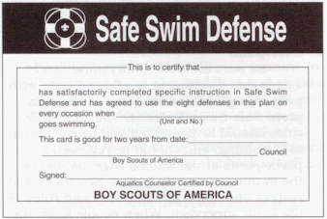
You will have to check with your local council for opportunities to attend this training. One of the best opportunities for Safe Swim Defense training is in summer camp. Often times it is given at a Roundtable in May or June.
The eight Safe Swim Defenses are:
- Qualified Supervision - All swimming activity must be supervised by a mature and conscientious adult age 21 or older who understands and knowingly accepts responsibility for the well-being and safety of youth members in his or her care, who is experienced in the water and confident of his or her ability to respond in the event of an emergency, and who is trained in and committed to compliance with the eight points of BSA Safe Swim Defense. (It is strongly recommended that all units have at least one adult or older youth member currently certified as a BSA Lifeguard to assist in the planning and conduct of all swimming activity.)
- Physical Fitness - Require evidence of fitness for swimming activity with a complete health history from physician, parent, or legal guardian. The adult supervisor should adjust all supervision, discipline, and protection to anticipate any potential risks associated with individual health conditions. In the event of any significant health conditions, the unit leader should require proof of an examination by a physician. Those with physical disabilities can enjoy and benefit from aquatics if the handicaps are known and necessary precautions are taken.
- Safe Area - When swimming in areas not regularly maintained and used for swimming activity, have lifeguards and swimmers systematically examine the bottom of the swimming area to determine varying depths, deep holes, rocks, and stumps. Packs should not be swimming in these types of areas but should make sure the pool or lake or water where they are is safe in accordance with these instructions. Mark off the area for three groups: not more than 3½ feet deep for nonswimmers; from shallow water to just over the head for beginners; deep water not more than 12 feet for swimmers. A participant should not be permitted to swim in an area where he cannot readily recover and maintain his footing, or cannot maintain his position on the water, because of swimming ability or water flow. When setting up a safe swimming area in natural waters, use poles stuck in the bottom, or plastic bottles, balloons, or sticks attached to rock anchors with twine for boundary markers. Enclose non-swimmer and beginner areas with buoy lines (twine and floats) between markers. Mark the outer bounds of the swimmer area with floats. Be sure that clear-water depth is at least 7 feet before allowing anyone to dive into the water. Diving is prohibited from any height more than 40 inches above the water surface; feet-first entry is prohibited from more than 60 inches above the water. For any entry from more than 18 inches above the water surface, clear-water depth must be 10 to 12 feet. Only surface swimming is permitted in turbid water. Swimming is not permitted in water over 12 feet deep, in turbid water where poor visibility and depth would interfere with emergency recognition or prompt rescue, or in whitewater, unless all participants wear appropriate personal flotation devices and the supervisor determines that swimming with personal flotation equipment is safe under the circumstances.
- Lifeguards on Duty - Swim only where there are certified lifeguards on duty. There are provisions for Troops to provide their own lifeguards. Cub Scouts are too young to serve as lifeguards.
- Lookout - Station a lookout on the shore where it is possible to see and hear everything in all areas. The lookout may be the adult in charge of the swim or several other adults and may give the buddy signals.
- Ability Groups - Divide into three ability groups: Learners, beginners, and swimmers. Keep each group in its own area. Learners have not passed a swimming test. Beginners must pass this test: jump feet first into water over the head in depth, level off, swim 25 feet on the surface. Stop, turn sharply, resume swimming as before and return to the starting place. Swimmers pass this test: jump feet-first into water over the head in depth. Level off and swim 75 yards in a strong manner using one or more of the following strokes: sidestroke, breaststroke, trudgen, or crawl; then swim 25 yards using an easy resting backstroke. The 100 yards must be completed in one swim without stops and include at least one sharp turn. After completing the swim, rest by floating. These classification tests should be renewed annually, preferably at the beginning of the season.
- Buddy System - Pair every youth with another in the same ability group. Buddies check in and out of the swimming area together. Emphasize that each buddy lifeguards his buddy. Check everyone in the water about every ten minutes, or as needed to keep the buddies together. The adult in charge signals for a buddy check with a single blast of a whistle or ring of a bell and a call of ''Buddies!'' The adult counts slowly to ten while buddies join and raise hands and remain still and silent. Guards check all areas, count the pairs, and compare the total with the number known to be in the water. Signal two blasts or bells to resume swimming. Signal three blasts or bells for checkout.
- Discipline - Be sure everyone understands and agrees that swimming is allowed only with proper supervision and use of the complete Safe Swim Defense. The applicable rules should be presented and learned prior to the outing, and should be reviewed for all participants at the water’s edge just before the swimming activity begins. Scouts should respect and follow all directions and rules of the adult supervisor. When people know the reason for rules and procedures they are more likely to follow them. Be strict and fair, showing no favoritism.

PACK ADMIN HELPS
Publicity
Word of mouth is the best publicity. Having your Cubs telling other boys how great it is. But never pass up the opportunity for some publicity in a local newspaper. Here is a great article about a Pinewood Derby in Pennsylvania I received from my friend, Rowland -
http://www.phillyburbs.com/pb-dyn/articlePrint.cfm?id=273061
Year Round Program
Circle Ten Council
THE BASIS OF A SUCCESSFUL PACK
Program planning is a simple but critical part of your pack's success. Throughout the process remember your goal is to deliver a high quality program to each boy and his family. It should be fun, exciting and focused on the purposes of Cub Scouting.
Setting an annual program plan provides direction and sense of satisfaction and a feeling of accomplishment in a job well done. Planning also makes the best possible use of your valuable volunteer time.
Planning Steps:
One of the most important responsibilities of the pack committee is to keep the pack operating with a first-rate, year-round program. The quality of the program will depend largely on the pack committee giving the Cubmaster, the Cub Scout den leaders and Webelos den leaders the help they need.
Cub Scout program planning includes four steps, dependent upon one another, which usually guarantee a strong pack program. The steps are:
Annual Pack Program Planning Conference
Monthly Pack Leader's Meetings
Monthly Den Leader Meetings
Monthly meetings of each den leader with the den chief
Steps to having a great Annual Program Plan
SET A DATE TO MEET - Set a date in August with the committee, including the Den Leaders and Webelos Leaders.
CHECK MEETING DATES - Before this time check with your chartering organization and school calendar to find available dates for pack meetings. They should be at the same time and date each month.
REVIEW LAST YEAR'S PROGRAM - Which activities worked and which did not? Decide what activities and special meetings you would like to do again. Also determine whether or not your budget was adequate for them.
SET NEW MEETING DATES - Review the available pack meeting dates with the pack committee and set dates for the coming year. Write pack meeting dates in your council calendar (extra copies are available through the Service Center for your committee members and den leaders). Be careful to avoid holidays and school breaks.
SET COUNCIL AND DISTRICT DATES - Review the council and district calendar and mark dates on your program schedule for district and council activities: Webelos Woods, Pinewood Derby, training sessions, and important meetings like roundtable.
SET SPECIAL PACK DATES - Set the dates for special activities your pack will be doing during the year and put them in your program calendar. These may include:
Pack Fundraiser (Product Sale)
Blue and Gold Banquet
Pinewood Derby
Friends of Scouting
Summertime Activities
Webelos and Tiger Graduation
Since June 1, 2003, adults giving leadership to a pack campout MUST complete the Basic Adult Leader Outdoor Orientation (BALOO). Please check council calendar for upcoming BALOO training sessions. (This is not required for council-run programs)
SCHEDULE YOUR MONTHLY COMMITTEE MEETING - Select dates for and schedule monthly meetings of your committee to meet and plan out the next month's activities and meetings (i.e. in September you should be planning for October). You should have a committee meeting every month.
SELECT A MONTHLY THEME - Select monthly themes from the Program Helps or choose your own. Write them in your annual calendar so everyone knows what the month's theme is for both Cubs and Webelos.
SET A BUDGET - Based on the meetings and activities you have planned for the year, number of boys who are likely to advance, and the number of youth and adult members of the pack, figure out what your approximate yearly expenses will be. You will need to plan enough fund raising activities to cover these expenses. The Budget Planning Worksheet will help you calculate and plan your annual expenses and income to create a budget.
DISTRIBUTE THE PLAN - Cub Scouts and their families will better participate in meetings and activities if they have a copy of the calendar. Every family should receive a copy of the annual calendar so they can plan accordingly.
These are the basic steps your committee will need to follow to have a complete annual program plan and calendar. This calendar will help insure that everyone in the pack knows exactly what is happening from month to month during the year. More important, it will help you plan in advance and avoid being caught off guard by rapidly approaching deadlines.
Remember that September brings *** Join Scouting Night and the start of a full year of activities. When you go to Join Scouting Night, if you have a well thought-out plan and distribute it to your members, new and old, you will find it is easier to recruit not only boys but also adult leaders.
TIGERS
Time for Bobcat
It is time for your tigers who have been with you since last June or September to earn their Bobcat and be promoted in the next month or so. It is, also, time to start Springrecruiting of new Tigers at Schools, Soccer fields and Little League fields. The cycle repeats. CD

Picnic Fun/ Fun Outdoors
Circle Ten Council
This is a great opportunity to take your Tigers out for a picnic at a local state or city park and walk around and see what they have you can learn about Your Home State CD Family Activity
Take a bike ride. (Be certain to practice bicycle safety.)
Play catch or Frisbee.
Go roller-skating or -blading. (Always wear protective gear.)
Visit the zoo.
Plant a flower and/or vegetable garden.
Visit a nearby playground or park.
Have a barbecue or picnic at a park.
If you cannot get to the park, have a picnic in your backyard.
Did your picnic get rained out? Do not despair. Do it indoors - complete with blankets, paper plates, cups, etc.
Go fishing.
Take a paddle boat ride.
Go swimming in a creek or pond (Practice water safety, of course!)
Take a blanket and several books outside and read under the shade of a tree.
Make homemade ice cream.
Wash the car together. This can be great fun on a hot day!
Camp out in the backyard.
Frisbee Golf.
This is a great game that can be set up in a backyard, in a park or around a neighborhood. The basic idea is that you have laundry baskets or some other sort of receptacle, some flags or a way to see the receptacle and a few Frisbees. Just like regular golf, you try to land your Frisbee in the "hole" in as few shots as possible.
Stories
Make up a great story and tell it outside. The longer, the better. Sit in a circle and take turns adding one paragraph to the story. You'll be surprised at how it all ends up.
Make homemade ice cream.
You can get a freezer for about $20. Pick up a bag of ice, rock salt, a gallon of low-fat milk, and a can of non-fat Eagle Brand. Let your child mix the Eagle Brand, a cup of sugar, 1/8 t salt, and tablespoon of vanilla extract with about two cups of milk. Stir until the sugar has dissolved, then pour into the freezer. Add more milk to the fill line, load it up with ice and rock salt, and let it run for about 40 minutes.
Watermelon and Sprinkler.
Watermelons are so sticky and messy in the house. Instead, just cut a whole watermelon into enough pieces for your family and their friends then send them outside and turn on the sprinkler. You don't even have to watch it; just let them loose to get as sticky and wet as they want.
Den Activity
Put up a hoop for basketball or suggest the boys get active with skipping, tag, racing, baseball, soccer or swimming. Always emphasize the fun and not the competition.
Go fly a kite! (If you don't have one, make one!)
Study the shapes of passing clouds, then use cotton balls and glue on paper to recreate the images they saw.
Bubble solution
Start by mixing together 1/4 cup of dishwashing liquid, 2 cups of water, and 1 teaspoon of sugar. Pour the mixture into a shallow container.
Bubble Mania
Have a bubble blowing frenzy using a variety of unusual bubble blowing tools! Plastic funnels, six pack soda rings, plastic cups with holes punched through the bottom.
Bubble Art
Now take the bubble mix, pour some into a cup and add a few drops of food coloring. Blow rainbow bubbles into the air, and try to catch them with a white sheet of paper! After the paper dries, use markers or crayons to finish your masterpiece!
Pet Rocks
Find smooth, flat or round rocks. Be sure to clean off any dirt or sand and dry completely before starting. Paint with acrylic paints. Decorate faces by using googly eyes, yarn for hair, markers, glitter, and any other tidbits you like.
Go See It Outing
Go to a state park, museum, aquarium, historic place
Music in the park concert
SPECIAL OPPORTUNITY
I don’t have one badge to tell you about this month – I have a bunch. It seems to me there are badges available in every state to encourage you to learn about your state or a certain part of your state.
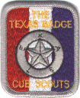
In Texas there is the Texas Badge. Go to http://www.pack129.org/cubs/texasbadge.shtml to learn about it.
In New Jersey the NJ State Aquarium has a Scout Patch that Scouts (Cub, Boy and Girl) can earn. We also have the Cape May Historic Trail, The Jockey Hollow Trail, Palisades Historic Trail and more. Our council has a conservation award just for Cubs.
I am sure if you look, you will find an award your Scouts could earn. And they would have fun doing it while learning about your state.
Maybe it is not a Scout award. Delaware has a state parks award for hiking/walking in all their state parks. This month get out there and find an award – Scouting, government or privately sponsored that your Cubs can earn while learning about your state.
STATE KIDS' PAGES
I put these lists up front because you are going to need them to develop some of the suggested activities in this month’s Baloo. Just remember – this is an OUTDOOR theme – don’t have your Cubs spend all their time inside or on the web
This first list has the link to the official state website for kids, if one exists. In cases where a state did not have a page dedicated to youth, we've selected an alternate from your submittals or from searching. Additional sites recommended by Baloo Readers are at the end of the list. I thank all of you who sent me info. And the USSSP team members who jumped in and helped me with this issue. You all deserve a Big Heap How!! Commissioner Dave
Alabama Kids Page
http://www.alabama.gov/facts/kidspages.html
Alaska Stuff for Kids
http://www.state.ak.us/kids/
American Samoa
http://academickids.com/world/geos/aq.html
Arizona - About Arizona for Kids
http://www.lib.az.us/links/kidsAZ.cfm
Arkansas Kids
http://www.arkansaskids.com/
California Kid's Korner
http://www.dre.ca.gov/kids_sub.htm
Colorado Kids and Students Page
http://www.state.co.us/kids/index.html
Connecticut ConneCT Kids
http://www.kids.state.ct.us/
Delaware Kids Page
http://www.state.de.us/gic/kidspage/kidspage.htm
District of Columbia Kids' Capital
http://kids.dc.gov/
Florida Kids' Corner
http://taxonomy.myflorida.com/Taxonomy/Visitor/Kids%20Corner
Florida Kids
http://dhr.dos.state.fl.us/kids/index.html
Georgia
http://www.atozkidsstuff.com/georgia.html
Guam
http://www.guam-online.com/people/people.htm
Hawaii
http://www.atozkidsstuff.com/hawaii.html
Idaho Kid Book
http://www2.state.id.us/gov/fyi/kidbook/index.htm
Idaho Just for Kids
http://www.accessidaho.org/education/kids.html
Illinois Kid Zone
http://www.state.il.us/kids/
Indiana Little Hoosiers' Kid Page
http://www.in.gov/sic/kids/
Iowa Kids Too
http://www.state.ia.us/main/addressbooks/ADkids/index.html
Kansas Lawrence Recycling Page
http://www.lawrencekidsrecycle.org/
Kansas
http://www.accesskansas.org/facts-history/index.html
Kentucky Kids' Pages
http://kentucky.gov/Portal/Category/fac_kids
Louisiana Just for Students
http://www.louisiana.gov/wps/portal/.cmd/cs/.ce/155/.s/1118/_s.155/1088/_me/1117/
Maine Kids' Page
http://www.state.me.us/sos/kids/
Maryland
http://www.mdkidspage.org/
Massachusetts Kids' Zone
http://www.state.ma.us/sec/cis/ciskid/kididx.htm
Michigan MI Kids
http://www.michigan.gov/mikids
Michigan Kidz Korner
http://www.mda.state.mi.us/kids/index.html
Minnesota Student Page
http://www.sos.state.mn.us/student/netscape4.html
Mississippi Treasure Chest of Educational Resources
http://www.ms.gov/frameset.jsp?URL=http%3A%2F%2Fwww.mde.k12.ms.us%2Fms.htm
Missouri Kids Page
http://www.gov.state.mo.us/kids/
Montana is for Kids
http://montanakids.com/
Nebraska Online
http://www.nol.org/html/293/index.phtml
Nebraska's Legislature's Website for Kids
http://www.unicam.state.ne.us/kids/index.htm
Nevada
http://firstlady.state.nv.us/Trivia.htm
New Hampshire Senate Page for Kids
http://www.gencourt.state.nh.us/senate/misc/kids.html
New Jersey Hang Out NJ
http://www.state.nj.us/hangout_nj/
New Mexico
http://www.state.nm.us/category/aboutnm/fastfacts.html
New York for Kids
http://www.iloveny.com/kids/index.asp
North Carolina Kids Page
http://www.secretary.state.nc.us/kidspg/
North Dakota Kid Zone
http://discovernd.com/kidzone/
Northern Mariana Islands
http://academickids.com/world/geos/cq.html
Ohio OH Kids
http://oplin.lib.oh.us/products/oks/
Oklahoma
http://www.youroklahoma.com/?c=8
Oregon Blue Book
http://bluebook.state.or.us/kids/kids.htm
Pennsylvania Kids Pages
http://www.state.pa.us/papower/taxonomy/taxonomy.asp?DLN=29872
Puerto Rico
http://www.elboricua.com/BoricuaKids.html
Rhode Island
http://www.ri.gov/browse.php?choice=mpage&mcat=8
South Carolina
http://www.50states.com/scarolin.htm
South Dakota
http://www.state.sd.us/about.htm
Tennessee Kids Pages
http://www.tennesseeanytime.org/residents/children.html
Texas Senate Kids
http://www.senate.state.tx.us/kids/
Utah Kids Page
http://www.utah.gov/learning/kidspage.html
Vermont Kid's Page
http://www.sec.state.vt.us/Kids/kids_index.htm
Virgin Islands
http://www.countryreports.org/virginislands.htm
Virginia Kids Commonwealth
http://www.kidscommonwealth.virginia.gov/home/
Washington Just for Kids
http://access.wa.gov/kids/
West Virginia Kids' Page
http://www.legis.state.wv.us/kids/kids.html
Wisconsin Agency Pages for Kids
http://www.wisconsin.gov/state/core/kids_page.html
Wyoming Kid's Page
http://www.state.wy.us/kids.asp
U.S. GOVERNMENT SITES FOR KIDS
FirstGov for Kids
Don’t miss this one!!!!!!!!!
http://www.kids.gov/
White House for Kids
http://www.whitehouse.gov/kids/presidents/
Agriculture Department
http://www.usda.gov/news/usdakids/
Army
http://www.army.mil/coolstuff/default.htm
ATF for Kids
http://www.atf.gov/kids/index.htm
CIA
http://www.cia.gov/cia/ciakids/index.shtml
Coast Guard
http://www.uscg.mil/news/Downloads/downloads.htm
EPA Environmental Kids Club
http://www.epa.gov/kids/
FEMA for Kids
http://www.fema.gov/kids/
Forest Service Conservation
http://na.fs.fed.us/spfo/ce/portal.html
Forest Service for Kids
http://na.fs.fed.us/spfo/ce/content/for_kids/index.cfm
Globe Program
http://www.globe.gov/globe_flash.html
Justice for Kids
http://www.usdoj.gov/kidspage/
Law-4-Kids
http://ogc.navy.mil/ogcwww/LAW-4-KIDS.asp
Minerals Management for Kids - Alaska
http://www.mms.gov/alaska/kids/index.htm
Minerals Management for Kids - Gulf
http://www.gomr.mms.gov/homepg/lagniapp/lagniapp.html
Minerals Management for Kids - Pacific
http://www.mms.gov/omm/pacific/kids/educate.htm
Minerals Management for Kids - Main
http://www.mms.gov/mmskids/
NASA Destination Earth
http://www.earth.nasa.gov/flash_top.html
NASA Mars Team
http://quest.arc.nasa.gov/mars/kids/index.html
NASA QUEST
http://quest.arc.nasa.gov/
National Science Foundation
http://www.nsf.gov/od/lpa/nstw/kids/start.htm
Peace Corps Kids World
http://www.peacecorps.gov/kids/
Railroad Fun Facts
http://www.rrb.gov/teachers.html
Social Security Administration
http://www.ssa.gov/kids/index.htm
State Dept. Future Diplomats
http://future.state.gov/
Treasury
http://www.ustreas.gov/education/index.html
Veterans Affairs for Kids
http://www.va.gov/kids/
US Freedom Corps
http://www.usafreedomcorps.gov/for_educators/index.asp

MORE FROM BALOO READERS
Here are a few more websites sent in by readers who endorsed them heavily. Thank you all for your help with this project. I salute you all with a big Heap How!!!
Commissioner Dave
All 50 States –
http://www.statelocalgov.net/index.cfm has a list of all State Government websites
http://www.graphicmaps.com/webimage/countrys/namerica/us.htm - Just click on the one you want!
http://www.50states.com/
http://www.gallopade.com/gallopade_pages/StateStuff.cfm This is a teachers’ resource site selling many things for each state. I got a lot of ideas for games and activities just be reading about what they had for sale.
www.crayola.com has some really neat color sheets with the state flag, bird, etc… listed on it as well as state fact cards; just type in the name of the state and all kinds of goodies pop up.
www.enchantedlearning.com has a really great state section complete with label me state and tons of facts on each state.
Connecticut –
http://www.ctbound.org/4Kids/Default.asp
Florida –
http://dhr.dos.state.fl.us/kids/
Idaho –
www.accessidaho.org/education/kids.html
Kansas - Websites related to Kansas History:
http://www.kshs.org/kids/
http://www.ipl.org/div/kidspace/stateknow/ks1.html
http://www.ukans.edu/heritage/kssights/
http://www.worldalmanacforkids.com/explore/states/kansas.html
http://kansasstatetreasurer.com/kidszone/kansas_history.ihtml
http://www.ksgovernor.org/kansas_facts.html
http://www.50states.com/kansas.htm
http://www.kslib.info/ref/symbols.html
http://www.kssos.org/resources/kansaskids_fieldtrip.html
http://femaweb4.fema.gov/cgi-shl/web_evaluate.exe
http://www.kgs.ukans.edu/Publications/primer/primer01.html (good for Webelos Geologists Badge)
Maine – by the way, Kathy from Maine was the first to send me a state web page link. Thanks
http://www.maine.gov/
Maryland
http://www.mdisfun.org/ - Kids link at top right
http://www.sailor.lib.md.us/index.html - general tourism
http://www.marylandagriculture.com/showall.cfm?categoryid=19 - Maryland Kid's Ag Links
http://www.maryland.gov/communities/community.asp?UserID=2&CommunityID=203&Folder=237|730 - MARYLAND.GOV - Kids' Page
http://mikulski.senate.gov/kids.html - Senator Mikulski's Virtual Office - Kids' Page
http://www.mpt.org/kidsfamily/ - MPT (Maryland Public television) Kids & Family Page
Minnesota –
http://www.state.mn.us - Click Kids Page at the top of the home page
Missouri –
http://emintsteachers.more.net/orlandom/socstlinks.htm
http://www.kidskonnect.com/Missouri/MissouriHome.html
New Jersey (You knew this one would be here)
http://www.judiciary.state.nj.us/kids/links.htm - NJ Judiciary page for kids
http://www.battleshipnewjersey.org/ - The Battleship New Jersey
http://www.njleg.state.nj.us/kids/index.asp - The NJ legislature’s kids’ page
http://www.state.nj.us/travel/ - NJ Travel and Tourism site
New York –
http://www.dos.state.ny.us/kidsroom/nysfacts/factmenu.html - New York State kids
North Carolina –
http://www.ncgov.com/asp/subpages/kidspage.asp
Ohio –
http://ohio.gov - Official State Site
http://www.ohiotourism.com/kids/ - Kid's Information
www.state.oh.us/ - State of Ohio Homepage, go to "live help"
www.dnr.state.oh.us/default.htm - Ohio Dept. of Natural Resources
www.dnr.state.oh.us/odnr/wildlife/ - ODNR - Division of Wildlife
Texas –
http://www.texas.gov/category.jsp?language=eng&categoryId=1.5 -
Virginia
http://legis.state.va.us/CapitolClassroom/Games2Go/SeekAndFind.htm
http://www.virginiaplaces.com/
Washington –
http://www.kidskonnect.com/Washington/WashingtonHome.html
http://www.leg.wa.gov/common/kids/colorbk.htm - coloring pages to print out of different things about Washington
GATHERING ACTIVITY
Here are some sample gathering activities. I am sure you can create similar ones for your states. CD
KNOW YOUR STATE - TEXAS
Circle Ten Council
Match up these answers to the questions below.
Mockingbird Houston Rio Grande
Bluebonnet San Antonio Horned Lizard
Dallas Austin
- What is the capital of Texas?
- What river forms Texas' southern border?
- What is the state reptile of Texas?
- In what city do you find the Alamo?
- What is the name of the state bird of Texas?
- What flower represents the state of Texas?
- The center of the space shuttle program (NASA) is located in what city?
- Where would you go to attend the Texas' state fair?
ANSWERS: 1. Austin, 2. Rio Grande, 3. Horned Lizard, 4. San Antonio, 5. Mockingbird, 6. Bluebonnet, 7. Houston, 8. Dallas
KNOW YOUR STATE – NEW JERSEY
Southern NJ Council
Select the correct answer from the following
- Violet
- Eastern Goldfinch
- Sussex County
- Rutgers
- Violet
- Atlantic City
- Hadrosaurus Foulkii
- Delaware
- Trenton
1. What is the capital of New Jersey?
2. What river forms New Jersey western border?
3. What is the state dinosaur of New Jersey?
4. In what city do they hold the Miss America contest?
5. What is the name of the state bird of New Jersey?
6. What flower represents the state of New Jersey?
7. What is the State University called?
8. Where would you go to attend the New Jersey state fair?
ANSWERS 1. Trenton, 2. Delaware, 3. Hadrosaurus Foulkii, 4. Atlantic City, 5. Eastern Goldfinch, 6. Violet, 7. Rutgers, 8. Sussex County
Note – These last two items were two column lists with draw a line to connect the right answer but in Baloo’s format my columns weren’t wide enough. CD
FAMOUS PEOPLE FROM NEW JERSEY
(or associated with New Jersey)
Southern NJ Council
Match the people with who they were or what they did. This may be better for parents at a Pack Show rather than boys at a Den Meeting
People
- William “Bud” Abbott
- Jason Alexander
- John Forsythe
- Bruce Willis
- Jerry Lewis
- Ozzie Nelson
- Stephen Crane
- Joyce Kilmer
- Frank Sinatra
- Bruce Springsteen
- Frankie Valli
- Derek Jeter
- Edwin “Buzz” Aldrin
- Wally Schirra
- Grover Cleveland
- Woodrow Wilson
- Norman Scwarzkopf
- Thomas Edison
What they did or Who they were
- Wrote “The Red Badge of Courage”
- Old Blue Eyes
- The Wizard of Menlo Park, invented light bulb
- President of Princeton before President of US
- The Labor Day telecast emcee
- NY Yankee player
- Son of founder of NJ State police, US Army General
- Half of famous comedy team
- One of two actors associated with Penns Grove, NJ
- Only US President with two non-consecutive terms
- The Four Seasons lead singer
- Wrote the poem “Trees”
- Member of Seinfeld cast
- Only Astronaut in all three programs – Mercury, Gemini, Apollo
- The Boss
- Second man on the moon
- The other Penns Grove, NJ, actor
- Put his family on TV
Answers – 1H, 2M, 3Q, 4I, 5E, 6R, 7A, 8L, 9B, 10O, 11K, 12F, 13P, 14N, 15J, 16D, 17G, 18C
FAMOUS TEXANS
Circle Ten Council
Can you match these famous Texans to the city they are from?
Tioga Houston San Antonio
Port Arthur Denison Weatherford
Lubbock Dallas San Saba
Abbot El Paso Rowena
Wharton Monahans Texarkana
- Gene Autry, singer, actor
- Red Adair, fireman oil well fires
- Carol Burnett, comedienne
- Janis Joplin, blues singer
- Dwight David Eisenhower, U.S. pres, general
- Mary Martin, actress
- Buddy Holly, musician
- Michael Johnson, Olympic sports
- Tommy Lee, Jones actor
- Willie Nelson, singer
- Sandra Day O'Connor, Supreme court judge
- Bonnie Parker, outlaw partner was Clyde
- Dan Rather, TV newscaster _
- Kathy Whitworth, golfer
- H. Ross Perot politician, philanthropist
ANSWERS: 1.Tioga, 2.Houston, 3.San Antonio, 4.Port Arthur, 5.Denison, 6.Weatherford, 7.Lubbock, 8.Dallas, 9.San Saba, 10.Abbot, 11.El Paso, 12.Rowena, 13.Wharton,
14.Monahans, 15.Texarkana
OPENING CEREMONY
ALL ACROSS OUR NATION
Circle Ten Council
Personnel: 8 Cub Scouts
Equipment: Picture of or a small flag. The following pictures: Statue of Liberty, steel mills or factory, scene of New Jersey, picture of the Alamo, picture of Alaska, Hawaiian scene, map or picture of the U.S.A. Recorded background music.
The Cub Scouts form a semi-circle around the flag and hold up their picture and say the short verse.
- (Statue of Liberty) New York is a lovely state where we see this lady stand.
- (factory or industry) Michigan is a very great state, they make many cars for our land.
- (New Jersey scene) New Jersey is our own home state, we’re proud in many ways.
- (Alamo scene) Texas is the Lone Star state, home to the Alamo.
- (Alaskan scene) Alaska has some very cold nights, with some short, short days.
- (Hawaiian picture) Hawaii is our newest state, and we’re proud to say she’s ours.
- (map or picture U.S.) But all of the states together, make a nation of beautiful stars.
- (Flag) Please join me in the Pledge of Allegiance
- Please join me in singing "God Bless America."
"UTAH" OPENING CEREMONY
Great Salt Lake Council
Set Up – Four Cub Scouts with card spelling out UTAH and their words in large print in the back.
All: In my state we have:
- U -The Uintas, Utes, uranium, and we are an upbeat utopian.
- T - Timpanogos, trappers, temples, turkeys, table salt, train meeting from east to west, tyrannosaurus bones, we have technical geniuses and the television inventor. We are temperate and theological.
- A - Apples, apricots, antelopes, many academic colleges, athletes, artists, April conference, and Apostles. Appetites for casseroles, green Jell-O salads, ice cream and church dinners.
- H - Honeybees, handcarts, a huge salty lake, a harmonizing choir, hieroglyphics, and many hobbies and handicraft. We harvest hay, pie cherries, peaches, and hams. We are known for being happy, helpful, and holding the best Winter Olympics ever.
All: This is truly the greatest place on earth!
Maybe you could write a ceremony like this for your state – Idaho, Iowa, Ohio, Maine would not be too bad. Indiana and Illinois, yes, but I can see problems with long names like West Virginia or South Carolina but am sure you can do it!! CD
A NEW JERSEY (or WISCONSIN OR IDAHO OR MAINE OR …) CUB SCOUT
Southern NJ Council
The US Flag and a pack flag are carried to the front by the color guards. They face the audience. The lights are turned down and a Cub Scout stands in between the flags. A spotlight is turned on the setting. An adult leader or a good reader reads the verse below.
He's just eight years old
He's made of the following ingredients: Noise, energy, imagination, curiosity and hunger.
He's the "cute little boy down the street", that "spoiled imp next door", or "My Son,"...
depending on who you are.
He's something to be kept fed, clothed, healthy, happy and out of trouble.
But.....................
He's something else, too..........
He's tomorrow. He's the future we've been fighting for.
He's part of the world's most important generation.
The generation who must carry on after us and win the peace.
PACK AND DEN ACTIVITIES
Remember this is a May Theme – We want to get our Cubs outdoors. I will have outdoor suggestions and paper suggestions. Please do not just do the paper suggestions. Also, check out your council’s Pow Wow Book for ideas for this theme. It is probable they already did a lot of the research for Historical sites, parks, and other places to go. The Circle Ten Book lists over 25 State parks and places within 100 miles of Dallas-Fort Worth. And about the same number of historic sites. Many local Councils maintain a “Where To Go” Book. Ask about it. Thanks CD
State Historical Sites
Southern NJ Council
What historical sites exist in your state that you could go tour with your Cubs?? Many are small and would work well for an after school meeting or a quick trio in the evening. The curators of many of smaller local historical sites are often looking for people to come and visit. Many of these sites are very underutilized. At the state level, The NJ DEP's Division of Parks and Forestry lists 57 historic sites and districts, and more than 24,000 museum objects and 68,000 archaeological artifacts. These historic resources span the 15th through 20th centuries and include Lenape Native American lands, Revolutionary War battlefields, lighthouses, a presidential birthplace, the home of Walt Whitman and five historic villages. What can you find in your state? I bet you are surprised!!!
State Parks and Forests
Southern NJ Council
What state parks and forests are near you?? Most offer nature programs and tours by Rangers and other staffers. Take your Cubs there for a day trip or an afternoon trip if you get it arranged. With a Ranger or staffer doing the talking, your program is planned and implemented without you having to do the work. Some parks are nature, some historical, some both.
Scavenger Hunt
Southern NJ Council
There is 20 question Scavenger Hunt on the NJ Hangout Web pages designed for Kids. You can check your answers when you are done, and print out a certificate. Go to
http://www.state.nj.us/hangout_nj to check it out.
Does your state have a similar game loaded on their website? Can you create questions that will interest your Cubs enough to search through the state (or another) website
New Jersey Teams
Southern NJ Council
Can you come up with a list like this for your state?? CD
Match these New Jersey teams to their sports and stadiums -
STADIUM/
TEAM SPORT ARENA
Atlantic City Surf
Camden River Sharks
NJ Devils
NY Giants
Gladiator Arena Football
NY Jets
Lakewood Blue Claws
NY-NJ Metrostars
NJ Nets
Newark Bears
NJ Cardinals
Somerset Patriots
Trenton Thunder
Trenton Titans
Here are some ideas for stadiums and arenas in New Jersey. The answers may or may not be here. This list is not complete. Check out http://www.state.nj.us/Attractions,+Arts,+Sports,+Recreation.html for more
Continental Airlines Arena Freehold Raceway
Giants Stadium Meadowlands
Campbell's Field Mercer County Waterfront
Monmouth Park Raceway Park
Riverfront Stadium Sandcastle Stadium
Tweeter Center Sovereign Bank Arena
Famous Firsts
Have your Scouts develop a list of famous first for your state like this list from New Jersey -
Southern NJ Council
First organized baseball game was played in Hoboken, 1846.
The first drive-in movie theater was built on a 10-acre plot in Camden County in 1933.
The first Miss America was chosen in Atlantic City in 1921.
The first phonograph was made by Thomas A. Edison in Menlo Park in 1877.
The first balloon flight in America was made by Jean-Pierre Blanchard. On January 9,1793, he landed a balloon at Deptford carrying a letter from George Washington.
The first professional basketball game was played in Trenton in 1896.
The first incandescent lamp (light bulb) was made by Thomas A. Edison in Menlo Park in 1879.
The first condensed soup in America was cooked and canned in Camden County in 1897.
The first saltwater taffy was produced at the Jersey shore in the 1870s.
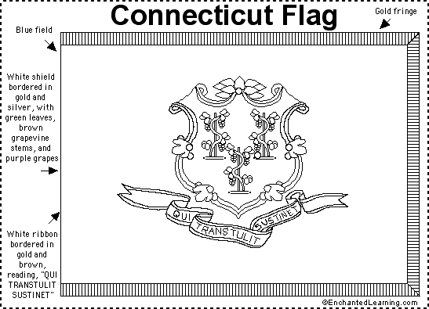
The first intercollegiate football game was played by Rutgers and Princeton in New Brunswick on November 6, 1869. Rutgers won 6 to 4.
Sate Map Quizzes
Connecticut Rivers Council
The Enchanted Learning web site has State Maps and State Flags with quizzes for your Cubs. They come in color or black and white. Check them out at http://www.enchantedlearning.com/usa/statesbw /
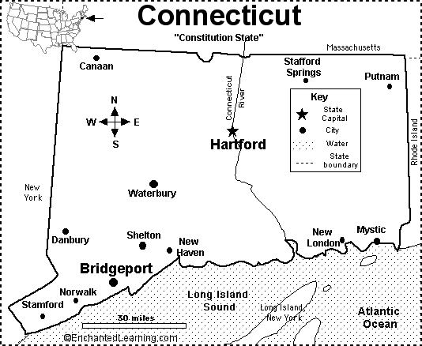
What is the capital city of Connecticut?
What state borders Connecticut on the west?
What state borders Connecticut on the east?
What state borders Connecticut on the north?
What large body of water (a sound) borders Connecticut on the south?
This sound is part of which ocean?
What is the name of the river that runs through Hartford?
What is the name of the largest city in southwest Connecticut?
Connecticut is the third smallest state in the USA. About how wide is this state: 50 miles, 100 miles, 200 miles, or 300 miles?
Connecticut is a state in New England. In which part of the US is this: northeast, southeast, northwest, or southwest?
Connecticut's official state flag was adopted in 1897. The flag features a gold- and silver-rimmed shield picturing three grapevines. On a gold- and brown-rimmed white ribbon under the shield is the state's motto, "QUI TRANSTULIT SUSTINET," which means "He Who is Transplanted Still Sustains." The grapevines represent the early English settlers (and their settlements) in Connecticut.
Connecticut was the 5th state in the USA; it became a state in 1788.
Questions:
What type of plant is featured on this flag?
What do these plants symbolize?
When did Connecticut become a state?
Whittlin’ Chit
Bryon from the SCFM Discussion Group
When beginning to teach knife safety and use, we have started the kids with "floral foam" (the green stuff they stick flowers into to make arrangements) and butter knives. Then we progress to bars of ivory soap, and then to soft woods with a (gasp) pocketknife.
In three years, we have not had a mishap, as the boys learn with the butter knives, and we keep a big red marker to mark the areas they have "cut" with their butter knife hitting their hand/fingers. This gives them a bit of respect for the knife/tool.
We have an adult present with each boy throughout to make sure they have a safety circle and carve away from themselves and their digits!
Big things to keep them from doing are:
- Closing the knife with their fingers in the way.
- Forcing the knife in such a way that it will try to close over their fingers. . .
- Trying to make too deep of a cut, or an angled deep cut.
Remember, the blades on Cub Scout knives are not locking blades.

AUDIENCE PARTICIPATION
WHERE IS YOUR HOME?
Bay Area Council Pow Wow, 1994
Via Circle Ten Council
Divide the audience into two groups and have them respond to the following key words:
Home: "Home on the Range"
United States: "This Land is your Land"
Be it ever so humble, there's no place like HOME.
No matter where in the UNITED STATES you may roam.
You may travel all over the UNITED STATES,
But your HOME state with you always rates.
Some choose to roam while others stay,
Always in their HOME state 'til their dying day.
No matter in what part of the UNITED STATES your HOME state may be,
There's one thing everyone says you see,
And everybody I'm sure will remember that.
HOME is where you hang your hat!
Here’s a newly written one for Utah. Could you write one for your state?? CD
Scouting on the Internet
Great Salt Lake Council
Divide audience into three parts and assign each apart. Whenever their name is said, they are to respond as follows:
KEN - Bear leader!"
CLAIR - "Guide leader!"
SCOUT--- "Do your best!"
KEN Ekker was a Cub SCOUT Bear Den Leader. KEN was also a computer whiz.
He was one of the first to get an e-mail address and encouraged others to get one too. He discovered that there were many SCOUTING sites. Sometimes he would communicate with someone and then find out he or she lived in a foreign country. Soon he was corresponding with other SCOUTERS all over the world. He discovered a SCOUTER in England. Her name was CLAIR and she was a SCOUT Leader for 8 & 9-year-old boys and girls. In England they are called Guides. They called themselves the Cellar Dwellers, because they met in the basement of an old church.
After KEN and CLAIR had corresponded for a while, CLAIR told KEN that she had always wanted to come and visit America. KEN invited her over, and soon CLAIR arrived at Salt Lake International Airport.. KEN, and his wife, Lee, had CLAIR stay at their house and took her all over to show her the tourist spots.
Utah has a completely different look and feel than England has. She was amazed at the mountains and canyons, the desert, the Great Salt Lake, and how few people there were in such a large area. She was surprised that she could visit three SCOUT shops for three different districts within 90 miles. Everyone was so friendly and kind to her that CLAIR loved it in Utah. When she left, she invited KEN & Lee to come to England where she could show them the sites.
ADVANCEMENT CEREMONY
Daniel Boone Advancement
Circle Ten Council
This would work fine if your from Kentucky but if you are from Tennessee change it to Davy Crockett. Or whoever your state celebrates for a hero. CD
ARRANGEMENT: Assistant Cubmaster is dressed in Daniel Boone costume, complete with wooden rubber handgun. Cubmaster is in uniform.
DANIEL: Howdy, folks! My name is Dan'l Boone. I understand this is a good place to get me a mess of Bobcats.
CUBMASTER: You must be a stranger around here. This is a Cub Scout meeting and the only Bobcats around here are the Cubs who have earned the Bobcat badge. Would the following Cub Scouts and their parents please come forward. (Cubmaster relates story of Bobcat badge) (Daniel comments that sounds like a tall tale to me! Cubmaster presents badges and pins to families and they return to their seats.)
DANIEL: Well, that was very interesting, but you must have that pack of Wolves I was told about.
CUBMASTER: No, Mr. Boone, our Wolves are the Cub Scouts who have climbed the trail of Scouting to the next advancement rank. (Cubmaster calls forward boys and parents to receive wolf rank and presents badges.)
DANIEL: Very impressive! But I don't see nary a single bear our there. (Shades eyes and looks into audience.)
CUBMASTER: Our Bears are a year older and wiser than our Wolves. They have learned to take care of knives and tools, learned how to tie knots, and even learned about you, Mr. Boone. (Cubmaster calls forward Bear recipients and their parents and presents badges.)
CUBMASTER: Would you like to see our Webelos get their awards?
DANIEL: What in tarnation is a Webelos? (Prompt boys in advance to yell, "We'll be loyal Scouts!")
DANIEL: Now, that I understand. I'm a loyal "Trail" Scout, too.
CUBMASTER: Webelos Scouts have learned about our government, know the rules of outdoor fire safety and have slept under the stars. (Cubmaster presents activity pins and Webelos badges.)
DANIEL: Well now, Cub Scouting sounds like a mighty fine way to raise up a young'un. Wish we had Cub Scouts when I was a lad. So long, now.
Jungle Book Advancement Ceremony
Erich, A Cubmaster, Eden Prairie, MN
People required:
Akela, the leader of the wolf pack (the Cubmaster)
Monkey Person 1
Monkey Person 2
Akela: The moon is full, just as it was long ago on that night in the jungle when Mowgli first joined the Seeonee wolf pack. It has been many years since Mowgli returned from living with the wolves. After he returned, he taught us many of the lessons he learned while in the jungle. The most important was that the strength of the wolf is the pack, and the strength of the pack is the wolf. That is why we are here tonight in this council ring. In the jungle, Mowgli was protected by Bagheera, the panther, and was taught the ways of the jungle by Baloo, the great bear. Tonight, we have young men who have walked the trails of the tiger, the bobcat, the wolf and the bear. It is time to honor these young men.
Akela: Scouts you have learned the Cub Scout Promise and the Law of the Pack. You have followed that law in your den, and you have learned many things. Tonight.....
Monkey person 1: Laws, laws, laws! Rules, rules, rules! What a drag!
Monkey person 2: Man cubs! Come with us to the tops of the trees. Man cubs! Come with us and play.
Akela: Oh no! The Bandar-log, the Monkey People!
Monkey person 1: We have no laws or rules. We are free! Come and play!
Akela: Silence! Once, when Mowgli disobeyed Bagheera, his teacher, he was captured by the Monkey People, the Bandar-log. The wolves despise the Monkey People because they have no law of the pack. The Monkey People think they are so smart that they do not need laws. But because they have no laws, they do not help each other. Instead of following Akela and cooperating, they fight among themselves. Because of this sorry behavior, the Monkey People have no pride, no strength of character, they aren't honest, they do not do their duty to God, and all the jungle knows it.
Monkey person 2: Laws and rules! Rules and laws! Who needs all that! Come and play!
Akela: You are irresponsible monkeys! These man cubs have learned better! You useless monkeys! You would rather have no laws and play in the treetops than even to see that your own friends have enough food. You selfish monkeys! You would only work to help yourself!
Monkey person 1: Yeah! Yeah! Yeah! Talk! Talk! Talk! These boys would rather not bother with all that! They really don't like all your pack laws and rules.
Monkey person 2: Yeah man cubs! You don't need to follow all those promises and rules and all that junk! Come on and play!
Akela: Silence Monkey People! I will show you that these boys have learned better! I will give them each a choice.
Tigers – Do you want to follow the trail of the pack? (They yell, YES)
Wolves – Do you want to follow the trail of the pack? (They yell, YES)
Bears – Do you want to follow the trail of the pack? (They yell, YES)
Webelos – Do you want to follow the trail of the pack? (They yell, YES)
Akela: Man cubs, you have chosen wisely. So that those useless Bandar-log will know what we expect of you, give the Cub-Scout sign with your right hand and repeat the Cub-Scout Promise with me.
I promise to do my best,
to do my duty to God and my country,
to help other people,
and to obey the Law of the Pack.
Akela: So let us all now repeat the law of the pack. Will all scouts that are here tonight please stand and give the scout sign and repeat the law of the pack with me?
The Cub Scout follows Akela.
The Cub Scout helps the pack go.
The pack helps the scout grow.
The Cub Scout gives goodwill.
(Akela motions for audience to be seated.)
Akela: Scouts of Pack XXX you have chosen wisely! Let us tell these Monkey People to be gone with a good wolf howl!
(Akela leads pack in wolf howl.)
Pack Promotion Night
Erich, A Cubmaster, Eden Prairie, MN
Here is a whole series of promotion (graduation) ceremonies developed, as Erich said, from other sources. You could do this at your spring pack picnic and promote everyone up to the next rank. My pack presents each Cub his next book when he is promoted so the parents have it to check things off from camp, their summer vacation trips and whatever happens around the house. Thank you Erich. CD
Junior to Senior Webelos Promotion
People – Akela and Baloo
Akela: Tonight I wish to honor our Webelos and recognize the fact that they are now the oldest scouts in our pack. It will be their job to tell the stories of the pack to the younger boys. They can tell them about camping, Pinewood Derby, meetings, advancement, games, and all the fun. Baloo, please call up the Senior Webelos:
Baloo: <<call up Webelos by name>>
Baloo: Since you are the youth leaders of our pack, I want to leave you with a challenge. Over the next year, help us find ways to make the pack even more fun. Will the pack join me in the Cub Scout cheer? After I say “Cub”, you reply “Scout”.
Akela: As senior members of the pack, the Webelos now have the honor and privilege of helping with the rest of tonight’s ceremonies.
Bear to Webelos - Broken Arrow Ceremony
Equipment: An Arrow per boy with their name on it.
Notch each arrow on the top and bottom about 3" apart.
People – Akela and Baloo
Akela: Will the Bear scouts and their parents please come forward:
Akela: As Bear Cubs, you have passed many tests and feats of skill. You have mastered the Bobcat, the Wolf and the Bear. Now you seek entry to become a Den of Webelos. To be a Webelos you must be brave and strong. You will be required to meet tests far more difficult than any, which you have performed up to now.
Baloo: You and your family have worked together to develop the skills of the Wolf and Bear. Together, you have strengthened your family and the Scouting Family. You will now start on the Trail of the Webelos, your goal is the Arrow of Light.
Akela: This group of arrows represents you, your family, your Leaders, and the Pack. Without any of these people, Scouting would not be strong. Take this group of arrows. Together, as a group, the arrows are strong.
Akela: As you have noticed, your names are on the arrows. When your arrow remains in the group, the strength of the group is added to it. Without any of the other members, Scouting will break as easily as I break the arrow.
<<Break each boy's arrow. Hand the point to the parents and the fletched end to the boy.>>
Baloo: Parents, you have received the head of the arrow. This signifies that you and the Webelos Leaders will guide these scouts over the next two years. New Webelos, you have received the flight feathers. This signifies your travels during the next two years. Your journey will end in two years with most of you reaching the Arrow of Light. At the end of that journey, you will have enabled this arrow to fly straight and true again.
Akela: Are you ready to become Webelos? When your name is called cross the bridge.
<< Cross the scouts over the bridge>>
Baloo: <<call up Bears>>
Wolf to Bear - Candle Ceremony
People – Akela and Baloo
Akela: The Native American Indians believed in animal spirits. These spirits helped the Indians and gave them special powers. It was good to have the strength from many animal spirits. But, each Indian also had a main spirit. The Indian would not reveal who his guardian spirit was unless he was near death.
Baloo: One advantage to spending time alone in the wilderness is that you might meet your spirit animal. And, to meet your spirit animal is to make your life more complete. An Indian might be canoeing alone across a lake when he spies a wolf on the shore. And as the wolf looks into his eyes, he’ll just know, that that is his spirit animal. Of course you can only meet your spirit animal when you are alone.
Akela: The wolf gives us two strengths: wisdom and bravery. The wolf is one of the smartest animals in the woods. This wisdom will serve our braves well. The wolf is also very loyal to the pack. Because of this, the pack is much stronger than the wolf by itself. Do we have any cubs that have earned the mark of the wolf?
Baloo: Yes. They have learned how to handle tools and how to display the flag; they know how to be healthy and safe. They have learned to serve in the community and conserve energy. They are physically active and like to read. They have fun with their families and have collected useful and beautiful things. They obey our country’s laws and worship God.
Akela: Bring the wolves and their parents forward.
Baloo: Will the Wolves of Den 5 please come forward.
Akela: As we gather around tonight the light is dim.
<<Hand each boy a candle and have them light them>>
Akela: Each of you has a spirit candle to light your way in life. Each candle alone provides some light, but when you gather together as a den notice how bright it becomes. <<have the boys gather together>> As you go forward along the scouting trail you will need the help of other scouts, your parents, and your leaders. You will also need to share your light with that of the other scouts in your den. Are you ready to become Bears? Please place your candles in the holder so we can all see the brightness in your spirits. When your name is called you may cross the bridge.
<<Cross the Wolves over the bridge>>
Baloo: <<Read off Wolves’ names>>
Tiger to Wolf – Cub Scout Colors Ceremony
Personnel: Akela, two Webelos Scout “braves”, and a narrator (Baloo)
Equipment:
A tripod with a large cooking pot suspended over a fire. A small pot fits inside the large one and contains a yellow Wolf neckerchief. Pack dry ice around the small pot to give a smoking effect (smoke increases as water is added).
Two small clear bottles, one filled with diluted yellow food coloring and the other with blue coloring.
Narrator: Many, many moons ago the great chief Akela called a council to see what could be done to make his tribe the best of all tribes. After many hours he called his two most trusted braves to the council fire.
<<Pause as two braves come to stand next to chief>>
He told the first brave to climb the mountain and tell the great eagle to fly high into the sky and bring back part of the beauty of the sun. <<First brave leaves>>
He told the second brave to go into the forest and tell the sparrow to fly high into the sky and bring back part of the sky.
<<Second brave leaves and both return immediately, one with blue bottle, one with yellow, and stand by the tripod with bottles raised for all to see>>
Akela to first brave: Pour some of the beauty of the sun into our council mixing pot.
<<First brave pours yellow liquid over dry ice, carefully to avoid hitting neckerchiefs in small pot>>
Akela to second brave: Pour some of the beauty of the sky into our council mixing pot.
<<Second brave carefully pours blue liquid over dry ice>>
Akela: From this day forward, blue will stand for truth and loyalty. Yellow will stand for warm sunlight, happiness, and good cheer. <<Stir pot, pull out neckerchief>>
Narrator: And that is why the Cub Scouts use the colors blue and gold. Tigers, you are now ready to become Wolves. Will the Tigers and their parents please come forward. When your name is called you may cross the bridge.
<<Tigers are called up>>

GAMES
BIG TEX, SPUD, BIG J, THE NUTMEGGER, THE YANKEE (a Maine-iac, not a ballplayer), THE HOOSIER, THE VOLUNTEER, …
Circle Ten Council
Have all players sit in a circle and then chose a person to be “it”. The “it” is to leave so that “it” cannot see or hear. Choose one person to be Big Tex, Spud, Big J, The Nutmegger, The Yankee (A Maine-Iac, not a ballplayer), The Hoosier, The Volunteer, …or something appropriate for your state and he will act out short movements. Examples are clapping hands three times, stomping feet 4 times, etc. All other players must do what the leader does. Have “it” return to the group to figure out who is Big Tex, Spud, Big J, The Nutmegger, The Yankee, The Hoosier, The Volunteer, …or something appropriate for your state, you can give him up to three guesses if there’s a large group.
Aggies and Longhorns (Bull Dogs and Yellow Jackets, Hoosiers and Boilermakers, Gators and Seminoles, Bruins (UCLA) and Trojans (USC))
Circle Ten Council
Have the players divide into two teams. Label one team AGGIES and the other LONGHORNS. Lay out two centerlines that are parallel to each other and three feet apart. Then set up two boundary lines about 20 feet from the centerlines for each team to cross for their safe zone. Use hoses or rope if outdoors and tape if indoors. To start, make teams stand with their backs toward each other at the centerlines. Toss the coin into the air. Once the coin has landed on the ground call out if it’s heads or tails. If it was tails, the LONGHORN team must run to their safe zone. The HEADS team will turn around and try to tag the LONGHORN team before they reach their safe zone. After each toss and chase, players are to return to the centerline, expect tagged players-they are out of the game. You play until one team has captured everyone on the opposite team and that team is the winner.
State Jeopardy
Set up a Jeopardy Board – for categories maybe
Famous (Your Staters)
(Your State) Cities
(Your State) Parks
(Your State) Cities
Dates in (Your State)
Historic places in (Your State)
Or maybe more esoteric – regions, on the move (transportation), trivia, All Around Our State (What states and rivers are on your borders?), Ancestors (Native Americans and First Settlers), Give Me Liberty (Revolutionary War questions), Colleges, Firsts, Shore (or Mountains), Weather, Places, Sports, Scientists, Government, Spooky things, Music, Art and Artists, Made in (Your State)
Then develop questions for each category. Set up teams in your den and play. I would set up Jeopardy games for my Sunday school class. It definitely increased their attention to the lesson. And we almost would up with “contact” Jeopardy. Some of the kids really got into it.
Although the TV Show uses 5 categories and 5 questions, that number is not mandatory. Four categories and four questions work, too. Decide on your group’s attention span and your ability to create questions.
Now let’s take this another step – How about –
(Your State) Wheel of Fortune – use only words and phrases for your state e.g. – Connecticut – Buckeye, Vermont – Green Mountain, New Mexico – Philmont, Maine – Down East, Washington – Olympia.
(Your State) Bingo – instead of letters and numbers create boards whose squares refer to things in your state. Use column titles like the ones for Jeopardy, then just list various parks, people, places, etc. Have a caller.
Use your imagination – the Cubs will love the competition – but keep the questions at their level. Most school systems spend at least one year on state history – find a teacher who teaches state history to use as a resource. CD
SONGS
COWPIES
Here’s one for those of you from ranching states. CD
Tune: Rawhide
Circle Ten Council
Watch 'em, watch 'em, watch 'em
Keep your eyes peeled for 'em
Think we're headed for some
COWPIES ------
They're round and green and mushy
They come from a cow's tushy
And soon they will be covered
With flies ---
COWPIES ------
Walkin' thru this pasture
Please don't walk no faster
It could be disaster
COWPIES ------
Don't try an' understand 'em
Just try an' walk around 'em
You could miss 'em if
You tried ----
COWPIES ------
Workin' in a stable
Scoop 'em if yer able
Do a dude a favor
COWPIES ------
He's riding on a pillow
His boots are armadillo
If he steps in one he surely
Would die ----
So, scoop em up, shovel 'em up,
Rake 'em up, pick 'em up
COWPIES ------

TEXAS WEATHER
(or KANSAS, GEORGIA, IDAHO, INDIANA, …)
Tune: Battle Hymn of the Republic
Circle Ten Council
I have seen the sky in darkness, I have seen it in the sun,
I have felt the rain upon me, I've enjoyed the snowy fun.
When the weather isn't cloudy or the wind it doesn't blow.
It isn't only raining, it's the weekend too, you know.
Glory, glory, it's (Your State) weather! [Repeat.]
I can tell because it's raining and it's 42 below,
As the Pack goes marching on.
Find out your state’s song, if you have one (NJ does not have an official state song but I know a few that work). If it is singable in Cub Scout style – do it!! If you don’t have a state song but there is one you like – teach it (Yellow Rose of Texas, California Here I Come) CD
CUB GRUB
WAGONS
Circle Ten Council
Ingredients:
2 Celery stalks
12 Toothpicks
16 Carrot rounds
1/2 c Peanut butter; cheese spread or ranch dressing
20 Raisins
DIRECTIONS:
Cut celery stalks crosswise into two pieces each, about 3" long. Push toothpicks through sides of celery to form axles for four wheels. Fill celery wagon with peanut butter, cheese or dressing. Stick carrot rounds onto ends of toothpicks. Cover tips with raisins. Stick a toothpick into the end of the celery at a 45-degree angle to form wagon handle. Cover tip with raisin.
JERSEY CHEX MIX
Southern NJ Council
Ingredients:
1 bag (3.5 ounces) Betty Crocker Pop Secret butter-flavored microwave popcorn
8 cups Corn Chex cereal
4 cups corn chips
2 cups bite-size cheese crackers
3 tablespoons margarine or butter, melted
1 teaspoon chili powder
1/3 cup grated Parmesan cheese
1/4 cup Bac O's bacon-flavored bits or chips, if desired
DIRECTIONS:
Microwave popcorn as directed on bag.
Mix cereal, corn chips and crackers in 2-gallon resealable plastic food-storage bag. Shake popcorn into cereal mixture, being careful not to add unpopped kernels. Drizzle with margarine. Shake to coat mixture.
Add remaining ingredients. Shake gently to blend all ingredients.
BARBECUED POPCORN
Circle Ten Council
Ingredients:
6 tablespoons Hot air-popped popcorn
1/3 cup Margarine
3 tablespoons Chili sauce
1 teaspoon Onion powder
1 teaspoon Chili powder
1/2 teaspoon Salt
2 tablespoons Grated Parmesan cheese
DIRECTIONS:
Place popcorn in large bowl. In small saucepan, melt margarine. Stir in chili sauce, onion and chili powder and salt. Pour chili mixture gradually over popcorn, tossing to mix well. Sprinkle with cheese and toss.
STUNTS AND APPLAUSES
Cheers
Circle Ten Council
TEXAS DESERT APPLAUSE - Yucca, yucca, yucca...
TEXAS (or New Jersey or Louisiana, …) OIL REFINERY APPLAUSE - Crude, crude, crude...
HOW WITH A SOUTHERN EXPOSURE YELL - How, How, How, You'all!
TEXAS WELCOME - HOOOW DDDDEEE PARRRD!!
TEXAS HOW - How! How! Howdy pardner!
WESTERN HOW -
Stamp feet three times,
slap knees three times,
whip hand around head three times, and yell "YIPPI-I-A."
BUFFALO BONZO YELL (For a 'corny' skit)
Bonzo
Buffalo bonzo
Buffalo buffalo bonzo
Cuckoo, cuckoo, cuckoo !
Southern NJ Council
SOUTH (JERSEY) WATERMELON CHEER – Do typical watermelon Cheer, end it with a “Y’ALL”
Great Salt Lake Council
GREAT SALT LAKE: Pretend to go swimming there. As you get in water, it is cold, so say "'Ouch, ouch, ouch!" Then float along without sinking, and say "Ahhhhh!'"
THE BEST WINTER OLYMPICS ANYONE EVER HAD: Everyone pat yourselves on the back.
BIG COTTONWOOD CANYON SKIING: Put on skies, ride up lift, take off, straight down, fall with a huge clap and slide down the mountain in a tangle of skies, bindings, arms, and legs. Get up unhurt and say, "That was fun!"
Connecticut Rivers Council
CONNECTICUT CHEER – Shout Connecticut three times, clap three times, repeat three times
There are obviously a few of these that are convertible to any state or any ski area. CD
RIDDLES
Circle Ten Council
Q: Why did the Texan buy a dachshund?
A: Because all the other cowboys were saying, Get a-long little doggie!
Q: - How many Cub Scout Leaders does it take to change a light bulb?
A: - 12
- One to call a planning meeting,
- One to call everyone to find a date when everyone can get together,
- One to conduct the meeting,
- One to make an announcement about the planned light bulb changing,
- One to lead a song,
- One to write a skit about light bulbs,
- One to screw it in,
- Two to do a run-on,
- One to lead a cheer for a job well done,
- One to bring refreshments,
- And one to buy patches for everyone who participated!
SKITS
TYPICAL TEXAS WEATHER
(or ILLINOIS, KENTUCKY, WASHINGTON, …)
Circle Ten Council
Props: TV Screen, Texas (or your state) map, Pointer, rain coat, winter coat, 2 paper fans, paper wads (hail stones)
Set - up: Weatherman is in the middle of the stage with the state map not moving yet. The TV is propped up against the chair. The leader walks in, turns on the TV and sits down to listen. After the TV is turned on, the weatherman starts.
Weather: (Using the pointer) Well folks, it looks like we're going to have a typical day of weather in (Your State) on this warm summer like day. All across the state there are sunny and clear skies. There is no chance of rain.
Leader: (Turns off TV) Good! The Cubs will be here soon and we can go outside.
- (Walks in fanning himself) Boy what a great day to be outside. The sun sure feels good.
- (Walks in wearing a rain coat) It sure did cloud up fast. It's starting to rain.
- (Walks in wearing a heavy coat) A cold front just came in. It must be freezing out there.
- Hey did you guys see the hail coming down out there? (Throws hailstones into the air).
- (Walks in wearing his uniform) The sun feels good out there.
Leader: Yes, it sure is another day of typical (Your State) weather.
You Know You’re From …
Southern NJ Council
Maybe your den can make up a skit by writing some funny lines about your state. Possibly starting with “You Know you’re From … , If …
Here are examples from New Jersey and Utah.
You're a genuine New Jerseyan, if
You know that the only people who call it "Joisey" are from the Bronx or Texas.
You don't think of citrus when people mention "The Oranges."
You know that it's called "Great Adventure," not "Six Flags."
You know that the state isn't one big oil refinery.
You know what town Jon Bon Jovi is from.
You know what a "jug handle" is.
You know that a WaWa is a convenience store.
You know that there are no "beaches" in New Jersey - there's "The Shore," & you know that the road to the shore is "The Parkway" - not "The Garden State Highway."
You know that "Piney" isn't referring to a tree.
You know how to properly negotiate a Circle.
You knew that the last question had to do with driving.
You know that "Acme" is an actual store, not just a Warner Bros. creation.
You know that this is the only "New..." state that doesn't require "New" to identify it like, try... Mexico, ... York, ... Hampshire (doesn't work, does it?).
You only go to New York City for day trips, & you only call it "The City."
You know that a "White Castle" is the name of BOTH a fast food chain AND a sandwich.
You don't think "What exit" (do you live near?) is very funny.
The Jets-Giants game has started fights at your school or work place.
You refer to all highways & interstates by their numbers.
Every year, you had at least one kid in your class named Tony.
You start planning for Memorial Day weekend in February.
You know that "youse" is not a synonym for utilize but for y'all.
And finally... you've never pumped your own gas.
YOU MIGHT BE LIVING IN UTAH IF:
Great Salt Lake Council
- You live on Redwood Road, but there are no Redwood Trees.
- Schools stay open, even if two feet of snow falls overnight, but close for the opening of hunting season.
- The most popular public transportation system is a ski lift (or in St. George, a golf cart).
- In-state college football rivalries are bigger than the Super Bowl.
- There is a town spelled Tooele that is pronounced 'two-ill-a' and the Oquirrh Mountains are called 'oak- ker'.
- Every driveway has an 8-passenger SUV and a pickup.
- Ninety percent of the population was born in California.
- Every back yard has at least one fruit tree and everyone grows a few tomatoes
- More movies and TV shows are filmed in your town than in Hollywood. 10 The July 4th celebration lasts 20 days.
CRYING SKIT
Circle Ten Council
Each boy comes in crying, each carrying a handkerchief progressing from small (tissue) to large (tablecloth to Super (bed sheet). Someone asks why they are crying. They just cry louder and walk off stage. Last boy is asked why they are crying? And he replies "it's because we don't have a skit!"

CLOSING CEREMONIES
NEW JERSEY IS DIFFERENT
Southern NJ Council
This one should be pretty easy for you to modify to your own state. You could change the song at the end to a song about your state – California Here I Come, The Yellow Rose of Texas, On Wisconsin, … CD
- New Jersey is different in climate, different in the food produced, and offers different ways of life.
- The beauty of New Jersey captured in our meadows, beaches, rivers, hills and the glorious sunrises and sunsets.
- New Jersey is a part of the fifty United States of America, pledging their allegiance to our flag.
- Just like the state of New Jersey. There are differences in a Cub Scout den. Each boy has different abilities, different interests and different needs.
- But we are united in Cub Scouting to develop ourselves mentally, physically and morally.
- Just as Cub Scouting keeps us together and our packs & dens are parts of the whole Scouting program. Our country, the United States of America, all 50 states united and working together.
- We become better citizens as we learn and achieve together in Cub Scouting. Just as our country gets stronger by working together.
- Let us close by singing "America” in remembering our differences and our unity. (Or another patriotic song)
MY STATE
Circle Ten Council
Have a Cub Scout read the narrative or pass out cards so the entire audience can read this pledge in unison or have 5 or 6 Cub Scouts repeat the lines from cards.
- This is my state I will use my eyes to see the beauty of this land.
- I will use my ears to hear it's sounds.
- I will use my mind to think what I can do to make it more beautiful.
- I will use my hands to serve it and care for it.
- And with my heart, I will honor it.
TEXAS (or any state with Cowboys) COWBOY'S PHILOSOPHY
Circle Ten Council
PERSONNEL: 5 Cub Scouts
SETTING: Boys up front
- We, the cowboys of the western plains are bound by our desire to live free.
- We must, therefore, show respect for our fellow man,
- Respect for his beliefs, Respect for his belongings, Respect for his privacy. Respect for the ground he walks on and the air he breathes.
- In doing so, we show respect for ourselves.
- And secure freedom for all.
CUBMASTER’S MINUTE
STATE PRIDE
Circle Ten Council
(Your State Name) needs men with a concern for the common good -- men who have the understanding and insight to help solve her problems and those of the changing world around us. She needs citizens of integrity who value their great heritage and who are determined to pass on to others an enduring faith in the ideals and methods of our free society.
How does a boy come to know and to appreciate his heritage as a citizen of this state? How does his sense of responsibility and his concern for others unfold?
Begin with him when he is a Cub Scout as he promises with all the solemnity of an 8-year old "to do my duty to God and my country..." Watch the pride and loving care with which he handles the flag as he is taught to fold it. He may not fully understand all that it stands for, but someday he will... with help.
Observe him later as he stands tall, alert and proud in his khaki uniform as the flag is lowered at Scout camp. He is living everyday experiences as a good citizen and showing concern for the needs of others. He is growing and practicing the fundamentals of citizenship. All of this time he is under the friendly guidance and companionship of men and women who care about him.
Now he is grown tall and in high school. An Explorer. He ponders the words of the Explorer Code. There is conviction in his voice as he says: "I will treasure my American heritage and will do all I can to preserve and enrich it."
And so this young American comes to manhood. He has grown through his Scouting experiences and though the influences of many men and women who have helped him. He has a job and a family and is making himself count in his community. He is a citizen of a great nation and state. He understands his heritage and cheerfully accepts his future obligations to all men. He has been a Scout. He is America's answer! He is (Your State Name) Pride!
THREE IMPORTANT THINGS
Great Sauk Trail Council, 2001
Via Circle Ten Council
Personnel: Cubmaster, if done as a Cubmaster’s minute. Or 4 Cubs each reading one part.
Equipment: Cub Scout badge, handbook and a candle.
To the sailor, three things were essential - a compass, a sextant, and a flag to tell which way the wind blew.
To Cub Scouts, these three things are important - (show items) a badge, a handbook, and a candle.
The badge tells who you are and where you are going, the handbook tells how to get where you are going, and the candle is a symbol of the light of Scouting.
It is a light that must be kept burning in the heart of every Scout.

BROKEN WATER JUG
Great Salt Lake Council
100 years ago a family lived in the St. George area. Water had to be carried from the creek everyday for the family's use. Two large pots were suspended across the carriers back on a stout stick. One of the pots had a crack in it, while the other pot was perfect and always delivered a full portion of water. At the end of the long walk from the stream to the house, the cracked pot arrived only half full.
All summer this went on daily, with the bearer delivering only one and a half pots full of water to his house. Of course, the perfect pot was proud of its accomplishments, but the poor cracked pot was ashamed of its imperfection, and miserable that it was able to accomplish only half of what it had been made to
do.
Finally it could bear it no longer and said to the bearer, "I am ashamed of
myself, and I want to apologize to you. I have been able to deliver only half my load because this crack in my side causes water to leak out all the way back to your house. Because of my flaws, you have to do all of this work, and you don't get full value from your efforts."
The bearer said to the pot, "Did you notice that there were flowers only on your side of the path? That's because I have known about your flaw, and I planted flower seeds, and every day while we walk back, you've watered them. I have been able to have these beautiful flowers to enjoy. Without you being just the way you are, there would not be this beauty for us all to look at"
It's the cracks and flaws we each have that make our lives together so very interesting and rewarding. Take each person for what they are, and look for the good in them.
WEBELOS
Please remember what I present here in Baloo’s Bugle for Webelos badges is meant to supplement your other resources – Webelos Leader Book, Webelos Scout Book, CS Program Helps, Roundtables, Pow Wow. I try to give you new ideas for some of the projects. I do not try and give you everything you need to complete the badge.
And speaking of new ideas – Webelos badge sis one area where I definitely need help. If you have tried something new and wish to share it – please send it to me. Thank you Commissioner Dave
OUTDOORSMAN
Circle Ten Council
Webelos Scouting is the bridge between Cub Scouting and Boy Scouting. The Outdoorsman activity badge is the pier that supports that bridge. In this badge, the Webelos Scout will receive a preview of the fun he will have in Boy Scouting. The best way to work on this badge is by doing a Webelos overnight campout. This is not a full-fledged Scout campout, but a taste of what is to come when a boy joins a Scout troop. After a boy becomes a scout, he will become proficient at handling himself in the woods. As a Webelos scout, he is not expected to master these skills.

PERSONAL CAMPING GEAR
You can check off your needs on the five fingers of one hand: sleeping, eating, being clean, being prepared, extras.
SLEEPING
You want to sleep well. To do this you must be warm. For your first overnight camp, one to three blankets will do. Eventually you will want a sleeping bag. Before you buy one, ask the advice of those who have been camping. Buy the best sleeping bag you can afford. A bag filled with polyester fiberfill is good. Down is better. If the winters are severe, buy a winter weight bag. Open it up for summer use. You also want to be comfortable. Many campers use a shoulder to hip length polyurethane pad. Others like an air mattress. You place it on top of a plastic ground sheet. For nightwear bring pajamas.
EATING
You want to eat. Here you’ll need an eating kit or separate knife, fork, and spoon. As well as a plate, cup, bowl, or a one man cook kit that includes all three.
BEING CLEAN
Bring soap in a plastic container, washcloth, toothbrush and toothpaste, comb and metal mirror, hand towel. Perhaps a plastic washbasin.
BEING PREPARED
Put in your pack a flashlight and a small individual supply of toilet paper wrapped in plastic. When you are not wearing them, outer clothing items go into your pack.
EXTRAS
You may want to take with you the Bible or prayer book of your faith. Plus a few favorite items you just can’t do without. Just remember not electronic games; boom boxes are camping to enjoy nature not to disrupt it.
KNIFE SAFETY
Facts every boy should know about knives:
- A dull knife doesn’t work and is, in fact dangerous.
- Dull blades cut more fingers than sharp ones.
- A camper should always carry a small sharpening stone in his pocket along with his knife. The knife and stone are partners and belong together.
- A sharpening stone is called a whetstone. One measuring 3” by ¾ “ is large enough to use and small enough to carry easily.
- A whetstone using water is more practical in camp then one using oil.
- Whetstones are made to provide a grinding surface. Fine stones are for knives while coarse stones are for axes.
POCKET KNIFE SAFETY CIRCLE
A pocket knife safety circle is similar to an axe yard only smaller and on an individual level. To establish a safety circle, grasp a CLOSED pocket knife in your hand, extend your arm and with the closed knife straight in front of you, rotate body to either side while continuing to extend the closed knife arm. No one or thing should be within this imaginary circle you have created. Also check your overhead clearance, as this is part of your safety circle.

A TYPICAL KNIFE
A pocketknife should have a good stout blade at least 3 ½” long. Here is a close up view of a typical knife:

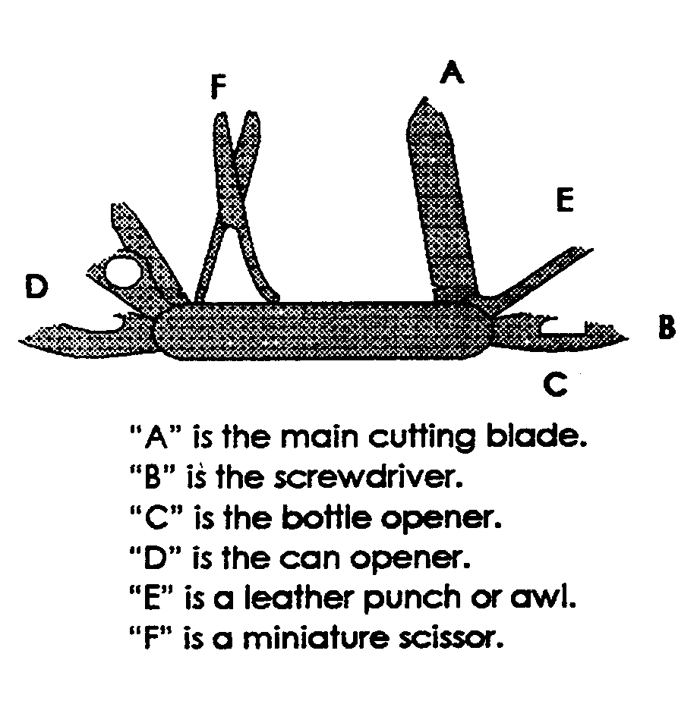

You may wish to copy this next one and enlarge it CD

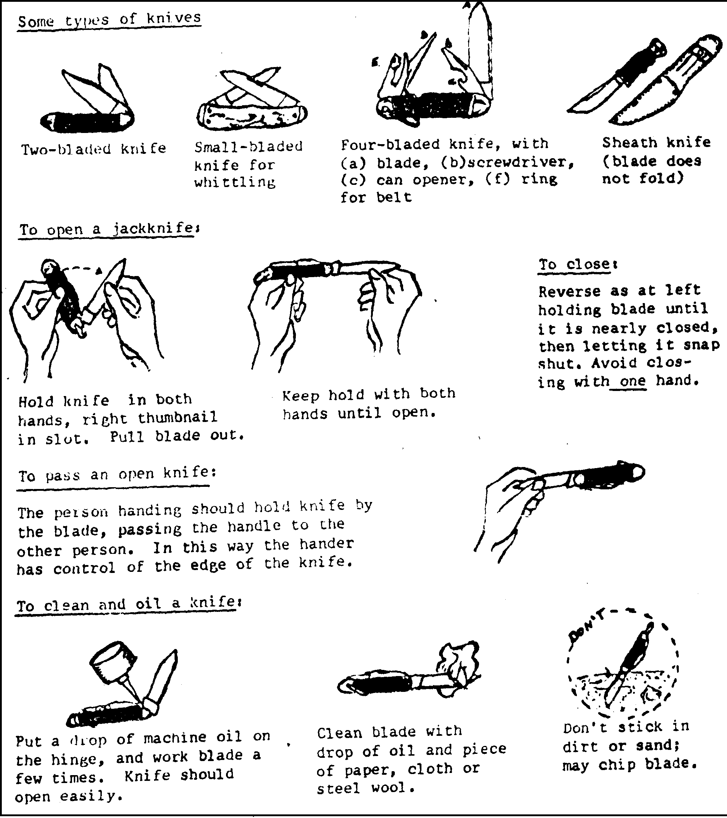
EASY CARVING/ WHITTLING
An easy way to teach boys to carve is by carving soap into a simple design. Fresh soap, especially Ivory soap which is ideal, may be too soft and crumble. To prevent crumbling open the soap up and let in air for about 5 - 10 minutes. These could be done will you explain the rules of using a knife to the boys. See, also, hint under “Whittlin’ Chit” in Den and Pack Activities. CD
Whittle away from you (until you are an expert)! Be sure that nothing (your leg, another camper, branches etc) are in the way of the sweep of your knife.
KNOTS
Knots are a very important part of Scouting. Begin now to learn them. Its lots of fun and you can make a display of those you have done. Put them on a wooden board, name them and frame the board for a permanent display.
These knot pictures may be better if you copy and enlarge them. CD
SQUARE KNOTS
This knot is used for joining two ends of a rope or string of approximately the same size or thickness. Use it to tie up a bundle or a bandage, to mend a shoestring, or to make a long rope from several small pieces.

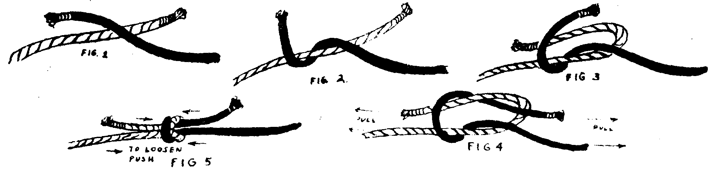
SHEET BEND
When you have two ropes that are not of the same thickness, a square knot will not hold them, but if you will give the square knot an extra twist, it will become a sheet bend, and will hold. This is one of several ways to make a sheet bend knot.
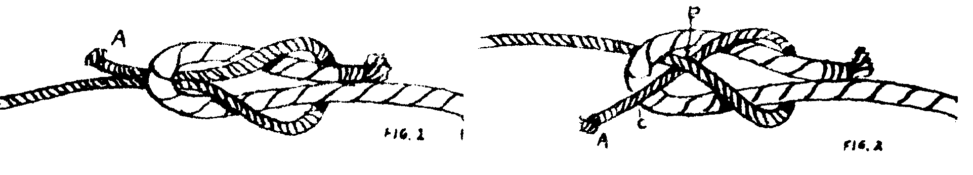
BOWLINE
Use this when you want a loop in the end of a rope. This loop will not pull tight, but will remain the size you made it. Use it to slip over a peg, or hook, or make the knot itself around a post or pole. It’s sometimes called the rescue knot.
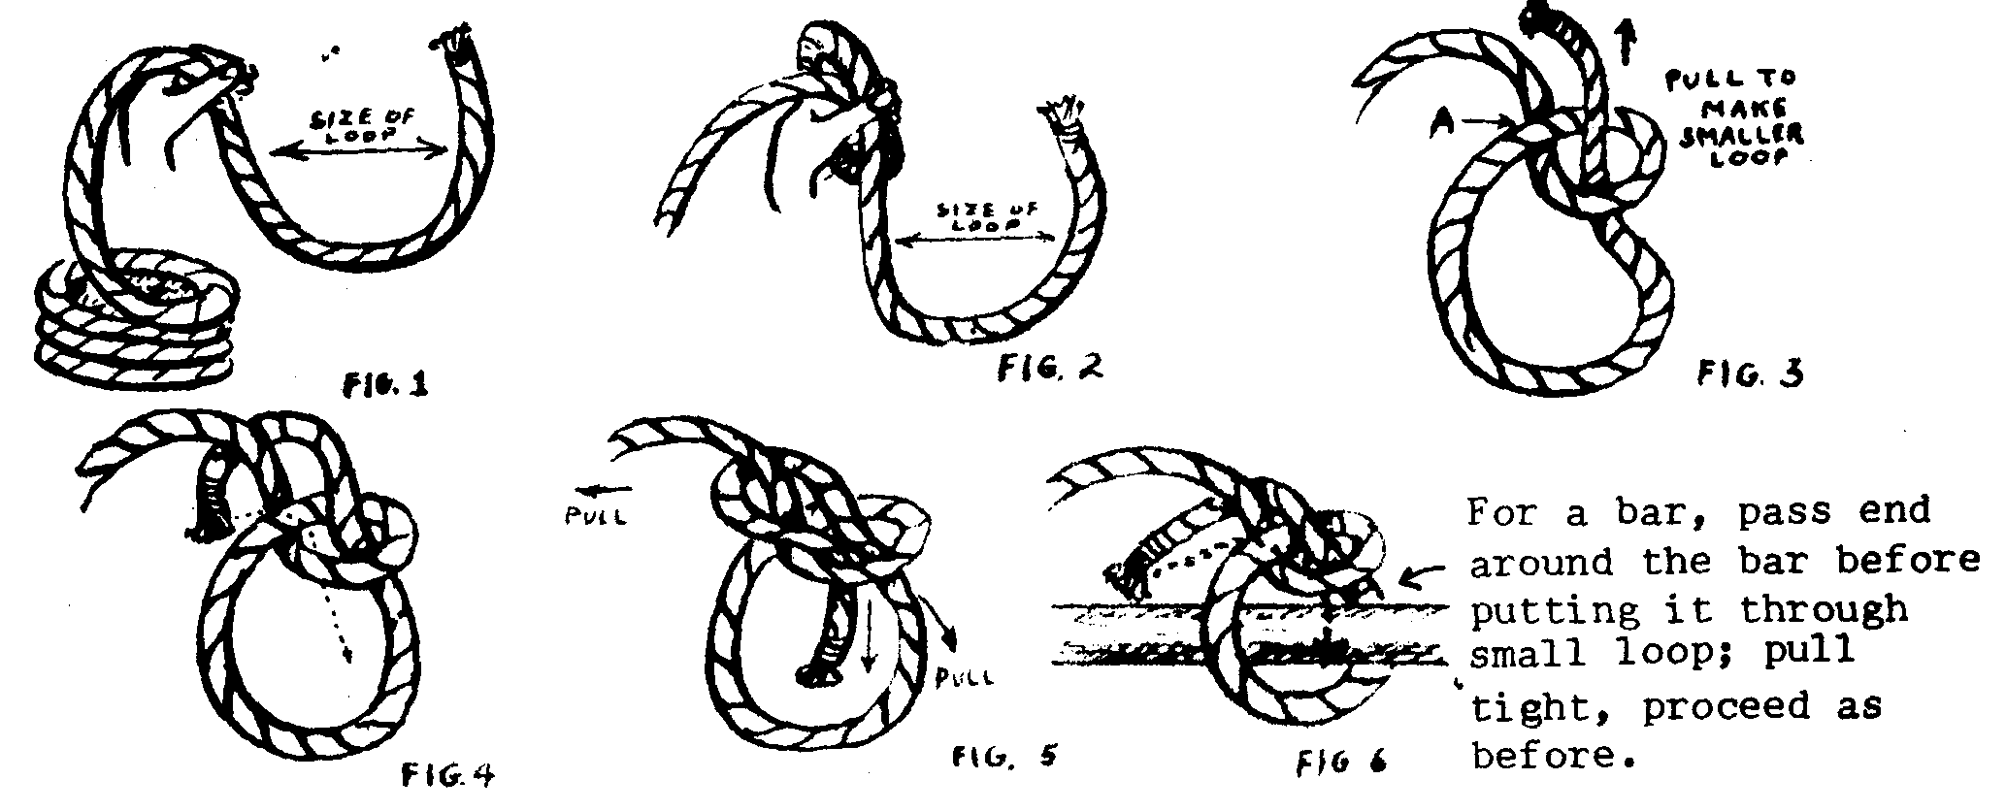

MAKE A COMPASS
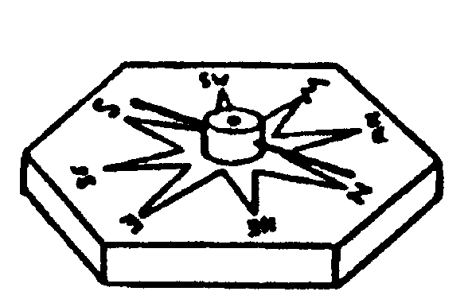
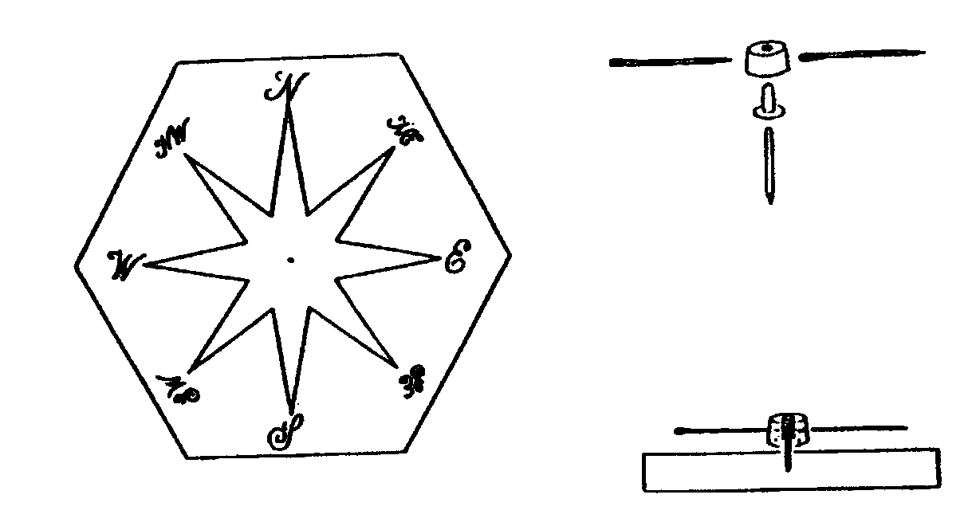
The face of the compass may be cut from ¼” plywood, ½” plywood, or ½” pine. The markings for the dial may then be applied with dark crayon, paint, or wood burning.
The needle for the compass consist of two 1 ½” darning needles which have been magnetized by drawing a magnet over them in ONE DIRECTION ONLY from eye to point. The two darning needles are then inserted in opposite sides of a piece of cork ¼” high and ½” in diameter, as illustrated.
The needle assembly is suspended by means of a lower portion of a leather rivet, which is inserted in the bottom of the cork disk as illustrated in drawing. Leather rivets of this type can be purchased inexpensively at most hardware or variety stores. A small nail that will not bend when inserted in the rivet is placed in the center of the compass dial, and the head is clipped off so that the nail extends approximately 3/8” above the wood surface. The protruding end of the nail should be rounded with a metal file to permit the needle assembly to swing freely.
After the wood block has been given a finishing coat of shellac or clear varnish and has dried thoroughly, the needle may be mounted on the nail. The compass needle will point North. Then carefully turn the block until the needle is in line with the point on the compass dial marked “N”.
SOME SAFETY RULES FOR OUTDOOR ACTIVITIES
Always have as first aid kit handy. If possible, have an adult trained in first aid and CPR attend pack functions.
Remember that adequate leadership and supervision help prevent accidents. Encourage boys to pair up in buddies to be aware of each other’s whereabouts at all times.
Have a plan for personal or natural emergencies (such as lighting storms, high winds etc.), which may occur during an outdoor activity. Know where emergency care can be obtained quickly. If possible, check out the location in advance for hazards.
Avoid such dangers as buildings in disrepair or under construction, fire hazards, stinging insects, poison plants, too-rough sports or games for age and size of boys. Accidents can be prevented.
Select a well-identified gathering place in the event the group is separated.
Always supervise when Cub Scouts are building fires and cooking. If the den is using a ground fire, clear a space 10 feet in diameter of all burnable materials. Stay away from low hanging branches. Use of chemical or liquid must be limited to adults.
HAND WASHING
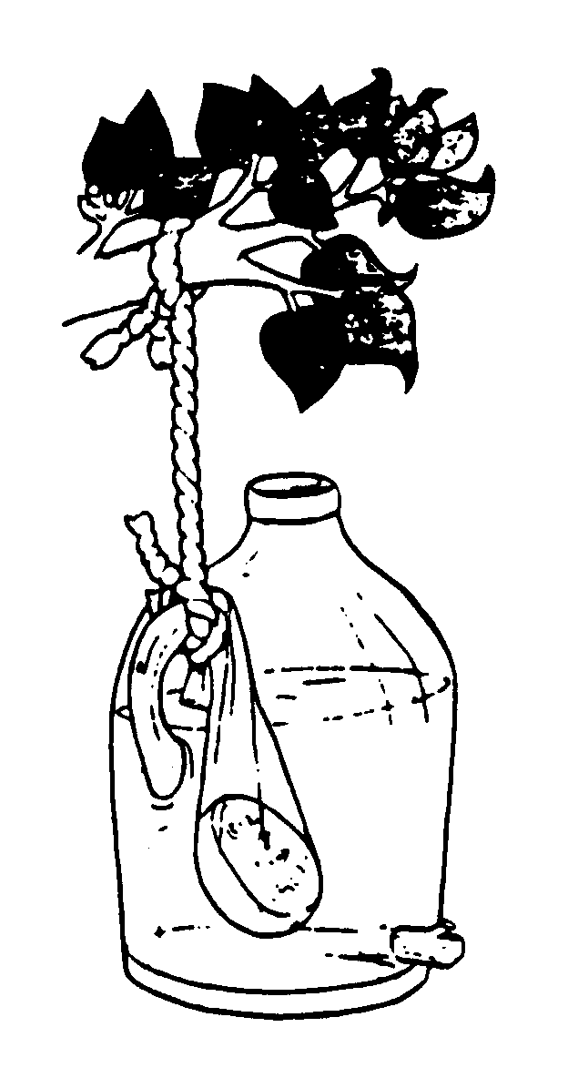
If running tap water is not available a simple hand-washing unit can be made from a plastic jug and a wooden dowel or twig. Make a small hole near the bottom of the jug. Use the twig or dowel to plug up the hole once you’ve filled the jug with water (a golf tee works very well). Place a bar of biodegradable soap in an old pantyhose leg and tie this to the handle of the jug. Now hang one of these hand-washing units near the kitchen. For better water flow, remove the cap from the jug.
HANDYMAN
Circle Ten Council
POUND, POUND, POUND THAT NAIL
Tune: Row, Row, Row Your Boat
Pound, pound, pound your nail
Pound it right on through!
If you miss and pound your thumb,
Then it will turn bright blue.
TOOLBOX SONG
Tune: I’m a Little Teapot
I’m a pair of pliers just because
Here is my handle here are my jaws
CHORUS:
Keep me in your toolbox bright and new
Take me out and I’ll work for you.
I’m a coping saw that’s strung too tight
Pull me then push me to use me right.
CHORUS
I’m a big strong hammer, a mighty tool.
Hit the nails only, that’s the rule.
CHORUS
I’m a happy C-clamp; tell you what I do,
I eat board sandwiches filled with glue.
CHORUS
I’m a handy wood plane, give me a try.
I can help you out if your door’s too high
CHORUS
HANDYMAN HINTS
- Place Dad’s old sock over shoes when painting.
- For plugged drains, mix 1-cup salt and 1-cup baking soda and pour down drain. Follow with kettle of boiling water.
- To seal a tiny leak in a plastic garden hose, touch the hole lightly with the tip of a Phillips head screwdriver that has been heated over a flame. The plastic will melt enough to plug the hole.
- Weeding is less tedious with the right toll. A claw hammer will pull out weeds by the clump. An apple corer is also an excellent weeder - it doesn’t disturb the roots of adjacent plants
TOOL CADDY
A neat carrier for garden tools is an old golf bag. It’s got pockets for tools, even a place to hang a towel, and you can whisk it along on its built-in wheels. Just roll it in the garage until you need it again.
GARDEN TOOL FIRST AID
Garden tools stow quickly and stay dry in a pail filled with sand. Mix sand with a little oil to keep the tools from rusting and to keep their edges sharp. If garden tools have rusted, clean them with a cork dipped in scouring cleaner.
STICK WITH WICKETS
Thread your garden hose through croquet wickets to keep it from running over your flowers.
IN THE BAG
An easy yard clean-up carrier is an old TV tray table. Remove the tray, and then hang a plastic garbage bag on the open framework between the legs.
OFF THE WALL
Prune shrubbery and trees to keep them from touching the house. The leaves retain moisture, which causes the paint to blister and peel.
FLOWER BOX SPLATTER CONTROL
Keep rain from splattering dirt out of your window box onto your window by placing a layer of gravel on top. The gravel will also keep the soil from drying out.
UNDER COVER
Paint the under side of your metal garbage can lid with rustproof paint so condensation from wet garbage won’t damage the paint on the lid.
STORAGE BOX
Paint a design on a discarded mailbox.
Use it to store barbecue supplies, paper cups, and plastic utensils

POW WOW EXTRAVAGANZAS

Southern NJ Council
Catch a Dream
January 22, 2004
Lakeview School, Millville, NJ
Call Southern NJ Council, 856-327-1700, extension 32, or visit the website, www.snjscouting.org for more information

I have no other Pow Wow notices. Please let me know as soon as your Council Calendars are released and I will start posting the 2004 – 2005 Pow Wows. CD

