FOCUS
Cub Scout Roundtable Planning Guide
Extra! Extra! Read all about it! This is the month for communication. Cub Scouts will learn ways that we spread the news. Let’s have fun with newspaper, television, and radio communication.
CORE VALUES
Cub Scout Roundtable Planning Guide
Some of the purposes of Cub Scouting developed through this month’s theme are:
- Character Development, Boys will learn to tell the truth at all times no matter how they are communicating with others.
- Personal Achievement, Boys will learn how to communicate with others using several types of media,
- Fun and Adventure, Boys will see first hand how much fun it is to let other people know about their adventures in Cub Scouting.
The core value highlighted this month is:
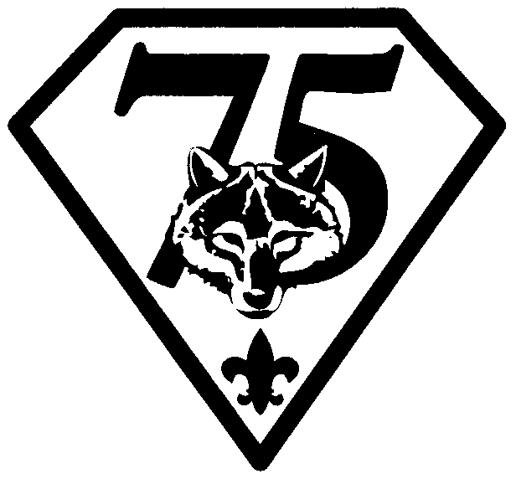
- Courage, Boys will learn that it is correct to do the right thing and speak the truth but that sometimes it takes courage to do so.
Can you think of others??? Hint – look in your Cub Scout Program Helps. It lists different ones!! All the items on both lists are applicable!! You could probably list all twelve if you thought about it!!
COMMISSIONER’S CORNER
I love doing January in December – being post-Christmas while everyone else is still getting ready (including me). MY Roundtable thismonth always has a different format. Our Council Exec visits in December for his annual “Fireside Chat.” It is nice to see him out and enjoying RT. He makes a great assistant song Leader.
Last month I had a typo for one of the Nutrition Websites I mentioned in Commissioner’s Corner – It is www.5aday.org (not .com) They sent me lots of stuff for my RT and unbeknownst to me the nutritionist from The Memorial Hospital of Salem County was featuring them in her talk so it worked out great!!
Now that it is winter I came up with a great analogy for Baloo’s Bugle. This publication is a like a snowball. Every time a theme comes around, a few more things get added into Baloo. As can be seen by the Similar Themes the basic theme this month, Communication, is an old stand by. Therefore, when I went to do Baloo, there was so much material I had trouble keeping it down to the normal length. I guess I am going to have to become more of an editor and less of a compiler or Baloo will get so big no one will want to read it.
Thanks to Wes at Circle Ten Council and Jim at Great Salt Lake Council for getting me their new Pow Wow books. I still could use a few more but am very thankful for the Baloo regulars coming through again this year.
One last mote
We are not the National council or the BSA. I received several E-mails this month asking about adding new awards and asking for what “we” meant by something in a list of requirements. www.USScouts.org is a group of volunteers like you that is trying to help others by putting our Scouting collections of info on the web for all to use. We have no more influence with National than you. And that is a good thing!! You are the ones on the front lines with the boys!!
Similar Themes to Look at for Ideas
Baltimore Area and Santa Clara County Councils
If you have old CS Program Helps, CS RT Planning Guides for these months, check them out for more theme related ideas. Also, Baloo is available on the Web for back from before I started reading it. CD
September 1980 Communications
October 1982 Communications
November 1987 Communications
September 1991 Communications
September 1996 World of Computers
November 1998 Stop the Presses
January 2002 Did You Get My Message?
PRAYERS AND POEMS FOR SCOUTERS
Opening Prayer
Cub Scout Roundtable Planning Guide
As we learn to communicate better with others, may we have the courage to always tell the truth. Amen
THE FOUNDER'S PRAYER
Lord Robert Baden-Powell of Gilwell
"Father of us all, We meet before Thee here today, numerous in the lands we come from and in the races we represent, but one in our Brotherhood under Thy Divine Fatherhood.
We come before Thee with hearts grateful and gladdened by the many blessings Thou hast granted us and thankful that our Movement has prospered as acceptable in Thy sight. In return we would lay on Thine Altar, as our humble thank-offering, such sacrifice as we can make of self in service to others. We ask that during our communion here together we may, under Thy Divine Inspiration, gain a widened outlook, a clearer vision of all that lies open before us and of our opportunity. Thus we may then go forth with strengthened faith to carry on our mission of heightening the ideals and powers of manhood, and of helping through closer understanding to bring about Thy happier Rule of Peace and Goodwill upon Earth."
Ten Essentials of Scoutmastership
An Old Scoutmaster’s Handbook
Although this says Scoutmastership, I believe most of the list can apply to any Scout Leader – Cub Scouting, Boy Scouting, or Venturing. You decide for yourself. CD
- A belief in boys that will make you want to invest yourself and your time on their behalf.
- A zeal focused upon one point - the boy’s happiness through his formative years - "A happy boy is a good boy, a good boy is a good citizen."
- An immense faith in Scouting as the program that will best serve to mold our youth into fine men.
- A realization that to the boys Scouting is a game - to you, a game with a purpose: Character building and Citizenship training.
- A knowledge that to your boys you are Scouting. "What you are speaks so loud that I cannot hear what you say!"
- A steadfastness of purpose to carry out a planned program with energy and perseverance, patience and good humor.
- A willingness to submerge yourself and make boy leaders lead and grow through an effective application of the Patrol Method.
- A desire to advance in Scoutmastership by making use of training offered and material available on the subject.
- A readiness to work hand in hand with home, church, sponsoring institution, school, Local Council, National Council for the good of the individual boy and the community as a whole.
- A love of the outdoors in all its phases and a vision of the hand that created it.
"The best teachers have shown me that things have to be done bit by bit. Nothing that means anything happens quickly – we only think it does." Joseph Bruchac
TRAINING TIP
Scouting Vocabulary
Commissioner Dave
There is a certain vocabulary used by National in writing requirements. Some phrases are obvious; some I find are often misinterpreted. The best advice I can give you is to look at he wording of each requirement and to look at the intent of the badge or the requirement. Then decide what your Webelos must do. Remember, you cannot add or subtract any requirements but your interpretation of what is required is important.
A few years ago I had a Mom tell me that singing a song while sitting in the audience during a Pack Meeting met the requirement singing for the Showman Activity Badge because all the words said was, “Sing a song alone or with a group.” And this certainly was group singing. This Mom is a Lawyer. I disagreed and wrote Scouting Magazine for resolution. The answer involved looking at the intent of the badge and therefore, they did not feel sitting in the audience was appropriate.
Now, to finish my point, the requirements are written for the boys to do to earn the ranks, awards, badges, … So when it says tell, show, explain – It is the boy who has to tell, show or explain the how to tie a knot, stop a cut from bleeding, what Bernoulli’s Theorem means. Having the leader (or other adult) tell, show or explain it to the Cub Scout does not meet the requirement. Sometime after the Cub is instructed on the skill, he should tell, show or explain it back to the Leader to receive credit. I have seen too many Dens sign Cubs books (and Merit Badge counselors sign blue cards for Boy Scouts) immediately after a talk without the Cub (or Boy Scout) ever doing anything that shows he heard what was the speaker talked about.
PREPARING YOUR SKIT
National Capital Area Council
Skits are another form of communication. They’re usually a dramatized joke or funny situation with a snappy line or sight gag at the end. Skits help channel a boy's imagination. He doesn't just play he's a pirate -- he IS a pirate, sailing the ocean blue under the Jolly Roger. Dramatics are important in the growth of a boy because it gives him an outlet for the "let's pretend" part of his character. It gives him a chance for creative expression. Skits help develop his power of observation and recognize the desirable characteristics in the people he sees. Skits help develop his coordination and timing, thus increasing his self-confidence. Skits show the importance of teamwork and cooperation.
Skits also set the mood of the monthly theme. Skits serve as icebreakers and comic relief during the pack meeting. Skits take the pack meeting out of the hands of adults and focuses on the boys.
Once in a while there is a shy boy who would prefer not to take part in skits. A costume often will help overcome his shyness. He can also handle other important roles like lighting, scenery or sound effects.
If a boy is having trouble remembering his lines, write them down on index cards or use cue cards (poster board size).
Keep It Simple
Simple lines, simple costumes, and simple props are more effective than elaborate ones done poorly. A sign can do wonders , it turns a box into a wagon, boat, plane, etc. It can even turn a boy into a tree or a mountain.
Basic Elements Of A Good Skit
Good skits….
Are short (3 to 5 minutes)
Have simple dialogue ... no long memorized lines
Can use pantomimes
Let every boy participate
Have liberal usage of stage direction ... who goes where, when and does what
Volume
Boys must speak loudly, slowly and face the audience. If the audience applauds or laughs, Scouts should pause before continuing.
You can pre-record all the sound effects, dialogue, music, etc. and play it back on a tape recorder. The advantage is that they can be heard. A disadvantage is that you can't react to the audience and if anything goes wrong, you'll have to ad-lib. Lip syncing takes lots of practice.
Scenery
Scenery can be made from corrugated cardboard, sheets or props you have in the house. Use latex or tempera paints to decorate as needed. Alternatively, you can just explain to the audience beforehand, "Here is the bedroom..." and so forth. Use the power of suggestion!
Make-Up
Make-up helps the audience identify the character and makes them more real.
Make-up base can be made with equal parts of liquid cleansing cream and powdered sugar. This is a simple white base for clown make-up. Add food coloring for monster make-up (green) or Indian paint (red, yellow and blue).
An eyebrow pencil can be used to darken or change the shape of eyebrows, to line the eyes, to make freckles, moustaches, sideburns, beards, and wrinkles.
Beards can be made with coffee grounds applied over a layer of Vaseline or cold cream.
Cornstarch powder or talcum powder in the hair makes characters look older. Hair usually begins to gray at the temples first.
A wig can be made by pulling an old stocking down over your hair and ears. Tie it off and cut off the excess. Use scotch tape to fasten colored cotton balls all over the stocking.
Six Indian braids can be made by cutting 3 strips of crepe paper into lengths about 3/4" wide. Twist each strip around the other. Now braid the 3 strips together.
Wounds can be made by drawing them with lipstick. Blend it in slightly with your finger. Edge the wound with white liner.
For shoulder padding, make small triangular cushions and insert them under the shirt with the points toward the neck. Cushions are made from scrap cloth stuffed with rags or foam.
Nose putty is often needed to make lumps, creepy hands, etc. Mix together 2 teaspoons white vegetable shortening, 5 teaspoons cornstarch, 1 teaspoon white flour, a few drops of glycerin, and food coloring. For a brown color add 2 teaspoons cocoa.
Role Playing
Help each boy bring his character to life. Add makeup to age him; use a wig to disguise him; to walk with a limp, place a small rounded rock in his shoe; to look old, have him walk with his feet about 8 inches apart.
Sound Effects
If you plan to use sound effects in your skit, it is important to have access to a microphone. Check with the facility where you are holding your pack meetings. Most rental stores carry karaoke sound machines. Also, you can pre-record your sounds on an audio cassette and play them back when needed.
Try some of the following to add sound to your skit:
- Airplane: Heavy paper striking blades of electric fan
- Auto brakes: Slide a drinking glass across a pane of glass
- Crashes: Drop two pie pans taped together with metal jar lids inside.
- Crickets chirping: Run a fingernail over a fine-tooth comb
- Door slam: Slam two hardback books together
- Fire: Crumple and twist cellophane into a ball and then release it.
- Gong: Hit a pan with a metal spoon.
- Gurgling stream or boiling liquid: Put a straw in a cup of water and blow hard.
- Hail: Pour rice on an upside down flat cake pan.
- Horse hooves: Alternately tap two inverted cups or bowls on a wood floor or board.
- Knock at door: Hit a half-gallon plastic milk jug on the end with a rubber spatula.
- Rain: Fill a soup can 1/3-full of dry peas or beans. Roll the can slowly on a table.
- Rustling in underbrush: Crush broom straw.
- Sword fight: Hold an aluminum cookie sheet in one hand, & hit with a metal spoon.
- Telephone ring: Use a bicycle bell.
- Thunder: Grasp a metal cookie sheet on one end, placing your thumb on the underside. Shake the cookie sheet so it vibrates. Bang it against the knee for an occasional loud thunderclap.
Writing Your Own Skit
Writing your own skits is simpler than it would first appear.
First, determine what the moral of the skit will be. Then follow this simple outline to write your skit.

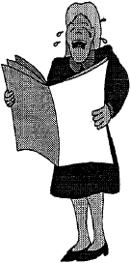
Boy wants something ... friendship, a gold mine, a trophy, to find something
Boy goes to get it ... by canoe, plane, horseback, foot
Obstacles stop boy ... crocodile, native hunters, a locked chest
Boy achieves goal ... through an act of kindness, bravery, wisdom, magic, unexpected help of some kind.
Write your skit to be 7 to 10 minutes long. The boys will shorten the skit when they present it.
PACK ADMIN HELPS
Real News!
Circle Ten Council
Does your pack get its name in the paper much? If not, now is a good time to recruit a public relations person to take pictures and write short articles for the local area newspaper. And if your pack does get in the paper, the Opening Ceremony could be used to “highlight” the articles that appeared over the month before. Have the PR person read “last month’s articles” after the flag presentation and the Pledge of Allegiance.
One of the ideas for Roundtables for this theme is for your Commissioner is to recruit a member of the local press to come and talk about how to get publicity for your pack. So come on out to roundtable and find out who to contact for your local papers and what sort of articles they want. CD
Your Pack Newsletter
Baltimore Area Council
Did you ever play a game called Telephone or Hearsay (See Games Section)? It’s a great game to play with your Den.
Have the Den stand in a circle. Tell the boys you will whisper a phrase that you have written down to the first boy. The message should be at least 3 to 4 sentences. He in turn will whisper it to the next boy and so on down the line. The last boy will repeat what he heard to the group. Was the massage the same? Read the message you started to the group. How easy it is to change a message when passed by word of mouth?
That’s why your Pack needs a newsletter!!
If no one has a computer you can still “Spread the News,” Neatly written stories can be cut and pasted to an 8 ½ x 11 sheet of typing paper. Mark the sheet into columns leaving a ½ inch margin on all sides, a 3½” column right and left, with a 1/2” free space in the middle Even if you are using a computer you may choose to cut and paste to add a picture or cartoon. Make a single photocopy. If the copy looks clean, go ahead and print enough for your Pack. If there are lines or smudges use liquid correction fluid and white out the problem areas before you photocopy. You may want to copy onto a special color paper so it will be recognized as the Pack Newsletter.
Start by checking your Unit Resource sheet. Do you have someone who has a computer, and wants to help the Pack? Ask them to be the editor and then give everyone a job.
So Lets get started -Think up a name for your Newspaper
The Blue and Gold Journal?
Pack 161 Gazette?
Akela’s Word?
Baloo’s Bugle?
Breakdown the work-load so no one has to do it all:
Publishing - Mrs. Jones, Editor in charge of the newsletter
News Dept. - Den Leaders and Committee who gather news and write articles
Feature Dept - Cubmaster Smith who writes the Cubmaster Report
Calendar, Upcoming Events Mr. Williams, Committee Chair sends in the calendar
Den of the month who may send in a cartoon or joke or idea
Production Dept - Mr. Brown, Makes copies for every family
Circulation Dept.- Mrs. Johnson the Pack Secretary makes sure every family gets a copy
What do your readers want to know?
What DID happen.
What IS happening, and
What WILL happen!
The Editor will have to decide which stories get printed.
F.O.S. -A GIANT SUCCESS
Our Pack Family Campout
100% PARTICIPATION
Save the date for family FUN
Reporters need to remember to include all the important information.
Who What When Where Why and How
A Pack newsletter needs to be fun to read and full of GOOD information. It may take telephone calls, e-mail and even the post office but is important to make sure everyone really knows what’s going on.
Here’s some more ideas on a Pack newspaper from another Pow Wow Book - CD
Pack Newspaper
Santa Clara Council
It doesn't have to be fancy nor computer-generated. Boys can hand-write their articles and illustrate them. Or adult can help type their articles. Cut and paste the articles and illustrations. Involve the boys. They like to see their own names in print.
At the pack meeting, set aside some time for "interviewing." Boys can interview Cub Scouts and ask them specific questions like their favorite Cub Scout activities, and their favorite after-school snack, etc. Make it short and simple. They can write a rough draft at the pack meeting and finish it up with illustrations at the den meeting. Each den can have their own page in the newspaper. Don't forget the news from the dens. (All of this ties in with Bear Achievements 8 and 18.)
How To Make Your Own Newspaper
Santa Clara Council
Get started: Think of a name for your newspaper and decide which stories to include.
Gather the Facts: Interview people who have information. Visit the location where the story is taking place.
Write the story: Make an outline or rough draft first--all news reporters do that. Put the basics of WHO, WHAT, WHERE, WHEN, WHY, and HOW at the beginning. Write a headline that tells the story in a few words. (Don't insist too much on correct writing style. If the boys enjoy writing, encourage them!)
Set up Pages: Set the words in columns, if you wish. Most papers use a column format.
Put it together: Begin to paste up the paper with articles and illustrations. Use glue stick or clear tape to hold in place.
Print your newspaper: Make one photocopy. If it looks good, make as many copies as needed. If dark lines show, use liquid correction fluid to cover. Make photocopies from corrected version. Deliver the newspaper to readers. (Have enough copies made for each boy in the pack. Some copying companies will give Scouters a discount. Others will give you a discount if you make at least 1000 copies, which is not difficult to do with the pack bulletin.
FUN WAYS TO SAY THANK YOU
Southern NJ Council
Don’t forget to recognize all the people who help your Pack GO! One of the best retention tools for leaders is recognition!!! Here are a few ideas.
Award What to say -
First Class envelope: “You did a first class job!”
Newspaper: “Thanks a bundle!”
Pencil: “You’re sharp and to the point!”
Toy telephone or two tin cans connected by a string:
For keeping everyone informed of changes.
For someone who coordinates the pack phone tree.
TIGERS
Achievement 3 Family Activity
3F Plan a family fire drill and practice it.
Be sure to plan a safe meeting place outside so that you will know when everyone in the family is safe. Go to that place as part of your practice.
Tell your Tiger Cub that if he ever feels that he is lost, he should stay where he is and hold onto something like a bench, a post, or a tree. Assure him that because you love him, as soon as you realize that he is not with you, you will quickly begin looking for him. Explain to him, that if he does not stay where he is when he is lost, it will take you a lot longer to find him. Practice a game with him where he pretends that he is lost, he holds onto something stationary, and you walk out of sight, wait a 3 to 5 min., and then come back for him.
Achievement 3 Den Activity
To keep your body healthy, it is important that you eat a well-balanced diet. The food pyramid in your book helps you by showing how many servings of certain kinds of foods you should have each day.
Also, check out last month’s Baloo for Nutrition ideas. Be sure to visit www.5aday.org to learn about eating your fruits and vegetables by the color and www.3aday.org to learn about your dairy needs. CD
3D Make a food pyramid.
Draw a food pyramid on a big piece of paper or a poster board. Using old magazines donated by the den families cut out pictures of food and glue them in the appropriate place on the pyramid. You can also draw pictures of different foods to add to the food pyramid.
Achievement 3 Go and See It
It’s fun to play games and to take part in sports. It’s also good exercise, which helps to keep your body healthy. Some games and sports are for one person, and sometimes people play games or sports on teams. It’s also fun to watch others play games or demonstrate their abilities. Understanding the game or sport you are watching makes it a lot more fun.
3G First, learn the rules of a game or sport. Then, go to watch an amateur or professional game or sporting event.
Local High School, Community College and other teams are great for this. We have a minor league Hockey team, The Philadelphia Phantoms, www.phantomshockey.com , which runs several Scout nights each year at reasonable cost!! You can get to all the other AHL team websites from their site. CD
More Ideas for Keeping Myself Healthy and Safe
Southern NJ Council
Den Activity
Emergency information is available from local libraries, the American Red Cross and the local fire departments. Some free handouts can include family disaster supply kits from the local fire department and the Red Cross.
Emergency Preparedness Ideas to consider:
Does your group have emergency supplies at the meeting site? Are there food supplies, warm blankets, flashlights, and water tucked away, just in case?
At home, how do you shut off the gas, the water and the electricity?
What neighbors can help? Have a neighborhood emergency plan ready. Who can be called when needed?
Every Tiger Cub will experience fire drills and storm drills at school. Do you have one established at your meeting site?
Nutrition
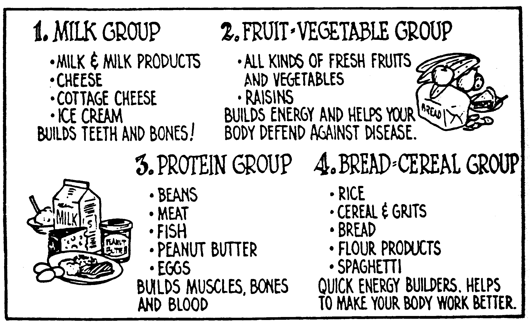
No program concerning fitness should leave out the subject of NUTRITION! Tiger Partners should plan to have some discussion of the importance of good nutrition. You might have a den discussion of the variety of good food for proper growth and development. The following chart about the 4 basic food groups might be helpful.
FITNESS
Tune: On Wisconsin
Hurry, Tigers, Build your muscles,
Get in shape for play.
When we feel our very best
We will do our best each day.
Hurry, Tigers, Build your muscles,
Get in shape for play.
Keep on running, keep on jumping,
Trying to improve.
When we’ve grown a little older,
We will still be on the move.
Keep on running, keep on jumping,
Trying to improve.
Electives
*4-Display a picture
It’s nice to have pictures of your family on display—especially when some of your family members are not close by all the time.
*Make a frame for a family picture. Glue tongue depressors or craft sticks together in a shape to fit your picture. Attach a string or ribbon to the upper corners to use as a hangar. Tape your picture to the back of the frame and display. You may want to use a photograph, or a picture that you draw of your family.
*10- Helping Hands
When people grow older, or if they become sick or have an accident, they sometimes have a hard time doing every day things. If you know an elderly person or if you know someone who is ill or recovering from an illness or accident, try to think of what things would be hard for them to do by themselves.
Along with your adult partner, help an elderly or shut in person with a chore. You might offer to do things such as helping to take out trash, rake leaves, mail a package, or bring in the mail. Ask first, and do it with a big Tiger Cub smile!
*32- Feed the Birds
Pop-bottle bird feeder
Materials: one plastic 2-liter bottle, two plastic lids about 5” in diameter (from coffee cans, large margarine containers, whipped topping, etc.), 30” heavy twine or rug yarn, scissors
Have your adult partner help you cut the bottle in half, crosswise. Poke a hole through the centers of the plastic lids with the point of the scissors or a nail. Tie a large knot in the end of the twine. Refer to picture and put your feeder together by stringing together one plastic lid (curved side up), then the inverted bottle, and then the second lid (curved side down). Fill the bird feeder with seed and hang it outside.
Pinecone Bird Feeder
Materials: 1/2 cup peanut butter, 1/2 cup shortening, 1-2 cups bird seed, large pinecone, thick twine, paper bag
Twist twine around the pinecone and tie it securely. Mix the peanut butter and shortening together. Spread the mixture between the petals of the pinecone, filling in as much as you can. Put the pinecone along with the birdseed in the paper bag. Close the bag and shake, coating the pinecone with birdseed. Hang the feeder on a tree where you can watch the birds enjoy it.
SPECIAL OPPORTUNITY
Next month – more info and ideas on 75th Anniversary Awards!! But I felt the Internet Patch and Boys’ Life Reading Awards fit this theme too good not to use them this month. CD
The Cub Scout Outdoor Award
The Cub Scout Outdoor Award was announced with the 75th Anniversary awards. The requirements for the award are in BSA publication 13-228 (and on many Council websites e.g. http://www.lastfrontiercouncil.org/cubs-outdoor-activity/)
Although the patch is pictured, the publication does not give the catalog number for the patch. So I went to the Del-Mar-Va Council Shop that is run directly by National Council and asked about the patch. The supervisor did not know about the award nor could she find it in any of her books.
My guess is since one of the requirements is to spend a week at Resident or Day Camp and since it states the requirements must be completed after September 1, 2004, National has delayed issuing the patch. There are not a whole lot of Day or Resident Camps after September 1 until next summer.
Internet Scout Patch - Earn It!
U.S. Scouting Service Project
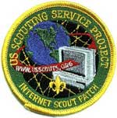
This is an educational program of the U.S. Scouting Service Project and is not part of the advancement program of any WOSM Scouting Association
Cub Scout (Under 11 years old) Requirements:
Do ANY 8 of Requirements 1 through 11 AND Do Requirement 12
Online help - http://usscouts.org/internetscoutpatch-earnit.asp.
(You can find the Boy Scout (over 11 years old) requirements here)
Computer Access Find out where computing resources are available in your community or school OR visit a store where computer hardware, software and accessories are sold. Share with your leader (or a parent) and with your Den what you learned.
Getting Connected Find out what internet service you use at home, or your parents use at work or learn about a service that is available in your home town. Discuss with your parents and Den Leader what you learned.
Online Safety Learn about Online safety and how to protect yourself on the Internet. With your parents, guardian, or Scout Leader, go to http://www.netsmartz.org/KIDS/index_hasFlash.html and complete each lesson.
Web Browsers Explain what a browser (for example; Netscape Navigator, Microsoft Internet Explorer, Opera, Amaya, or Lynx) is and how use a browser to find information on the World Wide Web.
Using the World Wide Web Demonstrate how to connect to the Internet and World Wide Web using a computer & modem or other device (Cable Modems, DSL, etc) . Once connected:
Explain the difference between a web page and a website.
Demonstrate what a "link" is and how it works.
Explain how to change from one URL to another.
Searching for Information Use a search engine on the World Wide Web Examples of search engines include; Google (http://www.google.com), Yahoo (http://www.yahoo.com), AltaVista (http://www.altavista.digital.com), Lycos (http://www.lycos.com) and FirstGov (http://firstgov.gov). Find a website which addresses some part of Scouting.
Using the Web for Scouting Visit http://macscouter.com/CubScouts/CubCmptr/index.html and under the category “Let’s Go Surfing”, find and print out games, songs or skits. (If Bears find a game, song or skit they like and get their Den Leader’s approval, they can plan and conduct one of the above during a den meeting and complete Achievement 24c.)
Your Own Web Page With the help of an adult build a simple web page and show it to your Scout Leader (or a parent). This web page should include text, a link, and a graphic. (note: This web page does not have to be put on the internet to qualify and can be done as a den project.) Discuss with your Scout leader (or a parent) how an individual with disabilities can access the web.
Using E-mail Show how to send and receive e-mail.
Internet Communications Explain what Messenger-type services (AOL Instant Messenger, MSN Messenger, Yahoo Messenger, etc.) are and how to use them. Explain to an Adult what to do when somebody you don't know tries to chat with you. Explain what to do when somebody tries to find out where you live or go to school. With an adult present, use one of these tools.
Safe Computing Explain what a computer virus and worm are. Explain how to protect your computer from viruses, worms, and other malicious programs.
Downloading Software Explain to your Scout Leader what can go wrong with your computer when you download software and how to safely download software. If you have a home computer, discuss with your parents what software you can download on your home computer.
Boys' Life Reading Contest
Enter the 17th Boys' Life Reading Contest Now!
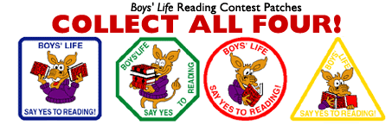
Write a one-page report titled "The Best Book I Read This Year" and enter it in the Boys' Life 2004 "Say Yes to Reading!" contest.
The book can be fiction or nonfiction. But the report has to be in your own words—500 words tops. Enter in one of these three age categories: 8 years old and younger, 9 and 10 years old, or 11 years and older.
First-place winners in each age category will receive a $100 gift certificate good for any product in the Boy Scouts Official Retail Catalog. Second-place will receive a $75 gift certificate, and third-place a $50 certificate.
Everyone who enters will get a free patch like the round one above. (The patch is a temporary insignia, so it can be worn on a Cub or Boy Scout uniform shirt. Proudly display it there or anywhere!) In coming years, you'll have the opportunity to earn the other patches.
The contest is open to all Boys' Life readers. Be sure to include your name, address, age and grade on the entry.
Send your report, along with a business-size, self-addressed, stamped envelope, to:
Boys' Life Reading Contest, S306
P.O. Box 152079
Irving, TX 75015-2079
For more details go to www.boyslife.org
Entries must be postmarked by Dec. 31, 2004.
Silver Beaver Award
Kommissioner Karl

It’s Beaver season in most councils! Each fall most councils seek out their top volunteers. The Silver Beaver is the highest award a local council can bestow upon a volunteer. The Silver Beaver Award is presented upon action of the Council Executive Board through the nomination and recommendation of the District Committee for outstanding service to youth within the Council or for outstanding longtime service to youth by a registered Scouter residing within the Council. The average tenure for Silver Beaver candidates is ten years or longer. Candidates for this award must be nominated, and self-nomination is not allowed. The amount of awards a council may present is determined by the size of the council. A council is allowed one Silver Beaver recipient for every 60 units chartered in its territory. Nominations are due to the Council by a date they set. Generally, nomination forms are available at Council Offices, on the web or at Roundtables. Be sure to nominate someone you know who is an outstanding Scouter. And keep nominating them. (Commissioner Dave told me he nominated one Scouter about five times until he was selected). It is said this award seeks the recipient. The recipient does not seek the award.
GATHERING ACTIVITIES
SPREAD THE NEWS
Circle Ten Council
This is a pretty simple, but fun activity that you can use for any theme or meeting. Using the letters from “Cub Scouts Spread the News” have people go around to everyone else trying to find names that begin with the letters. You can always offer a “prize” for the person or have a special ribbon for the den that gets the most names. Preprinted forms and pencils will help.
Find people in the Pack whose names begin with the letters below. Note: You can use two people with the same name, but do not use the same person for more than one line.
S
P
R
E
A
D
T
H
E
N
E
W
S
Comics
Baltimore Area Council

B | R | T | B | H | T | I | M | S | Y | F | F | U | N | E
A | E | R | N | I | E | I | D | N | O | L | B | S | S
B | X | E | T | A | H | C | A | E | P | S | S | I | M | S
Y | M | B | T | U | C | R | A | N | K | S | H | A | F | T
B | O | L | D | L | E | I | F | R | A | G | R | S | F | U
L | R | I | W | O | E | H | A | M | C | O | H | G | M | N
U | G | D | T | C | G | B | M | R | B | O | F | F | O | A
E | A | U | O | K | U | O | A | O | E | C | Z | N | T | E
S | N | F | R | H | M | R | T | I | R | Z | I | N | N | P
N | U | F | T | O | C | M | T | A | L | C | G | A | A | U
I | Z | Y | X | R | A | R | G | I | B | E | G | U | H | F
V | D | L | O | N | T | A | L | Z | S | C | Y | L | P | D
R | U | C | F | S | H | E | A | T | H | C | L | I | F | F
A | K | Z | C | V | Y | R | U | B | S | E | N | O | O | D
M | A | R | M | A | D | U | K | E | L | B | B | A | R | D
Find these in the Puzzle -
BABY BLUES HEATHCLIFF BC
KUDZU BEETLE BAILEY LOCKHORNS
BLONDIE LUANN CATHY
MARMADUKE CRANKSHAFT MARVIN
CROCK MISS PEACH CURTIS
MOMMA DILBERT MR BOFFO
DOONESBURY PEANUTS DRABBLE
PHANTOM DUFFY REX MORGAN
ERNIE ROBOTMAN FOXTROT
SHOE GARFIELD SNUFFY SMITH
GEECH ZIGGY HAGAR
Noodlegrams
Simon Kenton Council
In a saucer place a tablespoonful or more of uncooked noodles. Each person must try to compose a ten word message out of the alphabet noodles. This could be done in couples or singly as gathering time activity.
Jigsaw Puzzle Ads
National Capital Area Council
Cut up full page color pictures from magazines. Have at least one puzzle per scout. As each scout arrives, hand him one to put together. If time permits, let the scouts exchange puzzles.
Who Am I?
National Capital Area Council
Make up a "Who Am I" card for each scout. This card has the name of someone who is famous or well-known in some field of communication -- past presidents, politicians, actors, radio personalities, etc. Tape one card on the back of each scout as they arrive (be sure the scout does not see the name). The scouts are allowed to ask each scout two questions which can only be answered with "Yes" or "No" as they try to guess "Who" they are.
Find the Clues in the Newsletter
Circle Ten Council
This is an activity that keeps Cub Scouts busy and attentive at the start of the Pack meeting. Hand out a monthly newsletter with articles of interest – usually about the previous month’s events – and upcoming event announcements and award recognition. Peppered throughout the newsletter are clues to a puzzle that the readers try to solve – usually related to the theme or to Scouting. There is also an instruction hidden in the news that tells the boys who to “go see” with the answer to get “the prize”/ the prize can be access to the Pack Grab Bag that contains freebees or inexpensive items, like penlights, patches, collapsible cups, etc.
This gets the boys reading the newsletter and gets the parents of the non-readers reading too! It keeps them busy instead of just running all over the place, and sometimes even teaches them something! That is considered a success! Give it a try!
Comic Strip Jumble
Baltimore Area Council
Save one week of comics from the local paper. Cut up each comic strip, panel by panel and mix them up. Give each person a panel as they arrive. Each participant must find the other panels and place them in the correct order. Have the comic strip panels ready for inspection, or place the panels at a designated place before the meeting. The order of each comic strip may be peculiar. Lots of surprises await you.
What Is It?
Baltimore Area Council
Randomly hand out different colored 3 by 5 cards as “Press cards” to the boys and parents. Separate the players into color groups for the “What Is It?” Put a common household item on the table where each group will gather. (mop head, odd shaped cleaning brushes, novelty kitchen tools, etc.) Have each group of participants write down all the different uses they can think up for their item. (Example, use the mop head as a wig.) Then have each group pick a spokesman with a contract worth millions of dollars.
Special note to Cubmaster and Committee Chairpersons: This will put the spotlight on some very talented, enthusiastic and fun people. RECRUIT!!
How Many Words?
York Adams Area Council
See how many words each person can find in the phrase “Cub Scouts Spread the News”
Who Is It?
Southern NJ Council
Give everyone a 3x5 card. Have them all write down 4 things about themselves that no one else in the room should know. Have them put their name on the top of the card for future reference. Collect the cards. Then pass out a piece of paper to each person. Read the cards one at a time and have everyone write down who they think the person on the card is. Then read off the correct results (the names from the top of the cards) while they check their lists. The person who gets the most right is the winner.
Who Am I?
Southern NJ Council
Take a pile of 3x5 cards and write down a name of a person or character on each card. These names can be seasonal (Winter: Cupid, Jack Frost, New Year’s Baby, Old Man Time, etc.) or follow a theme (Presidents, George W. Bush, Kennedy, Jefferson etc.). Then tape a card to the back of every person in the room. They must now try to guess who they are by going around the room asking other people questions about the name on their back. These questions must be yes-no questions (ex. Q. "Am I green?" A. "Yes") and only one question can be asked to each person in the room (to get everyone talking to everyone else). The first person to guess the name on their back is the winner.
OPENING CEREMONIES
Reporters Opening Ceremony
Baltimore Area Council
Set Up: Cubmaster comes out followed by several Scouts dressed as press (hats w/press passes, some can carry cameras, etc.). The “press” are throwing out questions at random and generally making a lot of noise.
Cubmaster stops and holds up his hands for quiet)
CM: Ok, ok. We’ve only got time for a few questions.
REP1: Mr. Cubmaster, is it true that at the meeting tonight we’ll be doing songs, skits and other fun stuff?
CM: Yes, that’s true. Next.
REP2: Is it also true, sir , that you’ll be handing out awards to some of the Scouts?
CM: Yes, that’s also true. One more.
REP3: Sir, is it true that the committee chairman is an alien who has Elvis locked up in her garage? (at this point all the reporters get excited and run off stage as the Cubmaster in vain tries to deny this).
Opening Ceremony
Baltimore Area Council
Personnel: Cubmaster, Color guard, 5 Scouts to read the following parts.
PROPS: Make up names of 5 newspapers and put one of the following headlines on each paper. You can put the lines that go with each headline on the back of each paper in LARGE print so it is easier for the Scouts to read. After each line is read, the Color guard only advances a few steps until the last line is read and the colors are posted.
- Here are some headlines from the past.
- Headline - July 4, 1776 - America Wins Independence, The headline says, as you can all see, The British are gone, and we are now free.
- Headline - April 9, 1865 - North and South End War. A sad time in history is finally done. We put out a hand and set down our guns.
- Headline – November 11, 1918 – WW I is Over. This day began with the laying down of arms, blowing of whistles, impromptu parades, closing of places of business. All over the globe there were many demonstrations; no doubt the world has never before witnessed such rejoicing. Our flag of 48 stars was flying high.
- Headline - September 2, 1945 - WW II is Over! The World War is over, many are free. Our flag was still flying, as high as could be.
- Headline - April 29, 1975 - USA leaves Vietnam. As we leave this foreign land, we end a sad, sad story. But we still hold in our hand, a banner called Old Glory.
Color guard - posts colors.
- Our flag has been around for over 200 years. Let’s honor it by standing and saying the Pledge of Allegiance.
Hear Ye! – Hear Ye!
Circle Ten Council
Setup Scout is dressed in colonial outfit befitting the town crier. Walks to the front of the pack assembly with old school bell and scroll. He rings the bell to draw everyone’s attention. Unrolls the scroll and reads:
“By decree of the Continental Congress on this _____ day of January in the 2005, this Pack _____ assembly is now in session. All rise for the presentation of the flags.”
Den assigned to opening parades in the flags, flag bearers flanked by color guards to positions in front of the group.
Town crier continues:
As Americans, we have freedoms and responsibilities. Our founding fathers described these in the Constitution of the United States and in the Bill of Rights. One of the freedoms – or rights – is the right to Free Press. This means that our Government cannot keep us from saying and writing what we want. But with this freedom comes a responsibility – we must be responsible for what we say and write. We cannot tell lies about people or events. We cannot write and publish information without making sure that it is true. It is a balance that we must keep level. With every freedom comes a responsibility. Let us all join together in saluting out flag – the symbol of our country, the freedoms in which we believe, and the responsibilities by which we live.”
The Evening News!
Circle Ten Council
At the opening of the Pack Meeting, one of the leaders can open the newspaper and read off special “articles of interest.” Or after the flag is presented and the Pledge of Allegiance is recited, have everyone sit down and one of the boys or a leader open the newspaper to entertain the group with your own special news articles. You can have the den assigned to Opening prepare these. They can be news items like:
Alien Sightings – Several town residents have reported seeing strange-looking Blue/Gold and Tan creatures meeting mysteriously at _____ (Pack Meeting place). These sightings have been reported about once a month. Mayor _____ is quoted as saying “We will let these strange creatures into our community so long as they remain friendly and if they promise to do their best to serve the town.” Many of the creatures are reported to be decked out in animal badges with arrow points below them. We will continue to monitor and report on this situation.
Weather Report – Today’s weather is rainy and cloudy with snow in the mid 90’s. If you have an umbrella, do not open it in really windy conditions. If you see a rainbow and follow it to its end, make sure you share some of the Pot ‘o Gold with the Cubmaster.
News Flash! – [Here is where the boys can “go after” some of the more notorious leaders in their den or pack. They can make special reports about funny things that happened at a pack event or anything else that would strike the groups’ funny bone.
Who knows! Maybe the Evening News could become a regular part of your Pack Meeting!
Stop the Presses Opening
Trapper Trails Council
Personnel: Five Cubs
Equipment: A rolled newspaper for each boy
Set Up: The Cub Scouts run onto stage. As each Cub Scout repeats his part, he opens the paper to "read"
All Cubs: Extra! Extra! Let us read to you all about it!
- Wow! The headline says there's going to be a great Pack meeting for Pack (number) tonight! Sounds like fun!
- Hey! The Who's Who page says there's going to be some advancements and awards given out. That sounds neat!
- Would you look at the sports page? It says there's going to be fun games and activities for everyone. This is sounding exciting!
- Cool! The food section talks about the great refreshments that will be served. I know I can't wait!
- Hey Guys! In the comic section it says there's going to be some hilarious and funny skits and jokes. You know, that reminds me of a joke. What's black and white and black and white and black and white and black and white and read all over? A zebra, skunk, and Dalmatian reading a newspaper! Great joke, huh?!
All Cubs: Now that we've let you know what's going on we hope you'll enjoy the pack meeting as much as we will!!
Welcome
Southern NJ Council
Equipment: Seven pieces of construction paper each with one letter from the word WELCOME written on it. Cubs arranged to spell out the word their arts in LARGE print on the back of the cards.
- W - We've come here tonight to communicate with you.
- E - Each boy showing and telling what he can do.
- L - Let's all lend an ear for the message.
- C - Come now and direct your attention this way.
- O - Opening this meeting we're doing right here.
- M - Making for you a message soon dear.
- E - Everybody welcome is what we wish to communicate now to you and to tell you this meeting has now started, too!
Go into Flag Ceremony, Promise or Law, and Prayer
Maybe a Patriotic song, too
It Takes Work To Communicate
Southern NJ Council
Equipment: Eleven pieces of construction paper each with one letter from the word COMMUNICATE written on it and the Cubs part written on the back in BIG letters. Each Cub should draw a communications picture on the front around his letter. Make sure the Cubs are arranged to spell out the word.
- So often we have problems in our lives because we don’t “Get the message.” Tonight our Cub Scouts will review some basic rules needed to communicate properly.
- C stands for “Carefully” – Carefully listen when someone is telling you something.
- O stands for “One” – One and only one person is “transmitting” at a time; other person should be “receiving.”
- M stands for “Message” – Make sure you send the right Message when you communicate.
- M stands for “Minute” – Give the message a minute to sink in before responding.
- U stands for “Understand” – Make sure you understand the message before ending a conversation.
- N stands for “Noise” – Noise is what keep you from getting the message—noise from outside and inside your head. Avoid the noise!
- I stands for “I” – I am responsible for getting the message straight.
- C stands for “Carefully” – Carefully choose your words when you are sending a message
- A stands for “Attention” – Pay attention when you are sending and receiving a message.
- T stands for “Time” – Take your time to say things clearly and to hear things clearly.
- E stands for “Everyone” – It is everyone’s job to make sure the message gets across.
- If we follow these rules, we will always be able to Communicate!
- Lead Flag Ceremony, Promise or Law, and Prayer. Maybe a Patriotic song, too
Note: Cubs 1, 13 and 14 may be Adults or Den Chiefs who are helping with the ceremony. Cub 14 maybe several Cubs
PACK AND DEN ACTIVITIES
Story Box
Southern NJ Council
Use already-made boxes or boxes that Cubs have made themselves. Let their imaginations go! A Storytelling Box can also be done individually or as a group. It is a special box into which the following kinds of items, or combinations are placed:
Small, smooth stones (or ceramic squares) onto which words, signs or symbols are painted or written.
Small, unusual objects (e.g. toys, things from nature, household items, small bits of clothing, coins, and so on).
Slips of paper or flat sticks with words or pictures on them.
Cubs work in groups of 3-5. The Den Leader can start off with a beginning, then allow one of the group members to "set the stage", or leave it completely up to the individual storyteller from the very start.
The first Cub begins by drawing out an object from the box without looking (the element of surprise makes it more interesting!). The drawn item must be used sequentially in the story and stays out of the Box until the story is finished; i.e. it can't be put back into the box and exchanged, or saved until later in the story, or used again.
The story continues until such time as the Cub becomes "stumped", and pulls out another object. This process continues until the Cub determines that the story is finished.
DEN NEWSLETTER
Southern NJ Council
The den’s newsletter can be whatever the boys want to make it. Ask each boy to write at least one story for the paper. Here are a few possible topics:
  - A report on a recent den field trip.
  - Brief impression of a recent den or pack event.
  - Directions for playing the writer’s favorite game.
  - A report on an interview with the den leader.
  - A one- or two-paragraph description of each den member written by himself.
  - An interview with the den chief, who tells why he likes Boy Scouting.
  - A story on what the den plans to do for the Blue and Gold Banquet.
If you have an artist in the den, he may want to draw a cartoon or some other illustration. A boy interested in photography might choose to take photos of den activities.
Recruit boys and parents who have access to a computer to help produce some or all of the newsletter electronically using graphics and word processing programs.
Printing
Southern NJ Council
You can make designs and use them over and over to make greeting cards, gift wrapping, banquet programs and menus and stationary. Cover the table where you are working with newspapers because you must press down hard when printing to make a clear print. Design will print the reverse of what is seen on the block so if there is lettering or a design that has a right or left, it should be glued to the block backwards. Here are some ideas -
Potato Printing
Potatoes make good block prints, if used right away. They are easily carved, but last only a day or two. One potato makes at least two designs.
- Cut potato in half with one straight cut
- Blot the surface to remove as much moisture as possible.
- With an orange stick or pencil, trace design on potato.
- Cut away all parts without any design on them. Cut outline at least 1/3" deep to provide a good printing surface.
- Again remove additional moisture.
- Place paper to be printed on a pad of newspaper or a water-soluble printer's ink on design.
- Transfer potato design onto paper. Press had but do not move the potato or the design will smudge.
Potato Stamp Tip
Circle Ten Council
You can make the potato stamp in a couple of ways. One way is to cut the potato in half and carve a design on one-half. This should be a raised design, so you cut away what you do not want to see. There is a safety issue here of using knives. Plastic ones work if the potato is a softer variety.
Another way to potato stamp is to use cookie cutters. You push the cookie cutter all the way into the potato and cut off the excess with a butter knife. This can make better shapes and is a lot safer for the Cubs.
Leaf Printing
Trees shrubs, flowering plants and weeks offer an infinite source of leaf designs for printing. Use an inked stamp pad, place leaf, veins side down on pad. Lay a piece of newspaper over leaf and rub fingers over it. Remove leaf and place it on surface to be printed. Pace clean newspaper on tap and rub.
Crayon Rubbing
Place leaves veins side up on paper or textured surface, such as burlap, wood or leatherette. Cover with sheet of plain paper and rub crayon held sideways. Outlines and veining of leaves will stand out.
Printing With Sponges
On a dry plastic sponge draw or trace your design. Cut cleanly along the lines. Place poster paint in a dish, brush the paint onto the flat part of the sponge and stamp it on your paper.
Printing With Erasers
Draw your design on a gum eraser. Use a craft knife or scissors to cut away the part around the design so the pattern is raised.
Printing With Odds And Ends
Interesting and easy prints can be made with odds and ends from around the house. You will be surprised with the patterns you can make by pressing the bottom of a spice can or a bottle on an ink pad and then stamping your paper. Other things such as:
Matchbox Half an Onion Your hand
Buttons Coins Kitchen Utensils
Fork Toothbrush
"The Morning Times"
Southern NJ Council
Have a basket full of words that you have cut out of the newspaper. Hand out a piece of 8 1/2" X 11" paper to each boy as well as a roll of scotch tape. By picking words out of the basket, each little editor combines words to create his own newspaper headline. Write a short story based on your "Headline."
A-Hunting You Will Go!
Greater St. Louis Area Council
Without careful observation, it is hard to notice the many different things in the newspaper. Nick K., "Cub Reporter,” amazes his friends with his ability to find lots of hidden things written in the paper. Let's see how well you do!
Use the newspaper to find words for each category and letter listed on the chart below. When you find a word that starts with one of the letters and also fits in a category, cut it out; the glue it in the appropriate box.
 | Person's Name | Plural Word | Business Name | City or Country Name
N
E
W
S
P
A
P
E
R
Stop The Presses Newspaper Slide
Southern NJ Council
Shrink-It kits can be found in craft stores. This slide uses Shrink-It.
Materials: Newspaper story
Clear plastic Cardboard
Glue Pipe cleaner or PVC pipe ring or curtain ring
Shrink a story from the newspaper to size you want.
Glue it on cardboard and cover both sides with clear plastic.
Glue pipe cleaner on back.
MEMO HOLDERS
Southern NJ Council
Craft Stick –
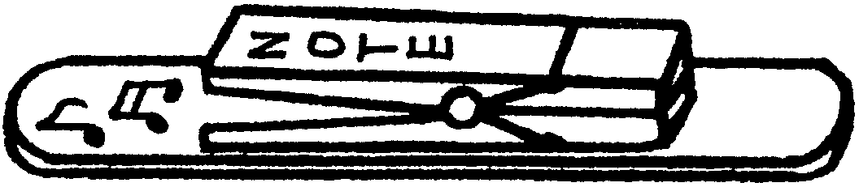
Materials: One large craft stick (tongue depressor); 1 spring-type clothes pin; Markers; Glue; Strip magnet.
Directions:
- Glue a clothespin near the end of the craft stick.
- Decorate with markers.
- Attach magnet on back.
Paint Stick
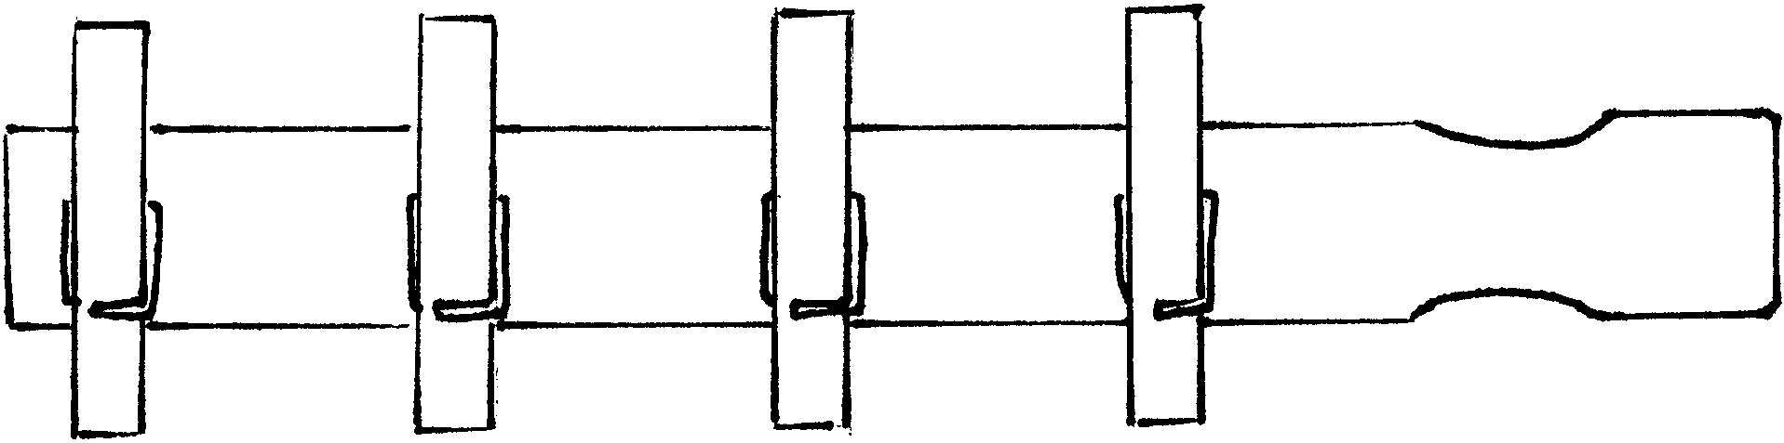
Materials: One paint stick (for quart or gallon can, about 14” long); Several spring-type clothes pins, Paint; Permanent markers; Glue; Strip magnet.
Directions:
- Paint the paint stick. Use any wood or acrylic paint.
- Attach clothespins. If desired, paint or decorate the clothespins before you glue them on the paint stick.
- Decorate with markers
- Attach magnet strips on the back of the paint stick.
LETTER OPENER
Southern NJ Council
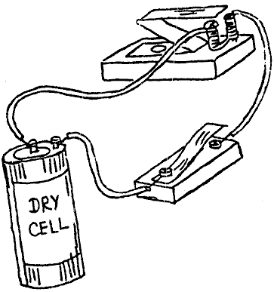
Materials: One craft stick (tongue depressor); Sandpaper; Yarn; Raffia; Twine; Plastic lacing; Small piece of cardboard; Permanent marker; Shellac (optional).
Directions:
- Sand one end to a point--not too sharp!
- Sand both edges until they are angled and smooth enough for opening letters. It’s easier if you move the craft stick over sandpaper than the other way. See Picture above.
- Wrap the handle end with yarn, raffia, twine, plastic lacing, or other material. Wrap about an inch and fasten the end. Put a dab of glue on each end to prevent unraveling.
- Fold the cardboard, draw a small, simple design. Cut both layers. Glue them over the top of the handle, one on each side of the stick.
- Draw design on the stick with markers.
- Finish with a coat of shellac (adult assistance necessary).
RUSTIC LETTER HOLDER
Circle Ten Council
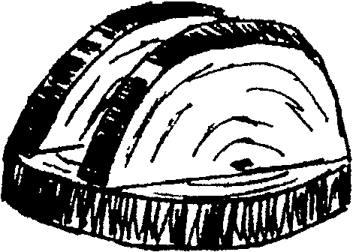
Material:
Two good-sized log slices about 1” thick;
Felt piece; Saw; Glue.
Directions:
- Sand the surface of wood pieces well.
- Use one for the base. Glue a piece of felt to the bottom.
- Saw the other piece in half and glue the straight edges of these halves across the base, leave space between for letters.
Paper cup Telephones
National Capital Area Council
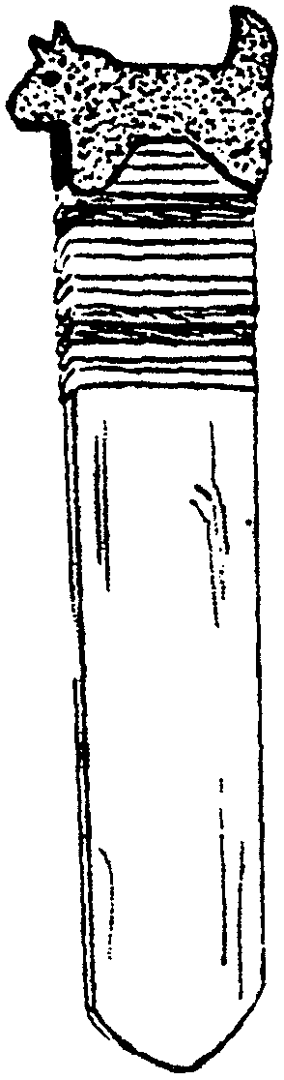

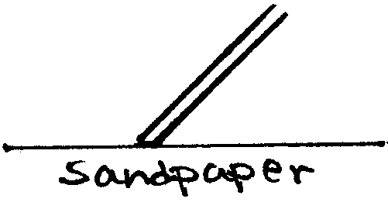
Make a small hole in the base of each cup. Insert one string from the outside to the inside of each set of cups and secure it with a piece of tape. Let the Cub and his partner talk to each other. Be sure to keep the string taut but don't pull so hard that the string comes untaped. Suggest they have a code word to indicate they are done talking, so each knows when to change from listening mode to speaking mode.
Family Communications Center
Baltimore Area Council
Create a message center using a wooden coat hanger and metal cup hooks.
Screw the cup hooks into the bottom of the wooden coat hanger, spacing them equal distances and using one for each member of the family.
Decorate the hanger any way you want, using Feathers, ribbon, seeds, dried flowers, material, etc.
Old Fashion Telegraph Set
Baltimore Area Council
Supplies: 2 wood blocks 2 nails
3 screws 1 dry cell battery 2 wires
2 metal tin can strips (Note: These cannot be from an aluminum can. Test it with a magnet first.)
- Using supplies, assemble, as illustrated.
- Bend the metal “Z” (sounder) so that it attaches itself to the nails when the key is pressed.
- After the boys have completed their old fashion telegraph set, they can have fun sending messages to each other using the Morse Code chart below.
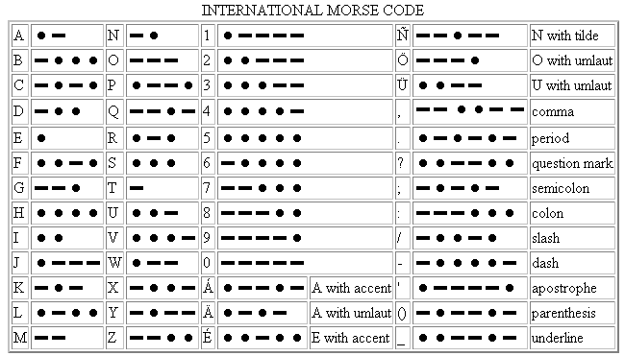
Historical Note: Samuel Morse became interested in telegraphy in 1832, and worked out the basics of a relay system in 1835. The equipment was gradually improved and was demonstrated in 1837. Morse developed “lightning wires” and “Morse code”, and applied for a patent in 1840. A line was constructed between Baltimore and Washington and the first message, sent on May 24, 1844, was “What hath God wrought!”
On May 24 2004, the 160th anniversary of the first telegraphic transmission, the International Telecommunications Union added the “@” (the “commercial at” or “commat”) character to the Morse character set and is the digraph “AC” ( probably to represent the letter a inside the swirl appearing to be a C).
It is notable since this is the first addition to the Morse set of characters since World War I probably, due to its popularity in e-mail addresses.
Newspaper Puppets
Circle Ten Council
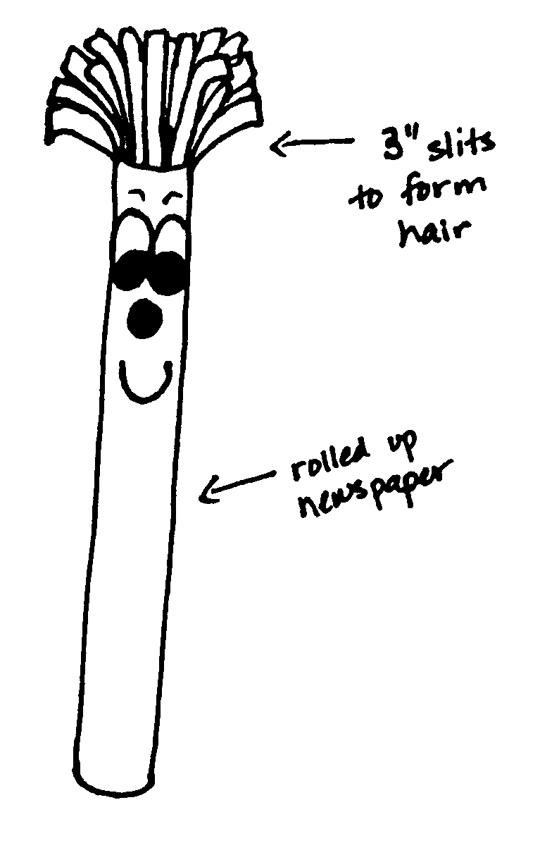
Materials: Newspaper, scotch tape, and white paper
Directions:
- Pile at least five pages of newspaper together.
- Fold them in half (so they are about 11 x 14) and roll them up lengthwise. Make sure that the roll is tight.
- Fold another page in half and wrap it around the roll.
- Tape them all together.
- From the top of the roll, make cuts about three inches long and 1/2 inch apart to make the hair.
- Draw eyes, nose and mouth on the white paper and cut them out. Glue the facial features on the roll just below the hair.
Paper Beads
Circle Ten Council
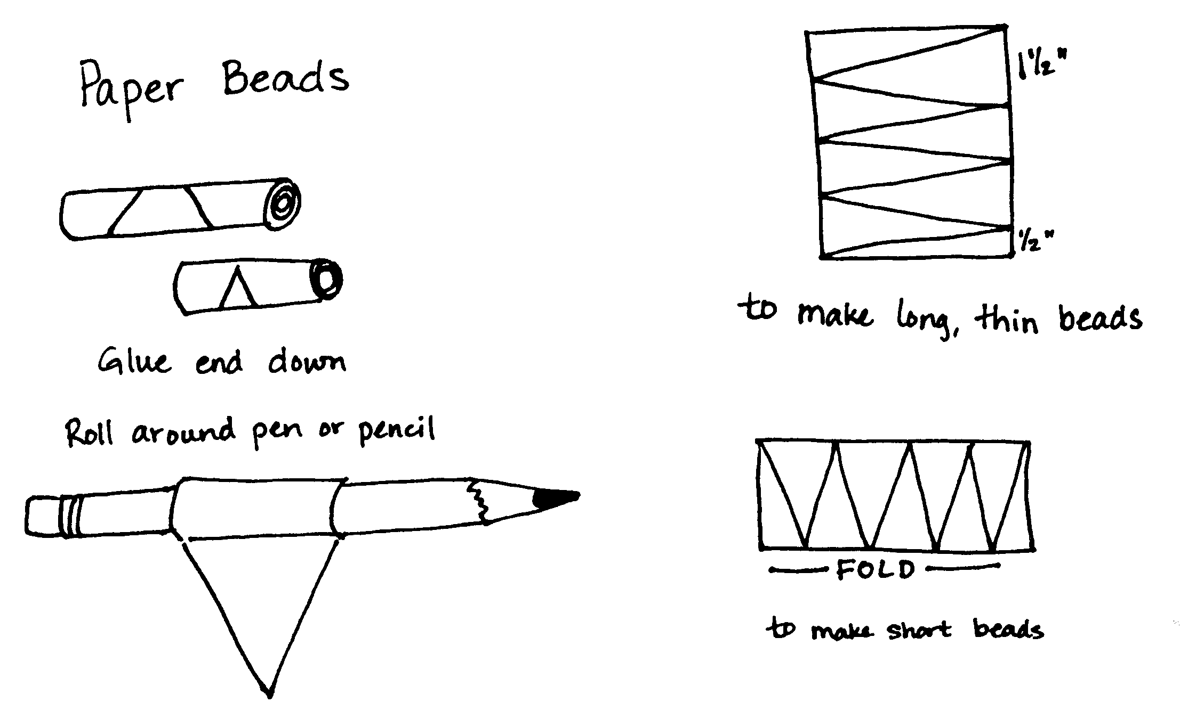
Materials: Old Magazines, glue, pencil or stick
Directions
- Find colorful pages in the magazines and cut them out.
- Cut triangle shapes the length of the page, having the widest part of the triangle 1/2 inch in width.
- Starting with the widest end of the triangle, roll the triangle around the pencil or stick.
- Put a drop of glue on the point and hold it in place for a few seconds to secure the end of the triangle around the roll. Make several beads and then string them on a string to form a chain or necklace.
Stickers
Circle Ten Council
Materials: A box of Jell-O or unflavored gelatin, old magazines or wrapping paper
Directions:
- Cut pictures from magazines, wrapping paper, comics, or other thin paper.
- Mix the gelatin as follows: one part gelatin to two parts boiling water. For example, use 1 teaspoon gelatin to 2 tablespoons boiling water. Let the mixture cool one minute.
- Use a paint brush to completely cover the back of the pictures with the gelatin mixture. Dry on a piece of wax paper.
- When the mixture dries, you can lick the pictures and stick just like stickers.
Telephone Den Meeting
Sam Houston Area Council
Practice your phone skills by holding the meeting over the phone. Set up a telephone schedule the previous week with the time that each boy is to call another. Give each boy a message to give to the others a week ahead of time. Put it in a sealed envelope and put them on their honor to open it only on the day of the calls.
On the day of the stay-home meeting, the boys should open their envelopes and keep their calling schedule. They should write down the messages that you gave them to share with one another. Have them bring the messages with them to the next den meeting. Compare the messages that the boys wrote down with the messages you gave them. Discuss how communication breaks down and how they can make it better.
:00 Boy 1 calls boy 5
Boy 2 calls boy 6
Boy 3 calls boy 7
Boy 4 calls boy 8
:05 Boy 5 calls boy 2
Boy 6 calls boy 3
Boy 7 calls boy 4
Boy 8 calls boy 1
:10 Boy 1 calls boy 6
Boy 2 calls boy 7
Boy 3 calls boy 8
Boy 4 calls boy 5
:15 Boy 5 calls boy 3
Boy 6 calls boy 4
Boy 7 calls boy 1
Boy 8 calls boy 2
:20 Boy 1 calls boy 2
Boy 3 calls boy 4
Boy 5 calls boy 6
Boy 7 calls boy 8
:25 Boy 2 calls boy 3
Boy 4 calls boy 1
Boy 6 calls boy 7
Boy 8 calls boy 5
:30 Boy 1 calls boy 3
Boy 4 calls boy 2
Boy 5 calls boy 7
Boy 8 calls boy 6
:35 Boy 1 calls Den Leader
:38 Boy 2 calls Den Leader
:41 Boy 3 calls Den Leader
:44 Boy 4 calls Den Leader
:47 Boy 5 calls Den Leader
:50 Boy 6 calls Den Leader
:53 Boy 7 calls Den Leader
:56 Boy 8 calls Den Leader
Stay on time!
If a boy is missing or you do not have eight boys, work with another den or give byes to those who have no one to call.
AUDIENCE PARTICIPATIONS
Computer Pals
National Capital Area Council
Divide the group into seven smaller groups and assign each group one of the words listed below. Have participants practice the parts as you assign them. Read the story. After each of the words is read pause for the group to make the appropriate response.
Jeff "Whew, it's hot!"
Mouse "Squeak, Squeak"
Vaughn "Burrrrrrrr, it's cold!"
Nome, Alaska "Watch out for the moose!"
E-Mail "Zoom, Bing!"
Orlando, Florida "Mickey Mouse"
Send "Click, Swish!"
Keyboard "Typety, typety"
Scout or Scouting "Do Your Best!" (ALL)
Vaughn had just attended School Night for Scouting in his home town of Nome, Alaska. He wanted to Send E-Mail to his computer pal Jeff, in Orlando, Florida to tell him that he joined Scouts. He knew that Jeff had been in Scouting for a while and wanted to find out what he was getting into.
So, Vaughn sat down at the computer Keyboard and reached for his Mouse. He typed in the message, hit Send with the Mouse and eagerly awaited Jeff’s reply.
While doing homework at the Keyboard, Jeff received Vaughn’s E-Mail. He was really excited to get Vaughn’s news. Jeff immediately sent E-Mail back to Vaughn in Nome, Alaska with all the fun Scouting stuff they do in Orlando, Florida. He talked about such things as the Pinewood Derby, Day Camp, the Blue & Gold, the Raingutter Regatta, plus all of the great hikes, field trips and more! When Jeff finished listing all the things they do in Scouts, he hit the Send key on his Keyboard. After Vaughn finished reading Jeff’s E-Mail, he began to think he had made a smart decision by joining Scouts.
A couple of weeks later, after Vaughn had attended his first Pack meeting, where he received his Bobcat badge, he decided to Send Jeff an E-Mail to tell him the good news. So he sat down at the Keyboard and reached for his Mouse to Send the message.
Jeff drew a card with his Mouse to congratulate Vaughn for earning his first Scouting badge.
After each of their meetings, Jeff from Orlando, Florida and Vaughn from Nome, Alaska would Send E-Mail to each other telling everything they had done in their meetings. They both agreed Scouting is a lot of fun. They also became life-long buddies and pen pals!
News Stories
Circle Ten Council
First, you need to come up with a set of newsworthy stories to read to the pack – probably enough to last 3 –5 minutes (max). They don’t need to be real and definitely they don’t need to be somber. Let them be light and enjoyable to hear read aloud.
Next, you need to assign a really animated leader/parent from the pack who will read the stories in front of the group.
Then (and here’s the catch), you need to have a few of the other leaders assigned to watch and take note of the reader’s animations while he/she reads the stories. These will need to be written down during the reading so that all animations are captured. Also, instruct the reader to be animated during the reading, making separate, noticeable animation. For example, the reader may pull hair, scratch knee, slap forehead, throw hands up in air, etc. Before the news is read, give the Den Leaders paper and pencils, and then give the pack these instructions:
Mr. / Ms. Smith has some very important news to read to us tonight. We ask everyone to sit quietly and pay very close attention, because, after the news is read, we will have a contest to see which den paid the most attention. The judges will be making notes as the news is read, but everyone else must just pay attention! No notes, please!
After the news is read, give the following contest instructions:
How much did you pay attention? Each group is to write down every action that is observed while Mr. / Ms Smith read the news. Then we will compare your lists to the judges’ list to see who paid attention the most.
Finally, have the judges read off their combined list and have the Den Leaders compare the den lists. The den that has the most notable actions wins. Maybe they can get the “Newsies” award for their flag – how about one of those dog chew newspapers hanging from a string?
ADVANCEMENT CEREMONIES
Advancement Ceremony
Baltimore Area Council
PERSONNEL: Cubmaster and 1 Scout for each badge or achievement being presented.
PROPS: 1 Newspaper for each Scout.
- “Extra! Extra! Read all about it! Cub Scout makes Bobcat!” (hands paper to Cubmaster)
Cubmaster: According to this, these boys have achieved the rank of Bobcat! (calls boys and their parents forward and gives badges to-parents to present to boys.)
- “Hot off the Press! New Wolves in the Pack! (hands paper to Cubmaster)
Cubmaster: It says here, we have some boys that have earned their Wolf Badge. (call new Wolves forward with parents and has parents present badges to boys. Can also present any arrow points earned to current Wolves at this point.)
- “Headline news! Bears emerge from their Pens!” (hands paper to Cubmaster)
Cubmaster: Well, looks like we have some new Bears among us! (call new Bears and parents forward. Have parents present badges to their boys. Again, present any arrow points to current Bears at this time.
- “Special edition! Webelos spotted!
Cubmaster: Webelos! What’s a Webelos?
- It says here that it means “We’ll Be Loyal Scouts!” (hands paper to Cubmaster)
Cubmaster: Oh, I see! Looks like these Cub Scouts are on their way to becoming Boy Scouts. (calls boys and parents forward. Have parents present Webelos badge to their boys. Present any other Activity pins or badges at this time)
- “Here you go! Brand new headline!” (hands paper to Cubmaster)
Cubmaster: This headline says “Arrow of Light achieved!” This is the highest award in Cub Scouting. The following boys have earned this award... (call forward boys and their parents. Parents present award to their sons.)
Cubmaster: We’ve sure have had a lot of good news tonight. Let’s congratulate these boys and their parents on their achievements! (If any ranks are not achieved, just omit that part of the ceremony.)
News Flash Advancement Ceremony
Circle Ten Council
This advancement ceremony is for all levels of Cub Scout badges (Tiger, Wolf, Bear, and Webelos), the Arrow Points for Wolf and Bear, and Webelos Activity Badges. It does not include the Arrow of Light award as this is a very special award that should be handled with a separate ceremony. This ceremony can be tailored to the number and types of awards you pack is presenting, by leaving out the award segments that are not needed.
Setup: A “news table” is set up off to the side of the stage. It can be decorated with a radio station logo and an old-fashioned mike – fancy things up as much as you want. The awards presenter (Cubmaster) has a walk-around microphone with the radio station logo on it.
At the appropriate time, the Announcer walks on stage to the news table and the Cubmaster picks up the mike
Announcer: We interrupt this Pack Meeting to bring you this late-breaking story. This is your news anchor, (name), with an important News Flash! (Radio Station name – WCUB, perhaps) has been following the progress of the Cub Scouts in Pack _____ over the past month. As reported by their Den Leaders, many of these Cubs have been working hard on their advancements and have earned special badges for their hard work. With more on this story, we take you to our roving reporter, Cubmaster (name).
Cubmaster: Thanks, _____. That’s right! We do have some Cub Scouts tonight who have worked hard and have earned advancements.
I have been talking with the Den Leaders for the Tiger Cubs and they have reported that ___ Tiger Cubs have earned their Tiger rank. Will the following Tigers and their Adult Partners please come forward?
(Call names, Boys and parents come forward)
Announcer: Now, these Tigers that have been growled and clawed their way through the Tiger handbook deserve a cheer
Cubmaster: I have also talked with the Den Leaders of Den _____ and Den _____ and learned that the following Cub Scouts have been working on the Bobcat rank. Would (names) and their parents please come forward?
(Call names, Boys and parents come forward)
Announcer: Now, Cubmaster _____ as I understand it, in order for the Cub Scouts to earn the Bobcat badge, they must learn about Cub Scouting. They have to know the Cub Scout Promise and the Law of the Pack. They also have to learn the Cub Scout sign, Salute, and Handshake; the Cub Scout Motto and the Webelos Code. Is that correct?
Cubmaster: That’s right, _____. And, with their parents, they also study “being safe” so that they know what to do to protect themselves if someone is bothering them.
Announcer: And the Cub Scouts here tonight have done all of that? Wow! For our viewing audience, could we get the Bobcat’s to give us an example of what they’ve learned? Maybe they could repeat the Cub Scout Promise with you.
Cubmaster: Sure! [Instruct the Cubs to repeat the Promise] One other important note for your listeners. A Cubmaster does not give the badges to the Cub Scouts because it is the parents who have worked with the Cubs to earn the badge. So I will ask the parents to please pin the Bobcat badge on tonight. (Parents awards Bobcats and the Cubmaster congratulates them and directs them back to their seats.) Back to you, _____.
Announcer: Thanks Cubmaster _____. But I also understand that the advancement trail includes this thing called Wolf. Does this have anything to do with the Boy Who Cried Wolf?
Cubmaster: Yes and No! Yes the advancement trail does include the Wolf rank and, no, it has nothing to do with the boy who cried wolf.
Announcer: So these Wolf Scouts . . .my report tells me they have to complete 12 Achievements for everything from doing physical fitness activities to learning about the neighborhood and, again, being safe at home. Do we have that right?
Cubmaster: Yes, _____. And tonight we have ___ Cub Scouts. who have done just that! Please come forward with your parents.
(Call names, Boys and parents come forward)
As with the Bobcat and Bear badges, the Wolf badge is earned by the Cub Scout working with Akela – his parents. So I think it is the parents who should award this badge to the Cub Scouts. (Hand out the badges for the parents to pin on the boys. Cubmaster congratulates the cubs and directs them back to their seats.)
Announcer: It says in my news report that there are Bears on the prowl. Is this something we should be worried about, Cubmaster _____?
Cubmaster : No, that means we can award the Bear badge tonight. Cub Scouts in the third grade work very hard to complete 12 Achievements. . .
Announcer: I thought they did that for the Wolf badge?
Cubmaster: A different set of achievements, _____. These are from the Bear book and cover the areas of God, Country, Family, and Self. Sometimes it involves learning about tall Tales and sometimes it’s about cooking in the kitchen, but it’s up to the Cub Scouts to choose the 12 achievements.
Tonight we will award the Bear badge to ___ Cubs if they and their parents would please come forward.
(Call names, Boys and parents come forward)
While the Bear achievements are a little harder than those for Wolf, the Cubs are older and can handle it. But they still have to work with their parents, so I will ask the parents to please award the Bear badge to the Cub Scouts. (Hands out badges for parents to pin on. Congratulates the boys and returns them to their seats.)
Arrow Points: (This can be combined with the Wolf and Bear Award elements, but its broken out separately because sometimes the arrow points are earned without any badges of rank being awarded.)
Announcer: Cubmaster _____, I think the natives are getting restless. My report says there are some arrows flying all over the place. Have you seen any signs of this?
Cubmaster: I think there’s a mistake in you report. The Cub Scouts earn Arrow Points after they have earned their wolf and Bear badges. And tonight some of the Cub Scouts, etc. are being awarded their Arrow Points. An Arrow Point is awarded for every ten electives the wolf or Bear completes – a gold Arrow Point for the first ten and silver arrow Points for each additional ten.
(Call names, Boys and parents come forward)
Present Arrow Points and give handshakes. The boys return to the audience as the awards are presented.
Announcer: Now we will move on to the Activity Badge presentation. Says here in the news bulletin that they are awarded to “Webelos.” What’s that, some long-ago extinct animal like the dinosaur?
Cubmaster: No, the Webelos is a fourth-or-fifth-grade Cub Scout who is preparing to become a Boy Scout. The word comes from the letters in “WE’ll BE LOyal Scouts” and it’s also the name of the Cub Scout tribe that includes all Cub Scouts in the BSA, led by their chief, Akela.
Announcer: Great! So these Activity Badges, what’s the scoop on them? Our report is a little sketchy. It says the Webelos can earn any of 20 different ones – almost sounds like Boy Scout merit badges.
Cubmaster: That’s right. The Activity Badges are very similar to Boy Scout merit badges and the Webelos get to choose – with their Den Leader – which ones they will earn. Tonight, our Webelos Scouts will receive the (list Activity badges they will receive)– for having completed the requirements over the past month. Would the Webelos Scouts, Den Leader and parents please come forward?
(Call names, Boys and parents come forward)
Give a talk about what ever badges are being presented, Use Webelos to demonstrate what they have learned. The Den Leaders are going to present the badges tonight. Den Leaders hand out badges, congratulating the boys and parents. The Cubmaster congratulates them and asks them to please be seated.
Announcer: Thanks, Cubmaster _____. For this last segment of our special report, the Webelos badge is awarded. How does a Cub Scout earn that?
Cubmaster: Well, the Webelos award is earned by completing eight requirements. Some have to do with earning Activity Badges – specific ones, others have to do with participating in the Webelos program as an active Scout, and the rest are about learning to be a Boy Scout.
Tonight, Webelos Scouts – (list the names and ask them to come forward with parents and Den Leaders) – will be awarded the Webelos badge for completing the requirements. It’s not an easy award to earn and not all Webelos Scouts earn it, so this is really pretty special. It shows us that they are serious about Scouting and willing to work hard. As with the Activity Badges, the Webelos goes through his Den Leader to earn the Webelos Badge. When the Den Leader agrees the Webelos is ready, we ask the leader to award the badge. Cubmaster congratulates them and asks them to return to their seats.
Cubmaster: One final word, _____. After the Webelos has earned his Webelos badge, he works toward his Arrow of Light Award – the highest award a Cub Scout can ever earn and an award he even wears on his Boy Scout uniform. So we raise the challenge to the Webelos receiving the Webelos badge tonight. Keep up the good work and let’s earn the arrow of Light Award!
To all of the boys, who have received special badges tonight, let’s give them the Noisy Newsie Cheer. -
EXTRA! EXTRA! READ ALL ABOUT IT! THESE BOYS SURE DID GREAT!
Announcer: Well that concludes our special awards broadcast for tonight. Stay tuned for more important breaking news, as it happens. In the meantime, I’m your anchor, _____ _____. Thank you, and good night!
Another Newspaper Advancement Ceremony
Baltimore Area Council
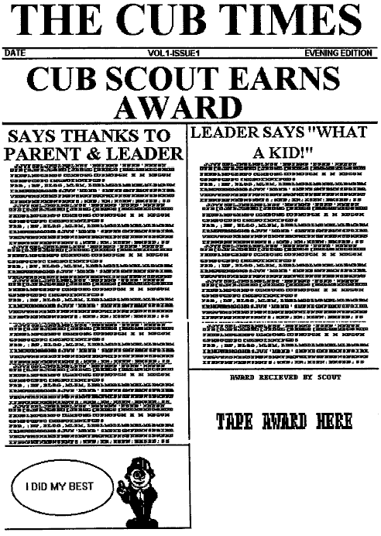
Use the newspaper shown (or make your own) to present the award(s). Simply tape the award where it says, “tape award here” and present the whole thing to the boy.
The Cubmaster could come out dressed as a reporter (trench coat, fedora hat, press card in hat, carrying small notebook and pencil, maybe a camera around his neck)
He could then say that tonight he is there to interview a young man who has accomplished a great feat. He then calls up the boy(s) and his parent(s) and leader(s). Once everyone is up front he then commences to interview them.
Here’s some sample questions:
To parents- Did he work hard at home to earn this?
Has he been doing good deeds?
Is there something you’d like to say to him?
To Leader- Is there a funny(inspirational) story related to this?
Do you think he’ll be getting his Eagle?
Is there something you’d like to say to him?
To Boy- What did you do to get this?
Is there anything you’d like to tell our readers?
It’s a good idea to let the adults know ahead of time what you’ll be asking, and if the boy seems to be embarrassed, or is having a hard time up front, don’t dwell on him.
Extra, Extra, Read All About It
Circle Ten Council
Props: A newspaper for each boy – on the newspaper, tape the Cub Scout’s name on top of the headline, making a new headline.
Cubmaster: (Dressed as a newspaper reporter, pen over ear, etc.) “Extra, Extra, read all about it.” [Cubmaster then reports the big news – Yelling] “_____ (put in the name of the Cub Scout who is receiving the award) just earned his (name the award) award!” (Report on some of the requirements that the Cub had to do to earn the award. Then give the Cub scout the newspaper along with the award.)
Reporter Award Ceremony
Santa Clara Council
Cubmaster comes out wearing a 30's style hat with the brim turned up and a "press card" tucked into the hatband.
Cubmaster: I'm hot on the trail of a story. I just need to find the right person to interview. Let's see! Can I interview you? (Pointing to a den leader.)
Den Leader: Yes, you can interview me.
Cubmaster: Tell me, what you have been doing this month.
Den Leader: Well, we have been learning about newspapers. We made our own paper.
Cubmaster: Oh, really! What else have you been doing?
Den Leader: All the boys in the den completed requirements for the badge.
Cubmaster: Super, will step up with their parents and receive their awards?
Advancement Ceremony
Southern NJ Council
For the ceremony to induct new Bobcats, the Cubmaster writes on a blackboard or butcher paper the code:
"YLIMAF ELOHW EHT ROF -- GNITUOCS BUC.: (Cub Scouting—for the whole family, written backwards. The Cubmaster then calls forward those boys receiving their Bobcat awards and their parents. Ask the boys if they can read the code. When they have figured it out, then speak briefly on the parents' role in the program. Award Bobcat badge and certificates.
For awarding Wolf and Bear badges, Arrow points, and Webelos awards have the Cubmaster act as emcee of an awards show, announcing names of the advancing boys and explaining their achievements, while the boys and their parents receive the badge from a pack committee member.
Place each boy’s awards in an envelope. Write the boy’s name on the envelope containing his awards in a secret code (mixed-up order). As each boy is called forward to receive his award, he must figure out which envelope is his. Then present the award to his parents to present to him.
ADVANCEMENT IDEAS
Santa Clara County Council
Use a secret code in the ceremony. Names of the boys receiving awards or their rank may be written in secret code.
Use messages written in invisible ink. Use a candle to make the message appear (light bulb takes too long. Message should be short and written big so the audience can see it. Practice ahead of time. For suggestions for the “ink,” see the Wolf Book
The Pack Advancement Chair may be a “radio announcer” who calls the boys up before the Cubmaster with appropriate announcement and calls for applause.
Cubmaster talks in Pig Latin. Assistant Cubmaster introduces Cubmaster as a guest from a far-away nation of Cubland. He says that this guest will give awards this month. Cubmaster talks slowly and the assistant repeats in “normal” English. Let the boys catch on
REPORTER ADVANCEMENT
Southern NJ Council
Setting: TV News Anchor desk (table) with Anchorman seated. Camera can be added off on the side taping the presentation.
Anchorman (Cubmaster):
Good evening and welcome to tonight’s broadcast of Channel (pack number), CUB Evening News. I am your newscaster, T.L.Meanething (pronounced “tell me anything”). We have exciting news this evening. We have learned that there are several awards to be presented. Will the following boys and their parents please come forward? (Call forward Cub Scouts receiving Bobcat, Wolf, Bear and Webelos badges)
To the Bobcats - You have just finished journalism school and like the Bobcat, you have taken your first step towards an exciting career. I encourage you to continue going forward in your endeavors. (Lead Cheer)
To the Wolfs - The next awards go to our Cub Reporters, the Wolves. They are learning the trade of reporting. Though they still have a long way to go, they’ve made a great start. (Lead Cheer)
To the Bears - Our next awards go to our Ace Reporters, the Bears. These guys know how to find and tell stories of interest, but still need help along the way. (Lead Cheer)
To the Webelos - Finally, these awards are for our Editors, the Webelos. These young men have learned not only how to find and report good stories, but also what it takes to make these stories exciting and different. As all good Editors, they are always preparing themselves for the next big assignment. (Lead Cheer)
Congratulations to you all.
That’s all the news we have for you in tonight’s program. Thank you for tuning in. This is T.L.Meanething signing off for stations (Pack Number), CUB Evening News.
GAMES
News Headlines
Circle Ten Council
Pack meetings are not “just for Kids!” How about a game for the Den Parents? The object of this game is to see which den can field the most news/history savvy “team” to answer a set of questions. Sort of like Jeopardy, it goes like this –
Before hand, someone from the pack has to do some research. Using the Internet go to newspaper archive sites or go to your local library and pick out some good famous headlines.
Have the parents within each den sit together – don’t need to move all the parents to one place, just get each den’s parents together – and give them paper and pencils. Using the collection of news items/headlines, begin asking questions or reading off headlines with key words or phrases missing. Ask enough questions to get a fairly good spread in the scores. And let the Cub Scouts/families help as much as they want. At the end of the questions, run through the answers and see which den gets the most correct answers. This is the winning den. Award them with the “headlines award” – go to an old car junk yard and ask for a piece of an old car headliner that you can make into a ribbon or something as suitable.
I love this award idea. CD
Snowfight
Baltimore Area Council
This one creates quite a mess, but it’s worth it. Divide into two teams and put a divider down the center of the room (like a couple of rows of chairs, back-to-back). The two teams are on opposite sides of the divider. Give each team a large stack of old newspapers, then give them five to ten minutes to prepare their “snow” by wadding the paper into balls-the more, the better.
When the signal to begin is given, players start tossing their snow at the opposing team, which really does look like a snowstorm.
When the whistle blows, everyone must stop throwing. Judges determine the winner by deciding which team has the least amount of snow on its side of the divider.
With larger groups, watch out for players who lose their eyeglasses or other personal belongings in the snow, which get pretty deep. After the game is over, provide plastic garbage bags and have a race to see which side can stuff the snow into the bags first.
Newspaper
Baltimore Area Council
This is a guessing game. Any number can play.
A player leaves the room while the others think of an activity (dancing, swimming, cooking, reading, or something similar). The chosen activity is called “Newspaper.”
When the absent player comes back, he tries to guess what “Newspapering” is by asking each player a question like “Do you “Newspaper” in the dark?” or “Can cows “Newspaper”?” until he guesses what “Newspaper” means. All questions must be answered with a “yes” or “no”.
When the questioner thinks he knows what “Newspaper” means, he may ask if his guess is correct, and if it is, the player who answered his last question goes out of the room and a new activity is chosen as “Newspaper”. But, if the questioner guesses wrong 3 times, he is out of the game.
“Nose for News”
Baltimore Area Council
This is an outdoor game for a Caller and 2 teams with equal numbers of players. One team is called “news” and the other “nose”. One person is chosen to be the “caller”.
Teams draw goal lines about 50 meters apart. The caller stands in the middle of the field, between the goal lines.
When he yells “Start walking!!!”, both teams walk slowly towards him. When they are quite close to him, he calls out “N-n-n-ews!” or “N-n-nose!” and whichever team he calls starts to run back to its goal line. The other team chases them and tries to tag as many players as possible before they are safe behind their own goal line. The tagged players join the opposite team. Both teams return to their goal lines, and the caller calls again.
The game is won by the team that tags the most players. The caller tries to keep the teams guessing which team he will call by dragging out the “N-n-n” as long as possible.
“Hearsay”
Baltimore Area Council
This game can be really fun! The more players you have, the better. You need at least 3 people. The players sit in a circle. The first player thinks of a word or phrase and whispers it to second player. Then, the second player whispers the message to the third player, and so on, until the message goes all the way around the circle. Finally, the last person to get the message says it out loud, and the person who started the message tells them if they are right!
Here’s a couple of tips;
- Hearsay can get really crazy if you use more than one word in your message. For example, a message like “Brown cats like purple bananas.” can get REALLY mixed up along the way!
- DON’T repeat the message! If the person didn’t hear it, let them say what they THINK they heard. The results can be hilarious!
Newspaper Boy
Baltimore Area Council
This is played with at least eight players and folded newspaper. One player is designated “It” and gets the newspaper. The other players form a circle holding hands. “It” walks slowly around the outside of the circle, chanting: “Extra! Extra! Read all about it!”
While chanting, “18’ drops the newspaper behind a player in the circle. That player then picks up the paper as quickly as possible and chases “It” around the circle. “It” tries to get back to the empty spot in the circle left by the chaser before being tagged. If “It” succeeds, the chasing player then becomes “It.”
The Newspaper Olympics
Baltimore Area Council
Here are some ideas for Olympic type events using newspapers in different ways:
- Javelin- Lay 1 sheet of newspaper fiat, then lay another down so that they overlap. Roll both up together. Tape in middle. See who can throw it the furthest.
- Shot-put-Crumple a page of a newspaper up into a small ball. See who can throw it the furthest.
- Newsboy archery-Take a sheet of newspaper and roll it tightly. Have boys throw it through a hula hoop.
- Relay Race-Take a rolled up newspaper and use it as the baton.
- 100 Yard Dash- Have boys put each foot on a sheet of newspaper and shuffle to finish line.
- Hammer throw-Take a piece of string and tie a stick to one end. Put other end of string through the middle of sheet of newspaper and tie stick to other end. crumple paper around string and keep adding paper till you have a ball about the size of a dodgeball. Put tape around it. Have boys swing around head and see who can throw furthest/most accurate.
Advertisement Hunt
Baltimore Area Council
Give each Scout seated at a table a popular magazine, containing a large number of advertisements. Have in mind several products that are advertised in these magazines such as toothpaste, cars, soap, etc. Start the game by calling out the name of the product. The Scout who is first to find the product and tears it out of the magazine and hold it up wins. If it is the right one, have him sit on it, and continue the game by calling for another item. After about a dozen or so calls, find out who is sitting on the most ads.
Paper Boy Relay
Baltimore Area Council
Materials: 2 or more trash cans, Lots of newspaper
Divide boys into teams. Divide the room into equal sections. Have teams fold up newspapers like they would on a newspaper route and line up as if they are going to do a free throw.
In turn each boy tries to make a basket by throwing paper at their trash can. Winner is the team with the most newspapers in there trash can.

Newsboy
Circle Ten Council
Materials: Rolled up newspaper
Directions:
Subscribers are in many cities and towns. Make up a list of towns or cities in your area. Use a map for more names. You will need 1 name for each cub, even the newsboy.
Everyone sits in a circle. Read off a city to each person, that will represent him as a subscriber from that area. They will need to remember it.
Choose one person to stand in the middle. He is the newsboy with the rolled-up newspaper. He will call out one city. That subscriber must stand and call out another city before the newsboy tags them with the rolled-up newspaper.
Then the subscriber that was called must stand and call out another city. This continues until the newsboy catches a subscriber before he calls out another city. Then that subscriber becomes the newsboy in the middle.
Story Game
Baltimore Area Council
Give each boy a set of 10 completely unrelated words. Have each boy write a story using each of the ten words that they have to read and/or act out at the next Pack meeting.
Newspaper Tapper
Baltimore Area Council
Equipment: Rolled newspaper to use as a swatter.
One person is selected to the center man. He takes his place in the center of a small compact circle formed by the other players standing shoulder to shoulder around him.
The players put their hands behind them and the leader secretly places a swatter in the hands of one of them. The player who receives the swatter either slyly passes it on or swats the center man, if his back is turned.
When hit, the center man turns and tries to point out, not the player who hit him, but the player who is then holding the swatter. The player who did the striking will have instantly passed the swatter either right or left.
When the center man points out a person who is holding, touching, or passing the swatter, they change places.
Ring the Antenna
Southern NJ Council
I love ring toss games. They can be adapted to any theme – for December’s Food theme you could have rings made to look like doughnuts. For Holidays – Wreaths. For water – Life Buoys.) Just use your imagination. CD
Cut out the shape of a radio or TV antenna, indoor or outdoor (or if no one remembers what a house antenna looks like – a tower as seen at the station or any shape consistent with theme (or any theme, for that matter) that the boys want to use) from cardboard or wood. Paint and decorate the cut-out. Hammer nails into the shape at different places. This is the target. Place it about 8 to 10 feet away. Have each player throw rubber rings at the antenna. The winner is determined by the number of rings that catch on the target. If you wish, you can mark each nail worth a certain number of points.
Sausages
Southern NJ Council
One player is chosen to be the questioner. He may ask any other of the other players whatever personal questions he might choose, such as - "What do you think your legs look like?", "What are your shoes made of?". "To what do you attribute your handsome looks and charm?" etc. Whatever the question, the player being asked must reply "sausages!" The first player who smiles or laughs or giggles or smirks or grins or guffaws or shows any other emotion other than deadly seriousness is out, and he becomes the questioner.
Capture the Fort
Southern NJ Council
Divide players into two sides: Attackers and Defenders.
Defenders form a circle, holding hands and facing outward, with their captain in the center.
Attackers surround the fort at about eight or ten paces distant. They try to kick a soccer ball into the fort; it may go through the legs of the defenders or over their heads. If it goes over their heads, the captain may catch it and throw it out. But if it touches the ground inside the circle, the fort is captured and the players change sides.
Line up the Lines
Southern NJ Council
This game easily be adapted for Webelos by doing the same thing for the Scout Oath and Law. CD
Take the Promise (or the Law of the Pack) and write it out on strips of paper in large letters. If you want, you can cut the lines up into chunks or half-lines. Then have a team challenge for the whole group. Mix up the strips on the floor or in a box. One by one, a Cub hops to the box, grabs a strip, and brings it back to the group. The next Cub hops up and gets another strip and brings it back to the group. Hopping is done to give the group time to arrange the strips in order. The group has to agree on how to arrange the strips. When done, they recite the Promise together.
Gossip Game
National Capital Area Council
Have everyone sit in a large circle. The host partner whispers a phrase or short sentence to the person on his left. That person whispers what he heard to the next player to the left, and so on. The last player to receive the message should repeat what the message is. The leader then repeats the original message which is often very different from the last person's message.
Hear, Bear Game
Southern NJ Council
This is a game of identifying sounds. The den chief produces the sounds below from behind a screen or in another room and the Cubs listen. As each sound is produced, the boys write down what they think it is.
Sample sounds are:
- Sandpaper rubbed on glass,
- Pack of cards dropped on a table,
- Egg beater whipping cream,
- Golf ball or ping-pong ball bouncing on a bare floor,
- Piece of metal being filed,
- Slicing bread,
- Cutting glass with a glass cutter,
- Bursting a paper bag.
Mysterious Message
Southern NJ Council
Mysteries sometimes include coded messages. Let your Cubs create a code, write coded messages and then decode each other's messages. Leaders if you have access to a computer and printer you can use wing dings (font) or let the Cubs develop their own secret code using the alphabet.
Materials: Paper and pencils
Sample Code –
Write the alphabet across a chalkboard.
Below the letters write the numbers 1-26, with "1" below "A," "2" below "B," etc.
Then write a simple, short sentence on the board and write the number equivalent of the first word.
Ask your Cubs to write the number equivalents of the remaining words.
Challenge each den group to make up a code based on a growing number pattern (e.g., 1, 2, 4, 7, 11 . . .).
On a sheet of paper, have Cubs write the alphabet and the number that will stand for each letter, just as you did
Now have the Cubs write a secret message (a short sentence) and encode the message on another sheet of paper.
Moriarty
Sam Houston Area Council
One Cub is secretly chosen to be Moriarty, the rest are English detectives. Everyone walks around shaking hands, introducing themselves and making small talk. A victim is killed when Moriarty tickles his palm during the handshake. The victim must wait at least 5 seconds before dying in as dramatic manner as possible; he may even have time to shake another hand in the interval. The object of the game is to discover Moriarty and publicly accuse him before being killed. If the accuser is discovered, he picks the next Moriarty and participates in the next game by shaking hands, etc. He cannot make an accusation but acts as referee since he knows who Moriarty is.
SONGS
What the World Needs Now
Baltimore Area Council
Chorus:
What the world needs now, Is more cartoons
It’s the only part that there’s just too little of.
What the world needs now, Is more cartoons.
Not just Beetle Bailey, but some Garfield too.
No, we don’t need the crossword puzzles;
There are wars and air crashes enough today.
There are crime stories, sports, news on every page.
The Dallas News needs a lot more fun.
Chorus
No, we don’t need more Ann Landers.
There are want ads and cars ads enough for me.
There are stories about saving cats from trees.
So listen please, give us what we need.
Chorus
I’ve Been Reading the Newspaper
Baltimore Area Council
Tune: I’ve Been Working on the Railroad
I’ve been reading the newspaper
All my live long days.
I’ve been reading the newspaper
Just to learn what I can learn.
I read about the news and sports,
Comics and classifieds.
I enjoy reading all about it,
Just so I can know it all.
The more I read and learn each day,
The more I can grow and grow.
The more prepared I will be
for the Boy Scout I become.
I’ll keep reading the newspaper
All my live long days.
I’ll keep reading the newspaper
so just you wait and see.
Joy from the News
Baltimore Area Council
Tune: Joy to the World aka Jeremiah Was a Bullfrog
Jeremiah threw our paper.
He worked for the Morning Star
He always threw the paper right up to our door.
Yes, that paper was always at our door.
Chorus:
Singin’ News to the McCoys,
To the Smiths and Browns and Troys.
News to the Jacksons on East Seventh Street.
News to you and me.
You know I love the comic
Love the sports page too.
I read the paper front to back
And I read the want ads too.
Chorus
If I was the Dallas News
Tell you what I’d do
I’d add a hundred pages to the news each day
And I’d throw it for you too.
Chorus
Communication Round
Baltimore Area Council
Tune: Are you Sleeping?
Are you sleeping, are you sleeping,
Billy Smith, Billy Smith?
The telephone is ringing, the telephone is ringing,
Answer it, answer it!
Roll the presses, print the paper,.
Read the news, read the news.
Delivery on schedule, delivery on schedule,
Worn-out shoes, worn-out shoes!
See a movie, see a movie,
See a show, see a show.
Have a bag of popcorn, have a bag of popcorn,
It helps you grow, it helps you grow!
Communication
Baltimore Area Council
(Tune: You Are My Sunshine
Communication gets information,
Across to people both far and near.
May be letter, a TV program,
Or a radio that you hear.
Communication is conversation
Between two people or maybe more.
By telephone or walkie-talkie, or a
Neighbor standing at your door.
Communication can cross the nation,
Or cross the ocean by satellite.
The world seems smaller, news travels
Quicker than we ever dreamed it might.
The Latest News
Baltimore Area Council
Tune: Are You Sleeping
Extra, extra, read the latest
Monday’s news, just off the press
What’s today’s disaster?
Cub Scouts worked with plaster
What a mess, what a mess.
Extra, extra, read the headlines
This weeks news. What’s the score?
Hurricane hits Elm Street,
Sixteen muddy Cub Scout feet
Track the floor. Leader sore.
Extra, extra, here’s your paper.
Read abut the latest riot
Eight Cub Scouts as Indian braves
Stomp and dance and yell and rave
Won’t keep quiet. Won’t keep quiet.
Extra, extra, what’s today’s news?
Is it sad? Is it bad?
Eight boys join the Webelos Den
Leader can relax again
We’re so glad! We’re so glad!
THE MORE WE COMMUNICATE
Southern NJ Council
Tune: The More We Get Together
The more that we communicate,
Communicate, communicate,
The more that we communicate,
The happier we’ll be.
Then you know what I know,
And I’ll know what you know.
The more that we communicate,
The happier we’ll be.
By telephone or e-mail,
By signal code or snail mail,
The more that we communicate,
The happier we’ll be.
The Gutenberg of Old
Chris, the Original Baloo
Tune: The Grand Old Duke of York
The Gutenberg of old,
He had 10,000 books,
He stacked them up the shelves, (stand)
And he knocked them down again. (sit)
And when they're up you're up. (stand)
And when they're down you're down (sit)
And when they're only halfway up, (squat)
You're neither up nor down.
Sing three times getting a little faster each time!
The Latest News
Circle Ten Council
Tune: Are You Sleeping
Extra, extra, read the headlines
This week’s news, what’s the score?
Hurricane hit Elm Street
16 muddy Cub Scout feet
Track the floor. Leader sore.
Extra, extra, read the latest.
Monday’s news just off the press
What’s today’s disaster?
Cub Scouts worked with plaster
What a mess! What a Mess!
My Scout Story
Circle Ten Council
Tune: My Bonnie Lies Over the Ocean
My Den Leader told me to write one –
A newspaper story on Scouts.
But when I was finished the story,
My Den Leader turned and ran out!
Chorus
Bring back, bring back,
Bring back my Leader to me, to me.
Bring back, bring back,
Bring back my Leader to me, to me.
The story, it talked about camping,
It told of the neat things we’ll do.
Like putting a snake in her backpack
And sinking her Grumman canoe.
Chorus
The newspaper story was printed.
It ran as a headline – first page.
And now my Leader won’t come back,
‘Cause the article mentioned her age!
Chorus
The coverage spread to the networks,
Today Show and Entertainment Tonight.
My Leader no longer will speak to me.
I guess I had better not write!
Communication
Circle 10 Council
Tune: Alouette
Refrain:
Communication, superb communication,
Communication, it’s the way to go
First you take a telephone
Never say you are alone.
Be polite, never fight,
Leader - Be polite, Response - never fight,
OOOohhhh,
Refrain:
Next you take a short email
Start with “Dear” it never fails
Subject line, then you sign.
Leader - Subject line, Response - then you sign
Leader - Be polite, Response - never fight,
OOOohhhh,
Refrain:
Last you take an envelope,
Don’t forget the stamp, nope, Nope!
Mailman comes, then your done
OOOohhhh,
Leader - Mailman comes, Response - then your done
Leader - Subject line, Response - then you sign
Leader - Be polite, Response - never fight,
OOOohhhh,
Add more verses – you can do this!!!
Commercial Mix-Up
York Adams Area Council
Tune: Farmer in the Dell
Last night I watched TV, I saw my favorite show
I heard this strange commercial, and I can't believe it's so
Feed your dog Chiffon. Comet cures the cold
Use S-O-S pads on your face to keep from looking old.
Mop your floors with Crest. Use Crisco on your tile
Clean your teeth with Borateem, it leaves a shining smile
For headaches take some Certs. Use Tide to clean your face
And do shampoo with Elmer's Glue, it holds your hair in place
Perhaps I am confused, I might not have it right
But one thing that I'm certain of, I'll watch TV tonight!
CUB GRUB
FIRECRACKER
Southern NJ Council
Materials Needed:
Twinkie (or other similar snack cake)
Red, White, and Blue Frosting
Red, Shoe String Licorice
Instructions:
- Cut a 3-4 inch length from a licorice piece.
- Poke one end of this piece into one of the ends of the Twinkie. This should look like the fire cracker's wick.
- Decorate the fire cracker with whatever design you like using the frosting!
CRITTER CRUNCH
Southern NJ Council
Great-tasting, fun-to-eat Critter Crunch is easy enough for kids to make. They can mix it up to a month ahead of time and store it in a covered container or zippered plastic bag.
Materials Needed:
1 C. animal crackers
1 C. teddy bear-shaped chocolate or
honey-flavored graham crackers
1 C. miniature pretzel twists
1 C. yogurt-covered raisins
1 C. candy-coated chocolate candies
Colorful ice cream cones (optional)
Instructions:
- Mix all ingredients except ice cream cones.
- Store in a covered container.
- Serve snack in cones if desired.
- Makes 10 servings (1/2 cup each)
APPLE SMILES
Southern NJ Council
Ingredients:
Apples
Peanut Butter
Miniature Marshmallows
Instructions:
- Cut apples into wedges.
- Smear peanut butter on one side of 2 wedges.
- Stick a few marshmallows on the peanut butter on one of the apple wedges and top with the other apple wedge - peanut butter side down.
- When you look at this it looks like a smile (the red part of the apple are the lips and the marshmallows are the teeth!)
Fred's Trail Mix
Greater Alabama Council
Ingredients:
1 Bag (large) Eagle brand Snack mix
1 16 oz. bag M&Ms
1 8 oz. bag semi-sweet mini M&Ms (cooking section of grocery store)
1 24 oz. can raisins (use as much as you think you need)
1 can mixed nuts (Adjust quantities to taste - this will get you started!)
This makes enough for a group of 6 for a weekend
Cranberries?
Viking Council
Did you know that the Pilgrims gave the cranberry its name? They thought the pink cranberry blossoms resembled the heads of cranes, so they called them "Crane berries." This was later changed slightly to "cranberries."
Look up pictures of cranes and the cranberry bogs of New England. During your den meeting, make fresh cranberry bread for your den snack.
Melt in Your Mouth Toffee
Southern NJ Council
Ingredients:
1 pound butter
1 Cup white sugar
1 Cup packed brown sugar
1 cup walnuts
2 cups semisweet chocolate chips
Directions:
- In a heavy saucepan, combine butter or margarine, white sugar, and brown sugar.
- Cook over medium heat,
- Stir constantly until mixture boils.
- Boil to brittle stage, 300 degrees F (150 degrees C).
- Remove from heat.
- Pour nuts and chocolate chips into a 9x13 inch dish.
- Pour hot mixture over the nuts and chocolate.
- Let the mixture cool and break it into pieces before serving.
Melt in Your Mouth Peanut Butter Balls
Southern NJ Council
Ingredients:
1 jar Peanut Butter
1 large bag of confectioners sugar
2 sticks butter, melted
Chocolate Almond Bark
Directions:
- Mix all ingredients together except for chocolate.
- Shape into 1-inch balls.
- Melt chocolate in microwave
- Dip balls in being sure to cover completely.
- Put on wax paper to harden.
Hint - use toothpicks stuck in the peanut butter balls. Work quickly; the peanut butter kind of melts if you don’t.
STUNTS AND APPLAUSES
CHEERS
Baltimore Area Council
Typewriter Applause - Move fingers as if typing, yell ‘DING”, and act as if you are returning the carriage.
Newsboy Cheer: Extra! Extra! Read all about it!
News Editor Cheer: Stop the presses! I want to get off!
Reporter Cheer: What a scoop!
Clark Kent Cheer: Looks like a job for Superscout!
Sam Houston Area Council
Eggbeater Cheer – Bend knees and swing them in and out like beaters while putting hand on top of the head to held handle and use other hand to turn beater crank.
Den How Cheer - “Strawberry shortcake, Eskimo pop, Den __, Den __ Always on top!”
RIDDLES
Viking Council
This is an easy way to get your Den Chief or Denner involved with the boys as they arrive. Everyone likes jokes and riddles. For more ideas, look in the current issue of Boys Life Magazine.
A Pilgrim had nine ears of corn in his barn. Each day a squirrel came to the barn and went away with three ears. It took nine days to remove all the corn. Why?
The squirrel went away with three ears,
but only one was corn. The other two were his own!
An Indian had 2 1/2 piles of corn in one field. He had
1 1/2 piles of corn in another field. Then he put them together. How many piles did he have?
One
Circle 10 Council
Why did the email go to the doctor?
It had a virus.
What has 1000 ears but can’t hear?
A cornfield.
A Sad State of Riddles
Baltimore Area Council
The answer to these riddles are found in the abbreviated names of states. how many do you know?
What state is always sick? ILL (Illinois)
What state ‘is the father state? PA (Pennsylvania)
What state wears skirts? MISS ‘(Mississippi)
What state is always surprised? OH (Ohio)
What state is very religious? MASS (Massachusetts)
What state prescribes medicine: MD (Maryland)
What state can count above nine? TENN (Tennessee)
What state cuts the grass? MO (Missouri)
What state does laundry: WASH (Washington)
Baltimore Area Council
Why should watermelon be a good name for a newspaper?
Because we’re sure it is red on the inside.
What is the tallest building in town?
The library. It has the most stories.
RUN ONS
Circle Ten Council
Set-up Have News announcers alternate reading in at various times during the Pack meeting with these (or similar) news stories. Or set this up as a skit.
A truckload of artificial hair has just overturned on the interstate. The police are combing the area for the truck driver.
A hundred dollar bill has just been found at Camp Roosevelt. Will the owner please form an orderly line outside the dining hall to claim it?
Doctors have just discovered that people with hairs starting to grow on the palms of their hands are going mad. [Pause] They also tell us that people looking for hairs on the palms of their hands are already mad.
Today thieves broke into the local police station and stole fifty pairs of trousers. The police are looking pretty silly.
Yesterday a chicken swallowed a Yo-Yo. It laid the same egg seventy-five times.
Here is a late railway announcement. The train now arriving at platforms 5, 6, 7 and 8 is coming in sideways.
Will the man who has just left the train stand on platform 5 please come and collect it. We have enough of our own, thank you.
There was a power outage at a department store yesterday. Twenty people were trapped on the escalators for 3 hours.
A rabbit was spotted in the woods yesterday, standing in front of a candle making shadows of people on a tree.
Today a Scout slipped on the ice and hurt his ankle. A little old lady had to help him across the street.
[Cubmaster’s name] announced his new invention today. It’s a solar-powered flashlight.
The crew of the next space shuttle will be monitoring about 25 milk cows up in space to see how they react to no gravity. It will be “The first herd shot round the world.”
Lost Dog
Baltimore Area Council
DAVE: Boo hoo hoo!
BOB: Hey Dave, why are you crying?
DAVE: (still sniffling) I lost my dog
BOB: Maybe he’ll come home.
DAVE: No, he won’t come home. He’s lost.
BOB: Why don’t you put an ad in the lost and found column of the newspaper?
DAVE No. It wouldn’t do any good.
BOB: Well, why not?
DAVE: Because my dog can’t read!
Librarian: Please be quiet, little boy. The people near you can’t even read.
Little Boy: Then what are they doing in a library.
Gulf Coast Council
Scout 1: I have been seeing spots in front of my eyes.
Scout 2: Have you seen the doctor?
Scout 1: No, just spots.
Scout FortuneTeller: That will be $20. for two questions.
Customer: Isn't that a lot of money for two questions?
Scout FortuneTeller: Yes, it is. Now what is your second question?
Scout 1: Why didn't you wait to see the second act of the play?
Scout 2: Didn't have time. The program said it took place a year later.
Feel the Pane
Gulf Coast Council
The Leader has a 'volunteer' who is going around the room, touching the wall.
Leader: "Do you feel it?" the Leader asks.
Volunteer "No" replied the volunteer.
Repeatedly, the leaders asks and get the same answer.
Volunteer The volunteer comes to the window.
Leader: "Do you feel it now?"
Volunteer "Yes, " says the volunteer (Perhaps he howls suddenly to make this more dramatic.)
Leader: "What do you feel?"
Volunteer "I feel the pane."
Circle 10 Council
Knock Knock
Who's there !
Cash !
Cash who ?
Cash me if you can !
Knock Knock
Who's there !
Cash !
Cash who ?
I knew you were nuts !
STUNTS
Rhyme Time
Baltimore Area Council
These are pairs of rhyming definitions. Give the boys a few examples and see if they can think of their own.
A skinny horse (bony pony)
A seafood platter (fish dish)
Comic little rabbit (funny bunny)
A foul in a prize fight (low blow)
Flowers asleep in the field (lazy daisy)
A bee’s home (live hive)
Happy father (glad dad)

SKITS
Newspapers Are Important
Circle Ten Council
Boys walk onto stage talking among themselves about how their parents get the papers every day. One boy might indicate that his dad picks it up off the porch every morning while another laments that their delivery is always in the bushes. Another points out that it is full of important information like sport scores and stock prices. Finally, they all shake their heads in agreement and face the audience.
- My parents told me that the newspaper is the most important thing we get in our house!
- Yeah, if my dad didn’t get the paper, he wouldn’t have anything to put under the car to soak up the oil in the garage.
- That’s really important, but my mom has to get the paper so she has something to clean the windows when we can’t see through them anymore.
- I didn’t know how important newspapers were until last summer. My folks told me that if they didn’t get the paper, they would have anything to put under the steamed crabs!
- No Kidding! And if my mom didn’t get the paper, I don’t know what she’d put under the kitty litter!
- Well, they’re right, you know! If my dad didn’t use the newspaper on the dining room table, my mom night find out and then she wouldn’t let him spray paint my pinewood derby there.
ALL See? Newspapers are really important!
The Hoot ‘N Holler Tribune
Baltimore Area Council
Cast:
EDITOR: dressed in shirt sleeves and an eyeshade.
REPORTER: wears fedora hat with sign “Reporter” pushed back on his head.
COPY BOY: dressed as “yuppie”
LINOTYPIST: dressed in work cloths carrying a clothes line.
WALTER WILLTELL: wears fedora hat, loud tie, & suit.
PROOFREADER: wears “Sherlock Holmes” hat & carries magnifying glass.
OFFICE BOY: wears sweater and slacks, and has long white beard.
CUB REPORTER: wears jeans and fedora hat and carries a teddy bear.
Props:
Two desks: One with “Editor” sign and a shadow box at each side labeled “Incoming” and “Outgoing.” The other desk is for the reporter. Put two or three phones on Editor’s desk and a wastebasket beside it. Place a typewriter on Reporter’s desk.
Alarm Clock: These are out of sight and set to go off at regular intervals during skit.
“The End” sign: hidden behind Editor’s desk.
Ice Cream Scoop: carried by Copy Boy.
Flash Bulb Camera: used by Walter Willtell.
The action takes place in the office of the “Hoot ‘N Holler Daily Trombone.” The Editor is seated at his desk. The Reporter is pounding away at his typewriter. Each time an alarm clock goes off, the Editor picks up a phone and bellows “Hello!” and bangs the receiver down saying “Wrong number!” There should be an air of hectic confusion throughout the skit.
Editor: (shouting) Copy Boy! (copy boy, paper in band, comes dancing in like a real “hep” cat.)
Copy Boy: Yeah, Man - like, I’m a Copy-Cat! (Editor snatches papers angrily; copy boy dances out.)
Reporter: (loudly) What’s the deadline? (Boy enters with paper in band; gives it to reporter.) This is no deadline. This is the obituary column! (Editor shakes bead in disgust.)
Copy Boy: Well, they’re all dead, aren’t they? (Reporter gets up menacingly, as if to choke copy boy. Boy scurries away.)
Editor: I wish we’d get a good “scoop” just once!
Copy Boy: (running in with ice cream scoop) Here’s one! (Editor snatches scoop and throws it at boy as be beats a hasty retreat, laughing.)
Office Boy enters and takes papers from the “Outgoing” box and starts to put them into the wastebasket.
Editor: (angrily) Who are you?
Office Boy: I’m the new office boy, Sir.
Editor: Well, get out of here and let my papers alone! (grabs papers and puts them back in “Outgoing” box as office boy exits.)
Reporter: Where’s that linotypist?
Linotypist: (enters currying a piece of clothesline) Cant’ find a linotypist, but here’s a piece of clothesline,
Reporter: I don’t want that. Get out of here! (Linotypist exits as Proofreader enters. He hovers around Editor’s desk, examining everything closely with the magnifying glass.)
Editor: What on earth are you doing here?
Proofreader: Who, me? I’m the proofreader, and I’m looking for proof. (Editor holds his bead in anguish as -proofreader ambles off, examining everything as be leaves.)
Editor: If this keeps up, we’ll have to stop the presses. News! News! News! That’s what we need. Instead, what have we got? A proofreader with a Sherlock Holmes complex. (Editor pounds fist on desk as be talks. He pick up phone.) Hello! City Desk? Send me some news.
(After be has completed his call, be paces up and down behind his desk. Cub reporter comes skipping in, carrying his teddy bear.)
Editor: Now, just tell me please, what have we here?
Cub Reporter: I’m your eager Cub Reporter. You asked for news, and here I am. I am reporting on the cubs at the zoo. There are exactly four Well, almost that is. Now there are only three. I brought one along.
Editor: Out! Out! Out! (holds bead and groans) Oh for some news.
Reporter: Here comes Walter Willtell. Now we’ll get some gossip!
Walter Willtell: (enters, and speaks very rapidly) Good evening, Ladies and Gentlemen and all the ships at sea! I’ll be back in a flash with a flash! (He runs out, re-enters with camera and takes a flash picture of the audience. Editor props “The End” sign in front of his desk.)
The Important Meeting
Baltimore Area Council
Scene: Six to eight players sit around a table scattered with papers, a couple of water glasses, etc. They mime a discussion, some jotting down notes, etc. Enter the narrator, outfitted as a news reporter. In confidential tones, the reporter explains that this is an important meeting of the group committee, gathered on this occasion to make some very important decisions.
As the narrator says something like, “Let’s see if we can get a bit closer to hear how things are going”, the group at the table adds some mumbling and unintelligible arguing to their mime. Occasionally, they punctuate the din with outbursts such as, “No, no!”; “I disagree!”; “That’s better”; “No way!” “That might work” and the like.
Finally, the hubbub dies, the group settles back. One member stands and announces, “Then it’s decided; a 12-slice pizza with olives, mushrooms, lots of cheese, but hold the pepperoni.”
All: Agreed!
The Big Story
Baltimore Area Council
A News reporter enters the stage and complains that there is no news. He sees a cliff and decides to jump off. He stands on the edge of the cliff ready to jump; he begins to swing his arms and to count to three a....l...a...
As he gets to two a second person runs on shouting STOP! What are you doing?
The new reporter explains. The second man decides that he’ll jump too, as he is the sheriff of this small town and there is no crime and his cell is empty. As they both prepare to jump a third man runs on...
1st and 2nd men explain what they are doing... . He decides that he will also jump because he is a doctor with no patients.
Then a dairy farmer runs on as he has an udder disaster because his herd has no milk. Finally they all jump except for the reporter. . . he shouts excitedly, “wow! Now I really have a story to write about! Four People jump from a cliff in mass suicide!”
Circle Ten Council
Circle Ten had a take off on this skit with the following characters – CD
Reporter who can’t find a story
Cub Scout whose Den Leader is mad at him because his buddy burner backfired and nearly burned down her house.
Den Leader who planned the Cub Scout Fair for my entire pack and their families. And then it rained, so they had to move everything into her living room. Now there’s nothing left of her furniture.”
Cubmaster who found the doors to the church locked, the Pinewood Derby track broke down during the race, and forgot the flags.
Gain everyone jumps except the reporter.
And the reporter runs off yelling, “Now I’ve got a story!”
Roving Reporter
Sam Houston Area Council
Reporter: Good evening, ladies and gentlemen. Here' s your roving reporter with another man-on-the-street interview. Tonight we are going to talk about mountains. Here's a man right here. How do you do, sir, can you tell me what is your impression of mountains?
First Man: "High!"
Reporter: Hi, yourself! Now tell me, what is your impression of mountains?
First Man: Just like I said "High!"
Reporter: Oh! Ha, ha, ha. My mistake. When you said "High! ", I thought you said "Hi!” get it? Oh well, let's talk to someone else. Here's a man. Tell me, sir, how do you feel about mountains?
Second Man: Well, I've never been there, of course, but if I had to feel about mountains, I'd do like always, feel with my fingers.
Reporter: Ha, ha, ha, ha. Seems we have some jokesters about today. Well now, let's try our question on this little boy here. Tell me, sonny, have you ever gone over the top of a mountain?
Small Boy: Yes, sir, lots of times.
Reporter: My, I'm surprised to hear that, must have been a hard trip for a youngster, actually to go clear over the top of a mountain.
Small Boy: Oh! No, sir, we were in an airplane.
Reporter: (to himself) This is getting ridiculous, but I’ll try one more time. How do you do, sir, May I ask you a question?
Third Man: Why sure, what’s your Problem?
Reporter: Tell me, sir, what’s your impression of life in the mountains?
Third Man: Well, from what I hear, it's a lot like an umbrella.
Reporter: An umbrella? I don't quite understand what you mean.
Third Man: Yup, like an umbrella. Life in the mountains is either up or down.
Reporter: Sorry, folks, some days you can't win.
PAINTING
Santa Clara County Council
- You know the den leader’s birthday is coming up.
- Yeah. We should do something for her.
- Yeah. She is so much fun. Let’s give her a present.
- I don’t have any money. Do you?
- No. But we could earn some money.
Cub #1: Good idea! Let’s go ask Mr. Smith. He’s real nice.
Boys walk up to house and knock on door
Cub #1: Hi, Mr. Smith. We are trying to earn money to buy a present for our den leader.
Cub #2: Do you have any jobs we could do to earn extra money?
Mr. Smith: Why, you boys came at just the right time! I was just about to go around back and paint my porch. Do you think you can handle that job?
All: Sure!
Mr. Smith: OK, then. You’ll find everything you need around back. Just knock on the front door if you have any questions.
All: Thanks, Mr. Smith!
Boys walk backstage behind house.
They return one at a time at ask questions then walk back
Cub #1: (Knocks on door) Is this the paint you wanted us to use, Mr. Smith?
Mr. Smith: Yes, that’s right. Thanks for checking with me.
Cub #2: (Knocks on door) We saw these old shirts in your garage, Mr. Smith. Is it OK if we wear them so we won’t get paint on our uniforms?
Mr. Smith: Good idea! Glad to see you boys take such pride in your uniforms.
Cub #3: (Knocks on door) Mr. Smith, do you have some newspaper we could spread out in case we drip paint?
Mr. Smith: Sure--here you go! You boys certainly are being careful.
Cub #4: (Knocks on door) Is it OK if we close the windows so we don’t splatter paint inside?
Mr. Smith: Sure--go ahead. You boys think of everything!
Cub #5: (Knocks on door) Did you want us to paint the door, too, Mr. Smith?
Mr. Smith: Sure--the door could use a fresh coat of paint!
Boys all return together to knock on door
Cub #3: We’re all done now, Mr. Smith.
Cub #4: Would you like to come around back and see how we did?
Mr. Smith: Oh no, that won’t be necessary. I know you Cub Scouts always do your best! Here’s some money for each of you for your hard work
All: Wow! Thanks, Mr. Smith!
Boys begin to walk away, then one turns back
Cub #5: Thanks again Mr. Smith. Oh, and by the way. You don’t have a “Porche.” You have a Ferrari!
SECOND LANGUAGE
Southern NJ Council
Arrangement:
One den member wears a sign reading “Mother Mouse.”
Another has a sign reading “Cat.”
All others wear signs reading “Mouse.”
Scene opens with Mother mouse taking her children for a walk. (You may have to explain this)
Mother Mouse: Come children it’s a beautiful day for a nice walk...
Other mice respond.
All making small talk while crossing the stage.
Suddenly Cat jumps into the path in front of the mice
Mother Mouse: (in a loud voice) Bow wow wow! Bow wow wow!
The cat screeches in fear and runs off.
Mice: Oh, Mother, we were so scared!
Mother Mouse: Let that be a lesson to you, children. It pays to learn a second language.
LISTEN AT THE WALL
Southern NJ Council
Cub #1 walks along a wall just listening, listening. Others come along and see him.
Cub #2: What do you hear?
Cub #1: (Dramatically) Listen!
Others listen. But they don’t seem to hear anything.
Cub #3: I don’t hear anything!
Cub #1: (More dramatically) Listen!
Others listen
Cub #4: (In a disgusted voice) I don’t hear anything.
Cub #1: (With a faraway look) You know, it’s been that way all day.
CLOSING CEREMONIES
Stop The Presses Closing Ceremony
Trapper Trails Council
If you want double up the parts or have the Narrator read them all. Make up a few of your own, too!!! CD
Narrator: Stop those presses. Some of the stories we've been hearing for years aren't quite right. Did you know…?
- An apple did not fall on Newton's head, he saw one fall from the corner of his eye.
- In old England, coins were saved in "pygg" banks which were dishes or jars made from a clay called "pygg". In 1600, a potter started the craze of making them into pig shapes.
- French fries are really from Belgium.
- Walt Disney started drawing characters with three fingers to save time.
- Napoleon started the tradition of buttons on uniforms so soldiers would not wipe their noses on the coat sleeves.
- The 4 and 20 black birds baked in a pie was actually a huge pie crust with 24 African musicians hiding inside to surprise a King Charles VII of France in the 1400's.
- Mice might eat cheese, but they like peanut butter and fly stuffed celery better.
- Elephants are not afraid of mice, which they can't even see or smell.
- Antidisestablishmentarianism is not the longest word, it is pneumonoultramicroscopicsilicovolcanoconiosis.
- Ostriches don't bury their heads in the sand. They eat rocks to help their digestion.
- The British arrested and took Paul Revere's horse before he finished his ride. He had to walk home.
- Camels store fat not water in their humps.
Narrator So stop those presses, we need to make a few changes.
Stories Of The Flag (facts or fiction)
Baltimore Area Council
A different boy could be used to read each paragraph:
Since there was a war going on when the United States flag was first designed, there was little written down about its origins. Only recently have we learned that Francis Hopkinson was probably the designer of the thirteen-star thirteen-stripe flag.
Other places and persons have been named as the first to display the United States flag and as flag designers. A very popular story is that about Betsy Ross of Philadelphia. She is supposed to have sewn the first United States flag at the request of George Washington.
The claim is based upon family tradition and was first mentioned in 1870 by her grandson, William J. Canby. Mrs. Ross was indeed a flagmaker and no doubt did sew American flags in her day. Yet, there is no mention of her sewing the first American flag in public records, newspapers, or private diary. Recently scholarship indicates that though Betsy Ross did sew flags at an early date, she probably did not design or make the very first one.
Another interesting story about early American flags is that of the Pickersgill family. Mrs. Mary Young Pickergill, a widow, was an expert maker of flags. She and her daughter Caroline lived and worked in Baltimore City. Her flags were flown on many of the ships that used Baltimore Harbor.
Mrs. Pickersgill was commissioned to sew a huge flag to fly over Baltimore’s Fort McHenry. It was a massive task. Finally, the work had to be moved to the floor of a local brewery to get room enough to assemble it. When completed it was thirty feet wide and forty-two feet long. This is the flag that is on exhibit today in the Smithsonian Institution’s National Museum of American History in Washington, D.C.
Another story about our American flag is that made popular by John Greenleaf Whittier, a poet and abolitionist. He wrote a poem called Barbara Frietchie in 1863, as the Civil War raged. It was set in September of 1862, in Frederick, Maryland.
In the poem an old woman, Barbara Frietchie, was supposed to have defied Confederate Army invaders by flying the American flag from her home. The Confederate leader, “Stonewall” Jackson, is supposed to have gallantly spared the old lady and her flag. Whether or not this is a true story is not known. There was, however, an older woman of that name in Frederick. Today we can visit the “Barbara Frietchie House” there. Her name is sometimes spelled “Fritchie.”
Pieces of material sewed together form a design. Created by man, it is an object with no life of it’s own. Yet, throughout history, men and women have given their lives for it; poems, songs, and stories have sung it praises; children have been taught to revere it; and hardened men have broken down in tears at the sight of it. It is called a flag. Now, please retire the colors.
Or you could use this information when talking about the flag in your Dens. CD
Here are some classic Cub Scout Closing Ceremonies I found in Pow Wow Books for this month. CD
Thank You
Viking Council
Let the Cub Scouts prepare eight large placards, each with a large letter painted on it to match the initial letter of each verse. As each verse is recited by a Cub, the proper letter is displayed so that at the end of the eight verses, the words "Thank You" are visible to all.
- T- stands for teacher, ours bear the test, as a Pack - we promise "We'll do our best".
- H - is for helpful, which we try to be as each helps the other in the highest degree.
- A - for advantages we all enjoy, we try to be grateful and wisely employ.
- N - is for nation whose future depends on all of us in the pack who want to be friends.
- K - is for knowledge we're going to need. We'll work hard to gain it and hope we succeed.
- Y - is for youth all over the land. God bless and keep us and steady our hand.
- O - for opportunity around everyone. We’ll grasp and hold tightly until we have won.
- U - stand for usefulness, we like to serve. We do what we can all praise to deserve.
A CUB SCOUT PLEDGE TO HIMSELF
Southern NJ Council
Arrangement: Pack flag is placed in center of stage. Ten Cubs in uniform, in turn, come on stage, stand near the Pack flag and recite one of the statements below. Upon finishing, each Scout salutes the Pack flag and retires to rear of stage, where a horseshoe is formed.
- May I grow in character and ability as I grow in size.
- May I be honest with myself and others in what I do and say.
- May I learn and practice my religion.
- May I always honor my parents, my elders and my leaders.
- May I develop high moral principles and the courage to live by them.
- May I strive for health in body, mind and spirit.
- May I always respect the rights of other.
- May I set a good example so that others may enjoy and profit from my company.
- May I give honest effort to my work.
- May I regard my education as preparation for the future.
After all Cubs are finished with their lines, all present can join hands for the Living Circle and repeat the Cub Scout Promise.
Cubmaster’s Minute
The History Of Scouting
Baltimore Area Council
In 1910, newspapers featured Model T Fords chugging along rutted roads at 8 miles an hour; Detroit’s center fielder, Ty Cobb, batting .385; and Tom Swift hitting the book market with a bang. Buried deep in one newspaper, it was reported: “William D. Boyce, a Chicago publisher, incorporated the Boy Scouts of America in Washington, D.C. on February 8.”
That was all it said.
We can’t blame reporters for missing the biggest story of the day, because who could have guessed that from such a small beginning, Scouting would become the giant it is today? From about 2,000 Boy Scouts and leaders in 1910, Scouting in the United States has grown to nearly 6 million strong. Although changes have been made in Scouting over the years, the ideals and principles have remained the same since its beginning--service to others and duty to God and country. Please join me in rededicating ourselves to Cub Scouting by reciting the Cub Scout Promise.
Free Press Closing
Baltimore Area Council
Thomas Jefferson wrote, “When the press is free and all men are able to read, all is safe.” A free press was so important to the fathers of our country; they included it in the First Amendment. This month our boys have had the opportunity to learn about the importance of free speech and a free press. The American press reports all the news. It may be news that is embarrassing to our government or in praise of it. There are few places in the earth which the importance of knowledge over rides the desire of a government. Let us stand up now and sing “God Bless America” (or other Patriotic song) remembering that while we may not like every individual’s opinion, our country will defend every person’s right to voice and embrace it.
Robert Frost Closing
Baltimore Area Council
Robert Frost was a great poet. He once worked for a newspaper and he said “I got something out of working on a newspaper. I learned that I had to wind things up. I used to leave things half-written you know. But things couldn’t go into the paper until they were rounded out”. You boys are still “half-written” Your life ahead will have many stories to round out. Remember to carry the Cub Scout Motto with you as you grow so everyone will say.. . . “He did his best.”
Freedom of the Press
Circle Ten Council
Needed: A poster with the Pledge of Allegiance. Have several key words covered with pieces of dark paper.
Cubmaster: “If it had not been for freedom of the press (show poster) much of our freedom that we enjoy today could have taken on a very different meaning. Even our well-known Pledge of Allegiance might have looked quite different. (Remove the pieces of paper covering key words). Let us stand now and close with a prayer of Thanksgiving for our Freedoms (or by singing “God Bless America” or another patriotic song)
Cubmaster’s Minute
Circle Ten Council
“Freedom of the Press” and “Freedom of Speech” are two of the freedoms granted to us as citizens of the United States through the first amendment in the Bill of Rights. Through it we have the right to express ourselves and to tell what we think about things that affect us. We cannot be punished for saying or writing what we believe.
But the first amendment also includes a big responsibility, too. We cannot abuse our right to “voice” our opinions by telling lies or hurting other people’s reputations by saying and writing things about others that aren’t true.
Tonight, as we leave our Pack Meeting, let’s recommit ourselves to live by the cub Scout Motto – Do Our Best – especially in how we use our Freedom of the Press and Freedom of Speech; to be honest and true in all that we say, write, and do. Good Night!
Town Crier Closing
Circle Ten Council
Setup Scout is dressed in colonial type outfit befitting the town crier. He walks to front of pack assembly with old school bell and scroll. He rings the bell to draw everyone’s attention. Unrolls the scroll and reads:
Hear yea! Hear yea! “By decree of the Continental Congress of this _____ of January in the year 2005, this Pack _____assembly is now closed. All are dismissed until we meet again on the _____ day of February in the year 2005.
Closing Thought
Baltimore Area Council
When our founding fathers were building this great nation of ours, they gave the citizens of the newly formed United States of America many freedoms: Freedom of speech, freedom of religion, and the freedom of press. By giving us the freedom of press they allowed us to have journalism that could print the truth without the government interfering. In many countries around the world the government tells the newspapers what to print, therefore the people only know what the politicians want them to know. In America, the newsmen and women can go out and find the truth so that we can know the truth and make informed decisions on that.
As Scouts, it is our jobs to search out the truth on many subjects and to make the right choice on these. Subjects such as drugs, prejudice, gangs, and many more are easier to make decisions on because our forefathers had the foresight to allow the journalists to bring us the truth. So stay informed.
A Good Thing Said About Newspapers
Baltimore Area Council
Gutenberg invented the movable type printing process. Reducing the “time to press” that documents had to endure. The Wolf, Bear, and Webelos books that you have are made from this method of print. Ideas and information can be given to many people at the same time.
Imagine having to write down the entire book by hand from a copy that was hand written from another copy. Or get your information from town criers and minstrels that simply holler or sing the news of the day. News from afar would both be late and quite probably mixed with other stories that have joined in the mind of the crier or minstrel.
In times of peace, our daily, weekly, and monthly papers and magazines can be full of fluff. But in times of need, the information is priceless. Think about all the great things said by great people and remember that newspapers bring that to you.
Closing Thought
Circle Ten Council
“Our newspapers have different sections to make them complete, like the front page headlines, the funnies, and classified sections. Our Cub Scouting program has essential sections that make a successful Pack Meeting. Out front page is our gathering or opening time. Out games and activities are like the funnies. Our announcements are like the classified. You families that come to Pack Meeting each month are like the subscribers to the newspaper. Without your support, it would not be successful”
This would be a good time for to express appreciation to the Cub Scout families for supporting the pack.
WEBELOS
WEBELOS -to- Boy Scouts Bridging Ceremony
Del-Mar-Va Council
I picked this up at Del-Mar-Va Council Pow Wow a few years ago and it has become my favorite bridging ceremony. The bridge I made for this ceremony generally gets used several times each year as other Packs in my district borrow it for the ceremony. CD
Props –
4 - 5 to 6 foot 4 X 4's (or 2X6’s) for foundation notched to interlock
5 - 4 foot 2x10's - one plain, one yellow, one blue, one green, one red
All words are spoken by same person (Narrator, Cubmaster) but you could divide them up amongst several leaders.
WEBELOS leader, will you please place the first post on the stage in a North/South direction. (WL places post)
WEBELOS Asst. leader, please place the second post on the stage three feet away from the first post in the North/South direction. (WA places post)
These two posts placed here are symbolic of the foundations of Scouting that these WEBELOS leaders have instilled in their WEBELOS Scouts through activities and outings as represented by the natural brown color.
Scout Master (name) and Assistant Scout Master or Senior Patrol leader), please place your posts in an East/West direction 3 feet apart over the North/South posts that are already in place. (SM and SPL place posts)
As represented by the structure assembly, Boy Scouting will build on the Scouting foundation begun in WEBELOS. These leaders have set the stage for bridging the boys from Cub Scouting into Boy Scouting.
WEBELOS Scout (name), will you and your parents please bring the unfinished plank forward and place it across the east/west posts. (Scout places plank)
This unfinished plank represents the boys as they arrived in Cub Scouting, full of potential but unfinished.
WEBELOS Scout (name), will you and your parents please bring the blue plank forward and place it snuggly against the unfinished plank. (Scout places plank)
This Blue plank represents the Wolf and Bear years of Cub Scouting where with the help of their parents the Scouts became true blue and loyal friends.
WEBELOS Scout (name), will you and your parents please bring the gold plank forward and place it snuggly next to the blue planks. (Scout places plank)
This Gold plank represents their golden years in Cub Scouting as Webelos learning important skills through activity badges and culminating in the Arrow of Light.
WEBELOS Scout (name), will you and your parents please bring the green plank forward and place it next to the gold plank. (Scout places plank)
This green plank represents their new beginning as Boy Scouts, who will soon be green Tenderfoot scouts, anxious to begin the Boy Scout trial toward Eagle.
WEBELOS Scout (name), will you and your parents please place the final plank onto the bridge. (Scout places plank)
This last plank is red the predominant color in the Eagle Scout Badge and represents the fact that as they step off the bridge from Cub Scouting to Boy Scouting they are beginning of their journey to becoming Eagle Scouts.
Webelos entering Troop (number), please assemble with your parents at the unfinished board of the now completed Bridge to Scouting?
As we present you with your Pack graduation Certificate, will each parent please remove your sons Webelos neckerchief and slide.
Scoutmaster invites boys across the bridge, calling each by name and (performing whatever ceremonies are customary for your pack and troop)
After all have crossed - Pack (number) please stand and show your pride to the new Boy scouts from this Pack. (Cheer (Blast Off), Applause)...
We are very proud of you all.
FITNESS
PHYSICAL SKILLS GROUP
Circle Ten Council
The body is a wonderful machine. It is much more complicated than the fanciest car or fastest computer. But the body needs the same kind of care that experts give to machines. What does that mean? It means that a body must be given the right fuels in a balanced diet. Avoid putting harmful substances into it. The body needs rest and exercise, just as a car needs maintenance. As your Cubs earn the Fitness activity badge, they will learn how to take care of the world’s most wonderful machine – their own body.
Den Activities
Circle Ten Council
- Invite the grade school gym teacher to your meeting. Get to know them on a personal basis. Why did they become a teacher? What kind of background do they have? What sports are they currently active in? What do they like about teaching kids?
- Invite a nurse, doctor, or dentist to your den to answer questions about health. Have the boys write the questions on cards do they are anonymous.
- Have your den write a skit depicting ways to say “NO” to drugs.
- Have the den make a poster designed to encourage people to say “NO” to drugs.
- Have a police officer involved with drug prevention attend a den meeting. Have the boys interview him and ask questions concerning drugs and alcohol.
- Have the boys find out what the policies in their school are about drugs and what would happen to students with drugs in their lockers, etc.
- Collect newspaper and magazine articles about accidents and crimes that are drug or alcohol related.
- Find out what some organizations are doing to stop use and availability of drugs, especially to children.
- Check with Circle Ten Council for the video, “Drugs, A Deadly Game.”
- Ask a Speaker – YMCA director, health class teacher, personal trainer, coach, CPR instructor, marathon director, little league coach, gym instructor.
- Visit your local YMCA or fitness club.
Games
Circle Ten Council
Remember that any fitness program will not be sustainable unless it is fun. Below are a few ideas for games to incorporate into your meetings. The Cub Scout How To Book and the Webelos Activity Book as well as your local library will also give you some ideas.
Jump the Bean Bag
A small beam bag is tied to the end of a rope or heavy cord. The leader stands in the center of the circle made up of the players facing him. The leader swings the bean bag around the circle at ankle height. Once a player is hit he must leave the circle. The last player left is the winner.
A. B. C.
Two players hold the end of a rope about 10 feet long. With the rope laying flat on the ground [A] each player jumps over the rope. The rope is then raised about four inches high [B] and every body jumps over. Continue raising the rope four inches with each letter of the alphabet until only one player is left.
Shuttle Run
Area and Equipment – you’ll need two blocks of wood, 2 inches by two inches by 4 inches and a stopwatch. Mark two parallel lines on the ground 30 feet apart. Then put the blocks of wood behind one of these lines. The Cub will start from behind the other line.
Procedure:
- The timer should raise his arm and say, “Get ready!”
- Then the timer simultaneously says ‘Go!” lowers his arm, and starts the stopwatch.
- The Scout runs from the starting line to the blocks, which have been placed just behind the second line. He picks up one of the blocks, runs back with it to the starting line, and places the block behind the line. The block must be placed, not thrown, on the ground.
- Then the Scout runs back to the other block, picks it up and carries it back across the starting line.
- As the Scout crosses the starting line with the second block, the timer should stop the stopwatch. The boy’s time should be calculated to the nearest tenth of a second.
- The Cub should then be given a chance to do the event again. The better of the two times will become his time for the shuttle run.
Activities
Diet and Drugs
Circle Ten Council
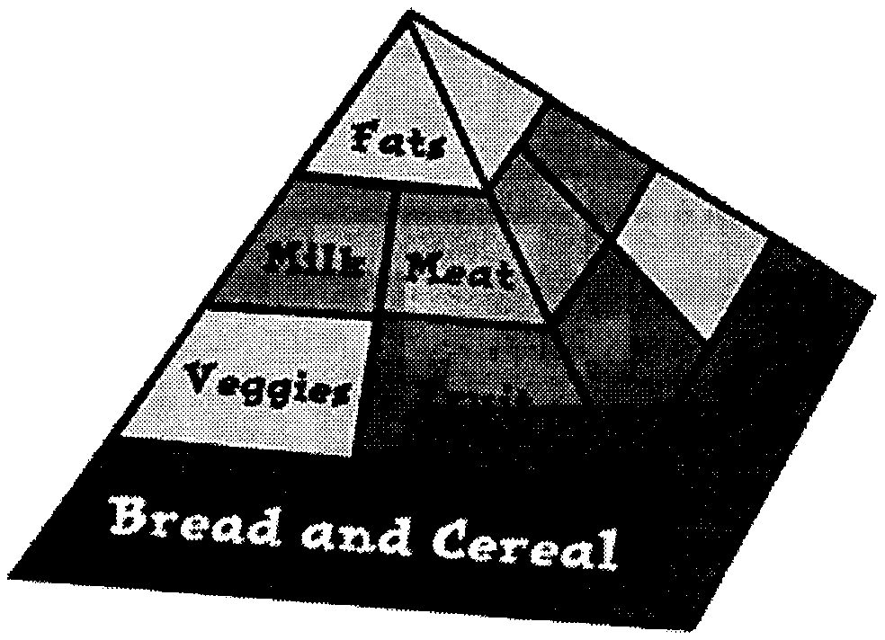
- Explain to your Scouts that exercise is only one part of fitness. A balanced diet is also important to being physically fit.
- Let them make up a menu for a week using the 5 basic food groups. See if they can stick to it for the whole week.
- Explain drug abuse.
- Plan a field trip to a drug abuse center.
- Have a nurse or doctor visit one of your meetings to explain the hazards of drug abuse.
For more information about drugs, diet, and alcohol, contact organizations in your area –
Circle Ten Council
Alcoholics Anonymous
American Caner Society
American Heart Association
MADD (Mother’s Against Drunk Driving)
SADD (Student’s against Drunk Driving)
Talking about Diet and nutrition –
Last month I had a typo for one of the Nutrition Websites I mentioned in Commissioner’s Corner – It is www.5aday.org (not .com) The site is all about kids and eating enough fruits and vegetables – games, activities, charts, fun stuff. They sent me lots of stuff for my RT and unbeknownst to me the nutritionist from The Memorial Hospital of Salem County was featuring them in her talk so it worked out great!!
Be sure to try www.3aday.org for Dairy products, too CD

How Much Do You Know About Drugs?
Fill in the blanks or circle the letter beside the best answer or the most appropriate response.
- Drugs are chemical substances that cause
  - growth of vital organs
  - changes in the human body
  - elevations in temperature
  - decreases in blood pressure
- Almost all drugs work by altering the __________ of cell activities.
  - number
  - shape
  - size
  - speed
- Which of the following is not a source of naturally occurring drugs?
  - animals
  - laboratories
  - minerals
  - plants
- In the United States, what government agency must approve every new drug before it can be sold?
  - American Medical Association (AMA)
  - Federal Trade Commission (FTC)
  - Federal Bureau of Investigation (FBI)
  - Food and Drug Administration (FDA)
- Drugs that can be sold lawfully without a prescription are called
  - hallucinogenic drugs
  - illegal drugs
  - over-the-counter drugs
  - prescription drugs
- Match each group of drugs with the primary effect these drugs have on the human body
a. analgesics
b. anesthetics
c. barbiturates
d. depressants
e. stimulants
1. slow down the activity of the central nervous system
2. speed up the activity of the central nervous system
3. make a patient feel relaxed and fall asleep more easily
4. relieve pain without deadening other senses
5. produce loss of feeling and sometimes loss of consciousness
- Which drug is found in chocolate, coffee, cola drinks, and tea?
  - alcohol
  - caffeine
  - cocaine
  - nicotine
- Which drug is a factor in at least half of all fatal traffic accidents?
  - alcohol
  - amphetamines
  - caffeine
  - nicotine
Answers: 1 – b, 2 – d, 3 – b, 4 – d, 5 – c, 6 / a – 4, b – 5, c – 3, d – 1, e – 2, 4 – 2, 7 – b, 8 – a

READYMAN
COMMUNITY GROUP
Bicycle Safety Quiz
Circle Ten Council
See how well you know your bicycle safety facts by taking this quiz. Circle the letter for the answer you choose.
- When approaching a stop sign, I should:
  - Look left and right and ride through the intersection without slowing down.
  - Slow down and then proceed through the intersection.
  - Come to a complete stop, check both directions and then proceed when it is safe.
- When approaching an intersection with no stop sign or light, the best thing to do is:
  - Ride through quickly.
  - Slow down, look to the left and right, and watch for tuning vehicles.
  - Stop in the middle of the road to see what’s coming.
- When making a turn or stopping on the road, I should use hand signals:
  - When a big steamroller is approaching.
  - If Mom is watching.
  - Every time I turn or stop.
- On two-way city streets as well as country roads, I should ride on the _____ side of the street.
  - Left – against traffic
  - Right – with traffic
  - Left or right, whichever is more convenient
- When is it okay to carry another person on my bicycle?
  - Never.
  - If there’s not much traffic.
  - If I stay on the sidewalk.
- If I am late starting home after dark and my light doesn’t work, I should
  - Walk my bike home on the sidewalk.
  - Ride on the left side of the street to see cars coming.
  - Ride on the right-hand side of the street.
- Good ways to be seen at night are by:
  - Wearing light-colored clothing and reflective tape.
  - Using bright reflectors, red to the rearm white or amber to the side, and white to the front.
  - Both A and B.
- The safest way to carry books or other gear on my bicycle is:
  - In pack on my back.
  - In a special carrier rack or basket.
  - In a bag in my hand.
- Leaves on the roadway and painted center lines can be hazardous to cyclists because:
  - They distract your attention.
  - They become slippery when wet.
  - They may both be yellow-colored.
- A good rule when riding in traffic is:
  - To listen as well as watch for cars.
  - To weave in and out of parked cars.
  - To yell at motorists who are in your way.
- If I approach a crosswalk when riding my bike, I should:
  - Yell so pedestrians will get out of my way.
  - Stop so that pedestrians may cross.
  - Ride my bike up the curb to avoid hitting anybody.
- When bicycling with a friend, we should always ride:
  - Single file.
  - Two abreast.
  - In no particular pattern.
- When riding with a group it is best to:
  - Tie a rope to the first rider and hang on.
  - Ride a little to one side of the rider ahead and overlap wheels.
  - Ride a safe distance behind the rider ahead in a single file.
Answers -
1c, 2b, 3c, 4b, 5a, 6a, 7c, 8b, 9b, 10a, 11b, 12a, 13c
True or False Safe Driving Quiz
Circle Ten Council
- A bicycle should be driven on the right-hand side of a street or highway.
- Bicycle drivers should obey all traffic signs and signals.
- Stop signs are round in shape.
- Pedestrians have the right-of-way on sidewalks and crosswalks.
- Bicycles should be “walked” across busy streets.
- The signal for a right turn is stretching the right arm straight out.
- Driving a bicycle at night without a front light or rear reflector is unsafe.
- It’s safe for a bicycle driver to carry a passenger.
- You don’t have to stop at an intersection if there is no traffic.
- Hitching a ride on another vehicle is safe if the driver is careful.
- Bicycle drivers should give a hand signal before making a turn or stopping on the street.
- It’s safe to drive a bicycle that is in poor condition if you are a good driver.
- If you’re driving bicycles with friends, you should go single file.
- Your chain should be loose enough to slip off easily.
- It’s okay to drive a bind in either direction on a one-way street.
- If you live in the country, it’s okay to drive on either side of the road.
- Even a good driver should “walk” his bicycle through heavy traffic.
- The faster you drive, the safer it is.
- Bicycle drivers should stay at least three feet away from parked cars.
- If you don’t ride on busy streets, you don’t need a horn or bell.
Answers –
- True
- True
- False, they have 8 sides. Railroad crossing signs are round.
- True
- True
- False, it’s extending the left arm with forearm raised and the palm of the hand facing forward.
7. True 8. False 9. False
10. False 11. True 12. False
13. True 14. False 15. False
16. False 17. True 18. False
19. True 20. False
Practice for Emergency Situations
Circle Ten Council
What Should You Do? Discuss the following situations with your den leaders and parents.
You awaken in the middle of the night. Your bedroom door is closed and you smell smoke. Mother and father are out of town and your grandmother is sleeping in their bedroom.
You are returning home from a baseball game and see a grass fire in a vacant lot near your home.
You see smoke coming out of a window in an apartment building across the street.
A stranger in a blue Volkswagen stops you on your way home from school and offers you a ride.
You find your 18-month-old baby brother playing with a bottle of aspirin that has been opened.
A dog, on the way from school home, bites a kindergarten child; you are witness to the incident.
A first grade boy falls off a swing and lands on his back. You are the first person to arrive on the accident scene.
You are witness to an auto accident in which a car strikes a girl on a bicycle and leaves her lying in the street.
You awaken in the middle of the night and hear the baby crying. The baby-sitter is asleep in front of the TV set.
A group of kids in your neighborhood are playing by locking one another in an old refrigerator they found in the alley behind a neighbor’s garage.
A gang of boys has been teasing a neighborhood dog. The dog is a family pet, but he is growling and shows signs of anger.
The fire bell rings at school and two of the girls decide they’ll play a trick on the teacher and hide under the library table while the class goes out for a fire drill.
A first grade boy steps on a rusty nail in the sandbox. It goes through the sole of his tennis shoe and makes a slight scratch on his foot. He doesn’t want to go to the school nurse.
Household Emergencies
Circle Ten Council
You may encounter a household emergency, which will require you to shut off one or more of the major systems of your home. Familiarize yourself with the shutoff switches and valves that control the flow of water, electricity and gas or oil. You should learn what to do promptly should an emergency arise.
Electrical Emergencies
Circle Ten Council
Lighting or receptacle not working
Check to see if a fuse is burned out or a circuit breaker has tripped/
Check to see if a light bulb has burned out.
Check to see if receptacles are working. Use a circuit tester.
Appliance smoking or sparking
Turn off the wall switch controlling it or unplug the appliance.
Turn off the male electrical disconnect switch if you are unable to unplug or switch it off.
When the appliance cools off have it repaired.
If appliance catches fire, get everyone out of the house. Call the fire department, disconnect the main electrical switch, and if possible extinguish the fire.
Plug of Appliance Sparks
Check the plug for signs of defect or damage. If it is damaged replace it.
Check for a blown fuse or tripped circuit breaker.
Try another appliance that you know is working correctly in the same receptacle, or use a circuit tester. If you still get sparks, then the receptacle is at fault. If you get no sparks, then probably the original appliance is faulty.
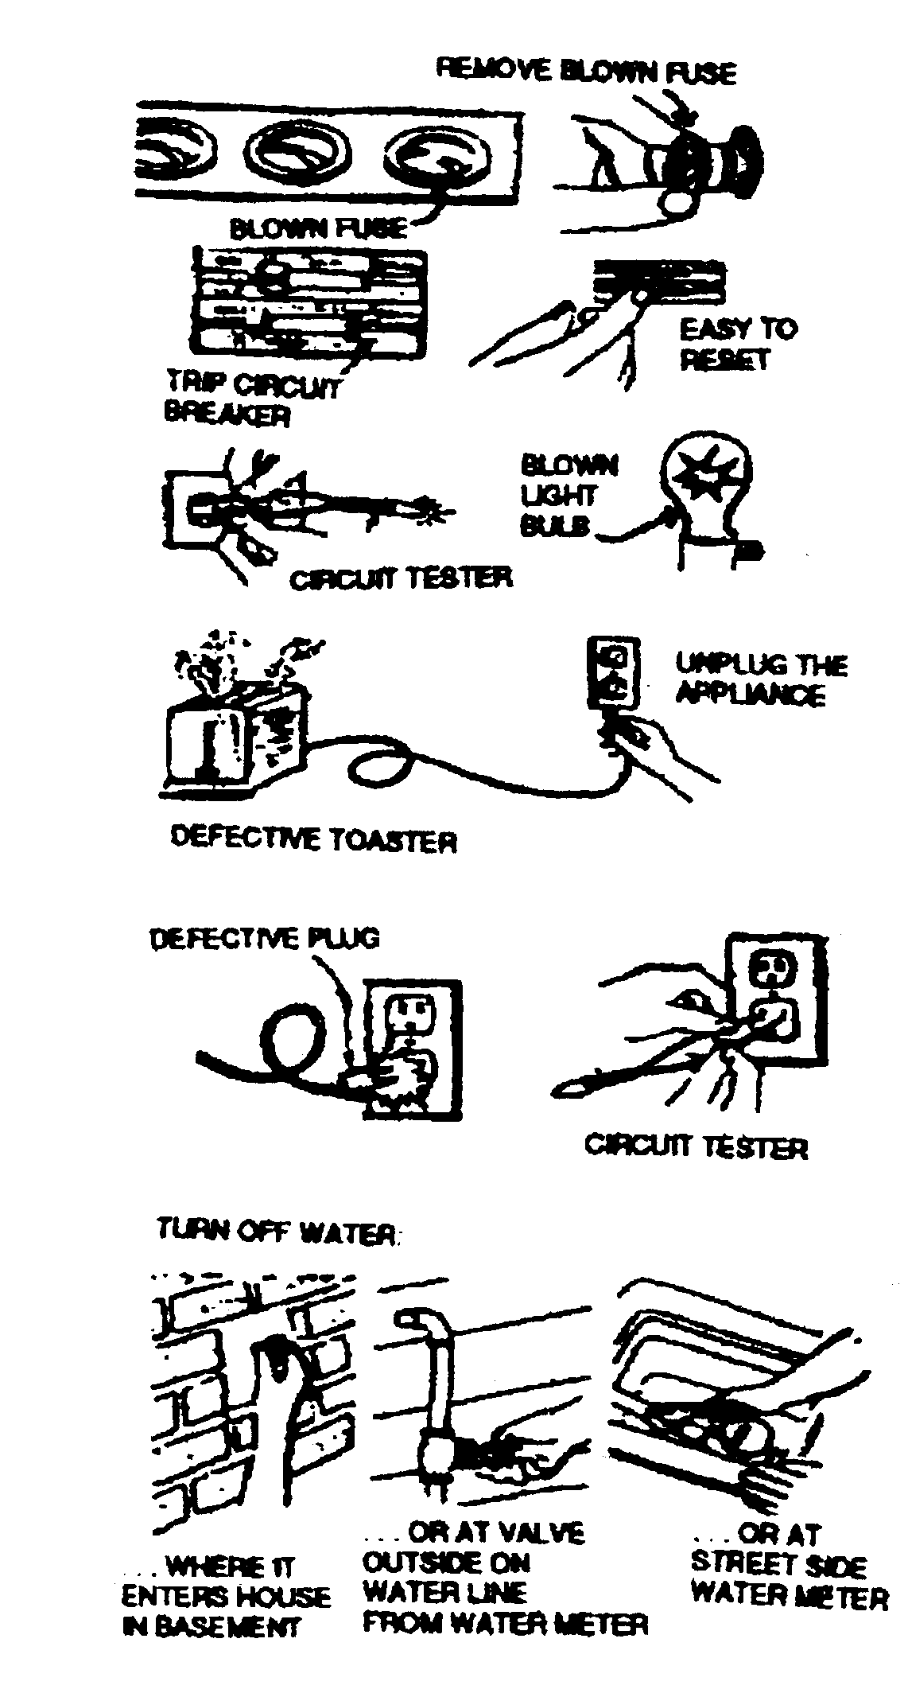
Plumbing Emergencies
Circle Ten Council
A pipe leaks or breaks – Turn off the main water supply valve.
A toilet overflows – Reach inside the tank and push down the tank ball or flapper valve. Shut the water supply to the tank off. You may need to get someone to unplug a clocked toilet.
Activities
Coffee Can First Aid Kit
Circle Ten Council
A very simple first aid kit can be made for the home or car by using a one-pound coffee can and adding the materials mentioned below. By sealing the lid tightly with tape, the contents of the kit will last indefinitely.
Materials: Safety pins
Tweezers Adhesive tape
Scissors Sterile gauze pads
2” triangular bandage 1” triangular bandage
3” roller bandage 2 triangular bandages
Emergency Phone Contact Numbers
Circle Ten Council
Using this chart as a guide, fill in the telephone numbers used in an emergency. You may also want to add pager phone numbers and cellular phone numbers to the list. Using this chart as a guide, fill in the telephone numbers used in an emergency. You may also want to add spaces, columns, or lines for adding pager and cellular phone numbers to the list.
Emergency Phone List
Mom at Work
Dad at Work
Neighbor’s Name
Neighbor’s #
Police
Fire Department
Gas Company
Electrical Company
Poison Control
Doctor’s Name
Doctor’s #
Be Prepared!
Circle Ten Council
You will probably want to copy this picture, then make it the width of he paper. CD
Find and circle these items, then color them in:
A C E F G L M N O R 9
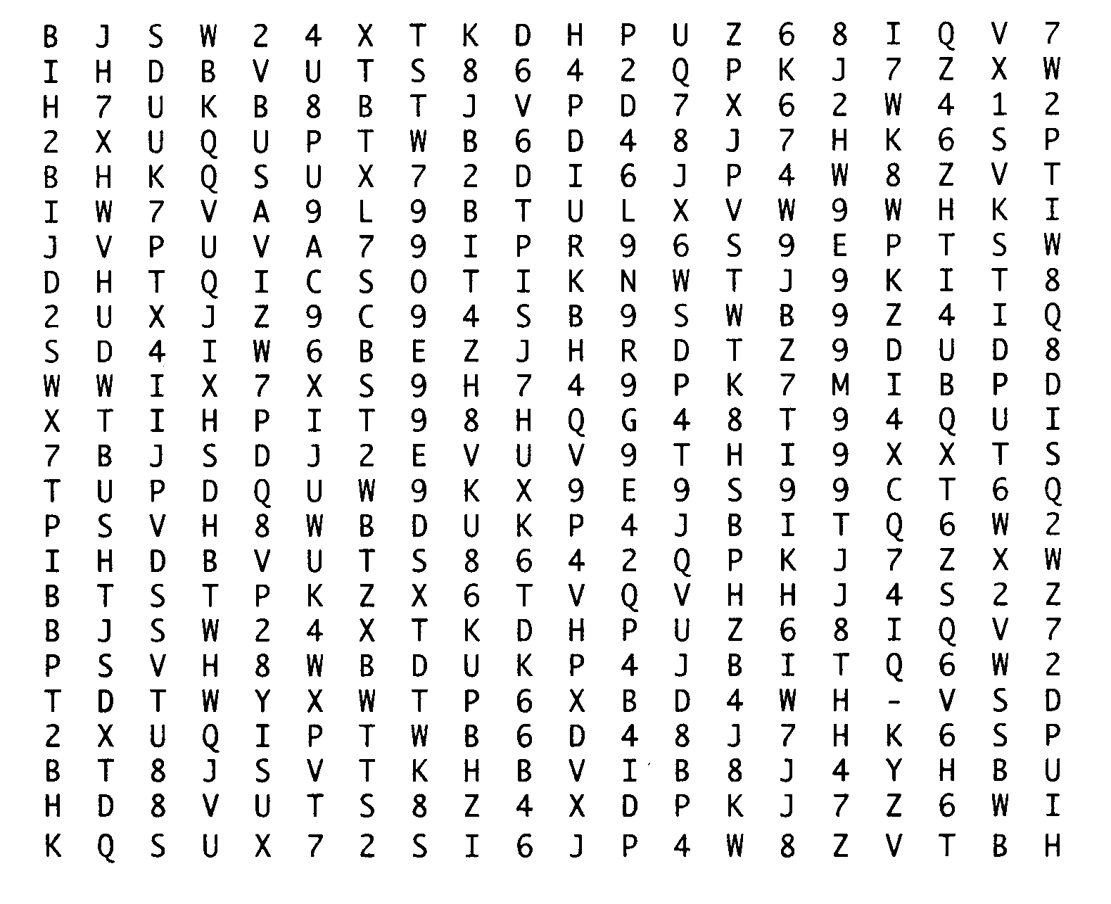
POW WOW EXTRAVAGANZAS
Clinton Valley Council
In the Tropics
Saturday, December 4, 2004
Waterford Mott High School,
151 Scott Lake Rd., Waterford, MI.
Contact Clinton Valley Council at (248) 338-0035 for more information, or visit http://www.cvc-bsa.org

Southern NJ Council
Catch a Dream
January 22, 2005
Lakeside School, Millville, NJ
Call Southern NJ Council, 856-327-1700, extension 32, or visit the website, www.snjscouting.org for more information
Indian Waters Council, BSA
"Set Sail for Adventure" University of Scouting
January 22, 2005
Swearingen Engineering Center, USC, Columbia, SC
Call Indian Waters Council, 803-750-9868 or visit the website, www.universityofscoutingiwc.com or E-mail,
universityofscouting@msn.com for more information
Buckeye Council
Baden Powell Institute (University of Scouting)
February 5, 2005
Stark State College - Media Center
Canton OH
Call Buckeye Council (800) 589-9812 or visit the website at http://www.buckeyecouncil.org/ for more information
Cradle of Liberty Council
“20,000 Leagues Under the Sea”
January 15, 2005
The Episcopal Academy
Merion, PA.
Call Cradle of Liberty Council (610) 688-6900 or visit the website at http://www.colbsa.org/ for more information
WEB SITES
The Rainy Day Resource Page
An Online Guide to Activities for Children
There is a computer section, an active section and an Easy Recipes section. How to make lots of gloppy stuff – Play Dough, Edible Peanut Butter Play Dough, Kool Aid Play Dough, Salt Clay, Finger Paint, “Oobleck” or Play Slime and more. Check it out!!
http://www.cp.duluth.mn.us/~sarah/rdr010.html#anchor229016
25 Ways to Recruit Cub Scouts
Santa Clara County Council
The article has lots of ideas of things that leaders and Scouts can do in preparation not only for a Joining Night but all year long and in a variety of settings. They may seem obvious but they are easy to do and are great conversation pieces while creating awareness of Cub Scouting in your community.
http://www.sccc-scouting.org/sccc/files/main/invitation_methods_cub_scouting.pdf
As leaders, you are Cub Scouting’s best sales force. This guidebook has been created by the staff of the Santa Clara County Council to assist leaders in offering a series of quality invitations to each and every young man. The goal is to leave no stone unturned. This collection of invitation ideas, will help ensure that no boy gets left behind, left out of the opportunity to build a pinewood derby car, or left out of the opportunity to “Do His Best”.
Take the challenge - use these ideas. Use your imagination and to help spread the excitement of the Cub Scout program.
National Quality Unit Award
Here is a great site to learn all about the National Quality Unit Awards. The history, the evolution, the patches, …
http://users.aol.com/randywoo/quality/
Youth Protection Training On-Line
Go here and you can see if your council is signed up to use the on-line youth Protection Training offered by National -
http://www.scouting.org/media/ypt/ypt-online.jsp
Scouting Values
Stories from Famous CEOs, Athletes, Coaches, Political/Military leaders
www.ScoutingWay.com
ScoutingArt.com
Fine Art Prints of Boy Scout Images Art of Norman Rockwell and Csatari
www.scoutingart.com
The SM's Other Handbook
How to manage a troop, maintain your sanity, and make a difference
www.eaglebook.com
Davey and Goliath
Here’s a link to an old TV show my younger brother used to watch when he was a Cub Scout. It is a series about a boy and his dog. It has been updated and is under direction of the Evangelical Lutheran Church in America. Davey and Goliath brings moral and faith-based values to a new generation of children in lively and engaging ways.
www.daveyandgoliath.com
Mothers Against Drunk Driving
www.madd.org/home
Alcoholics Anonymous
www.alcoholics-anonymous.org
Youth Education Life Line (YELL)
YELL (Youth Education Life Line) is an affinity group within ACT UP formed in 1989 to work on AIDS issues facing young people,especially AIDS education.
YELL has monitored and raised public awareness about AIDS education in the public schools and advocated a comprehensive, reality-based approach to HIV prevention for young people.
http://www.actupny.org/YELL/index.html
Students Against Drunk Driving
SADD's mission, simply stated, is to provide students with the best prevention and intervention tools possible to deal with the issues of underage drinking, other drug use, impaired driving and other destructive decisions.
http://www.saddonline.com/
American Cancer Society
www.cancer.org/
American Heart Association
http://www.americanheart.org/

