FOCUS
Cub Scout Roundtable Leaders’ Guide
It is time to celebrate 75 years of Cub Scouting at out Diamond Jubilee!! The year is 1930 and Herbert Hoover is president; for fun boys listen to their favorite shows on radio – “The Lone Ranger,” “Buck Rogers,” and “Superman.” Now, they have Cub Scouting! Packs will learn about and celebrate their history and will come to know lord Baden-Powell as an interesting leader and organizer of the Scouting movement. What a fun and exciting time to be a Cub Scout!!
CORE VALUES
Cub Scout Roundtable Leaders’ Guide
Some of the purposes of Cub Scouting developed through this month’s theme are:
- Spiritual Growth, Boys will be exposed to lord Baden-Powell’s devotion to God and then develop their own beliefs with their families.
- Fun and Adventure, Boys will enjoy celebrating the past, present, and future of Scouting.
- Preparation for Boy Scouts, Boys will be excited and motivated to continue down the path of Cub Scouting to Boy Scouting by learning about its founder and following his leadership.
The core value highlighted this month is:
- Citizenship, Cub Scouts will learn that only through the dedication of good citizens who went before them do we have the Cub Scouting program of today.
Can you think of others??? Hint – look in your Cub Scout Program Helps. It lists different ones!! All the items on both lists are applicable!! You could probably list all twelve if you thought about it!!
COMMISSIONER’S CORNER
I started prepping this issue in earnest the day after CHRISTmas. My wife and son were at work and daughter out with her boyfriend’s family. Then everything went south. We are in our 9th week of an extended outage on our “steam electric plant” (See Webelos Engineer for definition) and the pressure is high resulting in long days for the staff. But here it is, a little late but just chock full of ideas. This theme brought out a lot of Classic Scout stuff in the Pow Wow Books. I put some of that into Baloo but tried to keep looking for new things. Hope you like the blend that I present. When reading Baloo, the order of items in a section (e.g. GAMES) is random – I cut and paste from Pow Wow Books. Don’t ever assume the first one in a category is a favorite. Order is not important.
Two letters this month led to nice items – a request for information for Scouts with Disabilities and for a 75th Anniversary emblem in color. Thank you
I guess we have a really great Website (Thank you, Mike) because I, also, received several letters that sounded like the writer thought we were National Council of the BSA. They were asking where you can buy award patches and adding new Sports Awards. Please remember. USScouts is a group of volunteers who like the Web. We have no more power or influence than you (probably less). I have always found the editors at scouting Magazine very responsive to letters. They have replied to everyone I have written and have published a half dozen or so (The first was “Singing in the shower doesn’t count either” in the early 90’s). And now you can write just by clicking on website at www.scoutingmagazine.org
Speaking about Scouting Magazine, the current issue is great – There is a section on the Community Organization Award Knots (I’d say the copied from Kommissioner Karl’s article but their deadlines are much further ahead than that ☺). This summer’s offerings at the Philmont Training Center are listed (If interested, also, read this month’s Training Tip in Baloo). The Family Talk item on identifying areas of intense interest is great. There is a big Pinewood Poster sponsored by Lowes and Dremel announcing a nationwide contest. Apparently BSA has found a National Sponsor for the event. And 75th Anniversary ideas for Cub Scouts. Be sure to read it cover to cover.
There is some confusion about earning The Cub Scout Outdoor Award. The requirements for the award are in BSA publication 13-228 (and on many Council websites e.g. http://www.lastfrontiercouncil.org/cubs-outdoor-activity/) The first requirement is to spend a week at Resident or Day Camp after September 1, 2004. Attendance at this past summer’s camps is not eligible for the award. Therefore, unless your council ran a week long Day or Resident Camp after September 1, your Cubs must wait for next summer to earn the award.
Finally, I had a request for patterns for soap carving. If you have any in electronic form, please send them and we can get them onto the site for others to use. Thank you.
February 2005: It’s a Scouting Celebration
Baltimore Area Council and
Santa Clara County Council
Month’s with similar themes –
February 1977 Blue and Gold
February 1978 Blue and Gold Traditions
February 1982 Blue and Gold Tradition
February 1986 The Blue and Gold
February 1987 Blue and Gold
February 1988 Great Events of Scouting
February 1991 Blue and Gold Traditions
February 1994 Blue and Gold Traditions
February 1995 Great Events of Scouting
February 1996 The Blue and the Gold
February 1997 The Story of Blue and Gold
February 1998 Let’s Celebrate Scouting
February 1999 Baloo and Gold
PRAYERS AND POEMS FOR SCOUTERS
Great Salt Lake Council
The Lord said, you’re the salt of the earth. However, he didn’t mean for you to sit in the corner like a lump of salt, waiting for things to happen. So get off your laurels and make them happen.
Always make new mistakes – Esther Dyson
“If we all did the things we are capable of doing, we would literally astound ourselves” Thomas Edison
“The only normal people are the ones you don’t know very well!” Joe Ancis
For more quotes like this see Website list for “fridgedoor”
Ten Needs of a Boy
Circle Ten Council
To climb a mountain and look afar.
To sit around a campfire with good friends.
To test his strength and his skills on his very own.
To be alone with his own thoughts and with his God.
To be ready to reach out and find the hand of an understanding man ready and willing to help.
To have a code to live by – easily understood and fair.
A chance to play hard just for the fun of it –
And to work hard for the thrill of it.
To have a chance to fail – and know why.
To have and to be a good friend and a chance to prove both.
To have a hero – and a vision to measure him by.
After the tenth need is said, the following could be said:
In Cub Scouting these needs are not always filled for each boy. What Cub Scouting does is to put each boy on a path where he can travel the world in his backyard and fulfill his needs with confidence in himself and others.
Circle Ten suggests breaking this into parts and using it for an Opening Ceremony. Baltimore Council says this is best done using ten adults, each holding a white candle. When each speaks, he or she lights his candle from the Spirit of Scouting Candle. I like it for a Cubmaster’s Minute Closing. You choose! CD
Invocations and Blessing for the Blue and Gold Banquet
Baltimore Area Council
Our God and God of our fathers, we gather as loyal members of our Cub Scout Pack, and we pray for Thy blessings. Give us the vision to see our duty and the courage to perform it. Teach us to walk together in the spirit of brotherhood, so that we are true to Thee, who art Father of all. Guide us and guard us so that we shall be faithful sons of the righteous God, Who is from everlasting to everlasting.
Our dear Heavenly Father, we ask a special blessing on the families in our Cub Scout Pack. We ask a special blessing on each Tiger Cub, Cub Scout, and Webelos as they give service to other people. Guide their steps as they grow into men, and help them as they do their duty to You and our country. Bless our food and the people who have prepared it. Amen
A Cub Scout’s Prayer
Baltimore Area Council
0 Lord, that I will do my best,
I come to Thee in prayer.
Help me to help others every day.
And teach me to be fair,
To honor my Mother and Father,
And to obey the Cub Scout Law, too.
This I ask, that I may be a loyal
Cub Scout true. Amen
A Cub Scout Parent’s Prayer
Baltimore Area Council
Look down upon my son, Dear Lord
This smiling Cub of mine.
Please take his hand along the way,
So that he may never stray.
Bless my son tonight, Dear Lord,
And help him walk with Thee.
Give him comfort, warmth and love;
He’s all the world to me.
Bless his daily efforts,
And make them strong and true;
For life’s a heavy burden,
And we’re all in need of you.
Philmont Grace:
For food, for raiment,
For life, for opportunity,
For friendship and fellowship,
We thank thee, Oh Lord. Amen
A Boy in Blue:
Baltimore Area Council
Blue and gold are the colors tonight,
Boys in uniform shiny and bright;
With smiling faces to left and right,
We pay tribute to our Cub Scout tonight.
A Cubmaster who is loyal and true,
Who works with parents and boys in blue,
In hopes that these boys will grow up to be
Better citizens than you and me.
Den Leaders, too, in uniforms blue,
Teaching Cub Scouts the need to be true,
And working, singing, and playing with them;
Striving real hard to make better men.
So all of you Cub Scouts in gold and blue,
The door to Scouting - has been opened to you,
And I as a leader in Pack_,
Hope someday you’ll join up with me.
Benediction
Baltimore Area Council
May God bless us and protect us;
May God show us favor and be gracious to us;
May God show us kindness and grant us peace.
Scouting’s Bottom Line
Circle Ten Council
There is a ceremony in here somewhere.
Use it to make your own. CD
What happens to a Scout? For every 100 boys who join Scouting, records indicate that:
- Rarely will one be brought before the juvenile court system
- Two will become Eagle Scouts
- Seventeen will become future Scout volunteers
- Twelve will have their first contact with a church
- One will enter the clergy
- Five will earn their church award
- Eighteen will develop a hobby that will last through their adult life
- Eight will enter a vocation that was learned through the merit badge system
- One will use his Scouting skills to save his own life
- One will use his Scouting skills to save the life of another person
Scouting’s alumni record is equally impressive. A recent nation-wide survey of high schools revealed the following information:
- 85% of student council presidents were Scouts
- 89% of senior class presidents were Scouts
- 80% of junior class presidents were Scouts
- 75% of school publication editors were Scouts
- 71% of football captains were Scouts
Scouts also account for:
- 64% of Air Force Academy graduates
- 68% of West Point graduates
- 70% of Annapolis graduates
- 72% of Rhodes Scholars
- 85% of FBI agents
- 26 of the first 29 astronauts
TRAINING TIP
Leader’s Survival Checklist
Baltimore Area Council
- When the Pack won’t pay attention and you feel like blowing your top, count to ten.
- So you tied the flag on upside down. Smile knowingly like you planned it that way. Praise the Cub who saw it.
- Accept the boy for what he is. If that’s impossible, just be thankful he isn’t your son.
- Learn to laugh at yourself. The Cubs probably think you’re hilarious anyway.
- Too many Cubs and not enough leaders? What a compliment! It must be YOU they like!
- When everything goes wrong remember Job. At least you don’t have boils.
- Remember you’re a human, no matter what the boys might tell you
- Running a meeting is a breeze? You’re in trouble! Go take a Supplemental Training course.
HHMMmm – Take a Supplemental Training Course –
The Philmont Training Center (PTC) schedule for 2004 is out!! I have received my first invitation to a seminar this summer from the National Lutheran Association of Scouters. And my daughter’s staff application has been accepted for her third summer.
Cub Training at PTC in 2005 –
Adapted from National’s website (www.scouting.org/philmont) and my daughter’s and my memories
Week 2 - June 12-18 (Cub Scouting & Health & Safety)
- Pow Wow Leadership
- Cub Scout Outdoor Program
- Strictly for Cubmasters
- Cub Scout Roundtables
- New Directions in Membership Growth
- Training Cub Scout Leaders
- Webelos Scout to First Class Scout
- Pack Trainer
- Health and Safety/Risk Management
- Teaching Basic Outdoor Skills
- National Youth Leader Instructor Camp
Week 9 – July 31 - August 6 (Cub Scouting)
- Training Cub Scout Leaders
- Leading Pack Camping
- Strictly for Cubmasters
- Webelos Scout Program
- Supercharging Den and Pack Programs
- Cub Scout Roundtables
- Putting Pizzazz into Cub Scouting
- Connecting Character with Cub Scouting
If any of these interest you, contact your District Executive and ask how your council determines who is nominated to attend courses at Philmont
Check your Scouting Magazine to get descriptions of these seminars. Or call your council or Philmont, 505-376-5581 and request the brochure for 2004.
The weekly schedule at Philmont is relaxed. All the Free Time they took out of the Wood Badge course they put into Philmont training ☺ ☺
Sunday – Check In, Chapel, Evening campfire
Monday – Classes and Family program begin. All adults meet in Assembly for brief orientation. Cobblers and Band at Tent city.
Tuesday - Classes and Family program continue. Buffalo Bar-be-que, games on the lawn and western dancing, branding
Wednesday – Your day off. Enjoy the time with your family. Explore where you can around Philmont or travel to Cimarron and surrounding area. Watch “Follow Me Boys” at night with fellow Scouters. See how everyone laughs at lines like, “I promise, I am only going to do this for one year.”
Thursday - Classes and Family program continue. Cobblers and band at Tent city, branding
Friday - Classes and Family program continue. Graduation. Closing campfire
Saturday – Pack up and leave.
Family Programs
The Philmont Training Center offers a full, organized program for every member of the family—from infants to spouses. Family members will be joined by others in their age group and will participate in a carefully designed, age- and ability-specific program under the leadership of trained, experienced staff.
Each family program group will participate in activities designed with the age and ability of the family member in mind. The age grouping generally follows the same pattern you find in the Scouting program. There are horse and pony rides, handicraft, day hikes of various lengths, museum tours, ice cream socials, BB and archery, and more. Older youth get to go on an overnighter!!
Wives, husbands, and other adult family members have a wide range of planned activities to choose from - museum visits, local history, Indian arts programs, pottery-making demonstrations, guided nature walks and programs, Villa Philmonte tours, trips to nearby towns, COPE, and fishing.
An extensive day-hiking program is available to wives, husbands, and other adult family members. Hikes range from an easy one-mile nature walk to somewhat strenuous all-day hikes of three to eight miles. Possible hiking destinations include Abreu Camp, Lover's Leap, Cathedral Rock, Window Rock, Indian Writings Camp, Urraca Trail.
Tent City Accommodations
Tent cities accommodate all Training Center participants and their families. Tents are large (10 by 12), two-person wall tents with wood or concrete floors, electric lights, an electric outlet, wardrobe, and two twin-size beds with mattresses.
Living in tents may be a new experience, but you will find the leisurely life of a tent dweller to be comfortable and enjoyable in Philmont's climate. Each tent city has modern restrooms and showers, a playground, tent city office and shelter. The tent city staff is on hand to help you in any way possible. Irons, ironing boards, and other services are available for your use at no charge in your tent city office.
Your tent city staff or your fellow tent city residents may organize games, evening activities, cracker barrels, sing-alongs, patch-trading sessions, and other activities.
Meals
All meals are served in the two Training Center dining halls
PACK ADMIN HELPS
Adaptations for Individuals With Disabilities
The following is from Pack 215's Virtual Cub Leader Book -
http://www.geocities.com/cybercubber/aands-introduction.html#Adaptations
Flexibility and individuality are key words to remember when adapting Cub Scout Academics and Sports for boys with disabilities. For instance, a fast-moving sport may be difficult for some Cub Scouts with disabilities to participate in. The pace may be too quick, and they may not have enough time to make decisions. Scouting for Youth with Learning Disabilities (No. 33065), Scouting for Youth with Emotional Disabilities (No. 32998A), and Understanding Cub Scouts with Disabilities (No. 33839) are important resources for packs and dens using the Cub Scouts Academics and Sports program. Here are some general ideas for adapting the program for boys with disabilities.
Adapt the activity, or use mentors, to help a Cub Scout to participate. The boy should be involved to the best of his ability and so that he feels good about his participation.
Involve the boy in a needed, unique role that enhances the activity. For instance, he may be the team manager, the timekeeper, or the person responsible for equipment
Determine alternatives. For instance, miniature golf could be used instead of a full golf course; wheelchair races could be used instead of cycling.
Incorporate special helps into the activity. For instance, during bowling, use ramps with wheelchairs and guide rails for visually impaired youth. During basketball, youth can use a scooter board. During swimming, let youth use artificial aids to help them move across the pool.
Shorten time limits as needed for the mental or physical ability of the Cub Scout.
Include family members when planning a boy's participation in your activity. A knowledgeable parent or guardian is the best resource to help you adapt an Academics or Sports activity.
Pack leaders, with the boy's parent or guardian, may determine different requirements in a specific academic subject or sport to better suit the Cub Scout's ability.
Here are some other helpful hints:
Soccer, basketball, and volleyball are easy to adapt for wheelchair-bound youth.
Computers can often be adapted to deal with specific disabilities.
If baseball is too fast use tee ball or softball.
In basketball games, adaptations could be minor changes in the rules; for example, don't use the three-second rule, let players cross the centerline, and permit double dribbling.
Most youth with disabilities participate in physical fitness activities, and special-Olympics games are held in the summer and winter. Common sports for youth with disabilities include fishing, horseshoes, gymnastics, aerobics, hiking, and walking.
Cycling may be possible, but pay attention to potential added dangers on the road to some youth with disabilities.
Sports rating the highest in acceptability for youth with mental disabilities are swimming, softball, soccer, basketball, and physical fitness.
Serving Youth With Disabilities And Special Needs
From - http://www.bsa-heartofohio.org/CurrentEvents/serving_youth_with_disabilities_.htm
Since its founding in 1910, the Boy Scouts of America has had fully participating members with physical, mental, and emotional disabilities. Dr. James E. West, the first Chief Scout Executive, was himself disabled. Although most of the BSA's efforts have been directed at keeping such boys in the mainstream of Scouting, it has also recognized the special needs of those with severe disabilities.
The following BSA resources can be used to increase the awareness of Scouters working with people with disabilities:
A Scoutmaster's Guide to Working With Scouts With Disabilities, No. 33056A
Scouting for Youth with Physical Disabilities, No. 33057C
Scouting for Youth with Mental Retardation, No. 33059B
Scouting for the Hearing Impaired, No. 33061A
Scouting for Youth with Learning Disabilities, No. 33065A
Scouting for the Blind and Visually Impaired, No. 33063B
Scouting for Youth with Emotional Disabilities, No. 32998B
The following resources are BSA publications regarding membership and advancement for disabled Scouts:
Advancement Committee Policies & Procedures, No. 33088C
Boy Scout Requirements, No. 33215D
Boy Scout Handbook, No. 33105
Disabilities Awareness Merit Badge Pamphlet, No. 33370
Application for Alternate Eagle Scout Rank Merit Badges, No. 58-730
Cub Scout Leader Book, No. 33221B
Any of the above resources are available through your local Scout Retail Shop.
Audio Recordings of Cub Scout Leader, Wolf, Bear, and Webelos Books are available through the free library service provided by the National Library for the Blind and Physically Handicapped, Library of Congress. Families should also ask their cooperating libraries. For more information, including eligibility requirements and the nearest cooperating library, call 1-800-424-9100 or contact the Internet http://lcweb.locgov/vis or http://www.loc.gov/nis .
Braille printings of Bobcat, Wolf Cub Scout Book, and Bear Cub Scout Book are available from The Lighthouse of Houston, Houston, TX. 713/527-9561
Braille printings of Bear Cub Scout Book, Webelos Scout Book and Parent's Guide. National Braille Association, Rochester, NY, 716/427-8260
Boy's Life Magazine in Braille. Library of Congress for the Blind and Physically Handicapped, Washington, DC, 202/707-5104 (There is a leader in my district who receives this every month. She has been to my Roundtables and Pack Meetings to show it and talk about blindness CD)
Recordings of the Boy Scout Handbook and various merit badge pamphlets. Recordings for the Blind and Dyslexic, Princeton, NJ, 800/221-4792
Boy Scout Handbook in Braille. the Lighthouse of Houston, Houston, TX 713/527-9561
BSA merit badge pamphlets. National Braille Association, Rochester, NY. 716/427-8260
Other available resources -
There is a fact sheet on National's web site
http://www.scouting.org/factsheets/02-508.html
Jersey Shore Council has a pdf with available references and other info -
http://www.jerseyshore-bsa.org/docs/ScoutingResourcesDisability.pdf
The St. Louis Area Council has a great page with lots of practical examples -
http://www.siu.edu/~women/understanding_disabilities.html
This site has games for disabled boys -
http://www.inquiry.net/outdoor/games/disabled/
Special Thanks to Warren in Bloomington, IN whose question prompted my research on this topic. CD
TIGERS
Achievement 4, How I Tell It
This requirement is about Communication. Getting our Tigers to talk with others and be positive in what they say. They may learn how to carry on conversations and a little about mass communication.
Tigers can learn there are many modes of communication – when we talk, write, dance, sing or draw pictures. We communicate too with our faces when we frown or smile and our bodies with how we stand or move our arms.
Our uniforms and beads (on our Tiger totems) and patches communicate information about who we are and what we like to do.
Adults communicate through newspapers, magazines, books (Harry Potter) television and radio. Be open to showing all these to your tigers to help them search, Discover and Share.

Achievement 4 Family Activity
4F - At a family meal, have each family member take turns telling the others one thing that happened to him or her that day. Remember to practice being a good listener while you wait for your turn to talk.
Mealtime conversations should be kept positive. Sharing your day’s activities could be become a regular family activity. Try to do this at a meal when everyone is there. Sharing amongst family members is always good so try to keep doing it even if only a few members are present.
The requirement helps promote Family Understanding, one of the Ten Purposes of Cub Scouting!!
This requirement involves doing a Character Connection on Respect. There are three elements to every Character Connection. A Tiger must first know what is correct, then practice doing it and finally commit to doing it in the future. If you want more info on Character Connections there is a BSA Bin Item 13-323A or go to Bill Smith’s Virtual roundtable at - http://www.wtsmith.com/rt/chardev.html

For the Respect Character Connection –
Know – Have the Tiger discuss how he can show respect while talking with others. How to listen respectfully. How he may interrupt and still be respectful.
Practice – Have him participate in a family conversation (The one for this requirement would be great!!) Then discuss how he and others showed respect.
Commit – Have him discuss how it felt to be respected while he talked and how he felt showing respect o others. Have him make a list of three things to remember to help him talk respectfully.
Achievement 4 Den Activity
4D - Play "Tell It Like It Isn't"
This is the old “Whistling Down the Alley” game where the boys line up and pass a secret along. By the time it gets to the end, it usually is different than the start. The more boys the more fun. The Adults should join in, too, to make the line longer.
After the game discuss how things your Tiger may hear may not always be accurate. That messages change as they are passed from person to person. Discuss, too, how unkind words (gossip) can do harm and is often untrue. Cubs should only try and say things that are true. Honesty is a core value of Cub Scouting.
Achievement 4 Go and See It
4G - Visit a television station, radio station, or newspaper office. Find out how people there communicate with others.
This is very easy. Where I live we have a great radio station, WJBR (www.wjbr.com) that invites Scouts up to tour. Then, if the Den wants to, they tape them saying the Pledge of Allegiance. Every day at 7:00 AM, they play a tape of a group (school class, Den, Troop, Club). They even came to my roundtable and had us one morning saying the Pledge. I really like it when I hear a Tiger Den; they are so honest and excited. And most say it correctly – saying “One Nation Under God” as a continuous phrase without a pause. Of course it helps that the morning DJ, Michael Waite, grew up in Indiana, the Heartland of America, and his assistant, Mr. Rhoads is an experienced Philmont trekker!! I have heard the Pledge said on several other area stations so maybe there is one by you.
Our local newspaper encourages tours. When my son’s Den went for Communicator, they inserted a picture of the Den on the front page and ran enough copies so each Scout could get one!!
SPECIAL OPPORTUNITY
75th Cub Scout Anniversary Family Award
Kommissioner Karl
Featured here this month are the requirements for the Cub Scout 75th Anniversary Family Award. There are four awards. Each is distinguished by its unique color pattern, boys are red bordered, families are yellow bordered, Leaders are blue bordered and the pack is silver bordered. There is also a 75th Anniversary Commemorative Patch available from the BSA with no requirements. Each month we will be discussing specific activities you can do for each level of the award, so you are ready for the big 75!!
Our pack committee chair has taken the requirements for each of the awards and then added where appropriate pack activities that met the requirement. That way families can check off what they did and get inspired to do those other things needed to complete the award. CD
An in Depth Look at the…
75th Anniversary Family Award
For Tigers, Cubs, Webelos Scouts & Family Members
Complete Requirement 1 and complete 5 other activities.
Participate in a pack, district, or council celebration commemorating the 75th Anniversary of Cub Scouting. (This could be a Blue and Gold Banquet.)
The preferred Blue and Gold theme this year is the 75th Anniversary of Cub Scouting. Begin thinking of things you can do to celebrate! Perhaps you can have 1930’s games as a gathering activity, contact a local Scout collector or historian to see if you can display a collection of uniforms, pictures and books from the past 75 years of cub scouting, ask an older Scouter to come to your meeting a share a 10 minute story on what things were like when he was a cub scout
Invite another family to attend a 75th Anniversary event or activity to learn more about Cub Scouting and how to join.
Most Councils are planning a big celebration open to the whole family in 2005 to celebrate the 75th Birthday of Cubbing. If your does this, why not invite your best friend and his parents for the family weekend? Or, host a special 75th Anniversary Pack meeting with games and crafts from the 1930s and have each boy invite a friend and at least one parent and their other kids. Have a mini round up or Q & A session to discuss how Cubbing is a family affair and how to join.
Visit a business, landmark, or other site or structure in your community that is at least 75 years old. Talk to a representative about how the location has changed in the past 75 years.
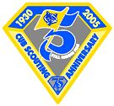
Look around; probably there are many structures in your town over 75 years old. You may be able to visit a local factory, (like the Timken Company or the Hoover Vacuum Cleaner Company in my area or the first Dupont plant near where Commissioner Dave lives.) There are Historical Societies and old houses that are open to the public in most towns as well. Check with your local historical society to see if there is a list of local landmark’s you can visit that may have changed since 1930.
As a family, make a list of household items that would not have existed 75 years ago. Discuss what might have been used instead and how life was different without these items.
- Television – in the 30s families huddled around that radio and listened to stories like the Shadow.
- Computers – took up huge rooms and a person could never afford one at home (or have the space to house it)
- Cable – what no 24 hour cartoons? How about no television just fuzzy broadcast signals on your radio.
- SUV’s – most people drove cars and a few drove trucks. There was no thought to putting the two together for a family.
- Direct dial telephones – back in the good old days, you had to ask an operator to connect you to a city and then ask the operator in that city to connect you to the person you were looking for, if they had a telephone.
- Commercial jet airlines – some commercial airlines existed, but most were on blimps like the Hindenburg.
- If you wanted to go somewhere you took the train or a passenger ship.
- Battleships – were the pride of every Navy in the world. They are gone now- the airplanes, long-range missiles and aircraft carriers made them obsolete.
- Calculators – handheld calculators were never thought of – you did all your math by hand the long way.
- Satellites – those things that link the whole world together. The first did not go up until 1959.
- Trips to the moon – only in storybooks. It wasn’t until 1960 that we even thought about it, and not until 1969 that we made it there.
- Space shuttle – We didn’t even know what rockets were in 1930, let alone a reusable rocket ship.
- Super oil tankers – supply oil all over the world instead of pumping from the back yard or local oil company.
- Fax machines – replaced telegrams and telegraphs. Now we can send papers over the phone lines.
- Mini-cameras – flash powder cameras were a luxury, and big and bulky. A pocket-sized camera that anyone could own was impossible in 1930. People often had their pictures painted instead of photographed. VCR/DVD – the only movies you saw were 5 cents at the theatre, instead of at home on the big screen.
- CDs – back in 1930, you played records made of brittle plastic on a wind up Victrola phonograph that would make the music play from a big bull horn shaped bell. No stereo or head phones.
Bake a cake, pie, cookies, or other dessert using ingredients that would have been available 75 years ago. Decorate the dessert with a Cub Scout theme.
The hard part here, is that they made everything from scratch. No cake mix, no heat and eat bread. Most of the ingredients are the same, we just have everything pre-mixed and made. How about making a cake from scratch. Search the web for some recipes for pies, cookies or cakes. You might try and make a loaf of bread from scratch too! Have your Pack sponsor a Parent-Cub cake bake where all entries must met the 1930 requirement.
Start a family scrapbook or add to an existing one. Include photographs or memorabilia from at least six different Scouting activities.
Not too hard. Scrapbooks and photo albums help satisfy requirements from Tigers to Webelos. How about theming the book with an antique look – or – with your parents consent, have family photo taken with everyone dressed up in clothes that may have been worn in the 1930s. Pick some of your favorite Cub pictures and make a special page just for your son.
Make a family time capsule with each family including items that represent what is important to each member of the family. Decide on a future date on which to open the capsule together.
We focused on time capsules back in August. Make a family time capsule, and agree to open it on a day in the future, perhaps your high school graduation, or the day you get married. Make sure everyone includes a note about what they think and feel about the world around them, written in their own handwriting. If you need help making one, search for time capsules on the web.
As a family, read an article together from Boy’s Life magazine (accessible via the Internet at www.boyslife.org). Talk about how this article would have been different had it been written 75 years ago.
This is pretty easy, and easier if you subscribe to Boy’s Life at home. Look for things that weren’t around 75 years ago, or things that we would have done differently. See if you can find an old picture of someone doing the same activity. Ask a grandparent to participate and share how they would have done the activity when they were your age.
Draw a family time line going back at least 75 years. Include significant dates such as birthdays, weddings, and when family members joined Scouting. Mark 1930 as the year Cub Scouting began.
This would be great as an entry in your family scrapbook project or as a poster for your sons room. Show a family tree and all of your relatives that can be remembered back 75 years or longer. For more information, you can look up genealogy on the web.
Find a picture or photograph of the Cub Scout uniform in 1930. Discuss how the uniform has changed. Have each family member draw a picture of what they think
the Cub Scout uniform might look like 75 years in the future.
District Award of Merit
Kommissioner Karl

The District Award of Merit is awarded by a District or Exploring Division to volunteer and professional adults for service to youth in the District or Division. Normally, the award is presented for service in excess of five years. Candidates for this award must be nominated (Self-nomination disqualifies the candidate). Guidelines are:
A nominee must be a registered Scouter; rendered noteworthy service to youth in Scouting, outside of Scouting, or both (Note: This may consist of a single plan or decisions that contributed vitally to the lives of large numbers of youth or it may have affected a small group over an extended period of time, and should be beyond the expectations of that Scouting position. The nominee's attitude toward and cooperation with the district, division, and/or council is to be taken into consideration as well.
Each district in the BSA sets their own calendar for when nominations are due and where the presentations are made. So if you know someone deserving of this award, check with your Unit Commissioner to find out when and how to make a nomination.

GATHERING ACTIVITIES
A Search for Blue and Gold
Baltimore Area Council
Directions: Go around the room and ask people if they have the following objects or fit the descriptions asked for. Have the person sign his or her name next to the statement that fits them.
Maybe you can arrange this into a Bingo board and award prizes. CD
- Do you have a gold watch on?
- Are you a child wearing a blue shirt?
- Are you an adult wearing a blue shirt?
- Do you have glasses with gold rims?
- Are you wearing gold socks?
- Do you have blue eyes?
- Do you have golden hair?
- Is your last or first initial “B”?
- Is your last or first initial “G”?
- How many electives to earn a gold arrow point?
- What does Blue and Gold mean?
- Are you wearing gold earrings?
- Do you have gold braces?
- Are you wearing a gold ring?
- Does your belt have a gold buckle?
- Is your belt blue?
- Are your shoes blue?
- Are you wearing a Blue ribbon?
- Are you wearing gold shoes?
- Are you wearing blue socks?
History of Cub Scouting
Santa Clara County Council
Identify the correct decade (1930, 1940, 1950, 1960, 1970, 1980, 1990) in which the following events occurred in Cub Scout history:
- Tiger Cubs introduced
- First Pinewood Derby
- Cub Scouting officially approved in the U.S.
- Garfield the Cat named National Cub Scouting “spokescat.”
- First Blue and Gold banquet. Packs sell war bonds and war stamps
- National Summertime Pack award introduced
- Five ranks established: Bobcat, Wolf, Bear, Webelos, Arrow of Light
Answers: 1-1980 (1982), 2-1950 (1953), 3-1930, 4-1990 (1999), 5-1940 (1943), 6-1960 (1964), 7-1970 (1978)
Jungle Book Characters Matching Quiz
Circle Ten Council
How well do you know you’re The Jungle Book characters?
1. Shere Khan a. Monkey People
2. Bagheera b. Rat
3. Mowgli c. Black Panther
4. Red Flower d. Teacher of the Law
5. Rann e. Kite
6. Mang f. Tailor-Bird
7. Tabaqui g. Bat
8. Gidur-log h. Wild Elephant
9. Raksha i. Rock Python
10. Mao j. Tiger
11. Akela k. Lone Wolf
12. Baloo l. Peacock
13. Bandar-log m. Jackal
14. Kaa n. Fire
15. Hathi o. Jackal People
16. Rikki-tikki-tavi p. Boy Cub
17. Chuchundra q. Musk-Rat
18. Darzee r. Mongoose
19. Chua s. Demon
See how well everyone did in putting the right animals with the names Kipling gave them in his book
Answers: 1– j, 2 – c, 3 – p, 4 – n, 5 – e, 6 – g, 7 - m, 8 – o, 9 – s, 10 – l, 11 – k, 12 – d, 13 – a, 14 – i, 15 – h, 16 – r, 17 – q, 18 – f, 19 – b
Baloo and Gold Word Search
Circle Ten Council
You may want to copy the picture and enlarge the size before having boys attempt the word search. CS
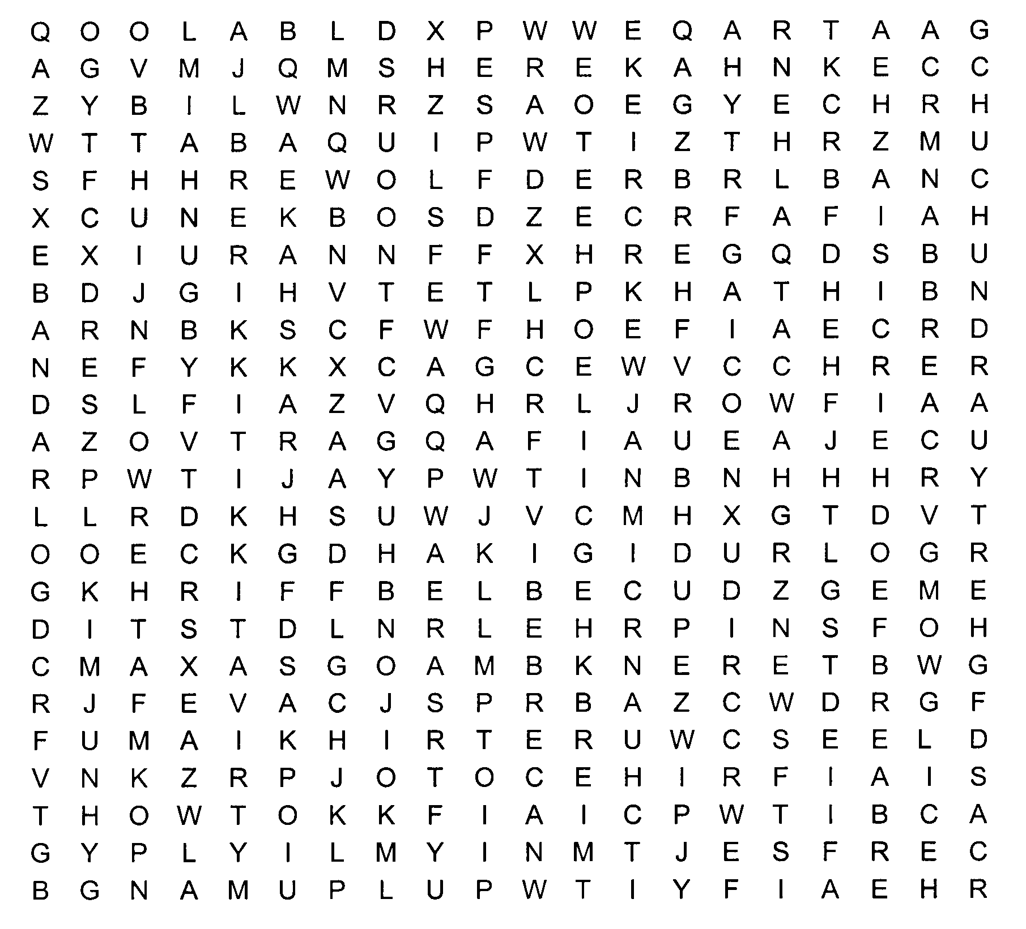
This puzzle contains words and phrase related to Cub Scouting. See how many you can find.
Shere Khan Bagheera Mowgli
Red Flower Rann Mang
Father Wolf Tabaqui Mother Wolf
Gidur-log Law of the Jungle Raksha
Council Rock Mao Akela
Bagheera Baloo Bandar-log
Kaa Lost City Hathi
Rikki-tikki-tavi Chuchundra Darzee
Chua
Roman Numerals
Great Salt Lake Council
Roman numerals are often used in marking the anniversary of special events (i.e. the Olympics, The Super Bowl, etc.). Can you write the Roman numeral for our 75th birthday of Scouting?
Here are some helps if you need them.
The basic symbols are:
I= 1, V= 5, X= 10, L= 50, C= 100, D= 500, M= 1000.
And there are two rules to remember. Put a number of lesser value before one of greater value to decrease the amount of the second letter by the amount of the first.
Put a number of lesser value after one of greater value to increase the amount of the first letter by the amount of the second.
Here are some examples:
1= I 8= VIII
2= II 9= IX
3= III 10= X
4= IV 40= XL
5= V 94= XCIV
6= VI 1,770= MDCCLXX
7= VII 1,999= MCMXCIX
Now write the Roman numeral for 75:

For extra practice, write the Roman numerals for the following:
98: 301: 1,240:
47: 532: 2,945:
(Answers: 98:XCVIII 47:XLVII 301:CCCI 532:DXXXII 1,240:MCCXL 2,945:MMCMXLV)
Oh yes – 75 = LXXV
Who Is Who? - Who Was Who?
Baltimore Area Council
Find 10 people here who fit the descriptions in #1 - #10. have him/her write their name in the blank provided. As you are meeting new people discuss the other questions and see if you can complete them.
Someone who:
- wears size 8 1/2 shoes:
- has blue eyes:
- plays a musical instrument:
- has red hair:
- has a younger sister:
- likes liver:
- speaks a foreign language:
- was born in another state:
- has a birthday in January:
- was a Cub Scout as a boy:
Who was the founder of Scouting?
When was the BSA incorporated?
Three men are generally regarded as the “fathers of’ Scouting in the United States. They were:
- E T S
- D C B
- J E W
When did Cub Scouting begin in the U.S.?
The words PACK, DEN, AKELA and the LAW OF THE PACK come from a book by an English author
The book is
It was written by
Think Fast
Baltimore Area Council
Assign people to groups as they arrive. Have them complete the following questions. Review answers during Roundtable (or Pack Meeting) Ice Breaker time or score and award prizes for most correct, fastest, …
- What letter is a beverage?
- What letter is a body of water?
- What letter is a bid?
- What letter is a sheep?
- What letter is a vegetable?
- What letter is a slang expression?
- What letter is a question?
- What letter is a verb of debt?
- What letter is a clue?
- What letter is an insect?
Answers: (T, C, I, U, P, G, Y, O, Q, B)

OPENING CEREMONIES
Blue and Gold Opening
Circle Ten Council
Props: Candelabra with 3 candles and 1 larger candle
Characters: Cubmaster and all present and former Cub Scouts
Cubmaster: Tonight we will have a lot of fun at this, the 75th birthday of Cub Scouting and Pack _____’s _____th birthday. As Cub Scouts and leaders, we are following a trail blazed by millions of other boys, men, and women, many of them who are with us tonight.
All of them have had the Cub Scout spirit, which we symbolize with the flame of this one candle. (Light the larger candle. Extinguish the room lights.) What is the Cub Scout spirit? That’s easy. It’s the three things we promise to do in the Cub Scout Promise.
We say “I promise to do my best to do my duty to god and my country.” That’s the first part. (Light one candle.)
The second part is, “To help other people.” (Light second candle.)
And the third is, “To obey the Law of the Pack.” (Light third candle.)
Now, while these candles burn as a reminder to us, will all Cub Scouts, and former Cub Scouts who are with us tonight, please stand, and repeat the Promise with me. (Lead the Promise.)
Cub Scouting is…
Baltimore Area Council
Arrangement: Seven Cubs line up across stage holding up posters as indicated. Each says his line, pausing a moment after the CUB SCOUTING IS…
- (Holds up poster of Bobcat Badge) Let’s Celebrate Cub Scouting. Cub Scouting is… That new Bobcat who the cub Scout promise makes.
- (Holds up a poster of Wolf Badge) Cub Scouting is… That Wolf Cub Scout with his first achievement undertakes.
- (Holds up poster for Bear Badge) Cub Scouting is… That older Bear cub who can tackle much more.
- (Holds up poster with Webelos emblem on it) Cub Scouting is… That Webelos Scout who’s running up a fine activity badge score.
- (Holds up poster with word FUN on it) Cub Scouting is…All that plus much more too, giving us the reason what we’re here to do.
- (Holds up poster with picture of a Cub Scout) Cub Scouting is…That boy clad in gold and blue making, this meeting important to me and to you.
- (Holds up some type of patriotic poster) Cub Scouting is…Being a good citizen you see, so won’t you now pledge allegiance to our flag with me. (This Cub leads audience in the Pledge of Allegiance.)
Interpretation of the Cub Scout Promise
Baltimore Area Council
Props: Each Cub Scout holding a sign with his part of the Cub Scout Promise on it.
- I, _________ PROMISE - A promise is a solemn vow, where your good reputation is at stake.
- TO DO MY BEST - Your best is giving all you’ve got when you have something to do... and working on it with all your heart and all your strength and devotion you have.
- TO DO MY DUTY - To do the job; to meet the responsibilities; to do what must be done, not just half-way, but completely and fully so that you’re proud of your work.
- TO GOD AND MY COUNTRY - First, duty to God. Fulfill your religious responsibilities and uphold our religious beliefs. Second, duty to country. I know you’ve been told how lucky you are to live in a free country and I hope you are aware of what freedom means. You should try to be a good citizen.
- TO HELP OTHER PEOPLE - To help... it doesn’t say how much. It could mean saving a life or changing a tire or carrying a bag of groceries. To help other people... not just your own family. The best time to help is when you have to go out of your way to do it.
- TO OBEY THE LAW OF THE PACK - So that we will all remember just what this law includes, will you please stand and repeat it with me?
MAKE AMERICA PROUD OF YOU
Great Salt Lake Council
Divide the following poem up into parts. Assign each part to a Cub. Have each Cub make a large card with a picture about America on front and his part in LARGE print on the back.
Make America proud of you,
In every thing you say and do.
Make America proud to say
That you’re a son or a daughter of the USA
In America you are free,
To write your name in history.
But now it’s up to you,
So what are you gonna do,
To make America proud of you.
What ever the game you choose to play, play fair!
What ever you are or hope to be—be square!
What ever the road you choose to take—take care!
Walk it straight with your head up in the air.
Have the Cubs all repeat first 8 lines and the have the Cubmaster (or someone lead the Pledge of Allegiance.
INFORMATION ABOUT BADEN-POWELL
Great Salt Lake Council
Assign parts to different Scouts. Have them place pictures of Baden-Powell on cards and their parts on the back in LARGE print.
Or maybe you just want to copy this list and every so often during the night toss out a fact or two about B-P. CD
- Robert Stephenson Smyth Baden-Powell was born Feb. 22, 1857. At 11 he was sent to boarding school, behind which was a wild woody area. He would skip school, hide out and camp in it, even killing rabbits for food.
- At 19 he took the exam to go to the University and failed, so he joined the army. He took a test and became an officer. He served in Afghanistan, India, and South Africa. They were peace-keeping forces most of the time and the men needed things to do to keep them occupied so he organized them into patrols and taught them scouting principles and skills. The men liked it.
- In South Africa he was in the town of Mafeking with 1000 men. The Boers lay siege to the town with 9000 men. He kept them away by fooling them into thinking he had many more men and unlimited supplies. He let them watch him bury ‘mines’ all around the town and once in a while one would explode. Actually, they did not have dynamite in them as they didn’t have any, but the Boers thought they did and it kept them away.
- He would ‘test’ his circle of searchlights that surrounded the town at night. Actually all they had was one on a pole that they would carry around and light it up once in a while. He held the town for 217 days.
- At night he would walk around the countryside and sketch the Boers positions. When they captured him he had a sketchbook of butterflies. On the wings were the maps but they didn’t know it. He was a very good artist.
- He came home on sick leave and people in England were already organizing themselves into patrols and were using his Scouting handbook. He was decommissioned and became the leader.
- On Oct. 30, 1912 he married Olave Soames, she was 22 and he 54, they had 3 children. They also started the Girl Scouts.
Flag Opening
Baltimore Area Council
Needed: Flag, 3 candles (red, white, blue), board or holders, narrator and three Scouts to light candles.
Have you noticed the strong bond between our flag and our promise? Let me show you.
(Scout lights white candle in center)
One of the colors of the flag is white. It is the symbol of purity and perfection. It is like the first part of our Scout Promise, Our Duty to God.
(Another Scout lights red candle)
The color red in our flag means sacrifice and courage, the qualities of the founders of our country. Red is the symbol of the second part of the Scout Promise. Our duty to other people requires courage to help anyone in trouble and the self-sacrifice of putting others first.
(Another Scout lights blue candle)
Blue is the color of faith. It represents the Law of the Pack, which we faithfully follow. We do our best to grow and learn while helping others.
Let us rise and dedicate ourselves with our Pledge to the Flag and follow with the Cub Scout Promise.
Campfire Candle Opening
Baltimore Area Council
Equipment: ‘Campfire’ built of logs around a yellow light bulb, electric candle with blue light, tape of crackling fire sounds.
Setting: Fire is dark as Akela enters and ‘lights’ candle (turns bulb).
Akela: We will light our council fire tonight with this candle that represents the Spirit of Cub Scouting, and the Cub Scout promise to do his best
This light is a symbol of a Cub Scout’s promise to do his duty to God and his country. This light is a symbol of a Cub Scout’s promise to help other people. This light is a symbol of a Cub Scout’s promise to obey the Law of the Pack
(Akela stops, touches ‘campfire’ with the ‘candle.’ Someone off stage then plugs in the fire and starts the tape.)
Akela: I now declare this council fire open. Let the ceremonies begin!
(At this point you may want the whole Pack to stand and repeat the Cub Scout Promise.)

PACK AND DEN ACTIVITIES
Activity Book
Circle Ten Council
An idea for the Blue and Gold Banquet is to put together an activity book to put at each of the children’s place settings. Then get some boxes of four crayons – available from Constructive Playthings or Oriental Trading Company. This provides entertainment during the “down” times of the banquet.
We have done this for years at my Pack’s Blue and Gold. It really works!!! CD
Diamond Crystal
Great Salt Lake Council
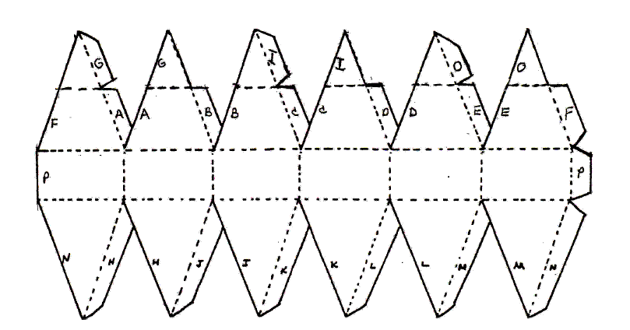
This is a pattern for a diamond crystal. When put together you can make a neckerchief slide for the 75th anniversary of Cub Scouting.
- Enlarge to appropriate size then make a copy of this page onto cardstock.
- Cut out pattern and a 75 years diamond logo.
- Now, be sure to cut down to the dotted line on the tabs. Folding over on each dotted line, crease up. This way all the lines will be inside your diamond at the end.
- Next, with a glue stick, glue the tabs H to H, J to J, K to K, L to L, M to M, N to N, and P to P. This finishes the bottom. Next, glue A to A, B to B, C to C, D to D, E to E, F to F, G to G, I to I, and O to O.
- With last three points, glue each on top over the other to form a flat top.
- Now glue the 75th logo on one of the rectangles and on the opposite rectangle on the back. Hot glue a slide, which can be made out of pipe cleaners or PVC pipe.
- You can also enlarge this and make large diamonds to decorate your tables. Put a dowel the height of your diamond through the tip for support. You can then glue the last three tabs to the dowel.
Marbleized Stationary for Invitations
Baltimore Area Council
Materials:
Newspapers bucket water
white paper envelopes
stick, dowel or chopstick blue and gold spray paint
Directions:
- Cover the work area thickly with newspapers.
- Fill a bucket ¾ full of water.
- Spray blue, gold, or both spray paints onto the surface of the water in the bucket. Spray lightly, but cover the entire surface of the water.
- Take a piece of the white paper and dip one corner into the water and immediately pull it out again.
- Repeat with other three corners.
- Decorate the comers of an envelope to match.
- Place paper and envelope on newspaper to dry.
- When the paint in the bucket coagulates and dries it must be removed. Do this by putting the stick into the water and slowly moving it through the paint, which will stick to it until all the paint is on the stick. Put the stick onto the newspaper to dry.
- Spray fresh paint onto the water.
- You can then dip the sides and top and bottom of the white paper into the paint and marbleize it on all edges.
- Let dry.
- The center of the paper is still white, so you can now write your Blue and Gold Banquet Invitation in the middle and it will be easy to read.
Accordion Table Runner
Baltimore Area Council
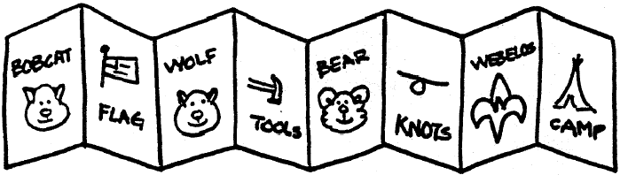
Use 5” x 7” cards that can be colored. Each boy makes drawing of a certain achievement or even a rank advancement. When all are done, then tape together to form an accordion look for the center of the tables.
Placemats
Baltimore Area Council
Even if you use paper tablecloths, placemats make the table look more festive. Here are some ideas for easy, fun placemats.
Marbleized
Equipment: White legal size paper, blue and gold paint, all equipment shown above. You can marbleize your placemats to match your invitations following the directions above and then have them laminated for the boys to take home and use again and again.
Waxed Paper Placemats
Equipment: Waxed paper, blue and yellow crayons, fruit peeler, iron Give each boy two pieces of waxed paper the size of a placemat. Shave pieces off blue and yellow crayons with a fruit peeler on one of the pieces of waxed paper and cover it with the other piece. Seal the paper and melt the crayon with a warm iron. Press slowly and uniformly.
Paw Prints Placemats

Equipment: Blue construction paper, potato, knife for carving, yellow poster paint Using a potato stencil (see Wolf - Elective 12) carved into a paw shape, cover a piece of deep blue construction paper with yellow paw prints.
Blue and Gold Twirlers
Santa Clara County Council
One way to show your Cub Scout colors is to hang an array of blue and gold twirlers at your Blue and Gold Banquet.
Supplies: Plastic coffee can lids, Marker, Scissors, String, Nail
Directions:
- Use a nail to poke a hole in the center of a plastic coffee can lid.
- With a marker, draw a spiral that starts 3/8 inch from the hole and gradually extends to the rim,
- Cut along the line with scissors.
- Knot an end of a piece of string, thread the other end up through the hole in the center, and the twirler is ready to hang up and spin.
- To spin, grasp each one at the bottom, twirl it around and around until the string is wound tight, let go and enjoy the show.
Blue and Gold Pin
Santa Clara County Council

This is an easy to make craft, and the Moms will be proud to wear it. Adult supervision is recommended for ironing.
Supplies:
About 60 Blue Perler Beads,
About 60 Yellow Perler Beads,
Perler heart-shaped form,
Special ironing sheet (comes with the Perler beads),
Iron and ironing board, Hot glue gun, Pin backing
Directions:
- Look at the picture above for an idea on how to lay out your beads on the heart-shaped form.
- Iron the beads per the manufacturer's instructions.
- Let cool completely.
- Carefully peel off the heart from the form.
- Hot glue the pin back to the side of the heart that has been ironed on.
- Give to the Moms to wear to the Blue and Gold Banquet, or any Pack Meetings.
Mini Music Shakers
Santa Clara County Council
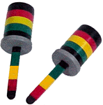
These are easy to make from empty film canisters and craft sticks.

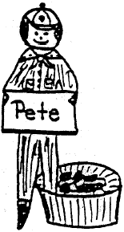
Supplies:
2 empty film canisters;
2 Craft sticks;
Colored vinyl tape;
Black marker or paint;
Rice, beans or beads;
Scissors
Directions:
- Paint the craft sticks black.
- Decorate the sticks and the containers using colored vinyl tape.
- Cut a slit in the tops to hold the craft sticks securely.
- Fill containers half full with rice, beans or beads.
- Replace the tops.
- Push in the crafts sticks.
3-Dimensional Star Centerpiece
Santa Clara County Council
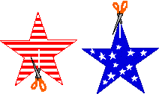


This 3-dimensional star decoration is made from 2 paper stars that are interlaced. These stars stand by themselves on a table, and make a great Blue and Gold Banquet table centerpiece.
Supplies:
Stiff paper (like card stock, oaktag or thin cardboard) or Styrofoam meat trays;
Scissors; Crayons or markers (optional)
Directions:
- Two paper stars are needed to make one 3-dimensional star. Either draw two identical stars on a piece of stiff paper or print out a star template.
- Decorate the two stars (if you like) on both sides, and then cut them out.
- Make one slit in each star. On one star, the slit goes from an inner corner to the center point of the star; on the other star, the slit goes from an outer corner to the center point.
- Slip the two stars together through the slits you just cut. For stability, you may have to tape the stars a bit where they meet at the slits.
Clothespin Cub
Baltimore Area Council
Paint a clothespin to resemble a Cub Scout. Cut out two paper arms, and glue them to the sides, facing outward. On a small piece of paper, print the boy’s name and glue the paper in the Cub’s hands. Glue the Cub to a cardboard circle securely, so that the Cub will stand erect. For a favor, you can tape the Cub to a nut cup with one leg in and one leg out of the cup. Serves as a nut cup and nametag. Make sure there are enough for parents and guest.
Egg Cup Corsages
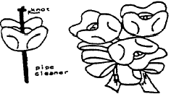
Baltimore Area Council
Use colored egg cartons if available, or otherwise use regular pulp cartons and paint with acrylic paint. Each flower is a section of an egg carton with the sides cut into rounded petals. Knot the end of a gold pipe cleaner and insert the other end through the center of the flower. This makes the flower center and also a stem. Combine several flowers by twisting stems, Finish with ribbon tied into a bow. Use a safety pin to pin to Mom.
Flag Placecard
Baltimore Area Council
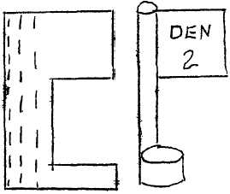
QUICK PAPER FLAGS can be made by folding a rectangular piece of construction paper in half. Crease then unfold. Cut out a section from one end. Decorate “flag area.” Roll the other end of the rectangle to form a flag pole. Next roll the base part to form a stand. Glue is applied to the last roll of the pole and to the end of the base. Use various of these quick flags to display historic flags or Den flag.
Write person’s name on the flag base.
Foam Ball
Great Salt Lake Council
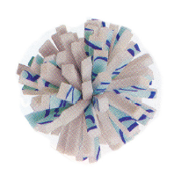
Material: 1 square foot of foam carpet padding, Permanent markers, 1 nylon zip tie, Pliers
Directions:
- To make your ball more colorful, draw some squiggly lines on the coated side of the foam and let dry.
- Use scissors to cut the foam into 24 strips, each a foot long by a ½ inch wide,
- Then cut each strip in half to make forty-eight 6-inch strips.
- Stack all the strips together and hold them tightly while another person wraps a nylon zip tie around the center of the stack.
- Use the pliers to pull the tie tight, and then snip off excess.
- If the ball is not spherical, use the scissors to trim
- it to your liking.
Tennis Ball Buddy
Great Salt Lake Council
Material:
Tennis ball any color Screw eye hook
2 pipe cleaners Craft foam any color
Fake fur 2 wiggle eyes
String Permanent marker
Tacky glue or hot glue gun Push pin
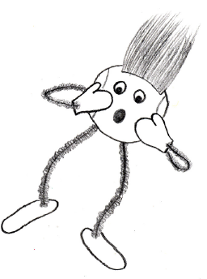
Directions:
- Use a push pin to make 4 starter holes in the ball for limbs,
- Then twist in a screw eye and remove it to enlarge each hole. Make another hole in the top of the ball but leave in the screw eye for the hanger.
- Cut 2 pipe cleaners in half and push the ends into the holes for the arms and legs.
- Cut hands and feet from the craft foam, poke the ends of the pipe cleaners through the shapes, and twist the pipe cleaners back on themselves to secure.
- Decorate using tacky glue or hot glue to attach wiggle eyes, fake fur, and other stuff. Draw with a permanent marker. Tie a string to the screw eye and hang where you want.
Patterns for Placemats or Masks
Baltimore Area Council
Enlarge this pattern to approximately 7 inches for masks
Even larger for Placemats
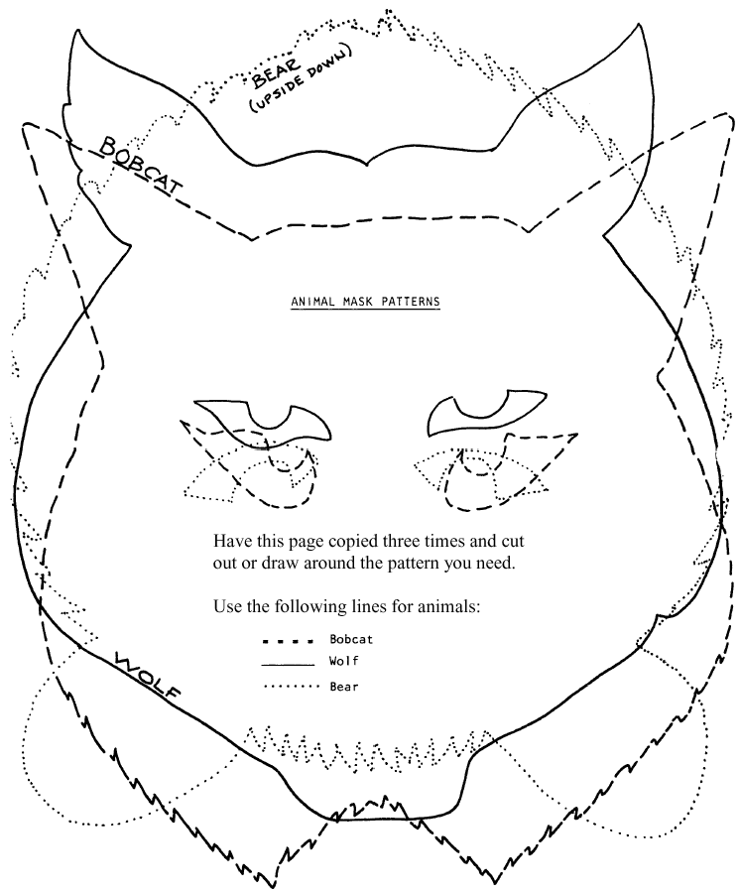

AUDIENCE PARTICIPATIONS
The Great Cub Scout
Baltimore Area Council
Break audience into four groups assign each group a part and a motion. Have everyone respond on CUB SCOUT Practice responses as you are assigning parts. Have ach group give the Cub Scout sign as it says its part.
FOLLOW - A Cub Scout Follows Akela (Give sign)
HELP - The Pack Helps the Cub Scout Grow (Give sign)
GIVE - A Cub Scout Gives Goodwill (Give sign)
PACK - A Cub Scout Helps the Pack Go (Give sign)
CUB SCOUT - Do Your Best (Give sign)
This is the story of a CUB SCOUT who wanted to do something to HELP his neighbor. She was a widow, and much too old to do very much for herself.
This CUB SCOUT wanted to FOLLOW the advice of his PACK leaders, who asked every CUB SCOUT to find some way they could GIVE HELP to someone else.
The best way he could think of to HELP his neighbor would be to shovel the snow off her driveway for her. But it was such a big driveway and he was such a little CUB SCOUT.
So he thought some more and decided he would go and talk to his PACK leaders and see if they could think of a way to HELP him. The PACK leaders said they would ask if any other CUB SCOUTS would like to HELP.
So what started with only one CUB SCOUT was soon being done by two CUB SCOUTS then three CUB SCOUTS then four CUB SCOUTS then five CUB SCOUTS.
(Continue adding CUB SCOUTS
until the audience starts to laugh.)
The moral of this story is that if you FOLLOW the advice of your PACK leaders, and GIVE HELP to those around you; you too could be a great CUB SCOUT.
A Very Special Birthday Party
Baltimore Area Council
Divide audience into four groups to respond with the following:
DEN LEADER: “Oh boy!”
CUB DEN 1: “Oh boy, oh boy!”
BIRTHDAY CAKE: “Happy birthday to you” (sung)
BIRTHDAY PARTY: “Yippee!”
This is a story of a DEN LEADER, CUB DEN 1, and a BIRTHDAY CAKE. One Thursday afternoon, as CUB DEN 1 was meeting at the home of their DEN LEADER, Mrs. Reid, the boys overheard her on the phone say “It will be a very special BIRTHDAY PARTY. “
“BIRTHDAY PARTY?” they said, to each other, “whose BIRTHDAY PARTY?” “That’s a neat idea, “ said Johnny. “Let’s have a BIRTHDAY CAKE, “ said Mike and Ike. “Swell, “ they all said.
So each went home and made special plans for the next Den meeting and the special BIRTHDAY PARTY for their DEN LEADER.
Den Meeting day dawned bright and sunny. At 3:30 all five boys arrived at their DEN LEADER’S house. Mike and Ike brought a BIRTHDAY CAKE. Jimmy brought paper hats, Johnny brought balloons and Billy brought ice cream for the BIRTHDAY PARTY.
As they trooped in the door, they all yelled, “Surprise! We’re having a BIRTHDAY PARTY”. Mrs. Reid, their DEN LEADER looked shocked. “My BIRTHDAY PARTY? Why? It’s not my birthday. “
But we heard you talking about a special BIRTHDAY PARTY on the phone last week, said Jimmy. “Oh,” said their DEN LEADER, and smiled. “It’s Cub Scouting’s birthday,” she said. “Cub Scouting is 75 years old this month. But I think this is a wonderful idea. We’ll just celebrate a little early. “
And so they did. And that is how CUB DEN 1 and their DEN LEADER had a very special BIRTHDAY PARTY!

ADVANCEMENT CEREMONIES
A History of Cub Scouting
York Adams Council
(Note that this and other ceremonies should be reviewed and modified to suit the specific awards being giving at the meeting. This ceremony is written so that any particular award can be used or omitted without impacting the whole of the ceremony.)
We all know that the Boy Scout movement in America was started by William Boyce after he was directed to an address in London by a boy who refused a tip because he was a Scout. Mr. Boyce was so impressed by his talk with Lord Baden-Powell that he helped incorporate the Boy Scouts of America of February 8, 1910. It is this date that we celebrate each year with our Blue and Gold Banquet.
Almost as soon as Scouting began, younger boys started clamoring for a chance to participate in Scouting. This resulted in the Wolf Cub program being started in England in 1916. It wasn't until August 1,1929 that the first demonstration Cub units were started. By 1933, it was felt the time had come for promoting Cub Scouting as a part of the Boy Scout program.
As we read in the Wolf book the basis for much of the program came from THE JUNGLE BOOK by Rudyard Kipling. In this book is the story of two wolves who find a man cub who is being hunted by SHERKAN, the tiger. They take in the boy, whom they name Mowgli, (which means frog) and raise him as part of their family.
The wolves are part of a pack, which is led by Akela, the great gray Lone Wolf. Once a month, the new cubs are presented to the pack for acceptance. If two members of the pack do not accept them, they are turned out. When Mowgli was presented to the council, none of the other wolves would speak for him. Just as Mother wolf was ready to give up. Baloo, the kindly brown bear who taught the wolf cubs the Law of the Jungle stood up and said, "I will speak for the man cub." When no one else spoke, Bagheera, the black panther rose and offered to pay one bull if the man cub would be accepted into the pack. And so it was that Mowgli became a part of the Wolf Pack, for the price of a bull and on Baloo's good word.
In looking back at old Cub Scout books, we are reminded that the Cub Scout program has survived with very little change. In a 1934 Cub Book, the rules for becoming a Bobcat are:
◊ He has taken the Cub Promise.
◊ Explained & repeated the Law of the Pack.
◊ Explained the meaning of the ranks.
◊ Shown the Cub sign and Handclasp.
◊ Given the Cub Motto and Cub Salute.
Today as Bobcats, we must do the same requirements. When Akela says that we are ready, we are presented to the Pack or recognition.
(BOBCAT)
(List names of Bobcat recipients and call them with their parents to the front of the room.)
(Hand parents the awards to present to the boys and congratulate them with the Cub Scout handshake. Offer an applause and ask them to take their seats.)
Just as the Wolf cubs learned about the world around them by taking short trips into the woods, so have our own Cubs grown in their understanding of nature and of their families.
(WOLF)
(List names and invite them with their parents to come forward)
(Hand out badges to parents to give to the boys. Congratulate them and offer a suitable applause. Have them sit down.)
Originally, only two arrow points could be earned for each rank. The basic rank was called the Bronze Badge. The first ten electives earned the Cub the Gold Rank, and the next ten elective the Silver Rank. Today we award the Gold Arrow Point for the first ten elective and Silver Arrow Points for each ten additional electives.
(ARROW POINTS)
(List names and invite them with their parents to come forward.)
(Hand out badges to parents to give to the boys. Congratulate them and offer a suitable applause. Have them sit down.)
Just as Baloo the kindly Bear, taught the young Wolves the secret names of the trees, the calls of the birds and the language of the air so must each of you help others in you Den in order to meet the requirements for Bear.
(BEAR)
(List off Bear candidate names and invite them and their parents to the front of the room.)
(Hand parents the awards to present to the boys and congratulate them. Offer an applause and ask them to take their seats.)
Up until a few years ago, the next rank was Lion. In 1967, this was dropped and the Webelos program expanded to cover an entire year. The Webelos Colors (GOLD representing the Pack; GREEN, the Troop, and RED the Explorers) and 15 activity badges were added at this time. A new Webelos Badge was also created and the original Webelos Badge retained as the Arrow Of Light.
The Webelos rank is the transition between Cub Scouting and Boy Scouting. Originally the name was derived from the three ranks: Wolf, Bear, Lion and Scouts. To become a Webelos requires a further expanding of one's horizons. Activity Pins must be earned and involvement in Church and Civic activities are encouraged.
(List names and invite them with their parents to come forward.)
(Hand parents the awards to present to the boys and congratulate them. Offer an applause and ask them to take their seats.)
The Arrow of Light is the highest award in Cub Scouting. It can also be worn on the Boy Scout uniform in recognition of your achievement. To be standing here tonight, means that you have reached the highest point along the Cub Scout trail. Do not stop here for the trail leads on to Boy Scouting and great new adventures that can only be dreamed about for now.
(ARROW OF LIGHT)
(List names and invite them with their parents to come forward.)
(Hand boys the parent's Arrow of Light pins to present to their parents. Then give parents the awards to present to the boys and congratulate them. Offer an applause and ask them to take their seats.)
Jungle Book Advancement Ceremony
Circle Ten Council
This a lot to do for the Cubmaster – split it up ad add in Assistant Cubmaster and Committee Chair and such. CD
Characters:
Cubmaster
Person offstage to shout part of Bandar-log
Cub Scout boys can be the Monkey People
Cubmaster You know that our lives today are much like the jungle that Mowgli lived in. Oh we don’t have a real jungle, but we do have a pack, and we have lots of people like Baloo the bear that have taught you the law of the pack. We also have Akela, the leader, in many forms – I, your Cubmaster, along with your parents, teachers, and your ministers. We also have Bandar-log, the Monkey people. Remember that they are the ones who are only brave when the odds are in their favor. They don’t follow any of the laws. They are thoughtless and silly. They have no goals and are ready to lead you into things that are bad for you like drugs, alcohol, tobacco, and gangs.
Offstage Rules, rules, rules!!! We don’t like rules, come and play with us.
Cubmaster Ah, hear them call you?
Offstage (different voice) Be gone, Bandar-log, they belong to the pack . . . you can’t have them!
Cubmaster Oh, Bageera, the Black Panther is watching out for you. While he watches out for the Bandar-log, lets give out some awards that you have worked so hard for.
(Webelos pins)
Offstage The man cub is mine, give him to me!
Cubmaster Oh, no! That’s Shere-khan, the fierce jungle tiger.
Offstage The man cub is mine . . . give him to me!
Cubmaster No, Shere-khan, these cubs are in the pack and you can’t have them. Be gone with you. Boy, the bad guys are everywhere. He is gone now. Would the Wolves that are receiving rank and their parents and den leaders please come forward.
Cubmaster The Cub Scout promise and the Law of the Pack are your guideline in Cub Scouts as well as in your life. Following these will make the Monkey people, the Bandar-log and Shere-khan pretty mad at you, but the pack is behind you. Keep these laws and you will succeed where the Bandar-log won’t. Light the candle from the spirit of scouting candle and repeat with your den the Cub Scout Promise and the Law of the Pack.
Offstage Laws and rules, laws and rules, come with us, we break them all.
Cubmaster Den leaders, ignore them, present the awards.
- Would the Bears that are receiving rank awards please come forward with your parents and den leaders! Please light your candle from the spirit of scouting candle and say the Cub Scout Promise and the Law of the Pack. Den leaders please present the awards.
- Will the Tigers that are receiving rank awards please come up with your parents and den leaders. Tigers please light your candle from the spirit of scouting candle and say the Tiger promise and the motto with your den. Den leaders please present the awards.
Offstage Laws and rules, laws and rules – who needs them!
Cubmaster We all need them silly Monkey people. Rules make games fair; laws keep us safe. You can’t have the cubs . . .Now leave us alone; go somewhere else, we aren’t Monkey people. All boys who are earning gold and silver arrow points please come forward with your den leaders.
Cubmaster Ten activities have to be completed to earn each arrow point. The first arrow point that is earned is gold. The rest that you can earn are silver. These boys have been working hard and these arrow points show it. Den leaders please present the arrow points.
Cubmaster Will the Webelos that are receiving rank, please come forward with your parents and den leaders.
Offstage Give the man cub to me!!! I want him!!
Cubmaster Shere-khan . . .This/these boy(s) have earned their Webelos rank. They are not about to come with you, and we are not giving them to you. They know about the Cub Scout Promise and the Law of the Pack; they also know the Boy Scout Oath and the 12 points of the Scout Law . . . They will never come to you or the Monkey people. There is nothing here for you . . .go away.
Cubmaster Webelos (names) your choice has been made. You have earned the Webelos rank. You have worked hard and kept yourself physically fit. You know about the citizenship that is required for our society to succeed. You are ready for the emergencies that can come up at any time. You will always have choices to make in life. The Shari-khans and the Bandar-logs of this world will always be there to tempt you to join them. Light your candle from the spirit of scouting candle and say the Scout Oath and the 12 Points of the Scout Law with your den. Den leaders present the awards.
Shorter Jungle Book Ceremony
Great Salt Lake Council
Preparation Ideas and Suggestions:
- Use a Jungle Book theme for the banquet; and use it in giving the awards.
- Seat the group to receive awards in a circle, adults towards the back and boys in front on the floor.
- Cubmaster is dressed as Akela, leader of the pack, and the other leaders are dressed appropriately.
- Have the pack leaders role play the parts of Bagheera, mother wolf, and Baloo, and Webelos leader.
NARRATOR: This month we are celebrating the 95th annual birthday of Boy Scouting in America and Cub Scouting 20 years later, February 22, 1930. Cubs traditionally hold the Blue and Gold Banquet to celebrate this birthday. Cub Scouting builds character in boys. The blue stands for truth and loyalty; and the gold, cheer and happiness. In addition, the blue and gold of Cub Scouting helps to build spirit in the pack. And so, you can see how society over the years has benefited from Scouting. Let us all, through our efforts, make this the best celebration yet.
CUBMASTER: Who will speak for the Bobcats?
BAGHEERA: I Bagheera, will speak for the Bobcats. (Call new Bobcats forward with parents). These are the young ones, but they have already begun to show skills. I present them to the pack (present awards).
CUBMASTER: Now it is time for the wolves. Who speaks for the wolves?
MOTHER WOLF: I, mother wolf, speak for the wolf cubs. I have nurtured them and watched them grow as they learn the skills of the wolf. These young ones are ready to be recognized. (Wolves come up and are awarded with parents. Wolf den gathers and gives a wolf howl).
CUBMASTER: Next we are ready for the bears, who speaks for the bears?
BALOO: I, Baloo, will speak for the bears. I have taught them well the Law of the Pack. They have come far and are ready to be recognized by the pack. (New bears come up with parents and are awarded. Den gathers and gives bear growl.)
CUBMASTER: Now we are ready for the maturest members of the pack to be recognized. Who speaks for the Webelos?
WEBELOS LEADER: I speak for the Webelos (same scenario). Recite the meaning of Webelos.
CUBMASTER: I have looked over the members of the pack and I am proud to be their leader; would all of the members of the pack come forward and join in all a Grand Howl.
Baden-Powell Advancement Ceremony - All ranks
Baltimore Area Council
You can have one person read this or divide it into sections and have several people present. Minimizing the reading (memorization) always enhances a ceremony.
Tonight we are celebrating the birthday of Scouting and the 75th anniversary of Cub Scouting. Many of you know that Scouting started in England in 1907 when Lord Baden-Powell took seven boys to Brownsea Island for a camping experiment. But the roots go even farther back. In 1899, Baden-Powell was a Colonel in the British Army fighting the Dutch Boers in South Africa. Colonel Baden-Powell was in charge of a town called Mafeking. It was under siege by the Boers. The Boers shelled the town every day except Sundays. When that happened, everyone had to hide in trenches until the shelling stopped. Baden-Powell noticed that the last ones into the trenches and the first ones out were the young boys. He needed to keep these young lads from doing risky things and getting wounded. So he organized them into a Boys Corps. They ran messages from Headquarters to the troops and citizens, and they practiced Army Scouting skills. This helped him enforce discipline on them in a way that they could accept.
The food was running out, the Boer force was ten times the size of the British force, but Baden-Powell used his cunning to hold the town for 217 days, until British reinforcements could arrive and rescue the town from the Boers. When he got back to England, he found himself a National hero and a small book he had written for the Army, “Aids-to-Scouting”, was being used by British boys to play games of Scouting. He remembered those boys in Mafeking and what his Boys Corps did for them. He rewrote his book into “Scouting for Boys” in 1908 and Boy Scouting was born.
The tradition Baden-Powell started in Mafeking, we are continuing tonight. When the boys in Mafeking learned their Scouting skills, they were rewarded with a promotion in rank. So too, do Cub Scouts, after showing their abilities in certain skills, earn their ranks of Bobcat, Wolf, Bear and Webelos. Would the following Scouts and their parents please step forward? (read names of award winners) You have learned new skills and have shown yourselves ready for ‘promotion. Wear your new rank proudly like all Cub Scouts have for the last 75 years. (Read the name and award given, exchange the Cub Scout Salute, and let the parent pin on the award.) Lead a cheer after presentation of each award.
Blue and Gold Advancement
Baltimore Area Council
Props: All awards have been individually wrapped in blue and gold paper and ribbon as birthday gifts.
Setting: Narrator presents ceremony from front of room with three stacks of “Birthday Gift Awards” on a table in front.
The presentation talk is arranged in rhyming couplets. Narrator:
Tonight being Cub Scouting’s 75th Birthday Party,
it’s time to give presents so we won’t be tardy.
Our first presents go to Cubs that are new.
So we would like to award Bobcat badges to these few.
(Read names and give each a “Birthday Gift”.)
To celebrate their efforts and time
we’d like to award Wolf badges to these Cubs combined.
(Read names and give each his “gift”)
This next group of Cubs to be recognized tonight,
Richly deserve this gift by right.
The Bear badge they’ve earned take time and attention,
And work on their part too numerous to mention.
(Read names and give each Cub a gift)
(After names have been read and gifts given, present Webelos badges in much the same fashion, and then give the closing thought below:)
Enjoy these small gifts from Scouting
that you have worked to achieve.
But, remember, a gift is much richer by far
when you give instead of receive.
So please give what you have learned of Scouting
to others, tonight when you leave.
Let’s Celebrate
Circle Ten Council
Props – Party decorations, streamers, boxed gifts
Awards – Wrap the awards like presents. Have a large gift-wrapped box in which you put all the presents.
Cubmaster “We’re here to celebrate the advancement of (boy’s name(s)) to the rank of (rank). As his (their) efforts to advance has been a gift to us, we present him (them) now with his (their) awards. Let’s all join in singing (to the tune of Happy Birthday)
Happy (actual rank earned) Bobcat to you!
Happy Bobcat to you!
Happy Bobcat dear (name of Cub)
Happy Bobcat to you!
Note – might be fun to have party noisemakers instead of cheers so the audience can raise the roof!
GAMES
Blue & Gold Stringer
Baltimore Area Council
People at each table form a team. Give each team a blue or gold chenille stem and several buttons (as many as will fit on the stem). At the signal, the first person strings a button on the stem and passes it to the next player, who does the same. Continue until all buttons are on the stem. First team to finish is the winner.
Lean-Too
Baltimore Area Council
A good game for the Pack meeting to get the parents involved. The boys and parents stand in a circle by Dens holding hands. Everyone numbers off alternately one or two. On the signal, keeping legs and backs as straight as possible, the players who are “ones” lean forward toward the center of the circle, while the “twos” lean outward. Players counterbalance each other for support. Once the group has gotten its balance, slowly reverse the leaners. Then have the players see how smoothly they can alternate.
Table Upset
Baltimore Area Council
Can be played in a circle or with people sitting at tables (although this can be a little hectic). The leader stands in the middle of the circle or room and gives each person the name of something connected with a Blue and Gold banquet, such as a dish, knife, spoon, plate, place card, napkin ring, placemat, etc. More than one person can have the same name. The leader then makes up a dramatic story of a Blue and Gold Banquet. As he names each banquet item, the players with that item must rise, turn around and resume their seat. The leader may mention these items as many time as he chooses. Suddenly he says: “The table turned over.” At this signal, all players must change seats. The leader sits in an empty chair and the player left standing becomes the new leader.
Blue & Gold Smile
Baltimore Area Council
Divide the group or table into two teams and line them up, facing each other about 10 feet apart. Name one team “Blues” and the other “Golds.” Then flip a coin and call out the side that turned up, heads means Blue and tails mean Gold. If it comes up heads, the Blues laugh and smile while the Golds try to keep sober faces. The Blues, of course, try to make the Golds laugh. Any who do laugh must join the other team. Then flip the coin again.
Toss the String
Baltimore Area Council
You will need a ball of yarn or string for each circle. Have the group form one or more circles of 15 or less players. The boy with the yarn starts by calling out another boy’s name in the circle and tosses the yarn to him, being sure to hold the end of the string in his own hand. The boy who catches the ball must call out another name and toss him the ball, while keeping hold of the string. The object is to include everyone and create a spider web with the yarn. The leader then asks one boy to pull on his string while everyone else holds on. Ask how many boys can feel the string being pulled. Ask another one to let go of his string and see what happens to the web. Experiment with the web, have everybody pull or half of them pull. This would be a good time to talk to them about the importance of cooperation and team work. It is also an excellent time to discuss the need to help each other when help is needed, and doing it with a positive attitude.
Dressed for the Blue and Gold
Baltimore Area Council
Have the Dens line up for a relay, each with a suitcase filled with the following clothing: old hat, trousers, shirt, jacket or overcoat and tie. On signal, the first boy in each line races with the suitcase to the center of the room, puts on the clothing, and then scrambles back with the suitcase to the starting point. He then takes off the clothing and repacks it in the suitcase. The second boy repeats the performance and so on until all have finished. First team wins.
Bean Pick Up
Baltimore Area Council
Arrange the players around a table or kneeling in a circle on the floor. Give each a saucer with two toothpicks and 12 beans. On signal, see who can be the first to lift out five beans.
Blue and Gold Toss
Baltimore Area Council
One blue team and one gold team. Have two butter dishes, one blue and one gold. Each team has a specified amount of change to toss into the dishes. Team with the most points wins.
Catch A Bear, Wolf, Or Etc.
Baltimore Area Council
Equipment: cup, cut out figures of bears, wolves or etc.
Cut out figures you want to use. They must fit into the cup. Place numbers on the figures. Players all toss several figures in the air and try to catch them with the cup. Add the numbers on the figures caught.
Blue and Gold Balloon Bang!
Baltimore Area Council
Relay teams line up at equal distance from group of balloons. Each player races to the group of balloons in front of his line, blows up a blue or yellow balloon, sits on it to pop it and then races back to touch off the next player.
Blue and Gold Source
Baltimore Area Council
This game is played in pairs. A number of pieces of colored blue and gold construction paper are scattered around the room. Boys are in pairs, some are blue and some gold. Boys are tied together as a pair at ankles with blue ribbon for blue’s and yellow ribbon ‘ for gold’s. Have only as many paper pieces on the floor as you have pairs of boys. A tape player or radio is used for music. When the music stops, each pair must find their color paper and stand on it (only one pair on each sheet of paper). During the music, the Leader removes one sheet of paper so one pair will be without a color. The pair who cannot find their “color” when the music stops is eliminated. Action is repeated until one pair remains.
Nonverbal Birthday Line-up
Santa Clara County Council
This game can be played with children and parents. Have all the players try to line themselves up according to the month and day of birth, without any talking. The game is a lot of fun with a large group of people.
Long, Long, Long Jump
Santa Clara County Council
The object of this game is for the group of children to jump collectively as far as possible. The first player begins at a starting line and makes a jump. The next player starts his jump where the previous person landed. The players can attempt to improve their total collective distance on successive tries. This can be played indoors or outside, with a backward broad jump, forward long jump (standing or running), hop-skip-and-jump, and so forth.
Wagon Wheels
Santa Clara County Council
A wagon wheel is created by having about seven children facing each other and joining hands to form a circle. The wheel then moves in a circular motion around the walls of gym. Two or three children (the bottom of the wheel) have their backs touching the wall momentarily as the wheel spins along the wall. The fun increases as the wheel picks up speed. Try putting the wheel into reverse or changing the speed.
The wheel can stop by turning itself into a human hubcap. One child lets go of his teammate’s hand on either side and begins to turn toward the inside of the circle, drawing the line into the center. This coiling process continues until everyone, still holding hands, is wrapped into a human hubcap.
Pass the Baton
Santa Clara County Council
Have the group form a circle. Give one person a baton-like item, such as a paper towel roll. Have the group members say the words of the Pledge of Allegiance, a song, cheer, prayer, etc. The first person says the first word, and pass the baton to the person on his left. The second person says the next word, and passes the baton, and so on until someone makes a mistake. If a mistake is made, that person steps out of the circle. The next person says the correct word, and play continues until only one person is left. Repeat the game with the Cub Scout Oath, or a new song or prayer.
Tug of War in the Round
Santa Clara County Council
Get a large rope about 24-feet in length and tie (or splice) the two ends together to form a large round rope.
Four teams line up on the four sides of a square that is drawn on the ground.
In the center square, the rope is placed opened out into a circle.
The teams should be equal in size and each team member is numbered off.
The leader then calls a number, and the four kids (one from each team) with that number grab one side of the rope and try to get back across their team’s line.
As soon as a player crosses the line (pulling the rope), he is declared the winner.
Continue the game until everyone has had a try.
You can also try calling out several numbers at once.
Blind Sardines
Santa Clara County Council
This is a good game for large groups. You will need a blindfold for each player – neckerchiefs work great for this.
To play, one person volunteers to be the sardine. The sardine may choose to wear or not wear a blindfold.
All the other players wear blindfolds, and their objective is to come in contact with the sardine.
As the players roam around the room, when one player touches or bumps into another, he grabs the other player and asks, “Are you the sardine?”
The sardine must answer, “Yes” if asked.
Once a player finds the sardine, he must hang onto the sardine for the remainder of the game and becomes a sardine too.
Eventually more and more players are bumping into the line of sardines and adding themselves to the chain.
The game is over when everyone has become part of the sardine chain.
Domino
Santa Clara County Council
This is a game that is as fun to watch, as it is to play. It’s also easy to play and requires no props.
Teams line up in single-file lines parallel to each other. The lines should have the same number of people, and everyone should be facing toward the front of the line.
At a signal, the first person in each line squats, and then each person in turn squats, all the way to the end of the team’s line. (You cannot squat until the person immediately in front of you squats first.)
The last person in line squats and then quickly stands up again, and in reverse, each person stands up in succession, instead of squatting.
The first team with the person standing at the front of the line is the winner.
This game works best with at least twenty people in each line (the more the better). Have the teams try it several times for speed.
Alphabet Pong
Santa Clara County Council
This is a good game for a den activity. Have the boys from a circle, with each boy holding a book (hardcover) with both hands. One player takes a ping-pong ball, hits it with the book across the circle, and calls, “A.” The person on the other side then returns it to someone and calls, “B,” and so forth. The circle works together to see how far down the alphabet then can go before they miss. There is no particular order for hitting the ball. Anyone can hit the ball when it comes to him or her, but no one may hit the ball twice in a row.
Blind Volleyball
Santa Clara County Council
Split the boys into two equal teams. The two teams then get on each side of a volleyball court and sit down either on chairs or on the floor in rows, arranged like regular volleyball. Hang a blanket over the net so that a solid barrier is form and obstructs the view of the other team. The divider should also be low enough that players cannot see under it. Then play volleyball, using a big, light plastic beach ball instead of a volleyball. Regular volleyball rules and boundaries apply. A player cannot stand up to hit the ball.
Trust Tag
Santa Clara County Council
This game is played like regular tag, except that the players play in groups of two. One partner must wear a blindfold. His teammate guides him by keeping his hands on his blindfolded partner’s waist and shouting directions. The object is for the blindfolded player to tag another blindfolded player.
Bumper Box Relay
Santa Clara County Council
For this game, you will need a large refrigerator box for each team. Each player stands with the box over his head and the open end at his feet. At a signal, the players race to the opposite wall (or goal) and back while their team shouts directions to them from behind the starting line. The boxes can be decorated ahead of time at a den meeting.
Human Obstacle Course
Santa Clara County Council
Each team lines up single file behind a starting line. Ten additional team members are used as the obstacle course: a standing pole to circle around, a leg tunnel to go under, kneelers on all fours to leap over, sitters with outstretched legs to step in and among, another standing pole to circle around and back to the starting line. At the signal, the first person runs the course, then the next person, and so on. If an obstacle is missed or improperly executed, the runner must repeat that obstacle.
Ping-Pong Ball Relay
Santa Clara County Council
This is a good party game for a den meeting. Give the boys a ping-pong ball and a party blower (the type that uncoils when you blow it), and have them line up at the starting line. Each boy is to push their ball across the floor using only their blower. He cannot blow directly on the ball or touch it in any way with the party blower. The first one across the finish line wins.
PASS YOUR INSTRUMENT
Great Salt Lake Council
Materials Needed: none
How to Play:
Players sit on the floor in a circle.
Each player chooses an instrument they want to represent. He must then decide on an action that will represent that instrument.
To begin play, have everyone demonstrate their instrument's action. Then one player is chosen to be the Conductor and stands in the middle.
One player begins by making the sign of his instrument and then makes the sign of another player's instrument.
The player whose instrument's action was made must then make the sign of his instrument and then the sign of still another player's instrument and so on.
This is to be done without letting the Conductor see any of the actions. If the Conductor catches any player making the actions of an instrument that player becomes the new Conductor and the old Conductor sits in that player's place.
THE HANDY BALLOON GAME
Great Salt Lake Council
Materials Needed: Many balloons of various colors inflated
How to Play:
On the signal "go" all balloons are tossed into the air. Players then try to keep them in the air as long as possible by batting them up with their hands. You may want to give specific directions to go with different colors of balloons. For example, red balloons may only be hit with the left hand, green balloons may only be hit with the head, all other colors must be hit with the right hand.
Any balloons that fall to the ground are considered out of play and cannot be picked up and restarted.
After 30 seconds the game director sounds the signal to "stop" and the balloons still in the air are caught and counted.
Compare how many your group has left to other groups or the last time you did it. Or do it again and try and improve.
This is really fun when done as teams.
CUB SCOUT DRESS UP RELAY RACE
Great Salt Lake Council
Materials Needed: 2 sets of large or extra large Cub Scout, Boy Scout, den leader, or Scout leader uniforms, 2 American Flags in stands
How to Play:
- Flags in stands are at one end of the playing area. The two sets of clothing are in a back pack, bag or suitcase about half-way down the playing area.
- Divide players into two teams and have them stand in lines at the beginning of the playing area.
- On the word "go" the first boy in line runs to one set of clothing. He opens the container and puts on the clothing. He then runs the rest of the way to the flag.
- The player salutes the flag and runs back to the clothing container. He removes the clothing and puts it back into the container making sure to close and fasten the container.
- He runs back to the beginning and tags the next boy in line. The next boy repeats the process. This continues until everyone on the team has had a turn.
- The first team completely finished is the winner.

SONGS
CUB SCOUT SAGA
Great Salt Lake Council
Tune - Battle Hymn of the Republic
Our shirts have seen the coming of another Scout award,
The Bobcat first, the Wolf came next and soon the Webelos,
We’re proud to wear them cause we’ve earned them
Now the question is,
How do we stick them on?
Chorus
Glory, glory, hallelujah,
Do we pin them, do we glue them,
Gee, I got to hand it to ya,
Thanks, Mom, you got it on.
My Fav’rite Cub Things
Baltimore Area Council
Tune: My Favorite Things, from Sound of Music
Blue and gold streamers and Den centerpieces,
Fun night for parents and nephews and nieces!
Indian dancers singing and cheering--
These are a few of my fav’rite Cub things
Feasting and friendship and families together,
Red, white, and blue and lots of cold weather!
Brownies and cupcakes, birthday for Scouting--
These are a few of my fav’rite Cub things!
Recognition! Pinewood derbies!
Outings to the zoooo!
All these are a few of my fav’rite Cub things
And I hope that they’re-yours too!
Tuna with noodles, hot Chinese dishes,
Spaghetti dinners and barbeque chicken
Medals and ribbons and awards galore
These are a few of my fav’rite Cub things!
Blue and Gold
Baltimore Area Council
Tune: Jingle Bells
While dashing all around
To prepare for Blue and Gold,
The boys made napkin rings
And placemats to behold.
The nut cups they were neat.
The nametags were just right.
Oh, what fun it is to have a
Blue and Gold tonight.
Chorus:
Oh Blue and Gold, Blue and Gold,
Banquet time again
Families gathered all around
Waiting to chip in.
Fried chicken and baked beans
Potato salad, too.
A piece of Birthday cake
Enough for me and you
Some people ate too much
But we all enjoyed the meal.
The friendship here tonight
Was warm and true and real.
Chorus
Gold and Blue
Baltimore Area Council
Tune: Michael Row the Boat Ashore
We are true to the Gold and Blue Hallelujah
We are true to the Gold and Blue Hallelujah
The sun is gold and the sky is blue Hallelujah
The sun is gold and the sky is blue Hallelujah
Cubs are bright and Cubs are true Hallelujah
Cubs are bright and Cubs are true Hallelujah
I've Got That Scouting Spirit
Great Salt Lake Council
This is a Classic that fits this theme very well CD
I've got that Scouting spirit up in my head, up in my head, up in my head.
I've got that Scouting spirit up in my head, up in my head to stay.
2. I've got that Scouting spirit deep in my heart…
3. I've got that Scouting spirit down in my feet…
4. I've got that Scouting spirit all over me…
Cub Scouts, Cub Scouts
Liz, Chief Seattle Council
Tune - New York, New York)
Cubs spread the news, come join us today
I want to be a part of it, Cub Scouts, Cub Scouts
These hiking shoes, are longing for trails
Camping and outdoor fun—Cub Scouts, Cub Scouts
I want to help out in the town, I grew up in
and find I’m doing my best—spreading goodwill
These Tigers & Wolves, are going to Bears
Than on to Webelos here we go--to the Boy Scouts
When we can make it here, we’ll make it anywhere
It’s up to you --Cub Scouts, Cub Scouts
Cub Scouts, Cub Scouts
I want to help out in the town, I grew up in
and find I’m doing my best—spreading goodwill
Helping our neighbors, service to all
These Tigers & Wolves, are going to Bears
Than on to Webelos here we go--to the Boy Scouts
When we can make it here, we’ll make it anywhere
It’s up to you --Cub Scouts, Cub Scouts
Cub Scouts!!!!!!!!!!!!!!!!!!!
Our Cub Scout Family I
Santa Clara County Council
Tune: The Addams Family
- Add sound effects & snap fingers between verses
Our Cub Scout pack is growin’
With lots of Cub Scouts showin’
The Cub Scout Spirit glowin’
Our Cub Scout family.
With Tigers, Wolves, and Bears
And Webelos who care
To live the Cub Scout Promise
Our Cub Scout family.
Our Cub Scout Family II
Santa Clara County Council
Tune: The Brady Bunch
- Adjust for # of boys in Pack
Here’s the story
Of our Cub Scout Family
Filled with 30* very active Cub Scout boys
All of them had lots of fun in their dens
Making lots of noise.
Once a month all the Cub Scouts go together
In our monthly pack meeting
With songs and games and lots of fun
With out Cub Scout Family.
Our Cub Scout Family,
Our Cub Scout Family,
Lot of fun with our Cub Scout family.
Our Cubmaster Had a Pack
Baltimore Area Council
Tune: Old MacDonald
Our Cubmaster had a Pack E-I-E-I-O
And in this Pack, he had some Dens E-I-E-I-O
With a Tiger Den here and a Tiger Den there,
Here a Tiger, there a Tiger, everywhere are little Tigers.
Our Cubmaster had a Pack E-I-E-I-O.
Repeat with Wolves, Bears, Webelos and Parents
Blue and Gold Family
Baltimore Area Council
Tune: Clementine
Boys: We’re the Cub Scouts.
Adults: We’re the parents.
All: Here we are, both young and old.
Here we are, both young and old.
Altogether we’re a Cub Pack
Having fun at Blue and Gold.
Boys: We’re the Bobcats
Wolf and Bear Cubs
And the Webelos are we.
Altogether we’re a Cub Pack
Having fun in harmony.
Adults: We’re the mothers.
We’re the fathers.
Helping Cub Scouts as they go
Up the ladder of achievement
Climbing higher as they grow.
All: Let’s give thanks on
This occasion
To the mighty Gold and Blue.
Pack _____ is the number
Representing me and you.
Happy Birthday Cub Scouts
Baltimore Area Council
Standard Happy Birthday Tune for all following
Cub Scouting -- Hooray!
Shout it out loud and clear,
For it is our Birthday,
Happy 75 years.
For Scouting we cheer,
Our Birthday is here,
The meaning is clear,
HAPPY 75 years!
To all Bobcats and Wolfs,
Bears, and Webelos too,
We sing Happy Birthday,
Happy 75 years.
Happy Birthday Cub Scouts,
We send up this cheer,
DO YOUR BEST always counts,
Has for 75 years.
Cubbing’s Birthday
Baltimore Area Council
Tune: “Auld Lang Syne”
Should Cubbing’s birthday be forgot)
No, not by Cubbers here.
Should Cubbing’s birthday be forgot
And fun we’ve had all year.
Oh, Cubbing’s fun and learning too
For any boy, and so
Let’s keep our Cubbing light aglow
So everyone will know.
Cub Scout Vespers
Tune: Oh, Tannenbaum
Softly falls the light of day,
As our campfire fades away.
Silently Cub Scouts should ask,
Have I truly done my task?
Have I helped the Pack to go?
Has the Pack helped me to grow?
Have I stood above the crowd?
Have I made Akela proud?
As the night comes to this land,
On my promise I will stand.
I will help the Pack to go,
As our Pack helps me to grow.
Yes, I’ll always give goodwill,
I’ll follow my Akela still.
And before I stop to rest,
I will do my very best.
Thanks to Ron in Marin County Council for the second verse
CUB GRUB
Blue and Gold Marble Cake:
Ingredients:
Box of cake mix, your choice of flavor
Your favorite homemade or canned frosting, white or yellow tinted
Fresh blueberries or blue jellybeans or blue M&M’s
Yellow or blue sugar sprinkles, optional
Directions:
- Bake a two-layer cake, following instructions on box.
- Cool the cake.
- Frost the cake.
- Place a ring of blueberries or jellybeans or M&M’s around the perimeter of the top of the cake.
- Do the same around the bottom edge.
- Place more berries or jellybeans around the sides of the cake, forming additional rings or zigzag patterns.
- Sprinkle with colored sugar sprinkles if desired.
Blue and Gold Mints
Baltimore Area Council
To make blue and gold mints for banquet:
Ingredients –
6 tsp. butter or margarine
3 Tbs. peppermint or spearmint flavor
3 Lbs. powdered sugar
7 Tbs. Water
food coloring
Dash of salt
Directions:
- Cream the butter;
- Add flavoring, salt and water.
- Combine with 2 lbs. powdered sugar.
- Blend in mixer and knead mixture with remaining sugar. (First divide in half if you want more than one color)
- Knead to right consistency.
- Cut or shape mints.
- Spread on cookie sheet and refrigerate.
- Cover and refrigerate unused mixture to keep from hardening.
Duff’s Gold Mine Salad:
Baltimore Area Council
From Boy’s Life Magazine; January 1989
Ingredients:
Lemon gelatin mix
Canned pineapple chunks
Small Blueberries, whole
Directions:
- Follow gelatin package instructions.
- After gelatin is thickened but not fully set, stir in the other ingredients.
- Chill until set. Mold if desired.
- Garnish with blue berries.
Banquet Treats:
Baltimore Area Council
Ingredients:
1 cup peanut butter
¼ cup mashed bananas
¼ cup cocoa
2 teaspoons vanilla
crushed cereal or cookies
Directions:
- Mix 1st four ingredients together.
- Shape into walnut-size balls.
- Roll in crushed cookies or cereal.
- Store in refrigerator or freezer.
Heavenly Hash
Santa Clara County Council
Ingredients:
2 cups cold cooked rice
1 8¾-oz can crushed pineapple
¼ cup sliced maraschino cherries
1 cup miniature marshmallows
Dash salt
1 cup whipping cream
Lightly mix rice, drained pineapple, cherries, marshmallows and salt. Chill well. Just before serving, whip cream and fold into rice mixture. Pile into dessert dishes and top with additional cherries, if desired.
Makes 6 servings.
Hot Apple Cinnamon Fluffs
Santa Clara County Council
Ingredients:
32 oz apple juice or apple cider
7 oz marshmallow cream or fluff
1 tsp vanilla
1 tsp cinnamon
½ tsp nutmeg
Heat apple juice and pour into 4 mugs. Put marshmallow fluff in stainless steel bowl and fold in vanilla, cinnamon, and nutmeg. Spoon the marshmallow mixture on top of the warm juice and serve.
Makes 4 servings.
Valentine Floats:
Baltimore Area Council
Ingredients:
32 oz. bottle cranberry juice cocktail, chilled
12 oz. bottle raspberry soda water, chilled
Raspberry sherbet
Fresh raspberries, chilled or frozen raspberries, thawed
Directions:
- In large pitcher, stir together juice and soda water.
- Spoon a little sherbet into each glass,
- Top sherbet with fruit.
- Fill glasses with mixture in pitcher.
- Garnish with sprig of mint and raspberry, if desired.

Homemade Ice Cream
Great Salt Lake Council
Ingredients:
4 eggs 3 cups sugar ½ tsp. salt
6 cups milk 1 qt. half & half 2 Tbsp. vanilla
Directions:
Beat eggs until light, gradually adding sugar and salt.
Pour in milk and half & half.
Mix vanilla in, stir,
Pour into ice cream freezer container and freeze.
Ice Cream 2
Great Salt Lake Council
Ingredients and Stuff:
2 - 1 quart Zip top Bags ¾ cup milk
2 - 1 gallon Zip top Bags 1 cup whipping cream
1 8 lb. bag of ice 1/3 cup sugar 1/2 cup rock salt
½ tsp. Vanilla Newspaper Duct Tape
Directions:
Place all ingredients in 1 qt. bag (squeeze out all the air),
Then place inside another quart bag.
Place into a gallon zip top bag.
Fill gallon bag with ice and rock salt.
Seal the bag then place into another gallon bag.
Wrap in several layers of newspaper and tape all sides to hold a ball shape.
Toss back and forth for about 15 minutes.
Skor Bar Cake
Great Salt Lake Council
Ingredients:
1 chocolate cake mix
1 jar caramel topping
1 can Eagles brand sweetened condensed milk
1 large container of whipped cream
4 Skor candy bars
Directions:
Bake cake as directed. Let cool.
Poke holes in cake with bottom of wooden spoon.
Mix caramel topping and sweetened condensed milk together,
Pour over the top of the cake.
Spread whipped cream over cake.
Top cake with crushed candy bars.
Dump Cake
Great Salt Lake Council
Ingredients:
2 cans pie filling (any flavor)
1 box yellow cake mix
1 cup walnuts
1 cup butter
cool whip
Directions:
Spread pie filling in 9”x 13” pan.
Sprinkle cake mix over pie filling. Top with nuts.
Melt butter and drizzle over top.
Bake at 350 degrees for 30 - 45 minutes.
Top with whipped cream.
Ice Cream Cone Cupcakes
Great Salt Lake Council
Ingredients:
1 cake mix (any flavor)
Ice cream cones with flat bottoms
Directions:
Mix cake mix as directed.
Place ice cream cone in muffin tins, so they will stand up. Fill ice cream cones half full of cake mix.
Bake as directed on cake mix box.
Decorate with frosting and sprinkles.

STUNTS AND APPLAUSES
CHEERS
Great Salt Lake Council
Divide into two groups.
Group One: "I like Cub Scouts; yes, I do! I like Cub
Scouts; how about you?" Points to Group Two.
Group Two: Responds in same manner.
Continue taking turns for a couple of rounds.
Cub Scout Yell
Great Salt Lake Council
Rip, Rap, Rap! Rip, Rap, Ree!
Loyal Happy Cub Scouts are We!
Do Your Best! Be Prepared! Shout! Shout! Shout!
Wolf Cub! Bear Cub! Webelos Scout!
Baltimore Area Council
Cub Den Cheers - Use these cheers separately for Den awards or have the boys do all four at one time to see who can cheer the loudest.
- Tigers yell ‘We’re grrrrrreat!”
- Wolves howl,
- Bears growl and
- Webelos yell, “We all yell, Webelos are swell!”
Pack Cheer - The Cubmaster says, Clap your hands (everybody claps two times) “stomp your feet” (everybody stomps two times), then everyone yells together “Pack _____ can’t be beat!”
When I Do – You Do - Tell the group that when you applaud so should they, and when you don’t, they shouldn’t either. Use false starts throughout the evening to try and trick them up.
Do a Good Turn - Have the group stand up to applaud. They clap once, turn a ¼ turn and clap again, turn another ¼ turn and clap again, and continue like that until they have completed a full turn.
Great Job Applause - Group stands and says “GREAT JOB GREAT JOB GREAT JOB, getting louder each time.
Good Going Applause - Group stands and says “ GOOD GOING GOOD GOING GOOD GOING starting off loud and ending softly.
Well Done - Say well done then have the audience echo it back to you.
Cracker Cheer - Hold imaginary cracker in hand. Pretend to take a bite. Smile and say “MMMM,GOOOD
“Six” Gun Salute - Point finger into sky and say Bang bang six times, then blow the “smoke” away.
Fruit Salad - Pretend like your eating a watermelon, spit out seeds, then a cantaloupe, then a cherry. (for cherry, put finger in cheek bone and pop out of mouth)
My pack’s favorite of late is the Samurai Warrior Watermelon Cheer – Commissioner Dave
- Everyone holds their watermelon in their hands (Arms a little wider than shoulder width with palms up)
- Then they toss their “watermelons” into the air
- Next they pull their sword and slice through the watermelon while its above their head as it falls (a Samurai yell is appropriate here)
- Catch a piece of the watermelon after slicing (Arms a little wider than shoulder width with palms up. Give a loud thud as the watermelon falls into your hands)
- Now do a classic watermelon cheer
- You can make it a Southern Samurai watermelon cheer by adding a “Y’All” after spitting the pits. (I learned the Southern Watermelon Cheer from J. Clay Dean of Montgomery, AL, and James Phillips of Alexander City, AL, while at NJLITC at Schiff Scout Reservation in 1963. We were in the Wolf Patrol of Troop 249 with Jim Walker as Scoutmaster and Ron Geddes as SPL. I saw Clay and Jim the next summer at the 1964 Valley Forge Jambo but never since. Any other 1963 NJLITC vets out there??)
RUN ONS
TALL TREE Run-on
Great Salt Lake Council
The first person calls from out of sight: "Hey Fred, look! I'm in the top of a 100 foot tall tree."
The second person: “But Joe, we don't have any 100 foot tall trees in camp.”
First person: "Oh noooo....", screams as he is falling.
Baltimore Area Council
Did you hear about the birthday candle that was upset?
Those birthday parties really burn him up!
What kind of bird is like a car? A goose, they both honk
What pets are found in most cars? Car-pet?
What do you get if you mix an egg with a scientist?
An egg-spearmint.
What should a Cub Scout keep after he gives it away?
A promise.
What is it that always increases the more Cub Scouts share it? Happiness.
SKITS
The Story of Scouting Skit
Baltimore Area Council
Set Up: A pantomime skit with four scenes. Pantomime takes place, then curtain closes and narrator describes scene, allowing time for scenery changes.
Scene 1: Outdoor setting: artificial campfire in clearing. Several boys in shorts and T-shirts, setting up a tent. A man stands to one side, giving directions. Boys sent selves around campfire; man faces them, gesturing with his hands as if telling a story. Curtain closes.
Narrator. The date was July 29, 1907; the place Brownsea Island, off England’s southern coast. 21 boys and 2 men had set up a makeshift camp; their home for the next 2 history making weeks. The boys came from all over England. They were the first Scouts. The man was Lord Robert Baden Powell. (Curtain opens)
Scene 2: Street scene in London-lamp posts, road signs. Man is walking down street. He glances at his paper, looks around, obvious lost. He shakes his head, discouraged. A boy appears, pantomimes questioning the man, shows him the way. Man offers boy money; he refuses, smiles and walks away. Curtain closes.
Narrator: Two years later. The place was London. The man was William D. Boyce, a Chicago businessman, lost in the fog. The boy helped him to his destination; but refused a tip; explaining that Scouts do not accept money for doing a good turn. Boyce visits with Baden-Powell and finds out about Scouting.
Scene 3: Steamship in Background. Boyce is boarding. Carries luggage. Sign nearby points to America. Curtain closes.
Narrator: When Boyce boarded the transatlantic steamer for home, he was afire with enthusiasm about Scouting. His suitcase was full of ideas. On February 8, 1910, he incorporated the Boy Scouts of America, in Washington, D.C. Four years later the B.S.A. was granted a Federal Charter by Congress. (Curtain opens.)
Scene 4: Small group of boys with woman in old-style uniforms. They are working on a craft protect around table. U.S. map in background. Curtain closes.
Narrator: Cub Scouting began in the United States in 1930, when boys of a younger age asked for a program of their own. The first year, there were five thousand Cub Scouts registered.
Scene 5: (Curtain opens to reveal three boys in today’s Cub Scout uniform; saluting the U.S. flag.)
Narrator: And now, 75 years later, there are more than two million Cub Scouts in our country. And Scouting continues to grow. (Curtain)
If I Weren't a Cub Scout ...
Great Salt Lake Council
Tune: This is the Music Concert
Seeing this done at least once is a treat. Each person must act out his part s he sings it. Each singer calls out what he would be then sings his verse twice. Then keeps singing t as each other person joins in with their part. In the end everyone is singing over the top of everyone else and all are moving.
Plumber steps out, says his line and then sings his verse twice, then he steps back and all do chorus
Carpenter steps out, says his line and then sings his verse twice. Then Plumber steps up and Carpenter and Plumber each sing their verses twice. Then they both step back and all do chorus
Teacher steps out, says his line and then sings his verse twice. Then Carpenter steps up and Carpenter and Teacher each sing their verses twice. Then Plumber steps up and Teacher, Carpenter and Plumber each sing their verses twice. Then they step back and all do chorus
Hippie steps out, says his line and then sings his verse twice. Then Teacher steps up and Teacher and Hippie each sing their verses twice. Then Carpenter steps up and Carpenter, Teacher and Hippie each sing their verses twice. Then Plumber steps up and Hippie, Teacher, Carpenter and Plumber each sing their verses twice. Then they step back and all do chorus
And so forth. Make up your own verses, too
Chorus:
If I were not a Cub Scout, I wonder what I'd be
If I were not a Cub Scout, a ......

- A plumber I would be - Plunge it, flush it, look out below!
- A carpenter I'd be - Two by four, nail it to the floor!
- A teacher I would be - Sit down, shut up, throw away your gum!
- A hippie I would be - Love and peace, Hey Man! Cool Man! Far out! Wow!
- A laundry worker I’d be - Starchy here, starchy there, starchy in your underwear!
- A cashier I would be – Twenty-nine, forty-nine, here is your change, sir!
- A doctor I would be - Take a pill; pay my bill! I'm going golfing!
- A fireman I would be - Jump lady, jump... whoa splat!
- A cook I would be - Mix it, bake it; heartburn-BURP!
- A lifeguard I would be - Save yourself, man. I'm working on my tan!
- A Cubmaster I would be - Do this, do that, I'm gonna take a nap.
Scouting Spirit
Baltimore Area Council
Characters:
#1 Old man with cane dressed as ghost
#2 83 year old man with a sign stating age around neck
#3 35 year old man with sign stating age around neck
#4, #5, #6 Cub Scouts in uniform
(All enter and stand in order 1 thru 6)
#4, #5, #6: Who are You?
#3: I am the father of a Cub Scout. I too was a Cub Scout
#2: I was the first American Scout. I became a Cub Scout in 1930 when Cub Scouting came to America 75 years ago.
#1: I am the spirit of the 24 boys who with Baden-Powell began the Scouting experiment on Brownsea Island.
ALL: We are the spirit of today’s Scouts and Scouting movement. We wish a happy birthday to all Scouts. Won’t all of you join us in singing Happy Birthday to Scouting.
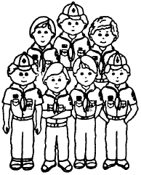
Blue and Gold Banquet Skit
Baltimore Area Council
You may want to use this for an opening or closing. CD
Preparation: Print large block letters with permanent markers on 8” x 10” sheets of white cardstock---the word BLUE in Blue, AND in black, and GOLD in red. Add silver stars to the letters. Printing parts on back of each card in big letters cuts memorization to a minimum.
Action: Boys hold up cards and say their parts in turn. 10 boys required
- B is for BOYS--Tigers, Bobcats, Wolf, Bears and Webelos
- L is for LEADERS--the Cubmaster who guides us
- U is for UNDERSTANDING--We learn to help others
- E is for EXCELLENCE--we try to “do our best”
- A is for ANNIVERSARY--Cub Scouting’s 75th
- N is for NEIGHBORHOOD--where Cub Dens meet each week
- D is for DEN CHIEFS--Scouts who help us in many ways
- G is for GOALS--for which Cub Scouting stands
- O is for OPPORTUNITIES--for boys to learn and do
- L is for LIBERTY--in the years to come
- D is for DEN LEADER--who loves and helps us
Blue and Gold Skit to Music
Baltimore Area Council
Tune: “I’ve Been Working on the Railroad”
Sing: Action:
I’ve been working on my Wolf patch,
Hold up Wolf patch sign
All the livelong day Wipe hand across forehead
I’ve been working on my Bear patch
Hold up Bear patch sign
Just to pass the time away. Pretend to look at wrist watch
Don’t you hear the Cub Scoutings shouting
Cup hands around ear
A Webelos we’ll soon be! Hold up Webelos sign
Can’t you hear Akela shouting, Cup hands around ear
Come and follow me! Come and follow me!
REPEAT CHORUS TWICE
( Sung by all the boys but one who blows the horn)
Tiger, won’t you blow Blow horn
Wolf, won’t you blow Blow horn
Bear won’t you blow your horn? Blow horn
Bailing Out
Santa Clara County Council
Cast: A Boy Scout, a priest, the Worlds-Smartest-Man, an airplane pilot
Scene: A crashing plane.
Setup: The group is flying in an airplane. The Worlds-Smartest-Man starts showing off his knowledge, telling the passengers all about the airplane, all about the country they are flying over, etc. He keeps bragging that he is the Worlds-Smartest-Man. Make it clear that one of the passengers is a priest and one is a Boy Scout.
Pilot: “I’m sorry folks, but the plane is going to crash. You’ll all have to bail out. I’m afraid there aren’t enough parachutes for everyone on board. But I’ve got mine! Good luck.”
(Pilot jumps out and disappears offstage in a free fall.)
Smartest-Man: “Well, the Worlds-Smartest-Man isn’t about to get caught without a parachute … I’ve got mine!”
(He freefalls offstage.)
(Priest offers last parachute to the Boy Scout)
Priest: “Here son, you take the last parachute.”
Boy Scout: “Thanks, but it’s no problem. I’ve got a parachute. The Worlds-Smartest-Man took my backpack!”
(The priest and the Boy Scout jump with their parachutes)
The FBI Office
Santa Clara County Council
Cast: A Cub Scout den, an FBI agent
Scene: An FBI office with mug shots on the wall.
Setup: A Cub Scout den is visiting an FBI office and stopped to look at the photographs of the ten most-wanted criminals.
(One of the Cub scouts points to a mug shot on the wall)
Scout: “Is that really a most-wanted criminal?”
FBI Agent: “Yes, it is.”
Scout: “Then why didn’t you keep him when you took his picture?”
CLOSING CEREMONIES
75th Birthday of Cub Scouting
Circle Ten Council
Have a small birthday candle at each Cub Scout table setting and have a larger candle on all tables. At the proper time, the Cubmaster announces that each Webelos Scout should come forward and receive a lighted candle to take to his table. After he reaches his table all other lights are turned off.
Cubmaster America’s manpower begins with boy power. As we light all our candles, you can see the room is growing brighter. (Cubs light their candles.) That is the way it is in Cub Scouting in our community as we increase our boy power. One Cub Scout may not be very big, but as our members grow we can light up all our homes and make everyone aware of our Cub Scout spirit. Let’s make Cub Scouting really shine with boy power (lights come on and candles are blown out. Do Your Best!
Cub Scouts We’ll do your best!
Baden-Powell Had A Vision
Circle Ten Council
The following closing could be done by a den of boys standing up front and reciting together the first eight lines or have one of them as narrator, take a few steps forward and say:
Baden-Powell had a vision,
That he made come true.
So now we can enjoy Scouting
And have fun while we do.
While he wasn’t an American,
He’s become famous to us,
Earning through America,
Our admiration and trust
Now may the Spirit of Scouting,
Be with both young and old.
As you remember again,
The meaning of Blue and Gold
May you strive for truth and spirituality.
In the warm sunlight under the sky above,
As you bring good cheer and happiness
With steadfast loyalty brought through love.
Happy 75th Birthday and Happy Scouting!
Cub Scouts
Baltimore Area Council
Prior to the meeting, prepare large cards with Letters on them for each Scout. Print the accompanying lines of text on the back of each card in large print. On cue, each Scout enters the stage area and presents his letter and words. Be sure to practice ahead of time and make sure everyone reads well and loudly enough to be heard.
- C stands for COURTEOUS, something that all Cub Scouts should be.
- U stands for UNIQUE, something that of our Cub Scouts are.
- B is for BOYS, without which there would be no Cub Scouting.
- S stands for SPECIAL, something that every Scouting volunteer is.
- C stands for CHARACTER, something developed by time in Scouting.
- O stands for OUTINGS, one of our favorite parts of Scouting.
- U stands for UNIFORM, we’re proud to be wearing ours.
- T stands for TALENT, something that each leader shares with the boys.
- S stands for SPIRIT OF SCOUTING, something that lives in the hearts of everyone involved in SCOUTING.
Cubmaster’s Minute
Do Your Best
Baltimore Area Council
One of the most important things to learn in life is to put forth your best effort when doing something. That is why we have the Cub Scout motto. As a member of this Pack, I hope you will put forth your best effort for the good of the Pack and for your own good.
Closing Thought
Baltimore Area Council
Those whom we seek to serve come our way but once – as boys. Neglect none of them – for somewhere among them may be the man who will lead the world to everlasting peace.
Good Hunting Closing
Circle Ten Council
You have wandered through the Jungle and your eyes have been opened to see many wonderful things. Now you go forward on your journey into the greater land of Scouting, and Akela and the pack speed you on your way with a cheery call of “good hunting.” You will never forget your days with the pack, one day, it may be that you will return to it and help other cubs to open their eyes in the jungle. Good Hunting.
WEBELOS
Webelos Graduation Arrows
Circle Ten Council
Start or continue a tradition, as each Webelos is crossing over from Cub Scouting to Boy Scouting – give each Webelos an arrow that marks his journey though Cub Scouts. Making the arrows is done “secretly” by the parents. It is also a great tradition to have the parents get together to make the arrows. It is great fellowship and friendship. These instructions are general in nature and you will want to adapt them to your own pack and pack traditions.
How to Make the Arrow
A. Materials needed:
Material needs to be as straight (as possible) 30 to 36 inch long by ¼ to ½ inch diameter shaft. A dowel can be bought, but natural sticks seem even more appropriate.
- Arrowhead – These are imitation real arrowheads. To use real ones is illegal in some areas. You can contact a Native American Organization and see if they can help you with arrows and materials.
- Fletching materials – Duck or Goose feathers work well or fletchings can be bought from sporting goods departments and stores. While one den tried to use real bird feathers, another den had a lost better success with turkey feathers dyed yellow and blue.
- Pseudo-Sinew – This can be bought from Native American craft suppliers and craft stores such as Tandy Leather. A large spool lasts a long time.
- PVC tape of various colors (red, blue, orange, yellow, white, green). If you can’t find orange, you can use white instead.
- Hot glue – this is to reinforce our knots on the arrowhead and to attach the fletchings which we know aren’t going to hold by themselves.
- Sharp knife and scissors – These supplies are needed to trim and cut stuff and to threaten whoever comes by and say, “You’re not done that yet?”
- Extras of all of the above – If we were perfect we would be God and we aren’t so we aren’t.
B. What to do:
If you are using epoxy glue that you need to mix ahead of time instead of hot glue, don’t mix it; it’s not time yet. It would be a good idea to plug in the glue gun now, though.
Clean up shaft as much as possible if it needs it. For arrow-wood, that means skinning it. For bamboo, it probably isn’t needed. While it’s not a listed supply, a vegetable peeler can be very effective for cleaning up and debarking, if desired. Work on the shaft until it’s close to neat and clean and straight as you are going to get it.
Notch the arrow-end of the shaft. You need to relieve the end of the wood as much as possible so the shaft doesn’t split when you stuff the arrowhead into the slot. Dry fit the arrowhead in the slot to make sure it fits. If it doesn’t, enlarge the slot as much as possible or cut a flat surface 1/2-inch along the end of the shaft, instead of having a slot.
Flatten shaft surfaces for fletchings. Fletchings are the feathers on the notch-end of the arrow. Typical arrows have three feathers at the end opposite the arrowhead. It’s a good idea because that’s that way it has always been done. Using the sharp knife, “skin” the three surfaces on the shaft where the feathers will be glued. These should start about 1/2 inch from the end of the shaft and should be about 3 inches long, spaced equidistant around the shaft.
Cut your fletchings. If pairs of people are doing this project, each pair should only need three feathers. One feather provides two fletchings; two feathers, four; and three feathers, six. And, if everyone did as they were told back in step 5, each person only needs three fletchings. Using new math: 3 fletchings/person x 1 feather/2 fletchings x 2 persons/team = 3 feathers/team
Anyway, using the sharp knife or scissors, split the feather in two by slicing/cutting it down the quill. Cut off the bare part of the feather quill. About two inches down from there, cut the feather at a 45-degree angle as shown.
If you are using epoxy that you need to mix ahead of time, mix it now because it’s needed for the next step.
Apply a liberal amount – but not too much – glue to the slot where the arrowhead goes. Insert the arrowhead and tie/wrap the sinew around the shaft and arrowhead. Leave the loose end of the sinew loose until the glue dries; then cut it off. The Native American Indians did not have store-bought glue to help them make arrows so you may want to limit the amount of it around the sinew and arrowhead to make it look as authentic as possible.
If you are using epoxy that you need to mix ahead of time, and you haven’t mixed it yet, you cheated or forgot to do the step before this one. Go do that step and then skip this one!
Smear some of the glue on one of the flat surfaces you carved for the fletchings. Gently but firmly put one of the fletchings in place where you smeared the glue. Try not to get your hand stuck to the shaft with the glue because the boys don’t like adults sticking to their arrows.
Repeat the last step for the other two fletchings.
If you want to, you can wrap some sinew around the shaft in front of and behind the three fletchings. This makes it look like the sinew is holding the fletchings in place.

How to Decorate the Arrow
Materials needed:
Colored tape or paints – Depending on how much patience you have, you can use either paints or pieces of colored tape to make the rings around the shaft to denote award levels for your Cub Scout. The colors are:
Metal silver and copper gold tapes for Arrow points are available from hardware and/or plumbing stores.
Feather for each award level. See color list below. Using feathers for the arrow points could be done too, if desired.
Tiger – orange Bobcat – yellow Wolf – red
Bear – green Webelos – blue
Arrow of Light – white
Glue – This is to stick the feathers to the arrow’s shaft or sinew. This is to tie and dangle the feathers from the shaft. If you use the sinew, you can also use beads and dangles to decorate the sting and feathers.
Sharp knife and scissors – These are needed to trim stuff and cut stuff.
Extras of all the above – if we were perfect . . . well you get the point.
What to do:
Make a list of the ranks your Webelos has attained and will attain by the graduation ceremony. This list should not include Eagle. For the Wolf and Bear ranks, note the gold and how many silver arrow pints are earned for each.
For each rank, select the appropriate tape. For each rank and arrow point, you will apply a ring of that color around the shaft between the arrowhead and the fletching. The colors should be placed in order of rank – Tiger – Bobcat – Wolf – Bear – Webelos – Arrow of Light – with appropriate gold and silver rings for the number of Wolf and Bear arrow points.
Try to evenly space the rings along the shaft. Also, select a width for the rings that looks best to you.
At each ring that gets a feather, put a drop of glue on the ring and place the bare end of the feather quill across the tape at a 45-degree angle so that the feather “hangs down.” Using some more sinew, cross-lash the feather to the shaft. You can leave the ends hanging for these. It looks neat! Other people have used other methods of attaching feathers. Some include tying the feathers with sinew/string and letting them hang down completely from the shaft, using the tape to hold the feathers.
If you haven’t already, you should stop mixing the epoxy at this time. You won’t need it any more. “The arrow is finished!”

SCHOLAR
MENTAL SKILLS GROUP
Baltimore Area Council
The quality that a Webelos leader will find most helpful on this badge is the ability to listen to a boy and praise him for his school accomplishments. Advance planning is important to make this badge appealing to a 10 year old.
You will need to find out who works at the school and how the education chain-of-command works in your locality. The school secretary can usually be very helpful. Also, the Board of Education will be glad to furnish you information. P. T. A. Officers will also be able to help you get information. Try to find out some of these things:
What jobs are there at school for the boys to do? What extra-curricular activities are available? For what activities in the community is the school used? Who are the people on the office staff, cafeteria staff, and custodial staff? What are their responsibilities? What are some of the problems of the school and how can you help?
Activities
English Class
Circle Ten Council
Find the following words concerning an English Class in the Word Search
COMPARE COMPOSITION CRITICIZE
DESCRIBE ESSAY GRAMMAR
NOVEL PARAGRAPH POEM
PRONOUNCE READ RECITE
SENTENCE SPEECH SPELLING
STORY VOCABULARY WRITE
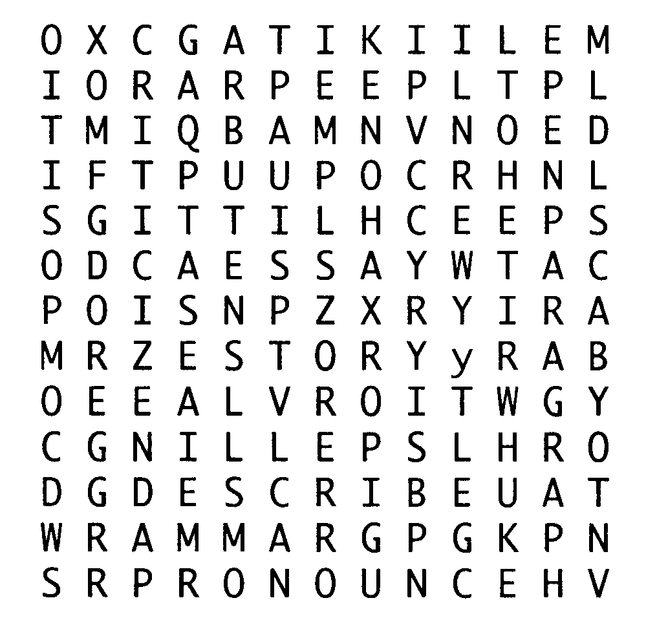
Name the States
Circle Ten Council
Give each boy a piece of paper and pencil and have them write down all 50 states. The first one that has all 50 yells STOP and the other boys count up how many they have. You can make up your own game using colors or animals in the zoo. Set a time limit.
Spelling Mixer
Circle Ten Council
Print large letters on 5 x 8 index cards, one letter on each card. Do not use the letters J, K, Q, V, or Z. Make several extra cards with vowels on them. Have a card for each person in the group. Three adults act as judges. On signal, people hold up their cards and rush around to find 2 letters that will make a 3 letter word. The 3 people lock arms and race to the judge, who writes the word on the back of their cards. Then they separate and rush back to find 2 more letters. This continues for 5 to 10 minutes. The winner is the person with the most words on his card.
Den Activities
Baltimore Area Council
- Invite a teacher or principal to one of your Den meetings. Not only will this provide you some expert help, but it will give the boys a chance to relate to this adult on an informal basis outside the classroom.
- Let the boys talk about what’s going on in school. Don’t try to change any of their ideas, but guide the discussion in such a way that they will see the value of an education.
- Prepare a chart of the school system and explain and discuss with the boys.
- Obtain some old school books for the boys to browse through. it will be interesting for them to see how fast education is moving forward.
- Discuss possible Den service projects for the school.
- Take a tour of the Board of Education.
- Exhibit: Chart of school system, old school books along side current books.
- Demonstration: Oral report on field trip. Explain chart of school system, oral report on responsibilities of employees of school.
NOTE: Most of the work on this badge will be done by the boy in school; but don’t let this deter you from planning interesting Den meetings. You needn’t limit the meetings to discussion. You might take a trip to a high school or college to show the difference from elementary school. The service project will make the badge seem more real to the boys.
Here are some suggestions to help a Webelos leader increase the value and effectiveness of the boys’ education, which can be worked into the Den program:
- By keeping physically fit, the boy is more likely to get the most out of school. Emotional health is as important as physical health. Help him with his emotional development. Encourage him to talk about his problems and listen when he does. Pat him on the back when he does well.
- Help each boy lead a balanced life. Studies should be counter-balanced with recreational and social activities.
- Help him make wise use of his time. Horace Mann wrote: “Lost, yesterday; somewhere between sunrise and sunset; two golden hours, each set with 60 diamond minutes. No reward is offered for they are gone forever.”
- A boy feels about school, to a certain extent, according to how he thinks adults feel about it. He’s looking to you for guidance.
Activities outside the classroom strengthen and extend the learning that goes on in school. His Webelos program is enhancing his education and you, as his leader, are an integral part of his growing up process.
Brain Teasers
Baltimore Area Council
Take the number of pennies in a dollar. Multiply by the number of thirds in a circle. Divide by the number of inches in a foot of string. Subtract the number of nickels in a quarter. Answer: 20
Take the number of toes on both feet. Multiply by the number of pints in a quart. Add the number of months in a half-year. Subtract the number of thumbs on two hands. Divide by the number of oranges in a dozen. Answer: 2
If three cats can catch three rats in three minutes. How many cats could catch one hundred rats in one hundred minutes? Answer: The same 3 cats
A boy, driving some cows, was asked how many cows he had. He said: “When they are in line, there are two cows ahead of a cow, two cows behind a cow, and one cow in the middle.” Now many cows were there? Answer: 3
If you went to bed at 8:00 at night and set the alarm to get up at 9:00 the next morning, how many hour of sleep would this permit you to have? Answer: 1 hour
Do they have a 4th of July in England?
Answer: Yes
Why can’t a man living in Winston-Salem, North Carolina be buried west of the Mississippi?
Answer: He must be dead first
How many birthdays does the average man have?
Answer: 1
If you have only one match and you enter a room in which there is a kerosene lamp. an oil heater and a wood burning stove, which do you light first?
Answer: The match
A man built a rectangle house. Each side has a southern exposure. A big bear comes wandering by. What color is the bear? Answer: White
Magic Squares
Baltimore Area Council
Arrange the numbers 1 through 9 in a three by three box so that the totals for each column, row, and diagonal are equal. Each number may be used only once. Can you calculate what each row, column, and diagonal are going to equal before you solve the puzzle?
Now for a bigger challenge - arrange the numbers 1 through 16 in a four by four box so that the totals for each row, column, and diagonal are equal.
Answer:
 | 8 | 1 | 6
 | 3 | 5 | 7
 | 4 | 9 | 2

Games. See website list for links to solutions
Scout Law Dart Board
Baltimore Area Council
Equipment: Dart board and darts. The dartboard should have spaces with numbers through 12.
Each boy, in turn, throws a dart at the dartboard and scores a point if he can recite the point of the Scout Law represented by the number in which his dart sticks. Score one point for each correct throw and identification. Permit each boy to continue throwing until he misses either in his throw or in his identification of the point of the Law the dart where the dart landed.
Quiz Games
Baltimore Area Council
For laughs, ask your Scouts the following:
At what time was Adam born? [A little before Eve]
What is it that can’t run and can’t walk, has a tongue and can’t talk? [A wagon]
On which side is a pitcher handle? [The outside]
What is the best bet ever made? [The alphabet]
What increases in value when it’s turned upside down?
[The number “6”]
What is it that can’t talk but always tells you the truth?
[A mirror]
What insect can be found in school? [A spelling bee]
Following Directions
Baltimore Area Council
1. 8. 15.
2. 9. 16.
3. 10. 17.
4. 11. 18.
5. 12. 19.
6. 13.
7. 14.
- If you ever saw a cow jump over the moon, write V in spaces 2, 3, 18, and 19. If not, write L in these spaces.
- If X comes before H in the alphabet, write Z in space 16. If it comes after H. write W.
- If 31,467 is more than 12 dozen, write G in spaces 8 and 12.
- If you like candy better than mosquitoes, indicate with an O in spaces 13 and 14. If not, consult a psychiatrist at once!
- Closing one eye and without counting on your fingers, write the 5th letter of the alphabet in space 11.
- If Shakespeare wrote “Twinkle, Twinkle Little Star,” put an O in spaces 9 and 17. Otherwise, put an I.
- If white and black are opposites, write V in space 10. If they are the same, write nothing.
- If 16 quarts make one pint, draw an elephant in space 7. Otherwise, write S.
- If summer is warmer than winter, write the 3rd, 2nd, and 4th letters of the alphabet in spaces 4, 6, and 15 respectively.
- If you can read this sentence, place the first and last vowel in spaces 1 and 5 respectively.
Now, read the message ... it makes sense!

ENGINEER
TECHNOLOGY GROUP
Baltimore Area Council
The engineer is someone who may be doing just about anything from working on a new chemical process, to planning how to get water to your house. Point out to the Webelos in your Den that an engineer is a planner who is found in many fields: civil engineers - plan towns, electrical engineers - plan power plants and large scale electrical wiring. chemical engineers, mechanical engineers; any field that needs to have its work done for utmost efficiency and reliability.
Circle Ten Council
Scientists who build machines are called engineers. They do tests and experiments that help them to invent new machines and make old ones work better. Without engineers we wouldn’t have tools, engines, trucks, trains, clocks or can openers. Humans are the only animals that invent and make machines. We use them to build skyscrapers, lift heavy loads, and move faster than the speed of sound. Humans have even made machines that can travel to the moon.
Den Activities
Baltimore Area Council
Arrange for boys to visit an engineer or surveyor in a municipal or county office. Plan for the boys to look through a surveyor’s transit and “read a rod” or visit a construction site and see the plans, which are being followed.
Make a block and tackle. Be sure to explain its purpose - to lift weights easily. A single block and tackle has an ideal mechanical advantage of two, which means that if there was no friction, a one pound force can pull two pounds. A double block with one pound pulling force could lift four pounds. As additional blocks are added, the mechanical advantage is increased, but each additional pulley also decreases the distance the load is moved. Friction is a factor affecting the lifting power.
Have the boys find pictures of different bridges and bring them to a Den meeting. The differences in many kinds of bridges will become apparent as the boys study them and construct models. The simplest ones are plank, beam, pier, deck, truss, and arch types. The more complex kinds are the bascule (the old castle drawbridge type). vertical lift, cantilever, and pontoon. Many swinging bridges are in use today.
Discuss property lines. Have an expert show the boys how property lines are determined, and how to measure one.
Discuss different types of engineers. If one of the dads is an engineer, ask him to describe briefly to the boys what his duties are.
Surveying Land
Baltimore Area Council
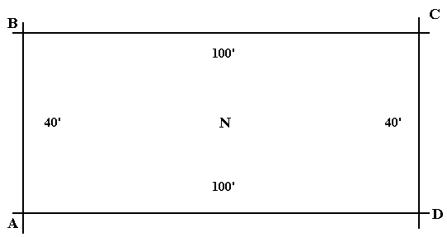
Survey land, it could be yours or a staked out section in a schoolyard or park with fixed points. To mark the points, you can use a nail pushed through a rag.
To do this, you will need a compass and a 100-foot tape measure. Put the compass on top of a 2 x 4 approximately three feet long. Start at one corner of the area to be surveyed. Take a reading of your compass and measure the distance to the next point. Do this all around the area that you have chosen to be surveyed - marking down your distance and degree.
360 degrees North 40’ Points A to B
90 degrees East 100’ Points B to C
180 degrees South 40’ Points C to D
270 degrees West 100’ Points D to A
A surveyor’s transit works much the same way. It gives the surveyor degrees in elevation as well as the degrees horizontally.
Steam Electric Power Plants
Baltimore Area Council
They create steam by heating water in a nuclear reactor or in a combustion chamber, where coal, oil or gas is burned. The steam turns a turbine that runs a generator. The generator has a rotating electromagnet called a rotor and a stationary part called a stator. A separate generator called an exciter powers the rotor, creating a magnetic field that produces an electric charge in the stator. The charge is transmitted as electricity. A transformer boosts the voltage. Exhaust steam passes cool water pipes in a condenser and turns back to water for re-heating. The water that has absorbed the steam’s heat in the condenser is piped to a cooling tower to be cooled.
Things To Make
Baltimore Area Council
Balance
A balance is not a weight scale, but is a device to measure an amount of one thing equally to another (in weight), not to a scale.
Materials:
1” x 4” - 12” long
1”x½” – 12” long
½” x 3” x 3” plywood for base
Wire coat hanger
2 cup hooks
2½” long bolt with washers and nut
(2) ½” x 3” diameter plywood circles
6 lengths of 6” chain
Instructions:
- On the 1” x 1/2”, carefully measure and find the centers for a hole in the middle, equal distance from both ends and from both edges.
- Drill it.
- Put cup hooks in the board bottom - 1” from the ends.
- On the bottom, equal distance from both ends; drill a hole big enough to put a piece of coat hanger through.
- On the 1” x 4”, drill a hole 2” from the top and equal distance from both sides on the 4” side of the board from top to center.
- Attach the 1” x 4” to the 3” x 3” in the center of the base.
- Cut a straight section of coat hanger about 6 to 8 inches long and glue into the hole on the 1”x 1/2”.
- Bolt the 1” x 1/2” to the 1” x 4” - You want enough play so the 1” x 1/2” moves freely, but not sloppy.
- On the 3” diameter circles, find 3 points equal distance around the edge and tack a length of chain to each point, then attach the three chains to the cup hooks.
- If all works well, the coat hanger should lay on the centerline of the 1” x 4”. If this doesn’t happen, weights (bent nails) can be hooked over the lighter arm and moved back and forth until balance is gained.
Bridges
Baltimore Area Council
The earliest bridges were probably a log fallen across a stream. Someone probably learned that several logs side by side made it wider and easier to cross. You could make a longer bridge by putting logs or slabs of stone across stepping-stones over a wider stream. These are the same principles that are used in many modern bridges.
Make a plank bridge out of a piece of poster board or a cereal box 10 inches long and 4 inches wide. Place it between two blocks or thick books. See how many toy cars it will support. Now bend the sides up 1/2 inch from the sides like handrails. See how many toy cars it will now support.
What you have done is changed a plank bridge to a beam bridge. It acts like a much thicker plank without the weight or expense of more material.
Beams are thick at the center where more weight is supported and thinner near the ends where there is less weight. The beams are usually made lighter by making them out of lots of small triangles. The beams are started at the center and built out on both sides equally to maintain balance like a seesaw.
Try this experiment to see why triangles are used. Nail the ends of four scrap boards together to form a frame. Use only one nail per corner. See how easily this four sided structure collapses? This is how a bridge would act made from a shape other than triangles. Now nail a board on a diagonal between two corners across the frame to form two triangles. See how much stronger it is?
Arch bridges are some of the longest lasting in the world. Some are over 1,500 years old! The arch can be entirely over the roadway, entirely under the roadway, or in the center. You can make a pretty good model of an arch bridge by using a hole saw, like you would use to drill a hole for a door knob, and drilling holes in a board. Cut this out with a cut through the center of the holes and you have the two sides of an arch bridge. Place another board on top for the road the draw and paint the stones on the side.
Bridge Activity
Baltimore Area Council
Have boys build two demonstration bridge side frames - one of rectangles and one of triangles. Use stiff cardboard or thin wood and brass fasteners. Have them experiment to see which type of bridge is stronger.
Ideas for Engineer
Circle Ten Council
Speakers – electrician, heavy equipment operator, plumber, telephone lineman, sanitation worker, railroad engineer, surveyor, city engineer, traffic planner, draftsman, architect.
Places to visit:
- Visit the municipal offices of the city engineer or surveyor. Look at a map of your town or city and try to find your house. Look at some of the surveying equipment and learn some of the simple math calculations.
- Tour the city water works, sanitary facility or recycling center. Ask about the current workload, and kinds of daily activities that go on. How do they handle emergencies?
- Visit an operational drawbridge, grain elevator, ship or grain loading operation, or other large industrial operation involving large cranes or other lifting equipment.
- Visit a jeweler and look at various gems under the microscope. How does the pattern affect the way a jewel is cut?
Den Activities:
- Ask your local Boy Scout troop to give a demonstration of some of the skills needed for the Pioneering Merit Badge. One particular item of interest would be to see a rope monkey bridge being lashed together.
- Ask Webelos to look through books and magazines at home and bring in pictures of bridges. Note the difference in construction.
Levers
Circle Ten Council
A lever helps you to lift things easily. A lever can be made by laying a plank over a wooden log or can with both ends intact. Balance the plank so that there is a short end and a long end. Place the short end under the object to be raised and push down on the long end. Try raising some bricks. To experiment you can try to raise things with the short end and you will find that it is more difficult or not possible to raise the object. The longer end of the plank gives you the ability to create more force and therefore raise weights easier.
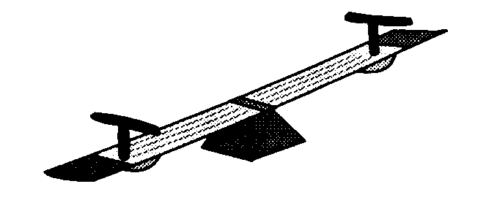
Perhaps the simplest machine of all for increasing force is the lever. A wheelbarrow is a king of the lever. Many other types of complicated machines are really just collections of levers that are put together to work in different ways.
Simple Levers
Materials:
Length of wood Glue
Small wooden dowel Ruler
Stripes of colored paper Pencil
Matchbox Weights (washers or coins)
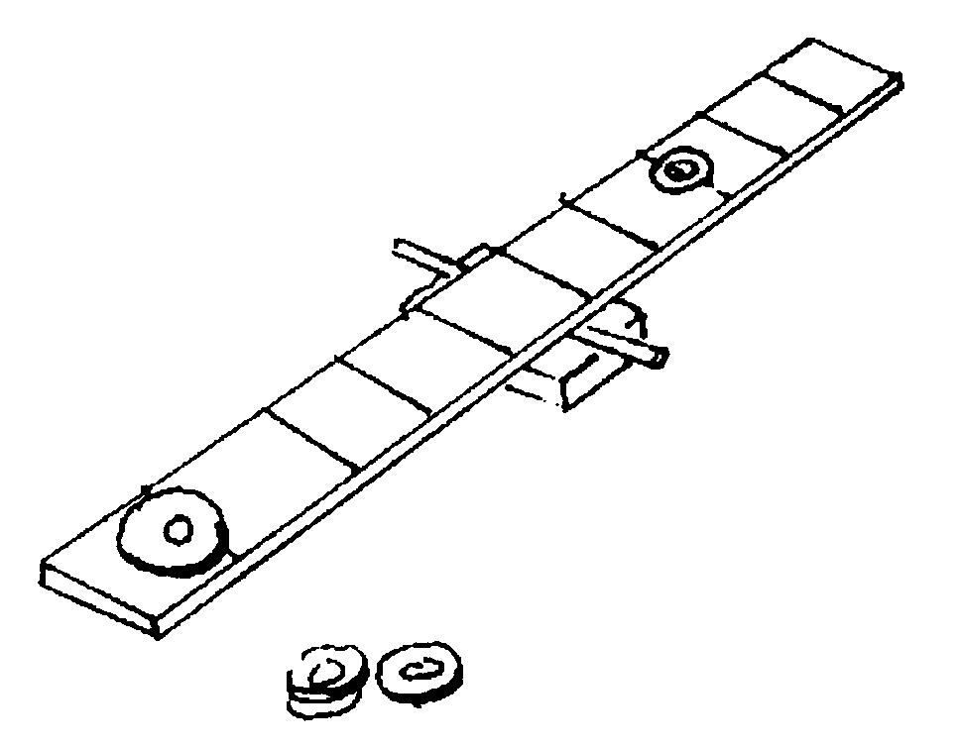
How it works –
A simple lever is a straight rod that rest on pivot or fulcrum. When you push one end of the rod down with an effort, the other end goes up, lifting the load.
Try making this model seesaw and find out for yourself how levers work.
Mark the length of wood with stripes spaced about 1-inch apart.
Glue the dowel to the matchbox to make a pivot.
Place the center of the length of wood on the pivot so that the two ends balance.
Now try some experiments with the weights.
Put a weight (the load) three marks from the fulcrum.
Where must you place another weight (the effort) to lift the load?
More load for less effort!
If the load is close to the fulcrum, it’s easier to lift and you don’t need so much effort. You may have noticed this if you’ve ever played on a seesaw – you can lift someone heavier than yourself if they sit nearer to the middle than you do.
Try putting two weights (the load) two marks away from the fulcrum of your seesaw. Where must you put a single weight to lift the load?
Belt Drive
Merry-go-rounds, sewing machines, record players, fishing reels, washing machines, and bicycles: these are just a few of the many machines that turn, or rotate, as they work.
All the different rotating parts inside a machine can be connected with a drive belt. As one part turns, it drags the belt around with it, carrying its turning motion to the other parts of the machine.
How it works – a drive belt runs round a series of pulleys to carry the turning force from one place to another. If the belt is going to work properly, there must be friction between it and the pulleys, so that the belt does not slip. If the belt is too slack it will not grip. If it is too tight, it might break or twist the pulleys out of line.
Whirling Acrobats
Circle Ten Council
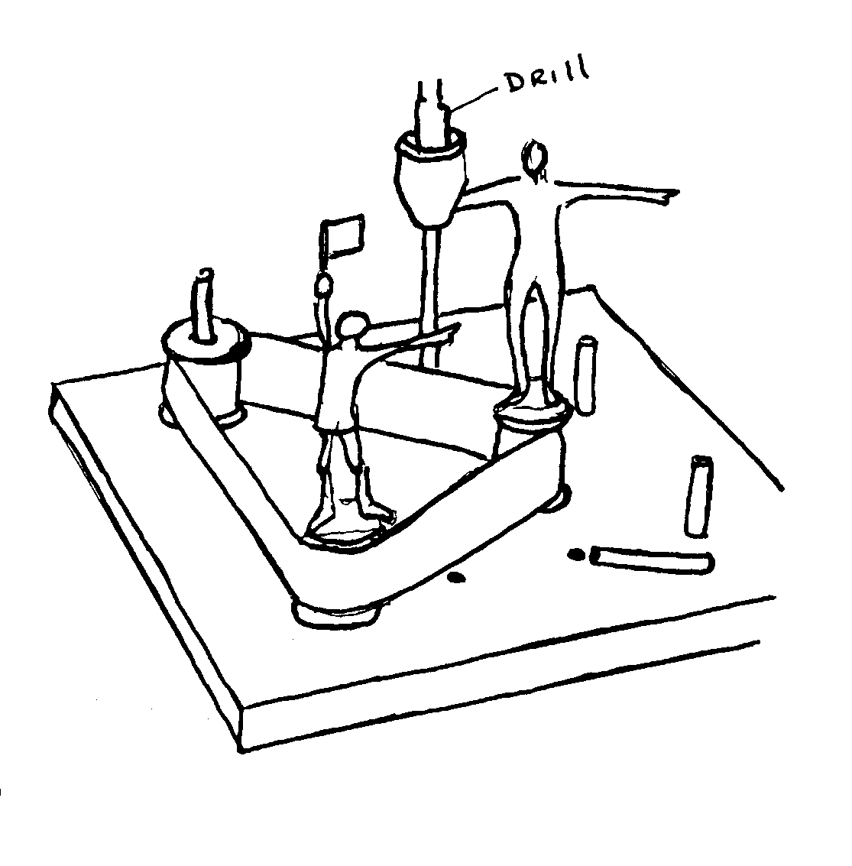
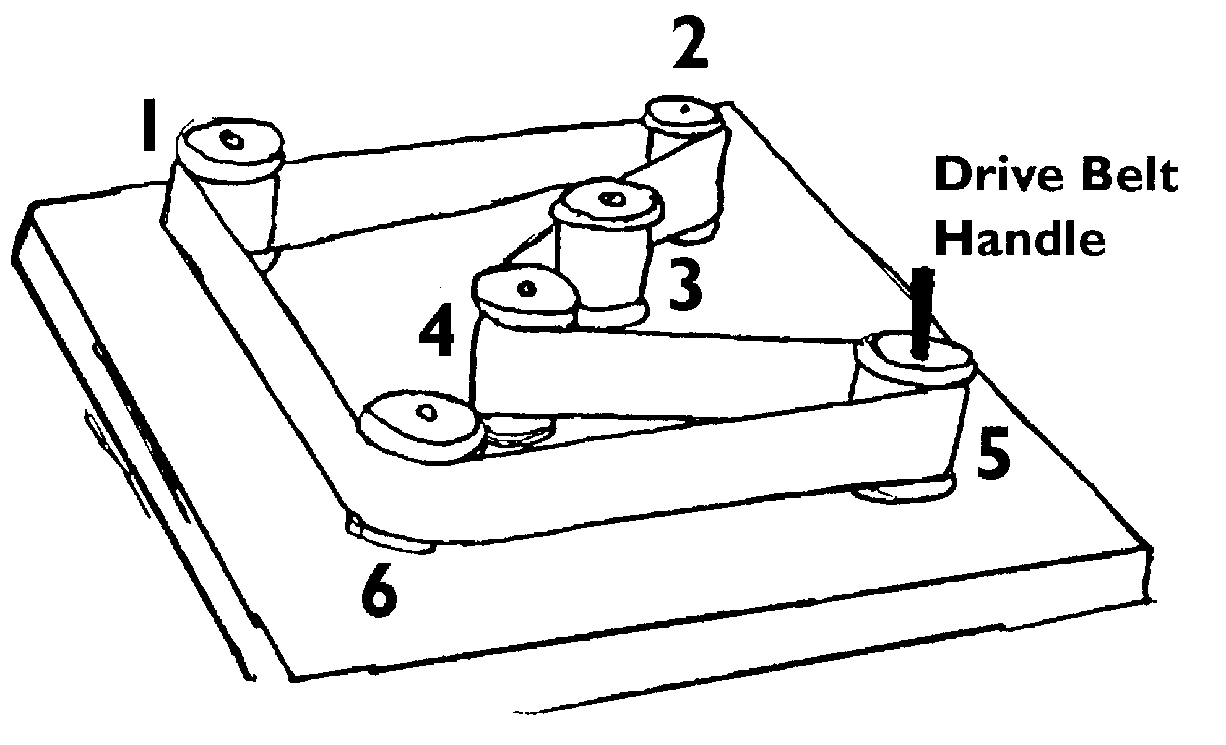
Materials:
Sandpaper Wooden board
Glue Cardboard
Velcro – self-adhesive Ribbon
Wooden dowel Empty thread spools
Directions:
- Cut sandpaper into strips, and glue a strip around each of the thread spools. The rough surface of the sandpaper is needed to make some friction between the reels and the belt. This way, the belt will not slip.
- Draw both the front and the back of each figure on a piece of cardboard as shown, leaving a space between front and back to make a base.
- Cut out the figures.
- Then fold and glue them so that they stand up.
- Glue a figure onto each spool.
- Cut the wooden dowel into a number of shorter dowel pegs.
- Smooth the ends of the pegs with sandpaper.
- Drill holes into the baseboard. They should be just big enough for the dowel pegs to fit snugly into them.
- Put the pegs into the holes,
- Put a thread spool onto each peg.
- Check that every reel can turn freely on its peg.
- Push a short piece of dowel into the top of one thread spool and glue the spool to the bottom peg. Put this spool on peg #5. This is the drive belt handle. You will use it to turn the drive belt.
- Stretch a length of ribbon around the spools so that it touches them all. Use a piece of Velcro to join the ends of the ribbon. Then you can adjust it so that it is not too tight and not too slack, and the figures will turn more smoothly.
Changing Direction
Both of the figures will turn in the same direction as the drive belt handle is turned when placed on any combination of spools 1, 2, and 6. Both of the figures will turn in the opposite direction of the drive belt handle when placed on spools 3 and 4. Notice what happens when one figure is on spools 1,2, or 6 and the other is on spool 3 or 4.
Changing Speed –
If all the thread spools have the same diameter, they all rotate at the same speed. But if you use different-sized spools, they turn at different speeds. To turn a big spool, the belt has to move farther than it does to turn a smaller one, and so the big spool turns around more slowly.
Gears
You’ll find gears inside nearly every machine that turns. Clocks, watches and bicycles all use them. Just like belt drive, the gears connect all of the rotating parts, but gears last longer than belts and are more precise. If you’ve ever ridden a mountain bike, you’ll know that gears are a good way of changing speed.
Cardboard Gears:
Circle Ten Council
This is a great section!! Having been a Machine Design major for my BS and MS ME, I can get into gears!! CD
How it works – the best way to find out how gears work is to make some of you own to experiment with. Each of these homemade gears is made from a jar lid with a strip of corrugated cardboard, stuck around the rim. The corrugations face put to make the gear teeth.

Materials:
Strips of corrugated cardboard (1/2” wide) with corrugations exposed
Jar lids and bottle tops of different sizes
Pin board and push pins
Short dowel peg
Glue and paper
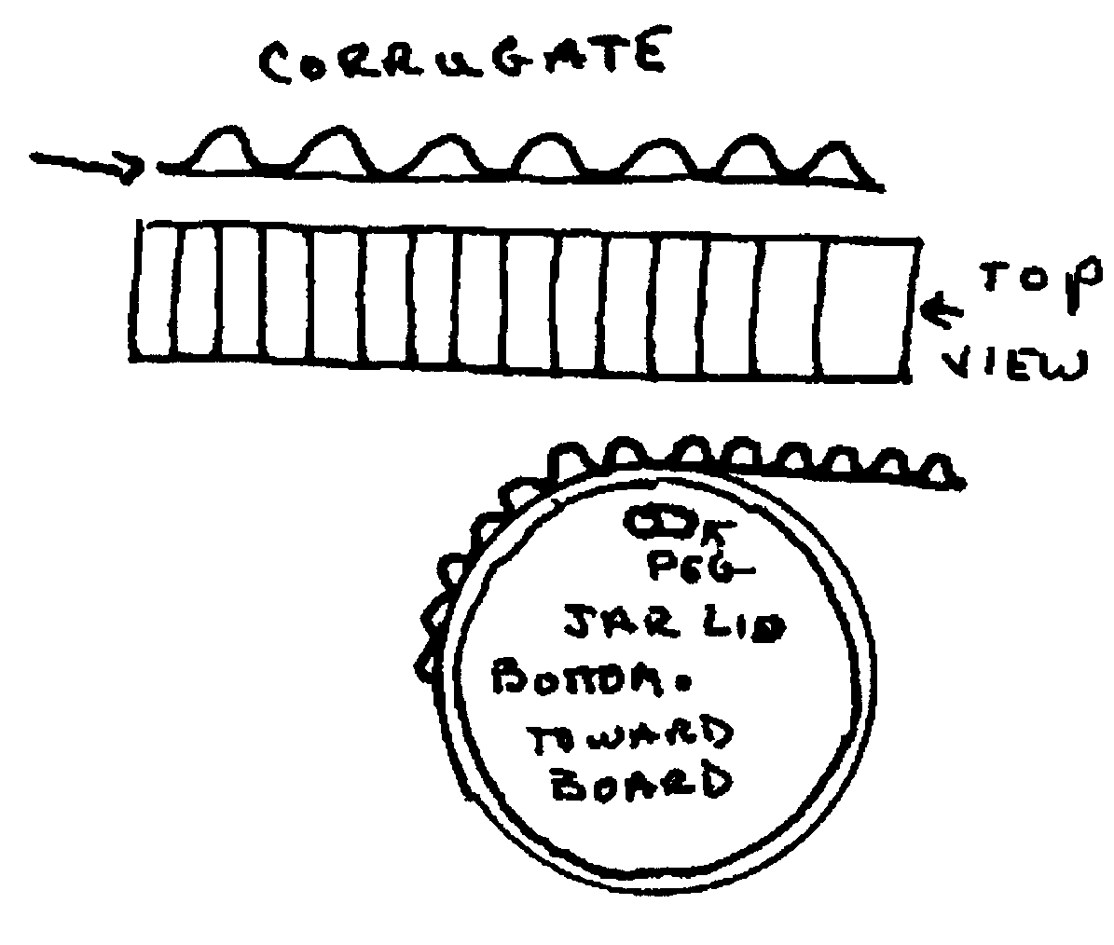
Directions:
- Bend a strip of cardboard around the rim of a jar lid. Try to stretch it into place so that there is a whole number of teeth evenly spaced around the lid. Cut the strip carefully to length and then glue it in place.
- Make a small hole in the middle of the gear and pin it to the board so that it spins freely.
- Make a selection of different-sized gears to add to the board. Glue a dowel peg to one of the gears to make a crank handle.
- To make the gears work you must place them so the teeth mesh. When you turn one gear its teeth will push on its neighbor’s teeth and make them turn in the opposite direction.
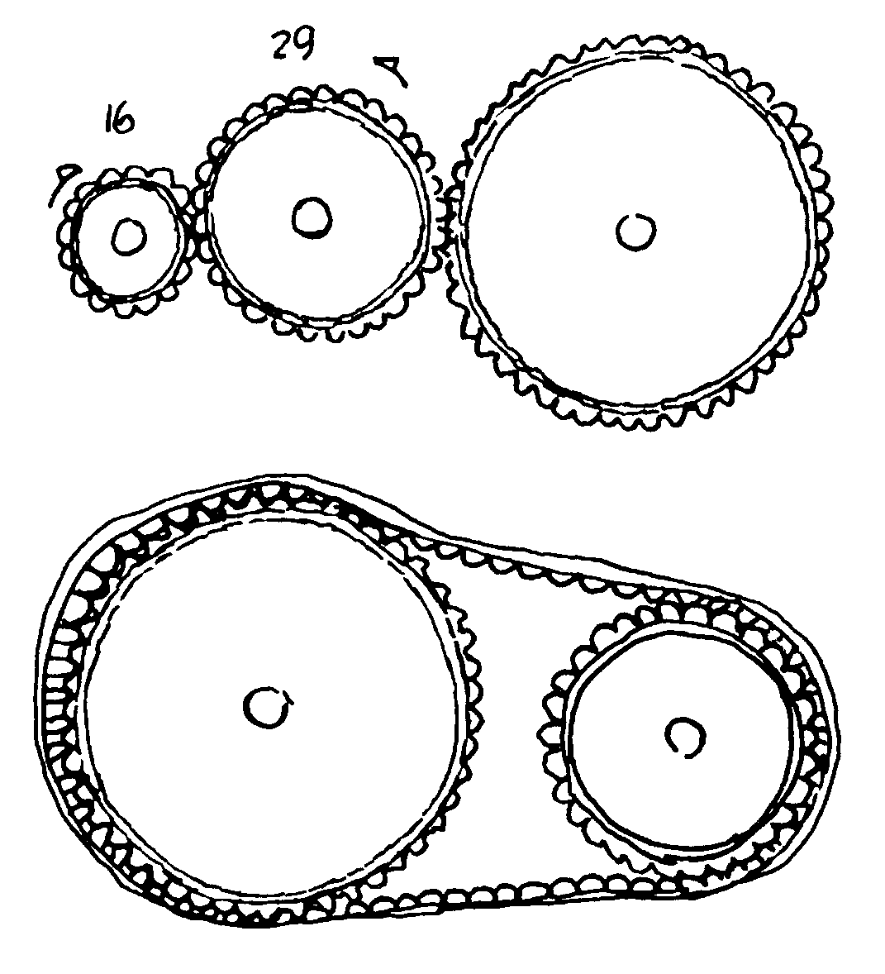
Gear Experiments
Connect a series of gears like the one shown.
If you turn the big gear,
- What happens to the two smaller ones?
- Which way do they go around?
- Which does a complete turn first?
Now try turning the small gear –
- Do the bigger gears turn more quickly or more slowly?
Count the number of teeth on each gear.
- If you turned a gear with 20 teeth around once, how many times would it turn a gear with 10 teeth?
Drive Chains –
Circle Ten Council
In some machines, gears called sprockets are connected by a drive-chain. A bicycle chain connects a sprocket on the pedals to another one on the back wheel. The chain transfers the movement from the pedals to the wheels.
Make a model chain from a long strip of corrugated cardboard with the ends taped together. Loop it around two different sized gears and work out how far the small gear moves then you turn the larger one.
Hollow Tubes
Circle Ten Council
To demonstrate the strength of hollow tubes, try laying a brick on a Styrofoam cup lying on its side. Place another cup on its rim and add bricks (2 to 3) until it crushed. Glue four cups together rim to rim and bottom to bottom with white glue and allow glue to dry. Place bricks (usually 4) on top until the structure crushes. Demonstration shows why engineers use columns in structures and bridges.
Springs –
Springs store energy when compressed, which is released when the spring is released. Catapults are a form of springs.
Catapult
Circle Ten Council
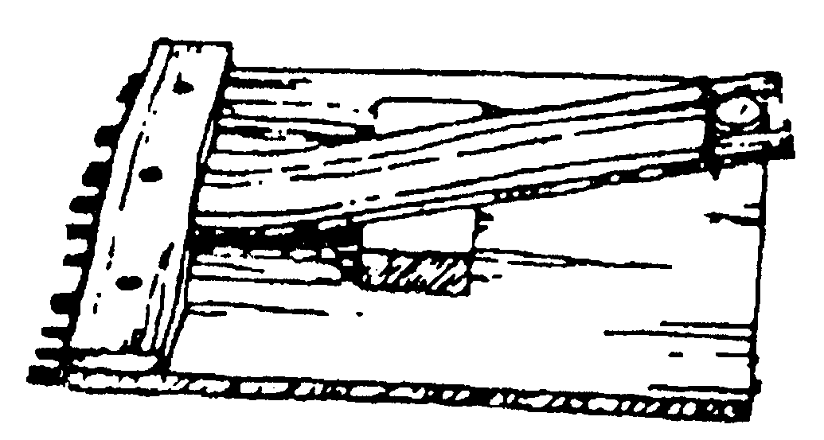
Materials:
Wood scraps Ruler or yardstick
It can be any dimension. Use a ruler or yardstick or any flexible wood for deadman arm. Leave spring bar loose so you can test catapult with various leverages.
Block and Tackle
Circle Ten Council
Materials:
2 Dowel rods (1” or larger) Sash cord or clothesline

Tie the cord to one dowel and make three wraps around both dowels. Have two big Webelos Scouts try to pull the dowels apart while a smaller boy pulls the loose end of the cord. He will be able to draw the larger boys together, no matter how hard they pull. The block and tackle does not create more power; it merely trades distance for force.
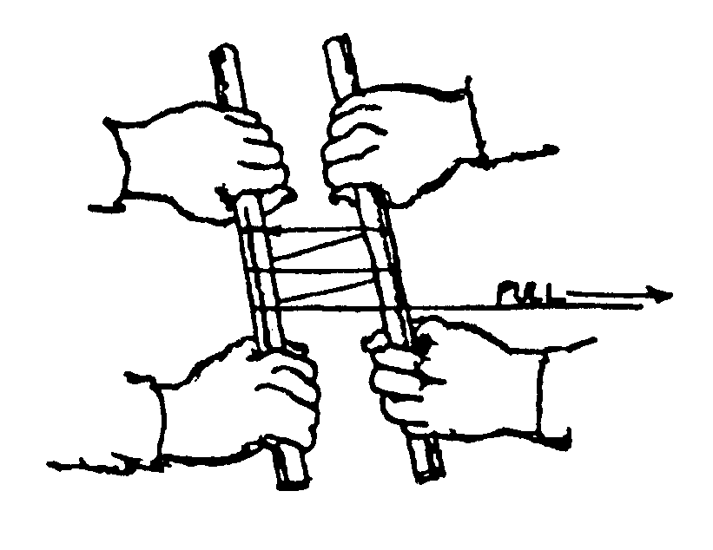
Block and Tackle Power (Part 2)
Baltimore Area Council
To show how a simple block and tackle increases pulling power, try this demonstration. You need two dowels of broomstick diameter and a length of clothesline. Tie the line to one of the sticks. Wrap it around both sticks two or three times. Have two of your larger Webelos Scouts grasp the sticks. Have the smallest boy pull on the line. He will be able to pull the two sticks together no matter how hard the bigger boys try to hold back.

POW WOW EXTRAVAGANZAS
Southern NJ Council
Catch a Dream
January 22, 2005
Lakeside School, Millville, NJ
Call Southern NJ Council, 856-327-1700, extension 32, or visit the website, www.snjscouting.org for more information
Indian Waters Council, BSA
"Set Sail for Adventure" University of Scouting
January 22, 2005
Swearingen Engineering Center, USC, Columbia, SC
Call Indian Waters Council, 803-750-9868 or visit the website, www.universityofscoutingiwc.com or E-mail,
universityofscouting@msn.com for more information
Buckeye Council
Baden Powell Institute (University of Scouting)
February 5, 2005
Stark State College - Media Center
Canton OH
Call Buckeye Council (800) 589-9812 or visit the website at http://www.buckeyecouncil.org/ for more information
Cradle of Liberty Council
“20,000 Leagues Under the Sea”
January 15, 2005
The Episcopal Academy
Merion, PA.
Call Cradle of Liberty Council (610) 688-6900 or visit the website at http://www.colbsa.org/ for more information

WEB SITES
Icebreaker ideas from a birthday party site
www.coolest-kid-birthday-parties.com/icebreaker-game.html

U.S. Patent Office and Trademark Office Kids
www.uspto.gov/go/kids/ kidpuzzle.htm

Create crosswords for ANY activity badge at
www.eclipsecrossword.com
and even better it is FREE (From Damon)

Dover Little Activity Books: Mazes, Puzzles
http://store.doverpublications.com/by-subject-children-dover-little-activity-books-activity-books--mazes--puzzles.html

Crossword Construction Kit (For Windows; Free 30-day trial)
www.crosswordkit.com

Word Search Construction Kit 98 (For Windows; Free download)
www.pcwin.com/software/review.asp?ProgramID=1971

Magic Squares –
If you want the solution to the 4 X 4 Square in Webelos Scholar or to learn other mathematics tricks go here –
http://www.roma.unisa.edu.au/07305/magicsq.htm
Here are 8 X 8 and 16 X 16 Magic Squares developed by Benjamin Franklin
http://www.mathpages.com/home/kmath155.htm
If you want more do a Google search on Magic Squares
Check this site for some interesting quotes and other stuff for your refrigerator
http://www.fridgedoor.com/
Answer:
 | 10 | 8 | 15 | 1
 | 13 | 3 | 12 | 6
 | 4 | 14 | 5 | 11
 | 7 | 9 | 2 | 16

