FOCUS
Cub Scout Roundtable Leaders’ Guide
Rivers are a vital part of our landscape; Cub Scouts can explore their local river, learning their history and their importance to their communities. Dens can work with a local environmental agency to clean up a river while working on the World Conservation Award or Conservation Good Turn Award. This is an excellent time to work on the Map and Compass Academics Belt Loop and Pin. Packs can hold a raingutter regatta using a variety of boat types.
CORE VALUES
Cub Scout Roundtable Leaders’ Guide
Some of the purposes of Cub Scouting developed through this month’s theme are:
- Good Citizenship, Cub Scouts will learn about their role in preserving our environment.
- Fun and Adventure, Boys will enjoy exploring the mighty rivers of the USA and will have fun preparing for the raingutter regatta.
- Friendly Service, Boys will learn to be friendly during their efforts for conservation and that those friendly efforts are warmly received.
The core value highlighted this month is:
- Perseverance, Boys will learn the value of sticking with a project or activity and not giving up, even if it becomes difficult.
Can you think of others??? Hint – look in your Cub Scout Program Helps. It lists different ones!! All the items on both lists are applicable!! You could probably list all twelve if you thought about it!!
Update on status of
www.USScouts.org
Fellow Scouts and Scouters,
Thank you for your patience and your generous contributions. Through your help we have been able to begin the process of recovering your websites after a catastrophic server failure.
In recent days we have been able to purchase a new server and after a lot of work, it is nearly ready to begin its job of providing you with the best Scouting information we can find.
In the near future you can look forward to visiting the sites we have operated including:
- USscouts.org
- Clipart.usscouts.org
- Jambo01.org
- Cubmaster.org
- Scoutmaster.org
- Scoutcamp.org
- MacScouter.com
- NetCommish.com
- WorldScouting.com
We have placed some recent items that we wanted to share with you while rebuild on-line for your use:
- Ask Andy from Mid January
- February Issue of Baloo's Bugle for March Theme
We apologize for any inconvenience or anxiety you may have experienced when you couldn't find information or join in a discussion. And most of all we look forward to serving you once again.
Board - U.S. Scouting Service Project, Inc.
Thanks to generous Scouters, Baloo's Bugle has two temporary homes -
Sean's scouting Pages -
http://scouting.argentive.com/bbugle.shtml
Bill Smith's Roundtable
http://wtsmith.com/rt/bb.html
If you have never visited Bill Smith's RT, take some time and look around it is a great site!!!
Sean’s site has the last year’s Baloo’s in .pdf format
Bill Smith’s site has more bandwidth and he has almost all the old Baloo’s. Some in MS Word some in .pdf
Donations are still needed -
To be able to continue we will need more donations to help us through this tight spot. Donations are accepted via PayPal™ by using the following email address:
donate2usscouts.org@verizon.net
The U.S. Scouting Service Project, Inc., started in 1994, is a non-profit organization that makes available to the Internet community additional information, resources and reference material concerning the Scouting programs carried out through the Boy Scouts of America. It is not funded nor supported by the Boy Scouts of America. All members of the Project serve as volunteers to plan, create, develop, post, maintain and enhance a family of websites and web resources as well as to promote the responsible usage of the Internet and its capabilities. This is in addition to their daily work, family and community, and Scouting obligations. The Service Project is always looking for additional hands to "share the fun of another one night a week" of Scouting and additional ways that we can leverage the potentials of the Internet and in particular the World Wide Web against the needs of the volunteer, professional, families and their youth involved in the programs of the Boy Scouts of America.
A special Thanks to the Northwest Scouters (www.nwscouters.org) for their generous donation!!
COMMISSIONER’S CORNER
This is a great theme that can build upon stuff you did last year – Take he interest you developed in your home state with that theme and the knowledge of the need for conservation the Cubs caught in Cubservation and go out and fire them up for a project on a local waterway. In my case – the Delaware River!!
I now have Southern NJ Pow Wow Book CDs available for trade for your Pow Wow Book CD. Please E-mail me (commissionerdave@comcast.net) and let me know. Apology needed – I lost the name and address of the Voyageur Council leader who sent me their CD. Please E-mail me and I will get an SNJC CD off to you quickly. Sorry, I had saved the mailer with your address but it is gone now.
Speaking of Pow Wow CDs – when prepping for your Pow Wow please review the material in your “Book” (CD) closely. I received a 2004 Pow Wow CD this month that had a Tiger Section explaining all about the 17 Big Ideas. Not a word on the 5 Achievements and the Tiger Badge.
Months with similar themes to
Waterways of the USA
Voyageur Area Council
June 2000 Sea to Shining Sea
April 2004 Cubservation
May 2004 My Home State
July 2004 Fin Fun
THOUGHTFUL ITEMS FOR SCOUTERS
After I had this Nathaniel Hawthorne quote last month
“Easy reading is hard writing”
My friend, Dr. Benson (of Penn), told me I left off the corollary. I told him I did not have a source but said I should run it anyway, so here it is –
“Hard reading is easy writing”
That reminds me of the following quote that is often misattributed to Mark Twain:
“If I had more time I would write a shorter letter.”
This quote is by the 17th-century French philosopher and mathematician, Blaise Pascal (1623-62), written in a letter to a friend. Maybe that explains why Baloo’s Bugle editions get so long!! CD
April Theme Prayer
Cub Scout Roundtable Leaders’ Guide
We give thanks for the journey that we as leaders are privileged to take with our boys. We hope to be the leaders they need to show them the way today, that they may become young men of character tomorrow. AMEN
"It is better to give others a piece of your heart rather than a piece of your mind."--Our Daily Bread
"Life can only be understood backwards; but it must be lived forwards." --Soren Kierkegaard
A Recipe for Children
Leslie of http://www.cubbobwhite.net
Reported that a friend found this in the “Centennial Cookbook 1875-1975," made by the ladies of First Baptist Church in Oelwein, Iowa. ☺
Be sure to visit her site for many useful items CD
Take:
1 large field
1/2 dozen children (any size)
3 small dogs
1 narrow brook. pebbly if possible,
- Mix children and dogs;
- Empty into field, stirring continually.
- Sprinkle with field flowers;
- Pour into brook gently over pebbles;
- Cover all with a deep blue sky to bake in the sun.
- When children are well browned they may be removed for they will be found
- All right and ready to be set away to cool in the bathtub.
The 12 Best Myths About Scouting
Baltimore Area Council
- It’ll take you only a couple of hours a week. It’s authorship has been lost in the mists of time, but this one has probably been around since 1908 when the first Scouters were being recruited. Being a dedicated Scouter (is there any other kind?) takes an average of at least seven hours, 52 minutes, and 36 seconds per week.
- The parents will help you. Sure, some parents will help you, but they will be the same few people every time. Remember, however, that the amount of parental help you receive is directly proportional to the amount of parental involvement you encourage. If you don’t ask, you won’t get.
- You only have to wear a uniform from the waist up. Originally, this may have been an attempt to soften the paramilitary label often hung on Scouting. Certainly, no one can accuse a bunch of half-dressed slobs of resembling anything military. If the members of your group look like the rear guard of a peasant revolt, who’s setting the example? Surely not you!
- You don’t have to take training if you don’t want to. Everyone knows that any adult Scouter can fool a bunch of kids, right? Who needs special training, right? What could you possibly learn? Well, with an attitude like that, probably not too much. But, would you want your kids coming to your meeting with the same attitude?
- The community will support you. They will support you. They’ll give you their newspapers in paper drives. They’ll donate food during food drives. But they won’t actually come out to your meetings to help you run an exciting program.
- You’ll love every minute of it. Let’s face it; you’ll have moments of deep, dark, desolate despair when you think your program will never work. Luckily, exhilarating flashes of sheer delight when your program does work will vastly outweigh these moments.
- It won’t cost you a dime. It will, however, cost you several dollars - for uniforms, transportation to and from events, training literature, annual registration, and badges. Yes, your Pack will have a budget for program items. You will still have to fork over some cash, usually when you can least afford it. Think of it as the best investment you will ever make.
- Your family will be thrilled by your involvement. Your family will initially be very proud of your altruism. Their pride will be replaced shortly by a sense of loss as you become more and more immersed in an organization they don’t understand. Examine your priorities. If Scouting is Numero Uno, review your list one more time.
- The youth you serve will thank you. They will, but probably not in your lifetime.
- The parents will thank you. Only mentally, for giving them a brief respite on Thursday nights from the onerous task of raising young Johnny (or Daniel or Nick...).
- Your country will thank you. Not really. The Governor may one day shake your hand in grateful acknowledgment of your contribution to the development of youth, but don’t hold your breath.
- Going back to the basics would solve all our problems. Retrospective rubbish that only rates about half on the scuttlebutt scale. We’re trying to develop leaders, not nostalgists. The past was a blast, but that was then, this is now. Current problems need modern solutions. By all means let’s keep this movement moving in the best direction… Forward.
TRAINING TIP
Safe Swim Defense and Safety Afloat Training
These training sessions are now available on-line from National Council. Go to -
http://www.scouting.org/pubs/aquatics/index2.html
and take either or both courses. You will get a certificate when you complete the course.
Wood Badge For The 21st Century

Don’t your Scouts deserve the best?? Then they need a well-trained leader!! Start planning now on attending Wood Badge. My council does a course in the Fall. Some councils do courses in the Spring. There is a course in Minnesota in March!! Figure out what is best for you and find a course!!
Leadership Training Wood Badge is advanced training in leadership development. There are two parts to Wood Badge training: First you will learn a series of leadership skills in a six-day course which takes place over two weekends. During that time you will develop a set of goals, to be completed in the next 18 months. These goals, centered on your current Scouting position, are called a ticket. This combination of hands-on direct experience and application of leadership skills is incredibly effective.
Wood Badge has served as a source of training and inspiration to thousands of Scouters, who in turn have affected the lives of millions of America’s youth. Most participants also discover ways not only to use the leadership skills in their Scouting positions but also to better their personal lives.
For two 3-day weekends, you live, learn, and work with other Scouters, while being exposed to the leadership skills applicable to the development of both Scouters and Scouts. Through this living and working experience, you develop knowledge and practical understanding of these leadership skills. You will clarify what you want to accomplish in your Scouting position, and learn how to apply these skills to your Pack, Troop, Team, or Crew.
Subsequently, you practice these leadership skills to help make you successful in your Scouting position. A guide helps you as a resource, a councilor, and a friend and assists you in fully understanding what you learned from the course. Your Guide will help you to accomplish your goals in Scouting, by applying that understanding.
PACK ADMIN HELPS
Cub Scout Achievement, Elective, Rank, and Academics and Sports Trackers
Roxanne@madsenco.com
A lot of websites carry the Excel based trackers she developed but have old and outdated versions. So Roxanne developed her own web page that will always carry the most recent versions (with all known bugs fixed and many enhancements recommended by users).
She recently revised the Cub Scout spreadsheets to –
- Include the Outdoor Activity Award that was launched in August 2004!
- Make them easier to work with in OpenOffice.
- Track Tiger beads and handle up to 15 tigers.
Please direct your den leaders or advancement chairs to the website for the most recent versions of the trackers. (feel free to add a link to your pack's website if that is helpful!)
http://www.madsenco.com/scouting.shtml
Thank you Roxanne!! CD
PS – She, also, has Girl Scout and Boy Scout Trackers!!!
Cub Scout Academics and Sports
Pack 215’s Virtual Cub Leader Handbook
http://www.geocities.com/~pack215/
The Cub Scout Academics and Sports program is a supplemental enrichment program that complements the existing Cub Scout program. The Academics subjects and Sports activities allow boys to learn new techniques, increase scholarship skills, develop sportsmanship-and have fun. Boys participating in the program will be recognized for enjoying teamwork, developing physical fitness, and discovering and building new talents. The Academics and Sports program encourages a boy to do his best
Concepts and Guidelines
The Cub Scout Academics and Sports program is based on the following concepts and guidelines:
- The program supplements the existing advancement and recognition program for Tiger Cubs, Cub Scouts, and Webelos Scouts; it does not replace it. The program is one element of Cub Scouting, as are den and pack meetings, day camp, and other activities.
- All registered Tiger Cubs, Cub Scouts, and Webelos Scouts have an opportunity to participate in the Academics and Sports program.
- Participation may take place at home, with the family, or within a den, a pack, or the community.
- Adult participation by a parent or adult relative, if possible, is strongly recommended for Cub Scouts and Webelos Scouts and is required for Tiger Cubs.
- Emphasis is placed on introducing a boy to a sport or academic subject, allowing him to participate in it and encouraging him to do his best. The Academics and Sports program focuses on learning and skill development, not winning.
- The primary focus of the program is on scholarship and sportsmanship.
- Each Tiger Cub, Cub Scout, and Webelos Scout will be presented with the appropriate recognition item for completing the requirements, whether he does so as an individual Scout, with his family, with his den or pack, or in his school or community.
- The Academics portion of the program covers a variety of subjects, including art, chess, citizenship, communicating, computers, geography, heritages, mathematics, music, science, weather, and wildlife conservation.
- The Sports portion of the program includes summer and winter sports, indoor and outdoor sports, active and less-active sports, and team and individual sports.
- Cub Scouts who have disabilities may select their own activities and design their own fitness or academic program with the help of a physician, teacher, or parent.
Implementing the Program
One member of the pack committee should be responsible for coordinating the Academics and Sports program and overseeing the integration of the Academics and Sports activities into the pack program. This person can also ensure that requirements for the different activities are available to boys, families, and dens so that all boys have opportunities to earn awards.
Pack leaders should encourage involvement by dens and families and make sure they have opportunities to participate. Many of these academic subjects or sports may become activities a Cub Scout will enjoy for the rest of his life.
The pack leaders should also define how costs of the program are budgeted, how requirements will be verified, when and how recognition takes place, and what constitutes a den or pack tournament.
The pack leadership can begin incorporating the Academics and Sports activities into the pack program during the annual pack planning meeting. Using a list of Cub Scout Academics and Sports activities, the committee reviews the annual program plan and decides where the academic subjects and sports activities might fit. Remember that these activities should complement the pack's program.
- As you consider which activities to use, ask,
  - Do the Academics and Sports activities fit into the pack's current program?
  - Which ones are natural parts of the pack program?
  - Which ones will help the boys to grow?
  - Which activities reinforce one or more of the purposes of Cub Scouting?
- Pack leaders should consider the boys in the pack and ask these questions:
  - What is the natural inclination of the boys?
  - Which activities seem to interest them?
  - How can we best use this program in conjunction with our current plans?
  - What is an avid interest of an inactive Cub Scout in the den or pack?
Remember the object of the program is to help boys learn a new skill or improve those they already possess - not simply to provide an opportunity for boys to earn additional recognition.
- As you review the Academics and Sports activities, keep the school year in mind. Check with school leaders for guidance.
  - Which of the academic subjects fit with the school's education plans?
  - When does the school offer instruction in certain sports or academic areas?
- Consider other community programs that affect a Cub Scouts involvement.
  - Are the boys playing organized sports that complement one of the sports in the Cub Scout Sports program?
  - Do they take part in music or art activities that complement one of the Academics subjects?
  - Do they participate in other activities covered by Cub Scout Academics and Sports areas?
Decisions about which academic subjects and sports to include in the pack's plan will be easier if you know the specific requirements for the activities you are considering. The "Academics and Sports Program Guide" book lists all requirements, with academic requirements beginning on page 26, and sports requirements beginning on page 51. You are sure to find several Academics and Sports activities that will interest the boys. Try to introduce several new ones each year.
Recognitions
Each activity has two levels of involvement: first, the belt loop; and second, the pin.
The Belt Loop: There are three specific requirements for each belt loop. As a Cub Scout completes these requirements, he is encouraged to do his best to learn about the activity. The Cub Scout or Webelos Scout can take part in one of three ways: (1) individually or with the family, (2) in the den or pack, or (3) in the school or the community. As Tiger Cubs participate in these activities, their adult partners must accompany them.
The Pin: Once the boy has earned the belt loop, he may choose to stop; however, some boys will want to continue with the activity. A Tiger Cub, Cub Scout, or Webelos Scout may complete additional requirements to earn a pin.
Each boy should be recognized for participating in the program. (Specifics about available recognition items can be found on the "Recognition page.") Once a boy has completed the requirements for recognition, a pack leader completes the Den Recognition Report. He or she secures the appropriate recognition items, and the boy is presented with the recognition in a meaningful setting, such as a pack meeting.
Working With Cub Scout-Age Boys
- You might often find yourself acting as teacher or coach as you work with boys in the Academics and Sports program. Keep these tips in mind.
- Keep instruction fun. The use of games and stunts will enhance learning and keep the experience enjoyable for everyone.
- When teaching skills, use words and ideas that children can easily relate to and enjoy. For instance, in swimming, you might tell boys they are going to "learn to float like a log" rather than learning "the prone float" Knowing the technical names of skills isn't as important as the skills themselves.
- Keep the boys busy and active. Be ready to change to a new activity or to another skill before boys become restless and bored.
- Don't tease, ridicule, or threaten learners especially in front of others!
- Demonstrate skills slowly and correctly. It may be helpful to have a boy who is proficient in a skill demonstrate it for his peers.
- Always provide for the overall protection and supervision of all the boys.
- And remember: Actions speak louder than words! Discussions you have with youth may be meaningless if your own behavior is inconsistent with what you say.
For more information on topics such as –
- Carrying out the Program
- Adaptations for Individuals With Disabilities
I recommend you consult the Cub Scout Academics and Sports Program Guide (WW34299B $6.25), go to Pack 215’s Virtual Cub Leaders Handbook, check out the information on this topic at www.usscouts.org and/or talk with other Cub Leaders in your District and Council and find out how they use the program.
TIGERS
WHERE DOES GARBAGE GO
Circle Ten Council
This one would work well with every level of Cub Scout. The Bear Achievement, Take Care of Your Planet, came to mind immediately. The visual images are great and last longer with our Cubs. CD
Before the Den arrives, set up a recycling bin to look like a big garbage can.
Read the book "Where does garbage go?" up through the part about Americans generating 4 lbs. of trash a day. Ask the boys to name the kinds of things they throw away.
Let the boys hold a bag with four pounds of trash in it to see/feel how much trash it contains (4 lbs.). Line seven bags up in a row to show them how much trash one person makes every week (28 lbs.).
Demonstrate what goes into a landfill. Ask the boys to pretend that the bin (recycle bin you disguised earlier) surrounded by a white sheet is a hole in the ground (landfill). More than half of the trash in landfills is paper. Ask a boy to put the paper provided into the landfill. Repeat the procedure with the correct proportions of other landfill trash (glass, metal, plastic, food and yard waste, other).
Read the pages about how many communities now recycle. Why do they recycle? (By recycling, these people cut down on the amount of trash they send to the landfills. By throwing away less trash, the people help to make the Earth a cleaner place.)
Ask the boys to look at the landfill again and name the things in the landfill that cannot be recycled. After taking out "other" and "food and yard waste," remove the sheet and show them that the pretend landfill is really a recycling bin. All of the items remaining in the bin can be recycled.
Show the boys a poster that shows the recycling symbol ("chasing arrow"). Ask the boys if they have seen these symbols before? Where? What do they mean? Explain that the boys and their partner will now work together. They will be recycling detectives and will look for these symbols on different items in their home to determine if the items can be recycled or not. Explain that not ALL of the objects that can be recycled have the symbol on them (like magazines and some cardboard, etc.), but many of the objects do. Looking for the symbol is a very good way to try and figure out if you can put the object out for the recycling truck or take it to a recycling center. Have them bring their list to the next meeting to share with each other. Have each boy name one thing on their list and continue until all items on each list have been named.
Go See It Outing
Circle Ten Council
- Tour a fast food restaurant or small restaurant
- Tour an energy conservation home
- Tour a Wildflower center and learn about landscaping that will conserve water
- Tour Electric plant or company and have them explain ways to save energy
- Tour the local Water Company and ask for ways to conserve water.
- Tour the Gas Company and ask about ways to conserve during winter months.
- Tour the local or county landfill and have them talk about recycling.
This last one was a big hit with our Den when my wife and I were Den Leaders. CD
SPECIAL OPPORTUNITY
75th Anniversary Unit Award
For Each Member of a Qualifying Pack
Kommissioner Karl

Complete Requirement 1 and complete 5 other activities.
- Participate in a pack, district, or council celebration commemorating the 75th Anniversary of Cub Scouting. (This could be a Blue and Gold Banquet.)
If you missed the opportunity for a Blue & Gold lay up here, start planning a 75th Anniversary Cake Bake birthday party with all the trimmings, an evening Pack family campfire for the spring with songs and skits, or ask your district or council what they are doing to celebrate the 75th and plan to help or participate in that celebration.
- Conduct an open house or recruiting event (an indoor event or help outdoors at a local park or other facility) to introduce new families to Cub Scouting and emphasize how Scouting’s values have remained constant throughout Cub Scouting’s 75-year history.
This is pretty easy with spring roundups around the corner. Offer to help your unit with the recruitment. Perhaps you can attend to talk to the parents about life from a volunteer leaders perspective. You might run a game for the boys while someone else talks to the parents. Or you might be a greeter to welcome the parents to the round up and make sure they know where the bathrooms are, get the pack information and feel welcome. If you are not having a spring round up, plan on helping during the fall round up instead.
- Take part in a parade or other community event through which your pack can promote the 75th Anniversary of Cub Scouting.
This can be as big or simple as you want it to be. Many small towns have Memorial, Independence and special occasion parades coming up. See if your unit can march in uniform on the parade route. Have the pack make a banner celebrating the 75th anniversary and toss small candy to the kids on the parade route. If you have a community festival, ask to set up a booth that focuses on the 75 years of Cub Scouting in your community. Look for interesting ways to display the history; with old pictures – and new ones. In larger communities – you may have the same opportunities, or perhaps you can participate in a city wide event that gives you opportunities for a run/walk team with anniversary shirts – and a special mention in the program.
- Conduct a pack derby in which boys are encouraged to decorate entries with a 75th Anniversary of Cub Scouting theme.
Once again, the Pinewood, Space Derby or Rain Gutter Regatta may be even more fun with a theme. Have boys make their cars into historical shapes from the 30s to 50s. Have a challenge to incorporate 75 into the design, either through decals, paint or shape. You might be surprise what you see show up on derby day!!
- Using the history of Cub Scouting as the theme, conduct an outdoor campfire program.
Wow, this sounds familiar. Oh yeah, see item 1. You might see if an “old timer” will come in their old boy scout uniform and campaign hat with a walking stick and talk about Baden Powell and scouting in the “old days”. A gentleman in a neighboring council, actually has a replica of the BP uniform, and come in his regalia to campfires to relay the story of Makeking – like it was a first hand account. There is probably some history buff you can get your hands on to do the same for you. If not, look online for Baden Powell, and you will find a wealth of short stories to share at your campfire. Teach your boys to sing Ging Gang Gooli – a song Baden Powell made up and lead at the first jamboree in 1930.
- Conduct a pack service project, such as Good Turn for America, that promotes and reinforces the concept of 75 years of Cub Scouts helping others. As a pack, contribute at least 75 hours of service.
Service projects and Good Turn for America have been covered in detail in this issue. What a great way to give back to a charter partner or community than to serve it by performing service. This once again can be as big or little as you want. Everything from a simple spring park clean up – to erecting a bridge across a stream along a trail – or painting rooms for non-profit, it is all good, done without the expectation of reward, and teaches our boys a valuable lesson.
- Work with your chartered organization to recognize Cub Scouting’s 75th Anniversary in the organization’s correspondence, newsletter, or other media.
If you charter partner does not have a newsletter, than see if you can make a special presentation to them to thank them for sponsoring you at one of there meetings. If they do, write a short article featuring the history of Cub Scouting and Cubbing in your area, and even in your charter partner. If you are not good at writing articles, then find one on the internet, and ask if you can reprint it. Be sure and get permission before reprinting something that is not your own work.
- Prepare a photo display for your chartered organization or other community location, highlighting activities of your pack today and in years past. This may also include photos from other family members who were in Scouting.
You may want to look up old Cubmasters, and see what pictures they have in there archives. Scan these into your computer and reproduce them, or take special care to return them in pristine condition. Make a huge shadow box – or have each den make their own and make arrangements to display them at a special event, like Scout Sunday, an annual meeting, or special dinner.
- Appoint a pack historian to document pack events during the 75th Anniversary celebration. The historian may add to an existing scrapbook or history or may begin a scrapbook or other record that the pack can build on in the future.
With scrapbooking being all the rage, this may be a great way to get more parents involved in the success and operation of your pack. Ask if there are any scrapbookers in the pack. Have a special meeting for just those that scrapbook, and ask if they would like to form a historians committee. Once they say yes, you may want to get others to help them. This in turn, would teach the other boys and adults that are interested in scrapbooking to see first hand how it is done.
- At your chartered organization, local park, or other community site, plant a tree to commemorate the 75th Anniversary of Cub Scouting.
Be sure to get permission before deciding on a site. You may want to plant a tree at your council camp, so that the boys can come back and visit in their scouting years to come. You might find a local city, county or state that will pay for your tree if you plant it in certain reclamation areas. This doesn’t have to be expensive, and usually a few phone calls to your local government – and a few clicks on the internet is all it takes to make this happen. If you do this for a number of trees, this would also qualify as a pack service project which helps the pack meet requirement 6.
Also available for the qualifying Cub Scout Pack is a special Cub Scouts 75th Anniversary Award Pack Ribbon. The ribbon is shown here.

Webelos Den Leader Training Award
Kommissioner Karl
The Webelos (Webelos always ends with an S whether talking about one Webelos Scout or a den of Webelos. It is an acronym – WE’ll BE LOyal Scouts. As the CS RT Commissioner who trained me says – if you don’t have an S at the end – then there is nothing to which to be loyal.) Den Leader Training Award program is a lot like most of the unit awards that you are able to earn. A leader that has completed the requirements and training, has assistants in place, plans meetings, etc., has made the commitment to do the program right. If you look at the requirements, we all are not doing them all, but if you have a FUN and successful program, you probably have already earned the award. This award recognizes people for putting the tools in place to succeed, and the rest is easy.
Requirements include serving one year as a Webelos Leader, getting trained and some service standards. A downloadable tracking card is available at: http://www.cornhuskercouncil.org/resources/forms/WebelosDenLeaderAward_2001.pdf
GATHERING ACTIVITIES
The Hidden Fleet
Baltimore Area Council
Go Forward, Backward or Diagonally to find the names of the fourteen different kinds of ships below:
(We've done the first one, to show you how)
P | K | T | H | R | O | N | T | K | E | T | C | H | F | R | O
F | R | Z | I | Z | M | S | B | H | H | R | W | N | L | W | L
H | Q | S | C | H | O | O | N | E | R | Q | K | A | S | K | E
J | K | L | S | Y | U | B | K | O | N | Z | X | S | B | R | S
B | G | A | X | W | C | R | B | N | U | Y | V | O | E | Q | A
P | S | C | N | V | J | I | Y | A | C | H | T | P | T | N | M
T | E | L | Z | A | K | G | U | C | U | H | P | J | T | V | P
J | F | I | O | T | F | A | Y | G | T | U | G | I | E | L | A
U | D | P | X | O | H | N | M | B | T | E | A | G | V | F | N
N | Y | P | G | C | P | T | V | E | E | N | L | F | R | Q | T
K | R | E | H | K | S | I | D | U | R | E | L | P | O | R | C
W | Q | R | C | B | O | N | N | L | T | O | E | A | C | N | T
I | L | B | H | P | C | E | I | Z | D | J | O | K | X | Y | W
R | S | Z | M | A | K | R | A | B | J | V | N | W | Q | G | L
YACHT SLOOP CUTTER
KETCH GALLEON BARK
SCHOONER CLIPPER JUNK
TUG CANOE BRIGANTINE
CORVETTE SAMPAN.
School of Fish
Voyageur Council
Pin pictures of fish on people as they arrive. Have cutouts of swordfish, tuna, trout, catfish, etc. On a signal, they are to see which “school of fish” can assemble first.
Mink in a Maze
Voyageur Council
Every wild animal must live in its chosen habitat. The mink prefers a riparian habitat. Can you help it find its way to the pond at the center of the maze?

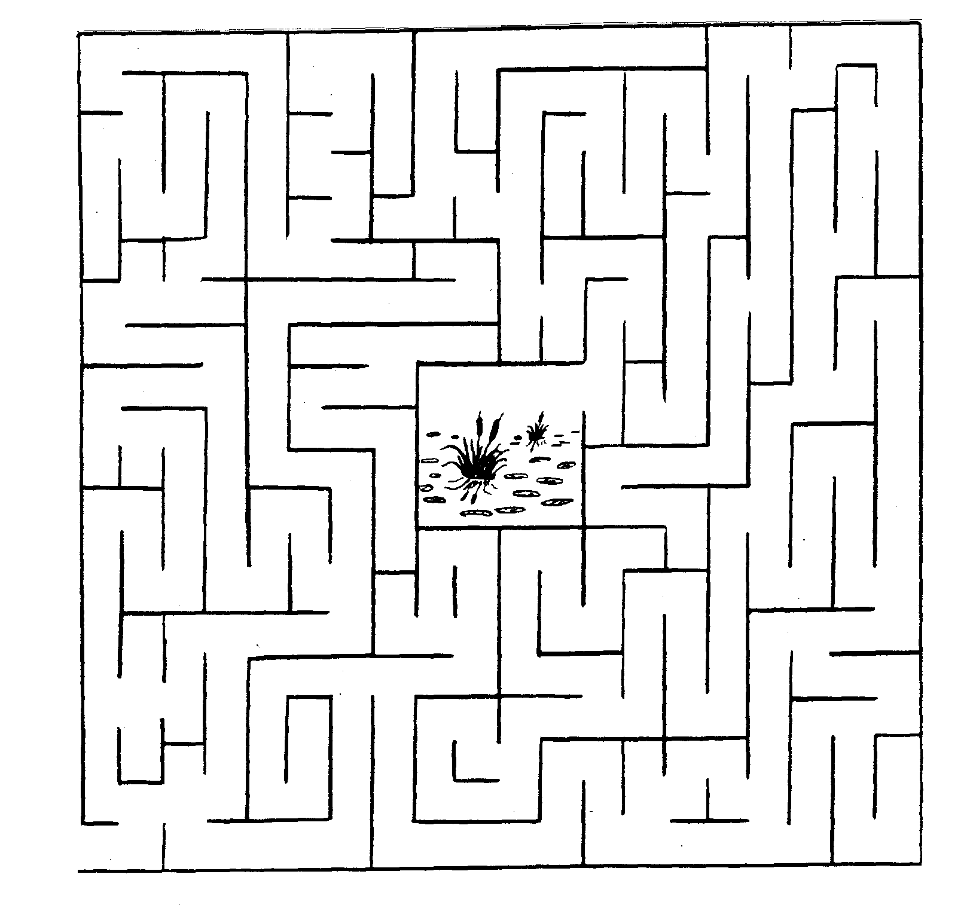

Ocean Objects Word Search
Voyageur Council
Find these things that can be found in or on the ocean. Look up, down, across, backwards and diagonally:
BOAT OCTOPUS BREEZE
PELICAN CORAL SALT
CRAB SAND EEL
SEA FISH SHARK
FLOTSAM SHIP FOG
STORMS GULL SUB
ICEBERG WAVES LIGHTHOUSE
WHALES
The remaining 13 letters, in order, spell the name of a beautiful sea.

L | M | F | N | A | C | I | L | E | P
A | I | O | F | I | S | H | E | S | I
R | C | G | E | D | E | M | E | I | H
O | E | T | H | T | L | A | S | E | S
C | B | O | A | T | A | S | R | U | B
S | E | V | A | W | H | T | P | D | R
H | R | R | A | N | W | O | S | N | E
A | G | U | L | L | T | L | U | A | E
R | B | A | R | C | E | F | B | S | Z
K | S | T | O | R | M | S | A | N | E
How Many Words
Baltimore Area Council
- Give each boy a pencil and a piece of paper.
- See how many words they can make out of the letters in the word “RIVERBOAT.”
- Each letter may be used only once (except “R” which may be used twice since there are two of them).
- “RIVER” and “BOAT” do not count.
Crossing the Quick Sand
Circle Ten Council
Place small pieces of masking tape on the floor to from a twisty line of stepping-stones with some close together and others far apart.
Each Cub in turn tries the course while balancing a tennis ball on a flat board.
Fishing in the Tropics
Place a dishpan with many plastic or rubber items in the bottom, on the floor in the middle of the room.
Provide a fishing pole consisting of a stick about two feet long, on one end of which is fastened a string with a hook. Velcro works great. Be sure you put Velcro on the items in the sea.
As they arrive, give each Cub Scout three minutes to snag as many “fish” as he can, and award a small prize when finished.
Float the Needle
Have bowl of water and a needle and challenge boys to try to make the needle float.
After they have tried and failed, place a small piece of tissue on water and the needle on top of that. As the tissue gets wet, it will sink to the bottom. The surface tension of the water will allow the needle to remain afloat.
OPENING CEREMONIES
The Six “Ships” of Scouting
Baltimore Area Council
A True Scouting Classic! CD
Arrangement: 6 Cub Scouts hold large cardboard cutouts of ships, on which have been printed the following words; SCHOLAR-SHIP; FELLOW-SHIP; FRIEND-SHIP; SPORTSMAN-SHIP; WORKMAN-SHIP; STATESMAN-SHIP on the front and their parts on the back in LARGE print.
Cubmaster: Tonight, Den __ would like to tell you about the Six Ships of Scouting. These are ships that were launched to sail the Waterways of the USA – strong and mighty... ships that will last forever.
- SCHOLAR-SHIP. This ship is very important on the Sea of Education. On her deck stand such officers as Ambition, Determination, Intelligence and Application. Her flag bears symbols of the letter “A” and the plus sign.
- FELLOW-SHIP. This ship stands for good spirit, fine cooperation and never-failing unity. Its flag floats high - the flag of Scouting.
- FRIEND-SHIP. This is the most handsome ship of all. It is true blue and its flag is golden - since friendship itself is golden.
- SPORTSMAN-SHIP. This is the ship that’s fair and square. It never veers from its course. Its flag is never at half-mast.
- WORKMAN-SHIP. This ship’s every line, every part, every mast, represents the best that a person can give. Its flag wears a laurel wreath.
- STATESMAN-SHIP. This ship represents wise guidance, constant counsel, unselfish interest and sincere endeavor. Its flag is white for purity.
Cubmaster: And there you have six strong and sturdy ships to brave the Waterways of the USA. Three cheers for the Scouting ships!
Trailblazer Opening Ceremony
Baltimore Area Council
Arrangement: Flags are advanced in the usual manner. Audience repeats Pledge of Allegiance. Flags are posted. Patriotic background music is played while narrator reads the following:
“Not gold, but only men can make
A nation great and strong.
Men who for truth and honor’s sake,
Stand fast and suffer long.
Brave men who work while others sleep,
Who dare while others shy.
They build a nation’s pillars deep,
And lift them to the sky. “
-Ralph Waldo Emerson
The Outdoor Code
Longhorn Council
SET UP: Poster with the Outdoor Code on it. Have parents repeat the outdoor code. Explain its meaning.
PACK: As an American, I will do my best to be clean in my outdoor manners.
CUBMASTER: I will treat the outdoors as a heritage to be improved for our greater enjoyment. I will keep my trash and garbage out of America's waterways, fields and roadways.
PACK: Be careful with fire.
CUBMASTER: I will prevent wildfire. I will build my fire in a safe place and be sure it is out before I leave.
PACK: Be considerate of the outdoors.
CUBMASTER: I will treat public and private property with respect. I will remember that use of the outdoors is a privilege I can lose by abuse.
PACK: Be conservation minded.
CUBMASTER: I will learn how to practice good conservation of soil, water, forests, minerals, grasslands and wildlife. I will urge others to do the same. I will use sportsman like methods in all my outdoor activities.
Now Sing "America, the Beautiful."
I Am The World
Longhorn Council
NARRATOR: (Out of sight. Done in dramatic fashion) I am the world - Some call me Mother Nature. I am the mountains and the valleys and the land and the seas. All living things exist in me from the birds of the air to the fish in the waters. You see me in the beauty of the flowers and in the glory of the trees. When ever you roam to see the wonders of the world, the animals and the plants, the moon and the stars and all that is pleasant to see, remember that man is the only one who can really keep this world of nature for the next generation to see
CM: Ask Cubs and parents to recite together, "The Conservation Pledge":
I give my pledge, as an American,
To save and faithfully to defend from waste,
The natural resources of my country, its soil and minerals,
Its forests and waters, and its wildlife."
This can be done in a repeat after me fashion or together using a large poster in front of the room. Or of you prefer, The Outdoor Code. CD
Raingutter Regatta Opening
Baltimore Area Council
Set Up - Have the boatswain (a good whistler) give a long, drawn-out note, dropping to a lower tone near the end, to welcome the Skipper (Cubmaster) aboard. Cubmaster then calls for each ship’s crew section (Den) to give its Den yell. The entire crew (Pack) then stands, pledges allegiance to the flag and sings “Row, Row, Row Your Boat” as a round.
Safe Swim Opening
Voyageur Council
Arrangement: Make card for each letter. Write the line for each boy in LARGE print on the back. The boys can carry water activity toys such as inner tubes, balls or snorkeling equipment.
- S S is for Scouts, we have fun.
- A A is for Activities, out in the sun.
- F F is for Friends, your buddies in the pool.
- E E is for Excitement, but keep your cool.
- S S is for Safety. That must come first.
- W W is for Water, not only for thirst.
- I I is for Instructions we follow with care.
- M M is for Merriment we all love to share.
ALL Putting them all together and we have SAFE SWIM. Let’s be safe and we will all win.
Spirit of Scouting
Setting: Before the opening ceremony, place a candle at one side of the stage or room but in view of everybody. When the time for the opening ceremony, the Cubmaster make the following statement.
Cubmaster: (light candle) This candle represents the spirit of Cub Scouting. It is going to burn throughout our meeting, representing the fun and friendship we have enjoyed together here. Let’s all stand and give the Pledge of Allegiance to the Flag.
Cub Scout Fish Opening
Voyageur Council
Arrangement: 8 Cub Scouts holding cardboard pieces, which make a fish when put together. Each part is lettered, so that all together they spell CUB SCOUT, C being the head of the fish and T the tail. Each boy’s lines are written on the back of his card in LARGE print.
(Boys enter one at a time and repeat their lines in order.)
- (Head of Fish) C is the part we build on. It stands for COURTESY in Cub Scouting and all through life.
- U is next. This part stands for UNITY, because united we are strong.
- B is the next added. That stands for BRAVERY in all our thoughts and all our deeds.
- S is next and that stands for SAFETY. We learn it and use it.
- C adds some more and it stands for CHURCH--the one of your choice.
  - is building it stronger, and it stands for OUTDOOR life, which is full of fun and adventure.
- U is near the finish and it stands for UNDERSTANDING, something that all our families have.
- (Tail of Fish) T is the tail that guides us. It stands for TRUTH in all things.
All: Will everyone rise and please join us in the Pledge of Allegiance?
Spyglass Flags Opening
Voyageur Council
A den of Cub Scouts, dressed in pirate costumes come to the front. There is a container in front with a sign that says “sea water waves” to indicate they are out at sea. One Cub is carrying a spyglass and one Cub is carrying a pirate flag. The pirate flag is held high to show that they are proud of it. The Cub with the spyglass points it toward the audience and looks around. At the rear of the room, a color guard is waiting to present the American and pack flags. The Cub gets a look of surprise on his face as he looks through the spyglass and sees the color guard. He excitedly shows some of the other pirates and they take turns passing around the spyglass.
In unison they say: Did you see that? They have TWO flags, and they’re REALLY beautiful flags, too!
The Cubs all look down at the little pirate flag in disgust. The Cub Scout holding the pirate flag tosses it into the “sea.” All the pirates run off as the Cubmaster comes walking out.
Cubmaster: Please stand for the presentation of the colors and join in the Pledge of Allegiance while Den ___ presents the great flag of our country and the pack flag.
PACK AND DEN ACTIVITIES
Raingutter Regatta
Baltimore Area Council
(See Cub Scout Activities Book for additional help)
Copy the picture and enlarge it for easier use CD
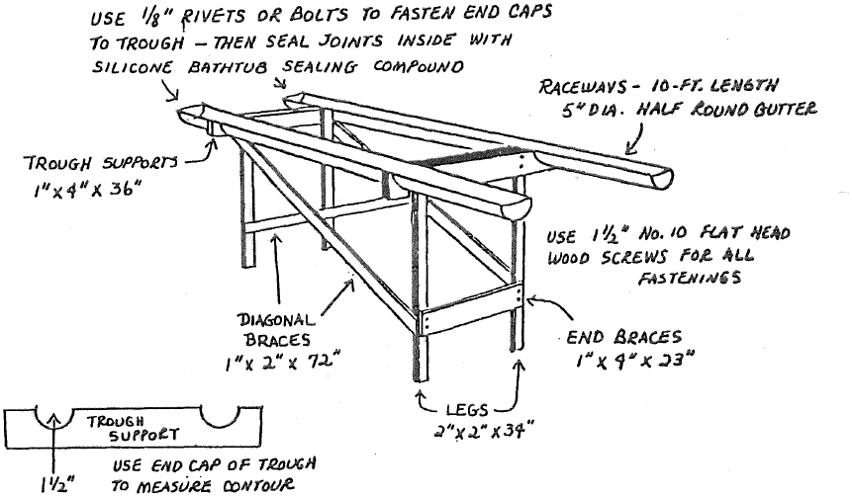
Ahoy mates! You’re watching the sailing regatta of the century! Although the waterways are only 10-foot lengths of rain trough filled with water and the ships are a mere six inches long, each race can be an exciting event. This is a very popular Pack race. Each Cub Scout makes his own boat (with a parent’s or grandparent’s help) to enter in the race.
The raceway consists of a simple frame that supports two 10-foot lengths of rain trough filled with eight gallons of water. The frame is designed so It can be assembled and disassembled quickly. The illustration shoes you what it looks like. The material sizes and fastening details follow.
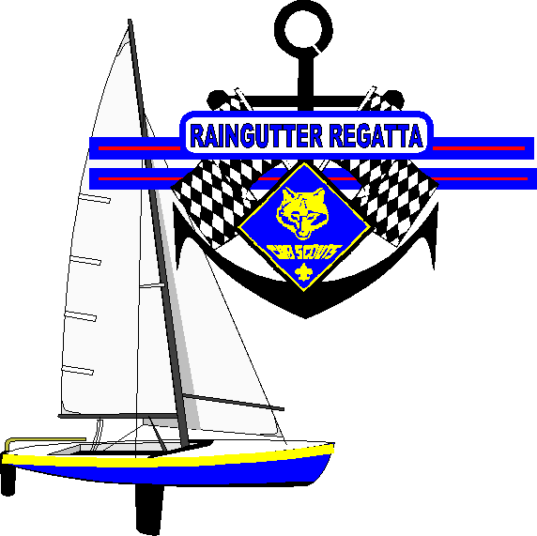
Materials Needed for Double Raceway:
- 2 - 10 ft. lengths of 5” diameter half round gutter
- 4 - End caps for gutter and rivets or bolts to attach end caps to gutter
- 2 - Trough supports 1” x 4” x 36” long boards. Cut them out so that gutter fits snuggly
- 2 - End braces - 1” x 4” x 23”
- 4 - Diagonal braces - 1” x 2” x 72”
- 4 - Legs - 2” x 2” x 34”
- 1½” #10 flat head wood screws for all fastenings (Bolts could be used to fasten the braces on the legs to allow for easier disassembly for storage.)
Fishing Derby
Circle Ten Council
The Derby can be as simple as a parent-son fishing trip to the local area river or lake, or as elaborate as a family event complete with a picnic, games and music. As an added challenge, you could have a cane pole derby in which only homemade poles (no reels) are used. Be sure to have lots of awards: Most Fish Caught, Biggest Fish, Best Fish Story, Ugliest Fish, Most Unusual Catch, etc. Check your local license requirements for adults and children. If you are fishing on private property, make sure you have the owner’s permission and never leave a mess.
Yacht Tie Slide
Baltimore Area Council
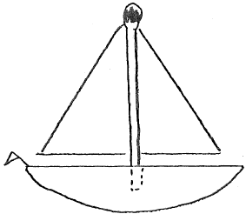
- The hull is whittled from white pine or balsa. The mast is a burned match. The boom is a toothpick. The sail is a triangle of white or red fabric.
- Whittle and sand hull, It is flat on back and curved on front,.
- Drill 3 holes, one in top for match mast, 2 in back for plastic or metal ring cut in half.
- Glue mast in place. Glue boom to lower edge of sail.
- Glue sail and boom mast and let glue dry,
- Glue ring in place, While it is drying, make small flag for stern from construction paper triangle (tiny) glued to straight pin,.
Build a Boat
Baltimore Area Council
Materials: Wood shingle, lollipop stick, colored paper, rubber bands, glue
Directions:
- Cut Cardboard template
- Trace on to Shingle
- Cut out boat outline
- Make Paddle
- Drill holes for the Rubber Bands
- Drill Hole for Mast
- Mount Mast
- Cut out flag, attach to stick, & Glue
- Wind Paddle Up
- NOW... LAUNCH YOUR BOAT!
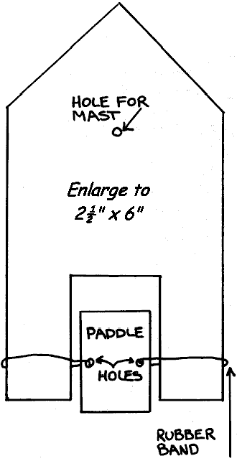
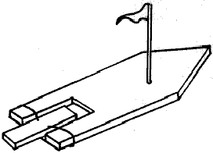
Leather and Button Puzzle
Baltimore Area Council
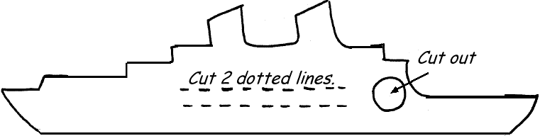
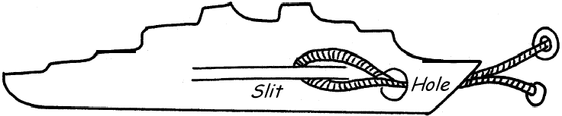
Trick: Remove string and button without untying buttons.
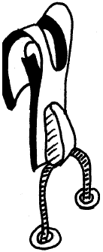
Trace the ship pattern on vinyl. Make 2 parallel cuts as per diagram) in center of strip of vinyl. At end cut hole, slightly larger then the width between the slits. Pass heavy string under slits, through the hole, and fasten buttons to loose ends of string. Buttons need to be too large to fit through the hole
To solve the puzzle, fold the vinyl, pulling the slit away from the body of the vinyl. Fold the slit material in half and pass it through the hole with the string pinched at the end of the folded slit. Once the slit and string are through the hole, the button on the end of the string can be pulled through the loop of vinyl and removed. Reassemble by reversing the process.
Jet Boat
Baltimore Area Council
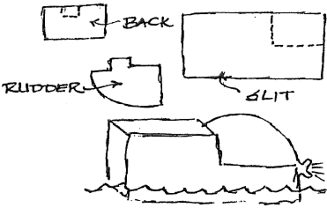
Materials:
Quart milk carton Tape
Scissors Balloon
Cut carton on dotted lines as shown and remove cut section. Make slit near front bottom for rudder, made from cut out section, and notch in rear as shown. Tape rudder in place. Place blown up balloon in boat and watch it go!
Submarine
Baltimore Area Council
Materials:
2 Plastic bottles Scissors
Adhesive tape 12” Piece of plastic tubing
24” Piece of plastic tubing Clay
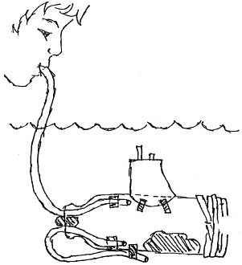
Directions:
- Remove cap from bottle.
- Cut around bottle 2” from bottom.
- Push both pieces of tubing into the bottle through the neck and secure as shown.
- Bend the short piece around and tape it to the outside of the bottle.
- To make it float properly add a large wad of clay inside bottle as shown. Be careful not to plug tubes.
- Use a second piece of clay to make the top air-tight.
- Replace bottom of bottle and tape tightly.
- Use second bottle to make conning tower, tape in place.
- Place sub in water.
- Blow into long tube to make it rise and suck air out to make it sink.
Wave Maker
Circle Ten Council
Fill a clean, empty, clear plastic soda bottle half full of water. Add some blue and/or green food coloring, twist on the lid and shake it to mix the coloring well. Now add vegetable oil nearly to the top (leave about 1” air space). Swirl the bottle while it is standing up or lay it on its side to watch the waves. Try creating large bubbles by turning the bottle over and over a few times. Really shake it up to create millions of tiny bubbles.
Sand Paperweight
Circle Ten Council
Mix some small shells and colored aquarium gravel into some sand. Pour this mix into a clean baby food jar. Spray paint the lid and screw it on tight. Set jar upside down on the lid for a paperweight.
“Clean Feet” Butterflies
Circle Ten Council
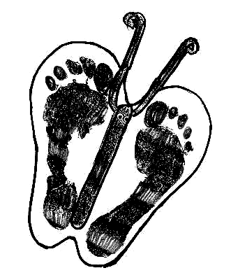
Materials
Poster board, acrylic paints in choice of color, ¼” wiggle eyes, jumbo craft sticks, washable markers, pipe cleaners, thick craft glue, scissors, masking tape, sheet of plastic to cover floor, bucket of warm soapy water, old towel, throw-away foil cookie sheet (for palette)
Directions
- Make the butterfly’s wings. Have child stand on poster board with feet together. Have adult outline both feet; cut out pattern slightly larger than outline and resembling shape of wings. Tape plastic sheet on floor. Apply paint(s) of color choice on palette. Paint can get from the palette onto the feet in two ways:
- Spread paint out in a thin layer. Using one foot at a time, step into the paint and then step onto the wing pattern. Remove feet and place in bucket. Wash thoroughly and dry on old towel. Allow wings to dry.
- If children are able, they may work in pairs to paint the bottoms of each other’s feet with a paintbrush. If not, have an adult paint the bottom of each child’s foot. Stand, placing one foot at a time on the wing pattern. Remove feet and place in bucket. Wash thoroughly and dry on old towel. Allow wings to dry.
- Make the butterfly. For body, use marker in choice your of color to color craft stick. See drawing. For antennae, fold pipe cleaner in half and curl ends. Glue antennae to back of body at centerfold of wings. Glue eyes on body as shown. Glue body on center of wings.
Fish Tank Neckerchief Slide
Baltimore Area Council

Materials needed: Empty Tic Tac container, construction paper, glue, scissors, colored fish tank beads or plastic gravel or craft melting beads, PVC pipe ring.
Directions:
- Carefully remove lid from Tic Tac container.
- Inside glue blue construction paper to the back.
- Spread glue on the bottom of the container and put in the colored fish tank beads or plastic gravel or craft melting beads as a colorful base.
- Use construction paper to make small fish and underwater plants.
- Glue the plants and some of the fish to the inside of the box. Put them on both the front and back of the box to give the tank a dimensional look.
- Glue PVC pipe ring to the back.
These next two items I remember running recently but they fit here so well, I am running them again. CD
Huck Finn’s Log Raft
Baltimore Area Council
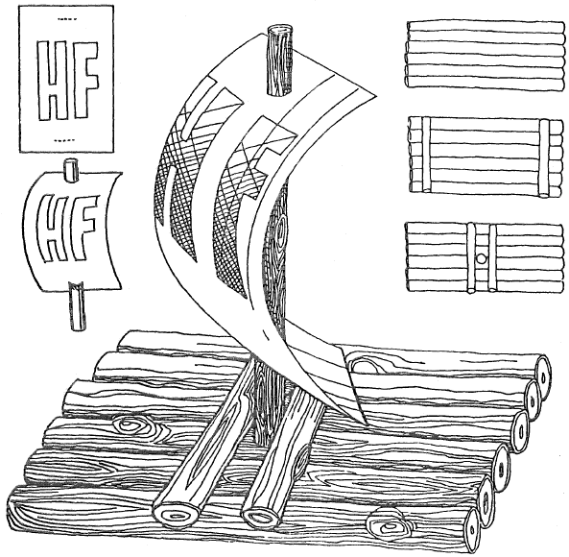
Materials:
11 twigs of equal thickness liquid white glue
1 sheet of white paper colored crayons or markers
wax paper.
Directions:
- Cut twigs a little longer than logs shown In illustration,
- Place six twigs on sheet of wax paper.
- Clue the twigs together with glue to form raft.
- Cut two twigs to fit the width of the six glued twigs.
- Glue these two twigs near the ends of the raft.
- Let the raft dry overnight. When dry turn upside down.
- Cut a twig to form the mast and glue it standing up to the center of the raft.
- Cut a twig to form the last two twigs to fit the width of the raft.
- Clue the remaining two twigs to both sides of the mast.
- Dry overnight.
- Cut the sail from white paper, decorate. Push sail through standing twig.
- Have a Den race with the boats in your Raingutter Regatta track.
Make a Paper Boat (and tell a story!)
Baltimore Area Council
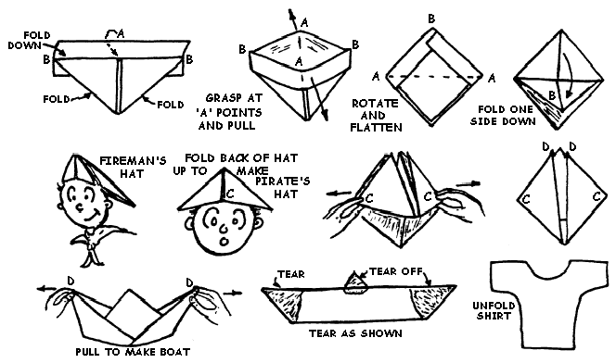
Folding Instructions: Take a full sheet of newspaper, folded on the center crease with the folded edge away from you. Take the two upper corners and fold them so that they meet at exact center. Fold the remaining flaps up, one on each side. Fold and tuck in the remaining points. Continue refolding following the illustrations outlined below to make two hats, then the boat.
After completing the boat, you can tell a funny story as you tear the boat apart (as shown in the last two steps).
“It was a dark and stormy night, and a ship was being tossed around off shore. The ship hit a rock, and the bow was ripped off (tear off one end of the boat as shown). Then it was whipped around, and the stern was demolished (tear off the other end of the boat). To make things worse, a bolt of lightening came and knocked off the mast (tear the top point off the boat). The boat then sank, and all that was ever found (here’s where you unfold the remains of the paper boat) was the Captain’s shirt.”
Practice the story and tearing off the pieces several times by yourself before you try to tell it in front of an audience!
AUDIENCE PARTICIPATIONS
Fisherman’s Luck
Circle Ten Council
In this audience participation, the audience will be divided into the necessary number of groups and each group will say the following lines when their name is called:
Fisherman Great day for fishing
Fish Bubble, Bubble
Worm Wiggle, Wiggle
Reel Everyone pretends to reel in a fish
Once there was a FISHERMAN who went FISHing on a sunny April day. He was hoping to catch a big FISH. He found a nice spot and stopped along the river.
The FISHERMAN put the REEL on his rod, and a worm on his hook and started to FISH. He patiently waited and waited, but no FISH came to eat the WORM on the hook. The FISHERMAN decided to leave his hook and WORM in the water and take a little nap. He was awakened by the screeching sound of his REEL; sure enough he had hooked into a great big FISH.
The FISHERMAN wounded in the REEL and to his surprise he found a stick on the end of his hook. The WORM was gone. So the FISHERMAN put another WORM on his hook and tossed his line into the water. Again he was awakened by the sound of the REEL, this time he found a tin can on his hook. “This is getting frustrating” he said, “I really want to catch a FISH before I run out of WORMs”.
One last time the FISHERMAN threw this line into the water and set his rod and REEL beside him. The sound of the REEL woke him once again. This time however he could not REEL in his FISH he knew for sure that his WORM was ling gone. He REELed and REELed until finally a large black fin rose out of the water. The FISHERMAN has caught a submarine. Riiinnnng . . . . went the alarm clock the FISHERMAN rolled over and said “six thirty in the morning”. The whole trip had only been a dream.
Travel Audience Participation Stunt
Baltimore Area Council
Divide the audience into 4 parts and as the narrator reads the following poem, the different groups say the key words when their assigned word is read.
CAR -- “Honk-honk” PLANE -- “Glide-glide”
BUS -- “Beep-beep” BOAT -- “Splash-Splash”
TRAVEL -- All sounds at once
When you want to TRAVEL from place to place.
There are many vehicles that could join the race.
There’s the CAR that comes in many assorted sizes,
With gadgets galore and full of surprises.
Or you could settle for a ride in a modern BUS
And save yourself worry and a whole lot of fuss.
If a CAR or a BUS does not meet your needs
You can TRAVEL in a PLANE at astonishing speeds
But before you choose to TRAVEL over a route that’s wet,
The finest of BOATS are yours to get.
When you want to TRAVEL whether near or far,
You can do it comfortably in a nice new CAR
If you listen when they say; leave the driving to us,
Then you certainly should TRAVEL around the place by BUS.
But if you are one that’s always in a hurry,
Then take a PLANE in your rush and your scurry.
But if over the water you may choose to ride,
Then pick a BOAT and through water you’ll slide.
Whatever the transportation you may chance to use,
When you TRAVEL, my friend, ‘tis yours to choose.
The Big Wheel
Baltimore Area Council
Divide audience into four groups to respond to the following words in the story:
BIG WHEEL: Spin, spin. CARS: Rattle, rattle, bang
CANOE: Paddle, paddle AIRPLANE: Zooooom
Man has invented many different things that go and have provided him with transportation down through the years. The Indian made his CANOE that took him from place to place and served his purpose well. Men like Henry Ford invented CARS which today Is the most popular type of transportation. There were men like the Wright Brothers who pioneered the invention of the AIRPLANE. And then there is a group of people called the BIG WHEELS who really don’t go anyplace nor do anything, but they like to feel important.
This story Is about one of those BIG WHEELS who just sat and spun his wheels and felt so important while he was doing nothing at all. Everyone around him was working on new and better types of CANOES, designing new and more efficient CARS and designing and testing new and faster AIRPLANES. But our BIG WHEEL Just sat around feeling important, not doing anything to help anybody, while everyone else was doing the work.
Somehow he always seemed to get by and fool people into thinking that he was important because everyone around him was making progress. The BIG WHEEL depended on their brains and energy to make him look good. Finally, one day something happened that changed things overnight for the BIG WHEEL.
Everyone who had been working on the CANOES, the CARS, and the AIRPLANES decided it was time to teach the BIG WHEEL a lesson. They were tired of him doing nothing except acting important. So they all became very busy and didn’t pay any attention to him. When something came up, the BIG WHEEL found he couldn’t rely on the others to answer questions and make him look important. Finally the BIG WHEEL realized that he could not accomplish anything without help from others. He realized he was making no contribution to the world at all. He was just sitting there spinning his wheels, while the others accomplished a lot on CANOES, CARS, and AIRPLANES. BIG WHEEL felt very bad.
It was a terrible feeling when BIG WHEEL finally realized something he should have known all along. If you’re going to get anyplace in this world, you can’t expect other people to do all the work. You must learn to do your part and paddle your own CANOE.
ADVANCEMENT CEREMONIES
Waterways Advancement Ceremony
Jim Jones, Great Salt Lake Council
I want to thank Jim for sending me his original ceremony for this theme to share with all Baloo Readers. CD.
Set Up – All parts are read by same person, or it could be broken up amongst Den Leaders, Assistant CM(s) and others. No props are required but pictures illustrating the various waterways would add to the ceremony (and the words could be placed on the back of the picture). If you want to get really creative, have the CM and an Assistant dress up as Lewis and Clark and modify the text to have them telling the story of their journey.
In 1804 Meriwether Lewis and William Clark began a journey at the request of President Thomas Jefferson to explore the west in search of a water route to the Pacific Ocean. Much of their journey was traveled on the great waterways and rivers of North America.
Tonight we honor others on their own journey of discovery. Will the following Cub Scouts and their parents please come forward? (Call forward all the Cub Scouts receiving their Tiger Cub Award.) These Cub Scouts represent the trickles of water from melting snow and ice that are the headwaters of America’s rivers and waterways. These Cub Scouts have earned the Tiger Cub Badge. (Present Tiger Cub Badges)
As these trickles of water come together they form small rivulets. As Tiger Cub Scouts grow they come together in the Wolf Den. Would the following Cub Scouts please come forward with their parents? (Call those Cub Scouts forward that are receiving their Bobcat Badges.) These boys represent those rivulets. Each of these Cub Scouts has earned the Bob Cat Badge. (Present Bobcat Badges.)
As these rivulets grow and move forward in their flow, they become streams. Would the following Cub Scouts please come forward with their parents. (Call those boys forward that are receiving their Wolf Badges.) These boys have grown and progressed in their Scouting journey of discovery and earned the Wolf Badge. (Present Wolf Badges.)
The streams grow and join becoming the rivers that are the tributaries of the great American Waterways. The Bear Den represents those tributaries. Would the following Cub Scouts please come forward with their parents. (Call forward the Cub Scouts receiving the Bear Badge.) These boys represent those tributaries in their own journey of discovery. They have earned the Bear Badge. (Present Bear Badges)
When those tributaries come together to form the great American Waterways, the journey is almost complete. Would the following Cub Scouts please come forward with their parents? (Call forward Cub Scouts receiving the Webelos Badge.) These boys represent Lewis and Clark’s Mississippi River. Each of these Cub Scouts has earned the Webelos Badge. (Present the Webelos Badge.)
Would the following Cub Scouts please come forward with their parents? (Call forward the Cub Scouts that are receiving the Arrow of Light.) The greatest Waterway in America is the Mississippi River. This is the beginning and ending point of Lewis and Clark’s journey of discovery. As great as the Mississippi River is, it eventually empties into the Gulf of Mexico ending its journey. Tonight these Cub Scouts are ending their journey of discovery in Cub Scouting and receiving their Arrow of Light, Cub Scouting’s highest honor. (Start your Pack’s traditional Arrow of Light Ceremony here)
Fishing Trip
Voyageur Council
Setting: The Cubmaster, or other leader, is recounting the vents of his recent fishing trip relating it to Cub Scouting.
Props: Cubmaster will need clothing for fishing, a pole that is hooked up with a magnetic hook. Cub River (some type of tub container to be the fishing hole).
Place advancements on the fish as
described below before the meeting.
Cubmaster: Well, before I tell you who are getting awards tonight, I want to tell you about my latest fishing trip. You all know that any good fisherman will get up before dawn to prepare himself to go fishing. That is when this day started for me. There are seven things I have to do to get ready for a fishing trip, and as I was doing these things, I remembered the seven requirements that my son had to do to get his Bobcat Badge. Just like I prepared to go fishing, my son had to prepare himself to be a Cub Scout.
Call up Cub Scouts and their parents who are getting their Bobcat Badges.
Scouts, here at Pack ____, we are really proud of your accomplishment of completing the 7 requirements for the Bobcat Badge. And just like I have to have a license to go fishing, you have to become a Bobcat to go on in Scouting. Scouts, tonight I'm presenting your parents with your Bobcat Badge. When they give it to you, I want you to always remember how you prepared yourself for Scouting.
Present badges on pretend fishing licenses to the parents
Well, let me continue on with my fishing trip. You won't believe the trouble that I had! Before I even got to the river, I got lost, and had to look at a map. I then had to make a phone call because I forgot to leave a note to let my family know where I was going to be. Then, once I was at the river, things didn't get any better. I dropped my bait bucket, I cut my finger. I got knots in my fishing line, I even had to go back to the car for the lunch that I had packed. But you know, some nice things did happen to me too. The day was beautiful, birds were out singing in the trees, and the trail to the lake was clean. I saw some really neat plants growing along side of the path, and I found a really great rock for my son's collection.
Oh, yes you are probably wondering what all of this has to do with Scouting. Well, as I was having all of these problems I remembered the 12 Achievements that Cubs have to do to get their Wolf and Bear badges. And you know, some of the things that they had to learn I needed that day. The first aid for my cut finger, the knots in my line, and the lunch I did remember to pack. In Cub Scouts, boys get a really good understanding of nature and how to take care of the land around them. That path was so clean I bet some fisherman who had been in Cub Scouting had come before me.
So I did go fishing, and caught (insert number of Wolf and Bear advancements that you have) really nice fish. Here let me show you.
Cast your line into Cub Lake and catch fish for the Wolf badge(s), and the Bear Badge(s)
Call up the Cubs with their Parents.
Scouts, you are receiving your Wolf Badge tonight, and, along with your parents, your Pack is really proud of you and the work you have done. Congratulations.
Scouts, you are receiving your Bear Badge tonight and you have shown us that you take your Cub Scouting seriously. Congratulations.
Well, my fishing trip continued on for a few more hours and I continued to think about Cub Scouting. I thought about how each of the Webelos Scouts earns the different Activity Badges, the badges give the Scout a taste of what Boy Scouting will be like. They just sort of cover what a Scout that is in 4th and 5th grade needs to know.
Will our Webelos leader please come up here tonight? I'm going to go fishing and see if I can find any Webelos Activity Badges down here. Yes, there does appear to be a few.
Have Webelos Leader give out the badges to the boys
I want to thank each one of you tonight for coming along with me on this trip, Scouting and fishing sure do have a lot in common, and don’t you agree?
Sailing Adventures
Voyageur Council
Cubmaster (CM): When a boy wanted to be a sailor, he would hire himself on as a cabin boy. There he learned the terminology of the ship. He learned his knots and the rigging.
Assistant Cubmaster (CA): When a boy wants to become a Cub Scout, he must learn the basics of Scouting. When he learns the Promise, the Law, the sign, the salute, the handshake, the meaning of Webelos, and the motto, a boy becomes a Bobcat. Will the Bobcat recipients please come forward with their parents?
(Present awards to parents to pin on their son)
CM: A sailor boy’s knowledge of the waterways did not end with his ship. As he traveled along the waterways, he saw many different types of ships and their uses. His world became larger. So too, does a Cub Scout grow. He learns about his national flag, about his family and world, about tools, and about many other things. It is then that he is recognized as a Wolf. Would our Wolf Cubs and their parents please come forward?
(Present awards to parents to pin on their son)
CA: A sailor even today has to know the methods of ship communication, whether it be flags or radio. He needs to know about radar. A Bear needs to be more aware of his Duty to God and how to worship, more about wildlife and the environment, more about family life and more about strengthening his body. Will our Bear rank recipients and their parents please come forward?
(Present awards to parents to pin on their son)
Webelos Leader 1: A sailor soon learns about river currents and tides. He learns to use these to travel. A Webelos Scout must earn several different kinds of activity badges to help prepare him for the future. Will our Webelos and their parents please come forward?
(Cubmaster presents awards to parents to pin on their son)
WL 2: Finally, a sailor has a destination, a goal; he must know where he is and how to get where he is going. He uses landmarks along the waterways, the constellations and the North Star to guide him. He uses a compass and a sextant to chart his course. So, too, does a Webelos Scout. He has earned more activity badges to give him skills for the future. He has visited Boy Scout troops, as he plots is course. He has filled out a Boy Scout application form. He is deciding on his goal, maybe even an Eagle Scout. Will our Arrow of Light recipients and their parents come forward?
(Cubmaster presents awards to parents to pin on their son)
WATER FUN
Circle Ten Council
Props: Various items used in the water: (e.g. mask, snorkel, fins, ski tube, skis, etc.) and leaders wearing them
Cubmaster needs to have a fishing hat and vest available.
Have a fish tank or fish bowl and enough dowel rods with strings attached to badges in plastic sealed bags. These are the awards for the boys.
Cubmaster: Water fun is something that is enjoyed by nearly everyone. We have some special people here tonight to show you ways to have fun in the water.
- Mask man The person who does not want to get water on his face, or the person who does not want to be seen.
- Snorkler The next person thinks he/she is a shark. They think they are a part of the great white shark family. In fact, _______ is a card-holding member of the JAWS fan club.
- Finner This person only walks on the beach and leaves big prints in the sand. He’s hoping you think that Bigfoot has reappeared.
- Tuber This person is someone who has always wanted to drive on water, but has not yet figured out how.
- Etc. (make up your own to fit the props)
These are just a few of the items that can be used to have fun in the water. Fishing is also very popular. (Put on fishing hat and vest.) In this fish tank I have caught some badges for Cub Scouts who have advanced in rank. (Pull badges out one by one and call boy forward with his parents.)
“Water Adventure” Graduation Ceremony
Baltimore Area Council
Note: This may be adapted to be an advancement for any Cub Scout rank advancement
Setting:
- Side view of a ship (USS WEBELOS) is cut from cardboard. Cubmaster, Webelos Leaders and Bear Leaders dressed as Ships Officers.
- Bear Dens are standing to the side of the ship.
- The Cubmaster and new Webelos Leader/s are standing behind the ship.
Cubmaster: (blows whistle). Bear First Mate, is your crew assembled and ready to board?
Bear Leader: Aye, aye, Sir!
Cubmaster: Webelos First Mate, are you ready to receive your new crew?
Webelos Leader: Aye, aye, Sir!
Cubmaster to Bears: Bears, are you prepared to board the Webelos Ship and continue along the trail that will lead to the USS Arrow of Light? (Prompt boys to say “Aye, aye, Sir!”) Before boarding the Webelos Ship, would you all raise your right hands in the Cub Scout Sign and recite the Cub Scout Promise? (CM leads boys in the promise)
Welcome aboard! (Motion the Bears toward the ship) Webelos First Mates, meet the new crew of the USS WEBELOS .
(Suggestion: Cubmaster can present the new Webelos with their neckerchiefs; the Webelos Leader with his/her badge of office, or the Den flag.)
Arrow of Light Ceremony
Baltimore Area Council
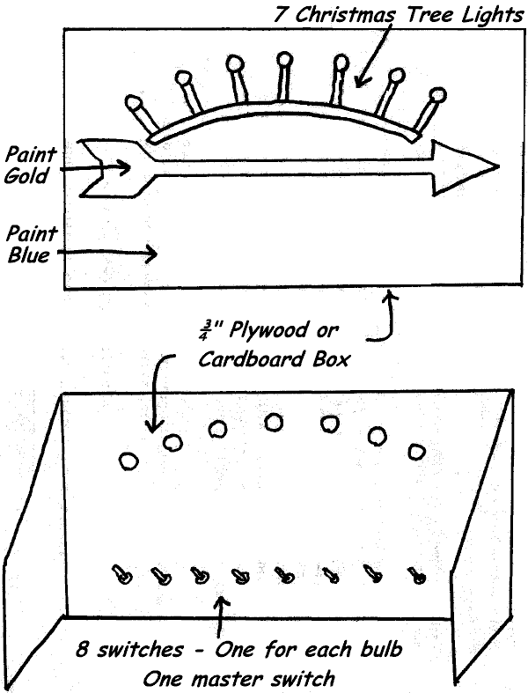
PERSONNEL: Webelos Leader or Cubmaster; Webelos Scout(s); parents.
EQUIPMENT: Ceremony board (see illustration)
ARRANGEMENT: Room is in darkness. Leader introduces Webelos Scout(s) who are receiving Arrow of Light, and explains they have met the requirements to receive the highest award in Cub Scouting.
LEADER: The purpose of Cub Scouting is to light the way to Boy Scouting.
The first rank in Cub Scouting is Tiger. (Turn on first light) A First Grade Cub Scout must complete 5 Achievements to earn this rank.
Before becoming a Bobcat a Cub Scout learns the Cub Scout Promise, the Law of the Pack, the Cub Scout sign, handshake; motto and salute. (Turn on second light)
The rank for second grade (eight year old) Cub Scouts is Wolf. (Turn on third light) Twelve achievements are required to earn the Wolf badge. Then he works on arrow Points until he is in third grade (nine years old). He can earn as many Arrow points as time and ambition will allow.
Twelve achievements are required for the Bear badge. (Turn on fourth light) You can see that as a boy progresses in Cub Scouting, his way becomes lighter. After receiving his Bear badge, he works on Arrow Points until he is in fourth grade (10 years old)
Now he becomes a Webelos Scout. (Turn on fifth light) They wear the Webelos tri-colors on their sleeve and work on Activity Badges to pin to the Tri-colors. To earn the Webelos badge, he must earn the Fitness and Citizen Activity Badges, plus one additional Activity Badge. Webelos stands for “We’ll Be Loyal Scouts” and it is the name of the Indian tribe of which Akela is chief. The Webelos Scout is older. He can do more for himself. His parents no longer sign for his advancement; his Webelos Leader does this.
When he is in fifth grade, he works on the Arrow of Light Award. (Turn on sixth light) To receive this award, he must earn the Outdoorsman and Readyman Activity Badges and at least four more Activity Badges. He learns the Scout Oath, the Scout Law, the Scout Motto, Slogan, Sign, Salute and Handclasp. He learns the parts of the Scout badge. He understands and supports the Outdoor Code. He plans and leads a flag ceremony at a Pack meeting. Now he has earned the Arrow of Light award, the highest award a Cub Scout can earn. (Turn on seventh light) His path to Boy Scouting is now fully lit.
Let’s review his path to Scouting. (Turn out all lights) This is what his path looked like before he entered Cub Scouting. (Turn on all lights) This is what his path is like now that he ‘ has progressed through the ranks of Cub Scouting to the Arrow of Light.
Goodbye Cub Scout… Hello Boy Scout.
GAMES
Forty Ways to Get There
Baltimore Area Council
Divide the boys into two or more teams. On signal, the first boy on each team runs to the finish line and returns. The next boy on the team must get to the finish line using a different method (e.g.., backwards, bunny hops, hopping on one leg, crab walk, etc.) Each player on the team must use a different way of getting to the finish line. The emphasis is on fun and ingenuity.
Over and Under the Waves
Baltimore Area Council
Divide teams equally and line up in relay formation. The first Cub Scout on each team is given a large ball. On signal, he passes the ball overhead to the second, player who passes it between his legs to the third, who passes it overhead, and so on to the end .of the line. The last player runs to the head of the line and passes it as before. The first, team back in its original order wins.
Crossing the River
Baltimore Area Council
With stones or stakes, mark out a ‘river’ 10 ft. wide. Divide the Den into two teams and have both teams on one side of the river. The Den leader or Den chief puts the ball in play by throwing it high into the air. Whoever catches it before it touches the ground shares its magic properties and is able to walk across the river. From the other side he throws the ball over to one of his own team while the others try to intercept the ball and gain passage across the river. Anyone stepping into the river in the excitement of the game loses a life. When he has lost three lives, he is considered drowned and is out of the game. The team that gets its members safely across first is the winning team.
Raft Race
Baltimore Area Council
Line up the Dens for a relay race. The first Cub Scout in each line is the “skipper.” He stands with each foot on a large pad of newspapers. The second Cub Scout is the “passenger” and he stands on the same papers with his skipper. On signal, the skipper bends over and grasps the papers with each hand. By shifting their weight and sliding the papers forward, the two boys maneuver themselves to the goal line without stepping off of the pads. On reaching it, the passenger runs back to his team with the newspapers and brings the next boy across the river. The first team to cross the river wins.
Leaking Relay
Baltimore Area Council
Items needed: Bucket of water, Two cups with holes in the bottom and sides (equally), and two containers about half gallon size.
Divide into two teams. First player on each team fills his cup with water from the bucket, then places the leaking cup over his head and runs around a previously marked course. When he gets back to the beginning he pours into the empty container, whatever water is left in his cup then hands the empty cup to the next player. The team that fills their container first wins.
Water Slides
Baltimore Area Council
Make a simple backyard water slide by laying a sheet of plastic down a gentle slope. Use giant staples made from hangers or stiff wire to fasten the edges, and make sure there is a safe way to stop at the end (bumpers of hay or a big, level grassy area). Run a sprinkler at the top, get it good and wet, and you are ready to slide! For safety sake, only slide lying down feet first.
Variation: Do this on level ground and do running slides, or play tug-o-war!
Water Balloon Volley Ball
Play volleyball except use a water balloon for the ball and have the teams use a bath towel to catch and throw the balloon. Have two boys to a towel. Play outside!!!
Sponge Wars
Fill two five gallon buckets with water. Place 30 sponges – the number of sponges is up to the pack – in each bucket. Divide the boys and adults into two teams. Mark a dividing line between the teams. Put one bucket of sponges on each side of the line about five to six feet back. When you yell “Sponge Wars!” the teams begin throwing the wet sponges across the line onto the other teams territory.
Rules:
- You can only throw one sponge at a time.
- The object is to get as many sponges as possible on the other teams side.
- You may pick up sponges that have been thrown on your side and throw them back as long as you only throw one at a time.
- At the end of one minute the leader yells peace and all sponge throwing stops.
- The team who has the fewest sponges on their side wins.
Rollero
Cut a toilet paper tube into two sections, so you have two rings. Cover each section with colored paper or decorate with markers. Set a starting point and a finish line on the table or the floor. You race to the finish line by blowing through a drinking straw so that you move your Rollero along. The first one to cross the finish line wins.
Hidden Object
Longhorn Council
Maybe after playing this they will be more able to find pollution (litter) and pick it up on hikes and camping trips.
Equipment: 1 thimble, ring or coin
Formation: Scatter
Send boys out of the room. Take a thimble, ring or coin and place it where it is perfectly visible but in a spot where it is not likely to be noticed. Let the boys come in and look for it. When one of them sees it, he should quietly sit down without indicating to the others where it is. After awhile, if no one else has found it, have him point it out to the group to make sure he really saw it.
Earth, Water, Air and Fire
Longhorn Council
Equipment: 1 bean bag
Formation: circle
- The Pack or den sits in a circle with one Cub in the center holding the bean bag. He throws the bag at someone and shouts 'Earth!', 'Water!', 'Air!' or 'Fire!'.
- If it is 'Earth', the chosen Cub must reply with the name of the animal, before the center Cub counts to ten.
- If it is 'Water!', he must think of a fish,
- If 'Air!' - a bird and
- If 'Fire' - whistle for the Fire Engine.
Note: Once a creature has been named, it may not be called again. If the Cub cannot reply in time, he changes places with the thrower.
Above and Below
Longhorn Council
Notes: After some discussion about pollution and what are ways we have polluted out environment, play this game where you come up with ways we have polluted our environment and ways we are trying to save our environment and are they above or below (meaning is it visible to us).
Equipment: None
Formation: Circle
Examples:
Pollution: litter on highways - above,
Garbage on the floor of the sea - below,
Saving our environment: Planting a tree - above)
Arrange the players in a circle. Call out ways we pollute the environment or save our environment that are found above or below. When you call something that signifies above, the players stand; if below, they sit down. Failure to do this eliminates the players who miss. The list of things to be named should be carefully worked out in advance to keep the game going smoothly.
WATER CARNIVAL GAMES
Circle Ten Council
Depending on where you live you may or may not want to do this in April (BBbbrrrrr) But mark it and put it away fro a great summer activity!! CD
Floating Target
Float a pie plate in a tub of water. Give each player ten beans. In turn, the players try to toss their beans into the plate from a distance of about five feet. Score 10 points for each bean that stays on the plate.
Penny Drop
Pour water about six inches deep in a bucket and drop in a dime. Each player is given six pennies. In turn, players drop their pennies in the water, trying to cover the dime with the penny. The successful player wins the dime.
Water Balloon Race
Give each player a balloon filled with water and a 30-inch-long string. The players tie one end of the string to the neck of their balloon and the other end to one ankle. On a signal, all players move toward the finish line 20 feet away, dragging their balloons behind them. A player whose balloon breaks must step out of the game. The winner is the first person whose intact balloon crosses the finish line.
Sand Castles
Locate a nice sandy area and bring lots of water, molds (cans, buckets, etc) and modeling tools (rakes, spoons, shovels, etc) and spend some time making sand creations. Have each Den or each family create something.
Alka-Seltzer Shoot-Out
Drill a hole in several Alka-Seltzer (or generic) tablets. Tie a string through them, put one on each boy’s neck and turn the boys loose with squirt guns to squirt each other’s tablets. When your tablet is gone, you are “out”. NOTE: This does not stain or hurt most fabrics, grass, sidewalks, skin, etc, but be careful of eyes and fine fabrics. Once everyone is wet, the tablets will not last long, so switch to a “squirt tag” game for a few minutes - if someone squirts you, you are “it” until everyone is caught. The last Scout caught starts as “it” for the next round.
Water Balloon Relay:
Form two lines about 8 - 10 feet apart, facing each other. Let’s call one line A, B, C, D, ...and the other is 1, 2, 3, 4, ... “A” takes a water balloon and tosses it to “1” who tosses is to “B” who tosses it to “2”, then “C” and so on to the last person who tosses it in a basket. The goal is to see how many can be passed unbroken in a set time limit.
Mini-Firefighter’s Tug-O-War:
Perhaps you’ve seen those battles where teams of Firefighters try to push a barrel on a cable using the powerful streams from the fire hoses. It’s easy to do this on a smaller scale by punching two holes in the middle of two foam plates. Fasten the plates together back to back, then string a thick cord through them and tie it about 5 - 6 feet off the ground, as tight as you can. Mark the center, or two “end zones”. Arm the Scouts with squirt guns or bottles (have quick refill barrels ready). Divide into two teams and set the teams to push the plate with water pressure alone. The team who pushes past the centerline or into the other team’s end zone is the winner.
Water Balloon Toss:
Form two lines standing 4 - 5 feet apart with Scouts facing toward each other. Each pair of Scouts is given a water balloon. Scouts toss the balloon back and forth from one side to the other. Once the balloon has been tossed from one side to the other and back, the Scouts take one step backward. When the balloon is dropped to the ground or bursts, that team is to sit down. The winner is the team left standing the longest.
Biathlon:
Instead of skiing and shooting, or biking and swimming, this biathlon involves running and squirting! Using squares of paper towels, draw a number or letter per Scout on each paper towel. (Use water-based markers - it’s fun to watch them run!) Stick the paper towels up around the yard or park. Each Scout starts on a signal, running the course and squirting his number only on the towels. Scour by total time, minus a second for each missed towel.
SONGS
The Erie Canal
Baltimore Area Council
This song was written in 1913 by Jerry Vogel. It is listed on www.pdinfo.com as being in the Public Domain (Thank you, Nancy). If you want to hear the tune, there is a midi file at http://www.kididdles.com/mouseum/e014.html CD
I’ve got a mule, and her name is Sal,
Fifteen years on the Erie Canal.
She’s a good old worker and a good old pal,
Fifteen years on the Erie Canal.
We’ve hauled some barges in our day
Filled with lumber, coal and hay
And ev’ry inch of the way I know
From Albany to Buffalo.
Chorus:
Low Bridge, ev’rybody down,
Low Bridge, for we’re coming to a town!
And you’ll always know your neighbor,
You’ll always know your pal,
If you’ve ever navigated on the Erie Canal.
We better get along on our way, old gal,
Fifteen miles on the Erie Canal.
Cause you bet your life I’d never part with Sal,
Fifteen miles on the Erie Canal.
Git up there, mule, here comes a lock,
We’ll make Rome ‘bout six o’clock.
One more trip and back we’ll go
Right back home to Buffalo.
Chorus
Red River Valley
Baltimore Area Council
This song was written in 1896 by Cass von Braun. It is listed on www.pdinfo.com as being in the Public Domain. If you want to hear the tune, there is a midi file at http://www.niehs.nih.gov/kids/lyrics/redriver.htm CD
From this valley they say you are going
We will miss your bright eyes and sweet smile
For they say you are taking the sunshine
That has brightened our path for a while
Come and sit by my side if you love me
Do not hasten to bid me adieu
But remember the Red River Valley
And the cowboy who loved you so true
Won’t you think of the valley you’re leaving
Oh how lonely, how sad it will be?
Oh think of the fond heart you’re breaking
And the grief you are causing to me
As you go to your home by the ocean
May you never forget those sweet hours
That we spent in the Red River Valley
And the love we exchanged mid the flowers
Row, Row, Row Your Boat
Baltimore Area Council
Row, row, row your boat
Gently down the stream.
Merrily, merrily, merrily, merrily,
Life is but a dream.
Blub blub blub your sub
Gently ‘neath the stream
Ha ha fooled you all
I’m a submarine
Propel Propel Propel your craft
Passively down the liquid solution
Ecstatic ecstatic ecstatic ecstatic
Existence is but an optical illusion
Sailing, Sailing
Baltimore Area Council
Sailing, sailing over the bounding main
Where many a stormy wind shall blow
‘Ere Jack comes home again
Sailing, sailing over the bounding main
Where many a stormy wind shall blow
‘Ere Jack comes home again
Little White Duck
Baltimore Area Council & Circle Ten Council
There’s a little white duck sittin’ in the water,
A little white duck, doin’ what he oughter.
He took a bite of a lily pad, flapped his wings
And he said I’m glad that I’m a little white duck
Sittin’ in the water, quack, quack, quack.
There’s a little green frog, swimmin’ in the water
A little green frog, doin’ what he oughter.
He jumped right off the lily pad the little duck bit
And he said I’m glad that I’m a little green frog
Swimmin’ in the water, croak, croak, croak.
There’s a little black bug, floatin’ on the water
A little black bug doin’ what he oughter
He tickled the frog on the lily pad that the little bug bit
And he said I’m glad that I’m a little black bug
Floatin’ on the water, chirp, chirp,
There’s a little red snake lyin’ in the water
A little red snake doin’ what he oughter
He frightened the duck and the frog so bad
He ate the bug and he said I’m glad that I’m a little red snake
Lyin’ in the water; ssss, ssss, ssss.
There’s A Hole In The Bottom Of The Sea
Baltimore Area Council
There’s a hole in the bottom of the sea
There’s a hole in the bottom of the sea
There’s a hole, there’s a hole
There’s a hole in the bottom of the sea
There’s a log in the hole in the bottom of the sea
There’s a log in the hole in the bottom of the sea
There’s a hole, there’s a hole
There’s a hole in the bottom of the sea
There’s a bump on the log in the hole
In the bottom of the sea
There’s a bump on the log in the hole
In the bottom of the sea
There’s a hole, there’s a hole
There’s a hole in the bottom of the sea
Keep building as long as your imagination let’s you. Be sure to repeat all the items each time.
There’s a frog on the bump on the log in the hole …
There’s a fly on the frog on the bump on the log …
There’s a wing on the fly on the frog on the bump…
There’s a flea on the wing on the fly on the frog …
After this you could have
A wing on the flea,
A hair on the wing,
But at Camp No-Be-Bo-Sco in the 60’s under the direction of “Golden” Eddie (Stoeffels) we would continue with –
There’s a truck on the flea on the wing on the fly …
There’s a tire on the truck on the flea on the wing …
And somehow we would wind up with
There’s a charge in the proton in the atom … I don’t remember it all. Sorry. However you choose to do it -
- Have Fun
- Make sure your Cubs are having fun, don’t drag it out too long. Commissioner Dave
SuperCalifornianExpertSurferoftheOcean
Circle Ten Council
(Tune: Supercalifragilistic)
Chorus:
SuperCalifornianExpertSurferOfTheOcean,
Even though most of them don’t use a suntan lotion
When they hit the waves too hard
They sure do cause commotion.
Super Californian Expert Surfer Of The Ocean.
Hum, diddle, diddle, diddle
Hum, diddle, I (up half-tone)
Hum, diddle, diddle, diddle
Hum, diddle, I
Because I was afraid to surf
When I was just a lad
My father took my board away
And told me I was bad
But then one day I learned a word
That every surfer knows
The biggest word you ever heard
And this is how it goes: Chorus
Chorus:
He Waded in the Water
Circle Ten Council
(Tune: Battle Hymn of the Republic)
Chorus:
He waded in the water and he got his feet all wet
He waded in the water and he got his feet all wet
He waded in the water and he got his feet all wet
But he didn’t get his (clap, clap) wet (clap) yet.
Glory, glory, hallelujah!
Glory, glory, hallelujah!
Glory, glory, hallelujah!
He didn’t get his (clap, clap) wet (clap) yet.
He waded in the water and he got his ankles wet (3x)
But he didn’t get his (clap, clap) wet (clap) yet.
Chorus
He waded in the water and he got his knees wet (3x)
But he didn’t get his (clap, clap) wet (clap) yet.
Chorus
He waded in the water and he got his thighs wet (3x)
But he didn’t get his (clap, clap) wet (clap) yet.
Chorus
He waded in the water and he finally got it wet (3x)
He finally got his bathing suit wet!
Cub Sailors
Circle Ten Council
(Tune: My Bonnie Lies Over the Sea)

The Cub Scouts sailed out on the ocean
One weekend with all of the pack
They didn’t remember the compass
Oh, please bring that Cub Scout Pack back.

Chorus:
Bring back, bring back
Bring back those Cub Scouts back home to me
Bring back, bring back
Bring those Cub Scouts to me.
They sailed till they reached Honolulu
They landed with nobody hurt
They went to a Hawaiian luau
Dressed up in blue and gold grass skirts
Chorus
They headed back home one gray morning
Got caught in a bad hurricane
They last report we heard of them
They were sighted off the coast of Spain.
Chorus
Columbus Song
Circle Ten Council
(Tune: Yankee Doodle)
In fourteen hundred and ninety two
Columbus sailed from Spain
With three small ships and eighty men
Across the bounding main
Chorus:
“Sail on and on,” he said
“There’s nothing you should dread.”
“We’ll find that New World soon I’m sure!”
“Just think what lies ahead!”
Columbus was a sailor fine
He knew his navigation
And even though his men were scared
He was their inspiration.
Paddle Song
Baltimore Area Council
Start out softly as if the canoes are at a great distance. Each time, get a little louder as the canoes pass you, then gradually get soft again as the canoes disappear from sight.
Our paddles keen and bright,
Flashing like silver.
Swift as the wild goose flight,
Dip, dip, and swing.
Dip, dip, and swing them back,
Flashing like silver.
Swift as the wild goose flight,
Dip, dip, and swing.
Shipwrecked Cub Scouts
Longhorn Council
(Tune: Gilligan’s Island Theme)
Our pack set sail on the sea one day,
In search of coins of gold.
A group of hearty Cub Scouts,
And leaders true and bold.
The weather started getting rough,
The tiny ship was tossed.
If not for the courage of our Cubmaster,
The whole pack would be lost.
Our boat touched ground on a rocky isle
And up walked a tall old man.
He tossed a towel to dry us off,
And raised high his right hand.
He said, “You’re a sharp pack of Cub Scouts,
Your courage brave and sure,
To sail out on a sea like this
On a Scouting adventure.”
He gave directions to get home.
We set sail with good cheer.
We reached home with the setting sun,
And tied up to the pier.
We looked in the bottom of the boat
And saw the old man’s towel.
His name was stitched along the hem,
The name was Baden-Powell.
CUB GRUB
Bears on a Raft
Baltimore Area Council
Ingredients: Graham crackers, gummy bears, icing
Use icing to let the boys glue 3 or 4 gummy bears to a square of graham cracker.
Edible Aquarium
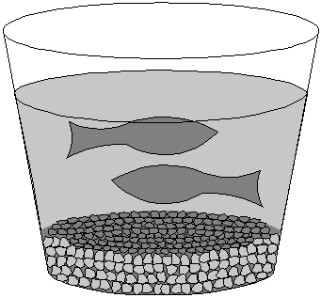
Baltimore Area Council
Make an edible aquarium in a cup. This is a great party treat you can make with your child.
You will need:
Blue Jell-O Gummy fish
Graham crackers clear plastic cups
- Crush graham crackers into crumbs for the aquarium “gravel.”
- Put about ½ inch of crumbs into the bottom of each clear plastic cup.
- Make blue Jell-O according to the directions on the box.
- Pour into clear plastic cups. Let them cool in the refrigerator until partially set - about an hour.
- When they’re partially set, place a few gummy fish in each cup.
- Put them in the refrigerator until they’re completely set. Eat and enjoy!
Variations include:
- Frozen fish-Popsicles (just freeze the Jell-O in Popsicle molds - add the gummy fish when they are partially set - unmold very gently when entirely frozen). These are really messy to eat and are best eaten outside.
- An entire punch bowl of fish Jell-O (made like the cup o’ fish)!
Edible Raft
Baltimore Area Council
Ingredients:
Fig Newton cookies pretzel sticks
Fruit roll-up sheets 4 sm. pkgs. Blue Jell-O
2 ½ c. boiling water
- Completely dissolve gelatin in boiling water or juice.
- Pour into 13”x9” pan. Chill until firm or about 3 hours.
- To remove, dip pan in warm water about 15 seconds.
- Cut into 3” squares.
- Lift gelatin blocks from pan and put on plates.
- Top each square of blue gelatin with a Fig Newton raft.
- Cut a square of fruit roll-up and push the pretzel stick through it twice for a mast and sail. Stand a pretzel stick and sail assembly in each Fig Newton.
STUNTS AND APPLAUSES
APPLAUSES & CHEERS
Baltimore Area Council
Buccaneer Applause: “Yo, ho, ho and a bottle of Coke”,
Deep Sea Diver Applause: “ Blubb, Blubb, Blubb”.
Water Cheer: “How, How, How, Water, Water, Water, Glug, Glug, Glug, Ah-hhh”
Clam Clap: Ask everyone to roll up his sleeves in preparation for this strenuous applause. Double up your fists with your left arm in front of your face and right arm over-head. Then silently open and close your right fist.
Motorboat Applause: Flutter tongue on roof of mouth.
Seal Applause: Extend your arm straight out in front of you and clap with stiff arms while saying, “‘Arf, arf, arf, arf
Beach Cheer: Divide your audience into 3 groups. When you point to group 1, they yell “Sand.” When you point to group 2, they yell “Surf” And when you point to group 3, they yell “Sun.”
Longhorn Council
Clean Air: Take a big sniff of air, exhale and say “AHHHHHHHHHHHHHHH!”
Give A Hoot: Divide the audience into two sections. Have one section yell, “Give A Hoot!” and the other section yell, ‘Don’t Pollute!” Alternate pointing at each section, pointing faster and faster.
Good Turn: Stand up and turn around
Noise Pollution: Raise hands and have everyone yell as loudly as they can. Lower hands and volume of yells go down. When hands are on floor, everyone must be extremely quiet. Do several times – raise and lower volume. Then, with hands on floor ask the Pack to listen to absolute quiet.
Reduce, Reuse, Recycle: Divide the audience into three sections. Have the first section yell, “Reduce!”, the second section yell, “Reuse!”, and the third section yell, “Recycle!” Alternate pointing at each section, pointing faster and faster.
Southern NJ Council
Water Sprinkler Applause Make fist with the right hand with thumb sticking out. Place end of thumb on end of nose. Rapidly open and close fist while saying "Choo, choo, choo, choo," etc. sounding like a water sprinkler and turning around as you go. After a complete turn spin back around the opposite direction, again like a water sprinkler, saying "Wheeee."
RUN-ONS
www.wtsmith.com/rt
Here are some classic run-ons from Bill Smith’s Unofficial Roundtable site – Be sure to visit his site to find a lot more.
Mother: Son, there were two pieces of pie on the shelf this morning, and now there is only one. How did this happen to be?
Son: I don't know. It must have been so dark, I did not see the other piece.
- Pardon me do you have a watermelon patch?
- Why is your watermelon leaking?
- Why did you eat that dollar bill? .
- It was my lunch money.
A man goes to see a psychiatrist.
- "Doc, one minute I feel like I'm a wigwam, then I feel like I’m a Teepee. Then I feel like a wigwam again, and a moment later I'm sure I'm a Teepee. What am I going to do?"
- The doctor said, "Just relax son, Your two tents!"
Cub 1: Enters with pine branch and pokes Cubmaster.
CM: What are you doing?
Cub 1: I'm needling you.
CUB #1: Yesterday a girl rolled her eyes at me.
CUB #2: Really? What’d you do?
CUB #1: Well, I picked them up and rolled them right back!
JOKES & RIDDLES
Baltimore Area Council
Why did the boy throw water out of the window?
He wanted to see a waterfall.
What does not get any wetter no matter how much it rains?
A lake.
Why didn’t the man swim on an empty stomach?
Because it is easier to swim in water.
Where do ships go when they are ill? To the “docks!”
SKITS
Waterways
Baltimore Area Council
This could easily be adapted for an Opening CD
Props: A picture indicating each boy’s sentence. Text can be cut and pasted to back of picture.
- (holds up picture of a lake) A waterway is any navigable body of water. These include rivers, lakes, oceans, and canals. In order for a waterway to be navigable, it must meet several criteria:
- (holds up picture of a sailboat with a big keel) The waterway must be deep enough to allow the draft depth of the vessels using it;
- (picture of boat pushing barges on the Mississippi) The waterway must be wide enough to allow passage for the beam width of the vessels using it;
- (picture of Niagara Falls) The waterway must be free of barriers to navigation such as waterfalls and rapids, or have a way around them, such as canal locks;
- (picture of whitewater rapids) The current of the waterway must be mild enough to allow vessels to make headway.
- (picture of a cruise ship) Vessels using waterways vary from small animal-drawn barges to immense ocean tankers and ocean liners, such as cruise ships.
- (picture of barge on canal) At one time, canals were built mostly for small wooden barges drawn by horses or other draft animals. Today, major canals are built to allow passage of large ocean-going vessels. See Ship Canal.
How Did You Get Here?
Circle Ten Council

The skit is introduced by saying, that “many different kinds of ships were used by the people that helped settle America. Any number of Cub Scouts can be used for this skit either by dividing the lines accordingly or creating new ones.
Cub 1: If the Pilgrims came over on the Mayflower how did the Cub Scouts get here?
Cub 2: I don’t know? How?
Cub 1: On handy crafts. (As he says this, a Scout comes on stage with a sample of the handicraft project and a sign identifying it)
Cub 1: If Pilgrims came on the Mayflower and the Cub Scouts came on handy crafts, how did the doctors get here?
Cub 2: I don’t know. How?
Cub 1: On blood vessels. (Boy dressed as a doctor enters)
Cub 1: How did the students get here?
Cub 2: On scholarships (Boy carrying books)
Cub 1: How did all the ordinary people get here?
Cub 2: On citizenship. (Boy carrying sign that says, “Don’t forget to vote”)
Cub 2: I know how the barbers got here.
Cub 1: How?
Cub 2: On clipper ships. (Boy dressed as a barber)
Cub 1: How did all the movie stars get here?
Cub 2: On a showboat. (Boy wearing fancy clothes and sun glasses)
Cub 2: I’ll bet you can’t guess how all the hot heads got here?
Cub 1: That’s easy, they all came over on a steam ship.
(Curtain closes the end)
Who Am I
Baltimore Area Council
Set Up: This is a spin off from Family Feud. The teams play the game for real. Respond to answer for the MC means for him to say something witty about the response. The Master of Ceremonies (MC) enters first
MC: Welcome to our show. Tonight our two teams are back stage, ready and anxious to begin. So lets bring out the first team… The CUBBIES! (Cub Scouts run out and take their place on one side of stage. As they run out the Master of Ceremonies assistant holds up a sign that says “CHEER”; This sign is to be held up each time the audience is to participate with a cheer).
Now, let’s bring out the second team… The C. P.’s - The Cubbies Parents. (Cheer)
The captain of each team has a bell, if you know the answer to the question - ring the bell. The Team to get the most correct answers of course is the winner. Now, if you are ready we will begin. (Teams both answer “READY”) We have celebrities here to ask the questions. Do not ring your bell until the entire question has been asked. First Celebrity please step forward. By the way, just a little clue, each of the Celebrities has something to do with water.
FIRST CELEBRITY: (Wearing a hat to depicting Columbus) I sailed the ocean blue in 1492 . . . Who am I?
MC: (Respond to answer) Now for the second Celebrity.
SECOND CELEBRITY: (Wearing hat to depict John Paul Jones) On many ships I did sail, in battle I must not fail! I fought hard through the night. You can quote my words, “I’ve just begun to fight.”
MC: (Respond to answer) Will the third Celebrity please come out?
THIRD CELEBRITY: (Wearing hat to depict Popeye) I love to sail, it is true. To make me strong I eat my spinach too!…Who am I?
MC: (Respond to answer) As our next celebrity comes out, listen very carefully as he whistles a tune to tell you who he is.
FOURTH CELEBRITY: (Wearing hat to depict Gilligan from Gilligan’s Island) Enters whistling Gilligan’s theme song.
MC: (Respond to answer)
MC: Both teams have done your best, however, the winner is (name team). (Cheer) (To the losers) You have tried hard, and you are a winner, too. So here’s a refresher for you, (assistant runs out with a bucket and it looks like he is going to throw water on the losers. (Ham this up) But when he finally goes to throw the contents only some confetti (or another gag item) comes out..
A Ship Like This
Baltimore Area Council
Characters: 3 boys
Scene: Aboard an ocean liner. A small table with a chair on each side. Mr. Niffy, who is very unhappy, sits in the right hand chair. He picks up a book, signs, puts down the book. Looks around. Taps the table with his finger tips. Tries to read again. Mr. Tiffy enters left.
Mr. Tiffy: Good Morning, Mr. Niffy. How are you, today?
Mr. Niffy: Oh, oh, I just don’t know.
Mr. Tiffy: May I sit down?
Mr. Nifty: Of course! Of course! Do whatever you wish. Anything you do is all right with me.
Mr. Tifty: Did you sleep well last night?
Mr. Niffy: No, no, not a wink!
Mr. Tiffy: Were you seasick?
Mr. Nifty: No, no, I wasn’t seasick.
Mr. Tiffy: Well, what’s your problem?
Mr. Nifty: I’m afraid.
Mr. Tiffy: Afraid of what?
Mr. Nifty: I’m afraid this ship will sink.
Mr. Tiffy: Oh, come on. That’s a silly fear. A ship this size doesn’t sink!
Mr. Nifty: Oh, I read about a ship that sank.
Mr. Tiffy: Here comes the Steward. Let’s talk to him.
Mr. Niffy: All right.
Mr. Tiffy: Pardon me, Steward.
Steward: Good Morning, gentlemen! May I help you?
Mr. Tiffy: I hope so. We have a question. Maybe you can answer it and put our minds to rest.
Steward: I’ll answer if I can.
Mr. Tiffy: Does a ship like this sink very often?
Steward: Oh, No! (Men smile happily.) A ship like this sinks only once!
CLOSING CEREMONIES
Transportation of Smiles
Baltimore Area Council
Set Up: 6 Cubs carrying posters of barges each with one of the following letters S-M-I-L-E-S and 2 Cubs carrying cartoon tug boats with smiles on both ends of the line.
- Something that should be transported every day, is a smile from one another as we hurry on our way,
- While carrying SMILES we’re transporting a valuable treasure
- For the value of transporting a smile to others we can’t even measure.
- That smile we give from the heart can lighten someone’s load,
- Making brighter his day as he travels down life’s road.
- So carry a smile with you wherever you go
- And transport to others a friendly glow.
- It only takes a mile with curves at beginning and end to give others smiles and win for us a friend.
Conservation
Longhorn Council
Cubmaster (holding picture of large local waterway (or a small one or a famous one (e.g. Mississippi, Hudson, or Delaware River or one of the Great Lakes)): The Waterways of the USA are great and beautiful. The Waterways and the rest of America is ours to enjoy. Surely we want to preserve it for the thousands of boys who will come after us. Let us close our meeting by standing and repeating in unison a pledge that will remind us to conserve our Waterways and other wonderful parts of our country for those who follow us. (Repeat the Outdoor Code.)
OUTDOOR CODE:
As an American, I will do my best to:
Be clean in my outdoor manners,
Be careful with fire,
Be considerate in the outdoors,
And be conservation minded.
Nature And The Good Visitor
Longhorn Council
Committee Chairman: Our pack meeting tonight brought us all together to think about the waterways near our town and the outdoor opportunities they provide. We can enjoy the waterways and the great outdoors but we must think of others who will follow us. Wherever you go in the great wide world of nature, try to be a "good" visitor who will leave the plants and the creatures for others to enjoy after you leave.
- The only shots I took were snapshots.
- I tried to walk on pathways to keep off plants.
- When I see animals or birds, I try to remember that I am a guest in their living place and I don't do anything to them but look at them.
- The one big thing I always do when I am ready to go home is to look and see that all fires are out in nature's backyard.
Cubmaster: With Cubs and Webelos like you to help keep our friends on the ball, I'm sure that the beauties of nature will be around for years to come. Thanks Cubs, Good night.
“A Guiding Star”
Baltimore Area Council
Personnel: Cubmaster, eight Cub Scouts
Equipment: Small campfire; blue paper or cardboard three feet square, with cutouts for stars in the Big Dipper and the North Star; eight small or pen-type flashlights, one for each Cub Scout.
Arrangement: Cubmaster and eight Cub Scouts stand near campfire with the figure of the Big Dipper and the North Star at one side of the fire. Cub Scouts stand behind the figure with lights, which they flash behind their star in the Dipper as they speak.
Cubmaster: For thousands of years people have grouped the stars together as figures in Constellations. The constellation we know best is the Big Dipper.
Taking the stars that form the outer edge of the Dipper, sight upward and the bright star you see is the North Star, which for centuries has been the guiding star for sailors on our waterways. (One Cub Scout flashes his light in cutout for North Star.)
It remains in the same place all the time. Let the North Star be our guiding star representing our God. Keep your eyes on the North Star. Each star in the Big Dipper can help you keep your eyes on the North Star -- to become your guide for living. Then let your light so shine that you can help others find the way. (As each boy speaks he shines his light behind his star.)
- The Holy Bible
- My minister (pastor, priest, or rabbi)
- My mother and father
- The Cub Scout Promise and the Law of the Pack
- My Den Leader
- My Cubmaster
- My Den Chief
Cubmaster: All of these are excellent guides for us to follow on our Cub Scouting trail. Let each one help you as you travel onward.
Beach Party
Voyageur Council
This can be done two ways –
- First - Cubmaster carries a water squirter and a beach towel. Now he lays them down after wringing out some imaginary drops of water from the towel and proceeds to talk.
- Second - Have Five cub Scouts dressed in beachwear and have each one say a part with appropriate pictures and actions.
Cubmaster - Well we've come to the end of another fun, fishy, delightful pack meeting. In planning a successful activity for Cub Scouts age boys, there are five essential ingredients to include:
First is ACTION. Boys find it impossible to sit and do nothing. Action makes everything much easier. Today we had ACTION!
Second is SOMETHING TO WATCH. Watching and helping celebrate another's accomplishments and hard work is one of the best ways to have fun watching
Third is having SOMETHING TO TALK ABOUT. It's fun for Scouts to hear adults telling stories and fun for them to do things that are worth talking about later. I think we accomplished that today.
Fourth is SOMETHING TO LAUGH AT. We all need to enjoy laughter, and sharing fun experiences is one of the best ways to do that. Did we succeed with laughter?
Fifth is SOMETHING TO HELP WITH. Parents, leaders and family members are involved in helping Cub Scouts move along on their trail toward Bobcat, Wolf, Bear, Webelos, and Arrow of Light. But just in case you missed out on helping this week, we have one more chance -- after the retiring of the colors, you can all HELP with the cleanup!
Cubmaster’s Minute
Circle Ten Council
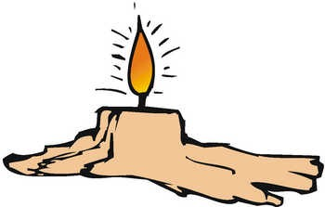
Throughout our meeting this evening, this candle, which represents the spirit of Cub Scouting, has burned. Look steadily at it for a moment. (Pause) Now close your eyes. The image remains with you. Now open your eyes. We will blow out the light. As the image of the light remained in our memory, so will the spirit of Cub Scouting stay with us. The evening of fun and good cub scouting will not soon be forgotten.
Mutiny
Baltimore Area Council
Mutiny is a word we hear connected with pirates on the waterways. It is the act of insurrection or a refusal to obey the authority of the captain of the ship. It is often the cause of a disastrous end to all involved.
As Cub Scouts, our promise to obey The Law of the Pack and to live up to the Cub Scout Promise can only lead to a better life as a good citizen of this great country of ours. Let us not be mutineers, but strong supporters of the Boy Scouts of America.
WEBELOS
It’s Springtime – Let’s get those Webelos outdoors!!!
How about planning an overnighter just for your den?? Or going along with a boy scout Troop?? Your Scouts probably can’t wait to get out in the woods!!!
Here are Six Steps for you to follow to ensure a successful Webelos Overnighter. There is one step that comes before any of these – Take the Outdoor Webelos Leader (OWL) Training or as one council called it Webelos Outdoor Leadership Fundamentals (WOLF)
Six Steps to a Successful Webelos Overnighter
Clinton Valley Council
Determine who is going on the campout. Encourage all your Scouts to attend. One adult should accompany every Webelos Scout and be primarily responsible for his behavior.
What To Bring. Both the Webelos Scout Handbook and the boy Scout Handbook have excellent lists of what to bring on camping trips. Make sure you have a First Aid Kit . See what equipment people have ad what you may need to borrow from a local Boy Scout Troop.
Where to Go – When planning your trip keep in mind that this may the Scouts first experience beyond the backyard. Be sure to consider travel time, accessibility of cars to site, size of site and number of people, water, facilities.
When to Camp – Webelos traditionally camp in spring, summer and fall. You don’t want a Scout on his first ever camping trip to be frozen the entire time.
Transportation to Camp - Make sure every boy has a seat belt and he wears it. Everyone who drives must have adequate insurance. File a Tour Permit!!
What to Do at Camp – Certain Activity badges are done more easily at camp. Outdoorsman and Traveler work well. You might be able to collect rocks for Geologist, bugs for Naturalist, leaves and plants for Forester. Work on Showman at the campfire. Use your imagination. Keep them busy!!
FAMILY MEMBER
COMMUNITY GROUP
Southern NJ Council
A family is a group of people who care for each other and share with each other. Your family gives you food, shelter, clothing and love. It teaches you religious beliefs and help’s you to learn right from wrong. In return, you should give the other members of your family your love. And you should learn how to do your share of the work that must be done around your home.
The Family Member activity pin is one that will need to be worked on mostly at home. While you are working on Family Member, you might want to have a “family night” inviting the whole family for an evening (or maybe Saturday afternoon) of activities. Let the boys plan the event. You may be surprised at how creative they can be. /
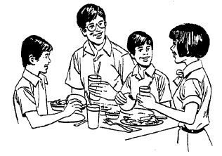
Making Family Decisions
Most families don’t have formal meetings, but when you are all at the dinner table, you probably talk about jobs that need to be done around the house. Maybe you decide whether the whole family should go to the movies on Saturday night, or where you are going on -vacation. Family meetings are important. Talking about things brings all family members closer together.
Say what you think when you are asked for your opinion. Other family members may disagree with you. Don’t get mad about it. Remember that they have their own interests and desires, just as you do.
Helping Your Family Save
It takes a lot of money to run a household and buy food for a family. As a good family member, you won’t want to add to the cost.
How can you help your family save money? Here are a few ways:
- Make your weekly allowance last for a week. Spend it wisely. Maybe you could have a paper route or mow lawns in the neighborhood.
- Take good care of your clothes and shoes. That saves money.
- Save energy. The bills for heating your home, electricity and water are a big part of your family’s expenses. Save energy by turning off the light when you leave a room. Keep the refrigerator door closed, and not wasting hot water when you shower.
Trash and Garbage
Garbage attracts flies, roaches, mice and other pests that carry diseases. Garbage can be a health problem unless you dispose of it properly. It should be kept in cans with tight lids or sealed plastic bags. Trash and litter are unsafe. Trash is ugly to look at, and is also a fire hazard. It can also cause bad falls and injuries. Clean it up and get rid of it.
Activities
- Have the boys make a chart showing the jobs that they and other family members have in their homes. Have them bring the charts to the meeting and tell what jobs they are taking on for the next two months, and how they will do them.
- Before the boys inspect the home and grounds make a list of hazards or lack of security to talk over with them.
- Contact the Police Department and ask if someone could attend one of your meetings and talk about security in your home.
- Make a contest out of making a list of things for which families spend money. See who can make the longest list. Talk about the list and see what important expenses were omitted. Give one point for each item. Most boys will forget things like rent, car payments, stamps, insurance, etc. You might think up a list of things that you think most boys will omit and award 2 points if they happen to list one of these.
- Have a contest - take a small piece of cloth, a button, needle and thread and have the boys sew on a button. Judge the button that is sewn best.
- Have a cooking contest. Have each boy cook one dish and bring it to the meeting. Be sure they can tell how they made the dish. You might think about making a small recipe book for your den. This could include breakfast, lunch and dinner.
- Have the boys fix a meal and invite the parents to your meeting for a feast! In the meal planning they must plan the meal, shop for the food and then cook it.
- Arrange for the local fire marshal or one of his investigators to visit your den and talk or demonstrate fire safety in the home and community. Perhaps he can also provide you with a copy of a home inspection sheet.
- Call the local health department to see if they can provide information about the dangers of trash and garbage piling up and ways in which your den might combat dump sites around your community.
- Visit our local financial institution to find out how the monetary system works and how saving money as a family unit can be beneficial in the long run.
- Contact the local public utility companies, or the environmental control agency to find out how your natural resources can be saved and what we can do as individuals -within the family unit to conserve energy.
- With the help of a nutritionist teach your den to plan meals for the family that cover all the basic food groups and the order in which they re needed. Perhaps your den could also plan a weeks worth of meals for a family and visit a retail food establishment and price the food required to sustain this family and see how it relates to the budget of your family.
Family Activities:
Families need time to do things together that are not work. No family wants to work all the time. You can help suggest things to do.
Here are some ideas:
- Visits to the park
- Cook outs in the park
- Church programs
- Synagogue programs
- School programs
- Family reunions
- Neighborhood events
- Tour of your town
- Holidays
- Fishing Trips
- Swimming
- Zoos
- Museums
- Martin Luther King’s Birthday
- Block Parties
- Fairs and Fiestas
- Tribal celebrations (Pow Wows)
- Sports activities
- Fruit picking trip
- Library visits
- Visiting relatives
- Movies
- Walks and visiting in street
What else might you and your boys be able to suggest as family activities?
Circle Ten Council
Field Trips:
- Tour an energy conservation home – underground or energy efficient
- Tour the local water company and ask for ways to conserve water
Den Activities:
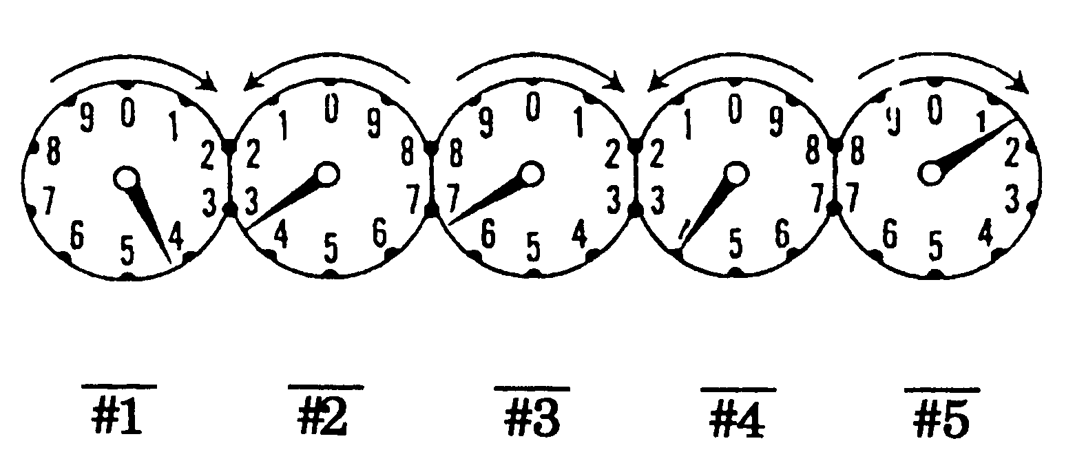
- Make a list of fun activities of little cost and do them over several den meetings.
- Switch chores with another family member for a month.
- Have the boys make their chart showing the jobs that they and other family member have in their homes.
- Before the boys inspect the home and grounds to make a list of hazards or lack of security you might want to talk over some of the home hazards they might find.
- Have a contest – taking a small piece of cloth and button, needle and thread. Have the boys sew on a button – judge the button that is sewn on the best.
- Have a cooking contest. Have each boy cook one dish and bring it to the meeting. Be sure they can tell you have they made the dish.
Genealogy
Tracing family roots can become a lifetime hobby. There are many books and classes on how to find information.
- Ask if any den parents have organized charts or have studied their heritage.
- Have the boys make a family tree for both their mother and father’s family from a list of all the members of their family. What are their birth date, date of marriage and year of death?
Magazine Wall File
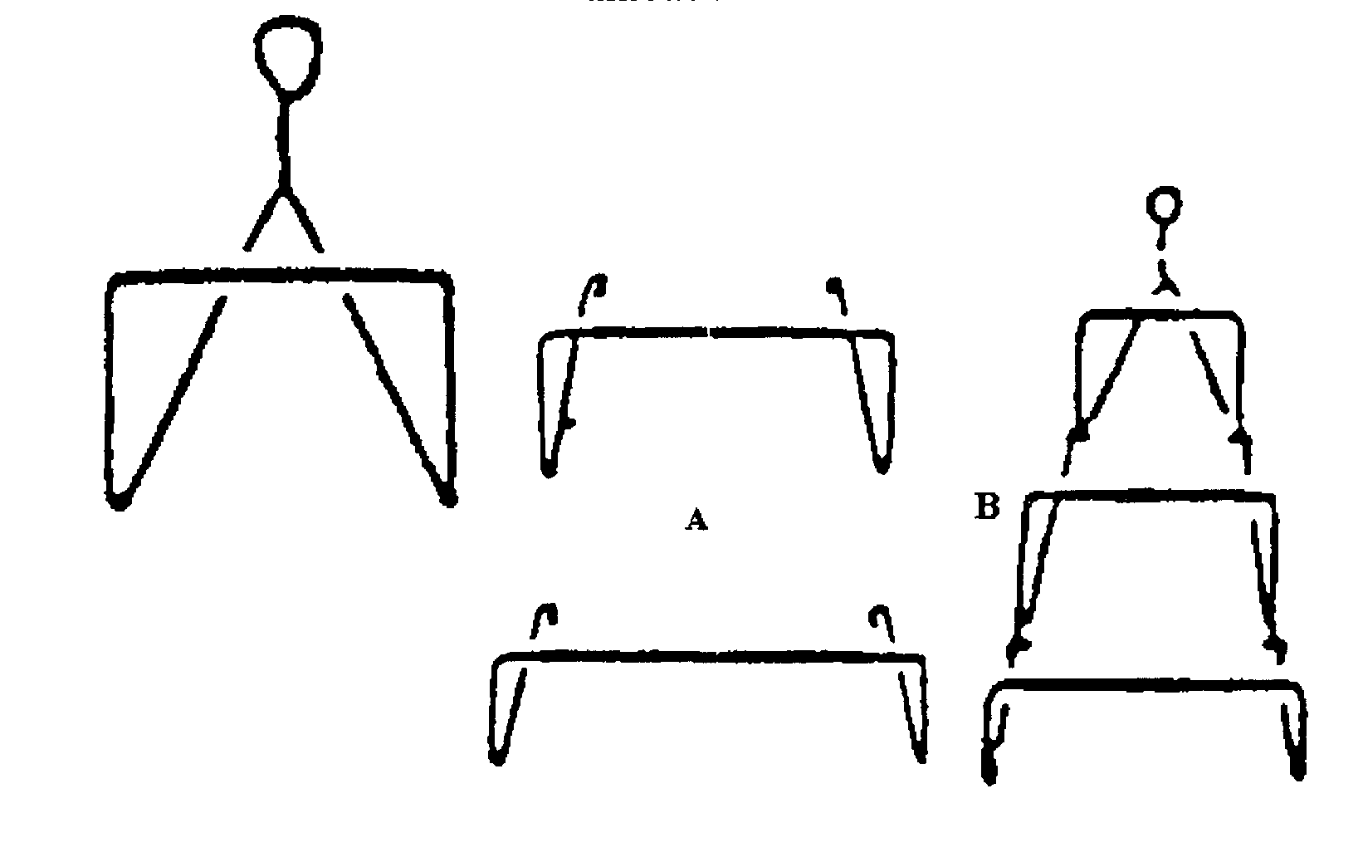
Materials:
3 wire coat hangers Enamel paint
Pliers Tin snips
Directions:
- Snip off the hooks of two hangers
- Bend hook of third to form circle.
- Use pliers to straighten hangers
- Bend as shown in figure A.
- Paint.
- Hang one over the other as in figure B.
- They are ready to use.
How to Read Your Electric Meter
Electric meters are precision measuring devices which record, in units called “kilowatt-hours” how much electricity you use. One kilowatt-hour (Kwh)) is 1,000 watts of electricity consumed for one hour, or the power required to burn a 100-watt light bulb for 10 hours.
The meter reading is made up of one number from each dial. When the pointer is between two numbers, you read the number it has just passed – the lower number.
Try reading this meter yourself. Then check your answer against the one below.
Answer: 43,641 Kwh
House Name Sign
Materials:
Scrap lumber 2 S-hooks Ruler
Brush Sand paper Saw
Hammer Plastic letters 4 screw eyes
Nails Stain
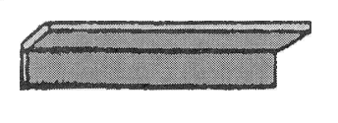
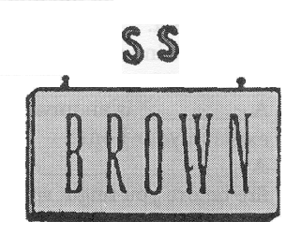
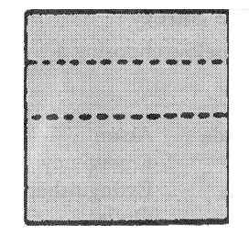
Directions:
- Measure wood and mark center.
- Divide one side in half.
- Saw boards into three pieces.
- Sand the wood smooth.
- Nail narrow pieces at right angle and stain wood.
- Tack plastic letters to the sign.
- Attach two screw eyes to the sign and two to sign holder.
- Fasten sign to holder with S-hooks.
- Attach sign holder to the house.
Accident Prevention in the Home
Be Your Own Inspector
First - Locate unsafe conditions and eliminate all hazards promptly. The following questions will aid you in making an inspection of your home.
- Is there a strong safe stepladder for reaching heights available?
- Are halls and stairways safe and well lighted?
- Are means taken to prevent rugs from slipping, particularly on polished floors?
- Is a rubber mat provided for the bathtub to prevent slipping?
- Are metal boxes provided for storing matches out of reach of children?
- Is there a screen for use in front of open fires?
- Are the furnaces and stovepipes clean?
- Are all gas pipes and fixtures tight, to prevent leaks?
- Is there a cabinet, which can be locked, for storing poisons and medicines out of reach of children?
- Are emergency numbers for police, fire and poison control handy by the telephone?
Second - Discover and correct unsafe habits, which you or other members of the family may have. The following questions will be helpful:
- Are toys, brooms, soap and other articles kept off stairs and walks?
- Are ice, snow, grease, or other slippery substances removed from stairs and walks promptly?
- Are flammable cleaning fluids used out of doors to use?
- Have the children in your home been taught the danger of playing with knives, scissors, bottles, and matches or near stoves and open fires?
- Is the garage door kept open when the car is inside with the engine running?
- Are appliances checked twice to be sure they are off before everyone leaves the house?
- Is the dryer lint filter cleaned after each load?
- Are tools used safely and stored properly?
- Are plastic bags and plastic materials kept out of reach of your children?
Find a Word for Fire Safety
Complete each sentence by choosing a word from this list:
Panic Explode Arson
Smoke Detector Ax Emergency
Escape Alarm Extinguisher
Fuse Plan Outlet
Scald Sparky Hazard
Flammable Crawl Call
Drill Roll Homes
Water Exit Burn
Hose Hot
- If trapped in smoke, _____ under the smoke to safety.
- Gasoline cans _____ near a flame or heat.
- Electrical _____ covers protect little children from shock.
- A _____ is used to put water on a fire.
- Treat a minor burn with cool _____.
- Use the enclosed stairs marked “_____” not the elevator, to escape from a burning building.
- Have a home fire _____ now. It could save your life later.
- Learn not to _____.
- _____ is NFPA’s Fire Safety dog.
- If there is a fire, get out fast. Then _____call the fire department.
- _____ is a crime. It is a fire set on purpose that does harm.
- Unless trained to use a fire _____, a person should get out and call the fire department.
- Most fires in which people die happen in their own _____.
- A _____ is an unsafe condition that exists in your home.
- A _____ _____ can warn you of a fire before you might smell, hear, or see it.
- If you smell smoke, don’t open the door. Feel it to see if it’s warm or _____.
- Fire fighters and paramedics respond to _____ calls.
- _____ causes more panic; set a calm example.
- Make a home escape _____. Practice it twice a year.
- In case of fire, you must have two _____ routes from your home.
- A false _____ may prevent fire fighters from getting to a real fire.
- _____ liquids catch fire easily.
- Sometimes fire fighters need to use an _____ to break through locked doors.
- A _____ disconnects overloaded electrical circuits.
- If your clothes catch on fire, stop, drop, and _____.
- A hot liquid burn is a _____.
Answers:
1 – Crawl 2 – Explode 3 – Outlet
4 – Hose 5 – Water 6 – Exit
7 – Drill 8 – Burn 9 – Sparky
10 – Call 11 – Arson 12 – Extinguisher
13 – Homes 14 – Hazard 15 – Smoke Detector
16 – Hot 17 – Emergency 18 – Panic
19 – Plan 20 – Escape 21 – Alarm
22 – Flammable 23 – Ax 24 – Fuse
25 – Roll 26 – Scald
Games
Feed the Baby
Divide the group into teams. Each team is either the feeder” or the “baby”. Neither team knows before hand what the activity will be. The “babies” are seated in a row, facing the “feeders” who stand in front of the “babies”. Each boy taking part is given a small cup or bowl of applesauce, a plastic spoon, and is blindfolded. At the signal, the “feeders” try to feed the applesauce to the “babies”. “Babies” may not use their hands to guide the spoon to their mouths, but may give the “feeders” all kind of advice and direction as to how to reach their mouths. First pair to finish the applesauce wins points for their team. They switch positions.
Shopping
This is a variation of the Kim game. Fill a grocery bag with items from your food pantry or cabinet before the den meeting. Just before the activity time, add cold items from the refrigerator. To play the game, take one item at a time from the bag and place it on the table. When the bag is empty put everything back in quickly. Give boys a paper and pencil and ask them to write down what items were in your shopping bag.
Who Are We?
Ask boys to bring baby pictures and family pictures to the next meeting. Hold the pictures up one at a time and try to guess who it is. Bring in family vacation pictures and try to guess where the family went. Take some den pictures and make up an album of your Webelos family or take slides and play music while you are watching them.
Home Hazards
This would be a great gathering activity CD
Before the den meetings, set up as many possible hazards around your house as you can – safely, that is. Examples: pan on the stove with the handle sticking out over the front, metal pan in the microwave, bags of newspaper in the middle of the stairs, (empty) bottle of ammonia sitting in the corner, matches too close to the fireplace. When the boys arrive, give them a paper and pencil and ask them to write down any hazards they see.
Churning Butter
Put a small amount of half and half or cream into a jar and screw the lid on tightly. Boys shake jars, until butter us formed. (Try this in advance to determine just how long it will take.) The boy who finishes first is the winner. (You may want to add just a pinch of salt to the cream.)
SPORTSMAN
PHYSICAL SKILLS GROUP
Circle Ten Council
Sports are high on the list of favorites of Webelos age boys. Most members of your den will show real interest in the Sportsman badge. Chances are the boys spend much of their leisure time in organized sports and loosely organized neighborhood games. Some of them probably already know enough about rules, scoring, and techniques of play for several sports and can pass those requirements immediately.
But that’s not really enough. One of the prime purposes of the Scouting program is encouraging good sportsmanship and pride in growing strong in mind and body. If the boys learn all the skills and rules involved in every sport this month, but don’t get an inkling of what good sportsmanship means, then everyone has wasted their time, including the den leader.
Agree on the importance of learning sportsmanship. What does it mean in practice? It means the least skilled gets just as much instruction and encouragement as the best athlete. It means the better athletes learn not just to tolerate the awkward boy, but also to help him. It means all boys can win and lose with grace and good sportsmanship. The leaders example will help to achieve these goals. Put stress on the fun of the game, not on winning. During competition in the den, choose the teams so that ability is equally divided. If boys choose teammates, there is a good chance that most of the best players will wind up on one team. Encourage the less skillful players. Discourage others from belittling them. Sports in a Webelos den should be full for all!
Speakers
- Coach
- Sports player
- Sports broadcaster
- Team manager.
Resources
- YMCA
- Youth sports groups (Little League, Pop Warner, …)
- Library
- Cub Scout sports program
Field Trips
- Go roller skating or ice skating
- Visit an archery range and receive instruction on safety and procedures
- Have a den outing to a sports event
- Hike around a golf course. Explain rules of etiquette and play to boys first so as not to disturb players.
Activities
- Invite a referee or official to your den meeting to teach signals and talk about teamwork, fair play and sportsmanship.
- Hold a parent/son sports tournament, such as bowling, tennis, volleyball, archery, etc.
- Have a den board game marathon. Provide treats and boys bring their favorite board games to play. Allow time for rotation to different games.
- Teach a card game to the boys and set up a couple of stations for playing.
- Make it easy on yourself and use the ready-made Cub Scouts Sports Program. The guide explain the rules, principles, and equipment for each sport, and the boys learn while earning the belt loops and sports pins.
- Have the Webelos figure out a football play or a baseball play and diagram it. Local high school or little league coaches are sources of assistance.
- Give Webelos a list of famous sports figures and have them name the sport involved.
Sportsmanship
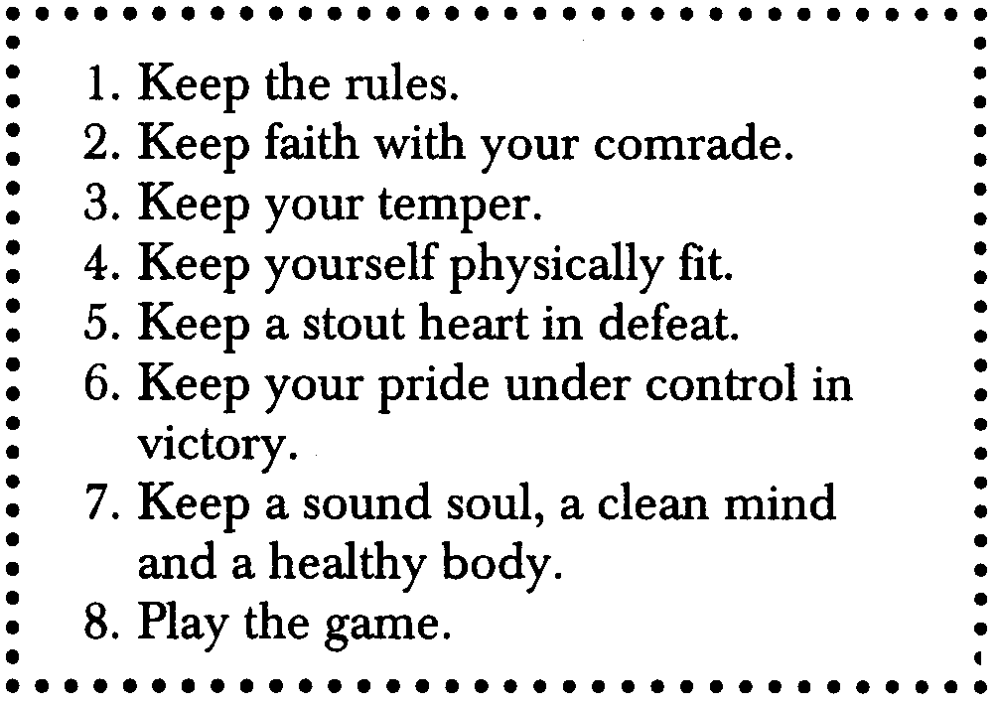
A real sportsman follows these rules not only in each game, but also in his life. Good sportsmanship is part of good citizenship – for example, to lose a class election gracefully. The following is the code of sportsmanship of the Sportsmanship Brotherhood.
The “Spirit of Good Sportsmanship” means being modest in victory as well as accepting defeat gracefully after trying your best.
Sports Skills to Practice
Take the Snap – Throw the Ball
Try this basic drill at your den meeting, even if a boy is not the pitcher on his team or maybe he does not play this particular sport. Practicing this drill will help him become used to handling the ball. It will teach his hands, legs, eyes, and arms to work together.
For your target hang an old automobile tire about six feet above the ground. From the center, take three or four steps back and fire away. Take it slow at first to get the feel of the action. Your tire target should be about 10 yards away when you throw the ball.
The Lay-Up Shot
The lay-up shots are the ones that win the game. The reason is simple. They go in for a score 80-90% of the time.
The lay-up starts with a powerful leap from the floor but a soft finish as the fingertips lay the ball gently up against the backboard. If you shoot from the side, lay the ball against the backboard and 18” above the hoop. Avoid putting any spin on the ball. From the front, try to drop the ball through the basket without hitting the backboard.
Practice the shot until the motion becomes automatic. When you see an opening, you’ll always have this game-winner ready.
How to Hit a Ball
Hitting a ball with a stick is the basis of two of our most popular sports, golf and baseball. As these sports have grown, some athletes have become so expert that their skills seem almost like magic. Some times a poor beginner gets so much good advice on the best way to become an expert that he forgets how to be a beginner.
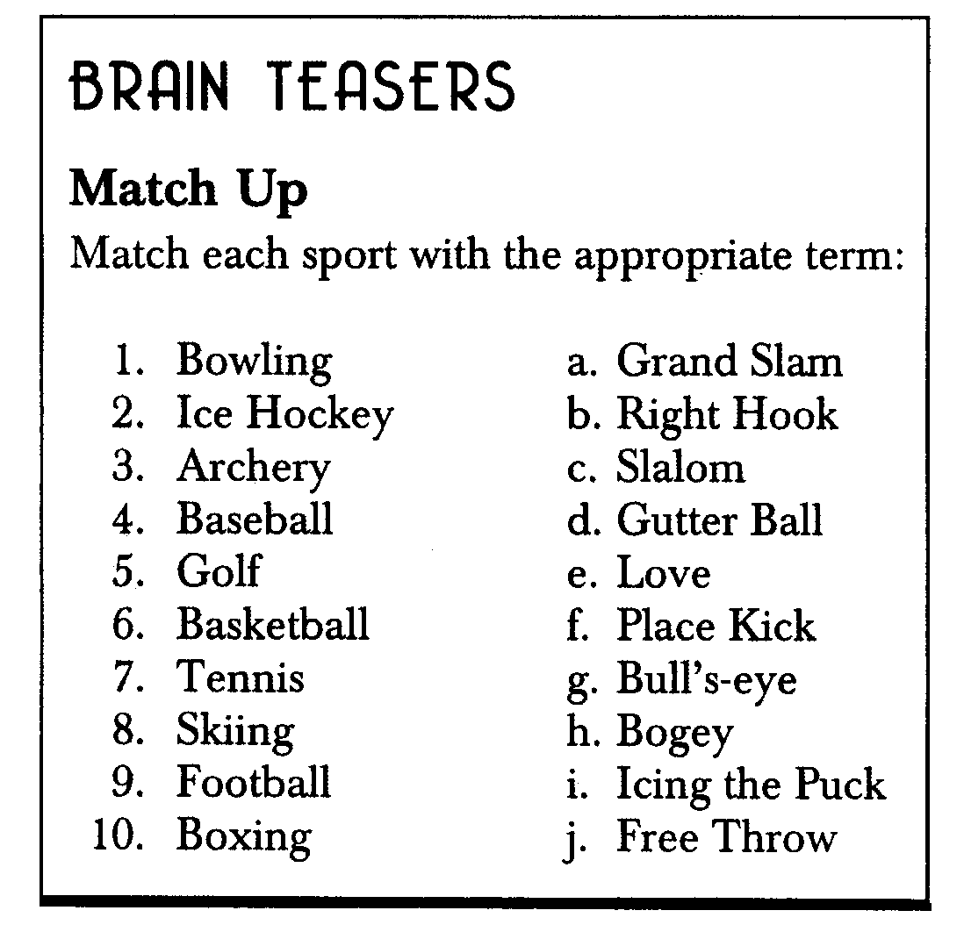
Games
Sidewalk Tennis – played with a tennis ball on two squares of sidewalk or patch of level ground marked off in similar size. Ball is batted with the hands. Use regular tennis rules, except that there is no serving court.
Broom Hockey – give each player an old household broom or similar stick. The puck is a small ball. Play one any size field. The goals are marked by rocks places about six feet apart and centered on the end lines of the playing field.
Frisbee Baseball – played according to regular baseball rules. The pitcher throws the Frisbee toward the “batter” who then catches it. If he misses it, it is a strike and if it is outside the strike zone, it is a ball. The “batter”, who has made a good catch, then throws the Frisbee and proceeds around the bases. If it is caught, the “batter” is out. The rest of the game follows baseball rules.
Soccer Ten Kicks – divide den into two teams. Each team tries to kick the ball between teammates 10 consecutive times while the opponents try to intercept and start their own sequence of 10 kicks. As he kicks the ball, each player calls out the appropriate number (1, 2, 3, etc.) Hands may not be used. The team making 10 kicks in a row without interception wins.
Soccer Triangle – on a large field, mark off a lane about 10 yards wide and 50 yards deep, using twine or lime. Three players are on offense, one on defense. Starting at one end of the lane, the three offensive players try to advance the ball by kicking and heading it, while the defensive player tries to intercept. The offensive players should stay in a triangle formation not more than 10 yards deep.
Potato Gold – draw concentric circles on the floor, and label each circle with a number representing the number of points it is worth – 10 in the center circle, decreasing outward. From a distance of 6 to 10 feet, each player putts a potato with a cane or an old hockey stick. Each player scores according to the numbers in the circles. No score is made if the potato stops on a line. Each Cub gets 10 tries, adding the scores together to get a total score. In place of a potato, use any durable fruit or vegetable – apple, grapefruit, etc.
Barrel Basketball – even the shortest Cub in your den can dunk if you play barrel basketball. All you must do is place 2 50-gallon steel drums 40 feet apart. Any asphalt parking lot not in use can be turned into a barrel basketball court. On this court, you can learn to pass, dribble, shoot, block, and set up plays. What’s important is that you’ll be learning how to play. If you have no steel barrels, use a big plastic garbage can. Even a pasteboard box will work if you put sand or dirt in the bottom to hold it down.
Sports Cards – make a set of 10 x 10 inch cards. On one side put a copy of the official signals for the game – football, basketball, hockey, baseball, soccer, etc. – of your choice. On the other side put an explanation of what the call means. The game can be played several ways.
- Hold picture and ask for the proper call or
- Read the explanation of the call and ask for its name or
- Execute the call and ask for its name.
This game can be played as a competition
- Divide den into two teams and give one point to the first person to guess the answer.
- Divide den into two teams and assign each team a sport and show each team a card for its sport. Each team will have a different sport. The first team to get the answer gets a point
Hold-Em Ball – players stand in a semi-circle facing the Webelos who is “It” at a distance of about 10 yards. “It” throws the ball to any of the players. If the player misses, he goes to the “low” end of the line. The ball is thrown back and forth until “It” misses. He then goes to the “low” end of the line and the player on the “high” end becomes “It”.
Foul Score – the leader gives the signal for a foul in any of the three sports: baseball, basketball, or football. Then he calls on a Cub to name the violation and the sport. If the Cub gets both answers right, he scores 2 points. If he gets only one correct, he scores 1 point and any other boy is allowed to try to correctly name the answer to the part missed and score a point. This can be played for individual scores. Just remember to ask each boy the same number of original questions. You can also divide the den into two teams.
Rec-Room Balloon Volley Ball – use a stripe or rope as a net and have the boys sit or kneel. Play as in volleyball with rules adapted to fit the size and shape of the room.
Penalty Box
Match the Official’s signal call to the correct sport.
F- Football BK-Basketball BA-Baseball
S-Soccer H-Hockey
Signal Call
Pass Interference
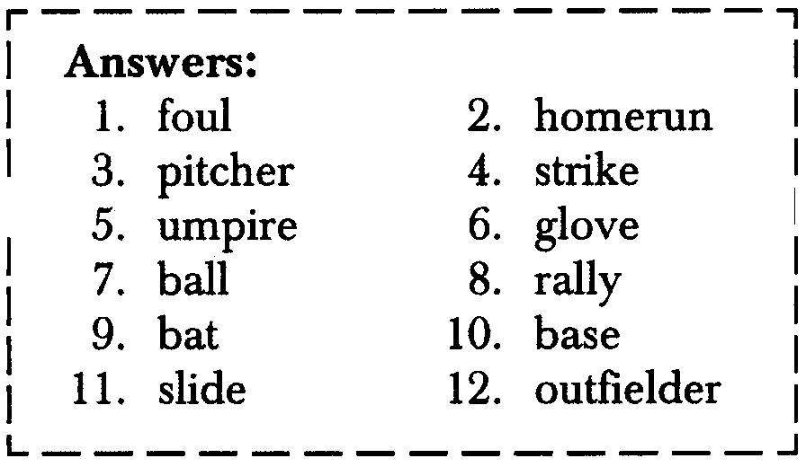
Technical foul
Offside
Ball Hooking
Incomplete Pass
Touchdown
Delay the Game
Clipping
Safe
Tripping
Unsportsmanlike Conduct
Illegal Dribble
Fair Ball
Substitution
Corner Kick
Strike
Penalty Kick Out
Holding
Foul Ball
Traveling
Illegal Motion Foul

Let’s Play Ball – using the clue sentences, fill in the blanks for baseball fun. The letters may fall at any point of the word.
- A ball is hit out of bounds.
- When a player makes every base.
- One responsible for throwing the ball.
- When a player fails to connect the bat with the ball.
- One in charge of calling plays.
- All leather and five fingers
- Necessary piece of equipment other than the bat.
- Come from behind, score a lot of runs
- Long, skinny, hitting object
- There are four in every game
- Horizontal position for reaching base
- One who can catch a high ball that’s hit past all the bases
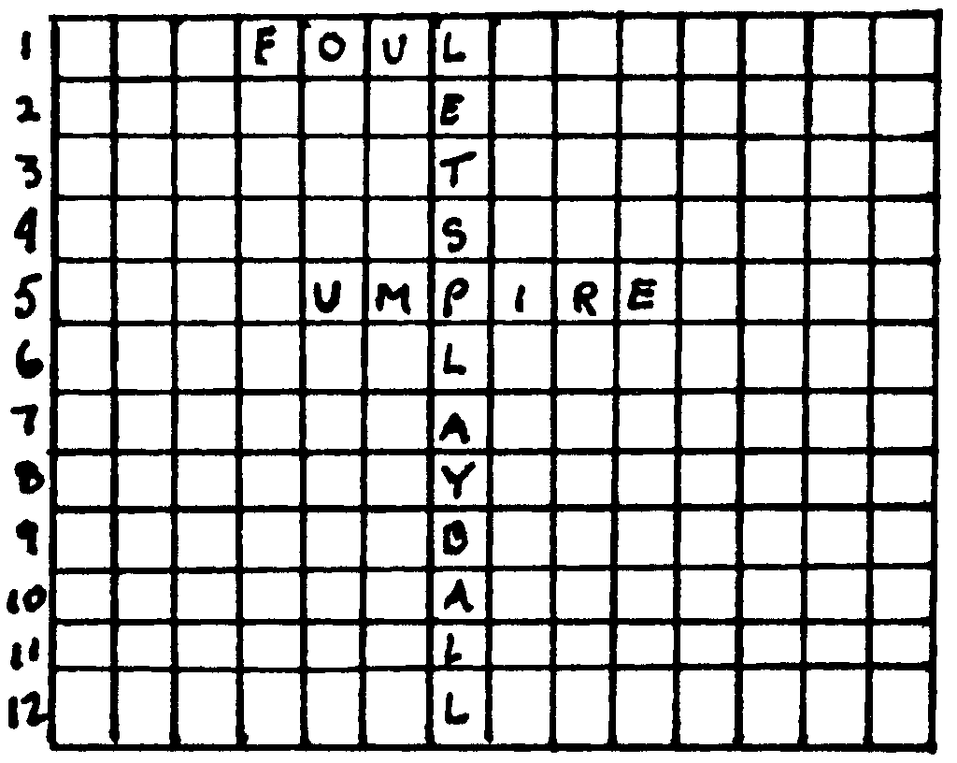
Do You Know Your NFL Teams?
- Army insects
- Seven squared
- Hostile attackers
- Helpers to relocate
- Various iron workers
- Sun tanned bodies
- I.O.U.’s
- Six rulers
- Opposite of ewe
- Class of Boy Scouts
- American Gauchos
- Loyal team
- Credit card users
- Indian leaders
- King of beasts
- Team of tigers
- A dollar for corn
- Hot epidermis
- Six shooters
- Rodeo horses
- Heavenly team
- Grumpy person
Answers
1-GI ants 2-49ers 3-Raiders
4-Packers 5-Steelers 6-Browns
7-Bills 8-VI Kings 9-Rams
10-Eagles 11-Cowboys 12-Patriots
13-Chargers 14-Chiefs 15-Lions
16-Bengals 17-Buccaneer 18-Red Skins
19-Colts 20-Broncos 21-Saints
22- Bears
World of Sports Game
Give this list of sports terms to the boys and let them write the game with which each term is associated.
- Spare
- Shell
- Shuttlecock
- Fairway
- Slalom
- Double fault
- Eight-ball
- Chukker
- Clay Pigeon
- Technical K.O.
- Jump Shot
- Puck
- Double Play
- Figure eight
- Lonesome end
Answers:
1-Bowling 2-Rowing or Hunting 3-Badminton
4-Golf 5-Skiing 6-Tennis
7-Pool 8-Polo 9-Trap shooting
10-Boxing 11-Basketball 12-Hockey
13-Baseball 14-Figure skating 15-Football
POW WOW EXTRAVAGANZAS
Let me know as soon as your date is set. I will post whatever I receive. I am hoping to retire in 2007 and visit lots of Pow Wows!!! CD
Southern NJ Council
Aloha, Cub Scouts
Pow Wow in Paradise
January 21, 2006
Lakeside School, Millville, NJ
Call Southern NJ Council, 856-327-1700, extension 32, or visit the website, www.snjscouting.org for more information
WEB SITES
Parent Orientation Information
The Cub Scout Roundtable Commissioner for Timucua District, Gulf Ridge Council, has created a teaching aid for new "Cub Scout parents", especially single moms. It can also be used for really green Cub Scout leaders. He coupled the parents guide from a Wolf Cub handbook, some info on the history of Cub Scouts, Rudyard Kipling's Jungle Book, and some other info, and assembled a self contained, simple study guide. You can download it from his pack website; http://www.pack92.net/akela.zip
He says anyone is entitled to use it qnd distribute it free of charge. It is an EXE file so that once downloaded, double clicking will run the program with its own built in viewer. The online version is on his pack website: http://www.pack92.net/akela.htm
Cub Scout Achievement, Elective, Rank, and Academics and Sports Trackers on their own website!!
Roxanne@madsenco.com
A lot of websites carry the Excel based trackers she developed but have old and outdated versions. So Roxanne developed her own web page that will always carry the most recent versions (with all known bugs fixed and many enhancements recommended by users).
She recently revised the Cub Scout spreadsheets to –
- Include the Outdoor Activity Award
- Make them easier to work with in OpenOffice.
- Track Tiger beads and handle up to 15 tigers.
Please direct your den leaders or advancement chairs to the website for the most recent versions of the trackers. (feel free to add a link to your pack's website if that is helpful!)
http://www.madsenco.com/scouting.shtml
Thank you Roxanne!! CD
PS – She, also, has Girl Scout and Boy Scout Trackers!!!
ONE LAST THING
MURPHY'S OTHER LAWS
- Everyone has a photographic memory. Some don't have film.
- He who laughs last, thinks slowest.
- Change is inevitable, except from a vending machine.
- Back up my hard drive? How do I put it in reverse?
- I just got lost in thought. It was unfamiliar territory.
- I feel like I'm diagonally parked in a parallel universe.
- You have the right to remain silent. Anything you say will be misquoted and used against you.
- I wonder how much deeper the ocean would be without sponges.
- Honk if you love peace and quiet.
- Despite the cost of living, have you noticed how it remains so popular?
- It is hard to understand how a cemetery can raise its burial costs and blame it on the higher cost of living.
- It is said that if you line up all the cars in the world end to end, someone would be stupid enough to try and pass them.
- You can't have everything. Where would you put it?
- Latest survey shows that 3 out of 4 people make up 75% of the world population.
- If the shoe fits, get another one just like it.
- The things that come to those that wait may be the things left by those who got there first.
- I started out with nothing, and I still have most of it.
- Light travels faster than sound. This is why some people appear bright until you hear them speak

