FOCUS
Cub Scout Roundtable Leaders’ Guide
This month is time for tools!! Cub Scouts will learn about tools and how to use them, with the grand finale of building a project. There is a lot to do and learn – take your den on a field trip to a hardware store or a home improvement store. Boys can have fun building planters or trash receptacles for their home or community. The building projects and enjoyment are endless!!
CORE VALUES
Cub Scout Roundtable Leaders’ Guide
Some of the purposes of Cub Scouting developed through this month’s theme are:
- Personal Achievement, What could give a boy more satisfaction than a project he builds with his own hands??
- Friendly Service, Boys will happily build needed projects for their community.
- Fun and Adventure, How exciting to learn about tools and then actually build something.
The core value highlighted this month is:
- Positive Attitude, Boys will take pride in their accomplishments and feel satisfied when they complete a project.
Can you think of others??? Hint – look in your Cub Scout Program Helps. It lists different ones!! All the items on both lists are applicable!! You could probably list all twelve if you thought about it!!
COMMISSIONER’S CORNER
When planning projects for this theme remember this from Bill Smith, the Roundtable Guy –
Wood is good. Large is better.
Projects are activities where Cub Scouts make things that are useful: that is, the things fly, make a lot of noise, explode or help the Cubs do other neat things. Do not confuse Projects with Crafts. Crafts are things that are pretty or cute.
Cub Scouts are not into pretty and cute.
Check out Bill’s Website – www.wtsmith.com/rt.html
and the September 2005 Baloo for more on this subject
So get out and have them build something this month!!
I used to teach Electricity Merit badge for boy Scouts. Each of my students would make an eight (+/-) foot 12 gauge extension cord with heavy duty safety plugs on the end. Sure we could have done something less. Yes, we could have all taken off and put on the same plug. BUT I wanted them to have something worthwhile to take with them from the sessions. I wanted to have something they may keep and someday when they are moving into a new home and looking for an extension cord, find the one they made for Electricity Merit Badge and say, “I made this in Scouts!.” So my challenge to you is to have your Cubs make something this month that will keep for years.
Our local pack had a Movie night in January and showed “Down and Derby.” Everyone had a great time. I now have two copies of the DVD with all the exclusive Scouting Edition extras from Yosemite Council. Hope all you get to see it. I don’t think it will bounce “Follow Me Boys” off Wednesday night at Philmont Training Center but …
Thank you for the Pow Wow Books. I received a lot of Pow Wow Books this year. By the time you read this, you should have gotten my swap Cd that I sent for yours. If not drop me a line, and I’ll get one out right away. I was late and apologize.
Months with similar themes to
Cubstruction
Dave D from Illinois
Den Fix-Up Month | September | 1943
Cub Scout Handyman | March | 1948
Cub Scout Handyman | March | 1967
Craftsman | March | 1970
Mr. Fix-It | September | 1983
Working with Wood | January | 1985
Cub Scout Handyman | April | 1989
Working with Wood | May | 1991
Working with Wood | January | 1996
Cubstruction | January | 1999
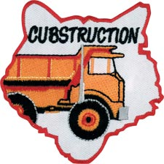
National makes a patch for every Cub Scout Monthly theme. This is the one for this theme. Check them out at www.scoutstuff.org
THOUGHTFUL ITEMS FOR SCOUTERS
Thanks to Scouter Jim from Bountiful, Utah, who prepares this section of Baloo for us each month. You can reach him at bobwhitejonz@juno.com or through the link to write Baloo on www.usscouts.org. CD
Cub Scout Prayer
Cub Scout Roundtable Planning Guide
We hope to build up our Cub Scouts just as we show them how to build things in our world. May we maintain the same positive attitude we want our Cub Scouts to have. My they be reminded of the wonder and beauty of the creation around them as they do their best to create their projects. Amen
Lessons I Learned From My Dad
Scouter Jim, Bountiful Utah
The earliest memories I have of my father are seeing him working on our house with his tool belt around his waist and a carpenter’s pencil behind one ear. I always remember he had one short index finger from an accident with a jointer. He was a carpenter from the age of fifteen-years-old. He learned the trade from his father. He did not teach the trade to any of his four sons, but he did teach us many lessons. One was the proper use of tools. He taught us to drive nails with a hammer and if the nail bent, he taught us how to coach it into the wood. None of our Cub Scouts are perfect, but with proper coaching, they all can become useful members of the whole. My dad taught me how to use a tape measure and a pencil. I learned from him to measure, mark, and then measure again before I cut. Sometimes as we work with our Cub Scouts, we need to think about what we want to teach them, and then decide if that is what is really needed before we start to speak. Words spoken like wood cut, can never be brought back. The most important thing my father taught me about building was to see the vision of the end result. Before he cut his first board, even made his first mark, he saw in his mind what he wanted the finished product to become. The same is true for Cub Scouts. Before we give them their Bobcat of even before we teach them the first skill, we must have in our mind a picture of what we want them to become.
Thoughts on Building
It's not what the boy does to the board that matters, it's what the board does to the boy. Bud Bennett
The ability to convert ideas to things is the secret to outward success. Henry Ward Beecher
They can because they think they can. Virgil
The thing always happens that you really believe in; and the belief in a thing makes it happen. Frank Lloyd Wright
The heights by great men reached and kept were not obtained by sudden flight.
But they, while their companions slept, were toiling upward in the night. Thomas S. Monson
The loftier the building, the deeper must the foundation be laid. Thomas á Kempis
People become house builders through building houses, harp players through playing the harp. We grow to be just by doing things which are just. Aristotle
It has always seemed to me that the most difficult part of building a bridge would be the start.
Robert Charles Benchley
The history of the building of the American nation may justly be described as a laboratory experiment in understanding and in solving the problems that will confront the world tomorrow. Dr. Nicholas Murray Butler
Where there is writing— there is a writer Where there is planning— there is a planner Where there is a building— there is a builder Where there is a miracle— there is a God!
William Bliss Carman
Hands untrained in the use of tools destroy what they want to build. It takes skill to use tools to achieve the result desired, whether it's tearing down an old house or building a new one. J. B. Charles
We shape our buildings; thereafter they shape us.
Sir Winston Leonard Spencer Churchill
The great successful men of the world have used their imaginations, they think ahead and create their mental picture, and then go to work materializing that picture in all its details, filling in here, adding a little there, altering this a bit and that bit, but steadily building, steadily building.
Robert Collier
The fate of the architect is the strangest of all. How often he expends his whole soul, his whole heart and passion, to produce buildings into which he himself may never enter.
Johann Wolfgang Von Goethe
Three things are to be looked to in a building: that it stand on the right spot; that it is securely founded; that it be successfully executed. Johann Wolfgang Von Goethe
Thomas Edison devoted ten years and all of his money to developing the nickel-alkaline storage battery at a time when he was almost penniless. . . . One night the terrifying cry of fire echoed through the film plant. Spontaneous combustion had ignited some chemicals. Within moments all of the packing compounds, celluloids for records, file, and other flammable goods had gone up with a whoosh. Fire companies from eight towns arrive, but the heat was so intense and the water pressure so low that the fire hoses had no effect. Edison was 67 years old — no age to begin anew. His daughter was frantic, wondering if he were safe, if his spirits were broken, how he would handle a crisis such as this at his age. She saw him running toward her. He spoke first. He said, “Where’s your mother? Go get her. Tell her to get her friends. They’ll never see another fire like this as long as they live.” At 5:30 the next morning with the fire barely under control, he called his employees together and announced, “We’re rebuilding.” Then, almost as an afterthought, he added, “Oh, by the way, anybody know where we can get some money?” Virtually everything we now recognize as a Thomas Edison contribution in our lives came after that disaster. Jeffrey R. Holland
Whatever good things we build end up building us.
E. James (Jim) Rohn
Character is the foundation stone upon which one must build to win respect, just as no worthy building can be erected on a weak foundation, so no lasting reputation worthy of respect can be built on a weak character. Without character, all effort to attain dignity is superficial, and results are sure to be disappointing. R. C. Samsel
“What are you doing?” a man asked of three laborers beside a building under construction. The first man replied, “Stone-cuttin’.” The second smiled. “Puttin’ in time—until a better job comes along.” The third man waited a moment and then said simply, “I’m building a cathedral!” Unknown
It's not a question of who's going to throw the first stone; it's a question of who's going to start building with it. Sloan Wilson
One only needs two tools in life: WD-40 to make things go, and duct tape to make them stop. G. M. Weilacher
TRAINING TIP
Electives
Bill Smith, the Roundtable Guy
I know that a lot of you like to have your Tigers, Wolves and Bears complete their respective badge requirements by the Blue and Gold celebration so I thought we should now take a good look at electives.
There is much value in these electives and I’m not sure we appreciate just how much they can contribute to reaching the purposes of the Cub Scout program. The boys’ books are full of wonderful opportunities for parents and leaders to involve Cub Scouts in things that will help them grow.
Too often, I think, we tend to dismiss the electives as a trivial add-on to the advancement method. The big badge is the goal; the arrow points are inconsequential. Yet, electives supply a richer variety of opportunities than do the achievements. They give boys and parents the chance to choose and explore – to develop the interests, curiosity and talents within the growing child. We should never underestimate the values of these options.
I have had the luck and the privilege to observe and participate in the work that goes into the boys’ books. I have worked on a task force to update the Wolf Handbook and another to create the first Tiger handbook. In both cases, I was awed by how much effort and concern went into the process. Questions like: What will this do to the boy? Can parents anywhere do this? How can a den leader use this? The first and last question was always: How does this fit into our Purposes of Cub Scouting?
One of the great joys of the electives is that the requirements are generally looser so that a boy can be rewarded for just exploring a new pathway to adventure.
As long as he does his best Akela can sign it off. Moreover, if he discovers a wonderful world that sparks a new fire within him, many electives provide chances to explore further. My Tiger Cub Handbook seems to set no limit on how often a boy may return to the same elective.
One aspect of electives sets BSA apart from any other youth program I know of. It gives parents a spectacular set of tools to use with their sons. Each elective consists of short projects designed so that a boy and his parent – or even his whole family – can work together on it. This gives families lots of short activities where a boy and his parents do things together.
These activities: preparing meals, singing songs, checking smoke detectors, building a model- automatically involve TALKING. They TALK, they listen to each other, they plan, they express their hopes, their concerns, and their jokes. They learn to respect each other’s moods and styles. They create special communication channels that remain vital and valuable for all their lives.
Nothing tells your child you care more than choosing to be with him.
Parent’s Little Book of Wisdom.
The time to do electives varies – some may be as short as fifteen minutes so that they can fit into anybody’s schedule. I remember a single mother telling me how she and her son did electives while waiting for the machines at the Laundromat to finish. If a parent spends as little as an hour a week doing these fun things with a Cub Scout son, they could easily earn an Arrow Point each month. Each Tiger Track Bead and Arrow Point on his shirt is a sign that says "We spent hours doing neat things together!"
When our task force worked on updating the Wolf Book, I was assigned the task to “do something about the Indian Sign Language Elective.” Space in these books is a critical issue and the sign language illustrations took up two whole pages. That was too much space for one little elective.
So I spent some time talking to a lot of people about what we could put in to replace the sign language. I was looking for more modern ideas of communication and I needed some expert advice. My list of experts included den leaders, teachers, parents, and, of course, Cub Scouts.
To my surprise there was almost unanimous opposition to removing the Indian Sign Language elective. Boys and leaders loved using the signs in ceremonies, skits and special messages. It was fun, it was special and it made the boys more aware of an important American heritage. The clincher came when a computer arts teacher reminded me of the value of learning another symbolic language to prepare children for their futures.
When I reported this back to the task force, we agreed to leave Indian Sign Language in the Wolf Book – at least until the next update. I notice that some 20 years later, Indian Sign Language is still there and now fills four pages.
In order to make electives work, we must somehow make every Cub Scout parent aware of how to use electives. Den and pack leaders should strive to show parents how to go through the books with their sons and pick out things that will work for them. It’s not going to happen unless we make the necessary effort to get the word out to every family. It can be done best at Parent Meetings, but we can also use news letters, ceremonies, and Cubmaster’s minutes. It helps if leaders show newly recruited parents examples of how electives can be used creatively.
You could even measure how good your pack is just by counting up the number of Arrow Points and Tiger Beads you present each month. It’s one of the best indicators of quality home and den Cub Scouting activity I can imagine.
PACK ADMIN HELPS
Character Connections Part 2
Carol E. Little
CS RT Commissioner,
American Elm District, Black Swamp Council
www.cubroundtable.com
In the earlier column, we learned about the history behind Character Connections (CC). We discussed the three different components – Know –become familiar with all 12 core character connections (head), be able to Commit (heart) to doing the CC values and put them into practice in their daily life (hand) on their own initiative.
For part of this column, I’d like to use a piece that I ran into from the special needs section from Heart of America Council Pow Wow book for 2005. I think that by using some of these activities we can use the Character Connections values and give our scouts a way to connect to others who have special needs.
Wear glasses that have been smeared with Vaseline to simulate impaired vision. What did you experience while wearing the glasses? What did you learn from about yourself? What was the purpose of trying the glasses?
Use a balance board with a circular board with an “x” below also circular, to simulate inner ear problems. (see teeterboard jousting in the How-To Book) What did you like about this exercise? How did you feel while standing on the board? What did you learn?
Set up a blind man’s maze, using wooden timbers to layout the maze. Each Cub was blindfolded, given a stick to tap out his way, and turned loose in the maze. Wow! Was that a site to see! What would you do differently in this exercise? How did you feel when you started to get around? What did you learn?
Type out the Cub Scout Promise and the Law of the Pack on computer then use a font to change the words to symbols such as MT Extra, Mobile, Cairo, Webdings, Symbols, Zapf Dingbats. Have the boys figure out what they say. What was the best part of this activity? Why do you think this activity was a good idea to do?
This exercise simulates vision challenges. Fill a bowl with pony beads and add 1 or 2 slightly larger different colored beads. The object is to pick out the larger bead of a specific color. The boys will always pick up one of the larger beads, but not necessarily the right color. What was the purpose of this game? What did you learn about yourself?
These are activities that are designed to give the boys the chance to experience the frustrations faced daily by people with disabilities. Unless a person has experienced a disability we really have no idea what others face day to day. Treat the disabled Scout with all the respect and consideration that you do with other Scouts. If the game being played requires a blindfold, the blind or visually impaired Scout should be given one as well. If the Scout is in a wheelchair, don’t stand over him to talk to him bend down to communicate face to face. If a hearing impaired scout has a signer, respond to the Scout not the signer. Our scouts look to us to set the example.
Games from Woods Wisdom 1996
Foggy Harbor Object: The group must maneuver an “oil tanker” (one member of the group) without bumping into the other “ships” (the remaining members). The oil tanker must be blindfolded. He is not to touch any of the other ships. These ships are distributed throughout the area. They remain stationary. As the oil tanker approaches on hands and knees, the nearest ship starts giving a warning signal, like a foghorn. The oil tanker then approaches slowly and attempts to maneuver across the harbor without colliding. What was the purpose of this game? What would you do differently? What was the best part of this game?
Everybody Up This exercise is a useful way to introduce the idea of group cooperation. Ask 2 scouts of about the same size to sit on the ground or floor facing each other with soles of their feet touching, knees bent, and hands tightly grasped. From this position they try to pull themselves into a standing position. If they succeed, ask another scout to join them and try standing with 3 scouts, then 4, etc. As the group grows, each player must grasp the hand of another person and must maintain foot contact with the group. An expanding group will find that thinking is required to come up with a solution that allows large numbers to get Everyone Up. What got you all going in the right direction? What would you try differently to get everyone up?
Bell Tag Equipment: Neckerchiefs or blindfolds and a hand bell. Method: Blindfold all scouts except the one who has the bell. Have blindfolded scouts mill around the room. The scout with the bell moves among the others, ringing his bell constantly. The blindfolded scouts try to tag the bell ringer. The scout who succeeds changes places with the bell ringer. What did you feel while playing this game? What did you learn from this game? What was the best part of the game?
I hope that you all had fun learning how to use Character Connections in your den and pack activities.
Examples found in the 2005 Character Connections Packet are collected from 2002 to present so that future Leaders will have the resources we had from the beginning.
To learn more check out Character Connections
The Purposes of Cub Scouting and Character Connections
How Character Connections are used as part of the requirements.
Character Connections Chart #13-323A Chart explaining Character Connections
2005 Character Connections Packet Examples of the different areas covered by Character Connections from past Program Helps (from 2002 to this year's 2005 - 2006), Roundtable Resource sheets, and the 2003 Cub Scout Books.
Character Connections Data Some history behind the program.
Character Connections Overview of all ranks on a chart.
Character Connections Outdoor Grid This is used for outdoor activities that connect with the 12 CC core values.
TIGERS
Tiger Flag Ceremony
Pack 531, Old North State Council
Preparation - Let the scouts use their own words for the ceremony. The important parts are for what the colors stand.
Material - You need a piece of blue, white and red cloth and a small US flag.
The first Tiger comes in with the Blue material. Blue is for courage.
They can say something like: "I am blue. I stand for courage. Courage is more than just standing on a battlefield defending our country. Courage means standing up for what you believe."
The next comes in with white cloth. White stands for loyalty.
They can say something like: “White stands for loyalty. Loyalty means staying true to what you promised. As a Tiger Cub, I have a duty to obey my parents and do what is right. I am proud to be loyal."
The next comes with the red material. Red stands for freedom
They can say something like: “Red stands for freedom. Freedom isn't free. Someone had to die so that I am free and can be here today. The red is for the blood shed so that I can be free. Thank you for my freedom."
The last scout(s) comes in with the US Flag.
He says something like "I am the Flag of the United States. I am made of courage, loyalty and freedom. As a Tiger Scout, I am glad to have the courage, be loyal and thankful for my freedom so that I can be here tonight. Would you please rise and recite the Pledge of Allegiance with me."
When you recite the Pledge, don't forget, One Nation Under God is one complete phrase.
Tiger Activities
Greater St. Louis Area Council
Construction can include a great many things, some are building skyscraper or a kite. Another is construction of the mind, an example might be building their skills. Through Cubstruction we can teach them to build a bird house and their skills.
High-Flying Kite
Supplies:
One 1/8” dowel rod, 48” long
Ball of strong string
Wrapping paper
Paper reinforcers
Strips of light weight fabric
Hobby Knife Scissors Pencil
Ruler
White glue, paste, glue stick or tape
Directions
- Cut the stick to size, then notch ends(watch that your notches all face the same way – One should be 26” and the other 22”
- Mark the 26” dowel 7 ½” from the top. Mark the other in the middle
- Tie the two stick together at the marks. Secure them tightly
- String the outside edge of the kite frame, slipping the string through the notches at the ends of the rods. This is why the notched need to face the same way. Secure the string tightly around the outside edge.
- Use the kite frame for making a pattern on the paper. Leaving about an inch on each side.
- Trim the paper and cut off the corners
- Fold the paper of the strings and secure with tape or glue
- Punch two holes in the paper. One 3” from the top and 4” from the bottom of the stick along the center rod. Put paper reinforcers on both sides of the holes to prevent ripping
- Cut a piece of string 30” long and secure to the long rod through the holes you made.
- Cut a piece of string; tie off at each end of the short rod leaving a gap of 4” between the string and the shorter rod. This will cause the kite to bend.
- Make a tail using the strips of fabric. I would make the tail 12-18” long. Tie shorter strips down the tail about every 3-4 inches. This will stabilize the kite.
- Wind a lot of string to a pencil or Popsicle stick. Tie the end of the string about a third of the way down the string you attached to the kite.
- Find a big open space and let ‘em run. See who’s kite will fly the longest, the highest or even the shortest.
Design, Layout And Construct Your Own Water Park
Supplies
Construction or plain paper
Rulers
Pencils
Food Coloring
CLEAR, Bendable straws (straight straws can work too, just not as well)
Modeling Clay
Styrofoam or paper cups
Directions
- First draw out on the paper the layout of your water park. You can include pools, slides and maybe even a fountain. Be sure to have a specific starting point, usually higher than the rest. This will be your blueprint.
- Figure how many cups and straws you will need to build your project. Also grab about ½ a stick of modeling clay. These items will be your building materials.
- You will need a large area, preferably outside, weather permitting. Otherwise you will want to be in an area you do not mind getting wet. You can call this area your construction site.
- Layout your cups and straws to match what you drew on your blueprint. Lay everything out before you try putting it all together. You may find you need something to set under some of your cups to gain height. You can turn a cup upside down and use it as you platform.
- Once you have everything set in place you can proceed with the final construction phase of your project. Using a pencil, poke a hole near the base of each cup where needed. Be sure not to make the holes too big. They only need to be big enough for the straw to fit snuggly in.
- Insert the straws one at a time, placing modeling clay around the holes in the cups and around any seems you made joining two straws together. This is necessary to keep the pipes from leaking.
- Once you are sure everything is connected and joints are sealed you can prepare your water. It does not take much water to get these projects to work depending on their size. A small picture should do nicely.
- To spice up your project you can as food coloring to the water. This makes it easier to see the water move through the straws. Start pouring the water into your starting cup and watch it flow.
Be sure to be prepared for leaks!
The boys will have a great time designing and building. Through this project they can see how the construction process progresses. They will also learn how gravity works (and so will the parents).
Helicopter
Everyone knows that when you run with a pinwheel the wheel will spin. What happens if you turn a pinwheel on its side and put it on top of a helicopter body? Try dropping this model off an upstairs porch or down a tall stairwell.
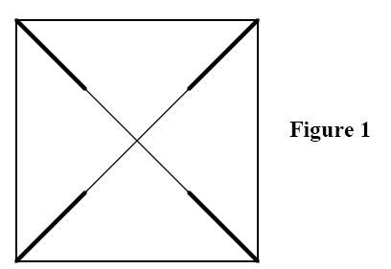
Supplies:
6” x 6” Square of Paper
Scissors
Colored Markers
Long Straight Pin with a Round Head
½” Long Piece of Plastic Drinking Straw
A Cork
Directions
- Fold the paper once into a triangle. Unfold it, and then fold it into the opposite triangle.
- Unfold the paper. It should have creases going from corner to corner, forming an X. The center of the X is the center of the square. Make a cut from each corner halfway to the center along each crease. See Figure 1.
- Use markers to color both sides of the paper and the entire cork.
- When the paper has dried completely, make the wheel. Pick up any point; stick the pin through the point about ¼” in from the point, skip the next point, but pick up the next and thread it onto the pin just as you did the first point. Continue around the square, threading Figure 1 every other point onto the pin until you have four points lying flat. Now stick the point of the pin through the center point of the square. Your paper should look like a pin wheel.
- Slip the piece of drinking straw onto the sharp end of the pin while holding all the points on the pin; then push the end of the pin into the side of the cork about ¼” from one end. Push the pin in firmly, but not all the way in. The straw should be able to move up and down slightly, and the wheel should feel springy.
- Thro the helicopter up and watch what happens as it drops. The longer the drop, the better, so look around for good launching places such as stairwells, upstairs porches and balconies.
Kids love to build! So find some tools, scrap wood, paper, string, clay and anything else you can find around the house and see what your future construction engineers can design and build!
SPECIAL OPPORTUNITY
Interpreters Strips
Bill James, International Representative,
Southern NJ Council,
Commissioner Dave and others
When I was a Boy Scout, if you chose a certain requirement for the World Brotherhood Merit Badge you could earn an Interpreter’s Strip for a foreign language. I elected this option when earning World Brotherhood (now Citizenship in the World and the foreign language option is no longer there.) I knew of no other way to obtain the strip except while earning the merit badge. But the Interpreter’s Strip still exists. My son earned Signing while a Boy Scout. And my daughter was presented her Italiano and Signing Strips at our January Roundtable. (She is now an Associate Venturing Advisor having turned 21 on January 10)
In 2003 I participated on a Wood Badge staff and our council’s International Representative was a participant in the course. What occurred was a classic case of student teaching teacher. He explained how any member of the BSA – Cub Scout, Boy Scout, Venturer or Leader could earn Interpreter’s Strips. This was exciting news for me as elementary schools now teach foreign languages to our Cub Scouts and many families are bilingual. A Leader earning an Interpreter’s Strip sets a great example for youth in showing that we do respect other peoples. Encouraging the Cubs to earn one helps them learn respect for others. Here is what Bill wrote me when I asked him for more information -
Around the world Cub Scouts are known by many different names. Beavers, Wolves, Joeys are just a few of the different names young Scouts are called in other lands. Although we have many different customs and traditions we have much in common with our Scouting friends in distant countries. For instance, all Cub Scout Associations have a Cub Scout Law and Promise that is very similar to our own. Additionally every country wears with pride their own distinctive uniform and Scouts worldwide wear the World Crest. On our uniform it’s placed on the left breast just below the blue epaulet loop. We do this in solidarity with our fellow Scouts around the world.
The International Division of Boy Scouts of America and local councils are hopeful that our Cub Scout leaders will do what they can to promote that solidarity and fellowship by wearing the World Crest and the interpreters strip which indicates a leader’s (or Cub’s) ability to reach out and communicate in a foreign language or signing to the hearing impaired. The requirements listed here are demanding yet very doable.
- Carrying on a 5-minute conversation in this language.
- Translating a 2-minute speech or address.
- Writing a letter in the language (Does not apply for sign language)
- Translating 200 words or more from the written word.
If you have any questions about this frequently overlooked uniform strip, you can E-mail me at wrjames@comcast.net
More Information –
From http://www.mninter.net/~blkeagle/preter.htm
The unit leader verifies the requirements, after receiving sufficient evidence of the Cub or Boy Scout’s, Venturer’s, or Scouter’s ability to read/write/speak/understand the language. The unit leader or representative should note the personal achievement on the BSA Advancement Report for youth or on the BSA Training Report for adults and submit to the local Council. The unit or qualifying leader may purchase the strip. The strip is worn on the right side of the field uniform above the "Boy Scouts of America" strip.
Most Cub Scouts, Boy/Varsity Scouts and Explorers earn an interpreter's strip in one of three ways: Their parents speak a language in addition to or other than American English; they learn how to speak a language or how to use American or Enhanced Sign Language in school or through Scouting or other agency; or they have lived overseas in a country for several years and had to learn the language on their own. Most adults earn an interpreter's strip by working or living overseas as part of business.
The Interpreter strip is an important communications award for Scouts and Scouters. For many, it represents a closer tie with their family and heritage. For some, it gives an additional form of service at the community, local Council, and National levels, because interpreters are often requested by community service agencies, local Councils and the BSA to work at special events, encampments and programs. It is not a "gimme" award but something that each person wearing the strip should be proud of.
Of course, when a Scout or Scouter feels that they can no longer understand or speak that language satisfactory, they should remove the strip and save it as a personal memory item. It does nobody any good at all when a person speaking German comes to you and you cannot understand them clearly enough to understand that they need help or require assistance in some way!
Two websites for more information –
http://www.mninter.net/~blkeagle/preter.htm
http://www.usscouts.org/advance/boyscout/interpreters.html
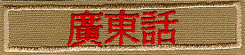
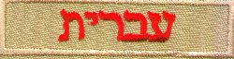
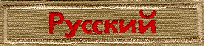
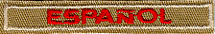

Test you knowledge of different languages. Match the following by drawing a line to the correct interpreters strip
Finnish
Spanish
Russian
Hebrew
Cantonese
The correct order top to bottom is – Cantonese. Hebrew. Finnish, Russian, Spanish
Boys' Life Reading Contest

Enter the 19th Boys' Life Reading Contest Now!

Write a one-page report titled "The Best Book I Read This Year" and enter it in the Boys' Life 2006 "Say Yes to Reading!" contest.
The book can be fiction or nonfiction. But the report has to be in your own words—500 words tops. Enter in one of these three age categories: 8 years old and younger, 9 and 10 years old, or 11 years and older.
First-place winners in each age category will receive a $100 gift certificate good for any product in the Boy Scouts Official Retail Catalog. Second-place will receive a $75 gift certificate, and third-place a $50 certificate.
Everyone who enters will get a free patch like the yellow one above. (The patch is a temporary insignia, so it can be worn on the Boy Scout uniform shirt. Proudly display it there or anywhere!) In coming years, you'll have the opportunity to earn the other patches.
The contest is open to all Boys' Life readers. Be sure to include your name, address, age and grade on the entry. Send your report, along with a business-size, self-addressed, stamped envelope, to:
Boys' Life Reading Contest, S306
P.O. Box 152079
Irving, TX 75015-2079
For more details go to www.boyslife.org
Entries must be postmarked by Dec. 31, 2006.
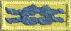
Cubmaster Training Award
Kommissioner Karl
The Cubmaster Training Award can be earned by any registered Cubmaster.
A brief summary of requirements include:
- Serve 2 years as Cubmaster, or 1 year as Assistant CM and 1 year as Cubmaster;
- Conduct a pack meeting once per month for the program year;
- While Cubmaster the Pack earns
    - The National Quality Unit Award and
    - The National Summertime Award; and
Complete
- Fast Start Training
- New Leader Essentials
- Position Specific for Cubmaster and
- Youth Protection training
- attend
    - 4 roundtables, or
    - 1 Pow Wow or University of Scouting.
For the complete requirements and a progress record, go to: http://www.scouting.org/forms/34169/53.pdf
For more information on the National Quality unit award, look in your Cub Leaders Guide Book or at:
http://www.scouting.org/forms/14-220-05.pdf
More on the National Summertime Pack Award and how to earn it can be found at:
http://www.scouting.org/forms/33748.pdf
GATHERING ACTIVITIES
Note on Word Searches, Word Games, Mazes and such – In order to make these items fit in the two column format of Baloo’s Bugle they are shrunk to a width of about 3 inches. Your Cubs probably need bigger pictures. You can get these by copying and pasting the picture from the Word version or clipping the picture in the Adobe (.pdf) version and then enlarging to page width. CD
Wood
Great Salt Lake Council
Lay out a display of wood samples. You can pick these up at most places that sell wood flooring. Label the samples 1, 2, 3 and so on. On a piece of paper to be handed out list the different kinds of wood you have and a space to put the corresponding number. This will give the boys an opportunity to check out the different types of wood, their textures and pattern designs.
Tools
Great Salt Lake Council
Take several different tools and list them on a piece of paper. Then on a table have these tools set out with #’s by them. See how well they can match them up. Just for fun see if you can find a few old-time tools to identify.
Pinewood Derby Logic Puzzle
Great Salt Lake Council
Object: Figure out from the clues the first and last name of each boy, the color of his car, and which race he was in.
Pack 999 had just finished their Pinewood Derby race. It had been a successful night every boy really had had a hand in making his car, no one cried, no Father yelled at the Cubmaster, and very single car made it to the end of the track.
- Bob’s ladybug car raced just before Sam, who raced just before Smith
- Tom and King are BYU fans and so neither one painted his car red.
- Slade had a soccer game and so was late and raced after John
- John and Jones made their cars together and didn’t paint them green.
- Sam used blue spray paint. What a mess he made!!
- The cute yellow taxicab ran in the third race.
Answers at the end of Baloo
Pictionary
Baltimore Area Council
Supplies – Flip chart or large sheets of poster paper, marker
This is a simple game (a commercial version is available in stores but not needed). Boys can join in as they arrive at the den meeting.
One member from the den comes up to the den leader, who whispers a word or phrase to him. The den member then goes back to his den and attempts to draw on a sheet of paper, what the den leader said. They are not allowed to give clues by actions, speech, or writing. The first member of the den to guess correctly wins the point.
This could be played with several dens at once al working on the same word or phrase and seeing which den guesses it first. Each den should have its own paper and marker.
Match Game (or Toothpick Game)
Sam Houston Area Council
There are many match puzzles, but this one is the best. Empty a box of ‘dead’ match sticks (or toothpicks) on to the table and invite everyone present to take eight only. With these eight, challenge them to produce two squares and four triangles. When the time limit is up, show them how easy it is:

OPENING CEREMONIES
CUBS BUILDING CHARACTER
Sam Houston Area Council
- (carrying hammer) In Cub Scouts we learn to build character.
- (carrying plank) It is not what the boy does to the wood, but rather what the wood does for the boy.
- (carrying a plane) Through Cub Scouting we learn to remove the sharp edges off our personalities.
- (carrying sand paper) As we grow in Cubbing we become more refined and smooth in our manners.
- (carrying a tool chest) Our talents are gathered together and we get a chance to try them out when our den works on the themes each month.
- (walking with parent) Our parents help us to learn how to use the tools of life when they help us pass our achievements.
ALL: Thank you all for helping us grow into well rounded citizens
This is recommended Opening in the CS RT Planning Guide, too. I guess SHAC really liked it!! I know I do. CD
Pinewood Derby Opening
Baltimore Area Council
Each boy should read his line from a card which has the first letter of the sentence on the front side.
- D Dads and sons this month have had some fun.
- E Everyone working to make their pinewood derby car run.
- R Races will be held right here tonight.
- B Boys and dads hoping they built theirs just right.
- Y Yearning to WIN a race or two.
- T Thinking hard about the competitions our car must go through
- I In just a short while the races will begin.
- M May all the best cars win.
- E Everybody please rise. Let us say the pledge to the flag.
With a few changes the following three Openings could become inspirational Cubmaster’s Minutes/ CD
Block of Wood
Baltimore Area Council
Equipment: A long table with a cloth covering the top and front and side A block of wood A variety of wood working tools A piece of wood carved and finished.
CM: You see this block of wood (holds up the block of wood, uncarved) which is much like a boy as he enters the Cub Scouting program. It is just a block of wood. It is plain and does not suspect what it can become.
Now, let’s look at a piece of wood (holds up the wood that is carved) that has been lovingly shaped, sanded, stained, and finished in every way to become something useful and beautiful. What makes the difference between the uncut block of wood and this fine piece of wood?
A patient wood worker, using tools that are properly cared for, follows a pattern to shape a block of odd into something of beauty and use. It takes time, it takes patience, it takes a plan. That’s what Cub Scouting is all about. A plan to help shape boys into achieving their potential. And that’s what we’re here to celebrate tonight.
Wood
Baltimore Area Council
Prop: - a hand carved item or a block of some exotic wood.
In the early days, wood was hard to cut and shape, Good tools were scarce and highly treasured. Those who had good tools and good wood used them with care. Fine wood carvings were admired and appreciated. As we gather for this pack meeting, let us remember to appreciate each other.
Constructing Greatness in America
Great Salt Lake Council
CM Cub Scouts are known for “building something”. The pages of history show how the ingenuity of ordinary men enables them to design and construct great and magnificent works.
CA It all starts when young boys such as our Cubs use their imagination and start putting things together.
CM This nation displays that ingenuity of man. Our country provides the opportunity for man to surpass his own expectations and provides for us as citizens the enjoyment of such beauty.
CA Here are only a few examples of masterpieces Americans have constructed: Georgia’s Stone Mountain Park, the Kennedy Space Center, the St. Louis Gateway Arch, Seattle Space Needle, the Empire State Building, Hoover Dam, Mount Rushmore, and many, many more.
CM Please stand and give the proper salute, and together we’ll give thanks for these great constructions and for the men that built them. Then in so doing we’ll give thanks to the country that gives us all the same opportunity. Please join with me in the pledge of allegiance.
PACK AND DEN ACTIVITIES
Greater St. Louis Area Council
Boys love to build things. This month have the dens work with tools and wood. Learn about different kinds of wood and where it comes from. Make gifts for your family or bird or bat houses for the community. Work with your family to make repairs around your home. Visit the local hardware store or home- improvement store and see all the different tools. Get permission to visit a local construction site. Since the best gifts are often homemade, make handcrafted awards to present at the pack meeting.
Sam Houston Area Council
March Tiger Activities
- Elective 5 – Make a family mobile
- Elective 17 - Make a model
- Elective 25 - Snack time
March Wolf Achievements and Electives
- Achievement 5 – Tools for Fixing and Building
- Elective 3 – Make it yourself
- Elective 5 – Spare time fun
- Elective 10d&e – American Indian Lore
- Elective 13e – make a birdbath or birdfeeder
March Bear Achievements and Electives
- Achievement 5b – build a bird feeder or bird house and hang it
- Achievement 9a - Make oatmeal cookies for den
- Achievement 10b – make a bootjack or bulletin board
- Achievement 20 – Sawdust and nails
- Achievement 21 – build a model
- Achievement 22 – tying it all up
- Elective 2a-b&c – make thermometer box, weather vane and rain gauge
- Elective 6d – build model wooden airplane
- Elective 7 – Things that go. Build pushmobile, windmill, waterwheel, etc.
- Elective 9a – Art. Make a mobile with dowels.
- Elective 14d – Landscaping. Build a greenhouse.
- Elective 18 – Build an outdoor gym
- Elective 22 – Collecting. Build a collection display case/box/frame
- Elective 24c – Build a model of an American Indian dwelling.
Pack Pushmobile Championship
Sam Houston Area Council
SHAC recommends you hold a Pack Pushmobile Championship in a parking lot or playground near the Pack Meeting. You can find plans in the Bear Book or several places on-line. When using plans on-line, have a few engineering parents check them out to make sure the plans are all there and they are safe. With Webelos working on Engineer this month, they should have a blast building one of these.
Clothespin Airplane:
Sam Houston Area Council
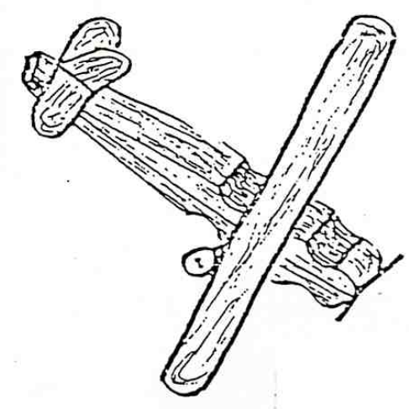
Materials:
Spring type clothespin
Ice cream sticks
Toothpicks
Buttons
Paints
Pipe cleaners (optional)
Tools:
Brushes White glue
Electrical wire cutters Markers

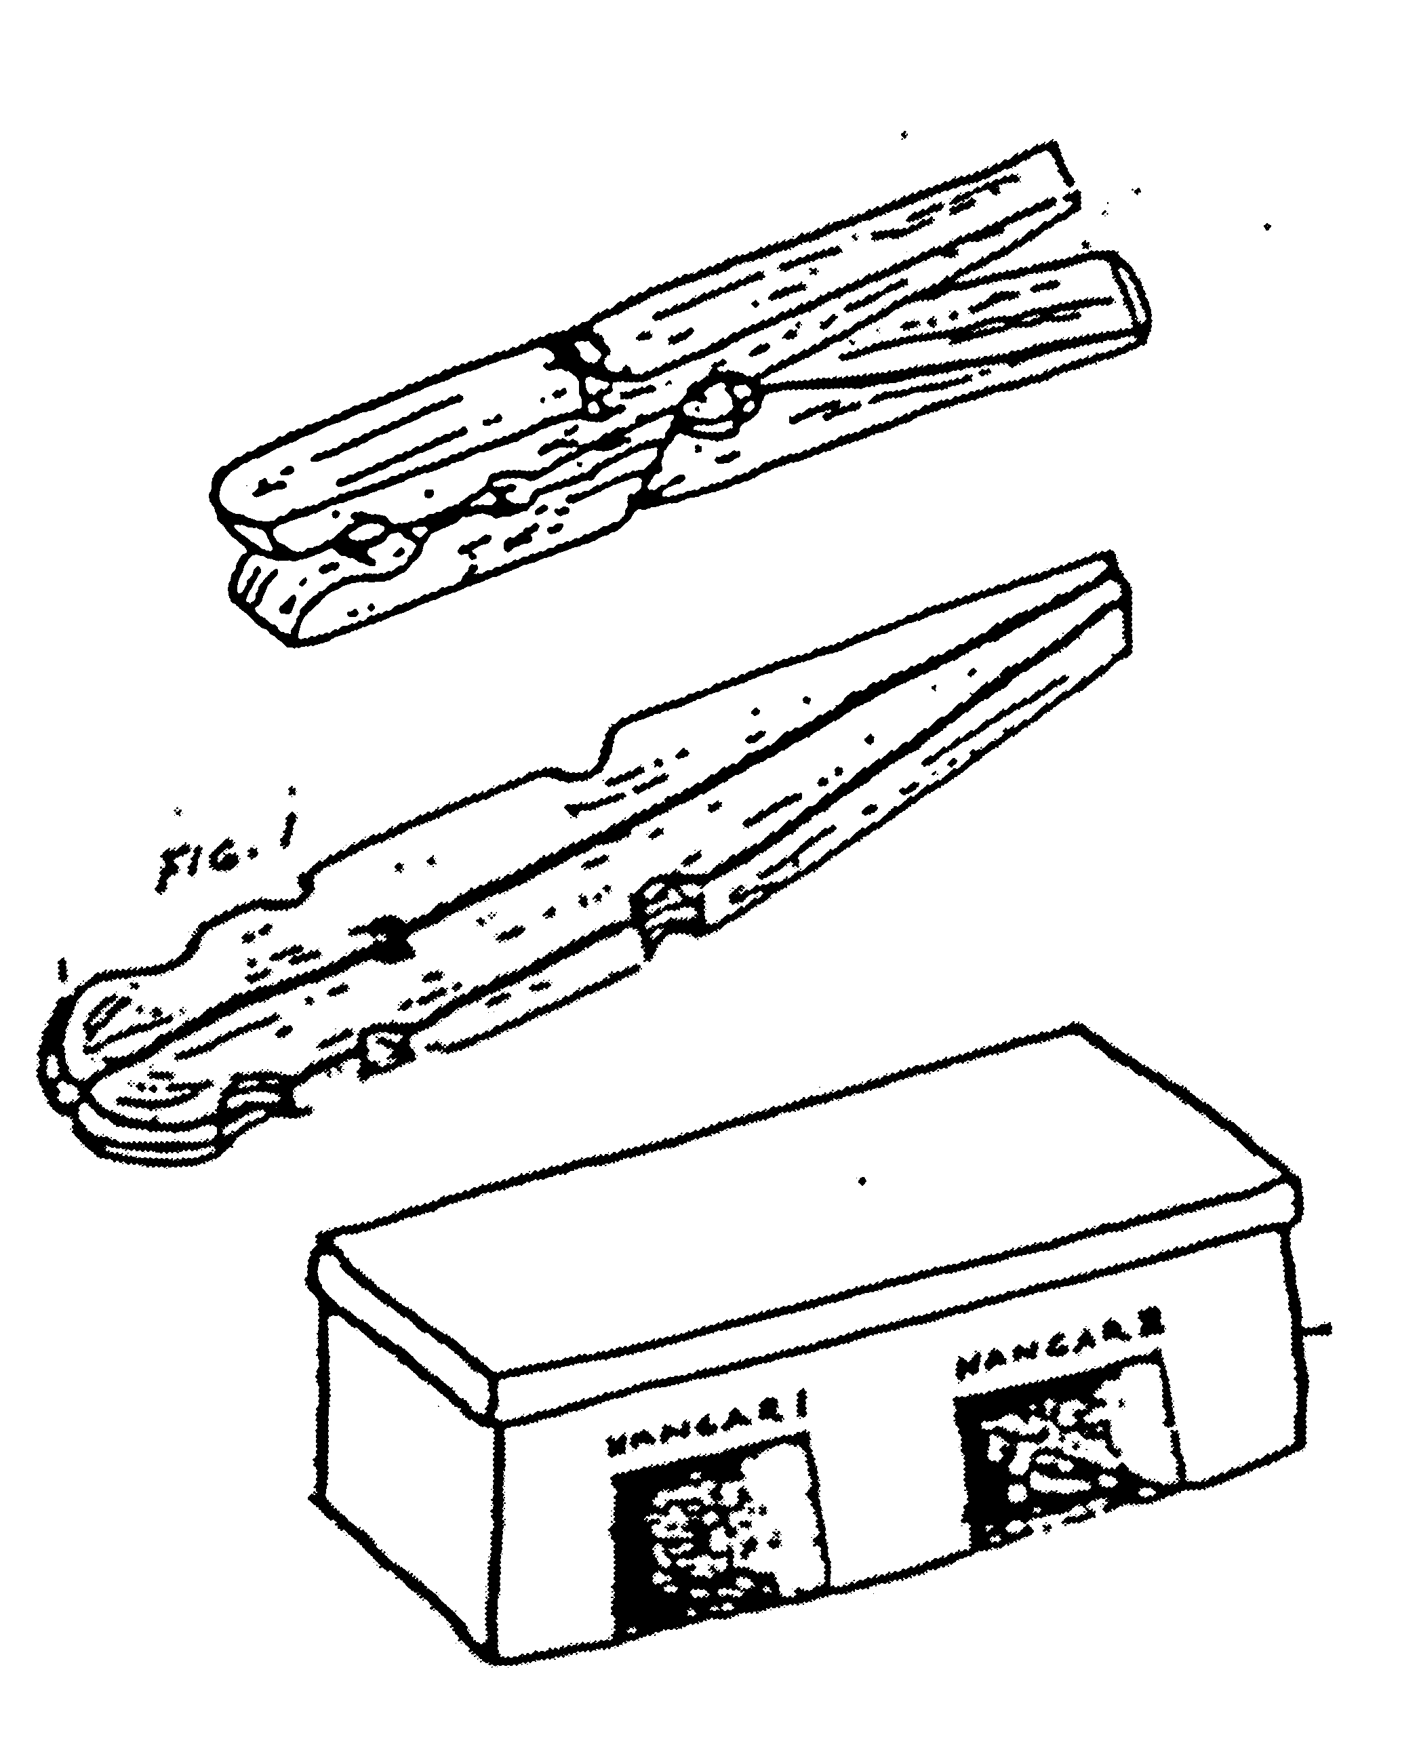
Construction:
- Remove the spring from a spring clothespin.
- Lay the two sticks back to back and glue them together. (Fig. 1).
- Glue on one ice cream stick for the wings as shown in Fig. 2,
or glue on 2 ice cream sticks to make a biplane as in Fig. 3.
- A short piece of toothpick can be glued into place for the propeller.
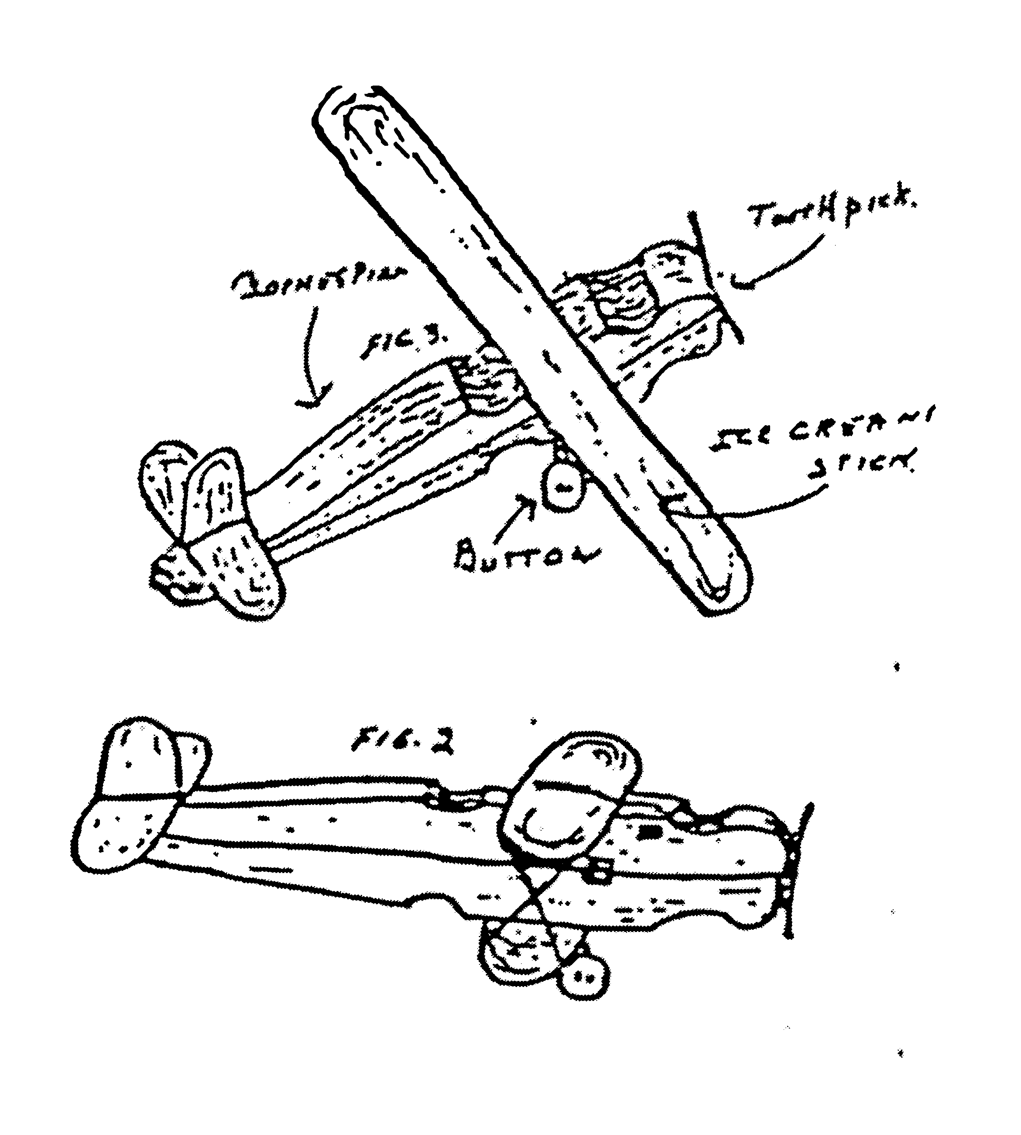
- The tail and rudder are made of pieces of ice cream sticks cut to size with a pocketknife or a pair of wire cutters then glued into place.
- Wheels are buttons mounted on toothpicks that have been bent to shape but not broken.
You may use pipe cleaners instead. (Soak toothpicks in warm water for a few minutes and they will bend more easily.)
- Finish by painting with markers.
Constructing Bluebird Boxes
Alapaha Council
Adapted from Georgia Department of Natural Resources website
http://www.gadnr.org/
Plans are the end of this issue of Baloo’s Bugle
Constructing and erecting the Perfect Home for Your Bluebirds Construct boxes using untreated wood. Ideally, boards used in nest box construction should be ¾ inch thick. If smooth lumber is used in nest box construction, roughen the wood on the interior of the box just below the entrance hole; this makes it easier for young birds to climb out of the nesting box. Assemble boxes using screws, aluminum nails or galvanized nails.
Entrance holes should be cut precisely 1 ½ inch in diameter. Larger holes permit European starlings to enter the box. All boxes should be provided with drainage and vent spaces.
The outside of bluebird boxes should be painted a light color. Boxes painted light colors stay cooler than those painted dark colors.
Do not equip a bluebird nesting box with a perch. Bluebirds do not need perches; however, nest competitors such as house wrens and house sparrows will use perches to gain access to a box.
Boxes should be equipped with predator guards. One of the simplest ways to thwart predators from entering boxes is to smear automotive grease on the pole beneath the boxes. An alternative method is to place a sheet metal cone (36 inches in diameter) around the pole beneath the box.
If you have a problem with flying squirrels increasing the size of the entrance holes to your boxes, install metal entrance hole shields around the entrance holes of all of your bluebird boxes. These shields can be obtained from stores specializing in bird-related items.
Remove sparrow nests as soon as they are discovered. While this procedure may have to be repeated several times, eventually the sparrows will nest elsewhere.
Erect boxes 5-6 feet above the ground. Whenever possible, mount bluebird nesting boxes on poles made of metal or sunlight-resistant PVC pipes. Boxes placed on such structures are easier to protect from rat snakes, raccoons and other nest predators. A piece of ¾ inch electrical conduit makes an ideal nesting pole.
If you must mount boxes on trees, leave at least a one-inch space between the nail or lag bolt and the box. This will allow the tree on which the box is mounted to grow without forcing the box off its trunk.
Boxes should be placed in open habitats with sparse trees and low vegetation. Many bluebirds' nest box efforts fail because boxes are erected directly in shrubby and forest conditions.
Position boxes so that they face a tree or shrub located within 100 feet of the box. These woody plants provide safe landing areas for fledglings on their first flight. A young bluebird landing on the ground is vulnerable to cats, dogs and other predators. Bluebirds do not seem to prefer boxes facing in a particular direction.
Boxes should be erected 100 yards or more apart. Nesting bluebirds will often fight with one another when boxes are placed close together.
Monitor boxes once a week during the nesting season. Once hatchlings appear, do not check boxes after the young are 12-14 days old as the young might try to leave their nesting box before they are ready to fly.
Do not take nesting boxes down in the winter season. Boxes make ideal roosting sites for bluebirds on cold winter nights.
Single Chamber Bat House (Wall Mounted)
Alapaha Council
Many people have discovered the benefits and wonder of attracting backyard bats. We hope you will join them by providing new homes for these fascinating mammals.
Bat Conservation International, Inc. http://www.batcon.org
Materials (makes 1)
1/4 sheet (2' x 4') 1/2" ACX, BCX, or T1-11 (outdoor grade) plywood. DO NOT use pressure treated wood.
One 1" x 2" (3/4" x 1 1/2" finished) x 8' pine furring strip
20-30 exterior grade screws, 1"
One pint dark, water-based stain, exterior grade
One pint water-based primer, exterior grade
One quart flat water-based paint or stain, exterior-grade
One tube paintable latex caulk
1" x 4" x 28" board for roof (optional, highly recommended)
Black asphalt shingles or galvanized metal (optional)
6-10 roofing nails, 7/8" (optional)
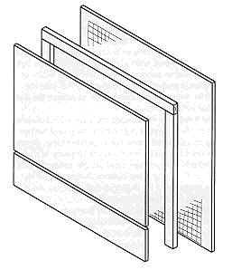
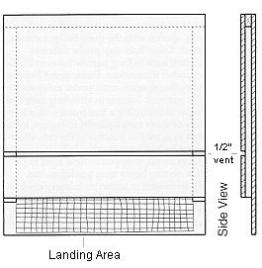
Construction Procedure
- Measure and cut plywood into three pieces:
26 1/2" x 24 16 1/2" x 24" 5" x 24"
- Roughen inside of backboard and landing area by cutting horizontal grooves with sharp object or saw. Space grooves about 1/2" apart, cutting 1/16" to 1/32" deep.
- Apply two coats of dark, water-based stain to interior surfaces. Do not use paint, as it will fill grooves, making them unusable.
- Measure and cut furring into one 24" and two 20 1/2" pieces.
- Attach furring strips to back, caulking first. Start with 24" piece at top. Roosting chamber will be 3/4" wide (front to back).
- Attach front to furring strips, top piece first (don't forget to caulk). Leave 1/2" vent space between top and bottom front pieces.
- Caulk around all outside joints to further seal roosting chamber.
- Attach a 1" x 3" x 28" board to the top as a roof, if desired (optional, but highly recommended).
- Paint or stain exterior three times (use primer for first coat).
- Cover roof with shingles or galvanized metal (optional).
- Mount on building (south or east sides usually best).
Durable plastic mesh can be substituted for roughening to provide footholds for bats. Attach one 20" x 24 1/2" piece to backboard after staining interior, but prior to assembly
Mini-Shadow Box
Baltimore Area Council
Supplies:
1 wooden yardstick
¼” plywood 10” x 1¾”
Decorative Hanger
glue
Directions:
- Cut stick as follows:
  - 2 - 10” pieces for sides
  - 2 - 2” pieces for top and bottom
  - 3 - 1¾” pieces split lengthwise, to make recessed shelves.
- Glue sides to outside of plywood back ,
- Glue on top and bottom pieces.
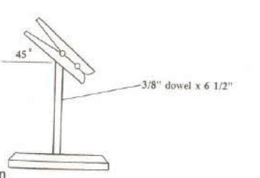
- Glue 2 of the narrow pieces to top and bottom, inside of box for added support
- Glue in 4 shelves.
- Let dry and sand rough edges.
- After glue has dried, paint or varnish
- Add ring to top back for hanging.
Note Holder I
Baltimore Area Council
Varnish or paint wood scrap. Add ring to back for hanging, Glue on clothespin and add a twig for decoration.

Bamboo Wind Chimes
Baltimore Area Council
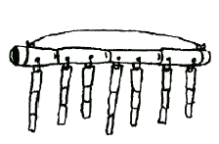
Supplies:
1 piece bamboo 8” long
7 pieces bamboo different lengths
nylon thread
drill
Directions:
- Drill holes in 8” bamboo at 1” intervals
- Drill hole through one end of remaining bamboo pieces
- Tie the 7 pieces of bamboo to the 8” piece
- Tie a thread from one end to the other for hanging.
Pinewood Derby Racer Holder
Great Salt Lake Council
Check orientation of picture before proceeding
Materials
2 – 1/ 4 in dowels, 3” long
1 – wood plaque 6 3/ 4” by 3 1/ 2” by ¾ ‘ thick
hanger brackets, stain or paint, drill
Instructions
- Drill holes for dowels
- Insert dowels 3” apart
- Stain or paint
- Attach hanger brackets on back
Note Holder II
Great Salt Lake Council
Materials
1 – 3/ 8 in dowel, 6 1/2” long
1 – wood plaque 2 3/ 4” by 1 3/ 4” by 1” thick
spring clothes pin, stain or paint, drill
Instructions
- Drill holes 1/ 4” deep for dowel
- Insert dowels
- Glue on clothespin
- Stain or paint
GENIUS KIT I
Baltimore Area Council
Genius kits are fun for the boys and their families to do together. You will need a paper sack for each boy (or team). Place several different items in the sack. Make sure that you give each boy the same identical items. The more items placed in the bag the more creative they can be.
Each boy is given their sack and they and their families have one half hour to make something out of the items in the bag. They can only use the items in the bag and the bag itself. Have them bring with them from home only the tools they think they might need to make something such as: Scissors, glue gun, hammer, screwdriver, etc. The following is a list of some possible items that can be used in the kits:
Different size wood pieces Styrofoam peanuts
Garbage bag ties Toilet paper rolls
2 liter bottles Nails
Cotton balls Nuts
Washers Bolts
String, rope or yarn Small individual cereal boxes
Tacks Paper plates
Beans’ Macaroni
Dried Peas Fishing line
Colored paper Feather
Pinecones Six-pack pop can holders
Juice can lids Rubber bands
Plaster spoons Paper clips
Used spark plugs Canning lids
Egg cartons Paper towel rolls
Paper cups Small cans (tuna, cat food)
Beans Aluminum foil
Pop bottle lids Popsicle sticks
Please keep your pieces ‘boy things.” Enable them to build something solid. Don’t make this another paper craft.
Genius Kit II
Alapaha Council
A genius kit is simply a bag full of odds and ends, any and all scrap materials available in your neighborhood. The contents of each bag should be identical. Include a copy of the rules in each bag.
Some ideas for the contents are:
2 blocks of scrap wood 3 nuts 12 beads
8 peanuts 2 screws 2 spools
1 tin can 1 cardboard tube 6 nails
1 wooden clothes pin 6 pipe cleaners
1 coat hanger 4 buttons 1 foot of rope
12 tacks 1 egg carton 1 small tube of glue
6 assorted corks 3 pieces of scrap leather
1 jar lid 3 pieces of sponge 4 feet of string
3 pieces of cloth 1 board, 1” x 6” x 10”
3 bottle caps 4 pieces of dowel 4 straws
Rules for parent/son genius kit project:
- Use only the material supplied;
- You do not have to use all of it.
- Cut them up any way you wish.
- Use any tools you wish.
- Use your imagination and have fun!
- Bring your genius creation to the pack meeting.
Judging prizes could be given for:
Best animal Most useful Most ingenious
Funniest Best invention Most decorative
Best workmanship Most unusual Best contraption
Best “what in the world?” Largest Smallest
You can establish other categories if you want, such as having everyone work on games, machines, boats, airplanes, undersea creatures, animals, robots, etc.
Making Clay:
Sam Houston Area Council
Here are two ways of making clays for Cub projects
Cornstarch Clay Recipe:
Materials:
- 1 cup salt
- water
- 1/2 cup cornstarch
- Food coloring (optional)
Directions:
  - Combine salt and 1/3rd cup water.
  - Stir and heat the water until the salt is thoroughly dissolved.
  - Take off of the stove and add the cornstarch and ¼ cup cold water.
  - Stir until it thickens and has a consistent texture. After it cools, knead it a bit.
  - Add food coloring while kneading, if desired.
Play Dough:
Materials:
- 1 cup flour
- 1 cup water
- ½ cup salt
- 1 tsp vegetable oil
- ½ tsp cream of tartar
- Food coloring (optional)
Directions:
  - In a saucepan cook the mixture over medium heat,
  - Stir constantly, until the mixture holds together.
  - Take off the stove and turn mixture onto a floured board.
  - When the clay is cool enough to touch, knead it and add food coloring.
Working on Science Belt Loop and /or pin??
The Scientific Method
Nancy in Texas
Adapted from www.ScienceBuddies.org)
The scientific method is a process for experimentation that is used to answer questions and explore observations.
Scientists use an experiment to search for cause and effect relationships in nature. In other words, they design an experiment so that changes to one item cause something else to vary in a predictable way. These changing quantities are called variables. Variables are a key element of the scientific method.
Here is an overview of the scientific method that you will need to understand in order to complete your science fair project. Don't worry about having to learn it all at once; this is just a basic introduction to help you see the steps of the scientific method from beginning to end. For each step, we offer a much more detailed explanation, including examples and samples from past science fair projects. You can access the detailed explanations by clicking on the link for the appropriate step or by using the menu on the left hand side of the screen.
- Stating the Question: What is it that you are trying to find out from your experiment? What is it that you are trying to achieve?
- Research Your Topic: Investigate what others have already learned about your question. Gather information that will help you perform your experiment.
- State Your Hypothesis: After having thoroughly researched a topic, you should have some prediction about what you think will happen in your experiment. This educated guess concerning the outcome is called your hypothesis. You must state your hypothesis in a way that you can readily measure.
- Test Your Hypothesis by Doing an Experiment: Now that you have come up with a hypothesis, you need to develop a procedure for testing whether it is true or false. This involves changing one variable and measuring the impact that this change has on other variables. When you are conducting your experiment, you need to make sure that you are only measuring the impact of a single change.
Scientists run experiments more than once to verify that results are consistent. Each time that you perform your experiment is called a run or a trial.
- Analyze Your Results: At this stage, you want to be organizing and analyzing the data that you have collected during the course of your experiment in order to summarize what your experiment has shown you.
- Draw Your Conclusion: This is your opportunity to explain the meaning of your results. Did your experiment support your hypothesis? Does additional research need to be conducted? How did your experiment address your initial question and purpose?
- Report Your Results and Conclusion: Since you are performing an experiment for the science fair, you will write a report and prepare a display board so that others can share in your discoveries.
Throughout the process of doing your project, you should keep a journal containing all of your important ideas and information. This journal is called a project logbook or laboratory notebook.
Scientific Method Quiz for Science Belt Loop
Nancy in Texas
Put the seven Scientific Method steps in their proper order.
State Your Hypothesis
Draw Your Conclusion
Report Your Results and Conclusions
Research Your Topic
Analyze Your Results
State the Question
Test Your Hypothesis by Doing an Experiment

AUDIENCE PARTICIPATIONS
This Is the House that I Built
Baltimore Area Council
Have audience repeat the words and actions along with you
This is the house
(Make a roof with arms, touching fingertips together)
That I built. (Point to self)
This is the saw that cut the boards (Make sawing motion)
That went into the house (Make roof with arms)
That I built. (Point to self)
This is the hammer (Make fist with right hand)
That nailed the boards (Pound right fist into left palm)
That I cut with the saw (Sawing motion)
That went into the house (Make roof with arms)
That I built. (Point to self)
These are my hands (Hold out hands and look at them)
That held the hammer (Make fist)
That nailed the boards (Pound right fist in left palm)
That I cut with the saw (Sawing motion)
That went into the house (Make roof with hands)
That I built. (Point to self)
I am sure you can think up more actions to keep this going and growing!! CD
HI MY NAME IS JOE
Sam Houston Area Council
Audience repeats after the leader and does what the song says Joe does
Hi, my name is Joe
And I work in a button factory
I have a wife and a fam-i-ly.
One day my boss ... he said Joe "Are you busy?"
I said NO.
He says, “Can you press this button with your RIGHT HAND?”
(You start repeatedly pressing a button with your right hand and saying doot, doot, doot. Keep the movement with your body parts while you sing the next verse)
Hi, my name is Joe
And I work in a button factory
I have a wife and a fam-i-ly.
One day my boss ... he said Joe "Are you busy?"
I said NO.
He says, “Can you press this button with your LEFT HAND? “
(Continue previous movements, but start repeatedly pressing a button with your left hand and saying doot, doot, doot. Keep the movement with your body parts while you sing the next verse)
Continue with
Right Leg,
Left Leg,
Your Head,
Hips,
Tongue,
Last Verse – done while doing all previously named motions –
Hi, my name is Joe
And I work in a button factory.
I have a wife and a fam-i-ly.
One day my boss ... he said Joe "Are you busy?"
I said YES! (Immediately stop all actions)
ADVANCEMENT CEREMONIES
Award ceremony for the Outdoor Activity Award
Bill Newman, Cubmaster, Pack 131
Clinton Valley Council
Can be performed indoors with appropriate candle lighting or outside at the campfire.
Cubmaster and award chair light one candle for each of the number of awards completed by the recipient (one year, two years, etc.)
Cubmaster Tonight we have a special award made to our scouts who have taken the extra effort to learn about the environment, the world around them, and the great outdoors. Just as Akela led the pack to be aware and considerate of the outdoors, so have our recipients tonight demonstrated this same dedication. Can I please ask ____________ (list scout names) and their parents / adult partners to come forward for the presentation of the outdoor activity award.
Camp Chair Scouts may earn the outdoor activity award in each of the program years as long as the requirements are completed each year. The first time the award is earned, the scout receives the pocket flap award, which is to be worn on the right pocket flap of the uniform shirt. Each successive time the award is earned, a wolf track pin may be added to the flap.
Cubmaster Tonight ____ (number) of scouts will earn their award for the (first / second/ third / etc.) time. We light one (two / three / etc.) candle(s) representing the number of years these scouts have earned the award.
Camp Chair The requirements to earn the outdoor activity award become more difficult as the scouts grow older in scouting. Regardless of their rank, all recipients must attend Cub Scout day camp or resident camp.
(Discuss each award per level, Tiger is provided, additional details may be found at www.scouting.org):
Tiger scouts, earning the award for the first time, need to complete one requirement in Achievement 5, "Let's Go Outdoors" and complete 3 of the listed outdoor activities to earn the award during a 12-month period.
Cubmaster These scouts have completed (three / four / etc.) or more of the following outdoor activities:
- Earn the Summertime Pack Award
- Attend a pack overnighter
- Complete a nature / conservation project in our area
- Complete an outdoor service project
- (additional activities can be mentioned)
Camp Chair On behalf of the pack and the council, we would like to present your (parent / adult partner) with this award to pin on your right pocket flap.
Cubmaster May the great Spirit of Scouting follow you always as you commit good deeds to care for nature and the great outdoors!
Cubstruction Ceremony
Great Salt Lake Council
Props:
Cubmaster in a work smock with a carpenter's tool belt.
Awards and mother's pins are taped to wood scraps that are hidden in tool belt.
Be sure to emphasize the "puns" though out the ceremony.
Cubmaster: Tonight, we have some boys who "saw" the opportunity to "nail down" some advancement. At times these boys had to keep "hammering" on some of the tougher requirements, but they kept on "drilling", "carving" and "sanding" and finally "cut" through. We "wood" like to honor them tonight. Will Cub Scout please come forward with his parents?
Cubmaster: has "chiseled" through the requirements for the Wolf badge. (Cubmaster takes the Wolf award from his tool belt and holds it up.)
We "wood" like to have his parents present him this award. (Cubmaster hands the award to the parents who present the boy the award.)
"Wood" you please pin the mother's pin on your mother.
Create similar presentation lines for other awards to be given that night.
Other "puns" which could be used when presenting awards include: "filed", "planed", "sharpened", "glued", "cut", "painted" or any other tool related name or adjective.
Working with Wood
Greater St. Louis Area Council
Boys love to build things. This month have the dens work with tools and wood. Learn about different kinds of wood and where it comes from. Make gifts for your family or bird or bat houses for the community. Work with your family to make repairs around your home. Visit the local hardware store or home- improvement store and see all the different tools. Get permission to visit a local construction site. Since the best gifts are often homemade, make handcrafted awards to present at the pack meeting.
Props: Pocket knife, Saw, Screw driver, Sandpaper and Varnish.
Narrator: Before you are a variety of tools used by carpenters and wood workers to transform plain wood into objects of beauty and usefulness. There are many steps between beginning to work with a piece of wood and completing a project. So it is with Cub Scouting. Tonight we are recognizing significant steps of progress along the Cub Scout trail.
Bobcat recognition- (Use a pocket knife) Of course a carpenter has to start with a plan. Once he has a plan in mind, the first tools he uses begin to shape the wood. We have young carpenters who have completed the initial step and are here to receive their Bobcat award.
Wolf recognition- (Use a saw)
Once started on the project, a carpenter has to focus on the major task of shaping this project- whether the finished product is a chair or a bowl. Many, many steps are required to complete this stage of the task. We have several Cub Scouts who have completed the Wolf rank and have earned
Wolf arrow points.
Bear recognition- (Use screw driver)
Once the wood is shaped, it is ready for the assembly process. This stage required many different types of tools and fasteners and precision in assembly. Much patience is needed. Our Bear Cub Scouts have a tougher set of requirements to fulfill to qualify for Bear rank and Bear arrow points. We honor them.
Webelos recognition- (Use varnish) The crowning touch to finishing a fine piece of furniture is what truly makes a piece of wood a masterpiece. Many coats of glass and sanding in between are needed to make wood glow. Drawers and doors without proper hardware are useless. Webelos who earn The Arrow of Light have demonstrated a commitment to becoming master craftsmen.
WOODY THE CARPENTER
PROPS:
- A worktable to the side of the awards table.
- Candles and rank poster on table.
- Large sign "WOODY THE CARPENTER AT WORK" to be set up to hide what is on table.
- Adult in work coveralls carrying tool box.
CUBMASTER: Hello, who are you?
ADULT: Hello, I'm Woody the carpenter. I have skills, but no work.
CUBMASTER: Well, let's see. I think I can use your help. Here, set up your tools on this worktable.
ADULT: (sets up sign to hide what he is doing) I'm ready, what do I do first?
CUBMASTER: I need a Bobcat plaque.
ADULT (Starts to hammer, saw, etc. hands a rough cut board with Bobcat rank on it.) Will this do?
CUBMASTER: Woody, this is a fine job. That is just like a Bobcat; it has been roughly cut but there is no question that it's a board not a tree.
A Bobcat has also just been cut. His skills and crafts are rough and just starting to develop. But he has just taken the first step in Cub Scouting. We can see the difference in this board and a tree.
ADULT: Will the following Cub Trade School Students and their teachers please enter the lumberyard? (Read Names.)
CUBMASTER: (puts board by Bobcat poster and lights candle) Parents I have the honor of giving this Rank to you so you may present it to your sons. Let's see, I guess we need a Wolf plaque next.
ADULT: (Starts to saw, hammer, sand etc. hands our a clean square cut board with Wolf rank on it). Will this do?
CUBMASTER: That certainly will do Woody. A Wolf is very much like this piece of wood. It is clean and square cut, but still pretty basic with a long way to go.
ADULT: Will the following Apprentices and their parents please come down to the shop? (Read names).
CUBMASTER: (Places board by Wolf poster and lights candle). Parents I give you the Wolf badge to present to your sons.
What next( pause) I know, Woody, I need a Bear Plaque.
ADULT: (saws, hammers, etc. hands a board with routed edges and the Bear rank on it) How is this?
CUBMASTER: Woody, you have done it again! This is just like the Bear Cub Scout, a lot of effort and accomplishment has gone into this, but, it's not quite completed yet.
A Bear has accomplished many things on the trail of Cub Scouting, yet he is not at the end and his training is not complete.
ADULT: Will the following Cub Journeymen and their foremen join us on the job? (reads names)
CUBMASTER: (Places board by Bear Poster and lights candle) Parents please present the Bear Badge, the third rank of Cub Scouting to your sons. Woody, I know what I need now, the Webelos plaque.
ADULT: ( Saws, Hammers, drills, paints, etc. ) Hands out a finished plaque with Webelos rank on it.
CUBMASTER: Woody, you certainly have done a fine job. This plaque is just like a Webelos Scout. His skills and crafts are almost completed. His Cub Scout trail has but a few steps left.
ADULT: Will the following Master Craftsman Cub Scouts and their parents join us? (Read names).
CUBMASTER: (Place plaque by Webelos poster and lights candle). Parents, you have the honor of presenting the Webelos Rank to your son. Just as a skill and accomplishments were shown on these pieces of wood tonight, the skills and accomplishments were shown on these pieces of wood tonight, the skills and accomplishments of these Cub Scouts were evident as they progress along the Cub Scout trail.
Pinewood Derby Advancement
Baltimore Area Council
Equipment: Pinewood Derby track, badges of rank, or decals, and awards to be given. Put decals or actual badges of rank on cardboard and attach to 8 inch long sticks. Tape or tack these to side rails of derby track in ascending order - Bobcat, Wolf, Bear, Webelos, and Arrow of Light. At the appropriate places on the track, have the badges and arrow points.
Cubmaster: We’ve all had a great time tonight watching the pinewood derby cars race down this track. They really speed downhill, don’t they? Well, you can go uphill on this track too. It’s a little harder, but it’s worth the climb from Bobcat to Wolf to Bear, etc. Some of our Cub Scouts have been climbing this course, and now we are going to show how far they have progressed. Will the following Cub Scouts who have made the climb as far as Wolf please come forward with their parents.
(When boys and parents come forward, remove the awards from the track and have the parents pin the badges on. Repeat for Bears and Webelos.)
Race Car Advancement Ceremony
Baltimore Area Council
The Cubmaster enters after a brief absence wearing a helmet and racing clothes. He carries with him a tool chest.
Race car teams need lots of tools to keep their cars running fast. They also need awards for the races they finish. I’11 bet that a tool chest this big holds lots and lots of awards.
The Cubmaster then proceeds with the award ceremony calling on the Chief Mechanics (Assistant Cubmaster and Den Leaders) to help him/her.
GAMES
Nail Driving Contest I
Baltimore Area Council
Object: To be the first team to drive nail into wood.
Materials: Scrap wood and 10-penny nails.
A hammer for each team.
- Divide the den into teams.
- In front of each boy place a hammer and a piece of scrap wood with a 10-penny nail already started a half-inch into it.
- Boys take turns hammering the nail until the head is flush with the wood.
- This is not a speed contest. Fewest strokes wins.
- If the nail is bent, start over with a new one.
Nail Driving Contest II
Alapaha Council
Divide the den into two teams. Line up the teams for a relay race about 10 feet from the driving area. Provide each team with a piece of two by four about 1 foot long, a hammer, and nails shorter than the thickness of the wood. Each boy runs to the board, drives 2 nails, runs back, and gives the hammer to the next player. The team driving the most straight nails (not the fastest) wins. Variation: Have boys switch hands.
Sawing Contest
Baltimore Area Council
Object: To be the first team to cut a 2x4 in half.
Materials: A 24-inch length of pine 2x4,.
A handsaw for each team.
- Divide the den into two teams.
- Give each team a handsaw and the 2x4.
- In turn, each boy takes one stroke with the saw until the wood is cut through.
- This is not for speed.
Stack the Bricks
Greater St. Louis Area Council
Equipment: Lots of Dixie cups (bricks)
Directions:
- Divide the den into 2 teams.
- At the other end of the hall or room is a pile of cups.
- In turn, each boy runs up and adds one cup to the tower started by the first boy.
- If it falls over the tower has to be rebuilt.
- The team with the tallest, the only, the neatest (you decide – pick one of these or choose one of your own) standing tower is the winner.
Tower of Cups
Greater St. Louis Area Council
Equipment: Lots of flat bottom plastic or foam cups
Directions: Using only one hand; see how many paper or plastic foam cups you can stack top-to- top and bottom- to-bottom before they fall.
Person who stacks the most is the winner.
Bricklayer's Relay
Greater St. Louis Area Council
Equipment: Per team: 1 hard hat; 1 dustpan; 1 flag; 3 or more 'bricks' - stones, pieces of Styrofoam, or blocks of wood.
Directions:
- Divide the group into teams.
- Have them stand in parallel straight lines at one end of the playing area.
- The leader shouts 'BUILD'.
- The first member of each team dons the hard hat,
- Places a brick in the dustpan and
- Runs down to the other end of the playing area.
- He places the brick on the ground and runs back to the starting line.
- Each team member in turn, races down to build up the wall.
- The race continues until all the bricks on each team are used up .
Long, Short, Round
Baltimore Area Council
Object: To run the relay keeping track of the location of three objects.
Materials: Each team requires two containers.
A long common tool, e.g. a wooden mallet;
a short common tool, e.g. a stubby screwdriver,
and a round object, e.g. a small disk of wood.
This is a good game to sharpen alertness if the leader keeps it moving fast.
- The teams sit down in a single file line with feet extended.
- They count off so that each Cub in the den has a number.
- At the start, the container with the objects is at the front and the empty container is at the back of the team line.
- The leader signals with his arms long or short or round,
- Then calls out a number.
- Scouts with that number race to their can, pick out the object, take it to the other container, and put it in the other container, and return to their places.
- The first Cub Scout back in place wins a point for his team.
- Keeping track of the location of the objects soon becomes a mental challenge.
- If a Cub heads for the incorrect can, he is bound to lose the point.
Tool Box Sort Out
Baltimore Area Council
Use an egg carton for the toolbox. Have an assortment of nuts, bolts, screws, etc, to be sorted. The first boy to sort by size in the proper place wins.
Name The Tools
Baltimore Area Council
Cut different silhouettes of tools from construction paper, such as a hammer, plane, brace, bit, screw driver, etc. Glue these on light weight cardboard and use as flashcards.
See the Craftsman section in Baloo a few months ago for pictures you can use. CD
Log Rolling Contest
Baltimore Area Council
Make logs from 4” cardboard cylinders. This can be a relay, with each boy rolling a log with a dowel or stick to a given point and back to the next person in line.
Human Ladder Crossing:
Sam Houston Area Council
Played with one Den, this is a timed event. With two dens, it’s a relay. Sit the team down in a straight line, with their hips about a foot apart and feet pointing in the same direction. Have them spread their legs, so that their feet touch those of the guy next to them.
Starting at one end of the line, upon command, one boy on each team jumps up and runs to touch the wall and then runs back over the “ladder” made by the legs of his team. He may not step on the boys’ legs and the ladder mustn’t move. After getting across the ladder, he then touches the opposing wall and runs back across the “ladder” to take his original position. Once he sits back down in his spot, the next boy in the ladder jumps up, crosses the ladder in both directions and gets back to his spot (and so on until everyone has had a turn).
This game can be made more interesting by providing simple obstacles around the two outside edges of the hall, e.g. car tires to get through, turned gym benches to walk along, or chairs to go under.
Timber
Alapaha Council
The players form a circle facing inwards and are given a stave or walking stick each to hold upright in front of them on the ground. The leader will call a direction and a number (e.g. 2 to your left.) Each player must let go of his stave (he must not push it, simply let it go in an upright position) and move to grab the appropriate one (e.g. the second one on their left) before it hits the ground. If the stave hits the ground first, he is out. The circle closes up any gaps and continues play. Play continues until only one player is left. Variations: To make a more challenging game, call directions faster and further.
Human Pinball
Alapaha Council
All players except one stand in a circle, facing outwards. Players spread their legs as wide as is comfortable, until their feet are touching their neighbors’ on either side. Everyone bends down and swings his arms between his legs – these are the pinball “flippers.” The one non-flipper enters the circle as the moveable target. The flippers try to hit him by knocking a volleyball or playground ball back and forth in the circle. Whoever hits the target gets to be the new target. The target’s only job is to avoid the ball. The flippers can only hit the ball, not catch and throw it.
Fumble Fingers
Alapaha Council
Divide the den into two teams. Tell players to untie their shoelaces. Then tell them to put one hand behind their back, or tie one hand to their belt. On signal, each team tries to tie their shoelaces, with each player using only one hand. The first team finished is the winner.
Kick the Can:
Sam Houston Area Council
Materials: One empty #10 metal can, like for coffee or restaurant-sized canned food
This great old-time game can keep boys occupied for hours. One person is chosen to be “It”, by a fair method. He (It) then has to hide his eyes and count aloud to a pre-chosen large number, while the others all find hiding places within earshot of the can. At the end of the count, “It” announces “Ready or not, here I come!” and then tries to find out where the boys are hiding.
If he identifies someone hiding, “It” has to say “I see ‘Johnny’ (or whoever) behind the tree” and then they both run to the can. If “It” picks up the can first, then the boy that was hiding gets captured. If any hiding boy kicks the can before “It” picks up the can (even if “It” didn’t see him), then everyone previously captured goes free. Ideally, “It” stays “It” until he captures everybody.
Since it can be very frustrating to be “It,” be sure to put the can in a large open area, so that he has a better chance. Also, to avoid frustration, perhaps you can change who is “It” after successfully capturing a few boys, otherwise, with a large group it’s nearly impossible to ever capture everyone.
Annie-Annie Over:
Sam Houston Area Council
It is played over a building that you can throw a bouncy ball over and be able to run all the way around it quickly. You call out “Annie-Annie Over” and throw the ball over the building to the kids on the other side. If they catch the ball without it touching the ground, they can sneak around the building and throw the ball at you or catch you and tag you. You have to keep an eye open for them coming and beat them to the other side of the building. If you make it then that is your side but if you are tagged then you are on their side.
If the ball is not caught then they can wait a moment to try and fool you and then holler out “Annie-Annie Over” and throw the ball back. If the ball doesn't go over the building, the throwers can yell “Pigtail!”, and then try to throw it again. The ball must be caught in order to run around the building after you. When the last kid on a team is tagged then that team wins.
Gates, Bridges & Tunnels
Great Salt Lake Council
Equipment: Rubber chicken
To Play:
- Divide players into groups of three.
- One player in each group is the gate person,
- One is the bridge person, and
- One is the tunnel person.
- All players then form a large circle,
- The players in a group of 3 stand next to each other
- The leader stands in the middle of the circle holding the rubber chicken.
- When “Gates” is called, the gate people leave their spot in their circle and run around the outside of the circle.
- The other two players form a gate by putting their arms together.
- When the gate person gets back to his group, he goes through the gate to the center of the circle and tries to grab the chicken.
- If “Tunnels” is called, the others in the group form a tunnel, which the tunnel person must pass through to get to the center.
- If “Bridges” is called, the others must form a bridge to be crossed to reach the center of the circle.
- The first player to grab the chicken each time becomes the new leader, and the former leader takes the empty place in the circle.
Dice Count
Great Salt Lake Council
Equipment: 1 die, pair of oven mitts, a chocolate bar or other wrapped treat, a hat
To Play:
- Before the game, wrap the chocolate bar in 5-6 layers of paper.
- Have the players sit in a circle and place the bar, the hat, and the mitts in front of one of the players.
- The player directly to the left of the person with the chocolate bar is given the die.
- On a signal, the person with the die starts rolling for a 6, while the other person puts on the oven mitts,
- Then the hat, and then starts to unwrap the chocolate bar.
- Once a 6 is rolled, everything is passed to the left and a new person rolls the die, and
- The previous roller tries to put on the mitts and hat and unwrap the chocolate.
- The player who completely unwraps the candy gets to eat it.
Blindfold The Cook
Great Salt Lake Council
Equipment: Blindfold, wooden spoon, 2 bowls –one full of marshmallows, timer (or watch)
To Play:
- Blindfold the first player, set the bowls and spoon in front of him.
- Time the player for one minute while he tries to scoop as many marshmallows as possible into the empty bowl.
- At the end of the minute, count how many marshmallows were successfully transferred.
- Reset for each player.
- The player with the most is the Champion Scooper! (But everyone gets to eat the marshmallows!)
Crazy Drawing
Great Salt Lake Council
Equipment: Paper and pencil for each player
To Play:
- Each player begins by drawing a single line on his paper.
- It can be any kind of line - straight, jagged, curvy.
- The papers are passed to the person to the left.
- Each player adds a line to the paper that is now in front of him.
- Continue to pass and add lines until the papers have gone around the circle.
- The object is to create something recognizable.
- Once the drawing starts to take shape, each player should continue to develop the picture, one line at a time.
SONGS
Cubstruction
Cub Scout Roundtable Leaders’ Guide
Tune – Alouette
Chorus
Cubstruction, we build with Cubstruction
Cubstruction, it’s how we build our world
First you take a block of wood
Then you cut it down to size
Block of wood – Down to size
OOOooohhh
Chorus
Next you take the right size nail
Then you hammer carefully
Right size nail –carefully
Block of wood – Cut to size
OOOooohhh
Chorus
Now you take a big paintbrush
Then you paint it very nice
Big paintbrush – Very nice
Right size nail –carefully
Block of wood – Cut to size
OOOooohhh
Last we put our name on it
Then we know that we a re done
Name on it – WE ARE DONE!
Taps for Cub Scouts
Tim, Cubmaster, Pack 65, Haddonfield, NJ
Tune: "Taps"
I heard this when I visited Tim’s Pack and had to get the words to share with everyone CD
Sun of gold, sky of blue
Both are gone from the sight, day is through.
Do your best, then to rest,
Peace to you.
Toolbox Song
Baltimore Area Council
Tune: I’m a Little Teapot
I’m a pair of pliers just because,
Here is my handle here are my jaws
Chorus:
Keep me in your toolbox bright and new
Take me out and I’ll work for you.
Chorus:
I’m a coping saw that’s strung too tight
Pull me then, push me to use me right.
Chorus:
I’m a big strong hammer, a mighty tool
Hit the nails only, that’s the rule.
Chorus:
I’m a happy C-clamp, tell you what I do
I eat board sandwiches filled with glue.
Chorus:
I’m a handy wood plane, give me a try
I can help you out if your door’s too high
Wood Working Is Fun
Greater St. Louis Area Council
Baltimore Area Council
Tune: Jingle Bells
Saw on wood, Hammer nails,
Wood working is fun!
We’ll get this project done on time
With the setting sun!
Stain the wood, Putty the nails,
Lets give a big hooray!
Now this project is done on time,
Let’s go out and play!
Don’t You Like to Saw
Baltimore Area Council
Tune: I’ve been working on the railroad
I’ve been sawing on this piece of wood.
All the live long day,
I’ve been sawing on this piece of wood,
Just to pass the time away.
Can’t you see the saw dust flying
Rise up so early in the ‘mom.
Can’t you see our leader shouting,
Not on my wood floor!
Don’t you like to saw,
Don’t you like to saw,
Don’t you like to saw,
More, more, more, more!
Don’t you like to saw,
Don’t you like to saw,
Even if it’s on the floor!
My Cub Scoutmobile
Alapaha Council
Tune: On Top of Old Smokey
One Saturday morning
My granddad and I
Went down to the woodpile
To get some supplies
Some long boards, some short boards,
A few thin ones too
Four wheels and a gear shift
We’re practically through
Some paint and a good seat
Completes our fine car
Now on to the race track
Where the Cub Scouts compete
Zoom! Down the roped off street
Cub Scouts dressed in blue
All had a real great time
We hope you did too!
Pinewood Derby Song
Baltimore Area Council
Tune: “Camptown Races”
Cub Scouts all join in the song, Doo-Dah, Doo-dah!
Pine car track is mighty long, Oh, do-dah day!
Chorus:
Going to run so fast, going to get ahead,
Bet my money on a blue pine car, Somebody bet on the red.
Chorus:
Red cars, blue cars, green and gray, Doo-Dah, Doo-dah!
Running on the track today. Oh, doo-dah day!
Chorus:
Pine wood cars have lots of class, Doo-dah, doo-dah!
Even though they don’t use gas, Oh, doo-dah day!
Chorus:
They’re the pride of all the lads, doo-dah, doo-dah!
Build by Cub Scouts and their dads, Oh, doo-dah day!
Chorus:
This song is a classic but could be updated. I googled “Pinewood Derby Song” to see if someone had rewritten the chorus to eliminate the word bet and couldn’t find one. If you come up with a new chorus, please send it to me. Thanks CD
Pound the Nail
Greater St. Louis Area Council
Tune: Row, Row, Row Your Boat
Pound, pound, pound the nail,
Pound it right on through!
If you miss and pound your thumb,
Then it will turn true blue!
Pinewood Derby Car
Greater St. Louis Area Council
Tune: I've Been Working on the Railroad
I've been working for the Derby,
Planning my racing car.
All the family's been helping,
My car should be the star!
Can't you hear the crowds a cheering
As we win the prize?
Pinewood Derby time's exciting
For all the Cub Scout guys!
Whacked My Thumb
Greater St. Louis Area Council
Baltimore Area Council
Tune: Jimmy Crack corn or The Blue Tailed Fly
When I was young I went to play
In father's workshop one fine day
I took a hammer, some wood and nails
And tried to make some kitchen scales.
Chorus :
Whacked my thumb and I don't care
Hurt real bad, but I don't care
Whacked it good, but I don't care
The feelings gone away
I tried to hang a picture frame
Sent to me by Aunt Jane
To hang the picture, I was dumb
I swung the hammer, and smashed my thumb
Chorus
One day I tried to make a boat
Worked real hard so it would float
I nailed my fingers to the bow
I'm bandaged to my elbows now
Chorus
I joined the local Cub Scout pack
I learned to make a neat tie rack
A little skill was all it took
They had instructions in the book
New Chorus :
I missed my thumb, I learned to care
I missed my thumb, I wouldn't dare
I missed my thumb, my thumbnail's bare
The feelings here to stay
CUB GRUB
Foundation Snacks
Baltimore Area Council
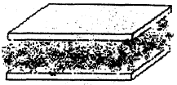
Ingredients
- Graham Crackers
- Chocolate frosting
- Peanut Butter
- Chocolate chips
- Mini M&Ms
- Chopped Peanuts
Directions
  - Break graham cracker into squares
  - Spread a layer of frosting on one side of a square
  - Spread the other square with peanut butter
  - Sprinkle chocolate chips or nuts top of the peanut butter.
  - Cover with the first cracker,
  - Frosting side down.
  - Gently press together.
House-Wiches
Greater St. Louis Area Council
Cut the top of a slice of bread in a triangle shape to resemble a roof shape.
Spread cream cheese or peanut butter over the bread shape.
Add a cheese slice, cut on the diagonal (triangle), to the roof area of the bread house.
Using more cheese pieces, cucumber slices, thin carrot slices
or whatever food item you can think of, add windows, and doors to the house.
Skiing Snowman
Baltimore Area Council
Ingredients
- 3 lg. Marshmallow
- 2 toothpicks
- 3 pretzels
- Pieces of black licorice lace
- 2 flat carrot Sticks
Directions
- Stack the 3 marshmallows. to form snowman,
- Hold them together with a toothpick.
- Push 1 pretzel through top of middle marshmallow to form arms.
- To make face and buttons press licorice into marshmallows .
- Place snowman on carrot skis.
- Lean remaining pretzel sticks against snowman’s arms for ski poles.
Marshmallow and Pretzel Towers
Ingredients
1 bag large marshmallows,
1 bag small marshmallows,
1 bag thin pretzel sticks,
1 bag large pretzel sticks,
Directions
- Place all 4 ingredients in separate bowls and put them where everyone can reach.
- Write on small slips of paper different things to make out of the pretzels and marshmallows fold them and place them in another bowl. For Example: A triangle, a circle, a square, a bridge, a ladder, a car, a boat, a train and a tower.
- Pull slips out one at a time and let the boys make each item.
Graham cracker Houses
You will need:
1-box graham crackers,
pint size milk carton for each child,
a small square of cardboard covered with tinfoil for each child,
assorted candies for decorating the houses,
royal icing
Royal icing
You will need:
2 egg whites,
3 cups confectioners’ sugar,
1 1/4-teaspoon cream of tartar
Directions for House and Icing
- Beat the egg whites with the sugar and cream of tartar with an electric mixer until creamy and smooth.
- When not using cover with damp clothe to keep it from hardening.
- Frost the bottom of the empty and cleaned milk carton and ‘glue’ to the cardboard.
- Allow drying for about 5 minutes.
- Then frost each side of the carton and put on graham crackers, until all four sides are covered.
- Let stand for another 5 minutes and then break one cracker in half to use for the roof and put onto the base.
- Wait another 5 minutes and then allow the children to decorate their houses the way they would like
STUNTS AND APPLAUSES
APPLAUSES & CHEERS
Great Salt Lake Council
Chip, Chop Divide audience into two sides.
One says “Chip,” the other “Chop”
After a few iterations, all yell, “Timber.”
Electric Drill (or Chain saw) – Make Brrrrrr sound for as long as you can
Sandpaper – Rub hands together as loud as you can
Glue – Clap hands together and they get stuck, struggle to pull them apart.
Super Glue – Hands get stuck on first clap and can’t be pulled apart. Have pack yell something for help (Home Depot, Lowes, Mr. Fix-It, be original)
Rubber Tree – Pretend to hold axe to chop tree. Every time you swing it bounces back. Make bouncing noise - “Boing, Boing”
Baltimore Area Council
Nail Pounding Cheer Start by pretending to drive a nail with a hammer, then hit your thumb. Make appropriate motions. Words go “Bang, Bang, Bang, Ouch.”
Lumberjack With a partner,
First person makes a fist with thumb up.
Second person grasp thumb and makes a fist with thumb up
First person grasp that thumb and makes fist thumb up.
Second person repeats.
With all four hands together, make back and forth sawing motion.
Pinewood Derby Hold your right hand over your head and bring it down as if it were a car coming down a track, while saying: “Swoooooosh,” then “Thud” as it hits the bottom of the track.
Sam Houston Area Council
All Temp-a Cheer 1/3rd of the audience is HOT, 1/3rd is WARM and 1/3rd is COLD, when you point to that part of the crowd, they yell their temperature
RUN-ONS
Baloo Goes to Court
Sam Houston Area Council
Here are a whole series of run-ons that could be used for a pack meeting or be transformed into a skit
Baloo comes on stage carrying a briefcase
Cubmaster: What are you doing now?
Baloo: I’m taking my case to court.
Baloo returns on stage later in the program. This time he’s carrying a ladder or step stool
Cubmaster: What are you doing now?
Baloo: I’m taking my case to a higher court.
Baloo returns even later with banana peels on top of his briefcase)
Cubmaster: I’m afraid to ask.
Where are you going now?
Baloo: I’m taking my case to a peels court.
Baloo returns with a flashlight and a briefcase)
Cubmaster: Baloo, where are you going?
Baloo: I’m going to night court.
Baloo returns one final time, his briefcase in his hand
Cubmaster: And now where are you going, Baloo?
Baloo: To the Supremes court. (arrange for three female leaders to jump up and sing “Stop in the Name of Love. Before you break my heart, think it o-over.” (Or another Supremes song))
Baloo wanders in with nothing, looks sad, and looks around for something
Cubmaster: is something wrong?
Baloo: I lost my case.
RUN-ONS:
Great Salt Lake Council
Cub 1: Knock, knock.
Cub 2: Who's there?
Cub 1: Matthew.
Cub 2: Matthew who?
Cub 1: Matthew has come untied.
Cub 1: Knock, knock.
Cub 2: Who's there?
Cub 1: Hannah.
Cub 2: Hannah who?
Cub 1: Hannah me another potato chip.
Cub 1: Knock, knock.
Cub 2: Who's there?
Cub 1: Dewey.
Cub 2: Dewey who?
Cub 1: Dewey have to keep doing these terrible knock-knock jokes?
JOKES & RIDDLES
Great Salt Lake Council
What nail should you never hit with a hammer?
A fingernail
What are sleeping trees called? Slumber
What ten letter word starts with gas? Automobile
What do you call a tree in trouble?
A birch in a lurch
What do you call a nice looking tree? Fine Pine
How would you be as a piece of wood? Bored
What is the longest furniture in the world?
The Multiplication Table
Brain Teasers
Alapaha Council
Need fillers for your meetings? Have a few of these of these in your pocket to stump your Scouts (Leaders, too)
- Professor Mumbles Professor Mumbles held up a vial of bubbling liquid and said "Class, I have a substance in this bottle that will dissolve any solid it touches. I intend to ..." A student from the back of the room interrupted the Professor and said, "You have the wrong bottle!" How did the student know?
- The Post Office Father asked Jason to go to the post office and buy a dozen one-cent stamps. Jason went to the post office and came home with twelve one-cent stamps. The next day Father asked Jason to go to the post office and buy a dozen two-cent stamps. How many stamps will Jason need to buy this time?
- Good Ewes If you were walking down a country road and there was a sheep in front of two sheep, and a sheep behind two sheep and a sheep between two sheep, how many sheep would you see?
- Mother's in a Jam Mother was making her favorite recipe for peach jam. Just as she was about to put the pot of jam on the stove, she noticed that the recipe called for one lemon for every dozen peaches. The recipe would be ruined if she didn't add lemons, but the peaches were already pureed into a jam mixture. How can Mother find out how many lemons to put into the jam?
- Smoke Screen An electric train is moving at the speed of 60 miles per hour against a very strong head wind of 57 miles per hour. Which direction will the smoke blow, backwards or forwards?
- The Broken Window Becky and Michael were playing in the house and accidentally smashed the picture window. "Oh, Mother will be so angry when she finds out," said Becky. "I know what to do," said Michael. He went outside and found a large rock and put it in the middle of the room.
When Mother came home from shopping the children told her that someone threw a rock from outside and smashed the window. Mother was very angry, not because the window was broken, but because the children lied. How did Mother know the children were not telling the truth?
- Leftovers Mother made twenty-four sandwiches for a picnic. All but seven were eaten. How many were left?
- The Farmer and the Squirrel Farmer Brown had nine ears of corn in his barn. A squirrel went into the farmer's barn and walked out with three ears each day. It took the squirrel nine days to take all the corn from the farmer's barn. Why?
- Mr. Hornbeeper's Dilemma Mr. Hornbeeper was driving in his car and heading west on a straight road. After driving for a mile, Mr. Hornbeeper found himself one mile east of his starting point! How can this be?
- All Wet Ronald and Donald were at the swimming pool. "I can hold my breath for a whole minute," said Ronald. "Watch me." He dived into the pool and sure enough stayed under water for a whole minute. "That's nothing," said Donald. "I can stay under water for five minutes." "That's impossible!" said Ronald. "No one can do that!" "Let's make a bet," said Donald. "I bet I can stay under water for five minutes." "It's a bet," said Ronald. Donald won the bet. How?
Solutions:
- A substance that melts anything it comes in contact with would have melted the bottle.
- Twelve - because a dozen is always a dozen.
- Three sheep.
- Count the peach pits.
- Electric trains don't have any smoke.
- If the window had been broken from the outside, there would have been glass all over the floor.
- If all but seven were eaten, then there were seven left.
- Two of the three ears were on the squirrel's head.
- Mr. Hornbeeper drove in reverse.
- Donald held a glass of water over his head for five minutes.
SKITS
The Invisible Bench
Baltimore Area Council
Need: 4 (or more) scouts and a leader .
Have two boys building an invisible bench using invisible tools. They can pretend to hammer and saw, lift pieces and carry the completed bench to a spot on stage. Make sure they make it look heavy!
Cub #1: Boy am I glad we are done building this invisible bench for Elective 92 in our Book (Or if a Webelos Den – for our Craftsman Activity Award)
Cub #2: Yes, let’s go get Mr./Miss (name of leader) and show him/her.
Two other boys now enter and move the invisible bench to the other side of the stage and leave.
Cub #1 returns and squats as though sitting on the invisible bench where it was originally placed
Cub #1: I’ll just sit here on the bench until (Cub #2’s name) returns with the (leader’s name) to check our work.
Cub #2: (enters with leader) Here it is (Leader’s name) Come try out our bench
Cub #2 and Leader sit in bench. All three discuss how comfortable and well made the bench is.
If you have more den members, have them come in one at a time and ask
Cub X: What are you doing?
Cub 1: I’m sitting on the invisible bench..
Cub X: Can I join you?
Cub 2: Sure, there’s plenty of room.
Each additional boy pretends to sit on the bench.
Go on for as many boys as you want.
After the last boy is sitting , the two Cubs who moved the bench return.
Cub 3# What are you guys doing?
All: We’re sitting on the invisible bench..
Cub #4: (points) But we moved it over there this morning!”
All: :AAAAHHHHHH!!!! All seated boys fall down.
New Saw
Baltimore Area Council
Greater St. Louis had this as the Cubmaster’s Saw CD
Announcer This scene takes place in a hardware store in a small north woods lumber town.
Lumberjack (Enters) My old crosscut saw is worn out, and I need something that will let me cut more wood or I’m going to go broke!
Owner: Yes, sir! For only one hundred bucks you can be the proud owner of this chain saw. I guarantee that it will cut twice as much wood in a day as your old crosscut.
Lumberjack: (Handing over money) O.K. great! (Exits)
Announcer: The next day.
Lumberjack: (Enters tiredly) There’s something wrong with this saw. I worked very hard yesterday but only cut half as much wood.
Owner: Well, sir, I have a lot of faith in this product. Here, I’ll put a new chain on it and you give it another try.
Lumberjack: O.K., but if it doesn’t do any better, I’ll be back! (Exits)
Announcer: The next day.
Lumberjack (Enters exhausted) This darned saw is no good. I worked even harder and still it won’t cut half the wood of my old saw! I want my money back!
Owner: Yes, sir! Just let me check it out here. (Pulls starter rope)
Announcer (Makes sound effects of saw running.) Lumberjack: Oh, my gosh! What on earth is all that noise?
MEASUREMENT PROBLEM SKIT:
Great Salt Lake Council
Cast: Two Webelos Scouts and one Cub Scout
Set Up: Two Webelos Scouts come on stage carrying a long pole. They prop it up, then stand back and look at it.
Scout 1: Now, there are several ways we can figure out the height of this pole. How do you want to start?
The Scouts unsuccessfully try various methods of estimation to calculate the height of the pole.
The conversation goes something like...
Scout 1: According to my calculations, that pole is about 2 meters high.
Scout 2: There's no way. It has got to be shorter than that. Just look at it.
This kind of exchange repeats several times as the Scouts obviously become more and more exasperated.
A Cub Scout strolls onto the stage.
Cub: Hi! (He watches a bit). What are you guys trying to do?
Scout 2: We are trying to measure the exact height of this pole.
Scout 1: We haven't had too much luck yet, but we will get it.
Cub: Why don't you just lay the pole on the ground and measure its length?
Scout 2: (To the Cub) Didn't you hear right? We want to know how tall the pole is—not how long it is.
Dad's Tools
Greater St. Louis Area Council
Props – tools mentioned through out the skit
Characters: Narrator, Dad, Mom, Cub Scout
Narrator: As our skit begins, Dad is looking for his hammer...
Dad: Has anyone seen my hammer?
Mom: No dear, did you look in your toolbox?
Dad: It's not there. No one ever puts anything back where it belongs around here.
Cub Look, Dad. I found it. It's over here behind the door where you used it to fix the loose door hinges.
Dad: Now, where is my saw?
Mom: It should be on your workbench.
Dad: Well, it's not there. No one ever puts my tools away.
Cub Dad, don't you remember? You left it out by the garage when you were sawing those boards to build my clubhouse.
Dad: Good grief! Now where is my file?
Cub Oh, that's out in the yard where you used it to sharpen the lawn mower blade.
Dad I can't find my screwdriver now, and I just had it! Did you use it, son?
Cub Yes, Dad. And here it is in the toolbox-right where I put it when I finished with it.
Dad Oh! I never thought of looking for it there!
Wood Project
Greater St. Louis Area Council
Cast: 1 Adult, 3 Cubs
Den Leader: Wow, boys, we've been working on this wood project for an hour now. I'm really tired!
Cub 1: I've almost finished mine, but my feet are tired.
Cub 2: I've stood here so long I think my feet are stuck to the floor.
Cub 3: Yeah, I agree. Let’s stretch and take off our shoes for a while.
All: Wow, what smells so bad? Is it the wood? Is it a stink bug?
Den Leader: Boys, I hate to tell you this, but I think it's your feet! (All boys pass out)
The Failing Engine
Baltimore Area Council
This skit takes place on an airplane. Participants enter and form up in two rows, seated. The Announcer becomes the pilot at the front. Various sound effects of flying are suitable.
Props: Seating for the pilot and two rows of passengers.
The plane is flying along when the pilot announces:
Pilot: Ladies and gentlemen, I’m sorry to tell you that the far starboard engine is overheating and the engineer is going to shut it down. Don’t worry, the plane is quite able to fly on three engines but the flight will take about an hour longer.
Passengers: Mumble unhappiness but then settle down.
Pilot: (A few moments later.) Ladies and gentlemen, I must tell you that the outside port engine has low oil pressure and the engineer must shut it down also. Again, don’t worry as the plane will fly on two engines but we will be delayed by two hours.
Passengers: More disgruntled mumbling then the sound of an engine sputtering.
Pilot: (After more flying with a tight, controlled voice.) This is your pilot. You will have noticed that the engineer has shut down the remaining port engine due to a faulty fuel line. The plane will fly on one engine but this is very difficult and we will arrive four hours late!
Passenger : (Loud voice.) What a rotten airline! If that last engine goes we’ll be up here forever.
Cub Cookout:
Sam Houston Area Council
Characters: Several Cubs around fake campfire pretending to cook hot dogs on sticks. Two Cubs dressed as mosquitoes--antennae, wings etc.
Setting: Boys around fire keep slapping as if they are being attacked by mosquitoes throughout the skit. As the scene opens, the two mosquitoes enter the stage and continue walking randomly around the boys as they deliver their lines.
Mosquito #1: Hey, I got a good one! Which sport do we mosquitoes like best?
Mosquito #2: Easy! Skin diving. Say, did you hear what the Cub Scout said to the mosquito.
Mosquito #1: No, what?
Mosquito #2: Don't bug me!
Mosquito #1: Are you related to any of the bugs around here?
Mosquito #2: Sure. My ant.
Mosquito #1: Did you hear what the mother grasshopper said to her children?
Mosquito #2: No -- tell me.
Mosquito #1: Hop to it!
Cub #1: These mosquitoes are awful! Lucky I brought the insect repellent.
(Pretends to spray air.) (Mosquitoes exit quickly -- choking and gagging.)
Cub #2: (To cub #1) Say, what has 18 feet, red eyes, and long claws.
Cub #1: I don't know.
Cub #2: Neither do I, but it's crawling up your neck.
(All boys run screaming from stage.)
CLOSING CEREMONIES
Tools That Build a Better World Arrangement
Greater St. Louis Area Council
Each boy holds a tool as he speaks - saw, hammer, wrench, ruler, plunger, drill, and pliers. You will need seven Cub Scouts. Maybe hang tags on the tools with their parts in LARGE print
- We are the future builders of America and the world. And this is how we will shape tomorrow.
- (Hammer) I will hammer out injustice.
- (Saw) I will help cut out crime.
- (Drill) I will drill love into every heart.
- (Wrench) I will wrench out discrimination.
- (Plunger) I will plunge out hatred.
- (Pliers) I will pinch out poverty.
A Simple Block of Wood
Baltimore Area Council
Baltimore has this listed as a Skit, other books had this for Opening and / or closing. Take your pick CD
Characters: Each Scout holds a the designated prop in front of him
- A rectangular block of wood.
- Roughed out pinewood derby racer right from the box
- A partially completed racer with a little paint.
- A finished Pinewood Derby Racer
- A finished Pinewood Derby Racer
Setting: Each boy walks on to the stage to read his part- The last scout runs onto the stage shouting his line.
- I’m only a simple block of wood,
Cut from a tree so tall.
Unlike the tree that thundered down,
No noise would I make should I fall.
- But in the hands of a wide eyed boy,
Armed with a knife and a saw.
There are many shapes that I can take,
Some wide, some short, some tall.
- A little paint, a line or two,
Nothing fancy, but not too plain.
No two alike, made with loving hands,
We are all of the tree that remains.
- Like each little boy’s life, starting with form.
Like a block of wood cut from a tree,
The loving hands of leaders like you,
Help us each to be what we shall be.
- And I’m gonna be a racer!
Cubmaster’s Minutes
Cubstruction Cubmaster’s Minute
Sam Houston Area Council
This month’s theme of Cubstruction is about building things. Anything worthwhile building takes some thoughtful planning, so that we know what materials we need, what rules we have to follow and when we need to get it done.
While you’re building something useful, you are also building your skills. So, what you had a tough time doing this time won’t be as hard the next time.
You’re not only building cool stuff, but you’re building your own personal toolbox of skills that you will carry with you for the rest of your life.
Builders
Greater St. Louis Area Council
Isn't it strange that princes and kings,
and clowns that caper in sawdust rings,
and common people like you and me,
are all of us builders of eternity.
To each is given a bag of tools,
a shapeless mass and a book of rules,
and each must make, ere this life is flown,
a stumbling block or a stepping stone.
Cubstruction (Engineering) Cubmaster’s Minute
(Or a Webelos Leader’s Den Meeting Closing Thought)
Great Salt Lake Council
When you were Bear Scouts, you learned about tools and how to use and take care of them. Then you learned how to build models and boats, go carts and a waterwheel. The Webelos Scouts can work on four different technology activity badges, one of which is the “engineer”. Why should you learn how to do these things at your age?
As you grow older, and become a scout, you may work on your engineering merit badge.
Engineering is the profession that puts scientific knowledge to practical use. Engineers have a direct role in creating modern technology—the tools, materials, techniques, and power sources that make our lives easier.
Take for instance the building of Hoover Dam. It not only brought about flood control of the Colorado River, but supplies domestic and irrigation water down stream. The Dam also provides hydroelectric power to the Pacific Southwest and created a reservoir, which is one of the world’s largest artificial lakes--Lake Mead.
There are many branches of engineering. So, study hard, do your science and math homework and you will prepare yourselves for a great future.
Pocketknife Closing
Baltimore Area Council
Cub Scouts, I hold in my hand a pocketknife. This is a valuable tool because it can be used for many useful things. It is a dependable tool as long as the blade is kept sharp and free from rust and the working parts are in good condition.
But, if it is neglected and becomes dull and rusty, it can be a dangerous tool.
The same principle applies to us. We have a body, which when kept in good condition, will serve us well. But if we fail to take care of ourselves, we can become rusty and dull like a neglected pocketknife. Do your best to keep fit
Closing Ceremony
Baltimore Area Council
Props: Nice wooden object
Show the boys something made of wood. Point out its beauty and fine points.
The wood carver did not learn to do this overnight It takes patience and hard work to learn how to carve well and make something beautiful. In the same way, you cannot learn to be adults over night You are learning a little more each day to make you better Cub Scouts, Scouts and adults.
Block of Wood
Baltimore Area Council
Hold up a nicely finished wooden item.
As the wood is shaped, assembled, sanded, finished, and adorned with the final details of a fine finished piece of furniture, so our Cub Scouts grow through experiencing the many trails Cub Scouting has to offer. And soon, almost before we know it, the boy has grown and developed until he is ready to advance into the Boy Scouting program. Before our eyes, a boy has turned into a well-adjusted young man.
But a boy doesn’t become a finished product all by himself. He needs challenge and direction. Our den leaders, assistants, and other pack leaders provide this help for our boys. They help to carve and shape the future of young men.
Parents provide vital support to help put the finishing touches on their sons.
Thanks so much to all of you who have reached out to help the boys in our Pack along the way to become all they can be.
Pinewood Derby Closing Thought
Baltimore Area Council
At the end of our pinewood derby night, I would like to say that we were all winners here tonight.
- Dad has more respect for his son whether he was a humble winner or graceful loser.
- Mom was proud of her son whether she gave him a hug of congratulations or comfort.
- Each boy gained a better knowledge of competition; how to win, how to lose, how to be happy for a friend who is taking home the trophy he wanted.
- The leaders, in the pride they felt, knowing each of their boys had done his best.
Building the car helped bring families together and cheering for our den members helped bring the den closer together. No, there are only winners here tonight. Thank you all for helping to make the pack go and Cub Scouts grow. Good night and CONGRATULATIONS TO ALL OF US WINNERS!
WEBELOS
This could be a Webelos Den’s last salute and thank you to the pack before graduation. CD
Graduation of a Webelos Den to Boy Scouts
Adapted from Alapaha Council Pow Wow Book
All graduating Cub Scouts stand at the front of the room.
Props: 10 candles, 10 cards with verse
Dim lights - candles are lit:
- We’ve played together and worked together.
- Maybe had a fight or two.
- We’ve taken trips and had some slips.
- And seen many projects through.
- That Tiger Badge seems so long ago
- We earned our Wolf and Arrow Points.
- And passed the tests for our Bear degree.
- We earned Activity Awards for Webelos
- And finally those for Arrow of Light
- Now, Boy Scouts we’ll soon be.
Leader: We hope you remember Den (#) with delight!
CM: We salute you Den (#)! Good luck! Happy Scouting!
At this time, the den does its cheer one last time and the Bridging Ceremony to Boy Scouts is begun
ENGINEER
TECHNOLOGY GROUP
Great Salt Lake Council
Den Activities
- Arrange for boys to visit an engineer or surveyor in a municipal county office. Plan for the boys to look through the surveyor's manual and read a rod.
- Visit a construction site and see the plans that are being followed.
- Visit the county water works or a TV or radio station.
- Have someone explain how to read topographic maps.
- Make a block and tackle. Be sure to explain its purpose.
- Make catapults and demonstrate them at pack meeting, shooting at a safe target (away from people) candies for distance.
- Discuss different types of engineers. If one can visit your den, let him describe briefly what his duties are.
- Have an engineer or surveyor visit your den meeting.
- Demonstrate the basic principles of leverage by using a teeter-totter or a plank with a fulcrum made of bricks or blocks.
- Invite a civil, electrical, mechanical or chemical engineer to the meeting to discuss his/her occupation.
- Obtain a blue print of a building and ask an engineer to discuss the plans. Then tour the building.
- Measure the dimensions of your meeting place and include the locations of doors and windows. Show how to sketch a simple floor plan with these measurements.
- Have a resource person demonstrate the use of drafting tools.
- Invent a machine to do a task. You might even have fun concocting a "Rube Goldberg" invention.
- Have an engineer visit your den and tell about his profession. He might be able to bring a set of blueprints, and explain the symbols used, and show how he uses blueprints.
- Ask your local Boy Scout troop to give a demonstration of some of the skills needed for the Pioneering Merit
- Badge. One particular item of interest would be to see a rope monkey bridge being lashed together.
Model Monkey Bridge
Circle Ten Council
Based on a foot bridge found in the high mountains of India, the monkey bridge uses one thick rope to walk on and two others as hand ropes.
The same design and knots used in the full-sized version are used in this model. The monkey bridge is often built in Scout camp as part of the Pioneering merit badge.
You'll need some hemp cord, some pieces of strong string, four 1/4" dowels 10" long, and two 1/4" dowels 4" long. A piece of scrap lumber at least 30" long and 4" wide makes a good base.
Make the shear lashings first, about 4" from the top of the shear legs. Tie loosely so the legs can open. Add the crosspieces, fastened with square lashings about 2" from the bottom. All lashings begin and end with a clove hitch.
Stretch the cord between the supports and tack the ends in place. Add the hand ropes and fasten them to the same anchor. Paint or stain the wood to give the bridge a rustic look.
Speakers in the following Fields of Engineering
Circle Ten Council
You may be lucky enough to have some Moms and Dads of your Scouts who are Engineers. Invite them to speak about what they do. Perhaps, they could even take the den to see where they work and what they do. Or maybe there is a big local plant near you that has Engineers who would be willing to volunteer some time to show your den around. I live near a large Dupont facility and have met some of their staff and toured their Waste Treatment facility.
Here are some ideas about what engineers do -
Aeronautical Engineering - deals with the whole field of design, manufacturing, maintenance, testing, and the use of aircraft.
Industrial or Management Engineering - pertains to the efficient use of machinery, labor, and raw materials in industrial production.
Chemical Engineering - concern with the design, construction, and management of factories in which essential processes consist of chemical reactions.
Civil Engineering - is one of the broadest of the engineering fields dealing with the creation improvement and protection of the communal environment. Buildings, roads, bridges, airports and other constructions are just a few of the areas civil engineers impact.
Electrical Engineering - involves the use of electrical power, electrical machinery and communication, information, and control systems.
Geological and Mining Engineering - includes activities related to the discovery and processing of minerals.
Mechanical Engineering - speaks to the design and operation of all types of machinery.
Safety Engineering - is concerned with the prevention of accidents.
Gumdrop
Toothpick
Side View Of Truss Bridge
End View Of Truss Bridge
Make A Steam Engine
Circle Ten Council
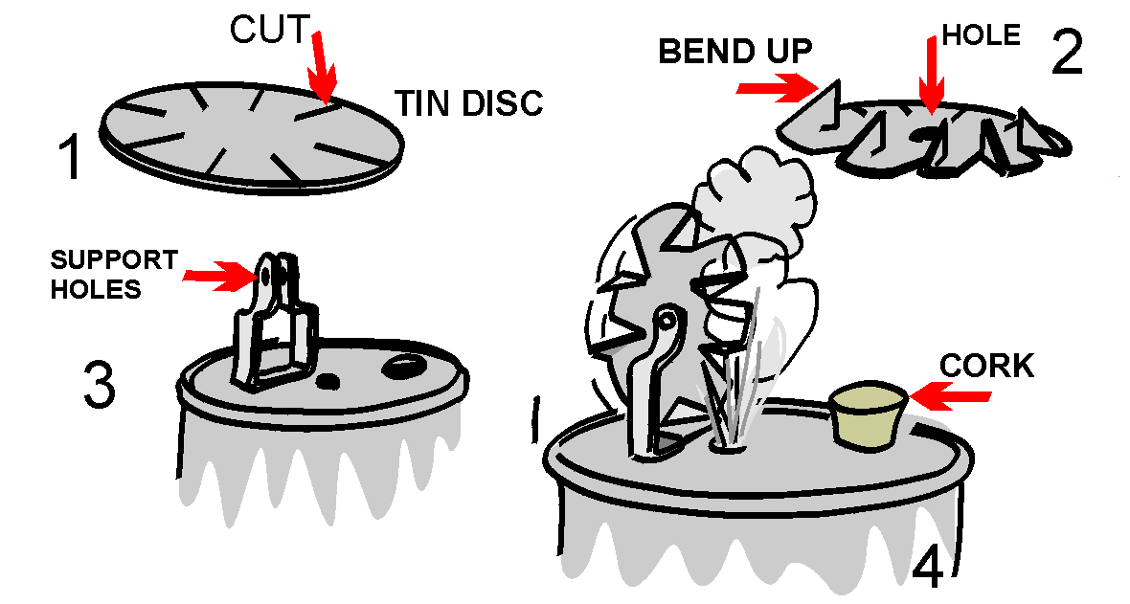
A Webelos Scout may get a graphic demonstration of the power of steam by building the simple steam turbine shown in this illustration. Materials needed are a tin can, a lid from a second tin can, a pair of tin snips, a sheet metal screw, a cork, a power drill, an extra piece of tin to make the support for the turbine wheel, a finishing nail, and a source of heat.
Assemble to look like the illustration.
Blueprint Symbols.
Circle Ten Council
Can be used in floor plans drawn for requirement 8 of the Webelos Engineer activity badge. Make a game of learning them by putting each one on a 3" x 5" card and using them as flash cards.
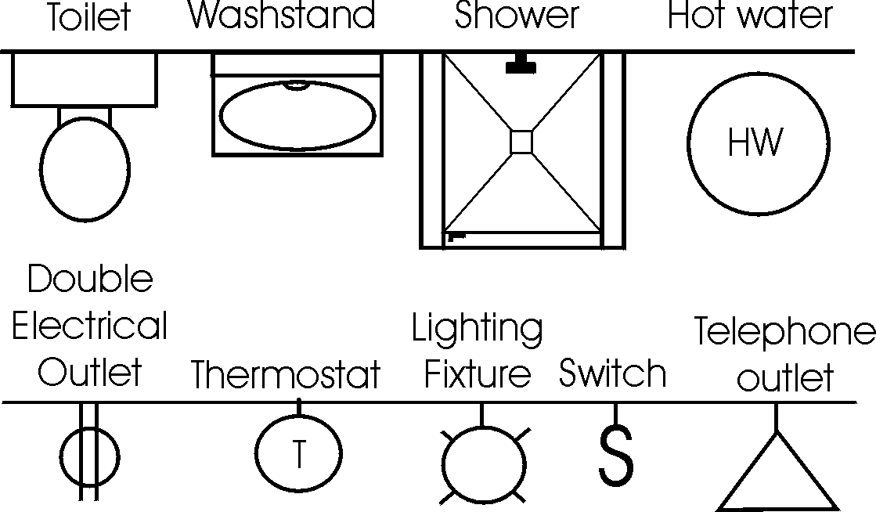
Paper Bridge Competition
Karen, Webelos Leader (and an engineer),
Pack 23, Suffern, NY
Materials:
2 rolls masking tape
2 stacks of newspaper (a good size Sunday paper will do)
4 chairs with backs
2 identical sets of books or blocks (for weight)
Divide the Den into two groups. Let an adult help each group if available. Give each group a roll of masking tape and a stack of newspapers. Set up the chairs in pairs about 4 feet apart. Each group must make a bridge using the materials provided that spans from one chair to the other.
After a set amount of time (15 to 20 min), see how much weight each bridge can support without failing. The bridges may be a truss, suspension, or cable stayed bridge, but must span from one chair to the other without touching the ground in between.
Gumdrop Truss Bridge
Karen, Webelos Leader (and an engineer),
Pack 23, Suffern, NY
This is a fun project that illustrates the strength and rigidity of a truss bridge. You will need a box of round toothpicks and a couple of bags of inexpensive gumdrops (or spice drops). Scouts can work as pairs or individuals on this project. Each scout should start by assembling a single triangular panel using 3 gumdrops and 3 toothpicks. (It is important to notice the strength of the triangular shape.) From there they can extend the side panel of the truss by adding more toothpicks and gumdrops.
Once the single truss is about 4 panels long, the scouts can begin the second side truss. The two sides are then connected together by adding toothpicks between matching gumdrop node points. This short bridge span, which is about 8 inches long, will be very stiff and strong. Spanning the bridge between two stacks of books, or the like can test the strength. A cup full of pennies can be used to load the truss. After testing the strength, the scouts can extend the bridge length by adding more pieces. A second level of truss may be added for really long spans (2 ft or more). The scouts will enjoy testing out various different bridge configurations.
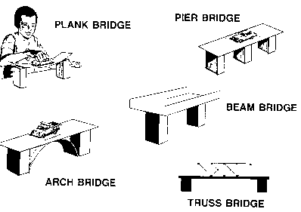
The Right "Man" (or Woman) for the Job!
Annawon, Cape Cod and Islands, and
Old Colony Council Pow Wow Book
Use a word from this list to fill in the correct answer.
Aeronautics Electrical
Chemical Physical
Computer Industrial
City Mechanical
Agricultural Civil
- An engineer who designs plants to make water safe to drink - __________.
- An engineer who designs machines in a factory - _________________.
- An engineer who tests new processes and checks old ones in a chemical plant - ________________.
- An engineer who plans new circuits and directs workers in an electrical plant - ________________.
- An engineer who designs and tests new space techniques - ________________.
- An engineer who designs and tests new techniques for new equipment for industry - ___________________.
- An engineer who designs and tests equipment for farmers and ranchers - __________________.
Bridges & Machines
Annawon, Cape Cod and Islands, and
Old Colony Council Pow Wow Book
Use a word from this list to fill in the correct answer.
Catapult Arch Bridge
Pulleys Suspension Bridge
Beam Bridge Levers
Plank Bridge Block & Tackle
Truss Bridge Pier Bridge
- A flat surface over two supports -
- A flat surface over three or more supports -
- A flat surface over an arched support -
- A flat surface with turned up edges -
- A bridge with sides made up of a series of triangles -
- A bridge that appears to hang from strong strung cables
- A pulley(s) and a rope or cable -
- A slingshot or other device used to project something -
Rubber Bands & Engineering
Rubber Band Strength
Annawon, Cape Cod and Islands, and
Old Colony Council Pow Wow Book
One of the requirements for engineer is to make a catapult. This requires the use of a rubber band or two, or a piece of tire inner tube. The rubber band is "elastic" and it stretches, but then returns to it's original shape. Before using materials in building, engineers must know the characteristics. Does it expand or contract? Is it weak or strong? Does it burn or not?
You can try an experiment to learn more of the characteristics of rubber bands and other elastic material. Get a collection of different sized rubber bands. Measure them for length, width and thickness (if you can). Make a chart that shows this information and mark each rubber band clearly so you know which is which. (Using colored rubber bands is best.)
Rubber  band | Original |  |  | Stretched
Rubber  band | Length | Width | Thickness | Length | Width | Thickness
With each rubber band, attach one end to a cup hook that is screwed into a board. Attach the other end to a known weight. How far down does each rubber band stretch? Does its thickness change? Does its width change? Which rubber band is the strongest? Which rubber band is the weakest? How can you tell?
Basketball Catapult
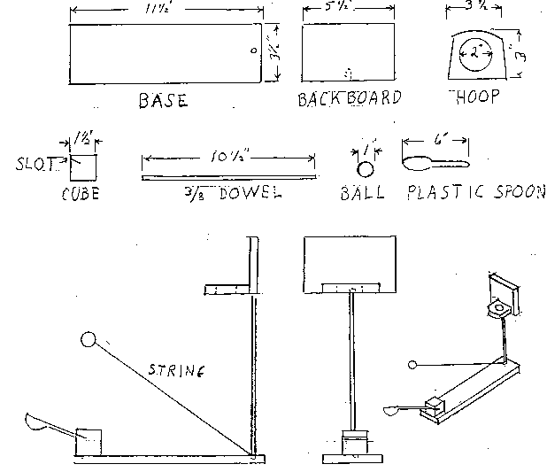
Annawon, Cape Cod and Islands, and
Old Colony Council Pow Wow Book
Instructions
- Base, backboard and hoop are made from a 1"x4" board.
- Drill holes in base and backboard 3/8" diameter and 1/2" deep.
- Cut a slot at a 15 degree angle in a cube block large enough for the handle of a plastic spoon.
- Cut hole for the hoop first; then finish cutting the hoop piece. (We used a slice of 2" diameter PVC pipe and screwed it into backboard.)
- Glue the hoop to the backboard; then glue dowel rod into backboard and base.
- Glue cube block to base and insert spoon into slot.
- Cut string and attach one end to dowel rod at base and the other end to any 1" sized ball (ping pong balls work well).
ATHLETE
PHYSICAL SKILLS GROUP
Being Healthy
Circle Ten Council
Good Health Habits Quiz
Circle the correct answer(s).
- Bathe/shower (everyday OR once per week) and especially after exercise.
- Wash your hair (1/month OR 2+ times/week).
- Wash hands (before eating OR after using the restroom) and when they're dirty.
- Eat right - (3 OR 4 OR 6) regular meals each day at regular times!
- Eat (just some OR a variety of) food from each of the 4 food groups.
- The average 10 year old should get at least (6 OR 9 OR 12) hours of sleep each night.
ANSWERS: 1. Everyday, 2. 2+ times, before eating and after using restroom, 3. 3 meals, 4. Variety, 9 hours
Clean & Strong
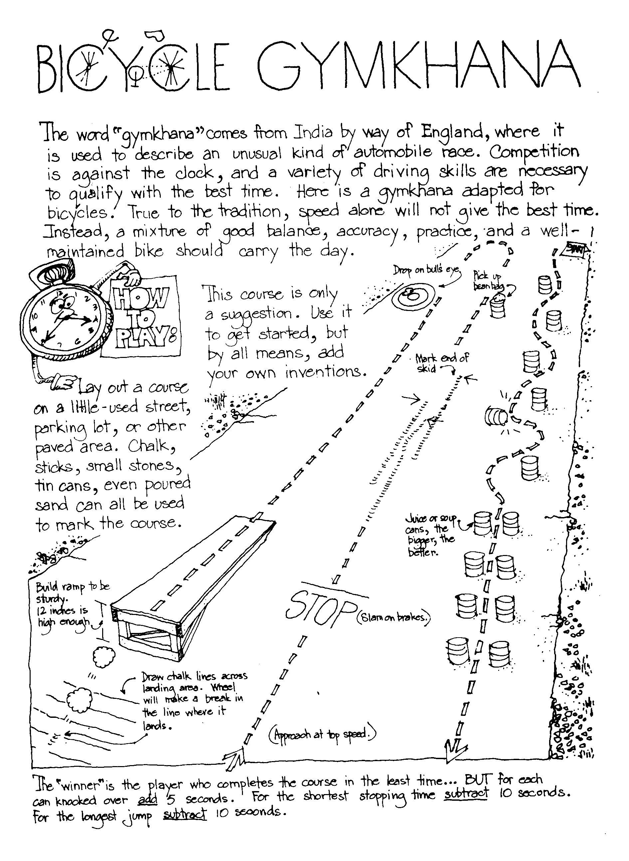
Circle Ten Council
Circle T for True or F for False.
T F | Our bodies "repair" themselves while we sleep.
T F | Clean clothes aren't necessary after a bath or shower - they are just in the morning.
T F | Use proper lighting for all activities including reading, TV viewing, and playing.
T F | Fitness is never just physical - it involves  both the mind and body together.
T F | Stand tall, and walk tall with shoulders  back and stomach in.
T F | It's OK to share drinking cups,  washcloths and towels.
T F | Different foods provide different nutrients,  and no one food can sustain us.
T F | Rushing meals or skipping meals can be harmful  to your body.
ANSWER: 1 - T, 2 - F, 3 - T, 4 - T, 5 - T, 6 - F, 7 - T, 8 - T
Volleyball Serve it Underhand
Circle Ten Council
The underhand serve is the easiest to master for volleyball. In a game you must put the ball into play from a 10 foot wide area behind the end line. Always practice with a line in front of you so you will learn not to cross it until you have released the ball.
For the underhand serve (if right handed), stands with your left foot about 13” in front of the right foot. Bend both knees a little, lift the ball in both hands out in front of your chest, to your right side. Hold the ball in the left hand and start to bring the right hand down. Close the finger of the right hand as if you were making a loose fist.
Keep your eyes on the ball. Bring right hand down, back, and up behind you. Step a quarter step forward on your left foot. Swing your right hand at ball. Just before you hit it, toss the ball up a little and drop your left hand away from it. (The rules say – release your left hand from the ball before hitting it.) Strike ball solidly with the palm side of your fist and follow through. (Of left handed, reverse from right to left.)
Once you master the serve, try using the heel of hand instead of fist. Close hand instead of your fist. Close your hand half-way so fingertips come just below the base of the fingers with thumb-tip beside the first joint of forefingers
The Athlete
Circle Ten Council
Tune: My Bonnie
They gave me a suit and a number
And sent me out on the field
They gave me a ball called the pigskin,
And shoes with some cleats, toe and heel
CHORUS
Muscles, Cramps, wracking my body with pain, with pain
I stand, wondering, if ever I’ll do this again!
Next time they gave me a racquet,
They sent me out on the court
Funny the things you encounter,
While trying to learn a new sport.
(CHORUS)
The ordeal was finally over,
At least, that’s what I thought,
When they shoved me the soccer equipment
I fainted dead on the spot!
(CHORUS)
Athlete Den Activities
Circle Ten Council
TOWEL PICKUP - Take off your shoes and socks. Pick up a towel with your toes.
PAPER PICKUP - Pick up a piece of paper from the floor without bending your knees
BOOK CARRY - Walk across the room with a book balanced on your head.
SKIN THE CAT - Clasp your hands in front of you. Try to step through the ring formed by your hands and finish standing upright with them clasped behind you. Return to your original position by stepping backwards through the ring.
TOE WRESTLING - Two wrestlers sit on the floor, facing each other with arms clasped around knees. When they are in this position, place a stick over each person’s elbows and under his bent knees. Their feet should be flat on the ground with the toes of one touching the toes of his opponent. The object is for one wrestler to get his toes under the toes of his opponent and roll him over backwards. If either wrestler breaks the handclasp above his knees, the other wins the contest.
SIDEWALK TENNIS - Played with a tennis ball on two squares of sidewalk or patch of level ground marked off in similar size. Ball is batted with the hands. Use regular tennis rules, except that there is no serving court
SUGGESTIONS FOR COMPLETING ATHLETE ACTIVITY BADGE
Requirement #1
Can be combined with the Fitness Activity Badge and the Sportsman Activity Badge. The subjects of being physically healthy, balanced diets, and bad effects of drugs, alcohol, and tobacco can be combined and signed off all together.
Requirement #2
Takes the longest amount of time to complete and sign off of all the Physical Skills Group. To earn the Physical Fitness Sports Pin, the boy needs to earn 60 points in a 90 day period. They must exercise or be involved in some activity for 30 minutes to earn one point. The boy can earn a maximum of five points in a day. Just remember 30 minutes for one point, 60 points total in a 90 day period.
You can pass off requirements 3 through 9 as part of this pin, use requirement 3 and 4 of the Sportsman badge to meet the requirement.
POW WOW EXTRAVAGANZAS
Let me know as soon as your date is set. I will post whatever I receive. CD
Black Swamp Area Council
2006 University of Scouting
"Growth in Sharing"
Saturday, March 25, 2006
Apollo Career Center, 3325 Shawnee Rd., Lima, OH
For more info and registration forms go to http://www.cubroundtable.com/university-of-scouting.htm
Southern NJ Council
Aloha, Cub Scouts
Pow Wow in Paradise
November 4, 2006
TBD, NJ
We lost our home and the committee decided to reschedule.
Call Southern NJ Council, 856-327-1700, extension 24, or visit the website, www.snjscouting.org or write the chair at pen25guin@comcast.net for the latest info
Central NJ Council
March 25, 2006
TBD, NJ
Call Central NJ Council, 609-419-1600, or visit the website, www.cnjcbsa.org or write the chair at 1hourscouter@comcast.net for the latest info
San Gabriel Valley, Long Beach Area, Verdugo Hills Councils
Rock Around the Pack
(1950’s theme)
February 4, 2006
Arroyo HS, El Monte, California
http://www.longbeachbsa.org/
http://www.sgvcbsa.org/
http://www.vhcbsa.org/
Great Smoky Mountain Council - BSA
University of Scouting
March 4, 2006
Pellissippi State Community College
Knoxville, Tennessee
Great Smoky Mountain Council's service center phone number is (865) 588-6514
WEB SITES

Great Salt Lake Council
http://www.exploratorium.edu/exploring/paper/airplanes.html
http://www.discoverengineering.org/
http://www.kids.net.au/encyclopedia-wiki/en/Engineering
http://www.midnightscience.com/project.html
http://pbskids.org/zoom/grownups/engineering/
http://www.coloring.ws/construction1.htm
http://www.dltk-kids.com/recipes/construction_snack.htm
http://www.matsuo-bridge.co.jp/english/bridges/index.shtm
Overview of Scouting’s Religious Award Program
An overview of Scouting’s Religious Award Program is available on National’s Website http://www.scouting.org/awards/religious/index.html
Catholic Religious Award Information
Information on the Light of Christ, Parvuli Dei, and Ad Altari Dei Awards is available through the Catholic Committee on Scouting, located at www.nccs-bsa.org .
Protestant Religious Award Information
Information on the God and Country Series is available through PRAY Publishing located at www.praypub.org.
Be sure to check out Danielle's Place. They believe learning should be fun. The site is dedicated to teaching children through crafts and activities. You will find hundreds of inexpensive crafts and activities for children. Most of the crafts and activities on this site are Bible-based and are great to use in Sunday School, Vacation Bible School, preschool, and home school . http://www.daniellesplace.com/
Science Buddies Need ideas for Science projects for Webelos or Belt Loops and Pins? Just want to do something different? Find them here! Science Buddies is a non-profit organization empowering students from all walks of life to help themselves and each other develop a love of science and an understanding of the scientific method.
http://www.sciencebuddies.org/
More than you could ever want to know about Balloons
Twist them; shape them, and more - http://www.mbd2.com/kidsstuff.htm
Engineering Websites –
Twenty Greatest Engineering Achievements of the 20th Century http://www.greatachievements.org/
Maybe better for the adults than the Scouts but I liked it.
National Engineer’s Week, February 19-25, 2006
Check it out things to do at http://www.eweek.org/index.shtml
Karen says there are lots of good things for Scouts (and others) to do
A good resource for engineering projects is http://pbskids.org/zoom/sci/
Engineering School sites –
Valparaiso University, College of Engineering http://www.valpo.edu/engineering/
Rensselaer Polytechnic Institute – www.rpi.edu
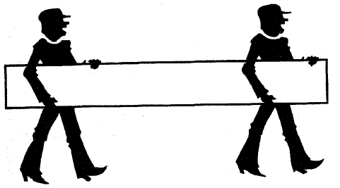
ONE LAST THING
The Seven Wonders
The first grade class assignment was to name the seven wonders of the world. Each student had to compile a list, and then share their list, aloud, with the class.
There was ardent interaction as the students called out entries from their lists: the Pyramids, the Empire State Building, the Amazon River, Yellowstone National Park, the Grand Canyon, the Taj Mahal and the list goes on.
The teacher served as the cheer leader, “Class, these are great answers. Well done!”
One girl sits silent. She is asked about her list. She says, “I don’t think I understand the assignment.”
“Why?”
“I don’t have any of the right answers,” she tells the teacher.
“Well, why don’t you tell us what you wrote on your paper, and we’ll help you.” the teacher encourages her.
“Okay,” says the little girl, “I think the seven wonders of the world are. . .
To See,
To Hear,
To Touch,
To Smell,
To Feel,
To Love,
To Belong.”
The room was so quiet you could have heard a pin drop. The things we overlook as simple and ordinary and that we take for granted are truly wondrous!! A gentle reminder that the most precious things in life cannot be built by hand or bought by man.
Somewhere along the way, we have buried this little girl’s wisdom.
There are only two ways to live your life.
- One is as though nothing is a miracle.
- The other is to live it as if everything is.
Answers to Pinewood Logic Puzzle
Race First Last Color
First Bob Jones Red
Second Sam King Blue
Third John Smith Yellow
Fourth Tom Slade Green

Blue Bird Box Plans
Alapaha Council
Adapted from Georgia Department of Natural Resources website, http://www.gadnr.org/
