FOCUS
Cub Scout Roundtable Leaders’ Guide
See the lights in the night sky and marvel!! Cub Scouts this month enjoy a look upward to the stars. They can spot the animals, people, and imaginary creatures of the constellations, and the powerful light cast off by objects far, far away. This month’s theme brings the stars closer to home with activities and fun.
CORE VALUES
Cub Scout Roundtable Leaders’ Guide
Some of the purposes of Cub Scouting developed through this month’s theme are:
- Spiritual Growth, Taking time to ponder the heavens makes a boy aware of the universe around him.
- Fun and Adventure, Boys can spot constellations and learn stories about them..
- Preparation for Boy Scouts, This month’ s theme opens a doorway preparing boys to later earn the Astronomy and Space Exploration Merit Badges.
The core value highlighted this month is:
- Responsibility, It is every Cub Scouts responsibility to care for others and himself. December is a good month for discussion of caring.
Can you think of others??? Hint – look in your Cub Scout Program Helps. It lists different ones!! All the items on both lists are applicable!! You could probably list all twelve if you thought about it!!
COMMISSIONER’S CORNER
POW WOW CD’s
There are a lot of Pow Wows on my list for November 4. I hope some of you can trade CDs this month so I can have some good info for the next Baloo. Just write me, either commissionerdave@comcast.net , or via www.usscouts.org website or and I will get you mailing info. Last year I received the Alapaha Area Council Book via E-mail. That works, too. It was a very useful book set up by monthly themes. I hope they send it again.
Well another great month has flown by and I did some flying – we flew out to Los Angeles so my daughter could visit Loma Linda University and learn about their Doctor of Physical Therapy program. It was a great, fast weekend and one of the reasons (excuses?) Baloo is late as usual. While I was setting up the trip, through a long series of events (that could only have been arranged by God to help me) I learned that a “boy” who was in my Mother’s Den with me and my patrol in Boy Scouts is a Doctor at the Medical Center operated by Loma Linda. So Don and I got together for the first time in 39 years!!
Don has the letters FASAM after his MD. That means he is a Fellow in the American Society of Addiction Medicine. He says he went into this field after starting in Emergency Medicine because he wanted to put a sign at the top of the waterfall to keep people (addicts) from going over the cliff. Isn’t that what we as Scout Leaders are trying to do? – Keep our sons and others boys on the correct path and not going off the cliff?? I told him how we usually talk about how it is easier to bend the sapling to get it to grow how you want rather than try and reroute the old oak tree. Just a thought for you to ponder – that we are at the top of a waterfall helping our Scouts make the right decision and not go off the edge.
Although it is theme-related, this month there is a great item on Neckerchief Slides from the San Gabriel Valley, Long Beach and Verdugo Hills Councils Pow Wow Book. Be sure to file this somewhere where you can easily find it.
Also, look for the items on BSA’s On-Line Learning Center, http://www.olc.scouting.org/ , and the National Centennial Awards.
Months with similar themes to Cub Scout Stars
Dave D. in Illinois
Sky Adventure | May | 1940
Eyes in the Sky | January | 1957
Lights in the Sky | January | 1971
Lights in the Sky | May | 1979
Adventures in the Sky | June | 1998
If you are looking for December Holiday (Christmas, Hanukah, Kwanzaa) ideas for your Den, just check any December back issue of Baloo. CD
National makes a patch for every Cub Scout Monthly theme.
This is the one for this theme. Check them out at www.scoutstuff.org go to uniforms and insignia, them emblems, and look for 2006 Cub Scout Monthly Theme Emblems.
THOUGHTFUL ITEMS FOR SCOUTERS
Thanks to Scouter Jim from Bountiful, Utah, who prepares this section of Baloo for us each month. You can reach him at bobwhitejonz@juno.com or through the link to write Baloo on www.usscouts.org. CD
Roundtable Prayer
Cub Scout Roundtable Planning Guide
For the Great One, who placed the stars in the heavens, we give thanks and praise. Watch over this gathering and keep its purpose true. Remind us of our responsibility to you and our duty to God and Country. Keep us strong of faith and keep the values of Scouting shining in our hearts. Amen
100 Mile High Handshake
Scouter Jim
When I think of the stars, I think of space travel. I remember watching the live broadcast of the landing of Apollo 11 on the moon. I remember holding my breath and praying during the return of Apollo 13. What I don’t remember is the historic 100 Mile Handshake. With the International Space Station, it is now common to see Astronauts and Cosmonauts working together with others from countries of the world.
On July 17, 1975, Soyuz 19 docked together with an Apollo spacecraft. The American crew had learned Russian and the Soviet crew had learned English. It was the first time the very secretive Soviet space program had broadcast live a space mission. At 3:19 PM, Apollo Commander Thomas Stafford shook the hand of Soyuz Commander, Alexei Leonov. “Glad to see you,” Commander Stafford said to Commander Leonov in Russian. “Glad to see you. Very, very happy to see you,” Leonov responded in Russian. The two crews exchanged flags and souvenirs. Both the Soviet Communist Party General Secretary, Leonid I. Brezhnev, and President Gerald R. Ford congratulated the crews and expressed their confidence in the success of the mission.
This event was during the middle of the Cold War between the Soviet Union and the United States. It has often been said by Astronauts, that from space there are no boundaries on earth. During a time of great tumult on earth, it is well to remember a 100 Mile High Handshake, and in that take hope.
Quotations
Quotations contain the wisdom of the ages, and are a great source of inspiration for Cubmaster’s minutes, material for an advancement ceremony or an insightful addition to a Pack Meeting program cover.
The following quotes are all from Astronauts. SJ
There's a need for accepting responsibility - for a person's life and making choices that are not just ones for immediate short-term comfort. You need to make an investment, and the investment is in health and education.
Buzz Aldrin
As you look back at your life, there are just a million different things that have happened, just in the right way, to allow you to make your dreams come true. And you know, someone has all that under control.
Michael P. Anderson
When you launch in a rocket, you're not really flying that rocket. You're just sort of hanging on.
Michael P. Anderson
I believe that the Good Lord gave us a finite number of heartbeats and I'm damned if I'm going to use up mine running up and down a street.
Neil Armstrong
It suddenly struck me that that tiny pea, pretty and blue, was the Earth. I put up my thumb and shut one eye, and my thumb blotted out the planet Earth. I didn't feel like a giant. I felt very, very small.
Neil Armstrong
Mystery creates wonder and wonder is the basis of man's desire to understand.
Neil Armstrong
One of the great things about the universe is that it's fair.
Alan Bean
We knew it was going to be difficult to get to the moon. We didn't know how difficult.
Alan Bean
Exploration is really the essence of the human spirit.
Frank Borman
I don't know what you could say about a day in which you have seen four beautiful sunsets.
John Glenn
So, we have to get up and get pumped up for each day.
Duane G. Carey
Problems look mighty small from 150 miles up.
Roger B. Chaffee
The world itself looks cleaner and so much more beautiful. Maybe we can make it that way - the way God intended it to be - by giving everyone, eventually, that new perspective from out in space.
Roger B. Chaffee
I felt the power of God as I'd never felt it before.
James Irwin
The Earth reminded us of a Christmas tree ornament hanging in the blackness of space. As we got farther and farther away it diminished in size. Finally it shrank to the size of a marble, the most beautiful marble you can imagine.
James Irwin
Be thankful for problems. If they were less difficult, someone with less ability might have your job.
James A. Lovell
There are people who make things happen, there are people who watch things happen, and there are people who wonder what happened. To be successful, you need to be a person who makes things happen..
James A. Lovell
As a child I went to a circus. They had a man shot out of a cannon into a net. I became intrigued with what was going on.
Wally Schirra
When a man looks across a street, sees a pretty girl, and waves at her, that's not a rendezvous, that's a passing acquaintance. When he walks across the street and nibbles on her ear, that's a rendezvous!
Wally Schirra
You may not have any extra talent, but maybe you are just paying more attention to what you are doing.
Alan Shepard
The stars don't look bigger, but they do look brighter.
Sally Ride
TRAINING TIP
Preparation for Boy Scouts
The 10th item in the Purposes of Cub Scouting.
Bill Smith, the Roundtable Guy
I’m going to assume that every Cub Scout leader and parent wants to prepare a boy for his joining a good Scout troop. But what is a good troop? Troops differ a great deal, yet here is what the BSA lists as the essential methods of Boy Scouting.
- Ideals: Scout Oath, the Scout Law, the Scout motto, and the Scout slogan. Do they follow these or just pay lip service?
- Patrols: The patrol method. This is the preferred method of Boy Scouting.
- Outdoor Programs: Boy Scouting is designed to take place outdoors.
- Advancement: The Boy Scout plans his advancement and progresses at his own pace.
- Personal Growth: The Good Turn. Boy Scouts take an oath to help other people at all times.
- Leadership Development: Learn and practice leadership skills..
- Uniform: The Boy Scout identity in a world brotherhood of youth who believe in the same ideals
I would first like to suggest that each of you go to:
http://www.scouting.org/boyscouts/index.html
and read what it says about each of these methods.
The Patrol Method, in particular, is an important characteristic of every good Scout troop. In the patrol method, gangs of about 6-8 boys form patrols, go camping and play the game of Scouting. The act of camping – the Outdoor Program - provides all sorts of challenges for these boys. They must somehow face up to the incumbent problems of living away from home while adhering to a set of ethical standards: the Ideals - Scout Oath and the Scout Law. In essence, this is all there is to Boy Scouting. Everything else, the badges, uniforms, other activities, exist only to support this process.
A patrol is the integral unit of Scouting where the members must work together to succeed. A patrol is a true gang of boys. The leadership of the patrol emerges from the patrol itself.
Boy Scout camping is not the same as Cub Scout or Webelos camping, In the pack or den, we have outdoor activities because it's more fun. We could, and often do, accomplish our purposes just as well indoors. It would just lack some luster. Outdoors and camping, however, are essential to Boy Scouting. This is the arena, where individuals and patrols must meet and overcome the challenges. The only reason for indoor Scout meetings is to prepare to go outdoors. That is where the problems await and that is where the Scouts must meet them and solve the problems.
The patrol method is the basic method of achieving the aims of Scouting. Outdoors is where patrols are isolated and become responsible for getting things done, where they are guided into looking within their own members to find the necessary resources. There is no Cub Scout equivalent to the patrol method. The family and parent participation provide some of the same benefits, but it works in different ways in Cub Scouting.
So, just how do we prepare our Cub Scouts and Webelos Scouts for this experience? We don’t need to do any special Boy Scout stuff. Here are some examples of how we can do it within the Cub Scout program:
Scouting Ideals: The Cub Scout Promise, the Motto and the Law of the Pack. Nothing prepares a Cub Scout better for Boy Scouting than instilling within him the attitudes that are contained in those ideals a boy first learns as he earns the Bobcat Badge. Doing his best, helping other people, giving good will, doing his duty to God and country prepare him emotionally to be a good Scout.
Responsibility The Boy Scout patrol method works by having each patrol member take on responsibilities to achieve the goals of the patrol (like eating on a camp out.) Pushing boys to be responsible shows up all through Scouting but it really pays off when a Scout patrol is filled with Scouts who take their responsibilities seriously. It make Scouting fun, and enables them to take on all sorts of exciting challenges.
Consider the following achievements:
- Tiger Achievement 1F: Think of one chore you can do along with your adult partner. Do it together. Well, we hit him right off the bat with a challenge to be responsible. Do your share. Help.
- Wolf Achievements 4 (Know Your Home and Your Community) and 12 (Making Choices) Again be responsible and help, but this time more personal.
- .Bear Achievement 6 (Taking Care of Your Planet) and 13 (Saving Well, Spending Well) Even more personal responsibility.
- Webelos Activity Badges Family Member and Handyman.
All these are designed to instill in a lad the values doing his share around home. These will come in handy to do his share and take on responsibilities with his patrol.
Meal Preparation and Cooking: Good meals on camp outs are essential to keeping a boy in the program. Boys Scouts, in a properly run troop, will be required to provide their own meals: make the menus, buy the food, carry it, store it safely, prepare the meals, serve it and clean up. They must do this in good or bad weather and always with the admonition that a Scout is cheerful and thrifty. If you want your Cub Scout to enjoy his Boy Scout experience, teach him to cook.
Cooking and meal preparation shows up in the following places:
- Tiger -Elective 24. Help prepare the family meal, set the table and clean up afterwards.
- Tiger Elective 25. Make a snack and share it with your family or den.
- Wolf - Achievement 8 Cooking and Eating,
- Bear - Achievement 9 What's Cooking,
- Webelos - Family Member Activity Badge - Feeding the Family
- Webelos - Outdoorsman A.B. - Cooking in Camp.
These achievements form a comprehensive learning opportunity .It's best for a boy to learn to cook in his kitchen before he tries it outdoors, over a fire. He should understand menus, shopping lists and recipes and know when to use each one. He should be acquainted with terms like, measure, mix, fry, bake, broil and simmer, and have tried a few of these before he has to do them on a Scout camp out.
Be Prepared. The Boy Scout Motto is Be Prepared. He should be prepared for anything. In Cub Scouts, Bear Achievement 11: Be Ready mirrors the Boy Scout motto. We expect a Cub Scout to think ahead and be ready to act in case of fire, water or traffic accident. This is the essence of Scouting: being ready and able to act appropriately and make things happen. Webelos Readyman Activity Badge is even more focused and more Scout like with some real first aid thrown in.
Be a Leader. In a Boys Scouts, leadership of patrols and the troop comes from the boys. The adults are mostly observers, sometimes guides or coaches but mostly in the background. Leadership skills are learned skills that require lots of practice. In Cub Scouting we give boys opportunities like Wolf Achievement 2b (Lead a Flag Ceremony) and Bear Achievement 15c (Lead a Game.) I particularly like Bear Achievement 24 (Be A Leader.) Expect boys to be really challenged by these. Not only is it tough to have a bunch of 7 year olds line up properly and salute the flag correctly, but then he must withstand the reactions of his den mates who will be quick to critique any lapses that they notice.
Be a Swimmer. When one imagines Scouts camping, there is usually water in the picture. It may be swimming, a canoe pulled up to a lake shore camping spot or whitewater rafting. A boy should be ready to participate in all these, safely and confidently, as soon as he joins a troop. Cub Scouting has an age appropriate, graduated program of aquatics activities.
Challenge for Cub Scout Leaders: Pick some recent activities that your Cub Scouts or Webelos Scouts enjoyed. Try to imagine how these may prepare them to become more successful Boy Scouts. It might have changed the boys’ attitudes or perhaps improved mental or physical skills. How will it make them better Scouts?
Extra Credit – Will it also prepare them to become better adults? – Better husbands? Better fathers? Better members of their communities?
Be sure to check out Bill’s “Unofficial Roundtable Site”
http://wtsmith.com/rt.html
If you wish to contact him with a question or comment, go to http://wtsmith.com/rt/gnolmm.html
BSA On-Line learning Center
Have you been to National’s On-Line learning Center?? National has taken all the courses they offer online and put them all together in one spot –
www.olc.scouting.org
OLC = On Line Learning Center
This site provides a variety of materials, from quick references to complete courses, all designed to help our members improve leadership skills and deliver a quality program.
At the OLC you can find the following E-Learning Courses -
- Youth Protection Training
- Cub Scout Leader Fast Start
- Boy Scout Leader Fast Start
- Venturing Advisor Fast Start
- Safety Afloat
- Safe Swim Defense
These courses can help adult leaders deliver quality Scouting experiences to youth. A log-in is required, however anyone may create a user account and view the courses. Registered members of the BSA may provide their member numbers (as part of the user profile) to receive credit.
They, also, have a multimedia course (They say “on-line exercises” for informational purposes. It is
- Venturing Crew Orientation
I am sure they plan to add more in the future
And a link to other helpful training information such as
- Soccer and Scouting Basic Training
- Courses at Philmont Training Center
So, get yourself organized and get your new leaders through Fast Start. No more looking around to see where that old VCR tape or DVD went!!
Your new leaders can do these alone or your Pack Trainer can organize a group session and all watch the screen together and talk about it.
Check It Out!!
PACK ADMIN HELPS
Centennial Quality Awards Program
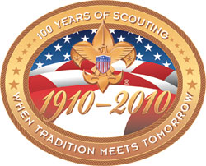
This summer at the Philmont Training Center the director of the BSA Division that wrote the requirements for and is now coordinating the implementation of the Centennial Quality Awards Program came to talk with my Commissioner Class. And of course we asked him -
Why -
“To improve the QUALITY of program
in every unit in America!”
The new program has each level of the organization establish annual goals to accomplish in key areas of quality program delivery from 2007 through 2010. When a unit, district, or council earns this award, it makes a statement that they have provided their youth members with the highest quality program experience possible.
He was very excited about the program and told us about a lot of the good ideas that went into creating the program and the requirements and how it is felt the Centennial Quality Awards Program can help units improve.
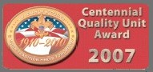
In the literature available on the awards from National’s Website ( www.scouting.org , then click on the Centennial Awards link) you can see how carefully they crafted this program.
2007 Centennial Quality Unit Award Commitment and Interpretation of Requirements
This information is taken from BSA Publication 14-175-1, “Centennial Awards Program - Council Implementation.” In bold print are the requirements. In Italics are interpretations to the requirements intended to help the unit leaders understand the requirements while they are completing the commitment form. CD
All units are encouraged to establish goals that increase their participation over the previous year.
We will have ______ percent of our direct contact leaders complete Basic Leader Training for their
position, including Youth Protection Training.
Each of our adult leaders (Cubmasters, den leaders, Webelos leaders and all assistants, Scoutmasters and assistants, crew Advisors and associates) who meet with youth regularly are trained in Fast Start and Basic Leader Training. You identify how many are registered and develop a plan to have them trained. If a leader is newly signed up within the past two months, you will want them to commit to getting trained, but they do not keep the unit from earning the award.
Number of direct contact leaders registered
Number trained
As one of the committed units in our district, we commit to retaining ______ percent of our members, recruiting ______ new youth, and rechartering on time.
Goal of retention of youth and goal for recruiting of new youth to be set with commissioner and unit leader at beginning of calendar year.
Goal new youth to recruit
percent retention last year
Actual new youth recruited
percent retention this year
Rechartered on time (Yes or No)
As a participating unit in the national parent initiative, we commit to recruit and train ___ new adults to be active.
Number of new adults recruited
We had a minimum of 60 percent of our youth members advance in rank for Cub Scouting and Boy
Scouting or earn Venturing recognition awards, or we improved by 10 percent over last year.
This includes the basic ranks of Cub Scouting and Boy Scouting. The recognition award program is the measure for Venturing.
Percent advanced/earned
last year,
this year
At least 70 percent of our youth members had an outdoor experience or one activity per month, or improve the percentage over last year.
Specify in advance the events that will be used and how many are required to qualify. (For Cub Scouting, this would include a pack meeting.) This may vary for each type of program.
percent participated last year.
percent participated this year.
We will conduct annual program planning and will provide the financial resources to deliver a quality program to our members.
Our unit has an annually planned program. The unit develops a budget of needed expenses and plans how they will provide the finances to achieve a quality program, either through unit fund-raisers or each member providing their own finances.
Yes No
Additional Goals.
When commissioners meet with units as part of the action planning meeting, they will review other areas critical to providing a quality program. These are part of the unit self-assessment process, provided to commissioners as a part of their monthly unit visit. These include 100 percent of families subscribing to Boys’ Life, an annual service project recorded on the Good Turn for America Web site, two-deep leadership, an active committee, youth training for Boy Scouting and Venturing, use of the patrol method for Boy Scouting, and other areas as needed for special emphasis annually.
Now that I have gotten you interested, I hope you will go to National’s Website and learn more about the National Centennial Awards. There is, also, an FAQ section with many questions and answers, including what do December chartering units do. Next month I will have information on Unit Self-Assessment and Action Planning Meetings held between Unit leader (Cubmaster), Committee Chair and Unit Commissioner. CD


Does Your Pack Have a Baloo??
Sam Houston Area Council
Baloo is a Cub leader who knows how to have fun, and likes to share that fun with others. Start every pack meeting with a fun participation song or activity for all Cubs and family members. This should be led by an energetic adult (or Webelos Scout) acting as Baloo for the Pack meeting. This encourages people to be at the pack meeting on-time and it gets the show rolling with a bang. Later in the Pack meeting, Baloo will also be the one leading cheers for songs, skits and awards.
TIGERS
Tiger Totem Ceremony
Baloo’s Archives
This ceremony was updated with deletion of the Tiger Cub Motto and Tigers earning Bobcat before Tiger Rank
This ceremony is designed to welcome new Tiger Cubs and/or groups into Tiger Cubs. The Tiger ceremony prop can be made from wood. Paint a simple Tiger Totem on it and mount the candles or lights as shown. I use a large black circle that I Velcro to a display board. Then I have four round toes, each with a picture for the part being read. The ceremony was based on the old Tiger Promise but was modified to be current. Don’t hesitate to modify it even further if you wish. CD
Ceremony:
Narrator: When a boy becomes a Tiger Cub, he is just beginning a trail that will lead him through Cub Scouting and into Boy Scouting. This Tiger Cub Totem (hold up) is a symbol of the first part of that trail, the Tiger Cub trail, one that you will walk with your adult partner during the coming year as you search, discover, and share the world around you. Tonight I would like to present to each of you this totem to wear on your uniform. It is to remind you of all the fun you will have while working on the Tiger Badge this year with your partner. As you progress through Tiger Cubs and finish each achievement requirement, you will be presented a bead to hang from your Tiger Totem. There are White beads for Family Activities, Orange beads for den activities, and Black beads for Go See It activities. The Tiger Totem has a special meaning for you. Listen carefully as we explain it.
Tiger Leader: The palm in the Totem represents the spirit of scouting (light the front candle). The spirit of scouting is one of helping and friendship. Each toe has a special meaning for you, too. Listen close.
Cubmaster: The first toe is (light first candle) to remind you to of your duty to God. Your parents and religious leaders teach you to know and serve God. By following these teachings, you show your love to God.
Asst CM: The second toe is (light second candle) to remind you to love your family. A Tiger Cub should always be kind and helpful to his family. By helping your home to be a happy place, you show your love to your family.
Asst. TL: The third toe is (light third candle) to remind you to love our country. This means being a good American. You help your community in any way you can. By being a good citizen, you show your love to your country.
Cubmaster: The fourth toe is (light fourth candle) to remind you to always Do Your Best, as you search, discover and share in our world. The world we live in is a big and beautiful place. There are many things to learn. As a Tiger cub, you will learn a lot about your world.
Now, each time you see a Tiger Totem, it will help you to remember how to be a good Tiger Cub. Would all Tiger Cubs and their partners please stand and repeat the Cub Scout motto.
"Do Your Best "
Congratulations on completing your first step as Cub Scouts. Welcome!! We are excited to have you in our pack.
I welcome all of you to the adventure of Tiger Cubs!
Cubmaster may now lead the pack in a Tiger "spelldown".
Give me a T----(audience yells T!)
Give me an I----(I!)
Give me a G----(G!)
Give me an E---(E!)
Give me an R---(R!)
What's that spell?-----(Tigers!)
What's that spell?-----(Tigers!)
What do they say?----(R-o-a-r!)
(or do The Tony the Tiger Cheer – “They’re great”)
Achievement #2 Where I Live
This achievement lets the boys learn about their communities. Learning about their communities will help them realize that when they take care of it the stronger it becomes. And they develop a sense of pride of their communities becoming good citizens of where they live.
Family Activity 2F -
Together with your adult partner, look at a map of your community. The map can be one your adult partner has, or a map that your adult partner draws with you. On that map locate your home, and find three places you like to go. Places to find on the map could be your school, your place of worship, the place where you have your pack meetings, a store, a park or playground, or the house of a friend or a relative.
If the choice is made to draw a map be sure to put this in their scrapbook.
From A to Z What Families Can Do
To Help Their Communities
Southern NJ Council
- Adopt a stream. park or roadside to clean up and keep beautiful.
- Bring lunch to school in a lunch box. Save your paper bags.
- Care for toys so they will last longer. Then you won't have to replace them and can pass them on.
- Donate clothes that you have outgrown to a needy person or someone smaller.
- Encourage others to join you in collecting glass, newspaper and aluminum to be recycled.
- Flatten empty cans. boxes and other containers to they don't take up so much space
- Get in the habit of turning off the water when you brush your teeth. Turn it on only to wet your brush and to rinse.
- Help by caring about our wildlife & be very careful with matches.
- Insist on buying products that are biodegradable (they rot or decompose when discarded.) Most plastics are not.
- Jog or walk, ride a bike or scooter from place to place to save energy.
- Keep jars of cold water in the refrigerator so you won't have to run the tap water waiting for it to get cold.
- Look for the recycled symbol on products you buy.
- Make it a habit to cut each six-pack ring. These sometimes wind up in the oceans. Animals often get caught in them.
- Never litter. Always put your trash in a trash can.
- Open the blinds in the wintertime to let in the sun. Close blinds in the summer to keep out the sun's heat.
- Plant a tree to stop soil erosion, give you shade and give birds a home.
- Quit buying products that have a lot of packaging.
- Reduce the amount of water you use to keep clean. Take showers, not baths.
- Save energy by asking your parents to turn down the thermostat.
- Turn off lights if you are the last person to leave a room. Turn off appliances if you are not using them.
- Use products made to be used many times, such as sponges or cloth towels.
- Value and appreciate your Earth. Realize that you can make a difference.
- Watch what you pour in the drain. Hazardous waste can get into the ground water.
- eXamine labels before using products Certain household cleaners can be dangerous.
- Yearn to do what you can to help our environment. Grow up to be an adult who takes an interest, too.
- Zip to close doors and windows if they are opened when the heater or air conditioner is on.
Den Activity 2D -
This Achievement fits with the Citizenship Character Connection. When we say the Pledge of Allegiance we show that we are proud to live in our country.
If you are wearing your Tiger Cub uniform when you say the Pledge of Allegiance, give the Cub Scout salute and face the U.S. flag. You do not have to take off your Tiger Cub cap if you are wearing one. If you say the Pledge of Allegiance when you are not in uniform, remove your hat, and place your right hand over your heart. When you salute or place your hand over your heart, you are showing your respect for the flag.
Practice the Pledge of Allegiance with your den, and participate in a den or pack flag ceremony.
In discussing the Pledge of Allegiance, The Tiger Book stresses the point that “One Nation Under God” should be said as a continuous phrase without a pause in the middle. From personal experience I know saying it this way (although hard at first) adds more meaning to the Pledge for me. Please teach this to your Tigers (and all Scouts). Thank You – Commissioner Dave
Go See It Activity 2G –
One of the easiest ways to get to know your community is to go out and “do the town.” Understand that each community is different and you may not be able to do in one community that you could do in another. The following is a list of suggested places besides the Police Station or Fire Station listed in the Achievement within many communities that the Tiger group could visit when working on this Achievement.
- Visit Town Hall. Learn what services are available for others within your community.
- Visit a bakery, a restaurant or store.
- Have a scavenger hunt. Plan the list of items that can be found locally.
- Plan a ‘make believe’ stay at home vacation.
- What other things can be done or visited in your area.
- Visit a nursing or retirement home.
- Take a tray of favors for the children's ward of a hospital.
- Visit community organizations that give aid to the needy.
- Visit a recycling center. Take aluminum cans and or plastic containers.
- Visit fire station, hospital or police station.
- Visit museums, zoos or historical sites.
WALK AROUND THE BLOCK
Circle Ten Council
Shadow Walk: Walk only in the shadows, that may require some jumping. (Don’t plan this walk at noon since that is when shadows are their shortest)
Smell Walk: Sniff your way around the block. Write down the odors you recognize, and draw a picture of what causes those smells. Label how you feel about each smell.
Color Walk: Choose a color like red and walk only toward red object for as long as you can. Can you make it all the way around your block? Write a history of your color walk. You might try drawing a map of it.
Sound Walk: Listen your way around the block. Write down the sounds you recognize. Draw a picture of the things, which cause these sounds. Label how you feel about each sound.
Other Achievement #2 Ideas
York Adams Council
Gathering: Have a map of your community spread out on a table. As scouts and their partners arrive, have them mark on the map the location of their home. Compare distances between each Tiger and to the nearest store or local landmark of your choice.
Opening: For Tigers this is short and sweet. Remember the new slogan you are learning in Scouts---KISMIF (Keep it simple, make it fun). Ask a Tiger and his partner to lead the group in the Pledge of Allegiance to the United States Flag. As group leader, explain the theme for this meeting and how you hope everyone will learn a little more about your community.
Information Sharing: Again this is as it sounds.
Share any information coming from the Pack, i.e. When is Pack meeting, what do the Tigers need to do to prepare, when the next meeting will be and who is running it. Should there be expenses for the group, now is the time that money should be collected.
Activity: Using the map, that now has the group’s homes located, start locating various other parts that make up a community. Go around the room and have each scout name another aspect of the community. Some of these may include: Fire Station, Police Station, Town Hall, Library, favorite restaurants, video store, personal place of worship, hospital or physician’s office, and more and more and more. Take a minute with each suggestion and see if your group can tell you how this place helps the community. Believe me the video store will have a totally different answer than the police station.
Now it is time to get away from the table. Ask the boys to do an impromptu skit where they meet one by one on the street and each is going somewhere different. See how many places within the community they wish to go. This is the adult partner’s time to see the hidden hams within their boys.
Closing: Congratulate the Tigers for a job well done on their skit. Remind partners of any future commitments and gather everyone in a circle for your closing comments. This can be just a single statement of what your community means to you. Thank everyone for coming and send them on their way.
Meeting Ideas
1. Draw a map of your community and include places of interest as listed from the group.
2. Make fire chief and policeman puppets as found in the Tiger Cub Resource book.
3. Play pin your town on the map, again described in the Tiger Cub Resource book.
4. Using a town map, plan and do a Town bike trip.
SPECIAL OPPORTUNITY
Emergency Preparedness Award
The Boy Scouts of America has joined with the U.S. Department of Homeland Security to ensure the nation’s youth are prepared for any situation. The United States Department of Homeland Security is supporting the Boy Scouts of America in the campaign to help citizens across the country prepare for emergencies of all kinds. The new initiative—Emergency Preparedness BSA—builds upon the organization’s well-known legacy of emergency and safety training.
“The U.S. Department of Homeland Security is pleased to partner with the Boy Scouts of America to promote preparedness for both youth and adults,” said Michael Brown, undersecretary for emergency preparedness and response. “By continuing to build upon the foundation of the department’s Ready campaign, we will work together to explore additional ways to make emergency preparedness information available to Scouts and Scouters alike.”
Roy L. Williams, Chief Scout Executive of the Boy Scouts of America, said the initiative is the most recent in a long line of community service projects Scouts have undertaken in support of the nation. “From its very inception, Scouting has taught our nation’s youth to do their best, to do their duty to God and country, and to be prepared,” said Williams. “The emergencies of today’s world demand more than ever that our young people and adults be trained to deal with many different situations, both as individuals and families.”

Tiger Cub Requirements
- Complete Tiger Cub Achievement 3—Keeping Myself Healthy and Safe. This achievement covers a family fire plan and drill and what to do if separated from the family.
- Complete Tiger Cub Elective 27—Emergency! This elective helps a Tiger Cub be ready for emergencies and dangerous situations and has him discuss a family emergency plan with his family.
- With your parent or guardian's help, complete one of these three activities.
  - Take the American Red Cross First Aid for Children Today (FACT) course.
  - Join a safe kids program such as McGruff Child Identification, Internet Safety, or Safety at Home.
  - Show and tell your family household what you have learned about preparing for emergencies.
Wolf Cub Scout Requirements
- Complete Wolf Cub Scout Achievement 9*—Be Safe at Home and on the Street. This is a check of your home to keep it safe.
- Complete Wolf Cub Scout Elective 16*—Family Alert. This elective is about designing a plan for your home and family in case an emergency takes place.
- With your parent or guardian's help, complete one of the following activities that you have not already completed for this award as a Tiger Cub:
  - Take American Red Cross Basic Aid Training (BAT) to learn emergency skills and care for choking, wounds, nose bleeds, falls, and animal bites. This course includes responses for fire safety, poisoning, water accidents, substance abuse, and more.
  - Make a presentation to your family on what you have learned about preparing for emergencies.
  - Join a Safe Kids program such as McGruff Child Identification program. Put on a training program for your family or den on stranger awareness, Internet safety, or safety at home.
* Achievement and elective numbers could change; the achievement or elective title determines what the requirement is.
Bear Cub Scout Requirements
- Complete Bear Cub Scout Achievement 11*—Be Ready. The focus of this achievement is the best way to handle emergencies.
- Make a small display or give a presentation for your family or den on what you have learned about preparing for emergencies.
- With your parent or guardian's help, complete one of the following activities that you have not already completed for this award as a Tiger Cub or Wolf Cub Scout:
  - Take American Red Cross Basic Aid Training (BAT) to learn emergency skills and care for choking, wounds, nose bleeds, falls, and animal bites. This course includes responses for fire safety, poisoning, water accidents, substance abuse, and more..
  - Put together a family emergency kit for use in the home.
  - Organize a safe kids program such as McGruff Child Identification program. Put on a training program for your family or den on stranger awareness, Internet safety, or safety at home.
* Achievement and elective numbers could change; the achievement or elective title determines what the requirement is.
Webelos Scout Requirements
- Earn the Readyman activity badge from the community badge group.
- Build a family emergency kit, with an adult family member participating in the project.
- With your parent or guardian's help, complete one of the following that you have not already completed for this award as a Tiger Cub or Wolf or Bear Cub Scout:
  - Take a first aid course conducted by your local American Red Cross chapter.
  - Give a presentation to your den on preparing for emergencies.
  - Organize a training program for your Webelos den on stranger awareness, Internet safety, or safety at home.
Unit Volunteer Scouter Requirements
This award is available to all registered Scouters who serve a unit, including all leaders and committee members.
- Do any three of the following:
  - Develop an emergency preparedness program plan and kit for your home and be sure all family members know the plan.
  - Participate actively in preparing an emergency plan of action for your Scouting unit meeting place. (This includes all locations where you might have a meeting.)
  - Put together a unit emergency kit to be kept at your unit meeting location. (This includes all locations where you might have a meeting.)
  - Take a basic first aid/CPR course, or participate as an active volunteer in a community agency responsible for disaster preparedness.
Council/District Volunteer Scouter Requirements
- Do any three of the following:
  - Develop an emergency preparedness program plan and kit for your home and be sure all family members know the plan.
  - Take a basic first aid/CPR course.
  - Participate as an active volunteer in a community agency responsible for emergency disaster preparedness.
  - Participate actively in developing an emergency preparedness program for a council or district activity. Example: a camporee, Scouting show, fun day, etc.
When a member has fulfilled the requirements appropriate to his age/program segment, a completed application is submitted to the council. Upon approval, an Emergency Preparedness pin is awarded. The pin may be worn on civilian clothing or on the uniform, centered on the left pocket flap. The award may be earned more than once; for instance, as a young person advances through the ranks and is capable of more complex preparedness activities, but only one pin may be worn. You can get the application at http://www.scouting.org/pubs/emergency/19-602.pdf

LAST CHANCE TO EARN THE 2006 PATCH
Boys' Life Reading Contest
Enter the 18th Boys' Life Reading Contest Now!
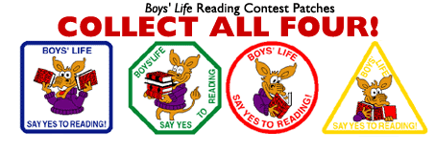
Write a one-page report titled "The Best Book I Read This Year" and enter it in the Boys' Life 2006 "Say Yes to Reading!" contest.
The book can be fiction or nonfiction. But the report has to be in your own words—500 words tops. Enter in one of these three age categories: 8 years old and younger, 9 and 10 years old, or 11 years and older.
First-place winners in each age category will receive a $100 gift certificate good for any product in the Boy Scouts Official Retail Catalog. Second-place will receive a $75 gift certificate, and third-place a $50 certificate.
Everyone who enters will get a free patch like the yellow one above. (The patch is a temporary insignia, so it can be worn on the Boy Scout uniform shirt. Proudly display it there or anywhere!) In coming years, you'll have the opportunity to earn the other patches.
The contest is open to all Boys' Life readers. Be sure to include your name, address, age and grade on the entry. Send your report, along with a business-size, self-addressed, stamped envelope, to:
Boys' Life Reading Contest, S306
P.O. Box 152079
Irving, TX 75015-2079
For more details go to www.boyslife.org
Entries must be postmarked by Dec. 29, 2006.
Knot of the Month
PACK TRAINER AWARD
Southwest Michigan Council, BSA
http://www.bsaswmc.org/
Note: tenure and performance requirements for this award may not be met retroactively. You may begin earning this award on or after September 1, 2006,
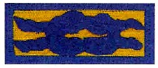
TRAINING:
- Fast Start training for the Pack Committee
- Complete NLE and be familiar with & able to explain the key elements of Leader Specific Training for all volunteer positions in the pack.
- Complete Youth Protection Training
- Participate in a TDC.
TENURE:
- Complete 2 years as a registered Pack Trainer
PERFORMANCE:
- Participate in a CS leader Pow Wow or University of Scouting during each year of tenure for this award.
- Have CS Roundtable staff certify your attendance for at least 30% of the roundtables during each year of your tenure for this award.
- Attain 100% trained leadership within the pack for the committee chairman, Cubmaster and all the den leaders.
- Have a working plan in place for delivering Fast Start training to new leaders within 48 hours of their joining your pack.
- Have a working plan in place for helping leaders who have not taken basic training to attend New Leader Essentials and leader specific training.
- Keep and update training records of all leaders in your pack.
- During the pack annual program planning meeting, be available to answer questions about training courses.
- Review ongoing pack leadership training status and provide leaders with updates on any available supplemental training.
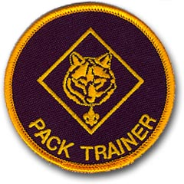
GATHERING ACTIVITIES
Note on Word Searches, Word Games, Mazes and such – In order to make these items fit in the two column format of Baloo’s Bugle they are shrunk to a width of about 3 inches. Your Cubs probably need bigger pictures. You can get these by copying and pasting the picture from the Word version or clipping the picture in the Adobe (.pdf) version and then enlarging to page width. CD
BSA Idol
Sam Houston Area Council
Have a Karaoke set up and let the boys and siblings ham it up with a BSA Idol competition as they arrive.
Space Derby
Sam Houston Area Council
Set up your space derby racer and have the boys play with either a few pre-made racers or have the kits there and they can make them and use them.
Paper Airplane Contest
CD
- Get ideas for folding paper and creating different paper airplanes from the web.
- Have supplies at the meeting place
- Have boys fold and make paper airplanes. Either designs they and their parents like or new ones from your search
- Let them fly their airplanes to see how they go.
STAR SEARCH
Grand Canyon Council
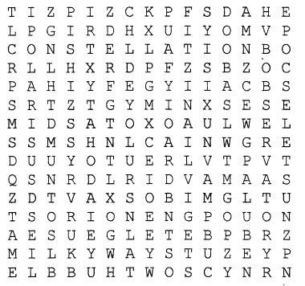
ASTRONOMY BETELGEUSE SUN
BINOCULARS CONSTELLATION GALAXY
HUBBLE LITTLE DIPPER
MILKY WAY NEBULA NORTH STAR
OBSERVATORY ORION PEGASUS
POLAR1S RED GIANT SIRIUS
TELESCOPE
Pre opening Game
Grand Canyon Council
- Have nametags made up using five constellations.
- As the people arrive, they are to find as many other people with same constellation as possible
Then they can – (Choose One)
  - Make a model of their constellation
  - Look up with something to say about their constellation
  - See who can remember the most names from the members of their group
C O N S T E L L A T I O N
Grand Canyon Council
How many 3 letter or more words can you find in the word, constellation?
STAR UNSCRAMBLE
- USN
- PPIBREGID
- LATSINNOTCELL
- XYLGAA
- ROONI
- TRYSAMOON
- TRAS
- YKLIM AYW
- PEELSTOCE
KEY
1. Sun 2. Big Dipper 3. Constellation
4. Galaxy 5. Orion 6. Astronomy
7. Star 8. Milky way 9. Telescope
Shooting Stars
Grand Canyon Council
Shooting stars are fun to find and watch.
For the pre-opening activity have the Cubs pack an egg so that it can survive a ten foot (large) drop onto a hard surface.
Materials: Eggs, Ziploc bags, tape, Styrofoam sandwich box, packing materials such as cotton, newspaper, peanuts, grass, leaves, etc.
Directions:
- Put the egg inside he Ziploc bag,
- Then pack it any way you want inside the box.
- Tape the box well and write name on it.
- Drop the boxes from a balcony, or high place,
Then check to see whose egg survived.
- Give out Mars, Milky Way or Starbursts for prizes
A-Mazing Star:
Sam Houston Area Council
Try your luck at navigating this real hedge maze. The Bellingham Maze is located in Queensland, Australia, and you can walk through it from the left-most point of the star and get to the right-most point…if you dare.
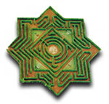
When you have a good repro of this maze in an appropriate size, you can do it. But a small black & white is hard to see the paths. You will probably need color reproduction. CD
Tongue Twister
Grand Canyon Council
Have boys try and say this and / or other tongue twisters as fast as they can -
WE SURELY SHALL SEE THE SUN SHINE SOON
OPENING CEREMONIES
OPENING CEREMONY IDEAS
Twinkling Stars
- Put a flashlight under a colander and turn out the room lights.
- As the flag is brought in, move the flashlight around to make the stars swirl on the ceiling.
- Den stands at attention for the Pledge, then sings the "Star Spangled Banner".
- Keep the stars swirling until the end.
Adventure In The Sky
San Gabriel Valley, Long Beach & Verdugo Hills Councils
Preparation: Have large pieces of construction paper with a picture representing each of the eight different aircrafts of the inventors. You can then put the boys lines on the back of each. Have the boys hold their paper down until it is time for them to say their part and then they should hold it up so everyone can see.
- Leonardo DaVinci had a vision of man in the sky.
- Orville and Wilbur built a plane, the first one to fly
- The sound barrier was broken by Chuck Yeager they say
- John F. Kennedy said we'd land a man on the moon one day.
- The Shuttle Atlantis now soars overhead.
- As I settle and snug in my bed.
- I lay down to rest and sleep I do try.
- But all I can dream of is "ADVENTURE IN THE SKY."
OUT IN SPACE
Grand Canyon Council
Setting:
4 Cub Scouts are standing on stage looking up to the sky.
- Cub 1: What's out in space?
- Cub 2: Mostly lots and lots of space, but also billions and jillions of stars, galaxies and solar systems, planets, and moons, blazing comets and deadly rays.
- Cub 3: Yeah, and sometimes even people!
- Cub 4 walks out dressed in a space helmet and says those famous words of Neil strong: ""One small step for man. One giant step for mankind".
- Cub 5: That's what's out in space!
- Let's all stand and remember the American flag flying on the moon. Please join with us in the Pledge of Allegiance.
STAR WARS
Grand Canyon Council
Cub Scouts have large cards each with a letter on front. The cards spell out STAR WARS. On the back of the cards are their parts in LARGE print. As each one steps forward, he holds up his card and says his line:
- S stands for seek.
Seek the mysteries of the future.
- T stands for Top. Top the obstacles of youth.
- A stands for Advance.
Advance in the Cub Scouting program
- R stands for Reap.
Reap the fruits of your labors.
- W stands for Watch. Watch for imperfections.
- A stands for Attack. Attack your shortcomings.
- R stands for Reach. Reach for the sky.
- S stands for Shoot. Shoot for the stars.
All: And may the force be with you,
all the days of your lives.
Constellations
San Gabriel Valley, Long Beach & Verdugo Hills Councils
Thoughts can be read by a leader. These could be used as part of opening or interspersed throughput the Pack Show. Maybe even used as a Cubmaster’s Minute for Closing.
- For thousands of years, people have gazed at the night sky with wonder and awe. As they studied the patterns of the stars, the early sky watchers drew imaginary lines from star to star, outlining the shapes of objects, animals, and gods. Some of their names for these constellations are familiar to us today.
- Stonehenge, a ring of mammoth boulders built several thousand years ago on the plains of Southern England, may well have functioned partly as a prehistoric observatory used to record important positions of the sun and moon, and perhaps even to predict eclipses. Some Egyptian pyramids were erected with features in line with certain stars, as were some of Central America's Mayan Temples.
- Even though most celestial features are far more permanent than terrestrial ones, our point of view is constantly moving, and thus different star charts are necessary to reflect the appearance of the sky overhead at different hours of the night and during different seasons of the year. The center of each chart usually corresponds with the zenith of the sky (the point directly overhead), and is marked with a small cross. The horizon, that line where the sky appears to touch the ground, is the circle bordering each chart.
Our Nation's Pledge
Sam Houston Area Council
D Ldr: The pledge was first used on October 12, 1892, during Columbus Day observances in the public schools. The original wording of the pledge was as follows:
I pledge allegiance to my flag and to the republic for which it stands: one nation, indivisible, with liberty and justice for all.
The pledge was amended with the substitution of the words "the flag of the United States of America" for the phrase "my flag." The newly worded pledge was adopted officially on Flag Day, June 14, 1924.
By joint resolution of Congress the pledge was further amended in 1954 by the addition of the words "under God."
Den __ will now present you the meaning of the pledge of allegiance, written by humorist, and Scouting supporter, Red Skelton.
- “I - - Me; an individual; a committee of one”
- “Pledge - - Dedicate all of my worldly goods to give without self-pity.”
- “Allegiance - - My love and my devotion.”
- “To the Flag - - Our standard; Old Glory ; a symbol of Freedom; wherever she waves there is respect, because your loyalty has given her a dignity that shouts, Freedom is everybody's job.”
- “United - - That means that we have all come together.”
- “States - - Individual communities that have united into forty-eight great states. Forty-eight individual communities with pride and dignity and purpose. All divided with imaginary boundaries, yet united to a common purpose, and that is love for country.”
  - “And to the Republic - - Republic--a state in which sovereign power is invested in representatives chosen by the people to govern. And government is the people; and it's from the people to the leaders, not from the leaders to the people. For which it stands…”
  - “One Nation - - One Nation--meaning, so blessed by God.”
  - “Indivisible - - Incapable of being divided.”
  - “With Liberty - - Which is Freedom; the right of power to live one's own life, without threats, fear, or some sort of retaliation.”
  - “And Justice - - The principle, or qualities, of dealing fairly with others.”
  - “For All - - For All- -which means, it's as much your country as it is mine.”
D Ldr: “Over 50 years ago, two words were added to the Pledge of Allegiance: Under God. Wouldn't it be a pity if someone said that the pledge is a ‘prayer’, and tried to eliminate it from schools too?
Now, please join us in reciting the Pledge of Allegiance:
CM I pledge allegiance to the Flag of the United States of America, and to the Republic, for which it stands; one nation under God, indivisible, with liberty and justice for all.
PACK AND DEN ACTIVITIES
Advancement opportunities
Sam Houston Area Council
Tiger Activities
Go and See it to the Houston Museum of Natural Science planetarium
Wolf Achievements and Electives
Elective 9 – Let’s Have a Party
Elective 11 – Sing Along
Bear Achievements and Electives
Elective 1 – Space
Elective 6 – Aircraft
Places to Go
Go to an observatory or planetarium. Many colleges have planetariums. Rowan University near me has a beautiful one and it is FREE to youth groups. Big city natural history and science museums (e.g. The Franklin Institute in Philadelphia) have planetariums. Check out your area. I remember seeing a show in the Hayden Planetarium in New York City when I was growing up where they tracked stars back to the birth of Christ and showed how the models projected that there was an exceptionally bright star in the heavens at that time.
Schedule an after dark meeting in a filed or park. Line up a local astronomy club (They love to show off) and have an evening of stargazing. We invited two Astronomy Clubs to set up at Webelos Resident Camp this summer and they brought out all the big scopes and such. The boys were really impressed. Make arrangements to use a local ball field or something. The middle of a big lake (frozen, of course) is great. My best stargazing nights when I was a Scoutmaster was from the middle of Sand Pond at Camp No-Be-Bo-Sco by the Delaware Water Gap. (By the way No-Be-Bo-Sco is an old Indian word meaning – North Bergen Boy Scouts back from when North Bergen County Council existed. I worked staff there in 1965 and 1967). Finish the night off with hot cocoa and goodies.
HOW TO FIND THE NORTH STAR & CASSIOPEIA
Grand Canyon Council
To locate the constellation Cassiopeia, you must look into the Northern section of the night sky. If you don't know someone who can point this area out to you, use a compass to find north.
Next, try to find the Big Dipper in this part of the sky. It will be near the northern horizon and is quite large. On winter evenings it will be standing on its handle, just to the right of due North. During summer evenings the Big Dipper will be to the left of due North and standing on the dipper part.
Regardless of the position of the Big Dipper, you can use it to find the North Star and Cassiopeia. The two stars that make the front edge of the dipper part are called the "pointers", and point to the North Star, which is about four times as far away from the Dipper as the pointers are apart.
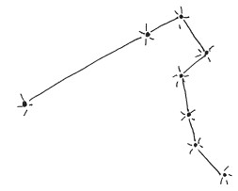
Don’t stop after locating the North Star. Continue along in the same direction, going an equal distance on the other side of the star until you see a group of stars that form a large zigzag W. This is the constellation Cassiopeia. It may not be right side up and may look more like an M.
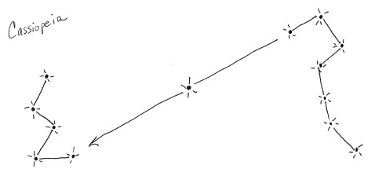
You will not be able to find Cassiopeia in the evening sky from May through August, because it will be below the northern horizon. However, on clear evenings during the winter months, you will be able to see this constellation as it arcs across the northern sky.
Easy Star Gazing
Commissioner Dave
I earned my Astronomy Merit Badge from Mr. Jacobsen in February in Hillsdale in Northern Jersey. It was cold. And as a result, I love the winter sky and get lost in the summer sky. Mainly because in the winter I can find Orion and from there find a lot of other stuff. Here are two basic keys to navigating the winter sky.
The Winter Triangle
This consists of three (duh) constellations and three bright stars. The constellations are Orion, the hunter, and Cannis Major and Cannis Minor, two of his dogs.
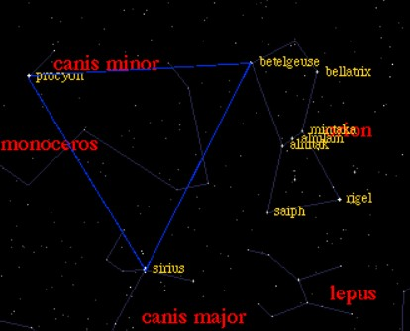
Look Up high in the heavens to locate the three stars making up the belt of Orion.
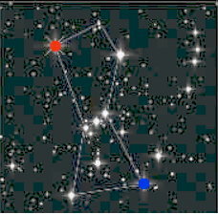
If you focus on the three stars in the Belt of Orion and follow them southeast (down and to the left), you will find they point to the brightest star in the heavens, Sirius. If you draw your focus out from the middle star of Orion’s Belt you will find that it points to the reddish star Betelgeuse in one direction (Betelgeuse is top left in the box of four stars surrounding the belt) and to a bluish star, Rigel, in the other direction. (Rigel is bottom right in the box of four stars surrounding the belt). Locating Sirius and Betelgeuse gives you two of the three points of the Winter Triangle. The third point, Procyon, is located well to the upper left of Sirius.
Here’s a Winter Triangle fun fact from Sky and Telescope:
One reason Sirius and Procyon look so bright is that they are among the closest of all the stars. Sirius lies 8.6 light-years, and Procyon 11.4 light-years, away from Earth. If you show them to kids whose ages are about 9 and 11 you can describe them as their birthday stars—the light they see tonight left Sirius and Procyon around the time these children were being born."
Procyon is in Canis Minor which is basically two stars, Procyon and one other.
If you connect Sirius, Procyon and Betelgeuse, you have the Winter triangle. And you have found three constellations – Orion, Canis Major and Canis Minor.
Ready for more???
The Winter Hexagon
Now we are going to do six constellations and add in a seventh for fun!!
The constellations are
Orion, the Hunter
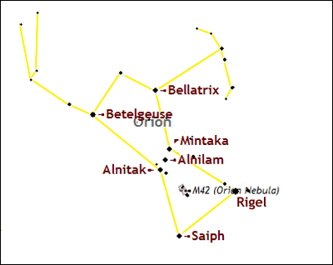
Cannis Major, the Big Dog
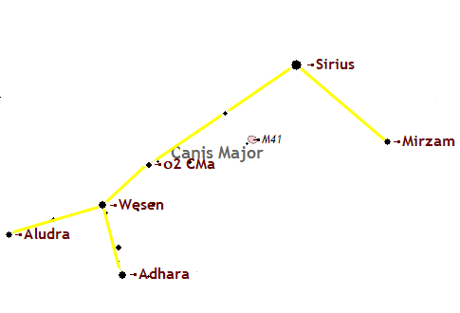
Cannis Minor, the Little Dog
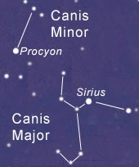
Gemini, The Twins
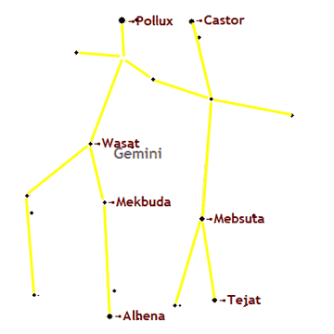
Auriga, The Charioteer
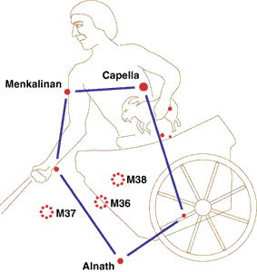
Taurus, the Bull
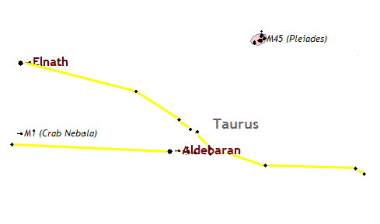
After locating and becoming familiar with the Winter Triangle composed of Betelegeuse, Sirius and Procyon, we're now ready to discover the Great Winter Hexagon, another divine design in the winter skies.
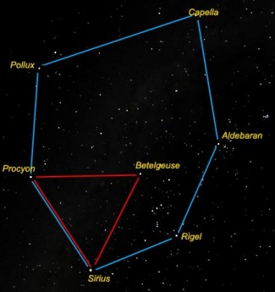
This heavenly hexagon houses the Winter Triangle with the stars Sirius and Procyon forming points in both of these geometric wonders. The six stars of the Great Winter Hexagon are Sirius (in Canis Major), Rigel (In Orion), Aldebaran (in Taurus), Capella (in Auriga) , Pollux (in Gemini) and Procyon (in Canis Minor).
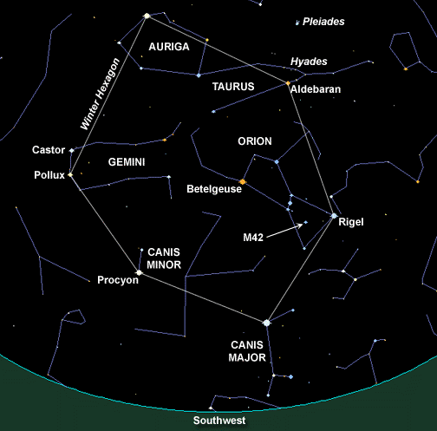
Locating the Winter Hexagon
Begin your star search on a clear winter night between 8:00 and 10:00 pm, look from overhead toward the south.
First find the three stars of Orion's belt and follow them southeast (down and to the left), you will find they point to the brightest star in the heavens, Sirius, and the first star in our hexagon. Sirius is also in the Winter Triangle. Go back to Orion's Belt, if you draw your focus out from the middle star of Orion’s Belt you will find that it points to the reddish star, Betelgeuse, in one direction and to a bluish star, Rigel in the other. Find the bluish star in the leg of Orion and imagine a line connecting Sirius to it. Once again follow the three stars in Orion's belt in the direction opposite of Sirius and you will find the bright red star of enlightenment, Aldebaran. Draw a line from Rigel to Aldebaran. Now head for the next closest brightest star Capella, the Charioteer's eye, which is directly opposite Sirius in our hexagon. As you connect Aldebaran and Capella the hexagon is now half imagined! Just east of Sirius is the brightest star of Canis Minor, Procyon, which also forms a point of the Winter Triangle. Between Procyon and Capella is another bright star Pollux of Gemini, the Twins. Connect Sirius to Procyon to Pollux to Capella and the Winter Hexagon is complete in your mind's eye!
Ponder on This
Sirius is known as the Christ Star or the God Star.
Rigel has been known as the mariners' star.
Aldebaran is the star of enlightenment.
Capella is the Charioteer's eye. The Charioteer is the heavenly Santa Claus.
Pollux and his twin Castor have been immortalized for brotherly love and their help has been invoked in war and storm. It is said that Pollux represents the Soul and Castor the personality.
Procyon is the brightest of the two stars that make up Canis Minor, the little dog, which now stands on the back of the Unicorn and has been associated with the Egyptian dogheaded God, Anubis, the guide of souls.
Now for a bonus –
Just to the right of Aldebaran in Taurus, you will see a small cluster of stars looking like a tiny dipper. That is the Pleiades, the seven sisters or seven boys (depending on which legend you read). There is a story about the Pleiades in Baloo this month!
For a cool site to play with for the winter hexagon -
http://canopus.physik.uni-potsdam.de/~axm/images/winter_hexagon.html
A great site for your Cubs –
http://www.dustbunny.com/afk/
(AFK – astronomy for kids)
This article was adapted from information I found at many web sites after I searched “Winter Hexagon” on Google.
http://homepage.mac.com/kvmagruder/bcp/aster/constellations/win6.htm
http://antwrp.gsfc.nasa.gov/apod/ap021106.html
http://www.souledout.org/nightsky/winterhexagon/winterhexagon.html
http://www.answers.com/topic/winter-hexagon
http://www.daviddarling.info/encyclopedia/W/Winter_Hexagon.html
TELLING TIME BY THE STARS
Grand Canyon Council
While the ancient Egyptians built sundials to keep track of daylight hours, during the night they measured the movement of the stars across certain portions of the sky.
They associated their goddess Isis, "the lady of all the elements, the beginning of all time" with the brightest star in the night sky, Sirius.
They built temples facing the point on the eastern horizon where Sirius first appeared before sunrise. Ancient Egyptian astronomers, tracking Sirius for their calendar, started a new year at the first new moon following the appearance of Sirius and all awaited the annual floods that irrigated the land.
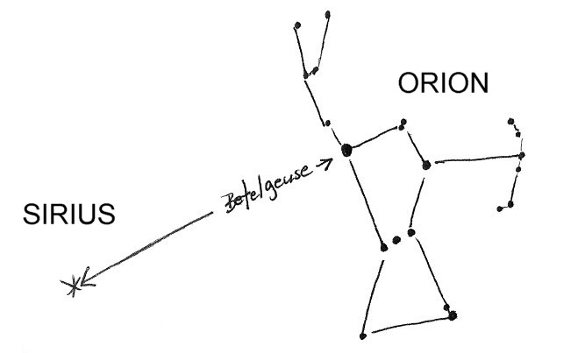
In the Northern Hemisphere, a February evening is a good time to look for Sirius to the side and a little below the group of stars knows as Orion the Hunter. Face south at about 9 pm. Orion is high in the winter sky but not visible in northern skies during the summer. Using the line of Orion's belt as a guide, look southeast for the Dog Star. (Find Orion by looking for his belt which has 3 stars in a row)
Tin Can Constellations
Sam Houston Area Council
Materials:
Empty “tin cans” washed, filled with water and frozen
Hammer
Nails, an ice pick or awl for punching holes
Directions
- First freeze water in the cans, before you try to hammer nails into them.
- By having ice in the cans, the bottoms of the cans will not bend as easily and you can make more accurate patterns.
- Enlarge one pf the patterns to fit the end of the can that is still attached
- Tape the pattern piece to the can or draw the constellation on the can using the pattern as a stencil
- Punch holes in the can where the stars are
- After punching the holes, let the ice melt and pour out the water.
- Shine bright flashlights through the cans toward a ceiling in a dark room.
Tin Can Constellation Patterns
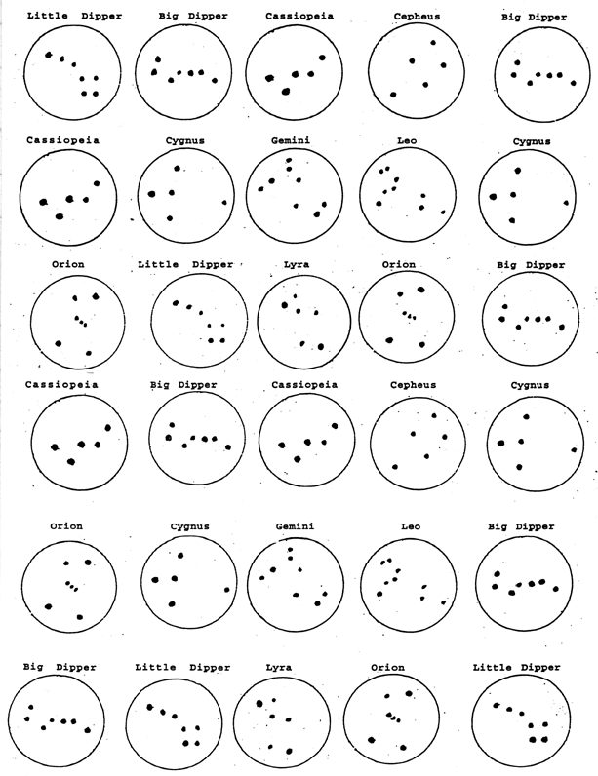
The full size version of this is at the end of Baloo.
I guess there are several of each constellation because the pattern can only be used once. Perhaps they, also, use it for a BINGO type game. If you can invent a game that uses the board, send it to me, please. CD
Identifying Constellations:
Sam Houston Area Council
After making the tin can constellations, shine sets of five on the ceiling and have a contest to identify them.
Once the boys have a good mastery of knowing the constellations, take them out on a dark, clear winter evening and have them identify as many constellations as they can.
Cereal Box Planetarium
Grand Canyon Council
Materials:
Round box (the kind that oatmeal or raisins are packaged in), tracing paper, pencil, glue, small nail, and flashlight.
What to do:
- Make a circle of tracing paper to fit the bottom of the box
- Then trace the illustration of the Big Dipper, the North Star, and Cassiopeia (found elsewhere in Baloo) onto the thin piece of paper.
- Glue the paper to the bottom of the box.
- With the nail punch holes through the box at each star.
- Take your planetarium into a dark room and stand facing one of the walls.
- At the open end of the box tilt a flashlight so that it shines against the side.
- Turn the box slowly.
What happens?
You get an enlarged image on the wall.
When you turn the box, you will see the various positions of the stars, as they seem to revolve.
Why:
The Earth rotates on its axis, so the constellations appear to circle around the North Star, which remains at the same place in the sky.
Therefore, you see these constellations in all positions - on their sides or even upside down. The "W" shape of Cassiopeia becomes an “M” depending on when it appears above the North Star.
You can, also, do this with tin cans of various sizes but be careful of the sharp metal edges. Freeze water in the cans first to keep them from collapsing as you hammer the nails.
THE SKY AS A COMPASS
Grand Canyon Council
If you are ever lost in a forest at night,
you can use the sky to find your way.
- Find the North Star, which is the brightest star in the northern sky. (Directions are in Baloo) When you face it you are looking north.
- Now turn halfway around (180 degrees, as they say) and look across the sky to the horizon. That is south.
- East is a quarter-turn (90 degrees) to the right when facing north.
- West is a quarter-turn (90 degrees) to the left when facing north.
- Can't find the North Star?
If it is Winter, look for the distinctive Orion constellation. It is in the South. Now, do you know how to find North?
Cut a 5-Pointed Star in One Snip
George Washington's original pencil sketch for the flag indicated 6-pointed stars, a form he apparently preferred.
Betsy Ross, however, recommended a 5-pointed star. When the committee protested that it was too difficult to make, she took a piece of paper, folded it deftly, and with a single snip of her scissors, produced a symmetrical five-pointed star. This seeming feat of magic so impressed her audience that they readily agreed to her suggestion.
To you we pass along the secret...
AS found on the Betsy Ross Website –
http://www.ushistory.org/betsy/flagstar.html
Take a thin piece of paper 8-1/2" x 10" NOT 8 ½ by 11(or an exact proportion thereof), fold it as indicated and cut yourself a perfect 5-pointed star.

Step #1:  Fold an 8-1/2" x 10" piece of paper in half. | 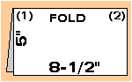
Step #2:  Fold and unfold in half both ways to form creased center lines. (Note: be sure paper is still folded in half.) | 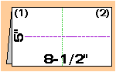
Step #3:  Bring corner (1) right to meet the center line. Be sure to fold from the vertical crease line. | 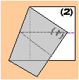
Step #4:  Bring corner (1) left till edges coincide, then make the fold | 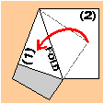
Step #5:  Bring corner (2) left and fold. | 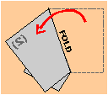
Step #6:  Bring corner (2) right until edges coincide. Then fold. | 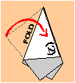
Step #7:  Cut on the angle as shown in the picture.  Then unfold the small piece | 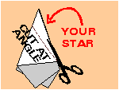
Step #8:  Marvel at your perfect (we hope!) 5-pointed star!  If your star is not perfect, take a fresh piece of paper (8-1/2" x 10" — not 8-1/2" x 11") and return to Step 1  . | 

Star Pinwheel:
Sam Houston Area Council
Materials:
unsharpened pencil with eraser
Colored construction paper,
Small plastic bead,
1” straight pin with a spherical end,
Wooden bead ½” wide,
Ruler, scissors, white glue, pencil
Directions:
- Cut the construction paper into a 5” square.
- Use the ruler to draw lines from opposite corners, so that they intersect at the very center of the 5” square.
- Draw a 1” diameter circle in the very center of the square.
- Cut the square from the tip of each corner straight to the edge of the circle in the center.
- Put a drop of glue in the center and carefully fold over one corner to be slightly over the center.
- Hold the paper on the glue (without creasing it) until it sticks.
- Now repeat this gluing, folding and sticking as you move clockwise around the square.
- Push the pin through the center of the folded and glued paper, so that the spherical end helps to hold it all together.
- Thread the sharp end through the small wooden bead and stick the pin into the pencil eraser.
- Decorate the pinwheel with stars, etc.
The pinwheel is now ready to spin, and
the boys can carry them around the room.
Pocket Sundial
Grand Canyon Council
The sundial is the oldest scientific instrument still in use. Long before mechanical clocks and watches were invented, people used sundials to tell time. As the sun moves across the sky, the shadows it casts change their position. Ancient peoples learned to mark where shadows fell on a sundial to tell the time of day.
This particular sundial is called a cylinder, or shepherd's dial. It was widely used hundreds of years ago because it was inexpensive, simple to make and easy to carry. Some sundials were more elaborate. George Washington carried a silver sundial in his pocket.
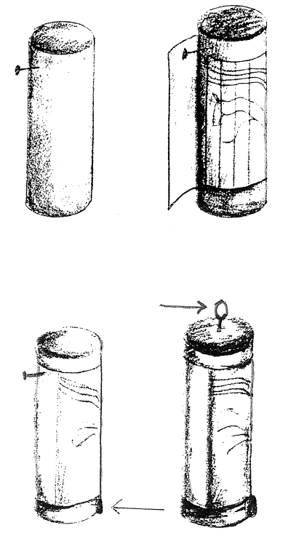
What You’ll Need
- 1 - wooden dowel - 1 inch thick (a piece of broomstick will do)
- 1 - nail or an awl
- 1 - screw eye
- 1 - wire nail 1 inch long
- A saw.
- A hammer
What to Do
  - Cut a 4” long piece of dowel
  - With the nail or awl, make a small hole in the top of the dowel.
  - Screw the screw eye into the hole. The screw eye must be in the center of the dowel end.
  - Hammer the wire nail lightly into the dowel about 1/2 inch from the top (the end with the screw eye). Drive the nail in only far enough to hold it firmly. Be sure the nail sticks straight out.
  - Use a photocopy machine to copy the sundial graph, and carefully cut it out along the dotted lines.
(You may have to adjust size of graph as you copy it. CD)
  - Wrap the graph around the dowel, with the top touching the nail.
  - Overlap the ends of the graph, and tape it with cellophane tape. Don't let the tape touch the dial. Leave the graph a little loose so it can turn freely on the dowel.
  - Push the graph up until it touches the nail, and place a thumbtack at the bottom of the graph to keep it from sliding back down. Don’t put the tack through the graph (the graph must turn).
  - Tie a short piece of string to the screw eye.
How To Use Your Sundial
- The letters at the bottom of the graph, represent the months of the year. Turn the graph on the dowel until the letter for the current month is directly below the nail.
- Stand with your back to the sun and hold your dial up by the string. (The sun mist be shining for the dial to work)
- Slowly rotate the entire dial until the shadow of the nail points straight down
- The shadow of the head of the nail will indicate the time on the graph. Notice where this nailhead shadow falls on the graph.
  - Each curved line on the graph stands for two different hours. For example, 9 am and 3 pm share the same line. If the shadow falls here it is either 9 am or 3 pm. You must decide which time it really is.
  - During Daylight Savings Time you will have to add one hour to the reading to get the correct time.
Important: Until you adjust the dial for your location it will not read correctly.
How To Adjust Your Sundial
- Hold the dial up in the sunlight and see where the nailhead shadow falls. Read the time on the graph.
- Now, read the time on a normal clock or watch. You must adjust the length of the nail until your dial reads the same time as the clock. You can do this by slowly hammering the nail in until the dial reads correctly, or you may cut the nail off until it is correct.
Important: If you are doing this during Daylight Savings Time (and use Daylight Savings Time) you must adjust the nail to read one hour less than what the clock reads.
Later, when using the sundial, you must add one hour to the reading to get the correct time.
Nocturne Night Dial
Grand Canyon Council
With this colorful dial you can tell time by the stars. Just turn the large outer dial so the current date is at the top, and look through the center hole at the North Star. Turn the pointer to the center star in Cassiopeia, and read the time in the slot. (During Daylight Savings Time, you'll have to add one hour to the time that appears in the slot.)
What You’ll Need
Scissors
White glue
Posterboard
A grommet
Directions:
- Copy the drawings of both dials-the round one and the pointed one on a photocopy machine. Drawings are at the end of this issue of Baloo.
- Cut out the photocopied dials
- Glue each one onto a piece of posterboard.
- Trim the posterboard to fit.
- Color both dials with anything you like--crayons, Sharpie markers, watercolors, and magic markers.
- Cut out the slot at the top of the pointed dial.
- Lay the pointed dial on top of the round one, so that the cutout slot is over the circle of times.
- Cut a hole through the center of both dials.
- Attach the two dials in the center with a grommet. Grommets have two important characteristics:
- They're hollow in the center, so you can sight through the center of the dial:
- They'll allow the pointed dial to rotate. A grommet is installed with an inexpensive metal tool.
- If you don't want to use a grommet, look for something else that might do the same job. For example, an audio intake valve-the kind used to attach an electric guitar to an amplifier would also work.
Dial patterns are at the end of Baloo
Slide Materials
San Gabriel Valley, Long Beach & Verdugo Hills Councils
This list is passed on to you from a leader in Long Beach Area Council, CA
As you go through the list of slides below, you will notice many different materials.
- I have found that for the loops, the best things are pipe cleaners (chenille stems), loops of leather, and my new favorite, clear flexible PVC (also known as Tygon tubing at the aquarium shop). You can get this hose material at the hardware store, it is very cheap (20-35 cents per foot) and you can cut it with a good, heavy scissors. Plus it is invisible!
- For leather, look to old purses, old leather coats (fur ones, too), leather belts, etc. Check the Goodwill or Salvation Army.
- Any leather or felt pattern can be duplicated easily using a material called Fun Foam. It comes in brilliant colors plus shades, can be cut with a scissors, and is so easy to use and very inexpensive if you watch for it on sale. Check your local craft store.
- A good leather substitute is vinyl (naughahyde) fabric. Go to an upholsterer's shop and ask for scraps. Also ask for scraps of trim, lacing, leather, and other materials.
- Plastic milk cartons have a very nice plastic that cuts easily for bases, loops, or cut-out slides.
- Paint-stirring sticks are great sources of free, good wood for slides and other projects.
- Check Clearance sales after Christmas and other holidays for wooden ornaments. I have some exquisite hand-carved cowboys and birds that were originally intended for a Christmas tree.
- Pins and large earrings also make good slides.
- Laminated Countertop samples make great backings for slides and also mini clipboards. Look in the cabinet section of the local Home Depot/Lowes/Do-It-Yourself Centers.
- Milk/orange juice jug caps make great 'frames' for plaster, cotton balls, cardboard circles covered with felt or pictures, etc.
- Refrigerator Magnets are a great, cheap resource. Hot glue a ring on the back. Check the "Dollar" stores for some real deals! Some even light up and make noises!
- Key chains, same as refrigerator magnets. I found one that is a miniature Coleman Lantern that really lights up. Drove my Scouter friends wild the first time they saw it.
- My best finds are in the hardware store. Go cruising, and use your imagination.
- The Butcher shop will give you leg bones cut into slices. Try scrimshawing them (older Scouts, only).
- Your local Pet Store will have rawhide dog chews that can be soaked, stretched, and made into various Indian styles of slides, such as drums, stretched hides, tiny shields, etc.
- Check Wal-Mart, Woolworth's, and the Dollar type stores for plastic frogs, insects, snakes, etc. They look great crawling across a neckerchief. Hot glue a clear PVC ring to them. Nature stores have these small model animals, too, but you should never pay more that 25-50 cents each for them. Puns abound with these (Don't get bugged about it, Hop to it, etc.).
Rocket Slides
San Gabriel Valley, Long Beach & Verdugo Hills Councils
Version 1
Materials: Standard slide materials, 3/8" X 1-1/4" dowel pieces, Bits of heavy paper, Decorating materials (paints, glitter glue, etc.)
Directions:
Have boys cut out and glue fins onto bottom of rocket and make a cone for the top. Decorate rocket and slide backing (1-1/4" paneling disk) as desired. Glue rocket onto backing. Glue slide ring onto back of slide.
Version 2
Materials: Art Foam, Tulip paint, glue, pipe cleaner
Cut rocket out of art foam. Decorate with paint. Glue pipe cleaner on back.
Quick Slides
San Gabriel Valley, Long Beach & Verdugo Hills Councils
This list is passed on to you from a leader in Long Beach Area Council, CA
Can't find your slide? Try these fast answers:
- Most costume jewelry rings or inexpensive rings make interesting, but rather small slides.
- Key chains can be interesting slides if they are the right size and have interesting things that hang down right. Those with tabs usually work the best.
- Pieces of clean tubing, such as plumbing pipe, conduit, chromed tubing, etc., can be used if smooth and de-burred.
- Napkin rings usually make good slides. Look for exotic slides at import shops.
- Some of the big 'conchos' with two big slots in them make good slides. Thread the neckerchief up from behind the top slot, then back down into the bottom slot.
- Hair barrettes (especially for tying back long hair)
- Decorative Pins (clay art ones and Indian design ones)
- Scarf holders and T-shirt loops (flat pieces of wood or plastic with 2 holes to gather your extra long T-shirts at the hem for that sporty, fashionable look. I have one that is a ceramic fish that is super!)
Here are some non-theme-related projects that would make great Holiday presents
Emergency Road Signal
Sam Houston Area Council
For safety purposes, keep an emergency road signal in your car.
Materials
Two – 1” hinges and screws
Two – small screw eyes
12” plumber’s chain or wire
Glass reflectors or reflector tape
Two – 4” X 24” X 3/4” boards
Sandpaper, Screwdriver, Hammer
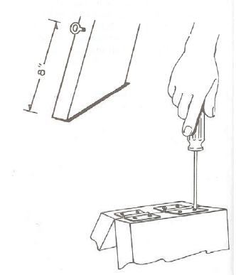
Procedure
- Cut the boards to length and sand edges smooth
- Nail the reflectors to one side of each board or apply reflector tape in several strips on each board
- Using the screwdriver, screw the hinges to the top of both boards
- Measure 8” from the bottom of each board
- Screw in a screw eye at that point
- Attach the plumber’s chain or wire to the screw eyes
If your car breaks down at night, place the emergency signal on the highway a reasonable distance back from your car
Golf Tee Game:
Sam Houston Area Council
Materials:
2x6 board (a 3’ board makes seven games)
14 wooden golf tees per game
3/16” drill bit
Hand Drills (Brace and bit) for Cubs
Hand saw if Cubs cut boards
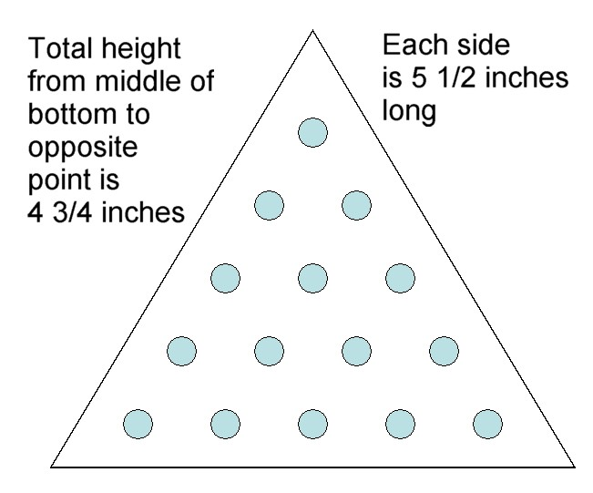
Directions
- Saw the 2x6 board into 4¾” lengths.
- Saw these lengths into equilateral triangles that are 5 ½ inches on a side.
- Drill fourteen 3/16” holes, in the pattern shown, straight down.
- Drill holes about 1¼” deep.
- Sand it well and round the corners.
- Stain the wood and let dry.
- Cover the bottom with felt.
When we made these, one dad made a template of the 14 holes. The boys could then put the template over their piece and start all 14 holes through the template.
How to play the game -
- Place the 14 tees in any of the 15 holes to start the game.
One of the tricks is to figure out how best to position them for the start.
- Tees can only be moved by jumping another tee that is in the same row and into an open hole.
- Every tee is a member of two (or sometimes three) rows.
- Once a tee is jumped over, then you take the tee that got jumped, off of the board.
- The object is to leave only one tee standing on the board at the end of the game.
- If you have left two or more tees that are not next to each other in a row, and thus can’t be jumped, then you start all over again.
There are several solutions to the game, but it can take a while to figure them all out.
Clatter Blocks
Sam Houston Area Council
Materials
One – 24” long strip of wood 3” wide by ¼” thick
36” long pieces of 3/8” cloth tape or heavy ribbon (for six blocks)
Stapler with staples or small tacks
Sandpaper
Procedure
- Cut the strip into 8 – 3” long pieces to make the blocks. You will need six or seven, so this gives you some extras.
- Sand all the edges.
- Lay six or seven blocks end to end with about ¼” gap between blocks.
- Next weave the two outer tapes around the blocks, stapling the tape to the top end of each block as shown
- Then weave in the center tape through the line of blocks in reverse direction and staple to the bottom end of each block as shown.
To Work:
- Hold one end block by its edges between thumb and fingertips.
- Start action by alternately dipping or raising the wrist and watch the amazing blocks perform.
To explain what this does is difficult, but the effect is very interesting.
As you twist the top block to touch the second block the blocks all seem to cascade downward.
An amazing trick and an excellent gift
Heavy ribbon works best, and be sure not to weave it too tightly.
Spinning Color Wheel:
Sam Houston Area Council
Materials:
Two pieces of string, each 28” long
Large needle
Scissors
Paints
Piece of Cardboard
Two large buttons
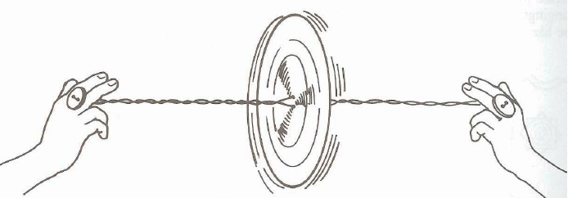
Directions:
- Cut the cardboard into 4½” circles.
- Paint each side of the disks with one of the patterns shown below.
- Thread the string through where the X’s are shown and tie through buttons at both ends.
- To make it spin, first roll it back, so that the string is twisted,
- Then pull outward on the string until it is straight.
- Let it keep spinning and twist up again, before you pull it again.
- Keep going as long as you want it to keep spinning.
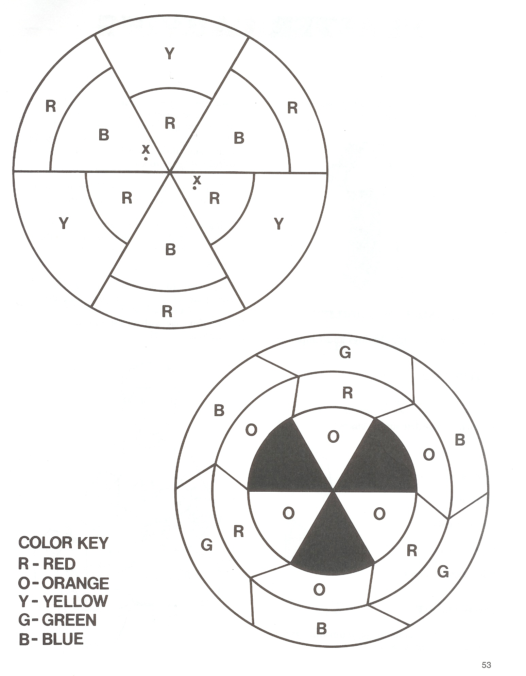
AUDIENCE PARTICIPATIONS
and STORIES
How The Sun, Moon And Stars Got Into The Sky
Grand Canyon Council
San Gabriel Valley, Long Beach & Verdugo Hills Councils
Divide audience into four sections. Assign each a word and a response. Tell them that when they hear their word in the story they are to give the response.
CHIEF: Stand with arms folded across
chest and say "Ugh! Ugh!"
SUN: Cover eyes with hands
MOON: Frame face with hands and smile
STARS: Blink rapidly
Long, long ago the Indians has no fire and no light. They suffered much during the cold of winter and they had to eat their food uncooked. They also had to live in darkness because there was no light.
There was no SUN, no MOON, and no STARS in the sky. The great CHIEF kept them locked in a box. He took great pride in the fact that he alone had light. This great CHIEF has a beautiful daughter of whom he was also proud. She was much beloved by all the Indians in the tribe.
In those days, the raven had the power of magic. He was a great friend of the Indians and the Indian CHIEF. He wondered how he might make life more comfortable for them.
One day he saw the daughter of the CHIEF come down to the brook for a drink. He had an idea. He would put a magic spell on her. In time a son was born to the daughter of the CHIEF. The old CHIEF was delighted as the boy grew. His grandfather, the CHIEF became devoted to him. Anything that he wanted he could have.
One day he asked the CHIEF for the box containing the STARS. Reluctantly the old CHIEF gave it to him. The child played for a while by rolling the box around. Then he released the STARS and flung them into the sky. The Indians were delighted. This was some light though not quite enough.
After a few days, the child asked for the box containing the MOON. Again the CHIEF hesitated, but finally, the boy got what he had asked for. Again, after playing a while with the toy, the boy released the MOON and flung it into the sky. The tribe was overjoyed. But still there was not enough light and the MOON disappeared for long periods.
Finally, the boy asked for the box with the SUN. "No," said the old CHIEF, "I cannot give you that." But the boy wept and pleaded. The old CHIEF could not stand the tears, so he gave him the box. As soon as he had a chance, the child released the SUN and cast it up in the sky.
The joy of the Indians knew no bounds. Here was light enough and heat as well. They ordered a feast of the SUN and all of the Indians celebrated it with great jubilation. And the old CHIEF was happy. He had not known that the SUN and the MOON and the STARS could mean so much for the happiness of his people. And for the first time, he too, enjoyed himself.
The Fire of the DRAGON:
Sam Houston Area Council
Divide the group into six smaller groups and assign each group one of the words listed below. Practice the parts as you assign them.
Read the story. After each of the words is read pause for the group to make the appropriate response.
ORION "Char-r-r-ge"
LITTLE DIPPER “drip - drip"
PEGASUS "Nei-i-i-gh"
DRAGON "Fire & Brimstone"
BIG DIPPER "DRIP! – DRIP!"
MILKY WAY “Moooo”
On a clear night in the winter months, you can look up in the sky and see something happening, if you use your imagination. We are going to do just that tonight. Pay attention now, so you won't miss any of the story.
Once upon a time, on a very dark night, a great hunter named ORION ___ started out to hunt a DRAGON ___. Now everyone knows that a DRAGON ___ can set almost anything on fire and ORION ___ knew this, so he took along with him the BIG DIPPER ___ and the LITTLE DIPPER ___ and the MILKY WAY ___.
As he mounted his horse, PEGASUS ___, he spilled the MILKY WAY ___ and had to dismount and refill the BIG DIPPER ___ and the LITTLE DIPPER ___. Once again he mounted PEGASUS ___ and away they flew, because PEGASUS ___ had wings and could fly through the sky. "Now to find the DRAGON ___," thought ORION ___. "He must be around here somewhere," and just then he saw him. He was really hard to miss as the DRAGON ___ was up to his old trick of breathing fire just to scare people.
"Whoa, PEGASUS ___," said ORION ___. "We must sneak up on him or he'll burn us up before we can put out his fire." PEGASUS ___ stopped and ORION ___ got off and took with him the BIG DIPPER ___ and the LITTLE DIPPER ___- Very carefully, ORION ___ made his way toward the DRAGON ___, then just as he was about to pour the MILKY WAY ___ from the BIG DIPPER __ and the LITTLE DIPPER ___ on him, the DRAGON ___ turned and saw him and started spouting dreadful fire at him
When PEGASUS ___ saw what was happening, he flew over the DRAGON ___, beating his wings. At the same time, ORION ___ threw the MILKY WAY ___ from the BIG DIPPER ___ and the LITTLE DIPPER ___ on him and put out his fire. The DRAGON ___, with his fire out, turned and fled into the darkness and to this day he will only appear in the daylight. Today he is known to us as the sun.
WAY OUT THERE:
Sam Houston Area Council
Divide the group in half. Assign each half one of the words listed below. Practice the parts as you assign them.
Read the story. After each of the words is read pause for the group to make the appropriate response.
SPACE: “Way out there”
(Point ahead moving finger from left to right)
ASTRONAUT/S: “Onward and upward”
(Stand up and thrust arm toward sky)
In the whole universe there's an enormous place, Which we all refer to as merely SPACE __. ASTRONAUTS __ spend many hours untold. Searching that SPACE __ where mysteries unfold. They bring back dust and rocks galore. Each ASTRONAUT __ striving to always learn more. The circle around for days in SPACE __. Keeping up such a strenuous place.
Our country explored SPACE __ and then very soon, Our ASTRONAUTS __ landed upon the moon. Oh what a thrill as we witnessed the sight. ASTRONAUTS __ raised our flag on that first moon flight. Right out there through outer SPACE __.
Upon the moon stands our flag in place. Just where the ASTRONAUTS __ left it that day. As a part in history they did play. One fact discovered which story writers won't please. Was that the moon is not really made of green Cheese. So way out in SPACE __ when you see the Man-in-the-moon. Remember the ASTRONAUTS __ proved we can't eat him at noon. But all of this is old today, ASTRONAUTS __ often go in SPACE __ and say, Travel in SPACE __, here and there, Is easily done without a care.
Service to Country
San Gabriel Valley, Long Beach & Verdugo Hills Councils
Divide audience into six sections. Assign each a word and a response. Tell them that when they hear their word in the story they are to give the response.
ARMY – Be all you can be!
AIR FORCE – No one comes close!
NAVY – Can do!
MARINES – Semper Fi!
COAST GUARD – Always ready!
CUB SCOUTS (All) – Do your best!
In the United States of America, we have several different branches of the military, all prepared to defend our freedom. There is the ARMY, the NAVY, the AIR FORCE, the MARINES, and the COAST GUARD.
All these different groups have mottos and slogans, just like the CUB SCOUTS. Part of the CUB SCOUT Promise includes duty to God and country, and certainly, all the men and women who serve in the ARMY, the NAVY, the AIR FORCE, the MARINES, and the COAST GUARD demonstrate their duty to country in a big way.
As CUB SCOUTS, we take pride in being good citizens, in honoring our flag, and in helping others. One day, some of you may choose to join the ARMY, the NAVY, the AIR FORCE, the MARINES, or the COAST GUARD. But, for now, we give thanks and appreciation for those who help protect and defend our county, while we learn to be the best we can be as CUB SCOUTS.
The Boys
Grand Canyon Council
The old people tell us that when the world was new, there were seven boys were used to spend all their time down by the townhouse playing the gatayA > >'sta game.(This is as close to the letters in the PowWow CD as I can get. Sorry. CD). This game is now called Chunkey, and is played by rolling a stone wheel along the ground and sliding a curved stick after it to strike it. Their mothers scolded them, but it didn’t do any good. One day the mothers collected some of the stones used for the game and boiled them in the pot with the corn for dinner. When the boys came home their mothers dipped out the stones and said, "Since you like that game better than working, take the stones now for your dinner.
The boys were very angry and went down to the townhouse, saying, "Since our mothers treat us this way, let’s go where we will never trouble them any more." They began a dance -- some say it was the Feather dance - and went round and round the townhouse, praying to the spirits to help them. At last their mothers were afraid something was wrong and went out to look for them.
They saw the boys still dancing around the townhouse, and as they watched they noticed that their feet were off the ground, and that with every round they rose higher and higher in the air.
They ran to get their children, but it was too late, for they were already above the roof of the townhouse - all but one, whose mother managed to pull him down with a gatayA > >'sta pole, but he struck the ground with such force that he sank into it and the earth closed over him.
The other six circled higher and higher until they went up to the sky, where we see them now as the Pleiades, which the Cherokee call Ani’tsuts A (The Boys).
The people grieved long after the boys were gone, but the mother whose boy had gone into the ground came every morning and every evening to cry over the spot until the earth was damp with her tears. At last a little green shoot sprouted up and grew day by day until it became the tall tree that we call now the pine, and the pine is of the same nature as the stars and holds in itself the same bright light.
From Blue Panther, Keeper of Stories, submitted by Brother to Horse:
The Pleiades is also known as the Seven Sisters and is the most famous open star cluster in the sky. It forms the bull's shoulder in the constellation, Taurus. You will find it NW of Orion. Another Native American tale, talks about seven youngsters who, on a walk through the sky, lost their way and never made it home. They remained in the sky, staying close together. The seventh sister is hard to see because she really wants to go back to Earth, and her tears dim her luster. It is best seen with binoculars.
NOTE:
There was no radio or television years and years ago. People entertained each other and passed down history by telling stories to their children and their children's children. It seemed that everything was explained with a story.
The Good Turn
(A one-man narrative about the birth of the BSA.)
San Gabriel Valley, Long Beach & Verdugo Hills Councils
Set Up: Dress as an early scout, i.e. campaign hat, knee high socks, shorts, walking staff, etc.)
Most of you don't know me, but you've all heard stories about me. Tonight I want to talk to you about a chance meeting that took place about 90 years ago. The place was London, England. The year was 1909. It was a typical day in London. The fog lay dense in the streets, as thick as pea soup. I was just a young lad at the time, having just celebrated my 13th birthday.
I was on my way to a Scout meeting when I happened upon a young American man who appeared lost. I approached the man and asked if I could be of some assistance since the streets of London can be quite confusing in the fog. "You certainly can", the man said, "for I am looking for the shipping offices of Kratchet and Crane in the center of the city." I told the man that I would gladly take him to his destination.
On the way to the shipping offices, the man introduced himself as William D. Boyce, an entrepreneur of sorts, looking for new opportunities in England. After we arrived at his destination, Mr. Boyce reached into his pocket and offered me tuppence for my assistance. (Reach into pocket and pull out several coins)
"No thank you, sir!" I replied. "For you see, I am a Scout and will not take anything for helping."
"A Scout? And what might that be?" asked Mr. Boyce.
I explained to him about Scouting and the movement started by Lord Robert Baden-Powell. Mr. Boyce grew excited as I told him what it meant to "do my duty" and asked me to wait for him to finish his business.
After he had finished, I escorted Mr. Boyce to meet with Lord Baden Powell. As he learned more about the Scouting program, Mr. Boyce decided to take Scouting with him back to the colonies.
Little did I realize what one, small good turn would do to the face of history. That one good turn started the largest youth organization in the world today.
I understand that because of that chance meeting, millions of American boys had the opportunity to become Scouts. Years later, Mr. Boyce and the Boy Scouts of America tried to locate me to thank me. I didn't want to be recognized, since I hadn't done anything that any one of my fellow Scouts would have done.
Unable to locate me, the B.S.A. dedicated a statue of the American Buffalo in my honour in Gilwell Park, England, the birthplace of Scouting. But, the statue shouldn't be for me, but for all the Scouts who strive to "do a good turn daily."
Good night and God bless!

ADVANCEMENT CEREMONIES
NASA Awards Ceremony
Sam Houston Area Council
Personnel:
Cubmaster - the Space Station Commander
Den Leaders
Assistant Cubmaster - the CAP COM (capsule communications) for Mission Control.
Cmdr: Mission Control, BSA Space Station Freedom is ready for a crew. We want the best of the best, and the most highly decorated Astronauts that you can send us.
CAP COM: Roger, BSA Space Station Freedom. I have just the crew members in mind for you. Prepare your arrival bays for five (or the number of dens) outstanding crews.”
CAP COM: Training Crew 5 (Den 5), have your crewmen completed their preparations for assent to Space Station Freedom?”
Webelos Ldr: Mission Control, our crew is ready for lift-off. Proving our preparation and readiness, on our Crew, Johnny Webelos has completed ___, Jimmy Webelos has completed ___, …”
CAP COM: Crew 5, you may proceed to launch in 5,4,3,2,1 blast off!” (Den rushes to the front to receive their awards from the Space Station Commander.
Bear Ldr: Mission Control, this is Crew 4 requesting permission to launch from the Bear launch pad.”
CAP COM: Crew 4, have you completed your pre-flight preparations and training?”
Bear Ldr: Mission Control, our crew is ready for lift-off. Proving our preparation and readiness, on our Crew, Josh Bear has completed requirements ___, Jeremy Bear has earned ___, …”
CAP COM: Crew 4, you may proceed to launch in 5,4,3,2,1 blast off!” (All of Den 4 rushes to the front to receive any awards from the Space Station Commander.
Wolf Ldr: Mission Control, this is Crew 3 requesting permission to launch from the Wolf launch pad.”
CAP COM: Crew 3, have you completed pre-flight preparations and training?”
Wolf Ldr: Mission Control, our crew is ready for lift-off. Proving our preparation and readiness, on our Crew, Jerry Wolf has completed requirements ___, Jeffrey Wolf has completed ___, …”
CAP COM: Crew 3, you may proceed to launch in 5,4,3,2,1 blast off!” (Den rushes to the front to receive their awards from the Space Station Commander. Etc.
Tiger Ldr: Mission Control, this is Crew 2 requesting permission to launch from the Wolf launch pad.”
CAP COM: Crew 2, have you completed pre-flight preparations and training?”
Tiger Ldr: Mission Control, our crew is ready for lift-off. Proving our preparation and readiness, on our Crew, Tony Tiger has completed requirements ___, Terry Tiger Wolf has completed ___, …”
CAP COM: Crew 2, you may proceed to launch in 5,4,3,2,1 blast off!” (Den rushes to the front to receive their awards from the Space Station Commander. Etc.
Cheer: Do the Launch (Blastoff) Cheer (Count down 10, 9, 8, 7, 6, 5, 4, 3, 2, 1 and toss a handkerchief into the air and cheer as loudly as they can until it hits the ground).
GAMES
Showing The Light
San Gabriel Valley, Long Beach & Verdugo Hills Councils
This night-scouting game not only affords recreation but is a good test for hearing and eyesight, and furnishes a splendid practice in judging distances.
- A Scout makes his way across fields, in the dark,
- When he hears the leader's whistle, he shows a light from a lantern for five seconds.
- He remains there, but hides the light,
- The rest of the Scouts estimate how far away and whereabouts he is.
- Then they set out to where they think the light was shown and each one tries to get there before the others.
- The lantern bearer hands over the lantern to the Scout who first reaches him, and then it is that boy's turn to go away and show the light.
- The Scoutmaster should note the various estimates propounded by the Scouts, and though he may be unable to discover the exact distance he should know which Scout gave the nearest figure.
Space Age Technology - Scavenger Hunt
San Gabriel Valley, Long Beach & Verdugo Hills Councils
Space invaders have demanded that you produce evidence of the earth's current level of technology by no later than....
You must collect samples that demonstrate our society's use of: transistors; incandescence; fluorescence; luminosity; polystyrene; polypropylene; polyester; acrylic; latex; nylon; laser; liquid crystal display (LCD); light emitting diode (LED); magnetic diskettes; magnetic recording tape; electricity (plug in); electricity (battery power); stainless steel; molded plastic; sheet plastic; laminated plastic; metal alloy.
Space Construction
San Gabriel Valley, Long Beach & Verdugo Hills Councils
GAME PARTS - 16 cardboard boxes all the same size, 6 large coffee cans, 3 thin strips of plywood, 2 poles with nails through the ends, several smaller dowels, tape measure.
The object is to build as tall a tower as possible with the material supplied. The tower must be free-standing and self-supporting, and stay up for at least 1 minute. DO NOT LET THE CREW DAMAGE OR MODIFY THE SUPPLIED MATERIALS! Measure the tower to the nearest inch. The crew can try several different configurations.
***WARNING!***
Wind and uneven terrain can dramatically affect this game. Try to locate it in a sheltered area with fairly even ground. It could also be done inside if the room has a tall ceiling.
Shopping:
Sam Houston Area Council
- Group sits in a circle.
- A player is sent out of the room and the others huddle and decide what this player will be when he comes back.
- They decide, for example, that he shall be a policeman.
- When he comes in he asks each of the players in turn what he can buy for himself.
- In this case he can buy a pair of black boots, a whistle, a flashlight, and so on.
- When he has gone round the circle he is given two chances to guess what he is and if he does not know he loses a point.
Variation: As above, but group decides who the person sent out of room will be. (Famous athlete, politician, musician, movie star, etc.) Person sent out of room tries to determine who he is by elimination: Am I living? Am I Canadian? Am I in sports? etc. Set a time limit of ten minutes.

Filling Santa's Sack:
Sam Houston Area Council
Equipment:
1 balloon per Cub, with a few reserves;
1 sack per assigned group
Directions:
One Cub in each group stands in his corner holding the sack.
The leader spaces the rest of the Cubs out as far away from their group’s corner as possible and gives each Cub a balloon.
When their leader calls 'GO', all the Cubs pat their balloon towards their corners and endeavor to get their balloon in the sack.
The balloons may not be held in the hand and must be patted.
The first group to get all their balloons into their sack is the winner.
Note: It is advisable to have different colored balloons for each group
Christmas Kim’s Game
Sam Houston Area Council
Kim is the name of another novel by Rudyard Kipling, and in it a young boy named Kim learns to quickly identify things after seeing them very briefly.
- In this game split up into two teams and hand each a pencil and paper.
- Under a blanket spread 20 Christmas or astronomical objects.
- For exactly one minute, have them look silently (No talking allowed) at the objects then cover them up.
- The teams may then go off and talk about what they saw and try to identify all of the objects.
- They get 5 minutes to come up with the list of everything,
- The team with the most correct objects wins.
- Since they probably learned better how to plan to do better, have a second blanket of covered objects prepared for them to try again.
SONGS
The Stars Tonight
San Gabriel Valley, Long Beach & Verdugo Hills Councils
(Tune: Deep In The Heart Of Texas)
The stars tonight are outta sight,
(clap, clap, clap, clap)
Here at our Cub pack meeting
The skits Scouts do will amaze you,
(clap, clap, clap, clap)
Here at our Cub pack meeting
The songs they sing will laughter bring
(clap, clap, clap, clap)
Here at our Cub pack meeting
So everyone, come join the fun,
(clap, clap, clap, clap)
Here at our Cub pack meeting
Mr. Sun
San Gabriel Valley, Long Beach & Verdugo Hills Councils
Oh Mr. Sun, sun, Mr. Golden Sun
Please shine down on me.
Oh Mr. Sun, sun, Mr. Golden Sun
Hiding behind that tree
_________ is waiting for you
So come on and do the things that you do
Oh Mr. Sun, sun, Mr. Golden Sun
Please shine down on, won't you shine down on
Please shine down on me
Shine down on me!
My Blue Heaven
San Gabriel Valley, Long Beach & Verdugo Hills Councils
When whippoorwills call and evening is nigh
I hurry to my blue heaven
A turn to the right, a little white light
Will lead you to my blue heaven
You'll see a smiling face, a fireplace, a cozy room
A little nest that's nestled where the roses bloom
Just Mollie and me, and baby makes three
We're happy in my blue heaven
Mr. Moon
San Gabriel Valley, Long Beach & Verdugo Hills Councils
Mr. Moon, Mr. Moon,
You're out too soon,
The sun is still in the sky.
Go back to bed
And cover up your head
And wait till the night draws nigh
Oh Give Me The Sky
San Gabriel Valley, Long Beach & Verdugo Hills Councils
(Tune: Home On The Range)
Oh, give the sky, where I like to fly.
Where the birds and the airplanes go by..
Where often is heard just a whirlybird.
And the skies are not cloudy all day.
Chorus:
Up, up in the sky.
Where the birds and the insects go by,
Where often it's heard just a whirlybird.
And the skies are not cloudy all day.
How often at night when the skies are bright,
With the light from the glittering stars,
Have I stood here amazed and asked as I gazed,
If I could touch one of those hot stars.
Chorus
Oh, give me a sky where the bright yellow sun,
Glows brightly down long, long sunbeams,
Where graceful white kites, go gliding along
Like white sheets in my silly day dreams.
Chorus
Where the sky is so pure, the west winds so free,
The breezes so balmy and light.
That I could always fly my plane in the sky.
Through all of the big cities bright.
Chorus
By The Light Of The Silvery Moon
San Gabriel Valley, Long Beach & Verdugo Hills Councils
By the light of the silvery moon
I want to spoon
To my honey I'll croon love's tune
Honey moon, keep a-shining in June
Your silvery beams will bring love dreams
We'll be cuddling soon
By the silvery moon
Be A Good Scout
San Gabriel Valley, Long Beach & Verdugo Hills Councils
Be a good Scout, and always wear a smile,
Be a good Scout, be cheerful all the while,
It's the creed, yes indeed, that a Scout must practice gaily,
Help those in need--do a Good Turn daily,
Be a good Scout--be Loyal, Clean land brave,
Never say die, just let your banner wave,
On your honor, do your best
When they put you to the test.
And always be a good scout.
Ghost Chickens In The Sky
San Gabriel Valley, Long Beach & Verdugo Hills Councils
(Tune: Ghost Riders In The Sky)
A chicken Farmer went out one dark and windy day
And by the coop he rested as he went along his way
When all at once a rotten egg hit him in the eye
It was the sight he dreaded, ghost chickens in the sky.
(Squawk Cluck etc.)
This farmer had these chickens since he was twenty four,
Working for the Colonel for thirty years or more
Killing all theses chickens and sending them to fry.
And now they want revenge, ghost chickens in the sky.
(Squawk Cluck etc.)
Their beaks were black and shining their eyes were burning red
They had no meat or feathers these chickens were dead.
They picked the farmer up and he died by the claw
They cooked him extra crispy, and ate him with cole slaw.
Be Your Best
San Gabriel Valley, Long Beach & Verdugo Hills Councils
(same tune of "Be Our Guest")
Be your best, be your best,
Put your body to the test.
Stretch your muscles, raise your heart rate,
And then you take a rest.
Eat good food, stay alive,
Of fruits and vegetables eat five.
Every day you need to eat them;
There is nothing that will beat them.
Brush your teeth, clean your face,
Why don't you join the human race.
You'll enjoy it when you know you look your best.
Come on and get the lead out,
Raise your chin and then shout,
Be your best, be your best, be your best!
The Cub Scout Pack
Sam Houston Area Council
(Tune: Grand Old Flag)
We’re a Cub Scout Pack
We’re a high flying Pack
Down the trail of Akela we go,
From Tiger Cubs to Webelos
As into good Boy Scouts we grow.
Ev’ry Cub is true to the gold and the blue
And he never forgets the fact
That all the fun a boy could want
he can find in a Cub Scout Pack.
Down in the Basement
Sam Houston Area Council
Tune: Up on the Housetop
Down in the basement Cub Scouts pause,
They are helping Santa Claus.
Toys, games, and puzzles; goodies, too.
Make children happy, yes they do.
Ho, ho, ho, who wouldn't go
Ho, ho, ho, who wouldn't go,
Out helping Santa, click, click, click.
Try a goodwill project quick, quick, quick.
Twelve days of Scouting
Sam Houston Area Council
Tune: 12 Days of Christmas
Have people act out the parts
On the first day of Scouting
Akela Gave to me
A Den Leader swinging from a tree.
On the second day of Scouting
Akela gave to me, Two Roaring Tigers
And a Den Leader swinging from a tree.
…Three Howling Wolves…
…Four Hungry Bears…
…Five We-Be-Los…
…Six Bobbing Bobcats…
…Seven Silly Songs…
…Eight Shouting Cub Scouts…
…Nine Den Chiefs Running…
…Ten Derby Cars…
…Eleven Funny Skits…
…Twelve Wacky Cheers…
Christmas Family Vespers
Sam Houston Area Council
(Tune: O Christmas Tree)
Quietly we join as one,
Thanking God for family fun.
May we now go on our way,
Thankful for another day.
May we always love and share,
Live in peace beyond compare.
As a family may we find
Friendships true with all mankind
Magic
San Gabriel Valley, Long Beach & Verdugo Hills Councils
CHORUS:
Magic is the sun that makes a rainbow out of rain.
And Magic keeps the dream alive to try and try again.
Magic is the love that stays when good friends have to leave.
I do believe in Magic, I believe.
When I was young, I thought the stars were made for wishing on.
And every hole deep in a tree must hide a leprechaun.
Old houses all had secret rooms, if one could find the key.
I do believe in Magic, I believe.
CHORUS
Growing up, the grownups said, someday I'd wake to find,
that Magic's just a childhood dream I'd have to leave behind.
Like clothes that would no longer fit, and toys that I'd ignore.
I'd not believe in Magic, anymore.
CHORUS
When I grew up, I learned again, that much to my surprise,
Magic did not fade away, it took a new disguise.
A child, a friend, a smile, a song, the courage to stand tall,
I do believe in magic, after all.
CHORUS
CUB GRUB
FOOD
Stars and Stripes Munch Mix
San Gabriel Valley, Long Beach & Verdugo Hills Councils
Ingredients
1 - 14-ounce bag potato chips,
1 - 7-ounce bag stick pretzels,
1 - 3.25-ounce can macadamia nuts,
3 tablespoons butter,
1 tablespoon peanut butter,
2 teaspoons ground cinnamon,
1 teaspoon sesame oil
Directions
- Preheat oven at 350°F.
- In a large pan, mix potato chips, pretzels and macadamia nuts together.
- Over low heat, melt butter, sesame oil, peanut butter and cinnamon.
- Stir well .
- When completely mixed and melted, drizzle over potato chip mixture.
- Bake for 10 minutes.
Metamorphic Rock Pancakes
San Gabriel Valley, Long Beach & Verdugo Hills Councils
Ingredients
Griddle or frying pan, lightly oiled
Spatula
Pancake batter
Assorted foods, some which melt and some that don't (examples: raisins, coconut, marshmallows, nuts, chocolate chips, etc.)
Plates, napkins, and utensils.
NOTE:
Caution Cubs about hot surfaces and/or open flames during this activity.
Directions
- Mix the pancake batter and add the assorted foods into the mixed batter.
- Mix gently to distribute the foods.
- Pour a smaller than normal pool of batter into the heated pan.
- After the batter is about half solid, press down with the spatula to exert pressure onto the pancake. The idea is to change the shape (by pressure) of those ingredients the heat hasn't changed.
- Turn the pancake over and repeat the process until done.
Since Cub Scouts will eat almost anything, Metamorphic Rock Pancakes (with whatever is inside them) should be a treat at a Den Meeting. For Webelos working on Geologist (or even Scientist), this would be extra fun to do the activity requirements. Explain to the Webelos how heat and pressure combine to create rocks, a process much like the pancakes they just made.
Morning Sunburst
San Gabriel Valley, Long Beach & Verdugo Hills Councils
Mix up an all-fruit body fuel with dried apples, pineapples, cranberries and cherries, as well as banana chips. and raisins.
As an added bonus - Eating 1 cup of this will fulfill two of the five daily minimum requirements of fruits and vegetables.
Apollo Float
San Gabriel Valley, Long Beach & Verdugo Hills Councils
Ingredients
12 oz ginger ale
2 Vanilla ice cream scoops
2 Sugar Cones
Directions
- Fill 2 glasses with equal amounts of ginger ale.
- Securely place ice cream on cones.
- Turn ice cream cones upside down and place one in each glass.
- Cones will stay afloat as ice cream melts.
- Drink with straws.
Red and Green Fizz
San Gabriel Valley, Long Beach & Verdugo Hills Councils
Food coloring is useful for adding novelty to clear drinks, such as 7-Up.
Just a few drops of red will color the drink.
Make colorful ice cubes by mixing a few drips of green into the water you use in the tray. (Or use 7-Up in the tray, so the ice doesn't dilute the drink.)
Homemade Root Beer
San Gabriel Valley, Long Beach & Verdugo Hills Councils
Ingredients
2 cups sugar
¾ to 1 teaspoon yeast
3 – 4 teaspoon root beer extract
4 quarts of water
Directions
- Dissolve yeast in ½ cup water for 15 minutes.
- While yeast is dissolving, dissolve sugar in 3 ½ quarts of water.
- Add root beer extract.
- After yeast has dissolved, add it to the root beer/water mixture.
- Mix together and pour in a gallon jar or jug.
- Cap.
- Let it sit in Warm place for 24 hours.
- Then refrigerate.
STUNTS AND APPLAUSES
APPLAUSES & CHEERS
Grand Canyon Council
Man In The Moon:
Circle face with hands and say, "I love green cheese!!”
Lights In The Sky Yell:
Put fingers facing up and wiggle them while saying, "Twinkle, Twinkle".
Sam Houston Area Council
Coffeehouse cheer - snap your fingers a lot
Starbucks Cheer - Whistle and shake your hand in the air like your fingers are burning
Launch (Blastoff) Cheer I Count down 10, 9, 8, 7, 6, 5, 4, 3, 2, 1 and toss a handkerchief into the air and cheer as loudly as they can until it hits the ground).
Launch (Blastoff) Cheer II
Baloo’s Archives
- Count down 10, 9, 8, 7, 6, 5, 4, 3, 2, 1
- Yell “Blast Off” as loudly as they can
- Go ZOOOooommmm!!
- Go POW (real Loud)
- Then OOOooohh and AAAaaahh
And be sure to work in some really good motions, too
RUN-ONS
Grand Canyon Council
Cub 1 runs on stage with a large ladle in his hand
"What do you have there?" Asks Cub 2
"The big dipper," replies Cub 1
Cub 3 runs on stage with a spoon his hand,
"And what do you have?' asks Cub 2 (or 4)
“The Little Dipper!" says Cub 2
Star Gazing:
Sam Houston Area Council
A scout walks to the center of the “campfire” looking up at the sky, keeping his head and neck very still. Soon he is joined by another scout and then another and so on. Each scout looks around and then begins to look toward the sky. The last scout enters and asked the scout next to him, "what are we looking at. He answers "I don't know, Stars, I guess." and then that scout asked the next until the question and get to the original scout. The original scout replies: "I don't know. I've got a stiff neck!"

JOKES & RIDDLES
Sam Houston Area Council
What nationality is Santa? North Polish
What do sheep say at Christmastime in Mexico?
Fleece Navidad

Did you know??
When John Glenn squeezed applesauce into his mouth from a toothpaste tube, about 40 years ago, he became the fast human to eat in space
Things that make you go Hmm:
Sam Houston Area Council
- Do Stars clean themselves with meteor showers?
- If athletes get athlete’s foot, do astronauts get mistle-toe?
- If outer space is a vacuum, who changes the bags?
- Why do tourists go to the tops of tall building and then pay money to use telescopes to look at things on the ground?
- Did you know that all the planets in our solar system rotate counter-clockwise, except Venus? It is the only planet that rotates clockwise.
- Did you know that it is impossible for most people to lick their own elbow?
- Did you know that odds are that 75% of you just tried to lick your elbow? (The rest wanted to)
SKITS
MEET THE HEAVENLY BODIES:
Sam Houston Area Council
CHARACTERS:
- 11 boys dressed as planets;
- One narrator,
- One Mom to be Venus
Planet costumes can be made from brown paper bags, trimmed appropriately (e.g. color Mars is red; give Saturn hula hoops for rings, Earth needs litter pasted to it, etc.)
SETTING: As each boy says his part, he takes his place in the 'universe' forming a sort of circle on stage.
NARRATOR: Since the beginning of time, men have studied the skies. Many truths have been discovered and many exciting myths have survived. First we introduce the most dazzling star of all - the Sun.
SUN: The center of the universe - that's me - the Sun. I brighten your world and warm it, and think it's lots of fun.
NARRATOR: We find the planet Mercury nearest to the sun. It appears to be yellowish-orange.
MERCURY: One side night and the other day, and that's the way I seem to stay. I'm the coldest and the hottest and named for a god, not a goddess.
NARRATOR: Next we have the most beautiful planet of all ... Venus!
VENUS (Mom): The fairest in the sky. The most beautiful of all just, call me Venus, boys.
NARRATOR: The next planet should need no introduction - the Earth.
EARTH: I'm the only known planet with life. I need your help to keep clean. (Costume covered with litter)
NARRATOR: And now our own little Moon.
MOON: Man at last has visited the Moon. Maybe you boys will get there soon. (Holds space ship)
NARRATOR: And Mars.....
MARS: 'Tis thought that lichens may grow on this place. But no people live on this planet in space.
NARRATOR: Next we have Jupiter, the largest planet of all.
JUPITER: Galileo went to jail saying moons around me sailed. My gravity is so great, gases around me can't escape. By Jupiter! I'm the greatest! I have a red spot.
NARRATOR: Except for Venus, this is the most beautiful planet.
SATURN: (surrounded by hula hoops ) Many rings encircle me. I am bright yellow. Saturn is my name. I'm a bright fellow.
NARRATOR: Next we have two green planets.
URANUS: Discovered in Gemini - green as could be - that's Uranus - that's me!
NEPTUNE: When Uranus changed its orbit, surely something was to blame. I was discovered close to it. Neptune is my name.
NARRATOR: And now the planet last discovered
PLUTO: Always in the dark. Pluto is my name. It sounds like a dog. What a doggoned shame!
NARRATOR: So now you have met all the planets.
Planets begin to rotate in a circle as curtain closes
The Constellations
San Gabriel Valley, Long Beach & Verdugo Hills Councils
Since time began, it seems that people have been fascinated by and interested in studying the stars. So much so that the groupings of stars, what we call constellations, have been given special names with special meanings. The Cub Scouts are at a perfect age to absorb all the information they can about anything, and constellations are no different. Here's a skit my son's Den did years ago (when he was a Wolf). It gets the parents interested and involved and teaches the boys a little while having fun at it. And at the Pack Meeting, it was a great success.
Activity: Do some research into the mythology behind some of the constellations. (We used Greek and Roman myths.) And get some pictures of the different gods after whom the constellations are named. Make sure the pictures show the relationship of the constellations to the gods. Then have the boys pick out characters they want to represent in the skit. Have them dress for the parts and attach tin foil stars at the right places on their costumes. (One of the favorites from when our boys did it was Gemini, The Twins, where two of the boys dressed together to be that constellation.)
Pick a narrator (not necessarily one of the Cubs because they like the acting out) who can talk a little about each constellation. Then, at the Pack Meeting, have all the boys line up in their costumes on stage.
The Good Samaritan
San Gabriel Valley, Long Beach & Verdugo Hills Councils
A Scout walks out from backstage, stumbles, and falls on his face. He struggles noisily to get up, but keeps his forehead on the floor. He sometimes succeeds in getting into a position with his feet and his forehead on the floor, and his butt in the air. He rotates in this position, keeping his forehead in one place. He calls for help for help, repeating "My forehead is stuck!"
As he struggles, other Scouts walk casually past. They ignore him, or look with curiosity, but they do not help.
Finally, a Scout comes running up and heaves the victim to his feet. The victim is effusively grateful, but the rescuer just looks at his face. He reaches out, plucks something from the victim's forehead, and pops it into his mouth. "Thanks," he says, "I knew I'd lost my gum somewhere around here!"
The Magic Bandana
San Gabriel Valley, Long Beach & Verdugo Hills Councils
Two guys come out, one is the magician, one his not so smart assistant. The magician introduces his act and sends his assistant to a table behind him. The magician facing the audience tells Herkimer to do exactly as he says. There is a table by Herkimer which has a bandana and a banana. The magician asks Herkimer to pick up the bandana and to perform various actions such as put the bandana in his right hand, fold it in half, fold the four corners together, stuff it in his left fist and upon one, two, three, it will disappear. However, Herkimer, picks up the banana, not the bandana and performs these actions. At the end when Herkimer is supposed to show his fist, for the disappearance of the bandana, he throws the mashed up banana at the magician instead. The magician chases him offstage.
The Magic Chef
San Gabriel Valley, Long Beach & Verdugo Hills Councils
Have boys' line up in chef hats, with illustrations of their magic recipes. The Magic Chefs of Den ___ have come up with some new holiday recipes for preparing that holiday turkey:
- I'm going to cross a turkey with a kangaroo, so I'll get a turkey with a convenient pocket to hold the stuffing.
- I'm going to cross my turkey with a centipede, so there will be plenty of drumsticks for everyone.
- I'm going to cross my turkey with an octopus--my family is smaller that his (points to previous Scout)-and then besides extra drumsticks, I'll have ink for thank-you notes.
- I'm going to cross my turkey with an electric eel and end up with a turkey that cooks itself!
- My recipe is the best of all--I'm going to cross my turkey with a chameleon. Then when we're tired of leftovers, it will change into something else!
The Magic Mirror
San Gabriel Valley, Long Beach & Verdugo Hills Councils
Characters: Gregory Q. Genius, an inventor, dressed in a smock and glasses; Man; Horse; Dog; Clown; Boys.
Setting: Screen is set up in middle of stage
GREGORY GENIUS: Hello, my name is Gregory Q. Genius. I am a world famous inventor. I have just invented a magic mirror. This magic mirror can instantly change a person into someone else. The magic mirror is behind this screen which I have set up on a busy sidewalk where lots of people pass by. Let's see what happens as people are changed by my magic mirror. (he steps aside)
Man enters from side and passes in front of screen.
He disappears behind screen.
He is quickly replaced by the horse who comes out on the other side of the screen
HORSE: Whinney, whinney (runs offstage)
Boy enters from side and walks behind screen.
He is replaced by dog who comes out on other side of screen
DOG: Arf, arf (runs offstage)
Boy enters and goes behind screen,
He is replaced by the clown and comes out on other side)
CLOWN: Ho, Ho. Ho. (bounces around and exits)
Continue this procedure using as many characters as you wish, to accommodate the number of boys taking part
GREGORY G.: Isn't that amazing? (he goes behind screen and is replaced by the monkey)
MONKEY: Well, all I can say is, be sure to watch out for the magic mirror. (hops offstage)
The Spirit of Scouting
San Gabriel Valley, Long Beach & Verdugo Hills Councils
This could also be a great Opening or Closing Ceremony
Narrator: I represent the spirit of Lord Baden-Powell, the founder of Scouting. I am also the spirit of Scouting past and present. Here is our future (sweeping hand across audience), the Cub Scouts of America.
- (Enters dressed in full uniform.) The two colors of the Cub Scout uniform have a special meaning. The blue stands for truth and loyalty, and the gold stands for good cheer and happiness.
- (enters carrying a Wolf Book and Kipling's Jungle Book). Many Cub Scouting words are taken from Rudyard Kipling's Jungle Book - Akela, Mowgli…
- (Enters carrying a craft project.) Cub Scouting means fun. We have lots of fun making craft projects - things we can play with that go along with the monthly theme.
- (Enters carrying a picnic basket). You can't take the outing out of Scouting, they say. Cub Scouts sure like to go on picnics and visit parks with their den. Field trips are really fun.
- (Enters carrying the U.S. flag.) Cub Scouts are proud to be Americans. They are proud of the flag. They are also proud of the pack flag because it reminds them they are a part of the 89 years of Scouting history.
Narrator: Yes, I am the spirit of the past and present. These boys, the Cub Scouts you see…these are the men of tomorrow. They will be the preservers of our American heritage and the leaders of Scouting in the future.
CLOSING CEREMONIES
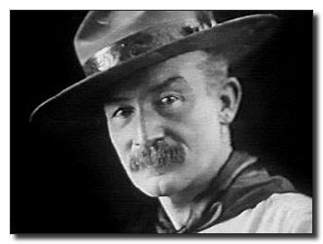
Here are two ways to present this thought from Baden-Powell the founder of Scouting, either as a Cubmaster’s Minute or a presentation by the Cubs
Good Deeds Closing Ceremony
San Gabriel Valley, Long Beach & Verdugo Hills Councils
Personnel: 6 Cub Scouts
Equipment: Stars of different sizes for the boys to hold
- Lord Baden-Powell, the founder of Scouting, said to Scouts everywhere:
- “I often think when the sun goes down, the world is hidden by a big blanket from the light of heaven…
- “but the stars are little holes pierced in that blanket by those who have done good deeds in this world.
- “The stars are not all the same size, some are big, some are little, as some men have done great deeds and some have done small deeds…
- “But they have all made their holes in the blanket by doing good before they went to heaven.”
Piercing Stars - Baden Powell Closing
San Gabriel Valley, Long Beach & Verdugo Hills Councils
Lord Baden-Powell, the founder of Scouting, said: "I often think that when the sun goes down, the world is hidden by a big blanket from the light of heaven, but the stars are little holes pierced in that blanket by those who have done good deeds in this world. The stars are not all the same size; some are big, some are little, and some men have done small deeds, but they have made their hole in the blanket by doing good before they went to heaven. Try and make your hole in the blanket by good work while you are on earth. It is something to be good, but it is far better to do good." Think of Baden-Powell's words when you promise to help other people.

GUIDING STAR
Grand Canyon Council
San Gabriel Valley, Long Beach & Verdugo Hills Councils
Personnel: Akela, 8 Cub Scouts
Equipment:
Small campfire;
blue paper or cardboard,
three foot square, with cutouts for stars in Big Dipper and the North Star;
8 small or pen-type flashlights, one for each Cub Scout.
Arrangement:
Akela and 8 Cub Scouts stand near campfire with the figure of the Big Dipper and North Star at one side of the fire.
Cub Scouts stand behind the figure with lights that they flash behind their star in the Big Dipper as they speak.

Akela: For thousands of years, people have grouped the stars together as figures in constellations. This was probably done by the early shepherds as they lay on the grass looking at the sky while tending their sheep. There they could see pictures of heroes, kings, queens, men, maidens and monsters in the stars. The constellation we know best is the Big Dipper.
Taking the stars that form the outer edge of the Big Dipper sight upward and the bright star that you see is the North Star (Polaris), which for centuries has been the guiding star for travelers.
- (flashes his light in the cutout for the North Star.) It remains in the same place all the time. Let the North Star represent our God. Keep your eyes on the North Star. Each star in the Big Dipper can help you keep your eyes on the North Star - to become your guide for living. Then let your light shine that you can help others find the way.
Now, each of seven Cub Scouts will tell what each star in the Big Dipper represents to him in his quest to find the guiding star.
As they speak, they flash their light behind their star.
- The Holy Bible
- My minister, pastor, priest or Rabbi
- My mother and father
- The Cub Scout Promise
- The Law of the Pack
- My Den Leader
- My Cubmaster
Akela: A11 of these are excellent guides for us to follow on our Cub Scout Trail. Let each one help you as you travel onward. Good Night.
I MADE A PROMISE
Sam Houston Area Council
Five boys are needed for this ceremony. Each should have his part printed on a small card he can conceal in his hand or have the part memorized.
- I made a promise... I said that whatever I did I would do the best I could.
- I made a promise...to serve my God and my country the best I could.
- I made a promise...to help other people the best I could.
- I made a promise.. .to obey the Law of the Pack the best I could.
- I have done my best, and I will do my best because I am the best... I am a Cub Scout.
Den Ldr: Will everyone now join us in repeating the Cub Scout Promise.
Cubmaster’s Minutes
ASTRONAUT PRAYER
Grand Canyon Council
Setting: Have Cub Scouts and their families form a circle
The Cubmaster then reads the following prayer, which was broadcast to earth by U.S. Astronaut Frank Borman while on a moon orbiting mission in December 1968. (Cubmaster should explain what he is reading)
Give us, 0 God, the vision which can see the love in the world, in spite of our failure.
Give us the faith to trust Thy goodness in spite of our ignorance and weakness.
Give us the knowledge that we may continue to pray with understanding hearts, and show us what each one of us can do to set forward the spirit of universal peace."
AMEN
Aim For The Stars I
Grand Canyon Council
San Gabriel Valley, Long Beach & Verdugo Hills Councils
If you want to aim for the stars, you must remember that you are building your launching pad right now by your willingness and initiative in every task you tackle, at home, in church, in school, and in Cub Scouting.
Aim For The Stars II
Grand Canyon Council
The words "Aim for the Stars" have an important meaning to Cub Scouts. There have been many before us who have set their sites and lived their lives by Aiming for the Stars.
And while they may not have it on the first try, or the second, or even the third, they eventually do make it.
A Cub Scout who does his best like our motto says, is bettering himself.
Sure, sometimes he may not "hit the stars," but he grows from his trying. He is preparing himself for greater attempts and for great successes.
Remember, not everyone makes their goals every time, but we all make the world a better place by doing our best and Aiming for the Stars. And isn't that what our real goal is in life?
Aim for the Stars III
San Gabriel Valley, Long Beach & Verdugo Hills Councils
The words, "Aim for the Stars" have an important meaning to Cub Scouts. Think of Thomas Edison who tried and failed hundreds of times before he perfected the electric light bulb. He never quit trying. A Cub Scout, who tries to do his best and keeps trying, is preparing himself for greater responsibilities when he becomes a man. What you do and how well you do it becomes your launching pad to "Aim for the Stars."
Guiding Stars
Sam Houston Area Council
Who knows the name for the North Star? That’s right, it’s Polaris. When you go out to look at the stars, in the northern sky is the North Star, and you can use it to help you find your way in the wilderness. For centuries man has known that the North Star is fixed in the heavens, and it has been used for navigation by sailors ever since the first adventurers sailed away from the sight of land. The North Star is still used that way by mariners and space explorers. So in learning how to find it, we are joining a very long line of adventurers.
There are other guiding stars in our everyday lives, too. One of them is our conscience. If we listen to our conscience, we can be sure to steer our lives in the right direction.
And let's not forget our Cub Scout Promise and Law of the Pack. They are our guiding stars, because they give us excellent guidance in how to behave and what we owe to God, country, our fellow human beings, and to ourselves.
When you're lost at night, look for the North Star. The rest of the time, steer your life with those other guiding stars.
CLOSING THOUGHT
Grand Canyon Council
We are members of a team of men and women and young people from many nations who have ventured into space seeking the star of peace throughout the world. Many of our U.S. astronauts were Scouts.
The ideals of Scouting - character development, citizenship training, and personal fitness - which they developed as Scouts have helped them in the tremendous task undertaken.
WEBELOS
Scout Law Straw Relay
Cindy, Mt Diablo Silverado Council
This came to me as a fun way to have Webelos learn the Scout Law. I agree, CD
Materials: straws, 2 sets of each word of the scout law on separate small pieces of paper
Set up:
Two teams
One straw for each player
Put the pieces of paper (spread out) on a table for each team Object: For the team to put the Scout Law in order
How to play:
One by one each team member will pick up piece of the Scout Law using only their straw and take it over to a specific destination.
The first scout must reach the destination and return before the next scout goes.
The team should try and assemble the Scout Law in order as each piece is added.
Once the team has moved all twelve pieces to the destination, they race over to check and, if needed, put the Scout Law in correct order.
The Scout with the last piece must return before all the scouts can proceed to the destination and check if the Scout Law is in order.
The first team to put the law in order is the winner.
Webelos Activity Badge Ceremony Ideas
Baltimore Area Council
AQUANAUT - If the Pack meeting is held at a pool, have the boys swim across the pool to receive their badge. If inside, have them demonstrate a swimming stroke and pretend to swim to you to receive his badge.
ARTIST - Webelos leader is dressed as an artist and pretends to paint portrait of the Webelos as he is sitting on a stool posing. He puts down his palette and paintbrush and says "Each boy is a masterpiece. " He then hands the boy a pre-made silhouette of the boy and the activity badge he has earned.
ATHLETE - Do a standing long jump and catch badge that the Webelos Leader is holding at arms length.
CITIZEN - The Webelos Leader dressed as judge, pounds gavel on table and says, "Hear ye, Hear ye, Hear ye. 1 present to you on this day of in the year of Our Lord. 20______, (boy's name) as a new citizen of our Pack and community."
COMMUNICATOR - Webelos leader uses sign language to tell what the activity badge is. He gives the badge to the Webelos Scout who thanks him in sign language also.
CRAFTSMAN - Webelos leader and boys are busy building crafts and leader says, "Well boys, we've sure had a busy month making all these things, but I think we have made more than just toys. We have come a step closer in making you young men." He then gives them their badge.
ENGINEER - Several boxes with the name of Pack Officers (Cubmaster, Den Leader, Committee Chairman, etc.) are scattered around. The Webelos Den Leader comes on stage and picks up a box and reads out loud what it says, and then places it back on the floor facing the audience. Start with the committee members first. Build the boxes up in the shape of a pyramid. As the name of a boy is read that has earned the activity badge he comes forward and is given the badge. His leader congratulates him on the achievement and tells him how great it is that he can be part of the Cub Scout pyramid.
FAMILY MEMBER - The Webelos Leader calls the Webelos Scout and all the members of his family including brothers, sisters, and aunts, uncles, etc. He lines them all up according to size from the tallest one next to him to the smallest one next to the Webelos Scout. He then says "Since this activity badge was earned with the help of all the family, I will give it to the tallest member of the family. Each of you will pass it down the line until it reaches the Webelos Scout."
FITNESS - Do a sit up and reach out and take the badge that is being held at the end of his feet. (Just far enough to give him a good stretch before getting it.)
Do a push-up. The boy will pick up the badge with his mouth as he lowers himself to the floor, and as the Webelos Leader is holding the badge near the floor beneath the boy.
FORESTER -The Webelos Leader has all the activity badges attached to a branch of a tree. he says "I am presenting you this activity badge in the hopes it plants a seed of knowledge that will grow with time."
GEOLOGIST - Webelos Leader is examining several large rocks that are out on the table. He comes to the largest one and picks up a hammer and chisel, and proceeds to chisel on the rock. He removes an award from the rock and calls forward the boy who is to receive it. The chiseling continues until all awards are presented.
HANDYMAN - The Webelos Leader rolls on old tire out. Inside the tire are the activity badges. He says, *'This tire is old. It has served its purpose. We have in our midst, several future mechanics." He calls up the boys who have earned the badge and takes the badges out of the tire and presents them.
NATURALIST - Webelos leader is inspecting insect collection and notices something different and out of place, "What is this? I don't remember seeing this before. Oh, (boys name) this must belong to you for earning your Naturalist Activity Badge.”
CRAFTSMAN
TECHNOLOGY GROUP
Baltimore Area Council
The requirements for the Craftsman activity badge include projects in wood, leather and tin. This activity helps the boys develop confidence in their abilities by encouraging them to use their talents and skills for more advanced handicraft projects, or perhaps to develop a hobby in one of these mediums.
Where to Go and What to Do
- Visit a furniture factory, sawmill, lumberyard, or cabinetmaker.
- Visit a tannery or leather goods manufacturer.
- Demonstrate the proper care and use of tools.
- Demonstrate metal work, using a tin snips and vise.
- Nave a nail-driving contest.
- Make a tool chest.
Carpenter's Level
Southern NJ Council
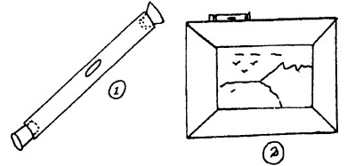
You can make a carpenter's level out of a glass tube - like dentists use or the kind of plastic tube a toothbrush comes in.
With the vial from the dentist's office, remove one rubber cork from the end. Rinse tube out good and then fill almost full of water and replace cork.
With a glass or plastic tube, cork one end, fill nearly full with water, then cork the end. (pic 1.)
Lay tube on a flat surface. If this surface is perfectly level, the bubble inside the tube will be exactly in the middle. If the surface is not quite level, the bubble will be off center one way or the other. (pic 2.)
Book Trough
Southern NJ Council
Copy picture and enlarge. Then trace diagram of book ends onto 3/8" board or plywood. Cut shelves from measurements. Make ends identical by clamping together before cutting and finishing.
Mountain Cabin Bookends
Baltimore Area Council
Using 3/4" wood, cut one back 4" x 6", one base 3" x 4", one cabin and one tree for each bookend. See pattern pieces
After making pieces, assemble and paint as desired.

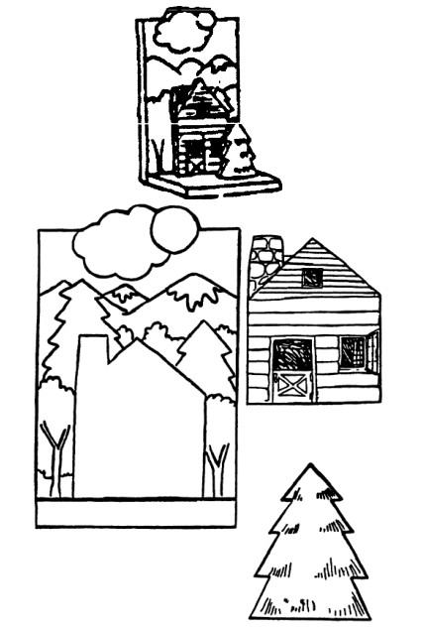
Two-Tone Code Whistle
Southern NJ Council
You can work out a series of code signals with this two-tone code whistle. The twin tones make it penetrate a long distance. Each hole may be used independently or both may be blended.
Walnut, maple or birch are good hardwoods to use. Make sure the holes are completely free of sawdust. Round off all edges and sand it smooth, then attach a neck strap lanyard long enough so that you can tuck the whistle into your shirt pocket.
Note that the plugs are flattened off at the top. Plugs should make a tight fit for the best resonance.
1. Drill holes as indicated in piece of hardwood. Cut air escape notch.
2. Insert 1/4-inch plugs flush to straight cut of notch. Cut off excess wood.
Personal Bike Rack
Southern NJ Council
Materials:
One 14" x 18" piece of 1/2" plywood;
One 1" x 2" x 2'; one 2" x 8" x 18"
No. 6 flathead screws (1-1 / 4" long);
Six-penny nails;
Varnish or paint;
White glue or powdered resin glue.
- Cut plywood triangles. Drill holes as show with a 5(32" drill bit. Paint or varnish the inside of plywood at this time. It will be difficult to do after rack is assembled.
- Cut the 1" x 2" pieces. Nail the two longest pieces at right angles.
- Cut the 2" x 8" piece. Attach the nailed 1"x2" with screws. Paint or varnish the 1" x 2" now. (Note the right angle is fastened to the 2" x 8" with screws from inside.)
- Fasten the plywood triangles in place with screws through pre-drilled holes. Don't forget the small piece of 1" x 2" that joins the tips of the triangle.
- Sand and complete paint or varnishing the piece.
Picture Frame House
Southern NJ Council
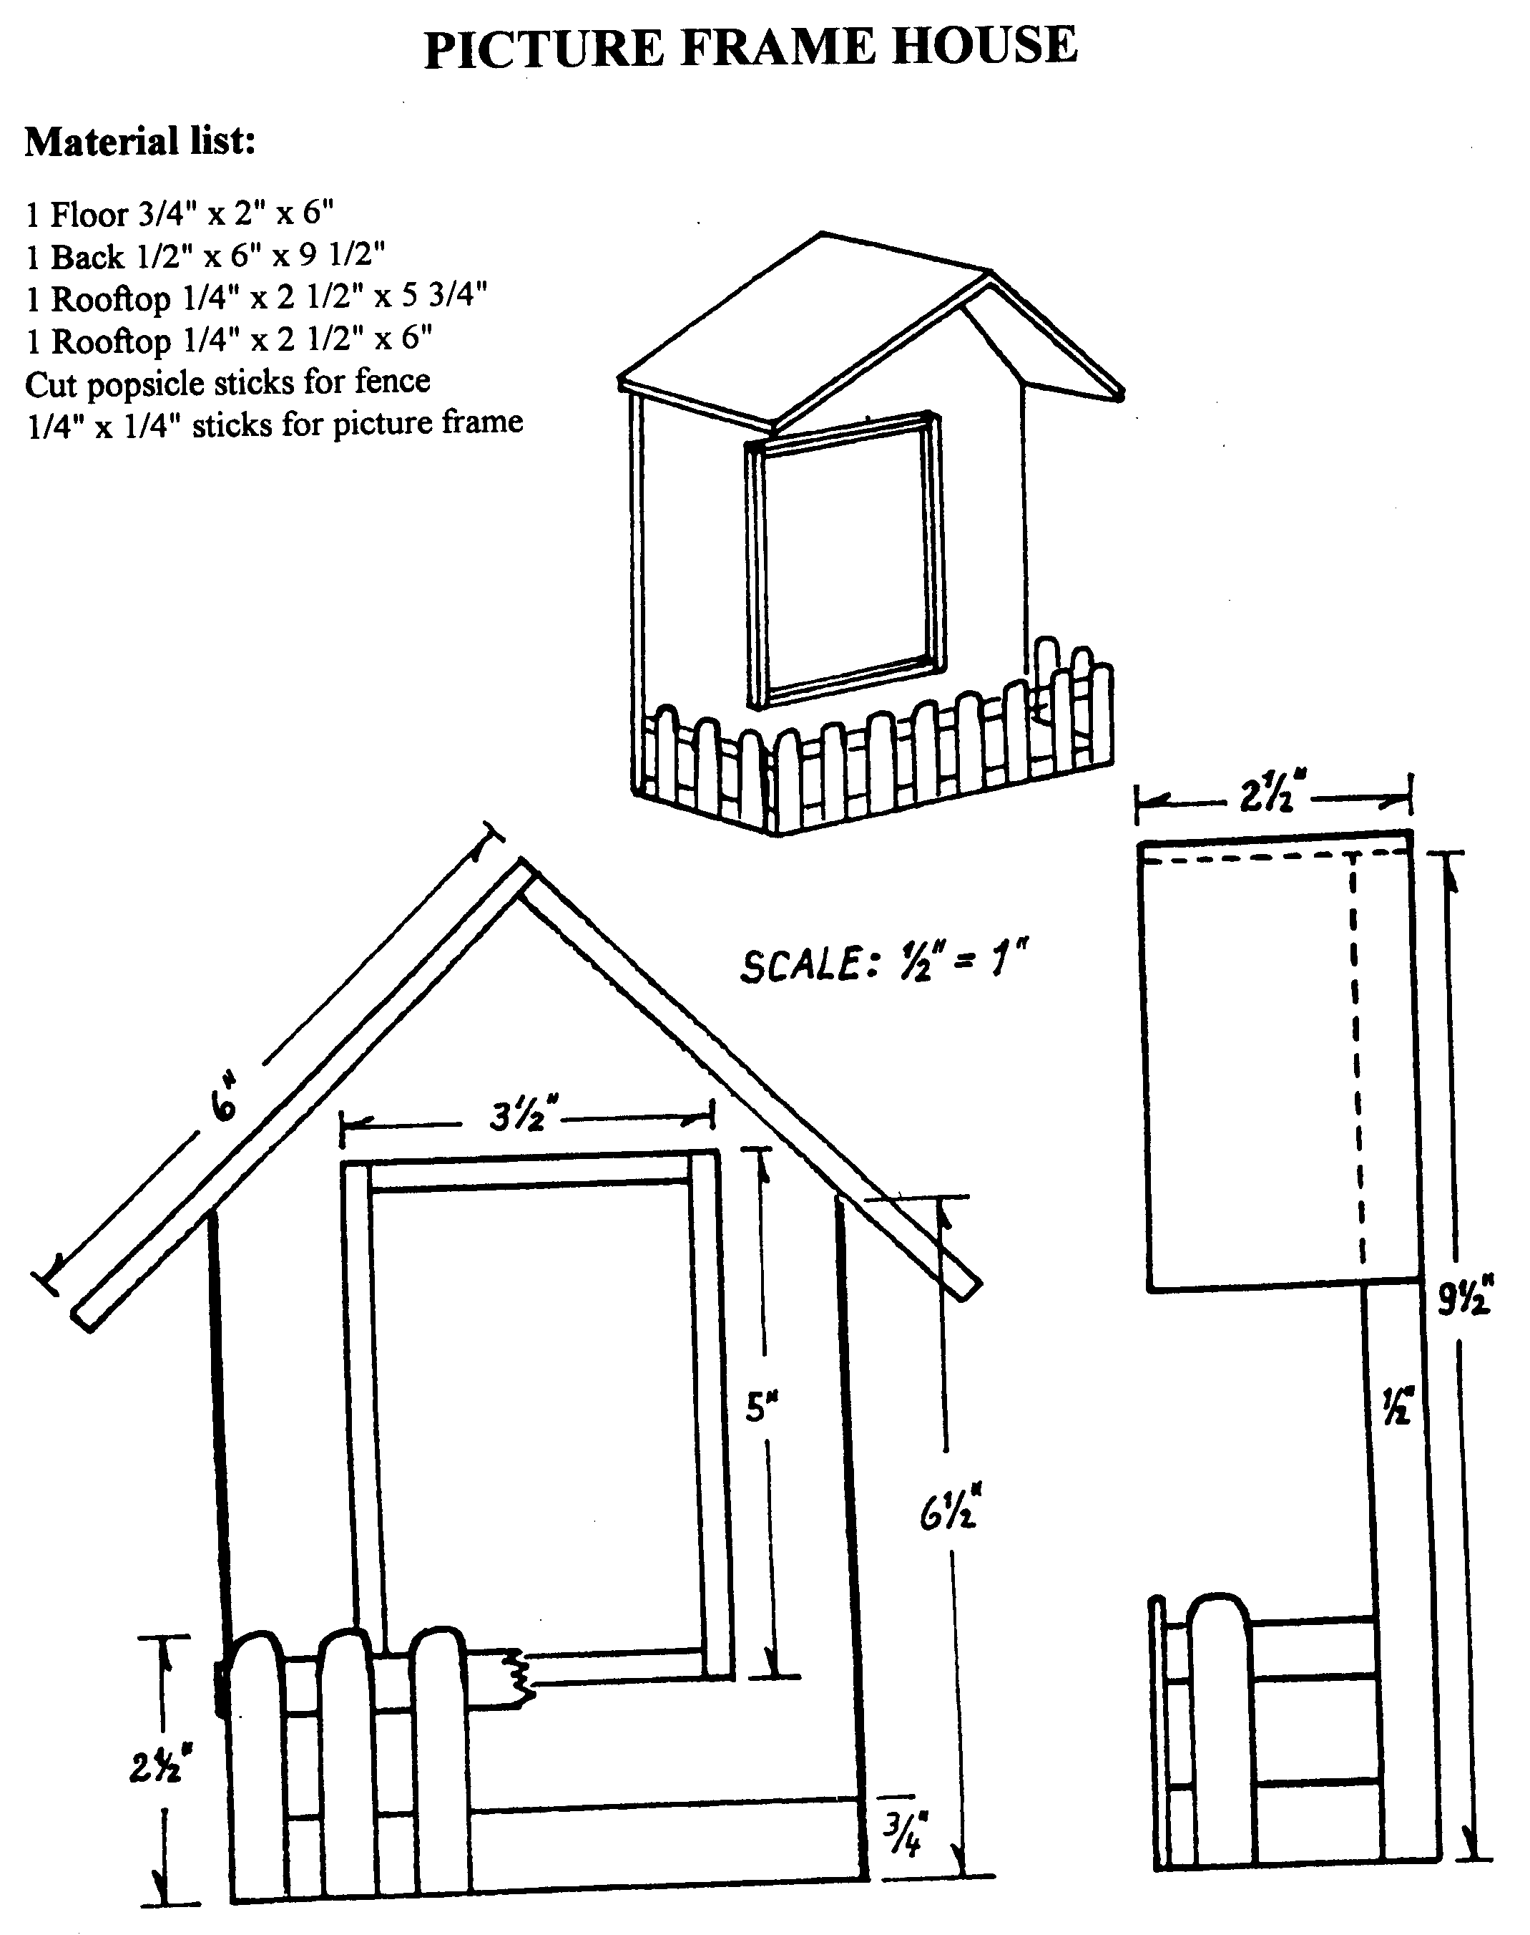

Leather Eyeglass Case
Baltimore Area Council
Measure eyeglasses and cut leather (a piece approximately 6” x 6") so glasses fit easily when case is folded. Fold leather and punch holes for lacing using the running stitch.
Cut simple design into head of a large nail with a file; then file off nail point. Dampen leather and use small hammer to tap the design on.
Wooden Trivet
Baltimore Area Council
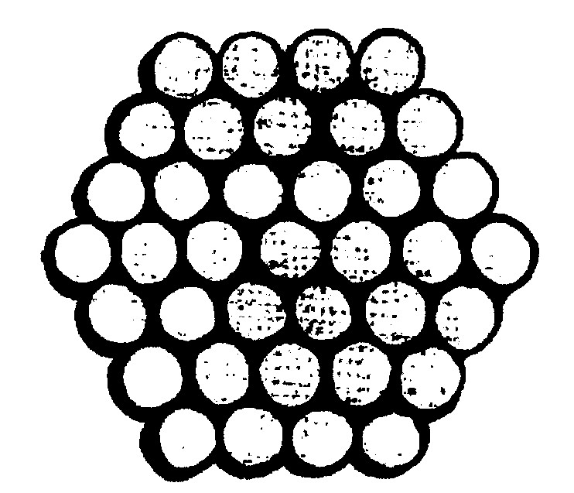
Materials:
1 dowel, 4' long, 1" diameter for each Webelos
Table saw, Sandpaper, Waxed paper, Carpenter's glue
Felt (approx. 6"X6")
Prior to the meeting - Cut the dowel into slices about 1 1/4" thick, using the table saw. You will need 37 pieces for each Webelos.
Have the Webelos -
- Sand any rough edges.
- Lay a piece of waxed paper on the working surface. It can be easily removed from the trivet after the glue has dried.
- Begin gluing the slices together as shown in the picture.
- When glue has dried, pull away waxed paper and cut the felt piece to fit the back of the trivet.
- Glue felt in place.
SCIENTIST
TECHNOLOGY GROUP
Baltimore Area Council
A scientist studies things to team how they behave and why. Scientists try to find out the laws of nature about the things they study. People can use these rules or laws in making things. While working on this activity badge, you will learn a few of the main ideas in physics. Physics is a science with several branches. One of these branches will be weather. You can learn a little about weather in these activity badge requirements. Another branch of physics is called optics. You will have a chance to learn something about sight and find out how your eyes work. Scientists learn a lot by experimenting or trying things out. Try things for yourself. Scientists take nothing for granted. They may be sure an idea is true, but they always test it, if possible, to make certain they are right.
Speakers:
Lab Technician Researcher Zoologist
Optometrist Ophthalmologist Nuclear Physicist
Weather Forecaster Nurse X-Ray Technician
Science Teacher
Pack Meeting
- Honor your Pack leaders by making up some "Scientific Awards." Cut them out of poster board. For example:
  - Gravity is a heavy subject. (Shape of the Earth)
  - Stars are night lights that don't run up bills. (Stars)
  - Astronomers are far-sighted. (Glasses with big eyeballs)
  - Chemists really, stir things up! (Beaker with bubbling mix.)
- Science Fair: Set up and hold a science fair during your Pack meeting. Show some of the simple experiments you have been doing in your Den meetings.
- Display items that you have made.
Den Activities
- Talk about the various branches of science and how they differ.
- Do the atmospheric pressure tests or balance tests in the Webelos Book.
- Make Fog.
- Make Crystals.
- Do the inertia experiments in the Webelos Book.
- Visit an eye specialist and learn how the eyes converge and find out what the various eye tests measure
- Invite a local weatherman to your Den meeting to talk about the climate during the year. How is weather different in the Southern Hemisphere?
- Have a slow-motion bicycle riding contest to illustrate balancing skills.
- Plan a scientific experiment to be demonstrated at the Pack meeting.
Field Trips
- Visit an eye specialist and learn how the eyes work.
- Visit the control tower of the Metropolitan Airport or visit a Municipal Airport.
- Learn about the principles of fight for an airplane and look at all the control dials.
INERTIA
Southern NJ Council
Inertia is the tendency of a thing at rest to remain at rest and a thing in motion to continue in the same straight line.
Get a small stick about 10-inches in length and the diameter of a pencil. Fold a newspaper and place it near the edge of a table. Place the stick under the newspaper on the table and let about half the stick extend over the edge of the table. Strike the stick sharply with another stick. Inertia should cause the stick on the table to break into two parts.
PASCAL'S LAW
Southern NJ Council
Materials:
Rubber balloon
Several pins with large heads
Roll of plastic tape
Inflate the balloon and affix little squares of plastic tape to it. Stick each pin through the center of the tape and to their amazement, the balloon will not burst. When you remove the pins, the balloon still will not burst.
What happens: The adhesive substance on the tape acts like a self healing automobile tire, adhering to the pin as it is pressed inward. When the pin is removed, the adhesive is forced outward by the air pressure from within the balloon, atomically sealing the tiny pinholes.
MYSTIC MATCHES
Southern NJ Council
Put several matches in a bowl almost full of water, making a shape like a star.
Stick a pin into a small piece of soap.
Gently dip the soap into the water at the center of the star of matches, taking care not to disturb them. The matches will all move away from the soap.
What happens: When you dip the soap in the water a little of the soap dissolves. The surface tension of the clean water is stronger that that of soapy water, so the clean water around them pulls the matches outward.
MAKE A FIRE EXTINGUISHER
Southern NJ Council
Materials: 1 or 2 quart bottle with stopper to fit
3” of ½ “ glass, metal or plastic tubing (Tube from an old Windex bottle can be used)
Spoonful of baking soda
Vinegar
Facial tissue
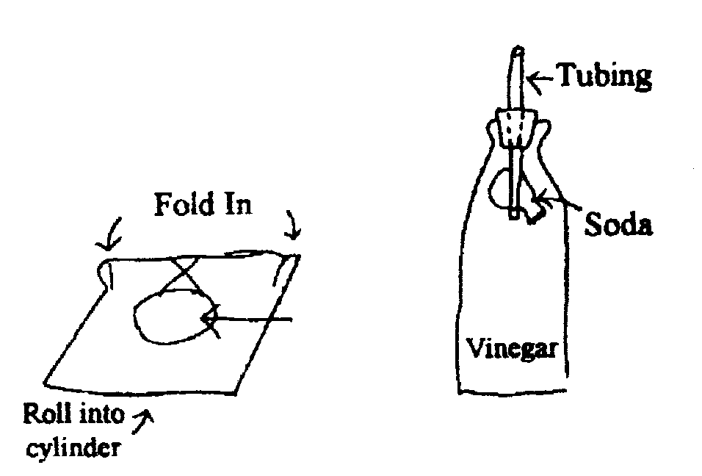
- Drill hole in stopper and insert tubing
- Wrap soda in tissue and attach tissue to tube with rubber band
- Fill bottle one half full of 1 part vinegar and 1 part water
- Insert stopper in bottle with soda inside bottle, but not touching vinegar solution
- To operate, tip bottle upside down, soaking the tissue paper with vinegar
RECORD WIND SPEED
Southern NJ Council
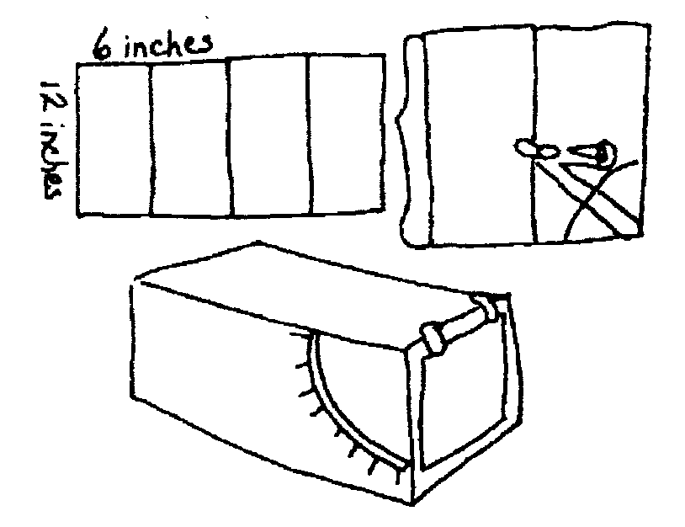
To see how fast or slow the wind blows, make an anemometer (a wind speed measurer)
You will need - stiff cardboard 24” x 12”
- Measure four 6” widths with a ruler, and draw pencil lines with scissors.
- Set a compass to 4” and draw an arc on the cardboard as shown.
- Cut out a narrow slot along the arc.
- Mark numbers at equal intervals along the slot.
- Fold the cardboard inward along the scored lines.
- Put cellophane tape along the two edges and along all the folded edges.
- Cut a piece of paper 4 ¾” square and tape it to the end of the box as shown. Take the anemometer outside and point the flap toward the wind. Each night and morning, record the level that the flap reaches
BOILING ICE
Southern NJ Council
In a heatproof jar with lid, boil a half-inch of water with the lid on loosely so some of the steam can escape. Then tighten the lid and turn jar over. Put an ice cube or two on the jar bottom. In a moment the water will boil again.
What happens? The air pressure has been reduced in the jar by the ice condensing the water vapor inside. The boiling point of a liquid depends on atmospheric pressure.
EXPERIMENTS IN AIR PRESSURE
Baltimore Area Council
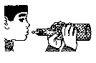
Shooting Back
Place an empty soda bottle on its side. Put a wad of paper in the neck and try to blow it in. It comes back out.
Why? When you blow into an enclosed space like a bottle, you increase the air pressure inside. Since pressure will equalize when it can, the air rushes out of the bottle, taking the wad of paper with it.
Balloon in Bottle –
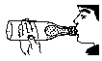
Place a deflated balloon inside a two-liter bottle, with the lip of the balloon over the top of the bottle. "Cry to blow up the balloon.
What happens? Air pressure inside the bottle increases as the balloon takes up space, so air pressure is fighting against you. To inflate the balloon, you would need to compress the air trapped between the balloon and the bottle. To compress air requires force. The human lungs are not strong enough to inflate the balloon and to compress the trapped air.
Making Air Work for Us
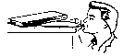
Use a balloon to pick up a glass -- Place a deflated balloon in a glass. Blow up the balloon until it is tight around the edge of the glass. Hold the end of the balloon shut and pick up the glass.
Use a balloon to lift books -- Place a deflated balloon under a stack of books. As you blow the balloon up, the books will rise. A hydraulic lift is based on this principle.
EXPERIMENTS IN ATMOSPHERIC PRESSURE
Baltimore Area Council
We live under a blanket of air called the earth's atmosphere. The air in the atmosphere exerts pressure of almost fifteen pounds per inch on every surface on earth.
Diving Bell

Place a piece of crumpled paper in the bottom of a glass or tin can. Turn the glass upside down and submerge it in a bucket of water. The paper will remain dry. Why? The air, which filled the "empty" space in the glass, stopped the water from entering.
Hanging Water
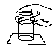
Fill a glass to overflowing and lay a piece of cardboard atop it. Support the card with one hand, turn the glass upside down, and remove your hand from the card. The card does not fall. It remains on the glass and allows no water to escape. Why? The air pressure from below the cardboard is greater than the pressure of the water above and presses the card tightly against the glass.
Wedged Glasses
Place two glasses together with a piece of wet construction paper between them. Burn a candle in the bottom glass. The glasses become "welded" together. Why? The flame uses up the oxygen in the bottom glass, so the pressure is now lower in this glass.
Auto Gyro
Baltimore Area Council
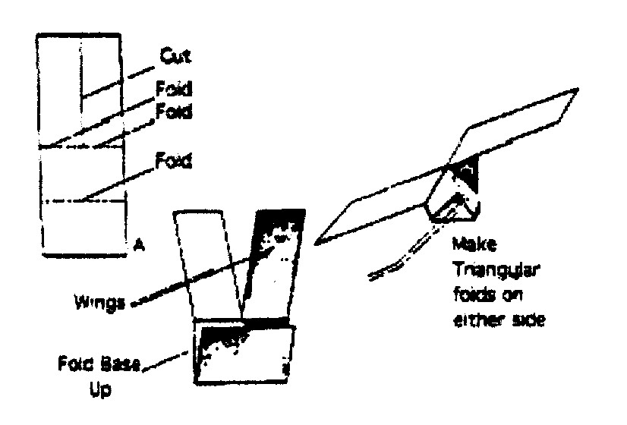
Materials: Paper 3 1/2" wide by 8 1/4" long
The principle of the Auto Gyro can be easily demonstrated by making one as shown in the sketch.
- Using a piece of paper 3 ½" wide by 8 ¼” long, cut down the center of the paper 4" and then fold the cut sections to opposite sides as shown, to form the two wings.
- Fold the balance in halt: and then make two triangular folds to the midline and your Auto Gyro is ready.
- Make two other Auto Gyros basically the same as the first one, but shorten the wing length from four inches to three inches on the second one and to two inches on the third one.
Try flying from the same height and observe how each model reacts. Does any thing seem to slow their descent'? What actually makes it spin'? Note the order in which the three models reached the ground. Are wing size, air resistance, and rate of descent related?
Spinner Scope
Baltimore Area Council
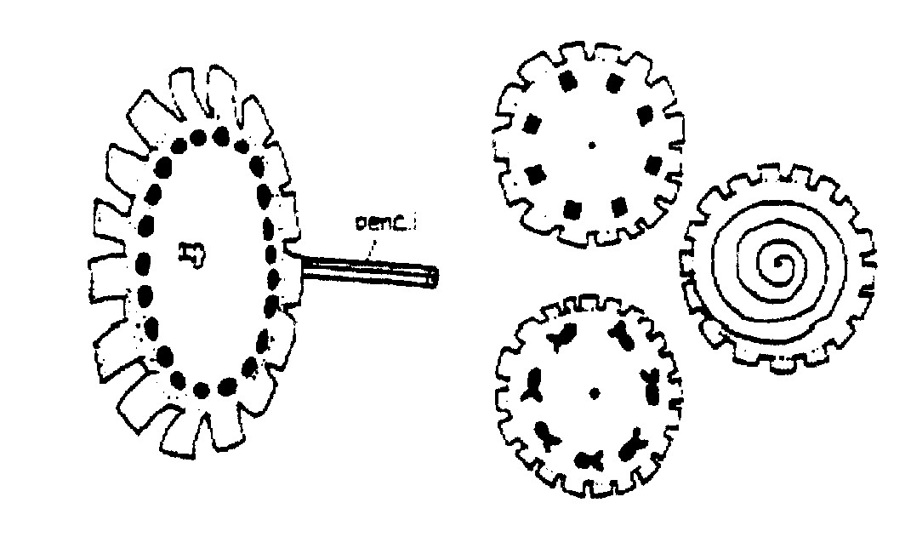
Materials: Paper plates, scissors, watercolor markers, pushpin, unsharpened pencil with eraser top
- Cut out notches around edge of plates as shown.
- Draw a design on each plate with markers. Draw a spiral, small circles close to each other, or a simple object, such as a fish.
- Poke a pushpin through center of plate, then into eraser end of pencil.
- Stand in front of mirror. Spin pencil between hands as you peer through the notches. Each design will produce a different optical illusion as the spinning elements appear to merge.
POW WOW EXTRAVAGANZAS
Let me know as soon as your date is set. I will post whatever I receive. I am hoping to retire in 2007 and visit lots of Pow Wows!!! CD
Southern NJ Council
Aloha, Cub Scouts
Pow Wow in Paradise
November 4, 2006
Lakeside School, Millville, NJ
Call Southern NJ Council, 856-327-1700, extension 32, or visit the website, www.snjscouting.org for more information
Baltimore Area Council
Cub Scout Rodeo
November 4, 2006
Overlea High School, Baltimore, MD
Call Baltimore Area Council, (443) 573-2500, or visit the website, http://www.baltimorebsa.org/ for more information
Sam Houston Area Council
Fun with Mother Nature
November 4, 2006
Spring Woods Senior High School
Houston, Texas
http://www.shac.org/Home/Training/CubScoutLeadersPowWow/
Longhorn Council
Panning for Gold
November 11, 2006
Tarrant County College – NE Campus
Hurst, TX
Call (817) 231-8500 or website http://www.longhorncouncil.org/training
Pioneer Valley & Mohegan Councils
University of Scouting
November 4, 2006
It’s on the council calendar but the website has no details yet
http://www.mohegancouncilbsa.org/
http://www.pvcbsa.org/training/
Clinton Valley and Detroit Area Councils
University of Scouting - Together We Serve
November 4, 2006
Lamphere High School, Madison Heights, MI
www.dacbsa.org or http://www.cvc-bsa.org
Suffolk County Council
All Aboard for Cub Scouting
December 2, 2006
KeySpan J.W. Dye Training Center, Hauppauge, LI, NY
Call (631) 924-7000 or check their website http://www.sccbsa.org/
Sioux Council
Pirates at Pow Wow
November 4, 2006
Southeast Technical Institute, Sioux Falls, SD
Call (605) 361-2697 or check their website
http://www.siouxbsa.org/Events/PowWow06
This should be a really great Pow Wow as my instructor for the Roundtable Class at Philmont, Diane, is chair. CD
Cape Fear Council
The Winning Edge – Pit Crew Training
November 11, 2006
It’s on the council calendar but the website has no details yet
http://www.capefearcouncilbsa.org/training.htm
San Gabriel Valley, Long Beach Area, Verdugo hills Councils
Waiting to here from them for their big February Pow Wow
California
http://www.longbeachbsa.org/
http://www.sgvcbsa.org/
http://www.vhcbsa.org/
WEB SITES
Astronomy for Kids – lots of good stuff here
http://www.dustbunny.com/afk/
The Night Sky
http://www.souledout.org/nightsky/nightskyintro.html
Grand Canyon Council
Space Place
http://spaceplace.jpl.nasa.gov/spacepl.htm
Smithsonian National Air and Space Museum
www.nasm.si.edu
The Space Hopper Game (u can use the tutorial)
www.funbrain.com/constellation/index.html
Lego Space Things
http://lego.jacob-sparre.dk/Ydre_rum/
Space Party
www.geocities.com/heartland/6459/space.html
Astronomy for Kids
http://www.frontiernet.net/~kidpower/astronomy.html
Challenger Center
http://www.azchallenger.org
Star Wars
http://starwars.com/kids
Timucua District Cub Roundtable
http://cubpack42.com/rt.htm
Russ has put together a great site and posts his Roundtable Handout. Lots of good ideas, links and materials.

ONE LAST THING
The Five Finger Prayer
It is sad but often a Cub Scout will ask his leader, “How do I pray to God?” Many of today’s families do not take the time to show their children how to pray. I know there were Boy Scouts in my troop whose only exposure to religious services were the “Scout’s Own” services my troop held at campouts. Here is an easy way to show a Cub how to pray.
Your thumb is nearest you. So begin your prayers by praying for those closest to you. They are the easiest to remember To pray for our loved ones is, as C. S. Lewis once said, a "sweet duty."
The next finger is the pointing finger. Pray for those who teach, instruct and heal. This includes teachers, doctors, and ministers. They need support and wisdom in pointing others in the right direction. Keep them in your prayers.
The next finger is the tallest finger. It reminds us of our leaders. Pray for the president, leaders in business and industry, and administrators. These people shape our nation and guide public opinion. They need God's guidance.
The fourth finger is our ring finger. Surprising to many is the fact that this is our weakest finger, as any piano teacher will testify. It should remind us to pray for those who are weak, in trouble or in pain. They need your prayers day and night. You cannot pray too much for them.
And lastly comes our little finger the smallest finger of all which is where we should place ourselves in relation to God and others. As the Bible says, "The least shall be the greatest among you." Your pinkie should remind you to pray for yourself. By the time you have prayed for the other four groups, your own needs will be put into proper perspective and you will be able to pray for yourself more effectively.
If you want to look for another good way to teach Cub Scouts to pray, in the God and Me level of the God and Country series, they talk about following the PATH while praying. The PATH is –
P – Praise to God
A – Apology for what you have done
T – Thanks to god for all he has given you
H – Asking for help for self and others
Check it out at P.R.A.Y.’S Website, www.praypub.org

