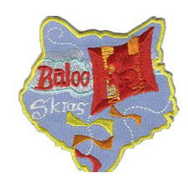
FOCUS
This month Cub Scouts will learn how weather impacts their daily lives. Visit a local weather station and find out what meteorologists are doing to make better weather predictions or watch the weather on radar via the Internet or on TV. Learn about temperature, barometric pressure, and what makes clouds and rain. Make a rain gauge. See how the wind affects the land and oceans. Build and fly a kite with your den or pack. Build a tornado in a bottle. Learn what birds do to “weather” the storms. Invite a science teacher, weather forecaster or meteorologist to come to your pack meeting. Earn the Weather Academic belt loop and pin.

Whether the Weather
Whether the weather be fine. Or whether the weather be not,
Whether the weather be cold. Or whether the weather be hot,
We'll weather the weather. Whatever the weather.
Whether we like it or not.

COMMISSIONER’S CORNER

Months with similar themes to
Baloo Skies
Dave D. in Illinois
Month | Year | Theme
March | 1945 | Cub Weathermen
March | 1977 | Kites-Spring
September | 1986 | Weather Observation
March | 1993 | Weather Observations
March | 1997 | Weather Observations

Weather Words
(from www.weatherwizkids.com)
Advisory: A forecast issued by the National Weather Service to highlight conditions that require caution but are not thought to be immediately life threatening.
Air: The mixture of gases which form the atmosphere of the Earth.
Air Pressure: The weight of air pressing down on earth. Air pressure can change from place to place, and this causes air to move, flowing from areas of high pressure toward areas of low pressure. It’s the same as barometric pressure.
Almanac: A calendar that uses astronomical information and weather data. Almanacs list tide data, give the positions of the stars and forecast weather each day.
Anemometer: A weather instrument that measures the wind speed.
Anticyclone: A high-pressure system that moves in a clockwise motion. These bring you sunny skies.
Arctic Air: An air mass that originates over Canada and brings us cold temperatures.
Atmosphere: A layer of gases surrounding a planet. The Earth’s atmosphere is divided into five layers: exosphere, thermosphere, mesosphere, stratosphere, and troposphere.
Barometer: An instrument that measures air pressure.
Barometric Pressure: The same as air pressure. The pressure exerted by the atmosphere at a given point.
Blizzard: An intense winter storm with winds of 35 mph. or higher with falling and/or blowing snow to reduce visibility below ¼ mile for at least three hours.
Breeze: A light wind.
Ceiling: The height of the lowest layer of broken or overcast cloud layer.
Cirrus Clouds: Thin, wispy clouds that form high in the atmosphere as their water vapor freezes into ice crystals. Cirrus clouds are a principal cloud type.
Clear Sky: When the sky has no clouds.
Clouds: A visible collection of tiny water droplets or, at colder temperatures, ice crystals floating in the air above the surface. Clouds come in many different sizes and shapes. Clouds can form at ground level, which is fog, at great heights in the atmosphere, and everywhere in between. Clouds offer important clues to understanding and forecasting the weather.
Cold Front: A boundary between two air masses, one cold and the other warm, moving so that the colder air replaces the warmer air.
Condensation: The change of water vapor to liquid water, as when fog or dew forms.
Coriolis Force: A force that deflects moving objects to one side because of the Earth’s rotation. The object is still going straight but the Earth moves underneath it, making it look like it is moving to one side. In the Northern Hemisphere, the Coriolis Force deflects objects to the right.
Cumulonimbus: A dense and vertically developed cloud that produces thunderstorms. The cloud can bring heavy showers, hail, lightning, high winds and sometimes tornadoes.
Cumulus Clouds: Fluffy, mid-level clouds that develop in towering shapes and signal fair weather. Cumulus clouds are a principal cloud type.
Cyclone: A low pressure system. It is a term variously applied to tornadoes, waterspouts, dust storms, hurricanes and even to any strong wind.
Dew: Water that forms on objects close to the ground when its temperature falls below the dew point of the surface air.
Dew Point: The temperature at which water starts to condense out of a particular air mass. The dew point temperature changes only when the moisture content of the air changes. The higher the dew point, the greater the moisture content is in the air.
Disturbance: A low pressure system, a tropical area of storminess, or any area in which the weather is in a state of cloudiness, precipitation or wind.
Drizzle: Light rain consisting of water droplets that are very small.
Drought: A period when a region has a lack of rainfall. Droughts can affect a fairly small area for a season or an entire continent for years. Too little rainfall can cause shortages in the water supply, destroy crops, and cause widespread hunger. Droughts also dry up soil, which then gets picked up by the wind and causes dust storms.
El Niño: The unusual warming of the surface waters of the eastern tropical Pacific Ocean. It causes changes in wind patterns that have major effects on weather all across the globe.
Erosion: The wearing away of the Earth’s surface by the action of the sea, running water, moving ice, precipitation or wind.
Evaporation: The process of changing a liquid (like water) to a vapor. It’s the opposite of condensation.
Flash Flood: Sudden flooding that occurs when floodwaters rise swiftly with no warning within several hours of an intense rain. They often occur after intense rainfall from slow moving thunderstorms. In narrow canyons and valleys, floodwaters flow faster than on flatter ground and can be quite destructive.
Flood: It results from days of heavy rain and/or melting snows, when rivers rise and go over their banks.
Flood Stage: The level at which a stream, river or other body of water begins to or will begin to leave its banks.
Fog: A cloud on the ground that reduces visibility.
Freeze: Occurs when the temperature falls below 32° F over a large area for an extended period of time.
Freezing Rain: Rain that falls in liquid form but freezes upon impact to form a coating of glaze on the ground and on exposed objects.
Front: A boundary between two different air masses, resulting in stormy weather. A front usually is a line of separation between warm and cold air masses.
Frost: White ice crystals that form on a surface, like the ground or leaves of a plant. Frost is created when the air temperature drops below freezing and the water vapor in the air freezes into ice crystals.
Funnel Cloud: A tornado that doesn’t reach the ground. It has a rotating cone-shaped column of air extending downward from the base of a cumulonimbus or thunderstorm cloud, but whose circulation does not make contact with the ground.
Gulf Stream: A warm swift current in the Atlantic Ocean that flows from the Gulf of Mexico along the eastern coast of the United States and then northeast toward Europe.
Hail: A mixture of liquid and frozen precipitation. Hailstones are composed of layers of ice and can become quite large when strong gusts of upward-moving air keep them inside the cloud. As they move around inside the cloud they collide with raindrops, adding layers and growing before they fall to earth.
Haze: Tiny particles of dust, smoke, salt or pollution droplets that are scattered through the air. The particles are too small to be seen or felt individually, but they diminish visibility.
Heat Advisory: An advisory issued by the National Weather Service within 12 hours of the onset of the following conditions: a heat index of at least 105° F but less than 115° F for less than 3 hours per day or if nighttime lows remain above 80° F for 2 consecutive days.
Heat Index: The ‘feel like’ temperature on a hot day. The heat index is a number that expresses the warming effect of humidity at different temperatures. Only air temperature and relative humidity are used in the calculation of heat index.
High Pressure System: A whirling mass of cool, dry air that generally brings fair weather and light winds. When viewed from above, winds spiral out of a high-pressure center in a clockwise rotation in the Northern Hemisphere. These bring sunny skies.
Humidity: The amount of water vapor in the air.
Hurricane: An intense storm with swirling winds up to 150 mph. Usually around 300 miles across, hurricanes are 1,000-5,000 times larger than tornadoes. Hurricanes are known by different names around the world. In Japan they are Typhoons while Australians call them Willy-Willys.
Hurricane Season: A six-month period from June 1 to Nov. 30, when conditions are favorable for hurricane development.
Hygrometer: An instrument that measures the water vapor content of air or the humidity.
Ice: A water substance in the solid phase.
Ice Storms: They occur when temperatures below a raining cloud are very cold, causing the raindrops to become supercooled (less than 32° F). Freezing rain covers streets, houses, and trees with heavy layers of ice, causing concern for dangerous driving, and damage from the weight of the ice.
Indian Summer: A warm, tranquil spell of weather in the autumn, especially after a period of cold weather. The term is used most often in the Midwest and New England.
Inversion: A layer in the atmosphere where the temperature increases with height.
Jet Stream: A strong high level wind found in the atmosphere that can reach speeds in excess of 200 mph, usually occurring 6 to 9 miles above the ground. These winds often steer the movement of surface air masses and weather systems.
La Niña: A widespread cooling of the surface waters of the eastern tropical Pacific Ocean. It’s the opposite of El Niño.
Lightning: An enormous and very hot spark of electricity produced by thunderstorms. The lightning bolt itself can heat the air through which it travels to 54,000° F.
Low Pressure System: A whirling mass of warm, moist air that generally brings stormy weather with strong winds. When viewed from above, winds spiral into a low-pressure center in a counterclockwise rotation in the Northern Hemisphere.
Meteorologist: A scientist who studies and predicts the weather. Meteorologists use sophisticated equipment, like Doppler radar and supercomputers, but they also rely on old-fashioned sky watching.
Meteorology: The study of the atmosphere and all its phenomena, including weather and how to forecast it.
Mist: Water droplets so small that they are floating in the air. Because mist droplets do not fall, mist is a type of fog.
Monsoon: A seasonal wind, found especially in Asia that reverses direction between summer and winter and often brings heavy rains.
Muggy: The description of warm and humid air.
National Hurricane Center: The federal agency that issues watches, warnings, forecasts, and analyses of hazardous tropical weather.
National Weather Service: The federal agency that provides weather, hydrologic, and climate forecasts and warnings for the United States.
Nor'easter: A powerful low-pressure system that moves north along the Atlantic Coast. It’s called a Nor’easter because the coastal winds are from the northeast. Heavy rain, snow and high surf often occur.
Occluded Front: A combination of two fronts that form when a cold front catches up and overtakes a warm front.
Overcast: When a widespread layer of clouds covers all of the sky. There may be thin or bright spots in the cloud layer but no openings.
Ozone: A form of oxygen that has a weak chlorine odor. Ozone heats the upper atmosphere by absorbing ultraviolet from sunlight. In the troposphere, ozone is a pollutant, but in the stratosphere it filters out harmful ultraviolet radiation.
Precipitation: General name for water in any form falling from clouds. This includes rain, drizzle, hail, snow and sleet, although dew, frost and fog are not considered to be precipitation.
Radar: An electronic instrument, which determines the direction and distance of objects that reflect radio energy back to the radar site. This is what meteorologists use to see rain or snow.
Rain: Liquid precipitation in the form of water drops that falls from clouds for several hours.
Rainbow: One of the most common but most spectacular sky displays. Rainbows are caused by the reflection and refraction (bending) of sunlight passing through raindrops. In heavy rains a double rainbow can often be seen. The sequence of a rainbow’s colors is red, orange, yellow, green, blue, indigo and violet.
Relative Humidity: The ratio of water vapor contained in the air compared to the maximum amount of moisture that the air can hold at that specific temperature and pressure.
Ridge: An elongated area of high pressure.
Saffir-Simpson Scale: A hurricane intensity scale that relates hurricane damage to wind speeds and central air pressures.
Category 1: wind speeds 74-95 mph
Category 2: wind speeds 96-110 mph
Category 3: wind speeds 111-130 mph
Category 4: wind speeds 131-155 mph
Category 5: wind speeds over 155 mph
Seasons: The earth's position in relation to the sun is always changing. The earth spins around its axis, an imaginary line that runs between the north and south poles. One complete spin takes 24 hours, and at any moment, half of the earth is lit and warm (day), while the other half faces away from the sun (night). While it spins the earth also moves around the sun in a circle, called an orbit, and the orbit takes one year to complete. As the earth moves and spins it is tilted in one direction at an angle of 23 degrees. It stays tilted all the time as it orbits the sun so that each area of earth receives different amounts of the sun's energy at different times of the year. This is why we have seasons.
Severe Thunderstorm: A thunderstorm with winds of 58 mph or greater and/or with hail ¾ inch in diameter or larger.
Severe Weather: Any kind of destructive or life-threatening weather event. Thunderstorms can be destructive, while tornadoes, high winds, hail, excessive rainfall and lightning can be life threatening.
Showers: Rain falling from the sky causing puddles to form on the ground.
Shear: A variation in the wind speed and/or direction over a short distance.
Sleet: Solid precipitation in the form of ice pellets form when raindrops, originating in warmer air aloft, freeze as they fall through subfreezing air near the surface of the Earth.
Snow: Precipitation that is composed of white ice crystals that fall from clouds. Snow may stick together to form snowflakes, which have a hexagonal or six-sided shape.
Snow Flurries: Brief occurrences of very light snow, which produce little or no accumulation.
Snow Showers: Brief occurrences of light to moderate snow, which could produce some snowfall accumulations.
Snowflakes: Packets of falling snow formed when at least a few ice crystals are matted together. The largest snowflakes tend to occur when temperatures are near freezing. Snowflakes have a hexagonal or six-sided shape.
Sprinkle: A very light shower of rain just barely wetting the ground.
Squall Line: A line of thunderstorms sometimes several hundred miles long that can produce strong thunderstorms and sometimes severe weather.
Stable Air: Air that is colder than its surroundings and is resistant to upward movement.
Stationary Front: A boundary between two air masses that more or less doesn’t move, but some stationary fronts can wobble back and forth for several hundred miles a day.
Storm: Any disturbed state of the atmosphere that creates unpleasant weather like rain, lightning, thunder, hail, snow, sleet, and freezing rain.
Stratus Clouds: Low-lying, gray and sheetlike clouds that often produce drizzle. Stratus clouds are a principal cloud type.
Supercell: A severe thunderstorm whose updrafts and downdrafts are in near balance for several hours. Supercells often produce large hail and tornadoes.
Temperature: The measurement of how hot or cold something is.
Thermometer: The instrument that measures temperature.
Thunder: The explosive sound of air expanding as it is heated by lightning.
Thunderstorm: A storm produced by a cumulonimbus cloud and always has lightning and thunder. Rain, hail and high winds may or may not occur.
Tidal Wave: A destructive and high rise of water along a seashore. Tidal waves are caused by underwater earthquakes, volcanoes or landslides, and have nothing to do with tides.
Tornado: Begins as a funnel cloud with spinning columns of air that drop down from a severe thunderstorm. When they reach the ground they become tornadoes. Tornadoes are between 300 and 2,000 feet wide and travel at speeds of 20 to 45 miles per hour. They usually only last a few minutes, but their spinning winds, up to 300 miles per hour, can lift houses into the air and rip trees from the ground.
Trade Winds: Winds which blow from tropical high pressure belts toward the equatorial region of low pressure. In the Northern Hemisphere, the trade winds blow from the northeast.
Tropical Storm: A low-pressure disturbance that forms over warm tropical ocean waters. In the United States, a tropical storm has winds between 39 -73 mph.
Tropical Depression: A low-pressure disturbance that forms over warm tropical ocean waters and produces winds of 38 mph or less.
Trough: An elongated area of low pressure.
Tsunami: A Japanese term for an unusually large ocean wave caused by undersea earthquake, landslide, or volcanic eruption. Only a few inches high in the open ocean, tsunamis steepen and rise in shallow water and can reach heights of 200 feet.
Typhoon: A hurricane in the western Pacific Ocean.
Unstable Air: Air that is warmer than its surroundings and tends to rise, leading to the formation of clouds and precipitation.
Veering Wind: A wind that changes its direction in a clockwise motion. For example, a west wind changing to a northwest wind.
Visibility: The greatest distance that is possible for a person to see with their eyes. When fog occurs, a person’s visibility is lowered.
Wall Cloud: An area of clouds that extends underneath a thunderstorm. If a wall cloud rotates, it might form a tornado.
Warm Front: The boundary between two air masses, one cool and the other warm, moving so that the warmer air replaces the cooler air.
Warning: A forecast issued by the National Weather Service indicating that a specific weather event is actually occurring.
Watch: A forecast issued by the National Weather Service indicating that conditions are favorable for a particular weather hazard.
Water Vapor: A gas in the atmosphere. There is very little of it in the air. Water vapor is only 1 to 4% of the atmosphere, but without it we would have no clouds, rain, or snow. Water vapor is one of the greenhouse gases which help to trap the earth's heat.
Waterspout: A tornado occurring over water.
Weather: Describes the condition of the air at a particular time and place. Weather also tells how the air moves (wind) and describes anything it might be carrying such as rain, snow or clouds. Thunder, lightning, rainbows, haze and other special events are all part of weather.
Wind: The movement of air relative to the surface of the earth. It’s considered to be severe if 58 mph or greater. Hurricane winds are 74 mph or greater and the highest tornado winds are about 318 mph.
Wind Advisory: An advisory from the National Weather Service when the winds are between 29-38 mph lasting more than one hour, or when wind gusts are between 44-57 mph.
Wind Chill: The ‘feel like’ temperature on a cold day when you factor in the winds.
Wind Chill Factor: A number that expresses the cooling effect of moving air at different temperatures. Only air temperature and wind speed is used in the calculation of wind chill temperatures. A wind chill temperature of 30° F below zero or colder on exposed skin can cause frostbite in a very short period of time.
Zonal Flow: When the winds in the upper levels of the atmosphere blow from coast to coast with little or no deviation. In other words, the jet stream creates a straight line.

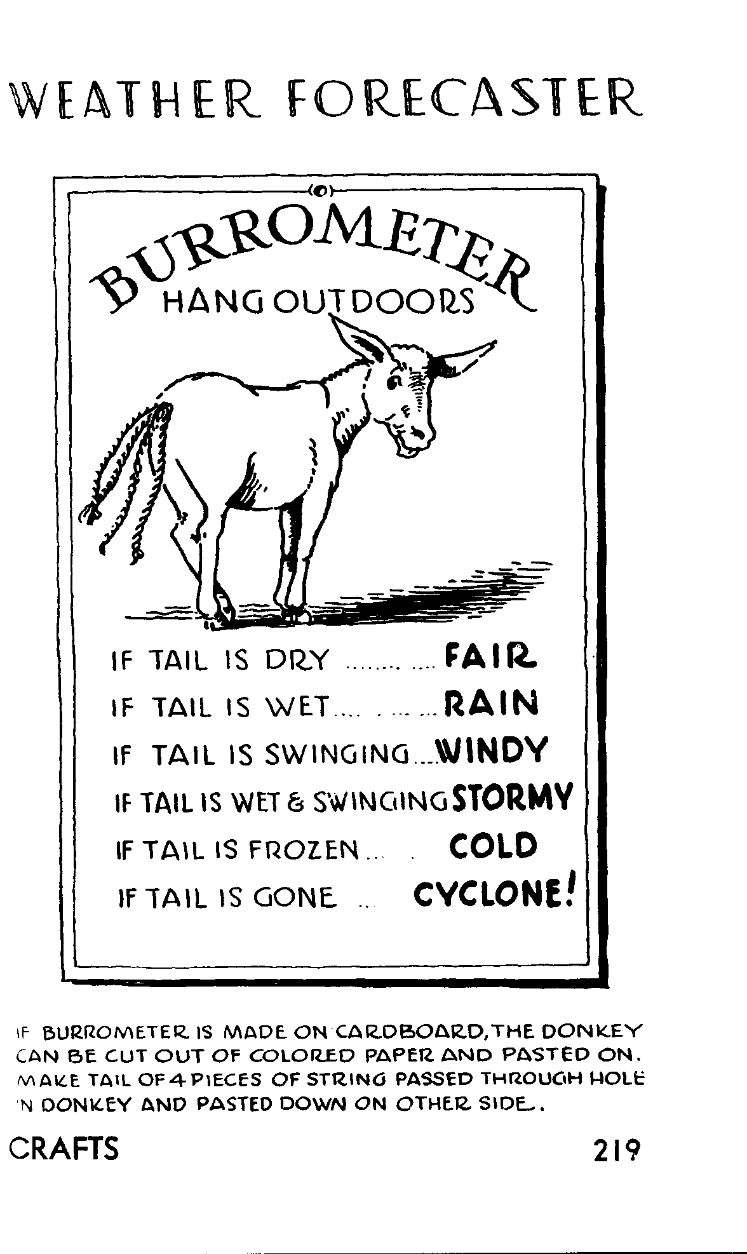
Like the Burrometer – Have your den build one!!!

CORE VALUES

BALOO SKIES CORE VALUE: RESPONSIBILITY
As the Cub Scouts learn about the local weatherman’s job, the National Weather Service, and how they affect our lives, they also learn the responsibility held by these important people. In den meetings, the leaders will tell about the National Weather Service, study relative humidity, and study different types of clouds. The scouts will learn how to measure rain, make a weather vane, and how weather affects farmers and airline pilots. To make pack meeting more meaningful, you could invite a meteorologist as a guest speaker. Ask him to assist with the awards. If a guest is unavailable, the Cubmaster could dress like a weatherman to present the awards. Use a large map or outline of the U.S. as a backdrop. The name of each scout receiving an award can be on either a cloud or raindrop and put on the map. (Under each cloud or raindrop is a sun with their name on it). As the scouts receive their award the cloud or raindrop will be taken from the map, leaving only a sun with their name, making it an all ‘Baloo’ skies.

THOUGHTFUL ITEMS FOR SCOUTERS
Thanks to Scouter Jim from Bountiful, Utah, who prepares this section of Baloo for us each month. You can reach him at bobwhitejonz@juno.com or through the link to write Baloo on www.usscouts.org. CD

Roundtable Prayer
Roundtable Planning Guide
Great Spirit, thank you for the weather each day.
The storms that show us how to work through our problems,
The Clear skies that brighten our days,
The breezes that bring us the fragrances of our world,
The rains that refresh all living things; and
Allow us to grow in your spirit, Amen.

Weather Watch
Scouter Jim, Bountiful Utah
During February we celebrate Groundhog Day. March is a month when the wind blows. April is known as a month of rain, followed by May, a month of flowers.
As Cub Scout leaders we are often leading boys in outdoor activities, camping, hiking, cooking or just being outside playing. It is wise for us to know some important things about weather.
Lightning can and should stop any outdoor activity in its tracks. A retired Weatherman has written a book on weather and writes the following:
“On any given day some 44,000 thunderstorms rage around the world, with approximately 100 lightning strokes hitting the earth per second. In the United States, lightning has killed more than 7,500 Americans over the past 40 years, (1939-1979), more than those killed by hurricanes and tornadoes.” Mark Eubank’s UTAH WEATHER, Bountiful, Utah, 1979.
That is not to say, we should let weather always cancel any outdoor activity, but we should seek direction. At each of our Scouting activities we have two parts to our openings; one honoring country and one honoring God. It is wise during our invocation to our Creator, that we ask for guidance and then listen when it comes.
John Newton was a young sailor on a slave ship in the 18th century when during a violent storm he made a promise to God that if he were to survive he would devote his life to God’s service. He became a minister, and penned the words to one of the most famous of Christian hymns, Amazing Grace.
Weather can be an aid to help us temper the metal of boys into the steal of great men, if we listen to the promptings we feel.

Quotations
Quotations contain the wisdom of the ages, and are a great source of inspiration for Cubmaster’s minutes, material for an advancement ceremony or an insightful addition to a Pack Meeting program cover.

Sunshine is delicious, rain is refreshing, wind braces us up, snow is exhilarating; there is really no such thing as bad weather, only different kinds of good weather. John Ruskin

A lot of people like snow. I find it to be an unnecessary freezing of water. Carl Reiner

The trouble with weather forecasting is that it's right too often for us to ignore it and wrong too often for us to rely on it. Patrick Young

The best thing one can do when it's raining is to let it rain. Henry Wadsworth Longfellow

There is no season such delight can bring
As summer, autumn, winter and the spring.
William Browne

I played as much golf as I could in North Dakota, but summer up there is pretty short. It usually falls on Tuesday. Mike Morley

Some people walk in the rain, others just get wet. Roger Miller

Rain! whose soft architectural hands have power to cut stones, and chisel to shapes of grandeur the very mountains. Henry Ward Beecher

Many a man curses the rain that falls upon his head, and knows not that it brings abundance to drive away the hunger. Saint Basil

A rainy day is the perfect time for a walk in the woods. Rachel Carson

The coldest winter I ever spent was a summer in San Francisco. Mark Twain, attributed

Where does the white go when the snow melts? Author Unknown

A snowflake is one of God's most fragile creations, but look what they can do when they stick together! Author Unknown

Snowmen fall from heaven... unassembled. Author Unknown

Bad weather always looks worse through a window. Author Unknown

There is little chance that meteorologists can solve the mysteries of weather until they gain an understanding of the mutual attraction of rain and weekends. Arnot Sheppard

I am sure it is a great mistake always to know enough to go in when it rains. One may keep snug and dry by such knowledge, but one misses a world of loveliness. Adeline Knapp

Weather Sayings
Old saws and their real meaning

When chairs squeak, it's about rain they speak.
Wooden chairs will absorb moisture from the air when humidity rises. This causes them to squeak.

"When clouds appear like rocks and towers, the earth will be washed by frequent showers."
When there are large tower-like clouds (cumulonimbus clouds), very big storms will occur.
This happens because cumulonimbus clouds are made of water droplets at lower elevations and ice crystals at higher elevations. When the ice crystals or water droplets detach from the clouds and start to fall, they melt and turn into heavy rain.

"When the wind is out of the east,
'Tis neither good for man nor beast."
Easterly winds usually indicate an approaching weather front or low pressure area. Low pressure generally brings bad weather. Remember that wind is out of the east, a "high" that came from the west has already passed you by, or is currently passing by on the north. A low pressure system is sure to follow since highs and lows usually tend to alternate in progression.

Evening red and morning gray, send the traveler on his way.
Evening gray and morning red, send the traveler wet to bed.
At dusk, a red sky indicates that dry weather is on the way. This is due to the sun shining through dust particles being pushed ahead of a high pressure system bringing in dry air. A red sky in the morning is due to the sun shining through dust. In this case however, the dust is being pushed on out by an approaching low pressure system bringing in moisture. Don't confuse a red sky in the morning with a red sun in the morning. If the sun itself is red and the sky is a normal color, the day will be fair.

"Sea gull, sea gull,
Sitting on the sand;
It's never good weather
When you're on land."
Birds settle on the sand or in trees when bad weather is coming. Some people say it is because the winds are stronger before a rain. Wind makes it harder to fly.

"Rainbow in the morning shepherds take warning,
Rainbow at night shepherds delight."
A rainbow in the morning is formed when light from the rising sun in the east strikes and refracts through the water droplets from a rain cloud in the western sky. Rainbows always occur in the part of the sky opposite the sun. Since most storms come out of the west a rainbow in the western sky is a sign of rain. A rainbow in the eastern sky as would occur in the evening is a sign that rain passed.

"When sounds travel far and wide, a stormy day will betide"
Sound travels at different speeds through different substances. It travels faster through a solid substance then it does through air, for instance. Sound travels better in air that is heavily laden with moisture than it does in dry air.

“I know ladies by the score whose hair foretells the storm;
Long before it begins to pour their curls take a drooping form."
Human hair, especially blond hair, has a tendency to expand In length as the humidity rises. This may cause naturally curly hair to droop. Or it may cause straight hair to curl up a little. The higher the humidity, the more likely it is to rain.

Moss dry, sunny sky; moss wet, rain we'll get.
Moss is like a sponge that soaks up water from the air. When moss feels very wet, it may rain.

When clouds look like black smoke , a wise man will put on his cloak.
Thick clouds laden with droplets of water look darker than the fair weather cumulus clouds.

When dew is on the grass, rain will never come to pass.
When dew is on the grass it means the air above is cool and dry and the air near the ground is warm and damp.

"The owls hoot peacocks toot, ducks quack Frogs Yak , 'Twill rain. The loons call swallows fall, Chickens hover Groundhogs take cover 'Twill rain."
Most animals are more sensitive than we are to changes in the pressure, temperature, and humidity of the air. Some changes in the weather, such as the low pressure and increased humidity before a storm, may make animals uncomfortable, restless, and noisy. Their behavior tells us the weather is soon to change.

Weather Humor
What is the Mexican weather report?
Chili today and hot tamale.

It was autumn, and the Indians on the remote reservation asked their new Chief if the winter was going to be cold or mild. Since he was a new Indian Chief in a modern society, he had never been taught the old secrets, and when he looked at the sky, he couldn't tell what the weather was going to be. Nevertheless, to be on the safe side, he replied to his tribe that the winter was indeed going to be cold and that the members of the village should collect wood to be prepared. But also being a practical leader, after several days he got an idea. He went to the phone booth, called the National Weather Service and asked,
"Is the coming winter going to be cold?"
"It looks like this winter is going to be quite cold indeed," the meteorologist at the weather service responded.
So the Chief went back to his people and told them to collect even more wood in order to be prepared. A week later he called the National Weather Service again.
"Is it going to be a very cold winter?"
"Yes," the man at National Weather Service again replied, "it's going to be a very cold winter."
The Chief again went back to his people and ordered them to collect every scrap of wood they could find. Two weeks later he called the National Weather Service again.
"Are you absolutely sure that the winter is going to be very cold?"
"Absolutely," the man replied. "It's going to be one of the coldest winters ever."
"How can you be so sure?" the Chief asked.
The weatherman replied, "The Indians are collecting wood like crazy!"

Although he was a qualified meteorologist, Hopkins ran up a terrible record of forecasting for the TV news program. He became something of a local joke when a newspaper began keeping a record of his predictions and showed that he'd been wrong almost three hundred times in a single year. That kind of notoriety was enough to get him fired. He moved to another part of the country and applied for a similar job. One blank on the job application called for the reason for leaving his previous position. Hopkins wrote, "The climate didn't agree with me."

The Michaels family owned a small farm in Canada, just yards away from the North Dakota border. Their land had been the subject of a minor dispute between the United States and Canada for generations. Mrs. Michaels, who had just celebrated her ninetieth birthday, lived on the farm with her son and three grandchildren.
One day, her son came into her room holding a letter. "I just got some news, Mom," he said. "The government has come to an agreement with the people in Washington. They've decided that our land is really part of the United States. We have the right to approve or disapprove of the agreement. What do you think?"
"What do I think?" his mother said. "Jump at it! Call them right now and tell them we accept! I don't think I could stand another one of those Canadian winters!"

It was so hot today I saw a robin picking earthworms out of the ground with a pair of tongs.

What happens when the fog lifts in California? UCLA.

How to predict weather in Seattle: If you can see Mt Ranier, it's going to rain. If not, it already is.

An honest weatherman says, "Today's forecast is bright and sunny with an 80% chance that I'm wrong."

First cave man to 2nd cave man: "I don't care what you say. We never had such unusual weather before they started using bows and arrows."

Nate: "Hey, what's the weather like out there?" Kate: "I don't know. I'll tell you when it clears."

Why did the lady go out doors with her purse open? Because she expected some change in the weather.

There's a technical term for a sunny, warm day which follows two rainy days. It's called Monday

Q) How do you spot a happy motorcyclist in fair weather?
A) He's got bugs on his teeth.

Whatever happened to that cow that was lifted into the air by the tornado.
Udder disaster!

Q) What's worse than raining buckets?
A) Hailing taxis!

One summer evening during a violent thunderstorm a mother was tucking her small boy into bed. She was about to turn off the light when he asked with a tremor in his voice, "Mommy, will you sleep with me tonight?" The mother smiled and gave him a reassuring hug. "I can't dear," she said. "I have to sleep in Daddy's room."
A long silence was broken at last by a shaken little voice saying, "The big sissy."

TRAINING TIP
Selecting Quality Leaders
I would think that the most effective way to have a successful Cub Scout program is to get the best leaders for your pack or your den. When we see leaders who are knowledgeable, enthusiastic and confident – who command the respect of the boys, the parents and other leaders – who are committed to reaching the goals of the Cub Scout program – then we also see packs and dens operating at their best.
There’s no doubt about it. Good packs are led by good leaders.
Now the national council has a wonderful pamphlet:
Selecting Quality Leaders (#13-500) that provides step-by-step instructions on how to do just that. It works. I have seen it used dozens of times and used successfully. It almost seems like magic when a well qualified leader is chosen, how she or he can produce results. It’s a real joy to see these folks – some quite young and brand-new to Scouting take this program to new heights.
However, much more often, I have seen the hunt for leaders in October go totally wrong. There was no selection. Quality was a non issue. It consisted mostly of a desperate organizer – Cubmaster, Commissioner or DE – begging someone – anyone – to step forward and take over this band of ruffians in blue. What we get then is a mixed bag. For most people, this plea for a sacrificial volunteer is the signal to sit on one’s hand and not move a muscle.
So, you may well ask, why don’t they use the method that National advocates?
Two reasons: first, hardly anyone has ever seen that pamphlet. I would guess that only a few of you have a copy of 13-500 sitting along side your copies of the Cub Scout Leader’s How-To Book and Program Helps. It just doesn’t seem to show up at Roundtables, Pow Wows or UOS very often. I rarely see a DE toting a bundle of them or a rack full in a service center.
Secondly, the steps in Selecting Quality Leaders can only work if you really know the individuals in the group you are selecting from. If you are trying to zero in on the best potential leader from a bunch of strangers, you are operating from a position of distinct disadvantage.
Just look at the list of qualifications in 13-500 to which we should rate each candidate as: Yes, No or Don’t Know.
- Accepts the ideals and principles of the BSA
- Sets a positive example as a role model
- Has the ability to delegate tasks
- Advocates youth development and growth.
- Appreciates the outdoors
- Has some experience in group activity
- Wins the confidence of parents, youth, and the community.
- Listens and builds rapport with others
- Is willing to invest time for training leadership.
- Is an active member of the CO

How can we make a fair selection unless we know a lot about the parents of our Cub Scouts and others associated with the pack? Chances are we will end up with a lot of Don’t Knows.
Yet selecting leaders is our job. I know most of you are involved because you want the best for boys. But you can only get the best if you have the leaders and involve all the parents at some level. It’s our job – no matter what your position is in Scouting - to work with parents and leaders as well as boys. It’s also our job to ensure that the future of our pack lies in good hands.
Whenever I hear the comment: Well I ‘m in it only for the boys. I wonder if that gang of Tigers will ever make to Webelos or even get to trade in their orange neckerchiefs for the yellow ones.
It’s my job, it’s your job, it’s everybody’s job
In order to know them, you have to care about them. Here are a few ideas on how Cu Scout leaders can care about parents and others and get to know them.

Parent Parties (let’s not call them meetings)
Throw a party for the parents of your den, or the whole pack – or maybe the kindergarten class at your school. This can work for any group of parents. Make it informal and fun. Use refreshments, prizes and especially name tags. Get to meet as many as you can. Find out a little bit about them. You don’t need to push Cub Scouting at them – the object is to make friends and learn a bit about each one.

Local Organizations
Get involved with local groups at your school, your church, sports or recreation committees where you can see these people in action. PTA, RE committee in your churche and Home School support groups are often excellent good places to meet dedicated and talented adults. You may find that members of your pack are already in some of these groups. Enlist their aid when you select leaders.

Survey Sheets
The Parent Talent Survey Sheet provided at training and others like it are great tools. I have found a couple interesting examples available on MSWORD. Just building a data base of what parents can do and are willing to do can be very helpful when you search for help.
The main point here is to select leaders rather that beg for volunteers.

The Six Steps to Select a Leader
This is the method outlined in 13-500.

- Appoint the Leadership Selection Team: You can do this right now. You don’t need to wait until the boys are standing there waiting for a leader. It might even help to form a separate team for each leader you may need.
- List and Appraise Prospects. Never assume anyone will refuse. Put their names on your list.
- Make an Appointment with the Prospect. Don’t try cornering you prospect at a meeting.
- Call on the Prospect. Go with someone the prospect knows and respects.
- Welcome the New Leader. Make a big show out of it.
- Fast Start Training. And, of course, New Leader Essentials, and Job Specific.

When you call to make the appointment, it is usually best to not reveal the specific request you will make. You may say, “We would like to talk to you about a situation in our Cub Pack that needs some help.” rather than, “We want you to take over the Webelos den next week.” This approach gives your selection team the opportunity to first tell the prospect why they think he or she is the best person to do the job.

Do Your Best
Remember, these boys are precious. They deserve the best leaders we can find. And these leaders deserve the best training and support that the rest of us can supply. Make sure that both boys and leaders get the best. That’s our motto.

PACK ADMIN HELPS
Maybe next month…

TIGERS

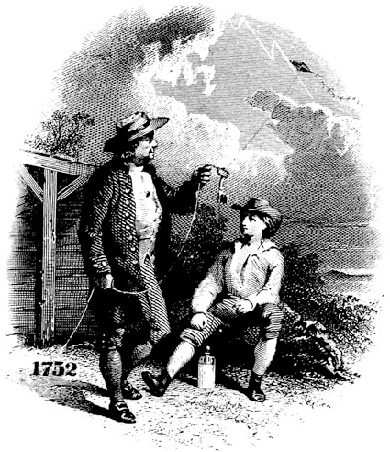

Benjamin Franklin Tiger Badge Ceremony
Materials: Badges and cards to be awarded attached to large keys. All badges are to be mounted on one large Kite or Lightning Bolt and hung in front of room.
Cubmaster: Our Tiger Cubs are challenged to search discover and share. As soon as they join, the Tigers and their Adult Partners stride out and begin exploring and understanding the world around them. For Requirement 5F they learn about weather just as you Wolfs and Bears did this month and the Webelos did when they earned the Scientist Activity Badge. Watching them search, discover and share about the weather I am reminded of Benjamin Franklin and his great experiment with the weather.
Quiz Tigers (or audience) on what Franklin did –
For what was Franklin searching? (Electricity)
What did he discover? (That there is electricity in lightning)
Did he share his findings about lightning? (Yes he did, we use electricity everyday)
Now that our Tigers have been successful in earning their Tiger Badges as Benjamin Franklin was successful in his discovery of electricity, I will present them to their Adult Partners who helped them most on their journey along with a key to remind them that one of the keys to Scouting and to life is to continue to search, discover and share all their life.

SPECIAL OPPORTUNITY
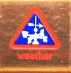
Weather Belt Loop Requirements
(from the Cub Scout Academic and Sports Program Guide)

- Make a poster that shows and explains the water cycle.
- Set up a simple weather station to record rainfall, temperature, air pressure or evaporation for one week.
- Watch the weather forecast on a local television station.

Outline for presenting and earning the Weather Belt Loop
The following is an outline for presenting the material for the Weather Belt Loop over a two week period. Completing these meetings and the home activities will allow each Scout to earn the Weather Belt Loop. If a Scout shows further interest, have him consider earning the Weather Academics Pin.

Week 1
- Use the Weather Word Search puzzle as a gathering activity.
- Introduce the requirements for the Weather Belt Loop.
- Present and explain the water cycle. Have each Scout create a poster illustrating the water cycle.
- Have each scout create one of the weather experiments or instruments in the Activities section.
- Assign experiments to be completed by the next meeting.
Week 2
- Use the Water Cycle handout and Water Match Puzzle as a gathering activity.
- Have Scouts share and discuss what they learned from watching the local weather report.
- Have Scouts share and discuss what they learned from the experiment they performed at home.
- Review the Water Cycle.
- Have each scout create another weather experiment or instrument.

GAMES
Snowball Fight
Designate an area and determine the turf for each of the teams. This can be halves of a room or even quarters of a room. Provide old newspapers or scrap 8½ x11” copy paper to each team with instructions that they are to crumple them up, piece by piece (you may want to pre-tear the pages in half) to make snowballs and then throw them at another team. After a set time, the team with the least number of snowballs on their turf is the winner. Everyone helps clean up and make sure they all wash the newsprint off their hands!

Cloud Collecting
Materials:
  - 30 cotton balls
  - 1 spoon
  - 1 blindfold
  - 1 shallow bowl
Sit the boys in a circle on the floor around the bowl. Blindfold one Cub and hand him the spoon. Scatter the cotton balls on the floor all around the bowl. Time him for 30 seconds to see how many cotton balls he can spoon into the bowl. He cannot feel around with his free hand or the back of his spoon hand. Because the cotton balls are so light, he won’t have any idea how many have been scooped up until the blindfold comes off.

Dress for the Weather Relay
Materials:
(need 2 sets of same/similar items making sure the size will accommodate all participants - especially if adults are included. Below is a suggested list – use your imagination):
  - 2 pairs of boots, mittens and caps
  - 2 umbrellas
  - 2 scarves
  - 2 rain coats or ponchos or swim trunks
  - 2 sunglasses
  - 2 sand pails
Divide the participants into 2 teams. This is a relay with half of each team at either end. On signal, the first team members begin attiring themselves as quickly as possible and hurry across to the other side. Once across the relay items are removed and the next team member dresses and hurries across to the other side. The first team to get everyone dressed and undressed as described above is the winner.

Pass the Weather Report
Divide into teams of 6-8 members. Give one member of each team a written weather report. Allow him to read the report, and then put it away. The first ream member comes forward and listens to the member whisper what was on the paper. This person tells the next team member and so on until the last member on each team has heard the weather report. The last team member then tells the weather report out loud. The first team member then takes the report out and reads it out loud. The team that gets the closest to the original wins. It is more fun if each team has a different report.

Where’s the Storm?
Spread the players around the room and have them orient themselves to “north”. North could be the real north or a convenient wall or corner in the room.

Everyone except for the caller and referees close their eyes (use blindfold if you don’t think the honor system will work).

The caller then calls out a direction of an approaching storm i.e. “The storm is coming from the East”. Each participant should turn (with eyes still closed) and point in the direction of east. Referees should go around and tap the shoulders of anyone not pointing in the right direction. They are now out. The game continues until one player is left. This game only discriminates by sense of direction, which improves as you play.

Static Electricity Balloon Race
This one will need a fairly dry room to work best. Blow up enough balloons so that there is one per boy and some extras. Have boys work in teams or pairs. Each boy rubs his balloon against something (his hair, a furry piece of material, etc.) to build up enough of a charge that the balloon sticks to his teammate’s back. Once each team member has a balloon on his back they move from the “start line” to the “finish line.” If the balloon falls off, they must stop and “reattach” it before moving further. The first team across the finish line is the winner.

PACK AND DEN ACTIVITIES

The Water Cycle
(from the U.S. Geological Survey Website: http://ga.water.usgs.gov/edu/watercycle.html)

- What is the water cycle?
The water cycle describes the existence and movement of water on, in, and above the Earth. Earth's water is always in movement and is always changing states, from liquid to vapor to ice and back again. The water cycle has been working for billions of years and all life on Earth depends on it continuing to work; Earth would be a pretty stale place to live without it.

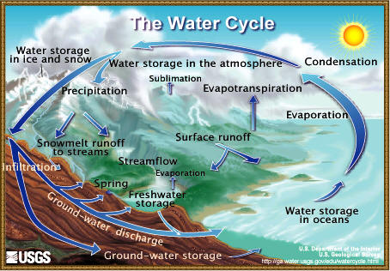

A quick summary of the water cycle
The water cycle has no starting point, but we'll begin in the oceans, since that is where most of Earth's water exists.
The sun, which drives the water cycle, heats water in the oceans. Some of it evaporates as vapor into the air. Ice and snow can sublimate directly into water vapor.
Rising air currents take the vapor up into the atmosphere, along with water from evapotranspiration, which is water transpired from plants and evaporated from the soil. The vapor rises into the air where cooler temperatures cause it to condense into clouds.
Air currents move clouds around the globe and cloud particles collide, grow, and fall out of the sky as precipitation. Some precipitation falls as snow and can accumulate as ice caps and glaciers, which can store frozen water for thousands of years. Snowpacks in warmer climates often thaw and melt when spring arrives, and the melted water flows overland as snowmelt.
Most precipitation falls back into the oceans or onto land, where, due to gravity, the precipitation flows over the ground as surface runoff. A portion of runoff enters rivers in valleys in the landscape with streamflow moving water towards the oceans.
Runoff and ground-water seepage accumulate and are stored as freshwater in lakes. Not all runoff flows into rivers, though. Much of it soaks into the ground as infiltration. Some water infiltrates deep into the ground and replenishes aquifers (saturated subsurface rock), which store huge amounts of freshwater for long periods of time. Some infiltration stays close to the land surface and can seep back into surface-water bodies (and the ocean) as ground-water discharge, and some ground water finds openings in the land surface and emerges as freshwater springs. Over time, though, all of this water keeps moving, some to reenter the ocean where the water cycle "ends" ... oops - where it "begins."
Evaporation: The process by which water is changed from liquid to a gas or vapor
Sublimation: The changing of snow or ice to water vapor without melting
Evapotranspiration: The transfer of water from the soil to the atmosphere by evaporation and plant transpiration
Water storage in the atmosphere: Water stored in the atmosphere as vapor, such as clouds and humidity
Condensation: The process by which water is changed from vapor to liquid
Precipitation: The discharge of water, in liquid or solid state, out of the atmosphere, generally upon a land or water surface
Water storage in ice and snow: Freshwater stored in frozen form, generally in glaciers, icefields, and snowfields
Snowmelt runoff to streams: The movement of water as surface runoff from snow and ice to surface water
Surface runoff: Precipitation runoff which travels over the soil surface to the nearest stream channel
Streamflow: The movement of water in a natural channel, such as a river
Freshwater storage: Freshwater existing on the Earth's surface
Infiltration: The downward movement of water from the land surface into soil or porous rock
Ground-water storage: Water existing for long periods below the Earth's surface
Ground-water discharge: The movement of water out of the ground
Spring: Place where a concentrated discharge of ground water flows at the ground surface

Water Cycle Match Puzzle
Match the words describing the water cycle with their meaning.
TERM |  | ANSWERS
1 | Evaporation | A | The change of water vapor to liquid water, as when fog or dew forms.
2 | Transpiration | B | General name for water in any form falling from clouds. This includes rain, drizzle, hail, snow and sleet.
3 | Condensation | C | The top of the water surface in the saturated part of a well or spring.
4 | Precipitation | D | The process of changing a liquid (like water) to a vapor. It’s the opposite of condensation.
5 | Runoff | E | The release of water from plant leaves. Every day an actively growing plant releases 5 to 10 times as much water as it can hold at once.
6 | Infiltration | F | Excessive rain or snowmelt that is not absorbed into the ground and becomes part of a stream, river or lake.
7 | Groundwater | G | The downward movement of water from the land surface into oil or porous rock. Also called percolation.
8 | Water Table | H | Water that exists for an extended period below the Earth’s land surface.

Water Cycle Match Puzzle (answers)
1D - The process of changing a liquid (like water) to a vapor. It’s the opposite of condensation. - evaporation
2E - The release of water from plant leaves. Every day an actively growing plant releases 5 to 10 times as much water as it can hold at once. - transpiration
3A - The change of water vapor to liquid water, as when fog or dew forms. - condensation
4B - General name for water in any form falling from clouds. This includes rain, drizzle, hail, snow and sleet. - precipitation
5F - Excessive rain or snowmelt that is not absorbed into the ground and becomes part of a stream, river or lake. - runoff
6G - The downward movement of water from the land surface into soil or porous rock. Also called percolation. – infiltration
7H - Water that exists for an extended period below the Earth’s land surface. - ground water
8C - The top of the water surface in the saturated part of a well or spring. - Water Table

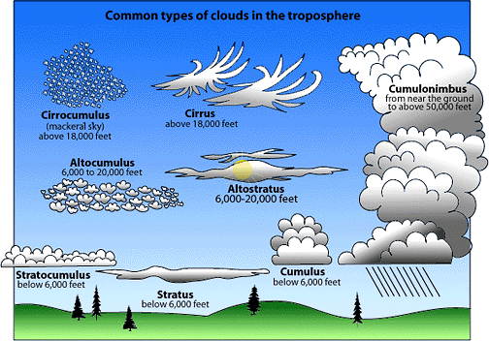

ACTIVITIES

Evaporation Experiment #1
Moisture in the air (humidity) is one part is the water cycle. This mainly comes from the oceans and smaller bodies of water (lakes & streams). This experiment will show how the water gets into the air.
Materials Needed:
  - 2 jars of the same size (one with a screw on lid (cover)).
  - Water
Directions:
- Place an equal amount of water in the two jars.
- Place a narrow strip of paper up the side of each jar
- Screw the lid on one jar.
- Place both jars on a table and leave for 1 week.
- Check them every 24 hours and mark the level on the strip, record your results and observations in a log.

Expected results:
The jar that was open contains less water than the jar that was covered.
This occurs because, even at room temperature, the tiny particles or molecules of water in the uncovered jar move fast enough to escape into the air. The water turns into water vapor, an invisible gas. This process is known as evaporation. The molecules of water in the covered jar cannot escape and remain in the jar. An example of this is how puddles of water disappear after the rain has stopped.

Evaporation Experiment #2
Which container of water will evaporate faster – a large flat dish or a narrow deep jar?
Materials Needed:
  - Large, flat dish
  - Narrow, deep jar
  - Water
Directions:
- Place an equal amount of water in the dish and jar.
- Place both on a table and leave for 1 week.
- Check them every 24 hours and record your results and observations.
Expected results:
The large, flat dish contains less water than the narrow, deep jar.
This occurs because the molecules of water can escape only from the surface. Therefore, water will evaporate faster when the surface is large. An example of this is a wide, shallow puddle will dry up faster than a deep, narrow one.

Evaporation Experiment #3
What role does the sun play in the evaporation of water into the air?
Materials Needed:
  - 2 dishes
  - sunny window
  - Water

Directions:
- Place an equal amount of water in the dishes so that they are half full.
- Place one dish in the sunny window and the other in the shade and leave for 1 week..
- Check them every 24 hours and record your results and observations. Observe the dishes and note which one dries out first.

Expected results:
The warmer the water, the faster the molecules move into the air. Therefore warmer water will evaporate faster than cooler water. Most water vapor comes from lakes, rivers, oceans, leaves of plants and wet ground. The heat from the sun causes the water to change from liquid to gas – thus evaporating into the air. As its temperature increases, air can hold more and more water. As it gets colder, air holds less and less water.

Evaporation Experiments Table

Use this table to conduct your evaporation experiments. The first lines are filled out as an example.

Start | Stop | Experiment | Initial Conditions | Observations
Friday  7:30 am | Saturday  7:30 am | Evaporation  #1 | Jar 1 (covered) = 4 oz.  Jar 2 (uncovered) = 4 oz. | Jar 1 had 3.5 oz and Jar 2 had 4 oz of water.  The uncovered jar evaporated faster than the covered jar.
Saturday  7:30 am | Sunday  8:00 am | Evaporation  #1 | Jar 1 had 3.5 oz and Jar 2 had 4 oz of water. | Jar 1 had 3.2 oz and Jar 2 had 4 oz of water.  The uncovered jar evaporated faster than the covered jar.
Sunday  8:00 am | Monday  8:00 am | Evaporation  #1 | Jar 1 had 3.2 oz and Jar 2 had 4 oz of water.

Air Pressure Experiment
Materials needed to make a homemade barometer:
- glass mayonnaise or canning jar
- balloon
- heavy duty rubber band
- straw
- toothpick
- glue
- index card
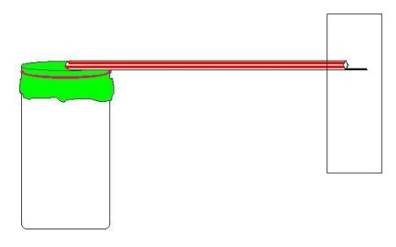
Directions:
- Carefully cut open a balloon so that it forms a thin sheet.
- Stretch the balloon over the jar and secure with a heavy duty rubber band, sealing the jar tightly.
- Glue the straw sideways to the balloon, placing it from the center of the balloon so that it extends over the side of the jar.
- Glue a toothpick into the end of the straw that hangs freely over the side of the jar.
- Tape an index card to a wall and set the barometer next to it so that the end of the straw points to the middle of the index card but does not touch it.
- Mark the spot on the card where the toothpick is pointing.
- Write the date next to this mark.
- Take measurements daily and mark the spot where the toothpick is pointing.
- Record the data in the Air Pressure Measurement Table.
- Be sure to note if the pressure is higher (toothpick moves up) or lower (toothpick moves down).

Explanation:
Barometers keep track of air pressure. When air pressure is high (which means fair weather), the toothpick will point up because air will be pressing down on the balloon. When air pressure is low (which means stormy weather is coming), the toothpick will point down because air inside the jar will be pushing up against the balloon.

Air Pressure Measurement Table

Date | Pressure  (Higher or Lower) | Observed weather outside | Predicted weather for NEXT day | Was prediction accurate?

Rainfall Measurement Experiment
Materials Needed:
- clear jar
- ruler
Directions:
- Set the jar outside in an open area before it starts raining.
- Make sure the jar is not under anything like trees or plants and away from structures like the house.
- At a specific time each day, use a ruler to measure the amount of rain in the jar and record this in the Rain Measurements Table.
- Empty the jar and set it back in the same place.
- Record the amount of rainfall at the same time the next day.
- Do this for 1 week.

Date | Time | Amount of Rainfall  (inches) | Observations

Weather Forecast Form
Use this form to record the forecast from a local television station.

Date:

Time:

Channel:

The forecast (what was said?):

Follow up (where they right?):

What did you learn?:

CRAFTS

Make A Weather Vane
It's easy to see which way the wind blows!
Materials: Cardboard, Drinking straw or a thin wooden dowel, Thread spool, Tape, Stapler, Modeling clay, and a few stones or rocks.
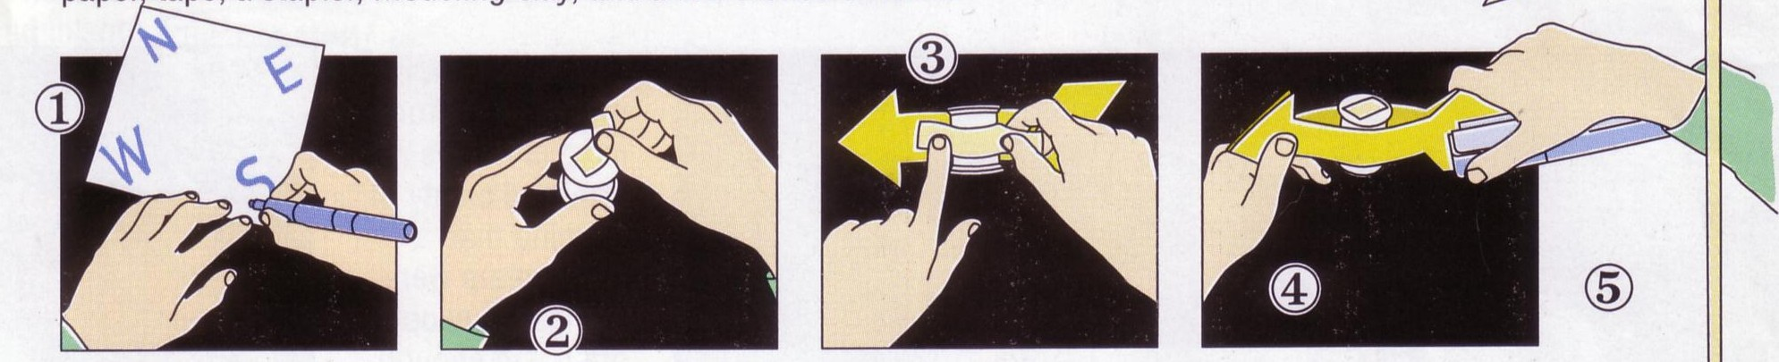
Directions:
- On a piece of cardboard about 6 inches square, mark the points of the compass: N, W, S, E.
- Tape a little piece of paper over the hole on top of the spool. On cardboard, draw two identical arrows about 7 inches long
- Cut the arrows out and tape one to the spool.
- Staple the other arrow to the first one and tape the ends together.
- Put a straw or a wooden dowel inside the spool. The spool should move freely. Put some modeling clay on the center of the cardboard square, then stick the straw or dowel into it. Position the cardboard so the compass points face the correct directions. (Use a compass).
- To keep the cardboard in place, weight it down with a few rocks or stones.
- When the wind blows, the arrow will point in the direction from which it comes.
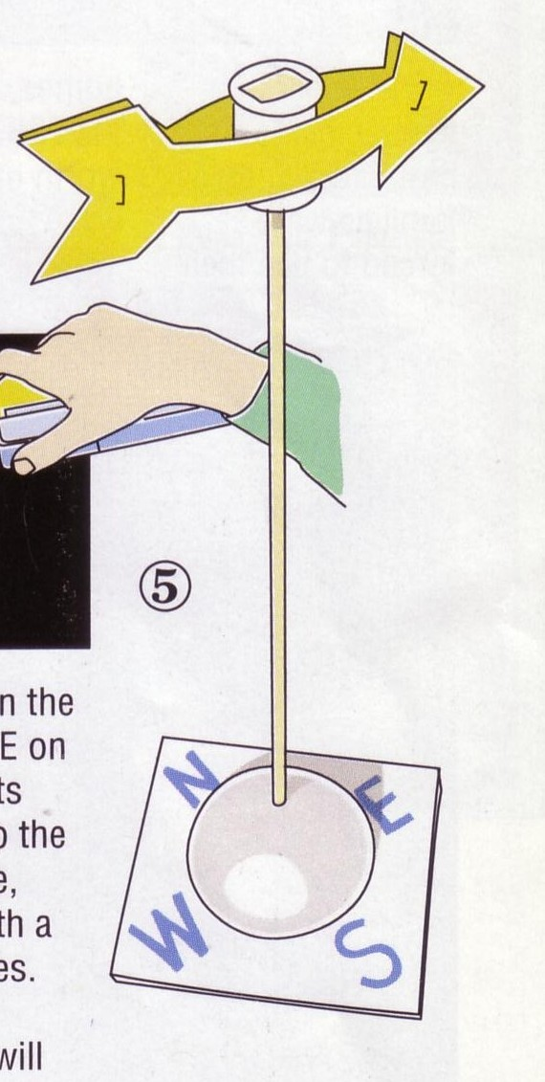

Uncle Jonathan's Easiest Kites
20 Kids – 20 Kites – 20 minutes – GUARANTEED!!!
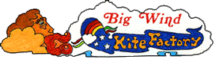
From “The big Wind Kite Factory,” http://www.molokai.com/kites/
Material list for 20 kites:
- 20 sheets of brightly colored 8 1/2" x 11" paper.
- 20 8" bamboo bar-b-que shish kebab sticks.
- 1 roll of florescent surveyor's flagging plastic tape.
A plastic bag cut in a 1" wide spiral all around will also work
- 1 roll 1/2" wide masking tape or any type of plastic tape..
- 1 roll of string. (At least 200', 6 to 10 feet for each child.)
- 20 pieces of 1"x 3" cardboard on which to wind the string.
- Scissors, Hole punch. (optional)
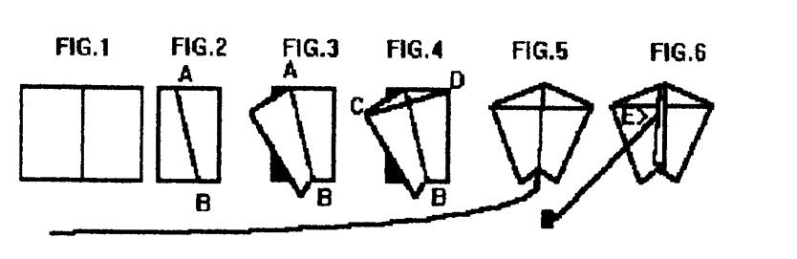
Directions:
- Fold a sheet of 8 1/2" x 11" paper in half to 8 1/2" x 5 1/2".
- Fold again along the diagonal line A in Fig.2.
- Fold back one side forming kite shape in Fig.3 and place tape firmly along fold line AB.(No stick is needed here because the fold stiffins the paper and acts like a spine.)
- Place bar-b-que stick from point C to D and tape it down firmly.
- Cut off 6 to 10 feet of plastic ribbon and tape it to the bottom of the kite at B.
- Flip kite over onto its back and fold the front flap back and forth until it stands straight up.(Otherwise it acts like a rudder and the kite spins around in circles.)
- Punch a hole in the flap at E, about 1/3 down from the top point A.
- Tie one end of the string to the hole and wind the other end onto the cardboard string winder.
Be sure to check their website for more pictures about how to do this and lots of neat stuff on kites!!! http://www.molokai.com/kites/

Straw Blown Painting
Can you see the wind? Maybe not, but you can see evidence of the wind. Cover your workspace with newspaper. Tape the corners of a clean piece of drawing paper in the center. Place one color of water-diluted poster paint on the paper and, using the straw and your own powerful lungs, blow the paint around on the paper. Before it dries, add another color and blow it around. Let some paint overlap or blend. Try different blowing techniques: from the center or from the corner.
Miniature Windsocks
Materials:
  - Toilet tissue roll
  - Crepe paper
  - Yarn
  - Construction paper, stickers or paint

- Decorate the tissue roll with construction paper, paint or stickers.
- Cut crepe paper strips 1 ½ “x 6” and glue to the inside of the tissue roll.
- Cut three evenly spaced holes in the top of the roll.
- Tie a 7” piece of yarn to each hole.
- Tie all three ends of the yarn together and hang.

Make a Thermometer
(http://www.weatherwizkids.com)

Materials:
  - clear, plastic bottle (11oz. water bottle works)
  - water
  - rubbing alcohol
  - clear plastic drinking straw
  - modeling clay
  - food coloring

Fill about ¼ of the bottle full with equal parts of water and rubbing alcohol. Add a few drops of food coloring. Put the straw in the bottle, but don't let it touch the bottom. Use the modeling clay to seal the neck of the bottle, so the straw stays in place. (Make sure the straw does not touch the bottom of the bottle.) Hold your hands on the bottom of the bottle and watch the mixture move up through the straw.

Explanation:
Why does this happen? Just like any thermometer, the mixture expanded when it was warmed. This made the mixture no longer fit in the bottom of the bottle. As the alcohol expanded the colored mixture moved up through the straw. If the bottle were to get extremely hot, the mixture would have come up through the top of the straw.

CUB GRUB

Glacier Treats
Ingredients
Ice
6 tablespoons salt
1 cup milk
1 tablespoon sugar
¼ teaspoon vanilla
1 pint zip-type plastic bag
1 gallon zip-type plastic bag
Directions:
- Put milk, vanilla and sugar into the small bag. Seal it.
- Fill the large bag half full of ice.
- Add the salt.
- Place the small bag in the large bag and seal it.
- Shake until the mixture is ice cream – about 5 minutes.
- Open large bag and remove small bag.
- Wipe off the top of the small bag.
- Open and enjoy.

Mud in the Hole
Ingredients
4 cups canned chocolate pudding
8 ice cream cones
Directions:
- Open can of pudding,
- Fill each ice cream cone and
- Serve immediately

Pudding In A Cloud
Ingredients
2 cups Thawed Cool Whip, non-dairy - whipped topping
1 package (4 serving size) Jello chocolate instant pudding
2 cups cold milk
Directions:
- Spoon 1/3 cup of whipped topping into each of six dessert glasses.
- Using back of spoon, make depression in center and
- Spread topping up sides of glass.
- Prepare pudding with milk as directed on package.
- Spoon pudding into glasses.
- Chill.
- Makes 6 servings.

Chocolate Thunder Cake
Ingredients
1 chocolate cake box mix
1 12-16 oz. jar hot fudge ice cream topping
1 12-16 oz jar caramel ice cream topping
1 12 oz. Cool Whip
Snickers bars
Directions:
- Bake cake according to box directions.
- As soon as it comes out of the oven, poke holes in it with a wooden spoon handle.
- Melt each of the ice cream toppings and pour over hot cake.
- Let cool completely.
- Top with Cool Whip and cut up Snickers bars.

WEBELOS

ENGINEER(2) --TECHNOLOGY GROUP
Boys have a natural interest in how things work. The Engineer Activity
Badge gives an introduction to how the big things in our lives work.
One of the purposes of Cub Scouting is "fostering a sense of personal achievement by developing new interests and skills" in boys. This activity badge probably does this more than any of the other badges.
Engineering is one of the most exacting of the professions and the badge includes projects that will give a boy an insight into some types of engineering.
One of the purposes of Cub Scouting is “fostering a sense of personal achievement by developing new interests and skills” in boys. This activity badge probably does this more than any of the other badges. Engineering is all about applied science, and it is one of the most exacting of the professions. This badge includes projects that give boys an understanding of this profession.
There are many types of engineers; chemical, electrical, civil, petroleum, mechanical and industrial are just a few. It usually takes a creative mind and attention to detail to be a good engineer. Through work on the Engineer Activity Badge, your Webelos Scouts will get an appreciation for engineering and what it takes to accomplish engineering feats.

Types of Engineers
- Aeronautical Engineering: Deals with the whole field of design, manufacture, maintenance, testing, and the use of aircraft both for civilian and military purposes.
- Astronautical Engineering: Closely related to aeronautics, but is concerned with the flight of vehicles in space, beyond the earth's atmosphere, and includes the study and development of rocket engines, artificial satellites, and spacecraft for the exploration of outer space.
- Chemical Engineering: Concerned with the design, construction, and management of factories in which the essential processes consist of chemical reactions.
- Civil Engineering: Perhaps the broadest of the engineering fields; deals with the creation, improvement, and protection of the communal environment; providing facilities for living, industry, and transportation, including large buildings, roads, bridges, canals, railroad lines, airports, harbors, and other constructions.
- Electrical Engineering/Computer Science: Divided broadly into the engineering of electrical power distribution systems, electrical machinery, and communication, information, and control systems.
- Geological & Mining Engineering: Includes activities related to the discovery and exploration of mineral deposits and the financing, construction, development, operation, recovery, processing, purification, and marketing of crude minerals and mineral products.
- Industrial or Management Engineering: Pertains to the efficient use of machinery, labor, and raw materials in industrial production.
- Mechanical Engineering: Covers the design and operation of all types of machinery and small structures.
- Safety Engineering: Concerned with the prevention of accidents.
- Sanitary Engineering: A branch of civil engineering that has acquired the importance of a specialized field due to its great importance for a healthy environment, especially in dense urban population areas.

Make Electricity with a Lemon Battery
Materials: Lemon, steel wool, copper nail, zinc nail.
- Scrub a copper nail and a zinc nail with a piece of wool until they are clean and shiny.
- Rinse the nails under the water faucet.
- Poke the pointed ends of the nails into the center of a fresh lemon. Spaces the two nails about
- 1” apart and leave 1/2” of each nail protruding.
- Take a small LED (light emitting diode) and touch the leads to the two nails. You should see a glow.
When I was a Cub Scout, we stuck out our tongue and touched the tops of the two nails and felt a tingle. What Happened? You have just made a simple chemical battery and the glow you saw or the tingle you felt on your tongue was electricity! Because the lemon contains acid and water, which reacts with the metals, zinc and copper, a slight electrical current was formed and it passed over your tongue from one nail to the other.

Unusual Catapult
Materials: Thin cardboard, colored pencils, long rubber band, scissors
Directions
- Draw two separate five sided shapes, tracing the pattern as shown.
- Cut out. Lightly fold back along dotted lines.
- Color each of the six separate sections a different color.
- Overlap the two shapes and loop the rubber band over every other corner to hold the two pieces of cardboard together. The rubber band should be stretched slightly but not too tight.
- When you let go of the cards, which should be laying flat on the table, the slightly stretched rubber band will contract which will cause your contraption to “leap” into a solid shape.
Why does this happen and is this really a Catapult? The energy in the stretched rubber band pulls the cardboard contraption into the shape. This illustrates what makes a catapult spring in the simplest way imaginable.
Explain to your Scouts that some substances, such as elastic or rubber, stretch when you pull them, but spring back into their original shape when released
Although most catapults “fling” or “throw” something away from them, this one uses the spring or force of the catapult to “throw its flat shape “up” into a ball or solid shape. Even though it is very different from a standard catapult, it nevertheless operates on the same principles, only in reverse.

SUGGESTED PATROL ACTIVITIES
- Have the boys find pictures of different bridges and put together a poster for the pack meeting.
- Visit a college engineering or architecture department.
- Invite an engineer or architect to visit the patrol meeting to talk about their job.
- Measure the dimensions of your meeting place and include the locations of doors and windows. Show how to sketch a simple floor plan with these measurements.
- Make a block and tackle and demonstrate its use.
- Make catapults and have a contest.
- Compare design and Construction of various kinds of bridges and make a model of one or more.
- Visit a construction site with a contractor. Ask him to explain the use of blue prints and the order of construction.
- Visit a power generation plant.
- Work on the Academics belt loop and pin for mathematics.

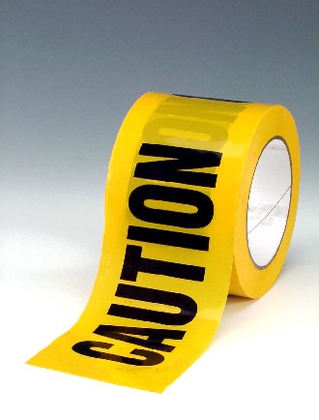
CATAPULTS ARE DANGEROUS
Be forewarned that like most machines, all catapults have the opportunity to be dangerous, even small ones. Catapults were originally invented with the intent to hurt people, so leaders need to be very safety conscious with boys around catapults. Be safe, so that mistakes won’t lead to injuries.

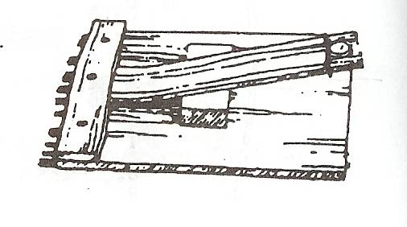

LEAF SPRING CATAPULT
Using wood scraps and an old ruler. Lay the ruler flat onto a larger board and nail another board over and inch of the end of the ruler. Then wedge a small board under the ruler to form the leaf spring catapult.
LEVER CATAPULT
Catapult Experiment: Use ruler and rubber eraser or other soft projectile. Have boy strike the short end of the ruler balanced on a dowel. How far did the eraser go? Now have him try it with half the ruler over the edge of a table and hit it with the same force. Why is there a difference in the distance that the eraser flies?
MOUSE TRAP-A-PULTS
The spring and lever action of a mousetrap can be harnessed for many kinds of fun machines. Give the boys mousetraps, string, tinker toys or K-nex and have a contest to build and see how far their mousetrap contraption could throw a small object like a dry bean. Below is an example with the mousetrap pulling a lever that then throws the bean.
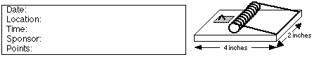

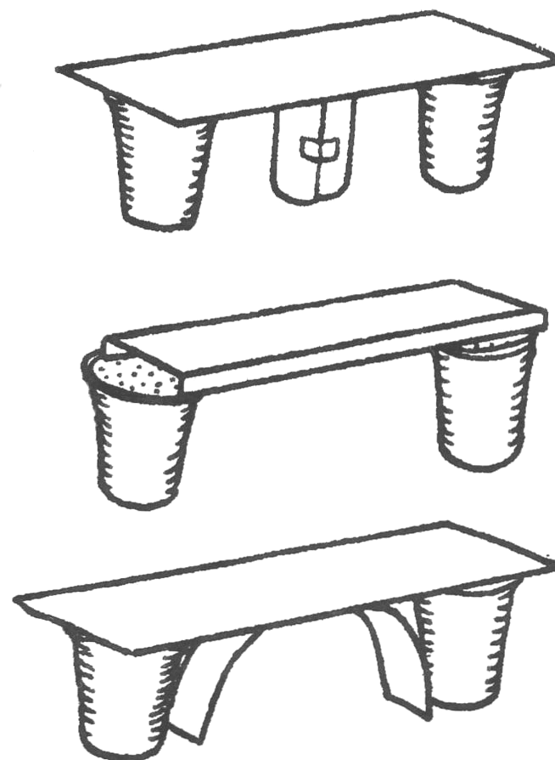
BUILDING CHALLENGES
PAPER BRIDGE CONTEST
Hand the Webelos each one sheet of 8½ x 11 paper, two foam cups, 4” of tape and a matchbox-sized car. Tell them to build a bridge that will support the toy car as it rolls across the bridge. They can cut or fold the paper into any shapes that they want. They may use small pieces of tape to help hold the paper in desired shapes but not to tape to the cups. This can be a group effort, team play or on an individual project. You can do something similar as a tower-building contest.
Strong Bridge Ideas:
- Cut a strip and roll it up. Use this as a center support.
- Fold two long edges of the card.
- Cut a strip and curve it under the bridge as a support.
- Cut three strips and sandwich one folded in a zig-zag.

TRUSS BRIDGES
You will need: Lots of mini-marshmallows, toothpicks, various weight objects.
- Give teams of boys an equal number of marshmallows and toothpicks.
- Between two equal-height objects (like tables) show them the distance that they must span with their bridge. Tell them that the contest will be to see how much weight their bridge can hold in the very center of the bridge
.
- The bridge must be at least one toothpick wide and you suggest that they use the marshmallows to connect the toothpicks.
- Tell them that the strongest shape is a triangle, so build a truss bridge that has lots of triangles in it.

PULLEYS, BLOCKS AND TACKLES
There are five kinds of basic machines that were discovered in ancient times. All complex machines are built out of some or all of these basic machines: wheel (with axle), pulley, wedge, screw and lever. This exercise will show the magic of how pulleys, and blocks and tackles can make lifting something heavy possible by exerting very little effort.

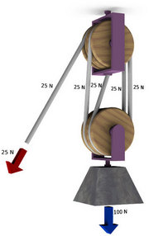
A pulley is a special kind of axle and wheel, where the axle is connected to some object, and a rope goes around the wheel. A block and tackle is formed by two pulleys that may each have several wheels, and a rope goes around both pulleys. Ropes and pulleys can be connected in many assorted ways to create different degrees of how easy it is to pull.
A simple “Come-along” can be made by tying a rope to a fixed object (like a tree), running the rope behind the object that you want to move, and pull on the rope while standing near the tree. You will only have to pull half as hard to make the object move, as if you tried to pull it directly, because the tree actually helps you pull. You can also achieve the same result by attaching a single-wheel pulley to the object that you want to move.
By using two pulleys, you may form a block and tackle. With pulleys that have enough wheels and enough rope, it would be possible for a Webelos Scout to move just about any heavy object that the rope and pulleys can support. The illustrations below show how to move more than what you normally are capable of pulling directly with a rope. The Mother Earth News website also has some excellent illustrations of blocks and tackles.

ELECTRICITY
All matter has electrons and when electrons move we see the effects of electricity. Metal and water are both good conductors of electricity. Metals like copper and aluminum are most often used to safely move electricity in appliances. Our bodies are also fairly good electrical conductors, because our bodies have a lot of water, which is why people have to be very careful around electricity.
Insulators are things that do not conduct electricity very well. Wood and plastic are two good examples of electrical insulators.
MAKE AN ELECTROMAGNET
Materials:
- Ten feet of 22-gauge coated copper wire
- 6-volt lantern battery
- 6 inch iron nail
- Steel paperclips
- Wire stripper and needle-nose pliers
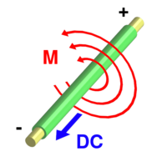
- Gloves
Electromagnets take advantage of a phenomenon where electricity moving in a wire causes a magnetic field around the wire (shown left).
A single straight wire, with electricity flowing through it, however, has a very small magnetic field. But when you wrap that wire round and round about 50 times in a long neat coil, the magnetic fields from all of the wraps add together to form a strong magnetic field. You can also multiply the strength of the coiled magnetic field, and make the coils much neater, by wrapping the coil around a long piece of iron or steel (like a nail). The more tight and neat the wraps are, the better it will work.
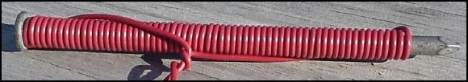
To make current flow through the wire, we need to make an electrical circuit. Strip a half inch of insulating plastic off of each loose end of the wire, and with the pliers curl the ends of the bare wires into U shapes. Scatter the paper clips on a table nearby. Put on a pair of dry, cloth gloves, because the wires may get hot when the current is flowing. Hook one bare wire onto one of the springs on the lantern battery. Now hook the other bare wire to the other spring connection on the battery and voila you now have an electromagnet that can pick up the paper clips and any other small ferrous objects. The electromagnet will work until the battery is drained or the circuit is broken.
Did you notice a spark when the second wire was connected to the battery? Notice how warm the wires get as the electrical current flows through them. Disconnect the wires while the electromagnet is holding paperclips and watch it drop them. Connect the circuit, pick-up paper clips in one place and move the electromagnet over a box, then disconnect a wire and drop the paperclips in the box. Continue this until all paperclips have been moved.

ATHLETE -- PHYSICAL SKILLS GROUP
An athlete is one who keeps his body physically fit, strong, graceful and agile - a desire of practically every boy. Tell your Webelos Scouts about the athlete and what it takes to become one. Impress them with the fact that the body is a priceless gift and only a few minutes of exercise each day are required to keep it physically fit.
By adequate exercise, getting the proper food each day and taking care of himself, a boy can become an athlete. The activities for this badge can help the Webelos Scout measure up to the standards of strength, agility, endurance, and coordination necessary for good active Scouting activities in later life.
Many Webelos leaders use this badge to introduce a new Webelos Scout to the program. This begins their Webelos year with an appealing badge to inspire them onward. By laying out a permanent accurately measured 50 yard dash and 600 yard run near your meeting place, you can easily test your new Webelos Scouts in less than half an hour. Use a stopwatch when timing these sprint and distance runs.
Make up a permanent Fitness Progress Chart and retest the boys at different times throughout the year and chart their progress. They will be interested in bettering their records.
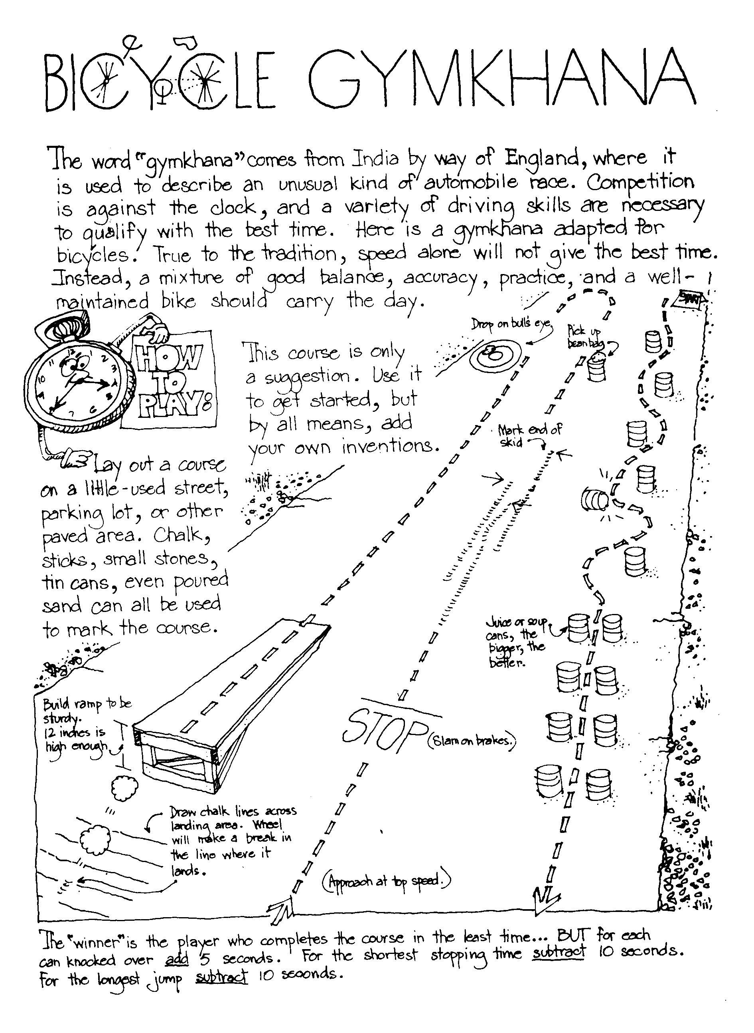
The boys can make their own physical fitness equipment. A barbell can be made using a 3 foot dowel or broomstick with 3/4" pipe caps on the ends. The latter are then embedded in 46 oz. cans filled with cement. Allow cement to set overnight. Dumbbells can be made similarly by using foot long dowels and No. 2 size cans filled with cement and placed on the ends of dowels. Plastic quart containers filled with sand may be used instead of the cans. A broomstick suspended at both ends in a garage, basement, or backyard makes an excellent chinning bar. A deflated bicycle inner tube makes a good exerciser.

Being Healthy
Good Health Habits Quiz
Circle the correct answer(s).
- Bathe/shower (everyday OR once per week) and especially after exercise.
- Wash your hair (1/month OR 2+ times/week).
- Wash hands (before eating OR after using the restroom) and when they're dirty.
- Eat right - (3 OR 4 OR 6) regular meals each day at regular times!
- Eat (just some OR a variety of) food from each of the 4 food groups.
- The average 10 year old should get at least (6 OR 9 OR 12) hours of sleep each night.
ANSWERS: 1. Everyday, 2. 2+ times, before eating and after using restroom, 3. 3 meals, 4. Variety, 9 hours

Clean & Strong
Circle T for True or F for False.
T F | Our bodies "repair" themselves while we sleep.
T F | Clean clothes aren't necessary after a bath or shower - they are just in the morning.
T F | Use proper lighting for all activities including reading, TV viewing, and playing.
T F | Fitness is never just physical - it involves  both the mind and body together.
T F | Stand tall, and walk tall with shoulders  back and stomach in.
T F | It's OK to share drinking cups,  washcloths and towels.
T F | Different foods provide different nutrients,  and no one food can sustain us.
T F | Rushing meals or skipping meals can be harmful  to your body.
ANSWER: 1 - T, 2 - F, 3 - T, 4 - T, 5 - T, 6 - F, 7 - T, 8 - T

Volleyball Serve it Underhand
The underhand serve is the easiest to master for volleyball. In a game you must put the ball into play from a 10 foot wide area behind the end line. Always practice with a line in front of you so you will learn not to cross it until you have released the ball.
For the underhand serve (if right handed), stands with your left foot about 13” in front of the right foot. Bend both knees a little, lift the ball in both hands out in front of your chest, to your right side. Hold the ball in the left hand and start to bring the right hand down. Close the finger of the right hand as if you were making a loose fist.
Keep your eyes on the ball. Bring right hand down, back, and up behind you. Step a quarter step forward on your left foot. Swing your right hand at ball. Just before you hit it, toss the ball up a little and drop your left hand away from it. (The rules say – release your left hand from the ball before hitting it.) Strike ball solidly with the palm side of your fist and follow through. (Of left handed, reverse from right to left.)
Once you master the serve, try using the heel of hand instead of fist. Close hand instead of your fist. Close your hand half-way so fingertips come just below the base of the fingers with thumb-tip beside the first joint of forefingers

SONGS
Scout Wetspers
(provided by Dave Lyons)
Softly falls the rain today
As our campsite floats away
Silently each Scout should ask
Did I bring my SCUBA mask?
Have I tied my tent flaps down?
Learned to swim, so I won't drown?
Have I done and will I try
Everything to keep me dry??

The Athlete
Tune: My Bonnie
They gave me a suit and a number
And sent me out on the field
They gave me a ball called the pigskin,
And shoes with some cleats, toe and heel
CHORUS
Muscles, Cramps, wracking my body with pain, with pain
I stand, wondering, if ever I’ll do this again!
Next time they gave me a racquet,
They sent me out on the court
Funny the things you encounter,
While trying to learn a new sport.
(CHORUS)
The ordeal was finally over,
At least, that’s what I thought,
When they shoved me the soccer equipment
I fainted dead on the spot!
(CHORUS)

Athlete Den Activities
TOWEL PICKUP - Take off your shoes and socks. Pick up a towel with your toes.
PAPER PICKUP - Pick up a piece of paper from the floor without bending your knees
BOOK CARRY - Walk across the room with a book balanced on your head.
SKIN THE CAT - Clasp your hands in front of you. Try to step through the ring formed by your hands and finish standing upright with them clasped behind you. Return to your original position by stepping backwards through the ring.
TOE WRESTLING - Two wrestlers sit on the floor, facing each other with arms clasped around knees. When they are in this position, place a stick over each person’s elbows and under his bent knees. Their feet should be flat on the ground with the toes of one touching the toes of his opponent. The object is for one wrestler to get his toes under the toes of his opponent and roll him over backwards. If either wrestler breaks the handclasp above his knees, the other wins the contest.
SIDEWALK TENNIS - Played with a tennis ball on two squares of sidewalk or patch of level ground marked off in similar size. Ball is batted with the hands. Use regular tennis rules, except that there is no serving court

SUGGESTIONS FOR COMPLETING ATHLETE ACTIVITY BADGE
Requirement #1
Can be combined with the Fitness Activity Badge and the Sportsman Activity Badge. The subjects of being physically healthy, balanced diets, and bad effects of drugs, alcohol, and tobacco can be combined and signed off all together.
Requirement #2
Takes the longest amount of time to complete and sign off of all the Physical Skills Group. To earn the Physical Fitness Sports Pin, the boy needs to earn 60 points in a 90 day period. They must exercise or be involved in some activity for 30 minutes to earn one point. The boy can earn a maximum of five points in a day. Just remember 30 minutes for one point, 60 points total in a 90 day period.
You can pass off requirements 3 through 9 as part of this pin, use requirement 3 and 4 of the Sportsman badge to meet the requirement.

Den Activities
· Make your own physical fitness equipment (see above)
· Watch a high school track meet.
· Have a Physical Education instructor talk to your den concerning fitness.
· Invite a professional weight lifter to talk to your den and demonstrate.
· Attend a gymnastics exhibition or meet.
· Plan a physical fitness demonstration for pack meeting.

Barbell Slide
Materials: 2 small 1" styrene balls, 1/2 of a black pipe cleaner, black paint, white paint, paint marker, or vinyl stick-on letters
Directions: Paint the two balls black. Cut the pipe cleaner into 2 equal pieces. Push the pieces into the ball about 1/4" apart. Pull the pieces apart slightly, curving them outward. With the white paint put the lbs. on the two balls. You can use 5 lbs., the Pack number, or some outrageous amount of weight.

Games
La Plama (Bolivia) -- The Indians of Bolivia used a bone, but you can use a stick for this game. Set the stick up on end in a hole in the ground. Draw a straight line away from the stick. Measure out a distance of 3' along the line and from the stick. Drive in a peg. Repeat until 6 pegs are in the ground along the line and spaced 3' apart. You will need a supply of tennis balls. The boys take turns trying to hit the stick from the first peg. Those who do hit it move on to the next peg. Those who do not stay at one peg until they hit the stick. The first boy to complete the six throws from the 6 pegs wins the game.

Crossing the Rice Fields (China) -- Players line up in teams of two, forming two or more columns as in relay formation. On the word "rice" the first team in each column forms a wheelbarrow and races across the rice fields to the river (two parallel ropes stretched out on the floor crossed by two 2 x 4's - one for each team). At the edge of the river, the players break up and walk across the "bridge" being careful not to fall in the river. On the other bank they turn around and come back across the bridge and then reform their wheelbarrow reversing positions and "roll" home again. The first team to get all of the pairs across the river and back again wins.

Activity Ideas
Agility Exercises -- Perform these exercises within the designated time limits. Rest two minutes between each set of exercises.
Set 1. (8 minutes)
- Fish Flops: Lie flat on your stomach, arms and legs extended and off the ground. Rock back and forth. (2 min.)
- Grass Drill: Run in place. Drop to ground and bounce up again. (2 min.)
- Quick Foot-Knee Touch: Drop quickly to one knee and bounce up again. Alternate knees. (2 min.)
- Root Drill: You need a partner for this one. Square off on all fours, locking right shoulder to right shoulder. Try to rock your opponent back off his feet. (2 min.)
Rest Two Minutes
Set 2. (6 minutes)
1. Crab Mirror: Two players on all fours. One moves at random to the left, right, back or forward and the other mirrors his moves. Switch leaders and repeat. (2 min.)
2. Bear Hug Take-Down: Two players, one standing behind the other. Player in rear grasps other player around arms and chest and tries to pull him down. Reverse positions and repeat. (3 min.)
3. Sit-ups: Lie on back, feet together, hands clasped behind head. Raise up and touch elbows to knees. Do as many as possible. (1 min.)
Rest Two Minutes

Flexibility Exercises
· Fingers: Extend arms to the side, palms down. Quickly flex fingers by alternating between fist and open-hand position. (30 sec.)
· Palms: Extend arms to the front, palms down, wrists locked. Turn palms inward and outward in quick, short movements. (30 sec.)
· Wrists: Same position as palms (above). Rotate wrists clockwise, then counter-clockwise.(30 sec.)
· Forearm Twist: Arms extended sideward and parallel to ground. Flex at elbow bringing tips of fingers to shoulders. Return to starting position. Perform both palms up and palms down. (1 min.).
Shoulder Stretches: 3-part exercise. (a) Rotate one arm over your head and down slowly. Repeat with other arm. (b) Shrug your shoulders slowly in complete circle starting the movement by moving up and back. (c) lock your hands behind head and pull back slowly from shoulders. (2 min.)

POW WOW EXTRAVAGANZAS
Stay tuned next month…

WEB SITES
Stay tuned next month…

The Pack Meeting

GATHERING ACTIVITIES

Weather Word Search

F | H | V | N | S | C | N | N | Z | R | Y | V | B | K | N | O | E | B | A | R
L | U | R | O | F | T | O | A | O | X | W | A | R | O | T | R | R | Y | C | E
R | R | G | I | F | O | O | N | H | I | R | U | I | T | E | H | U | J | C | H
Q | R | C | T | Z | N | R | R | D | O | T | T | W | T | A | R | T | O | U | L
Y | I | O | A | C | A | R | E | M | E | A | A | E | I | B | Q | A | D | M | K
V | C | X | R | N | F | Q | E | C | T | N | M | L | F | Q | S | R | A | U | X
R | A | A | I | Q | Y | T | O | I | A | O | S | I | O | D | Z | E | N | L | H
S | N | T | P | L | E | V | P | K | M | S | E | A | U | C | X | P | R | A | J
D | E | W | S | R | D | I | W | R | H | E | T | O | T | S | R | M | O | T | W
D | S | T | N | R | C | L | E | I | V | E | L | E | Q | I | C | E | T | I | I
F | H | I | A | E | I | H | Z | A | I | C | S | U | R | R | O | T | P | O | N
N | I | A | R | A | T | L | P | E | R | U | S | S | E | R | P | N | G | N | D
R | P | P | T | R | P | O | R | E | T | A | W | D | N | U | O | R | G | Z | B
M | E | T | E | O | R | O | L | O | G | I | S | T | R | U | N | O | F | F | H
S | Z | H | Q | A | L | A | X | J | W | C | U | W | P | R | L | Q | T | Q | Q
F | W | A | T | E | R | C | Y | C | L | E | N | R | O | O | Q | H | X | V | J
P | L | I | S | A | H | I | A | A | G | M | O | H | M | N | K | D | W | E | L
F | O | H | F | O | E | F | J | A | O | H | X | U | I | W | S | X | Y | W | D
N | X | A | G | Y | Y | W | O | Z | F | Z | R | Z | V | K | X | G | M | E | L
J | J | F | L | K | K | W | O | Y | I | V | P | G | M | F | B | F | Q | U | K

Find weather related words printed in the word search above. They can be upside down, backwards, forwards or diagonal.

ACCUMULATION BAROMETER CLOUDS CONDENSATION
EVAPORATION FOG FORECASTER GROUNDWATER
HAIL HURRICANE METEOROLOGIST PERCOLATION
PRECIPITATION PRESSURE RAIN RUNOFF
SNOW STORM TEMPERATURE THERMOMETER
TORNADO TRANSPIRATION WATERCYCLE WEATHER
WIND

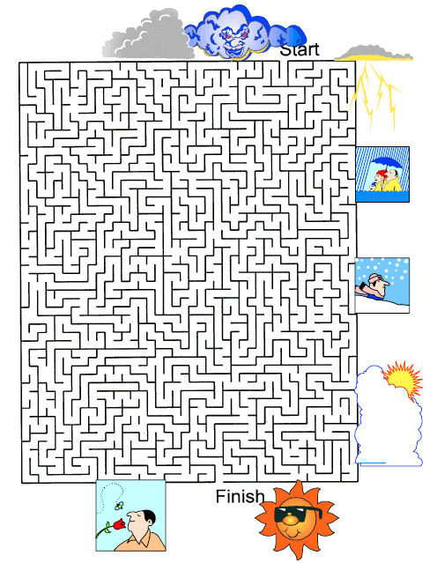

OPENING CEREMONIES

Nature Lover's Creed
- The things I prize of great worth,
Are just the common things of earth:
- The rain, the sun, the grass, the trees,
The flowers, the birds, the glorious breeze,
- Clouds that pass, the stars that shine,
Mountains, valleys, all are mine.
- Rivers broad, and open sea,
Are riches none can take from me.
- And God is here on every hand,
Upon the sea, upon the land.
- So day by day my thanks I give,
That with these common things I live.

Weather
- W: Wooly clouds in the sky
Will bring rain drops by and by
- E: Evening red and morning gray
Send the traveler on his way
- A: A sunny shower
Won't last and hour
- T: To the surface, quick to bite
Catch your fish, when rain’s in sight
- H: Hear the sounds traveling far and wide
A stormy day does this betide
- E: Evening gray and morning red
Send the traveler wet to bed
- R: Rain never comes to pass
When dew is on the grass

Cubbing in the Clouds
Cast: Four Scouts and a Leader
Materials: Have four Scouts each with a picture of a cloud on front of his card and his part in LARGE text on the back of the card. Pictures needed – Stratus Clouds, Altocumulus clouds, Cirrus clouds, Cumulonimbus clouds.
Leader: This month our Cubs were learning about weather and the sky. Let’s hear a little about what they learned and how it relates to Cub Scouting.
- Stratus clouds are uniform dull gray clouds that often cover the entire sky. Usually no precipitation falls from stratus clouds. When a thick fog "lifts," the resulting clouds are stratus. These drab, gray clouds are like the world of many boys before they experience the excitement of Cub Scouting.
- Altocumulus clouds are middle level clouds that are made of water droplets and appear gray and puffy. They frequently are in parallel waves or bands. This is like our Tigers as they learn to walk together in parallel rows in a parade and work together on a project by all going in the same direction.
- Cirrus clouds are thin, wispy clouds blown by high winds into long streamers. They are considered "high clouds" forming above 20,000 ft. They generally mean fair to pleasant weather. These clouds resemble our Wolfs and Bears going higher blown along by the help of their parents.
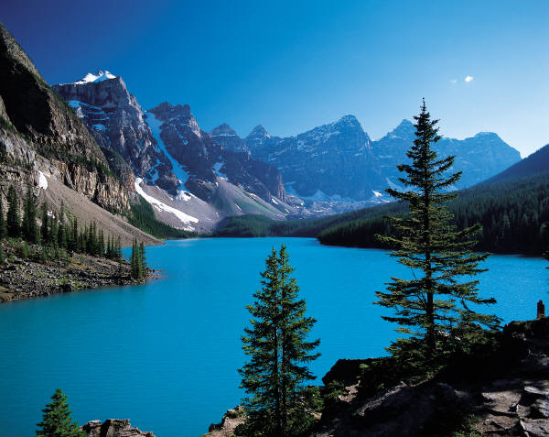
- Cumulonimbus clouds are very tall thunderstorm clouds that form if cumulus congestus clouds continue to grow vertically. Their tops may extend upward over 39,000 ft. They contain tremendous amounts of energy. Just like our Webelos who stand taller than the younger boys in the pack and are full of energy because they are excited about becoming Boy Scouts and going camping and doing outdoor activities with a troop.
Leader: Thank you. Now let us salute our flag which has one of the greatest constellations, the stars representing our 50 states.

AUDIENCE PARTICIPATIONS & STORIES

The Littlest Snowflake
The Snow Fluff, Fluff, Fluff (softly with downward hand motion)
The Ice Brr! Brr! Brrr! (hold arms around self to keep warm)
Little Snowflake Wheeeeeee! (hands held straight up)
The Wind Whooo! Whooo! Whooo! (arms up, sway back and forth)
The Sun Ahhh! Ahhh! (arms held in circle over head)
Legend has it that long ago in the winter time there was a happy LITTLE SNOWFLAKE. He was a jolly little fellow, floating along on the WIND . . . scooting across the ICE . . . and generally having fun with all the other SNOW. Now, the one guy that LITTLE SNOWFLAKE- didn’t care for was the SUN . . . cause he could melt him right away. One day, the WIND blew LITTLE SNOWFLAKE way up high in the trees and left him on a big fat limb. This was fun, because below him he could see the SNOW as it gleamed and the ICE, as it glistened, But then it started to get warm. And it got warmer and warmer, but there LITTLE SNOWFLAKE sat all by his lonesome self The WIND was having a --. good time blowing all the rest of the SNOW around. The SUN continued to shine down on the ICE and make it shine like a mirror. Now, LITTLE SNOWFLAKE was really starting to get worried because the SUN was starting to melt him and before long he would be ICE and not the happy LITTLE SNOWFLAKE he had always been. Suddenly, the WIND, seeing the fix he was in, blew extra hard and picked up a whole bunch of SNOW... scooted it across the ICE and up into the tree where they all rescued LITTLE SNOWFLAKE from the hot SUN. So the next time you are out and the WIND has blown some SNOW across the ICE and into SUN, look extra hard and you just might see I friend, the happy LITTLE SNOWFLAKE!!

Weather Observations
Rain: Drip, drip
Sun: Shine, shine
Clouds: Hi, Mr. Sun
Wind: Blow, blow
One day the SUN… had a talk with the CLOUDS… and the WIND…. The CLOUDS… were always coming along blown by the WIND… and covering up the SUN’S… rays. The talking got louder and louder. The WIND… blew hard and the CLOUDS… started bumping together creating a RAIN… storm. The RAIN… fell hard for a whole day and a night. The next day the CLOUDS…, the WIND…, and the SUN… all were happy and the WIND… blew the CLOUDS… away. The SUN… shone brightly and everyone was happy.

The Sun, the Frost and the Wind
SUN: "I'm Hot!"
FROST: "Bur-r-r-r"
WIND: "Whoosh"
FARMER: "How-dee!"
The SUN, the FROST and the WIND once went out walking together and they met a FARMER. The FARMER bowed politely to them and went on his way. "It was to me that he was bowing so politely," said the SUN. "He is most afraid of me, because I am the most powerful of us all!"
"You are quite mistaken," said the FROST. "He is most afraid of me, and it was to me that he was bowing so politely." And the WIND said, "You are both wrong. I am by far the most powerful, and that was why he was bowing to me." "Why go on arguing about it?" asked the SUN. "Let's go back and ask the FARMER himself!"
So they turned back and caught up with the FARMER. "Tell us, friend FARMER," said the SUN. "To which of us were you bowing so respectfully just now?" "I was bowing to the WIND," said the FARMER. "To the WIND," repeated the SUN angrily. "Just wait, I'll burn you up one of these days!" "Don't worry," said the WIND. "I'll blow on you and cool you." "And I'll smite you with such a FROST that you'll freeze to a stone!" said the FROST. "Don't be afraid of the FROST either," added the WIND. "I'll stop blowing, and without a WIND, FROST has no strength!"

Crazy Weather???
RAIN--drip, drip HAIL---bounce, bounce
SUN----blasted hot! WIND --- Woooooooooo
HURRICANE--roar (loudly)
We lay in our sleeping bags in the tents and listened to the RAIN ----pound down on us. We were spending the night on the Salt Flat west of Salt Lake. The SUN---- was supposed to have been out, but all we had was WIND----- & RAIN----, all day long.
Suddenly, as we lay listening, we heard a strange noise like balls being thrown against our tent! Our Cubmaster shouted, Good grief, its Hail----.
”Oh, No ”, the scouts shouted. "We were supposed to have good weather, not RAIN----, HAIL----, or WIND !---”. "It couldn't be worse!" answered our Cubmaster. He shouldn't t have said that’ll as we lay in fear of the HAIL----balls, we heard the WIND----pick up and become so loud that we couldn't hear one another speak! Our tent was torn from around us and we lay looking up at the dark gloomy RAINY---- and WINDY---- sky.
"Someone help," I heard, "Its a HURRICANE----”.
"Can’t be”, yelled the Cubmaster, ”We don’t have HURRICANES---- here in Kansas City. RAIN---- perhaps, and some light WIND----, but never a HURRICANE---- !! ”
Where was that hot SUN---- today? Why all this crazy weather?
I felt myself being blown by the HURRICANE----. I remember calling for help, but no one came to my aid. I felt a strong "something" pulling my arm; “what is happening, I wondered”. This is crazy.
In a moment, I opened my eyes, and what a surprise it was to find was to find my dad shaking my arm vigorously and saying, ”Come on, son, it’s time to get up and head out for the over-nighter. ” Dad never did quite understand why I started to laugh hysterically. It was especially funny when he said, "Hope we get some SUN----.”

ADVANCEMENT CEREMONIES
The Weatherman & Nature
CA: (Pretending to be a news anchorman, introduces Cubmaster) “That’s it for tonight's news and sports; it’s time now for our weather report. Cubmaster (name), what's in store for us tonight?"

(Cubmaster does the rest of the advancement ceremony as a weatherman; adapt "patter" to fit your recent weather)

CM: We've had some unusual weather patterns in the last few days. A twister dropped a new Tiger in our pack. (Call forward boy and parents to present Tiger award.)

CM: The sky cleared just long enough for a couple of Bobcats to emerge from their Dens. (Call forward boys and parents to present Bobcat award.)

CM: A cold front moving in off the coast brought a light (or 'heavy" depending on the number of boys receiving awards) shower of Wolf badges and arrow points. (Call forward boys and parents to present Wolf awards.)

CM: A hailstorm hit during the night and covered the ground with about an inch of snow, ice, and Bear awards! (Call forward boys and parents to present Bear badges and arrow points.)

CM: Fortunately the sun peeked out from behind the clouds long enough for the Webelos to work on their activity badges. (Call forward boys, parents, and Webelos Leader to present Webelos activity pins, badge, and compass points.)

CM: Let's move now to our satellite photo to see what's in store for the city this week - WOW! Did you see that Arrow of Light sweep across the sky? (Call forward boys, parents, and Webelos Leader to present Arrow of Light award.)

WEATHER BALOON ADVANCEMENT CEREMONY
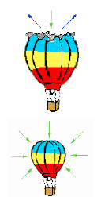
Personnel: Cubmaster
Material: 1 Large Balloon for each rank to be awarded plus 1 extra
Preparation:
1. Write the name of cub to be advanced on Balloon.
2. Insert Badge in Balloon.
3. Blow the balloon up and tie.
4. Repeat for each Boy.
5. Write Happy Birthday on one extra balloon
Set Up:
Place the balloons at the front on a table or have helpers hold so all can see the name on it.
Script:
Cubmaster: Once a family, for one of their children’s birthdays, decided to have a family picnic up at Solitude in the mountains. (Display the balloon with Happy Birthday written on it.)
They decided to blow up some balloons and put them in the back of the van to take up to the mountains to decorate the picnic site. The balloons were blown up big. They all piled into the van and drove up the mountain. Just before they got there, guess what happened? (Pop the "Happy Birthday" balloon) They heard a big bang. What do you think happened? (Pause: If a cub answers, let him explain. If not, explain as follows…)
Imagine that a balloon is sealed so that no air can escape from it. As the altitude of the balloon increases, (exterior air pressure is indicated by the arrows going in, or the green arrows) the air pressure outside of the balloon decreases. The amount of air in the balloon stays the same and therefore, so does the pressure that it exerts outward. (Interior air pressure is indicated by the arrows going out, or the blue arrows). When the balloon reaches a height where the interior air pressure becomes greater than the exterior air pressure along with the pressure exerted by the balloon's skin, the balloon will burst. (Some of these words may need some explanation in order that the boys will understand.)
Presentation:
Cubmaster: "Weathermen use balloons to tell them what the weather is like at different heights in the sky. Each of you scouts is at a different place on your scouting trail." Call out each boy and ask him to bring up his parents. Tell him that his weather balloon will show where he is on his path. If he would like, have him pop the balloon to discover his badge inside. Present his badge to parents to pin on their Cub Scout.

The Cub Spiritometer
Equipment: Spiritometer – a large cut out of a thermometer, with red ribbon or crepe paper to represent the mercury. Loop the ribbon or paper through a slit in the bottom so that it can be raised at the appropriate time. A tape loop under the end of the ribbon or paper will help hold it in the desired spot. Encouraging words (Great! Super! Good Job! Fantastic! etc.) can be written on the side of the thermometer, where the numbers usually are.
Cubmaster: A thermometer is a weather instrument used to measure the increase in air temperature. Advancement measures Cub Scout spirit in our pack. Tonight, we have a special instrument called the “Spiritometer” that will gauge our Cub Scout Spirit and show us which boys have climbed to new heights in advancing through the Cub Scout program. (Show Spiritometer to Pack.)
Cubmaster calls boys and parents forward to receive their awards. Each time an award is given, the red paper is raised a little higher. Judge how high to raise the paper each time by how many awards are to be presented.
Congratulate the boy, and let the audience applaud and cheer for him. The red of the Spiritometer should reach the top by the time all the awards are given.
Cubmaster: As you can see, our pack is filled with spirit and red hot on the trail of Cub Scout advancement.
(Lead an appropriate cheer for all who have earned awards.)

Raining Awards
Dress in raincoat and boots. Attach awards to raindrops and tape them to the outside of the raincoat. Raindrops with awards can also be attached onto or dangling from the edge of an umbrella. Tell the group that you have come through a downpour to get to the Pack Meeting. Maybe they can help dry you off by removing some of these raindrops. Call up boys and parents. Have parents remove the raindrop from the coat or umbrella and present the award to their son. The raindrop can have a saying written on it such as, “Just dropped by to say how proud we are of you. Congratulations on earning your ______.”

The Weather Forecaster
MATERIALS: Cubmaster dressed as weather forecaster; large map to depict weather in certain areas; pointer. Have advancement ceremony like the weather report. Have different areas on the map to represent Bobcat, Wolf, Bear and Webelos. Use terms used in weather forecasting. Watch the weather reports for some ideas on terms and procedures.
For Example: To the North, we have a jet stream carrying Bobcats with sunny faces. Coming in from the West, clear skies for the Wolf badge, etc.

Weather Forecaster Advancement
Have the CM dress as a weather forecaster, pointing a stick at a large map. Have different areas on the map represent the different ranks and use terms used in weather forecasting to present the badges.
CM: To the North, we have a jet stream carrying Bobcats with sunny faces. Coming in from the North-West, clear skies for the Tiger Cubs, etc.

Sunny Weather
Equipment: Helium balloons, one for each badge to be presented are handing above the Cubmaster with a basket which contains the badge.
Cubmaster: Tonight we are going to honor those Cub Scouts who have made the weather sunnier by advancing in rank. (He takes down a balloon and removes the badge.)
Will _________please come forward with his parents. ____________ has completed all the achievements for his Bobcat award. Whatever the weather, his parents have been behind him to help. (Hand badge to parent to present to son.)
Continue in same manner until all awards have been passed out.

Sunshine
Props: Large board with sun painted in fluorescent yellow pain. Rays should be extending out from the sun, one for each boy receiving an award. Awards should be attached to strips of black paper the size of one ray. Black rays are taped over yellow rays at the beginning.
Cubmaster: The sun shines brightly on our pack tonight. It brings warmth and good feelings. Our good feelings are increased by the achievements of the Cubs that we are going to recognize at this time.
(Call for ward boys and parents receiving awards. As each name is read or rank is presented, the parent removed the badge on the black strip from the board and a presents to son.)
Because of the efforts of these boys and their parents our sun shines even more brightly upon our Pack. Will all the Cub and families please rise and salute those who bring good weather to us.

SONGS

Baloo Skies
Tune – Caissons Go Rolling Along
From the clouds to the ground
Ba-loo Skies are all around
As we study and look in the air

Will it rain? Will it snow?
Use your book and you will know
Let’s get going the day will be fair

For rain, snow or sleet
It’s the fun of Cub Scouting
Whatever the weather may be
And when the sun is out
We will always shout
That Ba-loo skies will follow our Cubs
That Ba-loo skies will follow our Cubs

April Showers
(Tune: Frere Jacques)
April Showers, April Showers,
Bring May flowers, bring May flowers.
What do May flowers bring?
What do May flowers bring?
Allergies! Allergies!

Bad Weather Action Song
(Tune: If You’re Happy and you Know it Clap Your Hands)
If it’s raining and you know it, clap your hands.
If it’s raining and you know it, clap you hands.
If it’s raining and you know it,
Then your drippy clothes will show it,
If it’s raining and you know it, clap your hands.
If the mud is only knee deep, stomp your feet!
If the mud is only knee deep, stomp your feet!
If the mud is only knee deep,
And you wish that it were hip deep!
If the mud is only knee deep, stomp your feet!
If the wind is really blowing, shake your head!
If the wind is really blowing, shake your head!
If the wind is really blowing,
And your bald spot, it is showing,
If the wind is really blowing, shake your head!
If the temperature is falling, do all three!
If the temperature is falling, do all three!
If the temperature is falling,
And your spirits are a-dropping,
If the temperature is falling
YOU WILL FREEZE! (shout this line)

Campin’ In The Rain
(Tune: Singin’ in the Rain)

I’m campin’ in the rain, just campin’ in the rain.
The tent and the campfire are soggy again.
The clouds in the sky are making me cry.
My waterlogged shoes will never get dry.

All the mud in the place is stuck to my face.
The frogs and the turtles are starting to race.
Oh, what should I do, I need a canoe.
A web footed weasel ran off with my shoe.

I’m campin’ in the rain, just campin’ in the rain.
The good doctor said I’ve got water on the brain.
I can’t light the fire, I’m stuck in the mire.
The lightning just knocked down the telephone wire.

I’m drownin’ in the rain, just drownin’ in the rain.
Won’t it please stop raining, I hate to complain.
My sleeping bag’s wet, I’m starting to fret.
My life jacket wasn’t the thing to forget.

I’m campin’ in the rain, just campin’ in the rain.
What a glorious feeling, someone plugged the drain.
The pre-ci-pi-tate, will now dis-sip-pate.
The sun will soon dry up the puddle I hate.

No more campin’ - no campin’ in the rain.

Storm Clouds Go Rolling Along
(Tune: Caisson Song)
In the sky
On the ground
Weather signs are all around
As we study and measure them all.

Will it rain?
Will it snow?
Will there be a tornado?
Now get going and you’ll have a ball.
For it’s hing, hing, ping
In the fun of forecasting,
Write down your totals one and all!
And when the pressure’s low
You will always know
That those storm clouds go rolling along.
That those storm clouds go rolling along.

You Are My Sunshine

The other night dear, as I lay sleeping,
I dreamed I held you in my arms,
but when I woke dear, I was mistaken,
and I hung my head and cried.
Chorus
You are my sunshine, my only sunshine
you make me happy when skies are gray
you'll never know dear, how much I love you,
please don't take my sunshine away.
I'll always love you and make you happy
if you will only say the same
but if you leave me to love another
you'll regret it all some day
(Chorus)
You told me once dear you really loved me
that no one else could come between
but now you've left me and love another
you have shattered all my dreams.

(Chorus)

SKITS

Typical (Your State) Weather
Props: TV Screen, (Your State) map, Pointer, rain coat, winter coat, 2 paper fans, paper wads (hail stones)
Set - up: Weatherman is in the middle of the stage with (your state) map not moving yet. The TV is propped up against the chair. The leader walks in, turns on the TV and sits down to listen. After the TV is turned on, the weatherman starts.
Weather: (Using the pointer) Well folks, it looks like we're going to have a typical day of weather in New Jersey on this warm summer like day. All across the state there are sunny and clear skies. There is no chance of rain.
Leader: (Turns off TV) Good! We can go outside.
Cub Scout 1: (Walks in fanning himself) Boy what a great day to be outside. The sun sure feels good.
Cub Scout 2: (Walks in wearing a rain coat) It sure did cloud up fast. It's starting to rain.
Cub Scout 3: (Walks in wearing a heavy coat) A cold front just came in. It must be freezing out there.
Cub Scout 4: Hey did you guys see the hail coming down out there? (Throws hailstones into the air).
Cub Scout 5: (Walks in wearing his uniform) The sun feels good out there.
Leader: Yes, it sure is another day of typical (Your State) weather.

Crazy Weather
Personnel: 4 Scouts plus more to make sound effects
Equipment: Items to make sound effects (see below), sleeping bags
Scene: Boys are in sleeping bags in a tent for a campout

Cub 1: I thought the weather was supposed to be clear today! But all we’ve had is wind and rain, all day long.
Cub 2: What’s that pounding noise? (sounds of hail) Oh no - it’s hailing! The weather couldn’t be much worse!
Cub 3: Wow - the wind is getting so bad, I think our tent will soon blow away. (sounds of wind)
Cub 4: Help! Help! There goes our tent. Hang onto your sleeping bag. Watch out! It’s raining so hard! (sounds of tent flapping and wind and rain)
Cub 2: This must be a HURRICANE! But how can we be having one in this part of the country?
Cub 3: Someone help me! I can’t hang on anymore! It’s blowing me away! Help me! Help!
Cub 4: Wake up, wake up, John. It’s time to get up and get ready for our campout. I hear we’re going to have a clear day.
Cub 1: Oh yeah – sure, right. (to the audience, as the other boys pick up their sleeping bags and walk off) Thank goodness that was just a dream!

Old Fashioned Weather Forecasting
Scouts hold up a card explaining their part (i.e. pictures of a cloud, sailor, moon, etc.) with their speaking parts written on the back.
Narrator: Weather forecasting has been around for a long time. People have used all kinds of methods. Today scientific instruments are the basis for most of our forecasts. But just for fun, let’s look at some older weather forecasting.
Cub 1: Red sky at night, sailors delight. Red sky in the morning, sailors take warning.
Cub 2: When the dew is on the grass, rain will never come to pass.
Cub 3: A circle around the moon, tells of a storm pretty soon.
Cub 4: When the stars above are bright, a good day is still in sight.
Cub 5: Mackerel sky, storm is nigh.
Cub 6: Sounds travel far and wide, a stormy day will bring high tide.
Cub 7: When the grass is dry at night, look for rain before the light.
Cub 8: Cotton floating in the air (clouds), moderate wind and weather fair.
Cub 9: Evening red and morning gray are certain signs of a fine day.
Cub 10: Grasses dry in the morning light, look for rain before the night.

CHEERS & APPLAUSES, JOKES & RUN-ONS
Cub 1: Do you ever walk to school the snow?
Cub 2: Nope.
Cub 1: How about the rain?
Cub 2: Nope.
Cub 1: What about sleet, hail or even sunshine?
Cub 2: Nope.
Cub 1: Then what do you walk to school in?
Cub 2: Tennis shoes.
Cub 1: (runs on stage yelling) It’s all around me! It’s all around me!
Cub 2: What’s all around you?
Cub 1: Air.
Cub 1: Why won’t weather forecasters tell each other jokes?
Cub 2: They don’t want to laugh up a storm.

CHEERS & APPLAUSES
Lightning Applause
Shake your finger like jagged lightning and go Zing, Zing, Zap on each movement.
Lightning and Thunder Applause
Shake your finger like jagged lightning and go Zing, Zing, Zap two times and end by clapping the hands together and saying loudly “Boom!”.
Thunder Applause
Use feet to stomp on floor making thunderous applause. Gradually soften.
Rainstorm Applause
Pat the knees softly to simulate a gentle rain. Slowly get louder and faster, and then clap hands in front of you to resemble harder rain. Place the hands above your head and clap as loud as you can and yell “Boom!” to resemble thunder. Clap the hands in front of you, getting softer again, pat the knees and get softer until all is quiet again.

CLOSING CEREMONIES

Weather Symbols
Setup: Have 4 Cubs carry signs with four weather symbols - RAIN, SUNNY, SNOW and CLOUDY.

Cub 1 (RAIN): The rain keeps us indoors, most of the time, but the rain makes the crops grow, and the flowers to bloom. Rain is good for the earth.
Cub 2 (SNOW): The snow and cold causes trees to go into a winter sleep. This makes the tree rest, so that when the sun comes out and the seasons change again, the tree grows again, refreshed.
Cub 3 (SUNNY): The sun brings us warmth, the sun along with the rain make the grass and flowers grow. With the proper rain and sun, the fields are green with fruits and vegetables and grain. Oklahoma farmers depend on these crops for their livelihood.
Cub 4 (CLOUDY): Clouds, when the conditions are rights, will turn into rain. Clouds will block the rays of the hot sun during the summer heat to cool things off a little.
CUBMASTER: Cub Scouting is a program for all seasons and weather conditions.

Telling Winds
West Winds – usually bring clear bright weather.
East Winds – bring clear cold weather.
South Winds – bring heat and often quick showers.
North Winds – can expect rain in the summer and snow in the winter.
Northwest Winds – bring cooler weather in the summer and cold waves in the winter
Southwest Winds – warm and often scorching in the summer.
Southeast Winds – These are the wettest of all.
Thank you for coming, may the winds be with you tonight.

Cubmaster’s Minutes
Cubmaster: As we go back to our homes, parents might keep these thoughts in mind---council your sons that they have the eyes to behold the golden, red and purple sun sets, that they have the ears to hear the voice of the great spirit; guide them to have hands that respect the things that God has made. Help them seek strength, not to be superior to others but to be helpful to others. Help them along the Cub Scout Trail to do their best.

Lord Baden-Powell, the founder of Scouting, said this to Scouts everywhere: “I often think when the sun goes down, the world is hidden by a big blanket from the light of heaven, but the stars are little holes pierced in that blanket by those who have done good deeds in this world. The stars are not all the same size; some are big, some are little, and some men have done small deeds but they have made their hole in the blanket by doing good before they go to heaven. Try to make your hole in the blanket by good work while you are on earth. It is something to be good, but it is far better to do good.” Think of Baden- Powell’s words when you promise “to help other people.”

CLOSING THOUGHTS
Whatever the Weather: Whatever the weather,
Scouts always are prepared to do their best.
I predict great Scouting weather for us in the month ahead.
Goodnight.

Indian Prayer
Morning Star awake us, filled with joy,
To new days of growing to man from boy.
Sun, with your power, give us light,
That we can tell wrong and do what’s right.
South Wind, we ask, in your gentle way,
Blow us the willingness to obey.
North Wind, we ask, live up to thy name,
Send us the strength to always be game.
East Wind, we ask, with your breath so snappy,
Fill us with the knowledge of how to be happy.
West wind, we ask, blow all that is fair,
To us, that we may always be square.
Moon, that fills the night with red light,
Guard us well while we sleep in the night.
Akela, please guide us in every way,
We’ll follow your trail in work or in play.

ONE LAST THING
By now you have noticed that this issue of Baloo’s Bugle does not look anything like previous editions. That’s because you have a pinch hitter producing this issue. This is new for me. I’ve quietly worked behind the scenes for the past couple years, preparing the web pages from MS Word files. But this month, Commissioner Dave ran out of time before he had to leave for a previously scheduled and well deserved vacation. Very fortunately for me, he left a whole bunch of stuff for me to work from. Some things just didn’t happen this month, like the usual Pow Wow information, and web sites. I’m sure that CD will do all of that wonderful stuff next month. I hope you have found these resources useful for your Den and Pack program.
-- Gary Hendra, the MacScouter.

