CORE VALUES
Cub Scout Roundtable Leaders’ Guide
Core Value Highlighted This Month: Responsibility
Responsibility means fulfilling our duty to God, country, other people, and ourselves. Being responsible is being dependable and doing what you say you will do.
Why "Dollars and Sense" for Responsibility?
We learn to be responsible for certain jobs, our own belonging, thing in our home, and the property of others. We should all learn how to be responsible with our money as well. Not only is it wise to learn how money works, it is equally important to learn about the responsibilities that go along with having money. It all comes down to dollars and sense.
Scout Law equivalents to Responsibility are:
Trustworthy - A Scout tells the truth. He is honest, and he keeps his promises. People can depend on him.
and Helpful - A Scout cares about other people. He willingly volunteers to help without expecting payment or reward.

““You are not only responsible for what you say, but also for what you do not say.”
Martin Luther

TABLE OF CONTENTS
In many of the sections you will find subdivisions for the various topics covered in the den meetings
CORE VALUES 1
TABLE OF CONTENTS 1
PROGRAM UPDATE 2
DEN MEETING TOPICS 3
PACK MEETING THEMES 3
PROGRAM UPDATE 4
UPCOMING MONTHS 5
CORE VALUE RELATED STUFF 6
Connecting Responsibility with Outdoor Activities 6
The Character Connection Process 7
Responsibility Tips for Den Leaders 9
Crazy Holidays 9
THE BUZZ 12
Links for Annual program Planning - 12
Training Topics 12
Cub Scout Adventure Program Advancement Update 12
PRICE UPDATE 14
Roundtable Note 14
President Harry S Truman 15
Harry S Truman Quotes 16
THOUGHTFUL ITEMS FOR SCOUTERS 17
Prayer 17
Character for a Character 17
Quotations 17
Benjamin Franklin 19
DEN MEETINGS 19
TIGER 19
WOLF 22
State Websites for Kids 24
Wolf Ideas by Roxanne 26
Responsibility Ideas 43
Responsibility Word Search 43
Being Responsible Ceremony 43
I Made a Promise Ceremony 43
Who’s Responsible? Opening Ceremony 43
Responsible Bobcats Ceremony 44
“You Can Count on Me!” Advancement Ceremony 44
You Can Count on Me Song 45
Responsibility Song 45
Who’s Responsible Applause 45
Responsibility & Perception Run On 45
JOKES & RIDDLES 46
Campsite Cleanup Game 46
Who’s Responsible? #1 Game 46
Choice and Consequence Game 46
Who’s Responsible? #2 Game 46
Search for Responsibility Game 47
Watch your step! Game 47
A Scout is Responsible Closing Ceremony 47
Being Responsible Cubmaster’s Minute 47
Be A Giraffe! Cubmaster’s Minute 47
Responsibility and Dependability Equals Reputation Cubmaster’s Minute 47
Dollars and Sense Ideas 48
Name That Slogan 48
Three in a Row 48
Dollars Opening 48
Prayer (Cub Scout or Leader) 48
Audience Participation 48
Recognition Wise Investments 49
Closing Cubmaster’s Minute 49
Closing Ceremony Investment Closing 50
A Penny Saved Opening Ceremony 50
Dollar Bill Recognition 50
The Lost Quarter Skit 50
Whole Dollar in My Hand 50
Penny Game 51
Cub Cheer 51
Run-Ons 51
The Spirit of Sacrifice Opening 51
The Foolish Millionaire and the Clever Cub Scout 51
How Much? 52
The Great Seal 52
APPLAUSES 53
RUN-ONS 53
Lots of Change 53
The Doughnut Shop 53
Sort-Your–Savings Bank Billfold or Coin Purse 53
Coin Matchup 54
Stick Up 54
Tub Toss 54
Three Coins in a Fountain 54
Lucky Pennies 54
Carrot Pennies 54
Flea Market 55
Name Tags 55
Which Country’s Coins 55
How Much Does It Cost 55
Dollars Opening Ceremonies 55
A Penny Saved 55
Think About This 55
My Choice 55
Making Banks 56
Pringles Can Bank 56
Drum Bank 56
Kleenex Box Bank 56
Fireman’s Hat Bank 56
An Investment In The Future Advancement Ceremony 56
Passing The Buck Game 57
Minuteman Run Game 57
Guard the Treasurer Game 57
Game 57
How Much is That Doggie in the Window? 57
Ghost With One Black 57
I've Got Sixpence 57
Chest of Gold Skit 58
American Express Card Skit 58
The Lost Quarter Skit National Capital Area Council 59
Million Dollar Macaroni and Cheese Casserole 59
Million Dollar Pound Cake 59
Mamie Eisenhower’s Fudge 59
“Piggy” Bank 59
Foreign Exchange 60
Have A Party! 60
Play Financial Board Games 60
Investment Closing Ceremony 60
Cents and Sense 60

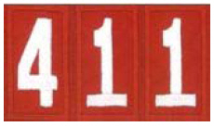

PROGRAM UPDATE
Commissioner Dave spent a great two weeks at the Philmont Training Center and wishes all of you could do that also. Or at least one week out!!! The second week he was learning about the new Cub Scout Adventure Program (and meeting many Baloo’s Bugle Readers!! Many thanks to all for all the kind words).
The new Adventure Program is great!! We worked the sample Adventures (one for each rank in both the Boys’ Sample Handbook and Den Leader Guide). The Den Leader guide is very complete to help guide DLs through the Adventures. (But feel free to modify the activities – NOT the requirements only the activities (games, projects, …). But be careful – the activities in the book were chosen as best ways to have the boys come to understand and learn the Aims of Scouting (Participatory Citizenship, Character Development, Personal Fitness) as well as “Outdoor Skills and Awareness” and “Leadership and Life Skills.” While you may know other games and activities that fit the theme, core value, requirement, …, it may fall short on the total package – the Three Aims of Scouting (Participatory Citizenship, Character Development, Personal Fitness) as well as “Outdoor Skills and Awareness” and “Leadership and Life Skills.” As might Baloo’s Bugle ideas as we work to bring you many ideas.
I will be presenting updates on the new Adventure Program throughout the year. I encourage the Cub Scout Roundtable commissioners and their Assistant Commissioners (We no longer have RT staff.) to do the same. Walk your participants trough the sample Adventures. This month I am preparing for my daughter’s wedding in September!! And so my Program Update stuff is a little weak, sorry. BUT you all have another year of the current program to run. Don’t jump on this program too soon. And when you do – hang on and hold tight. It is a leap forward.
I told Bob Scott, National’s Lead Professional for the New Adventure program, that the current system is the same as when I was a Cub Scout in 1957, therefore, by definition, it is obsolete. And he reminded me of something he told me in 2009 when presenting cub Scouts 2010 –
Jet pilots don’t use rear view mirrors.
They are always looking ahead.
Something we should all do!!!
A member of National’s Camping Staff who works with National Camp Schools sat next to me in class and she was writing down many ideas for the annual update to the NCS Cub scout day and Resident Camp Syllabi to make use of the new Adventures. The participants in all the Cub Scout 411 courses this summer worked to determine which new Adventures will be great at Day and Resident camps. There are quite a few. So Day and Resident Camp Directors and Program Directors – get excited!!!
Be sure you keep following the updates http://www.scouting.org/scoutsource/programupdates.aspx

DEN MEETING TOPICS
When a Den Meeting occurs depends on when you start your year and how often you meet. A Den that starts in August will be doing meetings 1 & 2 then, and 3& 4 in September. A den that meets three times a month will do 1, 2, and 3 in September. The pace is up to you!!
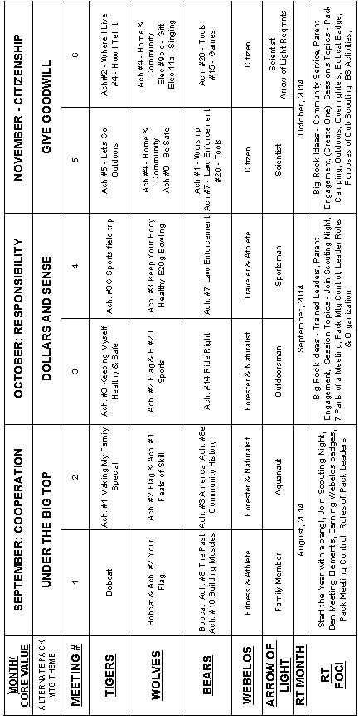

PACK MEETING THEMES
Commissioner Dave (with help from Kim)
All 36 Supplemental Pack Meeting plans are posted at: http://www.scouting.org/scoutsource/CubScouts/Leaders/DenLeaderResources/DenandPackMeetingResourceGuide/PackMeetingPlans.aspx
Any Pack/Cubmaster can use any theme any month. The year designation is to show you which themes will be featured at Roundtables each year. The 2014 - 2015 RT year kicked off in August with Cooperation and Under the Big Top. Now it is Responsibility and Dollars and Sense.

Here are the remaining themes to be featured for
2014-2015 in the CS RT PG -
Month Core Value Supplemental Theme
- September Cooperation Amazing Games
- October Responsibility Down on the Farm
- November Citizenship Your Vote Counts
- December Respect Passports to Other Lands
- January Positive Attitude Lights, Camera, Action
- February Resourcefulness Invention Convention
- March Compassion Pet Pals
- April Faith My Family Tree
- May Health and Fitness Destination Parks
- June Perseverance Over the Horizon
**Obedient Play Ball
- July Courage Space - the New Frontier
**Loyal Scout Salute
- August Honesty Heroes in History
**Courteous S'More Cub Scout Fun

** - These are the Core Values and Themes for the first three months of the new Cub Scout Adventure

Kim, the chair of the task force, says "I do want to stress that the focus is still the Core Value and the theme is just there as an enhancement. The theme pack meeting plans are specifically crafted to bring out the important points of the Core Value in a fun way."

Here are the first 12 Supplemental Themes
with their Point of the Scout Law
(replaces Core Values)
for the new
Cub Scout Adventure -

Point  of the  Scout Law | Supplemental  Theme | Month
Obedient | Play Ball | June  2015
Loyal | Scout Salute | July  2015
Courteous | S'More Cub  Scout Fun | August  2015
Clean | Cubservation | Sept  2015
Brave | Super Cub! | October  2015
Helpful | Cubs In Action | Nov  2015
Reverent | Winter Wonderland | Dec  2015
Trustworthy | The Great Race | January  2016
Friendly | Friends Near  and Far | February  2016
Thrifty | Cubstruction | March  2016
Cheerful | Strike Up  the Band | April  2016
Kind | My Animal  Friends | May  2016

PROGRAM UPDATE
GREAT NEWS!!!
Background -
As stated on BSA's Program Update pages (http://www.scouting.org/scoutsource/programupdates.aspx) Cub Scouting's 12 Core Values are being adjusted to align with the 12 points of the Scout Law as we move to
One Oath/One Law in September 2015.
NOTE:
YOU CAN START USING
SCOUT OATH & LAW NOW!!!

Action:
Kim has regrouped her Task Force and is working on new Pack Meeting plans and agendas using the Core Values based on the 12 points of the Scout Law. The first 12 have been drafted and are under review by National Council
(See list in previous column)!!
Thank you, Kim!!!

UPCOMING MONTHS

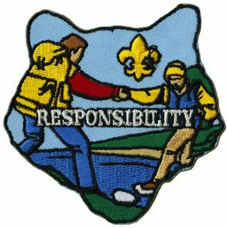
- October's Core Value, Responsibility, will use
"Down on the Farm."
- Month's that have themes that might help you with Responsibility and "Down on the Farm " are:

Month | Year | Theme
Dollars and Sense
Month | Year | Theme
November | 1986 | What Will I Be?
January | 2001 | When I Grow Up
March | 2002 | Dollars & Sense
March | 2009 | When I Grow Up
Responsibility
May | 1949 | Farming
April | 1950 | Country Fair
September | 1951 | Barn Raisin'
November | 1953 | Harvest Fair
April | 1959 | Down on the Farm
November | 1959 | The Country Store
September | 1961 | Harvest Fair
August | 1973 | County Fair
November | 1976 | Rural America
April | 1985 | Farmer Brown and His Friends
October | 2001 | Down on the Farm
October | 2007 | Down on the Farm
October | 2010 | Responsibility
October | 2011 | Responsibility
October | 2012 | Responsibility  (Jungle of Fun)
October | 2013 | Responsibility  (Down on the Farm)
Core Value Patches are available at www.scoutstuff.org
For Theme patches go to http://www.cubmasterbobkatt.com/Cubmaster-Bob-Katt-Cub-Scout-Monthly-Themes.htm

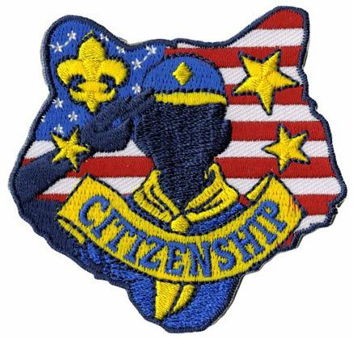
- November's Core Value, Citizenship, will use
"Gives Goodwill."
- Month's that have themes that might help you with Citizenship and "Gives Goodwill " are:

Month | Year | Theme
Gives Goodwill
December | 1940 | Good Will - Cub Style
December | 1941 | Giving Good Will
December | 1942 | Good Will
December | 1943 | Good Will Month
December | 1944 | The Other Fellow
December | 1945 | Follows - Helps - Gives
December | 1947 | Helps and Gives
December | 1948 | Goodwill
December | 1949 | The Other Fellow
December | 1950 | Helps (for institutions)
December | 1958 | The Golden Rule
December | 1961 | Follows, Helps, and Gives
September | 1965 | Barn Raising
December | 1969 | Cub Scout Gives Good Will
December | 1971 | Cub Scout Gives Good Will
December | 1972 | Follows, Helps, Gives
December | 1975 | Cub Scout Gives Good Will
December | 1984 | Do a Good Turn
December | 1985 | Follows, Helps, Gives
December | 1986 | The Golden Rule
December | 1991 | Follows, Helps, Gives
December | 1992 | To Help Other People
December | 1995 | Do a Good Turn
December | 1996 | Helping Others
December | 1997 | The Golden Rule
December | 2003 | A CS Gives Good Will
December | 2005 | Faith, Hope & Charity
November | 2008 | Spreading Seeds Of Kindness

Citizenship
Month | Year | Theme
September | 1960 | Cub Scout Citizens
September | 1972 | Cub Scout Citizens
October | 1980 | Cub Scout Citizen
July | 1983 | Stars and Stripes
October | 1988 | Cub Scout Citizens
February | 1989 | Strong for America
September | 1989 | Our American Heritage
February | 1993 | Old Glory
June | 1994 | Strong for America
July | 1999 | Our National Treasures
February | 2003 | Uncle Sam Depends on You
July | 2006 | Red, White and Baloo
July | 2007 | The Rockets Red Glare
July | 2010 | Celebrate Freedom
November | 2010 | Citizenship
November | 2011 | Citizenship
November | 2012 | Citizenship (50 Great States)
November | 2013 | Citizenship (Your Vote Counts)

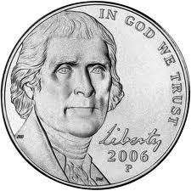

CORE VALUE RELATED STUFF

Connecting Responsibility
with Outdoor Activities
Commissioner Dave
(Adapted from B.A.L.O.O. Appendix E)
- HIKES - Pair up with a buddy and be responsible for him throughout the hike. Stay on the trail. Leave no trace.
- NATURE - Each boy brings a specific nature time to the meeting demonstrating he is responsible to remember his assignment. Also, each boy is responsible in bringing items that are allowed and not disturbing any nature preserve or ecology site.
- SERVICE PROJECTS - Mow the grass for elderly neighbor for a specified duration. Make a duty roster. Each Scout is responsible to do his part.
- GAMES & SPORTS - Each boy is responsible to bring certain piece of equipment to play a game (bat, ball, glove for baseball).
- CEREMONIES - Do a den ceremony where each boy is responsible to act or say his part. Adults model responsibility by having advancements ready to present.
- CAMPFIRES - Boys could help set up and clean up campfire area. They are responsible to make sure the fire is completely out.
- DEN TRIPS - Visit a local bank or credit union and talk about how these institutions are responsible for safeguarding other people’s money.
- PACK OVERNIGHTER - Have boys help to plan one of the overnighter activities. Be sure to evaluate afterwards to discuss how success is related to responsible behavior.

Responsibility is always discussed in reference to something – to be responsible to or for something. For example, the boys will learn to be more responsible with money and resources (conservation) later in the year. Because the topic of responsibility is so broad, there are many directions leaders can go with it.
This month the boys are learning about responsibility through the achievements and activity pins they are working on. The Tigers are learning to take more responsibility for their health by making better food choices. The Wolves are also learning to take more responsibility for their health, and are tracking their progress on their health charts. The Bears are learning to ride a bicycle responsibly, and to take care of their bicycles. The Webelos are gaining a deeper appreciation for nature, which will hopefully translate into greater environmental responsibility. And Arrow of Light Webelos are exercising (health & fitness responsibility) when they work on their Aquanaut.
Because responsibility is already built into this month’s activities, leaders can easily work in a quick discussion about responsibility as it relates to what they are doing in their dens.
Wendy, Chief Seattle Council

The Character Connection Process
RESPONSIBILITY
Character Connection
2011 - 2012 CS RT Planning Guide
What does it mean to be responsible? Why is it important that you act responsibly when you go on a campout? What can happen if you don’t act responsibly and don’t clean up after yourself at the pack overnighter?
During the next week, let’s pay attention to those things you are responsible for and make sure you do your best. How can you do that?
See Fun for the Family, No. 33012, for family activities related to this month’s core value, responsibility.
Carol at www.cubroundtable.com
Tiger Book
Character Connection - Responsibility
Achievement 1, "Making My Family Special," Requirement 1fa (Page 32)
- Practice - Do requirement 1F, Think of one chore you can do with your adult partner. Complete it together. This is part of Achievement 1, Making My Family Special.
- Know. - Think about the chore that you completed in the Practice section. What was the hardest part of doing the chore? How well was the chore done? What does it mean to be responsible?
- Commit - Why is being responsible important? Are there chores you can do by yourself? List other ways that you can be responsible.
Wolf Book
Character Connection - Responsibility
Achievement 9, " Be Safe at Home and On the Street," Requirement a (Page 82)
- Know. - Discuss these questions with your family: How does being responsible help us be safe? Within the past week, how did you show responsibility?
- Commit - Discuss these questions with your family: What happens when people are not responsible? What things can make you forget to be responsible? What things will help you be more responsible?
- Practice - Practice being responsible while doing the requirements for Achievement 9, “Be Safe at Home and on the Street.”
Bear Book
The Responsibility Character Connection is not part of an Achievement or Elective in this book.
Webelos Book
Character Connection - Responsibility
Handyman Activity Award, Requirement 1 (Page 300)
- Know. - List all the tasks you can think of that are necessary in keeping a household in good shape. Name the tasks that are your responsibility. Tell what it means to be responsible for these tasks.
- Commit - Talk about what happens when people don't do their jobs. Tell why it is important to be helpful and to be responsible. List ways that you can be more responsible on your own.
- Practice - Choose one of the requirements and show how you are responsible by doing that task well for 2 weeks.
Home Alone Booklet
Cub Scout Program Helps 2003-2004 page 8 January
Materials: Several (about 12) sheets of 8 1/2" by 11" paper, brads, pens, crayons, markers, stickers, stars, etc. First week: camera
Fasten the pages together with the brads so new pages can be added later during other meetings.
Some pages can be decorated with clip art.
During the first meeting, take the boys’ photos; each boy will decorate his booklet’s cover and next week will add his picture to personalize it.
Den leaders can provide special pages to be completed at home with parents. These pages might include:
- Home fire escape plan
- Family chore chart
- List of house rules
Character Connections for Home Alone Booklet
After Cub Scouts have completed these pages with their families, have them share the pages with den members. Then lead a discussion on .
- What does it mean to be ? If you’ve been trusted to be home alone, what do your parents expect?
- What makes it difficult to tell a friend that you’re not allowed to have friends in the house when your parents aren’t home? Why would your parents have this rule?
- What are some things you can do to show your parents that you are responsible?
Controlled Landing
Cub Scout Program Helps 2002-2003 page 8 September
- Divide boys into two teams,
- The first player on each team is blindfolded and turned around three times.
- He then tries to walk to his team’s goal line.
- His control tower (the other players on his team) may shout directions at him.
- When he reaches the goal line, he takes off the blindfold and runs back to the next player, who repeats the action.
Character Connection for Controlled Landing: Responsibility
- What does it mean to be responsible?
- Who had responsibilities in the game?
- What were they?
- How did you feel about being responsible for your teammate? What made being responsible difficult?
- How did it feel to have limited sight and have to rely on someone else?
- What can you do to help people who have impaired vision? What responsibility do you have for them?
Cubmaster's Minute
Cub Scout Program Helps 2003-2004 page 3 January
How can we expect boys to be responsible if we, as parents and leaders, don’t give them the opportunity? It’s only fair that if we want them to be responsible, we must teach them how.
And if you boys want and are to be given opportunities to prove that you can be responsible, it is necessary that you show that you have the skills needed and can be entrusted with the responsibility of being home alone.
Doing My Part
2004 Pow Wow Book, Cub Scouting Forever by Great Salt
Responsibility - Fulfilling our duty to take care of ourselves and others.
Activity -
- Create a large puzzle with one part for each person.
- Hold back one piece of the puzzle.
- Have the Cubs identify and look for the missing piece.
- After a short look, tell the boys you have the missing part.
- Explain that in order to complete the puzzle you (the leader) must contribute your part.
- Explain, too, that responsibility is not just doing your part. It is also trying your best to find out why something is not working right.
- We might have to encourage others to do their part.
Cookie Bake
Activity -
- Have the Cubs bake chocolate chip (or another of your favorites) cookies.
- Assign each child to bring one ingredient. Tell the Cub that is assigned to bring the chocolate chips not bring them.
- At the next meeting talk about what happens when someone doesn’t fulfill their responsibility. Explain when you agree to do something, do it. If you let people down, they'll stop believing you. When you follow through on your commitments, people take you seriously.
- Supply the chocolate chips and continue making the cookies.
Zoo Adventures or Response-ability Charades
2005 Pow Wow Book Cub Scouting Forever by Great Salt Lake Council
Explain that responsibility is fulfilling our duty to take care of others and ourselves. It is behaving appropriately without having to be told each time.
Divide the den into 2 teams.
Have one boy from each team select a card and act out the situation for his own team members to get.
Put a 1-minute time limit on each charade then give the other team a chance to perform and guess their charade.
Add more situations as necessary.
Examples:
- Picking up litter.
- Walking quietly at the zoo. No shouting.
- Feeding your pet.
- Taking your pet for a walk.
Character Connection for Zoo Adventures or Response-ability Charades:
- What does it mean to be ? Why is it important that you act towards animals at the zoo and at home?
- What can happen if an animal swallows a balloon or gets caught in plastic soda can rings? Is it your responsibility to dispose of trash properly that could harm animals when you're at the zoo?
- What are some things you can do to be when you visit the zoo?
Sink the Ship
Cub Scout Program Helps 2006-2007 page 10 October
Materials: Balloon and string for each player
- Players stand in a circle, each with an inflated balloon attached to a 36-in. string tied to an ankle.
- On a signal, each player tries to break the other balloons by stomping on them.
- Players have a responsibility to develop strategies to protect their balloons.
- When a balloon is broken, the “ship” is sunk, and the “captain” leaves the circle. The game continues until only one player is left.
Character Connection on Responsibility for
Sink the Ship
- Your responsibility was to decide which items would help you survive. What did that responsibility mean to you?
- Do you feel you are responsible for things in your life, your family, at school?
- During the next week, let’s pay attention to those things we are responsible for and make sure we do our best. How can you do that?
For other RESPONSIBILITY
Character Connection Activities go to ·
http://www.cubroundtable.com/assets/pdf-documents/2002-2010%20Character-Connections-Packet.pdf

Responsibility Tips for Den Leaders
Alice, Golden Empire Council
Check out these activities suggested by teachers and creative Den Leaders. They can help boys practice being responsible and also reward them!
Interpersonal Responsibility: Have Den Rules!
One teacher talks about classroom rules, letting her students help decide on rules and consequences. As a Den Leader, you can do the same – just make sure you have only a few basic rules that everyone understands. Post your list at the front of the den room each meeting – if a rule is being broken, just point to the list and ask “What’s the Rule?” No need to get into a discussion with an individual boy, since the den all worked on the rules and consequences together. (You might even have to check the boy’s ideas when they decide on consequences – they are often far too severe)
Behavior Journals: Send home Positive Reports!
Teachers often have students write in their own personal journals about their week’s behavior and how they handled problems that came up. At the end of the week, they take their journals home to share with parents.
As a Den Leader, you can help boys with behavior issues to take personal responsibility by having them write down what happened, and how they think the problem could be solved.
You can also give out “Positive” reports to take home to parents. Baden-Powell said “A pat on the back is a stronger stimulus than a prick with a pin. Expect a great deal of your boys and you will generally get it.” Set a goal to say at least one good thing about each boy at every den meeting. But don’t give undeserved compliments – boys know when the praise is genuine! Remember, “It’s better to build boys than repair men.”
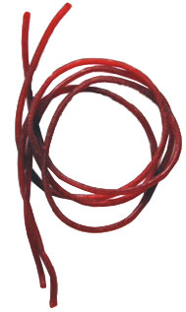
A Taste of Responsibility: Check this out under Gathering Activities
Responsible Service: Have each boy make a coupon book to give to his parents or teacher, or even to use at scouts. The boys should include coupons good for the adult to “redeem” in exchange for service from the boy. Each boy can include things such as “sorting the recycling” or “sweep the back porch” or “pass out materials.” Then have the boys turn in their completed coupon books when they have taken responsibility to do each promised task. A word of warning: these tasks should not include regular chores or assignments – they should be for extra things each boy can do.
“Caught Being Good Coins:” One Den Leader I worked with uses special plastic “coins” – when a boy is “caught” doing something good – helping without being asked, cleaning up after an activity, helping another boy with a project or craft. Boys cannot ask for a job to earn a coin – they are rewarded for choosing to be helpful and take responsibility for themselves and their materials, books, candy wrappers, whatever. Coins are redeemed for simple toys, stickers, party favor type stuff, sometimes a patch.
Assignment Organizer: Teachers often have their students record their assignments in a special notebook, so they can check off what they do in class – whatever isn’t done becomes homework, which they take home. Both parents and students initial the list before it returns to school.
As a Den Leader, have a process for “homework” – things that must be done at home. Make sure there is some kind of check-off for the boy to do – you could have a chart to post at the Den Meeting, so that boys can initial or put a sticker when they have completed the homework. Some dens have an email system – so parents can be reminded. But it’s important to have some way for each boy to keep and mark off his OWN record as well, especially with assignments that require more than one week.
Money Matters: To help students understand budgets, teachers often use play money, provide each student with a list of necessary expenses, and have them figure out how to use their “money.”
As Den Leaders, we can work on the scout or religious award requirements that involve learning how to use money. One favorite “field trip” I did was a visit to the grocery store where boys helped find the best value, compared not only cost, but price per unit, and also nutritional value.
We can also let the boys take an active role in planning the expenses for a den or pack activity, so they get a realistic view of how much things cost. Every scout should have an opportunity to earn at least part of the money for Day Camp – encourage parents to offer chores for hire, or use a den or pack project, such as a car wash or popcorn sales – where the boy himself can be responsible for part of the cost.

Crazy Holidays
Jodi, SNJC Webelos Resident Camp Director Emeritus,
2006-2011. Adapted from http://holidayinsights.com/moreholidays/index.htm
http://www.brownielocks.com/month2.html
October is:
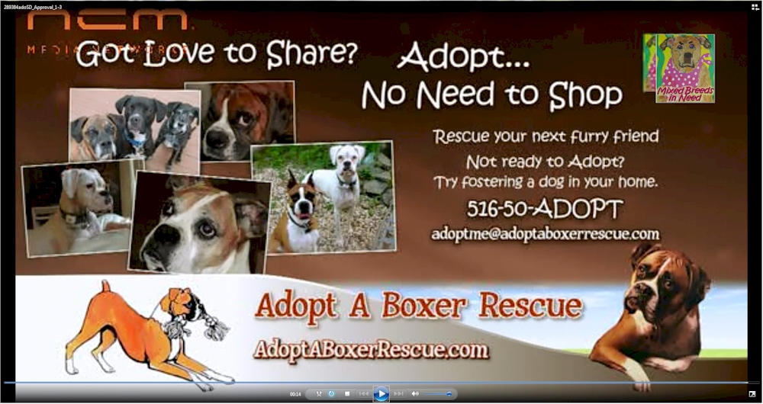
- Adopt a Shelter Dog Month
Our daughter and we have worked with,
adopted from and fostered for
Adopt a Boxer Rescue. CD
- American Pharmacist Month
- Apple Month
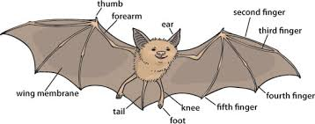
- Bat Appreciation Month
- Breast Cancer Awareness Month
- Celiac Disease Awareness Month
- Celebrating The Bilingual Child Month

- Clergy Appreciation Month
- Computer Learning Month
- Cookie Month

- Country Music Month
- Domestic Violence Awareness Month
- Down Syndrome Awareness Month
- Eat Better, Eat Together Month
- International Drum Month
- Lupus Awareness Month
- National Dental Hygiene Month
- National Diabetes Month
- National Liver Awareness Month
- National Pizza Month
- National Popcorn Popping Month
- Sarcastic Month
- Seafood Month

- National Vegetarian Month
As a recent convert to Vegetable Based & Whole Grain eating, I highly recommend you consider this life style or at least reducing the amount of meat you eat.
It was a personal choice. CD
Weekly Celebrations:
- Get Organized Week 1-7
- Universal Children's Week: 1-7

- 4H Week 3-11
- Albuquerque International Balloon Fiesta: 4-12
- National Storytelling Weekend: 3-5
- World Space Week: 4-10
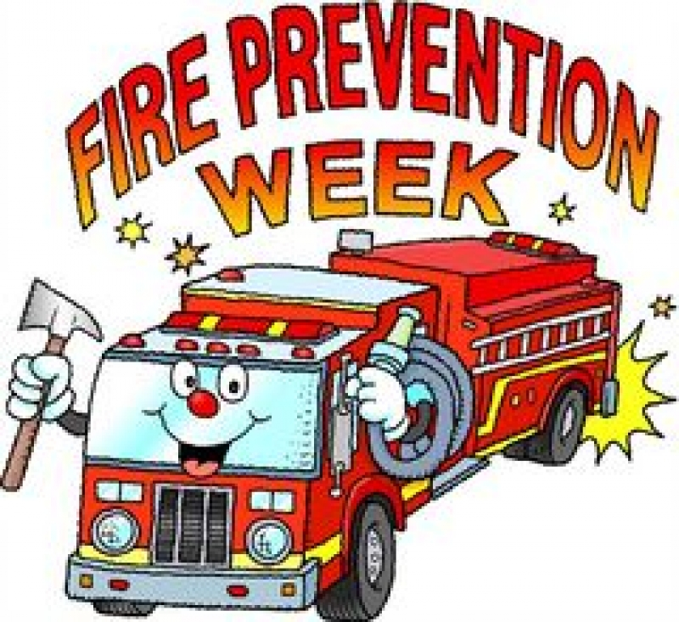
- Fire Prevention Week: 5-11
- Great Books Week: 5-11 (1st Full Week)
- National Carry A Tune Week: 5-11
- Spinning & Weaving Week: 6-12
- World Rainforest Week: 12-18
- Earth Science Week: 12-18
- Freedom From Bullies Week: 19-25
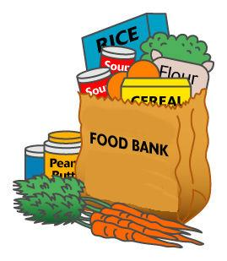
- National Food Bank Week: 12-18 (Week Always Has 16th in it, World Food Day)
- Teen Read Week: 12-18
- YWCA Week Without Violence: 12-18
- Freedom of Speech Week: 20-26 (3rd Full Week)
- National Character Counts Week: 19-25
- National Chemistry Week: 19-25

- National Friends of Libraries Week: 19-25

- National School Bus Safety Week: 20-24
- World Origami Days: 24-11/11
- International Magic Week: 25-31
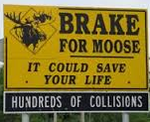
- Give Wildlife a Brake! Week: 10/26-11/1
October, 2013 Daily Holidays, Special and Wacky Days:
1 World Vegetarian Day
2 National Custodial Worker Day
2 Name Your Car Day
3 Techies Day
4 International Frugal Fun Day
This sounds like a great Cub Scout Idea!!
4 National Golf Day
4 National Frappe Day
5 Do Something Nice Day
5 World Teacher's Day
5 Oktoberfest in Germany ends, date varies
6 Come and Take it Day
6 Mad Hatter Day
6 Physician Assistant Day
7 Bald and Free Day
7 World Smile Day
8 American Touch Tag Day
8 Emergency Nurses Day- date varies
9 Curious Events Day
9 Fire Prevention Day
9 Leif Erikson Day
9 Moldy Cheese Day
10 National Angel Food Cake Day
10 World Egg Day - second Friday of month
11 It's My Party Day
11 Take Your Teddy Bear to Work Day
12 Cookbook Launch Day
12 Old Farmer's Day
12 Moment of Frustration Day
13 International Skeptics Day
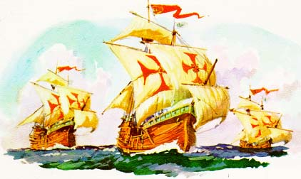
13 Columbus Day - second Monday of month
14 Be Bald and Free Day
14 National Dessert Day - take an extra helping, or two
15 White Cane Safety Day
16 Bosses Day
16 Dictionary Day
17 Wear Something Gaudy Day
18 Sweetest Day Third Saturday of month
18 No Beard Day
18 International Newspaper Carrier Day -date varies
19 Evaluate Your Life Day
20 Brandied Fruit Day
21 Babbling Day
21 Count Your Buttons Day
21 National Pumpkin Cheesecake Day find a recipe, too.
22 National Nut Day
23 National Mole Day
23 TV Talk Show Host Day
24 National Bologna Day
24 United Nations Day
25 World Pasta Day
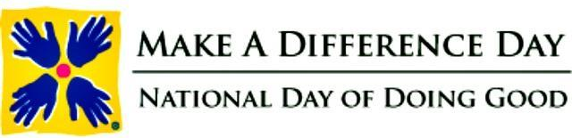
25 Make a Difference Day- fourth Saturday of the month, neighbors helping neighbors.
26 National Mincemeat Day
26 Mother-In-Law Day - fourth Sunday in October
27 National Tell a Story Day - in Scotland and the U.K.
27 Navy Day
28 Plush Animal Lover's Day
29 Hermit Day
29 National Frankenstein Day
29 Frankenstein Day - last Friday in October
30 National Candy Corn Day
31 Carve a Pumpkin Day - no surprise here
31 Halloween

THE BUZZ

Note - The Buzz is a biweekly video detailing recent changes and such in Boy Scouting.
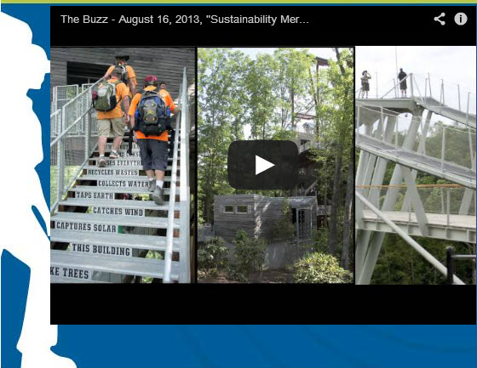
Scott Berger, chairman of the Sustainability Merit Badge Committee, and David Disney from the BSA Sustainability Advisory Council discuss how Scouts can make a lifelong commitment to sustainability by earning this new merit badge on their journey to Eagle.

Resources

Sustainability MB Requirements
with workbook at USScouts.org
( http://usscouts.org/mb/mb152.asp )
Sustainability Merit Badge Information
(http://scoutingmagazine.files.wordpress.com/2013/06/sustainability-flier.pdf)


View more episodes of The Buzz on our
YouTube channel.
Click on the picture above or go to:
http://www.scouting.org/sitecore/content/InternalCommunications/The%20Buzz.aspx
View our production schedule for The Buzz.


Links for Annual program Planning -
Get your Pack Annual Planning Conference Guide at - http://www.scouting.org/scoutsource/CubScouts/Leaders/ProgramPlanning.aspx
Get your Pack Calendar Template at - http://scouting.org/filestore/cubscouts/xls/2013-2014PackPlanningCalendar.xls
Baloo's Bugle had an item on Pack Annual Program Planning in the May 2013 edition available at - http://usscouts.org/bbugle/bb1305P.pdf
Here is the Cubcast link -
http://www.scouting.org/filestore/scoutcast/cubcast/201306_1/Planning_the_CS_Year.mp3

It is possible that by the time you get Baloo's Bugle and click the link, there may be a new Cubcast posted. Do not worry, all previous Cubcast are available from the home page.

Training Topics

Cub Scout Adventure Program
Advancement Update
Bill Smith, the Roundtable Guy, 2008
2014 Update by Commissioner Dave
All Cub Scout activities should involve as many of the three Aims of Scouting (Participatory Citizenship, Character Development, Personal Fitness) as well as “Outdoor Skills and Awareness” and “Leadership and Life Skills” as possible.
Adventure opportunities are prevalent in most of the things we do in Cub Scouts. In family and den activities, in ceremonies at pack meetings, in things we sew on the uniforms, advancement is there. And the new Adventure program capitalizes on this.
First of all recall that advancement is a Method of Cub Scouting. That means we should use it to achieve the Aims of Scouting (Participatory Citizenship, Character Development, Personal Fitness) and purposes of the program (“Outdoor Skills and Awareness” and “Leadership and Life Skills”). And have FUN doing it. The books, the requirements, the badges – everything - is there for us to help each boy develop. Think of the Adventure Program as a tool we use to help the Cub Scout grow.
Advancement is one of the methods used to achieve Scouting's aims—character development, citizenship training, and personal fitness. Everything a Cub Scout does to advance is designed to achieve these aims and aid in his personal growth. These badges are a means to an end—not an end in themselves. The Cub Scout Leader’s Book
Each requirement is an adventure that a young lad takes along with his special leader: his Akela. On the trail he is challenged to do his best to overcome the obstacles he meets. This gives the boy’s Akelas opportunities to achieve those Purposes of Cub Scouting. His parents and his den leaders who guide him and help him on these requirements should be aware of both the adventure and the purposes.
The Cub Adventure Team (CAT), the task force that updated the Advancement Program, spent a lot of time reviewing how requirements related to the aims and purposes Scouting (Participatory Citizenship, Character Development, Personal Fitness) and “Outdoor Skills and Awareness” and “Leadership and Life Skills” before writing changes and creating new ideas. They stayed focused on the correct goals listed above as well as making the program more active and current with today’s boys’ needs. This became extremely clear to me during the Cub Scout 411 course at Philmont Training Center.
Each requirement in each Adventure for each rank represents a challenge to that boy. How he reacts to each challenge will depend on how he perceives that particular encounter. Some boys revel in challenges. Others are intimidated. Each boy has his own unique responses. We need to be flexible in presenting the new Adventure Program and how we treat the advancement requirements. Don’t make them seem too easy or they lose meaning. Too hard, and boys get discouraged. It’s the boy that counts here, not necessarily the requirements. The journey rather than the destination is what is important. As Bill’s first Scouting Guru, Bud Bennett would say about Cub Scout projects,
“It’s not what the boy does to the board that matters; it’s what the board does to the boy.”
Remember, methods in Cub Scouting are meant to be flexible. We should do what we feel is best for each boy. The Parent Guide in the Wolf Cub Scout Book reminds us:
In Cub Scouting, boys are judged against
their own standard, not against other boys.
The Adventures are not tests that a boy must pass to advance in order to continue in Scouting. They are a series of experiences that help him grow into a more effective human being. All we ask is that he does his best in each of them.
Doing your best is one of the most important things for the Cub Scout to learn. Boys often become so interested in winning that they fail to see the importance of doing the best they can at everything. One boy's best might be quite different from another boy's best. The Cub Scout Leader Book
The new (Experienced leaders will find many familiar parts to the new Adventures) Adventure Program provides a series of surmountable obstacles and steps to help Leaders guide the boys to overcome them. The Scout plans his advancement and progresses at his own pace as he overcomes each challenge. The Scout is rewarded for completing each Adventure with a belt loop. The completion and the recognition help him gain self-confidence. The steps in the Adventure Program help a boy grow in self-reliance and the ability to help others.
The first rank that EVERY boy MUST earn when entering the Cub Scouting Program is the Bobcat rank. Bobcat features the Ideals of Scouting: The Scout Law, The Scout Oath (or Promise), the Cub Scout Motto (Do Your Best). These all teach participatory citizenship and contribute to a boy's sense of belonging.
The purposes and ideals of Scouting are excellent character guidelines for any group, organization or individual. School for Champions
The Adventures – There are 7 for each rank - Tiger, Wolf, Bear, Webelos, and Arrow of Light -
represent those things a growing boy should be doing as he learns to be a good citizen (Participatory Citizenship), to be a more responsible and capable person and to do the right thing (Character Development), and how to stay healthy (Personal Fitness). The Adventures give parents and others ample opportunities to observe and understand how this boy is growing up: what sort of adult he will be, what kind of husband, what type of father, and what quality of community member he will become. Informed parents and leaders can - and should - make the Adventures fun experiences.
The Tiger program is an effective process to introduce parents to the values and practices of Cub Scout Adventures. Family involvement is an essential part of Cub Scouting. When we speak of parents or families, we are not referring to any particular family structure. Some boys live with two parents, some live with one parent, some have foster parents, and some live with grandparents, other relatives or guardians. Whoever a boy calls his family is his family in Cub Scouting.
The Elective Adventures involve TALKING. The boy and his parent TALK, they listen to each other, they plan; they express their hopes, their concerns, and their jokes. They learn to respect each other's moods, ideas and styles. They create special communication channels that remain vital and valuable for all their lives.
Although most Adventures will be done at Den Meetings, encourage parents to do Elective Adventures with their sons to increase parental bonding. Encourage parents to help you teach the skills. What could make a boy prouder than to see his parent(s) teaching his buddies!! Leaders, do not shut out the parents by requiring all Adventures to be done at den meetings that denies the parents the opportunity to establish better relationships with their sons.
I am reminded of Linus, a boy who lived here in Portland. At a young age he became excited about a toy chemistry set and soon chemistry captivated him and he became so obsessed that he tended to neglect other activities and didn't even finish high school. Linus C Pauling went on to become a world famous pioneer in the application of quantum mechanics to chemistry, and one of the founders of molecular biology, and to win two Nobel Prizes.
Webelos and Adventure Pins
By the time boys are Webelos, they are more serious about goal setting, team building and reaching out to other adults in the community. The Webelos and Arrow of Light Adventures are designed to give them ample opportunities to become knowledgeable and even skilled in the outdoors and in the fields such as art, science, health, communication and government. The Webelos and Arrow of Light boys will receive a pin for each Adventure to be placed on the traditional Webelos colors.
About this age, boys start looking outside their families for acceptance and guidance. Good packs will ensure that Webelos and Arrow of Light den leaders have lots of adult help for their Adventures. This not only makes the Webelos and arrow of Light Den Leaders’ jobs easier but provides the boys opportunities to interact with a several adults. Build a data base of all the skills, hobbies and interests of parents as soon as the families join your pack.
And finally, remember to show off your leadership skills by recognizing each Adventure by presenting the belt loop (Tiger, wolf, Bear) or pin (Webelos, Arrow of Light) with an award ceremony that the boy will remember for years to come.
And then make the sure the rank presentation ceremony is even greater!! And don’t force it to the Blue and Gold – remember the motto – Do Your Best – present the awards when earned!!

PRICE UPDATE
The new belt loops will NOT be a Budget Buster!! They are a composite material, and will cost less than the current Cub Scout Academics and Sports Belt Loops and Pins. Also, the total cost per Cub Scout for the seven loops required for each rank is less the total cost per Cub Scout for the average number of offer Cub Scout Academics and Sports Belt Loops and Pins plus Instant Recognition devices and beads boys earned per year. Bob Scott, National’s professional lead for this project worked very hard to ensure total cost would be reduced. A big HEAP How and a hearty Thank You, Bob!!!
What are YOU going to do now?
The best gift for a Cub Scout.......
......get his parents involved!
The greatest gift you can give your child
..... good self respect!

Roundtable Note

For the RT article (or elsewhere, you can put a note that the RT Planning Guide Task Force is forming up again and plans to begin working on the 2015-2016 issue in September. Suggestions and comments can be sent to Dan Maxfield. His E-mail is dmaxfil@yahoo.com

Dan is the RT member of Tico's National Support Staff

Insert picture (from The Commissioner) if you wish
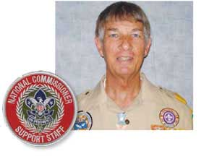

President Harry S Truman
The Buck Stops Here
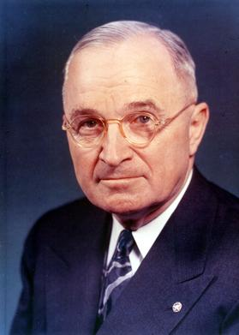
"I learned that a great leader is a man who has the ability to get other people to do what they don't want to do and like it."
Harry S Truman
The sign "The Buck Stops Here" that was on President Truman's desk in his White House office was made in the Federal Reformatory at El Reno, Oklahoma. Fred M. Canfil, then United States Marshal for the Western District of Missouri and a friend of Mr. Truman, saw a similar sign while visiting the Reformatory and asked the Warden if a sign like it could be made for President Truman. The sign was made and mailed to the President on October 2, 1945.
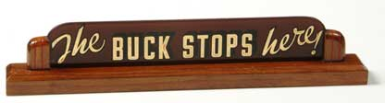
Approximately 2-1/2" x 13" in size and mounted on walnut base, the painted glass sign has the words "I'm From Missouri" on the reverse side. It appeared at different times on his desk until late in his administration.
The saying "the buck stops here" derives from the slang expression "pass the buck" which means passing the responsibility on to someone else. (Reference - A Dictionary of Americanisms on Historical Principles, Mitford M. Mathews, ed., (Chicago, University of Chicago Press, 1951), Volume I, pages 198-199.)
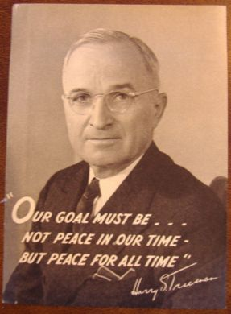
By today’s standards, Harry S Truman should never have become President. He was born in Missouri and became a farmer when he left school, because his parents could not afford college and his eyesight was not good enough to get into West Point. He became a farmer until the United States entered World War I and he went to France as a Captain of Field Artillery. He returned to Missouri as was an unsuccessful merchant before entering local politics. In 1934 he was elected to the United State Senate with the help of a powerful Democratic political machine. In 1944, in some back room deals, Truman was asked to run as Franklin D Roosevelt’s Vice President, knowing that President Roosevelt was not expected to survive his next term. As Vice President he returned to the Senate, acting a President of the Senate for the next 82 days.
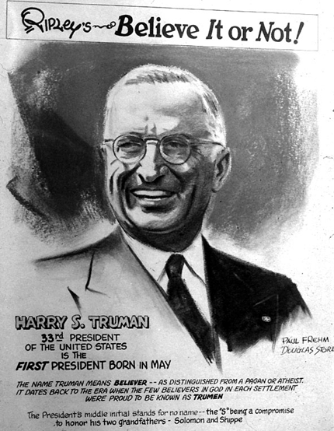
On the afternoon of April 12, 1945, Truman was presiding over the Senate in his capacity as president of the chamber. He had just adjourned the session for the day and was preparing to have a drink in House Speaker Sam Rayburn's office when he received an urgent message to go immediately to the White House. Truman assumed that President Roosevelt, who he knew was in Warm Springs, Georgia, had returned earlier than expected and wanted to meet with him, but upon his arrival, Eleanor Roosevelt informed him that the president had died after suffering a massive cerebral hemorrhage. Truman's first concern was for Mrs. Roosevelt. He asked if there was anything he could do for her, to which she replied, "Is there anything we can do for you? You are the one in trouble now!"
Upon assuming the presidency, Truman asked all the members of FDR's cabinet to remain in place, told them that he was open to their advice, but laid down a central principle of his administration: he would be the one making decisions, and they were to support him.
Shortly after becoming president, Truman was faced with one of the most difficult decision a president has ever faced. Would he drag out the War in the Pacific with an agonizing ground and sea battle risking the lives of thousands of soldiers, or unleash the most devastating weapon ever invented to that point and kill hundreds of thousands of Japanese citizens and bring a quick end to the War. The decision was made to use the Atomic Bomb, which ended the war with the total destruction of two Japanese cities and the deaths of hundreds of thousands of Japanese civilians.
In 1948 he ran for President himself. He confounded all predictions to win election in 1948, helped by his famous Whistle Stop Tour of rural America. He's featured in a famous article from that night, where the Chicago Tribune famously boasted, based on inaccurate opinion polling, "Dewey Defeats Truman" (he didn't). If you look at the example picture, you can see how happy he is.
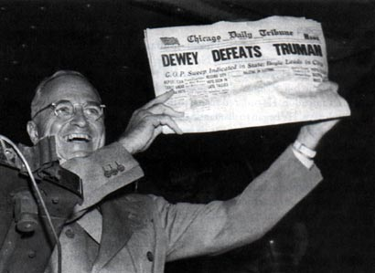
This can be considered his Crowning Moment of Awesome, especially when one considers that he had to contend with two third-party splinter candidacies during his campaign, one from Henry Wallace (a leftist who opposed Truman's anti-Communism) and another from Strom Thurmond (a Southern segregationist who opposed Truman's support for civil rights).
His Dismissal of General Douglas MacArthur during the Korean War was among the least politically popular decisions in presidential history. Truman's approval ratings plummeted, and he faced calls for his impeachment from, among others, Senator Robert Taft and the Chicago Tribune. Today this action is hailed as a great decision.
Truman would help create the United Nations and the North Atlantic Treaty Organization. He resisted Soviet aggression and with the Invasion of South Korea by North Korea, would embroil America in another war, which has never ended. Truman made the decision to recognize the establishment of the State of Israel over the objections of Secretary of State, who feared it would hurt relations with the Arab states. He desegregated the US military in 1948, because of his disgust over the way African-American war veterans were treated.
But he did not pass the Buck; he always accepted responsibility for his own actions.
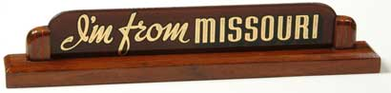

Harry S Truman Quotes
- The buck stops here!
- The atom bomb was no "great decision." It was merely another powerful weapon in the arsenal of righteousness.
- A pessimist is one who makes difficulties of his opportunities and an optimist is one who makes opportunities of his difficulties.
- Actions are the seed of fate deeds grow into destiny.
- All my life, whenever it comes time to make a decision,
I make it and forget about it.
- America was not built on fear. America was built on courage, on imagination and an unbeatable determination to do the job at hand.
- I do not believe there is a problem in this country or the world today which could not be settled if approached through the teaching of the Sermon on the Mount.
- I would rather have peace in the world than be President.
- If you can't stand the heat, get out of the kitchen.
- In reading the lives of great men, I found that the first victory they won was over themselves... self-discipline with all of them came first.
- It is amazing what you can accomplish if you do not care who gets the credit.
- It is understanding that gives us an ability to have peace. When we understand the other fellow's viewpoint, and he understands ours, then we can sit down and work out our differences.
- It's a recession when your neighbor loses his job; it's a depression when you lose yours.
- Men make history and not the other way around. In periods where there is no leadership, society stands still. Progress occurs when courageous, skillful leaders seize the opportunity to change things for the better.
- Most of the problems a President has to face have their roots in the past.
- My father was not a failure. After all, he was the father of a president of the United States.
- Study men, not historians.
- The only things worth learning are the things you learn after you know it all.
- The reward of suffering is experience.
- There is nothing new in the world except the history you do not know.
- You can always amend a big plan, but you can never expand a little one. I don't believe in little plans. I believe in plans big enough to meet a situation which we can't possibly foresee now.
- You know that being an American is more than a matter of where your parents came from. It is a belief that all men are created free and equal and that everyone deserves an even break.
You want a friend in Washington? Get a dog.

THOUGHTFUL ITEMS FOR SCOUTERS
Thanks to Scouter Jim from Bountiful, Utah, who prepares this section of Baloo for us each month. You can reach him at bobwhitejonz@juno.com or through the link to write Baloo on www.usscouts.org. CD

Prayer
Oh Great Creator of heaven and Earth and the all thing beneath Thy great sky. Let us use these things to help our fellows and teach our charges responsibility for Thy bounty. Let us care for the treasures of this earth and waste not a thing. Amen

Industry, thrift and self-control are not sought because they create wealth, but because they create character.
Calvin Coolidge

Character for a Character
Scouter Jim, Bountiful, UT

In the 25th Chapter of Matthew in the New Testament, Jesus Christ gives the parable of the talents. The two wise servants invested their talents and doubled their value.
I would like to introduce you to a neighbor of mine, who understands that concept. When he was young, about Tiger Cub age, he knocked on my door. In his hand he had a roll of specialized tape used by heating contractors. It was a roll of aluminum tape used to seal gaps in heating ducts.
“Will you trade me this for something better?” was his question.
I found something among my stuff to satisfy this request. He went from neighbor to neighbor, trading up until he got a prize he could keep.
When he was older, New Scout Patrol age, he wanted to attend a Basketball Camp at a local University, but he needed to raise the funds as his parents could not afford the registration. His grandmother had an unused solar greenhouse. As we talked, we decided that I would purchase some tomato seeds for him. In exchange, he would provide me with what plants I needed for the coming season. The others he planted he could sell to others. I was quite literally giving him “seed” money for his venture.
He went door to door selling the promise of tomato plants to all the neighbors, with the same determination he has used when he traded me the tape as a young Cub. By the time he was finished delivering his plants and tithing his profits; he had paid for his camp, supplied half the town with tomatoes, and had a few dollars spending money. He has also earned three merit badges in the effort.
Can we teach our charges the values of this young man? We must!

Quotations
You cannot escape the responsibility of tomorrow by evading it today
Abraham Lincoln

Quotations contain the wisdom of the ages, and are a great source of inspiration for Cubmaster’s minutes, material for an advancement ceremony or an insightful addition to a Pack Meeting program cover

If you want children to keep their feet on the ground, put some responsibility on their shoulders. Abigail Van Buren

Responsibility's like a string we can only see the middle of. Both ends are out of sight. William McFee, Casuals of the Sea, 1916

The willingness to accept responsibility for one's own life is the source from which self-respect springs. Joan Didion

The great thought, the great concern, the great anxiety of men is to restrict, as much as possible, the limits of their own responsibility. Giosué Borsi

We need to restore the full meaning of that old word, duty. It is the other side of rights. Pearl Buck

Being responsible sometimes means pissing people off. Colin Powell

I believe that every right implies a responsibility; every opportunity, an obligation; every possession, a duty. John D. Rockefeller, Jr.

If you could kick the person in the pants responsible for most of your trouble, you wouldn't sit for a month. Theodore Roosevelt

A new position of responsibility will usually show a man to be a far stronger creature than was supposed. William James

You must take personal responsibility. You cannot change the circumstances, the seasons, or the wind, but you can change yourself. Jim Rohn

Few things help an individual more than to place responsibility upon him, and to let him know that you trust him. Booker T. Washington

Whether or not you have children yourself, you are a parent to the next generation. If we can only stop thinking of children as individual property and think of them as the next generation, then we can realize we all have a role to play. Charlotte Davis Kasl, Finding Joy, 1994

Action springs not from thought, but from a readiness for responsibility. Dietrich Bonhoeffer

The commands of democracy are as imperative as its privileges and opportunities are wide and generous. Its compulsion is upon us. Woodrow Wilson

No man was ever endowed with a right without being at the same time saddled with a responsibility. Gerald W. Johnson

We are made wise not by the recollection of our past, but by the responsibility for our future. George Bernard Shaw

Thrift is not an affair of the pocket, but an affair of character. S.W. Straus

Thrift comes too late when you find it at the bottom of your purse. Seneca

Thrift was never more necessary in the world's history than it is today. Francis H. Sisson

Whatever thrift is, it is not avarice. Avarice is not generous; and, after all, it is the thrifty people who are generous. Lord Rosebery

The thrift that does not make a man charitable sours into avarice. M.W. Harrison

A bargain ain't a bargain unless it's something you need. Sidney Carroll, A Big Hand for the Little Lady

Be thrifty, but not covetous. George Herbert

By sowing frugality we reap liberty, a golden harvest. Agesilaus

I believe that thrift is essential to well-ordered living. John D. Rockefeller

Frugality may be termed the daughter of Prudence, the sister of Temperance, and the parent of Liberty. Samuel Johnson

Thrift means that you should always have the best you can possibly afford, when the thing has any reference to your physical and mental health, to your growth in efficiency and power. Orison Swett Marden

He who does not economize will have to agonize. Confucius

Beware of little expenses; a small leak will sink a great ship. Benjamin Franklin

We are not to judge thrift solely by the test of saving or spending. If one spends what he should prudently save, that certainly is to be deplored. But if one saves what he should prudently spend, that is not necessarily to be commended. A wise balance between the two is the desired end. Owen Young

Benjamin Franklin

If you would not be forgotten, as soon as you are dead and rotten, either write things workth reading, or do things worth writing. Benjamin Franklin

Benjamin Franklin was born on January 17, 1706, in Boston, Massachusetts to Josiah Franklin and Abiah Folger. Benjamin Franklin was the youngest son and fifteenth of his father’s children. His father only had funds to send him to two years of school.
At age 12, he was apprenticed to his brother James, a printer, who schooled Ben in the Printing Trade. When Ben was 15, his brother James, founded The New-England Courant.
Denied the chance to write under his own name, Ben created the pseudonym, “Mrs. Silence Dogwood,” a middle-age widow, and delivered letters which were published and became a matter of much discussion around town.
At the age of 17, Benjamin Franklin ran away to Philadelphia, Pennsylvania, seeking a new start in life. After a few months, he was convinced by Pennsylvania Governor, Sir William Keith, to go to London and acquire the equipment necessary to start his own newspaper in Philadelphia. Governor Keith’s promises of help were empty, so Benjamin Franklin found himself unemployed and a long ways from home. He found employment in a printer’s shop and earned enough for passage back to Philadelphia.
Back in Philadelphia, Franklin found work with Thomas Denham, a merchant, who employed Ben as a clerk, shopkeeper, and bookkeeper in his business. After Denham’s death in 1728, Benjamin Franklin with partner Hugh Meredith, became the publisher of The Pennsylvania Gazette newspaper.
During his lifetime, Benjamin Franklin invented Bifocal glasses, the Lightning rod, and the Franklin stove. He did not patent any of his inventions as he wanted all to benefit from their use.
Among other things he did in his life, He founding the first circulating library in America, the first volunteer fire department, the University of Pennsylvania, the first public hospital in America, and the first insurance company in America.
Benjamin Franklin was instrumental in writing the Declaration of Independence and the United States Constitution.
Not only did Benjamin Franklin has the skills and abilities to make a sound and prudent living, he also had the sense to use his talents to help others.

Hide not your talents. They for use were made. What’s a sundial in the shade? Benjamin Franklin.

DEN MEETINGS
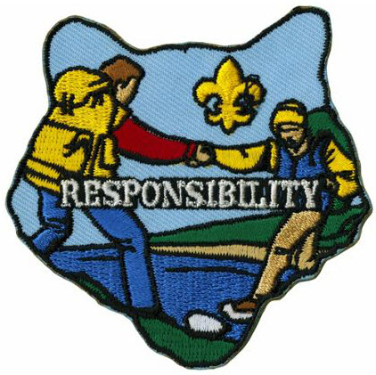



TIGER
Ach. #3 Keeping Myself Healthy & Safe,
E28 Smoke Detectors;
Den Meeting #3:
Ach. #3Fb What to do if lost;
Ach. #3D Food Pyramid;
Ach. #3Fa Plan a family fire drill;
E28 Check batteries in smoke detector;
Ach. #3D Health & Fitness Character Connection;
Ach. #3G Rules for sport or game.
Den Meeting #4: Field Trip:
Ach. #3G Watch a game or sporting event.
Tigers might also want to do El. #27 Emergency!
Food-related Games & Gathering Activities:
Word Search
Great Salt Lake Council
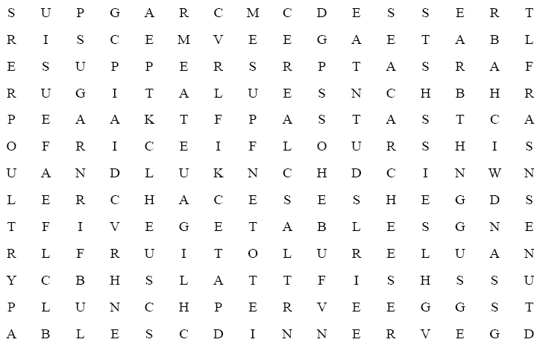
Find the following words in the puzzle that relate to food:
BREAKFAST FISH RICE CEREAL
FLOUR DESSERT CHEESE FRUIT
SANDWICH SALT LUNCH SUGAR
DINNER MEAT SUPPER EAT
PASTA VEGETABLES EGGS POULTRY
Baker’s Dozen
San Gabriel Valley-Long Beach Area-Verdugo Hills Councils
After you read the clues, fill in the blanks before or after this baker’s dozen of baked goods.
- Win the prize __ __ __ __ __ __ __ cake
- Scottish plaid tart__ __
- Package bun __ __ __
- Old Spanish pesos
pie__ __ __ __ __ __ __ __ __ __
- Livelihood bread __ __ __ __ __ __ __ __ __
- Fried pastry dough__ __ __
- Young rabbit bun__ __
- Full width bread__ __
- Showy dance step cake__ __ __ __
- Elevated amusement park railway
roll__ __ __ __ __ __ __ __ __
- Baker’s utensil roll__ __ __ __ __ __
- Lazy person loaf__ __
- Person or thing of excellence cracker__ __ __ __
Answers
Take the cake, tartan, bundle, pieces of eight, bread and butter, doughnut, bunny, breadth, cakewalk, roller coaster, rolling pin, loafer, crackerjack
Kitchen Anagrams
San Gabriel Valley-Long Beach Area-Verdugo Hills Councils
Add the letter shown after each word, and then rearrange the letters to spell the names of items that can be found in the kitchen.
- soon + p =
- beat + l =
- low + b =
- sags + l =
- fine + k =
- tale + p =
- kin + s =
- loot + s =
- vest + o =
- hid + s =
- lap + I =
- cause + r =
Answers
1) spoon 2) table 3) bowl 4) glass 5) knife 6) plate 7) sink 8) stool 9) stove 10) dish 11) pail 12) saucer
In the Refrigerator
Russ, Timucua District
What's one of a Cub Scout's favorite scouting places, but "in the refrigerator"? Give out sheets of paper that have "in the refrigerator" across the top. Then have everyone try to get as many words as possible from the letters. What should happen to the winner, but a trip to the refrigerator and an ice cream certificate!
Vegetable Letter Square
San Gabriel Valley-Long Beach Area-Verdugo Hills Councils
Find the following vegetables below by reading forward, up, down, and diagonally. Then read the leftover letters to discover what a vegetable truck would get if it went over a big bump!!!
Asparagus Avocado Beans Beet
Brussels Sprouts Carrot Cauliflower Celery
Corn Cucumber Eggplant Lettuce
Mushroom Okra Onion Peas
Pepper Potato Spinach Squash
Tomato Turnip Yam Zucchini
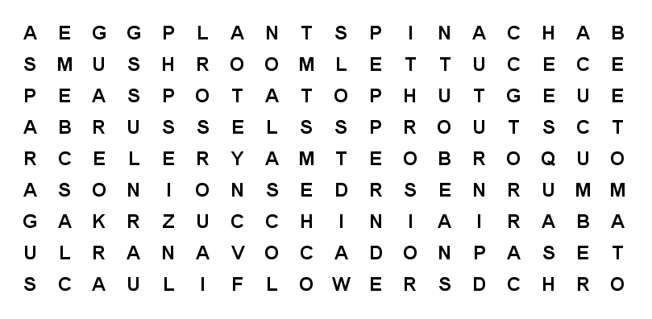
Taste Test
Russ, Timucua District
This is a takeoff on Kim's Game and is done using the sense of taste. Premix a dozen different flavors in liquid form and have them in small sampling jars (like mason jars or baby food jars. Flavors can include extracts (like vanilla and almond), drink flavors (like cherry and grape juices), diluted vinegar, etc. Place the flavors at numbered stations and hand out cards with the numbers next to blank lines. Also have toothpicks (many of them) at each station so that each person can use a different toothpick at each station. Let everyone try each flavor and try to identify as many as they can. The winners are those that identify the most flavors. As rewards for all the valiant efforts, give everyone flavored tootsie rolls or lollypops.
Taco Tie Slide:
Wendy, Chief Seattle Council
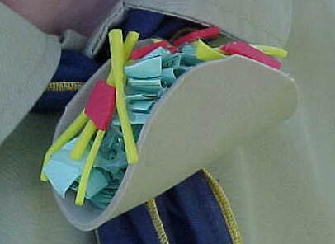
Materials
4" Tan Craft Foam
Red Craft Foam
Yellow Craft Foam Green Paper
PVC ring
Hot Glue
Scissors
Directions
- Cut 4" diameter circle from tan craft foam for taco shell.
- Cut thin strips of yellow craft foam for shredded cheese.
- Cut irregular shapes of red craft foam for tomato.
- Tear green paper into irregular shapes and wad up for lettuce.
- Fold taco shell in "U" shape.
- Using hot glue, attach cheese to bottom, then tomato, and finally lettuce on top.
- Make sure sides of taco are held in place, if not put on more hot glue.
- Hot glue a PVC ring to the back.
Bacon & Eggs Tie Slide:
Wendy, Chief Seattle Council
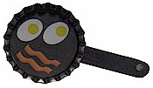
Materials
Bottle Caps
Can't find classic bottle caps??
Go to MakingFriends.com and you can buy them for less than 10 cents apiece. Unbelievable!! Of course, I never thought about buying crickets either until my daughter adopted an Anole CD
Bacon & Eggs
Scissors
Paint & Brush
Tacky Glue
1/2 Mini Craft Stick
3/4" PVC pipe about 1/2" long (for loop)
Low Temp Hot Glue Gun and Glue Sticks
Instructions:
- Have the boys draw bacon & eggs (or pancakes or ... ) on piece paper that will fit in the cap.
- You can cheat here a little. Click this link
- Glue the picture to inside of bottle cap.
- Break mini craft stick in half.
- Paint black to look like a pot handle.
- Glue to back of bottle cap.
- Glue on a PVC pipe
Connect the Dots
Timucua District, North Florida Council
Fire- Triangle Experiment
Baltimore Area Council
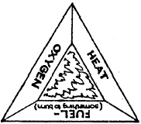
- Fire requires three things: air, fuel, and heat. Take away any one and the fire goes out. Demonstrate this with a wooden match and bottle.
- Have a Cub Scout (or a parent at the Den Meeting) strike a match (creating heat by friction). Let it burn a moment (using oxygen to burn the wood or fuel), and then drop it into the bottle and place his hand over the top. This cuts off the oxygen and the hatch goes out even though there is still plenty of fuel.
- Have a Cub Scout strike a match and dip it into a glass of water. The water cuts off the air and cools the fuel, extinguishing the fire even quicker
- Your boys may want to make a poster showing the fire triangle as illustrated.
Fire Safety Posters
Baltimore Area Council
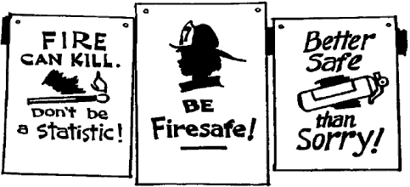
Have boys create their own slogans and designs for posters. Use Poster Board and felt tip pens, crayons, or paint. Display at Pack Meeting.
This web site has links to several publications (Including Baloo's Bugle) with ideas from Food related themes -
For "Cub Cafe", April 2007,
http://www.scoutingthenet.com/Training/Roundtable/Handouts/07/03/
For "Cub Grub", March 2000
http://www.scoutingthenet.com/Training/Roundtable/Handouts/00/02/
For "Holiday Food Fare", December 2004
http://www.scoutingthenet.com/Training/Roundtable/Handouts/04/11/
Fire Safety Ideas
Fire Safety Activities for children, US Fire Administration - Kids' Page, http://www.usfa.dhs.gov/kids/parents-teachers/resources.shtm
Fire-related Games & Gathering Activities:
Check out Gathering Activities, Den and Pack Activities, Games, and Songs for Fire Related things to use.
For more Fire Fighter Games & Crafts: http://www.amazingmoms.com/htm/party_firefighterparty.htm
http://familyfun.go.com/parties/birthday/feature/famf58birthday/famf58birthday2.html
Fire Fighter Hat: http://www.makingfriends.com/firemans_hat.htm



WOLF
Ach. #2 Your Flag,
Ach. #3 Keep Your Body Healthy,
E20 Sports, Bowling Belt Loop.
Den Meeting #3:
Ach. #2b or #2f Flag ceremony;
Ach. #2a Pledge of Allegiance;
Ach. #2c How to display, respect, and care for the flag;
Ach. #2d State Flag;
Ach. #2e Learn how to raise flag for outdoor flag ceremony;
Ach. #2g Fold the flag.
Ach. #3 Health Chart.
E20h sprint start;
E20i standing long jump;
E20 j Flag football, or E20k soccer, or E20l baseball or softball; or E20m basketball.
Bowling Belt Loop #1 Bowling rules.
Den Meeting #4:
Ach. #3a Verify health chart;
Ach. #3b Preventing colds;
Ach. #3c Treating cuts.
E20g Bowling
NOTE:
The Wolves may want to do their litter walk (Ach. #7d) in the next couple of months. If you follow the schedule in the new Cub Scout Den & Pack Meeting Resource Guide, the boys will be collecting litter in December.
Sports Ideas
Sports-related Games & Gathering Activities:
Blind Man’s Ball
York Adams Area Council
- Gather five or so different sports balls.
- For each one, get a large enough covered box into which the ball will fit.
- Cut hand-holes in the side of each box and cover the holes with “curtains” so the players can’t see into the box.
- Label the boxes for identification (e.g., 1, 2., 3. etc.).
- Have each person feel the ball in the box and figure out what type it is.
Team Logo Geography Quiz
York Adams Area Council
- Post logos from various professional sports teams.
- Have an answer sheet for people to write down the home city for the team
or
- Make a match game with logos in one column labeled as A to ??, and cities in the other column as 1 to ??
- Have the people match up the pairs.
Be careful not to use logos that give away the city
The Dodgers may be too easy - But the Orioles might work
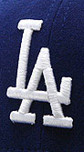
Gathering Activity
Crossroads of America
Set the room up with stations so the boys can do a different fitness event at each station as they wait for the opening.
Earth Ball
Sam Houston Area Council
- Using a beach ball the group task is to hit the "Earth" ball, keeping it in the air without letting it touch the ground.
- Additionally, no Scout can touch the Earth ball twice in a row.
- Set a goal with the group for the number of hits that the group can make following the rules.
DRIVEWAY OR PARKING LOT BASEBALL
Great Salt Lake Council
Draw a simple baseball field (not just diamond) on the ground with chalk. Mark different colored circles in various areas of the field. Each color would indicate a type of hit: single, double, triple, or home run.
To play, the player kneels or stands at home plate and tosses a stone into a circle. If he misses it’s an out. If it lands in the circle the other team can try to toss their stone into the same circle. If the second team makes it into the same spot it’s an out, if not the first team gains the number of bases listed by the spot. After three outs the teams switch sides.
SOCCER BOWL
Great Salt Lake Council
Set up 10 cans in the grass. Players kick a soccer ball at the cans to try and knock as many down as they can from 20 feet away.
OUTDOOR CHECKERS
Great Salt Lake Council
Use chalk to mark out a large checkerboard and use colored plastic plates for the checkers. As boys arrive they can join a side and work as a team to win the game.
ABILITY AWARENESS
Great Salt Lake Council
Provide a wheel chair, blindfolds, crutches and arm slings to debilitate the boys. Provide obstacles for them to accomplish in their new state of being.
PHYSICAL SKILLS
Great Salt Lake Council
Compete in the physical feats required for each rank. Crab walk, high jump, two-man games, etc.
TABLETOP HOCKEY
Great Salt Lake Council
Cut a plastic berry container or something similar, in half vertically. Invert one half of the container and set it at one end of a table. Cubs can line up at the opposite end and try to score by flicking “button pucks” into the net.
STICKS AND STONES (Native American)
Great Salt Lake Council
Take 3 popsicle sticks and color one side black. Players then drop their sticks on the ground and score based on the number of black sides that are up. This can also be done with flat rocks by marking one side with a marker.
SPORTS SCRAMBLE
Great Salt Lake Council
Write the letters of common sports onto colored paper. Cut the individual letters apart and scramble. Have the boys unscramble the letters.
Bike Check:
Alice, CS RT Commissioner
Pioneer District, Golden Empire Council
Have everyone bring their bikes and check for proper size, good brakes; make adjustments and repairs. (This is a great way to start off a Bike Rodeo)
Which Wheel Am I?
Alice, CS RT Commissioner
Pioneer District, Golden Empire Council
As people arrive at the Pack Meeting, tape one of the following on their back, without them seeing the name: Bicycle, Skateboard, Scooter, Inline Skates. Each person must locate others in the same name group by asking only Yes or No questions – or by making a noise that represents the wheel group they’re in.
Keep Your Body Healthy
What’s Missing First Aid Game
Wendy, Chief Seattle Council
This is a good Gathering Activity Wendy
Put about 10 first aid items on the table. Let the kids see them for a minute. Have the kids turn around and close their eyes. Leader removes one object. Kids turn around and open their eyes. The first kid to figure out what is missing wins. Put the missing object back on the first aid table. Re-arrange objects if desired, to make it a little more challenging. Kids close their eyes and turn around again. Winner from last round removes the object for this round.
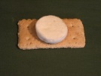
Band aid Treat
Wendy, Chief Seattle Council
Break a large rectangular graham cracker into 4 small rectangles. Put a small marshmallow in the center of the small rectangles. Microwave 10-15 seconds. (Wendy McBride)
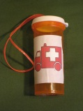
Mini First Aid Kit
Wendy, Chief Seattle Council
Using a nail, punch a hole in the lid of a pill bottle. Fold a 6” lace in half. Push the ends through the hole in the lid, and knot. Put a band aid, antiseptic wipe, and small piece of moleskin in the bottle.
What is it?
Alice, CS RT Commissioner
Pioneer District, Golden Empire Council
Mount an unlabeled picture of a bike on the wall – number each part of the bike, or block out the labels on a labeled picture. As they enter, each person or family gets a sheet with a list of the parts of a bike. They must decide which number goes with the part on their list. Winner is the one with the most correct answers when the meeting starts.
Or for more ideas -
http://usscouts.org/usscouts/bbugle/bb0207.pdf
Table Top Sports:
- Football: http://familyfun.go.com/playtime/play-tabletop-football-707287/
- Soccer:
http://familyfun.go.com/playtime/tabletop-games/tabletop-soccer-844529/
http://familyfun.go.com/playtime/tabletop-games/paper-ball-soccer-817885/
- Basketball: http://familyfun.go.com/playtime/tabletop-games/ping-pong-basketball-817459/
- Golf: http://familyfun.go.com/playtime/tabletop-games/flip-golf-817439/
- Shuffleboard: http://familyfun.go.com/playtime/tabletop-games/shuffle-caps-817886/
For more ideas see:
- 2008 Olympic theme “Go for the Gold”: http://www.scoutingthenet.com/Training/Roundtable/Handouts/08/05/
- 2002 “Sports Extravaganza” theme: http://www.scoutingthenet.com/Training/Roundtable/Handouts/02/07/
- 2009 “Be a Sport” theme: http://www.scoutingthenet.com/Training/Roundtable/Handouts/09/06/
- 2010 “Hoop-de-Doo” theme: http://www.scoutingthenet.com/Training/Roundtable/Handouts/10/05/
- 2005 “Play Ball” theme: http://www.scoutingthenet.com/Training/Roundtable/Handouts/05/06/
Your Flag Ideas
Ach. #2d Your State Flag, and state symbols:
Go to any of these sites to learn all about your state flag and other symbols -
- http://www.netstate.com
- http://www.enchantedlearning.com/usa/flags/
- http://www.50states.com/
In Baloo's Bugle for "My Home State," CD listed a kid's site for each state. Here it is. If your state's site has changed, drop Dave a note so he can update the list.

State Websites for Kids
Alabama Kids Page
http://www.alabama.gov/facts/kidspages.html
Alaska Stuff for Kids
http://www.state.ak.us/kids/
American Samoa
http://academickids.com/world/geos/aq.html
Arizona - About Arizona for Kids
http://www.lib.az.us/links/kidsAZ.cfm
Arkansas Kids
http://www.arkansaskids.com/
California Kid's Korner
http://www.dre.ca.gov/kids_sub.htm
Colorado Kids and Students Page
http://www.state.co.us/kids/index.html
Connecticut ConneCT Kids
http://www.kids.state.ct.us/
Delaware Kids Page
http://www.state.de.us/gic/kidspage/kidspage.htm
District of Columbia Kids' Capital
http://kids.dc.gov/
Florida Kids' Corner
http://taxonomy.myflorida.com/Taxonomy/Visitor/Kids%20Corner
Florida Kids
http://dhr.dos.state.fl.us/kids/index.html
Georgia
http://www.atozkidsstuff.com/georgia.html
Guam
http://www.guam-online.com/people/people.htm
Hawaii
http://www.atozkidsstuff.com/hawaii.html
Idaho Kid Book
http://www2.state.id.us/gov/fyi/kidbook/index.htm
Idaho Just for Kids
http://www.accessidaho.org/education/kids.html
Illinois Kid Zone
http://www.state.il.us/kids/
Indiana Little Hoosiers' Kid Page
http://www.in.gov/sic/kids/
Iowa Kids Too
http://www.state.ia.us/main/addressbooks/ADkids/index.html
Kansas Lawrence Recycling Page
http://www.lawrencekidsrecycle.org/
Kansas
http://www.accesskansas.org/facts-history/index.html
Kentucky Kids' Pages
http://kentucky.gov/Portal/Category/fac_kids
Louisiana Just for Students
http://www.louisiana.gov/wps/portal/.cmd/cs/.ce/155/.s/1118/_s.155/1088/_me/1117/
Maine Kids' Page
http://www.state.me.us/sos/kids/
Maryland
http://www.mdkidspage.org/
Massachusetts Kids' Zone
http://www.state.ma.us/sec/cis/ciskid/kididx.htm
Michigan MI Kids
http://www.michigan.gov/mikids
Michigan Kidz Korner
http://www.mda.state.mi.us/kids/index.html
Minnesota Student Page
http://www.sos.state.mn.us/student/netscape4.html
Mississippi Treasure Chest of Educational Resources
http://www.ms.gov/frameset.jsp?URL=http%3A%2F%2Fwww.mde.k12.ms.us%2Fms.htm
Missouri Kids Page
http://www.gov.state.mo.us/kids/
Montana is for Kids
http://montanakids.com/
Nebraska Online
http://www.nol.org/html/293/index.phtml
Nebraska's Legislature's Website for Kids
http://www.unicam.state.ne.us/kids/index.htm
Nevada
http://firstlady.state.nv.us/Trivia.htm
New Hampshire Senate Page for Kids
http://www.gencourt.state.nh.us/senate/misc/kids.html
New Jersey Hang Out NJ
http://www.state.nj.us/hangout_nj/
New Mexico
http://www.state.nm.us/category/aboutnm/fastfacts.html
New York for Kids
http://www.iloveny.com/kids/index.asp
North Carolina Kids Page
http://www.secretary.state.nc.us/kidspg/
North Dakota Kid Zone
http://discovernd.com/kidzone/
Northern Mariana Islands
http://academickids.com/world/geos/cq.html
Ohio OH Kids
http://oplin.lib.oh.us/products/oks/
Oklahoma
http://www.youroklahoma.com/?c=8
Oregon Blue Book
http://bluebook.state.or.us/kids/kids.htm
Pennsylvania Kids Pages
http://www.state.pa.us/papower/taxonomy/taxonomy.asp?DLN=29872
Puerto Rico
http://www.elboricua.com/BoricuaKids.html
Rhode Island
http://www.ri.gov/browse.php?choice=mpage&mcat=8
South Carolina
http://www.50states.com/scarolin.htm
South Dakota
http://www.state.sd.us/about.htm
Tennessee Kids Pages
http://www.tennesseeanytime.org/residents/children.html
Texas Senate Kids
http://www.senate.state.tx.us/kids/
Utah Kids Page
http://www.utah.gov/learning/kidspage.html
Vermont Kid's Page
http://www.sec.state.vt.us/Kids/kids_index.htm
Virgin Islands
http://www.countryreports.org/virginislands.htm
Virginia Kids Commonwealth
http://www.kidscommonwealth.virginia.gov/home/
Washington Just for Kids
http://access.wa.gov/kids/
West Virginia Kids' Page
http://www.legis.state.wv.us/kids/kids.html
Wisconsin Agency Pages for Kids
http://www.wisconsin.gov/state/core/kids_page.html
Wyoming Kid's Page
http://www.state.wy.us/kids.asp
Flag-related Games
& Gathering Activities:
Check out Gathering Activities, Den and Pack Activities, Games, and Songs for Flag Related things to use while working on the Flag Related Achievements and Electives.
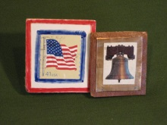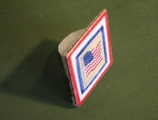
Postage Stamp Tie Slide
Wendy, Chief Seattle Council
Glue a flag or liberty bell stamp to a square of white cardboard that is about 2”. Decorate using markers. Glue a loop on the back of these to make a tie slide. Make loops from chenille stems, pvc pipe, or rings cut from the handles of plastic milk jugs. Be sure to sand the plastic jug rings before gluing. (Sanding raises a “tooth,” giving the glue something to stick to.)
Patriotic Activities:
http://familyfun.go.com/4th-of-july/
http://www.makingfriends.com/Patriotic.htm
For more ideas for “Your Flag” see
The 2001 & 2009 theme “American ABCs”:
http://www.scoutingthenet.com/Training/Roundtable/Handouts/09/01/
http://www.scoutingthenet.com/Training/Roundtable/Handouts/01/06/
The 2006 theme “Red, White, & Baloo”: http://www.scoutingthenet.com/Training/Roundtable/Handouts/06/0
The 2010 theme “Celebrate Freedom”: http://www.scoutingthenet.com/Training/Roundtable/Handouts/10/06/
The 2000 theme “Sea to Shining Sea”: http://www.scoutingthenet.com/Training/Roundtable/Handouts/00/06/

Wolf Ideas by Roxanne
RoxAnn, Heart of America Council
While working on the flag for Meeting 1, earn the Citizen Belt loop and part of the pin. For Homework assignment they may finish the pin and bring to Meeting 2.
Nutrition
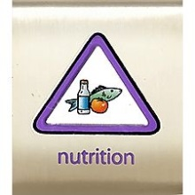
Belt Loop
Complete these three requirements:
- Make a poster of foods that are good for you. Share the poster with your den.
- Explain the difference between a fruit and a vegetable. Eat one of each.
- Help prepare and eat a healthy meal of foods that are included in a food pyramid.
(With your parent’s or partner’s permission, see http://www.mypyramid.gov.)
Pin
Earn the Nutrition belt loop and complete five of the following requirements:
- Make a poster that shows different foods that are high in each of the vitamins. Using your poster, explain to your den or family the difference between a vitamin and a mineral and the importance of each for a healthy diet.
- Read the nutrition label from a packaged or canned food item. Learn about the importance of the nutrients listed. Explain what you learned to your den or family.
- Make a list of diseases that can be caused by a diet that is poor in nutrition.
- Talk with your school cafeteria manager about the role nutrition plays in the meals your school serves.
- With an adult, plan a balanced menu of breakfasts, lunches, and dinners for your family for a week.
- Make a list of healthy snack foods. Demonstrate how to prepare two healthy snacks.
- With an adult, go grocery shopping. Report to your den or other family members what you learned about choosing good foods to eat.
- Demonstrate how to safely prepare food for three meals.
- Demonstrate how to store leftover food to prevent spoilage or contamination.
- Help with a garden. Report to your den or family about what is growing in the garden and how you helped. Show a picture of or bring an item harvested from your garden.
- Visit a farm or ranch. Talk with the owner about how the farm or ranch produces food for families.
Explain how physical exercise works with nutrition in helping people be fit and healthy. Demonstrate three examples of good physical activity. Interview someone who has become a naturalized citizen. Give a report of your interview to your den or family.

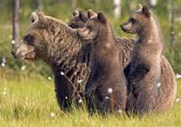
Core Value - Responsibility

Mtg Plan 4: A7 a, b, c, d. e, & f
Mtg 5: A1a &b, A20a. b, &c
Mtg 6: A15a

When planning your den meeting keep the following format in mind:
- Gathering Activity
- Opening - Say the Pledge of Allegiance, the Cub Scout promise & law.
- Discussion if any
- Activity
- Closing

If you haven’t already: assign the boys each a date to be Denner. On their day they bring the den snack, lead the pledge of allegiance (flag ceremony) A3f, & teach the den a new game A15c.

Bear Achievements:

Mtg Plan 4: Law Enforcement is a Big Job A7
Bear den plans can be found here www.scouting.org/scoutsource/CubScouts/Leaders/DenLeaderResources/DenandPackMeetingResourceGuide/BearDenPlans.aspx

Debra, from Plano, Texas offered us this great advice in 2010: If den meetings are fun and meaningful, the scouts are excited and happy. Her den meetings center around achievements and electives. She really thinks about how to make meetings fun and different. The proof is in the following awesome den plan she shared with us. Modified by myself (see Nov. 2010 for the original plan). Our thanks to Debra.

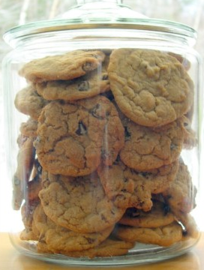

Bear CSI – “Who Stole the Cookies from the Cookie Jar?”

This is an achievement where a bit of prior planning and collusion with another den parent can make for a remarkable and memorable den meeting.
- Contact your crime prevention or public safety department of your local police department. Arrange for a police office to come to a den meeting to teach the boys about safety and to help them investigate a “real” crime scene.
- Choose or purchase an inexpensive drinking glass with smooth sides (so it is easy to take fingerprints off of it) & a cookie jar.
- Identify which of your scouts you want to “frame” for the crime. Get his parents “in” on the plan -- pick a boy who won’t get his feelings hurt, who would think this is fun, and who isn’t too obvious because his feet are either too big or too small in comparison to the group.
- A good two weeks or so before your CSI meeting, arrange to have this boy pick up and handle the glass on some pretext. For example, have the glass on the table (wiped clean of fingerprints before he touches it) and ask “Billy” to please move the glass over to the kitchen counter before it gets broken. Remember NOT to touch the glass without gloves from now on --- just move it to a safe spot in the house until the CSI meeting.
- Obtain “Billy’s” shoes from his mom, make them muddy on the bottom and put muddy footprints from the door to the milk glass & empty cookie jar. This works best on tile or wood floors (not recommending carpet here!) Billy’s mom needs to be sure he wears THOSE (now cleaned) shoes to the den meeting. (for those who have meetings where they can’t mess up the floor with footprints – put them on paper & tape them to your meeting room floor just before the meeting).
- Ask the police officer to arrive a few minutes early (having previously explained your master plan), and put crime scene tape on the door. As the boys arrive, a police car will be in front and the tape around the door. They will be immediately curious! Ask the boys to sit on the side walk, and the police officer can give them a talk about crime prevention A7b, how to help law enforcement A7f, & the phone numbers to call in an emergency A7c.

Then, in the most serious manner you can muster, tell them there has been a crime, and THEY will have to solve it. Someone has stolen all the cookies – leaving only the empty cookie jar & a milk glass. Break the boys into teams of 2 or 3, depending on how many boys are in the den.

Team 1 – Investigators. They are to interview all the suspects and take notes (see sample interview sheet).

Team 2 – Footprint Analysis Team. Their job is to take an aluminum foil imprint of each suspect’s shoe (easier than the plaster cast described in the handbook). Simply use sheets of heavy duty aluminum foil, placed on a folded over towel (so there is “give” and the impression will “take” on the foil). See attached worksheet). A7a

Team 3 – Fingerprint Analysis Team. They are to work with the police officer and obtain fingerprints of all suspects (fingerprint cards can be give to parents at end of meeting) and then dust the glass for prints (hint: harder to lift prints off a curved surface). You’ll need some wipes or soap and water so the boys can wash their hands after being fingerprinted and some rubber gloves for handling the glass so as not to contaminate the container with stray prints. See attached worksheet. A7a

Team 4 – CS Security Team. Their job is to secure the crime scene and take photos of the scene. They can use a digital, or better yet, Polaroid camera (you can ask parents if anyone has one to lend for this meeting). Lacking a camera, the boys can draw the details of the scene and mark their drawing with measurements (have a tape measure on hand). See details on attached worksheet.

8. Assist the boys as they work through this “game.” This is a fun meeting for other parents to attend and even participate in. Of course, you can end the meeting by serving those “stolen” chocolate chip cookies! AND, be sure to commend the “thief” on being such a good sport!

Of course, modify and embellish this as you would like.

Crime Scene Investigation Report
Suspect name: ________________________________
Suspect Birthday: _____________________________
Interview Questions:
1) Where were you yesterday afternoon after school?
2) Was anyone with you?
3) Have you ever eaten a chocolate chip cookie? Do you like chocolate chip cookies?
4) When was the last time you had a chocolate chip cookie?
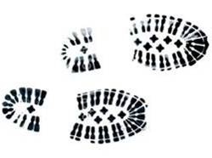
Crime Scene Footprint Analysis Team
Your job:
1) Obtain an aluminum foil imprint of everyone’s shoes.
2) Be sure to label the imprint with the suspect’s name.
3) Compare the imprints to the muddy prints in the living room.
4) Eliminate imprints until you arrive at your “prime suspect.”

Crime Scene Fingerprint Analysis Team
Your job:
1) Wear latex gloves to handle the milk glass.
2) With Officer Barnes’ help, dust the milk glass for fingerprints.
3) Obtain fingerprint cards on all the suspects. Be sure to label each card with the suspect’s name.
4) Compare suspect’s fingerprints to the ones noted on the milk glass.
5) Eliminate cards until you arrive at your “prime suspect.”


Crime Scene Security Team
Your job:
1) Secure the crime scene. Be sure not to touch or step on any evidence.
2) Before removing the milk glass, put on latex gloves. Place masking tape around the outline of the milk glass.
3) Take photographs of the crime scene.
4) Take photographs of the muddy footprints. Place ruler next to the footprint to measure it.
5) Discuss ways to prevent crime in your home with the den. Instruct boys to practice them at home. A7c
6) Assist the other team members.

Discuss home assignment – to make a list of who the cub scouts can go to for help in an emergency. A7d

For more ideas check out the 2002 Baloo’s Bugle “Kids Against Crime,”, another crime solving activity is on p. 5-6, called “Who Dunnit?”. http://usscouts.org/usscouts/bbugle/bb0210.pdf

If you decide to go to a police station
Permission Slips can be printed from this site http://www.scouting.org/filestore/pdf/19-673.pdf
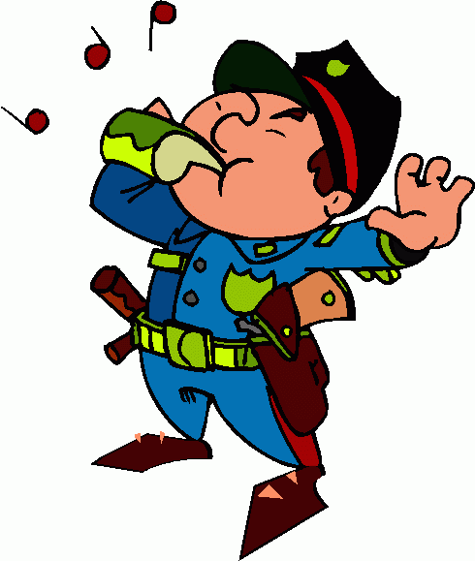 .
Police Jokes

Riddle: police officer had a brother, but the brother had no brother. How could this be?
Answer: The police officer was a woman.

Riddle: A policeman saw a truck driver going the wrong way down a one-way street, but didn't give him a ticket. Why not?
Answer: The truck driver was walking.

Police Officer: Why were you going so fast?
Speeding driver: I was trying to keep up with traffic.
Police Officer: There isn't any.
Speeding driver: I know! That's how far behind I am.

Traffic cop: I'll have to report you, sir. You were doing 85 miles an hour.
Speeding driver: Nonsense, officer - I've only been in the car for ten minutes.



Mtg 5: Ways We Worship A1



& Saw Dust & Nails A20
Bear den plans can be found here www.scouting.org/scoutsource/CubScouts/Leaders/DenLeaderResources/DenandPackMeetingResourceGuide/BearDenPlans.aspx
1a complete the character connection for Faith
1b list 3 things you can do to practice your religion
20a show how to use & care for 4 tools
20b build a toolbox
20c use 2 tools to fix something

Should you wish to try Achievement 19 Shavings & Chips (whittling chip) or 22 Tying it all up (knots) you can see Baloo’s Bugle February 2012 p.53-64 for ideas, tips, & advice. http://usscouts.org/bbugle/bb1201P.pdf


Tool Jokes

What's the difference between your finger & a hammer?
I don't know!
Well, you're not using my computer keyboard then!

Q. How did the chimpanzee escape from his cage?
A. He used a monkey wrench

Q. What animal is good with tools?
A. Hammer-head shark!

Q. What has 3 feet but cannot walk?
A. A yardstick!

Q. What is in fingers, toolboxes and snails?
A. Nails



Mtg 6: Games, Games, Games A15
Bear den plans can be found here www.scouting.org/scoutsource/CubScouts/Leaders/DenLeaderResources/DenandPackMeetingResourceGuide/BearDenPlans.aspx
15a Set up equipment & play any 2 of these outdoor games:
- Backyard Golf - Kickball
- Badminton - Softball
- Croquet - Tetherball
- Horseshoes - Volleyball
- Sidewalk Shuffleboard

Sport Jokes

Why is badminton so loud?
Because the players raise a racquet.

Why did the golfer have an extra pair of pants?
In case he got a hole in one!

Why did the volleyball visit the bank?
He wanted to know his net worth.

Why can’t you play sports in the jungle?
Because there are cheetahs.

Why did Tarzan spend so much time playing golf?
He was perfecting his swing.

Q: What kind of witches play croquet?
A: Wicket witches.

Q. What is a frog's favorite game?
A. Croak-et!

Q. Why didn't Cinderella make the Softball team?
A. She ran away from the ball!

Q. A man leaves home. He takes 3 left turns and returns home facing 2 men in masks, who are the men?
A. The catcher and the umpire.

Q. How is a softball team similar to a pancake?
A. They both need a good batter!

Q. What's a golfer's favorite letter?
A. Tee!

Q. What animal is best at hitting a softball?
A. A bat!

Q. What does it mean if you find a horseshoe in the road?
A. Some poor horse is walking around in his socks!

WEBELOS DENS

Joe Trovato,
WEBELOS RT Break Out Coordinator
Westchester-Putnam Council
Have a question or comment for Joe??
Write him at
webelos_willie@yahoo.com

There is an underscore between Webelos and Willie

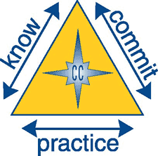

Core Value for October

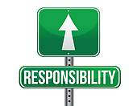

Responsibility: Fulfilling our duty to God, country, other people, and ourselves. Being responsible is being dependable and doing what you say you will do.

“I believe that every right implies a responsibility; every opportunity, an obligation; every possession, a duty.”
John D. Rockefeller, Jr.

John Davison Rockefeller, Jr. (January 29, 1874 – May 11, 1960) was an American financier and philanthropist who was a prominent member of the Rockefeller family. He was the only son among the five children of Standard Oil co-founder John D. Rockefeller and the father of the five famous Rockefeller brothers. In biographies, he is commonly referred to as "Junior" to distinguish him from his father, "Senior".

The core value of Responsibility can be woven into many Webelos activities and, as the scouts move towards Boy Scouting and the “patrol method” being responsible will affect the quality of the experience for each scout. Corresponding elements of the Scout Law are a Scout is HELPFUL and a scout is TRUSTWORTHY.

The weather is great for the outdoors in October, including pack camping events. Consider some of these outdoor-related activities to demonstrate and teach responsibility.

- Have boys help plan one of the overnighter activities. Be sure to discuss afterwards how success is related to responsible behavior.
- Boys could help set up and clean up the campfire area, making sure he fire is completely out.
- Do a den ceremony where each boy is responsible to act or say his part.
- Have each boy bring a certain piece of equipment to play a game (bat, ball, glove for baseball).
- Pair up with a buddy and be responsible for him throughout the hike. Stay on the trail. Leave no trace.

Some thoughts on “Responsibility”

"WE CREATE OUR CHARACTER BY THE CHOICES WE MAKE"
From Tom Lickona’s CHARACTER MATTERS
We create our character by the choices we make. Good choices create good habits and good character. Bad choices create bad habits and bad character.
How can we persuade young people that they’re making choices all the time—choices that affect the habits they’re forming and the kind of person they are becoming?
High school teacher Hal Urban put it this way to his students: "Life is a series of choices you get to make."
You get to choose how to treat other people. You can put them down—or build them up.
You get to choose how much you'll learn. You can loaf your way through school—or work hard and make the most of your education.
You get to choose how you'll handle adversity, the inevitable misfortunes of life. You can let adversity crush you—or you can look for a source of strength and deal with whatever life hands you.
You get to choose your belief system and purpose in life. You can wander through life aimlessly—or you can search for the ultimate meaning of life and then live according to it.
Finally, you get to choose your character. You can become less than you’re capable of—or all that you're capable of.
If young people see themselves as making choices, they're more likely to take responsibility for their choices. If you own the choice, you own the responsibility.

Book Corner
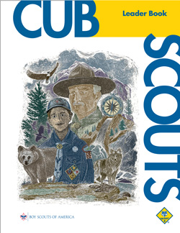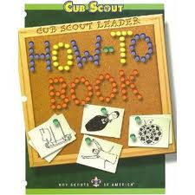

From the Cub Scout Leader Book:

On RESPONSIBILITY:

Some Practical Applications:
• Be dependable; do what you say you will do.
• Finish your homework.
• Take care of chores at home.
• Be helpful.
• Accept the consequences for your actions.
• Take care of your personal possessions. (Page 4-5)

You can find a copy of the Cub Scout Leader Book at
http://www.scouting.org/filestore/hispanic/english/33221_WEB.pdf

From the How-To Book:

DEN ADVANCEMENT CHART

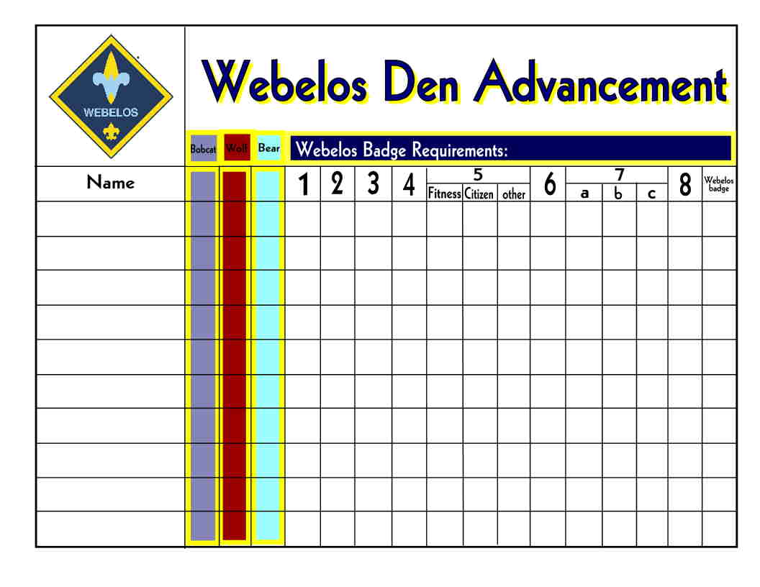

You can purchase Cub Scout and Webelos Scout den advancement charts from your Scouting distributor or local council service center. Or create one from posterboard. Place each boy’s name on the chart and add a sticker to the chart for each achievement as he completes them. Give the responsibility for updating the chart to the denner or the boy who has earned the achievement. (Page 1-3)

USE DEN DOODLES TO REWARD RESPONSIBLE BEHAVIOR

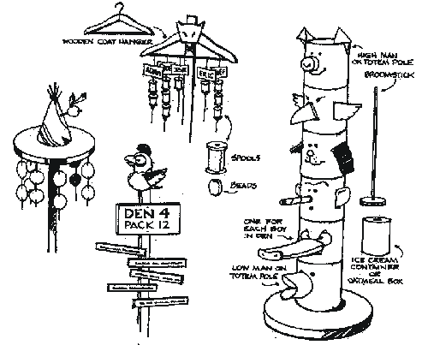

Dens may earn simple awards (sometimes called dingle dangles) for a variety of things, such as perfect attendance, good behavior, participation in service projects, or responsibilities at the pack meeting. For example, the den leading the flag ceremony at the pack meeting or at school might earn a small flag to hang on their den doodle; the den that leads a song might earn a musical note made of felt. (Page 1-3)

You can find a copy of the How-To Book at
http://www.scouting.org/filestore/hispanic/english/33832_WEB.pdf

Establish a Boy Scout Link



Now is the time for second year Webelos to start visiting Boy Scout Troops. Better yet, as a first (or second year Webelos Den Leader, develop an on-going relationship with one or more troops in your area. The pack committee can help by working with their unit commissioner to find local troops. As we discussed in prior editions, get a Webelos den chief and he can be a link between the den and the troop. It is extremely important to establish the link as early as possible. This will allow you to develop joint activities with the Troop, which will ease your Webelos scouts’ concern about leaving the Pack to joint a troop. Draw on the Webelos resource person or the Scoutmaster for help in developing joint activities. See page 22-3 of the Cub Scout Leader Book for some great examples of joint Webelos Scout and Boy Scout activities. I’ve reproduced a few below.

• The Webelos den visits a troop court of honor.
• The troop and Webelos den go on an overnight campout.
(See Chapter 21, “The Webelos Scout Program,” for more information on Webelos overnight campouts.)
• The Scoutmaster and junior leaders join in a Webelos den meeting or activity.
• The Webelos den and troop attend Scout Sunday or Sabbath services together in February.
• The pack and troop join in a community Good Turn or a
Good Turn for the chartered organization.
• The Webelos den takes a day hike with the troop.
When a Webelos den participates in a troop activity or campout, all health and safety and age-appropriate guidelines for Cub Scouts still apply. For example, a Webelos den may not use axes or participate in a troop archery activity. See “Age-Appropriate Activities” in the Guide to Safe Scouting.
http://www.scouting.org/scoutsource/HealthandSafety/GSS/toc.aspx

Meeting Planner



This month’s meeting plans for First year Webelos work on the Traveler Athlete, Forester and Naturalist badges.

Meeting 3: Do: Forester 5 and 6 Naturalist 6, 7, and 9
Home/Family Assignments: Review Traveler chapter

Meeting 4: Verify: Athlete 4–7
Do: Traveler 1, 9–12 (Geography belt loop)
Home/Family Assignments: Athlete 4–7. Webelos 8, review Citizen Chapter.

http://www.scouting.org/scoutsource/CubScouts/Leaders/DenLeaderResources/DenandPackMeetingResourceGuide/WebelosDenPlans.aspx
* * *
Second Year Webelos (Arrow of Light) work on Family Member, Outdoorsman and Sportsman.

Meeting 1: Do: Outdoorsman 1, 2, 5, 7, 8, 10, 11
Home/Family Assignments: Family Member 4, 9, Review Sportsman chapter

Meeting 2: Verify: Family Member 4 and 9
Do: Sportsman 1–4 (Ultimate belt loop)
Home/Family Assignments: Review Scientist chapter

http://www.scouting.org/scoutsource/CubScouts/Leaders/DenLeaderResources/DenandPackMeetingResourceGuide/ArrowofLightDenPlans.aspx

Flag Ceremony
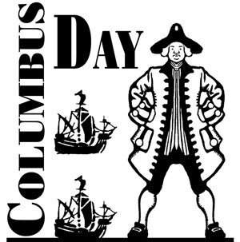

Columbus Day is celebrated this year on October 10 and our flag ceremony may include a reference to this observance.
October Flag Ceremony
Follow your standard Color Guard process (see prior month’s Bugle for a sample). After the Cub Scout promise (or Boy Scout Law, and Oath, if this is a Webelos Den meeting) and before posting the U.S. Flag you may insert the following:
Reader 1: Christopher Columbus was an Italian explorer who sailed across the Atlantic Ocean in 1492, hoping to find a route to India (in order to trade for spices).
Reader 2: Columbus sailed for King Ferdinand II and Queen Isabella of Spain. On his first trip, Columbus led an expedition with three ships, the Niña, the Pinta, and the Santa Maria (captained by Columbus), and about 90 crew members.
Reader 3: They set sail on Aug. 3, 1492 from Palos, Spain, and on October 11, 1492, spotted the Caribbean islands off southeastern North America. They landed on an Columbus later renamed it San Salvador. Columbus thought he had made it to Asia, and called this area the Indies, and called its inhabitants Indians.
Reader 4: Today we celebrate Christopher Columbus opening up the “New World” to the old world of Europe. Please join me in the Pledge of Allegiance.

Den Meeting Helpers
These activities can be used for the gathering or to reinforce/satisfy badge requirements.

Webelos


Working on the Athlete Activity Badge could be coordinated with the Fitness Activity Badge.

Fitness

Fitness is more than just nutrition. It is also understanding about drugs and alcohol and the dangers that come with them. We can make a difference by teaching the boys that a good diet and exercise is essential to be healthy and strong.

FITNESS IDEAS

- Have the boys read a story in a newspaper or magazine about a drug or alcohol related incident. Have them report back to the den and discuss what happened.
- Invite a nurse, doctor, or EMT to talk about the effects of tobacco, drug or alcohol abuse as well as the positive effects of eating a healthy diet.
- Invite a local sports figure or coach to come and discuss fitness with the boys.
- Let boys design posters on how to say no to drugs, cigarettes and alcohol. Display at a pack meeting.
- Show videos (approved by parents and pack committee) on drug and alcohol abuse.
- Invite a dietitian to come and discuss the benefits of a balanced diet.
- Take a field trip to a fitness or recreation center.
- Have the boys collect advertisements for tobacco and alcohol. Help the boys see that the activities in those ads have nothing to do with tobacco or alcohol. Have them read the warning labels on cigarette advertisements, note the size of the warning in relation to the ad.

MAGIC CIRCLE



Preparation: At least three people, roughly the same size
Can you and all your friends all sit down without touching the ground and without using a single chair? Everybody stands in a circle facing the same way with his or her hands on the next person’s waist. Now, everybody bends their knees until they are sitting on the knees of the person behind them. Lead your entire pack in this activity at the next
pack meeting. What is the largest Magic Circle you can make? All the workers at a Japanese car factory formed the world’s largest Magic Circle of 10,323 people!

JUMPING ROPE

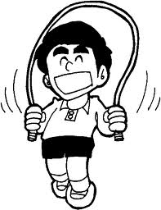
Jumping rope is wonderful aerobic exercise, which means that it exercises the heart. Professional athletes like boxers use skipping rope to built their endurance and coordination. See how many jumps you can do before making a mistake. How long can you jump rope? The world record is over 12 hours. How fast can you jump rope? Fast jumping is best done boxer style with both feet together all the time. It is helpful to have a short rope so that it just misses the ground as you jump. Can you jump backwards? With practice, you will find this almost as easy as skipping forward. Cross hand jump: jump in the normal way but, as the rope passes over your head, bring your hands forward and cross your wrists. Quickly uncross them before jumping over the rope.

ACTIVITY TAG

Materials
Activity Cards highlight activities like jumping jacks, sit-ups, push-ups, and other basic calisthenics.
Number cards from 1-10 to add to the tasks students complete. (You can use a deck of cards if the jacks, queens, jokers, aces, and kings are removed.)
Directions
Designate an “it” and give that person a stack of activity cards and the numbered cards. When they tag someone they give the tagged person an activity card and a number card. The person tagged is to perform the activity the number of times specified on the card. Once a boy finishes the task, they may enter the game again.
You can designate a safety zone with a time limit so children can rest and be safe.
HEALTHY BONE RELAY

Materials
Plastic eggs or Hard-boiled eggs
Two large spoons
Rubber band
Directions
Divide students into two teams. Each team is given an egg, a large spoon, and a rubber band. On the signal, the first person on each team will take the rubber band and wrap it around the egg. Then, they will walk their egg to the other end of the field and hand it to their teammate. The relay continues until all the students have taken their egg on a ride. If a team breaks their egg, they will continue the race without an egg.

PLATE = NEW SYMBOL FOR HEALTHY EATING
http://kidshealth.org/kid/stay_healthy/food/pyramid.html

Goodbye, pyramid. Hello, plate.
The Food Guide Pyramid was the model for healthy eating in the United States. Maybe you had to memorize its rainbow stripes in school.
But the USDA, the agency in charge of nutrition, has switched to a new symbol: a colorful plate —called MyPlate — with some of the same messages:
- Eat a variety of foods.
- Eat less of some foods and more of others.
The pyramid had six vertical stripes to represent the five food groups plus oils. The plate features four sections (vegetables, fruits, grains, and protein) plus a side order of dairy in blue.
The big message is that fruits and vegetables take up half the plate, with the vegetable portion being a little bigger than the fruit section.
And just like the pyramid where stripes were different widths, the plate has been divided so that the grain section is bigger than the protein section. Why? Because nutrition experts recommend you eat more vegetables than fruit and more grains than protein foods.
The divided plate also aims to discourage super-big portions, which can cause weight gain.

GOOD HEALTH HABITS
Circle the correct answer(s). (Correct answers in bold tyupe)
- Bathe/shower (every day OR 1/week) and especially after exercise.
- Wash your hair (1/month OR 2+ times/week).
- Wash hands (before eating OR after using the restroom) and when they're dirty.
- Eat right - (3 OR 4 OR 6) regular meals each day at regular times!
- Eat (just some OR a variety of) food from each of the 4 food groups.
- The average 10 year old should get (6 OR 9 OR 12) hours of sleep each night.

Athlete

ATHLELE IDEAS

MINI-OLYMPICS

This can be done with a den, between dens and even as a pack activity. Here the Scouts compete through the course outlined below - record each Scouts score. Be sure to have them do some warm-up exercises before starting (ex. ten
toe touches, deep knee bends, and jumping jacks and body twists). Afterwards, discuss a balanced diet and the effect
exercise may have on their performance. Then challenge them to do their chosen Fitness badge exercises for thirty
days and have them redo the course. Ask them how they think their performance will change. This will complete #5
of the Fitness badge and helps them to complete #2. If time is available #3, #4, and #6 of the Fitness badge should
be discussed.
The following is an example of a course:
Station #1 - Curl Ups (adult holds feet) - Do as many as possible. Record time and number. .
Station #2 - Pull Ups - Do as many as possible. Record time and number.
Station #3 - Push Ups - Do as many as possible. Record time and number.
Station #4 - Standing Long Jump - Mark off six feet in one-half foot increments (highlight the five foot mark). Begin
with toes at the start line and measure at the heel after the jump. Record the distance jumped.
Station #5 - Vertical Jump - Set up a post or a board. Mark the post starting from the bottom with a scale, in
inches from 0 - 15 inches. Attach a ball to a string and hang it over the post. Have an adult hold the end of
the string. The adult will need to adjust the height of the ball on the jump side, according to each Scout's
height - about a foot above the tips of their fingers when their arm is stretched above their head. They then try
to jump up and touch the ball. The adult watches to see how high they jump - the height of the jump is measured from the bottom of the post to the bottom of their feet at the height of the jump. Record height of jump
Station #6 - Tire Run - Scout must run through a series of tires, being sure to put one foot in each tire with alternating feet.
Station #7 - Hopping on One Foot - Scout has to hop on one foot through a set of cones. One foot must be help behind their back through the entire course. Record the time to complete the course.

OBSTACLE COURSE

Ask the Webelos to help with this project. They will have fun picking out a theme to use and making up stories for each station. Mix and match these ideas, and add more of your own.

1. Elephant Walk: you must step in four buckets in a row.
2. Climb over two sawhorses.
3. Swing across a stream: hang a rope on a tree limb and mark the banks of the stream with string.
4. Caves: crawl through several cardboard boxes in a row.
5. Crocodile River: lay a ladder flat on the ground. Boys must step on each rung to cross.
6. Under the falls: Spray a garden hose (On fine mist) from behind a bush.
7. Whirlpool: low garden edging stuck in the ground in a pattern.
8. Pretzel shot put: just what it says!
9. Carry a (chair) from one station to the next.
10. Fill up a small cup with water, using only a sponge to dip water out of a pail.
11. Ring toss: Clamp clothespins around the top of a can and throw jar rings at it.
12. Lift a small 5 pound barbell three times

MUSCLE BUILDING EXERCISES



Some muscles need more building up than others for increased strength and stamina. Start out slowly and increase gradually in these exercises designed for a 15 minute home workout program.

Biceps Builder
Bend one arm at the elbow and extend, palm up, from your side. Make a fist with this hand.
With the other hand, grab the extended arm just below the wrist. Push up with the extended arm
while pushing down with the other. Hold 10 seconds. Do this five times with each arm.

Neck Builder
Grab each end of a good strong bath towel with one hand on each end. Put the towel behind your head. While holding your head up straight, push hard against the back of the neck with the towel until your neck muscles quiver. Try this for three minutes.

Abdominal Muscle Builder
Lay on your back on the floor with your arms at your sides and your feet together. Raise and spread your legs slowly without touching the floor and hold for 10 seconds. Do this three times, then rest and repeat.

Back & Chest Strengthener
Lie face down with hands at the back of your neck, elbows out. Raise head and chest and hold.
Repeat.

Arm & Shoulder Muscle Builder
Push-ups are great for this. Keep back and arms straight while raising and lowering your body.
Work up to 20 push-ups a day.

Stomach Muscle Builder
Lie on your back with your arms straight above your head on the floor. Raise up and touch your toes with your fingers, keeping your legs straight.

Feet & Toe Conditioner
Walk pigeon-toed with your toes curled. Practice picking up marbles or smooth stones with bare feet.

Leg & Thigh Builder
Stand up straight with your hands on your hips. Rise up on your toes while bending your knees slowly until you are in a squat position. Repeat.

GAMES

Rooster Fight
Boys grasp one ankle, hopping on the other foot inside a circle. By bumping shoulders opponents try to cause each other to loose their balance or step out of the circle.

Gorilla Relay Race
Boys line up for the race. In turn, each boy spreads his feet shoulder width, then bends down and grasps his ankles.
He then races forward, keeping knees extended and legs straight out.

Wheelbarrow Race
Teams of two. One boy lies on the ground. His partner takes his feet. The first boy is the wheelbarrow. He walks on his hands while his partner holds his feet, and they race other teams to the finish line.

Forester

A forester deals with the care and growing of trees, and a Webelos Scout working on his Forester Activity Badge will learn how to recognize different species of trees by their shape, foliage, bark and types of wood, as well as animals who live and grow there.

A forester must learn how to do a great variety of things as well as know many facts about trees. Some of his tasks are making tree inventories, estimating the lumber content in standing timber, surveying, logging, tree planting, insect control, recreational planning, and the mapping and marking of trees for harvesting. He is interested in woodlands conservation and learns how to preserve and protect them from fire and disease. A forester must have excellent health and a love of the outdoors.

Great Salt Lake Council

FORESTER REQUIREMENT #7 –
Collect pieces of three kinds of wood used for building houses. Tell what kinds of wood they are and one place each of them might be used.

Oak: Hard Durable Wood. Used for cabinet, flooring, furniture, moldings. Found in almost every home in the United States.

Pine: Soft wood, durable as long as it is protected from the weather and hard use. Pine is used in framing structure of the home and furniture.

Cedar: Aromatic wood; differing levels of hardness; disease and insect resistant. Exterior trim, decks and fences; lining for closets, drawers and chests.

FIELD TRIPS

· Arrange a trip to a lumber yard. Talk to the salesman about the different woods available for use. How is wood treated for gardens, etc? What are the standard sizes of boards and plywood? How does a contractor know how much wood it takes to build a house?
· Visit a local nursery or tree farm, or an orchard in production.
· Contact a local tree service and ask if you can watch their crew in action. Watch a tree felling or brush chipping operation Find out about the safety features used.

BARK RUBBING
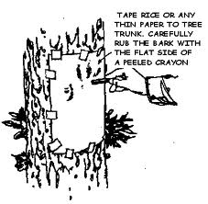

Needed –
- a tree,
- a piece of construction paper,
- a piece of screening 7-1/2” by 12-1/2”,
- masking tape, and
- a crayon.
Directions
  - Find an interesting patch of bark, and tape the construction paper over it.
  - Holding the crayon flat side against the tree, rub up and down over the paper, pressing firmly. Keep coloring until you get and interesting pattern.
  - Remove the tape and inspect your bark rubbing. Try different trees, and look at the different patterns you get.

TREE WORD SEARCH

We get many things from trees. Find and circle these 35 words in the tree above.
The words are horizontal, vertical, and diagonal, forwards and backwards.

ACORNS BAT BOX CHAIR COFFEE CONES DYE

FIREWOOD FRUIT FUN GUM HOUSES LADDER

LOGS NESTS NUTS OXYGEN PADDLE PAPER

PENCIL PLAY POLE POST RESIN RUBBER SEED

SHADE SHELF SPICES SUGAR SYRUP TABLE

TEA TAR WOOD

Naturalist

Great Salt Lake Council

NATURALIST REQUIREMENT #11 –
Learn about aquatic ecosystems and wetlands in your area. Discuss with your Webelos den leader or activity badge counselor the important role aquatic ecosystems and wetlands play in supporting lifecycles of wildlife and humans.

What is an aquatic ecosystem? It is an area where plants, animals, and microorganisms are dependent
on each other and their surroundings in a:
1. Marine environment (ocean) – Covers 71% of the Earth’s surface and contains 97% of the world’s water.
2. Freshwater environment (lakes, ponds, streams, etc.) – Covers 0.8% of the Earth’s surface, contains
0.009% of the world’s water and 41% of the world’s known fish.

What is a wetland ecosystem? There are four ingredients:
1. Water must be found for at least part of the growing season.
2. Hydric soils, or water-saturated soils, that have little or no oxygen so only certain plants which have adapted can grow there.
3. Hydrophytic plants which have adapted to the hydric soils.
4. Bacteria (decomposers) and animals, including beavers.

Why are aquatic and wetland ecosystems important?
1. Recycles nutrients – The many decomposers in the wetlands break down materials into nutrients for plants and animal.
2. Flood control and water storage –Wetlands control flooding by absorbing the water and slowing the spread of fast moving water. The absorbed water is then slowly released into downstream habitats and groundwater.
3. Decontamination – Wetland soils and plants remove harmful substances by absorbing them before they reach the aquatic ecosystems.
4. Climate control – Water is returned to the atmosphere helping to average out temperatures and reduces the carbon dioxide in the atmosphere by storing it in the soil.
5. Soil conservation and water purification – Wetlands strain up to 90% of the sediments and debris from upstream making the downstream waters and areas cleaner.
6. Human use – Aquatic and wetland areas are used for recreation and are important for tourism.

GAMES

Find ‘Em
Each Webelos Scout is given a written list of things that may be spotted along a hike route, with a point score for each. First player to find one reports to the leader and is given the appropriate score. The players have to stay quiet and they do not touch any of the things they find.

Examples:

Bird’s nest 20 points
Oak leaf 2 points
Blue Jay 10 points
Balsam Fir tree 5 points
Dandelion 1 point
Poison oak 10 points
Any animal track 15 points

Tree Tagging
Divide den into two teams. Give each team twenty strips of cloth and a felt-tip pen. Object of the game is for the teams to tag as many different kinds of trees as possible, making correct identification. Set the boundary and a time limit. At the end of the time, go over with the boys each tree they tagged and remove the cloth strips. The winners are the team with the most correct tags.

Check out http://www.arborday.org/treeguide/browsetrees.cfm for information on tree identification and additional ways to connect your scouts with nature.

Memory Hunt
Divide den into two teams. Each team is seated facing the same scene. For two minutes, all team members study the view in front of them, trying to memorize all plants, trees, and animal life, including insects and birds. At the end of two minutes, both teams turn around and list everything they remember. Longest correct list wins.

BUG MATCH

- Have someone cut out a bunch of different insect pictures and mount them on paper to hang around the Pack Meeting room. (Make sure you know the names of the different bugs.)
- Label the pictures with letters or numbers.
- Hand out sheets of paper with the names of the different bugs listed in a mixed up order.
- Ask people to match the pictures with the names.
- After the opening ceremony, read off the answers and ask everyone how they did.
- Give an appropriate cheer/applause to the one(s) who got the most matches.

Arrow of Light

WEBELOS-TO-SCOUT TRANSITION TIMETABLE

OCTOBER
- Complete and return your Webelos roster (tracking sheet) to your Unit Commissioner or pack committee chairman by October 30th for submission to area troops. Troops can send your Webelos information and invite them to orientation and camp promotion meetings.
- Meet with the local Scoutmaster(s) for transition planning.

ARROW OF LIGHT REQUIREMENTS

THE SCOUT LAW PUZZLE
Z U M Y N Q S R M K Y O H R Z
R T C J H E M H X L L E I N T
F J F H A T Y Z D N L C A R H
M K J W E V R N L P K E K E T
G E H R D E E O F A L T B V S
F K V R G I R U W C Y U K E U
B X P U R K L F J T T O S R O
U Y T F I R H T U I S X L E E
O B E D I E N T E L N U Y N T
J K I N D V D I V S F R R T R
Q K S S B K X L A F Y P D T U
N E P J K C M X R J Q Y V B O
L D P X T T J F B H Y P J L C
W X K T H C R N L N A X E Q X
B L T Z P T I W F G D D U R T
TRUSTWORTHY
LOYAL
HELPFUL
FRIENDLY
COURTEOUS
KIND
OBEDIENT
CHEERFUL
THRIFTY
BRAVE
CLEAN
REVERENT

The following is one of my favorite scout law games. The kids love the competition and they learn it fast.

SCOUT LAW SPEED TEST

Using a permanent marker, write each of the 12 parts of the scout law on a separate tongue depressor or ice cream bar stick. Mix them up, throw them on a table. Each Webelos Scout takes a turn to put them in order (i.e., Trustworthy, Loyal, Helpful, etc.) Using a stop watch, time each scout. The scout who is the quickest, wins.

ROLL THE DICE GAME
This requires one dice. Each boy rolls the dice and depending on what number comes up, he performs one of the requirements of the Bobcat trail. Score points for each boy who does the task correctly. Add some flavor - let a roll of 5 yield an extra roll.
1 = Boy Scout Oath & its meaning
2 = Boy Scout Law & its meaning
3 = Scout motto & slogan
4 = Scout sign/salute/handshake
5 = Scout badge & BS uniform
6 = Tie a square knot

Check out http://www.boyscouttrail.com/tests/arrow-test.asp for an on-line Arrow of light test!

Family Member
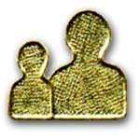

This badge focuses on helping each young Cub Scout learn how to contribute to the success of his family. It also helps prepare to him for the future by giving him a start on budgeting, planning family activities, thinking about health and safety issues, and improving his relationships with other family members.

FAMILY MEMBER IDEAS
http://www.buckeyescouts.org

-Start a family photo album
-Switch chores with another family member for a month
-Discuss “secret chores” that the boys can do for their families without their families finding out
-Send a “why my ___ (dad, mom, etc) is important” letter to someone in your family
-Teach the boys basic cleaning skills. If possible, invite a professional housecleaner to come to your den meeting.
-Have a contest and see who can sew a button on the fastest and the best.
-Have the boys fix a meal and invite the parents for a feast!
-Have the boys start their own recipe files. Invite a dietician to come visit the den and explain why balanced diets are important.
-Visit a grocery store.
-Go to a restaurant for a tour and then eat there!

GAMES AND ACTIVITIES
Santa Clara County Council
THE GREAT BATHTUB EXPERIMENT
Should you take a bath or a shower?
Materials:
Your bathtub with an overhead shower, a yardstick
Start by taking a bath. Fill your bathtub with water as usual, but before you step in, use a yardstick to measure the depth of the water in the tub. Be honest with the amount of water you use. If you are not, the experiment will be useless. Record the number for future reference.
Next time you bathe, take a shower. But before you begin, do something unusual. Close the bathtub drain so that the shower water will collect in the tub. When you are finished, measure the depth of the water that has collected.
Compare this reading in the shower with the bath water depth. You will find that your shower used substantially less water – probably less than half as much! A lot of this water is hot water. As a rule of thumb, figure that it takes a cubic foot of gas, or 1/4 kilowatt-hour of electricity to heat a gallon of water. So you can see showering saves energy – as well as water!

FAMILY FACTS

Save your family memories and pass them on to the next generation. Nothing gives more enjoyment to a family than “REMEMBER WHEN”. Children learn who they are from their parents and grandparents. To play FAMILY FACTS have each member of your family write out questions that only your family would know - the more personal the better.
Who went to Canada on vacation?
What was this family's first pet?
Who broke their arm during the school play?
Who ran into the basketball standard and chipped his front tooth?
What was the address of our first house?
When is Grandma's birthday?
When did dad graduate from high school?
Play in the car, home on a rainy day or at family gatherings.
For a different twist, make up cards in categories -dates, people, places, events, pets, vacations, etc., and play family trivial pursuit. Use the regular Trivial Pursuit game, but substitute your family cards.

FIND THE WASTED ELECTRICITY
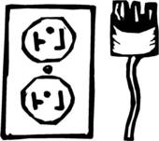
Have a lot of lights and appliances on in your house. Go outside your house to the electric meter and have the boys observe how fast the meter is spinning. Then have them go inside and turn off as many things using electricity as possible (leave the refrigerator plugged in!). Observe the results. Have them find and list the things using electricity in the house:
-Lights
-Washing machine
-Refrigerator
-Air conditioner
-TV
-Fans
FAMILY TREES
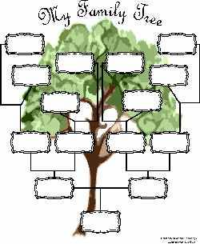
Materials: White and light green construction paper
Directions:
Have the boys cut trees out of the green construction paper and paste them onto the white paper.
Have them write their name and their siblings’ names, birthdates and birthplaces on the trunk of the tree.
Above this near the bottom of the leafy part of the tree write their parents’ names, birthdates and birthplaces.
Above each parent write the grandparents’ information.
Above the tree add Great-Grandparents, if possible.
Connect lineages with lines.

HOME INSPECTION CHECK LIST ADDITIONS
There is a good home inspection checklist in the Webelos handbook, but there are other important inspections to do. Here are a few that Webelos can do at their homes and at their grandparents’ homes:
1. Check to see that there are smoke detectors on every floor of the house, near all bedrooms and in hallways that connect sleeping areas to living areas of the house.
2. Test the batteries of all of the smoke alarms.
3. Use a “polarity tester” on every outlet inside and outside the house. Outlets are often wired with the black and white wires backwards or without a good ground wire. Inexpensive testers are available.
4. Are any power plugs hot or extra warm to the touch?
5. Check to see that appliance, telephone and lamp cords are not in places where people typically walk, so that they are unlikely to trip on them.
6. Check to be sure that power cords are not under any furniture legs, rugs or carpeting.
7. Are all power cords in good shape; not frayed or cracked?
8. Are several cords going into an extension cord that is not rated for the load?
9. Are any of the area rugs able to slip or slide?
10. Is there a list of emergency numbers near every telephone, including poison control, local police (911 and non-emergency), and fire?
11. Check the wattage of every light bulb versus the rating of the sockets.
12. Make an emergency exit plan so that the whole family knows how to get out of the home from any room. Everyone needs to know what the emergency gathering spot will be. Are there any safe alternative ways out of upstairs windows? Do a practice emergency escape from the home to see how long it takes.
13. Does the stove vent out smoke properly?
14. Are any appliances plugged in too near the sink in the kitchen of bathroom?
15. At night, is kitchen lighting bright enough to see adequately and be safe? Webelos Family Member Activity Badge
16. Does the fireplace have something to keep sparks from entering the room?
17. Are they any rugs or flammable objects near the fireplace?
18. Are hallways well-lit and free of clutter?
19. Do bathtubs and showers have non-skid surfaces to stand on?
20. Are poisons and household chemicals out of reach of small children?
21. Are there light switches at both the top and bottom of all staircases?

Aquanaut


PREPARING FOR BOY SCOUTS

Aquanaut Requirement 1 & 2 are similar to First Class Requirement 9b.
Aquanaut Requirement 5 is similar to Second Class Requirement 7c & First Class Requirement 9c.
Aquanaut Requirement 7 is similar to Second Class Requirement 7b.

Remember to check the Guide to Safe Scouting and Safe Swim Defense before engaging in any water activities!

You can find both here:

http://www.scouting.org/scoutsource/HealthandSafety/Resources/Guidetosafescouting.aspx

http://www.scouting.org/scoutsource/HealthandSafety/Aquatics/safe-swim.aspx

AQUANAUT IDEAS

• Invite a member of a scuba diving team to come to your meeting and bring equipment to demonstrate. Scuba demonstrations can be arranged at a local dive shops and outfitters.
• Go to see a swim meet or diving competition at the high school or college. Talk to the coach.
• Invite several Boy Scouts to come to your meeting and talk about earning water merit badges. Ask them to tell about the summer camp waterfront activities they have enjoyed.
Have them demonstrate and teach water rescue techniques.
• Visit your local police station and talk to the water search and rescue team. How often are they called out? What are some of the circumstances? What equipment do they take
along?
• Discuss the importance of the buddy swimming system.
• Have a demonstration of mask, fins, and snorkel by an expert.
• Take the Den swimming. Let them try to pass the 100-foot requirements, and surface dive and snorkel optional requirements.
• If a rowboat is available, have boat safety methods and rowing techniques demonstrated by an expert. Give boys a chance to practice the methods. Invite parents to come along.
• Teach the four basic rescue methods. Let boys’ practice reaching and throwing a lifeline for rescue.
• Practice rescue breathing on a dummy.
• Go to a canoe or sailboat race.
• Invite an expert to explain how to handle emergencies in the water. (Contact a swim instructor, the YMCA or Coast Guard)
• Visit a boat yard.
• Have a quiz on boat safety rules.

NEIGHBORHOOD WATER TOURNAMENT

1) Water pistol duels
2) Fishponds - can be made from cleaned out ice cream cartons or tubs (gallon size). Make "fish" out of sheet metal. Tie toy magnets to string of fishing poles. Numbers painted on fish indicate prizes won by fisherman.
3) Water Pistol Fireman - The object is to shoot out a candle flame with a water pistol. Make up your own rules.
4) Water Nail Driving - Attempt to drive nails in a piece of wood submerged in a waterfilled tub.
5) Throw wet sponges at a clown. His head sticks through a hole in a piece of canvas, plastic tarp or other heavy plastic.
6) Fill soda bottles with water carried in paper cups relay fashion.
7) Set up a large metal tub and duck for apples.
8) Divide the group into "armies" and have a water balloon fight.
9) Play Tug O' War with a hose set up on a ladder spraying water or a mudhole.
10) Skish - is a test of plug-casting skills. You'll need some casting rods, plastic plugs and targets (cardboard boxes, plastic hoops, chalk rings on the cement, etc.)

Responsibility Ideas

Responsibility Word Search
Alice, Golden Empire Council
In this puzzle you will find each of the words listed below – each word has something to do with being responsible. As in all word searches, the words can be forwards, backwards, or on the diagonal.
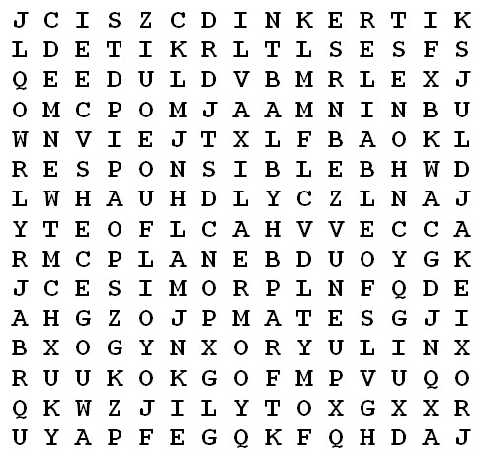
ACCOUNTABLE CHOICE CONTROL
DEPENDABLE GOAL HONEST
RELIABLE PLAN PROMISE
RESPONSIBLE

Being Responsible Ceremony
CS Roundtable Planning Guide 2011-2012
Personnel: Emcee (MC) or Narrator and a den of boys
Arrangements: The lines for the Cub Scouts below are examples. It is best if each boy says something for which he is actually responsible.
Each boy carries something that symbolizes his responsibility.
MC: Being responsible means doing what you said you
would do.
- I finish my homework without being told.
- I feed my dog at the same time every day.
- I pick up my dirty clothes and put them in the laundry.
- I always call my dad when I get home so he won’t worry.
- I clean my room once a week.
- I recycle paper, plastic, and cans.
- I water the garden regularly.
- Now let us all remember our duty to our country by repeating the Pledge of Allegiance.

I Made a Promise Ceremony
CS Roundtable Planning Guide 2010-2011
Arrangements: Each Cub Scout should have his part printed on a small card he can hold in his hand-or have the part memorized.
- I made a promise. ... I said that whatever I did, I would do the best I could.
- I made a promise ... to serve my God and my country the best I could.
- I made a promise ... to help other people the best I could.
- I made a promise ... to obey the Law of the Pack the best I could.
- I have done my best, and I will do my best because I made a promise. ... I am a Cub Scout.
- Will everyone now stand and join us in repeating the Cub Scout Promise and the Pledge of Allegiance.

Who’s Responsible? Opening Ceremony
Alice, Golden Empire Council
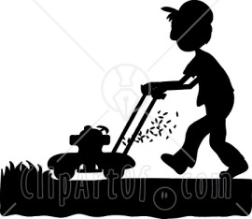
Materials: Life size silhouette drawings of scouts doing different chores and jobs that they are responsible for (have each boy lay down on large paper such as a roll of paper meant to cover tables, then draw around him as he takes the appropriate position to be doing a chore) You could also use stock silhouettes showing people doing various chores and jobs. Note: For an extra challenge, you can give everyone a numbered list that corresponds to a number by each figure – As a Gathering Activity, people take their list and a pencil and try to identify the silhouette and what they’re doing. Answers and winning audience member is not identified till the Opening is all done.
Cubmaster or Narrator: This month, the boys have been practicing being responsible. We thought it might be fun to see if you can recognize who is being responsible, and what they are doing. Let’s look at our first riddle. (Points to one of the figures) Who’s being responsible here?
(Let audience guess – when they guess the right person,
call that boy forward)
OK, __________, we know this is you being Responsible. Do you think anyone will guess what job you’re actually doing? (Narrator takes guesses from the audience, checking with the scout each time to see if the answer is right – when the correct guess is made, the scout can explain what his job is, when he does it and how often.) Boys could each have their response written out if they want, or narrator can just guide the answers from the scout with questions.
Narrator: Well, thanks ___________________. We can certainly see that you are trying to be responsible and do your chores!
This continues till each silhouette has been identified,
along with their job.
Narrator: Well, as you can see, our Scouts are learning to be responsible. There’s another responsibility that we learn about in Scouting – the responsibility to be a good citizen and honor our country’s flag. (Begin Flag Ceremony)

Responsible Bobcats Ceremony
Materials: Bobcat badges, safety pins
CUBMASTER: Being Cub Scouts means many things. It means making new friends, having fun and adventures, strengthening friendships and family ties, working hard toward advancement, and doing your best. It also means making promises and keeping them.
(Call forward the Bobcat candidates and their parents.)
The first rank earned by every boy in Cub Scouting is Bobcat. To become a Bobcat, a boy must complete eight requirements. One of them is to learn the Cub Scout Promise. Making a promise and keeping it means being responsible. These boys have learned the Promise and are ready to become responsible Cub Scouts.
Bobcat candidates, please make the Cub Scout sign and repeat the Cub Scout Promise with me. (Repeat the Promise with the boys.)
(Give each boy the Cub Scout handshake.
Hand the Bobcat badges to the parents
so they can pin them on their sons’ shirts.)
Congratulations! LEAD A CHEER

“You Can Count on Me!” Advancement Ceremony
Alice, Golden Empire Council
Materials: You will need a “You Can Count On ME” medal or badge for each boy. (Some ideas are shown under Gathering Activities) If you have access to a Button Maker (or a teacher in your pack) you could make buttons for each boy instead of medals on a lanyard. Assign Den Leaders to come up with an example of how each boy has shown he is responsible during the month, or have them check with parents for examples of dependability- the examples should be Specific to each boy!
In addition, you should have the advancements for each boy ready and listed so that when he is called up you can recognize that.
Cubmaster: As you probably know, the boys in our Pack have been learning all about Responsibility this month – part of being responsible is being dependable. And the Den Leaders have told me that they have some wonderful examples of how you boys have shown you can be counted on. So tonight, we will have the Den Leaders award a “You Can Count On Me” medal to those boys who have earned it.
First, I would like to call up the Tiger Den Leader.
Tiger Den Leader: Will the following boys come up with their parents? Calls off the names of every Tiger boy – this could be done individually if you want. Parents, I will hand you the medal to present to your son – we know that you are helping him become responsible. As the medal is put around the boy’s neck or pinned to his shirt, the leader tells the audience what that boy did to show he can “Be Counted On.”
Cubmaster: (If a boy has also earned advancement) Tiger Cub name has also shown he is responsible by completing the requirements for whatever has been earned. Parents, will you please present this award to your son? And Tiger scout will you please present this parent’s pin to your mother?
Let’s have an applause for these Tigers – choose an applause.
Cubmaster: The Wolf Den Leader(s) also reported that their boys have earned the “You Can Count on Me” medal. They will now present this award.
Wolf Den Leader: Will the following boys come up with their parents? Calls off the names of every Wolf boy – this could be done individually if you want. Parents, I will hand you the medal to present to your son – we know that you are helping him become responsible.
As the medal is put around the boy’s neck or pinned to his shirt, the leader tells the audience what that boy did to show he can “Be Counted On.”
Cubmaster: (If a boy has also earned advancement) Wolf Cub name has also shown he is responsible by completing the requirements for whatever has been earned. Parents, will you please present this award to your son? And Wolf scout will you please present this parent’s pin to your mother?
The presentations continue for the Bears, Webelos and Arrow of Light Dens, with an Applause of Recognition before each group returns to their seat. But if you have an Arrow of Light to award, be sure that is a separate ceremony with appropriate recognition!
Alternatively, the “You Can Count on Me” medals could be given out as a separate activity – but be sure to tell what each boy has done – or give out the medals to all at the same time, but have a display showing what each boy has done to earn it.
Cubmaster: As you can see, the boys of our Pack can be counted on to be responsible – but remember that you need to work on this every day!

You Can Count on Me Song
Alice, Golden Empire Council
(Tune: Row, Row, Row Your Boat)
You can always count on me
I’ll do just what I say
What I SAY is what I DO,
Each and every day!
When I have a chore,
I’ll see that it is DONE,
Do my best in every way,
And try to make it FUN!
I’ll bring my homework home each day,
And work to do my best,
Before I watch TV or play,
I’ll prepare for every test.
And when a scouting project calls,
I’ll be prepared to work
I’ll do my part – and cheerfully,
And I will never shirk!
Repeat First Verse

Responsibility Song
Alice, Golden Empire Council
(tune: Supercalifragilistic…song)
(Note from Alice – When you are spelling out the word, if you sing the letters” IB” and” LIT” together, it will fit the tune)
R..E..S..P..O..N..S..I B…LIT. ..and Y
That’s a way of acting with a worth you cannot buy
If you always do the thing you promised you would do,
Others will appreciate and always count on you!
When you see a job to do and finish what you start,
You will be RESPONSIBLE and always do your part,
People will depend on you and welcome you each day
When you are responsible and do just what you say!
If you have been working and have left a messy place
Don’t forget the job’s not done – and it’s YOUR mess to face!
Don’t wait till someone tells you “There’s a job that must be done,”
Just turn around and DO it, and you’ll soon be having FUN!
OOOOH…
R..E..S..P..O..N..S..IB…LIT..and Y
That’s a way of acting with a worth you cannot buy,
If you always do the thing you promised you would do,
Others will appreciate and always count on YOU!

Who’s Responsible Applause
- Divide into three groups –
- Explain that as the leader points to them, they say “We are!”
- Leader then points to each group randomly several times.
- Then he asks “Who’s responsible?” and points to all three groups at once.

Responsibility & Perception Run On
Alice, Golden Empire Council
“Do As I Say, Not as I DO!”
While on a car trip, a family stopped at a roadside restaurant for lunch. Only after traveling several miles did the son realize he had left behind a treasured baseball cap. By then, they had to travel quite a distance before they could find a place to turn around.
All the way back, Dad fussed and fumed about the delay, telling his son he should be more responsible about his belongings.
When they finally arrived, as the boy got out of the car to retrieve his forgotten treasure, his Dad said, "While you're in there, you may as well get my sunglasses, too."

JOKES & RIDDLES
Alice, Golden Empire Council
Q: Why is a diamond more responsible than a lump of coal?
A: Because a Diamond is a lump of coal that stuck to the job till it was done!
Q: Why did the lazy man want a job in a bakery?
A: So he could loaf around!

Campsite Cleanup Game
2011 - 2012 CS RT Planning Guide
Materials: Chairs, boxes, clean trash in various sizes (paper wrappers, empty bottles, bits of paper, etc.), a bag for litter for each player
Before the game, stress to the boys the importance of leaving a place better than how they found it. Explain the concept of the sweep. Boys line up shoulder to shoulder and carefully scan the ground in front of them. They are responsible for picking up any litter. The entire line then takes a step forward and scans the next section of ground.
- Divide the room into two. In each area arrange chairs and boxes, and scatter clean trash.
- Divide the group into two teams. Make sure teams are balanced in age of the players.
- Provide each player with a bag.
- Teams stand on one side of the room.
- On signal, they put away the camp equipment (chairs and boxes) in designated areas.
- Then they line up and perform the sweep.
- Judge each team for speed, thoroughness, and cooperation.
- If this game is played outdoors, provide the boys with disposable gloves.

Who’s Responsible? #1 Game
2011 - 2012 CS RT Planning Guide
Materials: Set of simple questions written on a card
Examples of questions:
- Where do you live?
- How old are you?
- What’s your name?
- Which school do you go to?
- Which den do you belong to?
- Players sit in a circle. One player is “it” and stands in the center.
- “It” points at a player and asks one of the simple questions written on the card and immediately begins to count to 10, while looking only at the boy he points at.
- But the boy who is really supposed to answer the question is not the one “it” is pointing at, but the third player on the left of that boy. It is his job to answer for the boy whom “it” is pointing at.
- If he fails to answer the question, he goes to the center and becomes “it.”
- Explain to the boys before the game that it is always the third one on the left who is responsible to answer the question for the boy who is pointed at.

Choice and Consequence Game
Alice, Golden Empire Council
Gather all kinds of items or pictures, such as a toy cash register, a picture of friends, a ball, a scout shirt, a picture of a boy’s room, a broom, a list of spelling words, a picture of a computer, a scout book, a calendar, a ticket to a movie or play, a bag of marbles - almost any items or pictures would work. Tell the boys they each can choose whatever item they would like, but they only have a minute.
Now have everyone sit down with their item. Ask each boy to tell you what he would do with this item if he was going to be responsible? What if he wasn’t going to be dependable? What would he do differently? Would his choice make a difference for him? For someone else?
To make it more challenging, you could also have each boy flip a coin or draw a card that will determine whether he has to tell about a responsible choice or an irresponsible one with his item. But give everyone a chance to tell what the opposite action would be.
Remind the boys the “When you Make a Choice, there is always a Consequence.”

Who’s Responsible? #2 Game
Alice, Golden Empire Council
A variation on an old game. The boys sit in a circle holding hands. One boy leaves the room and the leader identifies one boy to be “Responsible” – his job is to start the game on signal. “It” is called back into the room, and the boy who is Responsible begins to squeeze the hand of the boy on his left or right. The squeeze continues around the circle in the same direction, from boy to boy. Meanwhile, the boy in the center is trying to figure out where the action started. When the squeeze comes back to the beginning, the boy who is Responsible starts the squeeze again – but in the opposite direction. Whenever the boy in the middle thinks he know Who is Responsible – he walks over and challenges that person. He has three chances to guess, and then he is Out – the person who was Responsible now becomes “It.”
After you play the game a few times, talk about whether it was easy or hard to identify who was responsible. Is it like that in real life sometimes? To people sometimes act as if they are responsible when they are not? What about when something goes wrong? Are we tempted to say someone else was responsible? Why?

Search for Responsibility Game
Alice, Golden Empire Council
Print out a list of various words that describe responsibility – or that don’t describe it. Hide the words throughout the room before the boys arrive. Divide the boys into two teams. On signal, they search for word strips. When they have all been found, each team sorts their words into Responsible or Not Responsible piles. The team gets 2 points for each word that refers to Responsibility – and only 1 point for the other words. Talk about the words and see if everyone agrees about the definition of responsibility. See if the boys can come up with some examples from real life.
Need some ideas for words? Here’s a short list – but you could also have the boys look in a dictionary or thesaurus.
Responsible Words: Duty, Obligation, Dependable, Finish, Effort, Care, Safekeeping, Trust, Truth, Accountable, Reliable
Not Responsible Words: Procrastinate, Lazy, Blame, Unaccountable, Excuse, Fault, Careless

Watch your step! Game
Alice, Golden Empire Council
This game takes note of the abundance of manure around a farm, and also celebrates cooperation, which is a much needed and used quality on any farm. It could be played indoors or out, and could pair boys as a team, create a team of each den, or team together a boy with a parent.
Materials:
“Cowpies” to use as obstacles (Be creative making these!) Paper plates are okay but it’s a lot more fun to make your own “Cowpies” - Using a can of spray on foam insulation, form individual cow “patties” - form on sawdust and add more to the top for texture, and before each one dries, stick in a little hay to make it look authentic. They can also be spray painted if you wish.
Farmer’s bandanna or Cub Scout neckerchief or fabric for blindfold.
Directions:
- Scatter cowpies around the room or area.
- One boy is chosen to be “It” and will be blindfolded.
- Another boy is his “guide” and gives him verbal directions to avoid stepping on (or is it in?) a cowpie.
- If parents participate, the parent could be either the guide or the one blindfolded.
- Be sure and have a camera handy to catch the fun!

A Scout is Responsible Closing Ceremony
Alice, Golden Empire Council
(Pass out copies of the words to America, or have the words in large print in front of the room)
Cub Scout #1: (Holding up a Bible or other religious book, or a picture of a religious scouting award) Every scout has Duty to God.
Cub Scout #2: (Holding a picture of his family) Every scout has a Duty to be a Responsible Family Member.
Cub Scout #3: (Holding a picture of a group of friends) Every scout has a Responsibility to be a Good Friend.
Cub Scout #4: (Holding a knife or other tool) Every scout has a Responsibility to be careful for his own safety.
Cub Scout #5: (Holding a picture of the Outdoor Code or Leave No Trace Code) Every Scout has a Responsibility to take care of the Earth.
Cub Scout #6: (Coming out and standing by the American Flag) And every scout has a Responsibility to be a good citizen.
Cubmaster: Please join us as we sing “America” and prepare to retire our flag.

Being Responsible Cubmaster’s Minute
2011 - 2012 CS RT Planning Guide
Being responsible means you do what you say you will do. If you say you’ll take the trash out once a week, you’ll do that. If you say you’ll feed your dog, you’ll do that. What happens if you get sick and can’t feed your dog? Can you skip it? No, because your dog depends on you. Maybe you ask your brother to do it for you but you have to make sure the dog gets fed, no matter what. When you go camping you are responsible for cleaning up after yourself, no matter what. Sometimes being responsible sounds like a lot of work and not much fun. But remember, being responsible means being dependable. If you are dependable, you get to do more things like going on a fun campout. So boys, be dependable and be responsible and get to do more things. That’s what growing up means.

Be A Giraffe! Cubmaster’s Minute
Alice, Golden Empire Council
The giraffe can teach us a lot about Responsibility. First of all, it stands tall – and when the giraffe is out on the African plains, there’s no doubt where he stands. Each of us should also stand tall, and make sure that whatever we do is something we can be proud of – so stand tall! The giraffe is adaptable – willing to bend his long neck and stretch out his legs when he needs water. So be willing to bend - to adapt to change or follow a needed “Plan B.”
The giraffe is willing to stick his neck out to accomplish something – like eating the best leaves high in the tree. And we should also be willing to stick our necks out - to reach the highest goals and take responsibility for all that we do. So be a giraffe!

Responsibility and Dependability Equals Reputation Cubmaster’s Minute
Alice, Golden Empire Council
John and Horace Dodge were born in Niles, Michigan. They later commented, "We were the poorest little urchins ever born." But the red-headed brothers were hard workers, and their engineering genius soon led to their invention of a dirt-proof ball bearing – something that would make it possible for a bicycle to keep on going even on rough dirt trails! They started their own machine shop, then went to work for Henry Ford, supplying car engines and transmissions. In 1914, they introduced their own automobile – a sturdy Dodge.
John and Horace had a reputation for paying their debts, being fair to their workers and dependable and loyal to their business partners. They used their name “Dodge Brothers” – and to remind everyone of their reputation, they used “Reliable, Dependable, Sound” to market their cars – customers raved that this was a car that could be depended upon. In a stroke of marketing genius, Theodore McManus coined the word “dependability” to advertise the company. The new word began appearing in dictionaries in the early 1930’s – and it is now used by everyone to mean a person who is Dependable & Responsible. Each of us should try to make sure that our name will earn the same reputation!

Dollars and Sense Ideas

Name That Slogan
Prepare a poster with the following numbered sayings and a second poster with the answers listed
in alphabetical order. Give each boy a sheet of paper and ask him to number it from 1 to 10 and then
write the letter for the name of the product or company next to the number of its slogan.
1. Eat mor chikin.
2. Think outside the bun.
3. Got ___________________________ ?
4. Just Do It!
5. You’re not you when you’re hungry.
6. Snap, crackle, pop!
7. It’s a juicy contradiction.
8. Melts in your mouth, not in your hands.
9. Taste the Rainbow.
10. Have it your way.
Answers: 1. Chick-Fil-A 2. Taco Bell 3. Milk 4. Nike 5. Snickers 6. Rice Krispies 7. Starburst
8. M&M’s 9. Skittles 10. Burger King

Three in a Row
Put three coins in a row on the table. Challenge Cub Scouts to see if they can remove the middle
coin without touching it.
Solution: Move the coin on the left to the right end of the row, leaving the center coin at the left end
of the row.

Dollars Opening
Cub Scouts hold up large pieces of paper with the letters of the word “D-O-L-L-A-R-S” on them
and say the following:
D is for dollars, they help us to learn responsibility.
O is for ourselves and others, who we care for to the best of our ability.
L is for listen, advice we can hear.
L is for learn, more and more each year.
A is for Akela, the leader so grand.
R is for rank awards, the finest in the land.
S is for sense that we use every day, by being responsible the Cub Scout way.
Pledge of Allegiance
CUB SCOUT: Please stand and join me in the Pledge of Allegiance.

Prayer (Cub Scout or Leader)
“May we show sense when spending our dollars and show generosity at all times. May we always
show responsibility by fulfilling our duty to take care of others and ourselves.”

Audience Participation
The Cubmaster instructs the audience to respond with the corresponding phrase each time they hear
one of the words below.
FROG: Ribbet, ribbet!
CAR: Beep, beep!
LOAN: Gimme money!
BANK: Ka-ching, ka-ching!
Once there was a little FROG with a big problem. His CAR had broken down. Try as he may, he
couldn’t fix it, so he went to the BANK to get a LOAN to buy a new CAR. He walked up to the
LOAN officer of the BANK, Mrs. Paddywhack, and said, “I’d like to borrow some money to buy
a new CAR.”
Mrs. Paddywhack said, “The BANK can’t give you a LOAN for a new CAR just like that, Mr. FROG!
Do you have something of value to use as collateral against the LOAN?”
The FROG said, “The only thing of value I have is this little FROGGIE pin that my dear departed
mother gave me.”
Mrs. Paddywhack, the LOAN officer, told the FROG that she would have to go to the BANK
manager and ask him to approve the pin as collateral to LOAN money for the new CAR. Then she
left to go find the BANK manager. After hearing about the FROG’s need for a new CAR, the BANK
manager looked the LOAN officer straight in the eye and said, “It’s a knickknack, Paddywhack—
give the FROG a LOAN!”

Recognition Wise Investments
Use a bare tree branch with play money and the advancements hanging on it.
CUBMASTER: They say that money does not grow on trees. That’s true, but our pack has done
the next best thing to show how much we value the work of our boys. We have created a Pack
Dividend Tree. For those of you who do not know what a dividend is, it is a reward earned for an
investment, and an investment is giving something important with the hope of earning a reward. An
investment can be money, but it can also be time, energy, or effort. Each young man recognized here
this evening has made a wise investment in the Cub Scouting program and shown that he knows
the meaning of responsibility by faithfully attending meetings and investing his time, energy, and
efforts in the program. But the dividends—or rewards—earned are not his alone; they are shared
with everyone he came in contact with while he was working toward his Cub Scout rank because
the world becomes a better place when we become more responsible people.
Let us have our first investors and their parents join us at the front of the room. Will (call those who
are to receive the Bobcat badge) please come forward. Bobcats, you have made your first investment
in the Scouting program. I hope that each of you continues to make such wise investments. Because
of the responsibility that you showed in earning this first rank, our pack is stronger. (The Cubmaster
removes the Bobcat badges from the Dividend Tree and presents each Scout with his Bobcat badge.)
Let’s have our next set of investors and their parents join us at the front of the room. Will (call those
who are to receive the Tiger badge) please come forward. Tigers, you have shown that you have made
a wise investment by joining Cub Scouts, and you have shown that you understand how important
it is to be responsible in completing the tasks assigned to earn your badge. Our community is better
because of what you have learned and what you will share with others. (The Cubmaster removes the
Tiger badges from the Dividend Tree and presents each Scout with his Tiger badge.)
Let’s have our next set of investors and their parents join us at the front of the room. Will (call
those who are to receive the Wolf badge) please come forward. Wolf Scouts, you have also wisely
invested your time in learning how to make yourselves healthier and your community a better place.
You have shown that you know how important it is to care for others and yourselves. What great
responsibility you have shown. (The Cubmaster removes the Wolf badges from the Dividend Tree
and presents each Scout with his Wolf badge.)
Let’s have our next set of investors and their parents join us at the front of the room. Will (call those
who are to receive the Bear badge) please come forward. Our next Scouts to be recognized tonight
have shown their knowledge of a good investment by exhibiting responsibility in their Duty to God,
Duty to Country, Duty to Family, and Duty to Self. (The Cubmaster removes the Bear badges from
the Dividend Tree and presents each Scout with his Bear badge.) Investment in one of these areas is
admirable; investment in all four is spectacular.
Our final group of investors to recognize this evening is our Webelos. Will (call those who are
to receive their Webelos badge) please come forward. Gentlemen, you have made an investment
in the Cub Scout program and earned activity pins along the way, you have done service for the
community, and you have learned what it means to join Boy Scouts. I encourage each of you to
continue to invest in the Cub Scout program and earn the final dividend—the Arrow of Light.
(The Cubmaster removes the Webelos badges from the Dividend Tree and presents each Scout
with his Webelos badge.)
Pack, the Cub Scouts recognized tonight have shown that they know the value of a good investment.
I challenge each of you to continue to invest your time and energies in the Cub Scouting program. It
reaps rewards for all in the form of our leaders of tomorrow—you, our Cub Scouts of today.
Let’s give these responsible investors the Two Bits cheer:
Two bits, four bits, six bits, a dollar!
All for Cub Scouts, stand up and holler!”

Closing Cubmaster’s Minute
How can we expect boys to be responsible if we, as parents and leaders, don’t give them the
opportunity? It’s only fair that if we want them to be responsible, we must teach them how. If you
boys want and are to be given opportunities to prove that you can be responsible, it is necessary that
you show you have the skills needed and can be entrusted with the responsibility. A Scout is both
trustworthy and thrifty.

Closing Ceremony Investment Closing
CUB SCOUT 1: We would like to thank you for spending the evening with us.
CUB SCOUT 2: The time you spend with us is time well spent.
CUB SCOUT 3: You show us you value our program.
CUB SCOUT 4: Through your action you set the example.
CUB SCOUT 5: The return on your investment will be men of character in the future.
CUB SCOUT 6: Goodnight, everyone.
Have the preassigned den retire the colors.

A Penny Saved Opening Ceremony
CUBMASTER: Benjamin Franklin was one of America’s most prominent and inventive forefathers.
He helped to write the Constitution of the United States, he served the country in many important
positions, he invented the Franklin stove and bifocals, among many other innovations, and he is
honored with discovering electricity. Another of his attributes was his crafty yet true proverbs—all
of which seem to apply as much today as they did in his time. One such saying especially applies to
tonight’s theme: “A penny saved is a penny earned.”
As we ponder this and the man whose wisdom and insight led him to coin it, let’s remember and
be thankful for the many heroes—both the famous and the little known—who gave so much of
themselves to make America what it is today.
Please stand and recite the Pledge of Allegiance

Dollar Bill Recognition
Equipment: A large replica of a U.S. one dollar bill (a real dollar bill might be too small). Pass the
bill from leader to leader as the ceremony continues.
Personnel: Cubmaster, Cub Scout den leader, Webelos den leader, boys receiving advancements
CUBMASTER: This dollar bill has several things in common with Cub Scouting. George
Washington, the first president of the United States of America, is pictured on every dollar bill. In
Cub Scouting, every boy who joins must earn the Bobcat badge, the first rank of Cub Scouting.
Tonight, we have (number) boys earning the Bobcat badge. (Call forward boys and their parents.)
DEN LEADER: “Your Flag” and “Duty to God” are two achievements earned toward the Wolf badge. Wolf
Cub Scouts also work to earn arrow points. On the back of the dollar bill is an eagle wearing the American
flag as a shield and clutching 13 arrows. Also, our national motto, “In God We Trust,” is printed on the back.
Tonight, we have (number) boys earning the Wolf badge. (Call forward boys and their parents.)
DEN LEADER: The dollar bill shows 13 leaves on the olive branch held by the eagle, and the 13
arrows stand for the 13 original colonies and for their safety and protection. This coincides with the
“Be Ready” and “What Makes America Special” achievements for Bear Cub Scouts. Tonight, we
have (number) boys earning the Bear badge. (Call forward boys and their parents.)
WEBELOS DEN LEADER: Our boys are earning the Athlete and Engineer activity badges. Also on the
back of the dollar bill is a pyramid, which is a monument to great engineering. The numeral 1, printed
in several places on the bill, reminds me of how athletes strive to do their best to be No. 1. Tonight, these
boys have earned Webelos activity badges. (Call forward boys and their parents.)
CUBMASTER: There’s one more thing to notice about the dollar bill. In the top, left-hand corner
is printed “This note is legal tender for all debts, public and private.” That means merchants are
guaranteed it is worth one dollar. When you are in your Cub Scout uniform, people should be
guaranteed that you are a good Scout.

The Lost Quarter Skit
You will need five or more Scouts for this activity.
Scene: Cub Scout 1 acts as a lamppost, shining a flashlight on the ground. Cub Scout 2 is groping
around in the pool of light. Cub Scout 3 enters and sees Cub Scout 2 searching about.
CUB SCOUT 3 (asks Cub Scout 2): What are you looking for?
CUB SCOUT 2: A quarter that I lost.
(Cub Scout 3 joins Cub Scout 1 in the search. Cub Scouts 4 and 5 enter and repeat the above scene.)
CUB SCOUT 4 (to Cub Scout 2): Where did you lose the quarter?
CUB SCOUT 2 (pointing away): Over there.
CUB SCOUT 5: Then why are you looking here?
CUB SCOUT 2: Because the light is better over here!

Whole Dollar in My Hand
(Sung to the tune of “He’s Got the Whole World in His Hands”)
I have a whole dollar in my hand
I have a whole dollar in my hand
I have a whole dollar in my hand
And I want to buy a toy.
I have four quarters in my hand
I have four quarters in my hand
I have four quarters in my hand
And I want to buy a toy.
I have 10 dimes in my hand
I have 10 dimes in my hand
I have 10 dimes in my hand
And I want to buy a toy.
I have a hundred pennies in my hand
I have a hundred pennies in my hand
I have a hundred pennies in my hand
And in the bank it goes.

Penny Game
Hide pennies around the room and have teams direct a blindfolded person to find the pennies. The
team with the most pennies at the end of five minutes wins the pennies they found.

Cub Cheer
Flip a coin. If it’s heads, everyone cheers. If it’s tails, everyone claps.

Run-Ons
CUB SCOUT 1: How do skunks pay their bills?
CUB SCOUT 2: How?
CUB SCOUT 1: With dollars and scents!
CUB SCOUT 1: What do you call a rich person’s son?
CUB SCOUT 2: His name?
CUB SCOUT 1: No, you call him a million-heir!
CUB SCOUT: I’d like a quarter’s worth of bird seed.
CLERK: How many birds do you have?
CUB SCOUT: None yet, but I want to grow some!

The Spirit of Sacrifice Opening
In 1790, when the United States of America officially became a country, the Congress
came up with a monetary system that would be used. The dollar became the basic unit
and both gold and silver would be used in minting coins.
A few years later, there was not enough precious metal to make all the coins that were
needed. Many citizens contributed their candlesticks, jewelry and other valuable objects
to be melted down to make coins. It is said that George Washington used his own family
silver to mint some of the first coins.
This demonstrates that personal sacrifice for the benefit of our great country has long
been a part of the American spirit.

In God We Trust Closing
Cubmaster: A Scout is reverent. He is faithful in his religious duties and respects the
religious convictions of others.
Den Leader: We have spent this month learning about money and the monetary system.
One of the most important things we can remember is that on each coin
and piece of currency used in our nation is the phrase, “In God We Trust.”
Committee Member: This month, let us pledge to keep America great and keep
ourselves strong by living that motto, “In God We Trust.”

The Foolish Millionaire and the Clever Cub Scout
RICH MAN – I love money PENNIES – Jingle jangle
KENNY – I’m smart MONEY – Cha-ching!
There once was a very RICH MAN who loved MONEY more than anything else in the
world. He knew he had lots of MONEY, but he didn’t know exactly how much. So, he
hired KENNY the Cub Scout to count all his MONEY for him. It took KENNY six days
to count all the MONEY. When he finished, he went to the RICH MAN and said, “You
have forty-two million dollars.”
The RICH MAN was pleased. “How much pay do you want to counting my MONEY?”
he asked KENNY. He thought that because KENNY was just a young Cub Scout, he
could trick him into taking a very small amount. KENNY thought for a moment. “Well,
I worked for six days, so I think you ought to pay me for six days. Give me two
PENNIES for the first day. Each day after that, just give me the amount you gave me the
day before multiplied by itself.”
The RICH MAN thought about that. For the first day, he would pay KENNY two
PENNIES. For the second day, he would pay him two times two or four PENNIES. On
the third day, he would pay him four times four or sixteen PENNIES. The RICH MAN
smiled to himself. Why, at this rate, he would only have to give him a few dollars worth
of PENNIES. What a foolish boy! The RICH MAN had his lawyer write up a contract
which both he and KENNY signed. Now he couldn’t change his mind.
For the first day, the RICH MAN paid KENNY two PENNIES. For the second day, he
paid him two times two PENNIES, or four PENNIES. For the third day, he paid four
times four, or sixteen PENNIES. For the fourth day, KENNY was paid sixteen times
sixteen, or 256 PENNIES. For the fifth day, he got 256 times 256 PENNIES, which is
65,536 PENNIES. And finally, for the sixth day, KENNY was paid 65,536 times 65,536
PENNIES, which is 4,294,967,296 PENNIES!
“There,” said the RICH MAN, “take your MONEY and go home.”
“But I can’t,” said KENNY. “Now I have all your MONEY and it will be too hard for
me to carry it home.”
“All my MONEY?” shouted the RICH MAN. “But I only gave you PENNIES!”
“Yes,” replied KENNY, “but 4,294,967,296 PENNIES is much more than forty-two
million dollars, so I have all your MONEY. And you agreed to the deal.”
So, the foolish man had to give the clever Cub Scout all his money, and was no longer a
millionaire. KENNY, however, was still clever, and now, very rich, too!

How Much?
Characters: Bob (a cashier), Paul (a Webelos) and Mr. Jones (a Cubmaster)
Setting: Bob stands behind counter (table), waiting on Paul. He has a computerized cash
register (decorated box). Groceries indicated in italics are ready to be checked out
(empty cartons).
Paul: Hi Bob! How much are these eggs?
Bob: (Scans eggs) 70 cents a dozen.
Paul: How much for two dozen?
Bob: One dollar and forty cents.
(Paul writes down prices on a pad as Bob scans each item.)
Paul: How much for a six pack of soda?
Bob: One dollar and 89 cents.
Paul: How much for one can of peas?
Bob: Thirty-nine cents.
Paul: How much for one cake mix?
Bob: Seventy-nine cents.
Paul: How much is a pound of American cheese?
Bob: Two dollars and fifty-nine cents.
Paul: And a bottle of grape juice?
Bob: Seventy-nine cents. Say, you certainly are keeping good records of what you
spend.
Paul: One package of oatmeal?
Bob: One dollar and eighty-nine cents.
Paul: Now, how much does all this cost?
Bob: That’s eight dollars and 74 cents.
(Mr. Jones enters.)
Mr. Jones: Hi, Bob! Hi, Paul! Are you buying food the Webelos overnight campout?
Bob: Do you want all this in paper or plastic?
Paul: Oh, no! I don’t want to buy anything. I just had a math problem today. “How
much would the following items cost at today’s prices?” Thanks for your help,
Bob! Bye! Bye, Mr. Jones!

The Great Seal
Scene: Group of 5 Cub Scouts are talking.
Cub #1: Bet you never heard of the Great Seal of the United States.
Cub #2: You lose. I certainly have heard of it.
Cub #1: Okay, bet you don’t know where to find a picture of it.
Cub #2: You win. Where?
Cub #1: On a dollar bill. Look. (Holds up bill.)
Cub #2: You mean the picture of George Washington?
Cub #1: No, turn the bill over and look at the two circular designs.
Cub #2: That’s the Great Seal? Why are there two designs?
Cub #1: They show the front and the back of the Great Seal, like the front and back of a
coin.
Cub #3: What do the designs mean?
Cub #1: First there is the eagle. That’s our nation’s symbol. The shield over the eagle’s
breast has 13 stripes.
Cub #4: Four the 13 original states?
Cub #1: Right!
Cub #5: (Looking at the bill.) What’s the eagle holding in his beak?
Cub #1: It’s a ribbon with the words “E pluribus unum,” which is Latin for “one from
many.”
Cub #4: Meaning one nation from many states?
Cub #1: Right again!
Cub #3: What’s the eagle holding in his claw?
Cub #2: I know! There is an olive branch, the symbol of peace, with 13 leaves.
Cub #4: And he’s holding 13 arrows in the other claw, which means we intend to defend
our freedom.
Cub #1: Do you know why the eagle is facing right, toward the olive branch?
Cub #2: It means that peace is right. Peace is first.
Cub #3: What does the pyramid mean?
Cub #1: They pyramid is a symbol of strength and lasting power. But notice that it’s flat
on top—unfinished. That means the nation is unfinished. We still have a big
job ahead.
Cub #4: What about the triangular eye above the pyramid?
Cub #5: I think it represents God watching over us.
Cub #3: Gosh, I never realized there was so much crammed into the Great Seal.
Cub #1: And I’ll bet you never realized that it was right on a one-dollar bill!

APPLAUSES

Cub Cheer: “Two bits, four bits, six bits, a dollar!
“All for Cub Scouts, stand up and holler!”
Coin Flip: Flip a coin. If it’s heads, everyone yells. If it’s tails, everyone claps.

RUN-ONS
Cub #1: How doe skunks pay their bills?
Cub #2: How?
Cub #1: With dollars and scents!
Cub #1: What do you call a rich person’s son?
Cub #2: His name?
Cub #1: No. You call him a million-heir!
There are 3 kinds of people in the world: people who can count and people who can’t.
Cub Scout: I’d like a quarter’s worth of bird seed.
Clerk: How many birds do you have?
Cub Scout: None yet, but I want to grow some!

Lots of Change
Tune: I’m Alive, Alert, Awake, Enthusiastic
I have a penny, nickel, quarter and a dollar,
I have a penny, nickel, quarter and a dollar,
I have a penny, nickel, quarter,
I have a quarter, nickel, penny,
I have a penny, nickel, quarter and a dollar,
Actions: Penny – slap hands on legs
Nickel – clap hands together
Quarter – snap fingers
Dollar – shake hands in air

The Doughnut Shop
Tune: Turkey in the Straw
Oh, I walked around the corner,
And I walked around the block,
And I walked right into the doughnut shop.
I picked up a doughnut right out of the grease,
And I handed the lady by five cent piece.
Well, she looked at the nickel
And she looked at me,
And she said, “This nickel is no good to me.
There’s a hole in the middle
And it goes right through.”
Said I, “There’s a hole in the doughnut, too.
Thanks for the doughnut, goodbye!”

Sort-Your–Savings Bank Billfold or Coin Purse
Materials needed: Empty oatmeal container, cardboard, ruler, scissors, markers,
construction paper, crayons, glue.
To make dividers for inside your bank, measure the length and width of an empty oatmeal
container. Using these two measurements, draw a rectangle on the cardboard. Cut it out.
Use this rectangle as a pattern to make a second one. Cut lengthwise slits half way down
the center of each rectangle. Insert one slit into the other, then place the dividers into the
oatmeal container. The dividers now divide your bank into 4 sections.
Use a marker to draw lines on the outside of the container to show where the dividers are.
Do the same on the lid. Cut 4 slits in the lid for money. Use construction paper, markers
and other supplies to decorate the container and lid so that they show what you’re saving
for in each section.
Billfolds can be made by using discarded naugahyde, “leather-look” vinyl or leather
scraps. Cut two pieces larger than a dollar bill. Allow room for stitching around the
edges. Punch holes around sides and then lace with lanyard or leather lacing.
A coin purse can be made by cutting a large circle, punching holes around the edge, and
lacing a drawstring through the holes. Gather the drawstring together and knot to keep
the bag closed. Alternatively, cut a circle and a same size half circle. Punch two holes in
the semicircle and thread a short (4-inch +/-) piece of lanyard/leather lace through them
to be used as the fastener. Punch holes around the curved edge of the semi-circle and
matching holes in the circle, then lace these two pieces together. Fold the unlaced half of
the circle over the top, and punch two holes in it to line up with the fastening lace.

Coin Matchup
Match the name of the coin with the name of the person whose likeness appears on it.
1. Penny Thomas Jefferson
2. Nickel George Washington
3. Dime John F. Kennedy
4. Quarter Abraham Lincoln
5. Half dollar Franklin D. Roosevelt
Answers: 1-Abraham Lincoln; 2-Thomas Jefferson; 3-Franklin D. Roosevelt; 4-George Washington; 5-JF Kennedy

Stick Up
Select one player to be Sticky Fingers. Start the game by saying, “This is a Stick Up!” as
players scatter around the playing area. When Sticky Fingers tags a player, the one
tagged must place a hand on the place touched while still continuing to run. As more and
more players become “stuck” on themselves, Sticky Fingers has a better chance to totally
immobilize one player. Usually, when both hands are a player are stuck, the third touch
sticks him with being the next Sticky Fingers.

Tub Toss
Partially fill a large plastic container with water. Float a variety of light saucers in the
water and have the boys take turns throwing pennies into them.
Or, float a metal/aluminum pie plate in the but and have the players guess how many
pennies it will take to sink the “ship.” The, have the players – one by one – toss a penny
into the pie plate until it drops to the depths. The winner is the player who guessed the
closest.

Three Coins in a Fountain
Divide the group into 4 even teams. Give each person on the team a number, starting
with “1” and continuing in sequence for each team. Position four chairs in a square
roughly 15 feet apart for the teams to wait behind. Place some coins in the middle of the
square. When you call a number, that player from each team must try to get three coins
onto the center of his team’s chair. They may only carry one coin at a time, and must
place it on their chair to be easily visible. Once all the coins have disappeared from the
center, they may steal coins from other teams.

Lucky Pennies
2 ¼ cups all-purpose flour ¼ teaspoon salt
2 teaspoons baking soda ¾ cup (1 ½ sticks) unsalted butter, softened
1 teaspoon ground cinnamon 1 cup firmly packed brown sugar
1 teaspoon ground ginger ¼ cup molasses
¼ teaspoon ground nutmeg 1 large egg
¼ teaspoon ground cloves Granulated sugar (for coating cookies)
In a mixing bowl, stir together the flour, baking soda, cinnamon, ginger, nutmeg, cloves
and salt. In a separate large bowl, use a wooden spoon or electric mixer to cream the
butter and brown sugar until smooth. Add the molasses and egg, and mix until well
blended. Gradually add the flour mixture until combined. Cover the dough and
refrigerate firm enough to roll into balls (about an hour).
Heat the oven to 375 degrees. Use a tiny spoon to scoop out the dough, then roll it with
your fingertips into balls that are about ½ inch in diameter. Roll the balls in a shallow
bowl of granulated sugar. Place the balls on an ungreased baking sheet, leaving 2 inches
between the cookies. Bake for 7 to 9 minutes or until the cookies are crinkled and set.
Cool the cookies on the baking sheet for about 5 minutes. Using a spatula, transfer them
to a wire rack to cook completely.
The cookies can be stored in an airtight container in the freezer for up to 1 month and at
room temperature for up to one week. Makes about 10 dozen.

Carrot Pennies
2 medium-to-long carrots, sliced into thin rounds
2-3 teaspoons butter or margarine
2-3 shakes of salt
1 squeeze from a small lemon wedge
1-2 teaspoons sesame seeds, if desired
1-2 tablespoons brown sugar
¼ cup water
Place carrot slices into a pot and steam or boil until tender but not mushy. Add all of the
rest of the ingredients to the pot. Turn the heat to medium. Cook and stir until carrots
are nicely coated with syrup (add more sugar and/or water to make it as syrupy as you
like). Serve immediately, blowing on them to create non-mouth-burning “cool cash”!

Flea Market
Crossroads of America
Set up the room and have the boys bring things they want to sell and have a flea market.

Name Tags
Crossroads of America

Use pieces of paper cut out in the shape of a silver dollar.

Which Country’s Coins
York Adams Area Council
Gather coins from different countries and place them on display, labeled with unique identifiers. Then list out on sheets of paper the different countries represented. Have folks match the coins to the countries.

How Much Does It Cost
York Adams Area Council

Cut out pictures of different items of interest to the Cub Scouts and have these mounted around the room. Using your greatest diligence (searching high and lo) try to come up with real, advertised “bestprices.” Have everyone try to determine (guesstimate) the price of each item and then let them compare to what you have found.

Dollars Opening Ceremonies
Crossroads of America

Cubs hold up large pieces of paper with the letters “D-O-L-L-A-R-S” on them and say.

D –is for dollars, they help us to learn.
O –is for dough, the paper we earn.
L -is for “listen”, advice we can then hear.
L -is for learn, more and more each year
A -A is for Akela, the leader so grand
R -is for rank awards, the finest in the land
S -is for sense that we use every day.
ALL – And now stand and all together stand and say the Pledge of Allegiance.

A Penny Saved
York Adams Area Council

Benjamin Franklin was one of America’s most prominent and inventive forefathers. In his time, he helped to write the Constitution of the United States, he served the country in many important positions, he invented such machines as the Franklin stove and bifocals and he is honored with discovering electricity. Another of his attributes was his crafty, yet true proverbs—all of which seem to apply as much today as they did in his time. One such saying especially applies to our theme tonight: “A penny saved is a penny earned.”
As we ponder this and the man whose wisdom and
insight led him to coin it, lets remember and be
thankful for the many heroes—the famous and the
little known—who gave so much of themselves to
make America what it is today.
Please stand and recite the Pledge of Allegiance.

Think About This
National Capital Area Council

Our country, the United States of America, is one of the greatest countries to ever exist. It’s greatness lies in the strength of its citizens—you and me.
Think about this: The greatest road system in the world is the US road system. It provides more, larger, and better roadways than in any other country. How can this be? Could any one of us afford to build a length of highway in front of our house? Not too easily! But by all of the US citizens, pooling their financial resources together, we are able to make this happen. And it’s the same with our schools, our community buildings, and many other manmade resources we have. By all of us pitching in, we help make the United States the great country that it is. So when you’re thinking about tonight’s theme, Dollars and Sense, don’t forget that part of that sense is common sense—common as in “community.”
Let’s join together to recite the Pledge of Allegiance—the pledge that joins us all together in this great nation.

My Choice
Props: 8 Cub Scouts hold cards on which have been printed the letters "M Y C H O I C E".
In turn, each Cub steps forward, raises his card and speaks his lines.
Cub 1: "M" - If I could choose what I could be, I think I'd choose to be just me, To live where I am free
to talk, To choose my friends and where to walk.

Cub 2: "Y" - To choose the job I want to do, And live where I've a notion to.
Cub 3: "C" - To spend my money as I please and never have to bend my knees...
Cub 4: "H" - To any dictator or government boss who profits from the people's loss.
Cub 5: "O" - To choose the church in which I'll pray and worship God in my own way.
Cub 6: "I" - To vote for men who'll do their best to see our nation meets the test.
Cub 7: "C" - And conquer evils that would destroy the freedoms that I now enjoy.
Cub 8: "E" - To be my boss and live the way according to how I choose each day; Yes, if I could
choose what I could be, I'd be an American JUST LIKE ME.
Making Banks
National Capital Area Council

Pringles Can Bank
Materials: a large or small Pringles can with lid for each Cub Scout. Scraps of materials and items to decorate the cans with; glue or tape.
Directions:
- Cut a slit in the top of each lid
- cover the Pringles can with material and secure it with glue or tape
- decorate

Drum Bank
National Capital Area Council
Materials: Empty coffee can with a plastic lid or oatmeal box; masking tape; paper and crayons; yarn or string.
Directions:
  - Cut a slit in the top of each lid.
  - Secure the lid of your box or can with tape.
  - Cover with paper and decorate with crayons.
  - Tie or tape on some yarn or string so you can hang the drum bank up or let it stand.
Kleenex Box Bank
National Capital Area Council
Materials: Empty Kleenex box; paint, colored paper or old fabric; pictures from magazines, crayons or markers, glue or tape
Directions:
  - Paint or cover the outside of the box
  - Decorate with pictures from magazines
  - Crayons or markers. (You can do each side differently!)

Fireman’s Hat Bank
National Capital Area Council
Materials: a plastic container, with lid, from non-dairy whipped topping, cardboard (size 9” by 7”), pipe cleaners, paint, yarn or string, glue.
Directions:
    - Place the lid on the container and invert for the crown of the hat. Then cut a slit in the top of the crown for inserting the coins.
    - Cut the brim from the cardboard so the length of the hat is along the 9” side of the cardboard and the back of the rim is the 7” width.
    - For the ridges on the hat, glue pieces of yarn or pipe cleaners from the coin slot to the brim;
    - Paint the hat.
    - Cut a shield from extra piece of cardboard. Paint it any color you want, adding number of the Engine Company when the paint is dry. Glue the shield in place on the front of the crown.
    - Assemble the hat by gluing the lid of the crown onto the brim.
    - To remove coins lift the crown from the brim.

An Investment In The Future Advancement Ceremony
York Adams Area Council
What is Scouting? What is anything that’s worthwhile but an investment in the future. Tonight, as we reflect on “Dollars & Sense,” it makes absolute sense that, if it is nothing else, the Cub Scout program is about making a sound investment in the future—the future of our children, our community, and the world as a whole.
It starts small, just as most savings accounts do. Each boy invests his time in understanding the Cub Scouting program, what it is, who he is in it, and what the program demands of him. The dividend for his investment is not an award. It is not a badge.
The dividend is what he has gained in knowledge and in understanding his ability to grow. That’s a whole lot more than just a piece of cloth. What we do as a community is to properly and appropriately recognize him for his accomplishment. We do this by awarding him the rank, or status, of Bobcat. This is symbolized by his wearing the Bobcat badge. But just as a savings book is only the record of the savings (and not the money itself), the Bobcat badge is a record of all that the Cub Scout has accomplished.
If I want to grow my savings and investments, I have two options—I can depend only that initial investment to gain value or I can continue to add to the initial investment and watch the value grow a whole lot faster. Again, so it is with the Cub Scout program. What our boys gain from one level of investing themselves can never be taken away from them—that would be like trying to stop someone from knowing how to ride a bike after they’ve already learned. That investment is already locked in! But if our Scouts really want to grow, they must continue to invest their time and energy in the program.
Each “advancement level” of the Cub Scout program is more opportunity for each boy to invest and grow. To be more valuable than they were before.
Whether it is the Wolf, Bear, Webelos or Arrow of Light level, as the Cub Scout accomplishes the requirements for the level, he grows and improves himself. And as he sticks with it, he just gets better and better—more and more valuable.
Tonight we recognize all of the Cub Scouts in the Pack who have been working to invest in their own future and have made significant progress in doing that. [Call boys forward with parents and award the badges earned.]
Passing The Buck Game
Inland Northwest Council
Material: a beanbag or small rubber ball used as the "buck". Players form a circle and the "buck" is tossed from player to player. The person catching the "buck" must begin to tell a story - something made up on the spot. The player holding the "buck" tosses it to another player who must catch it and continue the story. The story can take any form just as long as there is an attempt to connect it to the last player's contribution. Players must not break the flow of the story no matter how fast the "buck" is passed. Those who have the "buck" must speak--if only a few words-then they can toss it to another.
Minuteman Run Game
Inland Northwest Council

To play this game, you'll need a group of about 10 boys. The players form a circle and hold hands. A person who is chosen "IT" stands inside the circle. He walks around the circle, tapping each player's hands as he says each word of the rhyme, "Red, white, blue, out goes you!" The two persons he taps on the word, "You," run around the circle in opposite directions,, "IT" steps into one of the empty places. The last one to get back to the other empty place becomes "IT,.
The game continues as long as you want it to, or until the players are tired out. You might want to include some variations in tile game such as hopping, skipping, walking, or galloping,
Guard the Treasurer Game
Inland Northwest Council
One boy is chosen to be "IT", the keeper of the treasure, who stands guard over the "jewels",(beanbag or whatever, My suggestion: you can find chocolate coins covered in gold foil at some discount stores--Baloo). Everyone else forms a circle around "IT". The group standing around "IT" must try to steal the treasure without being tagged. Those touched by "IT" are frozen in place and can not longer try for the treasure. Play ends when the "jewels" are captured.
Game
Crossroads of America
Hide pennies around the room and have teams direct a blindfolded person to find the pennies. The team with the most pennies at the end of 5 minutes wins the pennies they found.

How Much is That Doggie in the Window?
York Adams Area Council

How much is that doggie in the window? (arf! arf!)
The one with the waggley tail
How much is that doggie in the window? (arf! arf!)
I do hope that doggie's for sale
I must take a trip to California
And leave my poor sweetheart alone
If he has a dog, he won't be lonesome
And the doggie will have a good home
How much is that doggie in the window? (arf! arf!)
The one with the waggley tail
How much is that doggie in the window? (arf! arf!)
I do hope that doggie's for sale
I read in the paper there are robbers (roof! roof!)
With flashlights that shine in the dark
My love needs a doggie to protect him
And scare them away with one bark
I don't want a bunny or a kitty
I don't want a parrot that talks
I don't want a bowl of little fishies [Try our Swim with the Goldfish activity!]
He can't take a goldfish for a walk
How much is that doggie in the window? (arf! arf!)
The one with the waggley tail
How much is that doggie in the window? (arf! arf!)
I do hope that doggie's for sale
I do hope that doggie's for sale
Note:
Arf! Arf! sounds like a small dog.
Roof! Roof! sounds like a bigger dog.
Ghost With One Black
York Adams Area Council
Cast: Ghost, 3 Pedestrians
Setting: City Street
#1: (Bends over; picks up coin.) Wow! A loony!
Ghost: (Comes out; scary voice.) I am with one black eye! (#1 scared; drops loony; runs away)
#2: (Bends over; picks up coin.) Wow! A dollar!
Ghost: (comes out) I am the Ghost with eye!
(#2 scared; drops dollar; runs away)
#3: (Bends over; picks up coin.) Wow! Money!
Ghost: (Comes out.) I am the Ghost with eye!
#3: Keep it up, and you'll get another!

I've Got Sixpence
National Capital Area Council
I've got sixpence,
Jolly, jolly sixpence.
I've got sixpence
To last me all my life.

I've got tupence to spend
and tupence to lend,
and tupence to send home to my wife, poor wife.

Chorus:
No cares have I to grieve me.
No pretty little girls to deceive me.
I'm as happy as a lark, believe me,
As we go rolling rolling home.
Rolling home, (rolling home),
Rolling home, (rolling home),
By the light of the silvery moon.
Happy as the day, that we line up for our pay,
as we go rolling, rolling home.

I've got fourpence,
jolly, jolly fourpence,
I've got fourpence
to last me all my life.
I've got tupence to spend
and tupence to lend,
and no pence to send home to my wife, poor wife.

Chorus

I've got tupence,
jolly, jolly tupence,
I've got tupence
to last me all my life.
I've got tupence to spend
and no pence to lend,
and no pence to send home to my wife, poor wife.

Chorus
I've got no pence,
jolly, jolly no pence,
I've got no pence
to last me all my life.
I've got no pence to spend
and no pence to lend,
and no pence to send home to my wife, poor wife

Chorus

Chest of Gold Skit
Inland Northwest Coucil
Lets take a few minutes to show how thankful we are for one of our pack leaders. This could be a Cubmaster, Den Leader Coach, Committee Chair or anyone needing an extra pat on the back You will want to do this as a surprise to the leader. However let them know that as part of this skit, when it is time the boys will need them to come up on the stage and just stand there. A small token of appreciation for all the hours donated to the pack by the leader would be a nice addition.

Scene: 8 boys studying a treasure map
1st Boy: "I think we are looking in the wrong place."
2nd Boy: "I think we are looking for the wrong thing."
3rd Boy: "What do you mean, the wrong thing?"
4th Boy: "We're looking for a chest of gold, aren't we?"
5th Boy: "Oh course, but where's the best place to look for a chest of gold?"
6th Boy: "Probably at the end of the rainbow, but I don't see one."
7th Boy: "Let's look out there in that sea of faces." points to the audience)
8th Boy: "I'VE FOUND IT" (Walks to the leader and brings him/her on stage. Other boys look puzzled) "This is by far the best chest of gold: for in that chest pointing to leader) beats a heart of pure gold! Otherwise, why would he/she spend so much time being our Leader?
All Boys: (together) "That's Right!"

American Express Card Skit
Crossroads of America
A scout in a trench coat and hat enters and acts like Karl Malden in an American express Commercial “Do you know me? I’m Karl Malden and I carry the American Express card. Don’t leave home without it! You will see just watch.

Have another boy cross the room and have two other boys walk by the single boy and bump into him.

The single boy exclaims as the other two leave, “oh my wallet is gone. I’m far from home and have no money.”

Malden steps up and says “see it can happen to anyone, anywhere. Lets see it in slow motion.
Have the single person go across the room again and this time have the other two twist, turn and search everywhere, and then leave.

Malden says: The American Express Card, do not leave home without it.

The Lost Quarter Skit
National Capital Area Council
Personnel: 5 or more Scouts
Scene: One person acts as a lamppost, shining a flashlight on the ground. Another is groping around in the pool of light. (He's “Scout One”)
A third person enters, sees Scout One, and asks: "What are you looking for?"
Scout One: "A quarter that I lost".
He joins # 1, and helps him search. A fourth and fifth enter and repeat the above scene.
Finally one of them asks Scout One: "Where did you loose the quarter ?"
Scout One: (Pointing away) "Over there"
Other Scout: "Then why are you looking here ?"
Scout One: "Because the light is better over here!"

Million Dollar Macaroni and Cheese Casserole
Make 6 servings.
9 slices seeded rye bread, crust removed
2 cups grated Jarlsberg cheese
1 cup uncooked elbow macaroni
2-3/4 cups milk
4 large eggs
1 teaspoon salt
4 tablespoons melted unsalted butter

Cut bread into 1-inch cubes. Cover the bottom of a 2-quart baking dish with a layer of bread cubes. Top with a layer of Jarlsberg cheese and then a layer of macaroni. Repeat, ending with cheese, until all the bread, cheese, and macaroni are used up. Combine milk, eggs, and salt and beat until well blended. Pour egg mixture into the baking dish and top with melted butter. Cover and refrigerate at least 8 hours or overnight. Bake at 350 degrees for 50 minutes or until firm.

Million Dollar Pound Cake

Ingredients:
1 pound margarine at room temperature
3 cups sugar
6 eggs at room temperature
4 cups flour
3/4 cup milk at room temperature
3 teaspoons vanilla
1. Cream margarine & sugar for 5 to 10 minutes. Add eggs one at a time, beating well after each egg. Add vanilla. Add a little over half the flour, beating continuously, then add all of the milk. Beat mixture, then add the rest of flour, beat again. Stir 1 minute.
2. Transfer to a loaf pan and bake at 300°F for about 1 hour. Let cool before serving. Can be made ahead and refrigerated for the next day's dinner.

Mamie Eisenhower’s Fudge
(also called Million Dollar Fudge by former president Richard Nixon)
12 Oz. Semisweet Chocolate Bits
12 Oz. German Sweet Chocolate, Broken Into Pcs.
One Pint Marshmallow Cream
Two Cups Shopped Walnuts
One Can (13 - Oz.)Evaporated Milk
Four And One-Half Cups Sugar
Two Tablespoons Butter
Pinch Of Salt
In a large bowl, combine chocolate bits, sweet chocolate, marshmallow cream and chopped nuts. Reserve. In a saucepan, over medium heat, combine milk, sugar, butter and salt. Bring to boil, stirring constantly. for six to seven minutes. Pour the boiling milk and sugar mixture over the reserved chocolate-nut mixture, and beat until the chocolate is melted and the fudge is creamy. Pour fudge mixtures into buttered 9 x 9 inch pan, and let cool at room temperature for a few hours or overnight, before cutting into squares. Store in tin box or other airtight container. Makes about (5) pounds of fudge. Enjoy!!

“Piggy” Bank
York Adams Area Council
Here is a fun and very messy craft to make. Make sure to wear old clothing and cover your working area with lots of newspaper.
Supplies:
Homemade paste (see paste recipe)
Newspaper
Scissors
A balloon
Masking tape
Cardboard or box board
One cup from an egg carton
Pipe cleaner
Paint
Paint brushes
Varnish or Hodge Podge.
Paste Recipe: Ask a grownup to help. Combine six cups of water with 3 cups of flour and heat until mixture is like thick cream. Allow mixture to cool.
Directions:
1. Blow up the balloon and tie a knot at end. This will be the pig's body.
2. Cut or tear newspaper into strips.
3. Tape the cup from the egg carton on knot end of the balloon.
4. Cut two ears from the box board or cardboard and tape onto the balloon.
5. To make the legs:
A. Cut two circles from the box board or cardboard.
B. Cut circles in half.
C. Take each half circle and form cones.
D. Attach the legs with tape to the underside of your pig.
6. Cut and bend pipe cleaner into a curly tail and tape onto the large end of the balloon.
7. Paste on approximately 4 layers of newspaper strips over the entire pig.
8. Allow to dry for at least two days.
9. Ask a grownup to cut a rectangular coin slot in the top of your pig, then burst the balloon with a pin.
10. Decorate with paints and allow to dry.
11. Apply at least one coat of varnish or Hodge Podge to protect and strengthen your masterpiece.

Foreign Exchange
York Adams Area Council

Have all of the boys check with their families for different countries’ currencies and have examples brought in for a den meeting. If there are stories behind the currency, have the boys prepare to tell the stories. As an added activity, introduce the boys to exchange rates. There are many websites that have exchange rate calculators that the boys can try out.
Have A Party!
York Adams Area Council
It’s March and the program year is probably winding down for the den. What’s left in the den dues box? If there is enough money left in the dues treasury and it looks like your den could get by for the rest of the year on what it collects after the party (or if it can spare a small amount from the treasury), have the boys plan a fiscally responsible party. If I know the Cubs at all, chances are they’ll opt for the only “decent” food they know—PIZZA! What an opportunity! Go through some of your Sundaypapers and find coupons for different pizza party options. These can include Pizza Hut/Domino’s coupons, soda coupons, grocery store flyers, etc.
Figure out what you think would be the minimum cost to have a party using whatever savings methods you can find. Then prepare the “grocery list” for the party. Tell the boys they have X dollars to get the supplies and have them figure out how to make the party happen.
Play Financial Board Games
York Adams Area Council

Here is a list of money-related board games from one e-store. I am not advocating the store, just using it as a pretty good source for a lot of financial board game titles. The website is:
http://www.kidsmoneystore.com/bdgame.htm
• This Little Piggy Went to Market Game by Fisher Price (Age: 3 - 7 years))
• Bunny Money Games by International Playthings (Age: 5 years +))
• MoneyCents Game (Age: 5 - 9 years))
• Monopoly Junior by Parker Brothers (Age: 5 - 9 years)
• Presto Change-O Game (Age: 6 years +)
• Cool Cash Bingo by Learning Resources (Age: 6 - 8 years)
• Monopoly Deluxe by Parker Brothers (Age: 7 years +)
• Monopoly by Parker Brothers (Age: 7 years +)
• Monopoly Money by Parker Brothers (Age: 7 years +)
• Spanish Monopoly by Parker Brothers (Age: 7 years +)
• Spaceopoly Game by D & L Company (Age: 7 years +)
• Moneywise Kids by Aristoplay (Age: 7 years +)
• NFL Monopoly by Milton Bradley (Age: 7 years +)
• Pay Day by Parker Brothers (Age: 7 years +)
• Money Skills Card Game by Learning Resources (Age: 7 - 9 Years)
• Money Bags Coin Value Game by Learning Resources (Age: 7 - 9 Years)
• Monopoly Rent Calculator (Age: 8 years +)
• Monopoly Looney Tunes (Age: 8 years +)
• Nascar Monopoly by Milton Bradley (Age: 8 years +)
• The Game of Life by Milton Bradley (Age: 8 years +)
• Charge It Game by Talicor (Age: 8 years +)
• Triopoly by Reveal Entertainment (Age: 9 years +)
• Careers by Pressman (Age: 9 years +)
• Electronic Mall Madness Game by Milton Bradley (Age: 9 years +)
• Acquire Game by Avalon Hill (Age: 12 years +)

Investment Closing Ceremony
Crossroads of America

Cub 1: We would like to thank you for spending the evening with us.
Cub 2: The time you spend with us is time well spent.
Cub 3: You show us you value or program.
Cub 4: Through your action you set the example.
Cub 5: The return on your investment will be men of character in the future.
Cub 6: Good night everyone.

Cents and Sense
York Adams Area Council

Tonight we’ve focused on dollars and sense—not cents as in pennies, and nickels, and dimes—but sense as in common sense—sense, as in sensibility and sensitivity. Let’s think about that for a moment.
We are all charged with the job of being good stewards—caretakers of what we are given. But let’s not let money become our goal. Money is a tool that helps us reach our goal and we shouldn’t abuse it. As we move forward in life, let’s remember that it isn’t money that counts, but how we use it. Whether we are followers of a Christian religion or not, the phrase from the New Testament still applies to all of us: “I was hungry and you gave me food to eat.”
We mustn’t forget that there are some who cannot take care of themselves and that it is our job in life to help take care of them. Do not hoard your money such that it becomes the thing that drives you. Always be generous to others that are in need and you will be paid back many times over.

