http://www.USScouts.Org • http://www.MeritBadge.Org
Please submit errors, omissions, comments or suggestions about this workbook to: Workbooks@USScouts.Org
Comments or suggestions for changes to the requirements for the merit badge should be sent to: Merit.Badge@Scouting.Org
______________________________________________________________________________________________________________________________________________
1. Do the following:
a. Explain to your counselor the most likely hazards you may encounter while participating in astronomy activities, and what you should do to anticipate, help prevent, mitigate, and respond to these hazards.
Hazards:
What you should do:
b. Explain first aid for injuries or illnesses such as heat and cold reactions, dehydration, bites and stings, and damage to your eyes that could occur during observation.
Heat reactions:
Cold reactions;
Dehydration;
Bites and stings:
Damage to your eyes:
c. Describe the proper clothing and other precautions for safely making observations at night and in cold weather.
Night:
Cold Weather:

Then explain how to safely observe the Sun, objects near the Sun, and the Moon.
2. Explain what light pollution is and how it and air pollution affect astronomy.
3. With the aid of diagrams (or real telescopes if available), do each of the following:
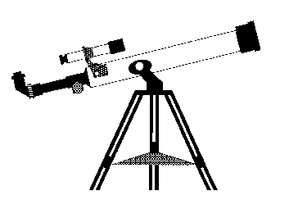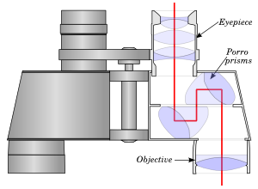
a. Explain why binoculars and telescopes are important astronomical tools.
Demonstrate or explain how these tools are used.
b. Describe the similarities and differences of several types of astronomical telescopes, including at least one that observes light beyond the visible part of the spectrum (i.e., radio, X-ray, ultraviolet, or infrared).
c. Explain the purposes of at least three instruments used with astronomical telescopes.
d. Describe the proper care and storage of telescopes and binoculars both at home and in the field.
4. Do the following:
a. Identify in the sky at least 10 constellations, at least four of which are in the zodiac.
1.
2.
3.
4.
5.
6.
7.
8.
9.
10.
b. Identify at least eight conspicuous stars, five of which are of magnitude I or brighter.
Name of star Magnitude 1 or brighter?
1.
2.
3.
4.
5.
6.
7.
8.
c. Make two sketches of the Big Dipper. In one sketch, show the Big Dipper’s orientation in the early evening sky. In another sketch, show its position several hours later. In both sketches, show the North Star and the horizon. Record the date and time each sketch was made.
Date:___/___/___ Time: _____ Date:___/___/___ Time: _____
North Star
West North East
Suggested procedure:
Choose a clear night when you will have time and the ability to make observations some hours apart. Looking north, draw the position of the Big Dipper with relation to the North Star. Note the time next to it. Several hours later (six hours are best but at least four hours and preferably more than five hours) draw the position of the big dipper with relation of the North Star and note the time next to it. (Be sure to clearly identify which diagram represents which observation)

d. Explain what we see when we look at the Milky Way.
5. Do the following:
a. List the names of the five most visible planets. Explain which ones can appear in phases similar to lunar phases and which ones cannot, and explain why.
Five Most Visible Planets Phases? Why?
b. Using the Internet (with your parent's permission), books, and other resources, find out when each of the five most visible planets that you identified in requirement 5a will be observable in the evening sky during the next 12 months, then compile this information in the form of a chart or table.
Planet Name
Month
January
February
March
April
May
June
July
August
September
October
November
December

c. Describe the motion of the planets across the sky.
d. Observe a planet and describe what you saw.
6. Do the following:
a. Sketch the face of the Moon and indicate at least five seas and five craters. Label these landmarks.

b. Sketch the phase and the daily position of the Moon, at the same hour and place, for four days in a row. Include landmarks on the horizon such as hills, trees, and buildings.
Date:___/___/___ Time: _____ Date:___/___/___ Time: _____
Date:___/___/___ Time: _____ Date:___/___/___ Time: _____
East South West
Suggested procedure:
First check to see whether it is a morning or evening moon and chose a time to view the moon. Avoid an observation period when there will be a new moon. Choose a time and place you are going to be able to observe the moon each day. On the first day, sketch the relative position of the moon across the southern horizon noting its height and shape (phase). Draw some landmarks on the sketch as points of reference. On the same drawing, repeat this at the same time each day for the next three days, showing the height and shape of the moon for each observation. Note the date and time of your observation next to each sketch of the moon. If the sky is overcast and the moon is not visible, either extend the observations until you can make four of them, and/or using the other observations, estimate where the moon would have been and what shape it would have been on the overcast day(s) and indicate that what is an estimate due to overcast sky.
Explain the changes you observe.

c. List the factors that keep the Moon in orbit around Earth.
d. With the aid of diagrams, explain the relative positions of the Sun, Earth, and the Moon at the times of lunar and solar eclipses, and at the times of new, first-quarter, full, and last-quarter phases of the Moon.
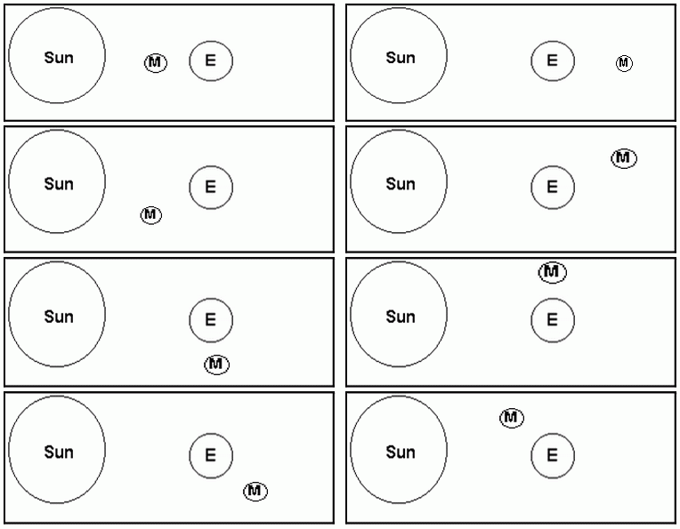
Editor’s Note: These diagrams can be used to show the relative positions of the Sun, Earth, and Moon during the new, first-quarter, full, and last-quarter phases of the Moon as well as during the Waxing Gibbous”, “Waning Gibbous”, “Waxing Crescent”, and “Waning Crescent” phases of the Moon (which is not required for the merit badge). Two of the diagrams can be used to show the positions both for a phase of the Moon and during an eclipse.

7. Do the following:
a. Describe the composition of the Sun, its relationship to other stars, and some effects of its radiation on Earth’s weather and communications.
Composition:
Relationship to other stars:
Effects on Earth’s weather:
Effects on communications.
b. Define sunspots and describe some of the effects they may have on solar radiation.
Definition:
Effects:

c. Identify at least one red star, one blue star, and one yellow star (other than the Sun).
Red star:
Blue star:
Yellow star:
Explain the meaning of these colors.
8. With your counselor's approval and guidance, do ONE of the following:
a. Visit a planetarium or astronomical observatory. Submit a written report, a scrapbook, or a video presentation afterward to your counselor that includes the following information:
1. Activities occurring there
2. Exhibits and displays you saw
3. Telescopes and instruments being used
4. Celestial objects you observed.
b. Plan and participate in a three-hour observation session that includes using binoculars or a telescope. List the celestial objects you want to observe, and find each on a star chart or in a guidebook.
Prepare an observing log or notebook. Show your plan, charts, and log or notebook to your counselor before making your observations. Review your log or notebook with your counselor afterward.
c. Plan and host a star party for your Scout troop or other group such as your class at school. Use binoculars or a telescope to show and explain celestial objects to the group.
d. Help an astronomy club in your community hold a star party that is open to the public.
e. Personally take a series of photographs or digital images of the movement of the Moon, a planet, an asteroid or meteoroid, or a comet. In your visual display, label each image and include the date and time it was taken. Show all positions on a star chart or map. Show your display at school or at a troop meeting. Explain the changes you observed.

9. Find out about three career opportunities in astronomy.
1.
2.
3.
Pick one and find out the education, training, and experience required for this profession
Discuss this with your counselor, and explain why this profession might interest you.

When working on merit badges, Scouts and Scouters should be aware of some vital information in the current edition of the Guide to Advancement (BSA publication 33088).Important excerpts from that publication can be downloaded from http://usscouts.org/advance/docs/GTA-Excerpts-meritbadges.pdf.
You can download a complete copy of the Guide to Advancement from http://www.scouting.org/filestore/pdf/33088.pdf.

